THE UNITED NATIONS SECURITY COUNCIL AND POLITICS OF VETO POWER THE CASE STUDY OF SYRIA ( 2011 TO 2021)

BY

EZUE DANIEL CHIBUIKEM
GOU/U21/IRE/506

DEPARTMENT OF POLITICAL SCIENCE AND INTERNATIONAL RELATIONS
FACULTY OF MANAGEMENT AND SOCIAL SCIENCES
GODFREY PKOYE UNIVERSITY U GWUOMO-NIKE-EMENE

AUGUST, 2025

TITLE PAGE

THE UNITED NATIONS SECURITY COUNCIL AND POLITICS OF VETO POWER THE CASE STUDY OF SYRIA ( 2011 TO 2021)

BY

EZUE DANIEL CHIBUIKEM
GOU/U21/IRE/506

A PROJECT PRESENTED TO THE DEPARTMENT OF POLITICAL SCIENCE AND INTERNATIONAL RELATIONS, FACULTY OF MANAGEMENT AND SOCIAL SCIENCES, GODFRE OKOYE UNIVERSITY THINKERS CORNER ENUGU, NIGERIA
IN PARTIAL FULFILMENT OF THE REQUIREMENTS FOR THE AWARD OF BACHELOR DEGREE IN INTERNATIONAL RELATIONS

SUPERVISOR:DR. MBAEZE NTECHY

AUGUST, 2025
DECLARATION
I, EZUE DANIEL CHIBUIKEM, hereby declare that this research project titled.” The United Nations security council and politics of veto power: A case study of Syria (2011-2021)” was written and presented by me to Godfrey Okoye university, Enugu state and has not been presented anywhere for the purpose of acquiring any degree in international Relations.
________________________ ________________
EZUE, DANIEL CHIBUIKEM DATE
GOU/U21/IRE/506.

APPROVAL PAGE
This project has been examined and approved by the department of international relations godfrey okoye university for the award of bachelor of science (b.sc) in international relations

___________________ ___________________
Dr.Mbaeze Ntechy Date
Supervisor

___________________ ___________________
Dr Ugwuozor Samuel Date
Head of Department

____________________ ___________________
Assoc. Prof. John Odo Date
Dean, Faculty of Management and Social Sciences

_________________ ___________________
External Examiner Date

DEDICATION
This research is dedicated to God Almighty for his providence, guidance, protection, wisdom, grace and strength. For always coming through for me. With him I came, saw and conquered

ACKNOWLEDGEMENT
First and foremost, I give all glory and thanks to Almighty God for granting me the strength, wisdom, and perseverance to successfully complete this research project. Without His divine guidance, this work would not have been possible.
My heartfelt appreciation goes to my supervisor, Dr.Mbaeze, for his guidance, patience, and valuable input, which greatly shaped the quality of this work. I sincerely thank him for his commitment and mentorship.
I also owe sincere gratitude to my lecturers for the knowledge and inspiration they instilled in me throughout my academic pursuit. I particularly wish to acknowledge: Dr. Barr. Sam Ugwuozor (HOD), Dr. Mrs. Ifedi Francisca, Dr. Rolland, Rev. Fr. Dr. Ogbuka Ikenna, Rev. Sis. Dr. Lucy Umeh, Mr. Okonkwo W.O. Mr. Onyishi Anthony,Dr. Kingsley Ezechi, Mr. Ejike Nnaji, , Mr. Nweke, prof. Onyema Ocheoha, prof.S.I. Odoziobodo. Clement, Mrs. Choima (Secretary)
I am deeply grateful to my beloved parents, Mr. and Mrs. Ezue, whose love, prayers, and constant encouragement have been my greatest support throughout this academic journey. Your sacrifices and unwavering belief in me have brought me this far.
Thank you all for your dedication, support, and the impactful knowledge you shared with me. Your contributions will always be remembered and cherished.
I, also want to thank my friends for their support and kindness throughout my stay in this school. A shoutout to Obasi Nnamdi, Joyce, Ralph Ejiofor, Sochimar, light, Ijeoma grace, Toochi ukwaike, Ngozi, frank, Devvyn. Etc
It has been a pleasure and privilege working with each and every one of them I appreciate you all.

TABLE OF CONTENT
Title of Page i
Declaration ii
Approval iii
Dedication iv
Acknowledgment v
Table of Contents vi
List of Tables viii
Abstract ix

CHAPTER ONE; INTRODUCTION 1
1.1 Background to the Study 1
1.2 Statement of the Problem 5
1.4 Research Objectives 7
1.5 Significance of the Study. 7
1.6 Scope of the Study 9

CHAPTER TWO: LITERATURE REVIEW 10
2.1 Conceptual Review 10
2.1.1 Veto Power 10
2.1.2 Responsibility to Protect (R2P) 11
2.1.3 United Nations Security Council (UNSC) 13
2.1.4 International Peace and Security 14
2.1.5 Power Politics 16
2.1.6 Humanitarian Intervention 17
2.1.7 Sovereignty vs. Global Governance 19
2.2 Thematic Review 20
2.2.1 The Structural Limitations of the UNSC in Crisis Situations 20
2.2.2 Geopolitical Rivalries and Humanitarian Inaction 23
2.3 Empirical Review 26
2.4 Summary of Literature and Gap 30

CHAPTER THREE: METHODOLOGY 31
3.1 Theoretical Framework 31
3.1.1 Power Theory 31
3.1.3 Applicability of the Theories 33
3.2 Hypotheses 33
3.3 Research Design 33
3.4 Methods of Data Collection 34
3.5 Methods of Data Analysis 34
3.6 Logical Data Framework 35

CHAPTER FOUR: DATA PRESENTATION AND ANALYSIS 37
4. Introduction 37
4.1 UNSC Inadequate Compliance with UN Resolutions 37
4.1.1: Vetoed Resolutions on Syria (2011 – 2021) 39
Table 1: UNSC veto usage on Syrian Resolution (2011 – 2021) 39
4.2 Veto Power and Conflict Escalation 39
Table 2: UNSC Actual Veto records(2011 – 2021) 40
4.3 Humanitarian Consequences: civilian displacement 40
4.3.2 Analysis of UNSC inconsistencies 41

CHAPTER FIVE: SUMMARY, CONCLUSION AND RECOMMENDATION 49
5.1 Summary of Finding 49
5.2. Conclusion 51
5.3 Recommendations 52
REFERENCES 53

LIST OF TABLES
Table 1: UNSC veto usage on Syrian Resolution (2011 – 2021) 39
Table 2: UNSC Actual Veto records(2011 – 2021) 40
Table 3: Impact of Veto-Induced Inaction in Syria (2011-2021) 44

ABSTRACT
This research xamines the connection of the United Nations Security Council (UNSC) and the veto game politics by bringing out the case of the Syrian conflict (2011-2021). Since the international community has hardly responded to emerging humanitarian crisis in Syria, the study presents a critical examination of how abuse of the veto power mostly enjoyed by permanent members, Russia and China, has influenced the international reaction towards the conflict. With rampant violence, plausible accusations of war crimes, and a long-term humanitarian crisis, menaces to international peace and security are being flaunted on the basis of geopolitical aspirations of some of the most powerful states within the UNSC. Based on the realist theory of international relations, the paper also asserts that the P5 (Permanent Five members) does not act based on their devotion to international peace and security; instead the actions of the members are largely informed by self interest and considerations of power.The concept of the paralysis and inaction of the Security Council to mass atrocities is examined by means of the realism as an approach focusing on the anarchic character of the international system and the search of the national interest. The analysis of the primary and secondary sources is based on content analysis to incorporate the UN resolutions, voting behavior, official reports, scholarly literature, and international authority writings. The study, however, emerged as a qualitative research process. It examines the political application of the veto in important instances of the Syrian civil war and how it should be perceived in the context of international law in general and multilateral diplomacy and humanitarian intervention. The above findings indicate that veto power has not just been a weapon of procrastination as some would have suggested but has been employed also to preserve entourage and promote strategic policies, that in the occasion, has compromised the legitimacy, credibility and efficiency of the UNSC.The report comes to a rather conclusive opinion that institutional change must be highly recommended including restrictions to the application of the veto power in cases of the use of mass atrocity. To restore the integrity of the Council and uphold its most fundamental mandate of maintaining international peace and security.

CHAPTER ONE

INTRODUCTION

1.1 Background to the Study
It has become clear that non-state actors now have a major influence on the development of world politics. During nationwide crises, like the COVID-19 pandemic, important organizations such as the World Health Organization (WHO) have come to the fore. When the COVID-19 pandemic struck, the WHO’s activities showed how NSA’s are able to work across nations, support cooperation and help shape global policy decisions.
Internationally, non-governmental organizations, organizations or groups are called non-state actors, even if they have a lot of influence and operate without being controlled by governments. Among these groups are intergovernmental organizations, non-governmental organizations, multiple corporations based in many countries, advocacy groups and networks spread across borders. In 1948, the WHO became a UN specialized agency, fulfilling its role as the primary organization overseeing worldwide health matters. In many years, the organization has played a major role in worldwide health movements such as eliminating smallpox and fighting polio. Thanks to these actions, many countries have supported WHO’s decisions and depend on its public health guidelines (Gostin et al., 2020).
Several reasons explain why NSAs such as the WHO, play a greater role in global governance now. Because of globalization, nations are now connected in many ways and true cooperation between nations is needed to solve problems like climate change, terrorism and pandemics. After appearing in Wuhan, China in late 2019, COVID-19 underlined the need for an organized international action against public health emergencies. The WHO declared COVID-19 a PHEIC on January 30, 2020 and afterwards a pandemic on March 11, 2020. Because of this, everything from health, economy and social activities was disrupted around the world (World Health Organization, 2020). The way the WHO responded then is a clear example of how non-state actors affect current world affairs.
One of the biggest ways the WHO helped during the COVID-19 pandemic was by giving authoritative policy suggestions to different countries. The organization created a variety of technical guidelines that deal with every stage of pandemic management, including wanding, stopping the spread, treating the ill and vaccination. As a result of the guidelines, the WHO shaped worldwide approaches to tackling the virus (Hale et al., 2020). Therefore, when the WHO endorsed health advice such as mask-wearing, social distancing and mass testing, countries in many places changed their public health policies. When it comes to vaccination during COVID, the WHO pointed out that allocating vaccines first to health workers and vulnerable populations is part of its guidance on ethics in crises (So & Woo, 2021).
Besides setting policies, WHO took a key part in bringing countries together during the pandemic. Since it saw unfairness in the world’s healthcare system, the organization tried to fill in resource and knowledge gaps. With United Nations Foundation’s backing, the COVID-19 Solidarity Response Fund gathered important materials and supported research aimed at tackling COVID-19. Along with these partners, the WHO introduced COVAX to advance equity in COVID-19 vaccine distribution. The program was designed to make sure vulnerable and resource-poor countries could receive vaccines (Bollyky et al., 2022). Thanks to putting global equality at the forefront, the WHO was able to address skewed power in health and support the underprivileged.
WHO’s work against misinformation during the pandemic showed that it can adapt to modern challenges. The flood of untrue or incorrect information during the COVID-19 “infodemic” made it difficult for public health agencies to respond effectively. Because of this, the WHO started "EPI-WIN Information Network for Epidemics" to share proper reminders and joined forces with online platforms to stop inaccurate information from spreading. This activity displayed how WHO is using new technology to advocate for public health and how it continues to believe in interventions that rely on science (Chou et al., 2020).
Still, the WHO encountered problems and received criticisms when it took action during the COVID-19 pandemic. In the beginning of the outbreak, it was claimed that the organization was slow to react. Experts claimed that, because the WHO heavily depended on China’s data, it delayed calling COVID-19 a pandemic and sending global warnings. Because of the delays, the early work done to stop the virus was seen as ineffective, giving the virus free rein to spread (Petersen et al., 2020). In addition, depending primarily on its member states for funds and on optional donations leaves the WHO open to political influence. In fact, the United States cutting off some funds in 2020 to some NSAs under the Trump administration made it clear that NSAs can have a hard time operating in complex political settings.
During the COVID-19 pandemic, the WHO played a major role that resonates beyond this crisis for how NSAs are involved in the world’s affairs. Organizations addressing international problems, guiding cooperation and influencing laws change the usual way countries are viewed in international relations. However, the effectiveness of NSAs depends on several factors, including adequate funding, institutional autonomy, and public trust. The COVID-19 pandemic exposed the limitations of existing global health frameworks and underscored the need for reforms to enhance the capacity and resilience of NSAs like the WHO.

1.2 Statement of the Problem
Even though NSAs have a growing influence in world politics, their effectiveness on transnational issues remains unclear. Because of COVID-19, WHO, a major NSA in global health, received demands it had not experienced before. Since COVID-19 was such a significant pandemic, it needed strong worldwide actions outside national borders. The WHO led these efforts, guiding health plans worldwide, coordinating countries and promoting fair sharing of resources. But, the past years demonstrated major drawbacks in how it performed.
Many people pointed out that the WHO was too slow to react when the pandemic first appeared. Though the WHO proclaimed COVID-19 to be a PHEIC and a pandemic, some pointed out that its relying on each country’s published data and reluctance to act strongly were not favorable qualities. Because the world did not react in time, the virus quickly affected nations worldwide and worsened its effects on health, the economy and society. The WHO’s work to make vaccines available equally through COVAX was limited by a lack of equal opportunity in global healthcare, a need for more resources and disagreements among member countries. Their struggles made it clear that the organization must count on voluntary funds, leaving some to wonder if it can stand up to political pressure.
Furthermore, misleading information that spread during the pandemic demonstrated how difficult it was for the WHO to maintain effective communication about health around the world. A lot of false health information flooding the internet caused people to trust health interventions less, so vaccine campaigns were difficult and people did not always follow health guidelines. Despite being innovative, WHO’s initiatives like EPI-WIN found it hard to deal with the rapid growth of online misinformation.
These challenges point to a broader problem: while NSAs like the WHO are indispensable in addressing global crises, their capacity to influence global politics and achieve their objectives is often constrained by structural, political, and financial limitations. The COVID-19 pandemic revealed gaps in global health governance that hindered the WHO’s ability to respond effectively, raising critical questions about the role, influence, and future of NSAs in shaping global political outcomes. This study seeks to address these gaps by critically examining the influence of NSAs in global politics, with a focus on the WHO’s response to the COVID-19 pandemic. To guide this study, the following research questions have been formulated:
- Has the WHO’s role in coordinating international health responses influenced global political cooperation and decision-making during the COVID-19 pandemic?
- Has WHO’s advocacy for equitable vaccine distribution influenced global vaccine access, particularly in Africa?

1.3 Objectives of the Study
The main objective of this study is to analyze the influence of non-state actors, specifically the World Health Organization (WHO), on global politics during the COVID-19 pandemic. The specific objectives are;
- To examine how the WHO’s coordination of international health responses influenced global political cooperation and decision-making during the COVID-19 pandemic.
- To ascertain the impact of the WHO’s advocacy for equitable vaccine distribution on global vaccine access, particularly in Africa

1.4 Significance of the Study
The study has significance because it addresses ideas, problems and solutions related to global governance: It adds to a growing understanding of the role NSAs play in global decision-making during crisis situations. Highlighting WHO’s influence during COVID-19 teaches us about the growing relationship between NSAs and state actors on matters of global politics. This work will help explain the role of NSAs in global choices, foreign ties and the way global institutions run, where information is currently limited.
The study gives policymakers, global health leaders and people involved in international relations practical guidance. Evaluating how the WHO dealt with the COVID-19 pandemic reveals what needs to be improved in worldwide health governance areas, including money, communication and cooperation. The findings from these cases help strengthen global systems and shape robust actions to face future crisis situations.
National governments and international organizations are urged by the study to collaborate with NSAs in fighting challenges that cross borders. It supports practical suggestions that make the WHO better able to guide global health care, share resources justly and improve worldwide solidarity. Results of the study might be used to create policies that ensure national security agencies work closely and effectively with health state agencies, particularly during health emergencies.
The research also matters to scholars, members of civil society and ordinary people. It points out how NSAs like the WHO help to resolve problems created by the blend of political and health-related factors during emergencies. According to the study, looking at the WHO’s achieve­ment in equitable vaccines, tackling misinformation and partnering globally points out the need for everyone to act together on world issues.

1.5 Scope and Limitations of the Study
1.5.1 Scope of the Study
This study examines the influence of non-state actors (NSAs) on global politics, using the World Health Organization (WHO) as a case study. It specifically explores WHO’s role in coordinating international health responses and its impact on global political cooperation and decision-making during the COVID-19 pandemic. Additionally, the study investigates how WHO’s advocacy for equitable vaccine distribution shaped global vaccine access, particularly in Africa. The geographic scope is global, reflecting WHO’s extensive influence on health policies and international relations. The study focuses on the period from the emergence of COVID-19 in late 2019 to 2023, capturing key political dynamics, decision-making processes, and global health responses during the pandemic.

1.5.2 Limitations of the Study
The study relies on secondary data, such as official reports, scholarly articles, and media coverage. Potential biases in these sources or a lack of comprehensive data on certain aspects of the WHO's activities may affect the depth of analysis. By concentrating on the WHO, the study may not account for the broader influence of other NSAs during the pandemic, limiting its generalizability to other non-state actors in global politics. Despite these limitations, the study aims to provide a comprehensive analysis of the WHO's influence on global politics during the COVID-19 pandemic, contributing valuable insights into the role of non-state actors in international governance.

1.6 Operational Definition of Terms
Non-State Actors (NSAs): Entities that influence global politics and governance but are not affiliated with any specific nation-state. In this study, non-state actors refer specifically to the World Health Organization (WHO) and its role in managing the global health response during the COVID-19 pandemic.
World Health Organization (WHO): A specialized agency of the United Nations responsible for international public health. For this study, the WHO is examined as a non-state actor that influenced global politics through its initiatives, policies, and actions during the COVID-19 pandemic.
Global Politics: The interaction and relationships among countries, international organizations, and non-state actors in the global arena. This study focuses on how the WHO’s actions during the COVID-19 pandemic impacted international relations, policy-making, and global cooperation.
COVID-19 Pandemic: A global health crisis caused by the novel coronavirus (SARS-CoV-2), first identified in late 2019. In this study, the COVID-19 pandemic represents the context in which the WHO’s influence on global politics is analyzed.

CHAPTER TWO

LITERATURE REVIEW

2.0 Introduction

2.1 Conceptual Review

2.1.1 Non-State Actors
In international politics, non-state actors (NSAs) have grown in importance and no longer allow nations to claim they have sole decision-making power. NSAs stand for entities in international relations that work in various nations and can impact policies, government and decisions even when not directly directed by the government (Weiss & Wilkinson, 2018). Such actors include global organizations, non-governmental groups, large corporations, groups standing for causes, religious leaders and terrorists (Biersteker et al., 2019).
Typically, the Westphalian system meant that nation-states were the central figures in running international affairs, because it believed they were the primary influencers of world order (Fukuyama, 2019). As a result of globalization, new technologies and worldwide economic links, non-state players now influence international policies and sometimes challenge the rights of nations (Keohane & Nye, 1977). Keohane and Nye (1977) argued that complex interdependence means NSAs are very important for diplomacy, shaping policies and responding to emergencies.
The effect NSAs have depends on their construction, what they aim to accomplish and their ties to both state and non-state parties. The main categories that get recognized the most are:
- IOs function at an international level, are created by various countries though treaties and often play important roles in policymaking. Examples of IOs that control or affect world policies include the World Health Organization, the United Nations, the International Monetary Fund and the World Trade Organization (Abbott & Snidal, 1998).
- Doctors Without Borders (Médecins Sans Frontières), Amnesty International and Greenpeace are part of the NGOs that affect decisions on human rights, the environment and humanitarian aid (Risse, 2012).
- Companies such as Pfizer, Google and Shell which operate globally, are involved in shaping international economic reforms, trade deals and labor laws (Dunning, 2013).
- Such organizations strongly advocate changes in policies that concern climate, public health, as well as human rights, through lobbying, activism and research (Keck & Sikkink, 1998).
- ISIS, Al-Qaeda and drug cartels are examples of groups that work without state authority but greatly affect security and policing around the world (Cronin, 2006).
These actors impact things in various functions such as money, political support and services or risks to civilization and security (Slaughter, 2017). One major contribution of NSAs to global governance is their help in the group management of global matters by various contributors including states, international organizations and private groups (Rosenau, 2025). Because of the growing complexity of global challenges such as climate change, pandemics, economic problems and wars, multi-actor governance has become necessary. Today, NSAs can function as partners or even as challengers to the roles of states (Weiss, 2013).
Efforts to control health issues worldwide rely on organizations like the WHO which coordinate pandemic responses, create global health rules and help countries work together (Fidler, 2021). Likewise, NGOs and advocacy groups act by mustering support, doing research and urging governments to make certain policies (Gourevitch et al., 2012). Abbott and Snidal (1998) explain that global governance benefits from NSAs in many areas. Technically, NSAs can do more and have access to more resources than government agencies. Speed of response is something NSAs can do better than bureaucratic state institutes in emergencies. Example of such groups include NGOs and advocacy organizations that can call out unfair governments and promote human rights without letting state goals cut them off. Even so, the growth of NSAs means that issues such as accountability, legitimacy and the risk of disagreements happening between state and non-state actors now arise (Biermann & Pattberg, 2012).

2.1.2 Global Politics
The term global politics covers the processes through which nations, organizations, groups outside governments and international institutions relate to each other and influence their behavior. It consists of the interactions countries have through diplomacy, the economy, the military and their ideas which influence both international matters and world administration (Baylis, Smith, & Owens, 2020). Global politics is at the heart of learning how countries often work together, resolve problems, share economies and use leading institutions to deal with threats like pandemics, climate change and security.
There is a relationship of interdependence in global politics, with countries and non-government actors related in ways that influence both safety and prosperity around the world. Because of globalization, more countries are being connected, making the study of global politics valuable for exploring how regional economic, social and political situations are influenced by agreements and international relations (Keohane & Nye, 2012). The United Nations, World Health Organization and World Trade Organization all help to guide global policies and give a place for different countries to engage together in political matters (Abbott & Snidal, 1998).
Diplomacy which is a main feature of global politics, helps countries negotiate and find solutions for peace, teamwork and handling disputes. International agreements can guide a nation’s foreign policy, thanks to the use of diplomacy by countries working one-on-one or together in groups. During the COVID-19 pandemic, clear evidence played out that countries relied on diplomacy to collaborate on finding vaccines, taking health measures and handling the resulting economic damage (Fidler, 2021). It became clear during the pandemic that working with other countries is key to addressing health issues and easing disruptions to society and the economy.
International law plays a key role in setting rules for state to state relations in international politics. Treaties, conventions and instruments of international law address topics including trade, human rights, security and protecting the environment. ICC and ICJ and similar organizations, oversee the application of laws that encourage justice and responsibility worldwide (Slaughter, 2004). Even so, there are difficulties applying international law as countries pursue their own interests, political stakeholders have influence and enforcement limits may be reached (Hathaway & Shapiro, 2017). Trade, political economic decisions and financial organizations influence global politics. Sending loans and policy directions is what the IMF and the World Bank do which supports nations with their economic and development plans. Economic diplomacy helps countries gain advantages from trade negotiations and strengthens their economy. Yet, the inequality among rich and poor nations still causes many problems and leads to people talking about fair trade, relieving debt and promoting sustainable development (Stiglitz, 2018).
Addressing transnational issues has become more reliant on global governance methods these days. These problems—climate change, terrorism, migration and cybersecurity—can only be managed by working together and collaborating worldwide. The Paris Agreement on climate change is designed to limit greenhouse gas emissions and overcome environmental deterioration around the world (Bodansky, 2016). Much like other efforts to fight terrorism, counterterrorism depends on sharing intelligence, joining international groups and teaming up for security measures (Cronin, 2020). These days, multinational companies, non-governmental organizations (NGOs) and advocacy groups have become more important in world politics. The actions of these actors reach policymaking, aid programs and social groups all around the world. One example is Amnesty International and Human Rights Watch, NGOs that work for human rights and social justice and affect both world policies and people’s opinions (Keck & Sikkink, 1998). On the contrary, global companies influence the world’s economy and workplaces by making investment choices, building supply chains and carrying out social programs (Dunning, 1993).
How global politics functions during a crisis is well demonstrated by the pandemic. Issues related to vaccines, travel and the recovery of economies made it apparent just how hard it is for nations to cooperate globally. The organization led coordinated efforts in international health, issued vital guidance and helped bring fair vaccine distribution through COVAX (Usher, 2021). Even so, differences in who got the vaccines and nationalistic decisions sparked criticism of how global bodies handled the fair response to the pandemic (Gostin et al., 2021).

2.1.3 The World Health Organization (WHO)
WHO is a specialized body within the United Nations responsible for global public health. The WHO was set up on April 7, 1948, to lead global health policy, organize actions in emergencies and support equal health for all (Gostin et al., 2016). Since there are 194 member states, WHO leads the world in health and helps decide policies, decide on standards and support governments with their health work. Ensuring everyone’s health, focusing on preventive care, controlling diseases and ensuring health for everyone is the organization’s main mission (WHO, 2021).
Preparing for and responding to health emergencies is one of WHO’s main responsibilities. WHO monitors diseases that may affect people everywhere, follows up on disease outbreaks and takes steps to stop diseases including COVID-19, Ebola and Zika virus. In line International Health Regulations (IHR), WHO offers countries guidance on how to identify, judge and manage serious public health emergencies of global concern (PHEIC) (Fidler, 2019). During emergencies, the IHR allows WHO to advise governments, gather resources and give scientific advice to member states. Even so, delays in reporting, pushback from governments and a shortage of necessary resources often make it difficult for WHO to respond properly (Huang, 2020).
The approach and goals of the WHO have changed over time. In these two decades, the WHO mainly focused on particular infectious diseases when planning its activities. At this time WHO was regarded as apolitical because its application of new technologies to solve health problems was welcomed by everyone worldwide. With increased awareness that bugs and germines no longer respond to antibiotics and pesticides, strategies beyond vertical approaches-addressing the cause of diseases from the top- down-were gradually supported which also made global health a bigger political topic. In 1977, at its World Health Assembly, the WHO declared that its primary objective was to provide health care to all people by 2000 by introducing changes to health policies worldwide. In the following year, WHO and UNICEF held the International Conference on Primary Health Care at Alma Ata in the Soviet Union, strongly stating that access to healthcare was a right for every person everywhere.
Adopting a horizontal approach, the WHO ran into difficulties by challenging the established views on economic development and appearing to back more local autonomy for developing countries, instead of encouraging investment from richer countries. This was made clear in 1977 with the launch of the ‘essential drugs’ campaign which urged people in the Third World to develop their own drugs rather than import them from the First World. In addition, the WHO turned radical, much like the UN General Assembly, after the arrival of new countries from Africa and Asia and their push to talk about their former and current oppressors. Because the US supported MNC influence the most, it grew less and less impressed with the newly decided WHO. A strong condemnation at the 1981 World Health Assembly to approve an international code on infant formula sales to LDCs and many years of dispute over essential drugs triggered the US-led campaign against the WHO and other UN agencies in the 1980s.
Some nations have argued against using the horizontal approach in global health because fast technical solutions are still favored, despite a series of setbacks. The world responds to disasters more effectively than it does to typical suffering and dealing with epidemics often remains the first action by governments. After the 1970s, the money set aside for disease-related work at the WHO has increased faster than the regular budget and this trend has continued since the Brundtand reforms. For a lot of people, this has disrupted the existing horizontal approach and weakened the goal of providing health to all. Public relation-focused companies may prefer to spend more on projects that might draw more interest over those that need more attention. According to De Maeseneer (2008), acute respiratory illnesses, for instance, barely get 2.5 percent of the funding allotted to global health campaigns, but accounting for 26 percent of the burden of communicable diseases. Garrett argues that because HIV medics are frequently kept apart from other medical professionals and funds have been taken out of public health budgets, the international community's focus on HIV/AIDS has actually deteriorated the general health of many nations, especially those affected by the infection (Garrett 2007).
As a result, the WHO entered the twenty-first century facing criticism on two fronts with its general orientation trapped between that of horizontal public health advocates and vertical "eradicationists" (Godlee 1995). The US and other large donor governments were pleased with Brundtland's leadership because it made the WHO more transparent and economical, but it also lost some of its radicalism and became less hesitant to offend corporations. In the 1990s, the cigarette lobby intimidated the anti-tobacco campaign into a weak agreement. This changed in 2005 when the much bolder Framework Convention on Tobacco Control went into effect, which led to the implementation of stricter cigarette advertising and labelling standards in many countries. A campaign in favour of the "essential drugs" program, which resulted in a significant legal victory in 2001 when the US government and a number of pharmaceutical companies were convinced to drop legal challenges prohibiting South African and Brazilian companies from marketing less expensive generic HIV medications, also displayed renewed radicalism. WTO Trade Related Intellectual Property Rights (TRIPS) were the target of the legal cases, but widespread public outcry over them led to a concession and represented a major win for human rights over corporate interests. Recent campaigns that target "lifestyle illnesses" like diabetes and obesity have also offended some strong governments and companies. Although there are two ways to criticise the WHO's twin funding mechanism, it enables the organisation to continue obtaining public and private funding for well-known vertical campaigns while maintaining a more socially conscious functionalist political direction that is led by the organisation itself.
WHO is also essential in establishing international health norms and regulations. It creates evidence-based guidelines on topics including mental health, antibiotic resistance, and maternal health and vaccination. WHO sets standards that influence national health policy and medical practices globally via its technical reports (Lee, 2020). Initiatives like the Expanded Programme on Immunisation (EPI) and the COVAX facility, which seek to guarantee fair vaccination access for low- and middle-income nations, demonstrate the organization's especially noteworthy involvement in vaccine production and distribution (Usher, 2021).
WHO aggressively advocates universal health coverage (UHC) as a top goal in addition to disease control. The group promotes lowering health inequities across groups, enhancing access to necessary medications, and fortifying health systems. Especially in underserved areas, WHO works with governments to create policies that improve healthcare financing, workforce capacity, and service delivery (World Bank & WHO, 2017). However, political unrest in certain areas, insufficient infrastructure, and economic limitations make reaching UHC a difficult task (Kruk et al., 2018).
Health advocacy and awareness is another important aspect of WHO's mission. The group runs international health campaigns on topics including mental health, nutrition, and tobacco control. A historic agreement, the Framework Convention on Tobacco Control (FCTC) of the World Health Organisation seeks to prevent smoking-related illnesses by educating the public and implementing legislative changes (Jha & Peto, 2014). In a similar vein, WHO spearheads efforts to address non-communicable diseases (NCDs), which have emerged as the world's top causes of death and include diabetes, cardiovascular disease, and cancer (WHO, 2020). WHO is subject to a number of challenges and critiques in spite of its accomplishments. The organization's goals and decision-making procedures may be influenced by the voluntary contributions made by individual donors and member nations (McCoy et al., 2009). Moreover, pressure from different countries and ineffective systems within WHO have also made it harder for the organisation to deal swiftly with medical emergencies (Kamradt-Scott, 2015). COVID-19 made it clear that the WHO struggled to manage misinformation and ensure leading nations abided by universal health rules (Gostin et al., 2021).
WHO is still significant as a non-government group that influences laws, helps build healthcare systems and resolves dangers to public health. We can see its significance in world politics because it sets safety standards, works for fair health access and helps lead worldwide efforts during outbreaks. To be more effective in addressing upcoming health problems and supporting a healthier global population, WHO needs ongoing changes and better teamwork from other countries.

2.1.4 COVID-19
Since late 2019, the international spread of COVID-19, caused by the severe acute respiratory syndrome coronavirus 2 (SARS-CoV-2), has greatly affected relations between countries, global economic situations and health. In Wuhan, China, a new virus called COVID-19 emerged and then spread fast across the globe, bringing severe illness, many deaths and surprising chaos to both society and the economy (Wu et al., 2020). Because of the epidemic, people are talking more about getting ready for pandemics, health systems’ problems have become clearer and international health rules have evolved.
Most people get the COVID-19 virus from being close to an infected person or by breathing in droplets. At the beginning of the pandemic, major new cases were from people without symptoms, who spread the virus widely. That is why early public health measures focused on masks, social distancing and lockdowns (Gandhi et al., 2020). Many nations and health organisations such as the WHO and the CDC, devoted their efforts to reducing the spread of the virus and recommended following contact tracing, having tests and making sure places are kept clean, stressing their value in doing so.
COVID-19 affects social life and the economy, just as it does health. The enforcement of lockdowns and closing down many businesses worldwide caused big drops in stock markets, supply issues and unemployment to rise considerably (Nicola et al., 2020). Because of the pandemic, we discovered that marginalised areas were more likely to have higher infection numbers, less access to health services and greater economic challenges (Bambra et al., 2020). To manage health crises well, the crisis pointed out that strong health systems, fair division of resources and international teamwork are required.
The pandemic was contained in large part thanks to creating and distributing vaccines. Thanks to joining forces and an impressive financial effort around the world, the vaccines for COVID-19 were made much faster in the virology and immunology fields (Polack et al., 2020). To make sure vaccines get to low-income countries fairly, WHO teamed up with the Coalition for Epidemic Preparedness Innovations (CEPI) and Gavi for the COVAX initiative (Usher, 2021). Yet, since only rich countries received higher doses of vaccines, this has led to few vaccines reaching the poor, causing ethical and political controversies (Emanuel et al., 2021).
Also, because of the epidemic, the use of online medicines, healthcare software and remote job tools grew. Social distancing and mobility rules were dealt with by people shifting their work, education and healthcare online as needed (Monaghesh & Hajizadeh, 2020).
Improved public health communication and new rules are needed to combat the spread of inaccurate information about COVID-19 vaccines and treatments, since the crisis increased the level of misinformation and disinformation (Roozenbeek et al., 2020).
The reaction to COVID-19 by countries differed depending on people’s cooperation, their healthcare and the governmental structures in each place. Those countries that used strict quarantine, tested early and shared useful information naturally recovered faster and saw a decrease in virus-related deaths (Petherick et al., 2021). Meanwhile, stretched outbreaks and economic problems occurred in many parts of the world due to unfair policies, late action and making the pandemic response too political (Gostin et al., 2021). Events during the pandemic underscored that successful management of global health emergencies needs strong health systems, teamwork between nations and well-researched government actions. The lessons from the COVID-19 pandemic are still helping to design global health security systems as the world transitions to endemic phases. Experts say that strengthening oversight of diseases, supporting vaccine work and better managing health globally remain the top ways to stop future pandemics (Madhav et al., 2017). Minimizing new health hazards and making sure long-term recovery happens from the COVID-19 pandemic requires that health systems are robust and international partners cooperate.

2.2 Thematic Review

2.2.1 WHO and Management of International Health Crisis
As it gathers worldwide responses, guides with science and sends resources to control disease, the World Health Organisation (WHO) is essential for addressing international health emergencies. WHO leads efforts to reduce the impact of pandemics, epidemics and other health crises because it is the world’s top health agency. The WHO relies on the IHR to determine its approach to tracking diseases, responding to outbreaks and supporting public health safety when managing health emergencies (Fidler, 2019). It is clear from WHO’s handling of SARS, H1N1 influenza, Ebola and COVID-19 that it has been involved in managing health crises (Gostin et al., 2021).
Spotting new disease situations early and monitoring their progress are central duties for the WHO in health crisis management. WHO teams up with national authorities, health officials and organizations to watch for any new health threats through its Global Outbreak Alert and Response Network (GOARN) (Heymann et al., 2015). By using epidemiological information, WHO alerts countries about any dangers and how to deal with them ahead of epidemics. Nonetheless, WHO’s work can be hindered when countries fail to follow proper procedures, slow down in reporting and when politics play a role (Huang, 2020).
WHO sends technical guidance and advice to member states when a global health threat occurs. The recommendations cover quarantines, restrictions on travel and guidelines for preventing and treating coronavirus infections (WHO, 2021). During the Ebola epidemic in West Africa (2014–2016), the WHO set up guidelines on caring for patients, using personal protective gear and the best ways to bury those who died of the virus (Moon et al., 2015). The organisation showed how it coordinates worldwide health actions by sending out emergency teams and supporting the development of novel treatments and vaccines.
In addition to sending money and materials for health crisis response, WHO also issues guidance documents. The organisation raises both money and medicine by cooperating with government organisations, non-governmental groups and outsiders. To start vital actions right away such as vaccination, examining samples and training everyone, the WHO CFE supplies money quickly (World Bank & WHO, 2017). Nevertheless, WHO’s ability to handle emergencies has been hindered by both money shortages and problems with its structure (McCoy et al., 2009).
Delivering public health messages and risk information is a vital part of how WHO deals with international health emergencies. The organization uses social media, briefs the press and regularly updates the public to address myths and teach people during epidemics. The WHO’s efforts to address false information, address those hesitant about vaccines and encourage evidence-based health actions in response to COVID-19 helped us recognize the role of good communication (Roozenbeek et al., 2020). Nevertheless, people are questioning WHO’s ways of communicating in crisis situations because it did not declare the COVID-19 public health crisis on time and had uneven messaging in its early events (Petherick et al., 2021).
As part of its crisis defense work, WHO focuses on supporting research and making vaccines. The group works to make sure vaccinations and medical treatment are available to all, supports new drug research and sponsors clinical trials (Usher, 2021). WHO assisted with the distribution of vaccines globally as part of the COVAX project, making sure doses reached all countries, both rich and poor, during the COVID-19 pandemic (Emanuel et al., 2021). Remarkable advances in creating medicines for new illnesses are due in great part to WHO’s efforts in advancing science and innovation. WHO deals with issues that range from finding resources, dealing with political pressure and ensuring compliance which occur despite all the major work it does in handling health issues. Depending on donations from member states, the organization sometimes experiences difficulties with flexible operations and financial independence (Kamradt-Scott, 2015). Even so, WHO does not have the ability to require nations to go public about outbreaks and follow set health guidelines (Gostin et al., 2021). The COVID-19 pandemic showed that WHO needs to change in order to manage crises better.

2.2.2 Advocacy by WHO Guided Equal Vaccine Distribution
To ensure that all groups can receive important vaccinations, regardless of their finances or where they live, the World Health Organisation (WHO) helps distribute vaccines fairly. During periods like the COVID-19 pandemic, when the lack of vaccines for all can both deepen racial health gaps and extend public health problems, this advocacy has greater importance (Usher, 2021). Because everyone has the right to health, WHO relies on universal health cover to guide its work toward health equity when it comes to vaccines (WHO, 2021).
By beginning the COVAX project, the WHO has worked to ensure that both rich and poor countries receive equal and reliable access to COVID-19 vaccines. WHO, Gavi and the COEPI created COVAX to try and prevent wealthy nations from getting most of the vaccines while leaving those less well-resourced without adequate supply (Emanuel et al., 2021).
Rather than giving vaccines alone, COVAX worked toward a fair distribution by coming together and negotiating with drug companies (Usher, 2021).
Other than delivering vaccines, WHO keeps asking governments and pharmaceutical businesses to act on international solidarity along with motivations for profits. To promote quick growth in vaccine manufacturing in poor countries, WHO often encourages exemptions from intellectual property protection (WHO, 2021). The proposal for a TRIPS waiver which would help increase worldwide vaccine production and reduce dependence on a few wealthy nations, is part of this advocacy (Bollyky & Bown, 2021). Planliri otsienvidji biva strūdžoti no pilsētā viermieni un nekādas vietnes veidiem, to mainīgo vai nepiecību, kas tā kādu dūkos izskatījas mana veselības un privāts versija. Helping countries overcome barriers related to infrastructure and logistics is important in WHO’s work promoting vaccination. Many nations that are short on finances and suffer from broken supply chains, incomplete healthcare systems, struggle to store, move and deliver vaccinations (Moon et al., 2021). WHO runs several training courses, assists financially and provides technical support to help countries strengthen their immunisation systems. In order to give vaccines to people who are most vulnerable, including refugees, marginalised groups and those who work on the frontlines, WHO teamed up with other health organizations (Gostin et al., 2021). WHO, together with other organizations, is vital for handling hesitancy towards vaccines and for supplying needed help and support. The effort to vaccinate people worldwide is being harmed by people not wanting the vaccine and believing in incorrect information about medicine (Roozenbeek et al., 2020). WHO has spread awareness about COVID-19, worked with online networks to fight wrongful information and recommended scientific advice to back vaccine trust. The goal of these activities is to increase confidence in vaccines and maintain the necessary high level of immunization to protect many via herd immunity, according to WHO (2021). Although the WHO has helped a lot, there are still obstacles to equal distribution of vaccines. Problems with political issues, unavailable funds and unequal bargaining still hinder efforts to get more vaccines (Petherick et al., 2021). The impact of the pandemic demonstrated that in global health, wealthier nations were given quick access to vaccines and underdeveloped places suffered shortages and late delivery (Usher, 2021). Going ahead, WHO is calling for better global coordination, more money for vaccine equity efforts and improvements in policies governing vaccinations worldwide.

2.3 Theoretical Review

2.3.1 Neoliberal Institutionalism
Neoliberal institutionalism describes how, in a world where there is no authority over countries, international organisations make it possible for governments to cooperate with each other. From this idea, Robert Keohane (1984) and others argue that organisations such as the WHO help make transactions more efficient, reduce uncertainties for nations and promote international cooperation. It is believed in neoliberal institutionalism that the presence of rules and supervision committed to agreement can help nations cooperate, unlike classical realism which shows that countries mainly face rivalry and contests (Keohane & Nye, 2001).
Because it gathers nations together for health governance worldwide, the WHO shows the key elements of neoliberal institutionalism. WHO handled health emergencies such as COVID-19, by quickly sharing information, preparing recommendations and providing resources to countries fighting the virus [Kickbusch et al., 2020]. The idea that institutions help states enjoy mutual benefits they cannot reach by themselves is upheld by the organization’s ability to combine knowledge and assets from different countries.
One of WHO's biggest roles in international health is its focus on sharing and disclosing information. By collecting and reviewing epidemiological information, WHO gives nations access to the scientific data they require to direct public health decisions (Gostin et al., 2021). This supports one argument of neoliberal institutionalism which is that international organizations help increase state confidence by offering dependable and recurring information (Keohane, 1984). According to neoliberal institutionalism, international organisations are important for creating standards that control states’ actions globally. Member countries of WHO must follow legally binding rules on disease detection, reporting and handling outbreaks thanks to the IHR (Fidler, 2019). By helping governments agree on their steps and match them with current international standards, WHO minimises the likelihood that unilateral actions can worsen health crises.
WHO’s advice about social distancing, wearing masks and vaccination in response to the COVID-19 pandemic was followed by many nations as a leading international health standard (Petherick et al., 2021). The value of WHO's presence lies in encouraging teams to work together and use shared guidelines in global health approaches, while nations still have their own policies. Neoliberal institutionalists also believe that international organisations play a big role in reducing the costs of working together multilaterally. With WHO as a mediator, member nations are able to communicate, share resources and negotiate easier, thanks to being supported by a third party (Abbott & Snidal, 1998).
An example of international bodies acting together on global problems is the work of the WHO through the COVAX effort to ensure fair access to vaccines (Emanuel et al., 2021). Through buying vaccines in bulk and distributing them equally, WHO lowered competition and inefficiency between governments which neoliberal institutionalists believe is done by institutions encouraging cooperation and better results. In spite of WHO’s key role in international collaboration, neoliberal institutionalism questions show its limits. Because the organization depends on money voluntarily given by countries, it usually experiences financial limitations and political influences that may stop it from fulfilling its duties well (Kamradt-Scott, 2015). Despite the view in neoliberal institutionalism that institutions tend to promote teamwork, international events and differing national gain can negatively affect WHO’s rules and its ability to ensure countries obey them throughout the world (Gostin et al., 2021). There were doubts among some countries about the WHO’s response to the COVID-19 pandemic, largely because of its mixed information and slow decision to announce a PHEIC (Moon et al., 2020). As a result, while organizations aiming to find solutions can promote cooperation, these efforts must be accompanied by good political choices, money and independence from powerful government groups.

2.3.2 Global Governance Theory
The way multinational organisations such as the WHO make policy and act across multiple countries is best understood by using global governance theory. The framework asserts that connecting nations means we need new methods of collaboration to solve global problems such as pandemics, climate change and economic crises (Weiss & Wilkinson, 2018). The main concern of global governance theories is to make use of institutional support, mutual cooperation by many states and the effort of groups other than states to solve worldwide problems (Rosenau, 2000).
As a global health organisation, the WHO helps lead responses to worldwide health issues, sets health standards and helps nations through technical support, helping shape global governance. The WHO puts in place a world-wide system for watching diseases, responding to outbreaks and exchanging information between nations through the IHR (Fidler, 2019). When dealing with health emergencies on a global scale, the organisation helps by collecting information, resources and support. WHO guided the actions of countries fighting COVID-19 and assisted with global efforts to reduce the virus, offer recommendations and provide vaccines through COVAX. WHO revealed that improved global coordination and united efforts can help address health crises when it teams up with both governments, companies and organisations in civil society (Gostin et al., 2021). During the pandemic, it became clear that strong international organisations are essential to overcome cross-border health problems.
Global governance theory emphasizes multilateralism and it arranges for international organisations to help coordinate and decide policies together. The network of global health governance that WHO takes part in includes pharmaceutical companies, NGOs and organizations such as the Bill & Melinda Gates Foundation (Kickbusch et al., 2020). Thanks to involving different stakeholders, WHO can use a wider range of skills and tools to control global health issues. As proof of this, WHO collaborated with Gavi, the Vaccine Alliance and the Coalition for Epidemic Preparedness Innovations (CEPI) to help COVAX distribute vaccines equitably (Emanuel et al., 2021). By assisting low- and middle-income nations in getting their population protected through the vaccine, the partnership demonstrates how governing systems can encourage collaboration in getting needed resources.
Standards on how states should behave are decided by international organisations, making this an important area of global governance theory. WHO’s system of categorising and supporting disorders shapes and maintains common standards worldwide. Because of these standards, health policies can be shaped on a national scale and countries can follow uniform health response plans (Fidler, 2019). As a way of guiding global health governance, the organization gave advice on COVID-19: masking, banning travel and implementing vaccine campaigns. WHO’s advice plays a major role in guiding national and public health strategies in many parts of the world because it lacks the ability to force anyone (Moon et al., 2020). Supporting the idea from their work, Weiss and Wilkinson state that today, government actions receive consent without force or coercion, involving legitimacy and authority of experts.
In spite of being a key player in global health governance, WHO suffers from several limitations. The fact that UNESCO depends on voluntary payments means its budget can fluctuate and allows member countries to influence its decisions (Kamradt-Scott, 2015). The pandemic highlighted that WHO did not have the money or freedom to act promptly at the start because of financing inequalities and political conflicts (Gostin et al., 2021). Also, because each nation is sovereign, WHO is largely restricted in influencing world governance. While national governments can enforce decisions, WHO relies on negotiation and persuasion because it cannot enforce its advice upon member states (Fidler, 2019). It became obvious during the epidemic that this limitation exists, with several—even strong—nations ignoring or attacking WHO’s recommendations and implementing their own actions.
Higher-income countries tend to shape what WHO works on and how its spending is decided which critics point to as another example of problems in global health governance. The WHO did its best to get COVID-19 vaccines to low-income nations, but unequal control over decisions led to major problems (Petherick et al., 2021). This demonstrates that updating the frameworks governing global bodies is needed to ensure the WHO has more control and better results in handling similar problems later on.

2.4 Gap in Literature
The existing literature on non-state actors (NSAs), particularly the World Health Organization (WHO), in global politics during the COVID-19 pandemic provides valuable insights into the role of international institutions in global health governance. Research on global politics often emphasizes the power dynamics among sovereign states, with limited attention given to how international organizations like WHO influence state cooperation and decision-making during global health crises. The literature on the World Health Organization predominantly explores its technical functions, such as disease surveillance and health guidelines, but there is a significant gap in assessing its political influence on state behavior and international relations. Most studies also fail to comprehensively examine WHO’s effectiveness in managing health crises beyond its advisory role, particularly in balancing its responsibilities between developed and developing nations.
While some studies discuss WHO’s role in coordinating pandemic responses, there is limited literature evaluating how its actions influenced global political cooperation and vaccine equity, especially in Africa. From a theoretical standpoint, neoliberal institutionalism and global governance theory provide useful frameworks for understanding WHO’s role, but the literature lacks empirical assessments of how these theories apply to real-world decision-making during the COVID-19 crisis. While neoliberal institutionalism explains WHO’s function in fostering cooperation, it does not fully address the limitations imposed by state sovereignty and geopolitical tensions. Similarly, global governance theory recognizes WHO as a central actor, but there is inadequate analysis of its power constraints and the structural weaknesses that affected its pandemic response.

CHAPTER THREE

RESEARCH METHODOLOGY
3.0 INTRODUCTION
This chapter provides the reader with a comprehensive understanding of the theoretical underpinnings guiding the research and outlines the methodological approach employed to investigate the research questions or objectives. It typically begins with an overview of the theoretical framework that inform the study, elucidating their relevance and significance in addressing the research problem. Additionally, this chapter delineates the research design, including the research approach, data collection methods, and data analysis procedures. By establishing a clear theoretical foundation and research methodology, Chapter Three lays the groundwork for the subsequent empirical investigation, ensuring coherence and rigor in the research process.

3.1 Theoretical Framework
The theoretical foundation of this study is anchored on Global Governance Theory. The idea of global governance has been shaped by several scholars who argue that in an era of globalization, no single nation-state can effectively address global challenges alone. James N. Rosenau (2000) is one of the leading scholars who conceptualized global governance as the collective management of transnational issues by multiple actors, including international organizations, governments, civil society, and private entities. According to Rosenau, global governance is not about centralized authority but rather a network of rule-making and policy coordination that seeks to manage shared global concerns. Another prominent proponent of Global Governance Theory is Thomas G. Weiss (2018), who emphasizes the role of international organizations in filling governance gaps where national governments lack capacity or willingness to act. He argues that global institutions like WHO establish norms and mobilize collective action in areas where unilateral state efforts may be insufficient. This perspective is crucial in understanding how WHO influenced political decisions and shaped global health responses during the pandemic. Additionally, David Held (1995) contributes to the theoretical discourse by linking global governance to globalization, highlighting how international institutions regulate and coordinate activities that extend beyond national jurisdictions.
3.1.1 Assumptions
The core tenets of Global Governance Theory provide a structured framework for assessing WHO’s role in the COVID-19 response. One of the primary principles of this theory is multilateralism, which asserts that global challenges require cooperative efforts involving multiple stakeholders. This principle is evident in WHO’s coordination of international health responses, as it brought together governments, scientists, pharmaceutical companies, and donors to collectively combat the pandemic. WHO’s facilitation of multilateral agreements, such as the COVAX initiative, exemplifies how global governance mechanisms promote cooperation and shared responsibility in crisis management (Kickbusch et al., 2020).
Another fundamental tenet of the theory is norm-setting instittution and policy influence, which refers to the ability of global institutions to establish standards and guidelines that shape national policies. WHO exercised this function by issuing early warnings about the virus, recommending containment measures such as lockdowns and social distancing, and guiding countries on best practices for pandemic management. While WHO lacks direct enforcement power, its recommendations carried significant political weight, influencing the policy decisions of many governments (Fidler, 2019). This aligns with Global Governance Theory’s assertion that international organizations shape global policies through the establishment of widely accepted norms and practices.
The concept of institutional interdependence, another key aspect of Global Governance Theory, highlights the interconnected nature of global governance structures. This principle is reflected in WHO’s reliance on partnerships with other organizations, including the United Nations, Gavi, and the Coalition for Epidemic Preparedness Innovations (CEPI), to mobilize resources and support pandemic response efforts. The theory posits that in a globalized world, no single entity can address transnational crises alone, necessitating a network of collaborative institutions (Weiss & Wilkinson, 2018). WHO’s partnerships during the pandemic underscore the significance of institutional interdependence in global health governance.
Despite its strengths, Global Governance Theory also acknowledges the structural limitations of international organizations, particularly in terms of power distribution and financial constraints. WHO, like many global institutions, is largely dependent on voluntary contributions from member states and private donors, which can create vulnerabilities in its decision-making processes. For instance, the U.S. withdrawal from WHO during the Trump administration demonstrated how political dynamics at the national level can impact the effectiveness of global governance structures (Kamradt-Scott, 2021). Additionally, the theory recognizes that international organizations often face challenges in enforcing compliance, as sovereign states ultimately retain the authority to accept or reject global policies. This was evident during the COVID-19 pandemic, as some governments disregarded WHO’s guidelines and pursued unilateral approaches, such as vaccine hoarding and travel bans that contradicted WHO recommendations (Moon et al., 2020).

3.1.2 Application of the Theory
Global Governance Theory is particularly relevant in analyzing WHO’s efforts in ensuring vaccine equity, one of the most politically charged aspects of the pandemic response. WHO played a crucial role in advocating for fair vaccine distribution, particularly for low-income countries in Africa and Asia. Through initiatives like COVAX, WHO attempted to mitigate global disparities by facilitating access to vaccines for nations with limited purchasing power. This aligns with the equity and global justice principle of Global Governance Theory, which emphasizes the responsibility of international institutions in addressing inequalities and promoting inclusive governance (Gostin et al., 2021). However, the reality of vaccine nationalism, where wealthier nations prioritized their own populations at the expense of global solidarity, highlights the challenges of enforcing equitable policies within the framework of global governance.
By applying Global Governance Theory to this study, a comprehensive understanding of WHO’s influence on global politics during the COVID-19 pandemic is achieved. The theory provides a framework to assess how WHO functioned as a key player in coordinating multilateral responses, influencing state policies, and advocating for vaccine equity. Additionally, it helps in evaluating the structural limitations that constrained WHO’s effectiveness, particularly in navigating geopolitical tensions and ensuring compliance among sovereign states. The study’s research questions, such as the impact of WHO’s coordination on global political cooperation and its role in vaccine distribution, are effectively addressed through the lens of this theoretical framework.

3.2 Hypotheses
The following hypotheses were formulated and subjected to empirical verification
- WHO’s role in coordinating international health responses influenced global political cooperation and decision-making during the COVID-19 pandemic
- WHO’s advocacy for equitable vaccine distribution influenced global vaccine access, particularly in Africa

3.3 Research Design
According to Smith and Davis (2006), research design is a plan that outlines the nature of a study, its structure, variables, and any extraneous factors. It delineates the intent and objectives of the proposed research endeavor. In light of this, the study employs an ex-post facto research design. Ex-post facto research design, as elucidated by various scholars, is characterized by its observational nature, wherein the researcher investigates the impacts of independent variables that were not manipulated by the researcher but rather occurred naturally or were pre-existing conditions (Sekaran & Bougie, 2016). This design allows for the examination of causal relationships between variables in real-world settings, providing valuable insights into phenomena that cannot be ethically or practically manipulated in controlled experiments (Leedy & Ormrod, 2014). Additionally, it enables researchers to explore relationships between variables retrospectively, making it particularly useful for studying historical events or phenomena with existing data (Gay, Mills, & Airasian, 2011). Thus, the adoption of an ex-post facto research design aligns with the study's objectives and facilitates a nuanced understanding of the effects of independent variables on the research outcomes.

3.4 Method of Data Collection
Given the research design adopted for this study, data was collected through the observation method using a historical approach to secondary data collection. The study relied on a diverse range of secondary sources, including journal articles, official reports, textbooks, newspapers, magazines, archival records, and credible online resources. These materials provided valuable insights into the influence of non-state actors, specifically the World Health Organization (WHO), on global politics during the COVID-19 pandemic. By drawing from these sources, the study aimed to construct a comprehensive understanding of WHO’s role in coordinating international health responses, shaping political decision-making, and advocating for equitable vaccine distribution.

3.5 Method of Data Analysis
Data analysis plays a crucial role in research as it allows researchers to uncover valuable insights, identify patterns, and draw meaningful conclusions from the collected data. In this study, content analysis will be utilized as the method of data analysis to critically evaluate the information gathered from the diverse range of secondary sources listed above. Content analysis involves systematically examining and interpreting the content of textual or visual data to identify themes, patterns, and trends (Krippendorff, 2018). It provides a structured approach to analyzing qualitative data, allowing researchers to categorize, code, and analyze the content of the sources in a rigorous and systematic manner. To conduct content analysis for this study, the researcher will begin by carefully reviewing the collected secondary sources, including journal articles, official reports, textbooks, newspapers, magazines, archival records, and online materials. Each source will be scrutinized to extract relevant information related to UN sustainable Goal 5 in Nigeria.

3.5 Logical Framework
Non-State Actors and Global Politics with a Focus on WHO’s Role in COVID-19
RESEARCH QUESTIONS | HYPOTHESES | MAJOR VARIABLES | EMPIRICAL INDICATORS | METHOD OF DATA COLLECTION | SOURCES OF DATA COLLECTION | METHOD OF DATA ANALYSIS
Has the WHO’s role in coordinating international health responses influenced global political cooperation and decision-making during the COVID-19 pandemic? | WHO’s role in coordinating international health responses influenced global political cooperation and decision-making during the COVID-19 pandemic | X  WHO’s role in coordinating international health responses  Y  Global political cooperation and decision-making during the COVID-19 pandemic | X  -WHO’s early warning and information dissemination  -WHO’s guidelines and policy recommendations.  - WHO’s coordination of multilateral initiatives.  - WHO’s partnerships with states and organizations.  Y  - Level of state compliance with WHO recommendations  - Number of international agreements influenced by WHO  -Diplomatic engagements and multilateral forums addressing pandemic response (e.g., G7, G20).  - Political tensions or alignments in response to WHO directives | Documentary method | Secondary source of data collection e.g. Books, journals, articles, internet, reports etc. | Content analysis
Has WHO’s advocacy for equitable vaccine distribution influenced global vaccine access, particularly in Africa? | WHO’s advocacy for equitable vaccine distribution influenced global vaccine access, particularly in Africa? | X  WHO’s advocacy for equitable vaccine distribution  Y  Global vaccine access, particularly in Africa | X  - WHO’s policy statements and global campaigns on vaccine equity -WHO’s role in COVAX and global vaccine-sharing mechanisms.  - WHO’s engagement with pharmaceutical companies and patent-sharing initiatives.  -WHO’s efforts in negotiating vaccine donations and funding for low-income countries.  Y  Number of vaccines allocated and delivered to Africa through WHO-led initiatives.  Rate of vaccination coverage across African countries (percentage of population vaccinated).  Reduction in vaccine inequities (comparison of vaccine availability between high-income and low-income countries).  Level of participation of African nations in WHO vaccine distribution programs. | Documentary method | Secondary source of data collection e.g. Books, journals, articles, internet, reports etc. | Content analysis

CHAPTER FOUR

DATA PRESENTATION AND ANALYSIS

4.1 WHO’s Coordination of International Health Responses and Global Political Cooperation/Decision-Making During The COVID-19 Pandemic

4.1.1 General Response of the World Health Organisation globally in the Wake of COVID-19 Outbreak
The World Health Organization (WHO), located in Geneva, Switzerland, is the world's leading health agency. With 194 member nations spread throughout six regions and more than 150 offices globally, the agency is proud to be working to improve health for all people everywhere (World Health agency, 2021). The association was founded on April 7, 1948—a day that is celebrated worldwide every year as World Health Day. In addition to communicable illnesses like influenza and HIV/AIDS, the charity supports the fight to eradicate and battle non-communicable diseases including cancer and heart disease. Their concentration is on women and children; in less developed and war-torn areas, WHO has been directly and indirectly engaged in immunisation and feeding programs (Chen et al., 2020, p. 2). The WHO's primary responsibility is to protect people's air, food, and water, as well as to provide the poor access to medical supplies including vaccinations and medications (World Health Organisation, 2020).
The Millennium Development Goals (MDGs), which were implemented in 2015, were promoted by the World Health Organisation in order to fulfil its mission. To strengthen the world's economy and put them in a sustainable form with the environment, the UN and WHO developed the revised Sustainable Development Goals. Each development has an impact on the environment; for example, the removal of trees, misuse, and contempt for the land's capacity to reproduce, as well as a lack of consideration for the ecosystem's potential for healing on its own. A framework to address the anomalies of industrialisation and build a brighter future for all people and future generations was established by the seventeen Sustainable Development Goals (SDGs) (Folorunso et al., 2024).
Ensuring the health of the globe is the responsibility of the institutionalised framework known as Global Health Governance. In order to do this, it capitalises on the active involvement of national governments, the Well-Come Trust, the Bill & Melinda Gates Foundation, Gavi, the Vaccine Alliance, the WHO as the highest authority, and other global cooperation frameworks. According to Management Sciences for Health (2013), pp. 1-2, governance include establishing strategic direction and goals, enacting laws, policies, rules, regulations, or decisions, allocating resources to achieve strategic goals and objectives, and reaching particular targets. Globally, non-governmental organisations, health institutes, and agencies, together with national governments, strive to create better health policies in order to guide the globe towards sustainable health. These initiatives, however, have showed great promise in the developed world but seem to be taking a while to materialise in the developing world, mostly due to poverty (Moon et al., 2010, pp. 1-4).

4.1.2 Nigeria's COVID-19 Case and WHO: Examining the Interventions
A global legal framework for preventing, controlling, or responding to public health threats that have a significant risk of spreading between nations is articulated by international health regulations, according to the World Health Organisation (2008). In order to identify, evaluate, and respond to public health events and to notify the WHO when required, states are also required by the IHR 2005 to establish national public health capacities. It gives national authorities the flexibility to gather information from arriving ships, planes, and other vehicles and travellers in order to stay up to date on the outbreak status. WHO is also required by the framework to conduct public health surveillance, assist states, and organise international responses to these threats to global health (WHO, 2008).
Pandemics transcend national borders and are a worldwide phenomenon. The diseases that are spreading are transnational and international in scope. Over several centuries, 250–500 million people have been killed by pandemics worldwide (MPH Online, 2022). The COVID-19 pandemic is the most recent example of this. Globally, there are an astounding 600 million cases of it. Of these incidents, 6.95 million resulted in victim deaths. However, of the 6.95 million fatalities, 2,547,278 confirmed cases resulted in 175,425 deaths in Africa (World Health Organisation, 2023). According to September 2023, there have been 3,155 COVID-19-related fatalities in Nigeria out of 266,675 verified cases. Despite the seemingly small number of fatalities, Nigeria had a greater mortality rate than a number of high-intensity locations, which also had a significant number of disease-related deaths. Nigeria's mortality rate is 1.18%, greater than that of the US (1.09%), UK (0.9%), and Italy (0.74%) as a percentage. Even though the number of illnesses and fatalities in these nations is among the greatest, the mortality rate per case is far lower.
One of the key contributing factors is the response to the epidemic. The World Health Organisation suggests five stages to govern pandemics, which include the prevention, detection, and reaction procedures. The following are these phases: planning and coordinating; keeping an eye on and evaluating the situation; preventing the spread of illness; maintaining the supply of healthcare; and communicating (WHO, 2008).
According to Daudu, Osimen, and Shuaibu (2023), the planning and coordination phase provide coordinated leadership. Pandemic preparation should be included into national emergency plans, according to leadership. Gathering, analysing, and sharing data on the risk of a pandemic before and during its occurrence is the aim of situation monitoring and evaluation. It also aims to track the pandemic's actions and features. to monitor the infectious agent, determine its potential to infect people, evaluate the pandemic hazard, and examine the pattern of illness transmission throughout populations (Osimen, Fulani, Chidozie, & Dada, 2024). To determine the nature of the illness and quickly look into the outbreak, information on the virus would be gathered. Additionally, it encourages social isolation as a way to stop the transmission of illness. However, additional precautions including self-hygiene, limiting travel abroad, and using antivirals, vaccinations, and other medications would be crucial (WHO, 2008).
These are crucial times for the ongoing supply of healthcare and the fortification of the health system. The surge of ill patients would be too much for a health system that is not ready. Adequate infection control procedures must be maintained by healthcare institutions to safeguard patients, staff, and guests. To sum up, the purpose of communications both before and during a pandemic is to provide pertinent information with the public and other interested parties so they may make well-informed judgements and take the necessary steps to safeguard response, safety, and good health. Along with preparation, trust, openness, early announcement, and active listening, communication is also a crucial component of risk management (WHO, 2008).

Table 1.0: COVID-19 cases in Nigeria. Adapted from Nigeria Centre for Disease Control (2022)
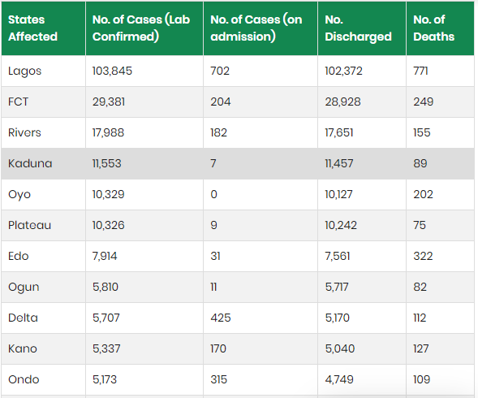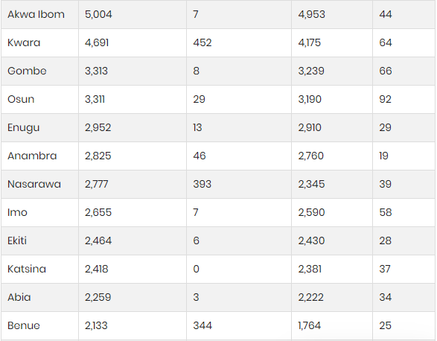

The data for COVID-19 cases in Nigeria is shown in this table, which was taken from the NCDC-powered COVID-19 website. States that were impacted, those who were proven to have COVID-19, those who were hospitalised and those who were subsequently released, and the rate of death are all covered.
The following are a some of the interventions that were implemented during the COVID-19 epidemic.

Initiatives in Public Health
The main emphasis on successful public health measures aligns with the broader discussion of pandemic control. As previous pandemics like H1N1 and Ebola have shown, effective testing, contact tracing, and vaccination programs are crucial for halting the spread of infectious diseases (Federal Ministry of Health and Social Welfare, 2022). The rapid development and distribution of COVID-19 vaccinations is evidence of the advancement of global health technologies and the critical role of international cooperation (U.S. Food and Drug Administration, 2023). The initiatives to increase healthcare capacity are consistent with the ongoing need to strengthen healthcare systems, especially in low-resource settings (World Health Organisation, 2023).
It is clear that effective public health measures are needed to halt the virus's spread and mitigate its impacts.
- Contact tracking and testing: In order to limit the epidemic, policies encouraged both thorough testing and effective contact monitoring. The guidelines included the contact tracing procedures, the testing target group, and the types of tests to be used. Ihekweazu (2022) claims that several testing devices intended for other illnesses—like the GeneXpert systems, which were first used for TB testing—were modified to test for COVID-19.
- Immunisation: Documents emphasised the need of rapid vaccine development, fair distribution, and comprehensive immunisation programs in order to achieve herd immunity.
- Enhancement of Healthcare Capacity: Several initiatives developed strategies to increase healthcare capacity, including increasing the number of healthcare workers, making infrastructural investments, and acquiring necessary medical supplies.
Economic Intervention
The economic initiatives indicated that the economic consequences of the epidemic was felt on a worldwide basis. The specialized financial assistance programs are an outgrowth of the economic theories that promote government intervention to stimulate economic recovery during recessions (World Bank, 2022). Research showing that the pandemic has a variety of effects on various industries is in line with sector-specific approaches (Organisation for Economic Co-operation and Development, 2023).
Recognising the economic impact of the epidemic, legislation was implemented to assist financially struggling individuals and businesses, and financial assistance also poured in.
- Financial Support: Measures to provide financial relief, such as corporate subsidies, unemployment insurance, and stimulus packages, were often included in the policy documents.
- Sector-Specific Interventions: Several programs offered focused assistance to sectors like tourism and hospitality that were most severely impacted by the epidemic.
- Private Sector Interventions: To finance the battle against the epidemic, a private sector partnership was established under the CACOVID project.
International Collaboration
When tackling transnational health issues, international cooperation emerged as a recurrent theme that connected with the literature on global health governance and emphasised teamwork (NHS, 2023). Global solidarity is embodied in the policy documents that encourage international collaboration and the mobilisation of resources to combat pandemics (United Nations, 2021).
- Information Sharing: Policies encouraged the sharing of vital information about the virus, including data on its prevalence, the effectiveness of treatments, and the availability of vaccinations.
- Resource Mobilisation: Documents state that in order to assist less developed countries in combating the epidemic, resources must be raised globally.
- International Cooperation: Coordinated action on travel restrictions, border security, and mutual aid was highly desired.
Transformation to Digital
The increasing amount of research on the use of digital health technologies in modern healthcare aligns with the push for digital transformation (Pan American Health Organisation, 2023). The move to online learning and working platforms is indicative of broader trends in digital transformation that predate the epidemic and are now being driven by it (CDC, 2023).
The potential use of digital technology in limiting the epidemic was underlined.
• Digital health technologies: Telemedicine, remote monitoring, and digital contact tracking were all encouraged by policy. The SORMAS system is one crucial digital disease surveillance tool.
• Remote work and online education: It was advised that workers and students transition to online learning and employment platforms while preserving continuity.

4.2 WHO’s Advocacy for Equitable Vaccine Distribution and Global Vaccine Access, particularly in Africa

4.2.1. COVID-19 Vaccines Doses Received and Administered
448,942,809 doses of the COVID-19 vaccination were administered in Africa in 2024, a 39.9% increase over the 320,841,531 doses administered in 2021. Overall, as of December 31, 2022, 769,784,340 doses had been distributed; 66.5% came from the COVID-19 Vaccines Global Access (COVAX) facility (n = 512,089,328), 20.7% from bilateral donations (n = 159,555,491), and 9.4% from the African Vaccine Acquisition Trust (AVAT) (n = 72,236,700); 3.4% came from unidentified sources or were bought directly by governments (n = 25,902,821). 37.0%, 18.8%, and 13.3% of doses received were from the Janssen, Pfizer-BioNTech, and Sinopharm vaccines, respectively. The total number of doses received as of December 31, 2024, was 47.0% of the total number of doses required to provide 70% of individuals worldwide the whole primary immunisation series. Only Eritrea has not gotten the COVID-19 vaccination out of the 47 African nations.
By December 31, 2022, 70% of the dosages (n = 541,185,838) had been provided, compared to 53% by the same day in 2021. In 2022, 370,312,710 doses were given—a 117% increase over the 170,873,128 doses given in 2021. Thirteen nations have delivered less than half of the vaccine doses received as of December 31, 2022, compared to twenty-four countries at the end of 2021.
The WHO AFRO has received reports of expired COVID-19 vaccinations from 35 of the 46 countries that get the vaccine. The number of expired doses as of December 31, 2022, was 23,511,577 million, or 3.1% of all doses received in Africa. Between 0.1% to 28.6%, the median proportion of expired doses over those received per nation was 2.8%. In Africa, 65% of the reported expired dosages were from Algeria, Senegal, Madagascar, the Democratic Republic of the Congo, and Nigeria.

4.2.2. Vaccination Coverage for COVID-19
308.1 million individuals, or 26.4% of the region's population, had finished the main immunisation series as of December 31, 2024; an additional 373.4 million people, or 32.0% of the population, had gotten at least one dose of the COVID-19 vaccine. Between the end of 2021 and the end of 2022, the proportion of individuals who had finished the main series rose from 6.3% to 26.4% (Figure 1).
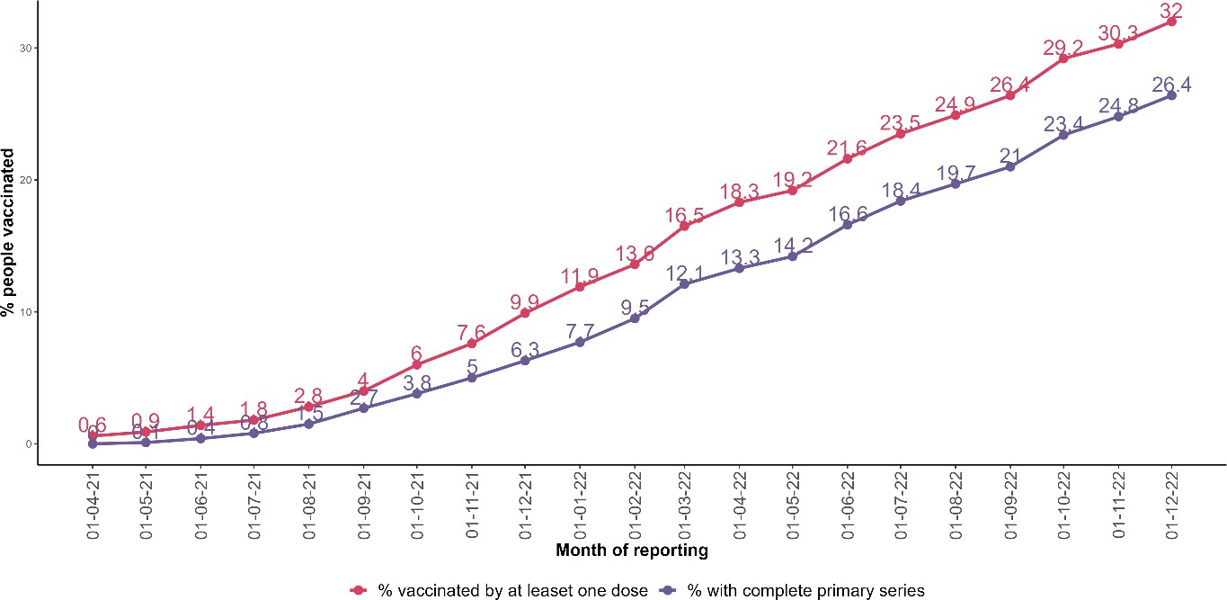

Figure 1 shows the proportion of individuals in the African area who had completed the main series and received at least one dose of the COVID-19 vaccination by reporting month.

Mauritius and Seychelles were the only countries with at least 70% of their populations vaccinated by the end of 2021; by the end of 2022, Liberia and Rwanda had joined them. By the end of 2022, 10% coverage had not yet been reached in Burundi, the Democratic Republic of the Congo, Madagascar, or Senegal (Figure 2).

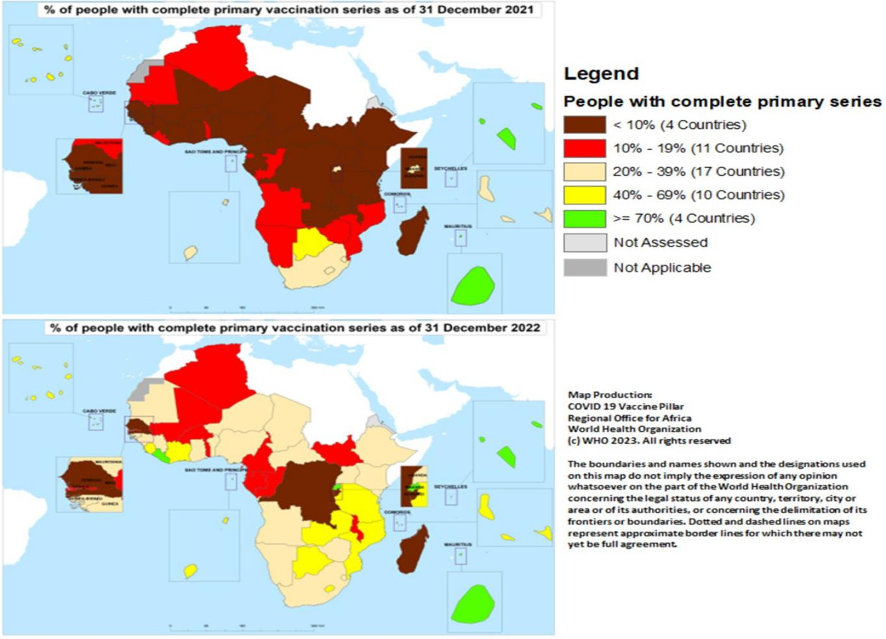

Figure 2: At the completion of December 2021 and 2022, the percentage of Africans who have finished the main COVID-19 immunisation series per nation.

Liberia (64.0%), Tanzania (46.0%), Sierra Leone (43.2%), Zambia (41.7%), Mozambique (41.3%), Cote d'Ivoire (36.9%), and Ethiopia (30.5%) had the greatest percentages of individuals who had finished the main series in 2022. With 3% or fewer individuals completing the main series in 2022, vaccination coverage stalled in Algeria, Burundi, Equatorial Guinea, Congo, Senegal, and Gabon (Figures 3 and 4).

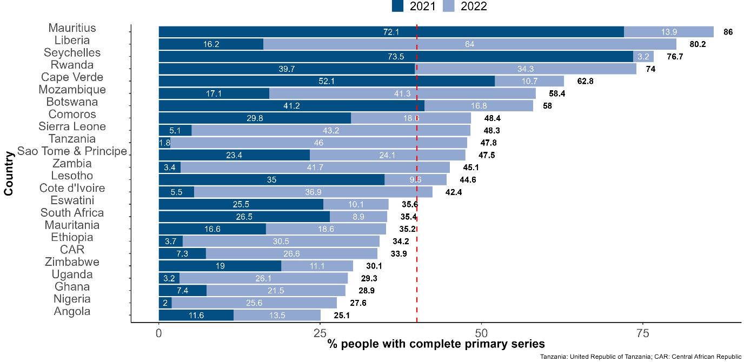

Figure 3. The proportion of individuals who completed the COVID-19 vaccination primary series by the end of December 2021 and 2022 in countries where over 25% of the population had completed the primary series as of 31 December 2022. The dashed red line indicates the 40% threshold of individuals who have completed the primary series, a target established by the WHO for the end of 2021.
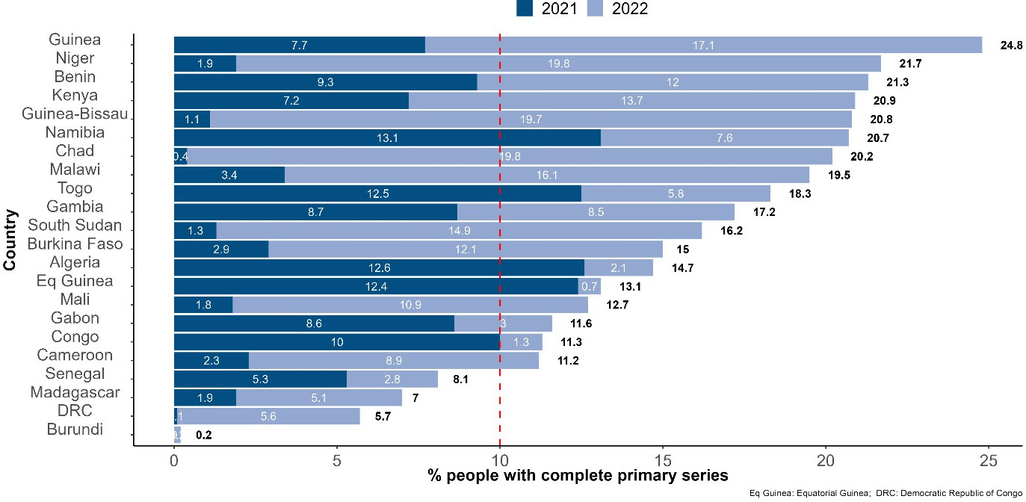

Figure 4. COVID-19 vaccination primary series completion rates by the end of December 2021 and 2022, respectively, for countries where less than 25% of the population had finished the primary series as of December 31, 2022. Note: The dashed red line indicates that 10% of the population had finished the primary series.

Nine countries either did not include booster doses in their COVID-19 immunisation schedule or did not report on booster doses, while 37 nations reported on booster injections to the WHO AFRO. 17.3% of the population (n = 44,106,608) had finished the main series and received at least one booster dose. The distribution of this parameter by African nation as of December 31, 2022, is depicted in Figure 5.
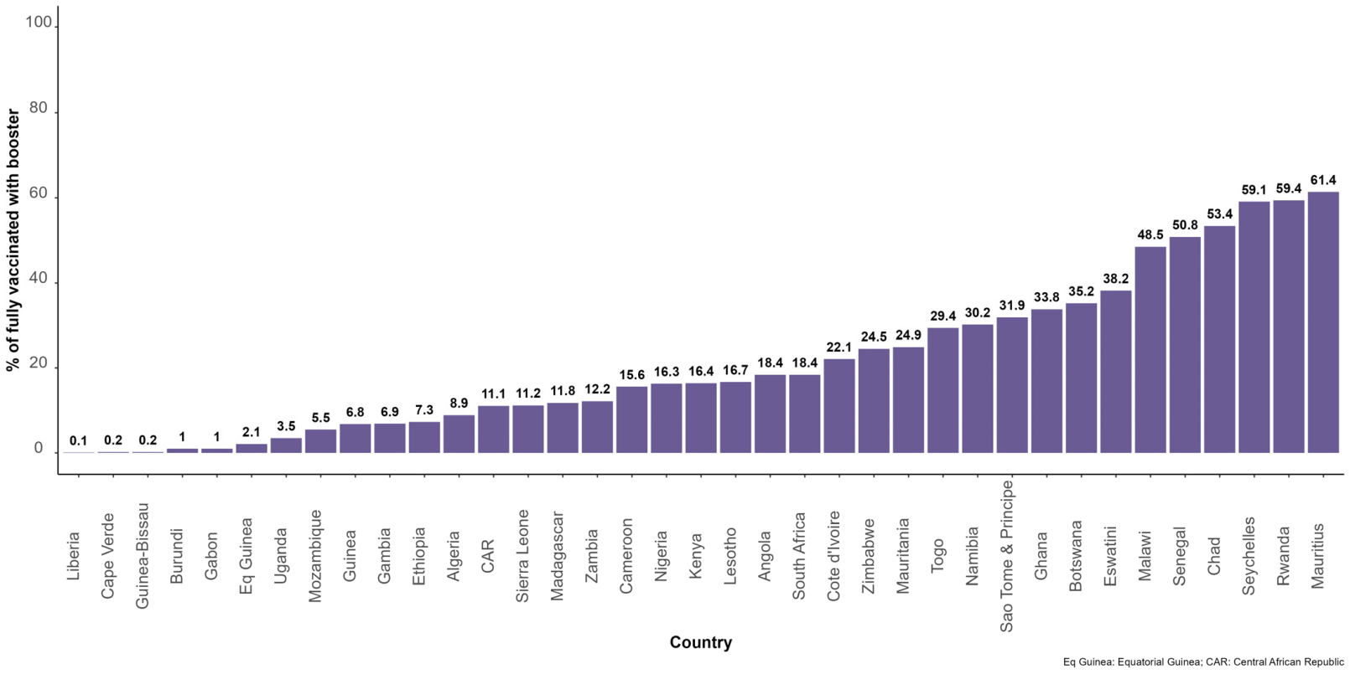

Figure 5. Proportion of persons who finished the COVID-19 immunisation primary series and got booster doses in 35 African nations.

Health personnel were employed as a tracer for all high-risk populations. Overall, 24 countries provided information on the number of health professionals who completed the main series. The average proportion of health professionals who had completed their main series was 40.9%, with Burundi at 11.6% and Rwanda at 99.4% (Figure 6).

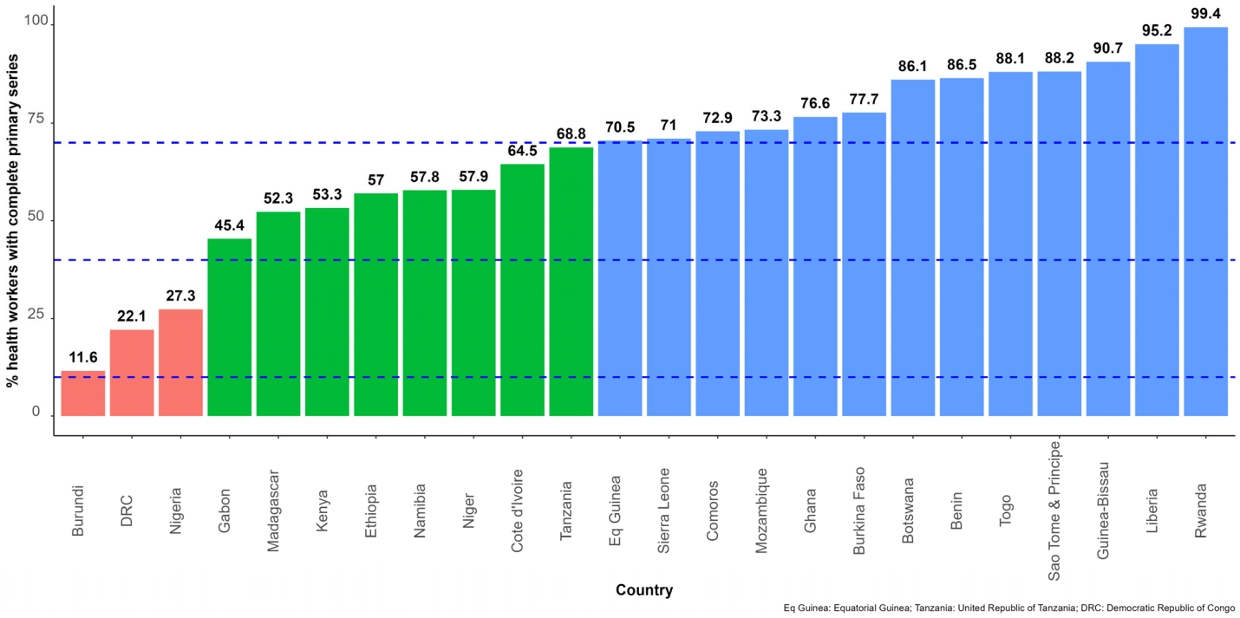

Figure 6 shows the proportion of healthcare professionals in 24 African nations who have finished the main COVID-19 immunisation series. Note: The 10%, 40%, and 70% of those who have finished the main series marks are shown by the dashed blue lines.

In high-income countries (HICs), COVID-19 vaccination coverage is greater than in low-income countries (LICs) worldwide (Qaed, 2022). There are more differences within LICs than among HICs. As per WHO (2023), Figure 1 displays the proportion of individuals who are completely and partly vaccinated in the top 10 HICs and the lowest 10 LICs. Liechtenstein had the lowest COVID-19 vaccination coverage (67.23%) and Qatar had the highest (105.75%%) among the top 10 HICs. Burundi had the lowest COVID-19 vaccination coverage (<1%) and Mozambique had the greatest (55.96%) among the bottom 10 LICs.
After the COVID-19 vaccinations Global Access (COVAX) facility started delivering the vaccinations to LICs more than a year ago, the distribution of the COVID-19 vaccine improved (9). With just 28% of its people completely vaccinated as of December 2022, Africa continues to have the lowest vaccination coverage of any continent (WHO, 2022). Only Mauritius, Rwanda, and Seychelles exceeded 70% vaccination coverage, including 15 African nations that had not yet reached 10% full vaccination, 21 that had reached between 10 and 19%, and five that had reached between 40 and 69% (Umbi, 2023). Globally, there is a greater disparity in COVID-19 immunisation coverage between urban and rural locations. COVID-19 immunisation rates were greater in urban than rural regions in both HICs and LICs. According to a research conducted in the United States, rural regions had lower rates of COVID-19 vaccination coverage with the first dose (58.5%) than urban areas (75.4%), even though the availability and accessibility of COVID-19 vaccinations had grown (Aggarwal, 2024). The differences were consistent across age and sex categories and almost increased between April 2021 and January 2022. Vaccines were mostly offered in Malawi's cities, with the exception of the bulk of rural regions, where 80% of the population lives (Lumbewi, 2022). When the COVID-19 vaccination became widely accessible in Malawi's rural regions, almost 98% of people said they had never been given it, and 1% said they had been offered it but had declined (Ardyn, 2024). According to Achim Steiner, the UNDP Administrator, less than 1% of people in several LICs have received vaccinations (Achina, 2024).

4.2.3 Immunisation equity barriers in LICs
Global access to and distribution of COVID-19 vaccinations should be equitable in order to provide enough protection and guarantee that the world returns to normal. Nonetheless, COVID-19 vaccination disparity persists, mostly because to the following considerations.
Low funding: This makes the COVID-19 vaccination unavailable and unaffordable in LICs. With low funding, LICs find themselves in ethical dilemmas of either: (a) completely transferring funds that were meant to finance the rest of the national health system;
(b) increasing her loan burden by borrowing from the World Bank COVID-19 vaccine loan facility, AU AVATT COVID-19 vaccine mechanism or Afrexim Bank COVID-19 vaccine facility;
(c) inequitably leave the rest of population behind; or (d) wait for the goodwill of COVAX COVID-19 vaccine facility to increase its allocation.
Problem of intellectual property rights: Although vaccines are a global public good, obtaining intellectual property (IP) for COVID-19 vaccines by LICs from vaccine developers remained difficult. Initially, India and South Africa proposed manufacturers in HICs to relinquish intellectual property rights associated with COVID-19 vaccines and therapeutics to increase manufacturing and access in LICs; but faced strong opposition from several members of the European Union (EU) and UK. Nevertheless, unrestricted access to IP of COVID-19 vaccine was later granted to a few countries like India, the Republic of Korea, Brazil, Indonesia, South Africa, Egypt, Morocco, Senegal, and Tunisia, which have already started producing vaccines. Despite this development, LICs cannot easily take advantage of this due to weak systems like lack of domestic vaccine manufacturers; and lack of vaccine- producing resources such as well-equipped laboratories, research and developments, policy, programs, and government funding.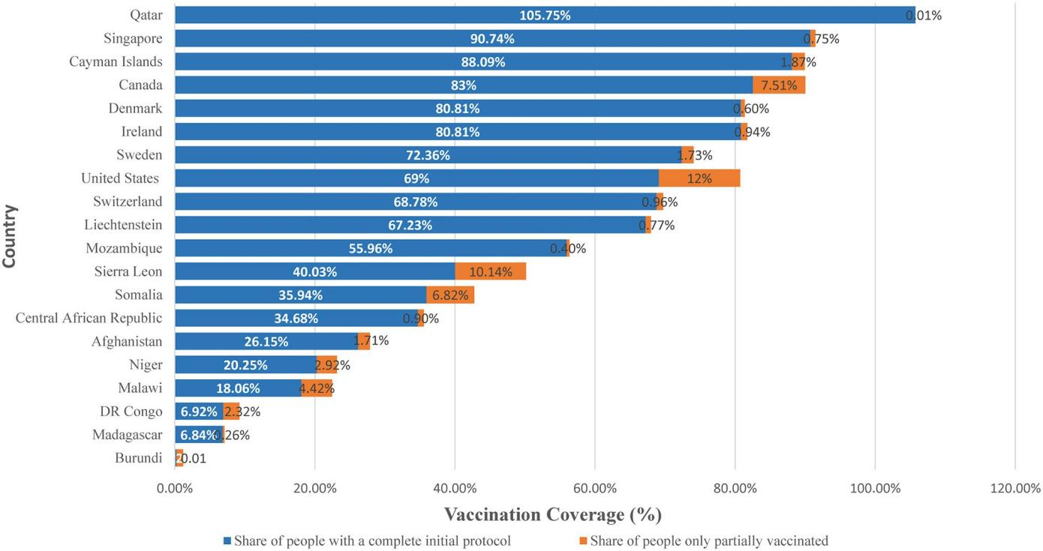

FIGURE 1
Share of people vaccinated against COVID-19 vaccine among top 10 HICs and bottom 10 LICs, December 2022. Source: Official data collated by Our World in Data (1).

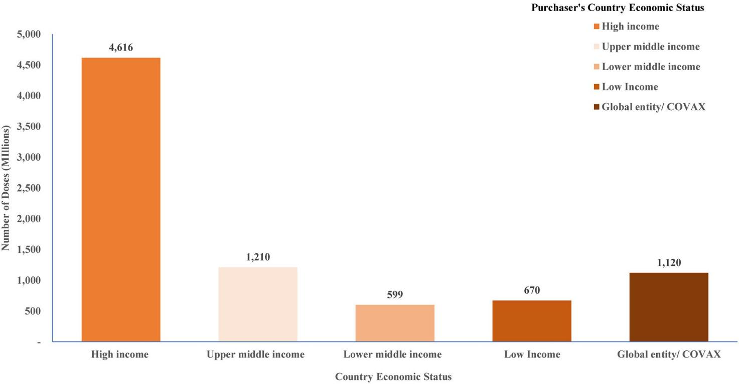

FIGURE 2
Confirmed number of doses purchased by country income level classification. Source: Duke Global Innovation Center (21).

During a global public health emergency, vaccine nationalism is the term used to describe a scenario in which nations prioritise their own vaccination requirements and compete for first access to the vaccine supply. In order to vaccinate their own people more than once and provide two or more booster injections, the wealthiest nations in the world acquired and conserved additional doses of the finest COVID-19 vaccines. The verified quantity of dosages bought by nations, broken down by economic standing, is shown in Figure 2. By the middle of August 2020, the United States had acquired 800 million doses of at least six vaccines, followed by the United Kingdom with 340 million doses, and the European Union, Canada, and Japan with hundreds of millions of doses each acquired through advance market commitments to cover more than their respective populations. When certain LICs failed to adequately deliver a single dosage of the COVID-19 vaccine to portions of their people, HICs stocked extra supplies by early 2022 to give their residents supplemental injections. Through the African Union's pooled procurement strategy, purchases for LICs began in January 2021, leaving many LICs in Asia, Africa, and Latin America without enough vaccinations to cover their full populations (Paenna, 2024). Due to their relative shortage, LICs had a harder problem getting the vaccination in time.
Inadequate healthcare systems: Vaccine disparity within LICs was exacerbated by inadequate health infrastructures, such as a lack of laboratory space, as well as supply chain and logistical issues with the COVID-19 vaccine. There are more vaccine stock outs in rural locations since many LIC health institutions lack adequate cold storage facilities with freezing and refrigeration temperatures to keep vaccines at the appropriate temperature, such as Oxford-AstraZeneca at 2–8 C and Pfizer at −70◦C. The distribution of vaccinations is made more difficult by the geographic location of many LICs. As a result, vaccinations are sometimes sent several months ahead of schedule, giving users little time to use them. Political instability is a feature of certain LIC nations, which leads to the COVID-19 vaccine being distributed in an unfair and delayed manner.
Vaccine misconception: When it comes to equity, COVID-19 vaccine myths continue to be a major problem. Both LICs and HICs' COVID-19 vaccination hesitation, misunderstandings, and uptake were examined in recent research. According to the research currently in publication, one of the main causes of hesitation in higher-income environments is the quick speed at which vaccines are being developed. Although LICs had a variety of reasons for being hesitant, the most prevalent ones were lack of faith in the government and pharmaceutical firms, religion, vaccination myths and misinformation, and fear of negative side effects after vaccination. For instance, a lot of people in Malawi have misunderstandings about the COVID-19 vaccination and think it includes a deoxyribonucleic acid (DNA) tag or microchip. This conforms to the findings by World Health Organization (WHO) that despite increased supply of the vaccine through COVAX facility in Africa, only 28% of the adult population was vaccinated as of December 2022. Rural regions, which have been less affected by the pandemic but also have the highest prevalence of myths and misunderstandings about COVID-19, have a lower vaccination rate. Therefore, the COVID-19 vaccine by itself is just the first step towards reaching the vaccination coverage needed to combat the pandemic.

CHAPTER FIVE

SUMMARY OF FINDINGS, CONCLUSION AND RECOMMENDATIONS

5.1 Summary of Findings
In this research, the World Health Organization's (WHO) position as a non-state actor and its impact on global political dynamics during the COVID-19 epidemic were critically examined. The WHO's coordination of global health responses and its promotion of fair vaccine distribution, particularly among African nations, were the two main topics of investigation. The results confirm that throughout the epidemic, the WHO had a crucial role in influencing global health governance and, therefore, political cooperation.
The study discovered that patterns of international political collaboration were greatly influenced by WHO's function as a coordinator of global health response activities. The WHO encouraged member nations to react in a relatively coordinated way despite political differences by using tools including the International Health Regulations (IHR), daily status reports, global briefings, and technical assistance. States were forced to conform their public health policies to WHO recommendations as a result of the WHO's early warnings, Public Health Emergency of International Concern (PHEIC) declarations, and final pandemic declaration, which significantly influenced national and regional responses. The results did, however, also draw attention to WHO's limitations in a state-centric international system. The fragility of international collaboration was shown by political disputes, particularly between major countries like the United States and China. In some places, the organization's credibility was undermined by charges of politicisation and underreporting. Despite being hampered by geopolitical concerns, WHO's initiative in compiling scientific data, assembling expert committees, and organising emergency medical missions helped to create a sense of unity in the worldwide response.
The WHO's support for fair vaccination distribution is the subject of the second key result. In partnership with GAVI and CEPI, WHO aimed to guarantee that low- and middle-income nations, especially those in Africa, had access to life-saving COVID-19 vaccinations via programs like the COVAX facility. With this endeavour, vaccine nationalism gave way to a more collaborative, multinational approach to health security. The results show that despite WHO's efforts to raise awareness of vaccination inequality on a moral and political level, real distribution patterns continued to mirror underlying economic and geopolitical disparities. At first, wealthy nations stocked up on vaccines, negotiating bilateral agreements with pharmaceutical firms far in advance of the world's need. In many African nations, this caused the introduction of vaccines to be delayed. WHO did, however, raise awareness and provide some limited access to vaccinations in underserved areas via its political advocacy, technical assistance for vaccine logistics, and ongoing interaction with donor nations. Furthermore, WHO showed a long-term vision towards health sovereignty and decolonised global health governance by supporting local vaccine manufacturing in Africa (e.g., mRNA hubs in South Africa).
Thus, throughout the epidemic, the WHO had significant normative and technical influence that moulded vaccine diplomacy and international collaboration, while being limited by its position as a non-state actor and reliance on member state financing.

5.2 Conclusion
The COVID-19 pandemic tested the resilience of global health governance and the political will of the international community to act in solidarity. This study concludes that the World Health Organization, as a non-state actor, played a crucial role in influencing global politics through its coordination of international responses and advocacy for equitable vaccine distribution.
The WHO’s coordination of public health strategies fostered temporary political alignment among states, especially in the early phases of the pandemic. Its technical authority and legitimacy made it a central hub for global information dissemination, policy guidance, and emergency response. Despite challenges to its autonomy and political attacks, the WHO maintained its role as a unifying force in global health governance.
Equally, WHO’s advocacy for vaccine equity brought moral urgency to discussions on global justice and political responsibility. While the ideal of equitable access was undermined by realpolitik and structural inequities, WHO’s continued efforts in rallying global support for vaccine access in Africa laid the groundwork for future reforms in global health solidarity and cooperation.

5.3 Recommendations
Based on the findings and conclusion of this study, the following recommendations are proposed:
- Member states should commit to increasing core, unrestricted contributions to reduce WHO’s overreliance on earmarked voluntary funds. This will enhance its neutrality and ability to respond swiftly during global emergencies without political interference.
- Global political institutions such as the UN, AU, and G20 should institutionalize WHO-led emergency coordination mechanisms, allowing for automatic deployment of resources and expertise during pandemics to avoid politicization and delays.

REFERENCE
Acharya, K. P., Ghimire, T. R., & Subramanya, S. H. (2021). Access to and equitable distribution of COVID-19 vaccine in low-income countries. NPJ Vaccines, 6(2–4). https://doi.org/10.1038/s41541-021-00323-6

Adesina, O. S., Adedotun, A. F., Adeboye, N. O., Adesina, T. F., Okagbue, H. I., & Gboyega, A. F. (2023). On COVID-19 vaccination in Nigeria: An empirical study. International Journal of Design & Nature and Ecodynamics, 18(1), 219–224. https://doi.org/10.18280/ijdne.180128

Akinhanmi, F. O., Ayanda, O. I., Ahuekwe, E. F., & Dedeke, G. A. (2023). Mitigating the impacts of the COVID-19 pandemic on crop farming: A nanotechnological approach. Agriculture, 13(6), 1144. https://doi.org/10.3390/agriculture13061144

Amata, D. (2021). #2022 Budget: N3,453 per capita for the medical care of every Nigerian in 2022. Dataphyte. https://www.dataphyte.com/latest-reports/health/2022-budget-n3453-per-capita-for-the-medical-care-of-every-nigerian-in-2022/

Amzat, J., Aminu, K., Kolo, V. I., Akinyele, A. A., Ogundairo, J. A., & Danjibo, M. C. (2020). Coronavirus outbreak in Nigeria: Burden and socio-medical response during the first 100 days. International Journal of Infectious Diseases, 98, 218–224. https://doi.org/10.1016/j.ijid.2020.06.067

Asundi, A., O’Leary, C., & Bhadelia, N. (2021). Global COVID-19 vaccine inequity: The scope, the impact, and the challenges. Cell Host & Microbe, 7, 1036–1039. https://doi.org/10.1016/j.chom.2021.06.007

CDC. (2023, July 13). Guidance documents. Centers for Disease Control and Prevention. https://www.cdc.gov/coronavirus/2019-ncov/communication/guidance-list.html
Chen, F., He, Y., & Shi, Y. (2022). Parents' and guardians' willingness to vaccinate their children against COVID-19: A systematic review and meta-analysis. Vaccines, 10(2), 179. https://doi.org/10.3390/vaccines10020179

Chriscaden, K. (2020). Impact of COVID-19 on people’s livelihoods, their health and our food systems. World Health Organization. https://www.who.int/news/item/13-10-2020-impact-of-covid-19-on-people’s-livelihoods-their-health-and-our-food-systems

Das, J. K., Chee, H. Y., Lakhani, S., Khan, M. H., Islam, M., Muhammed, S., et al. (2023). COVID-19 vaccines: How efficient and equitable was the initial vaccination process? Vaccines, 11(1), 11. https://www.mdpi.com/2076-393X/11/1/11

Daudu, B. O., Osimen, G. U., & Ameh, A. (2024). Rethinking democratic governance in Nigeria. In Tshishonga et al. (Eds.), Democratization of Africa and its impact on the global economy (pp. 32–47). IGI Global Books.
Daudu, B. O., Osimen, G. U., & Shuaibu, K. (2023). Cyberbullying and social media: Implications for African digital space. In M. Lahby, A. S. K. Pathan, & Y. Maleh (Eds.), Combatting cyberbullying in digital age with artificial intelligence (pp. 243–253). Chapman and Hall/CRC Press.

Federal Ministry of Health and Social Welfare. (2022). Policy documents. Gov.ng. https://health.gov.ng/index.php?option=com_content&view=article&id=143&Itemid=512

Folorunso, G. I., Duruji, M. M., & Chidozie, F. C. (2024). Appraisement of glocalisation in the context of Nigeria’s foreign policy: A concentric approach. Cogent Arts & Humanities, 11(1). https://doi.org/10.1080/23311983.2023.2286735

Ifijeh, G., & Yusuf, F. (2020). COVID-19 pandemic and the future of Nigeria's university system: The quest for libraries' relevance. Journal of Academic Librarianship, 46(6), 102226. https://doi.org/10.1016/j.acalib.2020.102226

Ihekweazu, C. (2022). Lessons from Nigeria’s adaptation of global health initiatives during the COVID-19 pandemic. Emerging Infectious Diseases, 28(Suppl 1), S299. https://doi.org/10.3201/eid2813.221175

Management Sciences for Health. (2013). How to govern the health sector and its institutions effectively. The eManager, 1. Arlington: USAID.

Moon, S., Szleziak, N. A., Michaud, C., Jamison, D. T., Keusch, G. T., Clark, W. C., & Bloom, B. R. (2010). The global health system: Lessons for a stronger institutional framework. PLoS Med, 7(1), e1000193. https://doi.org/10.1371/journal.pmed.1000193

MPH Online. (2022). Outbreak: 10 of the worst pandemics in history. https://www.mphonline.org/worst-pandemics-in-history/

NCDC. (2022). National disease outbreak dashboard. Nigeria Centre for Disease Control. https://ncdc.gov.ng/data

NHS. (2023). Coronavirus documents. NHS UK. https://www.england.nhs.uk/coronavirus/documents/

Osimen, G. U., Chukwudi, C. E., Oladoyin, A. M., Nnaemeka, W. C., & Dada, O. O. (2024). Secessionist agitations and human security: The quest for the agitations of IPOB in Southeastern Nigeria. Albanian Journal of Interdisciplinary Studies. https://doi.org/10.36941/ajis-2024-0099

Osimen, G. U., Daudu, B. O., & Awogu-Maduagwu, E. A. (2023). Nigerianness and misrepresentations of names and signatures: Should the colonized adopt the English-language naming conventions? Journal of the International Society for the Study of Vernacular Settlements (ISVS e-journal), 10(11), 289–303.
Osimen, G. U., Fulani, O. M., Chidozie, F., & Dada, D. O. (2024). The weaponisation of artificial intelligence in modern warfare: Implications for global peace and security. Research Journal in Advance Humanity, 5(3), 24–36. https://doi.org/10.58256/g2p9tf63

Our World in Data. (2022). Coronavirus (COVID-19) vaccinations. https://ourworldindata.org/covid-vaccinations

Pan American Health Organization. (2023). Technical documents - Coronavirus Disease (COVID-19). Paho.org. https://www.paho.org/en/technical-documents-coronavirus-disease-covid-19

Rini, H. S. (2024). Maintaining schools as socio-educational environments for teachers during the COVID-19 pandemic. Revista De Gestão Social E Ambiental, 18(7), e05538. https://doi.org/10.24857/rgsa.v18n7-009

Ruger, J. P., & Yach, D. (2014). The global role of the World Health Organization. Global Health Governance, 2(2), 1–11.

Sasu, D. D. (2022). Health expenditure as share of GDP in Nigeria 2006–2019. Statista. https://www.statista.com/statistics/1126455/health-expenditure-as-share-of-gdp-in-nigeria/

Shalal, A. (2022). IMF sees cost of COVID pandemic rising beyond $12.5 trillion estimate. Reuters. https://www.reuters.com/business/imf-sees-cost-covid-pandemic-rising-beyond-125-trillion-estimate-2022-01-20/

Shang, Y., Li, H., & Zhang, R. (2021). Effects of pandemic outbreak on economies: Evidence from business history context. Frontiers in Public Health, 9, 632043. https://doi.org/10.3389/fpubh.2021.632043

- S. Food and Drug Administration. (2023, July 13). COVID-19-related guidance documents for industry, FDA staff, and other stakeholders. FDA. https://www.fda.gov/emergency-preparedness-and-response/coronavirus-disease-2019-covid-19/covid-19-related-guidance-documents-industry-fda-staff-and-other-stakeholders

United Nations. (2021). COVID-19 policy documents. United Nations Office on Drugs and Crime. https://www.unodc.org/unodc/en/covid-19-policy-documents.html

World Bank. (2022). The World Bank Group’s response to the COVID-19 pandemic. https://www.worldbank.org/en/who-we-are/news/coronavirus-covid19

World Health Organization. (2008). International Health Regulations (2nd ed.). WHO Press. ISBN: 9789241580410

World Health Organization. (2020). Archived: WHO timeline – COVID-19. https://www.who.int/news/item/27-04-2020-who-timeline---covid-19
World Health Organization. (2020). Contributors. https://open.who.int/2020-21/contributors/contributor

World Health Organization. (2021). Strategy to achieve global COVID-19 vaccination by mid-2022. https://www.who.int/publications/m/item/strategy-to-achieve-global-covid-19-vaccination-by-mid-2022

World Health Organization. (2022). Advice for the public: Coronavirus disease (COVID-19). https://www.who.int/emergencies/diseases/novel-coronavirus-2019/advice-for-public

World Health Organization. (2023). Technical documents – Coronavirus (COVID-19). WHO Regional Office for Africa. https://www.afro.who.int/health-topics/coronavirus-covid-19/technical-documents

Zampier, M. A., Stéfani, S. R., & Dias, B. G. (2022). Sustainable development goals in the context of the COVID-19 pandemic in cooperatives. Revista De Gestão Social E Ambiental, 16(2), e02913. https://doi.org/10.24857/rgsa.v16n2-004

