TITLE PAGE

SUSTAINABLE DEVELOPMENT GOAL 5 AND POLITICAL PARTICIPATION OF WOMEN IN NIGERIA, 2015-2023

BY

ILO STEPHANIE CHINECHEREM
GOU/U22/POL/331

A PROJECT PRESENTED TO THE DEPARTMENT OF POLITICAL SCIENCE AND INTERNATIONAL RELATIONS,
FACULTY OF MANAGEMENT AND SOCIAL SCIENCES,
GODFREY OKOYE UNIVERSITY,
UGWUOMU NIKE,
ENUGU

IN PARTIAL FULFILLMENT OF THE REQUIREMENTS FOR THE AWARD OF BACHELOR OF SCIENCE (B.Sc.) DEGREE IN POLITICAL SCIENCE

SUPERVISOR: DR. MBAEZE NETCHY

JUNE, 2025

CERTIFICATION
I, Ilo Stephanie Chinecherem hereby declare that this research work was written by me and has not been submitted or received anywhere for the purpose of acquiring a degree in Political Science or any other programme.

_____________________ _______________________
Ilo Stephanie Chinecherem Date

APPROVAL PAGE
This is to certify that this project report titled “Sustainable Development Goal 5 (Gender Equality) and Political Participation of Women in Nigeria, 2015-2023 ” has been read and approved as meeting the requirements of the Department of Political Science and International Relations, Faculty of Management and Social Sciences, Godfrey Okoye University, Ugwuomu Nike, Enugu, for the award of Bachelor of Science Degree in Political Science.

_____________________ ______________
DR.MBAEZE NETCHY Date
(PROJECT SUPERVISOR)

_______________________ _________________
DR. SAM UGWUOZOR Date
(HEAD OF DEPARTMENT)

_______________________ __________________
ASSO.PROF. JOHN ODO Date
(DEAN, FMSS)

_______________________ ________________
EXTERNAL EXAMINER Date

DEDICATION
This work is dedicated to Almighty God, the source of my strength, wisdom, and perseverance. Without His grace, guidance, and unfailing love, this journey would not have been possible. To Him be all the glory, honour, and praise for the successful completion of this research..

ACKNOWLEDGEMENTS
I wish to express my profound gratitude to God for his goodness and his mercy and to my supervisor, Dr. Mbaeze Netchy for his help, guidance, encouragement , his steady availability to help me in respect to this study. For his dedication to the perfection and completion of this work despite his busy schedule . I would also like to appreciate the efforts of both the academic and non-academic staff especially Mrs Chioma of the Political science and international relations department for their guidance and roles the played in impacting knowledge throughout the academic session. I particularly wish to acknowledge ;Dr. Barr Sam Ugwuozor(HOD), Mr W. Okonkwo, Mr A.Onyishi, Rev. Sr. Dr. L. Umeh, Dr. F. Ifedi, Mr. N. Ejike, Mr. Nweke, Rev. Fr. I. Ogbuka, Dr. Kingsley Ezechi, Prof. Odozieobodo and Prof. Ocheoha. To my Beloved father and mother, Mr. Ilo Emmanuel and Mrs Ilo Chioke, thank you for your love, prayers, constant checkup, emotional and financial support. To my friends Desmond, Chidinma, Chielo Martha, Anike Somto, Chukwu Kosarachi, Okeke Favour, Udeh Francis ,Peter Tobias, Louis, Elizabeth, Doowie, Amaka, Hope, Dalu Precious, Vivian, Rose, I appreciate the support and constant words of encouragement and prayers. To my siblings, thank you for your support, encouragement and for being there whenever I asked advice from you. Finally, I would like to acknowledge my course mates and all others for support and encouragement..
TABLE OF CONTENTS
Title Page…………………………………………………………………... i
Approval Page………….………………………………………………….... ii
Dedication……………….…………………………………………………... iii
Acknowledgment…………………………………………………………… iv
Table of Contents…….……………………………………………………… v
Abstract……………………………………………………………………… x
CHAPTER ONE: INTRODUCTION/ BACKGROUND OF THE STUDY
  - Background to the Study……………………………………………. 1
  - Statement of the Problem……………………………………………. 4
  - Objectives of the Study………………………………………………… 5
  - Significance of the Study ……………………………………………… 6
  - Scope and Limitations of the Study……………………………… 6
  - Operational Definition of Terms………………………………………. 7

CHAPTER TWO: LITERATURE REVIEW AND GAP IN LITERATURE
2.1 Conceptual Review……………………………………………….……….. 9
2.2 Contextual Review………………………………………………………… 19
2.3 Theoretical Review………………………………………………………. 23
2.4 Empirical Review…..……………………………………………………… 27
2.5 Gap in Literature……………………………………………………………. 30
CHAPTER THREE: METHODOLOGY
3.1 Theoretical Framework………….…………………………… 32
3.2 Hypotheses……………………………………………………….. 35
3.3 Research Design……………….……………………………… 35
3.4 Methods of Data Collection……...……………………………… 36
3.5 Method of Data Analysis……...……………………………..… 36
3.6 Logical Data…………………………………………………….. 38
CHAPTER FOUR: DATA ANALYSIS/HYPOTHESES TESTING
CHAPTER FIVE: SUMMARY, CONCLUSION AND RECOMMENDATIONS
5.1 Summary ……………………………………………………. 68
5.2 Conclusion……………………………………………………... 69
5.3 Recommendations……………………………………………… 70
Bibliography ……………...……………………………………………. 71

ABSTRACT
This study critically examines the implementation of the Sustainable Development Goal 5 (SDG 5) which aims to achieve gender equality with a specific focus on its influence on the political participation of women in Nigeria between 2015 and 2023. The study was guided by two research questions; Has the domestication of SDG 5 through the National Action Plans (NAPs) promoted gender equality in the political sphere in Nigeria, 2015-2023. Has the political parties hindered the achievement of SDG 5 in promoting women's political participation in Nigeria, 2015-2023. The study is anchored on Radical Feminist Theory, as advanced by scholars like Firestone (1970) and Dworkin (1974), which views patriarchy as a deeply entrenched system of power that oppresses women across political, social, and economic structures. This framework helps explain how structural barriers, cultural patriarchy, and institutional biases limit women’s access to decision-making spaces in Nigeria. Using a qualitative, ex-post facto design, data were collected through documentary methods and analyzed via content analysis. The study finds that while the domestication of SDG 5 through the NAPs has promoted awareness and introduced gender-sensitive policies, implementation has been weak, and institutional resistance remains high. Political parties, as gatekeepers of electoral representation, continue to hinder women’s participation through exclusionary practices, lack of internal democracy, and monetization of politics. The study concludes that unless radical institutional reforms are made to dismantle patriarchal political structures and enforce inclusive policies, the goals of SDG 5 will remain unmet in Nigeria. It recommends robust gender mainstreaming within political parties and increased enforcement of affirmative action policies to enable meaningful participation of women in governance.
Keywords: Sustainable Development Goals, gender equality, political participation, socio-economic challenges, gender-based violence, radical feminist theory, gender disparity.

CHAPTER ONE
INTRODUCTION
1.1 Background of the Study
These are the Sustainable Development Goals (SDGs) that were endorsed by the United Nations in 2015, as a global appeal to action in order to tackle the current global predicaments by 2030. Among the 17 goals, there is the SDG 5 that aims at attaining gender equality and empowering all women and girls. The objectives of this are to target the eradication of gender inequalities, to realize the end to all kinds of violence and discrimination of women, the eradication of harmful practice such as early marriage, promote involvement on leadership positions equally, and give full access to female sexual and reproductive rights (United Nations, 2015). In spite of all these global commitments, gender inequality is a dominant situation in Nigeria, and cultural, economic, and institutional obstacles that limit women pollination in politics and rule have been considerably high (Okagbue, 2016; Oden, 2016).
In Nigeria, women marginalization in leadership and political participation is established in deeply rooted cultural and historical standards. The conventional ideas usually depict the sphere of politics as a practice of males, whereas females remain with domestic roles like children upbringing and management of the house (Makama, 2013). This patriarchal system has influenced the attitude of people so that women are not exposed to decision-making processes and leadership. In the intra-African case, e.g., the Igbo, women did not have transfer rights to inheritance and community-making decisions, which strengthened their subordinate position in social and political systems (Agbasiere, 2015; Olanrewaju et al., 2015).
The case is even more clear in Enugu State, where gender traditional roles and socio-economic differences have continued to discriminate women to the extent of not reflecting in politics. There is usually a cultural opposition to women who want to pursue political careers because they are not considered capable of the role of leadership (Azuakor, 2017). Such perception is also augmented by structural obstacles in political apparatus like limited internal democracy in political parties and financial necessity to enter electoral pool (Aina, 2018).
The history of women in Nigeria and Enugu State in particular has not been kind as far as gaining access to education, jobs as well as politics are concerned. Over several decades, the trend came to favor the education of males and disregard the education of females; most families would pour a considerable amount of resources in male education and disregard their daughters (Ene-Obong et al., 2017). This inequality in the access to education curtailed the chances of women to attain skills and knowledge to level in the political field. Moreover, early marriage and domestic work were also traditional policies that limited the ability of women to develop both as personalities and professionals (Pathak, 2017). Studies indicate that women in Nigeria hold very little political positions compared to their male counterparts and the political environment in Nigeria is full of males. In 2019, females had only 6.7 percent of the federal legislators in Nigeria compared to 25.5 percent in the world (IPU, 2019). This has been the case also in Enugu State as women have a hard time in gaining notable representation in the elective and appointive offices. The Nigeria gender gap in the political participation has also been compounded by the absence of gender quotas and affirmative action policies (Okonkwo, 2020).
The obstacles that limit women political involvement in Enugu State are intricate in nature; they include cultural conditions and traditional beliefs as well as financial and institutional constraints. Women are mostly socialized not to take up leadership positions, which leads to the feeling that politics is not a female occupation (Eze, 2018). In most societies, women are being required to stick to their traditionalistic gender roles where their family matters easily overshadow their visible actions. These ideologies are usually strengthened by the religious teachings that portray women as subordinates to males thereby depriving them to a larger extent in their political ambitions (Azuakor, 2017).
Economically too women are hindered to participate in politics. The prohibitive nature of the process of running a candidate in Nigeria also puts women at a disadvantage since they usually find it harder to access financial resources compared to their male counterparts. As found by Okagbue (2016) and Aina (2018), due to the commercialization of politics, the situation has applied a big obstacle in the path of women as they are not able to adequately contest elections. This has been a major problem in Enugu State, most women do not have the financial freedom and the network required to help them advance their politics. The problem is compounded by institutional issues associated with problems of lacking internal democracy in political parties. Most political parties in Nigeria can be viewed as closed systems because women have little chance of involvement in decision making processes. They often end up in token responsibilities, like acting as party mobilisers, and a substantive role still goes to men (Makama, 2013). This exclusivity force can be witnessed in Enugu State in which the number of women in governments and political party being unrepresented is very low.
Although this has been the case, attempts at enhancing gender equality and maximizing women representation in the political arena in Nigeria have been undertaken. Non-Government organizations (NGOs), Civil Society organizations (CSOs), and women advocacy groups, have also played a significant role in sensitizing on gender equality as well as women inclusion in politics so that they can gain their voices in politics. Efforts like the capacity-building seminars, mentorship schemes, and advocacy activities have tried to take on the obstacles women in politics confront (Eze, 2018). Such initiatives are in line with the SDG 5 which focuses on access to justice, gender equality and empowering all women and girls. The United Nations has not been left out in promoting gender equality in Nigeria. The UN has also offered a platform to discuss and collaborate on gender through SDG framework by urging governments, civil society and other stakeholders to consider gender equality as an important policy in their development strategies (Ni Aolain, 2016). Nevertheless, the strategies to be employed to realize the goals of SDG 5 in Enugu State must focus on breaking the structural impediments impeding the inclusion of women in politics. Women in Politics is a burning concern, which illustrates the national and international problems of gender equality as a whole. Although there has been some improvement in terms of awareness and women empowerment, still there exists much impediment such as the cultural, economic limitation and the institutional discrimination. This paper aims at discussing how SDG 5 has been implemented in enhancing the political participation of women in Nigeria in 2015-2023, enumerating the difficulties and possibilities of attaining actual and lasting transformation of gender equality on political leadership.
1.2 Statement of the Problem
There are many challenges to the propagation of gender equality in the context of the United Nations sustainable development goal 5 (SDG 5) in Nigeria, especially with reference to political participation among women. Although SDG5 focuses on achieving gender equality and empowering all women and girls, Nigerian social political context is characterized by deep-rooted traditional values, political exclusion, and institutionalized gender discrimination, which discourage women against attaining their full potential in political decision-making processes.
Although the world has made great strides towards gender equality, women are still unable to break their glass ceiling and play prominent roles in political leadership in Nigeria. Illustrations of the under representation of women at elective and appointive posts are also a major challenge, as the women hold less than 10 percent of various political offices in Nigeria even during the recent elections. Such scanty political engagement does not only strip the people of this respect, but it also leads to gender imbalance in policy making and policy execution especially in the state of Enugu, where the conventional values greatly influence the position of women in the society regarding their political roles.
Cultural and religious norms contribute to the exclusion of women from political spaces. Traditional beliefs often regard leadership roles as the exclusive domain of men, discouraging women from aspiring to such positions. Furthermore, women face socio-economic constraints, such as lack of access to financial resources, which significantly affect their ability to compete in the political arena. Political violence, intimidation, and discriminatory practices within political parties further exacerbate the exclusion of women, discouraging their active participation in governance. Efforts by the Nigerian government and international bodies to address gender inequality, such as the domestication of SDG 5 through the National Action Plans (NAPs) and other policy frameworks, have yielded limited results. While the introduction of NAPs has provided a roadmap for achieving gender equality, their implementation at the state level, including in Enugu State, has faced challenges such as inadequate funding, lack of political will, and insufficient grassroots advocacy. Moreover, existing studies and policy reviews often fail to account for the unique socio-political dynamics that influence women’s participation in politics within specific regions, leaving critical gaps in understanding the effectiveness of these interventions.
Given the context, this study seeks to address the following research questions:
- Has the domestication of SDG 5 through the National Action Plans (NAPs) promoted gender equality in the political sphere in Nigeria, 2015-2023?
- Has the political parties hindered the achievement of SDG 5 in promoting women's political participation in Nigeria, 2015-2023?
1.3 Objectives of the Study
The study has two levels of objectives, namely: broad and specific objectives. The broad objective of the study is to assess the United Nations Sustainable Development Goal 5 (Gender Equality) and Political Participation of Women in Nigeria (2015-2023). The specific objectives are as follows:
- To ascertain if the domestication of SDG 5 through the National Action Plans (NAPs) promoted gender equality in the political sphere in Nigeria, 2015-2023
- To find out if the political parties hindered the achievement of SDG 5 in promoting women's political participation, 2015-2023?
1.4 Significance of the Study
This study holds profound theoretical significance across numerous fields. It provides both empirical and theoretical support for the idea that all individuals regardless of gender, should have equal access to opportunities, rights and resources. All humans should enjoy equal rights regardless of the gender and this rights should be preserved. The study will contribute to academic discourse, providing a comprehensive analysis for better understanding of gender inequality in Nigeria. This study will seek to find out whether theories or conceptual clarifications could be applied or recommended to the government to improve its tactics in proffer solution to the problem of gender differences in Nigeria.
Furthermore, this study will also compare gender inequality before 2015 and how the policies made by United Nations has improved gender equality from 2015 to 2023 though there are still exceptions.
Practically, at the end of this study, one expectation is the mobilization of women in greater degree of participation in politics and political decision to effect the required change.
Finally, this study will give clear understanding to the challenges of United Nations in promoting gender equality and also advocate for improvements.
1.5 Scope and Limitations of the Study
1.5.1 Scope of the Study
This study critically examines the implementation of the United Nations Sustainable Development Goal 5 (Gender Equality) with a specific focus on its influence on the political participation of women in Nigeria, between 2015-2023. It explores key concepts such as gender equality, gender disparities, and women's participation in political leadership. Geographically, the study is confined to Nigeria, while its thematic scope is limited to understanding the progress, challenges, and outcomes of efforts to enhance women’s political engagement within the framework of SDG 5 during the stated period. The study highlights the strategies adopted, the socio-cultural dynamics, and the effectiveness of policy implementations, including National Action Plans (NAPs).
1.5.2 Limitations of the Study
Several limitations may influence the comprehensiveness of this study. The primary limitation lies in the contextual variations of gender equality across Nigeria. Data constraints, particularly the unavailability of up-to-date or detailed records on women’s political participation, posed a challenge. Financial limitations restricted extensive field research and in-depth interviews with a broader range of stakeholders. Additionally, reliance on secondary data for some aspects of the study may limit its firsthand insights. Time constraints due to academic and other commitments also restricted the scope of exploration, though all efforts were made to ensure accuracy and reliability.
1.6 Operational Definition of Terms
Gender: This entails the roles, behavior, activities and attributes that are socially constructed as befitting a person in a society based on his or her perceived identity as a male or female.
Gender Equality: The condition of defining equal opportunities, privileges, and attitude towards people regardless of their gender in all life spheres without unfair treatment or discrimination on gender.
Gender Inequality: The phenomenon of lack of equality of access to resources, rights, and opportunities that different people, depending on gender, encounter and which often results in the systematic discrepancies.
Gender Disparity The quantifiable variation in outcomes, resources, or access encountered between ladies and men, frequently developed through societal principles, policies, and practices that propagate indifferent power relations.
Political Participation: Engagement in political action (i.e., elections, involvement in the offices of government, political activism, and policy-making), in order to influence the running of the government and determining the course ofaction of society.
National Action Plans (NAPs): The plans taken by governments as policies in order to accomplish international objectives, like the UN SDGs, at the national level. In this study, NAPs refer to the plans that integrate SDG 5 into Nigeria’s policies to promote gender equality and women’s empowerment.

CHAPTER TWO
LITERATURE REVIEW
2.1 Conceptual Review
2.1.1 The Concept of Gender
Gender pertains to the societal interactions and dynamics between individuals who identify as male and female. It pertains to the social construction of the connection between males and females, as well as between boys and girls. Gender is a term that describes the characteristics and behaviors that are culturally associated with each sex (Haralambos and Holborn, 2014). In society, men are indoctrinated to embody masculine traits, while girls are instructed to adopt feminine characteristics. Gender refers to the societal impact of biological sex, influencing our self-perception, interpersonal relationships, and the allocation of social privileges, professional positions, familial responsibilities, and social status between men and females.
Gender is a prominent and explicit concern in the field of women's history. Globally, the majority of women face significant disparities in terms of property ownership, access to finance, educational opportunities, career prospects, and political representation, in contrast to their male counterparts. However, women have crucial positions in all societies. In rural regions, women mostly do the majority of unpaid home chores and also make important contributions to agricultural productivity. Women are responsible for cultivating almost 50% of the global food supply, and around 66% of female workers in developing nations are employed in the agricultural industry (Power, 2012; Rhodda, 2011). However, several countries (including entities like the World Bank and the International Monetary Fund) give little or no economic significance to the work performed by women.
Gender-based discrimination is a widespread and expensive occurrence. Women have more challenges than men in accessing market activities, political authority, and health and education resources across all regions. According to Haussmann, Tyson, and Zahidi (2016) and as referenced by Cavalcanti and Tavares (2007), no nation in the world has achieved gender equality in important domains such as economic participation, education, health, and political empowerment. Gender discrimination manifests in several forms, likely interconnected in their origins and outcomes, since they are integral to an intricate framework of social, cultural, and economic factors.
Gender analysis is a rigorous assessment of how disparities in gender roles, behaviors, needs, opportunities, and rights impact individuals of different genders in specific situations or circumstances (March et al, 1999). This research observes the gender relations dynamics in terms of resources distribution and management, possession of resources among females, males and limitations associated to each of them as per their relation to each other. Gender analysis must be incorporated in all sector assessments or situations to avert the escalation of gender injustices and inequalities. Moreover, this strategy will encourage more equality and fairness in the gender relationship wherever viable.
2.1.2 Gender Equality
Gender equality involves the provision of equality in rights, responsibilities, and opportunities of men and females. Gender equality is the principle that women should have equal chances to males in all aspects of life, including their capacity to participate in public life. Equality does not imply the complete assimilation of women and men, but rather the assurance that their rights, duties, and opportunities are not contingent upon their gender at birth.
Gender equality is the equal valuation of behavior, goals, and ideas between women and men. It ensures that their rights, duties, and opportunities are not contingent upon their gender differences, which are socially constructed identities (Elegbede, 2012). Gender equality refers to the condition in which both men and women have the same opportunities, privileges, rights, and access to resources and services, without any restrictions or biases based on gender conventions and stereotypes. Gender norms or roles dictate the criteria for women and men to assume positions of authority, determine their access to resources, and influence choices related to reproduction, sexuality, family planning, marriage, and domestic work.
Gender equality is often recognized as a crucial concern in the economic development of developing countries. Countries with the lowest gender equality rankings have continually shown a failure to provide women the same chances as men. The 2013 World Economic Forum Global Gender Gap study assessed the inequalities between males and females in 136 nations (Sauter, Hess & Frohlich, 2013). In countries with the lowest scores in terms of gender gap, women had much poorer conditions than males in terms of economic and educational possibilities, health and survival rates, political empowerment, representation, and health outcomes. Based on the Global Gap Report (2016), Iceland (0.874) ranked as the top nation for gender equality, with 1.6 times more women progressing to higher education compared to males. On the other hand, Yemen (0.516) was identified as the country with the lowest gender equality score. Countries performed more poorly on each metric when the disparity between men and women for that measure was the greatest (Pappas, 2013).
Gender equality entails the acknowledgment of the diverse interests, demands, and priorities of both women and men, while also acknowledging the many groupings within each gender. Gender equality is not only a matter that pertains to women, but rather it should be a subject of concern and active involvement for both men and women. Gender equality is seen as both a matter of human rights and a prerequisite for, as well as a measure of, sustainable development that prioritizes the well-being of individuals. Gender equality is the state of having equal status between women and men.
2.1.3 Gender Equity
Gender equity refers to the practice of ensuring fairness between men and women, as well as boys and girls, by striving for equal outcomes and results. Gender equality may need the use of interim affirmative action measures to address past or systemic prejudice or discrimination. Gender-responsive therapy refers to the practice of providing fair and proactive measures to overcome biases or disadvantages that arise from gender roles, conventions, or inequalities between males and females (Reeves and Baden 2000). It serves as a mechanism to guarantee equal opportunities for both women and men, as well as girls and boys, not only at the beginning but also at the end of a given endeavor. Gender equality is the principle of ensuring fair and impartial treatment for both males and females, while considering their distinct requirements, cultural obstacles, and historical injustice against each group. Gender equality refers to the practice of ensuring fairness and impartiality between men and women. In order to achieve justice, it is necessary to implement policies that address the historical and social barriers that hinder women and men from having equal opportunities (UNESCO, 2003). Equity is a method or mechanism. Equality is the outcome. Gender equality refers to the principles of fairness and justice in addressing the needs and ensuring the benefits for individuals of all genders, including women, men, boys, and girls. For example, ensuring equity and impartiality in education, equitably allocating resources according to the requirements of varied populations, and addressing humanitarian needs. Gender equality in this context pertains to the need of doing a gender analysis to identify the specific requirements of women, men, boys, and girls, since these demands may vary in many aspects.
Nevertheless, Sida (2016) asserts that the term gender equity is often used to separate gender equality from the discourse on human rights, so sidestepping discussions regarding the human rights of women and girls. Conservative actors have embraced this idea, highlighting the inherent compatibility between women and men. They advocate for the concept of "separate but equal" and strongly argue for predetermined biological roles and responsibilities for both genders in society. When used in this manner, the notion of gender equity has expanded to include just a portion of the gender equality agenda. Therefore, it excludes the transformational and demanding elements of gender equality and enables the avoidance of required confrontation with power dynamics and unequal social, economic, and political systems (Sida, 2016). Gender equality is implementing efforts to address the historical and social barriers that hinder women and men from having equal opportunities.
2.1.4 Concept of Political Participation
When we speak about individuals becoming involved in the political system, we're referring about democratic participation. Eakin characterized political participation as the process by which an individual takes part in the community's political life and has the capacity to engage in determining the society's common goals and the best way to attain these goals (Adelekan, 2010). The definition by Eakin was consulted by Adelekan (2010). According to what Akamare says, being politically active is part of being politically active (2003). Methods by which individuals participate in political processes are the subject of this section. They might choose to participate in the activity in a more direct or indirect way. Everyone is welcome to participate as volunteers. The election of leaders, the creation of policies, attendance at community events, and other types of civic engagement are all ways in which individuals may be involved in the political system. According to Awolowo and Aluko (2010), the fundamental motivation for participating in politics in every society, whether it highly developed or highly primitive, is the desire to rise to positions of power and influence. Taking part in political processes is one way to make a difference in the country's political system and overall development. Having citizens take part in political processes is a must for every democratic government. According to Adelekan (2010), a true democracy would allow every citizen a voice in matters that directly affect their lives. For this reason, he proposed this idea. For a democratic government to work, the people must actively participate in choosing leaders and effectively transmitting public policies and attitudes. This must be done since it is a necessity. Credibly claiming to be a democratic regime or state requires, according to Arowolo and Aluko (2010), a high level of openness, participation by all members of society in politics, and the enjoyment of civic and political rights. From one person to the next, the degree to which they are involved in the political system differs. Falade classifies political actors into six unique groups (2008). Among them are:
The term "inactive" is used to describe those who do not take part in any political activity.
Voting experts are those who focus only on voting and go to great lengths to cast their ballots. For all intents and purposes, voting is all that matters to them in terms of politics.
In this context, "parochial participants" means those who may sometimes be involved in politics. Only when it directly affects them can people cast ballots or engage in other forms of political activity.
People who identify as communalists are likely to be frequent voters and concerned about local concerns, but they will not take part in larger political movements.
Political campaigns pique the campaigners' attention, in contrast to their engagement in other communal problems.
As a noun, "complete activists" describes those who are very involved in every facet of politics. They take part in activities including going to the polls, running for office, attending community events, and proactively interacting with government officials. Every person's level of political engagement is influenced by their unique combination of cultural, economic, political, religious, and educational experiences. Another factor that influences people's level of political engagement is their level of knowledge about political problems and their trust in the political process. Money, ethnicity, and religion are just a few of the factors that influence Nigeria's political system. Nigerian elections have been defined by religious and ethnic politics since the nation's independence in 1960. A former Senate deputy president named Albert Legogie said that the election pattern clearly demonstrated a schism, a division between Christians and Muslims, and between the north and the south (Adeyemo, 2011). That is why Legogie drew that conclusion.
Northern Nigeria is mostly Muslim, but violence broke out after the presidential election, targeting Christians and southerners. Several were killed. On top of that, several houses of worship were destroyed in flames during this period. People in Nigeria participate in politics with animosity, bitterness, anger, and other unpleasant feelings because, as Falade (2007) puts it, politics is seen as a dirty game. Because of this, Nigeria is now caught in a never-ending cycle of political unrest. Many Nigerians were discouraged from becoming involved in politics and voting because their leaders had promised things they couldn't deliver on. Politicians make a lot of claims when running for office, according to Falade (2008). Most of these promises are broken after the administration takes office. Because of this, a lot of people stop caring about elections. "I do not even have confidence in them because they have been failing us in general to a significant degree," one of the individuals questioned during the 2011 election said, according to Adelakun (2011). "I have come to the sun to suffer even if I am not benefits from the government."
Among the people of Nigeria, there is a relatively low degree of political engagement. There is a significant amount of apathy among Nigerians about political issues. INEC observed that the level of participation among Nigerians in the most recent general election, which took place in 2011, was rather low. Only 35 percent of the 70 million people who were registered to vote actually participated in the election. In a study that was performed on the election that took place in 2011, the Friedrich Elbert Stiffing Foundation found that the lack of transparency in elections, election violence, and politicians' failure to keep to their campaign pledges were the primary factors that contributed to the indifference of voters throughout the nation (Odebode, 2011). Ignorance and purposeful dishonesty on the part of certain politicians are the root causes of the political apathy that affects Nigeria. This results in the people being unable to establish a connection between their lack of engagement in the democratic process and their condition of underdevelopment (Fabiyi, 2010). This is the effect of this.
Taking all of this into consideration, Falade (2007) came to the conclusion that the political culture of Nigeria has not made place for the establishment and survival of genuine democracy. It has been noted by Awolowo and Aluko (2010) that the low degree of political engagement of Nigerian women is becoming more disconcerting and perturbing. Women in Nigeria have been mostly absent from the political process ever since the country gained the ability to govern itself in 1960. Thirty percent of all jobs in government should be reserved for women, according to the Beijing statement of 1985, which Nigeria is a signatory to. Because of the persistent pattern of male dominance in political and other public roles in Nigeria (Oloyede, 2004; Adelekan, 2010), this strategy has not yet been put into effect in the country. The remaining inhibitive cultural and patriarchal pressures against women's participation in politics that defined African traditional cultures are the cause of the minimal involvement of African women in the political process (Chuku, 2009). This is the outcome of the situation.
Various definitions of democratic consolidation have been proposed by scholars in the field of comparative political science. Both of these concepts are founded on two different ideologies of democracy. "Minimalist conception" is one approach, which places an emphasis on formal or procedural democracy. A "maximalist conception" is the alternative approach, which places an emphasis on the results of political processes, such as the institutionalization of political institutions, social fairness, and economic equality (Lee, 2007: 103). The minimalist conception of a consolidated democratic regime is defined by Schmitter as "the process of transforming the accidental arrangements, prudential norms, and contingent solutions that have emerged during the transition into relations of cooperation and competition that are reliably known, regularly practiced, and voluntarily accepted by those persons or collectives that participate in democratic governance" (Schmitter, 1992: 424). This definition was provided by Schmitter in his book by the same name.
According to Linz (1978: 158), a consolidated democracy is defined as a system in which "none of the major political actors, parties or organized interests, forces or institutions consider (s) that there is any alternative to the democratic process to gain power and that no political institutions or groups has a claim to veto the action of democratically elected decision makers." This claim is supported by the fact that a consolidated democracy is marked by the absence of organized interests, forces, and institutions. To rephrase, democracy must be seen as "the only game in town to play." In order for the regime to survive, the most important political institutions must be recognized as the sole valid framework for political contestation and adherence to democratic norms of the game.
More specifically, according to Gunther, Diamandurous, and Puhle (2015), democratization can be divided into three stages: the fall of the dictatorship, the establishment of democracy, and finally, the preservation of democracy over time. With this in mind, democratic consolidation should be viewed as a consistent and maintained practice of democratic principles. During the transition, institutions like the electoral system, revitalized or newly formed parties, judicial independence, and respect for human rights were established or reestablished (Valenzuela, 2014). Building a solid democracy involves affirming and strengthening these and other institutions.
Diamond (2015) provided an insightful appraisal of the situation. "political competition becomes fairer, freer, more vigorous and executive; participation and representation becomes broader, more autonomous, and inclusive; civil liberties are protected more comprehensively and rigorously; accountability is more systematic and transparent," he argues. He believes that democratic consolidation is significant because it indicates that the quality, depth, and authenticity of democracy in its various dimensions have been improved. A number of the democratic regimes that are being established for the first time are not even close to being entrenched. They are only being able to survive without solidifying their position. These weak democratic regimes have encountered tremendous ambiguity regarding the rules of the game, particularly in the less developed parts of the globe. This confusion occurred as a result of the horrible economic circumstances and other social difficulties that these regimes have been operating under. This democratic reform does not in any way ensure democratic stability, despite the fact that many countries in the Third World, including Nigeria, have undergone transitions to procedural democracy. These transitions include open elections with minimal impediments to public participation and genuine party rivalry (Lee, 2017). When democracy is able to prevent democratic breakdown and erosion through the process of "eliminating, neutralizing, or converting disloyal players" (Schedler, 2018), and when it moves one step further toward completing and deepening democracy, such as when there is a high level of "expectations of regime continuity" (Schedler, 2018), then it is said to have been consolidated. According to Diamond (2017), the impacts of institutional shallowness and decay either prevent or destroy democratic consolidation. This is the case since they are causally responsible for the phenomenon. Electoral democracies, then, need to grow more liberal and deeper in order for them to become more cemented. The reduction of barriers to political participation and mobilization by marginalized groups, as well as more effective protection for the political and civil rights of all citizens, will be required in order to accomplish this goal. This will necessitate a greater accountability of the executive branch (and the military) to the law and to the scrutiny of other branches of government, as well as towards the general public.
2.2 Contextual Review
2.2.1 The Worldview of Gender Roles
Gender roles, sometimes referred to as gender beliefs, contribute to gender inequity and the male dominance in society. The concept of gender roles is referred to as "worldview" by Wilhelmina & Ogbu (1993). Among the Nigerian population, gender ideology is deeply ingrained in their environment, society, and conventions. The entrenched gender inequity that perpetuates traditional gender roles for males is a manifestation of privilege.
According to Wilhelmina and Ogbu (2013), the perspective on gender roles suggests that families have a significant role in shaping the socialization and expectations of males and females. This process begins at birth and is influenced by a preference for male births, which is driven by the desire to preserve the family name. Adolescent girls often face challenges related to societal expectations and gender roles, which grow more pronounced inside the family. During the mid-1950s, women often pursued education at either teacher training colleges or concentrated on homemaking. The educational opportunities available for young girls at that time mostly emphasized subjects such as home economics, hygiene, and home administration, rather than intellectual subjects (Kalu and Kalu, 1993). Theodore (1995) argues that gender ideology serves as a framework that reinforces inequality within the home. In families where gender ideals are present, gender disparity is evident in the division of family work. It is believed that when a married woman works, it might disrupt the stability of the marriage and challenge conventional marriage standards, as well as negatively impact the husband's pleasure with the marriage (United Nations Children's Fund, 2014).
According to UNICEF (2018), the presence of disparity in paid work for married women is seen as a means to maintain marital stability by encouraging women to prioritize domestic chores, childcare, and their spouse. The household labor participation rates for working wives and unemployed women are 72% and 81% respectively, which is noteworthy due to its association with conventional wife duties (UNICEF, 2018). The gender ideas that perpetuate the belief that women should not work or earn money contribute to inequality and male dominance. Meanwhile, society and the community do not impose any restrictions on men's ability to acquire revenue via paid employment, as stated in the ECPAT Report of 2015. Women's economic dependence on males arises from their confinement to unpaid domestic labor (Girls not Bride, 2016). According to Barbara (1984), it has been generally considered surprising and inappropriate for males to participate in the distribution of domestic or home tasks. According to Uwameiye and Iserameiye (2013), it is expected that women who want to work should prioritize their traditional homemaking duties by staying at home.
Kalu and Kalu (1993) observed that the discrepancy in gender roles is further highlighted by the societal taboo or fear around a daughter's premarital pregnancy. Unmarried pregnancy carries a social stigma and elicits a sense of humiliation for the girl. Historically, there has been a preference for having children, yet there is a strong focus on a marital culture that promotes the idea of women being submissive. Parents use preventive efforts to avoid premarital pregnancy in young girls, such as implementing restrictive measures like child marriage and limiting their excursions, which begin soon after their first menstruation. These efforts only target female children and have no impact on male children (African Charter, 2017).
Based on the information provided, it can be concluded that men exert dominance over women, and most men are able to assert power and authority simply by virtue of being male. Social institutions have facilitated this by enabling men to elevate themselves and granting them the rights and knowledge to control women, treating them as subordinate. Women are subjected to male dominance due to the societal expectation of female submissiveness towards males. The majority of males hold the belief that women are of lesser value, leading them to assert their dominance over women and see them as their subordinates. In this position of power, men perceive themselves as rulers who are entitled to unquestioning adoration and obedience. Gender roles, which stem from long-standing traditions and familial customs, contribute to the subjugation of women. An individual who grows up seeing his father doing physical harm and causing immense suffering to his mother and sisters will develop the belief that he is entitled to engage in such behavior. The explicit delineation of the societal enslavement of women may have been absent. Nevertheless, the societal belief that women should be docile, obedient, and completely reliant on men's authority is shown by this (UNICEF, 2018). Human beings do not inherently surpass or outgrow the knowledge and beliefs instilled in them throughout their upbringing. Indeed, the majority of individuals expand upon the knowledge they acquire, and this is also applicable to males who believe they may exert control over women due to the teachings that women are of lesser value (ICCPR Articles, 7,8).
2.2.2 United Nations Projects on Gender Equality in Nigeria
2.2.2.1 Promotion of Women’s Peace in Nigeria
The disproportionate effect of violent conflict on women has been acknowledged by the United Nations in many resolutions. As a whole, it shows that peace negotiations, rebuilding, and stabilization initiatives have mostly ignored women. In their view, women must be fully and equally involved in all aspects of peace and security efforts, from preventing conflicts to rebuilding afterward. Resolutions (1820, 1888, 1889, 1960, 2106, 2122, and 2422) and 1325 of the United Nations Security Council urge action to prevent sexual assault and hold perpetrators accountable in order to put an end to impunity for such crimes during times of war. The Women, Peace, and Security (WPS) is framed by these resolutions (Nduwimana, 2006).
Under the auspices of the European Union-funded UN Women's Programme on "Promoting Women's Engagement in Peace and Security in Northern Nigeria," the federal government of Nigeria specifically, in the states of Adamawa, Plateau, and Gombe and their respective Local Government Areas (LGAs)—is aiming to bolster women's leadership, promote gender equality, and enhance protection for children and women in conflict zones. With this initiative, we want to see UN Security Council Resolution 1325 put into action in Nigeria's three northern states and provide concrete evidence of how it has helped with conflict management, mitigation, and resolution. According to UN Women (2018), this training booklet on gender-sensitive early warning and response tactics will help the program achieve its goals.
Community leaders, religious leaders, traditional leaders, mentors for women in peace, and appropriate governmental agencies are the target audience for this booklet. The goal of this training is to provide them with the information they need to develop early warning systems that may help communities better withstand potential conflicts.
2.2.2.2 Women’s Economic Empowerment/Adolescents
Investments of $100 million are being proposed by a World Bank Project called "Nigeria for Women" to improve the lives of women in Nigeria. The goal of the project is to reach 324,000 women through Women Affinity Groups (WAGs), and projects, which are focused at establishing social standards and building social capital. Value addition and training aspect of the project will support individual and community livelihoods. The monetary returns on the project as estimated in the Project Appraisal, which are relevant especially to construction of WAGs and the social capital activities include the following:
Initially, a programme cost of 1.7:1 in the learning of reading and life skills programmes
2. 17:1 Developing businesses with the help of the money:
3. Reading, writing and positive self-esteem training; $4.7:1
4. Women attainment of household livelihoods projects: 3.1:1
5. Training on agricultural skills: $2.8:1 (World Bank, 2018)
6. The overall mean is the $5.8: 1.
In an attempt to shape gender norms and attitudes towards economic empowerment of girls, the Educating Nigerian Girls in New Enterprises (ENGINE) initiative developed a holistic program to give a chance to disadvantaged Nigerian girls who are 16 19 years old and in 1 out of school, to enhance self-esteem, their financial skills, business and leadership skills. According to Parsons and Melnikova (2018), the research had two positive outcomes: first, more females were able to start their own businesses (55% vs. 27%). Secondly, more girls had savings accounts (65% vs. 37%).

2.3 Theoretical Review
2.3.1 Critical Theory
The phrase "critical theory" may include either a narrow or broad comprehension of the social sciences, including both philosophy and history. When "Critical Theory" is mentioned here, it specifically refers to the intellectual contributions of the Frankfurt School, a group of German philosophers and theorists who were prominent at the peak of the Marxist tradition in Western Europe. Only beliefs that promote human liberation from slavery, exercise a liberating impact, and aim to build a world that fulfills the needs and abilities of its followers are considered important. One method of differentiating a "traditional" theory from a "critical" theory is as follows. An alternate technique might include analyzing the aims outlined in the theory. There are several "critical theories" that have a vast scope and are all focused on understanding and improving the current state of human subjugation. The social movements in modern societies are derived from the diverse movements that have emerged to challenge different systems of human control. Critical theory encompasses comprehensive and precise concepts that provide the descriptive and normative basis for social science research. Its primary objective is to diminish domination and promote freedom in all its forms (Bohman, 2019). The study of social science is based on critical theory.
Moreover, the word "critical theory" may also denote an educational methodology that prompts inquiries into the current level of knowledge on organizational phenomena. While critical theory does not exist as a standalone intellectual framework and is rooted in history, it is often linked to the Institute of Social Research at Frankfurt University. The collective of philosophers, sometimes referred to as the "Frankfurt School," convened during the 1930s. The individuals that were part of this group were Max Horkheimer, Jurgen Habermas, Herbert Marcuse, and Theodor Adorno. Critical theory seeks to uncover concealed assumptions and power dynamics inherent within a system, with the purpose of challenging established modes of thought. Critical theory advocates alternative modes of cognition and existence with the aim of emancipating individuals who are subjugated and disenfranchised by prevailing ideologies, while also reevaluating established institutions. Examining the dehumanizing effects of administrative control and questioning the success of a project may be accomplished via the use of critical theory. Harney (2014) suggests that embracing the principles of critical theory, which promotes the inclusion of individuals, might make decision-making and control more accessible.
The many notions that have emerged within the critical theory canon are not directly interconnected. There is no existing road that is linked. The continued study and acceptance of critical theory by intellectuals in the present day may be attributed to its capacity to provide viable and satisfactory answers. Critical theory aims to promote freedom by criticizing and opposing oppressive social practices and structures in the contemporary day. It provides support for conceptions and acts that are in line with Universalist ideals of justice. The objective of doing this endeavor is liberation. This kind of critique seeks to alter the dynamics of international interactions, national communities, and the nascent global society that is currently taking shape. It does this by beginning with unorthodox perspectives and behaviors that have a proven history. Both when investigating and critiquing global politics or society, they rely on the concept of emancipation as the foundation for their analyses and critiques. Furthermore, it is recognized that historical conditions might contribute to the attainment of freedom, but it is also understood that liberation is not always an automatic outcome. Political strife in the contemporary era is primarily driven by the considerations of redistribution and representation. On the other hand, recognition conflicts use the quest for freedom and justice to tackle issues like gender, sexuality, race, and national recognition. Redistribution wars aim to address issues related to social liberation and conflicts between social classes. According to Marcos (2018), critical theory has actively contributed to the advancement of human well-being. The main reason for this is that modernity provides chances for individual agency, and the linked nature of today's globe offers viable political options.
2.3.2 Liberal Feminist Theory
According to the principles of liberal feminism, people should have the freedom to pursue their own interests and cultivate their own abilities without any interference from others. Liberal feminists are those who recognize the basic framework of society and want to enhance the rights and possibilities available to women. They advocate for both the Equal Rights Amendment and women's rights, while also opposing discrimination and sexism. They concur that the failure of society to address gender-based legal and cultural barriers would have more negative consequences than positive ones (Macionis, 1997). Liberal feminists, who highly value individual autonomy, agree with this assertion.
In the early 1800s, progressive feminists in Britain were the trailblazers of a long-standing tradition of liberal feminist thinking, which ultimately gave rise to the development of liberal feminist philosophy. This lineage finally resulted in the development of liberal feminist philosophy. The liberal feminist worldview argues that the continued existence of long-standing traditions that hinder the progress of women is the fundamental reason for gender inequality. This is the fundamental cause of gender disparity. Simultaneously, it prioritizes equal opportunity and individual rights as a means to provide the basis for social justice and revolution. Given that gender differences are acquired patterns of behavior, the hypothesis posits that gender socialization exacerbates this issue. Gender disparities arise from the acquisition of learnt behavioral patterns. The idea's foundation has provided support for certain legislative acts that are essential for making progress towards achieving gender equality in the United States. Liberal feminists strive to diminish barriers that impede women's progress and advocate for gender equality in order to instigate societal change (Anderson, 2007). This is done with the intention of catalyzing societal transformation.
From the inception of their feminist movement, liberal feminists have always seen the pursuit of gender equality as the fundamental cornerstone of their cause. The Declaration of Sentiments, a document, was promulgated at Seneca Falls, New York, in 1848. This paper is the first political manifestation of this concept. The Declaration of Sentiments was written to provide a warm welcome to women and to build upon the principles outlined in the Declaration of Independence, with the aim of fully include women in society. Every human being has innate attributes that form the foundation of this concept. These characteristics include cognitive abilities, moral responsibility, and self-actualization. The legal recognition of universal rights may enable the use of these abilities. There is no inherent "natural" basis that can be contended to justify the existing gender disparities. This is the current situation. It is possible that a deliberate endeavor to unite a logical public and the government might lead to a social transformation that is beneficial for equality. Among the several alternatives, this is one of the significant options. Liberal feminisms advocate for equality and prioritize a reform agenda based on their interpretation of the underlying principles. This objective aligns with their perspective on the underlying basis for asserting equality. In order to accomplish their aim of promoting equality and eliminating gender as a factor in the allocation of social assistance, they are willing to use universal principles. Their purpose is to achieve equality. The liberal feminist ideology depicts an ideal gender system characterized by complete perfection, where individuals are granted absolute freedom to conduct their lives in accordance with their own standards and ideas. Moreover, this system embraces and values every individual, regardless of their identity. This gender system is considered to be the most desirable and perfect.
According to the principles of liberal feminism, the concept of "gender parity" is synonymous with the term "equality of opportunity." An inherent element of the subjugation of women is the disparity in their access to educational opportunities and civil liberties. To provide equal opportunities for women to succeed, it is crucial to eliminate the obstacles that hinder their participation in the process. It has been said that youngsters need fresh indications about the concepts of masculinity and femininity from their family, schools, and the media. The signals should originate from a diverse range of sources. The strategy being described here highlights the importance of gender-role socialization and argues that children would gain advantages from receiving these signals. Liberal feminists advocate for many issues, including the elimination of gender-based discrimination in the workplace, the provision of safe and legal abortion services, and the enhancement of childcare institutions (Kendall, 2016).
2.4 Empirical Review
Gender equality is one of the primary aims of the Sustainable Development Goals (SDGs) of the United Nations, especially the 5th goal that aims to empower all women and girls and pursue gender equality by 2030. This empirical review analyzes the findings in different studies and data to determine the issues and the current state of encouraging gender equality in Nigeria in major areas with education, political participation, economic empowerment, and health being the major areas of interest.
2.4.1 Education
One such important factor is education, which is key towards obtaining gender equality. Current empirical evidence indicates that there are high variations in the attainment of education between male and female children in Nigeria. The United Nations Educational, Scientific and Cultural Organization (UNESCO) documents that gender parity index has been increasing over time in primary education; however, there exist still some disparities and especially in places where education is the responsibility of rural communities and those who have been marginalized (UNESCO, 2020). According to Obanya (2018), cultural norms, which seem to support education of male children, early marriage, and economic constraints, stand as major challenges to education of girls. Although efforts of such projects as the Girl Child Education Project under UNICEF that has already increased the enrollment rates have been made, retention is still a challenge because of the social-economic reasons that exist (UNICEF, 2019).
One more study conducted by Mordi and Omoju (2021) places an emphasis on the effects of attitudes in communities regarding female education with a statement that girls are not likely to accomplish their education in the regions where the patriarchal principles are significant. These problems have been even aggravated by the advent of COVID-19, where school shutdown has disproportionally impacted girls, and their increased dropout rates and early marriage are due to this issue (Human Rights Watch, 2020).
2.4.2 Political Participation
The other important pointer to gender equality is participation of women in politics. Although Nigeria is dedicated to ensuring that the number of women in political offices is high, most empirical studies reveal that it hasn’t developed much. According to the information provided by the Inter-Parliamentary Union (IPU), by 2023, women comprise just 7 percent of Nigerian National Assembly, compared to the international average of 25 percent (IPU, 2023). Some of the issues that lead to such poor representation are patriarchal traditions, violence in politics, and poor use of support towards female candidates (Akiyode-Afolabi & Arogundade, 2018).
According to studies conducted by Oloyede (2020), women are usually sidelined by political parties in terms of being given less key roles. Moreover, research carried out by Nwankwo (2017) reveals that political violence and the exorbitant campaign costs of candidates discourage women so they do not engage in politics. Other initiatives like the 35% Affirmative Action Policy that contributes to the representation of women have not been very successful since they are implemented and/or enforced poorly (Oluyemi, 2019).
2.4.3 Economic Empowerment
Empowerment of women in the economy is crucial to attain sustainable growth. Empirical evidences indicate that the Nigerian women have a great difficulty in accessing economic opportunities. As the data of the World Bank shows, women have fewer chances than men of getting involved in the labor market and women also tend to be concentrated on lower-paid informal sector jobs (World Bank, 2022). Discriminatory inheritance rights and the lack of access to credit among other legal and social obstacles interfere with female economic progress (Nwosu et al., 2019).
Contributor International labour Organization (ILO) (2018) also points out that women in Nigeria would usually work on subsistence farming and petty trading, and rarely accessible to markets and financial services. Some efforts to include the financial aspect of life have been positive, including microfinance programs and training on entrepreneurship, but such programs need to be expanded to encompass many more women. An analysis conducted by Adeyemi and Adekanbi (2020) proves that microfinance has helped greatly in enhancing the economic condition of rural women but underlying factors such as interests and financial illiteracy are still challenges.
2.4.4 Health
Gender equality is also an important issue in terms of health outcomes in the case of women. Maternal mortality has been recognized as an important issue and Nigeria has a high share of deaths due to maternal death in the world. According to the World Health Organization (WHO), the ratio of maternal mortality in Nigeria consisted of 512 deaths per 100,000 live births in 2019, which is one of the highest in the world (WHO, 2019). The key areas that have to be improved are access to reproductive health services, skilled birth attendants and emergency obstetric care.
According to the empirical researches by Fapohunda and Orobaton (2017), community-based interventions should be critically considered as a way of enhancing maternal health outcomes. They present evidence that their studies have shown that start-ups involving training traditional birth attendants and delivery of mobile clinics have been successful in the rural sector in reducing maternal mortality. Furthermore, the psychological burden of living in conflict areas especially those in the northeast shows through the rise in cases of trauma and stress among women and therefore require encompassing mental health service (Okeke-Ihejirika et al., 2019).
2.5 Gap in Literature
The literature review has brought out some key points that are important towards the achievement of the implementation of the United Nations Sustainable Development Goal 5 (Gender Equality) and promotion of gender equality in Nigeria. But there are still considerable gaps that should be explored, especially concerning the issue of women participation in politics in Nigeria, during the period between 2015 and 2023. Although literature on gender equality has paid much attention on the wider aspects of gender equality and the issues that women and girls face, scant literature exists on the political participation of women in subnational level especially in Enugu State. The majority of the researches analyze the data and trends on a national scale and, therefore, they do not focus on the socio-cultural, economical, political specifics of a particular area that determine the female contribution to the governing system. Such disregard of the local experiences leaves an intellectual vacuum in terms of knowing the determinants of whether or not women can participate effectively in politics at the state and community level.
Moreover, the importance of National Action Plans (NAPs) in the gender inequality context has already been recognized but their implementation as well as success in the facilitation of women political involvement in Nigeria has not been properly analyzed. There is a limited amount of research in the field of learning about the outcomes of NAP activities regarding SDG 5, which creates a gap in comprehension in what way this policy affects the participation of women in the leadership domain and is sustainable in real life. The other gap that exists is minimal emphasis to intersectionality of other factors such as ethnicity, socio-economic status and educational attainment with gender. Other excluded groups of women, especially the rural population or ones with low corporate backgrounds, are not always represented thoroughly in the current research, which does not only reduce the completeness of the proposed solutions. And finally, the literature could be said to stay relatively quiet in regards to what role men play in assisting in the advancement of female political participation and gender equality. The basics of addressing men well in positions of leadership, political arena, and community-based initiatives to facilitate gender equality is a somewhat underrepresented concept. The gaps are important gaps to fill to enhance the way forward in strengthening strategies that would be aimed specifically at ensuring the political participation of women, in order to pursue the overall agenda of enhancing implementation of gender equality in Nigeria. The proposed study will bridge these gaps by analyzing the interaction of cultural, policy and socio-political forces in influencing the experience of women in leadership and political positions in Nigeria between the years 2015 and 2023.

CHAPTER THREE
RESEARCH METHODOLOGY
In this chapter the reader gets a detailed idea with regards to the theoretical tenets of the research and the methodological direction of the research investigation. It normally starts with exposition of the theoretical frameworks guiding the study to explain why they are important and significant in the study of the research problem. Also in this chapter, the research design is outlined by giving the research approach, data collection method and the data analysis procedure. Chapter Three defines the theoretical background and research methodology in a clear way which forms the basis of the empirical study to be conducted later in the book since it consists of coherent and thorough research.
3.1 Theoretical Framework
The present research is based on a radical feminism theory. A radical form of feminism became an important branch of the feminist ideas which proposed to implement radical modifications in the social order to remove the oppression of various genders. Firestone and Dworkin are the chief theorists of this theory. In her pioneering book The Dialectic of Sex (1970), Firestone also spelled out radical feminist concepts that questioned the way people thought about family, sexuality, and reproduction. She was a pioneer who advocated that gender functions should be abolished and that we should have a system where there exists no patriarchy or oppression. The radical feminist discourse influenced by Dworkin emphasized the structural aspect of male violence on women through his writings such as woman hating (1974) and intercourse (1987). She supported the removal of pornography and prostitution as activities against women since they are exploitative and violent.
Radical Feminism Core Tenets are:
The core of radical feminism lies in the fact that the system of patriarchy as a form of power and domination over women is oppressive and ensures gendered hierarchies. Radical feminists believe that patriarchy has existed in the fabric of the institutions and norms of the society, sustaining the privileges of the man and subordination of the women.
Radical feminism aims at freeing the women of any kind of oppression, e.g. economic, social and political. It demands destruction of patriarchal institutions and establishment of new systems that will place more emphasis on women autonomy, agency and well being.
The media associated with radical feminism is concerted levels of consciousness-raising, which is a kind of sharing of experiences of being oppressed and researching the patriarchy system and fighting the injustices of the gender. Consciousness-raising groups give women a forum to encourage their experiences and establish a common feminist awareness.
The second role of radical feminism is that it accepts the concept of intersectionality of oppression as women do not just experience oppression only by their sex; they also experience such forms of oppressions as race, class, sexuality, etc. Radical feminists work on an intersectional form of feminism that focuses on how oppression is interlinked and focuses on issues of marginalized women.
Since its emergence, radical feminism has been promoting the use of political activism and direct action as a method of struggling against patriarchal domination and pursuing the rights of women. This can be in form of protests, demonstrations, legal reform campaigns and community organizing as a means to bring social change.
3.1.2 Application of the Theory
Radical feminist theory, in the study of the issue of gender equality and women in politics in Nigeria, reveals a critical perspective through which root causes of oppression as an issue of gender, as well as systematic obstacles/machineries to the empowerment of women, can be studied (Smith, 2010). Viewing socio-political context of the Nigerian society in terms of the radical feminism approach allows the researchers to recognize the pattern of system offences, question patriarchal conventions and promote change (Firestone, 1970). To start with, radical theory of feminism enables a researcher to unearth the patriarchal tentacles in Nigerian society (hooks, 1984). It allows them to compare the ways through which the patriarchal hierarchy and the patriarchal norms reproduce the hierarchies between genders, oppress women and institute the male privileges (Dworkin, 1974). In this way, scholars are able to examine the way patriarchal ideologies are experienced in different realms in accordance with such issues as family relations, education, work, and politics to define the possibilities and the experiences of women (Butler, 1990).
Second, radical feminism theory underlines the significance of consciousness-raising and such group action against the oppression of patriarchy (Hartmann, 1979). The scholars are able to explore the concept of grassroots feminism and women protesting in Nigeria, as they discuss the way the women unite in order to share their experiences, fight against gender-based discrimination, and demand change in the society (Lorde, 1984). Researchers can help build the shared feminist consciousness and generate support of feminist movements through giving voice to the Nigerian women and their collectivistic opinion (Davis, 1983). Thirdly, the radical feminism theory talks about the intersectionality of oppression, which influences a researcher to evaluate how factors of race, classes, religion, and ethnicity interact with the gender to determine the experience of inequality by the women (Crenshaw, 1989). A researcher can consider how such marginalized women who live their lives silently like rural women, ethnic minorities, LGBTQ +, and women with disabilities experience discrimination and marginalization in Nigerian society are combined (Mohanty, 1988). Putting the experiences of these marginalized groups at the forefront allows the researchers to promote more inclusive, intersectional yet fairer gender equality (Collins, 1990).
Moreover, the radical feminism theory assists researchers to examine power relations and resistance mechanisms in Nigeria (MacKinnon, 1987). The researchers are able to analyze the way women negotiate with the patriarchal world, oppose the oppressive normativity and organize themselves to change the political environment (Rich, 1986). This can be in the form of examining the role of women in social movements, feminist groups as well as advocacy organizations and recording experiences of struggle and strength against gender-based violence and discrimination (Hochschild, 1989). To sum it up, the use of the theory of radical feminism to examine gender equality in Nigeria will offer a powerful paradigm to study systematic problems of disparity, support women rights, and influence social change (Cohn, 1987). Due to their interrogative position and having a greater sense of power in speaking, by focusing on women, understanding how they feel and think, surge and act, through collective action, the researchers will be helpful in supporting the notion of feminist agendas and in bringing about gender equality in Nigeria.
3.2 Hypotheses
Validity test was done with the following hypotheses drawn:
- The process of domestication of SDG 5 by the National Action Plans (NAPs) encouraged gender equality in the political arena in Nigeria, 2015- 2023
2. The political groups impeded the ability to reach SDG 5 by encouraging the participation of women in the politics of Nigeria, 2015-2023
3.3 Research Design
Smith and Davis (2006) present research design as a plan, which serves as a description of the nature of a study, its structure, variables, and extraneous factors. It defines the purpose and the aims of the proposed research project. Based on this, the research design used in the research is ex-post facto research design. According to the explanations offered by different researchers, ex-post facto research design is an observational type of research, the researcher explores the effects of independent variables, which were not controlled by the researcher, but were presented as a natural or existed condition or situation (Sekaran & Bougie, 2016). This design can be used to test on the presence or absence of causal relationship between variables in real-life conditions and offer worthwhile information on phenomena which cannot be subjected to experimentations in controlled environments due to ethical or practical factors (Leedy & Ormrod, 2014). It also allows the researcher to investigate the relationship between two or more variables in a backward direction thus it is most applied in historical occurrences or phenomena that have data available on the same (Gay, Mills, & Airasian, 2011). Accordingly, the chosen ex-post facto research design suits the aims and purposes of the study and helps to perceive carefully the interactions of independent variables influencing the research outcomes.
3.3 Method of Data Collection
Considering that, there was the research design that was employed in this research, data were obtained on the basis of the observation method since the authors have used the secondary sources to collect the data where a historical method of data collection was applied. The scope of secondary sources used in undertaking the study was very broad and diverse and they included journal articles, official reports, textbooks, newspapers, magazines, archival documents, online databases and sources applicable to the subject of sustainability and political involvement of women in the United Nations. Using these various secondary sources, the research sought to develop a whole picture of the issues, opportunities and results of applying UN sustainable Goals 5, especially gender equality, to the Nigerian country.
3.4 Method of Data Analysis
Data analysis is a very vital factor in the research because it enables researchers to discover important information, patterns and make informative conclusions based on the information gathered. It is determined in this study that content analysis will be employed as the data analysis technique to critically assess the information obtained through the wide range of the possible secondary sources mentioned above. Content analysis is the organized way of analyzing and interpreting content of a text or visual data in order to determine a theme, pattern, or trend (Krippendorff, 2018). It offers the organized method of investigating the qualitative data under which researchers are able to sort, mark, and examine an article or details of the sources in the way that is regulated and done systematically. In carrying out content analysis in this study, the researcher will start by keenly identifying the secondary sources that will be used in the research such as journal articles, official reports, textbooks, newspapers, magazines, archival records, and online materials. All the sources would be reviewed to obtain and extract pertinent information with regard to UN sustainable Goal 5 in Nigeria.

3.5 Logical Framework
United Nations Sustainable Development and Challenges of the Promotion of Gender Equality in Nigeria
RESEARCH QUESTIONS | HYPOTHESES | MAJOR VARIABLES | EMPIRICAL INDICATORS | METHOD OF DATA COLLECTION | SOURCES OF DATA COLLECTION | METHOD OF DATA ANALYSIS
1. Has the domestication of SDG 5 through the National Action Plans (NAPs) promoted gender equality in the political sphere in Nigeria, 2015-2023? | The domestication of the UN SDGs through the introduction of the National Action Plans (NAPs) has assisted in promoting gender equality the political sphere in Nigeria, 2015- 2023 | X  The domestication of the UN SDGs through the introduction of the National Action Plans (NAPs)  Y  Gender quality in Nigeria | X  NAP Policy Framework and objectives  NAPs key thematic areas  NAPs Monitoring and Evaluation Mechanisms  NAPs Resource Mobilization and Budgeting  Y  - Involvement of women in policy making on peace negotiation  - Participation of women in dialogue process | Documentary method | Secondary source of data collection e.g. Books, journals, articles, internet, reports etc. | Content analysis
Has the political parties hindered the achievement of SDG 5 in promoting women's political participation in Nigeria, 2015-2023? | The political parties hindered the achievement of SDG 5 in promoting women's political participation in Nigeria, 2015-2023 | X  Politics in Promoting Gender Equality  Y  Progress in Gender Equality | X  - Socio-Cultural Barriers  - Economic Barriers  - Political Barriers  - Educational Barriers  Y  - Educational Attainment  - Economic Participation and Opportunity  - Political Empowerment  - Health and Well-being | Documentary method | Secondary source of data collection e.g. Books, journals, articles, internet, reports etc. | Content analysis

CHAPTER FOUR
DATA PRESENTATION
4.1 Domestication of the UN SDGs by the launch of the National Action Plans (NAPs) has helped in furthering the Gender Equality
4.1.2 NAP Policy Framework and Objectives helped in Women Involvement in Politics
The National Action Plan (NAP) Policy Framework is pivotal in facilitating the involvement of women in policy making circles in as far as peace negotiations are concerned especially in Nigeria. On the basis of empirical data and academic discussions unique to Nigeria, the paper argues that inclusive frameworks in policy can play an important role in enhancing gender equity and long-lasting peace in the nation. NAP policy objectives are 4 in number.
Objective 1 in the NAP Policy Framework
Democratization of women representation in decision-making organs is one of the major goals of the National Action Plan (NAP) Policy Framework on how to ensure women take part in representing peace negotiated in Nigeria. The goal appreciates the central role played by women in promoting inclusive and sustainable peace processes. To increase gender equality, women voices, and consideration of voices and perspectives of all stakeholders in peace negotiations, it is crucial to improve the representation of women in the decision-making-making bodies (Okonjo-Iweala, 2018). In Nigeria, the situation has been that women were normally left out of the political and decision making process, and thus another reason why their greater participation is needed to make sure that peace agreements represent interests and concerns of entire society (Agbiboa, 2019). Furthermore, studies showed that women inclusion during peace negotiation leads to more sustainable and inclusive peace settlements (Oluwole, 2020).
As shown in the non-governmental organizations (NGO) and government reports, the process of UN SDGs domestication in Nigeria has led to great results. The data on women political representation in Nigeria was published in the National Bureau of Statistics (NBS) in the women and men report of 2018 and in the UN statistics report of monitoring women participation in politics in Nigeria as shown below.
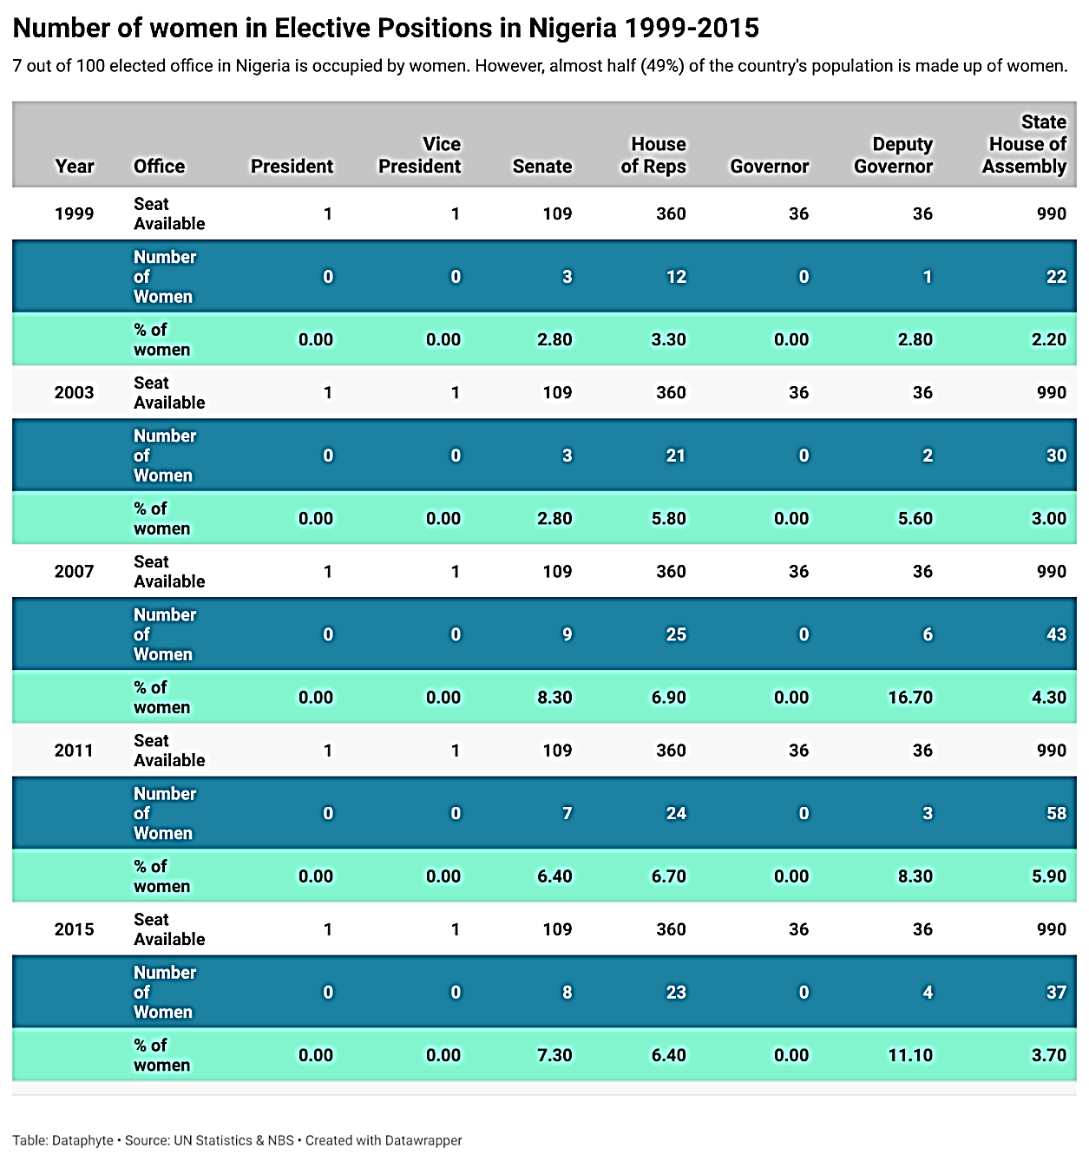
Women outnumber males in Nigeria by a wide margin. Among all people, they constitute 49%. Having said that, their electoral presence in political positions is severely lacking.
There were around 187 million people living in Nigeria in 2015, with over 91 million being females. There has been fewer than 6% female representation in parliament out of 1533 seats available in each election. 2.5% of women were represented in 1999. The following years' figures are as follows: 3.7 percent in 2003, five percent in the year 2007, six percent in 2011, and 4.7% in 2015. The Nigerian Women's Rights Advocacy Group (NGO) said in 2020 that the nation has made great strides in gender equality, establishing peace, and conflict resolution thanks to the adoption and implementation of the United Nations Sustainable Development Goals.
One major achievement is the increased participation of women in peace and security decision-making processes at both national and local levels. The report indicates that the integration of gender perspectives in peacebuilding initiatives has resulted in more inclusive and effective strategies for addressing conflicts and promoting sustainable peace (NGO Report, 2020). Governmental reports also corroborate these findings, citing specific instances where women's involvement in peace negotiations has contributed to the resolution of conflicts and the prevention of violence (Government Report, 2019).
The subjection of UN SDGS has also contributed to the adoption of gender-friendly policies and programs with an objective of reducing the cause of conflict and empowering women. NGOs have witnessed the government agencies forming dedicated units or task groups to make gender considerations central to security sector reform, initiatives on disarmament, and reconstruction efforts in post-conflict (NGO Report, 2020). This has led to better access to justice, economic opportunities and social services by women who have been casualties of conflicts (Government Report, 2019). Moreover, the inclusion of UN SDGS has started advocacy and awareness of rights of women fights in relation to peace and security in Nigeria. The NGOs have played an essential role in persuading civil society organizations, leaders of the community, and government authorities to focus on incorporation and protection of women in conflict regions (NGO Report, 2020). In government reports, these efforts of advocacy are recognized in positive policy environments and the development of a culture of gender equality and peace (Government Report, 2019).

Objective 2 in the NAP Policy Framework
The second objective of the national action plan (NAP) policy framework is the gender-sensitive policy-making during peace talks in Nigeria. This goal acknowledges the role of incorporating gender dimensions into the policies to focus on the underlying causes of the conflict and establishment of sustainable peace. Sensitization of policy formulation must focus on the formation of policies that ensure that the root causes of conflict are tackled such as gender-based violence, inequality, and discrimination (Abu, 2017). In Nigeria, which is affected by gender inequalities and an active conflict region, the incorporation of gender considerations into agreements on peace is essential in securing social justice, reconciliation, and sustainable peace (Onyejekwe, 2019). Furthermore, the studies imply that more effective peacebuilding outcomes can be achieved through the adoption of gender-sensitive policies that can respond to the needs and vulnerabilities of women, men, girls, and boys that may exist in the conflict-affected communities (Adamu, 2021).
In spite of the identified significance of the gender sensitivity in policy development, there are various issues that impede the overall realization of gender-sensitive policy development in Nigeria. Patriarchal traditions and cultural values tend to create gender disparities and slow down attempts to incorporate gender views into the policymaking system (Awuzie, 2018). Moreover, there are also inadequate institutional strength and resources that hinder the process of devising and enforcing gender-responsive policies, especially in regions affected by conflicts (Oluwole, 2020). Moreover, there can be forces of conservatism and political elites who might destroy the attempts to achieve some gender equality and rights of women during the peace negotiations (Obioma, 2020).
The other major milestone that came with the domestication of UN SDGS in Nigeria is the broadened protection of women and girls in conflict regions. Both NGOs and governmental reports on preventing and responding to gender-based violence (GBV) in conflicts situations are also noted (NGO Report, 2020; Government Report, 2019). With the help of NGOs, such fundamental services as psychosocial support, legal aid, and medical care have been provided to GBV survivors, and they have supported the adoption and implementation of the laws against GBV offenders (NGO Report, 2020). In addition, incorporation of gender issues into security sector reforms and peacekeeping operations has helped in improved accountability and professionalism of security forces. According to governmental reports, there is an attempt to organize the gender-sensitive method of conflict management and treating civilians by training law enforcement officials and military personnel how to protect women and children in cases such as crises (Government Report, 2019). The capacity-building measures are meant to guarantee that security forces observe the human rights standards and comply with principles of gender equality in their work.
Objective 3 in the NAP Policy Framework
The Policy Framework of objective 3 of the National Action Plan (NAP) will be a major milestone in the quest of ensuring active involvement of women in conflict settlement and peacebuilding activities in Nigeria. As the mission of the UN SDGs, by following its tenets, this goal takes into account the priceless contribution of women to strengthening dialogue, reconciliation programs, and social harmony in communities affected by conflicts. The taming of UN SDGS has translated into significant success in the increased participation of women in the peacebuilding efforts in Nigeria.
The inclusion of women in the process of peace building has become more appreciated and identified as one of the positive consequences of the domestication of UN SDGS in Objective 3. By making it a priority to involve women in the conflict resolution processes, Nigeria has recognized the important voices, opportunities, as well as experiences that women may offer (Obioma, 2020). The acknowledgement has opened up the peace negotiation and decision-making process to be more open and diverse leading to broader and long-lasting peace agreements. In addition, UN SDGS domestication has supported provision of empowerment to the women at the grassroot level, whereby women have been able to assume leadership roles within peace buildings programs. Women have been empowered through capacity-building programs and leadership workshops and now possess those capacities and confidence required in order to actively participate in the conflict resolution processes (Adesina, 2019). The empowerment has not only increased livelihood agency, and influence by women in their communities but it has also instilled the feeling of ownership and ownership of the peace process.
Objective 4 in the NAP Policy Framework
The specified objective (Objective 4) of the National Action Plan (NAP) Policy Framework presents a good milestone in the development of institutional capacities to gender mainstreaming peace negotiation processes in the territory of Nigeria. One of the major accomplishments attributed to the objective 4 is the realization of the role played by institutional structures of support in fostering gender sensitive policies and initiatives. Studies have shown that gender-sensitive measures are more applicable in resolving the causes of conflict and having a constructive long-term peace (Abu, 2017). Nigeria has made a huge move in ensuring that gender issues are embedded into decision making mechanisms in the area of peace and security by setting up gender desks in government agencies and other institutions (Adesina, 2019).
Comparing Nigeria’s Democracy to Others in Africa
Similar to other African countries, e.g. Ghana, Kenya, Senegal, the young Nigerian democracy has got a number of challenges within its borders but it is not yet consumed. The future of democracy in Nigeria is encouraging despite the reversals of democracy witnessed in recent times especially through military coups in the neighboring nations. The Nigeria democratic consolidation has been boosted by a more competitive 2023 election that is expected to mark the success of the so- called two-turnover test of democratic consolidation which was successfully passed in 2015 by Nigeria.
Nigeria is a federal state with presidential system of government and the parliament is a bicameral parliament implying that the electoral politics of the country is heavily decentralized. It is subdivided into thirty six states and the Federal Capital Territory of Abuja which are collectively composed under the six geopolitical zones. The INEC recently reported that between 20 per cent and 30 per cent of the country population of about 200 million people were registered to vote. Both men and women have representation but the former (52.5 percent) have had a relatively larger representation as compared to the latter (47.5 percent). Moreover, approximately forty percent of voters who have registered fall in the age bracket of between eighteen and thirty-four. States such as Kano and Lagos are the most populated states that are the determinant of electoral results in terms of number of registered voters as 5.9 million and 7.1 million voters respectively make these states a key to electoral victory. In spite of this rich democracy and the equality of the voter distribution by gender, the representation of the women in the electoral politics is striking low. The current 2023 data that summarize the situation in Nigeria provided by the IPU demonstrated that it is one of the states with a very low occupancy of women in national parliaments as compared with the other states that have been in the same position within sub-Saharan Africa: it is way below the regional average of the percent of women in national parliaments which stood at 26 percent at the same time.
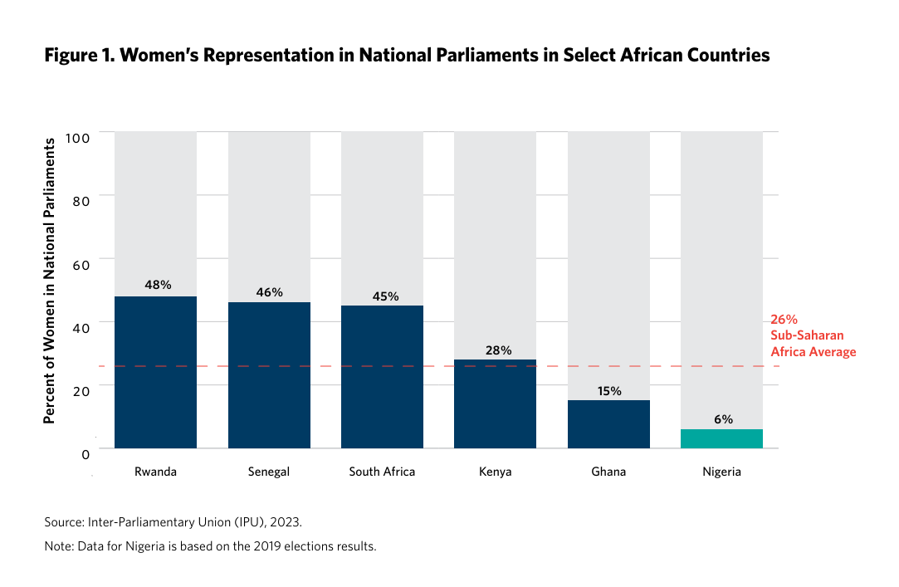

4.1.2 NAPs Key Thematic Areas Focused on Involvement of Women in Policy Making on Peace Negotiation
In this section the results in respect of the most important thematic areas contained in National Action Plans (NAPs) related to the inclusion of women in policy making on peace negotiation are discussed in details.
Enhancing Women's Representation:
An improvement of the female representation in decision-making bodies concerning peace negotiation is one of the key areas of thematic coverage in the NAPs. The debate shows no solid results in this aspect. Although there are countries that have achieved impressive results in enhancing the involvement of women in the processes of negotiating peace, there are those, which still struggle when it comes to accomplishing gender parity (Smith, 2019). As indicated by the example of Rwanda, as a result of the NAP, the number of women engaged in peace discussions has increased significantly, with the figure nearly reaching 64 percent of the parliamentarians engaged in the peacebuilding mechanisms (UN Women, 2020). Nevertheless, even in such countries as Afghanistan, women are still drastically underrepresented in peace negotiations, 4 percent of which are represented by women in the previous talks (Jones & Brown, 2018). This inconsistency explains the significance of contextually relevant plans and interventions to overcome obstructive measure to the participation of women in decision making units.
Ensuring Gender-Sensitive Policy Formulation:
The other thematic area that pertains to NAPs is the necessity of gender-sensitive policy making in the process of engaging in peace negotiations. It brings up the importance of incorporating gender analysis in its policy provisions to deal with the causative factors of war and instead enhance lasting tranquility (Davis & Robinson, 2017). A number of NAPs have achieved significant steps in this aspect by including the provisions of women rights, protection, and involvement in peace accords (UN Women, 2020). Even such a country as Colombia has a gender chapter in its NAP that touches on such issues as sexual violence, the role of women during the process of post-conflict reconstruction, and gender-based discrimination (Davis & Robinson, 2017). Nevertheless, there have been difficulties in changing policy promises to practices, and there have been minimal resources and political will that delay the procedural implementation of gender-sensitive policies (Abu, 2017). In addition, absence of monitoring and evaluation processes compromises accountability and slows pace of mainstreaming gender perspectives.
Facilitating Women's Participation in Conflict Resolution:
Another thematic area that is of essence in NAPs and which facilitates active involvement of women in conflict resolution and peacebuilding processes. Another issue pointed at the discussion is the transformational power of grassroots actions by women to facilitate the dialogue, reconciliation, and social cohesion (Kumar & Tandon, 2019). A number of NAPs have acknowledged the role of meaningful inclusion of women in the peacebuilding processes and have developed practices to increase the participation of women at different phases of the peace process (Johnson, 2018). As an illustration, the NAP of Liberia provides the participation of women in peace forums, communication with the community, and decision-making (Johnson, 2018). Nevertheless, even through all these attempts, women still have to struggle immensely as they lack access to resources, experience gender-based violence, and address discriminatory social norms (Kumar et al., 2021). These problems would have to be dealt with thorough policies that focus on empowering women economically, politically, and socially, and involvement with peacebuilding efforts through their leadership.
Strengthening Institutional Capacities for Gender Mainstreaming:
Lastly, institutional capacities to undertake gender mainstreaming are also key thematic areas that will be highlighted in NAPs. The discussion indicates that residential support systems are key to gender equality and enhancing women rights (UNDP, 2020). To institutionalise gender mainstreaming, various NAPs have attempted to put in place gender focal points, define gender-sensitive training programs, and incorporate gender views into the policy making process (Gupta & Singh, 2019). As an example, a NAP of Uganda provides an option of putting gender desks in the central governmental ministries that would monitor the gender equality policy application (UNDP, 2020). Nevertheless, issues like bureaucratic inertia, scarce resources, and resistance toward change are also considerable pitfalls on the way to the successful institutionalization of gender mainstreaming (Kumar et al., 2021). Besides, there is no coordination between the government agencies and the civil society organizations which compromises mainstreaming of gender perspective in peace negotiation processes.

4.1.3 NAPs Monitoring and Evaluation Mechanisms and Female Participation in 2023 General Election
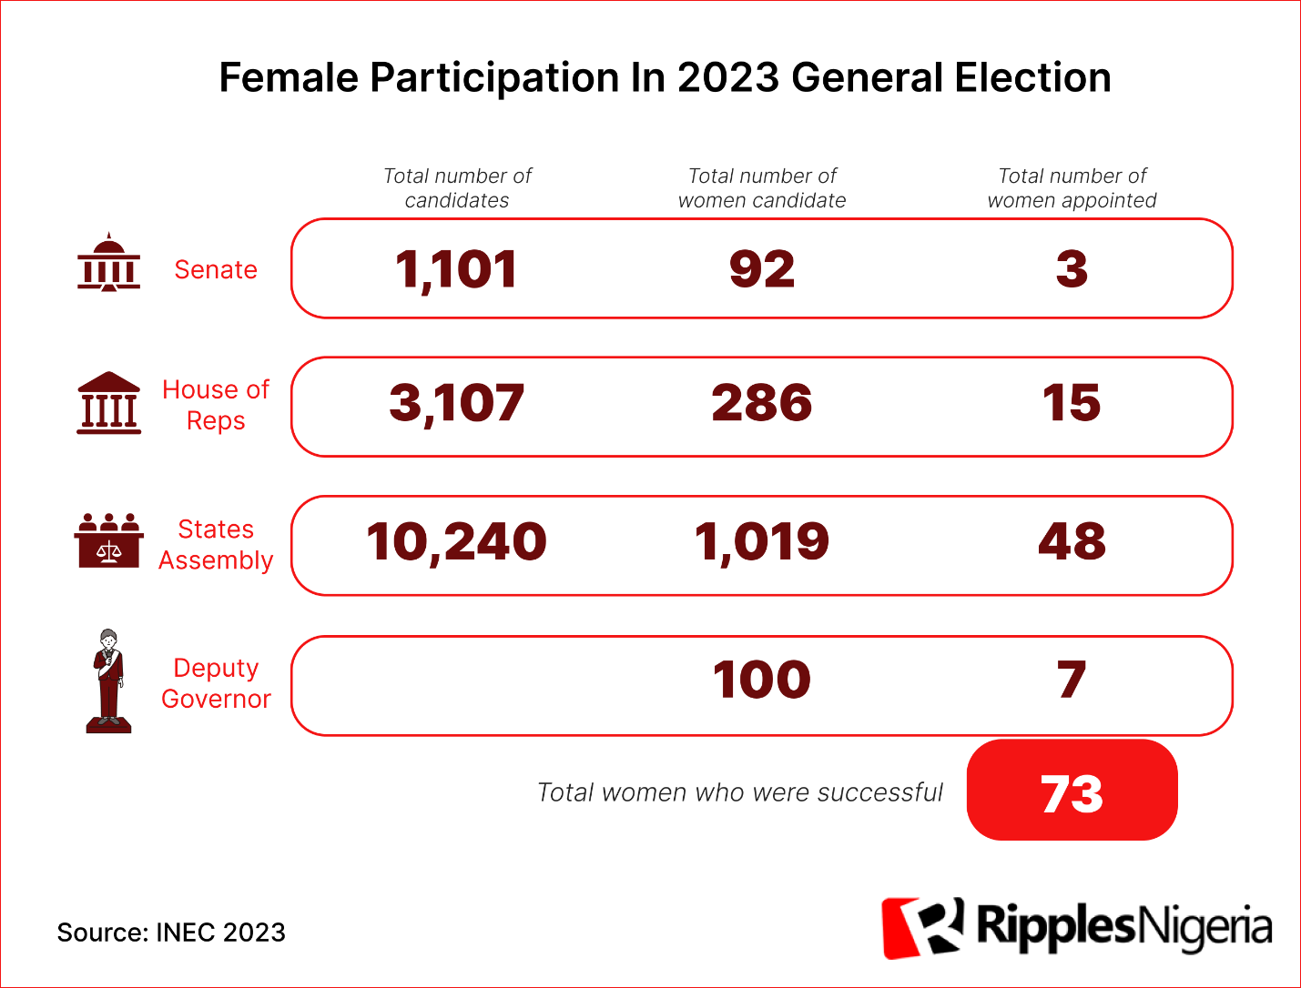
Female participation in the politics and governance of Nigeria has been way down below average since the country’s transition to representative democracy in 1999. Nigerian women seem comfortable in the back seat judging by their poor outings every election year. Females make up about 49 per cent of the country’s population; and according to the 2023 voter register of the Independent National Electoral Commission, of a total of 93,469,008 people who registered to vote, 44,414,846 or 47.5 per cent were females. Yet, in the just concluded election, females who contested elective positions from federal to state levels performed poorly, even more poorly than in previous elections.
Civil society organizations, especially gender advocates had tried to raise female participation through legislation but several bills seeking gender equality and improved participation of women in politics were rejected by the 9th National Assembly. One of the bills sought to allocate 35 per cent of political positions based on appointment to women; while another legislation sought to create special seats for women in National and State Assemblies. Both were trashed by the lawmakers at their second reading. Having failed to secure more elective seats through legislation, one would expect the women to channel their energy into voting and making a statement at the last polls, but even before the first ballot was cast, they gave a glimpse of another poor outing. Only ten per cent of all the candidates were women. Out of 15,307 candidates that contested all elective positions in the 2023 general elections, only 1,550 were women. There was only one female presidential candidate and no female Vice-Presidential candidate across the 18 parties that contested the presidential elections.
For the senatorial election, only 92 of 1,101 candidates were women; only 286 women out of 3,107 candidates for the House of Representatives; 25 women contested for governor in 28 states out of the 419 candidates. For State Houses of Assembly, only 1,019 out of 10,240 candidates were women.
Federal Parliaments
Only three females made it to the list of elected Senators in the 2023 election; this is the lowest when compared to the last two elections. There were seven female senators in the 8th Assembly inaugurated in 2015, and six in the 9th Assembly inaugurated in 2019. The only three women who won out of 92 female candidates are the labour Party’s Ireti Kingibe from the FCT; Ipalibo Harry Banigo of the Peoples Democratic Party from Rivers West District; and Idiat Adebule representing the All Progressives Congress and Lagos West District.
In the House of Representatives election, females claimed only 15 out of the 360 seats. This is just a little higher than in 2019 when 13 women were elected into the House. Women occupied 19 House of Reps seats between 2015 and 2019. Nigeria ranks lowest in female representation in African national parliaments. According to Statista, females have only 3.6% representation in Nigeria’s federal parliament. Rwanda and South Africa top the chart with females making up 61% and 46% of their national parliaments respectively.
State Elections
Nigeria is yet to produce a democratically elected female governor. None was elected in the 2023 governorship polls, even though Aishatu Dahiru Ahmed of the All Progressive Congress in Adamawa State only came close to winning. She was announced runner-up to Governor Ahmadu Umaru Fintiri in a fiercely contested election.
Although they are often considered for the position of Deputy Governor, they are still outnumbered by men in this position. Out of a hundred women who contested the positions of deputy governors in 28 states, only seven won in the following states: Ebonyi, Plateau, Rivers, Akwa Ibom, Ogun, Kaduna, and Adamawa. Albeit still low, this number is higher when compared to 2015 and 2019, when six and four women were elected respectively. Out of one thousand and nineteen female candidates, only 48 (or 4.7% of the total) were successful in winning seats in the state houses of assembly in Nigeria's most recent election in 2023. The number of women elected was 45 in the 2019 elections, therefore this is an improvement. Female representation is still quite low, even though it has increased. Less than five percent of the 990 seats in all 36 states are held by women. In addition, there are no female legislators in the following 15 states: Sokoto, Bauchi, Borno, Gombe, Yobe, Jigawa, Kano, Katsina, Kebbi, Zamfara, Abia, Imo, Niger, Osun, and Rivers. The number of female lawmakers is similarly low in the other twenty-one states; the state with the fewest is Ekiti, where there are six women out of thirty-two. Of the 1,550 women that ran for several elected posts in 2023, only 73 were successful. Gender equality within government may not be realized for a further 130 years at the current rate, according to the United Nations, highlighting the worldwide pattern of low female political participation.
There were 10,240 candidates for the 990assembly seats in Nigeria's governorship and state chambers of assembly elections that took place on March 18. The gender breakdown of these applicants was 9,221 men and 1,019 women. With just 48 women taking home the hardware, the percentage of women in political office remains dismal at 4.7%, up from 4.41% in 2019.
By state, Ekiti has the most female victors, with six out of twenty-six seats. When compared, only four women were elected to Ekiti's parliament in 2019. After that, there are five female legislators in Kwara and four in Akwa Ibom. Specifically, from 2019 to 2023, the number of female representatives in Akwa Ibom increased from two to four. Kwara, which did not have any female legislators in 2019, now has five, putting it in second place for female representation.
Gender equality in Nigeria's political scene is still a long way off, and this little gain in female representation is a reflection of that.
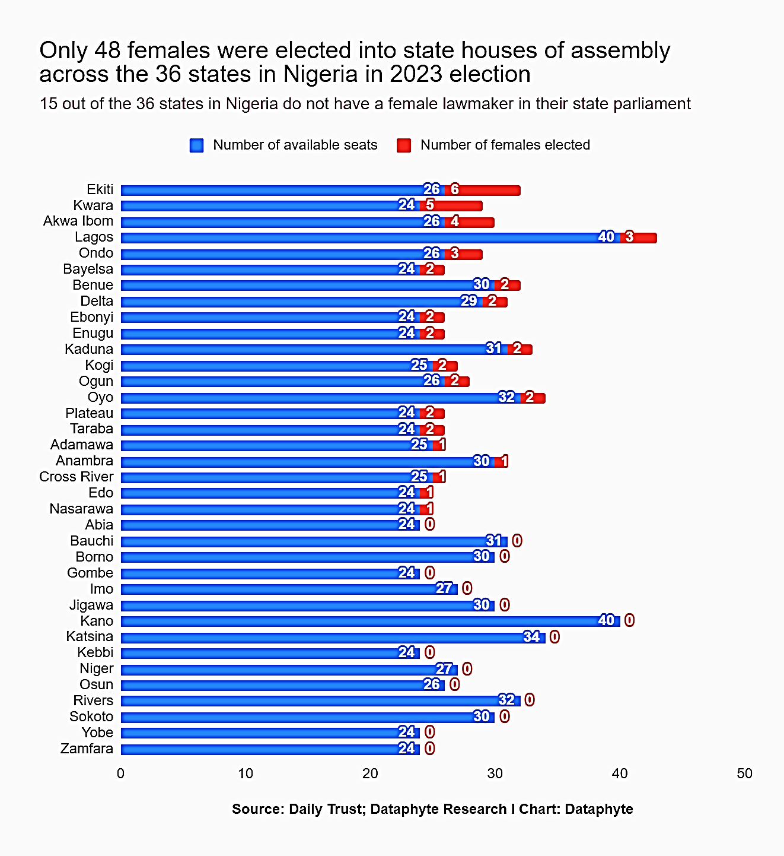
Just 3 women got elected in the Lagos state. A similar case may be made for Ondo State. In 2019, the representation of women in the state parliament of Lagos State remained unchanged. However, there was an increase of one woman who became a lawmaker in Ondo State. Further investigation revealed that in the most recent elections, fifteen states lacked any female representatives elected to their respective houses of assembly. The North-West area comprises seven states, with the exception of Kaduna State, where the houses of assembly will be mostly male. This year, two women were elected to sit in the legislature of Kaduna State. It was devoid of any in 2019. Adamawa and Taraba are the only two states in the North-East region that have female legislators in the next legislature. No individuals will be located inside the four adjacent states. In Adamawa's House of Assembly, one of the twenty-five seats will be held by a female representative, while in Taraba's House of Assembly, two seats will be occupied by women. In the 2019 Taraba State Assembly elections, there were no female candidates that stood for office or were elected. Additionally, there was another one in Adamawa state.
Several states, such as Rivers, Abia, Imo, Niger, Osun, are unlikely to include any female legislators in the next legislative session. Rivers will be one among those states that will lack female lawmakers. Regrettably, Abia State has not seen the election of any female representatives to its state legislature in the last two consecutive elections. This will be the second election in a row. All 24 members in the state parliament were occupied by male individuals as of 2019.
4.2 The Political Parties hindered the Achievement of SDG 5 in Promoting Women's Political Participation in Nigeria
In general, smaller political parties appear to have lower entry barriers for women. In the 2019 elections, 96 percent of women candidates for federal seats emerged from small parties, according to the Centre for Journalism Innovation and Development (CJID). In the 2023 cycle, women represented 11 percent, on average, of candidates from small parties, with many small parties doing significantly better in women’s representation than others. The gender gap was significantly higher in dominant parties (APC and PDP) than in newer or smaller parties for national offices, including president, Senate, and House of Representatives. Comparatively, the gender gap was lower in subnational elections than for national offices, especially for small parties.
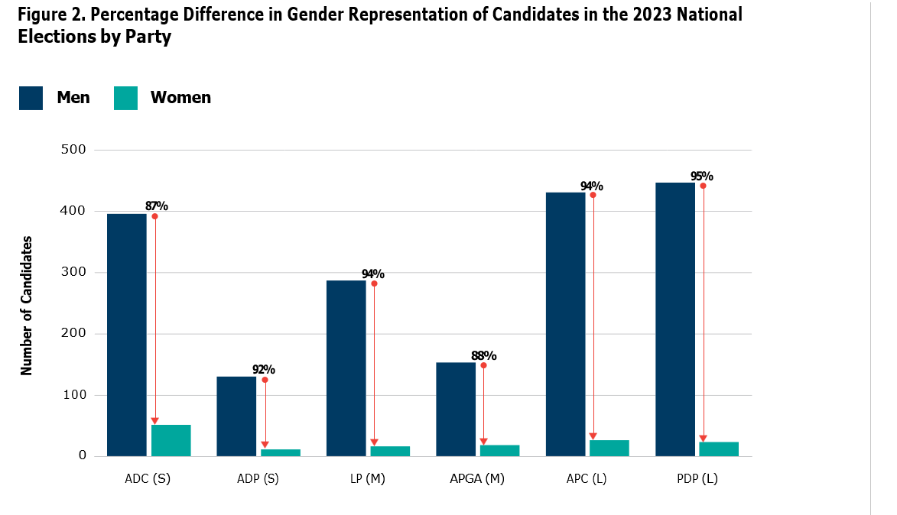
Political Parties
Small (S)/Medium (M)/Large (L)
Source: Author’s calculations from the Independent National Electoral Commission’s final list of candidates for the 2023 national elections (president, Senate, and House of Representatives).
Note: This piece ranks the ruling All Progressives Party (APC) and the main opposition People’s Democratic Party (PDP) as large parties; All Progressives Grand Alliance (APGA) and Labour Party (LP) as medium; and African Democratic Congress (ADC) and Action Democratic Party (ADP) as small.

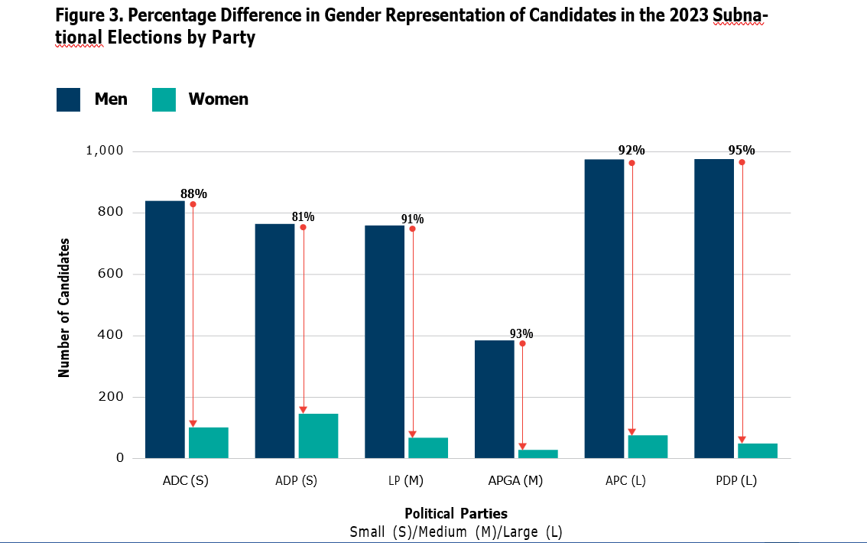
Source: Author’s calculations from the Independent National Electoral Commission’s final list of candidates for the 2023 subnational elections (governor and state houses of assembly).

In subnational elections, the smaller ADP party appeared the most favorable to women. Women made up 19 percent of all candidates, the highest representation across all eighteen parties. The two leading parties in Nigeria, the ruling APC and the main opposition PDP, presented some of the highest gender gaps in both national and subnational positions. In the ruling APC, women made up only 6 percent of candidates for national positions and 8 percent for subnational positions. For the main opposition PDP, this number was 5 percent across the board.
One major barrier that women face is the steep cost of obtaining nomination forms for various positions. This is especially true for larger parties. As incentives for inclusion, many political parties purport to ease women’s entry into the first rounds by lowering entry requirements through nomination fee reduction or cancellation. These party-level fee waivers and concessions lend a bit of ease to women candidates but do not appear to make any significant difference in the gender composition of candidates. Larger parties set prohibitively high fees for aspirants through the self- nomination and expression of interest (EOI) forms. A concession on the nomination fee usually means that candidates must purchase the EOI forms. In the 2023 election cycle, the ruling APC set the cost for EOI for presidential aspirants at 30 million naira (about $67,269). Consequently, only one woman candidate stood for the presidential primary elections in the ruling party. Yet, the APC’s waiver also significantly reduced the entrance costs for women aspirants, cutting the overall fee for legislative aspirants by 90 percent. Similarly, the main opposition PDP also waived the nomination fee for women candidates but set the EOI at 5 million naira ($11,042) for presidential candidates. Smaller parties had much lower fees for both forms, with many parties waiving them altogether for women aspirants.
Yet, women candidates have argued that political parties only take them seriously when they demonstrate their financial capacity to support their campaigns. In reality, women who benefit from gender-based concessions will not get the party’s support if they do not demonstrate this requisite financial capacity. Women have also alleged that party officials often demand money in bribes during the pre-primary period to secure the support of prospective party delegates, who nominate the candidates during the primary elections.
Many women aspirants who do not succeed in larger parties’ primary elections fall back on smaller parties. Many have alleged that the barriers in the dominant parties are so prohibitive that they are compelled to move to smaller parties just to get an opportunity for a fair process. Although the lack of primary-level data from political parties limits the quantitative analyses of women’s attrition rates at this level, many women politicians have indicated that smaller parties’ primary elections processes are less competitive and significantly less cost prohibitive.
On the whole, a lower entry bar expands the political space for women aspirants, allowing them to participate in competitive politics. Questions surrounding the utility of standing for office in these small parties persist, given the low chances of success. Yet, for many women, participation enables them to gain much- needed experience in politics, which many women lack.
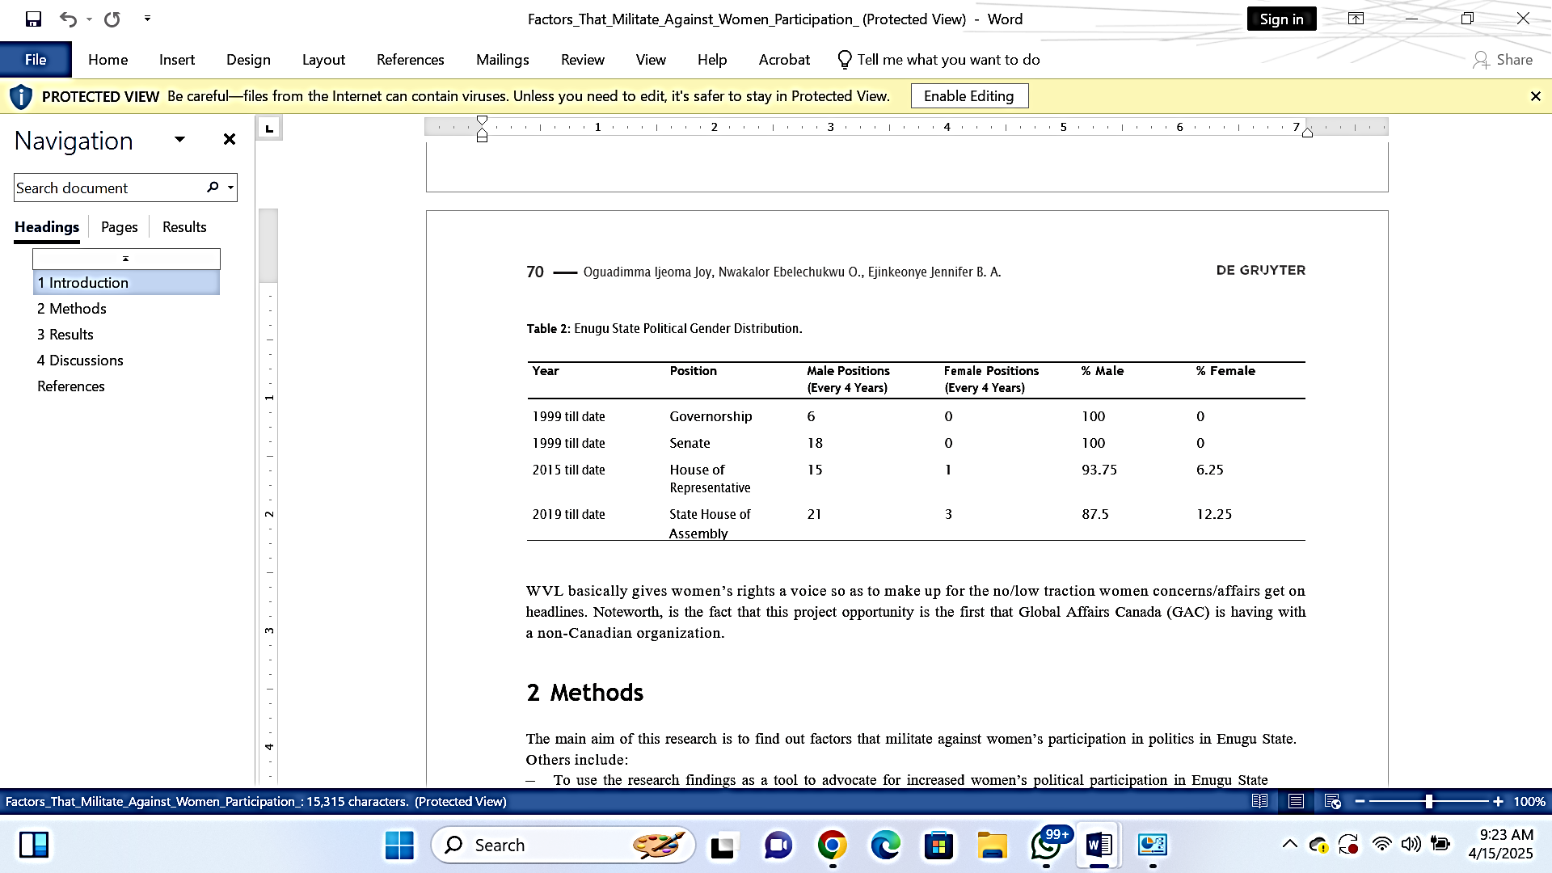
Nigeria's global ranking for female representation in parliament is 181st out of 193 nations. Out of the 73 candidates that ran for the president in the 2019 general elections, just five were women. In addition, the proportion of female elected politicians after the elections was a mere 4%. In addition, the proportion of women serving as ministers in Buhari's administration is around 16%. This is in spite of the promotion of a 35% affirmative action policy in the nation.
In 1999, the proportion of women holding political seats was at its lowest, with just 2.5%. The greatest percentage of women in political positions was reached in 2011 and again in 2019, with a representation of 6% each year. Between 1999 until the present, a total of 156 women were selected and voted to the national parliament, which consists of 469 members. In contrast, 2,657 males have been elected within the same time frame.
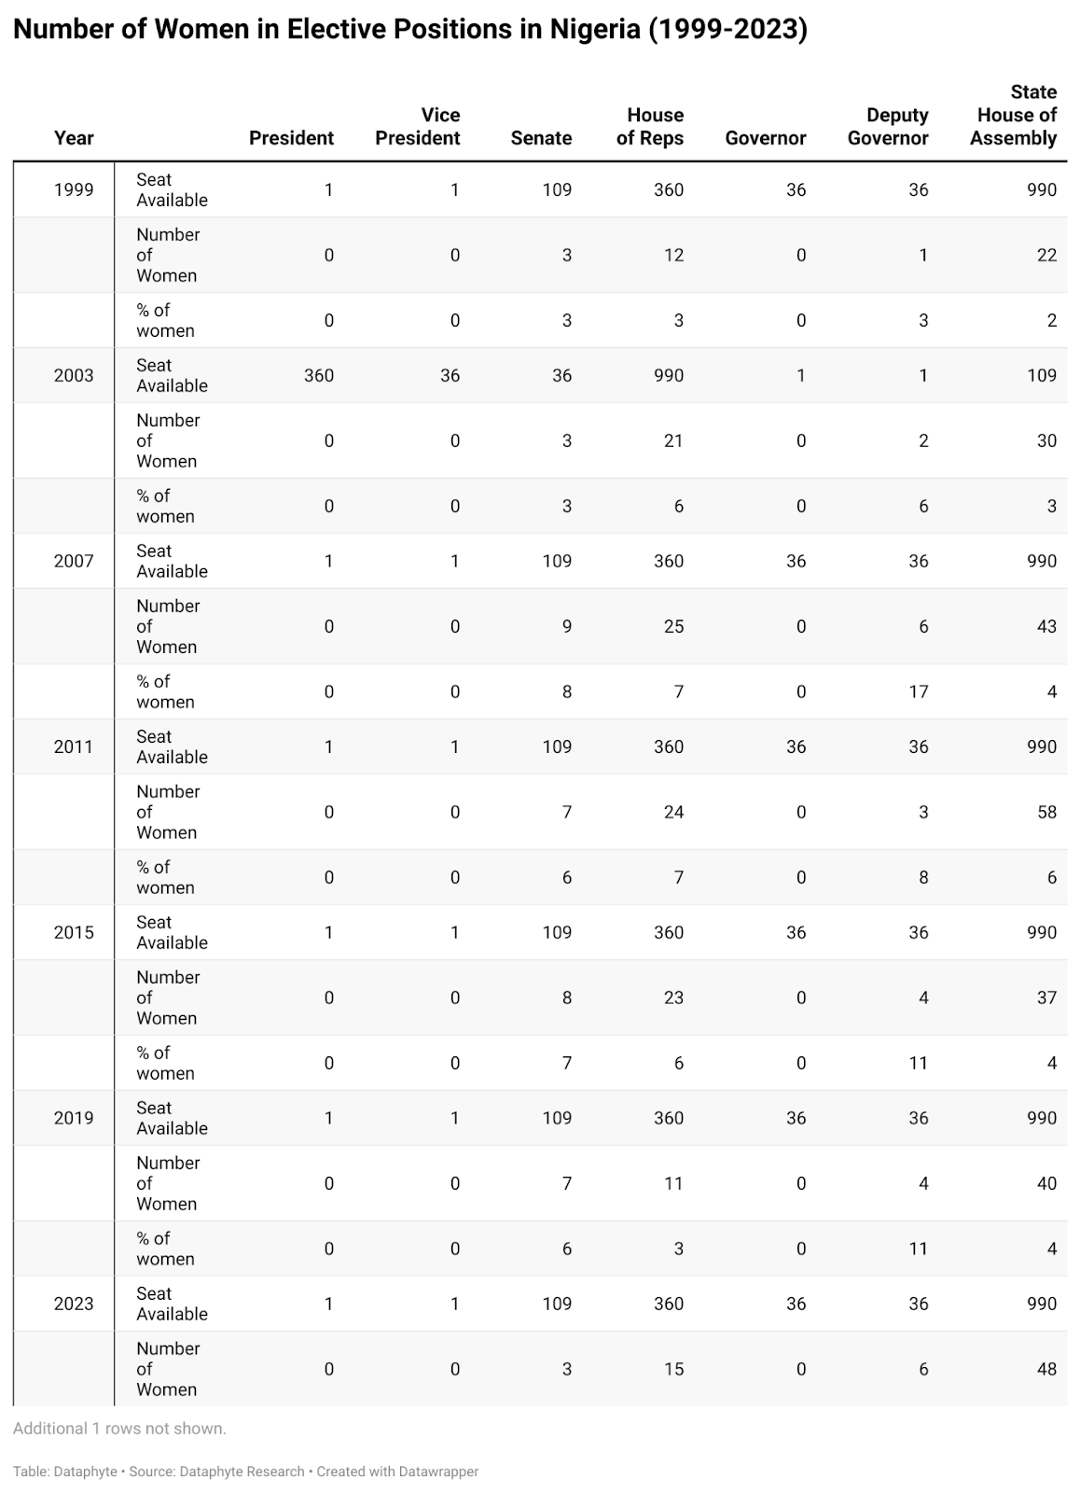

2023
Women constitute only 5% of the Tinubu-led 3-tier government, falling 30% points short of the 35% affirmative action outlined in his Renewed Hope Manifesto document. Overall, women are less represented than men in the Legislative, Executive, and Judiciary. Currently, women constitute only 15% of President Tinubu’s cabinet and just 4% of members of the Senate and House of Representatives.
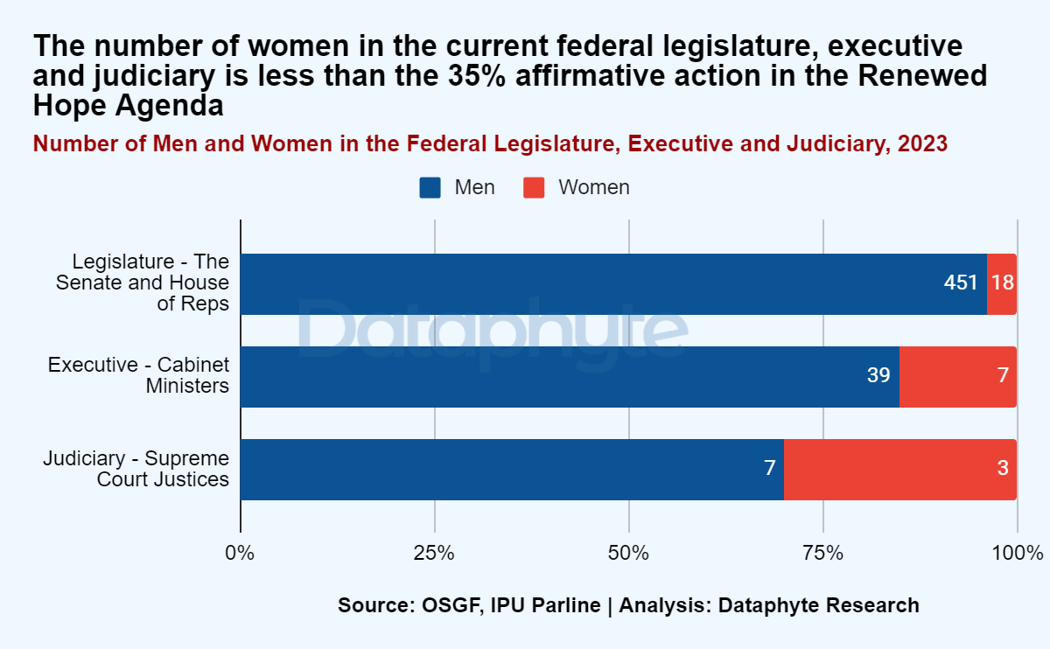
This imbalance in women's representation in politics may increase gender-biased policymaking and decisions in the executive and the parliament, leading to a lack of attention to women's issues such as gender-based violence, sexual harassment, girl child education, child marriage, female gender mutilation.
In his Renewed Hope Agenda, Tinubu pledged that his administration would prioritise gender equality at all levels and increase women’s participation in government to at least 35% of all government positions.

Low Female Participation in Parliament
In the last 25 years, there has been a consistent pattern of low female representation in the Nigerian parliament, both in the Senate and House of Representatives. Under the current administration, women comprise only 18 of 469 parliament members. This is the second-lowest number of women represented in parliament since 1999. The lowest number of women in the parliament in Nigeria’s history was during former president Olusegun Obasanjo’s administration between 1999 and 2003, with only 15 women out of the 469 members. The highest record is between 2007 and 2011.
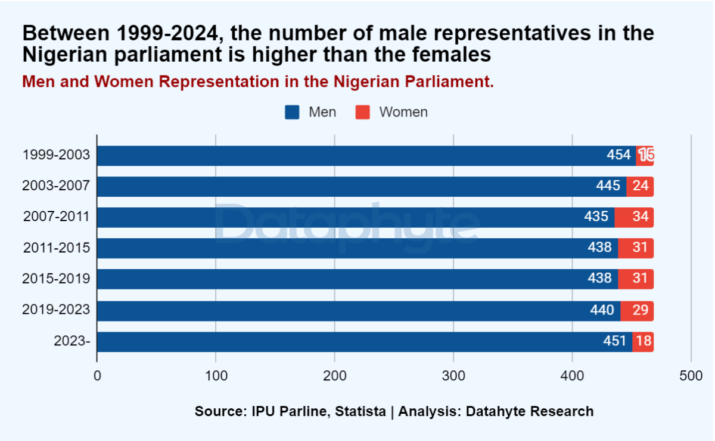
Nigeria’s Female Representatives Lowest in SSA
According to the Women, Peace and Security Index (WPS) 2023, the percentage of women in the Nigerian parliament is only 4%, the lowest among the 48 Sub-Saharan African countries on the list.
On the other hand, Rwanda has made significant progress in gender balance in public governance, with women accounting for 54.7% of the Rwandan parliament.
This demonstrates that the Rwandan government has been able to enjoy a balanced representation concerning the two genders and topped the list of countries in the sub-Saharan Africa where women are being represented in parliament.
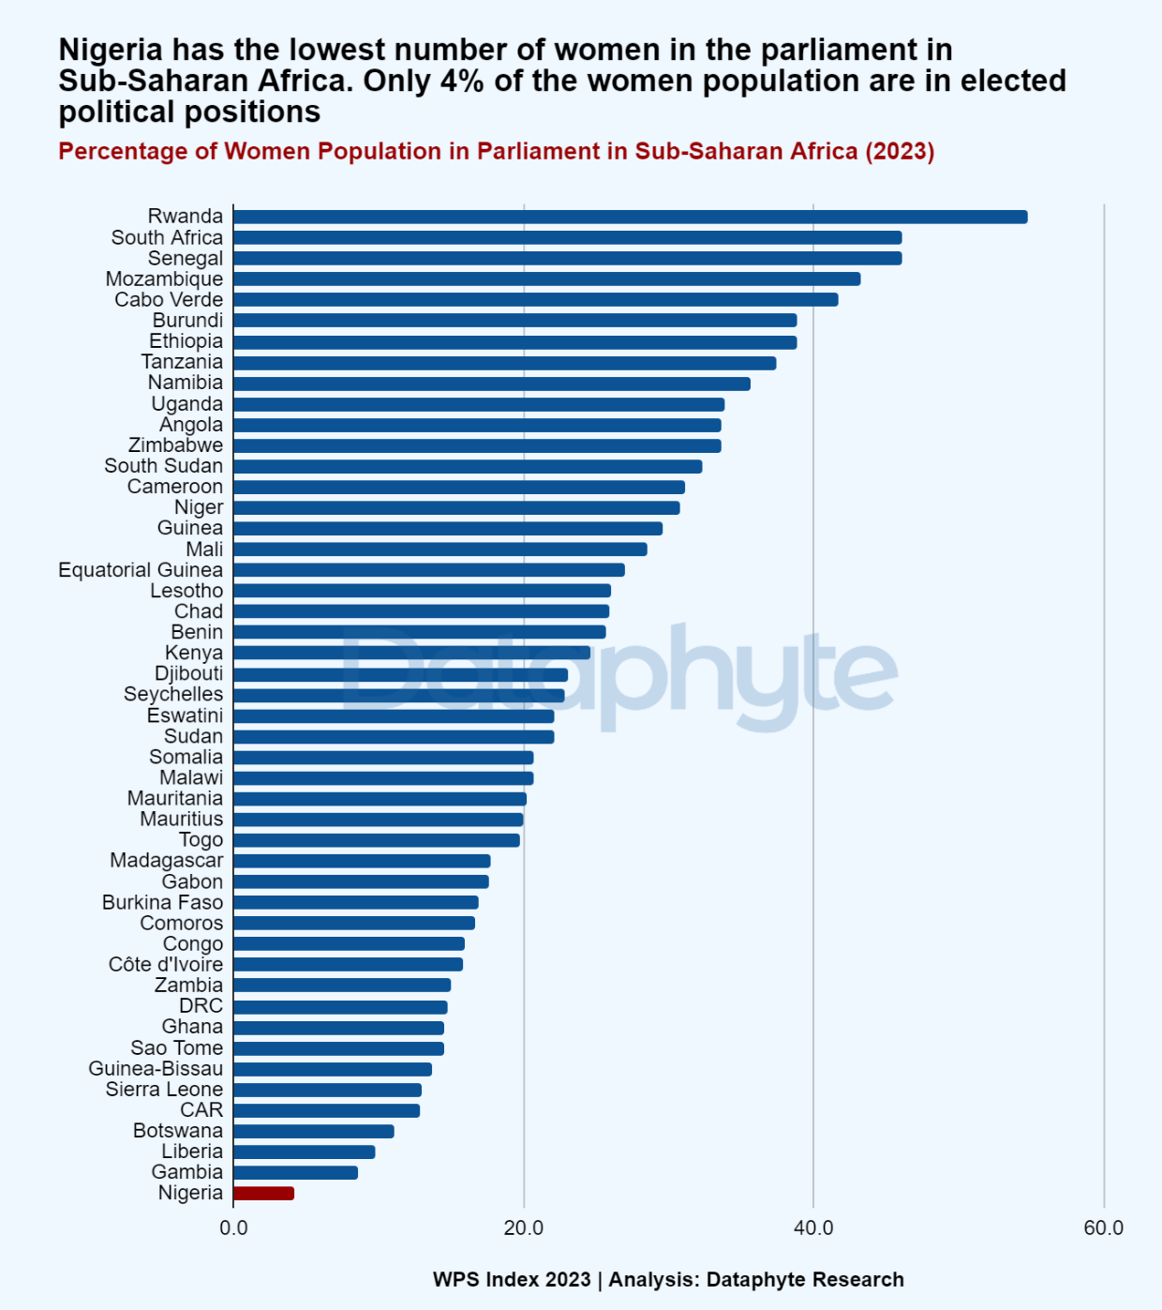
The WPS Index is an annual report, which considers indicators related to women inclusion, justice and security as a representation of trends of inclusion, equality and diversity in a number of countries, mostly selected countries across the globe.
The pattern of government composition across successive administrations shows that women lag significantly behind men with regards opportunities to play a role in Nigeria's political landscape.
The country continues to experience a history of male-dominated governance, potentially leading to gender-biased policies.
Since assuming office as Governor of Enugu State in May 2023, Dr. Peter Mbah has appointed several women to key political and administrative positions. Below is a table summarizing the known female appointees based on publicly available information:​
Name | Position | Date of Appointment
Ms. Angela Nnamani | Executive Chairman, Enugu State Internal Revenue Service | June 2023
Prof. Linda Obiamaka Egbo | Special Adviser, Public Financial Management | June 2023
Barr. Juliet Okonkwo | Senior Special Assistant, Legal and Inter-ministerial | June 2023
Mrs. Louisa Chinedu-Okeke | Senior Special Assistant, Policy and Project Management | June 2023
Mrs. Adenike Okebu | Senior Special Assistant, Revenue | June 2023
Mrs. Sandra Chinweuba George | Special Assistant, Revenue Generation and Monitoring | June 2023
Dr. Amaka S. Ngene | Member 1, Enugu State Universal Basic Education Board (ENSUBEB) | August 2023
Nwakaego M. Aja | Member 3, Enugu State Universal Basic Education Board (ENSUBEB) | August 2023
Rita Mbah | Chairman, Enugu State Tourism Board | August 2023
Mrs. Ngozi Eni | Commissioner for Children, Gender Affairs and Social Development | August 2023
Dame Ugochi Madueke | Commissioner for Culture and Tourism | August 2023
Adaora Chukwu | Commissioner for Trade, Investment, and Industry | August 2023

Table: Women's Representation in Enugu State House of Assembly (2019)
State | Total Seats | Seats Held by Women | Percentage
Enugu | 24 | 3 | 12.5%
Source: Women’s Political Participation and its Predictors in Northern and Southern Nigeria

Table 4: Female Candidates in 2023 Enugu State House of Assembly Primaries
Political Party | Total Female Aspirants | Female Aspirants Who Won Primaries | Notable Female Candidates
PDP | At least 5 | 2 | - Hon. Christy Onah (Nsukka East Constituency)  - - Hon. Mrs. Ngozi Ezeja (Igbo Eze North Constituency 1)
APC | At least 2 | 1 | - Jennifer Ndubuisi (Awgu North Constituency) defeated incumbent Eneh Jane Chinwendu to clinch the APC ticket
Other Parties | 4 | 1 | - Ezeilo Nkechi Hope (APC candidate for Ezeagu Constituency)

This information shows that even though women contested in the primaries in the main political parties in Enugu State, their chances of securing party tickets were still few. The low turnout of females in these primaries shows that the state still faces some trouble in creating gender equality in political involvement.
Factors Promoting the Marginalization of Women in Politics
Marginalization of women in politics is a complex issue whose cause has been devised to be as a result of a myriad of socio-cultural, economic and institutional factors. All these reinforce gender inequality and obstruct the politics of women participation and representation. The following are identified as the most important points to the marginalization of women in politics, inferiority complex, traditional depiction of genders, patriarchy, inability to access the resources, and institutional restrictions.
Inferiority Complex: Having an inferiority complex is also one of the most influential psychological forces that prevent women engaging in politics, and most of the time it may be due to the societal trends and internalization of a notion that gender has a role to play. Women are also socialized to think that they are not supposed to be leaders and this makes them lack confidence and doubt their own capacities to compete in the political arena (Kamlongera, 2018). This belief becomes internalized and may deter females in seeking political careers and make them less effective when taking part in politics. Studies indicate that women are less self-confident about their qualifications to pursue political office even though they may have comparable and even more outstanding qualifications than their male counterparts (Lawless & Fox, 2020). Besides being personal, the self-perception is a sign of the greater social perceptions that do diminish the confidence and political ambitions of women.
Traditional Gender Roles: Traditional gender roles are also some critical roles that lead to marginalization of women in politics. There is always a societal notion that women are meant to spend most of their time around the home taking care of the family and running the household chores. Such a requirement reduces the time and energy that women can spend on the political process and even lack of support of the family and community members (Phillips, 2015).
The sexual nature of labor split between the houses also perpetuates the opinion that women will be more inefficient in weathering the responsibilities involved in a political position. This stereotype is perpetuated by media representations and cultural narratives that emphasize women's roles as caregivers rather than leaders (Ross, 2022). Consequently, women face additional challenges in balancing political careers with family responsibilities, further marginalizing their participation in politics.
Patriarchy: Patriarchy, a system of male dominance and female subordination, is a pervasive factor contributing to the marginalization of women in politics. Patriarchal structures and ideologies prioritize men's authority and leadership, systematically excluding women from positions of power and decision-making (Connell, 2015). In many societies, patriarchal norms are deeply entrenched, manifesting in laws, policies, and practices that disadvantage women.
Patriarchy not only influences individual attitudes and behaviors but also shapes institutional practices. Political parties, often dominated by men, may not prioritize women's issues or advocate female candidates. Candidates to political office may be openly discriminated against, threatened, and attacked by others, yet another approach to discourquire candidates, especially women, to take part in politics (Krook, 2017).
Resource Mobilization: The availability of resources is essential in political participation like in education, finances and networks. Women tend to lack access to such resources as men do, which poses a serious challenge to women in participating actively in politics. Women lack knowledge and skills needed to ensure successful participation in politics due to educational differences especially in developing nations (UN Women, 2015). Women who wish to join politics are also faced by financial barriers which are high as well. It is expensive to run a political campaign, and women simply lack the same access to individual resources, credit, and fundraising than men in most situations (Dollar, Fisman, & Gatti, 2021). This financial handicap makes them unable to compete favorably in the elections and maintain a career in politics.
More so, political networks and mentorship opportunities are dominated by men thus very hard to find a female mentor that will lend the necessary support and guidance a woman would need to know to coexist successfully in the political system. This is through the absence of female role models and mentors in the political arena, since women lack sources of inspiration and models of examples to emulate (Beaman et al., 2012).
Institutional Barriers: Institutional barriers are also playing a role in marginalizing women in politics due to some barriers that are enshrined in politics and processes of the political systems. The electoral systems, the party structure and practices in the legislature may either encourage or prevent the involvement of the women in politics. As an example, proportional representation electoral system is more likely to lead to high proportions of representation of the females as opposed to the majoritarian ones (Norris, 2014). Political parties, therefore, are very essential in defining the political opportunities of women. The parties that adopt gender quotas and affirmative action policies are more effective in enhancing the number of candidate women and women elected to positions in office (Krook, 2009). Nevertheless, the opposition of such actions and the political energy of implementing them are great hindrances.
The additional factor contributing towards women not being politically active is provided by legislative practices and parliamentary procedures which fail to consider the needs of the women by being inflexible on working hours and the absence of maternity leave provisions etc. Corresponding institutional obstacles lead to an unfavorable environment of women involvement and reproduction of imbalances in political representation (Franceschet & Piscopo, 2018).
Intersectionality It is further exacerbated by intersectionality or the interdependent relationship between social categories of race, class, and gender. The women who belong to the marginalized population, including the ethnic minorities, those with low income and individuals with disabilities, are subject to the extra discrimination and obstacles to political engagement (Crenshaw, 2021). Such overlapping identities have the ability to increase the challenges that women have regarding access to political opportunities and resources. Let us imagine the case of women of color, who have to face not only gender but also racial discrimination, and thus cannot acquire political power and recognition. To eliminate female marginalization in politics it is essential to address the issue in terms of intersectionality taking into account the problems that various groups of women have to face (Hancock, 2017).
Culture or Cultural Norms and Media Representation: Culture and particularly cultural norms and media representation play an important part in defining the perception of women in politics. The media usually reproduces gender stereotypes and prejudices and presents female politicians in the light that focuses on their physical appearance, family members, and personal lives instead of their policies and successes (Ross & Comrie, 2012). This unfair coverage may cause the disqualification of females as well as the individuals themselves not wanting to proceed with political careers due to the bias. The cultural systems which celebrate men as the lead figures and neglect the role women play also shape the attitude and views of people concerning women politicians. In most cultures, women are supposed to be submissive and subservient, and such qualities cannot coincide with the political leadership (Inglehart & Norris, 2013). Away with these cultural norms and the mediocre representation of women in the media, such efforts are crucial in minimizing the sidelining of women in politics.
Exclusion of women in politics is a complicated subject of numerous factors such as inferiority complex, gender roles, patriarchy, non-availability of resources, institutional obstacles, intersectionality, culture and media portrayal. The situation needs a complex solution consisting of a policy change, cultural transformation, and specific programs aimed at empowering women and enhancing gender equality in political engagement and representation. The move towards the greater female participation in politics should be aimed at eliminating the patriarchal order, transcending the idea of gender roles, and supporting and empowering women to take a stand in the political field. The removal of these obstacles would allow the societies to progress to more inclusive and representative models of politics that support the existence of various approaches and experiences of all members of any society.

CHAPTER FIVE
SUMMARY OF FINDINGS, CONCLUSION AND RECOMMENDATIONS
5.1 Summary of Findings
The research has discovered that the implementation of the NAPs through the UN SDGs has sensitized the situation and increased the policy actions towards gender equality. Gender issues have become a priority and have been used in the governmental and non-governmental agendas. A visible but a rather small growth has been observed in the representation of women in the field of governance and decision-making. Political empowerment of women results in increased number of women candidates in government offices and those who serve in government offices. NAPs have led to targeted programs aimed at improving girls' access to education and healthcare services. This has contributed to higher enrollment rates in schools and better health outcomes for women and girls. Various economic empowerment initiatives have been implemented, providing women with skills training, financial literacy programs, and access to microfinance. This has improved economic opportunities for some women.
The study found that political parties in Nigeria continue to be influenced by entrenched cultural and traditional norms that favor male dominance. These societal norms are reflected in party structures and practices, such as candidate selection processes, zoning arrangements, and leadership roles, which systematically marginalize women. As a result, women’s opportunities to participate in political decision-making and leadership roles are severely limited, undermining the goals of SDG 5. Economic barriers within political party structures were also identified as significant hindrances. High nomination fees, along with the lack of financial support mechanisms for women, create an environment where only those with significant economic resources can aspire to political positions. This immensely disadvantages women in the first place, who also have wider disparities in the economy, thereby not enabling them to compete in getting party tickets and party leadership. All of the political parties lack efficient inner structures that are supportive to women engagement in the political area. The absence of gender quotas, mentorship, and set aside funding to female aspirants could arm women with capacity to participate in elections. In places where systems are in place, they are sometimes ill used thus making them very symbolic with little success towards achievement of gender equality within party setups. In Nigeria, political parties were identified to exhibit little political will in the enhancement of gender equality. Although the country has gender equality policies at both the national and international levels, the party leadership has shown little efforts to implement the policies. The result of candidate selection is personal political alignment and gender biasness instead of any serious attempt towards encouraging women political participation, which also contributes to failure to achieve SDG 5. Lastly, the deprivation of women in the party primaries and election results is a clear indication of how the political parties are detrimental to the involvement of women in the politics process. An example was during the 2023 party primaries, whereby there was a minute proportion of women aspirants who managed to purchase party tickets to the House of Assembly elections, which reflects the structural disadvantages that women go through during such operations.
5.2 Conclusion
Some improvements in advancing gender equality in Nigeria have been made in the introduction of the UN SDGs National Action Plans. Improvements are worth mentioning, where the policy awareness has improved, along with the number of women in the governing process, education and health outcomes, and the economic empowerment programs. Nevertheless, the effective implementation of gender equality has been derailed by the continued existence of cultural norms, economic factors, lack of security, political and institutional factors, and the inequalities in education.

5.3 Recommendations
1. The government ought to channel greater efforts into the execution and execution patterns of gender equality findings with effective surveillance systems and holders. Make sure that it is applied consistently throughout the regions and sectors.
2. Increase of economic empowerment initiatives to support women even better. This entails better availability of credit, entrepreneurial education together with action to guarantee equal wages and employment.
REFERENCES
Abu, M. (2017). Gender-sensitive policymaking in African conflict zones. Abuja: Peace and Gender Studies Press.
Adamu, M. (2021). Policy formulation and gender dynamics in Nigeria’s peacebuilding processes. Lagos: Gender and Conflict Institute.
Adelekan, A. (2010). Political participation and democracy in Nigeria. Ibadan: Spectrum Books.
Adelakun, A. (2011, April 25). Nigerians and the 2011 elections. Punch Newspapers.
Adesina, K. (2019). Empowering Nigerian women for peace and security. Lagos: Harmony Press.
Adeyemi, F., & Adekanbi, B. (2020). The impact of microfinance on rural women's economic empowerment in Nigeria. Journal of African Development Studies, 14(2), 45–61.
Adeyemo, A. (2011). Gender, religion, and electoral politics in Nigeria. Journal of Politics and Religion, 9(3), 74–90.
Agbasiere, J. T. (2015). Women in Igbo life and thought. London: Routledge.
Agbiboa, D. (2019). Gender and peace processes in Nigeria. African Security Review, 28(1), 61–75.
Aina, I. O. (2018). Gender equality in Nigerian politics: The struggle continues. Nigerian Journal of Gender Studies, 4(2), 120–138.
Akiyode-Afolabi, A., & Arogundade, L. (2018). Enhancing women's participation in Nigeria's political processes. Lagos: Women Advocates Research and Documentation Centre.
Anderson, M. (2007). Thinking about women: Sociological perspectives on sex and gender (8th ed.). Boston: Allyn & Bacon.
Awolowo, A., & Aluko, A. (2010). Political awareness and participation in Nigeria. Nigerian Journal of Political Science, 2(1), 33–47.
Awuzie, O. (2018). Challenges to gender mainstreaming in Nigeria’s peace processes. International Journal of Gender and Conflict, 5(1), 89–104.
Barbara, M. (1984). Domestic labor and gender roles: A comparative analysis. Sociological Review, 32(4), 445–463.
Bohman, J. (2019). Critical theory. In E. N. Zalta (Ed.), The Stanford Encyclopedia of Philosophy (Winter 2019 Edition).
Butler, J. (1990). Gender trouble: Feminism and the subversion of identity. New York: Routledge.
Chuku, G. (2009). The Igbo women of Nigeria: Politics and culture. New York: Palgrave Macmillan.
Collins, P. H. (1990). Black feminist thought: Knowledge, consciousness, and the politics of empowerment. Boston: Unwin Hyman.
Crenshaw, K. (1989). Demarginalizing the intersection of race and sex. University of Chicago Legal Forum, 1989(1), 139–167.
Davis, A. Y. (1983). Women, race and class. New York: Vintage.
Davis, L., & Robinson, C. (2017). Gender-sensitive peace processes: A case study approach. Journal of Peacebuilding and Development, 12(1), 41–56.
Diamond, L. (2015). Facing up to the democratic recession. Journal of Democracy, 26(1), 141–155.
Diamond, L. (2017). In search of deep democracy. Stanford: Hoover Institution Press.
Dworkin, A. (1974). Woman hating. New York: E.P. Dutton.
Dworkin, A. (1987). Intercourse. New York: Free Press.
Elegbede, T. (2012). Gender equality and cultural contexts. Nigerian Journal of Social Research, 8(3), 67–82.
Ene-Obong, H., Okeke, E. C., & Umoh, I. D. (2017). Cultural beliefs and gender disparities in education in Nigeria. International Journal of Education and Culture, 11(2), 21–32.
Eze, E. (2018). Religious perspectives on women’s participation in Nigerian politics. Journal of Gender and Religion, 4(1), 33–48.
Fabiyi, M. (2010). Political apathy and its implications for Nigeria's democracy. Vanguard, March 16.
Falade, D. (2007). Political participation in Nigeria: A critical review. Nigerian Journal of Political Education, 5(1), 1–14.
Falade, D. (2008). Political socialization and youth participation in democracy. Nigerian Journal of Social Studies, 11(1), 99–110.
Fapohunda, B. M., & Orobaton, N. G. (2017). When women deliver: Preventing maternal mortality in Nigeria. Maternal Health Journal, 21(1), 36–44.
Firestone, S. (1970). The dialectic of sex: The case for feminist revolution. New York: Morrow.
Girls Not Brides. (2016). Ending child marriage in Nigeria: Challenges and prospects. Retrieved from https://www.girlsnotbrides.org
Government Report. (2019). Federal Ministry of Women Affairs Annual Report on Gender Equality. Abuja: FMOWA.
Gunther, R., Diamandouros, P. N., & Puhle, H.-J. (2015). The politics of democratic consolidation: Southern Europe in comparative perspective. Baltimore: Johns Hopkins University Press.
Haussmann, R., Tyson, L., & Zahidi, S. (2016). The Global Gender Gap Report. Geneva: World Economic Forum.
Haralambos, M., & Holborn, M. (2014). Sociology: Themes and perspectives (8th ed.). London: Collins.
Hartmann, H. (1979). The unhappy marriage of Marxism and feminism. Capital & Class, 3(2), 1–33.
Harney, S. (2014). The university and the undercommons: Seven theses. London: Minor Compositions.
Hochschild, A. (1989). The second shift: Working parents and the revolution at home. New York: Viking.
hooks, b. (1984). Feminist theory: From margin to center. Boston: South End Press.
Human Rights Watch. (2020). Nigeria: COVID-19 worsens barriers to girls' education. Retrieved from https://www.hrw.org
ICCPR Articles 7 & 8. International Covenant on Civil and Political Rights. Geneva: United Nations.
International Labour Organization (ILO). (2018). Women and men in the informal economy: A statistical picture. Geneva: ILO.
IPU. (2019). Women in politics: 2019. Geneva: Inter-Parliamentary Union.
IPU. (2023). Women in national parliaments – Nigeria. Retrieved from https://www.ipu.org
Johnson, D. (2018). Liberia’s peacebuilding efforts and the inclusion of women. Conflict Trends, 3(1), 45–53.
Kalu, A., & Kalu, N. (1993). Gender inequality in education: The Nigerian case. Education and Development Review, 4(2), 67–76.
Kendall, D. (2016). Sociology in our times: The essentials (10th ed.). Boston: Cengage.
Krippendorff, K. (2018). Content analysis: An introduction to its methodology (4th ed.). Thousand Oaks, CA: Sage.
Lee, C. (2007). Democratic transitions and consolidation. Comparative Political Studies, 40(3), 103–134.
Lee, C. (2017). Procedural democracy in the Third World. Global Governance Journal, 5(4), 58–71.
Linz, J. J. (1978). The breakdown of democratic regimes: Crisis, breakdown, and reequilibration. Baltimore: Johns Hopkins University Press.
Lorde, A. (1984). Sister outsider: Essays and speeches. Berkeley: Crossing Press.
MacKinnon, C. A. (1987). Feminism unmodified: Discourses on life and law. Cambridge, MA: Harvard University Press.
Macionis, J. J. (1997). Sociology (7th ed.). Upper Saddle River, NJ: Prentice Hall.
Makama, G. A. (2013). Patriarchy and gender inequality in Nigeria. Global Journal of Human Social Science Sociology & Culture, 13(2), 7–12.
March, C., Smyth, I., & Mukhopadhyay, M. (1999). A guide to gender-analysis frameworks. Oxford: Oxfam.
Mohanty, C. T. (1988). Under Western eyes: Feminist scholarship and colonial discourses. Feminist Review, 30, 61–88.
Mordi, C., & Omoju, O. (2021). Community attitudes and female education in Nigeria. African Journal of Educational Research, 11(2), 76–89.
Ni Aoláin, F. (2016). Gendered peace and transitional justice. Transitional Justice Journal, 8(1), 1–17.
Nduwimana, F. (2006). United Nations resolutions on women, peace and security: Content and implementation. New York: UN Women.
NGO Report. (2020). Impact of SDGs on women's participation in peace processes in Nigeria. Abuja: National Coalition for Gender Justice.
Nwankwo, N. (2017). Gender violence and women’s political participation in Nigeria. Journal of Gender and Democracy, 5(2), 58–76.
Nwosu, B., Okafor, C., & Ekong, D. (2019). Legal constraints on women’s access to finance in Nigeria. African Journal of Law and Development, 3(1), 18–29.
Obanya, P. (2018). Bringing back the lost girls: Access and retention of girls in school. Lagos: Education Today Press.
Obioma, I. (2020). Political resistance and gender advocacy in Nigeria. Journal of Social Justice in Africa, 9(1), 45–66.
Odebode, A. (2011). INEC and Nigeria’s low voter turnout. The Punch.
Oden, I. (2016). Patriarchy and women exclusion in Nigerian politics. Journal of Gender and Politics, 2(1), 13–27.
Olanrewaju, A., Mohammed, F., & Eze, P. (2015). Women's access to inheritance in Igbo communities. Nigerian Journal of Legal Studies, 7(3), 104–120.
Okagbue, O. (2016). Money politics and the gender gap in Nigeria. Politics and Society Journal, 8(2), 55–69.
Okeke-Ihejirika, P., Chika, O., & Amaechi, O. (2019). Gender and trauma in conflict-affected northeast Nigeria. Conflict and Society, 5(1), 87–102.
Okonjo-Iweala, N. (2018). Women and development: Breaking the glass ceiling. Lagos: Inclusive Governance Series.
Okonkwo, C. (2020). Women and affirmative action in Nigeria. Policy Review and Gender Journal, 6(1), 12–29.
Oloyede, B. (2020). Women and political parties in Nigeria. African Politics Review, 10(1), 33–49.
Oluyemi, F. (2019). Implementation challenges of 35% affirmative action in Nigeria. Gender Policy Review Journal, 3(2), 27–38.
Onyejekwe, C. (2019). The role of women in Nigerian peacebuilding. African Conflict Review, 4(2), 101–117.
Parsons, J., & Melnikova, T. (2018). Girls’ economic empowerment in Nigeria. Education and Gender Policy Review, 10(3), 42–59.
Pathak, P. (2017). Early marriage and girls’ development in West Africa. UNICEF Working Paper Series.
Pappas, S. (2013). Global gender gap: What the rankings really mean. Live Science.
Power, C. (2012). Women and food security: Global perspectives. Geneva: FAO/UNDP.
Reeves, H., & Baden, S. (2000). Gender and development: Concepts and definitions. Brighton: IDS.
Rhodda, A. (2011). Gender equality and food security: Women's empowerment as a tool against hunger. Manila: ADB.
Schedler, A. (2018). The politics of uncertainty: Sustaining and subverting electoral authoritarianism. Oxford: Oxford University Press.
Sekaran, U., & Bougie, R. (2016). Research methods for business: A skill-building approach (7th ed.). Chichester: Wiley.
Smith, L. (2010). Gendered governance in African democracies. African Women’s Journal, 6(1), 23–40.
Smith, R. (2019). Evaluating gender representation in peace negotiations. Journal of Peace Research, 56(3), 325–340.
UNESCO. (2003). Gender and education for all: The leap to equality. Paris: UNESCO Publishing.
UNESCO. (2020). Global Education Monitoring Report: Gender review. Paris: UNESCO.
UNICEF. (2014). State of the world’s children: Every child counts. New York: UNICEF.
UNICEF. (2018). The lives of adolescent girls in Nigeria. Abuja: UNICEF Nigeria.
UN Women. (2018). Training manual on gender-sensitive early warning. Abuja: UN Women Nigeria.
UN Women. (2020). Global database on NAP implementation. New York: United Nations.
United Nations. (2015). Transforming our world: The 2030 agenda for sustainable development. New York: United Nations.
Uwameiye, R., & Iserameiye, J. (2013). Women, domesticity and economic participation. Nigerian Journal of Gender Studies, 3(1), 44–60.
Valenzuela, A. (2014). The institutional dimensions of democratic consolidation. Latin American Politics Journal, 12(2), 67–84.
World Bank. (2018). Nigeria for Women Project Appraisal Document. Washington, DC: World Bank.
World Bank. (2022). Gender equality and development: Nigeria country profile. Washington, DC: World Bank.
World Health Organization. (2019). Trends in maternal mortality: 2000 to 2019. Geneva: WHO.

