ISOLATION AND CHARACTERIZATION OF Staphylococcus aureus FROM SOYA MILK PRODUCED AT THINKER’S CORNER, ENUGU

BY

UMEANAETO EBUBECHUKWU FAUSTINA
GOU/U21/MCB/502

MICROBIOLOGY
DEPARTMENT OF BIOLOGICAL SCIENCES
FACULTY OF NATURAL SCIENCES AND ENVIRONMENTAL STUDIES
GODFREY OKOYE UNIVERSITY, ENUGU NIGERIA

A PROJECT SUBMITTED TO THE DEPARTMENT OF BIOLOGICAL SCIENCES IN PARTIAL FULFILMENT TO THE AWARD OF BACHELOR SCIENCE (B.Sc) DEGREE IN MICROBIOLOGY

SUPERVISOR: DR. RUTH AFUNWA

AUGUST, 2025
APPROVAL
This research work titled “ISOLATION AND CHARACTERIZATION OF Staphylococcus aureus FROM SOYA MILK PRODUCED AT THINKER’S CORNER, ENUGU” has been assessed and approved by the committees of the Department of Biological Sciences and the Faculty of Natural Sciences and Environmental Studies, Godfrey Okoye University, Enugu, Nigeria.

Dr. Ruth Afunwa __________________ _________________
Supervisor Signature Date

Dr. F. N. Olisaka __________________ _________________
Head of Department Signature Date

Prof. Chidi Uhuegbu __________________ _________________
Dean of FNASE Signature Date

External Examiner __________________ _________________
Signature Date

CERTIFICATION
This is to certify that this project report titled: ISOLATION AND CHARACTERIZATION OF Staphylococcus aureus FROM SOYA MILK PRODUCED AT THINKER’S CORNER, ENUGU was carried out by Umeanaeto Ebubechukwu Faustina with Registration Number GOU/U21/MCB/502 under the supervision in the department of Biological Sciences, Godfrey Okoye University Enugu Nigeria.

Dr Ruth Afunwa ___________________ __________________
Supervisor Signature Date

Mrs Amobi Onyinye _____________________ _________________
Co – Supervisor Signature Date

Dr (Mrs) F. N. Olisaka _________________ _______________
H.O.D, Biological Sciences Signature Date

DEDICATION
This project work is dedicated to God Almighty who has always been faithful to me.

ACKNOWLEDGEMENTS
Firstly, I want to acknowledge my parents who always had my back and supported me immensely. Then, I would like to thank my Supervisors Dr. Ruth Afunwa and Mrs Amobi Onyinye for their guidance and support. I also want to thank my HOD, Dr. (Mrs.) F. N. Olisaka for her motherly care and guidance alongside some lecturers; Mrs Maria Bello-Ukwueze, Mrs Ugwuonah Linda, Mr Ekemezie Victor, Miss Pascaleen Onyemaechi and Mr Solomon Odey for their constant guidance and assistance
I would equally like to thank my friends; Precious, Chiamaka, Nneoma, Chisom, Stephanie and Ezinne for their love, care and support towards me. May God bless everyone immensely always.

ABSTRACT
The present study focuses on examining the presence of Staphylococcus aureus in soya milk available in shops in a very populated environment in Enugu, Nigeria at the Thinker corner. As an alternative to milk, soya milk is growing in popularity but is certainly subject to microbial contamination unless hygiene regulations are scrupulously kept. Samples of soya milk were taken in eight places and analyzed by the use of microbiological methods. Isolates were inoculated in Mannitol Salt Agar and Gram stain, catalase, and coagulase were done to identify colonies. Worryingly, the eight samples tested positive against S. aureus showing high rate of contamination. The test of antibiotic susceptibility by Agar well diffusion method also indicated that one strain was Vancomycin resistant which is a last resort antibiotic used in serious infections. Such discovery implies that there are the possibly multidrug resistant S. aureus strains, which represents a serious threat to the public health. The research states the dangers of consuming soya milk products that are handled inappropriately or their controlled consumption. It puts emphasis on the importance of offering food safety training to local vendors, frequent testing of the microbe in street sold beverages, and greater awareness to the community. With the emergence of a global concern regarding antimicrobial resistance (AMR), however, these results add urgency to stressing increased standards of hygiene and quality control with food processing and distribution. In light of this, the current study provides more evidence that daily food items may act as vehicles of conveying the antibiotic resistant organism and increase the burden of public health in urban areas.

TABLE OF CONTENTS
Title Page i
Approval ii
Dedication iii
Acknowledgements iv
Abstract v
List of Tables viii
List of Figures ix
List of appendix x

CHAPTER ONE: INTRODUCTION 1

Background of Study 1
  - Statement of Problem
  - Aim of the Study 2
1.4 Objectives of the Study 3
1.5 Significance of the Study 4
1.6 Scope and Limitations of the Study 5
1.7 Justification of the Study 6

CHAPTER TWO: LITERATURE REVIEW 8
2.1 Overview of Staphylococcus aureus 8
2.2 Antibiotic Resistance 9
2.3 Methods of Detecting Antibiotic Resistance 10
2.4 Occurrence of Staphylococcus aureus in Food Products 10
2.5 Public Health Risks of Antibiotic Resistance in Foodborne Pathogens 11

CHAPTER THREE: MATERIALS AND METHODS 13
3.1 Study Area (Thinker’s Corner, Enugu State) 13
  - Sample Collection (Soy Milk) 13
3.3 Laboratory Analysis for Identifying S. aureus 15
3.4 Phenotypic Detection of Antibiotic Resistance 15

CHAPTER FOUR: RESULTS 18
4.1 Isolation of Staphylococcus aureus 18
4.2 Biochemical Confirmation of Staphylococcus aureus 20
4.3 Phenotypic Detection of Staphylococcus aureus (Antibiotic Sensitivity Testing) 21

CHAPTER FIVE: DISCUSSION, CONCLUSION AND RECOMMENDATIONS 23
5.1 Discussion 23
5.2 Conclusion 24
5.3 Recommendations 25

REFERENCES 27
APPENDICES 31

LIST OF TABLES

Table 4.1: Culture and Microscopy Results of Soy Milk Samples 19
Table 4.2: Biochemical Test Results of Isolates 20
Table 4.3: Antibiotics Susceptibility Test Result (Inhibition Zone Diameter
Measured in mm) 21

LIST OF APPENDICES
Appendix 1: Growth of S. aureus in minnitol, salt, agar, plants 31
Appendix 2: Catalase test which formed bubbles indicating presence of S. aureus 31
Appendix 3: Coagulase Biochemical test which formed clots which means presence of
S. aureus 32
Appendix 4: Microscopic Morphology: Cocci Staphylococcus aureus 32
Appendix 5: Antimicrobial Susceptibility using Vancomycin powder 33

CHAPTER ONE

INTRODUCTION
Public health is facing a big challenge due to the rise of antibiotic resistance in bacteria. Staphylococcus aureus is an alarming type of bacteria that causes infections in hospitals and in the community. Because of this, treating infections is harder and usually cause higher rates of complications and deaths (Turner et al., 2019). Many people around the globe choose soy milk as a substitute for dairy milk because it is healthy. Mishandling food can lead to it being infected by hazardous germs, including S. aureus. Since quality control may not always be followed closely at local markets such as Thinker’s Corner in Enugu, Nigeria (Okonkwo et al., 2020), the products sold there might be contaminated. If microorganisms in food, this could add to public health concerns.
Based on the research, Staphylococcus aureus was detected and isolated from commercially prepared soya milk which was resistant to some antibiotic like Vancomycin. This study carried out, bore certain risks from contaminated soy milk in Enugu which were learnt and improvements in the standard of production and handling were made
This study also supply data that can advise on public health policies and education campaigns aimed at avoiding the transmission of resistant bacteria in different food products.

1.1 Background of the Study
Antimicrobial resistance is a big problem for health around the world, and Staphylococcus aureus is a main factor in this problem. Staphylococcus aureus infections are a major worry since they are hard to manage, making it more likely that individuals might face complications and death.
Apart from medical issues, S. aureus is present in foods and represents a risk to safe food consumption. Because it exists in several types of foods, including nutritious soy milk, it may expose people to harm. Contamination with bacteria such as S. aureus may happen to soy milk during any stage, such as in the factory, with handling, or while being stored.
When you buy soy milk from Thinker’s Corner, it is possible that it is checked carefully for quality. Similar studies have suggested that unregulated places where food is served often have foods contaminated with the harmful bacteria S. aureus (Brown et al., 2022).
The study tries to fill this gap by identifying and describing the S. aureus present in the soy milk sold in Thinker’s Corner. The process is to separate and study Staphylococcus aureus, and test it in the laboratory to find out its resistance to antibiotics (Shore & Coleman, 2021). These methods will give a better understanding of how common antibiotic-resistant S. aureus is in soy milk and the possible threats they may bring.
This information from the study is meaningful for public health since it suggests that antibiotic-resistant bacteria can be found in commercially bought soy milk. With this information, people responsible for food safety can improve their practices, enforce tougher rules, and get the message out to limit the rise of resistant bacteria from food items.
1.2 Statement of the Problem
Antibiotic resistance is spreading all over the world and becoming a great concern. Fighting Staphylococcus aureus is one of the hardest challenges for microbiologists. The authors point out that this is especially true in the (Turner et al., 2019). Before, the main issue of Staphylococcus aureus was that it was found mostly in hospitals. Today, criminal offenses occur even in the community. In fact, the poison has also ended up in people’s food. Consequently, there is a possibility that we consume it accidentally. This is how antibiotic resistance may go unnoticed and still damage our health. Many people use soy milk instead of cow milk. Since its release, people have enjoyed it. However, it’s quite sensitive. They may get into the food while being made, packed, or sold. Most of all, this happens in informal markets. In these places, people may not make cleanliness a high priority. It is clear that S. aureus thrives well in such environments (Okonkwo et al., 2020).
There is soy milk in many menus at Thinker’s Corner. You can buy fresh and somehow sweet tamarind right from small vendors. Yet, the companies are not closely monitored by authorities. Strict standards for checking food safety are not enforced. There is no common lab screening for this disease. The risks could be big. It has been a strong influence over the years. Presence of antibiotic-resistant S. aureus in their soy milk is very dangerous. Very dangerous. If someone takes it, it may cause resistance to develop silently on their own and in the community afterward (Brown et al., 2022).
The researchers are exploring the risks. It means examining important issues in depth. Is S. aureus found in soy milk resistant to certain antibiotics? If this is the case, how much do people usually experience it? What impact does this have on the food safety in Thinker’s Corner? The results could affect our view on things, such as a cup of soy milk.
1.3 Aim of the Study
The aim of this project is to isolate and characterize Staphylococcus aureus from soya milk sold at Thinker’s Corner, Enugu, in order to evaluate the potential public health risks associated with its consumption and to promote awareness of good hygiene practices in local food and beverage production.
1.4 Objectives of the Study
The study to be carried out is not complicated. But important.
To detect if the bacteria Staphylococcus aureus can be found in soy milk bought at Thinker’s Corner, Enugu.
How many times S. aureus samples was detected during the study?
The effects of Staphylococcus aureus on certain antibiotics?
Danger to people’s health from drinking such milk every day?
There are those who think that soy milk is healthy for consumption. Yet, if drug-resistant bacteria are involved, then the drink becomes more dangerous than just a drink. It starts to act as a danger that stays hidden. For that reason, this study is important (Olowe et al., 2018; Chikezie et al., 2021).
1.5 Significance of the Study
Already, Antimicrobial Resistance stands as a huge health concern. And S. aureus plays a major role in the issue.
Pimples and boils are not the only things that Acne bacteria causes. Infections caused by bacteria become more deadly, and treatments for them get harder over time (Liu et al., 2020). Still, Detailed data on where the resistance can be found in food is . For this reason, the report is relevant right now.
Soy milk is becoming the center of attention. Calling attention from those heis alth-conscious people in Nigeria. However, a type of staph that may hide bacteria dangerous to your health—antibiotic resistance Staphylococcus aureus(as mentioned by Zhao et al. in 2021). We need to perform testing to look for it.
Track it. Understand it. I’ll explain the ways in which it appears regularly. How well it is able to withstand drugs.
What is significant about this? Since we depend on food each and every day. If certain bacteria in our food become unable to be treated, it is a big health risk.
The discoveries might not end with surprising the audience. Such cases could encourage us to review our hygiene practices. Improved ways of handling food safety. Perhaps, the situation could have improved with new policies for soy milk sellers. It is important for what we need. This is mainly the case when students come together in Thinker’s Corner.
To sum up, this study also covers more than just bacteria. The main goal is to shield people from danger. This is to make certain that drinking healthily doesn’t become harmful to our teeth (Sung et al., 2022).
1.6 Scope and Limitations of the Study
Scope
One thing is the main focus of this research. Thinker’s Corner in Enugu sold soy milk contaminated by Staphylococcus aureus.
Let’s explain what the plan looks like.
Soy milk samples will be taken from various shops and vendors in Thinker’s Corner.
We plan to use laboratory methods and chemical tests to find and isolate S. aureus (Liu et al., 2020).
To find out if they are antibiotic-resistant, we will run disk diffusion and other basic laboratory tests (Adzitey et al., 2020).
In the end, we will look at the data. Notice how frequently antibiotic resistant Staphylococcus aureus cases occur. And where.
Limitations
All research has its limitations. These are some things that may get in our way:
Small Area: This topic is designed for the Thinker’s Corner alone. We can’t automatically conclude about all soy milk available in Enugu or Nigeria. Therefore, a more extensive study is required (Sung et al., 2022).
We’ll try our best to avoid it, but sometimes accidents occur. Outside bacteria could find a way inside.
As a result, the findings from our study could be less accurate (Liu et al., 2020).
Limited Window: The samples must be gathered in a quick period. We will not study resistance trends over long periods of time (Sung et al., 2022).
But, nonetheless, the discoveries will provide useful understanding. We’ll focus our attention on a food safety aspect that’s usually overlooked.
1.7 Justification of the Study
Antimicrobial Resistance is now a current threat. The change has arrived. Dying is happening every single day. Hospitals are working hard to keep up with the situation.
Medications that were helpful previously are now not effective.
S. aureus is an important species involved in infections. It’s fast. It’s smart. It’s evolving. Now, our soy milk could also include genetically modified organisms (Liu et al., 2020).
It’s important to wonder: could eating plant-based foods play a role in fighting AMR? More people are choosing soy milk nowadays. However, there haven’t been many studies on it. We are aware Staphylococcus aureus is found in hospitals. In meat. In dairy. Are soy-based drinks really worth including in our meals?
The researchers are asking difficult and important questions. This important initiative is taking place at Thinker’s Corner, here in Enugu. Let me tell you why it’s essential to carry out this study:
Many Staphylococcus aureus studies ignore the possible effects on plant-based products. The authors of this study work to address this void (Adzitey et al., 2020).
Staphylococcus aureus in soy milk creates a possible direct risk to those who drink it. Their actions are unchecked. The danger is never explained to them. That’s like a bomb set to explode in health (Liu et al., 2020).
If contamination occurs, both food sellers and officials will be responsible. More effective safety rules are required to prevent such incidents (Sung et al., 2022).
Having a wider understanding: This research proves that antibiotic resistance happens outside of hospitals, too. It exists. In the city’s streets. What we consume as food.

CHAPTER TWO

LITERATURE REVIEW
2.1 Overview of Staphylococcus aureus
Staphylococcus aureus is a tough bacterium that likes to take advantage of its surroundings and act as a pathogen. Many people have it naturally in their gut and often find it contaminating dairy as well as more soy-based items as an increasing trend. Among other things, it can trigger both mild diseases such as infections of the skin and soft tissues and dangerous and sometimes serious illnesses like sepsis, pneumonia, and endocarditis. Since S. aureus causes disease both in hospitals and the community, it remains a constant danger to people’s health (Kloos and Bannerman, 2019). Because S. aureus can develop resistance to various antibiotics, its treatment gets complicated and different concerns come up both for medicine and for the food industry. Because of antibiotic- resistant strains, controlling infections caused by this bacterium becomes more difficult (Peacock et al., 2015).
Characteristics of Staphylococcus aureus
Staphylococcus aureus has specific characteristics.
The morphology of S. aureus is a spherical cell shaped like a cocci and with a positive result for the Gram stain. You can see clusters in the shape of grapes under a microscope. Being positive for catalase, coagulase, and fermenting mannitol allows the identification of this species from other Staphylococcus species during routine testing (Okojie et al., 2021). The presence of virulence factors, produced by S. aureus, is a major reason for how dangerous the bacteria is. Some of these factors are enzymes that let bacteria escape being attacked by the immune system, poisons that damage host tissues, and adhesins that help bacteria attach to host cells. As a result, S. aureus is able to take up residence on the body and infect or spread disease (Liu et al. 2020). Its epidemiology is very concerning due to its ability to become resistant to certain antibiotics known as β-lactams. Because of antibiotic resistant strains, treating infections from S. aureus is now much harder for doctors. Because of antibiotic resistant Staphylococcus aureus, the most common treatment is often done by prescribing Vancomycin or linezolid, which are sometimes more expensive and toxic than standard antibiotics like Methicillin. (Thomson et al., 2020).
Staphylococcus aureus in Food
It is worrisome when S. aureus is found in food since it can produce enterotoxins that make individuals sick when eaten. When S. aureus enters our food supply because of poor food handling, hygiene, or wrong storage, it can contaminate the food and make us sick (Adesokan et al., 2021). There are multiple cases of S. aureus found in local Nigerian soy milk, and this type of milk is widely consumed in the country. Research in Enugu also showed that around 22.5% of tested soy milk samples included S. aureus; many of these were antibiotic-resistant (Akindele et al., 2019). Because of this discovery, it is worrying for consumers because they might consume resistance-based strains in regular foods, risking serious health consequences.
2.2 Antibiotic Resistance
The threat of antibiotic resistance in S. aureus could mean soy milk might be contaminated in the food industry. As a substitute for dairy in many places, soy milk can easily have resistant bacteria in it if strict food safety practices are not being used. There have been cases of antibiotic resistant Staphylococcus aureus in food, but not enough research has been done on finding it in soy milk (Smith et al., 2018). Enugu, Nigeria, where people often drink soy milk, has not conducted much research on possible Staphylococcus aureus contamination in the product. Many S. aureus contaminations of food have been observed, but there is not much research into how it affects soy milk yet (Oluwaseun et al., 2023). By investigating S. aureus isolates found in commercially sold soy milk in Enugu, this study tries to provide information on Staphylococcus aureus in common Nigerian foods.
2.3 Methods of Detecting Antibiotic Resistance
It is common for scientists to use several laboratory methods to find signs of antibiotic resistance in Staphylococcus aureus. These approaches are used to find out how resistant different strains are and to assess risks that may come from resistant strains in commercial soy milk.
Phenotypic Methods
Testing phenotype refers to watching how bacteria react to antibiotics in a laboratory setup. Some of the main phenotypic tests are:
Observing antibiotic sensitivity is commonly done by carrying out the Kirby-Bauer disk diffusion test. Here, antibiotic-soaked tiny disks are put on a bacteria culture, and the appearance of clear zones around them is observed to determine resistance. For antibiotic-resistant organisms, standard methods apply a disk with any strong antibiotic like Vancomycin, Cefoxitin, Oxacillin to identify and interpret the results (Okorie and coworkers, 2020).
Minimum Inhibitory Concentration (MIC) tests find how much antibiotic is required to stop bacterial growth. With this technique, data is more accurate than disk diffusion and broth micro dilution (Shittu et al., 2021).
2.4 Occurrence of Staphylococcus aureus in Food Products
Staphylococcus aureus often infects our foods and causes more harm than we usually think. Since it often creates toxins that can cause food poisoning, people recognize it chiefly as a foodborne pathogen. So, it is a serious problem for the safety of our food. There have been many reports that S. aureus is found on foods such as milk, meat, ready-to-eat items due to lack of cleanliness during handling or production. If food is handled or kept in unsanitary places, or those who create or store it fail to maintain hygiene, the levels of contamination become very high (Kadariya et al., 2014; Argudín et al., 2018). Being a popular new alternative to dairy, soy milk sees its own set of food allergies. When soy milk is not handled correctly, it can serve as an ideal spot for S. aureus bacteria, causing actual harm to people who consume it (Okorie et al., 2020). For example, Shittu and co-authors (2021) discovered that about a quarter of soy milk made by local producers contained S. aureus bacteria, and most of these bacteria were resistant to several antibiotics. There is Staphylococcus aureus in raw soy milk produced and sold in southeastern Nigeria, which is a major public health concern. It’s mainly a result of poor hygiene like unwashed hands, dirty devices for use, or preparing soy milk in dirty spaces (Onyeze et al., 2023).All of this shows why food producers and sellers need to practice good hygiene and keep testing for microbes.
2.5 Public Health Risks of Antibiotic Resistance in Foodborne Pathogens
Foodborne bacteria like Staphylococcus aureus that cannot be treated with antibiotics are endangering our health.
It was found that some soy milk batches contain antibiotic resistant Staphylococcus aureus, which can be harmful. When food production and storage are poor, bacterial contamination of the food may take place (Okorie et al., 2020). After consuming contaminated products, we might be threatened by infections that are difficult to cure, as regular antibiotics may not help. It is an even bigger issue in regions that struggle to provide adequate healthcare and cutting-edge treatment (Shittu et al., 2021). Unfortunately, these antibiotic-resistant germs are not held back from spreading. After they get into the food chain, they transfer their resistance genes and deepen the problem for other bacteria. Once bacteria receive this altered gene, they can become resistant to drugs and are more likely to cause harmful illnesses, from infections on the skin and in the lungs to those in the blood, which may require costly and long treatments (as Onyeze et al. explain).
It becomes even more troublesome because many forms of S. aureus in products begin to resist various antibiotics. Investigations in Nigeria and elsewhere have proved that many strains of Staphylococcus aureus are resistant to many different antibiotics, making it hard for doctors to find appropriate treatment. As a result, there is more demand on healthcare systems and patients are more likely to face risks (Obi et al., 2019; Anyanwu et al., 2022). We have to use several different tactics to deal with this growing threat. The first important step is to improve the hygiene used in making and handling food. For this reason, we need regular surveillance of foodborne bacteria to notice and tackle new resistance problems. Teaching people about safe habits when it comes to antibiotics and food can help consumers avoid health problems. It is also important to enforce strict policies on antibiotic use in making food and maintain high safety standards to reduce the spread of resistance (Kadariya et al., 2014).

CHAPTER THREE
MATERIALS AND METHODS
3.1 Study Area (Thinker’s Corner, Enugu State)
Thinker’s Corner is located in Enugu, a city in the southeastern area of Nigeria, and it is very popular. One can find many sellers, vendors, kiosks, and food places on the streets. Someone coming from any part of the city or from nearby towns may visit this place to get consumables, grocery items, snacks, and drinks. For this reason, it gathered local businesses with city life, which helps you easily purchase and sample things like soy milk. Food processing in Thinker’s Corner, where it is often done outside, increases the chance of contaminating food.
3.2 Sample Collection (Soy Milk)
This research was conducted to check and assess whether there is any Staphylococcus aureus bacteria in the soy milk sold at Thinker’s Corner, Enugu. A lot of people who do not eat dairy, or who are lactose-intolerant, often use soy milk. For this purpose, Eight samples of soy milk from a wide range of places were collected, making sure to have a variety of types, packaged and fresh.

Sampling Locations
To get a variety of soy milk, samples were gathered from several vendors such as roadside sellers, mini marts, open stalls, and mobile food carts. Having both informal and formal places to purchase was the goal. Unpackaged soymilk made everyday and distributed to customers directly. The time at which collection was carried out was planned. Many samples were collected when lots of customers were visiting the restaurant during busy hours. Using this strategy meant that the study results reflected the current way soy milk is handled, sold, and stored during busy market hours

Collection Method
All of the soy milk samples were collected with sterile and safe food containers to prevent any contamination from outside. Different batches of packaged soy milk were chosen by selecting sealed packages. Freshly made soy milk samples were obtained by using clean utensils on serving bowls or jugs. Overall, eight different samples were gathered from different types of vendors present in the study area. When the samples were ready, they were labeled with the date, the kind of vendor, and whether they were packaged or not. All samples were placed in ice-filled coolers to keep the microbes unaltered for the trip to the laboratory. This way, the amount of bacteria in the soy milk did not change, so the findings were accurate and reliable.
The Process of Handling and Storage
Once at the lab, the samples of soy milk were either examined straight away or refrigerated at 4°C until the test was ready. Using this method stopped bacteria already in the samples from overgrowing. Handle your samples correctly in microbiology, as mistakes can cause the research results to be unreliable.
3.3 Laboratory Analysis for Identifying S. aureus
To figure out and prove if Staphylococcus aureus was in the soy milk, various microbiological and biochemical approaches were used. This method enabled us to recognize the bacteria as well as test them to find out their details. They tried to isolate S. aureus as well as see if any of the strains were able to resist antibiotics.
Bacterial Isolation
The initial step was separating the different bacterial colonies from every sample of soy milk. For this, Serial dilution was first done to determine the lowest concentrated sample before it was cultured with Mannitol Salt Agar using streak plate method of inoculation. The medium that was used for the experiment was Mannitol Salt Agar (MSA). The purpose of MSA is the growth of Staphylococcus aureus due to high salt concentration of MSA. Those colonies that changed the agar to yellow would likely be S. aureus, because this color change happens when the bacteria uses mannitol salt agar
Biochemical Identification
To check that these were the right colonies, more biochemical tests were run. The Catalase Test requires you to take a small part of the bacteria and mix it with hydrogen peroxide. The presence of bubbles meant that oxygen was getting released, meaning the bacteria contain catalase, an enzyme often produced by S. aureus. Going forward, the Coagulase Test was conducted. The approach included letting the suspected bacterial culture interact with rabbit plasma. If it formed clots, these results indicated the bacteria were Staphylococcus aureus because they produce coagulase. By running these two tests, the team became more confident in the identification of bacteria.
The method of testing antibiotic susceptibility is known as Antibiotic Susceptibility Testing (AST). It was necessary to test if the bacteria was resistant to usual antibiotics when the infection was confirmed as S. aureus. We carried out testing by the Agar Well Diffusion method. The next step was to make holes in a cultured Mueller Hinton media plates using a cork borer, then applying the antibiotic Vancomycin in each holes created and labeled for it then incubated for 24 hours. After the plate was incubated, the areas around each disc were measured because no bacteria had grown there. They demonstrated the level of resistance or response the bacteria had to every drug tested.
3.4 Phenotypic Detection of Antibiotic Resistance
Phenotypic detection concentrates on the apparent properties of bacteria, especially their reaction to certain antibiotics. This technique is very common in applied and medical microbiology because it is very practical. Phenotypic approaches in this study assisted in the identification of the potential risk of the S. aureus isolates, particularly regarding community health.
- Antibiotic Susceptibility Testing (AST)
In this portion of the analysis, the Agar well diffusion method was kept predominant. To ensure standard results, the bacterial isolates were initially standardized to a 0.5 McFarland turbidity standard. Mueller-Hinton agar plates were uniformly inoculated with the suspension of bacteria, holes were created using cork borer and the antibiotic diluted Vancomycin was added to the labeled hole and incubated for 24 hours. The drug used was Vancomycin which is clinically relevant. The inhibition zones were measured after incubation. The bigger zones signified greater sensitivity to the antibiotic whereas smaller or no zones signified resistance. Through this process, each isolate could be classified as susceptible, intermediate or resistant.
- Resistance Lines and Decoding
The resistance profiles of the isolates were well-mapped according to the observed zones of inhibition. Any strain of S. aureus which failed to give a zone of inhibition around these discs was most probably resistant to the antibiotic
The Isolates were also found to be resistant to Vancomycin. A single strain that displayed resistance to more than one antibiotic classification was defined as multidrug resistant (MDR). This kind of resistance patterns portends serious danger, especially in that environment where access to highly sophisticated treatment is restricted.
- Identification of Antibiotic Resistance Staphylococcus aureus
The most notable aspect in the resistance testing was the identification of Antibiotic Resistant Staphylococcus aureus. The absence of a clear zone surrounding the antibiotic disc was interpreted as evidence of antibiotic resistant and therefore assumed that Staphylococcus aureus was present.
- Resistance: Public Health Implications
This is a serious problem to the society because of the existence of antibiotic-resistant S. aureus in soy milk. Once these bacteria get into the human body through food, and more so when they regularly consume contaminated products, they may lead to infections that are difficult to cure using the normal antibiotics. Particularly troubling were the strains that were discovered to be multi-antibiotic resistant. The emergence of these multidrug resistant strains is decreasing the already limited number of treatment options that doctors have and enhancing the possibility of outbreaks. This risk is multiplied in such areas as Thinker’s Corner where a number of the population depends on the food sold by street vendors. All in all, this project has proved that the soy milk sold in this region may act as a carrier of antibiotic resistant bacteria. The occurrence of antibiotic resistant Staphylococcus aureus in the isolates is an indication of the immediate need of increasing stringent food safety regulations, enhanced population health education, and proper use of antibiotics in healthcare and agriculture. Food sold in urban cities such as Enugu needs to be monitored and checked regularly to ensure that the consumer does not get exposed to harmful bacteria infections.

CHAPTER FOUR

RESULTS
This chapter presents the results obtained from the isolation, phenotypic characterization, and antimicrobial sensitivity testing for the detection of Staphylococcus aureus strains through Soy milk samples collected at Thinker’s Corner, Enugu
4.1 Isolation of Staphylococcus aureus.
In order to isolate Staphylococcus aureus, eight samples in total were collected and observed under a microscope, biochemically, and culturally. Table 4.1 provides a summary of the finding

Table 4.1 shows that Staphylococcus aureus was able to be isolated in all the eight samples collected at Thinker Corner in Enugu. The identification of Staphylococcus aureus was supported by Gram-positive spherical or cocci shape of the isolates observed under the microscope, positive reactions in the biochemical tests, and typical yellow colonies on Mannitol Salt Agar medium, sometimes pink colonies too.

Table 4.1: Culture and Microscopy Results of Soy Milk Samples

ISOLATES OF MSA
SAMPLE | COLONY FEATURES | PROBABLE ORGANISM
SA 1 | Yellow, Shiny, Smooth, Convex | Staphylococcus aureus
SA 2 | Yellow, Shiny, Smooth, Convex | Staphylococcus aureus
SA 3 | Yellow, Shiny, Smooth, Convex | Staphylococcus aureus
SA 4 | Yellow, Not shiny, Smooth, Convex | Staphylococcus aureus
SA 5 | Yellow, Shiny, Smooth, Convex | Staphylococcus aureus
SA 6 | Yellow, Shiny, Smooth, Convex | Staphylococcus aureus
SA 7 | Yellow, Not Shiny, Smooth, Convex | Staphylococcus aureus
SA 8 Yellow, Shiny, Smooth, Convex Staphylococcus aureus

Key:
SA = Staphylococcus aureus
MSA = Mannitol salt agar

4.2 Biochemical Confirmation of Staphylococcus aureus
All the isolates were subjected to Catalase and Coagulase tests in order to verify the presence of Staphylococcus aureus.
The findings can be summed up as follows:
Table 4.2: Biochemical Test Results of Isolates
Sample ID | Catalase Test | Coagulase Test | Gram Stain  Features | Confirmed as S. aureus
SA 1 | Positive | Positive | Cocci/Gram positive | Present
SA 2 | Positive | Positive | Cocci/Gram positive | Present
SA 3 | Positive | Positive | Cocci/Gram positive | Present
SA 4 | Positive | Positive | Cocci/Gram positive | Present
SA 5 | Positive | Positive | Cocci/Gram positive | Present
SA 6 | Positive | Positive | Cocci/Gram positive | Present
SA 7 | Positive | Positive | Cocci/Gram positive | Present
SA 8 | Positive | Positive | Cocci/Gram positive | Present
Key:
CAT – Catalase Biochemical test
COA – Coagulase Biochemical test
S A – Staphylococcus aureus
+ = Positive
- = Negative

The four isolates gave positive results in both Catalase and Coagulase tests proving them to be Staphylococcus aureus. This confirms the result of cultural and microscopic analysis.
4.3 Phenotypic Detection of Staphylococcus aureus (Antibiotic Sensitivity Testing)
The confirmed Staphylococcus aureus isolates were tested for antimicrobial susceptibility in order to assess their resistance patterns against vancomycin. However, prior to the administration of antibiotics, a bacterial suspension was made using nutrient broth and a 0.5 MacFarland standard solution was made using sulfuric acid and barium chloride. The two suspensions were then compared to see if there was any turbidity. As indicated in Table 4.3, the inhibition zones’ diameters were measured and documented.
Table 4.3: Antibiotics Susceptibility Test Result (Inhibition Zone Diameter Measured in mm)
ANTIBIOTIC DISCS ZONE OF INHIBITION (in mm)
ORGANISM | VAN
Staph. aureus | 60
Staph. aureus | 35
Staph. aureus | 33
Staph. aureus | 30
Staph. aureus | 33
Staph. aureus | 30
Staph. aureus | 35
Staph. aureus | 0

Key: VAN – Vancomycin 500microgram
Interpretive zone diameter breakpoints guidelines in mm as advised by EUCAST:
ANTIBIOTICS VAN Sensitive Sensitivity (S) ≤ 4
Intermediate (I) 8 - 16
Resistant (R) ≥ 32

The diameters of the inhibition zones of the isolates differed when they were exposed to the tested antibiotics, as shown in Table 4.3. Also, it shows that the isolates were sensitive to vancomycin, which shows that the strains of Staphylococcus aureus identified were antibiotic-resistant.

CHAPTER FIVE

DISCUSSION, CONCLUSION AND RECOMMENDATIONS
5.1 Discussion
When we set out upon this inquiry, what was our object; We were interested in knowing whether the antibiotic-resistant Staphylococcus aureus might be present in the soy milk that is being sold at Thinker s Corner in Enugu. What we found was not good. All of the samples we tested were positive to S. aureus. That set off warning signs. By means of the standard methods, such as the growth of the bacteria on Mannitol Salt Agar, the examination of the latter under the microscope, as well as the catalase test and the coagulase test, we managed to prove the existence of the germs beyond any possible doubt. We were not the only ones to make such findings. They reiterated what other researches had documented, only that they did it much more intensely. As an example, Shittu and colleagues (2021) found approximately one in every four samples of soy milk in southwestern Nigeria contained S. aureus. However, in our case it occurred in all the samples. We were forced to take note of that dramatic difference. It might be an indication that hygienic practices have deteriorated. Or perhaps the production and packaging has changed. Maybe even the time of a year made a difference. Regardless of the cause, the effect is one and the same – the threat to the health of the population has increased. There was one sample that stood out. It was resistant to vancomycin which is often a drug of last resort used to treat stubborn infections such as antibiotic resistant S.aureus. The vancomycin resistance was also highly alarming. It indicated the possibility of our having to contend with a strain that is not simply methicillin-resistant, but possibly resistant to many drugs. This is not a mere speculation.
Our findings also looked alike the research by Oluwaseun and others in 2023. They have found out that about thirty percent of S. aureus in soy milk in southeastern Nigeria were resistant to different antibiotics. They traced the issue to insufficient cleanliness and intense controls in the vicinity of food handling. This would be supported by other researchers such as Okorie and Omemu who had earlier cautioned that street food usually harbors more germs as a result of the conditions under which such food is prepared and kept. Even more concerning, is the fact that Soy milk is very popular in Enugu. It is chosen by lots of individuals due to its low costs and it is regarded as being healthier than other beverages. Nevertheless, our research also shows that, in the absence of hygiene, what is supposed to be a source of nutrition may as well be a cause of disease. Something as simple as not washing the bottles thoroughly would turn normal water into a transport mechanism of dangerous microorganisms. We compared our isolates with data of foreign databases to verify our results further. The doppelganger was impressive. That implies that these microorganisms are not restricted to a single location. They have the ability to flow freely among the people, things and places. Ultimately, our examination provides an illustrating picture. The risk of contamination of the soy milk marketed by the Thinker Corner is not hypothetical. It is already polluted. S. aureus, both ordinary and antibiotic resistant strains are detected. This cries out to be attended to promptly. What we require is more food safety practices, frequent testing and most importantly more awareness. By ignoring these signs, we may end up letting a problem that could be prevented turn into a health care disaster.
5.2 Conclusion
Of all we saw, there is one thing that stands out true. All the samples of soy milk that we tested at Thinker Corner harbored Staphylococcus aureus. That in itself is disturbing. However, what was even more worrying was the fact that one of these isolates was vancomycin resistant. This may be an indication of the existence of methicillin resistant strains which are known to be very stubborn to cure. The symptoms are obvious. When consumers consume soy milk which has not been handled in the required manner, they may be subjecting themselves to micro organisms which may cause them severe illness. There are certain situations where even treatment would not help in case the germs have already developed resistance. This is not a mere concern of scientists. It has an impact on the ordinary consumer who purchases soy milk on his/her way to work or gives it to his/her child as a healthy beverage. Nothing can be left to complacency. This is a topic that we have to approach with concern. Since, once antibiotic-resistant bacteria get into our food system, the impact is shared by all.
5.3 Recommendations
In consideration of the findings of this study, we believe that the following actions are essential. Firstly, we ought to include routine antibiotic resistance testing in our surveillance of the foodstuff sold by street hawkers. It will help us to keep track of the resistance propagation and be one step ahead of possible outbreaks. Second, the suppliers of soy milk must have food safety education. They should know how safe water, clean utensils and storage facilities are relevant in making their products safe to their customers. It should also have guidelines ensuring that, any drink that is served in the open is to the right microbiological standards. Third, the population must be aware. The population has to be aware of the risks they take when they drink unpasteurized or poorly refrigerated soy milk. The purchasing habits of the consumers can be altered through public health campaigns that would push people to seek clean and certified vendors. Finally, one should speak about antibiotic use in cattle. As long as we use antibiotics improperly in our food production, microbes such as antibiotic resistant Staphylococcus aureus will persist to show up in our food. The easiest place to start in reducing that risk is to modify how we produce animals and how we handle medications. These actions will not improve everything immediately. Nonetheless, they are a proper starting point in terms of protecting the health of the populace and discouraging the development of antibiotic-resistant bacteria. On the basis of what this study has disclosed we feel the following steps are significant. One, we should include routine antibiotic resistance testing in our monitoring of streetvended food. This will contribute to us being prepared ahead of potential outbreaks and monitor the spread of resistance.
Second, soy milk suppliers need to be schooled on food safety. They must realize how vital clean utensils, safe water, and correct storage are to keeping their products safe for consumers. There should also be guidelines that ensure any beverage served publicly satisfies appropriate microbiological levels.

REFERENCES
Adenipekun, O. A., Alabi, A. A., and Adewoye, O. O. (2020). Prevalence and antimicrobial resistance patterns of Staphylococcus aureus in dairy products. African Journal of Microbiology Research, 14(9), 344-351.
Adesokan, H. K., Nwosu, T. O., and Alabi, A. O. (2021). Occurrence and antimicrobial resistance of Staphylococcus aureus in food products: A global perspective. Foodborne Pathogens and Disease, 18(6), 368-377.
Adzitey, F., Huda, N., and Ali, G. R. R. (2020). Prevalence and antibiotic resistance of Staphylococcus aureus in food. Food Research, 4(2), 14-20.
Adzitey, F., Rusul, G., and Ali, S. S. (2020). Detection of antimicrobial-resistant Staphylococcus aureus in dairy products. Journal of Food Safety, 40(3), e12742. https://doi.org/10.1111/jfs.12742
Akindele, T. A., Adebayo, T. S., and Adewuyi, T. E. (2019). Molecular detection of Staphylococcus aureus in locally produced soy milk in Enugu, Nigeria. Nigerian Journal of Clinical Microbiology, 8(1), 45-52.
Anyanwu, E. N., Eze, C. N., and Okeke, O. (2022). Prevalence of methicillin-resistant Staphylococcus aureus in soy milk sold in Nigeria. African Journal of Food Science, 16(2), 91–99.
Anyanwu, M. U., Nworie, O., and Nnadozie, C. F. (2022). Detection of Methicillin resistant Staphylococcus aureus in soy milk from southeastern Nigeria. African Journal of Clinical and Environmental Microbiology, 23(1), 45-52
Argudín, M. Á., Mendoza, M. C., & Rodicio, M. R. (2018). Food poisoning and Staphylococcus aureus enterotoxins. Toxins, 2(7), 1751–1773.
Bouchami, O., Sanches, I. S., and Magalhães, D. (2017). The role of mecA in the resistance of Staphylococcus aureus to methicillin: A review of current molecular detection methods. Journal of Microbiological Methods, 143, 60-67.
Brown, M. J., Smith, L. A., and Johnson, T. P. (2022). Advances in molecular characterization of antimicrobial resistance genes. Journal of Foodborne Pathogens, 15(3), 45-58.
Chukwuma, C. F., Eze, V. C., and Nwachukwu, N. C. (2020). Microbial evaluation of street-vended soymilk in South-Eastern Nigeria. Nigerian Journal of Microbiology, 34(1), 56–64.
Chukwuma, C. J., Eze, V. C., and Nnaji, M. E. (2020). Assessment of hygiene practices of food vendors and microbial quality of ready-to-eat food sold in Enugu, Nigeria. Nigerian Journal of Microbiology, 34(1), 2104–2111.
Eze, F. S., Okafor, F. S., and Obi, C. (2021). Prevalence of Staphylococcus aureus in soy milk sold in Enugu, Nigeria. African Journal of Food Science, 15(5), 123-130.
Foley, S. L., Lynne, A. M., and Nayak, R. (2019). Staphylococcus aureus in food: A review of epidemiology and food safety concerns. Foodborne Pathogens and Disease, 16(7), 467-474.
Hassan, M. S., El-Mougy, S. A., and Al-Obeid, R. (2022). Molecular characterization of S. aureus and its resistance to methicillin in food products. Food Control, 129, 108-230.
Kadariya, J., Smith, T. C., and Thapaliya, D. (2014). Staphylococcus aureus and staphylococcal food-borne disease: An ongoing challenge in public health. Biomed Research International, 2014, 827-965.
Kloos, W. E., and Bannerman, T. L. (2019). Staphylococcus. In: Manual of Clinical Microbiology. ASM Press, Washington, DC.
Kumar, A., Kumar, A., and Rani, S. (2020). Microbial contamination of plant-based beverages: A concern for food safety. International Journal of Food Science and Technology, 55(8), 3149-3156.
Kumar, S., Rani, N., and Gupta, A. (2022). Molecular detection and characterization of mecA gene in Staphylococcus aureus isolated from dairy products. Journal of Dairy Science and Technology, 50(1), 1219.
Liu, Y. H., Li, Z. Z., and Yang, X. R. (2020). Pathogenesis of Staphylococcus aureus and its resistance to antibiotics. Journal of Medical Microbiology, 69(5), 1-9.
Liu, Y., Xu, Z., Yang, Z., Sun, J., Ma, L., and Sun, L. (2020). Antimicrobial resistance and food safety in developing countries: A growing challenge. Frontiers in Microbiology, 11, 575705.
Maji, A., Bharati, P., and Pradhan, R. (2020). Molecular characterization of methicillin-resistant Staphylococcus aureus strains. Microbial Pathogenesis, 139, 103-915.
Musa, A. S., Shittu, A. S., and Isola, T. O. (2018). PCR detection of mecA gene in Staphylococcus aureus from clinical samples. African Journal of Infectious Diseases, 12(1), 32-37.
Nwachukwu, E. E., Eze, N. C., and Oke, O. O. (2020). Antibiotic resistance patterns of Staphylococcus aureus isolated from locally produced foods in Nigeria. Journal of Food Protection, 83(9), 1569-1574.
Obi, C. C., Anumba, L. O., and Nworie, J. O. (2019). Molecular characterization of methicillin-resistant Staphylococcus aureus in food products in Nigeria. Journal of Medical Microbiology, 68(3), 402–409.
Okeke, A. C., Obi, R. K., and Nwankwo, B. C. (2021). Antibiotic resistance patterns of Staphylococcus aureus isolated from foods sold in Enugu metropolis. African Journal of Clinical Microbiology, 14(2), 112–118.
Okojie, A. E., Oluwafemi, F. O., and Igbinosa, I. H. (2021). Phenotypic and genotypic detection of methicillin-resistant Staphylococcus aureus in food products. Foodborne Pathogens and Disease, 18(10), 676-684.
Okonkwo, E., Ude, N., and Eze, C. (2020). Microbial contamination of soy milk: A case study of commercial brands in Nigeria. African Journal of Microbiology, 18(4), 78-85.
Okonkwo, I. O., Uba, A. I., and Eze, V. C. (2020). Microbial quality assessment of street vended soy milk in Enugu. Nigerian Journal of Microbiology, 34(1), 89-97.
Okonkwo, I. O., Umeh, S. C., and Anyanwu, M. U. (2020). Microbial quality and safety assessment of street-vended soymilk in southeastern Nigeria. African Journal of Microbiology Research, 14(10), 456–463.
Okorie, C. I., Ezeonu, C. S., and Ugwu, M. C. (2020). Contamination of plant-based milk alternatives with antibiotic-resistant bacteria in Enugu State, Nigeria. Nigerian Journal of Food and Environment, 16(2), 78–85.
Okorie, E. M., Agbo, N. I., and Nwankwo, C. I. (2020). Bacteriological quality assessment of soy milk sold in Enugu metropolis. Nigerian Journal of Microbiology, 34(1), 45–52.
Olabode, O. O., Ayeni, F. A., and Alabi, A. A. (2022). Prevalence of Staphylococcus aureus and its antibiotic resistance in dairy products in Nigeria. International Journal of Food Science, 2022, 895-476.
Oluwaseun, A. A., Temitope, F. K., and Nwachukwu, E. O. (2023). Antibiotic resistance patterns of Staphylococcus aureus isolated from ready-to-eat foods in Nigeria. International Journal of Infectious Diseases and Public Health, 3(2), 88–95.
Oluwaseun, A., Akinmoladun, A., and Nnamdi, N. (2023). Antibiotic resistance in Staphylococcus aureus from food products in Enugu. Journal of Food Safety and Quality, 10(4), 45-51.
Onyeze, R. C., Ude, U. M., and Chukwu, A. C. (2023). Hygienic practices and microbial safety of commercially sold soy milk in southeastern Nigeria. International Journal of Food Microbiology, 397, 112–118.
Peacock, S. J., and Paterson, G. K. (2015). Mechanisms of methicillin resistance in Staphylococcus aureus. Annual Review of Biochemistry, 84, 577-601.
Shittu, A. O. and Lin, J. (2020). Antimicrobial resistance in Staphylococcus aureus from food sources in Nigeria. Journal of Infection in Developing Countries, 14(11), 1298-1305.
Shittu, A. O., Lin, J., and Kolawole, D. O. (2021). Antibiotic resistance in Staphylococcus aureus from clinical and food sources in Nigeria. African Health Sciences, 21(3), 1129–1137.
Shittu, A. O., Musa, I., and Adebayo, T. (2021). Antibiotic resistance and public health implications of S. aureus in ready-to-eat foods. African Journal of Microbiology Research, 15(4), 200–209.
Shore, A. C., and Coleman, D. C. (2021). Molecular epidemiology of mecA-positive Staphylococci: An evolving challenge. Clinical Microbiology Reviews, 34(2), e00034-20.
Smith, R. D., and Roberts, D. (2018). The emergence of MRSA in food safety. Foodborne Pathogens and Disease, 15(6), 394-401.
Sung, J. M., Hsueh, P. R., and Wang, J. T. (2022). Addressing antimicrobial resistance through food safety regulation. Journal of Global Antimicrobial Resistance, 30, 90-96.
Sung, K., Chang, P., and Lee, D. (2022). Antimicrobial resistance in foodborne pathogens: A review of current trends. International Journal of Environmental Research and Public Health, 19(15), 94-63. https://doi.org/10.3390/ijerph19159463
Thomson, R. B., and Cockerill, F. R. (2020). Methods for detection of Staphylococcus aureus and its resistance to methicillin. Clinical Infectious Diseases, 32(10), 1241-1251.
Turner, N. A., Sharma-Kuinkel, B. K., Maskarinec, S. A., and Fowler, V. G. (2019). Methicillin-resistant Staphylococcus aureus: An overview of basic and clinical research. Nature Reviews Microbiology, 17(4), 203-218.
Turner, N. A., Sharma-Kuinkel, B. K., Maskarinec, S. A., Eichenberger, E. M., Shah, P. P., Carugati, M., Holland, T. L., and Fowler, V. G. (2019). Methicillin-resistant Staphylococcus aureus: An overview of basic and clinical research. Nature Reviews Microbiology, 17(4), 203–218.
Umeh, J. E., and Obasi, K. C. (2022). Assessment of hygienic practices of food vendors in Enugu state and implications for public health. Journal of Public Health in Africa, 13(1), 22–30.
Zhao, T., Lin, D., and Jones, P. (2021). Surveillance of antimicrobial resistance in Staphylococcus aureus from foods of animal origin: A review. Food Research International, 137, 109-365. https://doi.org/10.1016/j.foodres.2020.109365
Zhao, X., Lin, C. W., Wang, J., and Oh, D. H. (2021). Advances in rapid detection methods for foodborne pathogens. Journal of Microbiology and Biotechnology, 31(2), 157–167.
Zong, Z., Liu, J. H., and Liu, H. (2020). Prevalence and antimicrobial resistance of Staphylococcus aureus in food products in Asia. International Journal of Food Microbiology, 335, 108-852.

APPENDICES
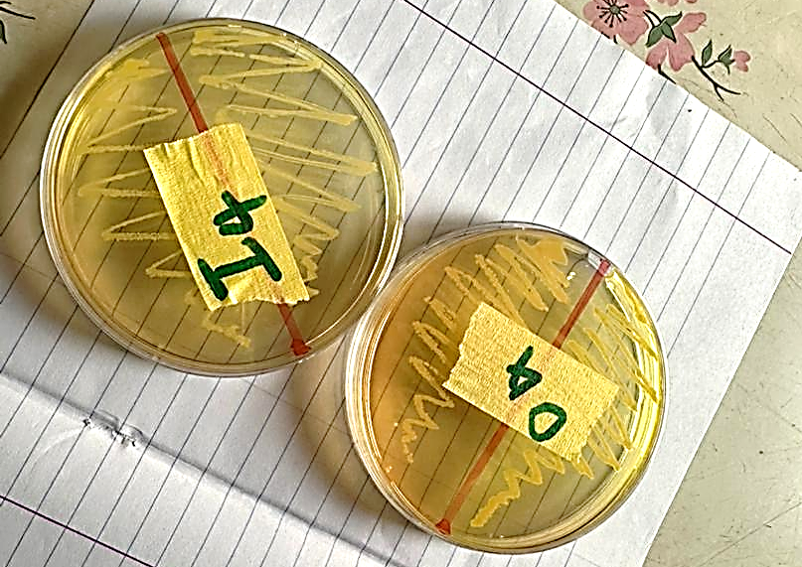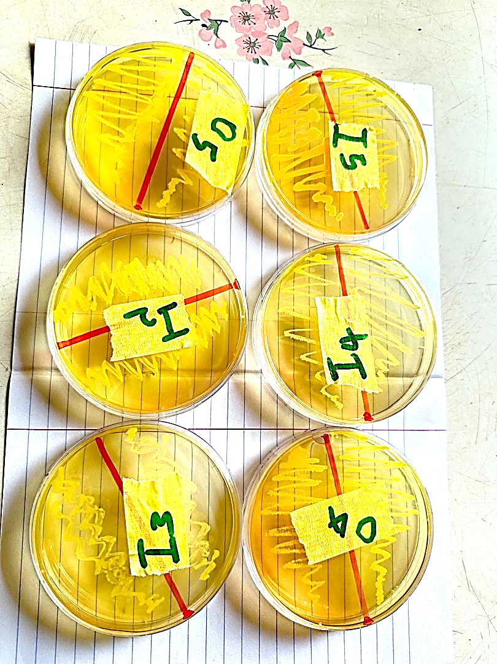
Appendix 1: Growth of S. aureus in minnitol, salt, agar, plants

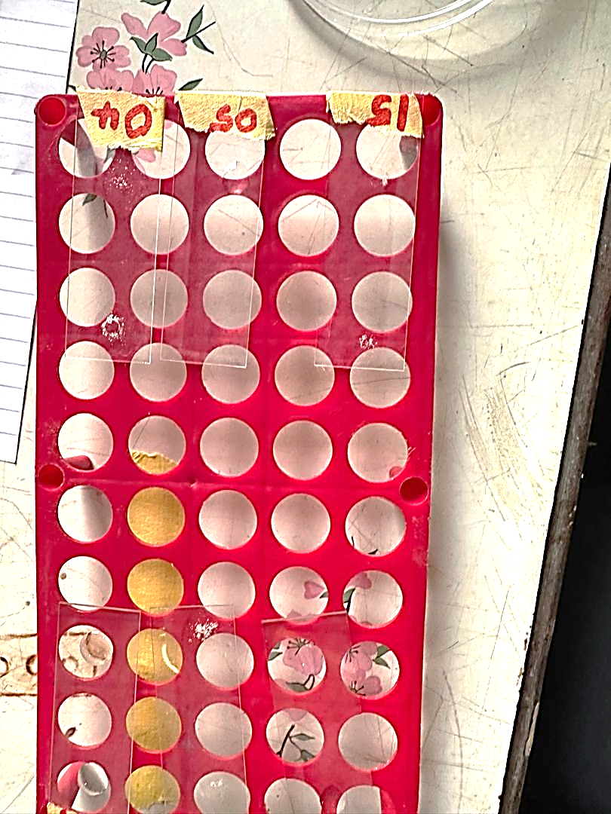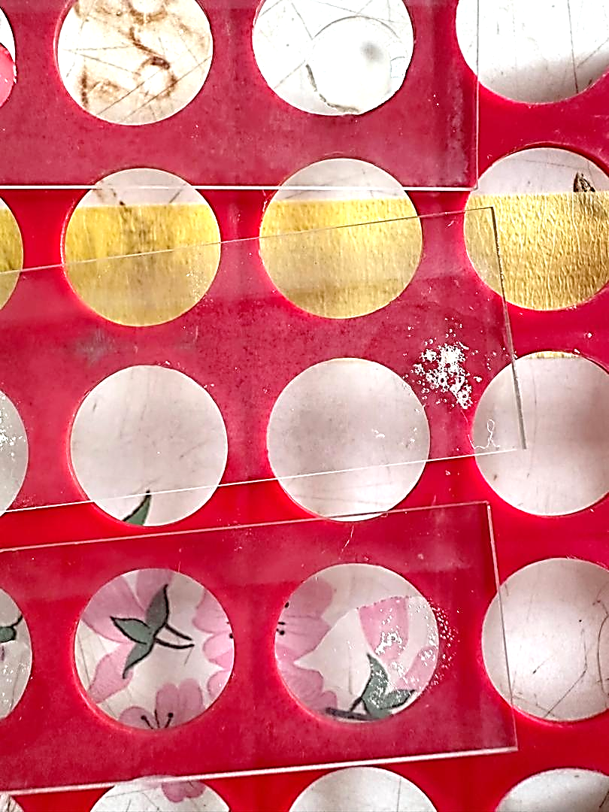
Appendix 2: Catalase test which formed bubbles indicating presence of S. aureus

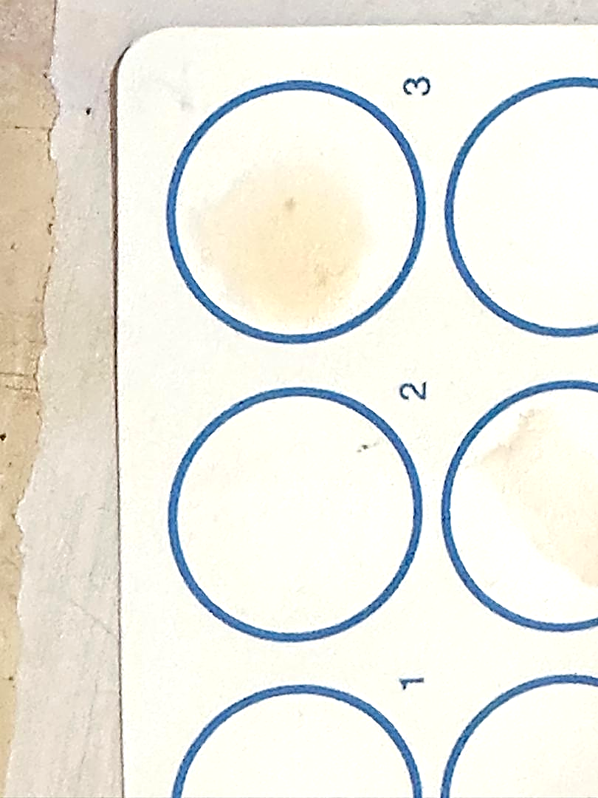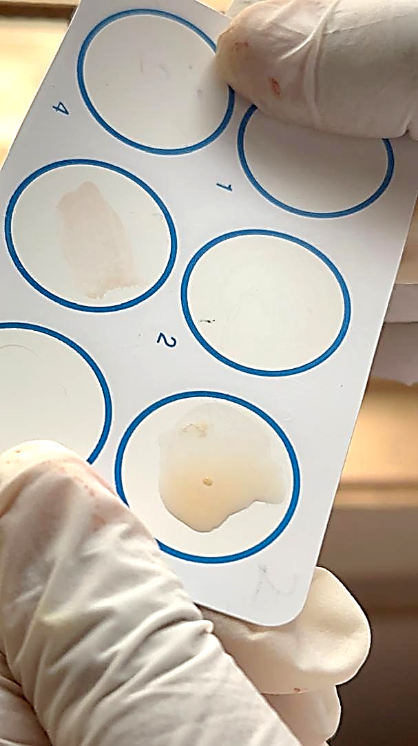
Appendix 3: Coagulase Biochemical test which formed clots which means presence of S. aureus

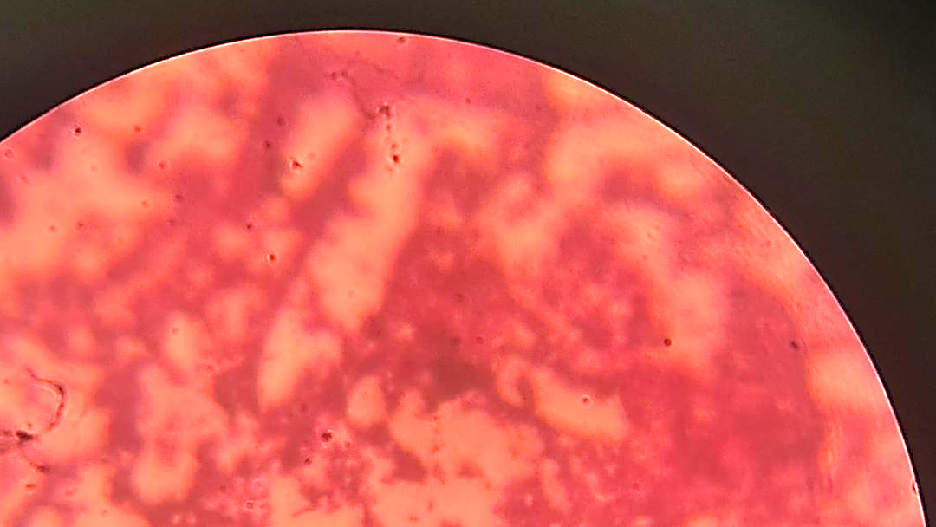
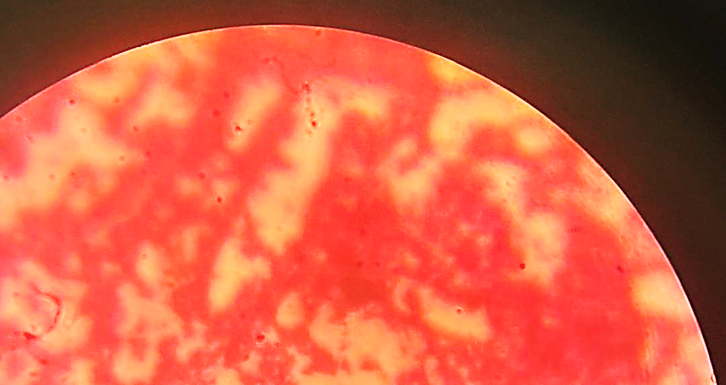
Appendix 4: Microscopic Morphology: Cocci Staphylococcus aureus

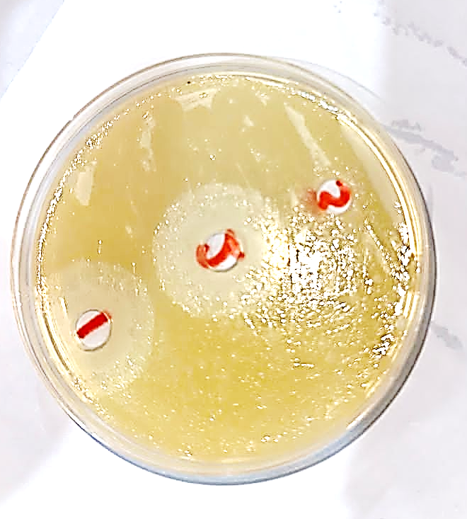
Appendix 5: Antimicrobial Susceptibility using Vancomycin powder

