PRODUCTION OF BIOFILM FROM CASSAVA STARCH FOR POSSIBLE USE IN GARBAGE COLLECTION

BY

OMEJE, PRISCILLIA EZINNE
U21/NAS/BCH/295

BIOCHEMISTRY PROGRAMME
CHEMICAL SCIENCE DEPARTMENT
FACULTY OF NATURAL SCIENCES AND ENVIROMENTALSTUIDES
GODFREY OKOYE UNIVERSITY, UGWUOMU-NIKE, ENUGU NIGERIA

AUGUST, 2025.
PRODUCTION OF BIOFILM FROM CASSAVA STARCH FOR POSSIBLE USE IN GARBAGE COLLECTION

BY

OMEJE, PRISCILLIA EZINNE
U21/NAS/BCH/295

BIOCHEMISTRY PROGRAMME
CHEMICAL SCIENCE DEPARTMENT
FACULTY OF NATURAL SCIENCES AND ENVIROMENTAL STUIDES
GODFREY OKOYE UNIVERSITY, UGWUOMU-NIKE, ENUGU
NIGERIA

A PROJECT RESEARCH REPORT SUBMITTED TO THE DEPARTMENT OF CHEMICAL SCIENCES IN PARTIAL FULFILMENT OF THE REQUIREMENTS FOR THE AWARD OF THE DEGREE OF BACHELOR OF SCIENCE (B.Sc) IN BIOCHEMISTRY

SUPERVISOR: PROF. OSCAR EZE

AUGUST, 2025.
APPROVAL PAGE
This research titled production of biofilm from cassava starch for possible use in garbage collection, has been evaluated and authorized by Godfrey Okoye University's Department of Chemical Sciences and Faculty of Natural Sciences and Environmental Studies in Enugu, Nigeria.

Prof. Oscar Eze ................................... ........................................
Supervisor Signature Date

Dr. Anosike Joy .C. ................................... ......................................
HOD, Signature Date
Department of Chemical Sciences

Prof. Chidi Uhuegbu ................................... .....................................
Dean, FNSES Signature Date

................................... .....................................
External Examiner Signature Date

CERTIFICATION
This is to certify that this research project titled “production of biofilm from cassava starch for possible use in garbage collection,” was carried out by Omeje, Priscillia Ezinne with registration number U21/NAS/BCH/295 under supervision in the Department of chemical science, Godfrey Okoye University Enugu Nigeria.

Prof. Oscar Eze ................................... ........................................
Supervisor Signature Date

Dr. Anosike Joy .C. ................................... ......................................
HOD, Signature Date
Department of Chemical Sciences

DEDICATION
This work is dedicated to Almighty God, whose grace, wisdom and strength have seen me through every step of this academic journey. His guidance has been my constant source of hope and perseverance.
To my late parents, my siblings and my husband whose quiet strength, constant encouragement has been my strength every step of my life.

ACKNOWLEDGMENTS
My deepest gratitude goes to my supervisor, Professor Oscar Eze, for his unwavering support, selfless guidance, invaluable advice, constant encouragement, and inspiration throughout the course of this project. I am especially grateful to my Head of Department, Dr. Joy Anosike, for her motherly support, kind words, and consistent encouragement. To my dedicated and highly esteemed lecturers, Prof. Chidi Uchegbu and also lecturers in the department; Prof Agbafor, Dr. Uhuo, Dr. Anosike, Dr. Agbara, Dr Chidimma , Dr. Obiudu, Dr. Ezeagu ,Mr Jachike thank you for the knowledge, mentorship, and discipline you have instilled in me. I am who I am today because of the values and virtues you nurtured in me throughout my academic journey. To my friends, loved ones, and all those who supported and stood by me in various ways, I say a big thank you. Your encouragement, prayers, and presence meant more than words can express. May the Good Lord richly bless you all.
To my late parents Mr Christopher Omeje and Mrs Caroline Asogwa and my siblings, thank you for the encouragement and faith in my potential which has been the driving force behind every step of my life. To my husband, Mr Abah Arinze and my brother Pharm. Martin Obinna, thank you for your patients, understanding , motivation and steadfast support which have been my anchor. Thank you for always standing by me through every challenge and success.

ABSTRACT
Cassava (Manihot esculenta) is an important crop, which grows in tropics and sub-tropics regions and is the main source of carbohydrates and primary food staple that feeds millions of humans. Cassava starch can form an excellent film; thus, it can be used to produce biodegradable polymers, which can be used to replace plastics. This study was aimed at producing biofilm from cassava starch for possible use in garbage collection. Fresh cassava was purchased from Abakpa Market in Enugu, Nigeria. Starch was identified, extracted from cassava, and used to produce a starch-based biofilm and a control film without starch. Characterization of biofilm such as tensile strength, elongation at break, shear strength, toughness, thickness, and hardness were performed on both the starch biofilm and control, alongside the foil and nylon type conventional materials. The results showed that the starch biofilm (285.53±3.26 N/mm²) and control (35.00 ± 0.00 N/mm²) attained less maximum stress, when compared to nylon (513.33±0.01 N/mm²) and foil (470.00±0.00 N/mm²), with nylon being significantly higher (p<0.05). The elongation at break (3.14±0.06 mm) was also significantly lower than control, nylon and foil. Toughness (3.04±0.14) was lower than nylon but higher than foil and control. The biofilm was thicker but had higher shear strength, breaking force (56.72±4.12 N), and hardness (16.38±0.62 N/mm²) than control, nylon and foil. Solubility in water (22.23%) was significantly lower than both materials, but higher than control. It withstood heat at 100°C, although foil had higher tolerance to heat compared to the biofilm, control and nylon. The study showed that cassava starch biofilm is an example of an eco-friendly, renewable alternative that could minimize the use of plastic and result in environmental sustainability within the solid waste systems of management. It is recommended that a cost-benefit analysis comparing cassava starch biofilm with synthetic plastics should be carried out to determine economic viability for large-scale waste management use.

TABLE OF CONTENTS
Title page i
Approval page ii
Certification iii
Dedication iv
Acknowledgements v
Abstract vi
Table of content vii
List of Tables ix
List of Figures x

CHAPTER ONE: INTRODUCTION
1.1 Background of study 1
1.2 Statement of problem 4
1.3 Justification of study 5
1.4 Scope of study 5
1.5 Aim and objectives 5
1.5.1 Aim 5
1.5.2 Objectives 6

CHAPTER TWO: LITERATURE REVIEW
2.1 Overview of biofilms 7
2.1.1 Formation of biofilms 8
2.1.2 Application of biofilm 10
2.1.2.1 Biofilm in environment 14
2.1.2.2 Biofilm in food and beverage industries 15
2.1.2.3 Biofilm in agriculture 15
2.1.2.4 Biofilm in pharmaceutical companies/industries 16
2.1.3 Characterization/analysis of biofilm 16
2.1.3.1 Elongation at breaking 16
2.1.3.2 Shear strength 17
2.1.3.3 Rupture or breaking force 17
2.2 Overview of starch-based packaging 18
2.2.1 Starch-based biofilm 19
2.2.2 Starch-based biofilm biodegradation 20
2.3 Cassava starch 21
2.3.1 Chemical composition and structural properties of cassava starch 23
2.3.2 Applications of cassava starch 23
2.3.3 Application of cassava starch biofilms in garbage collection 29
CHAPTER THREE: MATERIALS AND METHODOLOGY
3.1 Reagents and apparatus/equipment 32
3.1.1 Apparatus used 32
3.1.2 Reagents used 32
3.2 Collection and identification of sample 33
3.2.1 Sampling for qualitative analysis 33
3.2.2 Sampling for starch extraction 33
3.2.3 Sampling for the production of the bioplastic film 33
3.3 Experimental design 35
3.3.1 Qualitative analysis 35
3.3.2 Starch extraction 36
3.3.3 Production of bioplastic film 36
3.4 Characterization of the produced bioplastic film 36
3.4.1 Tensile strength 36
3.4.2 Elongation at breaking 37
3.4.3 Hardness determination 37
3.4.4 Shear strength 37
3.4.5 Thickness 37
3.4.6 Rupture/break strength 38
3.4.7 Toughness test 38

CHAPTER FOUR: RESULTS
4.1 Qualitative test for the starch 39
4.2 Extraction of starch 40
4.3 Production of bioplastic film 42
4.4 Table of result for the characterization of produced bioplastic film, control and other
Materials 43
CHAPTER FIVE: DISCUSSION, CONCLUSION AND RECOMMENDATION
5.1 Discussion 45
5.2 Conclusion 46
5.3 Recommendation 47

REFERENCES 48

LIST OF TABLES
TABLE PAGE NUMBER
Table 1: Mechanical properties of starch biofilm, nylon and foil 44

LIST OF FIGURES
FIGURE PAGE NUMBER
Figure 1: Diagrammatic illustration showing the growth cycle of a biofilm by a single bacterium species on a solid surface. 9
Figure 2: Biofilm dispersal. 14
Figure 3: Cassava starch. 22
Figure 4: Chemical structure of the major molecular components of cassava starch. 24
Figure 5: Outline of various applications of the cassava plant and its wastes. 28
Figure 6: Iodine test for starch 39
Figure 7: Peeled ground cassava tubers. 40
Figure 8: Extraction of cassava starch. 41
Figure 9: Biofilm production 42

CHAPTER ONE
INTRODUCTION
1.1 Background of Study
The production of agro-industrial goods has increased due to the growing worldwide population, and this has increased the amount of garbage produced by this industry. Around 2.0 billion tons of agricultural waste are produced annually worldwide, with an average increase rate of 5–10% each year (Huzairi et al., 2022). Therefore, in order to lessen the exploitation of natural resources, minimize emissions, and support sustainable growth in society, it is essential that methods for the utilization of these waste products be managed and innovated. Due to its exceptional qualities, such as being lightweight, widely accessible, sustainable, and environmentally conscious, new materials research has recently looked into potential in the field of eco-friendly composites made from natural fibers. These fibers have drawn interest from the academic and industrial sectors due to their affordability, diversity, and renewability as well as their additional benefits (Devnani, 2021). Therefore, because of their varying properties, concerns about natural resources and ecological safety have created opportunities for research into creating environmentally safe and nature-friendly materials, such as bioplastics, which concentrate on using plants and agricultural wastes like fruit and vegetable wastes to produce these materials (Kharb and Saharan, 2022).
Plastic pollution has evolved into one of the most important environmental issues of the 21st century. The widespread use of synthetic plastics, notably for garbage disposal and packaging, has led to severe environmental implications, including land and marine pollution, biodiversity loss, and public health problems. Single-use plastic materials, such as packing materials and garbage bags, have become the everyday norms of life. However, their excess use has given rise to artificial environmental disasters such as land and ocean pollution, animal and human biodiversity loss, and deplorable health consequences to life, including animals and human beings (Das and Chaudhary, 2021). The worst issue with conventional plastics is that it cannot biodegrade. It recycles plastics after centuries or millenaries and causes the continual accumulation of trash piles at landfills, oceans, and other areas causing the endangering of the planet (Silveira et al., 2025). This in turn encourages the increased need of bio-degradable and friendly alternative materials more so the ones that consist of the natural renewable elements. Starch biofilm has come into light as potential replacements to synthetic plastics because of their biodegradability and non-toxicity agency, as well as the facet of renewability (Maitha et al., 2024).
Cassava (Manihot esculenta) is also an important crop, which grows in tropics and sub tropics regions and is the main source of carbohydrates and primary food staple that feeds millions of humans to this date. Cassava along with its nutritive value has also been reported to contain a lot of starch which makes cassava to be a good source of bio-film production. Cassava starch can form an excellent film; thus, it can be used to produce biodegradable polymers, which can be used to replace plastics. These kinds of biofilms that are designed using starch are biocompatible, renewable, non-toxic, and their uses are numerous, thereby, having the ability to serve a wide range of industries including the food packaging one, agriculture, and, most importantly, the waste management industry (Jeencham et al., 2024; Maitha et al., 2024).
Cassava starch contents are high but it does not have good industrial application as compared to other sources of starch such as maize and potato. Underutilization of cassava starch in business particularly in production of biofilm has been one of the biggest issues. In enhancing the commercial exploitation of cassava starch as a source of biofilm, the agricultural sustainability strategy will further be supported by instituting the new economic value among the communities where the cassava is being produced. Besides, cassava starch biofilms will contribute to the creation of the circular economy as it will lead to a minimization of agricultural waste products and the optimization of the use of natural resources (Maniglia et al., 2019).
Recent study has concluded the possibility of developing bioplastics out of cassava starch with superior mechanical and functional properties. An excellent example is given indicatively of Silva et al. (2025) who produced an antibacterial character polymeric film fabricated on a cassava waste starch as a raw material that indicates its relevance in the bioplastic sector. In this study, it is pointed out that cassava starch has a higher application beyond the food industry primarily as a chemical agent in waste-management and as materials of alternative plastics (Silveira et al., 2025).
Biofilms based on starch are biodegradable polymers as an alternative to petroleum-based polymers that can curb pollution and permit establishing a circular economy. The development of the starch biofilm encompasses a collection of procedures; the extraction of the starch, the plasticization of the starch, and the formation of the film (Gomez et al., 2022). This involves extraction of the cassava starch, which is mixed with either glycerol, sorbitol or citric acid; the plasticizers that would make it flexible, more water resistant and tougher. The properties of biofilms are rendered mechanical to accommodate their applications in packaging items, medicinal stores, refuse administration systems etc. (Silveira et al., 2025). The property of cassava starch that makes it suitable to the production of biofilms is its capacity to form films. Once plasticizers have been added to the starch molecules, they arrange in a manner that forms a flexible and strong film that can be utilized in packaging and waste disposal functions as an alternative to the traditional forms of plastics (Żołek-Tryznowska and Kałuża, 2021). Studies reveal that cassava starch biofilms have favorable potential of biodegrading, mechanical strength and water resistance, which is crucial in making the product suitable in waste management operations such as garbage collection (García-Guzmán et al., 2022). Biofilms made with cassava starch have reported superior biodegradability and environmental-friendliness as compared to more frequent plastic bags which are likely to be the source of litter around garbage collectors (Silveira et al., 2025).
The use of cassava starch to make biodegradable biofilms is part of the global objectives of sustainability in the world, in the global objectives front of an attempt to halt possible environment pollution, and on the part of a circular economy growth. More so, the practice of using cassava starch to make biofilms can also empower other agricultural economies because the process would enhance value addition to cassava production and minimize post-harvest losses. Globally, governments and environmental groups are urging a decrease in single-use plastics, which is increasing demand for sustainable substitutes (Boonphayak et al., 2025).
1.2 Statement of Problem
Current environmental challenges, along with non-biodegradability, have led to the widespread use of synthetic plastic bags for garbage collection. The result of degradation becomes pollution, followed by soil contamination and marine pollution. The plastic accumulation causes a lot of ecological problems, as it requires hundreds of years to undergo degradation, leeching toxic chemicals in the process, which harm wildlife and human health. Even when public awareness is on the rise concerning the harmful impact of plastic waste, finding suitable biodegradable alternatives is still a challenge.
Cassava starch is one of the richest and most underused agricultural resources which can serve as a good substitute for producing biodegradable biofilms. However, little research was conducted on optimization of cassava-based biofilms for garbage collection, especially with regard to strength, durability, water resistance, and rate of decomposition. Evaluation of the economic and scaling feasibility of cassava biofilm production is also necessary to guarantee real-life applicability of cassava biofilms as an alternative for conventional plastic bags.
This study seeks to address these challenges by creating and analyzing biofilms formed from cassava starch, evaluating their mechanical properties, biodegradability, and suitability for waste disposal. This study aims to support worldwide efforts to lessen plastic pollution and advance sustainable waste management techniques by investigating the possibility of cassava starch biofilms as an environmentally friendly substitute.
1.3 Justification of Study
The study of biofilm production from cassava starch holds significant importance in various aspects, including sustainability, economic benefits, agricultural advancements, and social impact. The emergence of the biodegradable sources to form biofilms is a part of the global initiative to end the plastic waste and encourage the use of its sustainable alternatives. Since it can take advantage of cassava starch, the renewable and easy to obtain resource, the present study will provide additional solutions to the sustainable waste management processes as well as reduce the use of synthetic polymers.
1.4 Scope of Study
This study focused on the production of biofilm from cassava starch for potential use in garbage collection in Enugu State. The research primarily investigated the utilization of cassava, a widely available but underutilized agricultural resource, for biofilm production.
1.5 Aim and Objectives
1.5.1 Aim: This study is aimed at producing biofilm from cassava starch for possible use in garbage collection.
1.5.2 Objectives: These includes:
- To extract and process cassava starch for biofilm production.
- To develop biofilms from cassava starch using appropriate plasticizers and additives.
- To analyze the physical, mechanical, and biodegradability properties of the produced biofilm.
- To assess the strength, durability, and decomposition rate of the biofilm under different waste storage conditions.
- To compare the performance of cassava starch biofilm with traditional plastic bags in terms of tensile strength, water resistance, and environmental impact.
- To determine the potential benefits of cassava starch biofilm in reducing plastic waste and pollution.

CHAPTER TWO
LITERATURE REVIEW
2.1 Overview of Biofilms
Biofilm is a living community of microorganisms in which the society is of rigid syntrophic where cells are acquired with tensions on attachment in each other and frequently to a surface. The slimy extracellular matrix that comprises of extracellular polymeric substances (EPSs) supports the adhering cells which are located beneath the slimy layer. The cells making up the biofilm secrete the EPSs and are normally an extracellular combined polymer of polysaccharides, proteins, lipids and DNA. Thanks to the three-dimensional architecture and the assumption of the nature of communal living as microorganisms themselves, biofilms have been symbolically referred to as cities of microbes (Su et al., 2022).
The bacteria of the biofilms differ physiologically because the heterotrophic microbial cells grow and survive in a heterotrophic microbial state as opposed to free-floating single cell counterpart of the same bacteria, or planktonic cells. Biofilms naturally grow up on surfaces in natural environments, industrial as well as in a hospital, whether alive (biotic) or, dead (abiotic). The dental plaque is of biofilm, in fact, one that can cause gum disease and tooth decay and as such grow on the teeth of most animals (Singh et al., 2021).
Other terms covered with a biofilm include hydrogel that is a complex polymer that absorbs many multiples of its dry weight in water. They are more of a layer of bacteria slime; in fact, the biofilms is a type of biological system and the bacteria pattern itself into an entity. They can form by food of one sort or another, like a rock or a tooth, and they may be a single species or a series of organisms which are different microorganisms. The organisms that form the biofilm can share nutrients with each other and the organisms are also protected against the environment e.g., desiccation, antibiotics and immune system of the host body. Usually, a biofilm develops by a free-swimming, planktonic, bacterium adhering to a surface (Das, 2021).
2.1.1 Formation of Biofilms
The development of a three-dimensional biofilm mass include attachment, adhesion, microcolony formation, maturation, and dispersion (Figure 1). When there is a combination of solid liquid biofilm and an aqueous environment (blood or water), a close localization of bacteria in the biofilm colony, a gradient of nutrition availability, horizontal gene transfer and quorum sensing (QS) is present, bacteria will attach to the surface (Su et al., 2022).
In the case of Reynolds number (Re) exceeding 5000, the expression of the biofilms occurs under the turbulent flow regime. Re is a parameter described within fluid mechanics and is necessary to be a non-dimensional parameter and was used to predict the ratio of inertial and viscous forces is also a parameter used to predict flow phenomena in diverse circumstances; in the case of low Reynolds numbers, the flowing body is characterized as laminar in comparison to high Reynolds numbers whose flows are characterized as turbulent. The reason that turbulent flow assists in the formation of a biofilm is that it is mentioned that the colonization level on smooth and rough surfaces is equal, and the rest of the physical characteristics of a biofilm surface have a minor effect on bacterial adhesion (Li et al., 2022).
There are five stages that have been established in the biofilm development and growth, and these include: (i) initial bacterial attachment (the attachment could be irreversible or reversible), (ii) bacterial aggregation, (iii) the formation of the microcolonies, (iv) maturation, and (v) dispersion/ detachment. Step 1 is production of bacterial agglutinins that assist in adhering on surfaces. Free-floating floating bacteria (or planktonic bacteria) are the initial colonizers that colonize any surface present. These free floaters grow onto the ground, gluing, reproducing and becoming sedentary and, provided they are subject to the environmental factors, acquiring quite uncoherent different qualities (Su et al., 2022; Sharma et al., 2022).
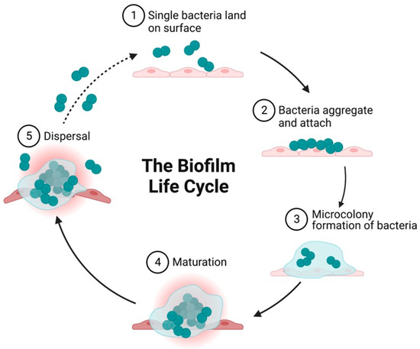
Figure 1: Diagrammatic illustration showing the growth cycle of a biofilm by a single bacterium species on a solid surface.
Note: (1) Reversible attachment of single planktonic bacteria to surfaces. The first attachment of the bacteria is influenced by attractive or repelling forces generated by nutrient levels, pH, and the temperature of the surface. (2) Aggregation of bacteria and irreversible attachment to surfaces. (3) Formation of an external matrix of multilayered complex biomolecules, microcolony formation, and EPS secretion that constitute the external matrix. Secretion of polysaccharides in biofilm forming strains enables aggregation, adherence, and surface tolerance, allowing for improved surface colonization. (4) Maturation of biofilms and acquisition of a three-dimensional structure as they reach maturity. These three-dimensional structures rest on self-produced extracellular matrix components. (5) Fully mature biofilms detach, which allows bacterial cells to take on a planktonic state once again and thereby establish biofilm in other locations.
Source: Sharma, S., Mohler, J., Mahajan, S. D., Schwartz, S. A., Bruggemann, L., and Aalinkeel, R. (2023). Microbial Biofilm: A Review on Formation, Infection, Antibiotic Resistance, Control Measures, and Innovative Treatment. Microorganisms, 11(6), 1614.

- Initial Attachment
The origin of attachment commences with the interaction of the free-floating planktonic bacteria and any surface. They are doomed to emerge either on the forces of the body or the bacteria processes including the presence of the flagellate and/or the pili. During this time, the attachment is momentary and merely reversible and more likely to occur in a circumstantial way (Sharma et al., 2022). The adsorption capacity of the bacteria on the surfaces is subject to a wide variety of other conditions such as the surface material to which the adhesion takes place, which contains the characteristics of the bacterial cell, temperature, pressure and many more. Hydrophobic, steric, electrostatic, van der Waals and protein adhesion are other forces that determine the adhesive capacity. They can all assist the bacteria to remain on the surface, against the repellent ones, form a monolayer, and adhere to the surface permanently (Pouget et al., 2020).
- Bacterial Adhesion and Aggregation
The second stage of adhesion, termed the anchoring or latching phase, involves a molecularly regulated binding of specific adhesins to their respective outermost layers. At this stage, the loosely connected organisms solidify by the adhesion mechanism through the production of extracellular polymeric substances (EPS) that interacts with surface materials as well as receptor-specific ligands on pili, fimbriae, and/or fibrillae within both fetal growth restriction and fetal growth. The end of the second stage sets the adhesion process in irreversible conditions, barring some physical/chemical intervention, while the organism aggregates on the surface in a stable and irreversible manner, very much like a cocoon attached on leaves (Su et al., 2022). Different bacteria may produce different adhesins, whereas some of those adhesins may be under transcriptional control that enables the organisms to switch from a sessile to a planktonic form depending on the environmental factors they are exposed to. Depending upon the stimuli present, some organisms may utilize several different adhesins to fix themselves onto surfaces. A planktonic microbe is able to dent at this point of the adhesion process upon numerous surface-bound organisms and some aggregates on a substratum. Intriguingly, the presence of one microorganism species on an outer layer can stimulate adherence of another microorganism species (Rather et al., 2021).
- Microcolony Formation
Bacterial attachment is followed by cell division and proliferation into microcolonies. The initiation of this event requires some chemical communications that take place among the microbial colonies within their extracellular polymeric substances (EPS) and micro-communities. A single solid colony of bacteria often contains a number of micro-communities in a biofilm. These micro-communities can act together in various ways. This collaboration might involve the exchange of substrates, the movement of vital metabolic products, or possibly the disposal of metabolic wastes. A complete environment is offered by biofilm for the establishment of syntrophic association. Syntrophic association refers to the affiliation of two or more metabolically different sets of bacteria that are mutually dependent on each other for the utilization of a particular substrate for their energy requirement (Rather et al., 2021).
- Maturation
Poised at the pinnacle of biofilm development, maturation as the fourth stage sees continued growth and alteration of connected cells. The release of signaling molecules by the related bacterial cells enhances the process of maturation and the induction of biofilm-specific genes. Signaling factors orchestrate the gene regulation that enhances bacterial virulence. EPS release by cells marks the onset of biofilm maturation and the stabilization of biofilm architecture, acting as a shield of defense against antimicrobial agents. For example, during maturation, P. aeruginosa generates specific saccharides (alginate, Pel, and Psl) for biofilm stability (Su et al., 2022).
Maturation is a two-stage process that consists of Stage I: cell-to-cell contact and the production of autoinducer signal molecules, e.g., N-acylated homoserine lactone (AHL); and Stage II: growth of the microcolony to a thickness and size of about 100 µm, which is that of a fully established microcolony. In the maturation stage, the bacteria in the biofilm actively form connections with one another, and the level of communication between them is determined by their distance from each other (Sharma et al., 2022). A way in which bacteria discriminate between the size and distance of neighboring clusters is by forming aggregates that possess stronger adhesive abilities with surrounding cells. The gene and protein expression in the biofilm is controlled by the whole bacterial community rather than by individual bacterial cells. Thus, the second phase entails EPS production, aggregation, chemical bonding, Quorum sensing, and the establishment of micro- and macro-colonies (Cangui-Panchi et al., 2022).
- Dispersion
In biofilm formation, dispersion is one of the most important steps, going from the bacteria moving to and fro in the infected host. Typically, biofilms consist of two fairly distinct layers. One is the lower layer, with the bacteria more concentrated; the second, called the upper layer, serves as a spreading ground for bacteria to disperse and occupy the environment. These processes can create dire consequences, such as embolism and chronic infection, requiring immediate management (Sharma et al., 2022). For these reasons, the process of dispersion is also sometimes referred to as metastatic seeding. Hence, these microbial cells disperse to other areas of the diseased host or the medical implant in order to multiply, obtain nutrients, and get rid of stresses and wastes. So, dispersion is initiated when single or a group of cells break away from the biofilm (Ma et al., 2023).
Biofilm dispersal can be enhanced by the presence of enzymes such as dispersin B and deoxyribonuclease that degrade extracellular components of the biofilm matrix. Enzymes that degrade the biofilm matrix may be good candidates as anti-biofilm agents. Studies suggest that a fatty-acid messenger, cis-2-decenoic acid, has the ability to induce dispersion and stop biofilm colony establishment. This compound, secreted by Pseudomonas aeruginosa, induces cycloheteromorphic cells in various bacterial species and the yeast Candida albicans. By inducing the dispersal of biofilms in some bacterial species at low non-toxic concentrations, nitric oxide has been shown to be another potential dispersal agent. This offers the prospect of using treatment with nitric oxide in patients that have persistent infections due to biofilms (Ma et al., 2023).
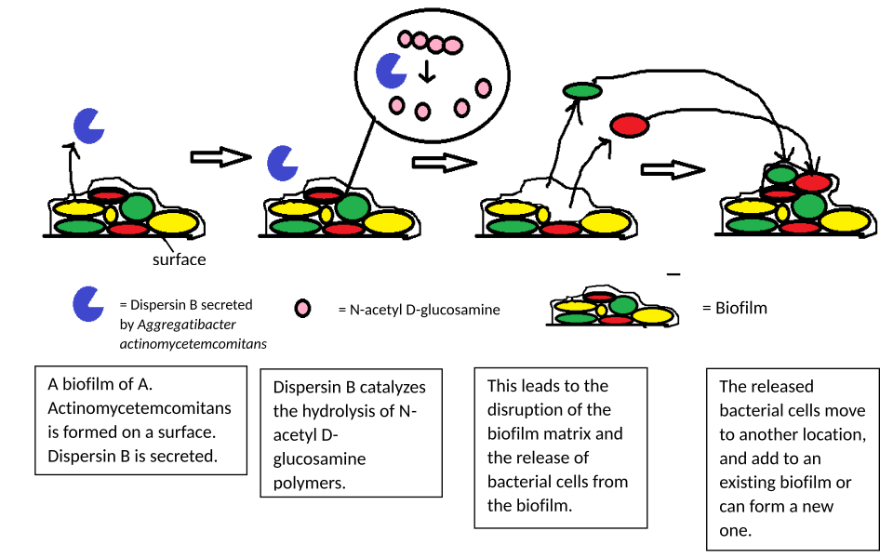
Figure 2: Biofilm dispersal.
Source: Ma, Y., Deng, Y., Hua, H., Khoo, B. L., and Chua, S. L. (2023). Distinct bacterial population dynamics and disease dissemination after biofilm dispersal and disassembly. The ISME Journal, 17(8), 1290–1302.

2.1.2 Application of Biofilm
Researchers increasingly recognize that biofilms have both beneficial and detrimental roles in contemporary pharmaceutical and medical applications. In agriculture, the same microbial communities shield plants from pests and enhance bioremediation by binding contaminants, improving soil health. Parallel advantages are noted in engineering: structured biofilms form protective layers that inhibit corrosion and serve as living filters in advanced wastewater reactors (Muhammad et al., 2020).
2.1.2.1 Biofilm in Environment
Biofilms typically consist of a diverse community of microorganisms, raising questions about how this variety influences food supply sectors such as fresh produce handling, dairy manufacture, beer brewing, seafood and meat processing, and fermentation technology (Yuan et al., 2020). Their rising prominence stems partly from a cost-effective, eco-friendly capacity to degrade organic residue. When tailored with designated electron-accepting species, these films not only hasten spoilage breakdown but can also mediate bioremediation, treating contaminated ground or soil over time (Sonawane et al., 2022).
2.1.2.2 Biofilm in food and Beverage Industries
They can be utilized as packaging materials in the food and beverage sectors to maintain product freshness due to their ability to act as an oxygen and moisture barrier. Unlike conventional plastics, biofilms dissolve harmlessly in water, giving manufacturers an eco-friendly option that eases litter clean-up and cuts landfill impact (Carrascosa et al., 2021). Their barrier properties slow microbial growth, extend shelf life and limit product spoilage, so retailers waste less stock and consumers throw away fewer leftovers (Carrascosa et al., 2021). Moreover, certain formulations can be fortified with vitamins or probiotics, elevating a product's nutritional profile while still replacing non-compostable wrappers (Kwok et al., 2022). Scientists are thus considering biofilms, with its dual-use; as a food-protective sustainable wrapper, and as a nutrient-releasing non-toxic wrapper when disposed into the soil (Kwok et al., 2022).

2.1.2.3 Biofilm in Agriculture
Weeds have always been perceived as the foe to the farmer, and in many cases, they have brought significant damage throughout the history. Biofilms offer a promising solution, as they can inhibit weed growth, making their prevention and control highly effective. Due to their biodegradable nature, these biofilms do not adversely affect the soil, even if accidentally deposited by humans. Using biofilms as physical barriers can prevent crop deterioration and post-harvest losses. Also, when applied to regulate nutrient release through encapsulation, biofilms can enhance soil nutrient efficiency while reducing contamination of soil and water sources (Liu et al., 2021).
2.1.2.4 Biofilm in Pharmaceutical Companies/Industries
Biofilms are versatile platforms for developing advanced drug delivery systems capable of controlled release and precise targeting within the body. They can encapsulate active pharmaceutical ingredients, protecting them from degradation and ensuring therapeutic effectiveness. Biofilms can also act as moist, antibacterial dressings, serving as supportive materials for wound healing by keeping microorganisms at bay and promoting an optimal healing environment (Chan et al., 2022).
2.1.3 Characterization/analysis of Biofilm
This represents the maximum tension a material can endure when being stretched or pulled before experiencing cracks or fractures. Brittle materials tend to reach their maximum tensile strength closer to their yield point, whereas ductile materials are notably stronger. To determine the material's final stiffness, an elastic test is commonly conducted, during which the relationship between applied pressure and resulting strain is recorded. It is worth the note that the pressure-strain curve, in particular, when subjected to bending, leads to tremendous resistance, measured in stress units. Contrary to strain, the compressive strength of material usually does not vary in the case of pressure.
2.1.3.1 Elongation at Breaking
One of the most widespread methods of testing a material ductility is the elongation of the break. It is a measure of the distance to which a material is capable of being stretched as opposed to its initial design. Both the tensile strength (TS) and elongation at break (EAB) are important among parameters used to define the performance of packaging films. According to Santana et al. (2019), the two parameters indicate that the food packaging should be able to sustain stress and it should not break which prevents the changes in quality of the food package in the process of manufacturing, handing, and storage. Starch-based materials are characterized by texture analyzer, energetic mechanical analyzer, or universal testing machines in general in order to examine the mechanical properties of these types of materials. As an illustration, it has been demonstrated in researches carried out with the help of a universal testing device that injecting nanocellulose into the starch films can significantly enhance their tensile strength (Santana et al., 2019).
2.1.3.2 Shear Strength
Shear strength is the resistance of a material to the forces, which have the tendency of making it slide along its plane of penetration. Such an item may be tested in various ways: the pressure may be applied uniformly on the material, or in the vertical direction. An example is when force makes the layers of a material slide over the other on a horizontal surface the material is said to have shear strength in that plane. On the contrary, when the layers move vertically downwards or upwards with the power, the material exhibits vertical shear strength (Santana et al., 2019).

2.1.3.3 Rupture or Breaking Force
Rupture or breaking force explains the amount of tension or strain that a material may tolerate before it fails or breaks. This is usually determined by the amount of force used or exerted on a cross-sectional region. The importance of this property is essential in areas like materials science and in mechanical engineering where the stress and resistance of any material is important. The ability of a material to withstand various pressures without degrading is one of its most essential and evaluated features. For weaker materials, their breaking point or rigidity is more important compared to more flexible ones (Santana et al., 2019).
2.2 Overview of starch-based Packaging
Natural semi-crystalline polysaccharide polymers, such as amylose (AM) and amylopectin (AP), form the building blocks of starch through their complex structures. Native starch is essentially a combination of these two components (McKeen, 2021). Starch can be found in almost all types of plant tissues, including leaves, fruits, pollen grains, roots, and stems, making it a common biological storage carbohydrate. Today, starch can be used in various industrial applications. For instance, starchy films are valued for their thickness, flexibility, and transparency. However, they have notable limitations, mainly their poor mechanical strength and high-water vapor transmission. Research indicates that the source of starch plays an essential role in the properties of films made from it. Variations in amylose to amylopectin ratios, and the physical characteristics of the starch molecules, greatly impact film quality. Compared to conventional polymers, unmodified starch-based materials tend to be less durable. Nevertheless, their film-forming abilities used in coatings and packaging make them commercially viable (Bangar et al., 2021). Besides, because starch molecules contain many hydroxyl groups, they are highly hydrophilic, which makes them less effective in moist environments, reducing their mechanical and barrier performance. Therefore, enhancing the properties of starch-based packaging materials remains an important goal (Congli et al., 2021).
Active biofilms, which are naturally occurring, biodegradable films, are designed to be safe for food contact and help prevent the spread of harmful biofilms across surfaces. Researchers and manufacturers collaborate to develop these active biofilms and coatings, using starch’s excellent film and coating qualities (Bangar et al., 2021). In microbial communities adhering to surfaces, the extracellular polymeric substance (EPS) matrix surrounds the cells, composed mainly of nucleic acids, proteins, lipids, polysaccharides, and other molecules, all embedded within a polysaccharide-based matrix (Usman et al., 2021). Interest in biodegradable food packaging has surged recently, leading to the development of various degradation techniques, including photodegradable and fully biodegradable options. Such compostable packaging films serve the same fundamental roles as traditional packaging: preserving food quality, aiding distribution, and enhancing product value (Shen et al., 2020).
2.2.1 Starch-based Biofilm
Biofilm is a type of plastic made from materials that can be broken down by living organisms. Sometimes, this biofilm is combined with an active substance, which is known as antimicrobial packaging. The study has shown that starch-based films are perceived as hard, not so flexible, which can be solved with alternative polymers, acting as a chemical supplement (Sadeghizadeh-Yazdi et al., 2019). These biodegradable films may be created out of several biopolymers including lipids, proteins, and polysaccharides (Benbettaïeb et al., 2019). Due to the ability of starch to coat surfaces well, it can be considered quite appropriate in terms of commercial uses (Bangar et al., 2021).
Starch-substructured biopolymers are now under a huge amount of focus due to their affinity to develop films, their usefulness, their relative cheap price on the scale of biopolymers and also the role they can play in governing taste, odor and flavor, which are three essential organoleptic properties. They are good in terms of light transmission or colorlessness and also make good gas separation barrier to both oxygen and carbon dioxide (Punia, 2020). Although possessing rather low mechanical strength and water vapor permeability (WVP), these characteristics precondition the fact that starch films can be highly beneficial in terms of packaging (Farajpour et al., 2020).
2.2.2 Starch-based biofilm Biodegradation
The use of compostable sheets and coatings is one of the key factors in the food packaging business, in particular because of the capacity to respond to various environmental conditions. The use of biodegradable films made through biopolymers is becoming an emerging trend in food science with many materials being exploited in food science including complex carbohydrates, pulses, lipids, and oils (Rangasamy et al., 2021). The compostable films are often made of these organic materials against which more complicated carbohydrates like starch are included since they have high availability, low cost, accessibility, environmental friendliness, and the ability to form films. The nature of starch films is also highly dependent on the origin of the starch and its total content (Elsheikh et al., 2022).
These films are normally tested on the basis of criteria such as cohesion, adhesiveness, water retention, resistance to moisture and oxygen barrier properties along with the ability of the surface to resist humidity change. Surprisingly, the color of the film and mechanical strength does not change significantly when glycerol is added to the mixture. Studies have shown that film-forming capacity of starch is highly influenced by structural characteristics of starch and the ratio of Amylose/Amylopectin. Starch-based polymers are becoming considered more as a sustainable substitute to conventional plastics, with their biodegradability being a factor in this, as the components will be broken down by bacteria. These films can be used to make soil healthier in the case of their degradation, and it serves as a convenient method of reducing the amount of plastic waste, and at the same time, contribute to the conditions of environmental health (Anand Raj et al., 2022).
2.3 Cassava Starch
Manihot esculenta (cassava) is an important staple food in tropical and subtropical areas, as it can be found in large regions of Africa, Asia, and South America. The potential of its carbohydrate-rich and tuberous roots transverses to its main value which is used in either culinary purposes or reliable industrial purposes. Tapioca starch made out of cassava roots is an interesting starch because of its great variety and wide known usage in both food products and industrial products. Specifically, cassava starch has come out as being used in the formation of biodegradable films. It is highly suitable because of its the characteristics that tend to make it extremely appropriate in this sense are its film forming capabilities, its transparency, flexibility, as well as ease of processing. It is through this cassava starch that biofilms are being investigated as the possible alternatives to conventional plastics. Examples are garbage bags, food, and agricultural mulching films, which can respond to environmental issues, defined by plastic waste (Abotbina et al., 2022).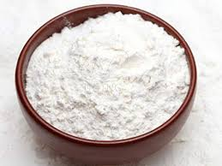
Figure 3: Cassava starch.
2.3.1 Chemical composition and structural properties of cassava starch
Cassava starch is composed of mainly two main polysaccharides; amylose and amylopectin that play major role in defining its film forming abilities, gelatinization properties and mechanical properties. The connection between these structural units is very complex and it affects seriously the physical and functional traits of biofilms based on cassava starch. The features therefore make cassava starch a potential resource in industrial applications that include biodegradable garbage packaging and green bags (Silveira et al., 2025).
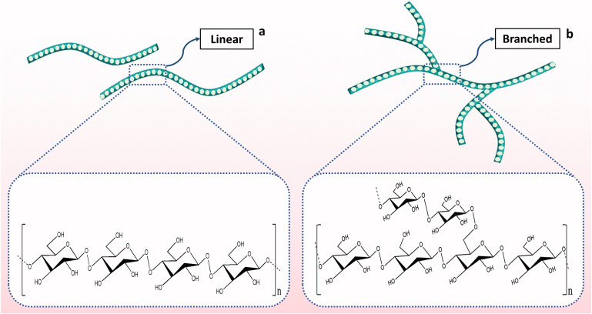
Figure 4: Chemical structure of the major molecular components of cassava starch.
(a) Amylose is predominately made up of long linear chains of α-(1 → 4) glycosidic bonds between two glucose units and has a molecular weight of 10⁵ to 10⁶ Daltons. (b) Amylopectin consists of α-(1 → 4) glycosidic bonds between two glucose units in the straight and α-(1 → 6) glycosidic bonds at the branches, and has a very high molecular weight of 10⁷ to 10⁹ Daltons.
Source: Das, S., Das, M. K., Jamatia, T., Bhattacharya, B., Mazumder, R., ..., and Mandal, S. (2024). Advances of cassava starch-based composites in novel and conventional drug delivery systems: a state-of-the-art review. RSC Pharmaceutics, 1(2), pp. 182-203.

- Amylose (15–25%)
Amylose, comprising roughly 15–25% of cassava starch, is a linear glucose polymer with a significant influence on starch film characteristics. Its structure imparts enhanced mechanical strength and structural integrity to biofilms, making them more resistant to rupture. Additionally, amylose decreases the hydrophilic nature of starch, thereby improving water resistance and minimizing moisture absorption in the films. This characteristic is especially relevant for biodegradable applications, as amylose readily breaks down in the environment, facilitating eco-friendly waste disposal (Lin et al., 2022).
- Amylopectin (75–85%)
Cassava starch consists of amylopectin that makes up 75-85%, and this starch is highly branched. This polymer is one of the major contributors towards the gelatinization, viscosity and adhesive nature of cassava starch. It also helps in formation of gels which are significant in swelling and thickening of the starch hence it is good in adhesives and coatings. Although amylopectin has been shown to elevate the flexibility of starch-based films, at higher concentrations it can decrease the stiffness and mechanical strength of these films. Moreover, an elevated level of amylopectin level relates to absorption of moisture and may restrict the water resistance of the cassava biofilms in some usages. Hydrophobic additives or plasticizers are most often added to alleviate the situation and increase water resistance (Zhang et al., 2024).
- Moisture content (10–15%)
Water percentage in cassava starch usually below 10 to 15%, is a major issue that determines the storability, shelf life and the processing characteristics of starch. High moisture contents may lead to lumping, microbial spoilage during storage, difference in gelatinizing temperature, and reduced film strength owing to over hydration. Thus, it is important to dry the cassava starch rigorously and using appropriate storage to keep its quality and functional presence in control of industrial applications (Fronza et al., 2022).
- Protein (<0.5%) and Lipids (<1%)
This is quite an interesting fact because cassava starch is immensely low in both protein (less than 0.5) and lipids (less than 1%) making it a cleaner source of starch than others. It results into such low proteins and fats, which makes the biofilms based on cassava transparent and smooth in texture and thus used to prevent the unpleasant odors or discoloration of the biodegradable polymers. In addition, its low protein and lipid content enhances its suitability with other biopolymers such as chitosan and polylactic acid (PLA) so that the composite films with enhanced functions can be produced (Silveira et al., 2025).
2.3.2 Applications of cassava starch
- Biofilm production: Cassava starch is highly known to be utilized in the manufacture of bio-degradable films and plastic. In combination with plasticizers like glycerol, cassava starch may be converted into flexible, transparent films that are especially useful in packaging and waste disposal (Bakky et al., 2021).
- Food industry: Cassava starch is used in the food industry very well in thickening and stabilizing. It is typically applied to processed foods, confectionary and dairy and is applied to aid texture and consistency (Mueller et al., 2024).
- Medical and pharmaceutical use: Cassava starch has been found to be a major excipient when it comes to the production of tablets due to its ability to both bind and disintegrate a tablet altering fill imparting. Additionally, the current studies are focusing on the possibility in biodegradable drug delivery systems whereby films with starch can be used in the regulation of the drug releasing rate (Gunathilake and Somendrika, 2024).
- Agricultural and waste management uses: Biofilms produced with cassava can be applied in either agricultural or waste management environments, as an adequate alternative to the commonly used plastics. They are degradable, and consequently, they do not negatively affect the atmosphere and decrease the necessity to employ traditional plastics (Gomez et al. 2023).
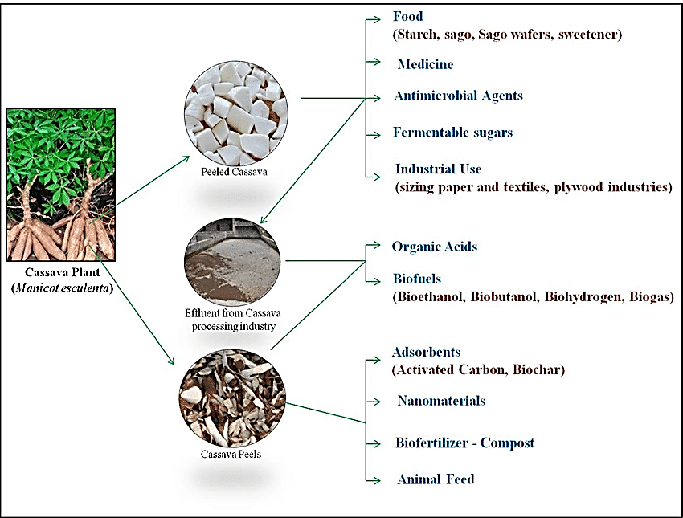
Figure 5: Outline of various applications of the cassava plant and its wastes.
Source: Nizzy A. M. and Kannan, S. (2022). A review on the conversion of cassava wastes into value-added products towards a sustainable environment. Environmental Science and Pollution Research, 29(46), pp. 69223-69240.

2.3.3 Application of cassava starch biofilms in garbage collection
Garbage collection, while perhaps overlooked in daily discourse, constitutes an indispensable pillar of urban infrastructure. The effective management of waste, encompassing domestic, industrial, and commercial sectors, safeguards public health, curtails pollution, and sustains urban sanitation. In the context of mounting concerns over environmental degradation, cassava starch-derived biofilms have emerged as a promising innovation within the field of sustainable waste management, particularly well-suited to the demands of densely populated urban environments. These biofilms possess a lot of benefits in various applications like the collection of wastes which promote the reduction of the reliance on the common uses of plastic in an environmentally feasible manner (Silveira et al., 2025).
- Biodegradable garbage bags: One of the main uses of this biofilms can be seen in the application of biodegradable garbage bags. As opposed to conventional plastics, which remain buried in landfills hundreds of years, cassava starch-based bags undergo a swift breakdown process both through compost and microbial assault, frequently in a matter of weeks or months. Not only does it decrease the masses of wastes to be disposed through the slow accumulations, but it also promotes the nutrients of the soil through its composting activities, which have positive advantages in the overall organic wastes recycling systems (Silveira et al., 2025).
- Organic waste collection and composting: The usefulness of cassava starch biofilms goes deeper into the field of organic waste. These organic-decomposable bags are also useful in the collection and composting of organic wastes such as food waste, such as garden waste, and farming wastes so as to minimize the reliance on landfills. This solution has several benefits: it redirects large volumes of waste into landfills, promotes sustainable farming through the production of high-quality fertilizer-compost, and blocks methane emissions that cause climate change due to anaerobic decomposition (Silveira et al., 2025).
- Segregation and recycling of waste: Segregation of waste is another element that should be used in the process of responsible waste management and cassava starch biofilms can be of use in this process. These materials can be color-coded or chemically altered to allow separating waste streams with organic items, recyclable diversion and non-recyclable materials, thus simplifying the process of recycling and supporting better community-based waste collection and sorting schemes (Silveira et al., 2025).
- Reducing coastal and marine plastic waste: The marine environment, where the problem of plastic pollution is the most acute, will be able to gain significantly through the replacement of plastic wastes with cassava starch biofilms. These are disposable bags which quickly disintegrate in the waters, minimizing the chances of adverse wildlife interaction and the eventual buildup of these plastic products on the coastlines. They also increase the effectiveness of beach cleanups in that the collection items remain to be a source of hazard rather than turning to be a problem themselves (Silveira et al., 2025).
In the health industry, cassava starch biofilms are useful in the operation of non-contaminated biodegradable trash, like kitchen waste and paper products which hospitals produce. The use of these biodegradable bags will minimize the risk of plastic leakage during processing of medical garbage when compared to the traditional waste bags, and offer safer and environmentally friendly solutions to waste disposal by institutions (Silveira et al., 2025).
- Industrial and commercial waste: Industries and commercial enterprises are major contributors to urban waste that can significantly reduce their environmental impact by adopting cassava starch-based biodegradable garbage bags. Such a shift aligns with broader sustainability objectives and corporate social responsibility goals, promoting a transition toward reduced plastic dependency within business operations (Silveira et al., 2025).

CHAPTER THREE
MATERIALS AND METHODOLOGY
3.1 Reagents and apparatus/equipment:
3.1.1 Apparatus used:
Beaker
Measuring cylinder
Stirrer
Spatula
Sieve
Muslin cloth
Dropper pipette
Transparent plastic bowl
Tray
Aluminum foil
EQUIPMENT USED:
Hot plate China
Electronic weighing balance Ohaus China
Hounsfield tensometer (Monsanto)
3.1.2 Reagents used:
Polyvinyl alcohol reagents SAE Manufacturing specialties corp.
Ethanol Corn LP, USA.
Iodine
Glycerin Trevent Chemicals, India
Distilled water Steam pure, Nigeria

Gelatin
Cassava Starch Nigeria
Acleric
3.2 Collection and identification of sample
3.2.1 Sampling for qualitative analysis
Fresh cassava was obtained at Abakpa market, Enugu, Nigeria, for starch detection. The method of identification used was the use of iodine on the cassava samples. The basis of this qualitative analysis is the creation of a certain complex by means of chemical processes, which may be observed as a certain, visible change of the color of the solution. When iodine reacts with the sample it gives a purple-black coloration, a positive result with sufficient amount of starch.
3.2.2 Sampling for starch extraction
Fresh cassava was bought directly in Abakpa Market, Enugu, Nigeria, to be used in the process of starch extraction. One of these substances is ethanol or ethyl alcohol which is a transparent liquid that has a specific smell. It is a chemical belonging to the group referred to as alcohols. It is easily accessible and its molecular formula is C₂H₅OH.
3.2.3 Sampling for the production of the bioplastic film
The bioplastic films were produced in this study by using fresh cassava starch, polyvinyl alcohol (PVA), glycerin, iodine, gelatin, acleric, and distilled water. Raw materials were all locally obtained at Ogbete market in Enugu, Nigeria. Polyvinyl alcohol (PVA), is the synthetic material that is non-toxic and semi-crystalline. Polymer which possesses a zigzag carbon chain. It forms in the presence of water and it is well known to have film-forming properties. Positive mechanical characteristics and, in particular, is well-suited when it comes to food packaging contexts (Suganthi et al., 2020). The nature of the chemical structure, symbolized by the CH₂CH repeating unit, emphasizing its versatility. Polyvinyl alcohol (PVA) is normally made using the hydrolysis of polyvinyl esters e.g., the derivative of polyvinyl acetic acid. It is a combination of the film-forming capability, biodegradability, and adjustable crystallinity, which gives it great importance. The favored ingredient in the production of biofilms. In addition to the packaging, polyvinyl alcohol (PVA) is used in adhesives, paper/textile processing, etc. These include emulsifier, thickening and suspending agents (Wong et al., 2020).
Glycerin is used as the main plasticizer when making films. It is a simple polyol. It is remarkable as colorless, odorless, viscous and a high boiling point. When frozen, a paste-like consistency is produced and its characteristic is known to have a sweet taste. Specifically, to bioplastic films, glycerin also increases flexibility and processability caused by decreased brittleness. It is useful even to the adhesives, as well as thickening, emulsifier and suspending agent in other formulations. The purpose of the use of plasticizers in general, is to enhance stretchability. They are more elastic than polymers and this enables them to have improved material properties. There is the incorporation of iodine as a major qualitative reagent of starch, which is attributed to the selective nature of the oligosaccharides. Interaction with amylose which forms purple-black complex. Although a nonfunctional film additive, iodine helps verify starch incorporation and possibly, convey some slight color-tone or antiseptic nature to the film. Gelatin, which is a protein found in collagen provides both elasticity and enhanced increase the film with tensile strength. When added to starch-based films, it leads to smoother textures, less brittle, and enhanced mechanically. Overall. Acleric is a polymer crosslinker, which facilitates the intermolecular interactions at the film matrix. Tensile can be enhanced by this crosslinking. It increases strength, decreases water solubility and alters the surface characteristics of the resulting biofilm. These parts collectively interact and as a result produce a bioplastic film that possesses better strength, flexibility and working properties, with a demonstration of the possibility of sustainable material, substitutes of locally obtainable resources (Suganthi et al., 2020).
3.3 Experimental design
3.3.1 Qualitative analysis
Exactly 0.5 grams of each sample were weighed on electronic balance and put in the respective 3 test tubes. 5mL of water was added to each of the tubes and the mixtures were well stirred. After that, few drops of iodine solution was added to every tube. The effects of any resulting color changes were accurately noted.
3.3.2 Starch extraction
An adapted technique of starch extraction outlined by Michael (2009) was employed during this process. First, the fresh cassava tubers (500 grams) were weighted using an electronic weighing scale and cleaned by rubbing off any soil or other material attached. The tubers were cleaned, peeled, and cut into smaller sections after which a dry grinding machine was used to mill the tubers producing a fine mash.
The resultant cassava mash was mixed with 1500mL of distilled water mixed with few drops of ammonium hydroxide that acted as microbe inhibitor in the extraction reaction. The mixture was allowed to stand for 50 minutes to facilitate starch release. After this period, the suspension was filtered through muslin cloth, and the filtrate was left undisturbed for 45 minutes to permit starch sedimentation.
A second filtration was performed, after which the mixture was allowed to settle for approximately 2 hours. The starch that accumulated at the bottom of the vessel was collected by decantation. To further purify the starch, the sediment was washed three times using a solution consisting of 150mL ethanol and 150mL distilled water. A final filtration was carried out using filter paper. The residue, representing purified cassava starch, was collected and dried appropriately for subsequent use.
3.3.3 Production of bioplastic film
Exactly 130 mL of water was added to a 1000 mL beaker and placed on a hot plate (HJ-3D constant temperature magnetic stirrer) pre-set to 60°C. Then, 15 g of cassava starch, 10 g of polyvinyl alcohol (PVA), 4 g of gelatin, 4 g of acleric, and 8 mL of glycerin were measured and introduced into the beaker simultaneously. The mixture was stirred continuously for five minutes using a hand stirrer. All components were mixed thoroughly in the water, maintaining a single stirring direction until a uniform paste formed. Finally, the paste was poured onto aluminum foil and left to dry.
3.4 Characterization of the produced bioplastic film
The bioplastic film was divided into two equal portions, designated as sample 1 and sample 2. These samples were subsequently utilized in the following experimental procedures.
3.4.1 Tensile strength
Tensile strength is defined as the ultimate force that a material is capable of withstanding when put under tension before it breaks apart. Bioplastic film samples were evaluated using a Hounsfield (Monsanto) tensometer to measure the tensile strength in this study. The films were carefully cut into strips whose width was 19mm and thickness 0.74mm. The tensile strength was also derived through a calculation of the applied force divided by the area of the sample under force.
3.4.2 Elongation at breaking
This is the percentage which shows how far the bioplastic film stretches before it breaks. With the use of the Hounsfield tensometer (Monsanto), testing was carried out. To ensure uniformity samples were cut out into two sections, each at a thickness of 0.74mm and a width of 19mm.

3.4.3 Hardness determination
Brinell hardness test was used to measure hardness of the bioplastic sheet. The size of the indenter (diameter) was determinate before testing. A measured axial load was then applied on the bioplastic film. After indentation the depth of the impression obtained was read, using a machine chart attached to the testing instrument.
The Brinell Hardness Number (HBN) is calculated as follows:
HBN=
Where p = known axial load.
D = indenter diameter.
d = depth of indentation.
HBN = Brinell Hardness Number.
3.4.4 Shear strength
Shear strength refers to the bioplastic film’s ability to resist tearing under applied forces. In this study, the tested sheet measured 160mm in length, 19mm in width, and had a thickness of 0.74mm. The calculation for shear force followed the formula πd²/4, where “d” represents the diameter of the shear spindle.
3.4.5 Thickness
Thickness is defined as the distance between the top and bottom surfaces (or front and rear faces) of the bioplastic film. To measure this dimension accurately, instruments such as micrometer calipers or vernier calipers were utilized.
3.4.6 Rupture/break strength
Rupture or break strength describes the force required to fracture the bioplastic film. For this test, samples were prepared with a width of 19mm and a thickness of 0.74mm.
3.4.7 Toughness test
Toughness test measures the ability of the bioplastic film to absorb energy and deform without breaking. Films used in this analysis were 160mm long, 19mm wide, and 0.74mm thick. Toughness was calculated by dividing the energy absorbed by the film during deformation by its volume, where energy is determined by multiplying deformation by the applied force, and volume is calculated as length × width × thickness.

CHAPTER FOUR
RESULTS
4.1 Qualitative test for the starch
Based on the image below, the cassava powder sample tested positive for starch. The presence of starch is clearly indicated in the results.
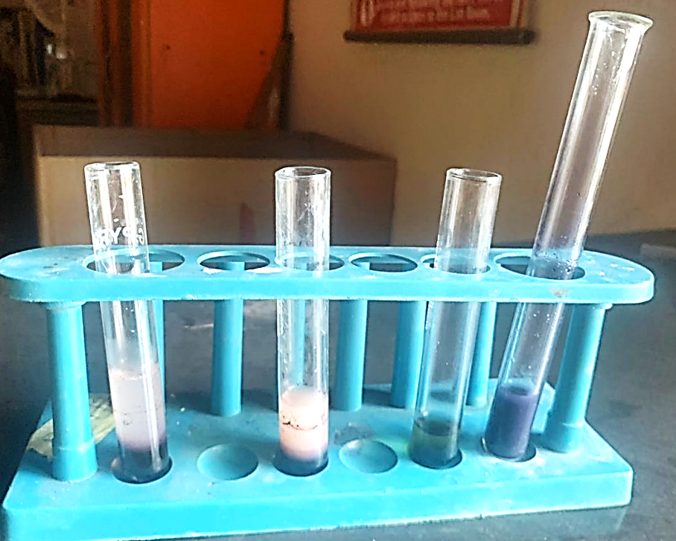
Figure 6: Iodine test for starch

4.2 Extraction of starch
The ground cassava tubers are processed into starch. It is shown below:
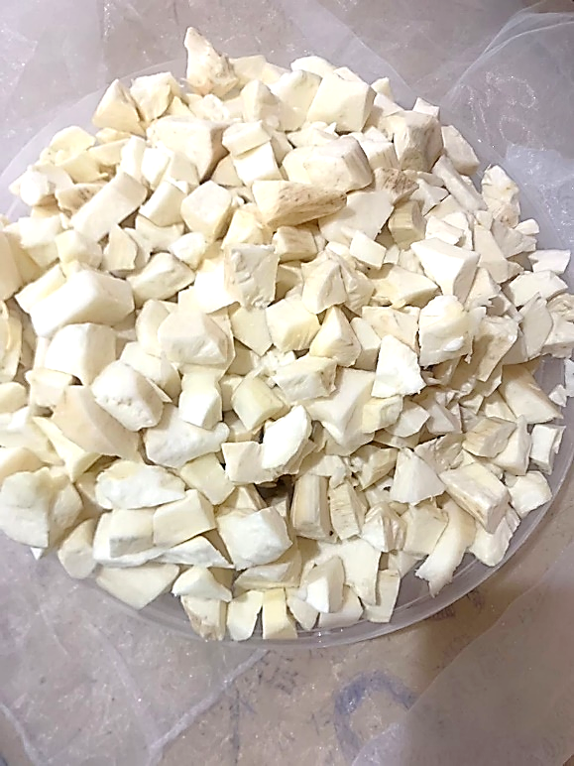
Figure 7: Peeled ground cassava tubers.
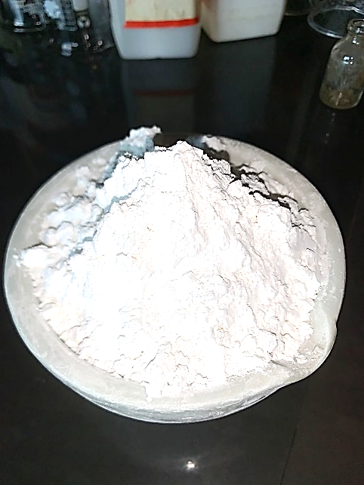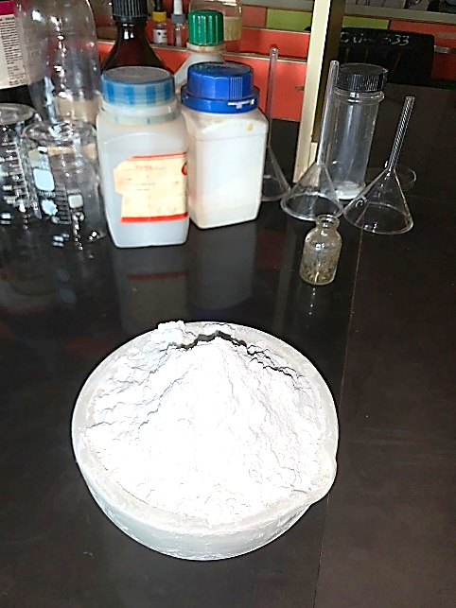
Figure 8: Extraction of cassava starch.

4.3 Production of bioplastic film
Upon heating, the bioplastic mixture transforms into a viscous paste. After drying, it forms a relatively thick, light brown film. The resulting material clearly demonstrated the successful formation of bioplastic. An image of the produced film is presented below.
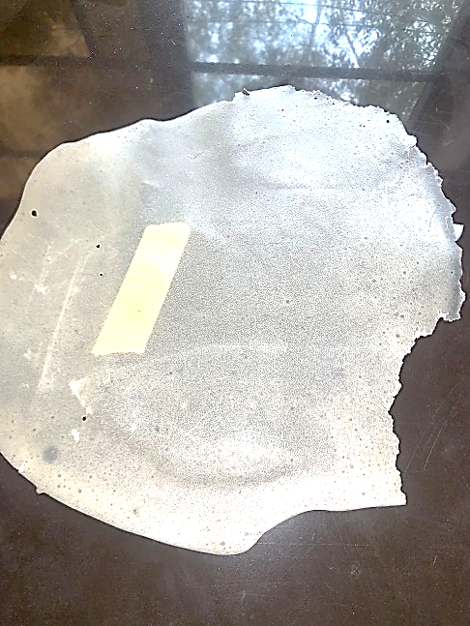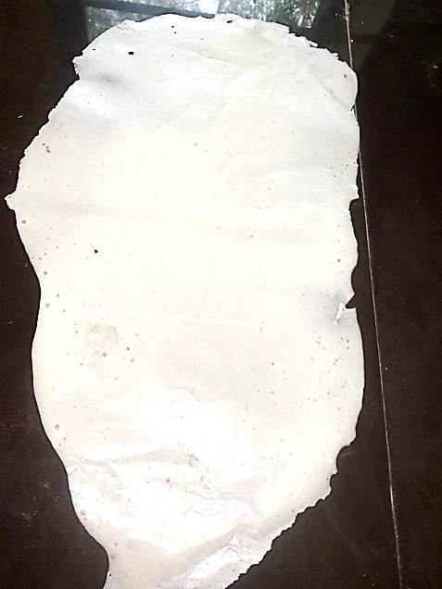
Slightly soluble with acrylic Highly soluble without acrylic
Figure 9: Biofilm production

4.4 Table of result for the characterization of produced bioplastic film, control and other materials
Table 1 shows that the starch biofilm attained less maximum stress before breaking as shown by the tensile strength when compared with nylon and foil. Nylon significantly (p < 0.05) has higher value of tensile strength compared to starch biofilm. The average flexibility of the biofilm as seen on elongation at break property have significantly (p < 0.05) lower value of 3.14±0.06 compared to nylon and foil. In toughness, the starch biofilm had 3.04±0.14 value which is lower than nylon but higher than foil. Nylon and foil were found to be significantly (p < 0.05) thinner compared to the starch biofilm. The property shear strength of the starch biofilm had significantly (p < 0.05) higher value if compared with nylon and foil. The breaking force and hardness of the biofilm is significantly (p < 0.05) higher at 56.72±4.12 and 16.38±0.62 compared to nylon at 15.40±0.00; 1.49±0.00 and foil at 23.50±0.00; 0.42±0.00 respectively. Starch biofilm is less soluble in water as seen in % Solubility in water, this is significantly (p < 0.05) lower than nylon and foil. The starch biofilm can withstand heat at 100° C compared to nylon, however foil had significantly (p < 0.05) higher tolerance to heat compared to the biofilm and nylon. The control generally showed lower mechanical properties, with a tensile strength of 35±0.00 N/mm² and toughness of 0.01±0.00 J/M³, but had a higher elongation at break (6.0±0.00 mm²) than the starch biofilm, indicating greater flexibility. It also exhibited moderate shear strength (2.0±0.00 N/mm²), rupture force (30±0.00 N), and hardness (12.0±0.00 N/mm²). The control was more soluble in water (15±0.00%) than nylon and foil but less than the biofilm, and had the highest heat capacity (3.0±0.00 W/m·K) among all samples.

Table 1: Mechanical properties of starch biofilm, control, nylon and foil
MECHANICAL PROPERTIES | STARCH BIOFILM | CONTROL | NYLON | FOIL
Tensile strength (N/mm²) | 285.53±3.26 | 35.0±0.00 | 513.33±0.01 | 470.00±0.00
Elongation at break (mm²) | 3.14±0.06 | 6.0±0.00 | 12.00±0.00 | 7.00±0.00
Toughness (J/M³) | 3.04±0.14 | 0.01±0.00 | 3.24±0.00 | 1.70±0.00
Thickness (mm) | 1.05±0.01 | 0.05±0.00 | 0.03±0.00 | 0.05±0.00
Shear strength (N/mm²) | 4.24±0.07 | 2.0±0.00 | 0.84±0.00 | 1.01±0.00
Rupture or Breaking force (N) | 56.72±4.12 | 30.0±0.00 | 15.40±0.00 | 23.50±0.00
Hardness (N/mm²) | 16.38±0.62 | 12.0±0.00 | 1.49±0.00 | 0.42±0.00
% Solubility in water | 22.23±1.22 | 15.0±0.00 | 1.40±0.00 | 1.65±0.01
Heat capacity (W/m·k) at 100° C | 1.07±0.08 | 3.0±0.00 | 0.26±0.01 | 235.01±0.02
Mean ± SD, n=3

CHAPTER FIVE
DISCUSSION, CONCLUSION AND RECOMMENDATION
5.1 Discussion
The results of the study indicated that all the differences in the study between the mechanical properties of the cassava starch biofilm, control, nylon, and foil were significant (p<0.05). The starch biofilm was also signified by a significantly reduced (285.53±3.26N/mm²) strength value compared to nylon (513.33±0.01 N/mm²), foil (470.00±0.00N/mm²), and the control film (35±0.00 N/mm²) respectively. Hence, the starch biofilm has moderate strength but significantly weaker compared to their synthetic counterparts (p<0.05). Its break elongation was 3.14±0.06mm significantly lower than other nylon (12.00mm), foil (7.00mm) and the control (6.0 mm²), meaning that starch film is less extensible and stretchable upon rupture. This finding is based on the fact that Silveira et al. (2025), indicated that the tensile strength of cassava starch-based films was average, and the elongation at break was moderate. Further, the results also match those of Singh et al. (2022), who stipulated that starch-based films, overall, exhibit low mechanical performances until they are modified with fillers, lipids, or plasticizers such as glycerol, which enhance flexibility, barrier response, and tensile strength.
The biofilm cassava starch had a far greater solubility in water (22.23%) compared to control (15%), nylon films (1.40%) and foil (1.65%). They explained this by referring to the fact that the hydrophilic nature of starch is related to the high swelling and water uptake (Singh et al., 2022). Wang et al. (2022) investigated the incorporation of geranium essential oil into cassava starch films, and reported reduced water vapor permeability and enhanced barrier properties even though they stated that there might be mechanical property drawbacks. The higher thickness (1.05mm) of the starch biofilm possibly led to high value of hardness (16.38N/mm²) and rupture force (56.72N). According to Yao et al. (2021), the addition of microcrystalline cellulose (MCC) to cassava starch films made them more rigid, stronger, and less flexible. On the same note, Jeencham et al. (2024) observed that cassava starch-MCC based films manufactured using cassava pulp possessed increased strength and thermal stability. They assumed that the structure would be strengthened using other structures so as to make them stronger so that the film would not be brittle and could generate durability in a shear. Lastly, the starch biofilm could withstand a temperature of 100ºC. Results of a study by Silveira et al. (2025), and Jeencham et al. (2024) showed that cassava starch films were well tolerated in higher temperatures of moderately high temperatures which points to the fact that the starch films can be used as functional films in warm climate of wastes.
5.2 Conclusion
The study was aimed at producing biofilm utilizing cassava starch that may be used in collecting garbage. The results indicated that cassava starch biofilm has a moderate mechanical strength, such as the tensile strength and hardness, but it is not very stretchable such as synthetic materials like nylon and foil. Nevertheless, its ability to be biodegraded implies that it can be utilized as an alternative source of sustainability in various fields. The biofilm made out of starch has the capacity to replace the traditional plastics reducing both waste and environmental pollution, and as well as to contribute to the sustainability of the soil through biodegradation. To conclude, cassava starch biofilm is an example of an eco-friendly, renewable alternative that could minimize the use of plastic and result in environmental sustainability within the solid waste systems of management.

5.3 Recommendation
- Further studies should explore varying concentrations of plasticizers, fillers (e.g., microcrystalline cellulose), and additives to improve the mechanical strength, flexibility, and durability of cassava starch biofilms.
- Pilot-scale testing should be conducted in actual waste-handling or garbage collection environments to assess the biofilm’s performance under real-world stress, moisture, and microbial exposure.
- Long-term biodegradability assessments and shelf-life analysis are needed to understand the environmental fate and storage stability of cassava starch biofilm in landfill or composting conditions.
- A cost-benefit analysis comparing cassava starch biofilm with synthetic plastics should be carried out to determine economic viability for large-scale waste management use.

REFERENCES
Abotbina, W., Sapuan, S. M., Ilyas, R. A., Sultan, M. T. H., Alkbir, M. F. M., …, and Bayraktar, E. (2022). Recent Developments in Cassava (Manihot esculenta) Based Biocomposites and Their Potential Industrial Applications: A Comprehensive Review. Materials, 15, 6992.
Anand Raj, M. K., Muthusamy, S., Panchal, H., Mahmoud Ibrahim, A. M., Alsoufi, M. S. and Elsheikh, A. H. (2022). Investigation of mechanical properties of dual-fiber reinforcement in polymer composite. Journal of Materials Research and Technology, 18, 3908–3915.
Bakky, A. A., Hoque, M. R. and Islam, M. S. (2021). Production of Biofuel from Cassava. Journal of Environmental Science and Natural Resources, 12(1–2), 171–174.
Bangar, S. P., Siroha, A. K., Nehra, M., Trif, M., Ganwal, V. and Kumar, S. (2021). Structural and Film-Forming Properties of Millet Starches: A Comparative Study. Coatings, 11, 954.
Benbettaïeb, N., Debeaufort, F. and Karbowiak, T. (2019). Bioactive edible films for food applications: Mechanisms of antimicrobial and antioxidant activity. Critical Reviews in Food Science and Nutrition, 59, 3431–3455.
Boonphayak, P., Muenyong, N., Chinchao, R. and Khansumled, S. (2025). Development of a Biodegradable Cassava Starch Biofilm based on a Combination of Plasticizers with Bio-SiO₂ Extracted from Sugarcane Leaves. Starch/Stärke, 77(1), 2300164.
Cangui-Panchi, S. P., Nacato-Toapanta, A. L., Enriquez-Martinez, L. J., Reyes, J., Garzon-Chavez, D. and Machado, A. (2022). Biofilm-forming microorganisms causing hospital-acquired infections from intravenous catheter: A systematic review. Current Research in Microbial Sciences, 3, 100175.
Carrascosa, C., Raheem, D., Ramos, F., Saraiva, A. and Raposo, A. (2021). Microbial biofilms in the food industry—A comprehensive review. International Journal of Environmental Research and Public Health, 18(04), 2014.
Chan, S. Y., Wong, M. W., Kwan, B. T., Fang, J. K. and Chua, S. L. (2022). Microbial–Enzymatic Combinatorial Approach to Capture and Release Microplastics. Environmental Science & Technology Letters, 9(11), 975–982.
Congli, C., Na, J., Yanfei, W., Liu, X. and Qingjie, S. (2021). Bioactive and intelligent starch-based films: A review. Trends in Food Science & Technology, 116, 854–869.
Das, P. P. and Chaudhary, V. (2021). Moving towards the era of bio fibre-based polymer composites. Cleaner engineering and technology, 4, 100182.
Das, S. (2021). Structural and mechanical characterization of biofilm-associated bacterial polymer in the emulsification of petroleum hydrocarbon. 3 Biotech, 11, 239.
Das, S., Das, M. K., Jamatia, T., Bhattacharya, B., Mazumder, R., ..., and Mandal, S. (2024). Advances of cassava starch-based composites in novel and conventional drug delivery systems: a state-of-the-art review. RSC Pharmaceutics, 1(2), pp. 182-203.
Devnani, G. L. (2021). Recent trends in the surface modification of natural fibers for the preparation of green biocomposite. In Green Composites, 273-293.
Elsheikh, A. H., Panchal, H., Shanmugan, S., Muthuramalingam, T., El-Kassas, A. M. and Ramesh, B. (2022). Recent progresses in wood-plastic composites: Pre-processing treatments, manufacturing techniques, recyclability and eco-friendly assessment. Cleaner Engineering and Technology, 8, 100450
Farajpour, R., Djomeh, Z. E., Moeini, S., Tavakolipour, H. and Safayan, S. (2020). Structural and physico-mechanical properties of potato starch-olive oil edible films reinforced with zein nanoparticles. International Journal of Biological Macromolecules, 149, 941–950.
Fronza, P., Costa, A. L., Franca, A. S. and de Oliveira, L. S. (2022). Extraction and Characterization of Starch from Cassava Peels. Starch, 75, 2100245.
García-Guzmán, L., Cabrera-Barjas, G., Soria-Hernández, C. G., Castaño, J., Guadarrama-Lezama, A. Y. and Rodríguez Llamazares, S. (2022). Progress in Starch-Based Materials for Food Packaging Applications. Polysaccharides, 3(1), 136-177
Gómez Rosales, Z., Solano, J. K., Orjuela, D., Rodrigo-Ilarri J. and Rodrigo-Clavero, M. E. (2022). Synthesis and Characterization of a Cassava Starch (Manihot esculenta) and Dried Coffee Pulp Mixture to Produce Biofilms. Chemical Engineering Transactions, 92, 439-444.
Gomez, Z. E., Solano, K. K., Orjuela, D., Felibert, D. J., Rodrigo-Ilarri, J. and Rodrigo-Clavero, M. E. (2023). Synthesis and Characterization of a Cassava Starch and Corn Husk Mixture for Biofilm Production. Chemical Engineering Transactions, 100, 679-684.
Gunathilake, S. and Somendrika, D. (2024). Development of a biodegradable packaging with antimicrobial properties from cassava starch by incorporating Ocimum tenuiflorum extract. Food Chemistry Advances, 4, 100658.
Huzairi, M., Zainudin, M., Zulkarnain, A., Azmi, A., Muniandy, S., ..., and Hassam, M. (2022). Enhancement of Agro-Industrial Waste Composting Process via the Microbial Inoculation: A Brief Review. Agronomy, 12, 198.
Jeencham, R., Chiaoketwit, N., Numpaisal, P. and Ruksakulpiwat, Y. (2024). Study of Biocomposite Films Based on Cassava Starch and Microcrystalline Cellulose Derived from Cassava Pulp for Potential Medical Packaging Applications. Applied Sciences, 14(10), 4242.
Kharb, J. and Saharan, R. (2022). Design and synthesis of eco-friendly cucumber peel-based bioplastic materials. Materials Today: Proceedings, doi.org/10.1016/j.matpr.2022.12.109
Kwok, T. Y., Ma, Y. and Chua, S. L. (2022). Biofilm dispersal induced by mechanical cutting leads to heightened foodborne pathogen dissemination. Food Microbiology, 102, 103914.
Li, S., Liu, S. Y., Chan, S. Y. and Chua, S. L. (2022). Biofilm matrix cloaks bacterial quorum sensing chemoattractants from predator detection. The ISME Journal, 16(5), 1388–1396.
Lin, L., Peng, S., Shi, C., Li, C., Hua, Z. and Cui, H. (2022). Preparation and characterization of cassava starch/sodium carboxymethyl cellulose edible film incorporating apple polyphenols. International Journal of Biological Macromolecules, 212, 155–164.
Liu, S. Y., Leung, M. M., Fang, J. K. and Chua, S. L. (2021). Engineering a microbial 'trap and release' mechanism for microplastics removal. Chemical Engineering Journal, 404, 127079.
Ma, Y., Deng, Y., Hua, H., Khoo, B. L. and Chua, S. L. (2023). Distinct bacterial population dynamics and disease dissemination after biofilm dispersal and disassembly. The ISME Journal, 17(8), 1290–1302.
Maitha, I., Okoth, M., Njue, L. and Mbuge, D. (2024). Development of eco-friendly food packaging bio-film from cassava starch plasticized with coconut oil. East African Journal of Science, Technology and Innovation, 5(4).
Maniglia, B. C., Lima, D. C., Matta Junior, M. D., Le-Bail, P., Le-Bail, A. and Augusto, P. E. (2019). Ozonation of cassava starch to produce biodegradable films. International Journal of Biological Macromolecules, 138, 1087-1097.
McKeen, L. (2021). The effect of heat aging on the properties of sustainable polymers. In The Effect of Long-Term Thermal Exposure on Plastics and Elastomers, 2nd ed.; William Andrew: Norwich, NY, USA, pp. 313–332.
Mueller, E., Hoffmann, T. G., Schmitz, F. R., Helm, C. V., Roy, S., …, and de Souza, C. K. (2024). Development of ternary polymeric films based on cassava starch, pea flour and green banana flour for food packaging. International Journal of Biological Macromolecules, 256, 128436.
Muhammad, M. H., Idris, A. L., Fan, X., Guo, Y., Yu, Y., ..., and Huang, T. (2020). Beyond Risk: Bacterial Biofilms and Their Regulating Approaches. Frontiers In Microbiology, 11, 928.
Nizzy A. M. and Kannan, S. (2022). A review on the conversion of cassava wastes into value-added products towards a sustainable environment. Environmental Science and Pollution Research, 29(46), pp. 69223-69240.
Pouget, C., Dunyach-Remy, C., Pantel, A., Schuldiner, S., Sotto, A. and Lavigne, J.-P. (2020). Biofilms in Diabetic Foot Ulcers: Significance and Clinical Relevance. Microorganisms, 8(10), 1580.
Punia, S. (2020). Barley starch: Structure, properties and in vitro digestibility—A review. International Journal of Biological Macromolecules, 155, 868–875.
Rangasamy, G., Mani, S., Senathipathygoundar Kolandavelu, S. K., Alsoufi, M. S., Mahmoud Ibrahim, A. M., ..., and Elsheikh, A. H. (2021). An extensive analysis of mechanical, thermal and physical properties of jute fiber composites with different fiber orientations. Case Studies in Thermal Engineering, 28, 101612.
Rather, M. A., Gupta, K., Bardhan, P., Borah, M., Sarkar, A., …, and Eldiehy, K. S. (2021). Microbial biofilm: a matter of grave concern for human health and food industry. Journal of Basic Microbiology, 61, 380–395.
Rather, M. A., Gupta, K. and Mandal, M. (2021). Microbial biofilm: formation, architecture, antibiotic resistance, and control strategies. Brazilian journal of microbiology: [publication of the Brazilian Society for Microbiology], 52(4), 1701–1718.
Sadeghizadeh-Yazdi, J., Habibi, M., Kamali, A. A. and Banaei, M. (2019). Application of edible and biodegradable starch-based films in food packaging: A systematic review and meta-analysis. Current Research in Nutrition and Food Science, 7, 624–637.
Santana, J. S., de Carvalho Costa, É. K., Rodrigues, P. R., Correia, P. R. C., Cruz, R. S. and Druzian, J. I. (2019). Morphological, barrier, and mechanical properties of cassava starch films reinforced with cellulose and starch nanoparticles. Journal of Applied Polymer Science, 136, 47001.
Sharma, S., Mohler, J., Mahajan, S. D., Schwartz, S. A., Bruggemann, L. and Aalinkeel, R. (2023). Microbial Biofilm: A Review on Formation, Infection, Antibiotic Resistance, Control Measures, and Innovative Treatment. Microorganisms, 11(6), 1614.
Shen, M., Song, B., Zeng, G., Zhang, Y., Huang, W., …, and Tang, W. (2020). Are biodegradable plastics a promising solution to solve the global plastic pollution? Environmental Pollution, 263 Pt A, 114469.
Silveira, Y. D. O., Franca, A. S. and Oliveira, L. S. (2025). Cassava Waste Starch as a Source of Bioplastics: Development of a Polymeric Film with Antimicrobial Properties. Foods, 14(1), 113.
Singh, G. P., Bangar, S. P., Yang, T., Trif, M., Kumar, V. and Kumar, D. (2022). Effect on the Properties of Edible Starch-Based Films by the Incorporation of Additives: A Review. Polymers (Basel), 14(10), 1987.
Singh, S., Datta, S., Narayanan, K. B. and Rajnish, K. N. (2021). Bacterial exo-polysaccharides in biofilms: Role in antimicrobial resistance and treatments. Journal of Genetic Engineering and Biotechnology, 19, 140.
Sonawane, J. M., Rai, A. K., Sharma, M., Tripathi, M. and Prasad, R. (2022). Microbial Biofilms: Recent Advances and Progress in Environmental Bioremediation. Science of the Total Environment, 824, 153843.
Su, Y., Yrastorza, J., Matis, M., Cusick, J., Zhao, S., …, and Xie, J. (2022). Biofilms: Formation, Research Models, Potential Targets, and Methods for Prevention and Treatment. Advanced Science, 9.
Suganthi, S., Vignesh, S., Kalyana Sundar, J. and Raj, V. (2020). Applied Water Science, 10(4), 1-11
Usman, A., Usman, K. M., Yaqoob, M., Maksim, R., Mars, K., …, and Muthu, T. (2021). Potentials of polysaccharides, lipids and proteins in biodegradable food packaging applications. International Journal of Biological Macromolecules, 183, 2184–2198.
Wang, B., Yan, S., Qiu, L., Gao, W., Kang, X., Yu, B., Liu, P., Cui, B. and Abd El-Aty, A. M. (2022). Antimicrobial Activity, Microstructure, Mechanical, and Barrier Properties of Cassava Starch Composite Films Supplemented with Geranium Essential Oil. Frontiers in Nutrition, 9, 2022.
Wong, C. Y., Wong, W. Y., Loh, K. S., Daud, W. R. W., Lim, K. L., Khalid, M. and Walvekar, R. (2020). Development of Poly (Vinyl Alcohol)-Based Polymers as Proton Exchange Membranes and Challenges in Fuel Cell Application: A Review. Polymer Reviews, 60, 171–202.
Yao Désiré, A., Charlemagne, N., Degbeu Claver, K., Fabrice Achille, T. and Marianne, S. (2021). Starch-based edible films of improved cassava varieties Yavo and TMS reinforced with microcrystalline cellulose. Heliyon, 7(4), e06804
Yuan, L., Hansen, M. F., Røder, H. L., Wang, N., Burmølle, M. and He, G. (2020). Mixed-Species Biofilms in the Food Industry: Current Knowledge and Novel Control Strategies. Critical Reviews in Food Science and Nutrition, 60, 2277–2293.
Zhang, Y., Xie, J., Ellis, W. O., Li, J., Appaw, W. O. and Simpson, B. K. (2024). Bioplastic films from cassava peels: Enzymatic transformation and film properties. Industrial Crops and Products, 213, 118427.
Żołek-Tryznowska, Z. and Kałuża, A. (2021). The Influence of Starch Origin on the Properties of Starch Films: Packaging Performance. Materials, 14(5), 1146.

