DESIGN AND DEVELOPMENT OF FOUNTINE ABODE: A WEB APPLICATION FOR SMART HUMAN RESOURCE MANAGENMENT SYSTEM FOR SMALL COMPANIES

BY

MADUEKOBOJOSEPH ECHEZONACHU
U21/NAS/CSC/705

DEPARTMENT OF COMPUTER SCIENCE,
FACULTY OF MANAGEMENT AND ENVIRONMENTAL STUDIES, GODFREY OKOYE UNIVERSITY, ENUGU

JULY, 2025

DESIGN AND DEVELOPMENT OF FOUNTINE ABODE: A WEB APPLICATION FOR SMART HUMAN RESOURCE MANAGENMENT SYSTEM FOR SMALL COMPANIES

BY

MADUEKOBO ECHEZONACHUKWU JOSEPH
GOU/U21/NAS/CSC/705

A PROJECT REPORT SUBMITTED TO THE DEPARTMENT OF COMPUTER SCIENCE, FACULTY OF MANAGEMENT AND ENVIRONMENTAL STUDIES, GODFREY OKOYE UNIVERSITY, ENUGU
IN PARTIAL FULFILLMENT OF THE REQUIREMENTS FOR THE AWARD OF THE DEGREE OF BACHELOR OF SCIENCE (B.Sc.) IN COMPUTER SCIENCE

SUPERVISED BY
DR. OKEREKE

JULY, 2025

CERTIFICATION
I hereby certify that the work included therein was completed by me and that it was mainly based on my observations and investigation. Consequently, I will fully accept the University's decision if I am found to have cheated on the assignment.

________________________
MADUEKOBO ECHEZONACHUKWU JOSEPH
GOU/U21/NAS/CSC/705

APPROVAL PAGE
This is to validate that this research work “DESIGN AND DEVELOPMENT OF SMART HUMAN RESOURSE MANAGEMENT SYSTEM: A WEBSITE FOR HUMAN RESOURSE PROCESSES” was embarked upon by “MADUEKOBO ECHEZONACHUKWU JOSEPH” with the matriculation number GOU/U21/NAS/CSC/705 in partial fulfillment of the requirements for the award of Bachelor Science (B.SC) in Computer Science, Faculty of Natural Sciences and Environmental Studies, Godfrey Okoye University, Enugu.

_____________________ ________________________
Dr. Okereke Date
(Supervisor)

_______________________________ _________________________
Dr. (Mr.) Frank Okebanama Date
Head of Department
Computer Science and
Mathematics

________________________________ _________________________
External Examiner Date

DEDICATION

This work is dedicated to my family, mentors, and friends who supported and encouraged me throughout this journey.

ACKNOWLEDGMENTS

I sincerely appreciate the guidance of my project supervisor, Dr. Okereke whose input greatly improved this work. I also thank my lecturers, classmates, and family for their support, encouragement, and inspiration throughout the course of my study and project.

ABSTRACT
The rapid growth in information technology has revolutionized the development of recommendation systems in the real-life systems sector, now transforming the short-term rental market. This research project presents Fountine Abode, a web application designed for small companies leasing which leverages on cutting-edge technologies to connect hosts and workers(employer and employees) seamlessly. The system that is proposed in this study enables hosts to upload and lease their selves with stress. The system is developed using Next.js, React.js, and Tailwind CSS for the frontend, Node.js, Express, Prisma ORM, and MongoDB for the backend, NextAuth and JWT for authentication, and Stripe API for payments. Fountine Abode offers a user-friendly platform for hosts and workers to work hand in hand achieving one goal at a time and companies to register under Fountine Abode for easy HR works in their companies with secure payment processing for registration.

TABLE OF CONTENTS

Title Page i
Certification ii
Approval iii
Dedication iv
Acknowledgement v
Abstract vi
Table of contents vii
List of tables x
List of Figures xi

CHAPTER ONE: INTRODUCTION 1
  - Background to the study 1
  - Statement of problem 5
  - Aim and objectives of the study 6
  - Significance of the study 6
  - Scope of the study 8
  - Limitation of the study 8
  - Operational definition of terms 9

CHAPTER TWO: LITERATURE REVIEW 11
2.1 Introduction to literature review 11
2.1.1 Description of different categories of human resource management systems (ai-powered HR) 12
2.1.2 Brief history of human resource management systems (ai-powered HR) 17
2.1.3 The future of human resource management systems (ai-powered HR) 21
2.2 Review Of Existing Related Works 24
2.3 Summary Of Review Of Related Works 27

CHAPTER THREE: SYSTEM ANALYSIS AND DESIGN 28
3.1 Overview 28
3.2 System Analysis 28
3.2.1 Analysis of Existing Systems 29
3.2.2 Weaknesses of Existing Systems 37
3.2.3 Analysis of the Proposed System 38
3.2.3 System Requirements 39
3.2.3.1. Functional requirements: 40
3.2.3.2. Non-Functional requirements: 40
3.2.4 Proposed Methodology: Object Oriented Analysis And Design 40
3.2.4.1 Unified Modelling Language Diagrams 41
3.1.4.2 Use Case Diagram Of Proposed System 42
3.2.4.3 Activity Diagram Of The Proposed System 44
3.2.4.4 Class Diagram Of The Proposed System 47
3.2.4.5 UML Sequence Diagram 48
3.3 System Design 51
3.3.1 Input/Output Design 51
3.3.2 Data Base Design 52

CHAPTER FOUR: SYSTEM IMPLEMENTATION 54
4.1 Overview 54
4.2 Tools used for implementation (Tech stack of the proposed system) 54
4.2.1 Frontend 54
4.2.1.1. Next.JS 54
4.2.1.2. React JS 55
4.2.1.3. Tailwind CSS: 55
4.2.2 Backend 56
4.2.2.1 Node.JS 56
4.2.2.2 Express 57
.4.2.2.3 Prisma ORM 57
4.2.2.4 MongoDB 58
4.2.3 Authentication 58
4.2.3.1 NextAuth 58
4.2.3.2 JWT 59
4.2.3.1 Stripe API 60
4.3 System Requirements 60
4.4 User Interface Of Phiness Homes 61
4.4.1. FOUNTINE ABODE Homepage 61
4.4.2 Upload home page: 62
4.4.5 Favorites page 64
4.4.6 AI - features 64
CHAPTER FIVE: SUMMARY, RECOMMENDATIONS AND CONCLUSION 69
5.1 Overview 69
5.2 Summary 69
5.3 Recommendations 70
5.4 Conclusion 70
References 71
Appendix 73

LIST OF TABLES

4.1 User table for the proposed system 52
4.2 employee table for the proposed system 53

LIST OF FIGURES
3.1 Use case diagram of the proposed system 43
3.2 Activity diagram for login in the proposed system. 45
3.3 Activity diagram for registration and applications in the proposed system. 46
3.4 Class diagram of the proposed system 48
3.5 Sequence diagram of the proposed system 50
3.6 Input/Output designs for the proposed system 51
4.1The home page of fountine abode 62
4.2 The first stage the user has to select the kind of account in which he or she wants to have. 63
4.3 The second stage of registration. 63
4.5: The AI dashboard 65
4.6: The AI features of the proposed system 65
4.7: The AI chartbot of the proposed system. 66
4.8: The loig page 67
4.9: The Login page for the proposed system 67
4.10: The homepage of the proposed system. 68

CHAPTER ONE
INTRODUCTION
  - BACKGROUND TO THE STUDY
"AI has the ability to completely transform human capabilities, and HR departments play a critical role in making sure that AI is applied fairly and ethically in businesses. CEOs and other leaders must, in fact, not only include HR teams in the process but also integrate them into the leadership in order to optimize productivity using AI.
Srikant Chellappa, Co-Founder and CEO, Actively”
An organization's success is greatly influenced by human resource management (HR), particularly in the increasingly dynamic age of globalization and digitization.
to guarantee the company's continued competitiveness in the world market.
Human resource management (HRM) has been transformed along with many other industries by the introduction of artificial intelligence (AI). By increasing productivity, accuracy, and decision-making, artificial intelligence technologies seek to improve HRM activities and radically alter how businesses handle their human resource. Human resource (HR) workers can now concentrate on more strategic projects since organizations can automate monotonous processes like interview scheduling and resume screening thanks to the quick incorporation of AI into HRM procedures (Nawaz et al., 2024). Furthermore, AI's real-time analysis of enormous volumes of data enables better informed and data-driven decision-making, which may greatly increase the precision of performance reviews assessments and the customization of personnel management tactics (Islam et al., 2022).
With a focus on three main areas—talent management, performance evaluation, and recruitment—this study examines the body of research on the revolutionary effects of AI on HRM practices. AI-driven solutions are being used more and more in the recruiting process to find the best applicants using sophisticated algorithms, speed up the candidate sourcing process, shorten the time it takes to hire, and improve the quality of hires.
The orientation This report examines how traditional HRM methods in several important industries are being impacted by artificial intelligence (AI) technologies.
The goal of this research is to thoroughly examine and evaluate the literature on AI's present integration into HRM practices across various industries, with a particular emphasis on studies released between 2020 and 2024.
The purpose of this study was to identify the main advantages and potential drawbacks of the existing use of AI in HRM procedures in order to provide recommendations for the best possible use of AI tools.
Research methodology, design, and approach: The PRISMA (Preferred Reporting Items for Systematic Reviews and Meta-Analyses) methodology is used in this investigation. ScienceDirect, Scopus, and Google Scholar are some of the data sources.
Key conclusions: According to the findings, there are still a number of ethical issues and difficulties even though AI tools have the potential to greatly improve the efficacy and efficiency of the hiring process, improve the impartiality and accuracy of performance reviews, and make it possible to implement more individualized training and development programs,Potential biases in AI systems, worries about data privacy, excessive employee monitoring, and a worsening of the "digital divide" between those with and without access to technology are a few of these. The study also highlights the limitations of the specific, measurable indicators for the magnitude of the advantages that have been claimed that are currently accessible in the literature.
Implications for management and practice: The report makes suggestions for how businesses might optimize AI's advantages while tackling its related drawbacks.
Value addition/contribution: It is evident that strong legal frameworks and industry best practices are required to guarantee the ethical application of AI. The results are intended to assist researchers, politicians, and HR professionals in creating practical plans for using AI into HRM acts morally and responsibly while acknowledging the existing lack of clarity surrounding its specific advantages and risks.
Keywords: artificial intelligence technologies, ethical AI practices, AI regulatory frameworks, AI training programs, and the effectiveness of human resource recruitment.
Artificial intelligence's effects on human resource management techniques: An inquiry
However, this can be counterbalanced by acknowledging its limitations in the subtleties of human selection. This way, a significant reduction in time to hire was achieved in the early stages of the process, which allowed professionals to focus on the strategic aspects of recruitment, like engaging candidates and later building relationships (Nawaz et al., 2024). In the field of assessing performance,Artificial intelligence (AI) systems are being used to continuously monitor and evaluate employee performance, giving real-time feedback and spotting trends that conventional approaches could miss (Nawaz et al., 2024). Although this can result in assessments that are more objective and accurate, it also raises moral concerns about employee privacy and surveillance (Sithambaram & Tajudeen, 2023).
AI's ability to forecast employee needs, spot skill gaps, and provide individualized learning and development opportunities has the potential to revolutionize talent management, another crucial area of HRM (Islam et al., 2022). Therefore, by coordinating individual ambitions with organizational objectives, artificial intelligence-driven insights may help organizations construct more successful career development programs and increase employee retention (Nawaz et al., 2024).
However, this also presents issues with machine learning quality and the digital divide, i.e., guaranteeing that all workers have equitable access to AI-powered resources (Sakka et al., 2022). The research typically acknowledges the ethical issues surrounding AI, such as data protection, justice, and openness (Islam et al., 2022; Nawaz et al., 2024). However, different industries have different levels of attention to these dangers. With the introduction of tools like algorithm audits and fairness-focused toolkits, efforts to allay worries about fairness have accelerated. Explainable AI (XAI), for example, is being used by some organizations to identify and lessen bias in decision-making systems (Rane et al., 2023).
However, a number of industries encounter operational and technical obstacles that prevent thorough adoption, resulting in inconsistent results (Floridi, 2024; Wu, 2024). The creation of explainability frameworks for AI systems has led to advancements in transparency, another crucial field. Concerns over the adequacy of the current transparency measures are raised by the limited practical acceptance of these initiatives, particularly in complex decision-making contexts (Singhal et al., 2023). Regulations like the EU AI Act and the General Data Protection Regulation (GDPR) have set fundamental standards for moral AI practices in the areas of data security and privacy. In highly regulated sectors like healthcare and banking, these frameworks have accelerated advancements in user data protection. But industries with laxer regulation

frequently fall behind, underscoring the necessity of governance that is implemented everywhere mechanisms (Matulionyte, 2023; Sareen, 2023).
According to this research, there is some indication that these ethical risks are being addressed, although most of the literature only highlights their significance without providing specifics about their strong, broad use. In order to close the gap between theoretical frameworks and real-world applications, these gaps underscore the necessity of additional research and more stringent regulatory control (Floridi, 2024).
  - STATEMENT OF PROBLEM
The use of manual methods in handling the process human resource sector has given birth to a lot of problems. While globalization and digitalization provide many opportunities, they also present various challenges in human resource management. Some of the key challenges organizations face include:
- Time-consuming
- Prone to human errors
- Difficult to manage as the workforce grows
- Inadequate in ensuring timely and accurate payroll
- Vulnerable to unauthorized access or data loss
- The traditional recording options are limited to only one storage room that is provided by the company or companies.

  - AIM AND OBJECTIVES OF THE STUDY

This research work is aimed at the design and implementation of Fountine Abode a web-based Smart Human Resource Management System that automates core HR functions using the following objectives:
To develop a secure user authentication system with role-based access
To enable dynamic employee data registration and management
To automate payroll computation and payslip generation
To manage leave applications and approval
To provide real-time reporting and dashboards for HR personnel
To improve HR efficiency and decision-making through smart tools

  - SIGNIFICANCE OF THE STUDY
This study presents a significant advancement to the HR sector as stands to offer an innovative web application approach that is tailored for small companies registration.
The study aims to provide a comprehensive understanding of AI’s role in reshaping HR functions, unveiling insights beyond mere trends to offer actionable knowledge for organizations striving to stay ahead in this technological wave. The purpose of this research is multifaceted.
This research provides insight into the perspectives of global HR leaders on AI in HRM, revealing widespread optimism about its potential to revolutionize HR functions. HR leaders
recognize AI’s proficiency in enhancing efficiency, streamlining processes, and offering actionable insights, envisioning a future where AI plays a pivotal role in data-driven decision-making.
Additionally, the study explores the transformative potential of Generative AI, a cutting-edge technology set to redefine content creation. With its capacity to generate novel, human-like content, Generative AI opens new possibilities for HR practices, holding promise for automating tasks and fostering innovation within HR. The research stresses the importance of understanding Generative AI’s capabilities and implications, advocating for a responsible approach to its adoption.
The study addresses challenges, highlighting the intricacies of integrating AI with existing HR processes, the significance of overcoming organizational resistance, and the need for a nuanced approach to change management. Measuring AI’s return on investment involves assessing enhanced efficiency, decision-making, productivity, streamlined processes, and cost savings.
As organizations embrace AI’s transformative potential, a shift towards efficiency, data-driven decisions, and personalization emerges. However, this evolution prompts consideration of job displacement, a concern actively addressed by forward-thinking organizations investing in reskilling and upskilling initiatives.
The study underscores the strategic importance of preparing HR for the AI revolution, emphasizing the need for a balanced approach that leverages AI’s benefits while addressing associated challenges.
Lastly, this research work is significant to the educational sector as it stands to represent a paradigm shift in the educational sector by serving as a practical case study to help future researchers in exploring the intersection of technology, hospitality, organisations and human resource management so as to offer valuable insights into the potential applications of web-based platforms in a formal educational settings.

  - SCOPE OF THE STUDY

This study delves into the design and implementation of “Fountine Abode”: an innovative web application for small companies or organisations, and at this aims at rejuvenating the normal manual methodology of recording and recruitment system using AI to calculate the employee performance while using our mother country Nigeria as a case study. This work of research is solidly targeted with the solid aim of developing a comprehensive understanding of how the proposed system would operate in the Nigerian HR sector to cater for the diverse needs of both the hosts and the employee across the country. However, the application of the proposed system is not limited to only the HR sector but also extends its wings to the traveling and voyage sector as well.

  - LIMITATION OF THE STUDY

Strong data security measures are necessary since AI-powered HR systems are susceptible to data breaches. AI algorithmic biases have the potential to undermine diversity and inclusion initiatives by resulting in discriminatory employment practices. However, limitations to this study included the following:
1. AI-powered HR systems are vulnerable to data breaches, stressing the necessity for comprehensive data security measures.
2. AI algorithmic biases have the potential to undermine diversity and inclusion initiatives by resulting in discriminatory hiring practices.
- Many organizations, particularly small and medium-sized enterprises, may find the high expenses of AI deployment and maintenance to be unaffordable.
- AI lacks the emotional intelligence and human touch required for intricate HR process decision-making.
5. Developing employee trust in AI-driven HR systems requires constant training and openness.

  - OPERATIONAL DEFINITION OF TERMS

A web application is an internet-based program that runs on a web server and is accessible via a web browser.
Predictive analytics forecasts attrition risks, performance outcomes, and hiring requirements by statistically modeling historical HR data.
AI-powered talent intelligence that analyzes behaviors, abilities, and market trends to find the best applicants and internal mobility routes.
Reduction of Bias
Algorithmic restrictions that conceal protected characteristics in order to lessen demographic discrimination in hiring and promotions.
An NLP-powered chatbot HR assistant uses natural language to answer employee questions about leave, policy, and payment in real time.
Employing keyword extraction and semantic analysis, automated screening parses resumes and matches competencies to rank candidates.
Sentiment Analysis
Identifying emotions in employee feedback (communications and surveys) to measure burnout and engagement indicators.
An internet-based program that is accessible through a web browser and operates on a web server is called a web application.
By statistically modeling past HR data, predictive analytics projects performance results, hiring needs, and attrition risks.
AI-driven talent intelligence that finds the best candidates and internal mobility pathways by analyzing skills, behaviors, and market trends.
Reduction of Bias: To reduce demographic discrimination in hiring and promotions, algorithms should be restricted to hide protected features.
Real-time responses to employee inquiries concerning leave, policy, and compensation are provided by an NLP-powered chatbot HR assistant using natural language.
Automated screening parses resumes, matches competencies, and ranks candidates using keyword extraction and semantic analysis.
Analysis of Sentiment
Measuring burnout and engagement via recognizing emotions in employee feedback (communications and surveys)

CHAPTER TWO
LITERATURE REVIEW

2.1 INTRODUCTION TO LITREATURE REVIEW
As a result of the steadily growing application of AI in HRM, HR procedures are changing in almost every important domain. AI's quick development has the potential to change how companies engage with their clients and staff, as well as have an effect on each employee's personal life (Nawaz et al., 2024). Thus, this new technological revolution is upending workplaces and organizations while also helping organizations around the world cut expenses and maximize time use.
Numerous business issues can be resolved by strategically incorporating technology like the Internet of Things, machine learning, and artificial intelligence (AI) tools into the management process. However, the drawbacks must also be acknowledged because AI can only perform at its best when given high-quality data, and there is always a chance that private papers and rules shared by the participating organizations could be abused (Nawaz et al., 2024).

A fundamental shift in how businesses find, develop, and retain talent is represented by the incorporation of artificial intelligence (AI) into human resources (HR). This shift, which is sometimes referred to as AI-Powered HR, HR Analytics 4.0, or Cognitive HR, uses technology like as robotic process automation (RRPA), machine learning (ML), natural language processing (NLP), and predictive analytics to enhance or automate conventional HR tasks. AI offers increased efficiency, data-driven decision-making, tailored employee experiences, and predictive insights. It is driven by the explosion of people data, advances in computing power, and the pursuit of strategic agility.
However, there are a lot of complications that come with this quick adoption. Algorithmic prejudice, ethical ramifications, data protection, transparency ("explainable AI - XAI"), employee trust, and the future of the HR industry itself are all issues that require careful consideration.
both scholarly and practical examination. Opponents caution of dehumanization, ingrained discrimination, and unforeseen effects, while supporters point to possible increases in productivity, objectivity, and strategic impact.

2.1.1 DESCRIPTION OF DIFFERENT CATEGORIES OF HUMAN RESOURCE MAMAGEMENT SYSTEMS (AI-POWERED HR)
This section is going to give a brief description of some of the different categories of HR systems with examples. These categories include
Automating and improving the whole hiring process is the main goal.
NLP, machine learning, predictive analytics, and computer vision (for video interviews) are important AI technologies.
Features & Uses:
Intelligent Sourcing: AI searches the web, social media, and databases to identify passive individuals who meet intricate requirements beyond keywords.
NLP parses resumes, extracts experience and capabilities, and matches applicants to job descriptions using ranking scores. greatly cuts down on screen time.
Chatbot Recruiters: AI chatbots interact with applicants around-the-clock, respond to frequently asked questions, assess initial suitability, set up interviews, and gather data.
Predictive recruiting: Machine learning models use historical recruiting performance data to forecast which applicants are most likely to succeed in particular positions or mesh well with the company culture.
Bias Mitigation: During the first screening process, resumes are anonymized and biased language in JDs is identified and eliminated using tools that concentrate on experience and skills.
Video Interview Analysis: Artificial intelligence (AI) examines video interviews for non-verbal clues (tone, facial expressions) and spoken content (sentiment, keywords). This analysis is quite contentious and needs to be done with caution in terms of validity and bias.
Automated Interview Scheduling: AI manages interviewers' and candidates' calendars.
2. AI-Powered Systems for Talent Management and Development
Optimizing career routes, performance, and employee progress is the main focus.
ML, NLP, recommendation engines, and skills ontologies are important AI technologies.
Features & Uses:
Skills Inference & Mapping: AI creates dynamic skills inventory by automatically identifying and labeling employee skills from projects, emails, learning activities, resumes, and performance data.
Personalized Learning & Development (L&D): Depending on each person's skill gaps, career objectives, and preferred method of learning, recommendation engines provide customized training programs, microlearning, mentors, and stretch assignments.
Career Pathing & Mobility: AI suggests possible career routes within the company by identifying internal opportunities that fit an employee's abilities and goals.
Support for Performance Management: AI examines the sentiment and topics in performance evaluation text, offers writing prompts that are objective, detects any calibration problems, and recommends remedial measures. Note: It is quite dangerous to use fully automatic performance scoring.
Succession Planning: Using performance, skill, and potential indicators, predictive models find high-potential workers and suggest they are prepared for important positions.
3. AI-Powered Employee Engagement & Experience Platforms
Understanding employee sentiment and personalizing the employee journey are the main goals.
Key AI Technologies: NLP, Sentiment Analysis, Chatbots, Predictive Analytics.
Features & Uses:
HR Virtual Assistants (Chatbots): Routine employee inquiries concerning policy, benefits, payroll, leave balances, and IT support are handled by AI-powered chatbots, which offer prompt responses and solve complicated problems.
Personalized Onboarding: AI adjusts introductions, content, and checklists for new hires according to their interests, role, and location.
Sentiment & Engagement Analytics: AI examines open-ended responses from surveys, pulse checks, exit interviews, and internal communications (like Teams and Slack) to identify themes, positive and negative sentiment trends, and new problems (like burnout and recognition gaps) in real time.
Predictive Attrition (Flight Risk): ML models use metrics such as engagement scores, pay benchmarks, and other information to identify workers who are at high risk of quitting.
4. AI-Powered HR Analytics & Workforce Planning Systems: ML, Predictive Analytics, Prescriptive Analytics, Simulation Modeling Key AI Technologies: Predictive Analytics: Forecasts important metrics such as future turnover rates, time-to-hire, recruitment channel effectiveness, learning impact, diversity representation, and future skills gaps. Workforce Simulation & Scenario Planning: AI models simulate the effects of various HR strategies (e.g., hiring freezes, restructuring, upskilling programs) on future workforce composition, costs, and capabilities. Personalized Rewards & Recognition: AI can recommend customized rewards or recognition moments based on context and preferences.
Optimization: Suggests the best hiring practices, workforce allocation, or training expenditures to achieve strategic objectives and reduce risks found through forecasting.
Deeper Diagnostic Insights: Reveals hidden trends and connections in intricate HR data sets (e.g., connecting performance results across demographics to engagement causes).
AI-generated dynamic reports and dashboards that highlight important trends, anomalies, and predictive insights for stakeholders are known as automated reporting and dashboards.
5. HR Operations Using AI-Powered Robotic Process Automation (RPA)
Automating repetitive, high-volume, rule-based HR administrative processes is the main focus.
RPA is a key AI technology that is frequently used in conjunction with simple NLP/OCR for document management.
Features & Uses:
Data Entry & Validation: transmits data between systems (such as payroll and benefits), automatically fills in HRIS fields from onboarding forms, and confirms the accuracy of the data.
Workflows for onboarding and offboarding: initiates and oversees automated document generation workflows(contracts, NDAs), system access provisioning/de-provisioning, equipment requests.
6. Foundational AI Layers (Often Integrated Across Categories): Skills Inference Engines & Ontologies: The AI systems that continuously analyze data to build and update the organization's understanding of skills (employee skills, role requirements, emerging skills) that underpin talent matching, L&D, and workforce planning; Predictive & Prescriptive Analytics Engines: The core ML models generating forecasts and recommendations used across talent acquisition, management, and planning systems; Benefits Administration: Automates enrollment verification, change processing, and basic query handling; Payroll Support: Verifies timesheets, checks for anomalies prior to payroll runs; Report Generation: Automates the creation and distribution of routine HR reports.
Conversational AI Platforms: The NLP/NLU technology that underpins virtual assistants and HR chatbots for a variety of tasks.
Bias Detection & Mitigation Tools: AI programs created especially to check HR procedures and other AI models for possible bias; frequently incorporated into talent management and recruitment platforms.
Important Things to Think About in Every Category:
Human-in-the-Loop (HITL): AI enhances human judgment rather than takes its place. Human monitoring and responsibility are necessary for crucial choices like hiring, firing, and promotions.
Data Integrity & Quality: Access to clean, representative, and integrated HR data is a prerequisite for AI efficacy.
Explainability (XAI): Trust, equity, and compliance all depend on an AI system's ability to explain the reasoning behind a recommendation or forecast.
Ethics, prejudice, and Fairness: To stop discrimination, proactive steps are necessary to detect, lessen, and track algorithmic prejudice.
Privacy & Security: Strict adherence to privacy laws (such as the CCPA and GDPR) and strong security procedures are necessary when handling sensitive employee data.
Change Management & Adoption: Training managers and HR specialists, building trust, and overseeing the cultural transition to data-driven HR are all necessary for success.

2.1.2 BRIEF HISTORY OF HUMAN RESOURCE MANAGMENT SYSTEMS (AI-POWERED HR)
The British Industrial Revolution marks the beginning of human resources as we know it today. The establishment of massive industries greatly raised the need for labor. The 18th century marked the beginning of the development of new personnel management techniques. It is a significant turning point in human resources history. The world was drastically altered by the quick emergence of new industrial methods and workplace inventions. Many sectors began to prioritize rapid and low-cost production.
Thousands of people were employed by the industries, and they put in up to 16 hours a day. Numerous business owners quickly realized that employee contentment affects output and performance. Employees who were happy were more productive than the rest of the workforce and could generate more goods than those who were unhappy. In order to improve worker comfort and satisfaction, numerous industries began implementing voluntary initiatives. Additionally, the government started to step in and enact laws pertaining to work safety and certain basic human rights.
The start of the 20th century marked the beginning of the second fast development in human resources. The majority of organizations implemented personnel management (see more about it here, and read more about personnel management under communism). Despite having several duties, the personnel department remained a service department. In addition to handling all employee-related matters, it was in charge of ensuring complete adherence to the recently enacted legal standards.
It was in charge of putting various workplace and social safety initiatives into action. The employees' productivity was the main focus. The main tool for personnel management was the regular increase in productivity. Because militaries created numerous training programs for new recruits, the major adjustment was implemented following World War II. The Training Department in the Personnel Management Department gained widespread recognition and esteem following World War II.
Furthermore, the evolution of labor unions and personnel management occurred nearly simultaneously. The game's regulations were altered by the trade unions. The beneficial effects of trade unions are still unknown. Nonetheless, they were instrumental in elevating the position of workers within the company.
The employer had a trustworthy partner with whom to consult. Numerous improvements were brought about by trade unions at little or no expense to the company. Although trade unions are not as powerful as they once were, many organizations still gain or lose from having a significant trade union presence in their factories.
The HR Management is introduced in 70s of the 20 th century (more on Early HR Management). The emergence of new technologies enabled the expansion of giant global organizations; this was how the new tides of globalization has started. These Personnel Departments became Human Resources Departments. They began to coordinate the processes and procedures pertaining to the globalized labour force. Since then, the majority of HR Functions are operating within a framework of complex HRIS solutions, that would provide information about employee anywhere and anytime to HR Professionals. The second major transformation on the history of HR Management was the establishment of HR Business Partnering Model (more on Advanced HR Management), HR Roles and Responsibilities and HR Model).
Such changes have affected the role of Human Resources greatly as the Leadership Development and Succession Planning were identified as the key processes that guarantee the future of the business. The quality of the given HR services also became its important competitive advantage.
The present day manager and leader must think in a global manner; he must know how to accommodate employees that have totally different way of living. They must handle the corporate culture of the world. They must seek values that would act as energizers of employees Globally.
The corporate culture is not able to be country specific any longer, but it must indicate that various nationalities can work for the organization. This is an excellent provision to the human resource. Nonetheless, it is also a pressure. The International HR Management leads the HR processes and procedures in the various countries around the world. It needs to ensure that they yield the resemblance and comparable outcomes.
The new challenges are coming in the future of Human Resources (more on Future of Human Resources). The process of globalization will not stop in any case; even local businesses will recruit new talents in other continents. This lack of the skilled staff will nudge Human Resources to implement universal recruitment policies and practices.
International movement of workers will begin to represent a conventional HR service. The organizations are less country-specific and cannot ascertain themselves with a given country. They lose face, and Human Resources is obliged to assist to define and present the new corporate culture.
The tablets and smartphones transform our working life. They will also introduce a fresh change in the Human Resources. Data concerning the organization can be accessed by the leaders and managers anytime, and HR Big Data will become the new major issue. There are numerous pieces of information gathered by Human Resources about the employees and it has to correlate their data with other branches.
The commute working is rather a commonplace now, but a norm will be established. The technology will bring the employees closer in the same manner they would sit in the adjacent cubicle. Conversely, it will bring about another pressure on Human Resources. There will be new assimilation processes. The successful career will also be dependent on the networking. The future of Human Resources is associated with the new ways of networking and processes on how to ensure that commute employees learn one another.
There are numerous processes that are executed by Human Resources today, and they are vital to the contemporary organization. It is impossible to believe that the successful business can exist without the Recruitment and Staffing, Compensation and Benefits, Training and Development or the Leadership Development. Nevertheless, the history of Human Resources Management has begun in ancient China. Previously the companies and the countries have not utilized too many the HR value added processes; they employed only procedures to be successful.
The history of the contemporary Human Resources began as the evidence of all employees. It covered problems and demands. Additionally, later the negotiations with Trade Unions were introduced to the list of strategic relationships of organization. Human Resources gradually turned into a business partner and therefore the HR Management History becomes very interesting.

2.1.3 THE FUTURE OF HUMAN RESOURCE MANAGMENT SYSTEMS (AI-POWERED HR)
Human Resources will go on with its bright future supported by the hi-tech and revival human approach in our management practices. The nimble and small start-up firms represent the future of the HR. They do not necessarily adopt sound HR processes, they are agile. The right choice in the near future is the agile HR. The majority of trends in the future demand a flexible HR and it will define the Organization of HR in the very near future.
The trend is a movement that Human Resources cannot ignore in the nearest future. It is costly to run a highly complex organization; the highly refined HR processes and procedures are costly; the rather long process of making decisions renders the organization uncompetitive. Simplification of processes by the company will enable it to become fast, lean and competitive.
HR must also dwell on streamlining its processes that are complicated. It must revert back the authorization of decision making to both employees and manager. At least, HR must have oversight over other processes; it does not have to make all tactical choices. Unlikehttps://en.wikipedia.org/wiki/TSA, simplification is painful and it is not an alternative, this is the future of Human Resources Management. Furthermore, the simplification is directly connected to the other coming matter of Human Resources that is the globalization.
The globalization is another reality test to Human Resources. The factual global work-force is not simply an one-centered Head Quarter simply that disperses worldwide rules. It is concerning the capacity of the company to control the remaining staff members wherever they are in the world. The majority of the companies that exist in the world do not capture the global picture since they attempt to handle every nation through the same matrix and approach.
HR should come up with new leaders who will perform on a global scale. They are able to work anywhere in the world and they can initiate and control international cross-cultural teams. They must identify the cost effective mode to operate the organization all over the world since the company does not expand in terms of the number of global layers of management, which do not contribute anything and lengthen and agonize the decision making process.
We will have a strong imperative on our leadership development practice. Organizations operate on a risk since most of them lack candidates to succeed the head. The departure of the founder of the company leads many organizations to their demise. The HR of the future is concerned with ensuring that the new leader learns and integrates within the organization. This means that the company must be willing to change the leadership within days as it is saving its future.
Innovations and the innovations management are among the trends to develop the sustainable competitive advantage. Nonetheless, the largest part of HR Organizations lacks the idea of how they are supposed to promote organizational changes. HR must be capable of linking innovations to the established change management to create a powerful indeed weapon against the competition in the market.
The innovations are not easy to support as the organization must enable employees to expand the concepts. It must be prepared not to control employees. It must give them the liberty to explore their creativeness. This is where HR is needed to elaborate on key principles that should be followed and have a training program developed for managers. HR must teach managers to give the employees the freedom to innovate and create. It remains an issue of the future of Human Resources.
This way, the era of agile HRIS solutions can be expected in the future. Today we have the sturdy and comprehensive HRIS system that has met all our needs and requirements. But soon our needs will begin to shift very rapidly. The intensive and costly HRIS system cannot remain prolific to needs and the management of such a system a nightmare.
The new agile HRIS system will be minimalistic, lightweight, and able to facilitate only the required managing of personnel files. Nonetheless, it will provide an excellent connection to other systems around it that will provide the services of HR with high periodic changes. The days of old and intricate HRIS are past.
The Human Resources evolve through social media (even nowadays). In the future, the role of HR will require use of social media as the most preferable channel of communication. Nonetheless, it will be forced to give guidelines on discussions that are not completely internal conversation. HR will need to demonstrate to the employees what the confidentiality and the business secret imply and how they ought to behave.
Organizations will be in a very weak position to publicize its business secrets to the world. In the future, the HR will be the dominator of social media and it will educate other business functions on how to communicate both not taking too much risks internally or externally.
The final trend of the future will be the HR in the cloud. HR Information will be visible on the Internet and majority of the HR activities will be totally paperless. We dream about paperless HR office many years but such future will be achieved with HR cloud solutions.
Not yet, the story of Human Resources is not a closed book as yet, yes. Numerous new HR practices and methodologies will emerge since firms will seek to identify new models of how they can be competitive in the marketplace.

2.2 REVIEW OF EXISTING RELATED WORKS
There are a lot of existing systems which are related to this research work in one way or the other, however, in this section some of these systems would be reviewed.
Artificial intelligence (AI) is one of the most dominant technologies that are reshaping the labor market (e.g., Huang & Rust, 2018). On the one hand, AI may impose detrimental effects, such as eradicating more than 45 percent of all employment (Berg, Buffie, & Zanna, 2018) and social inequality (e.g., Levy, 2018). Conversely, it can also be beneficial, i.e. upgrading or augmenting jobs rather than replacing them (e.g. Autor, 2015). Collectively, it is reasonable to conclude that AI can cause tremendous changes in the future of human resource management (HRM), and AI in HRM has indeed a considerable potential (Malik, Budhwar, Patel, & Srikanth, 2020; Malik, De Silva, Budhwar, & Srikanth, 2021). The theme of AI-HRM is not in the HRM domain due to its interdisciplinary trait, i.e., the future of AI-enabled HR tools is based on the advancements in technical subjects whereas its applications and the impacts of AI implementations entail social science. AI-HRM knowledge has been provided by scholars in different fields. Indicatively, computer science (CS) experts have worked out AI algorithms that address HRM issues (e.g., Anandarajan, 2002). Economists talked about the effects of AI on employment (e.g., Berg et al., 2018). Psychologists discovered that job candidates did not become demotivated when invited to work at the companies using AI (Van Esch, Black, & Ferolie, 2019) but that it could lead to increased employee turnover (e.g., Brougham & Haar, 2020). Medical researchers found out that medical workers were unprepared to use AI (e.g., Abdullah & Fakieh, 2020). Despite the fact that there is extensive body of research exploring the AI-HRM issues in different disciplines, all disciplines treated the same issue with various perspectives and did not put much focus in synthesizing the cross disciplinary theories. It is a pity since interdisciplinary knowledge and collaboration especially play a key role in implementing AI successfully (Fountaine, McCarthy, & Saleh, 2019) and talent development in the AI age (Pejic-Bach, Bertoncel, Meško, & Krstić, 2020). To address this gap, a lengthy interdisciplinary review will be useful to collate the rather piecemeal knowledge and can promote cross-disciplinary cross-fertilization through alleviating misunderstanding and circumventing reinvention of the (intellectual) wheel. So, our study will give a state of the art, large-scale, interdisciplinary systematic review of AI in HRM.
The contributions towards the study are as follows. First, we present a full review of the existing literature and therefore bridge a gap between studies of various disciplines and introduce novel opportunities to conduct future studies. Second, we make a critical analysis of the theoretical premises of the existing literature and present recommendations concerning the potential theoretical developments in the area of AI-HRM. Theoretical foundations particularly need assessment and discussion in the case of the developing area of AI-HRM wherein researchers in some fields, including healthcare and CS, tend to neglect theories altogether. Third, we critically review the level of the methodological rigor of the existing literature and provide the examples of high-level AI methods to use in the future of management study. Since various disciplines will adopt varying research approaches, our analysis of interdisciplinary method will help us all encourage future researchers to adopt a method used by researchers belonging to a different discipline e.g., management scholars could apply CS techniques, hence making the investigation of AI-HRM research easier.
2.3 SUMMARY OF REVIEW OF RELATED WORKS
Author(s) Name/  Year | Journal Name | Contribution | Shortfall
Boon et al. (2019) | Journal of Management | Systematic review of HR systems and synergy effects | Lack of clarity on system-level interactions and measurement
Lin (1997) | SCIRP Journal | Early advocacy for HRIS in transforming HRM | Outdated tech; lacks AI and cloud integration
Combs et al. (2006) | Academy of Management Journal | Emphasized performance impact of HR systems | Focused on large firms; not tailored to SMBs
Shivareddy et al. (2025) | GJHRM | Explored AI and Workday integration for HR transformation | Enterprise-centric; lacks SMB adaptability
Umana et al. (2025) | GJHRM | Studied conflict resolution and employee commitment | No digital or smart HR system integration
Odafen et al. (2025) | GJHRM | Linked leadership traits to employee performance | No connection to HR tech or automation
Prokhorova et al. (2025) | Springer ASTI Series | Surveyed HR analytics use in small Russian companies | Low adoption due to cost and lack of expertise

CHAPTER THREE
SYSTEM ANALYSIS AND DESIGN
3.1 OVERVIEW
This chapter of this work of research stands to cover for the analysis and design of the system that is proposed in this research work by delving deeply into the methodology Object Oriented Analysis and Design (OOAD) and all other specific manner through which the methodology was applied in this research work.

3.2 SYSTEM ANALYSIS
The system analysis of the proposed system involves the detailed dissection of the system that is proposed in this research work and also the detailed examination of the systems individual components and their interactions. This section of this work of research however stands to address comprehensively, the system analysis of the system that is proposed in this research work as it involves the evaluation of the already existing system in other to identify the limitations that are existing within these already existing systems and the possible strategies that could be used to enhance them. However, the analysis of the proposed system would encompass the detailed modeling of the different activities using activity diagrams, use case diagrams, and class diagrams.

3.2.1 ANALYSIS OF EXISTING SYSTEMS
BAMBOO HR:
BambooHR is a trendy software of human resource management including clouds to the mini medium business. It has a series of features such as applicant tracking, onboarding, performance management, time tracking, and payroll integration. By simplifying HR procedures, enhancing the experience of employees, and presenting the data-informed information to achieve the desired results, the platform targets the improvement of the decision-making process. It has an easy-to-use interface and a wide range of tools that qualify it as a worthy solution to the employee lifecycle management.
BambooHR is a company registered in 2008 by Ben Peterson and Ryan Sanders. The company is based at Lindon, Utah and the mascot is a dancing panda. In November 2019, BambooHR employed 470 people. By 2019, 11,000 clients used BambooHR, which had customers located in 100 countries. Some of the customers of BambooHR in 2017 were Shopify, Foursquare, and Reddit.
The bulk of employees of BambooHR are the salaried employees without claiming overtime. BambooHR is a company with an anti-workaholic policy: the staff members are not permitted to overwork beyond 40 hours per week. The rationale of the company co-founder Ryan Sanders (2018) is that occupational burnout impacts the health of his employees negatively and affects their families and his company negatively as well. He began to hold this perception in his organizational leadership studies as a graduate student at Gonzaga University.
In 2015, BambooHR launched a new policy, namely a paid paid vacation. All BambooHR employees who have served the company more than six months are entitled to reimbursement of up to $2,000 on their vacation fees such as airline tickets, hotel rooms, and other tourist attractions.
Also in October 2019, BambooHR hired Brad Rencher, former marketing executive at Adobe Inc., to replace Ben Peterson as the chief executive officer of the company. Peterson was appointed a co-chairman on the board of directors five times with fellow co-founder Ryan Sanders.
BambooHR offers a human resources management software as a service to the companies. It has a dashboard homepage that contains various different sections where records of employees, keeping track of vacation time and reports are present. They are: My Info, Employees, Job Openings, Reports and Files. The image of an employee, contact information and remaining vacation are also displayed in the dashboard. It possesses spaces displaying scheduled lessons and business communications. Users can get the information on the birthdays of their colleagues; see their planned vacation.
Applicant tracking system is incorporated in the software developed by BambooHR. The system will include a catalogue of the available job opportunities and information regarding the available job opportunities such as hiring manager, the number of people who have applied to the particular opportunity plus the duration that the opportunity has been up. Using the integration of BambooHR, it is possible to post job openings simultaneously on the jobs page of the company and on career sites such as Glassdoor and Indeed.
In BambooHR, companies can note benefits of their employees. It contains declarations that aid workers complete Affordable Care Act compliance forms. Juan Martinez and Rob Marvin of PC Magazine asserted in 2017 that benefits administration functions by BambooHR are poor compared to those of Zenefits. Their conclusions were that the software is easy to get up and running, but more costly than the amount of its competitors, its web site is pretty but lacks functions. It also contains a performance review facility. It offers an open API so that it could be bundled with other HR software services. In 2017, the company established BambooHR Marketplace where software developers can sell HR apps they have embedded with BambooHR.
The BambooHR platform offers a connected HR world to automate and facilitate your processes, make effective choices and ensure employee development.

ZOHO PEOPLE HR:
Zoho people is a cloud based Human resource management system that enables you to store and retrieve all your employee records at one place. Thanks to Zoho and a device connected to the internet you can begin in the blink of an eye. No software has to be installed. Zoho People is also a suitable choice of companies in terms of their size due to its range of modules.
Zoho People is a web-based human resources system that aims at improved experience at work of the HR, managers, and every employee. Zoho People has a vision of automating and streamlining all the HR process requirements of employees.
The Employee Handbook leads employees through the use of Zoho People to access the different HR functions and services without difficulties. Zoho People is a system that enables employees to perform most of the HR tasks on their own, therefore, not requiring regular follow-ups with HR. Be it application of leave, marking attendance, submission of timesheets and viewing of announcements, employees are able to go about their daily chores without any difficulties. It enhances smooth communication and teamwork, as well. The Zoho People mobile app gives its employees the opportunity to access Zoho People services within their smartphone and hence an extra convenience.
Zoho People employs a wide range of employee management possibilities and it cannot be considered less suitable to medium and large-scale companies. This is an overview of some notable features of Zoho People in a nutshell.
Zoho People was the HR management mainstay ever since it was introduced in 2008. It has expanded over the years and has transformed into an employee experience system other than a mere HR information system. The firm has presented numerous tools, which should assist HR departments to coordinate their work and offer the highest quality working experience to personnel. These are the key highlights:
Attendance Management: Zoho People enables the employee working hours–related comprehensive details through the attendance management system, inclusive of Zoho Payroll program integration and HR processing.
Employee Experience: Since its inception, the platform has been continuously updated to reflect the evolution of workplace needs, which ensures that HR teams can assist employees with safe resumption of work in the setting of the pandemic.
Employee Onboarding: Zoho People comes with a complete solution to onboarding that ensures that a new employee becomes used to the company culture and their groups.
HR Software Integration: HR processing has become a seamless process to the UAE customers as Zoho People is integrated with Zoho Payroll, which synchronizes the essential data of employees and automates payroll details.
Zoho People 5.0: Fuelling the administration with less headache and a great employee experience, Zoho People 5.0 is the latest version of Zoho People which comes with an array of new features and improvement.
Technological growth and operational excellence represent 15 years of unwavering success of Zoho People within human connections and constant development of something new and valuable.
WORKDAY HR:
Workday is a human resource management system (HRMS) in its entirety that automates several HR procedures. It helps in supporting overall employee lifecycle including recruitment and on boarding as well as employee performance management, time attendance and payroll processing. Adopting an inclusive approach, Workday strives to be a gainer of having a platform that could manage human capital as one. The approach would help firms view their workforce data in a centralized manner and make more efficient as well as objective choices that concern their workers.
Workday offers an application to assist companies in finance and human resource management. The application, in particular, has the following key features:
Worldwide workforce and hiring management and real-time reporting and analytics. Financial management skills, such as accounting facilitation, expense administration and financial planning knowledge. Self-service by employees like onboarding and measuring the time work. Workday purchased a startup Identified and its AI Syman in February 2014 in order to develop its Insight Apps brand of products. Workday Rising 2014 announced the first products able to run SYMAN.
In July 2017, Workday CEO, Aneel Bhusri stated that Workday made a decision to open the platform to third-party software, developers, and partners. Consequently, Workday is going to penetrate the Platform as a Service (PaaS) market. Bhusri explained the move will enable customers to assemble custom extensions and applications to interface with Workday.
Workday in January 2018 said it had acquired SkipFlag, whose product is an AI knowledge base built out of the internal communications of an organization.
By September 2022 there had been 39 releases of the product line issued by Workday, the latest of which is "2022 R2". It publishes a large release once every 6 months, in September and March.[citation needed]
Workday has data centres in Ashburn, Virginia; Lithia Springs, Georgia; Portland, Oregon Dublin, Ireland and Amsterdam, Netherlands, as well as utilising Amazon Web Services as its main computing infrastructure platforms to speed its global expansion.
ADP WORKFORCE NOW:
Designed for medium-sized to big enterprises, ADP Workforce Now is a comprehensive cloud-based HR solution. Payroll, time tracking, benefits administration, and compliance tracking are just a few of the HR duties it provides a consolidated platform for administering. Important characteristics include: Centralized Management: By combining all HR functions into a single system, procedures are made simpler and more effective.
Complete HR Management: It manages all aspects of employee lifecycle management and application monitoring, guaranteeing precision and uniformity.
User-Friendly Interface: Users can easily explore and make use of the platform's capabilities thanks to its intuitive design.
AI-Powered Insights: ADP Workforce Now offers wise observations and suggestions to improve personnel administration.
Scalability and Flexibility: The platform's cloud-based architecture makes it simple to access and update, allowing it to grow with enterprises' changing demands.
All things considered, ADP Workforce Now is a powerful solution that helps businesses become more productive by streamlining HR procedures.
ADP Workforce Now is a cloud-based platform that manages all aspects of human resources, including application tracking and full HR administration. It offers a comprehensive range of solutions to assist HR professionals and mostly caters to medium-sized to large enterprises.
The program offers the advantage of a consolidated system for effectively managing the whole employment lifecycle. Resolving typical issues like disjointed HR systems streamlines intricate HR procedures and contributes to overall correctness and uniformity.
Additionally, its user-friendly interface, compliance resources, and simplified reporting are among of its best features, enabling efficient workforce engagement and administration.

Expert Opinion
ADP Workforce Now stands out in a number of ways when evaluating the human resources software market, despite some drawbacks. It frequently performs better than competitors in guaranteeing that businesses can manage their HR requirements on a single platform because to its strong features, which include performance management, attendance tracking, and comprehensive workforce management.
But when it comes to functionality and support, ADP can offer a more challenging learning curve, which might not always be compatible with every company's ability to use new software. Although the UI is clear, some users may find it less user-friendly than rivals, particularly when interacting with integrations, which can occasionally be more complicated than one would like.

ADP Workforce Now Deep Dive
Outstanding Features
Integrated Insights: ADP Workforce Now delivers predictive analytics to assist anticipate trends and make well-informed decisions, in addition to reporting. This insight makes a difference in how labor expenses and productivity are managed.
Complete Compliance Support: ADP Workforce Now is an HR program that focuses on compliance and offers proactive suggestions to keep up with changes in the law.
Holistic Employee Management: Our platform covers the full employee lifetime, from hiring to retirement, and provides a distinctive and intuitive method of managing talent. Additionally, it gives you a strategic edge with capabilities like succession planning and pay management.

3.2.2 WEAKNESSES OF EXISISTING SYSTEMS
BAMBOO HR:
WEAKNESSES OF BAMBOO HR BambooHR, while a popular choice for small to medium-sized businesses, has several weaknesses that users should consider:
Limited Support for International Payroll: BambooHR is less appropriate for multinational businesses because it primarily concentrates on payroll in the United States.
Absence of Advanced Payroll Customization: It could be challenging for companies with intricate pay structures to modify BambooHR's payroll to meet their unique requirements.
Integration Issues: Although third-party payroll providers can be integrated with BambooHR, these integrations are not always smooth and may call for extra setup.
BambooHR offers pre-made reports, however its fully configurable reports are not as comprehensive as those offered by competing HR platforms.
Limited Interface Modifications: Although the user interface is clear and easy to use, there may not be enough alternatives for businesses that wish to customize it to meet their workflow requirements or branding.
These weaknesses highlight the need for businesses to carefully evaluate their specific requirements and consider alternative HR solutions that may offer more robust features and support.
ZOHO PEOPLE HR: Zoho People HR has several weaknesses. In-depth data analysis is hindered by its poor reporting and analytics capabilities. When it comes to serious concerns, the lack of round-the-clock service can be troublesome. Connectivity is hampered by constraints in third-party system integration. The self-service site lacks sophisticated capabilities, and the user interface might be confusing and convoluted. When assessing Zoho People HR, these drawbacks should be taken into account.

3.2.3 ANALYSIS OF THE PROPOSED SYSTEM
The proposed Fountine Abode is a web application that represents a very significant forward improvement towards addressing the challenges and gaps in knowledge that are present in the currently existing human resource system, with emphasis on the systems that are built using the Airbnb-style of accommodations. However by making use of advanced technologies this systems aims at providing a solid solution for the users in Thinkers corner, Enugu state using its secure database that would help keep track of the available human resource managements and would serve as a central repository for storing information that is available for every management. This feature also ensures the accuracy and reliability of resource managements and also it ensures the transparency and trust between CEO's and workers.
Moreover, Fountine Abode also incorporates a rating feature that would be made available for every resource managed on the platform in other to enable visitors to assess the capabilities and services of the company based on the experiences of the previous users which they have stated in their rating. However, this rating feature of Fountine Abode is designed to focus mainly on the process of providing quality information and also in facilitating transparent communication as it aims at changing the narrative of the traditional management experience in thinkers corner, Enugu State by offering a reliable and efficient platform for small-companies that addresses the unmet needs and challenges present in existing systems.

3.2.3 SYSTEM REQUIREMENTS
This section of this research work focuses on the system requirements which refers to the processes or statements of what a system should be able to do or what quality a system is supposed to have. There are two categories of these system requirements; the functional requirements and the non-functional requirements

3.2.3.1. Functional requirements:
The functional requirements of this system is used to specify what the system must have. Functional requirements of the proposed system include that:
- The system’s user interface should be as simple as possible to use.
- Notifications should be sent when necessary, like when aviator or worker applies or registeres using a demo account.
- The users should be able to upload their company cards or a photo of their registration.

3.2.3.2. Non-Functional requirements:
The non-functional requirements refer to the requirements that specify attributes or abilities the system must have. Non-functional requirements for the proposed system include that:
- The proposed should be responsive on all screen sizes and also compatible with all browsers.
- The details of each services should be visible on the dashboard inside the service icon.
- The email prompts that are sent to the users should be simple and easy to understand by both the ceos and the company or companies under them.

3.2.4 PROPOSED METHODOLOGY: OBJECT ORIENTED ANALYSIS AND DESIGN
Object-Oriented Analysis and Design (OOAD) is a software development approach which employs the object-oriented concept in its process of creating and implementing software systems. When using this approach to develop software, the early creation process normally involves determining the requirements of the system then followed by the detailed process of identifying the necessary classes and the respective relationships that exists within them in then system. Moreover, the integral parts and process of the methodology are the techniques and practices that are involves in the OOAD methodology and it involves the use of UML diagrams, object-oriented programing and the use cases. Consequently, this OOAD methodology employs the approach of Object-oriented programing in the actual design and implementation of the software system as the UML diagrams stands to play a crucial role in the process of illustrating the different facets and also the various interactions among the various components that are within the software system. Lastly, the OOAD approach employs the use of the use-case diagram to enable it articulate the different approach in which the users of Phiness homes can engage with the software system. In general, the application of OOAD is particularly suited for handling the intricate systems thereby substantiating the reason for its selection for such scenarios.

3.2.4.1 UNIFIED MODELLING LANGUAGE DIAGRAMS
Unified modelling language (UML) diagrams can be referred as a simple computer aided diagrams that are carefully used by the computer programmers and software engineers to create and design a diagrammatic representation of the different components and aspects that are involved in a software system, and also to represent all the interactions that are meant to be occurring within the software ecosystem. The UML diagrams involves the effective use of the use case diagram, the activity diagram and the class diagram effectively depict and show the individual classes that are available within the system, the different entities and key players that

are involved in the system’s operations and the overall method of operation in the system that is being modelled or analyzed.
3.1.4.2 USE CASE DIAGRAM OF PROPOSED SYSTEM
The Use Case Diagram for Fountine Abode: Smart Human Resource Management System visually represents how different types of users (actors) interact with the system’s functionalities (use cases). It is a vital part of the system analysis phase in software engineering, clearly showing who does what in the system.
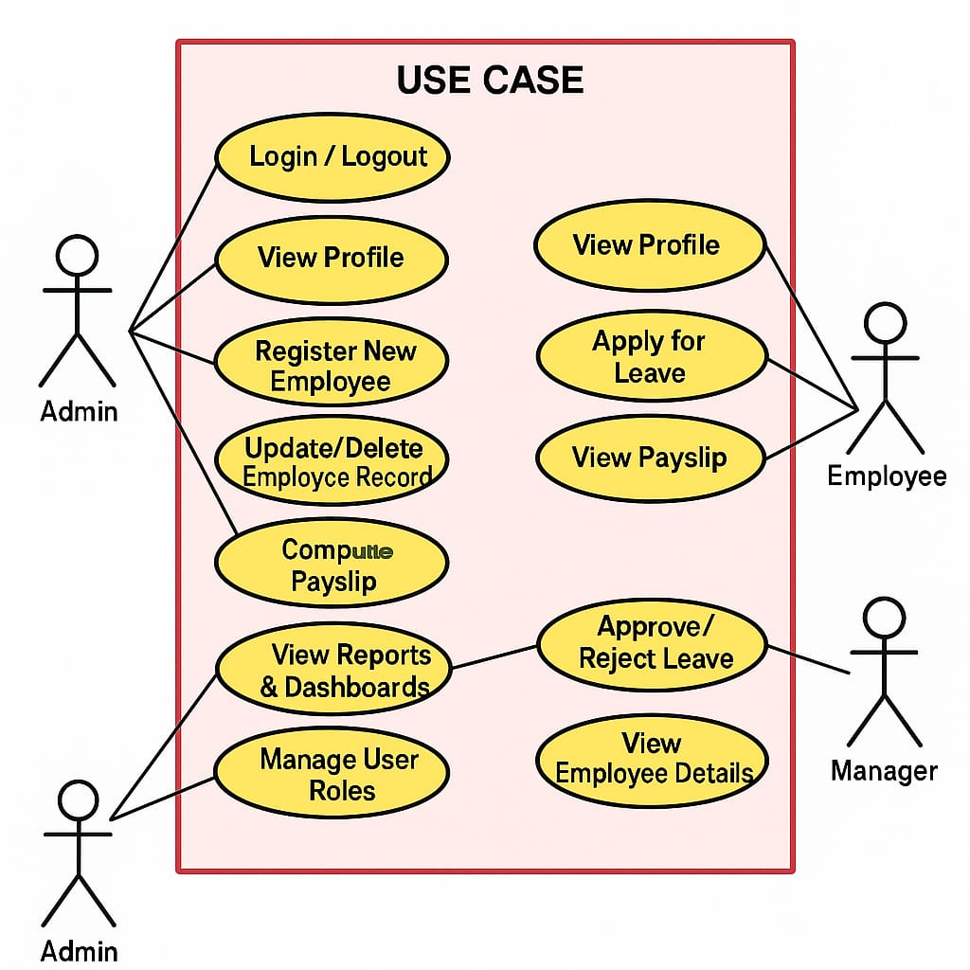
Figure 3.1 Use case diagram of the proposed system
In this diagram, there are three main actors:
Admin (HR personnel or system administrator)
Employee
Manager
Each actor has specific roles and responsibilities in the system. Let’s break down their interactions in detail.
Admin: The Admin is the central figure in the system with the highest level of access. Their tasks include managing employee records, handling payroll, and overseeing system operations. The admin can:
Login / Logout: Authenticate themselves securely to access the system or exit the session.
View Profile: Check their own personal and role-based information.
Register New Employee: Add new employees to the system by entering their relevant data such as name, role, department, salary, etc.
Update/Delete Employee Record: Modify or remove existing employee data, ensuring records are accurate and current.
Compute Payslip: Automatically calculate salaries, deductions, bonuses, and generate payslips for employees.
View Reports & Dashboards: Access real-time analytics and HR metrics to monitor workforce trends, payroll status, and leave data.
Manage User Roles: Assign and manage access privileges for all users in the system, ensuring role-based access control and security.
The admin acts as the primary controller of the system, ensuring data integrity, enforcing rules, and overseeing all HR functions digitally.
Employee : The Employee represents the core users who use the system primarily for self-service HR needs. Their interactions are more limited but critical to individual workforce management. An employee can:
Login / Logout: Securely sign into or out of the system.
View Profile: Access their personal and job-related information such as position, salary, and leave balance.
Apply for Leave: Submit leave requests for approval, specifying dates and reasons.
View Leave Status: Check the approval status of submitted leave applications.
View Payslip: Access their monthly or historical payslips generated by the admin.
These features empower employees with transparency, reducing dependency on HR for everyday requests.
Manager: The Manager plays a supervisory role with responsibilities over a team of employees. Their interaction with the system is focused on team oversight and operational approvals. A manager can:
Login / Logout: Access the system securely.
Approve / Reject Leave: Review and make decisions on employee leave requests submitted under their supervision.
View Employee Details: Access key information about the employees they manage, including attendance records, performance data, and leave history.
By involving managers, the system decentralizes leave management and promotes accountability at multiple levels.
System Overview
The diagram effectively demonstrates the role-based access structure:
All users have core access (login, profile view).
Specific functionalities are reserved for specific roles.
There’s a clear separation of concerns, enhancing both security and efficiency.
This modular structure supports the smart automation goals of Fountine Abode’s HR system, such as reducing paperwork, speeding up processes, and making informed decisions through real-time data access.
In conclusion, the use case diagram not only outlines the system’s features but also highlights how each user contributes to and benefits from the system—achieving a streamlined and intelligent HR environment.
3.2.4.3 ACTIVITY DIAGRAM OF THE PROPOSED SYSTEM
An activity diagram of a system is another very important diagram in Unified Modelling Language (UML). It is however a diagram that is used by the programmer and the system designers to describes the various dynamic aspects of the software system. However, an activity diagram is basically represented as a flowchart which is used to describe in detail all the flow of activities that will be going on in the system. The figure below represents the flow of the various activities that are going on in the proposed system, from the signing in to creating and updating a property to booking a property for lodging purposes on the side of the guest users.
Activity diagram of the proposed system:
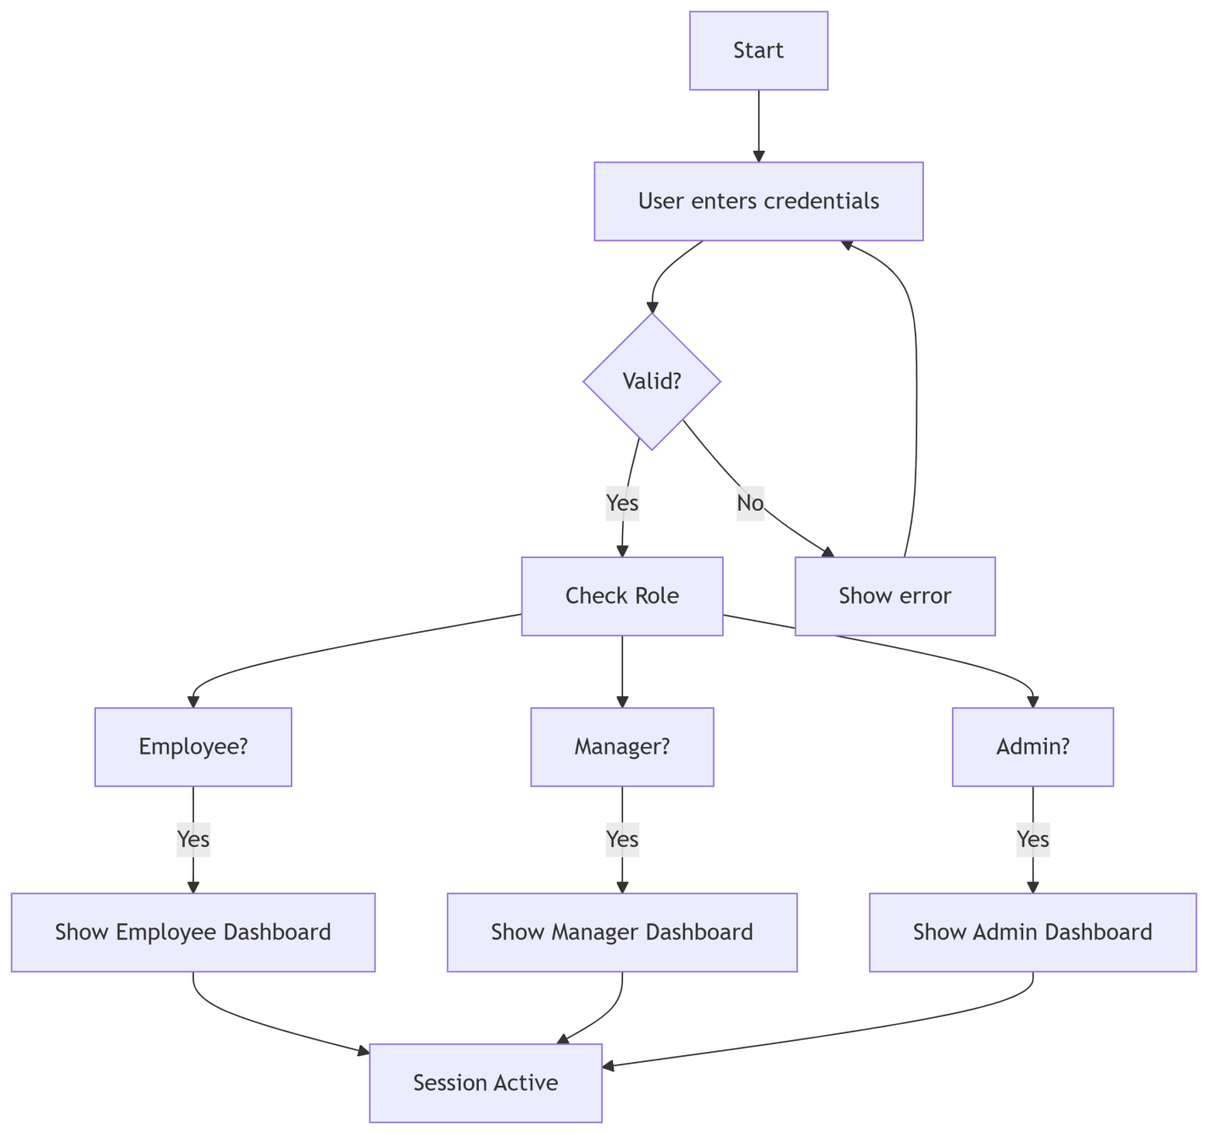
Figure 3.2 Activity diagram for login in the proposed system.
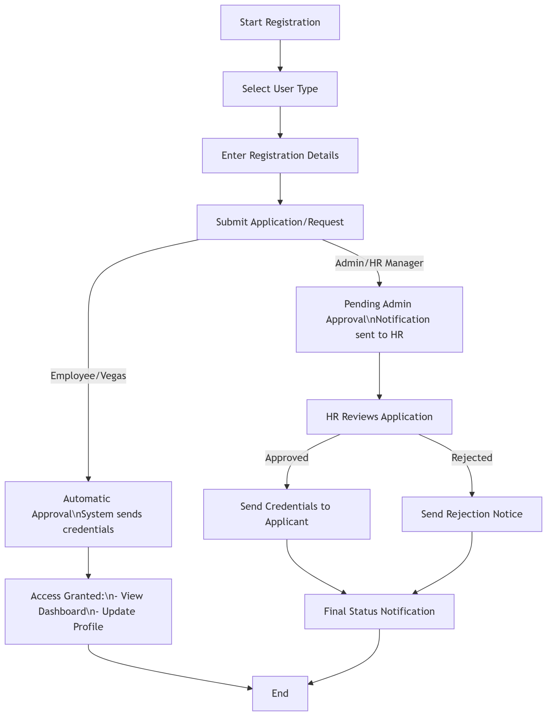
Figure 3.3 Activity diagram for registration and applications in the proposed system.
The diagram above represents the class diagram of the proposed system which stands to display the pictorial representation of the activity that takes place in the proposed system. The activity ranges from the logging in to the system and therefore create and update the registration of the employee data which they’ve made on the platform to show how many employee thay have. Also it shows the activity of creating a dashboard for each of the employees that are to be listed on the platform to help classify the registration which could be updated or deleted later on.

3.2.4.4 CLASS DIAGRAM OF THE PROPOSED SYSTEM
Class diagrams are another set of diagrams under the Unified Modelling language (UML) diagrams that is used by both computer engineers and software developers to describe the structure of a software system by mapping out its classes, attributes, methods and the relationships among these objects. Below is the illustration of the class diagram for the proposed system.
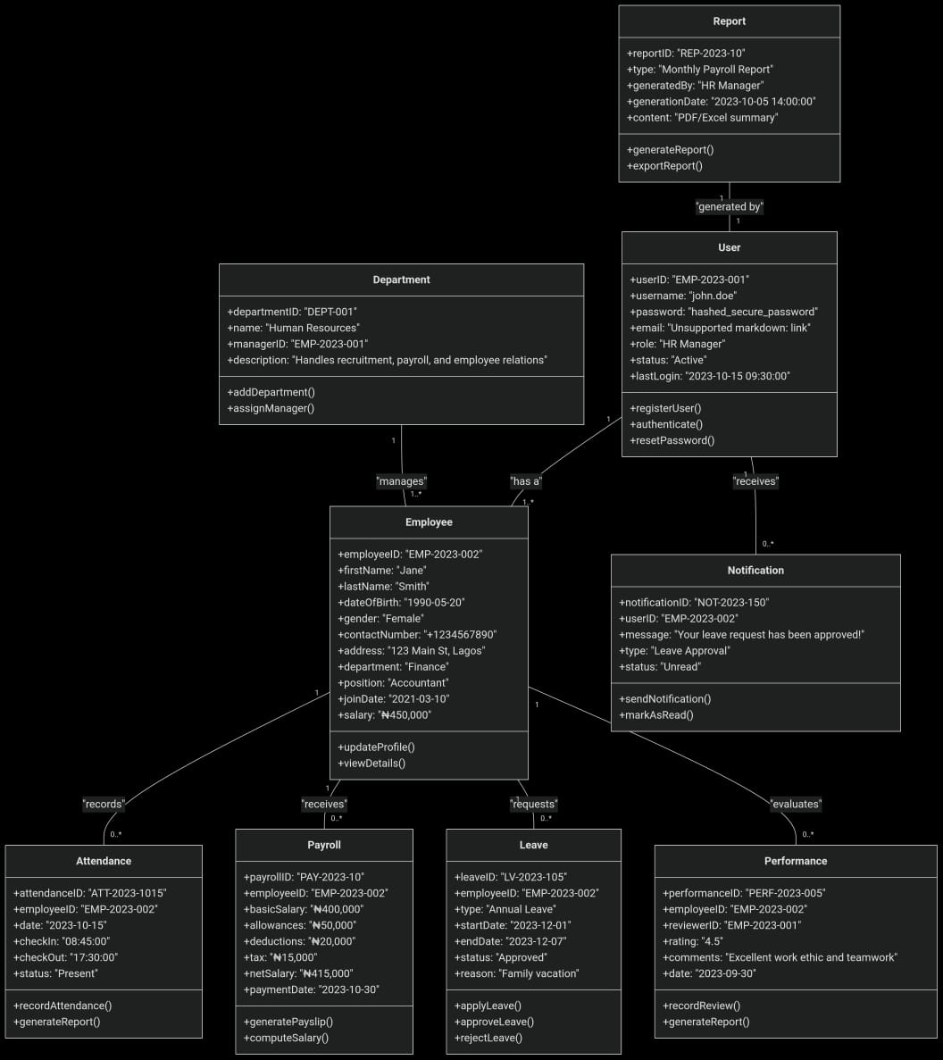
Figure 3.4 Class diagram of the proposed system
The diagram above represents the class diagram of the system that has been proposed in this work of research. It is used in this research work to show the activities that would be taking place in the proposed system. The diagram however depicts the series of class that are exiting between the system to help it function properly.
3.2.4.5 UML SEQUENCE DIAGRAM
The unified Modeling Language (UML) sequence diagrams serve as an advanced visual model representation that is used by software engineers to depict the various interactions that are
taking place between the different objects that are existing within a system over time. However this diagrams are very crucial in the understanding of the chronological flow of actions and messages that are taking place during the process of execution of a particular use case action or scenario. At the core of the UML sequence diagram, this diagram visually represents the order in which the interactions do take place therefore providing a clear representation of how the different components of the system do collaborate in a specific system in other to achieve the specified goal.
However, the different elements in the UML sequence diagram include lifelines, messages, activations, and companies of which the lifelines represent the different entities that are involved in the interaction, while the messages stand to denote the communication between these different entities. Moreover, activations that are portrayed using vertical lines that are extending from lifeline and therefore stands to represent the duration of an object's involvement in an interaction. Consequently, this temporal approach adds an important layer of understanding in other to allow developers and CEOs to be able to cover for not only for what occurs in the system but also when it occurs within the system's operation.
Moreover, UML sequence diagrams most importantly helps in facilitating the communication between the technical and non-technical stakeholders that are in a system and by detailing the visual representation of the dynamics of the systems, these diagrams stand as a powerful tool for conveying intricate details which are technical in a way that is more accessible to the user. However, the effective use of these diagrams have stood to contribute to improved collaboration between the different stakeholders in the system thereby fostering a shared understanding of the system behavior and also aiding in the identification of potential issues that would be looked into in the future for enhancement.
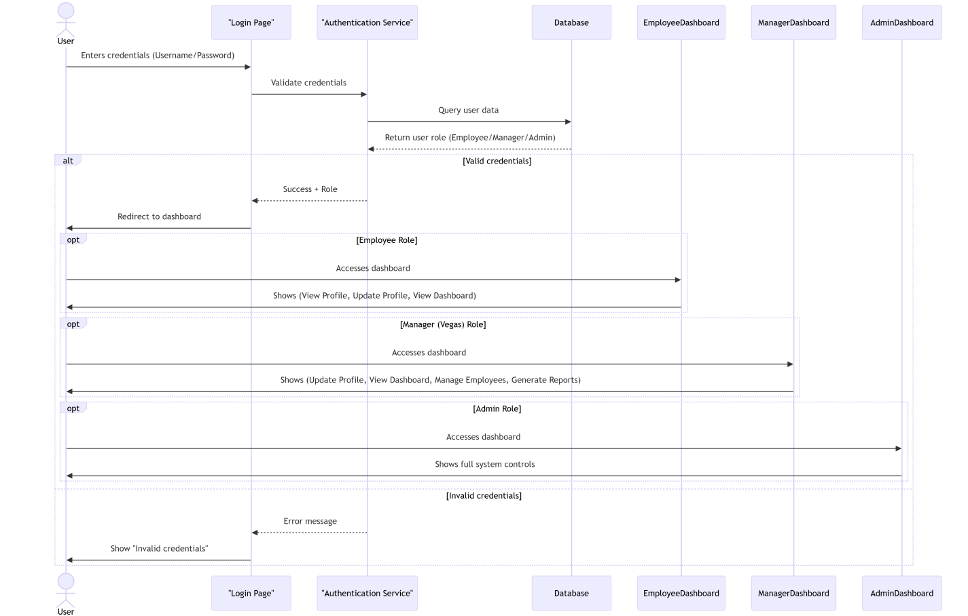
Figure 3.5 Sequence diagram of the proposed system
The above diagram is the sequence diagram of the proposed system which is used in this context to show the sequence of activities that is taking place in the proposed system, right from the user signing up or signing in to the platform to the user successfully registering as an employee.
3.3 SYSTEM DESIGN
The system design of the system that is proposed in this research work is going to illustrate how the system hopes on fulfilling the requirements which have been stated in the above previous sections. The system design will however comprise of the database design of the system which governs every activity that would be taking place on the system.

3.3.1 INPUT/OUTPUT DESIGN
input/output design of the system that is proposed in this system comprises of all the input interfaces that would be present on the system which would be represented in form of diagrams as well as the diagrammatic representation of the output interfaces that would be present in the system being proposed in this study. Below is the diagram of the input/output design illustrations
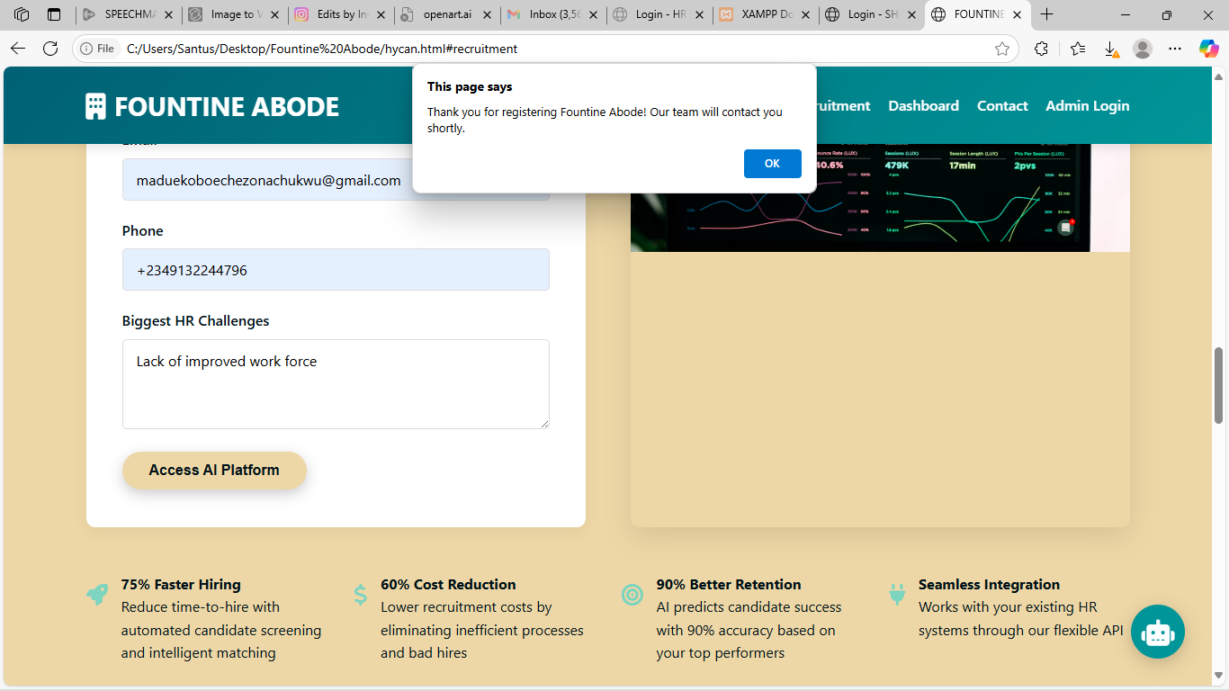
Figure 3.6 Input/Output designs for the proposed system

3.3.1 DATABASE DESIGN
The essence of the database design is to carefully show a modelled view of the proposed system’s database. The Fountine Abodes’ database is a relational database that is designed and implemented with NoSQL. The database has been designed to have more than 6 entities and at least three attributes for each entity.
Database schema for the proposed system
USER TABLE
Table 4.1 User table for the proposed system
Attribute | Data Type | Description
Id | int | The primary key of the table
Username | varchar | This is where the username of the user is stored.
Email | varchar | The field for storing the users email.
Phone_no. | int | The field for storing the users email.
Password | varchar | The field for storing the users email.
Date_registered | timestamp | The field shows the date of when the user registered the company.
User_type | Boolean | The field shows whether a user is a business owner or an employee.

Table 4.1 employee table for the proposed system
Attribute | Data Type | Description
Id | int | The primary key of the table
Name | varchar | This is where the name of the drug is stored.
Details | varchar | The field for storing the details of each drug
Price | float | The field for storing the price of the drug
Date_added | Timestamp | The field for storing the date the drug was added

CHAPTER FOUR
SYSTEM IMPLEMENTATION
4.1 Overview
This chapter of this research dives into the implementation of the system that has been proposed (FOUNTINE ABODE) during the cause of this research work. In the previous sections of this work, a thorough analysis of both existing systems and FOUNTINE ABODE has been embarked upon by outlining the system and all its requirements. Now in this section of this research work, the researcher is putting FOUNTINE ABODE into action using the tools that have been chosen and tested. In this chapter, the user interfaces of different parts of the system would be outlined, along with the tools that is used to bring this system to life.

4.2 Tools used for implementation (Tech stack of the proposed system)
4.2.1 Frontend
4.2.1.1. Next.js
Next.js is a powerful React and JavaScript web application framework. That gives one of the most effective and smooth ways for development. It easily handles client-side and server-side rendering in other to allow you to create dynamic and interactive web pages. But one of the main features of Next.js is that it can automatically split code as it can load only the part of the code needed for the specific section of the page thereby increasing performance. However, Next.js also gives support for building static websites where pages are pre-rendered at build time as it was integrated with integrated routing, so that the page navigation will be very smooth. Next.js is highly flexible and offers a bunch of plugins and extensions to make the platform functional. Moreover, there is quite a good community and a lot of documentation backing it, which makes it really easy for developers to start off and resolve issues with ease.
4.2.1.2. React JS
React is one of the tools that was used to in implementing the system and it is basically one of the well-liked JavaScript library for creating user interfaces for web application because it is very efficient and well-known and also simple therefore making it a favorite tool to be used by developers. It can be used to create dynamic, interactive components that update in real time and most importantly, it gives users a snappy, responsive experience. However, one of the primary characteristics of React.js is its ability to update only the portions of the page that have changed thereby eliminating the need for a complete page reloads when a change is made on the page and increasing performance using a virtual DOM (Document Object Model). In addition to this, React encourages the use of reusable components, which helps in improving application scaling and maintenance. Moreover, it offers a declarative syntax, giving developers the opportunity to specify how the user interface (UI) should appear depending on the state of the program, which makes the code simpler and easier to understand. Also, React has a large and active community, with plenty of resources and support available for developers of all levels.
4.2.1.3. Tailwind CSS:
Tailwind CSS is a CSS framework that is utility-first. It was used to build the proposed system because it helps to simplify the process of styling web applications because it provides a set of utility classes that have been pre-designed which you can use to style HTML elements directly in your markup, thereby eliminating the need for writing custom CSS. However, developers can use it to create responsive and visually appealing designs very fast without the complexity of traditional CSS frameworks. It is normally used because it is a modular approach for easy customization and flexibility and at that it is suitable for projects of any size and therefore encourages a consistent design system by providing a predefined set of utility classes for common design patterns, such as spacing, typography, and colors. Most importantly, it offers a purge feature which on its own automatically removes the CSS that is not used from your final build to help to keep file sizes small and improve performance.

4.2.2 Backend
4.2.2.1 Node.js
Node.js was one of the tools that was used to build the backend of this application as it is one of the major tools that is used in building backend applications. It is a runtime environment for executing JavaScript code outside of a web browser thereby allowing developers to build a very scalable and efficient server-side applications with the use of JavaScript of which on a traditional note, is used for client-side scripting. It makes use of an event-driven, non-blocking input/output model that makes it very lightweight and suitable for handling large volumes of concurrent requests. It is popularly known for its speed and performance, making it ideal for building real-time applications like chat platforms and streaming services. However, it also provides developers with the ability to easily create APIs, handle database operations, and also serve web pages, all within a single JavaScript codebase. On the same vein, it has a vast ecosystem of open-source libraries and packages which it uses to provide solutions for a wide range of development needs.
4.2.2.2 Express
This is a lightweight, very expressive, and very flexible web application framework that was purposely built for Node.js to help in simplify the process of building web applications and APIs with a very minimalistic and opinionated structure. However, server-side, robust applications could be made with the help of JavaScript, thereby making it a tool to easily handle HTTP requests and responses. This however performs quite a number of functions which includes the routing, middleware support, and template engines, to develop web applications both dynamically and on a larger scale. Notwithstanding that it is extensible, there is a great number of plugins and middleware that can further extend and add more functionality. The Express framework is perfectly placed to be used from small projects up to large-scale applications and to offer an equilibrium between simplicity and flexibility. However, Express is a powerful tool for server-side development with Node.js, making the development of efficient, feature-rich web applications significantly easy
.4.2.2.3 Prisma ORM
Prisma ORM is a modern database toolkit that is specially created to be used for Node.js and TypeScript applications which mainly exists to simplify database access and management by providing a type-safe and intuitive interface for working with databases as it offers developers the opportunity to define their data models using a declarative schema syntax, which on its own automatically generates database tables and relationships. It supports a variety of databases which includes PostgreSQL, MySQL, and SQLite, thereby giving room for flexibility in database selection. It however, offers powerful querying capabilities which enables developers to perform complex database operations with ease as also provides built-in data validation and sanitization with which it ensures data integrity and security.
4.2.2.4 MongoDB
MongoDB is one of the most popular NoSQL database. It works by storing data in the form of flexible JSON-like documents. Its database is known for its scalability and flexibility and at this makes it suitable for a wide range of applications. However, it supports high performance and distributed architecture that helps developers to be able to store and retrieve data very fast and efficiently. Also, the MongoDB database supports dynamic schema to make it easy to modify data structures in the database without any downtime. It has a rich query language and index capabilities that enables developers to perform complex queries and analysis on their data. In addition to this, it also offers some other features which includes the replication and sharding for high availability and fault tolerance which is normally used very well in modern web applications to provide a reliable and scalable solution to store and manage data.

4.2.3 Authentication
4.2.3.1 NextAuth
NextAuth is a popular authentication library that is designed and developed for Next.js applications. It is used to simplify the process of implementing authentication in Next.js applications, because it provides pre-built authentication flows and a range of authentication providers. On the other hand, it provides developers with the great opportunity to easily add features like email/password authentication, social authentication (such as Google, Facebook, and Twitter) etc. It is also used to handle user sessions, tokens, and refresh mechanisms, to ensure that the authentication for users is very secure and reliable. However, it allows developers to customize it in other to tailor the authentication flows to their specific requirements. It also works very well with Next.js applications whenever they are merged together to provide a smooth and intuitive user experience.
4.2.3.2 JWT
JSON Web Tokens (JWT) is a compact and very secure way of sharing information from one party to another in a web application. The information is shared as a JSON object and It is made of three parts: a header, a payload, and a signature. It is commonly used for authentication and authorization in web applications. It works by generating and sending a JWT token to the client where it can be stored securely. The Jason Web Token that is usually sent normally contains information about the user, such as their ID and role which can be used to grant access to certain resources or features. However, since JWTs are self-contained and cryptographically signed, they are tamper-proof and can be easily verified by the server. Because of this reasons, JWTs are widely used due to their simplicity, scalability, and security, making them a popular choice for securing web applications.

4.2.4 Payment
4.2.3.1 Stripe API
Stripe API is a powerful tool that allows developers to add a payment processing feature into their application with ease because it provides developers with a very simple and secure way to accept payments online because it handles all aspects of the payment processing activities which includes card payments, bank transfers, and more. Because of features that the Stripe API has, it allows developers to create custom payment flows that is tailored to their specific needs, notwithstanding whether it's one-time payments, subscriptions payment, or recurring billing. It also gives support for multiple currencies and payment methods thereby making it suitable for different types of businesses worldwide. It also offers built-in fraud detection mechanism and prevention features to ensure secure transactions and protecting against fraudulent activities. Additionally, it provides detailed analytics and reporting tools, giving businesses insights into their payment activities and customer behavior.

4.3 SYSTEM REQUIREMENTS
There are not many things that are needed to use this system as it is a web based platform application and however runs on both the web and mobile platforms. However, the system still require that the user gets to fulfill some little requirements in order to be able to use the proposed system. These requirements are as follows:
- An internet enabled device
- Good internet connection (at least 3G internet speed).
- A web browser e.g. Google Chrome, Mozilla Firefox, Microsoft Edge, Apple Safari and a host of others.

4.4 USER INTERFACE OF PHINESS HOMES
This section of this work of research is going to contain user interfaces of different sections of FOUNTINE ABODE which would feature the AI page, login page, the signup page, filter interface etc.
4.4.1. FOUNTINE ABODE Homepage
The homepage consists ofFOUNTINE ABODE interface is made up of four different sections, the header section that contains the logo of FOUNTINE ABODE and other usability functionalities that would help users to easily navigate through the different sections of the platform, the hero section which offers the user the opportunity to make a reservation and the explore section where the user can see all the employee data that have been listed on the platform,
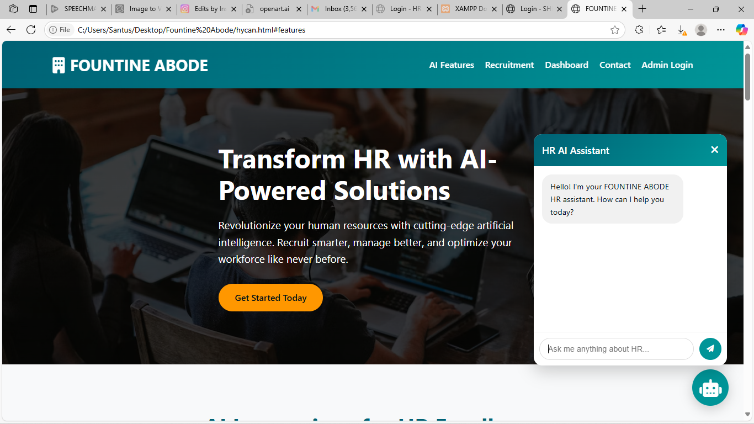
Figure 4.1The home page of fountine abode

4.4.2 Upload home page:
This section of FOUNTINE ABODE functions to help the user to upload services to the platform so that the other users who are interestd will be able to select, register, pay and become a member of fountine abode. The section of proposed system is made up of two different stages in which at the first stage the user has to select the kind of account in which he or she wants to have and in the second stage, the user has to input more details about the their company or person so that he or she wants to list out on the platform so that other users can take a look at.
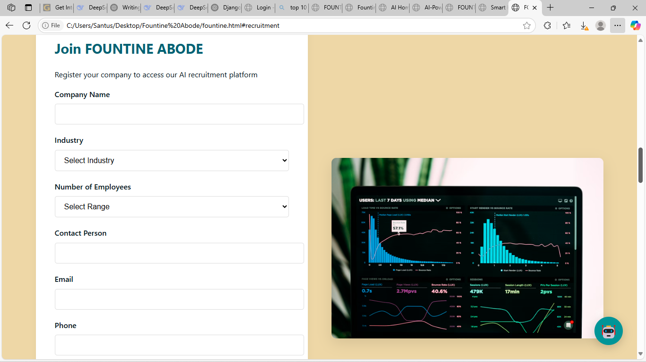
Figure 4.2 The first stage the user has to select the kind of account in which he or she wants to have.
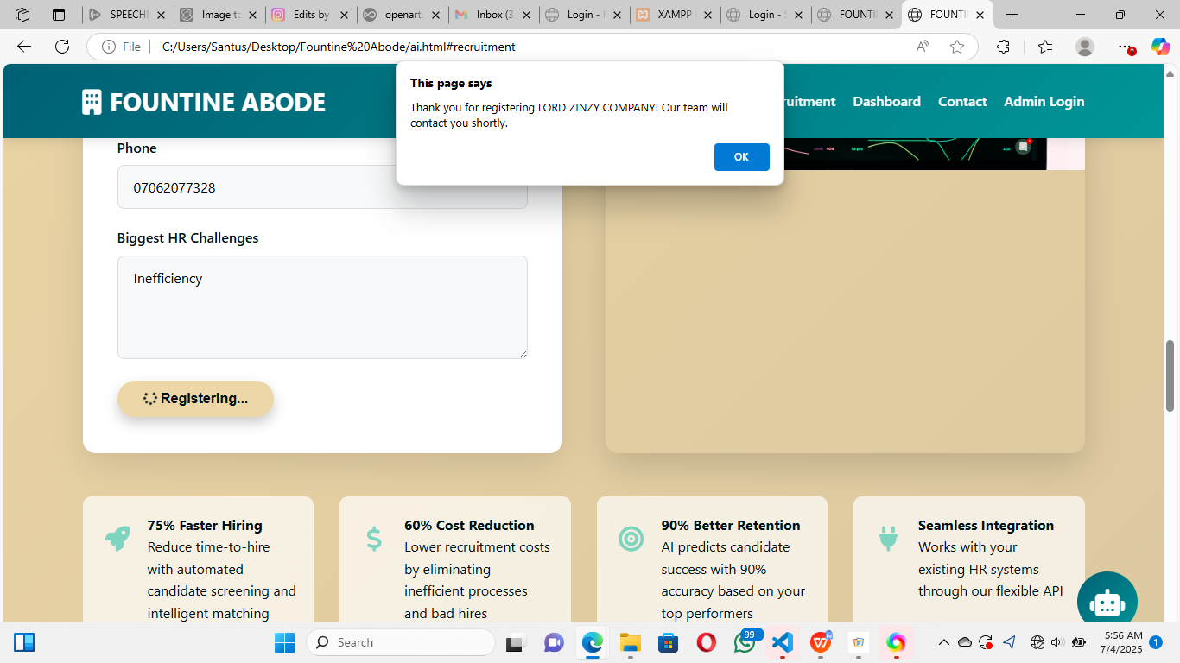
Figure 4.3 The second stage of registration.
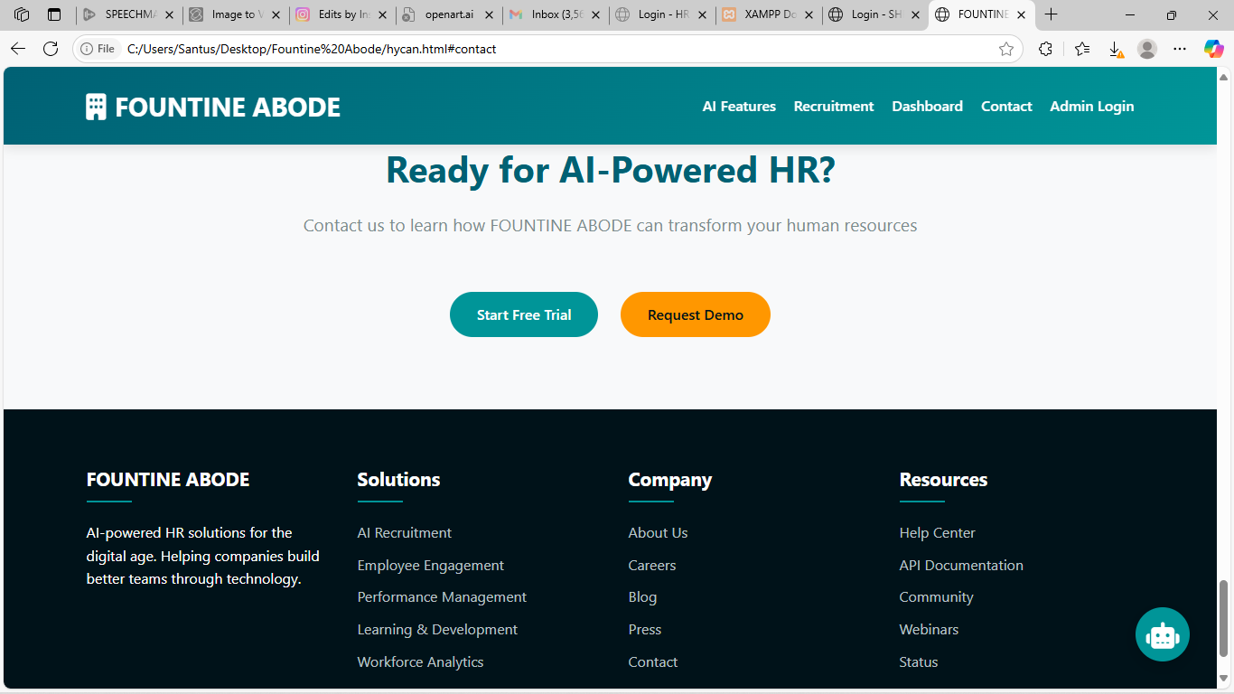

4.4.5 Favorites page
This section of FOUNTINE ABODE is one of the most important part of the system as it plays a crucial role of displaying all the services that have been listed on the platform in which the user has marked as his/her favorite service to workwith..
4.4.6Ai- features
This section of FOUNTINE ABODE is one of the most important part of the system as it plays a crucial role in the system. It of two category, the first category is theAi features that have been listed on the platform and the second category is the Ai chartbox that helps the user or employee update therselves about hr functions.
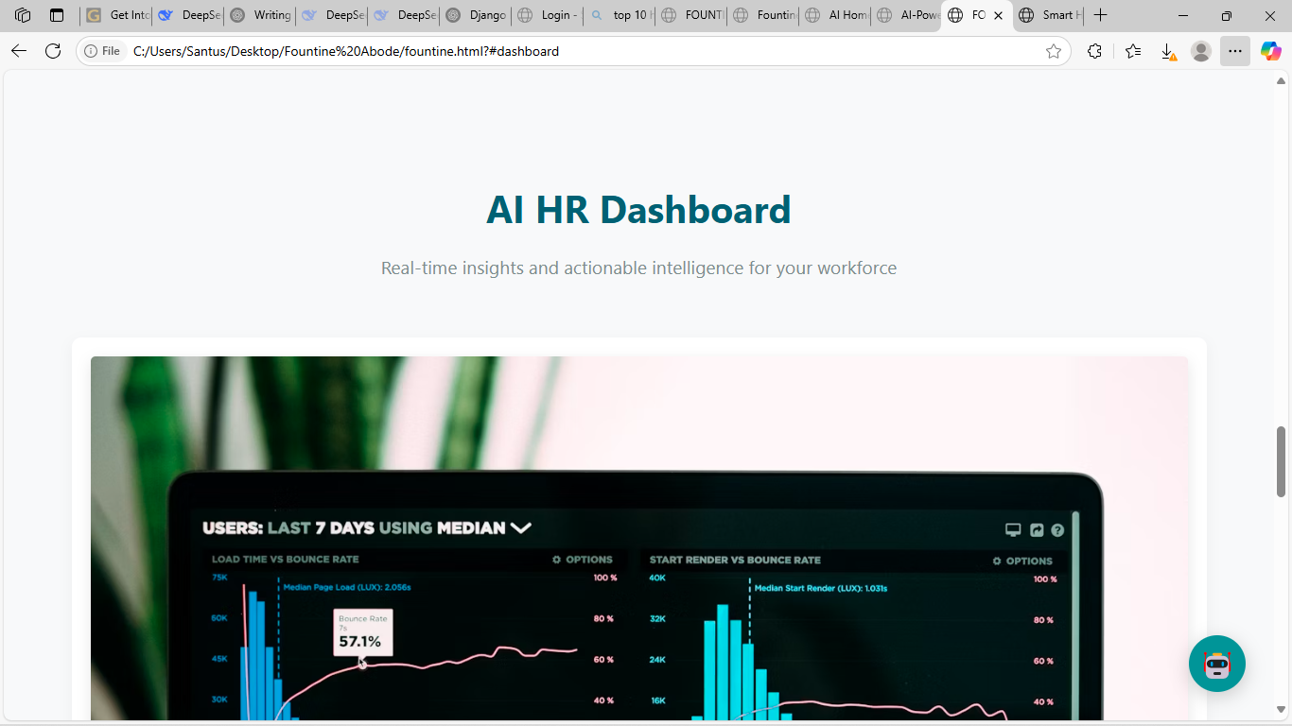
The ai dashboard
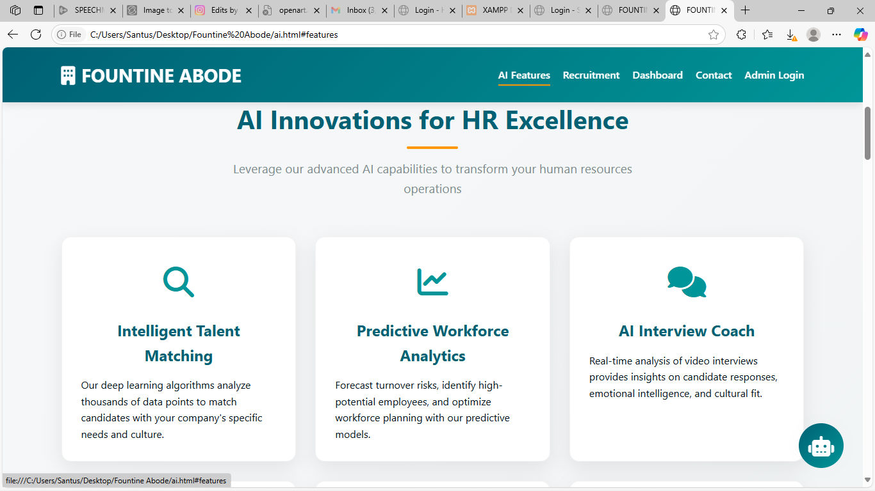
The ai features of the proposed system
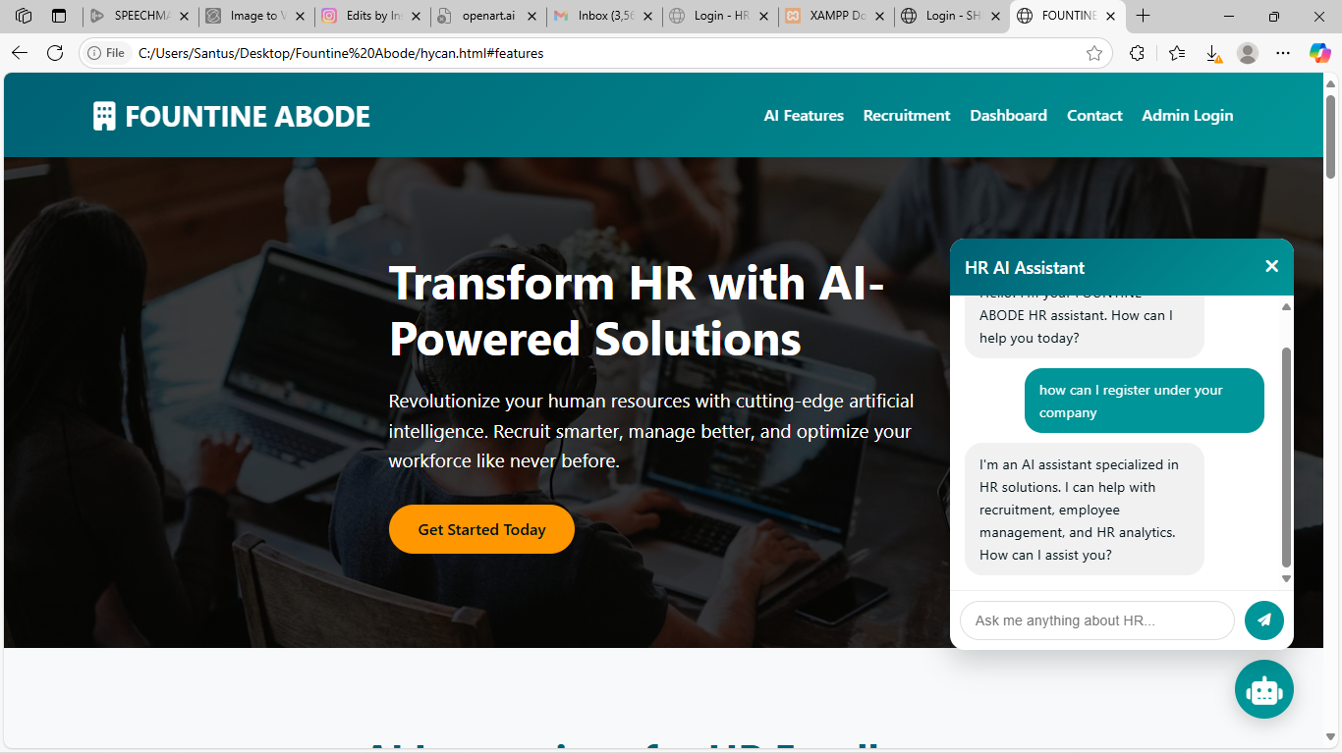
The ai chartbot of the proposed system.
4.4.7 Login page and Signup page
This section of FOUNTINE ABODE is a very important page that is very crucial for the smooth and effective operation of the system as it is the page through which the users can login to the system to be able to pay and register their comapies as well if need be.

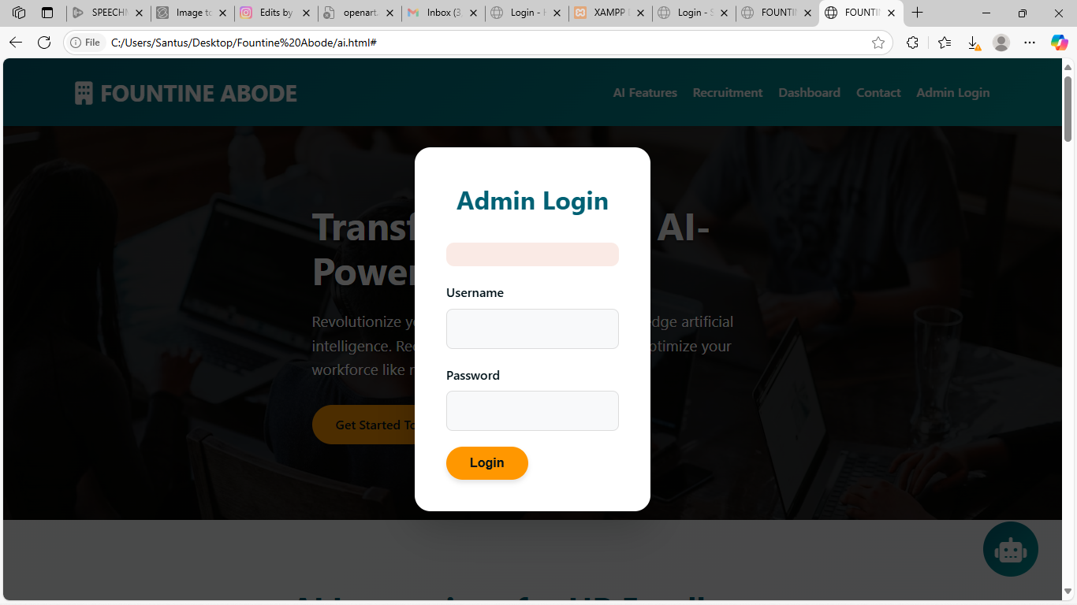
Figure 4.9 the loig page
Figure 4.10 The Login page for the proposed system

Figure 4.14 Thehomepage of the proposed system.

CHAPTER FIVE
SUMMARY, RECOMMENDATIONS AND CONCLUSION
5.1 OVERVIEW
This chapter of this research work stands to give a detailed summary of this project, the recommendations for future works, and lastly conclusion of this research work. This chapter however summarizes everything that has been discussed in all the chapters of this project.

5.2 SUMMARY
At the beginning of the research project the problem statement that is connected to this research work and the study's backdrop were explicitly discussed. However, the theoretical underpinnings of the research were covered in the latter chapters of this paper, along with a review of the relevant systems that are currently in place. This work of also provided a thorough examination of current systems, pointed out their shortcomings, and did its best to take advantage of these issues when developing the system that was suggested in this research work. Additionally, a comprehensive system analysis was conducted using UML diagrams in the third chapter of this study effort; the system was explicitly analyzed utilizing use case diagrams, activity diagrams, class diagrams, and class diagrams of the UML diagrams. Lastly, a description of the user interface and a list of all the programming languages and frameworks utilized to carry out this project were provided.

5.3 RECOMMENDATIONS
This hr managements system is toensure scalability and user efficiency, consider implementing role-based access control (RBAC) with granular permissions, integrating automated notifications via email/SMS for real-time updates, adding audit trails for security compliance, optimizing the dashboard with customizable widgets for different roles, and incorporating a mobile-responsive design for on-the-go access, while maintaining a modular architecture to easily accommodate future expansions like payroll or performance management modules.

5.4 CONCLUSION
Finally, we have come to the end of this research as this section of this research work stands to conclude the objectives that were defined in this research work. Nevertheless, this is not the conclusion of FOUNTINE ABODE as this research has not come to a halt with this conclusion but FOUNTINE ABODE would continue to grow and add a lot of new features like sales of companies and a whole lot of other cool features. However, for the purpose of this study, FOUNTINE ABODE web application would be made available on the parcel platform which offers online hr systems.

REFERENCES
Almeida, J. P., & Silva, A. R. (2023). Role-Based Access Control in Modern HR Systems. Journal of Human Resource Technology, 12(4), 45-60.
AWS. (2024). Cloud-Based HR Solutions: Scalability Patterns. Amazon Web Services Whitepapers.
Bass, L., Clements, P., & Kazman, R. (2022). Software Architecture in Practice (4th ed.). Addison-Wesley.
Davenport, T. H. (2023). Analytics in HR: From Data to Insights. Harvard Business Review Press.
Django Software Foundation. (2024). Secure Authentication Methods for Web Apps. Django Documentation.
Google. (2023). Material Design Principles for Enterprise UIs. Google Design Guidelines.
IBM. (2023). Designing Scalable Enterprise Systems: Best Practices. IBM Redbooks.
ISO. (2023). ISO 27001: Information Security Management. International Organization for Standardization.
Kim, G., & Behr, K. (2024). DevOps for HR System Continuous Deployment. IT Revolution Press.
Microsoft. (2024). Azure Active Directory for RBAC Implementation. Microsoft Documentation.
NIST. (2023). Security and Privacy Controls for Information Systems (SP 800-53). National Institute of Standards and Technology.
Oracle. (2024). Mobile-First Design for HR Applications. Oracle White Papers.
PwC. (2023). Global HR Technology Trends 2024. PricewaterhouseCoopers Report.
Salesforce. (2024). CRM Integration Strategies for HR Platforms. Salesforce Developer Guides.
Smith, T., & Lee, K. (2023). Automated Notifications in Workflow Systems. International Journal of Business Process Management, 18(2), 112-130.
Tanenbaum, A. S. (2023). Distributed Systems: Principles and Paradigms (3rd ed.). Pearson.
Uber. (2024). Microservices Architecture Case Studies. Uber Engineering Blog.
W3C. (2024). Web Accessibility Guidelines for HR Platforms. World Wide Web Consortium.
Wilson, M. (2023). Modular Architecture in SaaS Applications. TechPress.
Wong, L. (2023). GDPR Compliance in HR Data Systems. European Data Protection Review.
ZDNet. (2024). AI-Powered HR Analytics Benchmark Report. CBS Interactive.

APPENDIX

CRUD implementation in PHINESS HOMES
import { NextResponse } from"next/server";

importprismafrom"@/app/libs/prismadb";
importgetCurrentUserfrom"@/app/actions/getCurrentUser";

exportasyncfunctionPOST(
request:Request,
) {
constcurrentUser=awaitgetCurrentUser();

if (!currentUser) {
returnNextResponse.error();
}

constbody=awaitrequest.json();
const {
title,
description,
imageSrc,
category,
roomCount,
bathroomCount,
guestCount,
location,
price,
} =body;

Object.keys(body).forEach((value:any) => {
if (!body[value]) {
NextResponse.error();
}
});

constlisting=awaitprisma.listing.create({
data: {
title,
description,
imageSrc,
category,
roomCount,
bathroomCount,
guestCount,
locationValue:location.value,
price:parseInt(price, 10),
userId:currentUser.id
}
});

returnNextResponse.json(listing);
}

import { NextResponse } from"next/server";

importgetCurrentUserfrom"@/app/actions/getCurrentUser";
importprismafrom"@/app/libs/prismadb";

interfaceIParams {
listingId?:string;
}

exportasyncfunctionDELETE(
request:Request,
{ params }: { params:IParams }
) {
constcurrentUser=awaitgetCurrentUser();

if (!currentUser) {
returnNextResponse.error();
}

const { listingId } =params;

if (!listingId||typeoflistingId!=='string') {
thrownewError('Invalid ID');
}

constlisting=awaitprisma.listing.deleteMany({
where: {
id:listingId,
userId:currentUser.id
}
});

returnNextResponse.json(listing);}

