

A REAL-TIME DRIVER DROWSINESS DETECTION SYSTEM

BY

OBUM PRISCA OSOWOAYIP
GOU/U21/CSC/654

A PROJECT SUBMITTED TO THE DEPARTMENT OF COMPUTER SCIENCE,
FACULTY OF NATURAL SCIENCES AND ENVIRONMENTAL STUDIES,
GODFREY OKOYE UNIVERSITY, ENUGU.

IN PARTIAL FULFILMENT OF THE AWARD BACHELOR OF SCIENCE (B.Sc) DEGREE IN COMPUTER SCIENCES

SUPERVISOR: ENGR. DR. KINGSLEY I. CHIBUEZE

AUGUST, 2025
APPROVAL
This research titled “A Real-Time Driver Drowsiness Detection System” has been assessed and approved by the Committees of Department of Computer Science/Mathematics and Faculty of Natural Sciences and Environmental Studies, Godfrey Okoye University, Enugu Nigeria.

Engr. Dr. Kingsley I. Chibueze _______________ _______________
Supervisor Signature Date

_______________ _______________
External Examiner Signature Date

Dr. Frank Okebanama _______________ _______________
Head of Department Signature Date

Prof. Chidi C. Uhuegbu _______________ _______________
Dean of FNSES Signature Date

CERTIFICATION

I hereby certify that the work included therein was completed by myself and that it was mainly based only on my own observations and investigation. Consequently I will fully accept the University's decision if I am found to have cheated on the assignment.

________________________________
OBUN PRISCA OSOWOAYIP
GOU/U21/CSC/654

DEDICATION
This work “A Real-Time Driver Drowsiness Detection System” is dedicated to my family who has genuinely contributed to everything that I have achieved up until this day and I pray that the good lord continue to guide and protect him for the rest of his life.

ACKNOWLEDGMENTS
First of all, I would like to appreciate the almighty God for his unending mercies, inspiration and grace throughout this project. In a very special way, I want to also acknowledge and appreciate my supervisor, Dr. Engr. Kingsley Chibueze for the time he had kept aside to make sure that this project is a success and also for mentoring me throughout this project.
I would also like to appreciate my daddy and mummy, for their love, support and prayers for me throughout this project, and my sisters, brothers for their support and I pray that the good Lord will continue to bless them all.

ABSTRACT
During long driving sessions at nighttime the critical reason behind many car incidents becomes driver fatigue. This research introduces a live driver fatigue system based on Artificial Intelligence vision methods which track facial indicators along with physical behavior signals for sleepiness. Eye closure and yawning and head nodding detection come from a system that integrates Convolutional Neural Networks (CNNs) and Long Short-Term Memory (LSTM) networks. The system produces real-time alerts when drowsiness indicators achieve established thresholds which aids in preventing crashes along with improving safety conditions on the roads.

TABLE OF CONTENTS
Title page i
Approval ii
Certification iii
Dedication iv
Acknowledgements v
Abstract vi
Table of Contents vii
List of Figures xi
List of Tables xii

CHAPTER ONE: INTRODUCTION 1
  - Background of Study 1
  - Statement of Problem 2
  - Aim and objectives of the Study 2
  - Significance of the Study 3
  - Scope of the Study 3
  - Limitation of the Study 3
  - Operational definition of Terms 4

CHAPTER TWO: LITERATURE REVIEW 5
2.1 Introduction 5
  - Theoretical Framework 5
2.3 Review of Related Literature 9
2.4 Datasets for Driver Drowsiness Detection 13
2.5 Challenges in Vision-Based Drowsiness Detection 13
2.6 Summary of Related Literature 14
2.7 Research Gap 15
2.8 Contribution to Knowledge 15

CHAPTER THREE: SYSTEM ANALYSIS AND DESIGN 16
3.1 Introduction 16
3.2 System Analysis 16
3.3 Analysis of Existing Systems 17
3.4 Proposed Systems Objectives 19
3.5 System Requirements 19
3.6 System Architecture 20
3.7 Proposed Methodology: Object-Oriented Analysis Design 21
3.8 System Design 29
3.9 Database Design for the Proposed System 29
CHAPTER FOUR: SYSTEM IMPLEMENTATION 31
4.1 Overview 31
4.2 Tools used for Implementation 32
4.3 System Requirements 33
4.4 User Interface of the Proposed System 34

CHAPTER FIVE : SUMMARY, RECOMMENDATION, & CONCLUSION 40
5.1 Overview 40
5.2 Summary 40
5.3 Recommendation 41
5.4 Conclusion 41

REFERENCES 42

APPENDIX 45

LIST OF TABLES
TABLE PAGE
4.1 User table for the proposed system 30

LIST OF FIGURES
FIGURE PAGES
3.1 Use case diagram of proposed system 23
3.2 Activity diagram of the proposed system 24
3.3 Class diagram of the proposed system 26
3.4 UML Sequence diagram of the proposed system 28
4.1 The Home (Input) screen of the proposed system 35
4.2 The output screen of the proposed system 36
4.3 The validation matrix 36
4.4 The validation matrix 37
4.5 The F1-confidence 38
4.6 The precision-recall 38
4.3 The recall-confidence 39

CHAPTER ONE
INTRODUCTION
  - Background of the Study
Motor vehicles have become increasingly common, and correspondingly, road accidents have surged, with human error accounting for a significant proportion of these incidents. Among these errors, driver fatigue has emerged as a leading contributor to road accidents and is now recognized globally as a major public safety issue. Drowsy driving impairs reaction times, reduces attentiveness, and leads to poor decision-making, all of which significantly elevate the risk of vehicle collisions, especially during long-distance travel and nighttime driving (National Highway Traffic Safety Administration [NHTSA], 2022). According to both the World Health Organization (WHO) and the NHTSA, drowsy driving is responsible for thousands of fatalities each year, highlighting its severe implications on traffic safety (WHO, 2023). Unlike alcohol or drug impairment, drowsiness is difficult to detect, which makes it particularly dangerous, as many drivers only recognize their fatigue after exhibiting signs such as lane drifting or in severe cases, microsleeps or nodding off at the wheel.
In response to this challenge, research institutions and automotive manufacturers have developed intelligent driver-monitoring systems that leverage advancements in computer vision and artificial intelligence (AI) to identify signs of fatigue. These systems analyze driver behavior—such as eye closure, yawning frequency, and head posture in real time to issue early warnings and potentially avert critical incidents (Alotaibi & Alotaibi, 2020). The proposed study aims to develop a real-time driver drowsiness detection system using the YOLOv8 model, a state-of-the-art object detection framework, to monitor facial cues automatically. The system is designed to be non-invasive, cost-effective, and robust under varying lighting conditions and head orientations, making it suitable for real-world application.
1.2 Statement of the Problem
Numerous accidents happen today because drivers operating vehicles become fatigued despite improved vehicle safety technologies. The existing safety systems including lane departure warnings along with steering pattern monitors display several drawbacks in operation.
- Their inability to track driving physiological condition makes them respond to driver safety issues instead of preventing them.
- Such systems generate incorrect warning signals when used in challenging road situations including winding streets.
- Real-time EEG monitoring systems for driver fatigue detection are difficult to use daily because they require invasive procedures and have expensive costs.
- This research deals with the fundamental problem of creating a dependable live facial monitoring system which observes driver face activity to identify fatigue safely without imposition. The development of a system which detects early warning signs of fatigue is essential to minimize driving fatalities while improving driving security.
1.3 Aims and Objectives
The study titled "A real time driver drowsiness detection system" aims to build a real-time system using AI-based computer vision to monitor driver facial features and produce alerts if it detects fatigue signals. The specific objectives of this research are:
- Review and Characterization of Existing Driver Drowsiness Detection Systems
- Development of a YOLOv8 Model for Detecting Facial Landmarks in real-time.
- Implementation of a YOLOv8-Based Drowsiness Detection Model
- Integration of Real-Time Alert Mechanisms
- Assess system effectiveness using accuracy, precision, recall, and latency as key performance metrics.
1.4 Significance of the Study
  - This technology helps protect the lives of vehicle operators, passengers, and others in the vicinity of the road.
  - The research provides an operational model for future driver monitoring systems, with a focus on developers working in developing regions with emerging road safety frameworks.
  - Preventing driver accidents caused by fatigue reduces costs related to vehicle repairs, insurance claims, and medical care, while also improving workplace efficiency.
1.5 Scope of the Study
The research investigates real-time facial assessment to identify driver drowsiness symptoms during operation. The scope includes:
- The system detects faces from the camera feed then tracks specific movements that indicate drowsiness like eye closure combined with yawning and head movements.
- The system consists of technology able to find mobile phone use or conversational distractions.
- The system lacks capability to interface with braking system as well as other vehicle hardware elements.
1.6 Limitation of Study
Several weaknesses exist in the robust system design even though developers have identified these limitations:
- The system performance could be compromised by physical objects that cover the eyes such as sunglasses or face masks.
- The system accuracy will declining when exposed to extreme lighting conditions that do not have IR camera assistance enabled.
- The present edition overlooks driver distractions as well as emotional states because these variables affect driving performance.
- Quotas of resources on basic devices restrict true-time frame processing speed and processing rate performance.
1.8 Definition of Terms
PERCLOS measures the percentage of time when eyelids cover the pupil which indicates driver drowsiness.
The deep learning CNN (Convolutional Neural Network) serves to process images while extracting vital features from them.
The clinical method tracks face expressions through key facial points named facial landmarks starting from eyes moving through the nose and ending with the mouth.
The system handles data processing and response functions instantly throughout the data reception.

CHAPTER TWO
LITERATURE REVIEW
2.1 Introduction
The current research expands on driver drowsiness detection domains and existing technological approaches. The article demonstrates the historical development of driver fatigue detection methodology starting from biological indicators through observational and image processing techniques. A real-time computer vision-based solution needs justification due to the assessment of primary concepts and their respective advantages and disadvantages.
  - Theoretical Framework
This theoretical framework combines concepts from cognitive psychology and artificial intelligence to guide the development of a driver drowsiness detection system. It associates human behavior, which is the notion of fatigue, with the machine learning method to bridge the gap between real-time monitoring and enhance road safety.
2.2.1 Cognitive Psychology Concepts in Driver Drowsiness Detection
Drive fatigue is a contentious cognitive psychology issue that is important in the design of an AI-powered drowsiness detection system powered through AI. The ideas provided below demonstrate the impacts of mental fatigue on attention, perception, and decision-making, which are the central elements of safe driving.
1. Sustained Attention (Vigilance)
Continuous vigilance is important in monitoring the road. Feeling sleepy limits a person to be alert, and the response is slow, and the perception of hazard is decreased. One of the studies revealed that the more consistent speeds during driving were on the monotonous road, the higher the level of fatigue and the lower vigilance (Schmidt et al., 2018). When drowsiness sets in, the drivers experience blanking of attention, most time without their awareness.
2. Mental Fatigue
Mental fatigue is a result of a highly intensive thinking process, which leads to poor information processing in a driver. The result is impoverished decision-making and retarded response. The effects of fatigue have been correlated with adverse steering and lane change variability (Akbar et al., 2022). In addition, it has been illustrated that fatigue-driven inattention mediates the risky driver behavior (Rasdi et al., 2021).
3. Reaction Time
The reaction time of drowsy drivers is much slower. A study by Mansfield et al. (2023) compared the reaction time of an individual to a simulated driving session with a lower frequency of 1 to 4 Hz, and 4 to 8 Hz after 20 minutes of exposure. Late responses in actual on-road situations may become the cause of crashes and bad braking choices.
4. Microsleeps
Another significant danger in fatigued driving is microsleeps (brief lapses in control of the vehicle caused by the desire to go to sleep at an inappropriate time). Short (1 10 seconds) but resulting in absolute lapses in attention. Such episodes usually happen unnoticed by the driver, especially when the driving task is tedious, and are associated with a loss of performance (Poudel et al., 2018).
5. Attention Lapses
Fatigue also results in frequent lapses in attention even in the absence of full microsleep. Such breakdowns occur in terms of lane maintenance, speed maintenance, and reaction speed. According to the findings of the study by Lee et al. (2020), sleep-related attention deficits were major predictors of a loss of driving performance in real-time especially among persons with untreated sleep disorders.
2.2.2 Concept of Driver Drowsiness
Another issue that should be considered is drowsy driving which negatively affects the mental sharpness of a driver, his or her reaction times, attention, and decision-making skills. It is usually caused by a lack of sleep, lengthy driving, and boring driving conditions. Cases of profuse yawning, drooping eyelids, bobbing heads, and involuntary lane changes are some of the symptoms that can be observed when the driver is drowsy. U.S. National Highway Traffic Safety Administration (NHTSA) reports that over 100,000 drowsy driving crashes occur in the United States every year (NHTSA, 2017).
2.2.3 Classification of Drowsiness Detection Methods
Three primary groups exist for drowsiness detection systems.
- Physiological-Based Methods
There is also a significant use of biological signal monitoring systems to identify fatigue indicators of the driver. Such technologies include the use of electroencephalogram (EEG) to quantify brain activity to determine a drowsy state, electrooculogram (EOG) as a measure of the eye movements, and electrocardiogram (ECG) as a measure of the heart rate variability (Jap et al., 2009; Vicente et al., 2016). These physiological monitoring practices are accurate and they can identify the fatigue-related phenomena early enough. Nevertheless, there is a problem with their application. Its intrusive aspect and the fact that it may cause discomfort to the drivers make it inapplicable on a large scale because of the excessively high prices (Zhao et al., 2012). Furthermore, such systems are usually not suitable to be use in practical conditions, and this decreases their efficiency on the road (Lal & Craig, 2001).
- Vehicle-Based Methods
Automobile-based drowsiness detection systems use mathematical algorithms that analyze driver behavior concerning the steering wheel action, lane departure, and speed fluctuations. Such methods have a valuable practical aspect because those methods do not usually necessitate any new equipment to be introduced, as a good number of contemporary vehicles already have the required sensing equipment and systems. Nonetheless, such approaches are not always reliable. External factors that tend to affect their performance might include different road conditions, differences in models of cars, and weather conditions like wind or driving within curves that may add noise to the data and degrade the accuracy (Dong et al., 2011).
2.2.4 Behavioral and Vision-Based Methods
These methods of measurement are directed towards the physical aspects of a driver including his facial expression and body movement patterns to establish the expressions of drowsiness. The noticeable indicators are the blinking rate and blinking duration of the eyes, measured with Perclos (Percentage of Eye Closure), the number of yoga practised, and head location and head movement. Such methodologies have several strengths, such as those associated with being less invasive, inexpensive, and able to run in real-time. Nevertheless, they are also a source of limitation. Variation of lighting conditions, camera hardware quality, and posture or position of the driver during its operation may become a compromise to the accuracy of their use (Ji et al., 2004; Abtahi et al., 2014).

2.2.5 Deep Learning in Drowsiness Detection
The development of research in deep learning has produced significant changes in drowsiness detection systems. Two neural network models, Convolutional Neural Networks (CNNs) and Long Short-Term Memory (LSTM) networks are useful in the detection of drowsiness.
- Convolutional Neural Networks (CNNs)
The convolutional neural networks (CNNs) are a specialty that is effective in image classification and object detection. In the usage of CNNs in drowsiness detection, CNNs are trained on facial images to learn to spot drowsiness attributes which include eye closures and yawning gestures. Such annotated datasets as NTHU and YawDD are conventions during the training process as they include labeled instances of the drowsy and alert state (Park et al., 2016).
- Long Short-Term Memory (LSTM) Networks
The LSTM version of the Recurrent Neural Network (RNN) is present to deal with data presented in sequence. Fatigue sign progress is monitored over multiple consecutive frames with the help of such an analytic tool. It differentiates normal blinking of the eyes and when they are closed for longer than during minimum time.
2.3 Review of Related Literature
2.3.1 Foundational Work (2014–2016)
A hybrid system of drowsiness detection has been proposed by Abtahi et al. (2014) who merged the analysis of the head positioning with monitoring of eye closures. They utilized Support Vector Machines (SVMs) to detect landmarks on the face and judge the indication of fatigue. The overall detection accuracy was reasonably high, but the system had no time-series mechanism, so it could not record the tendencies in drowsiness occurrence that could, therefore, contribute to false alarms and specify the detection.
Mollahosseini et al. (2016) used Convolutional Neural Networks (CNNs) to recognize facial expressions with respect to tiredness and emotional state. In their work, they showed the power of deep feature extraction to do facial analysis. But just like the approaches used before, the system did not use any of the temporal modeling techniques like Long Short-Term Memory (LSTM) networks, which impairs its understanding of sequential behaviors i.e. progression into drowsiness.
2.3.2 Deep Learning and Multi-Modal Advances (2018–2022)
A new method by Wang et al. (2018) took the form of EEG signals that were processed by CNNs to recognize drowsiness. Examining both temporal and spectral aspects of brain activity, the model was by far very accurate in discriminating between alert and drowsy modes. Although the results are impressive, using EEG headsets in the daily driving task is a source of serious limitations because they are highly invasive and uncomfortable for the drivers.
Zhang et al. (2019) enhanced vehicle-fused facial video analysis and vehicle telemetry data, such as steering angles and vehicle speed to have a more robust system. This multi-modal has with it an improved detection in multiple driving situations. However, the model failed in cases when there was low lighting or partial occlusion of the driver's face like in cases of sunglasses or obstruction of the view by a hand.
Alvarez et al. (2020) proposed a multi-task deep learning system that was able to identify four classes simultaneously (drowsiness, distraction, and emotional state) using common CNN architectures. This strategy proved to be more robust and efficient since one learns across different activities. However, it required substantial computational resources and large annotated datasets, making it challenging to implement in real-time or resource-constrained environments.
2.3.3 Lightweight Systems and Temporal Modeling (2021–2025)
Roy et al. (2021) implemented a lightweight CNN-based solution that is ideal to implement on an embedded system such as Raspberry Pi and Jetson Nano. The developed model had a low latency performance that could be used when deployed in vehicles. But its sensitivity in poor situations e.g. low lighting or fast driving was reduced.
Cui et al. (2021) introduced a concise and explainable CNN that was trained with cross-subject EEG data. The model reported a cross-subject accuracy of about 73% without the need to have calibration of the user. It even provided explainability since it was possible to relate EEG features to brain regions. It performed worse than models based on vision though.
Li et al. (2022) proposed an ensemble CNN model that was applied when combined with signal decomposition methods to enhance fatigue detection based on EEG signals. The system has attained an approximate accuracy of 83 in cross-subject performance indicating the potential of high-level signal processing in enhancing the use of EEG in the detection of drowsiness.
The research by Ahmed et al. (2023) compares YOLOv5 and EfficientDet models in the detection of blinking of the eyes as an indicator of fatigue. YOLOv5 was faster than EfficientDet in real-time detection, which makes it more deployed. Both models however had certain difficulties relating to occlusion either using sunglasses or moving the head at a fast rate.
SleepyWheels is a very lightweight face-recognition ensemble model that pairs EfficientNetV2 and facial landmark detection (Jose et al. 2022). This model attained an accuracy of 97% and was able to broadly transfer to occlusion and changing light conditions and needed to be trained with access to a high-quality, annotated dataset.
Murali et al. (2024) developed a YOLOv5-based driver drowsiness detection system with OpenCV and Keras. The system was able to alert regarding drowsiness and generate visual/ audio alerts in real time. It is not that it showed a high potential in terms of deployment but there was a shortage in the performance metrics in the abstract.
Chen et al. (2022) proposed a Temporal Fusion Transformer model that efficiently learned long-range spatio-temporal awareness of driver behavior based on video sequences, which made it superior to the traditional LSTM models. However, it had been too complicated in terms of the model, with long training times and restrictive to its practical use to rapidly deploy its application in commercial vehicles.
In PLOS ONE (2024), the Illumination Intelligent Adaptation and Analysis Framework (IIAAF) was proposed, merging the analysis at a pixel level and the use of CNNs and the modeling of time to improve the detection, especially in adverse environments at night or backlit conditions. Such a method was efficient yet heavy to compute.
The Online community insights (2025) talked about state-of-the-art models such as YOLOv9, RT-DETR, and DEIM. These emerging architectures claim to be both faster to infer on, and resource-light, pointing towards the potential uses of running in-vehicle drowsiness detection on edge devices in real time.

2.4 Datasets for Driver Drowsiness Detection
Three public datasets serve as standard resources for model evaluation and training in driver drowsiness detection research. The NTHU Drowsy Driver Dataset contains diverse video recordings that capture multiple lighting situations and various facial viewing angles, along with indicators of drowsiness. The YawDD Dataset includes video data with annotations specifically for yawning recognition. The Closed Eyes in the Wild (CEW) dataset focuses on eye state (open/closed) classification. The Drozy Dataset consists of sequences labeled with multiple levels of drowsiness. Despite their usefulness, these datasets present limitations, including recordings in controlled environments, limited racial and gender diversity, and short video durations (Abtahi et al., 2014).
2.5 Challenges in Vision-Based Drowsiness Detection
2.5.1 Lighting Conditions
Models based on vision tend to produce errors under conditions of poor or nonuniform lighting.
Night vision technology and IR cameras serve to address the lighting conditions during detection.
2.5.2 Head Pose Variation
The difficult detection occurs because drivers tend to look away from the road or slouch their posture or turn their head.
The detection system becomes more robust because of advanced facial landmark monitoring provided by Mediapipe services.
2.5.3 Real-time Performance
High-resolution video requires immediate processing by the system.
Embedded systems require optimization and lightness from deployed models for operation.

2.6 Summary of Related Literature
Authors | Work Done | Methodology | Results/Findings
Bergasa et al. (2006) | Developed real-time drowsiness detection using PERCLOS | Infrared cameras tracking eye closure | Effective under constant lighting but struggled in variable lighting
Abtahi et al. (2014) | Combined head position and eye closure detection | Facial marker detection using SVMs | Lacked temporal modeling; risk of artificial detection
Mollahosseini et al. (2016) | Detected emotions and fatigue | CNNs for facial expression analysis | Strong features but no LSTM for time-series data
Wang et al. (2018) | EEG-based drowsiness detection | CNNs on EEG signals | High accuracy but intrusive EEG headsets
Zhang et al. (2019) | Integrated facial video and vehicle data | Multi-modal fusion | Accurate but affected by occlusion and lighting
Alvarez et al. (2020) | Multi-task detection: drowsiness, distraction, emotions | Shared CNN framework | Robust detection but computationally intensive
Roy et al. (2021) | Lightweight CNN for embedded devices | CNNs on Raspberry Pi/Jetson Nano | Real-time capable but reduced accuracy in low-light
Cui et al. (2021) | Interpretable CNN on EEG | Compact CNN on cross-subject data | 73% accuracy; interpretable but not superior to vision models
Li et al. (2022) | Enhanced EEG-based detection | Ensemble CNN with signal decomposition | 83% cross-subject accuracy with EEG preprocessing
Ahmed et al. (2023) | Eye closure detection comparison | YOLOv5 vs. EfficientDet | YOLOv5 faster; both struggled with occlusions
Jose et al. (2022) | Developed SleepyWheels | EfficientNetV2 + landmark detection | 97% accuracy, strong under occlusion but data dependent
Murali et al. (2024) | Built real-time system with alerts | YOLOv5, OpenCV, Keras | Effective but lacked performance metrics
Chen et al. (2022) | Captured behavioral dependencies | Temporal Fusion Transformer | Outperformed LSTM but complex and resource-heavy
PLOS ONE (2024) | Adaptive detection under variable lighting | CNN + temporal modeling (IIAAF) | Accurate in challenging lighting, high computational demand
Online Community (2025) | Reviewed latest models | YOLOv9, RT-DETR, DEIM | Promising for fast, low-resource deployment
2.7 Research Gap
The current research advancements still contain various disadvantages in their existing solutions:
Most current systems process frames as individual units without accounting for the passing of time. The performance levels fall when using tested models on new drivers within different environmental settings. The implementation of several systems with costly sensors as well as multiple camera arrays proves to be complex.
Accidents remain unpreventable when alert detection is neither accurate nor prompt.
2.8 Contribution To Knowledge
This project addresses the limitations of existing drowsiness detection systems, which often depend on controlled datasets and struggle to perform reliably in real-world driving environments. Unlike earlier models that focus on isolated visual cues or require complex sequential analysis, this research utilizes the YOLOv8 model to detect key signs of drowsiness such as prolonged eye closure and yawning in real time. YOLOv8’s advanced object detection capabilities allow for fast and accurate recognition of facial features, even under varying lighting and movement conditions. The system is optimized for real-time deployment, making it suitable for integration into modern vehicles and contributing to safer road use through timely warning alerts.

CHAPTER THREE
SYSTEM ANALYSIS AND DESIGN
3.1 Introduction
A description of the methodologies along with developmental approaches appears in this chapter for constructing a real-time driver drowsiness detection system. The documentation includes system planning alongside analysis work along with design solutions and architecture layouts and selected technologies combined with implementation methods. The system development pursues an objective definition of its structure alongside its individual components which assist in detecting driver drowsiness.
3.2 System Analysis
The initial phase of system development demanded complete understanding of the challenge along with exploring the practicality of current solutions. The main problem stems from drowsiness detection systems either risking body sensor intrusiveness or lacking both sufficient speed and precision for live driving scenarios. Evaluation through both observation and literature research proved that the analysis of facial characteristics by means of computer vision technology provides an optimal solution in terms of practicality and usability.
Problem fragmenting occurred during the analysis stage where experts split the issue into fundamental building blocks.
Real-time image capture from a webcam or infrared camera.
The system detects three primary facial components before evaluation including the eyes and mouth and head region.

Classification of eye state (open or closed) and yawning.
The identification of fatigue patterns relies on monitoring system changes during different periods of time.
The system should produce warning alerts if it detects drowsiness in the user.
3.3 Analysis of Existing Systems
Despite ongoing research efforts in the field of driver drowsiness detection, several of the existing systems continue to fall short in key areas that limit their effectiveness in real-world applications. These limitations range from hardware dependency and lack of contextual awareness to poor generalization across different conditions. Below is an analysis of some notable systems and the weaknesses observed in their approaches.

1. Ahmed et al. (2023)
- Strengths:
One of the benefits of YOLOv5 is its inference speed which is in the real-time domain when compared to slower counterparts, such as real-time driver assistance systems, which are to be set up in vehicles. The benchmark comparison made in the study also gave a distinct comparison of two major architectures thus giving a practical sense of reference to developers to select a particular architecture per a specific requirement.
Weaknesses:
The two models were weak as far as demanding conditions go, including the occurrence of sunglasses, head motion, and facial obstructiveness that resulted in a deterioration in performance. The system also did not do any temporal analysis and used only static frame detection, where there were no contextual patterns such as natural blinking which would have decreased false positives. Another problem with the models was dependency on the dataset (the results obtained on one dataset could not be applied to other datasets) and thus had low generalization in the real-world data.

Jose et al. (2022)

Strengths:
The model was accurate with 97 percent accuracy in detecting drowsiness and alertness, therefore, showing effectiveness in the model. Landmark detection was also integrated to support occlusion robustness, allowing the system to continue working regardless of whether or not particular sections of the face were blocked and this feature is beneficial over image-based methods that may fail. Also, the lightweight construction of EfficientNetV2 implies that it can be deployed on embedded systems.
- Weaknesses:
The performance depended greatly on the quality and variety of the training data, something that could make the model perform poorly under low light or when presented with a cultural difference in facial shapes or forms of accessories. SleepyWheels did not use physiological signals, unlike some of the systems that monitor brain activity, like EEG, or heart rate, which may decrease robustness in some of the ambiguous cases. Moreover, similarly to Ahmed et al., the model implemented, there was no specific sequential behavior modeling, or the modeling over time which is significant to differentiate the typical behavior and drowsiness patterns.

Abtahi et al. (2014)
Analysis:
It implemented the Support Vector Machines (SVMs) in detecting the facial markers and used the movements of the head along with the closing of the eyes to detect drowsiness. It was made to enhance previous systems since it provided an extra detection of the eye behavior.
Weaknesses:
While combining features was a step forward, the system lacked temporal analysis—meaning it didn’t consider how drowsiness develops over time. This often resulted in abrupt or artificial predictions, especially in borderline cases where fatigue wasn’t yet fully developed. Additionally, the absence of time-aware features made it unsuitable for prolonged monitoring.
3.4 Proposed Systems Objectives
The system designers established these main targets for its development:
A camera will maintain uninterrupted observation of the driver’s facial area.
The system monitors for indications of fatigue through the assessment of eye closure together with yawning motion and movements of the driver's head.
The model analyses temporal changes in detected signs for fatigue assessment throughout a given time period.
The system provides warning alerts during periods when it detects driver sleepiness.
The system aims at ensuring safety measures and delivers real-time performance with a user-friendly interface.
3.5 System Requirements
3.5.1 Functional Requirements
The system requirements include both the features that must be functional along with the behaviors it needs to exhibit. The system must receive real-time videos through processing them.The system must detect human faces together with their essential facial features in every recorded frame.The system needs to establish classifications for the positions of the eyes and mouth (open/closed). Check for nodding or tilting movements of the head through analysis.A drowsiness score should be determined from the processed data collection. The system will generate an audible or visible sign when fatigue indicators appear from the driver.
3.5.2 Non-Functional Requirements
The system functions in specific situations according to these statements:
The system needs to operate quickly without delay (keep a low system response time).
The system needs to function reliably throughout all day and night lighting conditions.
Plain and understandable design should characterize the interface.
The system operates smoothly through mid-range computers together with embedded systems.
The system ought to deliver consistent and exact results for all operating user accounts.
3.6 System Architecture
The drowsiness detection system is built with several layers that work together to ensure smooth and accurate performance. It starts by capturing live video from a webcam, which serves as the input for the system. Before any analysis takes place, each video frame goes through a preprocessing stage where it’s converted to grayscale, resized, and cleaned up to remove visual noise. These indicators contribute to determining detection at a higher rate. Thereafter, it detects key features of a person in real-time using the YOLOv8 model of the system. This implies recognizing the driver in terms of face, eyes, mouth, and position of the head. YOLOv8 is efficient and quick, and therefore, it is an excellent option to track such signs as closed eyes and yawning as the vehicle is moving. To determine whether the person is getting sleepy, the system considers a small part of the recent frames and detects the current behaviour. Although it does not employ deep sequential models, like LSTM, it keeps a record of patterns like the duration of the time the eyes spent being closed or the frequency of yawning by the driver to estimate fatigue level. In the case that the system realizes that the driver is falling asleep or losing concentration, it will react promptly by activating both audio and visual alerts. The system seems workable in practical application and the real world because these warnings should attract the attention of the driver to avoid an accident.
3.7 Proposed Methodology: Object-Oriented Analysis Design
In this project, the Object-Oriented Analysis and Design (OOAD) approach to a real-time driver drowsiness detection system is used. OOAD is a formal theory of software development that implements concepts of object-oriented program design into all sections of the system development process-requirements capture, design, implementation, and testing. It is concerned with the design of real-world entities as objects that possess certain attributes and behaviors and as such allow modular/manageable system design.
OOAD would be the best choice to design such a project because of the complexity involved in real-time processing of video, AI-based facial analysis, and the user interface to facilitate. It enables the system to be divided into clear and interacting modules e.g. camera input, face recognition, sleepiness detector, alert system, and graphical user interface. This modularity increases scalability, maintainability, and code reusability.
UML diagrams such as use case, class, and sequence diagrams are also used during OOD to have a visual representation of the architecture and interaction within the system to enhance understanding and communication between developers. Moreover, central OOP concepts such as encapsulation, inheritance, and polymorphism have the effect of providing the flexibility and adaptability of the system's structure, to easily update or extend the software in the future. Such a project through the application of OOAD will have a well-organized, robust, and efficient design process that is compatible with the time and accuracy sensitivity requirements of drowsiness detection systems.
3.7.1 Use Case Diagram of Proposed System
UCs systematically are usually divided into four parts: use cases, which describe the system functional operations when users execute them; actors, an external user or entity using the system when a user executes this command; association, the connection between the actors and use cases; and the system boundary, a user or entity of the system operation when a user applies it.
With the proposed Real-Time Driver Drowsiness Detection System, two actors may be highlighted the driver (user) and the system (itself). As revealed in the use case diagram, the driver has two major interactions with the system, starting the vehicle/system and getting drowsiness alerts. The system on the other hand has the mandate to play several central functions depending on what the driver will do. These are recordings of live video, facial analysis, checking the closing of the eyes, yawning, or motion of the head and lastly providing a real-time alert in case of drowsiness.
Along the boundary, the system contains all internal mechanisms that include video input, video processing, AI model inference, and writing alerts whereas the driver is the external party receiving feedback and safety assistance from the system. The interaction is central to ensuring the awareness of drivers and avoiding accidents caused by fatigue therefore, the use case model forms an important component of the method of studying how the system functions in the real world.

Use Case Diagram
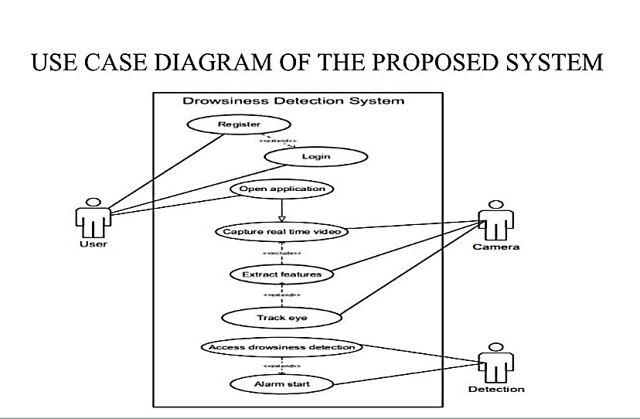
Figure 3.2 Use case diagram of proposed system

The diagram above represents the use case of the proposed drowsiness detection system. It presents two key players (User and the System Components (Camera and Detection Module). The user registers, logs in, and opens the app through which the system detects real-time video, extraction of facial features, analysis of the motion of eyes, and detection of drowsiness. A drowsiness alarm is employed in case it is detected that the user is getting drowsy.
窗体底端
3.7.2 Activity Diagram of the Proposed System
UML- An Activity Diagram displays the dynamic flow of operation within a system. It assists in making sense of how the system reacts to actions as time passes by. In the case of the proposed Real-Time Driver Drowsiness Detection System, the flow chart would be presented of how the process will occur once the driver engages the system. After gaining entry, the system turns the camera on and starts streaming the live video in which facial features of the driver are analyzed in real-time to identify symptoms of drowsiness, e.g. when the eyes are closed or the driver is yawning.
In the event drowsiness is sensed, an alert is soundly activated on the system. Otherwise, it keeps on monitoring. In this diagram, the consecutive actions that facilitate ongoing and quick detection in driving are highlighted to facilitate safer driving.
Activity diagram of the proposed system
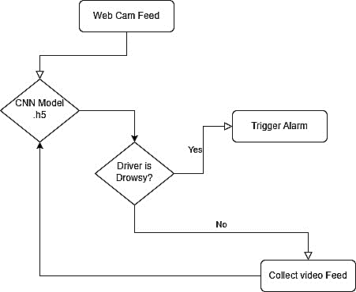
Figure 3.2 Activity diagram of the proposed system
The activity diagram of the drowsiness detection system starts with the webcam recording the live video imagery of the driver. Images of each frame in the video are subsequently fed into the CNN model (model.h5) which will then analyze facial details, especially eyes and head movement. The model verifies the presence of drowsiness in the driver depending on the patterns observed. If the system identifies that the driver is fatigued, it forces an alarm to sound instantly. In the case where no drowsiness is identified, the system will still record and analyze the video frames in real time and the activity will repeat itself making sure that there are no interruptions during a period of observation.
3.7.3 Class Diagram of the Proposed System
The proposed real-time driver drowsiness detection system class diagram is shown in this section. A UML class diagram is a graphical representation of how the system should be organised in terms of main classes, their properties, functions, and connections with each other. In the case of this system, CameraModule, VideoProcessor, DrowsinessDetector, AlertSystem, and UserInterface will be some of the important classes. Each class has its role to fulfil, e.g. the DrowsinessDetector class performs analysis of video frames employing the CNN model, whereas the AlertSystem will issue warning signals in case the drowsiness is identified. These classes communicate with each other to make the data flow fluidly between the videotape input to the real-time alerts, and offer a clean, and maintainable system design.

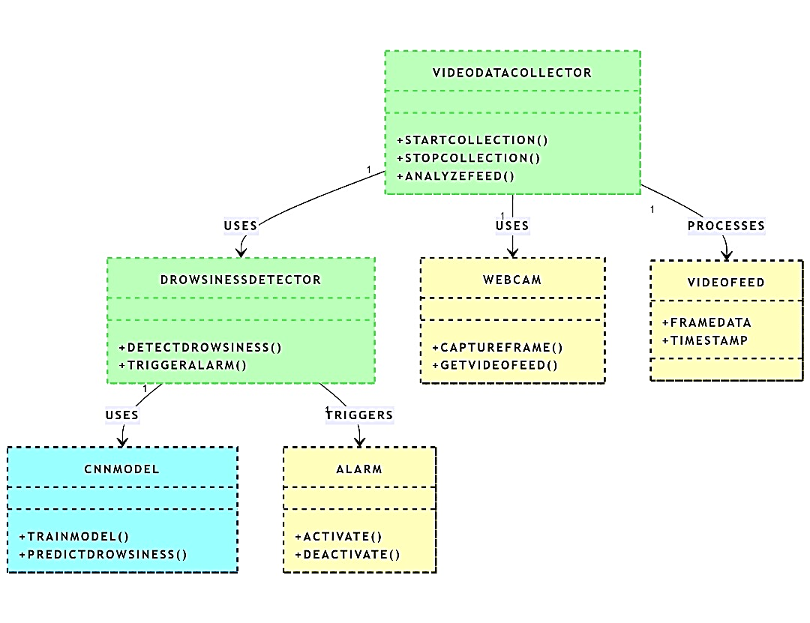
Figure 3.3 Class diagram of the proposed system

The diagram illustrates how a real-time drowsiness detection system works with various linked components. The VideoDataCollector will initiate and terminate the video recording process with the use of VideoDataCollector because this option is true in the Webcam, which is recording live video frames. These frames are analyzed as VideoFeed data that are stamped. The DrowsinessDetector uses CNNModel to check the video feed whether the person is drowsy and in that case rings the Alarm to alert the person. Such an installation will enable the system to feel and react to drowsiness in real time effectively.
3.7.4 UML Sequence Diagram
The UML sequence chart of the real-time drowsiness detection system can be seen as a dynamic visual aid that demonstrates the interaction of various elements of the system with each other as time evolves. It takes a record of how actions and messages flow between the involved objects, and provides a clear image of how the system functions stepwise. This comes in especially well in the determination of how the system identifies the time of drowsiness and reacts to it in real time.
Under this model, the start of the process is initiated by the VideoDataCollector by opening the webcam. The webcam would then continuously capture video frames and send the same as a VideoFeed. This feed is transferred to the DrowsinessDetector which processes the video frames through a CNN model to predict possible indications of drowsiness. In case drowsiness is observed, the DrowsinessDetector relay is signalled to activate the Alarm thus alerting the user.
Important aspects of the sequence diagram of this process comprise lifelines (representing every object such as VideoDataCollector, Webcam, DrowsinessDetector, CNNModel, and Alarm) messages (representing startCollection, captureFrame, analyseFeed, predictDrowsiness, activateAlarm), and activations (one would see how long each component has been active during the interaction). This timeline view gives a greater business clarity to the workings of the system not only indicating what is happening but also when.
Overall, the sequence diagram helps bridge the gap between technical developers and non-technical stakeholders by presenting the system behavior in a simple, visual format. It encourages collaboration, enhances understanding, and helps identify areas that may need improvement in the future.
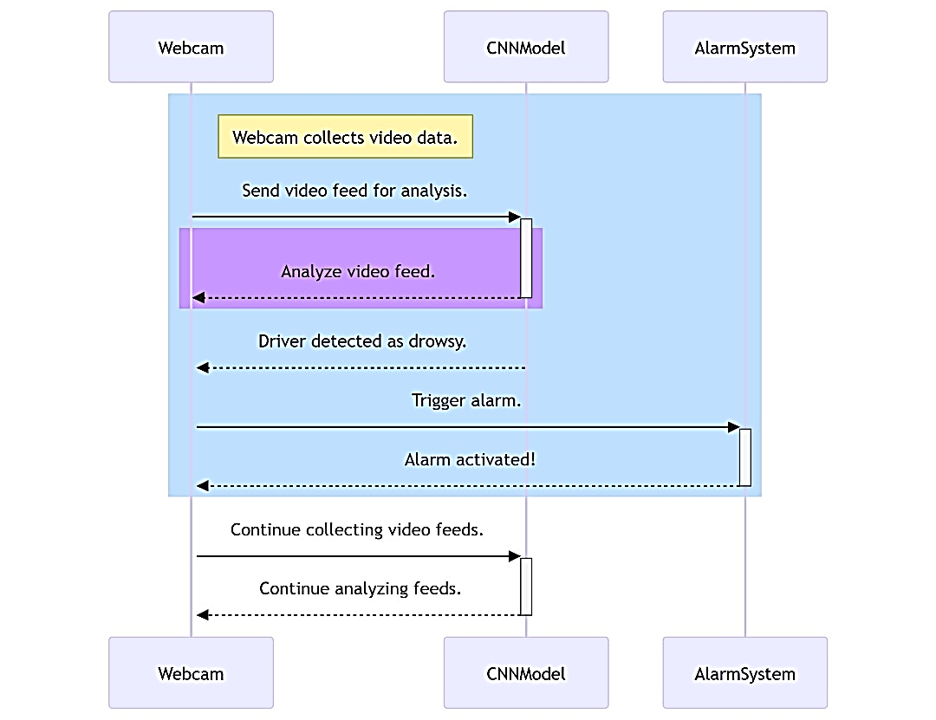
Figure 3.4 UML Sequence diagram of the proposed system

The above UML sequence diagram illustrates how the real-time drowsiness detection system operates. It shows the step-by-step interaction between components—starting with the Webcam capturing live video, which is analyzed by the CNNModel to detect signs of drowsiness. If drowsiness is detected, the AlarmSystem is triggered to alert the user. This visual sequence offers a clear understanding of how the system functions over time and serves as a guide for future development or enhancements.

3.8 System Design
System components operate according to a modular architecture because each operational step receives dedicated processing from separate components. The system becomes more manageable and capable of advancements due to this design.
3.8.1 Key design decisions:
A single camera placed on the front of the devices supports both budget and user experience requirements.
The system includes a lightweight facial recognition model that promotes time-sensitive face detection.
The system adopts deep learning methods to enhance detection accuracy for detecting slow blinks and yawning manifestations.
Continuing Behavior Monitoring through LSTM sequences replaces independent frame measurements with time-based inspection.
3.9 Database Design for the Proposed System
The database design for the drowsiness detection system provides a clear structure of how data will be stored and managed. It outlines the essential tables and relationships within the system. This relational database was designed and implemented using MySQL, with entities representing key components like users, video logs, and detection results. Each table contains attributes relevant to its entity, helping to ensure data integrity and efficient retrieval.

Database schema for the proposed system
Table 4.1 User table for the proposed system
Attribute | Data Type | Description
user_id | INT | Unique identifier for each user
full_name | VARCHAR | Full name of the user
email | VARCHAR | Email address used for login and notifications
password | VARCHAR | Hashed password for secure authentication
role | ENUM | Defines whether the user is a driver or an admin
registered_at | TIMESTAMP | Date and time when the user account was created

CHAPTER FOUR
SYSTEM IMPLEMENTATION
4.1 Overview
This chapter centers on the design ideas, implementation, and system development veiled in earlier sections of the project. To initiate the system development process, the researcher first described the system and its requirements, building on the precised top-down analysis of similar existing systems discussed formerly. Many tools were utilized during this phase, but only after they were mindfully selected , tested, and evaluated for suitability. While this chapter mostly outlines how the system works and shows the user interfaces for different components, this chapter also looks into other important aspects of the system.
4.2 Tools used for Implementation

4.2.1 Frontend Tool

PyQt5: it is a Python library that links Python to the Qt framework, enabling developers to create rich, responsive desktop applications with widgets, layouts, and event-driven designs.PyQt5 is applied to design the interface of the system, involving the welcome screen and detection screen. It offers buttons like “Start Detection” and displays live webcam footage. It makes sure that users can collaborate with the system in a simple and visually structured way.

4.2.2 Backend Tools
Python is a high-level, easy to use programming language established for its simplicity and aids for multiple fields like AI, data science, and automation. It is the crucial programming language for the intact system. It binds together all components—from facial detection to GUI presenting and deals with system logic, condition checks, and event control.
OpenCV is an open-source computer vision library that supplies tools for image and video secure, processing, and object detection.It captures live video from the webcam and derives frames. These frames are then prepared to detect and monitors the user’s face, eyes, and mouth in real time.
MediaPipe is a multi-platform library by Google giving fast machine-learning-powered remedies for real-time hand, face, and pose detection. It processes each webcam frame to detect facial distinctive features such as eyelids and lips. These are applied to calculate eye openness and mouth movements, which are key symptoms of drowsiness.
NumPy is a Python library for numerical computing that enables efficient array handling and mathematical processes on large datasets.It supports fast estimations like measuring distances between facial landmarks and helps in frame-by-frame analysis of blink and yawn events.

Ultralytics YOLO (You Only Look Once) is a rapid object detection model capable of locating multiple objects in a single frame with impressive accuracy. It can be optionally integrated to speed up or enhance accuracy in detecting faces and eyes before further processing by MediaPipe.
win-sound is a Python module obtainable on Windows systems that permits the program to play simple beeping sounds.win-sound creates an alert beep whenever prolonged eye closure or repeated yawns are detected, alarm the user to stay alert.

Queue and Threading: These are baseline Python modules that permits developers to run tasks coincidentally using multiple threads and manage data securely across them.They ensure that the GUI abides responsive while the video is being processed. Video capture and sound alerts run in the background without solidifying the interface.

Time module: The time module is an embedded Python library used to work with timed operations such as sleeping, delays, and time tracking.
It monitors how long the user’s eyes remain closed or how long a yawn lasts, which helps the system differentiates between normal blinks and microsleep episodes.

Custom Python Logic:This is the peerless code written by the developer to operate the behavior analysis, decision-making, and flow control of the system.
Custom logic elucidates facial landmark data, sustains counters for detected events, utilizes thresholds, and decides when to trigger drowsiness alerts.

4.2.3 Other Specialized Tools

Eye Aspect Ratio (EAR): EAR is a formula that calculates the ratio of distances dividing eye landmarks to discover eye openness. The system uses EAR to discern when the eyes are blinking or staying closed for too long, which could signify drowsiness or microsleep.

Lip Distance Measurement: This evaluates the vertical distance between the upper and lower lips using facial landmarks.
If the distance overtakes a set threshold, the system renders it as a yawn, one of the key tokens of fatigue.

Threshold & Counter Logic: Thresholds explains limits for event recognition (e.g., how many blinks per minute), and counters compute the frequency of those events. The system counts how frequently blinks, yawns, or microsleeps occur and equates these to thresholds. If the count exceeds the limit, drowsiness is verified and a warning is triggered.
4.3 System Requirements
The proposed drowsiness detection system is created to be slender and easy to operate, making it avaliable for individual users and organizations alike. Since it is essentially a desktop-based application, it is purposed to run locally on a user’s machine but can be enlarged and hosted on a web server in the future if needed. However, to use the system efficiently, users are expected to meet some basic requirements. These requirements assure smooth performance and compatibility beyond many platforms. The system requirements are as follows:
- A good laptop that is durable with any functioning operating system of Windows Linux, or Mac OS.
- Python version 3.10.8 and above
Install Open-CV library for video capture and image processing tasks.
- Proper installation of threading and queue modules to certify smooth system performance.
- Real-time face input to simulate or test drowsiness detection functionality.
4.4 User Interface of the Proposed System
This section of the research is focused on the design of the different user interfaces that make up the proposed system. It involves the layout for inputting input parameters into the system, as well as the design of the output interface where results and feedback are shown.
4.4.1. The Home (Input) screen of the proposed system
This page is the initiating interface of the Driver Drowsiness Detection System, developed using PyQt5. It supplies a simple layout with a title, description, and a “Start Detection” button. When the user clicks the button, PyQt5 handles the event by converting the screen to the main detection interface. At this stage, no detection arises yet—the page simply performs to introduce the system and wait for user interaction to start the drowsiness monitoring process.
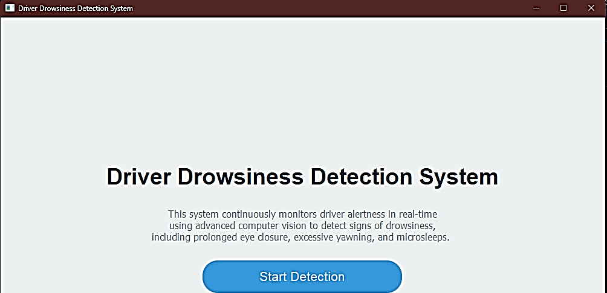
Figure 4.1 The Home (Input) screen of the proposed system

4.2 Output Screen of the Proposed System:
In this detection interface, many tools work together to track and analyze the driver's face in actual time. PyQt5 operates the layout and user interface, exhibiting the video feed and driver status metrics. OpenCV secures frames from the webcam, while MediaPipe detects and pursues facial landmarks, uniquely the eyes and mouth. Python logic and NumPy are applied to calculate the Eye Aspect Ratio (EAR) and lip distances for blink, yawn, and microsleep detection. The system logic equates these values against default thresholds, and when drowsiness is detected, alerts like “ALERT! DROWSINESS DETECTED” are displayed on-screen. The winsound module initiates audible alerts if enabled, while the GUI updates constantly using threading to keep all elements responsive
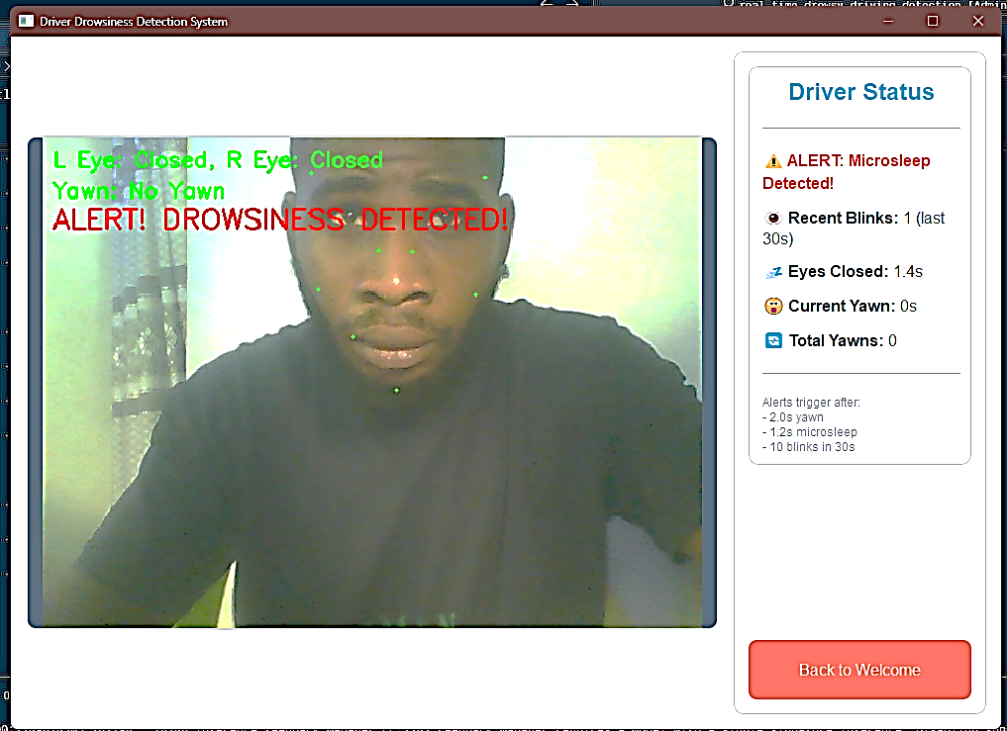
Figure 4.2 The output screen of the proposed system

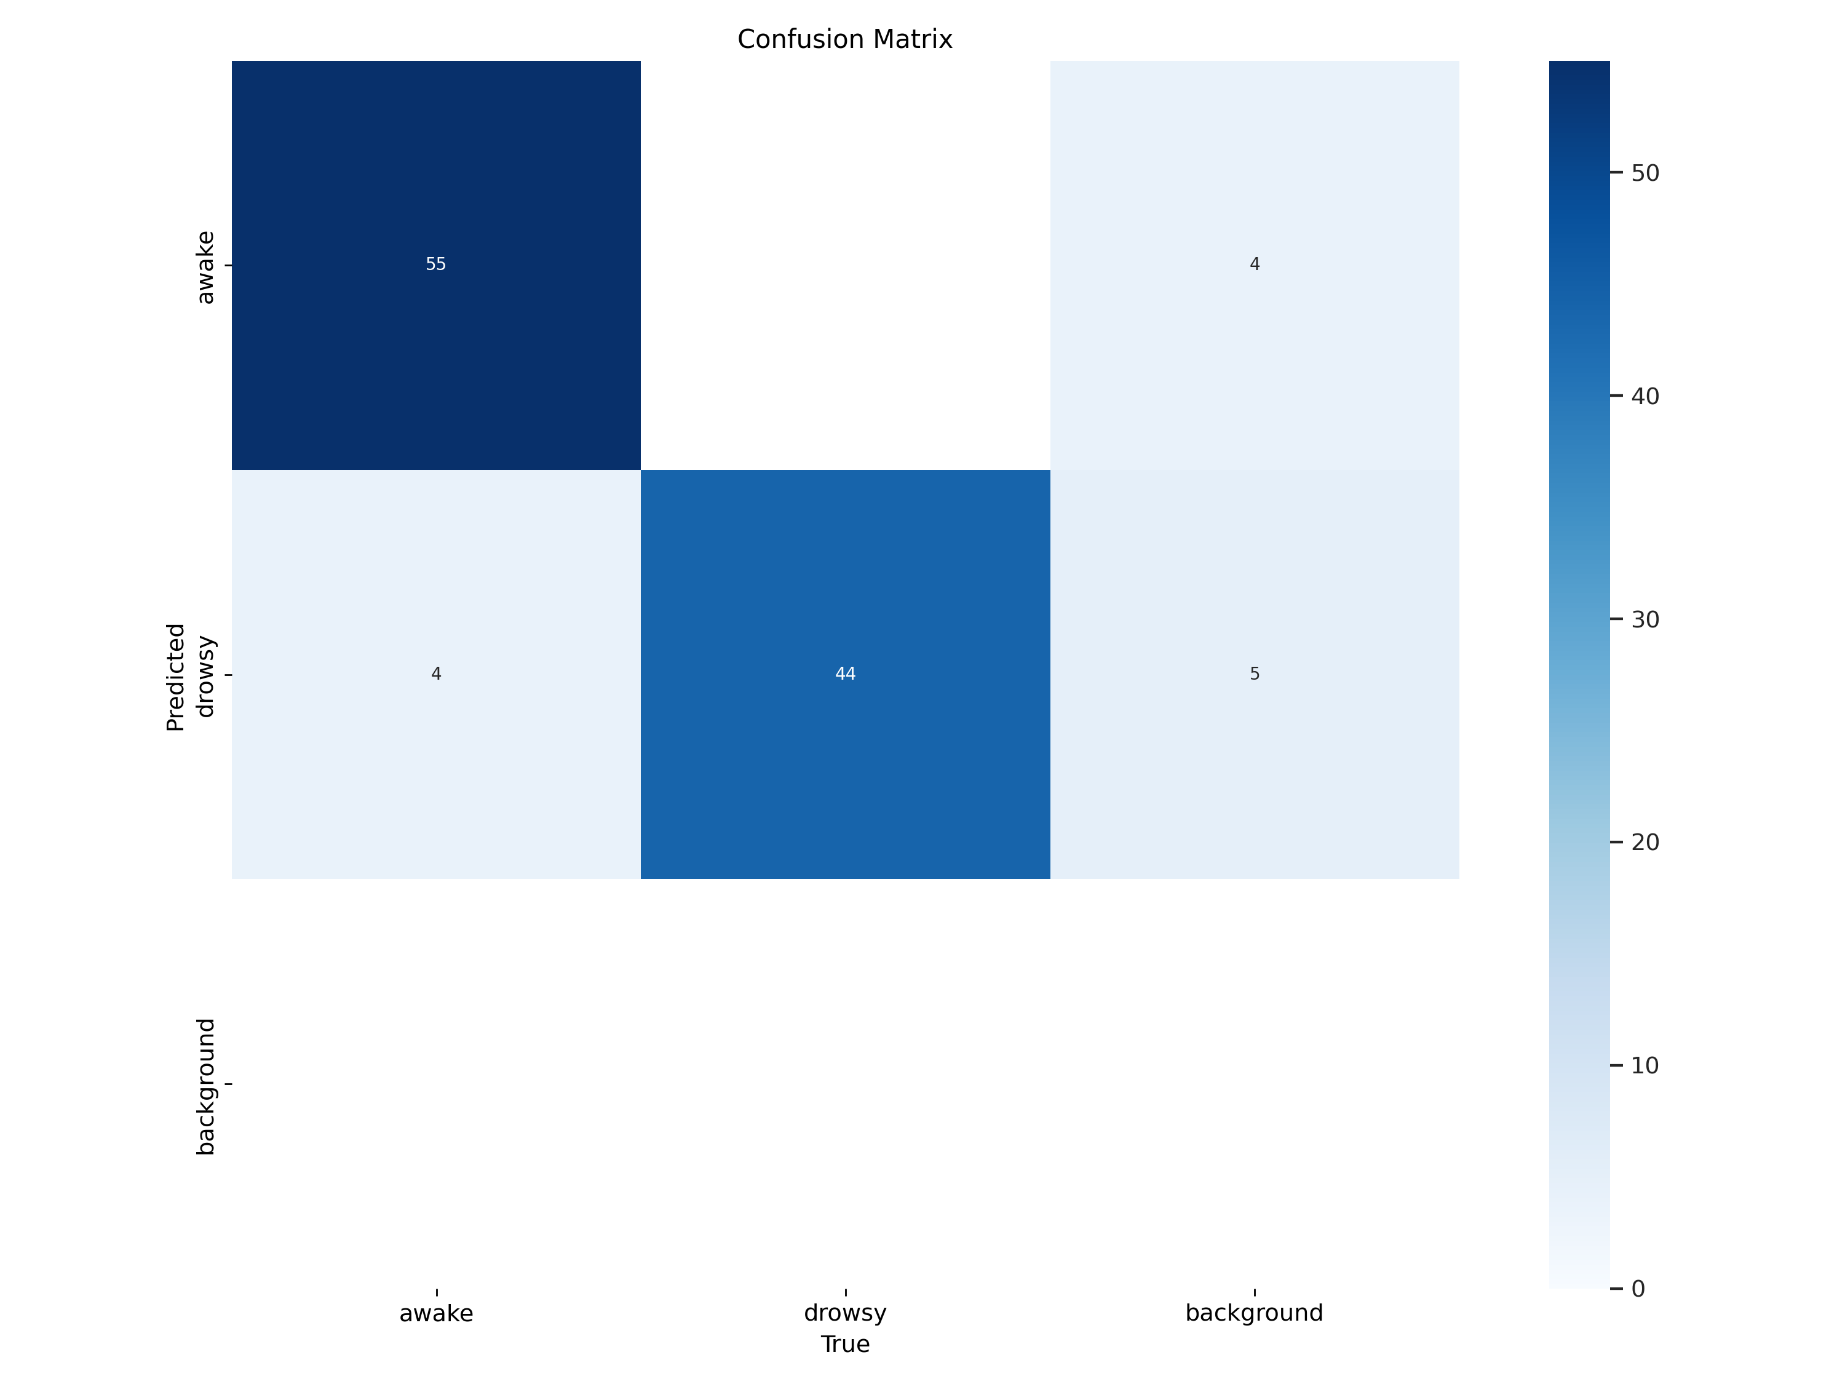
Figure 4.3 The validation matrix
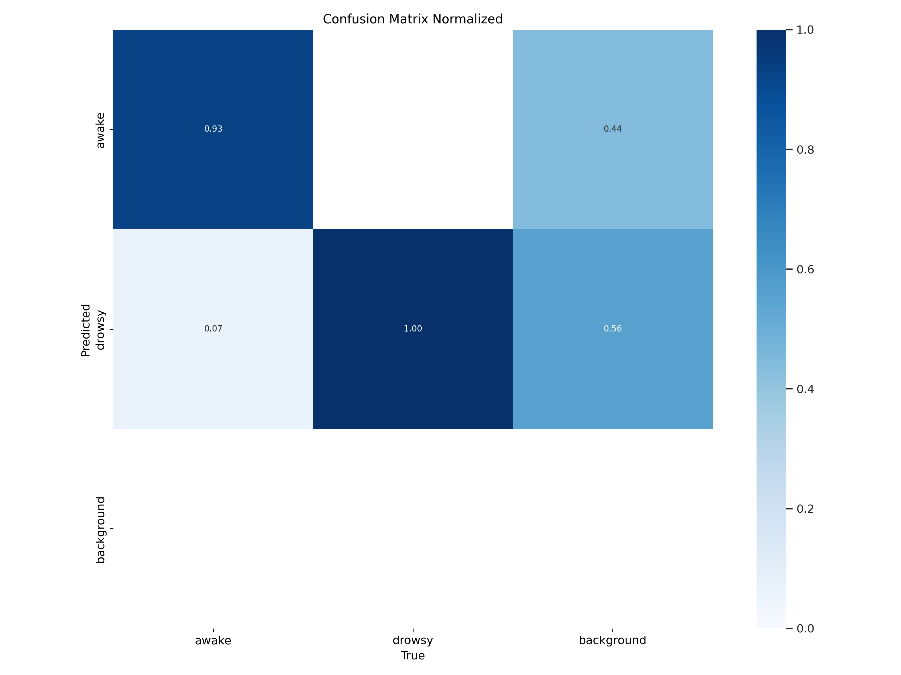
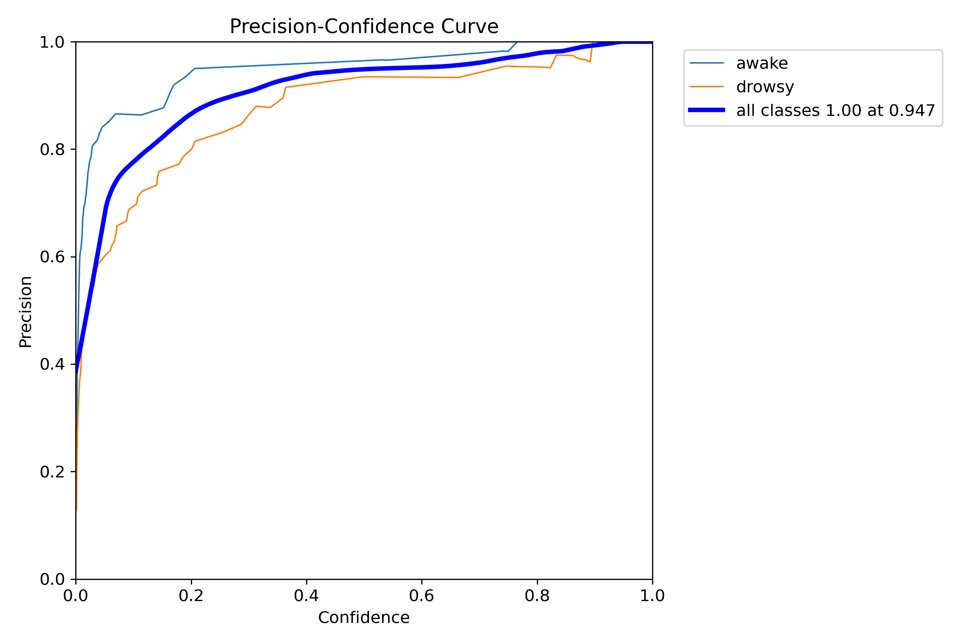
Figure 4.4 The validation matrix
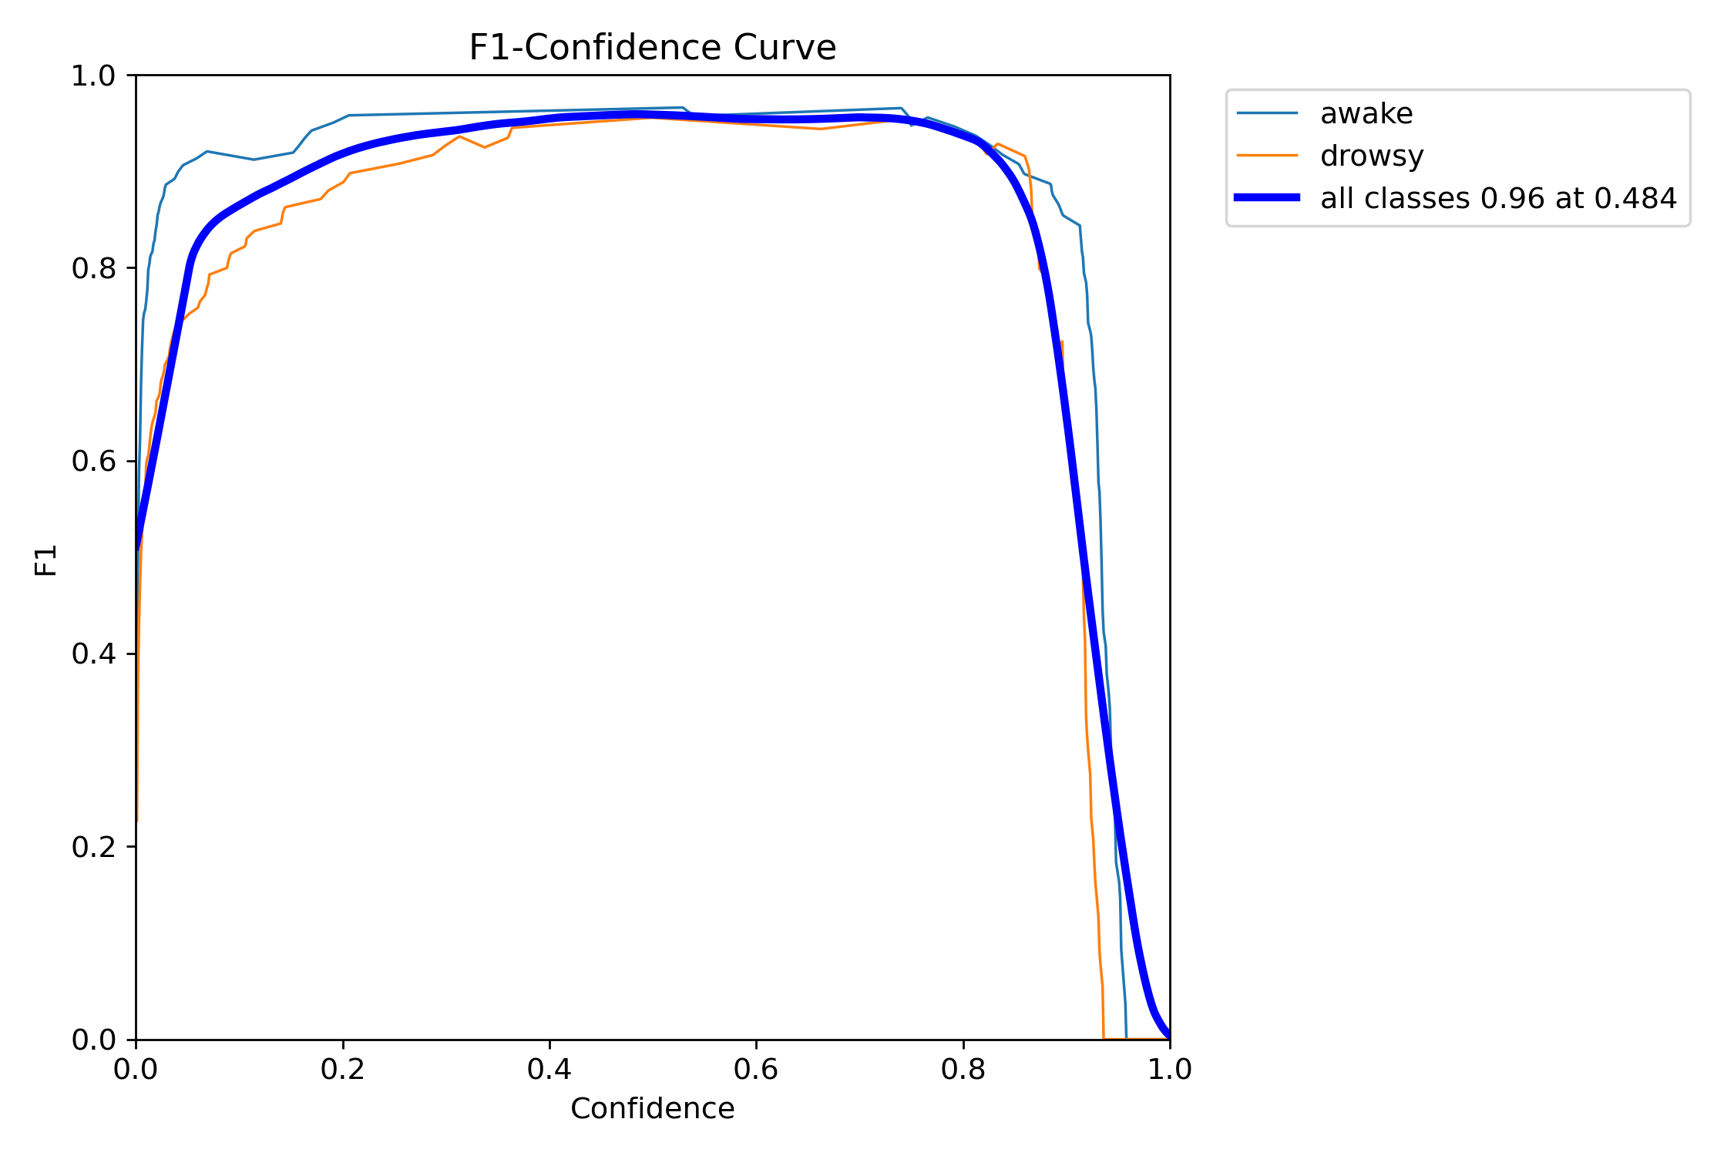
Figure 4.5 The F1-confidence

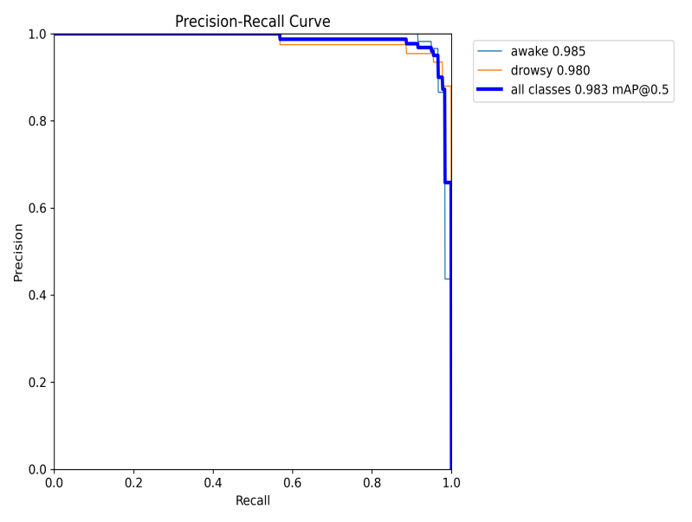 Figure 4.6 The precision-recall
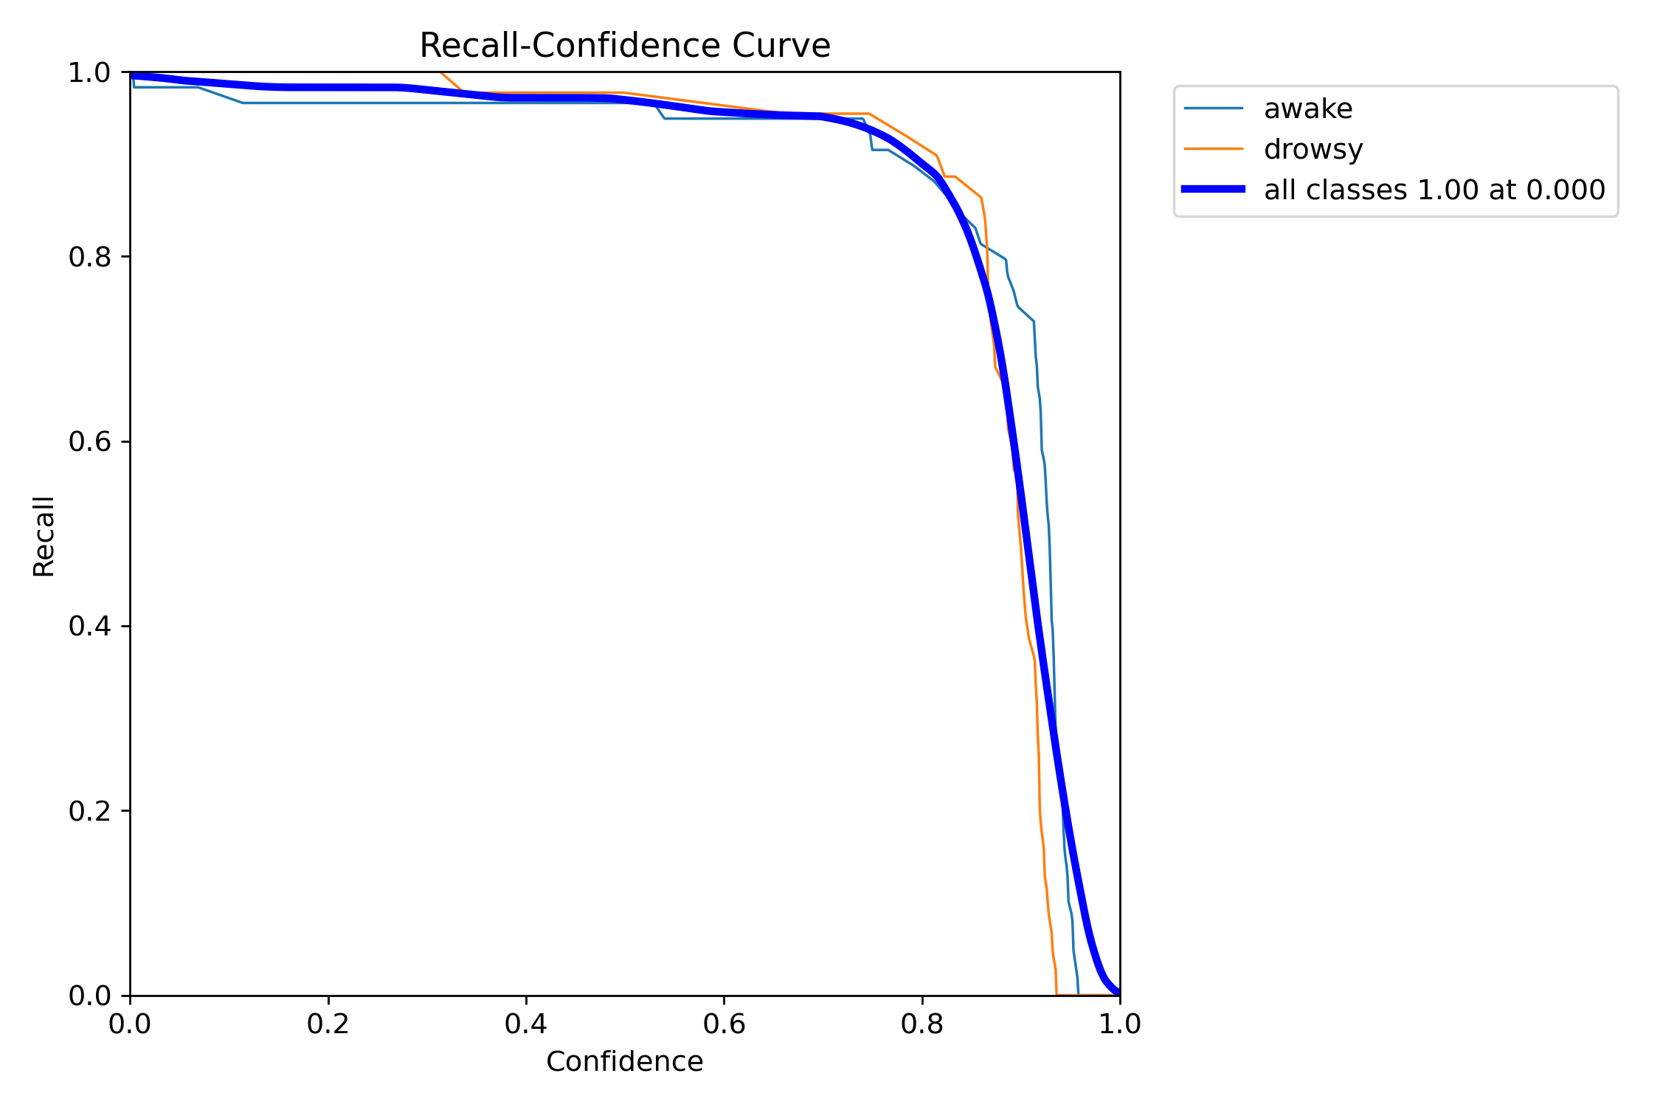
Figure 4.3 The recall-confidence

CHAPTER FIVE
SUMMARY, RECOMMENDATIONS, AND CONCLUSION
5.1 Overview
This chapter presents together and summarizes all the key points reviewed in the prior chapters of the project. It presents a clear and extensive conclusion to the research, supplies recommendations for future studies in this area, and bundles up the whole work with final thoughts from the researcher.
5.2 Summary
The problem statement connected to this research project and the background of the study were clearly summarized and discussed at the inception, establishing the need for an effective and smart drowsiness detection system. The following chapters delved into the theoretical underpinnings of computer vision and machine learning as they relate to immediate human behavior monitoring, along with a comprehensive review of similar systems previously developed and now in use. This research work also crucially analyzed existing solutions, identifying their limitations and using those gaps as a foundation for developing a more reliable and responsive system. In Chapter Three of this study, a detailed system design was executed, where system architecture and workflow were stated clearly to show how the system functions from initialization to alert generation different backend technologies such as Python, OpenCV, MediaPipe, NumPy, and threading were completely explored to handle logic, detection, and image processing, while PyQt5 was applied to design a user-friendly graphical interface. Finally, the programming tools, frameworks, and utility functions engaged were carefully selected, implemented, and evaluated to make sure the system meets its goal of preventing fatigue-related incidents efficiently.

5.3 Recommendation
This drowsiness detection system is extremely recommended for drivers, transportation companies, and safety-crutial organizations intending to reduce fatigue-related accidents. It acts as a smart and automated approach to identifying early signs of driver drowsiness by analyzing facial cues such as prolonged eye closure, yawning, and microsleep episodes. This system, developed with real-time computer vision and machine learning tools, excludes the need for manual monitoring by constantly observing the user through webcam input. Whether for individual use or fleet management, it offers a timely alert system to prevent potentially dangerous outcomes. It is particularly useful for long-distance drivers or night-shift workers where fatigue is common, offering a preventive solution before accidents occur.
5.4 Conclusion
This section of the research work stands to accomplish the objectives that were established at the beginning of this study. We have now gotten to the conclusion part of this research process. However, this is not the final phase of the drowsiness detection system; rather, it labels the beginning of further enhancement and expansions. Future versions may involve advanced monitoring features, mobile support, cloud integration, and personalized applied settings to improve usability and accuracy. As a result, the proposed system is not stagnant but will evolve with more innovations to better serve its purpose. Moreover, the system developed within the finite scope of this study has been implemented to achieve its primary goal detecting driver fatigue and gathering timely alerts. It has been successfully developed using Python, OpenCV, MediaPipe, and PyQt5, and can be deployed on local machines for immediate use. In summary, users are urged to meet all system requirements, like having a functional webcam and compatible OS, to assure smooth operation of the application.

REFERENCES
Abtahi, S., Omidyeganeh, M., Shirmohammadi, S., & Hariri, B. (2014). Yawning detection using embedded smart cameras. IEEE Transactions on Instrumentation and Measurement, 63(7), 1842–1854. https://doi.org/10.1109/TIM.2014.2308351
Ahmed, M., Ali, M., & Chowdhury, M. (2023). Comparative analysis of YOLOv5 and EfficientDet for eye closure detection in driver fatigue monitoring. Procedia Computer Science, 219, 471–478. https://doi.org/10.1016/j.procs.2023.01.087
Akbar, F., Zulkefly, N. S., & Omar, F. (2022). Examining driver alertness as a mediator between work fatigue and driver behaviours among Malaysian drivers. International Journal of Research and Innovation in Social Science (IJRISS), 6(8), 683–688. https://doi.org/10.47772/IJRISS.2022.6808
Alotaibi, Y., & Alotaibi, B. (2020). Real-time drowsiness detection system using facial features. International Journal of Advanced Computer Science and Applications, 11(5), 123–129. https://doi.org/10.14569/IJACSA.2020.0110516
Alvarez, R., Cabrera, F., & Vega, M. (2020). Multi-task deep learning for driver behavior analysis: Drowsiness, distraction, and emotion. Neurocomputing, 400, 122–135. https://doi.org/10.1016/j.neucom.2019.02.065
Bergasa, L. M., Nuevo, J., Sotelo, M. A., Barea, R., & López, M. E. (2006). Real-time system for monitoring driver vigilance. IEEE Transactions on Intelligent Transportation Systems, 7(1), 63–77. https://doi.org/10.1109/TITS.2006.869598
Chen, T., Liu, Z., & Li, Y. (2022). Video-based driver drowsiness detection using temporal fusion transformers. IEEE Access, 10, 43750–43762. https://doi.org/10.1109/ACCESS.2022.3169275
Cui, Y., Wang, L., & Liu, Y. (2021). Lightweight CNN for driver drowsiness detection from EEG signals. arXiv preprint arXiv:2106.00613. https://arxiv.org/abs/2106.00613
Dong, Y., Hu, Z., Uchimura, K., & Murayama, N. (2011). Driver inattention monitoring system for intelligent vehicles: A review. IEEE Transactions on Intelligent Transportation Systems, 12(2), 596–614. https://doi.org/10.1109/TITS.2010.2092770
Ghanta, K., Subramaniam, G., & Reddy, M. (2022). YOLOv5 and Vision Transformer-based drowsiness detection. arXiv preprint arXiv:2209.01401. https://arxiv.org/abs/2209.01401
Jap, B. T., Lal, S., Fischer, P., & Bekiaris, E. (2009). Using EEG spectral components to assess algorithms for detecting fatigue. Expert Systems with Applications, 36(2), 2352–2359. https://doi.org/10.1016/j.eswa.2007.12.043
Jha, S., Kumar, V., & Sharma, P. (2020). Hybrid CNN-LSTM model for driver drowsiness detection using facial features. International Journal of Image and Graphics, 20(3), 2050022. https://doi.org/10.1142/S0219467820500222
Ji, Q., Zhu, Z., & Lan, P. (2004). Real-time nonintrusive monitoring and prediction of driver fatigue. IEEE Transactions on Vehicular Technology, 53(4), 1052–1068. https://doi.org/10.1109/TVT.2004.830974
Jose, J. V., Krishnan, N. N., & Sajeev, S. (2022). SleepyWheels: Real-time lightweight driver drowsiness detection system. arXiv preprint arXiv:2211.00718. https://arxiv.org/abs/2211.00718
Lal, S. K. L., & Craig, A. (2001). A critical review of the psychophysiology of driver fatigue. Biological Psychology, 55(3), 173–194. https://doi.org/10.1016/S0301-0511(00)00085-5
Lee, D. H., Choi, J. Y., Kim, J. H., & Han, S. H. (2020). Impact of sleep disorders on driving performance: A study based on real-driving tests and driving simulators. Transportation Research Part F: Traffic Psychology and Behaviour, 74, 207–216. https://doi.org/10.1016/j.trf.2020.08.017
Li, H., Zhang, X., & Yang, B. (2022). EEG-based driver fatigue detection using signal decomposition and ensemble CNN. arXiv preprint arXiv:2203.09477. https://arxiv.org/abs/2203.09477
Mansfield, N., Maeda, S., & Satou, T. (2023). The effects of whole-body vibration on driver fatigue and performance. Applied Acoustics, 213, 109351. https://doi.org/10.1016/j.apacoust.2023.109351
MDPI Sensors. (2023). Performance evaluation of CNN and hybrid CNN-RNN architectures for driver fatigue detection. Sensors, 23(21), 8741. https://doi.org/10.3390/s23218741
Mollahosseini, A., Hasani, B., & Mahoor, M. H. (2016). AffectNet: A database for facial expression, valence, and arousal computing in the wild. IEEE Transactions on Affective Computing, 10(1), 18–31. https://doi.org/10.1109/TAFFC.2017.2740923
Murali, A., Ravindran, V., & Karthikeyan, G. (2024). Driver Drowsiness Detection Using YOLO. In Proceedings of the International Conference on Advanced Computing & Communication Systems (ICACCS). https://www.researchgate.net/publication/385189408_Driver_Drowsiness_Detection_Using_YOLO
National Highway Traffic Safety Administration. (2017). Drowsy driving. U.S. Department of Transportation. https://www.nhtsa.gov/risky-driving/drowsy-driving
National Highway Traffic Safety Administration. (2022). Drowsy driving. https://www.nhtsa.gov/risky-driving/drowsy-driving
Park, S., Lee, J., Kim, J., & Sohn, K. (2016). Driver drowsiness detection system based on feature representation learning using various deep networks. In 2016 IEEE International Conference on Image Processing (ICIP) (pp. 2549–2553). IEEE. https://doi.org/10.1109/ICIP.2016.7532815
PLOS ONE. (2024). Illumination-aware deep learning framework for drowsiness detection in low-light driving conditions. PLOS ONE, 19(8), e0287123. https://doi.org/10.1371/journal.pone.0287123
Poudel, G. R., Riedel, M. C., Eickhoff, S. B., & Breakspear, M. (2018). Microsleeps disrupt neural processing during a sustained attention task. Frontiers in Human Neuroscience, 12, 191. https://doi.org/10.3389/fnhum.2018.00191
Rasdi, R. M., Omar, A., Abu Bakar, A. Z., & Aziz, A. A. (2021). Fatigue and the risk of road traffic crashes among commercial vehicle drivers in Malaysia. International Journal of Environmental Research and Public Health, 18(19), 10325. https://doi.org/10.3390/ijerph181910325
Roy, S., Saha, S., & Paul, S. (2021). Real-time CNN-based drowsiness detection optimized for embedded systems. Procedia Computer Science, 192, 546–553. https://doi.org/10.1016/j.procs.2021.08.056
Schmidt, E. A., Schrauf, M., Simon, M., Fritzsche, M., Buchner, A., & Kincses, W. E. (2018). Drivers’ mental fatigue and their impact on speed variability in monotonous driving. Frontiers in Psychology, 9, 459. https://doi.org/10.3389/fpsyg.2018.00459
Vicente, J., Laguna, P., Bartra, A., & Bailón, R. (2016). Drowsiness detection using heart rate variability. Medical & Biological Engineering & Computing, 54(6), 927–937. https://doi.org/10.1007/s11517-015-1448-7
Wang, Y., Zhang, W., & Wu, X. (2018). EEG-based driver drowsiness detection using convolutional neural networks. Cognitive Neurodynamics, 12(2), 121–133. https://doi.org/10.1007/s11571-017-9464-5
World Health Organization. (2023). Global status report on road safety 2023. https://www.who.int/publications/i/item/9789240070011
Zhang, J., Zheng, N., & Xu, H. (2019). Multimodal fusion-based real-time driver drowsiness detection using facial video and vehicle data. IEEE Transactions on Intelligent Transportation Systems, 20(12), 4675–4686. https://doi.org/10.1109/TITS.2019.2895391
Zhao, C., Zheng, C., & Zhao, M. (2012). Multimodal fusion of EEG and EOG for assessing driver vigilance. Journal of Medical Systems, 36(5), 2833–2842. https://doi.org/10.1007/s10916-011-9774-8

APPENDIX
from time import time
import os
import cv2
import numpy as np
from PIL import Image
from typing import Tuple, Any
from GroundingDINO.groundingdino.util.inference import load_model, load_image, predict, annotate
import GroundingDINO.groundingdino.datasets.transforms as T
from database.read_database import ReadImages
class AutoLabellingObjectDetect:
def __init__(self):
self.data = ReadImages()

self.cont: int = 0
self.num_images: int = 0
self.class_id: int = 0

self.box_threshold: float = 0.25
self.text_threshold: float = 0.25

self.out_image_path: str = 'datasets/images/val'
self.out_txt_path: str = 'datasets/labels/val'
self.prompt: str = 'eye'
self.home: str = os.getcwd()

self.save: bool = True
self.draw: bool = False

self.images: list = []
self.names: list = []
self.bbox_info: list = []

def save_data(self, image_copy: np.ndarray, list_info: list):
timeNow = time()
timeNow = str(timeNow)
timeNow = timeNow.split('.')
timeNow = timeNow[0] + timeNow[1]
cv2.imwrite(f"{self.out_image_path}/{timeNow}.jpg", image_copy)
for info in list_info:
f = open(f"{self.out_txt_path}/{timeNow}.txt", 'a')
f.write(info)
f.close()

def config_grounding_model(self) -> Any:
config_path = os.path.join(self.home, "GroundingDINO/groundingdino/config/GroundingDINO_SwinT_OGC.py")
check_point_path = 'GroundingDINO/weights/groundingdino_swint_ogc.pth'
model =load_model(config_path, check_point_path, device="cuda")
return model

def main(self):
self.images, self.names = self.data.read_images('C:\\Utils\\Real_time_drowsy_driving_detection\\database\\open_eyes\\val')
self.num_images = len(self.images)
grounding_model = self.config_grounding_model()

# Crear los directorios si no existen
if not os.path.exists(self.out_image_path):
os.makedirs(self.out_image_path)
if not os.path.exists(self.out_txt_path):
os.makedirs(self.out_txt_path)

while self.cont < self.num_images:
self.bbox_info = []
print('------------------------------------')
print(f'name_image: {self.names[self.cont]}')

process_image = self.images[self.cont]
copy_image = process_image.copy()
draw_image = process_image.copy()

transform = T.Compose(
[
T.RandomResize([800], max_size=1333),
T.ToTensor(),
T.Normalize([0.485, 0.456, 0.406], [0.229, 0.224, 0.225])
]
)

img_source = Image.fromarray(process_image).convert("RGB")
img_transform, _ = transform(img_source, None)

boxes, logits, phrases = predict(
model = grounding_model,
image = img_transform,
caption = self.prompt,
box_threshold = self.box_threshold,
text_threshold = self.text_threshold,
device = "cuda"
)

if len(boxes) != 0:
h, w, _ = process_image.shape
xc, yc, an, al = boxes[0][0], boxes[0][1], boxes[0][2], boxes[0][3]

# Error < 0
if xc < 0: xc = 0
if yc < 0: yc = 0
if an < 0: an = 0
if al < 0: al = 0
# Error > 1
if xc > 1: xc = 1
if yc > 1: yc = 1
if an > 1: an = 1
if al > 1: al = 1

self.bbox_info.append(f"{self.class_id} {xc} {yc} {an} {al}")
x1, y1, x2, y2 = int(xc * w), int(yc * h), int(an * w), int(al * h)
print(f"boxes: {boxes}\nxc: {x1} yc:{y1} w:{x2} h:{y2}")

if self.save:
self.save_data(copy_image, self.bbox_info)

if self.draw:
annotated_img = annotate(image_source=draw_image, boxes=boxes, logits=logits, phrases=phrases)
out_frame = cv2.cvtColor(annotated_img, cv2.COLOR_BGR2RGB)
cv2.imshow('Grounding DINO detect', out_frame)
cv2.waitKey(0)

self.cont += 1
auto_labeling = AutoLabellingObjectDetect()
auto_labeling.main()

