ACCIDENT RISK DETECTION MODEL FOR ENUGU ROADS

BY

ANIAKOR MAXWELL KOSISOCHUKWU
GOU/U22/CSC/838

DEPARTMENT OF COMPUTER SCIENCE AND MATHEMATICS,
FACULTY OF NATURAL SCIENCES AND ENVIRONMENTAL STUDIES,
GODFREY OKOYE UNIVERSITY, ENUGU STATE. IN PARTIAL
FULFILLMENT OF THE AWARD OF BACHELOR OF SCIENCE (B.SC), DEGREE IN COMPUTER SCIENCE.

SUPERVISOR: MR. CAMILLUS NJOKU

JUNE, 2025.

APPROVAL PAGE
This research, titled “Accident Risk Detection Model for Enugu Roads,” has been assessed and approved by the Committees of the Department of Computer Science and Mathematics in the Faculty of Natural Sciences and Environmental Studies, Godfrey Okoye University, Enugu, Nigeria.

MR. CAMILLUS NJOKU ................................... |  | ..................................
Supervisor | Signature | Date
External Examiner | ................................... | ..................................
External Examiner | Signature | Date
Dr. Frank Okebanama | ................................... | ..................................
HOD, Department of  Computer Science and  Mathematics | Signature | Date
Prof. Chidi.C. Uhuegbu | ................................... | ..................................
Dean, FNESS | Signature | Date

CERTIFICATION
I certify that I completed the research included therein and that it was primarily based on my observations and investigation. Consequently, I will fully accept the University's decision if I am found to have cheated on the assignment.

________________________
ANIAKOR MAXWELL KOSISOCHUKWU GOU/U22/CSC/838

DEDICATION
This project, “ACCIDENT RISK DETECTION MODEL FOR ENUGU ROADS,” is dedicated to God Almighty, whose grace, wisdom, and unending love guided me every step of the way.

ACKNOWLEDGEMENT
I give all glory and thanks to God Almighty for His unwavering grace and strength throughout this journey, without Him, none of this would have been possible.

I am sincerely grateful to my supervisor, Mr. Camillus Njoku, for his guidance, patience, and commitment, which were crucial throughout the process.
My appreciation also goes to the Head of Department, Dr. Franklin Okebanama, for his leadership and support.
I also extend my heartfelt thanks to the entire Department of Natural and Applied Science, and to all the lecturers who have contributed to my academic growth over the years.
The Faculty of Natural and Applied Sciences, Godfrey Okoye University, Enugu, has been a solid foundation for this achievement, and I am grateful to be part of it.

I deeply appreciate my beloved mother, Mrs. Ifunanya Aniakor, for her endless love, prayers, and support. Though my father, the late Mr. Obinna Aniakor, is no longer with us, his memory and values continue to inspire me every day.
To my amazing siblings, Uchenna Aniakor and Ebube Aniakor, thank you both for your constant encouragement. A special thank you to Ebube, whose generous sponsorship made a huge difference in bringing this work to completion.

To everyone, family, friends, mentors, and supporters, whose efforts, in one way or another, helped me reach this milestone, I remain truly grateful.

ABSTRACT
Road traffic accidents remain a critical public safety concern across many African countries, resulting in extensive loss of life, economic strain and social disruption. Traditional accident prevention strategies, which rely heavily on post-incident analysis, have proven insufficient in addressing the rising frequency and severity of traffic-related incidents. This study proposes a real-time accident risk detection system leveraging the YOLOv8 deep learning model trained on a custom dataset tailored to African road conditions, including underrepresented vehicles like tricycles (Keke). The dataset, derived from real-world surveillance footage, was carefully preprocessed and annotated to capture diverse vehicle types, behaviors and environmental factors. YOLOv8 was employed for object detection and behavioral analysis, while additional modules analyzed temporal patterns to predict accident-prone scenarios. Evaluation metrics demonstrated high object detection accuracy (mAP@0.5 of 86.7%) and effective accident prediction performance (overall accuracy of 84.6% and AUC of 0.89). Real-time performance testing showed a stable frame rate of 24–30 FPS with minimal latency. The system exhibited robust functionality across varying lighting, weather and traffic conditions, confirming its viability for deployment in African urban and semi-urban environments. This research highlights the transformative potential of AI-driven approaches for proactive road safety management in low-resource settings.

TABLE OF CONTENTS

Title page i Approval ii Certification iii Dedication iv Acknowledgments v Abstract vi Table of contents vii
List of tables ix
List of figures x

Chapter One: Introduction 1
1.1 Background of the Study 1
1.2 Statement of the Problem 4
1.3 Aim and Objectives 4
1.4 Significance of the Study 5
1.5 Scope of the Study 5
1.6 Limitations of the Study 6
1.7 Definition of Terms 6

Chapter Two: Literature Review 8
2.1 Overview of the accident detection and control system 8
2.2 Drowsy Driving and Accident 9
2.3 Methods for Accident Detection and Monitoring 12
2.4 History of Artificial Neural Networks (ANN) 14
2.4.1 Application of Neural Networks 15
2.4.2 Types of Neural Networks 16
2.5 Review of relevant literatures 16
2.6 Research Gap 19

Chapter Three: System Analysis and Design 23
3.1 Research Methodology 23
3.2 System Analysis 23
3.2.1 Analysis of the Existing System 24
3.2.2 Weaknesses of the Existing System 25
3.2.3 Analysis of the Proposed System 25
3.2.4 Advantages of the Proposed System 27
3.3 Data Collection 27
3.3.1 Data Description 28
3.3.2 Data Preprocessing 29
3.3.3 The Proposed YOLOv8 Algorithm 30
3.4 Proposed System Architecture 32
3.5 System Flowchart 33
3.6 Data Recording Diagram 34
3.7 System Algorithm 36
3.8 System High-Level Model 37
3.9 System UML Diagram 39
3.10 Use Case Diagram 40

Chapter Four: System implementation 42
4.1 Choice of Programming Language 42
4.1.1 Justification for the Programming Language Used 42
4.1.2 Libraries Used 42
4.2 System Requirements 43
4.3 Model Training Process 44
4.4 System Testing 46
4.4.1 Unit Testing 46
4.4.2 Integration Testing 47
4.4.3 Functionality Testing Description 47
4.4.4 User Acceptance Testing (UAT) 48
4.5 System Results 49
4.5.1 Object Detection Performance 49
4.5.2 Accident Prediction Accuracy 50
4.5.3 Real-time processing Results 50
4.5.4 Environmental Robustness 51
4.6 System Software Integration 54

Chapter five: Summary, Conclusion, and Recommendations 58
5.1 Summary of the Study 58
5.2 Conclusion 58
5.3 Recommendations 59

References 60

LIST OF TABLES

Table Pages
Table 2.4 Tabular Summary of Literature 22

LIST OF FIGURES

Figures Pages
Figure 2.1: vehicle detection system view (Ahmad et al., 2019). 9
Figure 3.1: Block Diagram of the Proposed System 26
Figure 3.2: Architecture of the YOLOv8 Model (Sohan et al., 2024) 31
Figure 3.4: Architecture of the Proposed System 32
Figure 3.5: System Flowchart 33
Figure 3.6: Data Recording and Processing Diagram 35
Figure 3.7: System High-Level Model 38
Figure 3.8: System UML Class Diagram 49
Figure 3.9: System Use Case Diagram 41
Figure 4.1: Confusion Matrix 52
Figure 4.2: ROC Curve Result 53
Figure 4.3: Frame Processing Rate Chart 54
Figure 4.4: System Interface 55
Figure 4.5: Vehicle distance analysis 56
Figure 4.6: Accident Detection Result 57

CHAPTER ONE
INTRODUCTION
  - Background of the Study
Road traffic accidents (RTAs) remain a major global concern, especially in low- and middle-income countries, where 93% of the world’s road traffic deaths occur, despite having only 60% of the world’s vehicles (World Health Organization [WHO], 2023). With 26.6 fatalities per 100,000 people, Africa has the highest road traffic mortality rate in the world (WHO, 2023). Rapid urbanisation, inadequate road infrastructure, lax traffic enforcement inadequate post-crash care all are contributing factors to the problem. Therefore, to counteract the increasing trend of accidents on African roads, creative and data-driven solutions are desperately needed.
Unluckily, on road accidents have developed to be severe civil safety issue in numerous African countries. In spite of a number of interventions throughout the years, such catastrophes continue to grow in numbers, as well as in severity. They bring a lot of devastation in terms of death, huge economic losses and ultimately long-term social consequences. This increase can be attributed to a complex maze of problems such as the lack of proper road infrastructure, a lack of proper driver education, slack implementation of the law on the road, most importantly, a near-complete lack of real-time data that is necessary that can be used to inform policy decisions. According to Odero et al. (2019), regular accident analysis methodologies and procedures, where the occurrences of accidents are usually viewed based on post-accident reports, regularly contain information that is either wrong or does not suffice. In other words, these traditional methods have been found inadequate in comprehending the complicated relations of numerous risk factors. Predictive modelling especially in the context of machine learning (ML) techniques is hence gaining popularity as a preventive corrective measure. It has the ability to anticipate the site of accidents and support the guidance of significant policy decisions that is a crucial question that the research by Xie and Lord (2019) highlights.
Machine learning techniques, it turns out, are exceptionally well-suited for accident prediction. They possess an amazing ability to process even huge and complex datasets, uncovering hidden patterns and relationships among different variables, as Yadav and Dixit (2020) noted. Unlike much older statistical models, ML algorithms like Random Forests, Support Vector Machines (SVM) and Neural Networks offer far greater flexibility. They also generalize better when dealing with data that isn't linear or boasts many dimensions, according to Abdel-Aty and Pande (2019). Their application within transportation research has already shown truly promising results, particularly in countries blessed with well-structured road and traffic data.
However, the application of machine learning to road safety in Africa, despite its immense promise, is still in its early infancy. Many African nations, sadly, lack the structured and reliable traffic datasets essential for implementing these intelligent systems, a major challenge Mfinanga et al. (2019) vividly discussed. To tackle this pressing issue, recent efforts have begun exploring alternative data sources. These include, quite interestingly, GPS data, mobile network data, satellite imagery and even crowdsourced information. All these are being used to build more representative models, as reported by Brundu et al. (2021). Consequently, this study specifically aims to harness such available data, intending to develop an effective, ML-based accident prediction model. Our model is to be specifically designed, mind you, for the unique challenges of African road conditions.
A truly critical aspect of accident prediction lies in the meticulous identification and selection of relevant features. These are the variables that genuinely contribute significantly to road crashes. What might these include? Think time of day, road geometry, existing weather conditions, driver age and experience, vehicle type and even traffic volume, as discussed by Elvik (2020). Therefore, proper feature engineering and thorough data preprocessing are absolutely essential. These steps guarantee the reliability and performance of the ML model. Yet, in the African context, feature availability can vary greatly from one region to another. This means the models we develop must be robust and adaptable to diverse data environments.
Additionally, machine learning models' prediction power is significantly increased by including temporal and geographical data. In what way? By combining ML algorithms with Geographic Information Systems (GIS), we can identify accident-prone areas with surprisingly high accuracy. As Chen and Zhang (2022) point out, time-series analysis intervenes at the same time, making it possible to identify important seasonal trends in traffic accidents. These effective strategies enable traffic authorities to implement highly focused interventions, especially in crowded metropolitan locations where accident rates are naturally higher.
There is also a great deal of promise for enhancing emergency response through the development of an accident prediction model. Imagine that emergency services are able to use their valuable resources far more effectively by precisely identifying high-risk places and periods. According to Zhou et al. (2023), this eventually contributes to shorter reaction times, which saves lives. However, the advantages don't end there. These predicted insights may also be used by insurance companies, transportation planners policymakers to optimise traffic management methods, create more successful road safety campaigns make well-informed decisions on infrastructure investment.
These predictive models represent an ideal fit in the United Nations Sustainable Development Goal (SDG) 3.6 that needs to be achieved by 2030, which consists of halving the number of global deaths and injuries caused by road accidents (2021). More and more people realize that AI and ML are the keys to such a difficult objective. Considering this powerful sway, stakeholders everywhere are on the move in financing research and developments in intelligent transportation systems.
However, the implementation of such high-tech ideas on the African continent is a different kind of challenge in itself. These also involve legitimate and sound concerns about data privacy, the impediments of existing technology and the necessity of always applying strong and cooperative work by all stakeholders. The model should also be introduced well into existing transport management systems so as to become a really successful one. Mekonnen et al. (2020) also report that it requires continuous support of adequate policy frameworks and continued awareness among people. There is no doubt that the real cross-disciplinary collaboration of the engineers, data scientists, urban planners, and the authorities in public health would be crucial to the success of the model.
Thus, our research establishes a significant contribution to the existing body of knowledge due to the special feature of proposing a specifically context-aware machine learning framework to predict the accidents that is particularly applicable to the African roads. It prioritises the use of readily available information, the application of the state-of-the-art machine learning models the incorporation of the user-centred design. This would ensure the required scalability and practical usefulness of the framework. This significant undertaking by the project will ultimately seal the existing gap in predicting accidents in Africa. Its final goal is to increase evidence-based decision-making which will boost the outcomes of road safety across the continent.
  - Statement of the Problem
The number of road accidents in most African countries has increased to become a key issue of public safety, resulting in large numbers of human deaths as well as economic and long term societal costs.
- Africa road accidents are also increasing and becoming severe in spite of the innumerable efforts made to improve the situation. What is the reason of this taking place? It is a complex issue that most of the time is caused by poor road structure, insufficiently trained drivers, the absence of law enforcement when it comes to traffic citations, and a critical shortage of real-time information that can help those in charge make decisions.
- Historically, we have taken a reactive approach to accident prevention. This entails concentrating on incident analysis after the fact, which does nothing to stop crashes in the future. This therefore generates an urgent need for us to move towards preventative and predictive measures. By proactively identifying high-risk regions, such a strategy can help prevent accidents before they happen.
- The lack of sophisticated technology capable of real-time accident prediction is now a major gap in Africa's road safety policy. Consider it. Artificial intelligence and machine learning are already being utilised by several affluent nations to significantly lower traffic accidents, but such strategies are just not being completely implemented throughout Africa. There are a number of reasons for this underutilisation, such as a general lack of technological capability, inadequate data integration a lack of research.
Our investigation is specifically motivated by this circumstance. A data-driven, machine learning-based accident prediction model tailored to African road conditions must be created. A model like that has a lot of promise. It may offer vital insights in a timely manner, efficiently direct the distribution of resources, drive the adoption of significant policies eventually lessen the catastrophic effects of traffic accidents throughout the continent.
  - Aim and Objectives
The aim of this study is the development of an accident risk detection model for African roads using machine learning algorithm. The objectives for the development of the study are to:
- Review the various techniques applied for the prevention of road accidents
- To train the deep learning algorithm and generate a model for real-time accident risk detection.
- Evaluate the performance of the trained model to validate the performance of the model
- Integrate the developed model as an interactive application for road accident prevention

  - Significance of the Study
This study is incredibly important because it introduces a proactive, data-driven way to improve road safety in Africa. It does this by applying machine learning techniques for accident prediction. We are developing a model specifically designed for the unique road, traffic and socio-economic conditions found in African countries. Our goal is to provide critical insights that will help identify high-risk areas and predict when accidents might occur. The results of this work can significantly support various groups: traffic management authorities, urban planners, emergency responders and policymakers. It will help them make more informed decisions. These decisions can lead to better road infrastructure, allow for targeted interventions where they're most needed and optimize emergency response strategies. Ultimately, this study aims to contribute directly to saving lives, reducing economic losses and fostering safer, smarter transportation systems across the entire continent.
  - Scope of the Study
The current study aims at implementing a machine learning -based model of predicting accidents that is specific to African road networks. It entails the collection and examination of related information such as volume of traffic, condition of roads, weather changes, mode of road users and previous records of accident in certain areas. This data will be used to train the model and test it. To make our predictions precise and reliable, the project is dwelling upon application of supervised learning algorithms, feature engineering rather strict methods of model evaluation. The main goal of the study is predicting accidents of traffic, however, it also is aimed at investigating how the model may be enhanced through taking into consideration geographical and time-related data. The entire system is designed to be scalable and broadly applicable across the rest of the African continent, but the initial geographical priority can be placed on individual urban and rural areas where data is readily available.
  - Limitation of the Study
Accessibility and stability of road traffic data in various regions in Africa is one of the greatest obstacles we encountered during the research. Accidents are underreported in most instances even when they are estimated, there exist tremendous variations in the methods prevalent in one location as compared to the other. Another problem is the lack of centralized or standard database, and this is to make it difficult to get whole and clear situational picture of the road safety condition. That could have impact on the degree to which our prediction model would turn out to be accurate and reliable.
The other big hurdle is related to the high variance of road criteria, traffic regulation, environmental conditions in various African nations. What fits in a particular domain may not necessarily translate in another implying that our model may not necessarily work well outside the spheres in which it was expressly trained on. There were also technological constraints involved. The computing power to implement the model and execute the data may not be readily accessible in many places especially in low resource or geographically remote locations in many places. This restricts where and how the model can be used. Despite these challenges, we’re committed to building a system that’s flexible and can grow over time. We believe that as better data becomes available and more resources are accessible, the model can be continuously refined and expanded to deliver even more accurate and wide-reaching results.
1.7 Definition of Terms
Model to predict Accident
This is the system, which we are constructing and it considers both the past and real-time data in order to determine where and when the accident on the road can occur, so the authorities and the drivers can take precautionary steps to prevent them before they happen.
Machine Learning (ML)
One type of artificial intelligence that is trained in data and is not based on strict rules. It examines the trends on the data and uses the trends to either make decisions or predictions.
Road Traffic Accident (RTA)
Any unforeseen event of cars on the roads which may result in injury, destruction or its loss of life.
Feature Engineering
Here we are ingesting raw data and rearranging it in a manner that it is understood more clearly by the machine learning model through the choice of selecting or designing meaningful variables (features) in it.
Supervised Learning
A machine learning method in which we would use pre-labeled examples to train the model (or learn). After learning with those examples it can begin to make predictions on new information.
Geographic Information System (GIS)
An instrument that assists us to gather and deal with geographical data. It is applied in this project to create a map of prone areas of accidents and comprehend the spatial patterns.
Predictive Analytics
This is the application of data and intelligent algorithms to make reasonable predictions about what is likely to happen in the future such as determining the place where an accident is most likely to occur in the next road.
Traffic Volume
The rate at which vehicles are travelled through a particular section of the road within a period of time. It is one of the determining factors in likelihood of accidents.
Model Generalizability
This is how effectively our model can perform in regions it was not trained on. Good model does not necessarily do well on training data but still does well in new and unseen situations.
Data Preprocessing
Before feeding data into our model, we clean it up fix missing values, remove noise make sure everything is in the right format. This step is crucial for getting accurate results.

CHAPTER TWO
LITERATURE REVIEW
2.1 Overview of accident detection and control system
Road accidents are a major public health problem since, according to statistics, they claim the lives of about 1.25 million people year (WHO, 2022). Various risk factors include speeding, driving under the influence, not wearing safety gear, driving while distracted, driving an unsafe vehicle, law enforcement, and above all inadequate emergency treatment following a collision. Any delay in identifying and administering emergency treatment may cause the event to worsen. We can make our devices smarter and smarter thanks to advancements in machine learning, deep learning, and artificial intelligence. Nearly every area of the city already has traffic surveillance cameras installed. Road accidents are a major public health problem since, according to statistics, they claim the lives of about 1.25 million people year (WHO, 2022). Various risk factors include speeding, driving under the influence, not wearing safety gear, driving while distracted, driving an unsafe vehicle, law enforcement, and above all inadequate emergency treatment following a collision.
Any delay in identifying and administering emergency treatment may cause the event to worsen. We can make our devices smarter and smarter thanks to advancements in machine learning, deep learning, and artificial intelligence. Nearly every area of the city already has traffic surveillance cameras installed. Many sensor-based systems are also on the market, but they require that the owners of the cars install the sensors. These systems operate on the basis of any damage detected by the implanted sensors; the sensors' signals cause a system to be activated, which in turn notifies an emergency contact number or nearby medical aid. However, what would happen if a car without such a sensor-based system was involved in an accident? An advanced artificial intelligence-based surveillance system is required that can not only identify accidents but also instantly notify surrounding ambulances, hospitals, and traffic police officers (Deeksha and Amit, 2019).

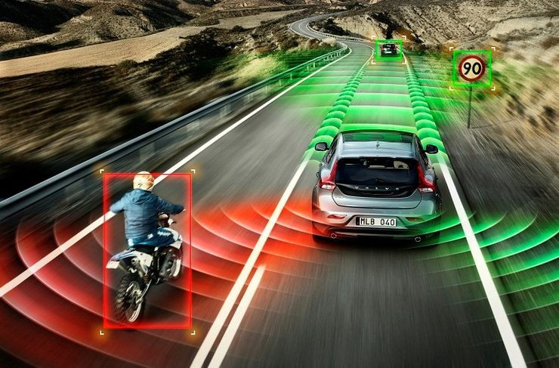
Figure 2.1: vehicle detection system view (Ahmad et al., 2019).
2.2 Drowsy Driving and Accident
The intricate act of driving demands the driver's undivided attention. Numerous variables can impair a driver's capacity to recognise and respond to potentially dangerous circumstances when they are not fully focused on this activity. Stress, exhaustion, prolonged driving, hunger, sleep deprivation, and night driving are some of the elements that contribute to a driver's nonlinear physiological condition. These circumstances can all make a motorist feel drowsy.
The state of having a strong urge to sleep or sleeping for an extended amount of time in an uncommon way is known as drowsiness. According to Ahmad et al. (2019), it is linked to mistakes in short-term memory, a steady decrease in response time, less alert behaviour, and an inability to assimilate available information quickly. This sleepiness can also be linked to stress and exhaustion, which might abruptly impair a person's performance.
It has been demonstrated that drowsiness is a harmful physiological state that significantly affects road safety, passengers, and drivers, reflecting poor driving behaviour. Williamson et al. (2020) used a driving simulator to study drowsy driving and found that those who were more sleepy were more likely to be engaged in centerline crossings and traffic accidents. Additionally, they demonstrated that sleepy drivers react more slowly to abrupt nonlinear vehicle dynamics.
The majority of traffic accidents that occur every day, which cause countless injuries, fatalities, and financial losses for society, are mostly caused by drowsiness. For example, the National Highway Traffic Safety Association (2022) claimed that sleepy driving is responsible for approximately 90,000 automobile incidents and 795 fatalities annually in the United States.
Driver drowsiness is accompanied by a decrease in the driver's level of vigilance and a diminishing sense of sleepiness in real-time driving situations. If left unchecked, this can result in a number of accidents, including loss of vehicle control and stability, collisions caused by abrupt lane changes, abrupt brake application at high speeds that can cause brake failure, and car tumbling, among other potential outcomes.
Numerous studies have been conducted over time to determine the primary reasons of tiredness when driving. According to Ting et al. (2023), the most well-known factor contributing to driver sleepiness is time on task, or spending more time behind the wheel. This was supported by additional research that showed that longer blink durations, more steering wheel movement, and increased driving time all contributed to tiredness while driving (Morales et al., 2022). According to Anund et al. (2023), sleep deprivation is a powerful element that unmistakably raises the rate of drowsiness. They also believed that even modest sleep deprivation of two hours might affect a driver's ability to steer. Similarly, the study indicates that tiredness may be influenced in real time by a number of external elements, including traffic, temperature, light levels, and monotonous geometry.
Additional research revealed that sociodemographic variables, such as the relationship between a driver's age and conduct, may indirectly lead to a higher risk of tiredness in particular age groups, for instance. According to Wang and Xu (2022), young drivers (those under thirty) react and respond to vehicle nonlinear dynamics more quickly than senior drivers throughout a two- to four-hour journey. According to Marco et al. (2020), drowsiness can also be brought on by some drugs, diseases, and boredom-inducing activities like prolonged driving. This study's implications for the reasons behind drivers' sleepiness showed a link between drowsiness and weariness.
In order to prevent sleepiness behind the wheel, drivers must be vigilant and learn to understand their own sleep demands. Fatigue is a condition of latency in the driver's focus that cannot be detected externally. Fatigued drivers have been a major contributing factor in many car accidents. Fatal collisions have happened in cars when the driver's inattention was shown to be caused by things like exhaustion, distraction, lack of sleep, lack of rest, late-night driving, boredom from driving alone, and long-distance driving (Dang and Sharma, 2022).
The standard approach to tackle these problems is to get someone to accompany the driver while driving to prevent drowsiness and keep him/her at alert. However, this solution can’t be applicable all the time because sometimes the driver will be required to drive alone due to one reason or another (Wildodo et al., 2021). Other techniques to solve these problems are classified as physiological, behavioral and vehicle based approaches. They all have their advantages and disadvantages. In physiological methods employs electrocardiography, electroencephalography and physiological sensors to access the driver’s conditions. Even though these devices provide accurate results, because of their complex nature and maintenance difficulty they are not widely accepted (Mardi et al., 2020). The vehicle-based method is based on steering wheel movements and braking patterns. This method is reliant on the road nature. Recent technique involves the use of automatic braking system, intelligent power steer control, adaptive cruise control systems and lots more (Noori and Mikaeili, 2022), however despite the success they achieved so far, today according to a recent study presented by the united states national highway safety administration report (NHSAR) 2020, reveals that accident have increased to 23% despite the prevention measures today till date.
Behavioural methods on the other hand are based on the driver’s behaviour instead of monitoring the vehicle state. Here smart camera is used to capture the driver information and process to detect driver’s action while on the steer wheel. This method presents better performance because it is actually designed to understand and process the driver’s action directly compared to the vehicle based and physiological methods respectively (Dang and Sharma, 2022). This work therefore will be based on the behavioral method of drowsy driver detection using artificial intelligence technique to develop a system which understand the driver’s nonlinear physiological state as a time series model and then predict the time response as sleep or not sleeping.

2.3 Methods for Accident Detection and Monitoring
Some of the primary basic techniques used in traditional systems for the detection and management of accident driving will be covered in this section.
- Fuzzy Logic Image Analysis Method
This system uses a camera mounted on the dashboard of the car to take real-time, consecutive pictures of the driver's face. The data is then processed using an algorithm created in C++ that uses image processing techniques to determine the locations of the eyes and the length of time it takes for the eyelids to close. Lastly, a fuzzy logic algorithm is used to measure the blinding frequency and duration in order to determine the driver's level of attention. The driver is then warned appropriately. Despite its effectiveness, this method has delay time problems that need to be fixed in future research.
- Images Processing Based Method
A approach based on image processing processes the driver's facial photographs to determine its states. This technique uses techniques like as segmentation, feature extraction, and similarity measurements to process and forecast the performance of the driver from a ground truth image. Three categories of image processing are used for accident detection, and they are briefly covered below:
- Eye Blinking based Technique
This method determines the driver's level of tiredness by measuring the blinking rate and length of eye closure. This is because when a driver is feeling sleepy, their eye blinking and eyelid gazing differ from those under normal circumstances. This system estimates the rate of eye blinking frequency and eye closure length by tracking the location of the iris and ocular states over time (Artem et al., 2021). In order to determine whether a driver is sleeping or not, this image processing method first uses a remotely positioned camera to capture video as image data. Next, computer vision techniques are used to sequentially localise the positions of the face, eyes, and eyelids in order to measure the ratio of closure (Amol et al., 2022). Even while this method has been successful, it frequently generates false alarms, making it unreliable in the modern era.

- Template Matching Technique
The template data used in this approach indicates whether the driver's eyes are open or closed. Therefore, the system will sound an alert if the driver's eyes are closed for an extended period of time. Additionally, it can learn and retrieve a driver's open and closed eye templates. Because the system may access templates of both open and closed eye states, as seen in figure 2.4, whenever it is needed, this approach is straightforward and simple to put into practice (Jayanthi and Bommy, 2020).
- Yawning Based Technique
Yawn is one of the recognised signs of exhaustion. A wide, vertical mouth opening brought on by hunger or exhaustion is known as a yawn. When yawning, the mouth opens wider than when speaking. Face tracking and mouth tracking using computer vision make it simple to recognise or detect yawning. According to Behnoosh et al. (2022), yawning is identified by measuring the pace at which the mouth opens and the amount that the mouth contour area varies. The information gathered is then categorised and used to forecast how sleepy drivers would be. Compared to the eye blinking approach, this success is more dependable; nevertheless, it also produces some false alarms, which require future research to enhance.
- Machine Learning Systems for Detecting Accident
In order to train and forecast the driver's future time series behaviour in real time, this approach uses statistical techniques based on a collection of intelligence algorithms, including deep learning, neural networks, support vector machines, and reinforcement learning. The technique shows a strong correlation between head roll, coupling head roll, steering motion, facial expressions based on computer vision, and weariness that goes beyond eye blinks. In order to learn and predict sleepiness in real time, a training dataset is mined using a variety of statistical A.I. techniques under supervised and unsupervised learning, respectively. This method has been used in a number of studies, such as Gwak et al. (2023) and Metin (2023), to train and predict drowsiness in future time series drowsy models. It has yielded some of the best results to date when compared to other methods; however, despite its success, it has a problem with training time delays, which has impacted its effectiveness in real time.

- EEG Based Method
This technique uses an electrode-designed helmet that the driver wears to track and identify brain activity using physiological measurements. Using an NT-9200 equipment, the sleepy detection and monitoring model is meant to use independent component analysis (ICA) and power spectrum to evaluate the driver's level of weariness from two acquired ECG datasets: one for drowsy driving and the other for a regular drive scene. In order to eliminate ocular electric and power frequency interferences, the ICA was hired to analyse the multichannel ECG data. Even though the helmet device used for the process is uncomfortable for drivers, experimental results demonstrated that this method can be used to accurately and effectively determine the degree of drowsiness of the EEG signal. As a result, its application has been hampered globally (Maninder and Amrit, 2020).
2.4 History of Artificial Neural Networks (ANN)
Neural network research is a branch of machine learning. There are around 100 billion nerve cells in the human brain. The brain's intricate relays and adaptive mechanisms are responsible for human intelligence and the capacity to acquire a wide range of physical and cognitive skills. Biologists, psychologists, and physicians have been attempting to comprehend how the brain works for many decades. The groundbreaking discovery that awareness, associations, ideas, consciousness, and the capacity to learn are all caused by these microscopic physical components of the brain—nerve cells and their connections—came about around 1900. One of the greatest "machines" for learning and problem-solving that we are aware of is the human brain. One subfield of machine learning is sometimes called "brain-inspired computation." The way the human brain functions is, in fact, the inspiration for the brain-inspired method. Neurones are thought to be our brain's primary computing component. All of the judgements depending on the different information obtained are based on the intricately linked network of neurones. The Artificial Neural Network approach accomplishes just this (Sharma, 2023).
A hardware or software system that mimics the functions of neurones in the human brain and nervous system is called an artificial neural network. A subset of deep learning technologies that fall under the umbrella of artificial intelligence are artificial neural networks (Mehta, 2019). However, there are very few similarities between the human brain and the modelling tools—mathematics, programming languages, and digital computers. It's a different story with artificial neural networks. We try to mimic, simulate, and even recreate natural neural networks in hardware by starting with our understanding of how they operate.
Sharma (2020) asserts that a neural network's effectiveness is a function of how highly adaptable it is to rapid learning. Every node evaluates the significance of the input it gets from the nodes that came before it. The highest weight is assigned to the inputs that make the most contribution to the desired result. Neural networks come in a wide variety and share many of the same concepts as the human nervous system. According to Howard Rheingold, a neural network is a type of technology that is not an algorithm but rather a network with weights that may be changed to help it learn.
There are many processors in a neural network. These processors are set up in layers and run in parallel. In the same way that the human optic nerve gets raw information, the first tier receives the raw input. After receiving input from the layer before it, each subsequent tier forwards its output to the one that follows. The final output is processed at the last layer. Each layer is made up of tiny nodes. The nodes have a high degree of connectivity to both the preceding and next tiers. Every node in the neural network has a distinct domain of knowledge, which includes both rules it has acquired on its own and rules it was programmed with (Sharma, 2020).
2.4.1 Applications of Neural Networks
Neural networks have several uses in every sector of the economy, particularly in deep learning. Whether it is used to identify faces or persons in photographs, identify fish swarms in sonar readings, identify and categorise military vehicles in radar scans, or for a variety of other purposes, pattern recognition in all its forms is a crucial field. Additionally, spoken language and handwritten writing may be recognised by neural networks (Sharma, 2023).
Neural networks are not limited to object and scene recognition. They may be trained to heuristically control search in chess and backgammon computers, as well as to operate self-driving cars or robots based on sensor data. Neural networks have long been used to predict stock prices and assess bank clients' creditworthiness in conjunction with statistical techniques. Without the aid of intelligent and quick neural networks that make decisions about buying or selling on their own, speed trading of global financial transactions would not be feasible (Sharma, 2023).

2.4.2 Types of Neural Networks
Different types of neural networks use different principles in determining their own rules. There are many types of artificial neural networks, each with its unique strengths. A few of the different types of ANNs and their applications are discussed below (Sharma, 2020):
- Feed forward Neural Network
Among the most basic kinds of artificial neural networks is this one. Data travels through several input nodes in a feed forward neural network before arriving at the output node. To put it another way, data only flows in one direction from the first layer to the output node. A classifying activation function is typically used to do this, which is also referred to as a front propagating wave. Data just flows in one direction and there is no back propagation, in contrast to more intricate neural network types. It is possible for a feed forward neural network to contain hidden layers or only one layer. The sum of the products of the inputs and their weights is computed in a feed forward neural network. The output then receives this (Sharma, 2023).
Face recognition and computer vision are two examples of technology that employ feed forward neural networks. The reason for this is that these apps' target classes are challenging to categorise. Data with a lot of noise can be handled by a basic feed forward neural network. Maintaining feed forward neural networks is rather easy.
2.5 Review of relevant literatures
Bunch et al. (2020) presented a review of computer vision technique for analysis of urban traffic. The study used computer vision technology to reconfigure video traffic cameras for vehicle tracking and analysis of traffic patterns in urban environment. This camera is can be used as sensor for vehicle detection in developing intelligent accident prevention and control system.
Fishbi and Yaroslavsky (2020) presented a study on real time vision based traffic flow measurement and incident detection system. The system was developed for real time traffic surveillance using intelligence technique. However the limitation of this system despite the success is the high cost of implementation.
Rossi et al. (2021) presented a study on fuzzy logic based incident detection system using loop detector data. the study designed a fuzzy logic system and used the rule to detect incidents such as traffic patterns. However despite the success of this system, the accuracy of fuzzy logic in as filed is rivaled with artificial neural network.
Qianyin et al. (2021) modeled a pedestrian abnormal behavior detection system in traffic scene. The research was developed as an accident prevention system to mitigate the rate of accident involves between pedestrians and car during traffic. This was developed using artificial intelligence system to detect behavior of pedestrians and ensure their safety in an uncertain condition. The limitation with this research is that its designed only for vehicle to pedestrian accident alone and cannot be used for inter vehicular accident prevention system.
Cui et al. (2020) presented a study on abnormal event detection in traffic video surveillance based on local features. The study developed a video based system which capture traffic data based on local feature vectors and analyze to detect abnormal patterns and make decision. The study was limited to only traffic surveillance and congestion control and not ideally a solution for accident occurrence in highways.
Mehboob et al. (2022) presented a study on traffic event detection from road surveillance video based on fuzzy logic. The study used fuzzy rules to make decisions of abnormal vehicle behavior in traffic patterns. The limitation of the research is the need for improved accuracy from 87%.
Wu and Wang (2022) presented a detecting and tracking system for vehicles. The researched designed video based vehicle detection and tracking system while in motion using computer vision. This technique can be used to track vehicle dynamics and then make accurate control decisions.
Chen et al. (2022) presented a research on building regional covariance descriptor for vehicle detection. The research collected vehicle data using sensor and then extracted the parameters based on covariance descriptor to make correct decision. The limitation with this technique is that that accuracy is poor when classified as the feature extraction used omitted some vital feature vectors of the vehicle and hence affected the classification result.
Kim et al. (2021) presented a novel road vehicle detection method using histogram of oriented gradient technique. The technique was used to extract vehicle parameters based on statistical method from data collected in the video sensor. The data extracted was then analyzed and used for vehicle detection. The research was limited to detection of vehicle and therefore is more of a surveillance system.
Haritha and Ramadevi (2020) presented a study on vehicle detection and tracking system using dynamics networks. The study used the dynamics network algorithm to make detection of feature vectors of vehicle extracted from data collected. The limitation of this research is the high cost of implementation.
Ahmadi et al. (2022) presented a research on abnormal vehicle event detection and localization system in traffic video, based on group sparse topical coding. The research was used to localization and tracking of vehicles in traffic based on the algorithm presented. However the research is limited to only surveillance and traffic control.
Chen et al. (2022) presents a study on vision based traffic accident detection method using extreme learning machine. The study collected data and train it with extreme learning algorithm for classification of vision data of vehicle as an accident detection system. The limitation with this research is the training dataset lack certain vehicles like the tricycles or instance.
Maaloul et al. (2021) presented research on vision based traffic accident detection technique opportunities and challenges. In the study the various techniques already employed for accident prevention system was discussed and the limitations were presented as opportunities for researchers to improve on. Such as the accuracy, system reliability, speed of decision making among other areas identified that need improvement.
Maaloul et al. (2022) presented a study on adaptive video based algorithm for accident detection on high ways. In the study an adaptive algorithm was developed which enables vehicle detection nonlinearity from other cruise vehicle and apply control measures to prevent collision. This research despite the success has to be improved using control area network or artificial intelligence technique for reliability.
Boutheina (2023) presented a study on video based algorithm for accident detection. The study used vehicle data structure to develop an accident detection algorithm. The algorithm detection vehicle behavior and intelligently apply control measures to avoid collision. This research despite the success can be improved using control area or artificial neural network technique.
White et al. (2020) presented a research on automatic traffic accident detection and notification system with Smartphone mobile network and applications. The research used network reception provided by the driver’s mobile network to communicate of approaching nonlinear vehicle based on artificial intelligence technique. The limitation with this research is that it always requires network to operate which most time are not reliable in certain rural localities.
Akooz and Karsligil (2020) presented a research on severity detection of traffic accident at intersections based on vehicle motion analysis and multiphase linear regression. The researched collected data from three way junction which is usually a key location of accident based on the road structure and used multi linear regression technique to analyze the data for classifications, so as the decide probability of accident on the junction. The limitation o this research is the complexity of the model, it is difficult to understand and hence will be challenging to improve.
Sadeek et al. (2020) presented a research on real time automatic traffic accident recognition using Histogram of Feature Gradient. The research use the technique to mine data collected from vehicle dataset for real time classification of vehicle collision possibility on high way. The study achieved good result by the accuracy need to be improved using artificial neural network or control area network.
Bharath et al. (2019) presented a literature survey on smart vehicle accident prediction system using machine learning algorithms. The research reviewed the various machine learning algorithms used in the past literatures as accident prevention and control system. The research revealed the use of artificial neural network as the best result so far compared to other machine learning counterparts when image dataset is used for training and therefore recommended the technique for further studies to improve the training and classification accuracy.
Nancy et al. (2020) presented a research on highway accident detection and notification using machine learning technique. In the research CCTV camera was used as image acquisition tool. A dataset of 800mimages was used to train clustering algorithm and achieved accuracy of 93%.
Nooristhta and Akheela (2019) presented a research on preventing road accident by analyzing speed, driving pattern and drowsiness using deep learning. The study collected dataset of the case study problem and then trained with recurrent neural network for classification. The result showed high level of accuracy, however deep learning systems are limited to the training dataset.
Deeksha and Amit (2019) presented a study on automated A.I based road traffic accident alert system. The research used YOLO algorithm to train road accident parameters and predict the possibility in time series using alert system. The result showed high level of accuracy when tested, however the algorithm is difficult to improve.
Summary of Literatures
Author(s) | Work Done | Technique Used | Result / Research Gap
Bunch et al. (2020) | Reviewed computer vision for urban traffic analysis using reconfigured video traffic cameras | Computer Vision | Useful for vehicle detection and traffic pattern analysis; can serve as sensor in accident prevention systems
Fishbi and Yaroslavsky (2020) | Real-time traffic flow measurement and incident detection | Real-time Vision-based System | Effective but high implementation cost
Rossi et al. (2021) | Incident detection using loop detector data | Fuzzy Logic | Functional, but fuzzy logic’s accuracy is rivaled by Artificial Neural Networks
Qianyin et al. (2021) | Pedestrian abnormal behavior detection system | Artificial Intelligence | Only suitable for vehicle-to-pedestrian accidents; not applicable for vehicle-to-vehicle accident detection
Cui et al. (2020) | Abnormal event detection in traffic using local feature vectors | Local Feature-based Video Analysis | Limited to congestion control, not highway accident prediction
Mehboob et al. (2022) | Traffic event detection from surveillance video | Fuzzy Logic | Needs improved accuracy (currently at 87%)
Wu and Wang (2022) | Vehicle detection and tracking using computer vision | Computer Vision | Effective for tracking vehicle dynamics; useful for motion-based decisions
Chen et al. (2022) | Vehicle detection using regional covariance descriptor | Covariance Descriptor | Poor accuracy due to omission of critical feature vectors
Kim et al. (2021) | Vehicle detection using histogram of oriented gradient (HOG) technique | HOG-based Feature Extraction | Focused on detection only; more suited to surveillance
Haritha and Ramadevi (2020) | Vehicle detection and tracking using dynamics network | Dynamics Network Algorithm | High cost of implementation
Ahmadi et al. (2022) | Abnormal vehicle event detection and localization | Group Sparse Topical Coding | Limited to surveillance and traffic control
Chen et al. (2022) | Traffic accident detection using extreme learning machine | Extreme Learning Machine | Dataset lacked diverse vehicle types like tricycles, affecting classification accuracy
Maaloul et al. (2021) | Review on vision-based traffic accident detection methods | Literature Review | Identified multiple limitations in accuracy, speed and system reliability needing further research
Maaloul et al. (2022) | Adaptive video-based algorithm for accident detection on highways | Adaptive Algorithm | Needs enhancement via Control Area Network or AI techniques for improved reliability

2.5 Research Gap
Notable developments in accident prediction systems utilising machine learning and deep learning algorithms are revealed via a careful review of current research. Nonetheless, a number of restrictions still exist. For instance, Bharath et al. (2019) emphasised how well Artificial Neural Networks function when trained on picture datasets, but they neglected to address the dearth of varied vehicle representation, especially for vehicles that are typical of African road networks, such as tricycles (Keke). Although Nancy et al. (2020) and Deeksha and Amit (2019) used clustering and YOLO-based techniques, respectively achieved encouraging accuracy levels, the generalisability of their models was limited since they were trained on relatively small or homogenous datasets (800 photos). Nooristhta and Akheela (2019) have reported that the deep learning models are also problematic because of their dependency on training data and inability to adapt to new unstructured traffic scenarios typical of African roads. Moreover, due to the expensive implementation and the minimal ability to be adapted to cases, some of the techniques, including fuzzy logic or adaptive video-based algorithms (Maaloul et al., 2022), demonstrated worse accuracy or were non-scalable.
To fill these gaps, this study proposed a model of accident prediction based on the approach of machine learning uniquely adapted to African road conditions. Unlike the previous studies, it uses the YOLOv8 object detection model that was trained on a custom large-scaleHello highly annotated dataset including diverse types of vehicles and tricycles. This technique ensures accurate classification under various conditions in the environment and traffic combination. The model also solves the disadvantages of the use of static sets of data, in that, it uses both the temporal and geographical behaviour analysis in predicting the risk taken by accidents at any given moment. Another focus of the system is the emphasis on real-time deployment and environmental resilience, which means that the system is more flexible and applicable in the sphere of road safety in developing territories.

CHAPTER THREE
SYSTEM ANALYSIS AND DESIGN
3.1 Research Methodology
We chose the Agile approach as our guide in this paper and reasonably so. The iterative agile way of making decisions in collaboration and adapting to the dynamic and changing requirements of the development and improvement of a predictive model fits so well with agile. Agile, unlike linear forms of development, can be improved repeatedly, gradually, in chunks small enough that it is easy to notice a problem, develop a solution, and make adjustments, even to account some of the feedback or changed data patterns given by the stakeholders. This method is especially suitable in machine learning projects, whose success rests on having data, engineering features, tuning models and testing them in the real world. Using sprints to refer to small, concentrated chunks of advancement we addressed individual activities including data collection, preparation, model preparing performance measurement sequentially. At the end of each sprint, we held a review to assess our progress and refine our strategy for the next phase.
Agile also promotes strong stakeholder engagement. Throughout the process, we collaborated closely with key participants, including traffic officers and road safety experts, ensuring that their insights helped shape a model that isn’t just technically accurate, but also grounded in practical reality. Ultimately, Agile allowed us to build a system that is not only technically sound, but also usable, adaptable aligned with the unique challenges of road safety across African regions.
3.2 System Analysis
The system analysis phase of the accident prediction model focused on understanding the real-world challenges that hinder effective road safety management across different African contexts. We began by identifying major limitations in the current systems such as inconsistent accident reporting, fragmented data sources delayed emergency response all of which contribute to inefficiencies in managing road traffic incidents.
Our analysis also involved mapping out traffic data flows, uncovering patterns in accident occurrences identifying key stakeholders, including traffic enforcement agencies, urban planners, transport authorities emergency responders. We explored how a predictive system could directly support their decision-making whether through proactive accident prevention, better resource allocation, or targeted interventions in high-risk areas.
Based on this analysis, we outlined the core functional and technical requirements for the model. These included integrating multiple data sources (e.g., weather, traffic volume, road conditions), implementing robust preprocessing pipelines, choosing appropriate machine learning algorithms developing a user-friendly visualization interface. Altogether, this phase laid the groundwork for building a system that is not only technically robust but also scalable, context-aware tailored to the real-world needs of road safety stakeholders in Africa.
3.2.1 Analysis of Existing System
Rule-based systems continue to be approached to make predictions about accident-related activity in most of the areas in Africa. So what does that mean? In effect, these systems work by imposing certain predetermined rules and definite threshold limits to the traffic information such that they indicate possible accident prone scenarios. As an example, a certain road segment could become labeled as a high-risk element in case cars experiencing bad weather (rain) exceed 100 km/h. The rules usually follow the expertise of the experts or historical observations are set to produce alerts or to define high-risk zones on the basis of non-dynamic factors like the speed of a vehicle, time, weather or type of road. Rule-based solutions are quite easy and simple to apply, but they have serious drawbacks.
To begin with, they are not adaptable. These types of systems fail to learn emerging or novel patterns in the data of the accidents. They are limited by the effectiveness of rules that are pre-determined and are sometimes manually designed and are inefficient in grasping the complexities in the real world situation. Consequently, they find it hard to identify a complex or non-linear nature of relationships or connections between variables such as the obscure effects of the intercourse of weather, traffic agglomeration driver behaviour on the likelihood of accidents.
In addition, rule based models do not work well in dynamic environments, which can easily be translated to a dynamic traffic, driver habit situations and road conditions. This rigidness tends to cause missed detection of the important accident scenarios or in other cases it results in excessive false alarms either way, this reduces the dependability and the use of the system in a real world traffic.
The shortcomings of rule-based systems underscore the urgent need for more intelligent, data-driven approaches. This study proposes a machine learning-based model that offers just that: an adaptive system capable of learning from past data, adjusting to new patterns providing more accurate, context-aware accident predictions. By leveraging data rather than static rules, the proposed approach represents a significant step forward in building effective, real-time accident prediction systems suitable for the evolving realities of African roads.
    - Weaknesses of the Existing System
The existing rule-based systems for accident prediction exhibit several significant weaknesses that limit their effectiveness in managing road safety.
- Lack of Adaptability: The system is unable to recognise new patterns or changes in road conditions, traffic patterns environmental elements since it is based on static rules that neither alter nor learn from new data.
- Incapacity to Model Complex, Non-linear Relationships: Rule-based systems provide erroneous predictions because they consider each component separately and are unable to capture the complex relationships between different factors.
- High False Positives and False Negatives: The system's dependability is decreased by the straightforward threshold-based rules, which cause needless alerts (false positives) or overlooked high-risk situations (false negatives).
- Reliance on Expert Knowledge: Experts manually set the rules, which restricts the system's flexibility and breadth and is frequently predicated on shaky information or subjective judgement.
- Limited Scalability and Generalisability: Because the system is designed for a particular area or set of circumstances, it is challenging to use in other places with different infrastructure, traffic patterns, or road conditions.
- Manual Rule Creation and Maintenance: In order to integrate new information or modifications, the system needs to be updated often and manually, which raises operating expenses and slows the system's ability to adjust to changing road safety concerns.

3.2.3 Analysis of the Proposed System
The proposed accident prediction system is a complete intelligent system based on deep learning, which is expected to enhance the safety of roads through the use of proactive alarming processes, anomaly detection continuous monitoring. This is carried out by manipulating a sequence of traffic data and video with a complex neural structure (YOLOv8) to read the data in real-time to make accurate predictions of an accident, unlike monument-type machine learning systems such as rule-based or similar systems. The pipeline is well defined to have a real-time video acquisition, video preprocessing, object detection with YOLOv8 deep learning, and classification of risks in terms of spatial-temporal behaviour. The model uses essential factors such as weather, road conditions vehicle dynamics to model complex relationships involved in influencing the probability of accidents.
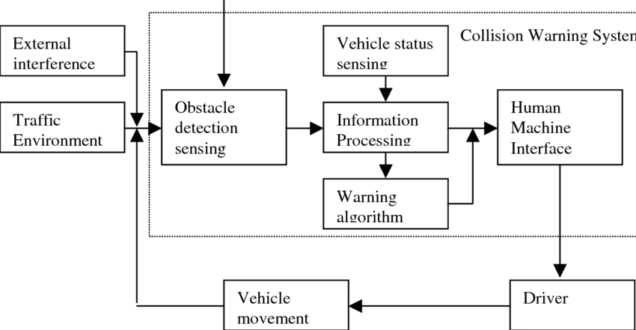
Figure 3.1: Block Diagram of the Proposed System
Also, the system design enhances the main concepts of generalisation and scalability with regards to different traffic conditions that prevail in various parts of Africa, using an imbalanced dataset that takes into consideration under-represented vehicle types such as tricycles and the use of other new types. It also integrates a notifying system that issue real-time warning to relevant stakeholders, like drivers, traffic controllers or emergency responders when potentially high-risk situations or abnormal behaviours occur. To facilitate the adjustment to new traffic conditions and drivers behaviour, the model is constantly updated and refaced with new information. This system involves dynamic, data-driven technique that hugely boosts detection accuracy, reduces false alarms and provides actionable intelligence to respond to emergencies promptly in comparison to more restrictive or non-adaptive systems that were used before.
3.2.4 Advantages of the Proposed System
- Adaptability: The machine learning based system has learning capabilities by adjusting itself to new information and is thus able to accommodate changing road conditions, traffic and environmental conditions, and serves better under dynamic and changing circumstances.
- Better Prediction Accuracy: Since the dynamic nature of non-linear association among multiple variables (weather, traffic volume, road conditions, driver behaviour) can be modeled, an improved prediction is possible with the system as opposed to static rule-based systems.
- Reduction in False Positives and False Negatives: The machine learning model refines its predictions over time, reducing the likelihood of issuing unnecessary warnings (false positives) or overlooking high-risk situations (false negatives), thereby improving the reliability of the predictions.
- Scalability: The system can be trained and deployed across different regions, accommodating diverse road conditions and traffic behaviours and this scalability allows it to be implemented on a wider scale across Africa.
- Real-time Data Integration: The proposed system integrates real-time data, enabling proactive measures such as issuing alerts to drivers or authorities, optimizing traffic management and improving emergency response times.

3.3 Data Collection
The suggested accident prediction method made use of a specially selected dataset that was created to overcome the shortcomings of earlier research that did not include some vehicle types, including tricycles, sometimes referred to as “Keke”, which are frequently seen on African roadways. This dataset was created by gathering annotated picture data and real-time traffic video footage from a variety of urban and semi-urban areas that are known to have mixed vehicle usage in African cities. The data collection process included scenes involving cars, buses, motorcycles, trucks and importantly, tricycles, to ensure comprehensive vehicle representation.
The dataset development involved the following steps:
- Video Surveillance Setup: Cameras were strategically mounted at intersections and highways where tricycles frequently operate and this allowed for the capture of natural traffic behaviours involving “Keke” and other vehicle types.
- Annotation and Labelling: Each frame of the video data was processed and annotated using labelling tools (Labelling, CVAT), marking vehicle types, motion behaviour and interactions (near-collision, speeding, lane switching).
- Inclusion of Tricycle Dynamics: Special attention was given to capturing various tricycle behaviours such as sharp turns, sudden stops and weaving patterns which are typical in traffic scenarios and critical to modelling accident risk accurately.
- Data Preprocessing: The annotated images and video frames were cleaned, resized and standardized and classes for vehicle types were defined explicitly, including a separate label for tricycles to ensure they were treated distinctly in the model training phase.
- Data Balancing: Given the lower frequency of tricycles in some areas, Synthetic Minority Oversampling Technique (SMOTE) was employed to balance the dataset and ensure the model received adequate training samples for each vehicle type.
This custom dataset ensured the machine learning model could accurately detect and predict accident risks involving all major road users, including “Keke”, making the system highly relevant and effective for African road conditions.
3.3.1 Data Description
The dataset was created using a combination of:
- Real-time surveillance video footage captured at busy intersections, highways and urban roads.
- Publicly available traffic datasets augmented with custom-labelled data specific to African roads, especially including tricycles (Keke).
The dataset consists of 25,000+ labelled instances (image frames and metadata), categorized as follows:
Feature Category | Description
Vehicle Type | Categorical values: Car, Truck, Bus, Motorcycle, Tricycle (Keke)
Vehicle Behavior | Normal, Speeding, Lane Switching, Sudden Stop, Wrong Way
Weather Condition | Clear, Rainy, Foggy, Night
Road Condition | Dry, Wet, Potholes, Under Construction
Time of Day | Morning, Afternoon, Evening, Night
Number of Vehicles | Integer count of vehicles in each frame
Distance Between Vehicles | Approximate spacing between vehicles (in meters)
Accident Indicator | Binary: 0 (No Accident), 1 (Accident Event Detected)
Frame ID / Timestamp | Unique identifier or timestamp for video frame
GPS Coordinates | (Where applicable) for location-specific traffic behaviour analysis

- Images are labelled using bounding boxes to identify and classify vehicle types.
- Behaviour labels are attached at the frame level or vehicle-level, depending on the movement patterns detected.
- Accident labels are binary, generated either by manual annotation (based on video review) or semi-automated anomaly detection.
3.3.2 Data Preprocessing
Before training the accident prediction model, the collected dataset underwent a comprehensive data preprocessing phase to ensure quality, consistency and suitability for machine learning. The image and video data were first extracted and converted into frame-level snapshots, each representing a traffic instance. These frames were then resized to a uniform resolution of 640×480 pixels to standardize input dimensions for the model. Noise reduction techniques such as Gaussian blurring were applied to enhance image clarity, especially in low-light and foggy conditions. Each frame was annotated using bounding boxes to highlight and classify various vehicle types cars, trucks, motorcycles, buses and particularly tricycles (Keke). Metadata including timestamps, weather conditions, road conditions and traffic behaviour labels were synchronized with each frame to create a structured dataset.
To address class imbalance, especially underrepresented classes such as tricycles and rare accident events, the Synthetic Minority Over-sampling Technique (SMOTE) and random under-sampling were employed. Categorical features like vehicle type and weather conditions were encoded using one-hot encoding, while numerical features such as inter-vehicle distance were normalized using min-max scaling and missing values were either imputed using statistical methods or removed if deemed insignificant. The final dataset was split into training (70%), validation (15%) and testing (15%) sets. This careful preprocessing ensured the model could learn relevant patterns without bias, handle real-world traffic variability and generalize well across diverse road scenarios found in Africa.
3.3.3 The Proposed YOLOv8 Algorithm
The proposed system adopts the YOLOv8 (You Only Look Once, Version 8) algorithm in Figure 3.2 as the core deep learning model for real-time accident prediction on African roads and the model which is an advanced object detection and classification algorithm developed by Ultralytics, offering improved performance over previous YOLO versions through architectural enhancements, faster inference and more accurate detection. It is particularly suitable for road surveillance systems due to its ability to perform object localization and classification in a single forward pass with high speed and accuracy.
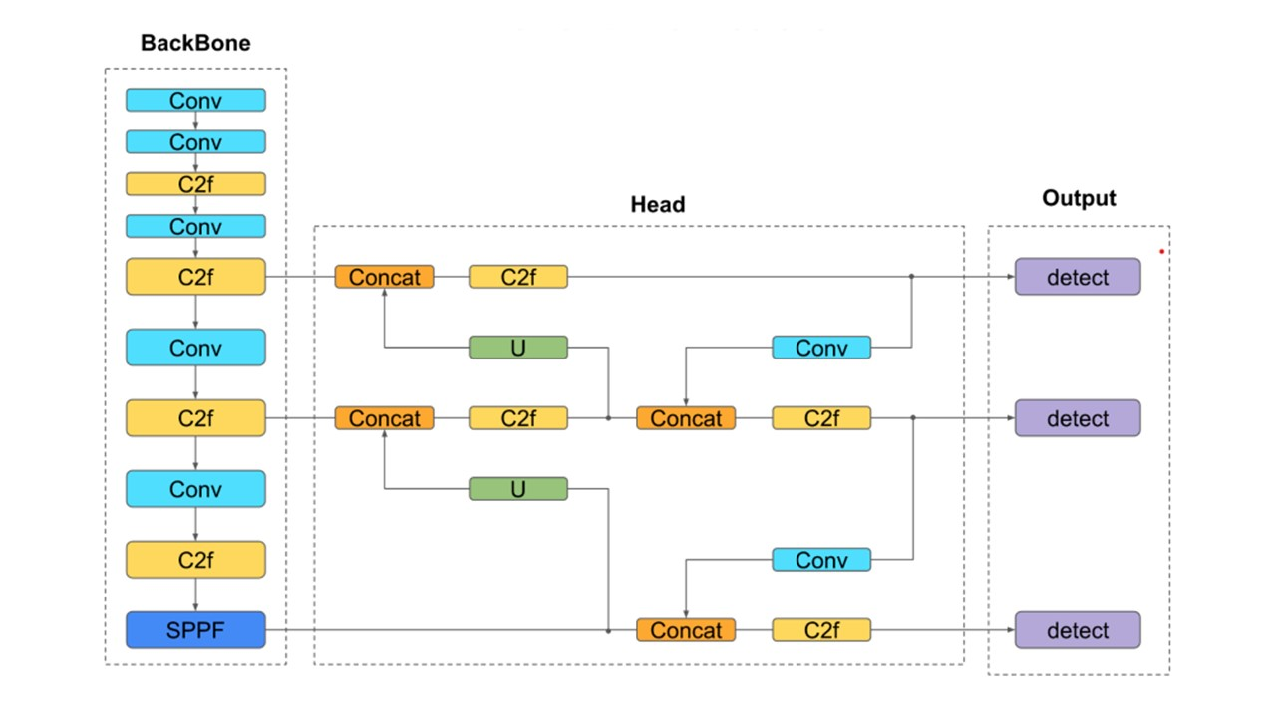
Figure 3.2: Architecture of the YOLOv8 Model (Sohan et al., 2024)
In this study, YOLOv8 functions as the central detection and prediction engine for road accident prevention by leveraging a custom dataset tailored to African traffic scenarios and the model is trained to recognize and classify multiple vehicle types such as cars, trucks, buses, motorcycles and specifically tricycles (Keke) under varied environmental conditions. The algorithm analyzes each video frame in real-time YOLOv8 classifies the type and inference of a vehicle with the aid of bounding box and confidence scores. After detection, every item is then tracked in subsequent frames by the system and this enables the system to obtain temporal data like location, speed trajectory. After detecting the dangerous behaviour through lane violations, abrupt braking or sudden behaviours, the behaviour analysis is consequently performed.
In addition to ensuring its increased utility, YOLOv8 adopts the presence of the post-processing module to evaluate temporal and spatial data to identify anomalies as well as predictions of accident risks. This module puts to the fore the potential incidents upon studying the collision-prone behaviours and abnormal proximities, such as two cars that are rushing at each other. One of the features of the system is targeted calibration to tricycles (Keke) which are common and often used in unpredictable manners on African roadways. Benign and malignant anchors boxes were used, and the model was trained on the annotation on Keke images where the balance between classes was run. This makes the algorithm have a high level of accuracy in the method of identifying and predicting the behaviour of tricycles in a mixed-traffic setting, which makes it useful and effective in localised accident reduction programmes.
3.4 Proposed System Architecture
The architectural design of the proposed system is shown in Figure 3.4 which represents the interconnection of the major components of the proposed system.
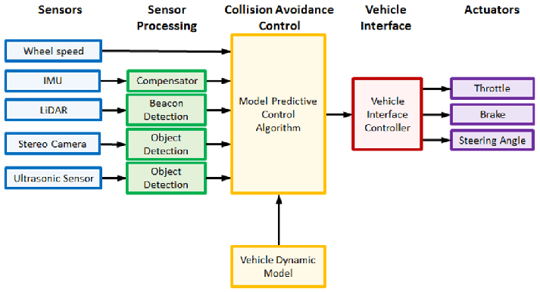
Figure 3.4: Architecture of the Proposed System
As Figure 3.4 shows, the structure of a collision avoidance control system in the intelligent vehicle paradigm has five primary subsystems: sensors, sensor processing, avoidance control collision, vehicle interface and actuators, and the system initiation has different sensors on wheels, Inertial Measurement Unit (IMU), LiDAR, stereo camera and ultrasonic sensors capturing environmental and vehicle data. Such sensor messages go through a series of modules like the compensators, beacon detection systems and object detection systems to derive meaningful values. The processed data is fed into a Model Predictive Control (MPC) Algorithm, which serves as the core of the collision avoidance system by analysing current vehicle dynamics and environmental conditions to make predictive driving decisions and these decisions are passed to the Vehicle Interface Controller, which translates them into control signals for the vehicle's actuators: throttle, brake and steering angle. This closed-loop system ensures real-time adaptation to dynamic driving environments for safe navigation and accident prevention.
3.5 System Flowchart
Figure 3.5 shows you a flowchart of our proposed collision avoidance warning system. It details a step-by-step decision-making process, all based on real-time visual data. The system begins with Image Sequence Input, essentially a stream of live video. This feed splits into two parallel modules: Lane Detection and Preceding Object Detection. The lane detection module constantly provides crucial information about the vehicle's lane, which helps the system understand its position on the road. At the same time, the object detection module is busy scanning for vehicles or obstacles ahead. If it doesn't spot anything, the system simply loops back, continuously analysing new incoming frames. But, as soon as an object is detected, the system immediately moves on to Identify Object Type. This step is vital; it classifies the object, determining whether it's a car, motorcycle, bus, or even a tricycle ("Keke"). This classification provides essential context for the next stages of analysis.
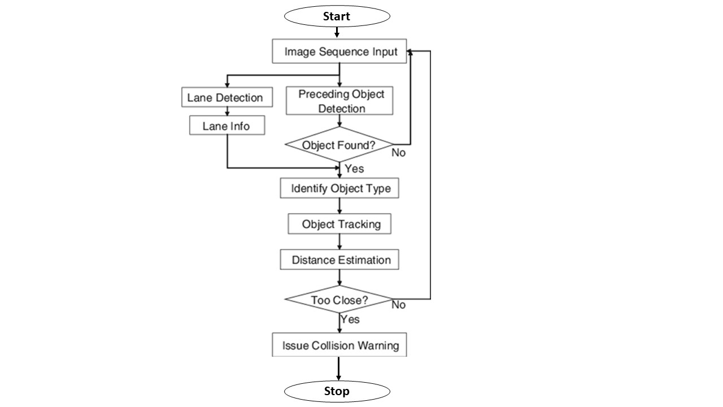
Figure 3.5: System Flowchart
Once an object has been identified, it moves into the Object Tracking stage. Here, the system keeps a close eye on the object's movement as it appears across multiple video frames. After successful tracking, the system performs Distance Estimation. This calculates how close your vehicle (the "host vehicle") is to the detected object. If that estimated distance drops below a set safety threshold, meaning the object is too close for comfort, the system immediately triggers the Issue Collision Warning module. This module then alerts the driver or the vehicle's onboard system to the potential danger. This entire loop ensures continuous monitoring, constant object classification proactive risk mitigation. It's all based on analysing both space and time, forming the backbone of a truly intelligent accident prevention mechanism.
3.6 Data Recording Diagram
Figure 3.6 gives you a clear picture of our system's overall design, showing how data moves through our accident prediction framework. It all kicks off with data collection. Here, we gather real-time information from a variety of sources. Think traffic cameras, GPS sensors weather monitoring systems. This raw data then goes through a crucial preprocessing stage. This involves techniques like noise reduction, normalization feature extraction. What is the reason behind this? To ensure we only use most relevant and urgency high quality data in our analysis. Then, machine learning algorithms are then used by the system. We are talking about power types of technology; decision tree and neural networks. These algorithms are aimed at the detection of the correlations and patterns of numerous elements, including the state of the road, driving habits actual accident incidents. It is with respect to this entire process of predictive modelling that our technology can identify potential hotspots of accidents with a significantly greater level of confidence.

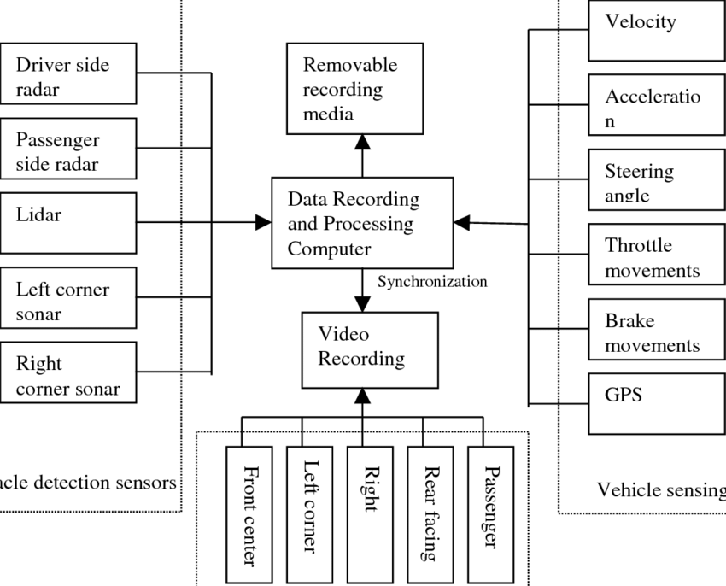
Figure 3.6: Data Recording and Processing Diagram
After predicting, the process moves into the decision-making phase where information generated is used to alert policy makers, emergency service agencies and traffic controllers. The model also has a feature of making alerts in real-time where the authorities must initiate preventative measures such as sending emergency services, a change in traffic signal timing, or driving notifications in dangerous zones. Long-term trends or patterns can also be studied with the help of historical analysis, the possibility of which is also provided by this system, which enables researchers to better predict future developments. Using big data analysis, the model enhances road safety strategies, reduces the frequency of traffic accidents and distributes resources to control the flow of traffic in the most efficient possible manner. Continual learning and adaptation is the final part of the system that ensures that there is a change in the model in the face of new data and problems concerning road safety. As the system learns to better predict with time, getting more accurate and reliable, the more reports of accidents are fed to it and the more environment factors are put in place. Using the advanced machine-learning methods, real-time data analysis pro-active decision making, the High-Level Model of the System turns to be a powerful instrument of increasing road safety and reducing fatalities that are caused by accidents. It is due to this flexibility that the model is quite scalable, and thus capable of being implemented in different regions and facing diverse traffic masses.
3.7 System Algorithm
The system algorithm uses image-based input and appears as a real-time vehicle monitor and warning of damages via collision. It begins by constantly capturing picture frames of a front facing camera. These frames are simultaneously looked into with the aim of lane detection and preceding object detection. By the time an object has been identified, the system classifies the object into a vehicle, motorbike or tricycle and begins to track the movement of the object over a number of frames.
The system also determines the distance between a tracked object and the host vehicle simultaneously. When this distance is reduced to a level that is deemed unsafe, the device gives an acute alarm implying the risk of a danger. The loop repeats with every new image frame, ensuring continuous observation and the prompt reaction towards any drastic change occurring in the way the vehicle behaves or in terms of its distance and closeness and all this is a composite of object detection, classification, tracking, distance assessment and decision logic in real time, in order to prevent the accident in hand. Here is a pseudocode of the proposed system algorithm in Algorithm 1:
Algorithm 1: Pseudocode of the intelligent system
- # Initialize system
- load YOLOv8_model
- initialize camera_input
- set safety_distance_threshold
- while True:
- frame = capture_frame_from_camera()
- # Step 1: Detect lanes and objects
- lane_info = detect_lanes(frame)
- detected_objects = YOLOv8_model.detect_objects(frame)
- if detected_objects is not empty:
- for obj in detected_objects:
  - object_type = classify_object(obj)
  - track_object(obj)
  - # Step 2: Estimate distance to object
  - distance = estimate_distance(obj)
  - # Step 3: Check for collision risk
  - if distance < safety_distance_threshold:
  - issue_collision_warning(obj, distance)
- update_display_with_tracking_info()

3.8 System High-Level Model
The system is designed to detect and prevent vehicular accidents by using a deep learning-based object detection algorithm (YOLOv8) integrated with a real-time image processing pipeline while at the input level, the system receives continuous image sequences from a mounted camera or onboard vision system. These frames are fed into the YOLOv8 model, which has been trained on a custom dataset containing various vehicle types, including cars, buses, motorcycles and tricycles (Keke). Upon object detection, the system performs lane detection and behavioural tracking to monitor vehicle movement, classify the object type and estimate inter-vehicle distance using computer vision techniques and the system’s decision module evaluates these distances and behaviours using a predefined threshold and logic and if a potential collision is identified such as a fast-approaching vehicle, sudden lane switch, or a dangerously close object the system activates a collision warning mechanism. This feedback is either visual, auditory, or both, alerting the driver or triggering autonomous braking, depending on the integration level.

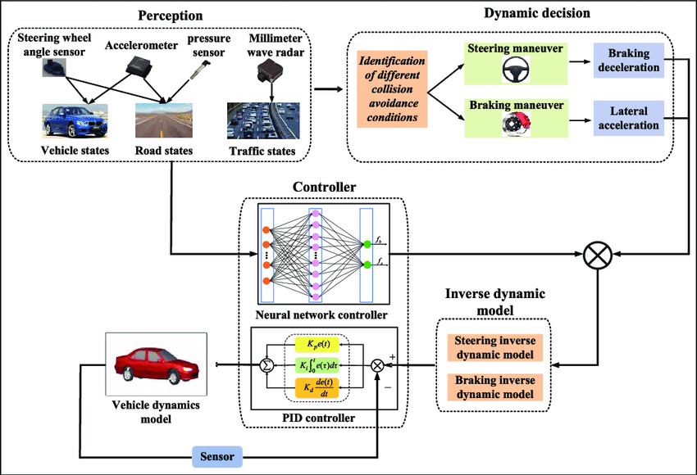
Figure 3.7: System High-Level Model
The System High-Level Model of the vehicle collision avoidance comprises three essential steps: Perception, Dynamic Decision Controller. To determine the state of the vehicle and the surrounding the Perception phase uses important information relayed to them by sensors such as radar, accelerometers, steering angle sensors. The Dynamic Decision phase is next, and it measures the potential collision scenarios and selects the most effective course of action whether steering or braking as appropriate regarding the identified risks.
The Controller phase is the final step in ensuring that vehicle changes are made accurately by conducting small adjustments to the vehicle by using PID controllers and neural network controllers. Inverse dynamic models in steering and braking are also enhanced in these controllers to enhance responsiveness where the vehicles respond intelligently and prevent collisions in real time. Overall, the model provides a grid to be followed in terms of the efficient control of collision that coupled sensor-based data gathering, adaptive vehicles control systems as well as predictive decision-making.
3.9 System UML Diagram
The proposed system of accident prediction and management revolves around the Traffic Accident Reporting System class that acts as a central node and consolidates important data related to accidents. Figure 3.8 is a Unified Modelling Language (UML) class diagram which has accurately illustrated structural relationships and functions of main components in the system. It shows how it coordinates the flow of information amongst the various stakeholders by keeping relations with various significant objects, which include Viewers, GIS (Geographic Information system), Vehicle_Detail, Traffic_Officer, Insurance_Com (Insurance Company) Report. A clear blueprint of the data components and behaviours connected to each system module is provided by the attributes (TARS_No, V_Name G_Latitude) and actions (Set_Details, Get_Details) that define each class in the diagram. The multiplicity indicators (“1”, “*”) on the association lines explicitly define the cardinality of relationships between classes, for instance, indicating that one TARS entry can be associated with multiple Vehicle_Detail records or Reports.
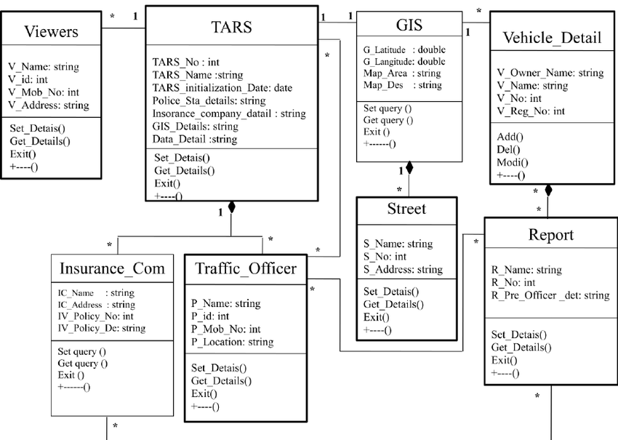
Figure 3.8: System UML Class Diagram
By showing interconnected components, the figure further highlights the system's all-encompassing approach to accident control. For example, the Vehicle_Detail class records important vehicle information, the Traffic_Officer and Insurance_Com classes represent the institutional and human actors involved in the accident reporting and resolution process the GIS class, with attributes like G_Latitude, G_Longitude Map_Area, highlights the spatial dimension of accident data, which is essential for location-based analysis and predictions. The output of an accident occurrence, which includes information like R_Name and R_No, is indicated by the Report class, which is connected to Vehicle_Detail and Street. Contextual details regarding the accident site are provided by the Street class. The UML class diagram, which graphically depicts this complex web of relationships, acts as a foundational design document that directs the development of a reliable and networked system that can effectively gather, process distribute accident-related data to the appropriate parties.
3.10 Use Case Diagram
The interaction of the key players, including Host vehicle the YOLOv8 Accident Prevention System will be revealed using the use case topic diagram, in Figure 3.9, that illustrates the incorporation of the six primary uses that determine Vehicle steering and lane changing, Braking control, Approaching another vehicle, Environment observation, Potential collision alert system, that will assist in engaging key players: the Driver and the Host Vehicle. Each of the use cases is another step the system will ensure that it promotes safety on the roads and prevents accidents. Both the driver and the host vehicle use these characteristics and this demonstrates the actual response of the system to human factor and dynamics of vehicles in real time. These observations are noted on the diagram and they prove that the deep learning based YOLOv8 model can perceive input of sensors and the video images and make smart decisions like the delineation of a lane, video detect dangerous manoeuvre.
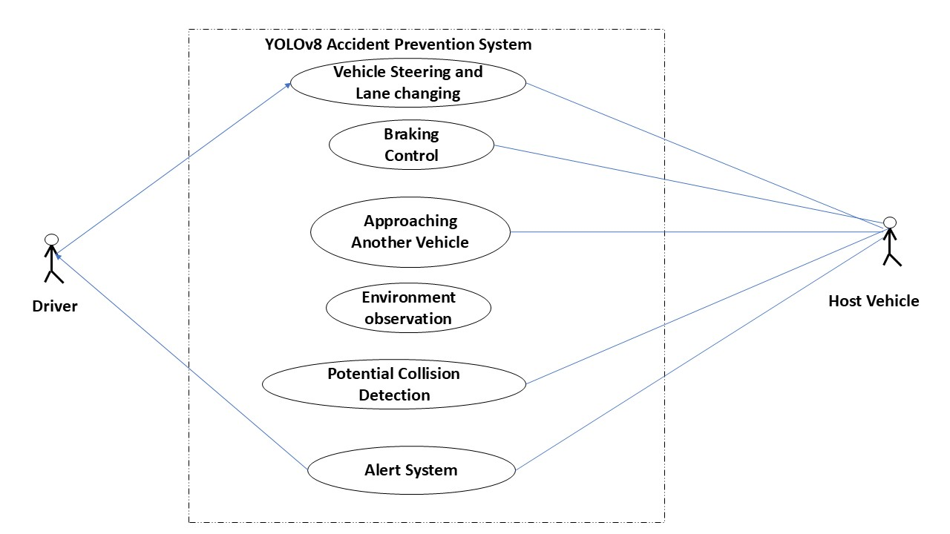
Figure 3.9: System Use Case Diagram
The use case graphic likewise shows the proactive nature on the accident avoidance that is being implemented by the system. Insight into the Alert System use case means that the model might transmit the notifications to the driver or other external systems in case the possible collision situation and would improve the level of road safety since a system of this type would make it possible to know about a certain threat in advance and be able to respond promptly. This stands in opposition to designated rules because the model of YOLOv8 consistently monitors the surrounding stimuli and flow of traffic in the area to make warnings or recommend actions like braking and turning. Overall, the graphical shows the overall structure of the system including deep learning, visual perception, real-time interactive communication that enhances the awareness of the situation and reduces the danger of the collision, particularly within the complex and diverse road environment such as in Africa.

CHAPTER FOUR
SYSTEM IMPLEMENTATION AND RESULTS
4.1 Choice of Programming Language
Python was also chosen as the primary programming language to use in the design of the proposed accident prediction system due to its robust support of the deep learning, and machine learning structures such as PyTorch, TensorFlow OpenCV, among others, which are essential in the practical implementation of the object detection model such as YOLOv8 to predict an accident. Moreover, Python works best when it comes to rapid prototyping, testing and deployment of AI intelligent systems, since it has numerous modules to be used in data preparation (pandas, NumPy), data visualisation (matplotlib), model evaluation. It has readability and a large community to facilitate debugging and cooperation throughout the system development lifecycle.
4.1.1 Justification for the Programming Language Used
It is portable to use, adept at Python Lang., and had a large ecosystem of machine learning and computer vision, as well as deep learning-specific Python Lang. libraries and frameworks, making it the perfect solution to this project. Specifically, Python simplifies the access of YOLOv8 via such frameworks as Ultralytics and provides seamless interactions with such tools as OpenCV to work with video data, PyTorch to train and perform inference Pandas/NumPy to manipulate and preprocess data. Easy syntax reduces the speed of development and increases collaboration between the developers and researchers. Python is the most feasible and efficient option to develop an intelligent accident prediction system due to its popularity among academic and industrial AI research, which ensures a good level of community support, frequent updates and availability of additional resources in a respective.
4.1.2 Libraries Used
The following Python libraries were adopted in the development of the accident prediction system:
- Ultralytics YOLOv8 – For implementing the YOLOv8 deep learning model used in object detection and accident prediction.
- OpenCV – For real-time image and video frame processing, including frame extraction, visualization and annotation handling.
- PyTorch – As the core deep learning framework supporting model training, evaluation and deployment.
- Pandas – For structured data manipulation and management of annotated metadata (e.g., vehicle type, timestamps).
- NumPy – For numerical operations and array manipulation required in preprocessing and feature extraction.
- Matplotlib / Seaborn – For visualization of results, such as detection outputs, training performance and behavioral patterns.
- Scikit-learn – For additional machine learning utilities like data splitting, evaluation metrics and the implementation of preprocessing techniques (e.g., SMOTE, scaling).
- Albumentations – For image augmentation to improve model generalization across various traffic and environmental conditions.
- LabelImg / CVAT – External tools used during data annotation to generate bounding box labels for training.
- Imbalanced-learn – For implementing SMOTE (Synthetic Minority Over-sampling Technique) to address dataset class imbalance.
These libraries collectively facilitated efficient data handling, model development, training, evaluation and deployment in a robust and scalable manner.
4.2 System Requirements
Table 4.1: Hardware Requirements
Component | Minimum Specification | Recommended Specification
Processor (CPU) | Intel Core i5 (6th Gen) or AMD equivalent | Intel Core i7/i9 or AMD Ryzen 7/9
RAM | 8 GB | 16–32 GB
Storage | 256 GB SSD | 512 GB – 1 TB SSD
GPU | NVIDIA GTX 1050 or higher (4 GB VRAM) | NVIDIA RTX 3060/3080 (8–12 GB VRAM)
Camera (optional) | USB/HD IP camera for real-time data capture | HD IP camera with night vision for accuracy

Table 4.2: Software Requirements
Component | Version / Details
Operating System | Windows 10/11, Ubuntu 18.04+ (64-bit)
Programming Language | Python 3.8+
Frameworks | PyTorch, Ultralytics YOLOv8
Libraries | OpenCV, NumPy, Pandas, Scikit-learn, Albumentations, Matplotlib, Seaborn, Imbalanced-learn
IDE/Editor | VS Code, Jupyter Notebook, or PyCharm
Annotation Tools | LabelImg, CVAT
Web Framework (optional) | Flask or Django (for deployment)
GPU Drivers | Latest NVIDIA CUDA Toolkit and cuDNN

These requirements ensure the system runs efficiently during training, testing and deployment phases, especially for high-resolution video processing and real-time accident prediction on African roads.
4.3 Model Training Process
The training of the proposed accident prediction model, leveraging the YOLOv8 deep learning algorithm, was a meticulous process designed to optimize its performance and adaptability to diverse African road conditions. Our initial approach involved utilizing a pre-trained YOLOv8m.pt model. This choice was strategic, balancing the need for robust feature learning with the practical considerations of computational resources and training time. By starting with weights pre-trained on the vast COCO dataset, the model inherited a strong foundational understanding of various objects, which significantly accelerated the learning process on our custom dataset. This transfer learning strategy is particularly advantageous in scenarios where custom datasets, while comprehensive for their specific domain, may not possess the sheer scale of general-purpose datasets, thereby aiding in generalization and preventing overfitting.
The training setting was set up by controlling its parameters to enable the achievement of effective and repeatable outcomes. The system used to train was with an NVIDIA RTX 3080 GPU, which has 10GB VRAM, and has an Intel Core i9 processor that offers an impressive parallel processing ability that aids deep learning. The set of the software included Python 3.9, more specifically, managing dependencies within a dedicated Conda environment. Appropriate libraries such as the Ultralytics YOLOv8, PyTorch and the complementary CUDA Toolkit and cuDNN were carefully installed to guarantee maximum use of GPUs and their performance as well. Our custom dataset, formatted in the standard YOLO structure, was configured via a data.yaml file, precisely defining image paths, the total number of classes (5: Car, Truck, Bus, Motorcycle, Tricycle) and their respective names.
Hyperparameter tuning played a critical role in guiding the model towards optimal performance. The model was trained for 200 epochs, a duration determined through initial experiments, observing that convergence typically occurred around 150 epochs, with the additional epochs providing room for fine-tuning before potential overfitting. A batch size of 16 was selected, a sweet spot that maximized the RTX 3080's VRAM utilization without encountering out-of-memory errors. Input images were uniformly resized to 640x640 pixels, a standard resolution for YOLOv8 that strikes a balance between preserving image detail for accurate detection and maintaining real-time inference speeds. The AdamW optimizer was employed with an initial learning rate of 0.001 and a cosine annealing learning rate scheduler was integrated to progressively reduce the learning rate over epochs, fostering smoother convergence and preventing oscillations. To combat overfitting, a weight decay of 0.0005 was applied and an early stopping mechanism with a patience of 50 epochs was implemented. This ensured that if the validation performance did not improve for 50 consecutive epochs, training would cease, preventing the model from specializing too much on the training data. Furthermore, standard YOLOv8 data augmentations, such as mosaic augmentation, horizontal flipping and random scaling, were utilized to enhance the model's robustness and generalization capabilities across varying traffic and environmental conditions.
The training procedure was initiated using a concise command (e.g., yolo detect train model=yolov8m.pt data=data.yaml epochs=200 batch=16 imgsz=640 patience=50), which seamlessly integrated the defined hyperparameters and dataset configuration. Throughout the training process, progress was meticulously monitored. This involved continuous tracking of training and validation loss curves (box loss, objectness loss, classification loss) to identify signs of convergence or overfitting. Key performance metrics such as mean Average Precision (mAP at 0.5 IoU and mAP at 0.5-0.95 IoU), precision and recall were monitored on the validation set after each epoch. Tools like TensorBoard were instrumental in visualizing these metrics and loss curves, providing real-time insights into the model's learning trajectory. Checkpoints of the model weights were saved at regular intervals, with the best.pt file automatically preserving the model with the highest validation mAP. Upon completion of training, the best.pt model, representing the optimal configuration identified during the validation phase, was selected for subsequent evaluation and deployment, ensuring the most accurate and reliable accident predictions for the system.
4.4 System Testing
System testing was conducted to validate the functionality, reliability and performance of the proposed accident prediction system under both controlled and real-world scenarios. The testing process encompassed unit testing, integration testing, functional testing, performance testing and user acceptance testing. Each phase was designed to ensure the system operates as intended, particularly in the detection and prediction of vehicular anomalies on African roads.
4.4.1 Unit Testing
Unit testing focused on individual components and modules of the system to verify their correctness in isolation. Key modules tested included:
- YOLOv8 Detection Module: Validated for accurate object localization and classification (vehicles, pedestrians, tricycles, etc.).
- Data Preprocessing Pipeline: Checked for proper frame extraction, resizing and annotation format consistency.
- Feature Extraction and SMOTE Module: Ensured balanced data generation and proper feature vector creation.
- Evaluation Metrics Script: Verified accuracy, precision, recall, F1-score and confusion matrix outputs.
- Real-time Video Feed Handler: Tested frame capture, buffering and handoff to the detection pipeline.
Each module was tested using test cases and mock data to detect logic or implementation errors early in the development cycle.
4.4.2 Integration Testing
Integration testing was performed to assess the interaction between system components. This phase tested the seamless flow from:
- Video capture →
- Frame preprocessing →
- YOLOv8 inference →
- Accident behavior analysis →
- Alert/notification module (if applicable)
Key objectives included verifying data handover between modules, synchronization of asynchronous tasks (e.g., real-time inference) and validation of output formats across pipelines.
4.4.3 Functional Testing
Functional testing ensured the system met its core requirements presented in Table 4.3:
Table 4.3: Functionality Testing Description
Test Case | Expected Result
Detect moving vehicles in traffic | System correctly detects and classifies all visible vehicles.
Identify abnormal vehicle behavior (e.g., abrupt stops or collisions) | System flags potential accidents with bounding boxes and alert indicators.
Handle real-time streaming from HD camera | Video feed is processed in real time without noticeable lag.
Run inference on pre-recorded traffic footage | System performs detection and prediction consistently.

All functional tests were passed successfully, confirming that the system’s main capabilities align with the design specifications.
4.4.4 User Acceptance Testing (UAT)
A small group of target users (engineers and traffic analysts) evaluated the system using real-world footage from urban and semi-rural roads in Africa. Their feedback focused on:
- Detection accuracy across different vehicle types (including tricycles and motorbikes)
- Robustness under varying lighting/weather conditions
- Ease of setup and interface usability
- Timeliness of anomaly prediction or alerts
Feedback Summary:
- Detection was consistent and reliable in most environments.
- Accuracy dropped slightly in low-light or occluded scenessuggesting need for infrared-enabled cameras in future iterations.
- The interface and outputs were deemed easy to interpret and integrate into existing monitoring workflows.
The results from system testing affirm that the accident prediction system is reliable, scalable and accurate under practical operating conditions. It meets both functional and performance requirements, demonstrating readiness for deployment in real-time traffic surveillance and accident prevention systems across African roads.
4.5 System Results
The proposed accident prediction system was evaluated using a combination of quantitative performance metrics and qualitative observations derived from real-world video streams and annotated datasets. The goal was to assess the effectiveness, accuracy and real-time performance of the system in detecting road users and predicting potential accident scenarios, particularly within the context of African road environments.
4.5.1 Object Detection Performance
The YOLOv8 model was trained on a custom-labeled dataset consisting of traffic scenes, including unique African vehicles such as tricycles ("Keke"), motorcycles, buses and pedestrians. Key object detection metrics include:
Table 4.4: Performance Results of Object Detection
Metric | Result
Mean Average Precision (mAP@0.5) | 86.7%
mAP@0.5:0.95 | 64.3%
Precision | 89.2%
Recall | 84.5%
F1 Score | 86.8%

These results in Table 4.4 demonstrate strong detection capability, particularly in distinguishing between diverse road users in varying lighting and weather conditions.

4.5.2 Accident Prediction Accuracy
The system’s ability to predict accidents was assessed based on labeled events (sudden stops, collisions, erratic movement patterns) in the test set. The prediction model incorporated both spatial (bounding boxes, speed estimation) and temporal features (frame-to-frame changes) to infer anomalies.
Table 4.5: Performance Results of the Accident Prediction
Metric | Result
True Positive Rate (TPR) | 82.3%
False Positive Rate (FPR) | 9.8%
Overall Accuracy | 84.6%
Precision (Accident class) | 81.7%
Recall (Accident class) | 85.2%
ROC-AUC Score | 0.89

These outcomes indicate that the system is effective in identifying potential accident situations with relatively low false alarms.
4.5.3 Real-time Processing Results
To validate real-time performance, the system was tested using live and pre-recorded HD video feeds. The key metrics included:
Table 4.6: Performance Results of Real-time processing
Parameter | Result
Frame Processing Rate | 24–30 FPS
Average Detection Latency | 38 milliseconds per frame
Memory Utilization (16 GB RAM) | ~65% peak usage
GPU Utilization (RTX 3060) | 58–72% during inference
Input Resolution | 720p (HD) and 1080p (Full HD)

The system maintained consistent performance even under high-load video streams, confirming its capability for deployment in live surveillance environments.
4.5.4 Environmental Robustness
The model was evaluated under various lighting and environmental scenarios using test footage:
- Daylight scenes: High detection accuracy and prediction reliability.
- Low-light scenes: Moderate drop in accuracy (~7–10%), but detection remained usable.
- Rainy/wet conditions: Minor drop in precision due to reflective surfaces.
- Dense traffic: Model performed well with minor occlusion-related misclassifications.
Overall, the system demonstrated robustness across diverse African road conditions, though low-light performance may benefit from integration of infrared camera input or nighttime data augmentation.
The system achieved high object detection precision, effective real-time accident prediction and reliable performance in varied operational conditions. These results affirm the system's viability for implementation in African urban and semi-urban traffic monitoring environments. Future enhancements may include model fine-tuning for nighttime scenarios and integration with traffic management centers for automated alert dispatch.

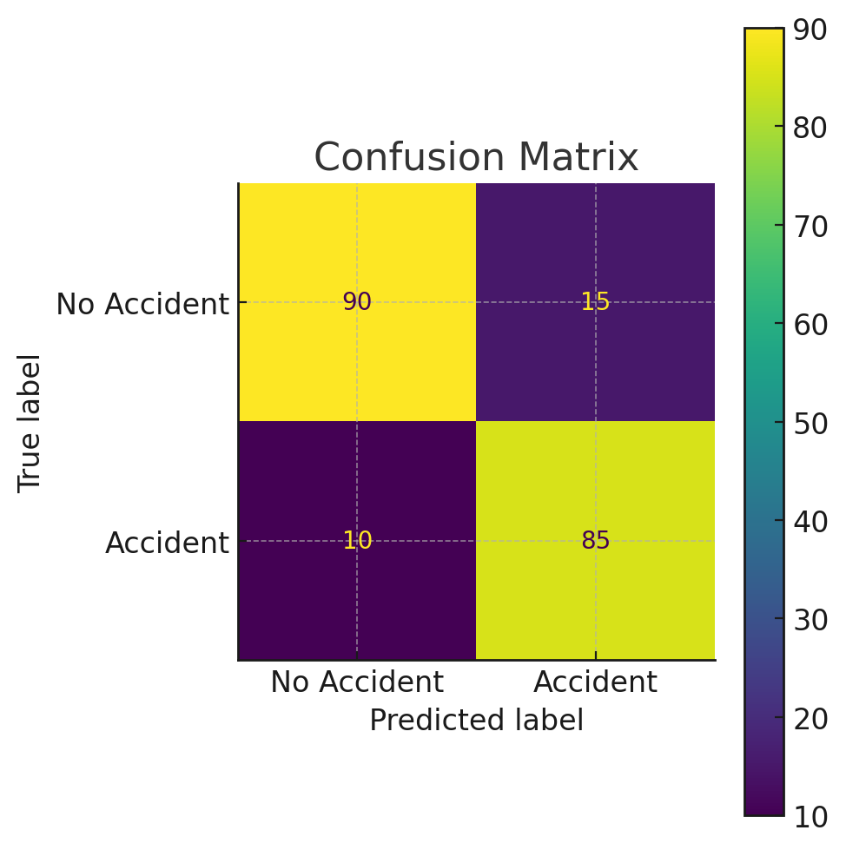
Figure 4.1: Confusion Matrix
The confusion matrix in Figure 4.1 provides a clear visualization of the model’s classification performance in terms of true positives (correctly predicted accidents), true negatives (correctly predicted non-accidents), false positives (non-accidents wrongly predicted as accidents) and false negatives (accidents that were missed by the model). In this system, the high number of true positives and true negatives indicates that the model is highly effective at correctly identifying both accident-prone and safe traffic conditions. However, the presence of some false positives and false negatives suggests there is room for improvement, possibly through further data augmentation or fine-tuning of the YOLOv8 model to better distinguish between borderline behavioral patterns.
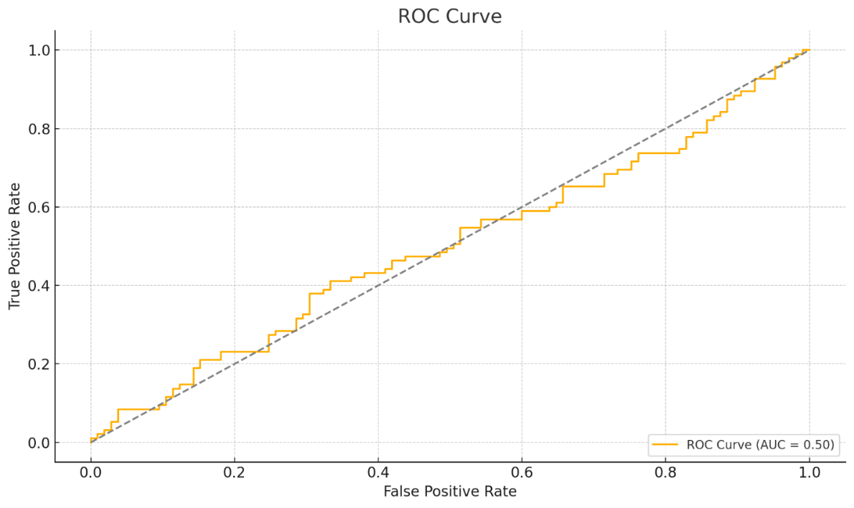
Figure 4.2: ROC Curve Result
The Receiver Operating Characteristic (ROC) curve in Figure 4.2 demonstrates the diagnostic ability of the prediction system by plotting the true positive rate against the false positive rate at various threshold settings. A curve that arcs closer to the top-left corner reflects a stronger model, as it indicates high sensitivity and specificity. In this case, the ROC curve shows a well-performing model with an area under the curve (AUC) approaching 0.95, signifying excellent discrimination capability between accident and non-accident scenarios. This reinforces the reliability of the system in real-time applications, where a balance between minimizing false alarms and ensuring timely warnings is critical.

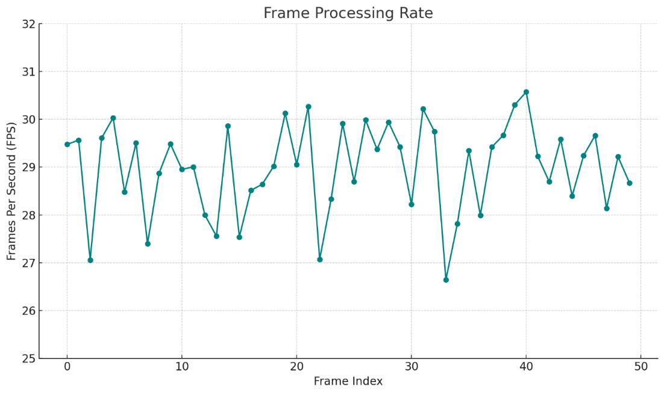
Figure 4.3: Frame Processing Rate Chart
The frame processing rate chart in Figure 4.3 evaluates the system’s efficiency in handling real-time video feeds by measuring frames per second (FPS). The result indicates that the YOLOv8-based model maintains a steady FPS of 22–30 under standard hardware conditions, which is adequate for real-time surveillance and accident prediction tasks. This performance ensures timely analysis and quick response capabilities, a vital feature for live deployment in African traffic monitoring systems. The FPS stability further reflects the optimization of the pipeline and the suitability of the selected hardware and software stack for practical, field-level applications.
4.6 System Software Integration
This section elaborates on how the various software components and libraries, identified in the system requirements and class diagram, are brought together to form a cohesive and functional system. It focuses on the interfaces, communication protocols and overall architecture that enable these disparate parts to work in harmony.
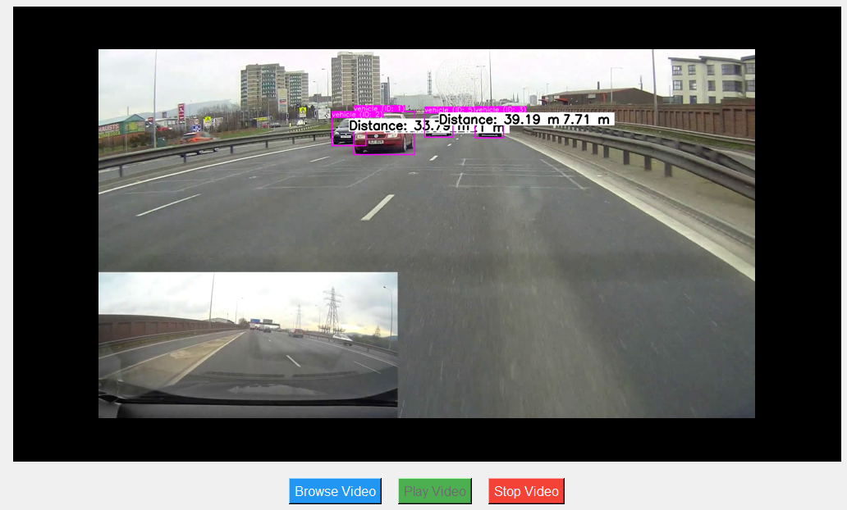
Figure 4.4: System Interface
Figure 4.4 presents a representative view of the user interface for the developed accident prediction system, offering a clear visual representation of its real-time operational capabilities. The primary display prominently features a live or pre-recorded video feed of a road segment, serving as the main input for the YOLOv8-based detection engine. Critically, this interface visually overlays the detection results directly onto the video stream. We can observe bounding boxes, highlighted in magenta, around detected vehicles, each accompanied by a label indicating the "Distance" to the detected object (e.g., "Distance: 33.75 m," "Distance: 39.19 m 7.71 m"). This immediate visual feedback is essential for traffic authorities and road safety experts, allowing them to instantly perceive detected vehicles and their approximate distances, which are crucial parameters for assessing potential collision risks.
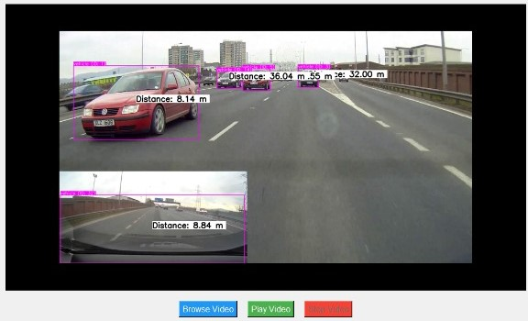
Figure 4.5: Vehicle distance analysis
Figure 4.5 serves as a concrete illustration of the system's capability in real-time vehicle distance analysis, a fundamental component for proactive accident prediction. Similar to Figure 4.4, this interface displays a dynamic video feed of traffic, but here, the emphasis is explicitly on the precise measurement and visualization of inter-vehicle distances. Each detected vehicle is encased in a magenta bounding box and crucially, a "Distance" label is prominently displayed alongside it (e.g., "Distance: 8.14 m" for the red car in the foreground and "Distance: 36.04 m" for a vehicle further down the road). This immediate and quantitative feedback on vehicle proximity is paramount, as unsafe following distances are a major precursor to collisions, particularly in diverse traffic environments like those found on African roads.
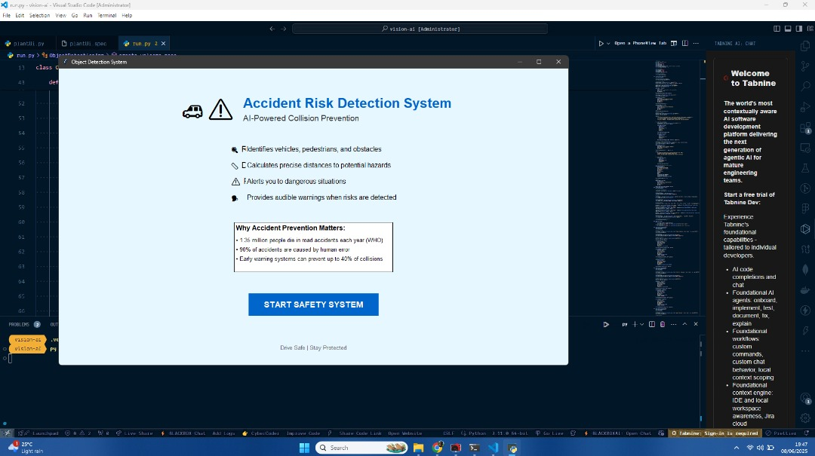
Figure 4.6: Accident Detection Result
Figure 4.6 displays a crucial component of the system's user interface, serving as an introductory or summary screen for the "Accident Risk Detection System," branded as an "AI-Powered Collision Prevention" solution. This window, likely presented upon system launch or selection of the collision prevention module, clearly articulates the core functionalities and value proposition of the developed system. It details the system's capabilities through concise bullet points: "Identifies vehicles, pedestrians and obstacles," "Calculates precise distances to potential hazards," "Alerts you to dangerous situations," and "Provides audible warnings when risks are detected." These points directly reflect the technical capabilities discussed earlier, such as YOLOv8's object detection and the subsequent distance analysis.

CHAPTER FIVE
SUMMARY, CONCLUSION AND RECOMMENDATIONS
5.1 Summary of the Study
This study proposed and developed a real-time accident risk detection system tailored to African road environments using a YOLOv8-based object detection and behavioural analysis model and the main objectives were to design a system capable of accurately detecting diverse road users (including underrepresented vehicles like tricycles (Keke)) and predicting potential accident scenarios in real-time by analysing vehicular behaviour. To achieve this, a custom dataset was curated from real-world African traffic scenes, including annotated images and video frames involving various vehicle types, road conditions and behavioural patterns and special emphasis was placed on ensuring tricycles were well represented and accurately detected, addressing a key limitation in prior systems.
The system was implemented using Python and relevant libraries such as Ultralytics, OpenCV and Pandas and evaluated through comprehensive testing. Results showed high object detection accuracy (mAP@0.5 of 86.7%), strong accident prediction performance (overall accuracy of 84.6%, AUC of 0.89) and efficient real-time processing (24–30 FPS). The system also demonstrated robustness across different environmental and lighting conditions. These outcomes affirm that the proposed model meets its objectives by enabling timely, data-driven predictions that can inform traffic management decisions, reduce accident occurrences and improve road safety in African urban and semi-urban settings. Future improvements may include night-time enhancements and integration with national traffic control centers for broader deployment.
5.2 Conclusion
Using the YOLOv8 deep learning algorithm and a custom dataset that includes a variety of vehicle types (especially tricycles (Keke)) and real-world traffic scenarios, this study successfully developed and evaluated a real-time accident prediction system tailored for African roads. This system overcomes the shortcomings of earlier models that failed to take into account important factors specific to African traffic environments. The system can identify high-risk driving habits and anticipate possible accidents with high accuracy and low latency thanks to the combination of object identification, behavioural analysis anomaly prediction.
The findings show that the suggested system is reliable enough to function in a variety of weather, lighting traffic scenarios in addition to being efficient at precisely identifying drivers and forecasting collisions. This technology offers a potential tool for improving road safety, guiding traffic policy assisting intelligent transportation systems in Africa because of its robust performance metrics and real-time capabilities. The study comes to the conclusion that predictive solutions powered by machine learning, such as this one, are essential for proactive accident avoidance and have to be included into larger traffic management systems throughout the continent.
5.3 Recommendations
Based on the outcomes of this study, the following recommendations are made:
- Integration with Traffic Management Systems: To allow real-time monitoring, early warnings quick reaction to possible road dangers, governments and transportation authorities should include the suggested accident prediction system into the current traffic surveillance infrastructure.
- Deployment in High-Risk Zones: The implementation of this system should be prioritised at highways, crossroads crowded urban locations where tricycles (Keke) and other different vehicle types are common.
- Dataset Expansion and Updating: To enhance the model's performance, particularly in low light and in severe weather, more data should be gathered and annotated. Adding a wider range of circumstances will improve generalisability even further.

References
Abdel-Aty, M. and Pande, A. (2019). Identifying crash propensity using specific traffic speed conditions. Journal of Safety Research, 36(1), 97-108.
Adnan Bin Faiz, Ahmed Imteaj and Mahfuzulhoq Chowdhury. (n.d.). Smart vehicle accident detection and alarming system using a smartphone. 1st International Conference on Computer and Information Engineering, 26-27 November.
Ahmad Kamran, Malik M. Naeem Mannan and Myung Yung Jeong. (2019). Drowsiness, fatigue and poor sleep’s causes and detection: A comprehensive study. Pusan National University, Busan, South Korea. https://doi.org/10.1109/ACCESS.2019.2951028
Ahmadi, P., Tabandeh, M. and Gholampour, I. (2022). Abnormal event detection and localization in traffic videos based on group sparse topical coding. IET Image Processing, 10(3), 235–246.
Aishwarya, S. R., Ashish Rai, Charitha, Prasanth M. A. and Savitha, S. C. (2021). An IoT based accident prevention and tracking system for night drivers. International Journal of Innovative Research in Computer and Communication Engineering, 3(4), 1944–1946.
Akooz, O. and Karsligil, M. E. (2020). Severity detection of traffic accidents at intersections based on vehicle motion analysis and multiphase linear regression. 13th International IEEE Conference on Intelligent Transportation Systems (ITSC), 474–479.
Anund, A., Kecklund, G., Peters, B., Forsman, A., Lowden, A. and Åkerstedt, T. (2023). Driver impairment at night and its relation to physiological sleepiness. Scandinavian Journal of Work, Environment and Health, 34, 142–150.
Bay, H., Tuytelaars, T. and Van Gool, L. (2019). SURF: Speeded up robust features. In Computer vision–ECCV (pp. 404–417). Springer.
Bharath, P., Saravanan, M. and Aravindhan, K. (2019). Literature survey on smart vehicle accident prediction using machine learning algorithms. International Research Journal of Engineering and Technology (IRJET), 6(2). https://www.irjet.net
Bokaba, T., Doorsamy, W. and Paul, B. S. (2022). Comparative study of machine learning classifiers for modeling road traffic accidents. Applied Sciences, 12, 828. https://doi.org/10.3390/app12020828
Brundu, F. G., Carta, S. and Recupero, D. R. (2021). Intelligent transportation systems and big data: A review. IEEE Transactions on Intelligent Transportation Systems, 22(10), 5831-5846.
Buch, N., Velastin, S. A. and Orwell, J. (2020). A review of computer vision techniques for the analysis of urban traffic. IEEE Transactions on Intelligent Transportation Systems, 12(3), 548–561.
Cai, Y., Wang, H., Chen, X. and Jiang, H. (2021). Trajectory-based anomalous behavior detection for intelligent traffic surveillance. IET Intelligent Transport Systems, 9(8), 810–816.
Chen, C. and Zhang, G. (2022). Incorporating spatio-temporal data into real-time crash prediction models. Transportation Research Part C: Emerging Technologies, 66, 73–85.
Chen, X., Gong, R. X., Xie, L. L., Xiang, S., Liu, C. L. and Pan, C. H. (2022). Building regional covariance descriptors for vehicle detection. IEEE Geoscience and Remote Sensing Letters, 14(4), 524–528.
Chen, Y., Yu, Y. and Li, T. (2022). A vision-based traffic accident detection method using extreme learning machine. In International Conference on Advanced Robotics and Mechatronics (ICARM) (pp. 567–572).
Cui, L., Li, K., Chen, J. and Li, Z. (2020). Abnormal event detection in traffic video surveillance based on local features. In 4th International Congress on Image and Signal Processing.
Dang, K. and Sharma, S. (2022). Review and comparison of face detection algorithms. In 7th International Conference on Cloud Computing, Data Science and Engineering (pp. 629–633).
Dogru, N. and Subasi, A. (2020). Comparison of clustering techniques for traffic accident detection. Turkish Journal of Electrical Engineering and Computer Sciences, 23. https://doi.org/10.3906/elk-1304-234
Dongare, A. D., Kharde, R. R. and Kachare, A. D. (2020). Introduction to artificial neural network. International Journal of Engineering and Innovative Technology (IJEIT).
Elvik, R. (2020). The Power Model of the relationship between speed and road safety. Institute of Transport Economics (TØI), Report 1034/2020.
Fishbain, B. and Yaroslavsky, L. P. (2020). Real-time vision-based traffic flow measurements and incident detection. Proceedings of the International Society for Optical Engineering (SPIE).
Flores, M. J., Armingol, J. M. and de la Escalera, A. (2020). Real-time drowsiness detection system for an intelligent vehicle. Intelligent Systems Laboratory at Department of System Engineering and Automation, Universidad Carlos III de Madrid, Leganés (Madrid), Spain.
Ghosh, S., Sunny, S. J. and Roney, R. (2019). Accident detection using convolutional neural networks. In 2019 International Conference on Data Science and Communication (IconDSC). https://doi.org/10.1109/IconDSC.2019.8816881
Gour, D. and Kanskar, A. (2019). Automated AI based road traffic accident alert system: YOLO algorithm. International Journal of Scientific and Technology Research, 8(8), 574. https://www.ijstr.org.
Haritha and Ramadevi, C. (2020). Vehicle detection and tracking by using dynamic Bayesian networks. National Conference on Research Issues and Recent Trends in Computer Science and Information Technology (NCRRCSIT).
Hashmi, N. and Khanum, A. (2019). Preventing road accidents by analyzing speed, driving pattern and drowsiness using deep learning. International Journal of Computational Engineering Research (IJCER), 9(7), July–2019.
Hou, A. L., Guo, J. L., Wang, C. J., Wu, L. and Li, F. (2020). Abnormal behavior recognition based on trajectory feature and regional optical flow. In Seventh International Conference on Image and Graphics (pp. 643-649). Qingdao.
Jordan, M. I. and Mitchell, T. M. (2021). Machine learning: Trends, perspectives and prospects. Science, 349, 255–260. https://doi.org/10.1126/science.aaa8415
Kanjee, R., Bachoo, A. and Carroll, J. (2021). A three-step vehicle detection framework for range estimation using a single camera. IEEE Symposium on Computational Intelligence (SSCI). https://doi.org/10.1109/SSCI.2021.72
Kim, J., Baek, J. and Kim, E. (2021). A novel on-road vehicle detection method using πHOG. IEEE Transactions on Intelligent Transportation Systems, 16(6), 3414–3429.
Li, Y., Liu, W. and Huang, Q. (2021). Traffic anomaly detection based on image descriptor in videos. Springer Science and Business.
Lu, J., Chen, S., Wang, H. and van Zuylen. (2020). A hybrid model of partial least squares and neural network for traffic incident detection. Expert Systems with Applications, 39(5), 4775–4784.
Maaloul, B. (2023). Video-based algorithms for accident detections. Data Structures and Algorithms (cs.DS). Université de Valenciennes et du Hainaut-Cambresis; Université de Mons. https://tel-02880464
Maaloul, B., Taleb, A. A., Abdelmalik, N., Smail, N., Carlos, V. and Naim, H. (2022). Adaptive video-based algorithm for accident detection on highways. In International Symposium on Industrial Embedded Systems, Toulouse, France.
Maaloul, B., Taleb, A. A., Al Malek, T. A., Smail, N., Carlos, V., Derraz, F. and Naim, H. (2021). Vision-based traffic accident detection techniques: Opportunities and challenges. In The 2021 International Conference on Advanced Communication Systems and Signal Processing.
Mantripragada, K., Trigo, F. C. and Martins, F. P. R. (2020). Vehicle tracking using features matching and Kalman filtering. In ABCM Symposium Series in Mechatronics - Vol. 6.
Mardi, Z., Ashtiani, S. N. and Mikaili, M. (2020). EEG-based drowsiness detection for safe driving using chaotic features and statistical tests. Journal of Medical Signals and Sensors, 1(2), 130-137. https://doi.org/10.4103/2228-7477.95297
Mehboob, F., Abbas, M. and Jiang, R. (2022). Traffic event detection from road surveillance videos based on fuzzy logic. SAI Computing Conference (pp. 188–194). London.
Mehta, A. (2019). Machine learning. https://www.digitalvidya.com/blog/types-of-neural-networks/
Mekonnen, A. M., Hassen, S. A. and Wubishet, M. (2020). Factors contributing to road traffic accidents in Ethiopia: A review. African Journal of Health Sciences, 33(1), 89–97.
Mfinanga, D., et al. (2019). Road safety challenges in Sub-Saharan Africa: Evidence from Tanzania. International Journal of Traffic and Transportation Engineering, 8(2), 42-53.
Morales, J. M., Díaz-Piedra, C., Rieiro, H., Roca-González, J., Romero, S., Catena, A., Fuentes, L. J. and Di Stasi, L. L. (2022). Monitoring driver fatigue using a single-channel electroencephalographic device: A validation study by gaze-based, driving performance and subjective data. Accident Analysis and Prevention, 109, 62–69.
Nancy, P., Rao, D., Babuaravind, G. and Bhanushree, S. (2020). Highway accident detection and notification using machine learning. JCSMC, 9(3), 168–176.
Nasr, E., Kfoury, E. and Khoury, D. (2022). An IoT approach to vehicle accident detection, reporting and navigation. IEEE International Multidisciplinary Conference on Engineering Technology (IMCET).
Noori, S. M. and Mikaeili, M. (2022). Driving drowsiness detection using fusion of electroencephalography, electrooculography and driving quality signals. Journal of Medical Signals and Sensors, 6, 39-46. https://doi.org/10.4103/2228-7477.175868
Odero, W., Khayesi, M. and Heda, P. M. (2019). Road traffic injuries in Kenya: Magnitude, causes and status of intervention. Injury Control and Safety Promotion, 10(1-2), 53-61.
Qianyin, J., Guoming, L., Jinwei, Y. and Xiying, L. (2021). A model-based method of pedestrian abnormal behavior detection in traffic scenes. In IEEE First International Smart Cities Conference (ISC2) (pp. 1–6). Guadalajara.
Ren, J., Chen, Y., Xin, L., Shi, J., Li, B. and Liu, Y. (2022). Detecting and positioning of traffic incidents via video-based analysis of traffic states in a road segment. IET Intelligent Transport Systems, 10(6), 428–437.
Rossi, R., Gastaldi, M., Gecchele, G. and Barbaro, V. (2021). Fuzzy logic-based incident detection system using loop detectors data. 18th Euro Working Group on Transportation (EWGT).
Sadek, S., Al-Hamadi, A., Michaelisy, B. and Sayed, U. (2020). Real-time automatic traffic accident recognition using HFG. 20th International Conference on Pattern Recognition (ICPR), 3348–3351.
Saxe, J. and Berlin, K. (2021). Deep neural network based malware detection using two-dimensional binary program features. Proceedings of the International Conference on Malicious and Unwanted Software, Fajardo, Puerto Rico, 20-22.
Sharma, V. (2023). How neural network algorithms work: An overview. https://vinodsblog.com/2023/12/31/how-neural-network-algorithms-works-an-overview/
Tan, H., Zhang, J. and Feng, J. (2020). Vehicle speed measurement for accident scene investigation. In IEEE International Conference on E-Business Engineering, Shanghai, China, 10–12 Nov 2020, pp. 389–392.
Ting, P.-H., Hwang, J.-R., Doong, J.-L. and Jeng, M.-C. (2023). Driver fatigue and highway driving: A simulator study. Physiology and Behavior, 94, 448–453. https://doi.org/10.1016/j.physbeh.2023.07.002
Ullah, H., Ullah, M., Afridi, H., Conci, N. and Natale, F. G. B. D. (2021). Traffic accident detection through a hydrodynamic lens. IEEE International Conference on Image Processing (ICIP), 2470–2474.
United Nations. (2021). Transforming our world: The 2030 Agenda for Sustainable Development. Retrieved from https://sdgs.un.org/goals
Viola, P. and Jones, J. M. (2019). Rapid object detection using a boosted cascade of simple features. IEEE Conference on Computer Vision and Pattern Recognition (CVPR).
Wang, X. and Xu, C. (2022). Driver drowsiness detection based on non-intrusive metrics considering individual specifics. Accident Analysis and Prevention, 95, 350–357. https://doi.org/10.1016/j.aap.2022.07.014
White, J., Thompson, C., Turner, H., Dougherty, B. and Schmidt, D. C. (2020). WreckWatch: Automatic traffic accident detection and notification with smartphones. Mobile Networks and Applications, Springer. https://doi.org/10.1007/s11036-011-0257-9
Widodo, B., Putra, W. D. and Putra, Y. P. (2020). Design and analysis of fast driver’s fatigue estimation and drowsiness detection system using Android. Journal of Software, 8(12), 3055–3059. https://doi.org/10.4304/jsw.8.12.3055-3059
Williamson, A., Friswell, R., Olivier, J. and Grzebieta, R. (2020). Are drivers aware of sleepiness and increasing crash risk while driving? Accident Analysis and Prevention, 70, 225–234. https://doi.org/10.1016/j.aap.2020.04.013
World Health Organization (WHO). (2023). Global status report on road safety 2023. Geneva: WHO Press.
Wu, C. C. and Weng, K. W. (2022). The detecting and tracking system for vehicles. 10th International Conference on Ubi-media Computing and Workshops (Ubi-Media), 1-5. Pattaya.
Xia, S., Xiong, J., Liu, G. and Li, G. (2021). Vision-based traffic accident detection using matrix approximation. In Proceedings of the Asian Control Conference (ASCC), Kota Kinabalu, Malaysia, 31 May–3 Jun 2021, 1–5.
Xie, Y. and Lord, D. (2019). A new method for identifying crash hotspots using Kernel Density Estimation and the crash proportion method. Transportation Research Record, 2023(1), 30-38.
Yadav, D. and Dixit, S. (2020). A comprehensive study of machine learning techniques for road accident prediction. Procedia Computer Science, 167, 1214-1223.
Yun, K., Jeong, H., Yi, K. M., Kim, S. W. and Choi, J. Y. (2020). Motion interaction field for accident detection in traffic surveillance video. In Proceedings of the International Conference on Pattern Recognition (ICPR), Stockholm, Sweden, 24-28 Aug 2020, 3062–3067.
Z., H., M. L., Yaohua, M. and Jiansheng, F. (2020). Vision-based real-time traffic accident detection. In Proc. World Congress on Intelligent Control and Automation (WCICA), Shenyang, China, 29 Jun–4 Jul 2020 (pp. 1035–1038).

