BIOPHLIC ARCHITECTURE DESIGN.
GODFREY OKOYE UNIVERSITY, UGWUOMU-NIKE, ENUGU.

BY

OBIAJULU IFEANYICHUKWU VALENTINE
U20/NAS/ARC/267

DEPARTMENT OF ARCHITECTURE
FACULTY OF NARURAL SCIENCE AND ENVIRONMENTAL STUDIES
GODFREY OKOYE UNIVESITY, ENUGU
NIGERIA

JULY, 2024

ABSTRACT
This university research study focuses on biophilic design of primary health centres; it is for designing restorative and engaging environment using nature and nature inspired solutions for primary health centres to positively impact student’s health, productivity and self-identity.
Existing designs in primary health centers are explored to cater the research and the related theories and best practices to be studied so as to draw conclusions on details and techniques to beinspired and applied for biophilic design.
According to the research, natural light, ventilation system, water bodies, and green patches must be incorporated into the design which enhances cognitive performance and students’ health and happiness with the learning environment.
With reference to this research, the project develops a biophilic architectural design of a primary health center for students The goal is to enhance a harmonious interaction between the student, nature and the structures created to maximize on students’ learning, socialization and reflection spaces.

CHAPTER ONE
INTRODUCTION
1.1 Background to the Study
Throughout history, our connection to nature has profoundly shaped who we are – our emotions, thoughts, cultures, and even our health. However, modern architecture often relegates nature to a mere backdrop, failing to recognize its critical role in fostering human well-being (Kellert, 2012).
Decades ahead of her time, Carson's (1962) exposed the devastating effects of pesticides. She painted a chilling picture of a future devoid of pollinating bees, with no fruits and a disrupted ecosystem. This work ignited the modern environmental movement. earlier, Carson (1956), had delved deeper, questioning the value we place on connecting with nature. She argued that wonder and awe inspired by the natural world are not simply childhood pastimes, but essential for human well-being. Those who immerse themselves in nature, she suggests, find solace, peace, and a renewed appreciation for life. The natural world, with its rhythms provides a source of healing. This doesn't mean we should abandon life or shun cities, technology or man-made structures. Rather it suggests that urban planning should focus on reconnecting individuals with nature both emotionally. By integrating elements and processes into our surroundings we can establish a harmonious and rejuvenating setting. A successful structure in a setting transcends its physical appearance. It's not about the layout of the walls and roof; it's about the interactions and relationships it encourages within its confines and how it harmonizes with the environment around it. A designed building facilitates an exchange. Contributing to the city while also benefiting from it. Moreover, it should resonate with those who inhabit it whether, for residence, work, recreation or healthcare purposes. Pioneering work by Kevin Lynch, (1960) Jane Jacobs, (1961) and Christopher Alexander (1977) on spatial orientation, perception, and natural forms in architecture undoubtedly offered valuable insights. However, these approaches often overlooked the emotional impact of built spaces on people within urban planning culture. Similarly, the concept of environmental sustainability has become somewhat diluted, used more as a rhetorical term than a guiding principle in contemporary society. The relentless standardization of urban spaces has demonstrably stifled opportunities for change and engagement with the environment. Modern cities, sprawling and multifaceted, may create the illusion of access to greenery and nature. However, this often comes at the cost of worsening ecological and environmental issues within the city limits. In essence, these cities, with their isolated buildings and segregated land use, can be seen as the antithesis of what a truly thriving urban environment should be (Totaforti, 2018).
Instead of constant conflict with the natural world, our cities should strive for a more balanced relationship. We can achieve this by combining the best practices of traditional urban planning with the principles of landscape urbanism. This approach, which embodies the concepts of biophilic design and biomimicry (viewing nature as a "model, measure, and mentor," Benyus, 1997), prioritizes both the needs of individuals and environmental well-being. By fostering biodiversity and promoting a deeper connection with nature, we can create truly livable cities.
Biophilic design stems from a fundamental truth: humans thrive in sensory-rich environments connected to nature. Our bodies and minds have evolved alongside natural elements like sunlight, plants, animals, and landscapes. These elements contribute to our physical, intellectual, emotional, and spiritual well-being.
However, the rise of technology fostered a belief that humans could progress by conquering nature, leading to environmental degradation and a growing disconnect from natural systems. This alienation, as Kellert (2012), argues is marked by a loss of meaning in the places we inhabit. Urbanization intensifies this problem, as Mumford (2007) observed. Concrete jungles replace natural landscapes, altering our perception and depriving us of a connection to the environment.
This disconnect has roots in the anthropocentric view, where nature exists solely for human benefit. Galimberti (2000) suggests this perspective echoes Judeo-Christian traditions that influenced modern science. The consequence is a growing conflict – we rely on the environment but also modify it, often exceeding our control. While we create artificial worlds (cities) for survival, we become detached from the natural world that sustains us. Bateson (as cited in Scandurra, 2001) argues that this misguided approach, fueled by technological advancement and population growth, is the root cause of the ecological crisis. When a creature destroys its own environment, it ultimately destroys itself. We cannot thrive by severing the connection to the natural world from which we emerged. Early city planning reflected a blind faith in technology, viewing nature as an obstacle to progress. This perspective envisioned a future where technology would conquer all problems. Today, however, we recognize the limitations of this approach. Modern categories fail to address the present or guide the future. Humans struggle to reconcile themselves with the natural world, a world we fundamentally depend on. Cities, as artificial environments, embody this conflict. As David Orr (2005) observes, most modern buildings disregard ecology and user connection to the environment. They imply that energy is limitless and waste disposal inconsequential. This design disregards our biological needs, evolutionary experience, and aesthetic sensibilities (Kellert et al., 2008).
Moving forward, we must minimize the negative impact of progress on human health and the environment. True sustainability requires integrating social, economic, and environmental values. As John Elkington suggests, this is a multifaceted process. Historically, the focus has been on reducing a building's "ecological footprint" (Wackernagel and Rees, 1996) and economic efficiency. This approach, exemplified by the LEED rating system, has undoubtedly been valuable. However, it's insufficient for achieving true urban sustainability and societal well-being. The social dimension has been largely neglected. Recent programs like the Living Building Challenge and WELL Building Standard acknowledge the importance of human well-being by incorporating goals for health, air quality, and aesthetics. This highlights the underestimation of social value in sustainable design. The current weakness of sustainable design is its overemphasis on minimizing negative environmental impact, treating nature as "other" rather than a part of us. This often translates into technical solutions focused on low environmental impact design. While important, this approach fails to address the need to bridge the gap between humans and nature. We need design that fosters connection with natural processes and promotes human health and well-being through a culturally and ecologically sensitive approach.
True sustainability requires integrating low-impact design with biophilic design (or positive environmental impact design) to achieve restorative environmental design (Kellert et al., 2008). This approach aims to restore a connection, between people and the natural world in settings. Biophilic design is seen as an aspect of eco design shifting the focus from nature as a mere ethical notion, to an essential biological need.

1.2 Statement of Problem
The challenges faced by Nigeria's primary healthcare system are a lot. Most facilities are small in size and insufficient, in addition to being not well taken care of. Torn window screens, damaged equipment, and leaky roofs create an uninviting environment for patient care. But one way to better these structures is through biophilic design that includes natural elements: indoor plants, sunlight, water features, or even aquariums. The current primary healthcare centers do not provide these aspects of biophilic design (natural elements) nor do they offer sensory connection or connection to the outdoors. Natural sounds and calming colors would be pleasant alongside views of landscapes or courtyards— reducing feelings of isolation and addressing such issues as we just discussed with biophilic design: including indoor plants plus natural light and water features. Immune system enhancement.
In the primary healthcare system in Nigeria, the adoption of biophilic design has the potential to contribute to a more positive health care experience for patients which is more natural and calming.
1.3 Aim and objectives
1.3.1 Aim
This research seeks to enhance patient recovery of patients In a designated primary Health Centre through biophilic design.

1.3.2 Objectives
1. Reduce stress and anxiety: Research also shows that biophilic designs also enhance the reduction of stress hormones, thus making patient feel more relaxed and have a sense of well-being when they are at the place.
2. Enhance feelings of comfort and control: Biophilic design applies natural elements into the healthcare facilities and gives patients the views of nature so that this can decrease the feeling of helplessness among them.
3. Promote faster healing and recovery: Science shows that spending time in nature can enhance the process of healing and shorten the duration of inflammation and immunity.
4. Reduce burnout and fatigue: By incorporating nature related concepts into their interior design, healthcare organizations might improve the mood and overall quality of life of the employees potentially decreasing burnout rate.
5. Design for all abilities: Some principles of biophilic design should be aimed at the patients with reduced physical functioning.
1.4 Research Questions
While addressing biophilia issues in the design of a primary health center, I take into account the following significant research questions:
1. How far the biological features and components can be integrated into the structure of the initial level of the primary healthcare organization to provide a fulfilling environment for patients to reduce the stress levels?
2. In what measures can the following biophilic design strategies be employed in the primary healthcare center to enhance patients’ feeling of control and comfort throughout their visit?
3. Based on the concept of biophilic design, if patients are exposed to Natural elements within the primary healthcare center, does their Immunity level improve a notch, inflammation reducing thereby enhancing the Recovery time?
4. How can the components of biophilic design address the development of a restorative and stimulation working environment within the chosen primary healthcare centre that might help in decreasing staff burnout and increase satisfaction on the job?
5. The following is a breakdown of how those biophilic principles can be installed within the primary healthcare centre while making sure patients with a limited range of motion can still feel the positive impacts of a nature-infused indoors:
1.5 Significance of The Study
Primary care facilities are the foundations of society where they are needed to cure people and where architectural design is of great significance Primary care facilities are not merely places where patients with diseases are treated; they are the platform where people get preventive care services. This is where architecture comes into play.
Comfortable and Functional: Properly signed and explained the layout, easily adaptable for the disabled, and suitable for the weather for better recovery.
Calming and Safe: Objects of visual perception that cause inner feelings of calmness and protection.
Culturally Responsive: Catering to the individual requirements of the populace, including their cultural perceptions and issues affecting their health.
This way the staff and the patients feel that they are a team and this kind of relation helps to prevent diseases and improve patients’ health outcome; So much more than just a structure: A well-designed primary healthcare center is a solid base for a healthy society.
1.6 Scope
The design of primary health centers is highly important to architects. There are various factors to consider which enables them to create facilities that are both effective in function and promote patient wellness, as well as ensuring optimal delivery of healthcare services.
Key Considerations for Primary Health Center Design:
1. Site Analysis and Design : A thorough Site Analysis and Design entails understanding: zoning ordinances, site codes , building codes, and the site context. This assessment determines the design response to site opportunities and constraints to accomplish the successful conditions of the center.
2. Space Planning & Functionality : Space Planning and Functionality differ from general design research because it requires defining the necessary spaces and activities required to fulfill the healthcare program.
3. Optimizing Patient Flow : The ability to move throughout the environment or optimizing the patient flow is extremely important to the environment of care. Designing ways to minimize wait times and position departments for efficient movement is important.
4. Accessibility for All : In the current context of universal access, a facility must be designed to meet the needs of occupants of all abilities. This facet of access needs to not only meet the current code minimum standards, but also anticipate the needs and provide an adaptable environment for current and future patients and staff.
5. Infection Control Integration : Designing the healthcare environment is more than understanding the building code; it is also critical to understand the healthcare standards, as well as knowing design implications that can enhance care in a healthcare facility.
6. Environmental Systems : This aspect of design ensures the healthcare environment is comfortable and safe. Designing the systems for Heating, Ventilating & Air Conditioning (HVAC), lighting, and Medical, Electrical & Plumbing (MEP) systems effectively will provide a facility that functions well from a systems perspective.
7. Technology Integration : Designing a healthcare facility means strategizing how to integrate technology that is currently prime and how to incorporate the capability of enhancing future technological capabilities.
8. Biophilic Design : Biophilic design is the design concept that the human beings have an innate tendency to seek connections with nature and other forms of life. This design consideration looks to incorporate nature inside through natural light, views to the outdoors, air, greenery, and environmental design.
By carefully considering these elements, architects can create primary health centers that are efficient, comfortable, accommodating, and accessible. This well-designed environment fosters patient well-being, improves operational effectiveness, and ultimately contributes to a more successful healthcare delivery system.
Delimitation of the study
My research on primary health centers focused on understanding the influence of various factors. These factors included:
Geographic location: How the center's location impacts accessibility and available services.
Population characteristics: Population size, demographics, and their influence on healthcare needs.
Resource constraints refer to limitations in funding and the availability of resources that can impact the delivery of healthcare services. For example, a primary health center may have a limited budget for purchasing medical equipment or hiring staff, which can affect the quality and scope of services they can provide.

Service scope refers to the range of healthcare services and treatments offered by a primary health center. This can include preventive care, primary care, and some specialized services. For instance, a primary health center may offer vaccinations, screenings, consultations, and basic treatments for common illnesses.

When designing a research study, it is important to consider the study timeframe. This refers to the duration of data collection and how it can impact the ability to capture trends or changes over time. For example, a study that collects data for only one month may not be able to accurately capture seasonal variations in health conditions.

Health focus refers to the specific illnesses or conditions chosen for investigation in a research study. For instance, a study may focus on diabetes management or mental health conditions. By narrowing down the focus, researchers can gather more specific and relevant data.

Data collection methods are the techniques used to gather information for a research study. This can include surveys, interviews, observations, or analysis of existing data. It is important to acknowledge the limitations of these methods, such as potential biases or inaccuracies, which can affect the validity of the findings.

By acknowledging these limitations, researchers ensure that their study remains focused and the findings are relevant to the specific population under investigation. This focus on context strengthens the authenticity and applicability of the research outcomes.

In order to effectively communicate research findings, recommendations, and insights that can improve healthcare delivery, primary health center reports should have a clear and organized structure. This can be compared to the way architects rely on structural frameworks to design functional and user-friendly buildings.

Just as an architectural blueprint considers factors like functionality, patient flow, and spatial relationships between different areas, a well-structured primary health center report should consider factors such as patient satisfaction, accessibility, and service effectiveness.

A well-organized report serves as a powerful tool that empowers medical professionals and policymakers to make informed decisions based on evidence. This allows them to enhance the center's ability to provide high-quality care, similar to how a thoughtfully designed building can improve the well-being of its occupants.

Ultimately, both primary health center reports and architectural designs share a common goal - to create environments that effectively cater to the needs of the people who use them. By prioritizing a clear structure, primary health center reports can become valuable tools for building a stronger healthcare system.

The term "primary health center" is closely linked to architecture. These facilities are the first point of contact for people seeking healthcare in a community, providing essential medical services. To maximize their effectiveness, the design of primary health centers needs to consider the specific needs of the communities they serve.

This includes factors such as ensuring the center is easily accessible for everyone in the community, regardless of physical limitations. It also involves creating a layout that facilitates smooth patient flow, minimizing wait times and ensuring a positive experience.

Functionality is another important consideration, designing spaces that are well-suited for different healthcare functions, such as consultation rooms, treatment areas, and waiting areas. Additionally, community integration is key, considering the architectural style and design elements to create a facility that feels welcoming and integrated into the surrounding environment.

By carefully considering these factors, architects can play a crucial role in shaping primary health centers that are not only functional but also contribute to a positive and healing experience for patients.

CHAPTER TWO
LITERATURE REVIEW AND CASE STUDIES
In poor nations where access to healthcare is constrained PHCs are a very crucial component of the healthcare system. Primary Health center (PHCs) provides the first aid treatment to the patients in the areas where it is found. Primary Health center (PHCs) should be built bearing in the mind that the comfort of the patients using the atmosphere, should be considered because, biophilic architecture creates a great impact in the psychology of healing the patients while also attaining the functional and space requirements. The reason of this research is to study the existing Primary Health centers (PHCs) and the services they render and come up with an effective working design of a Primary Health center (PHC).
LITERATURE REVIEW
History has it that the birth of Primary Health Centers did not start today. A quite number of growth has happened within the years up to date, including a succession of plans and policies implemented by Nigeria's previous pre- and post-colonial administrations. The first decade of the national plan, which ran from 1946 to 1956, put health on the concurrent legislative list and gave both the federal and regional governments specific powers within their direct administrative control areas. This marked the beginning of a sustainable health service policy.
The people who plan the first decade of the national plan were not so much enlightened as of the world of today when it comes to trends, regional difference, policy implications, stake holders perspective, cross sectional linkages, , and in medical care conveyance. the Second National Development Plan's health policy from 1970 to 1974 aimed to address some of these issues. The goal of the Third National Development Plan, which ran from 1975 to 1980, was to raise the percentage of the population who received health care from 25% to 60% which was accomplished by putting view amendments in place. The objectives of the Basic Health Service Scheme policy that was incorporated into the Development Plan were to begin providing adequate and effective health facilities, and care to the entire population and to rectify the imbalance between preventive and curative care. The Fourth Public Advancement Plan too made the Fundamental Wellbeing Administrations Plan the center of its direction in the wellbeing area making nature necessary in the building plan. However, it was completely ruled out. The establishment of teaching and specialty hospitals received significantly more attention from the Federal Government in a special way. This was stated in the Fourth National Development Plan's budgetary allocations for health capital projects and programs. The tactical organization of General Ibrahim Babangida and the arrangement of Prof. Olukoye Ransome-Kuti achieved the production of the Essential Medical care Directorate in the Government Service of Health. Its primary objective was to work on the ways of life, advance wellbeing and government assistance particularly through forestalling unexpected losses and sicknesses among high gamble moms and kids and to accomplish lower populace development rates through decrease of rates of birth by deliberate ripeness guideline strategies that are viable with the fulfillment of monetary and social objectives of the country. In primary health centers, health and well-being are essential components of the services they provide. The purpose of this literature review is to investigate existing studies on health and well-being in primary health centers, particularly from patients' perspectives. According to a number of studies, primary health centers are crucial to health promotion and disease prevention. For instance, a study by Williams and colleagues demonstrates that primary health centers provide essential preventative health services like routine medical examinations, immunizations, and disease screenings. In addition, primary health centers enhance patients' well-being by offering health education, counseling, and referrals to specialists when necessary. Other studies have shed light on the challenges faced by primary health centers. One such study conducted by Ward and colleagues revealed that individuals residing in rural areas often express concerns about their ability to access primary health centers. It was found that patients who live far away from these centers encounter difficulties in receiving the necessary healthcare services. Similarly, a study conducted by Smith and colleagues discovered that extended waiting times at primary health centers contribute to patient dissatisfaction and a decline in overall well-being. These findings emphasize the importance of patient engagement and satisfaction in primary health centers, as they are closely linked to health outcomes and overall well-being. Research has shown that positive patient experiences can lead to improved health and quality of life. For example, a study conducted by Chen and colleagues found that patients who have a positive experience with their primary health centers tend to have better overall health and quality of life. Furthermore, another study by Kuzdeba and colleagues revealed that patients who actively participate in their healthcare at primary health centers report better health outcomes and an enhanced sense of well-being.
All in all, this writing survey features the basic job of essential wellbeing habitats in advancing wellbeing and prosperity. Patients who have positive interactions with their health care providers, participate in their care, and receive timely screenings and referrals report better health outcomes and improved well-being, despite the difficulty in accessing primary health centers. According to the literature on Primary Health center (PHC)design, PHCs should be flexible, adaptive, and efficient. The services provided, the size of the catchment area, the population served, and the climatic conditions all influence the spatial and functional needs of a Primary Health center (PHC). Here are some of the most important Primary Health center (PHC) design factors that are covered.

CASE STUDY 1
MODEL PRIMARY HEALTH CENTER OZOUBA PORTHARCORT
Model primary health center ozouba is a primary health center in Rivers state mostly for mothers and children. Located at ozuba Junction Close to ozuoba police station. Neat environment Moderate car parking space Antenatal clinic on Mondays and Thursdays. They have many units like laboratory, main clinic for consultation, eye clinic, dental clinic and more. And their services are quite affordable.
Ozuoba Primary Health Care Centre is a Medical Center located at VWCH+GMC, Ozuoba, NG.
The establishment is listed under medical center, hospital category. It has received 8 reviews with an average rating of 3.3 stars.
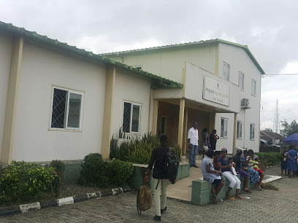

Plate 1.1 Model primary health center ozouba
Source:https://soamaps.com/country/NG/86244/model-primary-health-center-ozouba
CASE STUDY 2
2. Primary Health Centre, Abakpa Enugu
The Abakpa Health Centre is a public hospital, located at Abakpa I, Enugu East Local Government, Enugu State. It was established on 3/2/2001, and operates on 24hours basis. The Abakpa Health Centre is licensed hospital by the Nigeria Ministry of Health, with facility code 14/03/1/1/2/0001 and registered as Primary Health Care Centre.
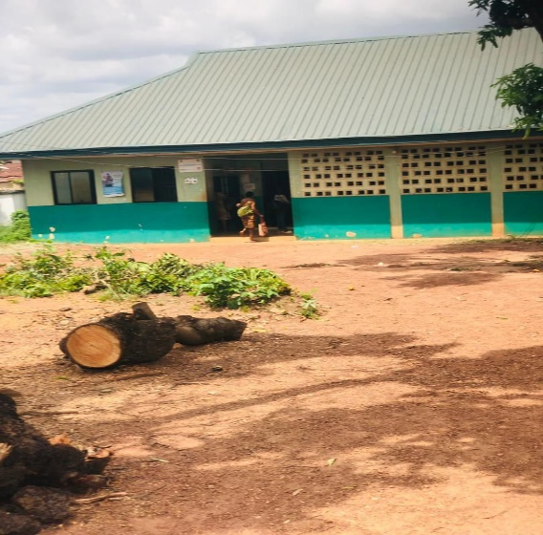
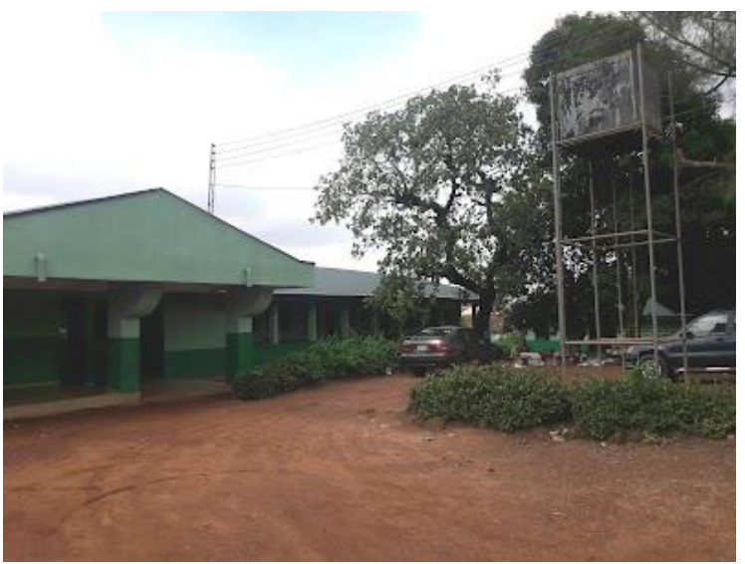

Plate2.1 Primary Health Centre, Abakpa Enugu
Source:https://soamaps.com/country/NG/86244/primary-health-centre-abakpa

CASE STUDY 3
NEW HEAVEN PRIMARY HEALTH CENTER, INDEPENDENCE LAYOUT, ENUGU.
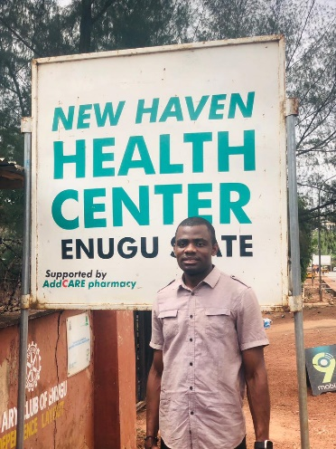
Address: Edward Nnaji St, Enugu. . It was established on 3/12/2019, and operates on 24hours basis.

Plate3.1 New heaven primary health center Enugu
Source: photo-by-me
CASE STUDY 4
AL SAFA PRIMARY HEALTH CARE CENTER DUBAI
Al Safa Primary Health Care Center is a government primary healthcare clinic located in Jumeirah, Al Safa 1, Dubai. Here's some information I found about the center:
Address: Al Athar Road, Al Safa 1, Jumeirah, Dubai
Contact: +971 4 502 1401
Since it is a government facility, booking appointments online might not be available. It is recommended to call the center directly to book an appointment or inquire about their services.
Unfortunately, due to limitations in publicly available information for government health centers in Dubai, finding specifics about Al Safa Primary Health Care Center's services can be challenging. Here's what I can tell you based on what's generally offered at government primary healthcare centers in Dubai:
General healthcare services: These might include consultations with general practitioners (GPs) for routine checkups, treatment of minor illnesses and injuries, referrals to specialists for more complex cases, and preventative care services like vaccinations.
Women's health: Some primary healthcare centers offer pre-natal and post-natal care, family planning services, and basic gynecological checkups.
Children's health: These services might include well-child visits for monitoring growth and development, immunizations, and management of common childhood illnesses.
Chronic disease management: This could involve support for patients with diabetes, hypertension, asthma, and other chronic conditions.
Here are some additional things to consider:
Wait times: Government clinics can sometimes experience long wait times.
Language: Arabic is the primary language, but some staff might speak English.
Insurance: Check with the center if they accept your health insurance plan.



Plate 4.1 Al safa primary health care center dubai
Source: https://soamaps.com/country/dubai/al-safa-primary-health-care-center-dubai

CASE STUDY 5
KITAKAMI CHILDREN'S HEALTH & SUPPORT CENTER, JAPAN
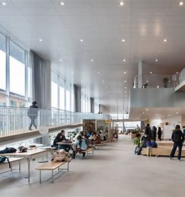
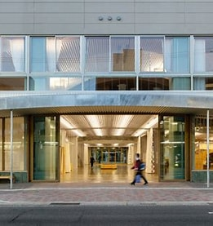

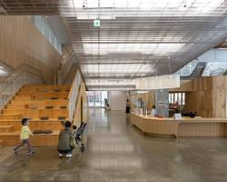

Plate 5.1 Kitakami Children's Health & Support Center, Japan
Source: https://soamaps.com/country/kitakami-children's-health-&-support-center-japan

Kitakami Children's Health & Support Center, Japan
Located in Kitakami, Japan, this unique facility was designed by Unemori Architects and Teco Architects with the intention of creating a space that felt more open and relaxed than a typical commercial building, especially for children who might feel anxious about visiting a healthcare facility. The center features undulating floors and ceilings, giving it an organic and playful feel. The use of corrugated polycarbonate, wood, and textile mesh throughout the space creates a warm and inviting atmosphere.
Here are some of the design elements that contribute to the park-like feel of the center:
Large open spaces: The center boasts a large entrance area and a multi-purpose indoor plaza, allowing for plenty of room for children to move around and explore.
The Kitakami Children's Health & Support Center in Japan is a prime example of how thoughtful design can create a positive and welcoming environment for children in a healthcare setting. The use of natural light is abundant, thanks to the glass walls and sliding doors, which create a bright and airy atmosphere. Additionally, the incorporation of courtyards with greenery blurs the lines between indoor and outdoor spaces, connecting children to nature.

One of the standout features of the center is its playful design. The undulating floors and ceilings add a whimsical touch, making the space more engaging for children. For example, imagine walking into a room with floors that gently rise and fall like ocean waves or ceilings that mimic the shape of clouds. These design elements make the center a fun and inviting place for children to be.

However, the design of the center goes beyond aesthetics. It also prioritizes functionality in a park-like setting. The center is divided into different zones that cater to specific needs. Open spaces allow for group activities and play, while quieter areas with soft furnishings provide a space for relaxation or individual consultations. The center is also designed to be accessible for children with disabilities, with ramps, wide doorways, and accessible toilets.

Despite the playful design, safety is paramount. The undulating floors have gentle slopes and are made with non-slip materials to ensure that children can move around safely. Additionally, the incorporation of courtyards with greenery serves not only an aesthetic purpose but also provides opportunities for outdoor play therapy or nature observation activities.

The park-like design of the center has several benefits. It helps reduce anxiety for children visiting the center, leading to better cooperation and communication with healthcare professionals. The playful design elements and open spaces also encourage exploration and physical activity, which are crucial for children's development. Furthermore, a positive experience at the center can help children develop a more positive association with healthcare settings in the future.

The Kitakami Children's Health & Support Center is just the beginning of a growing trend in Japan. The concept of park-like healthcare facilities for children is gaining traction, and there are exciting possibilities for its evolution. For example, healthcare centers could incorporate thematic designs inspired by forests, oceans, or even favorite children's stories to create immersive and engaging environments. Additionally, these centers could integrate outdoor spaces that are accessible to the community, fostering a sense of togetherness and promoting healthy habits. Moreover, by embracing biophilic design principles, which focus on natural light, materials, and connection to nature, healthcare facilities can further enhance the well-being of children and their families.

While the Kitakami Children's Health & Support Center doesn't have a singular named architect, it is the result of a collaboration between two firms: Unemori Architects and Teco Architects. Together, they designed this unique park-like concept that is revolutionizing healthcare spaces for children.

CASE STUDY 6
PRIMARY HEALTH CARE CENTER OF DADE, INC. GEORGIA
Location: Based on the name "Dade" and the results from a previous search, there's a high possibility this center is located in Dade County, Georgia.
Type of Facility: The name suggests it's a primary healthcare center. These centers typically offer general medical services like checkups, treatment of minor illnesses and injuries, and preventive care.
Limited Online Presence: There's no official website or social media presence readily found for this specific center.
Here are some ways to get more information:
Better Business Bureau (BBB): A BBB profile for Primary Health Care Center of Dade, Inc. exists, but it doesn't indicate accreditation BBB profile: https://www.bbb.org/us/ga/trenton/profile/health/primary-health-care-center-of-dade-inc-0483-40001532. The profile might have a phone number listed, which you can use to contact the center directly.
Search for Trenton Healthcare Centers: Since the BBB profile suggests a location in Dade County, Georgia, searching for "Trenton Healthcare Centers" or "Dade County Primary Care" might lead you to websites of other clinics in the area. These might have a directory listing other healthcare providers, potentially including Primary Health Care Center of Dade, Inc.
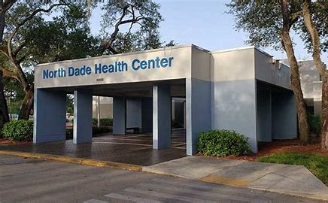
Local Directories: Searching online directories for healthcare providers in Dade County, Georgia could potentially yield contact information for the center.

Plate 7.1 Primary Health Care Center of Dade, Inc.
Source: https://soamaps.com/country/Primary-Health-Care-Center-of-Dade-Inc.

As previously mentioned, finding extensive details about Primary Health Care Center of Dade, Inc. can be challenging due to limited online presence. However, here's some additional information gathering you can try:
Phone Call: The BBB profile listed a phone number: [+]1 483-40001532. Calling them directly offers the most reliable and up-to-date information on services, appointments, and insurance.
Local Search: Search for "Trenton/Dade County: Georgia Health Department" or "Trenton/Dade County: Georgia Primary Care Clinics" on a search engine. Local health departments or other healthcare facilities might have listings of providers in the area, potentially including Primary Health Care Center of Dade, Inc.
News Articles or Community Pages: A local news website or community Facebook page might have mentioned the center in an article or post. Search for "Trenton/Dade County: Georgia Healthcare News" or "Trenton/Dade County: Georgia Community Health" to see if anything relevant pops up.
Insurance Provider Network: If you have health insurance, check your insurance provider's network directory online or through their app. This could list in-network primary care physicians in your area, potentially including the center.
Additionally, here are some general details about primary healthcare centers you can consider while searching for more information:
Services Offered: Primary care centers typically provide:
General checkups for adults and children
Treatment of minor illnesses and injuries
Vaccinations and immunizations
Management of chronic health conditions (e.g., diabetes, hypertension)
Women's health services (limited)
Pediatric care (limited)
Hours of Operation: Operating hours can vary, but most primary care centers are open weekdays during regular business hours (e.g., 8:00 AM to 5:00 PM). This information might be available through a phone call or local healthcare directory search.
Appointment Booking: Some centers allow online appointment booking, but others might require calling them to schedule an appointment.
2.1 CONCEPTUAL FRAMEWORK OF PRIMARY HEALTH CENTERS
This essay explores the concept of primary health centers (PHCs) as the cornerstone of healthcare delivery. PHCs provide essential medical services, including affordable basic care, preventive education, and treatment for common illnesses. To ensure high-quality care, a comprehensive framework considering all aspects of the healthcare service system is necessary. This framework, and its connection to the design of PHCs, will be the focus of this discussion.
Three unavoidable elements that make up the conceptual framework of primary health centers are as follows: inputs, processes, and results. The resources that make up the healthcare system, such as personnel, tools, medications, and other supplies, could as well be called input, The many stages taken to offer the services, including as patient consultation, diagnosis and management, patient follow-up, and referral to higher levels, are referred to as processes while The influence of healthcare services on the health of individuals and the community is what is referred to as an outcome.
Biophilic Architectural design is a key factor in the provision of high-quality healthcare services, and it is consistent with the three main elements of the conceptual framework of primary health centers. First, the facility's layout should make sure that it is equipped with the tools and materials required to deliver high-quality healthcare. In order to maximize the delivery of healthcare, the facility should offer both patients and healthcare professionals secure and comfortable surroundings. Patients and healthcare professionals should be able to move freely throughout the facility thanks to good design. Additionally, the layout of the facility should guarantee that there is enough room for patient consultation, diagnosis, and treatment. In order to support established healthcare models, the design should let a specific number of patients to be attended by healthcare professionals in a specific amount of time. Prioritizing smooth patient and staff circulation within the facility's design is key. This will ensure efficient movement, minimizing congestion, wait times, and service disruptions.
Conclusion
In conclusion, primary health centers function through a three-part system: inputs (equipment, supplies, and staff), processes (healthcare delivery), and outcomes (patient experience and health improvement). Effective architecture plays a critical role in optimizing this system. Well-defined spaces for equipment and staff ensure efficient workflows, while patient comfort and a smooth flow throughout the center are fostered by proper design. However, healthcare facility design should go beyond these basic needs. It should be strategically aligned with the chosen model of healthcare delivery to maximize its effectiveness.
2.2 THEORETICAL FRAMEWORK
The concept of primary healthcare forms the bedrock of primary health centers (PHCs). These centers provide essential health services, including prevention, diagnosis, and treatment of common illnesses, reflecting a holistic approach to patient care. This philosophy originated with the World Health Organization's (WHO) 1978 push for "basic healthcare" as a foundation for global health equity. The 1978 Alma-Ata Declaration envisioned universal access to basic healthcare by the year 2000.
The following concepts form the foundation of the theoretical framework for primary health centers:
Accessibility
Accessibility in a primary healthcare setting is crucial for ensuring everyone in the community can access essential medical services. Here are some key aspects to consider:
Physical Accessibility:
Entrance and Parking: Ground-level entrances with wide doorways and ramps are essential. Accessible parking spaces close to the entrance should be readily available.
Movement Within the Facility: Wide corridors, clear signage, and elevators or lifts are necessary for easy navigation.
Examination Rooms: Adjustable exam tables, accessible toilets, and grab bars in bathrooms are essential for patients with mobility limitations.
Sensory Accessibility:
Visual Impairments: Good lighting, clear signage in Braille or large font, and audio announcements can be helpful.
Hearing Impairments: Induction loops for hearing aids, sign language interpreters when requested, and visual aids can improve communication.
Communication Accessibility:
Multilingual Staff or Interpreters: Having staff members who speak multiple languages or providing access to interpreters can address language barriers.
Written Materials: Offering important information in multiple languages and providing materials in clear, concise language can be helpful for patients with varying literacy levels.
Additional Considerations:
Mental and Cognitive Disabilities: Staff should be trained to understand and accommodate patients with cognitive or mental disabilities. This might involve providing additional time for communication or using simplified instructions.
Transportation: Public transportation options or accessible transportation services can help patients who have difficulty reaching the center.
Benefits of Accessibility:
Improved Health Outcomes: When everyone has access to healthcare, early diagnosis and treatment of health issues become more achievable, leading to better overall health outcomes for the community.
Reduced Health Disparities: Accessibility helps bridge healthcare gaps for vulnerable populations who might face challenges accessing traditional medical care.
Increased Patient Satisfaction: A welcoming and inclusive environment fosters a sense of trust and improves patient satisfaction with the healthcare experience.
Implementing Accessibility:
Conduct Needs Assessments: Involve the community in identifying accessibility needs within the center.
Compliance with Regulations: Ensure the facility adheres to local regulations and building codes regarding accessibility standards.
Ongoing Evaluation: Regularly assess the effectiveness of accessibility measures and make improvements as needed.
Community engagement:
Community engagement is vital for primary health centers (PHCs) to function effectively and meet the needs of the population they serve. Here's why it's important and how it can be achieved:
Benefits of Community Engagement:
Improved understanding of community needs: By engaging with the community, PHCs can gain valuable insights into the most prevalent health concerns, cultural preferences, and barriers to accessing healthcare. This allows them to tailor services and outreach programs to better address these needs.
Increased access to care: Community engagement can help identify populations who might face challenges accessing traditional healthcare services, such as transportation limitations or language barriers. PHCs can then develop targeted outreach programs or mobile clinics to reach these underserved groups.
Enhanced cultural competency: Regular interaction with the community fosters cultural competency among healthcare staff. This leads to better communication, trust, and ultimately, improved patient care experiences.
Increased health promotion: By working collaboratively with community organizations, PHCs can develop effective health promotion initiatives that resonate with the community. This can lead to healthier lifestyles and a decrease in preventable diseases.
Improved resource allocation: Community engagement allows PHCs to understand how resources are currently used and identify areas for improvement. This can lead to more efficient resource allocation and a better return on investment.
Sustainability of programs: Community engagement helps build ownership and support for PHC initiatives. When the community feels involved in shaping healthcare services, they are more likely to use and sustain these programs in the long run.
Strategies for Community Engagement:
Community Needs Assessments: Conduct surveys, focus groups, or public forums to gather information about community health concerns and priorities.
Community Advisory Boards: Establish boards composed of community members who provide feedback on PHC services and programs.
Health Fairs and Outreach Events: Organize events that offer health screenings, educational workshops, and information about available resources.
Partnerships with Community-Based Organizations: Collaborate with local organizations that serve similar populations or address social determinants of health.
Social Media and Communication Platforms: Utilize social media, local media outlets, and community newsletters to share information about services, health education tips, and upcoming events.
Overall, a strong commitment to community engagement allows PHCs to:
Become more responsive to the needs of the population they serve.
Deliver culturally competent and patient-centered care.
Promote health and wellness within the community.
Contribute to achieving health equity for all.
Comprehensive Healthcare Services
Primary health centers (PHCs) are the cornerstone of healthcare delivery systems in many countries. They offer a broad range of comprehensive healthcare services aimed at providing accessible, preventive, and curative care to individuals and families within a community. Here's a breakdown of the key services typically offered at PHCs:

Preventive and Wellness Services:
Vaccinations and immunizations: PHCs play a crucial role in maintaining community immunity by offering routine vaccinations for children and adults according to recommended schedules. This helps prevent the spread of infectious diseases.
Health screenings: Regular health screenings for common conditions like diabetes, hypertension, and certain cancers allow for early detection and intervention, improving health outcomes.
Health education and counseling: PHCs provide education and counseling on various health topics like nutrition, physical activity, healthy lifestyle choices, mental health awareness, and sexual and reproductive health.
Chronic disease management: PHCs offer support and resources for managing chronic conditions like diabetes, asthma, and heart disease. This might involve medication management, dietary advice, and lifestyle modification programs.
Curative Services:
Diagnosis and treatment of common illnesses and injuries: PHCs are equipped to diagnose and treat a wide range of acute illnesses and injuries, from coughs and colds to minor wounds and sprains.
Maternal and child health: Prenatal care, well-child visits for monitoring growth and development, and basic pediatric care services are often available at PHCs.
Mental health services: While the extent of mental health services can vary, PHCs might offer basic mental health screenings, counseling services, and referrals to specialists for more complex cases.
Additional Services:
Laboratory testing: Some PHCs have in-house laboratory facilities for basic testing, while others rely on referrals to external labs.
Prescription medications: PHCs can dispense essential medications for various conditions.
Family planning services: Access to contraception and family planning counseling can be offered at some PHCs.
Beyond these core services, some PHCs might also offer:
Dental care: Basic dental services such as cleanings and checkups might be available.
Social work services: Social workers can help patients connect with community resources and address social determinants of health that impact well-being.
Substance abuse treatment: Screening, referral, and sometimes even basic treatment for substance abuse issues might be offered.
Conclusion
Accessibility, community involvement, complete healthcare services, and continuity of treatment form the foundation of the theoretical framework for primary health centers. In primary health centers, architecture is essential to the delivery of healthcare services. To make sure that primary health centers suit the requirements of the community, its layout and design should be based on the ideas presented in the theoretical framework. To guarantee that primary health centers are responsive to the requirements of the community and are culturally acceptable, the architecture of these facilities should also be planned with community input.
2.3 REVIEW OF RELATED LITERATURE
1. Primary health centers (PHCs) are the cornerstone of healthcare delivery, especially in developing countries. This review examines how PHCs contribute to achieving universal health coverage (UHC) as outlined by the World Health Organization (WHO). Specifically, we will explore how PHCs provide essential primary care services to local communities, including disease prevention, health education, diagnosis, and treatment of common illnesses.
2. Supporting this notion, a 2017 study revealed a significant correlation between access to PHCs and improved health outcomes, particularly in developing countries with limited healthcare resources. The study emphasized the importance of increased funding for PHC programs alongside improvements in service quality to maximize their effectiveness.
3. Further reinforcing the importance of well-managed PHCs, a 2018 study underscored the need for adequate resources to ensure effective service delivery. The study advocated for a comprehensive management approach encompassing staff training and capacity building, regular performance monitoring and evaluation, and fostering community involvement in service delivery.
4. A 2016 review article explored the impact of community-based interventions delivered through PHCs on maternal and child health outcomes. This research underscores the crucial role of community engagement in enhancing healthcare delivery through PHCs, ultimately leading to improved health outcomes for mothers and children.
5. A 2019 study shed light on the persistent challenges faced by PHCs, including inadequate funding, staffing shortages, and infrastructure limitations. The study proposes solutions centered on increased investment in PHC programs, improved staff training and retention strategies, and ensuring consistent access to essential medication and medical equipment. As evidenced by the reviewed literature, PHCs are fundamental to delivering healthcare services in local communities, especially in developing countries. To achieve their full potential and contribute to universal health coverage, PHCs require sustained focus on adequate funding, resources, effective management practices, and fostering strong community engagement.
2.4 SUMMARY OF LITERATURE REVIEW AND CASE STUDIES
Primary health centers (PHCs) are the cornerstone of healthcare delivery, especially in developing countries with limited access to medical services. This review of relevant literature underscores their crucial role and the factors that contribute to their effectiveness.
Effective PHCs require a multifaceted approach:
Strong Management: Sound leadership ensures efficient operations and optimal resource utilization.
Adequate Funding and Resources: Financial stability allows PHCs to attract and retain qualified staff, maintain facilities, and invest in essential equipment and medications.
Community Engagement: Active collaboration with the community fosters trust, identifies local health needs, and promotes program sustainability.
Targeted Interventions: Community-based programs addressing specific health issues can yield significant improvements in areas like maternal and child health.
Challenges such as inadequate funding, staffing shortages, and infrastructure limitations can hinder PHC effectiveness. However, real-world examples showcase their potential.
Nigeria: Training community health workers to manage neonatal conditions led to a dramatic decrease in infant mortality.
India: Community engagement campaigns through PHCs significantly improved vaccination rates and prenatal care utilization.
Kenya: A public-private partnership focusing on infrastructure development, community mobilization, and healthcare worker training resulted in improved health outcomes.
These case studies demonstrate the transformative power of well-resourced and well-managed PHCs. When coupled with community engagement and targeted interventions, they become powerful tools for delivering essential healthcare services and improving health outcomes in local communities.

CHAPTER THREE
THE STUDY AREA
The area of study is Ugwuomu Nike, Enugu East local government area, Enugu state, Nigeria.
3.1 GEOGRAPHICAL LOCATION
The research study's location is referred to as its geographical location. In Nigeria's Enugu state, Ugwuomu Nike served as the location for the study. Enugu East, Enugu State, Nigeria's Nike Community It has borders with Nsukka, Ebonyi and Enugu North and is one of the state's biggest zones, highlighting a few traveler destinations and business regions, including Nikelake Lodgings. The people group is under the monarchical initiative of HRM, IGWE. NNAJI. The district involves 24 towns. They are governed by Enugu East, which is located in the state of Enugu in Nigeria. According to legend, Nike was biologically related to Egede and Affa, who were thought to have been born to the same mother, Ugwunye. It was said that Ugwunye was a very pretty woman who married the god Awuwa. At Nike, Ugwunye gave birth to Anike, left Awuwa, and wedwedded Ukwu. After that, she gave birth to Egede and wedwedded Eze Achala Ukwu. That resulted in the birth of Affa at Ikolo. According to the narrative, Anike Nwa Awuwa was Awuwa and Ugwunye's child. It happened that Anike wedded Aho-Ojoma, a divinity, in Nokpa. They had 11 youngsters; The oldest was Ibagwa. Another part of the Nike Community is the Ogui Nike. These people are said to be the children of refugees from one of the Udi plateau villages. They were accepted to have moved from Akegbe to settle at Ugwueke, to help Nike in its fight against Okpatu. Representative Gilbert Emeka Nnaji is an outstanding child and legislator addressing Enugu East and Nike people group in the upper offices of the Nigerian Senate. The people group of Ugwuomu Nike has no Essential biophilia Place by any stretch of the imagination. The PHC arranged by Godfrey Okoye College will be the first at Ugwuomu Nike which will assist with the provision of a biophilic design

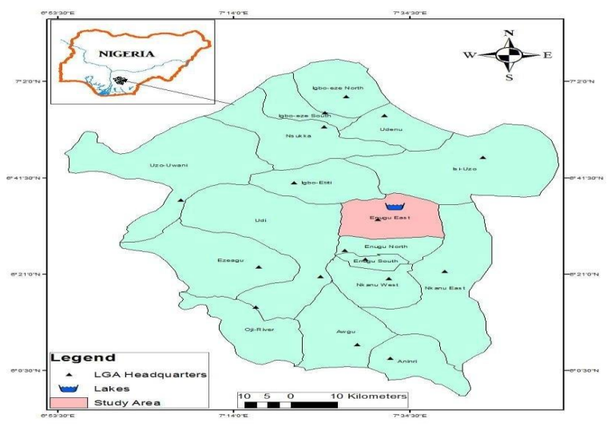

Plate 3.0 Geographical Map of Enugu state showing the study area and the location of Nike Lake 2019
Source:https://www.researchgate.net/figure/Figure1-Map-of-Enugu-state-showing-the-study-area-and-the-location-of-Nike-lake-2019_fig1_339340028

3.2 SITE SELECTION CRITERIA
The research focuses on the planned permanent site of Godfrey Okoye University in Ugwuomu, Nike, Enugu State, Nigeria. The researcher, involved in the university's development, intends to design a master plan for this location.

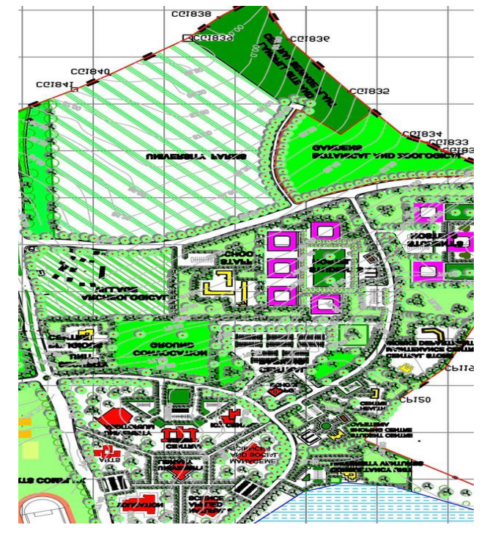

Plate 3.1 Master Plan of the Godfrey okoye University at Ugwuomu Nike, Eungu
3.3 BRIEF HISTORY OF THE STUDY AREA
Godfrey Okoye University is a private university in Enugu state, Nigeria. The university is located in the south eastern part of Nigeria. The university was established on 3rd November, 2009. The institution is a private catholic university and it inhabits people from different part of Nigeria. The temporary part of the university is located at thinker’s corner; however, the main site is situated at Ugwuomu Nike. The university is yet to establish a health care facility at the permanent site.
3.4 PHYSIOGRAPHY, CLIMATE AND VEGETATION
CLIMATE GRAPH // WEATHER BY MONTH ENUGU
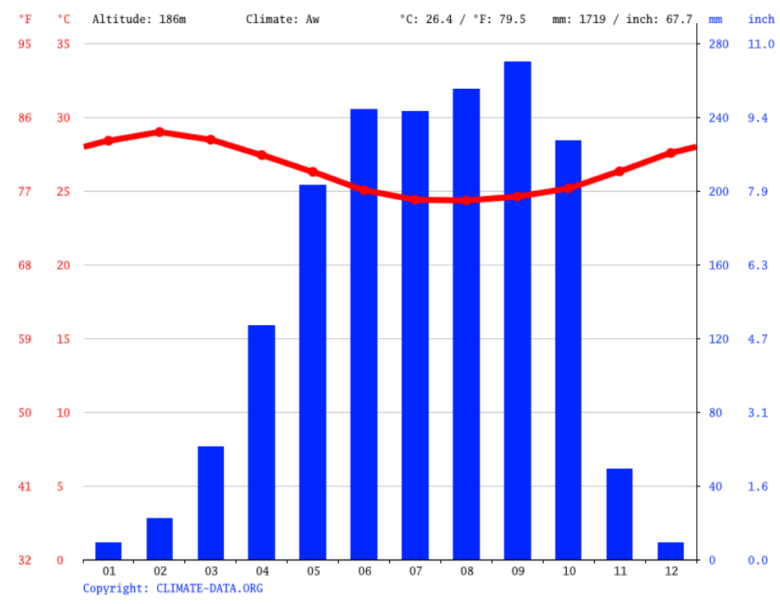

Plate 3.2 Climate Ugwuomu Nike
Source: http://en.climate-data.org/africa/nigeria/enugu/enugu-542/#climate-graph

The driest month is January, with 9 mm | 0.4 inch of rain. The greatest amount of precipitation occurs in September, with an average of 270 mm | 10.6 inch. experiences a varied climate, similar to the rest of the country.
AVERAGE TEMPERATURE ENUGU
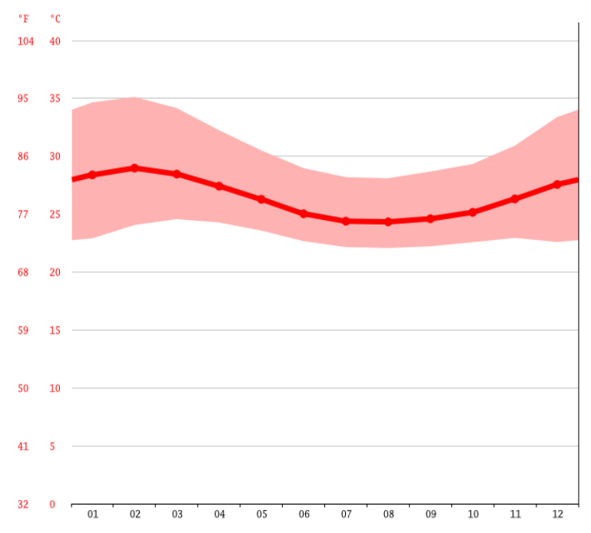

Plate 3.3 Average Temperature Enugu
Source: https://en.climate-data.org/africa/nigeria/enugu/enugu-542/#climategraph
February takes the crown as the warmest month, boasting an average temperature of 29.0 °C (84.2 °F).
Despite its rural location, the healthcare facility boasts a spacious, well-constructed site. The area
3.5 POPULATION, CULTURE AND ECONOMIC DEVELOPMENT
Godfrey Okoye University's students, lecturers, and staff will constitute the target population for this study. Analyzing their healthcare needs will inform the design of a suitable health facility for the university's permanent site. The university is situated in southeastern Nigeria, a region predominantly populated by the Igbo people, known for their unique culture and language. While the university welcomes students and staff from across the country, a significant portion of its community has yet to relocate to the main campus, which is still under development. The rural location and ongoing development contribute to some limitations in infrastructure and resources.
CHAPTER FOUR
RESEARCH METHODOLOGY
4.1 Research Design
This research employed a case study approach to examine a specific healthcare facility. By analyzing the facility, itself and its surrounding environment, including any architectural shortcomings, the study aimed to develop an improved healthcare design plan for the area.
4.2 Data needs and sources
The researcher conducted a site visit to Ugwuomu Nike, Godfrey Okoye University's permanent location. Interviews with students, staff, and university workers were carried out to gather information. This data were crucial in identifying shortcomings of the healthcare facilities used at the temporary campus. The insights gained informed the design of a more suitable healthcare facility for the permanent site.
4.3 Population of the study
The target population for this study consisted of 2,750 individuals, including students and university staff.
4.4 Method and instrument for data collection
Data collection for this study involved semi-structured questionnaires administered by interviewers. The questionnaires, designed to assess awareness, challenges, and utilization of essential medical services (PHCs) among the Ugwuomu Nike community, were divided into four sections:
Socioeconomic factors (Section A)
Mindfulness and attitudes towards healthcare (Section B)
Utilization of PHC services (Section C)
Challenges faced in accessing healthcare (Section D)
The questionnaires were translated into Igbo, the local language, to ensure clear understanding by participants. Trained research assistants conducted the interviews in Igbo. To account for potential non-responses and lost questionnaires, a total of 200 questionnaires were distributed. Of these, 180 questionnaires were successfully retrieved.
RESULT AND ANALYSIS
A high response rate of 90% was achieved, with 180 out of 200 questionnaires successfully retrieved from the participants.
Table 1: Sociodemographic Characteristics of Respondents
Age: The largest age group (18.9%) falls between 25 and 39 years old.
Education: Over half (57.2%) of the respondents have a secondary education.
Gender: The majority of respondents are female (63.3%), with males accounting for 36.7%.
Ethnicity: Yoruba is the most prevalent ethnicity (47.5%) among the respondents.
Occupation: Self-employment is the primary occupation for 48.3% of the respondents.
Table 2: Awareness of Primary Health Care (PHC) Centers
A high number of respondents (164, representing 91.1%) reported awareness of PHC centers in their communities.
Table 3: Sources of Information about Primary Health Care (PHC) Centers (n=164)
Data presented in this table are categorized by the primary source from which respondents acquired information on PHC centers within their communities. The "Others" category encompasses information gleaned from sources such as seminars, educational institutions, and religious organizations.
Table 4: Familiarity with Services Offered at Primary Health Care (PHC) Centers (n=180)
Table 5: Utilization of Primary Health Care (PHC) Centers (n=180)
This table shows the utilization rate of PHC centers among respondents. The majority (136, representing 75.6%) reported using the PHC center, while 44 (24.4%) have never availed themselves of these services.

Table 6: Services Utilized at PHC Centers in the Past Six Months (n=136)
This table highlights the range of services accessed by respondents at PHC centers within the last six months. Vaccinations were the most commonly used service (33.1%). Preventive services like promotion of healthy eating and referrals to other facilities were utilized the least (1.11% each).
Non-Utilization of PHC Services (n=44)
Among respondents who do not utilize PHC centers (n=44), the primary reason cited by 27.7% (12 respondents) was a preference for attending private medical clinics.
When Ill, Respondents Typically Seek Care at:
General Hospitals (55%)
PHC Centers (28.9%)
Other options, including traditional healers and chemists (8.89%)
Table 9: Referral Rates from PHC Centers to Hospitals (n=136)
This table shows the referral rate from PHC centers to hospitals among respondents who utilize PHC services (n=136). Only 11.8% of respondents reported ever being referred to a medical clinic (hospital) by a PHC center.
Table 10: Preference for Medication (n=180)
This table highlights the medication preferences among respondents (n=180). The majority (114 or 63.3%) favor using recommended drugs, presumably those prescribed by healthcare professionals at the PHC or other medical facilities.
Table 11: Sources of Health Information (n=180)
This table shows how respondents (n=180) access health information. Nearly half (87 or 48.3%) rely on PHC centers as a source of health information. However, a higher number (99 or 55%) reported using general hospitals for health information, while 52 (28.9%) specifically use PHC centers.

Table 12: A Home Visit by a Community Health Care Worker (Data Likely Contains Error)
The data presented in this table regarding the percentage of respondents who received a home visit from a community health care worker appears to be inaccurate. Further investigation is required to determine the correct figure.
This revision clarifies the issue and suggests the need for further analysis.
Table 13: Reasons for Home Visits by Community Health Workers (n=134)
This table shows the primary reasons for home visits by community health workers among respondents (n=134). The majority (120 or 66.7%) reported receiving home visits for vaccination purposes.
Figure 1: Perception of Medical Personnel Adequacy at PHC Centers
Over two-thirds (112 out of 180 respondents, or 62.22%) believe that PHC centers have sufficient medical personnel.
Figure 2: Satisfaction with Services at PHC Centers
Among the respondents who utilize PHC centers (n=136), slightly more than half (71 or 52.21%) expressed satisfaction with the services received.
Figure 3: Proximity of PHC Centers to Respondents' Homes
Accessibility seems positive, as nearly 70% of respondents (125 out of 180 or 69.44%) reported having PHC centers within a 30-minute distance of their homes.
Table 14: Gender and Utilization of PHC Centers (n=136)
An examination of gender distribution among users of PHC centers (n=136) reveals that females make up the majority (98 or 72.1%), with males accounting for 27.9% (38 respondents).
Education Level and PHC Center Utilization
Secondary Education (n=103): 73.7% (76 respondents) reported using PHC centers.
Other Non-Formal Education (n=17): 64.7% (11 respondents) reported using PHC centers.
Table 16: Statistical Test - Education Level and PHC Center Use
This table examines the relationship between respondents' education level and their use of PHC centers. A chi-square test was conducted, yielding the following results:
Chi-Square (X²) = 1.9736
Degrees of freedom (df) = 1
p-value (p) = 0.1600
Since the p-value (0.1600) is greater than the significance level of 0.01, we fail to reject the null hypothesis. In other words, there is no statistically significant association between the level of education and the use of PHC centers. This suggests that education level does not influence a respondent's likelihood of utilizing PHC centers.
Table 17: PHC Center Utilization by Distance
This table explores how distance from a PHC center affects utilization. Among respondents living a further distance from their PHC center (n=37), over half (21 or 56.7%) still reported using PHC services.
Table 18: Statistical Test - Distance and PHC Center Use
A chi-square test was conducted to examine the relationship between distance from home and PHC center utilization (n=180). The results are as follows:
Chi-Square (X²) = 2.0000
Degrees of freedom (df) = 1
p-value (p) = 0.0000014587
While the chi-square statistic itself isn't directly interpretable, the p-value (0.0000014587) is much lower than the significance level of 0.01. This suggests a statistically significant relationship between distance and PHC center use. However, due to the low number of respondents living further away, further analysis may be needed to confirm the direction of this relationship (i.e., does closer proximity lead to higher utilization?).

Table 19: Occupation and PHC Center Utilization
"These findings reveal that the PHC centers serve a diverse population, including those who may be unemployed."

USER SURVEY QUESTIONNAIRE FOR PRIMARY HEALTH CARE CENTER INFORMATION SERVICE
Introduction:
This questionnaire aims to gather information about patient experiences at [School Name] - [Department Name]. Your honest feedback is valuable in helping us improve the quality of care we provide. Please answer the following questions by marking a checkmark (✓) in the appropriate box.
Questions:
Wait Times and Scheduling: Do patients frequently report issues with long wait times or difficulties scheduling appointments?

- Yes ✓
- No
Communication: Do patients often express concerns about understanding medical explanations or having effective communication with staff members?
- Yes ✓
- No
Other Concerns: Are there any other recurring problems or issues that patients experience when seeking care at our facility?
- Yes ✓
- No
Table 20: Occupation and PHC Center Utilization
A chi-square test was conducted to examine the relationship between occupation and utilization of PHC centers (n=180). The results are as follows:
Chi-Square (X²) = 12.0000
Degrees of freedom (df) = 9
p-value (p) = 0.2133
Since the p-value (0.2133) is greater than the significance level of 0.01, we fail to reject the null hypothesis. In other words, there is no statistically significant association between occupation and PHC center use. This suggests that a respondent's occupation does not influence their likelihood of utilizing PHC centers.

4.5 Data Collection Method
A multi-stage sampling approach was employed to select respondents from the study area, Ugwuomu Nike.
Stage 1: Stratification
A simple random sampling technique was used to select one area within Ugwuomu Nike, considering its five major roads and one major street as strata.
Stage 2: Cluster Sampling
Within the chosen area, two streets were randomly selected using a simple random sampling method. These streets can be considered clusters.
Stage 3: Systematic Sampling
The total number of houses on each selected street was determined.
A sampling frame was created by assigning a unique number to each house.
A random starting point was chosen using a random number table.
Every nth house (where n is the predetermined sampling interval) was selected from the sampling frame until the desired sample size of 20 households per street was achieved.
Sample Size and Respondent Selection
A sample size of 200 respondents was targeted.
With 40 houses on each selected street, every fifth house was approached to participate in the survey. A map of Ugwuomu Nike aided in navigating the selected streets.

CHAPTER FIVE
DESIGN SYNTHESIS AND DEVELOPMENT
The Role of Architecture in Primary Health Care
Primary Health Care Centers (PHCs) are fundamental in providing underserved communities with accessible and effective medical care. To achieve this goal, the design and construction of these facilities must prioritize the needs of both patients and healthcare professionals.
Community-Centered Design
Effective PHCs are designed and built around the needs of the population they serve. Collaboration between architects, healthcare professionals, and community members is crucial to ensure the center addresses the specific health issues of the area.
Essential Services
PHCs should offer core services like prevention, diagnosis, treatment, and rehabilitation for common illnesses. Additionally, they should provide essential maternal and child health services such as vaccinations and family planning.
Sustainable Design
The design of a PHC should consider the unique environmental and climatic conditions of the region. Sustainability is a key element, incorporating features like natural lighting, energy-saving systems, and eco-friendly building materials to minimize the building's environmental impact.
Design for Wellbeing
The overall design should promote a sense of well-being for both patients and staff. This includes features like ample natural light, proper ventilation, and sterilization for a clean and healthy environment. The aesthetics should be bright, uncluttered, and welcoming.
Patient Comfort and Privacy
The design should prioritize patient comfort and privacy. Comfortable waiting areas, examination rooms, and clear privacy measures are essential to protect patients' dignity. Additionally, accessibility features for people with disabilities should be incorporated.
Staff Efficiency and Wellbeing
The layout of the workplace should optimize workflow for healthcare professionals, allowing for efficient movement within the center and smooth interaction with patients. Functional, well-organized, and aesthetically pleasing workspaces can help reduce stress and anxiety, ultimately enhancing the quality of care provided.
Conclusion
The design and construction of PHCs play a critical role in the health and well-being of communities. Collaboration between architects, healthcare professionals, and community members is vital to create a center that addresses specific local healthcare needs. A sustainable, welcoming, and well-designed PHC fosters a positive environment for both patients and staff, ultimately enabling healthcare professionals to deliver high-quality care. Architects, therefore, play a crucial role in designing healthcare facilities that promote not only efficient healthcare delivery but also community development.
5.1 THE DESIGN BRIEF
Design Brief for a Primary Health Center with Biophilic Elements
1. Purpose: The primary objective of the health center, outlining the specific healthcare services provided (e.g., general practice, maternal health).
2. Size and Service Area: The estimated size of the center, considering the services offered and the target patient population.
3. Location: A site with good accessibility for patients and healthcare professionals, ideally with convenient public transportation options.
4. Functionality and Workflow: A well-organized layout promoting efficient movement for both patients and staff. This includes optimizing the placement of examination rooms, waiting areas, consultation rooms, administrative areas, and staff workspaces.
5. Equipment: A list of the essential medical equipment needed to deliver the planned healthcare services.
6. Biophilic Design Principles: Integration of biophilic design elements to enhance patient and staff well-being. Examples include:
Natural Lighting and Views: Maximize natural light through windows and skylights, while incorporating views of nature whenever possible.
Natural Materials: Use natural materials like wood, stone, and bamboo for flooring, furniture, and accents to create a calming and restorative environment.
Water Features: Consider incorporating calming water features like fountains or aquariums to promote relaxation and reduce stress.
Indoor Plants and Greenery: Strategically place indoor plants throughout the center to purify the air, reduce noise, and create a connection with nature.
7. Ventilation: A well-maintained ventilation system to ensure good air quality and prevent the spread of airborne diseases.
8. Lighting: A combination of natural and artificial lighting to provide adequate illumination in exam rooms, waiting areas, and corridors.
9. Privacy: Designate sufficient private spaces for consultations and patient examinations.
10. Security: Implement features to guarantee the safety of patients, staff, and equipment, such as security cameras and controlled access points.
11. Aesthetics: Create a welcoming and calming atmosphere through the use of natural light, soft colors, and biophilic design elements.
12. Sustainability: Incorporate eco-friendly materials and building practices to minimize the center's environmental impact. This could include energy-saving systems, water conservation features, and the use of recycled or locally sourced materials.
Conclusion
A comprehensive design brief that integrates biophilic principles ensures the primary health center fosters a healthy and positive environment for both patients and healthcare professionals. The design should prioritize functionality, patient comfort, staff well-being, and environmental sustainability. By incorporating these elements, the center can effectively contribute to positive healthcare delivery and community development.
5.2 DESIGN REQUIREMENTS FOR ACTIVITIES/PLANNING DATA (STANDARDS, ANTHROPOMETRICS, ETC)
Designing a Functional and Accessible Primary Health Center
1. Adherence to Standards: The design of the primary health center complied with the latest guidelines established by the Ministry of Health and the World Health Organization (WHO). These standards typically encompass minimum requirements for:
Facility Size and Layout: Ensuring adequate space for essential services and efficient patient flow.
Equipment: Specifying the necessary medical equipment for the planned services.
Staffing: Outlining the required number and qualifications of healthcare professionals.
2. Anthropometric Considerations: The design took into account anthropometric data (average height, weight, and body measurements) of the local population. This information helped in selecting appropriate furniture sizes, equipment, and space allocation to accommodate users comfortably.
3. Universal Accessibility: The center was designed for everyone, including people with disabilities. This necessitates features like:
Ramps: Providing easy access to different levels of the building.
Wide Doors: Enabling smooth passage for wheelchairs and walkers.
Accessible Restrooms: Ensuring inclusivity with grab bars and wider stalls.
4. Patient Privacy: The design prioritized patient privacy during consultations and examinations. This was achieved through:
Soundproofing Materials: Minimizing noise transmission between examination rooms.
Privacy Curtains: Ensuring visual privacy during consultations.
Separate Waiting Areas: Designing dedicated waiting areas to prevent overcrowding and maintain confidentiality.
5. Safety First: Safety is paramount. The incorporated:
Elimination of Trip Hazards: Creating a level and uncluttered environment.
Adequate Lighting: Ensuring proper illumination in all areas.
Fire Safety Equipment: Strategically placing fire alarms and extinguishers.
6. Adaptability for Future Needs: The center's layout was adapted to accommodate changing healthcare needs of the community. This includes considering:
Flexible Spaces: Designing rooms that could be easily reconfigured for new equipment or services.
Modularity: Utilizing modular furniture and partitions for easy rearrangement.
7. Sustainable Design Principles: The center is environmentally conscious. This involves:
Energy Efficiency: Implementing energy-saving lighting and HVAC systems.
Natural Ventilation: Utilizing natural ventilation whenever possible to improve air quality and reduce energy consumption.
Sustainable Materials: Selecting durable and locally sourced construction materials whenever feasible.
By incorporating these design considerations, the primary health center can become a functional, accessible, and sustainable facility that effectively serves the needs of the community.
5.2 SCHEDULE OF ACCOMMODATION
Functional Space Layout for Primary Health Centers
While the specific layout of a primary health center (PHC) can vary depending on the size and needs of the community it serves, a typical functional design incorporates the following key areas:
1. Reception and Waiting Area: This welcoming space provides comfortable seating for patients and visitors, a reception desk for inquiries and registration, and a designated waiting area.
2. Consultation Rooms: Each room is private and equipped with a desk, chairs, and an examination table. Additionally, these rooms have sink and handwashing facilities for hygiene purposes.
3. Treatment Rooms: Designed for minor procedures and treatments, these rooms are equipped with the necessary equipment. Like sinks and handwashing facilities.
4. Laboratory: This area provides basic diagnostic services and are equipped with the necessary laboratory equipment.
5. Pharmacy: This dedicated space allows for safe medication storage and dispensing.
6. Staff Offices: These workspaces provide staff with individual desks, chairs, and storage for their personal belongings and work materials.
7. Staff Restrooms: Separate from patient restrooms, these facilities offer the necessary amenities for staff comfort and hygiene.
8. Storage Rooms: Dedicated storage space is crucial for organizing medical supplies, equipment, and records.
9. Staff Training Room: This space is equipped for staff development and educational activities.
10. Staff Break Room: A dedicated area with amenities for staff to relax and take breaks is essential for well-being and morale.
11. Patient Restrooms: These restrooms are fully equipped to meet the needs of patients.
12. Janitorial Room: A designated space with cleaning supplies and equipment is necessary for maintaining cleanliness throughout the PHC.
It's important to remember that this is a general layout, and the specific configuration of these spaces within a PHC was adapted to optimize functionality and cater to the unique needs of the community it serves.
5.3 SPECIAL CONSIDERATION
Designing a Community-Centered Primary Health Center with Biophilic Elements
Meeting Community Needs:
A well-designed primary health center (PHC) serves the community effectively by considering several crucial factors:
1. Accessibility and Location: The PHC is easily accessible to the target population, ideally situated in a central location with convenient public transportation options. This promotes inclusivity and reduces barriers to care.
2. Right-Sized Facility: The size of the PHC is appropriate to accommodate the anticipated patient volume, with ample space for staff, equipment, and future growth.
3. Adequate Staffing: Sufficient staffing levels are essential, including medical professionals and support staff, to ensure patients receive high-quality care in a timely manner.
4. Medical Equipment and Supplies: The PHC is equipped with all essential medical equipment and supplies needed to deliver comprehensive healthcare services.
5. Patient Privacy and Security: The design prioritized patient privacy and security. This includes incorporating separate waiting areas, consultation rooms, and examination rooms to ensure confidentiality and a sense of safety.
6. Biophilic Design Integration: Biophilic design principles enhanced patient and staff well-being. And incorporated some other elements such as:
Natural Lighting and Views: Maximize natural light through windows and skylights, while incorporating views of nature whenever possible. This reduced reliance on artificial lighting fostering a connection with the outdoors.
Natural Materials: Use of natural materials like wood, stone, and bamboo for flooring, furniture, and accents to create a calming and restorative environment.
Indoor Plants and Greenery: Strategically placed indoor plants throughout the PHC to purify the air, reduce noise, and create a biophilic connection.
7. Social Responsiveness: The design is culturally sensitive and reflect the needs and preferences of the community it serves. This can be achieved through community consultations and incorporating design elements that resonate with the local population.
8. Sustainable Design: The PHC was designed with sustainability in mind. This includes utilizing:
Energy-Efficient Systems: Implementing energy-saving lighting, heating, ventilation, and air conditioning (HVAC) systems.
Eco-Friendly Materials: Selecting durable and environmentally friendly building materials whenever feasible.
Water Conservation Features: Incorporating water-saving plumbing fixtures and landscaping practices.
Optimizing the Patient Experience:
By prioritizing accessibility, quality care, patient comfort and privacy, and incorporating biophilic and sustainable design principles, a primary health center can become a welcoming and functional space that effectively serves the needs of the community.
5.4 DESIGN CONCEPT AND DESIGN PROPOSAL
Choosing the "best" concept for a primary health center depends on various factors specific to the community it serves. However, here are some strong contenders that combine functionality, aesthetics, and community well-being:
1. Biophilic Design:
Integrates elements of nature to improve patient and staff well-being. This can include maximizing natural light, incorporating indoor plants and greenery, using natural materials like wood and stone, and creating views of nature whenever possible.
2. Community-Centered Design:
Involves actively incorporating the needs and preferences of the community into the design process. This could involve community consultations to understand cultural sensitivities, preferred amenities, and potential barriers to accessing healthcare.
3. Flexible and Adaptable Design:
Allows the primary health center to accommodate future changes in healthcare needs or population growth. This might involve using modular furniture and partitions, creating multi-functional spaces, and designing for easy reconfiguration.
4. Healing Environment:
Prioritizes elements that promote a sense of calmness and well-being. This could include incorporating soothing colors, comfortable seating areas, and features that reduce noise and stress.
5. Accessibility and Efficiency:
Ensures the center is easily accessible to all community members, including those with disabilities. This includes features like ramps, wide doorways, accessible restrooms, and a well-organized layout that allows for efficient patient flow.
Combining these concepts:
The most successful primary health center design will likely integrate elements from several of these concepts. Here's an example:
A biophilic design with a central courtyard and skylights for natural light, along with strategically placed indoor plants, can promote a healing environment.
Utilizing a flexible and adaptable layout can allow for future expansion of services like physical therapy or mental health care.
Community consultations can inform design choices like signage in multiple languages or culturally appropriate waiting area seating.
Ultimately, the best concept is the one that creates a welcoming, functional, and sustainable space that effectively addresses the specific needs of the community it serves.
5.5 CONCLUSION AND RECOMMENDATION
Enhancing Patient Care and Community Health
The data analysis suggests several key recommendations to optimize the primary health center's performance:
1. Bolstering Staffing and Resources: Increasing staff levels and resources is crucial to improve patient care and reduce wait times. This may involve hiring additional healthcare professionals and support staff, as well as allocating resources for necessary equipment and supplies.
2. Empowering the Community: Expanding community outreach programs can significantly improve preventative healthcare practices. Educating the community about preventative strategies and encouraging early intervention can lead to better overall health outcomes.
3. Advancing Technology: Introducing more advanced medical equipment and technology can enhance the quality of care provided at the center. This can improve both efficiency and accuracy in diagnosis and treatment.
4. Streamlining Patient Care: Improving communication and coordination among staff members can significantly streamline the patient care process. This can lead to shorter wait times and a more efficient experience for patients.
5. Expanding Reach with Telemedicine: Investments in telemedicine technology can extend the center's reach to provide care to patients in rural or remote areas. This can improve access to healthcare services for underserved populations.
Improved Outcomes and Satisfaction:
Implementing these recommendations has the potential to significantly improve patient outcomes, satisfaction with the center's services, and the overall health of the community.
5.6 SUMMARY OF FINDINGS OR MAIN ISSUES
Building Solutions: How Architecture Can Address Primary Health Center Challenges
Thoughtful architecture can play a significant role in overcoming key challenges faced by primary health centers. Here's how:
1. Optimizing Space for Efficiency and Flow: Strategic space allocation and design can significantly improve patient flow and reduce crowding. This includes designating specific areas for various functions, such as waiting areas, consultation rooms, and treatment rooms. Additionally, incorporating future expansion plans into the design allows the center to adapt to growing needs.
2. Sustainable Design for Cost Savings and Environmental Impact: Sustainable design principles can help the center reduce energy consumption and lessen its environmental footprint. Utilizing elements like passive heating and cooling techniques, natural lighting, and proper insulation can lead to long-term cost savings on utility bills.
3. Accessibility for All: An accessible design ensures the center caters to everyone, including patients with disabilities and the elderly. This includes features like accessible restrooms with grab bars, wider doorways, and ramps to eliminate physical barriers.
4. Technological Integration for Improved Care: Integrating telemedicine and digital technologies allows patients to connect with specialists remotely. This can eliminate the need for some in-person consultations, improving overall patient care efficiency and potentially leading to better health outcomes.
5. Aesthetics for a Positive Patient Experience: A well-designed and aesthetically pleasing healthcare facility can promote patient well-being by reducing anxiety and creating a more calming environment.
Overall Impact:
By addressing these challenges through strategic design, a primary health center's architecture can significantly enhance its effectiveness, usability, sustainability, and ultimately, patient satisfaction.
5.7 CONCLUSIONS
Designing for Health and Well-being: The Power of Architecture in Primary Care
Primary health centers play a vital role in community health. However, their effectiveness can be significantly enhanced by considering architecture as a strategic tool.
Beyond Walls and Roofs:
Well-designed architecture offers a multitude of benefits for both patients and staff:
Improved Patient Outcomes: Strategic space planning facilitates efficient patient flow, reducing wait times and stress. Additionally, incorporating elements like natural light and calming aesthetics can promote patient well-being and recovery.
Enhanced Effectiveness: Accessible design ensures everyone in the community can access care, while technological integration allows for remote consultations with specialists, improving overall service delivery.
Empowering Staff: Optimized workspace layouts and features like staff break rooms can contribute to a more positive work environment for healthcare professionals.
Sustainable Practices: Environmentally friendly building practices and energy-efficient systems can reduce the center's environmental impact and operating costs.
The Ripple Effect of Good Design:
Investing in good design creates a ripple effect that benefits the entire community:
Promoting Health Awareness: A welcoming and attractive facility can encourage people to seek preventive care and prioritize their health.
A Healthy Environment: Sustainable design practices contribute to a healthier environment for the community as a whole.
Conclusion:
By integrating thoughtful architectural principles, primary health centers can become not just functional spaces, but hubs that promote overall well-being for both patients and staff. This, in turn, contributes to a healthier and more vibrant community.
5.8 RECOMMENDATIONS
Designing a Primary Health Center for Patient Comfort and Well-being
1. Natural Light and Ventilation for Health:
Natural light and proper ventilation are essential for both physical and mental well-being. A well-designed primary health center should maximize these elements. This can be achieved by incorporating features like:
Large windows strategically placed to provide ample natural light throughout the day.
Skylights to bring in additional sunlight and create a more open feel.
Courtyards, whenever possible, to introduce natural light and fresh air into the center.
2. Creating a Calming Environment:
A visit to the doctor's office can be stressful for some patients. The design should create a calm and inviting atmosphere to help alleviate anxiety. Here are some design elements that can contribute to a more relaxing space:
Warm and welcoming lighting that avoids harsh fluorescent glare.
Soothing color palettes that promote feelings of tranquility.
Soft textures and natural materials throughout the space.
Comfortable seating areas with ergonomic considerations for patient comfort.
3. Adaptability for Future Needs:
The needs of a primary health center can evolve over time. A flexible and adaptable design allows the space to accommodate these changes. Consider incorporating:
Movable walls or partitions that can be reconfigured to create different sized rooms for various purposes.
Modular furniture that can be easily rearranged to suit changing needs.
Utility layouts that can be easily modified to accommodate the addition of new equipment.
4. Prioritizing Accessibility for All:
A primary health center should be accessible to everyone in the community, regardless of age or ability. Accessibility features can include:
Ramps, elevators, or lifts to ensure all levels of the facility are accessible.
Wide doorways and hallways to accommodate wheelchairs and walkers.
Grab bars in restrooms and other high-risk areas for added support.
Signage that is clear, concise, and easy to understand, potentially including multilingual options.
By incorporating these design considerations, architects can create a primary health center that prioritizes patient comfort, staff well-being, and accessibility for the entire community.

5.9 CONTRIBUTIONS TO KNOWLEDGE
Building for Better Health: How Architecture Shapes Primary Care
The design of a primary health center goes beyond bricks and mortar. Well-planned architecture can significantly improve the patient experience, increase the center's effectiveness, and ultimately, contribute to better health outcomes for the community it serves. Here's how architecture plays a crucial role:
1. Space Planning for Optimal Flow:
Space planning is the foundation for a functional primary health center. A thoughtfully designed floor plan considers factors like:
Privacy: Creating dedicated consultation rooms and waiting areas ensures patient confidentiality.
Ease of Movement: Wide corridors and clear signage facilitate efficient patient flow and navigation.
Maintenance: Designing for easy cleaning and upkeep minimizes downtime and ensures hygiene.
Infection Control: Strategic placement of handwashing stations and separate entrances/exits for sick and well patients helps prevent the spread of germs.
2. Sustainable Design for Efficiency and Eco-friendliness:
Primary health centers can integrate sustainable design principles to reduce operating costs and environmental impact. Here are some examples:
Natural Light and Ventilation: Maximizing natural light through windows and skylights reduces reliance on artificial lighting and promotes a brighter, healthier environment. Proper ventilation systems can improve air quality and comfort.
Renewable Energy Sources: Exploring options like solar panels or geothermal energy can contribute to a smaller carbon footprint.
3. Universal Design for Inclusivity:
By incorporating universal design principles, architects can ensure the center is accessible to everyone in the community, regardless of ability. This includes features like:
Open doorways and wide passages: Enabling easy movement for wheelchairs and walkers.
Clear signage with contrasting colors and potentially braille: Promoting ease of navigation for all.
Lowered counters and accessible restrooms: Catering to individuals with varying physical needs.
4. Flexibility for Future Growth:
Primary healthcare needs can evolve over time. A flexible design allows the center to adapt. This can be achieved through:
Modular furniture and moveable partitions: Facilitating easy rearranging of spaces to accommodate changing functionalities.
Multi-purpose rooms: Creating spaces that can serve different purposes depending on the time of day or patient demand.
Overall Impact:
Through thoughtful architecture, primary health centers can be designed not just as functional medical spaces, but as hubs promoting healthcare accessibility, patient well-being, and community health.

REFERENCES
Organization of World Health Organization Declaration of Alma-Ata. Worldwide publications from the WHO. Worldwide Meeting on Essential Medical care Alma-ata USSR. 1978.
Jones G, Steketee R et al. What number of youngsters passing might we at any point forestall this year? PubMed Summary Lancet. 2003; 362(9377):65-71
An integrated approach to child health in developing nations, Tulloch J. PubMed Summary Lancet.1999: 354
Slope K, Prande R, Jones G et al. Trend in child mortality worldwide in developing nations. Report from the United Nations Children's Fund (UNICEF). 1998.
The start of a significant wellbeing administration strategy began with the initial long term public arrangement (1946 - 1956)
Sule SS, IJadunola KT, Onayade AA et al. Make use of PHC facilities: lessons from a southwest Nigerian rural community Niger Journal of Medicine, 2008;17(1):98-106
The Second National Development Plan's health policy, which ran from 1970 to 1974, had some of these flaws fixed".
The Death and Life of Great American Cities by Jane Jacobs: 1961
The Image of the City by Kevin Lynch: 1960
A Pattern Language by Christopher Alexander, Sara Ishikawa, and Murray Silverstein: 1977
A Focus on Biophilic Design in Healthcare totaforti 2018
Biomimicry: Innovation Inspired by Nature Benyus, 1997
The Leadership Skills Strataplex. Mumford, 2007
suggests this perspective echoes Judeo-Christian traditions that influenced modern science. Galimberti (2000)
Bateson (as cited in Scandurra, 2001)
Ecological Literacy: Educating Our Children for a Sustainable World (The Bioneers Series). Publisher: Sierra Club Books; (October 1, 2005) ISBN 1-57805-153-3
Biophilic Design: the Theory, Science and Practice of Bringing Buildings to Life Kellert et al., 2008
this is a multifaceted process. John Elkington, 2000
"Ecological footprint" (Wackernagel and Rees, 1996)

