
DEVELOPMENT OF A QR-CODE-BASED ATTENDANCE MANAGMENT SYSTEM FOR MONITORING HOSTEL RESIDENTS

BY

ONAH,LUTHER CHIDERA
GOU/U21/CSC/729

FACULTY OF NATURAL AND ENVIRONMENTAL STUDIES,GODFREY OKOYE UNIVERSITY,ENUGU

FEBUARY 2025

CERTIFICATION
"I confirm that the work presented here is my own, primarily based on my own observations and research. I understand and accept that the University has the right to take appropriate action if any form of academic misconduct is detected."

________________________
ONAH LUTHER CHIDERA
GOU/U21/CSC/729

APPROVAL PAGE

This is to validate that this research work “DEVELOPMENT OF A QR-CODE-BASED ATTENDANCE MANAGMENT SYSTEM FOR MONITORING HOSTEL RESIDENTS” was embarked upon by “ONAH, LUTHER CHIDERA” with the matriculation number GOU/U21/CSC/729 in partial fulfillment of the requirements for the award of Bachelor Science(B.SC) in Computer Science, Faculty of Natural Sciences and Environmental Studies , Godfrey Okoye University, Enugu.

_____________________________ _______________
Dr.G.E Okereke Date
(Supervisor)

_____________________________ ______________
Dr. (Mr.) Frank Okebanama Date
Head of Department

______________________________ _____________
External Examiner Date

DEDICATION
I would like to dedicate this project to God Almighty, for being faithful and merciful, for seeing me through to the end of this project. I also dedicate this work to my Parents MR. and MRS. Onah for being a major source of support in every way, encouraging and present during the whole process of delivering this work

ACKNOWLEDGEMENTS
my sincere gratitude goes to the God who created all things and manifests himself in diverse ways than we can comprehend for his mercy, loving-kindness and presence in the times I was in need. I specially recognize my supervisor Dr .G.E Okereke for believing in me and pushing me to do more. ,The head of department, Dr Frank okebenama I also appreciate the entire staff of the department for the time they had kept aside to make sure that this project is a success and also the staffs management of Godfrey Okoye University for the immeasurable impact they have had on my life academically and spiritually. I duly appreciate my siblings, friends and colleagues without whom this journey could not have been a success. May the God of heaven water your lives.

ABSTRACT
The objective of this research was to design an information system needed for identity management of students hostel residents with the objective of keeping records of the students movements and attendance in their hostels. The research identified several user and system requirements, specified the system design and deployed the system. Literature review was underway to identify and comprehend current
Identity Management System to monitor hostel residencies using QR codes. System requirement and user of the system were realized from the users of the system through informal interviews. The system was modeled by UML diagrams, i.e., use case, sequence and class diagram. Firebase was used to deploy the database. HTML, CSS, and Bootstrap were used to deploy the frontend. Node JS and Express JS were used to deploy the backend.
The output of the system proposed the use of the system database in the saving of the information as well as the web and mobile app front-end. The output proposed that the system could identify each one of the hostel residents separately with a customarily generated QR code with which the movement of the students in and out of the hostels could be easily traced. The study concluded that the utilization of the system in the students' hostel will assist reduce most of the obstacles encountered in tracking the student movement in and out of hostels particularly with occurrence of accounting for the number of students available in the hostel during head counts.

TABLE OF CONTENTS

COVER PAGE
TITLE PAGE i
CERTIFICATION ii
APPROVAL iii
DEDICATION iv
ACKNOWLEDGEMENTS v
ABSTRACT vi
TABLE OF CONTENTS vii
LIST OF FIGURES xi
LIST OF TABLES xi

CHAPTER 1: INTRODUCTION 1
  - BACKGROUND OF STUDY 1
  - STATEMENT OF PROBLEM 1
  - AIM AND SPECIFIC OBJECTIVE
  - SIGNIFICANCE OF THE SYUDY 2
  - SCOPE 4
  - LIMITATION OF THE STUDY 4
  - OPERATIONAL DEFINITION OF TERMS 4

CHAPTER TW0: LITERATURE REVIEW
2.1 INFORMATION SYSTEM
2.1.1 THEORITICAL BACKROUND
2.1.2 TYPES OF INFORMATION SYSTEM
2.2 REVIEW OF RELATED WORKS
2.3 SUMMARY OF REVIEW OF RELATED WORKS
2.4 CONTRIBUTION TO KNOWLEDGE

CHAPTER 3 : SYSTEM ANALYSIS AND DESIGN
  - OVERVIEW
  - SYSTEM ANALYSIS
  - ANALYSIS OF THE EXISTING SYSTEMS
  - WEAKNESSES OF EXISTING SYSTEMS
  - ANALYSIS OF THE PROPOSED SYSTEM
  - SYSTEM REQUIREMENTS
    - FUNCTIONAL REQUIREMENTS
    - NON FUNCTIONAL REQUIREMENTS
    - PROPOSED METHODOLOGY
    - UNIFIED MODELLING LANGUAGE DIAGRAMS
    - USE CASE DIAGRAM OF THE PROPOSED SYSTEM
    - ACTIVITY DIAGRAM OF THE PROPOSED SYSTEM
    - CLASS DIAGRAM OF THE PROPOSED SYSTEM
    - UML SEQUENCE DIAGRAM
  - SYSTEM DESIGN
    - INPUT/OUTPUT DESIGN
      - INPUT DESING OF THE PROPOSED SYSTTEM
    - DATABASE DESIGN

CHAPTER FOUR: SYSTEM IMPLEMENTATION
  - INTRODUCTION
  - TOOLS USED FOR IMPLEMENTATION
    - LARVEL FRAME WORK
    - MY SQL
    - HTML
    - CSS
    - PHP
    - BARCODE GENRATION LIBRARY
  - SYSYTEM REQUIREMENTS
  - USER INTERFACE OF THE PROPOSED SYSTEM
    - THE STUDENT REGISTRATION PAGE
    - HOSTEL WARDEN LOGIN PAGE
    - HOSTEL WARDEN DASHBOARD PAGE
    - STUDENTS RECORD PAGE
    - STUDENTS ABSENTEE PAGE
    - STUDENTS PRESENT PAGE

CHAPTER FIVE
OVERVIEW
  - SUMMARY
  - RECOMMENDATIONS
CONCLUSION
REFFERENCES
APPENDIX

LIST OF FIGURES
FIGURE
3.1 USE CASE DIAGRAM TO GENERATE QR-CODE AND TAKE ATTENDANCE
3.3 ACTIVITY DIAGRAM OF THE PROPOSED SYSTEM
3.4 CLASS DIAGRAM OF THE PROPOSED SYSTEM
3.5 SEQUENCE DIAGRAM OF THE PROPOSED SYSTEM
3.6 INPUT DESIGNS FOR THE PROPOSED SYSTEM

4.1 THE STUDENT REGISTRATION PAGE
4.2 HOSTEL WARDEN LOGIN PAGE
4.3 HOSTEL WARDEN DASHBOARD PAGE
4.4 STUDENTS RECORD PAGE
4.5 STUDENTS ABSENTEE PAGE
4.6 STUDENTS PRESENT PAGE

LIST OF TABLES

CHAPTER ONE
INTRODUCTION
1.1 Background of the study
Identification and get entry to manipulate management have come to be critical subjects in organizational and institutional settings, mainly in environments like university dormitories. The initial motive of organising hostels arose due to the fact schooling is now not restrained to a person’s nearby place. With this shift, safety issues have emerged, and institutions that house college students are answerable for tracking their motion inside and out of dormitories. For effective tracking, establishments need to be able to appropriately perceive each resident and their detailed roles. Identity, on this context, refers back to the precise traits that set an man or woman other than others. These distinguishing capabilities enable the popularity and verification of people.
Identity Management (IdM) involves coping with person identities, together with authentication, authorization, roles, and privileges within or throughout device limitations to improve performance and reduce redundancy. Several identity and access manage management systems are to be had for this motive, consisting of biometric systems (like facial and fingerprint reputation), RFID, sensor tags, and QR codes. QR codes, specifically, are matrix or -dimensional barcodes that include encoded facts about the attached item, individual, or website (Muthukumar, Albert Mayan, Gokul, & Denil, 2019). This study specializes in the usage of QR codes to put in force an identity and get admission to manipulate machine, as they're cost-powerful in comparison to biometric systems and can keep encoded consumer statistics for identity.

1.2 Problem Statement
A. hostel officers (porters) manually oversee the every day monitoring of college students coming into and leaving the dormitories.
B.Student registration and room assignments are also achieved manually by using registration officials. A key difficulty with this manual machine is monitoring whether all students are present in the hostel at the quit of each day.
C. Hostel staff ought to go to every room on every ground to test and discover college students, a manner that is time-consuming and redundant.
These tasks create an delivered burden for the officials, specifically due to the fact no dedicated software (web or mobile) exists to streamline these duties inside the modern-day system.

1.3 Study Aim and Objectives
This look at targets to develop an Identity and Access Management System to make it less difficult for hostel personnel, mother and father, and college management to monitor and log college students' actions.

The specific objectives are to:
- Enhance Efficiency and Accuracy – minimize errors by replacing manual processes with an automated solution.
- Improve Security and Accessibility – Provide hostel staff with a platform that enables efficient tracking of students, ensuring their safety while making the management process easy
- Implement a Digital Check-in/Check-out System – Introduce an identity-based access control system that logs student entries and exits automatically.
- Automate Daily Attendance Monitoring – Integrate smart features such as, QR code scanning, to ensure quick and efficient verification of student presence.

1.4 Significant of study
This study addresses the developing want for efficient identification and get admission to management systems in better schooling. The machine pursuits to significantly enhance productivity for all concerned parties by decreasing redundancies, casting off paper-based totally records, minimizing human error, and easing the workload of these managing hostel operations.
1.5 Scope and Limitation of the Study
The scope of this study was centered on the development of an Identity Management System for Hostel Residents. The study proposes to develop a web-based application that would be used to manage registration, generation of the QR code, and monitoring and logging of day-to-day activities in the hostel. A mobile application that will be used to scan the generated QR code for each student will also be developed during the study. The limitations of this study include:
a. Developing a system that can handle multiple hostels in an institution and not multiple institutions; i.e., the system would vary based on each institution's need.
b. This system did not go into specific areas like room allocation, access control into each room, and other hostel management features. This system will not allocate rooms to students as that is part of a larger system.
1.6 Definition of Terms
a. Bootstrap: A powerful, open-supply front-give up framework used to layout responsive and current websites and net programs. It offers a number of free HTML and CSS templates for creating user interface additives like buttons and bureaucracy.

B. CSS (Cascading Style Sheets): A language used to style the presentation of net pages, masking factors like colors, layouts, and fonts. CSS permits net designs to be tailored across specific tool types, from huge monitors to small displays and printers.
C. Express.Js: A framework built for the Node.Js surroundings, tailor-made for growing web packages and APIs at the server facet.
D. Hostel Officer (Porter): A personnel member answerable for coping with the daily sports and operations within a hostel setting.
E. HTML (Hypertext Markup Language): A markup language that permits customers to create and structure factors inclusive of sections, headings, paragraphs, hyperlinks, and charges for websites and internet programs.
F. Node.Js: A platform that uses Chrome’s JavaScript runtime, designed to build excessive-velocity, scalable network packages. With its occasion-pushed, non-blockading I/O version, Node.Js is lightweight and green, best for real-time, data-heavy programs throughout more than one gadgets.
G. Registration Officer: An man or woman tasked with overseeing the admission of humans into an employer.
H. Database: An organized collection of virtual records that is structured for smooth retrieval or manipulation, also known as a "databank."
i. Student: A man or woman enrolled in an educational group, pursuing knowledge, skill improvement, and guidance for a destiny profession.
J. System: An arrangement of interconnected parts that feature together as a unified whole, usually following specific ideas or guidelines.

CHAPTER 2
LITERATURE REVIEW

2.1 Information Systems
Information is basically statistics that has been processed to carry meaning. It starts as raw information, however once it's far subtle and organized, it turns into precious for evaluation. Unlike uncooked statistics, data is established and has clean form and which means, which may be implemented to various contexts depending on the way it’s interpreted. According to Zoikoczy (2020), information is a meaningful illustration of records or ideas, which becomes beneficial while understood inside precise conventions or requirements applicable to a field of look at.

In an organizational placing, the idea of records is complicated. Every company features as an facts-based totally entity, making facts a critical useful resource—just like different critical sources. Stonecash (2019) explains that facts can take many paperwork, which include statistics, textual content, pictures, or sounds, which convey meaning through their order, timing, and context. Information serves as the muse for making knowledgeable decisions, building know-how, and using organizational methods.

An facts system’s center reason is to convert facts from internal and external sources into usable records and distribute it in a suitable format (O'Brien, 2023). For corporations, get admission to to accurate information is essential for control and selection-making. An statistics system includes nodes for records garage, channels for records distribution, and those—referred to as actors—who engage with and respond to the information. Thus, individuals aren't just customers however imperative components of the records device, as it can't function independently of them.

An facts system may be described as a group of humans, tactics, records, and on occasion hardware and software program that work collectively to collect, procedure, shop, and distribute facts. This information is then used in diverse organizational activities, from every day operations to strategic choice-making (Duff & Asad, 2023). Supporting this, Gary, Shelly, Cashman, & Vermaat (2023) defined information structures as an integration of hardware, software program, statistics, humans, and strategies created to support an company’s activities throughout diverse timeframes.

Information structures can be categorized into purposeful and structural sorts. From a purposeful perspective, an statistics system is a tool for recording and storing records, at the same time as from a structural perspective, it represents a coordinated community of humans, approaches, facts, and generation aligned to achieve organizational objectives.

According to Adeoti-Adekeye (1997), an data machine takes uncooked statistics and transforms it into significant data thru numerous approaches. These strategies consist of:

Perception: The initial access of statistics into the enterprise, whether or not via statistics or other method.
b. Data recording: Physically taking pictures facts.
c. Processing: Modifying statistics to meet organizational needs.
d. Transmission: Moving facts from one place to some other.
e. Storage: Retaining information for destiny use.
f. Retrieval: Accessing previously recorded information.
g. Presentation: Displaying information in an understandable manner.
h. Decision-making: Using processed data to aid managers at different stages.
The most important goal of data structures is to supply correct, timely, and value-effective records throughout all control tiers, permitting effective movements to steer organizational results (Yusuf, 2014).

Information Management refers to an organization’s potential to manage statistics effectively. This entails developing, retaining, retrieving, and making applicable records available in a timely way to the proper human beings within the proper vicinity for knowledgeable selection-making, all at minimal price (Langemo, 1980). Best (1988) describes data control because the coordination of statistics from internal and outside assets, ensuring green storage, retrieval, and distribution to enhance organizational overall performance. In this context, management refers to structuring how information is processed and added.

Organizations gain greatly from systematically collecting and responsibly making use of records, because it provides essential get entry to for including price and accomplishing organizational desires. Information can come from diverse sources, which include the net and inner facts. Thus, facts management covers the structures and tactics helping those sports, along with report and information management, virtual asset control, and organisation seek structures (Reddy, Srinivasu, Rikkula, & Rao, 2009).

The targets of statistics control cognizance on maximizing facts’s cost to make sure its benefits are fully realized. Robek, Brown, and Stephens (1995) outlined its primary goals:

a.To provide entire, correct, and timely data to aid selection-making and operations.
b.To supply information and hold data price-successfully.
c.To offer premier service to information users.
d.To get rid previous information which might be not useful to the business enterprise.

2.1.1 THEORETICAL BACKGROUND
Although the term information system has its root in various areas of Disciplines, its advent can be attributed to the development of the first computer, in the 1960s. This led several organizations to adopt the idea of ​​having are groups and departments because they recognized that there was a need to gather a 10 of systems, each using incompatible hardware and software. The field of Information systems have progressed significantly since their creation.
At the time of its creation, information systems were only considered useful for electronic data processing (EDP), which fueled simple data processing tasks as Maintain, accounting and transaction processing. They were known for a variety names at the time, including automatic data processing systems, transactions Processing systems, an information processing system. The addition of the paper of the data Processing in useful reports for computers in the 1960s required development business applications that would take advantage of this new role and provide Management end users with a set of predefined reports based on available data resources, Multar the birth of the Management Information System (MIS). Preseviated Management reports, such as sales analysis, cost and production trends report systems, this barely proved insufficient to meet the needs of decision making companies, giving rise to the notion of decision support systems.
Executive Information Systems (EIS) were created to address the above mentioned need combining important data from MIS reports with dss analytical models specially adapted to meet the information needs of Organizational leaders. EIS was rapidly improved after advances in Artificial intelligence methods in business, allowing most information systems to be capable of performing their main duties with little or no human interaction. This new race of Knowledge -based information systems were called specialized systems and was accepted by many companies as consultants in areas of restricted topics.
2.1.2 Types of information systems
In fact, there are several types of information systems that apply to specific business needs or business types. Mainly, there are six (6) types of information 11 Systems, each supported by a specific organizational level. These systems include:
a. Transaction Processing Systems (TPS)
The main business systems that serve at the company's operational level They are Transaction Processing Systems (TPS). Any event or activity that has an impact on The organization is called transaction. Transactions may differ from a Company for the next, depending on the nature of business. Therefore, the deduce that the transactions of each organization would differ from the other (Laudon & Laudon, 2006). Transaction processing systems support daily activities of The business. This type of information system goes through five steps: data input, data Processing, database maintenance, document and report generation, consultation processing.

b. Office Automation Systems (OAS)
This system can also be described as a corporate collaboration system. One Office Automation System (OAS) is a grouping of communication technologies, computers and people who work together to complete official activities. He manages Office transactions and assists with official activities at all levels of the organization. This is one of the most ways ways widely used in information systems to help managers in control of information flow in companies (Headarkhani, Khomami, Jahanbazi and Alipoor, 2013). This type of information system is not specific to one level in an organization, as it provides important support for each user It also enhances communication and productivity. Applications like Word Processing, emails, video conferencing are part of office automation systems.

c. KNOWLEDGE WORK SYSTEMS (KWS)
A knowledge work system (KWS) is a specialized system designed to promote the innovation process and ensure that knowledge and technical skills are properly 12 integrated with commercial operations. Provides graphs, analytics, communications, and document workers' intelligence management tools to help them in the creation and disseminate new information and insights. According to O'Brien and Marakas (2011), Knowledge management systems are knowledge -based information systems that help employees and managers of a company create, organize and publicize commercial knowledge. Some examples of knowledge work systems are computer assisted Design Systems (CAD), virtual reality systems and financial work stations.

d. Management Information Systems (MIS) Management information systems, according to Hasan, Shamsuddin and Aziati (2013), are information systems that receive internal data from a system and summarize in significant and useful ways, such as management reports, which are Then used to support management and decision -making activities. A management Information System (MIS) extract transaction data from underlying TPSS, compile and generates reports, views or responses as information products. Those Information products provide information adapted to managers and supervisors' decision making needs. Simple routines, such as summaries and comparisons, are used by management information systems to allow managers to make decisions for which The procedure to reach a solution was specified in advance.

e.Decision Support System (DSS)
Decision support systems are a type of computer organization Information system that helps managers make decisions that require modeling, formulation, calculation, comparison and selection of the best option or forecast of Scenarios (Headarkhani, Khomami, Jahanbazi and Alipoor, 2013). A support for the decision The system is an interactive information system based on computer that, as MIS, is used in the management level of a company. In contrast to MIS, it processes data to help 13 Managers in decision making. When compared to other information systems, decision Support systems have more analytical energy. They use a variety of decision models to Analyze data or summarize large amounts of data in a format (usually tables or graphs) This allows managers to compare and analyze data more easily. They provide a interactive environment in which users can work directly with them, add or change data as needed, and ask a new question.

f. Executive Support Systems (ESS)
An executive support system is a computer -based information system that helps Decision making at the higher level of an organization. It is a subset of MIS. ESS more general computing resources, best telecommunications and more efficient Display options than DSSS. They display critical information in the form of graphics or Graphs that help senior executives to solve a variety of problems using advanced Graphic software. They use summarized internal data of MIS and DSS, as well as data from external sources on events such as new tax laws, new competitors and Thus, to make effective decisions. They filter, compress and track critical data before available for senior executives.

2.2 REVIEW OF RELATED WORKS
The topic of identity is a concept that cannot be consistently defined, there are several exsisting system and this section will look at each of the exsiting systems which are in close proximity with this research work.
RITESH et al. (2020) introduced a web -based hostel management system designed to supervise various hostel activities. His research emphasized the inefficiencies of the traditional paper -based record, which is not only time consuming, but also prone to errors and redundancy. To solve this, they proposed a system built with HTML and CSS for an intuitive user interface, PHP and JavaScript for back -end functionality and RFID technology for access control. The study emphasized how this system could significantly improve productivity, student data management and profile integration. However, an important limitation identified was Scanner RFID's inability to check individual identities - they want unauthorized users to gain access using someone else's tag.
Similarly, Shoewu, Braimah and Duduyemi (2021) developed Homasy, a hostel management system aimed at computerizing the student and staff registration process. Its proposed system, developed using HTML for Front -END and PHP design with MySQL for database management, intended to automate room assignments and eliminate the need for manual allocation by student affairs offices. The resulting platform allowed students and porters to register and facilitate new room consultations. However, its scope was restricted to registration and lacked a robust identity verification mechanism.
In another study, Shoewu and Idowu (2021) faced the tracking of participation in the development of the Automated Digital Printing Frequency System (away). This biometric -based system registered student participation, comparing a digitized digital printing with stored biometric data, ensuring that only eligible students could participate in exams. The system effectively recorded and validated students' identities, but was limited in their functionality, as it focused only on tracking participation rather than broader access control.
Stephen, Chukwudebe, and Ezenkwu (2024) proposed the Tercarean Identity Management and Access (T-Aim) system designed to centralize student identity management in higher education institutions. Your system is designed to track student activity, manage academic records and facilitate course registration. Although it provided a structured approach to identity management, its main focus was on student records rather than monitoring hostel movements.
Muthukumar, Albert, Gokul and Denil (2020) applications explored the use of QR codes and biometric authentication on train box office systems. Its system allowed passengers to check -in without drivers, scanning QR codes linked to their tickets, simplifying the on -line seat and transactions reserve. Although your research has shown the efficiency of QR -based identification, it was designed specifically for train systems and did not respond to broader access or monitoring control.
Ayanlowo, Shoewu, Omtola and Babalola (2024) developed a computer -based hostel accommodation system designed to digitize hostel management processes. Its system, created using access to Visual Basic and Microsoft Office, facilitated the maintenance of records for students resident in large hostels. Although effective in automating record management, the system has faced scalability challenges and adaptability to institutions with larger and more complex infrastructures.
More recent studies continued to refine hostel management technologies. MONTHEH et al. (2022) introduced a web -based hostel management system that incorporated image recognition to track items property and increase operational efficiency. Although this system has added a new layer of functionality, it has not addressed scalability concerns or integration with existing university systems.
Bhat, Nithin and Pranav (2023) focused on improving room safety and automating participation in class using RFID -enabled identification cards. Their research showed how the RFID technology could automate administrative routines without compromising hostel security. Nonetheless, issues related to privacy of data and possible unauthorized access is a major system drawback.
Rosencrange & Mathias (2020) has extensively dived into the function of identity management in organizational settings, highlighting its pivotal role in controlling user access to digital resources.
Your work has reaffirmed the significance of IDM in managing user permissions, averting unauthorized access and ensuring the smooth functioning of authentication processes. Nevertheless, his work was mostly concentrated on conventional centralised identity management architectures. This paradigm, though apt in most situations, fails to address the increasing demand for decentralised and federated identity infrastructures, which are widely implemented in modern digital environments to offer increased flexibility, security and user control. Rosencrange & Mathias (2020) has extensively discussed the application of identity management in an organizational environment with relevance to how it is central in controlling access to digital assets by consumers.
Your study has re-emphasized the importance of IDM in the management of user permissions to prevent unauthorized access and to ensure the success of authentication operations. However, its research has typically revolutionized the traditional centralized identity management systems. This solution, while effective for most people, fails to address the increasing demand for federated and decentralized identity systems, which are being increasingly utilized in contemporary digital ecosystems to offer flexibility to information, security and user control. FERDOS & POET (2021) made a comparative evaluation of various IDM models, comparing identity management approaches on silo, federated and user-focused.
His work provided an in -depth evaluation of each model's strengths and weaknesses, offering valuable information on how identity management strategies have evolved over time. However, although his study has contributed significantly to the understanding of IDM structures, he did not emphasize sufficient emphasis on privacy improvement technologies, such as zero knowledge and blockchain -based identity verification. These innovations are rapidly gaining importance in the industry as users allow users to authenticate, minimizing the exposure of sensitive personal information, addressing major concerns related to data privacy and security.

2.3 SUMMARY OF REVIEW OF RELATED LITERATURE

 | Author(s) Name/Year | Name of Research Work/Journal Name | Contribution | Limitation
1 | Ritesh et al. (2020) | Hostel Management Framework | Developed a web-based system to manage hostel activities using HTML, CSS, PHP, JavaScript, and RFID. | RFID scanners do not support individual identification, allowing unauthorized access.
2 | Shoewu, Braimah, and Duduyemi (2021) | Hostel Management System |  | Limited to student and porter registration without broader identity verification.
  Designed a computerized system to register students and assign rooms, eliminating manual processes.
3 | Idowu (2021) | Automated Fingerprint Attendance System (AFAS) | Developed a biometric attendance system for student verification using fingerprint matching. | System only verifies student attendance and does not extend to broader access control.
4 | Stephen, Chukwudebe, and Ezenkwu (2023) | Tertiary Identity and Access Management System (T-IAMS) | Proposed a centralized student identity management system for tertiary institutions. | Focused primarily on student identity tracking rather than hostel access control.
5 | Muthukumar, Albert, Gokul, and Denil (2020) | QR Code and Biometric-Based Authentication System | Designed a QR-based train check-in system enabling online transactions and seat booking | Limited to train systems without monitoring passenger activity beyond check-ins.
6 | Ayanlowo, Shoewu, Omitola, and Babalola (2024) | Computer-Based Hostel Accommodation System | Automated hostel facility management using Visual Basic and Microsoft Office Access. | Limited scalability and adaptability beyond single institutions.
7 | Mensah et al. (2022) | Hostel Management System Using Image Recognition | Developed a web-based hostel management system incorporating image recognition for item management and detection, enhancing efficiency in hostel operations. | The study does not address scalability issues or integration with existing university systems.
8 | Bhat, Nithin, and Pranav (2023) | Enhancing Room Security and Automating Class Attendance Using ID Cards | Proposed a method utilizing ID cards with RFID technology to enhance hostel room security and automate class attendance, improving administrative efficiency. | The reliance on RFID technology may raise concerns regarding data privacy and potential unauthorized access.
9 | Rosencrange & Mathias (2020) | Organizational Identity Management | Defined IDM as ensuring that users have appropriate access to resources. | Lacked focus on decentralized and federated identity management.
10 | Kunz, Hummer, Fuchs, Netter & Pernul (2024) | Identity Management Technologies | Identified authentication methods such as biometrics, multi-factor authentication, and password management tools. | Did not cover emerging trends in AI-driven identity verification.
11 | Ferdos & Poet (2021) | Various Identity Management Models | Analyzed identity management frameworks, including silo, federated, and user-centric models. | Lacked emphasis on privacy-enhancing technologies in IDM.

2.4 CONTRIBUTION TO KNOWLEDGE
Currently, most QR code management systems come with a set of limitations, especially when it comes to validation, safety and accessibility. Many of them are fully web-based, which means they trust an Internet connection-by-manning them less flexible to users who need access in offline environments. In addition, many existing solutions do not have important resources such as real-time tracking, safe authentication, and simplified data management, which can make them less effective for companies and organizations that depend on them. This research faces these challenges by introducing an enhanced QR code management system that enhances efficiency, safety and accessibility. The system has been designed with real -time QR code generation and tracking, multiple layer authentication for greater security, offline access features and strong data validation to ensure soft and safe operations. By addressing the deficiencies of current QR code solutions, this study makes a significant contribution to the field of information systems. In addition to solving today's problems, this research also establishes the foundations for future advances in QR code technology. It offers information about identity check optimization, inventory tracking, secure access control and digital transactions. By filling out these gaps and introducing new innovative features, this study helps boost QR code management - taking advantage of the way for better safety, improved automation and smarter digital solutions in the future.

CHAPTER THREE
SYSTEM ANALYSIS AND DESIGN
3.1 INTRODUCTION
This chapter of this research work discusses in detail the complete analysis and design of the proposed improvements on QR-code hostel management system , the methodology that would be employed during this process (OOAD), and the approach through which the adopted methodology was incorporated into the development of the proposed system.
3.2 SYSTEM ANALYSIS
The requirement analysis phase is the starting point of the Software Development Life Cycle (SDLC) and plays a crucial role in the formation of the entire project. The main objective here is to bring together and document what users need the system before the start of development. This step is essential because having a clear understanding of expectations in advance helps ensure a smoother implementation process. By setting the requirements from the outset, project managers can set realistic goals and effectively manage expectations. It also ensures that all involved - developers, designers and stakeholders - have a shared understanding of the project scope and how each requirement will be met. In many ways, this phase in SDLC is closely aligned with Software Engineering Requirements Engineering, as it focuses on identifying, analyzing and documenting system needs.
3.3 ANALYSIS OF THE EXISTING SYSTEM
QR-code hostel management system is a dedicated attendance platform created for all and any schools . It was created with main aim of helping the students and hostel managers easily, take attendance, and monitor their puntucal activity . QR-code hostel management system however, present restriction as it is limited to an advanced web-based interface, which limits user accessibility and monitoring or students as this stands as a delaminating factor. Furthermore, QR-code hostel management system does not provide Qr-code authentication, which stands as a drawback on security for users.

3.4 WEAKNESS OF EXSISTING SYSTEM
The weakness of QR-code hostel management system stands on the fact that the system cannot provide analytics on scans and usage.
Difficult to Update Once printed, QR codes cannot be changed unless they use dynamic QR solutions. Can also otmonitor the students data

3.5 ANALYSIS OF THE PROPOSED SYSTEM
QR-code hostel management system represents a progressive evolution of advanced methods,Using informal interviews and an evaluation of existing methods for Identifying and accounting for students within the hostel, the user and the system Software system requirements were identified during this project. The techniques Used to highlight software system requirements include; Non -functional Requirements that specify criteria that can be used to judge the operation of the system, Functional requirements that describe the services that the software must offer, hardware Requirements and software requirements.
During the course of system development, the user requirements were identified and they include; System Administrator Requirements and User Basic Requirements. In This chapter, the following models; Use case, sequence, activity, class and system The architecture, which were used in system design, would be discussed properly.

3.6 SYSTEM REQUIREMENTS
This section covers both the functional and non-functional requirements of the system, outlining the necessary processes of what the system needs to do and how it should perform. It also details the key requirements for implementing the system,
    - Non -functional requirements

The system is designed to meet various non -functional requirements to ensure a soft and efficient user experience:

i.Ease of use the system is built to be intuitive and easy to use, requiring little or no assistance to operate. Buttons and text are clearly stylized to facilitate navigation, and each element performs exactly as intended. Users will be able to interact with the system according to their designated functions.

ii.Response and Speed ​​Time - The system is optimized for fast performance, ensuring that all requests are instantly processed and display the correct output without delay.

iii.The system can recognize students from different hostels and immediately notify chargers (users) when necessary, improving supervision and safety.

iv.Reliability – The system must accurately link each scanned QR code to the correct student, retrieving and displaying the relevant information from the database without errors.

v.Security – Access to different system features is role-based. Regular users and administrators can only interact with the sections assigned to them. For example, only the admin (registration officer) has permission to register new users and students, ensuring proper control and security.

3.6.2.Functional requirements

The system is designed to meet the following functional requirements:

i.Secure Access – Only authorized users can log in, and the system will display an interface tailored to their specific roles.

ii.Automated Student Status Updates – The system will automatically record a student’s status each time they are scanned in or out of the hostel.

iii.Student Activity Logs – Users will have access to view records of student check-ins and check-outs.

iv.QR Code Generation – During registration, the system will generate a unique QR code for each student.

v.Role Management – The admin (registration officer) will have the ability to create roles, assign them to users, and ensure that authenticated users can only access the appropriate interface based on their role.

vi.Users(porters) should look for students to know their state (inside or outside) in any point.

vii. Users (porters) should be able to add reasons to the "View" page to the interface attributed to their roles to the student who is absent when the trunk is being verified.

3.6.3 PROPOSED METHODOLOGY: OBJECT ORIENTED ANALYSIS AND DESIGN

Object -oriented analysis and design are a methodology used in software development that implies the use of object -oriented concepts to design and implement software systems. In this methodology, the system requirements are determined, classes are identified and the relationships between these classes are also identified. There are some techniques and practices that are used in this methodology that include; UML diagrams, object -oriented programming and use cases. OOAD uses object-oriented programming to design and implement this software, UML diagrams to design diagrams that represent different aspects and interrelationships between the different components of the software system and, finally, use cases to describe the different ways in which users interact with a software system. This methodology is designed to deal with complex systems and, therefore, the reason for the use of this methodology.

3.6.4 Unified Modelling Language diagrams

Unified Modeling Language (UML) diagrams are a standard, generic modelling language in object-oriented software development to model and document software systems. It is a visual means to show a system's structure and behaviour, which facilitates understanding, planning, and creating complex software.
UML is a system design, encompassing high-level ideas such as business processes and tangible facts such as system functions. By providing a common language among developers, designers, and stakeholders, it provides consistency and clarity in software development.

3.6.5 Use Case Diagram Of proposed system
Use case diagrams are categorized into four; the actors who are the external parties of the system, use cases which are functional elements of the system, relationships between use cases and actors, and finally the system boundary which is the system in which the actor is operating.
With respect to the proposed system Figure 3.1 shows all the users of the system, the roles that play and all they can do. It also describes every user's needs in order to successfully accomplish some tasks.
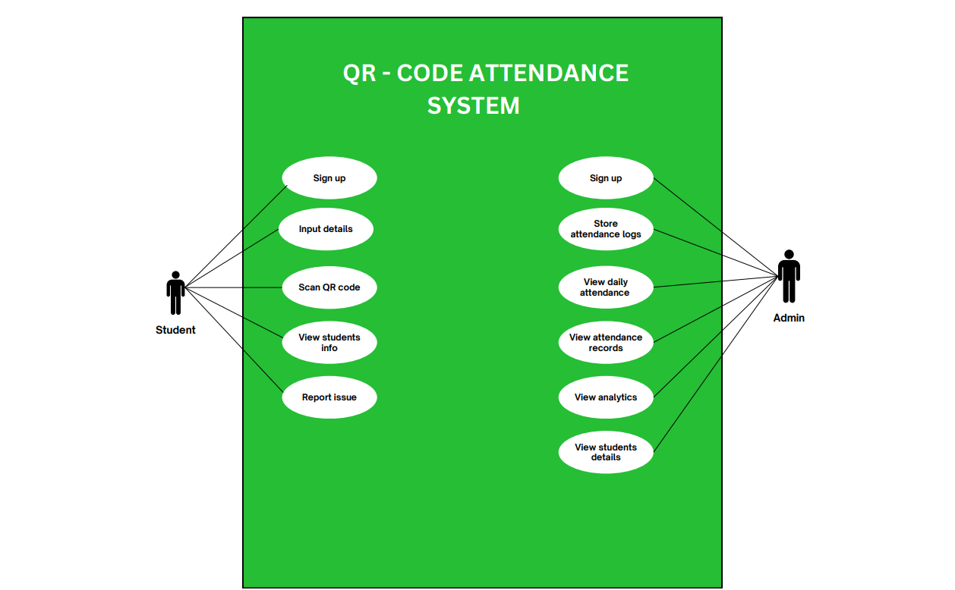

Figure 3.1 USE CASE DIAGRAM OF THE PROPOSED SYSTEM

3.6.6 ACTIVITY DIAGRAM OF THE PROPOSED SYSTEM

An activity diagram is a key element in the unified modeling language approach (UML), a graphical model of how various processes occur in a software system. In essence, it gives a dynamic image of the system, showing the sequence of activities that occur step -by -step. In essence, an activity diagram acts as a flowchart, offering a clear and systematic representation of interactions and decisions that conduct system functionality. It maps like users and system components interact, facilitating understanding of the logical flow of processes.
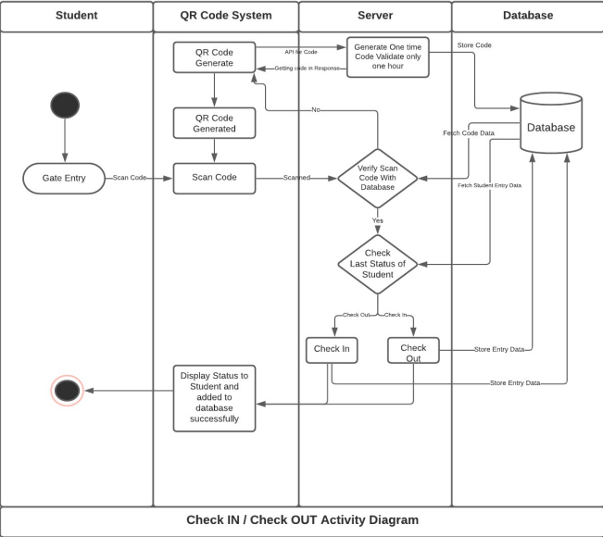

Figure 3.2 ACTIVITY DIAGRAM FOR THE PROPOSED SYSTEM

Figure 3.2 , describes the flow of activity of the system. QR Code Scanning Process for Hostel Entry
Before entering the hostel, students must scan a QR code provided by the gate guard.
How the QR Code is Generated
The gate guard is responsible for generating the QR code. To do this, the system makes a request to a QR code generation API.
One-Time Secure Code
When the API request is sent, the server generates a unique, secure one-time code. This code is then sent back to the system and stored in the database. For security purposes, the code expires every hour.
QR Code Creation
Once the system receives the secure code from the API, it uses that code to generate a QR code. Students can then scan this QR code at the entrance.
Verification Process
When a student scans the QR code, the system checks it against the database. If the code is valid, it verifies the student's last recorded status. If the code is invalid or expired, the system prompts the student to generate a new one.
Status Check & Entry Logging
- Checking Last Status: After scanning, the system verifies the student’s last recorded status in the database.
- Check-In: If the student was previously marked as Checked Out, their status is updated to Checked In.
- Check-Out: If the student was previously Checked In, their status is updated to Checked Out.
Finally, the system displays the updated status to the student and logs the entry in the database successfully.

3.6.7 CLASS DIAGRAM OF THE PROPOSED SYSTEM

This section shows the Class diagrams which help developers and stakeholders gain a clearer understanding of how different components of a system interact, making them invaluable for both planning and troubleshooting during the software development process.
They do this by visually representing its various classes, along with their attributes, methods, and the relationships between different objects.below is the figure for the qr-code management system.

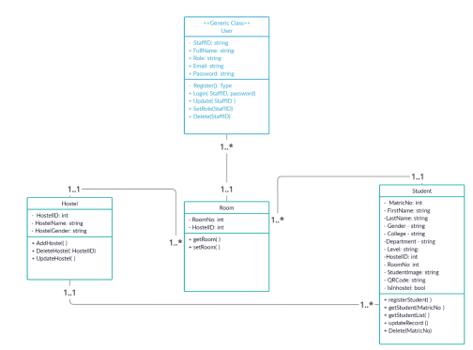

Figure 3.3 CLASS DIAGRAM OF THE PROPOSED SYSTEM

The second section contains an overview description of the system class diagram, in which the relationships between several system entities are graphically depicted. Each entity on the diagram maps to a particular component of the system, and its attributes copying the database table columns that they were modeled to resemble. One of the class elements of the class diagram is the class for the user, representing the types of users using the system. They are porters, loaders, and registration officers, each with their own unique attributes that govern their own roles and degrees of access within the system. By illustrating such relationships, class diagram gives a structured and concise image of how various components of the system interact with each other, maintaining maximum database design as well as user continuous interaction.

3.6.8 UML SEQUENCE DIAGRAM

Unified modeling language sequence diagrams (UML) serve as a dynamic and visual representation of how different objects within a system interact with each other over time. These diagrams are essential for understanding the chronological sequence of actions and messages that occur during the execution of a specific case or scenario. By illustrating the order of interactions, sequence diagrams provide valuable information on how various system components collaborate to achieve a common goal.
In essence, the UML sequence diagrams consist of various -chave elements, each playing a critical role in the system behavior capture. Life lines represent the different entities involved in an interaction, while messages illustrate communication between them. Activations, described as vertical bars that extend from a life line, indicate the duration of an entity's participation in an interaction, offering a clear view of when and how long an object is involved in a specific process. This temporal aspect increases understanding, not only showing what happens in a system, but also identifying exactly when each event occurs during system operation.
In addition to their technical applications, UML sequence diagrams serve as an effective bridge between technical and non -technical stakeholders. They offer a visually intuitive way to communicate the complex dynamics of the system by facilitating developers, business analysts, and other team members to align their understanding of how a system works. By promoting clearer communication, these diagrams promote collaboration, ensuring that all parties share a unified view of system behavior. In addition, they play a crucial role in identifying possible design failures, inefficiencies or areas of improvement, contributing to system refinement and future improvements.
In essence, UML sequence diagrams are more than just technical tools - are valuable active in system design and development. By mapping interactions in a structured visual format, they provide clarity, improve teamwork, and drive more efficient problems solving, ensuring that software solutions are functional and well optimized.

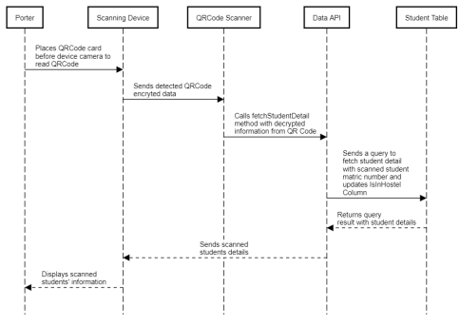
Figure 3.4: Sequence diagram to scan student QR code

3.7. SYSTEM DESIGN
The system design for the QR-Code Hostel Management System will show how the system is built to meet all the requirements we've discussed. It will cover everything from how the system takes input and provides output, to the design of the database that supports it.
3.7.1. INPUT/OUTPUT
The input/output design includes models that show how all different system sections deal with input and output information. It also features illustrations on how the system takes care of the inputs are processed. Below you will find a diagram that highlights these design/design output models.

INPUT DESIGNS OF THE PROPOSED SYSTEM

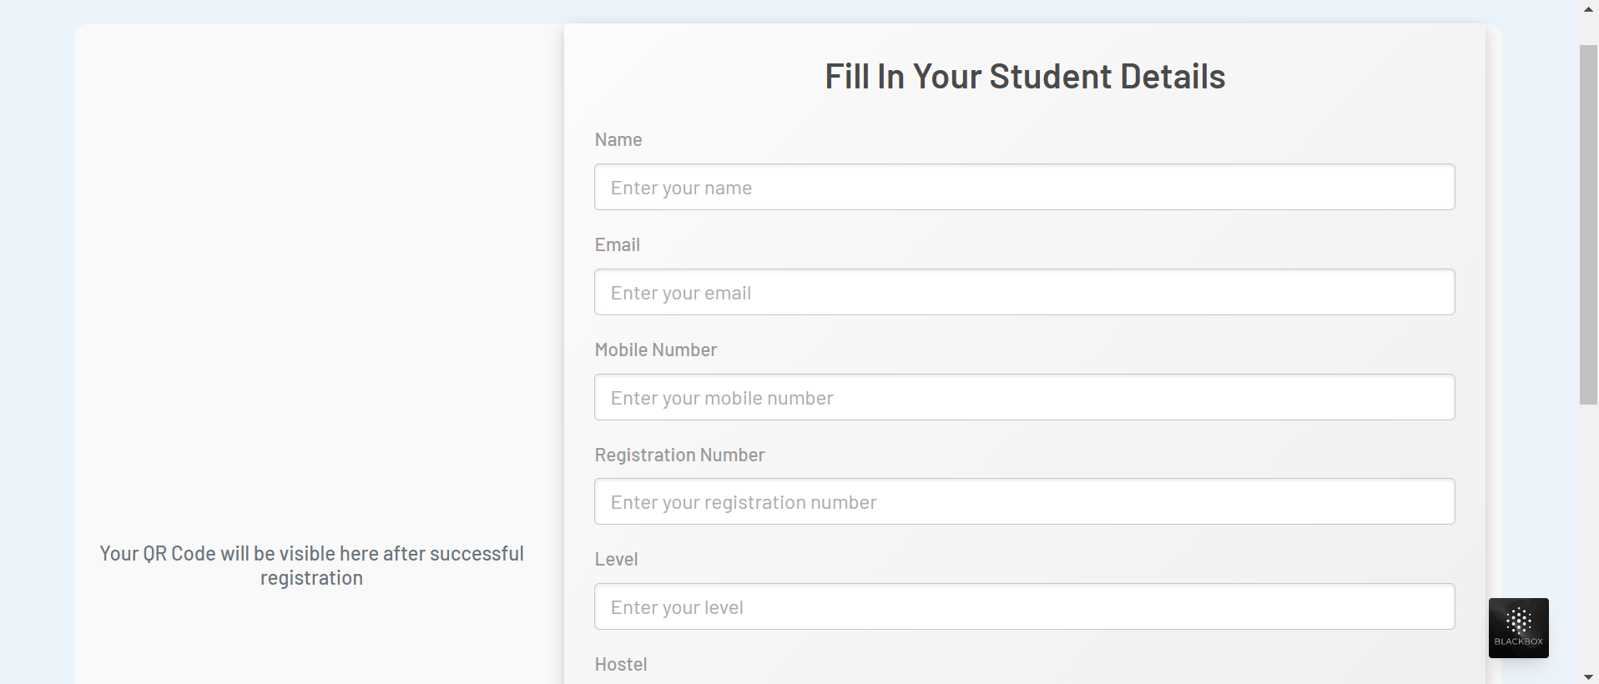

Figure 3.5 Input design for the proposed system
The diagram in figure 3.5 shows the user interface design for the student to register for his/her unique qr-code. It generally shows a pictorial representation of the interface used in inputting data into the proposed system. These inputs that are supplied to the platform cuts across mainly the act of generating the Qr-code on the platform. Therefore, the interface of the stands to showcase all different informations needed to generatethe qr-code.

3.7.2 DATABASE DESIGN
The main purpose of data base design is to show a modelled and well structured view of the Qr-code hostel management system

DATABASE SCHEMA FOR QR-CODE ATTENDANCE MONITORING SYSTEM

User table
Table 3.1 User table for Qr-code attendance monitoring system

Attribute | DataType | Description
Id | int | The primary key of the table
Name | varchar | Stores the name of the user.
Email | varchar | Stores the user's email address.
Password | varchar | Stores the user's encrypted password for authentication.
Role | varchar | Defines the user's role (e.g., "Admin", "Student", "Staff").
Created at | datetime | The date and time when the record was created.
Updated at | datetime | The date and time when the record was last updated.

Students table
Table 3.2 Students table for the Qr-code attendance monitoring system
Attribute | Data Types | Description
Id | int | The primary key of the table
Name | Varchar | The is where the username of the user is stored
Email | Varchar | The student's email address is stored in this field
Mobile | int | The student's mobile phone number, used for contact purposes.
Level | Varchar | The academic level or year of study, like "First Year" or "Postgraduate."
Reg no | Varchar | The unique registration number assigned to the student, often containing both letters and numbers.
Hostel | Varchar | The name or ID of the hostel where the student stays.
Room | Varchar | The specific room number or identifier within the hostel.
Image | Blob | A digital image file of the student, typically stored in formats like JPG or PNG.
Qr-code | Varchar | The data encoded in the student's QR code, or the QR code itself stored as an image file.

Attendance table
Table 3.3 Attendance table for the Qr-code attendance monitoring system
Attributes | Data Types | Description
Id | Int | The primary key of the table
Student Id | Int | A foreign key for the student, linking this record to the student.
Date | Datetime | The date and time when the record was created or the status was updated.
Status | Varchar | The status of the student, either present or absent
Created _at | Datetime | The date and time when this record was first created.
Updated _at | Datetime | The date and time when this record was last updated.

CHAPTER FOUR
SYSTEM IMPLEMENTATION
4.1 OVERVIEW
It describes how the Student Attendance Management System is set up as a web app that uses barcode scanning to keep track of attendance for students whether they live at school or in the hostel. Its main purpose was to move away from manual ways of tracking attendance which led to many mistakes and inefficiencies. Laravel was chosen to build the platform which helps generate barcodes for students, check their attendance and keep track of records. This chapter looks at how the development environment is set up, the system architecture, the various testing methods and the creation of documents.
4.2 TOOLS used for implementation (Tech stack of the prososed system)
4.2.1 Laravel Framework:
Because Laravel offers an expressive language, good documentation and a rich collection of tools and libraries, it was chosen as the main framework. The MVC (Model-View-Controller) pattern that the framework uses cleanly separates code, making it easy to manage and adjust as needed. Among the framework’s main features are Eloquent ORM for handling relations between objects and a database, page routing, middleware-based authentication and authorization and Blade for creating and displaying the front-end. Automating these tasks such as migrations, seeding data and initial code creation, is handled by Artisan, making development shorter. The strong focus on security, especially by preventing CSRF and storing passwords securely, strengthens Laravel as a good choice for building secure web apps.
4.2.2 PHP:
The Laravel framework relies on PHP as its main programming language, mainly for server-side logic and back-end development. Since PHP is a well-known scripting language for web development, it simplifies the work with dynamic content, session handling, file operations and adding databases to the system. Because the community is so large and there are many libraries, finding answers and packages for advanced features is simple. The fact that PHP is compatible with Apache (which is part of XAMPP) helps in deploying and testing apps smoothly and developers can add custom features because of PHP’s flexibility.
4.2.3MySQL:
In this system, MySQL which is a reliable open-source system, was responsible for managing and keeping critical details like student records, attendance logs and barcode identifiers. Because MySQL is fast, efficient and strong in data integrity, it is suited for handling complex queries and relationships important in handling real-time attendance systems. Because of Eloquent ORM, data is easily manipulated using object-oriented methods in Laravel. Also, aspects of MySQL security, for example user privileges and encrypted connections, help secure confidential data. Because so many use it, programming languages usually have lots of source materials and can live on for decades.

4.2.4 HTML, CSS AND JAVASCRIPT
The main front-end technologies helped build a responsive, interactive and user-friendly layout. HTML structuring allows web pages to display properly and clearly explain what the content means. Using CSS (Cascading Style Sheets) helped format and style the UI which made it look consistent, responsive to devices and match the brand style of the project. The application became more interactive and responsive because of JavaScript which enabled validation of forms, updated content in real time and allowed users to interact without refreshing pages. All these features allowed the system to be simple and easy for both administrators and students.
4.2.5 BARCODE GENERATION LIBRARY
Barcode generation was handled by Picqer Barcode, a PHP-driven library, guaranteeing every student gets a unique barcode as they start the registration process. A unique barcode appears on student ID cards or is shown digitally. Attendance marking happens by scanning the barcode which matches it to the database, noting that the student was present. Because of this, there is less chance for mistakes and the process goes much faster. Because the barcode library provides multiple formats (such as Code 128 or EAN), it is able to adapt to different needs and is compatible with many types of scanners.
4.3 SYSTEM REQUIRMENTS
Since the program is available through the internet on devices and phones, it does not require much hardware or software to execute. Since it is lightweight, web applications can be executed just on different devices as well as operating systems. Still, there are certain default settings that the users have to configure to ensure they efficiently use the system and its features despite the fact that the operating system does not occupy a large amount of space. Adhering to these needs enables the system to be executed at ease, made secure, and compatible. Therefore, the following are necessary:
- An internet enabled device
- Good internet connection (at least 3G internet speed).
- Xamp server version 8.1.12 and above
- A web browser e.g. Google Chrome, Mozilla Firefox, Microsoft Edge, Apple Safari and a host of others.

4.4 USER INTERFACE OF THE PROPOSED SYSTEM
The user interface for the landing page, login page, Registration page(Qr code generation page), student dashboard ,student attendance dashboard, and all other elements of the proposed system will be included in this section of the study of work.

4.4.1 THE STUDENT REGISTRATION PAGE FOR THE PROPOSED SYSYTEM
This section of the proposed system which is known as registration or qr-code generation page functions to allow users to create an account before they can be able to login to the system. The registration page allows users to fill in their information which includes their name, email, mobile number, registration number , level , hostel, room and profile picture.

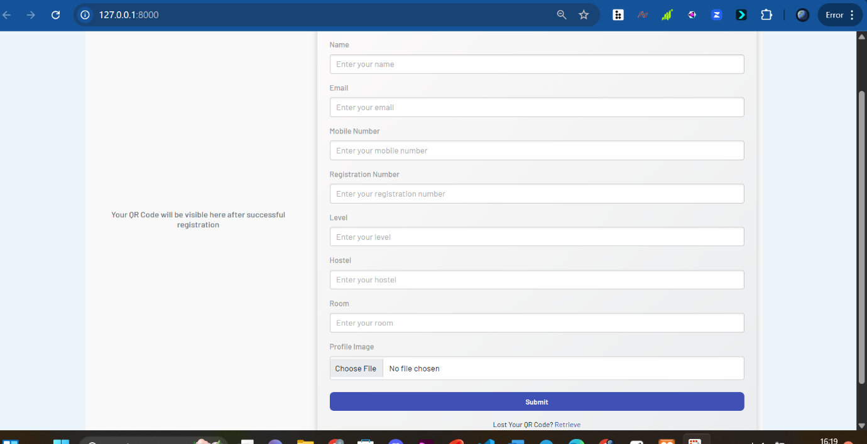
Figure 4.1 Student qr-code registration page
4.4.2 HOSTEL WARDEN LOGIN PAGE OF THE PROPOSED SYSTEM
The login page of the proposed system is the most important page of the proposed system as it allows the warden to login into the system in other to get full access to the systems functionality.
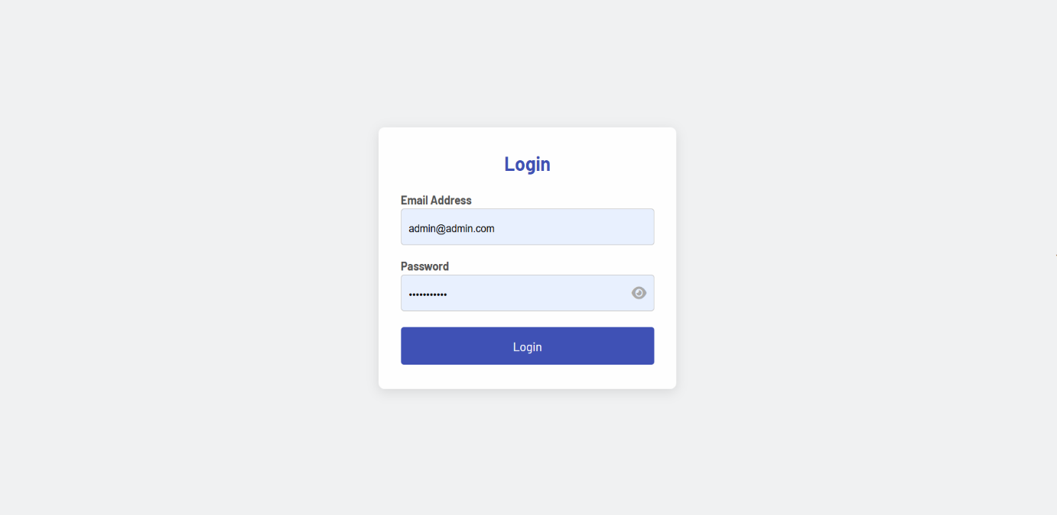
Figure 4.2 :Admin login page

4.4.3 HOSTEL WARDEN DASHBOARD PAGE OF THE PROPOSED SYSTEM
The Dashboard page of the proposed system is the most important page of the proposed system as it allows the warden to login into the system in other to get full access to the systems functionality and monitor the student attendance to keep check of the students records.
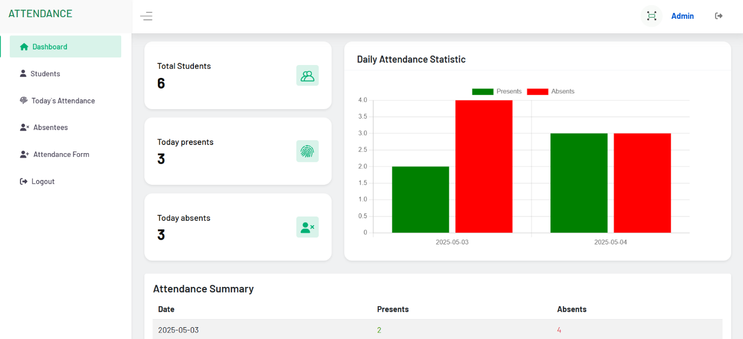
Figure 4.3.Hostel warden dashboard

4.4.4 STUDENS RECORD PAGE FROM THE WARDENS DASHBOARD
This dashboard page of the proposed systems shows the students registration details an records for the admin to be able to edit and rearrange.
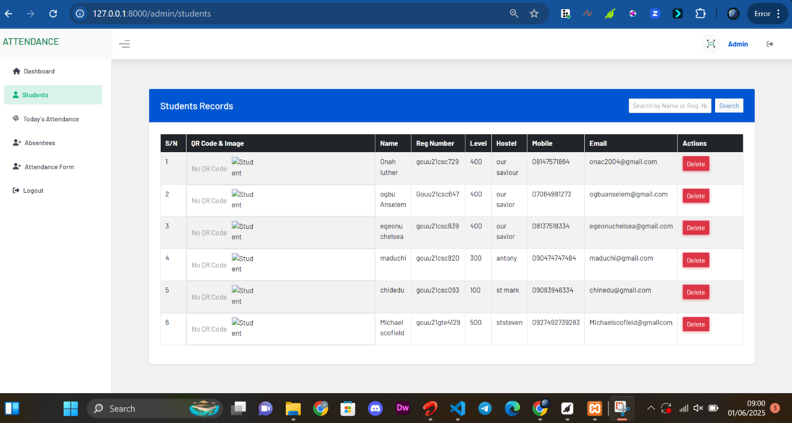
Figure 4.4: Studens record page

4.4.5 STUDENTS ABSENTEE PAGE FROM THE MENTORS DASHBOARD
This page of the hostel attendance management system shows to total number of absentees and students absent
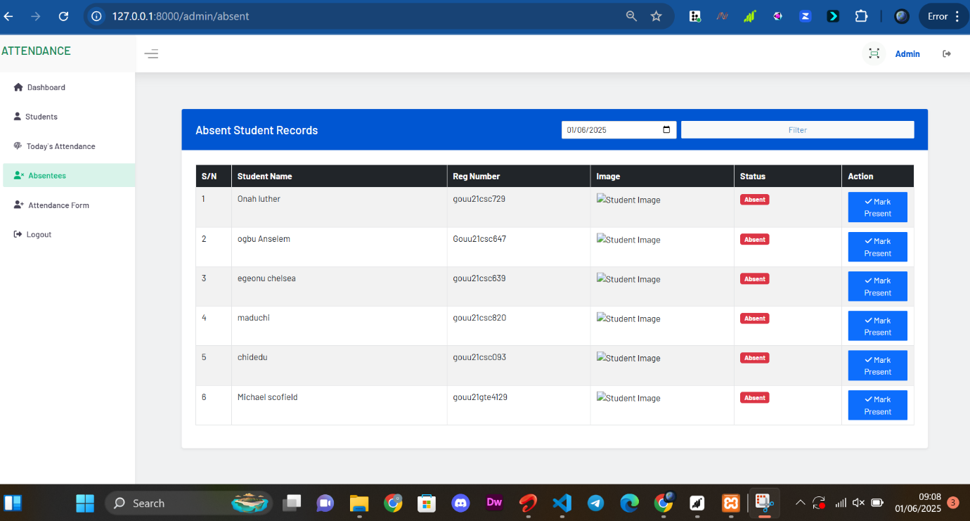
Figure 4.5:Students absentee page
4.4.6 STUDENTS PRSENTS FROm THE HOSTEL WARDEN DASHBOARD
This page shows the date and number of students that were present at that time and total number of times.
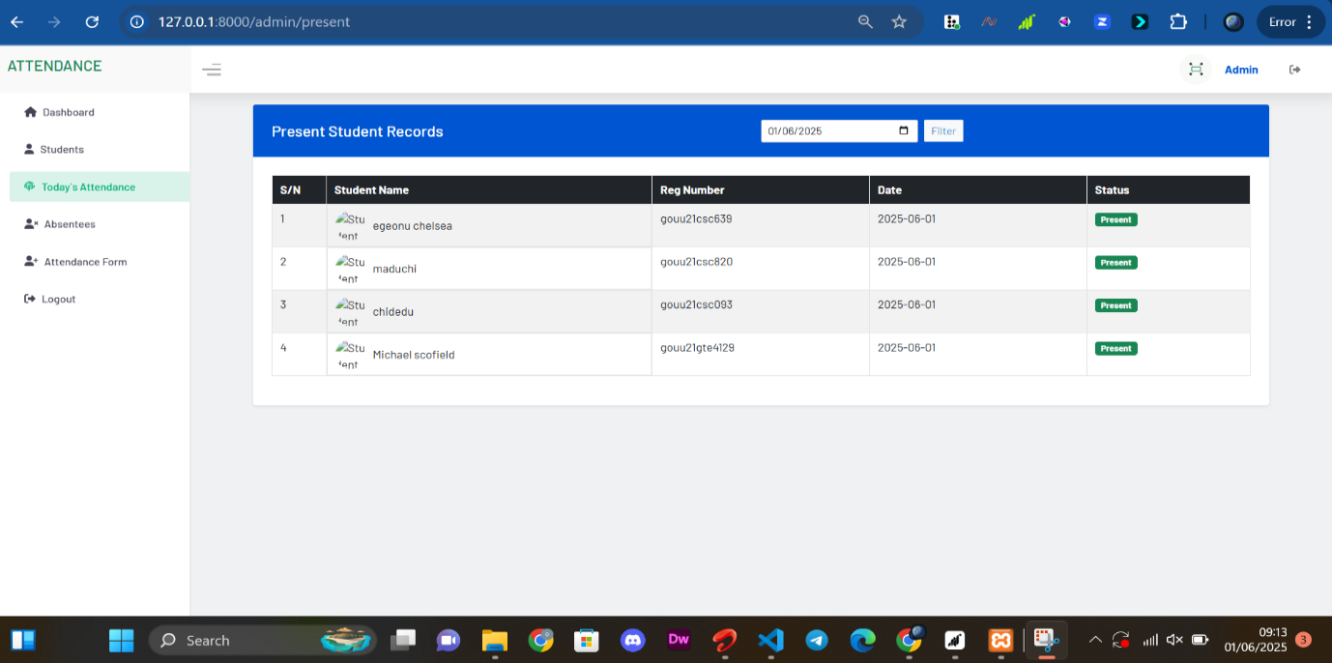
Figure 4.6:Student present page

CHAPTER FIVE
SUMMARY, RECOMMENDATIONS AND CONCLUSION
5.1 INTRODUCTION
This chapter of this work of research aims to provide a thorough overview of the project, suggestions for additional work, and, finally, a conclusion. On the other hand, this chapter provides an overview of all the topics covered in each of the previous project's chapters.
5.2 SUMMARY
The Student Attendance Management System was created to replace the inefficiencies of outdated manual recording of attendance in hostels and schools. The system offers a central platform for producing student barcodes, scanning attendance, and handling attendance records. Built with the Laravel framework, the system makes use of the Model-View-Controller (MVC) structure to provide a clean, modular, and scalable codebase.
The project initiated with a detailed examination of the current attendance tracking processes, followed by designing and implementing it. The system has salient features such as generation of barcode, scanning barcode, marking attendance, and report generation. The system has been tested very rigorously using different testing methods, i.e., unit testing, integration testing, user acceptance testing (UAT), performance testing, and security testing. End-users' feedback was also incorporated to further enhance the system to be able to respond to their needs and expectations.

5.3 RECOMMENDATIONS
Student Attendance Management System is worthy to be installed in schools since it aids in automated marking of attendance and reduces clerical work. Despite the fact that the system is implementable and functional, it would be more efficient and convenient if an adjustment is done.

Adding a mobile application would render the system more accessible, with the students and staffs being able to scan barcodes and see reports easily using handheld devices. Adding biometric features like fingerprint or face recognition would enhance security threats and assist in mitigating attendance forgery risks.In temporary addition of advanced analytics functionality, habit tracking of attendance would become more sophisticated and assist institutions in the identification and assistance of vulnerable students. Other system security through two-factor authentication and encryption of data is also suggested to protect confidential information. In addition, its integration with other school systems such as Learning Management Systems (LMS) or Student Information Systems (SIS) would be an entire digital experience. Having the bi-weekly monitoring of attendances interactive with rewards or badges could also help promote more student participation in other ways. Provided that the bi-weekly upkeep, frequent updates, and user training are ensured, long-term adoption and usability of the system would be assured. Implementing these proposals would ensure both the complete potential of the system is reaped for both students and administrators.
5.4 CONCLUTIONS
The Student Attendance Management System can effectively fulfill its role of sophisticated monitoring of the attendance of school and hostel dwellers using barcode scan. Using the Laravel framework in combination with software development best practices, the system takes on a strong, user-friendly, and extensible approach to marking attendance.
Application of the MVC architecture gave a clean and structured codebase, system scaling and maintenance simple. Sound testing gave the system stability, performance, and security, whereas user feedback gave feedback that enhanced the system to cater to the needs of the target population. User-friendliness of the user interface and high system functionality make the system an essential tool for the hostel administration, teachers, and students.
This project demonstrates technology being applied to actual problems and improving processes in the learning centers. It also has potential for further innovation in the industry, including the application of more advanced analytics and mobile apps to put even more functionality into the system.
5.5 REFERENCE
Ahmad, T., & Qamar, F. (2020). QR code-based attendance system with parental alert via SMS. International Journal of Computer Applications, 176(30), 1–4. https://doi.org/10.5120/ijca2020920305
Bansal, A., & Garg, A. (2018). Automated attendance system using Android platform and biometric verification. International Journal of Engineering Research and Applications, 8(2), 30–34.
Garg, N., & Arora, A. (2019). Implementation of QR code-based smart attendance system using Android. International Journal of Advanced Research in Computer Science, 10(5), 60–64.
Khan, R., & Alam, M. (2021). A review on biometric and QR code-based attendance monitoring systems. International Journal of Emerging Technologies in Learning (iJET), 16(5), 58–67. https://doi.org/10.3991/ijet.v16i05.18945
Lin, F., Leung, S., Wen, D., Zhang, F., & Kinshuk. (2010). E-advisor: A multi-agent system for academic counseling. International Transactions on Systems Science and Applications, 4(2), 89–98.
Mohanapriya, M., & Srinath, S. (2020). QR code based smart attendance system using IoT. Journal of Xi’an University of Architecture & Technology, 12(3), 1220–1226.
Nagothu, S., & Yadav, R. (2022). QR code-based hostel attendance tracking system. International Journal of Scientific Research in Engineering and Management (IJSREM), 6(7), 55–59.
Nithya, R., & Shree, P. K. (2019). Smart hostel management system using RFID and QR technology. International Journal of Scientific & Engineering Research, 10(3), 345–350.
Raj, A., & Gupta, K. (2019). Design and implementation of hostel attendance and visitor management system. International Journal of Computer Sciences and Engineering, 7(6), 542–546.
Shaik, M., & Chaitanya, S. (2020). QR code-based attendance system for academic institutions. International Research Journal of Engineering and Technology (IRJET), 7(4), 1236–1240.
Singh, V., & Jain, M. (2018). Real-time student attendance system using face recognition and QR code. In Proceedings of the International Conference on Smart Technologies and Management for Computing, Communication, Controls, Energy and Materials (ICSTM) (pp. 134–138). IEEE. https://doi.org/10.1109/ICSTM.2018.8544666
Sivakumar, B., & Anusha, R. (2021). IoT-based hostel monitoring system. Journal of Emerging Technologies and Innovative Research, 8(5), 451–456.
UC Davis Human Resources. (2018). Types of mentoring to choose from. Retrieved from https://hr.ucdavis.edu/departments/learning-dev/toolkits/mentoring/types
Wu, J. (2019). Offering mentoring assistance through group tutorials online. Journal of Educational Innovation, 12(4), 214–220.
Chavan, P., & Mahajan, A. (2020). Smart attendance system using QR code. International Journal of Advanced Research in Electrical, Electronics and Instrumentation Engineering, 9(5), 2270–2275. https://doi.org/10.15662/IJAREEIE.2020.0905007
Patel, R., & Sharma, S. (2021). QR code-enabled identity verification system for restricted area access. International Journal of Computer Sciences and Engineering, 9(6), 103–107.
Jadhav, R., & Pawar, S. (2020). A mobile-based attendance system using QR code and cloud technology. Journal of Information and Computational Science, 10(6), 1179–1186.
Nwankwo, C., & Okonkwo, M. (2022). Design of an automated hostel log system using QR code and real-time data monitoring. International Journal of Engineering and Technical Research, 11(1), 43–49.
Olaniyan, T., & Akande, M. (2019). Mobile application for hostel resident tracking using QR code authentication. Nigerian Journal of Technology, 38(3), 812–818.

APPENDICES

Appendix A: User interface

Appendix B:source code listing
<?php

namespace App\Http\Controllers\admin;

use App\Http\Controllers\Controller;
use App\Models\Attendance;
use App\Models\Student;
use Illuminate\Http\Request;

class AttendanceController extends Controller
{
//
public function present(Request $request)
{
// Default to today's date
$date = $request->input('date', now()->toDateString());

// Fetch attendance records for the selected date
$attendances = Attendance::with('student')
->where('date', $date)
->get();

if ($attendances->isEmpty()) {
return view('admin.present', [
'attendances' => [],
'date' => $date,
'message' => 'No records found for ' . $date,
]);
}

return view('admin.present', compact('attendances', 'date'));
}

public function Absent(Request $request)
{
// Default to the current date if no date is selected
$date = $request->input('date', now()->toDateString());

// Get all students who are not in the attendance table for the given date
$absentStudents = Student::whereDoesntHave('attendances', function ($query) use ($date) {
$query->where('date', $date);
})->get();

return view('admin.absent', compact('absentStudents', 'date'));
}

public function attendanceForm(Request $request)
{

return view('admin.attendance-form');
}

public function markPresent(Student $student)
{
try {
// Attempt to mark the attendance
$attendance = Attendance::updateOrCreate(
['student_id' => $student->id, 'date' => now()->toDateString()],
['status' => true]
);

// Redirect back to the same page with a success message
return redirect()->route('admin.present')->with('status', 'Attendance marked successfully!')->with('status_type', 'success');
} catch (\Exception $e) {
\Log::error('Attendance Error: ' . $e->getMessage());

// Redirect back to the same page with an error message
return redirect()->back()->with('status', 'Failed to mark attendance.')->with('status_type', 'danger');
}
}

}
<?php

namespace App\Http\Controllers\admin;

use App\Http\Controllers\Controller;
use App\Models\Attendance;
use App\Models\Student;
use App\Models\User;
use Auth;
use Illuminate\Http\Request;
use Illuminate\Support\Facades\Hash;

class DashboardController extends Controller
{
//
public function index()
{
$today = now()->toDateString();

// Count students marked as present (having an attendance record for today)
$todayPresent = Attendance::where('date', $today)->count();

// Find absent students (students without an attendance record for today)
$absentStudents = Student::whereDoesntHave('attendances', function ($query) use ($today) {
$query->where('date', $today);
})->get();

// Count absent students
$todayAbsent = $absentStudents->count();

// Total number of students
$totalStudents = Student::count();

// Prepare daily data for the chart
$dailyData = Attendance::selectRaw('date, COUNT(*) as presents,
(SELECT COUNT(*) FROM students) - COUNT(*) as absents')
->groupBy('date')
->orderBy('date', 'asc')
->get();

// Pass data to the view
return view('admin.dashboard', [
'todayPresent' => $todayPresent,
'todayAbsent' => $todayAbsent,
'totalStudents' => $totalStudents,
'dailyData' => $dailyData,
'absentStudents' => $absentStudents, // Pass absent students to the view
]);
}

//User Profile

public function updatePassword(Request $request)
{
$user = Auth::user();

if (!$user) {
return response()->json([
'message' => 'User not authenticated',
<?php

namespace App\Http\Controllers\admin;

use App\Http\Controllers\Controller;
use Illuminate\Http\Request;
use Illuminate\Support\Facades\Hash;
use Illuminate\Support\Facades\Mail;
use Illuminate\Support\Facades\DB;
use App\Models\{User,investment,plan,wallet,Deposit,Referral};
use Storage;
class ProfileController extends Controller
{
//

public function index()
{
$userData = auth()->user();

return view('admin.profile', compact('userData'));
}

public function updateProfile(Request $request)
{
$user = auth()->user(); // Get the currently authenticated user

// Validate the incoming request data
$request->validate([
'name' => 'required|string|max:255',
'email' => 'required|email|max:255|unique:users,email,' . $user->id,
'country' => 'nullable|string|max:255',
'password' => 'nullable|string|min:8|confirmed',
'image' => 'nullable|image|mimes:jpg,jpeg,png,gif|max:2048',
]);

// Update user information
$user->name = $request->name;
$user->email = $request->email;
$user->country = $request->country;

// Handle password update (if provided)
if ($request->filled('password')) {
$user->password = bcrypt($request->password);
}

// Handle image upload and deletion of the previous image
if ($request->hasFile('image') && $request->file('image')->isValid()) {
// Delete the old image if it exists
if ($user->image && Storage::exists('public/profile_images/' . $user->image)) {
Storage::delete('public/profile_images/' . $user->image);
}

// Save the new image with a unique name
$imageName = time() . '.' . $request->file('image')->extension();
$request->file('image')->storeAs('profile_images', $imageName, 'public');

// Store the filename in the database (not the full path)
$user->image = $imageName;
}

// Save the updated user data
$user->save();

// Flash a success message to the session
session()->flash('success', 'Profile updated successfully!');

// Redirect to the profile page with the success message
return redirect()->route('admin.profile');
}

}

<?php

namespace App\Http\Controllers\admin;

use App\Http\Controllers\Controller;
use App\Models\Student;
use Illuminate\Http\Request;

class StudentsController extends Controller
{
public function index(Request $request)
{
$query = Student::query();

// Filter by name or registration number
if ($request->has('search')) {
$search = $request->input('search');
$query->where('name', 'LIKE', "%{$search}%")
->orWhere('reg_number', 'LIKE', "%{$search}%");
}

// Fetch students
$students = $query->paginate(10);

return view('admin.students', compact('students'));
}

public function destroy($id)
{
$student = Student::findOrFail($id);

// Delete QR code file if exists
$qrCodePath = storage_path("app/public/qr_codes/{$student->reg_number}.svg");
if (file_exists($qrCodePath)) {
unlink($qrCodePath);
}

$student->delete();

return redirect()->route('admin.students')
->with('success', 'Student deleted successfully.');
}
}

