Abstract
Library stock system is a fast growing company since the ancient methods of maintaining it are no longer dynamic and efficient, for expeditious retrieval and dissemination of information and better services for the client, application of modern techniques have become absolutely indispensable. This project focuses on developing software for a web based library stock management system which can enable the librarian to record all the books stocked in the library and also assign. The objectives of this is to build a web database for storing books stocked in the library, also to develop a web base system which will help to manage and record books borrowed and returned in the library, to assign every book unique identification number. The method used in developing this software is the waterfall model.The researcher used this methodology in the design of the software and it was implemented using sublime text on a Microsoft windows operating system using basic HTML codes, PHP, CSS and MySQL language for the relational database. The result gotten from this project was a web based library stock management system.

CHAPTER ONE
- INTRODUCTION
Library is a fast growing company. The ancient methods of maintaining it are no longer dynamic and efficient. For expeditious retrieval and dissemination of information and better service for the client, application of modern techniques has become absolutely indispensable.
A properly computerized library will help its users with quick and prompt services. Library automation refers to mechanization of library housekeeping operations predominantly by computerization.
The most commonly known housekeeping operations are acquisition control, serials control, cataloguing, and classification and circulation control. Library stock managements is an enterprise resource planning systems for a library, used to tracks items owned, order made, bills paid etc.
  - STATEMENT OF THE PROBLEM
Some of the problems encountered in the manual library stock management system in institutions include:
- Lack of comprehensive database for book stocked in the library,
- Poor determination books due and overdue,
3. Lack of verifiable borrowed material from the borrowers (student and staff),
- Stress to the library attendance to attended the users

  - AIM AND OBJECTIVES
The aim of this project is to design and implement a library stock management system.
The objectives include:
- To build a web database for storing books using IDs assigned to each book,
- To develop a web base which helps to manage and record library stocks
- To give account of borrowed and un borrowed books ,
- Reduction of verbal words between the library users and the attendance
  - SIGNIFICANCE OF STUDY
With growth of information technology, the study offers numerous values in library stock management system;
- Library users get quality services,
- It will be easier to borrow books,
- It will provide efficient, effective and timely services,
- Record keeping will be more efficient.

CHAPTER TWO
Literature Review
2.0: Introduction
The aim of library stock management system is to reduce manual system of recording and increase accessibility of books stocked in the library. The web based library stock management system, tends to change the traditional way of managing the library stock, in order to reduce stress and tedious job of manual searching of books that are available in library.
The demerits of Web based library stock management, is centered on the area of illiteracy and availability of materials neededby the researcher or student at a particular time. This problem can be encountered mainly in rural areas where internet services are still limited.
2.1 Theoretical Background
The project was built with web technologies which are HTML, CSS, PHP, and wamp server, where relational database was integrated (MySQL and phpMyAdmin), having Apache as the engine controller. And it was made with a user friendly capability, with the help of an application program known as a “web browser”,example Mozilla Firefox, Opera mini, Internet Explorer, Google Chrome, Microsoft edge, and Maxton Cloud etc.
Every html tag in the web document has a function it does on the web browser, example if I write
<html>
<head>
<title>Library Stock Management System</title>
</head>
<body bgcolor=”red”>
<h2 align="center">Web BasedLibrary Stock Management System<br /><br /> by <br/><br />Happiness</h2>
</body>
</html>
This will output a title Library Stock Management System at the top of the web browser and the main page; Web Based Library Stock Management System by Happiness, all will be displayed in centered alignment. A form was designed to collect data from user which involves: surname, first name, middle name, faculty department, etc. which when entered and submitted with the submit button that sends the data to a browser, and into the relational database to hold the data.
HTML is the major tag, which forms the visual website that is used to create forms and specify a location onto which particular portion is mapped inside a web page e.g. <div id=”form”>form location
<form action=”” method=”post”>
surname<input type=”text” name=”surname”/>
first name<input type=”text” name=”first name”/>
Middle name<input type=”text” name=”middle name”/>
Faculty<input type=”text” name=”faculty”/>
Department<input type=”text” name=”department”/>
<input type=”submit” name=”submit” value=”Submit”/>
</form>
</div>
The HTML tag above when previewed on the browser appears on the screen as follows:
Surname
First name
Middle name
Faculty
Department
Submit

The division (div) positions and held every site layout.Cascading Style Sheets 3(CSS3) is a style sheet language used for describing the look and formatting of a documentwritten in a mark-up language.
PHP is a server-side scripting language created in 1995 and designed for web development, but also used as a general-purpose programming language. PHP code where used to send the collected data from the user to MySQL relational database.
2.2. Review of related Literature
There are existing researchworks on library stock management system; which are as follows:
Library Management System is an application which refers to library systems which are generally small or medium in size. It is used by librarian to manage the library using a computerized system where he/she can record various transactions like issue of books, return of books, addition of new books, addition of new students etc.…
PRABHAKAR KUMAR
RAHUL KUMAR
RAJAT SINGH
VIKRAM PRATAP SINGH
2014
Library is regarded as the brain of any institutes, of course many institute understand the importance of the library to the growth of the institute and their esteem users which we categorically call the students. Anintegrated library system, also known as a library management system (Adamson et al., 2008) is an enterprise resource planning system for alibrary, used to track items owned, orders made, bills paid, and users who have borrowed.
The Library Management System is a Library Management software for monitoring and controlling the transactions in a library (Ashutosh and Ashish., 2012). Library ManagementSystem supports the general requirement of the library such as the acquisition, cataloguing,circulation and other sections.
2.3. Summary
The researcher, cannot but have the same idea with the scholars, that our business premises payment system (revenue collection) needs total restructuring before effective and accurate means of revenue generation could be conducted, by using specialized method as check to ensure that revenue collected are channeled to the proper hands of government.
In most developing countries revenue collection and occupant willing to pay the levy imposed on the government property he/she is using, is what prompted this idea of business premises payment system. Occupants (landlords) must ensure that their tenants register all types of businesses established within the street or area as the case may be.

CHAPTER 3: SYSTEM ANALYSIS AND DESIGN
3.0 INTRODUCTION
The analysis of the existing system and design. This the method used in order to achieve the aim of the project, especially the requirements and implementation of the project work and clear explanation of reasons such methods were used for design and implementation of the proposed system, also included is a description of the new system of library stock management system.

3.0.1 METHODOLOGY
The methodology used in this research project is the water fall model. The waterfall model is a linear representation of various phases in development of a particular system software, often used in software development processes, in which progress is seen as flowing steadily in sequential downwards, (like a waterfall) through the phases of communication, planning, modeling, Construction, deployment, and Maintenance.
Waterfall model is the earliest SDLC (System Development Life Cycle) approach that was used for software development. The waterfall Model illustrates the software development process in a linear sequential flow; hence it is also referred to as a linear-sequential life cycle model. This means that any phase in the development process begins, only if the previous phase is completed. In waterfall model, phases do not overlap.

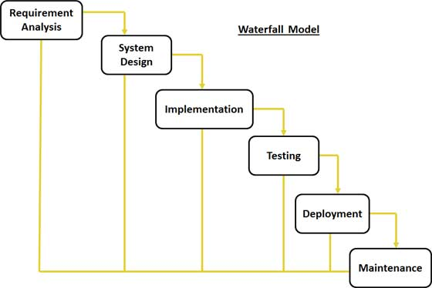
Figure 3.1: Structure of water fall model

The research project passed through the following waterfall phases in order to achieve this work.
- Requirement Gathering and analysis: All possible requirements of the system to be developed are captured in this phase and documented in a requirement specification document. It also includes the communication between the client and the developer inform of feasibility study.
- System Design: The requirement specifications from first phase are studied in this phase and system design is prepared. System Design helps in specifying hardware and system requirements and also helps in defining overall system architecture. The method of design to be used whether top-down approach or bottom-up approach.
- Implementation: With inputs from system design, the system is first developed in small programs called units, which are integrated in the next phase. Each unit is developed and tested for its functionality which is referred to as Unit Testing.
- Integration and Testing: All the units developed in the implementation phase are integrated into a system after testing of each unit. Post integration the entire system is tested for any faults and failures.
- Deployment of system: Once the functional and non-functional testing is done, the product is deployed in the customer environment or released into the market.
- Maintenance: There are some issues which come up in the client environment. To fix those issues patches are released. Also to enhance the product some better versions are released. Maintenance is done to deliver these changes in the customer environment.

3.1 ANALYSIS OF THE EXISTING SYSTEM.
The existing system of library stock management system is a manual process, in which students make use of their identification card as a means of borrowing books. For the librarian their use a piece of card attached to each book in the library to keep record of books students borrowed.

All the books are arranged in the library shelves and students will be going around search for the one that will give them the fact needed, which often cause delay during the research. And borrowing a book depends on when you find the book you wants to you the present you ID card (identification card) for them to collect the information needed from the student and write it down with the card at the back of the book, as a record purpose in cases if the student fails to return the book on the due date there will be means of contacting the person and penalize the student accordingly.

During the course of the analysis, the following problems were discovered:
- Time consuming.
- Poor accountability
- Delay when searching for book
3.2 ANALYSIS OF THE PROPOSED SYSTEM
The current library stock management system (LSMS) is a web based system where student register to create profile with library unit for easy accountability of the students borrowing books and book borrowed, the account created will then give then access using their registration number and password.

The librarians have administrative ends where there setting up the system, by inserting the books using the appropriate identification number assigned to it, the ISBN number , the book title and the department that most needs the book.
The system also have option for the librarians to view borrowed books, and return borrowed books by using the identification number to search the book returned by the student.
Any borrowed book is attached to the student information so that contacting the borrower will be easy incase if the book exceeds the period stipulated in the book.

3.3 DESIGN OF THE PROPOSED SYSTEM

3.3.1 DATABASE DESIGN
The required tables in the system include the following:
- Admin_login_tab
- Book_record_tab
- Borrowed_book_tab
- Lsms_login_tab
- Sts_reg_tab

Table 1: Admin_login
Field | Type | Null | Key | Default | Extra
Admin_login_id | Int(11) | NO | Primary | Null | Auto_increment
User_name | Varchar(25) | Yes |  | Null
Pass_word | Varchar(25) | Yes |  | Null
Table 2: book_record_tab
Field | Type | Null | Key | Default | Extra
book_record_tab | Int(11) | NO | Primary | Null | Auto_increment
Book_id | Varchar(25) | Yes |  | Null
Book_title | Varchar(255) | Yes |  | Null
Book_isbn | Varchar(25) | Yes |  | Null
Book_depart | Varchar(25) | Yes |  | Null

Table 3:borrowed_book_tab
Field | Type | Null | Key | Default | Extra
Borrowed_book_tab_id | Int(11) | NO | Primary | Null | Auto_increment
Book_record_id | Int(11) | NO |  | Null
Reg_no | Varchar(25) | Yes |  | Null
Full_name | Varchar(255) | Yes |  | Null
Phone_no | Varchar(25) | yes |  | Null
Faculty | Varchar(25) | yes |  | null
Depart | Varchar(50) | yes |  | Null
program | Varchar(100) | yes |  | Null
Book_id | Varchar(25) | yes |  | Null
Book_title | Varchar(255) | yes |  | Null
Book_isbn | Varchar(25) | yes |  | Null
Borrowed_date | Date | yes |  | Null

Table 4:lsms_login_tab
Field | Type | Null | Key | Default | Extra
Lsms_login_tab_id | Int(11) | NO | Primary | Null | Auto_increment
Reg_no | Varchar(25) | Yes |  | Null
Full_name | Varchar(255) | Yes |  | Null
Phone_no | Varchar(25) | yes |  | Null
Faculty | Varchar(25) | yes |  | null
Depart | Varchar(50) | yes |  | Null
program | Varchar(100) | yes |  | Null
Table 5:sts_reg_tab
Field | Type | Null | Key | Default | Extra
Sts_reg_tab_id | Int(11) | NO | Primary | Null | Auto_increment
student_reg | Varchar(25) | Yes |  | Null

3.3.2 System Architecture
Admin Login

Admin dashboard

Return borrowed books
View borrowed books
Insert books
Home
Logout

Database

Student Login

Sudent Home Page

View All Books
View Borrowed Books
Law
Arts
EDU
MSS
NAS
Home
Logout

Figure 3.3: System architecture.
3.3.3 INPUT DESIGN
STUDENTREGISTRATION FORM
PASSWORD
PROGRSMME
DEPARTMENT
FACULTY
PHONE NUMBER

FULL NAME
REGISTRATION NUMBER

SUBMIT

The input for this system is by keyboard, mouse and webcam. During this input operation there are some data that are required from the employee. These data are Staff ID, Password, Surname, First Name, Middle Name, Department and designation

Figure 3.3: Input Design

3.3.4 OUTPUT DESIGN

Figure 3.4: Registration form

BOOK ID | BOOK TITLE | ISBN | BORROW BOOK

Figure 3.4: Output Design

3.3.5 ALGORITHM DESIGN
ALGorithm for Admin Login
Step 1: Start
Step 2: Declare a variable username and password
Step 3: Read variable username and password
Step 4: if username = password
Open a new page
Else
Display error meassage
Step 5: Stop

CHAPTER 4:SYSTEM IMPLEMENTATION

4.0 INTRODUCTION
This chapter clearly explain how this newly developed library stock management system will be operated.

4.1 CHOICE OF DEVELOPMENT ENVIRONMENT.
The system was developed as a midiator between the user, administrator and the database, the database is the middle man which feeds the user and the administrator with the help of web browser. It was designed using notepad++ as an editor and wamp server which is the localhost that powers the website locally in developers system before going uploading to global server for public access. These tools enable the administrator through a browser to interact with MySQL database to enter, edit, view, and retrieve data from database, as a privilege granted. HTML and CSS which provides the graphical user interface, the HTMLforms which offer the best layout to enter data, change data and view the information in database. This forms was also kept as short and simple as possible to suit the individual who will provide data.
The choice of programming used in this research work is top-down approach.

4.1.1 Administrator Login Page

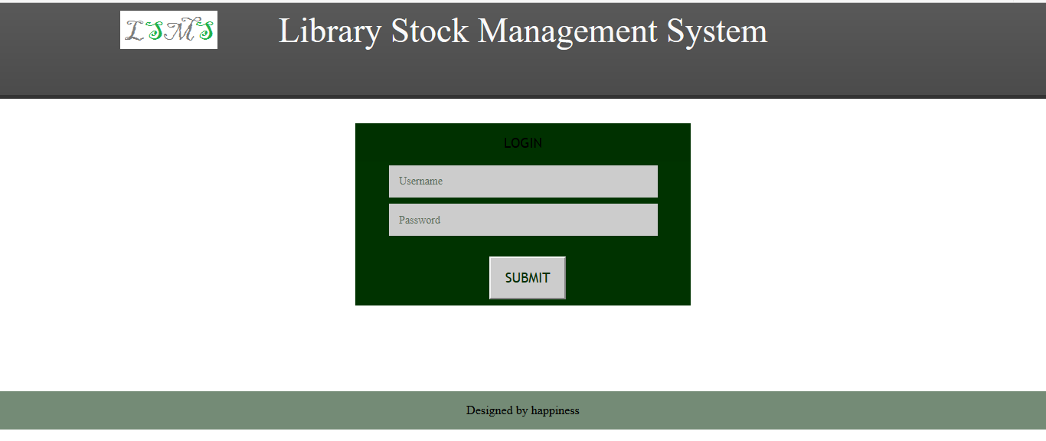

Figure 4.1: Screen shot of administrator login page.

This is where the administrator login using his or her username and password. The username and the password provided here must be collect otherwise he or she will not access the next page.
4.2 Implementation Architecture
Admin Login

Admin dashboard

Return borrowed books
View borrowed books
Insert books
Home
Logout

Search borrowed books
List of borrowed books
Submit Inserted Books

Database

Student Login

Sudent Home Page

View All Books
View Borrowed Books
Law
Arts
EDU
MSS
NAS
Home
Logout

List of depart
List of depart

List of borrowed books
List of all books
List of depart

Law
Arts

Figure 4. 3: Implementation architecture

4.3 SOFTWARE TESTING
There are two phases of system testing:
Firstly, testing done during development phase. This testing includes:
➢ Syntax error testing: syntax error testing is the method of error testing used to check all the code errors and structural errors during the development.
➢ Compatibility testing: this testing is used to test if all the languages used during the programming werecompatible with each other during integration of modules.
➢ Logical testing: thisincludes allthe argument stated during the programming. This will check whether the variable is accepted by the system or not.
Secondly, testing them by running the software on realistic data samples. This testing includes:
➢ Running the application in graphicaluser interface using a local server such as wamp server, xamp server lamp server etc that have local host which is using Apache as engine and MYSQL as the database.
➢ Browser testing: this testing is used to test the appearance and shape of the software on the browser.

4.3.1 INPUT SPECIFICATION
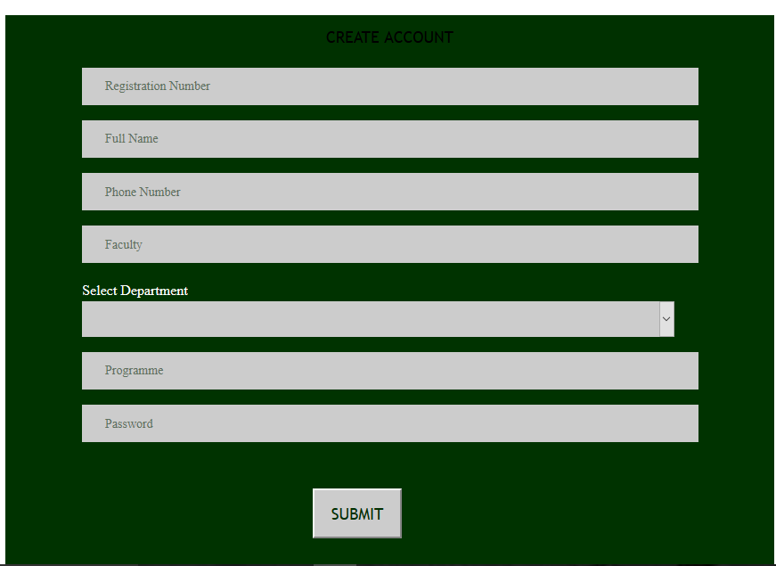

Figure 4.4: Screen shot of the input form,

4.3.2 Output Specification
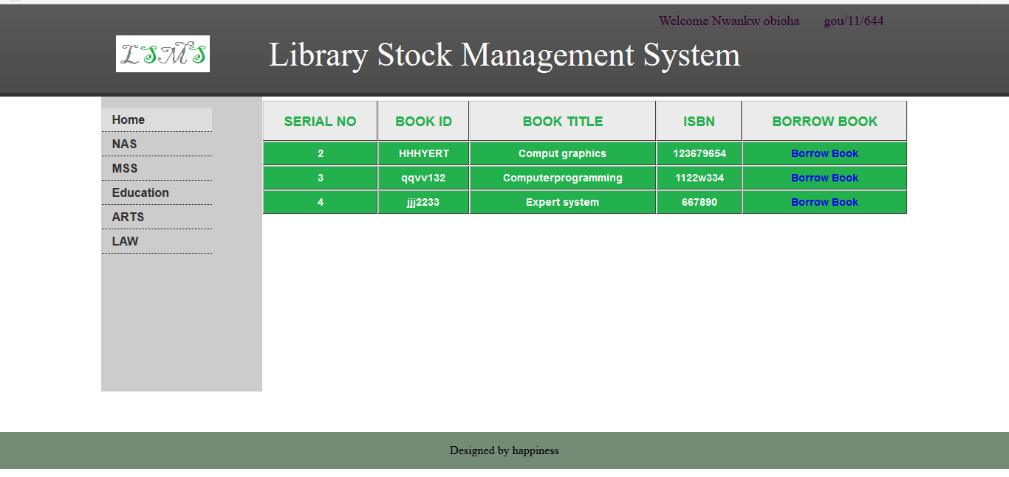

Figure 4.5: Screenshot of books stocked in library

4.4 DOCUMENTATION
As said earlier, that this system was built with basic HTML tags, PHP, CSS and MySQL, they are open source program that allowsmodification to be done in future.
HTML: This is an acronym for Hyper Text Makeup Language; it is a language for describing the web pages. Html form elements are elements that allow the user to enter information (like text fields, text area fields, drop-down menus etc.) in a form
CSS: This is the acronym for cascading style sheets, its codes are used to style html elements, when html tags are written and viewed on a web browser, it doesn’t really appear in animated format, so we used CSS to style the html tags.
PHP: Hypertext preprocessor is widely used scripting language that was originally designed for web development, to produce dynamic web pages. These codes can be embedded into html tags.
MySQL: This is my serial query language; it uses a standard form of well-known SQL data language. Different data types were used in this project. It was used aligns side with PHP to create and submit forms used in the software.
The developed system is packaged in a CD drive in a directory named library stock management system

4.4.1 USER MANUAL
Procedure on how to execute the program:
i. power on your computer
ii. Install notepad++ and wamp server.
iii. Launch notepad++ and wamp server.
iiii. Click on start button and then select all programs.
v. Select notepad++and click on it to open
vi. Open the file from the CD drive and copy the file(Library Stock Management System) to a wamp server foldernamed www.
vii. open a browser and type localhost/admin to access the backend and localhost/user to access frontend.

The system has the following menu commands for the admin:
- Home.This is default for immediately logged in person.
- Insert books. This menu is where the administrators records all the books stocked in the library.
- View borrowed books. The administrator also have the privilege to view all the borrowed books, in order to know the due date for return.
- Return borrowed books.This menu button returns the borrowed books
- Logout. This button takes you to the login page.

The system has the following menu commands for the admin:
- Home.This is default for immediately logged in person.
- NAS. This menu lists all the departments in natural and applied science faculty.
- MSS.This menu lists all the departments in management and social science faculty.
- Education.This menu lists all the departments in faculty of education.
- Arts.
- Law.
- View borrowed books.
- View all books.
4.4.2 Source Code
The source code of this system will be attached in the appendix.

CHAPTER FIVE
SUMMARY, CONCLUSION, AND RECOMMENDATION
5.0 SUMMARY
The web base library stock management system, will manage and keep information of all the books in a library, and also make it easy for students to search books their wants.
This is also a method of determining, whether a particular book is borrowed, or not borrowed, borrowed date. This system will help to eliminate the issue of not given proper accounts of books in the library and borrowed books.

5.1 CONCLUSION
The most important part of this project, library stock management system, is that it allows me to contribute what I have in mind, about stock management. This project gives the library attendance the confidence that all the books in store is complete when compared with what is recorded in database.

5.2 RECOMMENDATION
After clear analysis of the project library stock management system is a good means of managing, tracking and keeping records of all the books in the library.
I highly recommend that the web based library stock management system is served to be the best to put in use especially in this era of computer technology.

