THE INFLUENCE OF FREEDOM OF INFORMATION LAW ON JOURNALISM PRACTICE (A STUDY OF ESBS, FRCN, DREAM FM, NTA)

BY
JOHNSON PROMISE CHIOMA
GOU/12/1672

DEPARTMENT OF MASS COMMUNICTION,
FACULTY OF MANAGEMENT AND SOCIAL SCIENCES,
GODFREY OKOYE UNIVERSITY UGWUOMU-NIKE,
ENUGU STATGE

JULY, 2016

TITLE PAGE
THE INFLUENCE OF FREEDOM OF INFORMATION LAW ON JOURNALISM PRACTICE (A STUDY OF ESBS, FRCN, DREAM FM, NTA)

BY
JOHNSON PROMISE CHIOMA
GOU/12/1672

A PROJECT PRESENTED TO THE DEPARTMENT OF MASS COMMUNICTION, FACULTY OF MANAGEMENT AND SOCIAL SCIENCES, GODFREY OKOYE UNIVERSITY UGWUOMU-NIKE, ENUGU STATGE, FULFILLMENT OF THE REQUIREMENT OF THE AWARD OF BACHELOR OF SCIENCE (B.SC) DEGREE IN MASS COMMUNICATION

JULY, 2016

APPROVAL PAGE

This project study, titled “The influence of freedom of information law on journalism practice (case study of NTA, ESBS, FRCN, Dream FM) is approved as meeting partial requirement for the award of Bachelor of Science (B.Sc. Hons) degree in Mass Communication, Godfrey Okoye University Thinkers Corner Emene, Enugu State.

______________________ ____________________
Mr. George Nzekwe Date

_______________________ ____________________
Prof. Cosmos Nwaokafor Date
(Head of Department)

____________________ _________________________
External Examiner Date

DEDICATION
This project is joyfully dedicated to Almighty God who started this journey with me and ended it with me, and also to my incomparable parents for their love and support throughout my academic journey.

ACKNOWLED GEMENTS
I remain indebted to the author and scholars whose intellectual resources have made this research work a dream come true.
My sincere gratitude goes to my supervisor who is Mr. George Nwosu for his assistance, patience and effort for the fruitful turnout of this project work.
My profound gratitude goes to all my lecturers mr Micheal Nwosu, ment Nnomeh, Mr. Ben Chuks, Mr. Mike Nwosu, Ment Nnomeh, Dr Alex Onyebuchi, Mrs. Kate Agbo, Rev Fr. Paul Obayi, Prof Ike .S. Ndolo and other unmentioned lecturers for all their fruitful contribution to my success may God reward you all.
I also wish to record my immeasurable and sincere thank to my incomparable parents and siblings Mr. & Mr. Christopher Johnson who have partly set the ball rolling the years of suffering and training can never be forgotten.
Also to share in this acknowledgement is my course mates, roommates, friends and relatives. I salute your contributions may God bless you all.
Above all I bestow all credits and honor in a special way to God Almighty for bringing me this far after all ups and downs I encountered during this academic pursuit.

TABLE OF CONTENT
Title Page i
Declaration ii
Approval Page iii
Dedication iv
Acknowledgements v
Abstract vi
CHAPTER ONE
INTRODUCTION
1.1 Background of the Study 1
1.2 Statement of the Problem 4
1.3 Purpose/objective of the Study 6
1.4 Research question 6
1.5 significance of the study 7
1.6 scope of the Study 7
1.7 operational Definition of significant 7
1.8 definitions of terms 8
CHAPTER TWO
2.1 INTRODUCTION 10
2.2 Review of Concept 10
2.3 Review of Related Work 11
2.4 Theoretical framework 17
2.5 Summary 20
CHAPTER THREE
3.1 INTRODUCTION 21
3.2 Research design 21
3.3 Population of Study 22
3.4 sampling Technique 23
3.5 description of Research 25
3.6 validity and Reliability of Data Gathering Instrument 25
3.7 Methods of Data Collection 25
3.8 Method of Data Analysis 25
CHAPTER FOUR
4.1 INTRODUCTION 26
4.2 Data Presentation and Analysis 26
4.3 Discussion of Findings 36
CHAPTER FIVE
5.1 INTRODUCTION 38
5.2 Summary of Finding 38
5.3 Conclusion 39
5.4 Suggestions of further Studies 40
REFERENCES
APPENDIX
QUESTIONNAIRE

ABSTRACT
The Aim of this study was to determine the influence of journalism practice in Enugu. The objective of the study is to find out the influence of freedom of information law and high rate of curriculum in Government Business in Nigeria e.t.c. survey method is used as instrument for data collection (questionnaire) sources of data (primary and secondary data of population size total 110 sample size = 86 finding and recommendation).

DECLARATION
I Johnson Chioma Promise hereby declare that this research work was done by me under the supervision of Mr. George N. Nzekwe and to the best of my knowledge has not presented elsewhere for the award of Degree. This information provided is authentic.

__________________ _________________
Johnson Chioma P. Date

CHAPTER ONE
INTRODUCTION
1.1 Background of Study
Freedom of information (Press freedom) could be traced to that age of enlightenment and development of democracy in America. It is a product of libertarianism which derived unarguably from the libertarian theory of the press. It is one of the ingredients of libertarian approach to the theory of media (Goke, 2003). Freedom of information, specifically access to information held by public authorities is a fundamental element of the right to freedom of expression and vital to the proper functioning of a democracy. It is a law that makes provision for the disclosure of information held by public authorities and allowing democracy becomes the order of the day. There has been increasing acceptance of the importance of human rights and in particular of freedom of expression. For a country like Nigeria that has witnessed decades of military rule where press freedom was restricted, it came as a relief when the freedom of information bill was signed into law. Virtually all government information in Nigerian is classified as top secret. Longe Ayodu of Media Rights Agenda (MRA), a Logos based non-governmental organization (NGO), say this veil of secrecy makes\\\ it difficult to get information from any state agency (Ayode, 2011). Plethora of laws prevents civil servants from divulging official facts and figures, notably the official secrets act which makes it an offence not only for civil servants to give out government information but also for anyone to receive or reproduce such information. Further restrictions are contained in the Evidence Act; the pubic complaints commission Act, the Statistics Act and the criminal code amongst others.
Adeleke, (2011), says that idea behind these laws is to protect vital government information, but the level of secrecy is so ridiculous that some classified government files contain ordinary information like newspaper cuttings which are already in the public domain, so impenetrable is the veil of secrecy that government departments withhold information from each other under the guise of official secrets legislation. There are also instances where civil servants refuse to give the National Assembly documentation after being asked to do so.
The result of this is that journalists are denied access to information that is critical for accurate reporting, and unraveling the web of corruption in Nigeria. These issues motivated EdetaenOjoalong with other relevant NGOs to initiate the bill that has become freedom of information act. Historically, the freedom of information bill in Nigeria could be traced back to 1993 during the administration of General Sani Abacha in which transparent government was not the order of the day. EdetaenOjo, head media rights Agenda (MRA) a young organization for the defense of free expression rights. Civil liberties organization (CLO) and the Nigerian Union of Journalist (NUJ) Lagos branch spearheaded the drafting of freedom of information bill.
The draft went through several reviews before it was presented to former president Olusegun Obasanjo in early June 1999, with the hope that the bill would be forwarded to the National Assembly as an executive measure. He declined, advising MRA instead to do so if they wished. The bill was then submitted to the National Assembly in 1999, as advised by Olusegun Obasanjo but the legislature’s four year term passed without the bill being voted on. The bill was re-submitted after the present National Assembly was inaugurated a few years ago, it scaled through both the lower and upper chamber of the National Assembly and the harmonized version was passed by both chambers on May 26, 2011, it was conveyed to Goodluck Jonathan on May 27, and he singed it on May 28, 2011. so far two states in Nigeria namely (Ekiti and Lagos states) have adopted the freedom of information acts at state level but they have extended the response date of level from 7 days to 14 days (Ogbuokiri, 2011). Prior to signing this bill to law access to information especially of hybrid public authorities was no go areas for the journalists. People view some information as being sacred with the belief that it was not meant for public consumption.
Inspire of the law on freedom of expression, several institutions still find it difficult to implement this law fully. It is against this backdrop that the researcher decided to undertake the study in order to ascertain the influence of freedom of information law on journalism practice in Nigeria.

1.2 Statement of the problem
Inspire of the fact the freedom of information law have been seen as a potent instrument towards political, economic, social-economic development of Nigeria and closing the gap created by virtue of long military rule which led to lack of information on how government business is run within the country, several organizations are yet to fully adopt this instrument and put in into practice. The spate of high rate of corruption noticed in every sectors of the economy, the spate of massive ignorance on government daily business, tIe spate of information gap between the government and citizens, the spate of massive unemployment of youth in the country, fallout of secret deals by government which is not exposed, the spate of inequitable resonance sharing within the country are eloquent testimonies that there is dire need for the practice of freedom of information law in Nigeria.
1.3 Objective of the study
The researcher set out the following objectives for this study.
1. To ascertain the influence of freedom of information law on the journalism practice in Nigeria.
2. To find out the extent of adherence to freedom of information law by government agencies in Nigeria.
3. To ascertain citizens level of understanding of the freedom of information law in Nigeria.
1.4 Research Question
Based on the above objectives of the study, the following research questions were asked;
1. To what extent has the freedom of information law affected journalism practice in Nigeria?
2. Do government agencies adhere to the freedom of information law in Nigeria?
3. Does the average Nigerian have good knowledge of the freedom of information law?
1.5 Scope of the study
The study was conducted in media outfits located in Enugu state, they are NTA, FRCN, ESBS and Dream FM Enugu.
1.6 Significant of the Study
The researcher believes that on completion of the study should serve the following:
1. It will serve as a source of materials for students or interested researcher who intend to carryout further study on the same or similar topic.
2. It will assist government in bridging the gap in information created by obsolete laws restricting journalists from accessing vital information.
3. It will assist policy makers, analysts and media stakeholders make vital decisions in the media sector of the economy.
1.9 Operational Definitions of Terms
To guard against ambiguity in the meaning of the word and phrases used in the study.
The researcher would like reader to understand the following definition of terms.
1. Freedom of speech: the right to communicate one’s opinions and ideas without of fear of government retaliation or censorship.
2. Freedom of expression: any act of seeking receiving and imparting information or ideas regardless of the medium used.
3. Freedom of information: is an extension of freedom of speech, a fundamental human right arecognized in international law, which is today understood more generally as freedom of expression in any medium, be it orally, in writing, print, through the internet or through art forms.
4. Freedom: the power or right to act speak, or think freely, the state of having free will
5. Information: facts of knowledge provided or warned at what is conveyed or represented by a particular sequence of symbols, impulses etc.
6. Journalism: the activity or profession of being a journalist or from the Wikipedia is the work and distribution of reports on the interaction of events, facts, ideas, and peoples that are the news of the day and that informs the society to at least some degree. The word applies to the occupation (professional or not) the methods of gathering information, and the organizing literary styles.

CHAPTER TWO
LITERATUREREVIEW
2.1 Introduction
This chapter discusses extensively, studies and academic material related to the topic under review. It took the following pattern:
• Review of Concepts
• Review of Related Studies
• Theoretical Framework
2.2 Review of Concepts
2.2.1 Freedom of Information
Freedom of information is an extension of freedom of speech, a fundamental human right recognized in international law, which is today understand more generally as freedom of expression in any medium, be it orally, in writing or broadcast through the airwaves, Internet or through art forms. This means that protection of freedom of speech as a right includes not only the content, but also the means of expression. Freedom of information also refers to the right to privacy in the content of the internet and information technology. As with the right to freedom of expression, the right to privacy is a recognized human right and freedom of information acts as an extension to this right. Lastly, freedom of information can include opposition to intellectual property in general. The international and United States pirate party have established political plant firms based largely on freedom of information issues.
In June 2006 nearly 70 Countries had freedom of information legislations applying to information held by government bodies, in 19 of these countries the freedom of information legislation was increasingly recognized as a prerequisite for transparency and accountability of government, as facilitating ability to make informed choices and as safeguarding citizens ad nations against mismanagement and corruption. This has led an increasing number of countries to enact freedom of information legislation in the past years. In recent years, private bodies have started to perform functions which were previously carried out by public bodies. Privatization companies, hospitals and universities being run by private entities, leading to demands for the extension of freedom of information legislation to cover private bodies.
As of 2006, the following 19 countries has freedom of information legislation that extended to government bodies and private bodies. Antigna, and Barbuda, Angola, Armenia, Colombia, the Czech Rebulic, the Dominican Republic, Estonia, Finland, France Iceland, Gechtenstem, Panama, Poland, Peru, South Africa, Turkey, Trindad and Tobago, Slovakia, and the United Kingdom. The degree to which private bodies are covered under freedom of information legislation varies in Agoboa, rmenra and peru the legislation only applies to private companies that perform what and considered to be public functions in the Czech Republic, the Dominican Republic Finlaned, Irindad and Tobago, Slovakia, Poland and Iceland private bodies that receive public funding are subject to freedom of information legislation. Freedom of information legislation in Estonia, France and Uk covers private bodies in certain sectors. In South Africa the access provisions of the access to information Act have been used by individuals to establish why their loan application has been denied. The access provisions have also been used by minority shareholders in private companies and enc environmental change caused by company projects.
Consumer protection
In 1983 the United Nation Commission on transactional cooperation adopted the United Nations Guidelines for Consumer protection stipulation eight consumer rights including consumer access to adequate information to enable making informed choices according to individual wishes and needs. Access to information became regarded as a basic consumer right, and preventive disclosure, ie the disclosure of information on threats to human lives, health and safety, began to be emphasized.

Investors
Secretive decision making by company directors and corporate scandal led to freedom of information legislation to be published for the benefits of investors. Such legislation was first adopted in Britain in the early 20th Century, and later in North American and other countries. Disclosure regimes for the benefit of investors regained attention at the beginning of the 2lat Century as a number of corporate scandals were linked to accounting fraud and company director secrecy. Starting with Enron, the subsequent scandals involving world Corn, Tvco, Adecphia and Geobal Crossing prompted the US congress to improve new information disclosure obligations on companies with the sarbanies-oxely Act 2002.
Internet and information technology freedom of information (or information freedom) also refers to the protection of the right to freedom of expression with regard to the internet and information technology. Freedom of information may also concern censorship in an information technology context i.e. the ability to access web content, without censorship or restrictions the information society and freedom of expression the world submit in the information society (WSIS) Declaration of principles adopted in 2003 reaffirms democracy and the universality, inadvisability and interdependence of all human rights and fundamental freedoms. The declaration also makes specific reference to the importance of the right to freedom of expression for the information society in stating. We recipform as an essential foundation of the information society, and outhit in Article 19 of the Universal declaration of human right, that everyone has this right to freedom of option and expression, that this right include freedom to hold opinions without interference and to seek, receive and impart information and ideas through any media and regardless of frontiers. Communication is a fundamental society process, a basic human need and the foundation of all social organization. It is central to the information society. Everyone, everywhere should have the opportunity to participate and to one shall be excluded from the benefits the information society offers. The 200width WSIS Declaration of principles also acknowledge that it is necessary to prevent the us of information resources and technologies for the criminal and terrorist purposed while respecting human right . Wolfgang, Benedek comments that the WSIS Declaration only procedure or mechanism to assure that human rights are considered in practice.
Hack Twism
The digital right group Hack Twismfoundation 1999 argues that access to information is a basic human right. The groups beliefs are described fully in the Hacktwismo declaration which calls for the u universal declaration of human rights and the international covenant on civic and political (1CETR) to be applied to the internet. The declaration recalls the duty of the member states to the (ICEPR) to protect the right to freedom of expression with regard to the internet and in this context against human right abuses with respects to the internet and calls upon the hacker community to study ways and means of circumventing state sponsored censorship of the internet and implement technologies to the internet and right violations. The Hack twismo Declaration does, however, recognize that the right to freedom of expression is subject to limitations. Starting, we recognized the right of governments to find the publication of property categorized state secretes, child pornography and matters related to personal privacy and privilege, among other cepted restrictions. However, the Hacktwismo Declaration states but we oppose the use of state power to control access to the works of cities, intellectuals, artists or religious figures.
2.2.2 Freedom of Information in Nigeria
In Nigeria, freedom of information, specified access to information held by public authorities is a fundamental element of the right to freed of expression and vital to the proper functioning of a democracy. It is an act that makes provision for the disclosure of information held by public authorities or by persons providing services for them. This means that the act enables one sees a wide range of public information because it gives the right to ask any public body for all the information they have on any subject. According to the media right Agenda (2011). The net makes public records and information more freely available for public access to public records and information to the extent consistent with the public interest and protection of personal privacy, protect serving public officers from adverse consequences for disclosing certain kinds of official information without authorization and establish procedures for the achievement of those purposes and for related matters in a country where freedom of information act is in operation, anyone can make a request for information there are no restrictions on your age, nationality, or where you live you can ask for any information at all, but some information might be withheld to protect various interests which are allowed for by the act. If this is the case, the public authority must tell you why they have withheld such information. According to (Paked, 2011: 107), unless there is a good reason the organization must provide the information within seven (7) working days. In democratic world, the publicis expected to have ales to information particularly through the media not only on how they are governed but also on anything, the right to freedom of information in Nigeria has been overlooked. While many established democracies across the world have enacted freedom of information regime. Nigeria had before now regained freedom of information as a worly only practicable in the Western World and other established democracies. (Elunno, 2001:19); Ekume further asserts that a culture of secrecy had become entranched in Nigeria government and members of the public including the media are always denied ales to official information, which in a democracy, they should be entitited to. This breakdown in the form of information imperts the democratic process and slows economic and social development as citizens are unable to participate effectively in the process of government, make informed choices about who should govern them and to properly srutimize officials to ensure corruption is avoided.
2.2.3 Journalism Practice
This is the activity of journalists or others engaged in the preparation of written, visual, or codio material intended for dissemination through public media with reference to factual ongoing fronts of public concern. In some countries, the news media is controlled by government intervention, and is not a fully independent body. In others, the news media is independent from the government but the profit motive is in tension with constitutional protections of freedom of press. Access to freely available information gathered by independent and competing journalistic enterprise with transparent editorial standards can enable citizens to effectively participate in the political processes. The role and states of journalism along with that of the mass media has undergone profound changes over the last two decades with the advent of digital technology and publication of news on the internet. This created a shift in the consumption of print media channels as people increasingly consume news through readers. Smarthphones and other electronic devices, challenging news organizations to fully montetize their digital wing, as well as improvise on the conterena which they publish news in print notable, in American media landscape. Newsrooms have reduced their staff and cover age as traditional media channels, such as televisiQ, grapple with declining audiences for instame between 2007 and 2012, CNN edited its story packages into nearly half of their original time and length. This compactiness in coverage has been linked to broad audience altorition as alarge majority of respondents in recent studies show shanging preferences in news. Consumption. This digital era has also ushered in a new kind of journalism in which ordinary citizens pitary a greater role in the processes of news making with the rise of citizen journalism being possible through the internet using video camera equipped smartphones, active citizens are new enabled to record footage of news events and upload them onto channels like youtuba, which is often discovered and used by mainstream news media outlets. Meanswhile, easy access to news from a variety of online sources, like blogs and other social media, has resulted in readers being able to pick from a wider choice of official and unofficial sources in stead of only from traditional media organizations.
JoharmCarolus’s relation allierfurnem men undgedenckwurdigen his stories, published in 1605 in Strasburg is often recognized as the first newspaper. The first successful English daily, the Daily courant, was published from 1702 to 1735. The reform of the Diario carioca newspaper in the 1950s is usually referred to as the birth of modern journalism in Brazil.
2.3 Theoretical Framework
This study is anchored on the social responsibility theory of the press. The theory was put forth by the Hutchins commission and it stipulates that freedom requires responsibility. If the press would be free to publish anything, it bestows on them to be willing to accept responsibility for whatever is published. This focuses on press freedom and agrees that freedom has a great responsibility.
The theory is an offshoot of liberation theory and was propounded. after the Hutchins commission was set up to review press freedom and responsibility in 1947. The commission worked hard at developing what has become known as the social responsibility theory. This theory according to Christian, (2004) reflected a dissatisfaction with media owners and operators on the way they distributed media. The press was charged with the duty of servicing the political system, enlighten the public safeguard the rights of the individual, service the economic system, entertain the public provided that the environment is good and maintain own financial self-sufficiency. The commission saw the social responsibility theory as being a safeguard against totalitarianism. Hutchins main goal was to make the owners of the press responsible and still maintain freedom of the press. In this same light, Siebert Peterson and Schramm (1956) opine that the power and near monopoly position of the media impose on them an obligation to be socially responsible, to see that all sides are fairly presented and that the public has enough information to decide and that if the media do not take on such responsibility it may be necessary for some other agency of the public to enforce it. Freedom of expression under the social responsibility theory is not an absolute right unlike the libertarian theory. One’s right to free expression must be balanced against the private rights of others and against vital social interest.
This theory is relevant to the work because it focuses on themedia to be careful while exercising their freedom. The Nigerian media need to know the assumptions of the social responsibility media theory before campaigning to make use of the freedom of information act. Mcquall (1987) citied in (Anaeto, onabanjo, osifesom 2008), gives the assumption of theory as follows;
a. That media should accept and fulfill certain obligations to society.
b. That, through professional standards of in formativeness, truth, accuracy, objectivity and balance these obligations can be met.
c. That media should regulate itself within the framework of law and established institutions to be able to carry out its responsibilities.
d. That whatever might head to crime, violence, civil disorder or offense to minority groups, should be avoided by the media.
e. That the media should reflect its society’s plurality giving access to various points
of view and granting all the right to reply.
f. Based on the principle in (I) the society has the right to expect high standard so performance from the media, intervention can only be justified to secure public good.
g. Accountability of media professionals should be to the society, employers and the market with the above principles. It is glassing that the freedom of information act, is obliged to be responsible to Nigerians in carrying out certain essential function of mass communication.

CHAPTER THREE
Research Methodology
3.1 Introduction
This chapter discussed the method used to carryout this study. It took the following approach listed below:
• Research design
• Population of the study
• Sampling technique
• Sample size
• Research instrument
• Validly and reliability & research instrument
3.2 Research Design
Design is the mechanism or framework for planning and implementation of a scientific enquiry, Udi, (2005). It deals with the strategy for identifying the problem with the data collection method, the data processing and interpretation of a study.
According to Ebooh, (1998) the principles of research design refers to the procedures, methods and actions employed by a researcher.The method of research adopted by the research is the surety method. This method involves asking questions to respondents in research who have been exposed to the phenomenon or put in another way; it is systemic gathering of information from respondents in a given population.

3.3 Population of Study
Population may be defined as all the conceivable elements that make up group for study, the researcher studied both respondents randomly from top to bottom of the set organization representing the various departments of the organizations. The area of study is NTA, Enugu, FRCN Enugu, EBBS Enugu and Dream from Enugu State.
The breakdown is as flows:
3.4 Sample Technique
The sample size of the study was obtained using Taro Yemeni method.
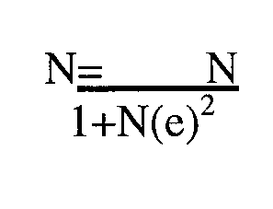
When n is the desired sample size
N= population
1= mathematical constant
E=margin of acceptable allowance error.
In the study the population is 110 and the margin of allowable acceptable or allowable error is 0.05 i.e 50% substituting in the above formula we obtained.
` 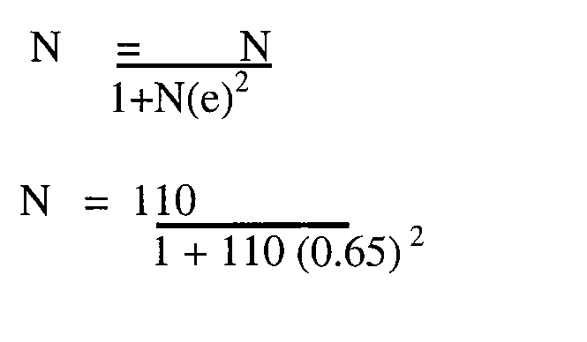
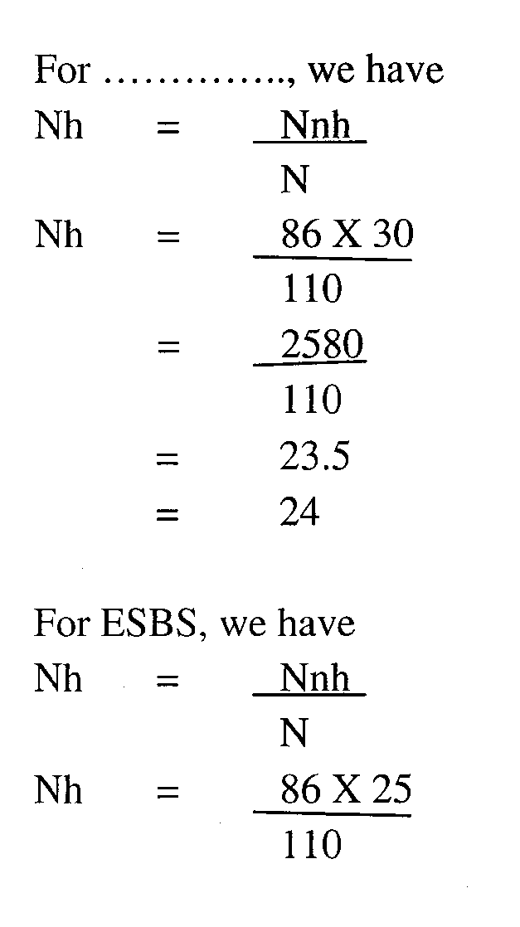
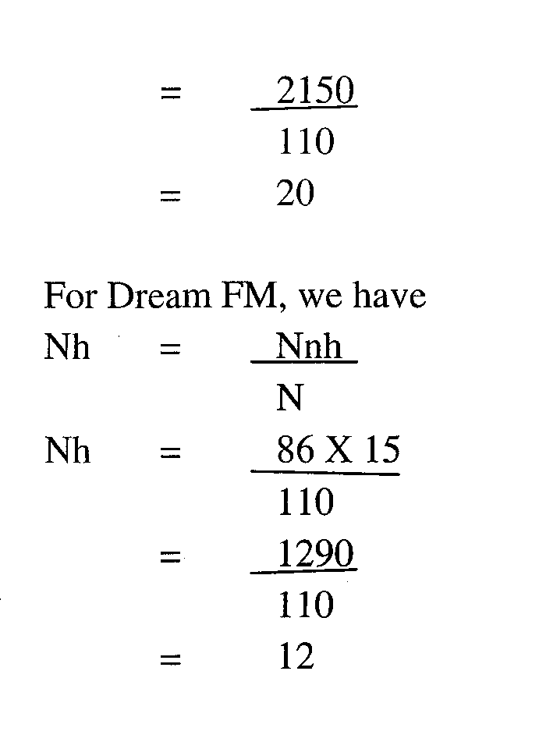
3.5 Description & Research Instrument
The questionnaire was used as the instrument. It consisted of close-ended questions designed to answer the researcher question set out in chapter one. The questionnaire was administered directly to respondents by the researcher to ensure guided responses and prompt retrieval of the questionnaire.
3.6 Validity and Reliability of data Gathering Instrument
Questionnaire was deemed most suitable for this study because it is the most appropriate instrument needed to elicit opinions from test subjects in a survey.
3.7 Method of Data Presentation and Analysis
The data for the study were presented in tables using frequencies and percentages.

CHAPTER FOUR
DATA PRESENTATION, ANALYSIS AND DISCUSSION OF FINDING
4.1 Introduction
In this chapter the statistical data from the respondents are collected, classified and presented in the simplest form to make the study easily understood, interpreted and analyzed. They are presented in a table form, frequencies and percentage. 400 copies of questioners were administered to the respondents 15 copies were not properly filled hence rate of 3.75 per cent was recorded.
4.2 Data Presentation and Analysis
The breakdown of the distribution and return of questionnaires is a follows:- Table 4.2.1: Distribution and return of questionnaire
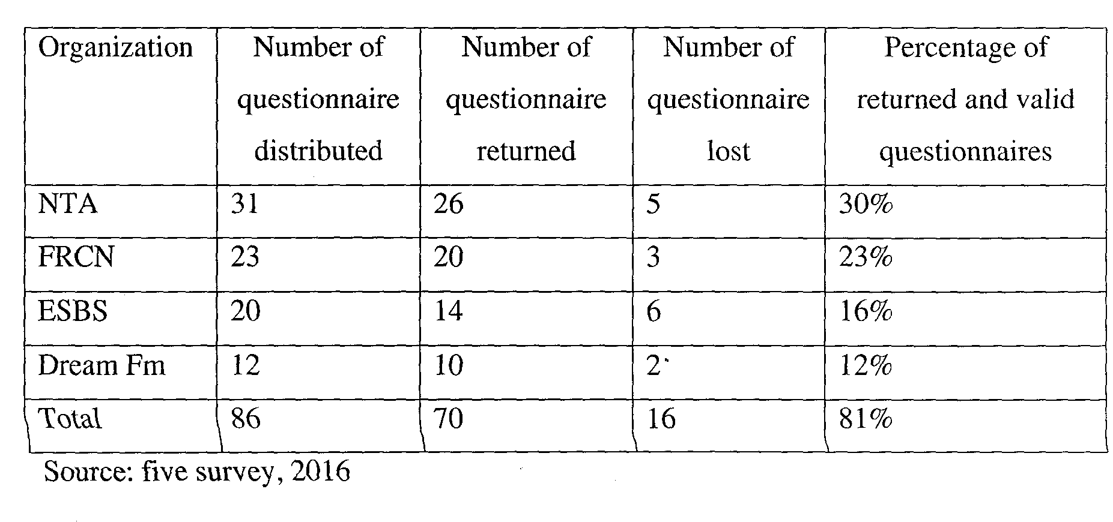
To respondents, representing 81% of the total number of respondents and questionnaires were returned based on the returned questionnaire; the researcher was ….to carryout this research work.

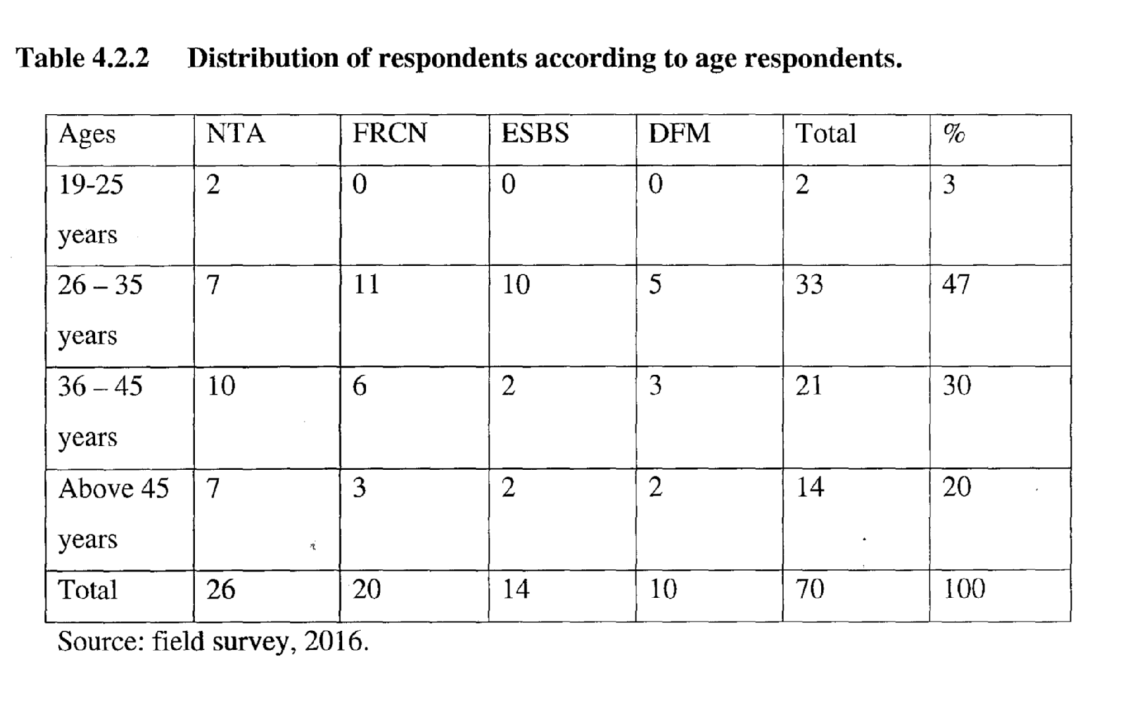

From the table 4.2.2 above 2 respondents representing 3% of the total respondents are between the ages of 16-25 years. 33 respondents, representing 47% of total respondents are between the ages of 26-35 years. 21 respondents, representing 30% of the total respondents are between ages of 36-45. 14 respondents, representing 20% of total respondents are above 45 years.
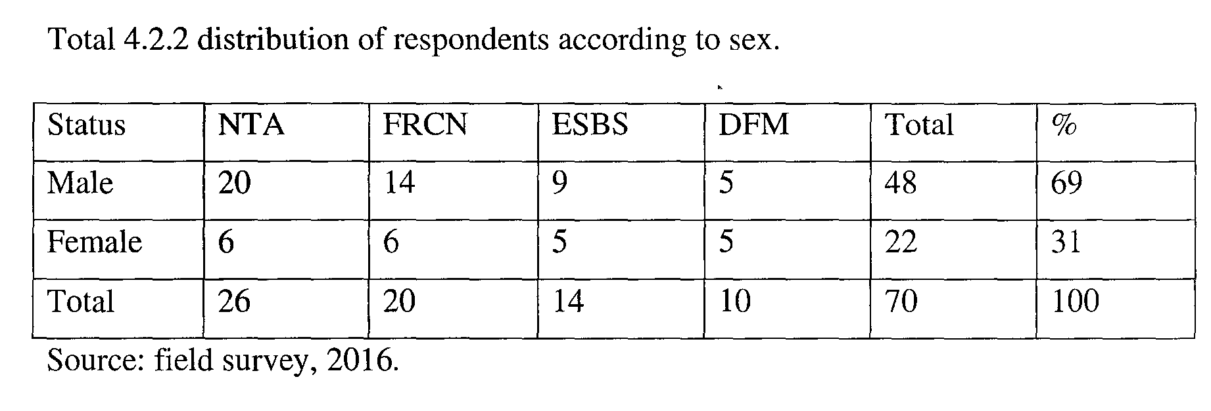

From table 4.2.2 above 48 respondents, represent 69% of the total respondents are males. 22 respondents, representing 31% of the total respondents are females.
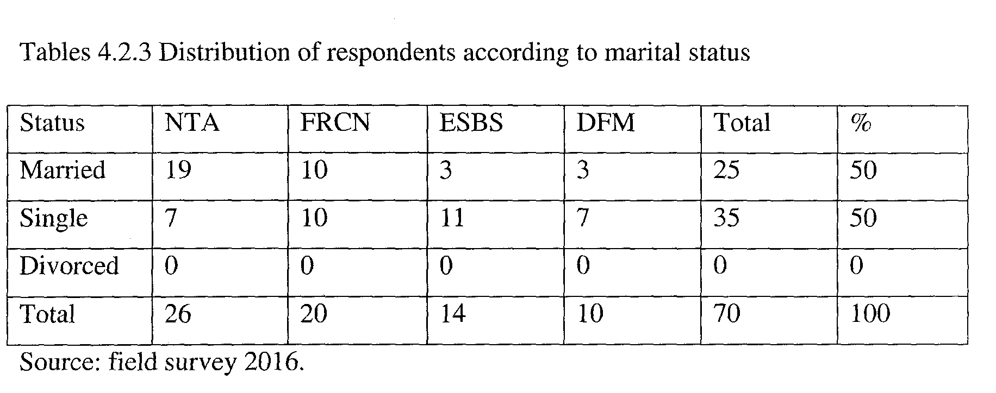
From the tables 4.2.3 above, 35 respondents, representing 50% of the total respondents, are married. 35 respondents, representing 50% of the total respondents are single.
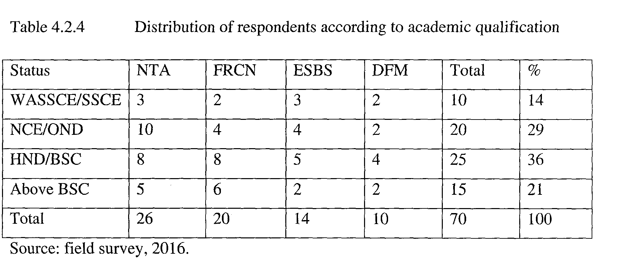
From the table 4.2.4 above, 10 respondents, representing 14% of the total respondents have WASSCE/SCE. 20 respondents, representing 29% of total respondents have NCEJOND. 25 respondents representing 36% have HNDIBSC. 15 respondents, representing 21% of the total respondents have above BSC.

Table 4.2.5 distribution of respondents according to does freedom of information law have any influence on the journalism practice in Nigeria.
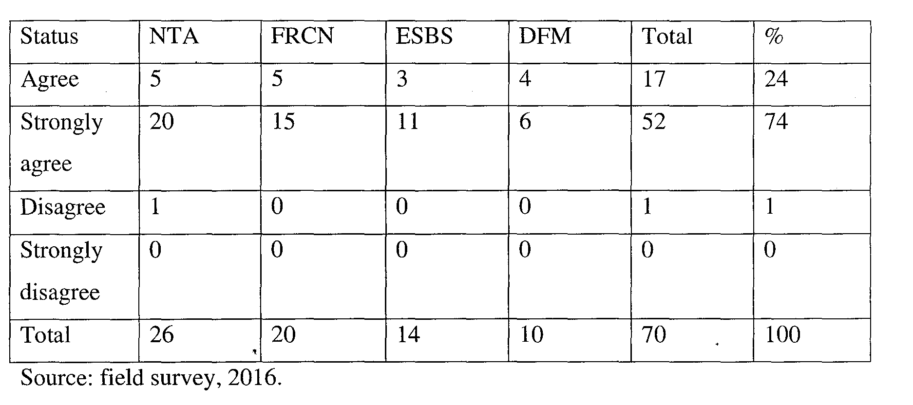
If respondents representing 24% of the total respondents agree that freedom of information law have influence on the journalism practice in Nigeria. 52 respondents, representing 74% of the total respondents, strongly agree that freedom of information have influence on journalism practice in Nigeria. I respondent, representing 10% of total respondents disagree that freedom of information law have influence on the journalism practice in Nigeria.
Table 4.2.6 Distribution of respondents according to information influence journalism practice in Nigeria.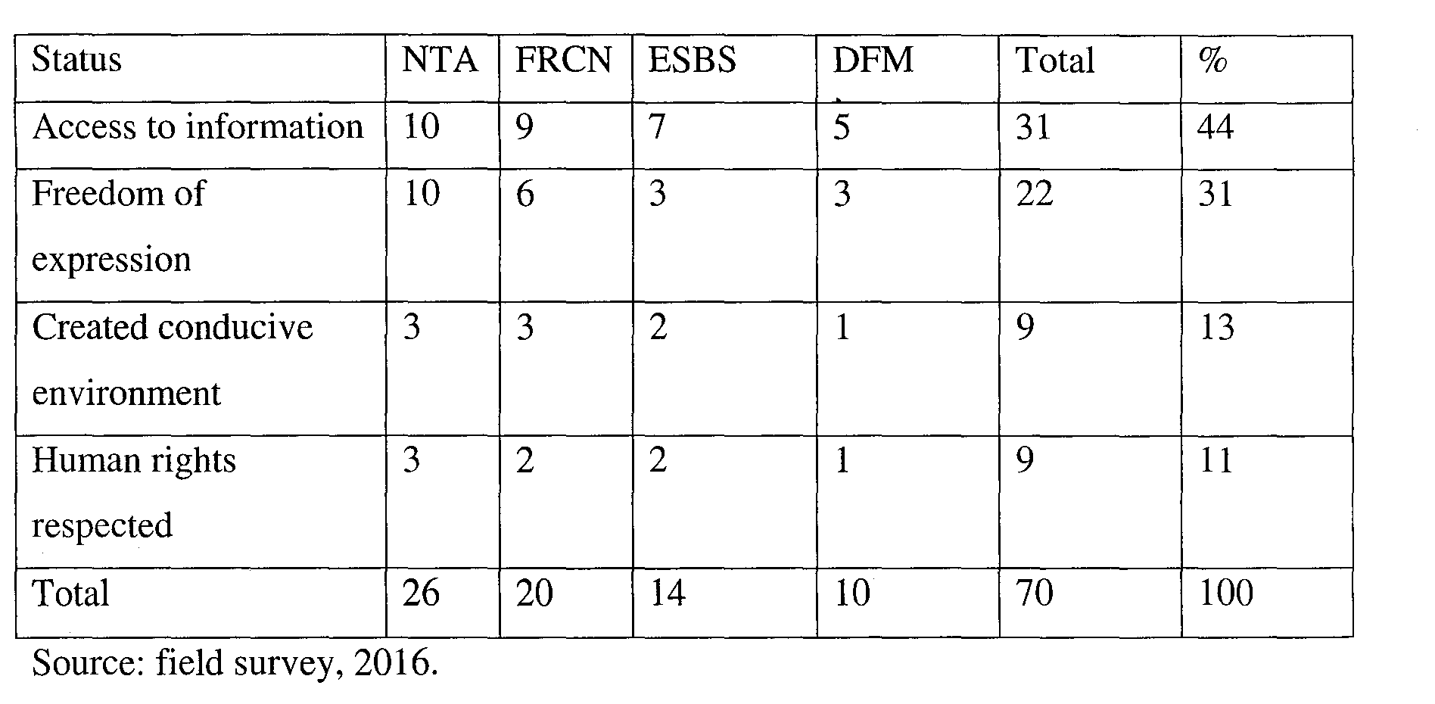
From table 4.2.6 above 31 respondents, representing 44% of total respondents said access to information. 22 respondents representing 31% of the total respondents said freedom of expression. 9 respondents, representing 13% of total respondents said created conducive environment. 8 respondents, representing 11% of total respondents said human rights respected.
Table 4.2.9 Distributions of respondents according to does freedom of freedom law influence the high rate of corruption in government business in Nigeria.
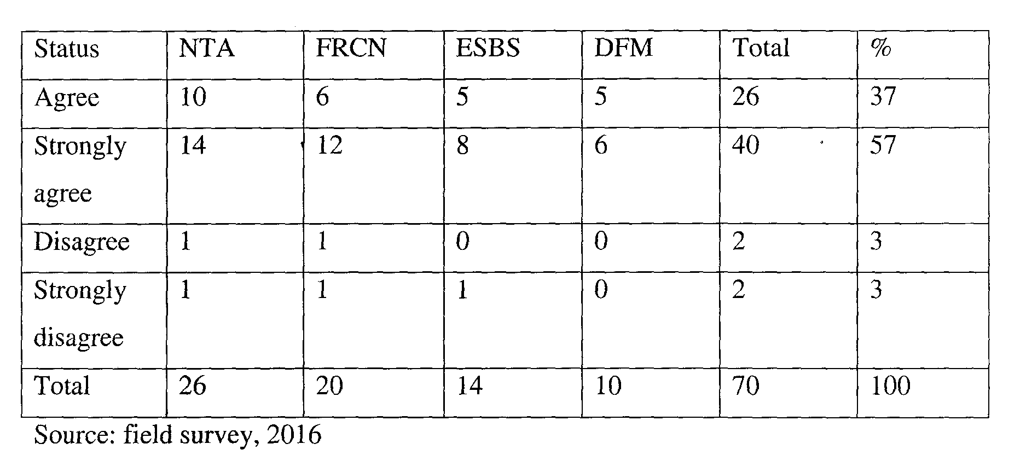
From table 4.2.9 above 20 respondents representing 27% of the total respondents 5 agree that freedom of information have influence on corruption in government business in Nigeria. 40 respondents, representing 57% of the total respondents. Strongly agree that the freedom of information have influence on corruption in government business in Nigeria. 2 respondents, representing 3% of the total respondents disagree that freedom of information law have influence on corruption in government business in Nigeria. 2 respondents representing 5% of this total respondents strongly disagree that freedom of information law have influence on corruption in government business in Nigeria.

Table 4.2.10 Distribution of respondents according to how does freedom of information law influence high rate of corruption in government business in Nigeria.
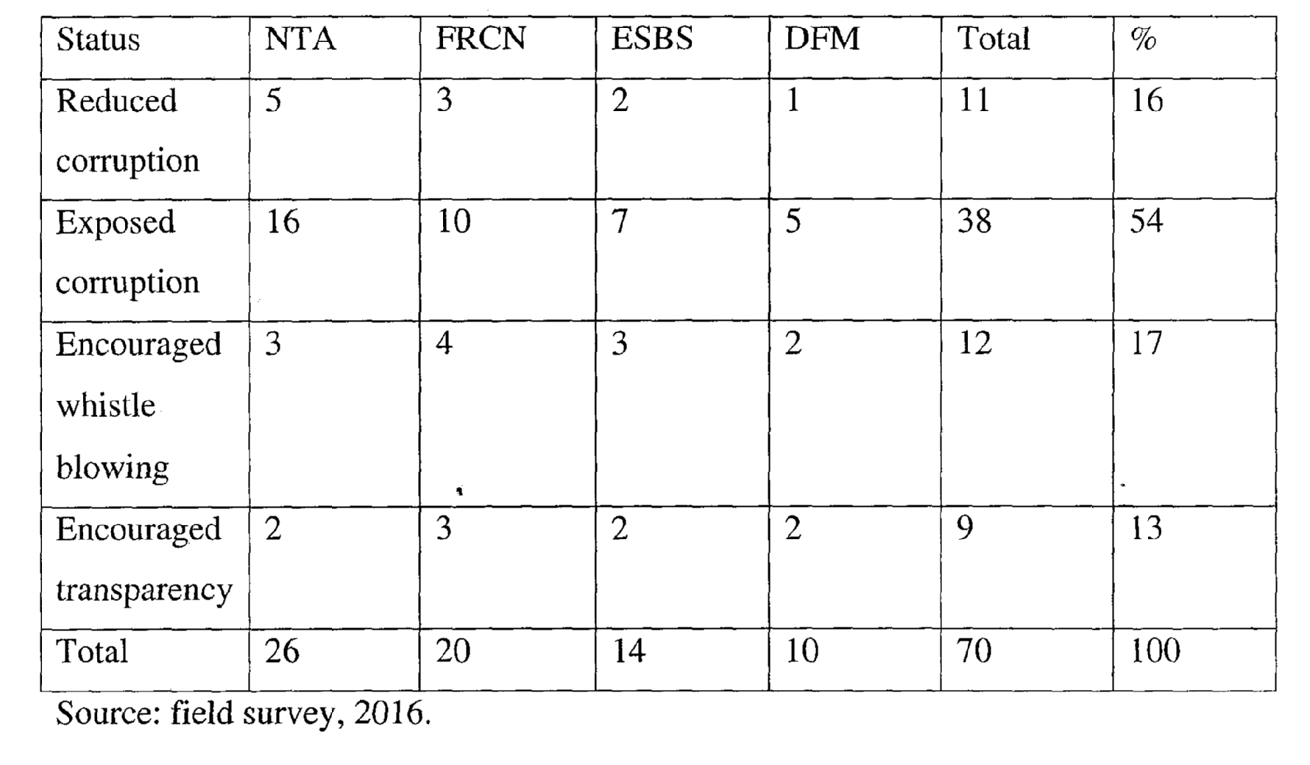
From table 4.2.10 above, 11 respondents representing 16% of total respondents said reduced corruption, 31 respondents, representing 54% of the total respondents said exposed corruption. 12 respondents, representing 17% of total respondents aid encouraged whistle blowing 9 respondents representing 13% of total respondents said encouraged transparency.

Table 4.2.11 Distribution of respondents according to does freedom of information law influence information gap between government and governed in Nigeria.
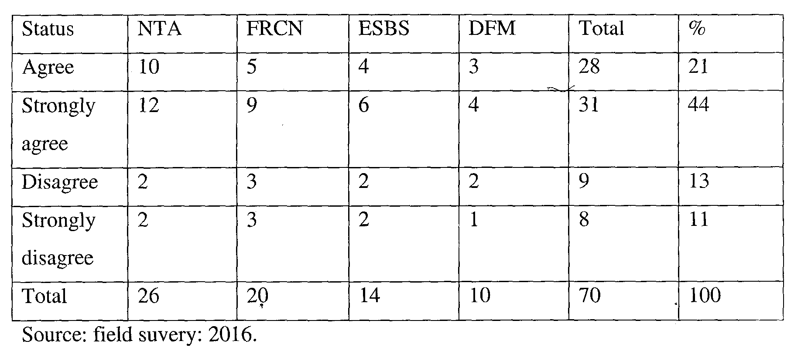
From table 4.2.11 above, 22 respondents, representing 31% of the total respondents agree the freedom of information law have influence on information gap between the government and governed in Nigeria 31 respondents, representing 44% of total respondents strongly agree that freedom of information law have influence on information gap between the government and governed in Nigeria. 9 respondents, representing 13% of the total respondents disagree that the freedom of information law influence information gap between the government and government in Nigeria. 18 respondents, representing 11% of the total respondents strongly disagree that the freedom of information law gap influence information gap between government and governed in Nigeria.
Table 4.2.12 Distribution of respondents according to how does freedom of information influence gap between government and the governed in Nigeria.
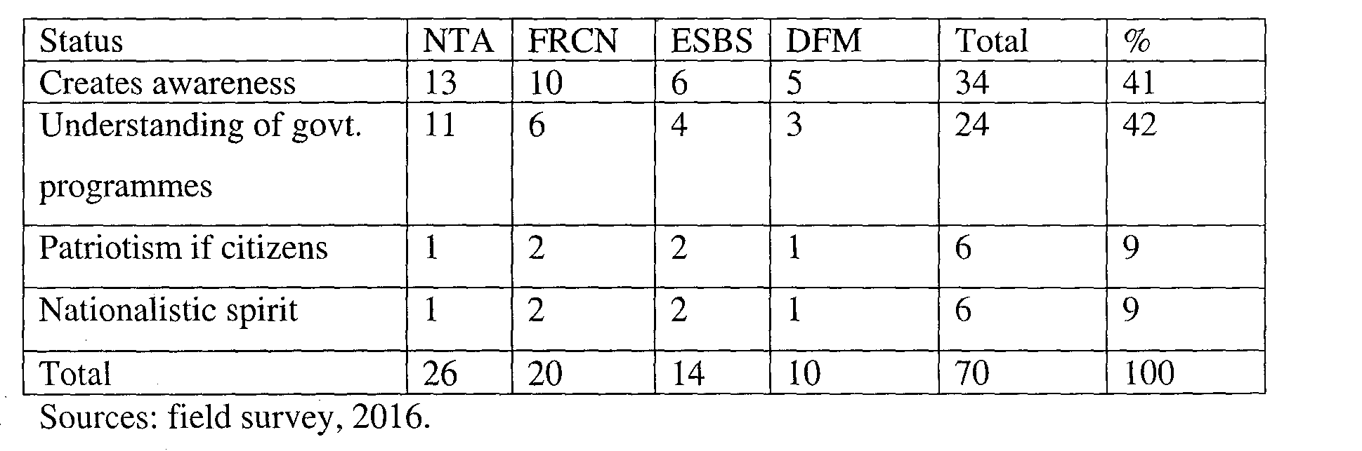
From table 4.2.12 above, 34 respondent representing 49% of the total respondents said creation of awareness. 24 respondents, representing 34% of total respondents said understanding of government programmes. 6 respondents, representing 9% of the total respondents said patriotism of citizens. 6 respondents, representing 9% of the total respondents said nationalistic spirit.
Table 4.2.12 Distribution of respondents according to does law influence massive unemployment of youths in Nigeria
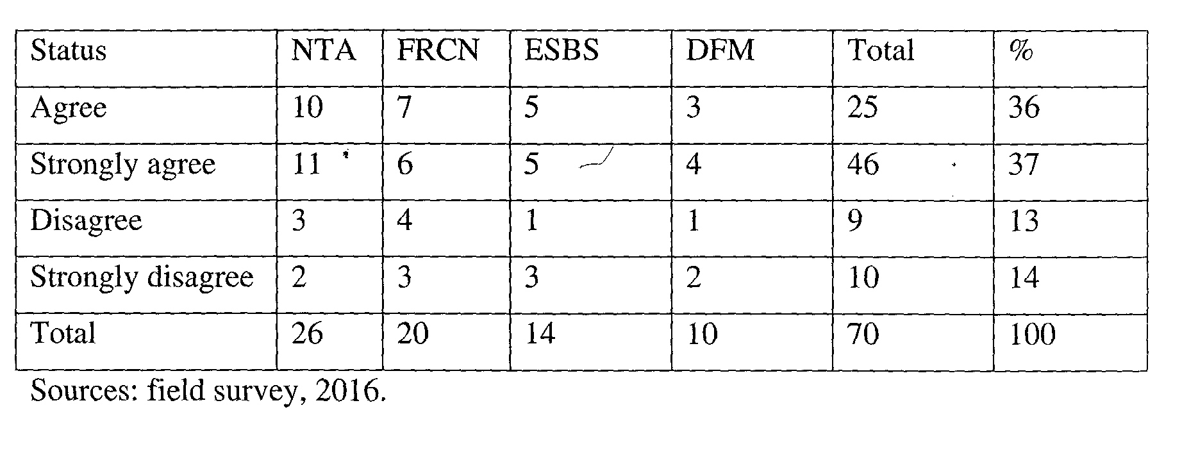
From table 4.2.12 above, 25 respondents, representing 36% of total respondents agree that freedom of information law influence massive unemployment of youths in Nigeria. 26 respondents, representing 37% of total respondents strongly agree that freedom of information law influence massive unemployment 13% of the total respondents disagree that freedom of information law influence massive unemployment in Nigeria. 10 respondents, representing 14% of total respondents strongly disagree that freedom of information law influence massive unemployment of youth in Nigeria.
Table 4.2.14 Distribution of respondents according to how does information influence massive unemployment of youths in Nigeria.
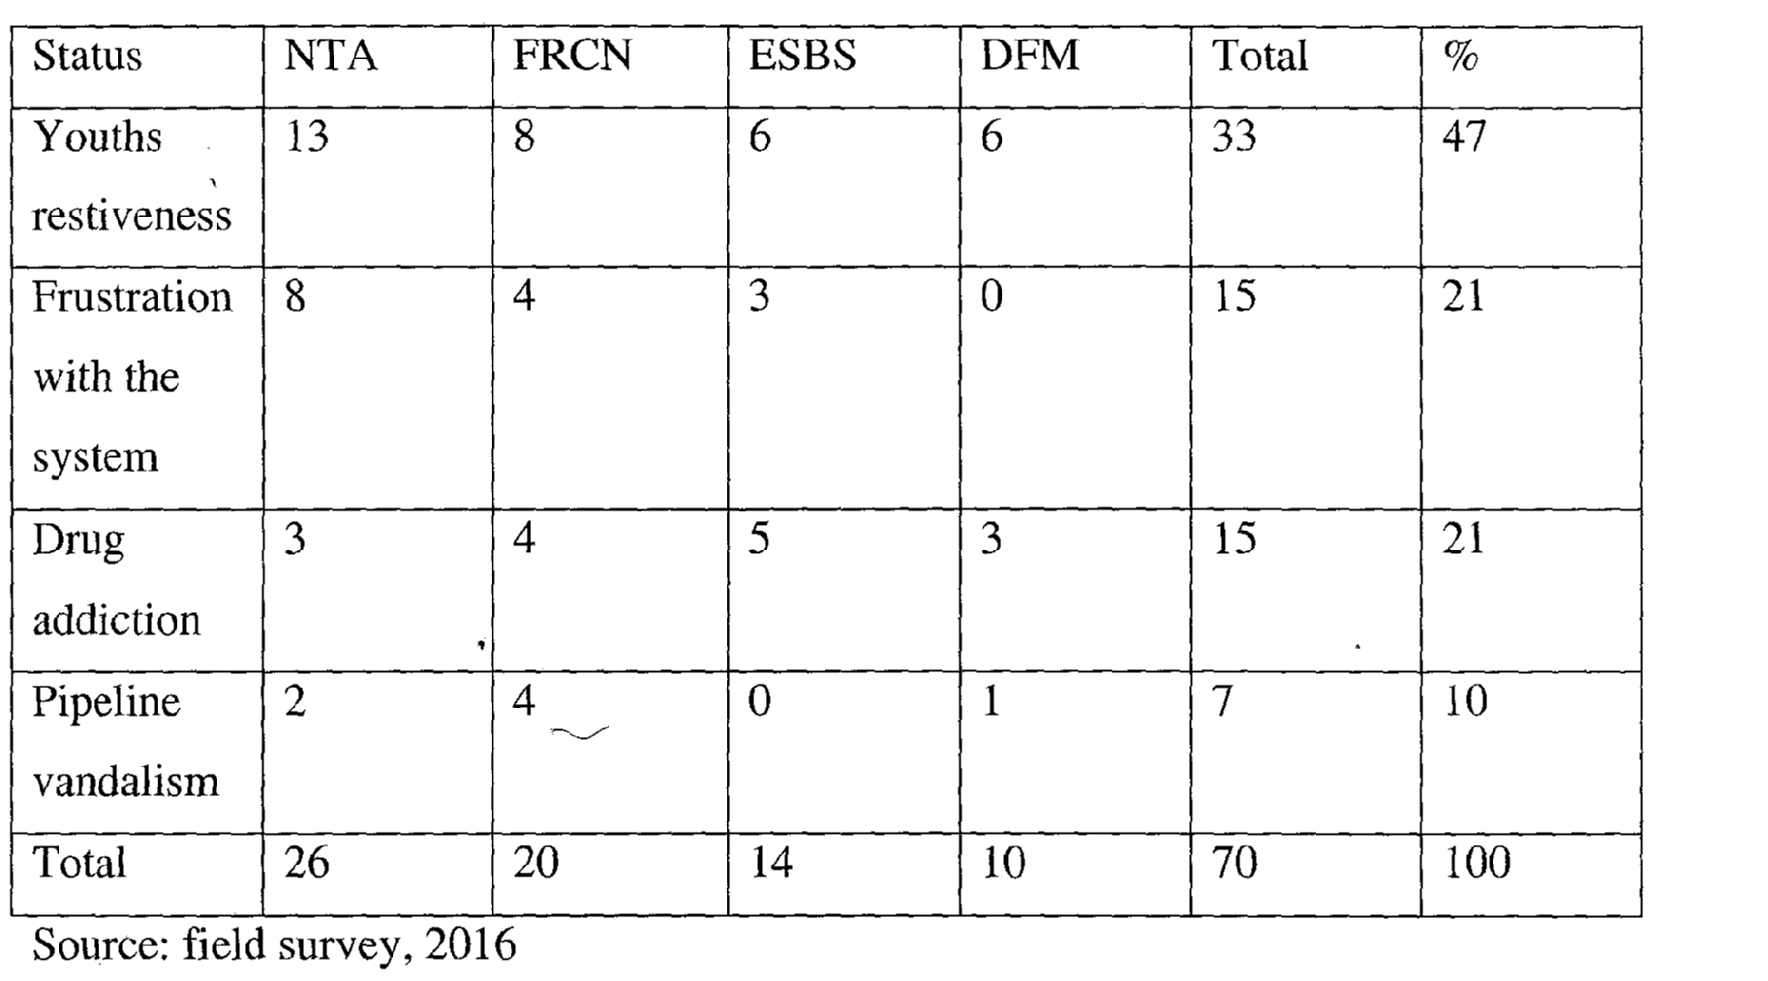

From table 4.2.14 above 33 respondents, representing 47% said youth’s restiveness. 15 respondents said frustration with the system 15 respondents representing 21% of the total respondents said drug addiction. 7 respondents, representing 10% of total respondents said pipeline vandalism.
4.3 Discussion of Findings
From table 4.2.5 17 respondents, representing 24% of the total respondents agree that freedom of information law have influence on the journalism practice in Nigeria. 52 respondents, representing 74% of total respondents have influence on journalism practice in practice in Nigeria. 1 respondent, representing 10% of the total respondents disagree that freedoms of information have influence on journalism practice in Nigeria.
From table 4.2.9 26 respondents, representing 27% of total respondents agree that freedom of information influence corruption in government business in Nigeria. 40 respondents representing 57% of the total respondents strongly agree that freedom of information law have influence on corruption in government business in Nigeria. 2 respondents representing 3% of the total respondents disagree that freedom of information law have influence on corruption in government business in Nigeria. 2 respondents representing 3% of total respondents strongly disagree that freedom of information have influence in corruption in Nigeria.
From table 4.1.11 22 respondents representing 31% of the total respondents agree that freedom of information law have influence on information gap between the government and the governed. 24 respondents representing 34% of the total respondents disagree that freedom of information law has influence on the information gap between the governments and governed in Nigeria. 6 respondents representing 9% of the total respondents disagree that freedom of information law has influence on the information gap between governments and governed in Nigeria. 6 respondents, representing 9% of the total respondents strongly disagree that freedom of information law have influence on the information gap between the government and governed in Niger.
From tables 4.1.13 25 respondents, representing 36% of the total respondents agree that freedom of information law have influence on massive unemployment of youths in Nigeria, 26 respondents, representing 37% of the total respondents strongly agree that freedom of information law have influence on the massive unemployment of youths in Nigeria. 9 respondents representing 13% of the total respondents disagree that freedom of information law have influence on the massive unemployment of youths in Nigeria. 10 respondents, representing 14% of the total respondents strongly disagree that freedom of information law have influence on massive unemployment of youths in Nigeria.

CHAPTER FIVE
5.1 Summary of findings, conclusion and recommendation
1. The researcher found out that the freedom of information law have influence on the journalism practice in Nigeria.
2. The researcher found out that the freedom of information law have influence on the corruption in government business in Nigeria
3. The researcher found out that the freedom of information law have influence on the information gap between the government and governed.
4. The research found out that freedom of information law have influence on massive unemployment of youths in Nigeria.
5. The researcher found out that freedom of information law have influence on the access to information in Nigeria.
6. The researcher found out that freedom of information law have exposed corruption in Nigeria
7. The researcher found out that freedom of information have helpin creating awareness about government activities in Nigeria.
8. The researcher found out freedom of information law have influence on massive unemployment of youths in Nigeria.
5.2 Conclusion
The reentry passed freedom of information law ahs been said to be the right that enables members of the Nigerian public to have access to information held by government bodies because of this, it is now recognized as a fundamental human rights to which Nigerians are entitled to the public is entitled to the truth, and only correct information can form the basis for sound journalism and ensure the confidence of the people with the fill, the press is now better armed to hold public officers accountable to the people. As the fourth estate of the realm, the effect on journalism will undoubtedly have a spiral effect on the entire society for the benefit of all. The success of implementation of the fill is the responsibility of both the government (supply side) and the governed (demand sides). The demand side which includes the citizens, civil society, and community organization media and the private sector must take responsibility for using the law as well as monitoring government efforts. The attitude of public administrators is critical to the successful implementation of the law because public administrators, who are the face of government, will determine the quality of access to information.
5.3 Recommendations
The researcher is recommending the following;
1. More campaigns need to be done to increase the level of awareness of the public about freedom of information law. The media as a core partner should increase public awareness and understanding of the law.
2. It is advised that the federal government and its agencies should take steps to ensure that necessary regulations or procedure are put in place for the effective implementation of the law. For instance, the attorney general of the federation (AGF) should ensure that regulations already produced for the swath implementation of this law are gazeted.
3. It must still be emphasized that it is the responsibility of all Nigerians to carry out the oversight function of ensuring compliance to the provisions of the law and that of the National Assembly alone.
4. The freedom of information law needs to be revered so that about to sections of the law which dwell on non disclosure of information will be looked into.
5. Training and workshop should be conducted in ministry, churches, organization within the country to being the public up to speed with latest review done the law.

5.4 Suggestion for further research
The researcher is suggesting the further researcher should be carried out on the influence of freedom of information law on the journalism practice in Nigeria. The idea is to compare with what is obtainable there and to expand the frontiers of knowledge.

References
Andrew Puddephat, (2005), freedom of Expression, the essentials of Human Rights, Hodder nold
Avast Network, what is the pirate party and why is it helping wikileaksp
Anaeto, S.G Onabanjo, OS, osifeso J.B, (2008), Models and theories of communication Maryland. African Renaissance books incorpatated
Arogundele F (2012), Constitutional recognition for press media freedom, a conference paper presentation delivereds during the review of 1999 constitution in Ibadan
Agode, S. (201 1(, Right Nigeria freedom of information bill proves Elusive
Ayode, S. (2011), Right Nigeria: freedom of information Bill provers Elysive
Adeleke, F. (2011), prospect and challenges of fol bill in Nigeria information technology journal
Benedek, wolfgang, veronica Bouer, Mathias kettemenn (2008), internet governance the information Society, Eleven international publishing
Christians, C. (2004), Social Responsibility worldwide, phicadephia law rencefribaum Associates
Enwnehe, E. (2012), what to expect from the newly signed freedom of information bill, a conference paper delivered at the media rights Agendt (MRA) workshop.
Ene, M. (2012), reasons for non-implementation of freedom of information bill. The Punch Newspaper of l5t1 August 2010.
Ehooh, E. (1998) Social and Economic Research Principles and Method Lagos, Academic Publications.
Freedom of information Vs protection of intellectual property (2012)

Goke R. (2003) Mass Media and the society: issues and perspective, Enugu, New Generation Ventures Limited
Ikegwu, E (1998) Groundwork for Research Methods and Process, Enugu Institutes of Department UNN.
Kiang Mathias, MarrayAndraw, (2005), Human Rights in the Digital age Rutledge
MarharSirayi, (2010), Exclusion of private sector from freedom of information laws implications from a human right perspectives (PDF) Journal of Alternative perspectives on Social Sciences 2
Media Right Agenda, (2011) fr’eedom of information net 2011, an explanatory memorandum
Ogbuokiri K. (2011), Nigeria. The unit of information act in freedom of information act 2011 and fight against corruption and corporate fraud in governance.
Protecting free Expression online with frenet-metenet computing (2011)
Ruth, E (2000) freedom of information in South Africa. A paper conference on freedom of information in Southern Africa. Africa journal of information.
Robert A. (2000), freedom of information act; parliamentary of the United Kingdom retrieved 20th April 2012 from http: 1 lwww.ukfreedom.com
Udezu J. (2005), Business Research, Methodology Enugu, OhiEzeugo Ventures.
Yamkne T. (1967), Statistics and………………. Analysis 3rd Editor New Year Harper
and Dow Publishers.

APPENDIX
Department of Mass Communication
Godfrey Okoye University,
Thinkers Conner Enugu
7th June 2016.
Dear Respondents,
REQUEST FOR THE COMPLETION OF QUESTIONNAIRE
I am final year student of Godfrey Okoye University Enugu, Enugu State. Currently researching on the topic the influence of freedom of information law on journalism practice in Nigeria. NITA, FRCN, ESBS and Dream FM as case study.
Please, kindly fill this questionnaire for me. Any information given is strictly confidential and is purely for academic purposes.
Thank you.
Yours Sincerely,

Johnson Chioma Promise
Researcher

QUESTIONNAIRES
Please tick (V ) where appropriate
1. What is your sex?
(a) Male { ] (b) female { ]
2. What is your age?
(a) 16 — 25 years [ I (b) 26 — 35years [ ] (c) 36 — 45 years [ ] (d) above 45 years [ ]
3. What is your marital status?
(a) Married [ ] (b) single [ ] (c) divorced [ ]
4. What is your academic qualification?
(a) WASSCE/SSCE [ ] (b) NCE/OND { ] (c) HND/BSC [ ] (d) above BSC
5. Dose freedom of information law have any influence on the journalism practice in Nigeria?
(a) Agree [ ] (b) strongly agree [ 1(c) disagree [ ] (d) strongly disagree [ ]
6. How does freedom of information law influence the journalism practice in Nigeria?
(a) Access to certain information [ ] (b) freedom of expression [ ] (c) created conducive environment [ ] (d) human rights responded [ ]
7. Does freedom of information law influence ingrate of corruption in government business in Nigeria?
(a) Agree [ ] (b) strongly agree [ ] (c) Disagree [ ] (d) strongly disagree
8. How does freedom of information law influence the corruption in government business in Nigeria?
(a) Reduces corruption [ ] (b) exposed corruption [ ] (c) encouraged whistle bellowing [ ] (d) encouraged transparency [ ]
9. Does freedom of information law influence information gap between government and the governed in Nigeria?
10. How does freedom of information law influence information gap between government and the governed in Nigeria?
(a) Creation awareness [ ] (b) better understanding of government programme [ ] (c) patriotism in citizens [ ] (d) Nationalistic spirit by citizens [ ]
11. Does freedom of information law influence massive unemployment of youths in Nigeria?
(a) Agree [ ] (b) strongly agree [ I (c) disagree [ ] (d) strongly disagree [ ]
12. How does freedom of information law influence massive unemployment of youths in Nigeria?
(a) Youths restiveness [ ] (b) frustration with the system [ ] (c) drug addiction [ ] (d) pipeline vandalism [ ]
32

