DESIGN AND IMPLEMENTATION OF TRAFFIC OFFENCE TRACKING SYSTEM

By

Onah Chukwuemeka K.
U13/NAS/COM/033

Being a BSc project report submitted in partial fulfillment of the requirements for the award of a Bachelor’s (B.Sc.) degree in Computer Science of the Godfrey Okoye University.

Supervisor: Dr. G.A.M Ikekeonwu

Department of Mathematics/Computer Science
Godfrey Okoye University, Enugu

JULY, 2017

Certification

This is to certify that this project, titled Design and Implementation of Traffic
Offence Tracking System for Federal Road Safety Commission which was carried
out by Onah Chukwuemeka K. With Registration Number U13/NAS/COM/033,
has met the requirements of the department of Computer Science,
Godfery Okoye University.

………………………………………. …………………………..
Onah Chukwuemeka K. Date

APPROVAL PAGE

In partial fulfillment of the requirement for the award of Bachelors in the Department of Computer Science this project which was presented by Onah Chukwuerneka K. with Registration Number U13/NAS/COM/033 has been approved by

…………………………………. ………………………..
Dr. Gam Ikekeowu, Date
(Project Supervisor)

…………………………………. ………………………..
Dr. Gam Ikekeowu, Date
(Head of Department)

Dedication
This work is dedicated to my lovely parents Mr. & Mrs. Onah for their help and supports both financially and otherwise to make this work a success. I am also dedicating this work to my friends and colleagues and we1lwishers who tirelessly
read and gave me guidance throughout this work.

ACKNOWLEDGEMENTS
My gratitude goes to God Almighty for his grace, kindness, and love upon my life, my project supervisor and Head of Department Dr. Gam Ikekeowu for his understanding and guidance and to all lecturers in Computer Science Department. I am also using this medium to say a big thank you to my loving parents Mr. & Mrs. Onah for their support towards my pursuit for academic excellence, to my brothers and sisters for their encouragement and prayers. My sincere appreciation also goes to my course mates who directly or indirectly affected my life in the progress of this work.
I won’t fail to acknowledge the admirable support and encouragement of my friends Obiekwe Miracle C , my roommates, and many others for their prayers and support throughout the period of this work.

ABSTRACT
Traffic Offence Tracking System is a useful web based and database program that records all the traffic offences committed nationwide. The system helps the Federal Road Safety Commission to keep adequate records of all traffic offences that has been committed, the offender details and penalty payment made. It also helps to heck financial fraud for the commission.
This work was developed with PHP, AJAX, Python and MYSQL database for effective information keeping.

CHAPTER ONE
INTRODUCTION
1.0 BACKGROUND OF THE STUDY
Prior to the establishment of Federal Road Safety Commission in 1988, there was no concrete and sustained policy action to address the carnage on Nigerian roads. Earlier attempts in this direction were limited to discrete and isolated attempts by some states of the Federation and individuals. The unpleasant trend in the nation’s road traffic system which resulted in upsurge in road traffic accidents made the Federal Government initiate a search for a credible and effective response to the challenge. In February 1988, the Federal Government established the Federal Road Safety Commission through Decree No .45 of the 1988 as amended by Decree 35 of 1992 referred to in the statue books as the FRSC Act cap 141 laws of the Federation of Nigeria (LFN) passed by the National Assembly as Federal Road Safety Commission (establishment) Act 200. Around the world road traffic injuries are a major public health challenges that requires concerted efforts for effective and sustained prevention. An estimated 1 .2rnillion people are killed in road crashes every year and as many as 50million puffer injuries. The world health organization believes that these figures could increase by more than half over the next 20years unless there is a firm commitment to road safety and accident prevention, especially in Nigeria, most adults will know of someone who has been killed or injured in a road traffic accident. It is a dead fact that many of these accidents and their consequences would have been avoided. Therefore the Computerized Traffic Offence System will help to keep records of all traffic offences committed by road users and also maintain the databases of the commission (FRSC).
1.1 STATEMENT OF THE PROBLEM
The present system of traffic offence system which is the manual system known as (Notice of Offence Sheet) has a lot of problems which are mentioned below:
TIME: Going by the present system of operation, time is consumed in the manual handling of operation involved in road traffic documentation.
COST: This is the reatest problem of the Federal Road Safety Commission. The commission tends to lose a lot of money running the agency manually. DOCUMENT INTEGRITY: This is viewed in the contest of safety, in validity of the records in document files used in report generation. In terms of safety, the nature of the system makes it vulnerable to theft, fire or accidental destruction.
This makes the system unsafe as the time needed to replace lost data or files is enormously large.
1.2 OBJECJES OF THE STUDY
The objectives of the study are as follows:
Provide better services to the public and users making the highway safe for motorists and other road users.
- To keep records that are complete, integrated and up to date, also recommending works and devices designed to eliminate or minimize accidents on the highways and advising the Federal and State Government including the Federal Capital Territory Administration and relevant governmental agencies on the localities where such works and devices are required.
- To produce a system where information and output report will be produced or made available much faster, more accurately and more detailed to the commission and the public by educating motorist and members of the public on the importance of discipline on the highway.
- Maintaining the validity period for drivers’ licenses which shall be three years subject to renewal at the expiration of the validity period as well as designing, registering and producing vehicle plate number.
- Conducting researches on the standardization of highway traffic codes.
1.3 SIGNIFICANCE OF THE STUDY
With the growth in information technology, the study offers numerous values to the Federal Road Safety Commission and any organization that deals with office documentation data/information. Huge files kept through the manual method in offices will no longer be there again because information will be stored on the computer with the help of the Computerized. Traffic Offence System. It will help to keep a comprehensive record of traffic offence documented.

CHAPTER TWO
LITERATURE REVIEW
2.0 INTRODUCTION
The system was developed using PHP, MYSQL, JavaScript and Ajax. The
theoretical background covered the various technologies use in this system and the related work on this project.
2.1 Theoretical Background
The Technologies used in this work are listed below
i. Hypertext preprocessor (PHP)
ii. JavaScript
iii. MYSQL database
iv. Ajax
PHP:
PHP is a server scripting language, and a powerful tool for making dynamic and interactive Web pages
Check offense display
<?php require_once(’Connections/frsc .php’);?> <?php
//initialize the session
if (!isset($ SESSION)) {
session startO;
}
/7 ** Logout the current user. **
$logoutAction = $_SERVER[’PFIP_SELF’] •1 ?doLogout=true”;
if ((isset($ SERVER[’QUERY STRING’])) &&
($ SERVER{’QUERY STRING’] != fl?)){ $logoutAction .“ &“. htmlentities($_SERVER[’QUERY_STRING’]);
}
if ((isset($ GET[’doLogout’fl) &&($_GET{’doLogout’]==”true”)) { I/to fully log out a visitor we need to clear the session varialbies $SESSION[’MMUsername’] = NULL;
$_SESSION[’MM_UserGroup’] = NULL;
$SESSION[’PrevUrl’l = NULL; unset($_SES SION[’MM_Usemame’]); unset($_SES SION[’MM_UserGroup’]); unset($SES SION[’PrevUrl’]);
$logoutGoTo “index.php”;
if ($logoutGoTo) { header(”Location: $logoutGoTo”);
exit;
}
}
<?php

if (!fiinction exists( “ GetSQLValueString”)) {
function GetSQLValueString($theValue, $theType, $theDefinedValue =
$theNotDefinedValue “)
{
if (PuP VERSION <6) {
$theValue = get_magic quotes gpc? stripslashes($theValue) : $theValue;
}
$theValue = function exists( “ mysqi_realescape string”)? mysql_real_escapestring($theValue) : mysql_escapestring($theValue);
switch ($theType) {
case “text”:
$theValue ($theValue !“)? “ $theValue. ““ : “NULL”; break;
case “long”:
case “int”:
$theValue ($theValue != “) ? intval($theValue): “NULL”; break;
case “double”:
$theValue = ($theValue != “) ? doubleval($theValue): “NULL”; break;
case “date”:
$theValue = ($theValue !=“)? “ $theValue. “ : “NULL”; break;
case “defined”:
$theValue = ($theValue ! “)?$theDefinedValue : $theNotDefinedValue;

break;
}
return $theValue;
}
}
$colnamcRecordsetl “-1 “;
if (isset($ POST{’id’])) {
$colnameRecordsetl = $POST[’id’];
}
rnysqlselect_db($databasefrsc, $frsc);
$query_Recordsetl sprintf(”SELECT * FROM payment WHERE transaction_id = %s”, GetS QL ValueString($colname Recordset 1, “text”)); $Recordsetl mysql_query($queryRecordsetl, $frsc) or die(mysql_errorO);
$rowRecôrdset 1 = mysqi fetch_assoc($Recordset 1);
$totalRowsRecordset 1 = mysql_num_rows($Recordset 1);
<!DOCTYPE html PUBLIC “-//W3C//DTD XHTML 1.0 Transitional//EN”“httpww.org/TR/xhtmll/DTD/xhtml 1-transitional. dtd”> <html xmlns”http ://www.w3 .org/1 999/xhtml”>
<head>
<meta http-equiv=” Content-Type” content”text/html; charsetutf- 8” /> <title>Autornated Road traffic Violation Tracking System</title> <style type=”text/css”>
body{
margin-left: Opx;
margin-top: Opx;

margin-right: Opx; margin-bottom: Opx; font-size: 18;
}
#hgywyyeye {
font-size: 1 8px;
}
#hvhvhv {
font-size: 24px;
color: #FOO;
}
</style>
</head>
<body>
<table width”9 13” border” 1” align=” center” cellpadding=” 1” cellspacing=” 1” bordercolor”#996600”>
<tr>
<td width=” 905” height=” 125” align” center”><img src=” images/logo_frsc. gif’ width”522” height”89” /></td>
</tr>
<tr>
<td height=”2 1” align”center” bgcolor=”#999966”>&nbsp;&nbsp;&nbsp;&nbsp; I&nbsp;&nbsp;&nbsp;<a href” <?php echo $logoutAction ?>“>Log out</a>&nbsp; &nbsp ;&nbsp;<a href=” index.php “>&nbsp ;Horne</a></td>
</tr>
<tr>
<td height=” 367” align=” center” valign=”top”><p>&nbsp ;</p>
<?php if($totalRows_Recordsetl > 0) { /7 Show if recordset not empty?> <form method”post” name”forml” id”forml”>
<table width”267” align=”center”>
<tr valign=”baseline”>
<td align=”left” nowrap=”nowrap”
id=”hgywyyeye “><strong>Transaction_id:</strong></td>
<td><?php echo $row_Recordsetl [‘transaction_id’]; ?></td>
</tr>
<tr valign=”baseline”>
<td align”left” nowrap”nowrap” id=”hgywyyeye”><strong>First Name: </strong></td>
<td><?php echo $row_Recordsetl[’fname’]; ?></td>
<tr valign”baseline”>
<td align”left” nowrap=”nowrap” id=”hgywyyeye”><strong>Last Name: </strong></td>
<td><?php echo $row_Recordsetl[’lname’]; ?></td>
<tr valign”baseline”>
<td align”left” nowrap”nowrap”
id=”hgywyyeye “><strong>Plate_number :</strong></td>
<td><?php echo $row_Recordsetl [‘plate_number’]; ?></td>
<tr valign”baseline”>

<td a1ign”1eft” nowrap”nowrap”
id=”hgywyyeye”><strong>Offence : </strong></td>
<td><?php echo $row_Recordsetl [‘offence’]; ?></td>
<tr valign=”baseline”>
<td aligw=”left” nowrap”nowrap”
id=”hgywyyeye “><strong>Amount : </strong></td>
<td><?php echo $row_Recordsetl [‘amount’]; ?></td>
<tr valign=”baseline”>
<td align=”left” nowrap=”nowrap”
id”hgywyyeye”><strong>Date : </strong></td>
<td><?php echo $row Recordsetl[’date’]; ?></td>
</tr>
<tr valign=”baseline”>
<td align”left” nowrap”nowrap” id=”hgywyyeye”><strong>Processing Officer: </strong></td>
<td><?php echo $row Recordsetl[’officer’]; ?></td> </tr>
<tr valign=”baseline”>
<td nowrap=”nowrap” align=”right”>&nbsp;</td>
<td>&nbsp ; </td>
</tr>
<tr valign”baseline”>
<td nowrap=”nowrap” align=”right”>&nbsp;</td>
<td>&nbsp ;<!td>
</tr>
<tr valign=”baseline”>
<td colspan”2” align=”left” nowrap=”nowrap”>For enquiring Call +2347000000000</td>
</tr>
</table>
</form>
<?php } II Show if recordset not empty?>
<p>&nbsp;</p>
<?php if ($totalRows_Recordsetl == 0) { // Show if recordset empty?>
<p id=”hvhvhv”>Sorry no record found</p>
<?php } // Show if recordset empty ?></td>
<tr>
</table> </body> </html> <?php
mysqljree_result($Recordset 1);

MYSQL:

MySQL is a popular choice of database for use in web applications, and is a central component of the widely used LAMP open source web application software stack LAMP is an acronym for “Linux, Apache, MySQL,
CREATE TABLE IF NOT EXISTS ‘payment’ (
‘transaction_id’ varchar(50) NOT NULL,
‘fname’ varchar(50) NOT NULL,
‘lname’ varchar(50) NOT NULL,
‘plate number’ varchar(20) NOT NTJLL,
‘car_colour’ varchar(50) NOT NULL,
‘offence’ varchar(30) NOT NULL,
‘amount’ varchar(30) NOT NULL,
‘payment_status’ varchar(30) NOT NULL,
‘date’ varchar(30) NOT NULL,
‘regno’ varchar(50) NOT NULL,
‘officer’ varchar(100) NOT NULL,
‘bank’ varchar(50) NOT NULL,
‘teller_no’ varchar(50) NOT NULL,
‘Amount_paid’ varchar(5 0) NOT NULL,
‘Date_of_payment’ varchar(50) NOT NULL
) ENGINEInnoDB DEFAULT CI{ARSET=latinl;

2.2 REVIEW OF RELATED LITERATURE
The increasing level of road traffic accidents (RTA) in Irno State and the consequent injuries and deaths strengthened the case for its regular analysis. Data on recorded cases of road traffic accidents were collected from the Motor Traffic Division (MTDRTR), the Nigerian Police Force, Divisional Headquarters Umuguma, Owerri West, Irno State Police command. Using the method of time series decomposition, traffic road accidents were characterized to have an upward trend and significant seasonal influences. Using the Chi-square test of significance, it was discovered that there were significant differences among the various causes of accidents and accident cases (Minor, Fatal and Serious) with respect to types of vehicles involved over the years. Out of 5921 accident cases, reckless driving, inexperience and mechanical fault and road defects accounted for 30.1, 21.5 and 21.1% respectively. Two motorcycles, motorcycle-vehicle and vehicle-vehicle crashes are the leadtypes and have resulted in 38.9, 37.5 and 14.9% of the total of 855 deaths recorded within the period of study. Furthermore, it was also found that private cars, minibuses and taxis accounted for most of the accidents with 94.7% of the total accidents. RTA results in the deaths of 1 .2million people worldwide each injuries about 4 times this number (WHO 2004).
2.3 Summary
According to Brutus, from India; A Database Management System (DBMS) is a software system designed to efficiently store, retrieve, manipulate and query large amounts of data. Since the introduction of the relational data model in 1970, the database management system industry has grown to $100 billion dollars a year and increases more by 25% every year. With the new and emerging internet applications posing new requirements in the DBMS design and implementation, the database market is expected to grow even faster, and database design and implementation techniques are constantly evolving to meet the new requirements. According to Micheal Stonebreaker’s Ingeres, DBMS are usually categorized according to the database model that they support. The data model tends to determine the query languages that are available to access the database. A great deal of the internal engineering of a DBMS, however is independent of the data model and is concerned with managing factors such as performance, concurrency, integrity and recovery from hardware failures. In these areas there are large differences between products. According to professor Allen S. Lee, Management Information System, MIS is a planned system of collecting, processing, storing and disseminating data in the form of information needed to carryout the functions of management. According to Philip Kotler “ A marketing information system consist of people, equipment and procedures to gather, sort, analyze, evaluate and distribute needed, timely and accurate information to marketing decision makers.”(Kotler, Philip and Keller, Kevin Lane; marketing management, Pearson Education, l2Ed, 2006). The terms MIS and information system are often confused. Information system include systems that are not intended for decision making MIS is sometimes referred to, in a respective sense as Information Technology Management. That area of study should not be confused with Computer Science. IT service management is a practitioner-focused discipline. MIS has also some differences with Enterprise Resource Planning (ERP) as ERP incorporates elements that are not necessarily focused on decision support. Database normalization, sometimes referred to as canonical synthesis, is a technique for designing relational database tables to minimize duplication of information and n so doing, to safeguard the database against certain type of logical or structural problems, namely data anomalies. For example, when multiple instances of a given piece of information occur in a table, the possibility exists that these instances will not be kept consistent when the data within the table is updated, leading to a loss of data integrity. A table that is sufficiently normalized is vulnerable to problems of this kind, because its structure reflects the basic assumptions for when multiple instances of the same information should be represented by a single instance only.

CHAPTER THREE
SYSTEM ANALYSIS AND DESIGN
3.0 Introduction
Methodology involves a process whereby the existing or current system is studied to identify the information requirements. It is used to refer to a specific series of steps or procedures which governs the analysis and design of a particular project. It also includes the techniques and methods which are used to collect and analyze Information.
To achieve all these stated above, an internationally accepted software engineering model was use which is Waterfall. Waterfall approach was first process model to be introduced and followed widely in Software Engineering to ensure success of the project. In “The Waterfall” approach, the whole process of software development is divided into separate process phases. The phases in Waterfall model are: requirement specifications phase, software design, Implementation and testing & maintenance. All these phases are cascaded to each other so that second phase is started as and when defined set of goals are achieved for first phase and it is signed off, so the name “Waterfall Model”. All the methods and processes undertaken in Waterfall Model are more visible.
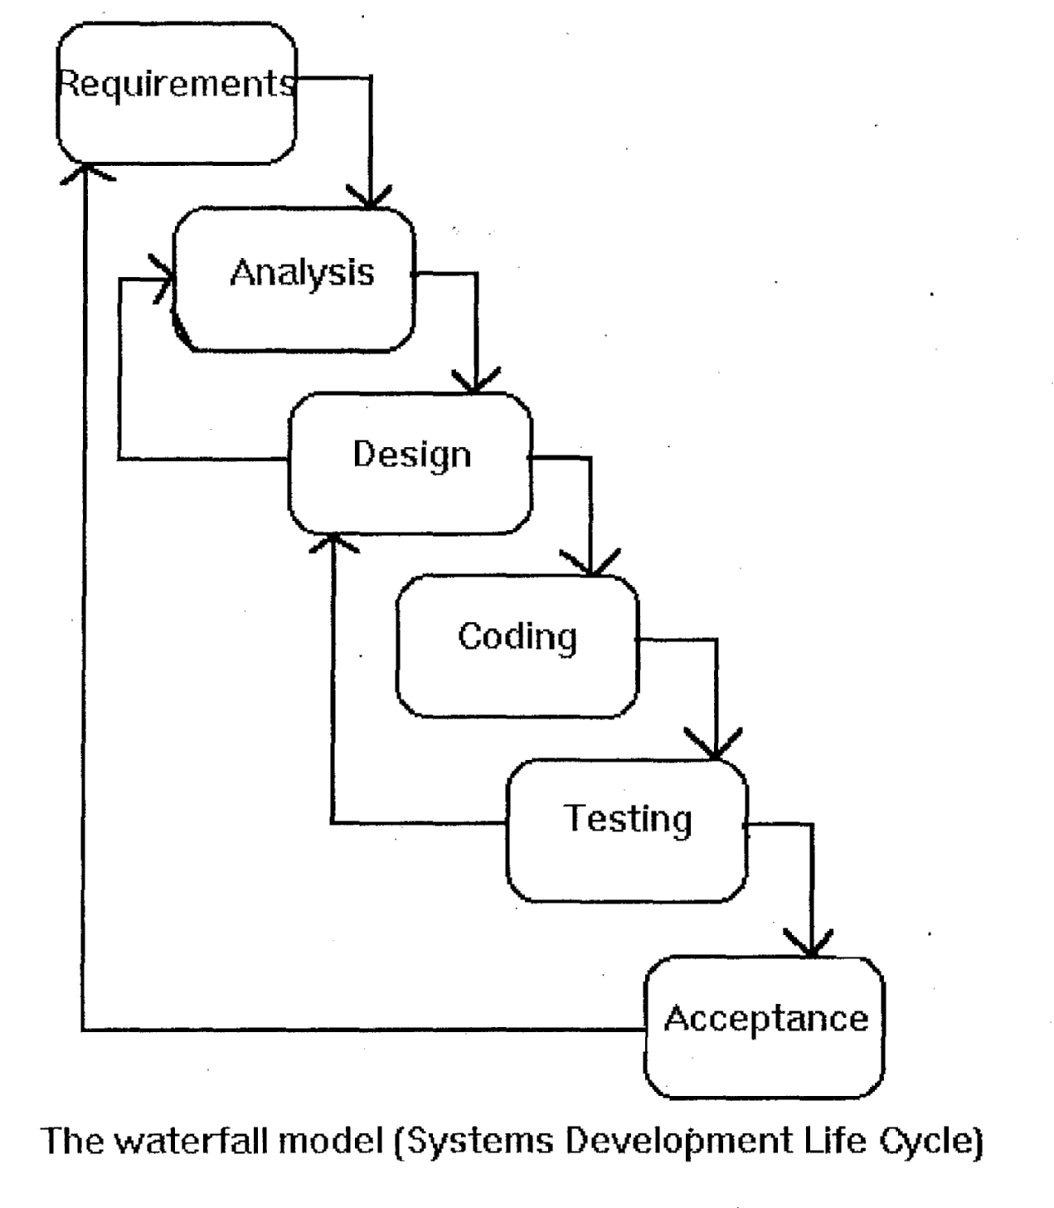
3.1 ANALYSIS OF THE EXISTING SYSTEM
The existing system is a method that is being carried out in terms of manual operation. A system where the processing and storing of offenders’ data and information are manually done. This approach is such that the management staff will the offenders’ data/information on a piece of paper or a register and kept in file cabinet or even on the desk of the officer in-charge. Critical analysis of this system reveals that it is a system prone to a lot of errors, careless handling, theft, flood, fire and other forms of accidents and it is not effective. Searching for someone’s record is time consuming and boring the system is such that the office is filled up with files which make the office dirty and a resting place for pest. Careftil analysis also shows that due to complexities of the manual system, information stored is difficult to retrieve. Also because of the inconsistency of the manual system, at times file are lost because of mismanagement.
PROBLEMS OF THE EXISTING SYSTEM
A lot of problems are associated with the existing system, involves the use of manual system to store data/information. The system has proved defective as the
objective to the system has also failed. Among the problems associated with the
existing system include the following:
- 1t can be easily damaged or destroyed
- Data redundancy
- Time wasted in searching/sorting for information
- Poor security and protection
- Misp1acing and Mismanaging of files
3.2 ANALYSIS OF THE PROPOSED SYSTEM
The proposed system is a web based, it take track of the traffic offense penalty by road driver with Geographical position system Map (GPS) to track the location. When a driver default, the Federal Road Safety Commission staff on duty will log into the portal url and fill in the details of the offender, the type of the offence committed and the cost of payment and a pay or transaction id will be generated for the offender who will proceed to the bank for payment after which he/she will fill the payment form on the portal and await the confirmation from the Corporation. When a driver default the system will take a snap photo of the default car for reference sake.
3.3 DESIGN OF THE PROPOSE SYSTEM
Database Design
The database was designed with MYSQL using the developed data flow diagram. The database contains information of the entities from the RFID device and cards. It organizes and manages the information to obtain the report required to support the application relational database where a common field relates to different tables of data to each other
Payment Database Table
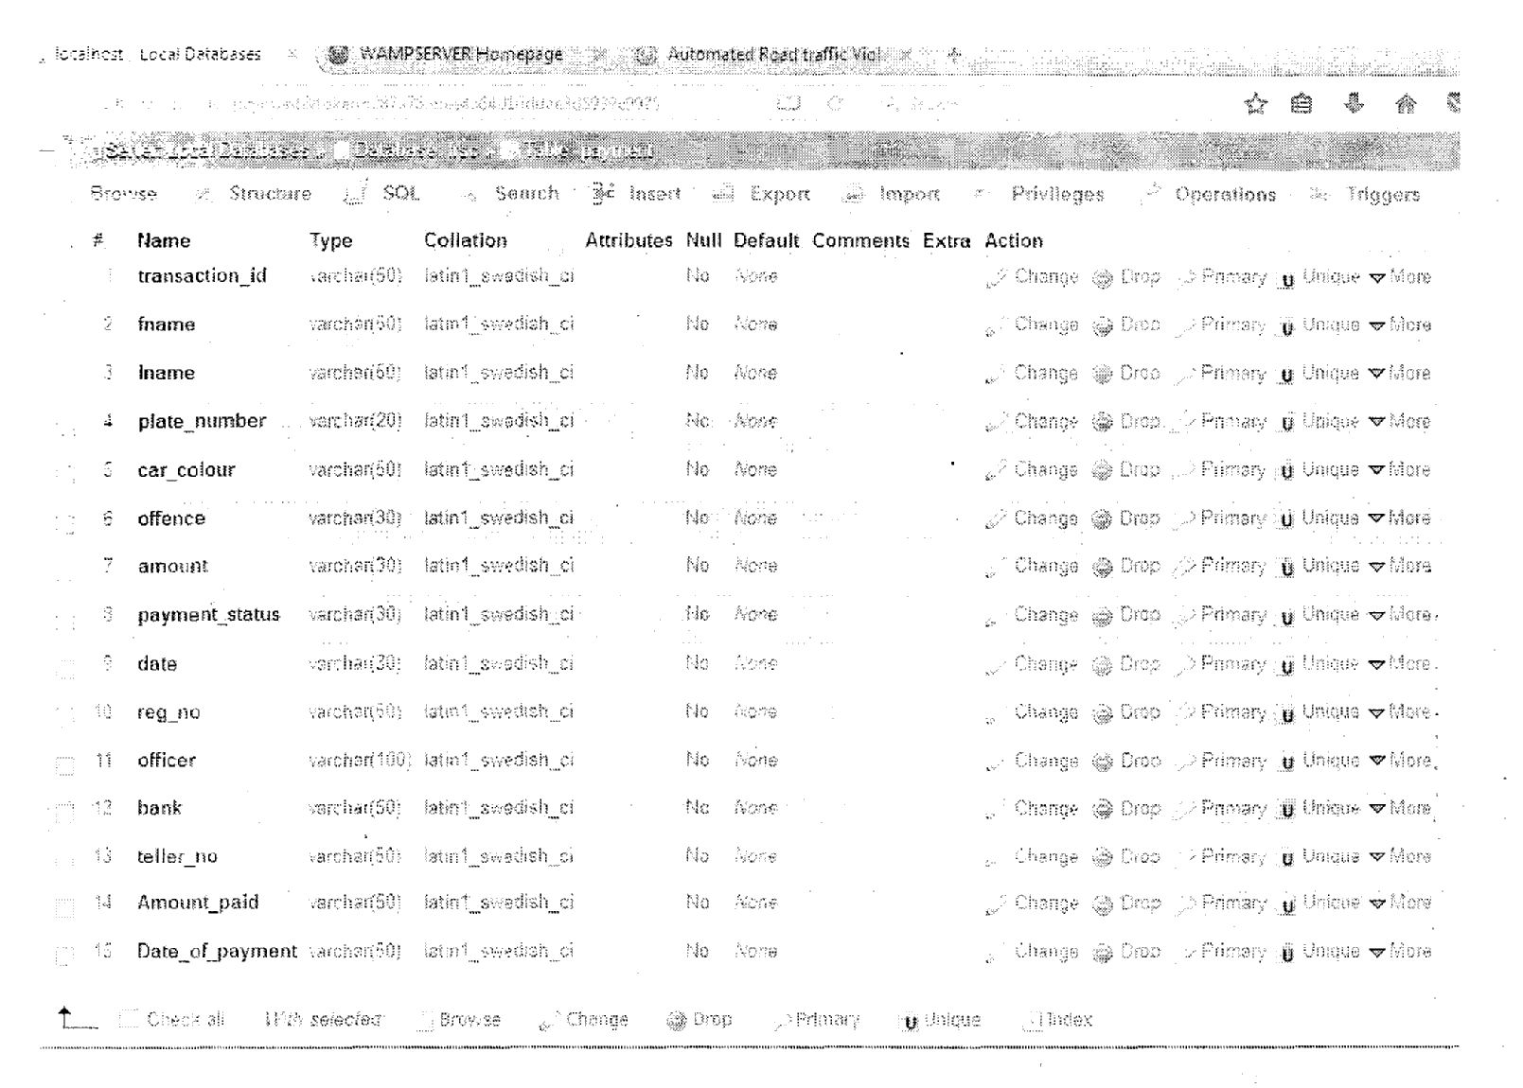
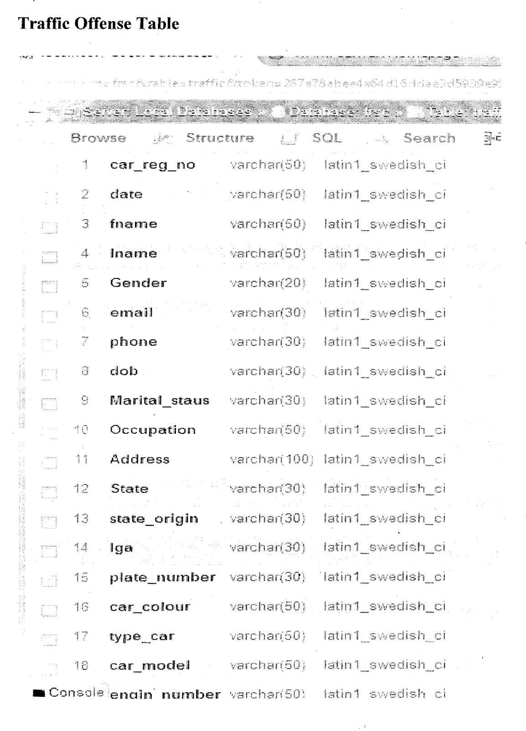
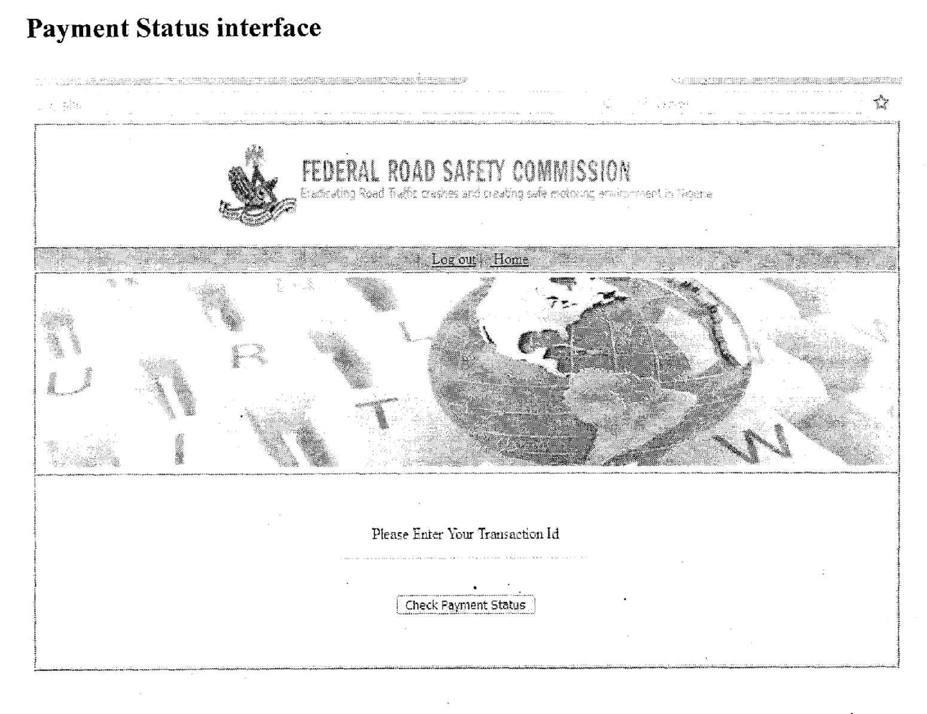
Check Offense Status Interface
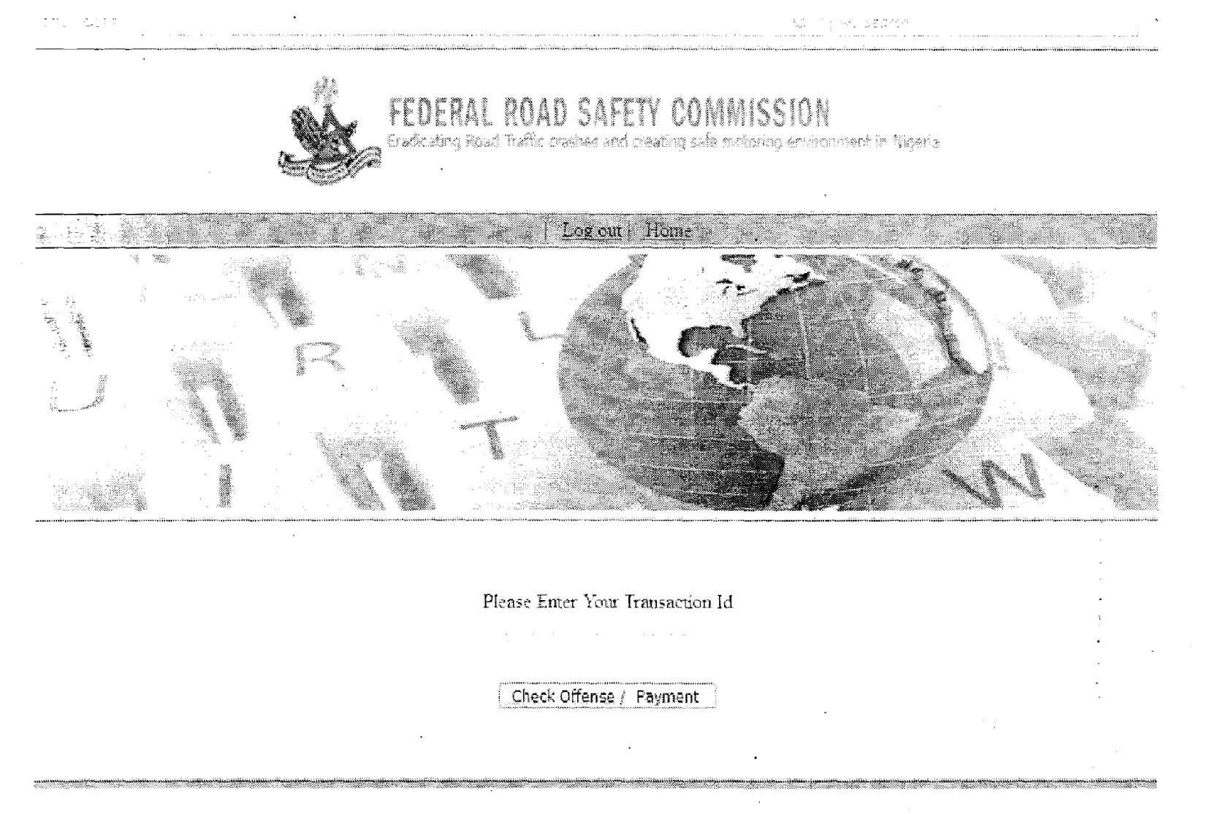
Admin Login Interface
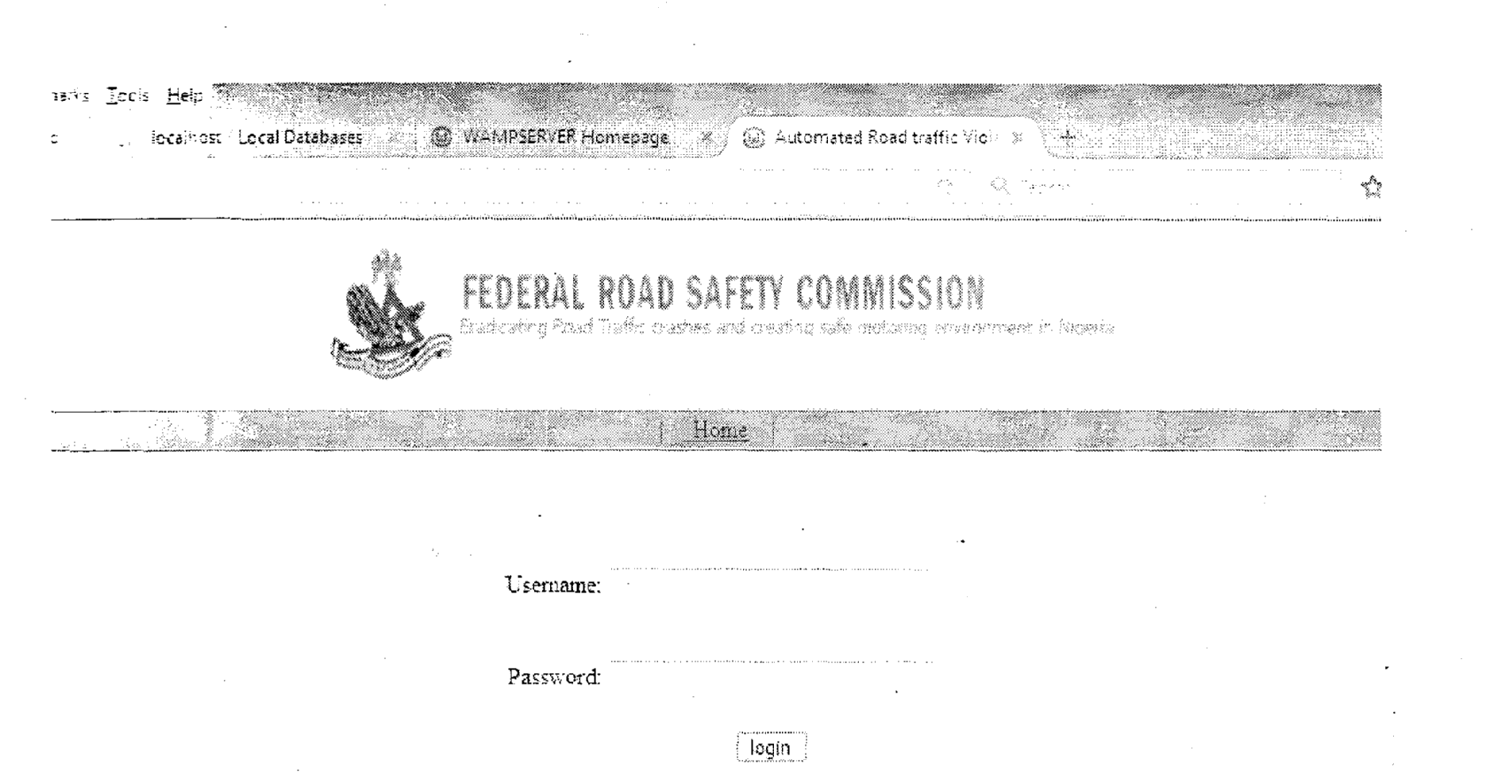
CHAPTER FOUR
SYSTEM IMPLEMENTATION
4.0 INTRODUCTION
System implementation is a collection of inter-dependent physical devices together with their programming which provides the functionality and performance for which the system was designed. It covers all the activities necessary to set the system that has been analyzed and designed to be fully functional to the users.
4.1 Choice of Development Environment
The development tools are the necessary requirement tools used during the design to enable us achieve the system design. The listed packages was used because of their features, accessibility and also because it is more effective.
1. My SQL database application
2. PHP scripting Language
3. HTML language and Javascript
4. Notepad plus
5. GPS
MySQL Database Server: MySQL is a popular choice of database for use in web applications, and is a central component of the widely used LAMP open source web application software stack—LAMP is an acronym for “Linux, Apache, MySQL, Perl/PHP/Python!JSP”. The MySQL Database powers the most demanding Web, E-commerce and Online Transaction Processing (OLTP) applications. It is a fully integrated transaction-safe, ACID compliant database with full commit, rollback, crash recovery and row level locking capabilities. MySQL delivers the ease of use, scalability, and performance that has made MySQL the world’s most popular open source database.
PHP: PHP is a server-side scripting language that allows your Web site to be truly dynamic. PHP stands for PHP: Hypertext Preprocessor its flexibility and relatively small learning curve (especially for programmers who have a background in C, Java, or Pen) make it one of the most popular scripting languages around. PHP’s popularity continues to increase as businesses, and individuals everywhere embrace it as an alternative to Microsoft’s ASP language and realize that PHP’s benefits most certainly outweigh the costs.
HTML Language:
Hypertext Markup Language (HTML), the standard text-formatting language for documents on the interconnected computing network known as the World Wide Web. HTML documents are text files that contain two parts: content that is meant to be rendered on a computer screen; and markup or tags, encoded information that directs the text format on the screen and is generally hidden from the user.
JavaScript is a programming language that adds interactivity to your website for example: games, responses when buttons are pressed or data entered in forms, dynamic styling, animation etc.

4.2 IMPLEMENTATION ARCHITECTURE
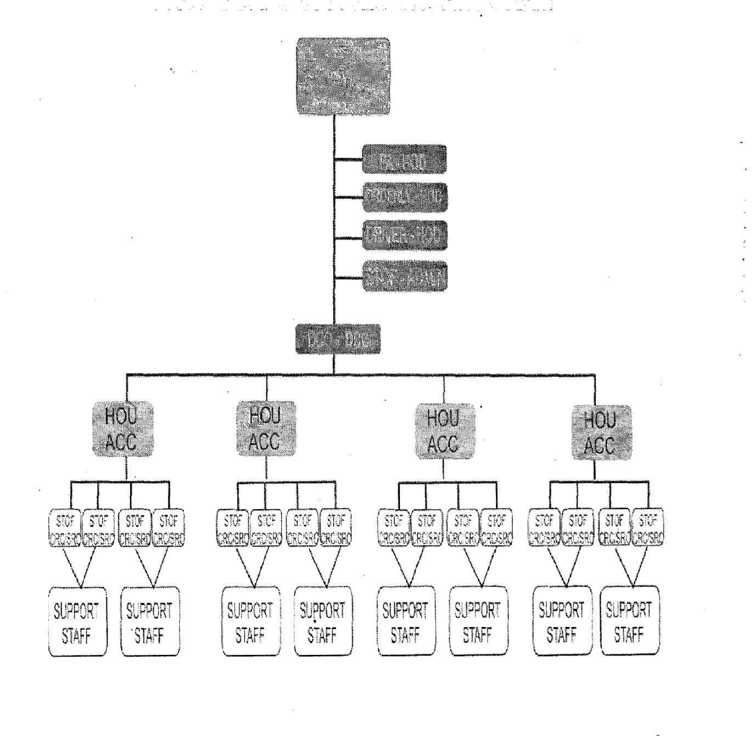

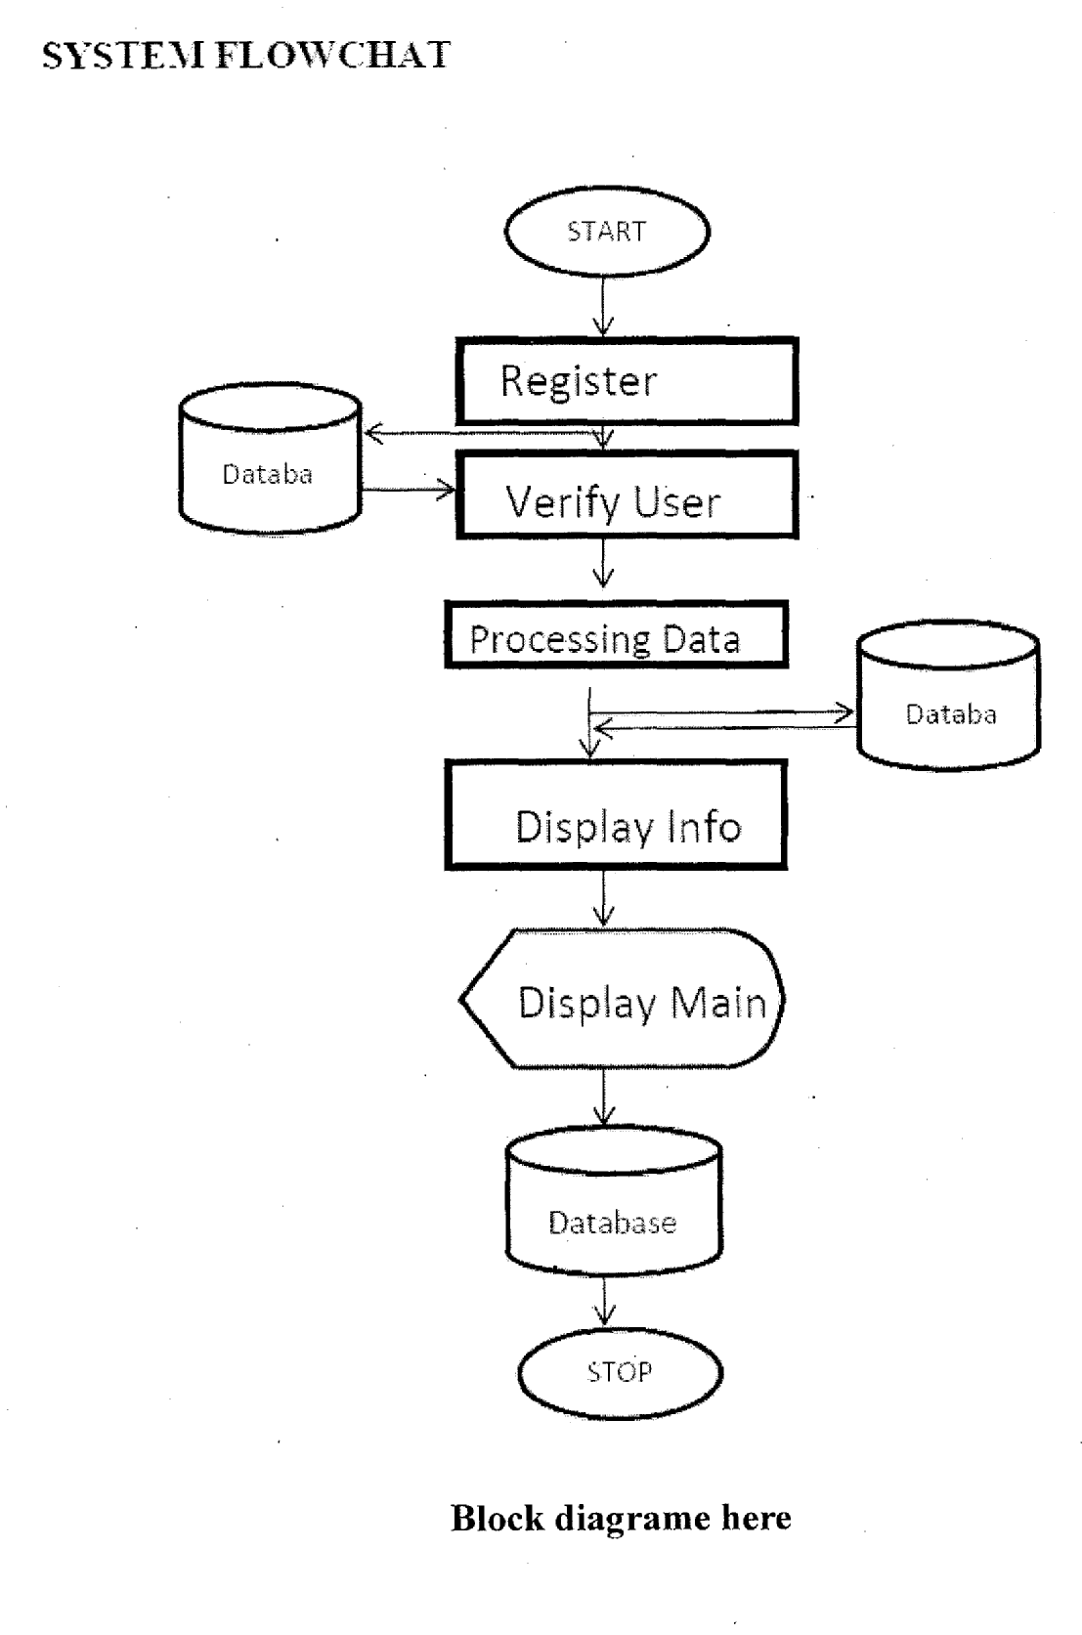

CHANGE-OVER PROCEDURE
To change over from the current system to the proposed system, a number of procedures may be employed. These include:
(1) DIRECT CHANGE-OVER PROCEDURE
This involves shutting down the old system completely, and switch over to the new system. It is however not advisable because if there is a problem, we cannot fall back on any system since the old system has been completely shut down.
(ii) PHASE CHANGE-OVER PROCEDURE
Here, we might implement registration of users with the new system while all the other operations will be normally carried out until we are sure that it functions very well before we integrate another operation. This is done in phases, but is safer.
4.3 SOFTWARE TESTING
Testing is the last stage in the software development and it presents an interesting anomaly for the software engineer where he attempts to build software from an abstract concept to a tangible product. During testing, the engineer creates series of test cases to discard preconceived notions of the “correctness” of software just
developed and overcome a conflict of interest that occurs when errors are uncovered. As a secondary benefit, testing demonstratçs that the software functions appear to be working according to specification, that behavioral and performance requirements appear to have been met. In addition, data collected as testing is conducted provide a good indication of software reliability and quality -as a whole.
Testing the software follows a certain process as shown below:
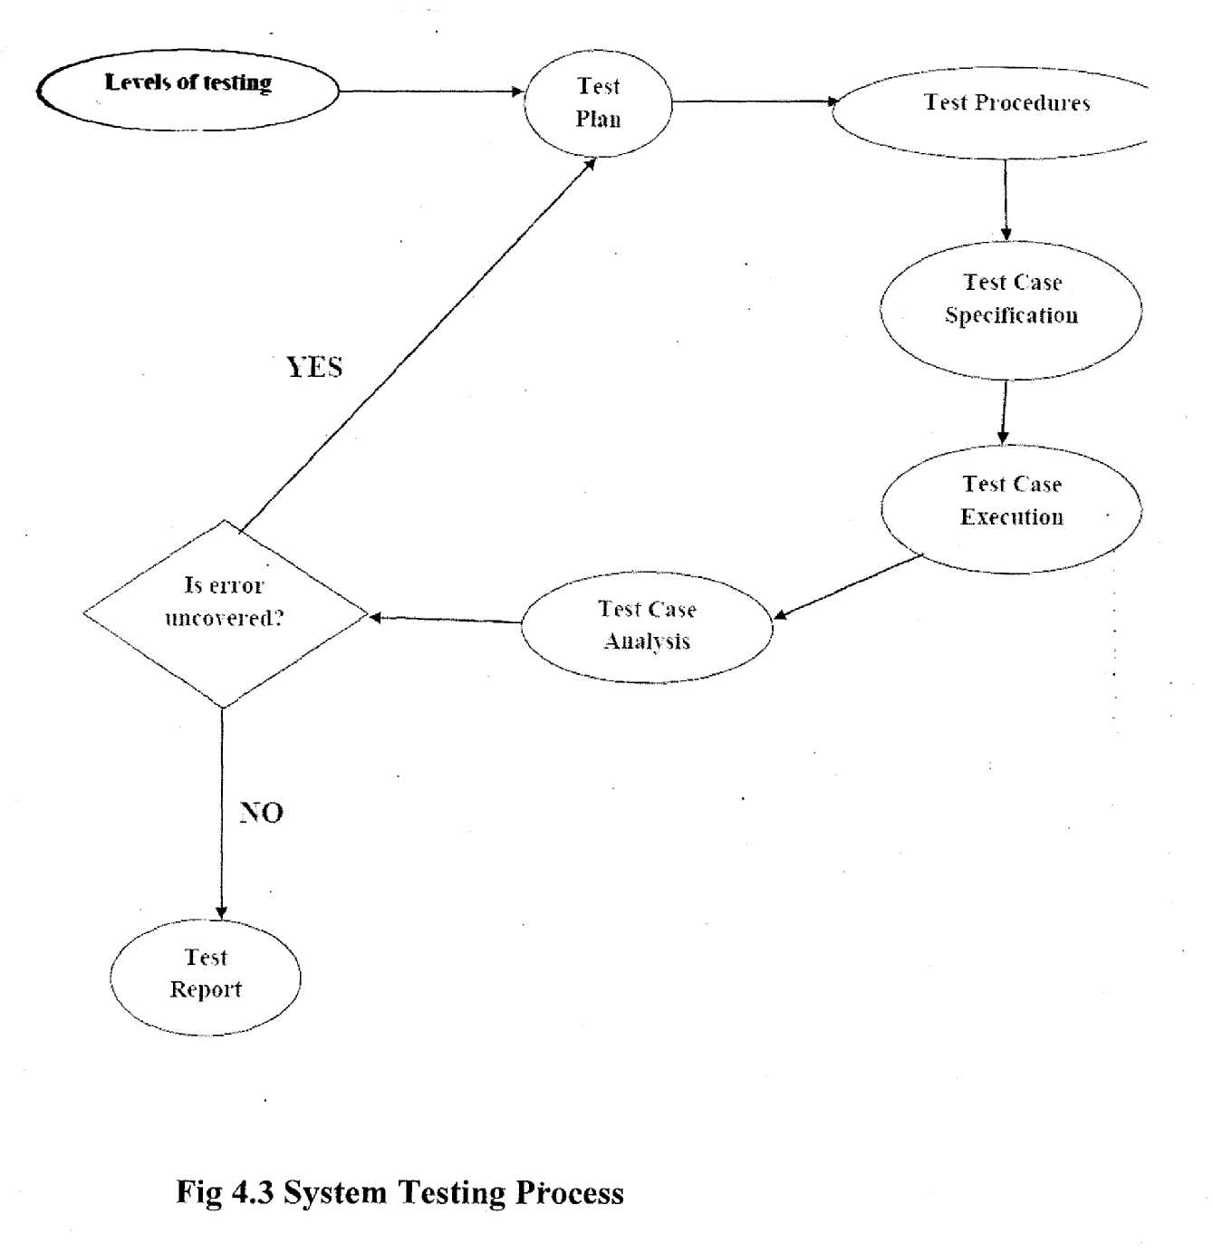
Unit Test
Each unit of the new system was tested (test run) individually along side with the old system in other to identify areas of further enhancement and development.
System Test
The entire system was as well tested (test run) in general along side with the old system in other to identify areas of further enhancement and development.
Packaging (Integration)
The software will be designed using visual basic. After which will be complied and packed for easy installation in any computer system and further use.The complied
software will be transferred.
4.4 Documentation
In order for the proposed system to be used on any computer system it takes the following:
- Boot the system.
- Login in to the ISP account
- Click on the file manager on the control panel.
- Click on directory and processed to click on upload
- Upload your web files into the directory
- Open any browser on your system (Microsoft internet Explorer, Mozilla Firefox, Netscape Navigator, Opera, Flock, Safari etc.)
- Type https://www.onah.tk on the address bar and press the return key or enter key.
- Then the website will come up
44.1 User Manual
The steps to use the proposed system are as follows:
i. On the address bar of any browser type https://www.onah.tk
ii. You have to choose from the toolbar the service you want to make use of. iii. The username and password are in three formats as an administrator, as a
iv. As an administrator you are to type https://www.onah.tk/ admin.php on the address bar.
v. As an administrator you are prompted with the administrator page that is the back end of the system.
4.4.2 Source Code
See appendix 1 a for source code.

CHAPTER FIVE
5.0 SIJMMARY, RECOMMENDATION, SUGGESTED STUDIES AND CONCLUSION
5.1 SUMMARY
Computerized Traffic Offence Documentation system is designed to overcome the problems encountered with the existing system (i.e manual) such as prone to attack, data redundancy, time wasted in searching for records, poor security and protection, misplacing and mismanaging of files. The new system is designed in such a way that records about each traffic offender are stored in a database for easy retrieval of data. The new system also helps the Federal Road Safety Commission to have an organized traffic offence documentation system to eradicate the use of the manual system.
5.2 RECOMMENDATION
The following are the recommendation required in order to effectively use the new design are:
- The hardware and software requirement should be as specified. 1 Staff should have basic knowledge of computer operation, the Federal
- Government should budget funds for adequate training of all personnel and the staff of Commission should be paid well in order for them to work effectively and yield maximum results.
- The Federal Road Safety on their own part should employ well educated graduates with the right discipline and qualifications to occupy right positions to function effectively and improve their efforts to serve the nation and mankind better.
5.3 SUGGESTED STUDIES
Due to limited resources, funds and time the researcher suggest that, other researchers who wish to embark on the mission of further improvement of the Federal Road Safety Commission should advocate for the adoption of the project which is the computerization of Traffic Offence Documentation System. Researchers should push for this project to be passed as a bill to the National Assembly and ensure it should be approved for the welfare of the Nation.
5.4 CONCLUSION
The Federal Road Safety Commission was established to control the rate of road traffic accidents and control road users. It is a good start towards the eradication of road accidents which has claimed a lot of lives, but the system used presently by the FRSC is the manual system which has a lot of limits presently, back in the days when the commission was first established, the manual system was effective. But presently the world has gone global and so should the FRSC. They should embrace and develop the computerized ideal of documenting Traffic Offences to help them function better and achieve the goal for which it was established.

REFERENCES
Blementhal, S.C (1999). Management Information System; New Jersey: Hall Inc.
Eaglewood Publishers.
Brutus, L. (1991). A Database Management Information System; India: Division of
Macmillam publishing.
David M.A (1999). FRSC and the Imperatives of Road Traffic Safety in Nigeria;
Jos: Chohu Business Enterprise.
Federal Road Safety Commission Nigeria (2008).Nigeria Highway Code; Abuja:
Detailwoks Ltd.
Federal Republic of Nigeria (2004).National Road Traffic Regulations;Lagos:
Federal Government Press.
Federal Republic of Nigeria (1949) chapter 548. Road Traffic Act; Lagos: Federal
Government Press.
Federal Republic of Nigeria (1988).Decree No.45, 1988.
Frobose, H.J. (1989). Models For Self-Financing of Road Safety work in
Developing Countries. Paper presented at the 2nd African Road Safety Congress,
Addis-Ababa.
Kotler,Philip and Keller, (2006).Marketing Management Twelfth Edition: Kevin
Lane: Perason Education.
Microsoft Encarta Premium, (2009).
Wikipedia, the Free Encyclopedia (2010)
UNIVERSAL RESOURCE LOCATOR (URL) http://www.FRSC.gov.ng/Offence & penalty
http ://www.FRSC . gov.ng/Creating safe road in Nigeria.html http ://www.FRSC . gov.ng/History .htrnl
http://www.the nigerianvoice. Corn

Appendix A
la. Source Code:
<?php require_once(’Connections/frsc .php’);?> <?php
I/initialize the session if (!isset($ SESSION)) { session startQ;
}

// * * Logout the current user. * * $logoutAction = $SERVER[’PHP_SELF’] . “?doLogouttrue”;
if ((isset($ SERVER[’QUERY STRING9)) && ($ SERVER[’QUERY STRING’] != “)){
$logoutAction .“ &“. htmlentities($_SERVER[’QUERYSTRING’j);
}

if ((isset($_GET [‘ doLogout’])) &&($_GET[’doLogout’]==”true”)) {
I/to fully log out a visitor we need to clear the session varialbies
$SESSION[’MMUsername’] = NULL;
$SESSION[’MM_UserGroup’j = NULL;
$SESSION[’PrevUrU] NULL;
unset($_SES SION[’MM Usemame’]);

unset($SES SION[’MM_UserGroup’j); unset($_SES SION[’PrevUrl’l);
$logoutGoTo = “index.php”;
if ($logoutGoTo) {
header(’Location: $logoutGoTo”);
exit;
}
}
<?php
if (!function_exists(”GetSQLValueString”)) {
function GetSQLValueString($theValue, $theType, $theDefinedValue =
$theNotDefinedValue =
{
if (PHP VERSION <6) {
$theValue = get_magic_quotes_gpc ? stripslashes($theValue) : $theValue;
}
$theValue = function_exists( “mysq1_rea1escapestring”)? mysql_real_escapestring($theValue) : mysql_escape_string($theValue);
switch ($theType) { case “text”:
$theValue = ($theValue !=“)? “ $theValue . “ : “NULL”; break;
case “long”:
case “inc”:
$theValue ($theValue ! “) ? intval($theValue) : “NULL”; break;
case “double”:
$theValue ($theValue ! “) ? doubleval($theValue) : “NULL”; break;
case “date”:
$theValue = ($theValue !=“)? “ . $theValue. “ : “NULL”; break;
case “defined”:
$theValue = ($theValue ! “)?$thDefinedValue : $theNotDefinedValue; break;
}

return $theValue;
}

}

$colname_Recordsetl = “-1”;
if(issct($POST[’textl 1’])) {
$colnameRecordset 1 $POST[’text 11’];
}
mysql_select_db($database_frsc, $frsc);
$query_Recordsetl = sprintf(” SELECT * FROM payment WHERE plate_number = %s”, GetSQLValueString($colnarne_Recordset 1, “text”));
$Recordsetl = mysql_query($query_Recordsetl, $frsc) or die(mysql_errorQ);
$row_Recordset 1 = rnysql_fetch_assoc($Recordset 1);
$totalRowsRecordset 1 = mysql_num_rows($Recordset 1);
<!DOCTYPE html PUBLIC “-//W3C//DTD XHTML 1.0 Transitional//EN”“http.org/TR/xhtmll/DTD/xhtml 1-transitional .dtd”>
<html xmlns”http ://www.w3 .org/ 1 999/xhtrnl”> <head>
<meta http-equiv” Content-Type” content”text/htrnl; charsetutf-8” /> <title>Autornated Road traffic Violation Tracking System</title> <style type”text/css”>
body{
margin-left: Opx;
margin-top: Opx;
margin-right: Opx;
margin-bottom: Opx;

}
#uuuuue {
color: #F00;
font-size: 24px;
}
</style>
</head>
<body>
<table width” 1000” border=” 1” align”center” cellpadding=” 1” cellspacing” 1” borderco1or’#9966O0”>
<tr>
<td width” 1805” height” 125” align=z”center”><img
src”images/1ogo_frsc.gif’ width” 522” height=” 89” /></td>
</tr>
<tr>
<td height=”21” align=”center”
bgcolor=”#999966”>&nbsp;&nbsp;&nbsp;&nbsp; I&nbsp;&nbsp;&nbsp;<a href” <?php echo $logoutAction ?>“>Log out</a>&nbsp; I &nbsp ;&nbsp;<a href” lOgin_pass .php “>&nbsp;Home</a></td>
<Itr>
<tr>
<td height=”3 13” aligw=”left” valign=”top”><p>&nbsp;</p> <p>&nbsp;</p>

<‘?php if ($totalRows_Recordsetl > 0) { /1 Show if recordset not empty?> <table border” 1” align”left” cellpadding” 1” cellspacing” 1”>
<tr bgcolor”#999966”> <td
width” 173 “>transactionid</td> <td
width” 125 “>First Name</td> <td
width” 124”>Sumame</td> <td
width” 133 “>Offence</td> <td
width”l 15”>Date</td> <td width=” 133 “>Amount</td> <td
width” 1 82”>Payment Status</td> <td
width” 1 27”>Officer</td> <td
width’119”>Bank</td> <td
width” 141 “>Teller No</td> <td
width=” 17 1.”>Amount Paid</td> <td
width” 195 “>Date of Payrnent</td>
<?php do {?>
<tr>
<td><?php echo $row_Recordset 1 [‘transaction_id’); ?></td> <td><?php echo $row_Recordsetl [‘fname9; ?></td> <td><?php echo $row_Recordsetl [‘lname’j; ?></td> <td><?php echo $row_Recordsetl[’offence’]; ?></td> <td”-<’?php echo $row_Recordset 1 [‘date’]; ?></td>
<td><?php echo $row Recordsetl[’amount’]; ?></td>
<td><?php echo $row_Recordsetl{’payment status’]; ?></td>
<td><?php echo $row Recordset 1 [‘officer’l; ?></td>
<td><?php echo $row_Recordsetl [‘bank’]; ?></td>
<td><?php echo $row Recordset 1 [‘teller_no’]; ?>!td>
td><?php echo $row_Recordsetl [‘Amount_paid’]; ?><itd>
<td><?php echo $row_Recordsetl [‘Date_of_payment’]; ?></td> </tr>
<?php } while ($row_Recordsetl m.ysqi_fetch_assoc($Recordsetl));?> </table>
<?php } 1/ Show if recordset not empty?> <p>&nbsp;</p>
<p>&nbsp ;</p> <p>&nbsp ; </p>
<p>
&nbsp;&nbsp;&nbsp;&nbsp;&nbsp;&nbsp;&nbsp;&nbsp;&nbsp;&nbsp;&nbsp;&
nbsp;
<?php if ($totalRows_Recordset 1 0) { /1 Show if recordset empty?>
<span id=”uuuuue”>&nbsp;&nbsp;Sorry no such record found kindle narrow your search Thanks</span>
<?php } // Show if recordset empty?>
<Ip><!td>
</tr>
<tr>
