CHAPTER ONE
INTRODUCTION
BASIC PRINCIPLES OF ELECTROMAGNETIC PROSPECTING
1.1 Definition, Concept and Historical Background
In Geology, Prospecting is the first stage of geological analysis; which entails the search for mineral deposits, especially by drilling and excavation. Elsewhere, in Electricity, Electromagnetism is the science of charges as well as the forces and fields associated with the charge.
However, Electromagnetic Prospecting seeks the study and application of electromagnetic methods to the idea of prospecting (I.E in the search for mineral deposits). By definition, It is a geophysical method employing the generation of electromagnetic waves at the Earth's surface, such that when the electromagnetic waves penetrate the Earth and impinge on a conducting formation or ore-body, currents are induced into the conductors, which forms new waves that are radiated from the conductors for which detectors can be used to record the waves at the surface. (Mindat.org, 2017).
The pioneer method used for the study of EM prospecting was the electrical method; it was one of the first geophysical exploration techniques widely used at the end of the 1920s and at the beginning of 1930s in oil, gas, and mineral-deposit exploration. The earth’s interior was being explored by practical use of electrical currents which was as a result of pioneering work of the Schlumberger brothers, Conrad and Marcel, who went on to engineer one of the world’s most successful geophysical service companies.
The1D model of a layered earth or the 2D models were the basic models of interpretation for so many years. However, during the last 20 years, geophysicists have developed and begun the use of 3D models for interpretation as well. This advancement has required developing the corresponding mathematical methods of interpretation, based on modern achievements of EM theory and computer science in numerical modeling and inversion.
The two main applications of electrical and EM methods are mostly for petroleum and other stratigraphic studies, and searching for discrete conductors in base-metal exploration.
The first successful application of electrical and EM methods was successfully applied first in the exploration of highly conductive metallic ores. Electromagnetic methods were applied in the exploration for massive sulfide ore bodies and disseminated metal ores. Even with the recent development of other methods of metallic ore body exploration, the use of EM methods in the search for metallic ores remains one of the most important commercial applications. The fact is that in the big picture of expenditures in exploration geophysics, EM methods are still small compared to seismic methods; and within EM methods, the search for minerals has held the dominant position. Electromagnetic methods in geophysics are distinguished by:
- Use of differing frequencies as a means of probing the Earth (and other planets), more so than source-receiver separation. Think “skin depth”. Sometimes the techniques are carried out in the frequency domain, using the spectrum of natural frequencies or, with a controlled source, several fixed frequencies (FDEM method ---“frequency domain electromagnetic”). Sometimes the wonders of Fourier theory are involved and a single transient signal (such as a step function) containing, of course, many frequencies, is employed (TDEM method - “time domain electromagnetic”). The latter technique has become very popular.
- Operate in a low frequency range, where conduction currents predominate over displacement currents. The opposite is true (i.e., has to be true for the method to work) in Ground Penetrating Radar (GPR). GPR is a wave propagation phenomenon most easily understood in terms of geometrical optics. Low frequency EM solves the diffusion equation.
- Relies on both controlled sources (transmitter as part of instrumentation) and uncontrolled sources. Mostly the latter is supplied by nature, but also can be supplied by the Department of Defense.
Some Electromagnetic (EM) methods include:
- Frequency domain EM methods, such as EM induction, EM utility locator/metal-detection methods, very low frequency (VLF) EM, and
- Controlled source audio-frequency magnetotellurics (CSAMT), as well as time domain EM methods (TDEM).
NB: GEO-Vision geophysicists have successfully utilized a wide variety of EM methods for hydro-geologic, engineering, and environmental investigations.
1.2 Early History
As early as 1882, Dr. Carl Barus conducted experiments at the Comstock Lode, Nevada, which convinced him that the method could be used to prospect for hidden sulfide ores. To Barus goes the credit for introducing the non-polarizing electrode. Conrad Schlumberger put the method on a commercial basis in 1912. The first plan map of self -potential over a metallic deposit was prepared by Conrad Schlumberger in 1913 and published in 1918; it pertained to the pyrite mines at Sain-Bel, France. Roger C. Wells, of the U.S. Geological Survey, in 1914 contributed the first chemical understanding of the passive self- potential phenomena. Kelly (1957) introduced the self-potential method to Canada and the United States in 1924.
Fred H. Brown, in the era from 1883 to 1891, and Alfred Williams and Leo Daft in 1897 first attempted to determine differences in earth resistivity associated with ore deposits and were granted patents on their methods. In 1893 James Fisher measured the resistivity of copper bearing lodes in Michigan (Broderick and Hohl, 1928), while in 1900, N. S. Osborne did equipotential work in the same district. The first practical approach to utilizing active electrical methods, wherein the earth is energized via a controlled source and the resulting artificial potentials are measured, was due to Conrad Schlumberger in 1912. At that time he introduced the direct current equipotential line method (Schlumberger, 1920).
The concept of apparent resistivity was introduced about 1915 by both Wenner (1912) of the U. S. Bureau of Standards and by Schlumberger (1920). The field techniques for apparent resistivity were then developed by O. H. Gish and W. J. Rooney of the Carnegie Institution of Washington and by Marcel Schlumberger, E. G. Leonardon, E. P. Poldini, and H. G. Doll of the Schlumberger group. Wenner used the equi-spaced electrode array which today bears his name while the Schlumberger group standarized on an electrode configuration in which the potential electrodes are sufficiently close together that the potential gradient, i.e. the electric field, is measured midway between the current electrodes (the Schlumberger array). The earliest attempt to understand telluric currents is generally credited to Charles Mateucci (1867) of the Greenwich Observatory. It was not until 1934 that Conrad Schlumberger (1939, p. 272-3) made commercial use of the method.

The three Geophysical Prospecting volumes of the Transactions of the American Institute of Mining and Metallurgical Engineers (AIME), in 1929, 1932, and 1934, provided forums for dissemination of knowledge of this rapidly growing field of electrical geophysical prospecting. These volumes were followed by Geophysics, 1940, Vol. 138 and Geophysics, 1945, Vol. 164 of the Transactions of AIME. The Society of Exploration Geophysicists published six papers on electrical methods in Early Geophysical Papers. Most of these papers dealt with oil and gas exploration. The first paper on electrical methods to appear in Geophysics (Vol. 1) was by Statham (1936). From these beginnings, the electrical methods slowly developed, with most of the development taking place after World War II. Highlights of these developments follow. (Bleil , D. F., 1953)

CHAPTER TWO
TYPES OF ELECTROMAGNETIC SYSTEMS
In the concept of EM prospecting, two main electromagnetic systems come into play, which are;
- Time-domain system(TEM)
- Frequency-domain system(FEM)
2.1 Time-Domain system (TEM)
Time-domain EM methods shows us an effective and alternative approach which is being applied in detecting weak secondary magnetic fields. This approach works simply by switching the primary field “off” and observing the decay of the secondary magnetic fields.
This method is often referred to as Transient electromagnetic exploration (TEM) or time-domain electromagnetic (TDEM) exploration.
2.1.1 Air Bourne Time domain system
This powerful system drives an alternating current through an insulated electrical coil system by employing a transient, also called a time-domain electromagnetic transmitter. GPRTEM’s receiver is installed in a towed-bird and is constructed as a fiberglass casing and the GPRTEM receiver is being installed on it. The system is attached to the helicopter by a weak link assembly. The system uses a 15HP (Horse-power) generator and a large condenser to transmit alternating 4-ms half-sine pulses at a frequency of 30Hz with a total dipole moment of 600,000 NIA. The GPRTEM’s system is coupled to a state-of-the-art data acquisition system to sample the transient data at 240 KHz.

An electromagnetic field is produced by the current in the coil. The termination of the current flow is not instantaneous, but occurs over a very brief period of time (a few microseconds) known as the ramp time can be defined as the brief period of time in which the termination of the current occurs because it is not an instantaneous process and during the period the magnetic field is time-variant. A secondary electromagnetic field is being created in the ground beneath the coil because of the time-variant nature of the primary electromagnetic fields, in accordance with Faraday's Law. This secondary field immediately begins to decay in the process, generating additional eddy currents that propagate downward and outward into the subsurface. Measurements of the secondary currents are made by a vertical component receiver located almost half way between the helicopter and the transmitter loop. The boom has an elastic suspension. A proprietary suspension system protects the orthogonal coils assembly and limits the total field excursions. The tear-drop vessel acts as a vane and maintains the mast in the line of flight.
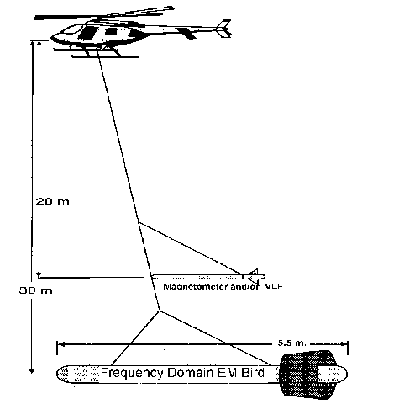
Fig 1: Diagrammatic description of the Air borne TDEM

2.1.2 Ground-based TDEM systems
- These ground-based TDEM
These systems exhibits flexibility in its layout and the TX size can be adjusted from 1 x 1 m to 2000 x 2000m. In order to boost signal strength and also to give deeper signal penetration larger loops are required. If the TX and RXare allowed to stay in the same location for a period of time; stacking is being observed i.e. record many on-off cycles of the TX and add the responses together. This allows detection of weaker signals and the removal of incoherent noise.

The RX can be placed in the center of the transmitter (central-loop configuration) or at a variable offset. Collecting transient data at variable offsets can give additional resistivitydepth information. It also takes advantage of the fact that it is logistically easier to move a small RX than the larger TX.
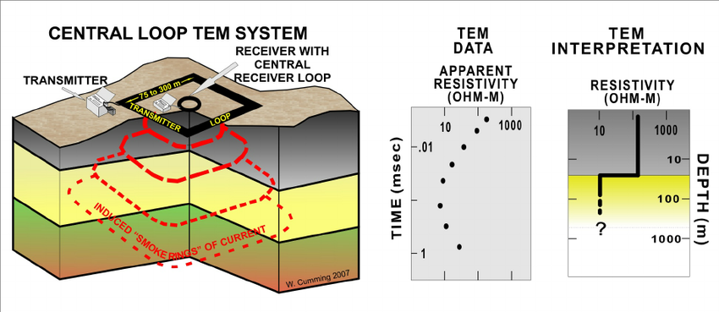
Fig 2: Diagrammatic representation of the Ground based TDEM

    - Time-domain EM systems for deeper exploration
For imaging of depths below 1-2km, Powerful specialized systems in TDEM are highly required. One of the most useful is the long-offset transient electromagnetic system (LOTEM), a profile of an array of receivers extending away from the transmitter is used in detecting the powerful transient generated. The LOTEM technique can be considered analogous to seismic refraction, with EM energy travelling horizontally in the Earth. In contrast, the EM energy travels vertically in magnetotellurics, which can be considered analogous to seismic reflection.
The transient signal is generally quite weak at the RX and stacking is needed to improve the signal-to-noise ratio.
Note that both electric and magnetic fields are recorded.
The LOTEM system is described by Strack et al., (1990) and an application to crustal scale exploration is documented by Hordt et al., (1992) and Hordt et al., (2000).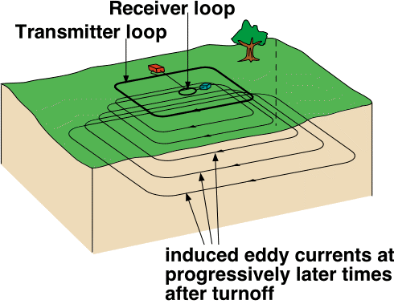
Fig 3: TDEM for deeper exploration

2.2 Applications of time-domain EM
2.2.1 GEOTEM exploration for kimber-lites
At the surface, a kimber-lite pipe can be often characterized by a low resistivity disk. When weathering of kimber-lite produces a clay layer which has a low electrical resistivity it is said to be produced. In places like northern Canada, glacial erosion often creates a lake and the clay becomes water saturated, further lowering the resistivity. The combination of airborne EM and aeromagnetic data is widely used in current exploration.
Example : Willy Nilly Kimber-lite pipe (www.fugroairborne.com.au)
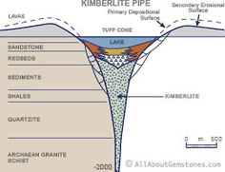
Fig 4: GEOTEM exploration for kimberlite
    - Groundwater exploration
In the search for groundwater using Electromagnetic methods, Time-Domain EM electromagnetic systems have been widely used. Here, The measurements are done as a function of time. The Time-Domain Electromagnetic (TDEM) methods are based on the principle of using electromagnetic induction to generate measurable responses from sub-surface features. When a steady current in a cable loop is terminated a time varying magnetic field is generated. As a result of this magnetic field, eddy currents are induced in underground conductive materials. The decay of the eddy currents in these materials is directly related to their conductive properties, and may be measured by a suitable receiver coil on the surface.

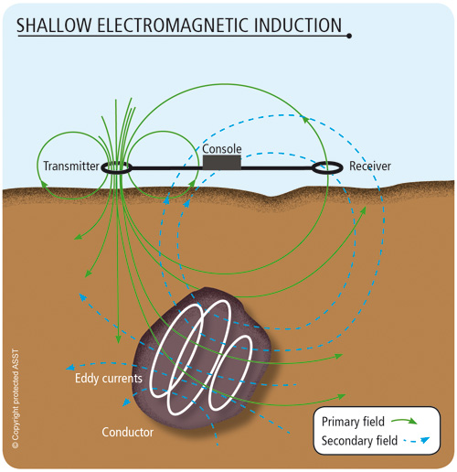
Fig5: TDEM for groundwater exploration
    - Geotechnical exploration
In a Time-domain EM study by Ersan Turkoglu in Avcilar, a suburb of Istanbul that was badly damaged by the 1999 Izmit earthquake. SIROTEM data were used to image resistivity in upper few hundred metres of the subsurface, and reveal possible shallow faults. Unlike MT, this technique can be easily used in urban areas with high levels of cultural noise.
This study also used DC resistivity data, and a joint inversion of TEM and DC data to overcome some of the inherent non-uniqueness.

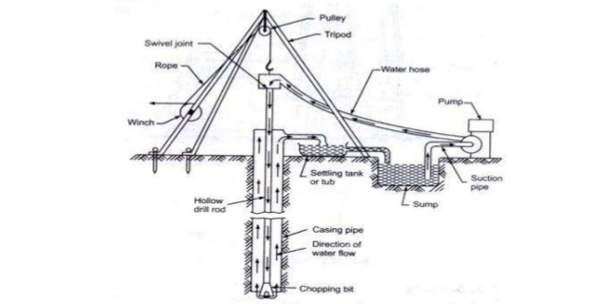
Fig 6: Wash Boring
2.3 Frequency-domain system
Frequency domain electromagnetic methods are very useful in detecting near surface conductors through the secondary magnetic fields that are induced by the primary magnetic field. The secondary magnetic fields can be 10-20% of the primary magnetic fields when systems such as the EM31 and EM34 are being applied.
The secondary magnetic field becomes weaker with depth in the presence of the primary magnetic field i.e. As the conductor becomes deeper, the secondary magnetic fields become weaker, and can be difficult to detect in the presence of the much stronger primary magnetic field. Typical secondary magnetic fields are expressed as parts-per-million (ppm) of the primary magnetic field. In this configuration, the towed bird is very difficult to use in measuring the secondary magnetic field in the frequency domain.

2.3.1 Basic Concept
In the frequency domain method, sinusoidally varying current at a specific frequencyis being emmited by the transmitter. For example, at a frequency of 100 Hz. Because the mutual inductance between the transmitter and conductor is a complex quantity, the electromagnetic force induced in the conductor will be shifted in phase with respect to the primary field. At the receiver, the secondary field generated by the currents in the conductor will also be shifted in phase by the same amount. There are three methods of measuring and describing the secondary field.
- Amplitude and Phase
The amplitude of the secondary field can be measured and is usually expressed as a percentage of the theoretical primary field at the receiver. Phase shift, the time delay in the received field by a fraction of the period, can also be measured and displayed.
- In Phase and Out-of-Phase Components
The second method of presentation is to electronically separate the received field into two components, The first component is in phase with the transmitted field whereas the second component is exactly 90° out-of-phase with the transmitted field. The in-phase component is sometimes called the real component, and the out-of-phase component is sometimes called the “quadrature" or "imaginary" component. Both of the above measurements require some kind of phase link between transmitter and receiver to establish a time or phase reference. This is commonly done with a direct wire link, sometimes with a radio link, or through the use of highly accurate, synchronized crystal clocks in both transmitter and receiver.

- Tilt Angle Method
Tilt angle systems these have no reference link between the transmitter and receiver coils and they are the simpler frequency domain EM system. Here the total irrespective phase of the receiver is being recorded, and the receiver coil is tilted to find the direction of maximum or minimum magnetic field strength. As shown conceptually in figure 8, at any point the secondary magnetic field may be in a direction different from the primary field. With tilt angle systems, therefore, in terms of geological conductors, the objective is to measure deviations from the normal in-field direction and to interpret these terms .
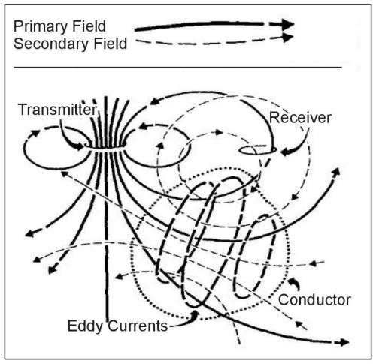
Figure 7. Generalized picture of electromagnetic induction prospecting. (Klein and Lajoie 1980; copyright permission granted by Northwest Mining Association and Klein)
The response parameter of a conductor is defined as the product of conductivity-thickness (σt), permeability (μ), angular frequency (ω = 2πf), and the square of some mean dimension of the target (a2). The response parameter is a dimensionless quantity. In MKS units, a poor conductor will have a response parameter of less than about 1, whereas an excellent conductor will have a response value greater than 1,000. The relative amplitudes of in-phase and quadrature components as a function of response parameter are given in figure 9 for the particular case of the sphere model in a uniform alternating magnetic field. For low values of the response parameter (< 1), the sphere will generally produce a low-amplitude out-of-phase anomaly; at moderate values of the response parameter (10-100), the response will be a moderate-amplitude in-phase and out-of-phase anomaly, whereas for high values of the response parameter (>1,000), the response will usually be in the in-phase component.
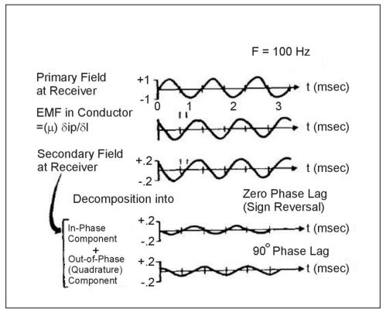
Figure 8. Generalized picture of the frequency domain EM method. (Klein and Lajoie 1980; copyright permission granted by Northwest Mining Association and Klein)
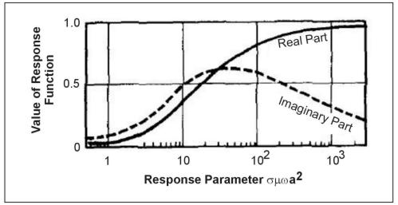
Figure 9. In-phase and out-of-phase response of a sphere in a uniform alternating magnetic field. (Klein and Lajoie 1980; copyright permission granted by Northwest Mining Association and Klein).
Figure 9 shows the response only for the particular case of a sphere in a uniform field, the response functions for other models are similar.
In frequency domain EM, the amplitude of the secondary field is affected by the depth and size of the conductor primarily. The quality of the conductor (higher conductivity means higher quality) mainly affects the ratio of in-phase to out-of-phase amplitudes (AR/AI), a good conductor having a higher ratio (left side of figure 9) and a poorer conductor having a lower ratio (right side of figure 9).
We have a large number of electrical methods, many of them are in the frequency domain electromagnetic (FDEM) category and are not often used in geotechnical and environmental problems. Most used for these problems are the so-called terrain conductivity methods, VLF (very low frequency EM method), and a case of instruments called metal detectors.

In certain cases the natural EM signals used in MT are not useful (convenient) for exploration.
For example:
- Shallow exploration (1-10 m) requires high frequency EM signals (short skin depth) that do not occur naturally.
- Survey needs to cover a large area and deploying MT instruments is not cost-effective.
- On the sea-floor, high frequency signals are screened out by the overlying ocean.
- There are problems coupling the MT instrument to the ground, or it is only possible to make– Groundwater investigations
A useful example of FDEM for groundwater studies has been given by Godio et al. (1998) in a mountainous area in north-eastern Italy. Here a number of water wells are located when information given by electrical resistivity are recorded and also the frequency domain should be around 20m and 40m coil seperation. The FDEM resistivity values were calibrated using the results of vertical electrical soundings and significant features noted along the FDEM traverses were collaborated with VLF profiles. Van Lissa et al. (1987) demonstrated the use of FDEM for mapping lateral geological changes and water bearing faults and fractures in the Nyanza Province, western Kenya. A methodology was developed that first located potential fault and fracture zones from aerial photographs and satellite images. These were then targeted with the FDEM together with resistivity profiling and vertical DC-resistivity electrical soundings. The combined use of the three geophysical techniques resulted in a success rate of over 80% for borehole locations with the depths for the boreholes determined by the geophysical method at only about half that for traditional boreholes and with yields of 140% of the traditional holes. Moreover, it was estimated that the relatively low survey costs for the geophysical methods approximated 3% of the construction costs of a borehole, and thus were more than justified by the increase in yield and success rates.
2.3.2 Applications of FDEM
- Minerals exploration
Our airborne EM system has been used for mapping host rocks containing minerals such as gold, copper, iron ore, diamonds and manganese. They can be used to identify geological faults and map geological structures such as paleo-channels. Airborne EM has been used extensively for uranium exploration.
- Detecting and mapping contaminant plumes
The lateral electrical conductivity (reciprocal of resistivity) variation in sub-surface materials are being measured by Frequency domain methods. They are useful for the lateral delineation of shallow plumes where the concentration of the contaminant in soil or groundwater is high enough to alter the natural electrical conductivity of the material to create a measureable change in conductivity when compared with background “clean” soils. Such plumes include high TDS plumes, LNAPL plumes, DNAPL plumes, leachate plumes and saltwater plumes. Frequency domain methods are especially useful where there is a large area to investigate, as an extremely large number of measurements can be made quickly and cost effectively. Spectrum commonly uses the Geonics EM-31 (near-surface) or EM-34 (depths up to 60 meters) terrain conductivity meters for frequency domain methods.

CHAPTER THREE
METHODS AND APPLICATIONS OF THE PRINCIPLES OF ELECTROMAGNETIC PROSPECTING
Electromagnetic prospecting, over the years, has proved to be a very useful technique; not only for the discovery of mineral deposits, but also for potential oil prospecting. Its applications therefore are not to be lightly spoken of, from oil exploration to communication technology. A few examples are explained herein.
3.1 Marine Controlled-Source Electromagnetic (CSEM) survey:
3.1.1 A brief history
Thorough reviews of the history of the CSEM method and its application to hydrocarbon exploration have been published by many authors (e.g., Chave et al., 1991; Edwards, 2005; Constable and Srnka, 2007; Constable, 2010), so only a short summary is provided here. The CSEM method was developed originally in the late 1970s as a tool to map the resistivity structure of the deep ocean floor, and applied successfully to this end in several surveys (Young and Cox, 1981; Constable and Cox, 1996). Throughout the 1980s and 1990s, the method evolved through surveys targeting mid-ocean ridge hydrothermal and magmatic systems (Evans et al., 1994; MacGregor et al., 1998, 2001). Even in these early studies, the importance of integrating seismic and CSEM was recognized. Seismic data were used to map the structure of the mid-ocean ridge system, with CSEM data providing complementary resistivity information used to constrain the fluid properties, primarily the saturation and/or temperature of melt or hydrothermal fluid, within the magmatic and hydrothermal systems under study (Sinha et al., 1998). Industry interest in CSEM began in the mid-1980s with theoretical work on the use of CSEM to directly map the fluid content of reservoir structures (Srnka, 1986). Although the application looked promising in theory, the economics of the survey prevented its application in practice. Throughout the 1990s however, industry interest in CSEM continued, applied as a complementary method to the mapping of sub basalt sediments and structure (MacGregor and Sinha, 2000). The first practical application of CSEM as a method of mapping resistivity within a hydrocarbon reservoir took place in late 2000 on a field offshore Angola. During the six weeks survey exercise, a full 3D CSEM survey (albeit on a relatively sparse grid) was acquired, processed, and interpreted. The results demonstrated in practice for the first time that the CSEM method could be used to map a hydrocarbon reservoir (Ellingsrud et al., 2002; Eidesmo et al., 2002). The history of the CSEM industry, born of that first survey offshore Angola, has been somewhat checkered. Early successes were followed by a dramatic rise in the number and value of companies offering CSEM surveys, and bold statements as to the utility of CSEM across the exploration industry were made. However, in 2007, there was a dramatic crash in the CSEM market. Multiple reasons for this can be mooted. First, the strong marketing and bold statements made in the early years were coupled with disappointing results where customers failed to realize value from their CSEM data, or were provided misleading results. Second, despite the marketing hype, the CSEM method was still relatively immature, in terms of acquisition and particularly interpretation. The importance of careful integration with seismic and wells was not well understood, nor were the effects of electrical anisotropy. Third, overly optimistic estimation of market size led to overcapacity. Finally, it can be argued that aggressive patent battles stifled market growth, making potential users wary of adopting the technology. However, resistivity remains a valuable attribute to include in an interpretation of rock and fluid properties, and CSEM, if acquired and interpreted carefully can provide a robust estimate of this property.
Therefore, CSEM survey has been transformed recently from a relatively obscure academic discipline to a promising new tool for remotely detecting and mapping off shore hydrocarbon reservoirs. This transformation has been driven in large part by the technical and economic challenges associated with exploration in the deep water environment. For example, seismic hydrocarbon indicators lack perfection, and deep water exploration wells are expensive; therefore, collecting additional data sets makes sense if they add information that can provide new insights and signiﬁcantly reduce risk. Early indications are that marine CSEM data may provide some risk reduction in this regard. Currently, the industry is in the process of assessing this new technology. It is fair to say that oil and gas companies, and the national licensing entities, hold views on marine CSEM varying from cautious observation, through judicious use, to enthusiastic embrace. In this paper, we view some of the history of the method and present some early examples of the technology in use. No attempt is made here to review all CSEM technology for hydrocarbon applications or to discuss on shore applications, which are receiving some renewed interest from the industry.
Controlled source electromagnetic (CSEM) techniques use the electromagnetic energy of an artiﬁcial transmitter for detecting contrasts in the subsurface electrical conductivity. The bulk conductivity of rocks is dominated by the content of pore ﬂuids, owing to the typically strong contrast between the highly resistive minerals and non-mineral substances, such as water, brine, or hydrocarbons. Even pore ﬂuid substances can exhibit conductivity contrasts which are easily detectable by CSEM methods. While saline formation water has a typical resistivity range between 0.5 and 2m, the resistivity of hydrocarbon ﬁlled rocks can be up to two orders of magnitude larger (Schlumberger, 1987). This has recently made the marine CSEM technique emerge with considerable potential of providing valuable complementary data to seismic hydrocarbon mapping. Seismic methods have a long and established history in hydrocarbon exploration, because they are proven to be very effective in mapping geological horizons with contrasting acoustic properties. CSEM methods, on the other hand, may delineate the different types of ﬂuids within the horizon. With the marine CSEM method, a deep-towed electric bipole transmitter is used to excite a low-frequency (typically 0.1–10 Hz) electromagnetic signal that is measured on the sea ﬂoor over electric and magnetic ﬁeld detectors, where larger transmitter–detector offsets can exceed 15km (MacGregor & Sinha 2000; Eidesmoetal 2002; Ellingsrudetal 2002).
In 2014, a borehole-to-surface CSEM configuration was deployed successfully across the Bockstedt oil field, whereby the current was injected via the metal casing of an abandoned production well. The set-up also allowed conventional magnetotelluric (MT) data acquisition when the transmitter is turned off at night. CSEM response functions are of good quality with high repeatability. Recordings from conventional and new borehole transmitters indicate different current distributions in the subsurface. Results of the tested source configuration are in agreement with predictions by numerical simulations. Preliminary 3D inversion is consistent with previous numeric simulations
With the current technology, typical depths of investigation range from 1 to 4 km for offshore prospects. Large-scale CSEM three-dimensional (3-D) geophysical imaging is now receiving considerable attention (Carazzoneetal, 2005). While one-dimensional (1-D) modelling is relatively easy and trial and error, 3-D forward modelling is straight forward (Hoversten et al. 2006; Weiss & Constable 2006). The need for 3-D imaging is necessary as the search for hydrocarbons now increasingly occurs in highly complex and subtle offshore geological environments. This also further emphasizes the importance of combining the information obtained by CSEM surveys with existing 3-D seismic depth migration technologies (Hoversten et al. 2000). Faster 2-D CSEM imaging has some relevance to this problem. However, because of its assumption of 2-D geology, it cannot always be relied upon for a consistent treatment of the real environment, especially when measurements are made on survey grids speciﬁcally designed for 3-D imaging experiments (Carazzone et al. 2005). In this study, we present techniques which further advance the 3-D CSEM inversion technique. Its inherently high computational requirements are a main obstacle to industrial applications. Whether ﬁnite volume, ﬁnite element, or ﬁnite difference (FD) techniques are used for simulating measurements in three dimensions, the modelling grids designed for approximating complex geology on a large scale usually become too computationally expensive for carrying out fast forward simulations.
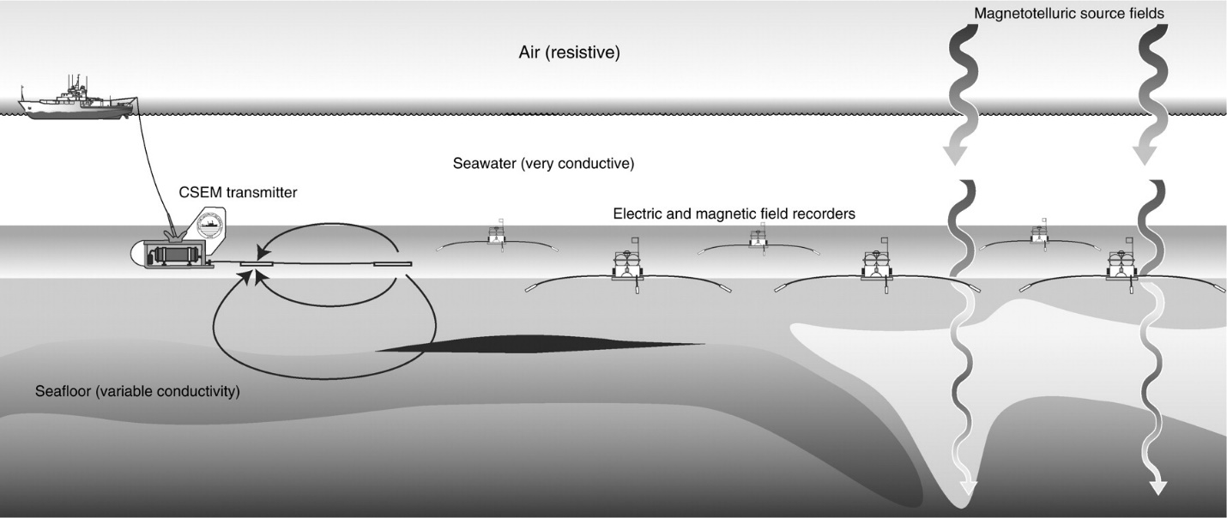
Figure10. Schematic representation of the horizontal electric dipole-dipole marine CSEM method. An electromagnetic transmitter is towed close to the sea ﬂoor to maximize the coupling of electric and magnetic ﬁelds with sea ﬂoor rocks. These ﬁelds are recorded by instruments deployed on the sea ﬂoor at some distance from the transmitter. Seaﬂoor instruments are also able to record magneto- telluric ﬁelds that have propagated downward through these a water layer
3.2. Very-Low frequency (VLF-tilt, VLF-R) Method
The VLF method uses powerful remote radio transmitters set up in different parts of the world for military communications (Klein and Lajoie, 1980). In radio communications terminology, VLF means very low frequency, about 15 to 25 kHz. Relative to frequencies generally used in geophysical exploration, these are actually very high frequencies. The radiated field from a remote VLF transmitter, propagating over a uniform or horizontally layered earth and measured on the earth's surface, consists of a vertical electric field component and a horizontal magnetic field component each perpendicular to the direction of propagation.
These radio transmitters are very powerful and induce electric currents in conductive bodies thousands of kilometers away. Under normal conditions, the fields produced are relatively uniform in the far field at a large distance (hundreds of kilometers) from the transmitters. The induced currents produce secondary magnetic fields that can be detected at the surface through deviation of the normal radiated field.
The VLF method uses relatively simple instruments and can be a useful reconnaissance tool. Potential targets include tabular conductors in a resistive host rock such as faults in limestone or igneous terrain. The depth of exploration is limited to about 60% to 70% of the skin depth of the surrounding rock or soil. Therefore, the high frequency of the VLF transmitters means that in more conductive environments, the exploration depth is quite shallow; for example, the depth of exploration might be 10 to 12 m in 25-Ωm material. Additionally, the presence of conductive overburden seriously suppresses response from basement conductors, and relatively small variations in overburden conductivity or thickness can themselves generate significant VLF anomalies. For this reason, VLF is more effective in areas where the host rock is resistive and the overburden is thin.
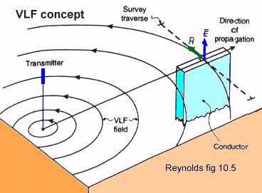
Fig. 11 Very low frequency method
3.3. Magnetotellurics Method (MT)
Magnetotellurics (MT) is an electromagnetic geophysical method for inferring the earth's subsurface electrical conductivity from measurements of natural geomagnetic and geoelectric field variation at the Earth's surface. Investigation depth ranges from 300 m below ground by recording higher frequencies down to 10,000 m or deeper with long-period soundings. Proposed in Japan in the 1940s, and France and the USSR during the early 1950s, MT is now an international academic discipline and is used in exploration surveys around the world. Commercial uses include hydrocarbon (oil and gas) exploration, geothermal exploration, carbon sequestration, mining exploration, as well as hydrocarbon and groundwater monitoring. Research applications include experimentation to further develop the MT technique, long-period deep crustal exploration, deep mantle probing, and earthquake precursor prediction research. Magnetotellurics is based on the simultaneous measurement of total electromagnetic ﬁeld, i.e. time variation of both magnetic ﬁeld B(t) and induced electric ﬁeld E(t). The electrical properties (e.g. electrical conductivity) of the underlying material can be determined from the relationship between the components of the measured electric (E) and magnetic ﬁeld (B) variations, or transfer functions: The horizontal electric (Ex and Ey) and horizontal (Bx and By) and vertical (Bz) magnetic ﬁeld components. According to the property of electromagnetic waves in the conductors, the penetration of electromagnetic wave depends on the oscillation frequency. The frequency of the electromagnetic ﬁelds development of the theory determines the depth of penetration. The basis for MT method is found by Tikhonov and Cagniard [1, 2]. In half a century since its inception, important developments in formulation, instrumentation and interpretation techniques have yielded MT as a competitive geophysical method, suitable to image broad range of geological targets.
The MT signals are generated from two sources: 1. At the lower frequencies, generally less than 1 Hz, or more than 1 cycle per second, the source of the signal is originated from the interaction of the solar wind with the earth’s magnetic ﬁeld. As solar wind emits streams of ions, it travels into space and disturbs the earth’s ambient magnetic ﬁeld and produces low-frequency electromagnetic energy that penetrates the earth (Fig. 2.1). 2. The high frequency signal is greater than 1 Hz or less than 1 cycle per second is created by world-wide thunder storm activity, usually near the equator. The energy created by these storms travels around the earth in a wave guide between the earth’s surface and the ions sphere, with part of the energy penetrates into the earth. Both of these signal sources create time-varying electromagnetic waves. Although the variations of electric and magnetic ﬁelds are small, they are measurable. Since these signals vary in strength over hours, days, weeks and even over the sunspot cycle (which is about 11 years and creates an increase in the number of solar storms). Geophysicists measuring MT for greater depths have to measure for long hours at each station in order to get good signal to ensure high-quality data. This is especially true when measurements are required for low frequencies (about0.001 Hz, or1cycleper1,000s). At these low frequencies, we need to record for 16 min(1,000 s) to get one sample of data! That means were ally need to record for several hours just to get many samples(25–50) for meaningful statistical average of the data.
Audio-magnetotelluric surveys (AMT) is a further adaptation of the MT method. It utilizes a passive, natural source predominantly resulting from equatorial lightning discharge as the signal for the MT measurement. The typical period range for an AMT survey is 0.0001 seconds to 0.1 seconds. AMT soundings image the apparent resistivity of the subsurface at shallower depths than broadband MT surveys, typically a few kilometers into the earth's crust.
The survey layout and equipment for the AMT stations is largely the same as for a MT survey. The only exceptions might be a smaller induction coils for the high-frequency magnetic measurements and shorter electrode lines, as well as more rapid data acquisition time.
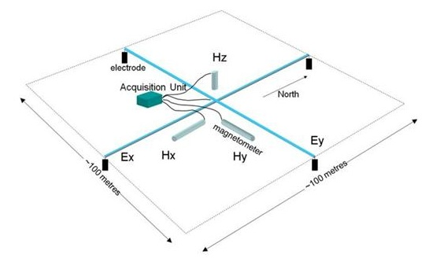
Fig. 12 Typical layout for a standard MT recording station, indicating relative electrode line and induction magnetometer positions.

CHAPTER FOUR
CASE STUDIES
4.1 Petroleum Electromagnetic Prospecting Advances and Case Studies in China
Electromagnetic (EM) techniques have contributed much to petroleum exploration in China, about which many Chinese geophysicists and geologists have ever given comprehensive description in their publications. Wei (2002) and Zhao et al. (2007) summarized and reviewed the development of EM survey techniques in terms of instrument, acquisition, processing and interpretation, numerical simulation, and application respectively. Moreover, Wang (2006) also reviewed the development of petroleum EM survey techniques in China, and pointed out that Chinese annual workload of EM acquisition is far higher than other countries. In fact, there are 14,000 magnetotelluric (MT) acquired points and some hundreds of thousands of kilometers in length each year in China. So it is easy to understand why someone said that the capital of MT is China.
Remarkable progress has been made in electromagnetic (EM) techniques as applied to the petroleum industry in instruments, data acquisition, and processing and interpretation in China. Included here is equipment, such as high-power Controlled Source EM (CSEM) acquisition systems, acquisition methods, such as the three dimensional small-bin Continuous Electromagnetic Array acquisition method, Time and Frequency Domain Controlled Source Electromagnetic, Borehole-to-surface Electromagnetic technique and marine magnetotelluric method. Data processing methods, such as fast three dimensional inversion using nonlinear conjugate gradients, and data interpretation methods, like Induced Polarization and Resistivity anomalies for hydrocarbon detection, are also included. These new techniques have been applied in petroleum survey and many cases are in complicated areas. They have successfully served the investigation of deep igneous rock reservoirs, and prediction of potential hydrocarbon targets. The cases indicate that electromagnetic techniques can help seismic survey to effectively detect hydrocarbon reservoir and remarkably improve drilling successes. MT was studied in 1970’s and a book titled “Magnetotellurics Sounding” was complied by three MT groups, including MT group of Institute of geology, CEA; Electric method group for petroleum of Geology College of Wuhan, and Electric method group of BGP, CNPC. MT was firstly used for hydrocarbon exploration in 1980’s in China (Yu and Ji 2002).
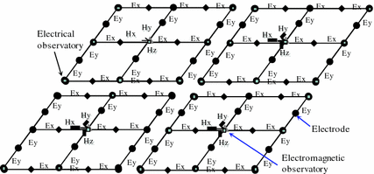
Figure 13 is the configuration of 3D small-bin CEMP acquisition. The electrodes (M, N) are deployed end to end in form of closed circuit with array of 2 × 2, or 3 × 3… or 5 × 5 (2 × 2:2 channel × 2 channel, 4 receiver sites). The receivers are synchronously controlled by GPS. The size of small-bin depends on the number of receivers and actual topography. When the receiver number is small and topography is poor, the array of a small-bin may be 2 × 2, i.e., four electric receivers and one magnetic receiver (as Fig. 1). Since electric responses are recorded synchronously, electric fields can be re-adjusted according as the principle of closed circuit in the processing indoor. 3D static corrections can be done at space domain simultaneously for all the recorded data of the same small-bin in time domain. Magnetic responses can be processed in the same way. The acquisition presents better anti-noise than CEMP,
thereby significantly improving the quality of acquired data (He et al. 2009).
The method is mainly used in complicated areas where seismic exploration is difficult to be conducted. It can provide guiding for seismic survey design, and provides the information about deep structures, thus target areas can be reduced and risk be decreased for seismic survey. The method has been applied in the western China, where the terrain presents complicated mountainous terrain, and in the southern China, where the ground is covered with carbonate rocks. The survey lines are in total several thousands of kilometers in length. Close attention has been paid to this method by oilfield companies (He et al. 2009).
4.2 Case studies of electrical and electromagnetic methods applied to mapping active faults beneath the thick quaternary
It is of considerable importance to explore the geological structure around active faults, especially near-surface unconsolidated layers, to estimate the faults' activity. There are numerous case studies to investigate active faults using geophysical exploration methods; however, only a few cases have been verified in detail by comparison with other geological information. We have applied electric and electromagnetic methods, which can be effective for exploring to several hundred meters depth, to reveal geological structures covered by thick Quaternary formations at four active fault sites in Japan. In this paper, we used the controlled source audio-frequency magnetotelluric (CSAMT) method, the direct current (dc) resistivity method, and the resistivity tomography method. The resistivity profiles were analyzed by two-dimensional inversion techniques, and the resulting models were verified by comparison with geological evidence obtained by drilling or trenching. Our results are as follows. (1) CSAMT is an effective method for defining an outline of geological structures around a fault to several hundred meters deep. It enables us to define a resistivity boundary between different kinds of bedrock with a fault contact. (2) The dc resistivity method distinguishes each sedimentary unit as a different resistivity zone and detects the vertical displacement in the Quaternary formations. (3) The resistivity tomography method is useful to determine in more detail the flexure structure produced by faulting. Using these latter two methods, we can select drilling positions and trenching locations. In addition, it is verified from the data measured along trench walls and electrical logging that the resistivity of soft sedimentary layers and clayey cataclastic bedrock conforms to the relationship established between the resistivity and the clay content. These resistivity methods have the advantages of detecting clayey layers as very low resistivity zones. The overall conclusion is that the combination of these resistivity methods provides us with more detailed and accurate information for estimating fault activity.
4.3 Very-low-frequency electromagnetic (VLF-EM) measurements in the Schirmacheroasen area, East Antarctica
To assess the feasibility of the very-low-frequency electromagnetic (VLF-EM) method in the Schirmacheroasen area of East Antarctica, and to investigate its response, VLF-EM measurements were performed along four traverses. The preliminary results reveal the locations of geological boundaries and shear zones/faults, which may indicate that VLF anomalies are due to shear zones or alteration zones located along contacts between different rock types. The strength of the VLF anomaly decreases over the polar ice cap. The inphase component of the VLF anomaly, when processed and interpreted with an analytic signal approach, yields a depth range of 15–30 m, whereas Fraser and Hjelt filter analyses yield a depth range of 25–60 m. The VLF-EM responses along all four traverses, along with their interpretations, are presented here as a case study.
Conclusion
Electromagnetic prospecting has proven to be one of the best methods for subsurface studies, prospecting for ore body and also for oil and gas prospecting and also it is cheap and affordable.

References
Al, E. P. (2013 ). Helicopter time-domain electromagnetics - Newmont and the NEWTEM experience. Geophysics, W45-W56.
Ambronn, R. (1928). Elements Of Geophysics. New York: McGraw Hill Book Company.
Arcone, S. A., Lawson, D. E., Delaney, A. J., Strasser, J. C. and Strasser, J. D. (1998). Groundpenetrating radar reflection profiling of groundwater and bedrock in an area of discontinuous permafrost: . Geophysics , 1573-1584. .
Balch, S. J., W. P. Boyko, N. R. Paterson. (2003). The AeroTEM airborne electromagnetic system. The Leading Edge , 562-566.
Bleil , D. F. (1953). induced polarizasion; a method of geophysical prospecting . Geophysics , 636-661.
Cagniard, L. (1953). Basic theory of the magneto-telluric method of geophysical prospecting. Geophysics , 18: 605–635.
Cai Y, Z. B. (2006). Application of some electrical meters in geology investigation. Geol Prospect (Chin) , 42(5):71–78.
Chen X, Z. G. (2004). Processing and interpretation system of MT data with visualization based on windows. Oil Geophys Prospect (Chin) 39(suppl), 11–16.
Cheng D, W. J. (2004). Development in the research of HSSMT instrument. Prog Geophys (Chin), 19(4):777–781.
Contaminant Plume Delineation. (2017, june 15). Retrieved from spectrum geophysics ; revealing the subsurface: https://spectrum-geophysics.com/plume.html
Deng M, W. W. (2003). Receivers for seafloor magnetotelluric dat. Chin J Geophys , 46(2):217–223.
Djadkov, P. G. (2005). Magnetometry of Tartas-1 and Preobrajhenka-6 in Barabinsk forest-steppe. . Problems of Archeology, Ethnography, Anthropology of Siberia and Adjacent Territories XI , 304-309.
Emofurieta, A. a. (1991). VLF anomalies at contacts between Precambrian rocks in south-western Nigeria. Geoexploration, 55-65.
FX, B. (1986). Electromagnetic array profiling (EMAP). 56th SEG Annual meeting expanded technical program abstracts with biographies, 60–61.
GeoExplo. (1976, February 10). Retrieved from Electro-Magnetic Airborne Surveys: http://www.geoexplo.com/airborne_survey_workshop_EM.html
Heliborne Time-Domain EM (GPRTEM). (2017, june 15). Retrieved from Geophysics GPR International Inc.: http://airborne.geophysicsgpr.com/en/techniques/electromagnetic-tdem-and-vlf/heliborne-time-domain-em-gprtem/
Jones, C. a. (2014, may 5). openEi. Retrieved from Exploration Technique: Audio-Magnetotellurics: http://en.openei.org/wiki/Audio-Magnetotellurics
Khan, S., & Jacobson, S. (2008). "Remote Sensing and Geochemistry for Detecting Hydrocarbon Microseepages". Geological Society of America Bulletin. , 120: 96–105.
Marescot, D. L. electromagnetic surveying . Zurich: Swiss federal institute of technology. mindat.org. (2017, June 15). Retrieved from Hudson Institute of Mineralogy: https://www.mindat.org/glossary/electromagnetic_prospecting
Wightman, W. E. (2003). Application of Geophysical Methods to Highway Related Problems. Federal Highway Administration, Central Federal Lands Highway Division , FHWA-IF-04-021.
Wightman, W. E., Jalinoos, F., Sirles, P., and Hanna, K. (2003). Application of Geophysical Methods to Highway Related Problems. califonia: Lakewood, CO, Publication.
Wold, B. a. (1963). Depth to magnetic basement in west Antarctica. J. Geophys. Res, 1145-1153.
Yuji Kanaori, K. T. (2000). Developments in Geotechnical Engineering. ELSEVIER, 29-45.
Zhdanov, M. S. (2010). Electromagnetic Geophysics. Geophysics , 49-50.
Zonge international. (2017, June 15). Retrieved from Frequency-Domain EM Induction: http://zonge.com/geophysical-methods/electrical-em/frequency-domain-em/

