ISOLATION AND IDENTIFICATION OF MICROALGAE FROM GODFREY OKOYE UNIVERSITY FISH POND

BY

ONU, MAURICE CHIDIEBERE
U15/NAS/MCB/088

A RESEARCH PROJECT SUBMITTED TO THE DEPARTMENT
OF MICROBIOLOGY, FACULTY OF NATURAL AND APPLIED
SCIENCE
GODFREY OKOYE UNIVERSITY UGWUOMU NIKE
ENUGU STATE

IN PARTIAL FULFILMENT OF THE REQUIREMENT FOR THE
AWARD OF BACHELOR OF SCIENCE (B.Sc.) DEGREE IN
MICROBIOLOGY
SUPERVISED
BY

MRS. OZOKONKWO, ONYINYE

JULY, 2018

APPROVAL PAGE
This project has been presented to and approved by Godfrey Okoye University, Enugu, in partial fulfillment of the requirement for the award of Bachelor of Science (B.Sc.), degree in Microbiology from the Department of Microbiology.

----------------------- --------------------
ONU, MAURICE C. Date

--------------------------- ------------------
Mrs. Ozokonkwo, Onyinye Date
Project Supervisor

---------------------------------- --------------------
Dr. (Mrs.) Marian N. Unachukwu Date
Head of Department

DEDICATION
I dedicate this project to God Almighty my creator, my strong pillar, my source of inspiration, wisdom, knowledge and understanding. He has been the source of my strength throughout this program and on His wings only have I soared. I also dedicate this work to the family of late Daniel Onu, who has encouraged me all the way and whose encouragement has made sure that I give it all it takes to finish that which I have started. God bless you all.

ACKNOWLEDGEMENT
I would like to express my deepest appreciation to all those who provided me the possibility to complete this project work. A special gratitude I give to my supervisor, MRS. OZOKONKWO, ONYINYE, whose contribution in stimulating suggestions and encouragement, helped me to coordinate my project especially in writing this report.
Furthermore I would also like to acknowledge with much appreciation the crucial role of the
HOD of Microbiology Department, who gave the permission to use all required equipment and the necessary materials to complete the task.

ABSTRACT
Chlorella vulgaris is an edible microalgae and a highly notorious potential feed resource for many agriculturally important animal species. Chlorella vulgaris intake has also been linked to improvements in animal health and welfare. Its influence over animal development stems from its nutritive and protein-rich composition, thus leading to an increased commercial production to meet consumer demand. The aim of this work is to isolate and identify microalgae used in poultry farming and objectives of this research work is to determine the growth condition of microalgae and harvest microalgae used in poultry farming. Centrifugation of the sample to concentration the algal cells and plating using pour plate method was done. One percent agar-agar BG-11 medium was used for the algae isolation. Antibiotic added to avoid bacterial growth. Microscopic identification of the isolates based on cell morphology and colonial characteristics was carried out. The isolate was cultivated in a sterile BG-11 medium in presence of light and carbon dioxide and BG-11 medium as source of nutrient. Harvesting of chlorella vulgaris involves filtration, centrifugation and drying using hot oven at appropriate temperature. This study was able to isolate and identify the microalgae of interest, which can later be used in poultry farming in future study.

TABLE OF CONTENT
Title page----------------------------------------------------------------------------------------------i
Approval page ----------------------------------------------------------------------------------------ii
Dedication --------------------------------------------------------------------------------------------iii
Acknowledgement ----------------------------------------------------------------------------------iv
Abstract -----------------------------------------------------------------------------------------------v
Table of contents ------------------------------------------------------------------------------------v-vi
List of tables ------------------------------------------------------------------------------------------vii
List of figures ----------------------------------------------------------------------------------------viii
CHAPTER ONE
1.0 Introduction-------------------------------------------------------------------------------------- 1 -2
1.1 Aim ------------------------------------------------------------------------------------------------ 3
1.2 Objectives ----------------------------------------------------------------------------------------- 3
CHAPTER TWO
2.0 Literature review ------------------------------------------------------------------------------------4
2.1Poultry farming --------------------------------------------------------------------------------------4
2.2 Types of poultry farming --------------------------------------------------------------------------4
2.3 Microalgae -------------------------------------------------------------------------------------------7
2.4 Characteristics of microalgae ---------------------------------------------------------------------7
2.5 Classification of microalgae -----------------------------------------------------------------------8
2.6 Major class and genera of microalgae ------------------------------------------------------------12
2.7 Fresh water microalgae -----------------------------------------------------------------------------13
2.8 Chlorella vulgaris -----------------------------------------------------------------------------------14
2.9 Nutritional values of chlorella vulgaris -----------------------------------------------------------16
2.10 Animal feed -----------------------------------------------------------------------------------------19
2.11 Method for cultivation of algae ----------------------------------------------------------------- 20
2.12 Advantage of microalgae over convention feeds -------------------------------------------- 21
2.13 Disadvantages of microalgae over conventional feeds --------------------------------------22
CHAPTER THREE
3.0 Materials and Methodology ----------------------------------------------------------------------23
3.1 Microscopic identification of the isolate -------------------------------------------------------24
3.2 Experimental set-up for the growth of the isolate ------------------------------------------------24
3.3 Analytical procedures ---------------------------------------------------------------------------------24
CHAPTER FOUR
4.0 Result ----------------------------------------------------------------------------------------------------26
CHAPTER FIVE
5.0 Discussion ----------------------------------------------------------------------------------------------30
5.1 Conclusion --------------------------------------------------------------------------------------------31
5.2 Reference -----------------------------------------------------------------------------------------------32
5.3 Appendix---------------------------------------------------------------------------------------------- 34
5.4 Appendix1: Microalgae (Chlorella vulgaris) grown in BG-11 medium in presence of
light and Carbon dioxide---------------------------------------------------------------------------------34
5.5 Appendix 2: Chlorella vulgaris analysis using Microscope-------------------------------------35
5.6 Appendix 3: Isolate (Chlorella vulgaris) inoculated in test tube containing BG-11---------36

LIST OF TABLES
1: Algae species used in poultry farming ----------------------------------------------- 13
2: Comparison between chlorella and different vegetables (per 100g) -------------19
3: Nutrient composition of conventional feedstuffs and various algae--------------20
4: Microscopic morphological features of Chlorella vulgaris--------------------------27
5: Chlorella vulgaris cell count--------------------------------------------------------------28
6. Determination of cell concentration ------------------------------------------------ 29

LIST OF FIGURES
1: Microscopic image of chlorella vulgaris-------------------------------------------------------------26

CHAPTER ONE
1.0 INTRODUCTION
Microalgae are microscopic, typically found in soil, marshes, freshwater, brackish water, seawater and thermal springs, living in both the water Colum and sediment. They are unicellular species which exist individually, or in chains or groups. Depending on the species, their sizes can range from a few micrometers (µm) to a few hundred micrometers. Unlike higher plants, microalgae do not have roots, stems, or leaves. They are specially adapted to an environment dominated by viscous forces. Algae are typically classified as green, brown and red algae. Some microalgae which are used as poultry feed include Athrospira maxima, Chlorella vulgaris, Athrospira platensis, Porphridium cruentum, Schizochytrium sp, Hizikia fusiforme, Undaria sp, Gracilaria sp, kappapaphycus sp Laminaria sp. The increasing demand for human protein food sources has resulted in a need for new feed materials which provide a safe source of nutrients for poultry and livestock. Several feeding experiments have demonstrated that microalgae of different species can be successfully included into poultry diets, for example as a defatted biomass byproduct from biofuel production, and can have a beneﬁcial inﬂuence on birds’ health, performance, and the quality of meat and eggs. Especially important for the poultry industry are recent studies where microalgae biomass was efficiently used in the production of eggs containing health-promoting lipids, i.e. eggs enriched with health promoting long-chain n-3 polyunsaturated fatty acids (LCPUFAs n-3).
The traditional method of enriching eggs with LCPUFAs n-3 is to incorporate linseed or ﬁsh oil

into the layer diet; however, this latter method is limited by the high demand for marine products and the risk of their contamination with heavy metals (Wu et al., 2012).
The identification of new feed resources is therefore crucial for sustainable animal production and future viability. Ideally, the new feed resource should have high nutritive value and conversion efficiency, be able to optimize animal product quality and use land and water efficiently (Poppi and McLennan, 2010). Consequently, chlorella vuigaris is emerging as a potential candidate to meet these criteria.

1.1 AIM
1. To isolate and identify microalgae used in poultry farming.

1.2 OBJECTIVES
- To identify microalgae used in poultry farming
- To grow algae used in poultry farming
- To harvest microalgae used in poultry farming.

3
CHAPTER TWO
2.0 LITERATURE REVIEW
2.1 POULTRY FARMING
Poultry farming is the process of raising domesticated birds such as chickens, ducks, turkeys and geese for the purpose of meat or egg for food. Poultry are farmed in greater numbers with chickens being the most numerous. More than 50 million chickens are being raised every year as a source of food, both their meat and their eggs. The chickens which are raised for eggs are called layers, and the chickens which are raised for their meat production are called broilers.
2.2 TYPES OF POULTRY FARMING
Layer poultry farming: The poultry birds which are raised for egg production are called layer poultry. Commercial hen generally starts laying eggs at the age of 12-20 weeks. They start laying eggs regularly at their 25 weeks of age. After 70-72 weeks of age egg production of layer poultry get reduced. For commerciallayer poultry farming, producers generally keep the hens for 12 months from their first laying period. And then sell them for slaughter purpose. For commercial egg laying poultry farming systems, the environmental conditions are often automatically controlled by the producers. Presence of light helps the bird for laying eggs earlier.
Free Range Farming: Free range poultry farming means providing free roaming facilities to the poultry birds for a certain period of a day. Although they are kept inside the house at night to
keep them free from predators and adverse weather. In free range farming method the poultry
4
birds generally roam freely throughout the whole day. This means they spend half of their lives
outside the house. Free range poultry farming system use a suitable land which has the facilities of adequate drainage system, good ventilation, appropriate protection from prevailing winds, and good protection from all types of predators and free from excessive cold, heat or dampness. Excessive cold, heat and damp is very harmful for poultry birds and reduce their productivity. This system also requires less feed than cage and barn systems. The poultry manure from free range farming is used as fertilizer for crops directly. Although free range farming method is very suitable for poultry birds but it has some difficulties too. In this system the poultry birds can be victim of predators easily and may catch various types of diseases.
Organic: Organic layer poultry rearing system is also one type of free range farming system. But the main differences between the two systems are; in free range farming method a large number of poultry birds are raised together but in organic method a certain species of poultry bird are raised in small group with low stocking density. Organic laying system has some restrictions in the routine use of synthetic yolk colorants, water, feed, medications, other feed additives and obviously a smaller group size with low stocking density. In organic laying system the producer keeps highest 1000 poultry birds per hector and maximum 2000 birds in each house.
Yarding Method: Yarding poultry farming method is such a method in which cows and chickens are raised together. The farmer makes a fence in his yard and keeps all the poultry birds and cattle there together. The birds and cattle have the freedom of movement inside the fence. It is a very popular system used by small farmer.
Battery Cage Method: Battery cage layer poultry rearing method is one of the very common methods used in many countries. In this system usually small sized metal cages are used. Every cage can accommodate about 3 to 8 hens. The walls of the cages are generally made of mesh or solid metal and the floor is made of sloped wire mesh which allows the faeces to drop down. When the hens lay eggs, then all the eggs gather in the egg collecting conveyor belt of the cage. In this system food is provided in front of the hens by a long bisected metal or plastic pipe and water served to them by using overhead nipple systems. The cages are arranged in long rows in one above another system. There may be several floors in a single shade which can keep many, even thousands of hens together.
Furnished Cage Method: Furnished cage method is a developed version of battery cage system. In this system the hens get more spaces and facilities than battery cage system. A furnished cage for hens contain sufficient space for walk, perch, flap their wings, nest, special feed and water pot etc
Broiler Poultry Farming: The poultry birds which are raised for commercial meat production are called broiler poultry. By usingmodern farming methods, broiler chickens become suitable for consumption within their 5 to 6 weeks of age.
Indoor Raising Methods: In this method broilers are kept inside a house. Rice hulls, wood shavings, peanut shells etc. are used as litter in the floor of the house. In this system the broilers are kept in a large and open house (known as grow out houses) and they become suitable for consumption within their 5 to 6 weeks of age. These types of poultry houses are well equipped with mechanical systems for delivering the feed and water to the poultry birds. Well ventilation system, coolers and heaters are must. It is very important to keep the house always dry and clean. Generally a house of 400 feet long and 40 feet wide can accommodate about 20,000 birds. One-half square feet space is required per bird.

2.3 MICROALGAE
Microalgae are small-sized organisms found in both fresh and saline waters, in both benthic and littoral habitats, and also throughout the ocean waters as phytoplankton, while the larger macroalgae (seaweeds) occupy the littoral zone (Hasan et al., 2009; Gamal, 2012). Microalgae are unicellular to filamentous in form. They lack roots, vascular systems, leaves and stems, and are autotrophic and photosynthetic. Microalgae are generally eukaryotic organisms, although cyanobacteria, such as Spirulina, which are prokaryotes, are included under microalgae due to their photosynthetic and reproductive properties (Ravishankar et al., 2012). Microalgae range in size from about 5 µm (Chlorella) to more than 100 µm (Spirulina) (Becker et al., 2013). The commercial cultivation of microalgae began in Japan with the cultivation of Chlorella in the 1960s, followed by the cultivation of Spirulina in Mexico and the USA in the 1970s. Since then, the industrial biotechnology of microalgae has grown tremendously. The immense chemical diversity of microalgae provides numerous applications in the food, feed and pharmaceutical industries. Microalgae are cultivated for the production of whole biomass and valuable substances such as nutraceuticals, carotenoids, phycocyanin and poly-unsaturated fatty acids (PUFAs), which are utilized in the food and feed (notably aquaculture) industry. The production of biofuel from lipid- or carbohydrates-rich microalgae is under way (Ravishankar et al., 2012).
2.4 CHARACTERISTICS OF MICROALGAE
The chemical composition of microalgae is not an intrinsic constant factor but varies over a wide range, both depending on species and on cultivation conditions. Some microalgae have the capacity to acclimate to changes in environmental conditions by altering their chemical composition in response to environmental variability. A particularly dramatic example is their ability to replace phospholipids with non-phosphorus membrane lipids in P-depleted environments. It is possible to accumulate the desired products in microalgae to a large extent by changing environmental factors, like temperature, illumination, pH, Carbon dioxide supply, salt and nutrients. Microphytes also produce chemical signals which contribute to prey selection, defense, and avoidance. These chemical signals affect large scale tropic structures such as algal blooms but propagate by simple diffusion and laminar adjective flow. Microalgae such as Microphytes constitute the basic foodstuff for numerous aquaculture species. Photosynthetic and chemosynthetic microbes can also form symbiotic relationships with host organisms. They provide them with vitamins and polyunsaturated fatty acids, necessary for the growth of the bivalves which are unable to synthesize it themselves. In addition, because the cells grow in aqueous suspension, they have more efficient access to water, carbon dioxide, and other nutrients. Microalgae play a major role in nutrient cycling and fixing inorganic carbon into organic molecules.
2.5 PHYLOGENETIC CLASSFICATION
The classification of algae is complex and somewhat controversial, especially concerning the blue-green (cyanobacteria) which are sometimes known as blue-green bacteria or cynophyta (cyanobacteria) and sometimes included in the Chorophyta. Veriag et al. (1993) in his book “algae” (Hoek et al., 1995) in their book “algae: An introduction of phycology” compiled the different phylogenetic classification of algae considering observations on ultra-structural studies and molecular genetics. The broad outline of classification of algae is as follows
1 Kingdom – Eubacteria
Division 1 – Cynophyta (cyanobacteria)
Division 2 –Prochylorophyta (chloroxybacteria)
2 Kingdom – Eukaryota
Division 1 – Glaucophyta
Class 1 – Glaucophyceae
Division 2 – Rhodophyta
Class 1 – Bangiophyceae
Class 2 – Florideophyceae
Division 3 – Heterokontophyta
Class 1 – Chrysophyceae
Class 2 – Parmophyceae
Class 3 – Saracinochrysidophyceae
Class 4 – Xanthophyceae
Class 5 – Eustigmatophyceae
Class 6 – Bacillariophyceae
Class 7 – Raphidophyceae
Class 8 – Dictyochophyceae
Class 9 – Phaeophyceae
Division 4- Haptophyta
Class 1 – Haptophyceae
Division 5 – Cryptophyta
Class 1 – Cryptophyceae
Division 6 – Dinophyta
Class 1 – Dinophyceae
Division 7 – Euglenophyta
Class 1 – Euglenophyceae
Division 8 – Chlorarachniophyta
Class 1 – Chlorarachniophyceae
Division 9 – Chlorophyta
Class 1 –Prasinophyceae
Class 2 – Chlorophyceae
Class 3 – Ulvophyceae
Class 4 – Cladophorophyceae
Class 5 – Bryopsidophyceae
Class 6 – Zygnematophyceae
Class 7 – Trentipohiliophyceae
Class 8 – klebsormidiophyceae
Class 9 –Charophyceae

2.6 MAJOR CLASSES AND GENERA OF MICRO-ALGAE
Table 1: Algal species used in poultry farming
Class Genus
Chryptophyceae Cryptomonas
Rhodomonas salina
Chroomonas salina
Eustigmatophyceae Nannochloropsis sp.
Xanthophyceae Olisthodiscus luteus
Cyanophyceae Arthrospira platensis
Chlorophyceae Tetraselmis suecica
Chlorella sp.
Scenedesmus obliquus
Dunaliella tertiolecta
Chlamydomonas khaki
Chlorococcum sp.
(Becker et al., 2013)

2.7 FRESHWATER ALGAE
Freshwater algae include a wide range of organisms that float in the water or grow on submerged surfaces and have the ability to photosynthesize (using sunlight energy), CO₂ and water to manufacture organic matter and O₂.
Freshwater algae are made up of:
  - The green and red algae (plant kingdom) multicellular
  - The bacteria blue (blue- green algae)
  - Protozoa (single- celled swimming groups)
  - Chromista e.g. diatom.
Green algae: This has 7500 species which form one of the largest group of algae. These algae contain chlorophyll (Like in plants) and a large amount of proteins. In addition, under stress condition they produce starch and oil that are stored inside the cell. Green algae exist as unicellular or multicellular species. Chlorella is a well-known single celled species, which also is grown commercially.
Red algae are a group of 5000 mostly multicellular marine species, living in the tidal zone of the sea.
Diatom has more than 100,000 species; this group of unicellular algae produces most of the biomass on earth. They are indispensable food source for the zooplankton in freshwater and seawater. These algae have a particularly attractive skeleton of silica that fits together like two halves of a sphere. Diatoms produce mainly oil that is stored in the cell. By varying the amount of oil they can regulate their buoyancy.
Brown algae: Virtually all 1500 to 2000 species are multicellular algae existing almost exclusively in the sea. Brown algae like kelp are often found on the beach, and are therefore regarded by many people as the traditional seaweed.
Gold algae: This group of 1000 species of beautifully coloured unicellular algae exists mainly in fresh water, but also a number of marine species are known. They possess flagella that are used for displacement.
Yellow-green algae: They are close relatives of the brown algae, but most of the approximately 600 species are unicellular and live in fresh water. Nannochloropsis is an exception as this fast-growing species is found in the sea. These algae produce large amounts of oil as a food reserve and are therefore highly suitable for the production of biodiesel.
Blue algae or cyanobacteria: Notorious algae that can produce toxins and, in situations of high concentrations, can seriously affect the water quality. Blue algae store food reserves in the form of starch, while the cell can consist for more than half out of protein.
2.8 CHLORELLA VULGARIS
One of the most remarkable is the green eukaryotic microalga C. vulgaris, which belongs to the following scientiﬁc classiﬁcation:
Domain: Eukaryota
Kingdom: Protista
Divison: Chlorophyta
Class: Trebouxiophyceae
Order: Chlorellales
Family: Chlorellaceae
Genus: Chlorella
Specie: Chlorella vulgaris
Martinus Willem Beijerinck, a Dutch researcher, ﬁrst discovered it in 1890 as the ﬁrst microalga with a well-deﬁned nucleus (Beijerinck et al., 1890). The name Chlorella comes from the Greek word chloros (Χλωρός), which means green, and the Latin sufﬁx “ella” referring to its microscopic size. It is a unicellular microalga that grows in fresh water and has been present on earth since the pre-Cambrian period 2.5 billion years ago and since then its genetic integrity has remained constant (Von-Ditfurth et al., 1972). By the early 1900s, Chlorella protein content (455% dry weight) attracted the attention of German scientists as an unconventional food source. In the 1950s, the Carnegie Institution of Washington (Burlew et al., 1953) took over the study and managed to grow this microalga on a large scale for CO₂ abatement. Japan is the world leader in consuming Chlorella and uses it for medical treatment (Kitada et al., 2009) because it showed to have immune-modulating and anti-cancer properties (Justo et al., 2001). Chlorella, a unicellular, freshwater green microalgae used mainly for human food and poultry feed, has been studied in several animal experiments as a potential source of high quality protein (approximately 60%), essential amino acids, vitamins, minerals, and antioxidants. Chlorella biomass is a very good source of carotenoids, as it contains 1.2-1.3% of total pigments in dry mass (Batista et al., 2013). Due to the content of many bioactive substances, even a low, economically acceptable dietary level of Chlorella biomass may beneﬁcially affect animal performance. A very early study with chickens (Combs et al., 1952) demonstrated that dried Chlorella, included into the diet at 10% could serve as a rich source of certain nutrients, i.e. carotene, riboﬂavin and vitamin B12, and increased performance in birds when the diet was deﬁcient in these nutrients. Grau and Klein, (1957) reported that Chlorella biomass grown in sewage was a rich source of protein and xanthophyll pigments, and levels up to 20% in the diet was well tolerated by chicks. Similarly, Lipstein and Hurwitz, (1983) found that Chlorella was a suitable protein supplement in broiler diets and, used at 5 or 10% dietary level, had no adverse effect on growth performance. Kang et al. (2013) studied the effects of the replacement of antibiotic growth promoter with different forms of Chlorella on performance, immune indices and the intestinal microﬂoral population. They found that Chlorella in its fresh liquid form included at a 1% dietary level beneﬁcial affected broiler growth weight, some immune characteristics (e.g. number of white blood cells and lymphocytes, plasma IgA, IgM, and IgG concentrations) and the intestinal production of Lactobacillus bacteria. Such an effect of dietary Chlorella appears to be based on multiple components, and the ﬁbre fraction, among others including a polysaccharide named immurella, glycoprotein, and peptides contained in Chlorella, stimulate the immune response of birds (Kang et al., 2013). Likewise, Kotrbacek et al. (1994) found that broilers fed a diet with 0.5% Chlorella signiﬁcantly increased the phagocytic activity of leucocytes and lymphatic tissue development.
2.9 NUTRITIONAL VALUES OF CHLORELLA VULGARIS
Chlorella vulgaris is rich in amino acids, complex carbohydrates, vitamins, minerals, fat (85% unsaturated fats), RNA (up to 10%), DNA (up to 3%), chlorophyll, an array of phytonutrients and carotenoids, enzymes (including pepsin for digestion), polysaccharides.
It is known to have the highest amount of chlorophyll compound to all other green algae and plants. The chlorophyll content in Chlorella can reach as high as 7% of its total weight and it contain 5-10 times more chlorophyll than Spirulina, and 10 times more than Alfafa. Due to its high chlorophyll content, it is also known as Supreme Whole Food concentrate. It is a complete protein where it contains all eight essential amino acids needed by the body with other non- essential amino acids. It is known to contain the full spectrum of B-complex vitamins where it contains twice the amount of folic acid compared to raw beef liver, and more vitamin B12 (normally lacking in vegetarians) than raw beef liver. It is one of the richest source of vitamin B3 (niacin) and rich in vitamin A that acts as an antioxidant to scavenge the free radicals in the human body in other to prevent cancer and slow down the ageing process. Chlorella has one of the highest amounts of beta-carotene among all green products.

TABLE 2: COMPARISON BETWEEN CHLORELLA AND DIFFERENT VEGETABLES (per 100g)
Chlorella spinach (raw) Pumpkin (raw)
Moisture (g) 4.2 90.4 88.9
Protein (g) 63.1 3.3 1.3
Fat (g) 11.3 0.2 0.1
Sugar (g) 0.3 3.6 7.9
Iron (mg) 52.7 3.7 0.4
Calcium (mg) 94 55 17
Potassium (mg) 1360 740 330
Phosphorus (mg) 1680 60 35
Sodium (mg) 50 21 1
Carotene (mg) 110 3.1 0.62
Vitamin B1 (mg) 2.32 0.13 0.07
Vitamin B2 (mg) 5.02 0.23 0.06
Vitamin C (mg) 70 65 15
(Lee et al., 1987).

2.11 ANIMAL FEED
It is estimated that about 30% of microalgal production is sold for animal feed purposes (Becker et al., 2007) due to the increasing demand for food with natural composition instead of synthesised ingredients. This has triggered intensive research into ﬁnding natural ingredients that improve the quality of animal food products (Fernandes et al., 2012).
TABLE 3: NUTRIENT COMPOSITION OF CONVENTIONAL FEEDSTUFFS AND VARIOUS ALGAE (% DRY MATTER)
Source Crude protein Carbohydrate Lipids
Soybean 37 30 20
Corn 10 85 4
Wheat 14 84 2
Anabaena cylindrical 43-56 25-30 4-7
Arthrospira platensis 60-71 13-16 6-7
chlorella vulgaris 51-58 12-17 14-22
Spirogyra sp. 6-20 33-64 11-21
synechococcus sp. 73 15 11
(Lum et al., 2013)

2.12 METHODS FOR CULTIVATION OF ALGAL
Open pond systems
Open ponds are the most common way of production and are the cheapest method for large-scale biomass production. These systems are categorised into natural waters (lakes, lagoons and ponds) or wastewater or artiﬁcial ponds or containers. They are usually built next to power plants or heavy industry with massive carbon dioxide discharge where the biomass absorbs nitrogen from the atmosphere in the form of NO₂. In order to allow easy exposure of all the cells to sunlight, especially at the end of the exponential growth phase, the optimal pond depth is 15–50 cm (Brennan et al., 2010). On the other hand, open pond systems have some limitations because they require a strict environmental control to avoid the risk of pollution, water evaporation, contaminants, invading bacteria and the risk of growth of other algae species. In addition, temperature differences due to seasonal change cannot be controlled and CO₂ concentration and excess exposure to sunlight are difﬁcult to manage. Moreover, near the end of the exponential growth phase, some cells are not sufﬁciently exposed to sunlight because other cells ﬂoating near the surface cover them, leading to lower mass yields. Therefore, stirring of the medium is preferable and is currently practiced.
Closed photo-bioreactor
This technology was implemented mainly to overcome some limiting factors in the open pond systems, thus growing the biomass in a managed environment (pH, light intensity, temperature, and carbon dioxide concentration) to obtain higher cell concentration as well as products that are
more suitable for the production of pure pharmaceuticals, nutraceuticals and cosmetics. In
addition, these systems are more appropriate for sensitive strains that cannot compete and grow in harsh environment. Feeding the biomass with CO₂ comes by bubbling the tubes. Fluorescent lights are used in case the tubes are not or not sufﬁciently exposed to sunlight. The tubes are generally 20 cm or less in diameter (Chisti et al., 2007) and the thickness of their transparent walls is few millimetres, allowing appropriate light absorption. Hence, multiple designs have been used and tested. Fat-plate photobioreactor (Zhang et al., 2001), tubular photo-bioreactor (Molina et al., 2003) and column photo-bioreactor (Kojima et al., 1999). (Degen et al., 2001) achieved 0.11 g L-1 h-1 dry biomass productivity after growing the cells of C. vulgaris in a ﬂat panel airlift photobioreactor under continuous illumination (980μEm2 s1). Nonetheless, the main disadvantages of a closed system are the cost of the sophisticated construction, small illumination area and sterilising costs (Lee et al., 2001).
There are other methods of growing microalgae like; Heterotrophic growth, Mixotrophic growth etc.
2.13 ADVANTAGE OF MICROALGAE OVER CONVENTIONAL FEEDS
- Microalgae cultivation system has no requirement regarding soil quality and a low water demand.
- Microalgae cultivation can limit negative effects of biomass production to humans and nature.
- Nutrient requirement of microalgae could be covered by utilizing waste stream such as
CO₂ from fissile fuel fired power plants and nitrogen, phosphate from waste waters.

- It boosts immunity.
- It has higher antioxidants.
- It is composed of 60-70% highly digestible protein.
- It has high concentration of beta carotene.
- It contains almost all the major vitamin, iron, trace mineral and rare essential fatty acid required for growth and development.
- It has high spectrum of amino acid.
- It is easy to grow and maintain.
- It lowers cholesterol level.
- It strengthens immune system.
- Decrease in mortality by at least 2%
- Increase in fertility and reproductivity.
- It is highly digestible.
2.14 DISADVANTAGES OF MICROALGAE OVER CONVENTIONAL FEEDS
- Growing microalgae in large scale to get enough quantity needed is not cost effective
- It requires large land mark for industrial production
- High technical expertise is needed

CHAPTER THREE
3.0 MATERIALS AND METHODOLOGY
Microalgae and culture collection
Microalgae were obtained from Godfrey Okoye University fish pond and were cultivated in BG-11 medium. The medium contains NaNO3 1.5 g, K₂HPO₄.3H₂O 0.04 g, KH₂PO4.3H₂O 0.2 g, disodium EDTA 0.001 g, Fe ammonium citrate 0.001 g, citric acid 0.006 g, Na₂CO₃ 0.02 g and 1 ml of trace metal solution per liter, pH 7.3. The trace metal solution contains H₃BO₃ 2.85 g, MnCl₂. 4H₂O 1.8 g, ZnSO₄.7H₂O 0.02 g, CuSO₄.5H₂O 0.08 g, CoCl₂ .6H₂O 0.08 g and Na₂MoO₄.2H₂O 0.05 g per liter. The isolate was cultivated in a 100 ml sterile medium contained in a 500 ml capacity sterile transparent Roux bottle capped with urethane foam. Pond water containing microalgae was inoculated and incubated near windows in the Laboratory at room temperature (30±2°C) under atmospheric CO₂. The incubation lasted between two and three weeks. Purification of the isolates involved successive decantation of the upper growing layer into a freshly prepared medium followed by plating on the BG-11 medium solidified with 1% agar-agar. Growth on the agar plates lasted also for about 2 weeks for the culture. The emergent colonies were re-inoculated into a sterile BG-11 agar medium with repeated sub-culturing. Thereafter, the colonies were transferred into a fresh sterile BG-11 medium.

3.1 Microscopic identification of the isolates
Microscopic identifications of the isolates were based on cell morphology and colonial characteristics. Cell micrographs were prepared using a Microscope Digital Camera model DCM310.
3.2 Experimental set-up for the growth of the isolates
Experimental set-up for the growth of the isolate involved cultivation on a 1000 mL transparent Teflon bottle containing 500 mL of sterile BG-11 medium at an initial pH of 7.3. The bottle was inoculated with the pure culture, capped with urethane foam and incubated at room temperature (30±2°C) for 12 days. They were illuminated by using energy bulb with maximum light intensity of 1000 lux. The photoperiod was 16 h (16 h light followed by 8 h dark). The light intensity was measured at the centre of the culture bottle with a digital light meter (model LX-1000, Custom Limited, Japan). The cultures were shaken twice manually every day and samples were taken every two days for analysis.
3.3Analytical procedures
Cell dry weight
Samples were harvested by centrifugation at 4000 rpm in a bench top for 5 min and were washed three times with distilled water. It was thereafter transferred to a pre-weighed filter paper (w1) and was dried to a constant weight in a hot oven at 70°C overnight. They were left in desiccators for 5 h before weighing (w2).
Cell concentration g/l = W2 − W1 X 1000
V
Where, w2 = weight of filter paper and dried cells (g), w1 = weight of filter paper (g), V= volume of culture (ml).

3.4 CELL COUNT
The cells of Chlorella vulgaris was counted using hemocytometer. The hemocytometer and cover slip was cleaned with 70% ethanol and one micro liter of the cell was pipetted and filled into the counting chambers. It was cover with cover slip and allowed the cell suspension to be drawn out by capillary action. Microscope was used to focus on the grid lines of the hemocytometer with 10X objective. The hemocytometer was moved to the next set of 16squares and cells were counted on four sets of the 16 corners.
Particles per µl = Counted particles
Area of hemocytometer

Area of the hemocytometer = length x height x depth

CHAPTER FOUR
4.0 RESULT
Microscopic identification of microalgae (Chlorella vulgaris).
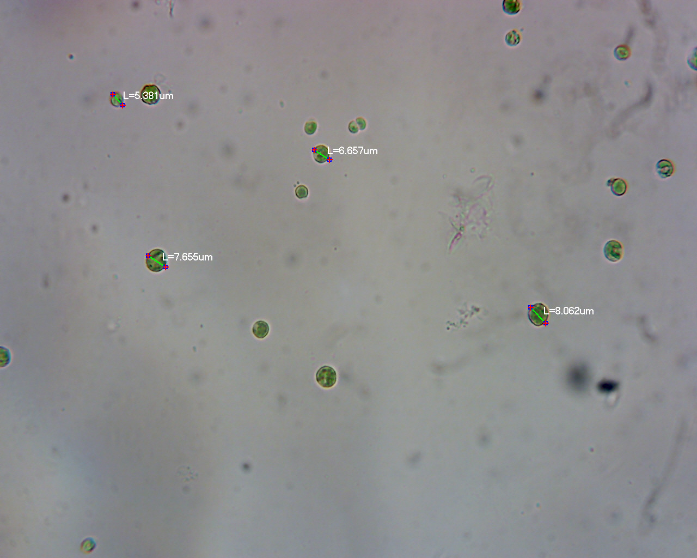
Figure 1: Microscopic image of chlorella vulgaris using digital camera.

Table 4: Microscopic morphological features of chlorella vulgaris
Shape Diameter colour Mortality

Spherical 2-10 µm Greenish Non-motile

Table 5: chlorella vulgaris cell count
Time (sec) Average no. of cell Number of cells per µl No. of cells per ml
0.00hr 0.00 0.00 40.00
45hrs 5.00 800 800000
96hrs 9.8 1560 1560000
144hrs 14.8 2386 2386000
192hrs 17.8 2848 28480000
240hrs 21.3 3408 3408000
288hrs 22.5 3600 3600000
336hrs 24.8 3968 3968000

Table 6: Determination of cell concentration
Weight of filter Volume of the culture Weight of Microalgae + paper filter paper

0.840 500 0.184

0.840 - 0.184 X 1000
500

Cell concentration = 1.312 g/l

CHAPTER FIVE
5.0 DISCUSSION
The overall economy of a broiler is determined by its growth performance. Poor management and feed contribute to reduced growth performance (Salim et al.,2012). The primary role of feed is not only to provide enough nutrients to fulfill metabolic requirements of the performance of broilers. Numerous studies shown that dietary supplementation of chlorella can improve the growth performance of poultry (Ross and Dominy, 1990;Qureshi et al., 1996; Al-Batshan et al., 2001; Raju et al.,2005; Kharde et al., 2012; Kaoud, 2013; Zahroojian et al.,2013; Mariey et al., 2014). Thus, while stressing Chlorella. vulgaris, it accumulates important amount of carotenoids and after feeding it to animals such as ﬁsh and poultry it showed interesting pigmentation potential for ﬁsh ﬂesh and egg yolk in poultry, together with enhancing health and increasing life expectancy of animals (Yamaguchi et al., 1996). In order to increase the bioavailability and accessibility metals can be chelated with biomolecules. Biosorption of metals can be the one of the modes to achieve this Various researchers have reported that body weight increased with inclusion of Spirulina platensis (Saxena et al., 1983; Ross and Dominy 1990;Ross et al., 1994, Venkataraman et al., 1994; Qureshi et al., 1996; Toyomizu et al., 2001; Raju et al., 2005; Kaoud,2013).
It is estimated that about 30% of microalgal production is sold for animal feed purposes (Becker et al., 2007) due to the increasing demand for food with natural composition instead of synthesised ingredients. This has triggered intensive research into ﬁnding natural ingredients that improve the quality of animal food products (Fernandes et al., 2012) .

5.1 CONCLUSION
Chlorella vulgaris was isolated from pond water, through morphological and colonial characteristics, it was confirmed that the isolated strain is C. vulgaris show increase in biomass in presence of light, carbon dioxide, water and nutrient medium. Microalgae (chlorella vulgaris) have an excellent nutritional profile and could be safely used as feed resource to support poultry production. This study has provided information that chlorella vulgaris enriched with microelements like iron and zinc can be used to improve the value of feed and to increase the productivity of poultry farming when used in bird feed.

5.2 REFERENCE
Becker, E. W., 2013. Microalgae for aquaculture: nutritional aspects. In: Richmond, A., Qiang Hu (Eds), 2013, Handbook of microalgal culture: applied phycology and biotechnology, 2nd edition, Wiley- Blackwell: 671-691.
Brennan L, Owende P. Biofuels from microalgae – a review of technologies for production, processing, and extractions of biofuels and co-products. Renew Sustain Energy Rev 2010;14:557–77.
Burlew JS. Algal culture from laboratory to pilot plant. Washington DC: Carnegie Institution of Washington; 1953.
Chang Y-R, Lee D-J. Coagulation–membrane ﬁltration of Chlorella vulgaris at different growth phases. Dry Technol 2012;30:1317–22.
Cheng YL, Juang YC, Liao GY, Ho SH, Yeh KL, Chen CY, et al. Dispersed ozone ﬂotation of Chlorella vulgaris. Bioresour Technol 2010;101:9092–6.
Chisti Y. Biodiesel from microalgae. Biotechnol Adv 2007;25:294–306
Degen J, Uebele A, Retze A, Schmid-Staiger U, Trosch W. A novel airlift photobioreactor with bafﬂes for improved light utilization through the ﬂashing light effect. J Biotechnol 2001;92:89–94.
Divakaran R, Sivasankara Pillai VN. Flocculation of algae using chitosan. J Appl Phycol 2002;14:419–22.
Fernandes B, Dragone G, Abreu A, Geada P, Teixeira J, Vicente A. Starch determination in Chlorella vulgaris – a comparison between acid and enzymatic methods. J Appl Phycol 2012;24:1203–8.
Frappart M, Massé A, Jaffrin MY, Pruvost J, Jaouen P. Inﬂuence of hydrodynamics in tangential and dynamic ultraﬁltration systems for microalgae separation. Desalination 2011;265:279–83.

Hagen C, Siegmund S, Braune W. Ultrastructural and chemical changes in the cell wall of Haematococcus pluvialis (Volvocales, Chlorophyta) during aplanospore formation. Eur J Phycol 2002;37:217–26.
Kitada K, Machmudah S, Sasaki M, Goto M, Nakashima Y, Kumamoto S, et al. Supercritical CO2 extraction of pigment components with pharmaceutical importance from Chlorella vulgaris. J Chem Technol Biotechnol 2009;84: 657–61.
Kojima E, Zhang K. Growth and hydrocarbon production of microalga Botryococcus braunii in bubble column photobioreactors. J Biosci Bioeng 1999;87:811–5.
Lee Y-K. Microalgal mass culture systems and methods: their limitation and potential. J Appl Phycol 2001;13:307–15.
Liang Y, Sarkany N, Cui Y. Biomass and lipid productivities of Chlorella vulgaris under autotrophic, heterotrophic and mixotrophic growth conditions. Biotechnol Lett 2009;31:1043–9.
Liu ZY, Wang GC, Zhou BC. Effect of iron on growth and lipid accumulation in Chlorella vulgaris. Bioresour Technol 2008;99:4717–22.
Vandamme D, Foubert I, Fraeye I, Meesschaert B, Muylaert K. Flocculation of Chlorella vulgaris induced by high pH: role of magnesium and calcium and practical implications. Bioresour Technol 2012;105:114–9.
Wu Z, Zhu Y, Huang W, Zhang C, Li T, Zhang Y, et al. Evaluation of ﬂocculation induced by pH increase for harvesting microalgae and reuse of ﬂocculated medium. Bioresour Technol 2012;110:496–502.
WU, X., OUYANG, H., DUAN, B., PANG, D,, ZHANG, L., YUAN, T., XUE, L., NI, D., CHENG, L., DOMG, S., WEI, Z., LI, L., YU, M., SUN, Q.Y., CHEN, D.Y., LAI, L., DAI, Y. and LI, G.P. (2012) Production of cloned transgenic cow expressing omega-3
Zhang K, Miyachi S, Kurano N. Evaluation of a vertical ﬂat-plate photobioreactor for outdoor biomass production and carbon dioxide bio-ﬁxation: effects of reactor dimensions, irradiation and cell concentration on the biomass productivity and irradiation utilization efﬁciency. Appl Microbiol Biotechnol 2001;55:428–33.

5.4 APPENDIX
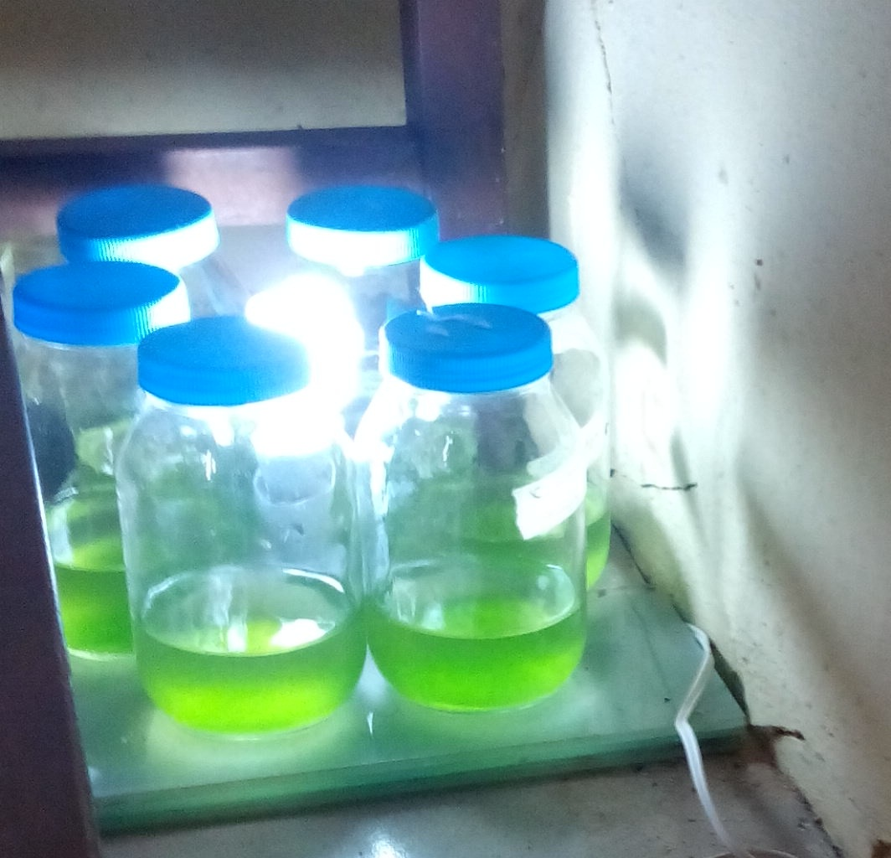
Appendix 1: Microalgae (Chlorella vulgaris) grown in BG-11 medium in presence of light and Carbon dioxide

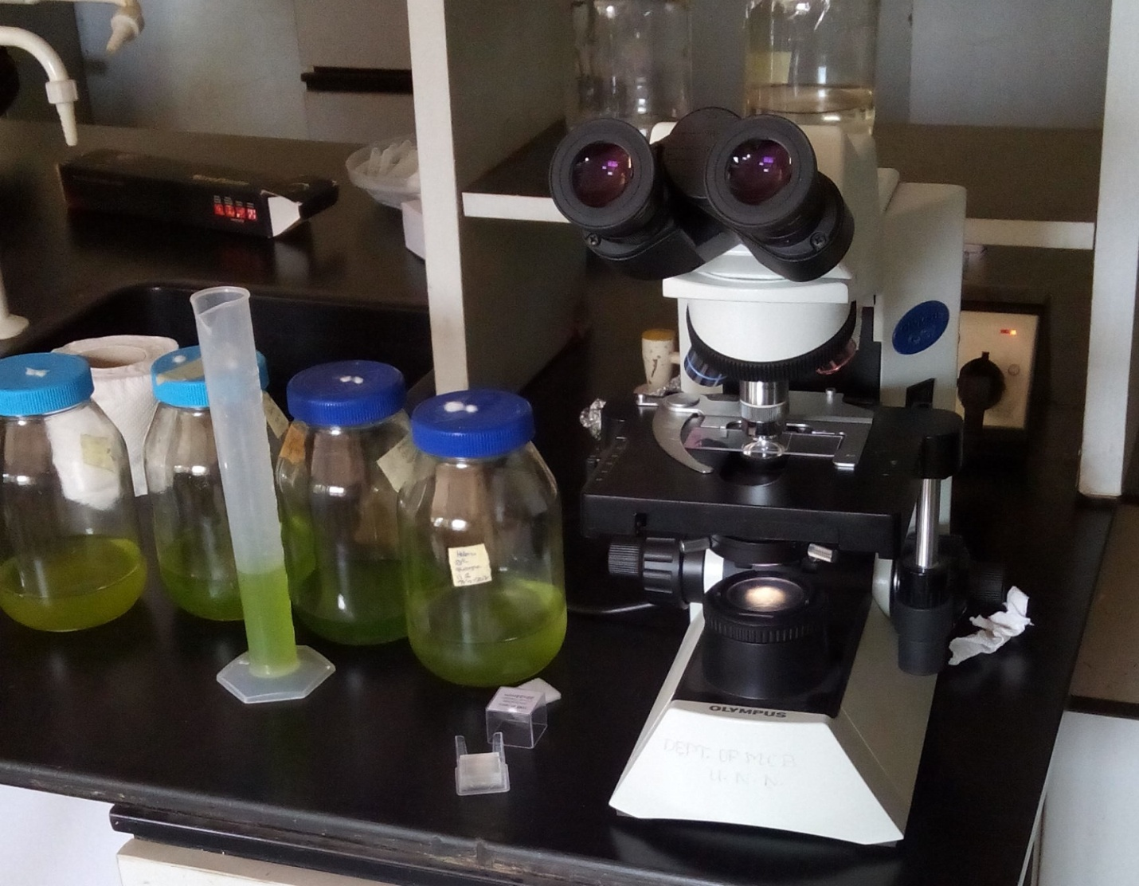 Appendix 2: Chlorella vulgaris Analysis using microscope

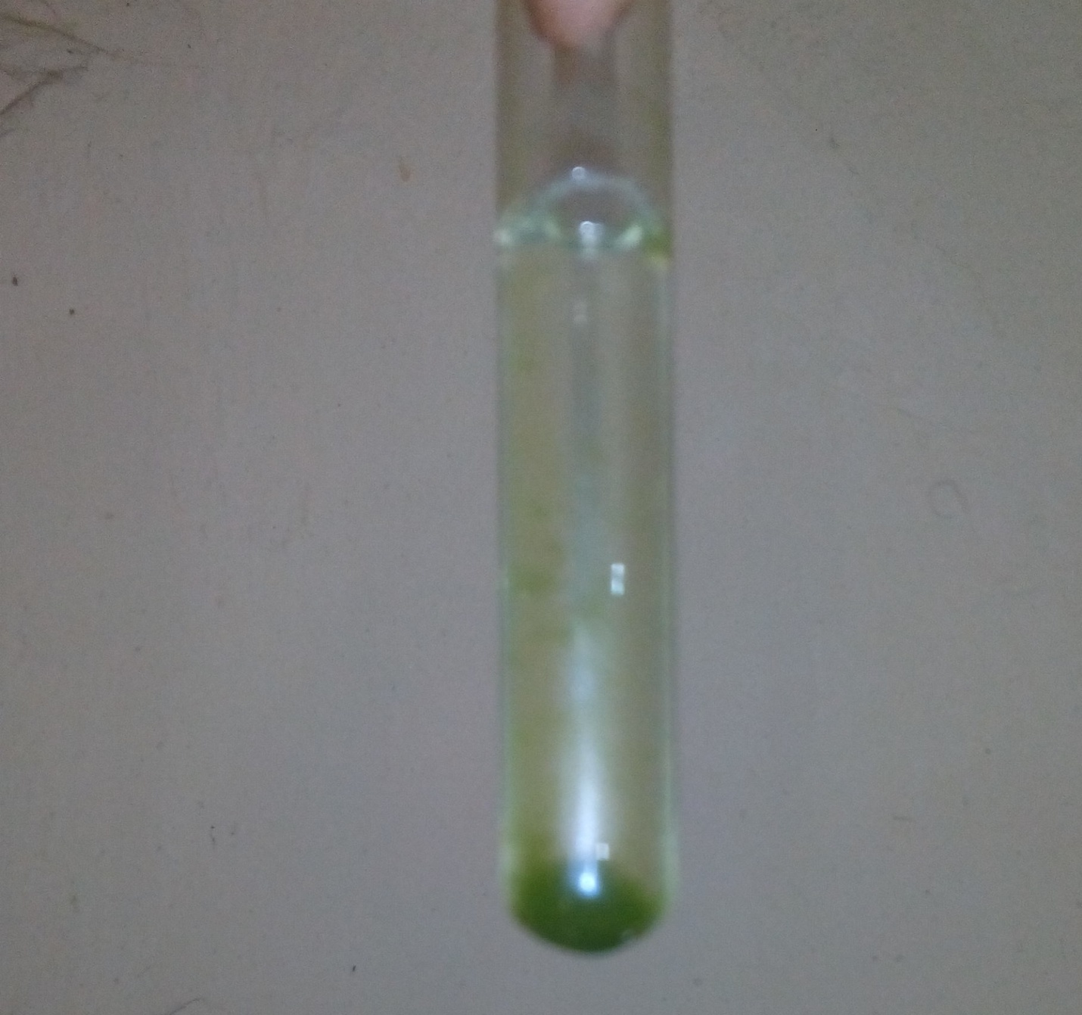
Appendix 3: Isolate (Chlorella vulgaris) inoculated in test tube containing BG-11 medium

\

