APPENDIX
SOLID MEDIA
NUTRIENT AGAR
This is a general purpose medium used for the cultivation of microorganisms. The medium composition is as follows;
Yeast extract 0.2g
Peptone (oxoid) 0.5g
Agar No.3 1.5g
Sodium chloride 0.5g
Distilled water 1L
About 10g of the medium was weighed and dissolved in 200mls of distilled water, homogenized with the aid of water bath machine and sterilized by autoclaving it at 121°C for 15minutes. The sterile medium was allowed to cool to about 45°C and aseptically poured into petri dishes and allowed to set on a flat surface.
Mac CONKEY AGAR
MacConkey agar is a selective and differential medium used for the isolation and differentiation of non-fastidious gram negative rods, particularly members of the family Enterobacteriaceae and the genus Pseudomonas. The medium composition are as follows
Peptone (Pancreatic digest of gelatin) 17gm
Protease peptone (meat and casein) 3gm
Lactose monohydrate 10gm
Bile salts 1.5gm
Sodium chloride 5gm
Neural red 0.03gm
Crystal violet 0.001g
Agar 13.5gm
Distilled water 1L
About 11.1g of the medium was weighed and dissolved in 200mls of distilled water, homogenized with the aid of water bath machine and sterilized by autoclaving it at 121°C for 15minutes. The sterile medium was allowed to cool to about 45°C and aseptically poured into petri dishes and allowed to set on a flat surface.
SABOURAUD DEXTROSE AGAR (SDA)
This is a medium generally used for isolation of fungi organisms. Its pH can be adjusted to approximately 5.6 in order to enhance the growth of dermatophytes, and to slightly inhibit bacterial growth in clinical specimens. Its composition are as follows;
Dextrose (Glucose) 40gm
Peptone 10gm
Agar 15gm
Distilled water 1000ml
About 7g of the medium was weighed and dissolved in 200mls of distilled water, homogenized with the aid of water bath machine and sterilized by autoclaving it at 121°C for 15minutes. The sterile medium was allowed to cool to about 45°C and aseptically poured into petri dishes and allowed to set on a flat surface.
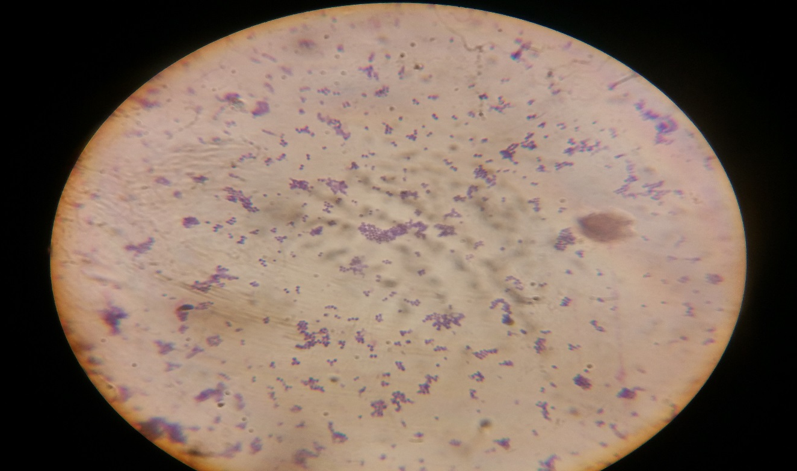
Microscopic view of the Staphylococcus species
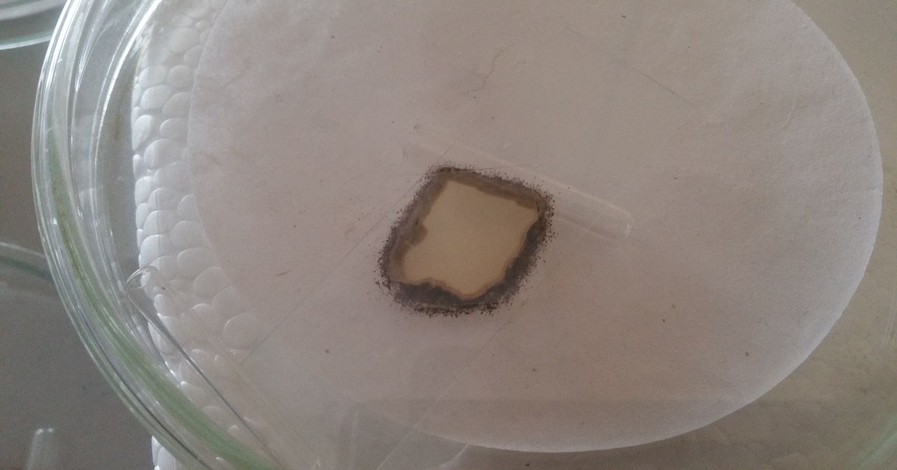
Macroscopic view of Aspergillus specie in slide culture

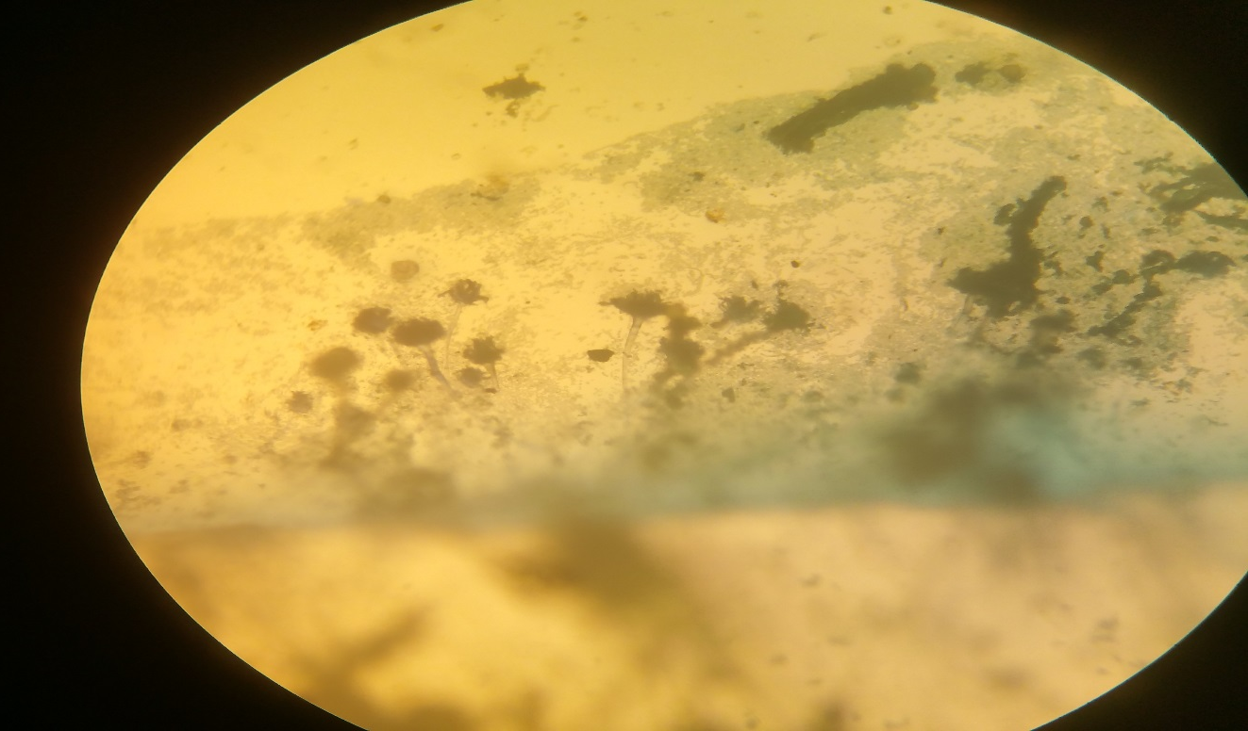
Microscopic view of Aspergillus specie
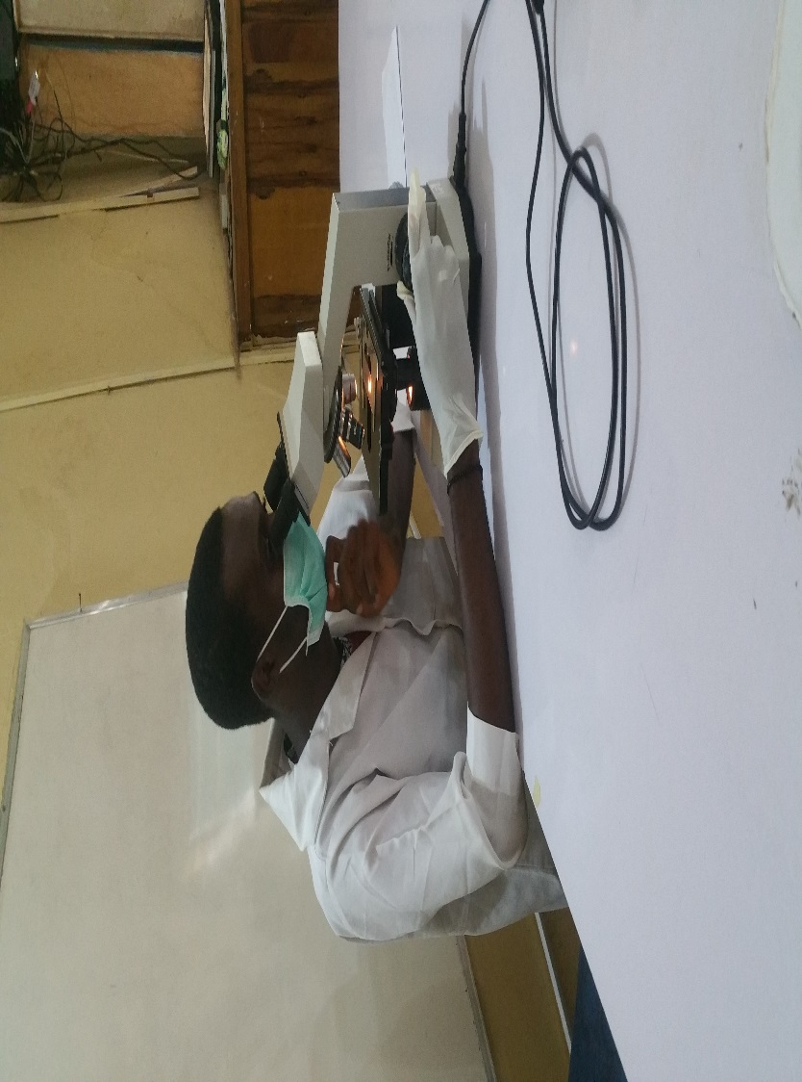
Research student observing a slide under microscope

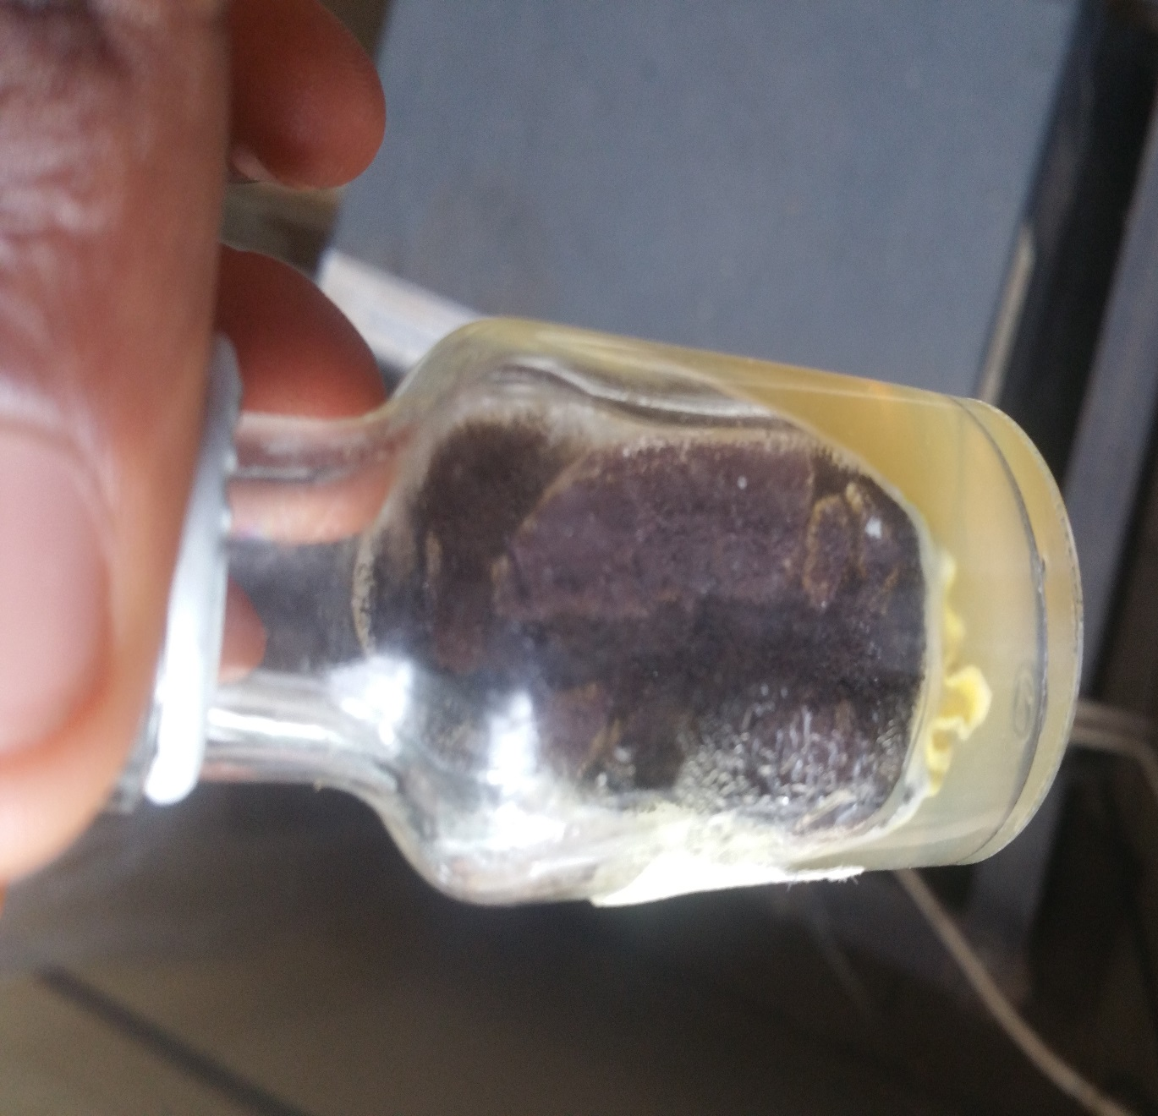
Aspergillus specie in agar slant
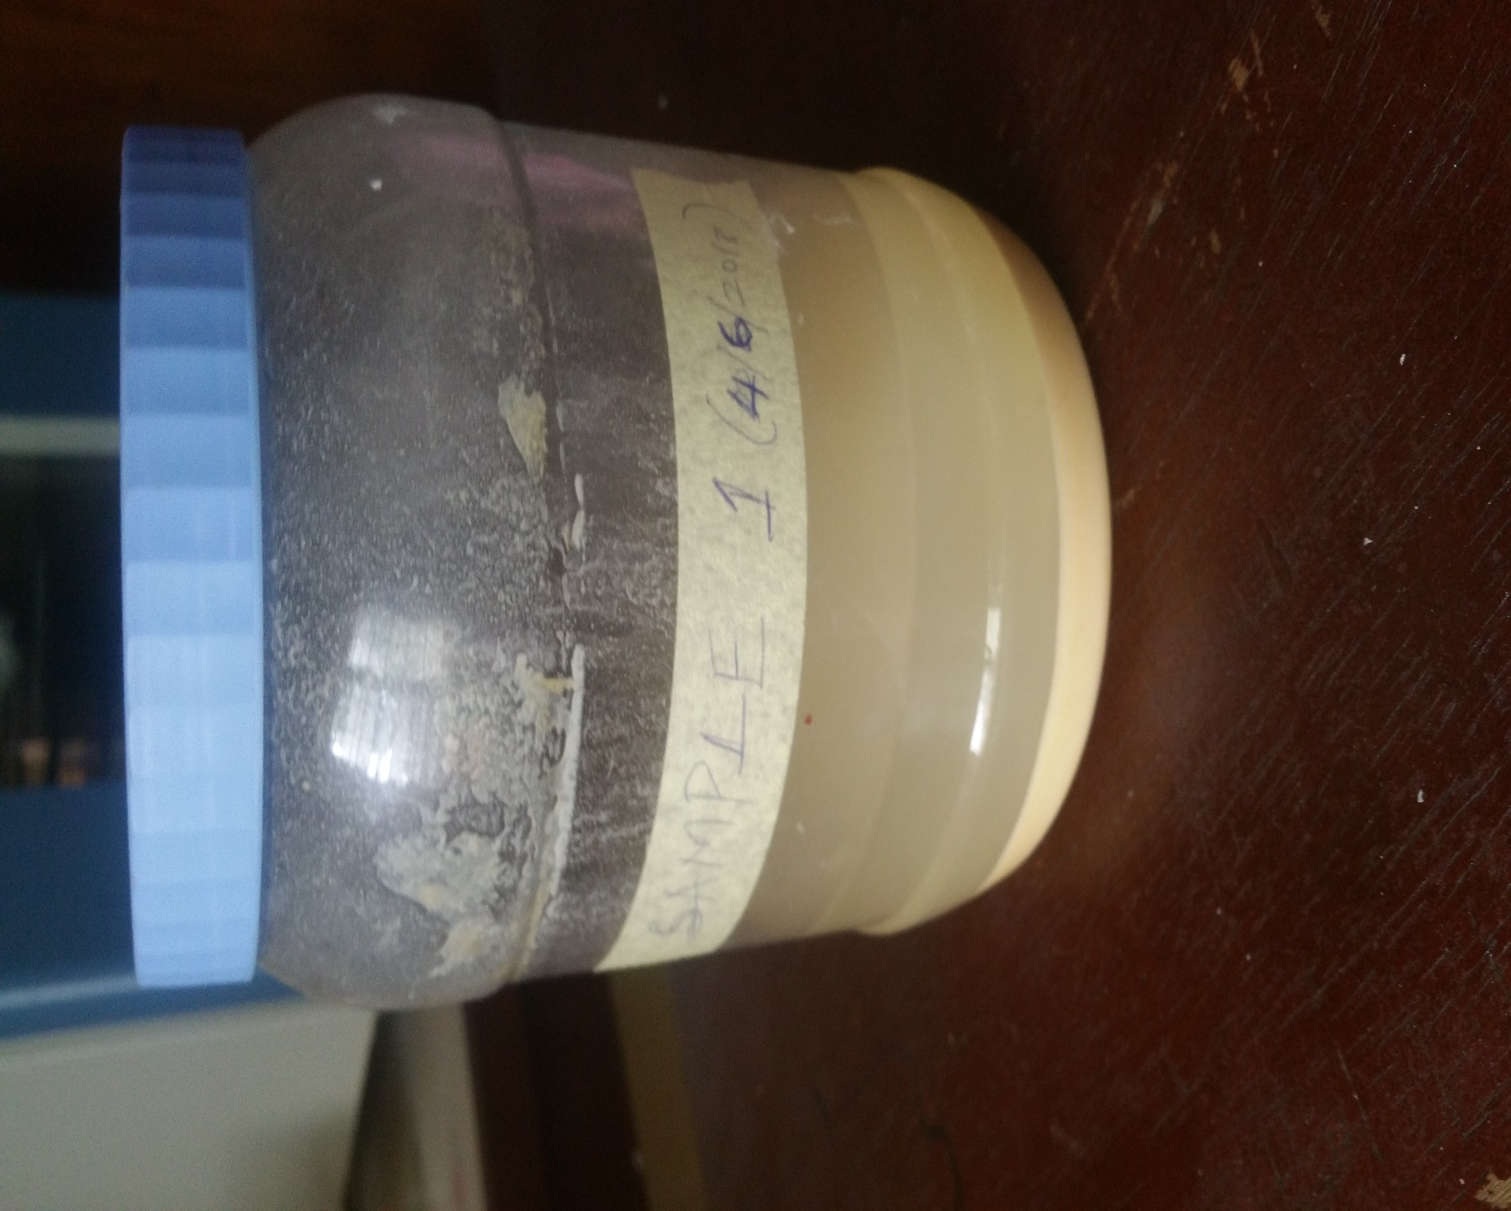
Image of the pap sample

