ISOLATION AND IDENTIFICATION OF FUNGI FROM PACKAGED AND UNPACKAGED POWDERED MILK, CORN FLOUR AND SOYBEAN FLOUR

BY

DRISU VICTORIA OJONOKA

U14/NAS/MCB/O77

DEPARTMENT OF MICROBIOLOGY

FACULTY OF NATURAL AND APPLIED SCIENCES

GODFREY OKOYE UNIVERSITY UGWUOMU NIKE ENUGU STATE

TITTLE PAGE
ISOLATION AND IDENTIFICATION OF FUNGI FROM PACKAGED AND UNPACKAGED POWDERED MILK, CORN FLOUR AND SOYBEAN FLOUR

BY

DRISU VICTORIA OJONOKA
U14/ NAS/MCB/077

A REASEARCH PROJECT SUBMITED TO THE DEPARTMENT OF MICROBIOLOGY, FACULTY OF NATURAL AND APPLIED SCIENCES
GODFREY OKOYE UNIVERSITY UGWUOMU NIKE, ENUGU STATE

IN PARTIAL FUFILLMENT OF THE REQUIRMENT FOR THE AWARD IN BACHELOR OF SCIENCE (B. Sc) DEGREE IN MICROBIOLOGY
SUPERVISOR
PROF. J.I. OKAFOR

JULY 2018

APPROVAL PAGE

This is certified that this research work “isolation and identification of fungi from corn flour, soybean flour and milk (measured and sachet). By Drisu Victoria Ojonoka in the Department of Microbiology has been presented and approved in partial fulfillment of the requirement of the award of Bachelor of Science (B. Sc.) Degree in Microbiology. Faculty of Natural and Applied Sciences Godfrey Okoye University, Enugu.

………………………. ………………..

Drisu Victoria Ojonoka Date

…………………….. ………………..
Supervisor Date
Prof. J.I. Okafor

……………………. ....….…………
Head of Department
Dr. (Mrs.) M. N. Unachuwu Date

DEDICATION
I dedicate this project to God Almighty my creator, my pillar, my source of inspiration, wisdom, knowledge and understanding. He has been the source of my strength throughout this program and on his wings only have I soared.

ACKNOWLEDGMENT

The success and final outcome of this project required a lot of guidance and assistance from many people and I am extremely privileged to have got this all along the completion of my project. All that I have done is only due to having a wonderful supervision and assistance and I would not forget to thank them. I respect and thank the vice chancellor, REV. FR. PROF. DR.Christian Anieke for providing me an opportunity to do the project work in microbiology laboratory Godfrey Okoye University and giving me all support and guidance which made me complete the project duly. I am extremely thankful to my head of department (Dr. N. M. Unachukwu) for providing such a nice support and guidance, although she had busy schedule managing the corporate affairs.I owe my deep gratitude to my project supervisor, Prof. J.I. Okafor who took keen interest on my project work and guided me all along.I would not forget to acknowledgemy able parents who were there for me financially and with their words of encouragement and prayer.I can’t also forget my very own brothers (Simeon and Precious) for their prayers and words of encouragement. I am very grateful to my friends and bunk mate (Anas, Chiamaka, Charity and Anita) who were also there to support and encourage me to see the completion of this project work.I am thankful to and fortunate enough to get constant encouragement, support and guidance from all Teaching staffs of department of microbiology who helped me in successfully completing my project work. Also, I would like to extend my sincere esteems to all staff in laboratory for their timely support.

TABLE OF CONTENT
Cover page………………………………………………………………………………..i
Tittle page……………………………………………………………………………..….ii
Approval page ……………………………………………………………………...……iii
Dedication …………………………………………………………………………….....iv
Acknowledgement …………………………………………………………………….....v
List of tables……………………………………………………………………………..vi
List of figures …………………………………………………………………………..vii
Abstract …………………………………………………………………………………vii
CHAPTER ONE:
1.0 Introduction …………………………………………………………………..….... 1
1.1Aim……………….…………………………….…………………………….……….3
1.2 Objective……………….….……………………...…………...……………….…….3
CHAPTER TWO
2.0 Literature review……………………………………………………………………4
2.1 Fungal agents ……………………………………………………………….….. 4
2.2 Fungal activities on food …………….…………………………………..... 8
2.3 Milk and the fungi spoilage ……………………………………………..... 15
2.4 Soybean and the fungi spoilage …………………………………………... 18
2.5 Corn and their spoilage fungi ……………………………………………...21
CHAPTER THREE
3.0 Materials and methodology ……….…………………………………….. 23
3.1 Reagents ………………………………………………………………….23
3.2 Sample collection …………………………………………………………23
3.3 Sterilization of glass wares ……………………………...………………..23
3.4 Preparation of culture media ……………………………..……………...23
3.5 Preparation of samples …………………………………………………….24
3.6 Spread plate method…………………………………………………….. 24
3.7 Isolation of pure culture ………………………………………………… 24
3.8 Identification of isolates ………………………………………………… 24
3.9 Cultural characteristics...………………………………………………… 25
3.9. Use of slide culture techniques….…..…………………………………… 25
CHAPTER FOUR
4.0 Result.………………………...………………...………………….………27
5.0 CHAPTER FIVE
5.1Discussion………………………..…………………………………………….…33
5.2 Conclusion ……………………………………………………………………..36
References…………………………………………………………………………….

LIST OF TABLES

Table1: morphological characteritic fungi………………………………………………….27
Table 2: identified fungi……………………………………………………………………28

LIST OF FIGURES

Figure1: morphology of Aspergillus fumigatu…………………..…………………….. 30
Figure 2: Morphology of Aspergillus niger…………………………….......…………..30
Figure3: Morphology of penicillium…………………………………………………….30
Figure 4: Morphology of mucor………………………………….…………..………….30
Figure5: microscopic view of A. flavus ..……...…………………………..…………….31
Figure 6: microscopic view of A. niger …………..………..……………………………31
Figure 7: microscopic view of p. reoqueforti .……………..……………………….……31
Figure 8: microscopic view ofF. oxysporum..…….………..…………………………….31
Figure 9: microscopic view ofM. heimalts..…….……………..…………………………32
Figure 10: microscopic view of A. fumigatus ..……………….………………..………..32

ABSTRACT

This research was carried out for the isolation and identification of fungal spoilage organisms in foods. The foods studied are, packaged and unpackaged powdered milk, corn flour and soybean flour. These samples were bought from Enugu main market (Ogbete) using sterile nylon bags for each samples and taken to the laboratory for analysis. One gram of each sample was put into nine (9) ml of sterile water, tenfold dilution was carried out upto the fithth srerile test tubes to reduce microbial load. Spread plate method was used by taking 0.1 from each dilution unto sterile prepared Sabouraud dextrose agar plates, the plates were incubated atleast for 48hrs for growth to occur. Representative growths from the plates were then sub cultured on agar slant to obtain pure cultures for identification. Slide culture technique was use for proper identification of the filamentous fungi and incubation was at least four (4) - six (6) days. Lactophenol blue was use to stain the fungi growth on the slide and the cover slip which was viewed under the light microscope. From this research carried out genera of fungi isolated were, Aspergillus, Fusarium, Pennicillium and Mucor. The dominant genus isolated was Aspergillus. The most contaminated food product from this research is the corn flour sample which was contaminated with all the fungal genera identified. The fungi isolated are known to be pathogens of man some species of aspergillus are known to produce toxins which is the aflatoxin causing the diseases known as aflatoxycosis in man. Also some species of penicillium and fusarium are known to produce mycotoxins which causes human diseases. These food products can be contaminated due to daily exposure to air as fungi spores are known to be present in large number in the air making it easy for them to invade exposed foods.

CHAPTER ONE
INTRODUCTION
Food products are a rich nutrient source that can attract both bacterial and fungal colonizers. Pitt et al (2009). As such, the food product can be regarded as an ecological resource. Colonization with a number of food-borne microorganisms is beneficial with respect to nutritional value and prolonged storage of the food product, which is known as food fermentation in other case. After successful colonization of the product, its nutritional properties are altered. Samson et al. (2004).When the nutritional value, structure, and taste of the product are negatively influenced, this colonization is called food spoilage. It can be accompanied by the production of toxic secondary metabolites which may result in serious medical problems (Dijksterhuis et al., 2007). These two aspects of food colonization are two sides of the same coin. Food spoilage is a major threat for our food stock and is responsible for enormous losses Pitt et al., (2009).
Fungi are the main degraders of the sturdy plant cell wall components that otherwise would accumulate within the ecosystems of the world. Prior to spoilage, the fungi can be present on or inside of the crop in low numbers, or as survival structures. Spoilage fungi can also be introduced to an empty habitat if the food is previously treated by pasteurization treatments. Food products include two main groups, which are living crops and processed food (Karlshøj et al., 2007).
Colonization of food products is hence very diverse. The relationship between the living crop and fungi can be illustrated. Then the association of fungi with different types of processed food is described. Preservation techniques make the food product a difficult environment to colonize, although it is also a rich medium. Only fungi (Springer-Verlag et al 2013) that can survive certain adverse conditions including high osmolarity and heat can successfully spoil processed food. Samson et al. (2004) provide overviews on the taxonomic description and specificity of food spoilage fungi, Dijksterhuis et al (2007) highlight numerous aspects of the relation between food and fungi including spoilage and fermentation.

AIM AND OBJECTIVES
This research is aimed at isolating and identifying fungi spoilage organisms in packaged and unpackaged milk, soybean flour and corn flour
OBJECTIVE
To isolate fungi spoilage organisms associated with packaged and unpackaged powdered milk, corn flour and soybean flour
To identify the isolated spoilage organism associated with the samples.

CHAPTER TWO
LITERATURE REVIEW
2.1 FUNGI AND THEIR CHARACTERITICS
Fungi are eukaryotic organism with membrane bond nucleus, well differentiated apparatus and a cell wall. They are much larger than bacteria, the vegetative cell been 2-10 micro ml in diameter (Pitt et al., 2007). Most fungi are non-motile throughout their life cycle although their spores are carried in a distance by wind. All fungi are heterotrophic and most of them are saprobes. Some can also be parasitic on living animals or plants but very few fungi require living in a living host (Kathleen 2005). Most fungi are dimorphic they exist in two forms; they have unicellular and yeasst like forms in their host but when growing saprophitically they are in filamentous forms. Almost all dimorphic fungi are pathogenic to man (Sendron et al., 2009). They replicate sexually by fusion of gametes and asexually by spore formation Cheesbrough (2000). They exist in macroscopic or microscopic form. Fungi play a critical role in our ecosystem than many realize. Fungi are a large group of eukaryotic organisms that encompass different characteristics that allow them to have multifaceted roles in our society. (Pitt et al., 1997) Fungi aid in benefitting the ecosystem by decomposing dead matter creating a recyclable source of nutrients lattukudyKo, et al., (2007). Cross-talk between host and fungus in many plants have a symbiotic relationship with fungi allowing both organisms to survive in various environmental changes. Certain fungi like yeast can be recombined and inserted into plant genomes to allow expression of certain proteins that prevent loss of crops. Ansloe et al., (1998) and Bruli et al., (1999). Within the human systems fungi aid in maintaining normal flora and they are used in antibiotic and viral drug therapies. Wort et al (2007). Fungi are commonly known to be pathogenic; however, they are present everywhere in our environment and have many beneficial effects on hosts like providing nutrients to organisms, working with plants to increase absorption, providing antibiotics and antiviral medications for humans, they aid in biotechnology by mass producing a hybrid organism, and they provide a source of food and nutrients to animals. many things they do when handling food is related to preventing growth of fungi. Taniwaki et al (2001a). A common fungal growth is bread mold or Rhizopus stolonifer that invades bread and spreads quickly. People are cautious of moldy bread because of the irritation it has on the GI tract. Also, there are fungi that can cause severe symptoms like sepsis, consolidations in the lungs that cause pneumonia, nephritis, mengititis and endocarditic (San-Blas). These symptoms will not only hospitalize patients, but there is a chance that they can die from these infections if it is not detected early enough. Parasitic fungi exist, but they are a small group of fungi. Deising (2006) Many fungi have a mutualistic, symbiotic or saprophytic relationship with their host. Saprophytic fungi specifically are mostly chemohetrotrophs that endocytose dead organic matter and break down matter by release proteases that breakdown protein into amino acids, lipases that break down fatty acids into glycerol, and amylases that break down starch into simple sugars (Pitt and hocking 2012). There are external factors that contribute to how fast the dead organic matter is digested like soil pH, temperature, ion, Oxygen, and water levels. Breaking down organic matter is important because nutrients become recycled and reused by other organisms (Whitman). Even when the fungal hyphae die the nutrients can be taken up by plants directly. This specifically helps hosts like plants, bacteria and other microorganisms so that they can take up monomers easily Wort et al., (2007). Mycorrhizae is a type of fungi that is known for its symbiotic relationship with certain plants. Some plants can be more susceptible of Mycorrhizae invasion based on its niche, environment and competitor for resources. Brul et al., (2009). This rhizomorphs efficiently transfer water and ions to the plant roots during environmental stresses (Klironomos). Many plants digest inorganic nitrogen, which is not readily available; however, the rhizomorphs can fix organic nitrogen for the plant allowing biochemical reactions to occur swiftly. This benefits the plant by increasing the amount of nutrients during a drought or unbalanced osmotic level. The fungus increases the surface area benefitting the plant and in return the plant provides the fungus with carbon products created from photosynthesis Taniwaki et al., (2001a). Fungus like yeast has another application that benefits hosts. Recently the applications of recombinant plasmids have been applied to organisms to express a gene of interest. For instance, yeasts were genetically transformed to produce vaccines for hepatitis B. They are also used to produce insulin, which is a drug that helps diabetic patient's decrease their blood sugar levels. Pro insulin is a gene that is inserted into the yeast plasmid to form a hybrid plasmid and the yeast will express the pro insulin gene that is modified by the body into functional insulin (Krasner). The yeast provides the body with the ability to regulate the sugar levels, which helps humans and other mammals with diabetes. Yeast is a great model to use in biotechnology because it is easy to grow, inexpensive and there is extensive research done on them. Yeast benefits humans by producing genetically altered drug therapies and studying them has provided insight into complex organism systems. The medical application of fungi is the ability to produce antibiotics from fungal metabolites. Taniwaki et al (2001a) In order to survive in the ecosystem fungi produce chemicals that prevent bacteria from invading them, which acts as a form of self-defense. Penicillium notatum is the fungi that derive the Penicillium antibiotic, which became popular during World War II for saving the lives of many soldiers by killing foreign parasitic microbes (Mailer). Another benefit is the fruiting body of the fungus can be edible. Many people incorporate mushrooms into their diet because of the richness of Potassium, vitamins, and low sodium and fat levels. Overall, the benefits of fungi outweigh the harmful effects because of the many roles they play with different organisms Ansloe et al., (1998). The benefits of fungi outweigh those of bacteria and viruses for humans. Bacteria are heavily used in biotechnology to express a gene of interest similar to yeast. However, the bacteria community becomes more vigorous due to over prescribed antibiotics that kill the weak bacteria and the resistant bacteria remain. Fungi are a group of organism that exists and help other organism by increasing nutrient absorption, providing a nutrient full meal, used in the formation of antibiotics, antivirals and involved in gene therapy. Fungi affect many different hosts like plants, mammals and the environment. There are fungi that negatively invade their hosts, but the benefits outweigh the negative (Pitt et al., 1997). They form mutualistic and symbiotic relationships with plants to help increase surface area for absorption of nutrients. This helps plants survive even in tough terrain and poor weather conditions. (Andrews et al., 2007) above all, people are unaware of how important fungi play a role in our ecosystem. Many times we become aware only when there are adverse symptoms or effects, but they are vital organisms. They are present everywhere and help humans and other organisms more than we expect.

2.2 FUNGI ACTIVITIES ON FOOD AND ITS SPOILAGE
Fungi spoilage organisms are silently invading, acidifying and fermenting microbes that render food products (dairy, grains with legumes like soybean and corn food) unsafe for human consumption. Fungi spoilage could be cause by two factors, (biotic) living which includes insects, birds, rodents and microorganisms and (non-biotic) non-living which includes temperature, humidity and time. The world is concerned with food safety that has enhanced interest in fungal and subsequent food spoilage. Contamination with mould causes deterioration of product which affects human and animal health. Because of this, interest is focused on food products because their important dietary staple (Pitt et al., 2002).The relationship between fungi and living agricultural crops can be regarded as plant-pathogenic in nature, which includes a complex communication between parasite and host. (Prusky et al., 2000). Some of these fungi enter intact crop cells without direct killing of the host. They initially establish a fungus–host interface as a biotrophic fungus that can exhibit prolonged survival in a quiescent state, which can be followed by a necrotrophic infection stage in which plant tissue is killed and lesions develop. The true necrotrophic fungi start to kill plant tissue directly upon entering the host. Following the initial stage of infection, the fungus resumes growth and develops from a biotrophic parasite characterized by fungal cells that are compatible with living plant cells towards a necrotrophic parasite that actively kills the host cells. This is characterize for a hemibiotrophic lifes (Prusky et al., 2007; Mu¨nch et al. 2008). Necrotrophic hyphae are thinner than biotrophic hyphae, and produce a variety of plant-cell-wall-degrading enzymes, and also produce other factors that lead to cell death such as reactive oxygen species or secondary metabolites. Truen necrotrophs directly start to kill plant tissue upon entering the host and some of them develop into broad spectrum pathogens that destroy many different and large amounts of vegetables, crops and fruits upon harvesting. Botrytis cinerea is a fungus that causes widespread infection of grapes, strawberries, and other fruits, as well as vegetables. The fungus enters the host by means of cracks on the plant or wounds (Gourgues et al., 2004). After entrance into the plant tissue, the fungus starts to kill host cells with the help of toxic secondary metabolites such as botrydial. There is evidence that the fungus uses the host hypersensitivity response for further infection (Choquer et al., 2007). The fungal genome of B. cinerea contains families of plant cell- wall-degrading enzymes, and up to 12 different lipases have been identified (van Kan et al., 2006). The enzymes involved in Fungal spoilage of crops and food pectin degradation, including endopolygalacturonases, are important for B. cinerea, and hosts with high pectin contents is an excellent target for the fungus. Any crop that did not have these activities showed clearly reduced and delayed infection development after inoculation with B. cinerea (Cantu et al., 2008). These findings show that the interaction between necrotroph and the host is considerably more complex than thought before (Amselem et al., 2011), and that there exists a balance between host and pathogen. B. cinerea is an avid producer of oxalic acid inside the lesion. This organic acid stimulates cell-wall-degrading enzymes, and also has a strong calcium chelating activity that helps to destabilize the pectin network in which calcium ions are embedded (van Kan 2006; Prusky and Lichter 2007). Oxalic acid production is even more a hallmark of infection by another widespread necrotrophic pathogen (Kim et al. 2007; Hegedus and Rimmer 2005) that is related to B. cinerea (Amselem et al., 2011). This fungus is notorious as a post-harvest pathogen of sunflower seeds, grains and bean pods among 400 plant species, most of them are dicots.
The oxalic acid also modulates the hypersensitivity response, including programmed cell death around the pathogen, in delaying the oxidative burst and prevention of callose deposition at the leading edges of the lesions. (Williams et al., 2011. Opportunistic fungi can grow well without plant hosts as saprotrophs on decaying plant material or in soil. They also infect crops mostly without the help of specialized infection structures, and need a natural opening or a wound in the outer layer of the crop. Despite their dual growth mode, they can develop into true pests of harvested crops. Opportunisic fungi can also enter through the dying leaves of the flower before the fruit is fully grown (Snowdon 2000). For most plant, fungi often develop first on

the remnants of the leaves present on the crop and then colonize the tissues of the crop (Smid et al., 1996). Careful handling of crops directly after harvesting is vital for the quality of the product. The more small wounds that are introduced by, for instance, rough treatment of the crop, the more damage occurs as a result of post-harvest diseases.
(Niem et al., 2007). The fungus can survive in a quiescent state in plant material, and enters plant tissues that are weakened as a result of wounds on the crop, but the formation of small appressoria is not ruled out. Deising et al., (2008) Like all other fungi involved in post-harvest rot, growing hyphae of the opportunistic fungi release enzymes that degrade the plant cell wall, which results in dry or wet rot of the food crop. This depends on the selection of enzymes formed by the pathogen. Cellulolytic enzymes do not disrupt the pectin middle lamella, and therefore do not dissociate plant cells, which results in a more preserved structure of the tissue after infection known as dry rot (as reviewed in Prusky and Kolattukudy 2007). Pectin-degrading enzymes destroy the connection between the cells, resulting in maceration and wet rot. The variety of the secreted polysaccharide-degrading enzymes is large. The variability of these enzymes have been reviewed (De Vries 2000; De Vries and Visser 2001; Pel et al. 2007) in the case of the fungus Aspergillus niger. The genome of this fungus contains ORFs of 131 secreted carbohydrate active enzymes, which illustrates the versatility of the tool box to degrade plant cell walls. J. Dijksterhuis et al. A. niger is a cosmopolitan fungus, and causes serious opportunistic infections in grains and hyacinth bulbs. In citrus fruit, the fungi Penicillium italicum and P. digitatum (blue and green rot of citrus respectively) cause the most serious and widespread rots of these crops. Other opportunistic fungi on these fruits plant are Alternaria alternata, A. niger, Fusarium spp., Geotrichum candidum, and Trichoderma viride (Snowdon 1990). In apple, P. expansum is a post-harvest problem of similar magnitude. P. italicum, P. digitatum, and P. expansum are all able to acidify the host tissue and form citric acid in liquid culture (Prusky et al., 2004). In citrus and apple fruit, citric acid and gluconic acid accumulate, and expression of an endopolygalacturonase was highest at pH 4.0. The fungi have a preference for ammonium as the nitrogen source. Ammonium levels had dropped sharply in decaying tissue because of uptake by the fungal cells, which excrete H+ and lower the pH inside the lesion. The production of gluconic acid was accompanied with the expression of a glucose oxidase gene (gox2), and virulent isolates showed more of both (Hadas et al., 2007). Interestingly, GOX activity, gluconic acid accumulation, and decay dropped significantly when oxygen levels dropped to 10 % or lower. This indicates that gluconic acid and not citric acid is an important factor for disease. In the case of processed foods spoilage, many processed foods contain powdered grains, processed milk and fruits, and other plant material that are treated to make the nutrients more available for the human digestive system. In a way, these foods are comparable to plant-based media that are used in microbiological laboratoria, and as such can be colonized and spoiled by fungi. Spoilage fungi can enter the food because of the basic components of the product. For example, some spoilage fungi enter the product through added spices (small pieces of plant material). In other cases, they are introduced during the food production chain or subsequent storage. In particular, airborne spores can enter food products that are not effectively shielded. Airborne contamination is characterized by the simultaneous outgrowth of more species of fungi in a product. The density of fungal spores in the (indoor) air varies greatly, and is correlated with the ability of certain fungal species to form large numbers of them. The propagules then enter food and crop, and can cause damage. In the case of Penicilliu expansum infecting apple, high spore densities in the air are probably caused by growth of the mould in high concentration in rotten organic material in orchards (Borner 2007). Fungi also develop inside buildings (where storage occurs), and their proliferation is then often related to leakage, Fungal Spoilage of Crops and Food looding, condensation, and humidity. Occupants inside homes also contribute to mould growth as a result of activities generating humidity (processing and breathing) in combination with the obstruction of venting of the building caused by, for instance, the insulation of buildings. Therefore, the composition of the fungal indoor mycobiota is very dynamic and correlated with and depending on human activity (Flannigan et al., 2011; Adan and Samson 2011). Previous indoor food spoilage may grossly enhance the inoculum pressure on newly introduced food products. For example, in Dutch cheese warehouses, Penicillium Post-harvest infection of tulip bulbs Dijksterhuis et al., discolor commonly occurs, and can cause serious spoilage when poor hygienic conditions increase the sporulation of this fungus. Massive production of conidia can be regarded as a vital strategy for dispersion of a number of important food-borne fungi. The order articles includes many relevant food spoilage fungi (Samson et al., 2004; Pitt and Hocking 2009), with an emphasis on the genera Paecilomyces Penicillium and Aspergillus. With respect to food spoilage, Aspergillus seems to be more suitable for tropical areas than Penicillium, which is observed more in temperate areas. Fungal spoilage organisms can build up considerable biomass in certain areas of the food production chain, and when not sufficiently cleaned act as a recurrent source of contamination. In this way a “house flora” can develop inside certain factories; e.g. Penicillium roqueforti which causes spoilage in rye bread factories, and Fusarium oxysporum in dairy products. Geotrichum candidum is known as the “machinery mould” or “dairy mould”, and is responsible for slime building in processing equipment and off-smells in finished products. In time, different preservation techniques are developed with the aim of discouraging fungal development in the food product. These include fermentation, addition of salts or high concentrations of sugars, pickling, drying, cooling, the addition of preservatives or a heating treatment before packaging. More recent techniques include modified atmosphere packaging and the application of high-pressure treatment of the food product, but heat-resistant ascospores clearly show survival of treatment (Butz et al., 1996; Palou et al., 1998). In addition, high pulse fields are applied to food products in order to evaluate if these are able to kill spoiling organisms. (Valencia-Chamorro et al., 2010; Mehyar et al., 2011). In certain aspects, the ecological niche of processed food products therefore can be regarded as an extreme environment with rich nutrients. This is of evolutionary interest; the fungi that are able to overcome these stresses are heavily rewarded. It was already recognized by (Johanna Westerdijk 1999) that there might be an association between specific fungal species with certain food products or crops. For instance, P. expansum is specific for pomaceous and stone fruits, while the species P. italicum and digitatum cause damage to citrus fruit. The adaptability of the fungal species to overcome the restrictions of the crop or the limitations introduced by preservation techniques determines the dominance of the species in relation to the relevant food product. Food parameters are surprisingly restrictive to the spectrum of species which are able to grow and thus spoil the individual food types. Normally, less than ten and often one to three species are responsible for spoilage.

2.3 MILK AND THE FUNGI SPOILAGE

Since prehistoric times, milk and dairy products due to their immense nutritive value form a major part of human food it play a prominent role in the diet. Milk is unique in nutritient and a major source of protein and calcium. It is estimated that billions of people around the world consume milk and dairy products every day as they are the vital source of nutrition for human health. Milk for human consumption is most commonly derived from cows but the milk from other animal species such as buffaloes, goats, camels and sheep is also used for the production of dairy products. Approximately 50% of the milk produced is consumed as fresh or boiled, one sixth as yoghurt or curd and remaining is utilized for manufacturing of many types of milk products .The dairy products such as cheese, butter, ice cream, milk powder and yoghurt are universally available. India is the leading producer of milk in the world, and therefore, a wide variety of indigenous milk products viz. burfi, rabri, peda, kalakand, kulfi, basundi, rasgulla ,gulabjaman, paneer, khoa ,rasmalai, chum chum etc. are prepared (Pal and Jadhav,2013). Powdered milk has a far longer shelf than liquid milk and does need to be refrigerated due to its low moisture content. It is less expensive and easier to store than fresh milk, but the disadvantage is that it never tastes quite like the real thing. Powdered milk was first made in 1802 by Russian doctor Osip Krichevsky. It is found abundantly in many developing countries because of reduced transport and storage cost (as it does not require refrigeration) like other dry foods. (Harper and Hill, 2006). It is considered non- perishable and is flavored by survivalist, hikers and other people in need of nonperishable easy to prepare food stuff. Powdered milk is often used in baking, in recipes where adding liquid milk would render the product too thin to be used. It is a common sight in UN food aid supplies, fallout shelter, warehouses and wherever fresh milk is not a viable option. Powdered milk is also used in western blosts as a blocking agent to prevent non-specific protein interactions The microbial contamination of milk and milk products is largely due to unhygienic conditions and human factors. Pitt and Hocking (2007) mentioned that some factors that can contribute to the contamination of various milk products by fungi include; if the premises of milk processing plants are unsanitary. If pasteurization temperature is inadequately maintained. If the good manufacturing practice is not followed. If the raw materials are of poor quality. If the equipment and utensils are not properly sterilized. If the preservation is omitted. If the water is unwholesome, unsafe and non-potable. If the sugar, fruits, nuts, and additives are contaminated. If the packaging material is not properly cleaned. Though the type of spoilage fungi differ widely among dairy products because of the effects of practices followed in the production, formulation, processing, packaging, storage, distribution and handling. Warm climate and inadequate refrigeration are the principal causes of high level of contamination of fungi. Some physical defects such as off color, loss of firmness and loss of aroma can occur following the spoilage of milk products by fungi. Moulds and yeasts are recognized as an important cause of spoilage of various dairy products (Filtenborg et al.,1996; Fleet,1999; Khalifa et al.,2013;Pal and Jadhav, 2013; Pal et al.,2014).The contamination of milk products with different types of fungi particularly of species of Aspergillus, Fusarium and Penicillium constitute a public health hazard as these fungi are known to produce mycotoxins that are injurious to human health ( Pal,2002;Sengum et al.,2008; Khalifa et al., 2013). The mouldiness can be considered as an indicator of deterioration in the milk products. The early detection of spoilage of milk products is necessary so that preventive measures can be applied. The significance of hazard analysis and critical control point (HACCP) system in food establishments is reviewed by Jadhav and Pal (2001).

2.4 SOYBEAN AND ITS FUNGI SPOILAGE
The diets of people in many developing countries comprise mainly starchy roots, cereals, and few legumes. Unfortunately, animal sources of protein, which are used to complement the starchy diets, are expensive and times, out of reach for low income families (Kolapo and Oladimeji, 2008). In recent years, different edible varieties of legumes have been identified to have high plant protein, and therefore could help to address a number of diet related problems globally (Sleemi et al., 2010). Grain legumes serve as a cheap source of proteins to a large proportion of the population in poor countries of the tropics. Several legume based milk and milk products have been developed in attempts to extend the supply of milk-like products especially in areas where milk is in short supply. Since legumes are important sources of relatively inexpensive protein, introduction of imitation milk products from legumes will contribute to the alleviation of protein malnutrition (Gesinde et al., 2008). Development of milk substitutes extracted from legume serves as an alternative way of producing an acceptable nutrious food. Soybean( Glycine max (L.) Merrill) is rich in protein, carbohydrate and oil. Soybean is particularly good source of protein (35–42%) and fat crops (Kumar et al., 2006). They can be used as a potential substitute to cow milk in terms of quality and nutritive properties.(Adebayo-Tayo et al., 2008)The increasing popularity of soymilk as a beverage worldwide (Dashiell et al., 1990) is credited to it health benefits. For example, low cholesterol and lactose levels, its ability to reduce bone loss and menopausal symptoms, prevention and reduction of heart disease and certain cancers. The attendant increase in the rate of soymilk consumption has encouraged low-scale production of the milk under house-hold conditions with little or no regard to quality control measures. Consumers are increasingly aware of the effect of good diet on their wellbeing and health soymilk is not only consumed for refreshment, but also to increase wellbeing and to help in preventing health related disorders. An increasing number of consumers prefer minimally processed products from natural raw materials for reducing the intake of chemical additive from food and for obtaining products with improved nutritive value Soybean (Glycine max) is recognized as one of such legume crops with huge potential the world. Its edible products include; soymilk, soy bean flour and other soy based products. They are food items consumed on purchase from vendor, hawkers and consumed immediately without any further preparation. Some of them are snacks which are also vended along highways linking several geographical areas in the country [Oranusi and Braide, 2012]. But most of them are found in public places including markets, motor parks, and streets, outside schools, hospitals and even express way [Izah et al., 2015]. Soymilk identified as one of the products (Osundahunsi and Awor, 2005, Kolapo and Sanni, 2-005) is a fine, off-white or creamy emulsion, which resembles cow milk in both appearance and consistency (Soya Be, 2006). Soy flour also as one of its product is normally manufactured with different fat levels: raw soy flour which doesn’t require the roasting step; defatted soy flour is obtained from- solvent- extracted- flakes, and contains less than 1% oil and natural or full-fat soy flour made from un-extracted, de-hulled beans with about 18% - 20% oil. The quality of the flour and storage condition after milling is very important in the shelf life and hygienic quality of the flour. Although flour is generally regarded as a safe product due to its low water activity, it has been reported that a variety of pathogenic and non-pathogenic microorganisms can contaminate it during processing [Berghofer et al., 2003]. Low-moisture foods and ingredients have not been discussed traditionally in terms of food safety, primarily because these products do not offer welcoming environments for microorganism growth [Akissoe et al., 2001]. Food borne outbreaks has been sometimes associated with consumption of flour, although most flour-based products reportedly undergo a validated kill step at the point of production (e.g. baking or cooking), other products may be at risk [Ndife et
al., 2011]. The greatest problem associated with soymilk remains its beany flavor and very short shelf life due to microbial activity. The nutritious nature of soymilk however, makes it prone to microbial attach if not properly processed and stored as the nutrients it contains are also required for the growth of most spoilage organisms. A large number of microorganisms such as fungi mesophilic aerobic bacteria and coliforms are known to be responsible for the spoilage of soymilk, producing undesirable changes in milk (Momoh et al., 2011). It is therefore of importance to subject soymilk production to a reasonable degree of hygiene. This coupled with the effect of refrigeration could help in extending the shelf-life (Hallsworth et al., 2009). The presence of fungi in soymilk generally provides an index of the hygienic standard of soymilk and its keeping quality (adeleka et al., 2000). Control of microbial growth and spoilage of product is achieved by restricting and controlling microorganisms from contaminating the product through good manufacture and handling practice (Ofoefule 2002).
2.5 CORN AND ITS SPOLAGE FUNGI
. Corn is extensively used by humans in form of different products and it is a major ingredient of the animal and poultry feed industry. Corn grows in “ears, each of which is covered in rows of kernels that are then protected by the silk-like threads called “corn silk” and encased in a husk. Corn is known scientifically as Zea Maize (Pitt and Hocking, et al., 2009). This moniker reflects its traditional name, Maize, by which it was known to the Native Americans as well as many other cultures throughout the world. Therefore, maize is grown on a vast area throughout the country, second only to wheat. Maize contain carbohydrate, protein and fat. Maize is purchased by feed mills for long storage to fulfill their future needs; if storage conditions are not proper it will lead to fungal contamination and consequently buildup of mycotoxins. Fungal growth and mycotoxin production are the consequence of an interaction among the fungus, the host and the environment. (Saleemi et al., 2010) Contamination of agricultural commodities by fungi results not only in downgrading of quality, but toxigenic fungi also represent a health hazard for humans, livestock and poultry (Anderson and Thrane, 2006). Cereal crops are at high risk for fungal contamination at both pre-harvest and postharvest stages. Mycotoxins are natural food and feed contaminants, mainly produced by moulds of genera Aspergillus, Penicillium and Fusarium (Zinedine et al., 2006). Maize is a cereal in which a range of mycotoxins have been found, e.g. aflatoxins Phytopathologia Mediterranea M.K. Saleemi et al. (Shotwell et al.,1973), ochratoxin A (Saleemi et al., 2010), zearalenone (Shotwell et al., 1970), deoxynivalenol (DON) (Gilbert et al., 1983), fumonisins (Gelderblom et al., 1988) and moniliformin (Shraman et al., 1991). Aflatoxins are produced by strains of Aspergillus flavus, Aspergillus parasiticus and Aspergillus nomius (Kurtzman et al., 1997). The incidence of aflatoxins in foods and feeds is relatively high in tropical and subtropical regions, where climatic conditions favor the growth of moulds (Rustom, 1997). Ochratoxin A is the second most important mycotoxin produced by Aspergillus ochraceous, Aspergillus carbonarius etc. It is receiving great attention worldwide because of the hazard it poses to animal and human health (Pitt et al., 2000). The contamination of cereal crops with ochratoxigenic fungi and ochratoxins is responsible for heavy losses in cereal crops. Devegowda reported that 25% of cereals approximately consumed in the world are contaminated with mycotoxins (Devegowda et al., 1998). Pakistan is situated in a subtropical to tropical region, with ideal environmental conditions and poor storage facilities that favor fungal growth. This fungal contamination of cereals, especially maize, leads to mycotoxin production. The farming community and agrarian society in the country have serious concerns about this important matter. In Pakistan, so far, little published information is available about fungal mycobiota in agricultural products, particularly those used as ingredients in poultry and animal feeds. Only few reports covering short periods and smaller regions have described the presence of some toxigenic fungi or mycotoxins in agricultural products (Saleemullaha, 2006); Hanif et al., 2006; Saleemi et al., 2010).

CHAPTER THREE
MATERIALS AND METHODOLOGY
The materials used for the work were autoclave, Refrigerator, Incubator ,Sabouraud dextrose agar, graduated cylinder, Hot air Oven, Wire loop, Bunsen Burner, Test tubes and rack, pH meter, staining Rack, Cotton Wool, Spatula, Beakers, inoculating needle, Weighing Balance, weighing boat, glass Slides, Cover slip, Glass rod, Conical flask, Petridishes, Test tubes, Pipettes and tips, tip waste maker, and Aluminium Foil.
3.1 Reagents
Distilled water, Ethanol, Lactophenol cotton blue.
3.2 Sterilization of Glass Wares
Petri-dishes, test tubes, conical flasks, beakers, pipettes, spatulas, etc. was sterilized in hot air oven at 180ºC for two hours (2 h) and stored at 40C.
3.3 Preparation of Culture Media
Sabouraud dextrose agar was weighed at 24.8g which was added in 200ml of distilled water which was properly dissolved using water bath and was autoclaved at 121⁰ C for 15minutes. The prepared medium was allowed to cool for few minutes then poured in 20 different sterile petri dishes and allowed to solidify within 30minutes on a sterile table. The table was sterilized using 70 percent of ethanol and cotton wool to clean the surface of the table.

3.4 Sample Collection
Four (4) samples which included corn flour, soybean flour, packaged and unpackaged Dano milk were collected aseptically from Enugu main market (Ogbete) using different sterile nylon bags.
3.5 Preparation of Sample: One gram of corn flour was put into 9lml of sterile water to get tenfold dilution. The dilution was then labelled as A1. One (1) ml of the diluted sample before settling was removed from the suspension using a sterile pipette and transferred in to a sterile test tube containing 9mls of sterile water. It was thoroughly mixed again and label A2. This dilution step was repeated three times for samples A3, A4 and A5, the same procedure was repeated for the soybean flour, the packaged and the unpackaged Dano powdered milk.
3.6 Making spread plate for fungi culture
Twenty prepared sterile plates were labeled using five plates per samples. Exactly 0.1ml was pipetted out from each of the labelled dilution using a micro pipette unto each plate as labelled by its diluting factor which is 10⁻¹, 10⁻², 10⁻³, 10⁻⁴ and 10⁻⁵ This was also repeated for the remaining three samples. A glass spreader was dipped in ethanol and flamed for few seconds; this was done to sterilize the spreader. The plate was opened quickly to avoid contamination. Using the spreader, the inoculum was spread around the surface of the agar until traces of liquid disappeared. The spreader was re-flamed and the process was repeated in the next plate, working quickly to avoid contamination of the agar with air borne organisms. The plates (20) were placed invertedly at room temperature for 24-72 hours for observation of growth
3.7 Isolation pure culture
Using agar slant, individual fungal colony from any of the plates representing each colony was collected using a sterile wire loop, as taken from a high diluted plate as its tends to have pure colonies that are well separated. The wire loop was sterilized, then the selected agar plate was quickly opened near the Bunsen burner, the selected colony was gently picked and the slant in the bjou bottle was opened as the tip of the bottle was flamed. The sterile wire loop with the colony was smeared at the surface of the sterile agar slant. This procedure was repeated for different growth observed macroscopically. The slant tip was re-flamed, covered and kept at room temperature for 3 to 7days. This was done to obtain pure colony
3.8 Cultural Characteristics
The growth pattern, pigmentation and size of colonies were recorded to aid in the identification of the organisms.
3.9. SLIDE CULTURE METHOD
With the help of sterile petri dishes, one (1) ml of sterile water was added into the each petri dish. A U shaped glass rod was placed in each of the petri dish. Sterile slides were placed on each of the U shape glass rod in the petri dishes. With the help of a scalpel blade the already prepared SDA was cut into cubes. Using a sterile wire loop, four days to 1 week fungal growth was collected and smeared by the four sides of the SDA. A sterile cover slip was collected using a well flamed forcept and placed on the inoculum in the petri dish. The plate was then covered and kept at room temperature for 4 to 7days as growth was observed before examination.
Staining with lactophenol blue
A drop of lactophenol (LP) was placed on a clean microscopic slide The cover slip from the culture was gently removed using a sterile forcept and placed in the drop of lactophenol (LP). A drop of LP was dropped on the slide from the old culture as the media cultured on the slide was gently removed. Sterile cover slips was placed on the slide containing a drop of lactophenol blue and observe microscopically. It was first viewed at X10 to focus the lens well then X40 to get a clearer view.

CHAPTER FOUR
3.0 RESULT
The growth of different genera showed different cultural characteristics on the agar (table 1). The different colors use for identification of the fungi was also observed (Figure: 1- 4). These fungal isolate belong to the genera of Penicillium, Aspergillus, Fusarium and Mucor. (Table 2) The most common genus isolated was Aspergillus (Table 2). Some species of the dominant genus are Aspergillus flavus, A. fumigatus and A. niger. These different species of Aspergillus were isolated from different samples tested along with other genera which were also identified.

TABLE 1
MORPHORLOGY APPEARANCE OF THE FUNGAL ISOLATES

 | COLOR | SHAPE | ELEVATION | SIZE
SAMPLE A | Black  Grey-Green  White  White-Pink  Gray green | Irregular  Oval  Irregular  Oval  Oval | Elevated  Elevated  Elevated  Elevated  Flat | 1-9cm in diameter  40-50mm  20um  64-70mmd  2-3um
SAMPLE B | Yellow-green  White  White-Pink  Black | Oval  Irregular  Oval  Irregular | Elevated  Elevated  Elevated  Elevated | 3-6um  20um  64-70mm  1-9cm in diameter
SAMPLE C | Yellow-green  Grey-green  Gray-green | Oval  Oval  Oval | Elevated  Not elevated  Elevated | 3-6um  2-3um  40-50mm
SAMPLE D | Yellow-green | Oval | Elevated | 3-6um

TABLE 2
THE IDENTIFIED FUNGI

GENUS | SPECIE | CORN FLOUR SAMPLE A | SOYBEAN FOUR SAMPLE B | MEASURED DANO SAMPLE C | SACHET DANO SAMPLE D
Aspergilus bn | A. flavus | + | + | + | +
 | A. niger | + | ₊ | _ | _
 | A. fumigatus | + | _ | + | _
Penecillium | P. digitatum | + | _ | + | _
Mucor | M. hiemalis | + | + | _ | _
Fusarium | F. Oxysporum | + | + | _ | _

THE MACROBILOGICAL VIEW OF THE FUNGI ISOLATE

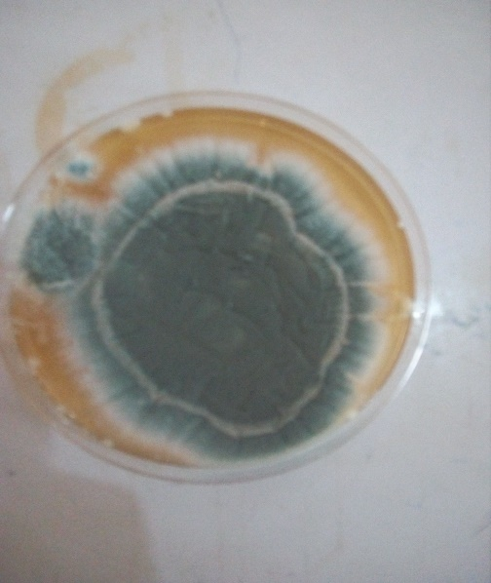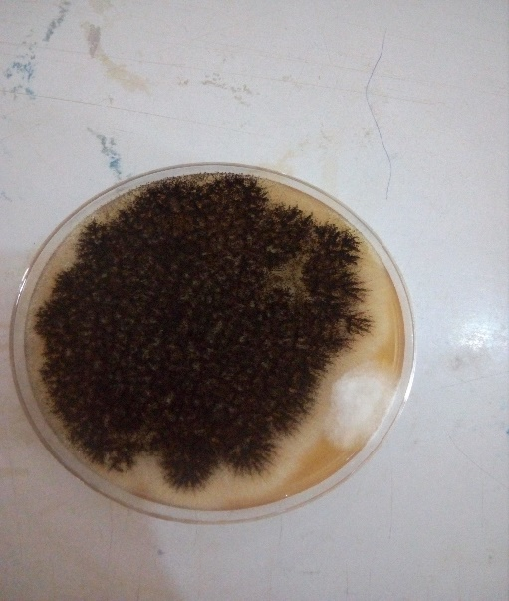
FIG.1 FIG.2
Aspergillus fumigatus Aspergillus niger

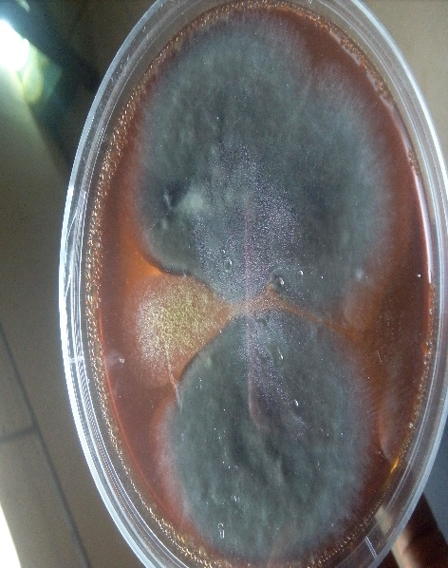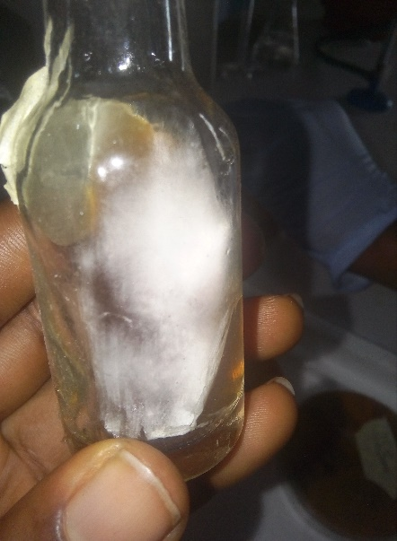
FIG.3 FIG.4
Penecillum Sp Mucor Sp

MICROSCOPIC VIEW OF THE FUNGI ISOLATE
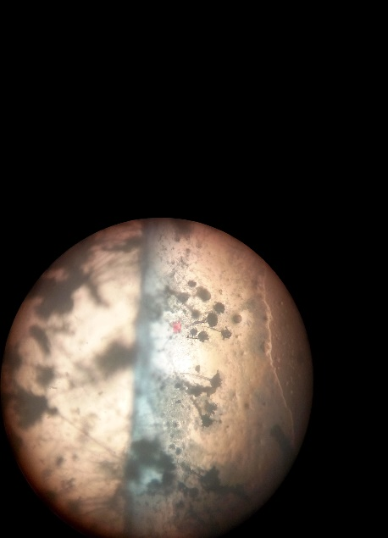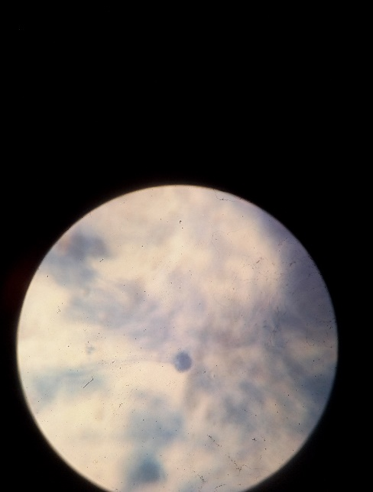
FIG.5 FIG.6
Aspergillus flavus Aspergillus niger

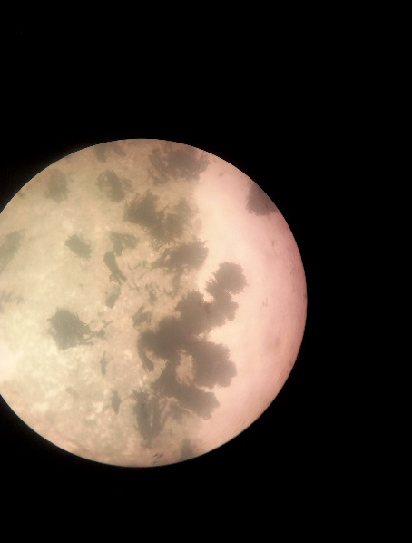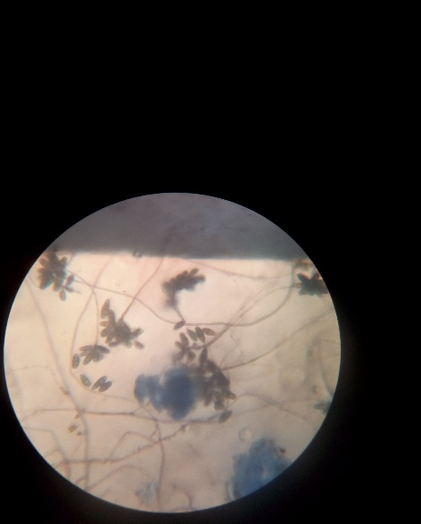
Fig.7 fig.9
Penicillium roqueforti Fusarium oxysporum
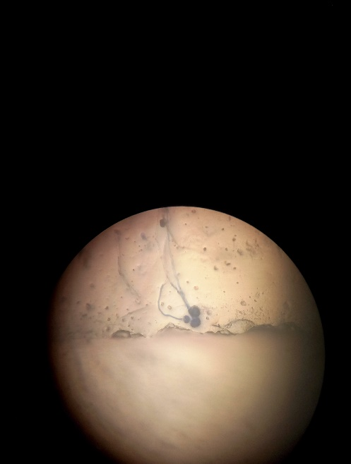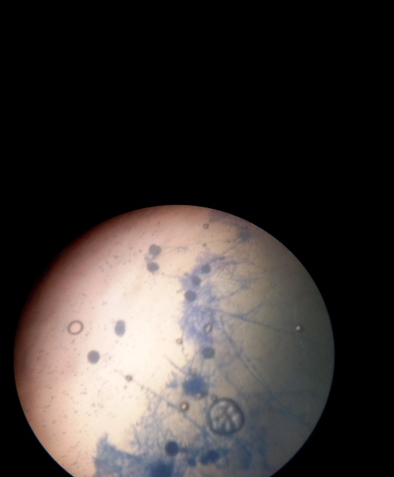
Fig.10 fig.11
Mucor hiemalis Aspergillus fumigatus

CHAPTER FIVE

5.0 DISCUSSION

From the research conducted, on corn flour, soybean flour and powder milk (measured and sachet), many genera and species of fungi were isolated and identified and they include Pspergillus, Penicillium, Fusarium and the Mucor specie. These food products were possibly contaminated by either the biotic or the abiotic factors which appeared to be one of the major factors that support fungal growth in food products. (Hill and Waller, 1999) As all the samples had different specie of the fungi isolated. The corn flour was more contaminated than other samples cultured because they were placed in exposed containers. Also storage facilities such as sacks, polythene bags and natural fibre, which are air-tight being used by the traders in the market (Personal observation) for storage of all the varieties might have encouraged the fungal growth. This is because they can lead to continuous increase in humidity and temperature of the food product, which consequently favours fungal growth as reported by Ahmad (2003). The most common fungus causing spoilage of food product is the Aspergillus flavus which was identified from the samples collected which showed the highest occurrence in this research (Table 2). Moreover, food products can encounter fungal infestation by influences from outside environment, such as insect’s infestation, wound and presence of foreign matter such as sand, dust and debris among others. Thus some of the identified fungal species could have come from any of these sources. Similarly, the constant exposure of food products to the outside environment at the time of sales could have aided in deposition of the fungal spores on them. Therefore, spores can germinate on the food products when temperature and humidity triggers the growth processes. Damage by insects has also been known to provide entry points for fungal infection (Dennis, 2002) and aid in their rapid spread. Hence, presence of insects may under certain critical circumstances be quite essential for establishment of infection. While several fungal species cause spoilage of food products worldwide, it is aiso noteworthy that presence of this known organisms isolated from this samples, are known to produce different mycotoxins like the ochratoxin, neurotoxin and aflatoxin. This mycotoxins may cause serious mycotoxicoses in man and in animal if produced in these food products tested. Example Penicillium roquefortine is known to produces neurotoxin. The extent to which neurotoxin affect nerve function depends on the toxicity of the substance either by ingestion or by inhalation depending on the individual age and immune status. This toxin can have long lasting effect by causing neurons to malfunction or by disrupting interneuron communication which may eventually lead to paralysis or death. The ochratoxin is a naturally occurring foodborne mycotoxin found in a wide variety of agricultural products that can be produced by several fungal specie and genera like Penicillium or the Aspergillus specie. Ochratoxin (OTA) causes nephrotoxicity and renal tumors in different animal species. However health effect has linked OTA exposure with human disease known as Balkan endemic nephropathy (BEN) and chronic intestinal nephropathy (CIN) as well as other renal diseases. The generally most common and deadly mycotoxin produce is the aflatoxin known to be produce by aspergillus species. Aspergillus infections have grown in importance in the last years. However, most of the studies have focused on Aspergillus fumigatus, the most prevalent species in the genus. In certain locales and hospitals, Aspergillus flavus is more common in air than A. fumigatus, for unclear reasons (Guinea et al., 2005). After A. fumigatus, A. flavus is the second leading cause of invasive aspergillosis and it is the most common cause of superficial and systemic infection. Common clinical syndromes associated with A. flavus include chronic granulomatous sinusitis, keratitis, and cutaneous aspergillosis, wound infections, osteomyelitis following trauma, liver disease and even deep or systemic aspergillosis. Outbreaks associated with A. flavus appear to be associated with single or closely related strains, in contrast to those associated with A. fumigatus. In addition, A. flavus produces aflatoxins, the most toxic and potent hepatocarcinogenic natural compounds ever characterized which is very deadly because it is a byoroduct that can cause serious damage to the DNA. Prolong exposure to aflatoxin, cell accumulate DNA mutations and thus are at risk of developing into cancer cells. Aflatoxins are known to be heat stable therefore heating of food products conterminated with aflatoxin cannot be destroyed by heat. This known mycotoxins that can be produce by this fungi species gets into the body either by inhalation of the spores, ingestion or cuts from the skin and this mycoses are more severe in immunocompromised individual. The spores of this fungi are in the air making it very easy for them to invade exposed food products or during the administration of immunosuppressive drugs use during organs transplanting thereby giving them easy access to cause infection as can be encouraged some environmental factors.
5.1 CONCLUSION
From this research carried out species of Aspergilus, Fusarium, Penicillium and Mucor were isolated from the food samples tested. Some species of the fungi isolated are known to produce toxins like Aspergillus, Fusarium and Penicillium. Recovery of these fungi (Table2) from this research shows that there is fear of consumption of mycotoxins because of their serious health implication, as they can be highly toxic and carcinogenic (AOAC, 2002; Shenasi et al., 2002), thus rendering the food products unfit for human and animal consumption. Contaminated food products should be sorted and eliminated to avoid re-infection. This will help to reduce the rate of mycoses.

References

Abarca, M.L., Basilico, J.C., Lopez, C., Pitt J.I. (2000). Mycotoxins and toxigenic fungi. Medical Mycology 38, 41‒46.

Abee, T., Chitarra, G.S., Dijksterhuis. J., Posthumus, M.A., Rombouts, F.M., (2004) Germination of Penicilliumpaneum conidia is regulated by a volatile selfinhibitor. Appl Environ Microbiol 70:2823–2829

Abee, T., Chitarra, G.S., Dijksterhuis, J., Rombouts, F.M. (2005) 1-Octen-3-ol has mild effects on membrane permeability, respiration and intracellular pH, but blocks germination and changes the protein composition of Penicilliumpaneum conidia. FEMS MicrobiolEcol 54:67–75

Adan, O.A., Bekker, M., Dijksterhuis, J., Huinink, H., Samson, R.A. (2012). Production of an extra cellular matrix is an isotrophic growth phase in Penicilliumrubens on gypsumButz P, Funtenberger S, Haberditzl T, Tausher B (1996) High pressure inactivation of Byssochlamysniveaascospores and other heat resistant moulds. LebensmWissTechnol 29:404–410

Adan, O.C.G., Samson, R.A. (2011) Fundamentals of mold growth in indoor environments and strategies for healthy living. Wageningen Academic Press, the Netherlands, 523 pp

Adeniyi, D.O., Amadi J.E. coote., (2009). Mycotoxins production by fungi isolated from stored grains. African Journal of Biotechnology 8, 1219‒1221.

Aldred, D., Dijksterhuis, J., Magan, N. (2012) the physiological state of fungal spores and survival dynamics. In: Dantigny P, Panagou EZ (eds) Predictive mycology. Nova, New York

Alonso, V.A., Astoreca, A.L., Cavaglieri, L.R., Chiacchiera, S.M., Dalcero, A.M., Gonzalez Pereyra, M.L., Magnoli, C.E., Morlaco, M.B., Rosa, C.A., Sager, R, (2008). Fungi and selected mycotoxins from pre- and post-fermented maize silage. Journal of Applied Microbiology 104, 1034‒1041.

Andersen, B., Dijksterhuis, J., Frisvad, J.C., Samson, R.A. (2007b) Association of moulds to foods. In: Samson RA (eds) Food mycology: a multifaceted approach to fungi and food. Taylor and Francis, Boca Raton, pp 199–239.

Anderson, B., Thrane, U. (2006). Food-borne fungi in fruit and cereals and their production of mycotoxins, advances in food mycology. Advances in Experimental Medicine andBiology 571, 137‒153.

Andrade, M.J., Casado, E.M., Co´rdoba, M.G., Co´rdoba, J.J., Rodrı´guez, M. (2010) Effect of selected strains of Debaryomyceshansenii on the volatile compound production of dry fermented sausage “salchicho ´n”. Meat Sci 85:256–264

Angelini, S., Benlemlih, M., Brera, C., Catano, C., Debegn, F., Elakhdari, S., Faid, M., Minardi, V., Miraglia, M., Santis, B.D., Zinedine A. (2006). Natural occurrence of mycotoxins in cereals and spices commercialized in Morocco. FoodControl 17, 868‒874.

Anonymous, (2000). Official methods of analysis. 17th ed. Chapter. 49, In: Official Methods of Analysis of the Association 224

Anonymous, (2009). Agriculture. Chapter 2. In: Pakistan EconomicSurvey. Government of Pakistan Finance Division Economic Advisory Wing, Islamabad. 1‒39.

Apps, P., Pinches, S.E. (2007) Production in food of 1, 3- pentadiene and styrene by Trichodermaspecies. Int J Food Sci 116:182–185

Arun Kumar, T.K., Binder, M., Boyd, A., Calvo, A.M., Padamsee, M., Riley, R. (2012) The genome of the xerotolerantmouldWallemiasebireveals adaptations to osmotic stress and suggests cryptic sexual reproduction. Fungal Gen Biol 49:217–226

Astoreca, A., Chiacchiera, S., Dalcero, A.M., Hallak, C., Magnoli C., Ponsone, L., (2006). Occurrence of ochratoxin A-producing fungi in commercial maize kernels in Argentina.
Mycopathologia161, 53‒58.

Atehnkeng, J., Bandyopadhyay, R., Cotty, P.J., Donner, M., Ikotun, T., Ojiambo, P.S., Sikora, R.A. (2008). Distribution and toxigenicity of Aspergillusspecies isolated from maize kernels from three agro-ecological zones in Nigeria. InternationalJournal of Food Microbiology 122, 74‒84.

Balague,´ M.M., Breukink, E., de Kruijff, B., Riezman, H., Souza, C.M., ten Napel, H.H., TeWelscher, Y.M., (2008) Natamycin blocks fungal growth by binding specifically to ergosterol without permeabilizing the membrane. J BiolChem 283:6393–6401

Battilani, P., Bertuzzi, A., Giorni P., Karlshøj., Magan, N. (2007). Studies on Aspergillussection Flaviisolated from maize in northern Italy. International Journal of Food Microbiology 113, 330‒338.

Beauvais, A., Clavaud, C., Fontaine, T., Fulgsang, C.C., Latge´, J.P., Loussert, C., Ohno, N., Prevost, M.C., Thevenard, B. (2010) Cell wall a1-3glucans induce the aggregation of germinating conidia of Aspergillusfumigatus. Fung Genet Biol 47:707–712

Bennett, A.B., Cantu, D., Dewey, F.M., Greve, L.C., Labavitch, J.M., Powell, A.L.T., Vicente, A.R. (2008). The intersection between cell wall disassembly, ripening, and fruit susceptibility to Botrytis cinerea. ProcNatlAcadSci USA 105:859–864.

Beuchat, L.R., Mann, D.A. (2008) Combinations of antimycoticsto inhibit the growth of molds capable of producing 1,3-pentadiene. Food Microbiol25:144–153

Bhaganna, P., Chin, J.P., Hallsworth, J.E., Linton, M., Magill, C.L., Megaw, J., Mswaka, A.Y., Nowotarski, K., Patterson, M.F., Underwood, G.J.C., Williams, J.P. (2010) Solutes determine the temperature windows for microbial survival and growth. ProcNatlAcadSci USA 107:7835–7840

Bollen, G.J., Nagtzaam, M.P.M., (1994) Long shelf life of Talaromycesflavus in coating material of pelleted seed. Eur J Plant Pathol 100:279–282.

Breukink, E.J., De Kruijff, B., Dijksterhuis, J., Eitzen, G., Jones, L., TeWelscher, Y.M., Van Leeuwen, M.R. (2010) Natamycin inhibits vacuole fusion at the priming phase via a specific interaction with ergosterol. Antimicrob Agents Chemother54:2618–2625

Cano, P., Casa, E., De Ancos, B., Peinado, J.M., Valderrama, M.J. (2004) Pentadiene production from potassium sorbate by osmotolerant yeasts. Int J Food Microbiol 94:93–96

Cavaglieri, L.R., Curvello, M.J., Dalcero, A.M., Fraga M.E., Gatti, F. (2007). Potential Aflatoxin and Ochratoxin A production by Aspergillusspecies in poultry feed processing. Veterinary Research Communications 31, 343‒357.

Chaveroce, M.K., D’Enfert, C., De Vries, R.P., Fillinger, S., Ruijter, G., Thevelein, J., Van Dijck, P. (2001) Trehalose required for the acquisition of tolerance to a variety of stresses in the filamentous fungus Aspergillusnidulans. Microbiol 147:1851–1862.

Cheesbrough, M. (2000). District Laboratory Practicein Tropical Countries Part 2, CambridgeUniversity Press, Cambridge. P. 47-54.

Chitarra, G.S., Dijksterhuis, J., Samson, R.A. ( (2007) the germinating spore as a contaminating vehicle. eds) Food mycology: a multifaceted approach to fungi and food. Taylor and Francis, Boca Raton, pp 83–100

Choquer, M., Fournie,r E., Kunz, C., Levis, C., Pradier, J.M., Simon, A., Viaud, M. (2007) Botrytis cinerea virulence factors: new insights into a necrotrophic and polyphageous –pathogen. FEMS Microbiol 277:1–10

Da Silva, P., Dantigny, P., de Rodriquez, M.P., Dijksterhuis, J., Panagou, E.Z. (2012) Primary models for inactivation of fungal spores. Predictive mycology. Nova, New York.
De Boer, W., Dijksterhuis, J., Smant, W., Van Leeuwen, M.R. (2008) Filipin is a reliable in situ marker of ergosterolin the plasma membrane of germinating conidia (spores) of Penicillium discolor and stains intensively at the site of germ tube formation. J Microbiol Methods 74:64–73

Deising, H., Floss, D.S., Lingner, U., Ludwig, N., Mu¨nch, S., Sauer, N. (2008) The hemibiotrophic lifestyle of Colletotrichum species. J Plant Physiol 165:41–51.

Del Rı´o, M.A., Palou, L., Pe´rez-Gago, M.B., Valencia-Chamorro, S.A. (2010) Effect of antifungal hydroxypropylmethylcellulose-lipid edible composite coatings on Penicillium decay development and postharvest quality of cold-stored “Ortanique” mandarins. J Food Sci 75:418–426

Dennis, S. H. (2002). Pests of Stored Products and Their Control, Belhaven Press, London.Djerbi, M. (1983). Report on Consultancy Mission on Date Palm Pests and Diseases. FAORome;October 1983. 28 pp.

Dijksterhuis, J., Golovina, E.A., Stark, J., Van Doorn, T., Van Leeuwen, M.R. (2010) Water- and air-distributed conidia exhibit differences in sterol content andFungal Spoilage of Crops and Food 55cytoplasmic microviscosity. Appl Environ Microbiol67:366–369

Dijksterhuis, J., Samson, R.A. (2004) Food mycology: a multifaceted approach to fungi and food. Taylor and Francis, Boca Raton, pp 101–117

Dijksterhuis, J., Samson, R.A. (2006a) Zygomycetes. In: de Blackburn CW (ed) Food spoilage microorganisms. Woodhead Publishing Ltd, Cambridge, pp 415–436

Dijksterhuis, J., Samson, R.A. (2006b) Activation of ascosporesby novel food preservation techniques. AdvExp Med Biol 571:247–260

Dijksterhuis, J., Samson, R.A. (2007) Food mycology: a multifaceted approach to fungi and food. Taylor and Francis, Boca Raton, 403

Dijksterhuis, J., Frisvad, J.C., Thrane, U., Samson, R.A. (2007a) Mycotoxin producers: Food mycology: a multifaceted approach to fungi and food. Taylor and Francis, Boca Raton, pp 135–159

Espin, S., Etcheverry, M., Gonzalez, H.H.L., Pacin A.M., Resnik, S.L., Vivas, L. (2002). Fungi associated with food and feed commodities from Ecuador. Mycopathologia156, 87‒92.

Feofilova, E.P., Kozlov, V.P., Memorskaya, A.S., Morozova, E.V., Tereshina, V.M. (2002) Changes in lipid composition and carbohydrate composition of Aspergillusniger conidia during germination. PriklBiokhimMikrobiol 38:149–154.

Filtenborg, O., Frisvad, J.C., Hoekstra, E.S., Samson, R.A. (2004) Introduction to food- and airborne fungi, 7th edn. CentraalbureauvoorSchimmelcultures, Utrecht, 389 pp

Flannigan, B., Miller, J.D Izah., Samson, R.A. (2015) Microorganisms in home and indoor work environments. Diversity, health impacts, investigation and control, 2nd edn. Taylor and Francis, Boca Raton, pg 539

Gao, J., Liu, Z., Yu, J. (2007). Identification of Aspergillussection Flavi in maize in northeastern China. Mycopathologia 164, 91‒95.

Gelderblom, W.C.A., Horak, G.R.M., Jaskiewicz, K., Marasas, W.F.O., Theil, P., Vleggaar, R., Springer-Verlag., Kriek, N.P.J. (2013). Fumonisins- novel mycotoxin with cancer-promoting activity produced by Fusariummoniliforme. Applied and EnviornamentalMicrobiology 54, 1806‒1811.

Gilbert, J., Shepherd, M.J. Stratin, J.R. (1983). A survey of the occurrence of trichothecencemycotoxindeoxynivalenol (vomitoxin) in United Kingdom grown barely and imported maize by combine gass chromatography-mass spectrometry. Journal of the Science of Food and Agriculture 34, 86‒92.

Gunde-Cimerman, N., Plemenitas, A., Ramos, J. (2009) Halotolerantand halophilic fungi. Mycol Res 13:1231–1241

Hallsworth, J.E., Williams, J.P. (2009) Limits of life in hostile environments: no barriers to biosphere function? Environ Microbiol 11:3292–3308

Hanif, N.Q., Khatoon, S., Malik, N., Naseem, M. (2006). Prevalence of mycotoxins in poultry rations. Pakistan Journal ofScientific Industrial Research 49, 120‒124.

Hell, K., Lamboni, Y. (2009). Propagation of mycotoxigenic fungi in maize stores by post-harvest insects. InternationalJournal of Tropical Insect Science 29, 31‒39.
Hocking, A.D., Pitt, J.I. (1997). Fungi and Food Spoilage. Blackie Academic and Professional, London, UK, 593 pp.

Hocking, A.D., Pitt, J.I. (2009) Fungi and food spoilage, 3rd. Springer, Dordrecht/Heidelberg, 519 pp Plumridge A, Hesse SJA, Watson AJ, Lowe KC, Stratford.

Hoogerwerf, S.A., Dijksterhuis, J., Kets, E.P.W. (2002) High-oxigen and high-carbon dioxide containing atmospheres inhibit growth of food-associated moulds. Let ApplMicrobiol 35:419–422.

Houbraken, J.A.M.P., Samson, R.A. (2011) Phylogenetic and taxonomic studies on the genera Penicilliumand Talaromyces. Stud Mycol 70, 183 pp

Iqbal, I., Khali, A., Saleemullah, A., Shah, H. (2006). Aflatoxin contents of stored and artificially inoculated cereals and nuts. Food Chemistry 98, 699‒703.

James, G. C., Natalie, S. (2001). Microbiology. Alaboratory Manual (ed.). Pp. 211-223. Jha, D. K. (1995). Laboratory Manual on SeedPathology. Vikas Publishing House (PVT) Ltd.. P.13-30.

Javed, I., Khan, A., Khan, M.K., Saleemi M.K. (2010). Mycoflora of poultry feeds and mycotoxins producing potential of Aspergillusspecies. Pakistan Journal of Botany 42, 427‒434.

Karlshøj, K., Larsen, T.O., Nielsen, P.V. (2007) fungal volatiles: biomarkers of good and bad food quality. In:Dijksterhuis J, Samson RA (eds) Food mycology: a multifaceted approach to fungi and food. Taylor and Francis, Boca Raton, pp 279–302

Kikoku, Y. (2003) Heat activation characteristics of Talaromycesascospores. J Food Sci 68:2331–2335

Kim, Y.T., Prusky, D., Rollins, J.A. (2007) An activating mutation of the Sclerotiniasclerotiorum pac1 gene increases oxalic acid production at low pH but decreases virulence. Mol Plant Pathol 8:611–622

lattukudyKo, P.E., Prusky, D. (2007) Cross-talk between host and fungus in postharvest situations and its effect on symptom development. In: Dijksterhuis J, Samson RA (eds) Food mycology: a multifaceted approach to fungi and food. Taylor and Francis, Boca Raton, pp 3–25

Lichter, A., Prusky, D. (2007) Activation of quiescent infections by postharvest pathogens during transition from the biotrophic to the necrotrophic stage. FEMS MicrobiolLett 268:1–8

Magashi, A. M., Dakin., Shamsuddeen, U. (2005). The Effect of Dehulling on the Occurrence and Distribution of Aspergillusflavusin Some Stored Maize Grains. Biological andEnvironmental Sciences Journal for theTropics, BEST 1(2): 26-28.

Martı´nez, J.L., Ramos, J., Sychrova, H. (2011) Monovalent cations regulate expression and activity of the Hak1 potassium transporter in Debaryomyceshansenii. Fungal Gen Biol 48:177–184.

May, G., Osherov, N. (2000) conidial germination in Aspergillus nidulan srequires RAS signaling and protein synthesis. Genetics 155:647–656.

Pitt and Hoockin. (2012) Pichiaanomalaas a biocontrol agent during storage of highmoisturefeed grain under airtight conditions. Postharvest BiolTechnol 15:175–184

Samson, R.A., Varga, J. (2007) Aspergillussystematic in the genomic era. Stud Mycol 59:1–206

