Gender Equality and Political Participation; an Assessment of AIT’s Influence on Women
Political Awareness and Participation in Enugu State
CHAPTER ONE
INTRODUCTION
  - Background of the Study
Women are underrepresented in most levels of government, as a result have made little progress in attaining political power in legislative bodies, or stamping equal relevance alongside their male counterparts in different political spheres in Nigeria. Consequentially, they have not achieved the decades old target of attaining relevance politically as set by the United Nations Economic and Social Council (ECOSOC) Resolution in 1990. Equal Opportunities Commission (2003) in reference to United Nation (1995), recommended targets for increasing the proportion of women in Leadership positions to 30% by 1995 and 50% by 2000. Historical evidences in many societies, both during the ancient and modern periods support the idea of male dominance over their female folks in many spheres of human endeavours (Aweofeso and Odeyemi, 2014). The trail of the female gender humiliation, manipulation and marginalization through a number of culturally biased practices has culminated into systematic institutionalization of male superiority over female in all sphere of life-socio-culturally, economically and politically. From the assertion above, it is evident that men play lead role in the political sphereAina (2012); Soetan (2014);Agbalajobi (2010).In 2015 the Deputy Director Gender Division of the Nigeria’s electoral body Independent National Electoral Commission (INEC), stated that fourteen (14) females out of three hundred and sixty lawmakers were elected into the House of Representatives and eight (8) women won as Senators in total of one hundred an nine senators. Again, out of the out of the fourteen (14) candidates that contested for the presidential position in 2015 general election, the only woman who contested found herself in the 12th position (Akor, 2015).
The struggle of women dates back to several decades ago when women like Amina of Zaria, Madam Tinubu of Lagos, Olufumilayo Ransom Kute of Abeokuta, Margaret Ekpo and Hajji of Gabon Swabia among others who fought to bring pride to women in Nigeria’s history show that good number of women have their interest in contributing to the general development of this country Okafor (2010). According to Ayabam (2013), several factors, including funding, women perception of politics in Nigeria, political violence during election, lack of self-confidence on the part of women, women marginalization in party leadership, illiteracy and low educational status for the girl child, cultural and religious discrimination have been identified as reasons for poor participation in social-political activities.
Munir S, et al (2014), media and politics go hand in hand as both depend on each other for their respective functioning. This accession explains the significance of media for political gains. Media is a potent tool for women political participation; they can set agenda and make voice of women to be heard through programs like Gender Agenda on AIT and so on. Gender Agenda, is women empowerment/political talk show on Africa Independent Television (AIT) seeks to address issues of state, Nationhood, Transformation, rule of law and psycho-social perspective of the role of women in governance and policy making. Gender and Youth Development is also another programme on AIT to champion the course of women. It is a female parliamentary programme which attracts participants from across the thirty six states of the federation aimed at attaining the affirmative action in favour of women. Focusing on Enugu state, this study sets out to examine how the media can be used to access and accelerate women participation in political programs and activities in Nigeria; as the media has been proven to be one of the vital factors through which gender equality in politics can be pursued (Nwankwo, 1996).
1.2 Statement of the Problem
It is no longer news that the percentage of women participation in politics in Nigeria is low. This poor participation reflected in the 2015 general elections in were only eight out of one hundred and nine senators are women, and out of three hundred and sixty members of National House of Representatives, only fifteen are women. Also, only five out of thirty seven ministerial appointments are women under the current federal government administration.
Since 1999, no woman has successfully contested for the presidency or served as vice president, no woman has successfully contested for a gubernatorial office and won, and currently, out of the thirty six states, only six states produced female deputy governors and two female chief judges.
The African belief system that relegates women to stereotype less significant roles has been a militating factor against women’s political awareness and participation in Nigeria. The misconception that women are soft, emotionally driven and intellectually inferior to their male counterparts could be a reason for the downward trend in female participation and attitudes towards politics, regardless of efforts made by gender equality advocates, agencies and media programs. Hence, this research sets out to examine the inputs of AIT’s gender equality advocacy programs towards women and its influence on women participation to Nigerian politics.
  - Objective of the Study
The objective of this study is to examine the influence of media on women political participation in Nigeria. To achieve this, the following objectives were drawn.
- To ascertain if women in Enugu state are exposed to political program on AIT
- To find out the level of acceptance of political program on AIT
- To ascertain the degree of their participation after exposure to political program on AIT
  - Research Questions
In the course of this study, the following questions would be answered.
- How exposed are women in Enugu to political program on AIT?
- What is the acceptance level of women in Enugu state to political program on AIT?
- What is the participation level of women in Enugu after exposure to political program on AIT?
  - Significance of the Study
This study will help policy makers design program that would engage women in political participation in Nigeria. It would also contribute to existing literature in this field. To this end, this research work upon completion will aid researchers, scholars and students of mass communication that may be interested in this area of study. It will give a better understanding to the influence of political programs on AIT.
  - Scope of the Study
This study focuses on women political participation and how political programs on AIT expose them to do so. Women with certain level of literacy are the ones in mind, reason being that to watch political program on television, some level of literacy is required.
This research was carried out in Enugu state metropolis. This consists of Enugu East, Enugu North and Enugu South local government areas. This researcher chose this area because the AIT program understudy is televised therefore requires an urban audience. This is not to say that there is no reach for rural dwellers but the tendency for urban viewers’ is high because television is mostly an urban medium.
  - Operational Definition of Terms
In this study, certain key words will be explained into conceptual and operational definitions.
- Political Participation: the art of taking part in selection of those who run the affairs of the country through voting electioneering campaign, rallies etc. it can also be seen as those activities voluntary through which an individual or public express their political views and their influence on the political process.
- Influence: this is an ability to change the character, development, behavior of someone or something. It’s the power to make people to agree with your opinions or do what you want.
- Women: any female being from the age of eighteen up wards who us eligible to vote and be voted for.
- AIT: African Independent Television Enugu Zone located 6th Floor, 36 ZikAvenue Uwani, Enugu Nigeria.

CHAPTER TWO
REVIEW OF LITERATURE
2.1 Introduction
This chapter deals with the review of literature that are relevant to the topic being studied. The chapter is structured as follows: introduction, review of concepts, and review of related study, theoretical framework and summary of literature.
2.2 Review of Concepts
The following concepts were reviewed to earn credence to this study:
- Political Participation.
- Women political participation Nigeria.
- Use of media for political discourse
- Gender Equality.
2.2.2. The Brief Knowledge of Television
Television
Okoye (2009) “the journey of television started in 1883 with the scanning disk, which a German scientist, Paul Nipkow invented, the scanning disk has the ability of breaking down an image before it in pictorial form into tiny dots, through the perforated holes on the rotating disk.”
The experiment was attempted forty-two years later in 1925 by an American, Charles Francis Jenkins in the broadcast of silhouette pictures. John Bair, a Scottish inventor tried a demonstration of the television once more in 1926 but ended up producing only silhouette pictures like Jenkins did, but he did not stop trying. He kept on trying, correcting his failures and by 1928, he was able to televise motion pictures.
Okoye (2009), television came to Nigeria through political quagmire between the colonial government under the governorship of James Robertson who accused the leader of the Western Regional Government of unfaithfulness and instigating his people against the government due to the crisis that followed his criticism. This led to the establishment of Western Nigeria Television.
Okunna (2012), television broadcasting began in Nigeria in October 1959 when the government of the former Western Region started the first television service in Nigeria and Africa, the Western Nigeria Television (WNTV) in Ibadan, Ester Nigeria Television on October 1, 1960 in Enugu. Regional development of television continued, according to ( Ndolo, 2006), the Northern Region government contracted with two foreign firms-Granada TV Limited and Pye Limited, to build its own television service. He went further to report, in March 1962, the Northern Regional Television Service popularly known as RTK (Radio Television Kaduna), started transmission.
The Federal Government also established its own television service named Nigeria Television Service in Lagos in April 1962, coupled with the establishment of few others, this also paved way for deregulation. To Okoye (2009), by the year 1992, deregulation of the broadcasting industry in Nigeria under the General Ibrahim BadamosiBabangida led military government promulgated decree No 38, which dissolved NTA’s monopoly of running the affairs of television broadcasting in Nigeria. This explains how individuals and corporate bodies began to own stations.
Today we have various television stations both private and government owned stations like African Independent Television (AIT), Nigeria Television Authority (NTA) and many others.
Television plays an important role because it has the ability to display pictures and sounds. Okunna (2012) posit that, the broadcast medium of television has the added advantage of combining sound with vision qualities to make it one of the most powerful communicative forces in the history of civilization.
The media despite its advantages, it also has its share of criticism as earlier mentioned in the introduction. To Okunna (2012) “the high cost of television sets and the poor or complete absence of electricity supply, especially in rural areas, make television an urban phenomenon.” To her, television is very expensive and only few can afford it and even at that, epileptic electricity is another hindrance.
Political Participation
Political participation is the activeness of citizens in the election of its leaders in the government. According to Anifowose (2004), political participation are those voluntary activities such as holding public and party office, being a candidate for office, attending election campaigns, voting and exposing oneself to political stimuli. Chatora (2012) views it as those various mechanisms through which the public express their political views and/or exercise their influence on the political process. From the definitions of the above authors it entails that political participation does not only have to do with voting, campaign and expression of views is paramount.
Awofeso and Adeyemi (2014), political participation is a voluntary which encompasses wide range of political activities, including voting at election, contesting for political and party offices, attending political rallies, joining political parties and more.
To Lewu (2005), political participation is a variety of ways in which people try to exercise influence over the political processes. Awolowo and Aluko (2010), the essence of political participation in any society, either civilized and primitive, is to seek control of power. Abubakar (2011) describes political participation as the involvement of people in any political process before a collective decision is arrived. In a wider extent, political participation is the engagement of citizen socio-political matters which serve as yardstick for ascertaining who their leaders become. In other words, it may include assessing abilities incumbencies and looking for ways to improve societal ills for a prosperous nation.
To Nnayeugo and Adibe (2013), political participation include such activities like political discourse , political campaigns, voter registration, the actual voting writing and signing of petitions, attending of civil protests, joining interest groups that engage in lobbying, political advocacy, monitoring and reporting of cases of violation of electoral process such as frauds, rigging, intimidation, violence, monetary inducement, underage voting etc.
Awolowo and Aluko (2010) opine, the essence of political participation in any society, either civilized or primitive, is to seek control of power.
OpCit Research (2013) in Verba and collegues (1995) gave eight point scale of civic political participation;
- Voting;
- Working in and contributing to electoral campaigns and organizations;
- Contacting government officials;
- Attending protests, marches, or demonstration;
- Working informally with the others to solve some community problems;
- Serving without pay on local elected and appointed boards;
- Being active politically through the intermediation of voluntary association;
- Contributing money to political causes in response to mail solicitations.
2.2.4. Women Political Participation in Nigeria
Political participation according to Maclosky (1968), is voluntarily activities shared by members of a society in the selection of their rulers directly or indirectly involved in the information of public policies. According to Okafor and Akokuwebe (2015), in many African countries, such as Nigeria, intolerable social norms, political exclusion and economic unevenness dictate the presence and voice of women in public life. Over the years, women political participation has been relegated to the background. To 2006 Nigeria population census, women constituted 49% of the total population, yet the gender gap between men and women in terms of political representation and economic management is of great concern.
s/  N | POSITIONS | NUMBER  OF SEATS | NUMBER OF WOMEN IN 1999 | 2003 | 2007 | 2011 | 2015
1. | Presidency | 2 | 0 | 0 | 0 | 0 | 0
2. | Senate | 109 | 3 | 4 | 8 | 7 | 8
3. | House of Reps | 360 | 12 | 21 | 26 | 26 | 14
4. | Governorship | 36 | 0 | 0 | 0 | 0 | 0
5. | Deputy Governorship | 36 | 1 | 2 | 6 | 3 | 4
6. | 36 State Houses of Assembly | 990 | 12 | 28 | 67 | 94 | 46
 | Total | 1533 | 28 | 67 | 94 | 98 | 72
Source: SEO Version of 2015 Nigeria Election Observation Report, compared with Analysis of Nigeria Women’s Score Card in 2015 polls ‘’Singaporean Journal of business Economics and Management Studies vol.4, No 4, 2015’’ and data from INEC’s web site.
The table above represents the number of women in the political arena of Nigeria since 1999.
Political equality is questionable in African, although progress has been made, men have had better share and asset control lack of awareness has also led to situation where women become dependent on male political positions or political parties.
According to Okafor and Akokuwebe (2015), In Nigeria, women lack effective power or influence, especially in federal government structure, many of them do not have the necessary skills to present ideas effectively. .
Okafor (2010) “Nigeria politics is replete with political thuggery, arson, political killings and excessive use of money, ritual, blackmail and other forms of electoral violence. These vices discourage good number of women from participating in politics.” Okafor and Akokuwebe (2015) “one of the important reasons why women have not received adequate benefits from years of planning and development is their inadequate representation, non-participation and non involvement in the preparation and execution of plans for their economic and social justice through decentralized institution.” Shamim and Kumari (2002) records that most political parties do not even maintain data on their women membership and few women are granted tickets for election. Since politics is dominated by male folks, all financial, economic, commercial and political and political negotiation conducted outside the home are by male, this is a huge challenge for Nigerian women as they have limited access to decision-making process and they have severe lack of access to and control of financial resources.
According to Oni and Abgude (2011), there have various degrees of women’s participation in Nigeria’s politics and governance and varying sets of limiting factors to their full involvement in the mainstream political development of the nation.
Some of the factors include but are not limited to the following;
- Okafor and Akokuwebe (2015), intolerable socio-cultural practices such as widowhood practices, female genital mutilation (FGM), restive religious practices (as observed in the northern geo-political zone) and purdah system as (observed in the northern part of the country). Many of these socio-cultural practices create barriers to women empowerment and gender equality, thereby placing a clearly greater burden to women. To Aina (2012), the shrouding different exclusions and deprivation in cultural and traditional beliefs often deprive them access to information, education and wealth-creating assets, such as land, capital (including credit facilities), labour and entrepreneurial skills. These restriction created by socio-cultural practices can be attributed to the poor participation of women to the political process and decision making.
- Dehumanizing treatment of widows, wife battering and other subjugating tendencies that can eventually make a woman to lose self-confidence. Such practices keep women “silent” in the public sphere and also private domain (Aina, 2012).
- Okafor, Fagbemi and Hassan (2011), conventional constraints against women in striving to attain political and organizational leadership roles to the top.
- Aina (2012), exclusion of girls from obtaining their share of family inheritance. In almost all the states of the federation, women have no right over land and landed property, as they cannot, under customary laws, inherit land/landed property, neither directly from their fathers nor from their husbands.
- The traditional role of the women and the girl-child in carrying out household chores, which often leaves them with little or no time for formal education and self –development (Okafor and Akokuwebe, 2015)
- Patriarchal setting in African family societies. The low status of the Nigerian women is greatly reproduced by the culture of male supremacy inherent in local tradition and cultures, including religious idiosyncrasies (Aina, 2012).
Matland (2005), spelt out three stages women must pass before entering national parliament;
- They need to select themselves.
- They need to be selected as candidates by the parties; and,
- They need to be selected by voters.
Matland equally noted that at first stage already, there are more men than women.
OpClit Research (2013), notes that “in order for women to make the first “stage” of a journey into politics, the; literature identified that interest in politics is an important prerequisite.”
    - Use of Media for Political Discourse.
According to Van Dijk (1997), political discourse is identified by its actors, viz, politicians. He went further to say “the vast bulk of studies of political discourse are about the text and talk of professional politicians or political institutions, such as president and prime ministers and other members of government, politician and political parties, both at local, national and international levels.” Islam (2017), politicians imply various strategies and techniques through political activities, acts and speeches to uphold their ideologies through political discourse.
According to Adebanwi (2000).The convergence of political leadership and communication through mass media content, has been found to impact the socio-economic lives of the citizens. To Blumler and Gurevitch (2000) political communication has become a viable field of theoretical exploration, characterized by the constant revisiting in order to appreciate its conceptual foundation.
Studies (Flew, 2005, Boy and Ellison 2007) notes, the possibilities for promoting an expanded conception of democratic political participation through information and communications technologies (ICT) have been widely observed. Television, radio, newspaper and social media (new media) as leading players for political discourse made their mark in the polity.
Odoeemelam and Adibe (2012) discourse on the role of social media on political participation and e-governance is often times influenced by the public sphere paradigm. To Anyadike, Ebeze and Odoemelam (2014), politicians in technologically advanced countries have already used online tools to great effect-most notably Barack Obama, raised nearly ₴750 million for his 2008 United States presidential campaign. Flew (2005) however, in his study, identified six requirements for using social media to enhance the democratic process:
- Widespread and effective access to decision-makers
- Provision of relevant and timely information
- Interaction within and between institutionally, politically or geographically distinct network communities
- Access to various positions in relation to policy issues
- The capacity to register choices, and awareness of the implication of different choices
- Evidence that such deliberations have informed actions by governing institutions or elected representatives in relation to those issues.
According to Adibe, Odoemelam and Chibuwe (2011), ex-president Goodluck Jonathan who also made use of the social media on Wednesday, September 15, 2010 announced his bid to be president in the land of face book. He informed his 2017,000 on the works most popular network, 24hrs later, 4,000 more fans joined his page. By the day of the election on 16th April 2011, he had over half a million followers in addition in addition to approximately 3million registered Nigerians on Facebook and 60,000 on twitter.
2.3 Review of Related Studies
A study carried out by Annete. A (2014),Perception of Women in Political Leadership Position in Nigeria, had the objective of exploring and describing the perception and experiences of Nigerian Women on gender equality and other issues affecting their political leadership. The research question delve into describing how women participation in the political sector and their challenges. Ten women were purposely selected in the political position and interviewed. Coding was included in data analyses, categorizing and analyzing themes were also involved. The seven (7) resulting themes were underrepresentation, gender inequality, male dominance, women empowerment, spousal support/approval, financial support and legislation reform.
Finding shows that women were still underrepresented in the political sector of government and lack of political power as they strive for equality to emerge as political leaders. The implication of social change is to educate the public, inform policy makers and to create legislatives to support an equitable society in Nigeria which would enable women to participate fully in political process.
Another study carried out by Luka R.C (2011), titled Women and Political Participation in Nigeria; the Imperative of Empowerment in a Journal of Social Science and Public Policy, strive to find out specific factors responsible for low level of political participation of women and to proffer recommendation that will enhance women’s participation in political activities. In sight of this, the study made use of existing data.
The researcher found that women actually face massive set back from participating in politics. Aside the fact that majority of husbands may not allow their wives to participate in politics, the study many of the female folks believe that participating in politics would prevent them from taking care of their families. Luca (2011), fear of broken homes, breeding irresponsible children and the need to perform their domestic activities were identified as major reasons preventing them from going into politics.
The researcher also noted the issue of thuggery, violence, intimidation and money politics are seen as secondary in women political participation in Nigeria. In order to ensure active participation of women in politics, civil society organization, government as well as political parties should increase the level of awareness of women by organizing seminar/workshops not only in cities but also in villages. Attendance to such seminar should be open to both women and men alike. Men should be given proper orientation to allow their women to participate in politics. This is necessary as most male respondents are of the opinion that any woman in politics is irresponsible. In addition, government at all level should encourage girl child education. Luka (2011) posits that, women have nothing to lose by their participation on the social, economic and policy scene; the incentives to gain are limitless.
Another study carried out by ShafqatMunia (2014), Media Analysis of Women’s Participation in Politic, The study on media analysis of women’s political participation provides a well researched and thought provoking policy position that the frequency of coverage of women politicians increased, but this increase could not be translated into acceptance of women politicians in society because they are put in a negative light on media. The researcher highlights the space available in the media and the need for women to take advantage of it for their political gains. The study provides an opportunity to media professional as well to review their current coverage pattern for women politicians.
Omojola (2014), Women’s Political Visibility and Media Access: the Case Study of Nigeria. This work exposes the connection between the logic of commercialism and its influence on the visibility on the politically active women; it also shows that significant relationship between citizen’s exposure to television broadcast and political participation. The broadcasts encourage them to find information political parties and election of candidates. The researcher traces women political participation in Nigeria and advice female folk to avoid reoccurrence of dismal outings in the previous elections and be strategic about the future. It equally found the inadequate media access is a major barrier to the realization of women political aspirations in Nigeria.
Another study carried out by Tiffany D. and Stephanie M. Burchard (2012) Engendering Politics: The Impact of Descriptive Representation on Women’s Political Engagement in Sub-saharan Africa. This is Comparative Studies, centred on the purpose of contributing to the understanding of how the presence of women in elite positions of political power affects the political engagement of individual women. The intuition is that women’s increased political participation at the elite level, by augmenting women’s symbolic representation, should encourage women’s political engagement at the mass or citizen level. In order to test the hypothesis, the researchers examine how the political presence of women in twenty (20) sub-Saharan African legislatures affects women’s individual-level political engagement in their respective countries. The researcher also found women descriptive representation increases the political engagement gender gap diminishes. The researcher’s findings also suggest that the incorporation of women into political institution encourages the political engagement of women at the citizen level.
Another work reviewed here is done by Awofeso O. and Odeyemi I (2014), Gender and Political Participation in Nigeria: a cultural perspective. Keywords according to this study are participation, politics, election, gender and political parties. The researcher review the historical evidence in many societies both during the ancient and modern period supports the idea and male domination over female folks in many spheres of human endeavour. Aina (2012), Soetan (2014) and Agbalajobi (2010) agrees with this fact when they unveiled the travail of the female gender humiliation, manipulation and marginalization through a number of culturally biased norms and practices which has culminated into a systematic institutionalization of male priority over the female in all spheres of life. The researcher also highlights the fact that Nigeria political scene has been characterized by partriarchism which in words of Heywood (2007) ‘rule by men.’
Two concepts were also clarified by the researcher, Feminism and Gender. Feminism is considered here as both ‘critique and an ideology’ (Udokang and Owofeso 2012) as a critique, feminism opposes patriarchy, that is a system by male authority which opposes women through the social, political and economic institution (Mclean and McMillan 2003). As ideology, feminism is a system which preaches equal rights for women and their emancipation from all forms of domination exerted by men.
Omodia, Erunke, Esedence and Abdul (2013) The Role of Women in Nigeria Politics: Conceptual and Theoretical Issues for and Enhanced Political Participation in the Fourth Republic.
In this Journal of Studies in Social Sciences, explores the role of women in Nigeria politics, it observes the inferiority complex of women regarding active political participation and representation. This paper took in-depth look at women marginalization and also listed out some factors responsible for all that;
- Religious/cultural belief: many African states prohibit women from in active politics base on religious beliefs. The researchers reports that politics is seen as dirty game in African society and so has the capacity of defiling any individual who is conscious of eternity, considering that there is life after death.
- Virility and Deficiency Syndrome: here, politics is seen as a game of the wit and strong. Agbalajobi (2010) opined that election in Nigeria is a matter of ‘do -or -die’ affairs.
- Lack of Finance
- Lack of Effective Means of Implementation of Affirmative Action
In MoralaOgundipe-Leslie and Boniface Emenalo’s work (2015). The Image of Women and the Role of the Media in a New Political Culture in Nigeria.
This article surveys how the Mass Media in Nigeria portray women and treat issues affecting them. It also argue that the media need to act responsibly in reporting women issues, particularly now in the transition program period when there is an undeniable movement of women’s awareness and a political period to commence soon in the second quarter.
Kikruneinuo K (2016). Political Impact and Its Awareness in Political Participation: A Gender Study in Nagaland, India.
The objective of this research is to identify gender gap in political awareness and aim to analyse gender gap in political awareness, weather media exposure, political interest, political discussion and Socio-Economic Status factors have an impact on their level of political awareness. Simultaneously, whether, any impact on political awareness influences their participation in electoral activities.

  - Theoretical Frameworks
The present study is anchored upon Source Credibility Theory. This theory was propounded by Carl Hovland, and Walter Weiss in 1951. It states that “people are more likely to be influenced once the source presents itself as credible. The theory is broken into three models that can be easily applied. The names of those models are: “the factor model, the functional model, and the constructivist model”. In 1951, Hovland Weiss designed an experiment to prove the theory. The same messages were presented to two groups of people; the first group was given a message from a high credible source while the second group got a message from a low credible source. The result of the experiment showed that the high credible source group did produce more opinion change on three out of the four topics presented to them. This theory has been criticized for being more scientific in nature. “It is believed to have high level of falsifiability, because a lot of scholars have found several ways to refute what the theory proposes”. It also has high level of inside reliabilities; however its three main models allow the theory to have a unifying influence (Ali 2016)..
This strand of source effect models explains that the acceptance and favourable response to an advertising message depends on the perception the audience have about the expertise, trustworthiness and knowledge of the source. It is also about the communicator’s positive characteristics that can influence the receiver’s acceptance of a message. Source credibility is the “extent to which the source is perceived as possessing expertise relevant to the communication topic and can be trusted to give an objective opinion on the subject”. When the source (the endorser) in an advertisement has a very high level of expertise in the area being advertised, his ability to make valid assertion about the product increases. Expertise as one of the components of the source credibility model implies that the knowledge and experience of the endorser on the product being advertised affects the acceptability of the product. Where the endorser appears to have a considerable knowledge and experience about the product being advertised, this elicits a favourable attitude from consumers. Trustworthiness as another attribute of the Source Credibility Model against expertise means that a celebrity needs to possess the quality of trustworthiness in order for an advert to achieve desired results in consumers (Schiffman and Kanuk, 2004 as quoted by Apajoye 2013). The import is that the targeted audience must find the endorser honest enough concerning what he says about the brand in order to be convinced (Apajoye, 2013).
According to Emeogu (2012), source credibility can be seen as situation where message believability is dependent on the credibility status of the sender in the minds and eyes of the sender. This theory is important to this study because AIT is a credible source of information; therefore women believe and accept messages from this platform to be credible
Summary
In the literature review, we tried to present a review of the basic concepts found in the study such as ‘’Political Participation’’ and “women political participation.” Some other studies related to the present study were also reviewed.
In view of this, the researcher looked at; The Impact of Descriptive Representation on Women’s Political Engagement in Sub-Saharan Africa by Tiffany D.Barnes and Stephenie M. Burchard (2012); Omodia, Erunke, Esedence and Abdul (2013) The Role of Women in Nigeria Politics: Conceptual andTheoretical Issues for and Enhanced Political Participation in the Fourth Republic; Awofeso O. and Odeyemi I (2014), Gender and Political Participation in Nigeria: a cultural perspective; ShafqatMunia (2014), Media Analysis of Women’s Participation in Politic,
In the choice of theory upon which this study was anchored, Source Credibility theory was chosen because of its relevance to this study. This theory explains why people accept certain media messages is because of the source of the messages, this means for people to accept a message or believe it, the sender have to be credible enough to convince the audience. AIT as source of information is seen as credible, any information from it is accepted to a large extent.

CHAPTER THREE
RESEARCH METHODOLOGY
3.1 Introduction
This chapter gives a detailed analysis of the research design, population of the study, sampling technique/sample size, and description of research instrument, validity and reliability of data gathering, method of data collection and lastly method of data analysis used in the study.
  - Research design
This study used survey research design. Survey allows people to give their opinion on a particular issue of public concern. According to Onwukwe (2011), survey research deals with the data gathering for the purpose of describing and interpreting a certain condition, practice, beliefs attitudes etc. This has to do with administering of questionnaires personally to gather data, and getting them back from the various respondents to enable better analysis of the data to enable a better result. The purpose is usually to for systematic description of facts, qualities or characteristics of a given population, events, or areas of interest concerning the problem under investigation.
3.3 Area of study
This study was conducted in Enugu Metropolis. This is because the women there have certain level of literacy, and because they have access to electricity and television. This is to get their answers if women in Enugu state are exposed to political program on AIT.

Some of the towns in the states are Udi, Nsukka Urban, and Enugu Urban. Enugu Urban which is the area of study is made up of Enugu East, Enugu North and Enugu South. Enugu urban is the educational, industrial and administrative center of Enugu state (Alabi&Enete, 2012). There are seventeen (17) important residential areas in Enugu urban. They are:
- Enugu East which include: Abakpa, Trans-Ekulu, Nike and Emene (Mbolujodo);
- Enugu North: GRA, Ogui, Asata, New Heaven, Ogbete, Iva Valley and Independent Layout;
- Enugu South: Achara Layout, Ugwuaji, Maryland, Awkanaw, Obiagu( Ogui New layout) and Uwani.
3.4 Population of the study
The population of this study is Enugu Urban area.
LOCAL GOVERNMENT AREA | POPULATION
Enugu South | 267,300
Enugu East | 374,100
Enugu North | 326,900
Total | 968,300
National population Commission (projected population 2016)
  - Sample size
Anaekwe, (2007) as cited in Ubayiet el (2016) sees sample as a portion of the population which is studied with a view to generalizing the findings there from, to the entire population. This explains that when a part of a population is well studied in a way that derivation of that part population represents the entire population.
The Wimmer and Dominic online calculator will be used to determine the sample size of this study. In order to determine the sample size for this study, the researcher employed Wimmer and Dominick online statistical calculator with error limit of 0.5 at the confidence interval of 95 percent. The sample size is 384.
3.5 Sampling technique
In order to determine the number of questionnaire to be administered to each of the 17 areas in Enugu Urban, Multistage Cluster Sampling technique was used since the exact population of each of the areas is not known. According to (Obayiet el 2016), “this type of sampling technique requires the use of multi stage in the sampling procedure. The researcher may have up to two, three, or four stages depending on the nature of the study” The study area here may be too large, what is required is to break the population into clusters that is manageable; now study is made easier to manipulate. To effectively carry out this study, the researcher adopted the multi-stage sampling technique. This was done to give every element of the population equal chance of being selected. First, cluster technique was used to divide the population into 17 clusters. The researcher deemed this necessary because the seventeen clusters represented the seventeen towns in Enugu Urban.
In order to determine the number of questionnaire to be administered to each of the 17 areas in Enugu Urban, non-proportionate quota sampling technique was used since the exact population each area is not known. This system is used when it is important to make sure that a number of sub-groups in the field of study are well covered, the number of sampled units is specified in each category, and this can be done by dividing the number of the sub-groups by the determined sample size.
384 divided by 17= 22.58
17
This means that each area gets twenty (22) copies of the questionnaire. Systematic sampling method is used to determine the process of administering copies of the questionnaire to the occupant of the areas.
3.7 Instrument for data collection
The instrument used for gathering information for this study was questionnaire and interviews. This is because they give first hand information.
The questionnaire has introductory letter which explains content of the questionnaire. The items in the questionnaire were divided into two parts, consisting of 20 questions. The first part dealt with demographic variables of the respondents while the second part was directly on respondents’ knowledge on the issue of study and answered the research questions posed.
3.8 Validity of data gathering instrument
The instrument for this study is valid; this is because it is ideal for measuring what it is designed for, which is an assessment of mass media influence on women mobilization and political awareness in Nigeria
According to Obasi (2008:20) validity is the appropriateness of an instrument in measuring what is intended to measure. Because of this, the researcher went further to test the validity of the instrument by adopting face to face validity where copy of the questionnaire was checked by the supervisor to give the instrument validity.
3.9 Reliability of Data Gathering Instrument
Reliability says, to what extent is the result true, thus the instrument was reliable because pilot of study was used on the questionnaire and it was given desired result. Some of the constructed questions was used and tested on few women in Thinkers Corner which is within the area of study.
3.10 Method of data collection
For the sake of this study, primary method of data collection was used. This study was an empirical one, the data for this exercise was however obtained from information gathered from the items on the questionnaire, distributed and collected by the researcher.
3.11 Method of analysis
Eboh (2009) opines that data analysis involves making sense out of the numerical values obtained through the data collection process. It was considered appropriate to make use of simple percentages, frequency table presentation, however, simple descriptive analysis was used to get meaning from the data in the table for analysis, reason for this is that, it will be easy and simple to understand the result by both academicians and non.

CHAPTER FOUR
DATA PRESENTATION AND ANALYSIS
4.1 Introduction
The aim of this study was to analyze the usage of AIT by women in the area of political awareness and participation in Enugu state. In this chapter, the researcher presented and analyzed the data generated through the administering of questionnaire instrument.
Three hundred and eighty four (384) copies of questionnaire were administered to the various respondents out of which the same number were retrieved and used for the analysis.
The research questions include:
- How exposed are women in Enugu to political program on AIT?
- What is the acceptance level of women in Enugu state to political program on AIT?
- What is the participation level of women in Enugu after exposure to political program on AIT?
The questionnaire which comprised of closed ended questions was divided into two segments. Part A was made up of items that dealt with the demography of the respondents, while part B answered questions on the psychographic data of the respondents.
4.2 Data Presentation and Analysis
This section focused on the analysis of items in the questionnaire which were drafted to address the three questions in the study.

4.2.1 Analysis of Demographic Data
The demographic data deals with analysis of data gathered on the age, occupation and marital status of the respondents.
Table 1: Age bracket of respondents.
Age |  | Frequency | Percent | Valid Percent | Cumulative Percent
Valid | Below 20 | 75 | 19.5 | 19.5 | 19.5
 | 21-40 | 233 | 60.7 | 60.7 | 80.2
 | 41-50 | 57 | 14.8 | 14.8 | 95.1
 | 51 and above | 19 | 4.9 | 4.9 | 100.0
 | Total | 384 | 100.0 | 100.0
Field Survey (2018)
Figure 1: Age bracket of the respondents.
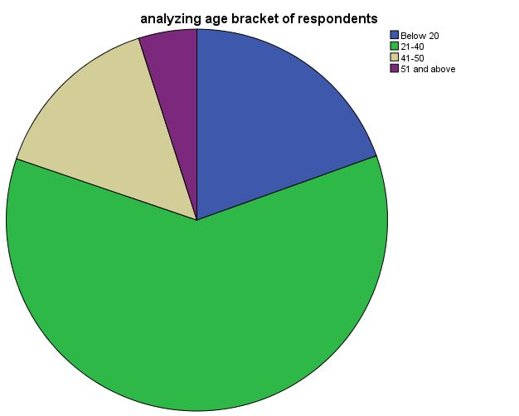
The age distribution of the respondents on the table 1 and figure 1 above, indicate 75 women representing 19.5% of the respondents are between the age of 20 below, 233 women representing 60.9% are between the ages of 21 to 40 and 57 women representing 14.8% are between 41 to 50 while 19 women representing 4.9% of the respondents are between the ages of 51 and above.
This means that the majority of the respondents are within the ages of 21-40, meaning that they constitute the adult population and active aspect of the respondents.

Table 2: Occupation of Respondents
 |  | Frequency | Percent | Valid Percent | Cumulative Percent
Valid | Farmer | 23 | 6.0 | 6.0 | 6.0
 | Teacher | 60 | 15.6 | 15.6 | 21.6
 | civil servant | 105 | 27.3 | 27.3 | 49.0
 | Business | 109 | 28.4 | 28.4 | 77.3
 | self employed | 87 | 22.7 | 22.7 | 100.0
 | Total | 384 | 100.0 | 100.0
Field Survey (2018)

Figure 2: Occupation status of the respondents
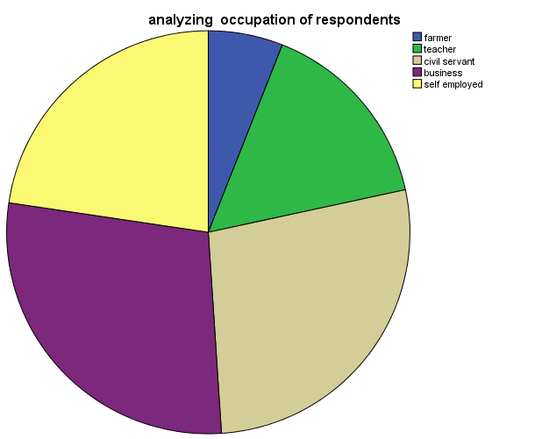
Table 2 and figure 2 above indicate that 23 women respondents making up for 5.0%, 60 of the respondents are farmers, representing 15.6%, while civil servants constitutes 105 number of respondents which 27.3%, 109 respondents are business women representing 28.4% and 87 respondents are self employed making up to 22.7%.

Table 3: Marital status of respondents
Status |  | Frequency | Percent | Valid Percent | Cumulative Percent
Valid | Single | 203 | 52.9 | 52.9 | 52. 9
 | Married | 120 | 31.3 | 31.3 | 84.1
 | Divorce | 38 | 9.9 | 9.9 | 94.0
 | Widow | 23 | 6.0 | 6.0 | 100.0
 | Total | 384 | 100.0 | 100.0
Field Survey (2018)

Figure 3: Marital status of respondents
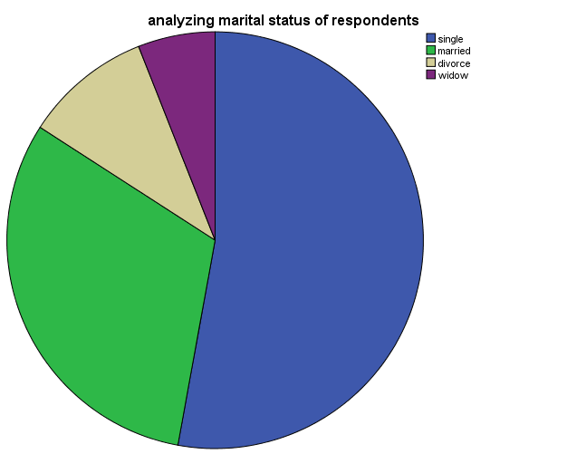
Table 2 and figure 2 above, indicate that 203 women representing 52.9% are single, 120 women representing 31.3% are married, and 38 of the respondents representing 9.9% are divorced while 23 of the respondents representing 6.0% are widow.
This means that majority of the respondents which is 52% are single who appear to have attained certain level of literacy.
Table 4: educational qualification
Education |  | Frequency | Percent | Valid Percent | Cumulative Percent
Valid | waec/neco | 104 | 27.0 | 27.1 | 27.1
 | OND/HND | 161 | 41.8 | 41.9 | 69.0
 | Bsc | 81 | 21.0 | 21.1 | 90.1
 | Phd | 38 | 9.9 | 9.9 | 100.0
 | Total | 384 | 99.7 | 100.0
Total |  | 384 | 100.0
Field Survey (2018)

Figure 4: Educational qualification of respondents
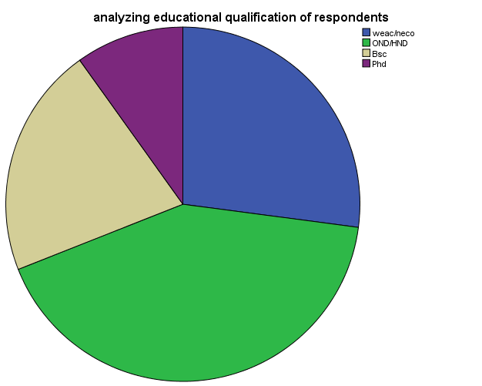
on the chart above, showing educational qualification, 104 respondents WASC/GCE holders representing 27.1%, 161 were OND/HND holders 41.9%, BSc were 81 which is 21.1% while 38 respondents had PHD which is made up of 9.9%.
The above implies that majority of the respondents at 41.9% has OND/HND.
SECTION B
    - Analysis of Data from Survey.
The analysis of psychographic data deals with analyzing data gathered from the behavior, attitude and mind set of the respondents towards television.

4.2.2.1. Research Question One: How exposed are women in Enugu to political program on AIT?
To answer this research question no 1-3 on the questionnaire, were used.
Table 4: Do you watch AIT?
Option |  | Frequency | Percent | Valid Percent | Cumulative Percent
Valid |  | 17 | 4.3 | 4.3 | 4.3
 | Yes | 342 | 85.5 | 85.5 | 89.8
 | No | 41 | 10.3 | 10.3 | 100.0
 | Total | 400 | 100.0 | 100.0
Field Survey (2018)
Table 4: analyzing number of respondents that watch AIT 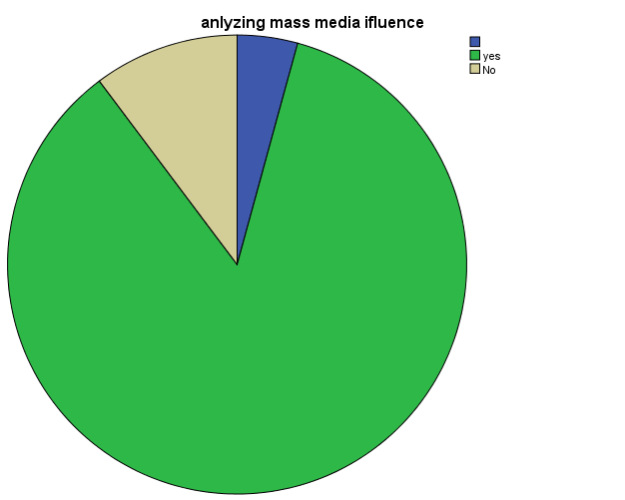
In the table 4 and figure 4 above, it is shown that 342 women respondents representing 85.5% of the respondents watch AIT. 41 women respondent which is 10.3% do not.
Table 5: Do you watch political program on AIT?
Options |  | Frequency | Percent | Valid Percent | Cumulative Percent
Valid | Yes | 264 | 68.8 | 68.8 | 68.8
 | No | 120 | 31.3 | 31.3 | 100.0
 | Total | 384 | 100.0 | 100.0
Survey (2018)
Figure 5: Analyzing number of respondents that watch political program on AIT
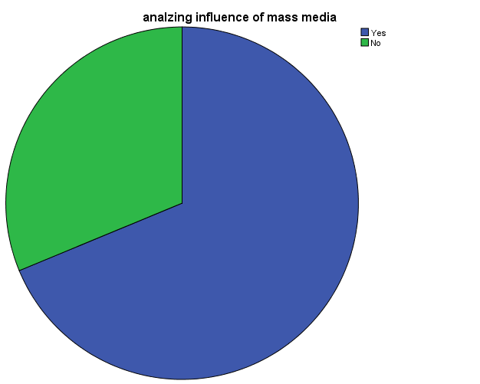
The table 5 above in figure 5 indicates that, 264 women respondents representing 68.8% watch political program on AIT while 120 representing 31.3% of the respondent do not.
Table 6: How often do you watch political program on AIT?
Option |  | Frequency | Percent | Valid Percent | Cumulative Percent
Valid | Daily | 129 | 33.6 | 33.6 | 33.6
 | several times in a week | 70 | 18.2 | 18.2 | 51.8
 | Weekly | 97 | 25.3 | 25.3 | 77.1
 | Never | 88 | 22.9 | 22.9 | 100.0
 | Total | 384 | 100.0 | 100.0
Field Survey (2018)

Figure 6: Analyzing how often respondent watch political program on AIT

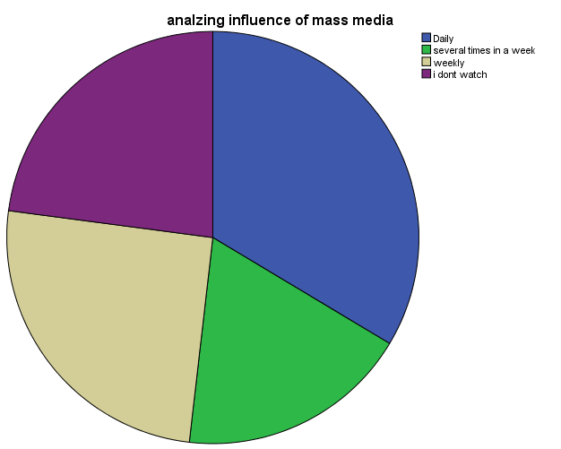
From table 6 and figure 6 above, it is shown that 129 women respondents representing 33.6% watch political program on AIT daily, 97 women respondents representing 25.3% watch weekly, 70 women respondent watch several times a week representing 18.2% while 88 women respondents representing 22.9% say never.

Summary of Research Question One
Considering that 85.5% of the women respondents watch AIT, while 68.8% of the women watch political program on AIT, it is clear that 33.6% of watch political program on AIT daily.
4.2.2.2. Research Question Two: what is the acceptance level of women in Enugu state to political program on AIT?
To answer this research question, items no 4-7, were used.
Figure 7: do you believe AIT political programs are credible source for political information?

Option |  | Frequency | Percent | Valid Percent | Cumulative Percent
Valid | Yes | 184 | 45.9 | 47.9 | 47.9
 | No | 200 | 49.9 | 52.1 | 100.0
 | Total | 384 | 95.8 | 100.0
Total |  | 384 | 100.0

Field Survey (2018)
Figure 7: Analyzing number of respondents that believe that AIT programs are credible source for political program
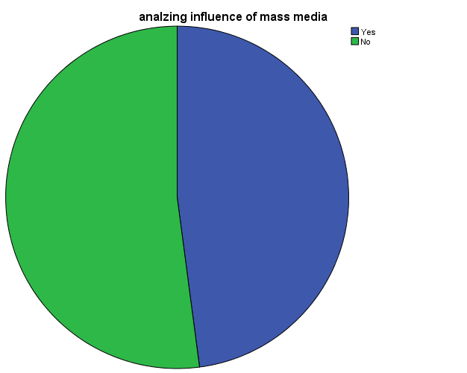
From table 7 and figure 7 above, 184 women respondents representing 47.9% believe that AIT political programs are credible source for political information while 200 respondents representing 52.1% do not.

Table 8: How often do you watch women political programs on AIT?
Option |  | Frequency | Percent | Valid Percent | Cumulative Percent
Valid | Daily | 129 | 33.6 | 33.6 | 33.6
 | several times in a week | 70 | 18.2 | 18.2 | 51.8
 | Weekly | 97 | 25.3 | 25.3 | 77.1
 | Never | 88 | 22.9 | 22.9 | 100.0
 | Total | 384 | 100.0 | 100.0
Field Survey (2018)
From table 8 and figure 8 above, it is shown that 129 women respondents representing 33.6% watch political program on AIT daily, 97 women respondents representing 25.3% watch weekly, 70 women respondent watch several times a week representing 18.2% while 88 women respondents representing 22.9% say never.

Table 9: do you agree that political programs on AIT give women and men equal relevance?
Option |  | Frequency | Percent | Valid Percent | Cumulative Percent
Valid | Yes | 113 | 29.4 | 29.4 | 29.4
 | No | 271 | 70.6 | 70.6 | 100.0
 | Total | 384 | 100.0 | 100.0
Field Survey (2018)

Figure 9: Analyzing if political programs on AIT give women and men equal relevance.
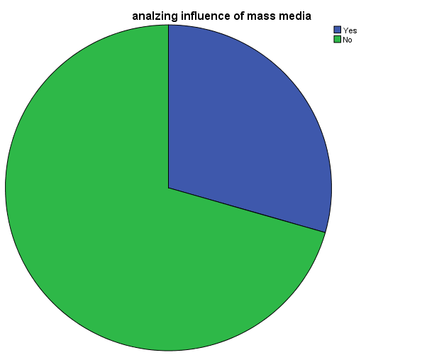
Table 9 and figure 9 above indicate that out of 384 respondents, 113 representing 29.4% women respondents said yes that women issues concerning women in politics are given equal relevance.

Table 10: Do political program on AIT change your perception about politics?
Option |  | Frequency | Percent | Valid Percent | Cumulative Percent
Valid | Yes | 184 | 45.9 | 47.9 | 47.9
 | No | 200 | 49.9 | 52.1 | 100.0
 | Total | 384 | 95.8 | 100.0
Total |  | 384 | 100.0
Field Survey (2018)
Figure 10: Analyzing if political program on AIT change women political perception

Table 10 and figure 10 above, indicate that 184 women respondents representing 47.9% agree that that political program on AIT change their political perception, 200 respondents representing 52.1% do not agree.
Summary of Research Question two.
According to findings, 47.9% women respondents believe that AIT political programs are credible source for political information while 52.1% do not. It is shown that 33.6% women watch political program on AIT daily, while 25.3% watch weekly, 18.2% several times a week while 22.9% say never. 29.4% of women say yes that AIT give issues concerning women and men are given equal relevance. 47.9% agree that political program on AIT change their perception about politics. 52.1% do not agree.

4.2.2.3. Research Question Three: what is the participation level of women in Enugu state after exposure to political program on AIT?
Items no. 11-12, on the questionnaire was used to answer this research question.

Table 11: Do you participate in politics after watching political program on AIT?
Option |  | Frequency | Percent | Valid Percent | Cumulative Percent
Valid | Yes | 184 | 45.9 | 47.9 | 47.9
 | No | 200 | 49.9 | 52.1 | 100.0
 | Total | 384 | 95.8 | 100.0
Total |  | 384 | 100.0

Field Survey (2018)
Figure 7: Analyzing number of respondents that participate in politics after watching political program on AIT
From table 11 and figure 11 above, 184 women respondents representing 47.9% participate in politics after watching political program on AIT while 200 respondents representing 52.1% do not participate.

Table 12: Women challenge male political dominance after exposure to political program on AIT?

Options |  | Frequency | Percent | Valid Percent | Cumulative Percent
Valid | Agree | 214 | 55.6 | 55.7 | 55.7
 | Disagree | 113 | 29.4 | 29.4 | 85.2
 | Strongly agree | 57 | 14.8 | 14.8 | 100.0
 | Total | 384 | 99.7 | 100.0
Total |  | 385 | 100.0
Field Survey (2018)
Figure 12: Analyzing if women challenge male political dominance after exposure to political program on AIT.

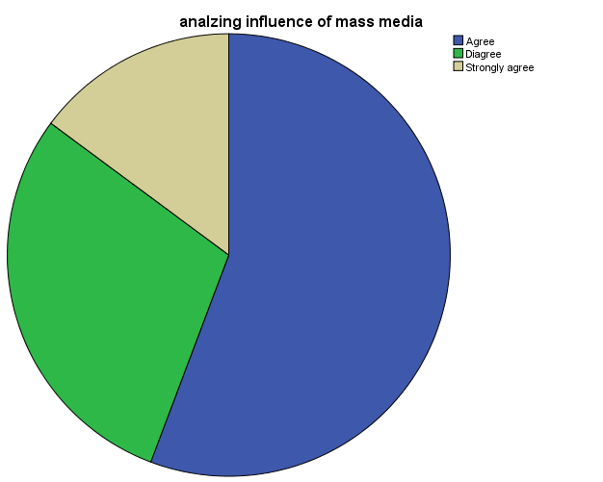
Table 12 and figure 12 above, indicate that 214 women respondents representing 55.7% are agreed that women challenge male political dominance after exposure political program on AIT , 113 respondents representing 29.4 disagreed while 57 respondents made up of 14.8 strongly agree.

Summary of Research Question Three.
Given that 55.7% of the women respondents challenge male political dominance after exposure to political program on AIT, 29.4% do not. 14.8% however strongly agree.

  - Discussion of Findings
This section discusses the findings of the study in relation to the three research questions raised.
4.3.1 Research Question 1: How exposed are women in Enugu state to political program on AIT?
It was revealed that 85.5% of women in Enugu state are exposed to political program on AIT. Finding is in conformity with the findings of Omojola (2014), on his work on Women’s Political Visibility and Media Access: the Case Study of Nigeria. This work exposes the connection between the logic of commercialism and its influence on the visibility on the politically active women; it also shows that significant relationship between citizen’s exposure to television broadcast and political participation. The broadcasts encourage them to find information.
    - Research Question 2: what is the acceptance level of women in Enugu state to political program on AIT?
This study further revealed that to 47.9% of women in Enugu state accept political program on AIT.
This finding is in relation with the findings of Murza (2004), The mass media plays an important role in modern society, being a powerful resource used by politicians. It has contributed to the creation of such phenomenon as political language. As a result, the informational field has become very inconsistent and created a set of various representations of one and the same phenomenon, reality or event, often mutually excluding each other.
    - Research Question 3: what is the participation level of women in Enugu state after exposure to political program on AIT?
This study also observed that 47.9% participate in politics after exposure to political program on AIT.

CHAPTER FIVE
SUMMARY, CONCLUSION, RECOMMENDATIONS
  - Introduction
This chapter gives brief summary of the entire research work, the findings, conclusion, recommendation and suggestion for further studies.
5.2 Summary of Findings
The findings made at the course of this study include:
- Women in Enugu Urban exposed to political program on AIT and majority of the respondents at 85.5% agreed to this.
- It was discovered that 31.3% of the respondents do not watch political program on AIT
- 33.6% of the women respondent said they watch political program on AIT daily, majority of the women respondents however do not participate in politics after watching political program of on AIT, 52.1% measuring more than half of the respondents accept this fact.
  - Conclusion
The findings of this study have established that aside watching AIT, women in Enugu state use AIT political programs as a means for political awareness and participation. If they have political interest, they should take the giant stride into increasing their political status, understanding and participation by watching political programs on AIT. This will bridge the gap between them and men, and also bring them close to the people. This will bring to an end the public judgment that women are not, or do not have the capabilities for political positions.
  - Recommendations
Based on the findings of this study and the conclusion above, the study makes the following recommendations:
- Women should endeavor to use AIT as a source for political awareness. This is in line with Source Credibility theory of mass Communication which states that information is credible base on the source.
- Women should break the gender gap by paying adequate to programs that edifies politically.
- Given the prospects of women using AIT for political awareness and participation, women should be encouraged to make public their political interest, using AIT as a platform.
5.5 Suggestions for Further Studies
The researcher is convinced that there is still need to conduct further research on this subject; this is because we cannot claim to have covered all the aspects of assessment of AITs influence on women political awareness and participation in Enugu state.

Reference
Aina, O. I & Olayode, K. (2012). Gender Equality, Governance And Women Empowerment Agenda. In A Democratizing Society Issues, Prospects And Challenges. Nigerian Sociological And Anthropological Journal.
Akor, O. (2015). “How Women Performed In The 2015 General Elections.” Daily Trust, 24.
Anifowose, R. (2004). Women Political Participation In Nigeria: Problem And Prospects. Paradox of Gender Equality in Nigeria Politics, Lagos: Public Concept Limited.
Annette, A. (2014). Perceptions of Women in Political Leadership Positions in Nigeria. Walden Dissertations and Doctoral Studies.
Arowolo, D & Aluko, F.S. (2010). Women Political Participation in Nigeria. European Journal of Social Sciences 14 (4), 581-593.
Baran, S. (1995). Introduction to Mass Communication. London, Mayfield Publishing Company.
Beverly, S. (1995). Building Gender Fairness In Schools. U.S.A: Southern IIIinois University Press.
Chukwu P. (2007). The 1999 Constitution And The Independent National Electoral Commission (INEC): Prospects For Supervision And Conduct Of Elections, In Jega Atahiru and Oke, I (Eds.) Elections And The Future Of Democracy In Nigeria: Nigerian Political Association.
Enete, I.C & Alabi, M.O. (2012). Ob served Urban Heat Island Characteristics in Enugu Urban During The Dry Season. Global Journal of Human Social Science, Geography & Environmental Geosciences. Vol. 12 Issue10 Version 1.0 Year 2012. Publisher: Global Journal Inc. (USA) Online ISSN: 2249-460$X$ & Print ISSN:0975-587X.
Equal Opportunities Commission. (2003). United Nations Targets for Proportion of Women in Leadership and Decision-Making Positions. Overview of context for the United Nations (UN) targets.
Flew, T. (2005). From E-Government To Online Delibrative. In: Summer Doctoral Programme (SDP2005), 7-21. Chinese Academy Of Social Science, Beijin. (Unpublished).
Lewu, M. A. Y. (2005). “Women In Nigeria Politics.” In Hassan A. Saliu (Ed) Nigeria Under Democratic Rule (1999-2003) Vol 2. Ibadan: University Press Plc.
Luka, R.C. (2011). “Women and Political Participation in Nigeria: The Imperative of Empowerment.“ Journal Of Science And Public Policy. Vol.3.
Magstadt, T. m. (2006). Understanding Politics, Ideas, Institutions, & Issues (7Ed). Califonia: Thomson Wadsworth.
Mayfield. (2008). Is Blogging Innovation Journalism? Retrieved from Http//www.innovation journalism.Org/Archive/Injobaltziz.pdf.
Ezekiel B. Peter O. (2014) “An Assessment of the Use of Radio and other Means of Information Dissemination by the Residents of Ado- Ekiti, Ekiti-State, Nigeria.” Library Philosophy and Practice (e-journal). 1088.
Olu A. & Temitayo I. (2014) “Gender and political participation in Nigeria: a cultural Perspective.” Journal Research in Peace, Gender and Development (JRPGD) Vol. 4(6) pp. 104-110
Nweke T. (1989). Women in Nigerian Society: The Media Women in Nigeria Today. London: Zed Books, p. 203.
Okonjo, K (1985) 'Dual Stratification'. In Ogundipe-Lesile Molara (ed.) Not Spinon the Axis of Maleness: Women in Nigeria, Sisterhood is Global. New York: Double Day and Pelican Books

APPENDIX A
LETTER TO RESPONDENTS

Department of Mass Communication
Godfrey Okoye University
Thinker’s corner
Enugu
Enugu State
24th May 2018

Dear Respondent,
My name is Jacob Mbah, a 400 level student in the department of mass communication, Godfrey Okoye University, currently conducting a research on, an assessment of mass media influence on women political mobilization and awareness in Nigeria. I request that you help me in answering the questions in this questionnaire to enable me conduct the research.
All information provided here will be treated with utmost confidentiality. Sincerity in your responses is needed for effective result in this study.
Thanks for your anticipated co-operation
Yours faithfully Mbah

……………………

Jacob C

APPENDIX ‘B’
QUESTIONNAIRE
PART ONE: DEMOGRAPHIC DATA
Please tick ( ⅟ ) where appropriate box that indicates your answer to the question.
PLEASE TICK AS IN THE APPROPRIATE SPACE
PART A
Socio Demographic Data
1. What is your age bracket?
- Below 20 (b) 21-40 (c) 41-50 (d) 51 and above E I
2. What is your marital Status?
Married Single Divorce Widow
3. What is your highest educational Qualification?
(a) WAEC/GCE/NECO (b) OND/HND/NCE (c) B.SC/MBA/MSC/ (d) PHD
4. What is your Occupation?
(a)Farmer (b) Teacher (c) Civil Servant (d) Business (e) Self employed

