TITLE PAGE

RADIO BROADCAST PROGRAMMES AND RURAL DEVELOPMENT IN NIGERIA; A STUDY OF RESIDENTS IN AGWU LOCAL GOVERNMENT AREA, ENUGU STATE

BY

ANOSIKE, FAITH OLUCHI
U14/MSS/MAC/069

A PROJECT SUBMITTED TO THE DEPARTMENT OF MASS COMMUNICATION,
FACULTY OF MANAGEMENT AND SOCIAL SCIENCES IN PARTIAL FULFILLMENT OF THE REQUIREMENTS FOR THE DEGREE OF BACHELOR OF SCIENCE (B.Sc) IN MASS COMMUNICATION

SUPERVISOR
DR. ALEXANDER ONYEBUCHI

JULY, 2018

DECLARATION
I, Anosike Faith Oluchi with the registration number U14/MSS/MAC/069 is a student in the Department of Mass Communication under the Faculty of Management and Social Sciences in Godfrey Okoye University. I declare that the research work submitted in partial fulfillment of the requirement for the award of Bachelor of Science (B.Sc) in Mass Communication is my original work and has not been submitted either in part or full for any other degree or diploma either in this or any other tertiary institution.

………………………. …………………
Anosike Faith Oluchi Date

APPROVAL PAGE
This is to certify that this research work “Radio Broadcast Programmes and Rural Development in Nigeria; A study of residents of Awgu Local Government Area, Enugu state” by Anosike, Faith Oluchi in the Department of Mass Communication has been examined and approved as meeting the requirements for the award of Bachelor of Science (B.Sc) Degree in Mass Communication, Faculty of Management and Social Sciences, Godfrey Okoye University, Enugu.

…………………………. …………………..
Dr. Alexander Onyebuchi Date
(Supervisor)

…………………………. …………………..
Prof. Cosmos Nwokeafor Date
Head of Department

…………………………. …………………..
Prof. Onyema Ocheoha (mni) Date
Dean of Faculty

…………………………. …………………..
External Examiner Date

DEDICATION
This research work is dedicated to my father in heaven God almighty the author and finisher of our Faith whom by his grace foreknew, predestined and made this work a success and for seeing me through my academic years, my parent Mrs Chioma Anosike and my esteemed supervisor Dr. Alexander Onyebuchi whom without their unceasing guidance, support and prayers it would not have been possible.

ACKNOWLEDGEMENTS
I give all the glory, honour and thanks to God Almighty for his infinite mercy, grace, guidance upon my life, he is the only reason why I am where I am today.
My gratitude also goes to my amiable supervisor Dr. Alexander Onyebuchi for his patience, guidance and candid advice. His expertise saw me through the whole process of my project writing. His fatherly love and care gave me reason to give my best and to realize that my best was just a stepping stone.
I will not forget to thank my lecturers, starting from; Rev. Fr. Prof Christian Anieke, Prof. Ocheoha Onyema, Prof Cosmos Nwokeafor, Rev. Fr. Dr. Paul Obayi, Prof. Armstrong Idachaba , Mr Ment Nnomeh, Mr. Ben, Mr nnamdi nzekwe, Miss Fiona Onwude, Mr. Dubem, Mr Ezema and a host of other lecturers too. They all contributed to the moulding process that transformed me into who I am today. No amount of words could repay you all, I am eternally grateful.
I wish to express my sincere appreciation to my parents and my siblings as well for their prayers and immeasurable support towards my education. Words will never be enough to thank them, may God in his infinite mercy reward them a hundred fold.

TABLE OF CONTENT
Title page i
Declaration ii
Approval iii
Dedication iv
Acknowledgements v
Table of Content vi
List of Tables ix
Abstract x
CHAPTER ONE; INTRODUCTION
1.1 Background of the Study 1
1.2 Statement of the Problem 3
1.3 Objective of the Study 3
1.4 Research Questions 4
1.5 Scope of the Study 4
1.6 Significance of the Study 4
1.7 Operational Definition of Terms 5
CHAPTER TWO; LITERATURE REVIEW
2.0 Introduction 6
2.1 Conceptual Literature 6
2.1.1 Radio and Development 6
2.1.2 The Concept of Development 9
2.1.3 Development Communication 10
2.1.4 Modes for Mobilization for change in the rural area 12
2.1.5 Community Radio Broadcasting 19
2.2 Theoretical Framework 21
2.2.1 Development Media Theory 21
2.2.2 Media Equation Theory 21
2.3 Empirical Literature 21
2.4 Summary of related Literature 28
2.5 Gap in Literature 28
CHAPTER THREE; METHODOLOGY
3.1 Introduction 29
3.2 Research Design 29
3.3 Population of the Study 29
3.4 Sampling Technique/Sampling 29
3.5 Instrumentation 30
3.6 Reliability of Instrument 31
3.7 Validity of Data gathering Instruments 31
3.8 Method of data Collection 31
3.9 Method of data Analysis 32

CHAPTER FOUR; DATA PRESENTATION AND ANALYSIS
4.1 Introduction 33
4.2 Presentation and Analysis of Data 34
4.3 Discussion of Findings 65
CHAPTER FIVE; SUMMARY, CONCLUSION AND RECOMMENDATIONS
5.1 Introduction 72
5.2 Summary of Findings 72
5.3 Conclusion of the Study 73
5.4 Recommendations 74
5.5 Suggestion for Further Studies 74
Reference 75
Appendix 77

Abstract

The research study was aimed at radio broadcast programmes and rural development in Nigeria; A study of residents of Awgu local government area. The study addressed four research questions. The study adopted the survey research design method using the questionnaire as the research instrument. The findings revealed among others that there are factors that hinder development of rural areas and its dwellers through the broadcast media (radio). The study recommended amongst others that the government should put up more and effective developmental programmes on radio ranging from educational programmes to enlightenment programmes and instructional programmes to foster development in rural areas and its dwellers. The study also suggested that further studies should be carried on radio broadcast programmes and rural development to eradicate the possible challenges emerging from rural development.

CHAPTER ONE
INTRODUCTION
1.1 Background of the Study
From time immemorial, information has always played a prominent role in human life but the emergence of social progress and the vigorous development in science and technology has immeasurably increased the role of information in every facet of human endeavor. Information means different things to different people, some it may be in form of news on radio or television, and the print media, to some it may be a medical report which may be used for taking health decision, to an investor, financial report of an organization as a vital information to decide whether to stake ones investment in such or to divest, to some is the stock analysis and daily trading in the stock market (David, 2012).
However, one of the recent means of information dissemination and communication is the radio gadget. Radio came to be as a result of the invention of technology, therefore the history of radio in Nigeria started way back with British Broadcasting Corporation. Radio broadcasting was introduced into Nigeria in 1933 by the then colonial government; it relayed the overseas service of the British Broadcasting Corporation through wired system with loudspeakers at the listening end (Harrison, 2011).
It is asserted that information aids and facilitates development at all levels. Information is now accepted as an important factor in the sustained development of any society because it reduces uncertainty, and enhances awareness of possible actions to take to solve problems. Lack of information is argued to act as a barrier to economic development because of importance of information provision in “capacity building” and “empowering communities” (Apata and Ogunrewo, 2015)
One of the vital sections of an economy that hungers for sustainable development is the rural areas. Hence, rural development remains one of the priorities of every present administration. Rural development is used to describe a strategy that is designed to improve the economic and social life of the people in the rural areas. The United Nations Development Programme (UNDP) sees rural development as a process of socio-economic change, involving the transformation of agrarian society, in order to reach a common set of development goals, based on the capacities and the needs of the people. Rural development is a strategy that is designed to improve the economic and social conditions of a specific group of people, that is, the rural people. It involves extending the benefits of development to the poorest, among those who seek a livelihood in the rural areas. Rural development generally, is used to denote the actions and initiatives taken to improve the standard of living in non-urban neighborhoods, countryside and remote villages (Johnson, 2013).
Through various developmentally oriented programs disseminated by various radio stations, it is expected that development will be triggered in rural areas. The three radio stations considered in this study are Radio Nigeria, Dream FM and Urban Radio. These radio stations broadcast various programmes ranging from entertainment programmes, political programmes and economic development programmes. However, the major programmes broadcasted by these radio stations that has the prospects of enhancing rural development are Economic Table, Political Voices and Talk Parlour hosted by Radio Nigeria Enugu, Dream FM Enugu and Urban Radio Enugu. In line with this, this study aims at carrying out empirically radio broadcast programmes and rural development in Nigeria (A study of residents of Awgu).

1.2 Statement of the Problem
The importance of Radio in promoting development at both the rural and urban areas cannot be overemphasized. This is because the advent of radio and their associated programs have tremendously transformed the way information is disseminated, prior to its invention, people most especially in primitive Africa society had their peculiar way of disseminating information such as the use of town criers and assembling people in strategic locations in the village such as market square to disseminate information to them. However, the massive and rapid growth and expansion of radio stations has raised concerns over whether they are contributing to the development of their designated states or the interests of advertisers and their profit minded owners (In the case of private stations).
There are schools of thought who argue that radio is a conduit of Western cultural products like music and advertisements, which are suppressing rural development-oriented local content. On the other hand, there are those who believe that radio has taken the government and its policies closer to the rural people than in the days back, and therefore helped to raise the level of awareness among the rural people, on government policies, national and international events, etc.
It is not however certain if the Radio stations and their associated programmes in Enugu state promote the development of Awgu local government. This becomes the rationale behind this study.
1.3 Objectives of the Study
In a general form, the study seeks to find out if radio broadcast programs influence rural development in Awgu local government area of Enugu state. Therefore the major focus of the study will be to:
- Find out the extent to which residents of Awgu listen to radio programmes on development.
- Find out how often the residents of Awgu listen to radio programms.
- Ascertain whether the residents of Agwu have experienced development through listening to the programs.
- Ascertain the challenges preventing the development of Awgu local government through local broadcast developmental programmes.
1.4 Research Questions
In the course of this study, the following research will pilot the study
- To what extent do residents of Awgu local government listen to radio programmes?
- How often do the residents of Awgu local government listen to radio programmes?
- What is the influence of these radio development programmes on residents of Awgu local government?
- What are the existing challenges preventing the development of Awgu local government?
1.5 The Scope of Study
This study will be limited to Awgu local government area of Enugu state and also to find out the radio broadcast programmes the residents of this community listen to. Reasons are the researcher has to be thorough with the investigation to produce realistic results on how radio broadcast programs influence rural development. The population will include all adults irrespective of gender, educational status and religion as well as income level in these communities.
1.6 Significance of study
The study will be significant to the community socially, morally and economically, especially in terms of development in the communities. It will also help the broadcast media to shape their programming pattern and content in order to suit and appeal to the viewing and listening abilities of the audience making it possible for the government to always be aware of the pressing issues of the communities. It will be significant to the government in terms of provision of information and training especially in the areas that are imperative for development.
The academic significance of this study is that it will be of great significance to students and researchers who might embark on a related study. It will serve as a point of reference and literature enhancement.
1.7 Operational definition of terms
RADIO- Radio is a medium that can be used to mobilize the rural dwellers and even urban dwellers for development purposes if effectively used.
BROADCAST PROGRAMMES- this is the practice of organizing and ordering of broadcast media programmes (internet, television, radio, e.t.c) in a weekly, monthly, quarterly or season-long schedule
RURAL DEVELOPMENT -Rural development is a strategy that is designed to improve the economic and social conditions of a specific group of people, that is, the rural people. It involves extending the benefits of development to the poorest, among those who seek a livelihood in the rural areas.
DEVELOPMENT: This is seen as the multidimensional and radical changes and improvements at the social, economic, psychological and related dimensions.

CHAPTER TWO
LITERATURE REVIEW
2.0 INTRODUCTION
This section of the research is focused on carrying out an extensive literature on the concept under study. This chapter is compartmentalized into three sections namely; conceptual literature, theoretical framework and empirical literature. The gap in literature was also elucidated.
2.1 CONCEPTUAL LITERATURE
2.1.1 Radio and Development
Since the dawn of civilisation about two and half million years ago, every society’s growth, survival and continuity depends on among other things, a system of communication, through which people exchange of ideas, feeling; an economic system for the production of goods and services, a health system to counteract disease and ensure human reproduction; a sociopolitical system to maintain control and order and a defence system to protect their territories against external aggression (Ugboaja, 2010).
Ndolo (2006) observes that the partial success of modern mass media application for development projects, especially in the rural areas have resulted in various calls by communication scholars for rural development agents in the field, for a greater utilisation of indigenous communication channels for rural development.
According to Mogekwu (2009), the importance of rural radio in the introduction and sustenance of change in rural communities is undeniable, yet, successive Nigerian leaders have continued to utilize the Western mass media as the panacea for rural development, thus, there is a pressing need to improve and create more rural stations and create programmes that will meet the needs of the rural dwellers, thereby, bringing about national development. Radio can be used to mobilise the people at the grass root level for community development and national consciousness. No serious mass-oriented development programme, especially in rural communities in Africa ever succeeds without the active involvement of the people within the traditional system.
Rural radio programme serves as a source of cultural, political, health and other educational and enlightenment programmes for the masses, leading them towards self-actualisation and national development. It is in this light that Okam (2013) submits that much of the failure that attends government mass–oriented programmes are traceable to the fact that policy makers at the national level fail to utilise this powerful and credible medium. Radio can be used as a source of entertainment through arts and cultural festivals, musicals and dramatic performance, by local singing groups, masquerades and other music and drama groups. Radio is a medium of communication through which the individuals share the world around them and beyond their immediate environment. Radio in a country should influence social and, especially the political fabric. The social objective of using radio to mobilise people in Nigeria entails the area of education, information and entertainment. It is essential to provide through radio a kind of general education for people, irrespective of their educational background. This would be by a combination of formal and informal form of education.
Electronic media generally, according to Asemah (2014), provide the public with information. Electronic media serve as watchdog and do not abuse power. For education, there is thrill of learning from the source material. Radio as an electronic media, is expected to play the role of improving and changing social, cultural, political and technological thinking, which will, in the long run, have positive results on the process of rural development. This sensitive role expected to be played by radio is not far from the fact that it shows special qualities in disseminating information. Radio is so powerful that it brings political, economic and social news to any community or group of communities faster than other medium. Nwuneli, cited in Asemah (2013) in his own contribution on the role of radio, says, it has brought stimulus into the house, brings about competitions within families, thereby, grooming people who will contribute positively to the process of development. This fact agrees with the idea of Wigwe (2015) because of the emphasis on grassroots development. Salama (2013) notes that radio serves as an opinion leader in its news commentary and editorial. It mirrors the society in programmes like drama that present issues relevant to society in action which creates easy understanding and learning.
It informs and educates the listeners in its discussion and documentary programmes. It entertains in its light programmes like musicals, sports comedy and dances. It also seeks to improve the society in its special occupational programmes geared towards agricultural business and other related areas. In essence therefore, radio can be employed to pass across vital information about latest techniques in agriculture, trends in agricultural extension services, etc, to the generality of rural dwellers. Moemeka (2012) remarks that a local broadcast media like radio, if well managed, fully operated, will provide a continuous flow of educational information on all aspects that affect the lives of rural communities and also arouse their awareness with a view to changing what is detrimental to their lives. Thus, radio can be effectively used to promote health related issues. Radio educates, informs and enlightens the public of which the rural populace are included.
Radio just like television is a tool that can be used to bring about positive attitudinal change in the audience. Radio helps to achieve development, both in the rural and urban areas, as issues of development are aired to the audience in the form of various programmes and individuals are exposed to happenings in and around their society, through listening to programmes.
Radio can be employed to pass vital information about the right attitude, behaviour, knowledge, techniques and skills, which are expected from the members of the public. Radio has been found to be one of the most effective media of transforming a hither-to, under-developed society to a developed polity. Ojebode (2003) concurs when he says that with few years of its emergence, radio has metamorphosed from being an object of private concern, to a political and development instrument in the hands of governments and NGOs. The information dispersing and the enlightenment role of radio is the commonest of its functions. This disseminating function according to Asemah (2011), covers information to people‟s alertness to health, agriculture, education, economy, politics, etc. In this case, lectures, news, entertainment, drama, discussions etc, can be used. Radio stations in Nigeria often relay special programmes that promote rural development. More so, radio has the capacity to mobilise support for government programmes. Thus, the government at various levels - local, state and national, have used both radio and television to mobilise support for its programmes. Arulogun and Adesiyan (2008) notes that successful governments in Nigeria have used the media to console people and reassure them of their support in times of fire disaster, religious crisis, flood and other catastrophic events. During the crises in plateau state, the government relied heavily on the mass media in holding together the people; not only in terms of crisis, but also for the continuous peaceful coexistence of the different ethnic groups. Both private and public television and radio stations have introduced programmes, relayed jingles that lay emphasis on the need for peaceful coexistence.
2.1.2 Concept of Development
Development as a concept is broad and therefore, does not subject itself to a single definition. It indeed covers a wide range of human endeavours. According to Asemah (2010), development is a process of change in attitude, social structure and general acceleration of economic growth, through reduction of poverty and inequality. Asemah (2011) notes that development in human society is a many sided process. At the level of the individual, it implies increased skills and capacity, greater freedom, creativity, self discipline, responsibility and material well being. The achievement of any of these aspects is very much tied in with the state of the society as a whole. Development involves the creation of opportunities for the realization of human potentials. Human beings have certain basic requirements, which must be satisfied so that they can properly function in the society. Among these are enough food, employment and the elimination of the kinds of inequality, which lead to poverty.
Asemah (2010) sees development as a gradual process of bringing about positive attitudinal change in the people. It is a continuous process of improving their living conditions, through positive change. The essence of development according to Asemah is the development of people with change in their attitude, leading to change of habit. This means that just changing things without concurrent change of habit or attitude is not a healthy development. Development is seen as a changing process of knowledge, attitude and practices. It is in this context that the writer looks at development. Keghku (2005) says that development generally implies change.
2.1.3 Development Communication
Information and Communication Technologies (ICTs) were recognized worldwide as agents of development and they had made some strides in Nigeria. These ICTs brought about radio of which the environment was such that it could not deliver significant dividends for development. No scholar disputes the fact that the media has enormous impact on any society. The only disparity of thinking is on whether the media-induced changes are good or bad for the community. It is also a question of how long it takes for media products to cause change in the lifestyles of people. Therefore the need to be aware of the happenings around us and embrace change brought about development communication. In the opinion of Okunna (2002:293) development communication, implies communicating development message. Quoting Edeani, she further defined development communication as the use of all forms of communication in reporting, publicizing and promotion of development at all levels of a society. In an attempt to give a vivid definition of the concept, Okunna cited Quebral who viewed it as the art and science of human communication applied to the speedy transformation of a country and the mass of its people.
Asadu (2009) demonstrates that development communication can also be called communication for development, development journalism or communication for social change. He further explained, that it simply means applying communication principles to development objectives of a society. It is a multi-communication approach aimed at informing, empowering, educating and mobilizing or motivating the people to better lives in a sustainable way. At the community level, this type of development exposes experts and local technologies in the village. Frazer and Restrepo-Estrada as cited in Asadu (2009) defined communication for development as the use of communication processes, techniques and media to help people towards consensus, to help people plan actions for change and sustainable development, to help people acquire the knowledge and skills they need, to improve their condition and that of society and to improve the effectiveness of institutions.
In development communication, the people are the drivers of their own development. It as well recognizes and respects the culture, attitude, intelligence and traditional wisdom of the people. Therefore development that does not occur with the consent or involvement of the beneficiaries, does not mean true development. Because people will not feel committed to the project. By 2003, there were 113 radio broadcasting stations in Nigeria, among these were 83 government-controlled and 30 commercial stations. All the existing radio stations were located in the urban areas which were either administrative capitals or commercial locations. Therefore the programmes of radio, catered for the tastes of the population in these areas for instance government agencies, elites etc.
And this makes development communication process unsuccessful when compared with that of other countries; in terms of the level of development in those countries. According to Ekwelie as quoted by Okunna (2002:293) a remarkable feature of development communication is that it is only concerned with peoples welfare as defined by them. The broadcasting environment as defined in policy, legislation and regulation was also unfavourable. For example, the existing National Mass Communication Policy is also unfavourable.
2.1.4 Modes of Mobilization for Social Change in the Rural Area.
According to Longman Dictionary of Contemporary English (1978) the verb ‘‘mobilize’’ means to gather together, people or things for a particular service or use. Ucheanya (2003:70) demonstrated that mobilization increases the participation of mature people in public issue, in quoting Nyirand he maintained that mobilization is aimed at mustering national support for a successful programme. Thus it helps in favourably modifying peoples behaviour and it enlightens people for mass participation in public programmes. Radio, mobilize the masses for social change through its various types of development programmes, which can also be called a typology of development programmes. In definition, typology of development programmes, means the different types of programmes that are deemed to be development-oriented. The interpretation of the development orientation of the different programmes is derived from the emphasis put on the development needs of the rural dwellers. Some of the programmes, apart from news bulletins, should be entirely in the local language. The time and days of the programmes are considered more important because of the time and days they attract more listeners. Therefore, programmes given more time also attract greater public interest than those given less time in a week.
Firstly, the news programmes are among the most programmes listened to. The fact is that the radio stations, schedule their news bulletins – both in the local language and in English – around the same time. According to Okunna (2002) news as a programme normally comes up around 7.00 - 8.30 local time and lasts for a duration of 30 -45 minutes. Which shows that news is among their top priorities, apart from major newscast, most radio stations also broadcast news updates, news commentaries, news analyses and news talks as addendum to major news cast. These are the times with highest number of listeners. As people always want to know what is happening around them, in the federal government or State government and outside the country. When things happens in the government house, within a few minutes even people deep in the rural areas have already gotten the information, this is development brought about by radio. This is good because it keeps the local community abreast with what transpires in other parts of the continent after the media have relayed with the foreign media or the internet.
Secondly the peace and reconciliation programmes are broadcast so as be able to bring peace to warring countries or communities after years of war, which is one of the duties of the media. For years now, the radio stations package peace and reconciliation programmes, in collaboration with church leaders and Non-Governmental Organizations (NGOs), drumming the spirit of reconciliation and forgiveness of the rebels who have killed, abducted or maimed many people, as well as destroyed or looted people’s property, the programme presenter play songs for the rebels. The songs are often dedicated by members of the audience of which provisions are made for phone-in, for the comments of the audience. So that after prolonged insurgency; people are desperate for peace, which is a prerequisite for development.
Thirdly are the cultural awareness programmes, of which the programme presenters are supposed to be well-versed with the norms, values and traditions of the community which surround them. This contributes to “preservation” of culture and knowledge of the traditional artefacts and certain important cultural practices which would otherwise be extinct and should be discarded. Local music are broadcast to promote culture and local artistes, The local musicians are invited to the studio to talk about their songs, the lyrics, how they started etc. These processes help to inspire other people, especially young ones, who may emulate and start performing or compose their own songs. Radio, have become the best “marketing forum” for musicians, through this musicians are brought to the limelight. The themes of the songs are mostly on social issues and therefore a source of education for the public on social values. This is one way to enhance development because the songs, motivate people into doing positive things advocated for in the songs.
In addition, the religious programmes apart from DJ presentations, music and advertisements, religious programmes are broadcast to enhance development, for instance church leaders preaching to people to obey God, love one another, repent of their sins in order to be forgiven, or renew their faith in the Lord. Sometimes prayers are said and people receive healing and deliverance especially from the barbaric activities in the rural areas and also ungodly acts. The fact that the radio stations package religious programmes, means that they are important to the community. It also mean that the radio stations choose to lay emphasis on religious programmes because they believe most of the listeners are Christians.
Health Education is an aspect that should not be neglected because, the society can only develop when people are healthy and the media have a responsibility to help people live healthily. Along this line, the radio stations broadcast programmes during which medical doctors appear in the studio(s) to talk about general or specific diseases, their causes, symptoms and how to avoid them or where to seek for treatment. Through it, the community gain tips on simple but important things like disposal of garbage, cleanliness of the surroundings and utensils, and also personal hygiene. This is an important element of development, because once people keep their surroundings clean, then they can certainly reduce the risk of catching bacteria-induced diseases.
The HIV/AIDS pandemic is another area that should be of interest to the radio crew. As a reflection of the national agenda, which considers HIV/AIDS as a big threat to national development, the radio crew package programmes aimed at sensitizing the community on the disease (http://www.nationsencyclopedia.com.September 11,2011page two). The medical officials are invited to sensitize the community on the ABC (Abstain, Be Faithful, and use Condom) model of HIV prevention, as well as on HIV/AIDS counselling, prevention of transmission from mother to child among others. The fact that health programmes are broadcast, reflects the ranking of health as very significant to the community. As a factor of development, human health is very important, and should be taken care of. The HIV patients should be taken care of and advised on how to move on with their lives and also socialize with others in order to move on.
Another vital point is information on Agriculture, the significance of radio in the promotion of rural agriculture and helping people improve the peasantry lifestyles of the rural dwellers show that farming is of great importance as a whole nation can be wiped out without it. The other type of programmes are those initiated by the radio crew themselves to update farmers about market prices, new crop uses, or the market demands for certain crops. It also teaches farmers about animal and crop husbandry, including techniques for planting, weeding, harvesting, storage and marketing approaches. Farmers are encouraged to grow organic crops, which fetch higher prices in the world markets. There should be a partnership between the agricultural experts and the radio crew which help to drive home the right messages for the farmers.
Through radio, agricultural experts will be able to raise massive farmers awareness on the symptoms of crop disease and how to handle it. Without radio, most people would probably not know about the various plant diseases. However, the money realized from farming and agricultural products could help solve some household problems and alleviate poverty.
Furthermore, environment alert is of utmost importance too. Over the last decade, following the first global summit on environment held in Rio de Janeiro, Brazil, in 1992, there has been a growing need for human beings to harness the environment/natural resources for sustainable development. Radio, can sensitize the public on the benefits of tree planting, nature conservation, protection of wetlands, garbage collection for recycling and disposal, and a number of other environmental topics. The key messages of the environmental experts should be, that for every tree cut down two trees should be planted to replace it. And many people have taken heed by planting trees.
2.1.4 Problems Associated with Using Radio for Rural Development
There are so many factors that hinder development communication in Nigeria. This informs why most social development programmes in Nigeria often fail. Among the problems are:
Communication Related Problems: The communicator plays a very significant role in the process of communication. The communicator is the man or woman who disseminates the information. The communicator has a big task to play in order to affect the people positively with his social development messages. If in the process of communication, the communicator is weak or bad, it will negatively affect the whole communication process.
Message Related Problems: The message is the actual physical product of the communicator. The message is the contents, the feelings, notions, ideas, etc, which we pass across to the people, so as to affect them. In communicating social development programmes, the communicator has to use the right codes, symbols, languages, etc. Thus, Nwosu (1990) says that one of such problems is the use of correct codes and symbols for communicating messages. This has to do with correct language, diction or right choice of words. What is called for here is correct use of whatever language you are using to communicate to your audience. The message must also appeal to the people's interest and value, before it can get their attention. The people, especially those in the rural areas are easily influenced when communicated messages are in line with their pre-existing attitudes. The message must reflect the culture, belief, attitudes, etc, of the people. The message according to Nwosu, must have some utilitarian values before it can catch people's attention, arouse their interests and possibly, move them to action. The message must also have attention getting devices such as bold heading, carefully selected typography, boxes and illustrations in order to be effective. However, many communicators in Nigeria do not yet seem to realise the import of good message presentation or are not putting into adequate practice what they know on this issue. The general trend is that, most communicators know what to say but, they do not know how to say it well. Any message that does not contain any substance will not be effective, even if it is well written, spoken or presented.
The Use of English Language by the Electronic Media: Most development communication messages are still carried out in English language, even when they are aimed at the rural dwellers. Despite the fact that radio and television sets are made available to Nigerians, research has shown that there are still by far, more English language programmes in Nigerian radio and television stations than local language programmes. Virtually all the broadcast programmes in our stations are produced in English language. This implies that the rural dwellers are not taken into consideration thus; the message will not have any effect on them.
Multiplicity of Language in Nigeria: There are so many languages in Nigeria and there is always a kind of confusion on which one to use to communicate development messages that will touch on every ethnic group. The problem of multiplicity of languages in Nigeria is largely responsible for the inefficient system of communication in Nigeria. Nwosu (1990) notes that there seems not to be an absolute agreement on the actual number of languages in Nigeria. While Frank Ugboaja says we have 178 Nigeria languages, William Hatchen says that we have 250 languages in Nigeria. Nwosu maintains that mediated message still go to literate Nigerians who can read and write English or any of the local languages while the majority of Nigerians who are illiterate and live in rural areas are still cut off from the flow of mass mediated information.
Lack of Audience Feedback: Feedback is very important in communication process. Little or no audience feedback can also hinder the social development programmes. Feedback according to Asemah (2009) is the reaction to the message sent to the receiver. The way the receivers (target audience) understand the message can affect their reactions or responses. Feedback, whether positive or negative, is necessary for effective two-dimensional or multi-dimensional communication process. It is important for the communicator to find out through feedbacks how his messages are perceived, good? bad?, etc. If the feedback is negative, he (communicator) will be able to make necessary adjustments that will improve and sustain his communication effort. The audience- members can also help by participating more in the communication process through feedback mechanism. Feedback is important because it enables the communicator to know whether the audiences actually understand the message and whether they are willing to practice what they have been told.
Dearth of Qualified Personnel: One of the problems facing development communication has to do with the quality of personnel. Most of those in the business of development communication are not really experts in various aspects of development studies. Most are at best experts only on core communication courses, without basic knowledge in other social science courses like rural sociology, economics and other related development studies, which promote sustainable human development.
Urban- Centred Development Journalism: A corollary to the above is that, because of the nature of their training, they are exposed to their foreign related mass communication. Most of the reports of development journalist are urban-based. Most development journalists focus mainly on the activities of urban setting. This is not unconnected with the fact that there is larger concentration of media practitioners in urban areas like Abuja, Lagos, Ibadan, etc.
2.1.5 Community Radio Broadcasting
Community broadcasting is a grassroots focused system of public communication which has become popular in many countries of the world especially Europe, North America and Latin America. Interestingly, the African Charter on Broadcasting recognises and advocates for a three tier radio regime in individual African countries: public service, commercial/private and community.
Pate and Abubakar (2013) quoting Fraser and Estrada (2001) observes that public service broadcasting is generally conducted by a statutory entity, usually but not necessarily state-supported or state-owned corporation with broadcasting policies and programming often controlled by a public body, such as a council or a legally constituted authority… and community broadcasting is that non-profit service that is owned and managed by a particular community, usually through a trust, foundation, or association. Its aim is to serve and benefit that community; relying on the resources of the community. A ‘community’ in communication parlance is understood within spatial and social contexts (Alumuku, 2006; Ayedum-Aluma & Olatubosun, 2011). In its spatial context, community is viewed relative to geographical territory or a particular cultural or political entity. In the social context, it is defined in terms of shared interests, tastes, and values as well as demographic and psychographic factors. It must be emphasized that people form community, not simply by living in proximity and having functional ‘utilitarian’ contacts with each other, but because they truly communicate with each other and create common symbols and meanings together. Therefore, the community for community radio is defined along these two contexts. Thus, according to Ayedum-Aluma and Olatubosun (2011), the community of community radio “may refer to a group having a common language, a common history, a common lifestyle, as well as a common residence or locality.” This also means that the community is not just a local entity, but could also be a global entity, reinforced by Information and Communication Technologies (ICTs). From a simplistic perspective, community radio is the radio station established and operated by the people of a specific community to advance, promote and protect the community’s common interest and objectives. In a broader sense, the African Charter on Broadcasting defines community radio as the “broadcasting which is for, by and about the community, whose ownership and management is representative of the community, which pursues a social development agenda, and which is non-profit” (portal.unesco.org).
2.2 Theoretical Framework
2.2.1 Development Media Theory
Theories are used as conceptual clarification in the conduct of a research that ought to be carried out as a guide to a subject practice. This is to help a researcher to design questions to apply for an investigation that is suitable for the study. The development media theory seems appropriate for this study. The theory holds that the media have a role to play in facilitating the process of economic development in the developing countries. According to the development media theory, the media are to be used to serve the general good of the nation. The media are seen as agents of economic development and social change in any community thus, the theory says that the media should be used to complement government's efforts by carrying out programmes that will lead to positive behavioural change among the people. The development media theory according to Okunna (1999), accepts that economic development and nation building should take precedence over some freedom of the press and of individuals. In addition, the theory advocates that the mass media should assist the government in the task of nation building and that government should control the media as well as journalist to achieve this goal. The theory is relevant to the study because it lays emphasis on using the media to develop the society. This implies that the media have the capacity to positively affect the society. Thus, the media need to be employed to bring about social, political and economic development in the society.
2.3 Empirical Literature
Some of the related studies carried out on the concept under study will be reviewed in this section.
Olusegun (2015) carried out a study on making a Case for Community Radio in Nigeria. According to him, community radio has assumed a monumental growth in the last two decades in several nations of the world. This development is largely due to its potential to democratize and provide a horizontal form of communication, thus, contributing more meaningfully to development efforts than the other forms of broadcasting. Despite these efforts, it is very disheartening to note the non-existence of a single community radio in Nigeria, while there are over a thousand community radios across Africa. Thus, the country’s political aspirations for inclusive participation of the majority and contextualization of development remained elusive due to non-democratization of access and use of information for freedom of expression. This imperative to positively and qualitatively hasten progress has eluded the citizenry due to unfavourable policies, legal and regulatory frameworks. This paper is a clarion call for immediate promotion and operation of community radio in Nigeria, from legal provision in holistic practice in consonance with the Universal Declaration of Human Rights, The African Charter on Broadcasting and the Windhoek Declaration to establish, maintain and foster independent, pluralistic and free press; all of which are essential to guaranteeing the fundamental human rights of Nigerians.
Princess (2010) assessed rural enlightenment and socio-economic development programmes of government radio broadcasting stations in Kaduna state, aimed at identifying the rural enlightenment and socio-economic development programmes, sectors involved, their aims, as well as the level of benefit and satisfaction derived from the programmes by the rural populace in Kaduna state. A survey method was adopted in undertaking the study and stratified random sampling technique was used in the selection of the sample size for the study. Five research questions were formulated for the study involving the staff of four government radio stations and the listeners (audience) from six selected local government areas of Kaduna state. Answers were sought on available types of information on rural enlightenment and socio-economic development programmes of government radio broadcasting stations which include: Our Health, Let Them Live, Agric Panorama, Animal Husbandry, Inside Politics, Politics Today, Entrepreneurship, Gar Wuriga Waina, Sports Arena, Mid-week Sports, Pace Setters, Al‟adum Mu, among others. From a sample population of three hundred and twenty three (323) questionnaires distributed, two hundred and ninety three (293) were returned. Data was analysed, using frequency tables, percentage count, pie charts, bar charts, and histograms. The researcher assessed the message content, language used in presenting the development programmes on health, agriculture, politics, sports, cultural activities and economic empowerment programmes. Efforts were made to ascertain whether listeners benefit from the programmes or not, the level of benefits and level of satisfaction derived from these development programmes by the rural dwellers that constitute the bulk of the state population. The study discovered that the rural enlightenment and government socio-economic development programmes aired by the radio stations including; Supreme FM 96.1 of Federal Radio Corporation of Nigeria (FRCN), Kaduna; Kaduna State Media Corporation (KSMC), Kaduna; Queen FM 94.1, Zaria; and Rockside FM, Kafanchan, played appreciable roles in effectively disseminating information to the rural dwellers of Kaduna state. The study found out that the management of government radio houses and audience were positive about the potential of enlightenment on government socio-economic development programmes, while some respondents took for granted the information they got from the programme. The study also discovered the challenges faced by government radio broadcasting stations such as inadequate modern equipment, inadequate funds, lack of ICT facilities, and clashes in time schedule for the programmes by different stations, security of their equipment and government interference.
Asemah (2013) examined the place of radio in rural development in Nigeria. The rationale behind the study is to find out the prospects and challenges of using radio as a tool for rural development in Nigeria. Communication generally, has a very crucial role to play in bringing about positive attitudinal change. The first requirement for the development of an information society that enables the effective use of the radio is wide spread access to the radio set and radio programmes. Radio plays a very significant role in the development of the rural and urban areas of any society. Several problems are however associated with the use of radio as tool for rural development in Nigeria; some of which are: communication related problems, message related problems, illiteracy, the use of English Language by the electronic media, multiplicity of language in Nigeria, lack of audience feedback, ownership problem, dearth of qualified personnel, urban-centred development journalism and dearth of community based or vernacular radio/telecommunication. The paper concludes that radio is an important tool for entertaining, informing and educating the society, but that there are certain factors that hinder the effective use of radio for rural development. It therefore recommends, among, others, that radio stations in Nigeria should endeavour to use local dialects, especially when the radio programme is aimed at the rural dwellers and that there is the need to establish community radio stations that will be closer to rural dwellers.
Seidu (2011) carried out a research on the contribution of Simli Radio to the livelihood improvement of the people in the Tolon-Kumbungu District of the Northern Region of Ghana. A multi-stage sampling technique was used to select 12 communities for the study. Data were gathered on the use of broadcasting as an educational tool, the promotion of traditional culture, communication and information sharing, entertainment and income promotion. The study established that Simli Radio has worked to improve awareness and knowledge of solutions to community development problems ranging from culture, rural development, education, hygiene and sanitation, agriculture to local governance. The station has been an appropriate medium that has facilitated an interface between duty bearers and rights holders. It has promoted small and medium enterprise development by creating market opportunities for Small and Medium Enterprise (SME) operators and consequently improved sales and incomes. It is recommended that regular feedback from the listening public is essential in identifying listeners’ preferences and the taste of various listeners segments (youth, women, men, aged, etc) and to avoid politics and religion.
Ridwan (2014) examined the role of radio in diffusing agricultural innovations among peasant fish farmers in Lagos metropolis. Using in-depth interview, the study found that peasant fish farmers are not aware of agricultural innovations on radio. They however acknowledged that they received commercials on agricultural products and technologies through radio, but in most cases, the commercials are not useful because the technologies advertised are often unaffordable. The respondents also believe that agricultural innovations are not available in radio programmes and the few programmes on agriculture are not useful because they do not address their problems. The findings oppose the basic tenets of the study’s theoretical framework: agenda setting theory, development media theory, diffusion of innovations theory and value – expectancy theory. One of the major implications of the findings is that the ongoing food crisis in Nigeria may continue, until there is a synergy of major stakeholders, including the media institution, to address the problems.
Jubril (1994) reviewed the proposed privatisation of the Nigerian broadcast media, notably radio and television. In doing this, the paper is divided into three components. In the first part, a considerable effort is made to examine the historical and political economic backgrounds of privatisation in general and as it relates to the broadcast media in Nigeria in particular. The second part identifies and critically discusses crucial issues, viz. the national interest, the need for quality programming, diversity in ownership and the preservation and promotion of our diverse cultures which, we argue strongly, must be acknowledged and resolved in as much as any meaningful effort to privatise the broadcast media in the country is concerned. In the third part, the paper considers as a challenge the necessity to resolve those issues aforementioned and concludes by recommending a policy option to guide the work of the newly formed National Broadcasting Commission (NBC) in resolving these knotty issues. This policy would facilitate the smooth take off of private broadcasting in the country and at the same time ensure that our national interest, the need for qualitative programmes, diversity in ownership, and the protection and development of our numerous cultures are not compromised.
Charles (2000) examined political and educational motivation for the establishment of television in Nigeria from 1959 when the Western Nigeria Television (WNTV) was established to early 1962 when the Federal Government and the three existing regional governments each had a television station of its own. The creation of new states was accompanied by the proliferation of television stations until the establishment of the Nigerian Television Authority (N.T.A.) checked this proliferation and wastage of resources. The article assesses the performance of educational television broadcasting in Nigeria and concludes that it has largely been successful.
Okwu (2007) investigated the use of radio as a medium of agricultural information delivery to farmers in Benue State, Nigeria. The objective was to determine the impact of radio agricultural programmes on the target audience (farmers). The data were collected from a sample of one hundred respondents selected through a simple random sampling technique. The data were analyzed with descriptive statistics viz frequency distribution and percentage. The findings of the study showed that 66% of the respondents listened to agricultural programmes aired on Radio Benue and 42% of the listeners indicated that the programmes were relevant to their agricultural information needs. Majority of the respondents admitted that they gained some new knowledge through listening to the programmes. Non-possession of radio set and unsuitable time of programme presentation were indicated constraints to listener- ship of the programmes. The programmes, to a large extent, had the desired impact on the listeners. It should therefore be sustained but with some modifications in terms of time of presentation and encouragement of group listenership.
Umaru (2013) analyzed the crucial role of the mass media, peculiarly TV and radio, in reversing the burgeoning socioeconomic challenges of Northern Nigeria. It argues that mainstreaming global development initiatives and integrating the specific regional, state and national goals and policies in line with needs and expectations of the people can guarantee their freedom of opportunities and prosperity. It proposes: true democracy, good governance, accountability and transparency, human rights, increased political will and support for community radio for community needs, among others as key enabling environment. It adds that media organizations and professionals need to resist political pressures and interferences to reflect the true feelings and needs of the people; institutionalize investigative/advocacy journalism to expose corruption and mismanagement of public resources by monitoring, criticizing, analyzing and interpreting public budget, expenditure, policy and implementation of global, national and local development initiatives instead of the norm of being appendages of governments. The research suggests further that the media in Northern Nigeria can strengthen their internal competence and ethical capacity for professionalism and adopt peace journalism in coverage of diversity and conflict, in their programming to illuminate the cherished values of the people and to guide and direct social conduct and behaviour for sustainable development.
2.4 Summary of Literature
This chapter of the research has been able to dwell on the review of related literature. This was compartmentalized into the conceptual, theoretical and empirical literature. The conceptual literature was focused on elaborating on the constructs or terms of the study. It basically focused on analyzing the various ideas of authors on the concept of radio, development and economic growth. Furthermore, the theoretical literature was focused on reviewing the theoretical framework of the study which was the development theory. Finally, the empirical literature focused on reviewing the past studies carried out on the concept under study.
2.5 Gap in Literature
A gap in literature in the context of a research is seen as a loophole identified from the avalanche of reviewed studies. In the context of this research, it was identified that majority of the works in literature focused on community and also gave little attention to development. In a bid to cover this gap, this study is thus focused on evaluating the impact of radio broadcast programmes on rural development in Nigeria with an empirical focus on the residents of Awgu loca government.

CHAPTER THREE
RESEARCH METHOD
This chapter presented the method used in conducting this research. It was treated under the following headings; Research design, Population of the study, Sample Size and Sampling Technique, Description of Research Instruments, Validity of gathering Instrument, Reliability of data gathering Instrument, Method of Data Collection, and method of Data Analysis .
3.1 Research Design
The research method used for this study was survey research method because it studies both large and small population by selecting and studying samples chosen from the population. The survey research design was considered appropriate for this study because it helped in gathering first-hand information on the influence of radio broadcast programmes to rural development. The method provides the researcher with the opportunity to ask direct questions that are relevant to the study that is being carried out.
3.2 Population of the Study
The population of this study is the generality of the Agwu local government area of Enugu state According to 2015 population projection Awgu local government has a population of 258,000 they all consist of working class, businessmen and women, traders, farmers and youth among others. The sample size will be acquired from the above population.
3.3 Sample Size Determination
Okwandu (2004, p.130) recommends the use of Taro Yamane‘s formula for researchers in determining the sample size from a given population. It was adopted in this study. Taro Yamane‘s formula is:
Where:
n = Sample Size [Unknown]
N = Population Size (258,000)
1 = Fixed Numerical factor
e = margin of error usually 5%
To derive the optimal sample size, we have:
= 399
n= 399

Using the above formula the sample size 399

3.4 Sampling Technique

The researcher in the course of conducting this study will use the simple random sampling techniques. Simple random sampling will be used as the sampling technique for the reason that the method ensures equal chance of selection among the respondents but also, the method avoids and minimizes biasness hence enhanced validity and reliability.

3.5 Instrumentation

The major instrument for data collection in this study will be the questionnaire. The questionnaire will cover information on the socio-demographic characteristics of the respondents. The questionnaire will be designed to have two sections. Specifically all questions in section ‘A’ were drawn to provide some general and demographic information of the respondents, while the remaining questions in section ‘B’ were formed and directed to address the research questions. The instrument were designed in a 5-point likert scale format.

3.6 Reliability of the Instrument

A reliability test will be conducted on the instrument to determine how consistent the responses are. The researcher will utilize test/retest method of reliability testing whereby the questionnaire was administered at two different times to the same group of respondents. The Cronbach Alpha reliability test will be utilized to conduct the reliability test. A cronbach alpha coefficient of 0.60 and above will be considered acceptable.

3.7 Validity of Instrument

To make sure that the research instruments in this study were valid, the researcher ensured that the instrument measured the concepts they were suppose to measure. A proper structuring of the questionnaire and a conduct of a pretest of every question contained in the questionnaire were carried out to ensure that they are valid. Also the design of the questionnaire was made easy for respondents to tick their preferred choice from the options provided.

3.8 Data Collection technique

Given that this study is survey in nature, the method of data collection is the construction and distribution of well structured questionnaires and micro interviews to the targeted respondents. Hence, this research will adopt questionnaire technique in gathering data for this study.

3.9 Method of Data Analysis
This research will make use of frequency tables/percentages to analyze the descriptive characteristics of the respondents and graphs and bar-charts to give answers to the various research questions. The formular for the descriptive analysis are given as:
Where n = Total Number of Response to a Question.
a = Number of respondents ticking a Particular answer option to the question.
A% = “a” expressed as a percentage of N.

CHAPTER FOUR
DATA PRESENTATION, ANALYSIS AND DISCUSSION OF FINDINGS
4.1 Introduction
This study set out to investigate radio programs and rural development in Nigeria a` study of residents in Awgu local government area of Enugu State. This chapter presented and analyzed the data collected as well as discussed the findings. The data collection instrument used for this study is a self-developed questionnaire. A total of 399 copies of questionnaire were administered to various respondents, all were retrieved.
The study posed the following research questions:
- To what extent do residents of Awgu local government listen to radio programmes?
- How often do the residents of Awgu local government listen to radio programmes?
- What is the influence of these radio development programmes on residents of Awgu local government?
- What are the existing challenges preventing the development of Awgu local government?

4.2 Data presentation and Analysis
4.2.1 Analysis of Demographic Data Demographic Data of Sex: Question 1: Gender
Male Female
Table 1 Analyzing gender of respondents
 |  | Frequency | Percent | Valid Percent | Cumulative Percent
Valid | Female | 195 | 48.9 | 48.9 | 48.9
 | Male | 204 | 51.1 | 51.1 | 100.0
 | Total | 399 | 100.0 | 100.0

Figure 1: Gender of respondents
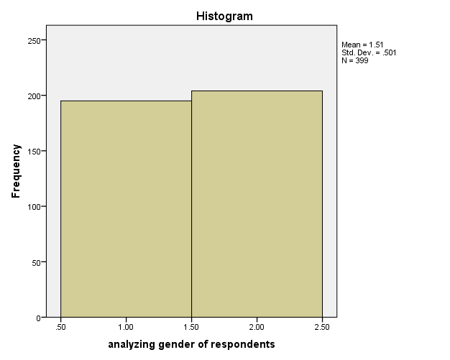
Table 1 above revealed the sex distribution of the respondents. Data revealed that 195 respondents (48.9%) are female and 204 respondents (51.1%) are male. This shows that the highest respondents were male
Question 2: Analyzing the age of the respondents
Table 2 Analyzing age bracket of respondents
 |  | Frequency | Percent | Valid Percent | Cumulative Percent
Valid | 18-30 | 249 | 61.3 | 62.4 | 62.4
 | 31-40 | 112 | 27.6 | 28.1 | 90.5
 | 41-50 | 34 | 8.4 | 8.5 | 99.0
 | 50 & above | 4 | 1.0 | 1.0 | 100.0
 | Total | 399 | 100.0 | 100.0
Total |  | 399 | 100.0

Figure 2: Age of Respondents
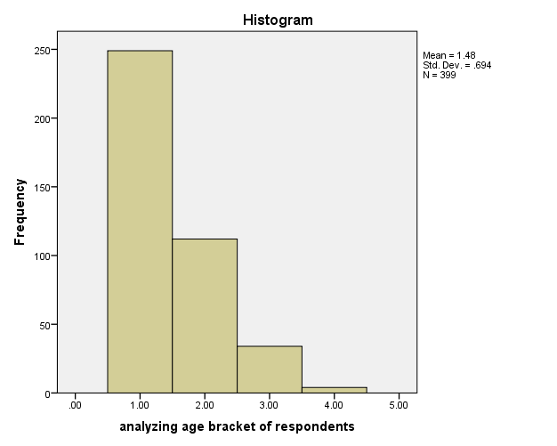
Table 2 revealed the ages of the sampled respondents. Data from the table indicated that the majority of the sampled respondents were people between the ages of 18 – 30 years. This was made up of 249 respondents representing 61.3%. Followed were respondents who fall within the age range of 31 – 40 years who actually constituted 112 representing 27.6% of the sampled respondents. Respondents within the age range of 41 – 50 years were 34 representing 8.4% of the total sampled respondents while the remaining 4 respondents representing 1.0% belonged to the age range of 50 and above.
Question 3: Academic qualification
Table 3 Analyzing Academic qualification of respondents
 |  | Frequency | Percent | Valid Percent | Cumulative Percent
Valid | WAEC/SSCE | 229 | 56.4 | 57.4 | 57.4
 | OND/NCE | 66 | 16.3 | 16.5 | 73.9
 | HND/B.SC | 46 | 11.3 | 11.5 | 85.5
 | MBA/M.SC | 25 | 6.2 | 6.3 | 91.7
 | PHD | 33 | 8.1 | 8.3 | 100.0
 | Total | 399 | 100.0 | 100.0
Total |  | 399 | 100.0

Figure 3: The Academic Qualification of the Respondents
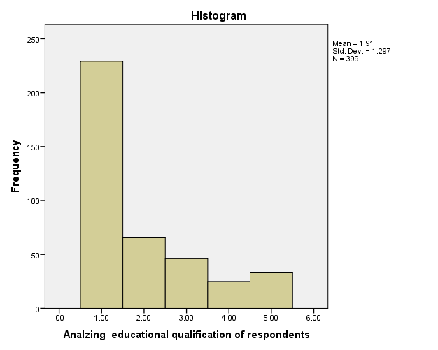
The information above shows that 229 respondents representing 56.4 %were WAEC/SSCE holders, 66 respondents 16.3% were OND/NCE holders, 46 Respondents 11.3% were HND/B.SC holders, 25 representing 6.2% were MBA/M.SC holders and 33 representing 8.1% were PHD holders. The highest were the WAEC/SSCE holders.

Question 4: occupation
Table 4 Analyzing occupation of respondents
 |  | Frequency | Percent | Valid Percent | Cumulative Percent
Valid | Farmer | 145 | 36.3 | 36.3 | 36.3
 | civil servant | 112 | 28.0 | 28.1 | 64.4
 | Others | 142 | 35.5 | 35.6 | 100.0
 | Total | 399 | 100.0 | 100.0
Total |  | 400 | 100.0

Figure 4: Occupation of respondents
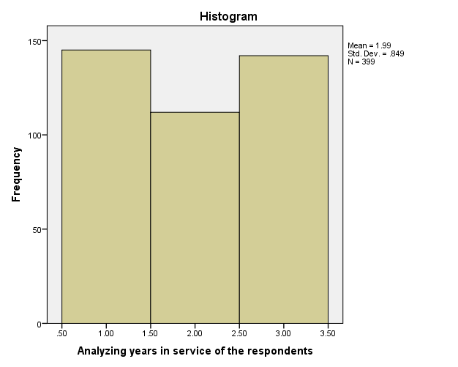
The above table showed that 145 respondents (36.3%) were farmers, 112 respondents (28.0%) were civil servants, and 142 respondents representing 35.5% were involved in other type of occupations. Farmers were seen to be higher in percentage than the other respondents

4.2.2 Analysis of Data from field
Research question one: to what extent to residents of awgu listen to radio programs on development?
Question 6: Do you have a Radio Set?
Table 6 Do you have a radio set
 |  | Frequency | Percent | Valid Percent | Cumulative Percent
Valid | Yes | 328 | 80.8 | 82.2 | 82.2
 | No | 29 | 7.1 | 7.3 | 89.5
 | Can’t say | 42 | 10.3 | 10.5 | 100.0
 | Total | 399 | 100.0 | 100.0
Total |  | 399 | 100.0

Figure 6: Number of respondents who own and don’t own radio sets.
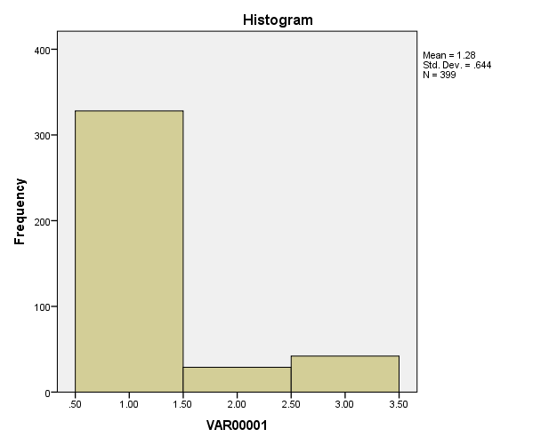
The focus of Table 5 was to find out the ownership status of radio sets by the sampled respondents. Data from the table showed that the majority of the sampled respondents 328 representing 80.8% have radio sets in their homes, 29 respondents representing 7.1% do not have radio sets in their homes while the remaining 42 respondents representing 10.3% were undecided.
Question 7: Do you listen to any radio programmes?
Table 7 Do you listen to any radio programmes
 |  | Frequency | Percent | Valid Percent | Cumulative Percent
Valid | Yes | 320 | 78.8 | 80.2 | 80.2
 | No | 42 | 10.3 | 10.5 | 90.7
 | Cant say | 37 | 9.1 | 9.3 | 100.0
 | Total | 399 | 100.0 | 100.0
Total |  | 399 | 100.0

Figure 7:
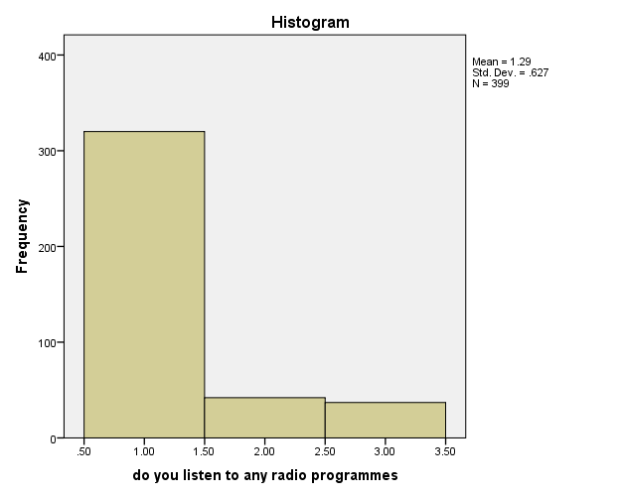
In response to the question above ,320 representing 78.8 respondents agreed that they listen to radio programs while 42 representing 10.3% said they do not listen to radio program and 37 representing 9.1% were undecided . more people listen to radio programs.
Question 7: Do you listen to radio programs on development?
Table 7 Do you listen to any radio programms on development
 |  | Frequency | Percent | Valid Percent | Cumulative Percent
Valid | Yes | 278 | 68.5 | 69.7 | 69.7
 | No | 67 | 16.5 | 16.8 | 86.5
 | Cant say | 54 | 13.3 | 13.5 | 100.0
 | Total | 399 | 100.0 | 100.0
Total |  | 399 | 100.0

Figure 7
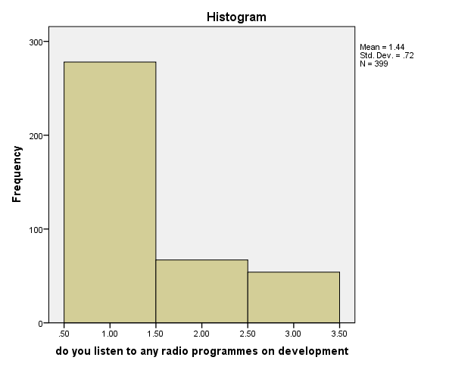
In responses to the above question 278 representing 68.5% agreed they listen to radio developmental programs, 67 representing 16.5 disagreed while 54 representing 13.3% were undecided. more people listen to radio developmental programs.
Research question 2: How often do the residents of Awgu local government area listen to radio programs on development
Question 8: To what extent do you listen to radio programs on development?
Table 8 To what extent do you listen to radio programmes on development
 |  | Frequency | Percent | Valid Percent | Cumulative Percent
Valid | Large | 145 | 35.7 | 36.3 | 36.3
 | Moderate | 109 | 26.8 | 27.3 | 63.7
 | Small | 74 | 18.2 | 18.5 | 82.2
 | can’t say | 71 | 17.5 | 17.8 | 100.0
 | Total | 399 | 100.0 | 100.0
Total |  | 399 | 100.0

Figure 8:
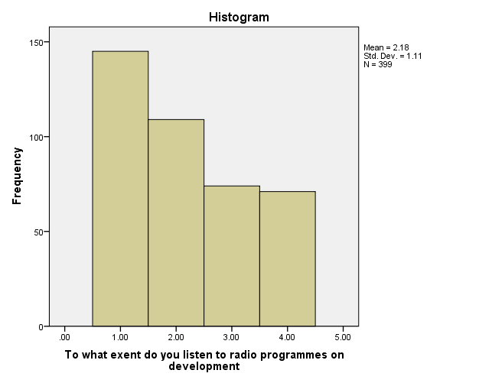
The information above shows that 145 representing 35.7% respondents listen to radio programs on development to a large extent , 109 representing 26.8% listen to a moderate extent ,74 representing 18.2 to a small extent while 71 representing 17.5% are undecided. This analysis shows that respondents listen to radio programs on development to a large extent.

Question 9a: what development program do you listen to (focus program)
Table 9a What development programme do u listen to (focus programme)
 |  | Frequency | Percent | Valid Percent | Cumulative Percent
Valid | Yes | 200 | 49.1 | 50.1 | 50.1
 | No | 107 | 26.3 | 26.8 | 76.9
 | Can’t say | 91 | 22.4 | 22.8 | 99.7
 | Total | 399 | 100.0 | 100.0
Total |  | 399 | 100.0

Figure 9:
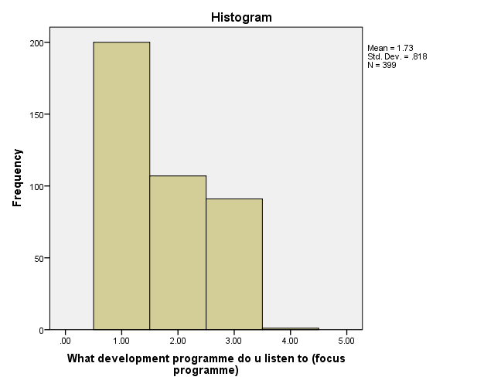
The table above shows that 200 respondents representing 49.1% agree that they listen to focus program ,107 representing 26.3% disagreed while 91 representing 22.4% were undecided. Analysis shows that more residents listen to focus program.
Question 9b: what development program do you listen to (people’s forum program)
Table 9b What development programme do u listen to (people's forum programme)

 |  | Frequency | Percent | Valid Percent | Cumulative Percent
Valid | Yes | 154 | 37.8 | 38.6 | 38.6
 | No | 153 | 37.6 | 38.3 | 76.9
 | Can’t say | 91 | 22.4 | 22.8 | 99.7
 |  |  | . | . | 100.0
 | Total | 399 | 100.0 | 100.0
Total |  | 399 | 100.0

Figure 9b:
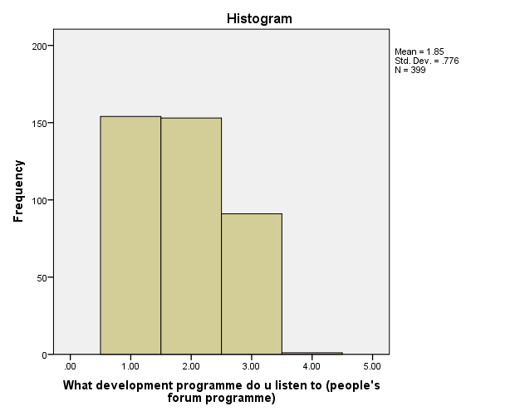
The table above shows that 154 respondents representing 37.8% agree that they listen to people’s forum program ,153 representing 37.6% disagreed while 91 representing 22.4 %were undecided. Analysis shows that more residents listen to people’s forum program.
Question 9c: What development program do u listen to (political voices program).
Table 9c What development programme do you listen to (political voices)
 |  | Frequency | Percent | Valid Percent | Cumulative Percent
Valid | Yes | 229 | 57.3 | 57.4 | 57.4
 | No | 100 | 25.0 | 25.1 | 82.5
 | Cant say | 70 | 17.5 | 17.5 | 100.0
 | Total | 399 | 100.0 | 100.0
 |  |  | .
Total |  | 399 | 100.0

Figure 9c:
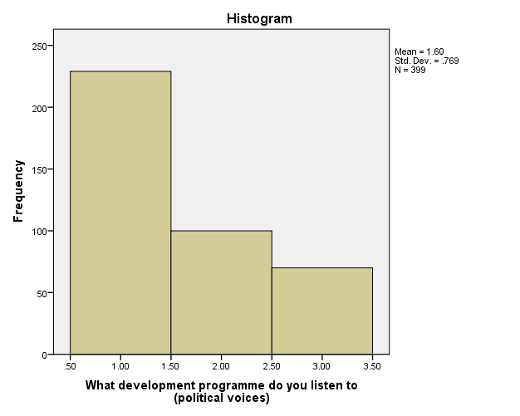
The above information shows that 229 respondents representing 57.3% agree that they listen to political voices program ,100 representing 25.0% disagreed while 70 representing 17.5 %were undecided. Analysis shows that more residents listen to political voices program.
Question 9d: What development program do u listen to (health watch program).
Table 9d What development programme do you listen to (Health watch)
 |  | Frequency | Percent | Valid Percent | Cumulative Percent
Valid | Yes | 195 | 48.8 | 48.9 | 48.9
 | No | 124 | 31.0 | 31.1 | 79.9
 | Cant say | 80 | 20.0 | 20.1 | 100.0
 | Total | 399 | 100.0 | 100.0
Total |  | 399 | 100.0

Figure 9d
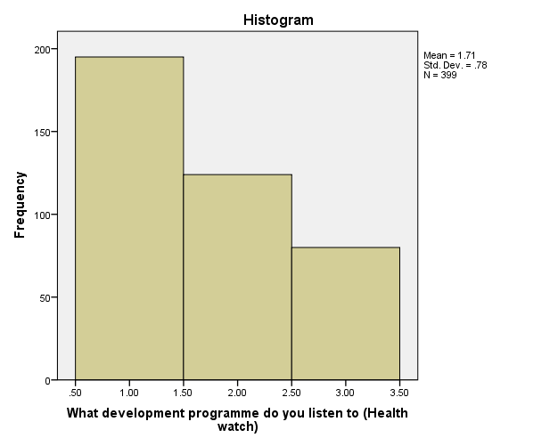
The above information shows that 195 respondents representing 48.8% agree that they listen to political voices program, 124 representing 31.0% disagreed while 80 representing 20.1 %were undecided. Analysis shows that more residents listen to health watch program.

Question 9e What development program do u listen to (Get it right program).
Table 9e What development program do you listen to (Get it right program)
 |  | Frequency | Percent | Valid Percent | Cumulative Percent
Valid | Yes | 91 | 22.8 | 39.6 | 39.6
 | No | 150 | 37.5 | 37.6 | 77.2
 | Cant say | 158 | 39.5 | 22.8 | 100.0
 | Total | 399 | 100.0 | 100.0
Total |  | 399 | 100.0

Figure 9e:
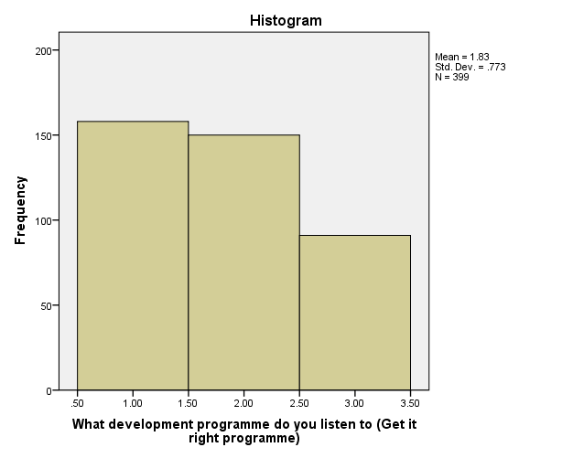
The table shows that 91 respondents representing 22.5% agree that they listen to Get it right program, 150 representing 37.5% disagreed while 158 representing 39.5 %were undecided. Analysis shows that less residents listen to get it right program.

Question 9f: What development program do you listen to (public compliant hour program).
Table 9f What development programme do you listen to (public complaint hour programme)
 |  | Frequency | Percent | Valid Percent | Cumulative Percent
Valid | Yes | 204 | 51.0 | 51.1 | 51.1
 | No | 124 | 31.0 | 31.1 | 82.2
 | Cant say | 71 | 17.8 | 17.8 | 100.0
 | Total | 399 | 100.0 | 100.0
 |  |  | .
Total |  | 399 | 100.0
Figure 9F:
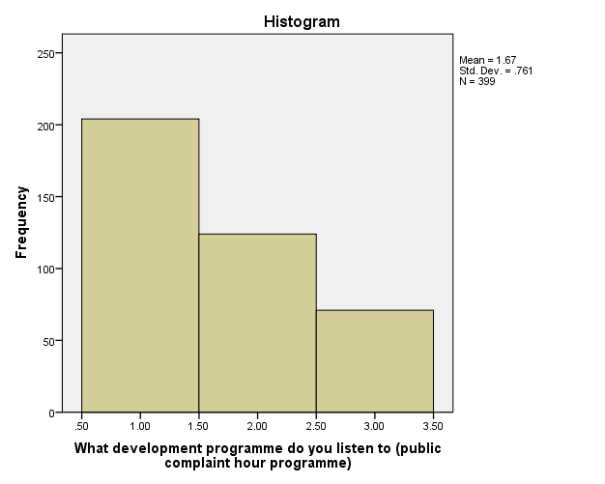
The table revealed that 204 respondents representing 51.0% agree that they listen to public compliant hour program, 124 representing 31.0% disagreed while 71 representing 17.8 %were undecided. Analysis shows that less residents listen to publc compliant hour program.

Research question 3: What is the influence of these radio developmental programs on the residents of Awgu local government?
Question 10: what influence do you derive from the above programs?
Table 10A What influence do you derive from the above programmes A
 |  | Frequency | Percent | Valid Percent | Cumulative Percent
Valid | Strongly agree | 154 | 38.5 | 38.6 | 38.6
 | Agree | 96 | 24.0 | 24.1 | 62.7
 | Disagree | 50 | 12.5 | 12.5 | 75.2
 | Strongly disagree | 12 | 3.0 | 3.0 | 78.2
 | can’t say | 87 | 21.8 | 21.8 | 100.0
 | Total | 399 | 100.0 | 100.0
Total |  | 399 | 100.0
Figure: 10A
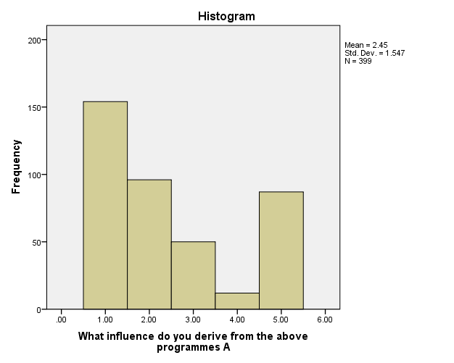
The majority of the respondents 154 (38.5%) as revealed in Table above strongly agreed that they go for regular checkups because they listen to health watch program.,96 respondents representing 24.0% agreed also while 50 respondents representing 12.5% disagreed ,12 respondents representing 3.0% strongly disagreed and 87 representing 21.8% were undecided,
Question 10B: what influence do you derive from the above programs?
Table 10B What influence do you derive from the above programmes
 |  | Frequency | Percent | Valid Percent | Cumulative Percent
Valid | Strongly agree | 96 | 24.0 | 24.1 | 24.1
 | Agree | 187 | 46.8 | 46.9 | 70.9
 | Disagree | 70 | 17.5 | 17.5 | 88.5
 | Strongly disagree | 20 | 5.0 | 5.0 | 93.5
 | can’t say | 26 | 6.5 | 6.5 | 100.0
 | Total | 399 | 100.0 | 100.0
 |  |  | .
Total |  | 399 | 100.0
Figure 10B
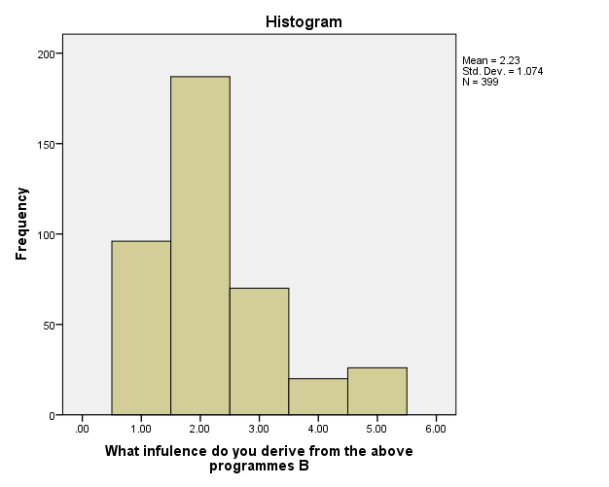
The majority of the respondents 187 (46.9%) as revealed in Table above agreed that they are now more aware of their health because they listen to health watch program. 96 respondents representing 24.0% strongly agreed also while 70 respondents representing 17,5% disagreed ,20 respondents representing 5.0% strongly disagreed and 26 representing 6.5% were undecided.
Question 10C: what influence do you derive from the above programs? C
Table 10C What influence do you derive from the above programmes C
 |  | Frequency | Percent | Valid Percent | Cumulative Percent
Valid | Strongly agree | 145 | 36.3 | 36.3 | 36.3
 | Agree | 120 | 30.0 | 30.1 | 66.4
 | Disagree | 70 | 17.5 | 17.5 | 84.0
 | Strongly disagree | 17 | 4.3 | 4.3 | 88.2
 | cant say | 47 | 11.8 | 11.8 | 100.0
 | Total | 399 | 100.0 | 100.0
Total |  | 399 | 100.0
Figure 10C
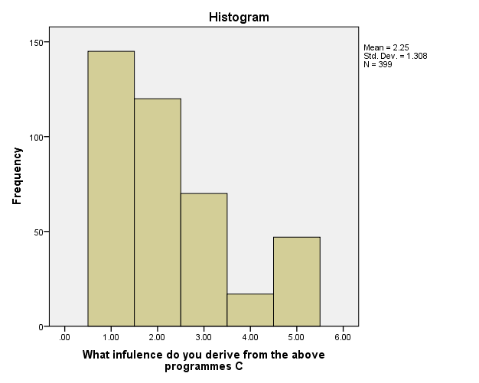
The majority of the respondents 145 (36.3%) as revealed in Table above strongly agreed that public compliant hour program has enabled meaningful development in Awgu, 120 respondents representing 30.0% agreed also while 70 respondents representing 17,5% disagreed ,17 respondents representing 4.3% strongly disagreed and 47 representing 11.8% were undecided.
Question 10D: what influence do you derive from the above programs? D
Table 10D What infulence do you derive from the above programmes D
 |  | Frequency | Percent | Valid Percent | Cumulative Percent
Valid | Strongly agree | 140 | 35.0 | 35.1 | 35.1
 | Agree | 122 | 30.5 | 30.6 | 65.7
 | Disagree | 53 | 13.3 | 13.3 | 78.9
 | Strongly disagree | 12 | 3.0 | 3.0 | 82.0
 | cant say | 72 | 18.0 | 18.0 | 100.0
 | Total | 399 | 100.0 | 100.0
 |  |  | .
Total |  | 399 | 100.0
Figure 10D
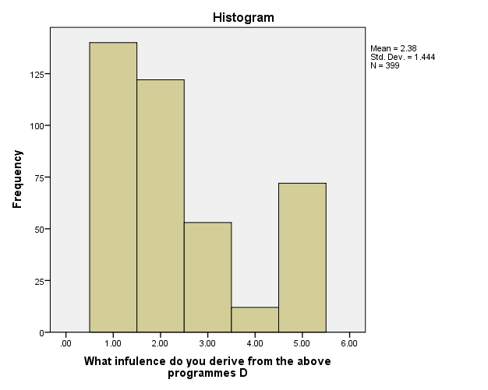
The majority of the respondents 140 (35.0%) as revealed in Table above strongly agreed that listening to political voices made them decide to get their PVC, 122 respondents representing 30.5% agreed also while 53 respondents representing 13.3% disagreed ,12 respondents representing 3.0% strongly disagreed and 72 representing 18.0% were undecided.
Question 10E: what influence do you derive from the above programs? E
Table 10E What influence do you derive from the above programmes E
 |  | Frequency | Percent | Valid Percent | Cumulative Percent
Valid | Strongly agree | 121 | 30.3 | 30.3 | 30.3
 | Agree | 116 | 29.0 | 29.1 | 59.4
 | Disagree | 94 | 23.5 | 23.6 | 83.0
 | Strongly disagree | 17 | 4.3 | 4.3 | 87.2
 | cant say | 51 | 12.8 | 12.8 | 100.0
 | Total | 399 | 100.0 | 100.0
Total |  | 399 | 100.0

Figure 10E
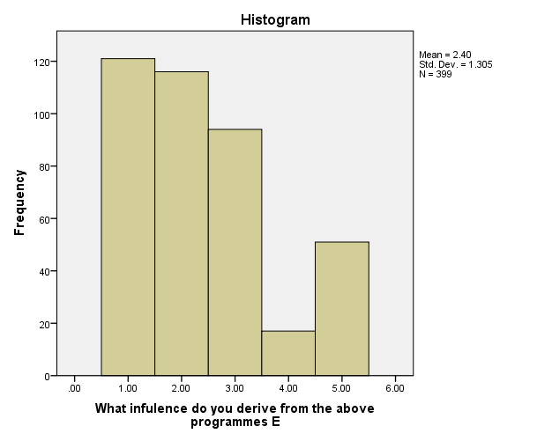
The majority of the respondents 121 (30.3%) as revealed in Table above strongly agreed that people’s forum program made them more aware of their fundamental human rights, 116 respondents representing 29.0% agreed also while 94 respondents representing 23.5% disagreed, 17 respondents representing 4.3% strongly disagreed and 51 representing 12.8% were undecided.
Question 10F: : what influence do you derive from the above programs? F
Table10F What influence do you derive from the above programmes F
 |  | Frequency | Percent | Valid Percent | Cumulative Percent
Valid | Strongly agree | 125 | 31.3 | 31.3 | 31.3
 | Agree | 162 | 40.5 | 40.6 | 71.9
 | Disagree | 36 | 9.0 | 9.0 | 81.0
 | Strongly disagree | 12 | 3.0 | 3.0 | 84.0
 | cant say | 64 | 16.0 | 16.0 | 100.0
 | Total | 399 | 100.0 | 100.0
Total |  | 399 | 100.0

Figure 10F
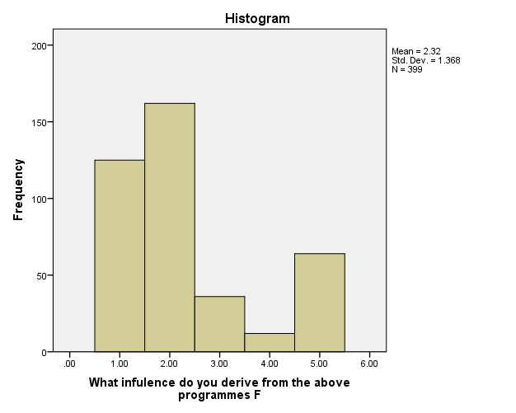
The majority of the respondents 125 (31.3%) as revealed in Table above strongly agreed that get it right program helped them correct simple grammatical errors in communication, 162 respondents representing 40.5% agreed also while 36 respondents representing 9.0% disagreed, 12 respondents representing 3.0% strongly disagreed and 64 representing 16.0% were undecided.

Question 10G: what influence do you derive from the above programs? G
Table10G What influence do you derive from the above programmes G
 |  | Frequency | Percent | Valid Percent | Cumulative Percent
Valid | Strongly agree | 166 | 41.5 | 41.6 | 41.6
 | Agree | 137 | 34.3 | 34.3 | 75.9
 | Disagree | 45 | 11.3 | 11.3 | 87.2
 | Strongly disagree | 21 | 5.3 | 5.3 | 92.5
 | can’t say | 30 | 7.5 | 7.5 | 100.0
 | Total | 399 | 100.0 | 100.0
Total |  | 399 | 100.0
Figure 10G
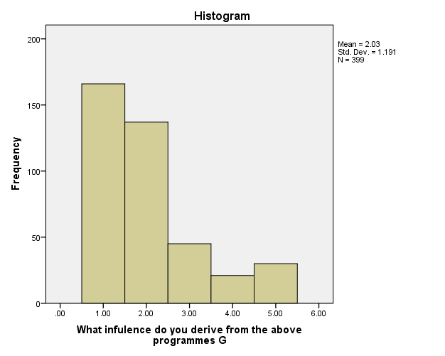
The majority of the respondents 166 (41.5%) as revealed in Table above strongly agreed that get it right program helped them correct simple grammatical errors in communication, 162 respondents representing 40.5% agreed also while 36 respondents representing 9.0% disagreed, 12 respondents representing 3.0% strongly disagreed and 64 representing 16.0% were undecided.
Question 10H: : what influence do you derive from the above programs? H
Table 10H What influence do you derive from the above programmes H
 |  | Frequency | Percent | Valid Percent | Cumulative Percent
Valid | Strongly agree | 162 | 40.5 | 40.6 | 40.6
 | Agree | 162 | 40.5 | 40.6 | 81.2
 | Disagree | 16 | 4.0 | 4.0 | 85.2
 | Strongly disagree | 37 | 9.3 | 9.3 | 94.5
 | can’t say | 22 | 5.5 | 5.5 | 100.0
 | Total | 399 | 99.8 | 100.0
Total |  | 399 | 100.0
Figure 10H
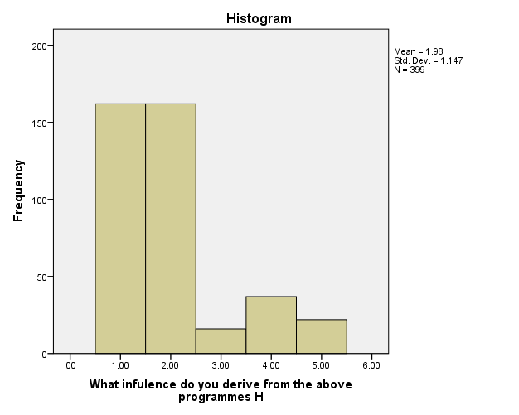
The majority of the respondents 162 (40.5%) as revealed in Table above strongly agreed that focus program has made them aware of current governmental processes in both local and national levels, 162 respondents representing 40.5% agreed also while 16 respondents representing 4.0% disagreed ,37 respondents representing 9.3% strongly disagreed and 22 representing 5.5% were undecided

Research question 4: What are the existing challenges preventing the development of Awgu local government?
Question 11: Do you feel there are factors that hindered the effect of development throught broadcast media in Awgu.
Table 11 Do you feel that they are factors that hinder the effect of development through broadcast media
 |  | Frequency | Percent | Valid Percent | Cumulative Percent
Valid | Yes | 290 | 71.3 | 72.7 | 72.7
 | No | 30 | 7.4 | 7.5 | 80.2
 | Can’t say | 79 | 19.4 | 19.8 | 100.0
 | Total | 399 | 100.0 | 100.0
Total |  | 399 | 100.0
Figure 11:
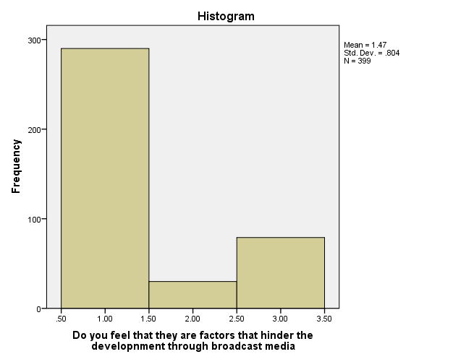
The table above showed that 290 representing 71.3% respondents agree that they are factors that hinder the effect of development through broadcast media in Awgu, 30 representing 7.4 respondents disagree while 79 representing 19.4 respondents are undecided. The analysis shows that the highest respondents agree that they are factors that hinder the development of Awgu through broadcast media.

Question 12: if yes, what are those factors?
Lack of resources
Table 23 if yes what are those factors? Lack of resources
 |  | Frequency | Percent | Valid Percent | Cumulative Percent
Valid | Strongly agree | 191 | 47.8 | 47.9 | 47.9
 | Agree | 108 | 27.0 | 27.1 | 74.9
 | Disagree | 36 | 9.0 | 9.0 | 84.0
 | Strongly disagree | 42 | 10.5 | 10.5 | 94.5
 | can’t say | 22 | 5.5 | 5.5 | 100.0
 | Total | 399 | 100.0 | 100.0
Total |  | 399 | 100.0

Figure 12: Lack of Resources
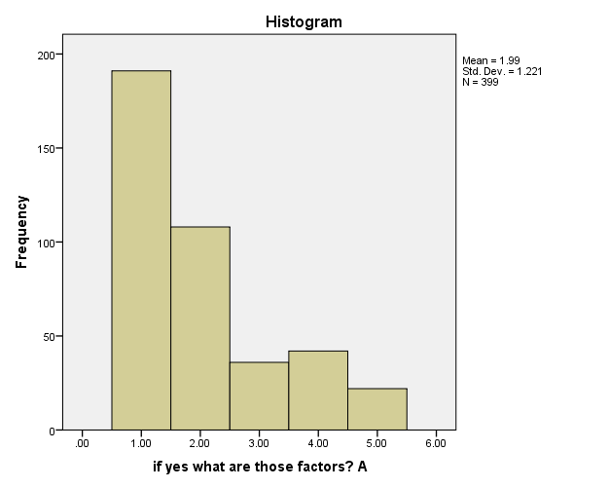
On whether lack of resources can hinder the development of awgu through the use of radio , Table 11 indicated that the majority of the respondents 191 (47.8%) agreed , 108 respondents representing 27.0% strongly agreed , while 36 respondents representing 9.0% disagree. The remaining 42 respondents or 10.5% however strongly disagreed ,22 respondents representing 5.5% were undecided whether lack of resources hinder the effect of development through the radio.
Question 12B: if yes what are those factors? Lack of government intervention
Table 24 if yes what are those factors? Lack of government intervention
 |  | Frequency | Percent | Valid Percent | Cumulative Percent
Valid | Strongly agree | 145 | 36.3 | 36.3 | 36.3
 | Agree | 92 | 23.0 | 23.1 | 59.4
 | Disagree | 99 | 24.8 | 24.8 | 84.2
 | Strongly disagree | 38 | 9.5 | 9.5 | 93.7
 | can’t say | 25 | 6.3 | 6.3 | 100.0
 | Total | 399 | 100.0 | 100.0
Total |  | 399 | 100.0

Figure 12B: lack of government intervention
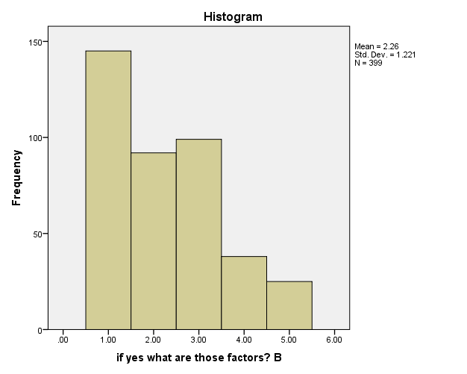
Responses from Table 12B indicated that the majority of the respondents 145 or(36.3%) strongly agreed that lack of government intervention can hinder development in awgu through the use of radio; 92 respondents representing 23,0% agreed ; 99 respondent representing 24.8% however disagreed ;38 representing 9.5 respondents strongly disagreed ;25 respondents representing 6.3% were undecided.
Question 12C: if yes, what are those factors? Poverty
Table 12c if yes what are those factors? Poverty
 |  | Frequency | Percent | Valid Percent | Cumulative Percent
Valid | Strongly agree | 162 | 40.5 | 40.6 | 40.6
 | Agree | 103 | 25.8 | 25.8 | 66.4
 | Disagree | 84 | 21.0 | 21.1 | 87.5
 | Strongly disagree | 21 | 5.3 | 5.3 | 92.7
 | can’t say | 29 | 7.3 | 7.3 | 100.0
 | Total | 399 | 100.0 | 100.0
Total |  | 399 | 100.0

Figure 12C: Poverty
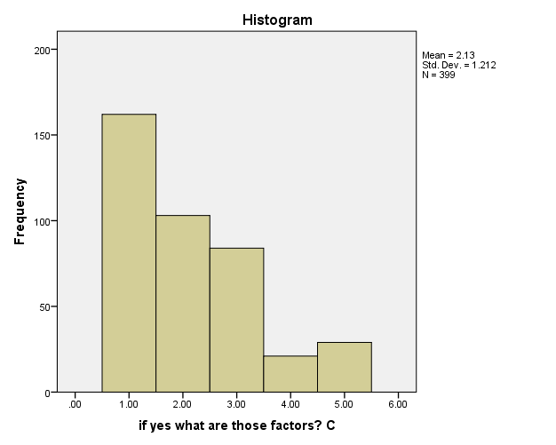
Responses from Table 12C indicated that the majority of the respondents 162 (40.5%) strongly agreed that poverty can hinder development in awgu through the use of radio; 103 respondents representing 25.8% agreed ; 84 respondent representing 21.0% however disagreed ;21 representing 5.3 respondents strongly disagreed ;29 respondents representing 7,3% were undecided
Question 12D: if yes, what are those factors? Lack of access to health care centers.
Table 12D if yes what are those factors? Lack of access to health care centers.
 |  | Frequency | Percent | Valid Percent | Cumulative Percent
Valid | Strongly agree | 83 | 20.8 | 20.8 | 20.8
 | Agree | 104 | 26.0 | 26.1 | 46.9
 | Disagree | 62 | 15.5 | 15.5 | 62.4
 | Strongly disagree | 125 | 31.3 | 31.3 | 93.7
 | can’t say | 25 | 6.3 | 6.3 | 100.0
 | Total | 399 | 100.0 | 100.0
Total |  | 399 | 100.0
Figure 12D: Lack of access to health care centers.
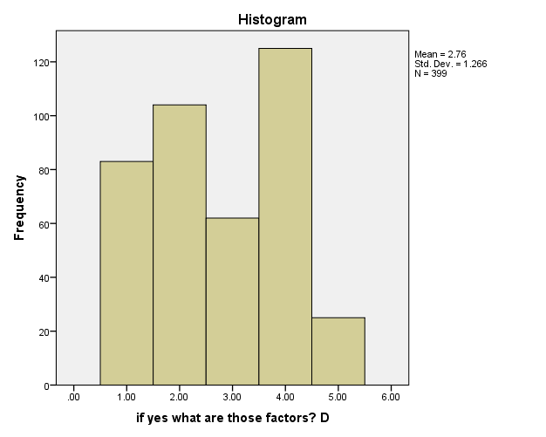
Responses from Table 12D indicated that the majority of the respondents 104 (26.0% )s agreed that lack of access to health care centers can hinder development in Awgu through the use of radio; 83 respondents representing 20.8% strongly agreed ; 62 respondent representing 15.5% however disagreed ;125 representing 31.3 respondents strongly disagreed ;25 respondents representing 6.3% were undecided.

Question 12E: If yes, what are those factors? Inability to participate in politices because of lack of mobilization practices.
Table 12E if yes what are those factors? Inability to participate in politics because of lack of mobilization practices
 |  | Frequency | Percent | Valid Percent | Cumulative Percent
Valid | Strongly agree | 100 | 25.0 | 25.1 | 25.1
 | Agree | 91 | 22.8 | 22.8 | 47.9
 | Disagree | 83 | 20.8 | 20.8 | 68.7
 | Strongly disagree | 83 | 20.8 | 20.8 | 89.5
 | cant say | 42 | 10.5 | 10.5 | 100.0
 | Total | 399 | 100.0 | 100.0
Total |  | 399 | 100.0

Figure 12E: inability to participate in politics because of lack of mobilization practices.
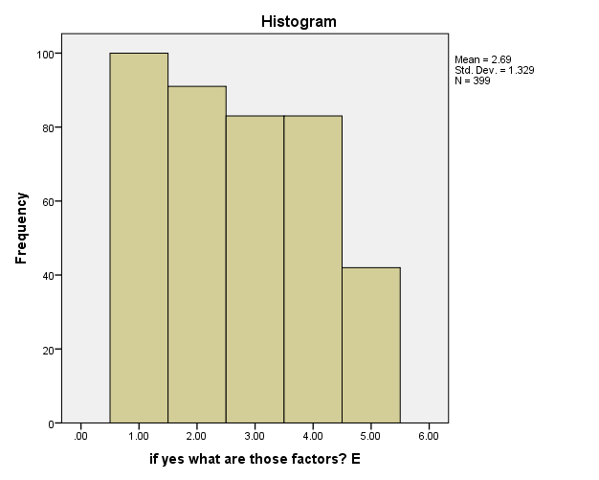
Responses from Table 12E indicated that the majority of the respondents 100 (25.0% )strongly agreed that inability to participate in politics because of lack of mobilization practices can hinder development in Awgu through the use of radio; 91 respondents representing 22.8% agreed ; 83 respondent representing 20.8% however disagreed ;83 representing 20.8 respondents strongly disagreed ;42 respondents representing 10.5% were undecided.

Question 12F: if yes, what are the factors? Wrong Programming.
Table 12F if yes what are those factors? Wrong programming
 |  | Frequency | Percent | Valid Percent | Cumulative Percent
Valid | Strongly agree | 145 | 36.3 | 36.3 | 36.3
 | Agree | 125 | 31.3 | 31.3 | 67.7
 | Disagree | 42 | 10.5 | 10.5 | 78.2
 | Strongly disagree | 33 | 8.3 | 8.3 | 86.5
 | cant say | 54 | 13.5 | 13.5 | 100.0
 | Total | 399 | 100.0 | 100.0
Total |  | 399 | 100.0
Figure 12F: Wrong Programming.
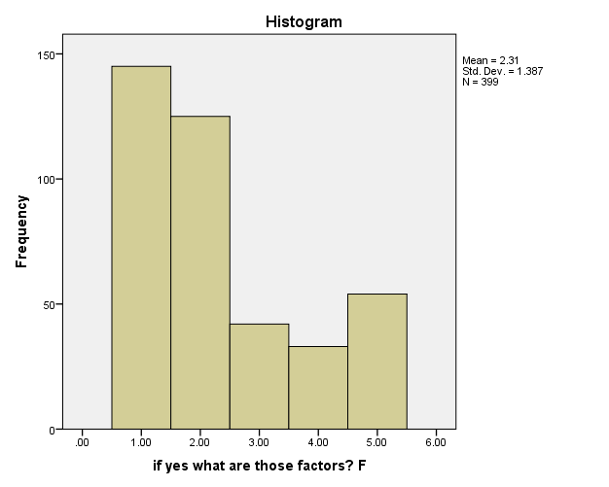
Responses from Table 12F indicated that the majority of the respondents 145 (36.3% )strongly agreed that wrong programming can hinder development in Awgu through the use of radio; 125 respondents representing 31.3% agreed ;42 respondent representing 10.5% however disagreed ; 33 representing 8.3% respondents strongly disagreed ; 54respondents representing 13,5% were undecided.

Question 12G: if yes what are those factors? Illiteracy rate in the village.
Table 12G if yes what are those factors? Illiteracy rate bin the village
 |  | Frequency | Percent | Valid Percent | Cumulative Percent
Valid | Strongly agree | 125 | 31.3 | 31.3 | 31.3
 | Agree | 137 | 34.3 | 34.3 | 65.7
 | Disagree | 42 | 10.5 | 10.5 | 76.2
 | Strongly disagree | 20 | 5.0 | 5.0 | 81.2
 | cant say | 75 | 18.8 | 18.8 | 100.0
 | Total | 399 | 100.0 | 100.0
Total |  | 399 | 100.0
Figure 12G: illiteracy rate in the village.
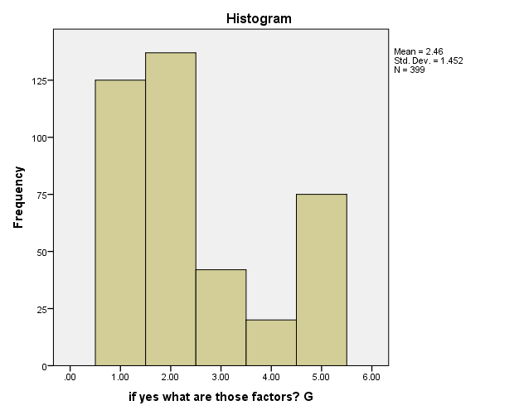
Responses from Table 12F indicated that the majority of the respondents 137 (34.3% ) agreed that Illiteracy rate in the village can hinder development in Awgu through the use of radio; 125 respondents representing 31.3% strongled agreed ;42 respondent representing 10.5% however disagreed ;20 representing 5.0% respondents strongly disagreed ; 75 respondents representing 18.8% were undecided.

4.3 Discussion and Findings
This section discussed the findings of the study in relation to the four research questions raised.
Research Question 1: To what extent do residents of Awgu local government area of Enugu listen to radio programs on development?
The answer to the above research question is found in Table 6 and 7 which presented that the residents of Awgu local Government area of Enugu state own radio sets ,they listen to radio programs they also listen to radio programs on development . The data showed that the majority of the sampled respondents 328 (80,8%) indicated that they have radio sets . 29 respondents or 7.1% indicated that they listen to radio programs while the remaining 42 respondents or 10.3% were undecided . This simply indicates that the residents of Awgu have radio sets where they rely on for information, entertainment and education. Similarly, data from Table 7 showed that the majority of the sampled respondents 320 ( 7.8%) agreed that they listen to radio programs and development programs 278 (6.8%) .Also 42 (10.3%) respondents indicated that they do not listen to radio programs and program on development 67 (16.5%) while the remaining 37 respondents or 9.1% ad on development 54 (13.3) were undecided on the issue.
This implies that most residents in Awgu local government area of Enugu state have radio sets and listen to radio programs and program on development .Table 7 showed that more people listen to radio programs and programs on development.
Research Question 2: How often do the residents of Awgu listen to radio programs on development?
The aim of this program was to fine how frequently the residents of Awgu listen to radio programs on development and the kinds of programs they listen to.
The data on table 8 and 9 answered the research question.
The data on table 8 answered the question to what extent do you listen to radio programs on development? The table shows that 145 (35.75%) said they listen to radio programs on development to a large extent ,109 representing 26,8% said they listen to radio programs on development to a moderate extent, 74(18.2%) listen to radio programs on development to a small extent while 71 representing 17.5 % are undecided about the issue. The data on table 9 answered the question what development program do you listen to under which 6 programs were listed
A: Focus program, B: peoples forum program, C: political voices D: Health watch E: Get it right
F: public compliant hour. The table shows that 200(49.1%) respondents listen to focus program, 107( 26.3%) don’t listen to focus program, 91(22.4%) were undecided , also 154 (37.8%) respondents listen to people’s forum program 153(37.6%) don’t listen to people’s forum program and 91(22.4%) are Undecided , 229(57.3%) listen to political voices program 100(27.0%) don’t listen to political voices program and 70 (17.5) were undecided ,195(48.8%) listen to health watch program ,124(31.0%) don’t listen to health watch program while 80(20,6%) were undecided ,158(39.5%) listen to get it right program, 150(37.5%) don’t listen to get it right program while 91(22.8%) were undecided , 204(51.0%) listen to public complaint hour program ,124 (31.0) don’t listen to public compliant hour while 71(17.8%) were undecided.
This implies that respondents listen to different developmental programs aired by different radio stations in Enugu to a large extent, according to the above finding it is seen that they listen to health watch program, get it right program, public compliant hour program, political voices program.
Research Question 3: what is the influence of these radio developmental programs on residents in Awgu local government area of Enugu state?
The aim of this research question is to find out what influence respondent derive from listening to the different developmental programs in the area of developing them personally?
The data was contained in table 10 which answered the question what influence do you derive from the above programs? The table revealed that respondent derived different influences from the programs 154(38.5%) respondents strongly agreed that they now go for regular health check-ups because they listen to health watch program ,96(24.0%) respondents agreed ,50(12.5%) respondents disagreed ,12(3.0%) respondents strongly disagreed while 87(21.8%) respondents were undecided on the issues. Also 96(24.0%) respondents strongly agreed that they are now more aware of their health because they listened to health watch program, 187(46.8%) respondents agreed, 70(17.5%) respondents disagreed, 20(5.0%) respondents strongly disagreed 26(6,5%) respondents were undecided on the issues. 145 (36.3) respondents strongly agreed that public compliant program has enabled meaningful development in Awgu local government area of Enugu state, 120(30.0%) respondents agreed, 70(17.5%) respondents disagreed ,17(4.3%) respondents strongly disagreed while 47 (11.8%) respondents were undecided. 140(35.0% respondents) strongly agreed that listening to political voices has made them decide to get their PVC, 122(30.5%) agreed, 53 (13.3%) disagree, 12(3.0%) strongly disagreed 72(15.0%)were undecided.
121(30.3%) respondents strongly agreed that people’s forum program made them more aware of their fundamental human rights 116(39.0%) respondents agreed, 94(23.5%) respondents disagreed ,17(4.3%) respondents strongly disagreed, 51(12,8%) respondents were undecided. 125(31.3%) respondents strongly agreed that get it right has helped the stop making common errors in communication 162(40.5%)agreed, 36(9.0%),disagreed ,strongly disagreed 12(3.0%), 64(16.0%)were in different. 166(41.5%) strongly agreed that political voices has made the more aware of government issues 137(34.3%) agreed, 45(11.3%) disagreed, 21(5.3%) strongly disagreed ,while 30(7.5%) were undecided. Finally 162(40.5%) strongly agreed that focus program has made them aware of current governmental process in both local and national levels 162(40.5%) agreed 16(4,0%) disagreed 37(9.3%) strongly disagreed and 22(5.5 %) were indifference.
This implies that residents of Awgu local government have decided to get their permanent voters card(PVC) and are ready for the 2019 election also it is seen that residents are now more health conscious and are aware of their fundamental human rights.
Research Question 4: What are does challenges preventing the development programs from affecting the residents of Awgu local government area of Enugu state.
This question aims at finding out those challenges that are hindering these development programs from developing the residents of Awgu local government area of Enugu state.
Data was contained in table 11 and 12
The data in table 11 shows that 290 representing 71.3% respondents agreed that they are factors hindering the effect of development through the radio, 30 representing 7.4% respondents disagreed while 79(19.4%) were undecided on the issue . table 12 went ahead to analyze those factors 191(47.8%) respondents strongly agreed that lack of resource can hinder the effect of development programs on the development of the residents of Awgu 108(27.0%) respondents agreed, 36(9.0%) respondents disagreed, 42(10.5%) strongly disagreed while 22(5.5%) respondents were undecided, 145 (36.3%) respondents strongly agreed that lack of government interventions can hinder the effect of development programs on residents of Awgu 92(23.0%) respondents agreed, 99(respondents 24.8) disagreed, 38(9.5%) respondents strongly disagreed ,25(6.3%)v were undecided ,162(40.5%) respondents strongly agree that poverty can hinder development in Awgu, 103(25.8%) respondents agreed, 84(21.0%) respondents disagree, 21(5.3%) respondents strongly disagree while 29(7.3%) respondents, 83(20.8%) respondents strongly agreed that lack of access to health care centers hinder the effect of development programs on developing Awgu 104(26.0%) respondents agreed, 62(15.5%) respondents disagreed, 125(31.3% respondents) strongly disagreed 25(16.3%) respondents were undecided. 100 (25.0%) respondents strongly disagree that inability to participate in politics because of lack of mobilization practices 91(22.8%)agree, 83(20.8%) respondents disagreed 83(20.8) strongly disagreed 42(10.5) respondents were undecided. 145(36.3%) respondents strongly agreed that wrong programming hinder the development programs from developing Awgu 125(31.3%) agreed ,42(10.5%)disagreed ,33(8.3%)strongly disagree 54(13.5%) respondents were undecided finally 125 (31.3%)respondents strongly agree illiteracy rate in the village can hinder development in Awgu 137(34.3%) respondents agreed 42(10.5%) respondents disagreed 20(5.0%) strongly disagreed 75 (18.8%) respondents were undecided
The findings above showed that there are factors that slow down or even stop development programs from having positive effect on the residents of Awgu.

CHAPTER FIVE
SUMMARY, CONCLUSION AND RECOMMENDATIONS
5.1 Introduction
This study examined radio broadcast programs and rural development in Nigeria (a study of residents in Awgu Local Government Area of Enugu State). The study was necessitated by the fact that rural broadcasting is an important tool for rural development especially in developing countries of Africa and Asia. This study adopted survey method and made use of a self-constructed questionnaire for the collection of data. The questionnaire enabled the researcher to obtain first hand information on the subject matter from respondents in communities in the area of study. Three hundred and ninety nine (399) respondents made up of 204 male and 195 female were randomly selected for the survey. The sample size was determined using the Taro Yamane‘s model of sample size determination.
5.2 Summary of findings
Data presented and analyzed in this study produced the following findings:
- A great number of respondents listen to different radio programs on development to a very large extent.
- The residents of awgu listen to Radio development program very often, programs like health watch program, get it right program and political voices program.
- Radio Broadcast Programs Have Influenced Residents Of Awgu To A Very Large Extent This Is Recognized When The Residents Agreed To Be More Aware Of Their Health, Get Their Permanent Voters Card(PVC) And Are More Aware Of Their Fundermental Human Rights By Listens To The Above Developmental Programs.
- Lack of government intervention, lack of resources and wrong programming are factors that hinder the development of rural areas and its dwellers through the broadcast media (radio).
5.3 Conclusion
This project has exposed a lot of information on radio broadcast program and rural development in Awgu local government area in Enugu state and in Nigeria in general. The research also observed that they are factor impeding the optimal development of awgu local government through local broadcast programs.

5.4 Recommendations
- The government should put up more and effective developmental programmes on radio ranging from educational programmes to enlightenment programmes and instructional programmes to foster development in rural areas and its dwellers.
- Although there are development programs aired on different radio there are no effective means of mobilizing people to actually move towards development. Therefore government should mobilize the rural dwellers to practices or works towards they have learnt through the broadcast programs.
5.5 Suggestions for Further Studies
The researcher suggests that further studies should be carried out on radio broadcast programmes and rural development to enable eradicate the possible challenges emerging from rural development.

References
Alkali M. N, Damatab J. (ed) (2015) Mass Communicationin Africa
Awotunde, Ugodulunwa & Ozoji (2013) Practical steps toResearch in Education, Deka Publications , Jos.
Bagdikan, B.H.(1971)The Information Machines. Harperand Raw, Publishers’.225-228.
BASEEDS, Bauchi State Strategy Development Document.(2004) A Publication of the Ministry of Budget and Economic Planning, Bauchi State.
Besette, G. (2014) Involving the Community – A guide toParticipatory Development Communication Oslo:International Development Research Centre (accessedonline at: http://www.undp.org/oslocentre/a2i.htm viewedon February 27, 2014 at 13:45)
BRC Bauchi Establishing Edict No 3, (2014) by theMinistry of Justice, Bauchi state.
Bunner B, (2014) Mass Communication an Introduction.Deacon, David et al. (1999) Researching Communications:A Practical Guide to Methods in Media and CulturalAnalysis, New York: Oxford University Press.
Emile, M. G. (2014). Radio Role in Development. FiveStrategies For Use Standford 1California Standard University Press. p 41.
FAO (September 2013) Report of the Communication forDevelopment Roundtable. 9th Communication forDevelopment Roundtable, Food & AgriculturalOrganization (accessed online at: http://www.fao.org/documents/show_ on May 6, 2006 at 7.32pm)
Hewitt de Alcantara, Cynthia (2014) The DevelopmentDivide in a Digital Age, Geneva. Issue Paper by UnitedNations Research Institute for Social Development. (seewww.unrisd.org accessed on February 14,2014 at 10:25.)
Human Development & Mass Communications,Background Paper for the Human Development Report2002, UNDP (accessed online at: http://www.undp.orgviewed on March 12, 2014 at 4.51pm)
Jengo E. (2016) Broadcasting Media and NationalDevelopment in Black Civilization and Mass Media Lagos.3rd press International. p. 30
Millennium Development Goals (MDGs),http://www.un.org/ millenniumgoals/ (website of the UnitedNations accessed on February 17, 2014, at 0225hrs)
National Broadcasting Commission (Nigeria) NBC – Codes(2012) 5th Edition Planet Press Ltd.
Nigeria Bureau of Statistics (NBS 2009) Annual Report ofStatistics Streeten, Paul (2002), Empowerment, Participationand the Poor, background paper for Human Development Report (HDR) 2002, UNDP (accessed online athttp://www.undp.org viewed on March 16, 2014 at1115Hrs)
UNDP, (2013) World Human index Report.( accessed at www.undpreport.org on 15 May, 2018 at 943hrs.)UNESCO Broadcasting Information Data, N.P UNESCO

APPENDIX II
Department of Mass Communication,
Faculty of Management and Social Science,
Godfrey Okoye University,
Thinkers Corner,
Enugu.
Dear Respondent,
REQUEST FOR FILLING QUESTIONNAIRE
I, Anosike Faith Oluchi, an undergraduate of the above named institution, is conducting an academic research on “Radio Broadcast Programmes and Rural Development in Nigeria; A study of Residents in Awgu Local Government Area of Enugu State”.

This attached questionnaire is part of my research work in fulfillment of the award of B.Sc (Bachelor of Science) degree in Mass Communication.

I, therefore solicit for your assistance in filing the questionnaire attached with this letter.
I promise that all the information given therein shall be treated with utmost confidence.
Thanks in anticipation.
Yours faithfully,

Anosike Faith Oluchi
(Researcher)

Questionnaire
Please Tick the option you consider the most appropriate.
Section A: Personal Data

1. Gender
Male
Female

2. Age
18 – 30
31 – 40 years
41 - 50
51 years and above

3. Academic Qualification
WAEC/SSCE
OND/NCE
HND/B.sc
MBA/M.Sc
Ph.D

4. Number of Years in Service
1 – 10
11 – 20
31 – 40
41 and above

5. Your Occupation
Farmer
Civil Servant
Others

6. Your favourite Radio Station
Radio Nigeria
Dream FM
Urban Radio

SECTION B
Instruction
Please tick the option that corresponds to your appropriate answer.
7. Do you have a radio set?
Yes
No
Can’t say

8. Do you listen to any radio programmes?
Yes
No
Can’t say

9. Do you listen to radio programme on development?
Yes
No
Can’t say

10. To what extent do you listen to programmes on development?
Large
Moderate
Small
Can’t say

11. What development programme do you listen to
Programmes | Yes | No | Can’t say
Focus programme
Peoples forum programme
Political voices programme
Health watch programme
Get it right programme
Public complaint hour programme

12. What influence do you derive from the above programmes?
Influence | Strongly agree | Agree | Disagree | Strongly disagree | Can’t say
I now go for regular health check-ups because I listen to health watch programme
I am now more aware of my health because I listen to health watch programme
Public complaint programme has enabled meaningful developments in Awgu Local Government Area
Listening to political voices made me decide to get my Permanent Voters Card (PVC)
People forum programme made me more aware of my fundamental human rights
Get it right has helped me stop making common errors in communicating
Political voices has made me more aware of government issues
Focus programme has made me aware of current governmental processes in both local and national level

13. Do you feel that there are factors that hindered the effect of development through broadcast media in Awgu?
Yes
No
Can’t say

14. If yes, what are those factors?

Factors | Strongly agree | Agree | Disagree | Strongly disagree | Can’t say
Lack of resources
Lack of government interventions
Poverty
Lack of access to health care centres
Inability to participate in politics because of lack of mobilization practices
Wrong programming
Illiteracy rate in the village

