GEOLOGY OF OSO EDDA AND ITS ENVIRONS

BY

NDULUE CHRISTOPHER
U14/NAS/GLM/033

A PROJECT REPORT IN THE DEPARTMENT OF PHYSICAL AND GEO SCIENCES FACULTY OF NATURAL AND APPLIED SCIENCES SUBMITTED TO THE DEPARTMENT OF PHYSICAL AND GEO SCIENCES GODFREY OKOYE UNIVERSITY UGWUOMU-NIKE IN PARTIAL FUFILLMENT OF THE REQUIREMENTS FOR THE AWARD OF BACHELOR OF SCIENCES IN (B.SC) OF THE GODFREY OKOYE UNIVERSITY.

JULY, 2017

CERTIFICATION
This is to certify that the research work for this project and the subsequent preparation by Ndulue Christopher department of physical and geo-sciences, Godfrey Okoye University were carried out under our supervision.

MR. UGOCHUKWU IYIOKU Date
Supervisor

PROF. C UHUEGBU Date
Head Of Department

PROF. C UHUEGBU Date
Dean Of Natural And Applied Sciences

External Examiner Date

DECLARATION PAGE
I hereby declare that this work The Geology of Oso Edde and its Environs is the product of my own effort under the supervision of Mr. U. Iyoku and has not been presented elsewhere for the award of a degree or certificate, all sources have been duly acknowledged.

SIGNATURE

Ndulue Christopher
NAME

DATE
July 2017

DEDICATION
This work is solely dedicated to God Almighty for his guidance, inspiration, kindness and provision throughout the period
To Him Glory and Praise Forever

ACKNOWLEDGEMENT
I want to give all the thanks to God Almighty; He has given me the privilege and grace to write this project research. In a special way, my appreciation goes to my departmental coordinator Mr. E.O. Ikejiaku who really was a source of encouragement and great help during this project, I really appreciate your tired less effort in making this project a success. To my able supervisor Mr. U. Iyoku whose tired less effort wasn’t hidden at all, I can’t thank you enough for your support, spending time to go through my work and correcting me were necessary. Dr Aghamelu O.P, am grateful for your support, explanations, and words of encouragement. To my course mates Ezeilo Elvis and Oyazi David, you both have been of great help throughout this period.

ABSTRACT
Oso Edda and environs is located within the flank of the Afikpo Basin and detailed geologic mapping was done in other to determine the various stratigraphic framework using the basic field and laboratory procedures. Field observations on exposed outcrops indicated that the study area consists of three basic lithologic units based on the general orientation of the rocks, sample identification and structural observations. These three units are all dipping southeastly towards the centre of the basin. The basal older Unit (Unit 1) is an interbedding of a highly indurated slaty cleavaged shale, calcareous rock and sand stone respectively, whose depositional environment is believed to be shallow marine based on the micro paleontologic and palynological evidence obtained from the shale bed. The shales are fractured and the careous rock is highly jointing showing an extesional type of deformation. This unit is dipping in a SSE direction whose average dip is about 76^{0.} It is thought to be affected by a kind of dynamothermal early metamorphism evidenced by high orientation, cleavage structure and baking, jointing and possibly folding. Unit 2 is generally made up of interbedding of coarse grained, poorly sorted arkosic to sub arkosic sandstones and laminated planar crosss bedded siltstone and mud which has a sallower dipping orientation of about 25⁰. Pebbles were also seen within the unit. The general depositional environment of the unit is fluvia from laboratory studiesl which is river dominated and subtidal environment whose energy of deposition is considered to be relatively low to very low. Unit 3 is the linear sandstone ridge that trends in the NE-SW direction which is thought to be an extention of the Vaious ride sections seenwithin the Afikpo basin belonging to the Amaseri sandstone. The ridgee is characterize by a coarsining upward ssandstone sequence. The base of the sandstone is a silty sandstone deposited in oxic environment while the top of the ridge is a trough cross bedded sandstone being dominated by a stormy environment. Most of the Units are mostly weathered as evidenced by structures associated by weathering like spheroidal weathering, pot holes and isolated large boulders. The age of the study area is that both Unit 1 and Unit 2 Upper Cenomanian-Middle Turonian in age which is general known as the Eze Aku Shale based on the palynological studies of the shales and Unit 3 is the Upper Turonian Amaseri Sandstone. They are generally referred to as the Age Group.

CHAPTER ONE

INTRODUCTION

Background study
Stating from the background of study, it has been taught that the Benue trough is a collection of pull apart basins related to transcurrent or strike-slip movement along deep-seated basement shear zones of Pan African origin reactivated as oceanic transform faults (Benkheli, 1982, 1989; Guiraud, 1993).This view is supported by field evidence in the northern Benue trough where the climate and the nature of the sedimentary units allow for classic geologic study. In the Southern Benue Trough, the fine grained nature of most of the units and the dense vegetation as a result of a wet tropical climate have hindered field studies and created a missing link in the proper explanation of the structural framework of the basin, (Okonkwo,2014)Afikpo Basin is located in the southern Benue Trough, between the Abakaliki Anticlinoriumrunning northeast and the Cameroon line in the southeast. It forms part of the lower Benue Trough and the adjacent Anambra basin. Sedimentation took place in the Afikpo basin ranging in age from Cretaceous to Mastrichian. On the other hand, the Ezeaku Formation is believed to represent typical shallow water deposit, consisting mainly of hard grey to black shales and siltstones. Facies changes to sandstone and sandy shales are common. The thickness of this Formation varies and locally may be up to 100m thick and passes laterally into sandstone ridges at Amasiri sandstone, calcareous sandstone, calcareous sandstone and sandy calcareous sandstone.
Geophysical and geological studies have aided with broad understanding of the geology of the Benue trough, only in the latter part of the 20th century that the picture of the structural framework, within which the Benue Trough has been largely resolve.

Aims and objectives
to study the lithostratigraphic of Oso Edda and its environs
to identify mappable rock units and logging
to produce a geologic map showing detailed description of the structures and lithologies present in the mapped area
description of the geologic details of the different lithology that were encountered
to deduce the geologic history and possibly geologic time sequence of the deposition

Location of the study area
The location of the study area is bound within longitudes 7º45ʺE and 7˚50ʹE and latitude 5˚55ˊN and 5˚50ˊN in the Southern Benue Trough within the Afikpo syncline and Abakaliki anticlinorium in south eastern Nigeria which is in Afikpo local government area of Ebonyi state, Nigeria. Various locations in the study area include: Ndi-Obasi, Oso Edda, Oso-Uduma, NduArusi, Amaso Nta, IfuObasi, Ndi Ikpo, Ndi Uche, Oso Owutu road. Oso is bound to the east by Amasiri, to the south by Amangwu, to the west by Akaeze area Ivo local Government Area in ebonyi state and to the north by Okposi. Accessibility was by road and tracks and interconnected bush paths and other footpaths. The Enugu-Abakaliki highway and the Okigwe-Afikpo federal road provides a good accessibility into the study area and out.

PHYSIOLOGY AND TOPOGRAPHY
Afikpo is about 164 square kilometers in size with an undulating topography and an elevation of about 17-m above mean sea level. Notably, sandstone forms its ridge and the shale forms its valley (Hulume, 1997). The shale unit underlies the bioturbated sandstones. These bioturbated sandstones have high attitude (deeply steeping strikes and dips), this might be because they have less period of exposure to erosion.

DRAINAGE
The shale underlying the sandstone also makes surface runoff possible as it does allow for water percolation. As a result of the landform of the study area, these seems to be surface water runoff.

VEGETATION
The vegetation type of the area is parkland; this is characterized by stunt trees and pockets of derelict woodland and secondary forest consisting of shrubs and large trees but where there is lowland displaying up accumulation of trees you get sparse vegetation but where there is upland or highland you get heavy vegetation because of the sandstone deposits.

WEATHER AND CLIMATE
There are two marked seasons in the study area; the wet and dry season. The wet seasons begins in March and ends in October and the dry seasons begins from October through February. These two seasons are dependent on the two prevailing winds blowing over the country at different times of the year. The dry harmattan wind from the Sahara desert prevails in the dry season ranges from 20ᵒC to 38ᵒC and during the rainy season temperature ranges from 16ᵒC to 28ᵒC. (Hulume, 1997).

CHAPTER TWO

LITRETURE REVIEW

Stating from my project research the intercontinental Benue Trough was initiated during the lower Cretaceous in relation with the Atlantic Ocean opening. Early accounts of the stratigraphy of the Benue were given by Falconer et.al. (1911) Wilson and Bain (1928), Tattam (1944) McConnel (1949), Farrington (1952) and Simpson (1954) as well as Shell (1957) who, as part of initial preliminary geological exploration work published a number of maps at a scale of 1:250000. From their works ( Falconer et al, Wilson , and others stated above) it was deduced that first stage of its evolution started in the Aptian, forming isolated basins with continental sedimentation.In the Albian times, a great delta developed in the Upper Benue Trough, while the first marine transgression coming from the opening Gulf of Guinea occurred in the south and reached the Middle Benue. Two major compressional phases occurred in the Abakaliki area (southern Benue) during the Santonian and at the end of the Cretaceous in the Upper Benue Trough. In Abakaliki, the sedimentary infilling was severely deformed through folding and flattening, and moderate folding and fracturing occurred in the northeast. The Cretaceous magmatism was restricted to main fault zones in most of the trough but was particularly active in the Abakaliki Trough, where it has alkaline affinities. From Albian to Santonian, the magmatism was accompanied in part of the Abakaliki Trough by a low-grade metamorphism (L C Amajor 1984). The study area consists of Asu River Group and Eze-Aku formation deposited in alternating transgressive and regressivephases. The Asu-River Group consisting of shale, calcareous sandstone and sandstone, it is the older lithostratigraphic unit in the area and was deposited during Albian transgressive phase.Reyment and Barber were of the view that the Asu River Group was deposited in a moderately deep water environment during the Albian, with abundant ammonities, forams, radiolarian, and pollens.According to the Reyment, the Albian sediments were moderately folded in many places with the fold axes trending NE – SW . On the other hand, the Eze-Aku Formation is believed to represent typical shallow water deposit, consisting mainly of hard grey to black shales and siltstones. Facies changes to sandstone and sandy shales are common.The thickness of this Formation varies and locally may be up to 100m thick and passes laterally into sandstone ridges at
Amasiri sandstone, lime stone, calcareous sandstone and sandy calcareous sandstone (C.A Kogbe).

Eze-Aku Group
The occurrence of the Cenomanian was characterized by the shallow marine Odukpani Formation (now considered defunct according to Nwajide, (2013)) consisting of sandstones, shales and calcareous sandstones of shallow marine shelf environment found in the Calabar flank of the basin (Kogbe, 1989; Reyment, 1965). The alleged absence of Cenomanian in the Abakaliki basin had been attributed to a possibly slight folding phase (Amajor, 1985; Nwachukwu, 1972). It has already been mentioned that the Agala and Ibir Formations are known to be Cenomanian and the absence of extensive marine deposition in the Cenomanian is related to a regression as a result of a fall in sea level and not as a result of an inferred folding episode (Nwajide, 2013; Ojoh, 1992). Marine shales outcropping at Ezillo originally classified as part of the Eze-aku Shale facies were also discovered to be of late Cenomanian age. They mark the start of a very extensive transgression which peaked in the lower Turonian with the first transcontinental connection of the Tethys Ocean (present day Mediterranean Sea) with the Atlantic Ocean through the Benue trough. The Turonian also marks beginning of subsidence on the western shelf of the lower Benue trough and a shift in the depocentre towards the west (the Anambra basin) (Ojoh, 1992). In the southern Benue trough, black shales with calcareous sandstone and calcareous sandstones occur (Nwajide, 2013; Odigi & Amajor, 2009b; Ojoh, 1992; Umeji, 1993). In the study area, on the eastern flank of the anticlinorium the Eze-Aku Group is represented by grey to black shales and linear ridges of sandstones termed the Amaseri Sandstones ranging from the upper Cenomanian to possibly as late as the 27 Coniacian (Amajor, 1987; Banerjee, 1980; Umeji, 1981, 1993). These units will be discussed in greater detail subsequently.

Awgu Group
The Late Turonian- Coniacian records the beginning of the regression that culminated in the uplift that ended the 1st tectonic phase. Marine deposition continued on the now subsiding western shelf with the Agwu Formation (Kogbe, 1989; Nwajide, 2013; Reyment, 1965) and the Nkalagu Formation (Ojoh, 1992) were deposited. In the late Coniacian to Early Santonian, a large deltaic complex developed on the Anambra platform; the Agbani Formation whose deposits were also encountered in Shell BP wells below the later Anambra basin deposits (Murat, 1972). The Awgu is absent on the eastern flank of the anticlinorium. There is some evidence though that some of the uppermost units of the Eze-Aku group in the study area may actually be of Coniacian age. But this is yet to be verified by paleontological evidence.

Anambra Basin
The Santonian period was one tectonism and structural inversion which, along with intense magmatism and regional metamorphism uplifted and exposed the central core of the Lower Benue basin and created the Abakaliki anticlinorium and the flanking Anambra and Afikpo synclines. The depocentre was shifted to the West, south and extreme southeast of the Abakaliki anticlinorium: the Anambra basin. In the Campanian the deposits that form the Nkporo Group were deposited. The Nkporo Shale Formation consists of dark grey shales with thin layers of sandstones and calcareous sandstone (Nwajide, 2013; Obi & Okogbue, 2004; Oboh-Ikuenobe et al, 2005; Reijers & Nwajide, 1998). In the Afikpo Syncline the Afikpo Sandstone Formation, consisting of pebbly, clayey, crossbedded and highly bioturbated sandstones interbedded with thin siltstones. The Afikpo Sandstone forms the basal unit of the Anambra basin in the study area where it rests directly above the Turonian (Coniacian?) Eze-Aku Group deposits in an angular unconformity. Ojoh (1992) suggests, from palynological evidence that deposition actually began in the Santonian period probably contemporaneous with the uplift and structural inversion. The Enugu Formation consists of black carbonaceous shales interbedded with thin layers of sandstone and siltstone with abundant plant debris deposited in a coastal swamp environment. The last member of the group is the fluviatile Owelli Sandstone Formation formed from short rivers that flowed onto the shelf area (Obi & Okogbue, 2004; Oboh-Ikuenobe et al., 2005; Reijers & Nwajide, 1998). 30 In the Maastrichtian stage a period of regression led to the deposition of the paralic Mamu Formation consisting of shales, heterolith, sandstone and coals. This formation is the major stratigraphic unit that forms the Enugu cuesta (Nwajide & Reijers, 1996). The Ajali Sandstone Formation lies conformably on the Mamu Formation. It consists of characteristically friable cross-bedded sandstones with a virtual absence of clay. It marks the height of the regression which ended the Nkporo depositional cycle. The youngest unit of the Anambra basin is the Nsukka Formation whose lithology is similar to Mamu Formation (shales, siltstones, heterolith, sandstone and coals) and whose age ranges from the later Maastrichtian to the Danian.

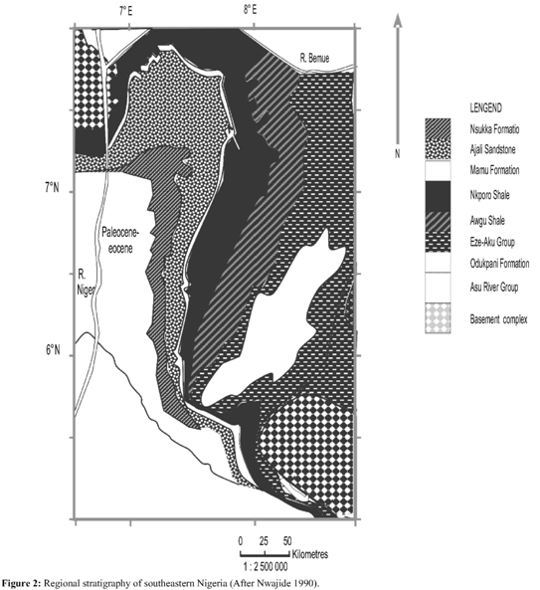
Figure 1Regional stratigraphy of southeastern Nigeria (After Nwajide 1990)

With the thickness of the sediment in the southern Benue Trough estimated to be about 6,500m, which tends to be generated by repetitive transgressive-regressive sedimentary cycles, has however suffered two deformations in the Cenomanian and Santonian along NE–SW axis. These deformations produced multiple folds and fractures parallel to the fold axis (Ofoegbu, 1985, Cratchley and Jones, 1965; Nwachukwu, 1972), and the Santonian deformation in particular produced the Abakaliki Anticlinorium with two synclinal basins (Anambra Basin and Afikpo Syncline) on its flanks (Kogbe, 1989), forming the main depocenters of the post-deformation era. However, the Asuu River Group, Eze-Aku and Awguformations were deposited during the first phase inthe Abakaliki-Benue Basin, the Benue Valley and the Calabar Flank. The second sedimentary phaseresulted from the Santonian folding and uplift of theAbakaliki region and dislocation of the depo-center into the AnambraPlatform and Afikpo region. The resulting succession comprises the Nkporo Group, Mamu Formation, Ajali Sandstone, Nsukka Formation, Imo Formation and Ameki Group.

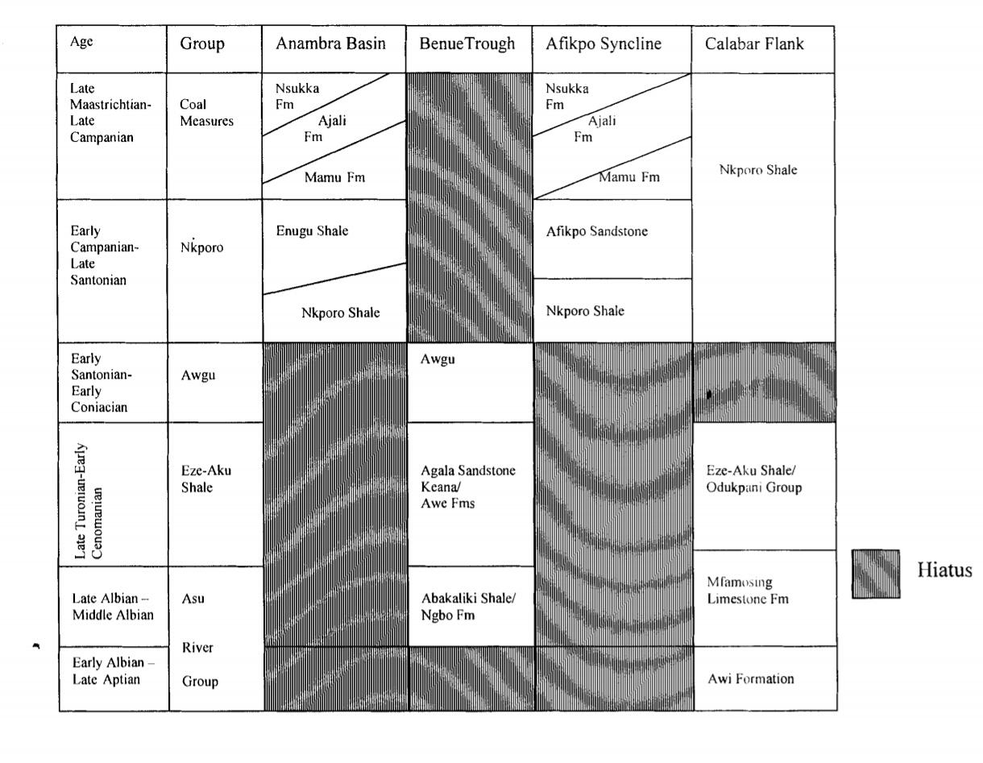
Figure 2Stratigraphic columns of the southeastern Nigerian sedimentary basins modified after (Reyment, 1982; Petters and Ekweozor, 1982 and Ojoh, 1992)

CHAPTER THREE

METHODOLOGY AND INSTRUMENTATION
DESK STUDY
The deck study was done at the school before going the the field. A thorough evaluation of the geologic and topographic maps of the area of study was carried out before the project site was visited. This gave idea and information on the location, possible lithological boundaries and accessibility.
FIELD STUDY
This has to do with the direct observations of outcrops, collection of rock or soil samples, measurement of the altitude of the bed and determination of the type of formation present in the area. These were carried out in three stages namely:
- Preliminary study
- Reconnaissance stage
- Detailed study

PRELIMINARY STAGE:
This involves detailed study of past work of the area by authors and researchers that have mapped the area, and the use of a topographic base map of the study area to locate possible outcrop exposures.
RECONNAISANCE STAGE:
This involves traveling to the study area and meeting with the local authorities, informing them of our intention and purposes to carry out a project work on their land.

DETAILED
Field study entailed carrying out a geological mapping of the rock types in the study area. The mapping exercise was basically aimed at identifying the rocks and establishing stratigraphic succession of the rocks on the basis of their field relationships. It also involved collection of spot rocks on the basis of their field relationships. It also involved collection of spot rock samples for laboratory studies. Field observations including grain texture, color, grains orientation, and mineralogical composition, measurements of dips and strikes of cross-beddings, thickness and lateral extent of beds, taking photographs of important sedimentary structures and logging of exposed vertical sections were done. Measurements of dips and strikes of the cross-beds were taken for palaeo-current analysis.

SAMPLING
A total of fifteen samples were gathered at different locations for laboratory analysis, that is, thin sectioning, sieve analysis and impregnation.

THIN SECTIONING: all fifteen samples were mademainly of indurated sandstones, siltstone, mudstone and Shales. Two samples were used for thin sectioning being one sandstone and one calcareous sandstone.

PETROGRAPHIC STUDIES: The sandstone samples collected from the field were analyzed for their composition, color, lithology thin section and were taken for petrographic studies. Petrographic studies is an aspect of petrology which considers the description of the mineral content, chemical composition, texture, structure, and classification of rocks. It is study of rock sample with the use of thin rocks section to study the optical properties of minerals and rocks. This is done to observe the interrelationship of minerals using a microscope with an analyses and a polarizer.

This simply refers to all procedures plans and principle applied by both students and lecturers in ensuring that the field work is completed successfully.
Location of oneself in the field.
Observation of various lithological units
Studying every lithology of an outcrop to obtain information like grain size,grain shape composition, sedimentary structures, textures. Lithology etc
Accurate measuring of attitude of different geological structures.
Taken note of the trends of every geological structures.
Collection of fresh samples at every location for further analysis in laboratory.
Measuring the thickness of the bed
Taken photography.
Many representative samples of sandstones were collected from the study area. The samples were later disaggregated and divided into two equal parts of 50gm each. Sieving was done for each sample for 15 minutes on a Ro-tap sieve shaker, using a set of U.S standard sieve at % phi sieve interval.

Material that were used in the field Trip and their importance are listed below:
Base map: is very important, it can be regarded as the first aid to every field trip in field mapping in geology. The base map shows the outcrop and the directions of a place under-consideration or mapping.
Compass: it is used to measure the attitude of the outcrops; it enables the trends of fault planner and trough cross beds to be measured.
Measuring tape and meter rule: It is used to measure the thickness of beds during logging
Hand Lens: it is used for magnification
Field note book: for recording information
Sample bags: for collection of rocks samples, for analysis in the laboratory.
Geological hammer: it is mostly used to extract samples from the rocks
Camera: for taking photography (image) of an outcrop.
Pen and pencil: pen for recording information while the pencil for sketching or drainage out crop.

METHODOLOGY
This covers the aspect of lithology, stratigraphy, and geomorphology, production of base maps and structural geology of the area. The methodology used during the field mapping exercise is the compass. Here, the major and minor roads, including foot paths were used in order to access the outcrops. We first located ourselves in the field using our Global Positioning System (GPS) after which it was indicated on the base map (topographical map). During the course of the exercise, GPS readings were taken at each location so as to obtain the latitude, longitude and elevation readings; observations based on the sediment types and sizes, along with the attitudes of beds (dip, strike, dip amount measurements and trends of joints) were made at the locations where needed. Outcrops and cross beddings were noted and measured. Some interbedded outcrops were logged from base to top at some of our locations. At various locations, we tried to determine the grain sizes, texture, sorting, mineralogy, sedimentary structures and other features of the outcrops, which aids in better description, naming and interpretation of the rock type.

REPORTING

It is often said that a report is as good as its data and thus the need to collect good accurate data cannot be overemphasized. Ultimately when all possible available data has been collected it is taken back to the office or laboratory for sorting, interpretation and analysis. This phase is the most challenging of all three as wrong analysis or misinterpretation of data can lead to an inaccurate report and in consequence misinformation. The resulting map or model is in most incidences drawn by persons of another section (for example cartography) who may have had no involvement in the field whatsoever. Thus it is crucial that the data collector, in this case the geologists, work closely with those involved in actual drawing of the map, since they can select the data that is relevant for final presentation in the map and that which is not.

CHAPTER FOUR

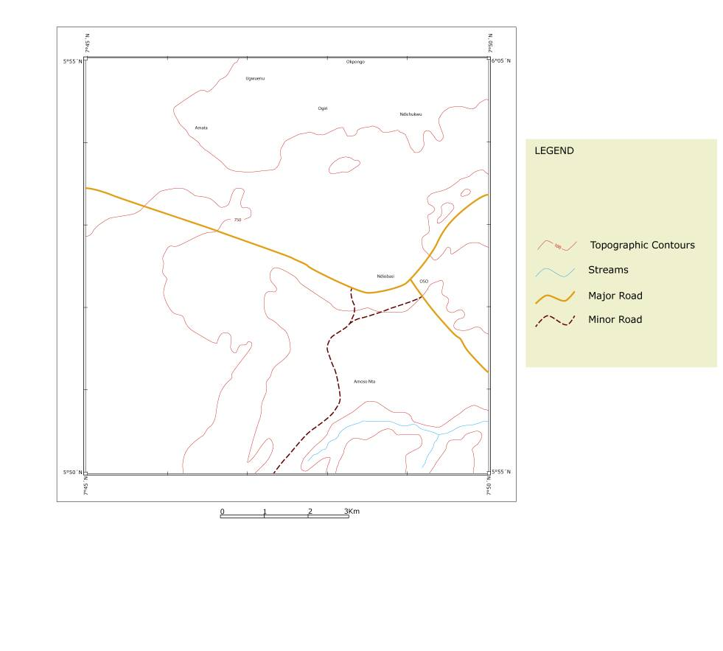
FILD DESCRIPTIONS
Figure 3 the topographic map of the area.
TOPOGRAPHIC MAP OF OSO-EDDA

Oso- Edda (the study area) is made up predominantly of Eze-Aku Formation. The principal rock types include sandstone and shale, and are thus divided into different units; these lithologic units include:
Unit 1- The Eze-Akufine sandstone/shale
Unit 2- the Eze-Aku sandstone
Unit 3- Amasiri Sandstone

UNIT 1
This unit is principally seen within the northern part of the map area. Outcrops were identified at three locations where the various rocks were studied based on physical observations. These locations are as follows:

OKPOROJO

GPS CORDINATES
N05ᵒ54.941
E007ᵒ48.696
ALTITUDE OF BEDS
DIP DIRECTION: S170E
STRIKE: S260W/ N80E
DIP AMOUNT: 65

This location shows an interbedding of highly dipping shales and calcareous sandstones. The shales are dark grey- black in colour. They are highly indurated showing high fissility or slaty cleavage structure. They are also highly fractured whose orientation is in one direction (SE-NW). The shales are brownish in colour when weathered. The average thickness of the individual bed is 60cm. The calcareous sandstone beds are dark grey in colour. They also show evidence of indurationupon the administration of a dilute Hcl, the rock sample effervesced showing chemical reactions between the Hcl and the carbonates.
2Hcl + caco₃ cacl₂ + H₂o + Co₂

The effect of jointing in the calcareous sandstone is evidenced by the presence of spheroidal weathering as show in in figure .The orientation of the fractures are almost perpendicular to the shale bedding plane.

AMATA

GPS CORDINATES
N05ᵒ 54.920
E007ᵒ47.634
ELEVATION: 45 ASL.

The shale samples observed from a road cut exposure within the locations are also highly indulated black to dark grey fissile to slaty cleavage shales. The shales are also fractured.

OGIRI

GPS CORDINATES
N05ᵒ54.865
E007ᵒ47.904
ELEVATION: 37 ASL
The Ogiri sandstone was seen at the base of a river serving as a river bed. It is highly fractured and the dip direction is S180ᵒE. The sandstones are dark and grey in color.

UNIT 2
The unit covers almost 2/3rd of the map area. The area is highly vegetated and having an average mean sea level height of 57m which is higher than unit 1. Therefore the unit 2 is lying on top of unit 1. The unit is composed of sandstones, siltstones and shales and the average dip of the unit is smaller than unit1. Vegetation makes it impossible for a more detailed outcrop locations.

AMASONTA
GPS CORDINATES
N05ᵒ51.232E007ᵒ47.878 ELEVATION: 50m.
The location is about 10m away from the Amasonta square having surface expression of interbed of sandstone and parallel laminated heteroliths (laminated siltstone and very fine grained sandstone with some mud drapes).

NDIKPO
GPS CORDINATES
N05ᵒ51.455 E007ᵒ47.985 ELEVATION: 64 ASL
ALTITUDE OF BEDS DIP S120ᵒESTRIKE N45ᵒEDIP AMOUNT:35ᵒ
The outcrop is located on a road side and consists of coarse ferrugenized coarse grained sandstone interbedding in planar cross bedded heteroliths. The thickness of sandstone is about 25cm while the lenticular bedding is about 100cm. the sandstone is weathered showing evidence of chemical weathering. Figure shows a cross section of the location. The sandstone bed in this location was analyzed petro graphically and thin section.

NDIUCHE
GPS CORDINATES
N05ᵒ51.699E007ᵒ48.219ELEVATION: 58m
There was no major outcrop seen in this location but pebbles of quartz which dis-aggregated from the sandy soil (sand) were observed. Visual inspection of these pebbles indicate that they are sub-rounded to rounded in shape. Further analysis of the pebbles were conducted in the lab such as pebble morphometric which will be used to interpret the provenance and environment of deposition of the location or unit.

UNIT 3
Uko Ridge
GPS CORDINATES N05ᵒ48.062E007ᵒ49.299Elevation74.9m.This is a sandstone unit that forms prominent asymmetric ridge reflecting the dip which make 60ᵒ okonkwo (2014). The unit is barren of vegetation showing dip or black weathering with good exposure only on road cuts. The base of the ridge consist of indurated coarse grained sandstone possibly indicating finning upward sequence. It shows a similar succession of facies described by amajor (1987). Sieve analysis of the upper facies of the ridge was done to ascertain the provenance and depositional environment. The upper part of the sandstone ridge shows bioturbation with small to medium scale potholes.

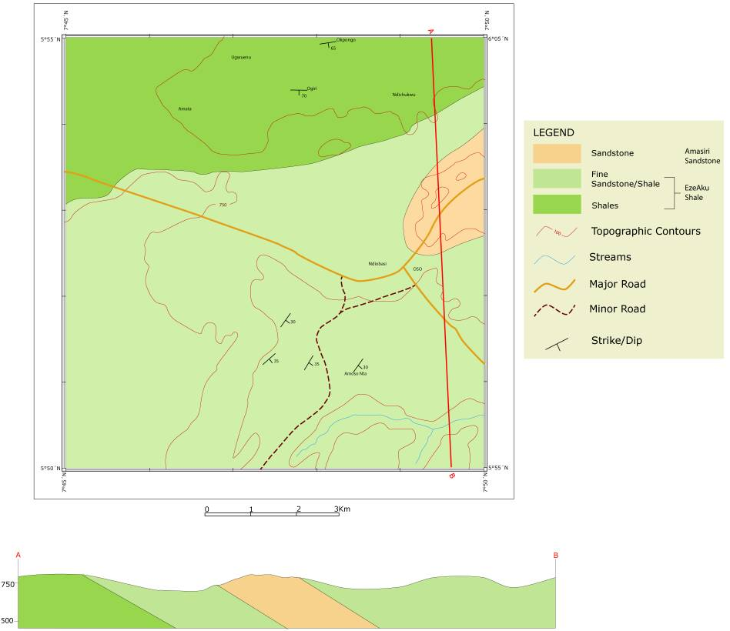
Figure 4 A detailed geologic map of the area.

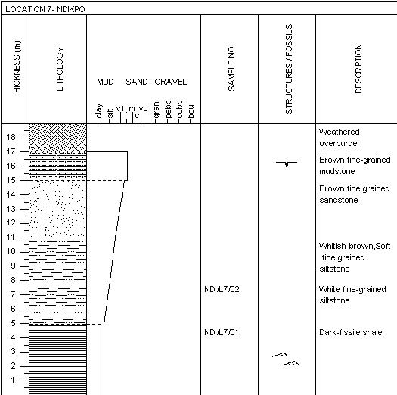
Figure 5A LITHOSECTION OF NDIKPO
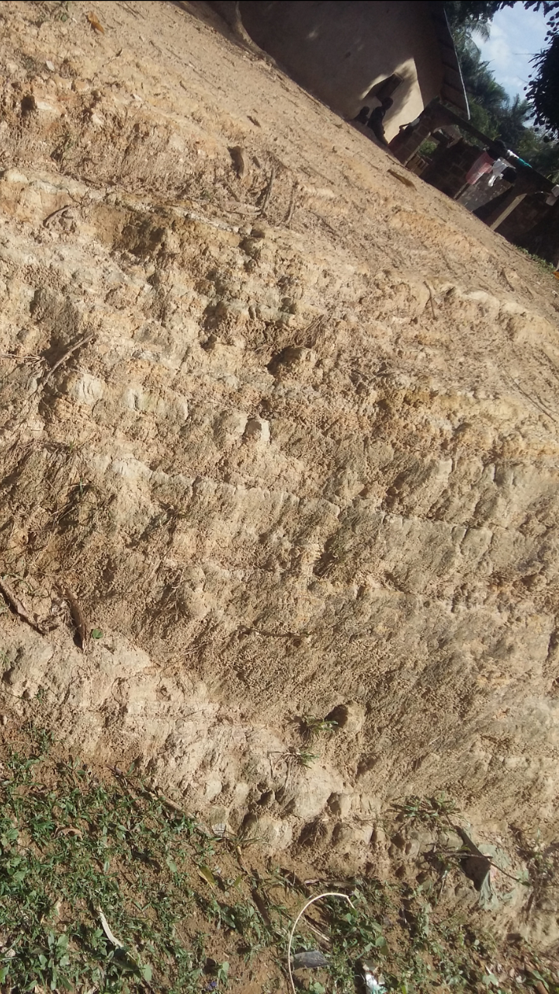
Figure 6Dipping planar cross bedded laminated siltstone
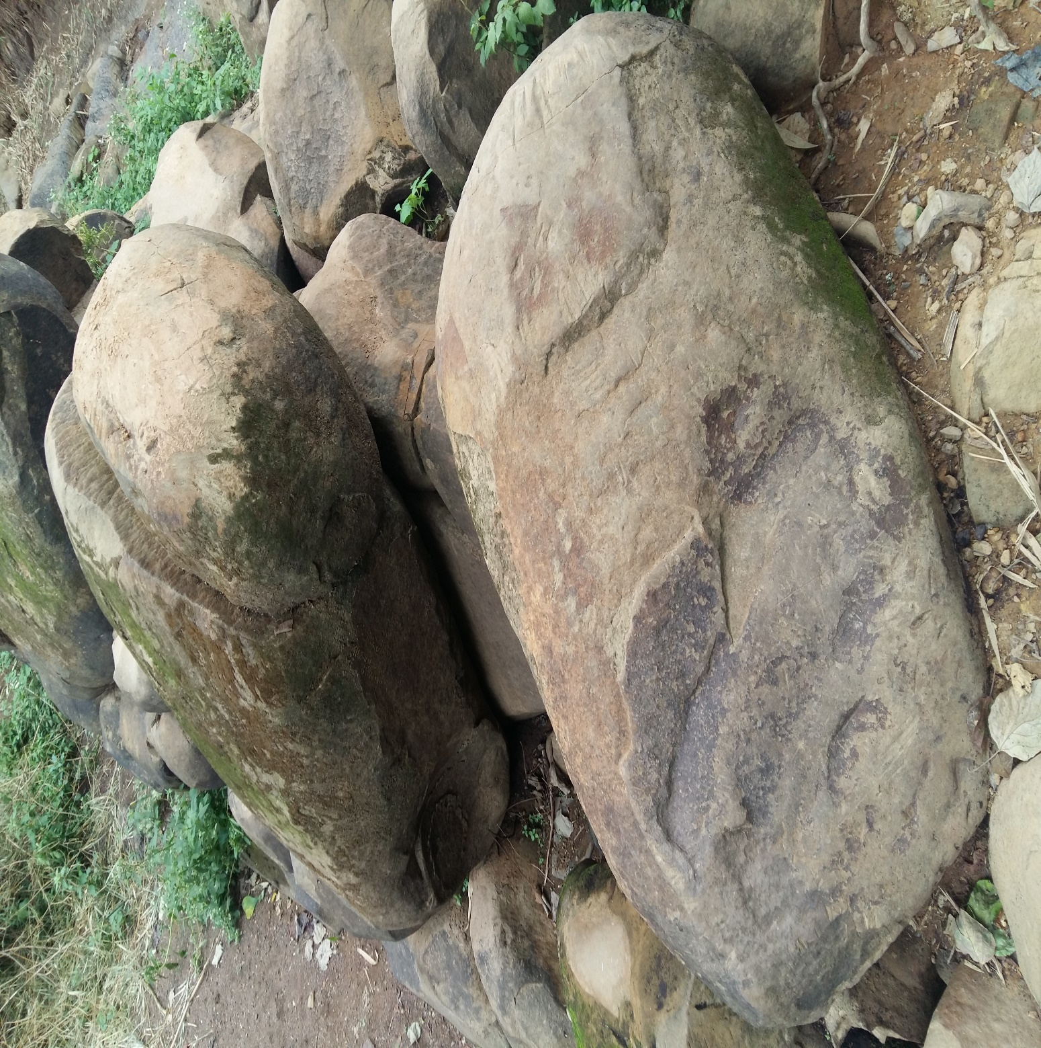
Figure 7 Showing spheroidal weathering at okporojo
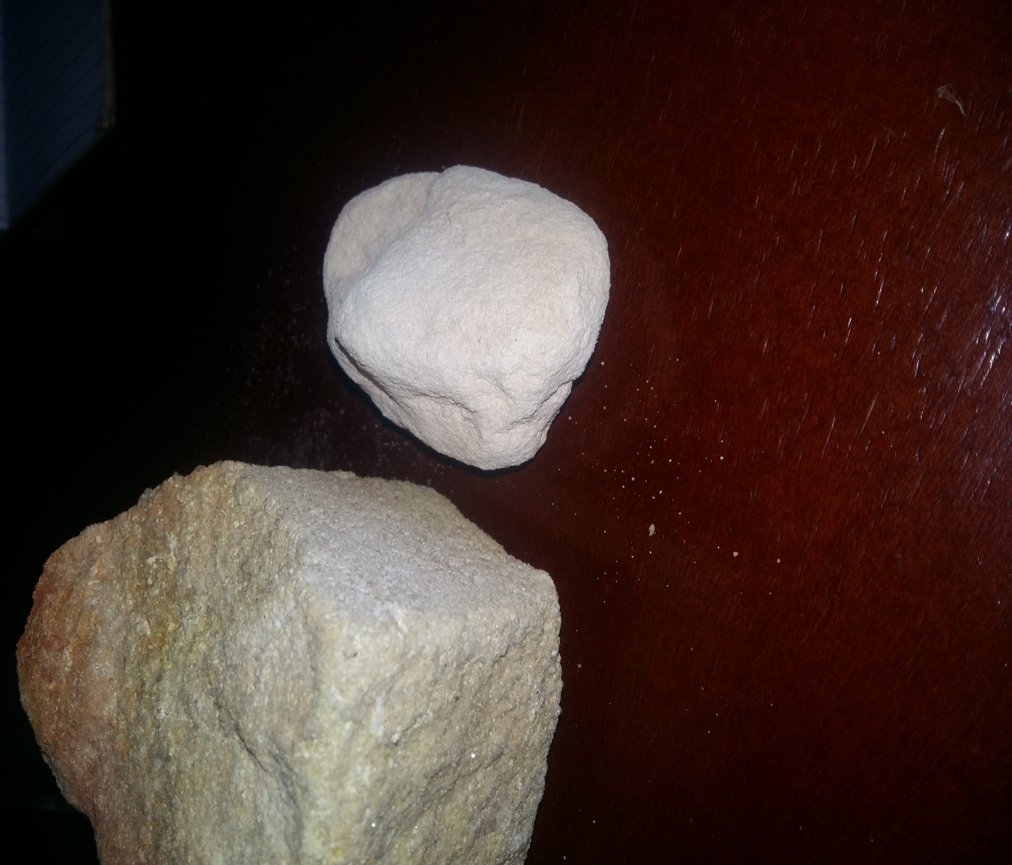
Figure 8showing the outcrop of uko ridge whereby by right is its fining and by left is its coarsening.
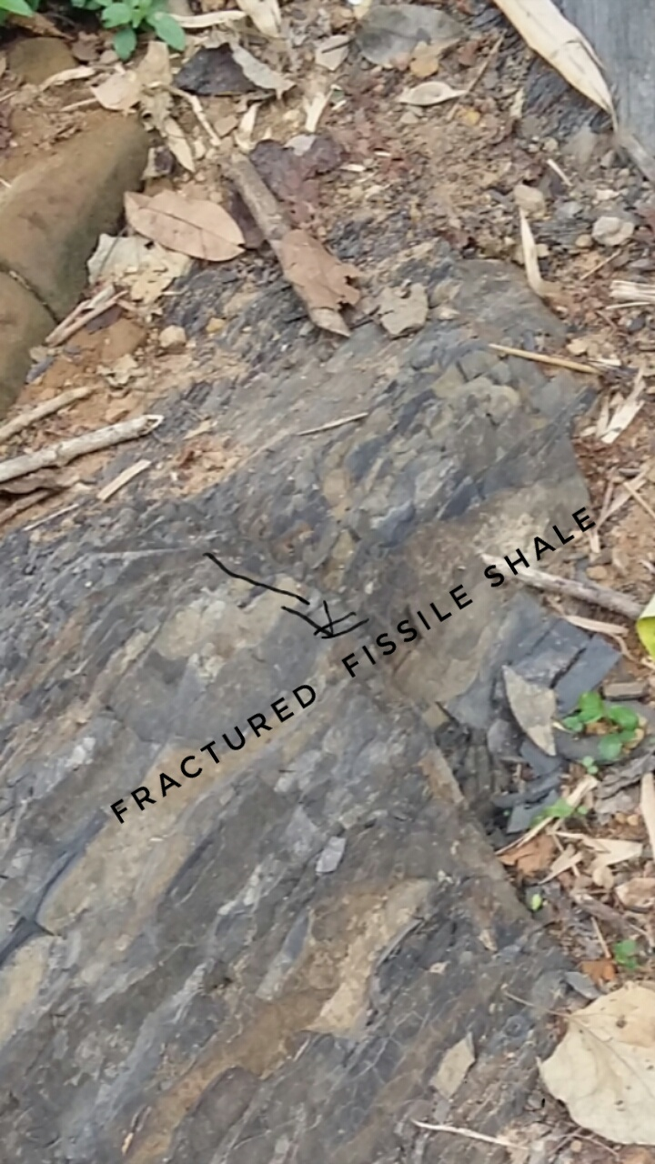
Figure 9showing fractured fissile shale at okporojo

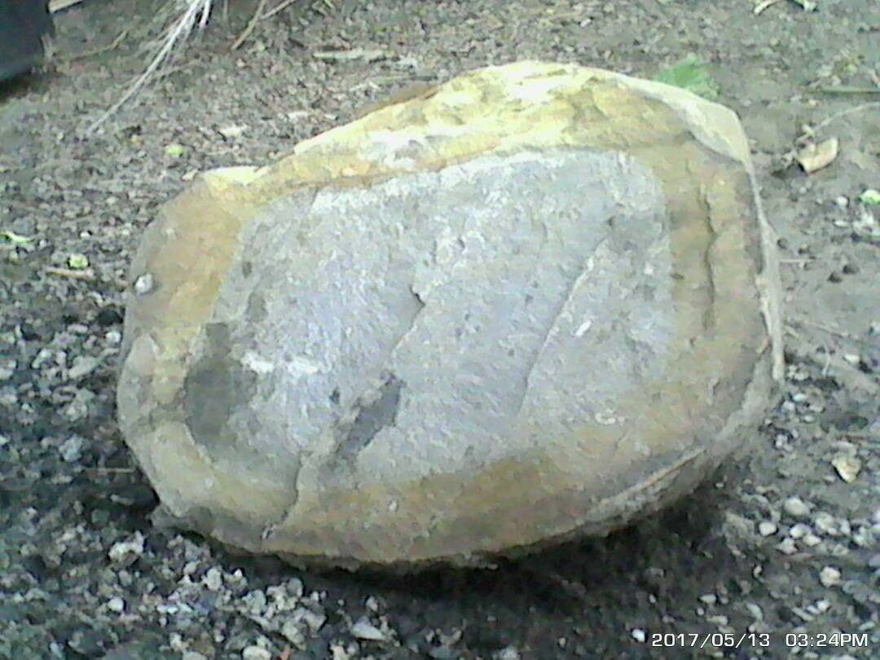
Weathering rind
Figure 10Showing a freshly broken spheroidal weathered calcareous sandstone at Okporojo showing differential chemical weathering (due to oxidation) progressing inwards forming a weathering ring.

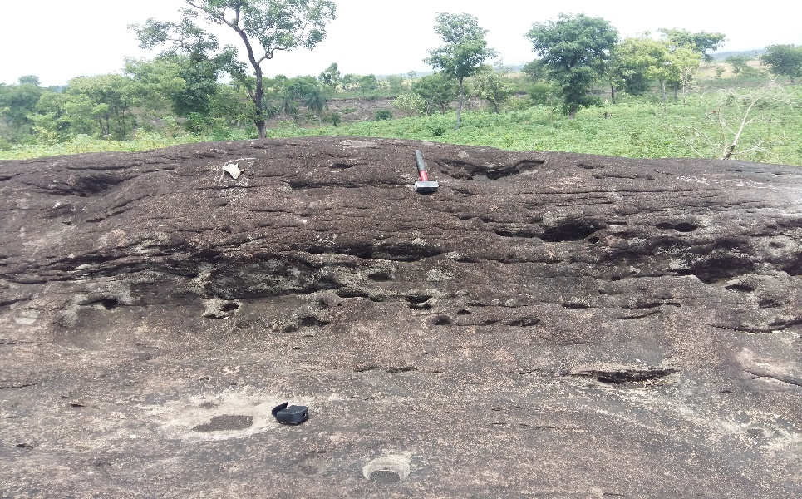
Figure 11The surface of uko ridge showing the potholes.
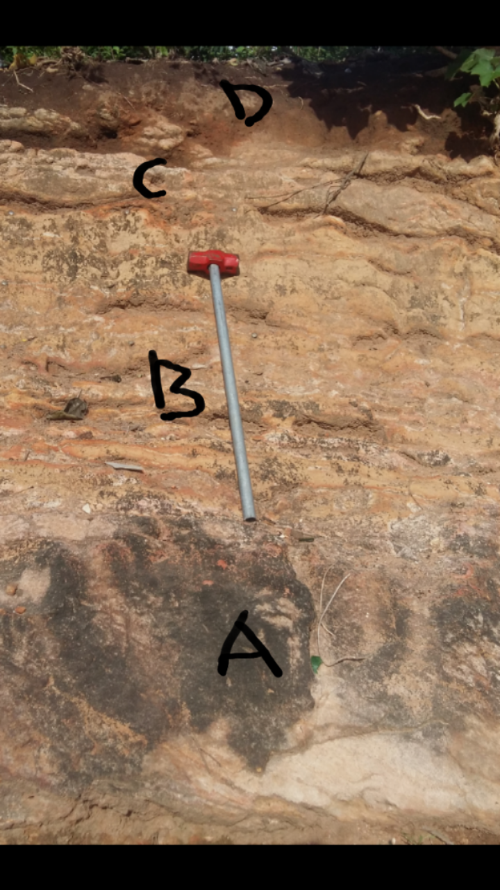
Figure 12SHOWING THE VARIOUS LITHOLOGIES OBSERVED AT NDIKPO.

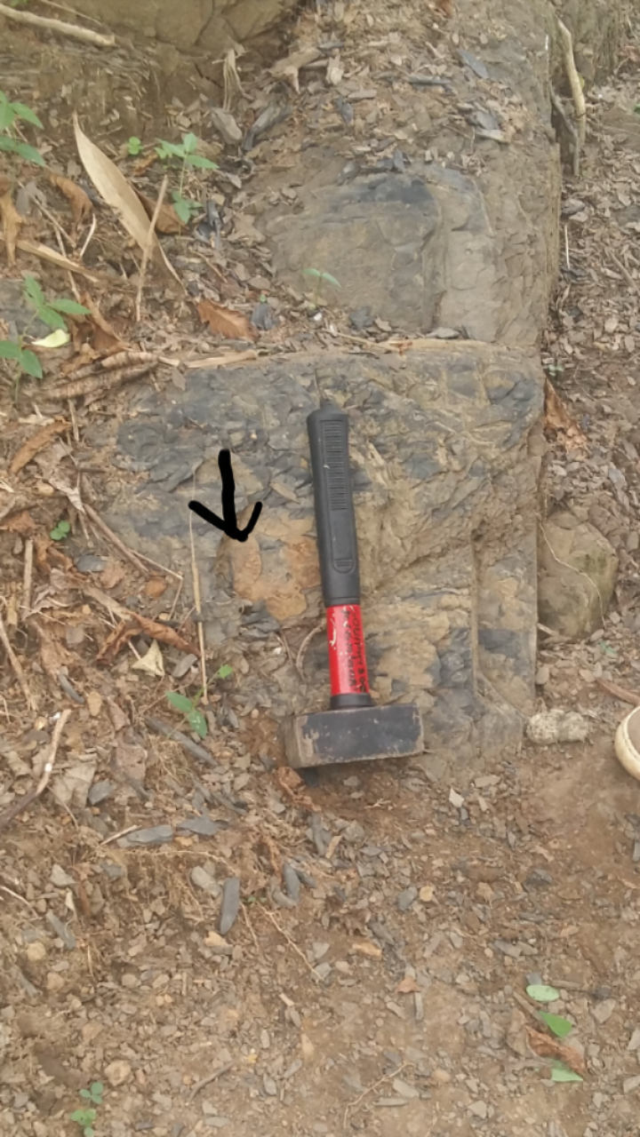
Figure 13SHOWING THE DIP OF THE STRIKES OBSERVED AT OKPOROJO (LOCATION

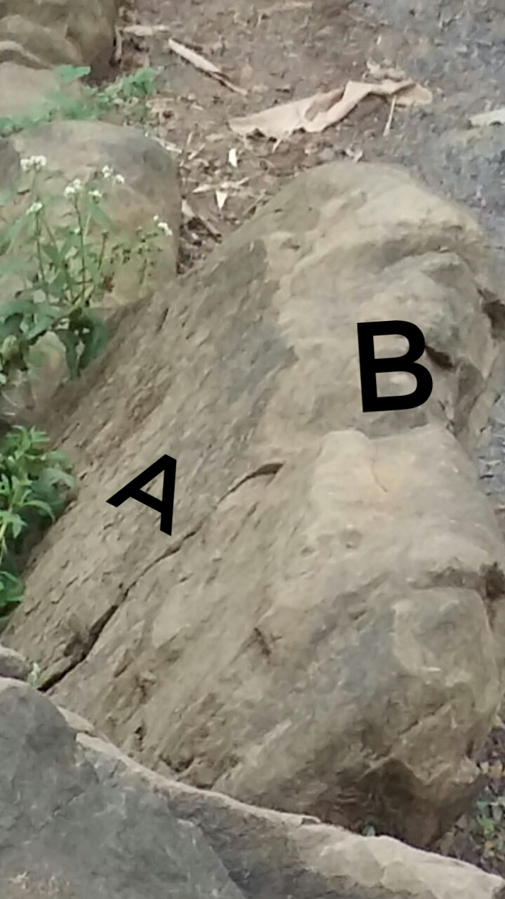
Figure 14 SHOWING THE ATITUDE AND DIP OF THE CALCAREOUS SANDSTONE BED AT OKPOROJO AND THE A IS THE DIP AND B IS THE STRIKE LINE STRIKING NORTH

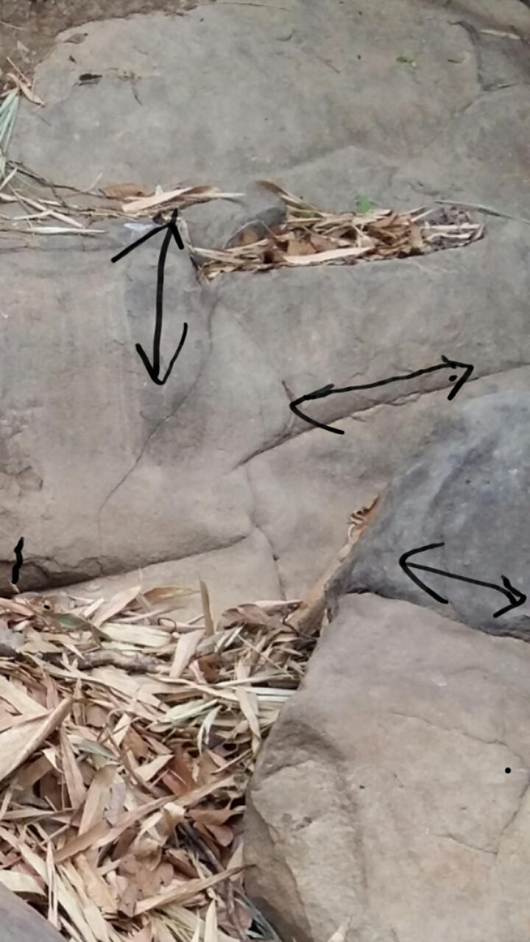
Figure 15 SHOWING THE JOINT LINE at ogiri

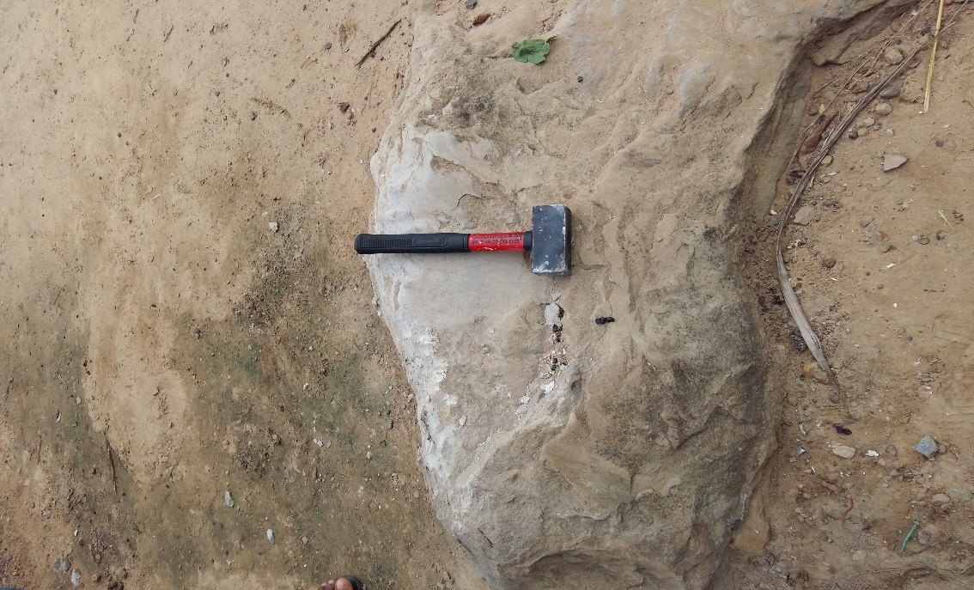
Figure 16EXPOSED OUTCROP FOUND AT AMATA

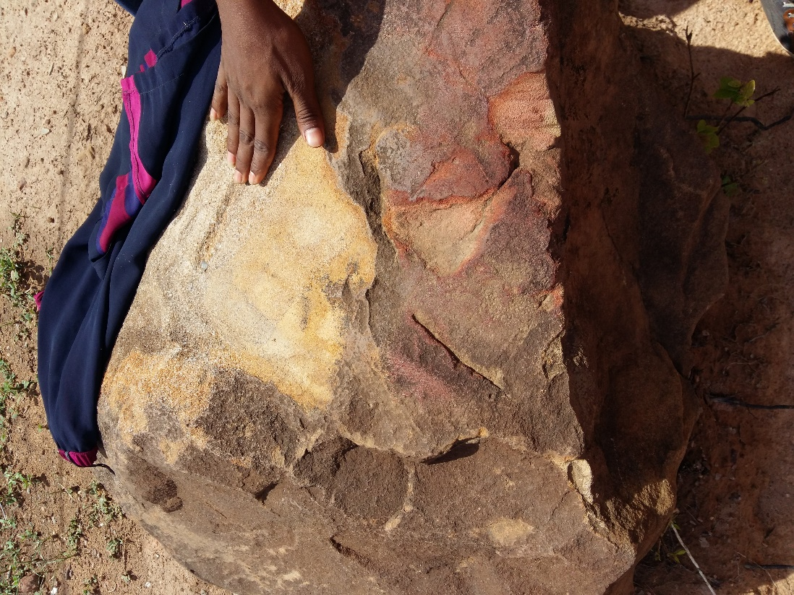
Figure 17 EXPOSED FERRUGINIZED SANDSTONE SHOWING CHEMICAL WEATHERING FOUND AT NDIUCHE

Figure 18 showing the slaty cleavages of the shale

CHAPTER FIVE

LABORATORY ANALYSIS OF FIELD DATA AND INTERPRETATION OF RESULTS

GRAIN SIZE ANALYSIS
This analysis was carried out to assess the particle size distribution (also called gradation) of granular material. In order to characterize the sediment, one would take a representative sample of the sediment and run it through a set of sieves to break the sample subset in to size classes and using statistics to reconstruct what the population's size characteristic are.

EQUIPMENT USED
Mechanical shaker
Electronic weighing scale
ASTM sieves
Brush

PROCEDURE
A representative dried rock sample (unconsolidated) of about 100g was used. The lumpy rock particles were crushed with care in order to disaggregate the lumps. The required amount of rock sample for this analysis is 50g therefore I weighed each sample using the electronic weighing scale then I prepared the sieves for the analysis. A set of fifteen sieves were used, I made sure the sieves were clean (by using a dry brush to poke the openings of the sieve), this was to make sure that I obtained accurate results. The sieves were then stacked, placing the sieve with larger openings at the top and placing the sieves with small openings at the bottom. I then placed the sample into the topmost sieve, set the timer of the mechanical shaker to twenty minutes then switched on the mechanical shaker; when the time (twenty minutes) elapsed, I weighed the mass of rock sample retained in each sieve then I tabulated my readings. This procedures were undertaken for two more samples (three in total) and results were also tabulated.

PEBBLE MORPHOMETRY
Pebbles samples collected from Ndikpo village of the study area were subjected to pebble morphometric analysis in order to diagnose the environment of formation. Pebble morphometric investigations relies on various independent and dependent functions. As an independent function, the coefficient of flatness ratio (FR), elongation ration (ER), maximum projection sphericity index (M.P.S.I), oblate-prolate index (OPI), roundness (%) and pebble form have been used as indices for the determination of environment of deposition. As dependent variables, scatter plots of maximum projection sphericity index (M.P.S.I) versus oblate-prolate index (OPI), roundness (%) versus elongation ratio (ER) and geometric form diagram have been used in determining the environment of deposition.

PROCEDURE AND INSTRUMENTS USED
Over 100 pebble samples were collected from Ndikpo area. Various sizes of pebbles were randomly oriented. The collected pebbles were later screened to exclude pebbles that were cracked or freshly broken. By the end of the exercise, a total of fifty (50) samples comprising pebbles of isotropic constitution and high resistance to wear were considered representative of the pebble bed in the study area, and therefore adopted for the pebble morphometric analysis. These pebbles were washed, numbered, and transported to the laboratory for analysis. The analysis involved the measurement of the magnitude of the long axes (L), intermediate axes (I) and the short axes (S) of the pebbles using Venier Caliper. Other relevant data were computed from the generated data. Someof the computed data includes indices such as: Flatness Ratio (FR), which is the ratio between the short axes to thelong axes, and Elongation Ratio (ER), which is the ratio of the short to the intermediate axis. The measure ofequidimensionality (sphericity) of the pebbles was determined using the Maximum Projection Sphericity Index (MPSI). Others including, the Oblate Prolate index (OPI) and Roundness were estimated. OblateProlate (OP) index shows how close the intermediate (I) axis of a pebble is to the short axis or long (L) axis.

PETROGRAPHIC ANALYSIS
The sandstone samples collected from the field were analyzed for their composition, colorlithology thin section and were taken for petrographic studies. Petrographic studies is an aspect of petrology which considers the description of the mineral content, chemical composition, texture, structure, and classification of rocks. It is study of rock sample with the use of thin rocks section to study the optical properties of minerals and rocks. This is done to observe the interrelationship of minerals using a microscope with an analyses and a polarizer. petrographic analysis were carried out on sandstone sample collected at Ndijpo area and calcareous sandstone sample at Okporojo area with the aim of ascertaining the mineral constituent and to provide knowledge of the depositional environment (diagenesis). Equipment needed for the analysis is petrographic microscope.

BIOSTATIGRAPHIC ANALYSIS
Biostratigraphy analysis were conducted on shale samples collected from locations four and five of the study area for age determination purposes and to provide knowledge onits paleo environment. The shale samples were taken to the laboratory where they were washed and cleaned for sample preparation before mounting the slide (after sample preparation) on the microscope (Leica) for analysis and to take light photomicrographs.
METHOD OF SAMPLE PREPARATION
Sample preparation was carried out using the conventional maceration technique for recovering acid insoluble organic-walled microfossils from sediments. Each sample was digested for 30 minutes in 40% hydrochloric acid to remove traces of carbonate and 72 hours in 40% hydrofluoric acid for removal of silicate. The extracts were sieve-washed through 10 microns nylon mesh. The sieve-washed residues were oxidized for 30 minutes in 70% HNO₃ and 5 minutes in Schulze solution to render the fossils translucent for transmitted light microscopy. The oxidized residues were rinsed in 2% KOH solution to neutralize the acid. Swirling treatment was undertaken in order to get rid of the resistant coarse mineral particles and organic matter. The residues were stained with Safranin – O to increase the contrast for study and photography.
Aliquots were dispersed with polyvinyl alcohol, dried on cover-slips and mounted in petro- proxy resin. Light photomicrographs were taken with a Leica microscope.

ANALYSIS OF RESULT AND INTERPRETATION
GRAIN SIZE ANALYSIS
Summary of results
Sample No | Mean size | Sorting | Skewness | Kurtosis
Sample 1  (location 1) | 0.77  Coarse grained | 0.89  Moderately sorted | -0.03  Near symmetrical | 1.31  Leptokurtic
Sample 2  (location 12) | 1.45  Medium grained | 2.17  Very poorly sorted | -0.59  Strongly negative skewed | 0.89  Platykurtic
Sample 3  (location 10) | 0.16  Coarse grained | 1.34  Poorly sorted | -0.24  Negative skewed | 1.27  Leptokurtic

Below are the log probability and arithmetic graph representations of the grain size analysis respectively:
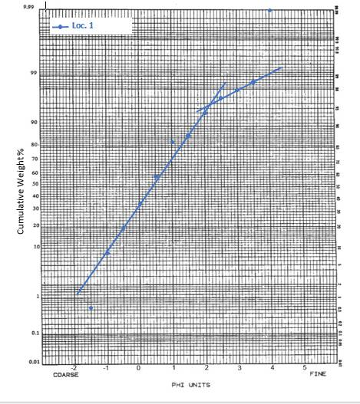
SAMPLE1
Uko ridge
Figure 19 the log probability graph of uko ridge

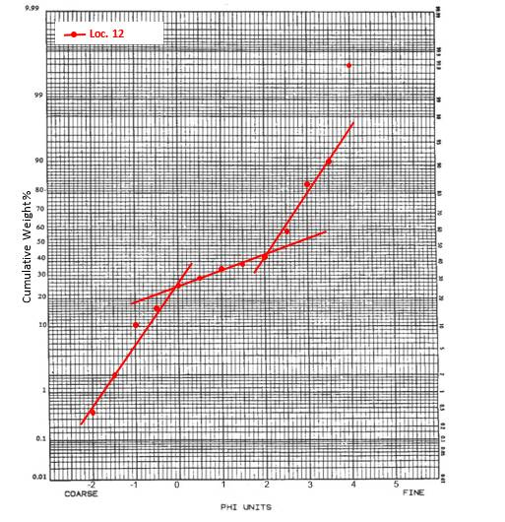
SAMPLE 2
AMASONTA
Figure 20 log probability graph of amasonta
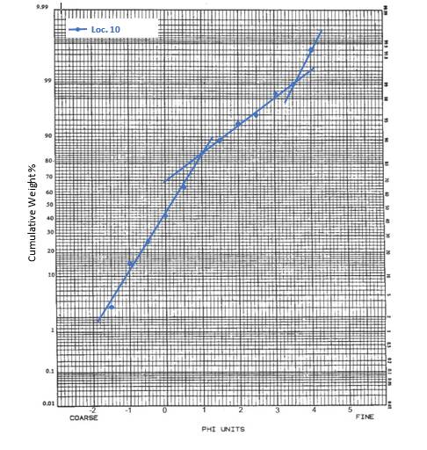
SAMPLE 3
NDIKPO
Figure 21 log probability graph of ndikpo
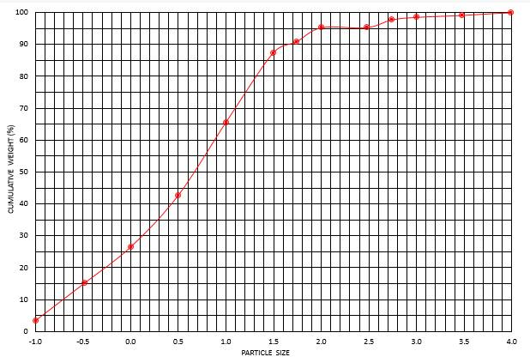
Figure 22 arithmetic graph of uko ridge

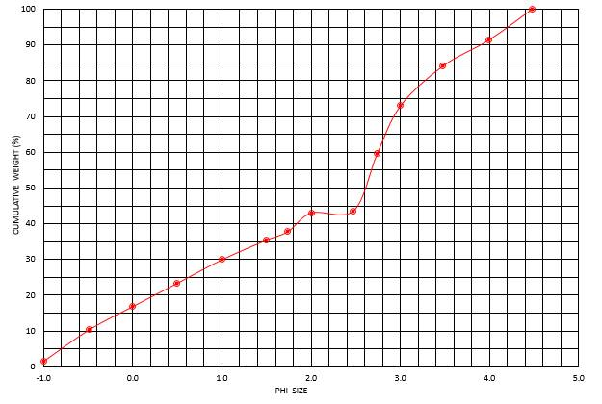
Figure 23 arithmetic graph of amasonta
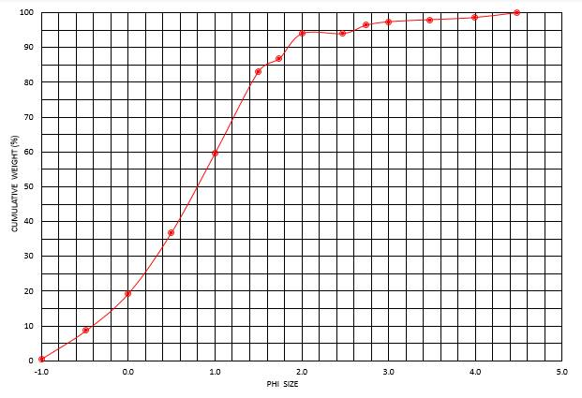
Figure 24 arithmetic graph of ndikpo

Below also are histogram plots of the grain size analysis results (SAMPLE 1 TO 3 RESPECTIVELY):
Figure 25 histogram for uko ridge'

Figure 26 histogram for amansonta

Figure 27 histogram of Ndikpo

Interpretations:
Sample 1 (Uko ridge): the uppermost part of the sandstone ridge was analyzed using grain size analysis and based on the results, the sandstone possesses coarse grains, moderately sorted near symmetrical and leptokurtic. Also, from the log probability curve it showed that the deposition was controlled by higher number of saltation and low number of suspension which shows evidence of moderate sorting which suggests area of moderate to high energy of deposition. The coarse grained and moderately sorted nature suggest a storm generated environment in a subtidal to tidal shelf environment. The whitish nature of the sandstone suggests it was deposited in an oxic environment.
Sample 2 (Amasonta): the sandstone facies found around Amasontais medium grained, very poorly sorted with strong negative skewdness and platykurtic. This sandstone whose thickness is about 60cm is deposited in a high energy environment. The paleogeographic environment is thought to be fluvial around shore. They almost have equal number of coarse, medium or fine grained sediments making up the sandstone (from the log probability graph results). The process of deposition include traction, suspension and saltation having almost equal activities.
Sample 3 (Ndikpo):the sandstone in this location is coarse grained, poorly sorted, negatively skewed and leptokurtic suggesting low to high energy of deposition. From the log probability graph, it showed that the three modes of deposition were active but is dominated by traction followed by saltation and the least is suspension.

PEBBLE MORPHOMETRY ANALYSIS
Summary of results
50 pebble samples were analyzed using the venire caliper to measure the long (L), intermediate (I), and short (S) axis which were then tabulated and used to check for the following parameters:
Coefficient of flatness (FL) = S/L *100
Maximum projection sphericity = (S²/LI)^{1/3}
Oblate prolate index = 10(L-I/L-S -0.50)S/L
Corey shape index = S/square root of IL
Disc-rod index = (L-I)/(L-S)
Effective settling sphericity =cube root of S²/LI
Their mean values were taken and used to plot some of the graphs while some were just plotted using the individual values of the pebbles.

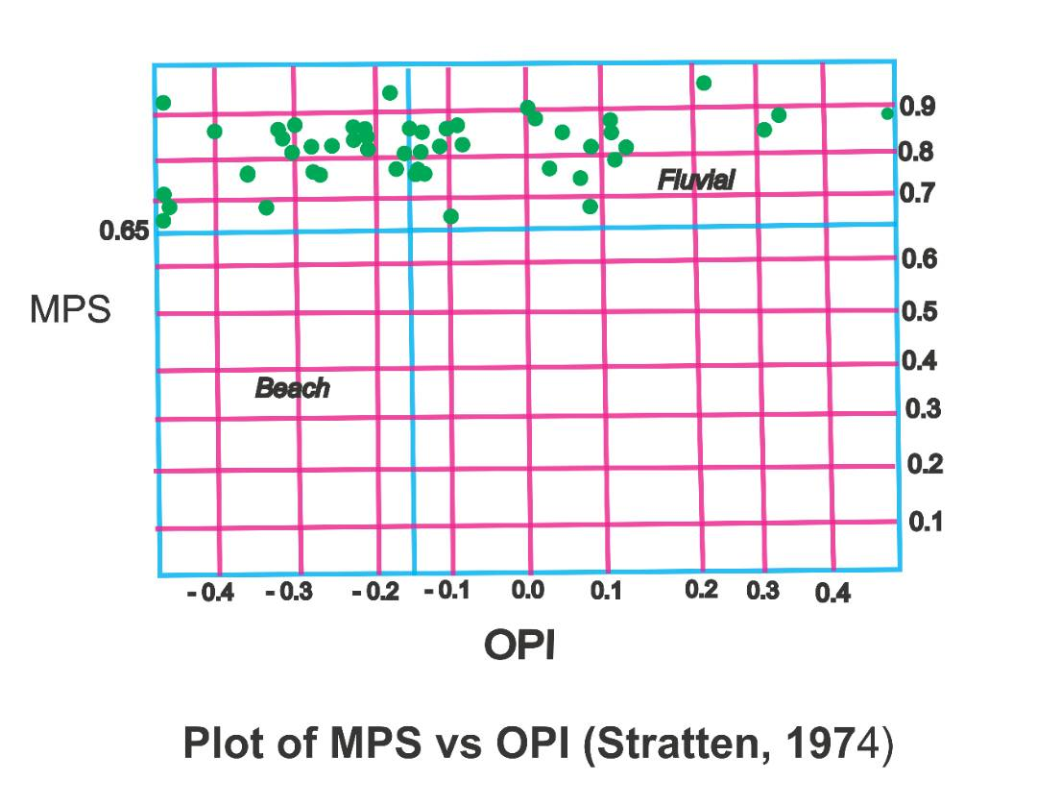
Figure 28 plot of MPs against OPI for the pebble morphometrey

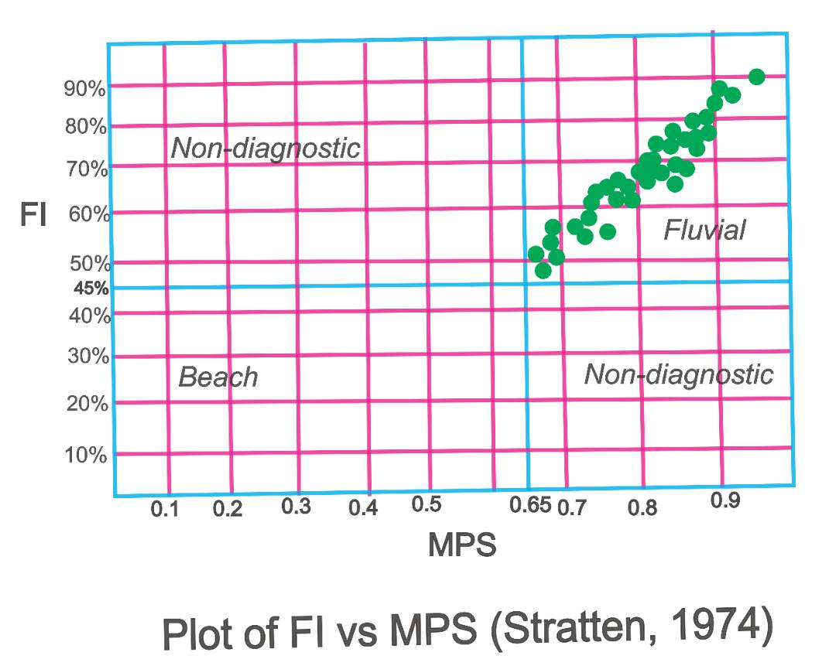
Figure 29 plot of FI against MPs
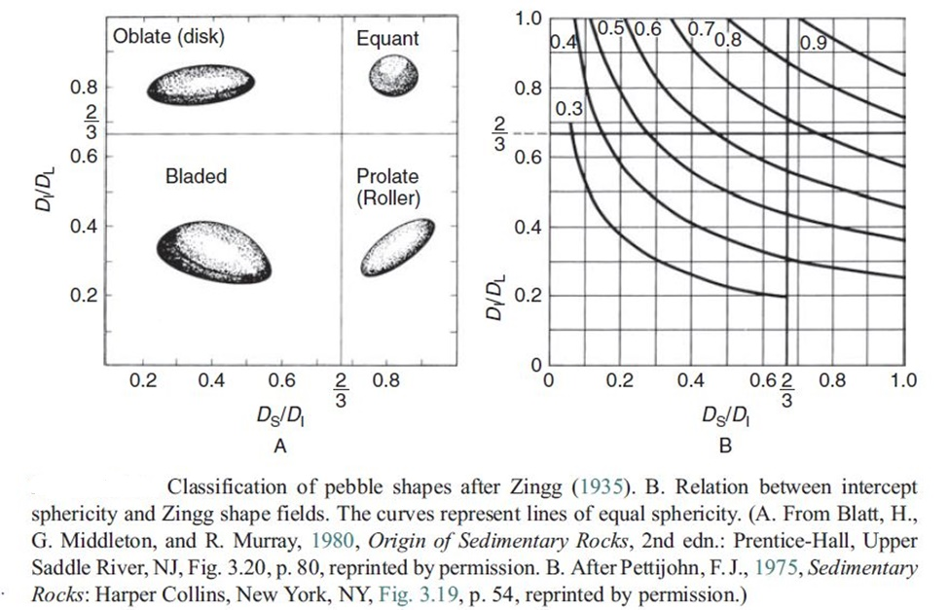
Figure 30
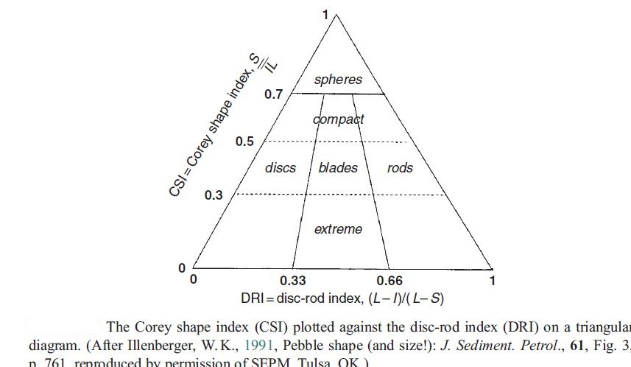
Figure 31

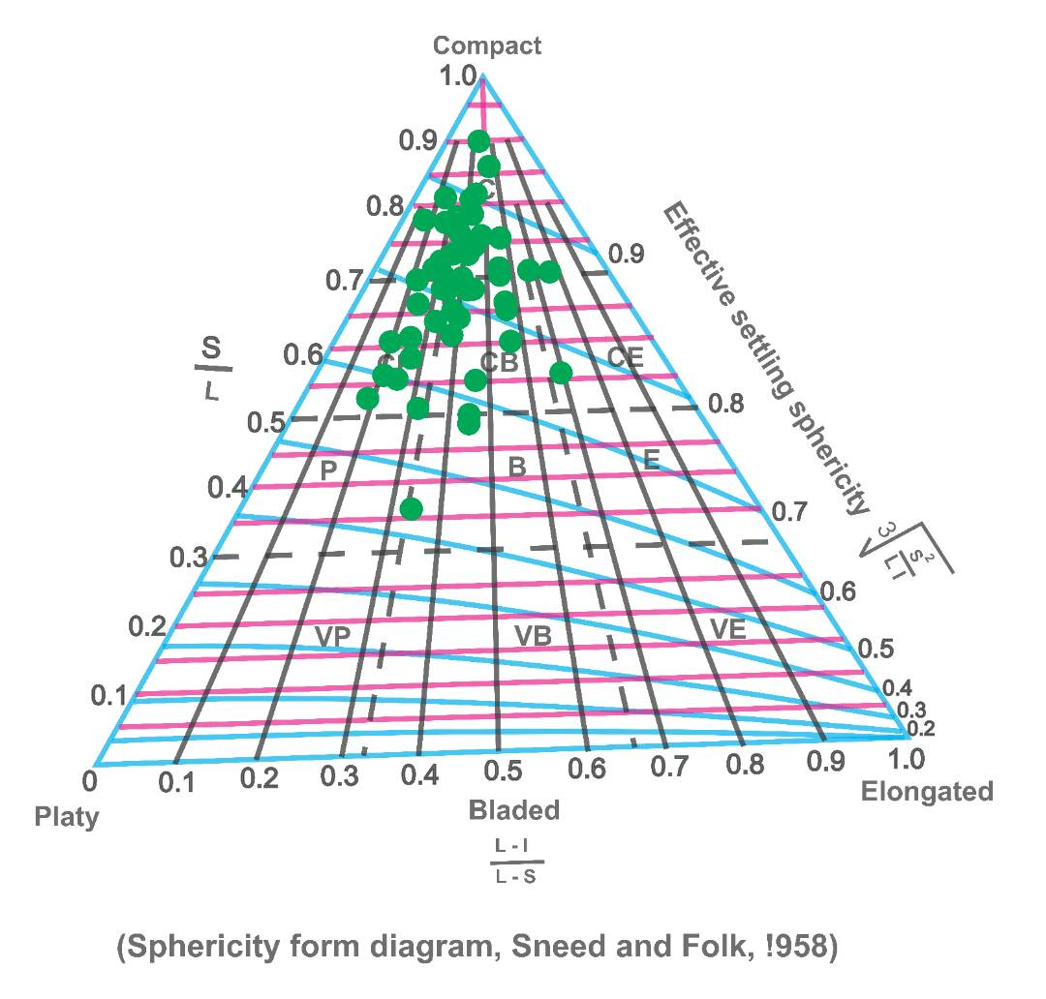
Figure 32 sphericity form diagram

The last graph presented above (sphericity form diagram) was used to determine the form name of the individual pebbles. The table can be seen below:

s/no (Pebble number) | Form name
1 | CB
2 | CB
3 | CB
4 | CB
5 | C
6 | CB
7 | C
8 | C
9 | C
10 | CB
11 | CB
12 | CB
13 | CB
14 | CB
15 | CB
16 | CB
17 | CB
18 | C
19 | C
20 | C
21 | CB
22 | P
23 | CB
24 | CB
25 | CB
26 | CB
27 | CB
28 | C
29 | CB
30 | CB
31 | C
32 | CB
33 | CB
34 | CB
35 | CB
36 | CB
37 | CB
38 | CB
39 | E
40 | C
41 | C
42 | CB
43 | E
44 | E
45 | CB
46 | CB
47 | C
48 | C
49 | C
50 | C
C= compact, P= platy, CB=compact bladed, E= ELONGATED.
INTERPRETATIONS
The pebbles analyzed indicate period of little quiescence; expression of particle form in addition to sphericity provided by the different shape classification of Zing (1935) and Sneed and Folk (1968) respectively. Zing’s shape class is divided into four which are roller, bladed, oblate and equant; these shape measure is somewhat similar to sphericity as classified by Sneed and Folk (1968) using a triangular diagram as opposed to that of Zings which is rectangular (all shown above). The end members of the particle shape as drawn by Sneed and Folk are compact, platy, elongated and within the triangular diagrams are other sub shapes compact bladed, compact elongated, very platy, very elongated etc. Illemberger (1991), presented a triangular diagram also in which a sphericity parameter is plotted against a disc-rod index.
The Zing’s pebble classification showed that the pebbles are majorly equant in shape while that of Sneed and Folk and Illemberger suggested compact to compact bladed and the mean roundness is sub rounded. Stratton (1974) used a graph of FI (coefficient of flatness index) against MPS (maximum projection sphericity) and also plotted a graph of MPS against OPI (oblate prolate index) to show its environment of deposition which both indicated a fluvial environment.

BIOSTATIGRAPHIC ANALYSIS
Results
LOCATION 4: (Amata)
Table 1: Occurrence and distribution of palynomorph species.
PALYNOMORPHS SPECIES | TOTAL COUNT
TERRESTRIAL SPECIES
Spores
Laevigatosporites ovatus | 5
Leiotriletes adriennis | 1
Pollen
Ephedripites multicostatus | 2
Galaecornea clavis | 3
Cretacaeiporites mulleri | 1
Monosulcites sp. | 1
MARINE SPECIES:
Dinogymnium euclaensis | 4
Exochosphaeridium bifidium | 2
Spiniferites ramosus | 6
Baltiacasphaera compta | 2
Pediastrum spp. | 1
Total | 28

Comments: Palynomorphs percentage frequency
Terrestrial species: Spores = 21 %
Pollen = 25 %
Marine species: Dinocysts = 54 %
Age: Probably Early – Middle Turonian
Paleoenvironment: Open Marine

LOCATION 5: (Okporojo)
Table 2: Occurrence and distribution of palynomorph species.
PALYNOMORPHS SPECIES | TOTAL COUNT
TERRESTRIAL SPECIES
Spores
Leiotriletes minor | 2
Cyathidites minor | 1
Laevigatosporites ovatus | 2
Pollen
Ephedripites multicostatus | 2
Galaecornea clavis | 1
Cretacaeiporites mulleri | 1
Monosulcites sp. | 0
Tricolporopollenites sp. | 2
MARINE SPECIES:
Dinogymnium euclaensis | 2
Spiniferites ramosus | 5
Cyclonephelium c.f membraniphorum | 1
Leiosharidea spp. | 4
Trichodinium spp. | 2
Total | 25

Comments: Palynomorphs percentage frequency
Terrestrial species: Spores = 20 %
Pollen = 24 %
Marine species: Dinocysts = 56 %
Age: Probably Early – Middle Turonian
Paleoenvironment: Open Marine
INTERPRETATIONS
The age determination of the examined samples was based on selected key age-diagnostic palynomorph assemblage encountered. They are summarized as follow:
From the tables 1&2 above, the samples from locations 4 and 5 were probably assigned to Early to Middle Turonian on the basis of the following recovered sporomorphs assemblage: Ephedripites multicostatus, Galaecornea clavis, Cretacaeiporites mulleri, Monosulcites sp., and Tricolporopollenites sp. This assemblage is typical of the Turonian of Herngreen, 1973, Lawal and Moullade, 1986 and Abubakar et al. 2011 in the Upper Benue Basins, Nigeria. Other important dinocysts assemblage present are Cyclonephelium cf. membraniphorum, Exochosphaeridium bifidium, Spiniferites ramosus, Batiacasphaera compta, as well as Dinogymnium euclaensis which first appeared in the Turonian (Lawal and Moullade, 1986; Umeji, 2007; and Abubakar et al. 2011). However, the absence of Cretacaesporites scabratus and Droseridites senonicus in the examined samples eliminate Cenomanian and Coniacian ages respectively (Lawal and Moullade, 1986; Umeji, 2007; and Abubakar et al. 2011).

Below are the micrograph pictures of some key palynomorphs species recovered from the examined samples.

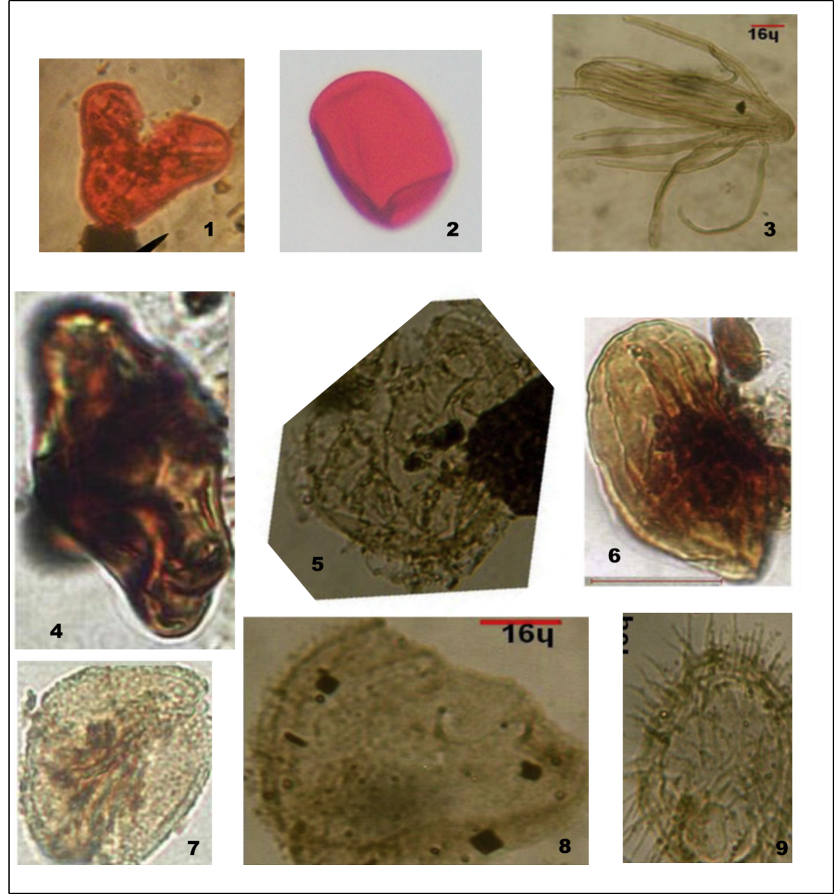
Figure 33Micrographs of some recovered palynomorphs from the examined samples.
Magnification (X 40); scale bar in microns 16
Cythidites minor 7. Tricolporopollenites sp..
Laevigatosporites ovatus 8. Microdinium cf. castaneum
Ephedripites multicostatus 9. Exochosphaeridium bifidium
Galaecornea clavis
Cyclonephelium membraniphorum
Ephedripites sp. 4

CHAPTER SIX

METARMORPHISM, WEATHERING AND STRUCTURAL GEOLOGY

The study of the shale, suggest dynamic metamorphism(temperature and tectonism) which affected the shale showing highly jointed beds (extensional joint). Because of tectonism, the rock units were deformed followed by igneous intrusion that affected the shale. Palynological studies of the shale unit shows that most fossils were destroyed hence committing the further analysis of the shales for the kerogen studies. Further evidence of metamorphism is the presence of slaty cleavage of the shales, hence, I am of the view that the shales within the map area is an aureole or close to an aureole. The steeply dipping beds of unit1 indicates an area of a probable limb of a fold.
Most of the rock units observed in the field were affected by weathering (gradual decomposition or breaking down of rocks, soil and minerals through contact with the earth’s atmosphere waters and biological organisms. Weathering most occurs in-situ with little or no movement. We have physical, chemical and biological type of weathering present in the rocks of the map area.
PHYSICAL WEATHERING: breaking down of rocks as a result of interaction of rocks, with the atmosphere and water. The fine sandstone within the ndiuche area were weathered as a result of interaction of the rock units with the atmosphere thereby changing the sandstone to sandy soil isolating the more resistant quartz pebbles which were seen within the area.

CHEMICAL WEATHERING: the calcareous sandstone unit is located at okporojo (unit 1) shows evidence of both physical and chemical type of weathering. Presence of spheroidal weathering is seen within the calcareous sandstone unit which is caused by the interaction of the water that penetrated through the joints during the raining season. Water expands the joints during the raining season and dries up and contracts through the dry season. The action of expansion and contraction within the joint breaks up the calcareous sandstone. Chemical weathering on these calcareous sandstone changes the composition of the outer part of the rock as a result of water interacting with the rock minerals to create various chemical compositions. This weathering isgradual and ongoing affecting the shape of the rock hence forming an isolated spheroidal shape (fig) shows a calcareous sandstone unit undergoing spheroidal weathering. Spheroidal weathering are usually seen within warm and wet climate.
H₂O + Co₂ H₂Co₃ (as rainfall)
H₂Co₃ + CaCo₃ Ca + 2HCo₃ (BICARBONATE)
BIOLOGICAL WEATHERING: it was observed within the top most part of the sandstone ridge (unit 3) as potholes. Potholes form on flat surface. The top of sandstone ridge is a very good habitat for such pothole development. The enlargement of potholes is usually slow in human time scale but over period of time, the process of change in water and time gradually increase the potholes. The potholes are circular in shape. The effect of weathering and erosion of the map area is responsible for the lowering of the topographic surface (denudation)
STRUCTURE AND TECTONICS (DEFORMATIONAL PATTERNS)
Tectonic structures are structures that result from the action of forces generated within the subsurface of the Earth at divergent or convergent plate boundaries. This external or endogenic force tries to transform the earth and its constituent there by leading to various structures and appearances retained by the rocks of the Earth involved, which serves as a criteria towards analyzing and interpreting the prevalent geological setting observed in the rocks. Tectonic structures in other hand can still be a crustal deformation with different or similar structural behavior.
JOINTS
It is a fracture or parting that cuts through and abruptly interrupts the physical continuity of a rock mass. It can still be defined as a divisional plan or surface that divides a rock along which there has been no visible movement parallel to the plan or surface.
Characteristics of Joints and their Formation
– Joint can be formed from compression tensional and shear stress
– They are range in size from microscopic to kilometers in length
– Erosion can occur at a faster rate along joint
With respect to the studied area, joints are located at out crop at Ogiri River and Okporojo shown in Fig they are tectonic structures which are post depositional structures. During their deposition, spaces that were created in these joints are filed with later sediment/minerals. The trends of joint was measured during the field trip as:
OGIRI RIVER
JOINT 1: N330W
JOINT 2: N310W
JOINT 3: N310W
JOINT 4: N290W
JOINT 5: N280W
OKPOROJO
JOINT 1: S115E
JOINT 2: N290W
JOINT 3: S170E
JOINT 4: S180E
JOINT 5: S115E
Noting joint 1 and 2 as a cross joint.
FAULTS
Surface of rock rupture along which has been differential movement. Faults can be classified on
– The sense of movement (the direction in which the blocks or either side of faults move) this is controlled by the type of stress that is applied
– The articulation of the fault surface (the angle of the plane fracture) in fault, as observe in Afikpo there is observable movement unlike in joint there is no movement. e.g of faults, normal fault, reverse or strike slip depending on the movements of the blocks relative to each other.
I am suggesting that prominent of features described by angular grain of crushed minerals of plagioclase feldspars (cataclasts or greywacke)
FOLDS
A geological fold occurs when one or a stack of originally flat and planar surfaces, such as sedimentary strata, are bent or curved as a result of permanent deformation. Syn-sedimentary folds are those due to slumping of sedimentary material before it is lithified. There is slow evidence of fold in the map area as change in dip direction from the general dip direction around okporojo area. Fold is high dip amount found at okporojo is high and slaty shales orientation are in line with general orientation proves that it is a limb of a fold as an anticline. Slaty cleavage is parallel to the bedding.

ECONOMIC GEOLOGY
Economic geology is concerned with earth material that can be used for economic and/or industrial purposes. The economic geology of the mapped area is as follows;
SANDSTONE: Sandstones are clastic sedimentary rock which are composed mainly of sand-sized minerals or rock grains. Most sandstones are composed of quartz or feldspar because there are the most common minerals in the Earth's crust. Sandstones vary in colors but the most common colors are tan, brown, yellow, red, grey, pink, white, and black. Since sandstone beds often form highly visible cliffs and other topographic features, certain colors of sandstone have been strongly identified with certain regions.

Uses of sandstone
• It is used in manufacturing plate glass, fine table glassware, and common glassware.
• can also be crushed in concrete and asphalt to fill in dike and jetty construction.
• Rough and weathered sandstone is used as fireplaces, walls, and walkways.
• As decorative stones.
• As bookends, clocks, paperweights, coaster, etc.
• In chemical industries as flooring, wall fixing and lining due to its acid and alkali resistant properties.
• It is ideal for carving and architectural uses as pillars, arches, garden furniture, fountains, landscaping products and stone arts & crafts.
• Sandstone blocks are used as foundations and stonewall.

CHAPTER SEVEN

GEOLOGIC HISTORY OF THE AREA

The Oso- edda area lies within the southern Benue Trough of the Nigerian sedimentary basins. The southern Benue Trough is clearly demarcated from the central Benue trough by the Gboko transform fault or the Gboko line. The lithic fill of the southern Benue Trough (Anambra basin) spans from lower cretaceous to santonian. The study area as earlier stated lies within the Anambra Basin. The major lithologies in the study area were sandstones and shale. The sandstones were of two types and the shales
The indurated sandstones
Sandstones
shales
oso- edda is made up of alternating high and low lands, the highlands represents more resistant lithologies i.e. indurated sandstones while the low lying shale represents a lesser resistant lithology. The Benue Trough was formed by two opposite normal faults, and its divided into the Northern, central and Southern Benue Trough. In the Southern Benue Trough where the study area is located, an unnamed marine incursion which resulted in lacustrine deposit was the earliest deposit. The Asu River group (Aptian/Albian) was the first named marine incursion. As the Trough was loaded with sediments, the fault line was re-activated and subsidence continued. The second deposited package was the Odukpani which occurred in the Cenomanian. The next sediment to be deposited was the Ezeaku Group: the Ezeaku Group is made up of shale and sandstone lithologies, in some localities strands of calcareous sandstone were repeated with shale; Worthy of note, the oso-edda sandstone is a member of the Ezeaku Group.

CHAPTER EIGHT
CONCLUSION

After clear observation in carrying out this research project, I can confidently conclude that the environments of deposition is fluvial indicating a low energy of deposition, the upper part of the ndikpo sandstone suggests a tidal to subtidal environment. Results of the biostratigraphy analysis suggests that the shales are of open marine environment as a result of the percentage of palynomorphs present in the samples.
The results of pebble morphometry also supported a low energy of deposition supporting the results derived from the grain size analysis.
The area shows trans-tensions and the shale unit shows some form of slaty cleavage whose orientation is parallel to the bedding plane, while the highly dipping of shales indicates probably highly dipping slaty cleavage indurated shales.

REFERENCES

Chiaghanam O.I, Chiadikobi K.C, Ikegwuonwu O.N, Omoboriowo A.O, Onyemesil, O.C and Acra E.J., 2013. Palynofacies and Kerogen Analysis of Upper cretaceous (Early Campanian to Maastrichtian) Enugu Shale and Mamu Formation in Anambra Basin, South Eastern, Nigeria. International Journal of Scientific and Technology research, 2(7): 225-229.

Ibrahim, M.I.A., Abul Ela, N.M, and Kholeif, S.E, 1997. Paleoecology, palynofacies, thermal maturation and hydrocarbon source-rock potential of the Jurassic-Lower Cretaceous sequence in the subsurface of the north Eastern Desert, Egypt. Qatar Univ., Sci. J., v. 17 (1), p. 153-172.

Zobaa, M.K., Zavada, M.S, and Whitelaw, M.J., 2007. Palynofacies analysis, source rock evaluation and organic thermal maturation of the Gray Fossil Site, Gray, Tennessee. In: Eastern Section, AAPG 36th Annual Meeting, Abstract, Lexington, Kentucky, USA, pp.

A. Irvin, and Ion, E, A regional study of south eastern Nigeria, University of Ibadan press, Nig; 1938, 21-26
R.L.Folk, petrology of sedimentary rocks, Hemphill, Austin, Texa, 1974, 182p.
R.L.Folk, Stage of textural maturity in sedimentaryrocks, journal of sedimentary petrology, vol. 21, 1951, 127-131.
R. C. Murat, Stratigraphy and paleography of the cretaceous and L. Tertiary in southern Nigeria. In dassauvagie, T.F. and Whiteman, AJ. (Eds). African Geol Univesity of Ibadan press, 1972, 251-266
Adighije, C. I. (1981). A gravity interpretation of the Benue trough, Nigeria. Tectonophysics , 79 (1–2), 109–128. doi:10.1016/0040-1951(81)90235-3
Ajakaiye, D. E., & Burke, K. (1973). A Bouguer gravity map of Nigeria. Tectonophysics , 16 (1), 103–115.
Ajibade, A. C., & Wright, J. B. (1989). The Togo-Benin-Nigeria shield: evidence of crustal aggregation in the Pan-African belt. Tectonophysics , 165 (1), 125–129.
Amajor, L. C. (1985). The Cenomanian hiatus in the Southern Benue Trough, Nigeria. Geological Magazine , 122 (01), 39–50. doi:10.1017/S0016756800034063
Amajor, L. C. (1987). The Ezeaku sandstone ridges (Turonian) of Southeastern Nigeria: A reinterpretation of their Depositional origin. Nigerian Journal of Mining and Geology , 23 (1), 17–26.
Anderson, E. M. (1951). The Dynamics of Faulting and Dyke Formations . Oliver and Boyd.
Angelier, J. (1994). Fault slip analysis and paleostress reconstruction. Continental Deformation. Pergamon Press, Oxford , 53–100.
Banerjee, I. (1980). A subtidal bar model for the eze-aku sandstones, Nigeria. Sedimentary Geology , 25 (4), 291–309. doi:10.1016/0037-0738(80)90066-4
Benkhelil, J. (1982). Benue Trough and Benue Chain. Geological Magazine , 119 (02), 155–168. doi:10.1017/S001675680002584X
Benkhelil, J. (1989). The origin and evolution of the Cretaceous Benue Trough (Nigeria). Journal of African Earth Sciences (and the Middle East) , 8(2–4), 251–282. doi:10.1016/S0899-5362(89)80028-4
Benkhelil, J., Guiraud, M., Ponsard, J. F., & Saugy, L. (1989). The Bornu–Benue Trough, the Niger Delta and its offshore: Tectono-sedimentary reconstruction during the Cretaceous and Tertiary from geophysical data and geology. In Geology of Nigeria. 2nd edn. Rock view Ltd Jos, Nigeria .
Binks, R. M., & Fairhead, J. D. (1992). A plate tectonic setting for Mesozoic rifts of West and Central Africa. Tectonophysics , 213 (1–2), 141–151. doi:10.1016/0040-1951(92)90255-5
Bosworth, W. (1992). Mesozoic and early Tertiary rift tectonics in East Africa. Tectonophysics , 209 (1–4), 115–137. doi:10.1016/0040-1951(92)90014-W
Bott, M. H. P. (1959). The mechanics of oblique slip faulting. Geological Magazine , 96 (2), 109–117.
Burke, K., Dessauvagie, T. F. J., & Whiteman, A. J. (1971). Opening of the Gulf of Guinea and Geological History of the Benue Depression and Niger Delta. Nature , 233 (38), 51–55.doi:10.1038/10.1038/physci233051a0
Byerlee, J. (1978). Friction of rocks. Pure and Applied Geophysics , 116 (4-5), 615–626. doi Maurin, J.-C., & Guiraud, R. (1993). Basement control in the development of the early
cretaceous West and Central African rift system. Tectonophysics, 228(1–2), 81–95. doi:10.1016/0040-1951(93)90215-6

McConnel, R. B. (1949). Notes on the Lead-zinc deposits of Nigeria and the
Cretaceous stratigraphy of the Benue and cross River valleys. Unpublished Geologic Survey of Nigeria. Report, (752).

McCurry, P. (1971). Pan-African orogeny in northern Nigeria. Geological Society of
America Bulletin, 82(11), 3251–3262.

Murat, R. C. (1972). Stratigraphy and paleogeography of the Cretaceous and lower
Tertiary in Southern Nigeria. In Proc. of the Conf. on African Geology held at
Ibadan, Nigeria. pp (pp. 251–266).

Nwachukwu, S. O. (1972). The tectonic evolution of the the southern portion of the
Benue Trough, Nigeria. Geological Magazine, 109(05), 411–419.
doi:10.1017/S0016756800039790

Nwajide, C. S. (2013). Geology of Nigeria’s Sedimentary Basins. Lagos: CSS Press.
Nwajide, C. S., & Reijers, T. J. A. (1996). Geology of the southern Anambra Basin. In
selected chapters on Geology, SPDC, Warri (pp. 133–148).

Obi, G. C., & Okogbue, C. O. (2004). Sedimentary response to tectonism in the
Campanian–Maastrichtian succession, Anambra Basin, Southeastern Nigeria.
Journal of African Earth Sciences, 38(1), 99–108.:10.1007/BF00876528
Okonkwo, I. A, (2014). Structual and paleostress analysis of the upper cretaceous afikpo syncline, south-eastern nigeria( pp. 1-42)

L | I | S | S² | LI | S²/LI | MPS | L-I | L-S | L-I/L-S | S/L | OPI | FI
2.7 | 2.4 | 1.7 | 3.0276 | 6.528 | 0.463787 | 0.77 | 0.3 | 1 | 0.326531 | 0.639706 | -0.27 | 63.97
2.1 | 1.6 | 1.5 | 2.3104 | 3.276 | 0.70525 | 0.89 | 0.5 | 0.6 | 0.931034 | 0.72381 | 0.60 | 72.38
2.7 | 2.3 | 1.7 | 2.9929 | 6.2832 | 0.476334 | 0.78 | 0.4 | 1 | 0.414141 | 0.636029 | -0.13 | 63.60
.3 | 2.1 | 1.2 | 1.44 | 4.7216 | 0.304981 | 0.67 | 0.2 | 1.1 | 0.17757 | 0.528634 | -0.61 | 52.86
2.9 | 2.4 | 2 | 3.8416 | 6.9258 | 0.55468 | 0.82 | 0.5 | 1 | 0.557895 | 0.67354 | 0.09 | 67.35
3.1 | 2.4 | 1.6 | 2.4025 | 7.3851 | 0.325317 | 0.69 | 0.7 | 1.5 | 0.454545 | 0.501618 | -0.09 | 50.16
1.8 | 1.4 | 1 | 1 | 2.6064 | 0.383671 | 0.73 | 0.4 | 0.8 | 0.45679 | 0.552486 | -0.08 | 55.25
2 | 1.8 | 1.4 | 1.9881 | 3.6984 | 0.537557 | 0.81 | 0.2 | 0.6 | 0.283333 | 0.701493 | -0.31 | 70.15
2 | 1.8 | 1.1 | 1.2769 | 3.471 | 0.367877 | 0.72 | 0.2 | 0.8 | 0.207317 | 0.579487 | -0.51 | 57.95
2.3 | 1.6 | 1.3 | 1.69 | 3.7191 | 0.454411 | 0.77 | 0.7 | 1 | 0.693069 | 0.562771 | 0.34 | 56.28
2.1 | 1.6 | 1.3 | 1.69 | 3.444 | 0.490708 | 0.79 | 0.5 | 0.8 | 0.575 | 0.619048 | 0.12 | 61.90
2 | 1.8 | 1.6 | 2.4025 | 3.654 | 0.657499 | 0.87 | 0.2 | 0.5 | 0.479167 | 0.763547 | -0.03 | 76.35
2.2 | 1.7 | 1.5 | 2.3104 | 3.762 | 0.614141 | 0.85 | 0.5 | 0.7 | 0.720588 | 0.690909 | 0.32 | 69.09
2.9 | 2.5 | 1.8 | 3.2041 | 7.0965 | 0.451504 | 0.77 | 0.4 | 1.1 | 0.339623 | 0.62807 | -0.26 | 62.81
2 | 1.6 | 1.4 | 1.96 | 3.1356 | 0.62508 | 0.86 | 0.5 | 0.6 | 0.737705 | 0.696517 | 0.34 | 69.65
2 | 1.8 | 1.4 | 1.96 | 3.6582 | 0.535783 | 0.81 | 0.2 | 0.6 | 0.311475 | 0.696517 | -0.27 | 69.65
1.9 | 1.6 | 1.2 | 1.5129 | 3.116 | 0.485526 | 0.79 | 0.3 | 0.7 | 0.38806 | 0.647368 | -0.17 | 64.74
1.6 | 1.5 | 1.3 | 1.6641 | 2.3944 | 0.694997 | 0.89 | 0.2 | 0.4 | 0.514286 | 0.786585 | 0.02 | 78.66
1.7 | 1.6 | 1.1 | 1.2769 | 2.652 | 0.481486 | 0.78 | 0.1 | 0.6 | 0.245614 | 0.664706 | -0.38 | 66.47
2.1 | 2 | 1.5 | 2.2801 | 4.2372 | 0.538115 | 0.81 | 0.2 | 0.6 | 0.253968 | 0.705607 | -0.35 | 70.56
2 | 1.8 | 1.6 | 2.4649 | 3.64 | 0.67717 | 0.88 | 0.2 | 0.4 | 0.418605 | 0.785 | -0.10 | 78.50
1.6 | 1.4 | 1.1 | 1.2321 | 2.2862 | 0.538929 | 0.81 | 0.2 | 0.5 | 0.38 | 0.689441 | -0.17 | 68.94
1.5 | 1.5 | 1.2 | 1.4641 | 2.2491 | 0.650971 | 0.87 | 0.1 | 0.3 | 0.1875 | 0.79085 | -0.40 | 79.08
1.3 | 1.3 | 1.1 | 1.1664 | 1.7152 | 0.680037 | 0.88 | 0.1 | 0.3 | 0.230769 | 0.80597 | -0.33 | 80.60
1.3 | 1.1 | 0.9 | 0.7921 | 1.4448 | 0.548242 | 0.82 | 0.2 | 0.4 | 0.425 | 0.689922 | -0.11 | 68.99
1.6 | 1.4 | 0.9 | 0.8281 | 2.1372 | 0.38747 | 0.73 | 0.2 | 0.7 | 0.292308 | 0.583333 | -0.36 | 58.33
1.2 | 1.1 | 1.1 | 1.1025 | 1.331 | 0.828325 | 0.94 | 0.1 | 0.2 | 0.6875 | 0.867769 | 0.22 | 86.78
2.2 | 2 | 1.7 | 2.9929 | 4.38 | 0.683311 | 0.88 | 0.2 | 0.5 | 0.413043 | 0.789954 | -0.11 | 79.00
2.1 | 1.9 | 1.5 | 2.3409 | 3.8335 | 0.610643 | 0.85 | 0.2 | 0.5 | 0.346154 | 0.746341 | -0.21 | 74.63
2.2 | 1.9 | 1.5 | 2.2801 | 4.0984 | 0.556339 | 0.82 | 0.3 | 0.7 | 0.447761 | 0.692661 | -0.08 | 69.27
1.8 | 1.7 | 1.4 | 1.9881 | 3.06 | 0.649706 | 0.87 | 0.1 | 0.4 | 0.25641 | 0.783333 | -0.31 | 78.33
1.9 | 1.7 | 1.2 | 1.4641 | 3.3389 | 0.438498 | 0.76 | 0.2 | 0.7 | 0.277778 | 0.626943 | -0.35 | 62.69
2.1 | 2.1 | 1.8 | 3.3124 | 4.368 | 0.758333 | 0.91 | 0 | 0.3 | 0.071429 | 0.866667 | -0.49 | 86.67
1.9 | 1.4 | 0.9 | 0.81 | 2.6741 | 0.302906 | 0.67 | 0.4 | 1 | 0.453608 | 0.481283 | -0.10 | 48.13
2.1 | 1.9 | 1.4 | 2.0449 | 3.906 | 0.523528 | 0.81 | 0.2 | 0.7 | 0.358209 | 0.680952 | -0.21 | 68.10
1.8 | 1.5 | 1.3 | 1.7161 | 2.7512 | 0.623764 | 0.85 | 0.3 | 0.5 | 0.58 | 0.723757 | 0.11 | 72.38
2 | 1.8 | 1.1 | 1.2321 | 3.6743 | 0.335329 | 0.69 | 0.2 | 0.9 | 0.23913 | 0.546798 | -0.48 | 54.68
2.2 | 2.1 | 2 | 3.9601 | 4.642 | 0.853102 | 0.95 | 0.1 | 0.2 | 0.428571 | 0.904545 | -0.08 | 90.45
2.2 | 1.9 | 1.5 | 2.1904 | 4.1065 | 0.533398 | 0.81 | 0.2 | 0.7 | 0.358209 | 0.688372 | -0.21 | 68.84
2 | 1.7 | 1.5 | 2.3104 | 3.3858 | 0.682379 | 0.88 | 0.3 | 0.5 | 0.586957 | 0.767677 | 0.11 | 76.77
MM | PHI | RETAINED ON SIEVE | CORRECTED SIEVE | CUMM WEIGHT | WEIGHT % | CUMM WEIGHT %
4.0 - 2.80 | - 2 | 0.2 | 0.2 | 0.2 | 0.40 | 0.40
2.80 – 2.00 | - 1.5 | 0.8 |  | 1.0 | 1.60 | 2
2. 00 – 1. 40 | - 0.5 | 4.4 | 4.4 | 5.4 | 8.8 | 10.8
1.40 – 1.00 | 0.00 | 3.2 | 3.2 | 8.6 | 6.4 | 17.2
1.00 – 0.710 | 0.50 | 3.2 | 3.2 | 11.8 | 6.4 | 23.6
0.710 – 0.500 | 1 | 3.3 | 3.3 | 15.1 | 6.6 | 30.2
0.500 – 0.355 | 1.5 | 2.7 | 2.7 | 17.8 | 5.4 | 35.6
0.355 – 0.300 | 1.75 | 1.2 | 1.2 | 19 | 2.4 | 3.8
0.300 – 0.250 | 2.00 | 2.6 | 2.6 | 21.6 | 5.2 | 43.2
0.250 – 0.180 | 2.50 | 0.3 | 0.3 | 21.9 | 0.6 | 43.8
0.180 – 0.150 | 2.75 | 7.9 | 7.9 | 29.8 | 15.8 | 59.6
0.150 – 0.125 | 3.00 | 6.7 | 6.7 | 36.5 | 13.4 | 73
0.125 – 0.090 | 3.50 | 5.5 | 5.5 | 42 | 11.0 | 84
0.90 – 0.063 | 4. 00 | 3.6 | 3.6 | 45.6 | 7.2 | 91.2
0.63 – 0.45 | 4.50 | 4.3 | 4.3 | 49.9 | 8.6 | 99.8

