Design and Implementation of an Online Recruitment System

By

Anaeke, Onyinyechi Favour, GOU/12/1408

Being a B.Sc. project report submitted in partial fulfillment of the requirements for the award of a Bachelor’s degree in Computer Science of the Godfrey Okoye University.

Supervisor: Prof. F.S.Bakpo

Department of Computer Science/Mathematics
Godfrey Okoye University, Enugu

JULY, 2016.
Certification
We hereby declare that the work, presented herein was done and carried out by me, and not by a third party. Should I be convicted of having cheated in this work, I shall accept the verdict of the university.

Anaeke Onyinyechi Favour, GOU/ 12/1408

Approval
This project report is approved for submission.

PROF. F.S. BAKPO
Dedication
This project work is joyfully dedicated to Almighty God who started this journey with me and ended it with me, and also to my incomparable parents for their love and support throughout my academic journey.
Acknowledgements
My sincere gratitude goes to my supervisor Prof. Bakpo for his assistance, patience and effort for the fruitful turnout of this project work.
My profound gratitude goes to all my lectures Dr. G.A.M Ikekeonwu, Mr. Ozomadu, Oracle, and other unmentioned lecturers for all their fruitful contributions to the success of this project. May God reward you all.
I also wish to record my immeasurable and sincere thanks to’ my incomparable parent who has partly set the ball rolling in the years of sufferings and training can never be forgotten.
Also to share in these acknowledgements are my course mates, roommates, friends and relatives. I salute your contributions may God bless you all
Above all I bestow all credits and honor in a special way to God Almighty for bringing me this far after all ups and downs I encountered during this academic pursuit.

Abstract
This project work is concerned with the design and implementation of Job Recruitment System. Recruitment refers to the process of screening, selecting a qualified person for a job. A thorough investigation into the existing job recruitment system was carried out. As a solution to inherent problems in existing ones, an online solution for job recruitment is proffered. The recruitment and job search engines are used to gather as many candidates as possible by advertising a position over a wide geographic area. It has also examined the relationship between the recruitment sources, job seekers perception and intention to pursue the job. In this project job recruitment application is developed and capable of advertising job vacancies, screening applications, short-listing candidates, inviting shortlisted candidates for interview, sending appointment letters to successful candidates via emails. The system adopted the project agile software development because it promotes planning, evolutionary development, early delivery and continuous improvement. The front end and backend were developed using html, CSS, Php languages and MYSQL, respectively. The proposed system is well able to provide best results to job seekers by preventing, nepotism, bribery, ethnicity, etc.
TABLE OF CONTENTS
Title Page - - - - - - - - - - I
Certification Page - - - - - - - - - II
Approval Page - - - - - - - - - - III
Dedication - - - - - - - - - - - IV
Acknowledgement - - - - - - - - - V
Abstract - - - - - - - - - - VI
Table of Content - - - - - - - - - - VII
List If Figures - - - - - - - - - - IX
List of Tables - - - - - - - - - - x
Chapter - - - - - - - - - - - 1
introduction - - - - - - - - - - 1
Statement of the Problem- - - - - - - - 2
Objectives - - - - - - - - - - 3
Significance of the Project - - - - - - - 3
Chapter Two- Literature Review - - - - - - 4
Introduction - - - - - - - - - 4
Theoretical Background - - - - - - - - 4
Review of Related Literature - - - - - - - 7
Chapter 3: System Analysis and Design - - - - - 9
Introduction - - - - - - - - - 9
Analysis of the Existing System - - - - - - - 9
Analysis of the Proposed System - - - - - - - 10
Design of the Proposed System - - - - - - - 13
Chapter 4: System Implementation - - - - - - - 24
Introduction - - - - - - - - - 24
Choice of Development Environment - - - - - - 24

Implementation Architecture - - - - - - - - 27
Software Testing - - - - - - - - - - 28
Documentation - - - - - - - - - 31
User Manual - - - - - - - - - 33
Source Code Listing (Appendix A) - - - - - - 36
Chapter 5: Summary and Conclusion - - - - - - 40
Summary - - - - - - - - - - 40
Conclusion - - - - - - - - - - 40
Recommendation - - - - - - - - - 41
References - - - - - - - - - - 42
Appendix A - - - - - - - - - - 43

Chapter1: INTRODUCTION
A survey carried out recently revealed that finding good employees is one of the major business challenges entrepreneurs face when starting a business from the scratch (1). As a matter of fact one of the business processes entrepreneurs dread most is the process of recruiting employees.
Recruiting employees who have the specific knowledge, skills, abilities and behaviors needed to support missions and goals enable the organization to achieve high performance, and enhance their competitive ability. In order to be complete, organizational success depends heavily upon the considerable imagination and initiative that is needed in developing recruitment and retention programs (2). Traditional, recruitment of officers into a vacant position is a difficult task in terms of collection and processing of data since a lot of applicant will apply for a particular job. In the cause of processing applicant data, this causes a lot of errors, inaccuracy, favoritism, nepotism and unreliability, which lead to the organization’s failure of recruiting the right caliber of persons to fill the available vacant positions.
Processing manually makes the organization to waste a lot of resources since there are many applicant data which allow recruiting more people to handle these tasks. Entrepreneurs are therefore often faced with fear when hiring their first employee because it is difficult to discover a good employee.
On the other hand, most job seekers complain that it is difficult to find the right job, that is, the one which would suit them. Job seekers resort to searching the Internet for job vacancies. This means that job vacancy adverts would get to a large number of potential employees, which also has its advantages and disadvantages. For the recruiters, one job vacancy may attract thousands of job applicants. This makes the process of job recruitment tedious both to the recruiters and job seekers in other to find the perfect fit to the job. Most large organizations even resort to employing the services of recruiting agencies. These are firms that specialized in finding employment opportunities based on a set of criteria provided by the job seeker. They keep record of all job vacancies and try to match it up with prospective employees. To some extent, this system has eased up the recruitment process. This project is therefore, aimed at solving problems related job recruitment. This project can be applied to any organization both public and private that are virtually concerned with productivity and cost effectiveness in managing resources.

1.1 STATEMENT OF THE PROBLEM
Currently, recruitment exercises are fraught with peril. This is partly due to several factors, of which unemployment has the highest rate in the country. Any job advert would definitely attract applicants. The recruiters would then go through tons of CV’S in a bid to find qualified candidates. A good example of the problems associated with this method of recruitment is IMMIGRATION RECRUITMENT EXCERSISE which occurred in 2014. Over six million Nigerians left their homes to sit for a recruitment test- for four thousand vacant positions. Some of these people lost their lives as a result of the stampede that occurred. Several sustained injuries.
This would have been avoided if an online recruitment platform had been put in place to conduct whatever form of screening that was required.

1.2 AIM AND OBJECTIVES
The main aim of the project work is to develop an online job recruitment system. Specific objectives are as follows:
- Determines the potentials of each applicant and retain the applicant whose performance could meet the organizational goals.
- Establishes a better way of recruitment and means of selecting the best performed candidate who is fit for the available vacancy.
- Capture data into a secure database which allow applicant data to be easily accessed anytime.
- Develops a user- friendly application that will achieve these objectives

1.3 SIGNIFICANCE OF THE PROJECT
The proposed system would simplify the process of recruitment for both employers and the employees. Moreover, the use of software in recruitment would allow job seekers to be screened for interviews without having to be physically present. Those who then meet up with the criteria would be invited over.

Chapter2: LITERATURE REVIEW

2.0 INTRODUCTION
Entrepreneurs are usually faced with fear when hiring their first employee. As a matter of fact one of the business processes entrepreneurs dread most is the process of recruiting employees. A survey carried out recently revealed that finding good employees was one of the major business challenges entrepreneurs face when starting a business from the scratch.

2.1 THEORITICAL BACKGROUND

2.1.1 THE CONCEPT
Presently, most job seekers complain that it is difficult to find the right job which would suit them. On the other hand, the employers say that it is hard to discover a good employee. Job seekers resort to searching the internet for job vacancies. This means that job vacancy adverts would get to a large number of potential employees, which also has its disadvantages. For the recruiters, one job vacancy attracts thousands of job applicants. Before the tedious process of sorting them. In other to find the perfect fit to the job. Most large organizations resort to employing the services of recruiting agencies. These are firms that specialize in finding employment opportunities based on a set of criteria provided by the job seeker. They keep record of all job vacancies and try to match it up with prospective employees. To some extent, this system has eased up the recruitment process. Some employment agencies tend to be fairly well connected, they are often difficult to work with at entry level. Before you can consider working with an employment agency, there is a need to understand the different types and how to approach each one.

2.1.2 TECHNOLOGIES
The following technologies are used in the development of these project:
- HTML
- PHP 4/5
- JAVA SCRIPT
- MYSQL
HTML (Hypertext mark- up language) is a language used to create web documents. It defines the syntax and placement of special instructions(tags) that are not displayed, but tell the browser to display the documents contents. It was also used to create links to other documents, either locally or over a network such as internet.
in practice, the HTML “standard” is influenced heavily by the tags that are introduced and supported by the popular browsers, such as Microsoft internet explorer, Mozilla Firefox and Netscape navigator. These tags may or may not be part of the current HTML specification at any given time. (3). Examples of the basic HTML tags that were used are <b><b/> (bold), <a href=’…’></a> (link to another page),etc. it al
PHP is a server-side scripting language designed specifically for the web. Within an HTML page, you can embed PHP code that will be executed each time the page is visited. The PHP code is interpreted at the web server and generates HTML or other output that the visitor will see. In this project, we used PHP (with embedded MySQL statements), to obtain data from the database, and generate pages to display the information.
PHP is an open source product, widely used in web development. As of October 2002, it was in use on more than nine million domains worldwide, and this number is growing rapidly. (4). You can use it, alter it, and redistribute all without charge. It was used in the sever side programming such as in the find eligible candidates.php program. This contained the function which performed the scanning, filtering, sorting and classification of CVs.
The JavaScript language is a web-enhancing technology. When employed on the client computer, the language can help turn a static page of content into content an engaging, interactive, and intelligent experience.
In this project, JavaScript was mainly used in client-side upper input validation, such as in login forms.
MySQL is a relational database management system (RDBMS) that runs a sever providing multi- user access to a number of database. It is named after a developer Michael Widenius’ daughter, My. The SQL phrase stands for structured query language. My sql is a popular choice of database for use in web application software. It is used in some of the most popular websites, such as Wikipedia, Google, Facebook, etc. (5). MySQL was used to store CVs, as well as other user account information.

2.2 REVIEW OF RELATED LITERATURE
As a result of the increase in internet usage, more people turn to web-based systems. The issue of the recruitment is no exception. In November 1,2015 edition, the premium times (a Nigerian- based newspaper) places the number of internet user in Nigeria at over ninety- seven million. This is based on data obtained from the Nigerian communication commission (NCC). The increase in Nigerian internet users shows that the web, thus making it more viable to render internet based service in the country the efficiency of an online recruitment system lies in its ability to filter the candidates applying for the jobs. While traditional systems merely attract more applicants, the advanced recruitment software would perform the initial screening and serve up a list of people who are indeed qualified for the position. Research conducted by academics in Ireland was presented recently at a conference of British psychological society. Its main focus was at concerns that the rise in the use of e-recruitment practices might alienate older and female candidates. The results of the survey showed that the number of older applicants increased with the use of an internet- based selection system. There was no change in the number of females applying, and the overall quality of candidates improved. The result also proved that online recruitment system could widen the diversity of people that would be brought into an organization.
Parry and Tyson conducted a study on the recruitment activities of corporations for a period of six years with the use of survey and interview methods. The results of the survey showed that the most common reasons of using corporate or commercial websites in their recruitment were cost-effectiveness (75%), ease of use for candidates (64%), and access to a larger candidate pool (53%) (6).
Evidence suggests that the cost of an online recruitment exercise is substantially less than traditional methods. (e.g. Saratoga reported that the average cost for an online job advertisement in 2004 was less than one- sixth that of a newspaper recruitment advert), it speeds up the whole recruitment process, assists in dealing with high volume of job applications and reaches a wide pool of candidates (7). However, the cost saving of online recruitment might incur hidden expenses, as employers spend more time and resources (due to greater quantity of applicants) screening resumes and performing background checks (8). Traditional print advertising whether national, local or trade press-face limitations: the success of a vacancy advertisement depends on people looking upon the ad on a particular page and in a particular issue. Online recruitment is completely different. A job vacancy advertisement on a website is generally more accessible, for as long as you desire. Candidates can come back to it again. From office administrator to financial director they are all online.

2.3 SUMMARY
The number of e-recruitment sites seems to be multiplying daily as it facilitates the recruitment process in more than one way. Initially, it was observed that this process was embraced by big IT firms but now it is becoming the part of every organization in business world. (9).

Chapter3: SYSTEM ANALYSIS AND DESIGN

3.0 INTRODUCTION
I had to adopt a software development process that would produce optimal results. The process would also be expected to enhance the stability and direction of the overall development. After due consideration, I decided to adopt the principles of agile software development, because it favours code over documentation. Moreover, instead of drawing up a detailed plan before the actual programming, I built basic software, with the intention of adding more modules as they are required.
In analyzing the existing systems, I conducted a thorough examination of the source code of some of the web pages. The syntax of script languages that are embedded within the HTML gave me an insight into the modus operandi of their back-end programs.
We shall now examine the features of a couple of these existing systems.

3.1 DESCRIPTION OF THE EXISTING SYSTEM
In the existing job recruitment websites, the system is designed as follows:
- Employers submit job vacancy adverts
- The adverts are sent to all Job seekers who are registered on the site via email
- Job seekers end up receiving emails about job vacancies in which they are not necessarily interested
- Though the Job seekers are allowed to submit CVs via file upload, these CVs are not used to determine their eligibility for the position. Instead, the CVs are stored so that if a job seeker decides to apply for a job, the CV he has uploaded would be sent to the employer. He / She wouldn’t have to go through the file upload process all over again.

3.2 ANALYSIS OF THE PROPOSED SYSTEM:
During analysis, the following problems were identified:
- The website relies heavily on JQuery, in updating the boards where job vacancies are posted. While this means that any new advert would appear on the site immediately (i.e. without a page refresh), it also means that the amount of data being transferred would be large. For users who have an internet plan which is based on the volume of data transferred, the data costs would be high.
PROPOSED SOLUTION: Instead of using asynchronous requests to update job vacancy advert, we can restrict their use to pages that would fetch data in form of plain text. This approach would result in a drastic reduction in the costs of data transfer, as some adverts on the website (www.jobvacanciesnigeria.com) contain graphics and flash animation.
- The job vacancies are displayed on job boards, like an advertisement. Recruiters would receive a large number of applications. Sorting through these applications would be time consuming.
PROPOSED SOLUTION: The most feasible solution to this problem is to avoid displaying job vacancy adverts. The Online Recruitment Agency would have embedded programs that would provide a list of the most eligible candidates, based on the criteria that are provided by the recruiter. In this way, the job seeker would not apply for a position. He or She would be invited, and he may, or may not accept the invitation.

- There is no system for filtering out unqualified candidates. Emails are generated and sent to job seekers, without checking if they meet the requirements for the position or not. Job seekers would be receiving email alerts about job vacancies for which they may not be completely qualified.
PROPOSED SOLUTION: The ORA would include programs based on advanced search algorithms. These programs would extract keywords from the job description supplied by the recruiter, and match them with the text contained in the CVs stored in the database. Only qualified candidates would be in a position to be invited for an interview.
- The CV is uploaded as an external file in .doc, .docx or .pdf format. While this makes it easier to submit the file to a prospective employer, it is also less economical, considering the storage space that such files would occupy on the server.
PROPOSED SOLUTION: A more efficient system would store CVs in a database as plain text. Storage space would be conserved.
- An attempt to search through the uploaded CV for keywords would require custom built applications. If the format of the CV file is .doc or .docx, an application designed with ASP.NET could open each file and search for keywords. A different file format e.g. pdf, would require a different application. Storing the CV in a format other than plain text would cause a significant increase in the length of processing time.
PROPOSED SOLUTION: This problem would be solved by storing the CVs in plain text. This format can easily be read using the intrinsic string manipulation functions in any conventional server-side scripting language. The resulting system would be more flexible, and can be implemented across a wide variety of platforms.
- Once a copy of the CV has been uploaded, one cannot modify its contents, except by deleting the existing file and uploading another copy.
PROPOSED SOLUTION: The CV could be broken down into sections, such as Education, Professional Qualification, Additional experience, etc. For every CV in the database, each section could be updated independently.
- There is no provision for the recruiters to interact directly with the jobseekers.
PROPOSED SOLUTION: The ORA includes a chat application that is based on php, Ajax and MySql. The application would allow recruiters to interview candidates from remote locations.
The requirement specifications for the system are split into:
- Server – side requirements
- Client – side requirements

3.2.1 SERVER – SIDE REQUIREMENT
- The website is to be hosted on a server that supports PHP 4/5, as this is the language of all the scripts that perform back-end processing.
- In addition, the webhost would be one which provides MySql databases, as part of the services rendered. Some webhosts place restriction on the size of the database. This is not acceptable, as it is expected that, as more users log unto the system, the database would grow in epic proportions. Thus, the webhost must be one which places no limit whatsoever on database size.

3.2.2 CLIENT – SIDE REQUIREMENTS
- On the client – side, A JavaScript – enabled browser is required for optimal performance. During the development of this project, UC Browser was used to test system components, but all modern browsers would be compatible with the web applications.
In summary,
S/n | Software / programming languages | Uses
1. | Wamp Server | - To test the database, and server – side components of the website.
2. | Microsoft FrontPage | - Text editor used to write the main codes including html, php, JavaScript, etc.
3. | Microsoft Visio | - Draw flow charts, layouts and other workflow diagrams
4. | PHP | - Server – side programming
5. | JavaScript | - Validation of user input on the client side
6. | MySql | - Database services.

3.3 DESIGN OF THE PROPOSED SYSTEM
The proposed system would be a php web application running on a mysql database. The job seekers would submit their CVs via a series of HTML forms. The data would be stored in plain text.
When an employer posts a job vacancy, the system would search through the database using regular expressions and key words to identify possible matches. A list of eligible candidates would appear, arranged in order of percentage match.

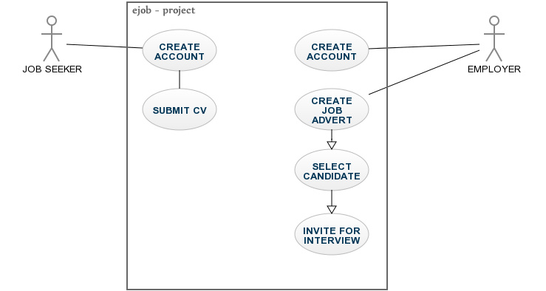

Fig. 3a: A Use case diagram of the online recruitment system

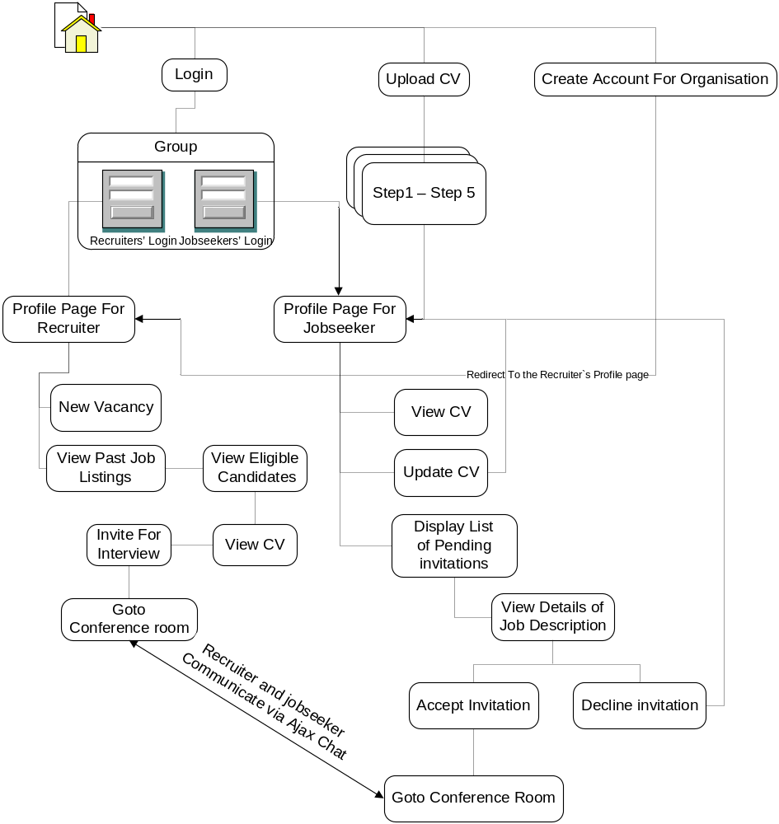
Fig. 3b: A General Layout of the web application Navigation Structure

3.3.1 DATABASE DESIGN
Initially, the database would have three tables:
- employer_accounts
- employees_accounts
- refresh_order
Employer accounts: This table would hold the data for each recruiter’s organization.
Field | Type(width) | Null | Default | Comments
name | varchar(200) | No
username | varchar(100) | No
password | varchar(100) | No
org_account_id | varchar(100) | No
company_name | varchar(200) | No
company_logo | varchar(200) | No
company_rep | varchar(100) | No
company_address | varchar(400) | No
email_of_company_rep | varchar(100) | No
company_email | varchar(100) | No
website | varchar(100) | No
phone_number | varchar(50) | No
active | varchar(20) | No

Employee Accounts: This table stores data contained in each job seeker’s CV
Field | Type(width) | Null | Default | Comments
username | varchar(100) | No
password | varchar(100) | No
account_id | varchar(100) | No

surname | varchar(50) | No
fname | varchar(50) | No
email | varchar(50) | No
dd | varchar(4) | No
mm | varchar(20) | No
yyyy | varchar(8) | No
sex | varchar(2) | No
nationality | varchar(30) | No
state_of_origin | varchar(25) | No
phone_1 | varchar(25) | No
phone_2 | varchar(25) | No
marital_status | varchar(20) | No
about_me | varchar(500) | No
name_of_institution_1 | varchar(200) | No
from_1 | varchar(8) | No
to_1 | varchar(8) | No
first_degree | varchar(150) | No
other_qualification_1 | varchar(8) | No
field_of_study_1 | varchar(100) | No
class_of_pass_1 | varchar(50) | No
class_of_pass_value_1 | Double | No
other_class_of_pass_1 | varchar(50) | No
name_of_institution_2 | varchar(200) | No
from_2 | varchar(8) | No
year_of_cert_4 | varchar(8) | No
cert_5 | varchar(50) | No
acronym_5 | varchar(12) | No
year_of_cert_5 | varchar(8) | No
cert_6 | varchar(50) | No
acronym_6 | varchar(12) | No
year_of_cert_6 | varchar(8) | No
cert_7 | varchar(50) | No
acronym_7 | varchar(12) | No
year_of_cert_7 | varchar(8) | No
cert_8 | varchar(50) | No
acronym_8 | varchar(12) | No
year_of_cert_8 | varchar(8) | No
cert_9 | varchar(50) | No
acronym_9 | varchar(12) | No
year_of_cert_9 | varchar(8) | No
cert_10 | varchar(50) | No
acronym_10 | varchar(12) | No
year_of_cert_10 | varchar(8) | No
Refresh order: This table holds values that trigger certain events, such as a page reload by an Ajax object running from a conference room.
Field | Type(width) | Null | Default | Comments
chat_table | varchar(60) | No
refresh | varchar(2) | No
last_qid | varchar(8) | No
status | varchar(4) | No

3.3.2 INPUT SPECIFICATION
Inputs are supplied to the server side programs via a series of html form elements such as text fields, text area, check boxes, etc. these type of input fields would accept data in form of plain text. Upon submission, the form sends the text to the server – side programs for processing.
For file upload, the form field would allow the user to select a file (e.g. logo, picture, etc). Upon submission, the validation occurs by checking the file extension to ensure that it conforms to the specified format.

3.3.3 OUTPUT SPECIFICATION
Lists extracted from database tables are generated by writing a loop that counts the number of entries. The data is then stored in an associative array, and a loop is written to echo all valid entries.
For instance, the list of eligible candidates is obtained by analyzing each CV in the database. The CVs are matched against the keywords from the requirements specified by the recruiter. Values are assigned to each requirement that is met and at the end of the cycle, a percentage is calculated.
After all the CVs have been checked, the list of eligible candidates appears, showing those with the highest percentage match at the top.

3.3.4 ALGORITHM DESIGN
The flowchart below shows the mode of operation of the main program – the one responsible for filtering eligible candidates.
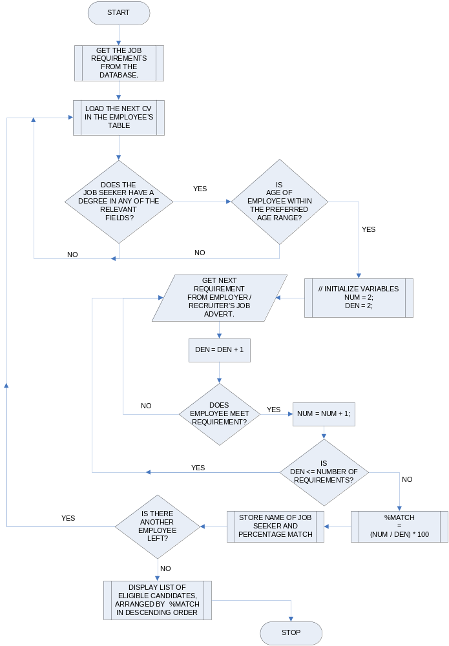
Fig. 3c: Flowchart for the script: find_eligible_candidates.php. The script is based on a search algorithm that would find eligible matches among the CV’s stored in the database.

3.4 SYSTEM ARCHITECTURE
The features of the interface would be considered in two parts:
- Job seekers interface
- Recruiter’s interface

3.4.1 JOB SEEKERS INTERFACE
Major features of the job seeker’s interface would include the following:
- Create account: The job seeker would be required to create an account for himself. Information provided in this section include username, password and email addresses.
- Upload CV: This interface is made up of a group of pages that contain a series of html forms. The user would provide details of his academic qualification, as well as personal data, past work experience, computer skills, etc.
- User Login: Here, the job seeker would be required to provide his username and password before he is granted access to his profile page.
- Profile page: This would display a list of pending invitation for job interviews.
- Update profile: This page would contain forms that allow the user to modify his account information. The user could also update his CV.
- Conference room: Every user would have access to a conference room. This would serve as a means of communication between the recruiter and the job seeker

3.4.2 RECRUITERS INTERFACE
Major features of the recruiter’s interface would include the following:
- Create account: The recruiter or its representative would be required to create an account for the organization. Information provided in this section require login information, contact and email addresses, url, name of company representative, etc.
- User Login: Here, the recruiter would be required to provide his username and password before he is granted access to his control panel.
- New vacancy: The recruiter would use this interface to create a new job vacancy. He would provide information such as job description, location, working conditions and relevant academic qualification. The data he provides here would be used to conduct a search so as to find eligible candidates.
- View existing candidates: This page would display a list of eligible candidates. The user may click on each candidate to view the full details of his résumé. This interface would also have links to invite the candidate for an interview.
- Edit existing job vacancies: This page would be similar to that used to create a new job vacancy. The difference is that on this page, the form fields would contain data that is already stored in the database. The recruiter can then modify these fields.
Conference room: On this page, the recruiter would have a list of all the
candidates that have been invited for job interviews. The page would show
which candidate is online and which is not. The recruiter can conduct online
job interviews on this page.

Chapter4: SYSTEM IMPLEMENTATION AND TESTING

4.0 INTRODUCTION
This section contains information about the implementation of the design specification of the ORA.

4.1 CHOICE OF DEVELOPMENT ENVIRONMENT
Considering our budget, I chose the programming languages that are open source so as to avoid the additional expense of paying for a software license.
The following programming languages would be used:
- HTML
- PHP 4/5
- MySql
- XML
- HTML
HTML (Hypertext Markup Language) is the language used to create web pages. It defines the syntax and placement of special instructions (known as tags). These tags tell the browser how to display the web pages. It may create links to other documents, either locally or over a network such as the Internet.
The HTML standard and all other Web-related standards are developed under the authority of the World Wide Web Consortium (W3C). Standards, specifications, and drafts of new proposals can be found at http://www.w3.org. In practice, the HTML “standard” is influenced heavily by the tags that are introduced and supported by the popular browsers, such as Microsoft Internet Explorer, Mozilla Firefox and Netscape Navigator. These tags may or may not be part of the current HTML specification at any given time.
- PHP 4/5
PHP is a server-side scripting language designed for the Web. PHP tags may be embedded within an HTML page; these will be executed each time the page is visited. Your PHP code is interpreted at the Web server and generates HTML or other output that the visitor will see.
PHP was conceived in 1994 and was originally the work of one man, Rasmus Lerdorf. It was adopted by other talented people and has gone through three major rewrites to bring us the broad, mature product we see today. As of October 2002, it was in use on more than nine million domains worldwide, and this number is growing rapidly.
PHP is an Open Source product. You have access to the source code. You can use it, alter it, and redistribute it all without charge. PHP originally stood for Personal Home Page, but was changed in line with the GNU recursive naming convention and now stands for PHP Hypertext Preprocessor. The current major version of PHP is 5.3.0.
- MySQL
MySQL is a relational database management system (RDBMS) that runs on a server providing multi – user access to a number of databases. It is named after developer Michael Widenius’ daughter, My. The SQL phrase stands for structured query language. MySQL is a popular choice of database for use in web application software. It is used in some of the most popular websites, such as Wikipedia, Google, Facebook, etc.
In addition, MySQL comes with an open source license which makes it ideal for developers and hobbyists.
XML:
Extensible Markup language is a markup language that defines a set of rules for encoding documents in a format that is both human-readable and machine-readable

4.2 IMPLEMENTATION ARCHITECTURE

4.3 SOFTWARE TESTING
In the development of any product, testing is a very important stage as it serves to ensure that all system components are operating as expected. Due to the fact that it is difficult to trace a fault in a large program, the website was developed in stages and each module was subjected to thorough tests. In this way, the complete product would have little or no errors.
The two stages of testing are:
- Pre-implementation testing.
- Post implementation testing.

4.3.1PRE-IMPLEMENTATION TESTING
While I was working on the website, it was necessary to preview the web pages in various browsers. One reason for this is that different browsers interprete JavaScript codes differently. I tried to find some common ground between the major browsers. Where this common ground did not exist, I would make provision for as many types of browsers as possible. An instance of this is in the creation of an Ajax object. The syntax for doing so varies. Thus, a part of the script would detect the browser version first before branching off to the block of code that creates the object in that browser.
Since php files cannot be previewed in a browser directly, I installed WAMP server on my computer, and created a database using the ‘phpmyadmin’ interface. I could then preview the site by typing the address: http://localhost/ejob_project/ in my web browser.

4.3.2 POST IMPLEMENTATION TESTING
Testing the website on local host had certain limitations. Some aspects of the website require a real server. An example of this is the auto responder which generates emails and sends to the people. It is impossible to send an email from a local server when the system is not connected to the internet. This feature of the website could only be tested after publishing.
The modules were updated, and we believed they were error free. However, we know from past experience, that Web Pages behave differently when transferred from a local host to a regular server.
Implementation consisted of two main parts:
- Setting up the back – end of the system, and ensuring that all modules were functioning correctly.
- Ensuring that the front – end of our system allow users to submit data. This includes setting up the client validation of user input (using JavaScript Functions).
I encountered some errors during the testing of the back – end of the system. One of them was that some of the pages were producing html codes, before header redirect statements. In php, you must send out all headers before your script produces a single html code. However, this constraint was not enforced when testing the website on the local host i.e. the server emulator installed on my computer. For this reason, I ignored the rule and the errors were discovered only after publishing.

This is an overview of the test plan, with some of the results obtained:
 | Test Name | Test Value | Test Case | Test Data | Expected Result | Actual Result
1 | Login | Username | Username and password fields must not be empty | <empty String> | Reject | Please Enter A username
1 | Login | Password | Username and password fields must not be empty | <empty string> | Reject | Please Enter a Password
2 | Find Eligible Candidates | Job description for a vacancy that is meant for computer science graduates. | List of eligible candidates must not include any candidate that did not study computer science, and must also conform to all the other requirements specified. | Required degree: Computer Science.  Minimum class of pass: 2.1 | Correct List of eligible candidates containing only computer science graduates. | Correct List of eligible candidates containing only computer science graduates.
Test plan

4.4 DOCUMENTATION
Forms are used to obtain input from the user. The data is then submitted to various .php files for processing.
Validation of user input occurs on the client side via a series of JavaScript functions. The functions display error messages and halt form submission if any invalid data is entered in any of the form fields.
Examples of invalid input are:
- Data entered in a form field exceeds the maximum length allowed.
- Data entered in a form field is less than the minimum length allowed.
- Alphabets are entered in fields where numbers are expected, e.g. phone numbers.
An excerpt from a JavaScript function for validation is as follows:
function login_validator(theForm)
{
if(theForm.username.value == '' || theForm.username.value == null)
{
alert('Please Enter A Valid Username');
theForm.username.focus();
return (false);
}
return (true);
}

As an additional precaution, I used drop - down boxes in getting data such as dates. This was to ensure that the date entered were in a uniform format, as the user is forced to make a selection from the available choices. It reduced the risk of variation in user input.
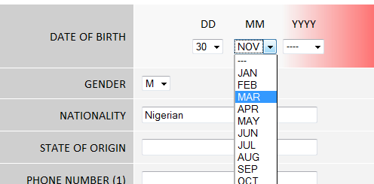
Fig. 4a: Drop – down boxes reduce variations in the format of user input
On the server form data is handled in the following stages:
STAGE 1: Receive the variables.
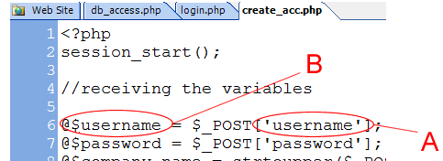 | A: | The name of the form field in the html form.
 | B: | The name of the variable used in the .php file, to store the text entered by the user.
Fig. 4b: Receiving the variables from a form.

STAGE 2: Open a connection to the database.
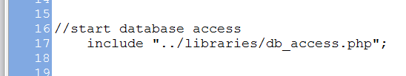
Fig. 4c: The database connection is opened by loading an external function.

STAGE 3: Insert data into the appropriate table.
STAGE 4: Redirect to a page indicating that the data has been saved.
The redirect statement is as shown below:
header ("Location: ../employers/comp_account_page.php?org_account_id=$org_account_id");

On this website, all form data are processed in a similar manner.

4.4.1 USER MANUAL
The process of uploading CV is broken down into stages. These are shown below.
- Account information: The user creates an account.
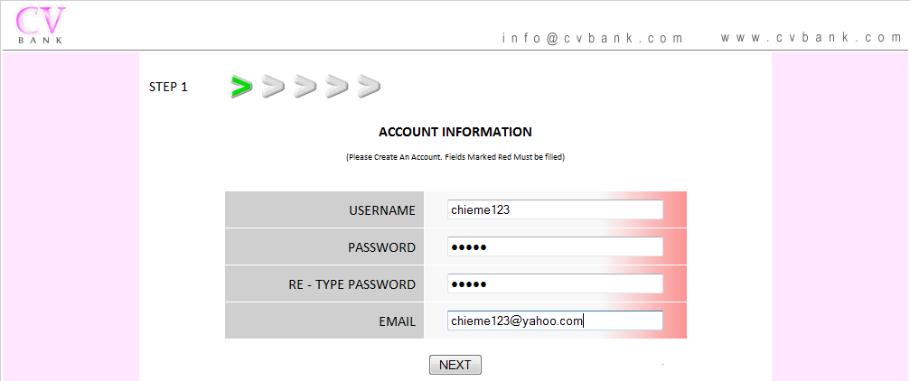
Fig. 4d: STEP 1: Account Information.

- Personal Information: The user will fill a personal data form. Data provided include full name, contact details, address, date of birth, etc. (The date of birth will be used to calculate the age of the candidate so that, if the recruiter specifies an age range, it can be used in the assessment).
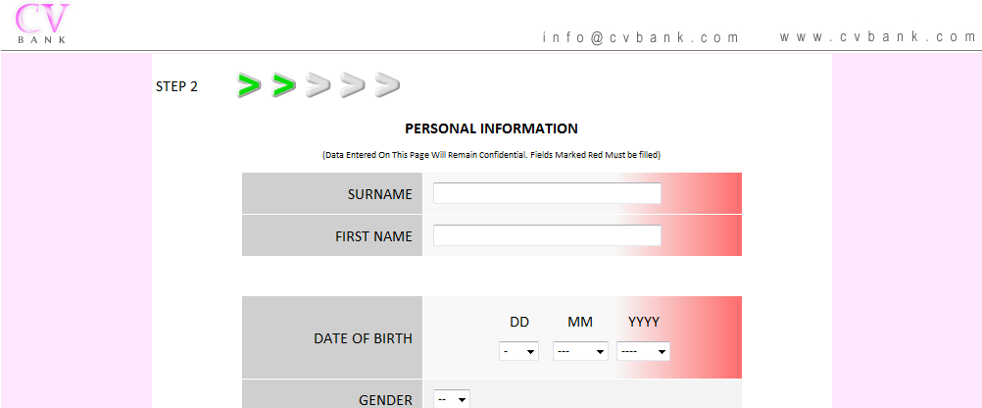
Fig. 4e: STEP 2: Personal Information

- Education: This form has provision for academic degrees (B Sc., B.A, etc). The class of pass would also be entered along with other details of academic programs.
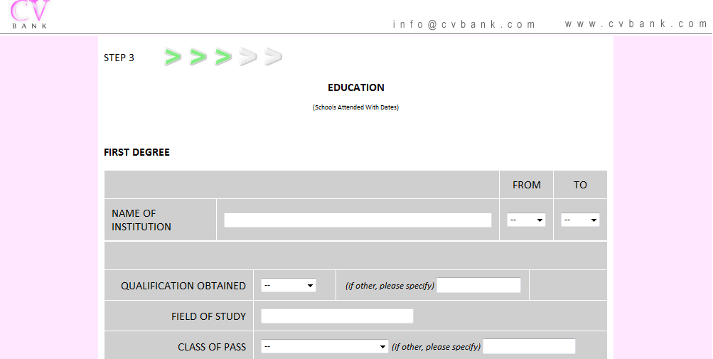
Fig. 4f: STEP 3 – Education
A job seeker may enter up to four degrees. On this form, the only fields that are compulsory are those which store data related to the first degree.
- Professional Qualification: Data entered on this form includes details of professional certification / accreditation, relevant computer skills, past working experience, additional experience and referees.

Fig. 4g: STEP 4: Professional Qualification

The job seeker may enter both the full name of the professional exam and its acronym. Other fields in this form include computer skills, additional experience and past work experience.
- Additional Information
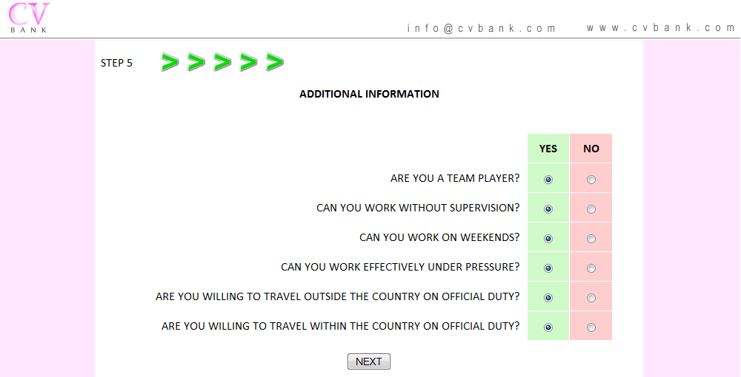
Fig. 4h: STEP 5: Additional Information
Job seekers who have already signed-up and uploaded their CV to the system are required to log in with their username and password, before they would have access to their profile. An html form is provided for this purpose.
4.4.2 SORCE CODE LISTING
For source code listing; see Appendix A

started.
<body onload=’update ();’ >

The function called on page load calls the one that checks for updates at regular intervals. In this case, the interval is 6 seconds.

function update ()
{
setInterval('loadQuestion()', 6000);
}

The function: loadQuestion() creates an object, and uses it to send asynchronous requests to a php file on the server. The method of creating the object differs from one browser to the other.

if (window.XMLHttpRequest)
{
//for Mozilla firefox, safari, netscape, etc
XMLHttpRequestObject = new XMLHttpRequest();
} else

if (window.ActiveXObject)
{
//for internet explorer
XMLHttpRequestObject = new ActiveXObject('Microsoft.XMLHTTP');
}

If the object is created successfully, the request is sent.

There are various methods of sending requests to the server. Some of them are:
- POST
- GET
- REQUEST
In this case, I used the GET method.

if(XMLHttpRequestObject)
{
//get the id of the div in which we intend to load the output
var obj = document.getElementById('target_div');
XMLHttpRequestObject.open'GET', '../../employers/interview/get_response.php?qid=$qid[$x] ');

XMLHttpRequestObject.onreadystatechange = function()
{
if (XMLHttpRequestObject.readyState == 4 &&
XMLHttpRequestObject.status==200)
{
obj.innerHTML = XMLHttpRequestObject.responseText;
}
}
$XMLHttpRequestObject.send(null);
}
The file retrieves the messages sent from the database on the server, and returns it to the page. The output is displayed in a target div by altering the innerHTML of the target_div.
In this way, chat messages are displayed without refreshing the entire page.

if($get_waiting_list)
{
$no_of_waiting_candidates = mysql_num_rows($get_waiting_list);

while($row = mysql_fetch_array($get_waiting_list, MYSQL_ASSOC))
{
$x++;
$account_id[$x] = $row['account_id'];
$timestamp[$x] = $row['timestamp'];

if ((time() - $row['status']) > 20){ $status[$x] = '<font color=red>offline</font>';
} else
{
$status[$x] = 'online';
}
}

Chapter5: SUMMARY AND CONCLUSION

5.0 SUMMARY
This project is a true example of an instance of using computer related technologies to solve real world problems. This project has produced the following achievements
- Determines the potentials of each applicant and retain the applicant whose performance could meet the organizational goals.
- Establishes a better way of recruitment and means of selecting the best performed candidate who is fit for the available vacancy.
- Capture data into a secure database which allow applicant data to be easily accessed anytime.
- Develops a user- friendly application that will achieve these objectives

5.1 CONCLUSION
The online recruitment agency will simplify the process of recruitment. It will make it easy for employers to staff their various organizations, thereby, increasing efficiency and the overall productivity of their various organizations.
In addition, it would encourage job seekers to improve themselves constantly; the candidates with better credentials stand a better chance of being considered for a position.

5.2 RECOMMENDATION
With more people using mobile devices to access the internet, it would be natural to develop a mobile version of the web application. Since the website relies on technologies

REFERENCES
Martins, A. T. (2011, March 14). Retrieved July 15, 2011, from http://www.strategicbusinessteam.com/: http://www.strategicbusinessteam.com/The Mafia Manager’s Guide to Hiring Good Employees _ How to Start a Small Business.htm
Niederst, J. (1999). Web Design In A Nutshell. Sebastopol: O’Reilly & Associates, Inc.
Sobel, J. (2007, December 21). Facebook Blog. Retrieved august 2011, 2011, from http://blog.facebook.com/blog.php?post=7899307130
Welling, L., & Thomson, L. (2003). PHP and MySql Web Developement (2nd Edition ed.). Indiana: Sams Publishing.

APPENDIX A: find_eligible_candidates.php
/**
This program would examine each CV in the database,
and determine the eligibility of each candidate.
It would then enter them in a database table, such that they
can be retrieved and arranged in order of reducing percentages
**/

<?php
session_start();

//receiving the variables
$org_account_id = $_GET['org_account_id'];
$job_id = $_GET['job_id'];

//create a numerator and a denominator and initialize them
$num = 1;
$den = 1;

//start database access
include "../libraries/db_access.php";

/**
we shall create a table where we shall store the names of eligible candidates
along with the percentages of their eligibility.
**/

$eligible_candidates = $job_id."_eligible_candidates";

//delete old table if it exists
mysql_query("DROP TABLE `$eligible_candidates`");

mysql_query("CREATE TABLE IF NOT EXISTS `$eligible_candidates` ( `name` varchar(60) NOT NULL,
`account_id` varchar(50) NOT NULL, `percentage` varchar(10) NOT NULL,
UNIQUE (`account_id`) ) ENGINE = MyISAM;");

/**
we shall create a table where we shall store the names of eligible candidates
who have already been interviewed for the position
**/

$already_interviewed = $job_id."_interviewed";

mysql_query("CREATE TABLE IF NOT EXISTS `$already_interviewed` ( `account_id` varchar(50) NOT NULL,
UNIQUE (`account_id`)
) ENGINE = MyISAM;");

//get job info from table
$get_data = mysql_query("SELECT * FROM `$org_account_id` WHERE job_id='$job_id'");

if($get_data)
while($row = mysql_fetch_array($get_data))
{

//new vars
$field_of_study_1 = strtolower(str_replace(" ","",$row['field_of_study_1']));
$minimum_class_of_pass_value_1 = $row['minimum_class_of_pass_value_1'];

$field_of_study_2 = strtolower(str_replace(" ","",$row['field_of_study_2']));
$minimum_class_of_pass_value_2 = $row['minimum_class_of_pass_value_2'];

$field_of_study_3 = strtolower(str_replace(" ","",$row['field_of_study_3']));
$minimum_class_of_pass_value_3 = $row['minimum_class_of_pass_value_3'];

$field_of_study_4 = strtolower(str_replace(" ","",$row['field_of_study_4']));
$minimum_class_of_pass_value_4 = $row['minimum_class_of_pass_value_4'];

$field_of_study_5 = strtolower(str_replace(" ","",$row['field_of_study_5']));
$minimum_class_of_pass_value_5 = $row['minimum_class_of_pass_value_5'];

//put the required degrees and their minimum class of pass into arrays
$req_degree = array(1=> strtolower(str_replace(" ","",$field_of_study_1)), strtolower(str_replace(" ","",$field_of_study_2)), strtolower(str_replace(" ","",$field_of_study_3)), strtolower(str_replace(" ","",$field_of_study_4)), strtolower(str_replace(" ","",$field_of_study_5)));

$req_min_class_of_pass_value = array(1=> $minimum_class_of_pass_value_1, $minimum_class_of_pass_value_2,
$minimum_class_of_pass_value_3, $minimum_class_of_pass_value_4,
$minimum_class_of_pass_value_5);

$cert_exams_acronym = array(1=> strtolower(preg_replace("/[^A-Za-z0-9]/", "", $row['acronym_1'])), strtolower(preg_replace("/[^A-Za-z0-9]/", "", $row['acronym_2'])), strtolower(preg_replace("/[^A-Za-z0-9]/", "", $row['acronym_3'])), strtolower(preg_replace("/[^A-Za-z0-9]/", "", $row['acronym_4'])),
strtolower(preg_replace("/[^A-Za-z0-9]/", "", $row['acronym_5'])), strtolower(preg_replace("/[^A-Za-z0-9]/", "", $row['acronym_6'])),
strtolower(preg_replace("/[^A-Za-z0-9]/", "", $row['acronym_7'])),
strtolower(preg_replace("/[^A-Za-z0-9]/", "", $row['acronym_8'])),
strtolower(preg_replace("/[^A-Za-z0-9]/", "", $row['acronym_9'])),
strtolower(preg_replace("/[^A-Za-z0-9]/", "", $row['acronym_10'])));

$cert_exams = array(1=> strtolower(preg_replace("/[^A-Za-z0-9]/", "", $row['prof_exam_1'])),
strtolower(preg_replace("/[^A-Za-z0-9]/", "", $row['prof_exam_2'])),
strtolower(preg_replace("/[^A-Za-z0-9]/", "", $row['prof_exam_3'])),
strtolower(preg_replace("/[^A-Za-z0-9]/", "", $row['prof_exam_4'])),
strtolower(preg_replace("/[^A-Za-z0-9]/", "", $row['prof_exam_5'])),
strtolower(preg_replace("/[^A-Za-z0-9]/", "", $row['prof_exam_6'])), strtolower(preg_replace("/[^A-Za-z0-9]/", "", $row['prof_exam_7'])),
strtolower(preg_replace("/[^A-Za-z0-9]/", "", $row['prof_exam_8'])),
strtolower(preg_replace("/[^A-Za-z0-9]/", "", $row['prof_exam_9'])),
strtolower(preg_replace("/[^A-Za-z0-9]/", "", $row['prof_exam_10'])));

$computer_skills_req = strtolower($row['computer_skills']);
$additional_experience_req = strtolower($row['additional_experience']);
$years_of_experience_req = $row['years_of_experience'];

$team_player_req = $row['team_player'];
$work_without_supervision_req = $row['work_without_supervision'];
$work_on_weekend_req = $row['work_on_weekend'];
$work_under_pressure_req = $row['work_under_pressure'];
$travel_abroad_req = $row['travel_abroad'];
$travel_locally_req = $row['travel_locally'];

$age_from_req = $row['age_from'];
$age_to_req = $row['age_to'];

//now we shall begin to check thru the client database to see if there are any matches
//first check if the person read the correct course

$check_for_qual = mysql_query("SELECT * FROM `employee_accounts`");

while($row = mysql_fetch_array($check_for_qual))
{
$employee_acad_degrees = $row['field_of_study_1'];
$employee_acad_degrees .= $row['field_of_study_2'];
$employee_acad_degrees .= $row['field_of_study_3'];
$employee_acad_degrees .= $row['field_of_study_4'];

$employee_acad_degrees = strtolower(str_replace(" ", "", $employee_acad_degrees));

