DESIGN AND IMPLEMENTATION OF AN ONLINE BARCODE ATTENDANCE SYSTEM

By

Umolu Bonaventure Ebubenna

Registration No:
U14/NAS/CSC/085

Being a BSc report submitted in partial fulfillment of the requirements for the award of a Bachelor’s degree in Computer Science of the Godfrey Okoye University.

Supervisor: Mr. Benson Ikenna

Department of Computer Science/ Mathematics Godfrey Okoye University, Enugu

July, 2018

CERTIFICATION

I UMOLU BONAVENTURE EBUBENNA, Registration No: U14/NAS/CSC/085 of the department of Computer Science, hereby declare that this work was carried out by me. Should I be convicted of having cheated in this work, I shall accept the verdict of the university.

Umolu Bonaventure Ebubenna

APPROVAL

This is to certify that this research titled DESIGN AND IMPLEMEMTATION OF AN ONLINE BARCODE ATTENDANCE SYSTEM was carried out by UMOLU BONAVENTURE EBUBENNA, Registration No: U14/NAS/CSC/085 of the department of Computer Science in partial fulfillment of the requirements for the award of Bachelor of Science in Computer Science.

________________________ _________________________
Mr. Benson Ikenna Date/sign
Project Supervisor

________________________ _________________________
Mrs. Monica Agu Date/sign
Head of Department

DEDICATION

I dedicate this project to God Almighty, for his infinite wisdom, knowledge and understanding. He has been the source of my strength throughout this program. I also dedicate this work to my family, my dad Sir Dave Umolu, my mum Lady Maureen Umolu, my very close friend Benson Sharon Chioma for the continuous love they showed me during the time of this write up and my supervisor Mr. Ikenna who showed great love and concern that the completion of this project was a success.

ACKNOWLEDGEMENT

The satisfaction that accompanies that the successful completion of any task would be incomplete without the mention of people whose ceaseless cooperation made it possible, whose constant guidance and encouragement crown all efforts with success.
I am grateful to my project supervisor Mr. Benson Ikenna for the guidance, inspiration and constructive suggestions that helped me in the preparation and completion of this project.
I also thank my colleagues who have helped in successful completion of this project.

ABSTRACT

Attendance is very important in every student. a single absent make a big difference in performance in the school. Most students of high school are prone to absence from classes claiming that the class is boring. Others due to laziness fail to attend classes, having preference of going to computer shops or playing games while some students cannot refuse the prospect of a friend asking them out during class period. Some of these actions are not reported to parents or guardians because the possible way of informing them is the traditional way which is by inviting the parents over through the students. With this, the authority would communicate the parents on the attendance level of the student. This process takes a long time and sometimes parents are not able to come because of their engagements, occupation or location. These are the reasons why parents/guardians are not informed about the absenteeism of the
students.
Online Barcode Attendance System is a software developed for daily student attendance in schools, colleges and institutes. It facilitates to access the attendance information of a particular student in a particular class. The information is sorted by the operators, which will be provided by the lecturer for a particular class. This system will help in evaluating attendance eligibility criteria of a student, and also help in parent involvement to the attendance performance of the student.
The Online Barcode Attendance System is developed using HTML, CSC, BOOTSTRAP, JAVA SCRIPT, PHP. It fully meets the objectives of the system which it has been developed.

TABLE OF CONTENTS
Tittle Page
Certification i
Approval ii
Dedication iii
Acknowledgement iv
Abstract v
Table of Content vi
List of Figures viii
List of Tables x

CHAPTER 1: Introduction Pages
1.0 Background of study 1
1.1 Statement of the problem 2
1.2 Objectives 2
1.3 Significance of study 3
CHAPTER 2: Literature Review
- Introduction 4
2.1 Theoretical Background 4-11
2.2 Review of Related Literature 11-13
2.3 Summary 13

CHAPTER 3: System Analysis and Design
3.0 Introduction 14-15
3.1 Analysis of the Existing System 15-21
3.2 Analysis of the Proposed System 21-23
3.3 Design of the Proposed System 23-30
CHAPTER 4: System Implementation
4.0 Introduction 31
4.1 Choice of Development Environment 31-32
4.2 Implementation Architecture 32
4.3 Use case diagram 33
4.3 Software Testing 34-44
4.4 Documentation 44
4.4.1 User Manual 45
CHAPTER 5: Summary and Conclusion
5.0 Summary 46
5.1 Conclusion 46
5.2 Recommendation 47

References
Appendices

LIST OF FIGURES

Fig. 2.1 HTML codes 5
Fig. 2.2 CSS codes 6
Fig. 2.3 Snapshot of Sublime Text Editor 7
Fig. 2.4 Snapshot of MySQL Database 9
Fig. 2.5 pHp codes 9
Fig 2.6 Student ID card with QRcode 10
Fig. 3.1 Flowchart of the existing system 20
Fig. 3.2 Flowchart showing the design of the proposed system 22
Fig. 4.1 Implementation Architecture Diagram 32
Fig 4.2 Use case diagram 33
Fig 4.3 Snapshot of the Login Page 35
Fig 4.4 Snapshot of the Login Page showing error message for
invalid course details 35
Fig 4.5 Snapshot of a student present 37
Fig 4.6 Snapshot of a Null attendance 37
Fig 4.7 Snapshot of the report modal 38
Fig 4.8 Snapshot of the admin page 38
Fig 4.9 Snapshot of the Admin Dashboard 39
Fig 4.10 Snapshot of all Registered Users 40
Fig 4.11 Snapshot of the Add User Page 40
Fig 4.12 Snapshot of all Registered students 41
Fig 4.13 Snapshot of the Add Student Page 42
Fig 4.14 Snapshot of Issue Tracking Page 42
Fig 4.15 Snapshot the DBM Page 43
Fig 4.16 Snapshot of the Settings Page 43
Fig 4.17 Snapshot of the Maintenance page 44

LIST OF TABLES

Table 3.1 Comparison between these four types of cards 17
Table 3.2 Advantages of Fingerprint System 18
Table 3.3 Table Structure for Site Settings 23
Table 3.4 Table Structure for Issue Tracking 24
Table 3.5 Table Structure for Registered Students 24
Table 3.6 Table Structure for Course Register 28
Table 3.7 Table Structure for Users 29

CHAPTER 1

INTRODUCTION

1.0 Background of study
In most educational institutions the attendance is taken manually. It is not only time consuming, but it is also insecure and unreliable and it can be lost. Some institutions are using punch card for attendance while this will be difficult for teachers to keep track of the large number of students because by using punch card, a student can help the other students or his/her friend to punch their card even the other student may be absent or come late in class, so it is not reliable.
To overcome these problems, I have developed a better system which is Web based; it is fully responsive where a user can use in mobile, tablets and different computer systems. In this system, records are kept safe and secure and the attendance information of particular or all students of particular class can be accessed easily and without time consuming, the report is generated automatically.
Attendance is very important in every student. a single absent make a big difference in performance in the school. Most students of high school are prone to absence from classes claiming that the class is boring. Others due to laziness fail to attend classes, having preference of going to computer shops or playing games while some students cannot refuse the prospect of a friend asking them out during class period. Some of these actions are not reported to parents or guardians because the possible way of informing them is the traditional way which is by inviting the parents over through the students. With this, the authority would communicate the parents on the attendance level of the student. This process takes a long time and sometimes parents are not able to come because of their engagements, occupation or location. These are the reasons why parents/guardians are not informed about the absenteeism of the
students.
In this manner, I proposed an Online Barcode Attendance System with Short Message Service (SMS). Its function is to send a notification to parents that their student is absent. Attendance Monitoring System with SMS provide a fast way of informing the parent anytime anywhere.

1.1 Statement of the problem
- Attendance is taken with student id card embedded with barcode containing full details about the student.
- The daily attendance of students is taken automatically by scanning the student ID card with a barcode scanner.
- The attendance report will be generated automatically without time consuming which is reliable and there will be not any mistakes.
- It is fully responsive and flexible; it can be accessed from any computer no matter where you are.

1.2 Objectives
The study aims to:
- Eliminate duplicate data entry and errors in time and attendance entries.
- Eliminate paperwork and save time.
- Automatic calculation of attendance
- To Increase security.
- To involve parents in student attendance performance.

1.3 Significance of the problem
Economic Significance
The system being developed is economic with respect to School or Collage’s point of view. It is cost effective in the sense that has eliminated the paper work completely. The system is also time effective because the calculations are automated which are made at the end of the month or as per the user requirement. The result obtained contains minimum errors and are highly accurate as the data is required.

Behavioral Significance
The system working is quite easy to use and learn due to its simple but attractive interface. User requires no special training for operating the system.

Parent Involvement
The system engages parents in the attendance performance of the student by notifying them through Short Message Service(SMS) on attendance report every weekend.

CHAPTER 2

LITERATURE REVIEW

2.0 Introduction
This chapter reviews literature relevant to the topic understudy to expose the researcher to what has been done in this area. To do this effectively, the following sub-headings were covered: Theoretical background and review of the related literature.

2.1 Theoretical Background
In this project the researcher is making use of several concepts and technologies which will be talking about. The major technologies used in this project are web technologies HTML (Hyper Text Make-up Language), CSS (Cascading Style Sheet), JAVASCRIPT, PHP (Personal Home Page) and relational database technologies. This site developed is a collection of web documents. These web documents are presented to the user through an application program known as a browser e.g. Internet Explorer Edge, Firefox, Chrome.

HTML and CSS
HTML stands for Hypertext Markup Language and CSS stands for Cascading Style Sheets are the crucial technologies for creating web pages. HTML supplies the structure of the page, and CSS the layout, for diversity of devices. Together with scripting and graphics, HTML and CSS are the fundamental of building Web Applications and Web pages. HTML provides designers and developers the following facilities, to design forms for directing transactions with remote services, for use in making reservation, searching for information, ordering products, and others retrieving online information through hypertext links. to include video and sound clips, spread sheets, and other applications straight in their documents, designer can publish online documents with text, headings, tables, photos and others.

CSS describes the Web pages’ presentation, involving layout, colors, and fonts. It enables the designer to adjust the presentation to various types of devices, like a
small screen, large screens, or printers. CSS is separate from HTML, and their separation makes it easy to preserve and maintain sites, share style sheets across pages, and accommodate pages to various environments.

<!DOCTYPE html>
<html lang="en">
<head>
<link rel="icon" type="image/png" sizes="16x16" href="../plugins/images/favicon.png">
<title><?php echo $sitename; ?> | Attendance</title>
<meta charset="utf-8">
<meta name="viewport" content="width=device-width, initial-scale=1.0">
<link rel="stylesheet" type="text/css" href="css/user.style.css">
<link rel="stylesheet" type="text/css" href="css/substyles.css">
</head>

Figure 2.1 HTML Codes.

@media screen and (max-width: 400px) {
.topnav a:not(:first-child) {display: none;}
.topnav a.icon {
float: right;
display: block;
}}
@media screen and (max-width: 400px) {
.topnav.responsive {position: relative;}
.topnav.responsive .icon {
position: absolute;
right: 0;
top: 0;
}
.topnav.responsive a {
float: none;
display: block;
text-align: left;
}

}

Figure 2.2 CSS Codes.

Bootstrap
Frameworks 2.5.1 Bootstrap is front-end framework and collection of tools and mechanisms for building web applications. It consists of HTML and CSS based design templates for navigations, forms, buttons, typography, and other interface elements, and also JavaScript extensions.

PhpMyAdmin
It is an open source tool and also, it is free written in PHP, XHTML, CSS, and JavaScript planned to manage the administration of MySQL by using of a web. It is able to perform various missions like creating, modifying databases, tables, fields, executing SQL statements or managing and supervise users.
Following is some features of the phpMyAdmin;
- It is web interface.
- It administrates multiple servers.
- It is able to create PDF graphics of the database layout.
- Importing data from SQL and CSV.
- Export data to different formats such as SQL, PDF, CSV, XML and others.
- It works with various Operating Systems and others.

The Sublime Text 3 Editor
Sublime Text is a cross platform source code editor written in C++ and python. It originally supports plenty of programming and markup languages, and its functionality can be increased via users with plugins.
Sublime Text 3 has two main features that are symbol pane management and symbol indexing. Through pane management users are to move between panes by hotkeys and symbol indexing.

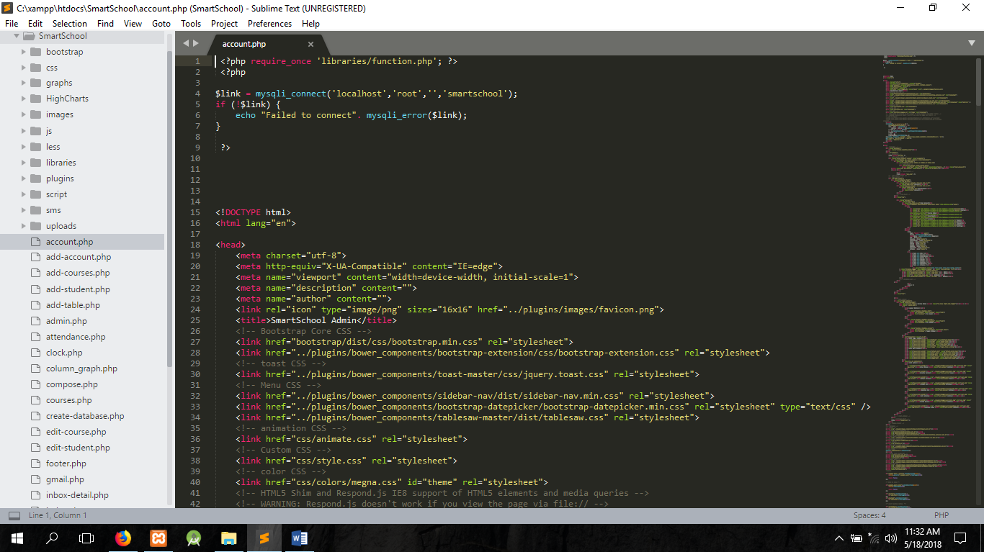
Figure 2.3 Sublime Text Editor.

MySQL
SQL stands for Structured Query Language. MySQL is an open source Relational Database Management System (RDBMS); it is a popular database for use in web applications, and is a central part of the greatly used LAMP (Linux, Apache, MySQL, Perl/PHP/Python) open-source web application software stack. MySQL is used by many applications like, WordPress, Joomla, TYPO3, Drupal, MyBB, phpBB, MODX and other software. Numerous large scale websites including Google, YouTube, Facebook, Twitter, and Flickr are also using MySQL. On all platforms excluding Windows, MySQL sends with no GUI (Graphical User Interface) to administer MySQL databases or managing the data held within the databases. Users may install MySQL Workbench by downloading separately or simply may use the command line tools. Numbers of third party GUI tools are also available. Swedish company has created MySQL which is written in C and C++. The first version of MySQL revealed on 23 may 1995. It has various versions. The general accessibility of MySQL 5.7 was broadcast in Oct 2015, and the version which is used in my project is 5.6.17.

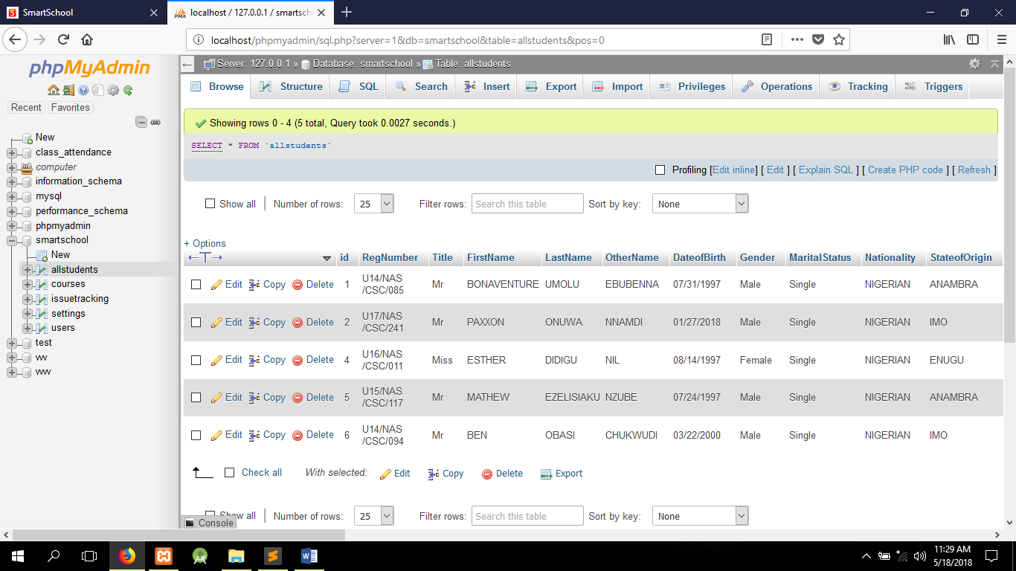
Figure 2.4 MySQL Database.

PHP
PHP also known as Personal Home Page which is used to design a dynamic website example: Facebook. PHP isn’t a code you see affecting the layout of the page, it’s a code that handles the connection to the database and so on.

<?php error_reporting(0); ?>
<?php
$server = "localhost";
$username = "root";
$password = "";
$db = "smartschool";
$link = mysqli_connect($server, $username, $password, $db) OR die() ;
?>

Figure 2.5 PHP codes.
Student ID Card
The use of ID card is mainly to verify the identity of the person who is holding it. Universities issue ID card to students so they can use it as a proof to prove that he/she is a student of the university. Normally, ID card only contains the essential information such as ID number, name of the person and other identity information.

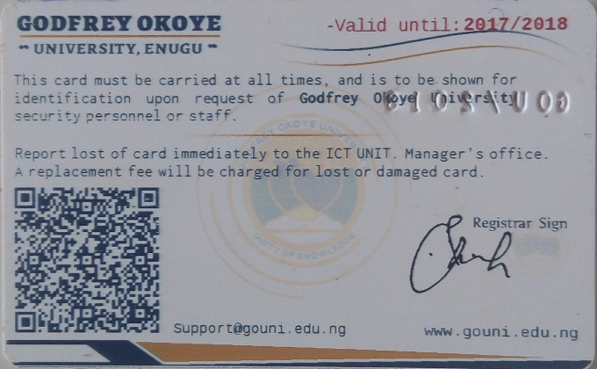
U14/NAS/CSC/001
Tiimmy Burner
Figure 2.6 shows a student ID card with QRcode.

Student ID card contains barcode of student Registration number. The barcode is a 1D barcode, with format CODE 128, and the type of information set is a simple text. To identify the barcode format and type of information set, users can use existing scanner application to identify the barcode format and its encoded information.

Barcode
A barcode is a pattern that consists of grouped dark bars and white spaces. Users encode data characters to generate barcode thus every barcode represent different data. It is a machine-readable pattern by using bar code scanner to decode it. In the current world, barcode is used to identify ID number of item such as retail sales product, books and others.
Based on community of ID Automation Incorporation (2012), the design of barcode is to eliminate the manual data entry error rate. In the case of manually enters data by keyboard, typo error always exists. By using barcode, error such as inaccurate or incorrect data can be reduced, at the same time shortens the working procedural. There are many types of barcodes use, the most common used barcode is Linear (1D) Barcodes and Matrix (2D) Barcodes. There are also 3D Barcodes developed.
The main difference between Linear barcodes and Matrix barcodes is the Linear barcodes hold less than 85 characters, and Matrix barcodes can hold hundreds of characters.

2.2 Review of Related Literature
Attendance is the act or fact of attending (being present at) school. Also, attendance is used to define the number of persons present on a particular day at school. An attendance policy provides the guidelines and expectations for students’ attendance at school as defined, written, disseminated, and implemented by the school. Depending on the school, attendance may be entered by the class representative or by the teachers, or possibly, both. Attendance can be recorded in many ways such as using web based, RFID, biometrics and bar code scanner. Since most of the application developed nowadays requires the world wide accessibility, web based system is the most common attendance system that available. Some institutions use RFID to record the attendance of their student and the record sent to online server for an online accessibility [1]. Apart from that, there is plenty of educational institutions used RFID technology to record their student attendance. Easy connection of data into internet make RFID technology most common technology used in recording student attendance [2], [3]. However, RFID technologies incur high cost and need experience people to handle the system. Apart from that, biometrics technology is another tremendous use of technology in the domain of attendance reporting and tracking. Most of the biometrics technology used thumb print as sign of system entry [4]. This allows a fair and reliable attendance to be recorded since there is no platform for any attendance cheating [5]. Biometric utilize the fingerprint apart from thumb print method. Fingerprint peripheral used to record the attendance and sent the data into system using wireless technology [6]. Image recording is another recent method used in recording attendance. Movement recorded in internal surveillance camera used as sign of attendance entry in one of the workplace in China [7]. These advanced technologies require high costing and well trained system developer. Use of bar code scanner is popular among educational institution which are not financially supported and it is not required any well trained people to install and fix [8]. Bar code scanner used as medium to record the attendance for one of the secondary school in Malaysia since their student card using bar code.

The impact of Parent involvement
Research [8] shows parent involvement has a positive impact on school attendance. In addition, Joyce Epstein and Steven Sheldon from Johns Hopkins University [9] found that certain parent engagement practices contribute to improving daily attendance and decreasing chronic absence. Schools have better attendance when they:
- Orient parents on school policies and expectations for student attendance and on-time arrival.
- Provide parents with a school contact person.
- Communicate often (as needed) to provide all families with information on attendance.
- Reward students for excellent attendance. (This is not the same as perfect attendance. Attendance Works suggests rewarding students for improved attendance as well.)
- Make home visits.
- Refer chronically absent students to a school counselor or a truant officer who intervenes in firm, but positive, ways.

2.3 Summary
The study is focused on the attendance monitoring of the students in the school through the design and development of a system providing a means of information on the attendance of the students on the school through SMS reminder notification.

CHAPTER 3

ANALYSIS AND DESIGN OF THE SYSTEM

3.0 Introduction
This chapter aims to show and display the existing system, identify its benefits and its flaws, emphasize the need for an upgrade or a change, and then propose a new system as well as its architecture. Also the methodology used in this project is SSADM (structured system analysis and design Method). SSADM is a widely used computer application development method. This methodology divides an application development project into modules, stages, steps, and tasks and provides a framework for describing project in a fashion suited to managing the project. SSADM sets out cascade or waterfall view of systems development, in which there are a series of steps, each of which lead to the next. The step or stages are;
- Feasibility
- Investigation of the current environment
- Business system options
- Definition of the requirements
- Technical system options
- Logical design
- Physical design
3.1 Analysis of Existing System
Currently, there are existing attendance system which are available in the market. In this section, all the systems will be studied and analyzed. The systems available in the market are:

Manual Punch Card Attendance System
In the early days of 1900s, punch card system was the primary method used by companies to store and retrieve data information. A punch card attendance system is a system where employees manually punch their card to a punch card clock machine at the arranged in-out time. The total working hours and overtime hours is recorded on the card, then companies collect the cards and generate payroll based on the record on the card [10].
The drawback of Manual Punch Card Attendance System is it takes up valuable time to collect and record time data on the card, especially to companies with large number of employees. In another situation, buddy punching is created where employees take advantage by having another person punch their card for them. This situation will lead to inaccurate or incorrect entry errors.

Card Reader Attendance System
A Card Reader Attendance System is an identification system that gets information from the card and perform action correlative to the card. This system can immediately capture information in the card, then send it to a central location where the data storage is located. This system typically consisting three important components:
- Cards with information that are carried by the users.
- Card reader machine.
- Control unit and its hardware and software.

A Card Reader System requires a control unit to control and manage the overall process of the system. This unit gets the information on the card and respond to user with appropriate response.
There are three types of card available in the market. There are:
- Proximity Card Proximity card is a technology that embedding Radio Frequency (RF) circuit with encoded unique data. The data encoded in the card is transmitted through the radio wave to the card reader machine when two of them go near to each other.
- Smart Card: Smart Card is a card that contains an embedded microprocessor. The microprocessor is a gold color chip that contains memory for data store. The chip on the smart card acts as a contact pad, users insert the card into a smart card reader to read the data. There are two types of smart card:
- Contact Smart Card: The embedded chip of contact smart card is visible. The transmission of data requires a physical contact point.
- Contactless Smart Card: Contactless smart card is similar to proximity card. The chip is embedded inside the card thus it is not visible to users. The transmission of data is also similar to the proximity card by going near to the smart card reader.
- Magnetic Stripe Card: Magnetic stripe card is also called swipe card. Users swipe past the card at a magnetic reader head and capture data on the card. Magnetic stripe card encodes data by using electromagnetic charges on the black tape. Magnetic stripe card is commonly used on card of bank such as ATM card and credit card.
- Barcode Card: Barcode card is the card with printed barcode that contain information. It is widely used on retail sales market. For example, the products are with a price tag that contains barcode which is storing price of the product.
Every type of card has its advantages and disadvantages.

Table 3.1 Comparison between these four types of cards.
Type of Cards | Security Level | Cost | Vulnerability | Life Cycle
Proximity | High | Moderate | Virtually none | Long
Smart Card | Highest | Expensive | High | Short
Magnetic Stripe | Moderate | Inexpensive | Moderate | Moderate
Barcode | Low | Inexpensive | Virtually none | Long

Fingerprint Attendance System
Fingerprint Recognition Attendance System is an attendance system which is able to record attendance data based on fingerprints. The fingerprints have to be registered and stored before using this system. Fingerprint attendance system provides better management and control of the human resources. Based on Dr.M.Ramakrishnan and Josphineleela.R [11] using fingerprint attendance system is more efficient than using card-based attendance system. Table 2.3 shows the advantages and comparison of Fingerprint and Card-based system.
Table 3.2 Advantages of Fingerprint System.
Advantages | Fingerprint System | Card-based System
Convenience in operation | Simple record attendance by using fingerprint | Have to carry card to record attendance
Better discipline control | Impossible to cheat | “Buddy punching” might occur
Lower cost | Longer lifespan, easy to maintain | Higher maintenance cost
Flexible deployment | Only consists of light weight machine | Space required for keeping cards
Reduce workloads | Automatic storing data once it is captured | Manually input data by referring to the cards
Better data management | Information is ready most of the time because it is stored immediately after captured | Data entry task have to be done first before using the data

Face Recognition Attendance System
Face Recognition Attendance System is similar to Fingerprint Attendance System, both of the systems are using biometrics recognition technology to record attendance.
Face recognition technology has four main processes [12].
- Face Detection This process is focus on separating the detected areas of the faces from the background of the image.
- Face Alignment This process focus on locating the position of the facial components, such as mouth, nose, eyes, ears and face outline.
- Feature Extraction This process is reducing the representation of an image.
- Face Matching This process is matching the output of feature extraction with the data stored in database, and made decision based on the confidence in the matching process.
The machine of the face recognition and fingerprint recognition machine also quite similar based on their appearance, but the process behind face recognition is more complex.
Matching This process is matching the output of feature extraction with the data stored in database, and made decision based on the confidence in the matching process.

Other existing system are as follows;
- At the beginning of every semester, the lecturer takes the total of the class list.
- The lecturer takes out a piece of paper after each lecture and
- Requires students to write their names and registration numbers inside the paper and attach their signatures, that paper is called the class attendance list.
- The same is repeated for every corresponding class.
- At the end of the semester, the lecturer compares the attendance of each student manually and compares it to the standard for qualified attendance.
- Students with lower marks than the standard are not allowed to write the examinations. Those who higher marks are deemed qualified.
The flowchart that describes the existing system is given below;
START
SEMESTER BEGINS
LECTURER GETS CLASS LIST
FOR A LECTURE, STUDENTS SUBMIT ATTENDANCE
EXAM TIME?
LECTURER ANALYSES STUDENT’S ATTENDANCE
LECTURER STORES CLASS LIST
STANDARD?
QUALIFIED
DIS-QUALIFIED
END
NO
YES
YES
NO

Figure 3.1 Flowchart displaying the existing system
After analysis, the following disadvantages were discovered;
- The attendance sheets can easily be manipulated, because student’s can easily fill in names of absent students as a way of showing favor.
- It is quite costly to have papers at every lecture for attendance. It often results to bulky list of records to store, maintain or analyze.
- Because of the number of attendance sheets, the manipulation and the subsequent manual analysis involved at the end of each semester, the lecturer may be forced to bypass the list or just use a few lists.
Because of these disadvantages, there is a need to create an automated attendance format that would analyze the class attendance behavior of students without any fear of malicious manipulation or phobia for the manual work involved in compiling them.

3.3 Analysis of the Proposed System
The proposed system is automated application software that runs on the internet or on the web. It uses database management methodology to store information about each student and the analysis is done by the computer system. The only manual involvement is the entrance of the student’s presence, which is done using a barcode scanner.
- Each student has a QR Code (Matrix Barcode) attached to his / her identity card. The QR code bears the registration number of the student. The user needs to display the barcode in front of the software camera.
- The software detects the registration number on the QR code and records the student as being present for that class in the database.
- At the end of the semester, or towards the semester exams, the software analyzes student’s academic attendance to activities and displays who is eligible and who is not.
The flowchart diagram for this proposed design is given below;
START
LECTURER DEMANDS ATTENDANCE
STUDENTS REGISTER COURSES IN PORTAL
STUDENTS PRESENT THEIR CARDS FOR SCANNING
MACHINE RECORDS SCANNED STUDENT AS PRESENT
SOFTWARE SUMMARIZES STUDENT’S ATTENDANCE RECORD
AT THE END, SOFTWARE NOTIFY STUDENT PARENT THROUGH SMS

STOP
RECORD FOUND IN DATABASE?
NULL
YES
NO

Figure 3.2 Flowchart showing the design of the proposed system.

The advantages of the proposed system are that;
- There is no need for physical attendance records that could easily get tampered with.
- The calculation of the student’s attendance records is done automatically and not collectively, and even displayed as a graph.
- The discovery of eligibility of a student to write exams as a result of attendance is easily detected.
- It cannot be manipulated, because every student must be appearing with their identity cards in order to be marked present.

3.3 Design of the proposed system
Database Design
The database in this project is made up a minimum of 4 tables, which would contain the attendance statistics of the students registered and the courses for which the attendance is to be taken. The screenshots below contain the database structures for these tables / relations.

Table 3.3 Table Structure for the Site Settings.
Field | Data Type | Size | NULL | Description | Action | Extra
Id | Int | 11 | No | Unique User Id | Primary key | Auto Increment
sitelogo | Varchar | 255 | No | For storing site logo
sitename | Varchar | 255 | No | For storing site name
pageback | Varchar | 255 | No | For storing page background image

Table 3.4 Table Structure for Issue Tracking.
Field | Data Type | Size | NULL | Description | Action | Extra
Id | Int(11) | 11 | No | Unique User Id | Primary Key | Auto Increment
CourseCode | Varchar | 255 | No | course code of reporting course
Issue | Varchar | 255 | No | Error encountered
Description | Varchar | 255 | No | Details of the error encountered
Status | Varchar | 255 | No | Status of issue reported

Table 3.5 Table Structure for the Students Registered.
Field | Data Type | Size | NULL | Description | Action | Extra
Id | Int | 11 | No | Unique User Id | Primary Key | Auto increment
RegNumber | Varchar | 255 | No | Student registration number
Title | Varchar | 255 | No | Student tittle
FirstNmae | Varchar | 255 | No | Student first name
LastName | Varchar | 255 | No | Student last name
OtherName | Varchar | 255 | No | Student other name
DateofBirth | Varchar | 255 | No | Student date of birth
Gender | Varchar | 255 | No | Student gender
Marital Status | Varchar | 255 | No | Student marital status
Nationality | Varchar | 255 | No | Student nationality
StateofOrigin | Varchar | 255 | No | Student state of origin
LGA | Varchar | 255 | No | Student local government
TownofOrigin | Varchar | 255 | No | Student town of origin
Address | Varchar | 255 | No | Student house address
Email | Varchar | 255 | No | Student email address
Mobile | Varchar | 255 | No | Student phone number
GuardianName | Varchar | 255 | No | Student sponsor name
GuardianNumber | Varchar | 255 | No | Student sponsor phone number
GuardianAddress | Varchar | 255 | No | Student sponsor address
Faculty | Varchar | 255 | No | Student faculty
Department | Varchar | 255 | No | Student department
Level | Varchar | 255 | No | Student level
Onleave | Varchar | 255 | No | If student is on leave
Onsuspension | Varchar | 255 | No | If student is on suspension
Expelled | Varchar | 255 | No | If student is expelled
Hostel | Varchar | 255 | No | Student hostel
OffCampus | Varchar | 255 | No | If student is on or off campus
MentorName | Varchar | 255 | No | Student school mentor
MentorNumber | Varchar | 255 | No | Student mentor phone number
MentorDepartment | Varchar | 255 | No | Student mentor department
Passport | Varchar | 255 | No | Student passport
Total | Int(11) | 255 | No | Student total attendance

Table 3.6 Table Structure for Course Register.
Field | Data Type | Size | NULL | Description | Action | Extra
Id | Int(11) |  | No | Unique User Id | Primary Key | Auto increment
RegNo | Varchar(200) |  | No | Student registration number
FirstName | Varchar(200) |  | No | Student first name
LastName | Varchar(200) |  | No | Student last name
Course1 | Varchar(200) |  | No | Course 1 point
Course2 | Varchar(200) |  | No | Course 2 point
Course3 | Varchar(200) |  | No | Course 3 point
Course4 | Varchar(200) |  | No | Course 4 point
Course5 | Varchar(200) |  | No | Course 5 point
Course6 | Varchar(200) |  | No | Course 6 point
Course7 | Varchar(200) |  | No | Course 7 point
Course8 | Varchar(200) |  | No | Course 8 point
Course9 | Varchar(200) |  | No | Course 9 point
Course10 | Varchar(200) |  | No | Course 10 point

Table 3.7 Table Structure for Users.
Field | Data Type | Size | NULL | Description | Action | Extra
Id | Int | 11 | No | Unique User Id | Primary Key | Auto Increment
Course | Varchar | 255 | No | Course name
CourseCode | Varchar | 255 | No | Course code
Department | Varchar | 255 | No | Course department
Level | Varchar | 255 | No | Course level
Email | Varchar | 255 | No | Course email
Mobile | Varchar | 255 | No | Course phone number
Password | Varchar | 255 | No | Course password
Status | Varchar | 255 | No | Course status if blocked or unblocked

System Architecture
This web application is designed to work with user applications such as a barcode scanner and database management system software.
- It gets the information from the barcode scanner, and searches for matching information from the database.
- When a match occurs, the system indicates that attendance for the student has been taken and the entry is saved into the database.
- If a match doesn’t occur, the application indicates that the student is not available or isn’t registered for that course.
- The administrator of the application software is allowed the following privileges;
  - Changing the student’s bio-data and status.
  - Adding and deleting courses from the software.
  - Creating a new database.

CHAPTER 4

SYSTEM IMPLEMENTATION

4.0 Introduction
This chapter is the part that puts a planned system into action and examine in details the analysis and design of the Online Barcode Attendance System with Short Message Service (SMS). The present chapter discusses the implementation of the system, highlighting the testing exercise and describing some of the main components of the system's Graphical User Interface (GUI). It will give an output from programming language and other tools used to develop our system. According to this plan, the activities are to be carried out, discussions made regarding the equipment and resources and the additional equipment has to be acquired to implement the new system.

4.1 Choice of Development Environment
The researcher will be talking about the system platform used, IDE (integrated development environment) used and programming language used.
The system platform used is windows 10. Also the IDE (integrated development environment) used is Sublime text 3 the latest version and the programming language used is PHP previously known as personal home page. PHP was created by Rasmus Lerdorf in 1994 and publicly released in June 8, 1995 and was known as Hypertext Preprocessor. PHP is a server-side interpreted scripting language designed for creating dynamic web pages and web pages that effectively work with databases. Several reasons ride the choice of using PHP for this system, one of which is its extensive portability and use over several web host servers on the internet. Also PHP possesses several inbuilt functions which allow it to integrate well with the widely used and accepted database storage management system for the Web-MySQL. Due to its wide use, several documentations are available online which will guarantee that materials about any aspect of its use will be easily found.
4.2 Implementation Architecture

Java Script, HTML, CSS, Bootstrap.
Front End
pHp
Forms
MySQLi
Database
Middle End
Back End

Figure 4.1 Implementation Architecture.

4.3 Use Case Diagram
Login

Take Attendance

Staff (Lecturer)
Modify Attendance

Search Attendance
<<Include>>
View Attendance
Staff (Admin)
<<Include>>
SMS Student Guardian

Figure 4.2 Use case diagram.
Users of the system:
1. Lecturer
2. Admin

Actions available of the system:
1. Take attendance
2. Modify attendance
3. View attendance
4. Search attendance
5. Send student attendance report to guardian via SMS

4.3 Software Testing
Shown below are the sample outputs of the newly proposed Online Barcode Attendance System.
Index/Login Page: This is an output of the Online Barcode Attendance System with Short Message Service (SMS) startup page. Here, the user logs in using the Course Code, Department, Level and Password of the desired Course. If the inputted details are correct, the page directs to the Attendance page for attendance taking. if not correct, the user will be notified to contact the admin.
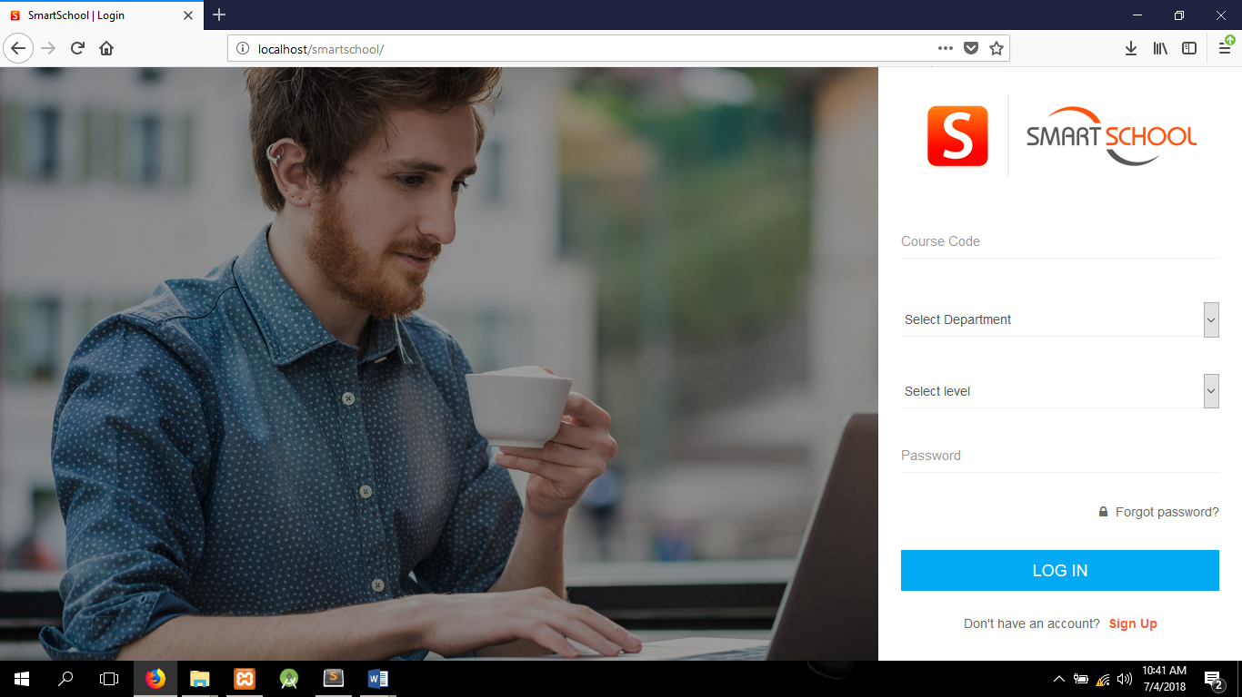
Figure 4.3 Snapshot of the Login Page.
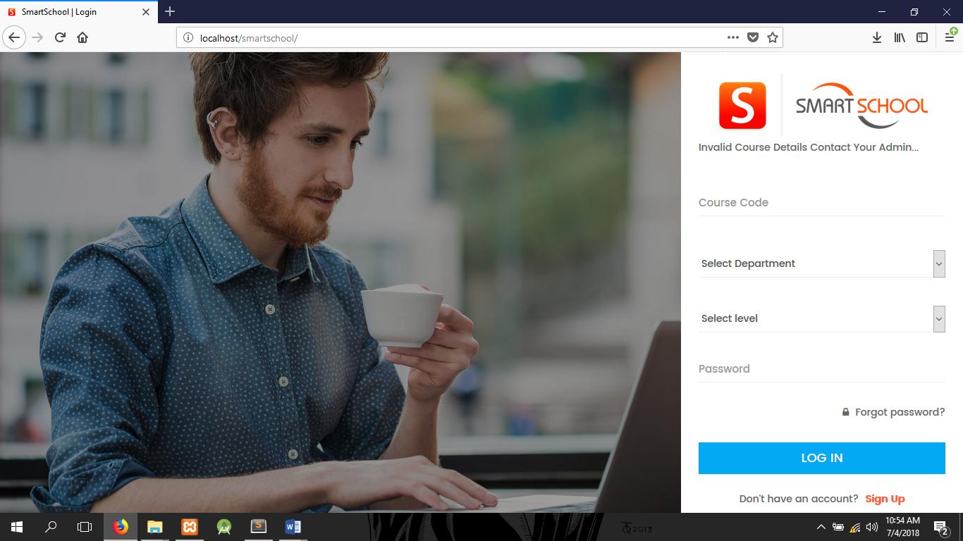
Figure 4.4 Snapshot of the Login Page showing error message for invalid course details.
Attendance Page: This is the output of the attendance page. It displays the Logged in Course Code at the top of the page. Here, the QR Code embedded on the student ID card is scanned, and the information about the student Full Name, Registration Number, Faculty, Department, Level and Passport is displayed on the screen. Also other Information about if the student is on Leave, Expulsion or Suspension is also displayed. Once this information is displayed, automatically attendance has been taken and generated without delay.
NOTE:
- Only students offering the particular logged in Course Code will be taken.
- Each attendance attracts 2 points.
- Lateness to class attracts 1 point.
- Absence to class misses 2 points.
- Attendance is NULL is student is not found in the course register or the student is either on leave, expelled or suspension.
- Id card will be confiscated due to Impersonation and attracts a fine.

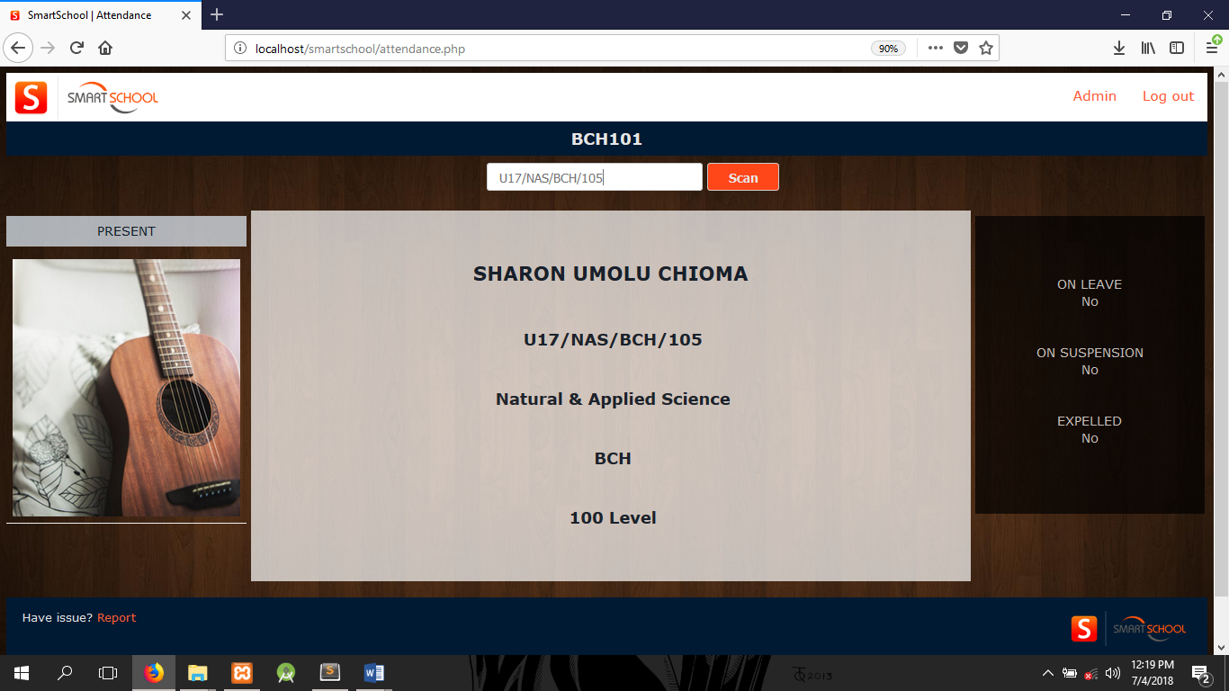
Figure 4.5 Snapshot of a student present.
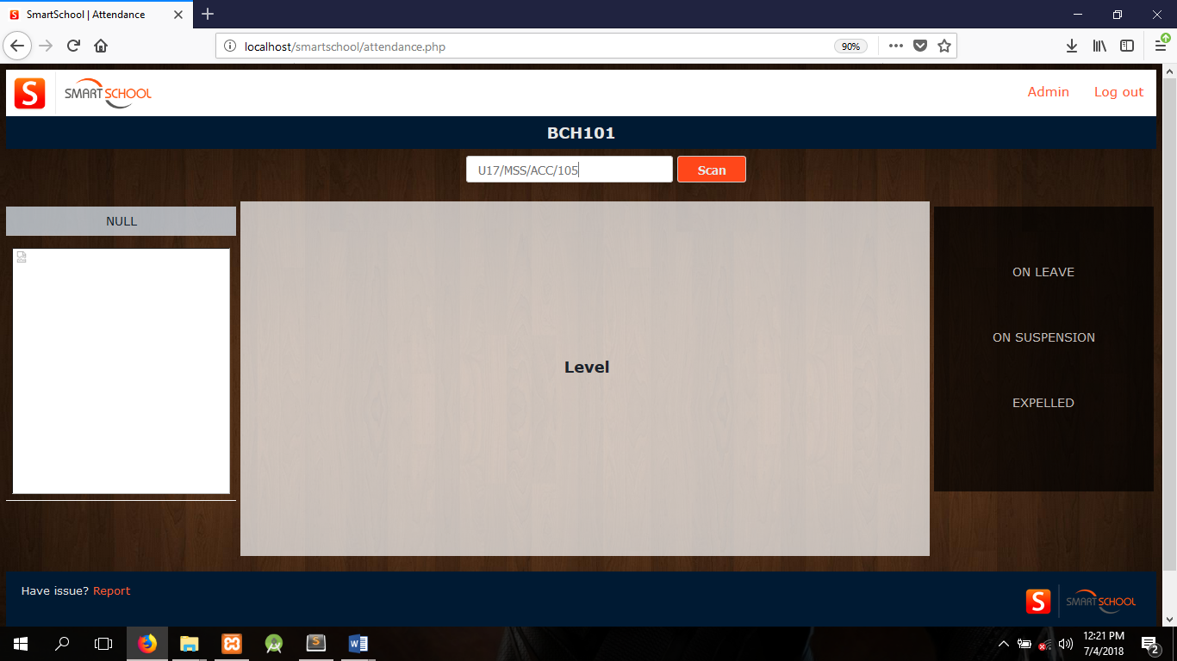
Figure 4.6 Snapshot of a Null attendance.

Report Page:
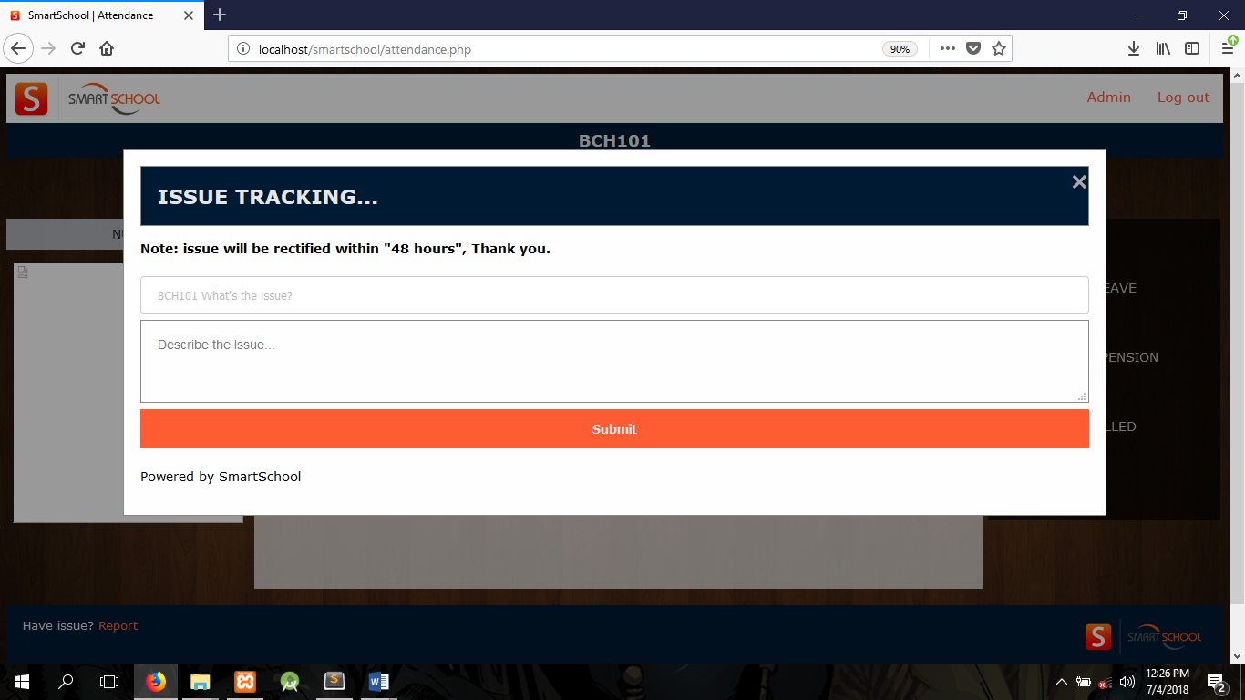
Figure 4.7 Snapshot of the report modal.
Here the logged in user can make a report to the admin on any issue encountered while taking attendance.
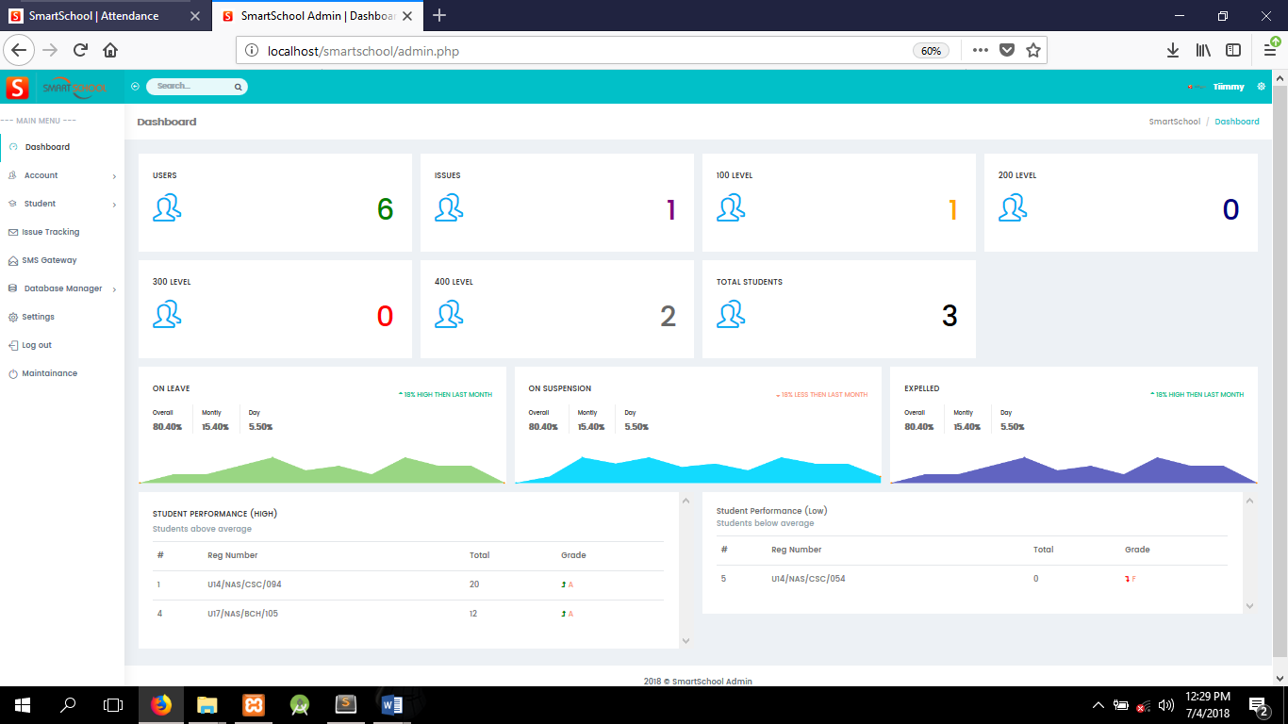
Figure 4.8 Snapshot of the admin page.
Admin Page: The admin page is used to manage users account, student’s information, SMS notification, database and the website design.

Figure 4.9 Snapshot of the Admin Dashboard.

Admin Dashboard: Here the admin monitors:
- The number of users, students of each level, total students, user’s issue and total students.
- Graphical reports of daily, monthly and yearly: leave, expulsion and suspension of students,
- Students with high performance and students with low performance.

Admin Accounts:
Here the admin can view the details of all registered users. Users can also be blocked from logging in.

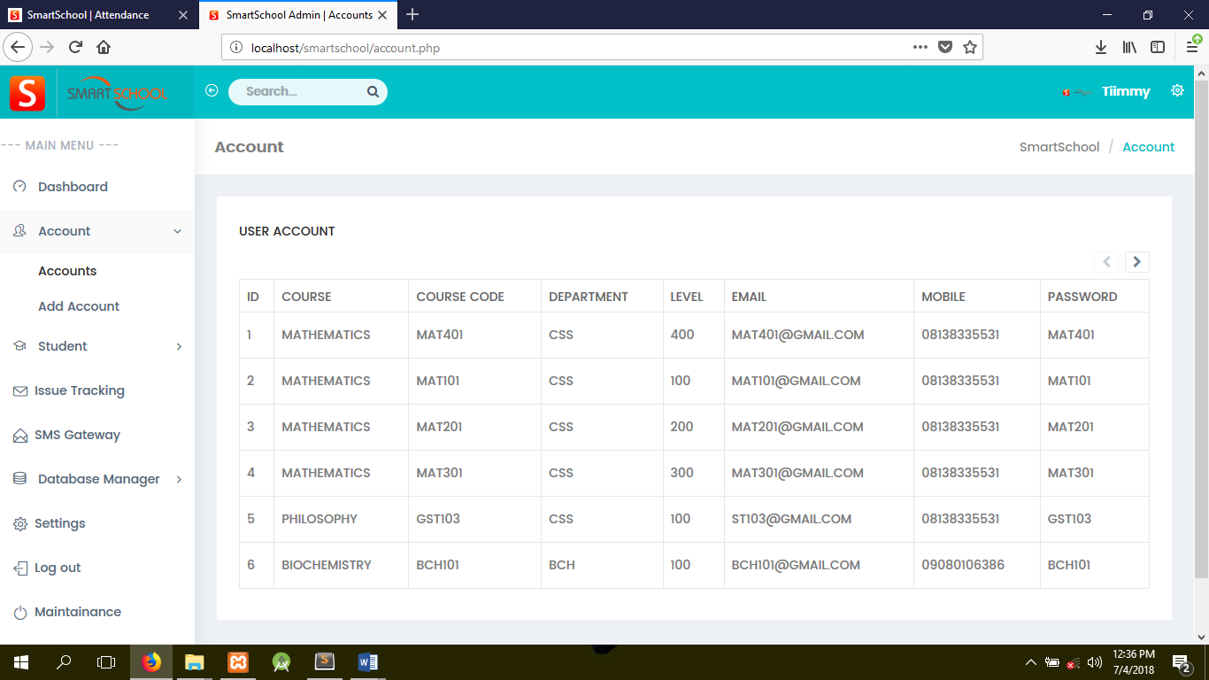
Figure 4.10 Snapshot of all registered Users.
Admin Add-Account: Here the admin creates a new user (New course attendance register).
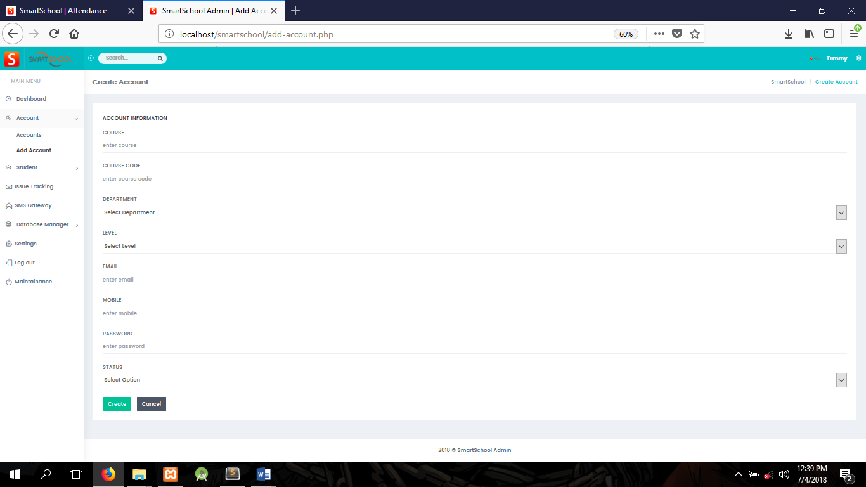
Figure 4.11 Snapshot of the Add User Page.
Admin Students: Here the admin can view all registered students. Student’s details can also be edited or deleted.
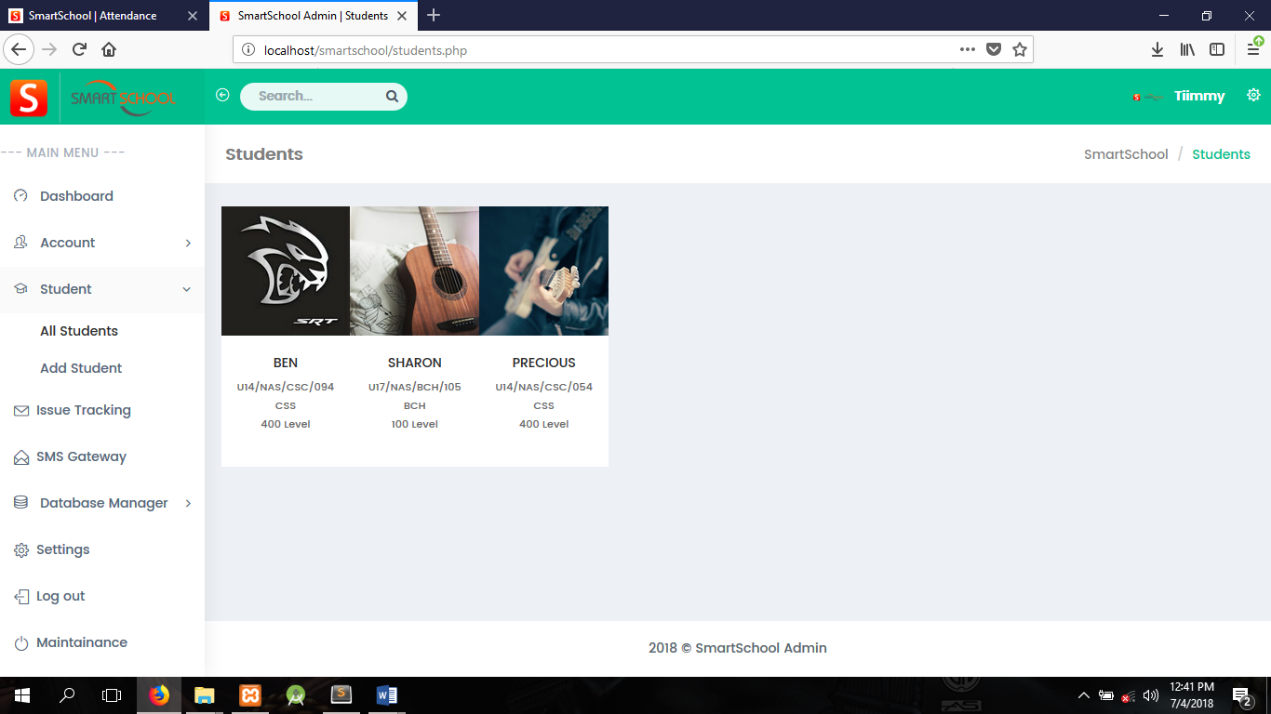
Figure 4.12 Snapshot of all registered students.

Admin Add-Student: Here the admin registers a new student using the following information about the student.
- Personal Information.
- Contact Information.
- Guardians Information.
- Academic and Campus Information.
- Mentors Information.
- Passport.
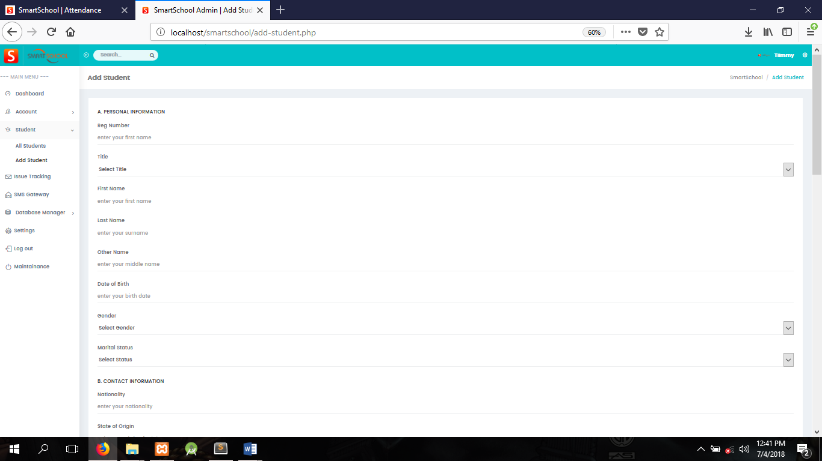
Figure 4.13 Snapshot of the Add Student Page.
Admin Issue Tracking: This page displays a table of reported issues by users in which the admin can look into and solve each problem.
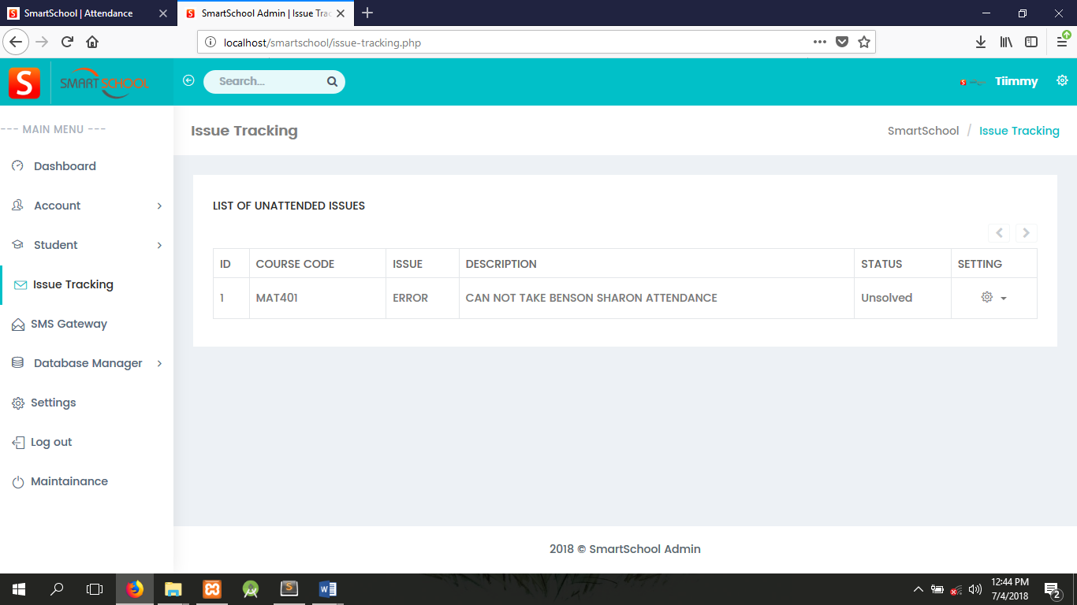
Figure 4.14 Snapshot of Issue Tracking Page.
Admin Database Manager:
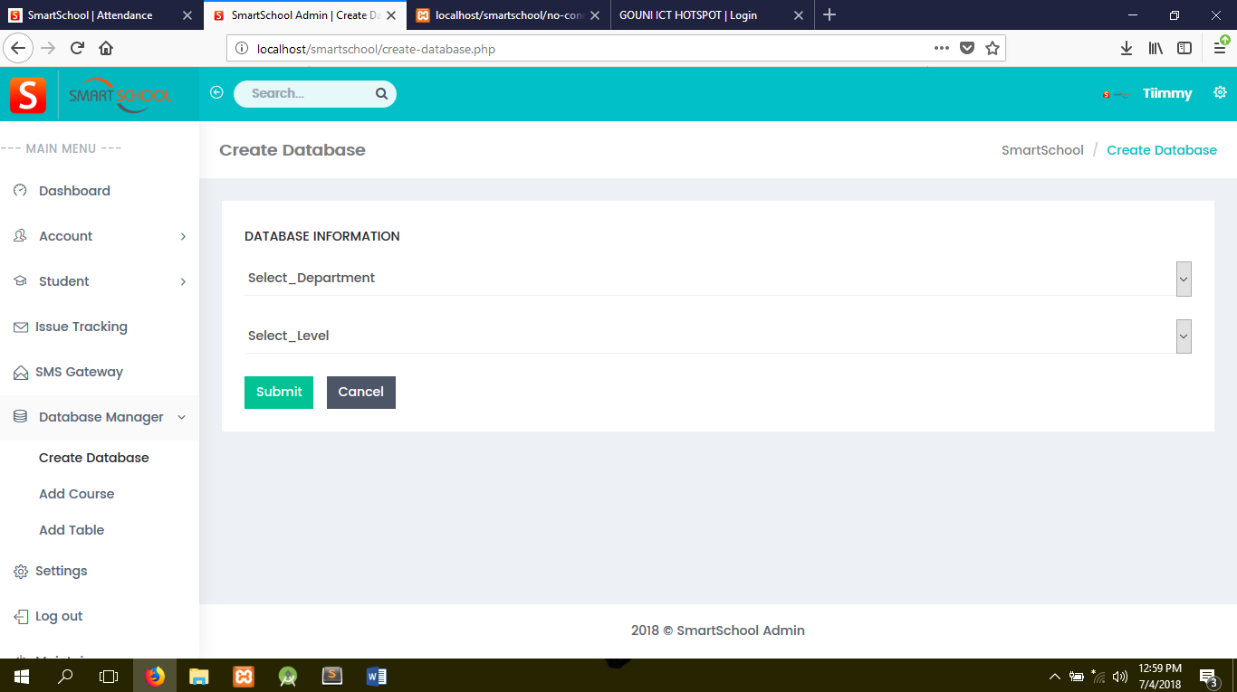
Figure 4.15 Snapshot the DBM Page.
Admin Settings: 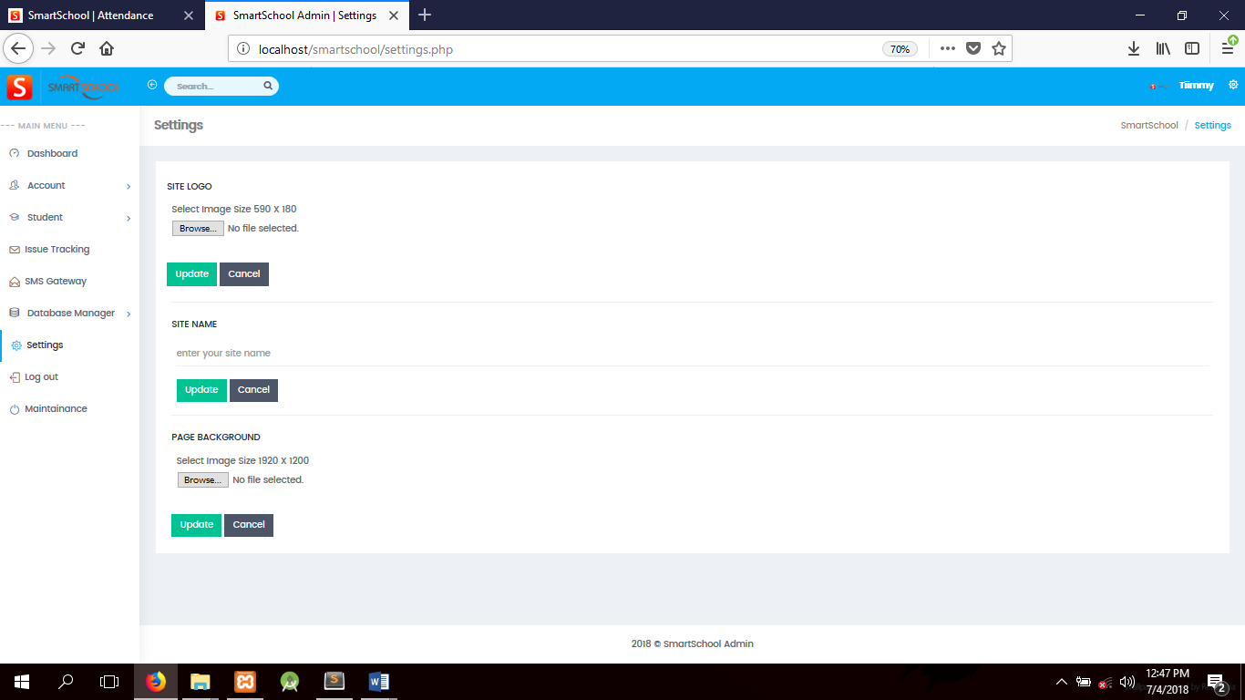
Figure 4.16 Snapshot of the Settings Page.

Here the admin can easily make changes to the site name, site logo and page background without necessary using codes or putting the site on maintenance mode.

Admin Maintenance: 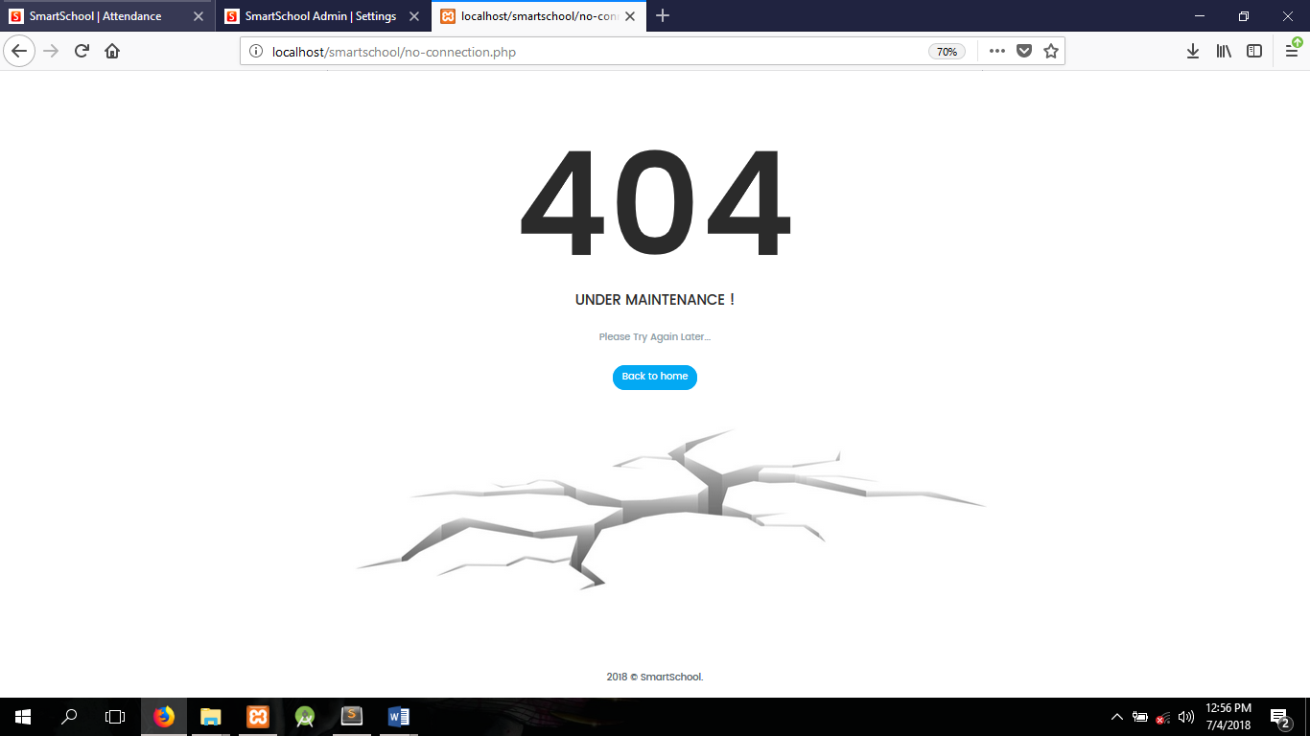
Figure 4.17 Snapshot of the Maintenance page.

The website is being redirected to the maintenance page whenever the admin is working to develop or manage the website. It keeps users from interfering.

4.4 Documentation
Installation Procedure
Some computer programs can be executed by simply copying them into a folder stored on a computer and executing them but this is quit advanced in nature because of the advancement in technology. Other programs are supplied in a form unsuitable for immediate execution and therefore need an installation procedure. Once installed, the program can be executed again and again, without the need to reinstall before each execution.

The following are the step involve in setting up the Quest website:
- Install the Xampp Server.
- Copy the Smartschool folder to your www directory.
Locating Root Folder.....Click on Computer....Click on Local disk c...navigate to Xampp.....Click on htdocs …..Paste the folder......
- Import the database file through phpMyAdmin in Xampp server.
- Launch your browser.
- Type localhost or 127.0.0.1/Smartschool in the address bar.
- Click enter.

4.4.1 User Manual
System Maintenance
The program may be maintained on the ground that the system requires an upgrade. When there is a new field to be added or a new form to be added in other to serve users well.
The following precaution should be done
- Ensure that the computer is kept in clean areas.
- System should be kept in cool places.
- Air conditioner is important to reduce room temperature and keep it constant.
- Backup of data is important.
CHAPTER 5

SUMMARY AND CONCLUSION

5.0 Summary
A child performance depends largely on his attendance to classes and parents would always want information about their child performance and attendance to classes. The researcher developed an Online Barcode Attendance System with Short Message Service (SMS) which takes and monitors the child regularity or punctuality to classes in line with this it also notifies the parents about the child’s performance in attendance through Short Message Service (SMS).

5.1 Conclusion
The Online Barcode Attendance System is developed using HTML, CSC, BOOTSTRAP, JAVA SCRIPT, PHP. It fully meets the objectives of the system which it has been developed. The system has reached a steady state where all bugs have been eliminated. The system is operated at a high level of efficiency and all the teachers and user associated with the system understands its advantage via User Manual. The system solves the problem It was intended to solve as requirement specification.
This project is completed by referring and following the project plan planned during the planning phases. The project breakdown in the project plan also acts as a guidance of this project.

In the conclusion, the result of this project has met all the requirements gathered during the planning and analysis phases. The system developed with the selected methodology. It is also passed all the test cases.

This project can be guidance and reference for future people who are going to develop the system similar to this project. People can refer this project and come up with a more creative and innovative idea.

5.2 Recommendation
In the development of this Online Barcode Attendance System with Short Message Service (SMS), I will recommend that if there is going to be any modification the developer should look forward in making it a stand-alone system, where by it does not require the use of external devices such as QR code scanner. This can be archived with the creation of android apps or IOS apps for the system, which uses built in camera as QR code scanner. In doing so, it further improves the portability, efficiency and reduces the time consumption of the system.

REFERENCES
[1] M. Kassim, H. Mazlan, N. Zaini, and M. K. Salleh, “Web-based student attendance system using RFID technology,” 2012 IEEE Control and System Graduate Research Colloquium, no. Icsgrc, pp. 213–218, Jul. 2012.
[2] M. K. Y. Sabri, M. Z. A. A. Aziz, M. S. R. M. Shah, and M. F. A. Kadir, “SMART ATTENDANCE SYSTEM BY USING RFID Abstract −,” no. figure 2, 2007.
[3] A. Qaiser and S. A. Khan, “Automation of Time and Attendance using RFID Systems,” no. November, pp. 13–14, 2006.
[4] T.-C. Li, H.-W. Wu, and T.-S. Wu, “The Study of Biometrics Technology Applied in Attendance Management System,” 2012 Third International Conference on Digital Manufacturing & Automation, pp. 943–947, Jul. 2012.
[5] I. A. Ujan and I. A. Ismaili, “Biometric attendance system,” The 2011 IEEE/ICME International Conference on Complex Medical Engineering, pp. 499–501, May 2011.
[6] Z. Yongqiang and L. Ji, “The Design of Wireless Fingerprint Attendance System,” 2006 International Conference on Communication Technology, pp. 1–4, Nov. 2006.
[7] H. Oktavianto, “Image-based Intell ligent Attendance Loggi ing System,” pp. 1–6, 2012.
[8] M. I. Moksin and N. M. Yasin, “The Implementation of Wireless Student Attendance System in an Examination Procedure,” 2009 International Association of Computer Science and Information Technology - Spring Conference, pp. 174–177, 2009.
[8] http://www.csos.jhu.edu/p2000/Research/researchpubs.htm. Accessed on 20th July 2018.

[9] Additional resources on parent engagement are also available from the National Network of Partnership Schools at Johns Hopkins University. http://www.csos.jhu.edu/p2000/program.htm. Accessed on 20th July 2018.

[10] FingerTec (2007) Overview of Punch Card & Card Reader System [Online] Available at http://www.fingertec.com/newsletter/images/PunchCard-E.pdf. Accessed on 8th August 2018.

[11] Dr.M. Ramakrishnan, Josphineleela.R (2012) An Efficient Automatic Attendance System Using Fingerprint Reconstruction Technique. International Journal of Computer Science and Information Security. [Online] Available at http://arxiv.org/ftp/arxiv/papers/1208/1208.1672.pdf. Accessed on 8th August 2018.

[12] Abhishek Jha (no date) Class Room Attendance System Using Facial Recognition System. The International Journal of Mathematics, Science, Technology and Management. [Online] Available at http://klresearch.org/IJMSTM/papers/v2i3_2.pdf. Accessed on 8th August 2014.

- www.google.com
- www.wikipedia.org
- www.w3schools.com
- www.youtube.com

APPENDICES

APPENDIX A
SOURCE CODES
These are the source codes for the index.php, attendance.php, admin.php.
index.php
<?php session_start(); ?>
<?php include'libraries/index.lib.php' ?>
<?php include'libraries/config1.php' ?>
<!DOCTYPE html>
<html lang="en">
<head>
<meta charset="utf-8">
<meta http-equiv="X-UA-Compatible" content="IE=edge">
<meta name="viewport" content="width=device-width, initial-scale=1">
<meta name="description" content="">
<meta name="author" content="">
<link rel="icon" type="image/png" sizes="16x16" href="../plugins/images/favicon.png">
<title><?php echo $sitename; ?> | Login</title>
<!-- Bootstrap Core CSS -->
<link rel="stylesheet" type="text/css" href="css/user.style.css">
<link href="bootstrap/dist/css/bootstrap.min.css" rel="stylesheet">
<link href="../plugins/bower_components/bootstrap-extension/css/bootstrap-extension.css" rel="stylesheet">
<!-- animation CSS -->
<link href="css/animate.css" rel="stylesheet">
<!-- Custom CSS -->
<link href="css/style.css" rel="stylesheet">
<!-- color CSS -->
<link href="css/colors/megna.css" id="theme" rel="stylesheet">
<!-- HTML5 Shim and Respond.js IE8 support of HTML5 elements and media queries -->
<!-- WARNING: Respond.js doesn't work if you view the page via file:// -->
<!--[if lt IE 9]>
<script src="https://oss.maxcdn.com/libs/html5shiv/3.7.0/html5shiv.js"></script>
<script src="https://oss.maxcdn.com/libs/respond.js/1.4.2/respond.min.js"></script>
<![endif]-->
<script>
function startTime(){
var today = new Date();
var h = today.getHours();
var m = today.getMinutes();
var s = today.getSeconds();
m = checkTime(m);
s = checkTime(s);
document.getElementById('txt').innerHTML = h + ":" + m + ":" + s;
var t = setTimeout(startTime, 500);
}
function checkTime(i){
if (i < 10) {i = "0" + i};
return i;
}
</script>
</head>
<body onload="startTime()">
<!-- Preloader -->
<div class="preloader">
<div class="cssload-speeding-wheel"></div>
</div>
<section id="wrapper" class="login-register" >
<!-- <div id="txt" style="float: left; font-size: 95px; text-align: center; width: 45%; margin-top: 200px; color: white;"></div>
--> <div class="login-box login-sidebar" id='log'>
<!-- <script type="text/javascript">
document.getElementById('boot').onclick = function() {
$('#log').show('slow');
}
</script> -->
<div class="white-box">
<form class="form-horizontal form-material" id="loginform" action="" method="POST">
<a href="javascript:void(0)" class="text-center db"><img src="<?php echo $sitelogo; ?>" alt="Home" class="smart" style="height: 100px;" /></a>
<?php error_reporting(0); ?>
<p><?php echo $msg; ?></p>
<div class="form-group m-t-40" >
<div class="col-xs-12">
<input class="form-control" type="text" name="coursecode" required="" placeholder="Course Code">
</div>
</div>
<div class="form-group m-t-40">
<div class="col-xs-12">
<select class="form-control" name="dept">
<option>Select Department</option>
<b><option>--ARTS--</option></b>
<option>ENG</option>
<option>HIS</option>
<option>MUS</option><br>
<b><option>--EDU--</option></b>
<option>CSS-EDU</option>
<option>BIO-EDU</option>
<option>CHM-EDU</option>
<option>PHY-EDU</option><br>
<b><option>--NAS--</option></b>
<option>ARC</option>
<option>CSS</option>
<option>CHM</option>
<option>BCH</option>
<option>BIO</option>
<option>BTG</option>
<option>ICH</option>
<option>MCB</option>
<option>PHY</option>
<option>GLM</option><br>
<b><option>--MSS--</option></b>
<option>ACC</option>
<option>ECO</option>
<option>IRE</option>
<option>MAS</option>
<option>MKT</option><br>
<b><option>--LAW--</option></b>
<option>LAW</option>
</select>
</div>
</div>
<div class="form-group m-t-40">
<div class="col-xs-12">
<select class="form-control" name="level">
<option>Select level</option>
<option>100</option>
<option>200</option>
<option>300</option>
<option>400</option>
</select>
</div>
</div>
<div class="form-group">
<div class="col-xs-12">
<input class="form-control" type="password" name="password" required="" placeholder="Password">
</div>
</div>
<div class="form-group">
<div class="col-md-12">
<div class="checkbox checkbox-primary pull-left p-t-0">
<input id="checkbox-signup" type="checkbox">
<!-- <label for="checkbox-signup"> Remember me </label> -->
</div>
<a href="javascript:void(0)" id="to-recover" class="text-dark pull-right"><i class="fa fa-lock m-r-5"></i> Forgot password?</a> </div>
</div>
<div class="form-group text-center m-t-20">
<div class="col-xs-12">
<button class="btn btn-info btn-lg btn-block text-uppercase waves-effect waves-light" type="submit" name="submit">Log In</button>
</div>
</div>
<div class="form-group m-b-0">
<div class="col-sm-12 text-center">
<p>Don't have an account? <a href="register.php" class="text-primary m-l-5"><b style="color: #ff5c33;">Sign Up</b></a></p>
</div>
</div>
<br>
<div class="form-group m-b-0">
<div class="col-sm-12 text-center">
</div>
</div>
</form>
<form class="form-horizontal" id="recoverform" action="index.php">
<div class="form-group ">
<div class="col-xs-12">
<h3>Recover Password</h3>
<p class="text-muted">Enter your Email and instructions will be sent to you! </p>
</div>
</div>
<div class="form-group ">
<div class="col-xs-12">
<input class="form-control" type="text" required="" placeholder="Email">
</div>
</div>
<div class="form-group text-center m-t-20">
<div class="col-xs-12">
<button class="btn btn-primary btn-lg btn-block text-uppercase waves-effect waves-light" type="submit">Reset</button>
</div>
</div>
</form>
</div>
</div>
</section>
<!-- <script type="text/javascript">
var f = document.ready
</script> -->
<!-- jQuery -->
<script src="../plugins/bower_components/jquery/dist/jquery.min.js"></script>
<!-- Bootstrap Core JavaScript -->
<script src="bootstrap/dist/js/tether.min.js"></script>
<script src="bootstrap/dist/js/bootstrap.min.js"></script>
<script src="../plugins/bower_components/bootstrap-extension/js/bootstrap-extension.min.js"></script>
<!-- Menu Plugin JavaScript -->
<script src="../plugins/bower_components/sidebar-nav/dist/sidebar-nav.min.js"></script>

<!--slimscroll JavaScript -->
<script src="js/jquery.slimscroll.js"></script>
<!--Wave Effects -->
<script src="js/waves.js"></script>
<!-- Custom Theme JavaScript -->
<script src="js/custom.min.js"></script>
<!--Style Switcher -->
<script src="../plugins/bower_components/styleswitcher/jQuery.style.switcher.js"></script>
<!-- <script type="text/javascript">
$(document).ready(function(){
$('#log').hide('fast');
});
</script> -->
</body>
</html>

ATTENDANCE PAGE.PHP
<?php session_start(); ?>
<?php include'libraries/attendance.lib.php' ?>
<?php require_once 'libraries/function.php'; ?>
<?php include"script/script.nav.php" ?>
<!DOCTYPE html>
<html lang="en">
<head>
<link rel="icon" type="image/png" sizes="16x16" href="../plugins/images/favicon.png">
<title><?php echo $sitename; ?> | Attendance</title>
<meta charset="utf-8">
<meta name="viewport" content="width=device-width, initial-scale=1.0">
<link rel="stylesheet" type="text/css" href="css/user.style.css">
<link rel="stylesheet" type="text/css" href="css/substyles.css">
</head>
<body style="font-family:Verdana; background-image:url(<?php echo $page; ?>); background-size: cover;">
<div class="topnav" id="myTopnav">
<!-- <a href="#home" class="active">Home</a> -->
<img src="<?php echo $sitelogo; ?>" style="height: 60px;">
<a href="logout.php" class="waves-effect"><i class="icon-logout fa-fw"></i> <span class="hide-menu">Log out</span></a>
<a href="admin.php">Admin</a>
<a href="javascript:void(0);" style="font-size:15px;" class="icon" onclick="myFunction()">&#9776;</a>
</div>
<div class="course">
<label><?php echo $_SESSION["CourseCode"]; ?></label>
</div>
<div class="search" >
<form method="POST" action="" style="border: 0px;">
<input type="text" name="barcode" id="scanid" autofocus placeholder="Scan ID....">
<input type="submit" name="submit" value="Scan">
</form>
</div>
<script type="text/javascript">
var input = document.getElementById(scanid);
if ( !("autofucos" in input) ) {
input.focus();
}
</script>
<div style="overflow:hidden;">
<div class="menu">
<div class="menuitem" style="text-align: center; color: #001a33; background-color: #e6f3ff; opacity: 0.7;"><?php if($queryscr){
echo "PRESENT";
}else{
echo "NULL";
}
?></div>
<div class="menuitem"><img src="<?php echo"$row[10]"; ?>" class="active" style="height: 320px; width: 100%; background-color: white;"></div>
</div>
<div class="main" style="margin-left: 5px; opacity: 0.7;">
<br><br>
<?php error_reporting(0); ?>
<h2><?php echo $row[1]; ?> <?php echo $row[2]; ?> <?php echo $row[3]; ?></h1><br>
<h1><?php echo $row[0]; ?></h1><br>
<h1><?php echo $row[4]; ?></h1><br>
<h1><?php echo $row[5]; ?></h1><br>
<h1><?php echo $row[6]." "."Level"; ?></h1><br>
</div>
<div class="right" style="height: 370px; background-color: black; opacity: 0.7;">
<br><br><br>
<label style="color: white;">ON LEAVE</label><br>
<label style="color: white;"><?php echo $row[7]; ?></label><br><br><br>
<label style="color: white;">ON SUSPENSION</label><br>
<label style="color: white;"><?php echo $row[8]; ?></label><br><br><br>
<label style="color: white;">EXPELLED</label><br>
<label style="color: white;"><?php echo $row[9]; ?></label><br>
</div>
<div class="footer2">
<p>Have issue? <a id="myBtn" style="color: #ff5c33;">Report</a>
<img src="<?php echo $sitelogo; ?>" style="float: right; margin-right: 20px; max-height: 48px;"></p>
<p style="margin-top: 40px; text-align: center; ">Copyright@<?php echo $sitename; ?></p>
</div>
<style>
body {font-family: Arial, Helvetica, sans-serif;}
/* The Modal (background) */
.modal {
transition: .60s all;
-webkit-transition: .60s all;
-moz-transition: .60s all;
-o-transition: .60s all;
-ms-transition: .60s all;
display: none; /* Hidden by default */
position: fixed; /* Stay in place */
z-index: 1; /* Sit on top */
padding-top: 100px; /* Location of the box */
left: 0;
top: 0;
width: 100%; /* Full width */
height: 100%; /* Full height */
overflow: auto; /* Enable scroll if needed */
background-color: rgb(0,0,0); /* Fallback color */
background-color: rgba(0,0,0,0.4); /* Black w/ opacity */
}
/* Modal Content */
.modal-content {
background-color: #fefefe;
margin: auto;
padding: 20px;
border: 1px solid #888;
width: 80%;
}
textarea{
background-color: #fefefe;
margin: auto;
padding: 20px;
border: 1px solid #888;
width: 100%; Full width
border: 1px solid grey;
font-family: Arial, Helvetica, sans-serif;
color: solid grey;
}
.cos{
font-size: 18px;
color: solid #888;
font-weight: bold;
}
@media only screen and (max-width:500px) {
.top{
font-size: 5px;
}
}
.top{
font-weight: bold;
color: #e6e6e6;
background-color: #001a33;
font-size: 25px;
margin: auto;
padding: 20px;
border: 1px solid #888;
width: 100%;
}
.but{
background-color: #ff5c33;
font-weight: bold;
}
/* The Close Button */
.close {
color: #aaaaaa;
float: right;
font-size: 28px;
font-weight: bold;
}
.close:hover,
.close:focus {
color: #000;
text-decoration: none;
cursor: pointer;
}
</style>
<div id="myModal" class="modal">
<?php
if (isset($_POST['track'])) {
$coscode = $_SESSION["CourseCode"];
$issue = $_POST['issue'];
$des = $_POST['des'];
$istrck = "INSERT INTO issuetracking(id,CourseCode,Issue,Description,Status) VALUES ('', '$coscode', '$issue', '$des', 'Unsolved')";
$queryi = mysqli_query($link,$istrck);
if ($queryi) {
header('location:index.php');
}
}
?>
<!-- Modal content -->
<div class="modal-content">
<span class="close">&times;</span>
<p class="top">ISSUE TRACKING...</p>
<p><b>Note: issue will be rectified within "48 hours", Thank you.</b></p>
<form method="POST">
<input type="text" name="issue" placeholder="<?php echo $_SESSION["CourseCode"]; ?> What's the issue?">
<textarea name="des" placeholder="Describe the Issue..."></textarea>
<button class="but" name="track">Submit</button>
<p>Powered by <?php echo $sitename; ?></p>
</form>
</div>
</div>
<script>
// Get the modal
var modal = document.getElementById('myModal');
// Get the button that opens the modal
var btn = document.getElementById("myBtn");
// Get the <span> element that closes the modal
var span = document.getElementsByClassName("close")[0];
// When the user clicks the button, open the modal
btn.onclick = function() {
modal.style.display = "block";
}
// When the user clicks on <span> (x), close the modal
span.onclick = function() {
modal.style.display = "none";
}
// When the user clicks anywhere outside of the modal, close it
window.onclick = function(event) {
if (event.target == modal) {
modal.style.display = "none";
}
}
</script>
</body>
</html>

