DESIGN AND IMPLEMENTATION OF WEB BASED``1`1`` VOTING SYSTEM

By

UBAKA IFECHUKWU JOSHUA
Registration no:
U14/NAS/CSC/081
Being a BSc report submitted in partial fulfillment of the requirements for the award of a Bachelor’s degree in Computer Science of the
Godfrey Okoye University.
Supervisor: Mr Micheal Kanife

Department of Computer Science/mathematics Godfrey Okoye University, Enugu

………, 2018

CERTIFICATION
This is to certify that this research titled online voting system is an original work of Ubaka Ifechukwu Joshua under the supervision of
Mr. Micheal Kanife

DEDICATION
I dedicate this project to God Almighty my creator, my strong pillar, my source of inspiration, my provider and wisdom, knowledge and understanding. I also dedicate this work to my family and friends, for the continuous love they showed me during the time of this write up and also my parents Mr. & Mrs. Ubaka together with my supervisor Mr. Micheal Kanife.

APPROVAL PAGE

This is to certify that this research titled online voting system was carried out by Ubaka Ifechukwu Joshua, Registration No: U14/NAS/CSC/081 of the department of Computer Science in partial fulfillment of the requirements for the award of Bachelor of Science in Computer Science.

________________________ _________________________
Mr. Micheal Kanife Date/sign
Project Supervisor

________________________ _________________________
Mrs. Monica Agu Date/sign
Head of Department

ACKNOWLEDGMENT
My gratitude goes to God Almighty who made it possible for me to come this far in my Academic pursuit. Without the guidance of my ever listening supervisor, Mr. Micheal Kanife this work would not have been this successful. I appreciate your support, encouragement towards me. Also wish to appreciate my Head of Department for the help rendered and all her advises to the students.My regard also goes to MRS. NJIDEKA ONOS, MR.BENSON, and Dr OZORFOR for their support and advises. I wish to thank my parents Mr & Mrs UBAKA for their immense support. To all my relatives and siblings.My gratitude also goes to all my friends Johnbosco, Chummy, Chidera, Ifeanyi, Hector, Obinna, Buffy, Chambers, Fenzy and all others who assisted me in one way or another to make my project successful and also made my stay in Godfrey Okoye University peaceful.

TABLE OF CONTENTS
Title page
Certification
Dedication
Approval page
Acknowledgement
Table of Contents
Abstract
CHAPTER ONE:
1.0 Background of study
1.1 Statement of the problem
1.2 Objective of study
1.3 Significance of study
CHAPTER TWO:
- Introduction
2.1 Background of study
2.2 Literature Review
2.3 Summary
CHAPTER THREE:
3.0 Introduction
3.0.1 Methodology
3.1 Analysis of the existing system
3.2 Analysis of the Proposed System
3.3 Design of the Proposed System
3.3.1 Database Design
3.3.2 System Architecture
3.3.3 Input Design
3.3.4 Output Design
CHAPTER FOUR:
4.0 Introduction
4.1 Choice of Development Environment
4.1.1 The login form
4.1.2 The voter registration form
4.2 Implementation Architecture
4.3 Software Testing
4.3.1 Input specification
4.3.2 Output specification
4.4 Documentation
4.4.1 User manual
4.4.2 Source code listing
CHAPTER FIVE:
5.0 Summary
5.1 Conclusion
5.2 Recommendation
Reference
Appendix

ABSTRACT

The project focuses on developing software for a web based voting system which will enable them to register, login with the voters card number, insert card number, count vote by clicking a button, view all registered voters and also give room for editing of errors. The objectives of this is to Conduct free and fair election since voters do not need to come to polling station, Safeguard data and information in the system by creating a relational database, to reduced workload in the process of conducting election, to keep accurate record of votes for future purpose, it will reduce time wasted in announcing election result since, once the period of voting is over, the system will not accept votes again, each voter is eligible to cast vote once the system allows the person to register. The methodology used in this project is Unified Modeling Language. UML is designed to enable users to develop an expressive, ready to use visual modeling language. In addition, it supports high level development concepts such as frameworks, patterns and collaborations. It was implemented using sublime text on a Microsoft windows system using HTML codes, PHP, CSS and MySQL language for the relational database. The result gotten from this project was a web based voting system.

CHAPTER ONE
INTRODUCTION

1.0 INTRODUTION
Today the Internet has been a fair concept that has profoundly affected our daily lives. As with anything new the internet possesses various mysteries. The advancement made in technology over the past few years is astounding. The computer alone has progressed at a remarkable pace, and updates are continually occurring. Online voting system opens the door to all sorts of possibilities for our state (country) voting future. One basic feature of democracy that cuts across all kinds of people is the act of election. Democracy thus encourages individual freedom according to the rule of law, so that people may behave and express themselves as they choose their leader. This not only gives people a chance to choose their leaders, but also to freely express their views on issues.

Alvarez R.M, Hall, T.E and Trechsel, A.H. Thus, voting is a method by which group of people make decisions. These decisions could be political, social or public. Voting is also a means of selecting or choosing leaders, it does not apply only to local government, states and federal government of Nigeria but also in different institutions and social organization.
For democracy to be sound, it should be free and fair.

Over the years, the voting system in Nigeria has been put under a manual system of operation which mostly results to inaccuracy and ineffective election.
It is gradually being realized that much faster accurate, effective and efficient system is needed to be adopted. Here, on-line system is to be adopted to handle voting.
This on-line voting system ensures that each intended voter is checked whether he/she is registered or not, if he/she is not registered, the system refuses him voting. Also it checks whether he/she has voted for that particular election. This on-line voting system prevents a situation where a particular candidate seizes the voters’ cards, and uses them to vote for himself. Hence the rigging associated with the manual voting systems has been completely handled. The system also takes care of result calculation of each candidate in particular election and the percentage scored in that election. This eliminates rigging associated with the calculation and counting of votes.

A means of showing the various outputs is also adopted by the system, the output can either be displayed on the screen or a hard copy of it can be produced depending on the choice of the user. This prevents intentional and unintentional typographical errors in showing the results of the elections.
With an on-line voting, voters can only cast once; it will also afford people who are sick and unable to go to polling stations to cast their vote.

  - STATEMENT OF THE PROBLEM
The following are the statements of problem:
1 This system will prevent disenfranchising eligible voters
- It will reduce the action rigging during election process
- It will eliminate a single voter casting his vote multiple times
- Inefficient and inaccurate counting of voters by officers concerned
- Long queues observed at polling stations
- Illegible voters casting their vote

1.2 AIM AND OBJECTIVES
The main objective of this study is to develop an online voting system and which will be able to achieve the following:
- Conduct free and fair election since voters do not need to come to polling station.
- Safeguard data and information in the system by creating a relational database.
- Reduced workload in the process of conducting election.
- Keep accurate record of votes.
- It will reduce time wasted in announcing election result.
- Each voter is eligible to cast vote once.
- Once the period of voting is over, the system will not accept votes again.

1.3 SIGNIFICANCE OF THE PROBLEM
- The online voting system shall reduce the time spend making long queues at the polling stations during voting.
- It shall also enable the voters to vote from any part of the globe as explained since this is an online application available on the internet.
- Cases of vote miscounts shall also be solved since at the backend of this system resides a well-developed database using MYSQL that can provide the correct data once it’s correctly queried.
- Since the voting process shall be open as early as possible, the voters shall have ample time to decide when and whom to vote for.
- It secures the data from hackers.

CHAPTER TWO
LITERATURE REVIEW

2.0 INTRODUCTION
The idea of online voting system which is to reduce anonymity and increase transparency was addressed by David Chaum. Online voting tends to take the place of traditional way of voting in order to reduce both human and material cost of voting in especially developing countries like Nigeria.
Most people who have in one way or the other have done work in online voting system seem to agree that online voting does not actually meet the requirement for public elections and that the current method of voting needs improvement.

Online voting system has disadvantages based on the areas of secrecy and protection against corruption and/or vote selling. The national attention to problems with current methods of casting and counting votes in public elections was brought about, by the Kenyan General elections of 2007. Most people believe and advice that the current system should be changed; there is much disagreement on how such changes should be made.

2.1 THEORETICAL BACKGROUND
The project was built upon with web technologies which are HTML, CSS, PHP and relational database technology. And it was made in such a way that the user can interact with it with the aid of an application program known as a web browser (Firefox, Opera, Internet Explorer, Google Chrome etc.)

Each HTML tag in the web document has a function it does on the web browser.eg if I write
<html>
<head>
<title>Online Voting System</title>
</head>
<body bgcolor="gray">
<p></p>
<h2 align="center"> Online Voting System <br /><br /> by <br /><br />Ubaka Josh</h2>
</body>
</html>

This will display a tittle online voting system at the top of the web browser and on the main page; Online Voting System by Ubaka Josh will be displayed in center alignment. A form was designed to collect registration data from a user which involves a user name and a password, which when entered and submitted, the submit button sends the data to a web document and into the database to act upon the data.

2.2 REVIEW OF THE RELATED LITERATURE
Other researchers have done work in electronic voting; while they may not explicitly mention voting from remote poll sites, their work is nonetheless relevant to any effort at designing or implementing a remote poll site voting system. Lorrie Cranor acknowledged the problems inherent in each kind of voting apparatus, but doesn't make an overt recommendation on her site for one technology over the rest.

Professor L. Adele Jinadu, in his opinion said that there is a critical need for an honest competent and non-partisan administrator to run elections. This is to support the basic conditions for the conduct of free and fair elections as the report of the electoral bureau stipulated (1987). Yet there was hardly an election that was conducted in this country that has been rig free. This question is “what is the nature of these malpractices: A lot of materials have been published concerning this issue. (1991).

O. Nnoli, According to him, these problems include: Electoral malpractice, Electoral violence, Inadequate security for the electorate. From the malpractice talked about the question now is “how will the conduct of future elections be improved?” (1990).

M. C. Andre, he said, several states have already attempted using online voting systems for their state or local elections, which is rig free. The trials were done in a small scale setting.

Furthermore, John Naughton in his article “Election of the future” quoted Churchill as saying that democracy is in such a poor state that some suggest financial incentives for voting as he famously observed is the worst system of government except for all the others. For all the gratifying footage citizens queuing interminably to cast their hard won votes. There is the reality of dreadful turnouts and voter’s droopiness throughout the more “mature” democracies of the west. He also enumerated that online voting system can completely eradicate the denial of voting right, the long queuing and time wasted while processing the result, the assault encountered during voting which has discouraged many from voting. Because it is a web-based voting system, it allows voters to vote from their various homes located at different geographical areas. Not only can they vote at various locations, the online voting system is absolutely secured, because they are protected by passwords and tamper-proof audit logs.

2.3 SUMMARY
The researcher cannot but have the same view with the scholars that our voting system needs a total restructuring before effective election could be conducted in this country.
In most developing countries, registration is the responsibility of the government, either local or national; and in some countries, some form of compulsory voting is required as part of each citizen’s civic duty. Even in many countries where the voting itself is not compulsory, registering one’s place of residence with government agencies is required, which automatically constitutes voter registration for citizens, and in some cases residents, of the required age. In other countries, however, people eligible to vote must opt in to be permitted to participate in voting, generally by filling out a specific form registering them to vote. Governments registering people has been shown to be one of the most powerful predictors of high voting turnout levels.

CHAPTER THREE
SYSTEM ANALYSIS AND DESIGN

3.0 INTRODUCTION
In this chapter, the choice of methodology used in this project work, the analyses of the existing system and among others are presented. It includes specific methods which were used in order to achieve the objectives of the project, particular requirements for implementation of the project and a brief explanation of why such methods were used for implementing the proposed system, also included is a brief description of the current system of voting.

The methodology used is Unified Modeling Language (UML). UML is a standardized modeling language enabling developers to specify, visualize, construct and document artifacts of a software system. Thus, UML makes these artifacts scalable, secure and robust in execution. UML is an important aspect involved in object-oriented software development. It uses graphic notation to create visual models of software systems.
UML is designed to enable users to develop an expressive, ready to use visual modeling language. In addition, it supports high level development concepts such as frameworks, patterns and collaborations.
UML diagrams can be divided into two categories. The first type includes six diagram types representing structural information. The second includes the remaining seven representing general types of behaviour. Structure diagrams are used in documenting the architecture of software systems and are involved in the system being modeled.
Different structure diagrams are:
- Class Diagram: represents system class, attributes and relationships among the classes.
- Component Diagram: represents how components are split in a software system and dependencies among the components.
- Deployment Diagram: describes the hardware used in system implementations.
- Composite Structure Diagram: describes internal structure of classes.
- Object Diagram: represents a complete or partial view of the structure of a modeled system.
- Package Diagram: represents splitting of a system into logical groupings and dependency among the grouping.
Behavior diagrams represent functionality of software system and emphasize on what must happen in the system being modeled.
Different behaviour diagrams are:
- Activity Diagram: represents step by step workflow of business and operational components.
- Use Case Diagram: describes functionality of a system in terms of actors, goals as use cases and dependencies among the use cases.
- UML State Machine Diagram: represents states and state transition.
- Communication Diagram: represents interaction between objects in terms of sequenced messages.
- Timing Diagrams: focuses on timing constraints.
- Interaction Overview Diagram: provides an overview and nodes representing communication diagrams.
- Sequence Diagram: represents communication between objects in terms of a sequence of messages.
UML diagrams represent static and dynamic views of a system model. The static view includes class diagrams and composite structure diagrams, which emphasize static structure of systems using objects, attributes, operations and relations. The dynamic view represents collaboration among objects and changes to internal states of objects through sequence, activity and state machine diagrams.

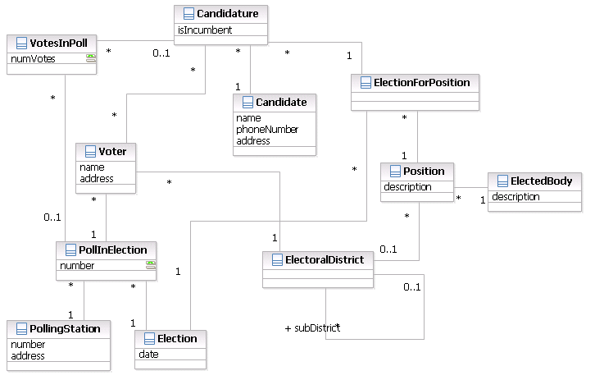
Fig 3.1 UML use caseDiagram

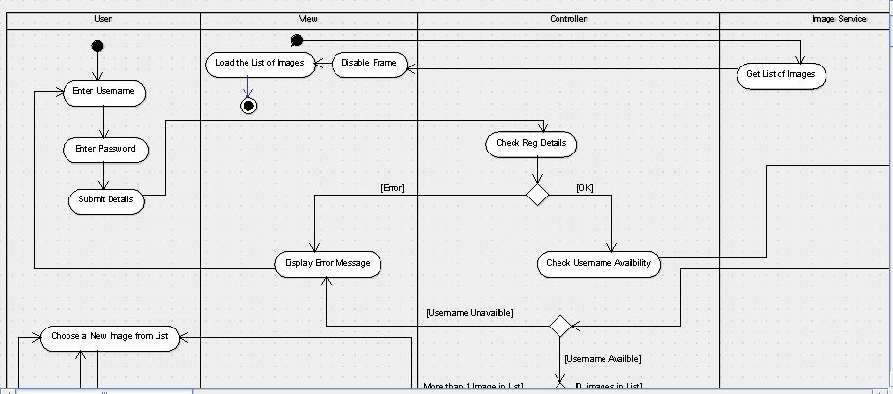

Fig 3.2: UML activity Diagram

3.1 ANALYSIS OF THE EXISTING SYSTEM.
The existing voting system is highly manual. Successful on-line voting site design and development requires a collective and cohesive effort by the researcher. This is why it is very important to study and understand the existing system properly, its problems and lapses, its inefficiencies and inability. The extent to which this is done determines the efficiency of the resulting system. A Period for registration is set to start and end on a particular day, such a period is announced to the public using the various mass communication media including newspapers and radio. During that period, eligible voters are expected to report to these officers in order to be registered using the manual method (i.e. paper and pen method). Every potential voter fills out a form with details such as surname, first name, location, date of birth among others; such an individual must be verified to be residents of that particular area.
The INEC officers then collects the filled in Data forms from officials at the end of the registration period to be taken to the central INEC offices where data entry clerks are then employed to do entry into the central database from which a voter’s registration card is produced. At the end of this process, voter’s registration cards are produced to be issued to voters. This process is quite tedious and stressful for the INEC official because it is time consuming.
During the course of the analysis, the following problems were discovered:
- Expensive and time consuming.
- Too much paper work.
- Errors during data entry.
- Loss of registration forms.
- Short time provided to view voters register form.

3.2 ANALYSIS OF THE PROPOSED SYSTEM
The proposed system is a full on-line voting system. Contained in the new system is all information about a voter which was keyed into the computer system and stored in a database during the course of registration. It is a system that allows the user to interact between the software and the database with the aid of a web browser. Data keyed into the system are being stored in a database where the admin can query records when needed.

3.3 DESIGN OF THE PROPOSED SYSTEM
The web-based online voting system is being developed as an online information system to offer users convenient access to the voter registration portal. The system was built to meet the need of the general public, allow voters to vote just once, minimize cost, analyze and output the total number of votes at the end of the election process and allows monitoring of votes tallies while voting is in progress.
The voter is required to visit the polling station in order for him/her to be registered online by the INEC official of which he will be given a from after the registration, this form contains some details which will be needed when he/she wants to vote for a candidate of their choice during the period of election. When it is time for election, the user will visit the voting site and then log in with credentials given to him when he registered. These credentials will authenticate the user into the system, so he would be allowed to choose and cast his vote online.

3.3.1 DATABASE DESIGN
The database management system used in this project is MySQL. This a freely available open source relational database management system that uses structured query language.
The required tables in the database include the following:
- Account
- Party
- Table_voters
- Votes

Table 1: Account
Field | Data type | Size | Attributes | Description | Null | Default | Extra
Uname | Varchar | 25 |  | User name | No | None
Pwd | Varchar | 20 |  | Password | Yes | Null

Table 2: Party
Field | Data type | Size | Attributes | Description | Null | Default | Extra
party_name | Varchar | 20 |  | Party name | Yes | NULL
Code | varchar | 20 |  | Party code | Yes | NULL
Hq | Varchar | 20 |  | Headquarter | Yes | NULL
Chairman | varchar | 20 |  | Party chairman | Yes | NULL
Sec | Varchar | 20 |  | Party secretary | Yes | NULL
Sn | int | 3 |  | Serial number | No | none | auto_increment

Table 4: table_voters
Field | Data type | Size | Attributes | Description | Null | Default | Extra
v_name | varchar | 20 |  | Voters name | Yes | NULL
v_number | varchar | 20 |  | Voter’s no | Yes | NULL
f_number | varchar | 20 |  | Form number | Yes | NULL
Sex | varchar | 8 |  | Gender | Yes | NULL
Address | varchar | 50 |  | Voters address | Yes | NULL
Age | varchar | 5 |  | Voter’s age | Yes | NULL
Ward | varchar | 20 |  | Voter’s ward | Yes | NULL
Lga | varchar | 20 |  | Local govt.area | Yes | NULL
Zone | varchar | 20 |  | Voter’s zone | Yes | NULL
State | varchar | 20 |  | Voter;s state | Yes | NULL
Occupation | varchar | 20 |  | Occupation | Yes | NULL
state_id | varchar | 20 |  | State id no | Yes | NULL
Sn | int | 3 |  | Serial no | No | None | auto_increment

Table 5: Votes
Field | Data type | Size | Attributes | Description | Null | Default | Extra
Party | varchar | 20 |  | Party | Yes | NULL
Contestant | Varchar | 20 |  | Contestant | Yes | NULL
Count | Varchar | 30 |  | Count of votes | No | None

3.3.2 SYSTEM ARCHITECTURE
DISPLAYS HOME PAGE

VOTER REGISTRATION
VIEW SCORE BOARD
VOTE
REPORT GENERATION
PARTY REGISTRATION

DISPLAY CANDIDATES
DISPLAY VOTER’S & PARTY INFORMATION
ENTER PARTY INFORMATION
ENTER VOTER’S INFORMATION
Figure 1: System architecture.
3.3.3 INPUT DESIGN
The input to this on-line voting site is via the keyboard, mouse and scanner. During this input operation there are some variables that are required for the acceptance of the data. These input variables are voters’ names, local government area, sex, age etc. The essence of the information is to ensure security over the multiple casting of votes by the same voter with different names. Once this is achieved, the system will automatically generate a “pin code” for each voter.

VOTER’S REGISTRATION FORM

Voter’s name

Voter’s number

Form number

Sex

Address

Age

Ward

LGA

Zone

State

Occupation

State Id

CANCEL
SUBMIT

Figure 2: Voters registration form.
After the registration is completed the voter will then visit the voting site where he needs to make a choice of who to vote for by using keyboard or mouse to make his/her selection. After making his/her choice, he/she will click the submit button and the vote goes.
Welcome to online voting site
Please click on vote button to vote for your candidate

Candidate 1
Candidate 2

Candidate 3

vote

vote
vote
idate 1

Log out

Figure 4: Voting site.
3.3.4 OUTPUT DESIGN
This involves the various outputs gotten from the data input in the system. The output of the on-line voting site will be displayed on the web pages which could contain all the necessary data needed. The output could be printed out for any further references; it could be shown on the screen. The major output document that will be generated by the system is the confirmation of the voter’s vote, and the election result.

The overall result will consist of the following information.
- Name and party of each candidate
- Total vote obtained by each candidate
The format and design of the pages are shown below:

Online voting result

Candidate 1
Result

Result

Candidate 2

Candidate 3

Result

Print

Figure 5: Result form.

CHAPTER FOUR
SYSTEM IMPLEMENTATION

4.0 INTRODUCTION
This chapter clearly explains the implementation and explanation of how the user can navigate through the new developed system of voting in order to use it easily. The system is user friendly and easy to understand.

4.1 CHOICE OF DEVELOPMENT ENVIRONMENT.
The system was developed as an interactive mechanism between the user at the interface and the database using the web-browser. It was designed using notepad++. This tool enables the admin through a web browser to interact with the MYSQL database to enter, edit, view and retrieve such data as the privileges granted. These activities were achieved using PHP. HTML forms offer the best layout to enter data, change and view the database. These forms were also kept as short and simple as possible for easy public awareness on the use of the tool.

4.1.1 THE LOGIN FORM
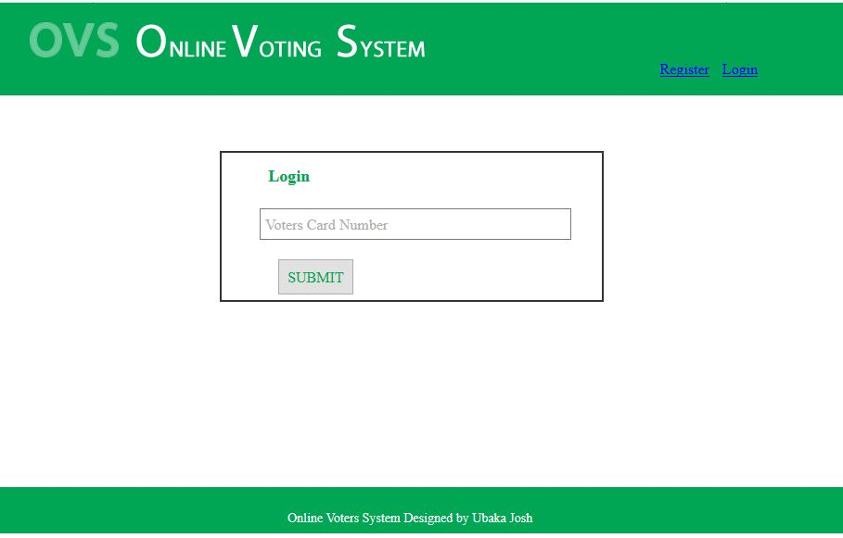
Figure 4.1: Screen shot of the login page.
This is where a new user/voter starts; the individual is required to provide a voters card serial number. When this is provided, the system validates the user if the entered information tallies with what is in the database. He/she is then logged in otherwise the voter/user isn’t logged in.

4.1.2 THE VOTER REGISTRATION FORM
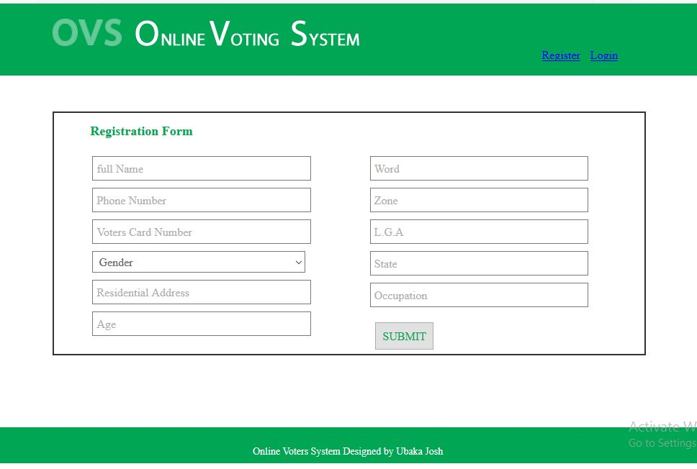
Figure 2: Screen shot of voters registration form.
This form can be accessed by the user (voters) and the administrator. This is because the administrator may not really have the time to start registering all the voters and also voters who may not have the chance to be registered by the admin can register on their own at home. So the link is made available for the admin and ordinary users.
4.2 IMPLEMENTATION ARCHITECTURE.
Here, the components of the software and their various linkages are shown in a block diagram

BEGIN

LOAD HOME PAGE

ADMIN LOGIN
VOTER’S LOGIN

DISPLAYS ADMIN PAGE
ENTER CREDENTIALS

DISPLAY CANDIDATES
PARTY REGISTRATION
VOTER REGISTRATION
REPORT GENERATION
ACCESS CONRTOL
VIEW SCORE BOARD

ENTER VOTER’S INFORMATION
VOTE
DISPLAY VOTE RESULT
CREATES NEW USER
ENTER PARTY INFORMATION
DISPLAY VOTER’S & PARTY INFORMATION
SAVE VOTE TO DATABASE
SAVE RECORD TO DATABASE
LOG OUT
SAVE RECORD TO DATABASE
SAVE RECORD TO DATABASE
INCREMENT

Figure 3: A block diagram showing the components of the software and their various linkages.
4.3 SOFTWARE TESTING
In the process of developing this software, the researcher made a lot of testing to make sure that all the syntax errors were eliminated in the software.
4.3.1 INPUT SPECIFICATION
This includes the information requirements for users or voters as they register and vote for a candidate of their choice. This page requests the user/voter to enter the necessary information provided on the page.
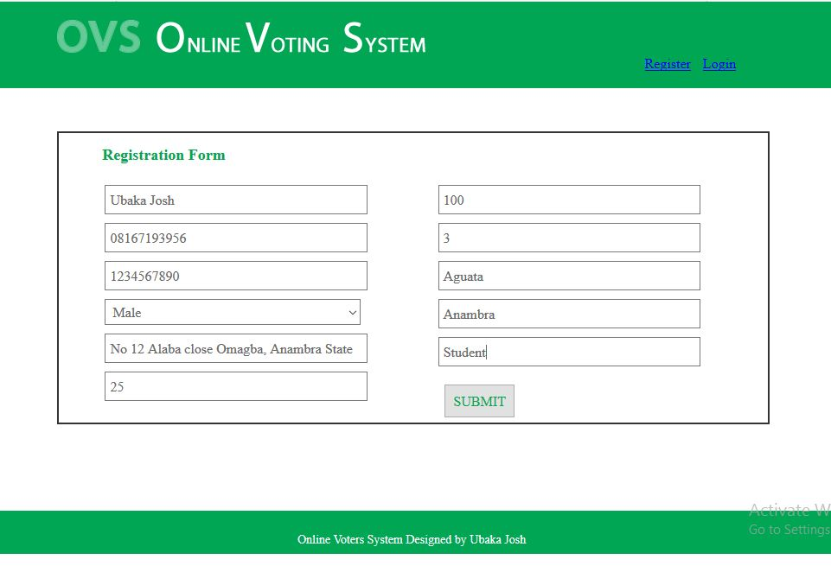
Figure 1: Screen shot of the input form requesting the user to enter the necessary information.

Once the voter provides this requirements and then click on the submit button, the system will now send it to database.
4.3.2 OUTPUT SPECIFICATION
The output specification contains basic output information after all necessary information has been supplied by a voter.
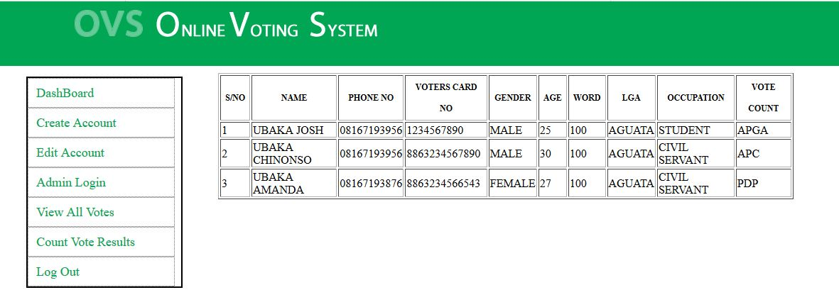 Figure 2: Screenshot of the registered voters.

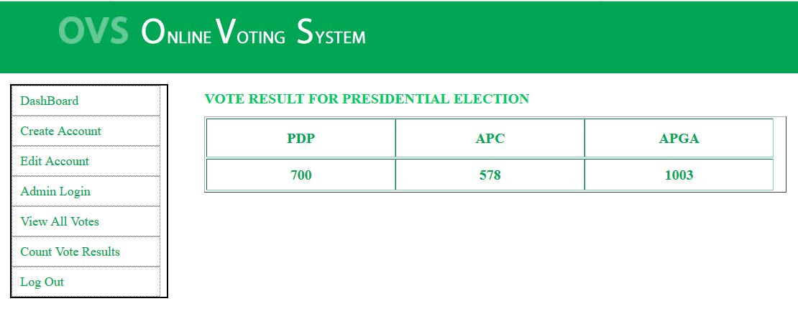
Figure 3: Screenshot of the votes casted result.

4.4 DOCUMENTATION
As said earlier, that this system was built with basic HTML codes, PHP, CSS and MySQL language, it is an open source program that enables changes to be done in future.
HTML: This is an acronym for Hyper Text Makeup Language; it is a language for describing the web pages. Html form elements are elements that allow the user to enter information (like text fields, text area fields, drop-down menus etc.) in a form
CSS: This is the acronym for cascading style sheets, these codes are used to style html elements, when html codes are written and viewed on a web browser, it doesn’t really appear in a beautiful format, so we used CSS to style the html codes.
PHP: Hypertext preprocessor is widely used scripting language that was originally designed for web development, to produce dynamic web pages. These codes can be embedded into html codes.
MySQL: This is my serial query language; it uses a standard form of well-known SQL data language. Different data types were used in this project. It was used aligns side with PHP to create forms used in the software.
The developed system is packaged in a CD drive in a directory named on-line voting system. To execute the program, open notepad by clicking on the start button on the task bar and then close program from the pop-up menu, select Accessories and click on Notepad. Open the file from the CD drive and include a HTML extension to the file name. Then click on the Internet explorer icon to view the page.
4.4.1 USER MANUAL
STEPS
    - Boot the system to windows
    - Open a notepad
    - Open the CD
    - Select the file-name
    - Click open
    - Click on file name
    - Click on save as
    - Add.HTML extension to the file name i.e. on-line .HTML
    - Click on save
    - Double click on the Internet explorer or any other browser icon with the filename
    - The page will be open.

The application has the following menu commands for the admin:
- Create Account: On clicking on this icon, it displays a form for the voter to be registered.
- Edit Count: Clicking on this button enables the admin to view the details of the registered sub-admins and also view the details of the party’s registered.
- Register Parties: This menu enables the admin to register the different parties for that particular election.
- Login: This enables the admin have access to the dashboard.
- View all voters: On clicking displays the list of all the people that registered and eligible to cast vote.
- Count votes: this menu gives the results of the votes, the party that win and the party that lost.
- Insert Card number: This menu enables the admin to insert ID card numbers that are valid for registration.
The application has just two menu commands for the user
- Voter’s Register: On clicking on this icon, it displays a form for the voter to be registered with the necessary information required.
- Login: Here, the voter can now login to access the page to cast for his/her vote.

4.4.2 SOURCE CODE LISTING
The source code of this designed system is attached in the appendix.
CHAPTER FIVE
SUMMARY AND CONCLUSION

5.0 SUMMARY
This Online Voting system will manage the Voter’s information by which voter can login and use his voting rights. The system will incorporate all features of voting system. It provides the tools for maintaining voter’s vote to every party and it count total number of votes of every party. There is a DATABASE which is maintained by the electoral commission in which all the names of voter with complete information is stored.

  - CONCLUSION
The main aspect behind online voting system is that it enabled us to bring out the new ideas that were sustained within us for many days. This project offers the voters to cast his/her easily through internet. Vote counting is also made easy by this system since it’s just a matter of querying the database. Developing a good system is critical to the success of the system to prevent system failures and to gain wide acceptance as the best method available. A good online voting system requires the following characteristics: Accuracy, Privacy, Social Acceptance, Reliability, Mobility, Convenience
In analyzing, designing, implementing, and maintaining standards, we considered these characteristics as the foundation. These standards were made national. This system will be an inexpensive, and less time consuming method once a system exhibiting national standards and the above mentioned characteristics is implemented.

5.2 RECOMNEDATION
After my research and my finalization of this project, I highly recommend that the online voting system serves to be the best to be put in use especially in the 21st century where human beings are embracing new technologies and where there is malicious struggle for power by leaders all over the world. This struggle for power has resulted in the use of all approaches by the leaders in power to remain in their positions at whatever costs even if it means applying vote rigging to win elections. With this system in place, a number of such problems shall be forgotten. Though the system will be costly especially in terms of personal computer and equipment, but I strongly believe that these costs will be offset if the new system is properly implemented based on the further improvement and working towards 100% taking into consideration the peculiar features of the Internet which is a valuable tool and the long-term benefits of the World Wide Web.
I therefore recommend that this system should be put in place so as to embrace the new technology to phase out some of the problems they go through during manual voting.

