CHAPTER ONE
1.0 INTRODUCTION
Fish has been one of the main foods for humans for many centuries and still constitute an important part of the diet in many countries (Leisneret al., 1995). In Nigeria, the short supplies of animal protein together with the increasing human population have raised the cost of animal protein to a level almost beyond the reach of the low income group (Ezeriet al.,2001). As a result, there is a considerable increase in the demand for fish being thecheapest source of animal protein. (Ladipoetal., 1981). The advantages of fish as a food are its easy digestibility and high nutritional value (Leisneret al., 1995). These important attributes make the commodity readily susceptible to microbial attack particularly bacteria (Adams et al., 1999). Fish flesh naturally contains very low levels of carbohydrates and these are further depleted during the death struggle of the fish (Adams et al., 1999). This has two important consequences for spoilage. Firstly, it limits degree of post mortem acidification of the tissue so that the ultimate pH of the muscles is 6.2-6.5 (Adamsetal., 1999).Disease breaks out in fish tank very quickly and you have to first identity the type of disease before you can take action.
The bacteria are transmitted by fish that have made contact with other diseased fish. Bacterialfish disease and infections are very common and are one of mostdifficult health problems toDeal with (Douglas et al., 2007). Bacteria can enter the fish body through the gills or skin or it can stay on the body surface of the fish (Douglas et al, 2007). There are four types of bacterial infections. Bacterial gill disease: The gills are the primary target Systemic bacterial disease: bacteria invades the fish’s body and damages internal organs, bacterial body ulcers: Lesions on the fish body that can be shallow or deep and fin rot: Most likely resulting from environmental stress. (Douglass et al., 2007). Secondly, the absence of carbohydrate means that bacteria present on the fish will immediately resort to using the soluble pool of readily assimilated nitrogenous material, producing off-odor. (Adams et al., 1999) Shell fish such as Tilapia have a particular large pool of nitrogenous extractives and are even more prone to raid spoilage, a factor which accounts for the common practice of keeping them alive until immediately prior to consumption (Adams et al., 1999). The speed with which a product spoils is also related to the initial microbial load on the product: the higher the count, the sooner spoilage occurs (Adams etal., 1999). The fresh water or rivers and lakes have a complex flora of microorganisms which include genuinely aquatic species as well as component introduced from terrestrial, animal and plant sources. (Adams et al., 1999). The scale of human activities has had a detrimental effect on coastal waters. Many shell fishes used for food out particles from large volume of waters. If these waters have been contaminated with sewage, there is always the risk that enteroorganisms from infected individuals may be present and will be concentrated by the filterfeeding activities of shell fish (Adams et al.,1999). Also during handling of the commodity,the natural flora of the environment may becontaminated with organisms associated withman such as members of the enterobacteriaceaeand Staphylococcus aureuswhich can grow wellat 30-37oc (Micealet al., 2007). By monitoring the bacteria contents of fish organs, the quality of fish can be measured since these will affect the storage life and quality of the fishery products (Kaneko et al., 1971). In order to provide a predictive capability for possible disease outbreaks and provide an opportunity to design preventive management actions, detailed information of the bacterial load and types of bacteria associated with the organs of apparently healthy Tilapia fish is needed.
AIM
To determine the bacterial microflora of fresh water fish (Tilapia).
OBJECTIVES
- To determine the type of microorganism in the gill, skin and intestine.
- To determine the type of micro algae found in the pond.

CHAPTER TWO
LITERATURE REVIEW
Tilapia is the generic name of a group of cichlids endemic to Africa. The group consists of three aquaculturally important genera Oreochromis and Sarotherodon. Several characteristics distinguish these three genera, but possibly the most critical relates to reproductive behavior. All tilapia species are nest builders; fertilized eggs are guarded in the nest by a brood parent. Species of both Sarotherodon and Oreochromis are mouth brooders; eggs are fertilized in the nest but parents immediately pick up the eggs in their mouths and hold them through incubation and for several days after hatching. In Oreochromis species only females practice mouth brooding, while in Sarotherodon species either the male or both male and female are mouth brooders.
During the last half century fish farmers throughout the tropical and semi-tropical world have begun farming tilapia. Today, all commercially important tilapia outside of Africa belong to the genus Oreochromis, and more than 90 percent of all commercially farmed tilapia outside of Africa are Nile tilapia. Less commonly farmed species are Blue tilapia (O. aureus), Mozambique tilapia (O. Mossambicus) and the Zanzibar tilapia (O. urolepishornorum). The scientific names of tilapia species have been revised a lot in the last 30 years, creating some confusion. The scientific name of the Nile tilapia has been given as Tilapia nilotica, Sarotherodonniloticus, and currently as Oreochromisniloticus.

2.1.1 Physical characteristics
Tilapia are shaped much like sunfish or crappie but can be easily identified by an interrupted lateral line characteristic of the Cichlid family of fishes. They are laterally compressed and deep-bodied with long dorsal fins. The forward portion of the dorsal fin is heavily spined. Spines are also found in the pelvis and anal fins. There are usually wide vertical bars down the sides of fry, fingerlings, and sometimes adults.
2.1.2 Banding Patterns and Coloration
The main cultured species of tilapia usually can be distinguished by different banding patterns on the caudal fin. Nile tilapia have strong vertical bands, Blue tilapia have interrupted bands, and Mozambique tilapia have weak or no bands on the caudal fin. Male Mozambique tilapia also have upturned snouts. Color patterns on the body and fins also may distinguish species. Mature male Nile tilapia have gray or pink pigmentation in the throat region, while Mozambique tilapia have a more yellow coloration. However, coloration is often an unreliable method of distinguishing tilapia species because environment, state of sexual maturity, and food source greatly influence color intensity.
The red tilapia has become increasingly popular because its similar appearance to the marine red snapper gives it higher market value. The original red tilapias were genetic mutants. The first red tilapia, produced in Taiwan in the late 1960s, was a cross between a mutant reddish- orange female Mozambique tilapia and a normal male Nile tilapia. It was called the Taiwanese red tilapia. Another red strain of tilapia was developed in Florida in the 1970s by crossing a normal colored female Zanzibar tilapia with a red-gold Mozambique tilapia.
A third strain of red tilapia was developed in Israel from a mutant pink Nile tilapia crossed with wild Blue tilapia. All three original strains have been crossed with other red tilapia of unreported origin or with wild Oreochromis species. Consequently, most red tilapia in the Americas are mosaics of uncertain origin. The confused and rapidly changing genetic composition of red tilapia, as well as the lack of head-to-head growth comparisons between the different lines, make it difficult for a producer to identify a best red strain. Other strains of tilapia selected for color include true breeding gold and yellow Mozambique lines and a Rocky Mountain white tilapia (a true breeding line originating from an aberrant Blue tilapia, subsequently crossed with Nile tilapia). Most strains selected for color do not grow well enough for food fish culture.
Identifying the species of an individual fish is further complicated by natural crossbreeding that has occurred between species. Electrophoresis is often used to determine the species composition of a group of tilapia.
Tilapia require the same ten essential amino acids as other warmwater fish, and, as far as has been investigated, the requirements for each amino acid are similar to those of other fish. Protein requirements for maximum growth are a function of protein quality and fish size and have been reported as high as 50 percent of the diet for small fingerlings. However, in commercial foodfish ponds the crude protein content of feeds is usually 26 to 30 percent, one tenth or less of which is of animal origin. The protein content and proportion of animal protein may be slightly higher in recirculating and flow-through systems.
The digestible energy requirements for economically optimum growth are similar to those for catfish and have been estimated at 8.2 to 9.4 kcal DE (digestible energy) per gram of dietary protein. Tilapia may have a dietary requirement for fatty acids of the linoleic (n-6) family. Tilapia appear to have similar vitamin requirements as other warmwater fish species. Vitamin and mineral premixes similar to those added to catfish diets are usually incorporated in commercial tilapia feeds. The feeding behavior of tilapia allows them to use a mash (unpolluted feeds) more efficiently than do catfish or trout, but most commercial tilapia feeds are pelletized to reduce nutrient loss. In the absence of feeds specifically prepared for tilapia, a commercial catfish feed with a crude protein content of 28 to 32 percent is appropriate in the United States.
Environmental requirements
Tilapia are more tolerant than most commonly farmed freshwater fish to high salinity, high water temperature, low dissolved oxygen, and high ammonia concentrations.
Salinity
All tilapias are tolerant to brackish water. The Nile tilapia is the least saline tolerant of the commercially important species, but grows well at salinities up to 15 ppt. The Blue tilapia grows well in brackish water up to 20 ppt salinity, and the Mozambique tilapia grows well at salinities near or at full strength seawater. Therefore, the Mozambique tilapia and some Mosambiquederived red tilapia are preferred for saltwater culture. Some lines of the Mozambique tilapia reportedly have spawned in full strength seawater, but its reproductive performance begins to decline at salinities above 10 to 15 ppt. The Blue and Nile tilapias can reproduce in salinities up to 10 to 15 ppt, but perform better at salinities below 5 ppt. Fry numbers decline substantially at 10 ppt salinity.

Water temperature
The intolerance of tilapia to low temperatures is a serious constraint for commercial culture in temperate regions. The lower lethal temperature for most species is 50 to 52 o F for a few days, but the Blue tilapia tolerates temperatures to about 48 o F.
Tilapia generally stop feeding when water temperature falls below 63 o F. Disease-induced mortality after handling seriously constrains sampling, harvest and transport below 65 o F. Reproduction is best at water temperatures higher than 80 o F and does not occur below 68 o F. In subtropical regions with a cool season, the number of fry produced will decrease when daily water temperature averages less than 75 o F. After 16 to 20day spawning cycles with 1/2-pound Nile tilapia, fry recovery was about 600 fry per female brooder at a water temperature of 82 o F, but only 250 fry per female at 75ºF. Optimal water temperature for tilapia growth is about 85 to 88ºF. Growth at this optimal temperature is typically three times greater than at 72ºF.
Dissolved oxygen concentration
Tilapia survive routine dawn dissolved oxygen (DO) concentrations of less than 0.3 mg/L, considerably below the tolerance limits for most other cultured fish. In research studies Nile tilapia grew better when aerators were used to prevent morning DO concentrations from falling below 0.7 to 0.8 mg/L (compared with unaerated control ponds). Growth was not further improved if additional aeration kept DO concentrations above 2.0 to 2.5 mg/L. Although tilapia can survive acute low DO concentrations for several hours, tilapia ponds should be managed to maintain DO concentrations above 1 mg/L. Metabolism, growth and, possibly, disease resistance are depressed when DO falls below this level for prolonged periods.
pH
In general, tilapia can survive in pH ranging from 5 to 10 but do best in a pH range of 6 to 9.
Ammonia
Massive mortality of tilapia occurs within a few days when fish are suddenly transferred to water with unionized ammonia concentrations greater than 2 mg/L. However, when gradually acclimated to sublethal levels, approximately half the fish will survive 3 or 4 days at unionized ammonia concentrations as high as 3 mg/L. Prolonged exposure (several weeks) to un-ionized ammonia concentration greater than 1 mg/L causes losses, especially among fry and juveniles in water with low DO concentration. The first mortalities from prolonged exposure may begin at concentrations as low as 0.2 mg/L. Un-ionized ammonia begins to depress food consumption at concentrations as low as 0.08 mg/L.

Nitrite
Nitrite is toxic to many fish because it makes the hemoglobin less capable of transporting oxygen; chloride ions reduce the toxicity. Tilapia are more tolerant of nitrite than many cultured freshwater fish. When dissolved oxygen concentration was high (6 mg/L) and chloride concentration was low (22 mg/L), the nitrite concentration at which 50 percent of the fish died in 4 days was 89 mg/L as nitrite. In general, for freshwater culture the nitrite concentration should be kept below 27 mg/L as nitrite. As a safeguard against nitrite toxicity in recirculating systems, chloride concentrations are often maintained at 100 to 150 mg/L chloride.
Diseases
Tilapia are more resistant to viral, bacterial and parasitic diseases than other commonly cultured fish, especially at optimum temperatures for growth. Lymphocystis, columnaris, whirling disease, and hemorrhagic septicemia may cause high mortality, but these problems occur most frequently at water temperatures below 68 o F, caused by the protozoan Ichthyopthiriusmultifiliis, can cause serious losses of fry and juveniles in intensive recirculating systems. External protozoans such as Trichodina and Epistylis also may reach epidemic densities on stressed fry in intensive culture. In recent years the bacterial infection Steptococcusspp has caused heavy losses, primarily in recirculating and intensive flow-through systems.
Fish surface contamination
Since fish is a food with high nutritional value with Ph close to neutral and high water activity, it is very susceptible to spoilage. Besides its autochthonous microbiota, located mainly in the intestines, gills, and surface mucus, they may also be contaminated by spoilage and pathogenic bacteria coming not only from
the aquatic environment, but also from inappropriate processing and storage (Ghaly et al., (2010), (Mol et al., (2011). Poor hygienization processes of surfaces that make contact with fish during all production stages are also acrucial factor for the quality of the final product (Kusumaningrum et al., 2003); (Temelli et al., (2006); Mol
et al.,(2011). Dirt particles and microorganisms that fail to be removed by correct hygienization procedures may start adhesion processes and lead to the formation of biofilms (Andrade et al., (2008); Salustiano et al., (2010). Microorganism contamination of equipment and utensils is a risk factor in the food industry, therefore the choice of material they are made of must be based on their mechanical and anti-corrosive properties and on the ease of hygienization (Silva et al., (2003),(Fuster-Valls et al., (2008). Some studies have reported high incidence of
microorganisms in equipment and utensils in foodprocessing areas caused by failures in employing correct hygienization techniques, which results in serious public health or economic issues (Temelli et al., (2006),(Oliveira et al., 2008, Kahraman et al., 2010). The Brazilian legislation does not set microbiological parameters for surfaces of equipment and utensils used in food processing, as well as for the handlers’ hands. The standards of the American Public Health Association (APHA) consider equipment and utensils clean if they have less than 2 log CFU/utensil or 0.3 log CFU/cm (Evancho et al., (2001).
However, developing countries have difficulties in adapting industries to the American standards, so the Pan American Health Organization (PAHO) recommends counts up to 1.7 log CFU/cm2 or 2 log CFU/utensil for aerobic mesophiles and absence of thermotolerantcoliforms mainly due to the ambient temperatures in these countries (Cardoso et al., 2011). Another factor that must also be taken into account in the food production chain is the handlers, who must be trained in Good Manufacturing Practices (GMPs) and have adequate personal hygiene (Brasil, 2009). Otherwise, they may carry pathogens, which is often reported as the cause of foodborne diseases (Rosas et al., (2008),(Dias et al., (2012). Andrade (2008) set two count ranges that could serve as a guideline to define hygienic-sanitary hand conditions: range 1 (up to 3 log) and range 2 (between 3 and 4 log), expressed as CFU/hand for aerobic mesophiles and total coliforms.
Surface cleaning and disinfection procedures, despite being essential for good quality and safe foods, are often not a priority. Not always is the cost-benefit relation of these practices acknowledged since their results are not easily measured in terms of economic gains (Aarnisalo et al., 2006).
Micro algae found in fish pond
Algal toxins can cause problems in the pond water aquaculture of both vertebrates (fish) and invertebrates (shellfish). Such problems include:
- off-flavor (Tucker et al., (2000),
- indirect toxicity through changes in water quality,
- direct toxicity.
Algal toxins are organic molecules produced by a variety of algae in marine, pond and fresh waters, as well as on wet soils (Falconer et al., (1993). They are a problem in aquaculture when they are produced in sufficient quantities, with sufficient potency, to kill cultured organisms, decrease feeding and growth rates, cause food safety issues, or adversely affect the quality of the product (Shumway et al.,(1990).
Algal blooms
The production of algal toxins is normally associated with algal blooms, or the rapid growth and exceptionally dense accumulation of algae. The term Harmful Algal Bloom (HAB) is used to describe a proliferation of algae, or phytoplankton. Severe blooms of even non-toxic algae can spell disaster for marine life which iclude fresh water and pond, because blooms deplete the oxygen in the shallow waters of many aquaculture systems. The number of HABs aroundthe world is increasing (Sunda et al., 2006), especially where almost every coastal state is now threatened, in some cases by more than one species of harmful algae. Scientists are unsure why this trend is occurring. The causes may be natural (species dispersal) or humanrelated (nutrient enrichment, climate change, and/or transport of algae in ship ballast water) (Johnk, et al. 2008),(Sunda et al., 2006). The effects of algal bloomsvary widely. Some algae are toxic only at veryhigh densities, while others can be toxic at very low densities (a few cells per liter). Some blooms discolor the water (thus the terms “red tide” and “brown tide”), while others are almost undetectable with casual observation (Shumway, 1990).
HABs can affect public health and ecosystems when:
• filter-feeding shellfish (clams, mussels, oysters, scallops) feed on toxic phytoplankton and accumulate harmful toxins that are passed up the food chain;
•fish, shellfish, birds and even mammals are killed by eating organisms that have consumed algal toxins;
• light cannot penetrate the water,thus changing the function and structure of the aquatic ecosystem;
• discoloration makes water aesthetically unpleasant
• the decaying biomass of a bloom depletes dissolved oxygen (especially critical in aquaculture); or
• blooms kill other algae important in the food web (Codd et al., 2005); (Landsburg et al.,(2002). HABs can cause serious economic losses in aquaculture if they kill cultured organisms or cause consumers concern about food safety.
HABs can cause serious economic losses in aquaculture if they kill cultured organisms or cause consumers concern about food safety.Toxin-producing algae may become more prevalent in the future (Sunda et al., (2006); Johnk et al., (2008), especially in eutrophic freshwater systems.This publication focuses on algal toxins in freshwater pond aquaculture. The most common toxin-producing algae in this topic are cyanobacteria,golden algae (Prymnesiumparvum) and euglenoids.

Cyanobacteria:the blue-green algae
Cyanobacteria (blue-green algae) inhabit fresh, brackish, marine and hypersaline waters, as well as terrestrial environments. Cyanobacteria grow inmany habitats from thermal springs to the arctic. They play important roles in biogeochemical cycle of elements and in the structure, function and biodiversity of aquatic
communities (from microbes through vertebrates). Some cyanobacteria can reduce both N2 and CO2. Some canconvert N2 into NH3 and, ultimately, into amino acids and proteins.Cyanobacteria have a relativelysimple prokaryotic structure and lack membrane-bound organelles (nucleus, mitochondria and chloroplasts). With
murien in the cell wall and reproduction by binary fission, cyanobacteria are structurally and physiologically like other gram-negative bacteria, but they conduct photosynthesis like plants in aquatic systems. Cyanobacteria are much larger than other bacteria and make a major contribution to world photosynthesis and nitrogen
fixation (Codd et al., 2005) ( Huisman et al., 2005) and (Hudnell et al., (2008) Cyanobacteria occur in unicellular, colonial and filamentous forms and most are enclosed in a mucilagenous sheath, either individually or in colonies. As single cells, large colonies and filaments (trichomes), blue-green algae can become the dominant algae in nutrient-rich waters. They can form blooms so thick it appears that blue-green paint covers the surface ofthe water. Several species found in the South and Southeast produce substances that cause taste and odor problems in
water supplies and aquacultural products (Tucker et al., 2000). Some blue-green algae, particularly Anabaena and Microcystis, produce toxins poisonous to fish and to wildlife and livestock that drink contaminated water. There are
also documented cases of blue-green algal toxins harming people in other parts of the world who drank poorly treated water.
Problems with cyanobacteria in aquaculture ponds
Cyanobacteria can rapidly overtake an aquaculture pond and contribute to unstable conditions. Cyanobacteriablooms can decrease fish production and kill fish because of oxygen depletion. Cyanobacteria can also cause off-flavor andobjectionable odor in fish. However, the role of cyanobacteriaand cyanotoxins in fish kills and other problems is not clear at this time. There are more than 1 million fish ponds in the Southeast and many of them have relatively frequent blooms of cyanobacteria that may produce toxins (e.g., Microcystis, Anabaena, etc.). Yet there are only a few reportsof fish kills that are directly related to algal toxin production (Zimba et al., 2001). So the mere presence of toxin-producing algae does not necessarily mean that enough toxin will be produced to harm fish in culture.

Prymnesiophytes: the golden-brown algae
The haptophyte genus Prymnesiumis comprised mainly of toxin-producing species that form harmful blooms usually in brackish water (West et al., 2006). Blooms of P. parvumhave been responsible for fish kills and significant economic losses in Europe, North America and other continents. Texas has been hit with recurrent blooms in several reservoirs and rivers and Texas Parks and Wildlife has offered some detailed advice regarding management options (Sager et al., 2007).Prymnesiumparvumis commonly called the “golden” alga. It is considered to be a haptophyteprotist (Green and Leadbetter, 1994). It is a relative small (~10 µm), generally halophilic organism that intermittently produces an ichthyotoxin. This organism has been implicated in numerous extensive fish kills in brackish waters andinlandwaterswith relatively high mineral content on five continents (Lindholmet al., 1999). P. parvumcells contain chlorophylls a and c as well as yellow-brown accessory pigments and are capable of photosynthesis. However, the organism is thought to be a mixotroph that can feed on bacteria and protists(Skovgaard et al., 2003) and phagotrophy has been observed in cultures. P.parvumhas a vitamin requirement in laboratory culture (Droop, 2006).
Euglenoids
Since 1991, several outbreaks of toxic Euglena have occurred in North Carolina hybrid striped bass (Moronesaxatilisx M. chrysops) production ponds, causing the loss of more than 20,000 pounds of fish. Relatively recent research has confirmed that Euglena species produce an ichthyotoxin in freshwater aquaculture (Zimba et al., 2004). The hybrid striped bass mortalities in North Carolina were caused by E. sanguinea, a widely distributed species in many shallow, relatively calm, eutrophic freshwater systems. Thisspecies also killed laboratory-reared channel catfish, tilapia (Oreochromisniloticus) and striped bass. In confirmatory studies, Zimba et al. (2004) noted that cultures of Euglena granulata(UTEX LB2345) caused similar mortalities and symptoms in channel catfish and sheepshead minnows (Cyprinodonvariegatus).

Reviews
(Austin et al., (2002) from Heriot-watt University, Scotland discussed about the bacterial microflora of fish.with results of the other numerous studies indicates that fish possess bacterial populations on or in their skin, gills, digestive tract, and light-emitting organs. In addition, the internal organs (kidney, liver, and spleen) of healthy fish may contain bacteria, but there is debate on whether or not muscle is actually sterile. The numbers and taxonomic composition of the bacterial populations often reflect those of the surrounding water. The role of the bacteria includes the ability to degrade complex molecule (therefore exercising a potential benefit in nutrition), to produce vitamins and polymers, and to be responsible for the emission of light by the light-emitting organs of deep-sea fish. Taxa, including Pseudomonasmaycontribute to spoilage by the production of histamines in fish tissue.(Shinkafi et al.,2010) from a research on bacteria micro flora associated with fresh Tilapia fish(Oreochromisniloticus) sold at Sokoto central market, Sokoto. Nigeria.

CHAPTER THREE
MATERIALS AND METHODS
MATERIALS
- Autoclave
- Nutrient Agar
- Burnsen burner
- Sterile scissors
- Mortal and pistol
- Fish sample
- Distilled water
- Petri dish
- Sterile wireloop
- Weighing balance
- Sterile container
- Ethanol
- Cotton wool
- Microscope
- Bijou bottles
- Test tubes
- Methyl-red
- Crystal violet
- Lugos iodine
- Acetone
- Hydrogen peroxide
- Benedict’s solution
- Fehlingssolutiom
- Kovac’s reagent
- Phenol red
- Alpha naphtol, 5%
- Absolute ethanol

Sample collection: Five different samples of Tilapia fish were collected from different pond locations in Enugu. Each fish sample was especially put into sterile polythene bag and taken to the microbiology laboratory of Godfrey Okoye University, Enugu for analysis.
Preparation of stock cultures: Section of the gills, skin and intestine of ten (5) randomly selected fish were especially removed by means of a sterile scalpel and pair of scissors and kept in sterile Petri dishes. 4g each of these sections was pounded with mortar and pestle. Homogenization was carried out is to obtain uniform distribution of cells through stock culture.
Enumeration, isolation and identification of Bacteria: Two serial dilutions of the original stock culture from the gills, skin and intestine were prepared. Each dilution was plated on solidified freshly prepared nutrient agar and spread using a sterile glass rod and incubated at 37oc for 24 hours after which the colonies that developed on the plates were counted. Those counts within 30-300 colony forming units (CFU) were reported as total viable count (TVC).Distinct colonies from each plate were then picked by means of a sterile wire loop and subcultured onto a freshly prepared nutrient agar medium contained in sterile plates. This wasdone with a view to obtaining pure culture of the growth. The plates were incubated at 37oc for 24 hours.
Characterization of the pure isolates was performed and involved colonial characteristics, cell micro morphology, motility test and biochemical test of gram reaction,catalasetest,citrate test, motility test, indoletest,methyl red test, vogespraskaure test and coagulase test. These tests were done to identify isolates to generic level as contained in (Chessbrough et al., 2000).

GRAM STAINING
- Place slide with heat fixed smear on staining tray.
- Gently flood smear with crysatlviolet and let stand for 1 minute.
- Tilt the slide slightly and gently rinse with tap water or distilled water using a wash bottle.
- Gently flood the smear with gram’s iodine and let stand for 1 minute.
- Tilt the slide slightly and gently rinse with tap water or distilled water using a wash bottle. The smear will appear as a purple circle on the slide.
- Decolourize using 95% ethyl alcohol or acetone. Tilt the slide slightly and apply the alcohol drop by drop for 5-10 seconds untill the alcohol runs almost clear. Be careful not to over- decolourize.
- Immediately rinse with water.
- Gently flood with safranin to counter-stain and let stand for 45 seconds.
- Tilt the slide slightly and gently rinse with tap water or ditilled water using a wash bottle.
- Blot dry the slide with paper.
- View the smear using light microscope under oil immersion.

CATALASE TEST
- Transfer a small amount of bacterial colony to a surface of clean dry glass slide using a loop or sterile wood stick.
- Place a drop of 3% H₂O₂ on to the slide and mix.
- Positive :Evolution of oxygen (within 5-10seconds) as evidenced by bubbling.
- Negative :No bubbles or a few scattered bubbles.

COAGULASE
- Place a drop of normal saline on each end of a slide or on two or on two separate slides.
- With the loop, emulsify a portion of the isolated colony in each drop to make two thick suspensions.
- Add a drop of human or rabbit plasma to one of the suspensions and mix gently.
- Look for clumping of the organisms within 10 seconds.
- No plasma is addded is to the second suspension to differenciate any granular apperance of the organism from true coagulase clumping.

CITRATE TEST
- Innoculatesimmons citrate agar lightly on the slant by touching the top of a needle to a colony that is 18 to 24 hours old.
- Incubate at 35⁰c to 37⁰c for 18 to 24 hours. Some organisms may require up to 7 days of incubation due to their limited rate of growth on citrate medium.
- Observe the development of blue colour denoting alkalinization.
- Postive :colour change (prussian blue).
- Negative : no colour change.
INDOLE TEST
- Take a sterilized test tubes containing 4ml of tryptophan broth.
- Innoculate the tube aseptically by taking the growth from 18 to 24 hours culture.
- Incubate the tube at 37⁰c for 24 to 28 hours.
- Add 0.5 ml of kovac’s reagent to the broth culture.
- Observe for the presence or absence of ring.
- Positive : Formation of pink or red colour (cherry-red ring).
- Negative : No colour change.

VOGES PRAUSKEUR TEST
- Innoculate the test organism into the vp medium.
- Incubate aerobically at 37⁰c for 24 hours.
- Following 24 hour of incubation, aliquot 2ml of the broth to a clean test tube.
- Reincubate the remaining broth for an addittional 24 hours.
- Add 6 drops of 5% alpha naphtol and mix well to aerate.
- Add 2 drops of 40% KOH, and mix well to aerate.
- Postive : Pink-red colouration surface within 30minutes (shake the tube vigorously during the 30 minute period).
- Negative : No colour change.

METHYL-RED TEST
- Innoculate two test tubes contatining VP-MR broth with a pure culture of the organism under investigation.
- Incubate at 35ºc for 4 days.
- Add 5 drops of MR indicate solution to the first tube (for VP test Barrit’s reagent to another tube).
- Postive : Red colouration.
- Negative : No colour change.
CHAPTER FOUR
RESULTS
From the table obtained in table 1 shows the results of the total viable count of bacterial isolates from the gills, skin and intestine of five sampled tilapia fish. The fishes were within a year before they were harvested.

Table 1: Total viable counts of bacteria in cfu/g of tilapia fish sampled from Enugu.
S/n | Fish parts | Total counts
1 | Gills | 20.3x 10⁷
2 | Intestines | 40.1 x10⁸
3 | Skins | 27.1 x10⁸

The mean total viable count shows that gills had 20.3 x 10⁷ while intestines and skin had 40.1 x 10⁸ and 27.1 x10⁸ respectively. Also from the table it also showed that gills had the lowest number of bacterial count while the intestine had the highest.

Table 2: Frequency of bacterial occurance
Isolates | Number of isolates | Frequency of occurance(%)
Salmonella spp | 2 | 4
Escherichia coli | 5 | 10
Staphylococcuaureus | 4 | 8
Micrococcus spp | 3 | 6
Bacillus spp | 3 | 6
Lactobacillus spp | 4 | 8
Enterobacterspp | 3 | 6
Klebsiellaspp | 4 | 8
Proteus spp | 3 | 6
Total | 31 | 59

Table 2 shows the frequency of occurance of bacterial isolates from the five fish samples. From the table it showed that Salmonella spphad the lowest frequency while Escherichia coli had the highest frequency.

Table 3: Gram reaction and morphology of the bacterial isolates
isolates | Gram reaction | Motility | Shape
Salmonella spp | -ve | Motile | Rod shape
E. coli | -ve | Motile | Rod shape
Listeriaspp | -ve | Motile | Rod shaped
Staph. aureus | +ve | Non motile | Cocci (clusters)
Micrococcus spp | +ve | Non motile | Cocci (pairs)
Bacillus spp | +ve | Motile | Rod shaped
Lactobacillus app | +ve | Non motile | Rod shaped
Enterobacterspp | -ve | Motile | Rod shaped
Klebsiellaspp | -ve | Non motile | Rod shaped
Proteus spp | -ve | Motile | Rod shaped

Table 3 shows the gram reaction, motilty, and cell morphology of the bacterial isolates.

Table 4: Biochemical analysis of the various bacterial isolates.
Catalase | Coagulase | Citrate | Indole | Vp | MR | Possible organism
+ | - | - | - | - | + | Salmonella spp
+ | - | - | + | - | + | E. coli
+ | - | - | - | + | + | Listeriaspp
+ | + | + | - | + | + | Staph. Aureus
+ | - | - | - | + | + | Micrococcus spp
+` | - | - | - | + | + | Bacillus spp
+ | - | - | - | - | - | Lactobacillus spp
+ | - | + | - | + | - | Enterobacterspp
+ | + | - | - | + | - | Klebsiellaspp
+ | - | + | - | - | + | Proteus spp

CHAPTER FIVE
DISCUSSION/ CONCLUSION
The result from this research shows that the Bacterial load varies in the three segments of the fishes analyzed, the skin, gills and intestine. The bacterial load in all sample was high (Gills, skins and ,intestines) and may be attributed to the high ambient temperature in the river where it was caught which is close to optimum for many mesophilic bacteria. Bacterial load in fish might increase with the increase of water temperature (Fernandeset al., ;1997, Hossainet al., 1999). Choudhuryet al., (1989) reported intestinal bacterial load of Tilapia fish as 5.5 x 109 cfug. This count is comparable to the results in this research at similar temperature. The bacterial count on the skin may be attributed to contamination by genuinely aquatic specie as well as those that contaminate the commodity during handling. The gills had the lowest bacterial population compared to the intestine and skin. According to (Trust et al., 1975), the number of bacteria associated with the gills are actively maintained at low level, there by implying that fish probably has mechanism which enables it to keep the bacteria number low, and therefore afford it some degree of protection against bacteria invasion by the gill microflora (Ezerietal., 2001).
Base on the percentage frequency of occurance ,Salmonella spp. Showed the least frequency of occurance of 4%. The presence of Salmonella spp. Indicates faecal contamination of water from which the fishes were harvested. The percentage frequency of occurrence of Bacillus spp6%. The presence of the isolated organism was not surprising since according to Draser et al., (1976) ; Hill et al., (1976), fish lives in water habitat full of microogrganism. Okpokwasili et al., (1990) confirmed that bacteria flora associated with a Nigerian water culture include the genera, Bacillus, Lactobacillus,Staphylococcus, Escherichia, Micrococcus, Proteus etc. Bacillus spp. are implicated in causing a wide range of infectious diseases including abscesses, bacterimia/septicimia, wound and food borneinfections, ear infections, endocarditis, meningitis, ophthalmitis, osteomyelitis peritonitis and respiratory and urinary infections (Morales et al., 2004). Escherichacoli, has been reported to cause lower respiratory tract infections and urinary track infection. Lactobacillus sppiis also implicated in causing travelers diarrhea. Staphylococcusaureushas been demonstrated to cause urinary tract infections (UTIs) in women. Salmonella spp. Has been reported to cause enteritis and systematic disease. (Adams et al., 1999) has demonstrated that fish and fish products are only occasionally associated with Salmonella and that filter feeding shell fish harvested from polluted water have been identified as higher risk products. Listeriamonocytogenesis widespread in the environment and humans can be exposed to the bacteria in various ways, though many persons remain symptomless (Cowan and Steel, 1999). Subpopulation who could develop the disease which sometimes can be life threatening include pregnant women, new born and infant and adults with a compromised immune system (Marth et al., 1988).
Listeriamonocytogenesproduces a series of toxins hemolytic, lipolytic, hemorrhagic and pyrogenic which are involved in the disease process (Schlech et al., 1988). Five forms of Listeriosis can be caused by infections with Listeriamoncytogenes; pregnancy infections, granulomatosisinfantiseptica, sepsis meningoencephalitis and focal infections. The bacterium can also invade the eye and skin cause conjunctivitis and skin lesions (Bahk et al., 1990).
Conclusively, this research has brought to light those bacterial species associated with fresh Tilapia fish and has shown that they are potentially pathogenic to humans. Hence adequate measures should be taken in processing the fish before consumption.

ABSTRACT
The study onbacteria associated with fresh Tilapia fish (Oreochromisniloticus) sold at Enugu market, Enugu. Nigeria. Sections of the skin, gills and intestine of five randomly selected fishes were aseptically removed by means of a sterile scalpel and pair of sterile scissors. Four (4g) each of the sections were homogenized in 6 ml of sterile distilled water, which served as the original stock culture. A serial dilution up to 10² was carried out, and surface plated on nutrient agar. A total of nine (10) bacterial species were isolated and identified. Six (6) were gram negative namely: Salmonella spp, Listeriamonocytogenes, Escherichia coli, Enterobacterspp,klebsiellaaerogenosa and proteussppand four gram positive bacteria namely: Staphylococcus aureus,Micrococcusspp, Bacillus spp and Lactobacillus spp. The frequency of occurrences of the isolated Bacteria indicated that Escherichia coli had the highest frequency of occurrence (10%), while Salmonella spp. had the least occurrence (4%). The mean viable Bacterial count
from each section of the samples revealed 20.3 x10⁷cfug-1 from the gills, 40.1 x 10⁸cfug-1 from the intestine and 27.1 x 10⁸cfug-1 from the skin. The isolates were found to be of medical importance.

APPENDIX
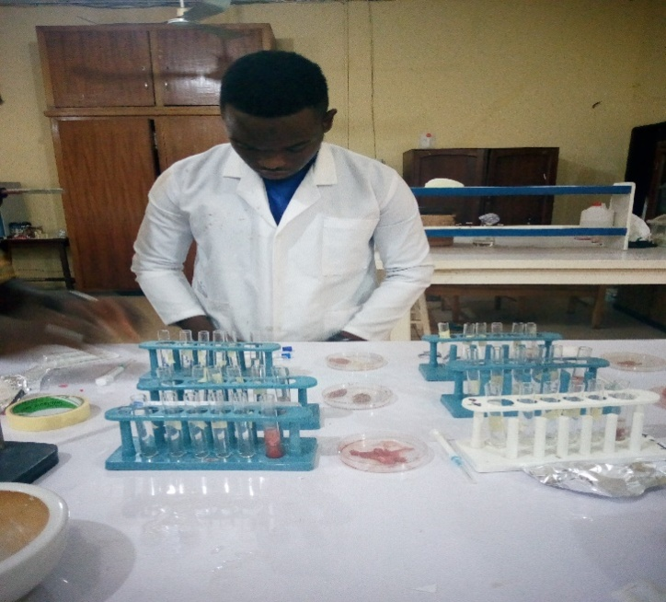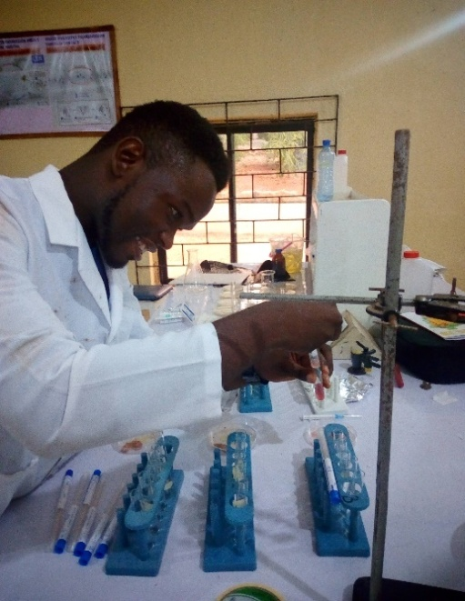

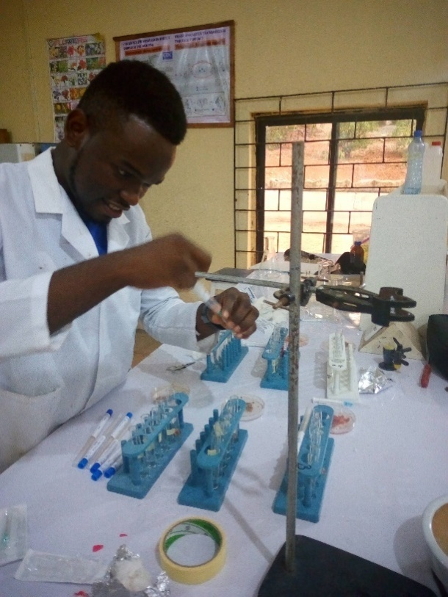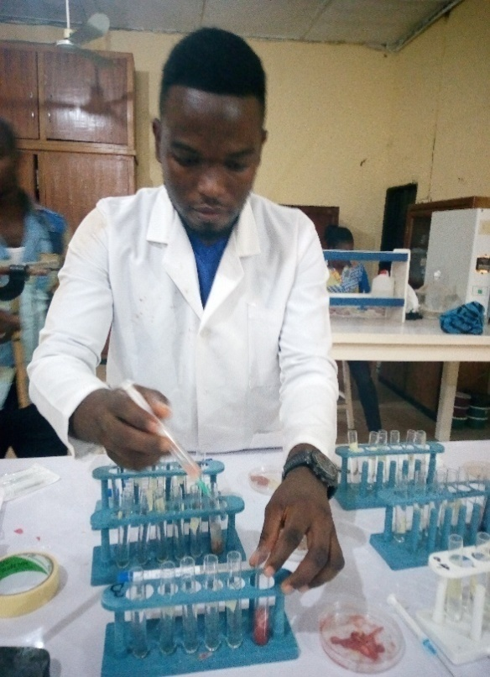

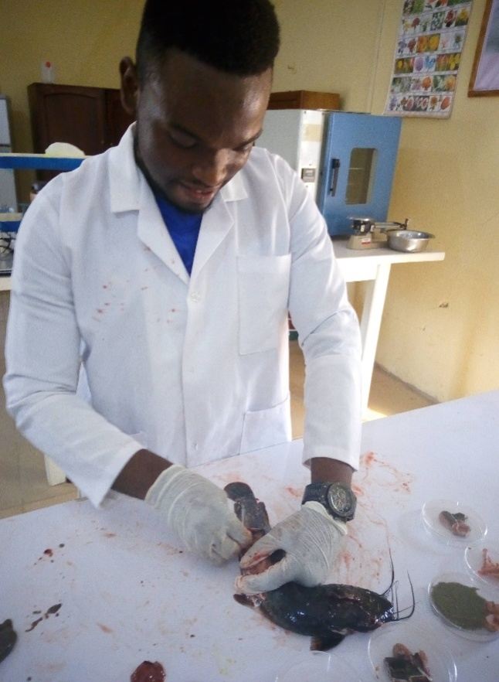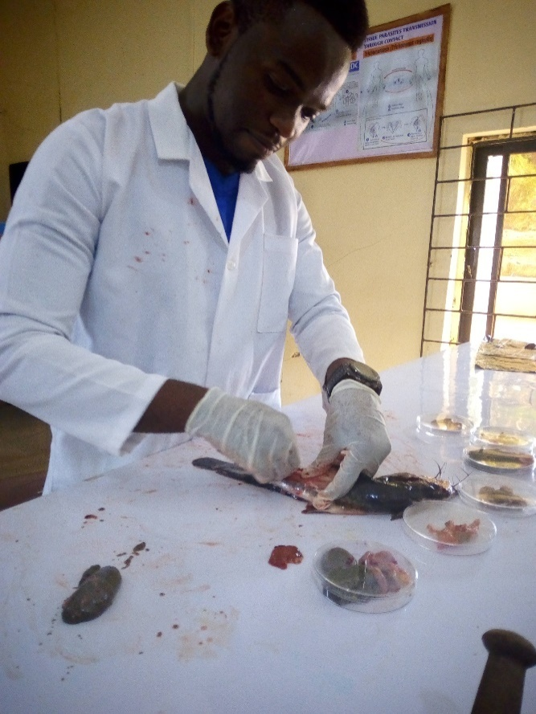

REFERENCES
Adam A.J. Tobaias W.J (1999) Red Mang rove prop-root habitat as a finfish nursery area; a case study of salt rivea bay, st. Croix, USVI. Proc Gulf Caribb fish inst 46: 22-46.

B. Austin (2002).The Bacterial Microflora of Fish.Department of Biological Sciences, Heriot-Watt University, Riccarton, Edinburgh EH14 4AS, Scotland, U.K. Received December 10, 2001; Revised January 16, 2002; Accepted January 16, 2002; Published March 5, 2002

Cheesbrough, M. (2000).District laboratory practice in tropical countries. Parts 2 published by Cambridge University Press. Pg 13-7

Douglas, D. (2007). Identifying fresh water Aquarium fish disease.Available on line at http://fishsuite101. com/article.cfm/identifyingfishdiseases.

Ezeri, G.N.O., (2001). Haematological response of clariasgariepinus to bacteria infection and prophylactic treatment.With antibiotcs, journal of Aquartic Science; 16:22-24.

Kakeko, S., (1971).Microbiaological Study of fresh fish.New food industry. 13:76-80.

Ladipo, O; Fabiyi and Fatula, G.T. (1981), Marketing and distribution of fish in Nigeria. Report submitted to the federal development of fisheries, Lagos. Pg 35.

Leisner. J.J., Vancanneyt, M., Rusul, G., Pot, B. Lefebvre, K., Fresi, A. and Tee, L.T (2001). Identification of lactic acid bacteria constituting the predom, natingmicroflora in an acid feamented condiment (tempoyak) popular in Malaysia. International Journal of food microbio 63: 147-157.

Miceal, W., Johan, Suen, F; Carina, K and Tor M. (2007).Journal of clinical Microbiology published by the American Society for Microbiology. 45:1-7.

S.A. Shinkafi and V.C. Ukwaja (2010). Bacteria Associated with Fresh Tilapia Fish (Oreochromisniloticus) Sold AtSokoto. Department of Microbiology, UsmanuDanfodiyo University, Sokoto, Nigeria. Nigerian Journal of Basic and Applied Science (2010), 18(2): 217-221. ISSN 0794-5698.Central Market in Sokoto, Nigeria.

Codd, G.A., L.F. Morrison and J.S. Metcalf. 2005. Cyanobacterial toxins: risk management for health protection. Toxicology and AppliedPharmacology203:264-272.

Droop, M.R. 1954. A note on the isolation of small marine algae and flagellates for pure cultures.Journal of the Marine Biology Association of the U.K. 33:511 514

Falconer, I.R. 1993.Algal Toxins in Seafood and Drinking Water. San Diego: Academic Press. pp. 224.

Hudnell, H.K. (ed.) 2008. Cyanobacterial Harmful Algal Blooms – State of the Science and Research Needs. New York: Springer. 949 pp.

Huisman, J., H.C.P. Matthijs and P.M. Visser. 2005. Harmful Cyanobacteria. Norwell, MA:Springer. pp. 241.

Johnk, K.D., J. Huisman, J. Sharples, B. Sommeijeri, P.M. Visser and J.M. Strooms. 2008. Summer heatwaves promote blooms of harmful cyanobacteria. Global Change Biology 14:495-512.

West, N.J., R. Bacchieri, G. Hansen, C. Tomas, P. Lebaron and H. Moreau. 2006. Rapid quantification of the toxic alga Prymnesiumparvumin natural samples by the use of a specific monoclonal antibody and solid-phase cytometry. Applied and Environmental Microbiology 860-868.

Zimba, P.V., L. Khoo, P.S. Gaunt, S. Brittain and W.W. Carmichael. 2001. Confirmation of catfish,
Ictaluruspuntatus(Rafinesque), mortality from Microcystistoxins. Journal of Fish Diseases 24:41-47.

Landsburg, J.H. 2002.The effects of harmful algal blooms on aquatic organisms.Reviews in Fisheries Science 10:113-390

Zimba, P.V., L. Khoo, P.S. Gaunt, S. Brittain and W.W. Carmichael. 2001. Confirmation of catfish,
Ictaluruspuntatus(Rafinesque), mortality from Microcystistoxins. Journal of Fish Diseases 24:41-47.
Sager, D., L. Fries, L. Singhurst and G. Southard (eds.) 2007.Guidelines for golden alga Prymnesiumparvum
management options for ponds and small reservoirs (public waters) in Texas. Texas Parks and Wildlife (Inland Fisheries): Austin, TX.

Lindholm, T., P. Ohman, K. KurkiHelasmo, B. Kincaid and J. Merilouto. 1999. Toxic algae and fish mortality in a brackish-water lake in Aland, SW Finland. Hydrobiologia397:109-120.

Green, J.C. and B.S.C. Leadbetter. 1994. The Haptophyte Algae. Systematics Association Special Volume No. 51.Clarendon, Oxford, England.

Shumway, S.E. 1990. A review of the effects of algal blooms on shellfish and aquaculture.Journal of theWorld Aquaculture Society 21:65-104.

Sunda, W.G., E. Granelli and C.J. Gobler. 2006. Positive feedback and the development and per-sistence of ecosystem disruptive algal blooms. Journal of Phycology 42:963-974.
Tucker, C.S. 2000.Off-flavor problems in aquaculture.Reviews in Fisheries Science 8:45-88.

Brasil, Ministry of Agriculture, Livestock and Supply (2009).Agriculture Defense Department.Circular letter GAB/DIPOA nº.25, 2009.Provides for the verification procedures of self programs in fishery products establishments. Available at: <http://www.pescado.hdfree.com.br/ofício_circular_25_2009.htm>. Accessed on 10 November 2012.

Cardoso MF, Miguel V, Pereira CAM (2011).Evaluation of sanitary conditions and good manufacturing practices in bakeries.Aliment.
Nutr. 22(2):211-217.

Dias MAC, Sant’ana AS, Cruz AG, Faria JAF, Oliveira CAF, Bona, E (2012). On the implementation of good manufacturing practices in a small processing unity of mozzarella cheese in Brazil. Food Control 24(1):199-205.

Evancho GM, Sveum WH, Moberg LJ, Frank JF (2001). Microbiological monitoring of the foods processing environment. In: Downes FP and
Ito K (eds.) (2001). Compendium of methods for the microbiological.Examinations of Foods Washington, DC: APHA. pp. 25-36.

Fuster-Valls N, Hernández-Herrero M, Marín-de-Mateo M, RodríguezJerez JJ (2008).Effect of different environmental conditions on the
bacteria survival on stainless steel surfaces. Food Control 19(3):308-314.

Ghaly AE, Dave D, Budge S, Brooks MS (2010). Fish SpoilageMechanisms and Preservation Techniques: Review. Amer. J. Appl.
Sci. 7: 859-877.

Mol S, Tosun Y (2011). The quality of fish from retail markets in Istanbul, Turkey. J. Fish. Sci. 5:16-25.

Oliveira MMM, Brugnera DF, Mendonça AT, Piccolo RH (2008).Sanitary condition of meat grinding machines, hands handlers and microbiological quality of ground beef. Ciênc.Agrotec. 32(6):1893-1898.

Salustiano VC, Andrade NJ, Ribeiro Junior JI, Fernandes PE, Lopes PC, Bernardes PC, Portugal JG (2010). Controlling Bacillus cereus adherence to stainless steel with different cleaning and sanitizing procedures used in dairy plants. Arq.Bras.Medic. Veter. Zoot. 62(6):1478-1483.

Silva CAS, Andrade NJ, Soares NFF, Ferreira SO (2003).Evaluation of ultraviolet radiation to control microorganisms adhering to low density polyethylene films. Braz. J. Microbiol. 34(2):175-178.

Temelli S, Dokuzlu C, Sen MKC (2006). Determination of microbiological contamination sources during frozen snail meat processing stages. Food Control 17:22-29.

Aarnisalo K, Tallavaara K, Wirtanen G, Maijala R, Raaska L (2006). The hygienic working practices of maintenance personnel and equipment hygiene in the Finnish food industry. Food Control 17:1001-1011.

Andrade NJ (2008). Hygiene in the Food Industry: assessment and management of adherence and formation of bacterial biofilms. 1st ed. Sao Paulo: Varela.
Kusumaningrum HD, Riboldi G, Hazeleger WC, Beumer RR (2003). Survival of foodborne pathogens on stainless steel surfaces and cross-contamination to foods.Int. J. Food Microbiol. 85(3):227-236.

Rosas P, Reyes G (2008). Evaluación de los programas pre-requisitosdel plan HACCP en unaplanta de sardinascongeladas. Arch. Latinoamer. Nutr.58:174-181.
Bahk, J. and Marth, E.M. (1990).Listeriosis and Listeriamonocytogenes in food borne
disease. Academic press Inc. new York. Pg 248-257.
Chowdhury, M.B Munirzzaman, M and Uddin, M.N. (1989) Study on the intestinal bacterial flora of Tilapia. Oreochromisniloticus. Bangladesh aquaculture 11:65-70
Fernandes, C.F., Flick, G.J., Sivia J.L and McCasky, T.A. (1997). Influence of processing schemes on indicative bacteria and quality of fresh aquacultured cat fish filts. 60: 54-58.
Okpokwasili, G.C., Alapiki, A. M.; (1990).Bacterial flora associated with a Nigeria fresh water fish culture. Journal of Aquaculture in the tropics. 5:87-90.
Trust, T.J (1975). Bacteria associated with the gill of Salmond fishes in fresh water. Journal of applied bacteriology.
Draser, B.S and Hill, M.J. (1976).Human Intestinal flora in gastrointestinal tract humans.1st edition. Academy press London Pg. 10-12.

