CHAPTER ONE
INTRODUCTION
1.1 Background Of Study
The prevalence of diabetes is increasing rapidly and electrolyte disturbances are common in patients with diabetes. According to World Health Organization, over 1.4 Nigerians are diabetic in 2017. Diabetes can be defined as a disease condition in which the body’s ability to produce or respond to the hormone insulin is impaired, resulting in abnormal metabolism of carbohydrates and elevated levels of glucose in the blood. They are two major types of diabetes; Type 1 and Type 2 diabetes.
In Type 1 Diabetes, the body does not produce enough insulin. Diabetic patients with Type 1 are advised to follow a healthy eating plan, do adequate exercise, and take insulin, so they can lead a normal life. In Type 2 Diabetes, the body does not produce insulin for proper function. Type 2 patients need to eat healthily, be physically active, and test their blood glucose regularly. They may also need to take oral medication to control blood glucose levels. As the risk of cardiovascular disease is much higher for a diabetic, it is crucial that blood pressure and cholesterol levels are monitored regularly. Smoking might have a serious effect on cardiovascular health; diabetics are advised to stop smoking. Hypoglycemia (low blood glucose) can have a bad effect on the patient. Hyperglycemia (when blood glucose is too high) can also have a bad effect on the patient. Hyperglycemia sets the internal environment for osmotic diuresis while causing a dilution effect on electrolyte concentrations. The osmotic effect of glucose results in decreased circulating blood volume and fluid shift from the intracellular spaces causing cellular dehydration. (Nabil, 2016) Then there is Gestational diabetes. This type affects females during pregnancy. It is the leading cause of blindness, kidney failure and lower limb amputations. The most common diabetes symptoms include frequent urination, intense thirst and hunger, weight gain, unusual weight loss, fatigue, cuts and bruises that do not heal, male sexual dysfunction, numbness and tingling in hands and feet. (Goldberg, 2004)
After food consumption, the body breaks down every sugar to its simplest form (glucose) which is then carried into the bloodstream for further cellular activities. The production of glucose for body cellular activities is regulated by insulin. Insulin is a hormone produced by the pancreas to control blood sugar. Diabetes can be caused by too little insulin, resistance to insulin, or both. Patients suffering from diabetes have high blood sugar because their body cannot move sugar from the blood into muscle and fat cells to be burned or stored for energy, also because their liver makes too much glucose and releases it into the blood. This is because either: their pancreas does not make enough insulin or their cells do not respond to insulin normally. When there's excess sugar (glucose) in the cell membrane, it disturbs that concentration of electrolyte in the cell and causes osmotic diuresis.
Osmotic diuresis refers to when there is excess glucose in the blood, and it passes through the kidneys for filtering, the excess glucose accumulates in the tubules within the kidneys. Once there, it blocks the re absorption of water, leading to an increased concentration of water in the bloodstream. The water in the bloodstream now distorts electrolytes in the body. Sodium for instance is an extracellular ion, when the excess fluid in the bloodstream it tends to follow down with water to the kidney causing two major diseases; Hyponatremia (occurs when there is low sodium ion the body) or Hypernatremia (when there is excess sodium ion in the body). In the case of hyponatremia, it could be the sodium ions gets excreted with water through the kidney. In hypernatremia, the excess sodium flows to the kidney where it is reabsorbed into the bloodstream thereby, creating unstable count of the ion in the body. The same thing applies to Potassium ion, which is an intracellular ion. Its movement is also not predictable as the body cells suffer from osmotic diuresis.
According to Webster Dictionary, electrolytes basically are any of the ions (sodium, chlorine, calcium, etc) that in biological fluid that regulate or affect most metabolic processes (such as the flow of nutrients into and waste products out of cells). Electrolytes are present in the human body. Fluid and electrolyte balance play important roles in maintaining the homeostasis in the body, and also in protecting cellular function, tissue perfusion, acid-base balance, nerve conduction, blood clotting and muscle contraction. Potassium, sodium, calcium, etc are all important for proper electrolyte balance. According to Husain (2009), the relationship between blood glucose and electrolytes is complex and electrolyte imbalance may affect the course of diabetes and its management. Electrolyte imbalance resulting from kidney failure, dehydration, fever, and vomiting has been suggested as one of the contributing factors toward complications observed in diabetes and other endocrine disorders. Electrolytes play an important role in controlling the fluid levels, acid base balance, and regulation of neurological and myocardial functions, oxygen delivery and many other biological processes. (Deepti, 2017) Patients with Diabetes mellitus are more prone to develop electrolyte imbalance and complications.
Diabetes is very serious that some of the complications can be life threatening if not carefully managed before it grows to a very critical stage. Researchers have put together some facts about diabetes such as the fact that diabetes is a long-term condition that causes high blood sugar levels.
Diabetic nephropathy is one of the complications of diabetes mellitus, which ultimately leads to renal failure, which is also a cause of electrolyte imbalance in diabetic patients. Diabetes mellitus was identified as an independent risk factor for hyponatremia and hypomagnesaemia. Various path physiological factors like; nutritional status, coexistent acid-base imbalance, certain drugs, other co morbid diseases like renal disease or acute illness, alone or in combination, also play a key role in electrolyte imbalance (Liamis et al 2013).
1.2 STATEMENT OF PROBLEM
Diabetes causes osmotic diuresis with lead to electrolyte imbalance and renal malfunction.
1.3 HYPOTHESIS
- Type 2 diabetic patients are more susceptible to electrolyte imbalance.
- Renal dysfunction is associated to Type 2 diabetes mellitus.
1.4 AIMS
- The aim of this study is to evaluate the relationship between electrolyte imbalance and renal function indices in Type II diabetes patients
1.5 OBJECTIVES
- To determine the blood sugar level of patients.
- To determine the blood electrolytes (Na⁺, K⁺, Cl⁻) levels in the patients.
- To determine the renal function indices (creatinine and urea) in patients.

CHAPTER TWO
LITERATURE REVIEW
2.1 HISTORY OF DIABETES
Diabetes is one of the first diseases described with an Egyptian manuscript from 1500 BC meaning "too great emptying of the urine" (Leonid, 2009). The first described cases are believed to be of type 1 diabetes. According to Zajac et al (2009), Indian physicians around the same time identified the disease and classified it as madhumeha or honey urine noting that the urine would attract ants. The term "diabetes" or "to pass through" was first used in 230 BC by the Greek Apollinus of Memphis, the disease was rare during the time of the Roman empire with Galen commenting that he had only seen two cases during his career. (Zajac et al, 2009).
According to Zajac et al (2009)., type 1 and type 2 diabetes were identified as separate conditions for the first time by the Indian physicians Sushta and Chararka in 400–500 AD, with type 1 associated with youth and type 2 with being overweight. The term "mellitus" or "from honey" was added by the Briton John Rolle in the late 1700s to separate the condition from diabetes insipidus which is also associated with frequent urination but effective treatment was not developed until the early part of the 20th century when the Canadians Fredrick Banking and Charles Best discovered insulin in 1921 and 1922 and this was followed by the development of the long acting NPH insulin in the 1940s. (Dallas, 2011)
Joseph von Mehring and Oskar Minkowski in 1890 discovered the role of pancreas in diabetes. They found that dogs whose pancreas was removed developed all the signs and symptoms of diabetes and died shortly afterwards. In 1910, Sir Edward Albert Sharpey-Schafer found that diabetes resulted from lack of insulin. He termed the chemical regulating blood sugar as insulin from the Latin “insula”, meaning island, in reference to the insulin-producing islets of Langerhans in the pancreas. (Von Mehring et al 1890)
In 1921 Sir Frederick Grant Banting and Charles Herbert Best repeated the work of Von Mering and Minkowski and went ahead to demonstrate that they could reverse induced diabetes in dogs by giving them an extract from the pancreatic islets of Langerhans of healthy dogs. Banting, Best and chemist colleague Collip purified the hormone insulin from pancreases of cows at the University of Toronto. This led to the availability of an effective treatment for diabetes in 1922. For this, Banting and laboratory director MacLeod received the Nobel Prize in Physiology or Medicine in 1923; both shared their Prize money with others in the team who were not recognized, in particular Best and Collip. Banting and Best made the patent available free of charge so that millions of diabetics worldwide could get access to insulin. In 1922 January, Leonard Thompson, 14, a charity patient at the Toronto General Hospital, became the first person to receive and injection of insulin to treat diabetes. Thompson lived another 13 years before dying of pneumonia at age 27. (Himsworth, 1936)
2.2 DEFINITION OF DIABETES?
Diabetes mellitus is defined as a metabolic disorder of multiple etiology characterized by chronic hyperglycemia with disturbances of carbohydrate, protein and fat metabolism resulting from defects in insulin secretion, insulin action, or both. The clinical diagnosis of diabetes is often indicated by the presence of symptoms such as polyuria, polydipsia, and unexplained weight loss, and is confirmed by measurement of abnormal hyperglycemia. (Porth, 1990) Patients with high blood sugar will typically experience polyuria (frequent urination), they will become increasingly thirsty (polydipsia) and hungry (polyphagia). After you eat or drink, your body breaks down the sugars in your blood and turns it into glucose. The glucose travels through your bloodstream and provides your body with energy. To accomplish this, your pancreas needs to produce a hormone called insulin. In a person with diabetes (diabetes mellitus), the pancreas either produces too little insulin or none at all, or the insulin can’t be used effectively. This allows blood glucose levels to rise while the rest of your cells are deprived of much needed energy. This can lead to a wide variety of problems affecting nearly every part of your body. (Pietrangelo, 2014)
2.2.1 TYPES OF DIABETES
Basically, diabetes can be classified in two types namely; Type I and Type II diabetes but some text will classify it into three adding Gestational diabetes. I will clearly explain all the three types diabetes in this work namely;
- Type I Diabetes
- Type II Diabetes
- Gestational Diabetes
2.2.1.1 TYPE I DIABETES
Type 1 is a form of diabetes mellitus in which not enough insulin is produced for sugar regulation. This results in high blood sugar levels in the body. The classical symptoms which include, frequent urination, increased thirst, increased hunger, and weight loss. Additional symptoms are blurry vision, feeling tired and poor healing. Symptoms typically develop over a short period of time. People with Type 1 diabetes must take insulin to live. Most people with Type 1 diabetes are diagnosed as children or young adults (Pietrangelo, 2014). The cause of type 1 diabetes is unknown. However, it is believed to involve a combination of genetic and environmental factors. Risk factors include having a family member with the condition. (Chiang et al., 2014) Type 1 diabetes is often known as insulin-dependent diabetes.
2.2.1.2 TYPE II DIABETES
Type 2 diabetes is where the body does not produce insulin to meet its own needs. This is known as insulin resistance. Type 2 diabetes usually develops gradually over time. Most individuals with the condition may be unaware of their disease especially at early stages as there may be no specific symptoms. Type 2 diabetes is often associated with obesity. (Davis et al,, 2009) Obesity-related diabetes is sometimes referred to as maturity-onset diabetes because it is more common in older people. In this sort of diabetes, the pancreas starts off robust in its production of insulin. However, cells that need energy don’t respond normally to the usual amounts of insulin. The pancreas has to produce much higher levels of the hormone in order to manage blood glucose levels. Over time, the insulin-producing cells in the pancreas can burn themselves out due to this overproduction. The development of type 2 diabetes is caused by a combination of lifestyle and genetic factors. (Ripsin et al., 2009) A lack of sleep has been linked to type 2 diabetes; this is believed to act through its effect on metabolism. (Touma et al., 2011) The intestinal bacteria Prevotella copri and Bacteroides vulgatus have been connected with type 2 diabetes. (Pedersen et al., 2016)At this point a person with Type 2 diabetes begins to require insulin medication. Type II diabetes is often referred to as insulin-independent diabetes.
2.2.1.3 GESTATIONAL DIABETES
Gestational diabetes is high blood sugar that develops during pregnancy. Most of the time, gestational diabetes can be controlled through diet and exercise, and it typically resolves after the baby is delivered. The nutritional status of a mother during fetal development may also play a role, with one proposed mechanism being that of altered DNA methylation. (Christian et al., 2010).
Kindly note, that I will be discussing basically type II diabetes in this work.
2.3 EFFECTS OF TYPE II DIABETES
Your pancreas produces and releases insulin to help make energy out of sugars. If your pancreas produces little or no insulin, or if your body can’t use it, this can create high levels of toxic chemicals, including acids and ketone bodies, which may lead to a condition called diabetic ketoacidosis. This is a serious complication of the disease. Symptoms include extreme thirst, excessive urination, and fatigue. Your breath may have a sweet scent that is caused by the elevated levels of ketone bodies in the blood. High blood sugar levels and excess ketones in your urine can confirm diabetic ketoacidosis. Untreated, the condition can lead to loss of consciousness or even death. Diabetic Hyperglycemic Hyperosmolar Syndrome (HHS) occurs in Type 2 diabetes. It involves very high blood glucose levels but without ketones. Symptoms also include dehydration and loss of consciousness. It usually happens to people whose diabetes is undiagnosed or who have not been able to control their diabetes. It can also be caused by heart attack, stroke, or infection.
I will explain how this affects the different systems of the body and their respective organs.
2.3.1 EFFECT OF DIABETES IN THE EXCRETORY SYSTEM
Diabetes can damage your kidneys, affecting their ability to filter waste products from your blood. Diabetes can cause microalbuminuria, an elevated amount of protein in your urine may be a sign that your kidneys aren’t functioning properly. Kidney disease related to diabetes is called diabetic nephropathy. This condition doesn’t show symptoms until it advances to later stages. People with diabetes should be evaluated for nephropathy in order to avoid irreversible kidney damage and kidney failure.
2.3.2 EFFECT OF DIABETES IN THE DIGESTIVE SYSTEM
High blood glucose levels can make it hard for your stomach to completely empty (gastroparesis). In turn, the delay causes blood glucose levels to rise. Diabetes is the leading cause of gastroparesis. Symptoms include nausea, vomiting, bloating, and heartburn. . (Pietrangelo, 2014)
2.3.3 EFFECT OF DIABETES IN THE CIRCULATORY SYSTEM
Diabetes in the circulatory system causes a disease known as atherosclerosis. This happens when high blood glucose levels contribute to the formation of fatty deposits in blood vessel walls. Over time, that can restrict blood flow and increase the risk of hardening of the blood vessels. One of the most dangerous effects of atherosclerosis is its ability to intermittent claudicating. This means poor circulation in the body which can pain in joints, stiffness in muscles etc. People with diabetes are particularly prone to foot problems due to narrowed blood vessels in the leg and foot. Your feet may feel cold, and you may be unable to feel heat due to lack of sensation. A condition called diabetic neuropathy causes decreased sensation in the extremities, which may prevent you from noticing an injury or infection. Diabetes increases your risk of developing infections or ulcers of the foot. Poor blood flow and nerve damage increase the likelihood of having a foot or leg amputated. If you have diabetes, it is critical that you take good care of your feet and inspect them often.
2.3.4 EFFECT OF DIABETES IN THE INTEGUMENTARY SYSTEM
Diabetes can affect your skin. Lack of moisture can cause the skin on your feet to dry and crack. It is important to completely dry your feet after bathing or swimming. You can use petroleum jelly or gentle creams, but be careful: creams or oils left between your toes can become so moist that it can lead to infection. You may also be more prone to boils, infection of the hair follicles (folliculitis), sties, and infected nails. People with diabetes have a higher incidence of bacterial infections, including Staphylococcus. A condition called diabetic dermopathy can cause brown patches on the skin. There’s no cause for concern and no treatment is necessary. Eruptive xanthomatosis causes hard yellow bumps with a red ring. Digital sclerosis causes thick skin, most often on the hands or feet. Both of these skin conditions are signs of unmanaged diabetes. They usually clear up when you get your blood sugar under control. (Pietrangelo, 2014)
2.3.5 EFFECT OF DIABETES IN THE CENTRAL NERVOUS SYSTEM
The major diseases caused by diabetes in the nervous system is peripheral neuropathy, which can affect your perception of heat, cold, and pain, making you more susceptible to injury. This also makes it more likely that you’ll ignore an injury, especially if it’s in a difficult place to see, such as between your toes, on your heels, or the bottoms of your feet. (Pietrangelo, 2014).
2.3.6 EFFECT OF DIABETES IN THE REPRODUCTIVE SYSTEM
In this case, the hormones of pregnancy can cause gestational diabetes. This also increases the risk of high blood pressure (preeclampsia or ecclampsia). In most cases, gestational diabetes is easily controlled, and glucose levels return to normal after the baby is born. Symptoms are the same as other types of diabetes, but may also include repeated infections affecting the vagina and bladder. Women with gestational diabetes may have babies with higher birth weight, making delivery more complicated. Women who have had gestational diabetes should be monitored, as there’s an increased risk of developing diabetes within ten years. . (Pietrangelo, 2014)
2.4 RISK FACTORS OF TYPE II DIABETES
Risk factors for prediabetes and diabetes in addition to being overweight or obese or being age 45 or older include the following:
- being physically inactive
- having a parent, brother, or sister with diabetes
    - giving birth to a baby weighing more than 9 pounds or being diagnosed with gestational diabetes
- having high blood pressure— 140/90 mmHg or above—or being treated for high blood pressure
- having HDL, or “good,” cholesterol below 35 mg/dL, or a triglyceride level above 250 mg/dL
- having polycystic ovary syndrome, also called PCOS
- having impaired fasting glucose (IFG) or impaired glucose tolerance (IGT) on previous testing
- having other conditions associated with insulin resistance, such as severe obesity or a condition called acantho-sis nigricans, characterized by a dark, velvety rash around the neck or armpits
- having a history of cardiovascular disease
If results of testing are normal, testing should be repeated at least every 3 years. Doctors may recommend more frequent testing depending on initial results and risk status. . (NZHIF, 2017)

2.5 CAUSES OF DIABETES
2.5.1 CAUSES OF DIABETES IN TYPE 1 DIABETES
Type 1 Diabetes is usually caused by the destruction of the cells in the pancreas which normally manufacture and secrete insulin, these beta cells are attacked by the body’s own immune system, a phenomenon known as an autoimmune response. (Reed, 2014)
Auto antibodies and the Immune Response our immune system normally protect us from disease via two basic types of cell:-
- B cells - B cells are programmed to make proteins called antibodies that recognise certain parts of invaders as foreign, then initiate their destruction. Sometimes B cells make antibodies which recognize certain parts of our own cells. These self-recognizing antibodies are called auto antibodies. (Reed, 2014)
- T cells - T cells can be primed to attack foreign invaders directly. Two subgroups of T cells (Th1 and Th2) usually maintain a balance between destructive and protective immune responses. The autoimmune response against the insulin-producing beta cells is thought to be caused by a series of events involving both of these types of immune cell. The final destruction of beta cells leading to clinical onset of the disease is possibly a result of an imbalance in Th1/Th2 T cell activity.
Auto antibodies directed against different entities have been detected in people with Type 1 diabetes. These include:
- Islet cells
- Insulin
- A protein known as GAD
- A protein known as IA-2 (Reed, 2014)
According to Reed (2014) these auto antibodies associated with Type 1 diabetes may be manufactured up to 8 years before the disease is evident in terms of a high blood glucose level and accompanying symptoms. This means that the disease process is actually a long drawn out one, probably consisting of several stages. The auto antibodies probably contribute to the disease process early on by selectively identifying the beta cells as those that will be destroyed.
The development of diabetes seems to be the result of a series of events which ultimately give rise to autoimmune destruction of the pancreatic beta cells.
- Firstly, the autoimmune process needs to be initiated and this may happen very early on in life - either in childhood, or perhaps even before birth, during fetal development.
- Further environmental factors may accelerate the process.
- Finally, some events may act to precipitate the onset of clinical diabetes, the stage at which diagnosis occurs and insulin replacement becomes essential. NOTE: There are many people who appear to experience some kind of immune attack on beta cells (indicated by auto antibodies, detected in their blood), but do not go on to develop diabetes.
2.5.1.2 SUPRESSION OF INSULIN BY GROWTH HORMONE
Growth hormone is also known as somatotropin. The most common age for developing Type 1 diabetes is in early puberty. (Greenwood et al., 1966) This is a time when growth increases rapidly and levels are high. Growth hormone hinders insulin action, so the beta cells are put under stress to produce more insulin. Again, if the beta cells are already partially damaged this extra stress may precipitate the onset of diabetes. Stress hormones such as cortical oppose insulin in a similar fashion to growth hormone. So during particularly stressful periods the beta cells need to work harder and this may add to an already worsening situation. Another possibility is that an environmental factor directly damages the beta cells. If proteins from the beta-cell are released or become exposed when the cell is damaged then these proteins which are normally kept hidden inside the cell may be considered foreign. The immune system may then mount an attack on the beta cells which is actually secondary to the damage caused by the environment. Coxsackie B4 virus, which causes inflammation of the pancreas, has been proposed to act in this way. (Reed, 2014)
2.5.2 CAUSES OF TYPE 2 DIABETES
Type 2 diabetes is, in many respects, more complex than Type 1 diabetes. The precise sequence of events which occur over many years has not yet been confirmed. There are a number of factors thought to be involved, but exactly what their individual roles are in causing, or contributing to, Type 2 diabetes is still under much investigation. In the non-diabetic person, when food is eaten, the blood glucose starts to rise. The pancreatic beta cells are prompted to release insulin so that the body’s cells can take the glucose from the blood and use it. Beta cells are ‘sensitive’ to glucose. Body cells, such as fat and muscle cells, are ‘sensitive’ to insulin. ‘Being sensitive’ involves a multitude of reactions between molecules and therefore there are a great number of potential places in these chemical pathways where something may be going wrong. Glucose enters beta cells by way of a transporter (a kind of molecular gate). The glucose is then modified by enzymes and this produces electrical changes within the cell. In response to these electrical changes, insulin secretion is triggered. In type 2 diabetics, the beta-cell doesn’t respond properly to the blood glucose level, and insulin secretion is not sufficient to keep blood glucose levels within ‘normal’ limits. The first enzyme to react with the glucose as it enters the cell is called glucokinase and a genetic defect in this molecule has already been verified as being responsible for many cases of MODY (Mature Onset Diabetes of the Young). (Reed, 2014)
Insulin resistance normally, body cells such as fat and muscle cells respond to insulin by taking glucose from the blood. Insulin reacts with a surface protein on the cell (insulin receptor) and this triggers a number of enzyme reactions in the cell. Glucose transporters appear on the cell surfaces and let the glucose in. In people with Type 2 diabetes (and in obese people that do not have diabetes) the fat and muscle cells do not seem to react properly to the insulin; this is called insulin resistance. The problem possibly lies with the glucose transporter, which is called GLUT-4. Alternatively, the insulin receptor has been proposed to be at fault. It is also possible that there is a problem in between insulin docking at the cell and glucose being taken in. (Reed, 2014)
Additional glucose from the liver to further complicate matters, when stimulated the liver releases glucose into the blood. Normally after a meal glucose is taken up and stored as glycogen. The glycogen is then later converted back to glucose and released when needed. This process is partly under the control of insulin - insulin binds to receptors on the liver cell and, through a series of signals, reduces the release of glucose. The liver is another site of insulin resistance in people with Type 2 diabetes. If the liver cells do not respond to insulin they may release more glucose into the blood, compounding the problem of a high blood glucose level. (Reed, 2014)
Clearly there are different factors and these may all be related to one another, either directly or indirectly. It is apparent that Type 2 diabetes takes a long time to develop, but exactly what causes what in the first place is still unclear. It is interesting that in the early stages of Type 2 diabetes, it has been noted that insulin levels in the blood are high. This has led scientists to believe that initially, the beta cells do respond to high blood glucose, but that they can’t keep it up and eventually suffer from ‘exhaustion’. Indeed, many believe that insulin resistance is the primary defect in Type 2 diabetes and that this puts extra strain on the pancreas to produce more and more insulin; if the beta cells can’t cope then diabetes results. It does now seem evident that, whether insulin resistance or a defect in insulin secretion comes first, (if they do not develop in parallel), one is ultimately followed by the other. Additionally, it is important to note that high blood glucose levels can further damage beta cells and reduce their sensitivity to the level of glucose in the blood; this conceivably adds to an already worsening situation. (Reed, 2014)
2.5.2.1 ROLE OF OBESITY IN TYPE 11 DIABETES
At least 80% of people with Type 2 diabetes are overweight. Obesity causes insulin resistance in its own right. The need for extra insulin to overcome this may just be too great in those who already have weak or weakening beta-cell function. Whilst genetics play a role in obesity, today’s sedentary and westernised lifestyle also add to the problem of insulin resistance in many populations.
2.6 COMPLICATIONS OF TYPE II DIABETES
- Cardiovascular disease. Diabetes dramatically increases the risk of various cardiovascular problems, including coronary artery disease with chest pain (angina), heart attack, stroke and narrowing of arteries (atherosclerosis). If you have type II diabetes, you are more likely to have heart disease or stroke.
- Nerve damage (neuropathy). Excess sugar can injure the walls of the tiny blood vessels (capillaries) that nourish your nerves, especially in your legs. This can cause tingling, numbness, burning or pain that usually begins at the tips of the toes or fingers and gradually spreads upward. Left untreated, you could lose all sense of feeling in the affected limbs. Damage to the nerves related to digestion can cause problems with nausea, vomiting, diarrhea or constipation. For men, it may lead to erectile dysfunction.
- Kidney damage (nephropathy). The kidneys contain millions of tiny blood vessel clusters (glomeruli) that filter waste from your blood. Diabetes can damage this delicate filtering system. Severe damage can lead to kidney failure or irreversible end-stage kidney disease, which may require dialysis or a kidney transplant.
- Eye damage (retinopathy). Diabetes can damage the blood vessels of the retina (diabetic retinopathy), potentially leading to blindness. Diabetes also increases the risk of other serious vision conditions, such as cataracts and glaucoma.
- Foot damage. Nerve damage in the feet or poor blood flow to the feet increases the risk of various foot complications. Left untreated, cuts and blisters can develop serious infections, which often heal poorly. These infections may ultimately require toe, foot or leg amputation.
- Skin conditions. Type II Diabetes may leave you more susceptible to skin problems, including bacterial and fungal infections.
- Hearing impairment. Hearing problems are more common in people with diabetes.
2.7 SIGNS AND SYMPTOMS OF DIABETES
Symptoms vary depending on how much your blood sugar is elevated. Some people, especially those type 2 diabetes, may not experience symptoms initially. In type 1 diabetes, symptoms tend to come on quickly and be moresevere. Sometimes type 2 diabetes can develop without any warnings signs.
Some of the signs and symptoms type II diabetes are:
- Increased thirst
- Frequent urination
- Extreme hunger
- Unexplained weight loss
- Presence of ketones in the urine (ketones are a byproduct of the breakdown of muscle and fat that happens when there's not enough available insulin)
- Fatigue
- Irritability
- Blurred vision
- Slow-healing sores
- Frequent infections, such as gums or skin infections and vaginal infections
- Dry mouth
- Diabetic coma (loss of consciousness)
2.8 DIAGNOSIS OF TYPE II DIABETES
- The American Diabetes Association (ADA) has recommended screening guidelines. The ADA recommends that the following people be screened for diabetes:
- Glycated hemoglobin (A1C) test. This blood test indicates your average blood sugar level for the past two to three months. It measures the percentage of blood sugar attached to hemoglobin, the oxygen-carrying protein in red blood cells. The higher your blood sugar levels, the more hemoglobin you'll have with sugar attached. An A1C level of 6.5 percent or higher on two separate tests indicates that you have diabetes. An A1C between 5.7 and 6.4 percent indicates prediabetes. Below 5.7 is considered normal.
- Random blood sugar test. A blood sample will be taken at a random time. Regardless of when you last ate, a random blood sugar level of 200 milligrams per deciliter (mg/dL) 11.1 millimoles per liter (mmol/L) or higher suggests diabetes.
- Fasting blood sugar test. A blood sample will be taken after an overnight fast. A fasting blood sugar level less than 100 mg/dL (5.6 mmol/L) is normal. A fasting blood sugar level from 100 to 125 mg/dL (5.6 to 6.9 mmol/L) is considered prediabetes. If it's 126 mg/dL (7 mmol/L) or higher on two separate tests, you have diabetes.
- Oral glucose tolerance test. For this test, you fast overnight, and the fasting blood sugar level is measured. Then you drink a sugary liquid, and blood sugar levels are tested periodically for the next two hours. A blood sugar level less than 140 mg/dL (7.8 mmol/L) is normal. A reading of more than 200 mg/dL (11.1 mmol/L) after two hours indicates diabetes. A reading between 140 and 199 mg/dL (7.8 mmol/L and 11.0 mmol/L) indicates prediabetes.
2.9 MANAGEMENT OF DIABETES
Diabetes can be managed in various ways such as;
- Healthy eating. Contrary to popular perception, there's no specific diabetes diet. You'll need to center your diet on more fruits, vegetables and whole grains foods that are high in nutrition and fiber and low in fat and calories and cut down on animal products, refined carbohydrates and sweets. In fact, it's the best eating plan for the entire family. Sugary foods are OK once in a while, as long as they're counted as part of your meal plan.
- Physical activity. Everyone needs regular aerobic exercise, and people who have diabetes are no exception. Exercise lowers your blood sugar level by moving sugar into your cells, where it's used for energy. Exercise also increases your sensitivity to insulin, which means your body needs less insulin to transport sugar to your cells.
- Monitoring your blood sugar. You may check and record your blood sugar as often as several times a week to as many as four to eight times a day. Careful monitoring is the only way to make sure that your blood sugar level remains within your target range. People who receive insulin therapy also may choose to monitor their blood sugar levels with a continuous glucose monitor. Although this technology doesn't yet replace the glucose meter, it can provide important information about trends in blood sugar levels.
Even with careful management, blood sugar levels can sometimes change unpredictably. With help from your diabetes treatment team, you'll learn how your blood sugar level changes in response to food, physical activity, medications, illness, alcohol, stress for women, fluctuations in hormone levels.
2.10 TREATMENT OF TYPE II DIABETES
- Insulin. People with type 1 diabetes need insulin therapy to survive. Many people with type 2 diabetes or gestational diabetes also need insulin therapy. Many types of insulin are available, including rapid-acting insulin, long-acting insulin and intermediate options. Depending on your needs, your doctor may prescribe a mixture of insulin types to use throughout the day and night. Insulin can't be taken orally to lower blood sugar because stomach enzymes interfere with insulin's action. Often insulin is injected using a fine needle and syringe or an insulin pen (a device that looks like a large ink pen) An insulin pump may also be an option. The pump is a device about the size of a cellphone worn on the outside of your body. A tube connects the reservoir of insulin to a catheter that's inserted under the skin of your abdomen. A tubeless pump that works wirelessly is also now available. You program an insulin pump to dispense specific amounts of insulin. It can be adjusted to deliver more or less insulin depending on meals, activity level and blood sugar level.
Oral medications. Sometimes oral medications are prescribed as well. Oral diabetes medications stimulate your pancreas to produce and release more insulin. Example of orsl medicstion drugs include; Acarbose, Alogliptin, Welchol etc
- Transplantation. In some people who have type 1 diabetes, a pancreas transplant may be an option. Islet transplants are being studied as well. With a successful pancreas transplant, you would no longer need insulin therapy. But transplants aren't always successful — and these procedures pose serious risks. You need a lifetime of immune-suppressing drugs to prevent organ rejection. These drugs can have serious side effects, including a high risk of infection, organ injury and cancer. Because the side effects can be more dangerous than the diabetes, transplants are usually reserved for people whose diabetes can't be controlled or those who also need a kidney transplant.
Bariatric surgery. Although it is not specifically considered a treatment for type 2 diabetes, people with type 2 diabetes who also have a body mass index higher than 35 may benefit from this type of surgery. People who've undergone gastric bypass have seen significant improvements in their blood sugar levels. However, this procedure's long-term risks and benefits for type 2 diabetes aren't yet known.
2.11.1 ELECTROLYTES IN THE BODY
Electrolytes are crucial to the function of every cell in the body. This is why electrolytes are tightly regulated, and why the body expends considerable energy to maintain a constant balance between the various electrolytes. Under conditions where a disease such as diabetes upsets metabolic function, the body's electrolyte control system breaks down, therefore the results of electrolyte imbalance can be severe, managing electrolytes is a major issue in diabetic care. (Armstrong et al., 2011).
Electrolytes such as sodium, potassium, calcium, magnesium and chloride come from minerals in your diet. Once the minerals are in a water environment, they are able to carry an electrical charge. The amount of one electrolyte relative to another is important to how every cell in the body functions at its most fundamental level. Physiological functions such as water balance, nerve signal transmission and energy utilization are just some examples that depend on a fine balance between the body's electrolytes.
According to Armstrong et al (2011) food is digested, the body extracts and then circulates electrolytes in the blood stream to be utilized by all tissues. Each cell dictates to the tissues its need for certain electrolytes. As the tissues use the electrolytes from the blood, the kidneys detect their total levels as well as the ratio of one electrolyte to another. The kidneys then adjust the rate of electrolyte retention or excretion in the urine to keep serum electrolyte levels constant. During certain conditions such as dehydration, diarrhea, renal failure and diabetes, the kidneys can fail to operate properly. This can result in problems with removal or retention of electrolytes. When this happens, the relative ratios of electrolytes can change, producing a cascading chain of events resulting in a variety of symptoms.
Seven (7) Major Electrolytes in the Human Body:
- Sodium (Na⁺)
- Chloride (Cl⁻)
- Potassium (K⁺)
- Magnesium (Mg²⁺)
- Calcium (Ca²⁺)
- Phosphate (HPO₄–)
- Bicarbonate (HCO₃⁻)
2.11.2 DIABETES AND ELECTROLYTES IMBALANCE
Electrolyte disturbances are common in patients with diabetes and may be the result of an altered distribution of electrolytes related to hyperglycemia induced osmotic fluid shifts or of total-body deficits brought about by osmotic diuresis. Complications from end-organ injury and the therapies used in the management of diabetes may also contribute to electrolyte disturbances. In this review, we highlight the ways in which specific electrolytes may be influenced by dysregulation in glucose homeostasis. Electrolyte imbalance in diabetes is primarily a result of elevated blood glucose. With hyperglycemia, the body tries to rid itself of the excess blood glucose by increasing urinary output. Increased urination produces water and electrolyte loss, which then upsets the body's balance of electrolytes. The balance is especially disturbed between sodium and potassium. Symptoms of electrolyte imbalance include headache, fatigue, muscle pain and irritability. As cells become more starved of glucose for their energy needs, the body tries to compensate by providing another energy source. That source comes from fatty acids, which are less efficient energy producing chemicals. Fatty acid metabolism can lead to a buildup of a byproduct called ketones, which can upset the acid and base relationship of the body. That acid/base upset may result in a condition known as ketoacidosis, which can be severe and even life threatening.
2.11.3 CONSEQUENCES OF ELECTROLYTES IMBALANCE IN DIABETES
2.11.3.1 Sodium (Na⁺)
An essential electrolyte for humans, sodium is responsible for controlling the total amount of water in the body. It is also important for regulating blood volume and maintaining muscle and nerve function. Sodium is the major positively-charged ion (cation) outside your body cells and is mostly found in blood, plasma, and lymph fluid. This creates one-half of the electrical pump that keeps electrolytes in balance between the intracellular and extracellular environments (i.e. sodium outside of cells and potassium inside of cells). Most sodium comes from consumption of sodium chloride (table salt) in the diet. The minimum requirement for the body to function properly is 500mg per day with a recommended intake of 2.3g. Increases in plasma glucose concentration can lead to changes in plasma sodium concentration through several mechanisms. Elevations in glucose concentration increase plasma tonicity, creating an osmotic driving force that favors the movement of water from the intracellular space to the extracellular space, thereby diluting the extracellular concentration of sodium. The plasma sodium concentration is usually low as a result of this osmotic flux of water. Increased or normal plasma sodium concentrations in the presence of hyperglycemia indicate a clinically significant deficit in total body water.
An excess of sodium in bodily fluids is called hypernatremia and generally comes from having too little water in the body you’re likely more familiar with it called dehydration. This can lead to weakness, lethargy, and in severe cases seizures or coma. Too little sodium is called hyponatremia and is the most common electrolyte disorder. (Morrow, 2016)
2.11.3.2 Chloride (Cl⁻)
The major negatively-charged ion (anion), chloride is primarily found in extracellular fluid and works closely with sodium to maintain proper balance and pressure of the various fluid compartments of the body (blood, inside cells, and the fluid between cells). It is also vitally important for maintaining proper acidity in the body, passively balancing out the positive ions of blood, tissue and organs.
Like sodium, most chloride is obtained through salt in the diet. Chloride toxicity (hyperchloremia) and deficiency (hypochloremia) are both rarities, but can occur due to other electrolyte imbalances caused by diabetes. Symptoms may include respiratory difficulty and pH imbalance. (Morrow, 2016)
2.11.3.3 Potassium (K⁺)
Whereas sodium is mainly found outside cells, potassium is the major cation inside cells and is hugely important for regulating heartbeat and muscle function. It forms the other half of the electrical pump that keeps electrolytes in balance and allows conductivity between cells, also making potassium a critical part of neuron transmission.
For the most part, potassium toxicity in the body (hyperkalemia) is fairly rare, but can be fatal if not treated quickly, causing irregular heartbeat, paralysis of the lungs, and cardiac arrest. Hyperkalemia is so dangerous, in fact, that it’s purposely induced for lethal injection executions in the United States using a solution of potassium chloride. Potassium deficiency (hypokalemia), on the other hand, is much more common and is, again, often caused by loss of water from severe vomiting or diarrhea. Minor cases may have lesser symptoms like muscle weakness and cramping, but severe cases can be as deadly as hyperkalemia and must be treated immediately. (Morrow, 2016)
2.11.3.4 Bicarbonate (HCO3-)
Our bodies rely on a sophisticated buffering system to maintain proper pH levels. Lungs regulate the amount of carbon dioxide in the body, most of which is combined with water and converted to carbonic acid (H2CO3). This carbonic acid can then be quickly converted to bicarbonate (HCO3-), which is the key component in the pH buffer.
When acids build up through metabolic processes or production of lactic acid in your muscles, the kidneys release this bicarbonate (an alkaline solution) into your system to counteract the increased acidity. If your body is becoming more basic, the kidneys will lessen the amount of bicarbonate to increase acidity. Without this system, rapid changes in pH balance could cause severe problems in the body like damaging sensitive tissue around the central nervous system. This bicarbonate buffer is one of the biggest reason our bodies can maintain homeostasis and function properly. (Morrow, 2016)

2.11.3.5 Creatinine
Diabetic patients also suffer from creatinine imbalance in their system. Creatinine a waste product from energy metabolism of muscle, doesn’t deposit too much in the body unless more than 50% of kidney function loses. Diabetes creates an imbalance of creatinine in the system which leads to kidney failure. This unhealthy kidney can cause metabolic acidosis that can lead to deep breath, poor appetite, stomach, nausea, vomiting, headache, etc. If you are suffering from metabolic acidosis, the above symptoms can warn you of this healthy problem. Also, Bone pain, skeleton deformity, short stature, the proximal muscle weakness and some other bone diseases all can contribute to the symptoms of high creatinine level.

CHAPTER THREE
MATERIALS AND METHODS
3.1 Study duration: This one month study was carried out between May to early June 2017 at Enugu State University of Science and Technology teaching hospital, Parklane, Enugu.
3.2 Study Participant: Subjects enrolled for the study comprised of type 2 diabetes mellitus patients (test) and forty four (42) apparently non-diabetic individuals (control) groups.
3.3 Ethical consideration: Ethical approval was sought and given by the institutional review board of ESUT teaching hospital Parklane, while informed consent was obtained from willing participants.
3.4 Sample collection: After an informed consent was obtained from subjects, five milliliters (5ml) of blood samples were collected by venipuncture technique from subjects (both test and control). 5ml of the sample collected was dispensed into EDTA and EDTA free tubes each, properly swirled to avoid clotting.

3.5 Procedures: You will be ask to take to provide basic information of you including your name, age, sex, familiar history of diabetes, ethnic group, state and country of origin. Measurements of your body such as height, weight, hips/waist circumference and blood pressure will be taken. Also a volume of 5ml of blood will be used to test for diabetes, electrolyte activities in the patients’ blood. After the study, the sample will be discarded and will not be reused for any other purpose.
3.6 MATERIALS AND REAGENTS
Consumable Materials
Eppendoff tubes (1.5ml)
EDTA tubes
EDTA free tubes
Pipette tips (50µl, 200µl, 1ml)
Test strips for glucometer
Hand gloves
Cotton wool
Non-Consumable Materials
Pipette pumps
Centrifuge
UV spectrophotometer
Glucometer
Beakers
Methylated spirit

Sodium kit

Potassium kit

Chloride kit

Creatine kit

Urea kit

3.7 Laboratory analysis
3.7.1 Determination of sodium concentration
Sodium assay: The sodium Na⁺ test is conducted using a Teco Diagnostics Sodium ion test kit..
PRINCIPLE: This present is based on modifications of those first described by Maruna (1958) and Trinder (1951) in which a precipitated as the triple salt, sodium magnesium uranly acetate, with the excess uranium then being reacted with ferrocyanide, producing a chromophore whose absorbance varies inversely as the concentration of sodium in the test specimen.
PROCEDURE
- Label test tube: blank, standard, control, patients etc.
- Pipette 1.0 ml of Filtrate Reagent to all tubes.
- Add 50 µl of sample to all tubes labeled test, 50 ul distilled water to the blank and 50ul of standard was added to tube labeled standard.
- Shake all tubes vigorously and mix continuously for 3 minutes.
- Centrifuge tubes at high speed (1500G) for 10 minutes and test the supernatant fluids as described below, taking care not to disturb the protein precipitate.
- Label test tubes corresponding to the above Filtrate tubes.
- Pipette 1.0 ml Acid Reagent to all tubes.
- Add 50 µl of Supernatant to respective tube and mix.
- Add 50 µl of Color Reagent to all test tubes and mix.
- Zero spectrophotometer with distilled water at 550 nm.
- Read and record absorbance of all tubes.
SAMPLE CALCULATION
(Abs. of Blank – Abs. of S) x Conc. Of STD = Conc. Of S (mEq/L)
(Abs of Blank – Abs of STD)

Where, Abs = Absorbance; S = Sample; STD = Standard
Classification of sodium ion
Value <135 mEq/L was classified as 1, hyponatremia.
Values 135-155 mEq/L was classified as 2, normal.
Values >155 mEq/L was classified as 3, hypernatremia
3.7.2 Determination of Potassium concentration
Sodium assay:
Potassium assay: The potassium K⁺ test is conducted using a Teco Diagnostics kit.
PRINCIPLE: The amount of potassium is determined by using sodium tetraphenylboron in a specifically prepared mixture to produce a colloidal suspension. Terri et al (1958). The turbidity of which is proportional potassium concentration in the range of 2 -7 mEq/L.
PROCEDURE
- Label test tube: blank, standard, control, patients etc.
- Pipette 1.0 ml of Potassium Reagent to all tubes.
- Add 10 µl of sample to all tubes, distilled water to the blank and add standard sample. Mix and let sit at room temperature for 3 minutes.
- After 3 minutes, set the wavelength of spectrophotometer to 500 nm, zero with reagent blank. Read and record the absorbance of all tubes.
SAMPLE CALCULATION
(Abs. of Blank – Abs. of S) x Conc. Of STD = Conc. Of S (mEq/L)
(Abs of Blank – Abs of STD)

Where Abs = Absorbance; S = Sample; STD = Standard
CLASSIFICATION OF RESULT VALUES
Value <3.4 mEq/L was classified as 1, hypokalemia.
Values 3.4-5.3 mEq/L was classified as 2, normal.
Values >5.3 mEq/L was classified as 3, hyperkalemia.
3.7.3 Determination of Chloride concentration
Chloride assay: The chloride Cl⁻ test is conducted using a Teco Diagnostics reagent kit.
PRINCIPLE: Chloride ions form a soluble, non-ionized compound with mercuric ions and will displace thiocyanate ions from non-ionized mercuric thoicyanate. The released ions react with ferric ions to form a color complex that absorbs light at 480 nm. The intensity of the color produced is directed proportional to the chloride concentration.
PROCEDURE
- Label test tube: blank, standard, control, patients etc.
- Pipette 1.5 ml of Chloride Reagent to all tubes.
- Add 10 µl of sample to all tubes, distilled water to the blank and standard sample.
- Incubate at room temperature for at least 5 minutes.
- Set spectrophotometer to 480 nm and zero with reagent blank. Read and record absorbance
SAMPLE CALCULATION
(Abs. of Blank – Abs. of S) x Conc. Of STD = Conc. Of S (mEq/L)
(Abs of Blank – Abs of STD)
Where, Abs = Absorbance; S = Sample; STD = Standard
Concentration of standard = 100 mEq/L
CLASSIFICATION OF RESULT VALUES
Value <98 mEq/L was classified as 1, hypochloremia.
Values 98-106 mEq/L was classified as 2, normal.
Values >106 mEq/L was classified as 3, hyperchloremia
3.7.4 Determination of Creatinine concentration
Creatinine assay: The creatinine test is conducted using a Vitro Diagnostics reagent set.
PRINCIPLE: Creatinine is the waste spontaneous product of creatine metabolism. It is an excellent marker of the renal function. The serum creatinine rate tends to remain constant. A high serum creatinine rate ( associated to high urea rate) corresponds to a decrease in the renal glomerular filtration.
PROCEDURE
- Label test tube: blank, standard, control, patients etc.
- Pipette 1.05 ml of Reagent R1 to all tubes.
- Add 40 µl of sample to all tubes, distilled water to the blank and standard t\sample.
- Shake all tubes vigorously and mix continuously for 5 minutes.
- Add 350 Reagent R2 to all test tubes.
- Zero spectrophotometer with distilled water at 546 nm.
- Read and record absorbance of all tubes.
SAMPLE CALCULATION
(Abs. of Blank – Abs. of S) x Conc. Of STD = Conc. Of S (mEq/L)
(Abs of Blank – Abs of STD)

Where, Abs = Absorbance; S = Sample; STD = Standard

CLASSIFICATION OF RESULT VALUES
Value classified as 1, meaning low.
Value classified as 2, meaning normal.
Value classified as 3, High
Value classified as 4, Very High
3.8 Statistical Analysis
Data was analyzed using Statistical Package for Social Sciences (SPSS) version 16. Results were expressed as mean ± Standard error (SE) and frequencies presented in tables and figures. Means of continuous variables in the diabetic & non-diabetic groups was compared using parametric independent sample T-test and interactions between independent variables. Pearson’s chi-square (χ2) test was used to compare the proportional difference of various parameters in diabetic and non-diabetic patient. Means of continuous variables in the diabetic and non-diabetic groups was compared using parametric independent sample T-test and interaction between independent variables was assessed using 2 Way ANOVA. Pearson correlation test was use to evaluate the association between quantitative variables. A difference between the groups was considered to be statistically significant when p ˂ 0.05

CHAPTER FOUR
RESULT AND DISCUSSION
4.1 Results
During one the study period, about 90 patients 48 diabetic and 42 (46.2%) non diabetic) were evaluated for fasting blood sugar, Sodium ion, Potassium, Chloride ion, Urea and Creatinine. From 90 patients, 32 (34.5%) were males and 59 (65.6%) were females. Baseline characteristics of the total both of the patients are shown in the (Table 2), the mean age of T2D patients was (58.11±1.46) and (47.07±2.57) for ND patients. The mean fasting blood sugar of diabetic patients was significant with p-value 0.000 (183.12±14.52mg/dL). The mean systolic blood pressure of diabetic patients was significant with p-value 0.0471 (127.83±2.716), while the mean diastolic blood pressure of diabetic patients was not significant (78.72±1.45). The electrolyte indices and renal function in T2D and ND patients are shown in (Table 3), the mean Potassium of the T2D was (3.81±0.28) and ND (2.57±0.29), the mean Sodium of the T2D (169.31±18.18) and ND (83.08±9.72) patients, the mean chloride of the T2D patients was (65.92±5.53) and ND(64.46±4.36) patients, the mean Urea of T2D patients was (33.60±3.51) and ND (38.80±9.07), and the mean Creatinine of the T2D patients was (1.76±0.62) and ND (0.88±0.07) patients.

Table 1: Summary of study participants

Characteristics |  | T2Diabets | Non-Diabetic | p-value
Study participants | Total | 48 (53.3%) | 42 (46.7%)
Sex | Male | 15 (16.7%) | 16 (17.8%) | 0.514
 | Female | 33 (36.7%) | 26 (28.9%)

Table 2: Baseline Characteristics of the study participants

Characteristics | Diabetic | Non-diabetic | Minimum | Maximum | p-value
Age (years) | 58.11±1.46 | 47.07±2.57 | 30 | 92 | 0.001
Height (m) | 1.58±0.01 | 1.60±0.02 | 1.37 | 1.83 | 0.294
Weight (kg) | 75.19±2.70 | 73.11±2.65 | 35.00 | 125.00 | 0.58
SBP (mmHg) | 127.83±2.72 | 106.94±4.03 | 100 | 170 | 0.0471
DSP (mmHg) | 78.72±1.45 | 74.06±2.26 | 60 | 100 | 0.0603
FBS (mg/dL) | 183.12±14.52 | 72.62±6.31 | 41.00 | 520.00 | 0.000

Legend: Results are presented as Mean± S.E.- S.E: Standard Error; SBP: Systolic Blood Pressure; DSP: Diastolic Blood Pressure; FBS: Fasting Blood Sugar

Table 3: Comparison of electrolytes and renal function in diabetic and non-diabetic patients
Parameter | Diabetic (n = 48) | Non-Diabetic (n = 42) | Minimum | Maximum | p-value
Potassium (mEq/L) | 3.81±0.28 | 2.57±0.29 | 0.2 | 11.8 | 0.003
Sodium (mEq/L) | 169.31±18.18 | 83.08±9.72 | 3.30 | 723.60 | 0.000
Chorine (mEq/L) | 65.92±5.53 | 64.46±4.36 | 9.48 | 176.30 | 0.840
Creatinine (mg/dL) | 1.76±0.62 | 0.88±0.07 | 0.02 | 29.34 | 0.188
Urea (mg/dL) | 33.60±3.51 | 38.80±9.07 | 1.29 | 276.5 | 0.576

Table 4: Association of electrolytes and renal function with gender in diabetic and non-diabetic patients
Parameter | Diabetic |  | Non-Diabetic |  | 2 Way ANOVA
 | Male | Female | Male | Female | Patient type | Sex | Patient type X Sex
Potassium (mEq/L) | 4.2±0.50 | 3.63±0.34 | 2.22±0.50 | 2.77±0.38 | 0.002 | 0.988 | 0.202
Sodium (mEq/L) | 206.96±26.10 | 152.20±17.59 | 102.75±26.10 | 72.31±19.82 | 0.000 | 0.064 | 0.594
Chlorine (mEq/L) | 55.15±8.71 | 70.81±5.87 | 62.00±8.71 | 64.10±6.62 | 0.993 | 0.245 | 0.374
Creatinine (mg/dL) | 1.54±0.83 | 1.86±0.56 | 1.07±0.83 | 0.74±0.63 | 0.275 | 0.994 | 0.655
Urea (mg/dL) | 29.20±11.46 | 35.60±7.73 | 43.77±11.46 | 37.10±8.71 | 0.423 | 0.989 | 0.514

Table 5
Parameter | Category | Diabetic (%)  [n =48] | Non-Diabetic (%)  [n = 42] | Total (%)  [n =90] | Pearson Chi-Square | p-value | Phi-Correlation | p-value
Potassium (mEq/L) | Hypokalaemia | 20 (22.2%) | 37 (41.1%) | 57 (63.3%) | 20.928 | 0.000 | 0.482 | 0.000
 | Normal | 20 (22.2%) | 3 (3.3%) | 23 (25.6%)
 | Hyperkalaemia | 8 (8.9%) | 2 (2.2%) | 10 (11.1%)
Sodium  (mEq/L) | Hyponatraemia | 23 (25.6%) | 36 (40.0%) | 59 (65.6%) | 14.266 | 0.001 | 0.398 | 0.001
 | Normal | 6 (6.7%) | 1 (1.1%) | 7 (7.8%)
 | Hypernatraemia | 19 (21.1%) | 5 (5.6%) | 24 (26.7%)
Chloride  (mEq/L) | Hypochloraemia | 41 (45.6%) | 40 (44.4%) | 81 (90.0%) | 2.624 | 0.269 | 0.171 | 0.269
 | Normal | 1 (1.1%) | 0 (0.0%) | 1 (1.1%)
 | Hyperchloraemia | 6 (6.7%) | 2 (2.2%) | 8 (8.9%)
Creatinine  (mg/dL) | Low | 15 (16.7%) | 13 (14.4%) | 28 (31.1%) | 2.624 | 0.269 | 0.171 | 0.269
 | Normal | 13 (14.4%) | 12 (13.3%) | 25 (27.8%)
 | High | 18 (20.0%) | 17 (18.9%) | 35 (38.9%)
 | Very High | 2 (2.2%) | 0 (0.0%) | 2 (2.2%)
Urea  (mg/dL) | Hypouraemia | 6 (6.7%) | 10 (11.1%) | 16 (17.8%) | 2.335 | 0.311 | 0.161 | 0.311
 | Normal | 34 (37.8%) | 24 (26.7%) | 58 (64.4%)
 | Hyperuraemia | 8 (8.9%) | 8 (8.9%) | 16 (17.8%)

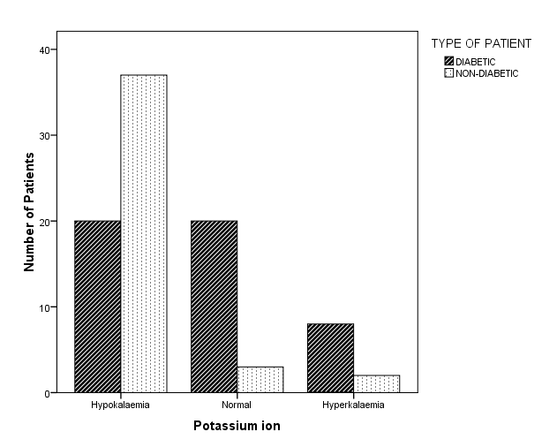
Figure 1: Classification of potassium ion in diabetic and non-diabetic patients

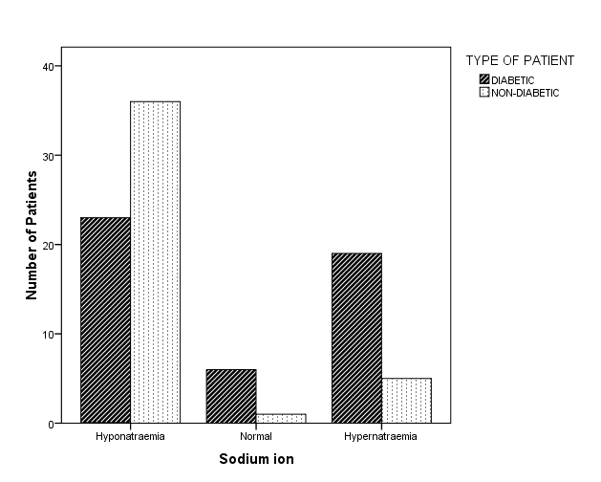
Figure 2: Classification of sodium ion in diabetic and non-diabetic patients

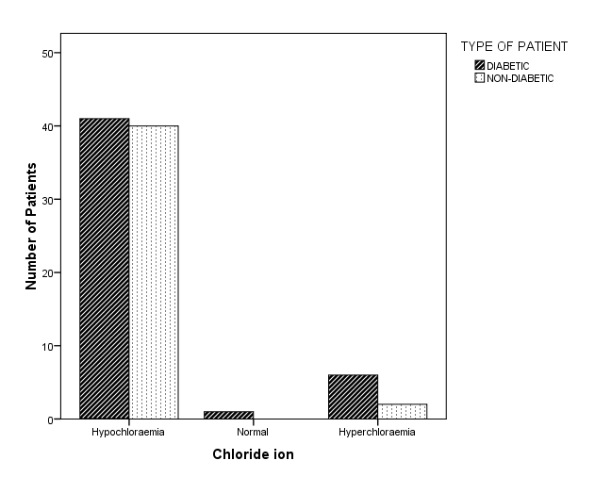
Figure 3: Classification Chloride ion in diabetic and non-diabetic patients

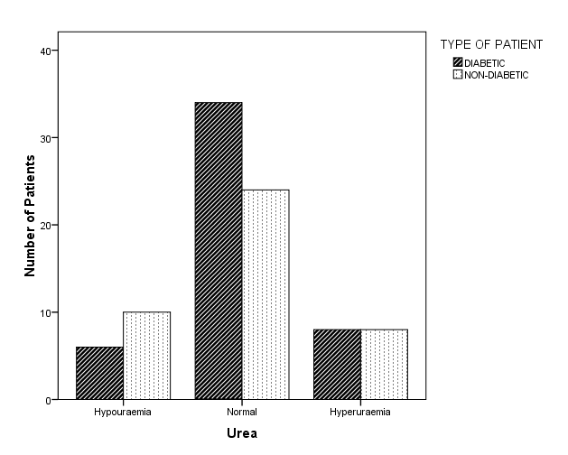
Figure 4: Classification of urea in diabetic and non-diabetic patients

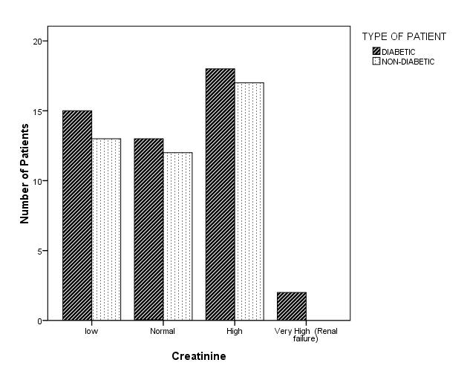
Figure 5: Classification of diabetic and non-diabetic patients

Table 6: Correlation of Age, SBP, DBP, and FBS to Serum electrolyte and renal function indices

Parameter | Potassium ion |  | Sodium ion |  | Chloride ion |  | Urea |  | Creatinine
 | PC | p-value | PC | p-value | PC | p-value | PC | p-value | PC | P-value
Age | 0.294 | 0.006 | 0.281 | 0.008 | 0.163 | 0.131 | 0.039 | 0.751 | 0.026 | 0.815
Systolic Blood Pressure | -0.171 | 0.179 | 0.184 | 0.145 | 0.096 | 0.451 | -0.043 | 0.776 | -0.185 | 0.146
Diastolic Blood Pressure | -0.206 | 0.105 | -0.208 | 0.099 | -0.074 | 0.562 | 0.002 | 0.987 | -0.086 | 0.502
FBS | 0.275 | 0.011 | 0.188 | 0.082 | -0.002 | 0.988 | 0.006 | 0.960 | 0.066 | 0.551
Legend: PC: Pearson Correlation; FBS: Fasting Blood Sugar

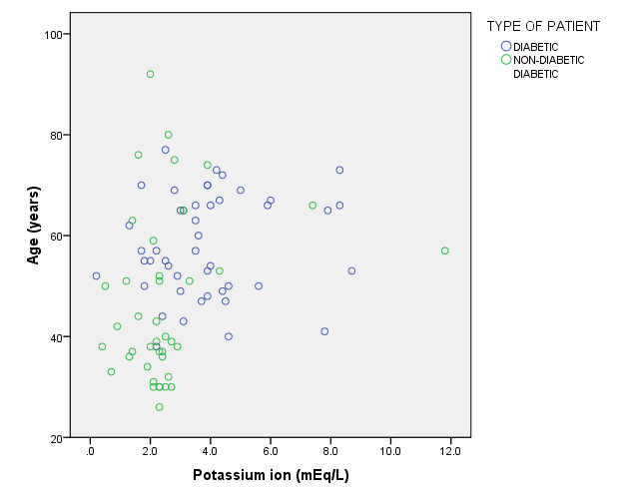
Figure 6: Correlation between age and potassium ion

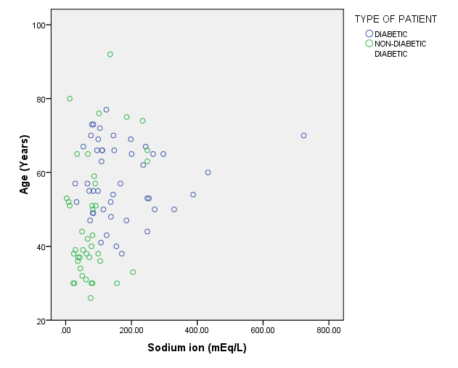
Figure 7: Correlation between age and sodium ion

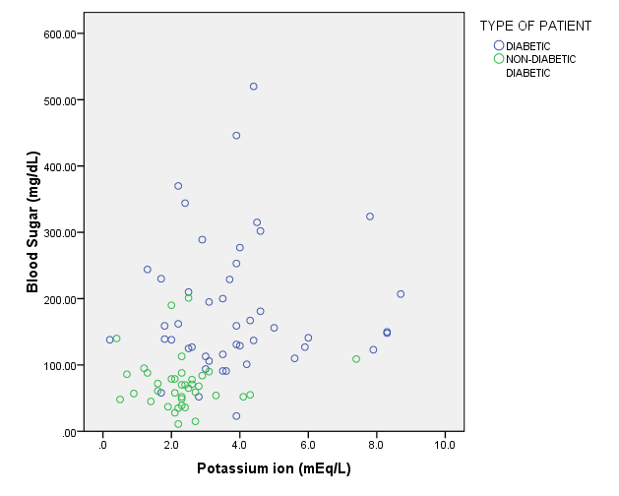
Figure 8: Correlation between blood sugar and potassium ion

Retinopathy

Parameters |  | Diabetic | Non-diabetic | Pearson Chi-square | p-value | Phi Correlation | p-value
Eye related problem | Present | 30(33.3%) | 14 (15.6%)
 | Absent | 18 (20.0%) | 28 (31.1%) | 7.626 | 0.006 | 0.291 | 0.006
 | Total | 48 (53.3%) | 42 (46.7%)

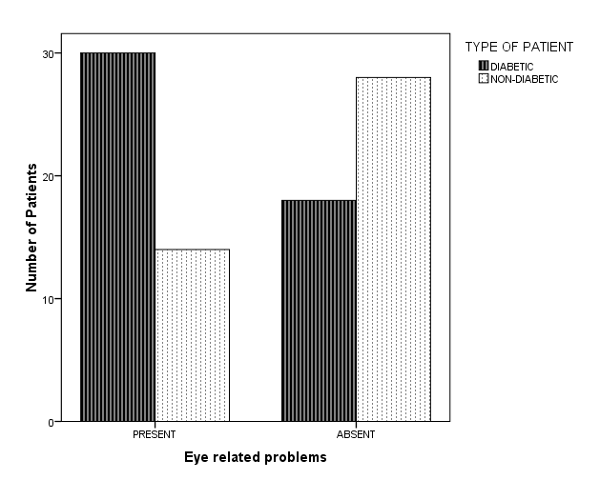
Figure 10: Classification of retinopathy in diabetic and non-diabetic patients

4.2 Discussion
Derangement of water and electrolyte balances may occur in subjects with diabetes mellitus, resulting from insulin deficiency, hyperglycemia, and hyperketonemia. (Kitabch et al., 2009) The prevalence of T2DM in Nigeria has quickly risen making her, the number one country in Africa suffering the disease with over 1.5 T2D patients. (Green et al., 2004) For the T2D patients, the mean sugar level (183.12±14.52mg/dL) and was significantly different (p=0.001) than that of the non-diabetic patients with a mean sugar level (72.62±6.31)
During an osmotic drift in the body, potassium an intracellular ion moves to the extracellular environment, joining sodium ions within this environment. The body requirement for Potassium is 50-150 mmol/d and sodium 1-2 mmol/d. (Sharma et al., 2014). T2D does not leave a constant concentration of the two ions in the body. The ions get excreted from the body through urine. Potassium and Sodium serum concentration (Table 3) were significantly higher (p < 0.05) in diabetic patients with mean a of 3.81±0.28 (mEq/dL) and 169.31±18.18 than in non-diabetic patients with a mean of 2.57±0.29 and 83.08±9.72 respectively. This may be caused by the osmotic drift in homeostasis because of irregular water movement. Under this condition, the reabsorption of sodium and potassium in the proximal tubules of the kidney is not efficient. (Liamis,2013). Chloride concentration between diabetic and non-diabetic patients was not significantly different (p= 0.840). The renal function of the participants was determined by urea and creatinine test (Table 3) showed no significant difference (p >0.05) between the diabetic and non-diabetic patients. This suggested that the kidney of the participants were not high risk of renal damage.
Sex was used as a major criterion to determine if electrolyte imbalance in the body was sex dependant. The interaction between sex and patients status on serum electrolytes as presented on table 4 showed no significant difference (p>0.05) indicating that sex difference does not influence the seru electrolyte level irrespective of the patients status (whether diabetic or non-diabetic). Hyponateria and hypokalemia (Table 5) are disorders that are characterised by low sodium and potassium ion in the body respectively. The low level of Potassium causes muscular weakness and sodium causes distort in the acid-base balance. As shown in Table 5, the proportion of hyperkaleemia was more in T2D patients (8.9%) than ND patients (2.2%) with significant difference (p=0.000), suggesting that during the movement of water out of the cell potassium ion moves out together with it in diabetic patients. Also, the proportion of hypernatremia was significantly greater (p=0.001) in T2D patients (21.1%) than in the ND patients (5.6%) suggesting excess sodium ion in the body which may be as a result of high blood sugar prootic osmotic drift. The proportion of hypochloremia was similar in T2D (45.6%) and ND (44.4) patients but the proportion of hyperchloremia was higher in T2D (6.7%) and ND (2.2%) patients. Chloride is actively reabsorbed in the body with “Chloride-Pump”, this makes the excretion of chloride in the kidney not easy. This result was consistent with those reported by previous studies. (Wang et al., 2013, Haglin et al., 2011). The renal function indices as shown in able 5 showed no significant difference; Creatinine (p=0.269) and Urea (0.311). The proportion of hypoureamia and hyperureamia are similar. The proportion of low and normal creatinine level was similar in T2D and ND patients except 2 T2D patients who showed very high creatinine level, which implies high risk of renal damage. The low and normal creatinine level implies that the stage of the disease in the participants of study is not advanced, also the consumption of diabetic drugs aid in making sure of a good renal function. This result was consistent with previous studies. (Wang et al., 2013, Haglin et al., 2011)
Age correlated positively with potassium ion (PC = 0.294) and sodium ion (PC = 0.281) significantly (p<0.05). This implies that the older one gets, the serum potassium and sodium ion also increases. Fasting blood sugar (FBS) correlated positively with potassium ion (PC = 0.275) significantly (p= 0.011). This implies that high fasting blood sugars in a patient will increase the serum potassium ion.

CHAPTER FIVE
CONCLUSION
5.1 Conclusion
The findings of this study showed that T2D is associated with electrolyte imbalance and not renal dysfunction. This may be due the osmotic drift in the cell by hyperglycaemia; causing intracellular ions to move out to the extracellular spaces. Also, T2D causes polyuria and osmotic diuresis which are means by which these ions are excreted from the body of patients.

REFERENCES
Anatomy and Physiology: The Unity of From and Function. Saladin Sixth Edition. New York, N.Y. 2012 by McGraw- Hill Companies, InC
Ann Pietrangelo Medically Reviewed by George Krucik, MD, MBA
on September 29, 2014 Healthline Media.
Ascherio A, E.B. Rimm, M.A. Herna´n, E.L. Giovannucci, I. Kawachi et al. Intake of Potassium, Magnesium, Calcium, and Fiber and Risk of Stroke Among US Men. Circulation 1998;98:1198-1204.
Bangladesh J. Med. Sci. 2009, 8, 52–56.
Barbagallo M, Dominguez LJ. Magnesium intake in the pathophysiology and treatment of the cardiometabolic syndrome: where are we in 2006? J Cardiometab Syndr. 2006;1(5):356–357.
Careen Reed 2014 PDF Causes of Type 1 and Type 2 Diabetes diabetesinfo.org
Chiang, J. L.; Kirkman, M. S.; Laffel, L. M. B.; Peters, A. L. (16 June 2014). "Type 1 Diabetes Through the Life Span: A Position Statement of the American Diabetes Association". Diabetes Care. 37 (7): 2034–2054. PMID 24935775.
Chiasson JL, Aris-Jilwan N, Belanger R, Bertrand S, Beauregard H, Ekoe JM, et al. Diagnosis and treatment of diabetic ketoacidosis and the hyperglycemic hyperosmolar state. Cmaj. 2003,168:859-866.
Christian, P; Stewart, CP (March 2010). "Maternal micronutrient deficiency, fetal development, and the risk of chronic disease". The Journal of Nutrition. 140 (3): 437–45.
Dallas, John (2011). "Royal College of Physicians of Edinburgh. Diabetes, Doctors and Dogs: An exhibition on Diabetes and Endocrinology by the College Library for the 43rd St. Andrew's Day Festival Symposium"
Davis N, Forbes B, Wylie-Rosett J (June 2009). "Nutritional strategies in type 2 diabetes mellitus". Mt. Sinai J. Med. 76 (3): 257–68. PMID 19421969
Deepti GN1, Sumina Cherian2, K. Lakshmi3 A comparative study of electrolyte imbalances in controlled and uncontrolled diabetes mellitus International Journal of Clinical Biochemistry and Research 2017;4(1):22-24

Diseases and Conditions, Diabetes, 2014 Diabetes management: How lifestyle, daily routine affect blood sugar mayoclinic.org 1998-2017 Mayo Foundation for Medical Education and Research (MFMER).

Diseases and Conditions, Diabetes, 2014 Tests and Diagnosis mayoclinic.org 1998-2017 Mayo Foundation for Medical Education and Research (MFMER).

Diseases and Conditions, Diabetes, Signs and Symptoms mayoclinic.org 1998-2017 Mayo Foundation for Medical Education and Research (MFMER).

Diseases and Conditions, Diabetes, Treatments and drugs mayoclinic.org 1998-2017 Mayo Foundation for Medical Education and Research (MFMER).

Dr. Josh Axe.com Symptoms of Electrolyte Imbalance, Plus How to Solve It 2017
Dyslipidemia in Diabetic PatientsMed. Sci. 2016, 4, 7; doi:10.3390/medsci4020007 www.mdpi.com/journal/medsci
Goldberg A, Hammerman H, Petcherski S, Zdorovyak A, Yalonetsky S, Kapeliovich M, Agmon Y, et al. Prognostic importance of hyponatremia in acute ST-elevation myocardial infarction.Am J Med. 2004;117(4):242-8.
Greenwood FC, Landon J (April 1966). "Growth hormone secretion in response to stress in man". Nature. 210 (5035): 540–1.
Haglin, L.; Backman, L.; Tornkvist, B. A structural equation model for assessment of links between changes in serum triglycerides, urate, and glucose and changes in serum calcium, magnesium and phosphate in type 2 diabetes and non-diabetes metabolism. Cardiovasc. Diabetol. 2011.
Healthline Media UK Ltd, Brighton, UK.
Himsworth (1936). "Diabetes mellitus: its differentiation into insulin-sensitive and insulin-insensitive types". Lancet. 227 (5864): 127–30. doi:10.1016/S0140-6736(01)36134-2

http://www.nzihf.co.nz/about-usThe New Zealand Institute of Health and Fitness The Diabetes Epidemic : What is Diabetes and why is it a problem? 2017
Husain, F.; Arif Maan, M.; Sheikh, M.A.; Nawaz, H.; Jamil, A. Trace elements status in type 2 diabetes.
Kitabchi, A.E.; Umpierre, G.E.; Murphy, M.B.; Kriesberg, R.A. Hyperglycemic crisis in adult patients with diabetes: A consensus statement from the American diabetes association. Diabetes Care 2006, 29, 2739–2748.

Larry Armstrong, 2011Electrolyte Imbalance in Diabetes. Leaf Group Ltd. LIVESTRONG.COM
Larsson SC, Orsini N, Wolk A. Dietary magnesium in-take and risk of stroke: a meta-analysis of prospective studies. Am J Clin Nutr. 2012;95(2):362–366. doi: 10.3945/ajcn.111.022376.

Leonid Poretsky, (2009). Principles of diabetes mellitus (2nd ed.). New York: Springer. p. 3. ISBN 978-0-387-09840-1.
Leutholtz, Brian C.; Ripoll, Ignacio (2011). "Diabetes". Exercise and disease management (2nd ed.). Boca Raton: CRC Press. p. 25. ISBN 978-1-4398-2759-8. OCLC 725919496.
Liamis G, Liberopoulos E, Barkas F, Elisaf M. Spurious electrolyte disorders: a diagnostic challenge for clinicians. Am J Nephrol. 2013;38(1):50-7. doi: 10.1159/000351804. Epub 2013 Jun 26.
Liamis G, Liberopoulos E, Barkas F, Elisaf M. Spurious electrolyte disorders: a diagnostic challenge for clinicians. AmJ Nephrol. 2013;38(1):50-7. doi:10.1159/000351804. Epub 2013 Jun 26.
Ma J, Folsom AR, Melnick SL, Eckfeldt JH, Sharrett AR, Nabulsi AA, Associations of serum and dietary magnesium with cardiovascular disease, hypertension, diabetes, insulin, and carotid arterial wall thickness: the ARIC study. Atherosclerosis Risk in Communities Study. J Clin Epidemiol. 1995;48(7):927–940. doi:10.1016/0895-4356(94)00200-A.
Menon V U, Kumar K V, Gilchrist A, Sugathan N T, Sundaram R K, Vasantha Nair, et al. Prevalence of known and undetected diabetes and associated risk factors in Central Kerala-ADEPS. Diabetes Res Clinic Pract. Dec 2006;74(3):287-292.
Mikaelian, N.P.; Gurina, A.E.; Terent’ev, A.A. Dysfunction of membrane-receptor system of blood cells and kidney tissue in experimental diabetes mellitus. Bull. Exp. Biol. Med. 2013, 154, 610–613.
Nabil A. Hasona 1,2, and Abdulbaset Elasbali 3 Evaluation of Electrolytes Imbalance and
Nate Morrow 2017 BUILTLEAN LLCWhat Are Electrolytes… And Why Are They So Important? November 28, 2012UPDATEDFebruary 20, 2016
Neha Sharma, Umesh Kumar Pareek, Avdheshkumar Sharma, Ketan Mangukiya, Mali KL, Kaushik GG. Comparative study of role of Macro minerals & Electrolytes with Atherogenic index of plasma in Diabetic men and women. Medical Science, 2014,13(50),32-38.
Palmer BF. Managing Hyperkalemia Caused by Inhibitors of the Renin–Angiotensin–Aldosterone System. N Engl J Med 2004;351:585-592.
Paolisso G, Sgambato S, Passariello N, Giugliano D, Scheen A, D’Onofrio F, et al. Insulin induces opposite changes in plasma and erythrocyte magnesium concentrations in normal man. Diabetologia.1986;29:644–7. [PubMed].
Porth, C.M. (1990). Pathophysiology: Concepts of altered health states. Philadelphia: J.B. Lippincott Company.
Raebel MA, Ross C, Xu S, Roblin DW, Cheetham C, Blanchette CM, Saylor G, Smith DH. Diabetes and drug-associated hyperkalemia: effect of potassium monitoring. J Gen Intern Med. 2010;25:326–333.
Uribarri J, Carroll HJ. Hyperkalemia in diabetes mellitus. And Diabetic Complications. 1990;4(1):3-7.
Von Mehring J, Minkowski O (1890). "Diabetes mellitus nach pankreasexstirpation". Arch Exp Pathol Pharmakol. 26 (5–6): 371–387. doi:10.1007/BF01831214.
Wang, S.; Hou, X.H.; Liu, Y.; Lu, H.J.; Wei, L.; Bao, Y.Q.; Jia, W.P. Serum electrolyte levels in relation to macrovascular complications in Chinese patients with diabetes mellitus. Cardiovascular diabetol. 2013.
Wild S, Roglic G, Green A, Sicree R, King H. Global prevalence of Diabetes: Estimates for the year 2000 and projections for 2030. Diabetes Care 2004; 27:1047-1053
World Health Organization. Expert Committee on Prevention and Treatment of Diabetes Mellitus; WHO Technical Series No 844; World Health Organization: Geneva, Switzerland, 1994.
Zajac Jacek; Shrestha, Anil; Patel, Parini; Poretsky, Leonid (2009). "The Main Events in the History of Diabetes Mellitus". In Poretsky, Leonid. Principles of diabetes mellitus (2nd ed.). New York: Springer. pp. 3–16. ISBN 978-0-387-09840-1. OCLC 663097550.

