THE GEOLOGY OF AMANGUWU AND ENVIRONS
BY

UMEH ZIMUZO TONNA
U13/NAS/GLM/020

A PROJECT REPORT IN THE DEPARTMENT OF PHYSICAL AND GEO SCIENCES FACULTY OF NATURAL AND APPLIED SCIENCES SUBMITTED TO THE DEPARTMENT OF PHYSICAL AND GEO SCIENCES GODFREY OKOYE UNIVERSITY UGWUOMU-NIKE IN PARTIAL FUFILLMENT OF THE REQUIREMENTS FOR THE AWARD OF BACHELOR OF SCIENCES IN (B.SC) OF THE GODFREY OKOYE UNIVERSITY.

JULY, 2016

CERTIFICATION
This is to certify that the research work for this project and the subsequent preparation by UMEH ZIMUZO TONNA department of physical and geo-sciences, Godfrey Okoye University were carried out under our supervision.

MR. S. E. NNAJI Date
Supervisor

PROF. C UHUEGBU Date
Head Of Department

PROF. C UHUEGBU Date
Dean Of Natural And Applied Sciences

External Examiner Date
iii

TITLE PAGE

TITLE PAGE

BY

UMEH ZIMUZO TONNA

U13/NAS/GLM/020

DEPARTMENT OF PHYSIACL AND GEO SCIENCES
GODFREY OKOYE UNIVERSITY

JULY 2016

DECLARATION PAGE
I hereby declare that this work The Facies Analysis Of The Cretaceous Sediments of Afikpo, Ebonyi is the product of my own effort under the supervision of MR. S.C.E NNAJI and has not been presented else where for the award of a degree or certificate, all sources have been duely acknowledged

SIGNATURE

NAME

DATE

DEDICATION
This work is solely dedicated to God Almighty for his guidance, inspiration, kindness and provision throughout the period
To Him Glory and Praise Forever

ACKNOWLEDGEMENT

I want to give all the thanks to God Almighty; He has given me the privilege, grace, and finances to write this project research to help me succeed. I am deeply grateful to the best mother in the whole world Mrs Apemaa Blessing L. my one and only father DR. Kagbo Mene F, you remain the best. Engr C.A Onu who stood as a mentor and a father to me. In a special way, my appreciation goes to my departmental coordinator Mr. E.O. Ikejiaku who really was a source of encouragement and great help during this project, I really appreciate your tired less effort in making this project a success. To my able supervisor MR Nnaji C.S.E. i can’t thank you enough for your support, spending time to go through my work and correcting me were necessary, you gave me the courage to work harder, and to my wonderful lecturers in the department of geo sciences, Mr Iyoku M.U, Dr Aghamelu O.P, Late. Prof. Awalla, and Dr Amobi J. O. am grateful for your support and for having time to go through my work, making corrections and explanations, and my able dean Prof Chidi may God almighty reward your efforts. To all my Course mates I want to say Love you all, you guys have been of great help throughout this period. To my siblings Kara, Vivian, and my cousins Jonathan and Gift and to my best friend SILAS PEACE Juliet you are really the best indeed, to someone very special and dear to my heart Ineke Joseph your wonderful, to my great and the most wonderful friends Micheal Okoro, Batubo Precious, Batubo Hope, Igwillo Nancy, Anieke Favour, Iyalla Lani, Mary Inyang, Nwachuchukwu Ugochi, Rajunor Bassey, Nnacho Charles, Abaa Victor…. I can’t express my profound gratitude to you guys, you were always there for me… I Love you all.

TABLE OF CONTENTS
Title page i
Certification page ii
Dedication iii
Acknowledgement iv
Table of contents v
List of tables ix
Abstract xi
CHAPTER ONE: INTRODUCTION
1.1 Back ground information
1.2 Objectives and scope of study
1.3 location and extent
1.4 Physiography of the area
1.4.1 Accessibility
1.4.2 Geomorphology Of The Area
1.4.3 Drainage
1.4.4 Vegetation
1.4.5 Climate
CHAPTER TWO: REVIEW OF LITERATURE
2.0. Previous Geological Work
2.1 Johanes Walther’s Observations of Sedimentary facies
2.2 Regional Geology ( Regional Geologic Settings)
2.3 Stratigraphic Setting
2.3.1 Campanian
2.3.2 Maastrichian
2.4 Stratigraghic Succession of Afikpo Basin
2.5 Cretacceous Sequence In Southern Western Nigeria, Eastern Nigeria
2.5.0 Lithostartigraphic Units
2.5.1 Formation
2.5.2 Group
2.5.3 Super Group
2.5.4 Member
2.5.5 Bed
2.5.6 Complex
CHAPTER THREE: (MATERIALS AND MATERIALS)
CHAPTER FOUR: (DESCRIPTION OF LITHOLOGIC UNITS)
CHAPTER FIVE (LABORATORY ANALYSIS OF FIELD DATA)
5.1 Equipments Used
5.2 Procedure For Analysis
CHAPTER SIX (ANALYSIS RESULTS AND INTERPRETATION OF FIELD DATA)
6.0 Univariate Analysis
6.1 Bivariate analysis
6.2 Facies Analysis
6.2.1 Meandering River Sandstone Facies
6.2.2 Bioturbated Sandstone Facies
6.2.3 laminated Sandstone Facies
CHAPTER SEVEN
7.0 Structural Geology
7.1. PRIMARY SEDIMENTARY STRUCTURES
7.1.1 Cross Beds
7.1.2 Joints
7.1.3 Beddings
7.2 SEDIMENTARY STRUCTURES
7.2.0 Mudcracks
7.2.1 Fractures
7.2.2 Joints
7.2.3 Faults
7.3 BIOGENIC STRUCTURES
7.3.1 Ophiomorphs and Skolithos
7.4 IGNEOUS ACTIVITY
7.5 ECONOMIC ACTIVITY
7.6 HYDROGEOLOGY
7.7 GEOHARZARDS OF THE AREA
CHAPTER EIGHT: CONCLUSION

LIST OF FIGURES
Fig 1.0 Presence of Trace fossils along Ugwuegwu
Fig 2.0 Bedded sandstone outcrop along Ugwuegwu Road
Fig 3.0 Presence of Observed Trace fossils on a sandstone outcrop along Ugwuegwu
Fig 4.0 Observed Skolithos on Sandstone outcrop at Ugwuegwu near Ololo River
Fig 5.0 Observed sandstone sample showing red colouration at Ugwuegwu near Ololo River
Fig 6.0 Observed sandstone beds with intercalations of shales and sandstones at the bottom layer at Nkpoghoro along Amaizu road
Fig 7.0 Observed portholes or bioturbations on the sandstone surface located at Nkpoghoro along Amaizu road
FIG 8.0 Observed exposure of five bedded outcrop along Ndibe Beach road
Fig 9.0 Exposure of the five bedded outcrop along Ndibe Beach Road
Fig 10 Sandstone layer with intercalations of clay at the bottom layer at Ndibe Beach
Fig 11 Observed Jointed structure along Magregor college road
Fig 12 Logged outcrop opposite the mechanic along Magregor College road
Fig 13 A picture of the outcrop of a sandstone unit at Magregor roundabout Above it is a litholog of the sandstone unit
Fig 14.0 Observed cross bed structures along Amasiri road
Fig 15 Lamination Structures along Amasiri road
Fig 16 Dolorite Intrusive Boulders
Fig 17 Bivariate gragh of Skewness against sorting
Fig 18 Bivariate graph of skewness against sorting
Fig 19 Table showing Bivariate analysis results
Fig 20 Sanstone outcrop undergoing bioturbation along Ndibe Beach Road
Fig 21 Sandstone outcrop with conglomerate on top along Ndibe Beach Road
Fig 22 Thin Laminations in a sandstone bed along Ndibe Beach Road
Fig 23 Bioturbated sandstone facies unit at Nkpoghoro along Amaizu Road
Fig 24 Parallel thin laminations along Ndibe Beach Road
Fig 25 Mudcracks shown at Ndibe Beach
Fig 26 A fault structure at along Ndibe Beach Road
Fig 27 Observed Ophiomorpha at Ugwuegwu near Ololo River
Fig 28 A skolithos trace at Ugwuegwu near Ololo River

ABSTRACT
The Main objective of this work is to study the geology and carry out the facies analysis of the Cretaceous Sediments of AFikpo at Ebonyi state and produce a geologic map of the study area. The work was done in the field making observations, taking measurements using the GPS, Compass, hammer etc, and taking down recordings, Laboratory analysis were also carried out on the samples from the field, Bivariate And Univariate analysis were done on the samples. The results from this analysis helped us decipher the facies found in the area which includes; Mudstone facies, Sandstone Facies which include; laminated Sandstone Facies, Biourturbated Sandstone Facies, Massive Sandstone Facies, Meandering River Sandstone Facies and Environments of depositions which incudes; possible dominant Marine Environment, Fluvial, Beach Environment. From the study this has pointed out that this area is dominantly a Marine, Beach, and from previous works carried out fluvial Environment. From previous works carried out I agree to the that fact that the area is a Marine, and Fluvial Environment and I want to also decipher from the result of the Bivariate analysis carried out that it is a possible predominantly Beach Environment, and from observations of field structures such as Biogenic structures e.g. skolithos that it is a predominant Marine environment

CHAPTER ONE (Introduction)
1.1 Background Information
Geology is an applied course that has been designed to enlighten and expose students to the procedures of practical field geologic mapping. This involves the study and practical significances of the study of outcrops on rocks in a study area to deduce important information. Research on the study of sedimentary rocks have shown that sediments, pieces and fragments of sedimentary old and pre-existing rocks have created some features and rock attributes which are especially distinct and useful in the sedimentary terrain. This concept makes up about 80%-90% of mineral products that are being utilized in our day to day living and up building. Product of sedimentary rocks which have been a major commodity which has sustained living economics of major developed or developing nations and detailed study on its further use and maintenance is necessary so as not only to develop new uses but also to preserve products of sedimentary rocks for future generations. Thus the field work at Afikpo provided a better practical understanding of the Geology of the area which involves its Geomorphology, regional/structural Geology, Hydrogeology, Economic Geology, Sedimentary facies of the area.
In the course of this research we would be looking at the facies analysis of the cretaceous sediments of Afikpo, facies deals with the chemical and biological aspects of sedimentary beds of the same geologic age. Sedimentary facies is defined as a mass of rock which can be defined and distinguished from others by its geometry, lithology, sedimentary structures, paleocurrent pattern and fossils. Facies analysis is done to construct a geologic model that describes an ancient sedimentary environment and this agrees with Ly’ells doctrine of uniformitarianism which means that (the presence is the key to the past) i.e. modern equivalences are used as analogs of ancient environment. In industries that exploit earth resources such as fossil fuels, facies analysis is very important in research apart from examination of rock specimens, this kind of analysis may also rely heavily upon the geophysical properties of the rock such as density, radioactive electrical and even magnetic properties of the rocks but for the cause of this research we would be using just examinations of rock specimen, biological and geological structures to analyze our facies.
1.2 OBJECTIVES AND SCOPE OF STUDY
The major objective of this field work is to:
- To study the facies of the area using lithological, physical characteristics and laboratory analysis
- To create a geologic map that gives a detailed structural and lithological description

1.3 LOCATION AND EXTENT
Afikpo and its environs is in Ebonyi State and is located geographically in the South-eastern part of Nigeria within the co-ordinate of latitude 5⁰53’N and 5⁰55’N, and longitude 7⁰54’E and 7⁰57’N. Afikpo is bounded by Owututu to the South, Abba-Omega to the North, Oso to the West, Nko (Cross River) to the East. Afikpo lies at an elevation of about 170m above sea level.
1.4 PHYSIOGRAPHY OF THE AREA
1.4.1 ACCESSSIBILTY
The primary access was through either the Amasiri-Akaeze road or the Abakiliki-Afikpo express road. Other accesses to the field area mapped are through minor roads and footpaths linking the various towns and communities around the area.
1.4.2 GEOMORPHOLOGY OF THE AREA:
Geomorphologically, the study area is undulating, composed of alternating highlands and lowlands with some of the low lands being occupied by surface water bodies.
The highlands are mainly the ridges and hills which are made up mainly of sandstone lithology, minor siltstones/mudstones and claystones which serve as cementing material that bind the quartz grains. Shales and then some siltstones usually underlie the lower areas. On a regional scale, Afikpo is a trough or sub-basin but in terms of local topography is commonly undulating.
1.4.3 DRAINAGE
The drainage of the study area is controlled by relief, topography and geology. The drainage pattern of the study area is dendritic (tree-like pattern). Some of the
streams are seasonal due to the fact that they dry up during the dry season and are restored during the rainy season.
1.4.4 VEGETATION
Afikpo is in transition between the tropical rain forest and guinea savannah. The field area comprises mostly of perennial trees, grasses, stubs and climbers. Its vegetation is affected by various factors such as:
- Human activities
- Annual rainfall
- Topography, and various climatic factors
The valley terrain produces thick, green vegetation even during the dry season due to availability of surface water caused by the shale which does not permit water to percolate deep into the soil, while partially withered grasses are found in the hills.
1.4.5 CLIMATE
The prevailing climate is typically tropical, with an average temperature of 25⁰C and average rainfall of about 200cm and 250cm (Offodile, 1992); though the temperature may be higher than 25⁰C during harmattan season. The climate is marked by 2 seasons:
- Rainy season (from April to October)
- Dry season
CHAPTER TWO: LITERATURE REVIEW
2.1 PREVIOUS GEOLOGICAL WORKS
The Afikpo area has been studied by various outstanding geologists such as Nwachukwu (1972), Murat (1972), Simpson (1955), Hogue (1977), etc.
Murat(1970), remarked three tectonic phases and epirogenic sedimentary cycle in Nigeria that affected the Benue Trough. In Southern Nigeria, sedimentation started with the formation of the North-East Benue Abakiliki Trough during the opening of the Atlantic Ocean and the separation of African Plate from the South American plate, during this period, shelf deposit were laid down on the Anambra Platform. The Santonian compression movement by Murat (second tectonic phase) probably folded the sediments in the Southern Benue Trough near the eastern flank, into a series of North-East trending folds which now constitute the Abakiliki Anticlinorium. Nwachukwu (1972) suggested that the sandstone in the study area is characterized by imprints of tectonic deformation with major unconformities marking the contact between some of the lithologic contacts.
Hogue (1977) established that the Eze-Aku group conformably overlain by the Awgu Shale and on the South-Eastern part of the Afikpo syncline which overlain unconformably by the Afikpo sandstone. He observed that the sands are made up of texturally and mineralogically immature feldsparthoid arenites.
Simpson (1955) noticed that the high angle of dip in the Eze-Aku was as a result of the Post-Turonian tectonic event which affected the Pre-Turonian units including the Eze-Aku Group. Ezepue (1984) established that a dolerite sill intruded the Eze-Aku Group. The Afikpo base on was formed during the santonian orogeny in the upper cretaceous time ( Campanian Maastrictian). Some of the research works on Afikpo where carried by notable researchers like; Sampson Rayment 1965, C.S. Wajide 1976, Mckay 1939, Murat R.C among others. Majority of the shale’s and silt stone sediments are carbonaceous as observed in an outcrop where Ammonite fossils, Echinods, Bryozons and other fossils where collected ,majority of the sediments where sand stone deposits , charges from calcerous sand stone along the Abakaliki anticlinorium to arenaceous sandstone towards the core of the basin. They also observed that an igneous intrusion occurred along the axis of the Abakaliki anticlinorium which is dated to be about 55 million y ears. Also Mckay 1939 dated the age of Afikpo synclinorium to be mid Cretaceous base on the observation made and the outcome from the structural and lithological difference that exist between Amasiri and Afikpo sand stone. The santonian event on the region resulted in fracturing and folding of the post santonian sediment found on
the Afikpo synclinorium.

2.1.0 JOHANES WALTHERS OBSERVATION OF SEDIMENTARY FACIES
A German geologist, Johanes Walthers, noted in 1894 that the vertical facies sequence in sedimentary basin undergoing expansion and deepening so that the sea transgresses the land surfaces (or the reverse a regression). The same as the horizontal, this has enabled geologists to know the pattern of the surface, to predict accurately what may also be found at the depth within a sedimentary basin. It is clear however, the walther’s observation only applies where there is no major break (i.e. an erosional interval in the continuity of the succession. Wealther’s law of facies named after James Wealther states “that a vertical succession of facies reflects lateral changes in the environment. Conversely it states that when a depositional environment “migrates” laterally sediments of one depositional environment come to lie on top of another”. A classic example of the law is the vertical stratigraphic succession that typifies marine transgressions and regression
2.2 Regional Geology (Regional Geological Setting)
This refers to scientific study of the origin, history and the structure of earth’s crust. There has been a lot of argument among researches and geologist for several years about the origin and evolution of Benue trough, Benue trough was under a tensional regime from the time when it originated as the failed arm of an RRR triple junction (Burke et al; 1970). Benue trough has often been described as elongate, partly fault- bounded depression occupied by up to 6,000m of marine and fluvideltaic sediments that have been compressionally folded in a non-orogenic shield environment (Might, 1976), Olade (1975, 1976) emphasizes the wholly ensiabic nature of the trough, the thinned crust beneath it, and the dominate influence of vertical movement as causes of the folding. Concede that the weight of evidence may eventually prove that the folding was in fact due to compressional movements, albeit accompanying broad regional uplift of the “Guinea dome” (Olade 1975), but Wright (1968), proved it wrong. So there is no obvious cause of the necessary compression movements. The lemuroid anticline, south of Gombe, one of the most impressive folded structures of the upper reaches of the Benue trough there is no question that it is a double plunging anticline, but its two virtually value-straight limbs provides evidence that at least some of the folding in the Benue trough may be controlled by a system of East-north east trending faults in the underlying basement, along which blocks have been differentially uplifted.
2.3 Stratigraphic Setting
2.3.1 Campanian
In south-eastern Nigeria, Campanian sediments probably belong to the base of Nkporo Formation (Taltan 1944). Outcrops of the Nkporo formation are scarce but boreholes cores show that the formation consists of dark shales and mudstone with occasional thin beds of sandy shale sandstone. Thin beds of shelly limestone may be present; the estimated maximum thickness is 1000 meters. No typical Campanian Ammonites have been found in Nigeria but it is probably that the base if the Nkopro Formation and lateral equivalents are Campanian in age.
2.3.2 Maastrichian
The Campano- Maastrichian in South-Eastern Nigeria consists of dark grey, often friable, shale with occasional thin beds of limestone and sandstone. This part of sequence belongs to the Nkporo Formation. The Owelli sandstone, Enugu shale and Asata shale are lateral equivalents of Nkporo Formation. These inner-basin sediments are of shallow water origin and there are frequently sharp facies changes. The basal part of the coal measure sequence previously known as the lower coal measures but now known as Mamu-Formation contains marine intercalations composed of Ammonitiferous shales (reyment 1964) the coal being part of the sequence consists of predominately fresh water and how salinity sandstone, shales, mudstones and sandy shales, coal seams occur at several levels (simpson 1955) excellent exposures of Mamu Formation can be seen along the Enugu- Onitshsa road at the Milliken hill just on the out skirts of Enugu
2.4 Stratigraghic Succession of Afikpo Basin
Age Formation Member Lithofacies Maastrichian campanian, Nkporo shale, Asaga shale Afikpo Sandstone, Gysum, evaporates micaceous Sandstone, Turonian Ezeaku shale, Amasiri sandstone and water works sandstone junction shale.
2.5 Cretaceous Sequence in Southern Nigeria, Western Nigeria, Eastern Nigeria
Paleocene, Abeokuta Formation, Nsukka Formation Maestrician Ajali Formation, Campanian-Maestrician Basement Complex, Mamu Formation, Nkporo Formation (Lateral Equivalents are Asata Shale, Enugu Shale, Owerri Sandstone.) Coniancian-Santonian Agwu Formation, Turonian Eze-Aku Formation (Lateral Equivalent Amasiri Sandstone.) Cenomanian Odukpani Formation Albian, Unconformity Unnamed Formations (Abakaliki Shales) “Asu River Group” Basement Complex.
2.5.0 Litho-stratigraphic Units
The litho-stratigraphic units give a detailed description of the studied area (Afikpo and its environs) and for easy and convenient purpose have been divided into seven [6] units, starting with the oldest formation to the youngest formation. The description starts from the formation, group, super group, member bed and complex.

    - Formation:
The litho-stratigraphic from action identified in the studied area include the Eze-aku formation and the Nkporo formation. The Ezeaku formation is Turonian in age and contains the Amasiri sandstone, Ozara, Ukwu shale and the Amauro sandstone. The Nkporo formation is Campanian in age and contains the Afikpo sandstone.
    - Group:
The studied area belongs to the Asu river group.
    - Super Group:
Stratigraphic group of Afikpo is categorized into lower Benue trough sediments, the stratigraphy of the Albian sediment is also called the Albian Asu River super group which contains the Afikpo Synclinorium.
    - Member:
This is the next in rank after bed in a lithostratigraphic unit, the observed lithostratigraphic members in the studied area include Amasiri sandstone member, Ozara Ukwu shale member, Afikpo sandstone member and others. However, the Amasiri sandstone member consists of the Amasiri sandstone type. The Ozara Ukwu shale member consists of fossil reddish brown-black shale formed as a result of oxidation process the Afikpo Sandstone member consist of coarse grained sands and pebbles that is milky in colour.
  - .5 Bed:
This is the lowest rank in lithostratigraphic unit it consist of layers of strat that ranges from 1cm-few meters ion thickness and can be distinct from one another either in colour, texture or thickness. With respect to the studied area, the beds studied include sandstone beds; shale beds coal beds and others.
2.5.6 Complex
The stratigraphic complex of the studied are belongs to the sedimentary complex of Nigeria. They are cretaceous in age.
Afikpo and its environs constitute major groups which are Eze-Aku Group as its oldest formation (Turonian), with also Nkporo Group (Campano-Maastrichtian). The principal rock types include sandstone and shale, and are thus divided into different units. These lithologic units include:
- The Amasiri sandstone
- Junction Shale
- Water-work sandstone
- Water-work shale, which are members of the Eze-Aku Group
- Afikpo sandstone (a member of the Nkporo Group)
Amasiri Sandstone: This unit consists of well indurated sandstone beds interbedded with soft sandstones. The softer beds are laminated and often interbedded with siltstones and shales, the beds are exposed as ridges and often have a large lateral extent, cross-bedded and bioturbated.
Junction Shales: Overlying the Amasiri sandstone is the Junction shale and is distinguished from other shale units by its moderate fissility, indicating a low calcium carbonate content. The sub units are Junction shale 1 and Junction shale 2, divided by a dolerite intrusion. The contact between the Junction shale and the Waterworks sandstone is gradational.
Waterworks Sandstone: This lies conformably on the junction shale. It is more compact and very thick. The road cuts in the major part of the waterworks sandstone reveal about 8 to 10 sub units, separated from one another by contrasting lithology, colour change, differential weathering and structural features.
Waterworks Shale: It is overlain uncomformably by the Nkporo shale which undergone serious weathering and is thus covered by plenty of loose soil.
Afikpo Sandstone: It is thick and lays uncomformably on the Eze-Aku shale. This unit outcrops by the roundabout along the road leading to Afikpo town on the left side of the road. There is also an upward coarsening of grains. There is also a fining upward sequence of sediments.

CHAPTER THREE
(Materials And Methods)
The equipment used during the field work include the base map, compass clinometers, hand lens, Global Positioning System(GPS), camera, geologic hammer, ranging pole, measuring tape, sample bags, field note, pen, ruler, mathematical set.
- BASE MAP: It showed the outcrop and the direction of a place under consideration or mapping, it also helped us locate ourselves in the field. It is very important, since it can be regarded as the first aid to every field trip in field mapping in geology. The base map helped us show the outcrop and the directions of the place under-consideration for mapping.
- COMPASS CLINOMETER: It was used to measure the attitude of outcrops/beds (dip, strike, dip amount, trends of faults and joints).
- MEASURING TAPE: It was used to measure the thickness of a bed during logging and to measure distances with the aid of a ranging pole.
- HAND LENS: It was used for magnification, and used to identify or view fine particles of the rock.
- SAMPLE BAG: It was used for collecting rock samples for analysis in the laboratory.
- GEOLOGICAL CAMERA: It was used for taking photographs (images) of an outcrop.
- PEN AND PENCIL: The pen was used for recording information, while the pencil is used for sketching or drainage outcrop.
- HAMMER: It was used to extract samples from the rocks.
- MASKING TAPES: They were used in wrapping the samples and writing the locations of where the samples were gotten from.
3.0 METHODOLOGY
The methodology used during the field mapping exercise is the compass and traverse method. Here, the major and minor roads, including foot paths were used in order to access the outcrops. We first located ourselves in the field using our Global Positioning System (GPS) after which it was indicated on the base map (topographical map). During the course of the exercise, at each location , GPS readings were taken so as to obtain the latitude and longitude readings, elevation, observations based on the sediment types and sizes, along with the attitudes of beds (dip,strike) amount measurements and trends of joints) were made at the locations where needed.
Outcrops and cross beddings were taken note of and measured. Some interbedded outcrops were logged from base to top at some of our locations. At these points/locations, we tried to determine the grain sizes, texture, sorting, and mineralogy. It involves four stages; Reconnaissance, field work, and laboratory work and analysis.
- DESKWORK; This research stage is basically the research work done on the study area that has been earlier carried out so as to help aid a better understanding of the nature of research that will be carried out later on, this constitute the early or initial part of the project.
- RECONNAISSANCE; At this stage the topo map was used in the survey area, the physical features were observed, drainage pattern, nature, and trends of outcrops, the lithologic units, vegetation variation and positions of contacts were also observed, a based camp which will be used later during the actual field map was located and field guards were met and introduced to, letters were given to the heads of the villages in the area, the D.P.O and security agents for security reasons.
- FIELD WORK; At this stage outcrops were located , observed and the position using the geographic positioning system (GPS) in the which was followed by describing the outcrop based on the rock types present, lateral extent, gross thickness, bed thickness, textural features. Sedimentary structures and tectonic structures as well as biogenic structure. The outcrop/exposure is logged and during the study samples were collected and properly labeled as well as photographs of the outcrops and important features was taken for reference purposes.
- LABORATORY WORK AND ANALYSIS; Samples were collected from outcrops and were sent into laboratory research for proper analysis. This form the most tedious aspect/ stage of the project and the last part of it.

CHAPTER FOUR
(Description of lithologic units)
4.1 Location 1
This location is located along Ugwuegwu road, opposite WIC practicing school. The outcrop was inside something like a ditch which was possibly caused by erosion. We observed the presence of a trace fossil, outcrop trends South- East, North- West. A bedded sandstone outcrop was encountered with a Brownish-white with black patches on the surface which was possibly due to weathering while the colour of the fresh surface was yellowish white. ATTITUDE OF BEDS Strike; S130E, Dipᵒ direction; S221W Dip֯ Amount; 9
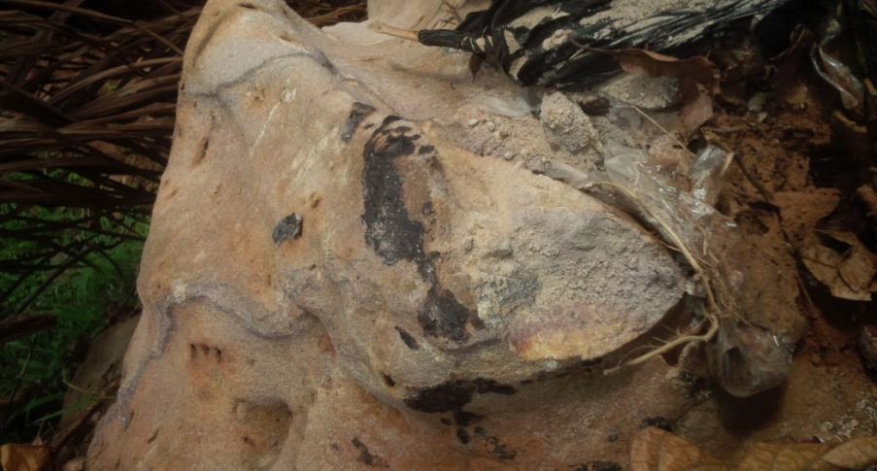
Fig 1.0 Presence Of Trace Fossils Along Ugwuegwu Road
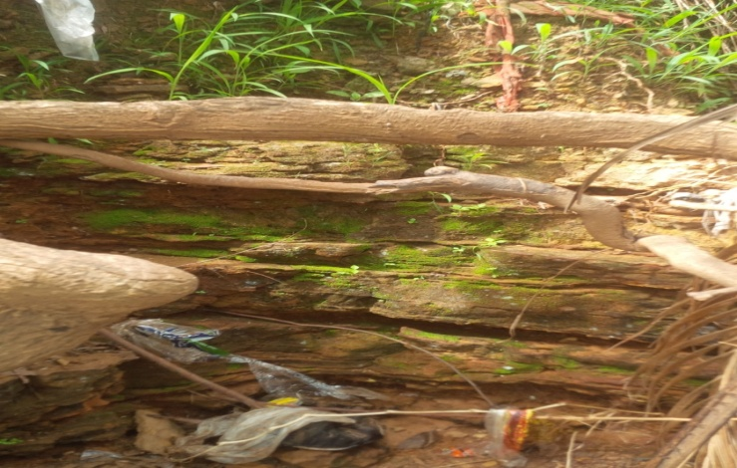
Fig 2.0 Bedded Sandstone Out Crop Along Ugwuegwu Road
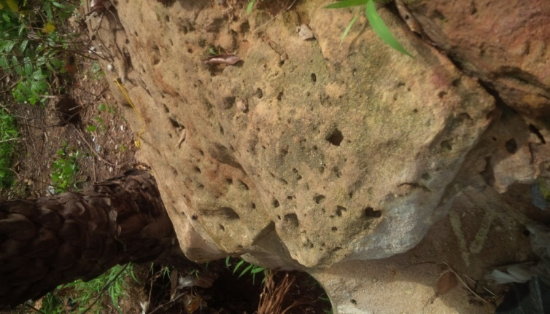
Fig 3.0 Presence Of Observed Trace Fossils On A Sandstone Outcrop Along Ugwuegwu
4.2 Location 2
It is located at Ugwuegwu near Ololo River that is about 2km far from Ugwuegwu main road. A river was encountered where the outcrop seemed to stop occurring following the trend of the outcrop, the river was trending S E – N W. The outcrop was found at the middle of a road which led to the river and farm lands situated in that area. At the point where the outcrop was first observed, trace fossils which could possibly be Skolithos caused by worm-like organisms were noticed. From the observation of those Skolithos, we infer that the place is a marine environment since the presence of Skolithos trace fossil in an area depicts a marine environment. Skolithos could also be found in a fresh water Lacustrine environment, so it could also be depicted that it is a fresh water lacustrine setting. Around the area, a massive sandstone outcrop was observed, fresh sample was collected and it showed a reddish purple colouration. Since the outcrop on which the Skolithos found was a dry ground and was close to a river, it wouldn’t be wrong to say that a river once existed there, although there was no presence of geologic or sedimentary structures, but biogenetic structures were observed which includes the Skolithos and Ophiomorpha trace fossil.
GPS COORDINATES;N 5°52'85.8" E 7°57'04.8" Elevation 74m
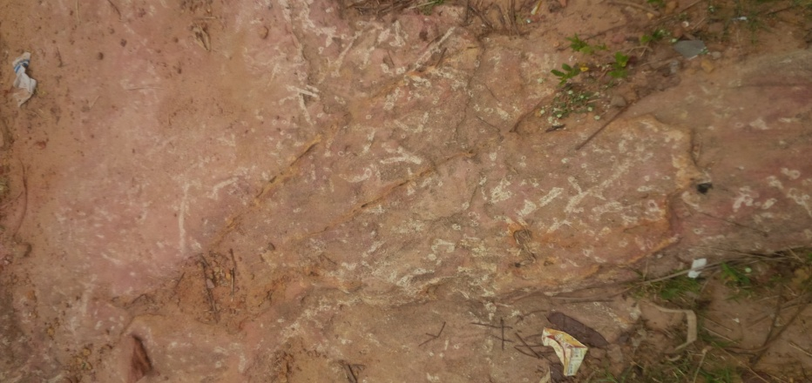
fig 4.0 observed Skolithos on sandstone outcrop at Ugwuegwu near ololo river
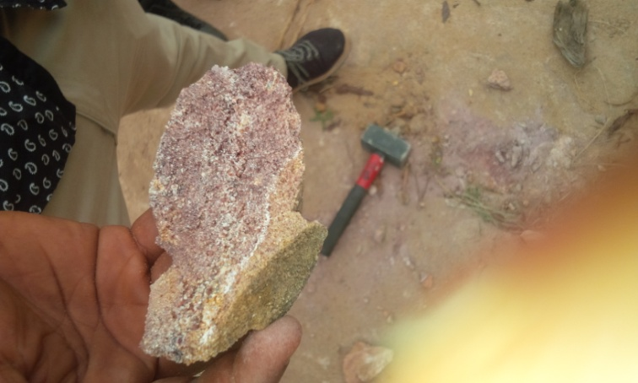
Fig 5.0 Observed Sandstone Sample Showing Red Colouration At Ugwuegwu Near Ololo River
4.3 Location 3
The outcrop is located at Nkpoghoro community along Amaizu road close to Ebonyi State Water Cooperation. The outcrop was first encountered at the right hand side of a road cut but looked like a massif ridge, but following the trend of the outcrop, a stratified sandstone bed with intercalations of clay and shale with sand stone at its top most layer and shale at the bottom layer. The outcrop surrounding the river was inferred to be a possible aquiclude because water kept dipping from the rock at a slow rate without any assistance from external source. At the topmost layer, we observed potholes which were caused possibly by human activities organisms that once lived there or probably by chemical reactions, a river was encountered which was trending SW- NE.

sandstone
Clay
Sandstone

Shale

the only observable structures were biogenic structures which occurred as potholes and were most likely formed as a result of bioturbation
GPS CO ORDINATE ATTITUDE OF BEDS
N 5°52'71.5" Strike; N88E
E 7°56'82.6" Dip direction; S175E
Elevation 66m Dip amount; 7°
Fig 6.0 above is the observed sandstone beds with imtercalations of shales and sandstone at the bottom layer at Npoghoro along Amaizu road
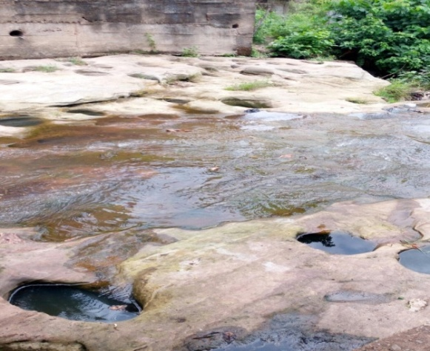
Fig 7.0 Observed Potholes Or Bioturbations On The Sandstone Surface Located At Nkpoghoro Along Amaizu Road
4.4 Location 4
The outcrop is located along Ndibe beach road and was first encountered east of the main road. The sandstone outcrop is made of five beds which the first two were fined grained, we logged the bedded sandstone and the following observations were made. At this location, a bedded sandstone outcrop extends to about 60m with a coarsening upwards sequence was encountered.

Very fine grained, has a texture almost like talc. The colour of the bed is whitish yellow it can be inferred that it was originally white but it due to weathering activities it has turned whitish yellow.

The texture of this bed is almost fine but it is not as coarse than the previous bed. This bed is almost whitish yellow in colour.

This bed is made up of conglomerate; here are large visible consolidated pebbles which are not well rounded depicting immaturity. The pebbles are reddish brown in colour
This bed is made up of coarse grains and it felt very rough when touched. This bed is reddish white possibly due to ferruginisation, it felt very rough when touched.

At this outcrop, both geological sedimentary and biogenic structures were Santonian Tectonism in the South Eastern art of Nigeria. Also there was presence of parallel lamination, which was possibly caused by cyclic changed in the form of a faunal activity (burrowing), most likely by a small organism. The attitude of the bed is almost negligible so no reading for strike and dip was taken.
COORDINATES N5°52'00.2" E 7°56'48.5" Elevation; 49m
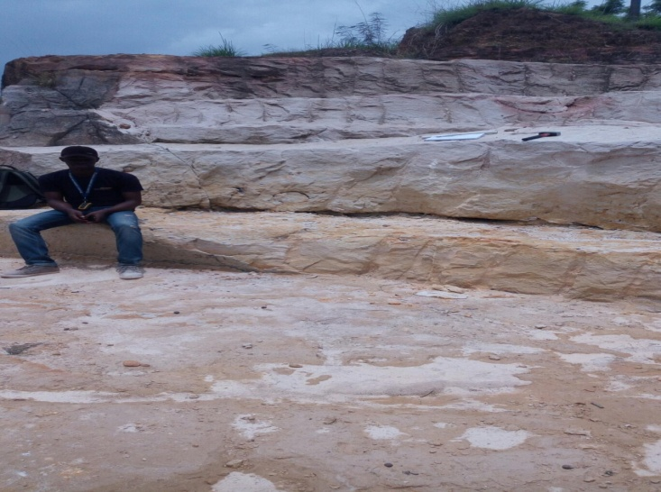
Fig 8.0. Exposure of the five bedded outcrop along Ndibe beach road.
4.5 Location 5
The type of locality of location 5 is Ndibe Beach meters westwards of Ndibe beach road. It was first encountered as a sandstone ridge which sloped towards the bank of the river, moving down the slope, it was also observed that sandstone was not the only lithology present but sandstones with intercalations of clay. The sandstone bed was about few centimeters (cm) but the clay was extensive, starting from the top to the bank of the river. Inside the river were found deposits of sand typically known as Ndibe Beach sand and are distinctively characterized by the presence of large flaky micas which is visible to the unaided eye, these sands were probably deposited by the process where overland flow can erode soil particles and transport them down slope. There were no observable fossils present but some geologic structures including bedding plane and mud cracks were observed.
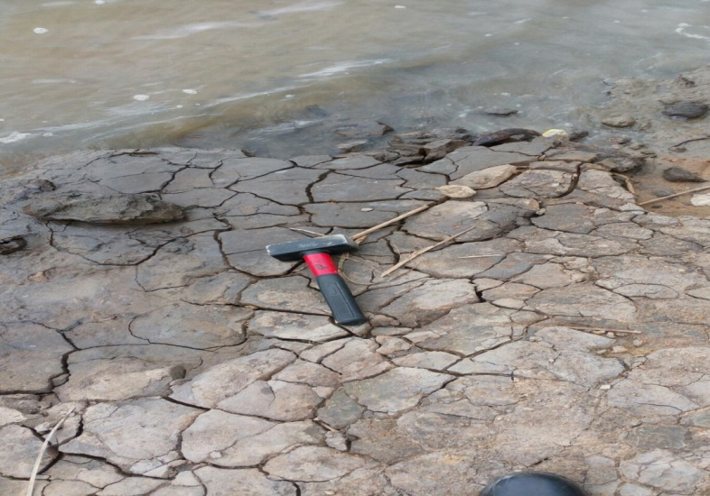
Fig 9.0 Showing observed Mudcracks inside Ndibe beach river
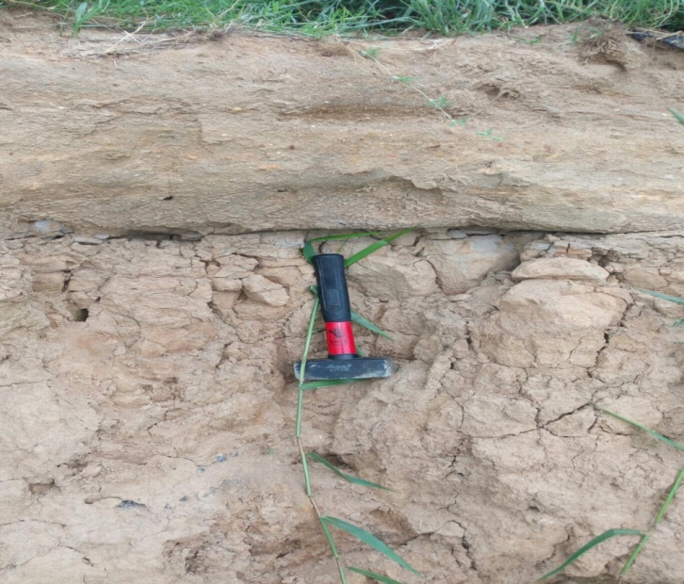
Fig 10.0 Sandstone layer with intercalations of clays at the bottom layer at Ndibe Beach

4.6 Location 6
Location six is along Magregor college road which is west of Magregor round about and is about 1km from the main road. A massive sandstone outcrop was encountered at the location; the rock type of this location is lithified sandstone. The outcrop was first encountered along a foot path off Magregor college road, in this location, the only structure observed are joints which is trending NE-SW, there is presence of bioturbation and sedimentary structures
CO ORDINATATES N5°53'60.5" E7°55'005" Elevation 94m
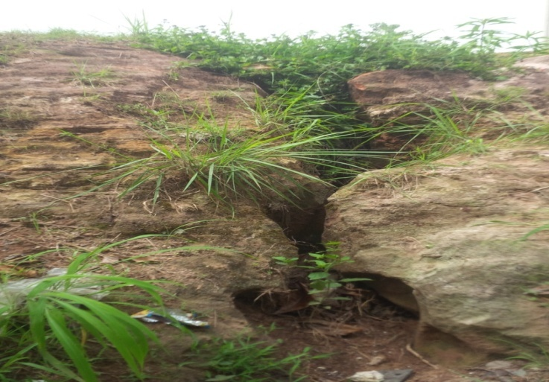
FIG 11.0 Observed jointed structure along Magregor college road
4.7 Location 7
This location is about 30m from location 6 and location 7 still along Magregor college road, the outcrop was first encountered opposite Ebonyi state hotels close to a mechanic workshop. The sequence Stratigraphy of the outcrop could not be deciphered, after logging the outcrop it was observed that both the first and last bed were coarse grained while in between them was fine and intermediate grains. A sandstone ridge was encountered at first but moving downwards slope a bedded sandstone outcrop was encountered. Observable geologic features include joints and bedding planes. CO ORDINATES 5°53'60.3" E 7°55'18.7" Elevation 98m
Coarse grain
Fine grain
Intermediate grain
Coarse grained

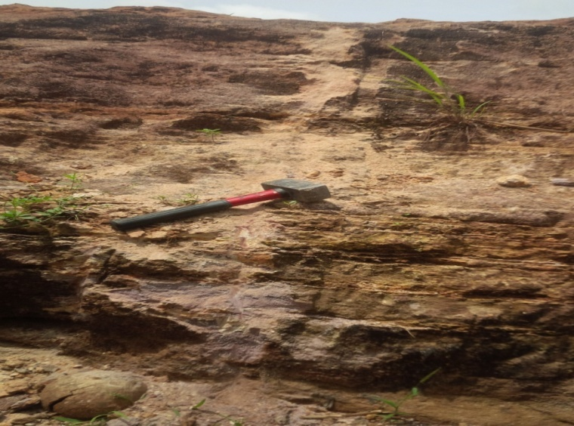
Fig 12.0 Logged Outcrop Opposite The Mechanic Along Magregor College.
4.8 Location 8
Location 8 is located around Magregor roundabout opposite the NYSC orientation camp sign board, it trends SW , it occurred along a road cut and extended about 45m, dipping out of appearance. It is a bedded sandstone outcrop which consists of 8differnt beds, each bed with distinct lithologies. We logged the outcrop and observed the following;

Conglomerate
Unconsolidated poorly sorted sandstone
Reddish brown sandstone moderately sorted
Medium grain sandstone, mixture of reddish brown and purple colourisation
Coarse grain reddish brown colour and consolidated sandstone
Coarse grain purple colourisation sandstone facies

Fine grain sandstone purple in colour
Reddish brown medium grained sandstone
The only geologic structure observed is bedding plane readcoordinates is as foll
ATTITUDES OF BEDS Strike; Dip direction; S214° W, Dip amount; 10 CORDINATES N5°53'62.3" E 7°55'30" Elevation 97m
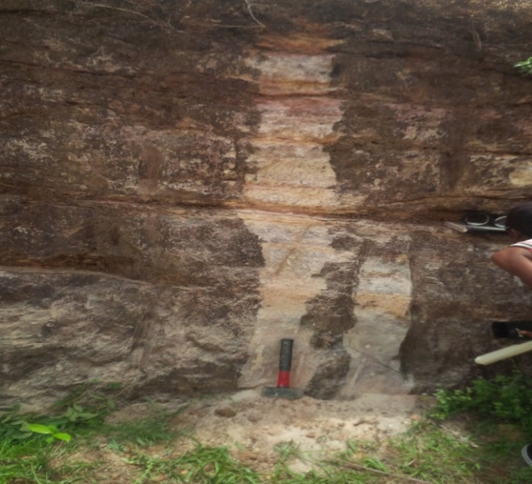
Fig 13.0 A Picture Of The Outcrop Of A Sand Stone Unit At Magregor Roundabout, Above It Is A Litholog Of The Sandstone Unit.
4.9 LOCATION 9
It is located along Amasiri road close to Magregor roundabout. The outcrop was first encountered about 100m from Magregor roundabout. The outcrop was a bedded sandstone outcrop, the weathered surface of the outcrop is black with whitish-yellow parallel lines running across them which are known to be laminations, trace fossils weren’t recorded and no bioturbation but we observed cross beds at a point on the outcrop, though no geologic structure like faults, joints etc was observed but we could notice the presence of laminations.
CORDINATES °53' 74.9'' E7°54'86.9"
ATTITUDES OF BEDS ; Strike; S240°W Dip direction; S 150°E Elevation; 17m Cross beds ,angular, unconformity, herringbone
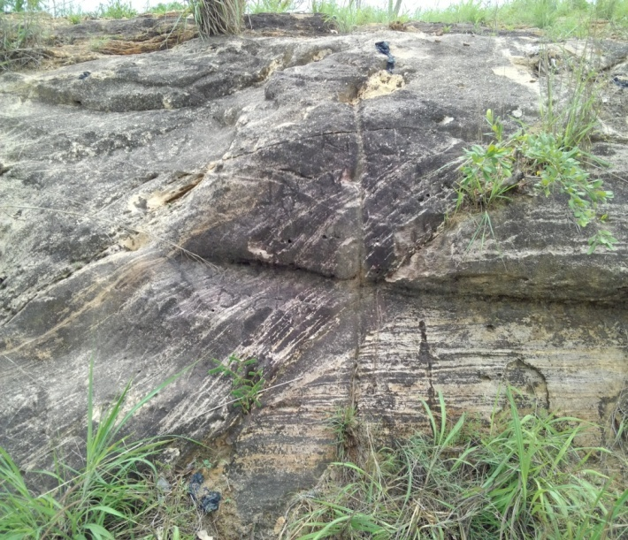
Fig 14.0 observed cross bed structures along Amaseri road
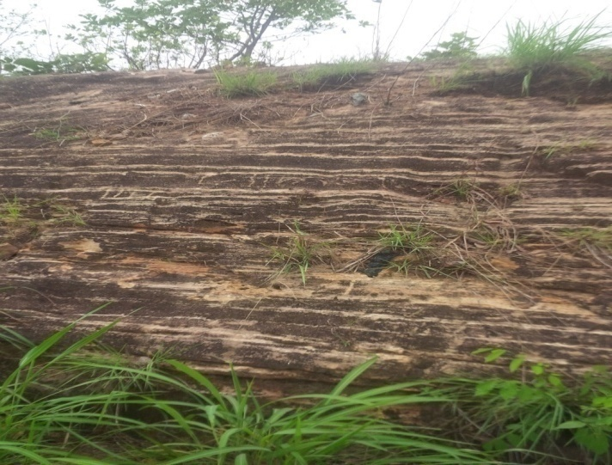
Fig 15.0 lamination structutres at a location along Amaseri road
4.10 Location 10
Location 10 is along Amasiri close to Ngodo community. The outcrop was first encountered about 20m east of Amasiri road. Two important geologic features were observed they include; the shale and igneous dolerite intrusion (sill). The shale is dark grey in colour and its fissile in nature, though it was observed that the shale was intruded by the dolerite igneous rock, the shale was observed to be well developed, it is plastic in nature with possible fossil content and its older than the dolerite igneous intrusion cutting through shale in a manner that is concordant to the bedding plane of the shale, it is dark in colour probably due to ferromagnetic minerals example olivine. It is very dense and hard making it impossible to extract or collect sample without a sledge hammer. The rock sample is fine to medium grained. Considering the law of cross cutting relationship which states that an igneous intrusion is always younger than the rock it cuts across, it won’t be wrong anyways to infer or decipher that the dolerite sill is younger than the shale it intruded.
CORDINATES; N5°53'.957"E 007°5428" ELEVATION 47m
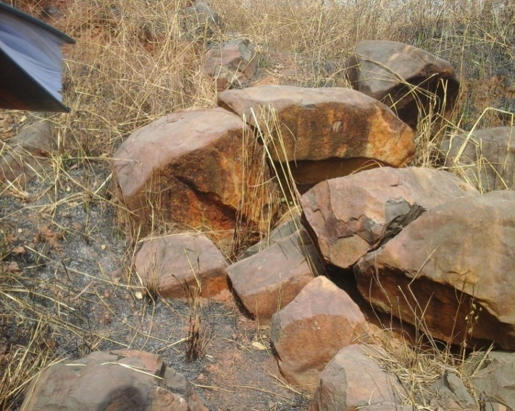
Fig 16.0 Dolerite intrusive boulders
CHAPTER FIVE
LABORATORY ANALYSIS OF FIELD DATA
Sieving is a method of mass measurement used in determining the size frequency distribution of sedimentary particles especially in the sand size range ( i.e 1/16mm-2.00mm). The grain size parameters calculated from sieve from sieve data e.g mean, grain size, sorting, skewness etc to infer the genesis/provenance, depostional processes and environment of deposition. Samples of consolidated friable sample
were collected from the field based on the locations where they were collected from.
5.1 Equipments Used
- Screen Type; Half Phi Internal
- Shaker type: ASTM
- Sieve time 15 minutes
- A Sensitive Electron Weighing Balance
- A Mechanical Sample Splitter
5.2 Procedure For The Analysis
The sample collected at the field was disaggregated by means of mechanical sampler splitter without altering the grain size, shape, and roundness. 50g of the sample was weighed with sensitive electronic weighing balance and it was shaken in a set of sieves arranged in ½ (phi) intervals with an automatic shaker for 15minutes. The sieves are later removed in a specially designed sieve analysis report sheet. Sieve loss was noted and recalculated, correct and corrected weights are converted to percentage weight and cumulative percentage weight. The results

CHAPTER SIX
ANALYSIS RESULTS AND INTERPRETATION
6.0 UNIVARIATE ANALYSIS
Sample No | Mean size  (Mz) | Sorting  (σ₁) | Skewness  (SKi) | Kurtosis  (KG)
Sample 1 | 1.12 medium | 0.58 moderately sorted | 0.33 very positively skewed | 1.73 very leptokurtic
Sample 2 | 0.81 coarse | 0.68 moderately sorted | 0.53 very positively skewed | 1.11 mesokurtic
Sample3 | 0.97 coarse | 0.66 moderately sorted | 0.41 very positively skewed | 1.30 leptokurtic
Sample 4 | 0.61 coarse | 0.47 well sorted | 0.49 very positively skewed | 1.34 leptokurtic
Sample 5 | 0.61 coarse | 0.64 moderately sorted | 0.76 very positively skewed | 0.99 mesokurtic
Sample 6 | 0.47 coarse | 0.24 very well sorted | 0.25 very positively skewed | 1.15 leptokurtic
Sample 7/1 | 0.50 coarse | 0.56 moderately sorted | 0.88 very positively skewed | 0.87 platy kurtic
Sample 7/2 | 0.37 coarse | 0.30 very well sorted | 0.60 very positively skewed | 1.66 very leptokurtic
Sample 7/3 | 0.50 coarse | 0.34 very well sorted | 0.46 very positively skewed | 0.75 platy kurtic
Sample 7/4
Sample 8 | 0.53 coarse | 0.5well sorted | 0.5 very positively skewed | 3.10extremely leptokurtic
Table 1: Summary of results of univariate analysis
6.1 Bivariate Analysis
Bivariate analysis is one of the simplest forms of statistical analysis. It involves the analysis of two variables for the purpose of determining the empirical relationship between them. Bivariate analysis is helpful in testing simple hypotheses of association and can help to determine to what extent it becomes easier know and predict a value for one various. From the sieve analysis results, I was able to run bivariate analysis in order to determine the depositional environment of the study area. In order to achieve this (determine environment of deposition) I plotted two graphs of mean size against sorting and skewness against sorting, the results are as follows;
Sorting
Mean Size
Figure17.0 : Bivariate graph of meansize against sorting

Skeweness
Sorting
Figure 18.0: Bivariate graph of skeweness against sorting

SAMPLE No | MzVs σ | SK Vs σ
S1 | Beach | Beach
S2 | Beach | Beach
S3 | Beach | Beach
S4 | Beach | Beach
S5 | Beach | Beach
S6 | Beach | Beach
S7/1 | Beach | Beach
S7/2 | Beach | Beach
S7/3 | Beach | Beach
S7/4
S8 | Beach | Beach
Fig 19.0 table showing bivariate analysis result

6.2 FACIES ANALYSIS
Facies analysis is a scientific approach to the study and interpretation of the characteristics of a sedimentary unit (Nichols, 2009). These characteristics include; depositional geometry, sedimentary structures, grain sizes and types, and biogenic contents of the sedimentary units. The method employed in this study involves the description of primary characteristics of the outcrops, important sedimentological features such as dominant lithology, sedimentary structures, textures, bed thickness and contact types as well as fossils were all put into consideration.
6.2.1 MEANDERING RIVER SANDSTONE FACIES
This facies comprises of conglomerate sandstone, medium to pebble sandstone, and fine grained sandstone subfacies. Generally, they are friable and contain pebbles of feldspars embedded in their clay and sand matrix. The thickness ranges from 0.5 to 2m averaging 1m. In some cases, medium to coarse grained sandstones are cross stratified, massive and commonly pass upward into conglomerate sandstone bed. They composed mainly of sands, minor silts and pebbles and their thickness range from 0.3 to 1m and frequently interbedded with claystone and fine sands. Also there is presence of thin lamination due to cyclic changes in sediment supply brought by the classic meandering river.
The sandstone facies comprising of the conglomerate sandstone and medium to coarse grained sandstone subfacies could be deciphered as a possible classic meandering river deposits. The classic meandering river origin is supported by presence of marine biogenic features in form of trace fossil.
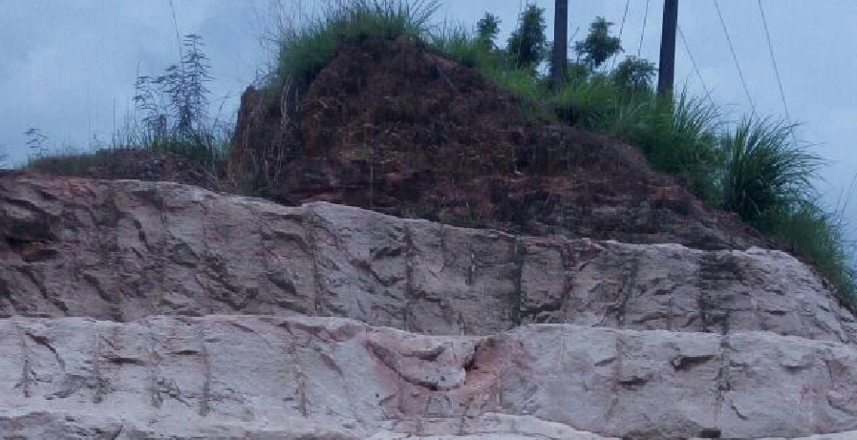
Figure21.0:
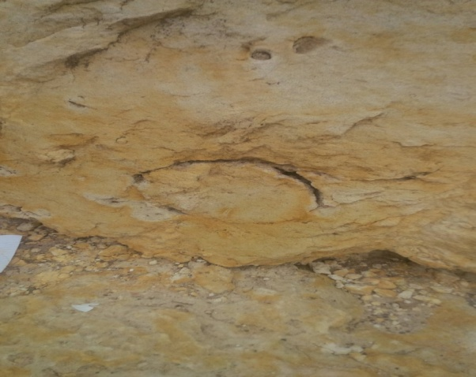
Faunal activity (bioturbation)
Figure20.0 Sandstone outcrop undergoing bioturbation along Ndibe Beach Road
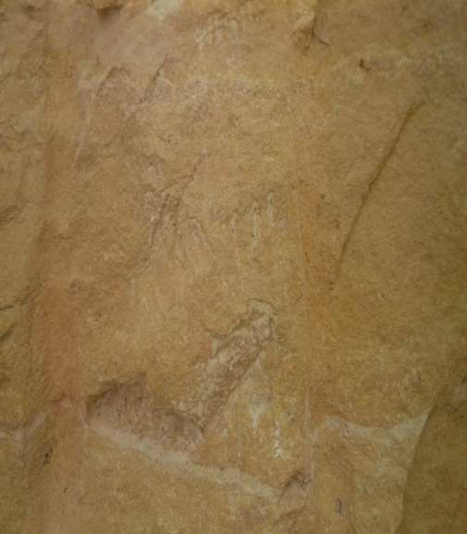
Thin laminations
Figure21.0 Thin laminations in a sandstone bed along Ndibe Beach Road
6.2.2 BIOTURBATED SANDSTONE FACIES
The bioturbated sandstone facies is composed of organic rich, medium- to dark-gray, very fine-grained moderate to well-sorted sandstone. Thickness ranges from 0.5 to 2 feet (0.15 to 0.6 m), with 1 foot (0.3 m) being average. This facies is characterized by a high degree of bioturbation, including lighter coloured vertical and horizontal burrows giving the facies a “mottled” appearance. The bioturbated sandstone facies is considered a transgressive lag or storm deposit forming following either high-energy current deposition due to marine flooding or storm currents that was subsequently bioturbated. This interpretation is evident by the comparison to overlying and underlying facies. The bioturbated sandstone facies caps a shoaling-upward cycle—typically heterolithic siltstone, grayshale, coal, or underclay facies, but may also be interbedded between two black The bioturbated sandstone facies is overlain by finer-grained, deeper water facies such as black shale or minor heterolithic siltstone grading into black shale. These relationships suggest a period or episode of higher energy current deposition brought about by marine flooding over storm reworking.
.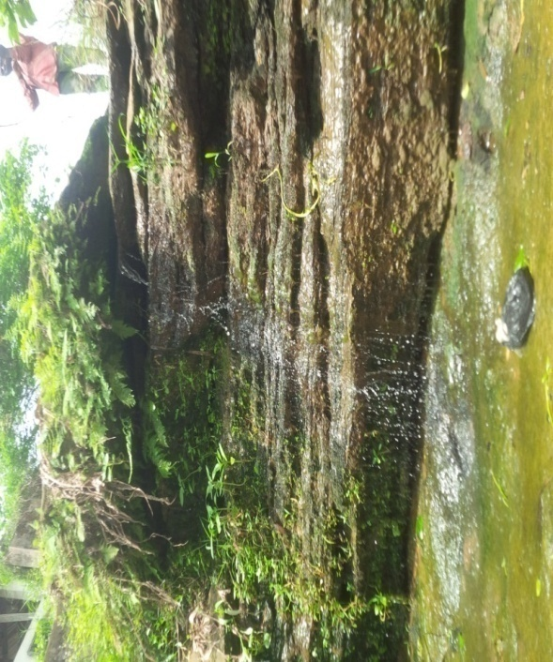
Bioturbated
Sandstone

Shale bed
Figure22.0: Bioturbated sandstone facies unit at Nkpogoro along Amaizu Road
6.2.3 Laminated Sandstone Facies
The facies is whitish yellow coloured parallel lines running across them which are known to be laminated, with geologic structures such as joints, faults etc. and this was observed at the outcrop along Indibe Beach road.
6.2.4 Massive Sandstone Facies
It is grey in colour fine to medium grained, moderately to poorly sorted sandstone. Its structureless nature may be as a result of it been deposited by extremely high energy current or its structure may have been destroyed by massive bioturbations.
CHAPTER SEVEN
STRUCTURES / IGNEOUS ACTIVITY / ECONOMIC GEOLOGY
7.1 STRUCTURAL GEOLOGY
This deals with the detailed analogy of sedimentary structures in the study area and it is classified into two major types;
- Primary sedimentary structures
- Secondary sedimentary structures
The above structures are observable in the field and are formed by the physical, organic and chemical processes. The primary structures are also called syngenetic structures i.e structures developed or formed from sediment deposition and secondary structures which are known as postgenetic or epigenetic i.e structures that develop on the sediment after deposition, both primary and secondary sedimentary structures were observed in the field.
7.1.0 PRIMARY SEDIMENTARY STRUCTURES INCLUDE;
LAMINATIONS: They are similar to beddings but with different thickness I,e less than 1cm
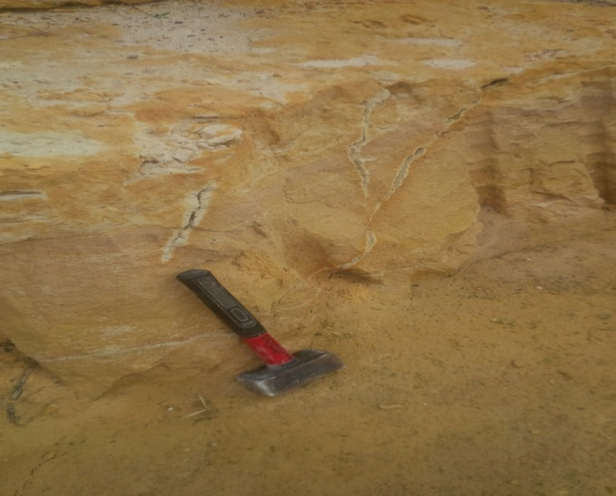
Fig 23.0 parallel thin laminations along Ndibe Beach Road
7.1.1 CROSS BEDDING: This occurs when the internal structure of some beds are such that they are deposited at an angle to the binding surface.
7.1.2 JOINTS: These are fractured blocks with no relative movement. These were found both on outcrops and on the surface.
7.1.3 BEDDINGS; A single bed is a sedimentation unit deposited under essentially constant physical conditions. It is the term used for sedimentary layers greater than 1cm thick. Beds thickness in the study area range from 1cm to 7cm, which infers they move from thin beds which are likely to be inequality of depositions of sediments as supplied to the deposition site. With finer grains or sediments, their bedding tends to become thinner as a result of slow rate of deposition.
7.2 Secondary Sedimentary Structures
7.2.0 MUDCRACKS; they are termed desiccation cracks or sun cracks because they generally formed by loss of water as a result of drying. They occur as irregular polygonal pattern cracks formed on clayey or muddy sediments. An example was observed at Indibe beach.
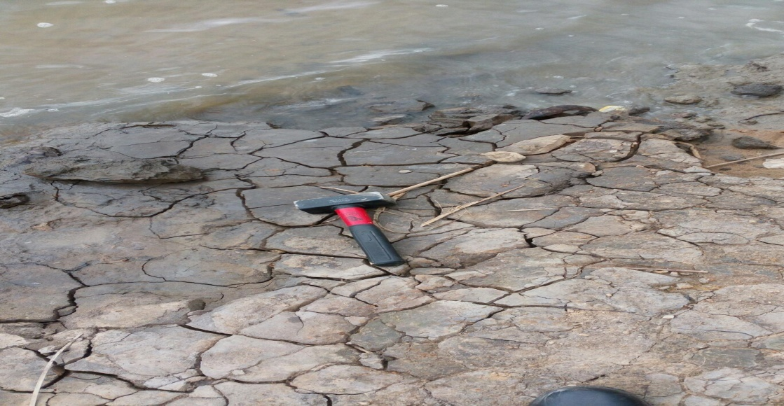
Fig 24.0 Mudcracks shown at Indibe Beach
7.2.1 FRACTURES: They are discontinuities in a rock caused by breakages of rocks relative to their smooth surface or bedding. The fractures observed were faults and joints.
7.2.2 JOINT; is a fracture in a rock in which there is no appreciable displacement along a crack.
7.2.3 FAULT; It is a structure that has major rock displacement a fault was observed at the outcrop along Indibe beach road. Fractures sometimes serve as passageways for ground water and host for valuable mineral deposits such as copper, lead, zinc, gold, silver, etc they also serve as pathways for hydrocarbons into traps.
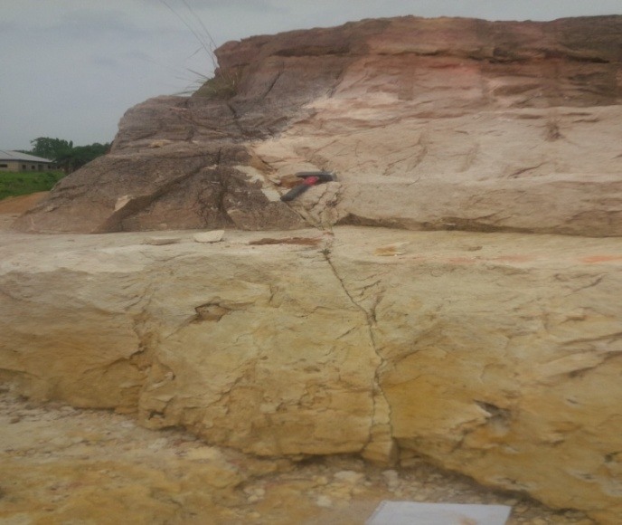
Figure25.0 A fault structure at outcrop along Indibe beach road
7.3 Biogenic Sedimentary Structures
They are tangible evidences of activities by organisms, fossil as trace other than the body parts, biogenic structures include bioturbations which reflects the disruption of biogenic and physical stratification fabrics by the activities of the organisms, these structures include trails, tracks, burrows and other miscellaneous features representing activities of organisms. Observed biogenic features in this area include; skolithos, orphimorphia and bioturbations.

7.3.0 Orphimorphia and Skolithos
Orphimorphia and Skolithos were found at location two at Ugwuegwu near Ololo River that is about 2km far from Ugwugwu main road. Ophiomorpha occurs as a knobby walled burrow, with walls thick and clayed with burrows ranging from 7cm to 20mm, there burrows are regarded as dwelling structures of suspension feeders produced by crustaceans, they indicate conditions of moderate to high sediment influx in a high energy marine environment in which suspension feeders flourish. The knobby walls and horizontal and vertical tunnels are characteristics of high energy environment of beaches, tidal flats and tidal delta. Skolithos burrows are generally vertical shafts measuring up to 5-6mm in diameter with the walls unlike the orphiomorpha which has a knobby thick wall the burrows are also regarded as a dwelling structures. The Skolithos Ichnofacies associations are normally found on the middle shore face to shore face (Frey, et al; 1978) or tide dominated shallow marine.
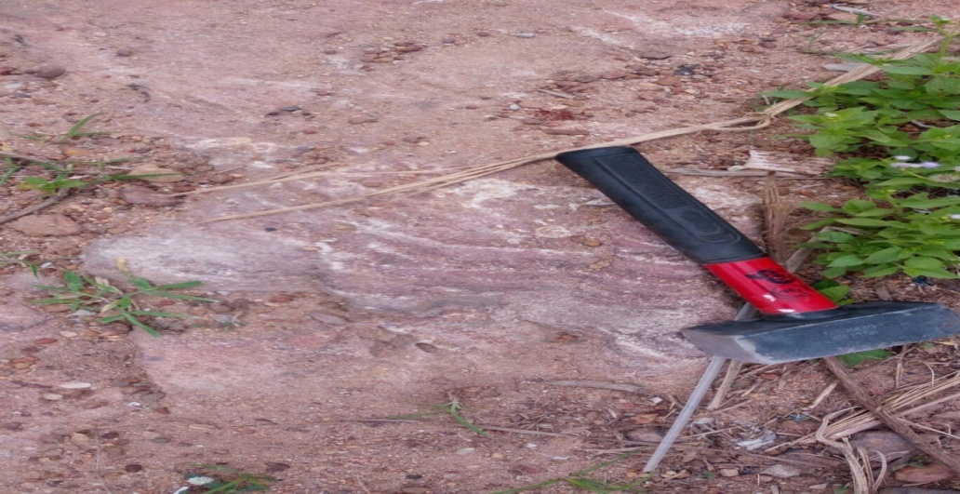
Figure26.0 Observed Orphiomorpha at Ugwuegwu near Ololo River
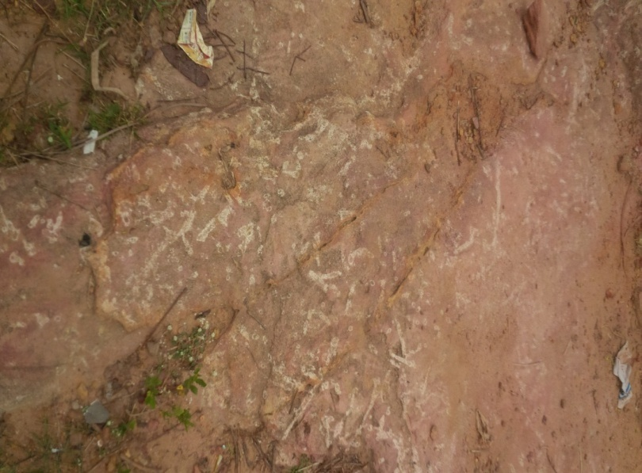
Figure show27.0 A Skolithos fossil trace At Ugwuegwu near Ololo River
7.4 Igneous Activity
Igneous Activities was observed in presence of a dolerite sill in out crop located about 400m from Amasiri Junction (Afikpo-Amasiri Road). The igneous intrusive rock is of Turonian time and was found in the boundary between the shale of the Eze-Aku formation.
The environment was discovered to be a sedimentary environment with basic rock and basic rocks are mostly made of basalt and gabbro the texture of the rock ranges from fine (Basalt) coarse grain (gabbro) it contain plagioclase angite and K-feldspar, also there are present of iron oxides which exists in the form of magnetides and some other minerals that makes up the rocks are the pyroxene and olivine. The igneous intrusive (dolerite sill) that was observed, was formed by an emplacement of the intrusive by the fault plane fracture from the upper mantle, It intruded over 37 km running parallel to the strike plane it occurs as sill or dyke which can be either volcanic or plutonic. The dolerite sill observed with the bedding plane and was a result of uplift and erosion (hyper basal) and the exposure leads to the formation of basalt which is hyperbasal. The sill that was observed where horizontal in its orientation and they are also characterized as concordant intrusive contacts because they are intrusive rock formation in contact with the host or country rock in horizontal plane. The sill also observe, hand a chilled zone a baked margin. It is zone from the core to the surface the core is coarser indicating shower cooling while the surface is fine grain indicating faster cooling at the surface.
7.5 ECONOMIC GEOLOGY
This constitutes the mineral resources of the study area. The stratigraphic pattern of sandstone and shale together along with some structural features control the mineral elements, with shale acting as a source rock and sandstone as a cap rock.
- Clay/Shale:It is used by the local farmers for agricultural cultivation. It also serves as a good cultivation ground due to its abundant organic remains. They also serve as raw materials for the manufacture of bricks, ceramic ware, etc.
- Sand/Sandstone: It is a sedimentary rock with grain size of 1/16- 2.00 (sand) which turns into sandstone rock due to cement which fill the pores in the sand making the sandstone less porous and permeable. Sandstones could serve as host for some economic minerals such as uranium, rutile gold, diamond, etc which can be deposited as placer deposits since it is very porous it serves as a cereal rock for aquifer and as oil reservoir. Its is one of the major minerals mined by large and small scale industries, which are basically used for construction of roads and buildings. They constitute important reservoirs for ground water, hydrocarbon, and can be used as filter paper and moulding sand.
- Laterite; It is a soil rich in iron oxide and it is derived from a wide variety of rocks weathering under strongly oxidizing and leaching conditions. It precisely contains goethite (FeO, HO), Bauxite (Al₂O₃) and titanium oxide and therefore can provide use for industrial development.
- Dolerite: It is basically used in road construction. Also quarrying of dolerite serves as a source of employment for people living in the area.

7.6 HYDROGEOLOGY
- Surface water: The springs and river channels are the major surface waters in the study area. The springs occur when water flows from rock unto the land surface naturally, and discharges where the water table intersects the land surface. It also flows through fractured rocks in the area. The rivers are mostly used for domestic use, like bathing, washing and drinking etc.
- Subsurface/Groundwater: As a result of alternation of shale and sandstone beds, the field area is a very good aquifer for the storage of water for commercial economic use.
- Ground water pollution: Due to the lack of big industries in the study area, it is free from industrial waste pollution. Thus the major source of pollution is through human activities. Also, the open dumping method of disposal of waste in the area constitutes a source of pollution to the aquifers
7.7 GEOHAZARDS OF THE AREA
Some of the major hazards prone to the Afikpo formation and its environs include:
- Erosion
- Groundwater contamination
- Pollution
The problem of erosion can be corrected by planting cover crops and practicing Shifting Cultivation. Pollution can be corrected by controlling the incessant burning of bushes and other substances dangerous to life.
Careful application of these control methods help to reduce these hazards to a large extent.

CONCLUSION
Sedimentary facies analysis, which is an important aspect of this work, is ideally the analysis of a distinctive rock that forms under modern equivalences used as analogs of ancient Environments. From Observations of structures in the field and several analyses which were done by me and my partner Nnacho Charles I came to the conclusion that the area mapped is a possible dominated Marine Environment due to facies analysis carried out. I could also decipher possible Fluvial, Barrier Beach, Braided River, and Meandering River Environment. Also facies includes mudstone facies, sandstone facies such as bioturbated sandstone facies, laminated sandstone facies, planar sandstone facies, and massive sandstone facies. The importance of Facies analysis cannot be overemphasized because it is used in industries that exploit earth resources such as fossil fuels (mostly hydrocarbons) etc. Facies analysis is also very important in research because it is used for Paleo Environmental Reconstruction. Since they have specified characteristics, and form under certain conditions of sedimentation they reflect a particular process or environment like The Tertiary Niger Delta. Apart from examination of rock specimens, this kind of analysis may also rely heavily upon the geophysical properties of the rock such as density, radioactive electrical and even magnetic properties of the rocks but for the cause of this research we used just examinations of rock specimen, biological and geological structures to analyze our facies.
REFERENCES
Agagu, O.K. and Ekweozor, C.M 1982 “ Source Rock Characteristics Senonian
Shales in the Anambra Basin of S E Nigeria” journal of geology and
Mining, 19;pp25-61
Barrell J. 1925, Marine and terrestrial conglomerate. Bull
Geo.soc.America, V.36, pp- 279-34.
Bassett D.A and Walton, E, K, 1960, The Hell’s Mouth’s Grits:
Cambrian grey wackes in the Tidwalls Peninsula.
Cross T.A Home wood P.W (1997) Amaz Gressly’s Role in Founding
H.G (1996) Sedimentary Environments and Facies Blackwell
Science Publications. Oxford 404p.
Hogue, M, 1977, Petrographic Differentiation of Tectonically Controlled Cretaceous Sedimentary Cycles, Southeastern Nigeria.
Iloeje, N.P. New Geography of Nigeria Longman. pp 210.
Inyang, P.E.B., Climate region. In G.E.K. Ofomata (ed), Nigeria in Maps
Eastern States. Ethiope pub. House, Benin Nigeria. pp38-45.
Ladipo, K.O. 1988. Paleography, sedimentation and tectonics of the upper Cretaceous Anambra Basin, Southeastern Nigeria” journal of African Earth Sciences. 7;pp815-821
Krumben 1948, Barrel J. 1925, Mariull Amer Association of Petroleum
Geology pg 32.
Krumben, W.c and Griffith, J.S, 1938, Beach environment in the little
Sister Bay, Wisconsin. Bull. Geol-Soc.Amer.V.4pp.629-652
Modern Stratigraphy Geological Society of America Bulletin (Geological
Society of America) 109 (12) 1617-1630.
Mode, A. W., Ichnostratigraphy and paleoenvironment of the Benue Trough,
Nigeria. J. Min Geol. Vol23, No2pp 115-126
Nurgaleva, N.G; Vinocurov, V.M. Nurgaliev D.K.(2007). “The
Geolovkinsky Trata formation model, basic facies law and
Sequence Stratigraphy concept: Historical sources and relations”
Russian Journal of earth sciences (1997) pg 9.
Pettijohn, F.J, Paleocurrent of Lake Superior, Precambrian quartzites:
Bull.Geol.Soc.London V-116 pp 85-110.
Pettijohn, F.J., 1975. Sedimentary Rocks. Third edition. Harper and row, New
York.pp306.
Stanley, Steven M. (1999) Earth System History. New York: W.H
Freeman And Company pg 134.
Selley, (1970) recognizing ancient sedimentary environments.
Simpson, 1954, The Geology of Southern Eastern Nigeria part of Abakiliki.
Simpson, A. 1955. “ The Nigerian Coal field. The Geology of parts Owelli and
Benue Provinces”. Bull. Geo. Surv. Nig.No 24:pp28
Whiteman, A.1982. Nigeria; Its petroleum geology resources and potentials vol,1
and 2 Graham and Trotman Ltd London, Uk.

