CHAPTER ONE: INTRODUCTION
1.1 Study background
The earth surface is an essential part of the ecological system. Geographically land covers about 30% of the entire area of the earth surface and in it terrestrial animals and human beings live and dwell (Ogunji, 2014). Biologically, the land surface of the entire earth surface makes up a small proportion of the total body solid system of living things (UNICEF, 2011). The study area, Amuro-Afikpo and its environs is located in Ebonyi State, South Eastern Nigeria. The study area is accessible by Enugu- Abakiliki expressway and some track roads and footpaths. The area is located within the lower Benue trough. Geomorphologically, the area is composed of an alternation of high and low land with some of these low lands occupied by surface water bodies. The area is composed of sediments of the Upper Cretaceous and the Formation encountered is the Ezeaku, which has both shale and sandstone and the Aus-River group which is composed of shale and intercalation of sands. The igneous activity found in the area show a doleritic intrusion (silt) probably of the initial phase of the rift formation. The Amuro area offers a unique opportunity to study and understand the deformational processes and to determine the tectonic stresses active in the southern Benue Trough as the highly indurated nature of the sediments allow for an abundance of outcrops that is unmatched anywhere else in the region. The study area lies between longitudes 70171 E and 70511E, and latitudes 50 461 N and 60 31 N within the Afikpo syncline of the Cross River basin of the Benue trough.
1.2 Aims and Objectives of the Study
This project is aimed at detailed geologic studies to map and denote the lithologic units underlying the study area, make a detailed description of different rock types encountered in some outcropping units in Amuro and its environs near Amasiri, Ebonyi State, Nigeria. The scope covers:
- To carry out detailed geologic mapping of the study area indicating the various lithologies and noting the physical characteristics of the observed lithologies within the area.

- To carry out petrographic study using representative samples of the sandstones in the area.
- Identification of the lithofacies using characteristics such as depositional geometry, texture, lithology, sedimentary structure, and fossil contents.
1.3 Location and Extent
The area mapped is Amuro town and its environs, in Ebonyi state, Southeastern Nigeria and lies between latitude 5º 53 N 5º 58 N and longitude 7º 52 E 7º 56 E. It covers an area of about 60km2 (sixty square kilometers). Major access roads into the area are through the Abakaliki – Afikpo Road, Okigwe – Afikpo Road, and Okposi – Amasiri – Afikpo Road, as well as Cross River – Afikpo Road. Good network of roads link up such areas as Abaomege, Akpoha, Ibi, Amasiri, Amuro and Afikpo. The major towns in the area are Amuro, Amasiri and Ozara ukwu
1.4 Physiography of the area
Afikpo area is about 164 square kilometrrs in size with an undulating topography an elevation of 17m above mean sea level.

1.4.1 Topography
The study area consists of alternating sandstone ridges that strike in the NE-SW direction with intervening lowland formed by the shale units. The seasonal streams abound in the low land areas. The lowlands are sparsely vegetated. The set of sandstone ridge observed in the area have an estimated average elevation of about 200m above sea level, while the intervening low lying shale dominated plains are about 100m above sea level. Igneous intrusions were observed in the lowland areas.
1.4.2 Drainage
The mapped area is drained by the streams of the Cross River system and Ebonyi River (Asu River). The drainage in the area consist of series of which emerge from the ridge and cleaned to the plain valley which widen at the foot of the ridge. The lithology of the area affects the development pattern and density of streams. The drainage pattern is mainly dendritic with a few rectangular or trellis patterns and the streams haven’t reached matured stage. These drainages serve as source of water supply to some of the villages and communities. Springs and seepages abound in the study area contributes to the drainage of the area.

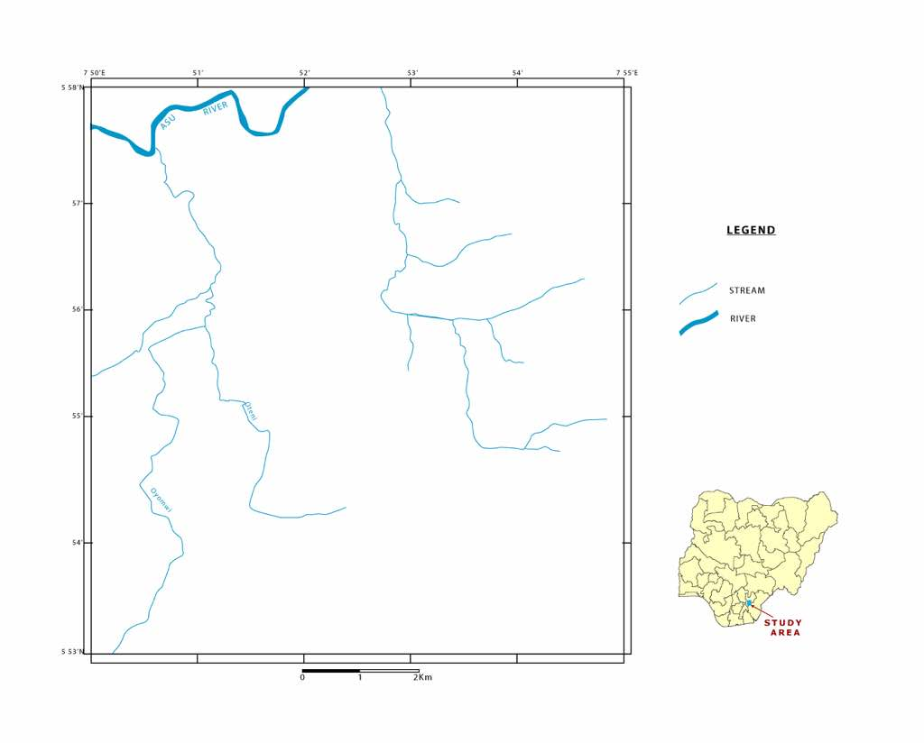
Fig 1.0 :Drainage of the study area.

1.4.3 Vegetation
The mapped area is sparsely vegetated. It is a mixture of eastern prototypes comprising of semi-savannah grassland with forest and swamps. It falls within the rain forest and savannah belts of the south-eastern Nigeria. The dominant vegetation is characterized by trees, shrubs, abundant palm trees particularly in the southern and central part of the area. Grasses are essentially found on the ridges and on the undulating shales too, while the trees tend to be more concentrated on the valleys (shales). The Prominent trees found in the area include Robinia pseudoacacia (the locust bean tree), and Elaeis guinensis (palm trees), which grow in clusters.

1.4.4 Climate
The study area has two distinct seasons, a wet season that lasts for eight months, and a dry season that lasts for four months. The period from April to November form the rainy season while the months December to March are dry. The months of December are cool and dusty because of harmattan while the period from February to March is the hottest. The annual rainfall varies between 1500mm and 2000mm, with the driest month recording less than 300mm of rainfall (Inyang, 1978). Relative humidity in the study area is generally high and ranges between 60% and 95% during the rainy season and fall below 60% during the dry season (Monanu, 1978; Nimako, 2008). The atmospheric temperature is intermediate from 27oC to 33oC with February and March as the hottest period/month in the area.

Fig 1: Drainage of the study area (Amuro)

Fig 2.: The picture shows the vegetation and topography of Amuro and its Environs. (Photograph taken behind Civic Center, in Amuro Afikpo)

CHAPTER TWO: LITERATURE REVIEW

2.0 Introduction
The study area (Amuro) which belongs to the Eze-Aku Group had been studied by a handful of renowned geologists and research institutes in the past. Based on this much literature work has been done and has formed a background for future researchers on the area. Some of the works were revisited during the course of this research.The first group of researchers to survey the area were Shell Petroleum Development Company of Nigeria, in the early 1960’s in their quest to find oil and most notably other independent researchers like Simpson, (1955); Reyment, (1965); Murat, (1972) Ikejiaku, (1975) Fayose and de Klasz, (1976) Arua and Rao (1978) Petters, (1978, 1980) Banerjee (1981) Umeji, (1982) Whiteman, (1982) Amajor, (1985; 1992) Ojo et al (2010) and Ehinola, (2010).
This survey confirmed the earlier inferred stratigraphic units of the Asu River Group and the Eze-Aku Group, which were originally put up by (Reyment and Barber 1956) and Simpson (1955).The stratigraphy of the area consists of the Asu river group being the oldest and the Eze-Aku Group depositing in alternating transgression and regression phases. The Asu River Group consist of shale, sandstone and limestone and it is the oldest lithostratigraphic unit in the area and was deposited during the Albian transgression phase, also the oldest dated sedimentary rock unit in the Southern Benue Trough (Anambra basin) (Whiterman 1982) Simpson (1955) and Reyment (1965), were all of the view that the Asu River Group was deposited in a moderate deep water environment during the Albian, with an abundant ammonite’s floras and pollens.
The rock sequence is of Turonian to Mastrichtian age. This geological dating was based on the paleontological evidences indicated by Simpson (1955). Reyment (1965), De Swardt and Casey (1961). The Ezeaku shale was deposited during the Turonian transgression cycle while Nkporo Shale was deposited during the Campanian – Maastrichtian marine transgression(Short and Stouble 1967 and Kogbe 1976). The Ezeaku Shale grades laterally into sandy shale and calcareous Amasiri sandstone, (Short and Stouble (1967). Simpson (1955) noted that an angular unconformity occurs between Ezeaku shale and Nkporo shale formations as revealed by the borehole log analysis carried out by SHELL.

Hoque (1976) discovered that the sandstones of the area are predominantly quartz arenites with some highly weathered feldspar, and these are thus interpreted to be from a granite source, probably from the basement complex rocks in the Oban Masif.

2.1 Regional geology of the study area
The Benue Trough originated from Early Cretaceous rifling of the central West African basement uplift. It forms a regional “Y” shaped structure which is exposed from the northern frame of the Niger Delta and runs north-eastwards for about 1000km to underneath Lake Chad, where it terminates. Regionally, the Benue Trough is part of an Early Cretaceous rift complex known as the West and Central African Rift System. An adequate interpretation of the geology and history of the Benue Trough requires a proper understanding of its regional tectonic framework. The origin, tectonic evolution, and the stratigraphy of the Benue Trough has been discussed by several authors (Wright, 1968, 1989; Burke et al., 1972; Grant, 1971; Murat, 1972; Petters, 1978; Olade, 1975, 1979; Ajakaiye, 1981; Benkhelil and Guiraud, 1980; Benkhelil, 1982, 1986, 1989; Benkhelil and Ronineau, 1983; Hoque and Nwajide, 1984; Sheideggar and Ajakaiye, 1985; Maurin et al., 1986; Amajor, 1985, 1987; Ojoh, 1990; Reijers, 1996; Odedede, 2011).
Benkhelil (1982, 1989) in his studies proposed a model in which transcurrent movements were considered to be the basic tectonic mechanism in the formation and subsequent evolution of the Benue Trough. This is the RRF (Rift – Rift – Fault) model in which he noted the presence of three Atlantic transform faults striking the Benue Trough, suggesting that the trough is a complex pull apart basin formed by transcurrent movement along these faults.Both field and geophysical evidence of structural patterns which are not consistent with simple orthogonal extension as proposed by the aulacogen model were preserved. The RRF model is consistent with alkaline magmatism in the trough and gives a good explanation for the Santonian compressive phase (Benkhelil and Robineau, 1983).
Generally, the Benue Trough is believed to be the failed third arm of the rifts originating from the early Cretaceous rifting of the African Basement, following the splitting of the Gondwanaland supercontinent and the subsequent drifting apart of the African and the South American plates during the Jurassic period (Murat, 1972; Hoque and Nwajide, 1984; Reijers, 1996). The trough forms a regional structure which is exposed from the northern frame of the Anambra Basin and runs north-eastwards for about 1000km to the southern fringe of the Chad Formation.The ages of the basin-fills in the Benue Trough generally decreases southwards from Pre-Albian to Coniacian (Amajor,1987) while sediment thickness increases southwards (Reijers, 1996). The Benue Trough is subdivided into the Lower, the Middle, and the Upper Benue Trough for effective description. The Gongola Basin and the Yola Rift make up the Upper Benue Trough. The Middle Benue Trough is the linear part of the basin and includes the Benue Basin proper, while the Abakaliki Anticlinorium, the Mamfe Rift, the Afikpo Synclinorium, the Anambra basin and the Calabar Flank make up the Lower Benue Trough (Hoque and Nwajide, 1984; Benkhelil, 1989; Reijers and Nwajide, 1996).
Sedimentation in the trough started during the Aptian to early Albian (Late early Cretaceous) with the deposition of the intercontinental arkosic sandstone and shales of fluviatile and lacustrine origin (the Bima Sandstone, and the Mamfe Formation) in the northern and southern parts of the trough respectively. Two cycles of transgressions and regressions followed this, from the middle Albian to the Coniacian, and filled the southern part of the trough with mudrocks, sandstone and limestones with an estimated thickness of 3,500km (Murat, 1972; Hoque, 1977, 1984; Olade, 1975, 1978). These sediments belong to the Albian Asu River Group, Cenomanian Odukpani Group, Turonian Eze-Aku Group, and the Coniacian Awgu Formation.During the Santonian, transgression epeirogenic movements folded, fractured and uplifted the Aptian to Coniacian sediments to form the Abakaliki Anticlinorium or Fold Belt (Grant, 1971; Murat, 1972; Whiteman, 1982). The Eze-Aku Group occupies both flanks of the fold belt while the Asu River Group is at the core. A SE to NW polarity relative to the axial fracture system resulted in the subsidence of the Afikpo Synclinorium and the Anambra Basin, east and west of the Abakaliki Fold Belt respectively (Benkhelil, 1987; Reijers, 1996).The study area is at the eastern flank of the Abakaliki Fold Belt, west of the Afikpo Synclinorium. The eastern flank of the Abakaliki Fold Belt (study area) is filled with the sediments of the Asu River Group and the Eze-Aku Group and is aerially flanked in the south and east by the Afikpo Syncline (southern Anambra Basin), in the north and northwest by the core of the Abakaliki Anticlinorium.
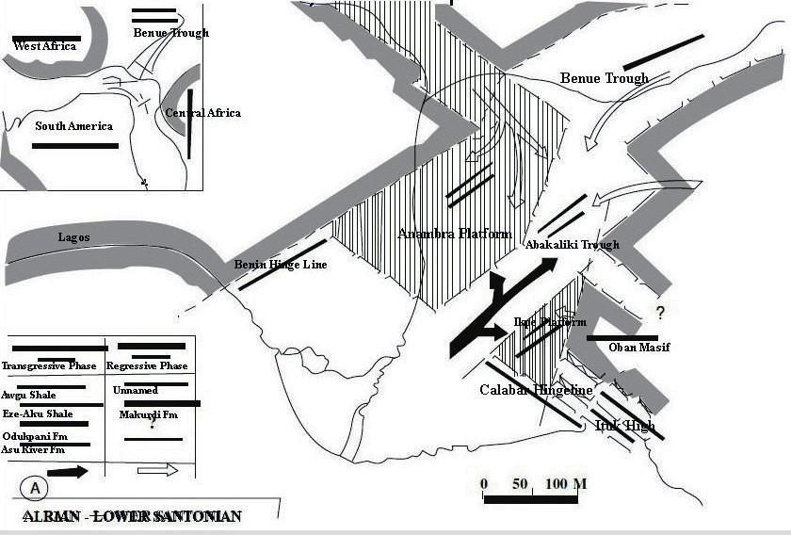

Fig. 3: Tectonic map of Southeastern Nigeria from Albian to Tertiary (Adapted from Murat 1970).

2.2 Regional Stratigraphic Setting and Basin fill
The stratigraphy of the southern Nigeria sedimentary basins is controlled by three tectono-sedimentary cycles (Fig 2) (Murat, 1972; Whiteman, 1982; Hoque and Nwajide, 1984). The first cycle started with the opening up of the Benue Trough during the Jurassic to Aptian times. Sediments in trough were deposited from Aptian to the Coniacian periods in environments believed to vary from continental to shallow marine, though Ojoh (1990) noted the presence of deep marine turbidites and megaslumps in some places. Nwachukwu (1972) noted a minor break in sedimentation during the Cenomanian.
In the second cycle, over 2,000m of sediments were eroded from the Abakaliki Fold Belt, and deposited in the post-rift subsiding depressions of the Anambra Basin from the Late Campanian to the Danian when the basin filled (Murat, 1972). The overall thickness of the sediments deposited was reported to be over 4,000m (Hoque and Nwajide, 1984).The third sedimentary cycle started after the filling up of the Anambra Basin and subsequent lateral shift of the sediments southwards into the modern Niger Delta depocenter from the late Paleocene to Recent (Murat, 1972).
2.3 The Stratigraphic fill of the Southern Benue Trough
The study area is underlain by unclassified intracontinental arkosic sandstone and shales believed to be of fluviatile and lacustrine origin, the Asu River Group, and the Eze-Aku Group (Simpson, 1954; Reyment, 1965; Murat, 1972).
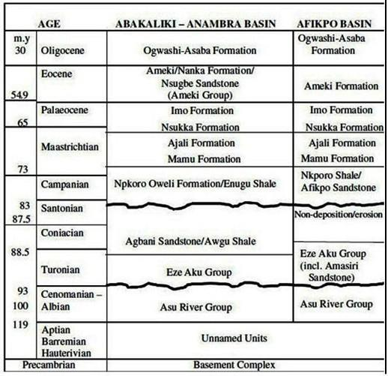
Table 1: Lithostratigraphic framework of southern Benue trough and Afikpo Sub basin. (Igwe et al 2013)

2.3.1 The Asu River Group
The Asu River Group occupies the base of the Abakiliki Anticlinorium/Fold Belt. It consists of poorly bedded, olive brown, sandy shales with fine-grained micaceous sandstones, micaceous mudstones, and sandy limestone lenses (Reyment, 1965; Cratchley and Jones, 1965; Whiteman, 1982; Kogbe, 1989) and coarse to very coarse arkosic sandstones of the Mamfe and Awi Formations.The sediments are strongly folded and are associated with extensive magmatism which resulted in the intrusion of diorites and dolerites in Abakaliki, Wonikande, Amasiri, and Ishiagu areas. The fold axis trends NE – SW with system of fractures which are filled with lead – zinc mineralization in the Abakaliki and Ishiagu areas. The Asu River Group is mainly restricted to the southern and middle Benue Trough, and includes such units as Abakaliki Formation, Yandev Limestone, Mamfe Formation, etc (Reyment, 1965; Whiteman, 1982; Ramanathan and Nair, 1984; Umeji, 2000). The Asu River Group is dated Middle – Late Albian and is believed to have been deposited as shallow – deep marine clastics during the medial Albian transgression based on diagnostic ammonite fauna (Reyment, 1965). The thickness ranges from 1500m to 1800m (Cratchley and Jones, 1965). Reyment (1965) gave the type locality of the Asu River Group as the Asu River Bridge along Okposi – Amasiri Road, in the Afikpo Synclinorium.

2.3.2 The Odukpani Formation
The Odukpani Formation consists of flaggy shales and calcareous sandstones alternating with limestone with Cenomanian ammonites, fragmentary crinoids and algae, and a basal sandstones and conglomerate (Reyment, 1965; Whiteman, 1982). The Odukpani Formation represents the products of the Cenomanian regression deposited under marine nearshore condition, and was thus dated based on recovered ammonite fauna, foraminifera evidence (Adeleye and Fayose, 1978). This formation is restricted to the Calabar flank (Reyment, 1965)

2.3.3 The Eze-Aku Group
The sediments of the Eze-Aku Group were deposited during the extensive marine transgression at the beginning of the Turonian when the sea invaded the Benue Trough from the Gulf of Guinea (Reyment, 1965; Kogbe, 1989). It unconformably overlies the Asu River Group. The Eze-Aku Group consists of calcareous shales, sandstones, and thin sandy or shelly limestones and calcareous fine to medium-grained sandstones (Reyment, 1965).
Occasionally, thick sandstones or limestone units alternate with the calcareous shales. The main shale unit in this group has its type locality at the Eze-Aku River, near Ake-Eze. The Eze-Aku Group was described by Simpson (1954) and Reyment (1965) at its type locality in the Eze-Aku River channel at Aka-Eze.The group comprises such lithostratigraphic units as the Eze-Aku Shale, the Amasiri Sandstone, Konshisha River Sandstone, the Agila Sandstone, the Makurdi Sandstone, and the Nkalagu Limestone (Whiteman, 1982). The Eze-Aku Group has been dated to be generally early Turonian in age, using such diagnostic ammonites as Vascoceras globosan, Neoptychites telingaeformis, and Eotissotia simplex (Reyment, 1965). Ojoh (1990) and Umeji (2009) dated the Eze-Aku Group as Cenomanian – Turonian based on palynormorph evidence. The group is also rich in pelecypods, gastropods, foraminiferas, ostracods, and fish teeth (Ojo et al., 2010; Ehinola, 2010).
The Amasiri Sandstone underlies the study area and forms NE – SW trending sandstone ridges and shale swales and constitutes the focus of this study.

2.3.4 The Awgu Shale
The Awgu Formation overlies the Eze-Aku Group stratigraphically, but is not represented in the eastern flank of the Abakaliki Fold Belt (Agagu et al., 1985). The formation was deposited during the regressive phase of the Turonian – Coniacian transgressive – regressive cycle, and comprises well bedded, bluish – grey shales with occasional intercalations of thin shelly limestones, and sandstones. The thickness of Awgu Shale is estimated to be up to 900m (Benkhelil, 1986). It is dated Coniancian – Santonian based on ammonites recovered from shelly limestones and calcareous shales (Reyment, 1965)

CHAPTER THREE: MATERIALS AND METHOD USED

3.0: Methodology
While carrying out the study three steps were adopted:
- Field investigation.
- Laboratory analysis, and
- Interpretation

3.1: Field Investigation
This involves field mapping and lithologic logging of outcrop sections to provide data for lithofacies and paleoenvironmental interpretation. Outcrops were studied lithologically with their attributes and characteristics recorded with representative samples taken in places. Sample locations and elevations were obtained using Global Positioning System (GPS). Sketches of lithologic logs of notable outcrop sections were produced.The attitudes of the beds and other structures were measured using the Rangers Compass. Collected samples were appropriately packaged, labeled and sealed in sample bags.

Instruments and materials used include:
- Topographic map covering the study area :This is the most important material used when embarking on a field work. The base map shows the outcrop and also the lithologies to map.
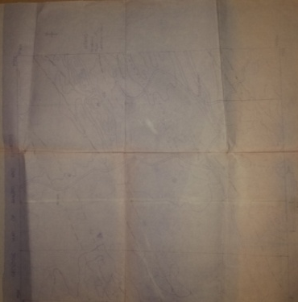

- Brunton compass: It is used to measure the strike and dip of an outcrop, and also used in determining the true north of a location.
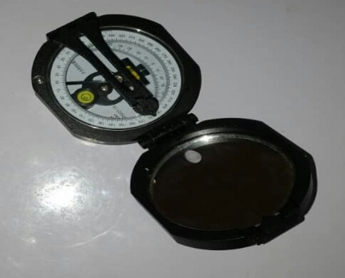

- Measuring tape: It is used to measure the distance from one location to another and also to measure the thickness of beds during logging.

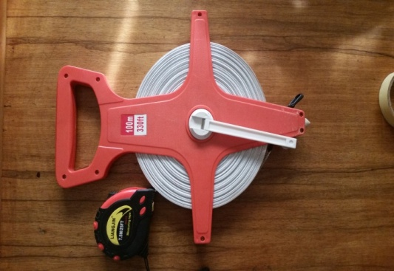

- Hand Lens: It is used for magnification of objects.

- Geologic hammer: It is used to break out samples from rocks.
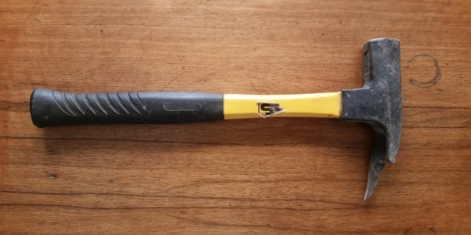

- Sample bags: They are used in collection of different kinds of rock samples collected at different stations for analysis in the laboratory.

- Masking tape: This is used for the identification or naming of rock samples collected at different location.

- GPS: Global positioning system (GPS) is a device used to locate the position on the earth in accordance with what is on the map.

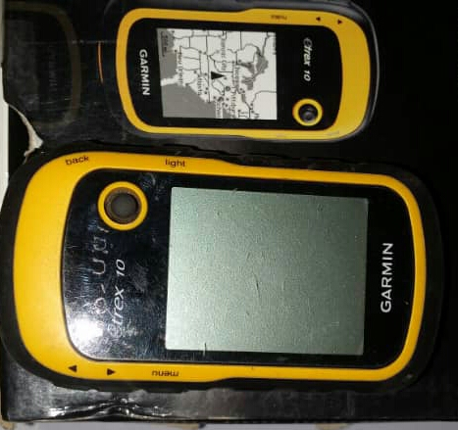

- Field notebook: This is used for recording information observed on the field for reference and documentary purpose.

xii. Sledge hammer : This is used for breaking of rocks and driving in fence posts.

3.1.1: Outcrop Mapping
The mapping was carried out using 1:25,000 Amuro topographic map (sheet 313) as base map. Some of the outcrops were studied and logged and some lithologic characteristics of the outcrop sections were captured using a logging format designed to provide an insight into the vertical variation in lithology, texture (grain size, sorting, roundedness), sedimentary structures, fossil content, bed thickness, and contact types. The lithologic logs were described in details for each outcrop studied. The outcrop locations (co-ordinates) were goe-referenced and elevation above sea level recorded using the Global Positioning System (GPS).
Representative samples were taken from all the logged sections for laboratory processing and more detailed textural and compositional analysis. Structural features such as dips and strikes of beds, faults and joints/fractures orientations were measured and described. Photographs and sketches of important sedimentary and structural features were also taken.
The locations mapped include the Crushed Stones Quarry along Amuro , Ozara Ukwu,Gorogoro local mine quarry. A total of three (3) outcrop sections were logged. The mapping was done by examining and describing the outcrops in detail ,the mapping exercise was done using the simple traverse and compass method. The various rock types were delineated using exposed contacts where they are available and by inferences using topography, soil type and vegetation. Unconformable contacts were mapped using high discordance in dips of lithologic units.
3.1.2: Facies Analysis
Facies analysis is a rigorous, scientific approach to the study and interpretation of the characteristics of a sedimentary unit (Nichols, 2009). These characteristics include depositional geometry, sedimentary structures, grain sizes and types, and biogenic content of the sedimentary units. These are determined by physical and chemical processes of transport and deposition, as well as the paleoecology during and after deposition of the sediments. By interpreting the sediments in terms of these physical, chemical and ecological conditions at the time of deposition, it is possible to reconstruct the paleoenvironment and the paleogeography of the sedimentary body (Nichols and Fisher, 2007; Nichols, 2009). The word facies is used in both a descriptive and an interpretative sense. The facies analysis method used in this study is descriptive. Descriptive facies include lithofacies and biofacies.
A lithofacies is a rock unit defined on the basis of its distinctive lithologic features including composition, grain size, bedding characteristics, and sedimentary structures (Nichols, 2009). Each lithofacies represent an individual depositional event. Lithofacies may be grouped into lithofacies associations or assemblages, which are characteristics of particular depositional environment (Shanmugam, 2007). These assemblages form the basis for defining lithofacies and depositional models.
A biofacies is defined on the basis of fossil components, mainly the body or trace fossils (Nichols, 2009). A study that focuses on the trace fossils in the rock defines the Ichnofacies (Sielacher, 1964).Facies analysis method employed in this study involves the description and logging of primary characteristic of the outcrops in terms of their vertical sequences of occurrence. Important sedimentological features such as dominant lithology, sedimentary structures, textures, bed thickness and contact types as well as fossil contents are logged. These sedimentological features were used to identify both lithofacies and the ichnofacies in the study area.

3.2 Laboratory Analysis
The laboratory analysis used in extracting information from the rock samples, logs and directional data taken in the field include lithologic log construction using a computer software, SEDLOGTM (Zervas et al., 2009).

3.2.1 Lithologic Construction
The construction of lithologic log of vertical sequences of important sedimentological features is a good way of interpreting depositional systems and environments of deposition for surface and subsurface outcrops (Visher, 1965; Zervas et al., 2009). Three outcrop sections were logged in the field, and sketches of their sedimentary logs produced.
CHAPTER FOUR: DESCRIPTION OF LITHOLOGIC UNITS

4.0 Methodology
The lithostratigraphic studies portray a detailed explanation of the geology of the studied area (Amuro) and have been divided into various units. Some of the dominant lithologies encountered at the study area are mainly Sandstones, Siltstones, Shale, dolorite, mudstones and diorite sill. These lithologic units are grouped based on there characteristics, structures and stratigraphic positions. The three most prominent lithologic unit in the study area are;
- Amasiri sandstone unit
- Afikpo sandstone unit
- Eze-Aku shale unit
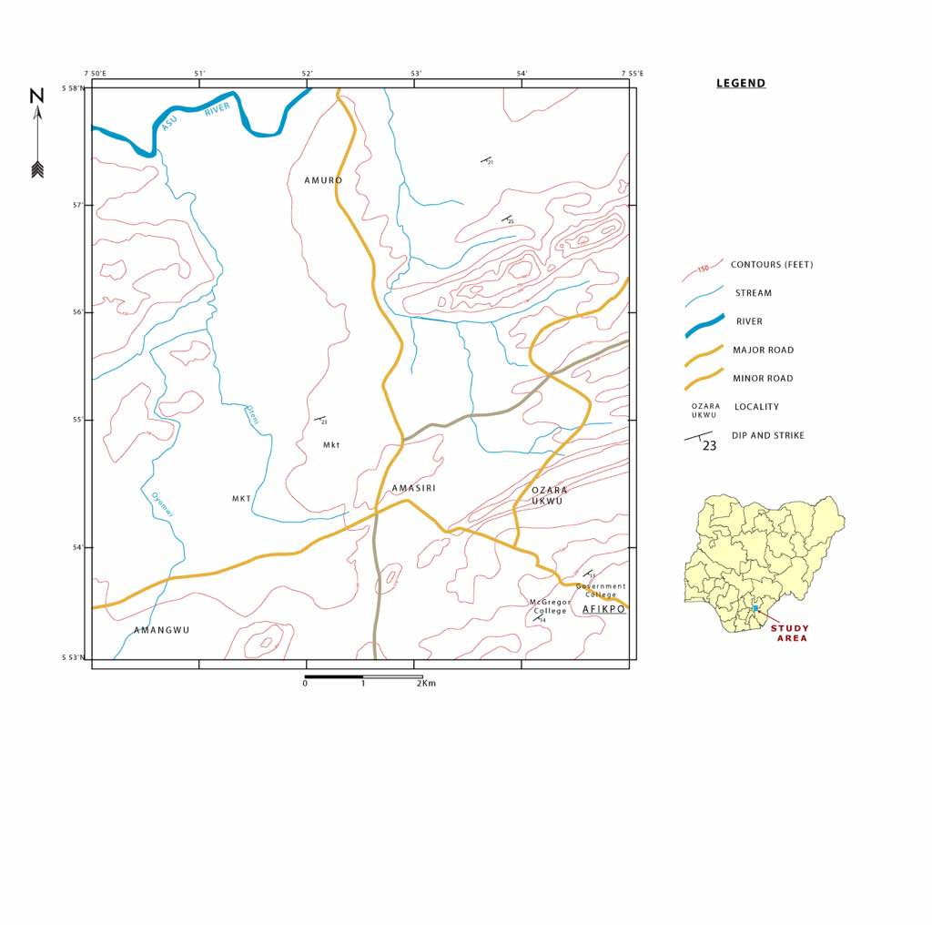
Fig 4.0 : Outcrop map of the study area.

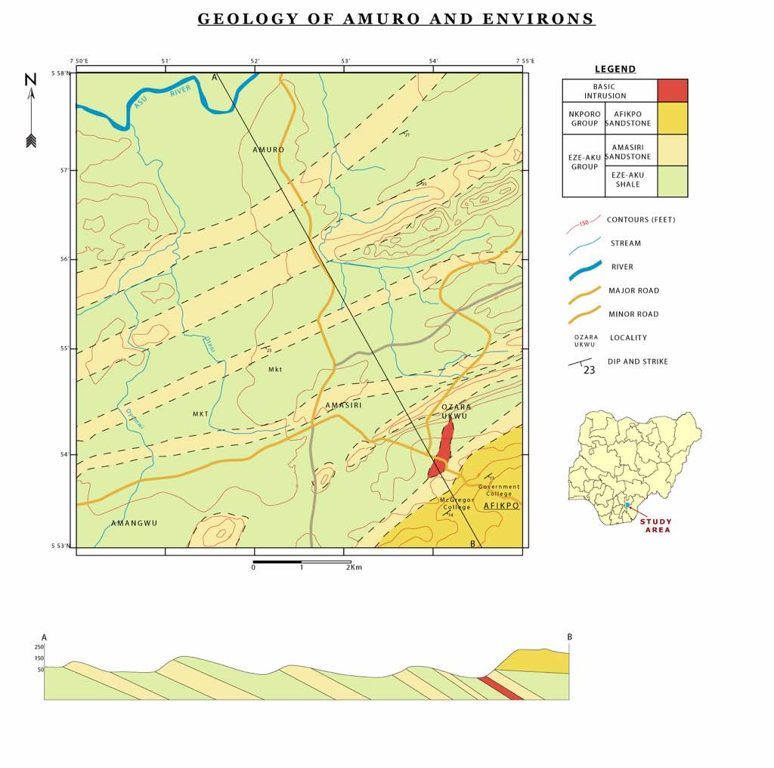
Fig 4.1 : Geologic map showing the cross-section of the study area

4.1 Description of outcrops

Location (1):Crushed stone quarry at Amasiri development center in Amuro Afikpo, North LGA.
(GPS coordinate: lat:E007◦ 53.200” long:N05◦55.987” elevation:26m )
(Strike: 5◦N185◦S ,Dip direction: 195◦SW , Dip amount: 3◦).
The crushed stone quarry is an exposed massive, very fine to fine grained, bioturbated sandstone containing clasts of crystalline limestone, mudstone. They have no distinct burrow, they are very calcareous and are light grey in colour.
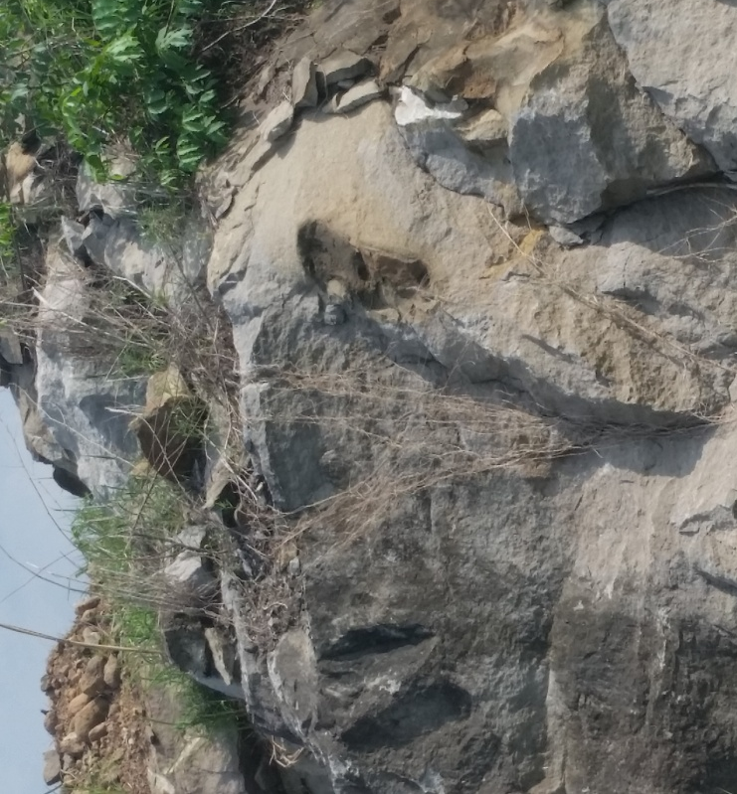
Fig 4.2: Outcrop located at crushed stone quarry at Amasiri

Location (2): Otueja opposite ezeke modern primary school, Amuro-ndukwe.
(GPS coordinate: lat: E007◦53.009” , long: N05◦55.649” , elevation: 36m )
(Strike: 350◦N173◦S ,Dip direction: 224◦SW , Dip amount: 2◦)
The outcrop is dominantly of shale with overburden at the top, it does not support agrictural purposeand and because it’s a humid area. It is dark grey in colour and it is compacted, there are no presence of burrows and trace of fossil seen.

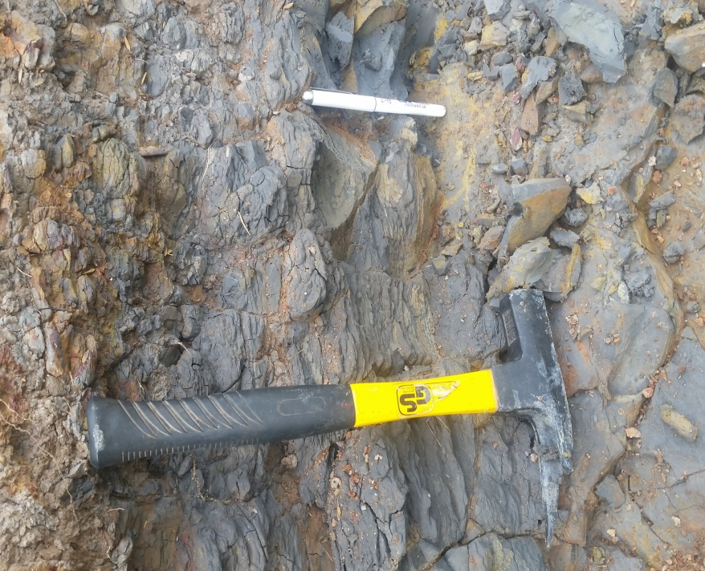
Fig 4.3: Outcrop located at Otueja opposite ezeke modern primary school, Amuro-ndukwe showing the shale unit

Location (3): Ozara Ukwu Quarry.
(GPS coordinate: lat: E007◦54.714”, long: N05◦55.232”, elevation: 50m)
(Strike: 295◦NW,114◦SE ,Dip direction: 115◦SE, Dip amount: 4◦)
The outcrop is bioturbated and is fine to very coarse grained sandstone. The formation is of Eze Aku formation, which exposes arenaceous sandstone with distinct burrows of ophiomorpha. It trends a NE-SW direction and are strongly cross bedded, the dorminant lithology is a diorite sill. It is an intrusive igneous rock which is overlain by mudstone.

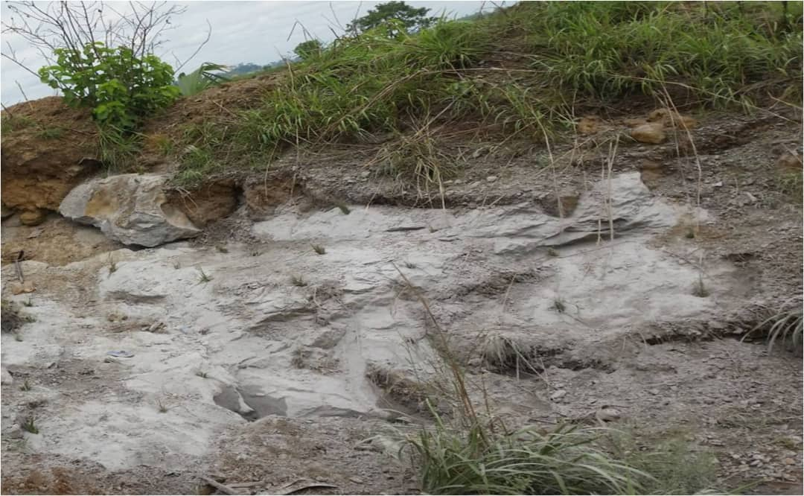
Fig 4.4: Photograph shows an outcrop with overburden located at Ozara Ukwu Quarry

Location (4): Gorogoro local mine pit along Ibii express road before ozara ukwu.
(GPS coordinate: lat: E007◦54.617”, long: N05◦54.743” ,elevation: 61m)
(Strike: 350◦NW172◦SE , Dip direction: 341◦NW ,Dip amount: 3◦)
The lower section of this quarry consist of fine – medium grained,massive sandstone. The sandstone is bioturbated and structuresless with occasional ophiomorpha and skolithos isp burrows as well as dispersed carbonaceous and shell debris. The section is overlain by a dark grey bioturbated mudstone unit and it is of Eze-Aku formation. They are consolidated and well sorted which have a light grey colouration to dark grey.

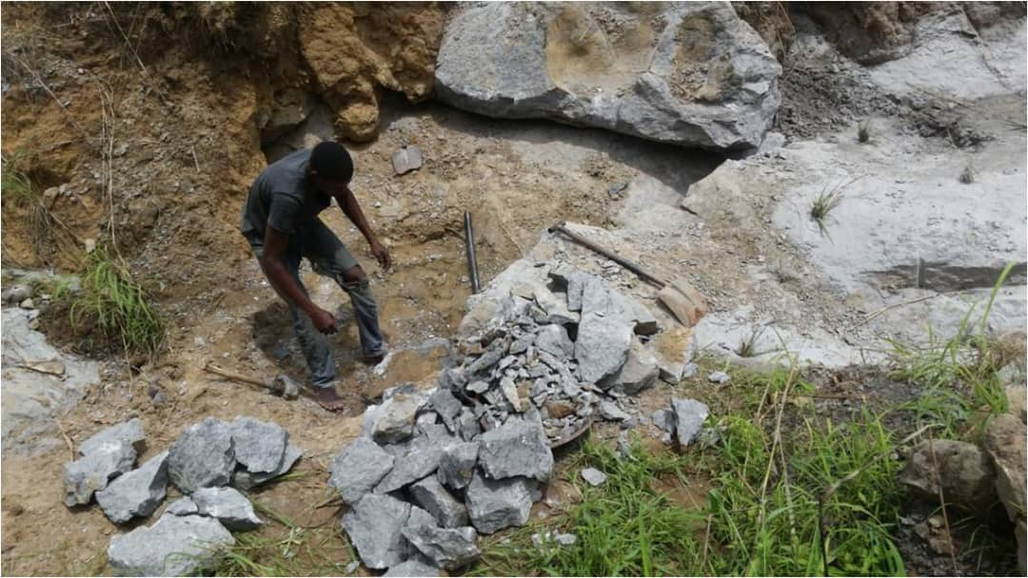
Fig 4.5: Photographs shows bioturbated sandstone at Gorogoro local mine pit along Ibii express road before ozara ukwu quarry

Location (5): Outcrop located at Ibii Akpoha express road.
(GPS coordinate: lat: E007◦54.339”, long: N05◦54.82”, elevation: 53m)
(Strike: 15◦NE196◦SW ,Dip direction: 195◦SW, Dip amount: 2◦)
This outcrop section moderately vegetated, it has a feature of ripple lamination on the surface and presence of pebble-like structures. It has a horizontal bedded medium to very coarse grained and massive but dominantly coarse grained, poorly sorted. It has a dirty grey coloration and it trends NE-SW direction which the grain shapes are subangular to angular.

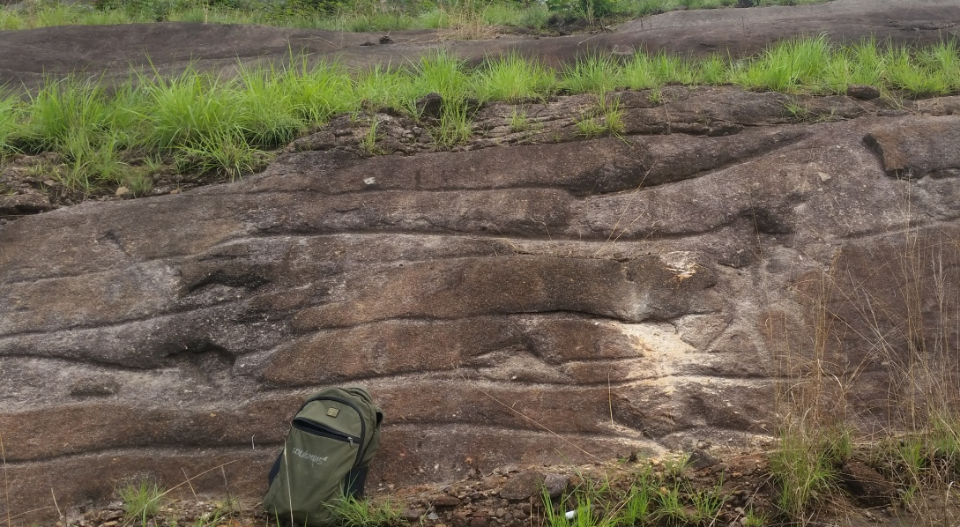
Fig 4.6: The figure shows a wavy/ripple laminated sandstone ridge located at Ibii Akpoha express road.

Location (6): Dolorite exposure located opposite timber shade Afikpo Amasiri junction.
(GPS coordinate: lat: E007◦54.591” ,long: N05◦53.980” ,elevation: 42m)
(Strike: 259◦SW80◦NE, Dip direction: 258◦SW, Dip amount: 2◦)
The outcrop is a boulder with no strata are of dolerite, it is blackish in nature with some crystalline features on the body of it. There are no features of any trace fossil which the vegetation is sparsely dense. The formation is of Nkporo formation.

Location (7): Mc Gregor hill opposite Mc Gregor hill block industry Afikpo.
(GPS coordinate: lat: E007◦55.097” ,long: N05◦53.634” ,elevation: 95m)
(Strike: 240◦SW58◦NE, Dip direction: 57◦NE, Dip amount: 4◦)
This outcrop is a bioturbated vross-stratified sandstone, it contains ophiomorpha isp burrows. This comprises of friable, moderately sorted,rounded to subrounded and very fine to medium but dominantly very fine to very coarse grained sandstones alternating with thinner beds of light grey to pinkish in colour. The formation is of Nkporo formation.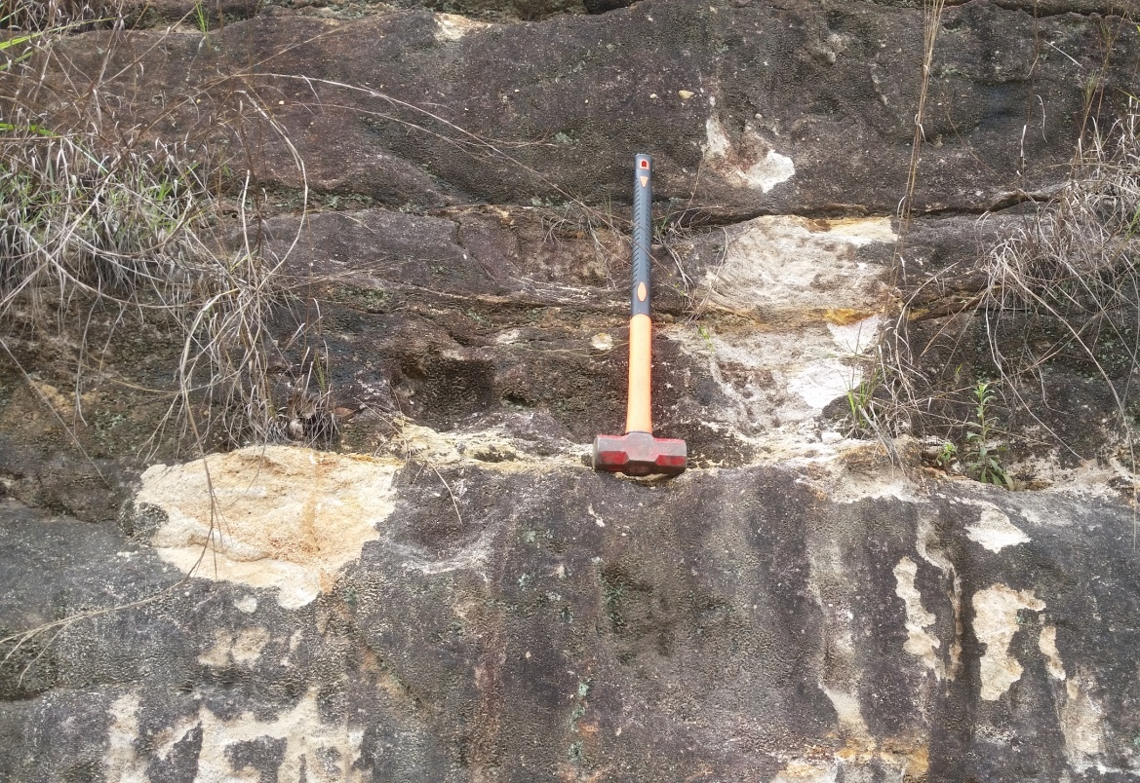
Fig 4.7: Outcrop located at Mc Gregor hill opposite Mc Gregor hill block industry

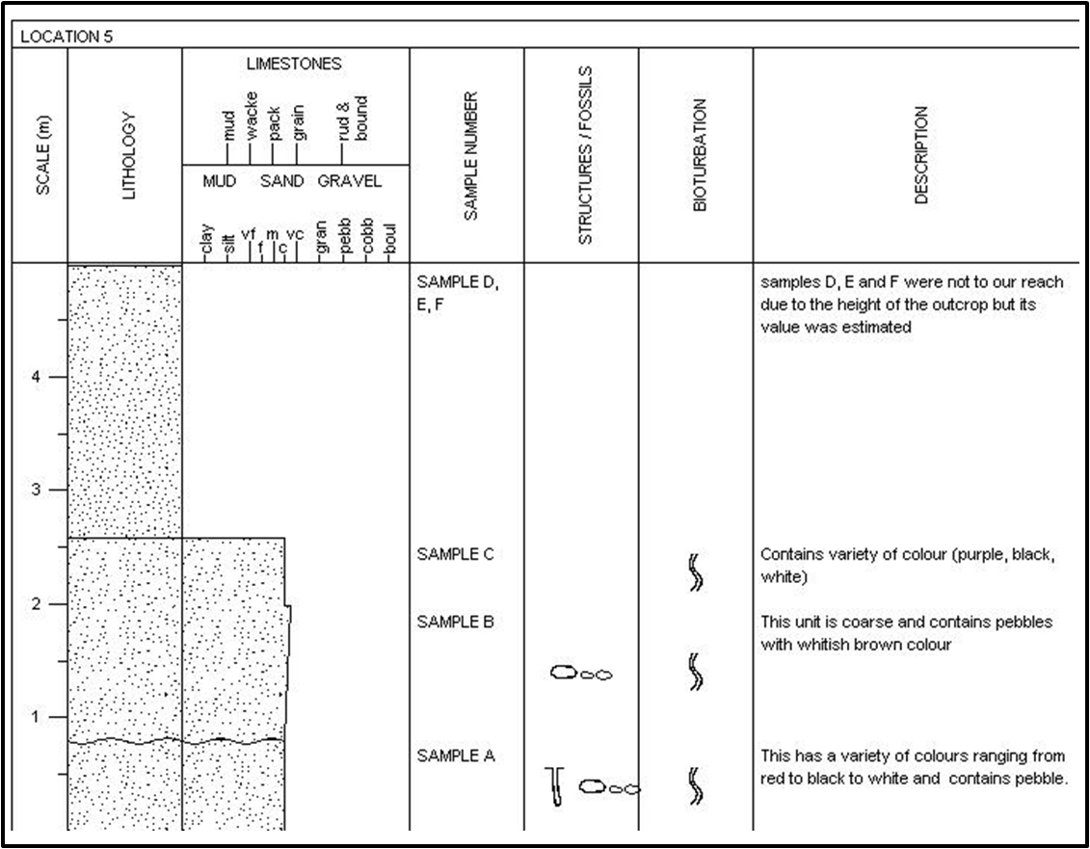
Fig 4.7.1 : Litholog of Mcgregor hill section(Afikpo)

Location (8): Located along Amasiri/Afikpo expressway about 300m away from Mc Gregor block industry.
(GPS coordinate: lat: E007◦54.873” ,long: N05◦53.751”,elevation: 65m)
(Strike: 139◦SE318◦NW, Dip direction: 138◦SE, Dip amount: 2◦)
This outcrop consist of cross bedded sandstone. The sandstone varies in grain size from fine to very coarse and exhibits an upward fining sequence with pebbly texture at the base. They are
friable and has pinkish to yellowish-white colour .

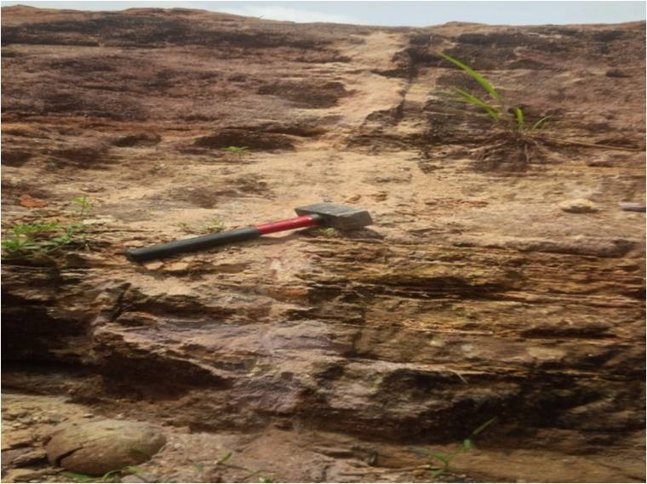
Fig 4.8: Located along Amasiri/Afikpo expressway about 300m away from Mc Gregor block industry.

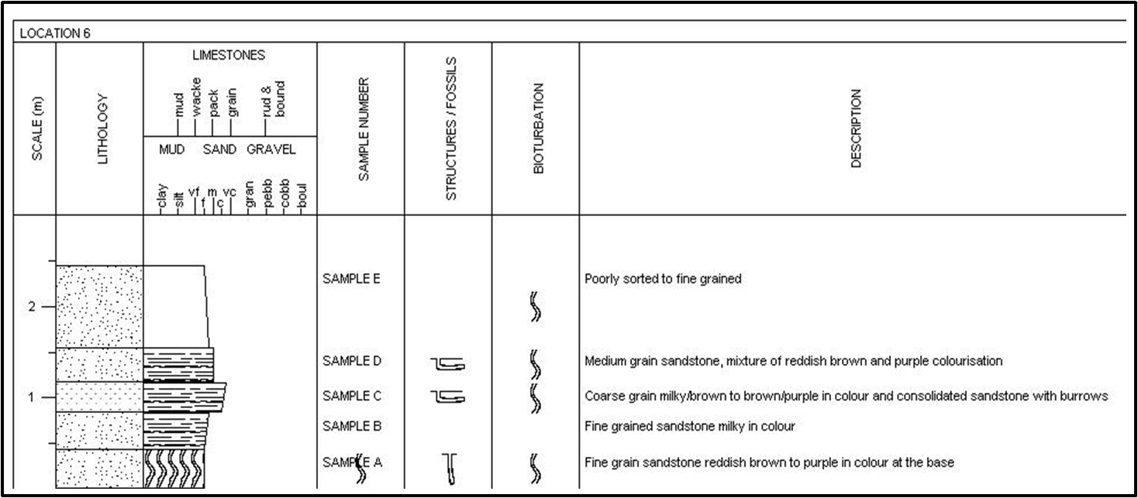
Fig 4.8.1 : Litholog of the outcrop section of Amasiri/Afikpo expressway about 300m away from Mc Gregor block

Location (9): Outcrop located along Amasiri expressway close to Naira & Kopo hotel, few meters away from the army checkpoint.
(GPS coordinate: lat: E007◦54.038” ,long: N05◦54.320” ,elevation: 46m)
(Strike: 236◦SW64◦NE, Dip direction: 235◦SW, Dip amount: 4◦)
This outcrop section is composed of two lithofacies comprising fine grained, bioturbated sandstone overlain by brown mudstones lamina, mud-dominant heterolithic lithofacies were identified in the outcrop with sandstone and mudstone.it is friable and has a vertical burrows, the outcrop has a whitish to yellowish coloration and it is highly bioturbated.the formation is of Eze-Aku formation.

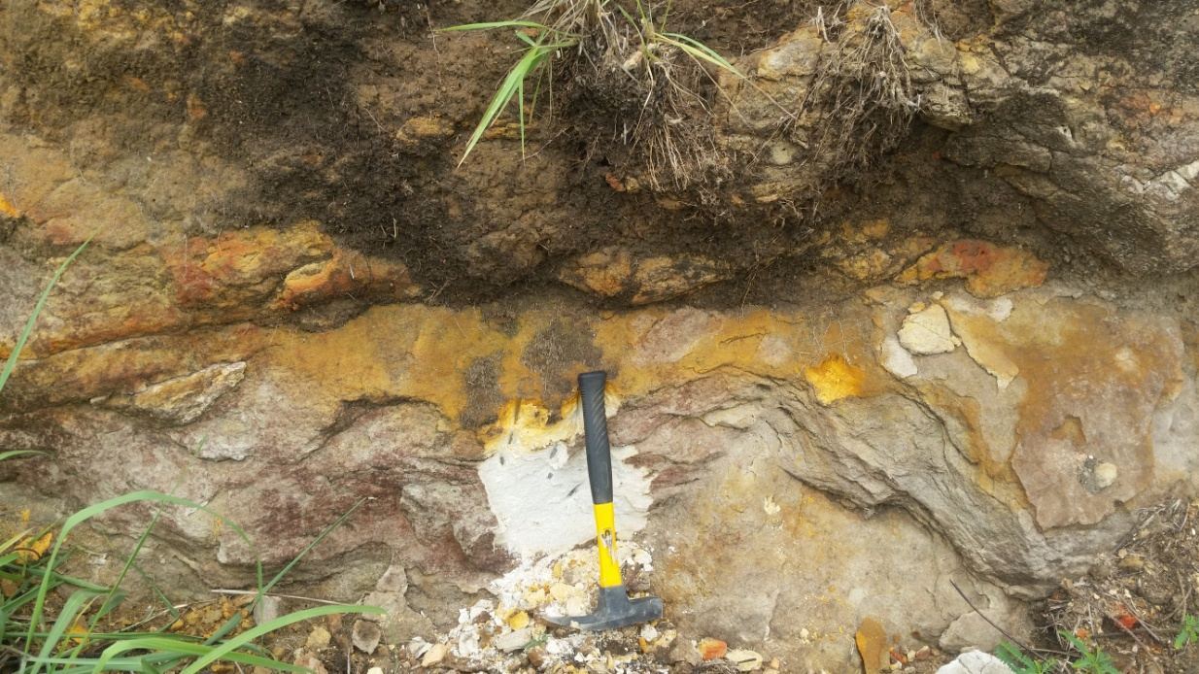
Fig 4.9: The figure shows the outcrop located along Amasiri expressway close to Naira & Kopo hotel. The outcrop show the mud dominant heterolithic facies underlain by bioturbated sandstone facies.

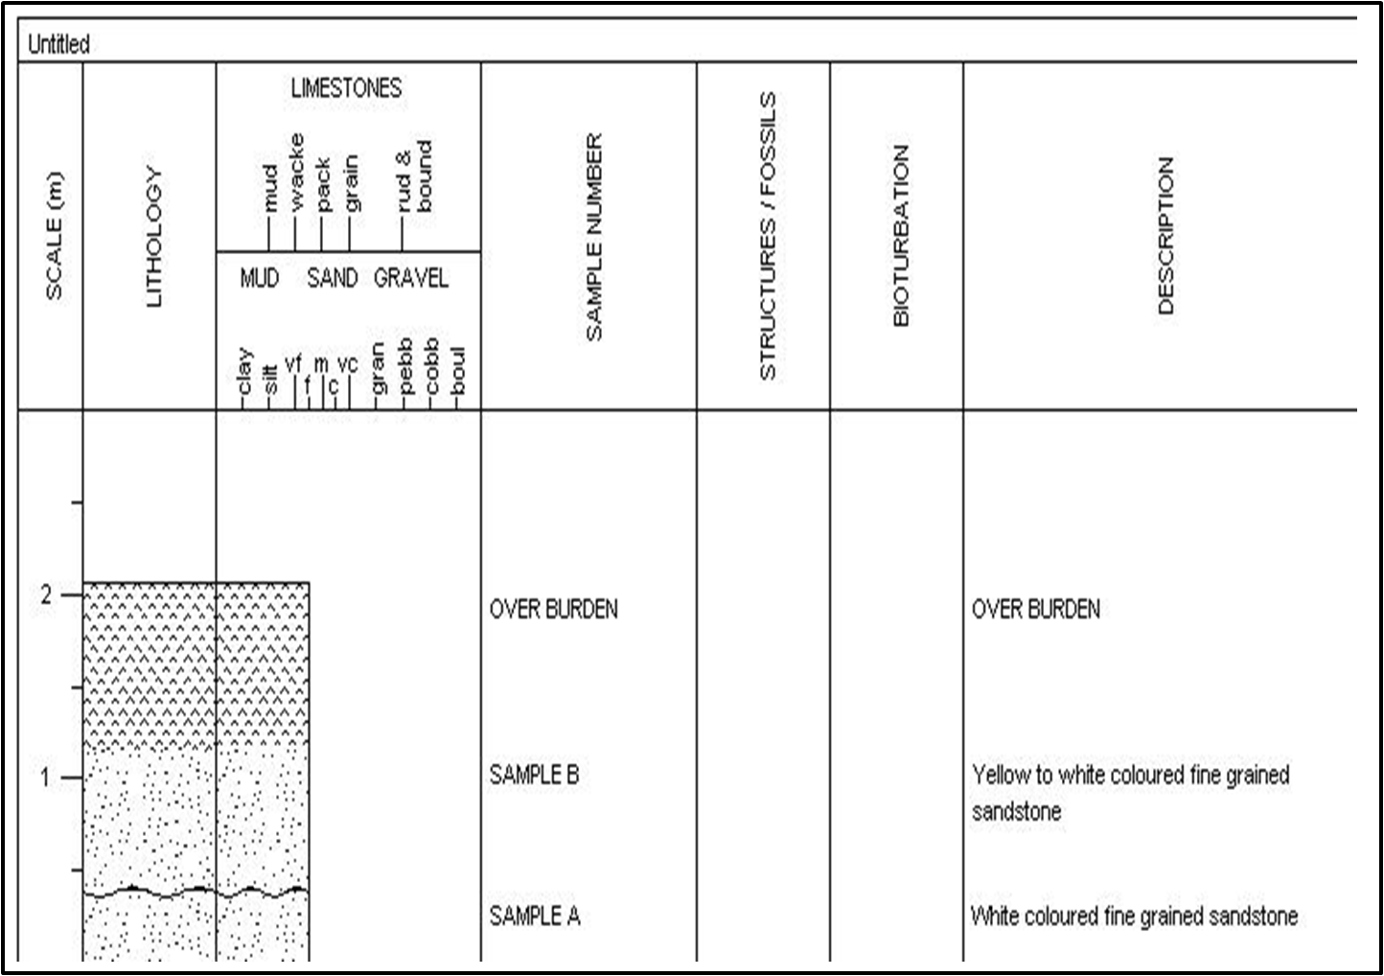
Fig 4.9.1: Litholog of the outcrop section of Amasiri expressway close to Naira & Kopo hotel.

Over Burden
0.9m

0.76m
Yellow to white Colouration

Fined Grained
Fined Grained
0.40m
White in Colour

CHAPTER FIVE: LABORATORY ANALYSIS AND RESULTS

5.0 Sieve Analysis

Grain size is a fundamental descriptive measurement of sediments and sedimentary rocks. Granulometric studies of beach sediments provide the wealth of information on the intrinsic properties of sediments and their depositional environment (Friedman, 1961; Visher, 1969). Udden (1914) documented the hydrodynamic conditions prevailing during deposition of clastic sediments controls the size and composition of the sediments. He therefore opined that sediments that accumulated under similar environmental condition should have similar grain size distribution. The objectives of this study are to describe, compare and interpret the various clastic sedimentary rocks with respect to their grain size distribution. Further, the characteristics of the grain size distribution are related to source materials, process of weathering, abrasion, corrosion and sorting process during the transport and deposition (Rajamanickam and Gujar, 1984). Texture is an important grain size ingredient that provides useful information on mode, extent of transport and environment of deposition of clastic materials, (Mason and Folk, 1958; Friedman, 1961; Visher, 1969). Moreover, the sediments can bestow information about various depositional processes like nature of the particle, mode of weathering and changes occur during transportation from place to place. We compared the size distribution of the respective clastic rocks by taking their representative samples and run it through a set of sieves to break these sample subsets into different class sizes, and using statistics to reconstruct what the population size characteristics are (Folk, (1974)).

  - Equipment Used:
The equipment used to run the process are listed below:
- Mechanical Sieve Shaker
- Electronic Weighing Balance/Scale
- ASTM Sieves
- Brush

  - Procedures:
A representative dried rock sample (unconsolidated) of about 100g was used. The lumpy rock particles were crushed with care in order to disaggregate the lumps. The required amount of rock sample for this analysis is 50g therefore each sample was weighed using the electronic weighing scale then prepared the sieves for the analysis. A set of fifteen clean sieves were used, and this was done by using a dry brush to poke the openings of the sieve, this was to make sure that accurate results were obtained. The sieves were then stacked, placing the sieve with larger openings at the top and the sieves with small openings at the bottom. The sample was placed into the topmost sieve, setting the timer of the mechanical shaker to twenty minutes then switched on the mechanical shaker. The mass of rock sample retained in each sieve was weighed then I tabulated my readings after twenty minutes elapsed. This procedures were undertaken for six more samples and results were also tabulated as shown in table below.

  - Analysis:
The tabulated retained weights of the respective grain sizes were reduced by correcting the weights and calculate the individual weight percentages as well as their cumulative weight percent. The techniques for reducing and presenting grain-size data include both graphical and statistical or quasistatistical methods. Graphical presentation of grain-size data commonly involves plotting the data on bivariate diagrams in which either individual weight percent of each grain-size class or cumulative weight percent is plotted against phi size, Histograms, Boggs( ). These curves were constructed with the use of an arithmetic scale and a log-probability scale and providing an easily visualized pictorial representation of the grain-size distribution, whose shape is defined by the phi-size intervals selected for plotting, Folk and Ward (1957). Mathematical methods that permit statistical treatment of grain-size data can be used to derive parameters that describe grain-size distributions mathematically since visual analysis can be cumbersome and sometimes deceptive, Boggs ( 2009 ). Different Percentiles (P₁, P₅, P₁₆, P₂₅, P₅₀, P₇₅, P₈₄, P₉₅) were derived from the curves with their corresponding phi values were determined, Reineck and Singh (1980). The method describes the Average Grain Size (Median, and the Graphic Mean and Mode), the Standard Deviation (Sorting), the Skewness (Dissymmetry) and the Kurtosis.
The mean size is the arithmetic average of all the particle sizes in a sample. It reflects the overall average size of the sediments as influenced by source of supply and environmental deposition. It is influenced by parameters like velocity of transporting agent, shape, specific gravity, composition, durability, resisting nature of the sediments and the amount of tossing during transportation. The grain size will be larger if the amount of imparting energy on the sediments is greater. So the mean size of the sediment serves as an index of measure of abrasion, attrition and accretion. An approximation of the mean size can be calculated from formula 1, Table ( ). The graphic mean size (Table ( )) is obtained by calculating the average of the 16th, 50th, and 84th percentile diameters determined from the cumulative curve, Boggs (2009). The median diameter (Md) is the 50% measure of the cumulative curve. It represents the midpoint of the grain-size distribution. Half of the grains by weight in the sample are larger than the median and half are smaller, Boggs (2009), and as only one point is considered, it has no value in bimodal or polymodal nature of the curves (Folk and Ward, 1957). The standard deviation measures the sorting or uniformity of the particle size distribution. The degree of sorting is dependent on the size of the sediments and serves as a measure to decipher the energy or the depositional environment and to know the presence or absence of coarse and fine-grained fractions (Mckirmey and Friedman, 1970). Standard deviation is one of the most useful textural attributes in classifying sands from different depositional environments. Sorting of sediments is influenced by many parameters like degree of turbulence, velocity of the transporting agent, hydrodynamic properties, nature of sediments supplied to the depositional environment and the rate of supply of detritus (Mckirmey and Friedman, 1970). The present study area sedimentary environment is classified on the basis of Folk and Ward (1957) formula as shown in Table ( ). The Skewness measures the asymmetry of particle distribution. It also shows that how the close grain size distribution advances the normal Gaussian probability curve, the more extreme values and more non-normal size curve. If the sediment is coarser, the trailing of the curve swings left which leads to the occurrence of coarse skewed material and the values become negative. If the sediment is finer, the trialing of the curve swings left which produces fine skewed material and the values are found to be positive, therefore, the skewness values of the samples vary from very positive skewed to very negative skewed, Folk and Ward (1957). The Graphic kurtosis is the qualitative measure of parts of sediments already sorted elsewhere in a high energy environment; it is later transported and modified by another type of environment (Folk and Ward, 1957). Hence, the kurtosis is the ratio between sorting of either extremes to the central portion of distribution. If the central portion is best sorted than the extremes then the frequency curve is said to be excessively peaked or leptokurtic. In contrast, if the extremes are better sorted than the central portion of the frequency curve then it is called flat peaked or platykurtic. Some bimodal curves are strongly platykurtic with central depression in the double peaked frequency curve (Folk, 1980). Textural parameters can give useful informations in determining the environments. Friedman (1967), showed that mean, standard deviation and skewness provide clear distinctions between beach sands and dune or river sands, and also established a useful correlation between sorting, measured by standard deviation, and the depositional environment of sediments. Many workers, in the field of sedimentology, tried to obtain informations about the environments of deposition from the statistical parameters obtained from the grain size distribution data. Stewart, 1958; Folk and Ward, 1937; Friedman, 1967; Moiola and Weiser, 1963 established the relationship between grain size distribution parameters and environment of deposition with the help of bivariate scatter plots. Friedman ( 1961, 1967) arrived Friedman ( 1961, 1967) arrived at the conclusion that a plot of skewness Vs. standard deviation was most effective in differentiating between river and beach sands, while Moiola and Weiser ( 1963) observed that most effective combination plot is mean size Vs. Standard deviation for discrimination beach and river sands.

  - Interpretation

Sample No: ST 8-A (300 meters away from McGregor Hill Block Industry)
This sample was collected 1.16 meters from the base of the outcrop. Graphical method of calculations shows that the sample has a mean grain size of 0.67 suggesting a coarse grained sandstone clastic sediment which is poorly sorted, very coarse skewed, and probably very leptokurtic in texture, Table (1). Histogram plot suggests that the dominant grain size based on their individual weight percentiles is Ф_{0.5} and Ф_{1,} both have almost equal weight percent, and the followed by the Ф₂ weight percentile, Figure (). The cumulative frequency plot on the log-normal graph also suggests that the sediments were transported is both traction – saltation acting on the sediment at the same time as well as some few fine grained materials were carried in tractionally suspended medium within a moderate to low energy environment where by the coarse grained sediments were transported in traction and saltation in a moderate medium and subsequent deposition of few suspended grain particles. The graphic method of to generate different bivariate plots, such as the combined plotting of the textural parameters, viz. Mean size vs. standard deviation, mean size Vs skewness, standard deviation Vs skewness, and mean size Vs standard deviation, shows that concentration of the points, in all the four bivariant plot, lie on the right hand sides specified for river deposits except for the mean size Vs skewness where the plot lies on the left hand side indicating beach deposit. This sample was probably deposited as a braided bar deposit as shown in figure (), Glaister and Nelson. (1974).

a. Sample A/ST8
S/N | Sieve size | Phi | Weight | Corrected | Cumulative | Percentage | Cumulative Percentage
 |  |  |  | Weight | Weight | Weight | Weight
 | (mm) | (Ф) | (gm) | (gm) | (gm) | (%) | (%)
1 | 4 | -2 | 0.7 | 0.70 | 0.70 | 1.40 | 1.40
2 | 2.36 | -1.25 | 2.3 | 2.31 | 3.01 | 4.62 | 6.02
3 | 1.4 | -0.5 | 5.7 | 5.73 | 8.74 | 11.47 | 17.49
4 | 1 | 0 | 4.9 | 4.93 | 13.67 | 9.87 | 27.36
5 | 0.71 | 0.5 | 8.4 | 8.45 | 22.12 | 16.91 | 44.27
6 | 0.5 | 1 | 8.7 | 8.75 | 30.87 | 17.51 | 61.78
7 | 0.355 | 1.5 | 4.9 | 4.93 | 35.80 | 9.87 | 71.65
8 | 0.3 | 1.75 | 2.4 | 2.41 | 38.21 | 4.82 | 76.47
9 | 0.25 | 2 | 7.4 | 7.44 | 45.65 | 14.89 | 91.36
10 | 0.18 | 2.5 | 1.4 | 1.41 | 47.06 | 2.82 | 94.18
11 | 0.15 | 2.75 | 1.5 | 1.51 | 48.57 | 3.02 | 97.20
12 | 0.125 | 3 | 0.5 | 0.50 | 49.07 | 1.00 | 98.20
13 | 0.09 | 3.25 | 0.4 | 0.40 | 49.47 | 0.80 | 99.00
14 | 0.063 | 4 | 0.0 | 0.00 | 49.47 | 0.00 | 99.00
15 | 0.045 | 4.5 | 0.5 | 0.50 | 49.97 | 1.00 | 100.00
16 |  |  | 49.70 | 49.97 |  | 100.00

Table (2)

Sample No: ST 9-A ( Foot of Ozara-ukwu ridge, Close to Naira and Kobo Hotel, at the Army Check point along Amaseri- Afikpo Road, Amaseri)

Graphical method of calculations shows that the sample has a mean grain size of 1.47 suggesting a medium grained clastic sediment which is poorly sorted, coarse skewed, and leptokurtic in texture, Table ( 2 ). Histogram plot suggests that the dominant grain size based on their individual weight percentiles is Ф_{0.5} and Ф_{2.5.} Figure (). The cumulative frequency plot on the log-normal graph also suggests that the sediments were transported is traction through saltation to suspension, acting on the sediment at the same time, within a moderately high to low energy environment where by the coarse grained sediments were transported in traction and saltation in a moderate medium and subsequent deposition of suspended grain particles. The graphic method of to generate different bivariate plots, such as the combined plotting of the textural parameters, viz. Mean size vs. standard deviation, mean size Vs skewness, standard deviation Vs skewness , and mean size Vs standard deviation, shows that concentration of the points, in all the four bivariant plot, lie on the right hand sides specified for river deposits except for the mean size Vs skewness where the plot lies on the left hand side indicating beach deposit. This sample was probably deposited as a braided bar deposit as shown in figure (), Glaister and Nelson. (1974).

b. Sample A/ST-9
S/N | Sieve size | Phi | Weight | Corrected | Cumulative | Percent | Cumulative Percent
 |  |  |  | Weight | Weight | Weight | Weight
 | (mm) | (Ф) | (gm) | (gm) | (gm) | (%) | (%)
1 | 4 | -2 | 0.00 | 0.00 | 0.00 | 0.00 | 0.00
2 | 2.36 | -1.25 | 2.50 | 2.51 | 2.51 | 5.02 | 5.02
3 | 1.4 | -0.5 | 3.00 | 3.01 | 5.52 | 6.02 | 11.04
4 | 1 | 0 | 0.80 | 0.80 | 6.32 | 1.60 | 12.64
5 | 0.71 | 0.5 | 4.80 | 4.82 | 11.14 | 9.64 | 22.28
6 | 0.5 | 1 | 7.30 | 7.33 | 18.47 | 14.66 | 36.94
7 | 0.355 | 1.5 | 7.50 | 7.53 | 26.00 | 15.06 | 52.00
8 | 0.3 | 1.75 | 1.40 | 1.40 | 27.40 | 2.80 | 54.80
9 | 0.25 | 2 | 8.50 | 8.53 | 35.93 | 17.06 | 71.86
10 | 0.18 | 2.5 | 1.80 | 1.81 | 37.74 | 3.62 | 75.48
11 | 0.15 | 2.75 | 6.40 | 6.43 | 44.17 | 12.86 | 88.34
12 | 0.125 | 3 | 1.30 | 1.31 | 45.48 | 2.62 | 90.96
13 | 0.09 | 3.25 | 1.30 | 1.31 | 46.79 | 2.62 | 93.58
14 | 0.063 | 4 | 0.30 | 0.30 | 47.09 | 0.60 | 94.18
15 | 0.045 | 4.5 | 2.90 | 2.91 | 50.00 | 5.82 | 100.00
16 |  |  | 49.80 | 50.00 |  | 100.00

Table (3)

Sample No: ST 9-B (Close to Naira and Kobo Hotel, at the Army Check point along Amaseri- Afikpo Road, Amaseri)

The sample was collected 0.7 meters above sample 10-A. Graphical method of calculations shows that the sample has a mean grain size of 0.92 of coarse grained clastic sediment (suggesting coarsening upward sequence strata from Sample 10-A), is poorly sorted, very coarse skewed, and leptokurtic in texture, Table ( 3 ). Histogram plot suggests that the dominant grain size based on their individual weight percentiles is Ф_{0.5} and Ф_{2.5.} Figure () with a very high value in the Ф_{1.75} percentile. The cumulative frequency plot on the log-normal graph also suggests that the sediments were transported is traction through saltation to suspension, acting on the sediment at the same time, within a moderately high to low energy environment where by the coarse grained sediments were transported in traction and saltation in a moderate medium and subsequent deposition of suspended grain particles. The graphic method of to generate different bivariate plots, such as the combined plotting of the textural parameters, viz. Mean size vs. standard deviation, mean size Vs skewness, standard deviation Vs skewness , and mean size Vs standard deviation, shows that concentration of the points, in all the four bivariant plot, lie on the right hand sides specified for river deposits except for the mean size Vs skewness where the plot lies on the left hand side indicating beach deposit. This sample was probably deposited as a braided bar deposit as shown in figure (), Glaister and Nelson. (1974).

c. Sample B/ST-9
S/N | Sieve size | Phi | Weight | Corrected | Cumulative | Percent | Cumulative Percent
 |  |  |  | Weight | Weight | Weight | Weight
 | (mm) | (Ф) | (gm) | (gm) | (gm) | (%) | (%)
1 | 4 | -2 | 3.4 | 3.4 | 3.40 | 6.80 | 6.80
2 | 2.36 | -1.25 | 3.0 | 3.0 | 6.40 | 6.00 | 12.80
3 | 1.4 | -0.5 | 3.4 | 3.4 | 9.80 | 6.40 | 19.60
4 | 1 | 0 | 2.3 | 2.3 | 12.10 | 4.60 | 24.20
5 | 0.71 | 0.5 | 4.4 | 4.4 | 16.50 | 8.80 | 33.00
6 | 0.5 | 1 | 5.9 | 5.9 | 22.40 | 11.80 | 44.80
7 | 0.355 | 1.5 | 0.0 | 0.0 | 22.40 | 0.00 | 44.80
8 | 0.3 | 1.75 | 0.9 | 0.9 | 23.30 | 1.80 | 46.60
9 | 0.25 | 2 | 14.4 | 14.4 | 37.70 | 28.80 | 75.40
10 | 0.18 | 2.5 | 5.0 | 5.0 | 42.70 | 10.00 | 85.40
11 | 0.15 | 2.75 | 2.4 | 2.4 | 45.10 | 4.80 | 90.20
12 | 0.125 | 3 | 1.4 | 1.4 | 46.50 | 2.80 | 93.00
13 | 0.09 | 3.25 | 1.0 | 1.0 | 47.50 | 2.00 | 95.00
14 | 0.063 | 4 | 0.5 | 0.5 | 48.00 | 1.00 | 96.00
15 | 0.045 | 4.5 | 2.0 | 2.0 | 50.00 | 4.00 | 100.00
16 |  |  | 50.0 | 50.0 |  | 100

Table (4)

Sample No: ST 8-B (300 meters away from McGregor Hill Block Industry)
Graphical method of calculations shows that the sample has a mean grain size of 0.95 suggesting a coarse grained sandstone clastic sediment which is poorly sorted, coarse skewed, and leptokurtic in texture, Table (4). Histogram plot suggests that the dominant grain size based on their individual weight percentiles is Ф_{0.5} and Ф_{1.75,} both have almost very high values in weight percentages, Figure ().The cumulative frequency plot on the log-normal graph also suggests that the sediments were transported is traction through saltation to suspension, acting on the sediment at the same time, within a moderately high to low energy environment where by the coarse grained sediments were transported in traction and saltation in a moderate medium and subsequent deposition of suspended grain particles. The graphic method of to generate different bivariate plots, such as the combined plotting of the textural parameters, viz. Mean size vs. standard deviation, mean size Vs skewness, standard deviation Vs skewness, and mean size Vs standard deviation, shows that concentration of the points, in all the four bivariant plot, lie on the right hand sides specified for river deposits except for the mean size Vs skewness where the plot lies on the left hand side indicating beach deposit. This sample was probably deposited as a braided bar deposit as shown in figure (), Glaister and Nelson. (1974).

d. Sample A/ST-8
S/N | Sieve size | Phi | Weight | Corrected | Cumulative | Percent | Cumulative Percent
 |  |  |  | Weight | Weight | Weight | Weight
 | (mm) | (Ф) | (gm) | (gm) | (gm) | (%) | (%)
1 | 4 | -2 | 0.4 | 0.40 | 0.40 | 0.80 | 0.80
2 | 2.36 | -1.25 | 2.9 | 2.91 | 3.31 | 5.82 | 6.62
3 | 1.4 | -0.5 | 5.2 | 5.22 | 8.53 | 10.46 | 17.08
4 | 1 | 0 | 3.5 | 3.51 | 12.04 | 7.02 | 24.10
5 | 0.71 | 0.5 | 5.9 | 5.92 | 17.96 | 11.86 | 35.96
6 | 0.5 | 1 | 13.4 | 13.45 | 31.41 | 26.91 | 62.87
7 | 0.355 | 1.5 | 1.1 | 1.10 | 32.51 | 2.20 | 65.07
8 | 0.3 | 1.75 | 0.0 | 0.00 | 32.51 | 0.00 | 65.07
9 | 0.25 | 2 | 12.0 | 12.05 | 44.56 | 24.11 | 89.18
10 | 0.18 | 2.5 | 0.0 | 0.00 | 44.56 | 0.00 | 89.18
11 | 0.15 | 2.75 | 2.8 | 2.81 | 47.37 | 5.62 | 94.80
12 | 0.125 | 3 | 0.8 | 0.80 | 48.17 | 1.60 | 96.40
13 | 0.09 | 3.25 | 0.5 | 0.50 | 48.67 | 1.00 | 97.40
14 | 0.063 | 4 | 0.4 | 0.40 | 49.07 | 0.80 | 98.20
15 | 0.045 | 4.5 | 0.9 | 0.90 | 49.97 | 1.80 | 100.00
16 |  |  | 49.8 | 49.97 |  | 100.00

Table (5): table 2-5 show result of the various grain size distribution of the various sandstones obtained from the map area.

S/N | Sample Name | Graphic Median (M_{d}) | Graphic Mean Grain Size (M_{z}) | Standard Deviation (Sorting)  (Iσ) | Graphic Skewness  (Sk) | Kurtosis  (K_{z})
1 | ST 8-A | 0.95 | 0.67 Coarse | 1.08 Poorly Sorted | -0.38 V. Coarse Skewed | 1.53 V. Leptokurtic
2 | ST 9-A | 1.55 | 1.47 Medium | 1.41 Poorly Sorted | -0.11 Coarse Skewed | 1.22 Leptokurtic
3 | ST 9-B | 1.40 | 0.92 Coarse | 1.69 Poorly Sorted | -0.44 V. Coarse Skewed | 1.30 Leptokurtic
4 | ST 8-B | 0.85 | 0.72 Coarse | 1.23 Poorly Sorted | -0.11 Coarse Skewed | 1.47 Leptokurtic
 | Average | 1.19 | 0.95 (Coarse Sand) | 1.35 (Poorly Sorted) | -0.26 (Coarse Skewed) | 1.38 (Leptokurtic)

Table (6.): Result of the analysis of the various textural grain size characteristics of Sand Samples obtained from the Mapped Area

 | Phi standard deviation  (Verbal sorting) | Calculated skewness  (Verbal skewness) | Calculated kurtosis  (Verbal kurtosis)
1 | < 0.35  (Very well sorted) | > +0.30  (Strongly fine skewed) | < 0.67  (Very platykurtic)
2 | 0.35 to 0.50  (Well sorted) | + 0.30 to +0.10  (Fine skewed) | 0.67 to 0.90  (Platykurtic)
3 | 0.50 to 0.70  (Moderately well sorted) | +0.10 to –0.10  (Near symmetrical) | 0.90 to 1.11  (Mesokurtic)
4 | 0.70 to 1.00  (Moderately sorted) | –0.10 to –0.30  (Coarse skewed) | 1.11 to 1.50  (Leptokurtic)
5 | 1.00 to 2.00  (Poorly sorted) | < −0.30  (Strongly coarse skewed) | 1.50 to 3.00  (Very leptokurtic)
6 | 2.00 to 4.00  (Very poorly sorted) |  | > 0.30  (Extremely leptokurtic)
7 | > 4.00  (Extremely poorly sorted)

Table (7) : Description of the various statistical parameters.

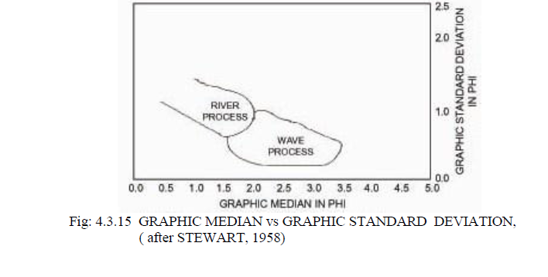
Fig 4.10 : Graphic median vs Graphic standard deviation,(after STEWART,1958)

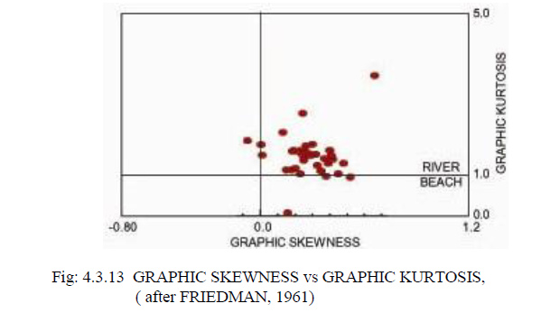
Fig 4.11 : Graphic Skewnwss vs Graphic Kurtosis (after Friedman, 1961)

Fig 4.12 : Graphic standard deviation vs Graphic skewness( after FRIEDMAN,1967)
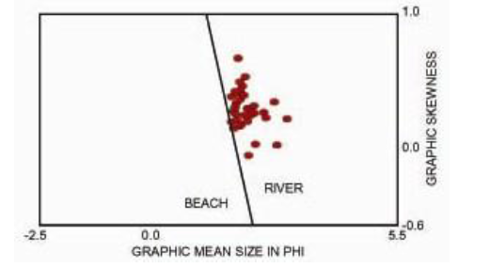
Fig 4.13 : Graphic mean size vs Graphic skewness( after MOIOLA and WEISER,1968)
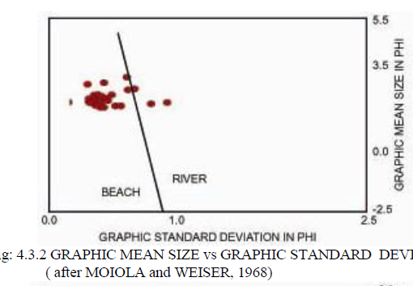
Fig 4.14 : Graphic mean size vs Graphic standard deviation ( after MOIOLA and WEISER, 1968)

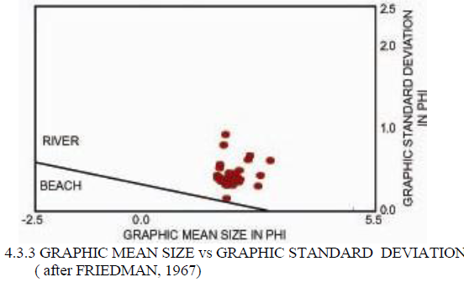
Fig 4.15 : Graphic mean size vs Graphic standard deviation ( after FRIEDMAN,1967)

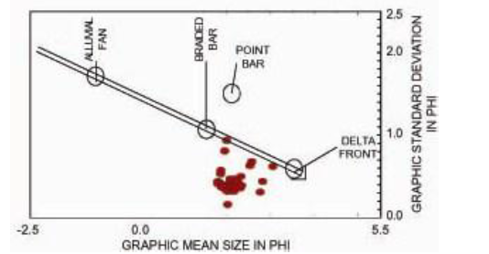
Fig 4.16 : Graphic mean size vs Graphic standard deviation ( after GLAISTER and NELSON,1974)

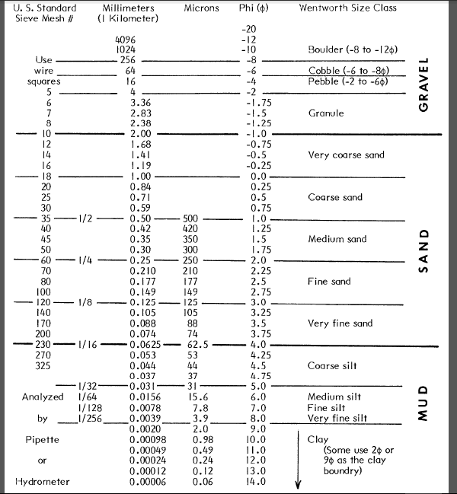

Fig 4.17 :Grain size standard (UDDEN WENTWORTH)
5.5 Summary:
Result of the analysis of the various samples in the study area shows that most of the sandstone sediments are generally coarse grained with compositionally mean grain size of 0.95, ranging from medium grained to coarse grained sandstone having a dominant grain size ranges from the Ф_{-0.5} to Ф_{1.75,} weight percentiles from the histogram plots. They are generally poorly sorted, with modal grain sizes ranging from pebbly materials (at the foot of the Mcgregor college sandstone outcrop) to fine silt, generally, coarse skewed and leptokurtic respectively. These suggest that the sediments were locally derived and deposited not too far away from the source in a fluctuating, high to low energy fluvial transport medium within a braided river bar channel as shown in the various probability log distribution plots and bivariate plots respectively.

UNIT | Quartz (%) |  | Feldspar (%) | Rock Fragment (%) | Matrix (%) | TOTAL
 | Polycrystalline | Monocrystalline
Amasiri | 20.94 | 44.76 | 13 | 10.8 | 10.5 | 100
L026 | 30.65 | 28.20 | 15.1 | 6.05 | 20 | 100
Unnamed | 45.15 | 21.30 | 14.56 | 6.72 | 12.72 | 100

Table 8: The table showing the various composition of mineral contents in the sandstone sample gotten.

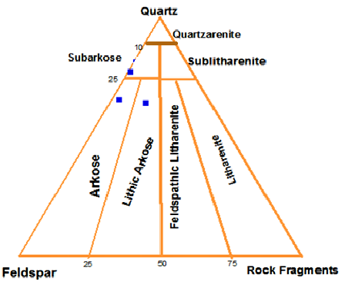
Fig 4.18: Sandstone classification after Folk, 1974.

The point counting was facilitated by the use of JMicrovision software for pointcounting. The recursive method was adopted and a minimum of one hundred grains was examined for each sandstone.
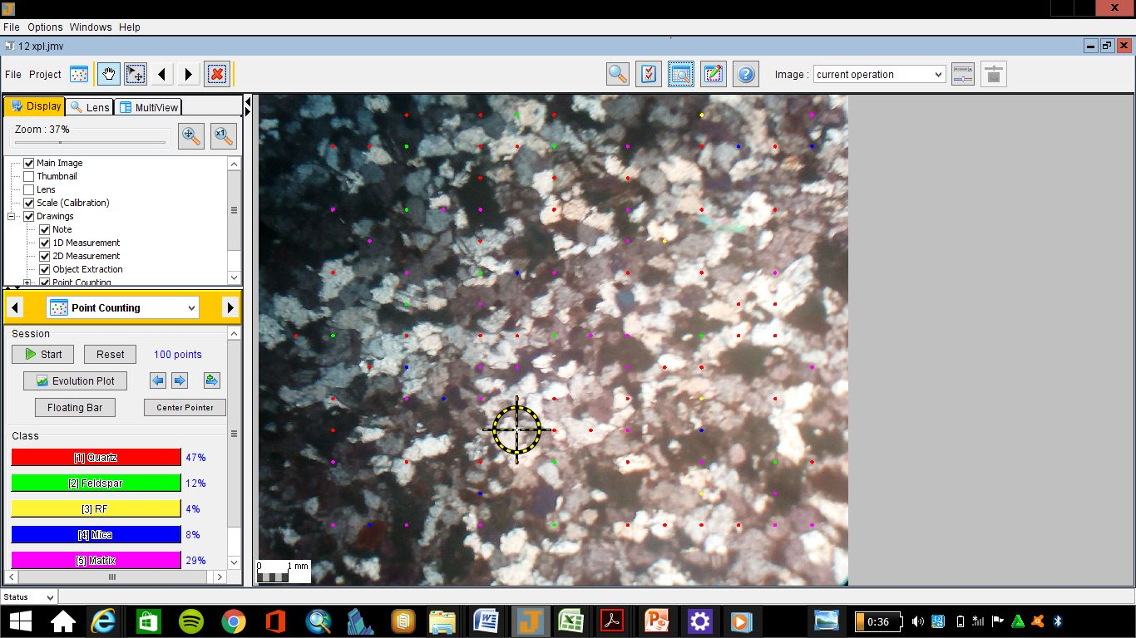

e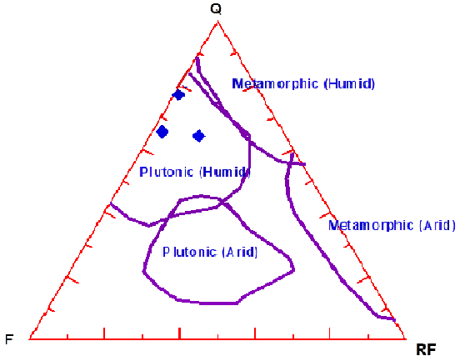
Fig 4.19: The QFR diagram showing effect of source rock on composition of Amasiri sandstone using Suttner et al., (1981)

The effect of source rock on composition of Amasiri sandstone using Suttner et al., (1981) the sandstone appears to be polygenetic (Igneous and metamorphic source). But the climatic condition is sure to be humid.For first cycle sediments, Basu (1976) has suggested that the ratio of quartz to feldspar (Q/F) be used as a guide in climatic interpretation. If Q/F is less than unity, it indicates humid climate in accepting the above criterion, one should not lose sight of the fact that the amount of feldspars in sandstone is a function not only of climate, relief and availability in the source rocks, but also of the rigor and duration of transport and post depositional processes. The presence of mica in the sandstones indicates deposition in low energy environment where sediments are rapidly deposited with little reworking (Reineck and Singh, 1973).From the foregoing, the provenance is most likely the metamorphic Precambrian basement complex of Southeastern Nigeria in the Oban and Bamenda massifs/cratons located at the eastern border of the rift, towards the eastern border of the study area.
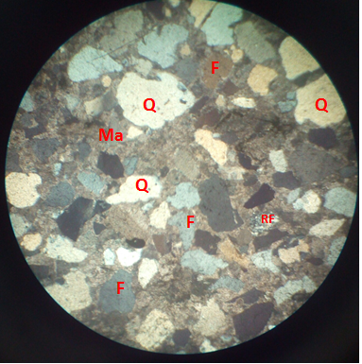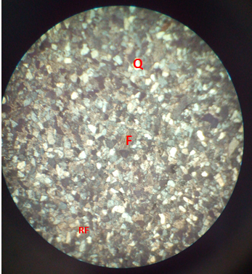
- (b)
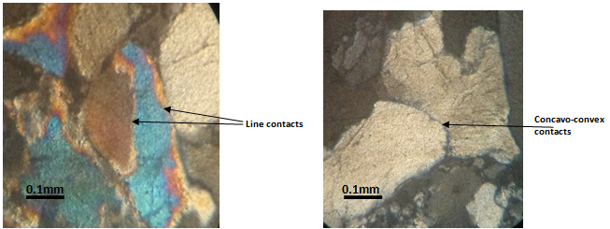
Concavo-convex contacts between quartz grains in the coarse- grained sandstone. Cross polars (x10)
Point and Line contacts between quartz grains in the medium- grained sandstone. Cross polars (x10)

Fig 4.20 : figure (a) showing the point and line contacts between quartz grains in medium grained sandstone.
Fig 4.20 : figure (b) showing a concavo-convex contacts between quartz in coarse-grained sandstone.
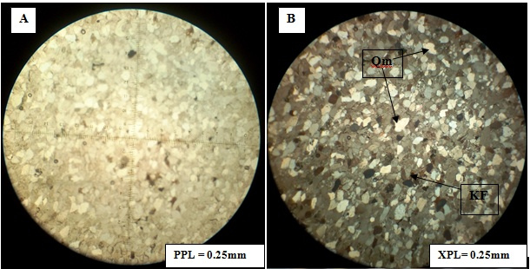
Fig 4.21: Photomicrographs Showing mainly fine to medium grained monocrystalline quartz (Qm).

Photomicrographs Show mainly fine to medium grained monocrystalline quartz (Qm) with elongate crystals, and straight boundaries, with very few feldspar grains. K-feldspars exhibit simple Carlsbad twin (KF). In PPL, both quartz and feldspar grains have low relief appearing white and cloudy. In XPL most of the mineral grains appeared clearly, some dark-bluish colour alterations of the grains by hematite.

Amasiri-Coarse grained Sandstone Unit
Classification: SUBARKOSE
This sample consists of medium to coarse grained, moderately to well sorted sandstone, rich in subangular to rounded quartz (monocrystalline and polycrystalline) grains, as well as plagioclase feldspars (multiple twinned) and k-feldspars and microcline (cross hatched and simple twinned), minor rock fragments and cement materials (clay minerals and calcite). The polycrystalline quartz exhibit undulose extinction (as a result of strain). The grain sizes range within 0.25 to 1.0 mm. A few grains of glauconites with brown margin, probably authigenic but possibly detrital is present.

LO26-Medium grained Sandstone Unit
Classification: ARKOSIC ARENITE
This sample consist of medium grained, moderately sorted, angular to sub-angular quartz grains, k-feldspars (simple twinned) and plagioclase feldspars (multiple twinned) and some rock fragments cemented by clay minerals and carbonates. The quartz are mainly polycrystalline with sutured boundaries, while the dominant feldspar mineral grain is plagioclase feldspars. The grain size ranges from 0.125 to 0.5 mm

UNNAMED-Fine grained Sandstone Unit
Classification: LITHIC ARKOSE
This sample consists of sandstone with fine grained, angular to sub-rounded, moderately to well sorted quartz grains, with very little k-feldspars (cross hatched and simple twinned), plagioclase feldspars (multiple twinned), rock fragments of sedimentary origin and some biotite minerals. There are minor clay minerals and calcite cements. The grain size ranges from 0.5 to 1.0 mm.

5.6 PALYNOLOGICAL LABORATORY ANALYSIS
5.6.1 METHOD OF SAMPLE PREPARETION
The method of study included laboratory sample processing and transmitted light microscopic logging. Four (4) samples from station 2, labeled (ST 2/SP A, ST 2/SP B, ST 2/SP C and ST 2/SP D), were subjected to palynological sample processing for their palynomorphs. The sample preparation was carried out, using the conventional maceration technique for recovering acid insoluble organic-walled microfossils from sediments. Each sample was digested for 30 minutes in 40% hydrochloric acid to remove traces of carbonate and 72 hours in 40% hydrofluoric acid for removal of silicate. The extracts were sieve-washed through 10 microns nylon mesh. The sieve-washed residues were oxidized for 30 minutes in 70% HNO₃ and 5 minutes in Schulze solution to render the fossils translucent for transmitted light microscopy. The oxidized residues were rinsed in 2% KOH solution to neutralize the acid. Swirling treatment was undertaken in order to get rid of the resistant coarse mineral particles and organic matter. The residues were stained with Safranin – O to increase the contrast for study and photography.
Aliquots were dispersed with polyvinyl alcohol, dried on cover-slips and mounted in petro- poxy resin. One slide was made from each sample and logged under the transmitted light microscopy. Light photomicrographs were taken with leica lll binocular microscope.

5.7 PALYNOLOGICAL RESULTS
STATION Two / SAMPLE A (ST 2/SP A)
Tables 9-12 show the occurrences and distributions of palynomorph species.
(Table 9)
Palynomorphs species | Total
TERRESTRIAL SPECIES
Spores
Laevigatosporites ovatus | 8
Leiotriletes adriennis | 2
Cingulatisporites ornatus | 3
Distaverrusporites simplex | 1
Zlivisporis blanensis | 2
Pollen
Buttinia andreevi | 1
Echitriporites trianguliformis | 2
Grimsdalea polygonalis | 3
Longapertites marginatus | 6
Monoporites annulatus | 2
Monocolpites marginatus | 2
Psilamonocolpites magnus | 1
Longapertites microfoveolatus | 2
MARINE SPECIES
Andalusiella polymorpha | 3
Ceratiopsis diebeli | 4
Senegaliniun sp. | 3
Glaphyrocysta ordinate | 2
Phelodinium sp. | 1
Dinogymnium acuminatum | 2
Total Counts | 50

Comments: Palynomorph percentage
Terrestrial species: Spores = 32 %
Pollen = 38 %
Marine species: Dinocysts = 30 %
Age: Late Campanian
Paleoenvironment: Marginal marine (estuary)
Paleo-salinity: Nearshore/brackish water
STATION Two / SAMPLE B (ST 2/SP B)
(Table 10)
Palynomorphs species | Total
TERRESTRIAL SPECIES
Spores
Laevigatosporites ovatus | 9
Leiotriletes adriennis | 0
Cingulatisporites ornatus | 2
Distaverrusporites simplex | 3
Zlivisporis blanensis | 0
Pollen
Buttinia andreevi | 3
Echitriporites trianguliformis | 1
Grimsdalea polygonalis | 0
Longapertites marginatus | 9
Monoporites annulatus | 4
Monocolpites marginatus | 2
Psilamonocolpites magnus | 0
Longapertites microfoveolatus | 0
MARINE SPECIES
Andalusiella polymorpha | 2
Ceratiopsis diebeli | 3
Senegaliniun sp. | 2
Glaphyrocysta ordinate | 0
Phelodinium sp. | 3
Areoligera senoniensis | 0
Paleocystodinium austrialinium | 2
Dinogymnium acuminatum | 1
Spiniferites sp. | 0
Glaphyrocysta ordinate | 1
Total Counts | 47

Comments: Palynomorph percentage
Terrestrial species: Spores = 30 %
Pollen = 40 %
Marine species: Dinocysts = 30 %
Age: Late Campanian
Paleoenvironment: Marginal marine (estuary)
Paleo-salinity: Nearshore/brackish water

STATION Two/ SAMPLE C (ST 2/SP C)
(Table 11)
Palynomorphs species | Total
TERRESTRIAL SPECIES
Spores
Laevigatosporites ovatus | 7
Leiotriletes adriennis | 3
Cingulatisporites ornatus | 0
Distaverrusporites simplex | 2
Zlivisporis blanensis | 1
Pollen
Buttinia andreevi | 1
Echitriporites trianguliformis | 4
Grimsdalea polygonalis | 1
Longapertites marginatus | 12
Monoporites annulatus | 2
Monocolpites marginatus | 3
Retidiporites magdalensis | 1
Longapertites microfoveolatus | 0
MARINE SPECIES
Andalusiella manthei | 1
Ceratiopsis diebeli | 2
Senegaliniun bicarvatum | 1
Glaphyrocysta ordinate | 2
Phelodinium sp. | 1
Areoligera senoniensis | 0
Paleocystodinium austrialinium | 1
Dinogymnium acuminatum | 2
Spiniferites sp. | 3
Glaphyrocysta ordinate | 2
Total Counts | 52

Comments: Palynomorph percentage
Terrestrial species: Spores = 25 %
Pollen = 46 %
Marine species: Dinocysts = 29 %
Age: Late Campanian-Earliest Maastrichtian
Paleoenvironment: Marginal marine (estuary)
Paleo-salinity: Nearshore/brackish water

STATION 2 / SAMPLE D (ST 2/SP D)
(Table 12)
Palynomorphs species | Total
TERRESTRIAL SPECIES
Spores
Laevigatosporites ovatus | 9
Leiotriletes adriennis | 0
Cingulatisporites ornatus | 2
Distaverrusporites simplex | 2
Cyathidites minor | 1
Pollen
Buttinia andreevi | 0
Echitriporites trianguliformis | 1
Grimsdalea polygonalis | 0
Longapertites marginatus | 7
Monoporites annulatus | 2
Monocolpites marginatus | 1
Retidiporites magdalensis | 2
Longapertites microfoveolatus | 3
MARINE SPECIES
Andalusiella manthei | 0
Ceratiopsis diebeli | 2
Senegaliniun bicarvatum | 1
Glaphyrocysta ordinate | 0
Phelodinium sp. | 3
Areoligera senoniensis | 1
Paleocystodinium austrialinium | 2
Dinogymnium acuminatum | 1
Spiniferites sp. | 0
Glaphyrocysta ordinate | 2
Total Counts | 42

Comments: Palynomorph percentage
Terrestrial species: Spores = 33 %
Pollen = 38 %
Marine species: Dinocysts = 29 %
Age: Late Campanian-Earliest Maastrichtian
Paleoenvironment: Marginal marine (estuary)
Paleo-salinity: Nearshore/brackish water

5.8 INTERPRETATION OF RESULTS
AGE DETERMINATION
The age determination of the examined samples was based on the selected key age-diagnostic palynomorph assemblages encountered. They are summarized as follow:
- From the tables 7 and 8 above, samples ST 2/SP A and ST 2/SP B, were assigned Late Campanian age based on the following index sporomorphs assemblage: Zlivisporis blanensis, Distaverrusporites simplex, Echitriporites trianguliformis, Longapertites marginatus, Monocolpites marginatus, Buttinia andreevi, and Longapertites microfoveolatus, (Lawal and Moullade, 1987; Umeji, 2007).
- Whereas samples ST 2/SP C and ST 2/SP D from tables 9 and 10 were dated Late Campanian-earliest Maastrichtian age, with the following index sporomorphs assemblage: Rugulatisporites caperatus, Retidiporites magdalensis, Distaverrusporites simplex, Echitriporites trianguliformis, Longapertites marginatus, Monocolpites marginatus, Buttinia andreevi, and Monocolpites marginatus, (Lawal and Moullade, 1987; Umeji, 2007; Chiaghanam et al., 2012).
- The age was further strengthened by the co-occurrence of the typical West African Campano-Maastrichtian dinoflagellate cysts association such as, Dinogymnium sp., Andalusiella polymorpha, A. manthei, Senegalinium ., Ceratiopsis diebeli, and Paleocystodinium autrialinium, (Lentin and Williams, 1978; May, 1980; Umeji, 2007) (Fig. 1).
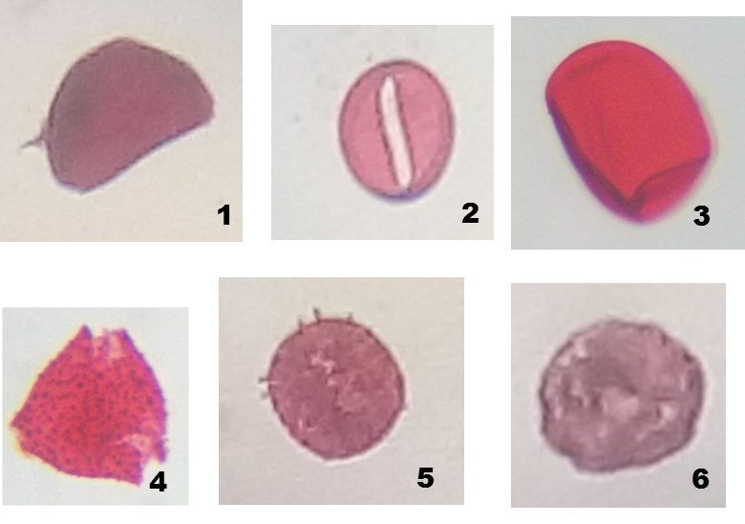
Fig. 4.22 : Micrographs of some palynomorphs recovered in the examined samples.
Magnifications nos. 2 and 4 (X 100 oil immersion), others (X 40)
- Longapertites marginatus
- Monocolpites marginatus
- Laevigatosporites ovatus
- Echitriporites trianguliformis
- Spinizonocolpites baculatus
- Buttinia andreevi

5.9 KEROGEN INVESTIGATION
Method of Study
The kerogen slides were prepared from 4 analyzed samples of shale from the station 2, labeled (ST 2/SP A, ST 2/SP B, ST 2/SP C and ST 2/SP D), one for each sample, using the conventional method of acid maceration (Fig.2). Each slide was examined using the transmitted light microscopy at X10 and 40 magnifications in order to make a qualitative as well as a quantitative analysis of particulate organic matter (POM), determine the palynofacies association and kerogen types, examine the spore /pollen colouration, estimate the Thermal Alteration Index (TAI), Vitrinite Reflectance (Ro %), as well as the degree of organic thermal maturation, (Fig. 3 and Fig. 4). Each slide was counted for its (POM) contents, in which the first 200 particles were counted in terms of abundant (>35 %), frequent (16-35 %), common (5-15 %) and rare (<5 %) (cf. Ibrahim et al., 1997; Zobba, 2007; Chiaghanam et al. 2013) table 5.

5.10 RESULT
Table 13 : Summary of % frequency distribution of the total Particulate Organic Matter (POM) present in the analysed samples.
SAMPLE NO. | PHYTOCLAST | OPAQUES | AOM | PALYNOMORPHS
ST 2/SP A | 69 % | 26 % | 4 % | 1 %
ST 2/SP B | 60 % | 32 % | 8 % | 0 %
ST 2/SP C | 55 % | 30 % | 8 % | 7 %
ST 2/SP D | 50 % | 32 % | 15 % | 3 %

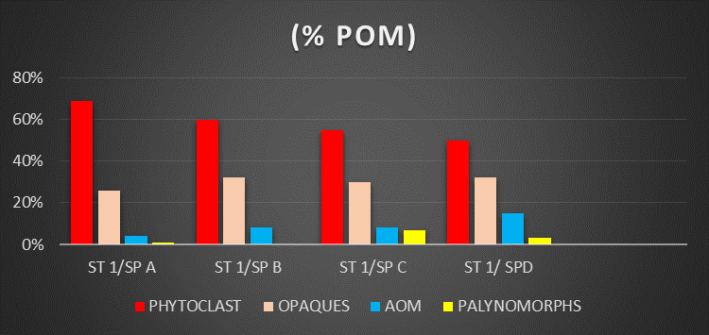
Fig 4.23: Histogram % frequency distribution of the total particulate organic matter (POM) present in the examined samples.

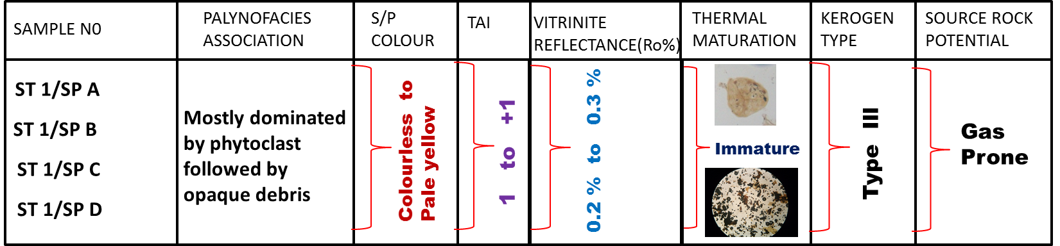
Table 14 : Summary of the kerogen characterization and interpretations.

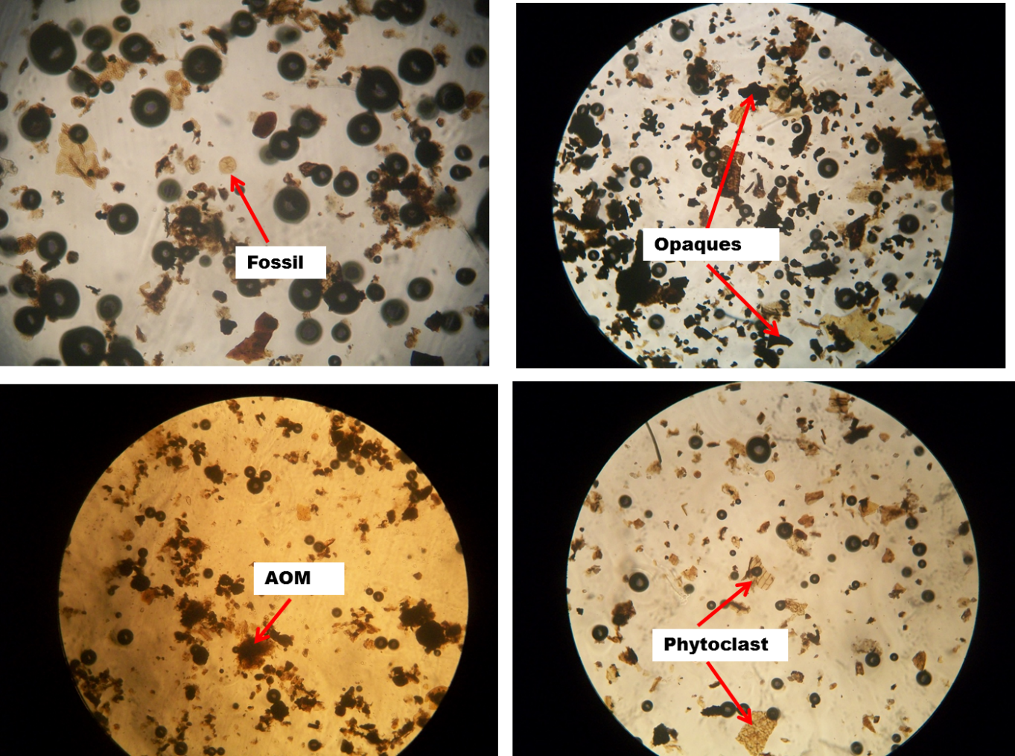
Fig 4.24: Photomicrographs of the kerogen slides showing the various (POM) in the examined samples.

CHAPTER SIX: STRUCTURAL GEOLOGY AND IGNEOUS ACTIVITY

6.0 Sedimentary Structures
They are the large scale features of sedimentary rocks and include the familiar cross beddings, ripple marks etc. This deals with the detailed analogy of sedimentary structures in the study area and it is classified into two major types;
- Primary sedimentary structures
- Secondary sedimentary structures
The structures mentioned are notable in the field and are formed by the physical, chemical and organic processes. The primary structures are also called syngenetic structures i.e structures formed from deposition of sediments and secondary structures are known as postgenetic or epigenetic.
PRIMARY SEDIMENTARY STRUCTURES INCLUDE;
JOINTS: These are fractured blocks with no relative movement. These were found both on outcrops and on the surface.
CROSS BEDDING: This occurs when the internal structure of some beds are such that they are deposited at an angle to the binding surface.
LAMINATIONS: They are similar to beddings but with different thickness i.e less than 1cm
BEDDINGS; A single bed is a sedimentation unit deposited under essentially constant physical conditions. It is the term used for sedimentary layers greater than 1cm thick. Beds thickness in the study area range from 1cm to 7cm, which infers they move from thin beds which are likely to be inequality of depositions of sediments as supplied to the deposition site. With finer grains or sediments, their bedding tends to become thinner as a result of slow rate of deposition.

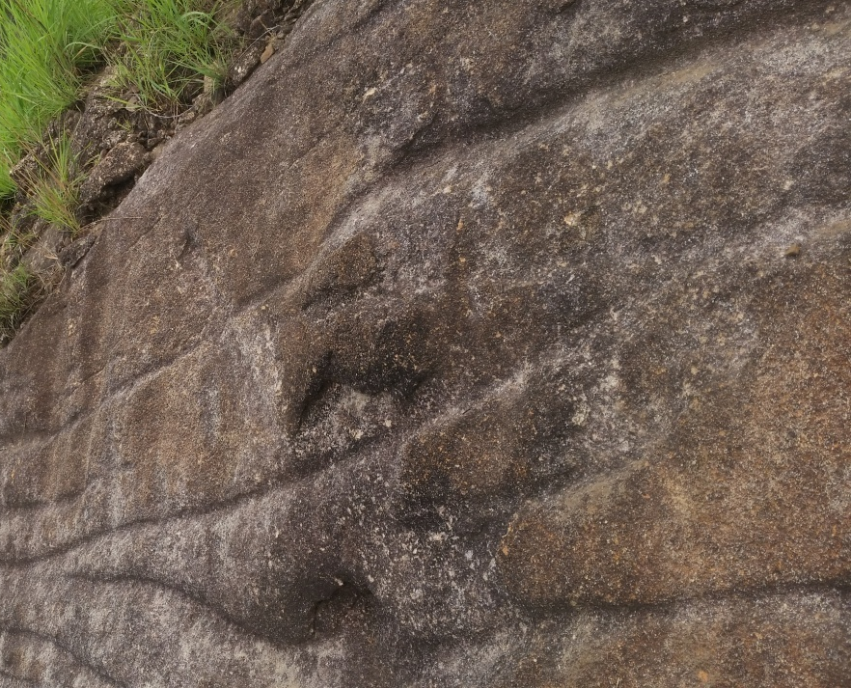
Fig 4.23: Presence of ripple mark on the surface of the outcrop at Ibii Akpoha express road
Ripple marks

Secondary Sedimentary Structures
FRACTURES: They are discontinuities in a rock caused by breakages of rocks relative to their smooth surface or bedding. The fractures observed were faults and joints.
JOINT; is a fracture in a rock in which there is no appreciable displacement along a crack.
FAULT; It is a structure that has major rock displacement a fault was observed at the outcrop along Indibe beach road. Fractures sometimes serve as passageways for ground water and host for valuable mineral deposits such as copper, lead, zinc, gold, silver, etc they also serve as pathways for hydrocarbons into traps.
6.1 Biogenic Sedimentary Structures
They are tangible evidences of activities by organisms, fossil as trace other than the body parts, biogenic structures include bioturbations which reflects the disruption of biogenic and physical stratification fabrics by the activities of the organisms, these structures include trails, tracks, burrows and other miscellaneous features representing activities of organisms. Observed biogenic features in this area include; skolithos, orphimorphia and bioturbations.

Orphimorphia and Skolithos
Ophimorphia and Skolithos were found at location eight at Mc gregor hil. Ophiomorpha occurs as a knobby walled burrow, with walls thick and clayed with burrows ranging from 7cm to 20mm, there burrows are regarded as dwelling structures of suspension feeders produced by crustaceans, they indicate conditions of moderate to high sediment influx in a high energy marine environment in which suspension feeders flourish. The knobby walls and horizontal and vertical tunnels are characteristics of high energy environment of beaches, tidal flats and tidal delta. Skolithos burrows are generally vertical shafts measuring up to 5-6mm in diameter with the walls unlike the orphiomorpha which has a knobby thick wall the burrows are also regarded as a dwelling structures. The Skolithos Ichnofacies associations are normally found on the middle shore face to shore face (Frey, et al; 1978) or tide dominated shallow marine.

6.2 Igneous Activity
Igneous Activities was observed in presence of a dolerite sill in out crop located about 400m from Amasiri Junction (Afikpo-Amasiri Road). The igneous intrusive rock is of Turonian time and was found in the boundary between the shale of the Eze-Aku formation.
The environment was discovered to be a sedimentary environment with basic rock and basic rocks are mostly made of basalt and gabbro the texture of the rock ranges from fine (Basalt) coarse grain (gabbro) it contain plagioclase angite and K-feldspar, also there are present of iron oxides which exists in the form of magnetides and some other minerals that makes up the rocks are the pyroxene and olivine. The igneous intrusive (dolerite sill) that was observed, was formed by an emplacement of the intrusive by the fault plane fracture from the upper mantle, It intruded over 37 km running parallel to the strike plane it occurs as sill or dyke which can be either volcanic or plutonic. The dolerite sill observed with the bedding plane and was a result of uplift and erosion (hyper basal) and the exposure leads to the formation of basalt which is hyperbasal. The sill that was observed where horizontal in its orientation and they are also characterized as concordant intrusive contacts because they are intrusive rock formation in contact with the host or country rock in horizontal plane. The sill also observe, hand a chilled zone a baked margin. It is zone from the core to the surface the core is coarser indicating shower cooling while the surface is fine grain indicating faster cooling at the surface.
6.3 ECONOMIC GEOLOGY
This constitutes the mineral resources of the study area. The stratigraphic pattern of sandstone and shale together along with some structural features control the mineral elements, with shale acting as a source rock and sandstone as a cap rock.
Clay/Shale:It is used by the local farmers for agricultural cultivation. It also serves as a good cultivation ground due to its abundant organic remains. They also serve as raw materials for the manufacture of bricks, ceramic ware, etc.
Sand/Sandstone: It is a sedimentary rock with grain size of 1/16- 2.00 (sand) which turns into sandstone rock due to cement which fill the pores in the sand making the sandstone less porous and permeable. Sandstones could serve as host for some economic minerals such as uranium, rutile gold, diamond, etc which can be deposited as placer deposits since it is very porous it serves as a cereal rock for aquifer and as oil reservoir. Its is one of the major minerals mined by large and small scale industries, which are basically used for construction of roads and buildings. They constitute important reservoirs for ground water, hydrocarbon, and can be used as filter paper and moulding sand.
Dolerite: It is basically used in road construction. Also quarrying of dolerite serves as a source of employment for people living in the area.

CHAPTER SEVEN: CONCLUSION

Some lithological units of the Eze-Aku Group were mapped in the study area. The Eze-Aku Group marked by Amasiri Sandstone and Eze-Aku shale which were both of shallow marine depositional setting and during the 2nd cycle of the Benue trough.
The Amasiri Sandstone is marked by the predominance of sandstone unit, bioturbation by organisms, calcareous, coarse grained massive sandstone, and the Eze-Aku shale marked by black shale which is also fissile. The sandstone are massive ridges trending NE-SE direction.
The poor moderate sorting sub angular-subrounded in texture of the sediments of the area suggest short transport.
The angular uncomformity marked by basal conglomerates boundary which demarcates the afikpo and amasiri sandstone units trend in the NE-SW direction as Eze-Aku Group.

References
Ajakaiye, D. E. 1981. Geophysical Investigations in the Benue Trough – A review. Earth
Evolution Science 2, 110 – 125.
Amajor, L. C. 1985. The Eze-Aku Sandstone Ridges( Turonian) of Southeastern Nigeria: A Re-
interpretation of the Depositional Origin. Nigeria Journal of Mining and Geology,23;1 &
2;17 – 26.
Amajor,L.C. 1992. Storm Induced Turbidite-like Deposit: An example from the Turonian Eze-
Aku Formation at Nkalagu, Southeastern Nigeria. Nigeria Journal of Mining and
Geology 28; 1;7-17.
Banerjee,I. 1980. Subtidal Bar Model for the Eze-Aku Sandstone, Nigeria. Sedimentary
Geology,2:4;291- 309.
Banerjee,I. 1981. Storm lag and related facies of the bioclastic limestone of the Eze-Aku
Formation (Turonian), Nigeria. Sedimentary Geology 30;133-147.
Benkhelil,J. 1982. Benue Trough and Benue Chain. Geological Magazine,199:155-168.
Burke,K.C.,Desavangie, T.F.J. and Whiteman, A.J, 1972. Geology History of the Benue Valley
and Adjacent Areas. In : Desavangie, T.F.J and Whiteman,A.J(eds) African Geology
University of Ibadan Press,Nigeria.
Chiaghanam. O.I, Chiadikobi, K.C, Ikegwuonu, O.N, Omoboriowo, A.O, Onyemesil, O.C
and Acra, E.J., 2013. Palynofacies and Kerogen Analysis of Upper cretaceous (Early
Campanian to Maastrictian) Enugu Shale and Mamu Formation in Anambra Basin,
South Eastern, Nigeria. International Journal of Scientific and Technology research,
2013; 2(7): 225-229.
Grant,N.K.(1971) South Atlantic, Benue Trough and Gulf of Guinea Cretaceous triple junction,
Geol.Soc.Am.Bull.,vol.82,Pp 2295-2298.
Ibrahim, M. I. A., Abul Ela, N. M., and Kholeif, S. E., 1997. Paleoecology, palynofacies,
thermal maturation and hydrocarbon source-rock potential of the Jurassic-Lower
Cretaceous sequence in the subsurface of the north Eastern Desert, Egypt. Qatar
University Science Journal, volume 17 (1), p. 153-172.
Ikejiaku,E.O. 1975. The Geology of Amasiri area, near Afikpo, Eastern Nigeria, Unpublished
B.Sc. thesis, University of Nigeria Nsukka.
Lawal, O. and Moullade, M., 1987. Palynological Biostratigraphy of Cretaceous Sediments in
The Upper Benue Basin, N.E. Nigeria, Revue De Micropaleontologie, vol. 29, nos 1, pp.
61-83.
Murat,R.C.1972. Stratigraphy and Paleogeography of Cretaceous and Lower Tertiary in
Southern Nigeria. 1st Cof. African Geol.Ibadan University Press.2-13.
Reyment,R.A.1965. Aspect of the Geology of Nigeria. University press: Ibadan, Nigeria.
Pp 25-45.
Zobaa, M.K, Zavada, M.S. and Whitelaw, M.J., 2007. Palynofacies analysis, source rock
evaluation and organic thermal maturation of the Gray Fossil Site, Gray, Tennessee. In:
Eastern Section, AAPG 36th Annual Meeting, Abstract, Lexington, Kentucky, USA, pp.
60.

APPENDIX
