DESIGN AND IMPLEMENTATION OF MEDICAL DIAGNOSTIC FOR. AVIAN FEVER (INFLUENZA) IN NIGERIA

BY
ONOVO CHIKAMSO
GOU/12/1411

DEPARTMENT OF MATHEMATICS/COMPUTER SCIENCE FACULTY OF NATURAL AND APPLIED SCIENCES
GODFREY OKOYE UNIVERSITY, ENUGU

JULY, 2016
ACKNOWLEDGEMENT
My profound gratitude goes to Almighty God who guided me through the period of study and also made it possible for me to complete my research work.
I wish to express my heartfelt gratitude to my supervisor Dr. Mrs. Ebem for her assistance, guidance and contributions.
Very special thanks to my parents Mr. and Mrs. Onovo, my sisters Blessing, Chidimma, and my siblings Bright, Precious for their moral and financial assistance all through my year in school.
More importantly, I am grateful to all my Lecturers, especially those in the department of Computer Science, to Dr. GAM Ikekeonwu, Prof. Bakpo, Dr. Mrs. Ebem, Mr. Peter Okeke, Dr. Ozofor, Mr. Ozomadu, I am grateful to you all.
Fondly Acknowledged are my friends, Amaka Beauty, Chiamaka Ugwu, Sonia, Chiamaka Ezenwa. God bless you all.
Finally, I thank everybody who in one way or another has contributed to my success during the course of my stay in Godfrey Okoye University.

ABSTRACT
This project, Expert System on Avian and Fever Diagnosis, is a software system tailored for use in the Diagnosis of Avian Fever Diseases. The software is an expert system with a database containing an expert knowledge. The user only uses it to determine whether he or she has any of the diseases within its domain and also Present expert system uses inference rules and plays an important role that will provide certain methods of diagnosis for treatment. The software has been designed to be interactive with audio capability eliciting from the user if they have symptoms of the diseases. The user response helps the expert system to determine the level at which the disease is present. The user is further advised on what next to do. This software is implemented in visual C# programming environment, due to its appropriateness and user-friendliness.

TABLE OF CONTENTS
Title Page i
Certification Page ii
Approval Page iii
Dedication iv
Acknowledgement v
Abstract vi
Table of Contents vii
List of Figures ix
List of Tables x

CHAPTER 1: Introduction 1
1.0 Introduction 1
1.1 Statement of the Problem 2
1.2 Objectives 3
1.3 Significance of the study 3

CHAPTER 2: Literature Review 4
2.0 Introduction 4
2.lTheoretical Background 4
2.1.1 Rule —Based Systems 4
2.1.2 Knowledge -Based Systems 5
2.1.3 Neural Networks 5
2.1.4 Fuzzy Expert Systems 6
2.2 Review of Related Literature 7
2.2.1 System Architecture and their Application 7
2.2.2 Intelligent Agents and their Application 7
2.2.3 Ontology and their Application 7
2.2.4 Database Methodology . 8
2.2.5 Discussions Based on the Methodology 8
2.2.6 Knowledge Acquisition 9
2.2.7 Knowledge Representation 9
2.3 Summary 10

CHAPTER 3: System Analysis and Design 12
3.0 Introduction 12
3.0.lMethodology 12
3.1 Description of the existing system 14
3.2 Analysis of the proposed system 15
3.3 Design of the proposed system 17
3.4 Database Design 19

CHAPTER 4: System Implementation 22
4.0 Introduction 22
4.1 Choice of Development Environment 22
4.2 Implementation Architecture 24
4.3 Software Testing 25
4.4 Documentation 27
4.4.1 User Manual 27
4.4.2 Soft code Listing 28

CHAPTER 5: Summary, Conclusion, Recommendations 29
5.0 Summary 29
5.1 Conclusion 29
5.2 Recommendation 30
Reference
Appendices

LIST OF FIGURES
Fig 3.1: Showing the Structure of Water Fall Model 13
Fig. 3.2: Showing of Flow Diagram of the proposed system 16
Fig. 3.3: Showing Adoptive Medical Diagnosis system using Expert System 18
Fig. 4.1: Showing Screenshot of C# IDE 23
Fig. 4.2: Showing Implementation Architecture 24
Fig. 4.3: Showing Screenshot of Login Page 25
Fig. 4.4: Showing Screenshot of Welcome Page 26
Fig. 4.5: Showing Screenshot of the data entry process 27

LIST OF TABLES
Table 3.1: Showing Users of Database 20
Table 3.2: Showing Summary of the date Entry process 20
Table 3.3: Showing Expert date set.xsd 21

CHAPTER ONE
INTRODUCTION
1.0 Introduction
Detecting diseases at early stage can help to overcome and treat them appropriately. Identifying the treatment accurately depends on the method that is used in diagnosing the diseases. A Diagnosis Expert System (DExS) can help a great deal in identifying those diseases and describing methods of treatment to be carried out taking into account the user capability in order to deal and interact with expert system easily and clearly. Present expert system uses inference rules and plays an important role that will provide certain methods of diagnosis for treatment.
Computer-based methods are increasingly used to improve the quality of medical services. Artificial Intelligence (Al) is the area of computer science focusing on, creating expert machines that can engage on behaviors that humans consider intelligent. The proposed system DExS is for dealing with the problem of a disease diagnosis as an’ expert system.
An expert system is a system that employs human knowledge captured in a computer to solve problems that ordinarily require human expertise. Expert system seeks and utilizes relevant information from their human users and from available knowledge bases in order to make recommendations. The data and knowledge of’ DExS are collected from different sources. The first primary source is the medical knowledge of expert doctors. The second source is from specialized databases, books and a few electronic websites.
On the other hand Avian Fever also called Bird flu or avian influenza is a viral infection that can also infect humans and other animals. Most forms of the virus are restricted to birds. Currently, the virus isn’t known to spread via human-tohuman contact. Still, some experts’ worry that H5N1 may pose a risk of becoming a pandemic threat to humans.
One may have H5N1 if you experience typical flu-like symptoms such as:
- Cough
- Diarrhea
- Fever (over 100.4°F)
- Headache
- Muscle aches
- Malaise
- Runnynose
- Sore throat
  - Statement of the Problem
- It is well known that developing countries like Nigeria are facing a lot of shortage of medical expertise in medical science. Due to this, they are unable to provide good medical services to the teaming population. Patients also have to stay in long queues for medical attention.
- Improper or wrong diagnosis has been known to be the bane of our hospitals. This has led to the, death of large number of people.
- Health care facility should be accessible by all at all times. But some of the people that should access these facilities are far removed from these facilities. More so, in the few available facilities, qualified medical personnel are always key issues that need urgent redress.
- In view of the foregoing, it would be of great necessity to provide a computerized system that will provide a complementary medical service, such as medical disease diagnosis in places where accessibility is a problem as well as health care facilities where qualified experts are lacking.

1.2 Objectives of the Study
- The major objective of this work is to develop an expert system on diagnosis of communicable diseases. It also targets towards contributing to academic research work.
- It is also to ascertain whether the diseases could be diagnosed based on signs and symptoms.
- It will also examine a patient based on simple clinical signs, and to improve family and community health.
- Also, because human disease diagnosis is a complicated process and requires high level of expertise. Any attempt of developing an expert system will eliminate the problems of wrong medical diagnosis.

1.3 Significance of the Study
- It will help to retain the skill of an expert medical doctor in case of any eventuality.
- It can support academic development.
- It can be useful in many hospitals, both private and government, cases where the expert is not on seat.
- It can also be used in the laboratory for quick research work.

CHAPTER TWO
LITERARURE REVIEW
2.0 Introduction to Expert Systems
Wikipedia online encyclopedia 2016 defines an Expert System (ES) as “a computer system that emulates the decision-making ability of a human expert. Expert systems are designed to solve complex problems by reasoning about knowledge, represented primarily as if—then rules rather than through conventional procedural code” Expert systems (ES) are a branch of applied artificial intelligence (Al), and were developed by the Al community in the mid-1960s. The basic idea behind ES is simply that expertise, which is the vast body of task- specific knowledge, is transferred from a human to a computer. This knowledge is then stored in the computer and users call upon the computer for specific advice as needed, in this case for the diagnosis of avian fever. The computer can make inferences and arrive at a specific conclusion. Then like a human consultant, it gives advices and explains, if necessary, the logic behind the advice (Turban & Aronson, 2) 01). ES provide powerful and flexible means for obtaining solutions to a variety of problems that often cannot be dealt with by other, more traditional and orthodox methods. Thus, their use is proliferating tomany sectors of our social and ethnological life, where their applications are proving to be critical in the process of decision support and problem solving.
2.1 Theoretical Background
2.1.1 Rule-based systems
A rule-based ES is defined as one, which contains information obtained from a human ex pert, and represents that information in the form of rules, such as IF— THEN. The rule can then be used to perform operations on data to inference in order to reach appropriate conclusion. These inferences are essentially a computer program that provides a ‘methodology for reasoning about information in the rule base or knowledge base, and for formulating conclusions.2.1.2 Knowledge-Based Systems

The most common definition of KBS is human-centered. This highlights the fact that KBS have their roots in the field of artificial intelligence (AT) and that they are attempts to understand and initiate human knowledge in computer systems (Wiig, 1994). The four main components of KBS are usually distinguished as: a knowledge base, an inference engine, a knowledge engineering tool, and a specific user interface (Dhaliwal &Benbasat, 1996). On the other hand, the term KBS includes all the organizational information technology applications that may prove helpful to manage the knowledge assets of an organization, such as ESs, rule- based systems, groupware, and database management systems (DBMS) (Laudon&Laudon, 2002).
Some of these applications which are implemented by knowledge-based systems include the following: medical treatment, personal finance planning, engineering failure analysis, waste management, production management, thermal engineering, decision support, knowledge management, knowledge representation, power electronics design, framed buildings evaluation, financial analysis, chemical incident management.
2.1.3 Neural Networks
An artificial neural network (ANN) is a model that emulates a biological neural network. This concept is ‘used to implement software simulations for the massively parallel processes that involve processing elements interconnected in network architecture. The artificial neuron receives inputs that are analogous to the electrochemical impulses that the dendrites of biological neurons receive from other neurons. The output of the artificial neuron corresponds to signals sent out from a biological neuron over its axon. These artificial signals can be changed similarly to the physical changes occurring at neural synapses (Turban & Aronson, 2001).

Some of the applications that are implemented by neural networks are the following: fault diagnosis, optimal power flow, decision making, alarm processing system, inference mechanisms, diagnostic system, machine learning, power load forecasting, facility layout design, process control, knowledge learning, gold mining process design, robotic systems, parameter setting, waste treatment, engineering ceramics, mitigation processes control, acoustic signal diagnosing, crude oil distillation, and biomedical application.

2.1.4 Fuzzy Expert Systems
Fuzzy ESs are developed using the method of fuzzy logic, which deals with uncertainty. This techniql4e, which uses the mathematical theory of fuzzy sets, simulates the process of normal human reasoning by allowing the computer to behave less precisely and logically than conventional computers. This approach is used because decision-making is not always a matter of black and white, true or false; it often involves gray areas and the term may be. Accordingly, creative decision-making processes can be characterized unstructured, playful, contentious, and rambling (Jamshidi, &Boverie 1997).

Some applications implemented by fuzzy ESs are such as: power load forecasting, online scheduling, chemical many different objects, but each will implement that message differently. An object’s data are encapsulated from other parts of the system, so each object is an independent software building block that can be used in many different systems without changing the program code. Some applications implemented by object-oriented methodology include the following: industry diagnosis, knowledge learning, manufacturing information network, power system maintenance, knowledge engineering, syntactic programming, and knowledge representation.

2.2 Review of Related Literature
2.2.1 System Architecture and their Applications
System architecture of an ES is similar, to an architectural sketch of a house. It gives users a general idea of what the system will look like and how it is going to implement systems. The architecture shows the general capabilities of the system, the users’ interfaces, system functions, system (data) flow, system management, DBMS, necessary protocol, and specific programming language, such as blackboard architecture, Common KADS, etc. Once the system architecture design and implementation are completed, users can manipulate and control system functions on the system architecture. Some of the applications implemented by system architecture illustrate the following: material evaluation and selection, computer aided design, ergonomics design, ISO system implementation, corporate recovery decision support, concurrent engineering, military application, training simulator, liquid retaining structure design, and ferryboat configuration.
2.2.2 Intelligent Agents and their Applications
An IA is a computer program that helps a user with routine computer tasks. This is a new technology, and as such there are several definitions, database capabilities, and different applications in autonomous programs. Several of the names used to describe lAs are include software agents, wizards, and. multi-agent (Turban & Aronson, 2001). Some of the applications implemented by lAs are such as: tutoring systems system analysis and design, electronic service maintenance, carbon contamination rules, knowledge representation, adaptive systems, air pollution control, building architecture design, agricultural decision support, industry simulation, and knowledge engineering on the WWW platform.
2.2.3 Ontology and their Applications
Ontology is a system of vocabulary, which is used as a fundamental concept for describing the task/domain knowledge to be identified. This vocabulary is used as a communication basis between domain experts and knowledge engineers.
Accordingly, a reusable task/domain model can be represented and a computer program code is generated in that ontology for knowledge acquisition, reuse, heuristic learning. Some applications implemented by ontology include the following: medical decision support, knowledge reuse, preventive control, landscape assessment, knowledge acquisition, and chess heuristic pruning.
2.2.4 Database Methodology and their Applications
A database is a collection, of data organized to efficiently. Serve many applications by centralizing the data and minimizing redundant. Data (McFadden, Hoffer, & Prescott, 2000). A DBMS is the software that permits an organization to centralize data, manage them efficiently, and provide access to the stored data by application programs (Laudon & Laudon, 2002). However, some large databases make knowledge discovery computationally expensive because some domains or background knowledge, hidden in the database may guide and restrict the search for important knowledge. Therefore, modern database methodologies need to process large volumes, multiple hierarchies, and different data formats to discover in-depth expert knowledge from large databases, such as, data mining and searching approach. Some applications implemented by database methodology present as the following: power system planning. geography planning, geographical information system, sedimentary rock interpretation,’ traditional Chinese medicine diagnosis, and medical ES.
2. 2.5 Discussions Based on the Methodology
ES methodologies and applications .are a broad category of research issues on ES Some specific methodologies and methods are presented as examples for exploring the suggestions and solutions to specific ES problem domains. Therefore, methodologies and applications of ES are attracting much attention and efforts, both academic and practical. From this literature review, it can be seen that ES methodologies and applications developments are diversified due to their authors’ backgrounds, expertise, and problem domains. On the other hand, some methodologies have common concepts, and types of methodology. For example, rule-based systems and knowledge-based systems, or fuzzy logic versus ANN methodology.
However, a few authors work in different methodologies and applications. This indicates that the trend of development on methodology is also diversified due to author’s research interests and abilities in the methodology and problem domain. This may indicate that the development of ES methodologies is directed toward expertise orientation. Furthermore, some applications have a high degree of overlap in different methodologies. For example, teaching! training, knowledge acquisition, knowledge representation, knowledge learning, fault diagnosis/detection, medical applications, production planning, system design/development, modeling, process control, decision making, waste treatment, resource management, biomedical application, robotic systems, forecasting, ecological planning, agriculture planning, geoscience, power system planning, chemical application, industry planning, management issues, and knowledge reuse, are all topics of different methodologies, which implement ES in a common problem domain. This indicates that those applications are the major trend of ES development, and many methodologies focus on these problems. This may direct development of ES applications toward problem domain orientation.
2.2.6 Knowledge Acquisition
The data and knowledge of DExS are collected from different sources. The first primary source is the medical knowledge of expert doctors. The second source is from specialized databases, books and a few electronic websites.

2.2.7 Knowledge Representation:
The proposed system is rule-based system and makes inferences with symbols, which require translation of a diseases specific knowledge in the standard symbolic form. In the first phase, the medical background of diseases is recorded through the creation of personal interview with doctors and patients. In the second phase, a set of rules is created where each rule contains in IF part that has the symptoms and in THEN part that has the disease that should be realized. The inference engine (forward reasoning) is a mechanism through which rules are selected to be fired. It is based on a pattern matching algorithm whose main purpose is to associate the facts (input data) with applicable rules from the rule base. Finally, the diseases are produced by the inference engine, This expert system then defines the symptoms for diseases.
DExS System can be used in consultation since it shows quickly the diagnosis and in addition, it offers explanations of the obtained results, being very helpful to the professional. With the expert system, the user can interact with a computer to solve a certain problem. This can occur because the expert system can store heuristic knowledge. The proposed system performs many functions, It will conclude the diagnosis based on answers of the user to specific question that the system asks the user. The questions provide the system for explanation for the symptoms of the patient that helps the expert system for diagnosis the disease by inference engine. It stores the facts and the conclusion of the inference of the system, and the user, for each case, in database. It processes the database in order to extract rules, which completes the knowledge base.
2.3 Summary
An expert system (ES) known as knowledge based system, is a computer program that uses knowledge and inference procedures to solve problems that are ordinarily solved through human expertise. The main components of an ES are: a) knowledge base, b) inference engine, c) user interface. There are many applications of expert systems such as diagnosis, design, planning, financial decision making etc. Most applications of expert systems in medicine involve predicting, diagnosing and treating a particular disease. Now expert systems have many other roles in clinical care such as disease prevention, therapy, rehabilitation of the patient after therapy etc. In medicine, expert systems are used to train the medical students on various medical tasks. In certain situations, where either the case is quite complex or there is no medical experts readily available for patients medical expert systems are useful. From the very beginning the main obstacle of using expert systems in medicine has been the accuracy of such systems. The development of an expert system requires medical data of specialized doctor. This data is collected in. two phases. Firstly, the creation of personal interview between doctor and patient record the medical background of heart disease. Secondly, medical data is turned into rules (IFTHEN). Rules for diagnosis contain in IF part the symptoms and in THEN part the disease. Rules for treatment contain in IF part the disease and in THEN part the treatment. The inference engine (forward reasoning) is the mechanism through which rules are selected to be fired. It is based on a pattern matching algorithm whose main purpose is to associate the facts (input data) with applicable rules form the rule base.

CHAPTER THREE
SYSTEM ANALYSIS AND DESIGN
3.0 Introduction
System analysis and design is an attempt towards understanding the existing system and deploying a better system. This phase focuses on the detailed implementation of the system. System design has two phases: logical design and physical design. During logical design phase, the analyst describes inputs (sources), outputs (destinations), databases (data sources) and procedures (data flows) all in a format that meets the uses requirements. The analyst also specifies the user needs and .at a level that virtually determines the information flow into and out of the system and the data resources. Hence, the logical design is done through data flow diagrams and database design.
3.0.1 Methodology
The methodology used in this research project is the waterfall model. The waterfall model is a linear representation of various phases in development of a particular system software, often used in software development processes, in which progress is seen as flowing steadily in sequential downwards, ( like a waterfall through the phase of communication, planning, modelling construction, deployment and maintenance.
Waterfall model is the earliest SDLC (System Development Life Cycle) approach that was used for software development. The waterfall Model illustrates the software development process in a linear sequential flow; hence it is also referred to as a linear-sequential life cycle model. This means that any phase in the development process begins, only if the previous phase is completed.

Requirement Analysis
Waterfall Model
System
Design

Implementation
Testing
Development

Maintenance

Figure 3.1: Structure of water fall model
The research project passed through the following waterfall phases in order to achieve this work.
• Requirement Gathering and analysis: All possible requirements of the system to be developed are captured in this phase and documented in a requirement specification document. It also includes the communication between the client and the developer inform of feasibility study.
• System Design: The requirement specifications from first phase are studied in this phase. and system design is prepared. System Design helps in specifying hardware and system requirements and also helps in defining overall system architecture: The method of design to be used whether top- down approach or bottom-up approach.
• Implementation: With inputs from system design, the system is first developed in small programs called units, which are integrated in the next phase. Each unit is developed and tested for its functionality which is referred to as Unit Testing.
- Integration and Testing: All the units developed in the implementation phase are integrated into a system after testing of each unit. Post integration the entire system is tested for any faults and failures.
- Deployment of system: Once the functional and non-functional testing is done, the product is deployed in the customer environment or released into the market.
- Maintenance: There are., some issues which come up in the client environment. To fix those issues patches are released. Also to enhance the product some better versions are released. Maintenance is done to deliver these changes in the customer environment.
3.1 Description of the Existing System
The current system of medical diagnosis in the hospital is not yet computerized and this has made the process of diagnosis and test to be very slow and tiresome. During an outbreak of epidemic, the time it takes, the normal diagnosis system to finish testing before treatment is much and this has led to the death of a lot of people. Blood samples are taken and are submitted to the lab attendant who in turns takes them for clinical ‘diagnosis and generates a document. Al 1 these processes take a lot of time. The current system being manual, the doctors do not have updated records of vacancies. To know whether there is still some room for further tests, the doctor in charge has to go back to the attendants to get new reports of cases. The manual system of diagnosis has another constraint of not accessing information from the patients’ database, hence there is a lot of strain on the person managing the patients’ record as no software is usually used in this context. This particular project deals with the problems of clinical diagnosis and avoids the problems which occur when carried, manually. Identification of the drawbacks of the existing system leads to the designing of expert system that will be compatible to the existing system with the system which is more users friendly.

We can improve the efficiency of the system, thus overcome the drawbacks of the existing system.
3.2 Analysis of the Proposed System
The proposed expert system assist user to diagnosis diseases, he/she might have, in a fuzzy way. Based on the selection of the problem area/problem, the expert system gives some symptom from which the user needs to select symptoms, based on the selection of symptoms the user is asked some questions, according to the answer selection the fuzzy expert system diagnosis diseases based on its knowledge, add catalyst factor (if any) and do ranking and gives result in fuzzy form. Fig. 1 represents the flow diagram of the proposed system.

A computer Program Capable of performing at a human expert level in a narrow problem domain area is called an expert system. Basic characteristics of expert systems are:
- Use knowledge rather than data.
- Knowledge is encoded & maintained as an entity separate from the control program
- Capable of explaining how a particular conclusion is reached and why requested information is needed

- Use symbolic representation and perform inference through symbolic computation
Now if the characteristics of the proposed system are observed, it is seen that, it performs in a narrow problem domain area (only diagnosis diseases) at a human expert level (like doctors). It uses knowledge to make diagnosis decision; the knowledge is given by some expert doctors. It can also explain how a particular decision made, that is why the proposed system is an expert system. As it is using knowledge base in making decision, so it is also knowledge based expert system.
3.3 Design of the Proposed System
In the design of the proposed system, “Expert System for diagnosis of avian fever”, there are three levels of the system. System level I is. an Adoptive Medical Diagnosis System; system level 2 is a Medical Expert System and system level 3 is an update Adoptive Medical Diagnosis System using Expert System. System level 1 describes general scenario thing about the patient how he can get the prescription from the doctor. Generally in this level, patients come to the hospitals with their diseases and. AMDS system user interviews the patients regarding their diseases and searches the prescription in database. If prescription was found in the database then the user gives the prescription to the patient. If prescription is not found in the database then the user goes to the incremental database into the second level of the system which is the expert system. The important parts of this system are Interface, Knowledge base Rules, facts, and Expert prescription, Patient. The inference engine is the program separation of an Expert System. It shows a problem solving model which uses the rules in the knowledge base and the situation-specific knowledge to resolve a problem.

In this level the user offered incremental database and system see ti’e questions that are prepared according to the patients diseases. After given the feedback by the patient expert system searches the possible disease description for the patients. System has a knowledge base rule and matches then patient disease with knowledge rule rules and recommends the possible prescription for patient disease. Good prescription gives to the patient and if the prescription is not good then system goes the third level and the rule will be updated by the human expert.
The knowledge base can be used as the mind of the Expert System as all the necessary facts for constructing the rules are contained in the knowledge base. This knowledge is used as a source rules for the Expert System. The most important source for knowledge acquisition for the Adoptive Medical Diagnosis System using Expert System was consultation with general physician doctors, Internet medical website, medical books and research papers. The knowledge based consisted of acquiring the symptoms of the diseases and possible treatments of the diseases. The knowledge is represented in the form of rules. The basic form of the rule is Rule: <name> IF condition 1, condition 2, condition 3...... condition n THEN act 1, act 2, act 3 act m. The, interface engine seeks to drive new
information about a given situation using a knowledge based expert system. There -
is also a choice for modifying and updating the expert system with new knowledge - and new rules. When the new rules are written and implemented the rules give solutions as a changed rule by human expert. The incremental database has all the data regarding patient disease and prescription and also old data and updated data,
3.4 Database Design
The database management system (DBMS). used in this project is SQL Server
Database with C# . NET. SQL Server Database tables

Table 3.1: Users
Coumn  Name | Data  type | Length | Allow | Unique  Key | Primary  Key
Name | nvachar | 50 | Yes | No | No
Age | nvachar  nvachar | 50 | No | No | No
Gender | nvachar | 50 | Yes | No | No
Genotype | nvachar | 50 | Yes | No | No
Blood  group | nvachar | 50 | Yes | No | No
Marital  Status | nvachar | 50 | Yes | No | No
ID | Int | 20 | No | Yes | Yes
Phone | nvachar | 20 | Yes | No | No
Address | nvachar | 50 | Yes | No | No

Table 3.2: Summary
Gender | Genotype | Blood group | Marital Status | ID | Phone

CHAPTER FOUR
4.0 INTRODUCTION
The design of the new system promises to boost the operational level of the existing system by proving easy means of clinical diagnosis for patients and medical practitioners. However, the innumerable lapses and limitations that are inherent with the use of usual diagnosis, such as transfer of virus, storage device failure and distance limitations have gotten their solution requirements in the design of new system. Similarly, it is carefully or specifically designed to achieve these aims.
All the major phases of software development, starting from input analysis to implementation and documentation were used in developing this project. Also the basic characteristics of good software were also implemented, like user friendliness, good documentation, keyboard access keys, appropriateness, shortcut keys and effective colour combination to help user with colour blindness.
4.1 CHOICE OF DEVELOPMENT ENVIRONMENT
This project was deployed with C# (C sharp), which is a pure object oriented programming language due to its user friendliness and good documentation.
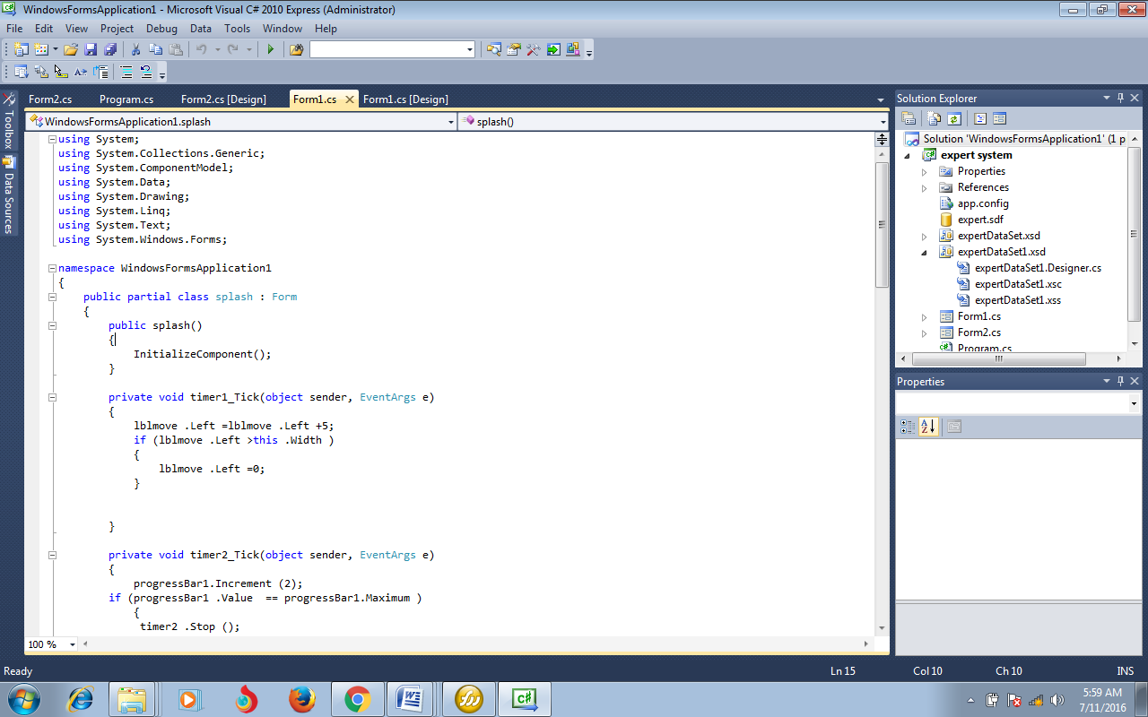
Figure 4.1C# IDE

4.2 IMPLEMENTATION ARCHITECTURE
Figure 4.2 Implementation Architecture
4.3 SOFTWARE TESTING
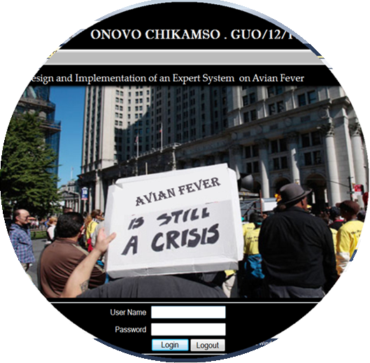
Figure 4.3 Login Page
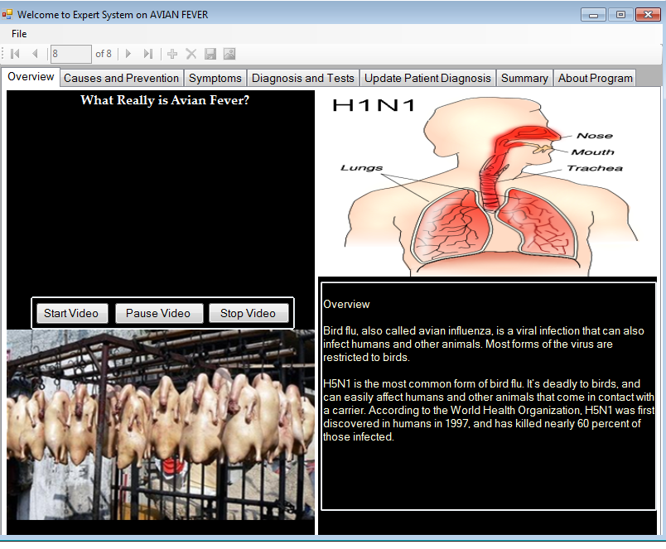

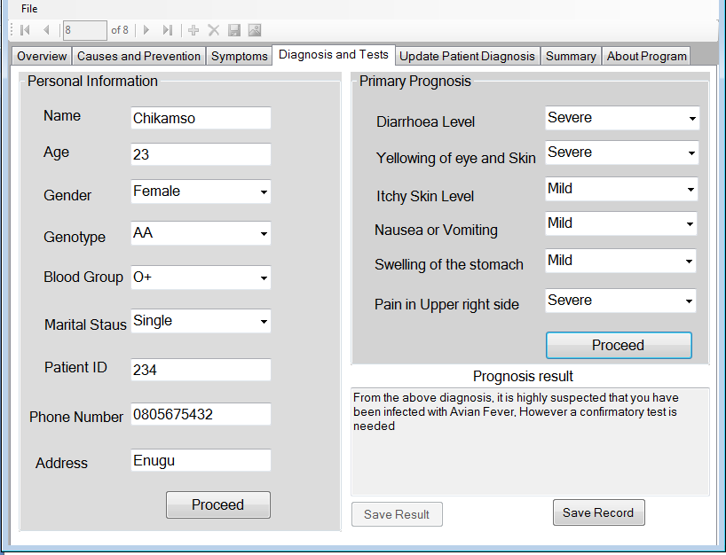

CHAPTER FIVE
SUMMARY, CONCLUSION AND RECOMMENDATION

5.0 Summary
Many developing countries are facing the shortage of medical experts in medical field. Due to shortage of medical expert they are getting a huge queue of patients in hospitals. Especially in rural areas we have young medical expert or doni have medical expert. This Adoptive Medical Diagnosis System Using Expert System can be substitute of the above, problem. This is very useful to diagnose patient diseases and prescribe the good prescription to the patients as a human medical expert. From the above study, it is concluded that this Adoptive Medical Diagnosis System using Expert System can be applied any hospitals any country for improving medical services. Also this system can be applied anytime, anyplace, any hospital to provides medical prescription for general diseases.

5.1 Conclusion
Different diagnosis strategies have been studied. Different e-hea[th websites have been browsed. Papers and articles on e-health management have been read and different diagnosis tools have been used. Noted down important information like which information they are collecting from the user! patients and which approach they are following in diagnosis. Then information (symptom, signs etc.) of different diseases have been collected for particular category as sample. Made a comparative analysis to identify which symptoms are major symptoms for particular diseases i.e. that symptom must be present, their acuity level etc. Then met with few doctors with different level of expertise in their field, Asked them about those diseases and their symptoms, which factors they consider while they diagnosis diseases, what approach they follow.
After studying and making a comparative analysis of what is gotten by consulting with different doctors about which factors they consider while they diagnosis diseases, what approach they follow, it is found that they are almost same. Then a uniform structure is made and a mathematical equivalence is formed, which will be used to diagnosis by the expert system. After that implementation of 1 he expert system is done and tested it thoroughly to check whether the desired result is coming or not. After necessary corrections, when it seems ok with respect to the desired goal, then consulted with the doctors again and explained about the software implementation and showed it to them and they acknowledged it, gave some suggestions to add catalyst factor which is some sort of persona! information! patient’s history information, according to which the system is revised.

5.2 Recommendation
Future researchers are encouraged to look into the area of fuzzy logic in details, in relation to expert system and also how it can boost the accuracy of the system.

APPENDIX B:

SOURCE CODE
using System;
using System.Collections.Generic;
using System.ComponentModel;
using System.Data;
using System.Drawing;
using System.Linq;
using System.Text;
using System.Windows.Forms;

namespace WindowsFormsApplication1
{
public partial class splash : Form
{
public splash()
{
InitializeComponent();
}

private void timer1_Tick(object sender, EventArgs e)
{
lblmove .Left =lblmove .Left +5;
if (lblmove .Left >this .Width )
{
lblmove .Left =0;
}

}

private void timer2_Tick(object sender, EventArgs e)
{
progressBar1.Increment (2);
if (progressBar1 .Value == progressBar1.Maximum )
{
timer2 .Stop ();
MessageBox .Show ("Welcome On Board");
this.Hide();

details newform;
newform = new details();
newform.ShowDialog ();

}
}

private void btnlogin_Click(object sender, EventArgs e)
{
if (txtname.Text == "expert" && txtpass.Text == "expert")
{
timer2.Start();
progressBar1.Show();
//'Me.Hide()
}
else
{
MessageBox.Show("Invalid Login Details", "Try again", MessageBoxButtons.RetryCancel);
txtname.Focus();
}
}

private void button1_Click(object sender, EventArgs e)
{
if (MessageBox.Show("Are you sure you want to quit?", "Quiting App", MessageBoxButtons.OKCancel) == DialogResult.OK)
{
Application.Exit();
}
else
{
txtname.Focus();
}

}

private void splash_Load(object sender, EventArgs e)
{
System.Drawing.Drawing2D.GraphicsPath mypath = new System.Drawing.Drawing2D.GraphicsPath();
mypath.AddEllipse(0, 0, this.Width, this.Height);
Region myregion = new Region(mypath);
this.Region = myregion;
}

private void txtpass_TextChanged(object sender, EventArgs e)
{

}

private void pictureBox1_Click(object sender, EventArgs e)
{

}
}
}

using System;
using System.Collections.Generic;
using System.ComponentModel;
using System.Data;
using System.Drawing;
using System.Linq;
using System.Text;
using System.Windows.Forms;

namespace WindowsFormsApplication1
{
public partial class details : Form
{
public details()
{
InitializeComponent();
}

private void timer1_Tick(object sender, EventArgs e)
{
lblmove.Left = lblmove.Left + 5;
if (lblmove.Left > this.Width)
{
lblmove.Left = 0;
}
}

private void sex_CheckedChanged(object sender, EventArgs e)
{
// picsex.Visible = true;
// lblsex.Visible = true;

// picsharp .Visible =false ;
lblsharp.Visible = false;

//picinfected.Visible = false;
// lblinfescted.Visible = false;

// picblood.Visible = false;
// lblblood.Visible = false;
}

private void sharp_CheckedChanged(object sender, EventArgs e)
{
// picsex.Visible = false ;
// lblsex.Visible = false ;

//picsharp.Visible = true ;
//lblsharp1.Visible = true;

//picinfected.Visible = false;
//lblinfescted.Visible = false;

//picblood.Visible = false;
//lblblood.Visible = false;
}

private void infected_CheckedChanged(object sender, EventArgs e)
{
// picsex.Visible = false ;
//lblsex.Visible = false ;

// picsharp.Visible = false;
// lblsharp.Visible = false;

// picinfected.Visible = true ;
// lblinfescted.Visible = true ;

// picblood.Visible = false;
//lblblood.Visible = false;
}

private void blood_CheckedChanged(object sender, EventArgs e)
{
// picsex.Visible = false ;
// lblsex.Visible = false ;

//picsharp.Visible = false;
// lblsharp.Visible = false;

// picinfected.Visible = false;
// lblinfescted.Visible = false;

// picblood.Visible = true ;
// lblblood.Visible = true ;
}

private void radioButton1_CheckedChanged(object sender, EventArgs e)
{
//picjounce.Visible = true;

// piceye.Visible = false;
// pictongue.Visible = false;
}

private void radioButton2_CheckedChanged(object sender, EventArgs e)
{
// picjounce.Visible = false ;

// piceye.Visible = true ;
// pictongue.Visible = false;
}

private void radioButton3_CheckedChanged(object sender, EventArgs e)
{
//picjounce.Visible = false ;

//piceye.Visible = false;
pictongue.Visible = true ;
}

private void splitContainer1_Panel1_Leave(object sender, EventArgs e)
{
axWindowsMediaPlayer1.Ctlcontrols.stop();

}

private void tabControl1_Leave(object sender, EventArgs e)
{

}

private void btnstop_Click(object sender, EventArgs e)
{
axWindowsMediaPlayer1.Ctlcontrols.stop();
}

private void btnstart_Click(object sender, EventArgs e)
{
axWindowsMediaPlayer1.Ctlcontrols.play();

}

private void btnpause_Click(object sender, EventArgs e)
{
axWindowsMediaPlayer1.Ctlcontrols.pause();

}

private void splitContainer1_Panel1_Enter(object sender, EventArgs e)
{
axWindowsMediaPlayer1.Ctlcontrols.play();

}

private void btnproceed_Click(object sender, EventArgs e)
{
string name;
name = txtname.Text;
MessageBox.Show ("Welcome " + name + " Please answer the following questions for Primary diagnosis");
grpprognosis.Visible = true;

}

private void btncheck_Click(object sender, EventArgs e)
{
if (cbodia.SelectedIndex == 1 && cboyello.SelectedIndex == 1)
{
txtresult1.Visible = true;
txtresult2 .Visible =false ;
txtresult3.Visible = false;
txtresult1.Text = "From the above diagnosis, it is highly suspected that you have been infected with Avian Fever, However a confirmatory test is needed";
}
else if (cboyello.SelectedIndex == 2 || cboswell.SelectedIndex == 2)
{
//txtresult2.Visible = true;
txtresult1.Visible = true ;
//txtresult3.Visible = false;
txtresult1.Text = "The above prognosis does not suggest that you have Avian Fever. But be careful especially if you share sharp objects or work in a medical facility. You may also wish to go for a confirmatory test.";
}
else if (cboswell .SelectedIndex ==1 || cboyello .SelectedIndex ==1)
{
//txtresult2.Visible = false;
txtresult1.Visible = true ;
//txtresult3.Visible = true;
txtresult1.Text = "The above prognosis suggest that you have Avian Fever. You may also wish to go for a confirmatory test.";
}
}

private void textBox6_TextChanged(object sender, EventArgs e)
{

}

private void expertBindingNavigatorSaveItem_Click(object sender, EventArgs e)
{
this.Validate();
this.expertBindingSource.EndEdit();
this.tableAdapterManager.UpdateAll(this.expertDataSet1);

}

private void details_Load(object sender, EventArgs e)
{
expertBindingNavigator.Visible = true;
// TODO: This line of code loads data into the 'expertDataSet1.expert' table. You can move, or remove it, as needed.
this.expertTableAdapter.Fill(this.expertDataSet1.expert);

if (btnnew1.Text == "New Patient")
{
txtname.ReadOnly = false;
txtage.ReadOnly = false;
txtid.ReadOnly = false;
txtaddress.ReadOnly = false;
txtphone.ReadOnly = false;

btnnew1.Text = "Cancel";
btnsave1.Enabled = true;
this.expertBindingSource.AddNew();

}
else if (btnnew1.Text == "Cancel")
{
txtname.ReadOnly = true;
txtage.ReadOnly = true;
txtid.ReadOnly = true;
txtaddress.ReadOnly = true;
txtphone.ReadOnly = true;

btnnew1.Text = "New Patient";
btnsave1.Enabled = false;
this.expertBindingSource.ResetCurrentItem();
this.expertBindingSource.MoveFirst();
this.expertBindingSource.ResetAllowNew();
}

}

private void btnnew_Click(object sender, EventArgs e)
{
if (btnnew.Text == "New Patient")
{
txtname.ReadOnly = false;
txtage.ReadOnly = false;
txtid.ReadOnly = false;
txtaddress.ReadOnly = false;
txtphone.ReadOnly = false;

btnnew.Text = "Cancel";
btnsave.Enabled = true;
this.expertBindingSource.AddNew();

}
else if (btnnew.Text == "Cancel")
{
txtname.ReadOnly = true ;
txtage.ReadOnly = true ;
txtid.ReadOnly = true ;
txtaddress.ReadOnly = true ;
txtphone.ReadOnly = true ;

btnnew.Text = "New Patient";
btnsave.Enabled = false;
this.expertBindingSource .ResetCurrentItem();
this.expertBindingSource .MoveFirst();
this.expertBindingSource .ResetAllowNew();
}

}

private void btnsave_Click(object sender, EventArgs e)
{
this.Validate();
this.expertBindingSource .EndEdit();
this.tableAdapterManager.UpdateAll(this.expertDataSet1);
btnnew.Text = "New Patient";
btnsave.Enabled = false;

}

private void splitContainer5_Panel2_Enter(object sender, EventArgs e)
{
nameTextBox.Text = txtname.Text;

}

private void btnnew1_Click(object sender, EventArgs e)
{
if (btnnew1.Text == "New Patient")
{
txtname.ReadOnly = false;
txtage.ReadOnly = false;
txtid.ReadOnly = false;
txtaddress.ReadOnly = false;
txtphone.ReadOnly = false;

btnnew1.Text = "Cancel";
btnsave1.Enabled = true;
this.expertBindingSource.AddNew();

}
else if (btnnew1.Text == "Cancel")
{
txtname.ReadOnly = true;
txtage.ReadOnly = true;
txtid.ReadOnly = true;
txtaddress.ReadOnly = true;
txtphone.ReadOnly = true;

btnnew1.Text = "New Patient";
btnsave1.Enabled = false;
this.expertBindingSource.ResetCurrentItem();
//this.expertBindingSource.MoveFirst();
this.expertBindingSource.ResetAllowNew();
}

}

private void btnsave1_Click(object sender, EventArgs e)
{
if (nameTextBox.Text == "")
{
MessageBox.Show("No record to update");
}
else if (nameTextBox.Text != "")
{
this.Validate();
this.expertBindingSource.EndEdit();
this.tableAdapterManager.UpdateAll(this.expertDataSet1);
btnnew1.Text = "New Patient";
btnsave1.Enabled = false;
}
}

private void splitContainer5_Panel2_Paint(object sender, PaintEventArgs e)
{

}

private void splitContainer5_Panel2_MouseEnter(object sender, EventArgs e)
{
nameTextBox.Text = txtname.Text;
ageTextBox.Text = txtage.Text;
genderComboBox.Text = cbogender.Text;
genotypeComboBox.Text = cbogenotype.Text;
bloodgroupComboBox.Text = cbobloodgroup.Text;
iDTextBox.Text = txtid.Text;
phoneTextBox.Text = txtphone.Text;
addressTextBox.Text = txtaddress.Text;
yellowskinComboBox.Text = cboyello.Text;
paininrightsideComboBox.Text = cbopain.Text;
resultTextBox .Text =txtresult1 .Text ;
swellingStomachComboBox .Text =cboswell .Text ;
diahroeaComboBox .Text =cbodia .Text ;
itchySkinComboBox .Text =cboskin .Text ;
vomitingComboBox .Text =cbovomit .Text ;
maritalStatusComboBox.Text = cbostatus.Text;
}

private void btnnext_Click(object sender, EventArgs e)
{
if (nameTextBox.Text == "")
{
MessageBox.Show("No active record to move");
}
else if (nameTextBox.Text != "")
{
this.expertBindingSource.MoveNext();
}

}

private void btnprevious_Click(object sender, EventArgs e)
{
if (nameTextBox.Text == "")
{
MessageBox.Show("No active record to move");
}
else if (nameTextBox.Text != "")
{
this.expertBindingSource.MovePrevious();
}

}

private void btnsaverecord_Click(object sender, EventArgs e)
{

}

private void btndelete1_Click(object sender, EventArgs e)
{
if (nameTextBox.Text == "")
{
MessageBox.Show("No active record to delete");
}
else if (nameTextBox.Text != "")
{
this.expertBindingSource.RemoveCurrent();
}
}

private void button1_Click(object sender, EventArgs e)
{
if (cboresult.SelectedIndex == 0)
{
txtconfirm.Text = "earliest sign of an active Avian Fever infection. This antigen may be present before symptoms of an HBV infection are present. If this antigen is present for more than 6 months, then you probably have a chronic (long-term) HBV infection. This means you can spread HBV to others throughout your life.";
}
else if (cboresult.SelectedIndex == 1)
{
txtconfirm.Text = "appears about 4 weeks after HBsAg disappears. The presence of this antibody means that the infection is at the end of its active stage and you cannot pass the virus to others (you are no longer contagious). This antibody also protects you from getting HBV again in the future. The test is done to determine the need for vaccination—the antibody will be present after receiving the HBV vaccine series, showing that you have protection (immunity) from the virus. Occasionally your test may show that you have both the HBsAb antibodies and HBsAg antigen. In this case you are still contagious.";
}
else if (cboresult.SelectedIndex == 2)
{
txtconfirm.Text = "is an Avian Fever protein that is only present during an active Avian Fever infection. This test determines how contagious you are. Testing for this antigen can also be used to monitor the effectiveness of treatment for Avian Fever.";
}
}

private void expertBindingNavigator_RefreshItems(object sender, EventArgs e)
{

}

private void splitContainer6_Panel1_Paint(object sender, PaintEventArgs e)
{

}

private void exitToolStripMenuItem_Click(object sender, EventArgs e)
{
if (MessageBox.Show("Are you sure you want to quit?", "Quiting App", MessageBoxButtons.OKCancel) == DialogResult.OK)
{
Application.Exit();
}

}

private void backToolStripMenuItem_Click(object sender, EventArgs e)
{

}

private void bindingNavigatorMovePreviousItem_Click(object sender, EventArgs e)
{

}

private void menuStrip1_ItemClicked(object sender, ToolStripItemClickedEventArgs e)
{

}

private void btndelete_Click(object sender, EventArgs e)
{

}

private void expertDataGridView_CellContentClick(object sender, DataGridViewCellEventArgs e)
{

}

private void textBox2_TextChanged(object sender, EventArgs e)
{

}

private void axWindowsMediaPlayer1_Enter(object sender, EventArgs e)
{

}
}
}

