TITLE PAGE
INFLUNCE OF POLITICAL ADVERTISING ON VOTER BEHAVIOUR: A STUDY OF 2017 GUBERNATORIAL ELECTION IN ANAMBRA STATE.
BY
EZEAMALU, CYNTHIA AMARACHI
U14/MSS/MAC/044
A RESEARCH PROJECT SUBMITTED TO THE DEPARTMENT OF MASS COMMUNICATION FACULTY OF MANAGEMENT AND SOCIAL SCIENCES GODFREY OKOYE UNIVERSITY, UGWUOMU-NIKE, ENUGU.
IN PARTIAL FULFILLMENT OF THE REQUIREMENT FOR THE AWARD OF BACHELOR OF SCIENCE (B.sc) DEGREE IN MASS COMMUNICATION
SUPERVISIOR
MENT NNOMENH

JULY, 2018

DECLARATION
I, Ezeamalu, Cynthia Amarachi declares that the research work was written by me and has not been submitted or received anywhere for the purpose of acquiring degree in Mass Communication.

……………………………….. ………………
Ezeamalu, Cynthia Amarachi Date

CERTIFICATION PAGE
This project has been read and approved as meeting the requirement of the Faculty of Management and Social Sciences for the award of Bachelor of Science, B.sc (Hons) Mass Communication.

…………………………… ………………
MENT NNOMEH DATE
(Project Supervisor)

…………………………… ………………
PROF. UCHE COSMAS NWAOKAFOR DATE
(Head of Department)

…………………………… ………………
EXTERNAL EXAMINER DATE

DEDICATION
This research is dedicated to God Almighty for His love, and protection throughout my stay in Godfrey Okoye University and for successful completion of this research work. Thank you Lord!

ACKNOWLEDGEMENTS
First and foremost, I thank the Almighty God for his mercy and guidance upon my life to finish my studies in this great citadel of learning inspite of all the struggles and hustles I went through during the period of learning.
My, supervisor, Ment Nnomeh,whose advice, teachings, criticisms has made me work so hard to achieve this work.
To my H.O.D, Prof. CosmasNwokafor, my co-ordinator Mr George Nzekwe and my great lectures, Dr. Regina Acholonu, Prof. Ike Ndolo, Prof. Armstrong Idachaba, Dr. Alex Onyebuchi,Dr.LouisEzema, Rev. Fr. Dr. Paul Obayi, Mr. BenjamineOnwukwalonye, Mr. Mike Nwosu, Mrs. Kate Agbo and Mrs. Flora Ojukwu, Mr.DubemUmeora, miss phiona, I thank them for their support and for the knowledge they impacted in me.
With great gratitude, i appreciate the Vice Chancellor of Godfrey Okoye University, Prof. Christian Anieke and the Dean faculty of Management and Social Science, Prof.Ocheoha and the staff of the University for their effort in grooming and developing the university.
To the Department of Mass Communication and all scholars whose work provided insights to this study, I honesty appreciate you all.
My profound gratitude also goes to my parents Mr. Lawrence and Mrs. CelestinaEzeamalu for their love, support (financially and morally) and for giving me sound Education and teaching me how to be independent. May God keep you alive to enjoy fruit of your labor and to my loving siblings; Sandra, Sigmund, god’swill and Joan, thanks for your support.
Also I thank my friends; Ezeh Sandra, Ignatius Chinyere, NwekeImmaculata, IgiligiKizito, AgboOgechukwu, Okonkwo Chigozie, IkejiakuKingsely, Levi, Nonso, Eneh Jacinta, Obi Ebele, Uwaoma Blessing, Ndukwe Norah, Ugwuemleda, Anosike Faith, AdadoDorathy. MY Mentor DrEneh. May God bless you all immensely.
My sincere thanks to my roommates; Jennifer Okere and AnyansiChidimma for your support all round may God bless you. To my Course mate and other friends for their encouragement.
May the Almighty God bless and grant you all your heart desire.
EZEAMALU, CYNTHIA AMARACHI

TABLE OF CONTENTS
Title-
Certification
Dedicationiv
Acknowledgements v
Table of contentsvi
List of figures ix
List of tables x
Abstract xi
CHAPTER ONE: INTRODUCTION
Background of the study1
Statement of Research Problem 3
Objectives of the study 3
Research Questions 4
Hypothesis 4
Scope of the study 4
Significance of the study 5
Definition of Terms 5
References 7
CHAPTER TWO: LITERATURE REVIEW
2.1 Introduction 8
2.2 Review of concepts 8
2.3 Theoretical Framework 28
2.4 references 29
CHAPTER THREE: RESEARCH DESIGN AND METHODOLGY

3.2Research Design
3.3Population of Study
Sample/Sampling Techniques
3.5 Description of Research Instrument
Validity/Reliability of Data Gathering Instrument
Method of Data Collection
Method of Data Analysis
References
CHAPTER FOUR: DATA PRESENTATION AND ANALYSIS
4.1 Introduction
4.2 Data Presentation and Analysis
4.3 Discussion of Findings
CHAPTER FIVE: SUMMARY OF FINDINGS, CONCLUSION AND RECOMMENDATION
5.1 Introduction
5.2 Summary of Findings
5.3 Conclusion
5.4 Recommendations
5.5 Suggestions for Further Studies
References
Appendix: Letter
Appendix: Questionnaire
LIST OF FIURES
Analysis on bio-data
Figure 1: Gender distribution of respondents
Figure 2: Age distribution of respondents
Figure 3: Educational Qualification of respondents
Figure 4: Marital status of respondents
Analysis on research questions
Figure 5: response to question 5
Figure 6: response to question 6
Figure 7: response to question 7
Figure 8: response to question 8
Figure 9: response to question 9
Figure 10: response to question 10
Figure 11: response to question 11
Figure 12: response to question 12
Figure 13: response to question 13

LIST OF TABLES
Analysis on bio-data
Table 1: Gender distribution of respondents
Table 2: Age distribution of respondents
Table 3: Educational qualification of respondents
Table 4: Martial status of respondents
Analysis on research questions
Table 5: response to question 5
Table 6: response to question 6
Table 7: response to question 7
Table 8: response to question 8
Table 9: response to question 9
Table 10: response to question 10
Table 11: response to question 11
Table 12: response to question 12
Table 13: response to question 13

ABSTRACT
It has become more fashionable to use political messages to create awareness during political campaigns. Indeed political advertising is becoming very popular since it aids the candidate to create awareness and persuade the people to buy into his views. Political campaign materials can come through different media: print (including billboards and flayers) or broadcast (Tv and Radio).This study examined the influence of political Advertising on the Behaviour of Anambra state Electorate: A study of 2017 Gubernatorial Election in Awka North. The study sought to determine the extent the people were exposed to the media, also to ascertain the medium through which they were exposed to political messages as well as if the people were influenced by the political messages. The study was designed as a survey. Findings revealed that the electorate in Awka North LGA were not always exposed to the media messages, the people of Awka North watched and listened more to television political messages and the people of Awka North were influenced by the political messages. The study concluded that indeed Political Advertising served as an effective political communication strategy through which political candidates market themselves and send information to the voters. The study therefore recommended that the media especially television should strategize message delivery to engender confidence in its listener to retain their trust, that candidates should enlarge and strengthen their political messages in both newspaper and radio and politicians and political parties should make efforts to give credible messages since most electorate are influenced at voting by political messages.

CHAPTER ONE
BACKGROUND OF THE STUDY

Political Advertising is the medium through which political candidates provide their electorates with adequate information on party policies, clear-cut vision as well as their political agendas to enable electorates actively choose their candidates based on full information. To achieve a political aim by the politician, political parties use the media in campaigns.
The media assists voters to make an informed choice at election time (Currance 2005, 129). This is done in form of paid political advertising, social media campaigns, commentaries and news stories.
Infact, political parties and their candidates are becoming aware of the importance of advertising and its role in getting the electorates choose a particular candidate or party over the other by way of informing them. The use of political advertising has become more important and popular in electoral process because it bridges the communication gap between political parties, political candidates and electorates.
Scholars and Communication experts argue that, when the politician crafts his campaign messages as being the fight to improve voters’ lives or something similar and come with some good measure of integrity, the voter are more likely to believe him (Feyipitan, 2015). More so, the electorates believe more on the candidate that proposes something to offer than the candidate that based his campaign on his achievement only.
Political advertising is the skillful or flexible deployment of information, facts, figures, images and imagery often exaggerated in proportions to persuade the electorates including opponents believe in his ability. This practice is not strange to Nigerian political environment. However, over the year, the use of advertising in politics has become tense and problematic.
This study examines political advertising in Nigeria as it relates to the behavior of voters during electioneering, particularly in the 2017 Gubernatorial election of Anambra State with a view to determine its productivity for promoting, pertinent national, regional,social,economic and cultural issues it will also try to find out if there is tendency towards personal attacks, ethnicslurs or promotion of hate messages.
Advertising comes in various forms and media. As such, it is classified based on the type of media and the purpose for which it is used, hence, advertising types such as print advertising, broadcast advertising, public service announcements, advocacy advertising, product advertising, political advertising and so on exists. Political advertisements are one of the various forms of advertising; (Okwechime2006, 198) traced the origin of political advertising to 1952 when President Eisenhowerwon elections through the placement of many spot commercials during his political campaign. Political advertising can also be used to promote political parties and candidates canvassing for political office. Usually Political advertisers use jingles or commercials musicals to set the tone or agenda. Advertising effects are so notable that they cannot be ignored. Advertising will reflect the level of the organization’s commitment to quality, excellence and relationships with its various constituents including governing bodies and the general public.
Advertising has grown rapidly with the improvement in technology: it has gone from the stage of the use of planks (which is still in use) to fliers. Today, there are electronic advertiser like on the television (here it is audio-visual), radio (audio), internet (social media) electronic billboard e.t.c. Advertising plays significant role in shaping public perception on various important issues, through information, persuasion which is the key role of advertising. The advertisements shape modern culture by selecting and portraying a particular set of beliefs, values and traditions as reality.
Advertising has its primary function which is to persuade people or the decision taken most of the times derived from the amount of information obtained from the advertising messages. The importance of advertising in the development of the society has attained a greater level. The role is to collect, select, certify and repackage information. Advertising is a persuasive mechanism; it can reshape the view of the members of the society for or against the sponsors. An individual may consciously or unconsciously select the thoughts and impressions upon which an image is based. Thus, advertising function becomes the bridge between the people and the sponsor in testing of dissemination and feedback process. Advertising becomes fundamental to the success of corporate or government programmers and projects.

1.2 STATEMENT OF THE RESEARCH PROBLEM
Advertising in general terms is used to persuade people into agreeing with the sponsors’ intention.
There is no disputing fact that the media play a key role or central role in the behavior of the voters during electioneering. This role may be in the form of informing, educating, entertaining, persuading, promoting culture e.t.c. Advertisement was delivered don’t mean that it was received, nor it indicate that it was understood and accepted as true. This background has provided the basis for understanding the role of advertising on the behavior of voters during electioneering campaign. Okoro (1988) remarks that political advertising is a special type of advertising which calls for high strategic thinking and action initiative.

1.3 OBJECTIVE OF THE STUDY
The objective of this research is to find out:
- To determine if the political messages in the media were used during the 2017 gubernatorial election in Anambra state.
- To determine which media were the electorate exposed to political Advertisement.
- To determine if the political Advertisement influenced the behavior of residences of Awka North during their election..

1.4 RESEARCH QUESTIONS
In order to establish and determine the influence of political advertising in the behavior of voters during electioneering campaign these questions were viewed as relevant to this study.
- Were the people of Anambra state exposed to the political messages?
- Which media/medium were the people exposed to?
- Were the people influenced by the political messages?

HYPOTHESIS
H1: the people of Anambra were exposed to media message
H0: the people of Anambra were not exposed to media message
H2: the people of Anambra were exposed to media channel
Ho: the people of Anambra were not exposed to media channel
H3: the people of Anambra were influenced by the political messages
H0: the people of Anambra were not influenced by the political messages

SCOPE OF THE STUDY
The scope of this research work was limited to the behavior of the people of Awka North during electioneering campaign and on how they used the media and the effect of messages they were exposed to. This is to enable the researcher carry out the study effectively since studying and comparing the whole country would create some difficulties to the researcher. The researcher limited the work to the use of advertising as tool for running the government of Anambra State during election.

SIGNIFICANCE OF THE STUDY
The significance of this study is to measure the use of mass media in political communication and the success of the users. Certainly, good political messages on the media are good PR stuff designed to sell the capacity and capability of political aspirants.
Further, this study will assist in bringing into focus what images they portrayed during 2017Governorship election in Anambra State. It will also serve as a document for Mass Communication scholars in further studies.

OPERATIONAL DEFINITION OF TERMS
POLITICAL ADVERTISEMENT: information conveying candidates ofgubernatorial election in Anambra messages to acquaint voters with his accomplishments and personalities.
ADVERTISING; it is a form of mass communication through which the candidates of Anambra state gubernatorial election designed his ideas to promote his political office ambition.
CAMPAIGNit is the way candidates of Anambra state election created awareness of their political ambition with the aim to persuade people to vote for them.
ELECTORATE: They are the Anambra people persuaded by the candidates to vote for them.
BEHAVIOR: It is the response illicit by the people of Anambra through the political messages.
ELECTIONEERING: It is how the candidatesparticipated during the campaign toearn voters votes.

CONCEPUTAL DEFINITION
POLITICAL ADVERTISEMENT: his can be defined as the political candidates, aspirants, political parties’ manifestoes, programmers and ideas, electoral body activities and political messages and programmers through advertisement placement in the media (Osho S.A (2008).

ADVERTISING: It is a form of communication through the media to persuade people accept their products, services and ideas usually paid for by an identified sponsor.
CAMPAIGN: Creating awareness by a candidate on his political office ambition.
ELECTORATE: People who are entitled to vote in an election.
BEHAVIOR: It is an observable response produced by an organism.
ELECTIONEERING: Campaigning for elective office on behalf of oneself or another candidate.

CHAPTER TWO
LITERATURE REVIEW
2.0 INTRODUCTION
This chapter is a review of related studies on the topic: “Influence of Political Advertising on the Behavior of the Voters during electioneering campaign”.
2.1 Review of concepts
2.1:1 Concept of Advertising
Advertising is a form of communication through the media to persuade people to accept their products,service and ideas usually paid for by an identified sponsor.
Advertising has so far been defined by different individual and organization. As explained byAdvertisingPractitioners Council of Nigeria (APCON) ‘as a form of communication through media about product, service and ideas paid for by an identifiable sponsor and directed at a targeted audience.’
Also advertising been broken down into clearer view by Ozor (1998) that what mass media sell through advertising “may be a product, service, idea or cause”. Sambe (2005) Advertising is any paid form of non-personal presentation and promotion of ideas, goods and services by an identified sponsor’.
“Sandman and his associates underscore the economic function of mass communication, when they say that the fundamental purpose of advertising “is to induce the buyer to purchaser something that the seller has, to seek a product, a service of a political candidate whatever”. They point out that advert is not successful if it does not sell. As they put it, “A successful Ad is an Ad that sells.
One function of mass media which is becoming increasingly important in the modern world is the economic function of advertising. Advertising belongs to industrial world and to those countries which are developing and become industries. Interestingly, there are some people who claim to enjoy the advertisement on TV more than the programs and do not still believe advertisement presents a true picture of the product yet they buy it. The researchers identified three main and extreme groups.
- Moralists (41%) who regard ads as bad influence on society.
- The advertising immune (46%) who pay little attention to advertisements.
- The enthusiast (9%) who pay great attention to advertising.
“Without advertising modern industrial society would not exist”. Sometimes questions like this can be asked, “What do people who advertise in the mass media pay for and the answer is ‘time in electronic media and space in the print media.
HISTORY OF ADVERTISING
The origin of advertising as a public announcement is traceable to the town crier and village drummer. These used their lungs to shout out their own or other’s messages. The messages could relate to government proclamation or even to sales of goods on market days.
However, it was not until the emergence of advertising agencies in the latter part of the 19th century that advertising became a fully-fledge institution, with its own way of working and with its own creative values.
During the World War1, the government saw the importance of advertising, they used it as propaganda. The British used advertising as propaganda to convince its own citizens to fight and also to persuade the Americans to join. Advertising quickly took advantage of the new mass media of the first part of the twentieth century, using cinema and to a much greater extent, radio, to transmit commercial messages.

2.1:2 Concept of voter’s behavior
Voting behavior is a form of electoral decision making process. Voters are influenced by the political leader’s decision through the media or any available medium including face to face campaigns. The field of political psychology has emerged to interpret voting behavior; studying ways in which affective influence may help voters make more informed voting choices. Equally making political decisions sometimes takes reasoning from attachment to race, culture, or religion. In Nigeria, like most developing democracies, voters like political, canvases realize this cleavage in designing their political ca mpaign copies.
Key public influence includes the role of emotions,political socialization,tolerance of diversity of political views and the media.
Effects of these influence on voting behavior is best understood through theorieson the formation of attitudes, beliefs, schema, knowledge structures and the practice of information processing. For instance: surveys from different countries indicated that people are generally happier in individualistic cultures where they have rights such as the right to vote.
The degree to which voting decision is affected by internal processes and external influences alters the quality of making truly democratic decision.
TYPES OF VOTING BEHAVIOR
According to Cypriot referendum of 2004, identified four distinct voting behaviors depending on the election type: presidential, national, local or regional and referendum.
- In National election: people vote based on their political beliefs.
- In Local and Regional election: people tend to elect those who seem more capable to contribute to their area.
- A Referendum is logic as people are asked to vote for or against a clearly defined policy.

From a psychological perspective; the Loss Aversion theory by Amos Tversky and Daniel Kahneman is then associated with voting behavior as people are more likely to use their vote to avoid the effect of an unfavorable policy.
2.1:3 POLITICAL CAMPAIGN
It is an organized effort which seeks to influence the decision making process with a specific group. In democracies,political campaigns often refer to electoral campaign,by which representatives are chosen or referendums are decided.
CAMPAIGN MESSAGE;
They are those ideas that the candidates have to offer, more like a talking point that will draw more voters to the candidate. The message will be used during his or her office.
For Example; during the 2025 Presidential election, the campaign message for PMB was*change*. This message drew so many voters to him because they believe that they need change. His message *change* was refined and used for his office. The message often consists of several talking point about policy issues. These points summarize the main ideas of the campaign and are repeated frequently in order to create a lasting impression with the voters.
CAMPAIGN FINANCE;
The candidate will call for fund raising; thereby, meeting with the large donorsand then sending direct mail to small donors, whose interest is significant to theirs.
ORGANISATION
In organizing a company, they are personnel who are solely involved in it. They work so hard to make sure that the campaign is a success.
[
CAMPAIGN MANAGER;
In every successful campaign,there is a campaign manager behind it, who coordinate and control the campaign operations. They are incharge of executing strategy other than setting it.

POLITICAL CONSULTANTS
They are the ones that set the parameters for the campaign. He conducts research to make sure that nothing is left untouched. For Instance;
Candidate research: here, the consultant research to those running for the same seat has a little background of them.
Voter research; what the people what to hear.
Opposition research also known as OPPO research; is the practice of collecting information on a political opponent of other adversary that can be used to discredit or otherwise weaken them.

ACTIVISTS
They are the foot soldiers. They are the ones that do they underground jobs for the campaign they go door to door and making phone calls on behalf of the campaigns.

CAMPAIGN PLAN
The plan takes account of a campaign’s goal, message, target audience and resources available.
- Campaign communication; it refers to party-controlled communication, e.g. media coverage of elections.
- Campaign advertising: is the use of paid form of media by an identified sponsor to influence the decisions of the voters. These Ads are designed by political consultants and campaign’s staff.
- Media Management: they try to lay more emphasis and create more impression on the elected candidate.
- Mass meetings, rallies and protests: the elected candidate moves out to get to know his people or voter and in return they get to know him.
- Modern Technology and the internet: internet is core element of modern political campaigns. Individual political candidate are also using the internet to promote their election campaign. Also, the use of social media most especially the Facebook was not left out. Facebook is the primary platform for marketing.
- Hustling: it is a physical platform where by representative present their view or cast votes before a parliamentary or other election body. It comes in different forms like debates or speeches.

CAMPAIGN TYPES
INFORMATION CAMPAIGN
It is a political campaign designed to raise public awareness and support for the positions of a candidate. It typically focuses on low-cost outreach such as news release, getting interviewed in the paper, making a brochure for door to door distribution, organizing poll workers e.t.c. it is more intense than a paper campaign but is less intense than a competitive campaign, which aims to actually win election to the office.
PAPER CAMPAIGN
It is a political campaign in which the candidate only files the necessary paperwork to appear on the ballot. The reason for the effort is simply to increase name awareness of minor political party or to give voters of a certain ideology an opportunity to vote accordingly.

In order to succeed, the campaign must have a strong message that targets the voters of the district.
POLITICAL CAMPAIGN IN ANAMBRA
In Anambra politics, ten things play major roles in determining how political event than out. They are:
- Godfatherism
The politics in Anambra State is the case study for Godfather Politics in Nigeria where the quest to hold on to power with so much enthusiasm by politicians is on the increase. From the Fourth Republic, the state has witnessed these ugly trends as political actors and their estranged political godfathers are always in contention for control of state resources. For each electoral cycle, there is a godfather.
The political brawl (which could be said to have birthed godfatherism), in Anambra State began with Governor Mbadinuju and EmekaOffor. The trend continued with the inception of Governor Chris Ngige and his political godfather, Chris Uba; a crisis that caused a lot in the polity of the nation and Peoples Democratic Party (PDP) in particular.
Below, is a compilation of godsons and their godfathers since 1999:
1999-2003: Governor ChinwokeMbadinuju and EmekaOffor
2003- 2006: Governor Chris Ngige and Chris Uba
2006-2014: Governor Peter Obi and EmekaOjukwu
2015-date: Governor Willie Obiano and Peter Obi
Each of the front liner candidates in the Saturday elections is already linked to a godfather. However, the fight between Peter Obi of PDP and Willie Obiano of APGA, will partly define the electoral outcomes.
List of Governors of Anambra State from 1999 to 2017:
ChinwokeMbadinuju: From May 29, 1999 to May 29, 2003 PDP
Chris Ngige: From May 29, 2003 to March 17, 2006 PDP
Peter Obi: From March 17, 2006 to November 3, 2006 APGAVirginiaEtiaba: From November 3, 2006 to February 9, 2007 APGA. (Appointed when the previous governor, Peter Obi, was impeached by the state legislature for alleged gross misconduct. She transferred her powers back to Peter Obi three months later when an appeal court nullified the impeachment).
Peter Obi: From February 9, 2007 to March 17, 2014 APGA. (Andy Uba was elected and sworn in as the governor of Anambra State on 29 May 2007. He was removed by a Supreme Court decision on June 14, 2007. He governed the state for 14 days).
Willie Obiano: From March 17, 2014 to date APGA
Anambra State is the only state that paraded five governors under controversial circumstances from 1999 to 2007, including one who spent just 14 days in Office.
- Power RotationThe matter of zoning or power rotation – where elected positions rotate between different geographical areas – has emerged as a major factor in the campaign for the Anambra State November governorship election.
The popularity of zoning in Anambra State politics was developed while Peter Obi was rounding off his eight years in office as the governor of the state. It was initially dismissed by his political opponents as a non-issue in the Anambra governorship election. Many stakeholders in the state are, however, beginning to realise that it is the only way to ensure equity and fair play among the three senatorial zones
In the run up to the 2017 governorship election, the issue of zoning prevailed in all the major political parties in the state. The three major political parties, the All Progressives Grand Alliance, APGA, (with Willie Obiano as its governorship candidate), the All Progressives Congress, APC, (with Tony Nwoye as its governorship candidate) and the Peoples Democratic Party, PDP, (with OselokaObaze as its governorship candidate), have all zoned their governorship candidate to Anambra North. This has set the stage for a bull fight in the upcoming governorship election in November.
- No Referendum, No Election
The Indigenous People of Biafra, IPOB, has threatened to stop the November 18 elections by utilizing the strategies of community evangelisation, awareness raising, rallies, posters and circulation of text messages.
Earlier proscribed by the government as a terrorist group and barely a week to the governorship election in Anambra State, members of IPOB, on Friday, November 10, marched around some streets in Onitsha, Anambra State, chanting :“if you vote you will die. Don’t go out, stay in your house,” They vowed not just to disrupt the elections but also ensure a lockdown on the day of the election on Saturday, November 18.
The IPOB leader, Nnamdi Kanu, whose whereabouts remain unknown, earlier said that unless the Nigerian State calls for a referendum to determine the status of the country, no election will be held in Anambra State or indeed the South-east in 2019
4) Battle Field
The Idemili North State Constituency in Anambra State elections will be held alongside the governorship election on November 18. The following areas are considered battleground in the state, including Idemili South and North Local Government Areas.
Local Government Zone
Onitsha North Anambra North
Onitsha South Anambra North
Idemili South Anambra Central
Awka South Anambra Central
Ihiala Anambra South
Ekwusigo Anambra South
Notwithstanding, contest for vote will be stronger in local government areas in Anambra South Senatorial district. This is because no candidate from the three major political parties emerged from there. The three major parties are expected to focus more in the South for votes during their campaigns and election.
5. Parties and Candidates
There are 37 political parties running in the elections with five identified as frontline candidates. They are OselukaObaze (PDP), Tony Nwoye (APC), OsitaChidoka (UPP), Ezemuo (PPA) and the incumbent governor Willie Obiano of APGA.
Anambra State is the first to have 37 candidates contesting for a governorship position in an election since the history of elections in Nigeria.
Full list of candidates and their political parties (Anambra election)
S/N NAME OF CANDIDATE DEPUTYPARTY
1 UJU UCHENDU OZOKA THERESA NNALUE AA
2 NWEZI FELIX AMECHI OKEKE FLORENCE NJIDEKA AGAP
3 OBY KATE OKAFOR ONYEKWULUJE CHIDI ACD
4 AKUNWATA EJOH OJIBA EBELE ONYINYE ANGEL ACPN
5 PAUL CHUKWUDI OBIANASO FRANCIS AMECHI AGUMADU ADC
6 IFEANYICHUKWU EDWARD REGINALD NNADOZIE NDUJEKWU IKE ADP
7 NWOYE TONY OKECHUKWU DOZIE IKEDIFE ARINZE APC
8 ADAEZE CHIZUBE OKAFOR OGUEJIOFOR FRANKLIN APDA
9 WILLIE MADUABUCHI OBIANO NKEMAKONAM C. OKEKE APGA
10 NWEKE CHRISTOPHER AKABIKE IFEANYICHUKWU APP
11 OHANUGO IKEM CECIL EZE NNABUIKE OGBONNA BNPP
12 EMMANUEL UCHENNA NWIBE OKPEZUNE NNAEMEKA DA
13 EDOCHIE YUL CHIBUIKE OKEKE OLUCHUKWU DPC
14 ONUORAH BASIL ONYEACHONAM CHUKWUANU GENEVIEVE GPN
15 SAMUEL OSITA ORAEGBUNAM ARTHUR REGIS ODIDIKA HDP
16 NDIFE FRANKLIN IKENNA NWABUDE STEPHEN JACHIKE ID
17 RUFUS OKEKE SUNDAY EZEOKOLONKWOR EZEONYIRIMBA CHARLES KOWA
18 CHRISTIAN OKECHUKWU ENEMUO OKOYE OBI VINCENT LP
19 OKAFOR ONYEKA CHRISTIAN ONWUKA OSITA MMN
20 PRAISE OKECHUKWU UGOCHUKWU EMMANUEL MPPP
21 CHINEDU UZOMA OKPALANMA CHUKWUMA IVAN EGEONU NCP
22 BENNETH ABANIWU PETER CHUDI OKOYE NDLP
23 FELIX A.R. OBI-OKAFOR NNEKA ANASUDU NEPP
24 OKAFOR CHARLES OGBONNA OKOLIE OLIVER ELVIS NNPP
25 VAL. OKEY OGUEJIOFOR OKAFOR EJIKE SAMUEL NPC
26 NNOLI AMECHI JUSTIN AGBATA MARTIN NUP
27 PETER CHIBIKE OKUDO CHUKWUEMEKA PDC
28 OSELOKA HENRY OBAZE CHIDI ALEXANDRA PDP
29 GODWIN CHUKWUNAENYE EZEEMO PRINCE LEONARD UCHENDU PPA
30 HENRY IKECHUKWU ONUORAH IGBOANUSI GLORY UGOCHI PPN
31 KENNETH EJIKE MODEZIE CHINWEZE OGECHUKWU PPP
32 STEPHEN OBIORAH MBAH ONYEJIAKA ANABALAONYE PRP
33 IFEANYI L. OBALUM CLEMENT CHUKWURAA OKAFOR SDP
34 STANLEY UCHE EZEANYAKU ERIC CHIJIOKE ENEMO UDP
35 OSITA CHIDOKA OKEKE MARCEL OGBONNAYA UPP
36 OZOEMENA NONSO UGOCHUKWU NWOFOR YDP
37 NNAEMEKA IFEOMA EZIBE ODINIRU CHIGOZIE FAMINUS YPP

6. Low Voter Turnout
Since the inauguration of the Fourth Republic in 1999, governorship elections in the state have never witnessed up to 50 per cent of voter turnout except in 2007 which was massively rigged.
A review of the voter turnout since 2007 reveals a progressive decline in voters’ turnout.
By INEC’s election result, 1.84 million registered voters existed in Anambra State for the 2010 governorship election. Only 302,000 voted, a miserly 16 per cent voter turnout. In 2013, a total of 1, 770,127 were registered, but only 465,891 voted, representing 24 per cent.
7. 13 Female Candidates
Only five of the 37 candidates contesting for the governorship position are women. Also, of the 37 deputy governorship candidates, eight are women. They include:
Governorship candidates
UjuUchenduOzoka (AA)
Oby Kate Okafor (ACD)
AdaezeChibubeOkafor (APDA)
Praise Okechukwu (MPPP)
NnaemekaIfeomaEzibe (YPP)
Theresa Nnalue (AA)
Okeke Florence Njideka (AGAP)
EbeleOnyinye Angel (ACPA)
Chukwuanu Genevieve Nonye (GPN)
NnekaAnasudu (NEPP)
Chidi Alexandra Onyemelukwe (PDP)
Igboanusi Glory Ugochi (PPN)
OgechukwuChinwueze (PPP)
This means that women make up only 13.5 per cent and 21.6 per cent of total number of candidates vying for governorship and deputy governorship positions respectively. Except for PDP, none of the other major political parties has a female candidate.
.8) Over Two Million Registered Voters
According to the Independent National Electoral Commission, INEC, about 2,158,171 million people in Anambra have registered for the November 18 governorship election.
INEC further revealed that 50.3 per cent are females while 49.6 per cent are males. Also, the highest voting population is students who make up about 48 per cent of registered voters while Idemili North Local Government Area has the highest number of registered voters.
9. 26,000 Security Personnel Deployed To the State
The Nigerian Police have deployed about 26,000 police officers to Anambra State ahead of Saturday’s election.
The state initially had 5,000 police officers who are now to be joined by 21,000 others from neighbouring states.
The deployment is to ensure the forthcoming election is free and fair, the police said.
The security personnel and equipment deployed include Police Special Forces, Police Mobile Force, the Counter Terrorism Unit, CTU, Special Protection Unit, SPU, the Anti-Bomb Squad, EOD, the Force Marine Police, Conventional Policemen, the Force Armament Unit, personnel from Force Criminal Intelligence and Investigation Department, FCIID, Mounted Troops, the attack and Sniffer Dogs Section, Police Gun Boats, Police Helicopters and Armoured Personnel Carriers, APC.
10 Absences of Litigations after Party Primaries in the State
Party primaries conducted ahead of the November 18 governorship election is a watershed in the history of elections in Nigeria’s fourth republic. Since the return to democracy in 1999 in Anambra state and Nigeria in general, there is hardly a time of absence of court cases after governorship party primaries to challenge their outcomes. For this election, primaries were concluded without any court case. Internal mechanisms were promptly deployed by leadership of several parties to address any crisis that emerged from the primaries.

2.2 THEORITICAL FRAMEWORK
In this work, we will explore the Agenda-setting theory as a working frame that does not leave anybody as to influence of the media. The Agenda setting theory was proposed by Maxwell McCombs and Donald L. Shaw(1972). The major assumption of the theory is that the media set Agenda for the public to follow. The media, according to Cohen (1963), may not be successful in telling people what to think but they are stunningly successful in telling them what to think about. This theory assumes that while the media set the agenda, political actors, such as governments, political organizations and activist group, can influence the media to set the agenda in a way they want, which is a process called Agenda-building.
Wimmer and Dominic(2000) argues that “Agenda Setting by the media suggests that the public agenda or what kind of things people discuss, think or worry about is powerfully shaped and directed by what the media choose to publicize. The theory is relevant to the study in the sense that mass media sets agenda for what the electorate discuss or think in any election process. Hence, the media can be used to persuade the people to accept a particular candidate or political party during elections.

Theory of Selectivity was used to explain and back-up this research work. According to Florain (2005), the theory of selectivity explains selective exposure, perception and retention. People deliberately expose themselves to messages or advertisement which they have interest in while those that are against their beliefs are not sought after. After the message might have been seen, heard or read, the individuals perceive the messages in the light of their individual idiosyncrasies. This theory is applicable in the sense that the electorate choose what they want to be exposed to, what information about candidate, they want to rentain.

CHAPTER THREE
3:1 Research Design
Research design is the plan which specifies how data relating to a given problem should be collected and analysed or the procedural outline for the conduct of any given investigation (Nworgu 1991). The research adopted the survey research design because it creates a cordial relationship between the research and the respondents of the source(s) of the information/ it aims at eliciting people’s opinion through questionnaire.
According to Onwukwe(2011) in Okoro and Adide,(2013)’’survey research is concerned with the collection of data for the purpose of describing and interpreting a certain condition, practice, beliefs, attitudes e.t.c.’’ This implies that survey helps the researcher get original information more like a firsthand information from the respondent on his or her opinion.
3:2 Population of the Study
Population is the total number of people in an area of study. (Kerlinger, 1981) defines population as a well-defined class of ‘’all the people, events members, or of objects which can be living or non-living things’’. The population of the study covered the entire electorate in Awka North LGA in Anambra State. The population was 112,608 according to statistics from the Independent National Electorate Commission (INEC).
3.3 Sample size
(Koleoso 1999 p.11) sample is a portion of population selected for the study and sample size in the method of selecting the samples from the population’’.
The Taro Yamen’s model of determining sample size was adopted to determine the sample size for the study.
$$S=\frac{N}{1+N\left(e\right)2}$$
$$\frac{112,608}{{1+112,608(0.05)}^{2}}$$
$$\frac{112,608}{1+112,608\left(0.0025\right)}$$
$$\frac{112,608}{1+281.52}$$
$$\frac{112,608}{282.52}=0.398.584$$
$=$The sample size for this study is therefore
$=39$9
3.4 Description of Research Instrument and Administration
The questionnaire was the research instrument used for the data collection. It was divided into two parts. Part A which consisted of the demography of the respondents and Part B consisted of the research question, which were written in closed ended questions.
3.5 Validity and Reliability of Data
In order for research data to be of value and of use, they must be both reliable and valid.
Validity refers to the credibility or reasonability of the research. According to Odo Williams (1992:59) he defined validity as the process of finding out the degree to which in a measure will yield similar result for the same subjects at different times or under different condition on a consistent, dependable, stable, predictable and accruable way.
Questionnaire was prepared for this study. The supervisor examined the content and approved it based on the fact that the operational definitions measured the concept and the questions were adequate enough to generate data. Also pilot study was carried out, where also the same question was repeated to be sure of the responses from the respondents.
Reliability refers to the repeatability of the findings if the study were to be repeated the second time and it still gave the same result that simply shows that the data is reliable.
3.6 method of data collection
Data was collected using the questionnaire which the researcher administered face to face to the respondents. Total number of 399 questionnaire was distributed and retrieved thereby giving the researcher a response of 100%.

3.7 method of Data Analysis
The data collected from the respondents was analyzed and interpreted by using the simple tables, percentages,frequency analysis and pie chart.
Simple tables, frequencies and percentage were adopted in the presentation and analysis of the data generated for the study. The statistical tools were suitable means of breaking down and analyzing the generated data.
CHAPTER FOUR
DATA PRESENTATION AND ANALYSIS
4.1 Introduction
The purpose of this study was to determine the influence of political advertising on the behavior of the voter at electioneering campaign during the Anambra State Governorship election 2017: A Study of the Residents of Awka North LGA.
This chapter is concerned with the presentation and analysis of data generated through the administration of questionnaire. Three hundred and ninety nine copies of questionnaire were administered to the various respondents, out of which 399 copies were recovered. This presented a response rate of 100%.
The study answered the following research questions:
- Were the people of Anambra state exposed to the political messages?
- Which media/medium were the people exposed to?
- Were the people influenced by the political messages?

4.2 Data presentation and analysis

Analysis of Bio-Data

Items 1-5 in the questionnaire answered questions on the bio-data of the respondents.

Question 1: What is your gender?
Table 1: Gender Distribution of Respondents
 |  | Frequency | Percent | Valid Percent | Cumulative Percent
Valid | Male | 219 | 54.9 | 54.9 | 54.9
 | Female | 180 | 45.1 | 45.1 | 100.0
 | Total | 399 | 100.0 | 100.0
Table 1 above shows that 219 out of all the respondents which represent 54.9% are male and180 people represent 45.1% are female. This shows that there were more males in number than the females.
Figure 1: Gender distribution of respondents
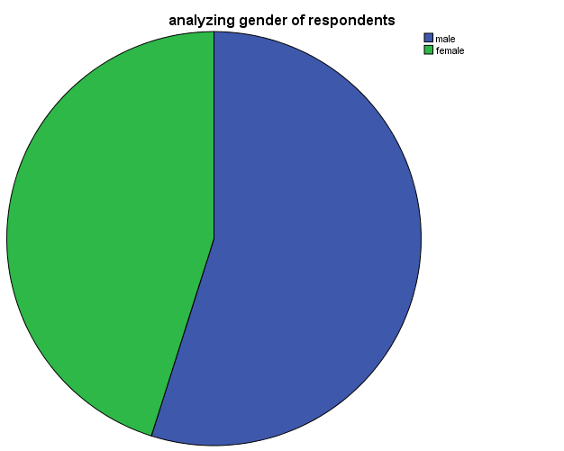

Question 2: What is your age (in years)?
Table 2: Age Distribution of Respondents
 |  | Frequency | Percent | Valid Percent | Cumulative Percent
Valid | 18-30 | 209 | 52.4 | 52.4 | 52.4
 | 31-40 | 130 | 32.6 | 32.6 | 85.0
 | 41 and above | 60 | 15.0 | 15.0 | 100.0
 | Total | 399 | 100.0 | 100.0

The table above shows that the age distribution of the respondents in which 209 people representing 52.4% of the respondents between the age of 18-30, 130 people representing 32.6% are between the ages of 31-40, 60 people representing 15.0% are between the ages of 41 and above.

Figure 2: Age bracket of the Respondents.

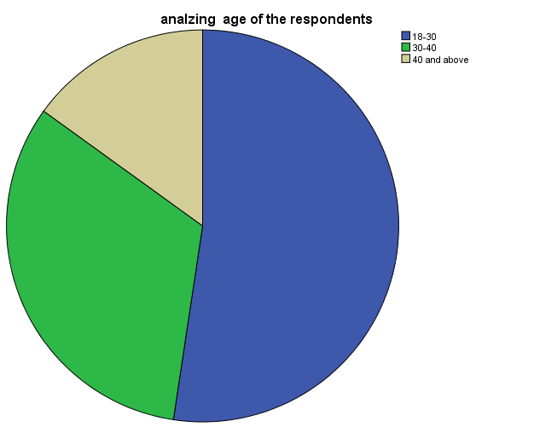

Question 3: What is your educational qualification
Table 3: Educational Qualification of Respondents
 |  | Frequency | Percent | Valid Percent | Cumulative Percent
Valid | WEAC/NECO/GCE | 140 | 35.1 | 35.1 | 35.1
 | OND/NCE | 71 | 17.8 | 17.8 | 52.9
 | HND/B.SC/BA | 109 | 27.3 | 27.3 | 80.2
 | MSC/MA | 30 | 7.5 | 7.5 | 87.7
 | PhD | 49 | 12.3 | 12.3 | 100.0
 | Total | 399 | 100.0 | 100.0

From the above table, 140 respondents (35.1%) were WASSCE/NECO/GCE holders, 71 respondents (17.8%) were OND/NCE holders, 109 respondents (27.3%) were BSC/BA/HND holders, 30 respondents (7.5%) were MSC/MA and 49 respondents (12.3%) were PHD holders.
Figure 3: The Educational Qualification of the Respondents
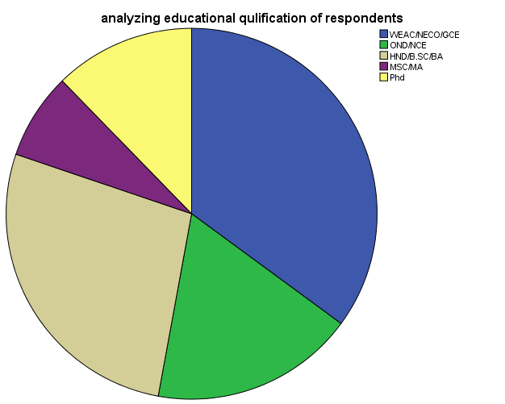

Question 4: What is your marital status?
Table 4: Marital Status of Respondents

 |  | Frequency | Percent | Valid Percent | Cumulative Percent
Valid | Single | 170 | 42.6 | 42.6 | 42.6
 | Married | 140 | 35.1 | 35.1 | 77.7
 | Divorced | 89 | 22.3 | 22.3 | 100.0
 | Total | 399 | 100.0 | 100.0

On the table above, 170 respondents (42.6%) were single, 140 respondents (35.1%) were married while 89 respondents (22.3%) were divorced.
Figure 4: Marital Status of Respondents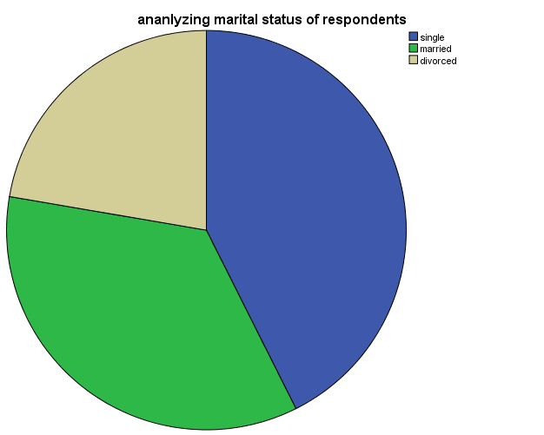
Analysis of Data from Research
- Research question 1:Were the people of Anambra state exposed to the political messages?
Items 5-8 answered research question 1
Question 5: Do you get political information from any media channel?
Table 5: Response to Question 5
 |  | Frequency | Percent | Valid Percent | Cumulative Percent
Valid | yes | 309 | 77.4 | 77.4 | 77.4
 | no | 90 | 22.6 | 22.6 | 100.0
 | Total | 399 | 100.0 | 100.0

From the above, 309 respondents (77.4%) answered yes that they got political messages from the media channel, 90 respondents (22.6%) answered no. This hypothesis one-CHi
Figure 5: Number of respondents that answered yes and no.
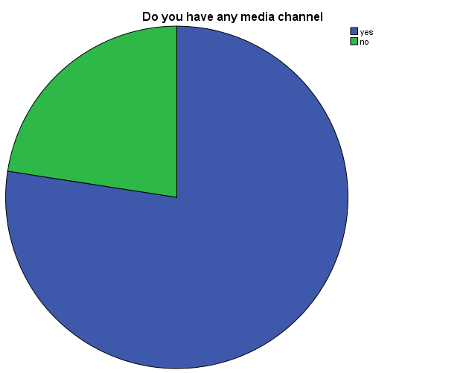

Question 6: Which of this medium do you rely for political information?
 |  | Frequency | Percent | Valid Percent | Cumulative Percent
Valid | Radio | 40 | 10.0 | 10.0 | 10.0
 | Television | 80 | 20.1 | 20.1 | 30.1
 | Newspaper | 109 | 27.3 | 27.3 | 57.4
 | All | 170 | 42.6 | 42.6 | 100.0
 | Total | 399 | 100.0 | 100.0

In response to the question above, 40 respondents (10.0%) rely on Radio for political information, 80 respondents (20.1%) rely on Television for political information, 109 respondents (27.3%) rely on Newspaper for political information, and 170 respondents (42.6%) rely on all the media for political information.
Figure 6: Media which they relied on for political information.
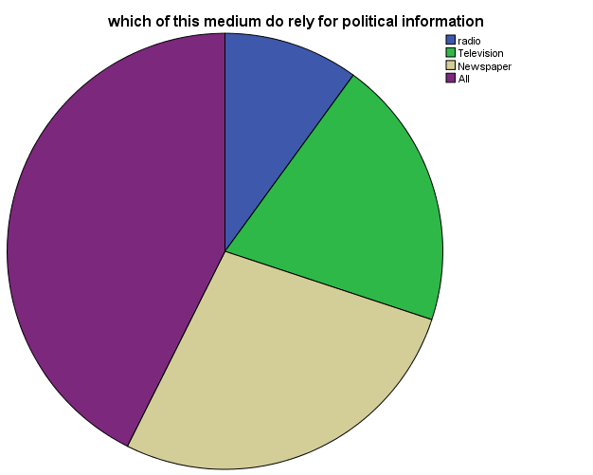

Question 7: How often do you listen to political message on radio?
Table 7: Response to Question 7
 |  | Frequency | Percent | Valid Percent | Cumulative Percent
Valid | Always | 110 | 27.6 | 27.6 | 27.6
 | once a week | 158 | 39.6 | 39.6 | 67.2
 | not at all | 131 | 32.8 | 32.8 | 100.0
 | Total | 399 | 100.0 | 100.0

In response to the question above, 110 respondents (27.6%) always listen to the political message on radio, 158nrespondents (39.6%) listen to the political message on radio once a week, 131 respondents (32.8%) did not at all listen to the political messages on radio.
Figure 7: How often you listened to political messages
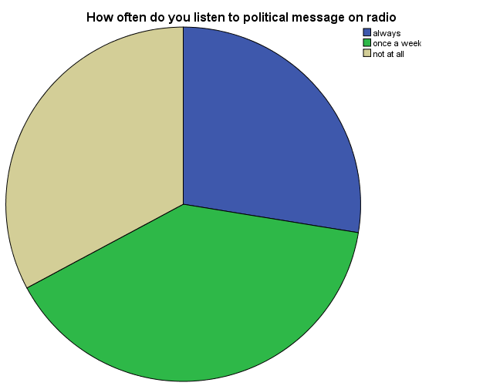
Question 8: How often do you read newspaper for political messages?
Table 8: Response to Question 8
Q |  | Frequency | Percent | Valid Percent | Cumulative Percent
Valid | Everyday | 119 | 29.8 | 29.8 | 29.8
 | once a week | 180 | 45.1 | 45.1 | 74.9
 | not at all | 100 | 25.1 | 25.1 | 100.0
 | Total | 399 | 100.0 | 100.0

In response to the question above, 119 respondents (29.8%) read the newspaper everyday, 180 respondents (45.1%) read the newspaper once a week, 100 respondents (25.1%) did not at all read the newspaper.
Figure 8: How often you read the newspapers
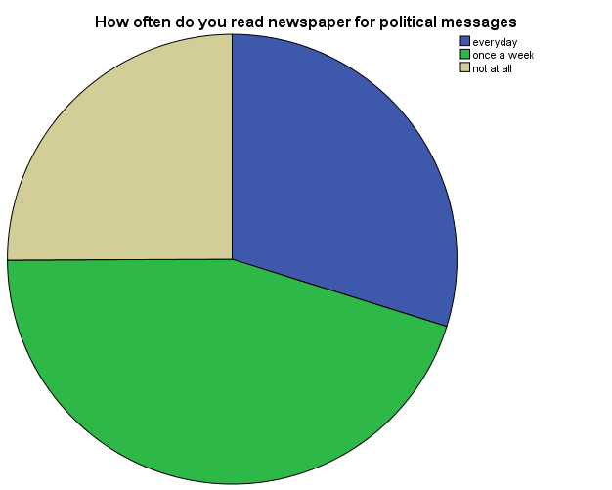

Research question: Which of the media/medium were the people exposed to?
Item 9-10 answered research question 2
Question 9: Which media do you think is most suitable to pass across political messages?
Table 9: Response to question 9
 |  | Frequency | Percent | Valid Percent | Cumulative Percent
Valid | Radio | 80 | 20.1 | 20.1 | 20.1
 | Newspaper | 103 | 25.8 | 25.8 | 45.9
 | Television | 216 | 54.1 | 54.1 | 100.0
 | Total | 399 | 100.0 | 100.0

The table above indicates that 80 respondents (20.1%) agrees that radio is most suitable to pass across political messages, 103 respondents (25.8%) agrees that newspaper is most suitable to pass across political messages, 216 respondents (54.1%) agrees that television is most suitable to pass across political messages.
Figure 9: Media suitable to pass across political media.
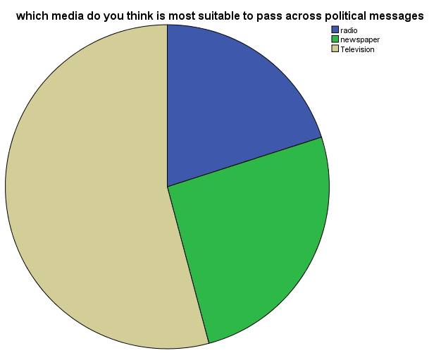
Question 10: Do you engage in the political message exercised in the media channel?
Table 10: response to question 10
 |  | Frequency | Percent | Valid Percent | Cumulative Percent
Valid | Yes | 271 | 67.9 | 67.9 | 67.9
 | No | 128 | 32.1 | 32.1 | 100.0
 | Total | 399 | 100.0 | 100.0
From the table above, it shows that 271 respondents (67.9%) said yes to engaging to political message exercised in the media channel, 128 respondents (32.1%) said no to engaging to political message exercised in the media channel. Question ten upholds that Hypothesis two: the people of Anambra were exposed to media channel.
Figure 10: Engaging in the political messages in the media channel

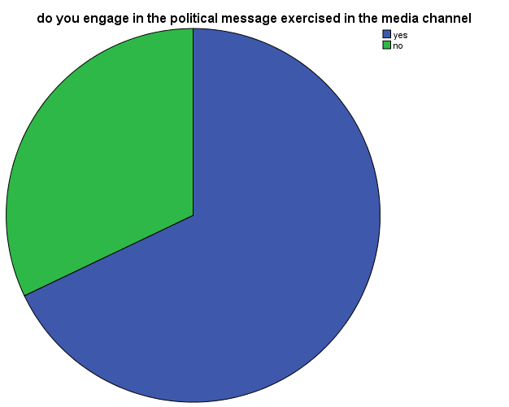
Research question 3: Were the people influenced by the political messages? Items 11-13
Table 11: Response to Question 11
 |  | Frequency | Percent | Valid Percent | Cumulative Percent
Valid | Yes | 243 | 60.9 | 60.9 | 60.9
 | No | 156 | 39.1 | 39.1 | 100.0
 | Total | 399 | 100.0 | 100.0
The table above shows that out of 399 respondents, 243 respondents (60.9%) relied yes that the political messages influence their voting behavior, 156 respondents (39.1%) said no that they were not influenced by the political messages.
Figure 11: If the political messages influenced their voting behavior

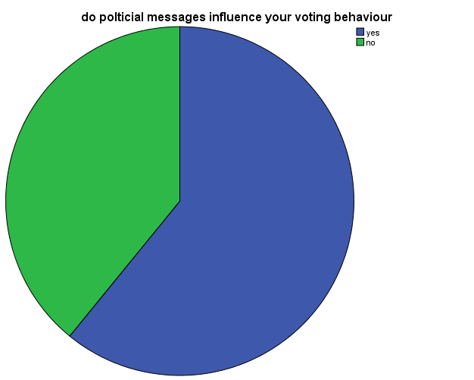
Question 12: Do you agree political messages change voters’ behavior
Table 12: Response to question 12
 |  | Frequency | Percent | Valid Percent | Cumulative Percent
Valid | Agree | 64 | 16.0 | 16.0 | 16.0
 | strongly agree | 207 | 51.8 | 51.9 | 67.9
 | Disagree | 88 | 22.0 | 22.1 | 90.0
 | strongly disagree | 40 | 10.0 | 10.0 | 100.0
 | Total | 399 | 99.8 | 100.0
According to the table above 64 respondents (16.0%) agrees that the political messages change voters behavior,207 respondents (51.8%) strongly agreed that the political messages change voter behavior,88 respondents (22.0%) disagreed that the political messages change voter behavior,40 respondents (10.0%) strongly disagreed that the political messages change voter behavior.Question twelve upholds Hypothesis three: the people were influenced by the political messages.
Figure 12: Political messages change voters behavior
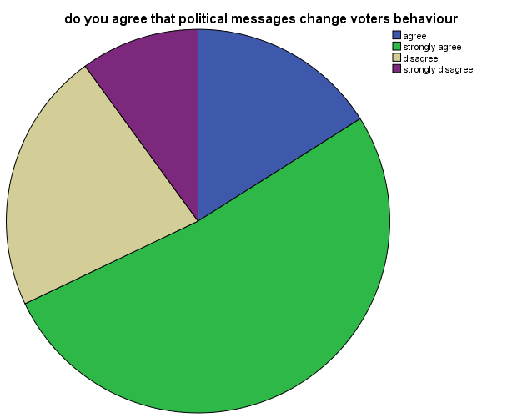

Question 13: Do you agree in excising your vote?
Table 13: Response to question 13
 |  | Frequency | Percent | Valid Percent | Cumulative Percent
Valid | Agree | 110 | 27.5 | 27.6 | 27.6
 | strongly agree | 201 | 50.3 | 50.4 | 77.9
 | Disagree | 60 | 15.0 | 15.0 | 93.0
 | strongly disagree | 28 | 7.0 | 7.0 | 100.0
 | Total | 399 | 99.8 | 100.0

The table above shows that 110 respondents (27.5%) believes in excising their votes, 201 respondents (50.3%) really believes in excising their vote, 60 respondents (15.0%) disbelieve in excising their vote,28 respondents (7.0%) totally disbelieved in excising their vote.
Figure 13: Excising their vote
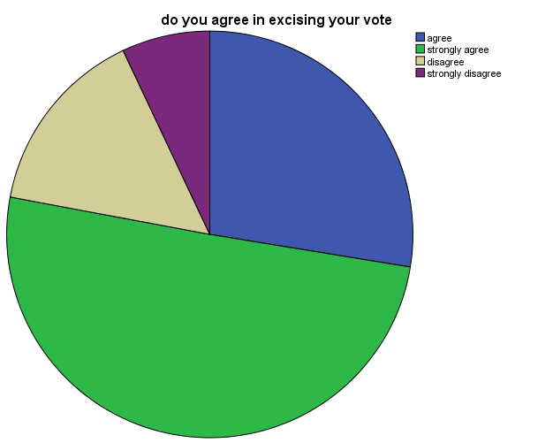

4.3 Discussion and Findings
In this section of data collected from the survey on the topic “Influence of Political Advertising on the Voters Behavior of the Electioneering Campaign” would be discussed. The data were contained in 399 questionnaire distributed and retrieved from the respondents. Responses that answered the research questions would be discussed.
4.3.1 Research Question 1: To what extent were the people of Anambra state exposed to the media messages?
The purpose of this question was to find out if the people of Anambra state were exposed and how often they listened to the media messages. The data on table 5, 6, 7, and 8 were used to answer the research question. Hypothesis one uphold that: the people of Anambra were exposed to media message. Data from table 5; figure 5 showed that 309 or 77.4% of the respondents answered yes that they have media channel while 90 or 22.6% of the respondents answered no that they did not have media channel. Also, data from table 6, figure 6 showed that 40 or 10.0% of the respondents rely on radio for political information, 80 or 20.1% of the respondents rely on television for political information, 109 or 27.3% of the respondents rely on newspaper for political information while 170 or 42.6% of the respondents rely on all the media for political information. Data on table 7, figure 7 showed that110 or 27.6% of the respondents always listen to political messages on radio, 158 or 39.6% of the respondents listen to the political messages once a week while 131 or 32.8% of the respondents do not listen to political messages.
Data on table 8,figure 8 indicated that only 119 or 29.8% of the respondents always read the newspaper for political messages,180 or 45.1% of the respondents read the newspaper once a week for political messages, 100 or 25.1% of the respondents do not read the newspaper for political messages.
From the above findings, it shows that most people in Awka North LGA own media channel and have an idea on what it is like and what it is used for. Table 6 shows that most people rely on the entire media channel for political information than specifying on media channel. Table 7 reveals how often the people listen to the political messages on radio which is once a week. Table 8 shows that a great number of people read the newspaper once a week against those that read newspaper every day.
This shows how exposed people are to media messages, some people may have a media channel while some won’t have, some people actually pays close attention to the political messages through various medium.
Research Question 2: which media channel were they more exposed to?
The aim of this question was to find out the media channel the respondents were more exposed to and if they followed up in the political message exercise.
The data on the table 9 and 10 answered this research question.
The Data on table 9 shows that out of 399 questionnaires distributed and retrieved 216 finds television most suitable to pass across political followed by newspaper then lastly radio.
The Data on table 10 indicate that majority of the people engage in the political messages exercised in the media channel. Hypothesis two upholds: the people of Anambra were exposed to media channel.
From the findings above it shows that the people are aware of the political messages and also are engaged in some of the exercise carried out during the election.
Research Question 3: were the people influenced by the political messages?
The aim of this research question is to find out how effectively the political messages changed the voting behavior of the people. The data was contained in tables 11, 12 and 13.
The Data in table 11 revealed that greater number 243 of the respondents voting behavior was influenced by the political message while 156 was not influenced by the political messages.
The Data in table 12 shows that 207 of the respondents strongly agree that political messages can change voters behavior, 88 respondents disagree that the political messages cannot change voters behavior, 64 respondents agree that the political messages can change voters behavior, 40 strongly disagree that political messages can change voters behavior. Hypothesis three upholds: the people of Anambra were influenced by the political messages.
The Data in table 13 reveals that 201 respondents strongly agree in excising their vote, 110 respondents agree on excising their vote, 60 respondents disagree on excising their vote, 28 respondents strongly disagree on excising their vote.
These findings agreed with the Agenda setting which performed the foundation of this study and which stipulates media’s ability to tell us what issues are important and what persons are important in the society. It also agreed with the selectivity theory where by the people are allowed to choose what they want to be exposed to, perception and retention to the political messages.

CHAPTER FIVE
SUMMARY, CONCLUSION AND RECOMMENDATIONS
5.1 Introduction
The aim of this study was to examineInfluence of Political Advertising on the Behaviour of Anambra State Electorate: A study of 2017 Gubernatorial Election in Awka North . Survey research design was adopted using questionnaire for data gathering.
5.2 Summary of Findings
The findings showed that;
- The people of Anambra state were not always exposed to the media messages.
- The people of Anambra state listened more to television political messages.
- The people of Anambra state were influenced by the political messages.
This, therefore, follows that political messages influenced voter behavior during the 2017 Gubernatorial Election in Anambra state based on the study sample size of Awka North LG.
5.3 Conclusion
This finding in the study concludes that political messages influence voters behavior during the 2017 Gubernatorial Election based on the study of Awka North LGA.
Indeed, Political Advertising serve as an effective political communication strategy through which political candidates market themselves and send information to the voters. The research further affirms that the electorate accesses political advertising messages, more through the television than any other medium.
5.4 Recommendations
Based on our findings we recommend that:
- The media especially television should strategize message delivery to engender confidence in its listener to retain their trust.
- Candidate should broaden their political messages in other medium- newspaper and radio.
- Politicians and political parties should make efforts to give credible messages since most electorate are influenced at voting by political messages.
5.5 Suggestions for further studies
The researcher suggests that further studies should be carried out on theInfluence of Political Advertising on the voters’ behavior.

REFERENCES
Agbo, B. and Ugwu, B. (20110. Introduction to Research Methods. Enugu: John Jacob’s cclassic Publishers. Pg. 107.
Amos Tversky and Daniel Kahneman(1991). Loss aversion in riskless choice. A refrerence dependent model.
APCON (2005). Code of Advertising Practice Lagos. APCON
Baran,S. (2004) . Introduction to Mass Communication Media Literacy and Culture. 3rd edition. Boston: McGraw-Hill.
Currance (2005). Media and Culture Theory Routledge: New edition. Pg 129.
EwenMacAskill and Helena Smith (2004). New date to be set after blunder over Cyprusreferendum. The Guardian. Retrieved 9 december 2011
Feyipitan (2015). Agenda Setting and Political Advertising staking interity.www.vanguardingng.com.2015
Folarin, B. (2005). Theories of Mass Communication. An introductory Text Ibadan: Stirling. Horden publishers.
Frank Jefkins (1994).Advertising, 3rd edition, Singapore, financial Times and Pitman Publishing, 659.1
Holtz-Bacha, etJohansonByleidenbeger. J., Maarck P.J and Merkie, S. (2012). Advertising for EuropeanTV Ads during the 2009 European election campaign in 4 countries, nordicon review. 33(2); 77-79
Okoro and Adide, (2013). Social Media and Political Particpation in Nigeria during the 2011 General Elections: the lapses and the lessons. Global Journal of Arts Humanities and social sciences 1(3) pp 29-46.
Okwechime (2006). Essentials of Advertising in Nigeria Asabs. Prime Legacies limited. 198.
SambeJ.A (2005). Introduction to mass communication Nigeria; Ibadan, spectrum Books Limited and Safari Books {Export} Limited.
Seema Hasan (2013). Mass Communication principles and concepts CBS publishers anddistributorsPrt. It New Delhi 2nd edition pg 412.
Stanley J. Baran and McGraw Hill (2001). Introduction to Mass Communication media literacyand culture. 4th edition.
Stella Okunna (1999). Introduction to Mass Communication, 2nd edition. New generation books, Enugu, Nigeria.
Wimmer, R.O. and Dominic, J.R. (2006). Mass Media Research: An introduction. 8th edition. Boston:Wadsworth
www.akinwunmiambode.com
www.apcon.gov.ng. Retrieved 30 April 2018.
www.apconng.blogspot.com. Retrieved 30 April 2018
www.premium timesng.com. Retrieved 30 April 2018.
www.youtube.com/akinwumiambode”i believe”.
www.youtube.com/akinwunimiambode”Gbabe

APPENDIX 1

Department of Mass Communication
Godfrey Okoye University,
Enugu.

DearRespondent,
I am a student of Godfrey Okoye University. I am carrying out a project work which is part of the requirements for the award of Bachelor of Science (B.Sc) degree, in Mass Communication. It is purely an academic exercise. Please respond to the questionnaire as honestly as possible. There is no right or wrong answer. All responses are confidential.
Thank you for your involvement.
Yours Faithfully

Ezeamalu, Cynthia Amarachi

APPENDIX 2

SECTIONA. INSTRUCTION: please tick the appropriate box or fill in the blank spaces as appropriate:
(1).Gender: Male [ ] Female [ ]
(2).Age: (18-30): [ ](30-40): [ ] (40 and above): [ ]
(3). Educational level:WASSCE/NECO/GCE [ ], OND/ NCE [ ], BSC/BA/ HND [ ], MSC/MA/MBA [ ], PhD [ ]
(4) Marital status: Single [ ], Married [ ], Divorced [ ]
SECTION B. INSTRUCTION: Read each statement carefully and indicate the extent to which it is true by ticking only one of the options in the space provided after each statement. Work rapidly. The numbers stand for:
- Do you have any media channel YES{ } NO { }
- Which of this medium do you rely for political information
Radio { } TV { } Newspaper {} All { }
- How often do you listen to political message on Radio
Always { } Once a week { } Not at all { }
- How often do you read newspaper for political messages
Everyday { } Once a week { } Not at all { }
- Which media do you think is most suitable to pass across political messages

Radio { } Newspaper { } TV { }
- Do you engage in the political message exercised in the media channel YES{ } NO{ }
- Do political messages influence your voting behavior YES{ } NO{ }
- Do you agree that political messages change voters behavior
Agree { }, Strongly Agree { }, Disagree { }, Strongly Disagree { }
- Do you agree in excising your vote
Agree { }, Strongly Agree { }, Disagree { }, Strongly Disagree { }

