NEWS PREFERENCE IN ENUGU STATE: AN ANALYSIS OF BROADCAST MEDIA & SOCIAL MEDIA NEWS CONSUMPTION

BY
ITEM MERCY CHINEMEREM
U14/MSS/MAC/046

THE DEPARTMENT OF MASS COMMUNICATION,
FACULTY OF MANAGEMENT AND SOCIAL SCIENCES,
GODFREY OKOYE UNIVERSITY UGWUOMU- NIKE, ENUGU STATE

JULY, 2018

NEWS PREFERENCE IN ENUGU STATE: AN ANALYSIS OF BROADCAST MEDIA & SOCIAL MEDIA NEWS CONSUMPTION

BY
ITEM MERCY CHINEMEREM
U14/MSS/MAC/046

A PROJECT PRESENTED TO THE DEPARTMENT OF MASS COMMUNICATION, FACULTY OF MANAGEMENT AND SOCIAL SCIENCES, GODFREY OKOYE UNIVERSITY UGWUOMU- NIKE, ENUGU STATE, IN PARTIAL FULFILLMENT OF THE REQUIREMENTS FOR THE AWARD OF THE OF BACHELOR OF SCIENCE (B.SC) DEGREE IN MASS COMMUNICATION
SUPERVISOR
PROF. COSMAS NWOKEAFOR

JULY, 2018
DECLARATION
I, Mercy Item Chinemerem, declare that this research work was written by me and has not been submitted or received anywhere for the purpose of acquiring a degree in mass communication.

Mercy Item C. Date

---------------------------- ---------------------

CERTIFICATION PAGE
Item Mercy Chinemerem with the registration number U14/MSS/MAC/046 of the Department of Mass Communication, Faculty of Management and Social Sciences, Godfrey Okoye University, Ugwuomu -Nike, Enugu state, has satisfactorily completed the requirements for the award of Degree in mass communication.
This project is original and has not, to the best of my knowledge, been submitted in part or full for any other certification, diploma or degree program of this or any other University.

----------------------- ---------------------------
Prof. Cosmas Nwokeafor Date
Supervisor

--------------------------------- --------------------------
Prof. Cosmas Nwokeafor Date
Head of Department

-------------------------------- ------------------------
Ass. Prof. Levi Nwodu, C.
External Examiner Date

DEDICATION
This work is dedicated to the God Almighty. He has been the source of my strength, guidance and integrity which have made me come this far. With a grateful heart, I say thank you.

ACKNOWELDGMENTS
A host of amazing individuals were contributors and mentors throughout my remarkable journey in Godfrey Okoye University and through the completion of my project work.
My parents, Chief Anthony Uche Item, and Mrs Patience Olohitia Item, were not only my sponsors through this program but my number one motivators. I appreciate you guys specially. My siblings, Vivian, Justice, Izuchukwu, Shekinah, and Praise ceaselessly prayed for my success through this course, and for this, I am truly grateful. I thank Mr Daniel from National Planning Commission Abuja. He was a helpful resource person.
I would forever appreciate my Vice Chancellor, Prof Christian Anieke, for the immeasurable roles he played through the selected of my research topic down to the completion of the work. I am honoured to have been academically supported by such a man. A thousand thanks would not be enough to appreciate my project supervisor and HOD, Mass Communication, Prof Cosmas Nwokeafor. He is a role model for me and I am so grateful to have met and worked with such an amiable personality.My esteemed gratitude goes to Prof Armstrong Idachaba for his intellectual support and textbooks/journals he lent me during my research work. Dr Alex Onyebuchi was an amazing teacher and mentor, who supported me both intellectually, and otherwise. He is a great supervisor. Mr George Nnamdi Nzekwe, Coordinator, Mass Communication, was relentlessly supportive in seeing to the successful completion of my project work, and for this I am totally grateful.
Special thanks goes to my lecturers, Dr Louis Ezema, Mr Ben Onwukalonye, Mr Ment Nnomeh, Mr Chidubem Umeora, Dr Regina Acholonu, Fr. Paul Obayi and the amazing Fiona Onwude. The knowledge with which they impacted me, would indeed go a long way for me in life.
Finally, I appreciate, Ignatuis Chinyere, Ekwe Uchenna, Ajani Chioma, Faith Anosike and a host of my other friends. Thank you for being there through the years.
God bless you all.

TABLE OF CONTENTS
Title page ----------------------------------------------------------------------------------------- i
Declaration---------------------------------------------------------------------------------------- ii
Certification-------------------------------------------------------------------------------------- iii
Dedication---------------------------------------------------------------------------------------- iv
Acknowledgement------------------------------------------------------------------------------- v
Table of Contents-------------------------------------------------------------------------------- vi
List of Tables------------------------------------------------------------------------------------- viii
List of Figures------------------------------------------------------------------------------------ ix
Abstract-------------------------------------------------------------------------------------------- x
CHAPTER ONE: INTRODUCTION
  - Background of the study---------------------------------------------------------------------- 1
1.2 Statement of the problem--------------------------------------------------------------------- 4
1.3 Objectives of the study------------------------------------------------------------------------ 5
1.4 Research question------------------------------------------------------------------------------ 5
1.5 Scope of the study------------------------------------------------------------------------------ 6
1.6 Significance of the study----------------------------------------------------------------------- 6
1.7 Operational definition of significant terms--------------------------------------------------- 7
CHAPTER TWO: REVIEW OF LITERATURE
2.1 Introduction---------------------------------------------------------------------------------------- 8
2.2 Review of concepts------------------------------------------------------------------------------- 8
2.3 Review of related studies------------------------------------------------------------------------ 19
2.4 Theoretical framework-------------------------------------------------------------------------- 24
2.5 Summary------------------------------------------------------------------------------------------- 27
CHAPTER THREE: RESEARCH METHOD
3.1Introduction------------------------------------------------------------------------------------------ 29
3.2 Research design------------------------------------------------------------------------------------- 29
3.3 Population of the study----------------------------------------------------------------------------- 29
3.4 Sample size------------------------------------------------------------------------------------------- 30
3.5 Sampling technique--------------------------------------------------------------------------------- 30
3.6 Research instrument-------------------------------------------------------------------------------- 31
3.7 Validity of data gathering instrument------------------------------------------------------------ 32
3.8 Reliability of data gathering instrument -------------------------------------------------------- 32
3.9 Method of data collection -------------------------------------------------------------------------32
3.10 Method of data analysis--------------------------------------------------------------------------33
CHAPTER FOUR: DATA PRESENTATION AND DISCUSION
4.1 Introduction------------------------------------------------------------------------------------------ 34
4.2 Data presentation and analysis-------------------------------------------------------------------- 34
4.3 Discussion of findings------------------------------------------------------------------------------ 60
CHAPTER FIVE: SUMMARY, CONCLUTION AND RECOMMENDATION
5.1 Summary of findings------------------------------------------------------------------------------ 61
5.2 Conclusion------------------------------------------------------------------------------------------ 62
5.3 Recommendations--------------------------------------------------------------------------------- 62

List of Tables
Analysis of Bio-Data
Table 1: Gender distribution of respondents---------------------------------------------------35
Table 2: occupation of respondents-------------------------------------------------------------36
Table 3: Age of respondents---------------------------------------------------------------------37
Table 4: Educational Qualification of respondents------------------------------------------ 38
Table 5: Marital Status of respondent----------------------------------------------------------39
Analysis of Research Question
Table 6: response to question 6----------------------------------------------------------------- 40
Table 7: response to question 7----------------------------------------------------------------- 41
Table 8: response to question 8----------------------------------------------------------------- 41
Table 9: response to question 9----------------------------------------------------------------- 42
Table10: response to question 10--------------------------------------------------------------- 44
Table 11: response to question 11-------------------------------------------------------------- 45
Table 12: response to question 12-------------------------------------------------------------- 46
Table 13: response to question 13-------------------------------------------------------------- 47
Table 14: response to question 14-------------------------------------------------------------- 48
Table 15: response to question 15-------------------------------------------------------------- 49
Table 16: response to question 16-------------------------------------------------------------- 50
Table 17: response to question 17----------------------------------------------------------------51
Table 18: response to question 18-----------------------------------------------------------------52
Table 19: response to question 19-----------------------------------------------------------------53
Table 20: response to question 20-----------------------------------------------------------------54
Table 21: response to question 21-----------------------------------------------------------------57
List of Figures
Analysis of Bio-Data
Figure 1: Gender distribution of respondents------------------------------------------------35
Figure 2: Age distribution of respondents----------------------------------------------------36
Figure 3: Marital status of respondents-------------------------------------------------------37
Figure 4: Educational Qualification of respondents---------------------------------------- 38
Figure 5: Occupation of respondent-----------------------------------------------------------39
Analysis of Research Question
Figure 6: response to question 6---------------------------------------------------------------- 40
Figure 7: response to question 7---------------------------------------------------------------- 41
Figure 8: response to question 8---------------------------------------------------------------- 41
Figure 9: response to question 9---------------------------------------------------------------- 42
Figure10: response to question 10-------------------------------------------------------------- 44
Figure 11: response to question 11------------------------------------------------------------- 45
Figure12: response to question 12-------------------------------------------------------------- 46
Figure 13: response to question 13------------------------------------------------------------- 47
Figure 14: response to question 14------------------------------------------------------------- 48
Figure 15: response to question 15------------------------------------------------------------- 49
Figure 16: response to question 16------------------------------------------------------------- 50
Figure 17: response to question 17--------------------------------------------------------------51
Figure 18: response to question 18--------------------------------------------------------------52
Figure 19: response to question 19-------------------------------------------------------------53
Figure 20: response to question 20-------------------------------------------------------------54
Figure 21 response to question 21------------------------------------------------------------57
Abstract
The technological breakthrough of web 2.0 revolutionized communication channels, increasing information traffic from source to sender and vice versa. Media convergence is one of the many outcomes of this technological revolution whereby traditional media and the internet merge to disseminate information to audience. However, news preferences seem to relegate different audience demographics to particular channels of communication. This study which analyzed the most preferred medium for news consumption in Enugu between the broadcast media and social media was anchored on the Uses and Gratification theory as well as Choice theory. The study was based on survey research method which involved the use of multistage sampling technique to distribute 384 copies of the questionnaire to residents in Enugu state. Data retrieved were analyzed using descriptive technique including percentages, frequencies, and bar chart. The results of the research found that people of Enugu state were largely exposed to broadcast media and social media and these media were used to by the residents of Enugu state to a high extent. Broadcast media was chosen to be more credible than social media. The most preferred news media for the people of Enugu state was the broadcast media for mostly reasons of its news credibility, reliability and currency.

CHAPTER ONE

INTRODUCTION
1.1 Background of the study
Mass media play crucial roles in the connection of individuals and its success is enabled through the dissemination of news. While the focus of this research study is the preference of news in Enugu which further now compares the Broadcast media and social media news consumption, Encarta, (2009) cited in Ekwueme and Akpan, (2011) explains that broadcasting is the primary means by which information and entertainment are delivered to the public in virtually every nation around the world.
Similarly, Bolalek, (2013) opines that not only are social media beneficial for creating and maintaining social relationships but also, because of their popularity, social media have become a way to access news. News organizations and journalists now participate in sharing the news via social media.
It is generally said that if a news report provides answers to six questions, then it should be considered a news item. These six questions include five Ws and H: Who, What, When, Where, Why and How? According to Williams, (1899) if ‘A dog bites a man’-that’s a story; but if ‘A man bites a dog’ –that’s a good news. This is true in the real sense but suppose a dog bites the president of a country, it most certainly makes big news. In this context, therefore, the understanding of news becomes an obvious imperative to give clarity to how Journalists and News Anchors gather and process news. National Broadcasting Commission (NBC) Code, (2016) defines news as a truthful account of an event that assists the recipient live in a complex, dynamic and humane society.
Despite the criteria stipulated that a news item should possess, the importance of whom the news is gathered for should be in consideration. The mass media audience is heterogeneous and as such respond to media messages differently. This has further led individuals into vying into different sources in search of news they prefer that best suits them. This is in accordance with Olorunnisola, (2009) cited in Ojebuyi, (2013), who states that given the new trend of growing competition occasioned by liberalization of the media and communication industries and emergence of new media, the media audience now have greater freedom and a wide range of alternatives from where to get information about events that affects their lives.
According to NBC, (1996) audience research intervals to ascertain the taste and preference of the audience and it is therefore unwise for broadcasters arrogating to themselves the knowledge of the audience’s taste and preference to media content based on simple assumption.
This study, wishes to explore the channels through which news is consumed by audience and the most preferred channel of news consumption from the various mediums at the audiences reach. The traditional channels of news are the television and radio. In recent times, social media has also come into limelight which houses news and entertainment disseminating platforms like facebook, twitter, instagram, whatsappe.t.c. Ojebuyi, (2013) argues that Radio no doubt, has unparalleled capacity to reach the mass audience at a relatively cheaper cost and within a short time. This is against television which is the most expensive medium of mass communication but has an attractive motion picture inclined potential Esan, (2009). Television has the advantage of using a combination of sight through pictures, hearing, through sound which aids in attracting its audience unlike radio with sounds alone. These are notable attributes as to why some people prefer or are against the traditional radio and television to social media and vice versa.
Opinions differ in this context as (Ha, Yoon, & Zhang, 2013, p. 2) argue that news consumption behavior of Social media users is a salient research topic in online social media studies because the characteristics of Social network sites such as feedback, instantaneousness and connectedness are powerful advantages as a news medium.
Despite the seeming challenges and gallops this social media is beginning to create, one cannot help but to observe that in order for the traditional media to keep up with the new age, it has practiced ‘media convergence’ in some areas of news dissemination. Flew (2017) describes it is a phenomenon involving an interconnection of information and communications technologies, computer networks and media contents. Flatzer, (2013) argues that with the rapid proliferation of internet based services, especially with social media and wireless communication and introduction of web 2.0 sites, the convergence phenomenon has attracted more attention since the 21st century. The digitization of media content and popularization of the internet is encouraged and adopted by the traditional broadcast media to keep up with the pace of the transforming news times.
Even with these changes, the big question remains why some audiences prefer broadcast media to social media for their news consumption and vice versa. This work therefore, sought to analyze the news consumption habits of the people of Enugu state to discover what news channel between the broadcast and social media platform is mostly preferred.
1.2 Statement of the Problem
The emergence of internet technology and social media has posed tremendous challenges on the kind of news medium mostly preferred by the news consumers. Similarly, it has become imperative to examine the traditional media and social media for news consumption in order to ascertain which is mostly preferred by the mass audience.
Furthermore, some factors like the convenience, cost, credibility, quick access and instantaneousness in the aspect of feedback of the broadcast and social media sources all act as reasons as to why news consumers prefer certain sources over others. It has been observed that most news materials derived from, television and radio are further restructured to the taste of the retriever and then disseminated to the online audience who nowadays find it easier to subscribe to social media application like twitter, facebook, instagram and whatsapp for news materials. But then again most of the social media develop their own content. (Pew Research Center, 2010a) cited in Ha et al. (2013) agrees with the above when they described social media as a news portal for its users because the users are constantly participating in the production and consumption of news through this medium.
The broadcast media and social media are now in competition for which serves better and is mostly used by news consumers. Hence, this study sought to discover the news medium mostly preferred in Enugu state by comparatively analyzing the broadcast media and social media used for news consumption.

1.3 Objectives of the Study
The main purpose of this study will be to compare broadcast media and social media news preference and consumption in Enugu State.
Specifically other objectives of this study were to:
- Ascertain the extent to which the people of Enugu State have access to broadcast & social media news content.
- Find out the extent to which they use these media for their news consumption.
- Find out the level of credibility in the news contents derived from these sources.
- Identify the most preferred media for news consumption.
1.4 Research Questions
- What is the extent to which the people of Enugu State have access to broadcast & social media news content?
- What is the extent to which they use these media for their news consumption?
- What is the level of credibility in the news contents derived from these sources?
- What is the most preferred media for news consumption?
1.5 Scope of the study
This research study is limited in scope and content. It takes a look at the news preference in Enugu state and comparatively analyzes traditional broadcast media and social media news consumption. This research study is to use Enugu metropolis as the focus.

1.6 Significance of the Study
This research will provide a valuable base for theory, research and practice. The findings are expected to support previous theories and premises in the area of news preference and the sources of news consumption.
It will educate the Nigerian general public on the widely preferred news medium in Enugu state through a critical comparative analysis of the traditional broadcast media which comprises of radio and television news reception and the modern day social media news consumption.
The research work will as well serve as a resource base to other scholars and researchers interested in carrying out further research in this field.
1.7 Operational Definitions of Terms
News: newly received information about a recently changed situation or events in the country or the world.
Preference: strong liking or a predisposition in favor of something. It is also the right to choose or grant favor over other news sources.
Comparative Analysis: is a research methodology employed for both quantitative and qualitative research studiesin social sciences that aim to make comparisons across different thematic issues.
Broadcast Media: radio and television devices used in transmitting informative contents to a mass audience.
Social Media: websites and applications that enable users to create and share content or to participate in social networking
News .Consumption: the reception and utilization of news material
News Preference: audience news choice or ability to select what kind of news or news medium to expose themselves.

CHAPTER TWO
REVIEW OF LITERATURE

2.1 Literature review provides a close examination of literature related to the topic of study. According to Wimmer and Dominick (2004), the review provides information about what other people have done and what result it generated. This chapter is divided into three segments: the conceptual, empirical and theoretical section.
2.2 Review of Concepts
It is necessary to conceptually clarify of the concepts of this study in order to enhance understanding of the subject matter. The conceptual review looks at the available literature on the following concepts:
- The Concept of News
- News Elements
- The 5 W’s and H)
- The Concept of News Preference
- Broadcast Media
- News Types
- Social Media Defined
- Brief Knowledge of Some Social Media Platforms
- Methods of Social Media News Dissemination

2.2.1 The Concept of News Defined
News is describe as the spinal cord of journalism which consist of factual events that represent reality. According to Naveed (2017), news is anything out of the ordinary. It is the unusual picture of life. He further describes it as an event that is fresh, unusual and interesting to a greater number of people. The term news according to Palczewski (2009) comes from the word new: written in old English either as newes or Niwes. In modern day, it is considered an acronym for the four sides of the world – north, east, west and south. According to Schudson (1978) a researcher of journalism history in the United States, the idea of news was created during Andrew Jackson’s presidency (1830s), tied to theidea democratization of policy, expansion of market economy and growing power of urban middle class. The developing then penny press treated news as current, accurate and complete information, focused on daily matters and personalized (human interest story). After the invention of the telegraph and the establishment of the first press agency, Associated Press in 1848, news was understood as objective and based on fact information (factual news).
The first, frequently cited and, at the same time, one of the most popular news definitions from late XIX century is the saying that, “news is when a man bites a dog”. This saying is attributed to at least two journalists. In the US, the authors are considered to be Charles Dana (“New York Times” journalist in the 1860s) or Charles Stanton, assistant to Secretary of State during Abraham Lincoln’s presidency and co-owner and publisher of “New York Sun” or John B. Bogart (journalist for “New York Sun”). Regardless who was the first to come up with this early definition, it definitely outlines the characteristic traits of news. Firstly, it is sensational, secondly its presents an event which is extraordinary, unusual and atypical. Thirdly – it reveals the astonishing character of human nature. Lord Northcliffe’smotto, also from late XIX century, states that “news is what somebody somewhere wants to suppress. All the rest is advertising”.
An interesting point was introduced by Schramm (1949), who pointed out that news exists in the minds of the people, “news is not the event but is the report of the event”.
A popular and commonly cited definition of news was put forward by Walter Gieber (1964). According to him, news is what appears in the press and more precisely, “news is newspapermen make it”. Whether an event is to become news or not is decided by what newspapermen do with it. Gieber states, “[…] news does not have an independent existence; news is a product of men who are members of a news-gathering (or a news originating) bureaucracy.
2.2.2 News Elements
News element are factors that make stories news worthy. Most good news stories have more than one news elements. The 7 news elements are proximity, prominence, timeliness, oddity, consequence, conflict, human interest. These are briefly discussed below.
Proximity: is the location in which a news worthy event occurs. Mudd (2014) argues that if an event is happening nearby, it will impact readers more than if it were happening somewhere else that doesn’t affect them as much in another state or in another country. Hohman (2011) further agrees when he says stories about events community are more newsworthy than events that take place far away.
Prominence:people with a certain level of popularity who are well known to a large number of people often catch the interest of news consumers. Hohman (2011) agrees when he said people on the public eye have higher news values that obscure people. For example, Nigerian citizens cared that cared that Yusuf Buhari, the son of the President, Mohammadu Buhari, had a motorbike accident and worried about his health. This would be contrary in a case whereby an ordinary citizen with such accidents had been announced.
Timeliness:the currency of an event would add an even greater news value to such story. According to Mudd (2014) current news has more impact than something that happened yesterday or last week the news media loses interest in past events because there is always fresh news somewhere. Farooq (2015) argues that immediacy of timeliness is an important requisite of news in which a reporter places emphasis on the latest angles of an event. The word ‘today’ and ‘tomorrow’ are related in most of the news stories and occasionally a story may concern events that happened in the past. In this case, the reporter discusses some aspects of a past event.
Oddity: the greater the degree of oddity or bizarreness in a story, the greater its value as news. If something is unusual, shocking or queer, the strangeness alone could make it newsworthy.
Consequence: According to Mudd (2014) if the impact of an event may directly affect readers, they will want to know about it. It is basically the number of people whose lives will be influenced in some way by the subject of the story.
Conflict: in simple terms, Hohman (2011) puts ‘strife is newsworthy. War. Public anger or bitter disagreement over fundamental issues’. Farooq (2015) further explains that news of conflict generally also involves other news values as drama and oddity and therefore, has an emotional impact, a factor that appeals to many people. Many types of stories have conflict as their underlying element the struggle against odd. A few of these types are:
- Man’s struggle with nature
- Struggle between individual and organized society
- Struggle between political and economic groups i.e wars, campaigns, strikes.
Human Interest: according to Mudd (2014) if a situation draws any sort of emotional reaction, then it might contain the news element of a human interest story. It is imperative that a news worthy story must be able to incite or arouse emotions from it readers.
2.2.3 The 5 W’s and H
The five W’s and H of mass communication which are applicable to the lead in news stories are; who, what, when, where, why, and how. According to Mairo (2017) some good reporters answer the question WHO in the lead. The ‘who’ seeks to know the person involved in the story especially when the story concerns a personality. The ‘what’ answers the question what happened? The ‘where’ is simply the location where the story occurred? ‘When’ is concerned with the date and sometimes the time. Why is associated with the reason(s) the incident occurred giving more insight into the story. Finally. The ‘how’ elucidates the process of the occurrence.
The concept of the 5 ‘w’s and H allows the news writer provide a detailed background and convincing information about the story.
2.2.4 The Concept of News Preference
Audience news preference refers to audience news choice or ability to select/choose what kind of news or news medium to expose themselves to. To prefer something is to ‘like’ such a thing over others. Coleman (2018) defines preference as certain characteristics any consumer wants to have in a good or service to make it preferable to him. This could be the level of happiness, degree of satisfaction, utility from the product, e.t.c. This economist definition of preference is in concurrence with the news preference habits exhibited by audience and news consumers.
Nigatu (2014) observed that we live in a world where there are different types of media (both foreign and domestic) doing their utmost endeavor to attract the attention of audience. Media contents are addressed to a larger number of audiences that have different compositions.
According to Dominick (1999) mass media have surveillance, interpretation, linkage, transmission of values and entertainment functions for society. The uses and gratifications model also divulges that mass media have cognition, diversion, social utility and withdrawal functions. Nowadays, audience are exposed to various media outlets; prints broadcast and the internet. But audience have their own reasons for choosing a given media and media content over others. In relation to media choice, Rosengren et al. (1985) cited in McQuail (1992:178) indicate the presence of a ‘range of various motives for choosing media for amusement, information, social contact, excitement, involvement, e.t.c or more generally, the bases for (and degree of) selectivity which is actually exhibited in media choice behavior’. This notion is very similar to uses and gratification approaches in that it perceives ‘audience as active and goal oriented. The audience members are largely responsible for choosing media to meet their own needs. ……….. Audience know their needs and how to gratify those needs (Littlejohn and Foss, 2008:301).
2.2.5 Broadcast Media
Broadcast media is the most expedient means to transmit information immediately to the widest possible audience. Broadcast media refers to primarily television and radio. Radio transmits audio through voice while television transmits visuals using a combination of sounds and visuals in motion pictures. Radio is an audio medium which is relatively cheap and can operate without electricity: it is therefore more within the reach of Third World populations than television. It is portable and in most developing countries radio is by far the most widely-used mass medium (Okunna & Omenugha, 2012).
Relatively, television has the added advantage of combining sound with vision qualities to make it “one of the most powerful communicative forces in the history of civilization. People learn through eye and ear, and will remember things better because of television’s audio-visual effects (Pokharapurkar, 1993).
2.2.6 News Types
Types of news stories come in two unique forms. These are the hard news stories and soft news stories. These are further explained below:
Straight news/Hard news
Stories that report only the most essential information in a concise and impartial manner are referred to as straight or hard news stories. Limor and Mann (1997) cited in Seletzky (2010) noted that it usually involves political (domestic and international), economic or social topics. Hard news demands immediate reporting due to its importance and short lifespan (continuing stories tend to follow shortly).
Shoemaker and Cohen (2006) argues that hard news items are urgent occurrences that have to be reported right away because they become obsolete very quickly. These items are truly new. Patterson (2000) agrees with the above when he referred to hard news as coverage of breaking events involving top leaders, major issues, or significant disruptions in the routines of daily life, such as earthquakes or airline disaster. Information about these events is presumably important to citizen’s ability to understand and respond to the world of public affairs.
Feature/ Soft news
The primary difference between a soft news and hard news story is the style in which it was written. According to Patterson (2000) cited in Seletzky (2010) soft news is characterized as having sensationalist elements regarding famous personalities, utilitarian in nature (personally useful for the common reader), and/or based on a specific event. He further describes it as news that typically is more personality centered, less time-bound, more practical, and more incident based than other news. The news is said to have become more personal and familiar in its form of presentation and less distant and institutional. Soft news is focused on gossip, local scandal and human interest stories.A feature story is more indepth than a traditional hard news article and uses the types of storytelling devices and details that on might find in novels.(Nations, 2010)
2.2.7 Social Media x Defined
Social media are platforms that involves the use of the internet to connect users with their friends, family and acquaintances. Mayfield (2008: 12) describes social media as a group of new kinds of online media, which share most or all of the following characteristics of participation, openness, conversation, community and connectedness. He further states that social media are in six kinds; social networks, blogs, wikis, podcasts, forums, content communities and micro blogging.
Doris (2014:5) “social media, basically, concerns all forms of new media technology that offers active sharing of information, videos, pictures, text and comments with such platforms as Twitter, Facebook, YouTube, Blog, Myspace, Instagram, Whatsapp and Linkedin”.
Adibe and Odoemelam (2011:12) observe that the new media of communication have in no small measure helped human society to be aware of each other’’. This agrees with the submissions of Brewer (2008) that it provides a direct link from a media organization to a connected, empowered, and active audience, and, in doing so totally change the relationship. The use of social media has ushered in a new era of journalism as citizens play a bigger role in the process of news making.
2.2.8 The Brief Knowledge of Some Social Media Platforms
Facebook
Doris (2014: 5) “In 2004, Harvard student Mark Zuckerberg created Facebook as a way to connect with fellow students. Initially adopted by high school and college students, the social network, according to its 2012 initial public offering filing, has grown to 845 million active users worldwide, with approximately 161 million active monthly users in the US, making it the premiere social media service in the world. If Facebook were a country it would be the third largest behind China and India”.
According to Nations(2018) Facebook is a social networking website and service where users can post comments, share photographs and links to news or other interesting content on the web, play games, chat live, and stream live video. Shared content can be made publicly accessible, or it can be shared only among a select group of friends or family, or with a single person.
Facebook originally began as a service only offered to universities, but continually expanded its availability until Facebook allowed global registration in September 2006. Facebook introduced the ‘groups’ application in September 2004 as one of its basic features. An application that allows users share common interests by creating a common space where users can meet others interested in a specific topic, disseminate information about such topic as well as public discussions.
Twitter
Doris (2014: 6) “Launched in July 15 2006, Twitter is an online social networking and micro blogging service that has grown to over 330 million active users as of 2017. It allows users to exchange photos, videos, and messages of 140 or more. The social network was created by Jack Dorsey, Noah Glass, Biz Stone, and Evan Williams.
Twitter is an “information network that connects you to the latest information about what you find interesting”. Users communicate via “Tweets” which are short posts limited to 140 characters, but on November 7, 2017, the limit was doubled to 280 characters for all languages except Japanese, Korean, and Chinese. Registered users can post tweets, but those who are unregistered can only read them. Twitter users can “follow” or essentially subscribe to the updates of other users, some of which include conventional media sources, such as Newsweek or Al-Jazeera, celebrities, and friends. Additionally, tweets can be categorized using “hashtags” which “group posts together by topic or type”.
YouTube
Founded in 2005 by Steve Chen and Chad Hurley, YouTube provides a forum for the distribution of video content – everything from cute kittens sleeping to first-run television programs to eyewitness videos of political protests. The two created the site based on their own frustration when trying to share video files. Google bought the site in November 2006. YouTube was the first website dedicated solely to uploading and sharing personal video. Odinakadotnet (2012) “over 3 billion videos are viewed each day on YouTube, reaching 700 billion playbacks in 2010. As well as uploading and viewing media, users can also leave comments on videos. YouTube is the third most frequented website online”. As of February 2017, there are more than 400 hours of content uploaded to YouTube each minute, and one billion hours of content are watched on YouTube every day. As of August 2017, the website ranked as the second most popular site in the world by Alexa Internet, a web traffic analysis company.
Weblog (Blog)
Another social media platform is weblogs, commonly referred to as blogs. According to Geraldine, Melanie and Herlitz (2014) ‘Blogs are websites hosted and authored by individuals or groups who regularly publish editorial content. Blogs are characterized by the fact that posts can be commented on and linked, enabling the creation of content networks’. Blogs are “an easy-to-use content management tool. When one ‘blog’, one is instantly adding new content to one’s site via a web interface. No technical or programming skills are necessary. “Blogging requires merely Internet access and typing skills, and these low-cost barriers have led to personal blogs proliferating worldwide.
Hopedotcom (2017) ‘blogs are often maintained and run by a single individual, updated daily, or contain personal remarks about a topic, a personal ramble, or an update on the person’s life. Some examples of software and services you can use to create and start personal weblogs include; Blogger, Manila, Movable Type, Live Journal, Radio User land, Type pad, Word Press.
2.2.9 Methods of Social Media News Dissemination
Some methods of disseminating news on social networking sites are RSS Feeds and Podcasts. Pollette (2008) describes it as a way to keep track of news, sports, weather, and blogs. RSS is short for Really Simple Syndication and it aids to subscribe to a source of information, such as website, and get brief updates delivered to you.These sources are called feeds. When you subscribe, you’ll get a feed—often a series of headlines and brief summaries –of all the articles published on that particular web page.
Another method is the use of Podcasts, which allows virtually anyone with a computer to become a radio disc jockey, talk show host or recording artist. Watson (2008) states that unlike internet radio, users don’t have to ‘tune in’ to a particular broadcast. Instead, they download the podcast on the demand or subscribe via an RSS feed, which automatically downloads the podcast to their computers. According to Pew Research Center (2014) facebook is an important source of website referrals for many news outlets, but the users who arrive via Facebook spend far less time and consume far fewer pages than those who arrive directly. The same is true of users arriving b search. An analysis of com Score data found visitors who go to news media website (Howe, 2011)directly spend roughly three times as long as those who wind up there though search or Facebook, and view roughly five times as many pages per month. A study conducted by Pew Research Center (2013) found out that facebook is the obvious news powerhouse among social media sites estimating about two-thirds (64%) of U.S. adults who use the site, and half of those users amounting to 3o%of the general population. This is closely followed by YouTube.
2.3 Review of Related Studies
A study carried out by Iffat A. Ali and Zahid Yousaf (2017) entitled ‘Information Acquisition and Social Media: An Analysis of Pakistani University Students’ in a Journal of MassCommunication & Journalism, strived to find out the use of social media by youths for news acquisition, consumption which come under cognitive needs.The researcher found out that youths are heavy user of social media and there is a shift in usage patterns among youths. Initially, they used it for communication and socialization but the revolution in social media gained a place in news domain as well. The results indicated a difference in age and gender is wider in using social media for news. The study discovered that there is also a major difference in their tendency towards type of news as they consume social media more for soft news as they are more interested in entertainment news (Ali, Yousaf 2017).The researcher further noted that people showed interest in local news. Social networks such as Twitter and Facebook play a leading role in the spreading of news stories. The use of social media increased for news acquisition during crisis situation (Ali, Yousaf 2017).
A dissertation by Jonna H. (2011), on Social Media and News Consumption, had the objective of exploring how the popularity of social media and other user generated content venues have impacted the way in which news is consumed and distributed. It aimed to examine the way in which individuals use social media to share and consume news stories and if they feel more informed as a result. The study was conducted using an online survey. The findings indicated that individuals under the age of 35 rely heavily on their social networks for tips and alerts to news stories. The majority of all respondents are exposed to news stories that they may have otherwise missed or overlooked as a result of Facebook and Twitter.(Miller)(Anna Van Cauwenberge, 2013)(Bolalek, 2013)(Jason Rittenberg, 2012).
Another study carried out by Charles O. (2013) entitled Radio News Source Preference by Residents of Uyo Urban, Nigeria which aimed at finding out which radio station (s), residents of Uyo Urban, tune to for news on important local and national issues. It also studied what factors influence their choice of radio station for news on socio-political crisis in Nigeria. The findings showed that majority of the respondents prefer foreign radio stations – Voice of America (VOA) and British Broadcasting Corporation (BBC) for news on socio –political crisis in Nigeria. The survey also revealed that media credibility exerted great influence on audience exposure to broadcast news and choice of broadcast mediums for news. It was the submission of the work that the continuous presentation of one-sided point of view, whether in government- controlled media or privately owned ones not only makes the audience hold their news content suspect but also make such mass medium to rank low in terms of perceived credibility. Furthermore, the study noted that audience members are not taken in by the sophistication of broadcast media in their news listening activity. Instead, the perceived reliability and balanced news reporting of the medium influence their choice of radio station(s) for news.
Another dissertation by Jennifer M. (n. d) on The New News Media: Democratic implication of undergraduate education and news consumption over social and traditional media which aimed at surveying and interviewing students at Simon Fraser University to deduce perception and behavior of news consumption over social and traditional media. The findings of the study showed that traditional media does not appear to be on its way out with young adults but is rather re integrated into patterns of consumption that are most suitable to the consumer. Primary news sources for the population consist of traditional media, specifically that of online news websites. Accessibility of content and education are large factors that cause this shift towards media dualism in news content consumption. Social media does not appear to be eclipsing mainstream media, but functions alongside it and as a supplementary tool for including multiple alternative voices. The population reports that their education has a great impact on their current news behavior.
Cauwenberge, d’Haenens and Beentjes (2013:38) in the work Young people’s news orientations and uses of traditional and new media for news aimed at finding Flemish college students’ news orientations and their uses of traditional and new media within a public service media environment. The study used five homogenous focus groups that covered variation in media usage. The analysis of the focus group found that major differences in news behaviors and attitudes between participants who mainly depended on traditional media for news, and those who also went online for news. While a growing body of research on young people reports on increasing use of online media for news, particularly among those that are most disengaged with traditional news media, the research findings indicated that only the most eager news-users were motivated to gather information online. Additionally, it was found that traditional media, are still main reference points for public affairs information among participants.Furthermore, in line with previous studies, it was found that evidence of perceptions of traditional news media bias among participants, however, only the most eager news-users were motivated to gather additional information online that helped them to form a balanced opinion on a news event. The less interested news-users, who depend mainly on traditional media for news, turned out to be the most vulnerable news audiences. When confronted with ‘boring news’ on television or in newspapers, they tuned out from the news completely. Nonetheless, given that these participants did not want to spend too much time and effort on news, traditional news media, which pointed out and interpreted for them the relevant news stories of the day, were preferred over online platforms that required active search engines.
A study by Bolalek (2013), on News Source Preferences and News Source Credibility among College Staff, Faculty, and Students which aimed at finding out where people say they turn to for primary sources of news and the credibility people assigned to various news sources. Respondents where split up into two groups, heavy and light social media users. Result suggest that regardless of social media use, there was no difference in judgments of credibility for different news sources. The study’s sample did not make any discrimination in credibility among the various news sources. Additionally, the current study found that traditional media is still dominant for news.
Another dissertation by Rittenberg, Tewksbury & Casey (2012) on Media Preferences and Democracy: Refining the “Relative Entertainment Preference” Hypothesis aimed at extending the work of research connecting media choice and relative preferences for entertainment to voter turnout. Markus Prior found that individuals who both preferred entertaining content to news and had either cable or internet access were less likely to vote than were other citizens.As an update to his work, this article uses more recent Pew Research Center for the People and the Press surveys to test alternative measures of entertainment preference and to update the internet access findings for the broadband age. As a theoretical extension, the work looks at turnout differences among those with even finer content preferences. The results indicate that there is value in considering Relative Societal Welfare News Preferencein addition to or even instead of – entertainment preferences alone.
Saleeman, Budiman& Ahmad (2015) on the Comparative Study of Media Usage in News Consumption: A qualitative Approachaimed at using uses and gratification approach to compare how news gratification are sought and obtained in both online and conventional media. Interviews were conducted with 14 members of the National Youth Service Corps (NYSC) in Nigeria between January and April 2014. The findings showed that news gratifications are sought more in the online media and less in the conventional media. The most relative advantage of the online media as news sources is the quick update which they give which makes them faster news sources. The most relative disadvantages of the conventional media are ownership interference and erratic signals. The online media are especially good for their speed of delivering news while the conventional media are especially desirable for details.
A dissertation by Journal of Media Practice, (2014) on Mass Media Preference and Consumption in Rural India: A Study on Bharat Nirman Campaign – Journal of Media Watch which sought to find out the media habits and preferences of rural audience in India.The results indicated that television is the best medium to target rural and semi urban audience for public service advertising. Newspaper and radio appeared to seriously lag behind as mass media vehicles of choice in comparison to television. The mobile telephone had made some inroads: however, it was hardly being used as a medium for accessing public service information.
A study by Brenda O. (2016) on An Analysis of Media Channel Consumption Preferences Among Residents of Kisumu County aimed to find out the factors that influence consumers preference and behavior towards the media channel.The study revealed that residents of Kisumu County preferred vernacular radio stations. The study showed that the reason for the preference were: entertainment, information education, good presentation, good reception and programmes for both radio and television. In spite of media diversity and popularity, radio remains a dominant medium for Kisumu county residents. The outcomes recommend that TV is beginning to win more steadfast audience, particularly among the individuals who live in high society local locations. This has challenged TV to overhaul its execution. Accordingly, when individuals return home from work or school, TV media is viewed as a standard partner. Some television slots create more than one media program, which means more decisions for the media and other data concerning Kisumu audiences.

2.4 Theoretical Framework
This study was built on two theories which are the Uses and gratification and Choice theory.
2.4.1 Uses and Gratification Theory
This study was anchored on a communication theory called the Uses and Gratification Theory of the media, propounded by Elihu Katz and Jay Blumler in the year 1974. Katz and Blumler opinion of Uses and Gratification theory is based on the idea that media audiences are active rather than passive, meaning they do not only receive information, but also unconsciously attempt to make sense of the message in their own context (Peirce, 2007).
The concept of Uses and Gratification theory refers what people do with the media. It presents the media audience as active users and participants in information dissemination and acquisition. The audience are no longer passive as they develop interactive relationship with the media, select and acquire gratification from what the media has to offer. Katz (1974) called attention to the need for a functional uses and gratifications approach to understanding media effects. According to him, uses and gratifications theory is concerned with the social and psychological origins of needs, which generate expectations of the mass media other source, which leads to differential patterns of media exposure (or engagement in other activities), resulting in need gratification and other consequences, mostly unintended ones. Purely audience-centered, the theory addresses needs like, surveillance, excitement, guidance, relaxation, tension release social integration entertainment, e.t.c.
This theory is relevant to this work because it talks about the preferred channels of the media audience align themselves with. It is a limited effect theory that makes reference to
Audience choice. The underlining principles of the uses and gratification is based on audience content choice and the gratification derived from the content sought. Since this study focuses on news preference of audience between traditional broadcast media and social media, it is in line with the theory as it states how audience goes to the media to choose what they want instead of being passive and let the media influence their choice. It further acknowledges media users as active audience in communication process as it makes reference to the fact that they possess the power of choice and decide what to use the media for. ‘Media audiences will make choices depending on their needs, satisfactions, motives and choose certain forms of media, whether it is a medium (television or radio, for example) or a specific program over another form in order to satisfy needs or wants’ (Peirce, 2007).
2.4.2 Choice Theory
Another theory relevant to the study is William Glasser’s(1998) Choice Theory which focuses on the Psychology of humans in relation to choices they make. Choice theory contends that every part of our behavior- thoughts, feelings, physiology and ‘doings’, and these impact on the former two. Glasser argues that we have total agency in the entirety of our ‘total behavior’, leading to a more dependency, blame free, life. According to Doring (2017) the theory is that nobody can make one feel anything, as all we do is give or receive information. This information can neither make us do or feel anything. It is our choice how we perceive or filter the information, and it is our choice how we respond to it. According to Glasser (1998) the choice theory states that: all we do is behave, almost all behavior is chosen and that we are driven by our genes to satisfy five basic needs which are survival, love and belonging, power, freedom and fun. He further states that the most important need is love and belonging, a closeness and connectedness with the people we care about is a requisite for satisfying all of the needs.
Gap in Literature
Given the reviewed related studies, researchers have carried out several researches on news source and media preference in Nigeria and the world over. However, given the high rate of social media usage, no comparative analysis has been carried out on both social media and broadcast media to find out the most credible, and preferred platform for news in Enugu state. Hence the need for this study.
2.5 Summary of Literature Review
In this chapter, the researcher reviewed the concept of the study, in view of News defined as the spinal cord of journalism which consist of factual events that represents reality, as well as anything out of the ordinary. Also reviewed were the 7 News elements that make news worthy. Following closely was the concept of the 5 W’s and H which allows the news writer provide a detailed background and convincing information about the story. The concept of news preference was discussed. The broadcast media consisting of Radio and Television was also discussed alongside the type of news, consisting of hard and soft news. Social media was further defined as all forms of new media technology that offers interactive sharing of information, videos, pictures, text and comments with such platforms as Twitter,Facebook, YouTube, Blog, Myspace, Instagram, Whatsapp and Linkedin”.
Reviewing the related studies, the researcher looked at; Information Acquisition and Social Media: An Analysis of Pakistani University Students by Iffat A. Ali and Zahid Yousaf (2017); Social Media and News Consumption, by Jonna H. (2011); A study carried out by Charles O. (2013) on Radio News Source Preference by Residents of Uyo Urban, Nigeria. The researcher further looked at another dissertation by Jennifer M. (n. d) on The New News Media: Democratic implication of undergraduate education and news consumption over social and traditional media. Cauwenberge, d’Haenens and Beentjes (2013:38) in the work Young people’s news orientations and uses of traditional and new media for newswas also review. A study by Bolalek (2013), on News Source Preferences and News Source Credibility among College Staff, Faculty, and Students, closely followed.The theory reviewed was the Uses and Gratification theory, which based on audience media choice and the gratification derived from the content sought.The literature review has now acknowledged that audience have preferences and choice over the medium they wish to consume news contents from, the question remains, which medium is mostly preferred between the broadcast and social media for news consumption by the people of Enugu state.

CHAPTER THREE
RESEARCH METHODOLOGY

3.1 This chapter discusses the method of research used by the researcher in this study. It focuses on research design, population of the study, sampling technique and sample size, research instrument used for the study and the methods of data collection and analysis.
3.2 Research Design
A research design is a plan and structure of investigation so conceived as to obtain answers to research questions (Kerlinger, 1986, p.279). In scientific research, the nature of a study determines the design the researcher adopts. As a result, since this study examines audience’s views/reception of news across various media, the researcher deems survey research most apt for this study.
Survey research studies large and small populations (or universe) by selecting and studying samples chosen from the population to discover the relative incidence, distribution and interrelation of sociological and psychological variables. Survey research method focuses on a representative sample derived from the entire population of the study (Nwodu, 2006). It provides equal chance for the entire population to participate in the study, and also provides a face to face interaction between the researcher and the respondents.
3.3 Population of the Study
A population is simply the total number of respondents in an area of study. The population for this study is drawn from the entire population of Enugu State. The total
Population as derived from 2015 projection of the National Population Commission of Nigeria is 4,273,200.
3.4 Sample Size
A sample size of 384 was drawn from the population using Wimmer and Dominick online calculator. The researcher used an error margin of 5%.
Workings: with Confidence level at: 95%
Margin of error (%): 5
Population size: 4273200
A click on the calculate button results in a sample size of 384. Hence, the answer above.
3.5 Sampling Technique
To achieve the desired results and findings in this study, the researcher adopted the Multistage Sampling technique to determine the process of administering the required copies of the questionnaire. Multistage Sampling refers to sampling plans where the sampling is carried out in stages using smaller and smaller sampling units at each stage. The final stage of sampling involves choosing a random sample of people in the clusters selected at the penultimate stage. For the purpose of the study, the sample population is Enugu state, Nigeria. The breakdown of the stages are as follows;
STAGES
Stage 1 | Enugu State
Stage 2 | Nsukka Senatorial Zone, Udi Senatorial Zone, &Nkanu Senatorial Zone
Stage 3 | Required 3 selected Local Government Areas from each of the zones which are: Nsukka LGA, Udi, LGA, and Nkanu LGA. With the sample size at 384, when divided by the 3 LGA’s, it equals 128 in each. Hence, 128 questionnaires were shared in each Local Government Area.
Stage 4 | Purposive or Judgmental non-probability sampling technique were used to select sample for the study. These respondents were selected based on certain characteristics they possessed.

3.6 Research Instrument
To generate primary data from the study, the researcher administered copies of questionnaires to 384 respondents. Questionnaire is a scientific tool for data collection which uses various questions to achieve the research objectives (Madueme, 2010). Interviews were also conducted for clarity sake. The questionnaire for this study were made ip of 21 instruments. The first aspect was the Psychograpic section for the respondent’s occupation, marital status, educational qualification, age and gender which were five (5) items in number. While the demographic section which consists of 16 items in number included nominal scale, Likert scale of agree, disagree, strongly agree , strongly disagree, can’t say. The researcher used closed and open ended questions.
3.7 Validity of Data Gathering Instrument
The instrument for this study was valid because it was ideal for measuring what it was designed for, which was analyzing the most preferred medium for news consumption between broadcast and social media in Enugu state. Obasi (2008) notes that “validity is the appropriateness of an instrument in measuring what it intended to measure” for this reason, the researcher went further to test the validity of the instrument using face to face validity by which a copy of the questionnaire was checked for validity by the project Supervisor.
3.8 Reliability of Data Gathering Instrument
Reliability says of what extent is the result reliable, thus, the instrument was reliable because the researcher made use of Pilot study on the questionnaire and the questions were given the desired results.Using the pilot study, the researcher shared 20 copies before proceeding with the work and they came back reliable. This entailed the distribution of some copies of the questionnaire by the researcher to regular news listeners in Enugu state.
3.9 Method of Data Collection
The researcher administered all the copies of the structured questionnaire to the respondents in Enugu state. In the course of this study, the researcher employed the primary method of data collection. Since the study was an empirical one, the data for this exercise was obtained from information gathered from the items on the questionnaire, distributed and collected by the researcher. It questionnaire was face to face self-administered. 380 copies of the questionnaire were retrieved, while 4 copies got missing.
3.10 Method of Data Analysis
The researcher used tables and simple percentages for the purpose of presenting and analyzing data for this study. This was to make simplicity of data presentation and analysis and its comprehension on the part of readers of this work.

CHAPTER FOUR
DATA PRESENTATION AND ANALYSIS

4.1 The aim of this study was to analyze the most preferred medium for news consumption between Broadcast and Social media in Enugu state. In this chapter, the researcher presented and analyzed the data generated through the administration of questionnaire instrument. Three hundred and eighty four (384) copies of questionnaire were administeredto the various respondents, out of which 380 copies were retrieved and used for the analysis.
The research questions includes:
1. What is the extent to which the people of Enugu State have access to broadcast & social media news content?
2. What is the extent to which they use these media for their news consumption?
3. What is the level of credibility in the news contents derived from these sources?
4. What is the most preferred media for news consumption?
The questionnaire which comprised of closed and open ended questions were divided into two segments. Part A was made up of items that dealt with the demography of the respondents, while Part B answered questions on the psychographic data of the respondents.
  - Data Presentation and Analysis
This section focused on the analysis of items in the questionnaire which were drafted to address the four research questions in the study.

4.2.1 Analysis of Demographic Data
The demographic data focuses with analysis of data gathered on the sex, occupation, age, educational qualification, and marital status of respondents.
Table 1: Sex of Respondents
Sex of Respondents
 |  | Frequency | Percent | Valid Percent | Cumulative Percent
Valid | Male | 186 | 48.9 | 48.9 | 48.9
 | Female | 194 | 51.1 | 51.1 | 100.0
 | Total | 380 | 100.0 | 100.0
Field Survey (2018)
Figure 1:

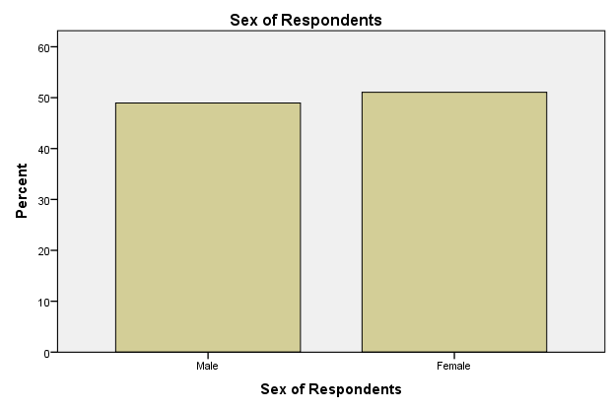
The sex distribution of the respondents on Table 1 and figure 1 above, indicate 186 male representing 48.9% of the male respondents while 194 females representing 51.1% of female respondents. This implies that the female respondents constituted the higher number of the entire sample population.
Table 2: Occupation of Respondents

Occupation of Respondents
 |  | Frequency | Percent | Valid Percent | Cumulative Percent
Valid | Student | 101 | 26.6 | 26.6 | 26.6
 | Civil Servant | 91 | 23.9 | 23.9 | 50.5
 | Business | 108 | 28.4 | 28.4 | 78.9
 | Self Employment | 80 | 21.1 | 21.1 | 100.0
 | Total | 380 | 100.0 | 100.0
Field Survey (2018)
Figure 2:

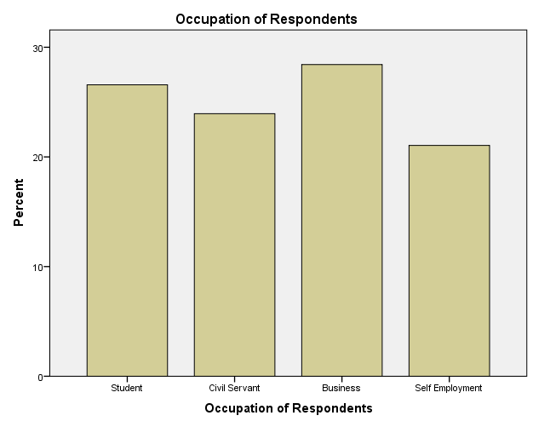
Table 2 and Figure above indicates that 101 respondents representing 26.6% are students, 91 respondents representing 23.9% are Civil Servants, 108 respondents representing 28.4% are Business Men and Women, and 80 respondents representing 21.1 % of the population are Self Employed.
This means that majority of the respondents which is 28.4% are Business men/ women who listen to news.
Table 3: Age bracket of the respondents
Age Bracket of Respondents
 |  | Frequency | Percent | Valid Percent | Cumulative Percent
Valid | 18-25 Yrs | 117 | 30.8 | 30.8 | 30.8
 | 26-35 Yrs | 162 | 42.6 | 42.6 | 73.4
 | 36-45 Yrs | 51 | 13.4 | 13.4 | 86.8
 | 46 Yrs& Above | 50 | 13.2 | 13.2 | 100.0
 | Total | 380 | 100.0 | 100.0
Field Survey (2018)
Figure 3:
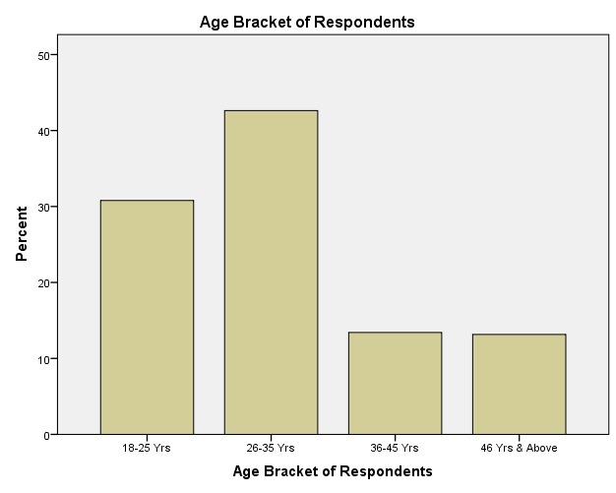
The age distribution of table 3 and figure 3 above, indicates 117 representing 30.8% respondents are between the ages of 18-25, 162 representing 42.6% of respondents are within the ages of 26-35, it further indicates 51 representing 13.4% of respondents between the ages of 36-35, and 50 representing 13.2% of the respondents within the ages of 40 & Above.
This implies that the majority of respondents are within the ages of 26-35. Meaning that they constitute the adult population and active aspect of the respondents.
Table 4: Educational qualification of respondents
Educational Qualification of Respondents
 |  | Frequency | Percent | Valid Percent | Cumulative Percent
Valid | SSCE | 126 | 33.1 | 33.2 | 33.2
 | B.Sc | 176 | 46.2 | 46.3 | 79.5
 | M.A | 58 | 15.2 | 15.3 | 94.7
 | P.hd | 20 | 5.2 | 5.3 | 100.0
 | Total | 380 | 100.0 | 100.0
Total |  | 380 | 100.0
Figure 4
Field survey (2018)
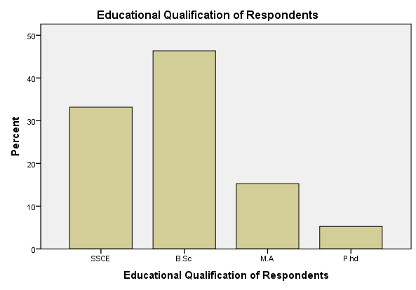
The educational distribution of the respondents in table 1 and figure 1 above indicates that 126 equivalent to 31.1% of respondents hold SSCE educational qualification, 176 equivalent to 46.2% of respondents hold B.Sc certificates, furthermore, 58 representing 15.2% of respondents hold M.A certificates and 20 representing 5.2% of the respondents hold P.hd certificates.
The majority of the sample population and respondents of the study are B.Sc holders constituting of 176 equivalent to 46.2%.

Table 5 Marital Status of Respondents
Marital Status of Respondents
 |  | Frequency | Percent | Valid Percent | Cumulative Percent
Valid | Single | 183 | 48.0 | 48.2 | 48.2
 | Married | 161 | 42.3 | 42.4 | 90.5
 | Divorced | 16 | 4.2 | 4.2 | 94.7
 | Widowed | 20 | 5.2 | 5.3 | 100.0
 | Total | 380 | 100.0 | 100.0
Total |  | 380 | 100.0
Figure 5
Field Survey

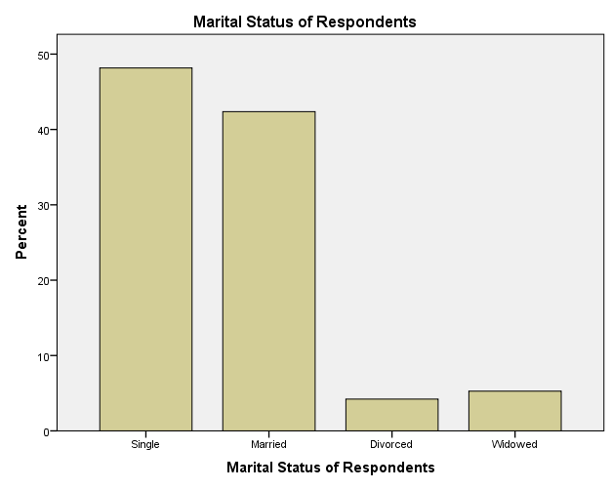
The marital distribution of table 5 and figure 5 above posits that the single respondents were 183 equaling to 48.0%, married respondents were 161 equivalent to 42.3%, divorced respondents were 16 equaling to 4.2%, and the widowed respondents amounting to 20 which translates to 5.2% of the population.
4.2.2. Analysis of Psychographic Data
The analysis of psychographic data deals with analyzing data gathered from the behavior, attitude and mind set of the respondents towards the social media.
4.2.2.1. Research Question One: What is the extent to which the people of Enugu State have access to broadcast & social media news content?
To answer this research question, items no 6-9 on the questionnaire, were used.
Table 6:
Analyzing the number of Radio/Tv Owners
 |  | Frequency | Percent | Valid Percent | Cumulative Percent
Valid | Yes | 346 | 91.1 | 91.1 | 91.1
 | No | 34 | 8.9 | 8.9 | 100.0
 | Total | 380 | 100.0 | 100.0
Field Survey (2018)
Figure 6:
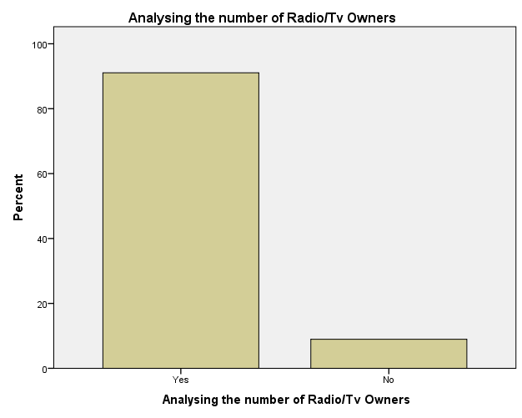
From the table 6 and figure 6 above, it shows that 346 respondents representing 91.1% of the population own radio/Tv sets while 34 respondents representing 8.9% of the population do not own radio and television sets.

Table 7:

Analyzing the Number of Social Media Accounts Like Facebook, Instagram, Twitter, e.t.c Owners
 |  | Frequency | Percent | Valid Percent | Cumulative Percent
Valid | Yes | 323 | 85.0 | 85.0 | 85.0
 | No | 57 | 15.0 | 15.0 | 100.0
 | Total | 380 | 100.0 | 100.0
Field Survey (2018)
Figure 7:
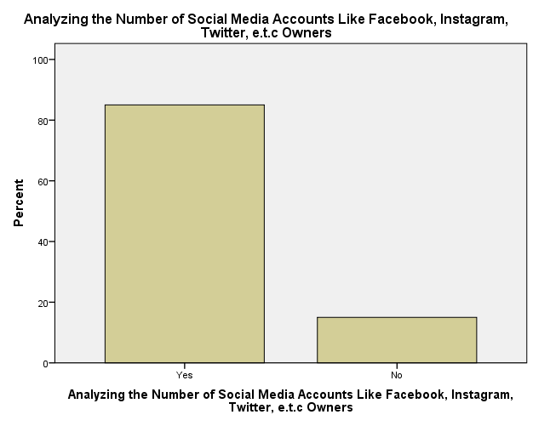
From the above table 7 and figure 7, it is visible that 323 respondents own social media accounts like facebook, instagram, and twittere.t.c representing 85.0% of the population. 57 respondents representing 15.0% indicated that they not own social media accounts.
Table 8:
Analyzing the Number of Radio/Tv News Listeners
 |  | Frequency | Percent | Valid Percent | Cumulative Percent
Valid | Yes | 331 | 87.1 | 87.1 | 87.1
 | No | 49 | 12.9 | 12.9 | 100.0
 | Total | 380 | 100.0 | 100.0
Field Survey (2018)
Figure 8:
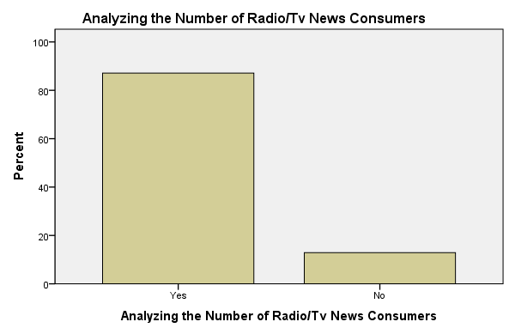

The table 8 and figure 8 above signifies that 331 respondents listen to radio/TV which represents 87.1% and 49 respondents representing 12.9% of the population do not listen to Radio/TV news.
Table 9:
Analyzing the Number of News pages Followers on Facebook, Instagram, Twitter or any other News Blog or Website
 |  | Frequency | Percent | Valid Percent | Cumulative Percent
Valid | Yes | 281 | 73.9 | 73.9 | 73.9
 | No | 99 | 26.1 | 26.1 | 100.0
 | Total | 380 | 100.0 | 100.0
Field Survey (2018)
Figure 9
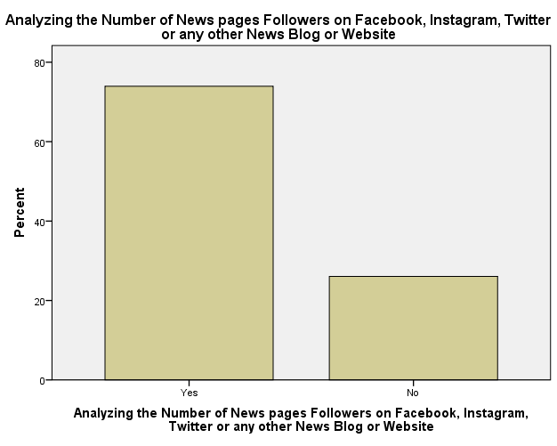
From the table 9 and figure 9 above, it is shown that 281 respondents follow news pages on social media and news blog or website. Furthermore, 99 respondents do not follow news pages on social media and news blogs/websites.
Summary of research question one
The above diagrams under this research question illustrates that 91.1% of respondents have radio/tv, further illustration illuminates that 85.0% of respondents owned accounts on social media like facebook, twitter, instagram, whatsappe.t.c it becomes clear that 87.1% which represents majority of respondents listen and watch news on radio/tv. While, 73.9% of respondents follow news pages on social media, news blogs and websites.
4.2.2.2 Research Question Two: What is the extent to which they use these media for their news consumption?

To answer this research question, items no 10-13 were used.

Table 10:
Analyzing the time span at which the respondents listen to or watch news on Radio/Tv
 |  | Frequency | Percent | Valid Percent | Cumulative Percent
 | I do not | 40 | 10.5 | 10.5 | 10.5
 | Within 24hrs | 249 | 65.5 | 65.5 | 76.1
 | Within 48-72hrs | 38 | 10.0 | 10.0 | 86.1
 | Over 72hrs ago  Can’t say | 53  0 | 13.9  0 | 13.9  0 | 100.0
 | Total | 380 | 100.0 | 100.0
Field Survey (2018)
Figure 10

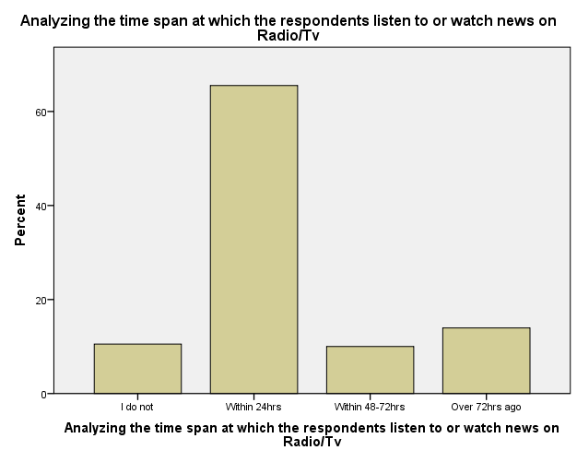
The table10 and figure 10 above indicates that 40 respondents equaling to 10.5% do not listen to or watch news on radio/Tv, 249 respondents resulting to 65.5% last watched news on radio/Tv within 24hours, 38 respondents which equals 10.0% of the respondents last watched radio/Tv news within 48-72hrs while 53 respondents equivalent to 13.9%watched radio/Tv news over 72hrs ago. 0% of respondents can’t say when last they watched news on radio/Tv.

Table 11:
Analyzing the time span at which the respondents browsed Facebbook, Instagram, Twitter, Newsblogs or Websites for News
 |  | Frequency | Percent | Valid Percent | Cumulative Percent
Valid | I do not | 63 | 16.6 | 16.6 | 16.6
 | Within 24hrs | 244 | 64.2 | 64.2 | 80.8
 | Within 48-72hrs | 40 | 10.5 | 10.5 | 91.3
 | Over 72hrs ago  Can’t Say | 33  0 | 8.7  0 | 8.7  0 | 100.0
 | Total | 380 | 100.0 | 100.0
Field survey (2018)
Figure 11:
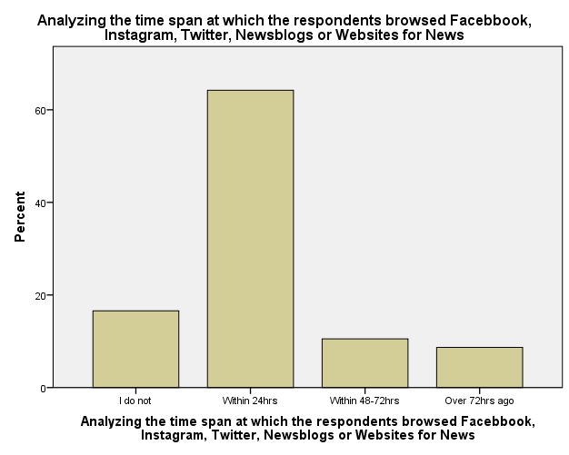

The table 11 and figure 11 above illustrates that 63 equaling to 16.6% of the respondents do not browse social media, news blogs and websites for news, 244 equivalent to 64.2% of respondents last browsed social media, blogs and websites within 24hours, 40 equaling to 10.5% of the respondents lasts browsed facebook, instagram, twitter, news blogs or websites within 48-72 hours and 33 respondents representing 8.7% of the population browsed these social media platforms, news blogs and websites 72hours ago. 0% responded to the cant say option.
This signifies that244 respondents representing 64.25 are the majority of the population that browse social media and news blogs/websites.
Table 12
Analyzing the Extent to which the Respondents Listen to News of Radio/Tv in a Day
 |  | Frequency | Percent | Valid Percent | Cumulative Percent
Valid | I do not | 61 | 16.1 | 16.1 | 16.1
 | 1-5 Times | 228 | 60.0 | 60.0 | 76.1
 | 6-10 Times | 45 | 11.8 | 11.8 | 87.9
 | Over 10 Times  Can’t say | 46  0 | 12.1  0 | 12.1  0 | 100.0
 | Total | 380 | 100.0 | 100.0
Field survey (2018)
Figure 12
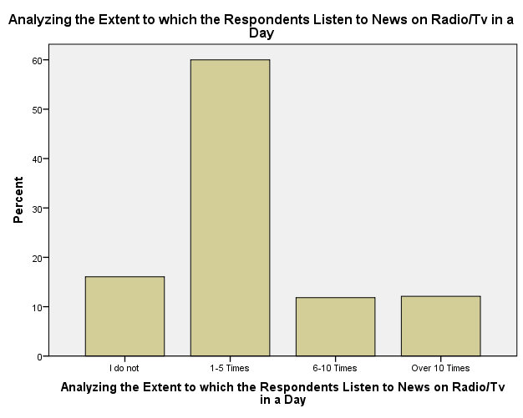
The above table 12 and figure 12 illustrates that 61 respondents representing 16.1% do not know the extent to which they listen to or watch news on Radio/Tv in a day, 228 representing 60.0% of the respondents listen to and watch radio/Tv news 1-5 times in a day, 45 representing 11.8% of respondents listen to and watch radio/Tv news 6-10 times in a day, while 46 representing 12.1 % of the respondents listen and watch radio/Tv news over 10 times in a day. 0% responded to the cant say option.
Table 13:
Analyzing the Extent to which the Respondents Browse Facebook, Instagram, Twitter, or Blogs and Websites for News in a Day
 |  | Frequency | Percent | Valid Percent | Cumulative Percent
Valid | I do not | 68 | 17.9 | 17.9 | 17.9
 | 1-5 times | 144 | 37.9 | 37.9 | 55.8
 | 6-10 times | 57 | 15.0 | 15.0 | 70.8
 | Over 10 times | 111 | 29.2 | 29.2 | 100.0
 | Total | 380 | 100.0 | 100.0
Field Survey (2018)
Figure 13
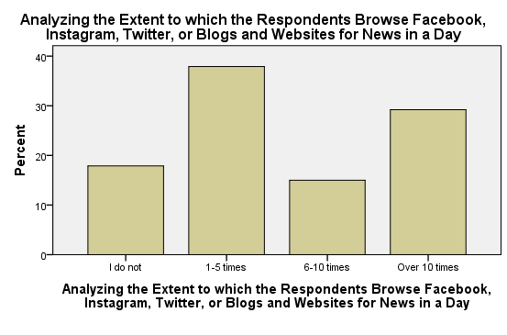
From the table 13 and figure 13 above it is illustrated that 68 representing 17.9% of respondents do not know
the extent to which they browse Facebook, Instagram, Twitter or blogs and websites for news in a day, 144 representing 37.9% of the respondents browse Facebook, instagram, twitter news blog and websites 1-5 times for news in a day, 45 representing 15.0% browse social Facebook, instagram, twitter, news blogs, and websites 6-10 times for news in a day, and 111 representing 29.2% of respondents browse these social media, news blogs and websites over 10 times for news in a day. 0% responded to the Cant say option.

SUMMARY OF RESEARCH QUESTION 2
It has so far been illustrated that 65.5% of respondents last listened to and watched news on radio/tv within 24hours, and 64.2% of respondents last browsed facebook, instagram, twitter, news blogs or websites for news within 24hours. Furthermore, 60.0% of respondents listen to news on radio/tv 1-5 times in a day while, 37.9% of respondents browse facebook, instagram, twitter, or blogs and websites for news 1-5 times in a day.

RESEARCH QUESTION 3: What is the level of credibility in the news contents derived from these sources?
To answer this research question, items no 14-19 were used
Table 14
Analyzing the Respondents Perception to the Truthfulness of Radio/Tv News
 |  | Frequency | Percent | Valid Percent | Cumulative Percent
Valid | I Agree | 196 | 51.6 | 51.6 | 51.6
 | I Disagree | 59 | 15.5 | 15.5 | 67.1
 | Strongly Agree | 81 | 21.3 | 21.3 | 88.4
 | Strongly Disagree | 35 | 9.2 | 9.2 | 97.6
 | Can't Say | 9 | 2.4 | 2.4 | 100.0
 | Total | 380 | 100.0 | 100.0
Field survey (2018)
Figure 14

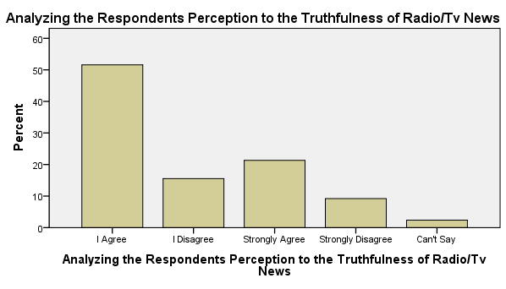
The table 14 and figure 14 above show that 196 representing 51.6% agreethat news gotten from radio and Tv are truthful, 59 representing 15.5% of respondents disagree that news gotten from radio/tv are truthful, 81 representing 21.3% of respondents strongly agree that news gotten from radio/tv are truthful, furthermore, 35 representing 9.2% of respondents strongly disagree that news gotten from radio and tv are truthful and 9 representing 2.4% of respondents can’t say if news gotten from radio/tv are truthful or not.

Table 15
Analyzing the Respondents Perception on the Truthfulness of Facebook, Instagram. Twitter or Blogs and Websites News
 |  | Frequency | Percent | Valid Percent | Cumulative Percent
Valid | I Agree | 125 | 32.9 | 32.9 | 32.9
 | I Disagree | 140 | 36.8 | 36.8 | 69.7
 | Strongly Agree | 57 | 15.0 | 15.0 | 84.7
 | Strongly Disagree | 56 | 14.7 | 14.7 | 99.5
 | Can't Say | 2 | .5 | .5 | 100.0
 | Total | 380 | 100.0 | 100.0
Field survey (2018)
Figure 15
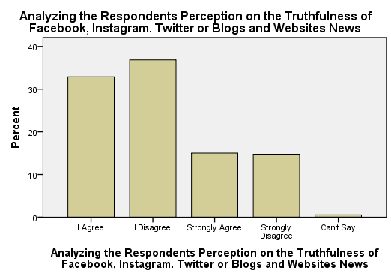
The above table 15 and figure 15 illustrates that 125 representing 32.9% of the respondents agree that news gotten from Facebook, Instagram, Twitter, Newsblogs and Websites are truthful.
140 representing 36.8% of respondents disagree that news gotten from Facebook, Instagram, Twitter, Newsblogs and Websites are truthful. 57 representing 15.0% strongly agree that news gotten from Facebook, Instagram, Twitter, Newsblogs and Websites are truthful. While, 56 representing 14.7 strongly disagree that news gotten from Facebook, Instagram, Twitter, Newsblogs and Websites are truthful. 2 representing 5% of respondents can’t say if news gotten from Instagram, Twitter, Newsblogs and Websites are truthful or not.
Table 16
Analyzing the Audience Perception on the Trustworthiness of Radio/Tv News Content
 |  | Frequency | Percent | Valid Percent | Cumulative Percent
Valid | I Agree | 223 | 58.7 | 58.7 | 58.7
 | I Disagree | 55 | 14.5 | 14.5 | 73.2
 | Strongly Agree | 72 | 18.9 | 18.9 | 92.1
 | Strongly Disagree | 25 | 6.6 | 6.6 | 98.7
 | Can't Say | 5 | 1.3 | 1.3 | 100.0
 | Total | 380 | 100.0 | 100.0
Field Survey (2018)
Figure 16
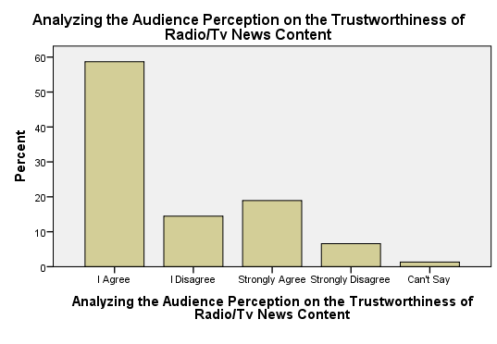
The table 16 and figure 16 above illustrates that 223 representing 58.7% of the respondents agree that news content on radio/Tv can be trusted.
55 representing 14.5% of the respondents disagree that news content from radio/tv can be trusted. 72 representing 18.9% of respondents strongly agree that news gotten from radio/tv are trustworthy. While, 25 representing 6.6% of respondents strongly disagree that news gotten from radio/tv are trustworthy. 5 representing 1.3 of respondents in the population can’t say if news gotten from radio/tv can be trusted or not.
Table 17

Analyzing Respondents Perception on the Trustworthiness of Facebook, Instagram, Twitter or Blogs and Websites News Content
 |  | Frequency | Percent | Valid Percent | Cumulative Percent
Valid | I Agree | 128 | 33.7 | 33.7 | 33.7
 | I Disagree | 150 | 39.5 | 39.5 | 73.2
 | Strongly Agree | 48 | 12.6 | 12.6 | 85.8
 | Strongly Disagree | 51 | 13.4 | 13.4 | 99.2
 | Can't Say | 3 | .8 | .8 | 100.0
 | Total | 380 | 100.0 | 100.0
Field survey (2018)
Figure 17

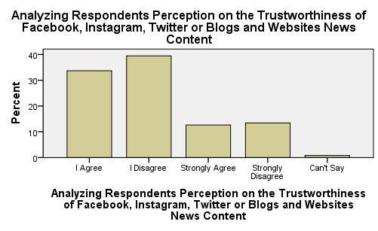

The table 17 and figure 17 above illustrates that 128 representing 33.7% of respondents agree that news content on facebook, instagram, twitter or blogs and websites are trustworthy.
150 representing 39.5% of the respondents disagree that news content gotten from facebook, instagram, twitter, newsblogs, and websites are not trustworthy. 48 representing 12.6% of the respondents strongly agree that news gotten from facebook, instagram, newsblogs, twitter, and websites can be trusted while 51 representing 13.4% of respondents strongly disagree that news retrieved from facebook, twitter, instagram, newsblogs and websites can be trusted. 3 representing .8% of the respondents can’t say if news gotten from these social media platforms, newsblogs and websites can be trusted or not.
Table 18
Analyzing the Respondents Confidence in Radio/Tv News
 |  | Frequency | Percent | Valid Percent | Cumulative Percent
Valid | Yes | 289 | 76.1 | 76.1 | 76.1
 | No | 91 | 23.9 | 23.9 | 100.0
 | Total | 380 | 100.0 | 100.0
Field survey
Figure 18
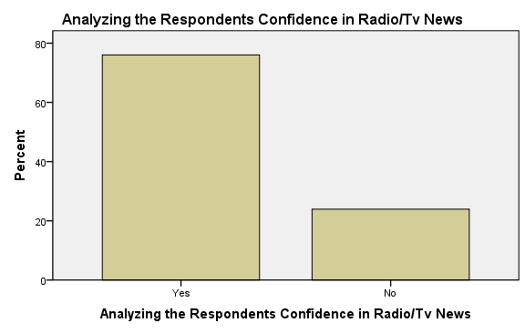
The table 18 and figure 18 above illustrates that 289 representing 76.1% of respondents can confidently make reference to information gotten from radio/Tv news during social interactions with peers, friends or colleagues while 91 representing 23.9% of the respondents cannot confidently make reference to information gotten from radio/tv news during social interactions.

Table 19
Analyzing the Respondents Confidence in Social Media/Blogs/Websites News
 |  | Frequency | Percent | Valid Percent | Cumulative Percent
Valid | Yes | 190 | 50.0 | 50.0 | 50.0
 | No | 181 | 47.6 | 47.6 | 97.6
 | Can't Say | 9 | 2.4 | 2.4 | 100.0
 | Total | 380 | 100.0 | 100.0
Field Survey (2018)
Figure 19
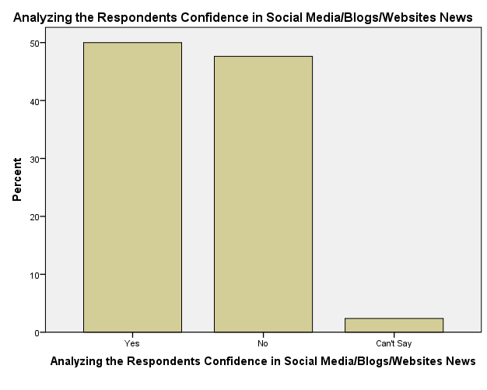
The table 19 and figure 19 above illustrates that 190 representing 50.0% of respondents would confidently make reference to news they got from Facebook, instagram, twitter, news blogs and websites during discussion with peers, friends and colleagues. 181 representing 47.6% of respondents would not confidently make reference to news gotten from facebook, instagram, twitter, news blogs and websites during discussion with friends or colleagues. 9 representing 2.4% of respondents can’t say if they would confidently make reference to news they got from social media, news blogs, and websites.
SUMMARY OF RESEARCH QUESTION 3
Given that 51.6% of the respondents agree that news gotten from radio/tv are truthful, 36.8% disagree that news gotten from facebook, instagram, twitter or blogs and websites are truthful, while 58.7% of the respondents agree that news content on radio/tv can be trusted, it appears that 39.5% of the respondents disagree that news content on facebook, instagram, twitter or blogs and websites can be trusted. 76.1% of respondents can confidently make reference to information gotten from radio/Tv news during social interactions with peers, friends or colleagues while 50.0% of respondents would confidently make reference to news they got from Facebook, instagram, twitter, news blogs and websites during discussion with peers, friends and colleagues.

RESEARCH QUESTION 4
To answer this research question, items no20-21.
Table 20

Analyzing the Respondents Most Preferred News Channel
 |  | Frequency | Percent | Valid Percent | Cumulative Percent
Valid | Radio | 99 | 26.1 | 26.1 | 26.1
 | Television | 175 | 46.1 | 46.1 | 72.1
 | Facebook | 41 | 10.8 | 10.8 | 82.9
 | Instagram | 19 | 5.0 | 5.0 | 87.9
 | Twitter | 19 | 5.0 | 5.0 | 92.9
 | Blogs and Websites | 27 | 7.1 | 7.1 | 100.0
 | Total | 380 | 100.0 | 100.0
Field Survey
Figure 20
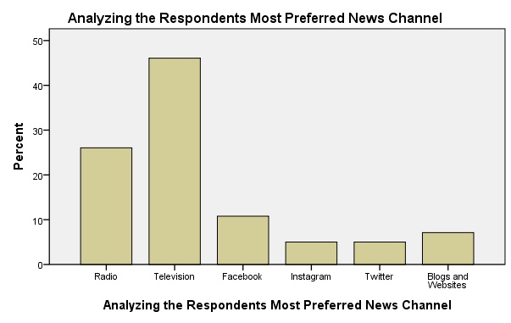
The table 20 and figure 20 above indicates that 99 representing 26.1% of respondents mostly preferred Radio broadcast channel for news, 175 representing 46.1% of respondents mostly preferred Television broadcast channel for news, 41 representing 10.8% of respondents mostly preferred Facebook social media channel for news, 19 representing 5.0 of respondents mostly preferred Instagram social media channel for news. Furthermore, 19 representing 5.0% of respondents mostly preferred Twitter social media channel for news, 27 representing 7.1% of respondents mostly preferred Blogs and Websites channels for news.
The figure above illustrates that majority of the respondents prefer television news channel for their news closely followed by radio news channel. This indicates that most respondents prefer broadcast news channel to social media news channel.
Table 21
Analyzing the Respondents Reasons for Broadcast Channel Preference
 |  | Frequency | Percent | Valid Percent | Cumulative Percent
Valid | News Credibility | 113 | 41.9 | 41.9 | 41.9
 | News Reliability | 76 | 28.1 | 28.1 | 70.0
 | News Currency | 33 | 12.2 | 12.2 | 82.2
 | Ease of Access/Convenience | 15 | 5.6 | 5.6 | 87.8
 | News Accuracy | 11 | 4.1 | 4.1 | 91.9
 | Radio Affordability | 11 | 4.1 | 4.1 | 95.9
 | TV Entertainment Through Sound/Pictures | 11 | 4.1 | 4.1 | 100.0
 | Total | 270 | 100.0 | 100.0
Field Survey (2018)
Figure 21
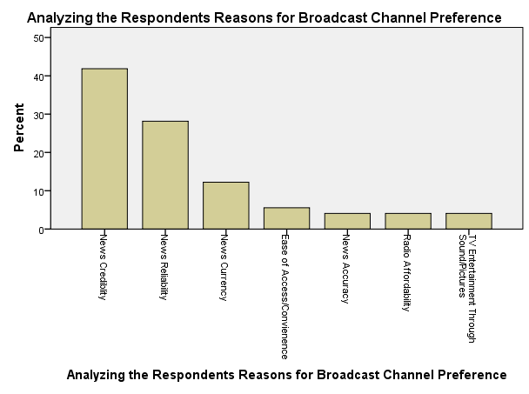From the table 21 and figure 21 above, it is shown that 113 representing 41.9% of respondents prefer Broadcast news channel for reason of its news credibility, 76 representing 28.1% of respondents prefer broadcast news channel for reason of its news reliability, 33 representing 12.2% of respondents prefer broadcast news channel for reasons of its News currency. 15 representing 5.6% of the respondents prefer broadcast news channel for reasons of Easy accessibility and convenience of the news channel. 11 representing 4.1% of respondents prefer broadcast media due to the reason of its News accuracy. 11 representing 4.1% of respondents prefer Radio broadcast media for reason of its affordability. 11 representing 4.1% or respondents prefer television broadcast media for the reason of entertainment which they derive through sound and pictures.
The figure above illustrates that the majority of respondents prefer broadcast media for mostly the reason of its news credibility.

Table 21
Analyzing Respondents Reasons for Social Media Preference
 |  | Frequency | Percent | Valid Percent | Cumulative Percent
Valid | News Credibility | 11 | 10.0 | 10.0 | 10.0
 | News Reliability | 11 | 10.0 | 10.0 | 20.0
 | News Currency | 15 | 13.6 | 13.6 | 33.6
 | Easy Access/Convenience | 38 | 34.5 | 34.5 | 68.2
 | News Accuracy | 8 | 7.3 | 7.3 | 75.5
 | Active participation/ interactiveness | 19 | 17.3 | 17.3 | 92.7
 | Entertainment Via Pictures/Videos | 8 | 7.3 | 7.3 | 100.0
 | Total | 110 | 100.0 | 100.0
Field survey (2018)
Figure 21
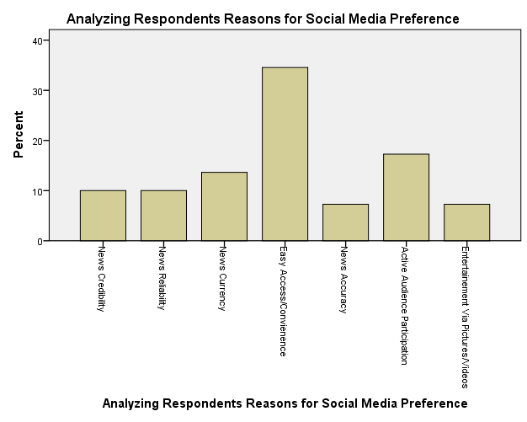
The table 21 and figure 21 above illustrates that 11 representing 10.0% of the respondents prefer social media news channel for reasons of news credibility, 11 representing 10.0% prefer social media news channel for reasons of news reliability of that channel, 15 representing 13.6% of the respondents prefer social media channel for reasons of news currency. Furthermore, 38 representing 34.5% prefer social media channel for reasons of easy access and the convenience that accompanies browsing social media for their news, 8 representing 7.3% of respondents prefer social media for reasons of news accuracy, 19 representing 17.3% of the respondents prefer social media news channel for the reason of active participation/interactiveness of audience online. While, 8 representing 7.3% of the respondents prefer social media due to the entertainment function derived from the pictures and videos online.
The figure above illustrates that majority of the respondents prefer social media for news and information because of its easy accessibility and convenience to operate.
SUMMARY OF RESEARCH QUESTION 4
According to the findings, 46.1% mostly prefer television and 26. 1% prefer radio news channels above social media news channels. Most respondents representing 41.9% gave the reason that news from broadcast media has more credibility than that of social media while other respondents with 34.5% admitted that they preferred social media news channel due to the ease and convenience at which they are able to access these social media channels, news blogs and websites.
  - Discussion of Findings
This section discusses the findings of the study in relation to the four research questions that were raised.
    - Research Question 1: What is the extent to which the people of Enugu State have access to broadcast & social media news content?
The findings revealed that 84.2% of the people of Enugu state have access to broadcast and social media news content. The result of this finding correlates with Cauwenberge, d’Haenens and Beentjes (2013) study on Young people’s news orientation and uses of traditional and new media for news which states that only the most eager news user were motivated to gather information online. Additionally, it was found that traditional media are still main reference points for public affairs information among participants. It also conform with the findings of Ali and Yousaf (2017) which indicated that youths are heavy users of social media and difference in age and gender I wider in using social media for news.
    - Research Question 2: What is the extent to which they use these media for their news consumption?
This study reveals that to a large extent at 56.9% people of Enugu state often use these media such as broadcast and social media for their new consumption.
This findings correlates with Joanna (2011)findings on social media and news consumption,which indicates that individuals under the age of 35 rely heavily on their social networks for tips and alerts to new stories. The majority of all respondents are exposed to news stories that they may have otherwise missed or overlooked as a result of facebook, twitter e.t.c.
    - Research Question 3: what is the level of credibility in the news contents derived from these sources?
This study further revealed that people of Enugu state agreed with 62.1% that broadcast media channel news content is more credible than news content derived from social media channel. Furthermore, it was also discovered that, people of Enugu state disagreed to social media news contents credibility with 42.1% which is higher than other responses.
The findings of this work is in conformity with that of Charles(2013) entitled radio,news source preference by residents of Uyo Urban, Nigeria in which it was revealed that media credibility exerted great influence on audience exposure to broadcast news choice of broadcast mediums for news. It further noted that audience members are not taken in by the sophistication of broadcast media in their news listening activity. Instead, the perceived reliability and balanced news reporting of the medium influence their choice of broadcast stations for news.
    - Research question 4: What is the most preferred media for news?
The findings of this study has revealed that the people of Enugu state preferred getting news from Radio news channel at 26.1% and Tv at 46.1% resulting to 72.2% which is the majority of the population of Enugu state that prefers broadcast media to social media for news. In opposition to this, it was revealed that the people of Enugu state preferred social media with just 27.9%. This goes further to indicate that broadcast media is the most preferred media for news consumption. It was further realized that the people of Enugu state mostly stated the reasons of;
- News credibility
- News reliabilityand,
- News currency as major reasons for preferring broadcast media over social media. While other people stated reasons of ;
- Easy nature and convenience at which they operate social media channels
- The active audience participation online and,
- News currency of the news content on social media channel as reasons for preferring social media channel.
The findings of this study are in conformity with that of Bolalek (2013) entitled News source preferences and news source credibility among college staff, faculty and students which indicates that traditional media is still dominant for news. It also conforms with Charles (2013) work entitled radio news source preference by residents of Uyo urban which found out that media credibility exerted great influence on audience exposure to broadcast news and choice of broadcast mediums for news. Furthermore, the study noted that perceived reliability and balanced news reporting of the medium influence their choice of broadcast stations for news.

CHAPTER FIVE
SUMMARY, CONCLUSION, RECOMMENDATIONS
The researcher gave in this chapter, a brief summary of the entire work done in this research work, the findings, conclusion, recommendations and suggestion for further studies. This very chapter now brought the research study to an end as it made some explanations while lending recommendations on the way forward.
5.1 Summary of Findings
In the course of this study, the following findings were made:
- 89.1% of Enugu residents have access to Radio/Television news content, while 79.4% of Enugu Residents have access to Social media news content. People of Enugu state have access to broadcast and social media news content. Majority of the respondents at 84.2% attested to this fact.
- 65.5% of respondents last listened to and watched broadcast media news within 24hours, and 60% of respondents listen to news on radio/Tv 1-5 times in a day. 64.2% of respondents last browsed Social media for news within 24hours. 37.9% of respondents browse social media for news 1-5 times in a day.This means that to a large extent at 56.9% people of Enugu state most often use these broadcast and social media for their new consumption.
- This study further revealed that people of Enugu state simple agreed at 62.1% that broadcast media channel news content is more credible than news content derived from social media channel. Furthermore, it was also discovered that, people of Enugu state disagreed to social media news contents credibility with 42.1%. This implies that broadcast media news channel was chosen to be more credible than social media news channel.
- Finally, People of Enugu state preferred getting news from Radio news channel at 26.1% and Tv at 46.1% resulting to 72.2% which is the majority of the population of Enugu state that prefers consuming broadcast media news to social media news. Reasons of News credibility, Reliability, and Currency were mostly contributing factors as to why broadcast media is preferred for news consumption over social media. While, 27.9% of Enugu residents preferred social media news contents due to its easy accessibility, interactiveness and timeliness.
5.2 Conclusion
Based on the findings of this research, the study comes to a conclusion that although there is a large extent of exposure to both broadcast news and social media news in Enugu State and a large extent to which these media are used for news consumption, the residents prefer consuming their news from broadcast media than social media. This is based on mostly the news credibility, reliability, and currency which is contained in the broadcast media news.
5.4 Recommendations
In line with the findings of this research, the following recommendations are hereby made:
- More advertising and news content should be disseminated through broadcast channels. This is because of the 89.1%access to broadcast channels in Enugu state as revealed by this study.
- More research should be conducted to find out what can be done to make social media a credible source for news dissemination.
5.5 Suggestions for Further Studies
This study researched on the news preference in Enugu state by analyzing the broadcast media channel and social media channel for news consumption and found that broadcast media is the mostly preferred channel for news consumption. Other researchers can research on the influence of media professionalism on news content credibility of broadcast media and social media.

References
Adibe, O. C. (2011). Social Media, Electioneering and Sustenance of Democracy in Africa. The African Media and Democracy Conference. Accra, Ghana.
AKPAN, A. C. (2O11). Problems and Prospects of COMMUNITY Broadcasting in NIgeria. Journal of COMMUNICATION and MEDIA RESEARCH, 95.
Bolalek, L. A. (2013, December 18). News Source Presferences and News Source Credibility among College Staff, Faculty, and Students. Rochester Institute of Technology RIT Scholar Work.
Brewer, D. (2008, January 17). The importance of social media in news production and news dissemination. Retrieved from Media Helping Media: www.mediahelpingmedia.org/training-resources/media-management/769-
Cauwenberge, A.V., L. d. (2013). Young people's news orientations and uses of traditional and new media for news. Communications: 38 (4), 367-388.
Centre, P. r. (2013, December 30). Social Media Update. Retrieved from Pew Research Centre: www.pewinternet.org/2013/12/30/social-media-update-2013/
Coleman, B. (2018). Definition of 'Preferences'. Retrieved from Economic Times: https://m.economictimes.com/definition/preferences
Commission, N. B. (2008, June). Literature Review. Broadcast Programme Rating, p. 1.
Commission, N. B. (2016). NEWS AND CURRENT AFFAIRS. NIGERIAN BROADCASTING CODE, p. CHAPTER 5.
D, M. (1992). Mass Communication theory: An introduction. London: Sage Publications.
Doris, G. (2014). An Assessment of the Role of Social Media in Political Education and Mobilization. Benue State, Makurdi: Department of Mass Communication.
Esan, O. (2009). NIGERIAN TELEVISION Fify years of televisison in Africa. Princeton NJ: AMV Publishing.
Farooq, U. (2015, December 9). Elements of news are Immediacy, Prominence, Drama, Oddity & Conflict. Retrieved from Study Lecture Notes: www.studylecturenotes.com/journalism-mass-communication/elements-of-news
Flew, T. (2017). encyclopaedia Britannica, Inc. Retrieved from Media Convergence: http://www.britannica.com
Geraldine, B. M. (n.d.). Social media and Political Participation. Gesellschaft Fur Internationale Zusammenarbeit (GIZ)Gmbh. Konnektiv-Eschborn.
Gieber, W. (1964). People, Society and Mass Communication. New York: L.A Dexter.
Hope, C. (2017, November 10). Weblog. Retrieved from Computer Hope Free computer help since 1998: https://www.computerhope.com/jargon/w/weblog.htm
Howe, J. (2011, December). Social Media and News Consumption. Gonzaga: Faculty in Communication and Leaership Studies School of professional Studies .
I.G. Saleeman, A. B. (2015). Comparative Study of Media Usage In News Consumption: A qualitative Approach. African Journal of Computiing & ICT Vol 8 No.1, PP 143-154.
Iffat Ali A, Z. Y. (2017). Information Acquisition and Social Media: An Analysisof Pakistani University Students. Journal of Mass Communication & Journalism Vol 7 (5), 350.
Katz, E. e. (1974). "Utilisation of Mass Communication by the Individual" In J.G. Blumler and E. Katz (eds), The Uses of Mass Communication. Beverly Hills: Sage Publications.
Kerlinger, F. N. (1986). Foundations of behavioral research. (2nd edition). New York, NY: CBS College Publishing
Latzer, M. (2013, April). Media Convergence. Retrieved from mediachange.ch/media/pdf/publication/Latzer2013_Convergence.pdf: http://www.mediachange.ch
Littlejohn S, F. K. (2008). Theories of Human Communication (9th edition). USA: Wardsworth Cengage Learning.
Louisa Ha, K. Y. (2013). Consumption and Depency of social Network Sites as a News Meduim: A Comparison between Colege Students and General Population. Journal of COMMUNICATION and MEDIA RESEARCH Vol. 5 No. 1, 2,4.
Madueme, I. S. (2010). Fundamental rules in social sciences research methodology. Enugu, EN: Jolyn Publishers
Mairo, M. (2017, January 19). What are the five W's and H in Mass communication. Retrieved from Quora: https://www.quora.com/what-are-the-five-Ws-and-h-in-mass-communication
Mass Media Preference and Consumption in Rural India: A Study on Bharat Nirman Campaign - Journal of Media Watch. (July 2014). Journal of Media Practice Vol 5 (3), 382-396.
Mayfield. (2008). Is Blogging Innovation Journalism? Retrieved from Innovation Journalism: Http://www.innovationjournalism.org/archive/injobaltaziz.pdf
Miller, J. (n.d.). The New News Media: Democratic implications of undergraduate education and news consumption over social and traditional media. Communication Honours Thesis. Simon Fraser University.
Mudd, J. (2014, October 13). 10 elements of news and newsworthiness. Retrieved from Axia Public Relations: www.axiapr.com/blog/elements-of-news
Nations, D. (2010). What if social media? Retrieved from Nigeriansabroad: webstrand.about.com/od/webb2.0/a/entreprenuership.
Nations, D. (2018, February 02). What is Facebook? Retrieved from Lifewire: http://www.lifewire.com/what-is-facebook-3486391
Naveed, F. (2017). Definitiom of news by Different authors. Retrieved from Scribd.com: http://www.scribd.com/document/331490463/DEFINITION-OF-NEWS-BY-DIFFERENT-AUTHORScloser_user_setting_menu
NBC, A. T. (1996). BRODCAST MEDIA USAGE and PREFERENCES. Lagos: NIGERPRINT NIGERIA LTD.
Nigatu, B. A. (2014). Media preferences and perceptions: The case of Bahir Dar University instructors. Journal of Media and Communication Studies Vol. 6 (12), pp 179-185.
Nwodu, L. (2006). Research in communication and other behavioral science. Enugu, EN: Rhyce Kerex Publishers
Obot, C. (2013). Radio News Source Preference By Residents of Uyo Urban, Nigeria. the arts journal, 32.
Odinakadotnet. (2012). Retrieved from Wordpress: Blog@wordpress.com
Ogutu, B. (2016, November). An Analysis of Media Channel Consumption Preferences Among Residents of Kisumu County. Nairobi, Kenya: The University of Nairobi.
AKPAN, A. C. (2O11). Problems and Prospects of COMMUNITY Broadcasting in NIgeria. Journal of COMMUNICATION and MEDIA RESEARCH, 95.
Commission, N. B. (2008, June). Literature Review. Broadcast Programme Rating, p. 1.
Commission, N. B. (2016). NEWS AND CURRENT AFFAIRS. NIGERIAN BROADCASTING CODE, p. CHAPTER 5.
Esan, O. (2009). NIGERIAN TELEVISION Fify years of televisison in Africa. Princeton NJ: AMV Publishing.
Flew, T. (2017). encyclopaedia Britannica, Inc. Retrieved from Media Convergence: http://www.britannica.com
Latzer, M. (2013, April). Media Convergence. Retrieved from mediachange.ch/media/pdf/publication/Latzer2013_Convergence.pdf: http://www.mediachange.ch
Louisa Ha, K. Y. (2013). Consumption and Depency of social Network Sites as a News Meduim: A Comparison between Colege Students and General Population. Journal of COMMUNICATION and MEDIA RESEARCH Vol. 5 No. 1, 2,4.
NBC, A. T. (1996). BRODCAST MEDIA USAGE and PREFERENCES. Lagos: NIGERPRINT NIGERIA LTD.
Ojebuyi, B. R. (2013). Listeners' Preference and the Media's Thematic Focus on Public Issues:An Exploration of Agenda-Setting as a Two Way Process. Journal of COMMUNICATION and MEDIA RESEARCH, 2
Okunna, C.S, K. O. (2012). Introduction to Mass Communication 6th edition. Enugu: New Generation Books.
Palczewski, M. (2009). The term news - its concept and definition in Anglo-Saxon tradition. A review and classification attempt. Retrieved from Studiamedioznawcze.pl: Studiamedioznawcze.pl/Numery/2009_3_38/palczewski-en.pdf
Patterson T, E. (2000). Doing Well and Doing Good: How Soft News are Shrinking the News Audience and Weakening Democracy. Cambridge, MA: Harvard University Press.
Peirce, K. (2007). Uses and Gratifications Theory. In Encyclopedia of Children, Adolescents, and the Media Vol. 2, pp. 841-843.
Pokharapurkar. (1993). Rural Development Through Television. New Delhi: Concepts.
Pollette, C. (2008). How RSS Works. Retrieved from Howstuffworks: http://computer.howstuffworks.com/internet/basics/rss.htm
R, D. (1999). The dynamics of mass communication. USA: McGraw-Hill Companies,Inc.
Rittenberg, J., D. T. (2012). Media Preferences and Democracy: Refining the 'Relative Entertainment Preference" Hypothesis. Journal of Mass Communication and Society Vol 15 (6), 921-942.
S, H. (2011, April 5). Seven News Values: Review. Retrieved from Timberwolf Photojournalism: tuhsphotojournalism.blogspot.com.ng/2011/04/seven-news-values-review.html?m=1
Schramm, W. (1949). The Nature oof News. Journalism Quarterly, pp. nr 26, p. 259.
Schudson, M. (1978). Discovering the news: A Social History of American Newspapers. New York.
Seletzky, M. (2010). Hard news, soft news, 'general' news: The necessity and utility of an intermediate classification. Sage Journals, 37-56.
Shoemaker P.J, C. A. (2006). News around the World. Content, Practitioners, and the Public. . New York: Routledge.
Watson, S. (2008). How Podcatsing Works. Retrieved from howstuffworks: http://computer.howstuffworks.com/internet/basics/podcasting.htm
Wimmer, R. D. (2004). Mass media rearch: An introduction (4th ed.). California: Wadsworth publishing company.

APPENDIX ‘A’
LETTER TO RESPONDENTS

Faculty of Management and Social Sciences
Department of Mass Communication
Godfrey Okoye University
Ugwoumu-Nike, Emene
Enugu State
Dear Respondents.
I Mercy Item, am a final year student of mass communication department of the above institution, conducting an academic research on ‘News Preference in Enugu State: An Analysis of Broadcast Media and Social Media News Consumption’.The attached questionnaire is part of my research work for the award of the first Degree in Mass Communication.
You are kindly required to answer all the questions as contained in the attached questionnaire by ticking. All the information therein shall be treated with outmost confidentiality.
Thanks for your co-operation.
Yours faithfully
……………….
ITEM, MERCY

APPENDIX ‘B’
QUESTIONNAIRE
Dear respondent, kindly answer the questions contained in this questionnaire by ticking on the selected option of your choice. You can only select one option for each question. It may please you to know that this survey is purely for academic purposes and your response will be treated with utmost confidentiality. We indulged your honest input to this questionnaire as it will aid the researcher in successfully completing this study. Thank you for your cooperation.
PART ONE: DEMOGRAPHIC DATA
- Sex a. Male b. Female

- What is your age bracket?

- 18-25years b. 26-35years c. 36-45years d. 46years and above

- What is your occupation?

- Student b. Civil Servant c. Business d. Self Employed

- What is your educational qualification?

- SSCE b. B.Sc c. M.A d. P.hd

- What is your marital status?

- Single b. Married c. Divorced d. Widowed

PART TWO: PSYCHOGRAPHIC DATA

- Do you have a radio or TV set?
Yes | No

- Do you have a social media account like Facebook, Instagram, and Twitter?
Yes | No
- Do you listen to or watch news on radio/TV?
Yes | No
- Do you follow any news pages on Facebook, Instagram, Twitter or any news blog or website?
Yes | No
- When was the last time you listened to or watched news on radio/TV?
I do not | Within 24hrs | Within 48-72hrs | Over 72hrs ago
- When was the last time you browsed Facebook, Instagram, Twitter or any news blog or website for news?
I do not | Within 24hrs | Within 48-72hrs | Over 72hrs ago
- How many times in a day do you listen to news on radio/TV?
I do not | 1-5 times | 6-10 times | Over 10 times
- How often do you browse Facebook, Instagram, Twitter or blogs and websites for news in a day?
I do not | 1-5 times | 6-10 times | Over 10 times
- News gotten from radio/TV are truthful
I agree | I disagree | Strongly agree | Strongly disagree
- News gotten from Facebook, Instagram, Twitter or blogs and websites are truthful
I agree | I disagree | Strongly agree | Strongly disagree
- News content on radio/TV can be trusted
I agree | I disagree | Strongly agree | Strongly disagree
- News content on Facebook, Instagram, Twitter or blogs and websites can be trusted
I agree | I disagree | Strongly agree | Strongly disagree
- During your social interactions with peers, friends or colleagues, can you confidently and authoritatively make reference to information you got from radio/TV news?
Yes | No
- Would you use news you got from Facebook, Instagram, Twitter or blogs and websites as a strong reference point in an argument or discussions with peers, friends or colleagues?
Yes | No
- Which channel do you prefer getting news from?
Radio | Television | Facebook | Instagram | Twitter | Blogs and websites
- What is your reason for the preferred channel?

APPENDIX ‘C’
SAMPLE SIZE CALCULATOR DIAGRAM

