A PROJECT REPORT
C
ON
TESTICULAR AND HEPATIC TOXICITY OF MONOSODIUM GLUTAMATE ON ADULT WISTAR RATS
BY
OJIOGU, ALEXANDER N.
U14/NAS/BTG/011
SUBMITTED TO
DEPARTMENT OF BIOTECHNOLOGY AND APPLIED BIOLOGY
FACULTY OF NATURAL AND APPLIED SCIENCES
GODFREY OKOYE UNIVERSITY, ENUGU STATE
IN PARTIAL FULFILLMENT OF THE REQUIREMENT FOR THE AWARD OF BACHELOR OF SCIENCE (B.Sc) HONOURS DEGREE
IN
BIOTECHNOLOGY
JULY, 2018

Title Page
A Project Report
On
Testicular and Hepatic Toxicity of Monosodium Glutamate on Adult Wistar Rats
By
Ojiogu, Alexander N.
U14/Nas/Btg/011
Submitted To
Department of Biotechnology and Applied Biology
Faculty of Natural and Applied Sciences
Godfrey Okoye University, Enugu State
In Partial Fulfillment of the Requirement for The Award of Bachelor of Science (B.Sc) Honours Degree
In
Biotechnology
July, 2018

APPROVAL
This project work has been presented to and approved by the Department of Biotechnology and Applied Biology, Faculty of Natural and Applied Sciences, Godfrey Okoye University Enugu.

……………………… ……………………….
Ojiogu, Alexander N. Date Research Student
……………………… ………………….........
Miss. Chikezie Chidimma C. Date
Project Supervisor
……………………… ……………………….
Felix Chukwuebuka Onyia Date
Project Supervisor
……………………… ……………………….
Dr. (Mrs.) C. Onyia Date
Head of Department

CERTIFICATION
This is to certify that the project work with the topic testicular and hepatic toxicity of monosodium glutamate on adult wistar rats is the original work of Ojiogu, Alexander N. with the registration number U14/NAS/BTG/011; that the work is accepted in partial fulfillment of the requirements for the award of a Bachelor of Science Degree (B.Sc) in the department of Biotechnology and Applied Biology, Godfrey Okoye University, Ugwu-Omu Nike Enugu State, Nigeria.

………………………… …………………………
Miss Chikezie Chidimma C. Date
Project Supervisor

………………………… …………………………
Felix Chukwuebuka Onyia Date
Project Supervisor

………………………… ………………………...
Dr. (Mrs.) C. Onyia Date
(Head of Department)
DEDICATION
I dedicate this work to God.

ACKNOWLEDGEMENT
My thanks goes to God for his goodness, grace and mercy with which he has brought me this thus far and for accomplishing a project as this, to the school authorities for their unwavering support. To my parents, brothers and sisters whose profound support, sacrifice and love are immeasurable. Also to my classmates, lecturers and colleagues for their unexplainable kindness, care and support. To my project supervisors, Miss Chikezie Chidimma C. and Felix Chukwuebuka Onyia for their help and undiluted support. To the academic and non academic staff for their untiring will to see that we study in a good environment.

ABSTRACT
Monosodium Glutamate is a widely used food additive and flavor enhancer that is present in most soups, salads and processed meat and also present in packaged food without appearing on the label. This could result to inadvertent consumption of monosodium glutamate in high concentrations. The present study investigated the effect of monosodium glutamate on liver and testes of adult male wistar rats, by daily oral exposure of different doses. Wistar rats (n=20) of the average weight of 250-280g were randomly assigned to four group, control, group A, B and C in which (n=5) rats are contained in each group. By the end of the stipulated number of days for the exposure, their organs were subjected to histopathological, biochemical hematological and sperm analysis. The results obtained from these examinations showed the deleterious effect of monosodium glutamate on the liver and fertility. Statistical analysis on sperm motility using ANOVA were carried out and revealed significant difference in the mean percentage of motile cells but no significant difference in the mean percentage of slow motile cells and non motile cells. The liver function parameters revealed no significant difference in the ALP, and AST while there is significant difference in ALT. The hormonal parameters revealed no significant difference in the Luteinizing Hormone, and testosterone but significant difference in the follicle stimulating hormone. However, Monosodium glutamate consumption should be minimized, if not completely avoided to curb its deleterious effect to the hepatocytes and male fertility.

LIST OF ABBREVIATIONS USED IN THIS THESIS

MSG – Monosodium Glutamate
GRAS – Generally recognized as safe
CRS – Chinese Restaurant Syndrome
FDA – Federation of Drug Administration
SCOGS – Select Committee on GRAS substances
LSRO – Life Sciences Research Office
FASEB – Federation of American Societies for Experimental Biology
NIH – National Institute of Health
FBR – Federal Board of Revenue
SCID – Severe combined Immune Deficiency
e-number – Europe Numbers
DNA – Deoxyribonucleic acid
NMDA receptor – N-Methyl-D-Aspartate Receptor
AMPA receptor – α-amino-3-hydroxy-5-methyl-4-isoxazolepropionic acid receptor
GABA – Gamma Aminobutyric Acid
GAD – Glutamate Decaboxylase
ALT – Alanine Transaminase
AST – Aspartate Aminotransferase
ALP – Alkaline Phosphatase
SGPT – Serum glutamic-pyruvic transaminase
DILI – Drug Induced Liver Injury
mAST – Mitochondrial Aspartate Aminotransferase
ICH guideline - The International Council for Harmonisation guideline
F.S.H – Follicle Stimulating Hormone
L.H – Luteinizing Hormone
ICSH – Interstitial cell stimulating hormone
SGOT – Serum glutamic oxaloacetic transaminase
LCD – Screen of Ichroma reader
FIA – Fluorescence Immunoassay
BSA – Bovine Serum Albumin
DPX – A mixture of distyrene, a plasicizer and xylene
NaCl – Sodium Chloride
CHC$l_{3}$- Chloroform
PTFE – Polyteytra fluoro ethylene
HE – Hematoxylin-Eosin
EDTA – Ethylenediamine tetraacetic acid
LDPE – Low density polyethylene
ANOVA – Analysis of Variance
SPSS – Statistical Package for the social sciences
C – central vein
HV – hepatic vein
BD – bile duct
HA – hepatic artery
L – lumen of seminiferous tubule
ST – Spermatids
SM – Spermatocytes
SP – Spermatogonia
SC – Sertoli cell
HS number – Harmonized system number
Na – Sodium
US – United States
UK – United Kingdom
Glu – Glutamic acid

TABLE OF CONTENTS
Title Page…………………………………………………………………………………………..I
Approval…………………………………………………………………………………………..II
Certification……………………………………………………………………………………...III
Dedication………………………………………………………………………………………..IV
Acknowledgement………………………………………………………………………………..V
Abstract…………………………………………………………………………………………..VI
Table of Contents……………………………………………………………………………….VII
List of Tables…………………………………………………………………………………..XIV
List of Figures…………………………………………………………………………………..XV
CHAPTER ONE
- Introduction……………………………………………………………………………………1
1.1 Background of the Study……………………………………………………………………...1
1.2 Statement of the Research Problem…………………………………………………………...1
1.3 Research Objectives………………………………………………………………………….10
1.4 Significance of the Study………………………………………………………………….....11
1.5 Plan of the Study……………………………………………………………………………..11
CHAPTER TWO
2.0 Literature Review…………………………………………………………………………….13
2.1 Wistar Rat……………………………………………………………………………………13
2.2 Reasons for Mice and Rats in Research……………………………………………………13
2.3 Monosodium Glutamate……………………………………………………………………...15
2.4 Uses of Monosodium Glutamate…………………………………………………………….16
2.5 Glutamic Acid………………………………………………………………………………..16

2.6 Chemistry of Glutamic Acid…………………………………………………………………17
2.7 Optical Isomerism……………………………………………………………………………18
2.8 Function and Uses of Glutamic Acid………………………………………………………...18
2.8.1 Metabolism………………………………………………………………………………...18
2.8.2 Neurotransmitter…………………………………………………………………………...19
2.8.3 Brain Nonsynaptic Glutamatergic Signaling Circuits……………………………………...20
2.8.4 GABA Precursor…………………………………………………………………………21
2.8.5 Flavor Enhancer……………………………………………………………………………21
2.8.6 Nutrient…………………………………………………………………………………….21
2.9 Liver Function Test…………………………………………………………………………..22
2.10 The Most Common Liver Function Tests…………………………………………………..23
2.10.1AlanineTransaminase(ALT) Test…………………………………………………………23
2.10.2AspartateAminotransferase(AST) Test…………………………………………………...25
2.10.3 Alkaline Phosphatase Test………………………………………………………………..27
2.11 Testicle……………………………………………………………………………………...29
2.12 Development of the Testis………………………………………………………………..29
2.13 The Adult Testis and Male Reproductive Tract……………………………………………30
2.14 Sperm Analysis…………………………………………………………………………….31
2.14 Hormones…………………………………………………………………………………..32
2.15.1 Testosterone………………………………………………………………………………32
2.15.1.1 Biological Effect of Testosterone……………………………………………………....33
2.15.2 Follicle-Stimulating Hormone (FSH)…………………………………………………….34
2.15.3 Luteinizing Hormone (Interstitial-Cell-Stimulating Hormone)…………………………..34
2.16 Monosodium Glutamate Linked To Weight Gain………………………………………….35
CHAPTER THREE
3.0 Materials and Methods……………………………………………………………………….38
3.1 Chemicals…………………………………………………………………………………….38
3.2 Animals………………………………………………………………………………………38
3.3 Experimental Procedure……………………………………………………………………...38
3.4 Hematological and Biochemical Studies…………………………………………………….39
3.4.1 Liver Function Test of Rats Treated With Methanol Extract Of Fermented Prosopis Africana Seed…………………………………………………………………………….39
3.4.1.1 Determination of Aspartate Aminotransferase (AST)…………………………………...39
3.4.1.2 Determination of Alanine Aminotransferase (ALT)……………………………………..40
3.4.1.3 Determination of Alkaline Phosphatase (ALP)…………………………………………..40
3.4.2 Sperm Analysis…………………………………………………………………………….41
3.4.2.1SemenpHandSpermMotility………………………………………………………….......41
3.4.2.2 Sperm Viability…………………………………………………………………………..41
3.4.2.3 Sperm Count……………………………………………………………………………..42
3.4.2.4 Sperm Head Abnormality Test…………………………………………………………..42
3.4.3 Hormonal Assay……………………………………………………………………………43
3.4.3.1 Testosterone Determination Method for Testosterone Assay: Ichroma Testosterone Method…………………………………………………………………………………..43
3.4.3.2 Follicle-Stimulating Hormone Determination…………………………………………...45
3.4.3.3 Luteinizing Hormone Determination…………………………………………………….46
3.4.4 Total White Blood Count…………………………………………………………………..47
3.4.5 Tissue Preparation………………………………………………………………………….48
3.5 Reagents and Apparatus……………………………………………………………………...49
3.5.1 Reagents……………………………………………………………………………………49
3.5.2 Equipment………………………………………………………………………………….49
3.5.2.1 Components of Ichroma Testosterone…………………………………………………...50
3.5.2.2 Components of Ichroma Luteinizing Hormone…………………………………………51
3.6 Reagents………………………………………………………………………………….......51
3.6.1 Ajinomoto………………………………………………………………………………….51
3.6.2 Normal Saline……………………………………………………………………………...51
3.6.3 Calculation for Normal Saline Solution…………………………………………………....52
3.6.4 Proceedure for 10 Liters Normal Saline Solution………………………………………….53
3.6.5 Chloroform…………………………………………………………………………………53
3.6.6 10% Neutral Buffered Formalin…………………………………………………………...53
3.6.7 DPX Mountant……………………………………………………………………………..54
3.6.8 Ethanol……………………………………………………………………………………..54
3.6.9 Xylene……………………………………………………………………………………...54
3.7 Equipment……………………………………………………………………………………54
3.7.1 Intravenous Cannula……………………………………………………………………….54
3.7.2 Syringe……………………………………………………………………………………..55
3.7.3 Beaker……………………………………………………………………………………...55
3.7.4 Light Microscope…………………………………………………………………………..55
3.7.5 Improved Neubauer Counting Chamber…………………………………………………...55
3.7.6 Hematocrit Tube…………………………………………………………………………...56
3.7.7 Ethylenediaminetetraacetic Acid Bottle…………………………………………………...56
3.7.8 Plain Tube………………………………………………………………………………….56
3.7.9 Measuring Cylinder………………………………………………………………………..56
3.7.10 Weighing Balance………………………………………………………………………...56
3.7.11 Autoclave…………………………………………………………………………………56
3.7.12 Sample Bottle……………………………………………………………………………..57
3.7.13 Scalpel Blades…………………………………………………………………………….57
3.7.14 Scissors…………………………………………………………………………………...57
3.7.15 Thumb Forceps…………………………………………………………………………...57
3.7.16 Lead Pencil………………………………………………………………………………..57
3.7.17 Mettlers Weighing Scale………………………………………………………………….57
3.7.18 Tissue Tek II Embedding Machine……………………………………………………….57
3.7.19 Glass Slides……………………………………………………………………………….58
3.7.20 Cover Slip………………………………………………………………………………...58
3.7.21 Motic Compound Light Microscope……………………………………………………...58
3.7.22 Statistical Analysis………………………………………………………………………..58
CHAPTER FOUR
4.0 Result………………………………………………………………………………………...59
4.1 Sperm Assay…………………………………………………………………………………59
4.2 Liver Function Test…………………………………………………………………………..65
4.3 Testicular Hormone………………………………………………………………………….71
4.4 Histopathological Examination of the Liver………………………………………………..76
4.5 Histopathological Examination of Testes……………………………………………………81
CHAPTER FIVE
5.1 Discussion……………………………………………………………………………………86
5.2 Conclusion…………………………………………………………………………………...91
References………………………………………………………………………………………..92
Appendices……………………………………………………………………………………...100

LIST OF TABLES
Table 1: Result of the statistical analysis on motility of semen. This result shows the mean value between the two animals in each group, the standard deviation, the standard error and the interval of mean…………………………………………………………………………………………...59
Table 2: ANOVA Result of the Statistical Analysis of semen motility. This result gives information about the mean square between and within the groups, the sum of squares and the significant difference with p-value (p<0.05)…………………………………………………….60
Table 3: Descriptive of the statistical analysis on the liver function parameters. This result gives informational data about the mean, standard deviation, standard error and the interval of mean between the groups………………………………………………………………………………66
Table 4: ANOVA for Liver Function Parameters. This gives data about the information concerning the mean square, sum of squares and the significant difference between groups with p-value (p<0.05)………………………………………………………………………………….67
Table 5: Descriptive of the Statistical Analysis of the Testicular Hormonal Parameters. This table gives the mean between the two animals in a group, their standard deviation and standard error of mean. It also gives the interval for mean……………………………………………….71
Table 6: ANOVA for the Testicular Hormone Parameters. This table gives information about the mean square, the sum of squares and the significant differences of the parameters between the groups with p-value (p<0.05)…………………………………………………………………….72
Table 7: Total White Blood Count……………………………………………………………..100

LIST OF FIGURES
Figure 1. A bar chart showing the varying differences and error margin of mean percentage of alkaline phosphatase between and within the groups……………………………………………61
Figure 2. A bar chart showing varying and inconsistent differences of the man percentage and error margin of slow motile cells between and within groups…………………………………...62
Figure 3. A bar chart showing varying and inconsistent differences and error margin of the mean percentage of non motile cells between and within groups……………………………………...63
Figure 4. A bar chart showing the seemingly differences of the mean percentage and error margin of the total cell count between and within groups……………………………………….64
Figure 5. A bar chart showing varying differences of the mean of alkaline phosphatase and the error bar between and within the groups…………………………………………………………68
Figure 6: A bar chart showing varying differences of the mean of alanine transaminase and the error margin between and within groups………………………………………………………...69
Figure 7. A bar chart showing the seemingly differences of the mean of aspartate aminotransferase and error margin between and within groups…………………………………70
Figure 8. A bar chart showing varying and inconsistent differences and error margin of the mean of luteinizing hormone between and within the groups………………………………………….73
Figure 9. A bar chart showing varying and inconsistent differences and error margin of the mean of follicle stimulating hormone between and within groups…………………………………….74
Figure 10. A bar chart showing varying and inconsistent differences and error margin of the mean of testosterone between and within groups………………………………………………..75
Figure 11. (Control) A photomicrograph of a section of liver of experimental animal showing normal hepatic Histomorphology. The tissues sections showed numerous normal hepatic lobules, containing normal hepatocytes (arrow) arranged in radiating interconnecting cords around the central veins (C). hepatic veins (hv), bile duct (bd). H&E x 160……………..............................77
Figure12. (Group A) A photomicrograph of a section of Liver of experimental animal showing histomorphological changes consistent with mild hepatotoxicity. The hepatocytes in the centrilobular region, (i.e around the central veins) those in the mid-zonal areas and outer periportal areas of the hepatic lobules appeare swollen. They also contain numerous small clear vacuoles in their respective cytoplasm. Central veins (C). H&E x160………………………….78
Figure 13. (Group B) A histomicrograph of a section of Liver of experimental animal showing histomorphological changes consistent with toxicity. The hepatocytes in the centrilobular region, (i.e around the central veins) and those in the mid-zonal areas and outer periportal areas of the hepatic lobules showing lesions of micro-vesicular steatosis. The individual cells appearing swollen, partially occluding the adjacent sinusoidal spaces and containing numerous small clear vacuoles in their respective cytoplasm. Hepatic veins (hv), bile duct (bd), central veins (C). H&E x160………………………………………………………………………………………………79
Figure 14. (Group C) A photomicrograph of a section of liver of experimental animal showing similar histopathological changes consistent with toxicity. The hepatocytes in the centrilobular region (i.e around the central veins) and those in the mid-zonal areas and outer periportal areas of the hepatic lobules showing lesions of micro-vesicular steatosis. Central veins (C). H&E x160 ……………………………………………………………………………………………………80
Figure 15. (Control) A photomicrograph showing normal testicular histo-architecture for laboratory rodents..........................................................................................................................82
Figure 16. (Group A). A photomicrograph showing normal testicular histo-architecture for laboratory rodents..........................................................................................................................83
Figure 17. (Group B). A photomicrograph showing normal testicular histo-architecture for laboratory rodents..........................................................................................................................84
Figure 18. (Group C). A photomicrograph showing normal testicular histo-architecture for laboratory rodents..........................................................................................................................85

CHAPTER ONE
- INTRODUCTION
1.1 BACKGROUND OF THE STUDY
Monosodium Glutamate occurs naturally in many foods, such as tomatoes and cheeses. People around the world have eaten glutamate-rich foods throughout history. In 1907, Kikunae Ikeda began a research project to identify the substance in kelp (Laminariaceae) that produced a unique taste favoured in soup stocks in Japan. His research was based on the hypothesis that one or more taste substances may exist in Kelp that could not be categorized as bitter, sour, salty, or sweet (the known basic taste at the time). He named this putative fifth basic taste umami. More generally, Ikeda hoped that, if successful, the results of his research might have a commercial application, such as in a seasoning that would contribute to the improvement of human nutrition in Japan. In 1908, he identified the Umami taste component of kelp as L-glutamate. He filed a patent claim for a process to produce a new seasoning consisting mainly of a salt of L-glutamic acid (Ikeda, 1908). Saburousuke Suzuki, a well-known entrepreneur in the chemical and pharmaceutical industry, then began collaboration with Ikeda to produce and commercialize the seasoning. In 1909, this seasoning was named AJI-NO-MOTO and was registered as a trademark. AJI-NO-MOTO was then known and widely used throughout the world.
1.2 STATEMENT OF THE RESEARCH PROBLEM
Monosodium glutamate was originally designated as a Generally Recognized as Safe (“GRAS”) ingredient by the FDA in 1958, along with other commonly used food ingredients like salt and baking powder (Singh, 2005). Specifically the relevant portion of the United States Code of Federal Regulations states, “It is impracticable to list all substances that are generally recognized as safe for their intended use. However, by way of illustration, the Commissioner regards such common food ingredients as salt, pepper, vinegar, baking powder and monosodium glutamate as safe for their intended use” (FDA, 2017). The safety of MSG has been repeatedly reaffirmed by a number of different sources within the scientific community, including the FDA, since that time. In 1987, the Joint Expert Committee on Food Additives of the United Nations Food and Agriculture Organization and the World Health Organization placed MSG in the safest category of food ingredient (Singh et al., 2005). In addition, a report done in 1991 by the European Communities’ Scientific Committee for Foods confirmed this finding, classifying the “acceptable daily intake” of MSG as “not specified,” which is the most favorable categorization for a food ingredient. The Council on Scientific Affairs of the American Medical Association also weighed in on the issue, stating that glutamate has not been shown to pose a “significant health hazard” in any form (Singh et al., 2005). And yet despite the seemingly general scientific consensus that MSG is safe, the food ingredient has nonetheless been subject to overwhelming controversy in the past several decades.
Moreover, the FDA’s position on MSG labeling has remained relatively static for some time, and yet has become a key component in the larger MSG controversy. The FDA requires labeling of all ingredients in processed and packaged foods. Therefore, whenever MSG is added to a food product, it must be listed on the ingredient list under its common name, “monosodium glutamate.” However, when glutamate-containing ingredients, such as Parmesan cheese, soy sauce and hydrolyzed proteins, are included in a food, they are to be listed by their common name (Singh et al., 2005). The FDA, in 1993, proposed adding the phrase “contains glutamate” to certain protein hydrolysates that contain substantial amounts of glutamate, however this initiative was never finalized. For a food ingredient that has received so many safety approvals and for which there is virtually no confirmed scientific evidence of deaths or serious illness, MSG has nevertheless created what can essentially be termed “mass hysteria” in the general population. MSG has been faulted for a whole host of medical conditions, from headaches to cardiac arrhythmia; it has even been blamed for murder (Warren, 1993). One of the most contested issues that arise in the MSG debate is the question of whether to base findings of MSG safety solely on double-blind scientific studies or to take into consideration the anecdotal evidence. A great deal of the outcry against MSG based on potential adverse health effects relies on these personal accounts of MSG intolerance. These types of reports, though not inherently invalid, do raise scientific concerns in that these episodes cannot be directly linked to the ingestion of MSG, and could in fact be attributed to a variety of other factors. A medical dictionary blurb defines Chinese Restaurant Syndrome as follows:
The syndrome refers to a group of symptoms that can occur after eating Chinese food. The symptoms can include headache, sweating, facial pressure or swelling, nausea, numbness or burning around the mouth, chest pains and heart palpitations. Typically, the symptoms are temporary and not life-threatening, said William Geimeirer, a Wilmington-based allergist. The food additive monosodium glutamate, or MSG, which is commonly used as a food preservative, flavor enhancer or meat ten-derizer, has been implicated but never proven to be the cause, according to the National Institutes of Health. The condition was first reported in 1968, the Institute said. Treatment depends on the symptoms. Most people recover on their own (Singh et al., 2005)
The term “CRS” was first coined in 1968 by Dr. Robert Ho Man Kwok to describe the above-noted collection of symptoms he experienced after eating Chinese food. Anecdotal reports of MSG inducing CRS have been repeatedly subject to scientific examination. The vast majority of these studies have been relatively unfavorable, or at best inconclusive, towards these anti MSG claims. A study by two Italian scientists, P.L. Morselli and S. Garatini of the Institute of Pharmacologic Research in Milan, indicated that CRS may ultimately be a result of “autosuggestion.” In a double-blind crossover study, the two scientists examined 17 males and seven females, between the ages of 18 and 34. The two administered 3 gram doses of MSG via 150ml of beef broth and evaluated the participants every 20 minutes for a three hour period. There were two groups of subjects, one group that received broth with MSG and one group that received broth without MSG. An examination of the test results revealed that the group that had received the broth without MSG reported a number of CRS symptoms, including headache, flushing and tightness in the chest, whereas the group that received the actual MSG broth reported no such symptoms. Other researchers have reached similar conclusions with regard to the scientific link between MSG and CRS. Richard Kenney, MD, of George Washington University has done a number of different studies to examine whether there is in fact any scientifically credible evidence indicating a food intolerance to MSG. In one study, Kenney fed 60 subjects a variety of liquids, including orange juice, black coffee, flavored milk, spiced tomato juice and a two percent MSG solution. Kenney’s results indicated that six subjects reacted to coffee, six to spiced tomato juice and only two subjects responded to the MSG, indicating that “MSG was not unique in producing symptoms typical of CRS.” Kenney did a follow-up double-blind study using subjects who claimed that they suffered adverse reactions after ingesting foods with MSG. The test participants drank a “soft drink” solution for four days, on two of which the solution contained 6 grams of MSG. Once again, Kenney’s results proved unfavorable to the anti-MSG camp. Two of the six participants reacted to both of the solutions (with and without MSG), and the other subjects reacted to neither of the solutions. Indeed, there are number of other studies that have produced similar results, failing to produce the adverse reactions that many individuals associate with dietary intake of MSG. One researcher has attempted to explain the existence of these “CRS-like” symptoms even without exposure to MSG, attributing some of these postprandial adverse reactions to high histamine levels in some foods (Chin, 1989). Of course, these studies and their accompanying results are not without critics. One of the most outspoken opponents of MSG, Dr. Adrienne Samuels, has publicly disapproved of many of these studies on grounds that they have been industry-sponsored, “sloppy in . . . design and execution; focus[ing] on areas which were irrelevant to an understanding of the toxic effects of MSG; and . . . even . . . involved in clear-cut scientific fraud.” Specifically, Samuels suggests that some of the placebo studies were inappropriate since the placebos themselves contained glutamate resulting from manufacture. Samuels and her husband, Jack Samuels, who claims to suffer life-threatening symptoms following ingestion of MSG are by far the most vocal of the anti-MSG activists. Their claims seem to center primarily on the fact that these studies are funded by industry and that the FDA has been bought by these very same industry players. However, there is evidence of studies conducted independent of industry that have resulted in the same dubious conclusions regarding the claim that MSG causes CRS; moreover, there is indication that these anti-MSG activists may sometimes attribute industry ties to those who do not hold them.
The FDA has been repeatedly criticized for not proactively addressing the MSG controversy, for not implementing more stringent regulations and more generally for siding with industry executives. Some have even paralleled FDA’s handling of the MSG issue to its management of silicone breast implants on the grounds that, as with implants, the FDA is exhibiting a preference for “erroneous and in some cases deliberately falsified or deceptive industry data.” (Schwartz, 1992)

However, the FDA has defended its handling of the MSG issue on the grounds that it has appropriately engaged in a process of reassessment and evaluation. Dr. Fred Shank, as the director of the FDA’s Center for Food Safety and Applied Nutrition, commented on the MSG controversy, stating, “the public wants a quick fix: Ban it, remove it, or put a warning label on it.” Though FDA has not taken such definitive actions, it does require that when MSG is added to a food, it be included on the ingredient list using its full name, “monosodium glutamate.” Moreover, the FDA considers it misleading for a product to advertise “No MSG” if it includes other forms of free glutamate, given that the average consumer generally associates the term “MSG” with all free glutamate. In addition, the FDA has repeatedly commissioned studies to reaffirm the safety of MSG. The Select Committee on GRAS Substances (“SCOGS”) of the Life Sciences Research Office (“LSRO”) and the Federation of American Societies for Experimental Biology (“FASEB”) reviewed the health aspects of MSG in two independent studies in 1978 and 1980 as part of FDA’s update of GRAS safety assessments. The Committee concluded that MSG was generally safe at ordinary levels of consumption. The 1980 report did indicate that additional research was necessary to determine whether significantly higher levels of glutamate consumption would produce adverse effects. Taking into account the new studies and the development of additional information regarding the physiological effects of glutamic acid that has accumulated since the publication of the SCOGS reports, combined with the ongoing public concern surrounding this food ingredient, the FDA announced in 1992 that it was contracting with FASEB to review the available scientific data on MSG and to prepare a comprehensive evaluation of glutamate safety.

FASEB REPORT
The FDA specified that this scientific review of MSG was to have five primary objectives:
- To determine whether MSG can induce a complex set of symptoms known as Chinese Restaurant Syndrome, or other serious adverse reactions, after oral ingestion of MSG at levels ranging up to or beyond 5 grams per meal;
- To determine whether MSG as used in the American food supply (including as used in hydrolyzed protein products) has the potential to contribute to brain lesions in neonatal or adult nonhuman primates and whether there is any risk to humans from dietary MSG;
- To determine whether hormones are released from the pituitary of nonhuman primates following ingestion of MSG and whether there exists any comparable risk to humans;
- to define the metabolic basis that might underlie these types of adverse reactions; and
- To compile a report on the findings of the review and evaluation.”

The review was to be conducted in two separate phases – the first being an exhaustive review of the existing scientific literature and the second being a comprehensive evaluation of the safety of MSG using the Phase I results as the focus for the Phase II analysis. The FDA put forth 18 detailed questions regarding MSG that FASEB was to focus on in preparing its report. The questions generally dealt with the possible role of MSG in eliciting MSG symptom complex, the possible role of dietary glutamate in causing brain lesions in humans, any underlying conditions that may predispose an individual to adverse effects from MSG, whether levels of consumption or other factors may affect an individual’s response to MSG and the quality of previous scientific data and safety reviews. The FASEB Report deemed the symptoms associated with MSG as “MSG symptom complex,” a term the Expert Panel preferred over the more popularized CRS which the panel felt was “pejorative” and “not reflective of the extent or nature of the symptoms that have been associated with the myriad of potential exposure possibilities.”

The FASEB final report is detailed and complex, over 350 pages long. The general consensus has been that the report reaffirms the safety of MSG for the general population at normally consumed levels, finding no evidence connecting MSG to any serious, long-term medical problems. Specifically, the report stated that though endogenous glutamate metabolism has been linked to certain neurological diseases, such as Alzheimer’s disease or Huntington’s Chorea, there is no evidence indicating that dietary or circulating MSG or glutamate contributes to changes in brain neurochemistry and therefore chronic consumption of MSG cannot be deemed to contribute to or exacerbate any of these glutamate-mediated neurodegenerative diseases. Moreover, while the Expert Panel indicated that some studies have documented the impact of parenterally administered MSG on the hypothalamus of nonhuman primates, the Panel maintained that no studies performed in the prior fifteen years had indicated the ability of orally ingested MSG to produce lesions or damage nerve cells in nonhuman primates.

The report did, however, indicate possible short-term effects following MSG ingestion in two particular subgroups of the general population:
- Otherwise healthy individuals who, within one hour of exposure to a dosage of MSG greater than 3 grams in the absence of food, experience manifestations of the MSG Symptom Complex; and
- Individuals with severe and unstable asthma who may experience MSG Symptom Complex when given MSG in the absence of a meal containing protein and carbohydrate.
With regard to this latter subgroup, the Expert Panel reviewed 11 available reports regarding the link between MSG and asthma, and found that all of the studies were flawed in some capacity or presented insufficient evidence with which to characterize the patient sample. With respect to this “asthma effect,” the FASEB report recommends additional research.

The Expert Panel maintains that reports of adverse reactions to MSG in the scientific and medical literature are case reports as opposed to experimental studies, and the “majority of these reported symptoms are transient and not life-threatening.” The Expert panel did note two exceptions in the case studies that reported cardiac arrhythmia following ingestion of wonton soup. However, in response to these reports, the Panel notes that “the evidence linking these symptoms in these studies with MSG is presumptive, as neither the glutamate content of the individual food or foods consumed nor the blood glutamate levels or any other corroborative evidence was presented.” Moreover, even with these potential subgroups, the Expert Panel maintains that, with the exception of one study, there is no evidence in humans of response when an MSG challenge is given with a mixed meal.

The Expert Panel declined FDA’s request to determine a reasonable classification scheme for the different types of adverse reactions to MSG, declaring that given the limited state of knowledge and the absence of valid epidemiological data, such a scheme would be premature. The Panel recommended “vigorous research and statistical corroboration” before a valid classification scheme could be designed. The Panel did indicate that adverse reactions were more likely to occur when MSG was ingested in capsule or liquid form on an empty stomach or without food. For purposes of determining an appropriate range of doses and methodology to administer during MSG testing, the Expert Panel recommended a double-blind, placebo-controlled test using 0.5g and 3g doses of MSG.

In summary, given that adverse effects were only seen after ingesting 3 grams or more of MSG on an empty stomach, and that the typical serving of glutamate-treated food contains less than 0.5 grams of MSG, the FASEB Report essentially reaffirms the safety of MSG at normal consumption levels for the general population. The Report does however call for further, more extensive research in certain areas of MSG study, in particular the effect of glutamates on asthmatics.

1.3 RESEARCH OBJECTIVES
Monosodium Glutamate (MSG) is one of the world’s most widely used food additives that enhances food taste and increases appetite. Many anecdotal report have suggested Monosodium glutamate to cause diseases known as Chinese restaurant syndrome but still, the Federation of drug administration have marked monosodium glutamate as a safe food. Thus, Monosodium glutamate is a sodium salt of glutamic acid that has been approved to be a safe food and seen as ‘recorgnized as safe’ list of foods despite the contrary anecdotal report by some as causing a disease as earlier mentioned. Meanwhile, there were a large number of documents available about toxic effects of MSG particularly in children, but few observations had been recorded on the changes occurring in liver and testes following MSG administration. Hence, present study is undertaken to see the sub-chronic effects on histology of liver and testes in adult wistar rat after MSG administation.

1.4 SIGNIFICANCE OF THE STUDY
Monosodium glutamate is commonly marketed as a flavor enhancer and is used as a food additive particularly in West African and Asian dishes (Farombi, 2006). Generally, Monosodium glutamate is accepted as a safe food additive that needs no specified average daily intake or an upper limit intake (Samuels, 1999).
However, inadvertent abuse of this food additive may occur because of its savory, meaty taste and abundance, mostly without labeling, in many food ingredients (Egbuonu, 2009).
This study has become important therefore as to venture, delve into the safety of monosodium glutamate when taken in as a food additive especially in the liver and testes

1.5 PLAN OF THE STUDY
Twenty adult male wistar rats are to be used with a weight range of 250-280g. These rats will then be put into groups of four for each five rats. This is done so as to decongest them and to allow them get acclimatized to the new environment. This acclimatization will be done for four week before carrying out the administration of monosodium glutamate doses on them. Before the administration starts, these rats will be grouped according to their close related weight range of five rats for each group in a total of four groups. There will be the control while the rest of the three groups will serve as the treatment groups. The treatment group will be numbered alphabetically; Group A, Group B and Group C. Group A will be administered 8mg/g body weight of monosodium glutamate. Group B will be given 12mg/g body weight of monosodium glutamate. Group C will be administered 16mg/g body weight of monosodium glutamate. The control group will be given food and water in the same amount given for the treatment group. The administration of these male wistar rats will last for twenty eight days.
At the end of the twenty eight days, the rats will be bled for hematological and biochemical study and will eventually be sacrificed and the needed organs which are the liver and the testes will be taken, preserved in neutral buffered formalin 10% solution and prepared for histopathological analysis. The outcome of the analysis will now be given out as the result and interpreted. These results will be discussed and there will be some conclusion.

CHAPTER TWO
2.0 LITERATURE REVIEW
2.1 WISTAR RAT
The Wistar rat is an outbred albino rat. This breed was developed at the Wistar Institute in 1906 for use in biological and medical research, and is notably the first rat developed to serve as a model organism at a time when laboratories primarily used the common house mouse (Mus musculus). More than half of all laboratory rat strains are descended from the original colony established by physiologist Henry Donaldson, scientific administrator Milton J. Greenman, and genetic research/ embryologist Helen Dean king.
The Wistar rat is currently one of the most popular rats used for laboratory research. It is characterized by its wide head, long ears, and a tail length that is always less than its body length. The Sprague Dawley rat and Long–Evans rats were developed from Wistar rats. Wistar rats are more active than others like Sprague Dawley rats. The spontaneously hypertensive rat and the Lewis rat are other well-known stocks developed from Wistar rats.
2.2 REASONS FOR MICE AND RATS IN RESEARCH
Scientists and researchers rely on mice and rats for several reasons. One is convenience: rodents are small, easily housed and maintained, and adapt well to new surroundings. They also reproduce quickly and have a short lifespan of two to three years, so several generations of mice can be observed in a relatively short period of time.
Mice and rats are also relatively inexpensive and can be bought in large quantities from commercial producers that breed rodents specifically for research. The rodents are also generally mild-tempered and docile, making them easy for researchers to handle, although some types of mice and rats can be more difficult to restrain than others.
Most of the mice and rats used in medical trials are inbred so that, other than sex differences, they are almost identical genetically. This helps make the results of medical trials more uniform, according to the National Human Genome Research Institute. As a minimum requirement, mice used in experiments must be of the same purebred species.
Another reason rodents are used as models in medical testing is that their genetic, biological and behavior characteristics closely resemble those of humans, and many symptoms of human conditions can be replicated in mice and rats. "Rats and mice are mammals that share many processes with humans and are appropriate for use to answer many research questions," said Jenny Haliski, a representative for the National Institutes of Health (NIH) Office of Laboratory Animal Welfare.
Over the last two decades, those similarities have become even stronger. Scientists can now breed genetically-altered mice called "transgenic mice" that carry genes that are similar to those that cause human diseases. Likewise, select genes can be turned off or made inactive, creating "knockout mice," which can be used to evaluate the effects of cancer-causing chemicals (carcinogens) and assess drug safety, according to the FBR.
Rodents also make efficient research animals because their anatomy, physiology and genetics are well-understood by researchers, making it easier to tell what changes in the mice’s behaviours or characteristics are caused by.
Some rodents, called SCID (severe combined immune deficiency) mice, are naturally born without immune systems and can therefore serve as models for normal and malignant human tissue research, according to the FBR.
Mice are also used in behavioral, sensory, aging, nutrition and genetic studies, as well as testing anti-craving medication that could potentially end drug addiction. (Melina, 2010)
2.3 MONOSODIUM GLUTAMATE.
MSG is short for monosodium glutamate. It is a common food additive that is used to enhance flavor. It has the HS number 29224220 and the E-number E621. MSG is derived from the amino acid glutamate, or glutamic acid, which is one of the most abundant amino acids in nature. Glutamate is one of the non-essential amino acids, meaning that the human body is able to produce it. It serves various functions in the human body, and is found in virtually all foods. As the name implies, monosodium glutamate (MSG) is the product of sodium (Na) and glutamate, known as a sodium salt. The glutamate in MSG is made via fermentation of starches, but there is no chemical difference between glutamate in MSG and glutamate in natural foods.
However, glutamate in MSG may be easier for the body to access, because it isn't bound inside big protein molecules that need to be broken down. MSG enhances the savory or meaty umami flavor of foods (Yeomans, 2008). Umami is the fifth basic taste that humans sense, along with salty, sour, bitter and sweet. It is popular in Asian cooking, and is used in all sorts of processed foods in Western countries. The average daily intake is around 0.55-0.58 grams in the US and UK, and 1.2-1.7 grams in Japan and Korea.
2.4 USES OF MONOSODIUM GLUTAMATE
Monosodium glutamate (MSG) has the ability to increase salivation. It has been used as a flavor enhancer for a variety of foods such as Asian cuisines, canned vegetables, soups, and processed meats. It has also been used to treat patients with hyperammonemia in conditions such as hepatic encephalopathy. it has been used to reduce blood ammonia levels in ammoniacal azotemia, therapy of hepatic coma, in psychosis, and mental retardation. It has been estimated that the average daily intake of MSG is 0.3 to 1 g in industrialized countries.

2.5 GLUTAMIC ACID
DESCRIPTION OF GLUTAMIC ACID
Glutamic acid, or glutamate, is a major "building block" of many proteins in foods, such as cheese, meat, pea, mushrooms, and milk. MSG is the monosodium salt of L-glutamic acid. Some glutamate is present in foods in a "free" form, not bound with other amino acids. It is only in this free form that glutamate can enhance a food's flavor. Part of the flavor-enhancing effect of tomatoes, certain cheeses, and fermented or hydrolyzed protein products is due to the presence of free glutamate.
Glutamic acid (symbol Glu or E) is an α-amino acid with formula C₅H₉O₄N. Its molecular structure could be idealized as HOOC-CH(NH₂)-(CH₂)₂-COOH, with two carboxyl groups -COOH and one amino group -NH₂. However, in the solid state and mildly acid water solutions, the molecule assumes an electrically neutral zwitterions structure ⁻OOC-CH(NH⁺₃)-(CH₂)₂COOH. The acid can lose one proton from its second carboxyl group to form the conjugate base, the singly-negative anion glutamate ⁻OOC-CH(NH⁺₃)-(CH₂)₂-COO⁻. This form of the compound is prevalent in neutral solutions. The glutamate neurotransmitter plays the principal role in neural activation (Robert, 2005) (NH₂)-(CH₂)₂-COO⁻ prevails. The radical corresponding to glutamate is called glutamyl. Glutamic acid is used by almost all living beings in the biosynthesis of proteins, being specified in DNA by the codons GAA or GAG. It is non-essential in humans, meaning the body can synthesize it.

2.6 CHEMISTRY OF GUTAMIC ACID
When glutamic acid is dissolved in water, the amino group (-NH₂) may gain a proton (H⁺), and/or the carboxyl groups may lose protons, depending on the acidity of the medium. In sufficiently acidic environments, the amino group gains a proton and the molecule becomes a cation with a single positive charge, HOOC-CH(NH⁺₃)-(CH₂)₂-COOH (Neuberger, 1936). At pH values between about 2.5 and 4.1, (Neuberger, 1936) the carboxylic acid closer to the amine generally loses a proton, and the acid becomes the neutral zwitterion ⁻OOC-CH(NH⁺₃)(CH₂)₂-COOH. This is also the form of the compound in the crystalline solid state (Rodante, 1989). The change in protonation state is gradual; the two forms are in equal concentrations at pH 2.10 (William, 2008).
At even higher pH, the other carboxylic acid group loses its proton and the acid exists almost entirely as the glutamate anion ⁻OOC-CH(NH⁺₃)-(CH₂)₂-COO⁻, with a single negative charge overall. The change in protonation state occurs at pH 4.07 (William et al, 2008). This form with both carboxylates lacking protons is dominant in the physiological pH range (7.35–7.45). At even higher pH, the amino group loses the extra proton and the prevalent species is the doubly-negative anion ⁻OOC-CH(NH₂)-(CH₂)₂-COO⁻. The change in protonation state occurs at pH 9.47 (William et al., 2008).
2.7 OPTICAL ISOMERISM
The carbon atom adjacent to the amino group is chiral (connected to four distinct groups), so glutamic acid can exist in two optical isomers, D(-) and L(+). The L form is the one most widely occurring in nature, but the D form occurs in some special contexts, such as the cell walls of the bacteria (which can manufacture it from the L form with the enzyme glutamate racemase) and the liver of mammals (Liu, 1998).
2.8 FUNCTION AND USES OF GLUTAMIC ACID
2.8.1 Metabolism
Glutamate is a key compound in cellular metabolism. In humans, dietary proteins are broken down by digestion into amino acids, which serve as metabolic fuel for other functional roles in the body. A key process in amino acid degradation is transamination, in which the amino group of an amino acid is transferred to an α-ketoacid, typically catalysed by a transaminase. The reaction can be generalised as such:
R₁-amino acid + R₂-α-ketoacid ⇌ R₁-α-ketoacid + R₂-amino acid
A very common α-keto acid is α-ketoglutarate, an intermediate in the citric acid cycle. Transamination of α-ketoglutarate gives glutamate. The resulting α-ketoacid product is often a useful one as well, which can contribute as fuel or as a substrate for further metabolism processes. Examples are as follows:
Alanine + α-ketoglutarate ⇌ pyruvate + glutamate
Aspartate + α-ketoglutarate ⇌ oxaloacetate + glutamate
Both pyruvate and oxaloacetate are key components of cellular metabolism, contributing as substrates or intermediates in fundamental processes such as glycolysis, gluconeogenesis, and the citric acid cycle.
Glutamate also plays an important role in the body's disposal of excess or waste nitrogen. Glutamate undergoes deamination, an oxidative reaction catalysed by glutamate dehydrogenase, (Grabowska, 2011) as follows:
glutamate + H₂O + NADP⁺ → α-ketoglutarate + NADPH + NH₃ + H⁺
Ammonia (as ammonium) is then excreted predominantly as urea, synthesised in the liver. Transamination can thus be linked to deamination, effectively allowing nitrogen from the amine groups of amino acids to be removed, via glutamate as an intermediate, and finally excreted from the body in the form of urea.
Glutamate is also a neurotransmitter, which makes it one of the most abundant molecules in the brain. Malignant brain tumors known as glioma or glioblastoma exploit this phenomenon by using glutamate as an energy source, especially when these tumors become more dependent on glutamate due to mutations in the gene IDH1. (Van Lith, 2014)
2.8.2 Neurotransmitter
Glutamate is the most abundant excitatory neurotransmitter in the vertebrate nervous system (Meldrum, 2000). At chemical synapses, glutamate is stored in vesicles. Nerve impulses trigger release of glutamate from the presynaptic cell. Glutamate acts on ionotropic and metabotropic (G-protein coupled) receptors (Meldrum et al., 2000). In the opposing postsynaptic cell, glutamate receptors, such as the NMDA receptor or the AMPA receptor, bind glutamate and are activated. Because of its role in synaptic plasticity, glutamate is involved in cognitive functions such as learning and memory in the brain (McEntee, 1993). The form of plasticity known as long-term potentiaton takes place at glutamatergic synapses in the hippocampus, neocortex, and other parts of the brain. Glutamate works not only as a point-to-point transmitter, but also through spill-over synaptic crosstalk between synapses in which summation of glutamate released from a neighboring synapse creates extrasynaptic signaling/volume transmission (Okubo, 2010). In addition, glutamate plays important roles in the regulation of growth cones and synaptogenesis during brain development as originally described by Mark Mattson.
2.8.3 Brain Nonsynaptic Glutamatergic Signaling Circuits
Extracellular glutamate in Drosophila brains has been found to regulate postsynaptic glutamate receptor clustering, via a process involving receptor desensitization (Augustin, 2007). A gene expressed in glial cells actively transports glutamate into the extracellular space (Augustin et al., 2007) while, in the nucleus accumbens-stimulating group II metabotropic glutamate receptors, this gene was found to reduce extracellular glutamate levels (Zheng, 2002). This raises the possibility that this extracellular glutamate plays an "endocrine-like" role as part of a larger homeostatic system.

2.8.4 GABA Precursor
Glutamate also serves as the precursor for the synthesis of the inhibitory gamma-aminobutyric acid (GABA) in GABA-ergic neurons. This reaction is catalyzed by glutamate decarboxylase (GAD), which is most abundant in the cerebellum and pancreas.
Stiff person syndrome is a neurologic disorder caused by anti-GAD antibodies, leading to a decrease in GABA synthesis and, therefore, impaired motor function such as muscle stiffness and spasm. Since the pancreas has abundant GAD, a direct immunological destruction occurs in the pancreas and the patients will have diabetes mellitus.
2.8.5 Flavor Enhancer
Glutamic acid, being a constituent of protein, is present in foods that contain protein, but it can only be tasted when it is present in an unbound form. Significant amounts of free glutamic acid are present in a wide variety of foods, including cheese and soy sauce, and is responsible for umami, one of the five basic tastes of the human sense of taste. Glutamic acid is often used as a food additive and flavor enhancer in the form of its sodium salt, known as monosodium glutamate (MSG).
2.8.6 Nutrient
All meats, poultry, fish, eggs, dairy products, and kombu are excellent sources of glutamic acid. Some protein-rich plant foods also serve as sources. 30% to 35% of gluten (much of the protein in wheat) is glutamic acid. Ninety-five percent of the dietary glutamate is metabolized by intestinal cells in a first pass (Reeds, 2000).
2.9 LIVER FUNCTION TEST
Liver function tests help determine the health of the liver by measuring the levels of proteins, liver enzymes, or bilirubin in the blood. Liver function tests are blood tests used to help diagnose and monitor liver disease or damage. The tests measure the levels of certain enzymes and proteins in the blood. Some of these tests measure how well the liver is performing its normal functions of producing protein and clearing bilirubin, a blood waste product. Other liver function tests measure enzymes that liver cells release in response to damage or disease. Abnormal liver function test results don't always indicate liver disease. Liver function tests check the levels of certain enzymes and proteins in the blood. Levels that are higher or lower than normal can indicate liver problems.
A liver function test is often given in the following situations:
- To screen for liver infections, such as hepatitis C
- To monitor the side effects of certain medications known to affect the liver
- If one already has a liver disease, to monitor the disease and how well a particular treatment is working
- To measure the degree of scarring (cirrhosis) on the liver
- If one is experiencing the symptoms of a liver disorder
- If one is planning on becoming pregnant
Many tests can be performed on the liver, but most of them don’t measure the overall function of the liver. Commonly used tests to check liver function are the Alanine Transaminase (ALT), Aspartate Aminotransferase (AST), Alkaline Phosphatase (ALP), albumin, and Bilirubin tests. The ALT and AST tests measure enzymes that the liver releases in response to damage or disease. The albumin and bilirubin tests measure how well the liver creates albumin, a protein, and how well it disposes of bilirubin, a waste product of the blood. Having abnormal results on any of the liver function tests do not necessarily mean one has liver disease or damage. .
2.10 THE MOST COMMON LIVER FUNCTION TESTS
Liver function tests are used to measure specific enzymes and proteins in the blood. Depending on the test, either higher- or lower-than-normal levels of these enzymes or proteins can indicate a problem with the liver.
Some common liver function tests include:
2.10.1 Alanine Transaminase (ALT) Test
An alanine aminotransferase (ALT) test measures the level of ALT in the blood. ALT is an enzyme made by cells in the liver. The liver is the body’s largest gland. It has several important functions, including:
- making proteins
- storing vitamins and iron
- removing toxins from the blood
- producing bile, which aids in digestion
Proteins called enzymes help the liver break down other proteins so the body can absorb them more easily. ALT is one of these enzymes. It plays a crucial role in metabolism, the process that turns food into energy.
Alanine Transaminase is used by the body to metabolize protein. If the liver is damaged or not functioning properly, ALT is released into the blood. This causes ALT levels to increase. ALT is normally found inside liver cells. However, when the liver is damaged or inflamed, ALT can be released into the bloodstream. This causes serum ALT levels to rise. Measuring the level of ALT in a blood can help to evaluate liver function or determine the underlying cause of a liver problem. The ALT test is often part of an initial screening for liver disease. An ALT test is also known as a serum glutamic-pyruvic transaminase (SGPT) test or an Alanine Transaminase test. A high result on this test can be a sign of liver damage. The normal range for ALT is 7–55 units per liter (U/L), Low ALT is not indicative of any health issues.
Alanine Aminotransferase Clinical chemistry data are routinely used for noninvasive monitoring of liver disease in preclinical species and humans, and Alanine Aminotransferase (ALT) is the most widely used clinical biomarker (Ozer, 2008). ALT is responsible for the metabolism (transamination) of Alanine and is found at much higher concentrations in the liver compared to other organs. When hepatocellular injury occurs, the liver-abundant enzyme ALT will leak into the extracellular space and enter the blood, wherein it shows a slow clearance rate with a half-life of approximately 42 h (Ozer et al., 2008). The typical reference range is 7 to 35 IU/L in females and 10 to 40 IU/L for males (WebMD, 2013). An elevation of serum ALT activity is often reflective of liver cell damage. Unfortunately, extra hepatic injury, such as muscle injury, can also lead to elevations in ALT, making ALT not entirely hepato-specific. In addition, fenofibrate was found to increase ALT gene expression in the absence of apparent liver injury (false positive) (Edgar, 1998), and hepatotoxin microcystin-LR was reported to suppress ALT gene expression (false negative) (Shi, 2010). Despite the fact that extrahepatic injury, such as muscle damage or cardiac injury, can lead to increases in ALT, serum ALT remains the most widely used and universally accepted biomarker for drug induced liver injury (DILI). It is deemed to be the clinical chemistry gold standard for DILI detection and has long been used at the FDA to facilitate regulatory decision-making (FDA, 2009). Periodic monitoring of serum ALT is also a common recommendation given to clinical practice for attempting to reduce the risks of liver injury when patients are taking drugs with known DILI potential. Recent studies have suggested that measuring the ALT isozymes, ALT1 and ALT2, may aid in differentiating the source of injury (Yang, 2009). ALT1 has been noted to be localized in human hepatocytes, in renal tubular epithelial cells, and in salivary gland epithelial cells. ALT2, on the other hand, is localized to human adrenal gland cortex, neuronal cells bodies, cardiac myocytes, skeletal muscle fibers, and endocrine pancreas (Lindblom, 2007). Compared to ALT1, ALT2 was found to contribute less to the total serum ALT activity and was probably a reflection of mitochondrial damage (Yang et al., 2009). A novel immunoassay has been developed to discriminate human ALT1 and ALT2 activities and might improve the ALT assay (Ozer et al., 2008).

2.10.2 Aspartate Aminotransferase (AST) Test
Aspartate Aminotransferase (AST) is an enzyme that’s present in various parts of the body. An enzyme is a protein that helps trigger chemical reactions that the body needs to function. AST is found in the highest concentrations in the muscles, heart, red blood cells, and liver. A small amount of AST is typically in the bloodstream. Higher-than-normal amounts of this enzyme in the blood may be a sign of a health problem. Any AST level below 40 units per liter (U/L) in adults isn’t uncommon.
AST levels increase when there’s damage to the tissues and cells where the enzyme is found. Elevated levels indicate that there is a certain amount of damage in that area. AST levels can rise as soon as 6 to 10 hours after damage occurs and remain high for months, depending on the cause. It’s normal for AST levels to be elevated in children from birth up to 2 years old. They generally decrease with age into adulthood, and then increase slightly in older adults.
Since AST levels aren’t specific for liver damage, it’s usually measured together with ALT to check for liver problems. Doctor may use an ALT-to-AST ratio to help with their diagnosis. When the liver is damaged, AST is released into the bloodstream. A high result on an AST test might indicate a problem with the liver or muscles. The normal range for AST is 8–48 U/L. Low AST is not indicative of any health issues.
The AST test measures the amount of AST in the blood. The test is also known as a serum glutamic-oxaloacetic transaminase test. Aspartate Aminotransferase Based on the same rationale as ALT, aspartate aminotransferase (AST) has also been introduced as a standard biomarker for Drug Induced Liver Injury (DILI) and is well accepted by clinicians (Shi et al., 2010). Similar to ALT, AST is responsible for the metabolism (transamination) of Aspartate. Even though the sensitivity of the AST test is believed to be lower than that of ALT, it is still a widely used liver biomarker. Owing to its more ubiquitous expression in extra hepatic organs, such as the heart and muscle, AST is significantly less specific than ALT in detecting DILI (Ozer et al, 2008). It appears that the ratio between serum ALT and AST activity is useful in differentiating DILI from extra hepatic organ injury (Ozer et al., 2008), as well as to help in diagnosing acute alcoholic hepatitis and cirrhosis with an AST/ALT ratio at 2:1. At least two isoenzymes of AST have been found; one is cytosolic AST and another is mitochondrial AST (mAST). The relative contributions of cytosolic AST or mAST to serum AST elevation have not been critically assessed. In addition, it remains unknown whether AST isoenzymes are susceptible to drug-driven induction or inhibition.
2.10.3 Alkaline Phosphatase Test
An alkaline phosphatase level test (ALP test) measures the amount of alkaline phosphatase enzyme in the bloodstream. The test requires a simple blood draw and is often a routine part of other blood tests.
Abnormal levels of ALP in the blood most often indicate a problem with the Liver, gallbladder, or bones. However, they may also indicate malnutrition, kidney cancer tumors, intestinal issues, a pancreas problem, or a serious infection. The normal range of ALP varies from person to person and depends on age, blood type, gender, and whether one is pregnant.
The normal range for serum ALP level is 20–140 IU/L, but this can vary from laboratory to laboratory. The normal range runs higher in children and decreases with age (UCSF, 2015)
Alkaline Phosphatase?
Alkaline phosphatase is an enzyme found in the bloodstream. ALP helps break down proteins in the body and exists in different forms, depending on where it originates. The liver is one of the main sources of ALP, but some are also made in the bones, intestines, pancreas, and kidneys. In pregnant women, ALP is made in the placenta.
Alkaline Phosphatase (ALP) is an enzyme found in the bones, bile ducts, and liver. An ALP test is typically ordered in combination with several other tests. High levels of ALP may indicate liver damage, blockage of the bile ducts, or a bone disease. Children and adolescents may have elevated levels of ALP because their bones are growing. Pregnancy can also raise ALP levels. The normal range for ALP is 45–115 U/L. Low levels of ALP can occur following a blood transfusion or heart bypass surgery. Low ALP can also result from a variety of conditions, including zinc deficiency, malnutrition, and Wilson disease.
2.11 TESTICLE 2.12DEVELOPMENT OF THE TESTIS: In early embryonic development, the gonad is the same for males and females. The mesenchyme tissue from the genital ridge forms the basic structure of both male and female gonads (Johnson, 2007). Primordial germ cells, the precursor germ cells, develop from the coelemic epithelium in the hindgut mesentery (Brennan, 2004). They migrate to the genital ridge, guided by chemotactic agents (Johnson et al., 2007). Development of the testis is an active process, under the action of the Y-chromosome derived Sry gene (reviewed in Clarkson and Harley, 2002). Sry expression promotes differentiation of cells derived from the coelomic epithelium, the precursor Sertoli cells. These cells penetrate the mesenchyme and aggregate around the primordial germ cells, forming testis cords (Brennan and Capel, 2004). Cells also migrate from the mesenophric primordia into the developing gonad. These cells were previously thought to be precursor peritubular myoid cells, however, this has recently been shown not to be the case (Cool et al., 2008). Whilst the cords are forming, Leydig cells, also derived from the coelomic epithelium, differentiate and migrate into the spaces between the seminiferous cords (Sharpe, 2006). Testosterone produced by these fetal Leydig cells has a role in differentiation of the Wolffian duct into the epididymis, vas deferens and seminal vesicles (Sharpe, 2006). Anti-müllerian hormone, another important hormone, secreted by the developing Sertoli cells, promotes regression of the Müllerian duct (in females, this would develop into the fallopian tubes and uterus) (Behringer et al., 1994).
The testes develop below the kidneys in the embryo. The testes must descend from the abdomen, through the inguinal canal into the scrotum as the fetus develops. This occurs in response to androgens and insulin-like growth factor 3, produced by the fetal Leydig cells (Sharpe et al., 2006). Testes finally complete descent into the scrotum at about postnatal day 20 in the rat (Vitale et al., 1973). During postnatal and pubertal development, Sertoli cells change in morphology and function from the immature proliferative cells to mature non-proliferative cells (Sharpe et al., 2003). Differentiation and proliferation of the gonocytes also occurs, forming the spermatogonia that will undergo spermatogenesis. Fetal Leydig cells mature into adult Leydig cells accompanied by an increase in testosterone biosynthetic enzymes and a decrease in testosterone metabolism, resulting in production of five times more testosterone (Shan, 1996).
In the rat, the onset of spermatogenesis occurs at around postnatal day 8 (Vitale, 1973). Junction protein complexes form between adjacent Sertoli cells, creating the blood-testis barrier, dividing the tubule into two compartments, the basal, and adluminal compartments separating the pre- and post-meiotic germ cells. Formation of the functional blood-testis barrier occurs around postnatal days 15-19 in the rat (Russell, 1989). This corresponds with the time that the first spermatocytes form.
2.13 THE ADULT TESTIS AND MALE REPRODUCTIVE TRACT
The function of the male reproductive system is to produce and release sperm to allow fertilisation of an ovum leading to the production of offspring. The adult male reproductive system consists of two testes, each joined to its own epididymis and connected to the penis via the vas deferens. Germ cells develop in the testes, and then travel through the epididymis (caput to cauda) where maturation, including gain of motility, takes place. The epididymis connects to the vas deferens, which converges with the seminal vesicles at the site of the ejaculatory ducts. The sperm then travel through the urethra, ready for ejaculation. During sexual intercourse, the sperm are released, as semen, into the female reproductive tract, where the final stages of maturation occur (capacitation). This final stage of maturation leaves the sperm ready for fertilisation should an ovum be present. The sperm are protected during their journey from the epididymis into the female tract by seminal vesicle fluid and prostatic fluid. These three components make up semen.
The main parts of the male reproductive tract are found outside of the body; with the testes and epididymis located in the scrotum. The scrotum functions to regulate the temperature of the testes between ${2-7}^{o}C$ cooler than the rest of the body, the temperature required for spermatogenesis (Setchell, 1970).

2.14 SPERM ANALYSIS
ICH guidelines suggest that sperm analysis (sperm counts, motility and morphology) can be used as an optional way to confirm findings and further characterise effects observed with histopathological analysis, but are considered more relevant to fertility tests (ICH Safety Guideline S5(R2)). Sperm analysis is a non-invasive method of detection of testicular damage in many species, and can be used in both clinical and non-clinical studies. Many parameters such as sperm concentration, motility, vitality, and morphology, and homogenisation-resistant testicular spermatids and spermatozoa from the epididymis can be measured (Piffer et al., 2009). Sperm analysis provides a rapid, inexpensive and quantitative method for analysis of testicular damage in humans (Wyrobek et al., 1984). There are many variables in the analysis of sperm parameters, with different protocols set up in different laboratories. Guidelines on standardising the procedures have been discussed (Seed, 1996) in order to allow comparison of data from different sites. Sperm abnormalities, however, are unlikely to provide an early indication of testicular damage. Disruption leading to sperm abnormalities will have likely occurred at a much earlier time point in the spermatogenic cycle. Sperm analysis also provides no information on the genetic integrity of the sperm, an important consideration for reproduction (Rockett and Kim, 2005).
2.14 HORMONES
The second function of the testis is the production of hormones and reproduction is controlled by the gonadotrophins (LH and FSH). Analysis of plasma hormone levels (LH, FSH, testosterone, Insl3 and inhibin B) could be used to evaluate testicular damage in combination with the techniques described above (Piffer, 2009). This method is, however, not commonly used in non-clinical toxicology studies, perhaps due to the invasive method of measuring hormone levels with repeated blood sampling required (Butterworth et al., 1995), and the inability to detect initial toxicant effects (such as those caused by HD treatment on Sertoli cells) (Chapin, 1982).
2.15.1 TESTOSTERONE
Testosterone is the primary male sex hormone and an anabolic steroid. In male humans, testosterone plays a key role in the development of male reproductive tissues such as testes and prostate, as well as promoting secondary sexual characteristics such as increased muscle and bone mass, and the growth of body hair (Mooradian, 1987). In addition, testosterone is involved in health and well-being (Bassil, 2009) and the prevention of osteoporosis (Tuck, 2009) Insufficient levels of testosterone in men may lead to abnormalities including frailty and bone loss. Testosterone is a steroid from the androstane class containing a keto and hydroxyl groups at the three and seventeen positions respectively. It is biosynthesized in several steps from cholesterol and is converted in the liver to inactive metabolites (Luetjens, 2012). It exerts its action through binding to and activation of the androgen receptor (Luetjens et al., 2012). In humans and most other vertebrates, testosterone is secreted primarily by the testicles of males and, to a lesser extent, the ovaries of females. On average, in adult males, levels of testosterone are about 7 to 8 times as great as in adult females. (Torjesen, 2004). As the metabolism of testosterone in males is greater, the daily production is about 20 times greater in men (Southren, 1967). Females are also more sensitive to the hormone (Dabbs, 2000)
In addition to its role as a natural hormone, testosterone is used as a medication, for instance in the treatment of low testosterone levels in men and breast cancer in women. Since testosterone levels decrease as men age, testosterone is sometimes used in older men to counteract this deficiency. It is also used illicitly to enhance physique and performance, for instance in athletes.
2.15.1.1 Biological Effect of Testosterone
In general, androgens such as testosterone promote protein synthesis and thus growth of tissues with androgen receptors (Sheffield-Moore, 2000). Testosterone can be described as having virilising and anabolic effects (though these categorical descriptions are somewhat arbitrary, as there is a great deal of mutual overlap between them) (Handelsman, 2013)
- Anabolic effects include growth of muscle mass and strength, increased bone density and strength, and stimulation of linear growth and bone maturation.
- Androgenic effects include maturation of the sex organs, particularly the penis and the formation of the scrotum in the fetus, and after birth (usually at puberty) a deepening of the voice, growth of facial hair (such as the beard) and axillary (underarm) hair. Many of these fall into the category of male secondary sex characteristics.
Testosterone effects can also be classified by the age of usual occurrence. For postnatal effects in both males and females, these are mostly dependent on the levels and duration of circulating free testosterone.
2.15.2 Follicle-Stimulating Hormone (FSH)
Follicle-stimulating hormone (FSH) is a type of gonadotropin; it is concerned with the regulation of the activity of the gonads, or sex organs, which are endocrine glands as well as the sources of eggs and sperm. FSH stimulates development of the graafian follicle, a small vesicle containing an egg, in the ovary of the female mammal. In the male it promotes the development of the tubules of the testes and the differentiation of sperm. FSH, like thyrotropin, is a glycoprotein, with an estimated molecular weight (in humans) of 41,000 to 43,000.

2.15.3 Luteinizing Hormone (Interstitial-Cell-Stimulating Hormone)
Luteinizing hormone (LH; also called interstitial-cell-stimulating hormone, or ICSH) is another gonadotropin, a glycoprotein with a molecular weight of 26,000 in humans. In the female mammal it promotes the transformation, following release of the egg (ovulation), of the graafian follicle into the corpus luteum, an endocrine gland. In the male LH promotes the development of the interstitial tissue (Leydig cells) of the testes and hence promotes secretion of the male sex hormone, testosterone. It may be associated with FSH in this function. The interrelationship of LH and FSH has made it difficult to establish with certainty that two separate hormones exist, particularly since both are glycoproteins. Although the existence of two hormones has been established in mammals, the situation in lower vertebrates is not yet certain. All vertebrates undoubtedly have gonadotropic activity in their pituitary glands; but, although FSH-like and LH-like effects are detectable, it is not yet clear that two distinct hormones always exist.
An unexpected property of mammalian FSH and LH is that both have a thyrotropic action (i.e., stimulate secretion of thyroid hormones) in lower vertebrates. This so-called heterothyrotropic effect has led to the supposition that FSH, LH, and thyrotropin may have evolved by modification of a common ancestral glycoprotein molecule, resulting in an overlap of properties.
2.16 MONOSODIUM GLUTAMATE LINKED TO WEIGHT GAIN
The flavor enhancer monosodium glutamate (MSG), most often associated with Chinese food and after-dinner headaches, may also be enhancing waistlines, a new study finds. Researchers found that people who eat more MSG are more likely to be overweight or obese. And the increased risk wasn’t simply because people were stuffing themselves with MSG-rich foods. The link between high MSG intake and being overweight held even after accounting for the total number of calories people ate. Ka He, a nutrition expert at the University of North Carolina, Chapel Hill, who led the study, said that although the risk of weight gain attributable to MSG was modest, the implications for public health are substantial. “Everybody eats it,” He told Reuters Health.
MSG is one of the world’s most widely used food additives. Although it tends to be more popular in Asian countries, Americans manage to get their share in processed foods, from chips to canned soups, even when it’s not labeled as such. Americans’ typical daily intake of MSG is estimated to be only about half a gram, whereas estimates for Japan and Korea put average intakes anywhere between a gram-and-a-half and 10 grams a day.
MSG is considered safe, but some people complain of headaches, nausea and other bad reactions to it. Several studies have examined the potential link between MSG and body weight, with conflicting results. Scientists have speculated that people may eat larger helpings of food with MSG because it just tastes better. Other evidence suggests that MSG might interfere with signaling systems in the body that regulate appetite.
In the latest research, published in the American Journal of Clinical Nutrition, He and his colleagues followed more than 10,000 adults in China for about 5.5 years on average. The researchers measured MSG intake directly by before-and-after weighing of products, such as bottles of soy sauce, to see how much people ate. They also asked people to estimate their intake over three 24-hour periods. Men and women who ate the most MSG (a median of 5 grams a day) were about 30 percent more likely to become overweight by the end of the study than those who ate the least amount of the flavoring (less than a half-gram a day), the researchers found. After excluding people who were overweight at the start of the study, the risk rose to 33 percent.
Obesity is not as much of a problem in China as it is in the United States, which might suggest that MSG is not a significant culprit in weight gain. But the Chinese tend to be physically active, which might help offset the pound-producing properties of the additive, He said.
Why MSG and weight gain may be linked isn’t clear, He added, but it may have something to do with the hormone leptin, which regulates appetite and metabolism. He’s group found that people who consumed more MSG produced more leptin. “MSG consumption may cause leptin resistance,” He said, so that the body cannot properly process the energy it receives from food. That, He added, could explain why people who ate more MSG gained weight regardless of how many calories they consumed.
But Ivan E. de Araujo, a Yale University neurobiologist who has studied the effects of MSG on leptin, was not convinced by the new findings.
Leptin is released by fat cells, so as people gain weight they have more leptin in their blood, Araujo said. The effect of MSG on leptin levels, then, may simply be a reflection of growing body mass. Araujo called the researchers’ suggestion that prolonged exposure to high quantities of MSG may trigger leptin resistance by damaging an area of the brain called the hypothalamus, “rather speculative, given the current lack of direct evidence that” MSG in normal dietary amounts could produce a physical injury to that part of the brain. Araujo added, it is “somewhat intriguing” that moderate weight gain was only seen in the group with the very highest MSG intakes. People who consumed the most MSG also consumed the most salt in their diets, Araujo noted, which can itself cause water retention and weight gain.
For a follow-up study, He and his colleagues hope to see whether people who stop using MSG experience any health benefits attributable to the change in diet. (Adam, 2011)

CHAPTER THREE
3.0 MATERIALS AND METHODS
3.1 CHEMICALS
Monosodium Glutamate (MSG) ($c_{5}H_{9}{NO}_{4}.Na)$ with purity 99%+ sold under the license and supervision of AJINOMOTO CO., INC. TOKYO, JAPAN was purchased from a reputable local market in Enugu, Nigeria. MSG was in the form of crystal and before usage, it was dissolved in normal saline and later bottled water was used, in 8g and later 6g of MSG in 10ml of 800mg/ml and 600mg/ml respectively. The dose schedule was so adjusted that the amount of MSG administration per animal was as per their respective weight.
3.2 ANIMALS
This study was performed on twenty (20) adult male wistar rat weighing between 250-280g b.wt. (3 months). They were procured from a local dealer in Nsukka, Enugu State Nigeria. The animals were bred and maintained under standardized condition away from any stressful conditions with 12/12 light dark cycle with free access to food and water in the animal house. They were acclimatized for four weeks prior to the experiment and caged five per cage in fully ventilated room at room temperature. All experimental procedures and animal maintenance were conducted in accordance with the accepted standards of animal care.
3.3 EXPERIMENTAL PROCEDURE
Rats were divided into 4 groups of 5 rats each with respect to their closely related weight. Control was given food and water. Group A, B and C were treated with 8, 12 and 16mg/kg/b.wt of MSG respectively for 28 days. All drugs were administered orally. After the 28-day treatment, rats were bled and blood was collected using capillary tube into clean plain tubes as well as EDTA tubes and later anesthetized with chloroform and dissected for the collection of the liver, epididymis and testes. Blood sample was analyzed for liver function test, testicular hormone test, total white blood cell count and sperm analysis. Sperm samples from epididymis were analyzed. The liver and testes were preserved in 10% solution of neutral buffered formalin for four days and assayed for histopathological analysis.
3.4 HEMATOLOGICAL AND BIOCHEMICAL STUDIES
Total white blood cell count was determined using improved neubauer counting chamber method. Liver function test - Alanine Aminotransferase (ALT), Aspartate Aminotransferase (AST) as well as Alkaline Phosphatase (ALP) levels were estimated using Randox kits method. The hormonal assay was determined using the Ichroma method.
3.4.1 LIVER FUNCTION TEST OF RATS TREATED WITH METHANOL EXTRACT OF FERMENTED PROSOPIS AFRICANA SEED
Liver Function Test (ALT, AST and ALP) was determined using the method of Reitman and
Frankel (1957) and Klein et al. (1960)
3.4.1.1 Determination of Aspartate Aminotransferase (AST)
Principle: AST or SGOT is measured by monitoring the concentration of oxaloacetate hydrazone formed with 2, 4-dinitrophenylhydrazine. The colour intensity is measured against the blank at 546 nm.
Method: The blank and sample test tubes were set up in duplicates. A volume, 0.1ml of serum was pipette into the sample tubes and 0.5ml of reagent 1 (buffer) was pipette into both sample and blank tubes. The solutions were thoroughly mixed and incubated for exactly 30 minutes at 37 ⁰C and pH 7.4. 0.5ml of Reagent 2 containing 2, 4-dinitrophenylhydrazine was added into all the test tubes followed by 0.1ml of sample into the blank tubes. The tubes were mixed thoroughly and incubated for exactly 20 minutes at 25 ⁰ C and 5.0ml of sodium hydroxide solution was then added to each tube and mixed. The absorbance was read against the blank after 5 minutes at 546 nm.
3.4.1.2 Determination of Alanine Aminotransferase (ALT)
Principle: ALT is measured by monitoring the concentration of pyruvate hydrazone formed with 2, 4-dinitrophenylhydrazine. The colour intensity is measured against the blank at 546nm.
Method: The blank and sample test tubes were set up in duplicates. 0.1ml of serum was pipette into the sample tubes. To these were added 0.5ml buffer solution containing phosphate buffer, L-alanine and α-oxoglutarate. The mixtures were thoroughly mixed and incubated for exactly 30 minutes at 37 ⁰C and pH 7.4. A volume, 0.5ml of reagent containing 2, 4-dinitrophenylhydrazine was later added to both tubes while 0.1ml of sample was added to sample blank tube. The tubes were mixed thoroughly and incubated for exactly 20 minutes at 25 ⁰ C. Five millilitres of sodium hydroxide solution was then added to each tube and mixed. The absorbance was read against the blank after 5 minutes at 546 nm.
3.4.1.3 Determination of Alkaline Phosphatase (ALP)
Principle: The principle of this method is based on the reaction involving serum alkaline phosphatase and a colourless substrate of phenolphthalein monophosphate, giving rise to phosphoric acid and phenolphthalein which at alkaline pH values, turn pink that can be determined spectrophotometrically.
P-nitrophenylphosphate + H₂0 -------- ALP ------ PO₄²⁻ + P-nitrophenol (pink at pH=9.8)
Method: The blank and sample test tubes were set up in duplicates and 0.05ml of sample was pipette into the sample test tubes. 0.05ml of distilled water was pipette into the blank tube. Three milliliters (3.0ml) of substrate was pipette into each tube respectively, which was then mixed and the initial absorbance taken at 405nm. The stop watch was started and the absorbance of the sample and the blank read again three more times at one minute interval.
3.4.2 Sperm Analysis
3.4.2.1 Semen pH and sperm motility
Immediately after dissection, a puncture was made in the epididymis with a sterile pin. The semen smeared on the pin was rubbed on a pH paper of range 1.0-10.0. The colour change corresponds to the pH and was read from the paper. The dissected epididymis was measured and sliced into small pieces with a sterilized surgical blade and finally introduced into a beaker. The epididymal sperm samples were obtained by macerating this known weight of cauda epididymis in physiological saline in the ratio of 1:10 weight by volume. After vigorous shaking two drops of sperm suspension was put on a microscope slide and cover slip was placed. The numbers of progressively motile sperm cells were counted under $×$40 lenses.
% Motility = No of motile spermatozoa × 100
Total no of spermatozoa counted

3.4.2.2 Sperm viability
The sperm viability test was determined using “Eosin-Nigrosin one-step staining technique” (Bjorndahl et al, 2003). A portion of the sperm suspension was mixed with equal volume of Eosin-Nigrosin stain and two (2) air-dried smears were prepared on glass slides for each sample. The slides were examined for percentage viability. Normal live sperm cells excluded the stain and appeared whitish, whereas dead sperm cells took up stain and appeared pinkish. Percentage viability was calculated based on the number of live sperm cells out of the total number of sperm cells observed.
Sperm viability count$=$ Life cell/viable cell × 100
Total cells (both dead & life) 1

3.4.2.3 Sperm count
The dissected epididymis was measured and sliced into small pieces with a sterilized surgical blade and finally introduced into a beaker. The epididymal sperm samples were obtained by macerating this known weight of cauda epididymis in physiological saline in the ratio of 1:10 weight by volume. After vigorous shaking two drops of sperm suspension was put on a microscope slide and cover slip was placed. Epididymal sperm count was obtained by cytometry using the improved Neubauer cytometer and was expressed as million/mL of suspension (Ekaluo et al., 2008).

3.4.2.4 Sperm Head Abnormality Test
A known volume of the sperm suspension was mixed with 1% eosin solution (10:1) for 30 min and air-dried smears were prepared on glass slides for each sample. The percentage of sperm head abnormality was calculated according to Ekaluo et al, (2009).

3.4.3 HORMONAL ASSAY
3.4.3.1 Testosterone Determination Method for testosterone assay: Ichroma testosterone method.
Ichroma testosterone method is a fluoresecence immunoassay for quantitative determination of testosterone in serum. Testosterone is used as an aid in the screening and monitoring of androgen level.
Principle
The principle uses a competitive immounofluoresence assay. A fluorescence conjugated anti-testosterone in a material known as buffer (detection) binds to the testosterone in a specimen or sample and unbound anti-body binds to covalently coupled testosterone-BSA (testosterone and bovine serum albumin) which has been made immovable on what is known as a test strip as specimen or sample migrates via the nitrocellular matrix. This way, the more testosterone in blood, smaller quantities of unbound fluorescence labeled antibodies accumulates on the material called test strip. The anti-testosterone antibody fluorescence intensity reflects the quantity of antigen captured and the ichroma reader processes it to determine the level of testosterone in the sample.

Set up
Check the test components of Ichroma testosterone, Sealed Test Catridge, ID chip, displacing reagent vial and detection buffer tubes. Ensure that the lot number of the Test Catridge matches that of the ID clip and displacing reagent vial as well as the detection buffer tubes. Keep the Sealed Test Catridge, Displacing reagent vial and detection buffer tubes at room temperature for 30 minutes. Turn on the Ichroma Reader. Insert the ID Chip into ID Chip port of the Ichroma Reader
Press the “select” button on the Ichroma Reader
Procedure
Thirty microliters of displacing reagent was transferred to the sample mixing tube. Seventy-five microliters of sample was transferred using a transfer pipette to the sample mixing tube containing the displacing reagent. The lid of the sample mixing tube was closed and the sample was mixed thoroughly by shaking it for about 10 times. The sample mixture was used immediately. Incubation was carried out at room temperature for 3min. Seventy-five microliters of the sample mixture was transferred using a pipette and dispensed into the tube containing detection buffer. The lid of the detection buffer was closed immediately and mixed thoroughly for 10 minutes. Seventy-five microliter of the sample mixture was transferred using a pipette and dispensed into the sample well on the test-cartridge. The catridge was left at room temperature for 12 min before the catridge was inserted into the holder. The sample-loaded test catridge was inserted into the Test Catridge holder in the ichroma Reader for scanning. Before this, the ichroma reader was turned on, the ID chip was inserted into the ID chip port of the reader and the select button was pressed on the reader. The proper orientation of the test catridge was ensured before being pushed all the way inside the test catridge holder. The select button was pressed on the ichroma Reader to start the scanning process. The ichroma Reader immediately scanned the sample loaded Test Cartridge. The test result was read on the Ichroma Reader.

Interpretation of result.

i-chroma reader automatically calculates the test results and display the testosterone concentration of sample in terms of ng/ml.

3.4.3.2 Follicle-Stimulating Hormone Determination
Principle
This test is based on immunoassay system using antigen-antibody interaction and fluorescence technology. If sample and a detection buffer are mixed completely and then loaded onto a sample well on a catridge, the complex of antibody (anti-FSH)- antigen (FSH)-antibody (anti-FSH)- fluorescence is formed on the membrane of the catridge. Thus, the more FSH is in human serum/plasma, the more complexes are accumulated on the membrane. I-chroma reader scans the intensity of the fluorescence on the membrane, and then displays the FSH concentration on the LCD screen of the reader.
Procedure
Seventy-five microliters of sample was transferred using a single transfer pipette to a tube containing the detection buffer. The lid of the detection buffer tube was closed and the sample was mixed thoroughly by shaking it for about 10 times. The sample mixture was used immediately, seventy-five microliters of the sample was transferred using a pipette and dispensed into the sample well on the test catridge. The sample-loaded test catridge was inserted into the test catridge holder of the ichroma Reader for scanning. Before this, the ichroma reader was turned on, the ID chip was inserted into the ID chip port of the reader and the select button was pressed on the reader. Proper orientation of the test catridge holder was ensured. Select button on the ichroma Reader was pressed to start the scanning process. The Reader started the scanning process immediately and the test result was read on the display screen of the Ichroma Reader.
3.4.3.3 Luteinizing Hormone Determination
Method for Luteinizing hormone assay: Hormones immune detection method called (Ichroma)
Ichroma is a fluorescence Immunoassay (FIA) for the quantitative determination of luteinizing hormone (LH) in human serum. It is useful as an aid in management and monitoring/evaluating fertility issues, function of reproductive organ (ovaries or testicles) or detection of the ovulation.
Principle
The principle uses a sandwich immunoassay using direct fluorescence technology, such that the antibody contained in a buffer detector sticks to the LH in blood specimen. And as sample mixture migrates through the nitrocellular matrix, complexes (antigen-antibody) are captured to antibody that has been immovable on the test strip material. Thus the more luteinizing hormone antigens in the blood, there is accumulation of complexes (antigen-antibody) on the test strip. Quantity of antigen captured on the test strip is indicated by the signal intensity of fluorescence on the accumulated antibody detector. Then ichroma Reader processes the fluorescence signal to show luteinizing hormone concentration in specimen.
Set up
The catridge contains a test strip, the membrane which has anti human LH at the test line, while rabbit IgG at the control line. Each catridge is individually sealed .Cartridges are packed in a box which also contains an ID chip. The detection buffer contains anti human LH-fluorescence conjugate, anti-rabbit IgG-fluorescence conjugate, bovine serum albumin (BSA) as a stabilizer and sodium azide as a preservative in CAP so the detection buffer is pre-dispensed in a tube. 25 detection buffer tubes are packaged in a box.
Procedure
One hundred and fifty microliters of sample was transferred using a transfer pipette to a tube containing the detection buffer. The lid of the detection buffer was closed and the sample was transferred using a pipette and dispensed into the sample well on the test cartridge. The sample-loaded test cartridge was inserted into the test cartridge holder of the ichroma Reader for scanning. Before this, the ichroma reader was turned on, the ID chip was inserted into the ID chip port of the reader and the select button was pressed on the reader. Proper orientation of the test catridge was ensured before pushing it all the way inside the test cartridge holder. Select button on the ichroma Reader was pressed to start the scanning process. The Reader started the scanning process immediately and the test result was read on the display screen of ichroma Reader.
3.4.4 TOTAL WHITE BLOOD COUNT
Principle
A sample of whole blood is mixed with a weak acid solution that lyses non nucleated red blood cells. Following adequate mixing, the specimen is introduced into a counting chamber where the white blood cells (leukocytes) in a diluted volume are counted
Procedure for Total White Blood Count
The sample was diluted using Turks solution which was composed of 1% glacial acetic acid tinged in gential violet. The gential acetic acid lysed the red blood cell while the gential violet stained the white blood cell. Then a 1 in 20 dilution was prepared by adding 0.02ml of sample in 0.38ml of Turks solution using pipette and it was mixed. A cover slip was placed on an improved neubaer counting chamber. The dilution was then placed on the improved neubaer counting chamber. It was then viewed under a light microscope. At objective magnification of 10, the white blood cells was seen clearly with tiny magnification of cells. At objective magnification of 40, white blood cells are visible and suitable for counting.
White blood cell was counted from the four large squares and white blood count per ${mm}^{3}$ of blood was estimated
The formula is as follows:

WBCs per cu mm =$\frac{Average number of chambers \left(2\right)WBCs counted ×dilution (20)}{volume (0.4)}$

The depth of the counting chamber is 0.1 mm and the area counted is 4 sq mm (4 squares are counted, each with an area of 1.0 sq mm therefore, 4 x 1.0 sq mm = a total of 4 sq mm). The volume counted is: area x depth = volume. Four sq mm x 0.1 mm = 0.4 cu mm.

HISTOPATHOLOGICAL EXAMINATION
3.4.5 Tissue Preparation
At the end of the study, sections of the liver and testes were collected for histopathological examination. The tissue samples were fixed in 10% phosphate buffered formalin for a minimum of 48 hours. The tissues were subsequently being trimmed, dehydrated in 4 grades of alcohol (70%, 80%, 90% and absolute alcohol), cleared in 3 grades of xylene and embedded in molten wax. On solidifying, the blocks were sectioned, 5µm thick with a rotary microtome, floated in water bathe and incubated at 60˚C for 30 minutes. The 5µm thick sectioned tissues were subsequently cleared in 3 grades of xylene and rehydrated in 3 grades of alcohol (90%, 80% and 70%). The sections were then stained with Hematoxylin for 15 minutes. Blueing was done with ammonium chloride. Differentiation was done with 1% acid alcohol before counterstaining with Eosin. Permanent mounts were made on degreased glass slides using a mountant; DPX.
3.5 REAGENTS AND APPARATUS
The reagents and apparatus/equipment used were as follows:
3.5.1 Reagents
- Ajinomoto
- Normal saline
- Chloroform
- 10% Neutral buffered formalin
- DPX Mountant
- Ethanol
- Xylene
3.5.2 Equipment
- Intravenous cannula
- Syringe
- Beaker
- Hematocritspin
- Hematocrit reader
- Light microscope
- Neubauer counting chamber
- Capillary hematocrit tube
- EDTA bottle
- Plain tube
- Measuring cylinder
- Weighing balance
- Autoclave
- 3 inch Sample bottles
- Scalpel blades and blade holders
- Scissors
- Thumb forceps
- Lead pencil
- Mettlers weighing scale
- Tissue Tek II embedding machine
- Glass slides
- Cover Slips
- Motic Compound light microscope
- Motic plus 2.0 microscope camera
3.5.2.1 Components of Ichroma Testosterone
- Test Cartridge Box:
- Sealed test cartridges
- ID clip
- Packaging insert
- Sample mixing tube
- Vial Containing Displaying Reagent
- Displacing reagent vial (1ml)
- Box Containing Detector Buffer Tube
- Detection buffer tubules
3.5.2.2 Components of Ichroma Luteinizing Hormone
- Catridges
- Detection buffer tubules
- ID chip

3.6 REAGENTS:
3.6.1 Ajinomoto
It is the food flavor substance known as monosodium glutamate. It is the main substance of target in the rat when administered to the rat to check its toxic effect. It is crystal white and 99+% pure.
3.6.2 Normal saline
The normal saline solution is simply the 0.85% sodium chloride (NaCl) solution which can be prepared in the laboratory by dissolving the calculated amount of sodium chloride crystals in the required quantity of distilled water.

3.6.3 CALCULATION FOR NORMAL SALINE SOLUTION
A normal saline solution is the 0.85% sodium chloride solution
That means 0.85gm of sodium chloride in 100ml of distilled water
For preparing 1L normal saline solution we require,
$\frac{W_{1}}{V_{1}}= \frac{W_{2}}{V_{2}}$
$W_{1}$= Required quantity of sodium chloride for 100ml normal saline = 0.85gm
$V_{1}$= Required volume for 0.85gm sodium chloride to make normal saline = 100ml
$W_{2}$= Required quantity of sodium chloride to make desired quantity of normal saline solution
$V_{2}$ = 1000ml ( or desired quantity of normal saline to be prepared)
For 1L normal saline solution,
$$\frac{W_{2}}{1000ml}=\frac{0.85gm}{100ml}$$
0.85gm$×$1000ml = $W_{2}$ $×$ 100ml
$W_{2}$ = $\frac{0.85gm ×1000ml}{100ml}$
$W_{2}$ = 8.5gm
Thus, to prepare 1000ml of normal saline solution 8.5gm sodium chloride crystals should be dissolved in 1000ml of distilled water.

3.6.4 PROCEEDURE FOR 10 LITERS NORMAL SALINE SOLUTION
8.5gm of sodium chloride (NaCl) was weighed with the help of weighing scale
Then 3liters of distilled water was measured using a beaker and 8.5gm of sodium chloride (NaCl) was added to it.
The gallon was shaken gently to mix the contents
When sodium chloride dissolved completely, distilled water was added to make the final 10 liters.
Normal saline was transferred to volumetric flask and then autoclaved at${ 121}^{o}C$, 15psi pressure for 15 minutes to sterilize the solution and make it the laboratory grade normal saline solution that can be used in pathological as well as microbiological analysis
3.6.5 Chloroform
Chloroform or trichloromethane is an organic compound with formula CHC$l_{3}$. It is a colourless, sweet-smelling, dense liquid that is produced on a large scale as a precursor to polytetrafluoroethylene (PTFE). It is also a precursor to various refrigerants. It is one of the four chloromethanes and a trihalomethane. It is a powerful anesthetic, euphoriant, anxiolytic and sedative when inhaled or ingested. It was used or anesthesis on rats
3.6.6 10% Neutral buffered formalin
Fixation is the preservation of biological tissues from decay due to autolysis or putrefaction. It is applied in the fields of histology, pathology and cell biology. It ends any ongoing biochemical reactions. It may also increase the mechanical strength or stability of the treated tissues. Neutral buffered formalin is used to do these. Tissue fixation is an essential step in the preparation of histological sections, its broad objective is to preserve cells and tissue components and to do this in such a way as to allow for the preparation of thin, stained sections. This allows for tissues’ structural investigation that is determined by the shapes and sizes of such molecules as protein and nucleic acids
3.6.7 DPX Mountant
It is a mixture of distyrene, a plasticizer and xylene used as a synthetic resin mounting media, that replaces xylene-balsam. DPX mountant dries quickly and preserves stain. DPX mountant is suitable for HE- (Hematoxylin-Eosin) and Masson-Goldner staining.
3.6.8 Ethanol
A colourless volatile flammable liquid that is used in histopathological examination by replacing water with it.
3.6.9 Xylene
It is a volatile liquid, paraffin solvent used in preparing the organs for embedding with paraffin wax. It is obtained by distilling wood, coal tar or petroleum used in fuels and solvents and in chemical synthesis.
3.7 EQUIPMENT:
3.7.1 Intravenous cannula
It was used to administer monosodium glutamate solution (Ajinomoto) to the adult male wistar rats
3.7.2 Syringe
The syringe is used to measure the quantity of monosodium glutamate solution given to the rats. It was also used to fix the intravenous cannula. It was used in administering the monosodium glutamate to the rats.
3.7.3 Beaker
The beaker contains the monosodium glutamate solution. It was also used as an equipment for mixing the liquid solution of monosodium glutamate and normal saline.
3.7.4 Light Microscope
It is used to view microorganisms and cells that cannot be seen with the eyes. It was used for total white blood cell count, sperm analysis as well as histopathological analysis.
3.7.5 Improved Neubauer counting chamber
The neubauer chamber is a thick crystal slide with the size of a glass slide. (30 x 70mm and 4mm thickness). In a simple counting chamber, the central area is where cell counts are performed. The counting region consists of two square shaped ruled areas. There are depressions or the moats on either side or in between the areas on which the squares are marked thus giving an ‘H’ shape.
The ruled areas is ${3mm}^{2}$ divided into 9 large squares each with a ${1mm}^{2}$ area. The large central square (which can be seen in its entirety with the 10X objective), is divided into 25 medium squares with double or triple lines. Each of these 25 squares are being again divided into 16 small squares with single lines, so that each of the smallest squares has an area of $1/{400}{mm}^{2}$. It was used in total white blood cell count.
3.7.6 Hematocrit Tube
It is a tiny glass cylindrical tube used to collect blood sample from the EDTA bottle and placed in the hematocrit centrifuge for spinning.
3.7.7 Ethylenediaminetetraacetic acid bottle
This is an anti-coagulating bottle that prevents the clotting of blood. It is used to contain blood samples.
3.7.8 Plain tube
It is a tube used to contain blood sample for immediate analysis. It does not contain any anti-coagulating agent
3.7.9 Measuring Cylinder
It is a glass or plastic calibrated cylindrical apparatus used in measuring the volume of normal saline.
3.7.10 Weighing balance
It is used to measure the weight of the monosodium glutamate crystal, rat and required organs. It is either electrically or battery operated
3.7.11 Autoclave
Autoclave is a device that uses steam to sterilize equipment and other objects. This means that all bacteria, viruses, fungi and spores are inactivated. It is used to sterilize the normal saline.

3.7.12 Sample bottle
This is a bottle that is used for holding specimen. It is used in preserving the liver and testes organs of the laboratory rat.
3.7.13 Scalpel Blades
Scalpel blades is a disposable laboratory equipment that ensures safety and convenience. Blades are carbon steel, sterilized and protected by LDPE guard. It was used in cutting out slices of the organs for histopathological examination
3.7.14 Scissors
It is an instrument that is usually used for cutting
3.7.15 Thumb Forceps
Thumb forceps are spring forceps used for compression between the thumb and forefinger and are used for grasping, holding and manipulating the liver and testes organs
3.7.16 Lead Pencil
It is writing or drawing implement made of graphite in a wooden or metal holder
3.7.17 Mettlers weighing scale
They are weighing scales that are used to measure the weight of the organs
3.7.18 Tissue Tek II Embedding Machine
All the blocking steps can be performed with the help of tissue embedding machine. It contains the following parts – mould warmer, cassette bath, working surface warmer with a nozzle for pouring the wax, forceps well and cold plates of high efficiency refrigeration system. Large 3-5 liter capacity paraffin reservoir, optional vacuum lids, forceps warmer convenient drain etc.
3.7.19 Glass slides
It is a thin flat piece of glass, typically 75 by 26mm ( 3 by 1 inch) and about 1mm thick. It is used in holding sliced liver and testes organs for examination under a microscope.
3.7.20 Cover Slip
This is a thin flat piece of transparent material, usually square or rectangle, about 20mm (4/5 in) wide and a fraction of a millimeter thick, that is placed over the tiny sliced organs for viewing with a microscope
3.7.21 Motic Compound Light Microscope
It is a high optical performance microscope that meets the demand for applications from cell imaging, routine laboratory work to research of dynamic processes in living cells. They are ergonomically designed to observe the liver and testes organs (animal and botanical cells and tissues) with translucent or incident light.
3.7.22 Statistical Analysis
The group data obtained was subjected to statistical analysis. All data was expressed as mean ± standard deviation. Means were compared using analysis of variance (ANOVA) by SPSS statistical tool. p – values less than 0.05 were considered to be significant

CHAPTER FOUR
4.0 RESULT
4.1 SPERM ASSAY
Table 1: Result of the statistical analysis on motility of semen. This result shows the mean value between the two animals in each group, the standard deviation, the standard error and the interval of mean
 |  | N | Mean | Std. Deviation | Std.  Error | 95% Confidence Interval for Mean |  | Minimum | Maximum
 |  |  |  |  |  | Lower Bound | Upper  Bound
%  MOTILE  CELLS | 1  2  3  4  Total | 2  2  2  2  8 | 67.5000  52.5000  30.0000  15.0000  41.2500 | 10.60660  3.53553  14.14214  7.07107  22.79568 | 7.50000  2.50000  10.00000  5.00000  8.05949 | -27.7965  20.7345  -97.0620  -48.5310  22.1923 | 162.7965  84.2655  157.0620  78.5310  60.3077 | 60.00  50.00  20.00  10.00  10.00 | 75.00  55.00  40.00  20.00  75.00
% SLOW MOTILE CELLS | 1  2  3  4  Total | 2  2  2  2  8 | 25.0000  17.5000  30.0000  50.0000  30.6250 | 7.07107  3.53553  14.14214  14.14214  15.22158 | 5.00000  2.50000  10.00000  10.00000  5.38164 | -38.5310  -14.2655  -97.0620  -77.0620  17.8994 | 88.5310  49.2655  157.0620  177.0620  43.3506 | 20.00  15.00  20.00  40.00  15.00 | 30.00  20.00  40.00  60.00  60.00
% NON MOTILE CELLS | 1  2  3  4  Total | 2  2  2  2  8 | 7.5000  30.0000  40.0000  35.0000  28.1250 | 3.53553  .00000  .00000  21.21320  15.56954 | 2.50000  .00000  .00000  15.00000  5.50467 | -24.2655  30.0000  40.0000  -155.5931  15.1085 | 39.2655  30.0000  40.0000  225.5931  41.1415 | 5.00  30.00  40.00  20.00  5.00 | 10.00  30.00  40.00  50.00  50.00
Table 2: ANOVA Result of the Statistical Analysis of semen motility. This result gives information about the mean square between and within the groups, the sum of squares and the significant difference with p-value (p<0.05)
 |  | Sum of Squares | df | Mean Square | F | Sig
% MOTILE CELLS | Between Groups  Within Groups  Total | 3262.500  375.000 | 3  4  7 | 1087.500  93.750 | 11.600 | 0.19
% SLOW MOTILE CELLS | Between Groups  Within groups  Total | 1159.375  462.500  1621.875 | 3  4  7 | 386.458 | 3.342 | .137
% NON MOTILE CELLS | Between Groups  Within Groups  Total | 1234.375  462.500  1696.875 | 3  4  7 | 411.458  115.625 | 3.559 | .126

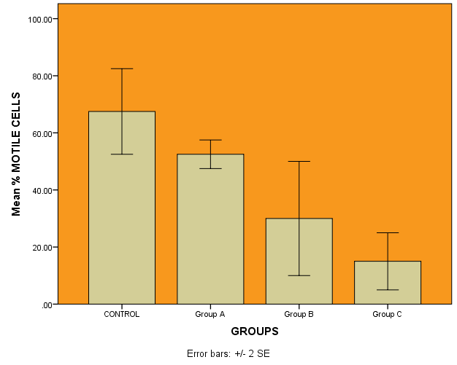
Figure 1. A bar chart showing the varying differences and error margin of mean percentage of alkaline phosphatase between and within the groups

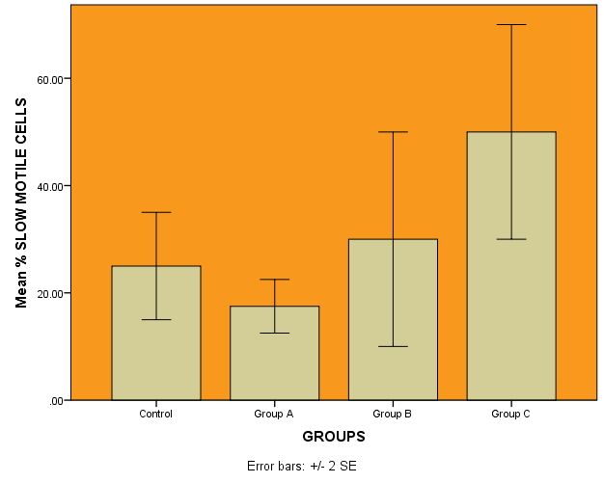
Figure 2. A bar chart showing varying and inconsistent differences of the man percentage and error margin of slow motile cells between and within groups.

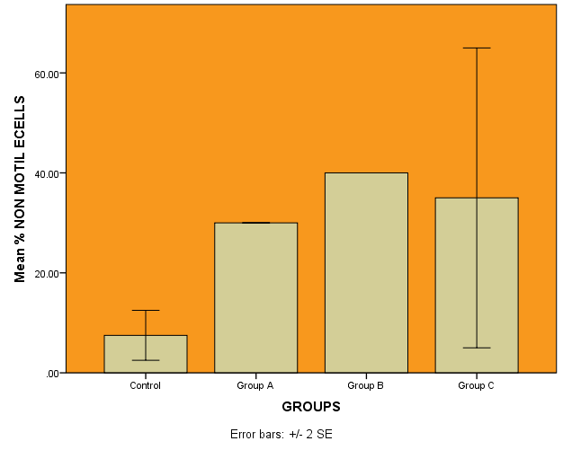
Figure 3. A bar chart showing varying and inconsistent differences and error margin of the mean percentage of non motile cells between and within groups

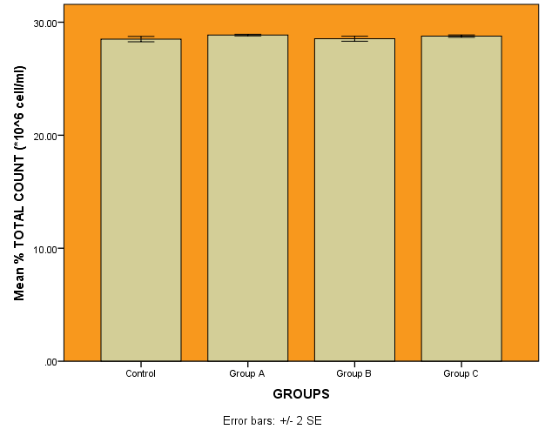
Figure 4. A bar chart showing the seemingly differences of the mean percentage and error margin of the total cell count between and within groups

4.2 LIVER FUNCTION TEST
These results show the level of concentration of biomarkers that are yardstick to assessing the possibility of liver damage. These liver parameters that are normally found in the liver and help in the breakdown of other protein as well as triggering chemical reactions that the body needs to function if were seen in excess in the bloodstream was indicative of the liver damage caused by monosodium glutamate administration

Table 3: Descriptive of the statistical analysis on the liver function parameters. This result gives informational data about the mean, standard deviation, standard error and the interval of mean between the groups.
 |  | N | Mean | Std.  Deviation | Std.  Error | 95% Confidence Interval for Mean |  | Minimum | Maximum
 |  |  |  |  |  | Lower Bound | Upper Bound
ALP  $${(μg}/{L)}$$ | 1  2  3  4  Total | 2  2  2  2  8 | 13.5400  17.4200  26.2200  33.1200  22.5750 | 1.21622  1.21622  9.75807  3.90323  9.09309 | .8600  .8600  6.90000  2.76000  3.21489 | 2.6127  6.4927  -61.4528  -1.9491  14.9730 | 24.4673  28.3473  113.8928  68.1891  30.1770 | 12.68  16.56  19.32  30.36  12.68 | 14.40  18.28  33.12  35.88  35.88
ALT  $${(μg}/{L)}$$ | 1  2  3  4  Total | 2  2  2  2  8 | 12.709050  26.443150  32.010400  50.020050  30.295663 | 3.5593634  5.0448533  2.8284271  11.6418768  15.1840991 | 2.5168500  3.5672500  2.0000000  8.2320500  5.3683897 | -19.270561  -18.883059  6.597991  -54.578063  17.601438 | 44.688661  71.769359  57.422809  154.618163  42.989887 | 10.1922  22.8759  30.0104  41.7880  10.1922 | 15.2259  30.0104  34.0104  58.2521  58.2521
AST  $${(μg}/{L)}$$ | 1  2  3  4  Total | 2  2  2  2  8 | 28.502100  28.862250  28.536250  28.767700  28.667075 | .1654630  .0515481  .1563413  .0770746  .1872811 | .1170000  .0364500  .1105500  .0545000  .0662139 | 27.015474  28.399109  27.131579  28.075212  28.510504 | 29.988726  29.325391  29.940921  29.460188  28.823646 | 28.3851  28.8258  28.4257  28.7132  28.3851 | 28.6191  28.8987  28.6468  28.8222  28.8987
Table 4: ANOVA for Liver Function Parameters. This gives data about the information concerning the mean square, sum of squares and the significant difference between groups with p-value (p<0.05)
 |  |  | Sum of Squares | Df | Mean Square | F | Sig.
ALP (µg/L) |  | Between Groups | 465.377 | 3 | 155.126 | 5.471 | .067
 |  | Within Groups | 113.414 | 4 | 28.353
 |  | Total | 578.790 | 7
ALT (µg/L) |  | Between Groups | 1432.245 | 3 | 477.415 | 10.513 | .023
 |  | Within Groups | 181.653 | 4 | 45.413
 |  | Total | 1613.898 | 7
AST (µg/L) |  | Between Groups | .185 | 3 | .062 | 4.085 | .104
 |  | Within Groups | .060 | 4 | .015
 |  | Total | .246 | 7

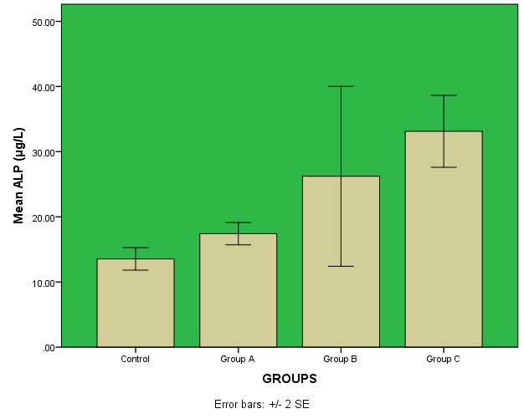
Figure 5. A bar chart showing varying differences of the mean of alkaline phosphatase and the error bar between and within the groups

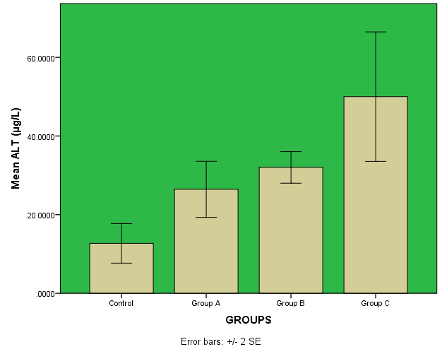
Figure 6: A bar chart showing varying differences of the mean of alanine transaminase and the error margin between and within groups

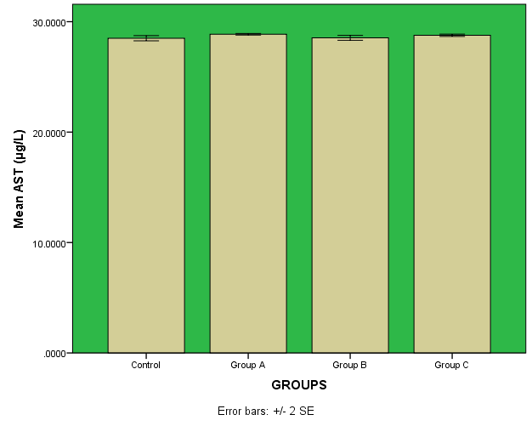
Figure 7. A bar chart showing the seemingly differences of the mean of aspartate aminotransferase and error margin between and within groups

4.3 TESTICULAR HORMONE
Table 5: Descriptive of the Statistical Analysis of the Testicular Hormonal Parameters. This table gives the mean between the two animals in a group, their standard deviation and standard error of mean. It also gives the interval for mean
 |  | N | Mean | Std. Deviation | Std. Error | 95% Confidence Interval for Mean |  | Minimum | Maximum
 |  |  |  |  |  | Lower Bound | Upper Bound
L.H | 1 | 2 | .8050 | .00707 | .00500 | .7415 | .8685 | .80 | .81
 | 2 | 2 | .7150 | .04950 | .03500 | .2703 | 1.1597 | .68 | .75
 | 3 | 2 | .9200 | .05657 | .04000 | .4118 | 1.4282 | .88 | .96
 | 4 | 2 | .8200 | .07071 | .05000 | .1847 | 1.4553 | .77 | .87
 | Total | 8 | .8150 | .08701 | .03076 | .7423 | .8877 | .68 | .96
F.S.H | 1 | 2 | 1.2400 | .02828 | .02000 | .9859 | 1.4941 | 1.22 | 1.26
 | 2 | 2 | .8100 | .11314 | .08000 | -.2065 | 1.8265 | .73 | .89
 | 3 | 2 | 1.4650 | .06364 | .04500 | .8932 | 2.0368 | 1.42 | 1.51
 | 4 | 2 | 1.2500 | .04243 | .03000 | .8688 | 1.6312 | 1.22 | 1.28
 | Total | 8 | 1.1913 | .25958 | .09178 | .9742 | 1.4083 | .73 | 1.51
Testosterone | 1 | 2 | 1.6550 | .06364 | .04500 | 1.0832 | 2.2268 | 1.61 | 1.70
 | 2 | 2 | .8800 | .02828 | .02000 | .6259 | 1.1341 | .86 | .90
 | 3 | 2 | 1.6950 | .17678 | .12500 | .1067 | 3.2833 | 1.57 | 1.82
 | 4 | 2 | 1.6350 | .03536 | .02500 | 1.3173 | 1.9527 | 1.61 | 1.66
 | Total | 8 | 1.4663 | .36986 | .13077 | 1.1570 | 1.7755 | .86 | 1.82

 |  | Sum of Squares | df | Mean Square | F | Sig.
L.H | Between Groups | .042 | 3 | .014 | 5.271 | .071
 | Within Groups | .011 | 4 | .003
 | Total | .053 | 7
F.S.H | Between Groups | .452 | 3 | .151 | 31.002 | .003
 | Within Groups | .019 | 4 | .005
 | Total | .472 | 7
Testosterone | Between Groups | .920 | 3 | .307 | 32.851 | .003
 | Within Groups | .037 | 4 | .009
 | Total | .958 | 7
Table 6: ANOVA for the Testicular Hormone Parameters. This table gives information about the mean square, the sum of squares and the significant differences of the parameters between the groups with p-value (p<0.05)

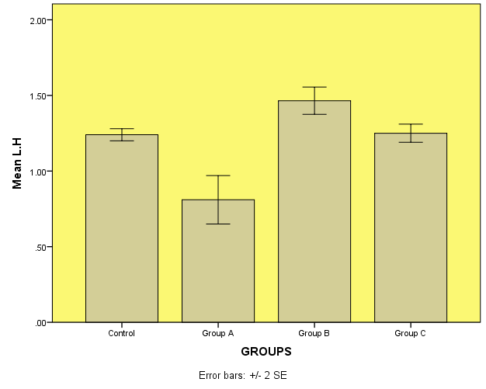
Figure 8. A bar chart showing varying and inconsistent differences and error margin of the mean of luteinizing hormone between and within the groups

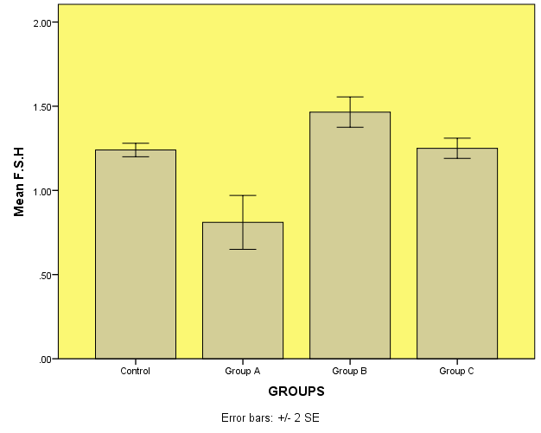
Figure 9. A bar chart showing varying and inconsistent differences and error margin of the mean of follicle stimulating hormone between and within groups

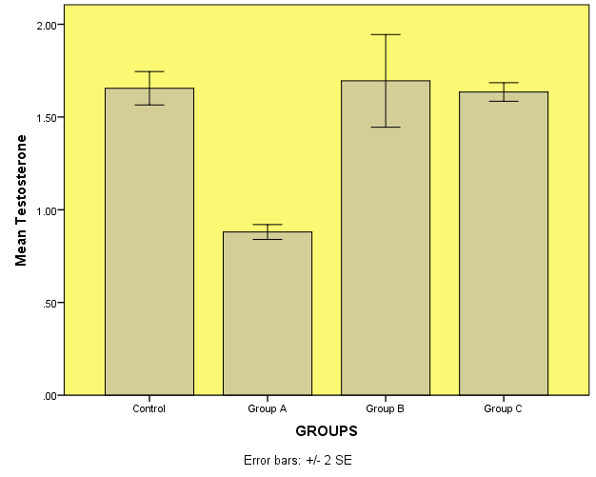
Figure 10. A bar chart showing varying and inconsistent differences and error margin of the mean of testosterone between and within groups

4.4 HISTOPATHOLOGICAL EXAMINATION OF THE LIVER
This examination helps to find out through a photomicrograph the monosodium glutamate effect on the liver. It applied H&E staining technique. At the end of the study, sections of the liver were collected and viewed through a microscope and these were the findings.

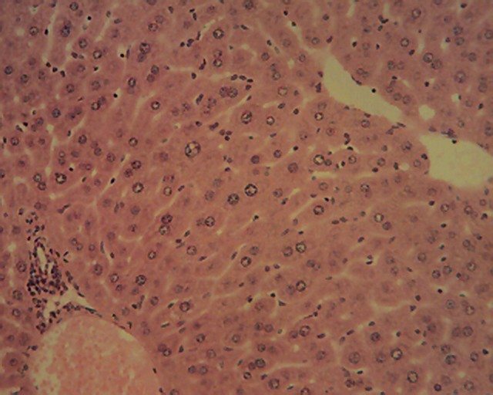
hv
bd
C
Figure 11. (Control) A photomicrograph of a section of liver of experimental animal showing normal hepatic Histomorphology. The tissues sections showed numerous normal hepatic lobules, containing normal hepatocytes (arrow) arranged in radiating interconnecting cords around the central veins (C). hepatic veins (hv), bile duct (bd). H&E x 160

C
bd
hv

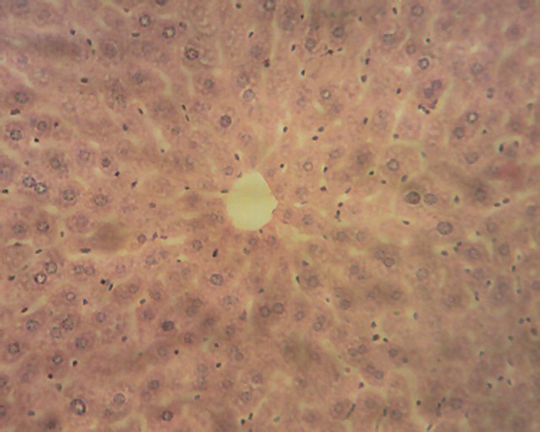
C
Figure12. (Group A) A photomicrograph of a section of Liver of experimental animal showing histomorphological changes consistent with mild hepatotoxicity. The hepatocytes in the centrilobular region, (i.e around the central veins) those in the mid-zonal areas and outer periportal areas of the hepatic lobules appeare swollen. They also contain numerous small clear vacuoles in their respective cytoplasm. Central veins (C). H&E x160

BD
HV
C
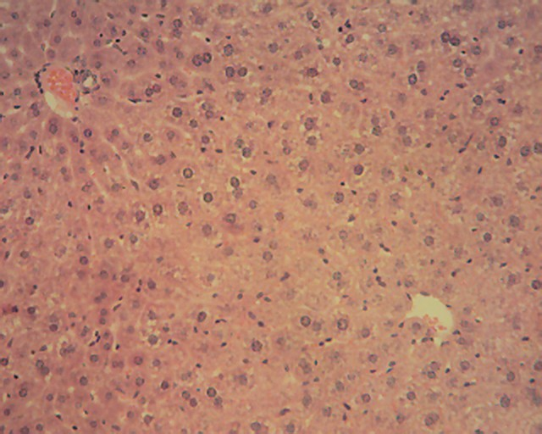
Figure 13. (Group B) A histomicrograph of a section of Liver of experimental animal showing histomorphological changes consistent with toxicity. The hepatocytes in the centrilobular region, (i.e around the central veins) and those in the mid-zonal areas and outer periportal areas of the hepatic lobules showing lesions of micro-vesicular steatosis. The individual cells appearing swollen, partially occluding the adjacent sinusoidal spaces and containing numerous small clear vacuoles in their respective cytoplasm. Hepatic veins (hv), bile duct (bd), central veins (C). H&E x160
C

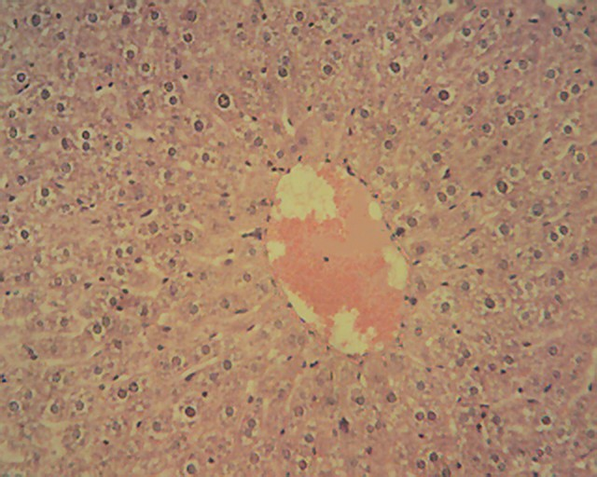
Figure 14. (Group C) A photomicrograph of a section of liver of experimental animal showing similar histopathological changes consistent with toxicity. The hepatocytes in the centrilobular region (i.e around the central veins) and those in the mid-zonal areas and outer periportal areas of the hepatic lobules showing lesions of micro-vesicular steatosis. Central veins (C). H&E x160
C
C
BD
HV
C
C
4.5 HISTOPATHOLOGICAL EXAMINATION OF TESTES
Samples of the testes collected from the animals in all the experimental groups [groups A, B, C & Control] showed the normal testicular histo-architecture for laboratory rodents. Each examined section showed numerous normal seminiferous tubules lined by a stratified epithelium of spermatogenic cells and Sertoli cells.

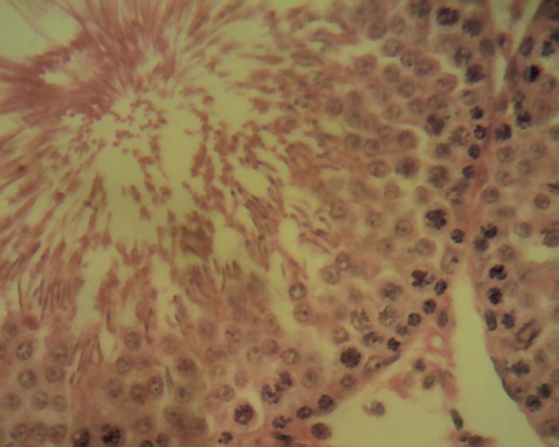
SP
SC
SM
ST
L
Figure 15. (Control) A photomicrograph showing normal testicular histo-architecture for laboratory rodents.
C

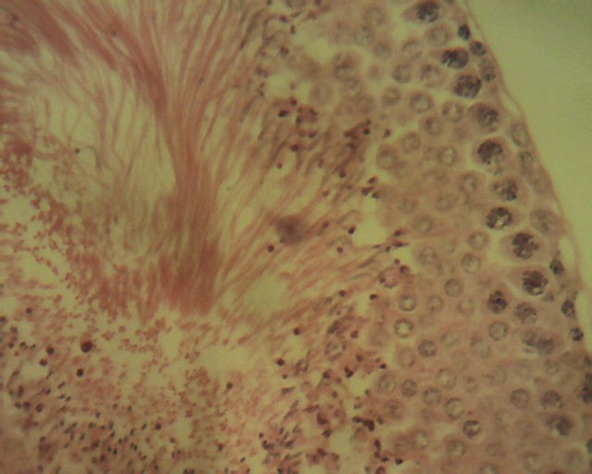
L
ST
SM
SC
SP
Figure 16. (Group A). A photomicrograph showing normal testicular histo-architecture for laboratory rodents.

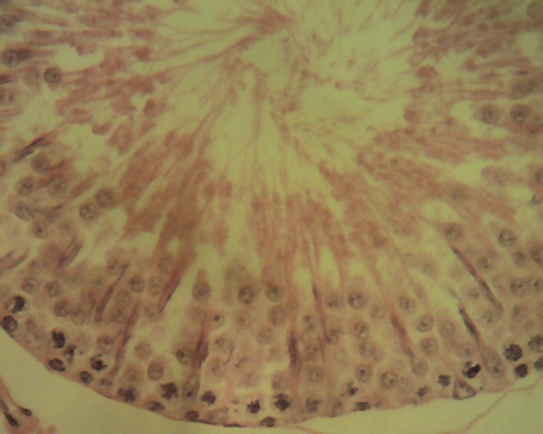
SP
SC
SM
ST
L
Figure 17. (Group B). A photomicrograph showing normal testicular histo-architecture for laboratory rodents.

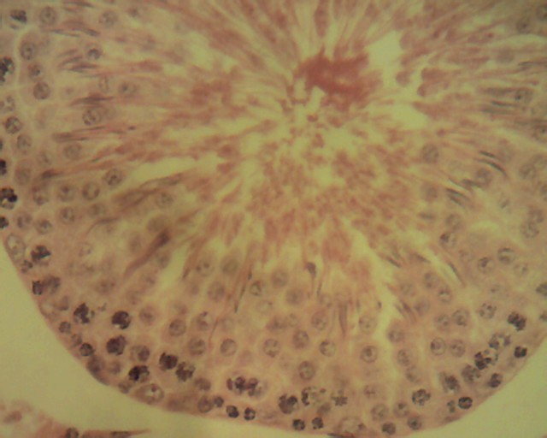
SC
SP
SM
ST
L
Figure 18. (Group C). A photomicrograph showing normal testicular histo-architecture for laboratory rodents.

CHAPTER FIVE
5.1 DISCUSSION
MSG gained popularity in first half of twentieth century as taste enhancer but at the same time doubts were raised about MSG as a causative agent of Chinese Restaurant Syndrome, Extensive research were been carried out on different types of animals including human to clear the doubts. It was observed that infant mice on account of poorly developed blood brain barrier showed neurological lesions even when MSG was given in lower dose (Olney, 1970).
Different workers applied different routes of administration though subcutaneous and intraperitoneal injections were the most preferred routes. (Takasaki, 1978). A maximum intake of 60 mg/kg b.w is regarded safe for human consumption (Walker, 1978). Some researchers reported that MSG taken with food showed no adverse effect (Stegink, 1985).
Where, Marasie, observed that according to the national institute of health, male infertility involved approximately 40% of infertile human couple and the environmental causes represent one of the major factors affecting male fertility Marcia, (2007). Moore mentioned that monosodium glutamate (MSG) is known to affect the structure and function of male reproductive system and showed to be toxic to the liver and testis of human and experimental animal (Moore, 2003).
Easy handling, early sexual maturity, large litter size and high sensitivity to MSG etc made wistar rat preferred animal. The experiment can be repeated easily hence we selected wistar rats as the experimental animal. We used oral administration through the mouth route in doses of 8 mg/g b.w, 12mg/g b.w and 16mg/g b.w (Bhattacharya, T. 2011) and Hamaska, (1986) administered 2mg/g b.w (subcutanous) for 5 days after birth, after neo-natal exposure. A dose schedule different from ours. While Bahttacharya made dose schedule of alternate days to avoid acute toxic effect, ours were maintained for the different treatment groups but volume of MSG solution was based on individual weight.
In the present study the liver of experimental animals showed histomorphological changes consistent with hepatotoxicity from mild-hepatotoxicity to change consistent with toxicity. The hepatocytes in the centrilobular region (i.e around the central veins) and those in the mid-zonal areas and outer periportal areas of the hepatic lobules appear swollen and contains numerous small clear vacuoles in their respective cytoplasms as can be seen in figure 12. There was then a histomorphological changes consistent with toxicity as can be seen in figure 13. The hepatocytes in the centrihobular region (i.e around the central veins) and those in the mid-zonal areas and outer periportal area of the hepatic lobules show lesions of micro-vesicular steatosis. The result was in agreement to the report by Eweka who reported disruption of architecture of liver and evidence of hepatocyte degradation and hypertrophy as a response of oral MSG in adult wistar rats (Eweka, 2011). The histopathological changes in figure 14 showed similarity with the changes seen figure 13 with consistency in toxicity.
Meanwhile, some sensitive markers were pointers to the effect of MSG on the liver. The ALT enzyme is a sensitive maker of liver damage (AL-Mamary et al., 2002). Therefore, the increase in the serum ALT activity observed in rats that were fed MSG at the tested dose as evidenced in figure 6 with (p<0.05) may perhaps be an indication of liver damage. MSG could dissociate easily to release free glutamate. The deamination of GLU produces ammounium ion ${(NH}_{4}^{+})$ that could be toxic unless detoxified in the liver via the reaction of the urea cycle. Thus, the possible ammonium ion overload that may occur as a result of an increased level of glutamate following MSG intake could damage the liver, consequently releasing the ALT enzyme that may lead to its observed elevation. The result seemingly agrees with the reports of Farombi and Onyema (Farombi and Onyema, 2006) and Onyema et al (2006) that the activity of serum ALT increased in male rats that were fed MSG probably due to MSG induced oxidative stress in the livers. Thus, it could be concluded that during the treatement of liver disorders, MSG should be avoided as it may be hepatotoxic at a low dose. Furthermore, since ALT was a strong positive indicator of insulin resistance, diabetes mellitus and obesity (Chung et al., 2003) which are risk factors for coronary heart disease (Grundy, 1999; Haffner, 1998; Wilson, et al., 1999),
The seemingly stability in the serum AST activity observed in rats that were fed MSG at the tested dose may indicate absence of adverse effect of MSG intake in myocardial infarction as suggested by Rodwell and Kennelly (2003) and also predicting no damage to the liver and other organs with high metabolic activities (including the brain, heart and lungs) as reported by Bain (2003).
However, the increase in the serum ALP activity observed in rats that were fed MSG at the tested dose may indicate adverse effects of MSG intake on the pathologies of the bone since increased serum ALP activity has been associated with bone diseases (Bush, 1991). This finding however agrees with previous reports in TILC (Anonymous 2004 a, b) that the oral intake of MSG caused stunted bone development in rats. It also agrees with the report of Elefteriou et al., (2003) that MSG treatment caused hypogonadism, a condition inducing bone loss in mice.
The findings however, neither agrees with the previous report by Egbuonu et al, (2009) that the signifcant reduction in serum ALP activity by MSG perhaps indicate the absence of cholestasis (lack of bile flow). It was also reported by Kaneko (1989). Cholestasis may result from the block age of the bile duct, or from a disease that impairs bile formation in the liver itself (Stegink et al., 1985). Thus, due to the involvement of bile duct in the liver, there is the possibility of blockage of this bile duct that could result to the cholestasis.
Meanwhile, there was normal histo-achitecture of the testes collected from the animals in all the experimental groups (group A,B,C and Control). Each examined section showed numerous normal seminiferous tubules lined by a stratified epithelium spermatogenic cells and sertoli cells. This was not in agreement with Ismail whose section of testes of rats give a daily dose of MSG 8mg/g b.w for 90 days depicted severely damaged of seminiferous tubules where majority of the seminiferous tubules exhibited, severely atrophied. Malformed semininferous tubules, and hyaline material in the intertubular connective tissues. Exfoliated spermatids appeared in the lumena due to cellular debris in some tubules and sloughing in other tubules (Ismail, 2012).
Meanwhile, each examined section in the present study showed numerous normal seminiferous tubules lined by a stratified epithelium of spermatogenic cells and sertoli cells. The spermatogenic cells undergo a series of division to give rise to spermatozoa.
The second function of testis is the production of hormones and reproduction is controlled by the gonadotrophins (LH and FSH). Analysis of plasma hormone levels LH, FSH, and testosterone carried out showed significant difference on F.S.H and testosterone between groups as seen in table 6. Luteinizing hormone revealed no significant difference between the groups.
The present study also showed a reduction in the sperm viability of rats treated with MSG in close dependent level compared to the control. MSG administration on treated groups showed significant difference in the mean percentage of motile cells as seen in figure 1. No significant difference was observed in the mean percentage of slow motile cell observed in the groups treated with MSG as there was no gradual increase in the percentage of cells compared to control but increase can be observed between the treatment groups. There was inconsistency in the mean percentage of non motile cells as there was a descent of group C. However, there was close relatedness between the groups, in their mean percentage of total cell count compared to the control as seen in figure 4. This was in agreement with Oforofuo et al (1997) and Nayanatara et al (2008) who mentioned that… and MSG induced decrease in the sperm count.

5.2 CONCLUSION
The results of the present investigation have shown that monosodium glutatmate (MSG) at low doses has the potential of producing alteration in the liver. This alteration appear in the liver probably because this organ is mainly responsible for detoxification of foreign compounds in the body. The examined liver sections strongly suggest that the test agent at the selected doses may have a detrimental effect on the liver. This is evidenced by the cytoplasmic changes observed in the hepatocytes of the treated groups. These observed changes are characteristic of fatty liver disease, otherwise known as steatosis. This is a degenerative change and if not treated, would progress to cell death (necrosis). Thus, it could be concluded that during the treatement of liver disorders, MSG should be avoided as it may be hepatotoxic at a low dose. Furthermore, since ALT was a strong positive indicator of insulin resistance, diabetes mellitus and obesity which are risk factors for coronary heart disease, the use of MSG at low dose should not be encouraged because of the possible untoward health implications.
In the testes, normal histomorphological structures were observed in all the experimental groups. The observed seminiferous tubules were in active spermatogenic stages, thus it can be suggested the test agent at the test doses may not have a detrimental effect on the testicular function. However, there was an effect in the sperm analysis. The motility of sperm cells which is vital for fertilization was adversely affected thus monosodium glutamate consumption can affect fertility negatively. Its consumption should be minimized if not completely avoided to curb its deleterious effect to the hepatocytes and male fertility.

REFERENCES
Albert Neuberger (1936). “Dissociation constants and structures of glutamic acid and its esters”. Biochemical Journal. 30: 2085-2094.
Al-Mamary, M., Al-Habori, M., Al-Aghbari, A.M., and Baker, M.M. (2002). Investigation into the toxicological effects of Catha edulis leaves: a short-term study in animals. Phytoetherapy Research Journal. 16: 127-132.

Alt.Tox.org (2011). Genotoxicity: validated. Non-animal Alternatives. Accessed 15 april, 2018. Alttox,org/map/toxicity-endopoints-tests/genotoxicity/.
Augustin, H. (2007). “Non-vesicular Release of Glutamate by Glial XCT Transporters suppresses Glutamate Receptor clustering in vivo”. Journal of Neuroscience 27:111-123.
Bain, P.J. (2003). In: Latimer KS, Mahaffrey EA, Prasse KW, eds. Duncan and Prasse’s Veterinary Laboratory Medicine: Journal of Clinical Pathology. Fourth edn. Lowa State Press. pp. 193-414.
Basil, N., Alkaade, S., and Morley, J.E. (2009). “the benefits and risks of testosterone replacement therapy a review”. Journal of therapention and Clinical Risk Management. 5: 427-48.
Betringer, R.R., Finegold, M.J., and Cate, R.L. (1994). Mullerian inhibiting Substance funcftion During mammalian sexual Development. Journal of cell. 79:415-425.
Bhattacharya,T., Bhakta, A., and Ghosh, S. K. (2011). Long term effect of monosodium glutamate in liver of albino mice after neo-natal exposure. Nepal Medical College Journal. 13: 11-16.
Bjorndahl, L., Soderlund, I., and Kvist, U. (2003). Evaluation of the one-step eosin-nigrosin staining techniques for human sperm vitality assessment. Human Reproduction Journal. 18(4):813-6.
Brain, K., and Jacquelyn, C. Liver function tests in Healthline. Accessed 27 April, 2018. www.healthline.com/health/liver-function-tests
Brennan, J., and Capel, B. (2004). One tissue, two fates: Molecular genetic events that underlie testes versus ovary development. Journal of Natural Reviews genetics 5: 509521.
Burke, D., and Wu, B. Aspartate Aminotransferase (AST) Test in healthline. Accessed 27 April, 2018. www.healthline.com/health/ast
Bush, B.M. (1991). Interpretation of laboratory results for small animal clinicians. Blackwel Scientific Publications. Oxford.

Butter worth, M., Creasy, D., and Timbrell, J.A. (1995). The detection of subchronic testicular damage using urinary creatine: studies with 2-methoxyethanol. Journal Archives of Toxicology. 69:209-11.
Chapin, R.E., Norton, R.M., Popp, J.A., and Bus, J.S. (1982). The effects of 2,5-Hexanedione on eproductive Hormones and Testicular enzyme-Activities in the F344 rat. Journal Toxicology and Applied pharmacology 62: 262-272.
Chin, K.W., Garriga, M.M., and Metcalfe, D.D. (1989). The Histamine content of oriental foods. Journal of food and Chemical Toxicology. 27:2830287.
Christensen, A.K. Photographs of rat testicular development. University of Michingan. Accessed 15 April, 2018. www.personal.umich.edu/~akc/testisdev.htm.
Clarkson, M.J., and Harley, V.R. (2002). Sex with two sox on: SRY and SOX9 in testis development. Journal of trends in endocrinology and Metabolism. 13:106-111.
Cool, J., Carmona, F.D., Szucsik, J.C., and Copel, B. (2008). Peritunular myoid cells are not the migrating population required for testis cord formation in the XY Gonad. Sexual Development. Journal 2: 128-133.
Dabs, M., and Dab, J.M. (2000). Heros, rogues and lovers: testosterone and behavior. New York: McGraw Hill.
Dr. Spencer Nadolsky. How Much Protein should you Eat per Day. In health line. Accessed 19 April, 2018. www.healthline.com/nutrition/how-much-protein-per-day.
“Definition of Toxicity” by Merriam Webiter Dictionary updated 30 march,2018.Accessed 11 April, 2018. https://www.merriam-webster.com/dictionary/toxicity.
Edgar, A. D., Tomkiewicz, C., Costet, P., legendre, C., Aggerbeck, M., Bouguet, J., staels, B., Guyomard, C., Pineau, T., and Barouki, R. (1998). Fenofibrate modifies transminase gene expression via a peroxisome proliferator activated receptor alpha-dependent path way. Journal of Toxicology letter. 98:13-23.
Egbuonu, A.C.C., Obidoa, O., Ezeokonkwo, C.A., Ezaeanyika, L.U.S., and Ejikeme, P.M. (2009). Hepatotoxic effects to low dose oral administration of monosodium glutamate in male albino rats. African Journal of Biotechnology 8(13): 3031-3035.
Ekaluo, U.B., Ikpeme, E., and Udokpoh, A.E. (2009). Sperm head abnormality and mutagenic effects of aspirin, paracetamol and caffeine containing analgesics in rats. International Journal of toxicology 7:1-9.
Ekaluo, U.B., Udokpoh, A.E., Ikpeme, E.V., and Peter, E.U. (2008). Effect of chloroqwne treatment on sperm count and weight of testes in male rats. Global Journal of Pure Applied Science 11:81-84
Elefteriou, F., Takeda, S., Liu, X., Armstrong, D., and Gerard, K. (2003). Monosodium glutamate-sensitive hypothalamic neurons contribute to the control of bone mass. Journal of Endocrinology. 144 (9): 3842-3847.
Ellis, M.E. “ ALP(Alkaline Phosphatase Level) Test” in healthline. Accessed 27 April, 2018. www.healthline.com/health/alp

Eweka A. O., and Om’lniabohs F. A. E. (2011). Histochemical studies of the effects of Monosodium glutamate on the liver of wistar rats. Annals of Medicine and Health Science Research Journal. 1: 21-9

Farombi, E.O., and Onyema, O.O.(2006). Monosodium glutamate induced oxidative damage and genotoxicity in rat: modulatory role of vitain C, vitamin E and quercetin. Journal of Human Experimental Toxicology. 25:251-259.
FDA (2009) FDA guidance for industry. Drug-induced liver injury. Premarketing clinical evaluation. Accessed 6 June, 2018. <www.fda.gov/Drugs/guidancecomplianceregulatoryinformation/guidances/ucmo64993.htm>.
FDA (2017). Food code: Accessed 29 July 2018. http://www.fda.gov/downloads/food/guidance regulation/retail food pritection/food code/ucms 595140. pdf.
Grabowska, A., Nowicki, M., and Kwinta, J. (2011). “Gltamate dehydrogenase of the germinating triticole seeds: Gene expression activity distribution and kinetic characteristics.” International journal of Acts physiologiae plantarum. 33:1981-1990.
“Glutamate Receptors and their characterization.” Learning and Memory. Retrieved 5 April, 2018 from encyclopedia.com :http://www.encyclopedia.com/psychology/encyclopedias-almanacs-transcripts-and-maps/glutamate-receptors-and-their-characterization.
Hamaoka, K., and Kusunoki, T. (1986). Morphological and cell proliferative study on the growth of visceral organs in monosodium Lglutamate–treated obese mice. Journal of Nutritional Science and Vitaminology. 32: 395-411.

Handelsman, D.J. (2013).”Androgen physiology, pharmacology and Abuse. Endotext [internet]. Accessed 10 June, 2018. www.ncbi.nlm.niti.gov/books/NBK279000/.
Horatill, V., and Vinerean D.V.M. “Rats-Biology and Husbandry” Floride international University. Accessed 23 April, 2018. Research.fill.edu/documents/facilities/acf/documents/rats-biology-husbandry.pdf.
HSDB: Monosodium Glutamate in U.S. national Library of Medicine. Accessed 17 April 2018. Https://toxnet.nlm.nih.gov/cgi-bin/sis/search2/r?dbs+hsdb:@termt@rnt@rel+142-47-2.
Ikeda, k.(1908). New Seasonings. Oxford Journals of Chemical Senses. 29: 847-849

International Glutamate Information Service (IGIS) on Scientific Evaluations of MSG. accessed 17 June, 2018. www.glutamate.org/safty/scientific-evaluations.
Ismail, N. H. (2012) Assessment of DNA Damage in Testes from Young Wistar Male Rat Treated with Monosodium Glutamate. Life Science Journal.;9(1)

IUPAC Gold Book on Acute Toxicity. Accessed 11 April, 2018. Goldbook.iupac.org/html/A/ATO6800.html.
Johnson, M.H.(2007). Essential Reproduction. Oxford, Bladcwell publishing Ltd.
Karla, B. “ALT (Alanine Aminotransferase) Test” in healthline. Accessed 27 April. 2018. www.healthline.com/health/alt
Klein, G., Sjogren, O.H., Klein, E., and Hellstrom, K.E. (1960). Demonstration of Resistance against Methylcholoanthrene induced sarcomas in the primary autochthonous host. Cancer Research Journal 20: 1561-72.
Lindblom, O., Rafter, I., Copley, C., Andersson, U., Hedberg, J.J., Berg, A., Samuelsson, A., Hellmold, H., Cotgreave, I., and Glinghammar, B. (2007). Iso-forms of alamine amino-transferase in human tissues and serum-differential tissue expression using navel antibodies. Archives of Biochemistry and Biophysics Journal 466:66-77.
Liu, L., Yoshimura, T., Endo, K., Kishimoto, K., Fuchi-Kami, Y., Manning, J. M., Esaki, N., and Soda, K. (1998). “compensation for D-Glutamate anxotrophy of Escherichie coli WM335 by D-amino acid aminotransferase gene and regulation of murl expression”. Journal of Bioscience Biotechnology and Biochemistry 62:193-195.
Luetjens, C.M., and Weinbauef, G.F. (2012). “charpter 2: Testosterone Biosynthesis, transport, metabolism and (non-genomic) actions.” In Nieschlag, E., Behre, H.M., and Nieschlag, S. Testosterone: action, deficiency, Substitution (4th ed). Serum testosterone in women as measured by an automated Immunoassay and a RIA”. Journal clinical Chemistry 50:678; author reply 678-9.

Marcia, C. (2007). Masculinity, Reproduction and male infertility in the Middle East. Journal of Middle East Women Studies, 3(3), pp 1-20.

Mathew, A., Varkey, A., and Eldo, A.N. (2008). cytotoxic and genotoxic effect of ajinomoto (monosodium Glutamate) on Allium cepal.root meritems. Journal of Ecology, Enviroment and Conservation 14(1): 119-122.
Mayo Clinic (2005) Liver function tests. Accessed 27 April, 2018. www.mayoclinic.org/test-procedures/liver-function-tests/about/pac-20394595
McEntee, W.J., and Crook, T.H. (1993). “Glutamate: its role in learning, memory, and the aging brain.” Journal of psychopharmacology 11:391-401.
Meldrum, B.S. (2000). “Glutamate as a neurotransmitter in the brain: Review of Physiology and pathology.” The Journal of nutrition 130:1007S-1015S.
Melina, R. (2010). Why do medical Researchers use Mice? In live science Accessed 20 April, 2018. www. Live science.com/32860- who-do-medical-researchers-use-mice.html.
Mooradian, A.D., Morley, J.E., and Korenman, S.G (1987). “Biological actions of androgens”. Oxford Journal of Endocrine Reviews 8:1-28.

Moore, K.L. (2003). Congenital Malformations Due to Environment in Developing Humans. 2nd ed. Philadelphia, W.B. Saunders co. Ltd., pp. 173-183.

MSDS Hyper Glossary on Acute Toxicity Safty emporium.Accessed 11 April, 2018. http://en.wikipedia.org/wiki/Acute_toxicity#cite_notemsds-1.
Muser, G. “Rat” in Encydopaedia Britannica. Accessed 20 April, 2018. www.britannica.com/animal/rat.
Nayanatara, A., Vinodini, N., Damadar, G., Ahemed, B., Ramaswamy, C., Shabarinath, M., and Bhat, M. (2008). Role of ascorbic acid in monosodium glutamate mediated effect on testicular weight sperm morphology and sperm count in rat testis, Journal of Chinese Clinical Medicine. 3: 1–5.
NCBI Gene (2018) INSL 3 insulin liki 3 [Homo scpiens (human)]. Accessed 10 June, 2018. www.ncbi.nlm.nil.gov/gene?Db=gene&Cmd=showDetailView&termtoSearch=3640.
Nomenclature and Symbolism for amino Acids and Peptides”. NPAC-IUB joint Commission on Biochemical Nomenclature 1983.accessed on 4 April, 2018.www.sbcs.qmulrac.wk/iupac/Amino Acid/AA1n2.html.
Nutrition Digest (1995). Reviews of Excitotoxins: The taste that kills. Publisher American Nutrition Association Volume 38: accessed 5 April, 2018. www.american nutrition association.org/newsletter/review-excitotoxins-taste-kills.
Ofofrofuo, I.A.O., Onakewhor, J.U.E., and Idaewor, P.E. (1997). The effect of chronic administration of monosodium glutamate on the histology of the adult wistar testes. Bioscience Resource Communication Journal. 9: 6-15.
Okubo, Y., Sekiya, H., Namiki, S., sakamoto, H., Linuma, S., Yamasaki, M., Watanabe, M., Hirose, K., and Lino, M. (2010). Imagining extrasynotic glutamate dynamics in their brain. Journal proceedings of the National academy of Sciences 107:6526-65.
Olney, J.W., and Ho ,O. (1970). Brain Damage in Infant Mice following Intake of Glutamate, Aspartate or Cysteine. International Journal o Science on Nature. 227: 609-611
Onyema, O.O., Farombi, E.O., Emerole, G.O., Ukoha, A.I., and Onyeze, G.O. (2006). Effect of vitamin E on monosodium glutamate induced hepatoxicity and oxidative stress in rats. Indian Journal of Biochemistry and Biophysics. 43: 20-24.

Ozer, J., Ratiner, M., Shaw, M., Bailey, W., and Shomaker, S. (2008). The current state of serum biomarkers of hepatotoxicity. Journal of Toxicology 245:194-205.
Piffer, R.C., Gorcia, P.C., Gerardin, D.C.C., Kempinas W.G., and Pereira, O.C.M. (2009). Semen parameters, fertility and testosterone levels in male rats exposed prenatally to betamethasone. Journal of Reproductive fertility and Development 21: 634-639.
Pub. Med. Health. How does the liver work. Last update: August 22, 2016. Accessed on 14 April, 2018. www.ncbi.nlm.nil.gov/pubmedhealth/PMH0072577/.
Ratman, S., and Frankel,S. (1957). A colorimetric method for determination of serum glutamate oxaloacetate and glutamic pyruvate transaminsae. America Journal for Clinical Pathology 28:56-58.
Reeds, P.J., Burrin, D.G., Stoll, B., and Jahoor, F. (2000). “Internal Glutamate Metabolism.” Journal of nutrition 978s-982s.
Rock ett, J.C., and Kim, S.J. (2005). Biomarkers of reproductive toxicity. Journal of Cancer Biomarkers 1: 93-108.
Rodante, F., and Marrosu, G. (1989). “Thermodynamics of the second proton dissoaction process of nine x-amino-acids and the third ionization process of glutamic acid, aspartic acid and tyrosin.” Journal of Themochimica Acts.141:297-303.
Rodwell VW, Kennelly PJ (2003). Enzymes: Mechanism of action In: Murray, R.K., Granner, D.K., Mayes, P.A. and Rodwell, V.W. ed Harper’s Illustrated Biochemistry 26th edn Lange Medical Books/McGraw-Hill, New York. chap 7, p. 57.

Russell, L.D., Bartke, A., and Goh, J.C. (1989). Postnatal-Development of the Sertoli- Cell Barrier, tubular lumen, and cytoskeleton of sertoli and Myoid Cells in the Rat, and their Realtionship to tubular Fluid secretion and Flow. American Journal of Anatomy. 184:179-189.
Samuels, A. (1999). “The toxicity/safety of MSG: A study in superssion of information.” Journal of Accountability in Research: 6: 259-310.
Schwartz, G.R. (1992). Parallels Between FDA Handling of MSG, Breast Implants. Food chemical News volume 33.
Seed, J.., chapin, R.E., Clegg, E.D., Dpstal, L.A., Foote, R.H. Hurtt, M.E., Klinefelter, G.R., Markeris, S.L., Perreault, S.D., Schrader, S., Seyler,D., Sprando, R., Treinen, K.A., Vecramachaneni, D.N.R., and Wise, L.D. (1996). Methods for assessing sperm motility, morphology and counts in the rat, rabbit and dog: A consensus report. Journal of Reproductive Toxicology 10: 237-244.
Setchell , B. (1970). Testicular Blood supply, lymphatic Drainage, and Secretion of Fluid. In Johnson, A.D., Gomes, W.R., and Vandemark, N.L. (Eds). The Testis. New York, Academic press.
Shan, L., Gao, H., and Hardy, M.P. (1996). Hormonal Regulation of the differentiation of Leydig Cells from Mesenchymal-like progentitors during Puberty. In Desjardins, C. (Ed.) Cellular and Molecular Regulation of Testicular Cells. New York, Sringer.
Sharp, R.M. (2006). Pathways of endocrine disruption during mole sexual differentiation and masculinisation. Journal of Best Practice and Research clinical endocrinology and Metabolism. 20:91-110.
Sharp, R.M., McKinnell, C., Kivlin,C., and Fisher, J.S.(2003). Proliferation and functional maturation of sertoli cells, and their relevance to disorders of testis function in adulthood. Journal of Reproduction 125:769-784.
Sheffield-Moore, M. (2000). “Androgens and the control of skeletal muscle protein synthesis”. Annals of Medicine Journal 32:181-6.
Shin, Q., Hong, H., Senior, J., and Tong. W. (2010). Biomakers for drug-inuced liver injury Journal of Expert Review of Gastro enterology and Hepatology 4:225-234.
Singh, M.(2005). Fact or fiction? The MSG controversy. Accessed on June, 17, 2018. Hyyps://dash.harvard.edu/handle/1/88-46733.
Southern, A.L., Gordon, G.G., Tochimoto, S., Pinzon, G., Lane, D.R., andStypulkowski, W. (1967).” Mean plasma concentration, metabolic clearance and basal plasma production rates of testosterone in normal young men and women using a constant infusion procedure: effect of time of day and plasma concentration on the metabolic clearance rate of testosterone.” The Journal of Clinical Endocrinology and Metabolism. 27:686-94.
Stegink, L. D., Filer L. J (Jr)., and Baker, G.L. (1985). Plasma glutamate concentrations in adult subjects ingesting monosodium Lglutamate in consommé. American Journal of Clinical Nutrition; 42: 220-5.

Takasaki, Y. (1978). Studies on brain lesions after administration of monosodium L-glutamate to mice. II. Absence of brain damage following administration of monosodium L-glutamate in the diet. Journal of Toxicology. 9: 307-318
TILC (Truth In Labeling Campaign)(a). (June, 2, 2004). Neuroendocrine disorders. Accessed 28 July, 2018. www.truthinlabeling.org

TILC (Truth In Labeling Campaign) (b). (July, 3, 2004). Learning and memory disorder.Accessed 28 July, 2018. www.truthinlabeing.org

Tuck, S.P., and Francis, R.M. (2009). “testosterone, bone and Osteoporosis.” Journal of frontiers of Hormone research 37:123-32.
“The Wistar Institute: History.” The Wistar Institute (2007) “The Wistar Institute: History. Accessed 20 April, 2018. www.wistar.org/about-wistar/history/html.
“Toxicity endpoints and Test” alt Tox.org Accessed 11 April 2018. www.altox.org/mapp/toxicity-endpoints-test/.
U.S. food and drug Adminstration (2012) “FDAQ & A on MSG.” Accessed 30 July 2018. www.fda.giv/food/ingredientspackaginglabeling/foodadditivesingredients/ucm328-728.htm.
U.S. food and Drug Adminstration. (2017). CFR-code of Federal Regulations Title 21. Accessed 27 June, 2018. https://www.accessedate.fda.gov/scripts/cdrh/cfcfr/CFRSearch.cfm?fr=182.1.
Vitale, R., Fawcett, D.W., and dym, M. (1973). Normal development of Blood Testis Barrier and Effects of Clomiphene and Estrogen-Treatment. Journal of Anatomical record. 176:333-344.
Warren, J.(1993). Gunman listed Grievances in Rambling Letter. Accessed June 17,2018. www.articleslatines.com/1993-07004/news/mn-9958_1_letter-gunmen-rambling.
Why are rats the most preferred Animals for Experiments? In science ABC. Accessed 16 April, 2018. www.scinceabc.com/humans/why-are_rats-the-most-preferred-animals-for-experiments.htlm.
William, H.B., and Lawrence, S.B. (2008). Organic chemistry. (5th edition). Cengage learning 1041.
Wyrobek, A.J., watchmaker, G., and Gordon, L. (1984). An evaluation of Sperm Testis as Indicators of Germ-Cell Damage in Men exposed to Chemical or Physical Agents. Journal of Teratogenesis Carcinogenesis and mitagenesis. 4:83-107.
Yang, R.Z., Park, S., Reagon, W.J., Goldstein, R., Zhang, S., Lawton, M., Rajamohan, F., Qian, K., Liu, L., and Gond, D. (2009). Alamine amino-transferase isoenzymes: molecular cloming and quantitative analysis of tissues expression in rats and serum elevation in liver toxicity. Journal of Hepatology. 49:598-607.
Yeomans, M.R., Gould, N. J. Mobini, S., and Prescott, J (2008). Acquired flavor acceptance and intake facilitated by monosodium glutamate in humans. Journal of physiology and Behaviour 93:958-966

Zhens Xi., Baker, D.A., Shen H., Carson, D.S., and Kalivas, P.W. (2002). “Group II metabotropic glutamate receptors modulate extracellular glutamate in the nucleus accumbens.” Journal of Pharmacology and Experimental Therapentics 300:162-171.

APPENDICES
Table 7: Total White Blood Count
S.I UNIT | CONTROL 1&3 |  | GROUP A |  | GROUP B |  | GROUP C
 | Black 3 | Red 1 | Blue | Green | Green | Red | Blue | Black
$${mm}^{3}$$ | 6,800 | 7,600 | 9,000 | 4,600 | 6,400 | 8,200 | 14,600 | 11,000
Liter | $$6.8 X {10}^{9}$$ | $$7.6 X {10}^{9}$$ | $$9.0 X {10}^{9}$$ | $$4.6 X {10}^{9}$$ | $$6.4 X {10}^{9}$$ | $$8.2 X {10}^{9}$$ | $$14.6 X {10}^{9}$$ | $$11.0 X {10}^{9}$$

