**EVALUATION OF IMMUNOMODULATORY EFFECT OF *PAUSINSYTALIA YOHIMBE* METHANOL EXTRACT ON MICE**

**BY**

**ASADU OGOCHUKWU CYNTHIA**

**U13/NAS/BCH/004**

**DEPARTMENT OF CHEMICAL SCIENCES**

**A PROJECT SUBMITTED TO THE DEPARTMENT OF CHEMICAL SCIENCE, FACULTY OF NATURAL AND APPLIED SCIENCES, GODFREY OKOYE UNIVERSITY, UGWUOMU-NIKE, ENUGU, ENUGU STATE**

**IN PARTIAL FUFILMENT OF THE REQUIREMENT FOR THE AWARD OF BACHELOR OF SCIENCE (B.SC) DEGREE IN BICHEMISTRY**

**SUPERVISOR**

**MR. UGWU FRANCIS CHIMEZIE**

**AUGUST, 2017**

**CERTIFICATION**

This project titled: Evaluation of immunomodulatory effect of *Pausinystalia yohimbe* was carried out by Asadu Ogochukwu Cynthia, U13/NAS/BCH/004 under the supervision of the Department of Chemical Sciences, Godfrey Okoye University, Enugu.

.………………………

PROJECT SUPERVISOR Date MR FRANCIS UGWU

.………………………

HEAD OF DEPARTMENT Date

MR. AYUK EUGENE L.

.………………………

DEAN OF NAS Date

PROF. UHUEGBU CHIDI

.………………………

EXTERNAL EXAMINER Date

**DEDICATION**

This project work is dedicated to Almighty God and my family.

**ACKNOWLEDGEMENT**

My sincere appreciation goes to God Almighty, the Alpha and Omega the giver of all good things for his protection and guidance and most of all for his infinite goodness most of upon my life.

With honour and profound gratitude, I appreciate my supervisor, Mr. Francis C. Ugwu whose paramount effort and complete compliance led to the successful completion of this project work and for their time, energy and advice throughout period of this work. I pray you will be rewarded by God abundantly.

I thank my honourable and caring H.O.D whose advice always kept me focused throughout the period of this work, even when it was as if, I had lost all hope .To all my lecturers, I feel highly indebted for their help , quality academic empowerment and series of advice given to me throughout the period of my studies , My God shall always enrich you with success , favour and prosperity.

My immense apperception goes to the laboratory technologist of Mercy Hospital Eke Emene, Mr. Endurance whose effort greatly helped me a lot in the course of work. I am so grateful for the way you assisted me especially during this project work. Also, I thank the laboratory Scientist of Godfery Okoye University Mrs. Amarachi Osuji and Mr. Ogodo whose effort and directives took me a long way to the success of this work.

I give glory to my family with lovely parents and my siblings whose moral, financial and spiritual supports guided me through my studies and during the period of this work. I appreciate greatly their innumerable love, care and advices throughout this journey.

Finally, my heartfelt thanks are extended to myself, my lovely pastors Engr. and Mrs Exllence and also my dearest love Engr. Uchechukwu Elugu who always stood beside me to make sure this work yielded success. To all my friends and well wishers mostly; my grandparents Engr. and Mrs Nwachukwu Ezeah ,Miss. Ijemoa Ezeah, Mrs.Ugomma Eze and also Miss Chidera . My departmental folks like Chioma, Ifeoma etc, and all those who helped directly or indirectly during this project work, I say a very big thanks to you all, may God reward you abundantly.

**ABSTRACT**

*Pausinystalia yohmibe* is a member of thefamilyRubiaceae. It is a valuable medicinal tree, distributed in evergreen closed canopy forests in West Africa. It is traditionally used for treatment mostly on erectile dysfunction. This research was carried out to evaluate the immunomodulatory effect of (*Pausinystalia yohmibe)* stem bark methanolic extract. The yohimbe extract has been reported for its medicinal use for the treatment of impotence in men and for its anti-oxidants effects but have not be reported for any sign of immunomodulation or suppressive activity, which Is the basic aim for this research. This was achieved by assessments of the extract in the following parameters, using albino mice the phytochemical analysis which received the presence of alkaloids, flavonoids, tannnis . The acute toxicity effect of the extract which showed LD50 above 1000mg/kg and other signs of toxicity like dizziness and depression at dose 800mg/kg on a prolong administration . The animals were divided into four groups which received 100, 300 and 600 mg/kg , respectively while group four served as the control which revived a standard drug (levmisole) for the Delayed-type hypersensitivity response analysis while group four in the determination of humoral received distilled water .The extract significantly (p < 0.05) showed dose related stimulation of humoral immunity at 600mg/kg dose compared to the standard and also a significantly (p>0.05) anti-inflammatory activity at 300mg/kg compared with the control group. This result showed potential immunomodulatory effect because the immunomodulatory suppressed the antigenic response in system.

**TABLE OF CONTENTS**

Title Page pages

Certification i

Dedication ii

Acknowledgement iii

Abstract iv

Table Contents vi

List of Tables vii

List of Figures

**CHAPTER ONE: INTRODUCTION**

* 1. Background of study 1
  2. *Pausinystalia yohmibe* 2
  3. Botancial information 2
  4. Traditional uses 3
  5. State of the problem 3
  6. Aim and objectives 3

**CHAPTER TWO: LITERATURE REVIEW**

2.1 pausinystalia yohmibe 4

2.2 General description of the plant 4

2.3 Botanical description 5

2.4Botanicalclassification 5

2.5 chemical formular 7

2.6 chemical composition 7

2.7 phytochemical constituens 8

2.7.1 Alkaloid 8

2 .7.2 Terpenoids 9

2.7.3 flavonids 9

2.7.4 saponins 10

2.8 Medicinal use 11

2.8.1 Pharmcology and toxicology 11

2.8.2 In virto data 11

2.9 Mechanism of immunomodulation 12

2.9.1 Benfits of immunomodulation 13

2.9.2 Drug used for immunomodulation 14

2.9.3 Immunosuppressants 15

2.9.4immunosutimulnts 15

2.9.4.1 Baciillus calmette – Guren (BCG) 15

2.9.4.2 Levamisole 16

2.9.4.3 Thalidomide 16

2.9.4.4 Recombinant Cytokines 16

2.9.4.5 Interfons 16

2.9.4.6 Interleukins 16

2.9.4.7 Isoprinosins 17

2.9.4.8 immunocynin 17

**CHAPTER THRE : MATERIALS AND METHODS**

3.1 Materials 18

3.1.1 Chemcials 18

3.1.2 Reagents 19

3.1.3 Preparation of reagents 19

3.1.4 Equipments 19

3.1.5 Biological materials 20

3.2 collection and identification of sample 20

3.2.1 Collection plants materials 20

3.2.2 collection of animals 20

3.2.3 Animal grouping 20

3.2.4 Preparation of extracts 21

3.2.5 Antigen 21

3.2.6 Preparation of sheep blood cell 22

3.2.7 Micro- organism 22

3.2.8. Handling of animals 22

3.2.8.1 Acute toxicity study 22

3.2.8.2Delay- type hypersensivitity response (DTHR) 22

3.2.8.3 Determination of humoral immune response (DIHR) 23

3.2.8.4 In vivo analysis 23

3.3 Preparation candida albicans 24

3.3.1 Evaluation of phagocytosis 24

3.4 Preparation of reagents 25

3.4.1 Preparation of drangedoff 25

3.4.2 Preparation of phosphate buffer saline 25

3.4.3 Preparation of normal saline 25

3.4.4 Preparation of Mc-Farland standard 25

3.4.5 Preparation of diluted sodium hydroxide 25

3.4.6 Preparation of 1% lead acetate 25

3.5 Qualitative phytochemical analysis 25

3.5.1 Test for Alkaloids 25

3.5.2 Test for Flavonoids 26

3.5.3 Test for saponins 26

3.5.4 Test for Tanins 26

3.6 Statistical analysis 26

**CHAPTER FOUR : RESULTS**

4.1 Acute toxicity LD50 27

4.2 phytochemicals 28

4.3 Delay-type hypersensivity response (DTHR) 29

4.4 Determination of humoral immune response (DHIR) 32

4.5 Evaluation of Phagocytosis 35

**CHAPTER FIVE:**

5.1 Discussion 39

5.2 Conclusion 40

**References** 41

**Appendices** 45

**LIST OF TABLES**

**PAGES**

Table 2.1 Classification of immunosuppressants 14

Table 3.1 Chemicals 18

Table 3.2 Reagents 19

Table 3.3 Equipments 19

Table 4.1 Phytochemical analysis 28

Table 4.2 Delay –type hypersensitivity response 29

Table 4.3 Determination humoral Immune response 32

Table 4.4 Phagocytic stimulation index 35

**LIST OF FIGURES**

**PAGES**

Figure1 The whole tree of *pausinsystalia yohmibe* 6

Figure 2 The leaves of pausinsytalia yohmibe 6

Figure3 The stem bark of pausinsytalia yohmibe 6

Figure 4 The broken stem bark of pausinsytalia yohmibe 6

Figure 5 The grinded stem bark 6

Figure 6 Structure of Yohmibe 7

Figure 7 Structure of Alkaloid 8

Figure 8 Structure of Terpenoid 9

Figure 9 Structure of Flavonid 10

Figure 10 Structure of Saponin 10

Figure 11 Delay-type hypersensitivity 30

Figure 12 Percentage delayed-type 31

Figure 13 Primary titre on humoral immune 33

Figure 14 Secondary titre on humoral immune 34

Figure 15 Phagocytic index 36

Figure 16 Phagocytic effect 36

Figure 17 Phagocytic effect 38

**CHAPTER ONE**

**1.1 BACKGROUND OF STUDY**

Many plants have been screened for their medicinal properties; this includes yohimbine, which is an alkaloid chemically similar to reserpine. It is gotten from the bark of the *yohimbe* tree, it posses alpha-adrenergic blocking properties and is used as hydrochloride sympatholytic, mydriatic and for the treatment of impotence (Dorland’s medical dictionary 2007). Sexual dysfunction is a serious medical and social problem that occurs 10%- 52% in men and 25%-63% in women numerous central and peripheral neural circuits control sexual activity impairment one or more of these functional circuits may have a significant impact on personal , social and biological relationships. Although several aspects of sexual motivation and performance are known, complete picture of the various factors that control human sexual activity is still unknown and the available drugs and pleasant side effects and contraindications in certain disease conditions. A variety of botanical plants are known to have a potential effect on immunomodulatory (suppressive and stimulatory) functions thereby supporting older claims and offering newer hopes (Therakan and Manyam, 2005).

Presently, there is a growing interest in the use of various natural plants parts and plants products as medicines and these folk medicines are being marked in almost all parts of Nigeria and the world at large. They range from herbal toothpaste to various drug supplements. Some of these herbal preparations may have some properties, which have contributed to their persistent use over the years, under scoring the need for validation of most them. It is said that only about 2% of all the plants on the earth have been subjected to pharmacological investigation. The rational able for utilization of medical plants has rested largely on long term clinical experience with little or no scientific data on their effect and safety (Zhu M, *et.al* 2002), with the upsurge in the use of herbal medicines through scientific investigation of these plants is imperative, based on the need to validate their folk usage (Sofowora E.A,1989).

*Yohimbe* bark extracts standardized to varying amounts of yohimbine are widely available in health food stores and through direct mail companies. Extracts are supplied as capsules tablets and liquids. Some of these *yohimbe* preparations are sold in combination formula’s with other herbs. Yohimbine hydrochloride is a Food and Drug Administration (FDA) approved prescription drug for the treatment of impotence (Bet J.M, *et.al*, 1995).

Bet J.M and Coworkers (1995) also investigated *yohimbe* in commercial *yohimbe* products. Gas chromatography determinations were done on liquids and powders (from capsules and caplets). Virtually all the products tested did not specify on their labels that the products contained *yohimbe* bark extract concentration of yohimbine in the commercial products ranged from > 0.1 to 489pppm , compared with 7089ppm in authentic bark material of the 26 products examined , nine contained no quantifiable amount of *yohimbe* ; eight contained only trace amounts (0.1-1ppm). The authors suggest that the absence of alkaloids in the products indicated that the original extracts was aqueous (because the alkaloids are not particularly water soluble), the extract was extremely diluted in the final dosage form or no *yohimbe* bark was used to make the product.

*Yohimbe* is available in research quantities at 98% purity from Aldrich chemical company. Yohimbine hydrochloride from Aldrich and Sigma are available at 99 and 80% purity, respectively (Aldrich chemical co., 199; sigma, 1999).

**1.2 *PAUSINYSTALIA YOHIMBE***

*Pausinystalia yohimbe* is also known as *corynanthe yohimbe*. Another common name is Yocon, the Yorubas’ know it as Idagbon, while the Hausas’ call it Dankamaru.

**1.3 BOTANICAL INFORMATION**

It is an evergreen tree which grows to a height of 30m with a spread of 8m, the stem is erect and branching the less are oval, acuminate and about 10cm long. The seed are small winged silvers, almost paper thin. *Pausinystalia yohimbe* is a native of the rain forest of Nigeria, Cameroon and the Congo. It prefers rich soils in a protected part sun to shady position, and is drought and frost tender. The propagation of *pausinystalia yohimbe* is by seed or cutting. Seeds are sown in a free draining seed micorshagnum moss and will need temperature above 250C to germinate quickly. Seeds have a very short viability, which declines rapidly in dry and warm conditions (Shaman Australia Botanicals 1998).

**1.4 TRADITIONAL USE**

*Yohmibe* is the only natural medicinal aphrodisiac. It popularly used as an aphrodisiac in its native area and has been well documented and its unique effect was soon valued in many parts of the world, especially in Europe, Africa and Nigeria. Its modern times products have found a wide market ranging from medically treated impotence and self administered sexual enhancement “smart products” like “Cloud 9”™, “Viagra”, Barbecue for Suya and other herbal ecstasy formulations.

**1.5 STATEMENT OF PROBLEMS**

Although *yohimbe* has been found to reduce blood sugar level in induced diabetic mice and impotency, but its administration has be seen to be an unsafe herbal practice because the percentage yohimbinein *yohimbe* bark has not been documented, making it impossible to determine the exert percentage concentration presents in various *yohimbe* products used as folk medical and other health benefits of such as immunomodulatory potentials of this plant has not been fully investigated. Many countries especially in Nigerian, *Yohimbe* extract and its products are promoted and still been indiscriminately used.

**1.6 AIM AND OBJECTIVES**

The aim of this research work was to evaluate the immunomodulatory effects of *Pausinystalia yohimbe* methanolic extractin albino mice.

This aim was achieved through the following objectives;

1. Quantitative and qualitative analyses of the phytochemical constituents of *Pausinystalia yohimbe*.
2. Investigation of the toxicity effect (LD50) of the methanol extract.
3. Investigation of the immunomodulatory potentials of *Pausinystalia yohimbe* methanol extract in mice via the following parameters;
4. Evaluation of phagocytosis
5. Determination of delayed-type hypersensivity response (DTHR).
6. Determination of humoral immune response (IgG and IgM).
7. *In vivo* leucocyte mobilization test.

**CHAPTER TWO**

**LITERATURE REVIEW**

* 1. **PAUSINYSTAILA YOHIMBE**

Zanolari, B., *et al* (2013), reported that the plant *Pausinystalia yohimbe* contain up to 6% of total alkaloids of which 10-15% is *yohmibe*, *yohmibine* is the principal alkaloid (as well as the most studied one) extracted from the bark of *Pausinystalia yohmibe* of West Africa. The quality and quantity of *yohimbe* in the bark is highly variable, the quantity and quality ratio being reached in the bark of the principal trunk .The concentration of the active compound is subject also to seasonal changes being the highest during the rainy season and lowest during the dry season. Normally, the minced bark is used after dissolving it in alcohol.

The use of natural product for the treatment of diseases has increased for the last four decades. Medicinal plants have played important roles in the world health care system. It is said that only about 2% of all plants on earth have been subjected to pharmacological investigations. The rationale for the utilization of medicinal plants has rested largely on long term clinical experience with little or no specific data on their efficacy and safety (Zhu M. LewKt and Leung P. 2002), with increase in the use of herbs for medicine, a scientific investigation of these plants is very important on the need to validate their un scientific usage (Sofowora E.A; 1989).

There are insufficient information on the phytochemical components in *Pausinytalia yohimbe* and their structural relationship necessary to provide their structural relationship to bioactivity. The bark extract has also been use traditionally as tonic for the management of exhaustion, chest pain, skin disorders epilepsy and inflammations (Duke J; 1985). There are several alkaloids in *Pausinytalia yohimbe* but the *yohimbine* is an indole alkaloid similar to iboganic and mitragyine and is present in the bark of the species between 2 and 15% (Zanolani B; 2003).

**2.2** **GENERAL DESCRIPTION OF THE PLANT**

*Pausinystalia yohimbe* is known as *Corynanthe yohimbe* which has a common name as Yocon . The Hausa tribe in Nigerian calls it Dankamaru.

**2.3** **BOTANICAL DESCRIPTION**

The tree of *Pausinystalia yohimbe* (*pierre ex bielle*) is a tall seldomly exceeding 18m in height and 1.2m in girth. It is abundant in the forest, the bark is gray and rough skeletal in nature. It has fibrous leaves that are 7-20cm long by 3.5-7.5cm broad, the shape of the leaves varies from ellipsoid to oblong, sharply acuminate, narrowly cuneate, and rather thin; with 5-10 pairs of lateral veins. Its stalk is short, about 2.5cm long or almost stalkless. Its flowers (May to Sept) are white, covered with axillaries and terminal panicles. The fruit (January to March) is spindle-shaped, measuring up to 2cm long with narrowly elongated winged seeds. It is found to extend from South Western Nigeria to Gabon and Zaire. Yorubas call it ‘‘Agbo idagbon’’ while the Hausas call it “Marke” but all plants belonging to this family are traditionally called “Magani Burantashi” (Kaey, R.W.J., *et al*, 1964).

**2.4 BOTANICAL CLASSIFICATION**

According to Kuhlman, H. (1999), the plant was classified under the following botanical cadre;

Family: Rubiacease (bedstraw)

Tribe: Naucleae

Genus: *Pausinystalia L*

Species: *Pausinystalia yohimbe* (*k.schumann*) *pierre ex beille*

Synonyms: *Pausinystalia johimbe*, *Corynanthe yohmibe*, *Corynanthe johimbi, corynanthe yohimbi*

Common names: Yohimbe, johimbe, liebesbaum, lustuolz, potenzbaum,

Part of plant used: Stem bark

Geographical origin: Tropical West Africa (Cameroon, Congo Gabon, Equatorial Guinea, Nigeria)

Active compound: yohimbine, α-yohimbine, allo-yohimbine, corynathine, ό-yohimbine (<http://www.pureworld.com/redirect-pw2nhtm>

[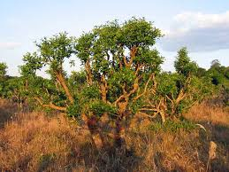](https://www.google.com.ng/imgres?imgurl=http://clf1.medpagetoday.com/media/images/53xxx/53660.jpg&imgrefurl=http://www.medpagetoday.com/endocrinology/generalendocrinology/53660&docid=oRE3n_QmL25MxM&tbnid=lOnKQj_1kDXwaM:&w=720&h=540&bih=623&biw=1366&ved=0ahUKEwingr2J3s_NAhWlKsAKHeKOB6YQMwgnKAcwBw&iact=mrc&uact=8) 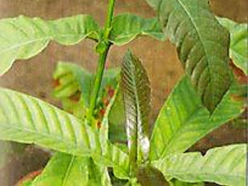

**Fig1: the whole tree fig2: the leaves**

[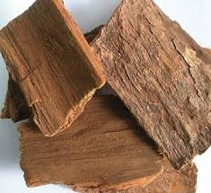](https://www.google.com.ng/imgres?imgurl=http://i01.i.aliimg.com/img/pb/080/538/737/737538080_318.jpg&imgrefurl=https://www.alibaba.com/product-detail/High-Quality-Pausinystalia-Yohimbe-Extract_1241647646.html&docid=7G9PTdRCiQH_YM&tbnid=qnv1yv6M_vhexM:&w=360&h=329&bih=623&biw=1366&ved=0ahUKEwingr2J3s_NAhWlKsAKHeKOB6YQMwiGAShcMFw&iact=mrc&uact=8)[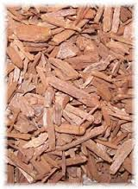](https://www.google.com.ng/imgres?imgurl=http://www.anniesremedy.com/images/oils/yohimbe7.jpg&imgrefurl=http://www.anniesremedy.com/herb_detail295.php&docid=0PcotklYet_KxM&tbnid=bY_pnIr6TChDwM:&w=200&h=274&bih=623&biw=1366&ved=0ahUKEwingr2J3s_NAhWlKsAKHeKOB6YQMwhFKBswGw&iact=mrc&uact=8)

**Fig:3 the stem bark fig4: the broken stem bark**

[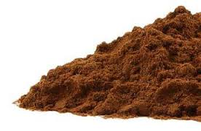](https://www.google.com.ng/imgres?imgurl=https://s3.amazonaws.com/images.production.mountainroseherbs.com/1040/yohimbe_bark_powder-product_1x-1403634735.jpg&imgrefurl=https://www.mountainroseherbs.com/products/yohimbe-bark-powder/profile&docid=AkE7ssnzAiHzIM&tbnid=1iwAR_g-kKW_8M:&w=345&h=226&bih=623&biw=1366&ved=0ahUKEwingr2J3s_NAhWlKsAKHeKOB6YQMwiDAShZMFk&iact=mrc&uact=8)

**Fig: 5 the ground powder**

**The part used in the present study**

**2.5 CHEMICAL FORMULAR AND PHYSICO-CHEMICAL PROPERTIES OF THE ACTIVE COMPOUND**

NAME: Yohimbine

MOLECULAR FORMULAR: C21H26N2O3 (molecular weight =354.4)

SYSTEMATIC NAME: Yohimban -16-α-carboxylic acid, 17-α-hydroxymethyl ester.

CAS REGISTRY NUMBER: 146-48-5

MELTING PIONT: 2410C

UVMAX: (methyl alcohol) 226, 280, 291nm

SOLUBILITY: Limited solubility in water, moderately soluble in ether, soluble in alcohol, chloroform, warm benzene.

[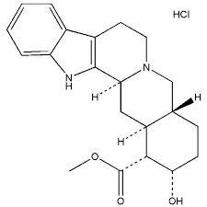](https://www.google.com.ng/imgres?imgurl=http://www.shgosun.com/pic/other/2013-02-02-16-52-496.jpg&imgrefurl=http://www.shgosun.com/Yohimbine-HCL-p159.html&docid=odpoKrPDOSZCFM&tbnid=pbhzI3kUZL_KMM:&w=600&h=600&bih=623&biw=1366&ved=0ahUKEwingr2J3s_NAhWlKsAKHeKOB6YQMwiJAShfMF8&iact=mrc&uact=8)

**Fig 6: Yohimbine** (Budvari S, 1997).

**2.6** **CHEMICAL COMPOSITION:**

The total alkaloids content data of *Pausinystalia yohimbe* varies, depending on the method used. The total alkaloid content of the bark is 2-61mg/get, while the drug should contain >15mg /g (Brandt, W., 1992; Madus, G., 1983; and Bet, J.M., *et.al* .1995; HagerROM, 2006). Wink *et al* (2008) opined that the drug should contain from 30 to 150mg/g monoterpene indole alkaloids of the yohimbe bark type. The alkaloids content increase with the age of the branches. A preparation made from the extract should contain 95-105mg/g of total alkaloids, calculated as yohimbe (HagerROM, 2006).

Bet, J.M., *et.al*, (1995) and Zanolari, M., *et al* (2003) revealed that *yohimbe* content in the bark stem is given as 7-115mg/g and is usually around 10mg/get, the value depend largely on the method used and *yohimbe* is well soluble in alcohol and poorly soluble in water. A Variety of Yohimbe bark extracts are offered as monopreparations or combined with other substances in liquid, powder, capsule or tablet form. The quantities of *yohimbe* in these products vary. A study conducted by showed that extracts contain a maximum of 7% of the *yohimbe* detectable *yohimbe* content. The authors explain this by the very high rate of dilution of the end-product and by watery extraction methods. The letter methods are poorly suited to transferring the alkaloids, which are poorly soluble in water, to the extract. The highest content was found in liquid products with high ethanol content (=70%) (0.03% and 0.05% *yohimbe*)

**2.7 Phytochemical Constituents of plants and properties:**

**2.7.1 Alkaloids**:

These are organic compounds, present only in plants, containing at least one basic nitrogen atom in its structure. They are usually colourless, crystalline, non-votalitile solids which are insoluble in water but soluble in ethanol, ether, chloroform and other original solvents. Only very few are liquid which are soluble in water (example nicotine) and a few are coloured e.g berberine which is yellow . Most alkaloids have a bitter taste and are optically active. Alkaloids have eight groups and are based on the type of “organic nucleus present”. Such groups are quinidine, isoquinoline , phenanthrene, pyridine, phentylethyl amine, pyrrolidine, pyrrolidine -pyridine and indole group (Ajali, U., 2004).

**Examples**

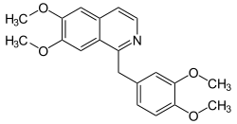 **Fig 7.** Isoquinoline group like papaverine

**2.7.2** **Terpenoids**:

They are Phytochemicals built up from Terpenoids and Terpenoids is the generic name of group of hydrocarbons with general formula (C5H6)n and their oxygen derivatives mainly alcohols, aldehyde and ketone. All Terpenoids, except few liquids with low boiling temperature making it almost impossible to separate them from the various essential oils by fractional distillation. According to the number of units of isoprene present in the molecules, Terpenoids are classified as Hemiterpenes, Momoterpenes, seaquiterpenes, determines, etc where in ( C5H8)n is respectively. Examples of monoterpenes include; caphor, Myrcene, ᾳ-terpineol, etc (<http://www.academic> journals.org/JMPR.05/10/10 and Ajali, U., 2004).

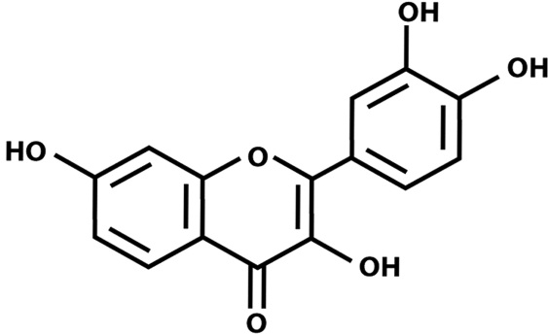

Fig 8 structure of a terpenoid

**2.7.3 Flavonoids:**

Flavonoids constitute one of the largest class of naturally occurring plant products mostly phenols either in the free-state or as their respective qlycosides. The family include; monomeric Flavonoids, flavaonones, anthocynidins, flavours, isoflavonid and flavonols They are compounds possessing 15 carbon atoms; two benzene rings joined by a linear three carbon chain that is C6-C3-C6 system. They are mainly water soluble compounds (Ajali, U., 2004 and Biyiti, L., *et.al* 1998). Examples Flavaonones, epicatechin, etc.

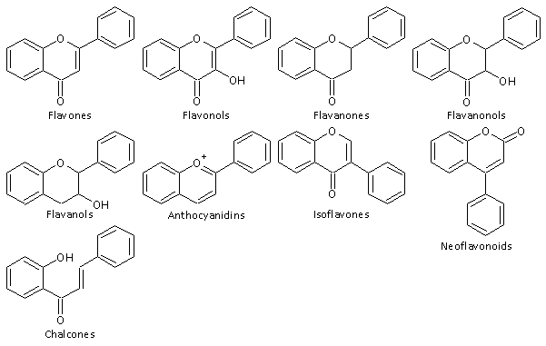

Fig. 9 Family of flavonoids

**2.7.4 Saponins:**

Saponins are glycoside with distinctive foaming characteristics. They have high molecular weight and can be hydrolyzed by acid to give a glycone (spogenin) with various sugars and related ionic acid. The foaming ability of saponins is due to combination of hydrophilic sapogin and a hydrophilic sugar part. Saponins have bitter taste, some which are toxic are known as sapotix (Okwu, D.E; 2005 and Ajali, U; 2004).

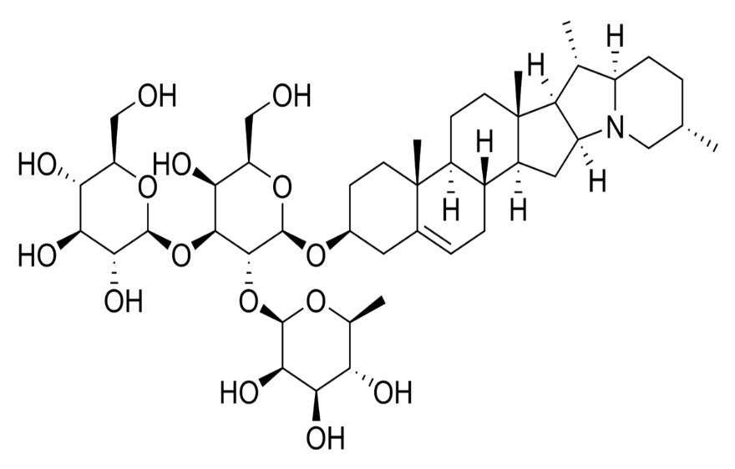

Fig. 10 Structure of Saponin

**2.8 MEDICINAL USE**

**2.8.1 Pharmacology and Toxicology:**

Yohimbine HCL being the active alkaloid in *Pausinystalia yohimbe* (ᾳ-2-adrenoreceptor antagonist and less pronounced) is therapeutically used primary to treat erectile dysfunction. Although 34-86% of patients responds to treatment, because of the pronounced placebo effects only few studies show significant pharmacological effect compared with the control group (Tam *et.al* 2001). To treat loss of libido and the desired effect sometimes occurs with latency period of 2-3weekd (Fach information yohimbe “spiegel”2008).

In case of overdose, weakness, generalized paresthesia, loss of course ordination and memory problems, as well as severe headaches combined with dizziness, tremor, palpitations and fear occurs after 20-30mins. After 4 hours severe chest pain-occur, lasting for several hours. Other side effects include headache, increased blood pressure, tachycardia lasting several hours, nausea, vomiting, mydriasis, increased saliva and tear flow and perspiration. Greatly increased norepinephrine values as have been shown (Fach information yohimbe “sipegel”2008).

**2.8.2 *In Virto* data**:

*In Vitro* studies show that *yohimbe* is a selectively and competitive ᾳ-2-adrenoreceptor antagonist with a low antagonist effect with regard to ᾳ-1-adrenoreceptor (Tam *et.al*, 2001). Both the metabolic products of *yohimbe* also bind to this receptor, but *yohimbe* has a higher binding affinity. In the presence of 5%a lbumin, the ᾳ -2-adrenoreceptor binding affinity reduces 10 folds to that of its active metabolite 11-hydroxy-yohimbe. The plasma protein is 82% 43% and 32% for yohimbe, and 11-hydroxy-yohimbe respectively (Berlin, M., *et.al* 1993). 11-hydroxy -yohimbe is biologically active and has a capacity to block ᾳ -2-adrenoreceptor in cells similar to that of *yohimbe*. Although 11-hydroxy-yohimbe has a lower binding affinity to ᾳ-2-adrenoreceptor than *yohimbe*. This is probably compensated by a significantly lower plasma protein binding as revealed by Berlin *et.al* (1993).

2.9 **MECHANISM OF IMMUNOMODULATION**

The immune system response to substances which modify or modulate its interactions should begin with a definition of terms. To this, Immunomodulators are those intrinsic or extrinsic type, duration or competency of immune response. In the innate cellular immunity there is involvement of monocytes macrophage system, while in innate humoral immunity there is activation of component system. On the other hand the cellular component of acquired immunity consists of T-lymphocytes while the humoral component of this immunity involves the role of B-lymphocytes. Normally the innate and acquired immune responses act in concerted manner to contain or eradicate infection. In some cases innate responses are enough to neutralize the offending agent. However in many other cases, certain cells of innate immune system, such as antigen presenting cells (APC), can also process the offending agent into smaller fragments which then activate adaptive immune system to neutralize or kill these pathogens. The elements found in the blood are erythrocytes (RBC), leukocytes (WBC) and thrombocytes (platelets). The leukocytes are of two types: granulocytes (neutrophils, eosinophils and basophils) and agranulocytes (T-lymphocytes, B-lymphocytes and monocytes). The process by which blood cells are formed is called haemopoiesis. All such cells are involved in exerting immune response develops from pluripotent haemotopoietic stem cells which resides in bone marrow. These stem cell gives rise to lymphoid stem cell, trilineage myeloid stem cell, megakaryocytes (from platelets) and erythroblasts (from erythrocytes). The lymphoid stem cells through their progenitors, gives rise to mature lymphocytes (T-lymphocytes and B-lymphocytes) and natural killer cells (NK cells). T-Lymphocytes and B-lymphocytes are involved in mediating adaptive immune responses while Natural Killer cells exert innate immune response along with mature cells originating from trilineage myeloid stem cells. When exposed to specific antigens, B-lymphocytes differentiate into antibody producing plasma cells in the bone marrow. Simultaneously, T-cells, under the influence of thymic hormones, migrate to the thymus and on appropriate stimulus by Antigen Presenting Cells (APC), acquire T-cell receptor (TCR) and get differentiated to helper T-cells (with specific protein cluster of differentiation- CD4+) and cytotoxic T-cells (with specific protein cluster of differentiation- CD8+). The CD4+ (TH cell) subtypes of T-cells differentiate further outside the thymus into several phenotypes: TH1, TH2 and TH3 which are distinguished by the different cytokines (IL-2 and IFN-γ) they synthesize. TH1 T-cells produce cytokines that stimulate proliferation and differentiation of T-lymphocytes and NK cells. These cytokine play an important role in cell mediated immunity (CMI). TH2 T-cells release cytokine (IL-4, IL-5, IL-10 and IL-13) that stimulate B-lymphocytes production for humoral immunity. TH3 T-cells play an important role in resting phases of immune response and in the production of anti-inflammatory immunoglobin-A (IgA) antibodies that are important in secretory immunity [Sharma, H.L. and Sharma, K.K. 2007].

**2.9.1 Benefits of immunomodulation**

Through immunomodulation, the ability to stimulate natural and adaptive defense mechanisms, such as cytokines, which enables the body to help itself, is achieved (Alamgir, M. and Udden, S.J., 2010). The natural immunomodulators act to strengthen weak immune systems and to moderate immune systems that are overactive. Plant sterols and sterolins are natural immunomodulators found in some raw fruits and vegetables and in the alga spirulina. Spreads and yoghurt type foods containing high levels of plant sterols are commonly to be found on sale as ‘cholesterol-reducing’ agents. These compounds are destroyed when vegetables and fruits are cooked. Other natural immunomodulators include *aloe vera, plumbago* S*indica, aegle marmalos* (Arokiyaraj, S. andPerinbam, K., 2007), ginseng root, chamomile tea, reishi mushroom extract, olive leaf extract, *N. sativa* oil, polysaccharides isolated from *Juniperus scopolorum*, *Isodon serra* extract, *ficus* *carica* leaf extract (Shin, J. *et.al,* 2002; Salem, M.L. 2005; Qunin, M.T. *et.al,* 2005; Zang, Y. *et.al,* 2005, and Patil, V.V. *et al,* 2010). In children, immunomodulators are less likely to cause growth failure than corticosteroids. Topical immunomodulators are well tolerated even in infants (Malfitano, A.M. *et.al,* 2006). Recent research carried out in Russia has identified extracts of certain Siberian plant species (*Aconitum baikalense, Cirsium setosum* and *Saussurea controversa*) as potent natural immunomodulators. The extracts are dissimilar chemically but have similar immune system enhancing effects. They have successfully been used for the treatment of benign and malignant tumors, antibiotic resistant infections, allergies, polyarthrites, thyroid diseases, psoriasis and other pathologies which can be treated with medicines only with difficulty, if at all. The synthetic immunomodulator capsaicinanandamide (hybrid arvanil) has been found to ameliorate symptoms in autoimmune encephalomyelitis in mice. The relevance of these findings suggests that arvanil and related compounds may offer benefits in the treatment of multiple sclerosis. A series of triptolide analogs have been successfully synthesized one of them is 5(R)-5-hydroxytriptolide showed low cytotoxicity and relatively high immunosuppressive activities as compared with its parent compound triptolide (Patil, V.V. and Bhangale, S.C., 2010, Yang, Y., *et.al* 2005). Patent immunomodulator preparations containing naturally-derived ingredients include Immunoferon™, Licopid™, Biobran™, AHCC, Noxylane4™, Leucomeal™ and MGN.

**2.9.2** **Drugs used for Immunomodulation**

All drugs which modify immune response are generally categorized as immunomodulators. These can either function as:

a. Immunosuppressants

b. Immunostimulants.

Some of these can have both the properties depending on which component of immune response they affect. There is also an upcoming generation of immunosuppressants called tolerogens

**2.9.3** **Immunosuppressants**

TABLE 2.1: **Classification of immunosuppressants**

|  |  |  |
| --- | --- | --- |
| S/NO | Mechanism of action | Examples |
| 1. | Inhibitors of lymphocyte gene expression | Glucocoticoids |
| 2 | Inhibitors of lymphocyte signaling  a] calcineurin inhibitors  b] mTOR inhibitors | Cyclosporine, Tacrolimus  Sirolimus, Everolimus |
| 3 | Cytotoxic agents  a] Antimetabolities  b] Alkylating agents | Azathiprine, methotrexate, leflunomid. Cyclophosphamide |
| 4 | Cytokine inhibitors [anticytokine- antibodies]  A] TNF-inhibitors  B] IL -1 inhibitors  C] IL-2 inhibitors | Etanercept, infliximab, Adalnunab  Anakinra  Bastiliximab |
| 5 | Antibodies against specific immune cell molecule  A] polyclonal antibodies  B] Monoclonal Antibodies | Antithymocyte Globulin [ATG]  Alemutuznab [anti CD -52 Antibodies] Muromunab [ Anti CD-3 antibodies , OKT -3] |
| 6 | Inhibitors of immune cell adhesion | Efalizumab [LFA-inhibitors] |
| 7  8 | Tolerogens or inhibitors of immune cell postulation  Miscellaneous | Rho [D] immune Globulinss |

**2.9.4 Immunosutimulants**

In contrast to immunosuppressive agents that inhibit the immune response in transplant rejection and autoimmunity, a few immunostimulatory drugs have been developed with applicability to infection, immunodeficiency, and cancer. These work on cellular as well as humoral immune system or both (Goodman and Gilmans, 2008). Some of these immunostimulants include;

**1. Bacillus Calmette-Guerin (BCG):**

Live *bacillus* *Calmette-Guerin* (BCG; TICE BCG, THERACYS) is anattenuated, live culture of the *bacillus* of *Calmette* and *Guerin* strainof *Mycobacterium bovis.*

**Mechanism of action:** Induction of a granulomatous reaction at the site of administration. Therapeutic they are used for the treatment and prophylaxis of carcinoma of the urinary bladder, prophylaxis of primary and recurrent stage Ta and/or T1 papillary tumors after transurethral resection. Their adverse effects comprises Hypersensitivity, shock, chills, fever, malaise, and immune complex

**2. Levamisole:**

Levamisole (ERGAMISOL) was synthesized originally as an anthelmintic but appears to restore depressed immune function of B-lymphocytes, T-lymphocytes, monocytes and macrophages (Shah, D., *et.al* 2011). It is therapeutically used as Adjuvant therapy with 5-fluorouracil after surgical resection in patients with Duke’s stage C colon cancer, agranulocytosis. It has an adverse effects of Flu-like symptoms, allergic manifestation, nausea and muscle pain (Sharma and Sharma KK 2007).

**3. Thalidomide:**

Thalidomide has been reported to decrease circulating TNF-α in patients with erythema nodosum leprosum, but to increase it in patients who are HIV-seropositive. Alternatively, it has been suggested to affect angiogenesis.It is therapeutically used for severe, refractory rheumatoid arthritis with an adverse effect of teratogenicity (Sharma and Sharma KK 2007, Goodman and Gilman’s 2008, Katzung GB and Trevor JA 2009).

**3. Recombinant Cytokines**

**Interferons**: Examples are Alpha, beta, gamma. Their mode of action comprises the induction of certain enzymes, inhibition of cell proliferation, and enhancement of immune activities, including increased phagocytosis by macrophages and augmentation of specific cytotoxicity by T-cells. Therapeutically, they are used in Hairy cell leukemia, malignant melanoma, follicular lymphoma, AIDS-related Kaposi's sarcoma, chronic hepatitis B and condylomata acuminate. Their adverse effects include; Hypotension, arrhythmias, and rarely cardiomyopathy and myocardial infarction, GI distress, anorexia, weight loss, myalgia and depression. They include;

**a. Interleukins:** Drugs grouped under this sub-type include; Aldesleukin, des-alanyl-1, serine-125 human IL-2.They are known to activate cellular immunity during lymphocytosis, eosinophilia, and thrombocytopenia by releasing multiple cytokines (e.g., TNF, IL-1 and interferon-G).Therapeutically, they are used for metastatic renal cell carcinoma and melanoma**.** Its adverse effect comprises capillary leak syndrome, Hypotension, reduced organ perfusion, and death

**b. Colony stimulating Factors:** Example: Filgrastim (rmetHuG-CSF). It Increases the number and differentiation of myeloid progenitorand it is therapeutically used for leucopenia and ganciclovir induced neutropeniawith an adverse effect of myocardial infarction and anorexia.

**c. Isoprinosine:**

Isoprinosine (Inosiplex) is a complex of the pacetsamidobenzoate salt of N, N-dimethylamino-2- propanol: inosine in a 3:1 molar ratio. It has been shown to augment production of cytokines such as IL-1, IL-2 and IFN-γ. It increases proliferation of lymphocytes in response to mitogenic or antigenic stimuli, increases active T-cell rosettes and induces T-cell surface markers on prothymocytes. Therapeutically, it is used for herpes simplex infections, sub-acute sclerosing panencephalitis, acute viral encephalitis caused by herpes simplex, Epstein-Barr and measles viruses. Its adverse effect causes minor CNS depressant, transient nausea and rise of uric acid in serum and urine (Phamham MJ and Nijkamp FP 2005).

**d. Immunocynin:** It is a stable form of haemocynin, non-haem oxygen carrying, copper-containing protein found in arthropods and molluses.It is chiefly used therapeutically for urinary bladder cancer. Its adverse effect causes rare-mild fever (Phamham MJ and Nijkamp FP 2005).

**CHAPTER THREE**

* 1. **MATERIALS AND METHODS**

All materials, glass wares, chemicals and reagents used for this research work were sourced from Godfrey Okoye University, Enugu. All the analysis carried out during project work was performed at the Biochemistry Laboratory of Chemical Science Department, Godfrey Okoye University. The glass wares and some other materials used for this project work include: Whatmann (no.1) filter paper

Foil

Animal cages

Insulin syringes

2ml syringes

Hand towels

Hand gloves

Spatula

Reagents bottles

Dropper

Micro pipettes

Microscope

Slides

**3.1.1: List of chemicals:** All the chemicals used for this research work are of analytical grade and were sourced and prepared at the Biochemistry Laboratory of Godfrey Okoye University Enugu. Table 3.1 below shows list of chemicals used for this work.

**Table 3.1: CHEMICALS**

|  |  |
| --- | --- |
| Chemicals | Company |
| HCL | Naafco |
| Sodium hydroxide | Alpha chem |
| Lead actete | Avishkar |
| Potassium chloride | Avighkar |
| Bismuth | BDH |
| Acetic acid | JHD |
| Ethanol | Alpha chem |
| Methanol | Alpha chem. |
| Di-sodium hydrogen phosphate | BDH |
| Di-hydrogen tetetra oxide phosphate | BDH |
| Bismuth | BDH |
| n-butanol | E. Merck |

**3.1.2: List of reagents:** All the reagents used for this analysis are of reagent grade and were prepared at the Biochemistry Laboratory of Godfrey Okoye University, Enugu using standard procedures. Table 3.2 below shows list of regents used for this analysis.

**Table 3.2: REAGENTS**

|  |
| --- |
| Dragendoff’s |
| Phosphate buffer saline |
| Normal saline |
| Mc-Farland standard |
| Diluted sodium hydroxide |
| 1% lead acetate |
| Diluted HCl |
|  |

**3.1.3: List of equipments:** Table 3.3 below shows the description of equipments used for the analysis**.**

**Table 3.3: EQUIPMENTS**

|  |  |
| --- | --- |
| Electrical weighing balance | Model No. Yp-502N |
| Oven | DHG-9101-ISA |
| Water bath | Model H H .W 21.cr 4211 |
| Auto clave | DESCO |
| Improved hemocytometer art | Hospital and home care UK No. 1280 |
| Incubator | DHP-9032 |
| pH meter | Rated capacity :3W |
| Centrifuge | Model 80-2 |

**3.1.4 BIOLOGICAL MATERIALS**

Fresh stem bark of *Pausinystaila yohimbe*

Forty (40) adult albino mice of both sexes

*Candida albicans*

Fresh sheep blood

**3.2 COLLECTION AND IDENTIFICATION OF SAMPLES**

**3.2.1 COLLECTION OF PLANT MATERIAL**

Fresh stem bark of *Pausinystaila yohmibe* were cut from its tree in November, 2016 from Abu, Local Government Area, Zaria in Kaduna State and was authenticated by Prof. C .U Okeke, a botanist at Nnamdi Aziweke University Awka, with a Herbarium number 35. The stem bark was dried for three months under controlled room temperature of between 280C - 350C. The dried samples were ground into powder with an electric blender and stored in airtight container until use.

**3.2.2 COLLECTION OF ANIMALS**

Eighty (80) male and female mice between the ranges of 19g to 29g obtained from the Department of Pharmacology and Veterinary Medicine, University of Nigeria Nsukka, served as the experimental animals. They were transported in plastic cage covered with wire gauze to the animal house of Godfrey Okoye University, Enugu. These animals were acclimatized for fourteen (14) days prior to the experiment and fed with guinea feed Nigeria, Ltd and water.

**3.2.3 ANIMAL GROUPING**

After the acclimatization period, the weight of the experimental animals were measured and divided into four groups of five (5) animals each with regard to their weight range for each parameter. Groups one to three (1-3) served as the test group while group four (4) served as the control group which received standard drugs.

On the day 7 of the acclimatization period, the acute toxicity (LD50) of the extract was analyzed using a method of (Lorke, D. 1983). For this, the animals were placed in six groups of three animals each as stated bellow;

Group One (1) received 50mg/kg of extract

Group Two (2) received 500mg/kg of extract

Group Three (3) received 1000mg/kg of extract

Group Four (4) received 1800mg/kg of extract

Group Five (5) received 3000mg/kg of extract

Group Six (6) received 5000mg/kg of extract

For each parameter (Delayed-Type Hypersensitivity, Evaluation of Phagocytosis, *In vivo* Leucocytes Mobilization Count, Humoral Immune Response), the experimental animals were divided into four groups as stated below;

Group One (1) received 100mg/kg of extract

Group Two (2) received 300mg/kg of extract

Group Three (3) received 600mg/kg of extract

Group Four (4) received 800mg/kg of standard drugs

**3.2.4 PREPARATION OF EXTRACTS**

A ground weight of 700g of *Pausinystalia yohimbe* stem bark was extracted with methanol using cold maceration method for 72 hrs. The entire bulk was filtered and concentrated using a rotary evaporator under reduced pressure of 40°C to obtain the methanol extract of the Pausinystaila *yohmibe* stem bark. The extract were determined and stored in a refrigerator at 50C until use.

**3.2.5 ANTIGEN**

Fresh sheep blood (10ml) was aseptically taken from the jugular vein of healthy male sheep obtained in the animal house of the Department of Vetinary Medicine, University of Nigeria, Nsukka and transferred to an EDTA tube. The blood sample was washed thrice with 5ml of sterile phosphate buffer saline by centrifugation at 3000rpm for 10minutes on the each occasion. The washed sheep red blood cell (SRBCs) was adjusted to a concentration of $1 x {10}^{9}$ cells/ml with sterile phosphate buffer saline (PBS) and used for immunization and challenge.

**3.2.6 Preparation $1x{10}^{9}$ cell/ml of sheep red blood cell**

A volume of 9990ul sterile phosphate buffer saline was pipetted in a test tube, 10ul of sheep red blood cell was added. The cell were counted under 40x magnification in a microscope using the Improved Neuber Hemocytometer .

**3.2.7 Micro-organism:** Clinical isolates of *candida albicans* was obtained from the Mircobiology laboratory, University of Nigeria teaching hospital Enugu. The *C. albicans* had been isolated from a high vaginal swab in the microbiology lab.

**3.2.8 HANDLING OF ANIMALS**

**3.2.8.1 Acute toxicity study**

The acute lethal dose (LD50) of *Pausinystalia yohime* methanolic extract (PYME) was ascertained by the method described by (Lorke D. 1983). Briefly, the study was performed in the two phases. In first phase, 9 mice were divided into 3 groups of 3 mice per group. These groups wee orally administered with the extract at the doses of 50mg/kg, 500mg/kg and 1000mg/kg body weight respectively. The animals were observed for 24 h for signs of toxicity. In second phase, 9 mice were divided into 3 groups of 3 animals and used for the study. There were treated separately with oral administration of the extract at doses of 1800mg/kg, 3000mg/kg and 5000mg/kg respectively.

**3.2.8.2 Determination of delayed-type hypersensitivity response (DTHR)**

This parameter was carried out as describe by (Shinde UA ,*et.al;* 1999, Nworu CS, *et.al;* 2007, Naved T, *et.al*; 2005 ) with little modifications. Twenty mice were randomly divided into four groups consisting of the five animals per group. Delayed-type hypersensitivity was induced in the mice using sheep red blood cells (SRBCs). The extract was administered by oral gavage to the animals, group 1, 2 and 3 received 100mg/kg, 300mg/kg and 600mg/kg of the extract respectively while group 4 received Levamisole (control). The animals were treated with the extract 3 days prior to sensitization and continued till the challenge. On day 0, one hour after the extract administration, the mice were sensitized by injecting 0.02ml of ${10}^{9}$ cell/ml of sheep red blood subcutaneously into the right hind foot paw. Then on day 5, the mice were challenged by subcutaneous injection of the same amount of antigen (0.02ml SRBCs) into the left hind foot paw. The oedema produced by antigenic challenge in the left hind paw was measured as the difference in the paw thickness before and 24 hours after the challenge. The paw thickness was measured with a pocket-sized screw gauge.

**3.2.8.3 Determination of humoral immune response**

Twenty mice were randomly selected and divided into four groups of five animals in each group. The extract, suspended in distilled water, was administered by oral gavage to the animals. Group 1, 2 and 3 received 100mg/kg, 300mg/kg and 600mg/kg body weight of the extract respectively, while group 4 (control) received distilled water . The method of (Nelson and Mildenhall, 1967) was used with little modification to the determine the effect of the extract on the antibody level of the animals resulting from sensitization with SRBCs. Briefly, on day zero, 0.1 ml of the ${10}^{9}$ cell/ml SRBCs was administered by intra-peritoneal injection (i.p) to all the groups for immunization. The experimental animals were challenged on the day 7 by similar intra-peritoneal injection of the same amount (0.1ml SRBCs) ${10}^{9}$ cell/ml SRBCs. The extract was administered 3 days prior to sensitization and continued daily for 7 days after the challenged (Nworu CS, *et.al*; 2007). The Primary antibody titre was determined on the day 7 (before the challenge) while the secondary antibody titre was measured on day 14 after after the challenge. For this, blood samples were obtained by retro orbital puncture into plane (non-anticoagulant) tubes and allowed to clot. A 25ul serum from each animal was obtained after centrifugation and serially diluted two-fold in 96-U well microtitre plates using sterile phosphate buffer saline. The last well on each row contained sterile phosphate buffer saline served as as control. Each of the diluted sera were challenged with 25ul of 1%v/v SRBCs and then incubated at 37◦C for 1 hour. The highest dilution giving rise to visible heamagglutination was taken as antibody titre. The Antibody titres were expressed in graded manner, the minimum dilution (1/2) being ranked as 1 (calculated as $log2$ of the dilution factor).

**3.2.8.4 In vivo leucoyte mobilization test**

The method of (Riberio RA, *et.al*, 1991) was used with little modification in the test for the effect of the extract on the *in vivo* leucoctye mobilization induced by inflammatory stimulus. The mice were divided into four groups of five animals each. Group 1, 2 and 3 received the extract 100mg/kg, 300mg/kg and 600mg/kg body weight respectively while group 4 received the vehicle. One hour after the administration of the extract, each mice in the groups received intra-peritoneal injection (i.p) of 0.5ml of 3% w/v agar suspension in normal saline. Four hours later, the mice were sacrificed and the peritoneum washed with 5ml of 5% solution of EDTA in phosphate buffer saline (PBS). The total and differential leucocyte counts (TLC and DLC) were performed on the perfusates while the percentage leucocytes mobilization (PLM) was calculated using the formula; PLM (%) =TLC (Test)-TLC (Control)/TLC (control) x 100.

**3.3 PREPARATION OF *CANDIDA ALBICANS* SUSPENSION**

*Candida albicans* culture was incubated in sabouraud dextrose broth overnight and centrifuged to form a cell button on the bottom of the tube. The supernatant was discarded and the cell button was wash by centrifugation at 3000rpm 3-4times with sterile phosphate buffer saline (PBS). The washed cell button was re-suspended in a mixture of PBS and mice serum in the proportion of 4:1 and the count of *Candida. albicans* was adjusted to 1x108 cell/ml using 0.5 MC-Farland standard. The *C albicans* count was used for the evaluation of phagocytosis.

**3.3.1 Evaluation of phagocytosis**

About 0.2ml of mice whole blood obtained retro-orbital puncture was smeared on the sterile glass slides and incubated at 37°C for 20 min for clotting to occur. The slides were there after drained slowly with sterile normal saline in order not to wash off adhered neutrophils/polymorphonuclear leucocytes. The slides consisting of neutrophils was flooded with the extract, artesunate and combinations of the extract and artesunate at different concentrations (25ug/mg, 50 ug/mg, 100ug/mg) respectively and incubated at 37°C for 1 hour. Thereafter, the slides were drained, fixed with methanol under oil immersion and phagocytosis evaluated by the method described by (Ganachari MS, *et.al*, 2004). The number of *C. albicans* cells phagocytose by polymorphonuclear on the slide was determined microscopically for granulocytes using morphological criteria. The number was regarded as phagocytic index (PI) and was compared with PI of the control treatment. Immunostilulation was calculated using the following equation:

% Phagocytic Stimulation (PPS) = PI (Test) - PI (Control) / PI (control) x 100.

**3.4 PERPARATION OF REAGENTS**

**3.4.1 Perparation of drangendoff**

A quantity of 0.5g of bismuth nitrate weighed and transferred into an empty beaker. To this, a volume of 10ml of concentrated hydrochloric acid was added. Into another empty beaker, 4g of potassium iodide was added and dissolved with little water (H2O) on continuous stirring until the KI was completely dissolved. Then the two solutions where mixed together in which formation of dark orange solution was observed.

**3.4.2 Preparation of phosphate buffer saline**

A volume of 800ml distilled water was poured into an empty beaker and added 8g of (NaCl) sodium chloride, 0.2g of (KCl) potassium chloride, 1.44g of (Na2HPO4) di-sodium hydrogen phosphate six, 0.24g of (KH2PO4) potassium di-hydrogen tetra oxide phosphate six then adjusted the pH to 7.4 with (HCl) acid and then distilled water (H2O) was to make up a volume of 1liter.

**3.4.3** **Preparation of normal saline**

A quantity 9g of (NaCl) sodium chloride was dissolved in 700ml of distilled water in a beaker and added H2O to make the solution of the volume 1000ml.

**3.4.4 Preparation of MC-Farland standard**

A quantity of 1g barium chloride (BaCl) was dissolved in 100ml of water. Then 1% of sulfuric acid was prepared by diluting 1ml of sulfuric acid in 99ml of water (H2O). From these two separate solutions, 0.05ml of barium chloride (BaCl) solution was transferred into a test tube followed by addition of 9.95ml of 1% sulfuric acid into test tube.

**3.4.5 Preparation of diluted sodium hydroxide**

A quantity 0.04g was added into 100ml of H2O.

**3.4.6 Preparation of** **1% of lead acetate**

A quantity of 1g of lead acetate was dissolved into 100ml of distilled H2O.

**3.5 QUALITATIVE PHYTOCHEMICAL ANAYLSIS**

**3.5.1 Test for alkaloids**

A quantity of 5ml of the extract was added to 2ml HCl, followed by addition of 1ml of Dragendoff’s reagent. An orange precipitate was produced immediately indicating the presence of alkaloids.

**3.5.2 Test for flavonoids**

A quantity of 1ml of the extract was measured in a test-tube, to this test-tube few drops of diluted sodium hydroxide was added and an intense yellow colour was produced which turned colourless on the addition of a few drop of diluted HCl showing the presence of flavonoids.

**3.5.3 Test for saponins**

A quantity of 2g of the extract was diluted with distilled water and agitated in graduated cylinder for 15minutes. The formation of 1cm layer of the foam indicates the presence of saponins.

**3.5.4 Test for tannins**

To volume of 5ml of the extract, a few drops of the 1% lead acetate was added and a yellow precipitate was formed in each, indicating the presence of tannins.

**3.6 Statistical analysis**

The results from the experiment were analyzed using one way Analysis of variance (ANOVA; Dunnett post hoc test) and expressed as the mean values for each group ± SEM. The statistical significance between the test and the control groups were considered at p < 0.05.

**CHAPTER FOUR**

1. **RESULTS**

**4.1 Acute toxicity LD50**

The Median Lethal Dose (LD50) was calculated by the method described by (karber, G. 1931)

The LD50 as shown in the result below indicates that the *Pausinystalia yohimbe* extract is toxic and can probably cause lethality at range above 1000mg/kg.

LD50 =LD100 - Ƹ(a x b)/ n

LD50 =1, 440mg/kg

**4.2 Phytochemical analysis**

The results obtained from the phytochemical evaluation of *Pausinystalia yohimbe* extract as shown in table 5 below, indicates an adverse presence of tannins, and saponins with moderate alkaloids and flavonoids. Theses active phytochemical components which have ethno pharmacological significant may be responsible for the extract’s medicinal value.

**Table 4.1: Phytochemical analysis**

|  |  |
| --- | --- |
| Alkaloids | ++ |
| Flavonids | + |
| Tanins | +++ |
| Saponins | +++ |

**KEY:** + = slightly present

++ = moderately present

+++ = highly present

* 1. **Delayed-type hypersensitivity response**

The results obtained from the delayed-type hypersensitivity as indicated in table 6 below shows that the extract was able to inhibit the inflammation of T-cell caused by the antigenic substance. From the table below, the treatment groups showed effective response compared to the control group.

**Table 4.2: Delayed-type hypersensitivity response**

|  |  |  |  |  |
| --- | --- | --- | --- | --- |
| Group | Treatment | Dose (mg/kg ) | Paw thickness(mm) | %Inhibition of DTHR |
| One | PYME | 100 | 1.600 ± 0.54 | 63.33 |
| Two | PYME | 300 | 2.4000 ± 1.14 | 53.66 |
| Three | PYME | 600 | 1.8000 ± 0.83 | 61.66 |
| Four | Levamisole | 40 | 0.8000 ± 0.45 | 78.66 |

**Key:**  PYME = *Pausinystalia yohimbe* methanolic extract

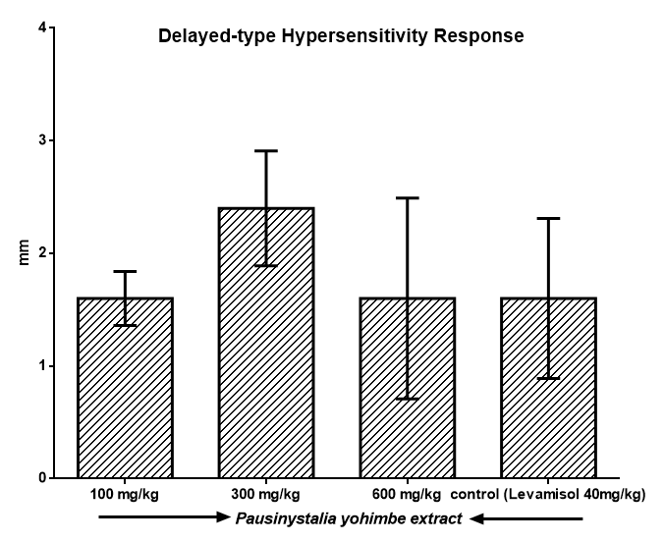

**Figure 11. Delayed-type hypersensitivity response of *Pausinystalia yohimbe* methanol extract.**

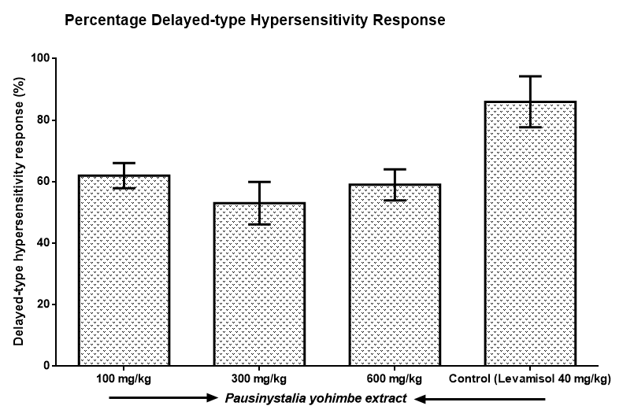

**Figure 12. Percentage delayed-type hypersensitivity response of *Pausinystalia yohimbe* methanol extract.**

* 1. **Humoral immune response**

The table 7 below shows the primary and secondary titre of humoral immune response. The extract as shown in the result below presented and increased immunity compared to the control group. This indicates the cell-mediated immunity response and its ability to neutralize antigenic substance leading to agglutination of the antigen thereby activating lyses of the antigen and probably leading to the death of the antigenic cells.

**Table 4.3: Humoral immune response**

|  |  |  |  |  |
| --- | --- | --- | --- | --- |
| Group | Treatment | Dose (mg/kg) | Primary titre | Secondary titre |
| One | PYME | 100 | 0.013± 0.15 | 0.059±0.02 |
| Two | PYME | 300 | 0.030± 0.24 | 0.037±0.03 |
| Three | PYME | 600 | 0. 060± 0.68 | 0.037±0.03 |
| Four | Control | Distilled H2O | 0.045 ± 0.68 | 0.018±0.00 |

**Key:**  PYME = *Pausinystalia yohimbe* methanolic extract

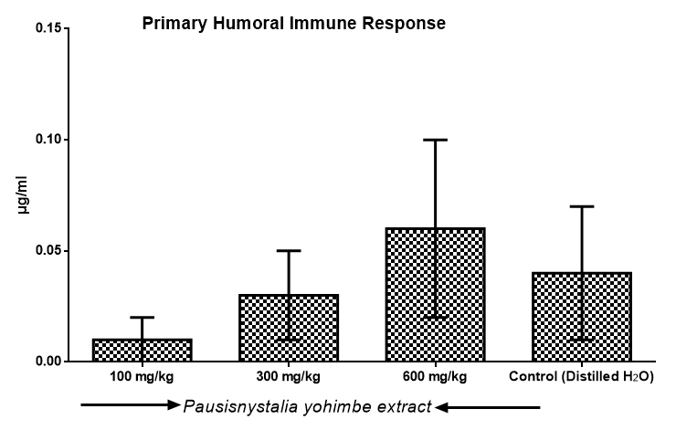

**Figure 13. Primary antibody titre of humoral immune response of *Pausinystalia yohimbe* methanol extract.**

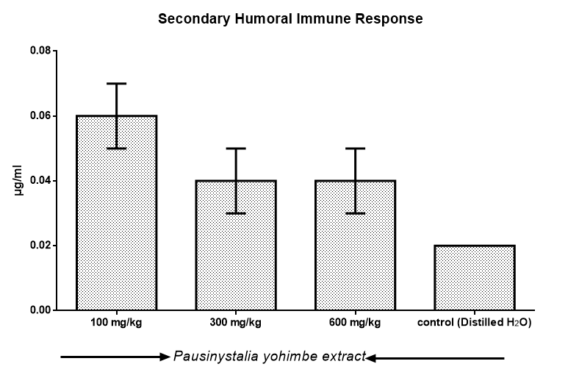

**Figure 14. Seconary antibody titre of humoral immune response of *Pausinystalia yohimbe* methanol extract.**

* 1. **Phagocytic stimulation**

The table 8 below shows the relationship in the phagocytic stimulation of the extract, artesunate and a combined treatment of extract and artesunate. The extract exhibited tremendous immunomodulatory effect on the phagocytic activity of polymorphonulear compared to the artesunate as shown in the table below.

**Table 4.4: Phagocytic stimulation index**

|  |  |  |  |  |  |
| --- | --- | --- | --- | --- | --- |
| Group | Treatment | Dose (mg/kg) | Extract (25ugml) | Artesunate (50ug/ml) | Extract and Artesunate (100ug/ml) |
| One | PYME | 100 | 48.3±1.50 | 46.5±3.69 | 41.8±6.7 |
| Two | PYME | 300 | 51.0±0.81 | 38.5±3.87 | 47.8±2.63 |
| Three | PYME | 600 | 48.0±3.55 | 43.0±8.48 | 48.3±2.06 |
| Four | Control | Distilled H2O | 42.8±3.40 | 55.5±2.38 | 42.3±2.63 |

POSTHOC=LSD DUNNETT ALPHA (0.05)

*. The mean difference is significant at the 0.05 level.

b. Dunnett t-tests treat one group as a control, and compare all other groups against it.

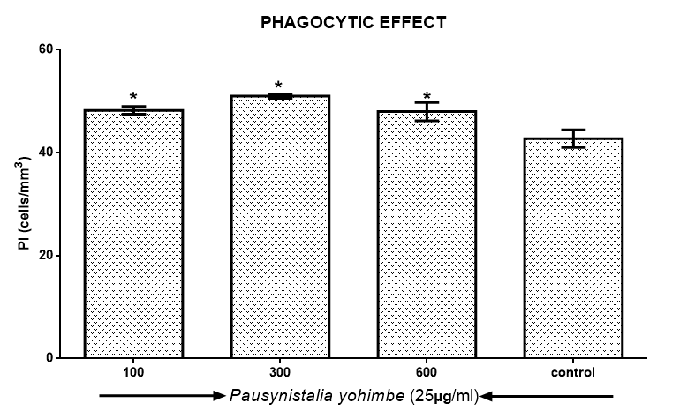

**Figure 15. Phagocytic Index (PI) of 25 µg/ml *Pausinystalia yohimbe* methanol extract against *Candida albicans*.**

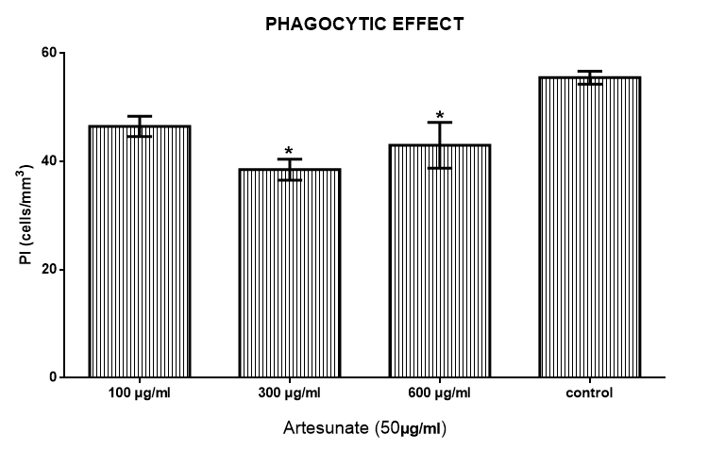

**Figure 16. Phagocytic Index (PI) of 50 µg/ml artesunate against *Candida albicans***

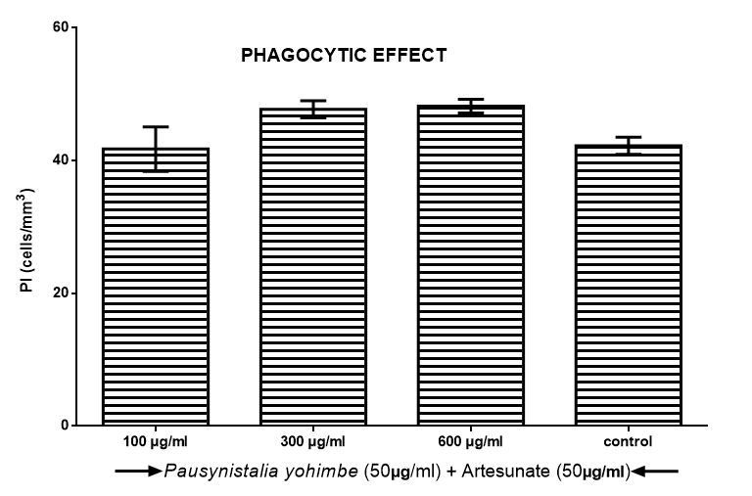

**Figure 17. Phagocytic Index (PI) of 50 µg/ml *Pausinystalia yohimbe* methanol extract + 50 µg/ml artesunate against *Candida albicans***

**CHAPER FIVE**

**DISCUSSION AND CONCLUSION**

**5.1 DISCUSSION**

The low percentage yield of the methanol extract could be a result of the fact that active ingredients in the plant material are not very soluble in the solvent (methanol). This is consistent with the result of methanol extraction of the plant seed by (Ezeigbo I.I.2011).

The presence of the various identified phytochemicals may be responsible for the therapeutic usage of *Pausinystaila yohmibe* sterm bark in the treatment of various illnesses and disorder such as sexual malfunction, anti-inflammatory potentials etc. Pervious phytochemical analysis has reported the presence of alkaloids, saponins, tannins and flavonoids (Ajali U; 2004) in sterm bark of *Pausinystalia yohmibe.*

Acute toxicity studies of *Pausinystalia yohmibe* extract showed an estimated LD50 greater 1000mg/kg, which is an indication of relative safety and remote risk of acute intoxication.

Findings from the study showed that *Pauinystalia yohmibe* extract exhibited potent immunomodulatory effect on humoral mediated and cell immune responses with its quick response on Delayed-type hypersensitivity effect compared to the control group. On humoral mediated immune response, the extract enhanced antibody synthesis where as it stimulated phagocytic activity of ploymorphonuclear leucoytes (PMNs) and suppressed the delayed-type hypersensitivity reaction induced by SRBCs which are all cell-mediated events. It also enhanced leukocyte migration under inflammatory stimulus.

The increase in antibody titre evoked by extract clearly indicates stimulation of the humoral immunity .Humoral mediated immunity involves the production specific antibodies (immunoglobulins) by bursa equivalent lymphocytes or plasma cells following sensitization to specific antigen (Dean JH and Murray MJ; 1993). Humoral immunity or antibody-mediated immunity is the part of the body adaptive immune response produced by the B-cell lymphocytes responsible for antibody production. It is activated by the alpha globulin antibodies on contact with antigenic substances such as proteins or polysaccharides foreign to the body.

The phagocytotic actions of these cells at sites of inflammation or microbial invasion and the extent of their migration is equally important, the effect of *Pausinystaila yohmibe* extract on the leukocyte migration also showed it may enhance cell migration under inflammatory stimulus.

The immunomodulatory activity of *Pausinystalia yohmibe* extract alone comparable to that of levamisole, a standard immunomodulatory agent. Levamisole, an immunostimulant , has the tendency to restore depressed immune function of the B-lymphocytes , T-lymphocytes, monocytes and macrophages (Rang HP, *et.al*;2007). The combined treatment of artesunate, a derivative of artemisinin with immunomodulatory effects (Gumebe B, *et al, 2009*), and the *Pausinystaliia yohimbe* extract exhibited enhanced immunomodulatory activity on phagocytic activity of PMNs. The enhanced effect on phagocytic index elicited by the artesnate, *Pausinystalia yohimbe* extract combination could be due to increased phagocytosis by the PMNs (neutrophils) exhibited by both agents. The PMNs being the first of the blood leucocytes to enter an inflamed cellular area can exhibit appreciable modulation of pro-inflammatory cytokines such as TNF-a, IL-1and IL-10. Modulation of cytokines by artesunate could be possible mechanism of its immunomodulatory actions since previous studies have reported the immunomodulatory effects of artesunate on cytokine production (Veerasubramnia P, *et.al* 2006, Green RJ and Harris ND; 1996*).*

**5.2 CONCLUSION**

The result showed that methanolic *Pausinystalia yohmibe* extract have a potent immunomodulatory effect that can be used as an immunomodulator to suppress an antigen response in the system which is a benefit in pharmaceutical industry production of drug.

**REFFERENCES**

Ajali, U., (2004) Chemistry of Biocompounds, *Rhyce Karex Publisher, Nigeria*, 21and 149.

Alamgir, M., and Uddin, S .J (2010). Recent advances on the ethnomedicinal plants as immunomodulatory agents. Ethnomedicine: *A Source of Complementary Therapeutics*. 227-244.

Arokiyaraj, S. and Perinbam, K., (2007) Immunosuppressive effect of kolli hills on mitogen-stimulated proliferation of the human peripheral blood mononuclear cells in vitro. *Indian Journal of Pharmacology*.39: 180-183.

Berlin M, Leverge R, Galitizky J , and Lecorre, P. (1993). Alpha 2-adrenoceptor antagonist potenices of two hydroxylated metabolites of yohmibine .Br. *Journal of pharmacology* 108:927-932.

Bet, J. M, White, K. D.,and Marderosian, A.H (1995). Gas chromatography determination of *yohmibe*  in commercial yohmibe products. *International Journal Advances in Data Analysis and Classification international.* 78:1189-1194.

Biyiti L, Pesando D and Purseux-Dao S (1998). Antimicrobial activity of two Flavonone isolate from the Cameroonian Plant Enythrina symoidea planta. *Journal of Medicine* vol. 126.

Brandt, W., (1922). Monographe der gattugen corynathe welwitsch und pausinystalia pierre, Rubiacae.”uber die stampflanze der yohimbeinde und ihre verwandten “.*Arcihivder pharmazie* 260:49-94.

Dean, J.H, Muarry MJ (1993). Toxic responses of the immune system. In casarett and Doull’s *Text book of Toxicology*, 4th edition by Amdur MO, Doull J, Klassen CD. New york :*MC-Graw-Hill*; 282-286.

Dorlands (2007). Medical dictionary for health consumers. *Saunders, an imprint of Elsevier, inc.*

Duke J (1985) CRC Handbook of medicinal herbs, Boca Ration FL: CRC press 351.

Ganachari M.S, Kumar S, Bhat K.G (2004). Effect of Zizphus jujuba leaves extract on phagocytosis by human neutrophils . *Journal National Remedies* 4:47-51.

Goodman and Gilman’s (2008). *Manual of Pharmacology and Therapeutics*, Professor of Pharmacology & Medicine, University of California, 5th ed. San Diego LaJolla, California, 262-279.

Green RJ, Harris ND (1996). Cell-mediated immunity. In pathology and Therapeutics for Pharmacists. London: Chapman and Hall; 21-22.

Gumede B, Waako P.J, Folb P.L and Ryffel B (2009). Modulation of IFN-y TNF-a, IL-10 and IL-12 production by Artesunate in mitogen treated splenocytes. *International Journal Of Tropical Medicine* 4(2):65-69.

Hager R.M., (2006). Hagers Handbuch der Drogen und Arzneisoffe.

<http://www.acadmeic> journals.org/JMPR.05/10/10.

Kaey, R. W. J., Onochie, F. A., and Standfield, D.P. (1964). Nigerian Trees: 2nd Edition: 413-425.

Katzung G.B, Trevor J.A (2004). *Basic and Clinical Pharmacology* 11th edition. 363-435

Kuhlman, H., (1999). Yohimbine. Potenzkraff von aquator . *pharmazeutische zeitung* 47: 11-16.

Lorke D. (1983). A new approach to practical acute toxicity testing. *Archives Toxicology* 54:272-289.

Madaus, G., (1938). Lehrbuch der biologischen Heilmitel Leipzig.

Malfitano AM, Matarese G, and Pisanti S (2006). Arvanil inhibits T-lymphocyte activation and ameliorates autoimmune encephalomyelitis. *Journal of Neuroimmunology*. 171: 1-2.

National toxicology program (1999). *Nomination of background yohmibe bark extract*.

Naved T, Siddiqui J.I, Ansari A.A, and Mukhtar H.M (2005). Immuunomodulatory activity of Mangifera indica L.fruits (C.V Neelam). *Journal National Remedies* 5: 137-140.

Nelson D.A and Mildenhall P. (1967). Studies on cytophillic antibodies . The production by mice of macrophage cytophillic antibodies to sheep erythrocytes:relationship to the production of other antibodies and development of delayed type hypersensitivity. *Australian journal of experimental biology and medical science* 45:113-120.

Nworu C.S, Akah P.A, Okoli C.O, Esimone C.O, and Okoye F.B.C (2007). The effect of methanolic seed extract of *Garcinia* kola on some specific and non-specific immune responses in mice. *International Journal Pharmacol* 3(4):347-351

Okwu D.E (2005) Phytochemicals, Vitamins and Mineral contents of Nigerian medicinal plants. *International Journal of Molecular Medicine and Advanced science pg.48.*

Parnham M.J and Nijkamp F.P (2005). *Principles of Immunopharmacology*. 2nd edition. Birkhauser Verlag 377-389.

Patil, V.V., Bhangale, S.C., (2010). Studies on immunomodulatory activity of ficus carica. *International Journal of Pharmacy and Pharmaceutical Sciences* 2010; 2(4): 97-99.

Quinn, M.T., Scheptkin, I.A., Wiley, J.A., (2005). Macrophage immunomodulatory activity of polysaccharides isolated from Juniperus scopolorum. *International journal of Immunopharmacology* 5: 1783-1799.

Rang HP, Dale MM, Ritter JM, Flower RJ (2007). Local hormones, inflammation and immune reactions. *In Rang and Dale’s Pharmacology 6th edition Churchill Livingstone, Phiadelpha*: 202-208.

Ribeiro R.A, Flores C.A, Cunha F.Q and Ferreira S.H (1991). IL-8 causes in vivo neutrophil migration by a cell dependent mechanism . *Immunology* 73:472-477.

Salem, M.L. (2005). Immunomodulatory and therapeutic properties of the *Nigella sativa* L. seed. *International journal of Immuno pharmacology* 5: 1749-1770.

Shah D, Londhe V, Parikh R (2011). Can levamisole alone maintain the immunity? *Int ernational Journal of pharmacy and pharmaceutical sciences* 3 (2): 161-164.

Sharma, H.L. and Sharma, K.K., (2007). Principals of Pharmacology. 1stedition. *Parasitological and Medical Publishers, New Delhi*; 428-453.

Shinde U.A, Phadke A.S, Nair A.M, Mungantiwar A.A, Dikshit V.J and Saraf M.N (1999). Preliminary studies on the immunomodulatory activity of cedrus deodara wood oil. Fitoterapia 70: 333-339.

Shin J, Yun Y, Pyo S (2002). Immunostimulanting effect of acidic polyssharides of *Panax ginseng* on macrophage function. *International Journal of Immunopharmacology and Immunotoxicology* 24: 469- 482.

Sofowora E A (1989). Medical plants and traditional medicine in Africa. 1st ed. *Spectrum books Ltd,* Ibadan Nigeria.

Tharakan B and Manyam BV (2005). Botanical therapies in sexual dysfunction. *Phyto- therapy research,* 19 (6): 457-63.

Veerasubramania P, Gosi P, Limsomwong C, Walsh DS (2006). Artesunate and a major metabolite, Dihydroartemisnin, diminish mitogen-induced lymphocyte proliferation and activation .Southeast Asian *Journal of Tropical and Medical Public Health*, 37(5):838-847.

Yang, Y., Zuo, J., Zang F, Zhu, Y. (2005). Prevention of graft-versus-host disease by a novel immunosuppressant, (5R)-5-hydroxytriptolide (LLDT-8), through expansion of regulatory T-cells. *International Journal of Immunopharmacology* 5: 1904-1913.

Zang, Y., Ting, L.I., and Jia, W., (2005). Distinct immunosuppressive effect by *Isodon serra* extracts. *International Journal of Immunopharmacology* 5: 1957-1965.

Zanolari B (2003). Natural Aphrodisiac studies of commercially available herbal pecepes and phytochemical investigation of erthroxylum vacinifilium (mart exthroxylacae) from Brazil. *Phd thesis University of Lausanne*, Lausanne.

Zhu M, Lew KT and Leung P (2002). Protective effect of plant formula on ethno-induced gastric lesions in rats. phyotheres. 16:276-28

**APPENDIX I**

**WEIGHT OF ANIMALS IN EACH GROUP**

**Acute Toxicty**

**Phase I**

Red tail – 25.05 (50mg/kg)

Green tail- 26.91(500mg/kg)

White tail – 21.65(1000mg/kg)

**Phase II**

Red tail -31.05 (1800mg/kg)

Green tail – 25.56(3000mg/kg)

White tail -24.20(5000mg/kg)

**Delay type hypersensivity response**

Group 1 (100mg/kg)

Red tail -29.11

Green tail -17.92

White tail -22.69

Group 2 (300mg/kg)

Red tail -28.75

Green tail -25.85

White tail – 25.71

Group 3 (600mg/kg)

Red tail – 26.50

Green tail – 31. 25

White tail -28.04

Group 4 (levmisole/distilled water

Red tail -35.62

Green tail -27.54

**Determination of Humoral Immune response**

Group 1 (100mg/kg)

Red tail – 24.19

Green tail -28.44

White tail – 30.98

Group 2 (300mg/kg)

Red tail - 26.58

Green tail -25.11

White tail – 25.75

Group 3 (600mg/kg)

Red tail – 29.29

Green tail -29.34

White tail -32.17

Group 4 (distilled water)

Red tail -40.53

Green tail -29.78

**In vivo**

Group 1 (100mg/kg)

Red tail – 27.68

Green tail – 32.00

White tail – 28.63

Group 2 (300mg/kg)

Red tail -27.60

Green tail -25.25

White tail -40.02

Group 3 (600mg/kg)

Red tail – 30.78

Green tail - 24. 84

White tail – 24.46

Group 4 (distilled water)

Red tail -27.30

Green tail -23.02

**Preparation of stock solution**

Total body weight =1069.17g

200mg of extract = 1000g

X g of extract = 1069.17g

Cross multiply

/1000g

213.834mg

Convert to gram

213.834mg /1000 = 0.21

213.834mg or 0.21 of extract is required to feed mice with total weight of 1069.17g

**Preparation of stock solution**

10g of extract in 100ml

0.21 = ?ml

0.21 x 100ml/10g = 2.1ml

0.21 of extract =2.1ml

**Acute Toxicty**

Phase 1

25.05 red tail 50mg/kg

50mg = 100g

Xmg =25.05g

Cross multiply

50mg x 25.05g/100g = 2.505mg

Convert to g

2.505/1000 =0.002505g

Vol of extract

0.21g = 2.1ml

0.002505 =xml

Cross multiply

2.1 x 0.002505/0.21 = 0.02505

Convert ml to ul

0.0250 x 1000 =25.05ul

Green tail 500mg/kg

500mg =1000g

Xmg =26.91g

Cross multiply

500mg x 26.91g/1000g =13.45mg

Convert to g

13.455/1000 = 0.013455g

Vol of extract

0.21g = 2.1ml

0.013455 = x ml

Cross multiply

2.1ml x 0.013455g/0.21g = 0.013455ml

Convert to gram

0.13455 x 1000 = 13.455ul

White tail 1000mg/kg

1000mg = 1000g

X mg = 21.65

1000mg x 21.65g/1000g = 21.65mg

Convert to g

21.65/1000 = 0.02165

Vol of extract

0.21g = 2.1ml

0.02165g = xml

2.1ml x 0.02165g/0.21g = 0.2165ml

Convert to ul

0.2165 x 1000 = 216.5ul

Phase ii

Red tail 1800mg/kg

1800mg = 1000g

X mg = 31.05g

Cross multiply

1800mg x 31.05g/1000g =55.89mg

Convert to g

55.89/1000 = 0.05589g

Vol of extract

0.21g = 2.1ml

0.05589g =x ml

2.1mg x 0.05589g /0.21 =0.5589ml

Convert to ul

0.5589 x 1000 = 558.9ul

Green tail 3000mg/kg

3000mg = 1000g

X mg = 25.66g

Cross multiply

3000mg x 25.56g/1000g = 76.68mg

Convert to gram

7.668mg /1000 = 0.07668g

Vol of extract

0.21g = 2.1mg

0.007668 = x mg

2.1mg x 0.007668g/0.21g = 0.7668ml

Convert to ul

0.007668 x 1000 = 766.8ul

White tail 5000mg/kg

5000mg = 1000g

X mg = 24.20g

Cross multiply

5000mg x 24.20g /1000g = 121mg

Convert to gram

121mg /1000 = 0.121g

Vol of extract

0.21g =2.1 mg

0.121g = x mg

2.1mg x 0.121g/0.21g = 1.21ml

Convert to ul

1.21 x 1000 = 1210 ul

**Determination of delay-type hypersensitivity response**

Group 1

Red 100mg

100mg = 1000g

X mg = 29.11g

Cross multiply

100mg x 29.11g/ 1000g = 2.911

Convert to gram

2.911/1000 = 0.002911g

Vol of extract

0.21g = 2.1mg

0.002911g = x mg

2.1mg x 0.002911g/0.21g = 0.02911ml

Convert to ul

0.02911 x 1000 = 29.11ul

White tail 100mg

100mg =1000g

X mg = 22.69g

Cross multiply

100mg x 22.69g /1000g =2.269mg

Convert to gram

2.269/1000 = 0.002269g

Vol of extract

0.21g = 2.1ml

0.002269g = x ml

Cross multiply

2.1ml x 0.002269g /0.21g = 0.02269ml

Convert to ul

0.02269 x1000 = 22.69ul

Group 2 300mg/kg

300mg = 1000g

X mg = 28.75g

Cross multiply

300mg x 28.75g/1000g = 8.625mg

Convert to gram

8.625/1000 = 0.008625g

Vol of extract

0.21g = 2.1ml

0.008625g =x ml

Cross multiply

2.1ml x 0.008625g/ 0.21g = 0.08625ml

Convert to ul

0.08625 x 1000 = 86.25ul

Green tail 300mg/kg

300mg = 1000g

X mg =25.85g

Cross multiply

300mg x 25.85g /1000g = 7.755mg

Convert to gram

7.755/1000 = 0.007755g

Vol of extract

0.21g = 2.1ml

0.007755g =x ml

Cross multiply

2.1ml x 0.007755g / 0.21g = 0.07755ml

Convert to ul

0.07755 x 1000 = 77.55ul

White tail 300mg/kg

300mg = 1000g

X mg = 25.71g

300mg x 25.71g/ 1000g = 7.713mg

Convert to gram

7.713/1000 = 0.007713g

Vol of extract

0.21g = 2.1ml

0.007713g = x ml

Cross multiply

2.1ml x 0.007713g/ 0.21g = 0.07713ml

Convert to ul

0.07713 x 1000 = 77.13ul

Group 3 600mg/kg

600mg =1000g

X mg = 26.50g

Cross multiply

600mg x 26.50g/1000 = 15.9mg

Convert to gram

15.9/100 = 0.0159g

Vol of extract

0.21g =2.1ml

0.0159g = x ml

Cross multiply

2.1ml x 0.0159g/0.21g = 0.159ml

Convert of ul

0.159 x 1000 = 159ul

Green tail 600mg/kg

600mg = 1000g

X mg = 31.25g

Cross multiply

600mg x 31.25g/1000g = 18.75mg

Convert to gram

18.75/1000 = 0.01875g

Vol of extract

0.21g = 2.1ml

0.01875g = x ml

Cross multiply

2.1ml x 0.01875g/0.21g =0.1875ml

Convert to ul

0.1875 x 1000 = 187.5ul

White tail 600mg/kg

600mg =1000g

X mg = 28.04 g

Cross multiply

600mg x28.04g/ 1000g = 16.824mg

Convert to gram

16.824/1000 = 0.016824g

Vol of extract

0.21g = 2.1ml

0.016824 = xml

Cross multiply

2.1ml x 0.016824g/0.21g = 0.16824ml

Convert to ul

0.16824 x 1000 = 168.24ul

**Determination humoral immune response**

Group 1 100mg/kg

100mg = 1000g

Xmg = 24.17g

Cross multiply

100mg x 24.17g / 1000g = 2.417mg

Convert to gram

2.417/ 1000 = 0.002417mg

Vol of extract

0.21g =2.1ml

0.002417g = x ml

Cross multiply

2.1 ml x 0.002417g/ 0.21g = 0.02417ml

Convert to ul

0.02417 x 1000 = 24.17ul

Green tail 100mg/kg

100mg = 1000g

X mg = 28.44g

Cross multiply

1000mg x 28.44g /1000g = 2.844mg

Convert to gram

2.844/1000 = 0.002844g

V0l of extract

0.21g = 2.1ml

0.002844g = x ml

2.1ml x 0.02844/0.21 = 0.02844ml

Convert to ul

0.02844 x 1000 = 28.44ul

White 100mg/kg

100mg =1000g

X mg =30.98g

Cross multiply

100mg x 30.98g /1000g = 3.098mg

Convert to gram

3.098/1000 = 0.003098g

Vol of extract

0.21g =2.1ml

0.003098 = x ml

Cross multiply

2.1ml x 0.003098g /0.21g = 0.03098 ml

Convert to ul

0.03098 x 1000 = 30.98ul

Group 2, 300mg/kg

300mg =1000g

X mg = 26.58g

Cross multiply

300mg x 26.58g /1000g = 7.974mg

Convert to gram

7.974/1000 = 0.007974g

Vol of extract

0.21g =2.1ml

0.007974g = x ml

2.1ml x 0.007974g/0.21g = 0.07974ml

Convert to ul

0.07974 x 1000 = 79.74ul

Green tail 300mg/kg

300mg =1000g

X mg = 25.11g

300mg x 25.11g/1000g = 7.533mg

Convert to gram

7.533/1000 = 0.007533g

Vol of extract

0.21g = 2.1ml

0.007533g = xml

2.1ml x 0.007533g /0.21g = 0.07533ml

Convert to ul

0.07533x 1000 = 75.33 ul

White tail 300mg/kg

300mg =1000g

X mg = 25.75g

300mg x 25.75g /1000g = 7.725mg

Convert to gram

7.725/ 1000 =0.007725g

Vol of extract

0.21g = 2.1 ml

0.007725g = x ml

2.1ml x 0.007725g/ 0.21g =0.07725ml

Convert to ul

0.07725 x 1000 = 77.25ul

Group 3 600mg/kg

600mg =1000g

X mg = 29.29g

Cross multiply

600mg x 29.29g / 1000g = 17.574 mg

Convert to gram

17.54/1000 = 0.017574g

Vol of extract

0.21g = 2.1ml

0.017574 = x ml

2.1ml x 0.017574g/ 0.21g = 0.17574ml

Convert to ul

0.17574 x 1000 = 175.74ul

Green tail 600mg/kg

600mg = 1000g

X mg = 29.34g

600mg x 29.34g /1000 =17.604mg

Convert to gram

17.604/1000 = 0.017604g

Vol of extract

0.21g = 2.1ml

0.017604g = x ml

2.1ml x 0.017604g/ 0.21g = 0.17604mg

Convert to ul

0.17604 x 1000 = 176.04ul

White tail 600mg/kg

600mg =1000g

Xmg = 32.17g

Cross multiply

600mg x 32.17g/1000g =19.302mg

Convert to gram

19.302/1000 =0.019302g

Vol of extract

0.21g = 2.1ml

0.019302g = x mg

Cross multiply

2.1ml x0.019302g /0.21g = 0.19302ml

Convert to ul

0.19302 x 1000 =193.02ul

**In vivo**

Group 1,(100mg/kg)

100mg =1000g

X mg = 27.68g

Cross multiply

100mg x 27.68g/1000g =2.768 mg

Convert to gram

2.768/1000 = 0.002768g

Vol of extract

0.21g =2.1ml

0.002768g =xml

2.1ml x 0.002768g/0.21g = 0.02768ml

Convert to ul

0.02768 x1000 = 27.68ul

Green tail 100mg/kg

100mg =1000g

X mg = 32.00g

Cross multiply

100mg x 32.00g/1000g = 3.2mg

Convert to gram

3.2/1000 = 0.0032g

Vol of extract

0.21g = 2.1ml

0.0032g = x ml

Cross multiply

2.1ml x 0.0032g/0.21g = 0.032ml

Convert to ul

0.032 x 1000 = 32ul

White tail 100mg/kg

100mg = 1000g

X mg =28.63g

Cross multiply

100mg x 28.63g /1000g = 2.863mg

Convert gram

2.863/1000 = 0.002863g

Vol of extract

0.21g = 2.1ml

0.002863g = x ml

Cross multiply

2.1ml x 0.002863g /0.21g = 0.02863ml

Convert to ul

0.02863 x 1000 =28.63ul

Group 2 300mg/kg

300mg =1000g

X mg = 27.60g

Cross multiply

300mg x 27.60g/1000g =8.28mg

Convert to gram

8.28/1000 = 0.00828g

Vol of extract

0.21g = 2.1ml

0.00828g =x ml

Cross multiply

2.1ml x 0.00828g /0.21g = 0.0828ml

Convert to ul

0.0828 x 1000 = 82.8ul

Green tail 300mg/kg

300mg= 1000g

X mg = 25.25g

Cross multiply

300mg x 25.25g/1000g = 7.575mg

Convert to gram

7.575/1000 = 0.007575g

Vol of extract

0.21g =2.1ml

0.007575g =x ml

Cross multiply

2.1ml x 0.007575/ 0.21g = 0.07575ml

Convert to ul

0.07575 x 1000 = 75.75ul

White tail 300mg/kg

300mg =1000g

X mg = 40.02g

Cross multiply

300mg x 40.02g/1000g = 12.006mg

Convert to gram

12.006/1000 = 0.012006g

Vol of the extract

0.21g =2.1ml

0.012006g =x ml

Cross multiply

2.1ml x0 012006g/0.21g =0.12006ml

Convert to ul

0.12006 x1000 = 120.06ul

Group 3 600mg/kg

Red tail

600mg = 1000g

X mg = 30.78g

Cross multiply

600mg x 30.78g /1000g = 18.468mg

Convert to gram

18.468/1000 =0.018468g

Vol of extract

0.21g = 2.1ml

0.018468g = x ml

Cross multiply

2.1m x0.018468g/0.21g =0.18468ml

Convert to ul

0.1848 x 1000 = 184.68ul

Green tail 600mg/kg

600mg = 1000g

X mg = 24.84g

600mg x 24.84g / 1000g =14.90mg

Convert to gram

14.904/1000 = 0.014904

Vol of extract

0.21g = 2.1ml

0.014904 = x ml

Cross multiply

2.1ml x 0.014904/0.21g = 0.149 04ml

Convert to ul

0.14904 x 1000 = 149.04ul

White tail 600mg/kg

600mg =1000g

X mg = 24.46g

Cross multiply

600mg x 24.46g/ 100g = 14.676mg

Convert to gram

14.676/1000 = 0.014676g

Vol. of extract

0.21g = 2.1ml

0.014676 = xml

Cross multiply

2.1ml x 0.014676g/0.21g = 0.14676ml

Convert to ul

0.1467 x1000 = 146.76ul

**APPENDIX I**

**To determine the difference before and after challenges on delayed-type hypersensitivity response**

|  |  |  |  |  |
| --- | --- | --- | --- | --- |
| GROUPS | BEFORE CHALLENGE(mm) | AFTER CHALLENGE (mm) | AFTER –BEFORE CHALLENGE(mm) | PERCENTAGE INHIBITION OF (DTHR)% |
| ONE | 3 | 5 | 2 | 60 |
|  | 3 | 4 | 1 | 75 |
|  | 2 | 3 | 1 | 66 |
|  | 2 | 4 | 2 | 50 |
|  | 3 | 5 | 2 | 60 |
| TWO | 3 | 4 | 1 | 75 |
|  | 3 | 5 | 2 | 60 |
|  | 3 | 6 | 3 | 50 |
|  | 2 | 4 | 2 | 50 |
|  | 2 | 6 | 4 | 33 |
| THREE | 1 | 3 | 1 | 66 |
|  | 3 | 5 | 2 | 60 |
|  | 2 | 5 | 3 | 40 |
|  | 2 | 3 | 1 | 66 |
|  | 2 | 3 | 1 | 66 |
| FOUR | 2 | 3 | 1 | 100 |
|  | 2 | 2 | 0 | 100 |
|  | 3 | 3 | 1 | 66 |
|  | 3 | 3 | 1 | 66 |
|  | 2 | 4 | 2 | 100 |

**APPENDIX III**

**DETERMINATION OF HIGHEST VISIBLE AGGLUTINATION IN PRIMARY TITER FOR HUMORAL REPONSE IN MICE**

**GROUP A (i)**

This was calculated using the formula;

Log 2 x highest agglutination visible

Log 2 x  = 0.0376

(ii) log 2 x = 0.0188

(iii) log 2 x =0.009

**GROUP B (i)**

This was calculated using the same formula above;

Log 2 x highest agglutination visible

Log 2 x  = 0.0752

(ii) log 2 x  = 0.0752

**GROUP C (i)**

log 2 x =0.1505

(ii) log 2 x=0.1505

**GROUP D (i)**

Log 2 x = 0.0752

(ii) log 2 x =0.1505

**DETERMINATION OF HIGHEST VISBLE AGGLUTINATION ON SECONDARY TITER FOR HUMORAL IMMUNE REPSONE**

**GROUP A**

This calculation was done using this formula;

Log 2 x highest agglutination visible

(i) Log 2 x  = 0.0752

(ii) log 2 x  =0.0752

(iii) log 2 x  =0.0376

**GROUP 2**

(i) Log 2 x  =0.0188

(ii) log 2 x  =0.0752

**GROUP 3**

(i) Log 2 x  = 0.0752

(ii) log 2 x  = 0.009

**GROUP 4**

(i) Log 2 x  =0.0188

(ii) log 2 x =0.1505

**APPENDIX III**

**PREPARATION OF SHEEP RED CELL AT 1 X****cell/ml**

This was calculated using this formula;

10ml = 9990ml

Number of SRBCs present = 723cells

723 x 10 x / 4 = 7230/4

= 1807 x 

= 18 x +  = 18 x  cell/ml

**APPENDIX IV**

**EVALUATION OF PHAGOCYSTOSIS**

**A =** Artesunate

AE= Artesunate combination with extract

E= Extract

**THE MORPHOLOGICAL CRITERIA:**

N = Neutrophil

LY= lymphocyte

M=Monocyte

TN= total number

The total number of neutrophil, lymphocytic and monocyte in group one to three are the PI (test) while the total number in group four are the PI (control).

**A= artesunate, AE= artesunate versus extract, E= extract**

**N= neutrophil, LY= lymphocyte, M= monocyte,**

**GROUP1 N LY M TN**

A 18 24 2 44

AE 22 14 1 37

E 28 19 3 50

**N LY M TN**

A 33 16 2 51

AE 27 19 1 47

E 27 17 3 47

**GROUP 2 N LY M TN**

A 26 15 2 43

AE 31 18 1 50

E 26 22 3 51

**N LY M TN**

A 20 16 1 37

AE 25 19 2 46

E 27 22 3 52

**GROUP3 N LY M TN**

A 18 12 3 33

AE 27 18 1 46

E 30 19 2 51

**N LY M TN**

A 22 27 2 51

AE 33 16 1 50

E 21 19 3 43

**GROUP 4 N LY M TN**

A 32 26 1 59

AE 24 14 2 40

E 21 19 3 45

**N LY M TN**

A 24 18 2 54

AE 23 22 1 46

E 22 15 1 38

The immunostimulation was calculated using the following equation:

Percentage phagocytic stimulation (PPS) = PI (test) –PI (Control)/PI (control) x 100

**GROUP 1**

**A** = 18 + 24 + 2 = 44

=  = 40%

=  = 54%

=  = 4%

**AE** = 22 + 14 + 1 = 37

=  = 59%

=  = 37%

=  = 2%

**E** = 23 + 19 + 3 = 50

=  = 56%

=  = 38%

=  = 6%

**A** = 33 + 16 + 2 = 51

=  = 64%

=  = 31%

=  = 3%

**AE** = 27 + 19 + 1 = 47

=  = 57%

=  = 40%

=  = 2%

**E** = 27 + 17 + 3 = 47

=  = 57%

=  = 36%

=  = 6%

**GROUP 2**

**A** = 26 + 15 + 2 = 43

=  = 56%

=  = 34%

=  = 4%

**AE =**  31 + 18 + 1 = 50

=  = 62%

=  = 36%

=  = 2%

**E =** 26 + 22 + 3 = 51

=  = 52%

=  = 44%

=  = 6%

**A**  = 20 + 16 + 1 = 37

=  = 42%

=  = 43%

=  = 2%

**AE**  = 25 + 19 + 2 = 46

=  = 54%

=  = 41%

=  = 4%

**E**  = 27 + 22 + 3 = 52

=  = 51%

=  = 42%

=  = 5%

**GROUP 3**

**A =** 18 + 12 + 3 = 33

=  = 54%

=  = 35%

=  = 9%

**AE =** 27 + 18 + 1 = 46

=  = 58%

=  = 39%

=  = 2%

**E=** 30 + 19 + 2 = 51

=  = 58%

=  = 37%

=  = 3%

**A =**  22 + 27 + 2

=  = 43%

=  = 52%

=  = 3%

**AE =** 33 + 16 + 1 = 50

=  = 66%

=  = 32%

=  = 2%

**E**  = 21 + 19 + 3 = 43

=  = 48%

=  = 44%

=  = 6%

**GROUP 4**

**A =** 32 + 26 + 1 = 59

=  = 54%

=  = 44%

=  = 1%

**AE =**  24 + 14 + 2 = 40

=  = 60%

=  = 35%

=  = 5%

**E =**  21 + 19 + 3 = 43

=  = 48%

=  = 44%

=  = 6%

**A =**  24 + 18 + 12 = 54

=  = 44%

=  = 33%

=  = 22%

**AE =** 23 + 22 + 1 = 46

 = 50%

=  = 47%

=  = 2%

**E =** 22 + 15 + 1 = 38

 = 57

 = 39%

 = 2%

**APPENDIX**

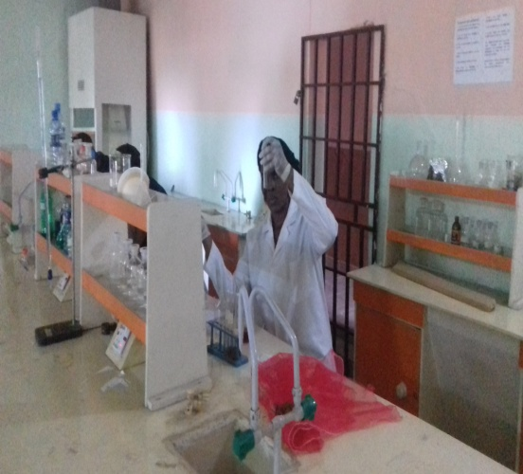 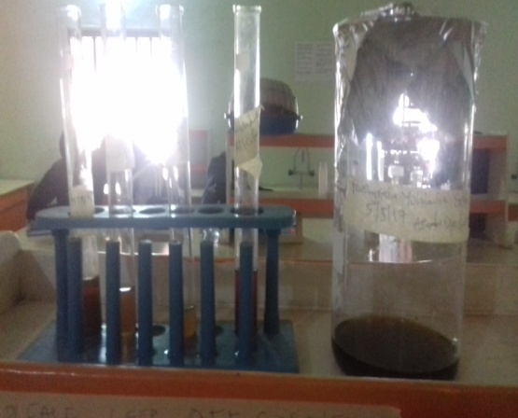

Phytochemical screening phytochemical results for : alkaiods,

Tannin,flavnoid and saponin

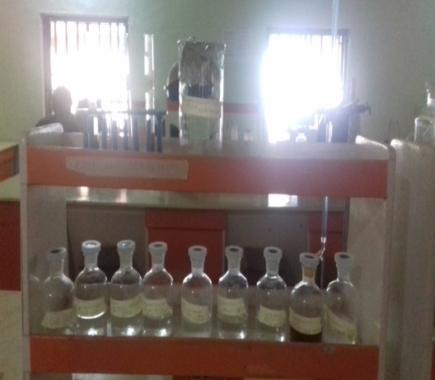

working reagents