CHAPTER ONE
INTRODUCTION
- Background to the study
In the northern Benue trough, where the climate and the nature of the sedimentary units allow for geologic studies, which in turn help to provide field evidence supporting the view of the Benue Trough as proposed by Benkheli (1982) and later by Guiraud (1993) which explains that The Benue trough is taught to be as a collection of pull apart basins related to transcurrent or strike-slip movement along deep-seated basement shear zones of Pan African origin reactivated as oceanic transform faults. the fine grained nature of most of the units and the dense vegetation as a result of a wet tropical climate in the southern Benue Trough have hindered field studies and created a missing link in the proper explanation of the structural framework of the basin. Afikpo Basin is located in the southern Benue Trough, between the Abakaliki Anticlinorium running northeast and the Cameroon line in the southeast (Okonkwo 2014). It forms part of the lower Benue Trough and the adjacent Anambra basin. Sedimentation took place in the Afikpo basin ranging in age from Cretaceous to Mastrichian. Due to unique geological features in Afikpo basin, different scholars have taken the basin as point of research interest. In light of this therefore, we carried out geological mapping in Amaekpu and its environs to study the geological feartures and deposition environment of the area.
  - Aims and objectives
The aim of the study is to study the geological feartures of Amaekpu and its environs. The objectives of the study among others are
- To carry out detailed geologic mapping of Ama-Ekpe, with a view to delineating lithologic contacts, stratigraphic relationships, sedimentary structures and paleontologic association.
- To establish the age of sediment and reconstruction the depositional environment of deposition.
- To evaluate the hydrocarbon source rock potential of the sediments and their degree of thermal maturation.
- To document the economic potential and hydrogeological characteristics of the study area.
1.2 Significance of study
The findings from this study would definitely provide more evidence to support or discredit what were already know about the Afikpo basin and also provide data for other geologists who are looking forward to conducting further studies on Ama-Ekpe and its environments. 1.3 Location and Accessibility
The studied area lies within longitudes 70 49l E and 70 54l E and latitudes 50 45l N and 50 50l N. It covers an area of 54km² on a scale of 1:25,000. It is situated in the southern part of the Lower Benue Trough and also within the southern part of Abakaliki Anticlinorium Fig.1 is the accessibility map of the area. Accessibility into the study area is made possible through Amasiri-Edda road and Abiriba-Nguzu-Edda road. Minor routes include the Owutu—Nguzu-Edda road, Ebunwana road, Ufueseni road, and a network of footpaths .
Villages within the study area include; Ndiba, Amaoba, Ama-Ekpu, Amaiyi, Ebunwana, Ekeje, Ekoli, NdiOloughu, Nkawu, Okpocha, Ufueseni.

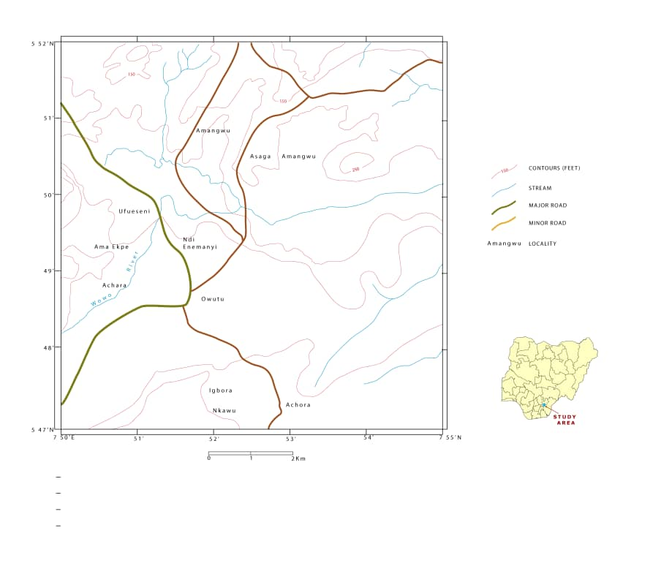
Figure 1 : Map showing the accessibility and location of study area

1.4REGIONAL GEOLOGIC SETTING AND GEOMORPHOLOGY
Geomorphology is the interpretation of landforms based on the effect of certain factors such as vegetation, drainage, erosion and weathering. The geomorphology of Amaekpu and its environs is the characteristics of the lithology of the area. The area is characterized by undulating highland that has a height of about 250ft at Asaga area, its slopes descend abruptly in some area and gently in some area,the hill is predominantly sandstone which is resistant to erosion and has sparse vegetation.The stream that cut through Ufoeseni take their source from Asaga hill, the low land areas close to this streams are characterized by shale with lush or huge vegetation.

1.4.1 Relief
Afikpo is about 164 square kilometers in size with an undulating topography. Sandstone forms its ridge and the shale forms its valley (Hulume, 1997). The shale unit underlies the bioturbated sandstones.
1.4.2 Drainage
The drainage pattern is mainly dendritic with a few rectangular or trellis patterns and the streams haven’t reached matured stage. As a result of the landform of the study area, these seem to be surface water runoff. The shale underlying the sandstone also makes surface runoff possible as it does not allow for water percolation. These drainages serve as source of water supply to some of the villages and communities. Springs and seepages abound in the study area contributes to the drainage of the area.Fig. shows the drainage pattern of the area.
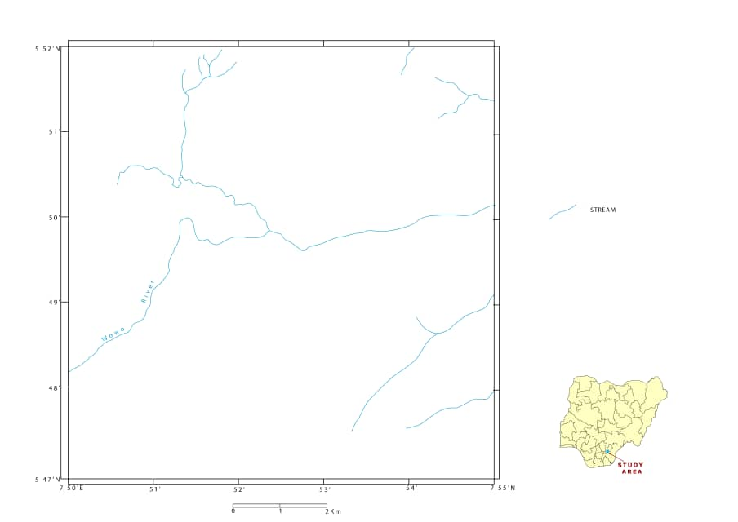
Figure 2:Map showing the drainage of the area

1.4.3 Vegetation
This is characterized by stunt trees and secondary forest consisting of shrubs and large trees but where there is lowland displaying up accumulation of trees you get sparse vegetation. The vegetation condition of the area is controlled by the lithology of the area, sparcesschrups and grasses cover the sandstone area while thick vegetation is a characteristics of the claye and shale areas,the major crops cultivated in the area is cassava and vegetable especially towards Ufueseni river banks.Fig. 3 shows the vegetation of the area.
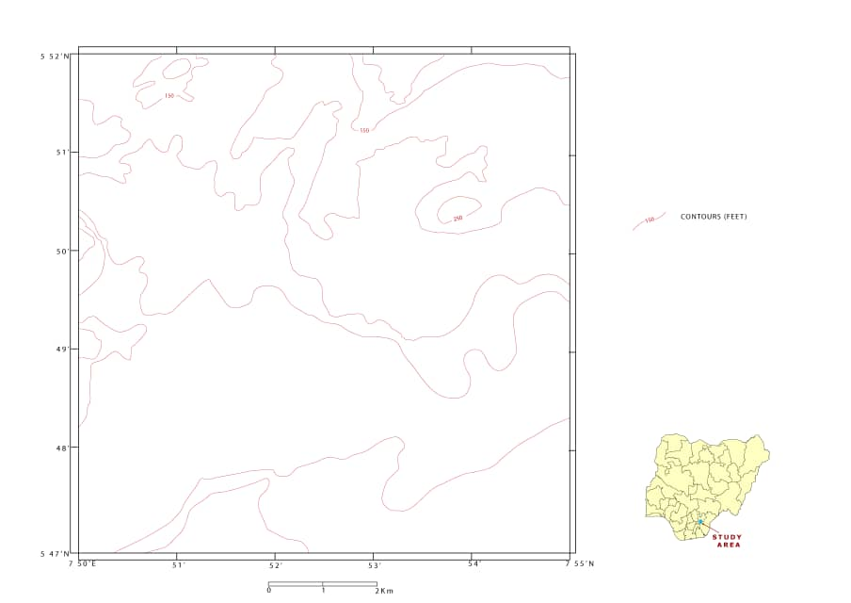
Figure 3:Showing the vegetation of the mapped area

1.4.4 Weather and Climate
The study area lie within humid tropical rainforest,it is bounded by fresh water swamp to th south and guinea savannah grass land to the north,The major variable are the wet and dry season. The wet seasons begins in late March and ends in October and sometime in November.the dry seasons begins from November to March. The rainfall is sometime turbulent and accompanied by thunderstorms. The annual rainfall in the area is about 1000mm to 1500mm,the month with the highest is September where rainfall can be as high as 2500mm,during the raining season in the month of August there is an August break which has .During the dry season, in December hammartan sets in,it is characterised by low humidity,the temperature of the study area leads to oxidizing condition that cause chemical weathering of outcrops. Fig 4 shows the mean annual distributing map of south eastern Nigeria.
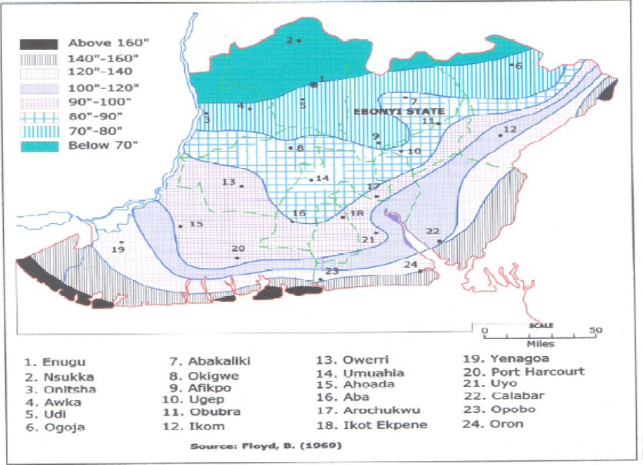
Figure 4: Mean annual rainfall distribution map of southeastern Nigeria (Floyd, 1969)

CHAPTER TWO
LITERATURE REVIEW
2.0 Regional Geology
Regionally, the study area is within the southern end of the Benue trough. The oldest sedimentary rock in Nigeria is in this trough and they are of lower Cretaceous age. The cretaceous stratigraphic record of the Southern Benue trough is represented by sediments deposited by three main marine depositional cycles: Albian-Cenomanian; Turonian-Santonian and campano-Maastrichtian. (Reyment, 1965, Ofoegbu, 1985). Shortly after the breakup of African and South America, a continental condition favourable for the deposition of fluvio-deltaic sediment which occurred in the Albian age. The aptian sediment is presented by the Ogoja sandstones.
The first marine transgression in this trough occurred in the middle Albian age with the deposition of the Asu river group sediments with type locality along the banks of Asu River (Reyment, 1965). The sediments consist of rather poorly bedded sandy shales with sandstone and sandy –limestone lenses. The regressive phase of the first marine transgression led to the deposition of the Cenomanian sediments. The beds of this age are located in the Southeastern part of Nigeria, around Calabar. These beds have been assigned as the Odukpani Formation (Reyment, 1965). It consist of arkosic sandstones, limestones and alternating limestones and shales which became gradually more predominantly shally in its uppermost parts (Reyment, 1965).The Turonian is overlain by sediments of Coniacian age. The Coniacian is represented by the Awgu Formation (Reyment, 1965). The formation consists of bluish grey, well bedded shales. The Santonian age was heralded by a tectonic event. This tectonic epirogenic event led to the uplift, folding and widespread erosion of the pre-santonian sediment in the trough.
Table 1: Regional Stratigraphic Sequence of South Eastern part of Nigeria. (Modified
By Reyment (1965), Murat (1972)

AGE | FORMATION | SEDIMENTARY CYCLE
Pliocene | Benin Formation | Niger-Delta Basin  ( Third tectonic phase)
Pleistocene | Ogwash- Asaba Formation
Eocene | Ameki formation
Paleocene | Imo shale
Maastrichian | Nsukka Formation  Ajali Sandstone  Mamu Formation
Campanian | Nkporo/Enugu shale  (Including Afikpo sandstone and Owerri sandstones). | Anambra-Afikpo Basin ( Second sedimentary cycle)
SantonianConiacian | Awgu shale | Abakaliki-Benue Basin  (First Sedimentary cycle)
Turanian  Cenomanian  Albian | Ezeaku Formation  Odukpani formation  Asu-River Group

The Campano-Maastrichtian experienced the third sedimentary cycle in this trough. It started with the deposition of the Nkporo formation (Nkporoshales). It consists of dark shales and mudstone with occasional thin beds of sandy shales and sandstones. A regressive phase of this transgression occurred in middle Maastrichtian with the deposition of the mamu formation and subsequent deposition of Ajali sandstones. A minor transgression occurred in late Maastrichtian with the deposition of Nsukka formation.

2.1 Origin and Evolution of the Benue Trough
The current observation is supported by both field geological observations as well as geophysics (Adighije, 1981; Benkhelil et al, 1989; Ofoegbu and Onuoha, 1990; Ofoegbu and Onuoha, 1991). From gravity and aeromagnetic studies carried out by Benkhelil et al. (1989) the entire Benue trough was seen as a combination of complex pull apart sub-basins separated by axial ridges. They described and gave names to a number of these ridges which were interpreted as forming as a result of releasing bends along strike-slip faults. These transcurrent faults are believed to be reactivated basement shear zones and are also intimately related to the formation of the oceanic transform faults involved in the opening of the central Atlantic (Benkhelil et al.,1989. The sub-basins served as centres of both continental and marine deposition from before the Albian to the early Santonian. One of these sub-basins is located in the study area and is called the Afikposub basin (Benkhelil et al., 1989).
2.2 Regional Stratigraphy of South Eastern Nigeria
2.2.1 Eze-Aku Group
The occurrence of the Cenomanian was characterized by the shallow marine Odukpani Formation (now considered defunct according to Nwajide, (2013)) consisting of sandstones, shales and calcareous rocks of shallow marine shelf environment found in the Calabar flank of the basin (Kogbe, 1989; Reyment, 1965). The alleged absence of Cenomanian in the Abakaliki basin had been attributed to a possibly slight folding phase (Amajor, 1985; Nwachukwu, 1972). It has already been mentioned that the Agala and Ibir Formations are known to be Cenomanian and the absence of extensive marine deposition in the Cenomanian is related to a regression as a result of a fall in sea level and not as a result of an inferred folding episode (Nwajide, 2013; Ojoh, 1992). Marine shales outcropping at Ezillo originally classified as part of the Eze-aku Shale facies were also discovered to be of late Cenomanianage. They mark the start of a very extensive transgression which peaked in the lower Turonian with the first transcontinental connection of the Tethys Ocean (present day Mediterranean Sea) with the Atlantic Ocean through the Benue trough. The Turonian also marks beginning of subsidence on the western shelf of the lower Benue trough and a shift in the depocentre towards the west (the Anambra basin) (Ojoh, 1992). In the southern Benue trough, black shales with calcareous rock and calcareous rocks occur (Nwajide, 2013; Odigi&Amajor, 2009b; Ojoh, 1992; Umeji, 1993). In the study area, on the eastern flank of the anticlinorium the Eze-Aku Group is represented by grey to black shales and linear ridges of sandstones termed the Amaseri Sandstones ranging from the upper Cenomanian to possibly as late as the 27 Coniacian (Amajor, 1987; Banerjee, 1980; Umeji, 1981, 1993). These units will be discussed in greater detail subsequently.
2.2.2 Awgu Group
The Late Turonian- Coniacian records the beginning of the regression that culminated in the uplift that ended the 1st tectonic phase. Marine deposition continued on the now subsiding western shelf with the Agwu Formation (Kogbe, 1989; Nwajide, 2013; Reyment, 1965) and the Nkalagu Formation (Ojoh, 1992) were deposited. In the late Coniacian to Early Santonian, a large deltaic complex developed on the Anambra platform; the Agbani Formation whose deposits were also encountered in Shell BP wells below the later Anambra basin deposits (Murat, 1972). The Awgu is absent on the eastern flank of the anticlinorium. There is some evidence though that some of the uppermost units of the Eze-Aku group in the study area may actually be of Coniacian age. But this is yet to be verified by paleontological evidence.

2.2.3 Anambra Basin
The Santonian period was one tectonism and structural inversion which, along with intense magmatism and regional metamorphism uplifted and exposed the central core of the Lower Benue basin and created the Abakaliki anticlinorium and the flanking Anambra and Afikpo synclines. The depocentre was shifted to the West, south and extreme southeast of the Abakaliki anticlinorium: the Anambra basin. In the Campanian the deposits that form the Nkporo Group were deposited. The Nkporo Shale Formation consists of dark grey shales with thin layers of sandstones and calcareous rock (Nwajide, 2013; Obi &Okogbue, 2004; Oboh-Ikuenobe et al, 2005; Reijers&Nwajide, 1998). In the Afikpo Syncline the Afikpo Sandstone Formation, consisting of pebbly, clayey, cross bedded and highly bioturbated sandstones interbedded with thin siltstones. The Afikpo Sandstone forms the basal unit of the Anambra basin in the study area where it rests directly above the Turonian (Coniacian?) Eze-Aku Group deposits in an angular unconformity (Fig.5). Ojoh (1992) suggests, from palynological evidence that deposition actually began in the Santonian period probably contemporaneous with the uplift and structural inversion. In the Maastrichtian stage a period of regression led to the deposition of the paralicMamu Formation consisting of shales, heteroliths, sandstone and coals. This formation is the major stratigraphic unit that forms the Enugu cuesta (Nwajide&Reijers, 1996). The Ajali Sandstone Formation lies conformably on the Mamu Formation (Fig.6). It consists of characteristically friable cross-bedded sandstones with a virtual absence of clay. It marks the height of the regression which ended the Nkporo depositional cycle. The youngest unit of the Anambra basin is the NsukkaFormation whose lithology is similar to Mamu Formation (shales, siltstones, heteroliths, sandstone and coals) and whose age ranges from the later Maastrichtian to the Danian.

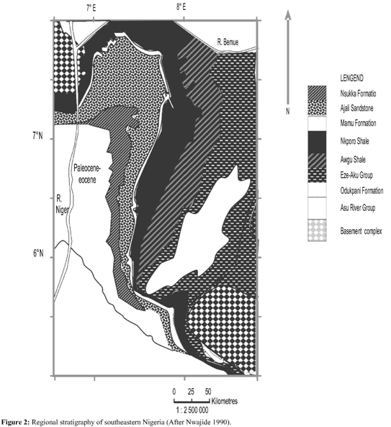
Figure 5:Regional stratigraphy of southeastern Nigeria (After Nwajide 1990)

2.3 Tectonic setting
Tectonism in southern Nigeria started in early Cretaceous period, with the separation of Africa from South America and consequently the opening up of the Atlantic (Nwachukwu, 1972; Wright, 1981).The NE-SW trending Benue Trough is thought to be the result of a pre-Albian rifting of the Africa shield prior to the opening up of the South-Atlantic (Uzuakpunwa, 1974). According to Furon (1963), the sedimentary basin of southern Nigeria is fault controlled and originatedin the Cretaceous time as an x-depression in the basement complex.
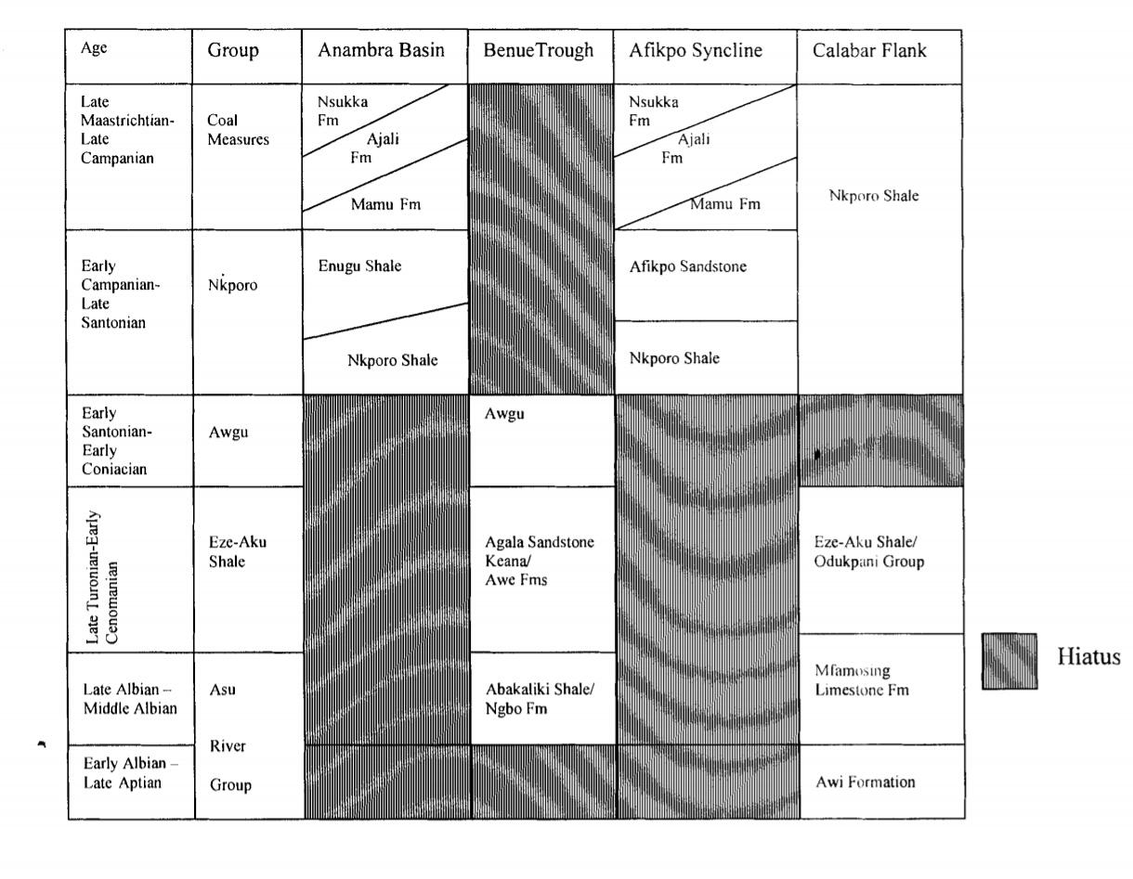
Figure 6:Stratigraphic columns of the southeastern Nigerian sedimentary basins modified after (Reyment, 1982; Petters and Ekweozor,1982)

Murat (1972) noted the three major phases that have been displaced given rise to the Abakaliki-Benue Trough, Anambra Basin and Niger Delta Basin. The first phase occurred during Albian times and was characterized by trending faults resulting in the formation of the rift like Abakaliki-Benue Trough. The second phase commenced from upper Santonian to Middle Eocene times. At the end of the Eocene, the third phase occurred giving rise to the formation of Niger Delta Basin
2.4 Stratigraphic Setting
The stratigraphy of the southern Nigerian sedimentary basins have been studied by various workers among Bain (1924), Wilson and Bain (1925), Tattam (1994), Simpson (1948), and Reyment and Barber (1956). The sedimentation in the area was controlled by four transgressive - regressive cycles, which resulted from eustatic and isostatic rise and fall of sea levels and global tectonics. Each phase of the cycle has a characteristic sediments. The oldest sediments belong to the Upper Cretaceous of Albian period. These were deposited as “Asu River Group”. The Asu River Group unconformably overlies the basement rock.
In mid-Albian times, the first known marine transgression invaded the Benue Trough from the Gulf of Guinea and deposited sands along the shoreline, shales offshore, and limestone on the shelf zone. These deposits are represented in Afikpo Syncline by the Asu River Group. The Asu River Group is dominated by shale, with localized development of sandstone and limestone beds. The sequence has a maximum thickness of about 6,000m containing ammonites. During the Cenomanian, the Sea began to regress and restricted itself to the southeastern corner of Nigeria around the Calabar Flank. The cause of the regression is believed to be a result of the mid tectonic event, which uplifted the sediments trending parallel to the trough in a NE-SW direction. Most extensive marine transgression, which completely invaded the Benue Trough in the Turonian was believed to come in form of both the Tethys sea and proto south Atlantic in the North and South respectively. The Seas deposited shales, sandstones and limestone, which are represented in Afikpo by the Eze-Aku Shale, Amasiri Sandstone and Nkalagu limestone(Table 2).
The Turonian transgression extended into the Coniacian times. Towards the end of the Coniacian and into the Santonian, tectonic event occurred, which resulted to uplift, folding and deformation. This event compressed the pre-Santonian sediments within the Benue Trough. Uplift of the Abakaliki Anticlinorium gave rise to the contemporaneous subsidence of Anambra and Afikpo platforms to the West and East of the Anticlinorium respectively.
Table2. Regional stratigraphic sequence of southeastern part of Nigerian sedimentary basins. (Modified after Reyment, 1965; and Murat, 1972).

AGE | FORMATION | SEDIMENTARY CYCLE
Pliocene | Benin Formation | Niger-Delta Basin (Third sedimentary cycle)
Pleistocene | Ogwash-Asaba Formation
Eocene | Ameki Formation
Paleocene | Imo Shale
Maastrichtian | Nsukka Formation  Ajali Sandstone  Mamu Formation | Anambra-Afikpo Basin (Second sedimentary cycle)
Campanian | Nkporo/Enugu Shale (Including Afikpo Sandstone and Owelli Sandstones)
SantonianConiacian | Awgu Shale | Abakaliki-Benue Basin (First sedimentary cycle)
TuronianCenomanian | Eze-Aku Formation  Odukpani Formation
Albian | Asu-River Group (Abakaliki Clay)

CHAPTER THREE

MATERIALS AND METHODS

3.1 Materials and Descriptions

Materials used in the field Trip are as follows;
- Base map: This is very important, it can be regarded as the first aid to every field trip in field mapping in geology. The base map shows the outcrop and the directions of a place under-consideration or mapping.
- Compass: it is used to measure the attitude of the outcrops; it enables the trends of fault planner and trough cross beds to be measured.

3. Measuring tape and meter rule: It is used to measure the thickness of beds during logging

4. Hand Lens: it is used for magnification

5. Field note book: for recording information

6. Sample bags: for collection of rocks samples, for analysis in the laboratory.

7. Geological hammer: it is mostly used to extract samples from the rocks

8. Camera: for taking photography (image) of an outcrop.

9. Pen and pencil: pen for recording information while the pencil for sketching or drawing out crop.

3.2 FIELD MAPPING PARAMETERS
Dip: It is the acute angle that a rock makes with a horizontal plane. It is measured with the compass clinometers.
Strike: is the direction of the line formed by the intersection of a rock surface with a horizontal plane. Strike and dip are always perpendicular to each other on a map. This also measured with clinometers.
Direction of dip: is a short line attached and at right angles to the strike symbol pointing in d direction which the planer surface is dipping down. The angle of dip is generally included on a geologic map without the degree sign.

3.3 Method of study

This covers the aspect of lithology, stratigraphy, and geomorphology, production of base maps and structural geology of the area. The methodology used during the field mapping exercise is the compass. Here, the major and minor roads, including foot paths were used in order to access the outcrops. We first located ourselves in the field using our Global Positioning System (GPS) after which it was indicated on the base map (topographical map). During the course of the exercise, GPS readings were taken at each location so as to obtain the latitude, longitude and elevation readings; observations based on the sediment types and sizes, along with the attitudes of beds (dip, strike, dip amount measurements and trends of joints) were made at the locations where needed. Outcrops and cross beddings were noted and measured. Some interbedded outcrops were logged from base to top at some of our locations. At various locations, we tried to determine the grain sizes, texture, sorting, mineralogy, sedimentary structures and other features of the outcrops, which aids in better description, naming and interpretation of the rock type.

The general methods used in this study aresummarized in the following headings;
- Desk studies: The available literature on the study area where studied to get a pre knowledge of the geology of the area, base map for the preliminary survey and field work were prepared. Theliterature studies include journals, unpublishedhandouts, geologic maps and books. The original topographic map of the area was blown and digitized to aid easy locations to be made.
- Reconnaissance survey: This involves the preliminary survey of the study area and was done by transversing the area and noting possible access and outcrop of interest and proper field study. Theindigenes of the area were also met during this survey and the aim was to sensitize them on the proper mapping and create good personal relationship with them, this make our mapping easy.
- Detailed geological survey: the detail geologic mapping of this study area were carried out during the month of March 2018, the study was based in investigation of lithology, structures and other geologic features. Outcrop study was carried out along erosion site, road cut and other natural exposed sites, the investigation concentrate on the texture of grain, color, matrixcharacteristics, degree of weathering, sedimentarystructures. The study of the outcrops was carried out by taking the coordinate of the location on the GPS recording the rock types after which beds are measured for thickness and other properties such as color, grain size and roundness. Theattitudes of the beds are measured if a good surface is found and also the geologic structures are recorded. Samples were also collected and labeled from the studied outcrop and were taken to laboratory for analysis.

The equipment used in the field study include clinometer, compass, geologichammer, measuringtape,magnifyinglense,
- Laboratory and statistical analysis

3.3.1 Methods of data analysis

The data analysed in this study are summarised under the following headings;
- Grain size and lithofacie analysis:

Five samples were collected at different locations in the study area and were sieved according to the techniques of Friedman 1979 the nest of sieve was arranged with the coarsest at the top and the finest pan at the bottom. The disaggregated and weighed samples of the sand were poured into the uppermost part of the sieve and shaken for 15minutes,the data obtained were used in plotting the cumulative probability curve and histogram in other to determine the grain size parameter of the sand, the parameters include mean,median,mode,skewness,kurtosis and graphic standard deviation.

The linear discrimination functions (y1,y2,y3) of Sahu (1964) and the bivariate plot of skewness against standard deviation (Friedman 1961) and mean diameter against standard deviation (Moiola and Weiser 1968) were used for environmental discrimination.

The method used in the statistical analysis of the samples were the Folk and Ward(1957) formula (eqn 1-5), and these gives information that were analysed.
According to Folk and Ward (1957),
Median = ∅50 -------------------------------- (1)
Mean = ----------------- (2)
∅16 + ∅84 + ∅50
3
Standard deviation = ---------------- (3)
∅84 - ∅16 + ∅95 - ∅5
4
6.6
∅84 + ∅16 - 2∅50 + ∅95 + ∅5 - 2∅50
2(∅84 - ∅16) 2(∅95 - ∅5)
Skewness = ------ (4)
∅95 - ∅5
2.44(∅75 - ∅25)
Kurtosis = --------------- (5)

Where, ∅95 = phi value at 95 percentile
∅84 = phi value at 84 percentile
∅75 = phi value at 75 percentile
∅50 = phi value at 50 percentile
∅16 = phi value at 16 percentile
∅25 = phi value at 25 percentile
∅05 = phi value at 05 percentile
The terms used in describing these parameters are shown in tables (3 to 6).

Table 3: Typical values for mean (Mz) (After Folk and Ward, 1957)
SOIL TYPE | RANGE ∅
Gravel | -∞ to -1
Very coarse sand | -1 to 0
Coarse sand | 0 to 1
Medium sand | 1 to 2
Fine sand | 2 to 3
Very fine sand | 3 to 4
Silt | 4 to 8
Clay | >8

Table 4: Terms used to describe the sorting values (After Folk, 1974)
DEGREE OF SORTING | ∅ VALUE
Very poorly sorted | 2.00 to 4.00
Poorly sorted | 1.00 to 2.00
Moderately sorted | 0.71 to 1.00
Moderately well sorted | 0.50 to 0.71
Well sorted | 0.35 to 0.50
Very well sorted | <0.35
Extremely poorly sorted | >4.00

Table 5: Terms used in describing skewness (After Folk, 1974)
DEGREE OF SKEWNESS | ∅ VALUE
Strongly fine skewed | <0.30
Fine skewed | 0.30 to 0.10
Nearly symmetrical | 0.10 to -0.10
Coarse skewed | -0.10 to -0.30
Strongly coarse skewed | <-0.30

Table 6: Terms used in describing kurtosis (After Folk and Ward, 1957)
EXTENT OF KURTOSIS | ∅ VALUES
Very platykurtic | 0.67
Platykurtic | 0.67 to 0.90
Mesokurtic | 0.90 to 1.11
Leptokurtic | 1.11 to 1.50
Very leptokurtic | 1.50 to 3.00
Extremely leptokurtic | 3.00

3.3.2 Methods of Graphic Presentation of Sieved Data
Two types of graphic presentation of grain size data were used;
Histogram
Cumulative probability curve
In constructing the histogram, the grain size was plotted on the horizontal scale while the percentage was plotted on the vertical scale. This was done to get a good pictorial view of the grain distribution, and hence, obtaining the modal distribution.
The cumulative curve was plotted on a semi log (probability) graph with the percentage weight on the vertical scale and the grain size on the horizontal scale. From the graph, the various phi values for obtaining the statistical parameter were obtained respectively. Almost 15 samples were gathered at different locations for laboratory analysis, that is, thin sectioning, sieve analysis and impregnation. Field observations were also recorded on field notebooks which in turn provide data for logging of sediments as well as for further analysis.

3.3.3: Biostratigraphic Analysis

This focuses on correlating and assigning relative ages of rock strata by using the fossil assemblages contained within them. Usually the aim is correlation, demonstrating that a particular horizon in one geological section represents the same period of time as another horizon at some other section. The fossils are useful because sediments of the same age can look completely different because of local variations in the sedimentary environment. For example, one section might have been made up of clays and marls while another has more chalky limestones, but if the fossil species recorded are similar, the two sediments are likely to have been laid down at the same time.

Paleontologists have traditionally used fossil data to provide information about the relative age, stratigraphic correlation, and paleoenvironment (notably paleobathymetry) of sedimentary strata. The importance of these tasks remains high, but new approaches and technology have extended the applicability of biostratigraphic data to analyzing thermal maturation and sequence stratigraphy.
Method of sample preparation
The method of study included laboratory sample processing and transmitted light microscopic logging.Four (4) shale samples from station 1, labeled (ST 4, ST 5, ST 7, ST 10 and ST 11 ), were subjected to palynological sample processing for their palynomorphs. The sample preparation was carried out, using the conventional maceration technique for recovering acid insoluble organic-walled microfossils from sediments. Each sample was digested for 30 minutes in 40% hydrochloric acid to remove traces of carbonate and 72 hours in 40% hydrofluoric acid for removal of silicate. The extracts were sieve-washed through 10 microns nylon mesh. The sieve-washed residues were oxidized for 30 minutes in 70% HNO₃ and 5 minutes in Schulze solution to render the fossils translucent for transmitted light microscopy. The oxidized residues were rinsed in 2% KOH solution to neutralize the acid. Swirling treatment was undertaken in order to get rid of the resistant coarse mineral particles and organic matter. The residues were stained with Safranin – O to increase the contrast for study and photography.
Aliquots were dispersed with polyvinyl alcohol, dried on cover-slips and mounted in petro- poxy resin. One slide was made from each sample and logged under the transmitted light microscopy. Light photomicrographs were taken withleicalll binocular microscope.

3.3.4: Hydrogeological Studies

The shape of the earth's surface determines how water flows. Hydrology analysis provides a useful method for describing the physical features of the earth surface. You can model the flow of water and perform quantitative analysis on a DEM data. Hydrology analysis can extract the information about where water comes from and where it is going across on any cell of a raster data.

DEM hydrology analysis model can be used to identify the extent of flood, position the pollution resource of a river, forecast how changes in that area may affect that flow. This is useful in many fields, such as regional planning, agriculture, and forestry.

CHAPTER FOUR
RESULTS AND INTERPRETATION
4.0 Lithostratigraphic descriptions
4.1:location one:Osso-Edda Junction along Ama-Ekpu Edda road
Nature of exposure: Road cut
Elevation: 10ft
Morphology: Hill
Attitude: 5ºNE 195ºSW, Dip: 189ºSW, Dip amount: 8º
GPS COORDINATES: N05º52.’017’, E007º49.’013’
4.1.1Outcrop description
Highly weathered andindurated sandstones are common in this location. From the field observation, the sandstones are grey in color. They are generally dipping towards the south east. Massive overhead borehole serving the surrounding communities was dug in this location. As seen in the log chat figure 8 shows the base of the sandstone ridge was deeply biotubated while the top of the sandstone bed which were intercalated with mudstones which were also highly weathered and faulted. Towards the south, the sandstone ridges gradually grade into shale with sandstones beds dominating.
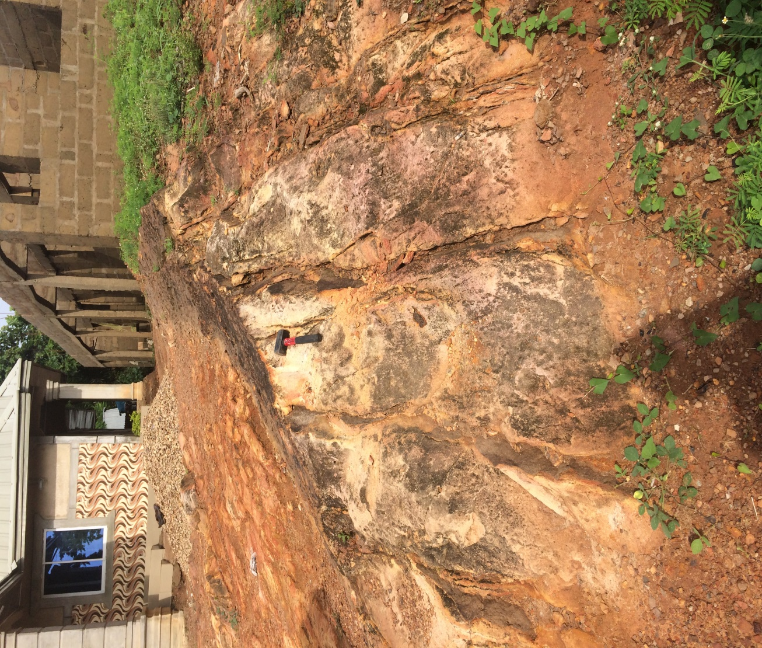
Figure 7: outcrop of massively weathered sandstone beds at Osso-Edda
4.2: Location 2: Ndi Ugbo Edda
Nature of exposure: Road cut
Elevation: 8ft
Morphology: Continuous

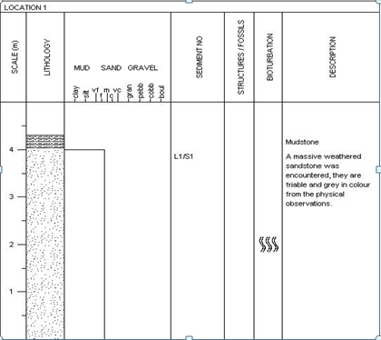
Figure 8:log section of the outcrop in location 1(Osso-Edda Junction along
Attitude: Strike: 24ºNE 205ºSW,Dip direction: 295ºNW,Dip amount: 7º
GPS coordinates: N05º52.’047’,E007º49.’101’
4.2.1:Outcrop Description: The outcrop is predominantly sandstone with intercalation of mudstones. The weathered portion of the sandstone is yellowish to brownish in color while the freshly exposed surface is creamish in color. The sandstone grains ranges from fine to coarse with poorly sorted beds. The sandstone samples were collected for sieve analysis studies. Figure 9 shows the logged stratigraphic section in the station 2.
4.3: Location Three:Owutu Edda road after the roundabout.
Nature of exposure: Road cut
Elevation: 215ft
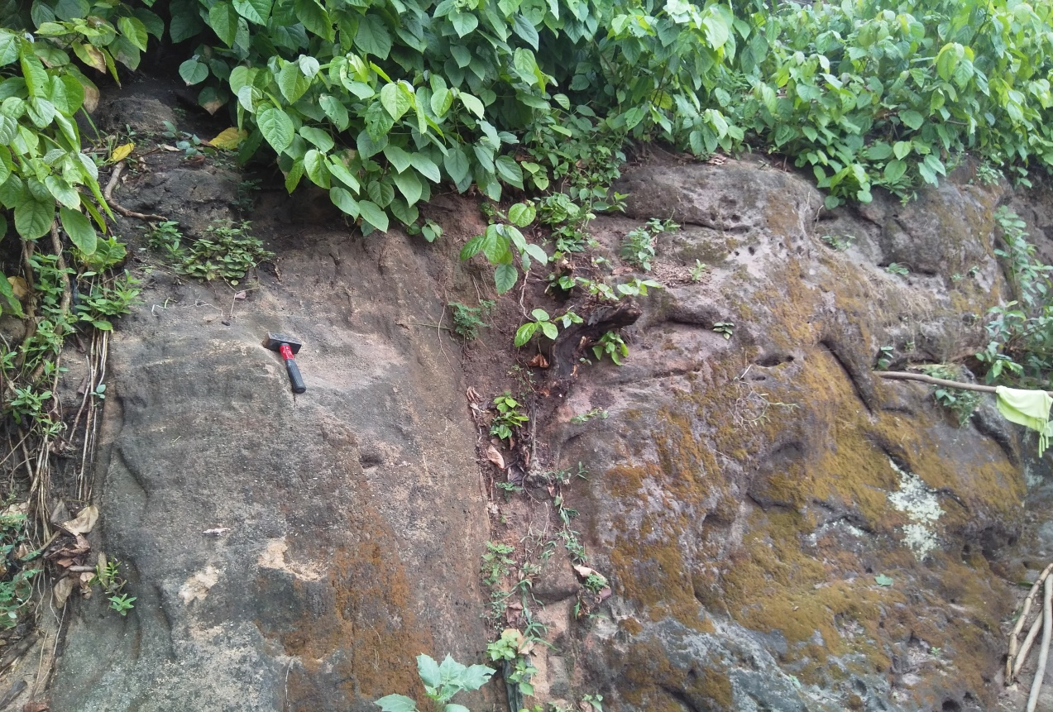
Figure 9: Indurated sandstones at OwutuEdda (station 3)
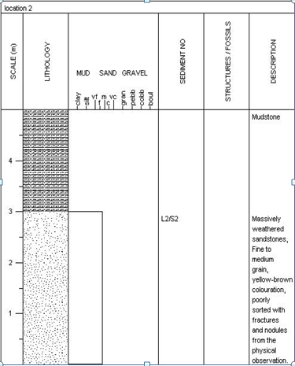
Figure 10: log section of the outcrop in location 2(NdiUgboEdda)

GPS Readings:N05°48.870’ E007°52.049
Attitude: Strike 204⁰, Dip 294⁰, Dip amount 28⁰
4.3.1: OutcropDescription
The sandstone beddings in this location is massively weathered. The topmost layers of these beds were made up of very thin mudstones of about 0.5m. The base of the logged sandstones beds were deeply faulted and also consist of burrows possibly initiated by rodents. (Table 8) illustrates logged section of the outcrop.

4.4:location four: Asaga-Amangwu village
Nature of exposure: River channel
Elevation: 80ft

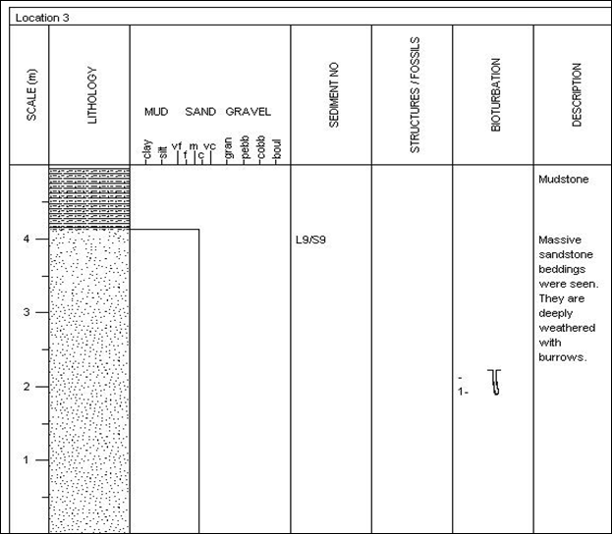
Figure 11:logged section of the outcrop in location 3 (OwutuEdda road)
Gps reading: N05°50.580’ E007°52.667’
Attitude: Strike 170⁰, Dip 260⁰, Dip amount 24⁰
4.4.1:Outcrop Description
This location is an intercalation of sand and shale from physical observation, Moderatelycoarse grain and darkish grey in color. (Table 9) shows the logging of the outcrop seen in this location.
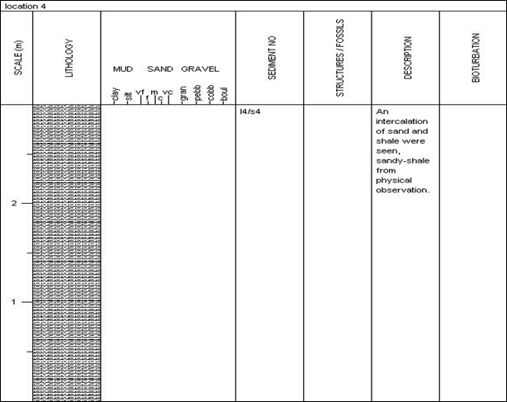
Figure 12:logged section of the outcrop in location 4 (Asaga-Amangwu village)
4.5: Location 5:EgbaraEbunwanaEdda junction round about
Elevation: 271ft
Gps reading: N05°47.470’ E007°52.411’
Attitude: Strike 170⁰, Dip 260⁰, Dip amount 24⁰
Nature of Outcrop: Shale

4.5.5: Outcrop Description
In this location, the outcrop seen is shale entirely

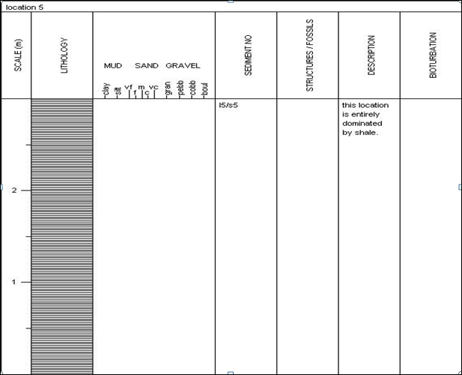
Figure 13:: logged section of the outcrop in location 5 (EgbaraEbunwanaEdda

Table 7:Grain size analysis data for sand sample 1

Sieve size  (mm) | Phi value  ∅ | Weight retained(g) | % weight retained  (Rn) | Cum. Weight retained  (SRn) | Cum.% passing  (100-SRn)
1.18 | -0.25 | 1.26 | 0.63 | 0.63 | 99.37
0.60 | 0.75 | 2.64 | 1.32 | 1.95 | 98.05
0.30 | 1.75 | 3.61 | 1.81 | 3.76 | 96.24
0.15 | 2.75 | 130.95 | 65.48 | 69.24 | 30.76
0.075 | 3.74 | 53.81 | 26.905 | 96.145 | 3.85
0.063 | 4.00 | 4.00 | 2.00 | 98.145 | 1.85
Pan |  | 1.50 | 0.75 | 99.41 | 0.59
 |  | 198.79

Total sample used 200g

Figure 14:Historam plot of the weigth retained as a function of sieve size

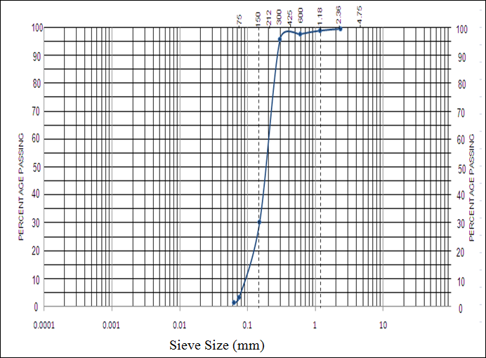
Figure 15:Cumulative frequency plot of the grain sample at location 1

Table 8: Grain size analysis data for sand sample 2
Sieve size  (mm) | Phi value  ∅ | Weight retained(g) | % weight retained | Cum. Weight retained | % passing
2.36 | -1.25 | 0.77 | 0.39 | 0.39 | 99.61
1.18 | -0.25 | 2.24 | 1.12 | 1.51 | 98.50
0.60 | 0.75 | 2.81 | 1.41 | 2.92 | 97.08
0.30 | 1.75 | 2.55 | 1.28 | 4.20 | 95.80
0.15 | 2.75 | 107.95 | 53.98 | 58.18 | 41.82
0.075 | 3.74 | 80.85 | 40.00 | 98.18 | 1.82
0.063 | 4.00 | 2.32 | 1.16 | 99.34 | 0.66
Pan |  | 0.41 | 0.21 | 99.55 | 0.00
 |  | 199.90
Total sample used 200g

Figure 16: Histogram chart of sample 2

Figure 17:Probability curve for sample 2

Table 9: Grain size analysis data for sand sample 3
Sieve size  (mm) | Phi value  ∅ | Weight retained(g) | % weight retained | Cum. Weight retained | % passing
2.36 | -1.25 | 0.09 | 0.05 | 0.05 | 99.95
1.18 | -0.25 | 1.28 | 0.65 | 0.69 | 99.31
0.60 | 0.75 | 3.14 | 1.51 | 2.26 | 97.74
0.30 | 1.75 | 4.53 | 2.27 | 4.53 | 95.47
0.15 | 2.75 | 5.96 | 2.98 | 7.98 | 92.02
0.075 | 3.74 | 165.74 | 82.87 | 90.85 | 9.15
0.063 | 4.00 | 15.59 | 7.80 | 98.65 | 1.35
Pan |  | 3.98 | 1.49 | I00 | 0.00
 |  | 199.31

Figure 18:Histogram chart of sample 3

Figure 19: Probability curve for sample 3

Table 10: Grain size analysis data for sand sample 4
Sieve size  (mm) | Phi value  ∅ |  | Weight retained(g) | % weight retained | Cum. Weight retained | % passing
4 | -2 |  | 7.26 | 2.42 | 2.42 | 97.58
2 | -1 |  | 4.05 | 1.35 | 3.77 | 96.23
1.19 | -0.25 |  | 34.14 | 11.3 | 15.15 | 84.85
0.91 | 0.5 |  | 62.83 | 20.94 | 36.10 | 63.90
0.149 | 2.75 |  | 184.88 | 61.62 | 97.73 | 2.26
0.125 | 3.0 |  | 5.74 | 1.91 | 99.64 | 0.35
0.105 | 3.25 |  | 0.335 | 0.11 | 99.75 | 0.25
0.075 | 3.75 |  | 0.415 | 0.138 | 100 | 0.00
 |  |  | 299.99
Total sample used is 300g

Figure 20: Histogram Chart for sample 4
Figure 21: Probability curve for sample 4

Table 11: Grain size analysis data for sand sample 5
Sieve size  (mm) | Phi value  ∅ | Weight retained(g) | % weight retained | Cum. Weight retained | % passing
2 | -1 | 2.00 | 0.5 | 0.50 | 99.5
1 | 0 | 21.60 | 5.40 | 5.90 | 94.1
0.425 | 1.234 | 176.80 | 44.20 | 50.10 | 47.9
0.150 | 2.737 | 171.20 | 42.80 | 92.90 | 7.1
0.075 | 3.737 | 21.80 | 5.45 | 98.35 | 1.65
pan |  | 6.40 | 1.60 | 99.95 | 0.05
 |  | 399.8
Total sample used 400g

Figure 22 : Histogram chart of sample 5

Figure 23: probability curve for sample 5

Table 12:Grain size analysis data for sand sample 6
Sieve size  (mm) | Phi value  ∅ | Weight retained(g) | % weight retained | Cum. Weight retained | % passing
2 | -1 | 1.70 | 0.40 | 0.40 | 99.57
1 | 0 | 4.52 | 1.13 | 1.56 | 98.44
0.425 | 1.234 | 29.18 | 7.30 | 8.86 | 91.14
0.150 | 2.737 | 320.80 | 80.20 | 89.06 | 10.94
0.075 | 3.737 | 37.30 | 9.33 | 98.39 | 1.65
pan |  | 5.90 | 1.48 | 99.87 | 0.31
 |  | 399.4
Total sample used 400g

Figure 24: Histogram chart of sample 6

Figure 25: Probability curve for sample 6

Table13: Computed grain size parameter drive from probability curve
Sample No | Sorting | Values | Skewness  (SK) | values | Kurtosis  (KG) | values | Mean(Mz) | Values
Sp1 | Very well sorted | -0.54 | Coarse skewed | -0.1 | Mesokurtic | 1.02 | Fine sand | 2.5
Sp2 | Very well sorted | -0.53 | Coarse skewed | -0.1 | Mesokurtic | 0.93 | Fine sand | 2.6
Sp3 | Very well sorted | -0.48 | fine skewed | 0.32 | Very leptokurtic | 1.64 | Fine sand | 3.3
Sp4 | Very well sorted | -1.0 | Coarse skewed | -0.1 | Platykurtic | 0.8 | Coarse sand | 0.48
Sp5 | Very well sorted | -1.1 | Fine skewed | 0.22 | Leptokurtic | 1.34 | Medium sand | 1.5
Sp6 | Very well sorted | -0.51 | Nearly symmetrical | 0.04 | Very leptokurtic | 1.68 | Fine sand | 2.2

Table 14: Average values for the parameters
Standard deviation () | -0.7 very well sorted
Mean (Mz) | 2.1 Fine sand
Skewness (Sk) | 0.05 Nearly symmetrical skewed
Kurtosis (KG) | 1.24 Leptokurtic

Table 15: Linear discrimination functions (Y1, Y2, and Y3) result for the analysed samples.
Sample No | Y1 | Y2 | Y3
SP1 | -4.566 | 75.8270 | -1.2944
SP2 | -5.235 | 75.1639 | -1.1952
SP3 | -6.4857 | 102.9100 | -2.5640
SP4 | 4.6157 | 86.5188 | -8.0900
SP5 | 2.8409 | 131.7700 | -11.1844
SP6 | -3.6780 | 83.7090 | -1.7649

4.6:GRAIN SIZE ANALYSIS
Interpretation of depositional environment and environmental discriminations are best done using various statistical measures obtained from grain size analysis data. The grain size distribution analysis of different soil samples in the study area have been shown.
4.6.1 GRAIN SIZE HISTOGRAM INTERPRETATION
The plots show unimodal, this signifies that a particular size fraction in the distribution is better sorted than others in each of the plots and thus suggests some variation in the energy of the current that deposited the sediments. The modal class of the distributions falls within fine to coarse grain, indicating that the sediments were deposited in low energy environment with high energy dominating at intervals.
4.6.2 ENVIRONMENTAL DISCRIMINATION
The variations in the energy and fluidity factors seem to have excellent correlation with different processes and environment of deposition (Sahu, 1964). The linear discrimination functions of Sahu (1962, 1964) for finding the relation between variances exhibited by parameters were used to discriminate the environment.
(a) For the discrimination between Aeolian processes and littoral (intertidal) environments, the discriminate function used is given below:
Y1 = -3.5688 MZ + 3.7016 δ1² - 2.0766 SK1 + 3.1135 KG
Where MZ is the grain size mean, δ1 is inclusive graphic standard deviation (sorting), SK1 is skewness and KG is the graphic kurtosis.
When Y1 is less than -2.7411, Aeolian deposition is indicated whereas if it is greater than -2.7411, a beach environment is suggested.sss(b) For the discrimination between beach (back- shore) and shallow agitated marine (subtidal) environment, the discriminate function used include;
Y2 = 15.6534 MZ + 65.7091 δ1² + 18.1071 SK1 + 18.5043 KG
If the value of Y2 is less than 65.3650 beach deposition is suggested whereas if it is greater than 65.3650 a shallow agitated marine environment is likely.
(c) For the discrimination between shallow marine and the fluvial environments, the discriminate function below was used
Y3 = 0.2852 MZ - 8.7604 δ1² - 4.8932 SK1 + 0.0482 KG
If Y3 is less than -7.419 the sample is identified as a fluvial (deltaic) deposit, and if greater than -7.419 the sample is identified as a shallow marine deposit.
From the values of Y1, Y2, and Y3 for the analyzed samples as shown in table 14;
80% of the analyzed sand samples showed Y1 values that are less than -2.7411, and thus indicates Aeolian deposition.
100% analyzed sand samples showed Y2 values that are greater than 65.3650 and thus, indicates shallow agitated marine environment.
80% of the sand samples showed Y3 values that are greater than -7.419 and thus, is identified as a shallow marine deposit.
4.6.3: CUMULATIVE PROBABILITY CURVE.
This curve shows the distribution of the grain size of the samples obtained in the study area. From the curve, the statistical analysis as proposed by Folk and Ward (1957) were obtained for interpretation of the depositional environment.
The probability curves of the analysed samples are shown in (fig 14 to 24).
4.7: BIOSTRATIGRAPHIC ANALYSIS
Biostratigraphy analysis were conducted on shale samples collected from locations of the study area for age determination purposes and to provide knowledge on its paleoenvironment.The shale samples were taken to the laboratory where they were washed and cleaned for sample preparation before mounting the slide (after sample preparation) on the microscope (Leica)for analysis and to take light photomicrographs.
4.7.1: PALYNOLOGICAL RESULTS
STATION FOUR (ST 4)
Tables 16-20 show the occurrences and distributions of palynomorph species.
Table16:Palynomorphs species result at station 4
Palynomorphs species | Total
TERRESTRIAL SPECIES
Spores
Laevigatosporitesovatus | 11
Leiotriletesadriennis | 0
Cingulatisporitesornatus | 1
Distaverrusporites simplex | 0
Zlivisporisblanensis | 3
Pollen
Buttiniaandreevi | 1
Echitriporitestrianguliformis | 2
Grimsdaleapolygonalis | 0
Longapertitesmarginatus | 7
Monoporitesannulatus | 2
Monocolpitesmarginatus | 0
Psilamonocolpitesmagnus | 1
Longapertitesmicrofoveolatus | 2
MARINE SPECIES
Andalusiellapolymorpha | 2
Ceratiopsisdiebeli | 0
Senegaliniunsp. | 3
Glaphyrocystaordinata | 1
Phelodiniumsp. | 3
Dinogymniumacuminatum | 2
Total Counts | 41

Comments: Palynomorph percentage
Terrestrial species: Spores = 37 %
Pollen = 37%
Marine species: Dinocysts = 26 %
Age: Late Campanian-Early Maastrichtian
Paleoenvironment: Marginal marine (estuary)
Paleo-salinity: Nearshore/brackish water
STATION FIVE (ST 5)
Table 17:Palynomorphs species result at station 5
Palynomorphs species | Total
TERRESTRIAL SPECIES
Spores
Laevigatosporitesovatus | 10
Leiotriletesadriennis | 3
Cingulatisporitesornatus | 0
Distaverrusporites simplex | 1
Zlivisporisblanensis | 2
Pollen
Buttiniaandreevi | 0
Echitriporitestrianguliformis | 3
Grimsdaleapolygonalis | 1
Longapertitesmarginatus | 5
Monoporitesannulatus | 2
Monocolpitesmarginatus | 4
Psilamonocolpitesmagnus | 0
Longapertitesmicrofoveolatus | 2
MARINE SPECIES
Andalusiellapolymorpha | 0
Ceratiopsisdiebeli | 2
Senegaliniunsp. | 0
Glaphyrocystaordinata | 1
Phelodiniumsp. | 2
Areoligerasenoniensis | 0
Paleocystodiniumaustrialinium | 2
Dinogymniumacuminatum | 3
Spiniferitessp. | 2
Glaphyrocystaordinata | 0
Total Counts | 45

Comments: Palynomorph percentage
Terrestrial species: Spores = 36 %
Pollen = 38 %
Marine species: Dinocysts= 26 %
Age: Late Campanian-Early Maastrichtian
Paleoenvironment: Marginal marine (estuary)
Paleo-salinity: Nearshore/brackish water
STATION SEVEN (ST 7)
Table18:Palynomorphs species result at station 7
Palynomorphs species | Total
TERRESTRIAL SPECIES
Spores
Laevigatosporitesovatus | 6
Leiotriletesadriennis | 1
Cingulatisporitesornatus | 2
Distaverrusporites simplex | 0
Zlivisporisblanensis | 2
Pollen
Buttiniaandreevi | 3
Echitriporitestrianguliformis | 2
Grimsdaleapolygonalis | 1
Longapertitesmarginatus | 5
Monoporitesannulatus | 0
Monocolpitesmarginatus | 2
Retidiporitesmagdalensis | 1
Longapertitesmicrofoveolatus | 2
MARINE SPECIES
Andalusiellamanthei | 0
Ceratiopsisdiebeli | 3
Senegaliniunbicarvatum | 4
Glaphyrocystaordinata | 0
Phelodiniumsp. | 1
Areoligerasenoniensis | 1
Paleocystodiniumaustrialinium | 0
Dinogymniumacuminatum | 2
Spiniferitessp. | 0
Glaphyrocystaordinata | 2
Total Counts | 40

Comments: Palynomorph percentage
Terrestrial species: Spores = 28 %
Pollen = 40 %
Marine species: Dinocysts = 32 %
Age: Late Campanian-Early Maastrichtian
Paleoenvironment: Marginal marine (estuary)
Paleo-salinity: Nearshore/brackish water
STATION TEN (ST 10)

Table19:Palynomorphs species result at station 10
Palynomorphs species | Total
TERRESTRIAL SPECIES
Spores
Laevigatosporitesovatus | 4
Leiotriletesadriennis | 3
Cingulatisporitesornatus | 0
Distaverrusporites simplex | 2
Cyathidites minor | 3
Pollen
Buttiniaandreevi | 2
Echitriporitestrianguliformis | 3
Spinizonocolpitesbaculatus | 1
Longapertitesmarginatus | 5
Monoporitesannulatus | 2
Monocolpitesmarginatus | 3
Retidiporitesmagdalensis | 2
Longapertitesmicrofoveolatus | 0
MARINE SPECIES
Andalusiellamanthei | 2
Ceratiopsisdiebeli | 1
Senegaliniunbicarvatum | 4
Glaphyrocystaordinata | 1
Phelodiniumsp. | 0
Areoligerasenoniensis | 0
Paleocystodiniumaustrialinium | 1
Dinogymniumacuminatum | 2
Spiniferitessp. | 0
Glaphyrocystaordinata | 1
Total Counts | 42

Comments: Palynomorph percentage
Terrestrial species: Spores = 29 %
Pollen = 43 %
Marine species: Dinocysts = 28 %
Age: Late Campanian-Early Maastrichtian
Paleoenvironment: Marginal marine (estuary)
Paleo-salinity: Nearshore/brackish water
STATION ELEVEN (ST 11)
Table20:Palynomorphs species result 11
Palynomorphs species | Total
TERRESTRIAL SPECIES
Spores
Laevigatosporitesovatus | 4
Leiotriletesadriennis | 0
Cingulatisporitesornatus | 0
Distaverrusporites simplex | 2
Zlivisporisblanensis | 1
Pollen
Buttiniaandreevi | 0
Echitriporitestrianguliformis | 2
Rugulatisporitescaperatus | 1
Longapertitesmarginatus | 3
Monoporitesannulatus | 0
Monocolpitesmarginatus | 2
Retidiporitesmagdalensis | 4
Longapertitesmicrofoveolatus | 0
MARINE SPECIES
Andalusiellamanthei | 0
Ceratiopsisdiebeli | 0
Senegaliniunbicarvatum | 2
Glaphyrocystaordinata | 2
Phelodiniumsp. | 3
Areoligerasenoniensis | 0
Paleocystodiniumaustrialinium | 0
Dinogymniumacuminatum | 1
Spiniferitessp. | 2
Glaphyrocystaordinata | 0
Total Counts | 42

Comments: Palynomorph percentage
Terrestrial species: Spores = 24 %
Pollen = 41 %
Marine species: Dinocysts = 35 %
Age: Late Campanian-Early Maastrichtian
Paleoenvironment: Marginal marine (estuary)
Paleo-salinity: Nearshore/brackish water

4.7.3: INTERPRETATION OF RESULTS
AGE ASSESSMENT
The age determination of the examined samples was based on the selected key age-diagnostic palynomorph assemblages recovered. They are summarized as follow:
- Fromtables 16-20 above, samples ST 4, ST 5, ST 7, ST 10 and ST 11, were datedLateCampanian-Early Maastrichtian age on the basis of thefollowingindexsporomorphs assemblage:Echitriporitestrianguliformis,Retidiporitesmagdalensis, Zlivisporisblanensis, Distaverrusporites simplex, Longapertitesmarginatus, Monocolpitesmarginatus, ButtiniaandreeviandLongapertitesmicrofoveolatus, (Lawal and Moullade, 1987; Umeji, 2007; Chiaghanamet al., 2012).
- The age was further confirmed by the presence of the typical West African Campano-Maastrichtian dinoflagellate cysts association such as, Senegalinium, Ceratiopsisdiebeli, Dinogymnium sp., Andalusiellapolymorpha, A. manthei, and Paleocystodiniumautrialinium,(Lentin and Williams, 1978; May, 1980; Umeji, 2007) (Fig. 20).
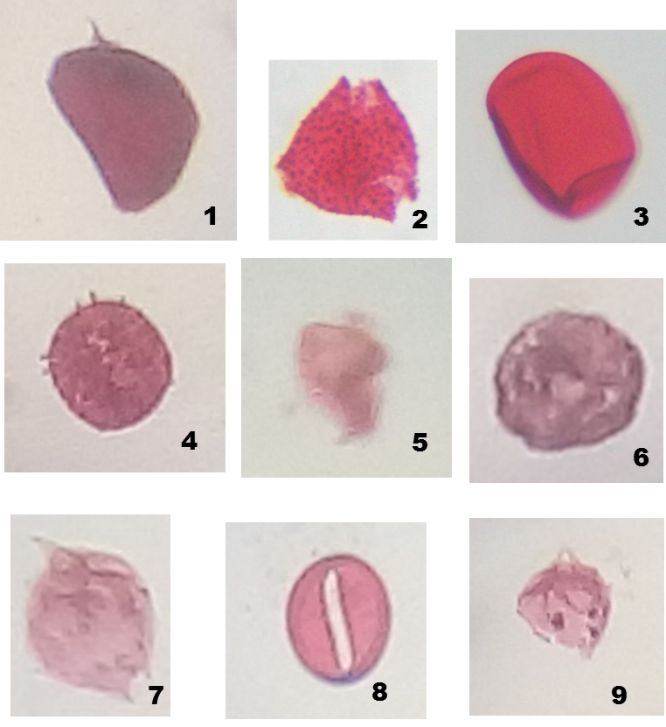
Figure 26: Micrographs of some palynomorphsrecovered in the examined samples.
Magnifications nos. 2 and 4 (X 100 oil immersion), others (X 40)

- Longapertitesmarginatus
- Echitriporitestrianguliformis
- Laevigatosporitesovatus
- Spinizonocolpitesbaculatus
- Dinogymniumacuminatum
- Buttiniaandreevi
- Andalisiellamanthei
- Monocolpitesmarginatus
- Andalisiellapolymorpha

4.8: KEROGEN INVESTIGATION
4.8.1:Method of Study
The kerogen slides were prepared from 5analyzed samples, labeled(ST 4, ST 5, ST 7, ST 10 and ST 11), one for each sample, using the conventional method of acid maceration (Fig. 2). Each slide was examined using the transmitted light microscopy at X10 and 40 magnifications in order to make a qualitative as well as a quantitative analysis of particulate organic matter (POM), determine the palynofacies association andkerogen types, examine the spore /pollen colouration,estimate the Thermal Alteration Index (TAI), Vitrinite Reflectance (Ro %), as well asthe degree of organic thermal maturation, (Fig. 3 and Fig. 4). Each slide was counted for its (POM) contents, in which the first 200 particles were counted in terms of abundant (>35 %), frequent (16-35 %), common (5-15 %) and rare (<5 %) (cf. Ibrahim et al., 1997; Zobba, 2007; Chiaghanamet al. 2013)table 5.

4.8.2: RESULT
Table 21: Summary of % frequency distribution of the total Particulate Organic Matter (POM) present in the analysed samples.
SAMPLE NO. | PHYTOCLAST | OPAQUES | AOM | PALYNOMORPHS
ST 4 | 59 % | 36 % | 3% | 2%
ST 5 | 50 % | 42 % | 6% | 2 %
ST 7 | 57 % | 25% | 10 % | 8 %
ST 10 | 60 % | 22 % | 15 % | 3 %
ST 11 | 55 % | 27 % | 13 % | 5 %

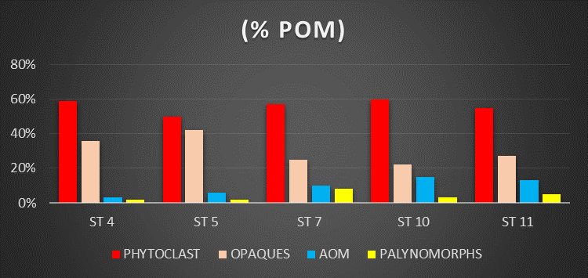
Figure 27: Histogram % frequency distribution of the total particulate organic matter (POM) present in the examined samples.

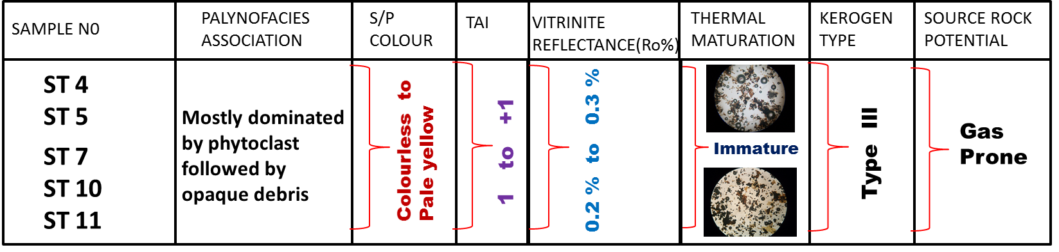
Figure 28: Summary of the kerogen characterization and interpretations.

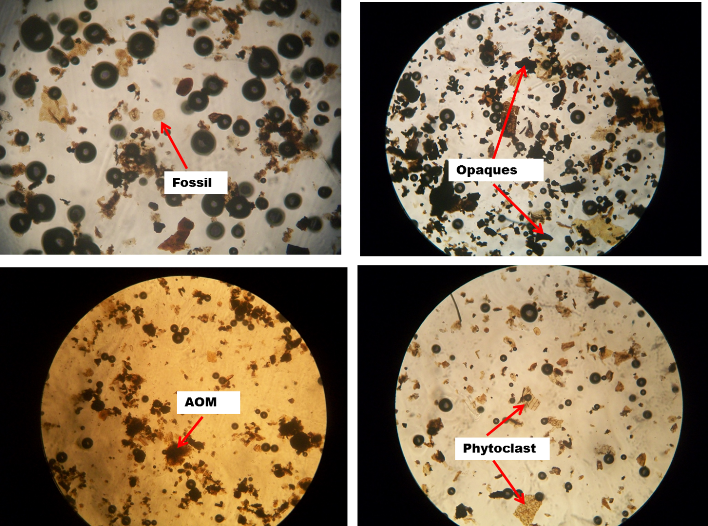
Figure 29: Photomicrographs of the kerogen slides showing the various (POM) in the examined samples.
Table 22: Hydrogeological Test of Ufueseni River.
1 | Conductivity uohm/cm | 42.1
2 | Appearance mg/l | Light yellow
3 | Calcium mg/l mg⁺²⁴ | 7.1
4 | Magnesium mg/l mg⁺²⁴ | 3.0
5 | Sodium mg/l Na⁺⁴ | 0.0
6 | Potassium mg/l K⁺⁴ | 1.3
7 | Sulphate mg/l SO₄⁻² | 2.5
8 | Chloride mg/l CL⁻ | 3.6
9 | Bicarbonate mg/l HCO₃ | 59.1
10 | PH | 6.2
11 | Temperature 0c | 25
12 | Total hardness mg/l CaO₃ | 11.7
13 | Salinity mg/l Nacl | 0.0
14 | TDS mg/l | 5.1
15 | Iron mg/l Fe⁺²⁴ | 0.0
16 | Floride mg/l f | 0.2
17 | Feacal coliform/100 of H2⁰ | 4.3
18 | Total dissolved solid | 25

4.9 INTERPRETATION OF WATER ANALYSIS
4.9.1 PH Assessment
The test result reviewed that Ufueseni River which also serves as a sourse of drinking water for the community is slightly acidic (6.2).The presence of the acid water is probably due to leaching of organic acid from the vegetation which massively infilterate the water table. Acid water may also result from the hydrolysis of iron in laterite deposits which are rampant in Ufuesenicommunity,the general effect of this water ranges from corrosion of pipes and casing.Based on this result the water is not safe for drinking.
4.9.2 Chemical Assessment
The total dissolved solid for the sample is relatively low with the value of 25.2 for the surface water. This is a consequence of resistant proffered by sand grain and heavy mineral constituent to chemical weathering. As evident in the chemical test result, the water sample is characteristically soft. The advantage of this is that the water will consume less amount of soap, thus it is suitable for laundries
4.9.3 Bacteriological Assessment
The bacteriological test shows that Ufueseni River contains coliform organism. This indicates that Ufueseni River is rich in feacal contamination and other biological materials which are sole cause of water borne diseases. This generally suggests that Ufueseni River is not good for domestic and industrial consumption.

4.10:ECONOMIC GEOLOGY OF AMA EKPU AREA
Economic geology is concerned with earth materials that can be used for economic and/or industrial purposes.
4.10.1: Sandstone:
Sandstone is a clastic sedimentary rock composed mainly of sand-sized minerals or rock grains. Most sandstone is composed of quartz and feldspar because these are the most common minerals in the Earth's crust. Like sand, sandstone maybe any color, but the most common colour are tan, brown, yellow, red, grey, pink, and black. Since sandstone beds often form highly visible cliffs and other topographic features, certain colours of sandstone have been strongly identified with certain regions.
Sandstone can be used for the following purposes.
- Manufacturing of plate glass, fine table glassware, and common glassware
- When crushed are used as concrete and asphalt in construction
- Rough and weathered Sandstone is used as fireplaces, walls and walkways
- As decorative stones
- As flooring or paving material
- Load bearing masonry
- Sandstones slabs and sandstone tiles are used in cladding.
4.10.2: Shale: shale is a fine grained sedimentary rock which weathers to clay. In occurrence oil and gas, shale serve as source rocking it contains kerogen and in some cases it could serve as an oil trap or seal. Oil shale is a black or brown bioturbated and a lot of trace fossils were found such as modusa and ophiomorpha.
The area had abundant surface water and groundwater which provides abundant water supply to the inhabitants. Also sandstones, shales and clay can be of economic importance.

CHAPTER FIVE
5.0 SUMMARY AND CONCLUSION
Based on the comprehensive field and laboratory studies in Amaekpu and its environs,twolitholigic unit were identified and they are Nkporo Shale and Afikpo Sandstone.
The Nkporo shale of the Campanian-Maastricthian sediments belong to the Nkporo Group while Afikpo Sandstone consist of interbedded coarse grain,poorly sorted fluvial tidal ferrogenised Sandstone and parallel heterolites of laminated siltstone and mud.The study area generally consist of lowland with the bed generally dipping towards the southeast. After extensive field mapping, the project area found to be predominantly composed of sandstone beds which was underlain by shale beds. The samples collected for analysis showed that the sandstone beds are medium to coarse, poorly sorted, and positively skewed and mainly platykurtic to leptokurtic. These result were used to plot vicariate graphs which showed that the sandstone in the area were deposited in a beach and fluvial environment. Also the textural maturity showed sub-mature to mature sediments which indicated low to high energy of deposition. The shales found in the area are dark grey in colour and showed extreme fissility. The area suffered extreme bioturbation and a lot of trace fossils were found such as thalasonoides, Medusa and ophiomorpha.
The area had abundant surface water and underground water which provides abundant water supply to the inhabitants although not suitable for drinking. However, sandstones and shale were the two minerals with huge economic importance encountered in the area.

