DESIGN AND IMPLEMENTATION OF WEB BASED SYSTEM
FOR INTERNET BANKING

BY

AGBEDO PETER ODINAKA
U14/NAS/CSC/046

Being a B.Sc project report submitted in the partial fulfillment of the requirement for the award of a Bachelor’s degree in Computer Science of the Godfrey Okoye University.

Supervisor: Dr. (Mrs.) Monica Agu
Department of Mathematics / Computer Science
Godfrey Okoye University, Enugu.

JULY, 2018

CERTIFICATION
We hereby declare that the work presented herein was done by me, and not by a third party. Should I be convicted of having cheated in this work, I shall accept the verdict of the University.

Agbedo Peter Odinaka, U14/NAS/CSC/046

APPROVAL PAGE
This is to certify that this project work titled the DESIGN AND IMPLEMENTATION OF AN ONLINE INTERNET BANKING SYSTEM is authentic and the research work used for the project has been approved by the supervisor of the project and the head of department, Computer Science, Godfrey Okoye University, Enugu.

………………………………. …………………………..
Dr. (Mrs.) Monica Agu Date
(Project Supervisor)

……………………………... ……………………………
Dr. (Mrs) Monica N. Agu. Date
(HOD, Computer Science)

DEDICATION
This project is dedicated to my loving parents Mr. and Mrs. Agbedo whom I adore and cherish for their priceless love, care and understanding. My love continues.

ACKNOWLEDGEMENT
My appreciation also goes to my Head of Department and Supervisor, Dr. (Mrs.) Monica N. Agu for working hard enough to make sure that we as students are given the right treatment and the right information in all ramifications. Also to all my departmental lecturers who taught me during the course of my study in school as well as my amiable coursemantes, am eternally grateful.

ABSTRACT
This project work is concerned with the use of the internet in banking operation.The internet in its ever evolving state, is becoming a serious method of business communication and data transfer worldwide. As such banks and other financial institutions are beginning to use the internet as new vehicle for doing business. The internet allows banks to offer both new services and level of convenience for existing services and allowing the consumers and customers to internet from any computer capable of making appropriate connection .The technological development which made most banks and other financial institutions more responsive to changes and imperative to adopt the latest art of technology is for the purpose of maintaining operational efficiency as a means of warding off competitive threat, and also to improve on the security measures, checkmate fraud and error, to increase the speed of transaction and improvement of customer’s convenience by reducing barriers to entry into payment systems and retail banking. The internet allows banks to offer both new services and level of convenience for existing services and allowing the customers to interact from any computer capable of making appropriate connection and also to provide fast services, this reduces the queue in the banking hall and permits on-line time data storage and information retrieval; to build a one- time entry for customer details in the system and provide the use of account ID and password for the customer. At the end of all to generate consistent, accurate, timely and pie liable reports or information for effective control in internet banking and to improve in current automated system that support internet banking service.The methodology for designing this project is the Structured System Analysis and Design method.The programs used to develop this system are PHP, My SQL, CSS and HTML. These packages make the Graphic Interface User friendly enough for even those with little or no computer knowledge.

TABLE OF CONTENTS
Title page i
Certification ii
Approval Page iii
Dedication iv
Acknowledgement v
Abstract vi
Table of contents vii
List of Figures ix
List of Tables x

CHAPTER ONE INTRODUCTION
  - Background of the study 1
  - Statement of the problem 2
  - Objective of the study 2
  - Significance of the study 3
CHAPTER TWO REVIEW OF RELATED LITERATURE
2.0 Introduction 4
2.1 Theoretical Background 4
2.2 Review of Related Literature 8

CHAPTER THREE SYSTEM ANALYSIS AND DESIGN
  - Introduction 14
  - Analysis of Existing System 15
  - Design of the Proposed System 16
    - Database Design 18
    - System Architecture 19

CHAPTER FOUR SYSTEM IMPLEMENTATION
4.0 Introduction 21
4.1 Choice of Programming Environment 22
4.2 Implementation Architecture 24
4.3 Software Testing 24
4.4 Documentation 29
4.4.1 User Manual 29
4.4.2 Source Code listing 30
CHAPTER FIVE SUMMARY AND RECOMMENDATION
5.0 Summary 31
5.1 Recommendation 31
References 32
Appendix 33

List of Figures
Fig 1: SSADM Methodology 14
Fig 2: Design of proposed system using UML use case diagram 16
Fig 3: Implementation Architecture 24
Fig 4: Screenshot of Homepage 25
Fig 5: Screenshot of Registration Page 26
Fig 6: Screenshot of User-Login Page 27
Fig 7: Screenshot of user page 28
Fig 8 Screenshot of admin page 29

List of Tables
Table 1: Database Design using Account-details table structure 33

CHAPTER ONE
INTRODUCTION
1.0 BACKGROUND OF THE STUDY
One of the major forces behind the changes happening to business today is technology, which creating new products, service market opportunities and developing more information and system oriented business and management processes. As an information medium, the internet offers different information service that has been developed over the time. The services are e.g. electronic mail, file transfer protocol and the worldwide web (www). The internet has no central owner, but the connected networks are owned and administrated by different universities, companies, authorities and other organizations, in future the customer will be able to buy the goods and services on the internet from all over the world and over the internet with the minimal risk. Recent trends show that most brick and mortar banks are shifting from a product-centric model to a customer-centric model as they develop their new internet banking capabilities. They have, over a long time, being using electronic and telecommunication networks for delivering a wide range of value added products and services. The delivery channels include direct dial up connections, private networks, public networks etc and the devices include telephone, personal computers including the automated teller machines etc. With the popularity of PCs, easy access to internet and worldwide web (www), banks increasingly use internet as a channel for receiving instructions and delivering their products and services to their customers. This form of banking is generally referred to as internet banking, although the range of products and services offered by different banks vary widely both in their content and sophistication.
1.1 STATEMENT OF THE PROBLEM
The advantages offered by these toll calls for a review of an existing automated system and subsequent design and implementation of interactive web-site to improve the existing system.
- In banking industries today, queuing has become the order of the day, customers’ line up for hours waiting to withdraw or deposit money. This creates a lot of problem to both customers as they waste their useful time in the banking hall. The management also wastes their time as they run around to find solution to their problems.
- It is observed that customers cannot withdraw money any time they want as banks has their working hours. This is a big problem as needs can arise at any time and human beings will always like to have those needs solved.
- Money deposited into accounts at times takes some hours to reflect in the persons account balance hence making banking operations slow and unhealthy for business growth.
1.2 OBJECTIVES OF THE STUDY
In a nut shell is to design and implementation of an interactive website for internet banking therefore, the following are the major objective of this work:
- Provide fast services, this reduces the queue in the banking hall and permits on-line time data storage and information retrieval.
- Build a one- time entry for customer details in the system and provide the use of account ID and password for the customer.
- Generate consistent, accurate, timely and pie liable reports or information for effective control in internet banking and to Improve in current automated system that support internet banking service.
1.3 SIGNIFICANCE OF THE STUDY
The study and subsequent design and implementation of this program will be of immense use to the organization, the administration and the customers in realizing the long south goal of speed, efficiency, effectiveness and convenience the program take care of those factors that militated against the smooth running operation of the organization using the on-line services provided by the web.
Better still scholars who intend to carry out subsequent research could have this as base from where improvement could be made.

CHAPTER TWO
LITERATURE REVIEW
2.0 INTRODUCTION
A literature review is an analysis of the project and all that it intends to work on, including the instruments used in the construction of the project, as well as the background history of the works done on the project and the methodologies used. This chapter analyzes this project in terms of the works done on it before as well as the methodology used in its construction.
2.1 THEORETICAL BACKGROUND
A website or simply a site is a set of related web pages typically served from a single web domain. A website is hosted on at least one web server, accessible via a network such as the internet or a private local area network through an internet address known as a uniform resource locator (URL). All publicly accessible websites collectively constitute the World Wide Web (WWW). The pages of a website can usually be accessed from a simple URL called the web address, the URLs of the pages organizes them into a hierarchy, although hyper linking between them conveys the reader’s navigation of the site which generally includes a homepage with most of the links to the sites web content and a supplementary about, contact and link page.

TYPES OF WEBSITES
They are two types of websites namely;
STATIC WEBSITE: is the one that has web pages stored on the server in the format that is sent to a client web browser. It is primarily coded in hyper text markup language. This type of website usually displays the same information to all visitors. It is manual process to edit d text, photos and other content and may require basic website design skills and software. Simple forms or marketing examples of website such as classic website, a five-page website or a brochure website are often static website, because they present predefined, static information to the user this may include information about a company and its products and services through text, photos, animations audio/video and navigation menus.
Static website can be edited using four board categories of software namely;
1. Text editors such as notepad or text edit, where content and html markup are manipulated directly within the editor program.
2. WYSIWYG (What you see is what you get) offline editors such as Microsoft front page and adobe Dreamweaver which the site edited using a GUI and final html markup is generated automatically by the editor software.
3. WYSIWYG online editors which create media rich online presentation like web pages, widgets, intro, blogs and other documents.
4. Template-based editors such as web allows users to create and upload web pages to a web server without detailed HTML knowledge, as they pick a suitable template from a palette and add pictures and text to it in a desktop publishing fashion without direct manipulation of HTML codes.
DYNAMIC OR INTERACTIVE WEBSITE: is one that changes or customizes itself frequently and automatically various web application frame works and web template systems are available for general-use programming language like PHP, perl, python and ruby to make it faster and easier to create complex dynamic website. Dynamic website can be interactive by using HTML forms, storing and reading back browser cookies, or by creating a series of pages that reflects the previous history of clicks. The HTML uses JavaScript code to instruct the web browser on how to interactively modify the page content.
PROGRAMMING LANGUAGES USED
This website was constructed using a set of web documents and a database management system. These web documents are a collection of different programming languages and scripts that allows the documents interact with each other. The programming languages that make-up these scripts are as follows;
- HTML: This is an acronym for Hyper-text markup language, which is the foundational language used to design almost all websites that exist in the world today. HTML was the first language used to design web-pages in the mid-1990’s. Right now, every website is built at the beginning stage with HTML codes. The basic syntax for html is given below;
- CSS: CSS is an acronym for Cascading Style Sheet, a scripting language used for styling html sheets. It was invented by the owners of HTML because it was difficult for them to add styling abilities to HTML syntax. It can be used to add font type, font size, background color, text alignment, margin etc. The Basic Syntax involves using a html selector and adding features to it;
- JAVASCRIPT: Javascript is a scripting language (language that adds extra features to the main programming language) used in functionality to a html document. Javascript handles issues like validation and submission of forms to the databases, prompts or alerts requesting for an action from the user, as well as hiding or displaying a html element upon a particular action from the user. Javascript is called a client-side scripting language because its codes can be viewed by the user from the website. HTML and CSS are also client-based languages.
- PHP: This is an recursive acronym for Hyper-text preprocessor. This is a language used in collecting html form data and submitting it to the database. Anytime a user submits a form (registration form, application form, request, search term), it is PHP that is responsible for collecting the data and submitting it to the database using SQL (Structured Query Language) as a query; the query stores the data or gets the data from the database, then PHP sends back information to the website on the success or failure of the query. PHP codes cannot be viewed by the user on the website, a feature which makes it known as “server-side” language.
- SQL: SQL stands for Structured Query Language, it is the language used for manipulating databases in order to get data, store data, update data or make changes to the database by adding or removing tables or changing the structure of the tables. In website design, it is carried by PHP; hence, it is executed inside a PHP tag and the result is sent back using PHP tag.
2.2 REVIEW OF RELATED LITERATURE
Internet banking simply refers banking products and services offered by institutions on the Internet through access devices, including personal computers and other intelligent devices.
Modern companies, particularly, banks have resorted to the automation of processing capabilities and the substitution of labour intensive process by machine processed applications. Rifklin (1995) noted that new and more sophisticated software technologies are going to bring evaluation over closer to the new workerless world. He then concludes that information technology otherwise refers to as e-banking has been used to deskill, discipline and displace human labour in a global speed up of unprecedented proportions. The modern banking service places more emphasis on technological innovations to improve service
delivery and high level of customers’ satisfaction; and this however increases the level of employees’ job insecurity by rendering some skills obsolete and demanding high level of skill in information technology (Olusegun, Ishola & Hammed, 2011). They pointed out that adoption of e-banking leads to loss of jobs and early retirement of employees in Nigerian banking sector. Similarly, they asserted that adoption of automated teller machine and other e-payment system effect job stability and employment of teller officers in the Nigerian
banking sector. Modern day banking services emphasize on the usage of technological innovations to improve service delivery and increase customers’ satisfaction. This explains why we experienced high level of job insecurity among employees in the modern-day banking industry.
E-Banking and Customers’ Satisfaction
Agboola (2001) studied the impact of computer automation services and discovered that electronic banking (e-banking) has tremendously improved the services of some banks to their customers in terms of satisfaction in Lagos. He averred that e-banking provided customers with a wide range of financial benefits such as lower transaction handling fees, higher deposit rates, opportunities to win prizes and extra credit card bonus points. It allows customers to save time by conducting their transactions quickly without having to queue up and to use paper documents. E-banking offers customers the opportunities to interchange electronic data to communicate with bank staff with a view to enhancing customers’ satisfaction. Customers’ complaints are part of the business life of any corporate entity. This is more so for banks because they are service organizations, customer service and satisfaction should be prime concerns of the banks. The banks believe that providing prompt and efficient service is essential not only to attract new customers but also to retain existing one. Adewuyi (2013) noted that customers’ complaints, grievances and dissatisfaction can
be reduced by banks through proper service delivery and review mechanism. Prompt service delivery has been described to be one of key performance indicators of corporate organizations including banks. The extent to which customers of banks are satisfied with the service rendered has impact on the overall performance and must be seriously taken by players of the industry. Quality of services is a key determinant of customer satisfaction and customer loyalty. E-banking is expected to improve banks service delivery in a form of transactional convenience, saving of time, quick transaction alert and cost savings, ultimately customers’ satisfaction.
E-banking and Security of Financial Transactions.
Security of financial transactions being executed from some remote locations and transmission of financial information over the air are the most complicated challenges affecting e-banking in Nigeria. It is one of the needs that should be addressed jointly by mobile application developers, wireless network service providers and the banks’ information technology departments. Several banks in Nigeria have lunched the mobile banking services that enable customers to carry out simple transactions based on short message service technology with customers’ mobile phones serving as the terminals. Such transactions include account balance enquiries, funds transfers between customers’ own accounts and to other accounts within the same bank, transaction tracking and third party payments such as bills payments, cheque book request and balance confirmation. The security controls used are pin code and pass code identification (Adewuyi, 2013). Also, to enhance effective security measure, banks have since been upgrading their ATM cards from the magnetic stripe to the Euro-Visa-Master card standard, popularly known as Verve Card (www.businessdayonlinc.com). This latter technological device is more fraud resistant because all the data of the customer are recorded on the chip. The union of technology and
finance have recorded huge success and has impacted on financial transactions. E-banking system has become the main technology-driven revolution in conducting financial transactions. However, banks have made huge investments in telecommunication and electronic systems, users have also been validated to accept e-banking system as useful and easy to use (Adesina & Ayo, 2010)
Challenges of E-Banking
Banking organizations have been delivering electronic services to consumers and businesses remotely for years. Electronic funds transfer, including small payments and corporate cash management systems, as well as publicly accessible automated machines for currency withdrawal and retail account management, are global fixtures. However, the increased world-wide acceptance of the Internet as a delivery channel for banking products and services provides new business opportunities for banks as well as service benefits for their customers (BCBS, 2001). Notwithstanding the significant benefits of E-banking and its capabilities, it carries risks and challenges which must be recognized and managed by banking institutions in a prudent manner. The speed of change relating to technological and customer service innovation in E-banking is unprecedented. Historically, new banking applications were implemented over relatively long periods of time and only after in-depth testing. Today, however, banks are experiencing competitive pressure to roll out new
business applications in very compressed time frames, often only a few months from concept to production. This competition intensifies the management challenge to ensure that adequate strategic assessment, risk analysis and security reviews are conducted prior to implementing new e-banking applications (BCBS, 2001).
E-banking increases banks’ dependence on information technology, thereby increasing the technical complexity of many operational and security issues and furthering a trend towards more partnerships, alliances and outsourcing arrangements with third parties, many of whom are unregulated. This development has been leading to the creation of new business models involving banks and non -blank entities, such as Internet service providers, telecommunication companies and other technology firms (BCBS, 2001). The Internet is ubiquitous and global by nature. It is an open network accessible from anywhere in the world by unknown parties, with routing of messages through unknown locations and via fast evolving wireless devices. Therefore, it significantly magnifies the importance of security controls, customer authentication techniques, data protection, audit trail procedures, and customer privacy standards (BCBS, 2001). Other E-banking related problems are user error, bad internet connections, access problems and security issues. Most of these problems may or may not outweigh the benefits.
2.3 SUMMARY
This chapter discusses the technologies used in the design of this project including the programming languages used which are HTML (Hypertext markup language), PHP (Personal Homepage), Javascript language, CSS (Cascading Style Sheet), and SQL (Structured query language) for database implementation. It also discusses the history of internet banking as well as the advantages and the factors that influence the users choice of internet banking in the society.

CHAPTER THREE
SYSTEM ANALYSIS AND DESIGN
3.0 INTRODUCTION
In this chapter, the researcher discusses the existing system used in banking for microfinance banks; it includes the analysis of the system and the proposal of the new system as well as the system architecture. The methodology for designing this project is the Structured System Analysis and Design method. This methodology is popularly described as a waterfall methodology for the design of information systems. The processes in this methodology are as follows;
FEASIBILITY
INVESTIGATION
BUSINESS SYSTEMS OPTIONS
REQUIRMENT DEFINITION
TECHNICAL SYSTEM OPTIONS
LOGICAL DESIGN
PHYSICAL DESIGN

Figure 1: SSADM methodology
  - ANALYSIS OF THE EXISTING SYSTEM
After an analysis of the microfinance banks in Enugu, the following details were found about their operational methodology;
- The customers can only open an account by filling a form at the bank
- All requests from the customer to the bank are done manually; there is always a need to fill a deposit slip, withdrawal slip, cheque etc, no matter how meager the amount may be.
The following defects were found with the existing system of operations;
- The fact that the customers must visit the bank to carry out any transaction or operation, an activity that is stressful.
- The fact that the operations are manual means that all customers must visit the bank to execute any operation. As a result, the banks are usually very much crowded as well as the degree of bureaucracy being very high.
- The cost of maintaining and buying forms is always very high.
- Theft and other corrupt practices are easily achieved when many things are done manually.
- Some operations that need a degree of discretion (such as transfer of huge sums of
- money, getting a bank statement, or applying for a loan) are much difficult to execute in such manual system.
  - Design of the Proposed System
The proposed system is highly automatic and is built such that consumers can carry operations on their account from anywhere across the world, and banks have lesser number of departments and fewer jobs to do. The diagram below describes the existing system using Use case diagram.
VIEW BANK SERVICES
ACCESS BANK SERVICES
NEW ACCOUNT
Customer
Registered Customer
New Customer
Authentication

Fig 2: Design of the Proposed System
The proposed system has the following advantages;
- The customer can access the utility from anywhere across the world.
- The customer can perform many functions without having to move from one department or another.
- The bank has lesser workload in terms of handling customer’s requests because most of the work is done by the web utility, and all they have to do is to keep records.
- The handling of records and customer’s requests is cheaper and less bulky. Because there would be lesser need for numerous forms for each operation a patient needs to carry out. Even the assignment of account numbers to customers is done by the banking utility.
The disadvantages of this system are that;
- In operations such as withdrawal of money, the customer must have to visit a bank branch to get it done, or better still, use an Automated Teller Machine outlet. Hence, the presence of physical banking is still very much necessary.
- The performance of the utility is dependent on the strength of the internetwork. In cases of poor weather, or low data transmission, performing operations on the web utility would be difficult to achieve.
The proposed system has the following advantages;
- The customer can access the utility from anywhere across the world.
- The customer can perform many functions without having to move from one department or another.
- The bank has lesser workload in terms of handling customer’s requests because most of the work is done by the web utility, and all they have to do is to keep records.
- The handling of records and customer’s requests is cheaper and less bulky. Because there would be lesser need for numerous forms for each operation a patient needs to carry out. Even the assignment of account numbers to customers is done by the banking utility.
The disadvantages of this system are that;
- In operations such as withdrawal of money, the customer must have to visit a bank branch to get it done, or better still, use an Automated Teller Machine outlet. Hence, the presence of physical banking is still very much necessary.
- The performance of the utility is dependent on the strength of the internetwork. In cases of poor weather, or low data transmission, performing operations on the web utility would be difficult to achieve.
3.2.1 Database Design
This project was built with a relational database (database that is built using tables). A sample of the database design is done using the design for the table of account_details of a customer, given below;
Table 1: Database design using Account_details table structure
S/N | Name | Type | Attributes | Null |  | Default | Comments | Extra
1 | Id | Int(200) |  |  | No | None |  | Auto_Increment
2 | Username | Varchar(200) |  |  | No | None
3 | Account  number | Varchar(250) |  |  | No | None
4 | Account Balance | Varchar 200 |  |  | No | None

    - System Architecture
The system architecture is the conceptual model that defines the behavior and structure of a system. This system is run using database correlation. Most operations carried out using the web application require one or more queries to the database. The following rules are observed;
- The user must login to the website to see information related to his account.
- All requests of the user such as statement of account, applying for loans, airtime recharge, application for credit card etc all require the submission of filled forms to the database, from which the administrator can read the requests.
- The administrator must also have an account with the application for him to access information about the customers.
- All administrators’ have a unique password that acts as a passkey (apart from their separate passwords) and serves as an identity for recognizing an administrator.

CHAPTER FOUR
SYSTEMS IMPLEMENTATION
4.0 INTRODUCTION
Implementation is the process by which a system develops is utilized and made functional or the process of converting a new system design into operation. It is the delivery of the system into production. This is the phase where all the requirement analysis design is put to test to ensure effective delivery of the system.
Implementation of the system involves writing a computer program testing and eventually changes over to the new systems. It also spells out how the entire system or program is and how it works both the arrangement of the program flowchart and pseudo code and equally the program design, the source program is also attached as well as some print outs from the program. In this project this chapter will elaborates more on the second phase of the project under hardware requirement which involves various hardware components of a computer system and their functions, (Assembly and Re-assembly) of a computer system.

4.1 CHOICE OF DEVELOPMENT ENVIRONMENT
Programming is a set of instructions written by a programmer, with a particular programming language which enables particular processes to be performed by a computer.
The system platform used in the development of this project is the windows operating system. It is used because;
- it is easy and cheap to acquire
- install,
- setup and
- troubleshoot.
The Integrated development environment (a software application that provides comprehensive facilities to computer programmers for software development. An IDE normally consists of a source code editor, build automation tools, and a debugger. Most modern IDEs have intelligent code completion.) used for this project is the sublime text editor. It was chosen because of the following features;
- One can run as many projects as possible on the editor.
- There is always a need to show the presence of different programming languages significantly. Sublime text does this using syntax highlighting (highlights syntax of different languages differently using colors).
- It is easy to setup, install, and troubleshoot.
The programming languages used were;
- Hyper-text markup language (HTML): HTML is used because it is the universal and generalized language for web programming. It is the most versatile and complete programming language for website development.
- Cascading Style Sheet (CSS): The cascading style sheets is used for styling web documents such as the addition of color, width, height, font size, font family etc. It was chosen for this project because it is the most complete and popular as well as easy to learn style sheet language known. It was actually invented for HTML. Thus, one who learns HTML is also required to have learnt CSS.
- Javascript: Javascript is a complete scripting language that is used to boost the functionality of a web document. Cases such as warnings, prompts, form validation etc. are done using javascript language. The language is also complete with sub-libraries such as Jquery that enable one to use Javascript on a simpler scale.
- Hypertext preprocessor. (PHP):
- Structured Query Language (SQL).
The database management system used for information storage is phpMyAdmin. The server used is localhost while the control panel used for managing it is Xampp control panel.

  - Implementation Architecture
HTML , CSS, JAVASCRIPT, JQUERY
PHP (Forms)
SQL (DATABASE)
BACK END

MIDDLE END

FRONT END

Fig 3: Implementation Architecture
4.3 Software Testing
In this part of this project, the researcher displays the produced work step by step using screenshots of the input and output to evaluate its capacity to deliver. The testing is done in order to find out errors during production and fix them immediately.
- Homepage: The homepage houses the general introduction to the microfinance bank and what it stands for, its vision, logo, mission and motto. It shows the general products the bank offers as well as the links for the user to create an account or log into one as well as the branches where the user can visit if he or she needs extra services the website cannot offer.

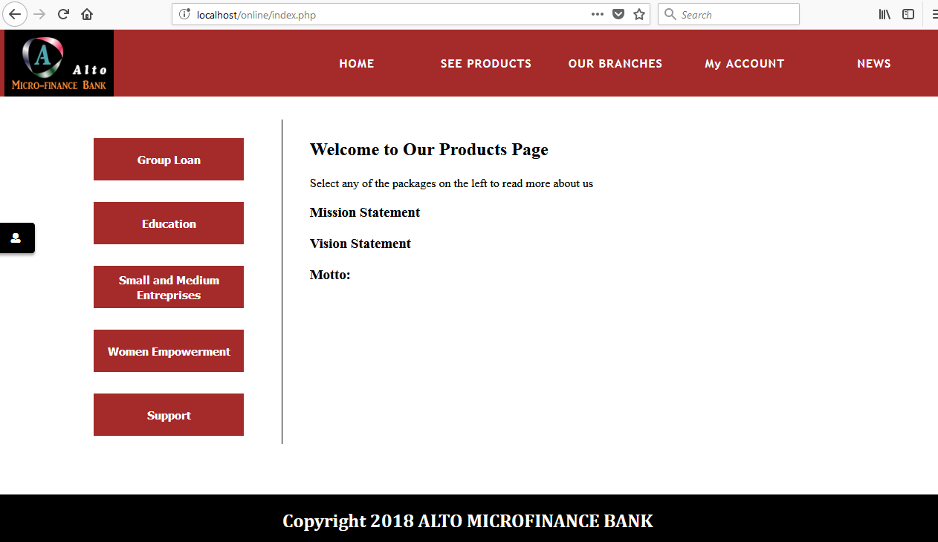
Fig 4: Screenshot of Homepage
- User Registration Page: This page is for the user who needs to open an account with the bank, the user fills in his / her personal details, contact details and account details. Upon submission, an account number is generated for the user and his or her details are stored in the database.

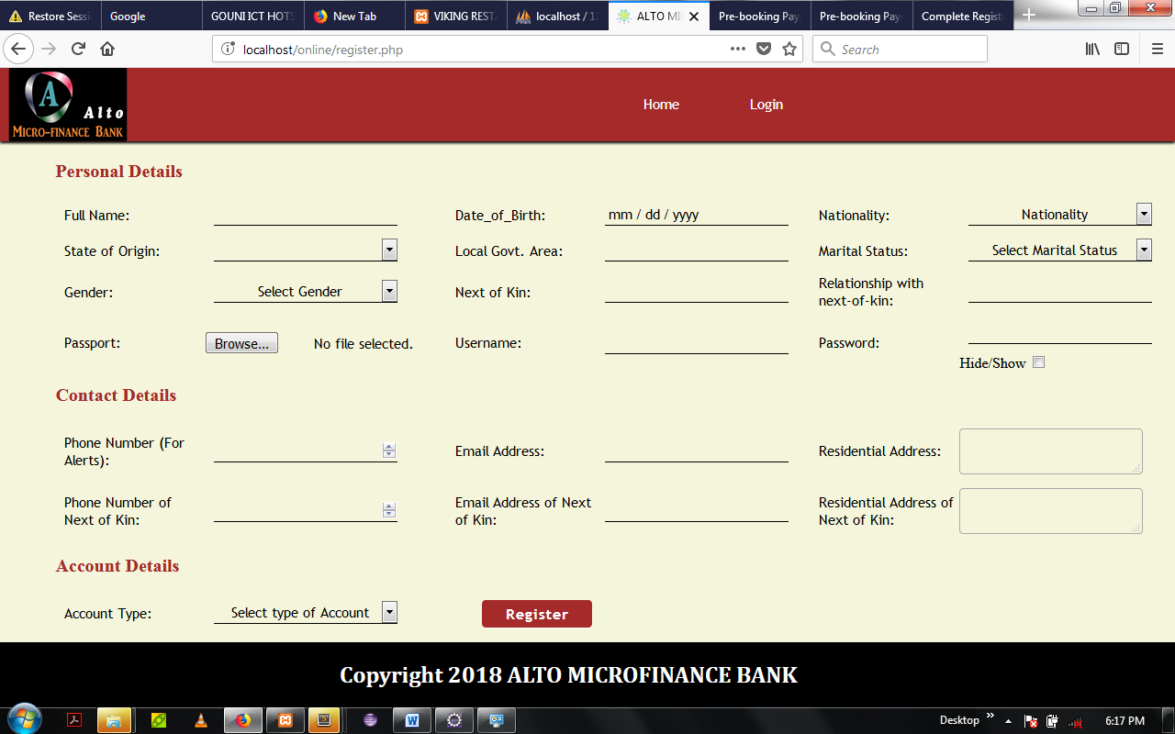
Fig 5: Screenshot of Registration Page
- Login Page: The Login page is the page that allows the user who already has an account to login to his homepage by inserting the username and password. A couple of authentication’s are made to ensure that the user is registered in the database. If successful, the user is logged in to his account dashboard.

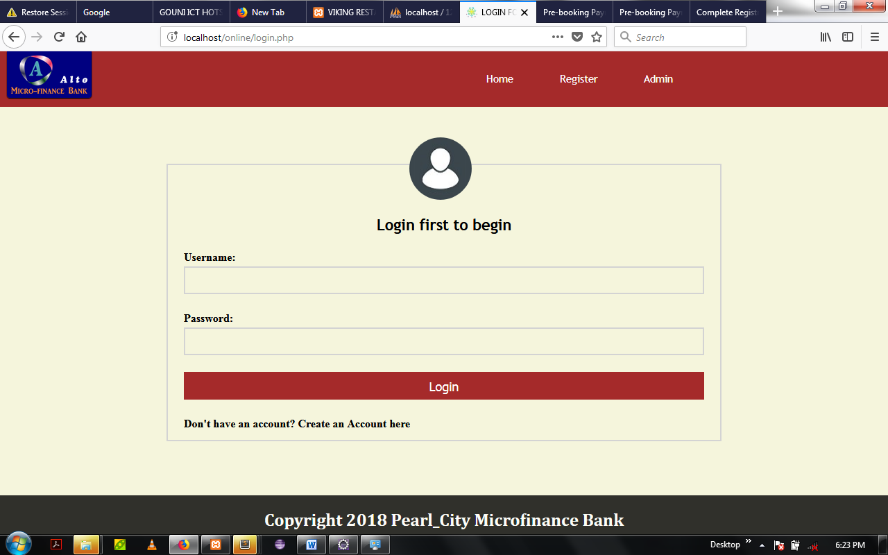
Fig 6: Screenshot of User-login Page
- The User Page: The user page contains the information about the logged in user and his account details with the bank. Including the account balance, transactions carried out, date of registration, account number, username, and the services offered by the bank which are readily available to the customer.

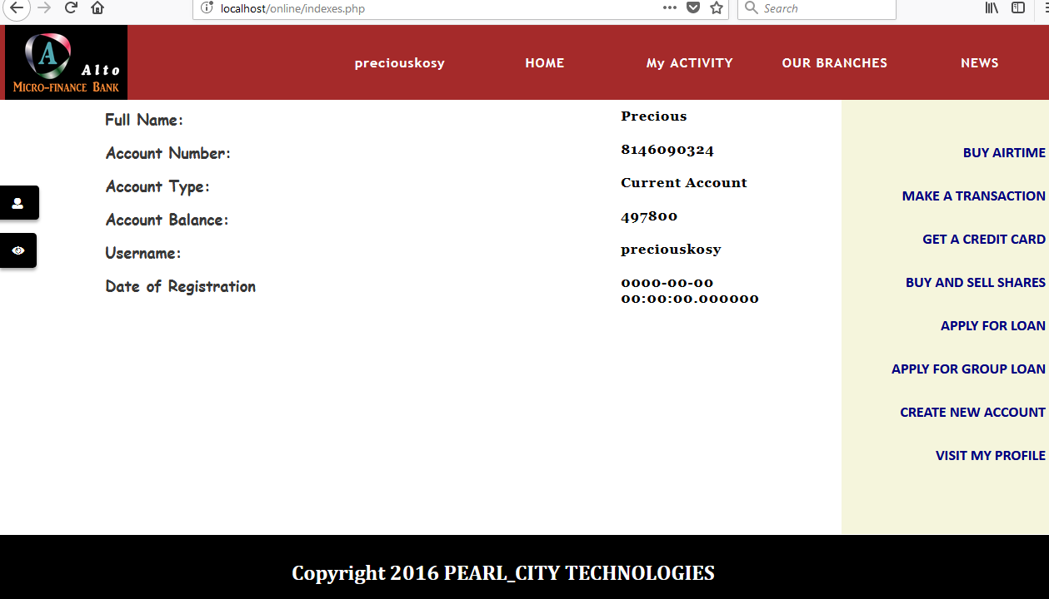
Fig 7: Screenshot of user page
- The Administrative Page: The administrative page shows all activities undertaken by the end-users and their state of processing. It is designed not to be visible to the user. To enter the administrative page, one needs to register as an administrator and have the key-password (a general password that is only known to the administrator) which is stored in the database. The administrator has the following rights;
  - See entries made by the users
  - Respond to mails sent by the users
  - Delete or edit entries made by the users such as double accounts, or double credit card requests.
  - Block the account of a user (maybe because the user is under investigation or that the user has other legal issues with the bank).
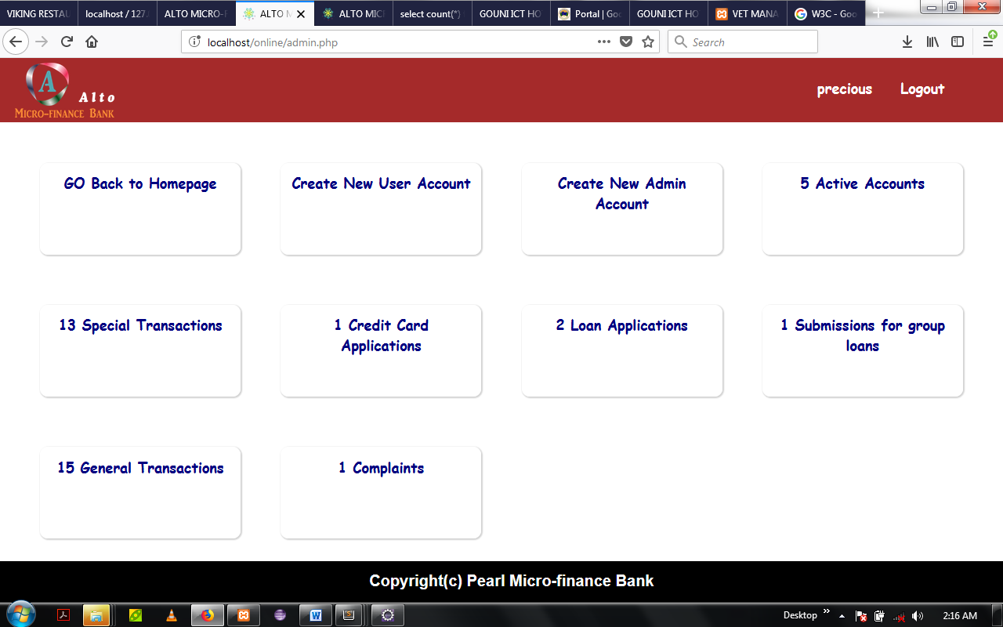
Fig 8: Screenshot of Administrative Page
4.4 Documentation
4.4.1 User Manual
To open the web application, follow these steps;
- Boot your laptop and open your browser.
- Turn on the internet or intranet server (whichever is available).
- In your browser’s search pane, type in ‘localhost/banking’ to access the application.
- The application would load in a homepage where your tour of the software begins.
- To get the admin page (it doesn’t have a link to the user page for security purposes), type in ‘localhost/banking/admin.php’ and press “Enter” to get the administrator page.
- When the administrator page loads, you are prompted to login or create an administrative account because you are already logged out by default.
- After logging in or registration, the login page loads from which you can operate as an administrator.
4.4.2 Source Code listing
- Refer to Appendix B for the source code of the homepage.
- Refer to Appendix C for the source code of the user page.
- Refer to Appendix D for the source code of the administrative page.

CHAPTER FIVE
SUMMARY, CONCLUSION AND RECOMMENDATION
5.1 SUMMARY
The primary purpose of this project is to replace the existing manual processing with error free, high speed and low cost and should improve the system capability. Working on the project was good experience. I understand the importance of planning and designing as a part of software development.
5.2 CONCLUSION
The aim of this project is to provide an interactive website for internet banking to be used in the bank to improve efficiency. Though in the long run, more features could still be added which will entail expanding the program to be more complex than this.
5.3 RECOMMENDATION
The Proposed system improves the systems performance because the current system is based on manual processing while the proposed system is based on computer processing. The project can be further enhanced to provide different types of account facilities with providing different of interest on each type of accounts available in system.

References

[1] Abor, B. (2004), “Use of E- Banking in 21st Century: The major Challenges”, Journal of
Business and Finance, 4(3), 2-9.

[2] Aladwani, A.M (2001), “Online Banking a Field Study of Drivers, Development
Challenges and Expectations”, International Journal of Information and Management, 2(1), 213-225.

[3] Balachandher, K.G (2001), “Electronic Banking in Malaysia: A Note on Evolution of
Services and Consumer Reaction, Retrieved from http://www.mmu.edu.my.

[4] Cain, G. (2004), “An Empirical Investigation of the Level of Users. Acceptance of E-
Banking in Nigeria”, Journal of Internet Banking and Commerce, 15(1), 7-12.

[5] Claessens, J., Dem, V., De Cock, D., Preneel, B. & Vandewalle, J. (2002), “On the
Security of Today’s Online Electronic Banking System”, Computers & Security 21, 257-269.

[6] Henry, L. (2000), “The Adoption of Internet Banking in Nigeria: An Empirical
Investigation, Journal of Internet Banking and Commerce. 11(3).

[7] Idowu, P.A., Aliu, A.O. & Adagunodo, E.R. (2002), “The effect of Information
Technology on the Growth of the Banking Industry in Nigeria”, The Electronic Journal on Information System in Development Countries, EJISDC, 10(2) 1-8.

[8] Imiefoh, P. (2012), “Towards Effective Implementation of Electronic E-Banking in
Nigeria”, An International Multi Disciplinary Journal, 6(2), 290-300.

[9] Olusegun, A.S, Ishola,G.K. & Hammed, A.B. (2011), “Effect of Electronic Banking on
Employees’ Job security in Nigeria”, European Journal of Humanities and Social Sciences, 4(2), 69-84.

[10] Qureshi, T.M., Zafar, M.K. & Khan, M.B. (2008), “Customers Acceptance in
Developing Economics”, Journal of Internet Banking and Commerce, 13(1), 6-8.

APPENDICES

APPENDIX A: Source Code listing for Homepage

<?php
//include_once 'libraries/config.php';
//include_once 'libraries/functions.php';
session_start();
?>

<html>
<head>
<meta charset="utf-8">
<meta http-equiv="X-UA-Compatible" content="IE=edge,chrome=1">
<meta name="viewport" content="width=device-width, initial-scale=1">
<title> ALTO MICRO-FINANCE BANK</title>
<link rel="stylesheet" type="text/css" href="css/font/web-fonts-with-css/css/fontawesome-all.css">
<script type="text/javascript" src = 'js/javas.js'></script>
<script type="text/javascript" src = 'js/jquery-2.2.0.min.js'></script>
<script type="text/javascript" src = 'js/jquery.cycle.all.js'></script>
<link rel="stylesheet" type="text/css" href="css/logger.css">
<link rel="shortcut icon" href="Images/Pearl.png" type="image/png">
</head>

<body>
<div id = 'header'>
<img id = 'ico' src="css/Ace.png">
<div id = 'cont'>
<button id = 'loan' onclick = "javascript:ace('index.php')"> HOME </button>
<button id = 'services'> SEE PRODUCTS </button>
<button id = 'location'> OUR BRANCHES </button>
<button id = 'begin' onclick = "javascript:ace('indexes.php')"> My ACCOUNT </button>
<button id = 'benin' > NEWS </button>
</div>
</div>
<script type="text/javascript">
var scroll_pos = 0;
$(window).scroll(function(){
scroll_pos = $(this).scrollTop();
if (scroll_pos > 210) {
$("#header").css('background-color', 'brown')
$('#header button').css('color', 'white');
$('#header img').css('background-color', 'transparent');
$('#header button').each(function(){
$('#header button').mouseover(function(){
$(this).css('color', 'white');
$('#header').css('background-color', 'brown');
});
$('#header button').mouseout(function(){
$(this).css('color', 'white');
$('#header').css('background-color', 'brown');
});
});
} else {
$("#header").css('background-color', 'transparent');
$('#header button').css('color', 'brown');
$('#header img').css('background-color', 'black');
$('#header button').each(function(){
$('#header button').mouseover(function(){
$(this).css('color', 'white');
$('#header').css('background-color', 'transparent');
});
$('#header button').mouseout(function(){
$(this).css('color', 'brown');
$('#header').css('background-color', 'transparent');
});
});
}
console.log(scroll_pos);
});
</script>

<div id = 'many'>
<div id = 'slideshowContainer'>
<script type="text/javascript">
$(document).ready(function(){
$('#slideshow').cycle({
fx: 'fade',
pause: 4
});
});
</script>
<div id = 'slideshow'>
<div id = 'img1' class = 'img'><p> Education for All </p></div>
<div id = 'img2' class = 'img'><p> We have all the advice </p></div>
<div id = 'img3' class = 'img'><p> Access us from anywhere</p></div>
<div id = 'img4' class = 'img'><p> Your hustle is our interest </p></div>
<div id = 'img5' class = 'img'><p> Relax, you're covered </p></div>
</div>
</div>

<div id = 'entry'>
<button id = 'group'> Group Loan </button>
<button id = 'edu'> Education </button>
<button id = 'smaller'> Small and Medium Entreprises </button>
<button id = 'womens'> Women Empowerment </button>
<button id = 'supports'> Support </button>
<script type="text/javascript">
$(document).ready(function(){
$('#contents').show('slow');
});

document.getElementById('group').onclick = function() {
$('#group-loan').show('slow');
$('#education').hide('slow');
$('#small').hide('slow');
$('#women').hide('slow');
$('#support').hide('slow');
$('#contents').hide('slow');
}

document.getElementById('edu').onclick = function() {
$('#education').show('slow');
$('#group-loan').hide('slow');
$('#women').hide('slow');
$('#small').hide('slow');
$('#support').hide('slow');
$('#contents').hide('slow');
}

document.getElementById('smaller').onclick = function(){
$('#education').hide('slow');
$('#group-loan').hide('slow');
$('#women').hide('slow');
$('#small').show('slow');
$('#support').hide('slow');
$('#contents').hide('slow');
}

document.getElementById('womens').onclick = function(){
$('#education').hide('slow');
$('#group-loan').hide('slow');
$('#women').show('slow');
$('#small').hide('slow');
$('#support').hide('slow');
$('#contents').hide('slow');
}

document.getElementById('supports').onclick = function(){
$('#education').hide('slow');
$('#group-loan').hide('slow');
$('#women').hide('slow');
$('#small').hide('slow');
$('#support').show('slow');
$('#contents').hide('slow');
}
</script>
</div>

<div id = 'content'>
<div id = 'contents'>
<p id = 'text'>
<h2> Welcome to Our Products Page</h2>
Select any of the packages on the left to read more about us
</p>

<p id = 'text'>
<h3> Mission Statement </h3>
</p>

<p id = 'text'>
<h3> Vision Statement </h3>

</p>

<p id = 'text'>
<h3> Motto: </h3>
</p>
</div>

<div id = 'group-loan'>
<h2 id = 'topic'> GROUP LOANS </h2>
<p id = 'text'> <img src="slides/gloans.png">
A group loan is a business credit facility that is designed to finance groups
of 5 to 10 in capacity. The loan is often devoid of collaterals and is often
given by micro-finance banks as a source of micro-credit to poor people or
people with little financial abilities.

The growth of your business should not be constrained by lack of capital or
the fear of collateral cages.

To grant a group loan, the entrepreneurs choose members of their group and guarantee
each other, the minimum size is 5 and the maximum size is 12.

We have finance management experts who will help you determine how much you can or
should be loaned to avoid over indebtedness based on your business type and
requirements. <br><br>

<b> WHAT DO YOU GAIN ?</b>

<li> Competitive interest rate on a declining rate: meaning that, as the months go by
and you pay your dues, the interest rates drop.</li>
<li> The repayment schedule is dependent on your business requirements (type). </li>
<li> We also give additional working capital </li>
<li> Just in case something unforseen occurs, we have insurance backup on all the loans </li>
<li> Our prices are transparent as a mirror. What you see is what you get.</li>

<br><br>
<b> REQUIREMENTS AND INCENTIVES </b>
<br><br>
<li> The group range is from 5 - 12 </li>
<li> No collaterals, because you are in existing group.</li>
<li> We take care of our customers; you don't need to leave your business to come to us,
we have customer relationship officers assigned to a set of customers, they will
come to you. </li>
<li> Depending on the nature of your business, our loan repayment is flexible between
6 and 12 months. </li>
<li> The group members act as guarantors to each other. </li>
<li> Interest rates are accrued on declining rate </li>
<li> The earlier your repay your loan, the faster the speed of interest declination. </li>

<b> To apply, you need to at least create a current account with us. <a href="register.php"> Click here to begin </a> </b>
</p>
</div>

<div id = 'education'>
<h2 id = 'topic'> EDUCATIONAL PACKAGES </h2>
<p id = 'text'> <img src="slides/slideshow1.png">
With respect to education, we are highly philanthropic, hence, while
working with us, the education of your child or someone or yourself
shouldn't by much of a worrying topic.

Here at ALTO micro-finance bank, we have assorted competitive packages
that could secure anyone a sound education with respect to what money can
help you do. For instance, our scholarship packages are of three parts;
<br><br>

<li>Simplex Package: The bank keeps you on complete scholarship. This is
only available for tertiary education. </li>
<li>Half-Duplex: The Bank pays your fees half-way. Available for secondary and
tertiary education. </li>
<li>Full Duplex: The Bank loans you money for education. You payback without
interest years as the years go by, in most cases, the repayment isn't always
complete. However, to achieve this, one must have already created a savings
account with the bank and have not less than $5,000.00 average input. </li>

<b> To apply, you need to at least create a current or savings account with us. <a href="register.php"> Click here to begin </a> </b>
</p>
</div>

<div id = 'small'>
<h2 id = 'topic'> SMALL AND MEDIUM ENTERPRISES </h2>
<p id = 'text'> <img src="slides/slideshow6.png">
With respect to education, we are highly philanthropic, hence, while
working with us, the education of your child or someone or yourself
shouldn't by much of a worrying topic.

Here at ALTO micro-finance bank, we have assorted competitive packages
that could secure anyone a sound education with respect to what money can
help you do. For instance, our scholarship packages are of three parts;
<br><br>

<li>Simplex Package: The bank keeps you on complete scholarship. This is
only available for tertiary education. </li>
<li>Half-Duplex: The Bank pays your fees half-way. Available for secondary and
tertiary education. </li>
<li>Full Duplex: The Bank loans you money for education. You payback without
interest years as the years go by, in most cases, the repayment isn't always
complete. However, to achieve this, one must have already created a savings
account with the bank and have not less than $5,000.00 average input. </li>

<b> To apply, you need to at least create a current or savings account with us. <a href="register.php"> Click here to begin </a> </b>
</p>
</div>

<div id = 'women'>
<h2 id = 'topic'> WOMEN EMPOWERMENT </h2>
<p id = 'text'> <img src="slides/women.jpg">
With respect to education, we are highly philanthropic, hence, while
working with us, the education of your child or someone or yourself
shouldn't by much of a worrying topic.

Here at ALTO micro-finance bank, we have assorted competitive packages
that could secure anyone a sound education with respect to what money can
help you do. For instance, our scholarship packages are of three parts;
<br><br>

<li>Simplex Package: The bank keeps you on complete scholarship. This is
only available for tertiary education. </li>
<li>Half-Duplex: The Bank pays your fees half-way. Available for secondary and
tertiary education. </li>
<li>Full Duplex: The Bank loans you money for education. You payback without
interest years as the years go by, in most cases, the repayment isn't always
complete. However, to achieve this, one must have already created a savings
account with the bank and have not less than $5,000.00 average input. </li>

<b> To apply, you need to at least create a current or savings account with us. <a href="register.php"> Click here to begin </a> </b>
</p>
</div>

<div id = 'support'>
<h2 id = 'topic'> CONSULTATION AND SUPPORT </h2>
<p id = 'text'> <img src="slides/support.jpg">
With respect to education, we are highly philanthropic, hence, while
working with us, the education of your child or someone or yourself
shouldn't by much of a worrying topic.

Here at ALTO micro-finance bank, we have assorted competitive packages
that could secure anyone a sound education with respect to what money can
help you do. For instance, our scholarship packages are of three parts;
<br><br>

<li>Simplex Package: The bank keeps you on complete scholarship. This is
only available for tertiary education. </li>
<li>Half-Duplex: The Bank pays your fees half-way. Available for secondary and
tertiary education. </li>
<li>Full Duplex: The Bank loans you money for education. You payback without
interest years as the years go by, in most cases, the repayment isn't always
complete. However, to achieve this, one must have already created a savings
account with the bank and have not less than $5,000.00 average input. </li>

<b> To apply, you need to at least create a current or savings account with us. <a href="register.php"> Click here to begin </a> </b>
</p>
</div>
</div>

<button id = 'rigid' onclick = 'javascript:ace("register.php")'><i class = 'fas fa-user'></i><label class = 'text'> Create Account </label></button>
<script type="text/javascript">
$('#rigid').mouseover(function(){
$('.text').css('display', 'block');
});

$('#rigid').mouseout(function(){
$('.text').css('display', 'none');
});
</script>
</div>

</body>
</html>
<?php include_once 'footer.php'; ?>

APPENDIX B: Source Code Listing for User Page

<?php include_once 'libraries/config.php';?>
<?php include_once 'libraries/functions.php' ?>
<?php session_start();
if(isset($_SESSION['user'])) {
$user = $_SESSION['user'];
}
else {
//session_destroy();
header('location: login.php');
}
?>
<html>
<head>
<meta charset="utf-8">
<meta http-equiv="X-UA-Compatible" content="IE=edge,chrome=1">
<meta name="viewport" content="width=device-width, initial-scale=1">
<title> ALTO MICRO-FINANCE BANK</title>
<link rel="stylesheet" type="text/css" href="css/font/web-fonts-with-css/css/fontawesome-all.css">
<script type="text/javascript" src = 'js/javas.js'></script>
<script type="text/javascript" src = 'js/jquery-2.2.0.min.js'></script>
<script type="text/javascript" src = 'js/jquery.cycle.all.js'></script>
<link rel="stylesheet" type="text/css" href="css/logger.css">
<link rel="shortcut icon" href="Images/Pearl.png" type="image/png">
</head>

<body>
<div id = 'header'>
<img id = 'ico' src="css/Ace.png">
<div id = 'cont'>
<button id = 'begin' onclick = "javascript:ace('indexes.php')"> <?php echo $user ?></button>
<button id = 'loan' onclick = "javascript:ace('index.php')"> HOME </button>
<button id = 'services'> My ACTIVITY </button>
<button id = 'location'> OUR BRANCHES </button>
<button id = 'benin' > NEWS </button>
</div>
</div>
<script type="text/javascript">
var scroll_pos = 0;
$(window).scroll(function(){
scroll_pos = $(this).scrollTop();
if (scroll_pos > 210) {
$("#header").css('background-color', 'brown')
$('#header button').css('color', 'white');
$('#header button').each(function(){
$('#header button').mouseover(function(){
$(this).css('color', 'white');
$('#header').css('background-color', 'brown');
});
$('#header button').mouseout(function(){
$(this).css('color', 'white');
$('#header').css('background-color', 'brown');
});
});
} else {
$("#header").css('background-color', 'transparent');
$('#header button').css('color', 'brown');
$('#header button').each(function(){
$('#header button').mouseover(function(){
$(this).css('color', 'white');
$('#header').css('background-color', 'transparent');
});
$('#header button').mouseout(function(){
$(this).css('color', 'brown');
$('#header').css('background-color', 'transparent');
});
});
}
console.log(scroll_pos);
});
</script>

<div id = 'many'>
<div id = 'slideshowContainer'>
<script type="text/javascript">
$(document).ready(function(){
$('#slideshow').cycle({
fx: 'fade',
pause: 4
});
$('#slideshow').show('slow');
});
</script>
<div id = 'slideshow'>
<div id = 'img1' class = 'img'><p> Education for All </p></div>
<div id = 'img2' class = 'img'><p> We have all the advice </p></div>
<div id = 'img3' class = 'img'><p> Access us from anywhere</p></div>
<div id = 'img4' class = 'img'><p> Your hustle is our interest </p></div>
<div id = 'img5' class = 'img'><p> Relax, you're covered </p></div>
</div>
</div>

<div id = 'container'>
<div id = 'prov'>
<button id = 'aid' class = 'airtime'> Buy Airtime </button>
<button id = 'aid' class = 'tras'> Make a transaction </button>
<button id = 'aid' class = 'credits'> Get a Credit Card </button>
<button id = 'aid'> Buy and Sell Shares </button>
<button id = 'aid' class = 'loans'> Apply for Loan </button>
<button id = 'aid' class = 'grouper'> Apply for Group loan</button>
<button id = 'aid' onclick = 'javascript:ace("register.php")'> Create New Account </button>
<button id = 'aid' class = 'profiles'> Visit my Profile </button>
</div>

<div id = 'stats'>
<?php
$sql = mysqli_query($link, "SELECT * FROM users WHERE username = '$user'");
$queen = mysqli_fetch_assoc($sql);
$acc = $queen['account_number'];
$type = $queen['Account_type'];
$name1 = $queen['fullname'];
$user = $queen['username'];
$date = $queen['date_of_registration'];

$sel = mysqli_query($link, "SELECT * FROM account_details WHERE username = '$user'");
$queue = mysqli_fetch_assoc($sel);
$bal = $queue['account_balance'];
?>
<div id = 'ball'>Full Name: </div>
<div id = 'balls'><?php echo $name1?></div>
<div id = 'ball'> Account Number: </div>
<div id = 'balls'> <?php echo $acc ?></div>
<div id = 'ball'> Account Type: </div>
<div id = 'balls'><?php echo $type ?> Account </div>
<div id = 'ball'> Account Balance: </div>
<div id = 'balls'><?php echo $bal ?></div>
<div id = 'ball'> Username: </div>
<div id = 'balls'><?php echo $user ?></div>
<div id = 'ball'> Date of Registration </div>
<div id = 'balls'><?php echo $date ?></div>
</div>

<script type="text/javascript">
$('.airtime').click(function(){
$('#stats').hide('slow');
$('#air').show('slow');
$('#prov').hide('slow');
$('#intro').show('slow');
});

$('.tras').click(function(){
$('#stats').hide('slow');
$('#trans').show('slow');
$('#prov').hide('slow');
$('#extro').show('slow');
});

$('.loans').click(function(){
$('#loaner').show('slow');
$('#prov').hide('slow');
$('#antro').show('slow');
$('#extro').hide();
$('#intro').hide();
$('#trans').hide();
$('#air').hide();
$('#stats').hide('slow');
});

$('.credits').click(function(){
$('#prov').hide('slow');
$('#stats').hide('slow');
$('#card').show('slow');
$('#cred').show('slow');
});

$('.grouper').click(function(){
$('#prov').hide('slow');
$('#stats').hide('slow');
$('#group').show('slow');
$('#grouped').show('slow');
});

$('.profiles').click(function(){
$('#account').show('slow');
$('#prov').hide('slow');
$('#stats').hide('slow');
$('#grease').show('slow');
});
</script>

<div id = 'intro'>
<div>
Airtime purchase allows you to recharge your mobile devices directly from your account. <br>
All you need to do is to specify the phone number you have to transfer call credit to,
it could be yours or someone else. <br>
Follow these guidelines <br>
<li> Your phone number for the transfer must be the same with the one used in opening the account.</li>
<li> Your recipient is the number you're transferring money to.</li>
<li> The password is your online password. (i.e. the one used in opening your account online)</li>
<li> The network is the network used for the transfer, we have MTN, AIRTEL, GLO, ETISALAT and VISAFONE </li>
</div>
</div>

<form method = 'POST' id = 'air' action = 'airtime.php'>
<table border = "0">
<th colspan = "5"> Airtime Purchase </th>
<tr colspan = "2" ><td><label> Your Phone Number: </label></td></tr>
<tr colspan = "2" ><td><input type = "text" name = "user"></td></tr>
<tr colspan = "2" ><td><label>Recipient Phone Number: </label></td></tr>
<tr colspan = "2" ><td><input type = "text" name = "recipe"></td></tr>
<tr colspan = "2" ><td><label>Amount: </label></td></tr>
<tr colspan = "2" ><td><input type = "text" name = "amount"></td></tr>
<tr colspan = "2" ><td><label> Account Password: </label></td></tr>
<tr colspan = "2" ><td><input type = "password" name = "pass"></td></tr>
<tr colspan = "2" ><td><label> Network: </label></td></tr>
<tr colspan = "2" ><td><select type = "text" name = "net">
<option value = ''> </option>
<option value = 'MTN'> MTN </option>
<option value = 'ETISALAT'>ETISALAT</option>
<option value = 'AIRTEL'> AIRTEL </option>
<option value = 'GLO'> GLO </option>
<option value = 'VISAFONE'> VISAFONE </option></td></tr>
<tr colspan = "1" ><td><input type = "submit" name = "submit" value = "Purchase"></td></tr>
</table>
</form>

<div id = 'extro'>
<div>
Airtime purchase allows you to recharge your mobile devices directly from your account. <br>
All you need to do is to specify the phone number you have to transfer call credit to,
it could be yours or someone else. <br>
Follow these guidelines <br>
<li> Your phone number for the transfer must be the same with the one used in opening the account.</li>
<li> Your recipient is the number you're transferring money to.</li>
<li> The password is your online password. (i.e. the one used in opening your account online)</li>
<li> The network is the network used for the transfer, we have MTN, AIRTEL, GLO, ETISALAT and VISAFONE </li>
</div>
</div>

<form method = 'POST' id = 'trans' action = 'transact.php'>
<table border = "0">
<th colspan = "5"> Make a transaction </th>
<tr colspan = "2" ><td><label> Your Account Number: </label></td></tr>
<tr colspan = "2" ><td><input type = "text" name = "user" required></td></tr>
<tr colspan = "2" ><td><label>Recipient Account Number: </label></td></tr>
<tr colspan = "2" ><td><input type = "text" name = "recipient" required></td></tr>
<tr colspan = "2" ><td><label>Amount: </label></td></tr>
<tr colspan = "2" ><td><input type = "text" name = "amount" required></td></tr>
<tr colspan = "2" ><td><label> Brief Reason: </label></td></tr>
<tr colspan = "2" ><td><input type = "text" name = "pass"></td></tr>
<tr colspan = "1" ><td><input type = "submit" name = "transact" value = "Purchase"></td></tr>
</table>
</form>

<div id = 'antro'>
<div>
Airtime purchase allows you to recharge your mobile devices directly from your account. <br>
All you need to do is to specify the phone number you have to transfer call credit to,
it could be yours or someone else. <br>
Follow these guidelines <br>
<li> Your phone number for the transfer must be the same with the one used in opening the account.</li>
<li> Your recipient is the number you're transferring money to.</li>
<li> The password is your online password. (i.e. the one used in opening your account online)</li>
<li> The network is the network used for the transfer, we have MTN, AIRTEL, GLO, ETISALAT and VISAFONE </li>
</div>
</div>

<form method = 'POST' id = 'loaner' action = 'loan.php' enctype = 'multipart/form-data'>
<table border = "0">
<th colspan = "5"> Apply For Loan </th>
<tr colspan = "2" ><td><label> Your Account Number: </label></td></tr>
<tr colspan = "2" ><td><input type = "text" name = "user" required></td></tr>
<tr colspan = "2" ><td><label> Attach application letter here: </label></td></tr>
<tr colspan = "2" ><td><input type = "file" name = "letter" required></td></tr>
<tr colspan = "2" ><td><label> Amount: </label></td></tr>
<tr colspan = "2" ><td><input type = "text" name = "amount" required></td></tr>
<tr colspan = "1" ><td><input type = "submit" name = "loan" value = "Apply"></td></tr>
</table>
</form>

<div id = 'card'>
<div>
Airtime purchase allows you to recharge your mobile devices directly from your account. <br>
All you need to do is to specify the phone number you have to transfer call credit to,
it could be yours or someone else. <br>
Follow these guidelines <br>
<li> Your phone number for the transfer must be the same with the one used in opening the account.</li>
<li> Your recipient is the number you're transferring money to.</li>
<li> The password is your online password. (i.e. the one used in opening your account online)</li>
<li> The network is the network used for the transfer, we have MTN, AIRTEL, GLO, ETISALAT and VISAFONE </li>
</div>
</div>

<form method = 'POST' id = 'cred' action = 'credit.php' enctype = 'multipart/form-data'>
<table border = "0">
<th colspan = "5"> Apply For Credit Card </th>
<tr colspan = "2" ><td><label> Your Account Number: </label></td></tr>
<tr colspan = "2" ><td><input type = "text" name = "user" required></td></tr>
<tr colspan = "2" ><td><label> The Credit Card Password: </label></td></tr>
<tr colspan = "2" ><td><input type = "password" name = "pass1" required></td></tr>
<tr colspan = "2" ><td><label> Confirm Credit Card Password: </label></td></tr>
<tr colspan = "2" ><td><input type = "password" name = "pass2" required></td></tr>
<tr colspan = "2" ><td><label> Type of Credit Card: </label></td></tr>
<tr colspan = "2" ><td><select type = "text" name = "type" value = 'Credit Card Type' required>
<option value = ''> Credit Card Type </option>
<option value = 'MasterCard'>MasterCard</option>
<option value = 'Visa'>VISA</option>
<option value = 'Verve'> VERVE </option>
<option value = 'PayPal'>PayPal</option>
</td></tr>
<tr colspan = "1" ><td><input type = "submit" name = "cardcred" value = "Get Me One"></td></tr>
</table>
</form>

<div id = "account">
<div id = 'grease'>
<table>
<tbody>
<?php
error_reporting(0);
$sell = "SELECT * FROM users where username = '$user'";

$query = mysqli_query($link, $sell);

while($queue = mysqli_fetch_array($query)){
?>
<tr>
<td colspan = '2'><p>Full Name: </p></td>
<td colspan = '2'><p>Date of Birth: </p></td>
<td colspan = '2'><p>Account Type: </p></td>
</tr>
<tr>
<td colspan = '2'><input type = 'text' value = "<?php echo $queue['firstname']; echo " "; echo $queue['middlename']; echo " "; echo $queue['lastname']; ?>" readonly></td>
<td colspan = '2'><input type = 'text' value = "<?php echo $queue['date_of_birth'] ?>" readonly></td>
<td colspan = '2'><input type = 'text' value = "<?php echo $queue['Account_type'] ?>" readonly></td>
</tr>
<tr>
<td colspan = '2'><p>Gender: </p></td>
<td colspan = '2'><p>Country: </p></td>
<td colspan = '2'><p>State of Origin: </p></td>
</tr>
<tr>
<td colspan = '2'><input type = 'text' value = "<?php echo $queue['gender'] ?>" readonly></td>
<td colspan = '2'><input type = 'text' value = "<?php echo $queue['nationality'] ?>" readonly></td>
<td colspan = '2'><input type = 'text' value = "<?php echo $queue['state'] ?>" readonly></td>
</tr>
<tr>
<td colspan = '2'><p>Local Government: </p></td>
<td colspan = '2'><p>Marital Status: </p></td>
<td colspan = '2'><p>Next of Kin: </p></td>
</tr>
<tr>
<td colspan = '2'><input type = 'text' value = "<?php echo $queue['local_govt'] ?>" readonly></td>
<td colspan = '2'><input type = 'text' value = "<?php echo $queue['marital_status'] ?>" readonly></td>
<td colspan = '2'><input type = 'text' value = "<?php echo $queue['next_of_kin'] ?>" readonly></td>
</tr>
<tr>
<td colspan = '2'><p>Relationship with next of kin: </p></td>
<td colspan = '2'><p>Phone Number: </p></td>
<td colspan = '2'><p>Email: </p></td>
</tr>
<tr>
<td colspan = '2'><input type = 'text' value = "<?php echo $queue['relationship_with_next_of_kin'] ?>" readonly></td>
<td colspan = '2'><input type = 'text' value = "<?php echo $queue['phone_number'] ?>" readonly></td>
<td colspan = '2'><input type = 'text' value = "<?php echo $queue['email'] ?>" readonly></td>
</tr>
<tr>
<td colspan = '2'><p>Residential Address: </p></td>
<td colspan = '2'><p>Next_of_Kin_Contact: </p></td>
<td colspan = '2'><p>Next of Kin email: </p></td>
</tr>
<tr>
<td colspan = '2'><input type = 'text' value = "<?php echo $queue['residential_address'] ?>" readonly></td>
<td colspan = '2'><input type = 'text' value = "<?php echo $queue['phone_no_of_next_of_kin'] ?>" readonly></td>
<td colspan = '2'><input type = 'text' value = "<?php echo $queue['email_of_next_of_kin'] ?>" readonly></td>
</tr>
<tr>
<td colspan = '2'><p>Residential address of next of kin: </p></td>
</tr>
<tr>
<td colspan = '2'><input type = 'text' value = "<?php echo $queue['residential_address_of_next_of_kin'] ?>" readonly></td>
<td colspan = '2'><input type = 'button' id = 'edits' value = 'Edit My Data' name = 'edit_data'>
<script type="text/javascript">
document.getElementById('edits').onclick = function(){
window.location = 'update.php';
}
</script>
</td>
</tr>
<?php
}
?>
</tbody>
</table>
</div>
</div>

<div id = 'group'>
<div>
Airtime purchase allows you to recharge your mobile devices directly from your account. <br>
All you need to do is to specify the phone number you have to transfer call credit to,
it could be yours or someone else. <br>
Follow these guidelines <br>
<li> Your phone number for the transfer must be the same with the one used in opening the account.</li>
<li> Your recipient is the number you're transferring money to.</li>
<li> The password is your online password. (i.e. the one used in opening your account online)</li>
<li> The network is the network used for the transfer, we have MTN, AIRTEL, GLO, ETISALAT and VISAFONE </li>
</div>
</div>

<form method = 'POST' id = 'grouped' action = 'group.php' enctype = 'multipart/form-data'>
<table border = "0">
<th colspan = "5"> Apply For Group Loan </th>
<tr colspan = "2" ><td><label> Your Application in PDF format: </label></td></tr>
<tr colspan = "2" ><td><input type = "file" name = "user_app" required></td></tr>
<tr colspan = "1" ><td><input type = "submit" name = "g_loan" value = "Get Me One"></td></tr>
</table>
</form>
</div>
</div>

<button id = 'rigid'><i class = 'fas fa-user'></i><label class = 'text'> Help </label></button>
<button id = 'visa' onclick = 'javascript:ace("logout.php")'><i class = 'fas fa-eye'></i><label class = 'texts'> Logout </label></button>
<script type="text/javascript">
$('#rigid').mouseover(function(){
$('.text').css('display', 'block');
});

$('#rigid').mouseout(function(){
$('.text').css('display', 'none');
});

$('#visa').mouseover(function(){
$('.texts').css('display', 'block');
});

$('#visa').mouseout(function(){
$('.texts').css('display', 'none');
});
</script>

<div id = 'Modal'>
<div id = 'myModal'>
<form method = 'POST' id = 'question' action = 'help.php'>
<table border = "0">
<tr colspan = "2" ><td><label> Ask your question </label></td></tr>
<tr colspan = "2" ><td><textarea type = "text" name = "quest" required></textarea></td></tr>
<tr colspan = "1" ><td><input type = "submit" name = "ask" value = "I need help"></td></tr>
</table>
</form>
</div>
</div>

<script type="text/javascript">
var bid = document.getElementById("Modal");

var ale = document.getElementById('ride');

ale.onclick = function(){
$('#Modal').show('slow');
}
window.onclick = function(event){
if(event.target == bid){
$('#Modal').slideUp('slow');
}
}
</script>

<div class = "divL">
<label class = "labi">
Copyright 2016 PEARL_CITY TECHNOLOGIES
</label>
</div>
</body>
</html>

APPENDIX C: Source Code Listing for Administrative Page

<?php
include_once 'libraries/config.php';
include_once 'libraries/functions.php';

session_start();
if(isset($_SESSION['users'])) {
$users = $_SESSION['users'];
}

else {
?>
<script type="text/javascript">
alert("You're not an admin");
window.location = 'admin_login.php';
</script>
<?php
session_destroy();
}
?>
<html>
<head>
<title> ALTO MICRO-FINANCE BANK</title>
<link rel="stylesheet" href="css/admin.css">
<link rel="shortcut icon" href="Pearl.png" type="image/png" />
<script type="text/javascript" src = 'js/javas.js'></script>
<script type="text/javascript" src = 'js/jquery-2.2.0.min.js'></script>
</head>
<body>
<div id = 'header'>
<img id = 'ico' src="css/Ace.png">
<div id = 'cont'>
<button> Logout </button>
<button> <?php echo $users ?></button>
</div>
</div>

<div id = 'accounts'>
<div id = 'detail'> New User Account </div>
</div>
<div id = 'accounts'>
<div id = 'detail'> New Admin Account </div>
</div>

<div id = 'info'>
<p> ----- Activity Count ----- </p>
<div id = 'account'>
<a href="accounts.php" style = 'text-decoration: none;'>
<div id = 'detail'><?php
$query = mysqli_query($link, "SELECT COUNT(*) AS total FROM users");
$data = mysqli_fetch_assoc($query);
echo $data['total'];
?> Active Accounts</div></a>
</div>
<div id = 'account'>
<a href="transactions.php" style = 'text-decoration: none;'>
<div id = 'detail'><?php
$query = mysqli_query($link, "SELECT COUNT(*) AS total FROM airtime_transactions");
$data = mysqli_fetch_assoc($query);
echo $data['total'];
?> Special Transactions </div></a>
</div>
<div id = 'account'>
<a href="credit.php" style = 'text-decoration: none;'>
<div id = 'detail'><?php
$query = mysqli_query($link, "SELECT COUNT(*) AS total FROM credit_card_applications");
$data = mysqli_fetch_assoc($query);
echo $data['total'];
?> Credit Card Applications </div></a>
</div>
<div id = 'account'>
<a href="loans.php" style = 'text-decoration: none;'>
<div id = 'detail'><?php
$query = mysqli_query($link, "SELECT COUNT(*) AS total FROM loan_applications");
$data = mysqli_fetch_assoc($query);
echo $data['total'];
?> Loan Applications </div></a>
</div>
<div id = 'account'>
<a href="gloans.php" style = 'text-decoration: none;'>
<div id = 'detail'><?php
$query = mysqli_query($link, "SELECT COUNT(*) AS total FROM group_loans");
$data = mysqli_fetch_assoc($query);
echo $data['total'];
?> Group loans applications </div></a>
</div>
<div id = 'account' class = 'owl'>
<a href="general.php" style = 'text-decoration: none;'>
<div id = 'detail'><?php
$query = mysqli_query($link, "SELECT COUNT(*) AS total FROM transactions");
$data = mysqli_fetch_assoc($query);
echo $data['total'];
?> General Transactions </div></a>
</div>
<div id = 'account'>
<a href="complain.php" style = 'text-decoration: none;'>
<div id = 'detail'><?php
$query = mysqli_query($link, "SELECT COUNT(*) AS total FROM complaints");
$data = mysqli_fetch_assoc($query);
echo $data['total'];
?> Complaints </div></a>
</div>
<div id = 'account'>
<a href="business.php" style = 'text-decoration: none;'>
<div id = 'detail'> Business Summary </div></a>
</div>
</div>

<div id = 'footer'>
Copyright(c) Pearl Micro-finance Bank
</div>
</body>
</html>

