MEDIA’S INFLUENCE ON CRISES MANAGEMENT IN NIMBO COMMUNITY

BY

IGNATIUS CHINYERE MERCY
UI5/MSS/MAC/072
DEPARTMENT OF MASS COMMUNICATION
FACULTY OF MANAGEMENT AND SOCIAL SCIENCES, GODFREY OKOYE UNIVERSITY, UGWUOMU- NIKE, ENUGU

JULY, 2018

TITTLE PAGE
MEDIA’S INFLUENCE ON CRISES MANAGEMENT IN NIMBO COMMUNITY
BY
IGNATIUS CHINYERE MERCY
UI5/MSS/MAC/072

A PROJECT PRESENTED TO THE DERPARTMENT O MASS COMMUNICTION, FACULTY OF MANAGEMENT AND SOCIAL SCIENCES, GODFREY OKOYE UNIVERSITY UGWUOMU- NIKE, ENUGU STATE, IN PARTIAL FULFILLMENT OF THE REQUIREMENTS FOR THE AWARD OF THE BACHELOR OF SCIENCE (B.SC) DEGREE IN MASS COMMUNICETION
SUPERVISOR
MR NNAMDI NZEKWE
JULY, 2018
DECLARATION
I Ignatius Chinyere mercy declare that the research work is written by me and has not been submitted or received anywhere for the purpose of acquiring degree in mass communication

Ignatius Chinyere Mercy Date
---------------------------- ---------------------

CERTIFICATION PAGE
Ignatius Chinyere Mercy with the registration number U15/MSS/MAC/072 of the Department of Mass Communication, faculty of management and social science, Godfrey Okoye University, Ugwuomu -Nike, Enugu state, has satisfactorily completed the requirements for the award of Degree in mass communication.
This project is original and has not, to the best of my knowledge, been submitted in part or full for any other certification, diploma or degree program of this or any other University.

----------------------- ---------------------------
Nnamdi Nzekwe Date
Supervisor

--------------------------------- --------------------------
Prof.Cosmas Nwokeafor Date
Head of Department

-------------------------------- ------------------------
External Examiner Date

DEDICATION
This research is dedicated to God Almighty for his love mercy and protection throughout my stay in Godfrey Okoye University and for the successful completion of this research work. Thank you Lord.

ACKNOWLEDGENTS
First and Foremost, I thank God almighty for his will upon my life to complete my studies in spite of the ups and down faced during the period of my studies.
With great gratitude, I want to appreciate my supervisor, Nnamdi George Nzekwe, whose inspiration and correction expanded my learning and understanding in the aspect of my study and in research as a whole.
I own much gratitude to the head of department of the department of mass communication, Prof.Cosmos Nwakeofor and my lecturers, Mr. Nnamdi George Nzekwe, Mr. Dubem Umeora, Dr. Mrs. Acholonu Regina, Prof. Armstrong Idachaba, Dr Ezema, Dr Alex Onyebuchi, Rev. Fr. Dr. Paul Obayi, Mr. Benjamin Onwukwalonye, Mr. Mike Nwosu, for their support and encouragement and the knowledge they impacted in me.
My profound gratitude goes to my parents and my elder bother Dr. Ayogu Ignatius I. and Mr. Thomas Ayogu O. for their love and support (financially and morally) may God bless you, protect you and keep you all.
Also, l thank my friends Mercy Item, Cynthia Ezeamalu Lawrencia Eke, Faith Anosike Jacob Mbah Ezinne Odionyefe Chinasa Ene, Uche Chinonye, Obi Ezinne Chika Mbogu, Adanna Ozodinaobi.
Thank you all may God bless you all for your support.
To my roommates and course mates in all levels of department of mass communication.
God bless you all.

IGNATIUS CHINYERE MERCY.

TABLE OF CONTENTS
Title page ----------------------------------------------------------------------------------------- i
Declaration---------------------------------------------------------------------------------------- ii
Certification-------------------------------------------------------------------------------------- iii
Dedication---------------------------------------------------------------------------------------- iv
Acknowledgement------------------------------------------------------------------------------- v
Table of Contents-------------------------------------------------------------------------------- vi
List of Tables------------------------------------------------------------------------------------- viii
List of Figures------------------------------------------------------------------------------------ ix
Abstract-------------------------------------------------------------------------------------------- x
CHAPTER ONE: INTRODUCTION
  - Background of the study---------------------------------------------------------------------- 1
1.2 Statement of the problem--------------------------------------------------------------------- 3
1.3 Objectives of the study------------------------------------------------------------------------ 4
1.4 Research question------------------------------------------------------------------------------ 4
1.5 Scope of the study----------------------------------------------------------------------------- 4
1.6 Significance of the study----------------------------------------------------------------------- 5
1.7 Operational definition of significant terms--------------------------------------------------- 5
CHAPTER TWO: REVIEW OF LITERATURE
2.2 Introduction---------------------------------------------------------------------------------------- 7
2.2 Review of concepts------------------------------------------------------------------------------- 7
2.3 Review of related studies------------------------------------------------------------------------ 20
2.4 Theoretical framework------------------------------------------------------------------------- 23
2.5 Summary------------------------------------------------------------------------------------------- 28
CHAPTER THREE: RESEARCH METHOD
3.1Introduction------------------------------------------------------------------------------------------ 29
3.2 Research design-------------------------------------------------------------------------------------29
3.3 Population of the study-----------------------------------------------------------------------------30
3.4 Sapling technique/sample--------------------------------------------------------------------------30
3.5 Description of research instrument---------------------------------------------------------------31
3.6 Validity and reliability of data gathering instrument-------------------------------------------31
3.7 Method of data collection--------------------------------------------------------------------------32
3.8 Method of data analysis----------------------------------------------------------------------------32
CHAPTER FOUR: DATA PRESENTATION AND DISCUSION
4.1 Introduction------------------------------------------------------------------------------------------33
4.2 Data presentation and analysis--------------------------------------------------------------------33
4.3 Discussion of findings------------------------------------------------------------------------------52
CHAPTER FIVE: SUMMARY, CONCLUTION AND RECOMMENDATION
5.1Introduction------------------------------------------------------------------------------------------ 54
5.2 Summary of findings------------------------------------------------------------------------------ 54
5.3 Conclusion------------------------------------------------------------------------------------------ 55
5.4 Recommendations--------------------------------------------------------------------------------- 56
References Appendix

List of Tables
Analysis of Bio-Data
Table 1: Gender distribution of respondents---------------------------------------------------37
Table 2: Age distribution of respondents------------------------------------------------------38
Table 3: Marital status of respondents---------------------------------------------------------39
Table 4: Educational Qualification of respondents------------------------------------------40
Table 5: Occupation of respondent-------------------------------------------------------------41
Analysis of Research Question
Table 6: response to question 6-----------------------------------------------------------------42
Table 7: response to question 7-----------------------------------------------------------------43
Table 8: response to question 8-----------------------------------------------------------------44
Table 9: response to question 9-----------------------------------------------------------------46
Table10: response to question 10---------------------------------------------------------------47
Table 11: response to question 11--------------------------------------------------------------48
Table 12: response to question 12--------------------------------------------------------------49
Table 13: response to question 13--------------------------------------------------------------50
Table 14: response to question 14--------------------------------------------------------------51
Table 15: response to question 15--------------------------------------------------------------52
Table 16: response to question 16--------------------------------------------------------------53

List of Figures
Analysis of Bio-Data
Figure 1: Gender distribution of respondents------------------------------------------------37
Figure 2: Age distribution of respondents----------------------------------------------------38
Figure 3: Marital status of respondents-------------------------------------------------------39
Figure 4: Educational Qualification of respondents----------------------------------------40
Figure 5: Occupation of respondent----------------------------------------------------------- 41
Analysis of Research Question
Figure 6: response to question 6----------------------------------------------------------------42
Figure 7: response to question 7----------------------------------------------------------------43
Figure 8: response to question 8----------------------------------------------------------------44
Figure 9: response to question 9----------------------------------------------------------------46
Figure10: response to question 10--------------------------------------------------------------47
Figure 11: response to question 11-------------------------------------------------------------48
Figure12: response to question 12--------------------------------------------------------------49
Figure 13: response to question 13-------------------------------------------------------------50
Figure 14: response to question 14-------------------------------------------------------------51
Figure 15: response to question 15-------------------------------------------------------------52
Figure 16: response to question 16-------------------------------------------------------------5

Abstract
Crises between herders and farmers have been a recurring issue in Nigeria most especially in the North Central states of Taraba, Nasarawa, Plateau, and Benue and recently, in the south east sate Nigeria. This bloodlust has resulted in displacement of families, loss of lives and destruction of families. As broadcast media consumption patterns continue to evolve, surveillance still remains one of the cardinal functions of this channel of communication, especially in the matters of security. This study examined how rural broadcasting can help intercede in conflict resolution between farming communities and herdsmen in Nimbo community, Enugu state. It adopted survey research method with the questionnaire and interview as its instrument of data collection. The population was made up of residents of Uzo-Uwani local government area of Enugu state. The findings revealed that community broadcasting has done nothing in the dissemination of safety guidelines to tackle the challenges of rural dwellers and they have failed to intercede in conflict resolution between farming communities and herdsmen in Nimbo community through their programs.

CHAPTER ONE
INTRODUCTION
1.1 Background of the Study
Broadcasting have played many roles in the Nigerian society since its evolution in the 1950s, the broadcast media of radio and television are very familiar to most people(Okunna, 2012),and they are distinct from other media because they make use of transmission technology through which their signals are scattered far and wide. Through broadcasting, the lives of Nigerians in the cities and rural areas are directly or indirectly affected through programs, information dissemination, commercials and so on. Every day of our lives we witness the incredible power of broadcast media to provide all sorts of information. There is need for exchange of information to ensure completion of task; such exchange is even more pertinent especially on sensitive areas such as security and crisis management. Inefficiency will be the result were exchange of information is low or there could be a breakdown of law and order, destruction of lives and property as is seen in some parts of Nigeria in recent times. It is no surprise Stappard, cited in Okunna (2012) said information is light and Odogwu (1998), further emphasizes this when he says that information is light, information on anything is light. Information is a vital resource that needs to be properly developed and managed because it can have a negative boomerang effect on society if ignored. Broadcasting constitutes an increasingly important source of citizens’ knowledge about public affairs and contributes significantly to the social construction of reality (Ross, 2003). Broadcast media are recognised as agents for framing constructive forces that contribute to the production of social reality in general and the understanding of the nature of specific social problems in particular. Schneider et al., (2010) agree that media content does not only provide the unknown to readers, but also confirms or disconfirms reality about which they already know and of some event they have witnessed. Sundin (2010) opines that while information or news reflects what goes on in a community, it also shape social phenomena in important ways; it projects a collective knowledge and perceptions of reality about politics and conflicts and subsequently affects opinions and behaviour.
Community broadcasting forms an important third pillar of broadcast media, alongside commercial and public broadcasters, and are a crucial part of a healthy, pluralistic media sector. The advocacy for the community radio came with the realization that commercial radio may be excluding so many people in access and participation (Okunna, 2012).Community broadcast programs are often built around the concepts of access and participation. Vigil (1997) cited in Opubor (2007, p.7) elucidates the philosophy of community broadcasting thus:“When radio fosters the participation of citizens and defends their interests; when it reflects the tastes of the majority.... when it truly informs; when it helps resolve the thousand and one problems of daily life; when all ideas are respected; when cultural diversity is stimulated over commercial homogeneity; when they are main players in communication and not simply a pretty voice or a publicity gimmick; when no type of dictatorship is tolerated, not even the musical dictatorship of the big recording studio; when everyone’s word fly without discrimination or censorship, that is community radio broadcasting. Radio stations that bear this name do not fit the logic of money or advertising. Their purpose is different; their best efforts are put at the disposal of the civil society”.
Attacks by herdsmen are understood to have taken more sophisticated dimensions with the use of new types of weapons and communication devices. North Central region of the country appears to be the hotbed of these conflicts (Ciboh, 2017),although the problem remains spread across other parts of the country like in Nimbo community, a border town in Uzo-Uwani LGA, Enugu state, where seven villages Ekwuru, Nimbo-Ngwoko, Ugwuijoro, Ebor, Enugu-Nimbo, Umuome and Ugwuachara were invaded and their inhabitants massacred by several armed herdsmen. All the communities attacked are rural communities with a likelihood of lack information on safety or preventive measures against such attacks. Nwosu et al, (2005 p. 38) cited in Edegoh et al, (2013), opined that there is high rate of ignorance in the rural areas beyond poor physical development of such areas. Rural broadcasting must present itself as the direct mirror image of the rural dwellers particularly during crises and conflict by giving them necessary information especially guidelines to handle herdsmen which is one of the major roles broadcasting play in the society.
1.2 Statement of the Problem
Conflicts between herders and farmers have been a recurring issue in Nigeria most especially in the North Central states of Taraba, Nasarawa, Plateau, and Benue (McGregor, 2014), and recently, in the south east sates. In 2004, herder-farmer conflicts resulted in ‘near-genocide’ of Christians and Muslims in Plateau State, with more than 20,000 refugees fleeing to neighbouring Cameroon (Moritz, 2010). Conflicts resulting from cattle grazing actually accounted for 35% of all reported crisis between 1991 and 2005 in Nigeria (Fasona and Omojola, 2005).Between June 2006 and May 2014, about one hundred and eleven violent attacks by Fulani herdsmen were reported by the press across the 36 states of Nigeria with seven incidents in 2006, nine in 2007, six in 2008, thirteen in 2009, nine in 2010, fifteen in 2011, seventeen in 2012, twenty seven in 2013, and eight as at May 2014 (Olayoku, 2014 p.7). According to a report published by SMB Intelligence over 2,000 people have been killed in conflicts between the herdsmen and different host communities in 2015 alone, (Amzat et al, (2016) cited in Ciboh (2017). These attacks are continuing and spreading across Nigeria with more sophisticated dimensions, adopting new types of weapons and communication devices (Olayoku, 2014).
Conflict is of major news value to media and as such remains foremost fodder for broadcast media. This study examines if rural broadcasting has interceded in conflict resolution between farming communities and herdsmen in Nimbo, Uzo-Uwani LGA through disseminating relevant information on security and safety guidelines.
1.3 Objectives of the Study
The following are the objective of the study:
- To ascertain the level of exposure to community broadcasting in Nimbo.
- To find out how residents of Nimbo perceive community broadcasting.
- To find out how residents of Nimbo respond to security and crisis information concerning their communities.
- To ascertain whether security and safety information are disseminated through rural broadcasting channels in Nimbo.
1.4 Research Questions
- To what extent are residents of Nimbo exposed to community broadcasting?
- How do residents of Nimbo perceive community broadcasting?
- How responsive are residents of Nimbo to security and crisis information concerning their communities?
- Are security and safety information disseminated through rural broadcasting channels/programs in Nimbo?
1.5 Scope of the Study
The study is limited in scope and content as it focuses specifically on efforts made by media through community broadcasting or community programs to provide safety guidelines for Nimbo community during the herdsmen-farmer crisis. The study focuses on Nimbo community in Uzo-uwani LGA, Enugu state.
1.6 Significance of the Study
The findings of this study will show whether community broadcasting has helped in disseminating safety guidelines in tackling farmers and herdsmen clashes through their program contents. Also, it will contribute to already existing literature in this area, thus serving as a resource base to other scholars and researchers interested in carrying out further research in this field subsequently, and if applied will provide new explanation to the topic.
1.8 Operational Definition of Significant Terms
Media: is a rural broadcasting programs or stations that concerns Nimbo community
Influence: ability to utter people’s psychological state of attitude.
Crises: behaviours that result in loss of lives and properties.
Crises management: how to avert loss of lives and properties.
Nimbo: villages attacked by Fulani herdsmen.

Community: a group of the same interest, sharing same values and aspiration with cultural affinity in Nimbo or living together in a particular geographical location.

CHAPTER TWO
LITERATURE REVIEW
2.1 Introduction
This chapter deals with the review of literature related to this study. For the sake of clarity and easy understanding, it is divided into various sub headings, they are, review of concept, review of related literature, theoretical framework and summary of literature review.
2.2 Review of Concepts
2.2.1 A Critical look at Farmers and Herdsmen clashes in Nigeria
Nigeria is made up of 250 ethnic groups among which are the Yoruba, Igbo, and Hausa. Within these ethnic groups are several tribes numbering 371, and the Fulani tribe fall within the Hausa ethnic group. The Fulani herdsmen crisis remains a major issue in Nigeria so far with several thousands of people killed, families displaced from their homes and countless property destroyed. The Fulani are nomadic or semi nomadic herders whose primary occupation is raising livestock. The pure Fulani pastoralist engages in random movement of cattle while the semi-nomadic makes migration and return to their camps or homes. According to Ishola (2016).The Fulani herdsmen are largely located in the Sahel and semi arid parts of West Africa but due to changes in climate patterns, they move from one place to another in search of green pasture, which is the major reason for their migratory lifestyle. They also move to avoid tax collectors, harmful insect, hostile weather and social environment, especially in Nigeria. Consequently, this has resulted in bloodshed and senseless acts of violence between Fulani herdsmen and farming communities in the north central, southeast and southern states of Nigeria. It is an age old problem but it has escalated in the last decade and has assumed a very deadly shape this conflict occurs when Fulani herders move into community farmlands with their cattle either in search of food for cattle or travelling through. This usually leads to the destruction of farmers’ crops and as a result, provokes farmers and/or community residents to acts of resistance (keeping them away from entry into farms, killing or stealing cattle, or poisoning fields). In response, the herders wage deadly attacks on the resisting communities.
In some part of Northern, southern and southeast Nigeria, they have been constantly menaced by Fulani herdsmen. In nearly every state in the region, Fulani herdsmen graze where they like, destroy crops, block traffic, rape women, beat up hunters, and wage deadly armed attacks on villagers, where there is the small resistance to their movement.
According to reports by vanguard newspaper publication the crises between herdsmen and farmers between November 2011 and August 2013, illustrate the frequency and extent of these conflicts. The following headlines, as cited in Okeke (2014), each of which deals with an event that occurred between November 2011 and August 2013, illustrate the frequency and extent of these conflicts. They are: Nasarawa: Fulani Herdsmen Allegedly Kill 16, Destroy Houses In Shooting Spree‖ (News Byte, August 1, 2013), ―Fulani Herdsmen Kill 3, Burn Houses in Nasarawa‖ (http://flashynewsnaija.blogspot.com/2013/07/fulani-herdsmen-kill-3-burn-houses-in.html, retrieved on August 17, 2013), and ―5000 Flee As Fulani Herdsmen Attack Benue And Nassarawa‖ (http://www.nairaland.com/815595/5000-flee-fulani-herdsmen-attack, Others are: ―Fulani herdsmen kill 34 in Benue‖ (The Vanguard, July 8, 2012); ―Fulani herdsmen strike again, kill two, kidnap others in Benue‖ (Daily Post, May 23, 2013, http://dailypost.com.ng/2013/05/25/fulani-herdsmen-strike-again-kill-two-kidnap-others-in-benue/; ―Suspected Fulani Herdsmen Kill 12 in Benue‖ (This Day, June 2, 2013).
The Fulani herdsmen have borne a large proportion of the blame for most conflict and environmental degradation in policy statements in Guinea Savannah region of West African states the baud and Batter burry, (2001).
Stein (2016), opines that Over time, pastoralists-farmers’ conflicts in Nigeria have grown, spread and intensified over the past decade and today poses a threat to national development. Thousands of people have been killed, communities have been destroyed and so many farmers have lost their lives and property in an orgy of killings and destruction that is not only destroying livelihoods but also affecting national cohesion. Each day, we witness more reprisal killings that are simply making the possibilities of peaceful resolution more difficult. Rural banditry is becoming the norm in the Nigerian hinterland and has been transformed into a vicious criminal activity. it implies that the conflict between farmers and Fulani herdsmen had make the life of the people more difficult, confusion, and resulting in the magnitude of loss of both human life, and herders – subsistence farmers, commercial farmers, man, woman, youth, children because of lack of security and necessary information.
According to Stein (2016), Nigeria has a large pastoral population the logic of whose livelihood is often misunderstood. What is better understood is the culture of farming, which is rooted in a specific location and has activities that take place regularly. The assumption that pastoralism is in itself an irrational production system is far from the truth. Pastoralism is the main livestock production system in much of Africa where pastoralists live in semi arid zones. It is a historically developed strategy to cope with the uncertainties associated with climate change, build up of parasites and other related challenges. It is above all an efficient way to produce livestock at relatively low prices through the use of non-commercial feeding stock. Historically, pastoralists have been able to access pasture resources across regions in order to ensure food security for the herds. Hence, pastures, woody vegetation, water resources and land are taken as a common property resource as reported by Berger (2003). But the complex land-use system that has changed markedly over time has culminated in the present day tension and conflicts between herdsmen and host communities. Jibo et al. (2001) reported that the Benue Valley region in Nigeria had witnessed violent conflicts enough to attract both State and National attention in areas around such towns Haro and Doyo (2005). These new Crops, livestock’s, water resources and other vegetal resources played key roles in the development, maintenance and projection of socio-economic strength of a society Schama, (1996). The Fulani herdsmen livelihood strategies had resulted in conflicts over the destruction of crops. The environmental degradation is perceived to be contributing enormously to the deterioration in ecosystem services to the environment of various host communities. Although, more than eighty percent of Nigeria depends on the pastoral Fulani, the custodians of the nation’s herds for meat, milk, manure, incense, animal blood, poultry products, and hides and skins, this does not mean that they destroy crops in the local community.
2.2.2 Agriculture in Nigeria
Agriculture according to Rimando (2014), is the systematic raising of useful plants and livestock under the management of man, Agriculture is derived from Latin word Agricultra. Agri means land or field and Culture means cultivation. Barnhart et.al. (1977). Therefore, the term agriculture means cultivation of land. i.e. the science and art of producing crops and livestock for economic purposes.
Agriculture is defined in the Agriculture Act 1947, as including ‘horticulture, fruit growing, and seed growing, dairy farming and livestock breeding and keeping, the use of land as grazing land, meadow land, osier land, market gardens and nursery grounds, and the use of land for woodlands where that use ancillary to the farming of land for Agricultural purposes”. It is also defined as ‘purposeful work through which elements in nature are harnessed to produce plants and animals to meet the human needs. It is a biological production process, which depends on the growth and development of selected plants and animals within the local environment
Agriculture is defined as the art, the science and the business of producing crops and the livestock for economic purposes.
As an art, it embraces knowledge of the way to perform the operations of the farm in a skillful manner.
The skill is categorized as;
Physical skill: It involves the ability and capacity to carry out the operation in an efficient way for e.g., handling of farm implements, animals etc., sowing of seeds, fertilizer and pesticides application etc.
Mental skill: The farmer is able to take a decision based on experience, such as (i) time an method of ploughing, (ii) selection of crop and cropping system to suit soil and climate, (iii) adopting improved farm practices etc.
As a science: It utilizes all modern technologies developed on scientific principles such as crop improvement/breeding, crop production, crop protection, economics etc., to maximize the yield and profit. For example, new crops and varieties developed by hybridization, transgenic crop varieties resistant to pests and diseases, hybrids in each crop, high fertilizer responsive varieties, water management, herbicides to control weeds, use of bio-control agents to combat pest and diseases etc.
As the business: As long as agriculture is the way of life of the rural population, production is ultimately bound to consumption. But agriculture as a business aims at maximum net return through the management of land, labour, water and capital, employing the knowledge of various sciences for production of food, feed, fibre and fuel. In recent years, agriculture is commercialized to run as a business through mechanization.
Agriculture contributes 40% of the Gross Domestic Product (GDP) and employs about 70% of the working population in Nigeria (CIA, 2012). Agriculture is also the largest economic activity in the rural area where almost 50% of the population lives.
Nigeria suffers from the resource curse (Aluko, 2004; Otaha, 2012). Given the enormous resource endowment both in human capital and natural resources, the performance of the economy has been far below expectation. The most populous nation in Africa, with a population of over 150million and a labour force of 53.83million (2012 estimates; CIA, 2012), Nigeria is blessed with ample source of labour to fuel economic growth. Besides being Africa‟s largest producer of oil, Nigeria’s gas reserves ranks 6th globally and it has the 8th largest crude oil reserve in the world Sanusi, (2010). About 31 million hectares of the land area is under cultivation and the diverse climate makes production of a variety of products, from tropical and semitropical areas of the world possible (Chauvin, Mulangu and Porto, 2012). Despite these endowments, the nation ranks among the world’s poorest economies. The agriculture sector has been the mainstay of the economy since independence and despite several bottlenecks; it remains a resilient sustainer of the populace. In the 1960s, Nigeria was the world‟s largest exporter of groundnut, the second largest exporter of cocoa and palm produce and an important exporter of rubber, cotton Sekunmade, (2009). More recently, agriculture employs about two-thirds of Nigeria‟s labour force, contributes significantly to the GDP and provides a large proportion of non-oil earnings (CIA, 2013, Sekunmade, 2009).

2.2.3 Importance of Agriculture to Nigeria Economy
For decades, agriculture has been associated with the production of essential food crops. Thus agriculture could be refers to as the production, processing, promotion and distribution of agricultural product. it is based on this that this project tends to look at how agriculture has contributed to the Nigerians economy. Azih. (2008), Agrees with this when he opines that The Nigerian agricultural sector has remained a resilient sustainer of the economy and the Nigerian people in terms of food supply, employment, national income generation and industrialization. It has also struggled to perform the above functions over the years in spite of declining effectiveness of policy attention since the 1980s.
The importance of agriculture to the Nigerian economy cannot be overemphasized, agriculture is seen as the “engine house”, the backbone of the world economies which has to be one hauled and repaired so that the tears of the Nigerians nation might dry up. This could only be doable when the government addresses the issue of insecurity, the crises of the Fulani herdsmen and farmers and starts investing substantial capital into the sector. Conjointly the banks, insurance firms, co-operatives and individual teams and cooperate investors should be inspired to invest in this sector. Johnston and Mellor (1961) observe that agriculture contributes to economic growth and development through five inter-sectoral linkages.
The sectors are linked via:
i. supply of surplus labor to firms in the industrial sector.
ii. Supply of food for domestic consumption.
iii. Provision of market for industrial output.
iv. Supply of domestic savings for industrial investment, and
v. Supply of foreign exchange from agricultural export earnings to finance import of intermediate and capital goods.
Agriculture helped in the massive employer of labour: Although no longer the largest sector of Nigeria economy, agriculture still remains the single highest employer of labour in Nigeria, most especially in the rural areas. as at 2010, agriculture alone was employing about30 percent of the population, and this figure is steadily on the increase because a whole lot of young people are picking up agriculture as an alternative after leaving school
Nigeria currently has a very high youth unemployment rate and this is beginning to result in a security threat in the country. Agriculture has potential to rescue Nigeria from this quagmire.
Foreign exchange earner again after oil agriculture is the second highest foreign exchange earner for the country. In the agricultural sector, cocoa is the highest foreign exchange earner with Nigeria producing more than 200,000 tons of cocoa per annum. This output can be greatly increased if the current traditional methods of cultivation are traded for more modern mechanized methods, after cocoa, rubber is currently the second highest non- oil forge earner for Nigeria.
Diversification of the economy: with the dwindling of crude oil prices in the international market, there has never been a time that Nigeria needs to diversify more than now in the quest for diversification; agriculture seems to the most sustainable way forward.
Food security and provision of raw material to support industries currently agriculture has contributed to the provision of agro base raw materials to cater for the fledgling manufacturing and production industry, crops such as cotton, cassava and oil palm as well as animal products.
Agriculture has also helped to meet the basic needs of human and their civilization by providing food, clothing, shelters, medicine and recreation. Hence, agriculture is the most important enterprise in the world. It is a productive unit where the free gifts of nature namely land, light, air, temperature and rain water etc., are integrated into single primary unit indispensable for human beings. Secondary productive units namely animals including livestock, birds and insects, feed on these primary units and provide concentrated products such as meat, milk, wool, eggs, honey, silk and lace.
Agriculture provides food, feed, fibre, fuel, furniture, raw materials and materials for and from factories; provides a free fare and fresh environment, abundant food for driving out famine; favours friendship by eliminating fights. Satisfactory agricultural production brings peace, prosperity, harmony, health and wealth to individuals of a nation by driving away distrust, discord and anarchy. It helps to elevate the community consisting of different castes and clauses, thus it leads to a better social, cultural, political and economical life. Agricultural development is multidirectional having galloping speed and rapid spread with respect to time and space. Nwafor et al., 2011 opinions that agriculture plays a critical role in poverty reduction in Nigeria is the agriculture sector as over 40% of the GDP comes from the sector and it employs about 60% of the working population.
After green revolution, farmers started using improved cultural practices and agricultural inputs in intensive cropping systems with labourer intensive programmes to enhance the production potential per unit land, time and input. It provided suitable environment to all these improved genotypes to foster and manifest their yield potential in newer areas and seasons.
However as Nigeria is known as the highest nation that practice agriculture and grow different types of crops like rice, millet, cocoa, cassava and among others and has contributed been immensely to nation’s economy even though it has been neglected unlike before nations especially Nigeria depend on it for its survival. Today agriculture, farmers, has suffered in the hands of Fulani herders as graze through farm produce and destroy them leading to crises and destruction of life and property even though that the Fulani also represent a significant component of Nigeria economy, they also constitute the major breeders of cattle, the main source of meet, the most available and cheap source of animal proteins consumed by Nigerians the Fulani own. Over 90 percent of the nation livestock population which accounts for one third of agriculture GDP and 3.2 of nations GDP Eniola (2007). It is important to note that those responsible for the killings are not brought to justice. It is important to note, too, that the herders are not forced to return to their own states of origin after these massacres. They remain where they have killed the owners of the land, and remain above the law. Okeke (2014)
2.2.4 Community Broadcasting
Community is defined as a group of the same interest, sharing same values and aspiration with cultural affinity or living together in a particular geographical location. A community is viewed as a group with common interest
A group could also be a community based on communality of interest among members who so desire to develop via the use of broadcasting.
Community broadcasting is broadcasting which is for, by, and about the community, whose ownership and management is representative of the community, which pursues a social development agenda, and which is non-profit, African Charter on Broadcasting, (2001). Community broadcasting (radio) was thus advocated to further democratize community radio been variously defined according to Tabing (2002 p.11) cited in Okunna ( 2012) community broadcasting radio is one that is operated in the community, for the purpose of community. community media in relation to broadcasting exist to satisfy the communication needs of their communities members and enable them to exercise their rights of access to information and freedom of expression their aims are directly related to the communities they serve and represent including the promotion of social development, human rights, cultural diversity, pluralism of information and opinion, peaceful coexistence, and the strengthening of social and cultural identities, among others they are pluralistic media, and for that reason must ensure the access, dialogue and participation of a range of social movements, races ages and others.(UNESCO.ORG). It is also inherent in the idea of community broadcasting that it is serves the community. This has important definitional implications in terms of the type of programming that it carries, it must carry relevant programme produced in language or languages commonly used, spoken or understood by the community. But the very idea behind community broadcasting also suggest that it must cover issues of immediate and special relevance to the community, whether of social, cultural, political, economic, conflict, crisis security, and other nature.
Consequently, Community broadcasting (radio) has been playing a significant role in raising the voice, thought, problems and issues of those people who do not have access to mainstream community and media. It facilitates the right to information, promoting the right to communication, in assisting the flow of information. It also ensures the democracy in the country by expressing and sharing the views of rural communities. The linkage between community radio and community people is increasing day-by-day. In some areas, community radio has become a part of local-level people. It is a powerful and effective medium for widespread education in rural areas. Rural broadcasting can be used to bring about attitudinal change among the rural areas. Rural broadcasting contributes toward the development of rural women by educating them about banking, child health and government policies among other issues. Iyer (2011) opines that rural communication imparts knowledge of new technologies to rural dwellers, helps them improve their earnings and increase development. Access to accurate information and timely information to rural dwellers can result to change their mindset.
2.2.5 Role of Community Broadcasting
Educational Role: Rural broadcasting is a powerful and effective medium for wide spread of education in rural areas through their programme. It comprises both intellectual, development, acquisition of skills and capabilities, and the formation of character. Okunna C.S (2012) agrees that broadcasting aimed at formally imparting different kinds of skills and knowledge to media audiences.
Advertising: The broadcasting performs the role of bringing people together for the exchange of goods and services through advertising. Advertising practitioners council of Nigeria (APCON) define advertisement as a communication in the media paid for by an identified sponsor and directed at a target audience with the of imparting information about a product, service, idea or cause.
According to Ozoh (1998 p.2), he agree with the definition and explained that the media sell through advertising maybe product, service, idea or cause. Broadcasting also play the role of Community broadcasting helps in rural development community broadcasting helps to achieve development in the rural areas, as issues of development are aired to audience in the form of various programmes and individual are exposed to happenings in around the society. The basic role of rural community news reporting in any community is to foster development at grass root level. By reporting news about the rural areas, development needs in those areas are made known to government, policy makers, change agents and stakeholders in the society. Nwabueze, (2010).
Informational role: Community broadcasting inform the rural dwellers about happening in their environment of the environment which refers to the collection and distribution of information concerning the events in the environment, both outside and within any parts of the society; they also correlate issues in the environment, interpreted to the members of the society.
Mobilisation role: Community broadcasting helps in mobilising the rural community creating awareness about issues in the society through campaign during election, enlightenment programmes empowering human on various entrepreneurship programmes that can enhance and improve their livelihood. They also mobilise people to embrace government policies and programmes geared towards development.
Entertainment role: Community broadcasting entertains the community through their programs by the use of arts and cultural festivals, musicals and dramatic performance, local singing groups, masquerades and other music drama groups.
However, having noted some of the role of community broadcasting it is important to note that rural community is yet to be rooted in Nigeria and this has resulted in alienation of rural people in regards to government intervention programs in the time past and present dispensation it is only some of urban broadcasting radio disseminate rural programs to the communities. Thus, countries like Mali, Senegal, South Africa, India, Ghana Kenya etc. have reaped tremendous benefit from establish chains of community media in their respective country.
2.2.6 Insecurity in Nigeria
Nigeria has been tangled with issue of insecurity leading to scores of deaths of innocent souls civilians, foreigners, some members of security personnel, government, workers, and farmers. The insecurity challenge has assumed formidable dimensions forcing the country’s political and economic managers and, indeed the entire nation, to rue the loss of their loved ones, investments and absence of safety in most parts of the country. The number of violent crimes such as kidnappings, ritual killings, carjacking, suicide bombings, religious killings, politically-motivated killing and violence, ethnic clashes, armed banditry, rape and others has increasingly become the regular signature that characterises life in Nigeria since 2009 Imhonopi and Urim, 2012). There has also been strong advocacy for a multi stakeholder intervention to the insecurity question rather than lean on military options alone Imhonopi and Urim, (2013). Open Society, (2012), Ujomu, 2001), but the problem has defied the present medication it is getting. This may not be unconnected with the increasing ethnic hate, religious bigotry, political rivalry and a growing population of disgruntled citizens in the country who feel that they have been short-changed and given very limited or no access to the common patrimony. Egwu (2001) had made this observation when he argued that the primordial tendencies of various ethnic groups towards violence, the perennial eruption of various ethnic militias and the preponderant religious fundamentalism in place, given expression to by some sections of the dominant religious establishments in Nigeria, have inevitably aggravated the scale and propensity of insecurity and widened its scope in various ramifications. Not only has the continued state of insecurity threatened the very fabric of national integration in the country and created the ecology of fear, disquiet and anxiety among people, it has also meted a deadly blow or what Imhonopi & Urim (2012) call “spectral bite” to industrial development.
Insecurity in Nigeria has been as result of illiteracy, bad leadership, corruption, lack of understanding between ethnic groups and many other, leadership of Nigeria has also contributed so much to the insecurity problem facing Nigeria today which has lead to many mass murder by herdsmen crises, physical and physiological toll on Nigerians, people sleep every night with one eye open; no one really feels safe. In this case a lot of measures need to be put in place, new security policies, thinking strategies to be developed, corruption has to be stopped by all means to resolve insecurity and ensure peaceful co-existence among Christians and Muslims in Nigeria.
2.3 Review of Related Literature
According to Anowarul A. K., Mostafizur R.K, Mahmudul A. and Shah R.H. (2017), The International Technology Management Review: Role of community radio for community development tin Bangladesh. Vol. 6, No. 3, 94-102. The study reveals that radio is popularly known as the mass media which has the maximum number of listeners. It has significant effect on the societal condition of our country till now. He also finds out that Community FM radio will help, inter alia;
- To facilitate the social advancement especially for hard to reach areas
- Setting up more community FM radio station is necessary to spread the voice of marginalized and vulnerable group to the policy makers, social scientist and others.
- To build up awareness about social issues, social problems like child marriage, poverty and unemployment problems can be ensured through community FM radio station
- Any area based upcoming natural calamity could broadcast towards the focused group of people
- Education and training could be provided easily
- Community broadcasting would be sustained by the principles of access and participation, volunteerism, diversity, independence and locality.

According to Asemah, E. S.; Anum, V. and Edegoh, L. O. (2013), Radio as a Tool for Rural Development in Nigeria: Prospects and Challenges Vol. 2 (1), S/No 5,:17-35.the study reveals that radio is an important tool for entertaining, informing and educating the society. Radio play the role of improving and changing social, cultural, political and technological thinking, which will in the long run, have positive results on the process of rural building. Rural radio can contribute to the development of rural community.
Felix O.A, Simon O. E., and Angela O.A., (2013). The media and conflict in Nigeria: International journal of Asian social science, through their findings, reveal that media play a vital role in promoting peace and preventing conflict by embracing the principle of peaceful coexistence as against the policy of disseminating only the kind of information those who pay their wages want them to.
Ezekiel B. F. and Peter O.O. (2014), An Assessment of the Use of Radio and Other Means of Information Dissemination by the Resident of Ado-Ekiti, Ekiti State, Nigeria: library philosophy and practice e-journal, reveal that radio is the most important instrument in information dissemination because it reaches larger percentage of people irrespective of their location, they also find out that radio create the level of awareness of the people on socio-political and economic issues and it also enable people to be adequately informed about programs and activities of the government.
According to Seidu A., Alhassan A. and Abdulai A. (2011), The Role of Community Radio in Livelihood Improvement: study of Simli Radio find out that Simli Radio has been used to improve awareness and knowledge of solutions to community development problems within various sectors including culture, rural development, education, hygiene and sanitation, agriculture and local governance among rural people living in the Dagbani speaking districts in particular.
Nico C., and Vaia D. (2013), Community Media for Reconciliation: An article of communication, culture and critique: a study of Cypriot, through their study reveal that community media can play a role in conflict resolution, by creating more opportunities for mutual understanding and for the humanization of the other. Similarly, JO M. (2015),The Contribution of Radio to Conflict Resolution: a study of Amani Nakuru find out that radio, being an appropriate, cheap and easily accessible medium of passing peace messages, contributes considerably to the de-escalation of conflict and reducing the frequency of conflict. The study also reveals that radio greatly influences the contribution to conflict resolution in terms of peace programming.
Olubunmi A., and Soji A., (2017) Community Radio in Nigeria: Issues and Challenges; Covenant Journal of Communication Vol. 4 No. 1, reveals that community radio in Nigeria remains the most potent means of reaching the vast majority of Nigerians who reside mostly in the rural areas.
According to Grade I. (2013), Mass Media Management of the Inter-Ethnic Conflict in Warri Delta State, Nigeria: An Evaluative Study, journal of New Media and Mass Communication Vol.17.He finds out that the role of the media Delta state broadcasting service in the prevention, resolution and transformation of the conflict has been minimal and underplayed. There was no organizational capacity for conflict prevention and resolution. Delta state broadcasting service was not able to objectively manage the conflict due to the gate keeping function of its owners and inadequate fiscal, human and technical capacity of the media organization, to design, produce and transmit programs.
2.4 Theoretical Framework
This study is anchored on development media theory, the Agenda setting theory and the source credibility theory.
The Development Theory
The development media theory, founded by Denis McQuail in 1987, is a set of socio-political principles that lends credence to development ideas about the relationship between media and society. Mostly applicable in countries with low economic power; which are mostly developing African nations, it is a normative theory that is concerned with what the media ought to be doing in society to foster development. The theory proposes a system where media freedom is limited and institutions in society are subordinated to the requirements of social, economic and political development. The idea is to adopt an approach whereby communication through the mass media is used to engage and carry out development objectives that are in line with national policies. This theory is opposed to dependency and foreign domination and to arbitrary authoritarianism. It accepts economic development and nation building as overriding objectives. Press freedom should be opened to restriction according to economic priorities and the development needs of the society. In the interest of development ends, the state has the ultimate control Ndolo, (2005).The theory holds that the media have a role to play in facilitating the process of development in the developing countries. According to the development media theory, the media are to be used to serve the general good of the society especially in the rural areas. The media are seen as agents of development and social change in any community thus, the theory says that the media should be used to complement government's efforts by carrying out programmes that will lead to positive behavioural change among the people in the society. The development media theory according to Okunna (1999), accepts that economic development and nation building should take precedence over some freedom of the press and of individuals. In addition, the theory advocates that the mass media should assist the government in the task of nation building and that government should control the media as well as journalist to achieve this goal. The fundamental principles of the theory are given by McQuail (1987 P.121) as follows.
- Media should accept and carry out positive development tasks in line with nationally established policy;
- Freedom of the press should be opened to restriction according to economic priorities and development needs of the society;
- Media should give priority in news and information to link with other developing countries, which are close geographically, culturally or politically;
- In the interest of development ends, the state has the right to intervene in or restrict media operations and devices of censorship, subsidy and direct control can be justified; and
- Journalists and other media workers have responsibilities, as well as, freedoms in their information gathering and dissemination tasks.
The theory is relevant to the study because it lays emphasis on using the media to develop the society. This implies that the media have the capacity to positively affect the rural areas; they have the capacity to change the mindset of the rural dwellers through development programs and enhance their living. This theory suggests that community broadcasting will help to ensure that the residents of Nimbo have access to information and also participate by expressing their voice and thoughts. It also suggests that community broadcasting will reflects their culture, ideology and thoughts, norms and values of the Nimbo community.
The Agenda Setting Theory
The agenda setting theory was first put forth by Maxwell Mccombs and Donald Shaw in (1972 1976). This theory originally suggests that the media sets the public agenda, in the sense that they may not tell you exactly what to think, but they may tell you what to think about. The power of the news media to set a nation’s agenda, to focus public attention on a few key public issues, is an immense and well-documented influence Mccombs (2003). Not only do people acquire factual information about public affairs from the news media, readers and viewers also learn how much importance to attach to a topic on the basis of the placed emphasis on it in the news. It also explains the effects of mass communication on culture and society; it describes a very powerful influence of the media the ability to tell us issues of importance. Ndolo, (2005).
According to Mccombs (2003), the agenda setting theory rest on two basic assumptions
First is that the media flitters and shapes what we see rather than just reflecting stories to audience.
Second is that the more attention the media gives to an issue, the more likely the public will consider that issue to be important.
Agenda-setting effects also have been found at the local level, and the evidence for both national and local effects is found in a wide variety of settings around the world. In Spain, unemployment and urban congestion were the major concerns of Pamplona, Spain, residents in the spring of 1995. Comparisons of all six major concerns on the public agenda with local news coverage in the preceding two weeks found a high degree of correspondence.
Agenda-setting at the community level also occurred in a 1986 Japanese mayoral election.⁷ Voters in Machida City, a municipality of 320,000 residents in the Tokyo metropolitan area, regarded welfare policies, urban facilities, and local taxes as the three most important issues in the election.
In sum, the news media have a substantial influence on the content of the public agenda, and the phrase “setting the agenda” has become commonplace in discussions of community broadcasting and rural dwellers.
This theory is relevant to this study because the media has the ability to influence the audience, the importance placed on the topics of the agenda, they have the ability to tell us what issues are important, Just as far back as 1922, when the newspaper columnist Walter Lippman was concerned that the media had the power to present images to the public. Mc combs and Shaw investigated presidential campaigns in 1968, 1972 and 1976; in their research they focused on two elements: awareness and information. Investigating the agenda-setting function the mass media, they attempted to assess the relationship between what voters in one country said were important issues and the actual content of the media messages used during the campaign. Mccombs and Shaw concluded that mass media exerted a big significant influence on what voters considered to be the major issues of campaign. So this theory suggest that the media can set agenda for the residents of Nimbo through community broadcasting by influencing their attitude, changing their mindset, perception by constant repetition of issues that are of relevance to them, if issue of crises, is covered frequently and prominently, when importance is placed on security and crises management by constant dissemination of safety information, guidelines by which crises can handle effectively through community broadcasting programs the community will focus more attention on that and adopt that strategy.
Source Credibility Theory
Source credibility theory is an established theory that explains how communications persuasiveness is affected by the perceived credibility of the source of the communication. The idea of credibility was first derived from Aristotle who argued that the speaker’s reliability must be built and establish in speech and that what the speaker did or said before such a speech was not of importance.
The source credibility theory as propounded by Hovland, Ja-nis and Kelly (1963) stated that people or receivers are more likely to be persuaded when the source presents itself as credible. Furthermore, Hovland (1963) and Weiss (1974) later studied the influence of sources in persuasion. The study was done by comparing credible and non-credible sources using same persuasive message to test if the sources seen as credible could influence opinions change in the message receivers more than the non-credible source. The study confirmed the assumption that credible sources tend to create the desired impact on the audience.
On a similar note, McCroskey et al. (1974) submitted that communicators with high credibility in the eyes of message receivers tend to have respect and their words are accepted more readily. Also, middle Brook’s findings (1974) showed that differences in receivers attitudes have a bearing to source credibility. There is obvious diversities in communication theories that message receivers relate source credibility to the communicator’s favorable character that give knowledge, moral standards and goodwill towards the message receivers. That is, favorable senders’ character equal credibility and believability.
Be that as it may, there are two most commonly visible elements which positively influence source credibility and they are: perceived expertise and trustworthiness of the source. Commenting on this is Cornan et al. (2006), who submitted that three key dimensions of credibility: trustworthiness, competence, and goodwill. These three dimensions are not empirical realities but perceptions that can be created, man- aged, and cultivated. This requires a coordinated approach to message design, delivery, and most importantly adaptation to the given audience and current media situation.
This theory is relevant to this study because it suggests that people are more likely to be persuaded if the person doing the persuading is seen as being credible, expert and trustworthy it implies that the Nimbo community will accept safety and crisis information about their community on community broadcasting if the media present themselves credible.
2.5 Summary
This chapter reviewed the concepts of farmers and herdsmen clashes in Nigeria, Agriculture, importance of agriculture to Nigeria economy, Community Broadcasting, Role of community Broadcasting, Insecurity in Nigeria. It also reviewed related studies by other researchers. The Agenda Setting theory, Development theory, and Source Credibility theory formed the theoretical base of the study and its relevance to the study was clearly stated.

CHAPTER THREE
REASERCH METHODOLOGY
3.1 Introduction
This chapter deals with the method used in carrying out the study; it consists of the research design, the population of the study, sample size, the sample technique, instrument for data collection, validity and reliability of instrument for data collection, method of data collection and method of data analysis.
3.2 Research Design
Research is a systematic investigation to find out solution to a problem (Cooper and Schindler, 2004). Best, (2002) defined research as a systematic and objective analysis and recording of controlled observations that may lead to the development of organisations principles and possibilities’ ultimate control of events. It is a systematic inquiry to describe, explain, predict and control the observed phenomenon. Research involves inductive and deductive method Trochim (2006). Inductive methods analyse the observed phenomenon and identify the general principles, structures, or processes underlying the phenomenon observed; deductive methods verify the hypothesized principles through observations.
The research design refers to the overall strategy that you choose to integrate the different components of the study in coherent and logical way, thereby, ensuring you will effectively address the research problem. It constitutes the blueprint for the collection, measurement, and analysis of data. This study focuses mainly on the opinions of residents in farming communities in Enugu state about what the media has done or is doing to provide a safer environment with regards to violent clashes between herders and these farming communities, hence a survey was deemed apt for the study. According to Onwukwe (2011) survey research deals with the data gathering for the purpose of describing and interpreting a certain condition, practice, beliefs attitudes, etc. It has to do with administering questionnaires to gather data, and collecting them back from various respondents in other to analyse the data for better result. In this regard, interviews and questionnaires were the main instruments adopted for data collection for this study.
3.3 Population of the Study
The population of the study consisted of people living in Uzo-uwani LGA, Enugu state which is 171,600. This data is a 2018 projection of the National Population Commission, and was sourced from the commission’s website. www.citypopulation.info/php/nigeria.adnin.retrieved 30th July 2018.
3.4 Sample Size
In order to determine the sample size for this study, the researcher employed Wimmer and Dominick online statistical calculator with error limit of 0.5 at the confidence interval of 95 percent. The sample size is 383.
3.5 Sampling Technique
To effectively carry out this study, the researcher adopted the multi-stage sampling technique. This was done to break the study into measureable clusters with each level being in a stage. First, cluster technique was used to divide the population into seven clusters. The researcher deemed this necessary because the seven clusters represented the seven communities attacked by herdsmen on April 25, 2016. They are; Ebor, Ekwuru, Enugu-Nimbo, Nimbo-Ngwoko, Ugwuijoro, Umuome and Ugwuachara.
From the seven communities, the researcher adopted purposive sampling technique to select households that had radio sets or listened to radio programs because we believe they stood a better chance of being exposed to safety guidelines if disseminated through community broadcasting. A proportional representation was achieved to this effect and the researcher distributed copies of questionnaires based on this. The implication is that those who are exposed to radio broadcasting were selected for the study. The reason is that only those who were qualified by means of the knowledge about safety guideline if provided by the media were selected.
3.6 Description of Research Instrument
The measuring instruments for this study are questionnaire and interviews. Questionnaire gave respondents freedom to answer without bias as this will help to validate or disapprove our research question. However, interviews were conducted were illiteracy was a challenge.
The questionnaire was divided into two segments, part A dealt with the demography of the respondents and part B asked question on the psychographic data of the respondents. Close-ended and open-ended question were used in the questionnaire.
3.7 Validity and Reliability of Data Gathering Instrument
Validity examines how an instrument actually measure what it is supposed to measure. Obasi (2008 p.20) noted that validity is the appropriateness of an instrument in measuring what it is supposed to measure. Since the study on human opinions and attitudes, the instruments adopted for this study is survey. The data gathered with the instruments were consistent with the research questions raised hence the instruments were deemed reliable.
Reliability is to what extent is the instrument reliable. Reliability reflects consistency and replicability over time. Furthermore, reliability is seen as the degree to which a test is free from measurement errors, since the more measurement errors occur the less reliable the test (Fraenkel and Wallen, 2003; McMillan and Schumacher, 2001, 2006; Moss, 1994; Neuman, 2003). In the same way, Maree and Fraser (2004) ask how far the same test would produce the same results if it was administered to the same children under the same conditions. This helps the researcher and educator to make comparisons that are reliable.
3.8 Method of Data Collection
In the course of carrying out this study the data used were collected from two major sources, these sources are the primary sources and secondary sources
Primary sources: the information used in this primary data is collected from the copies of questionnaire administered. Also, interview was conducted in some cases.
Secondary sources: the secondary sources of data are made up of information collected from the already existing works both published and unpublished that have some degree of relevance to the subject under study. As a result the researcher obtained information from textbooks, past projects, academic journals and articles available libraries and the internet, and other reference materials in this field.
3.9 Method of Data Analysis
The researcher considered it best to use Tables and simple percentages for data analysis and presentation and charts, while simple descriptive analysis was used to infer meaning from the data in the table for analysis because in that way, the result would be easily understood by both everyone.
CHAPTER FOUR
DATA PRESENTATION AND DISCUSSION OF FINDINGS
4.1 Introduction
In this chapter the researcher presented and analysed the psychographic data gathered through the administering copies of the questionnaire. Three hundred and eighty three (383) copies of the questionnaire were distributed to the respondents out of which 383 representing 100% was received and analysed.
4.2 Data Presentation and Analysis
This section focused on the analysis of items in the questionnaire which were drafted to address the four questions in the study.
4.2.1 Analysis of Demographic Data
Table 1 Analyzing gender of respondents
 |  | frequency | percent | valid percent | cumulative percent
Valid | Male | 234 | 61.1 | 61.1 | 61.1
 | female | 149 | 38.9 | 38.9 | 100.0
 | Total | 383 | 100.0 | 100.0

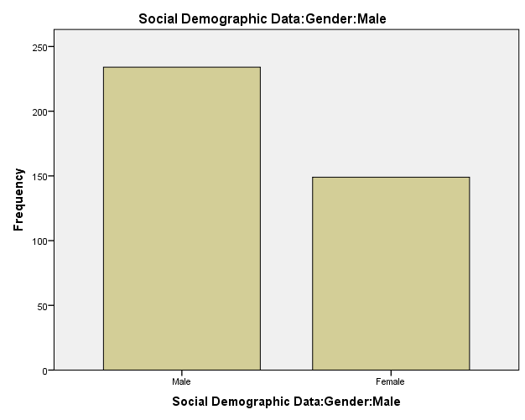
Field survey 2018

The respondents cut across the male and female gender. The majority were male with 234 responses representing 61.1% and female respondents are 149, representing 38.9%
Table 4:2 Analyzing Age bracket of Respondents
 |  | Frequency | Percent | Valid Percent | Cumulative Percent
Valid | below 20 | 17 | 4.4 | 4.4 | 4.4
 | 21-40 | 87 | 22.7 | 22.7 | 27.2
 | 41-50 | 153 | 39.9 | 39.9 | 67.1
 | 50 and above | 125 | 32.6 | 32.6 | 99.7
 | 44.00 | 1 | .3 | .3 | 100.0
 | Total | 383 | 100.0 | 100.0
Field survey 2018
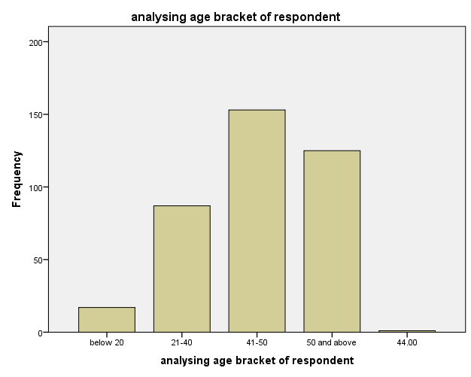
The table above shows that age range of respondents of age bracket of below 20 years were 17 in number representing 4% of the total respondents.87 respondents are between the age of 21-40 years, which makes 22% of the total respondents. Those within the age range o41-50 years are 153 in number representing 40% of the total respondents and 50 years and above are 125 in number representing 35% of the total respondents.
Table 4:3 Analysing Marital Status of Respondents
 |  | Frequency | Percent | Valid Percent | Cumulative Percent
Valid | Married | 234 | 61.1 | 61.1 | 61.1
 | Single | 94 | 24.5 | 24.5 | 85.6
 | Divorce | 8 | 2.1 | 2.1 | 87.7
 | Widow | 28 | 7.3 | 7.3 | 95.0
 | Widower | 19 | 5.0 | 5.0 | 100.0
 | Total | 383 | 100.0 | 100.0
Field survey 2018
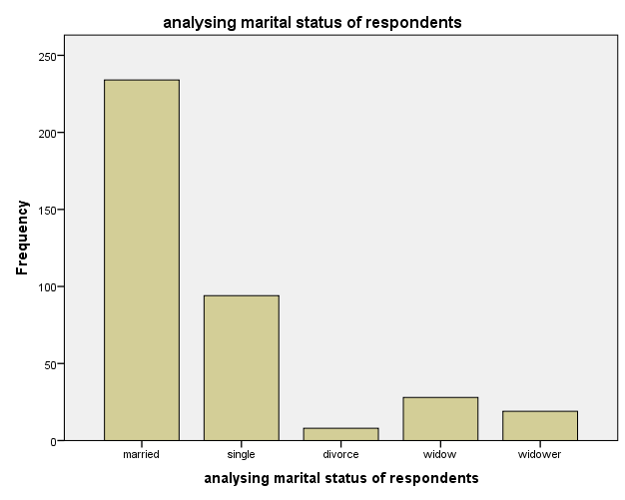

The number of respondents who affirmed to their marital status is 234 in number representing 61% are married, Single 94 in number representing 226%, divorce 8 in number representing 2% widow 28 in number representing 7% widower 19 in number representing 5%

Table 4 Analysing Educational Qualification of Respondents
 |  |  | Frequency | Percent | Valid Percent | Cumulative Percent
 | Valid | WAEC/GCE/NECO | 326 | 85.1 | 85.1 | 85.1
 |  | OND/HND/NCE | 57 | 14.9 | 14.9 | 100.0
 |  | Total | 383 | 100.0 | 100.0
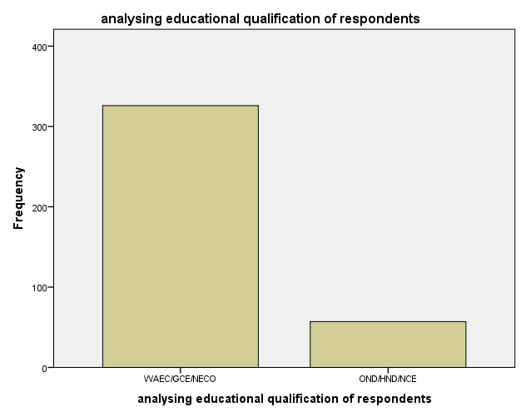

pertaining to the educational levels of respondents 326 representing 85% hold WAEC/GCE/NECO. While 57 respondents representing 15% hold OND/HND/NCE.

Table 5 Analysing Occupation of the Respondents
 |  | Frequency | Percent | Valid Percent | Cumulative Percent
Valid | Farmer | 216 | 56.4 | 56.4 | 56.4
 | Teacher | 37 | 9.7 | 9.7 | 66.1
 | civil servant | 10 | 2.6 | 2.6 | 68.7
 | Business | 69 | 18.0 | 18.0 | 86.7
 | self employed | 51 | 13.3 | 13.3 | 100.0
 | Total | 383 | 100.0 | 100.0
Field survey 2018
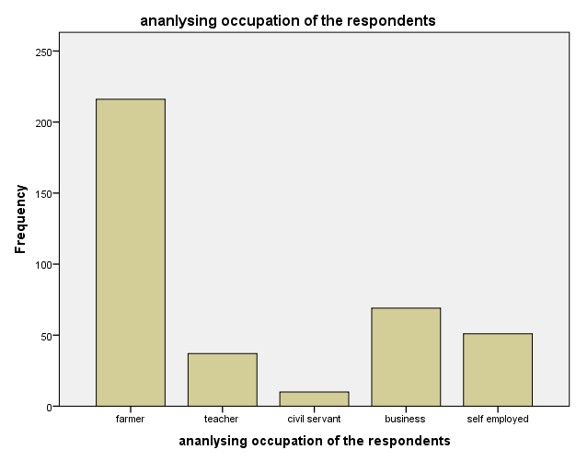
The occupation of the respondents, farmers are 216 respondents representing 56%, teacher 37 in respondent representing 8%, civil servant 10 respondents representing 3%, business 69 respondents representing 18% ,self employed 51 in number representing 13% .

4.2.2 Analysing of Data from Survey (Field)
Research Questions
The data collected for this study was analysed with special references to the research question formulated for this study.
Research Question 1
To what extent are south easterners exposed to community broadcasting or community programs?
To answer this question we use questionnaire items 1, 2 and 3
Table 6 Are there Programs about your Community on Radio
 |  | Frequency | Percent | Valid Percent | Cumulative Percent
Valid | Yes | 124 | 32.4 | 32.4 | 32.4
 | No | 259 | 67.6 | 67.6 | 100.0
 | Total | 383 | 100.0 | 100.0

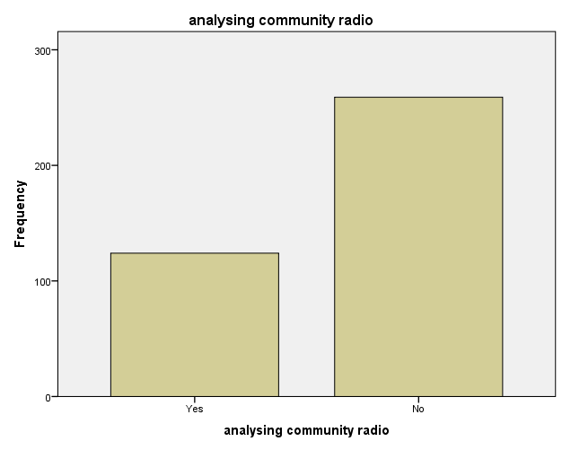
Field survey 2018

The table above shows that 124 respondents representing 34% says that there are programs about their community on radio while 259 respondents representing 68% say there is no program about their community on radio.
Table 7 Do you listen to program about your Community on radio
 |  |  | Frequency | Percent | Valid Percent | Cumulative Percent
 | Valid | Yes | 105 | 27.4 | 27.4 | 27.4
 |  | No | 278 | 72.6 | 72.6 | 100.0
 |  | Total | 383 | 100.0 | 100.0
Field survey 2018

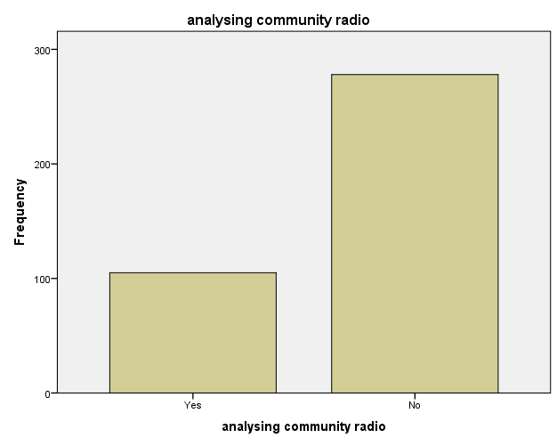
2. Do you listen to programs about your community on radio?
The data in table 4:2:2 above shows that 105 respondents, representing 27% listen to programs about their community on radio while 276 respondents representing73% don’t listen to programs about their community on radio.

Table 8 If yes how often do you listen
 |  | Frequency | Percent | Valid Percent | Cumulative Percent
Valid | Daily | 15 | 3.9 | 3.9 | 3.9
 | several times in a week | 36 | 9.4 | 9.4 | 13.3
 | Weekly | 60 | 15.7 | 15.7 | 29.0
 | I don't listen | 272 | 71.0 | 71.0 | 100.0
 | Total | 383 | 100.0 | 100.0
Field survey 2018

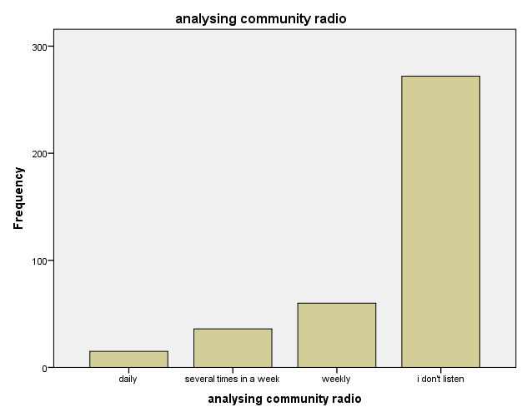
3 .If yes how often do you listen to community broadcasting?
The above table shows that 15 respondents representing 4% listen to radio daily, 36 respondent representing 10% listen to it several times in a week, 60 respondent representing 16% listen to it weekly and 172 respondent representing 71% don’t listen to community broadcasting.
Research Question 2
How do south easterners perceive community broadcasting?
To answer this question we use questionnaire items 4, 5 and 6

Table 9 Do you like Community Broadcasting
 |  | Frequency | Percent |  | Valid Percent | Cumulative Percent
Valid | Yes | 358 | 93.5 |  | 93.5 | 93.5
 | No | 25 | 6.5 |  | 6.5 | 100.0
 | Total | 383 | 100.0 |  | 100.0
Field survey 2018
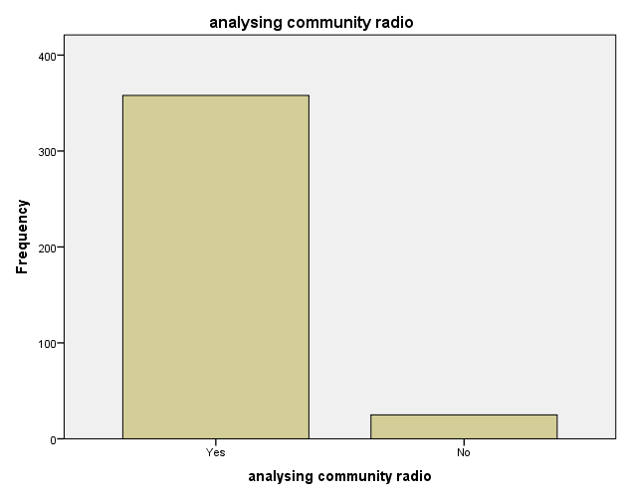

4. Do you like community broadcasting?
The table depicted that 358 respondents representing 93.5 % like community broadcasting and this table also reveals that 25 respondents representing 7% don’t like community broadcasting.
Table 10 Do trust the contents of Community broadcasting
 |  | Frequency | Percent | Valid Percent | Cumulative Percent
Valid | Yes | 343 | 89.6 | 89.6 | 89.6
 | No | 40 | 10.4 | 10.4 | 100.0
 | Total | 383 | 100.0 | 100.0
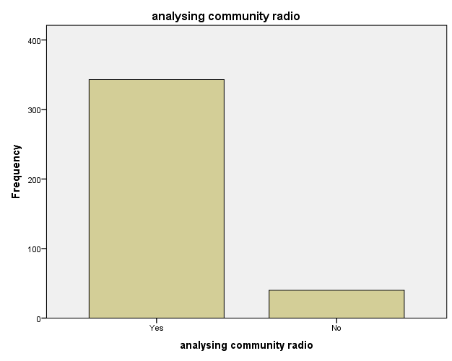
Field survey 2018

5. Do you trust contents of community broadcasting?
This table shows that 343 respondents representing 89.6 % trust the contents of community broadcasting while. 40 respondent representing 10% don’t like community broadcasting.

Table 11 Will you accept safety information if you heard it in your community program?
 |  |  | Frequency | Percent | Valid Percent | Cumulative Percent
 | Valid | Yes | 364 | 95.0 | 95.0 | 95.0
 |  | No | 19 | 5.0 | 5.0 | 100.0
 |  | Total | 383 | 100.0 | 100.0
Field survey 2018
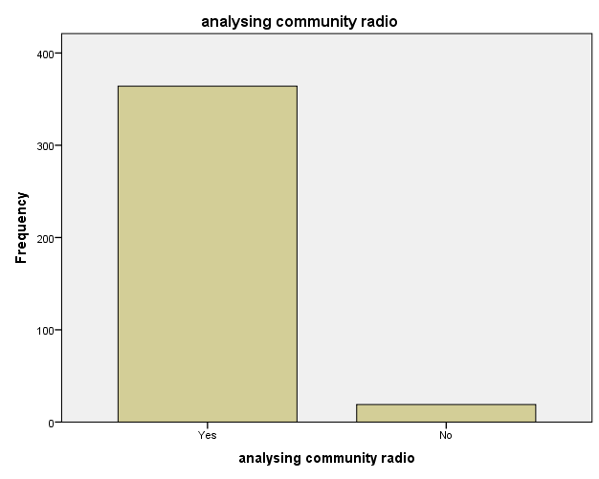
6 .Will you accept safety information if you heard it in your community program?
This table shows that 364 respondents representing 95% accepts safety information if they hear it in their community program while 19 respondents representing 5% will not accept will not accept safety information if they hear it in their community program.
Question 3
How responsive are the south easterners to security and crisis information concerning their communities?
To answer this question we use questionnaire items, 7,8and 9.
Table 12Do you believe the contents of community broadcasting are always truthful
 |  | Frequency | Percent | Valid Percent | Cumulative Percent
Valid | Yes | 220 | 57.4 | 57.4 | 57.4
 | No | 163 | 42.6 | 42.6 | 100.0
 | Total | 383 | 100.0 | 100.0
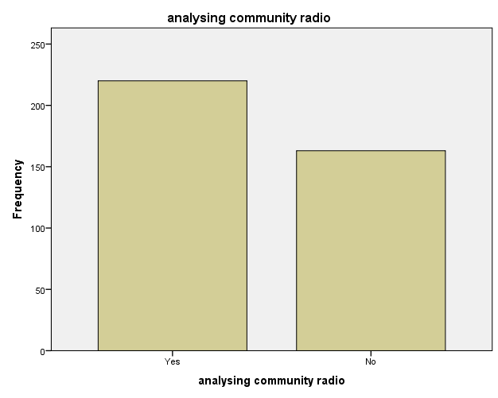
Field survey 2018

7. Do you believe contents of community broadcasting are always truthful?
This table shows that 220 respondents representing 57% believe that the contents of community broadcasting are always truthful while 163 respondent representing 43% do not believe that the contents of community broadcasting are always truthful.
 | Table 13 If There’s a Broadcast Message about an impending attack in your Community, how will you react?
 |  |  | Frequency | Percent | Valid Percent | Cumulative Percent
Valid |  | hide for safety | 85 | 22.2 | 22.2 | 22.2
 |  | confront the attackers and defend your community | 149 | 38.9 | 38.9 | 61.1
 |  | gather your family and hide others | 149 | 38.9 | 38.9 | 100.0
 |  | Total | 383 | 100.0 | 100.0
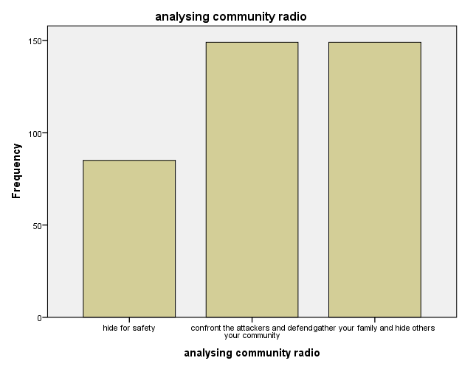
Field survey 2018

8. If there’s a broadcast message about an impending attack in your community, how will you react?
The table above shows that 85 respondent representing 22% hide for safety if there’s broadcast message about impending attack in their community ,149 respondents representing 38.9% will confronts the attackers and defend their community 149 respondents representing 39% will gather their family and hide others.
Table 14Do you rely on Media for Safety Information about your Community?
 |  | Frequency | Percent | Valid Percent | Cumulative Percent
Valid | Yes | 297 | 77.5 | 77.5 | 77.5
 | No | 86 | 22.5 | 22.5 | 100.0
 | Total | 383 | 100.0 | 100.0
Field survey 2018
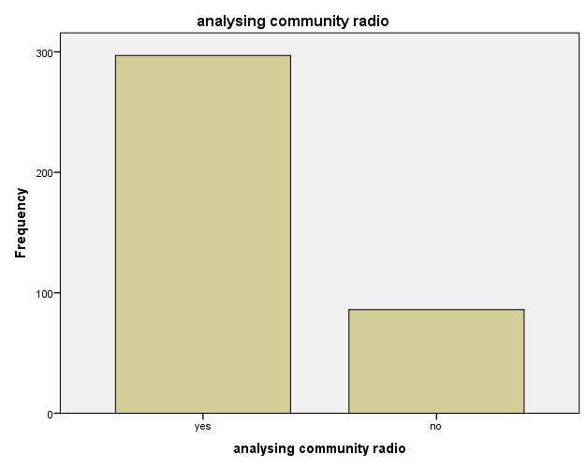

9. Do you rely on media for safety information about your community?
This table shows that 297 respondent representing 78% rely on media for safety information about their community while 86 respondent representing 22% don rely on media for safety information about their community.
Research Question 4
To ascertain whether security and safety information are disseminated through rural broadcasting channels/programs and if so, its usefulness to south easterners?
Table 15 Have you ever heard any Safety Information about your
Community through Community Broadcasting?

 |  | Frequency | Percent | Valid Percent | Cumulative Percent
Valid | Yes | 59 | 15.4 | 15.4 | 15.4
 | No | 324 | 84.6 | 84.6 | 100.0
 | Total | 383 | 100.0 | 100.0
To answer this Question we used questionnaire items 10 and 11.
Field survey 2018
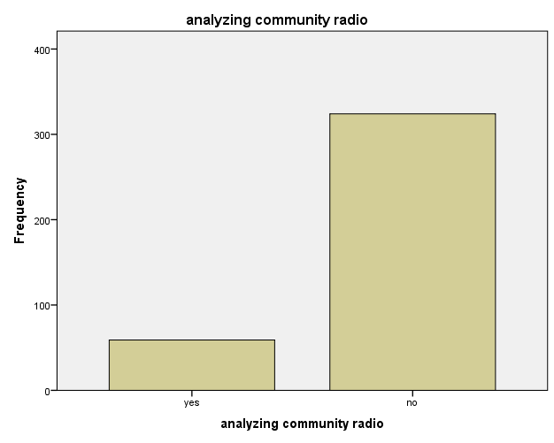

10. Have you ever heard any safety information about your community through community broadcasting?
From the above table, it reveal that 59 respondents representing 15% have heard safety information on community broadcasting, while 324 respondent representing 85% have not heard any safety information about their community through community broadcasting.
Table 16 If yes, how did you react?
 |  | Frequency | Percent | Valid Percent | Cumulative Percent
Valid | Mobilization | 50 | 13.1 | 13.1 | 13.1
 | Attitude change | 9 | 2.3 | 2.3 | 15.4
 | Invalid | 324 | 84.6 | 84.6 | 100.0
 | Total | 383 | 100.0 | 100.0

Field survey 2018

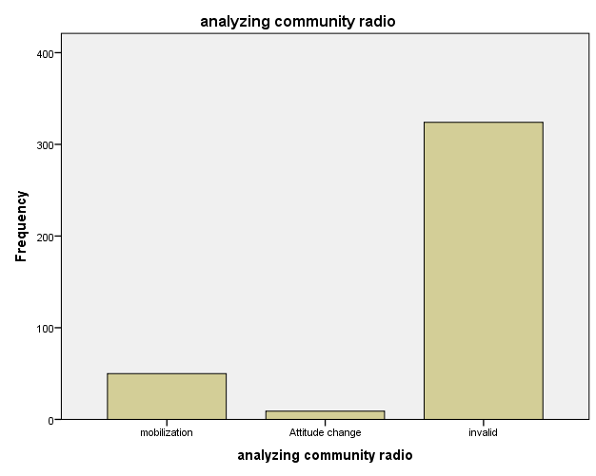

11. If yes, how did you react?
The table above reveals that 50 respondents representing 13% mobilize others when they hear safety information on community broadcasting also 9 respondents representing 2% change their attitude when they hear safety information on community broadcasting this table also depict that 324 respondents representing 85% have not heard any safety information on community broadcasting.
4.3 Discussion of Findings
Research Question 1: To what extent are residents of Nimbo exposed to community broadcasting?
The result shows that the residents of Nimbo to a large of 70.4% are not exposed to community broadcasting. this finding is line with what Andrew A.M. (1998), said that the rural and urban poor communities in Nigeria constitute 70-80% of the population of the country, and over 80% of the land area. This rural population suffers from a high rate of illiteracy and absence of social amenities like pipe-borne water, electricity and good roads. In many of these rural areas there are schools, but school buildings are generally below standard and lack such amenities as libraries, gymnasia, desks and such teaching tools as audio-visuals, radio and television. The schools are poorly staffed and equipped. Majority of the men are farmers, who live on subsistence agriculture; and majority of women are very small scale traders. Politically, rural communities are on the outskirts of the mainstream and are used by the political elite as tools to gain political power, but forgotten as soon as the politicians have gained their desired power. What they frequently get are socioeconomic promises for improvement of their communities; but these promises are hardly ever kept, creating a feeling of perpetual frustration and fatalism.
Research Question 2: How do residents of Nimbo perceive community broadcasting?
The finding shows that the resident of Nimbo to a large extent of 92.5% perceives community broadcasting as one of the effective means of developing their community and trust it for this finding corroborates with what Asemah, E. S.; Anum, V. and Edegoh, L. O. (2013), that rural radio helps to achieve development in the rural areas, as issues of development are aired to audience in the form of various programs and individuals are exposed to happenings in and around their society, through listening to these programs. Also that radio is an important tool for entertaining, informing and educating the society, but that there are certain factors that hinder the effective use of radio for rural development. It therefore recommends, among, others, that radio stations in Nigeria should endeavour to use local dialects, especially when the radio program is aimed at the rural dwellers and that there is the need to establish community radio stations that will be closer to rural dwellers.
Research Question 3: How responsive are residents of Nimbo to security and crises information concerning their community?
The study reveals that the resident of Nimbo to large extent of 57.9% respond to security and crisis information concerning their community. And this is line with Nico C., and Vaia D. (2013), that community media can play a role in conflict resolution, by creating more opportunities for mutual understanding and for the humanization of the other.
Research Question 4:Are there security and safety information disseminated through rural broadcasting channels/programs in Nimbo.
The result of this study shows that to a large extent of 84.2% says there is no security and safety information disseminated through community broadcasting.

CHAPTER FIVE
SUMMARY, CONCLUSION AND RECOMMENDATION
  - Introduction
This chapter presents the summary, conclusion and recommendations of this research.
The researcher gave adequate background of broadcasting, the roles it has played in the society and also community broadcasting which forms the third pillar of broadcast media. She also identified the problems that necessitated the study. To clearly define the direction, the researcher mapped out objective that guided the study from which the research questions were raised.
In order to make the study more objective, the researcher reviewed different works of prominent authors and experts in the field of mass communication. The purpose is to determine expert views on the role community broadcasting play in resolving conflict in rural communities which is geared towards development of rural community through their programs. The review helped to illuminate the problem at hand, concerning theoretical framework perspective used as framework, the researcher utilized the agenda setting theory, development media theory and source credibility theory to address the researcher nature and problem.
In choosing research design, we had in mind the nature of the problem the researcher used survey design since the problem could be solved through sampling of opinions.
The analysis of collected data was based on percentage frequency, presented in simple tables and bar charts.
  - Summary of Findings
1. Large number of residents of Nimbo are not exposed to community broadcasting.
2. The resident of Nimbo perceive community broadcasting as one and most effective means for conflict resolution and for the development of their community,
3. The residents of Nimbo respond to security and crises information by mobilizing others if heard on community broadcasting.
4. No security and crises information was disseminated through community broadcasting.
5.3 Conclusion
Community broadcasting which is meant for those at the grassroots level has the characteristic of reaching a maximum number of audiences. It has significant effect on the societal condition of our country till now. In today’s world, people are familiar with radio and community FM radio because it has the capacity to reach the local level rural population. For ages, there is a criticism in context of presented radio broadcasting environment, Community broadcasting can focus the voice of vulnerable and marginalized population of our community, facilitate rural development and agricultural promotion, ensures local level good governance and accountability, disaster preparedness and managing conflict, ensuring gender equality, as well as protect the local Community from crises. This project has exposed to a large extent that community broadcasting has done nothing in the dissemination of safety guidelines to tackle the challenges of rural dwellers and they have failed to intercede in conflict resolution between farming communities and herdsmen in Nimbo community. This study made us to understand that community broadcasting has not done anything towards cubing crises in Nigeria, particularly the recurring violence involving herdsmen and farmers in the south east.

5.4 Recommendations
Based on the findings of the study, the researcher recommends that hard to reach areas can benefit from programmes of community broadcasting. Hence, agencies and relevant stakeholders should ensure that broadcast programs designed for and targeted at rural communities get to these target audiences.
The residents of Nimbo community should be supported through programs designed to help them recover from the shock of the gruesome attack by herdsmen. The media should play a key role in disseminating information about these programs and also help integrate them into normalcy.
Feedback channels and awareness campaigns on security should be put in place in Nimbo community and other farming communities that may likely fall victims to herdsmen attacks.

REFRENCES
Action Aid, Nigeria. (2008).Middle Belt, Not Killing Belt! The History, Dynamics and Political Dimensions of Ethno-Religious Conflicts in the Middle-Belt. Garki Abuja: Action Aid Nigeria.
Aho, M. (2004).Media’s Role in Peace-Building: United Nations Peace Support Operations. Virginia: George Mason University American Economic Review 51 (4): 566-593.
Aluko, S. (2004). Making Natural Resources into a blessing rather than a curse: in covering oil. A Reporter’s Guide to Energy and Development. Open Society Institute .
Asemah, E., Anum, V. and Edegoh, L.O. (2013). Radio as a Tool for Rural Development in Nigeria: Prospects and Challenges: An International Journal of Arts and Humanities Bahir Dar, Ethiopia Vol. 2 (1), S/No 5, February, 2013:17-35
Berger R (2003). Conflict over Natural Resources among Pastoralists in Chris, s. (2016). Farmer-Herder Conflict Rises across Nigeria

Cooper and schindler (2004). Business research methods. New DelhiTataMc-Graw-Hill publishing co.

Cornan, S., Hess, A., & Justus, Z. (2006). Credibility in the Global war in Terrorism: Strategic Principles and Research Agenda. Consortium for Strategic Communication, Phoenix Metropolitan Area: Arizona State University.
Egwu, S. G. (2001). Ethnic and Religious Violence in Nigeria. Jos: St. Stephen Book House.

Fasona, M. and Omojola, A. (2005). Climate Change, Human Security and Communal Clashes in Nigeria. Paper Presented at the International Workshop on Human Security and Climate Change, Holmen Fjord Hotel, Oslo Oct. 21-23.
Imhonopi, D. & Urim, U. M. (2012). The Spectre of Terrorism and Nigeria’s Industrial Development: A Multi-Stakeholder Imperative. The paper was prepared for the Nigerian Anthropological and Sociological Association (NASA) Conference with the theme “Theoretical and Conceptual Issues on Social Values, Corruption and Security” held at the Nnamdi Azikiwe University, Awka, Anambra State, between November 5-9, 2012.

Johnston, B. & Mellor, J. (1961). The Role of Agriculture in Economic Development. The American Economic Review, 51 (4), 566-593.
Johnston, B. and J. Mellor (1961): The role of agriculture in economic development. In:
May 11, 2016 9:40 PM
McGregor, A. (2014). Alleged Connection between Boko Haram and Nigeria’s Fulani Herdsmen could Spark a Nigerian Civil War. Terrorism Monitor, 12(10), 8-10.
Moritz M. (2010). Understanding Herder-Farmer Conflicts in West Africa: Outline of a Processual Approach. Human Organization, 69(2), 138 – 148.
Ndolo, I. E. (2005). Mass Media System and the Society. Enugu: Rhyce Kerex Publishers.
Northern Kenya: A Look at Recent Initiatives in Conflict Resolution. J.Int. Dev. 15: 245-257.

Nwabueze, C. (2010). Reporting: Principles, Approaches and Special Beets. Enugu: To Shelve Publishers.
Nwafor, M., E.C., Ehor, O.J. ,Chukwu and J.I. Amuka (2011). Cost-Effective Agriculture Growth Options for Poverty Reduction in Nigeria: Evidence and Policy Implications. AIAE Research Paper 6. African Institute for Applied Economics, Enugu
Odogwu A., (1998). News commercialization and objectivity: A private media experience”. Paper presented at NUJ seminar, in Awka, November 24, 1998.
Okeke, O.E, (2014) Conflicts between Fulani Herders and Farmers in Central and Southern Nigeria: Discourse on Proposed Establishment of Grazing Routes and Reserve: An International Journal of Arts and Humanities Bahir Dar, Ethiopia Vol. 3 (1), S/No 9, January, 2014: 66-84
Okunna C.S. (2012). Introduction to mass communication 3rd (ed), New generation publisher.
Okunna, C.S. (1999). Introduction to Mass Communication. Enugu: New Generation Books.
Olayoku, P. A. (2014).Trends and Patterns of Cattle grazing and Rural Violence in Nigeria (2006 – 2014): Nigeria Watch Project. IFRA-Nigeria Working Paper 34.
Opubor A. E (2007). Can Radio Build Communities?. In A. Akingbulu (ed.) Building Community Radio in Nigeria Issues and Challenges: institute for Media and Society, pp. 7-18
Otaha, J. (2012). Dutch Disease and Nigeria Oil Economy. African Research Review , 6 (1), 82-90.
Pate, U. A. and Dauda, S. (2015).The Media, Responsibility and Conflict Sensitive Reporting in Nigeria. In Ike, S. Udeze (Eds.) Emerging Trends in Gender, Health and Political Communication in Africa: A Book in Honour of Prof. Ikechukwu Ndolo (pp. 214-227). Enugu: Rhyce Kerex Publishers.
Ross, S. D. (2003). Framing of the Palestinian-Israeli Conflict in Thirteen Months of New York Times Editorials Surrounding the Attack of September 11, 2001. Conflict & Communication Online, 2(2), 1-11.
Sanusi, L. S. (2010). Growth Prospects for the Nigerian Economy. Convocation Lecture delivered at the Igbinedion University Eighth Convocation: Research Department, Central Bank of Nigeria.
Sekunmade, A. (2009). The effects of petroleum dependency on agricultural trade in Nigeria: An error correlation modeling (ECM) approach. Scientific Research and Essay, 4 (11), 1385-1391.
Ujomu, P. O. (2001). “National Security, Social Order and the Quest for Human Dignity in Nigeria: Some Ethical Considerations.” Nordic Journal of African Studies 10(2): 245-264.

Vanguard (2016, August 2). UN: Nigeria Accounts for 70% of 500m Illicit Weapons in West Africa. Vanguard. Retrieved from http://www.vanguardngr.com/2018/03/un-nigeria-accounts-for-70-of-500m-illicit-weapons-in-west-africa.

APPENDIX
Department of Mass Communication
Godfrey Okoye University
Thinker’s corner
Enugu
Enugu State
12th April 2018

Dear Respondent,
I am Ignatius Chinyere Mercy, a 400 level student in the department of mass communication, Godfrey Okoye University, currently conducting a research on, An analysis on security and crisis management: the role of rural community broadcasting in disseminating safety guidelines to tackle farmers and herdsmen crises in the south east Nigeria. I request that you help me in answering the questions in this questionnaire to enable me conduct the research.
All information provided here will be treated with utmost confidentiality. Sincerity in your responses is needed for effective result in this study.
Thanks for your anticipated co-operation
Yours faithfully Ignatius chinyere M.

PLEASE TICK AS IN THE APPROPRIATE SPACE
PART A
Socio Demographic Data
1. What is your Gender?
- Male (b) Female
2. What is your age bracket?
- Below 20 (b) 21-40 (c) 41-50 (d) 51 and above E I
3. What is your marital Status?
Married Single Divorce Widow Widower
4. What is your highest educational Qualification?
(a) WAEC/GCE/NECO (b) OND/HND/NCE (c) B.SC/MBA/MSC/ (d) PHD
5. What is your Occupation?
(a)Farmer (b) Teacher (c) Civil Servant (d) Business (e) Self employed

PART B
1. Are there programs about your community on radio?
Yes No
2. Do you listen to programs about your community on radio?
Yes No
3 .If yes how often do you listen to community broadcasting?
Daily several times a week weekly I don’t listen
4. Do you like community broadcasting?
Yes No
5. Do you trust contents of community broadcasting?
Yes No
6 .Will you accept safety information if you heard it in your community program?
Yes No
7. Do you believe contents of community broadcasting are always truthful?
Yes No
8. If there’s a broadcast message about an impending attack in your community, how will you react?
Hide for safety confront the attackers and defend your community Gather your family and hide others
9. Do you rely on media for safety information about your community?
Yes No
10. Have you ever heard any safety information about your community through community broadcasting?
Yes No
11. If yes, how did you react? ---------------------------------------------------------------------------------------
--------------------------------------------------------------------------------------------------------------------------------------------------------------------------------------------------------------------------------------------------------------

