DESIGN AND IMPLEMENTATION OF SUPERMARKET INFORMATION MANAGEMENT SYSTEM

By

Nnanyerem Goodness Chidera

Registration no:
U14/NAS/CSC/068

Being a BSc report submitted in partial fulfillment of the requirements for the award of a Bachelor’s degree in Computer Science of the Godfrey Okoye University.

Supervisor: Dr. (Mrs.). Monica Agu

Department of Computer Science/ Mathematics Godfrey Okoye University, Enugu

JULY, 2018

CERTIFICATION
I hereby declare that the work presented herein a done by me, and not by a third party. Should I be convicted of having cheated in this work, I hall accept the verdict of the university

Nnanyerem Goodness Chidera

APPROVAL PAGE
This is to certify that this research titled DESIGN AND IMPLEMENTATION OF SUPERMARKE MANAGEMENT SYSTEM was carried out by NNANYEREM GOODNESS CHIDERA, Registration No: U14/NAS/CSC/068 of the department of Computer Science in partial fulfillment of the requirements for the award of Bachelor of Science in Computer Science.

________________________ _________________________
Dr. Mrs. Monica Agu Date/sign
Project Supervisor

________________________ _________________________
Dr. Mrs. Monica Agu Date/sign
Head of Department

DEDICATION
I dedicate this project to God Almighty my creator, my strong pillar, my source of inspiration, wisdom, knowledge and understanding. He has been the source of my strength throughout this program and on His wings only have I soared. I also dedicate this work to my family, for the continuous love they showed me during the time of this write up and also my supervisor Dr. (Mrs.) Monica Agu.

ACKNOWLEDGEMENT
Initially, I should convey my feeling to the almighty God for granting me the privilege to undertake this program and bringing it to successful end.
I am immensely grateful to my project supervisor who despite her tight schedule had time to guide me, a woman of intelligence, hard work and competence, Dr.
(Mrs.). Monica Agu for her time, support, patience and advice within the time of this project work, and to other lecturers of the department for bringing out the best in me through advices and making themselves available when I need help.
My unreserved gratitude goes to my parents for their support and sacrifices throughout the program.
I also express my gratitude to my friends, Ameh, Achele Eunice, Ogbe, Blessing and my colleagues in the department; Nweke, Charles Ifeanyi and others for being a motivation to me. May God in his infinite mercy continue to bless and protect you all.

ABSTRACT
This supermarket management system has realized the transmission and control of large goods, so as to facilitate the management and decision of sales, and reduce a big burden for supermarkets and supermarket managers. It also can help to improve the work efficiency of supermarket. Its objective is to provide the basic information maintenance function of employees, memberships and products so that managers can through the function to add, delete, and modify the basic information of employees and the employees can through it to add, modify and delete the basic information of memberships and goods. Supermarket management system is very convenient for manage, input, output, and find the data so as to make the messy supermarket data to specific, visualizations, rationalization. In the aspect of software. In the cause of writing this project, HTML, CSS, JS and Sublime text were used to design the system (front end) and Wamp Server and PHP was used to store the database (middle end). The website has a large memory of storing all the goods in the store and also keeping record, it is highly effective and accurate. I will recommend that if there is going to be any modification the new writer should endeavor to improve on the limitations such as inclusion of payment processor to further increase the system architecture and to satisfy users need more for writing of the source code, latest PHP version should be used and MySQL for the database, which is the back end. In the aspect of software, various configurations in computer including input and output capacity, internal memory and external memory capacity can meet the requirements of users. The methodology used in this project is the Object Oriented Analysis and Design methodology (OOAD).

TABLE OF CONTENTS
Title page
Certification I
Dedication II
Approval page III
Acknowledgement IV
Abstract V
Table of Contents VI
List of Figures VII
List of Tables VIII
CHAPTER ONE:
1.0 Background of study 1
1.1 Statement of the problem 2
1.2 Objective of study 3
1.3 Significance of study 3-4
CHAPTER TWO:
- Introduction 5
2.1 Background of study 5-6
2.2 Literature Review 6-8
2.2.1 The concept of Management System 9
2.2.2 Types of Supermarket 9-11
2.2.3 Introduction to Online Marketing (E-commerce) 11-13

2.2.4 Benefits of E-commerce to Consumers 13
2.2.4.1 Benefits of E-commerce to Society 13-14
2.2.4.2 Limitation of E-commerce 14
2.2.4.3 Limitation of E-commerce to Consumers 14-15
2.2.4.4 Limitation of E-commerce to Society 15
2.2.5 Introduction to Management 15-17
2.2.6 Introduction to System 17-18
2.2.7 Supermarket management Using Shoprite Nigeria 18-20
2.3 Summary 20

CHAPTER THREE:
3.0 Introduction 21
3.1 Description of the Existing System 21-22
3.2 Analysis of the Proposed System 22-24
3.3 Design of the Proposed System 24-31

CHAPTER FOUR:
4.0 Introduction 32
4.1 Choice of Development Environment 32-33
4.2 Implementation Architecture 33
4.3 Software Testing 33-34
4.4 Documentation 35
4.4.1 User Manual 35-36
4.4.2 Source code Listing 36
CHAPTER FIVE:
5.0 Summary 37
5.1 Conclusion 37
5.2 Recommendation 38
Reference
Appendix

LIST OF FIGURES

2.1 Comparison of Prices between Shoprite, Oke-Arin market and Ojuwoye market 20
2.2 Comparison of Prices between Shoprite, and Ojuwoye Market 21
3.5 Output Design to Add New Customer details 26
3.6 Output Design to Add New Workers Details 27
3.7 Output Design for Workers Login 27
3.8 Output Design for Customer Login 28
3.9 Database Design for Customer 29
3.10 Database Design for Workers 29
3.11 Database Design for Product 30
3.12 Database Spreadsheet Design for Product 30
3.13 System Architecture 31
4.1 implementation Architecture 33
4.2 Add New User 34
4.3 Result of the New User Added 34

LIST OF TABLES

3.1 Input Design for staff Information 25
3.2 Input Design for Membership Information 25
3.3 Input Design to Add Stock 25-26
3.4 Input Design to Login 26

CHAPTER ONE
INTRODUCTION
1.0 BACKGROUND OF THE STUDY
The essence of a supermarket management system is for an effective automation of the management of a supermarket. The Supermarket Management System is a project that deals with supermarket automation and it includes both purchasing and selling of items. Supermarket management system is the system where all the aspects related to the proper management of supermarket is done. These aspects involve managing information about the various products, staff, managers, customers, billing etc. This system provides an efficient way of managing the supermarket information. Also allows the customer to purchase and pay for the items purchased. This study is based on the sales transaction and billing of items in a supermarket.
This study is to produce software which manages the sales activity done in a supermarket, maintaining the stock details, maintaining the records of the sales done for a particular month/year. The users will consume less time in calculation and the sales activity will be completed within a fraction of seconds whereas manual system will make the user to write it down which is a long procedure and so paper work will be reduced and the user can spend more time monitoring the supermarket. The program will be user friendly and easy to use.
The system will display all the items whose name start with the letter selected by the user. He can select out of those displayed. Finally a separate bill will be generated for each customer. This will be saved in the database. Any periodic records can be viewed at any time. If the stock is not available, the supermarket orders and buys from a prescribed vendor. The amount will be paid by deducting the total amount acquired in the sales activity. Admin provides a unique username and password for each employee through which he can login.

1.1 STATEMENT OF THE PROBLEM
The manual management of a supermarket is besieged with numerous problems. Among these problems are the following:
1. Time Consumption: Manual systems are time consuming, as the business owner must keep track of Supermarket sales on a daily basis, while updating the system manually at the end of the day.
2. Poor Communication: A manual Supermarket system requires employees and managers to write down each time an item is removed from the Supermarket. If one employee forgets to mention that the last coffee product has been removed from the Supermarket, a manager expects the item to still be available for a customer during a sale. Compared with a technical Supermarket system, a manual Supermarket system does not help the communication in the workplace.
3. Physical Counts: A manual Supermarket system does not provide any number, as all numbers from the Supermarket are gained through physical Supermarket counts. One of the difficulties of running a manual Supermarket system is that physical Supermarket counts must be performed frequently to control the items in the Supermarket. This is time consuming and can cost the business money, if employees must come in to help out outside of business hours.
4. Daily Purchases: Keeping track of daily purchases is another difficult controlling measure with manual Supermarket systems. A manual Supermarket system requires the employees to write down the items sold during a single work day. This can be a difficult task, as one employee may lose the list of items sold or another may forget to write down a sale.
5. Ordering Supplies: A manual Supermarket system does not update at the end of the day with updated Supermarket.

1.2 OBJECTIVES OF THE STUDY
The main objective of this project is to design a Computerized Supermarket Management System to
- ascertain stock level of a supermarket,
- To know when to order for more goods, keep status and updates of transactions, thereby helping progress level,
- To determine stock taking and managerial decisions.
.
1.3 SIGNIFICANCE OF THE STUDY
For every new thing developed there must be an advantage, a disadvantage and a significance it will have in the world. Just like cars they are built to reduce stress of moving from one place to another especially when it’s over a long distance, but every car is prone to fail at some point and that’s one of the biggest disadvantages, but the researcher won’t be writing about advantages and disadvantages of a car, the researcher will be writing on the significance of an supermarket information management system. The researcher said before, everything developed has significance to the world and supermarket information management system is significant to humanity in the following ways:
- The management system will be of great benefit to supermarkets and it will improve the managerial cum administrative strength of the business and move the business forward to meet the demand of times and globalization in this era of technology.
- To explore the challenge being faced by the manual system.
- For easy record of goods and proper identification.
- This piece of work will add to the already existing literature review and act as a reference work for future researchers.

SCOPE OF THE STUDY
This project work covers stock control, management and tends to correct anomalies in Supermarket business. It analyses opening of new stocks, stock updates and ability to view existing ones. It provides quick way of operation by capturing the manual process and automating them. This project is helpful to computerize the item transaction, sales activity record keeping which is a very huge task and maintaining the stock

LIMITATION OF STUDY
Due to time and basic factors like unstable electricity, poor networks, unavailability of concrete business idea and many more this research has been limited to certain areas in supermarket management we only looked more into the supermarket inventory management area using Microsoft access and Visual basic.

CHAPTER TWO
LITERATURE REVIEW
2.0 INTRODUCTION
This chapter reviewed relevant literature and articles related to the topic. It reviewed the relevance of management system in Super Markets.
2.1 THEORETICAL BACKGROUND
In this project the researcher is making use of several concepts and technologies which he will be talking about. The major technologies used in this project are web technologies HTML (Hyper Text Markup Language), CSS (Cascading style sheet), JAVASCRIPT, PHP (Personal Home Page) and relational database technology. This site developed is a collection of web documents. These web documents are presented to the user by an application program known as a browser e.g. Internet explorer, Firefox, Opera mini, Chrome.
HTML: Also known as Hyper Text Markup Language. It is used for creating webpages. Webpages are usually viewed in a web browser. They can include writing, links, pictures, and even sound and video. HTML can also be used to add Meta information to a webpage. Meta information is the information about the web page. For example, the name of the person who made it. Example:
CSS: Also known as Cascading Style Sheet which is used to style a web page to suite the form which you want it to take. Also CSS can be used to work on a concept which you want be it a slide in text or a hover concept.
JAVASCRIPT: JavaScript is used to make an interactive web site which like a slideshow and so on. Not all websites are developed using JavaScript because the developer probably decided not to use it but JavaScript was used in this project.
PHP: PHP also known as Personal Home Page which is used to design a dynamic website example: Facebook. PHP isn’t a code you see affecting the layout of the page, it’s a code that handles the connection to the database and so on.
MYSQL: It handles the details of a website which needs to be saved and so much more.
Coming over to the concepts. I used a lot of concepts so that the project will look attractive because without concepts your work will look boring example of some concepts I used are: Grid view concept, hover concept zoom in concept, slideshow concept etc.
2.2 REVIEW OF RELATED LITERATURE
(According to Ballou, R.H. 1999), he defined supermarket as a large form of the traditional grocery store, it is a self-service shop offering a wide variety of food and household products, organized into aisles. It is larger in size and has a wider selection than a traditional grocery store, but is smaller and more limited in the range of merchandise than a hypermarket or big-box market. [1]

(According to Yang, B and Burns, N.D. 2003), the concept of an inexpensive food market relying on large economies of scale was developed by Vincent Astor. He founded the Astor Market in 1915, investing $750,000 of his fortune into a 165 by 125 corner of in the famous 95 Manhattan avenue, creating in effect, an open air mini-mall that sold meat, fruit, and flowers. The expectation was that customers would come from great distances ("miles around"), but in the end even attracting people from ten blocks away was difficult, and the market folded in 1917. The concept of a super market was developed by entrepreneur Clarence Saunders and his Piggly Wigglystores. His first store opened in 1916. Saunders was awarded a number of patents for the ideas he incorporated into his stores. The stores were a financial success and Saunders began to offer franchises. The Great Atlantic & Pacific Tea Company, which was established in 1859, was another successful early grocery store chain in Canada and the United States, and became common in North American cities in the 1920s.[2]
(According to Rietze, S. 2006), there was debate about the origin of the supermarket, with King Kullen and Ralphs of California having strong claims. Other contenders included Weingarten's Big Food Markets and Henke & Pillot. To end the debate, the Food Marketing Institute in conjunction with the Smithsonian Institution and with funding from H.J. Heinz, researched the issue. It defined the attributes of a supermarket as "self-service, separate product departments, discount pricing, marketing and volume selling". [3]
(Pagh, J.D. and Cooper, M.C. 1998), said that it has been determined that the first true supermarket in the United States was opened by a former Kroger employee, Michael J. Cullen, on August 4, 1930, inside a 6,000-square-foot (560 m²) former garage in Jamaica, Queens in New York City. The store, King Kullen, (inspired by the fictional character King Kong), operated under the slogan "Pile it high. Sell it low." At the time of Cullen's death in 1936, there were seventeen King Kullen stores in operation. Although Saunders had brought the world self-service, uniform stores and nationwide marketing, Cullen built on this idea by adding separate food departments, selling large volumes of food at discount prices and adding a parking lot. [4]
Other established American grocery chains in the 1930s, such as Kroger and Safeway at first resisted Cullen's idea, but eventually were forced to build their own supermarkets as the economy sank into the Great Depression, while consumers were becoming price-sensitive at a level never experienced before. Kroger took the idea one step further and pioneered the first supermarket surrounded on all four sides by a parking lot by (Bowersox, C. 2009).[5]

According to (Ballou, R.H. 1999), Supermarkets proliferated across Canada and the United States with the growth of automobile ownership and suburban development after World War II. Most North American supermarkets are located in suburban strip shopping centers as an anchor store along with other smaller retailers. They are generally regional rather than national in their company branding. Kroger is perhaps the most nationally oriented supermarket chain in the United States but it has preserved most of its regional brands, including Ralphs, City Market, King Soopers, Fry's, Smith's, and QFC.
In Canada, the largest such chain is Loblaw, which operates stores under a variety of regional names, including Fortinos, Zehrs, No Frills, the Real Canadian Superstore, and the largest, Loblaws, (named after the company itself). Sobeys is Canada's second largest supermarket with locations across the country, operating under many banners (Sobeys IGA in Quebec). Québec's first supermarket opened in 1934 in Montréal, under the banner Steinberg's. [1]
(Yang, B., and Burns, N.D. 2003), said that, in the United Kingdom, self-service shopping took longer to become established. Even in 1947, there were just ten self-service shops in the country. In 1951, ex-US Navy sailor Patrick Galvani, son-in-law of Express Dairies chairman, made a pitch to the board to open a chain of supermarkets across the country. The UK's first supermarket under the new Premier Supermarkets brand opened in Streatham, South London, taking ten times as much per week as the average British general store of the time. Other chains caught on, and after Galvani lost out to Tesco's Jack Cohen in 1960 to buy the 212 Irwin's chain, the sector underwent a large amount of consolidation, resulting in 'the big four' dominant UK retailers of today: Tesco, Asda (owned by Wal-Mart), Sainsbury's and Morrisons. [2].
According to (Patton, 1990), said that in the 1950s, supermarkets frequently issued trading stamps as incentives to customers. Today, most chains issue store-specific "membership cards," "club cards," or "loyalty cards". These typically enable the card holder to receive special members-only discounts on certain items when the credit card-like device is scanned at check-out. Sales of selected data generated by club cards are becoming a significant revenue stream for some supermarkets. [3]

2.2.1 THE CONCEPT OF MANAGEMENT SYSTEM
According to (Rietze, S. 2008), Management system (Software) is a general phrase used to describe a category of computer software designed to help streamline the complexity of large projects and tasks as well as facilitate team collaboration and project reporting. Most management software solutions can also handle resource and employee management, schedule coordination, task assignment, budgeting, time and risk analysis and more.
Management software is a broad term that can also apply to financial management software, network management software, customer relationship management software, asset management software or inventory management software. [4]
2.2.2 TYPES OF SUPERMARKET
(According to Pagh, J.D. and Cooper, M.C. 1998), Supermarket is categorized into different type due to their size, scale, products offered, Store Format and TrendsWhile people use the terms "Grocery Store", ”Hypermarket” and "Bigboxmarket" interchangeably to refer to retail food stores, industry watchers offer more specific guidelines about different types of Supermarket. "Hypermarkets" are on the larger end of this spectrum and carry a diverse mix of food and general merchandise. Nomenclature is not always uniform Financial Institutions Fund places Wal-Mart in the same category as supermarkets, but accounting for only the supercenter's grocery division. The Food Marketing Institute classifies superstores as a large type of supermarket, while designating warehouse stores as grocery stores. [5]
Grocery Store: A grocery store is a retail store that primarily sells food. A grocer is a bulk seller of food. Grocery stores often offer non-perishable food, with some also having fresh produce, butchers, delis, and bakeries. Large grocery stores that stock significant amounts of non-food products, such as clothing and household items, are called supermarkets. Some large supermarkets also include a pharmacy and an electronics section, the latter selling DVDs, headphones, digital alarm clocks, and similar items. Grocery stores operate in many different styles ranging from rural family-owned operations, such as IGAs, boutique chains, such as Whole Foods Market and Trader Joe's to larger supermarket chain stores. In some places, food cooperatives or "co-op" markets, owned by their own shoppers, have been popular. However, there has recently been a trend towards larger stores serving larger geographic areas by (Bowersox, C. 2009). [6]
Hypermarket: Is an advanced supermarket which has an additional department store. The result is an expansive retail facility carrying a wide range of products under one roof, including full groceries lines and general merchandise. In theory, hypermarkets allow customers to satisfy all their routine shopping needs in one trip. After the successes of super-markets and hyper-markets and amid fears that smaller stores would be forced out of business, franchise laws that made it more difficult to build hypermarkets and also restricted the amount of economic leverage that hypermarket chains can impose upon their suppliers. In France, hypermarkets are generally situated in shopping centers (French: centre commercial or centre d'achats) outside of cities, though some are present in the city center. They are surrounded by extensive car parking facilities, and generally by other specialized superstores that sell clothing, sports gear, automotive items, etc by (Yang, B. and Burns, N.D. 2003). [2]
Bigboxmarket: Is a physically large retail establishment, usually part of a chain. The term sometimes also refers, by extension, to the company that operates the store. The store may sell general dry goods, it is generally inaccessible to pedestrians and often can only be reached by motor vehicles, the big-box store is regarded as unsustainable and a failure of urban planning.
Some conservatives worry about the economic impact of big-box retailers on established downtown merchants or the sprawl-inducing impacts on the character of such developments, as these stores are often associated with heavy traffic in the areas around the store locations. Some communities have adopted a higher level of architectural treatment and regulations to ensure that the superstores relate better to their environs and neighbors. Many regulate signage and landscaping.
There are also concerns surrounding traffic and roads. The increased traffic leads to more air pollution in an area and higher taxes in order to maintain the roads. By (Ballou, R.H. 1999). [1]
2.2.3 INTRODUCTION TO ONLINE MARKETING (E-COMMERCE)
(According to yang, B. and Burns, N.D. 2003), The internet marketing has been active for a long time now, the cumulative events occurring in online marketing is leading up to where we are now it have impacted the entire globe faster than any marketing revolution in history.
Over the past decade or so, supermarkets and other grocery retailers have continued to invest significantly into broadening their Internet presence and expanding the number of channels through which their goods are sold. Key Note estimates that sales of groceries transacted via online channels observed double-digit growth between 2007 and 2011, increasing by 127% overall.
One of the major trends to have driven growth within the Internet grocery market is m-commerce that is sales made via mobile channels, i.e. smart phones and tablet computers. The increasing popularity of smart phones and tablets among consumers has resulted in a whole host of retailers investing significant sums of money into mobile sales platforms, as well as downloadable applications (apps'), which offer a more interactive and personalized shopping experience.
Despite the growth of online grocers in recent years, online spending still accounts for a relatively small proportion of the overall Internet grocery market, with just 3.9% of total grocery sales estimated to have been transacted via e-commerce and m-commerce channels. However, the share of the total grocery market represented by online grocers has continued to increase year-on-year since at least 2007, when their market share stood at just 2.1%. [2]
Key Note expects the Internet grocery market to continue to go from strength to strength over the forthcoming years and has forecast year-on-year double-digit growth for 2012 to 2016. The rising uptake of Internet-connected mobile devices, such as smart phones and tablets, should boost sales transacted via m-commerce channels, while continued Government investment in the rollout of superfast broadband, alongside the introduction of the UK's first 4G mobile network, will also help to boost Internet activity and the use of e-commerce services throughout the country by (Bowersox, C. 2009). [6]

(According to Patton M.Q. 1990) [3], online marketing can broadly be defined as the process or areas involved in the running and operation of an organization that are electronic or digital in nature. These include direct business activities such as marketing, sales and human resource management but also indirect activities such as business process re-engineering and change management, which impact on the improvement in efficiency and integration of business processes and activities.
In 1994, spending for internet marketing totaled nearly nothing, but increased to over $300 million in 1995. Now, little more than a decade later, marketing spending and internet marketing business has exploded to nearly $200 billion (according to Forrester Research). Today, it’s hard to believe in having an organization which doesn’t have some kind of online presence.
When the internet was first introduced in the early 90s, it wasn’t considered to be an advertising medium at all. Instead, the internet was treated as a tool for exchanging emails and digital information, but wasn’t yet considered valuable for reaching customers. However, it wasn’t long before marketing pioneers began to see the potential for internet marketing business as millions of web surfers logging on each day to find valuable and relevant information. Within just a few years, informative and educational marketing, as well as graphically enticing banner ads began to be show up. It wasn’t long before results began to flood in which proved the value of the internet marketplace to even the most skeptical advertisers.
Factors that affect online marketing are as follows:
- Technological Factors,
- Social Factors and
- Economic Factors.
2.2.4 BENEFITS OF E-COMMERCE TO CONSUMERS
24/7 access: It enables customers to shop or conduct other transactions 24 hours a day, all year round from almost any location. For example checking balances, making payments, and other information. By (Rietze, S. 2008). [4]

Price comparisons: Customers can ‘shop’ around the world and conduct comparisons either directly by visiting different sites, or by visiting a single site where prices are aggregated from a number of providers and compared.

Improved delivery processes: This can range from the immediate delivery of digitized or electronic goods such as software or audio-visual files by downloading via the Internet, to the on-line tracking of the progress of packages being delivered by mail or courier by (Pagh, J.D. and Cooper, M.C. 1998). [5]

2.2.4.1 BENEFITS OF E-COMMERCE TO SOCIETY
(According to yang, B. and Burns, N.D. 2009), e-commerce to society enables more flexible working practices, which enhances the quality of life for a whole host of people in society, enabling them to work from home. Not only is this more convenient and provides happier and less stressful working environments, it also potentially reduces environmental pollution as fewer people have to travel to work regularly.
Enables people in developing countries and rural areas to enjoy and access products, services, information and other people which otherwise would not be so easily available to them.
Facilitates delivery of public services: For example, health services available over the Internet (on-line consultation with doctors or nurses), and filing taxes over the Internet through the Inland Revenue website. [2]

2.2.4.2 LIMITATIONS OF E-COMMERCE
(According to Bowersox, C. 2009), there was much hype surrounding the Internet and e-commerce over the last few years of the twentieth century. Much of it promoted the Internet and e-commerce as the panacea for all ills, which raises the question, are there any limitations of e-commerce and the Internet? Isaac Newton’s 3rd Law of Motion, for every action there is an equal and opposite reaction suggests that for all the benefits there are limitations to e-commerce. These again will be dealt with according to the three major stakeholders’ organizations, consumers and society.
Rapidly evolving and changing technology, so there is always a feeling of trying to catch up and not be left behind. Under pressure to innovate and develop business models to exploit the new opportunities which sometimes leads to strategies detrimental to the organization. The ease with which business models can be copied and emulated over the Internet increases that pressure and curtails longer-term competitive advantage. [6]

2.2.4.3 LIMITATIONS OF E-COMMERCE TO CONSUMERS
(According to Rietze, S. 2008), computing equipment is needed for individuals to participate in the new ‘digital’ economy, which means an initial capital cost to customers.
A basic technical knowledge is required of both computing equipment and navigation of the Internet and the World Wide Web.
Cost of access to the Internet, whether dial-up or broadband tariffs.
Cost of computing equipment. Not just the initial cost of buying equipment but making sure that the technology is updated regularly to be compatible with the changing requirement of the Internet, websites and applications.
Lack of security and privacy of personal data. There is no real control of data that is collected over the Web or Internet. Data protection laws are not universal and so websites hosted in different countries may or may not have laws which protect privacy of personal data.
Physical contact and relationships are replaced by electronic processes. Customers are unable to touch and feel goods being sold on-line or gauge voices and reactions of human beings. [4]

2.2.4.4 LIMITATIONS OF E-COMMERCE TO SOCIETY
Breakdown in human interaction: As people become more used to interacting electronically there could be an erosion of personal and social skills which might eventually be detrimental to the world we live in where people are more comfortable interacting with a screen than face to face.
Social division: There is a potential danger that there will be an increase in the social divide between technical haves and have-nots – so people who do not have technical skills become unable to secure better-paid jobs and could form an underclass with potentially dangerous implications for social stability by (Patton, M.Q. 1990). [3]

2.2.5 INTRODUCTION TO MANAGEMENT
(According to Rietze, S. 2008), the term management is the organization and coordination of the activities of a business in order to achieve defined objectives. Management is often included as a factor of production along with machines, materials, and money. According to the management guru Peter Drucker (1909-2005), the basic task of management includes both marketing and innovation. Practice of modern management originates from the 16th century study of low-efficiency and failures of certain enterprises, conducted by the English statesman Sir Thomas More (1478-1535).
Management consists of the interlocking functions of creating corporate policy and organizing, planning, controlling,and directing an organization's resources in order to achieve the objectives of that policy.
The size of management can range from one person in a small organization to hundreds or thousands of managers in multinational companies. In large organizations, the board of directors defines the policy which is then carried out by the chief executive officer, or CEO. Some people agree that in order to evaluate a company's current and future worth, the most important factors are the quality and experience of the managers.
Management involves the manipulation of the human capital of an enterprise to contribute to the success of the enterprise. This implies effective communication: an enterprise environment (as opposed to a physical or mechanical mechanism), implies human motivation and implies some sort of successful progress or system outcome. As such, management is not the manipulation of a mechanism (machine or automated program), not the herding of animals, and can occur in both a legal as well as illegal enterprise and environment. Based on this, management must have humans, communication, and a positive enterprise endeavor. Plans, measurements, motivational psychological tools, goals, and economic measures (profit, etc.) may or may not be necessary components for there to be management. At first, one views management functionally, such as measuring quantity, adjusting plans, meeting goals. This applies even in situations where planning does not take place. From this perspective, Henri Fayol (1841–1925) considers management to consist of six functions:
- Forecasting
- Planning
- Organizing
- Commanding
- Coordinating
- Controlling. [4]

2.2.6 INTRODUCTION TO SYSTEM
(According to Patton, M.Q. 1990), the word system in its meaning here, has a long history which can be traced back to Plato (Philebus), Aristotle (Politics) and Euclid (Elements). It had meant "total", "crowd" or "union" in even more ancient times, as it derives from the verb sunìstemi, uniting, putting together. [3]
(According to Seuring, S. 2011), "System" means "something to look at". You must have a very high visual gradient to have systematization. In philosophy, before Descartes, there was no "system". Plato had no "system". Aristotle had no "system".
In the 19th century the first to develop the concept of a "system" in the natural sciences was the French physicist Nicolas Léonard Sadi Carnot who studied thermodynamics. In 1824 he studied the system which he called the working substance, i.e. typically a body of water vapor, in steam engines, in regards to the system's ability to do work when heat is applied to it. The working substance could be put in contact with either a boiler, a cold reservoir (a stream of cold water), or a piston (to which the working body could do work by pushing on it). In 1850, the German physicist Rudolf Clausius generalized this picture to include the concept of the surroundings and began to use the term "working body" when referring to the system.
One of the pioneers of the general systems theory was the biologist Ludwig von Bertalanffy. In 1945 he introduced models, principles, and laws that apply to generalized systems or their subclasses, irrespective of their particular kind, the nature of their component elements, and the relation or 'forces' between them.
Significant development to the concept of a system was done by Norbert Wiener and Ross Ashby who pioneered the use of mathematics to study systems.
In the 1980s the term complex adaptive system was coined at the interdisciplinary Santa Fe Institute by John H. Holland, Murray Gell-Mann and others.
System is therefore an organized, purposeful structure that consists of interrelated and interdependent elements (components, entities, factors, members, parts etc.). These elements continually influence one another (directly or indirectly) to maintain their activity and the existence of the system, in order to achieve the goal of the system.
All systems have inputs, outputs and feedback mechanisms, maintain an internal steady-state (called homeostasis) despite a changing external environment, display properties that are different than the whole (called emergent properties) but are not possessed by any of the individual elements, and have boundaries that are usually defined by the system observer. Systems underlie every phenomenon and all are part of a larger system. Systems stop functioning when an element is removed or changed significantly. Together, they allow understanding and interpretation of the universe as a meta-system of interlinked wholes, and organize our thoughts about the world. [7]

2.2.7 SUPER MARKET MANAGEMENT USING SHOPRITE NIGERIA AS CASE STUDY
(According to Rietze, S. 2008), Shoprite is the leading retailer across Africa and is the brand of choice for many consumers across the African continent. Shoprite's large following of loyal customers can be attributed to their ability to offer the widest range of products and the highest standards of goods and services which is a necessary factor in building a formidable supermarket. Shoprite works hand in hand with many local Nigerian suppliers, buying in bulk in order to pass the cost savings onto you as the customer. So this way, you can continue to enjoy a world class shopping experience whilst saving money.
There are series of comparison between the prices of Shoprite and some other lower market which shows the huge standard created by the Supermarket.
The Bar chart illustrating the comparison of prices between Shoprite, Oke-Arin market and Ojuwoyemarketis indicated in diagram 2.1 and diagram 2.2 shows the comparison between Shoprite and Ojuwoye market only.
In Nigeria, Shoprite is arguably the darling of grocery-store patrons. The fanfare and feverish public following that heralded the opening of its first retail store in Ibadan, southwestern Nigeria, in June 2013 underscored its popularity among citizens of a country whose penchant for ostentation is unrivalled in many other parts of the world. The anticipation and reception of Ibadan people about the formal opening of the grocer was enormous that the social media was soon satiated with jokes of how N102,000 people went shopping at the store but only N35,000 was made in sales that day! And on a serious note, young ladies in Ibadan soon began boasting of fast sealing the gap between their more urbane Lagos counterparts just on account of the opening of the city’s first Shoprite.
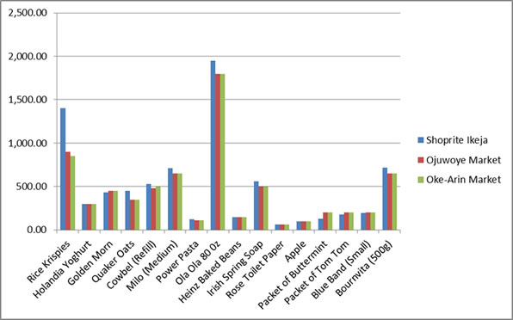
Figure 2.1: Comparison of Prices between Shoprite, Oke -Arin Market and Ojuwoye Market
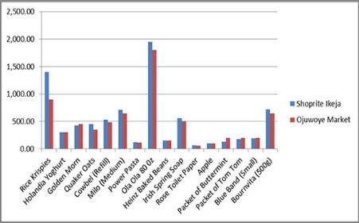
Figure 2.2: Comparison of Prices between Shoprite and Ojuwoye Market only. [4]

2.3 SUMMARY OF LITERATURE REVIEW
The literature reviewed various concepts relating to management system (Software) in Super market. It defined the concept of management system and evaluated the challenges faced in the management of the system. The relevance of Management system in Supermarket and the need for E-Commerce in the Business Sphere was evaluated in the Literature review.
CHAPTER THREE
SYSTEM ANALYSIS AND DESIGN
3.0 INTRODUCTION
This chapter deals with the analysis of the existing system and the propose system. It evaluates the designs of the proposed system. The System Analysis of the existing system to be improved upon and the proposed solutions to the short comings of the current mode of Supermarket will be thoroughly discussed. Also the methodology used in this project is the Object Oriented Analysis and Design methodology (OOAD).
.
3.1 DESCIPTION OF EXISTING SYSTEM
The current system operates manual supermarket management system, from stocks, products, ordering and purchases etc. recorded in a book. This is faced with errors, incompleteness, and insufficient data for analysis. Information regarding stocks, products, sales and purchases are still in black and white which is not properly organized and managed. From the wholesalers to retailer bills, tickets, vouchers, receipts of products are recorded in a book but further operations are not being properly handled. As a result it is difficult in processing, updating and managing.

THE FACTORS FOR THESE DIFFICULTIES ARE:
Labor-Intensive: A manual Super Market management systems is that they can be highly labor-intensive to operate. They require continuous monitoring to ensure that each transaction is accounted for and that products are maintained at the appropriate stocking levels. It is also more difficult to share inventory information throughout the business, because the lack of computerization makes accessing inventory records a more cumbersome process. The time spent monitoring inventory levels could be used on more productive activities for the business.
Human Error: A manual Supermarket management system relies heavily on the actions of people, which increases the possibility of human error. People might forget to record a transaction or simply miscount the number of goods. This results in needless additional orders that increase the company's inventory carrying costs and use up precious storage space. Inaccurate physical counts could also result in not ordering enough of a product, meaning the business could run out of a crucial item at the wrong time.
Time Wasting: A manual Supermarket management system has a huge tendency of time wasting as the sales manager could have a lot to tackle while many customers seeks attention and this is really affecting the business.

3.2 ANALYSIS OF THE PROPOSED SYSTEM
To reduce the shortcomings of the existing system there is a need to develop a new system that could upgrade the status of the current system which is manual and slow to the system that will be automatic and fast. The new system should be concern with offering the requirements of the customer and the workers, the system should be reliable, easier, fast, and more informative. It reduces paperwork, manpower requirement, and increases the productivity of the supermarket using this application, on can add, modify, update, save, delete, and print details.

FEATURES:
- It reduces the time and manpower required for management and maintenance of different tasks.
- It reduces the paper work in existing system; hence it is economical and efficient.
- With this system customers get quality of service; customers can give feedback which can be stored in the database.

MODULES:
- Administration module: This nodule is handled by an admin who has full control over the system. Admin is required to log into the system with a unique user id and password. The have control over all the modules and features of the system.
- Employee module: Employee can use this module with their user id. They can keep track of items in the supermarket, and they are responsible for recording details of purchases and sales.
- Purchase module: this module stores all the purchase details of the supermarket.
- Sales module: this module stores all the sales details of the supermarket.
- Billing module: with the help of this module, all the payment details based on purchases and sales can be shown.
QUALITIES OF THE NEW SYSTEM
1. Reduction in processing cost.
2. Error reduction.
3. Automatic posting.
4. Improve reporting.
5. Faster response time.
6. Ability to meet user requirements.
7. Flexibility.
8. Reduction in use of the paper.
9. Reduction in Man Power.
The System Can’t
- Print out bills
- Manage promotion
Due to the following reason:
This project is based on the sales transaction and Stocking of items in a supermarket.
3.3 DESIGN OF THE PROPOSED SYSTEM
System Design is one of the tasking sections of the Programming. In this section of the project many previews are going to be seen and we are gradually getting close to the new system. System design is a transition from a user-oriented document to a document oriented to programmers or database personnel. The system design is structured into the following parts:
- Input Design
- Output Design
- Database Design
- System Architecture

INPUT DESIGN
In any organization, institution or any system of operation there is always an input into the system which keeps a system going, if the input is wrong definitely the output will be wrong. This design is meant to handle data about a particular product or stock in the Supermarkets as shown in figure 3.1- figure 3.4

No | Field | Data Type | Length
1 | Staff ID | Int | 10
2 | Staff name | Varchar | 10
3 | Gender | Varchar | 10
4 | Age | Int | 10
5 | Date of birth | Date/Time | 10
6 | Address | Varchar | 20
7 | Contact | Int | 22
8 | Date of entry | Date/Time | 10
Table 3.1: Table for the input design for staff information

No | Field | Data Type | Length
1 | Membership ID | Int | 10
2 | Membership name | Varchar | 10
3 | Gender | varchar | 10
4 | Date of birth | Date/Time | 10
5 | Address | varchar | 20
6 | Contact | Int | 20
Table 3.2: Table for the Input Design for membership information

No | Field Name | Data type | Length
1 | Product Name | Varchar | 15
2 | Product Number | Int | 2
3 | Product Quantity | Int | 2
4 | Date Received | Date | 10
5 | Description | Varchar | 40
6 | Price | Currency | 4
7 | Stocks | Number | 10
Table 3.3: Table for the Input Design to Add Stock

No | Field | Data type | Length
1 | User name | Varchar | 15
2 | Password | Varchar | 20

Table 3.4: Table for the Input Design to login

OUTPUT DESIGN
In a very competitive world that we are, a good and attractive GUI is needed to make customers and administrators enjoy the services of a system, which would serve as a system to increase productivity in supermarket business below are previews of the output designs.
The previews of the output view of the design is shown in figure 3.5 – 3.8

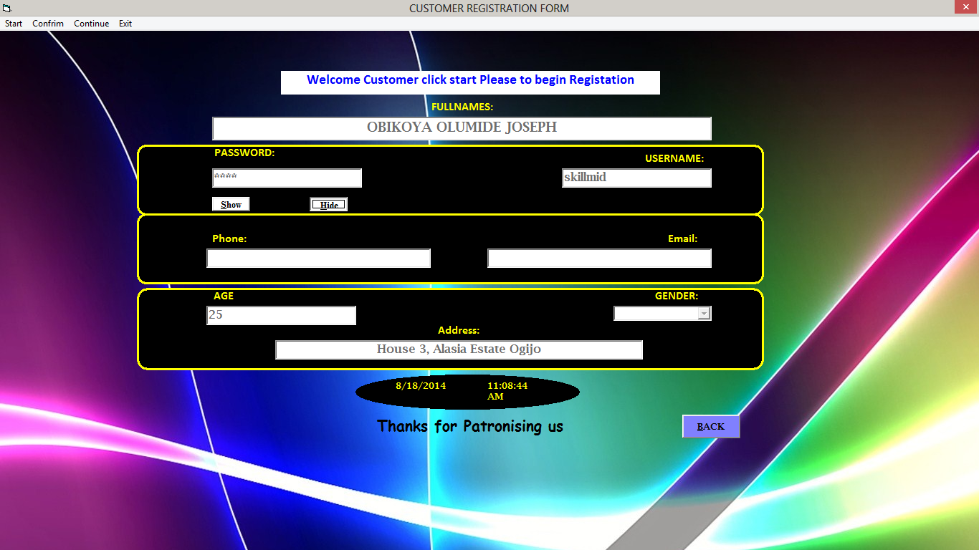
Figure 3.5: Preview of Output Design to Add New Customer Details
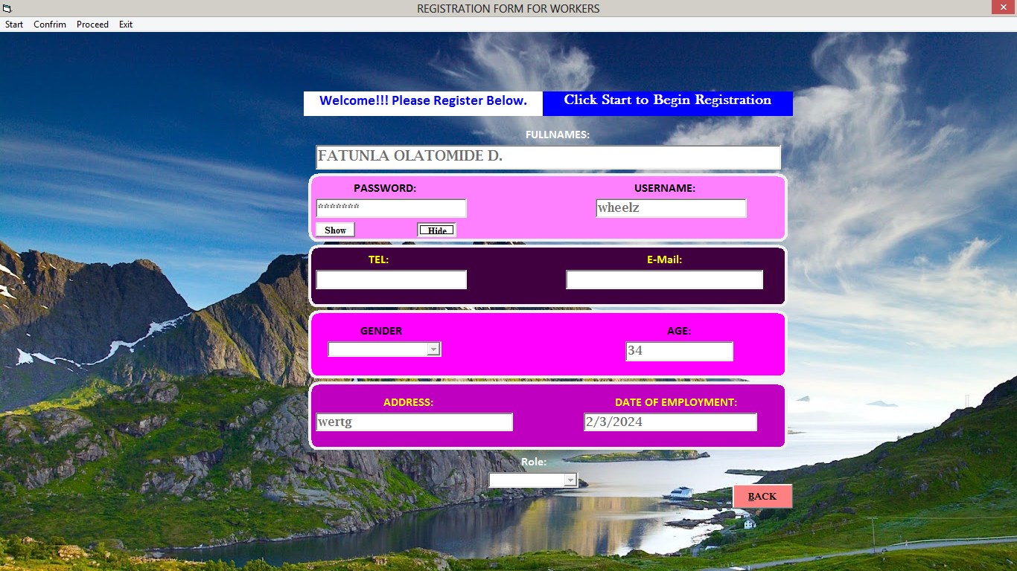
Figure 3.6: Preview of Output Design to Add New Workers Details

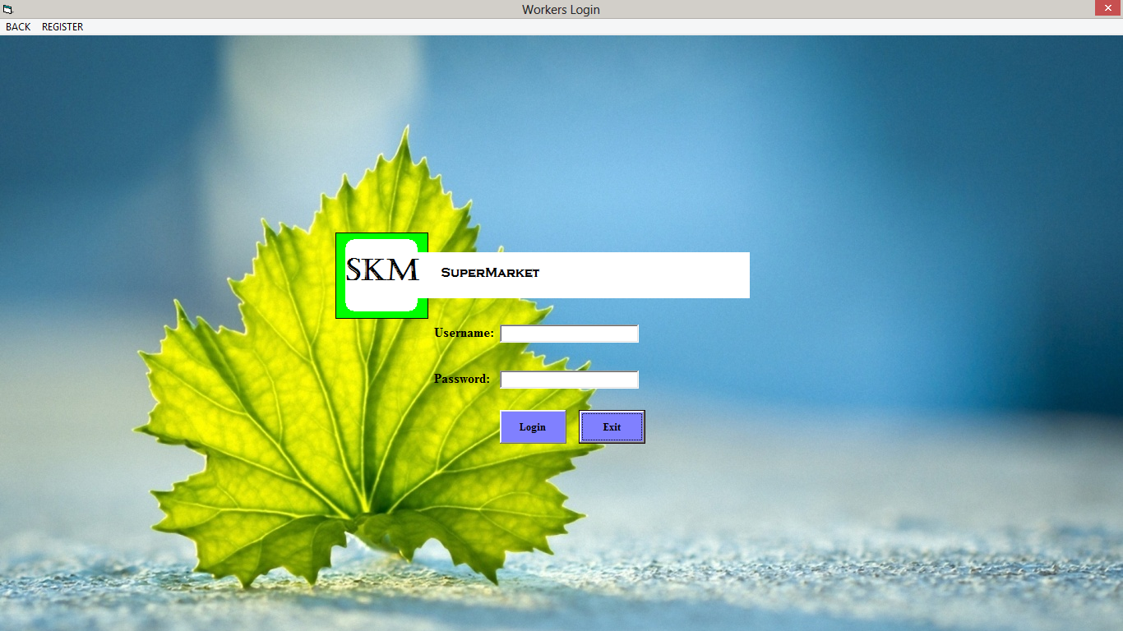

Figure 3.7: Preview of Output Design for Workers Login

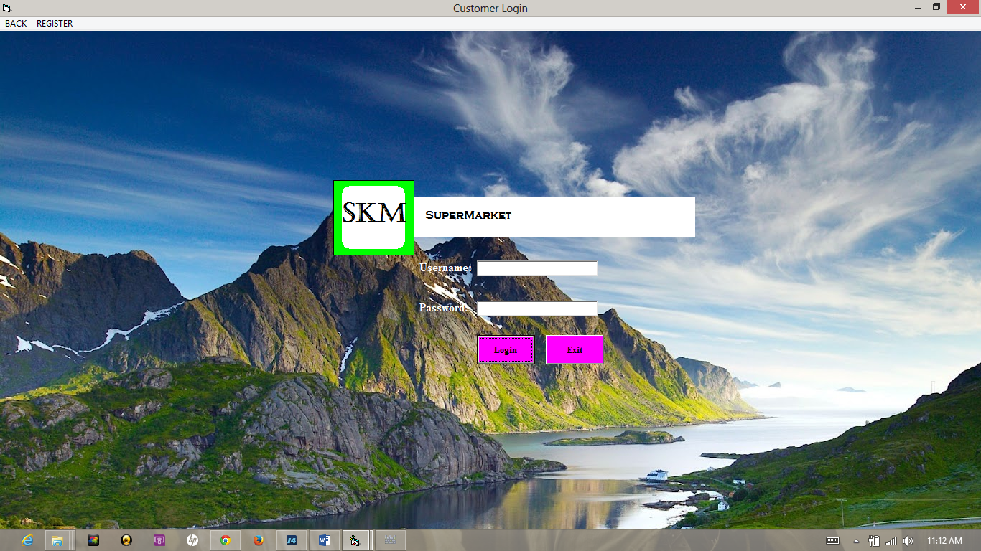

Figure 3.8: Preview of Output Design for Customer Login
DATABASE DESIGN
Database is a file composed of records, each containing fields together with a set of operations it helps in organizing data in a logical order for references.
Database contains related data which are organized together in a group of object, table, and file. It can be in form of node. In this project a relational database concept will be used in this appraisal, related data will be store or organize in different table.
The Database design of this system is showed in figure 3.9 – 3.12 while the system architecture is shown in the figure 3.13
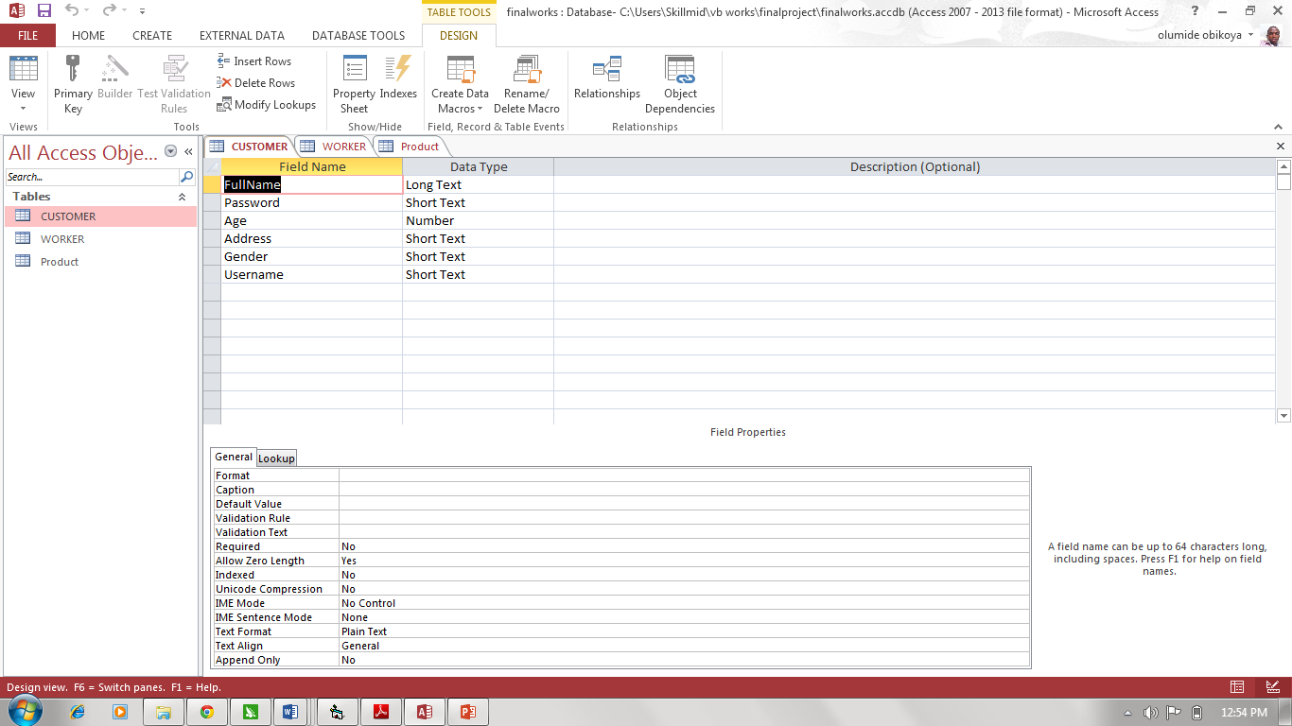
Figure 3.9: Preview for Database Design for Customer

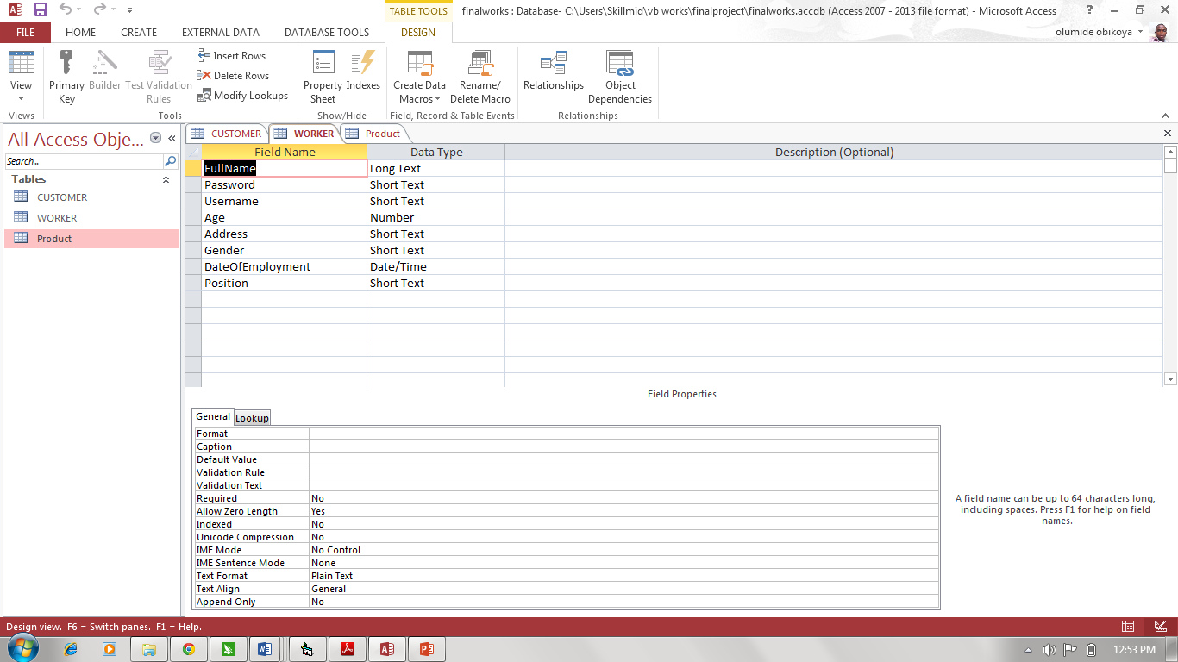
Figure 3.10: Preview for Database Design for Workers

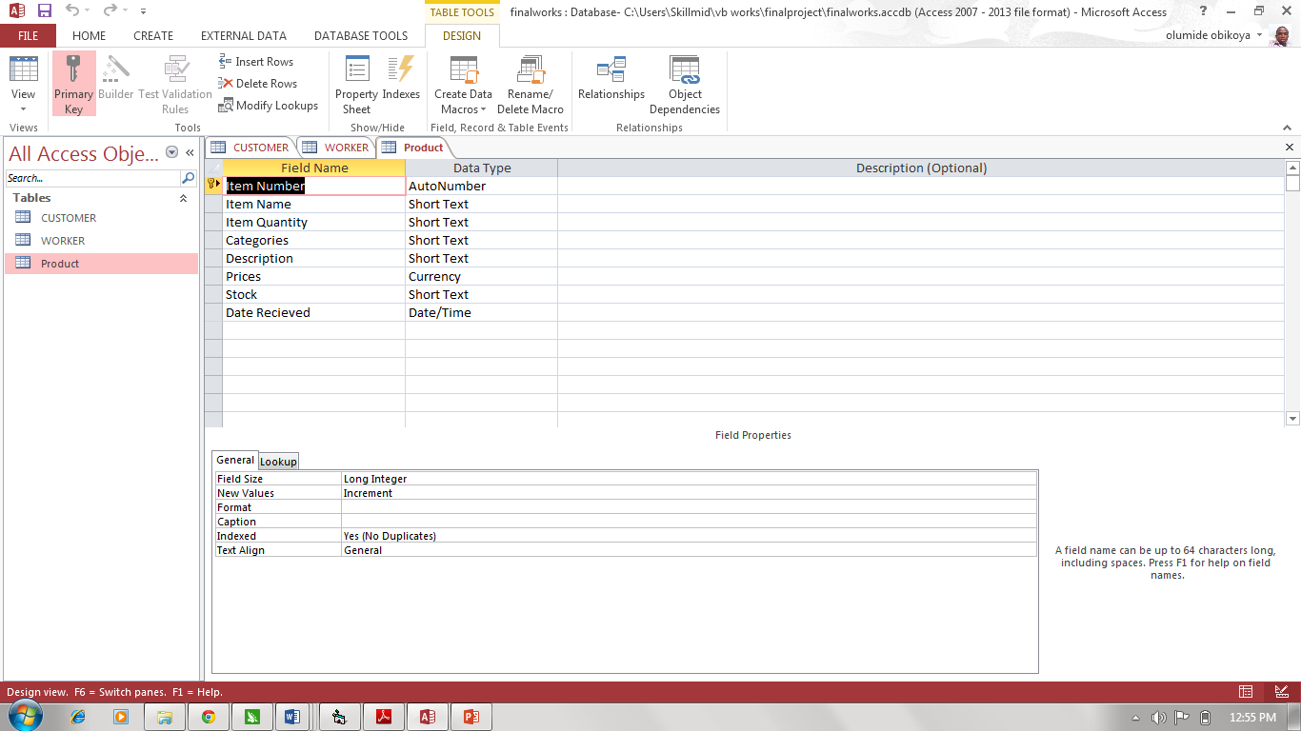
Figure 3.11: Preview for Database Design for Product

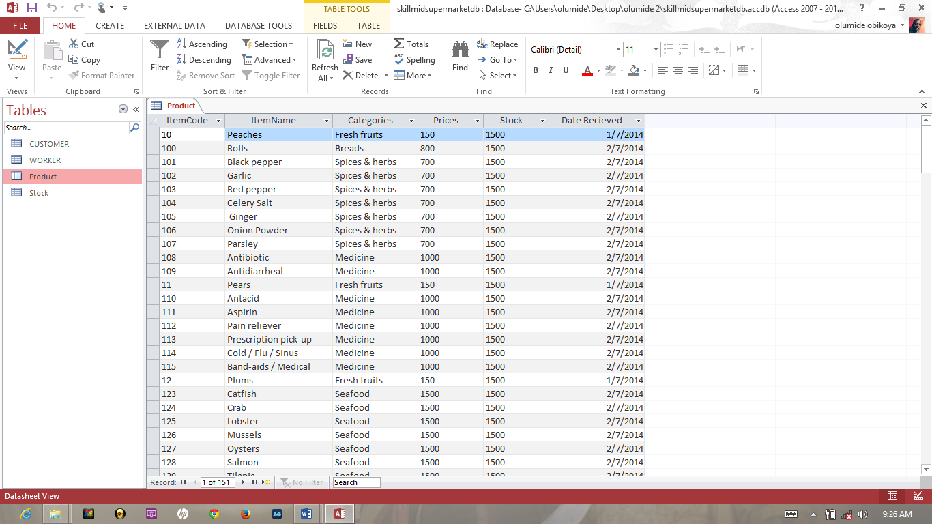
Figure 3.12: Preview for Database Spreadsheet Design for Product

SYSTEM ARCHITECTURE
This is the logical structure that represents the blue print of proposed system in other words; it defines as the algorithm of the software in a concise and logical order. The process design is represented diagrammatically in the form of system architecture as shown below
Account
Account
Account
Workers/Administrator
Customer
Products
Stocks
Suppliers
Products
Items
Customer
SAVE
DELETE
CLOSE
MODIFY
Start

Stop
Purchase Bill payments
Customer Bill Payment
Bill

Figure 3.13: System Architecture

CHAPTER FOUR
SYSTEM IMPLEMENTATION
4.0 INTRODUCTION
This chapter deals on the procedures and steps needed for the implementation of the supermarket management system. It evaluates the choice of development environment, the implementation architectures, software testing, documentation
and the user manuals of the proposed system. This puts a planned system into action and examine in details the analysis and design of the Skillmid supermarket system. The present chapter discusses the implementation of the system, highlighting the testing exercise and describing some of the main components of the system's Graphical User Interface. It will give an output from programming language and other tools used to develop our system. According to this plan, the activities are to be carried out, discussions made regarding the equipment and resources and the additional equipment has to be acquired to implement the new system.

4.1 CHOICE OF DEVELOPMENT ENVIRONMENT
The system platform used is windows 10. Also the IDE (integrated development environment) used is Sublime text 3 the latest version and the programming language used is PHP previously known as personal home page. PHP was created by Rasmus Lerdorf in 1994 and publicly released in June 8, 1995 and was known as Hypertext Preprocessor. PHP is a server-side interpreted scripting language designed for creating dynamic web pages and web pages that effectively work with databases. Several reasons ride the choice of using PHP for this system, one of which is its extensive portability and use over several web host servers on the internet. Also PHP possesses several inbuilt functions which allow it to integrate well with the widely used and accepted database storage management system for the web-MySQL. Due to its wide use, several documentations are available online which will guarantee that materials about any aspect of its use will be easily found.
4.2 IMPLEMENTATION ARCHITECTURE

MIDDLE END
FRONT END
BACK END
HTML CSS, JAVASCRIPT
&
SUBLIME TEXT

MYSQL
Database

PHP
& WAMP Server

Figure 4.1 Implementation Architecture

4.3 SOFTWARE TESTING
This software is a high standard program that can weather the storm of technology advancement, it is most needed in all supermarkets and it is an antidote for poor business speed and transaction with record keeping and maintenance, it will be very helpful to clients and customers in the marketing business. All it needs is a computer literate operative to make it work.
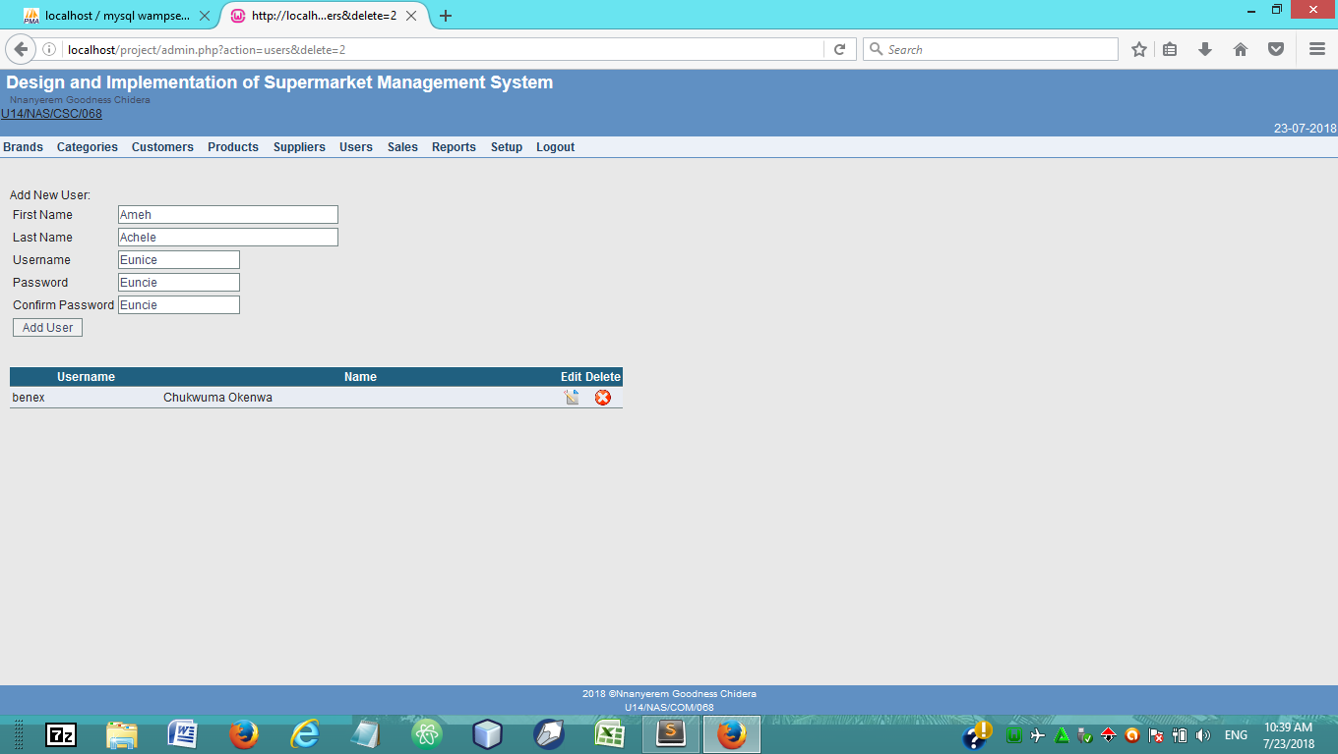
Figure 4.2. To Add New User
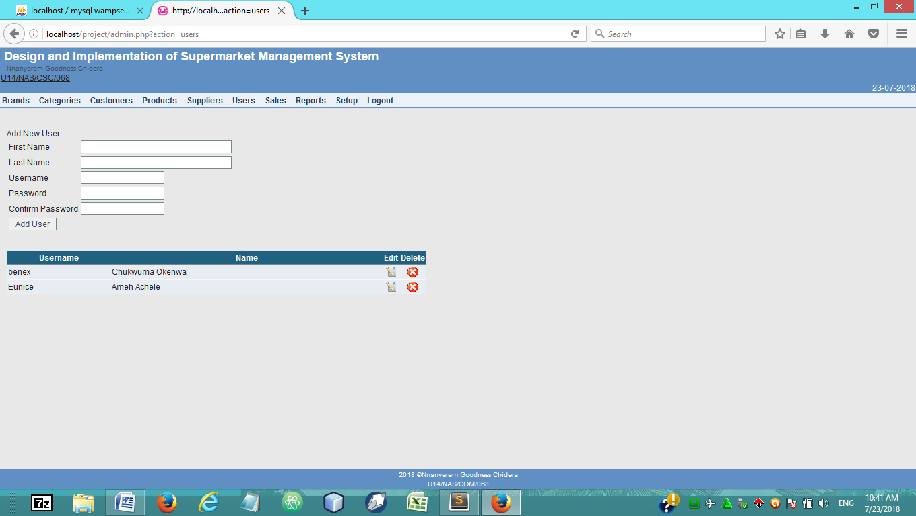
Figure 4.3.Result of the new user added

4.4 DOCUMENTATION
Installation Procedure
This program is already packaged having its installer package some computer programs can be executed by simply copying them into a folder stored on a computer and executing them but this is quit advanced in nature because of the advancement technology. Other programs are supplied in a form unsuitable for immediate execution and therefore need an installation procedure. Once installed, the program can be executed again and again, without the need to reinstall before each execution.
The following are the step involve in installing Skillmid supermarket management system:
- Install the general programming language platform.net frame work. Go to www.Microsoft.com and install the latest version of .net frame work appropriate for your computer (Windows, Mac, and Linux).
2 Copy the skillmid supermarket database file to your Windows root folder
Locating Root Folder.....Click on Computer....Click on Local disk c...navigate to windows......paste the file......
3 Click on Setup
4 Follow the installation step and ignore all Prompted display
5 Go to all Programs
6 Click on Skillmid Supermarket
4.4.1 USER MANUAL
The program may be maintained on the ground that the system requires an upgrade. When there is a new field to be added or a new form to be added in other to serve users well. Though it is compiled as standalone software the database can be tempered with but it’s advisable that the admin put a password on the file to secure the database from intrusion.
THE FOLLOWING PRECAUTION SHOULD BE DONE
- Ensure that the computer is kept in clean areas.
- System should be kept in cool places.
- Air conditioner is important to reduce room temperature and keep it constant.
- Backup of data is important
4.4.2 SOURCE CODE LISTING
The Source code for this work is attached as an appendix 1.

CHAPTER FIVE
SUMMARY AND CONCLUSION
5.0 SUMMARY
This project is on the design and implementation of supermarket management system. To effectively drive home the meaning and concept of this system, the project is subdivided into five chapters, the first chapters evaluates the background of the study, stating the problems that the newly proposed system is about to resolve. In furtherance it explicated the significance, and defines the terms and terminologies required for the implementation and use of this system. The second chapter of this project reviewed relevant literatures that reiterated on the necessity of the implementation of management system in the management of supermarkets. Shoprite was used as a case study. The third chapter of this project evaluated the system analysis and design. It laid emphasis on the nature of the manual systems and described the need for the new system and its advantages over the old system. The fourth chapter is based on the system implementation and how to use the system for effective performance. The final chapter summarised and draw conclusion based on the functionality of the system and make possible r3ecommendation on how to enhance the management of supermarkets in Nigeria.
5.1 CONCLUSION
In conclusion, Supermarket Management System has to do with making appropriate effort to stop the rising problem to all manual supermarket operation in order to enhance the operation of such supermarket. In this project, the software or system that can be used to aid all supermarkets that are still operating manually have been successfully developed. The software can be implementing in all types of supermarket as mentioned in the second chapter. The software has a large memory of storing all the goods in the supermarket and also keeping record it is highly effective and accurate.

5.2 RECOMMENDATION
In the development of this supermarket management system, I will recommend that if there is going to be any modification the new writer should endeavor to improve on the limitations such as inclusion of the billing and printing to further increase the system architecture and to satisfy users need more for writing of the source code, latest PHP version should be used and Microsoft access for the database. There are some limitations during the development of this supermarket management system that will require improvement as stated in previous chapter writer should put them in mind and face it as a challenge and not a problem.
PROBLEM ENCOUNTERED
A lot of challenges surfaced during the development of this incredible application though it tried stopping this project but the doggedness and consistency of the writer was in match with the challenge
The following are some of the problems or challenges encountered.
- Expensive internet facility.
- Inadequacy of power supply and many more.
- Time factor on research to get a way of packaging the application successively.
- S FURTHER RESEARCH
In the future, the following components can be added to the system in order to improve the effectiveness and efficiency of the system, which includes:
- An advanced password system that will be embedded into all login pages to increase the security of the system.
- A good Printing module should be included.
- A good internet backup should be automated after everyday sales.
- Internet Transactions should be allowed.

REFERENCES/BIBLIOGRAPHY
- R.H. Ballou, (1999). Business Logistics Management: Planning, Organizing and Controlling the Supply Chain, 4th ed., Prentice-Hall International, London.
- B. Yang, and N.D. Burns, (2003). "Implications of postponement for the supply chain", International Journal of Production Research, Vol. 41 No.9.
- M.Q. Patton, (1990). Qualitative Evaluation and Research Methods, 2nd edition, New Bury Park, CA.
- S. Rietze, (2008). “Examination of supply response”, WA 98237, Vol 7.
- J.D. Pagh, and M.C. Cooper, (1998). "Supply chain postponement and speculation strategies: how to choose the right strategy", Journal of Business Logistics, Vol. 19
- C. Bowersox, (2009). “Inventory Speculation: Cause and Effect”, Ohio, United States 89511
- S. Seuring, (2011), “Supply chain management for sustainable products – insights from research applying mixed methodologies”, Cleveland, OH 44106 Vol. 11.
- C. Billington, G. Callioni, B. Crane, and J.D Ruark, et al, (2004) “Accelerating the Profitability of HewlettPackard's”
- C. Wallin, M.J. Rungtusanatham, and E. Rabinovich, (2006). “What is the "right" inventory management approach for a purchased item?” International Journal of Operations & Production Managemkent.
- “Opportunities for active stock-out management in computerized stores: The impact of the stock-out policy on computerized stock-out reactions © 2006 New York University. Published by Elsevier Inc.
- Supply Chains”. Interfaces. Linthicum Breugelmans, E., Campob, and K., Gijsbrechts (2006).
- L.P. Bucklin, (1965). "Postponement, speculation, and the structure of distribution channels", Journal of Marketing Research, Vol. 2 No. 1.
- M. Fleischmann, J.A.E.E. van Nunen, and B. Grave, (2003). “Integrating Closed-Loop Supply Chains and Spare-Parts Management at IBM” Interfaces.

http://msdn.microsoft.com/en-us/library/aa645481(v=vs.71).aspx
http://www.visualstudio.com/en-us
http://support.microsoft.com/kb/2899270
http://www.vbtutor.net/vb6/lesson28.html
http://www.profsr.com/vb/vbless08.htm
http://www.pudn.com/downloads51/sourcecode/os/detail176563.html
http://en.wikipedia.org/wiki/Inventory://
www.barcodesinc.com/

APPENDIX
CODE FOR: ADMIN.PHP
<?php
include("config.php");
include("languages/" .POS_DEFAULT_LANGUAGE .".php");
require_once("database.php");
$db = new database($dbhost,$dbuser,$dbpassword,$dbname);
if(isset($_GET['action']) && $_GET['action']=="logout"){
session_destroy();
header("Location:admin.php");
}
if(isset($_POST['adminlogin'])){
if($adminname == trim($_POST['adminname']) &&
$adminpassword == md5(trim($_POST['adminpassword']))){
$_SESSION['admin'] = trim($_POST['adminname']);
$_SESSION['user'] = trim($_POST['adminname']);
}
}
?>
<html>
<head>
<title></title>
<meta http-equiv="Content-Type" content="text/html; charset=iso-8859-1">
<link href="pos.css" rel="StyleSheet" type="text/css">
<script language="javascript" src="general.js"></script>
</head>
<body>
<table width="100%" height="100%" cellspacing="0" cellpadding="0">
<TR height="20"><TD>
<?php
require_once("header.php");
?>
</TD></TR>
<TR><TD valign="top">
<?php
if(!isset($_SESSION['admin'])){
?>
<br><br>
<center><b class="blt"><?php echo LOGIN_WELCOM; ?></b></center>
<form action="admin.php?action=login" method="POST" class="loginform">
<table align="center" class="tlogin">
<TR><TD align="right" width="40%"><?php echo LOGIN_ADMIN; ?></TD><TD width="60%"><input type="text" name="adminname"></TD></TR>
<TR><TD align="right" width="40%"><?php echo LOGIN_PASSWORD; ?></TD><TD width="60%"><input type="password" name="adminpassword"></TD></TR>
<TR><TD colspan="2" align="center"><input type="submit" name="adminlogin" value="<?php echo LOGIN_SUBMIT; ?>"></TD></TR>
</table>
</form>
<center><a href="index.php" class="stronglink">Sales</a>&nbsp;|&nbsp;<a href="admin.php" class="stronglink">Administrator</a></center>
<?php
}
else{
CODE FOR: USER.PHP
<?php
session_start();
if(!isset($_SESSION['admin'])){
header("Location:admin.php");
}
if(isset($_POST['submituser'])){
$sql = "insert into users(first_name, last_name, username, password, type) values ('" .$_POST['firstname'] ."','" .$_POST['lastname'] ."','" .$_POST['username'] ."','" .md5($_POST['password']) ."','')";
$db->query($sql);
}
if(isset($_POST['edituser'])){
$sql = "update users set first_name='" .$_POST['firstname'] ."', last_name='" .$_POST['lastname'] ."', username='" .$_POST['username'] ."' " .($_POST['password']=="" ? "" : ",password='" .md5($_POST['password']) ."' ") ."where id=" .$_POST['user_id'];
$db->query($sql);
}
if(isset($_GET['delete'])){
$sql = "delete from users where id=" .$_GET['delete'];
$db->query($sql);
}
?>
<div class="admin_content">
<script language="JavaScript">
function validate_form(frm){
if(frm.firstname.value=="" || frm.lastname.value=="" || frm.username.value=="" || frm.password.value=="" || frm.password.value != frm.confirm_password.value){
alert("Error, verify fields!");
return false;
}
else return true;
}
function validate_edit_form(frm){
if(frm.firstname.value=="" || frm.lastname.value=="" || frm.username.value=="" || frm.password.value != frm.confirm_password.value){
alert("Error, verify fields!");
return false;
}
else return true;
}
</script>
<?php
if(isset($_GET['edit'])){
$sql = "select * from users where id=" .$_GET['edit'];
$result = $db->query($sql);
$row = mysql_fetch_row($result);
?>
<form action="admin.php?action=users" onsubmit="return validate_edit_form(this);" method="POST">
<input type="hidden" name="user_id" value="<?php echo $_GET['edit']; ?>">
<table>
<TR><TD><?php echo TXT_FIRSTNAME; ?></TD><TD><input type="text" name="firstname" size="40" value="<?php echo htmlspecialchars($row[1]); ?>"></TD></TR>
<TR><TD><?php echo TXT_LASTNAME; ?></TD><TD><input type="text" name="lastname" size="40" value="<?php echo htmlspecialchars($row[2]); ?>"></TD></TR>
<TR><TD><?php echo TXT_USERNAME; ?></TD><TD><input type="text" name="username" value="<?php echo htmlspecialchars($row[3]); ?>"></TD></TR>
<TR><TD><?php echo LOGIN_PASSWORD; ?></TD><TD><input type="text" name="password">(*)</TD></TR>
<TR><TD><?php echo LOGIN_CONFIRM_PASSWORD; ?></TD><TD><input type="text" name="confirm_password"></TD></TR>
<TR><TD colspan="2"><small>(*)<?php echo EDIT_PASSWORD_INFO; ?></small></TD></TR>
<TR><TD colspan="2"><input type="submit" name="edituser" value="<?php echo TXT_SAVE ?>"></TD></TR>
</table>
</form>
<?php
}
else{
?>
<form action="admin.php?action=users" onsubmit="return validate_form(this);" method="POST">
<?php echo ADD_NEW_USER; ?>:<br>
<table>
<TR><TD><?php echo TXT_FIRSTNAME; ?></TD><TD><input type="text" name="firstname" size="40"></TD></TR>
<TR><TD><?php echo TXT_LASTNAME; ?></TD><TD><input type="text" name="lastname" size="40"></TD></TR>
<TR><TD><?php echo TXT_USERNAME; ?></TD><TD><input type="text" name="username"></TD></TR>
<TR><TD><?php echo LOGIN_PASSWORD; ?></TD><TD><input type="text" name="password"></TD></TR>
<TR><TD><?php echo LOGIN_CONFIRM_PASSWORD; ?></TD><TD><input type="text" name="confirm_password"></TD></TR>
<TR><TD colspan="2"><input type="submit" name="submituser" value="<?php echo USER_SUBMIT ?>"></TD></TR>
</table>
</form>
<br>
<script language="JavaScript">
function delete_user(user){
op = confirm("<?php echo CONFIRM_DELETE_USER; ?>");
if(op)document.location.href="admin.php?action=users&delete="+user;
}
</script>
<table cellspacing="0">
<TR><TH width="150"><?php echo TXT_USERNAME; ?></TH><TH width="400"><?php echo TXT_NAME; ?></TH><TH><?php echo TXT_EDIT; ?></TH><TH><?php echo TXT_DELETE; ?></TH></TR>
<?php
$sql = "select * from users";
$result = $db->query($sql);
while($row = mysql_fetch_row($result)){
?><TR><TD class="tvalue"><?php echo htmlspecialchars($row[3]); ?></TD><TD class="tvalue"><?php echo htmlspecialchars($row[1] ." " .$row[2]); ?></TD><TD class="tvalue" align="center"><a href="admin.php?action=users&edit=<?php echo $row[0]; ?>"><img src="images/edit.gif"></a></TD><TD class="tvalue" align="center"><a href="javascript:delete_user(<?php echo $row[0]; ?>)"><img src="images/delete.gif"></a></TD></TR><?php
}
?>
<TR><TD></TD></TR>
</table>
<?php
}
?>
</div>
CODE FOR: SUPPLIERS.PHP
<?php
if(!isset($_SESSION['admin'])){
header("Location:admin.php");
}
if(isset($_POST['submitsupplier'])){
$sql = "insert into suppliers(supplier, address, city, pcode, state, country, phone_number, contact, email, comments) values('" .$_POST['supplier'] ."','" .$_POST['address'] ."','" .$_POST['city'] ."','" .$_POST['pcode'] ."','" .$_POST['state'] ."','" .$_POST['country'] ."','" .$_POST['phone_number'] ."','" .$_POST['contact'] ."','" .$_POST['email'] ."','" .$_POST['comments'] ."')";
$db->query($sql);
}
if(isset($_POST['editsupplier'])){
$sql = "update suppliers set supplier='" .$_POST['supplier'] ."', address='" .$_POST['address'] ."', city='" .$_POST['city'] ."', pcode='" .$_POST['pcode'] ."', state='" .$_POST['state'] ."', country='" .$_POST['country'] ."', phone_number='" .$_POST['phone_number'] ."', contact='" .$_POST['contact'] ."', email='" .$_POST['email'] ."', comments='" .$_POST['comments'] ."' where id=" .$_POST['supplier_id'];
$db->query($sql);
}
if(isset($_GET['delete'])){
$db->query("delete from suppliers where id=" .$_GET['delete']);
}
?>
<script language="JavaScript">
function validate_supplier(frm){
if(frm.supplier.value==""){
alert("<?php echo ERROR_SUPPLIER_SUBMIT; ?>");
return false;
}
else return true;
}
function delete_supplier(supplier){
op = confirm("<?php echo CONFIRM_DELETE_SUPPLIER; ?>");
if(op)document.location.href="admin.php?action=suppliers&delete="+supplier;
}
</script>
<div class="admin_content">
<?php
if(isset($_GET['add_supplier'])){
?>
<form action="admin.php?action=suppliers" method="POST" onsubmit="return validate_supplier(this);">
<table>
<TR><TD><?php echo TXT_SUPPLIER; ?></TD><TD><input type="text" size="60" name="supplier"></TD></TR>
<TR><TD><?php echo TXT_ADDRESS; ?></TD><TD><input type="text" size="60" name="address"></TD></TR>
<TR><TD><?php echo TXT_CITY; ?></TD><TD><input type="text" size="40" name="city"></TD></TR>
<TR><TD><?php echo TXT_PCODE; ?></TD><TD><input type="text" size="20" name="pcode"></TD></TR>
<TR><TD><?php echo TXT_STATE; ?></TD><TD><input type="text" size="40" name="state"></TD></TR>
<TR><TD><?php echo TXT_COUNTRY; ?></TD><TD><input type="text" size="50" name="country"></TD></TR>
<TR><TD><?php echo TXT_PHONE; ?></TD><TD><input type="text" size="20" name="phone_number"></TD></TR>
<TR><TD><?php echo TXT_CONTACT; ?></TD><TD><input type="text" size="60" name="contact"></TD></TR>
<TR><TD><?php echo TXT_EMAIL; ?></TD><TD><input type="text" size="60" name="email"></TD></TR>
<TR><TD valign="top"><?php echo TXT_COMMENTS; ?></TD><TD><textarea rows="5" cols="50" name="comments"></textarea></TD></TR>
<TR><TD colspan="2"><input type="submit" name="submitsupplier" value="<?php echo SUPPLIER_SUBMIT; ?>"></TD></TR>
</table>
</form>
<?php
}
//Edit a supplier
if(isset($_GET['edit_supplier'])){
$result = $db->query("select * from suppliers where id=" .$_GET['edit_supplier']);
$row = mysql_fetch_row($result);
?>
<form action="admin.php?action=suppliers" method="POST" onsubmit="return validate_supplier(this);">
<input type="hidden" name="supplier_id" value="<?php echo $row[0]; ?>">
<table>
<TR><TD><?php echo TXT_SUPPLIER; ?></TD><TD><input type="text" size="60" name="supplier" value="<?php echo htmlspecialchars($row[1]); ?>"></TD></TR>
<TR><TD><?php echo TXT_ADDRESS; ?></TD><TD><input type="text" size="60" name="address" value="<?php echo htmlspecialchars($row[2]); ?>"></TD></TR>
<TR><TD><?php echo TXT_CITY; ?></TD><TD><input type="text" size="40" name="city" value="<?php echo htmlspecialchars($row[3]); ?>"></TD></TR>
<TR><TD><?php echo TXT_PCODE; ?></TD><TD><input type="text" size="20" name="pcode" value="<?php echo htmlspecialchars($row[4]); ?>"></TD></TR>
<TR><TD><?php echo TXT_STATE; ?></TD><TD><input type="text" size="40" name="state" value="<?php echo htmlspecialchars($row[5]); ?>"></TD></TR>
<TR><TD><?php echo TXT_COUNTRY; ?></TD><TD><input type="text" size="50" name="country" value="<?php echo htmlspecialchars($row[6]); ?>"></TD></TR>
<TR><TD><?php echo TXT_PHONE; ?></TD><TD><input type="text" size="20" name="phone_number" value="<?php echo htmlspecialchars($row[7]); ?>"></TD></TR>
<TR><TD><?php echo TXT_CONTACT; ?></TD><TD><input type="text" size="60" name="contact" value="<?php echo htmlspecialchars($row[8]); ?>"></TD></TR>
<TR><TD><?php echo TXT_EMAIL; ?></TD><TD><input type="text" size="60" name="email" value="<?php echo htmlspecialchars($row[9]); ?>"></TD></TR>
<TR><TD valign="top"><?php echo TXT_COMMENTS; ?></TD><TD><textarea rows="5" cols="50" name="comments"><?php echo htmlspecialchars($row[10]); ?></textarea></TD></TR>
<TR><TD colspan="2"><input type="submit" name="editsupplier" value="<?php echo TXT_SAVE; ?>"></TD></TR>
</table>
</form>
<?php
}
if(!isset($_GET['edit_supplier']) && !isset($_GET['add_supplier'])){
?>
<input type="button" value="<?php echo ADD_NEW_SUPPLIER; ?>" onclick="document.location.href='admin.php?action=suppliers&#038;add_supplier'"><br><br>
<table cellspacing="0">
<TR><TH width="250"><?php echo TXT_SUPPLIER; ?></TH><TH width="60"><?php echo TXT_PHONE; ?></TH><TH width="60" align="left"><?php echo TXT_CONTACT; ?></TH><TH width="250" align="left"><?php echo TXT_EMAIL; ?></TH><TH><? echo TXT_EDIT; ?></TH><TH><? echo TXT_DELETE; ?></TH></TR>
<?php
$result = $db->query("select id,supplier,phone_number,contact,email from suppliers");
while($row = mysql_fetch_row($result)){
?>
<TR><TD class="tvalue"><?php echo htmlspecialchars($row[1]); ?></TD><TD class="tvalue"><?php echo htmlspecialchars($row[2]); ?>&nbsp;</TD><TD class="tvalue"><?php echo htmlspecialchars($row[3]); ?>&nbsp;</TD><TD class="tvalue"><?php echo htmlspecialchars($row[4]); ?>&nbsp;</TD><TD class="tvalue" align="center"><a href="admin.php?action=suppliers&#038;edit_supplier=<?php echo $row[0]; ?>"><img src="images/edit.gif"></a></TD><TD class="tvalue" align="center"><a href="javascript:delete_supplier(<?php echo $row[0]; ?>)"><img src="images/delete.gif"></a></TD></TR>
<?php
}
?>
</table>
<?php
}
?>
</div>
CODE FOR: DATABASE.PHP
<?php
<?php
class database{
var $conn = null;
function database($server, $username, $password, $database){
$this->conn = mysql_connect($server, $username, $password);
if ($this->conn) mysql_select_db($database);
}
function close() {
mysql_close($this->conn);
}
function query($query) {
$result = mysql_query($query, $this->conn);
return $result;
}
function getConnection(){
return $this->conn;
}
}
?>
CODE FOR: CLINITE.PHP
<?php
if(!isset($_SESSION['admin'])){
header("Location:admin.php");
}
if(isset($_POST['submitcustomer'])){
$sql = "insert into customers(first_name, last_name, account_number, address, city, pcode, state, country, phone_number, email, comments) values('" .$_POST['firstname'] ."','" .$_POST['lastname'] ."','" .$_POST['account_number'] ."','" .$_POST['address'] ."','" .$_POST['city'] ."','" .$_POST['pcode'] ."','" .$_POST['state'] ."','" .$_POST['country'] ."','" .$_POST['phone_number'] ."','" .$_POST['email'] ."','" .$_POST['comments'] ."')";
$db->query($sql);
}
//Edit customer data
if(isset($_POST['editcustomer'])){
$sql = "update customers set first_name='" .$_POST['firstname'] ."', last_name='" .$_POST['lastname'] ."', account_number='" .$_POST['account_number'] ."', address='" .$_POST['address'] ."', city='" .$_POST['city'] ."', pcode='" .$_POST['pcode'] ."', state='" .$_POST['state'] ."', country='" .$_POST['country'] ."', phone_number='" .$_POST['phone_number'] ."', email='" .$_POST['email'] ."', comments='" .$_POST['comments'] ."' where id=" .$_POST['customer_id'];
$db->query($sql);
}
//Delete a customer
if(isset($_GET['delete'])){
$db->query("delete from customers where id=" .$_GET['delete']);
}
?>
<div class="admin_content">
<?php
if(isset($_GET['add_customer'])){
?>
<form action="admin.php?action=clients" method="POST">
<table>
<TR><TD><?php echo TXT_FIRSTNAME; ?></TD><TD><input type="text" name="firstname" size="40"></TD></TR>
<TR><TD><?php echo TXT_LASTNAME; ?></TD><TD><input type="text" name="lastname" size="40"></TD></TR>
<TR><TD><?php echo TXT_ACCOUNT_NUMBER; ?></TD><TD><input type="text" name="account_number" size="30"></TD></TR>
<TR><TD><?php echo TXT_ADDRESS; ?></TD><TD><input type="text" size="60" name="address"></TD></TR>
<TR><TD><?php echo TXT_CITY; ?></TD><TD><input type="text" size="40" name="city"></TD></TR>
<TR><TD><?php echo TXT_PCODE; ?></TD><TD><input type="text" size="20" name="pcode"></TD></TR>
<TR><TD><?php echo TXT_STATE; ?></TD><TD><input type="text" size="40" name="state"></TD></TR>
<TR><TD><?php echo TXT_COUNTRY; ?></TD><TD><input type="text" size="50" name="country"></TD></TR>
<TR><TD><?php echo TXT_PHONE; ?></TD><TD><input type="text" size="20" name="phone_number"></TD></TR>
<TR><TD><?php echo TXT_EMAIL; ?></TD><TD><input type="text" size="60" name="email"></TD></TR>
<TR><TD valign="top"><?php echo TXT_COMMENTS; ?></TD><TD><textarea rows="5" cols="50" name="comments"></textarea></TD></TR>
<TR><TD colspan="2"><input type="submit" name="submitcustomer" value="<?php echo CUSTOMER_SUBMIT; ?>"></TD></TR>
</table>
</form>
<?php
}
if(isset($_GET['edit_customer'])){
$result = $db->query("select * from customers where id=" .$_GET['edit_customer']);
$row = mysql_fetch_row($result);
?>
<form action="admin.php?action=clients" method="POST">
<input type="hidden" name="customer_id" value="<?php echo $row[0]; ?>">
<table>
<TR><TD><?php echo TXT_FIRSTNAME; ?></TD><TD><input type="text" name="firstname" size="40" value="<?php echo htmlspecialchars($row[1]); ?>"></TD></TR>
<TR><TD><?php echo TXT_LASTNAME; ?></TD><TD><input type="text" name="lastname" size="40" value="<?php echo htmlspecialchars($row[2]); ?>"></TD></TR>
<TR><TD><?php echo TXT_ACCOUNT_NUMBER; ?></TD><TD><input type="text" name="account_number" size="30" value="<?php echo htmlspecialchars($row[3]); ?>"></TD></TR>
<TR><TD><?php echo TXT_ADDRESS; ?></TD><TD><input type="text" size="60" name="address" value="<?php echo htmlspecialchars($row[4]); ?>"></TD></TR>
<TR><TD><?php echo TXT_CITY; ?></TD><TD><input type="text" size="40" name="city" value="<?php echo htmlspecialchars($row[5]); ?>"></TD></TR>
<TR><TD><?php echo TXT_PCODE; ?></TD><TD><input type="text" size="20" name="pcode" value="<?php echo htmlspecialchars($row[6]); ?>"></TD></TR>
<TR><TD><?php echo TXT_STATE; ?></TD><TD><input type="text" size="40" name="state" value="<?php echo htmlspecialchars($row[7]); ?>"></TD></TR>
<TR><TD><?php echo TXT_COUNTRY; ?></TD><TD><input type="text" size="50" name="country" value="<?php echo htmlspecialchars($row[8]); ?>"></TD></TR>
<TR><TD><?php echo TXT_PHONE; ?></TD><TD><input type="text" size="20" name="phone_number" value="<?php echo htmlspecialchars($row[9]); ?>"></TD></TR>
<TR><TD><?php echo TXT_EMAIL; ?></TD><TD><input type="text" size="60" name="email" value="<?php echo htmlspecialchars($row[10]); ?>"></TD></TR>
<TR><TD valign="top"><?php echo TXT_COMMENTS; ?></TD><TD><textarea rows="5" cols="50" name="comments"><?php echo htmlspecialchars($row[11]); ?></textarea></TD></TR>
<TR><TD colspan="2"><input type="submit" name="editcustomer" value="<?php echo TXT_SAVE; ?>"></TD></TR>
</table>
</form>
<?php
}
if(!isset($_GET['add_customer']) && !isset($_GET['edit_customer'])){
?>
<script language="JavaScript">
function delete_customer(customer){
op = confirm("<?php echo CONFIRM_DELETE_CUSTOMER; ?>");
if(op)document.location.href="admin.php?action=clients&delete="+customer;
}
</script>
<input type="button" value="<?php echo ADD_NEW_CUSTOMER; ?>" onclick="document.location.href='admin.php?action=clients&#038;add_customer'"><br><br>
<table cellspacing="0">
<TR><TH width="250" colspan="2"><?php echo TXT_NAME; ?></TH><TH width="60"><?php echo TXT_PHONE; ?></TH><TH width="250" align="left"><?php echo TXT_EMAIL; ?></TH><TH><?php echo TXT_EDIT; ?></TH><TH><?php echo TXT_DELETE; ?></TH></TR>
<?php
$result = $db->query("select * from customers");
while($row = mysql_fetch_row($result)){
?>
<TR><TD class="tvalue"><?php echo $row[0]; ?></TD><TD class="tvalue"><?php echo htmlspecialchars($row[1] ." " .$row[2]); ?></TD><TD class="tvalue"><?php echo htmlspecialchars($row[9]); ?>&nbsp;</TD><TD class="tvalue"><?php echo htmlspecialchars($row[10]); ?>&nbsp;</TD><TD class="tvalue" align="center"><A href="admin.php?action=clients&#038;edit_customer=<?php echo $row[0]; ?>"><img src="images/edit.gif"></A></TD><TD class="tvalue" align="center"><A href="javascript:delete_customer(<?php echo $row[0]; ?>)"><img src="images/delete.gif"></A></TD></TR>
<?php
}
?>
</table>
j

