DESIGN AND IMPLEMENTATION OF A WEB-BASED VEHICLE LICENSEING SYSTEM
BY
OGBE BLESSING
U14/NAS/CSC/072
BEING A BSC PROJECT REPORT SUBMITTED IN PARTIAL FULFILMENT OF THE REQUIREMENTS FOR THE AWARD OF A BACHELOR’S DEGREE IN COMPUTER SCIENCE OF THE GODFREY OKOYE UNIVERSITY.

SUPERVISOR: MRS. EZUGORIE M.O

DEPARTMENT OF COMPUTER SCIENCE/MATHEMATICS
GODFREY OKOYE UNIVERSITY,ENUGU
JULY,2018

CERTIFICATION

I hereby declare that the work presented herein was done by me and not by a third party. Should I be convicted of having cheated in this work, I shall accept the verdict of the university.

OGBE BLESSING U14/NAS/CSC/072

APPROVAL PAGE

This is to certify that this research titled DESIGN AND IMPLEMENTATION OF A WEB-BASED VEHICLE LICENCEING SYSTEM was carried out by OGBE BLESSING, registration number No: U14/NAS/CSC/072 of the department of computer science in partial fulfilment of the requirements for the award of bachelor of the science in computer science.

Mrs. Ezegorie M.O Date
(Project Supervisor)

Dr. (Mrs). Monica Agu Date
(Head of Department)

DEDICATION

I dedicate this project to God Almighty my creator. He has been my strength throughout this program. I also dedicate this work to my family, for love and care they showed me.

ACKNOWLEDGEMENT

I am eternally grateful to the almighty God for his guidance, Immeasurable love, Abundant blessings unmerited grace. It is said that no individual can accomplish any good venture without assistance from others.
First, my profound gratitude goes to my sweet mother, Mrs. Christian Ogbe a jewel of inestimable value, for her unfailing support and provision and my Eldest brother, Mr. Isioma Ogbe whose advice and teaching steered me in the right 1direction. I remain grateful to my supervisor Mrs.Ezegorie M.O who despite her tight schedule and engagements patiently took her time nurture, scrutinize and correct my work. Her immense support, ideas, sacrifices and contributions during this course of work is Immeasureable. I want to say a big thank you to my HOD Dr.(Mrs.) Monica Agu words cannot express my immense gratitude for your support and counsel. I remain grateful to all my lectures and staff of computer science/mathematics department especially Dr. Ndidiamaka Ozofor and Mrs Onus for the training and support given to me and assistance at different stages of this study.
To my indescribable siblings (favour, Isreal, Isioma and wisdom) and my three best friends Stacey, Jessica and Nancy whose companionship and love made my life infinitely more rewarding. Thank you for loving me unconditionally. A big thank to my lovely ones Goodness, yoonis, stella, blessing, Lucyann, Ifunanya, Ifeanyi, Precious, Austin, to all my colleagues and others too numerous to mention, may God bless you all.

ABSTRACT
The traditional approach to Vehicle licensing in Nigeria has been a very manual method in Nigeria in the sense that the payment and delivery is manual. Although this method is easy and understandable, it poses problems on the long run because users are always expected to travel long distances from wherever they live to the license station in order to make payments and obtain Vehicle licenses, it is also observed that record keeping is largely manual and subject to disorganization and irreparable loss of data. Because of this, the design and implementation of a Web-based Vehicle Licensing System aims to reduce the number of time-consuming processes involved in obtaining Vehicle licenses, provide secure and cost effective methods of storing and maintaining user data and improve the working experience of both staff and Vehicle users. The methodology used in this project is Structured System Analysis and Design Methodology, the programming languages used in the design of this project are HTML (Hyper-text Markup Language), PHP (Hyper-text Preprocessor), CSS (Cascading Style Sheet) and SQL (Structured Query Language).

TABLE OF CONTENTS
DECLARATION i
CERTIFICATION ii
DEDICATION iii
ACKNOWLEDGEMENT v
ABSTRACT vi
LIST OF TABLES ix
LIST OF FIGURES x
CHAPTER 1 INTRODUCTION
- Background of Study 1
1.1 Statement of the Problem 4
1.2 Objectives 6
1.3 Significance of the Project 7
CHAPTER 2 LITERATURE REVIEW 8
- Introduction 8
2.1 Theoretical Background 10
  - Review Of Related Literature 11
2.1.1Algorithms Requirement For Identifying A Licence Plate 12
    - Automation And Law Enforcement 13
2.3 Related Works 18
CHAPTER 3 SYSTEM ANALYSIS AND DESIGN 20
3.0 Introduction 20
3.1.1 Data Collection Flow Chart 24
3.2 Diagram Showing the Organization 27
3.1.4 Information Flow Diagram 27
3.1.5 Objectives of the Existing System 28
3.1.6 Problems of the Current System 29
3.1.7 Evaluating the Existing System 30
3.2 Analysis of Proposed System 31
3.3 Design of Proposed System 33
CHAPTER 4 SYSTEM IMPLEMENTATION
4.0 Introduction 39
4.1 Choice of Development Environment 39
4.1.1 Front End 39
4.1.2 Back End 41
4.2 Implementation Architecture 43
4.3 Software Testing 43
4.4 Documentation 47
CHAPTER 5 SUMMARY AND CONCLUSION
5.0 Summary 51
5.1 Conclusion 51
5.2 Recommendation 52
Reference 54
Appendix 56

LIST OF TABLES
Title Page
Table 3.1 Admin table of the database 39
Table 3.2 driver table of the database 40
Table 3.3 vehicle table of the database 41

LIST OF FIGURES
Title Page
Fig 3:1 Data Collection Flow Chart 24
Fig 3:2 Diagram Showing the Organization Structure 27
Fig 3:3 Information Flow Diagram 28
fig 3:4 Registration Form 33
Fig 3:5 Plate Registration Form 34
Fig 3: 6 Driving Licence Registration Page 35

CHAPTER ONE
INTRODUCTION

Background of Study
Vehicle Registration in Nigeria began over 100 years ago and the records have been essentially manual which in turn has not help to raise the efficiency of general automotive services in recent years. Today, computer has been discovered as a very efficient instrument, which has played a very significant role in adequate management of information. Besides, it has played more roles in the country. However, computerization has helped in many areas of life and due to the great number of vehicle owners, the thought of computerization of this operation becomes of great important in order to wipe out the manual data processing system from which many problem have originated. The problems, which have engulfed the objectives of motor vehicles registration, are extensively discussed in this project together with the new method that was innovated. This work is conducted towards the computerization of the various problems in processing data in order to identify the various problems that are been encountered in the registration of vehicles manually. This theory also compares the existing system with the new system, which is exact, and a faster way of processing data and the problem faced by customers when they are registering their vehicles. There are different programming languages that can be used to develop such programs, PASCAL, JAVA (Just Another Vague Acronym), VISUAL BASIC, and C++ (
C Object-Oriented Programming Language) etc. But the researcher will be making use of PHP, Database (MySQL) they are both working with Apache server (XAMPP).
The World is experiencing an information knowledge revolution that is fundamentally transforming the way in which human activities are carried out. Governments worldwide are adopting e -government as a means of improving their services to businesses and citizens, promoting economic and social development, and enhancing the effectiveness and efficiency of government operations.
Computer plays vital role in the development of any company it also saves some of its complex problems that are been faced by man and processes voluminous data within a short period of time or at an incredible speed. Recent emphasis on information and data processing in most of our business has grown adversely as in the case of motor vehicle license and plate registration. In as much as motor vehicle registration has been in existent for ages now, the old system of registration has been in adoption which did not play a significant role on highway safety until the development of the new system of vehicle registration where a reflective sheeting which is more visible to read even in the dark. This new system of motor vehicle and plate number registration, which is the main focus of this project, came into existent on the 19th March 1997 and handled by the motor licensing officer. It was introduced to enforce strict compliance to traffic rules and regulation as well as providing a proper data as to the behaviour of road users. Thus the role this study is going to play is to computerize the motor vehicle and plate number registration thereby bringing about more efficiency, effectiveness and improved competence.
Motor licensing office Abuja only focuses on vehicle registration and inspection, and not on other supporting services such as vehicle tracking, learner’s driving permission, and drivers’ license management, monitoring of drivers and vehicles operations and documentation of both accident and crime report.
Vehicle registration in the city, state, and district offices burdened applicants by requiring them to personally deliver the certified copy of resident’s registration and other documents.
Vehicle Registration used to involve manual recording of vehicle’s information which ranges from cars to buses and later to trucks and heavy duty equipment on ledgers and tracking other related information such as registration, road worthiness test certificates, change of ownership, engine and chassis numbers; and expiration of road license. This process has been extremely inefficient and the recovery of the information was not possible once ledgers were damaged or lost as it frequently occurs.

1.1 Statement of the Problem
These are the problems that are being encountered in the manual system of assigning a plate number to newly acquired vehicle in the department of vehicle licensing and registration, (Licensing office Abuja). The limited factors listed below have slowed realization of the good intention:
- Participation of Unauthorized Officers: Unauthorized offices according to the researchers’ observation are involved in this work especially in the registration of illegal vehicles which can encourage fraud.
- Wrong Charging of Fees: The officer in-charge is bound to charge a wrong bill to vehicle owners, which may be as a result of underassessment or over assessment of vehicles. This could be with motive to commit fraud or as a result of mistake on the part of the officer at work.
- Wrong Sales Allocation: Staff under a particular state motor vehicle licensing office indulges in registering of vehicles that does not belong to their state.
- Improper Accounting: There is the tendency of the cashier involved in the handling of income generated to make mistake during this process, thus having some measures of inaccuracy in the work.
- There is difficulty at times in tracing a record/information cautioning a vehicle owner due to improper information keeping as a result of carelessness or volume in the size of record kept.
- Mental/Manual Labour: This involves the use of strength and Brain and the body. The officer in-charge goes through mental labour because he has to sort the records of the entire vehicle in his domain of jurisdiction. He suffers from Manual labour because he has to write all the way.
- Excess Time Consumption: There is excessive time consumption because the motor licensing officer has to write and enter the information of the vehicle after the person whose vehicle is to be registered has paid a prescribed amount of money to the licensing authority accompanied with duly completed application, depending on the type of vehicle, write personal information about the person whose vehicle is to be registered and the category of vehicle whether commercial, privates, special purpose and so on, then your plate number and vehicle license is prepared after a given period of time. When put together, the time spent on all of these is much.

1.2 Objectives
As we have seen from the statement of the problems, the things that stand as puzzle in the manual system of motor vehicle registration aim at introducing a better system which is the computerized system which will contribute in providing solution to the problems.
- Reducing the amount of time spent in registration of motor vehicle and information for all the vehicle owners.
- To ensure a very high level of accuracy during registration of certain vehicle or category of vehicles that are prone to errors in the manual system.
- Developing a system that will allow for the generation and assignment of an infinite identification mark or number (that is, the vehicle plate number).
- To replace the manual system of registration with a computerized system that will make registration simple and easy for registration officer and vehicle owner.
- It provide restriction of illegal access of this program will be limited therefore password will be created for the application software. This password will just be limited to the officer in charge of the work.
- This also aims at giving an up-to-date report of the revenue generates from vehicle registration within a defined period.

1.3 Significance of the Project
Due to the constant rise in technology, it is necessary to use computer to Process voluminous data within a short period of time or at an incredible speed. This project is to help provide efficiency, effectiveness and improve competence issuance of vehicle license, plate number and other related activities. The importance of this study includes:
- To expedite the efficiency of principal licensing officer in the processing of vehicle registration documents.
- To develop a method that will allow easy storage and retrieval of vehicle and owner’s registration information at any time in the future.
- To develop a highly accurate method of generating and assigning plate numbers and how to interpret them.
- To determine the easiest and fastest way to access vehicle owner’s registration information and missing vehicles.
- To enable security agencies find missing vehicles.
- To develop an easy method for generating and assigning plate numbers or identification mark.

CHAPTER TWO

LITERATURE REVIEW

Introduction
Transport system represents a major interface between the location of activities and the general movement of people in an urban system. Hitherto, urban transport problems are becoming more and more acute in the cities in Nigeria. World Health Organization (2000) recently articulated that health concerns related to traffic and transportation have become a worldwide phenomenon and will likely become more of an issue in the future. Findings from other recent studies suggest that stress from transportation may represent an important factor that influences the well-being of urban population.
The trend of urbanization and city growth in developing countries are characterized by rapidity of urban increase, urbanization outpacing industrialization, and a high rate of urban population growth by natural increase and migration. In Nigeria, urbanization has a fairly long history in its growth and development. Historical account shows that extensive urban development in Nigeria precedes the British colonial administration. Early explorers, missionaries and merchants estimates of population of towns show the existence of substantial human settlements in this part of the world in the 19th century. During this period, the major factors crucial to the growth and development of cities were trading, marketing and administration.
The second half of the 20th century witnessed rapid rate of urbanization and emergence of cities in various parts of Nigeria due to a number of factors among which are: introduction of wheeled transportation, particularly railway and road; categorization of settlement into hierarchical order of township; introduction of monetized economy and consequently production of cash crops and exploitation of mineral resources; continuous geopolitical restructuring, through creation of states and local governments in 1967, 1976, 1987, 1991 and 1996,; and the industrialization process between 1960 and 1975, which was based on import substitution strategies and consumer market for imported goods and services.
In Nigeria the pace of urbanization has been dramatic showing extraordinarily high rates of 5 - 10 percent per annum. Consequently, there has been rapid expansion of Nigerian cities’ a real extent, which is now sometimes tenfold their initial point. A crucial aspect of this is that city growth and expansion in Nigeria has been largely uncontrolled.

2.1 Theoretical Background
The major technologies used in this project are web technologies (HTML, CSS, and PHP) and MySQL database technology. HTML, CSS, and PHP are acronyms for different coding languages used for displaying webpages on the internet. Each has a different purpose and function and they work together to deliver beautiful websites with updated content to your web browser. HTML stands for Hyper Text Mark-up Language, CSS for Cascading Style Sheets, and PHP for PHP Hypertext Pre-processor. We will start with HTML, each of our HTML documents is a sequence of elements.
The major HTML features used were form and cascading style sheet (CSS). We used the form to collect information from the students and staff alike and processed the information in PHP and stored the information or data collected in the MySQL database.
PHP and MySQL instructions are used in our code to open the database, establish a connection between it and the HTML code to insert data, retrieve data, delete data and also modify data.

2.2 Review of Related Literature
In many Nigerian cities, urban transport exhibits remarkable features. Several studies have revealed these features of Nigerian urban transport. Among these features as summarized by:
- Features of Urban Transport System in the Nigerian cities
95% of urban trips are by road. Out of this, about 70% of the urban trips are made by public transport.
Inter modality of trips is limited to public transport journey by road based public transport.
Ownership and organization of road public transport systems are characterized by haphazard and uncoordinated operators.
Complete absence of comprehensive and integrated of urban mass transit public transportation system. Specifically poor condition of city roads which in turns shortens life span of motor vehicles and high cost of maintenance.
Nigeria has the lowest level of motorization in West Africa with as low as 4 vehicles per 1000 inhabitants [3]. To compound the problem further, the rate of vehicle growth is much lower than the population growth rate. Resulting from this mismatch is a general fall in the level of motorization in all parts of the country. Since 1982 and up till 1989/1990 there was a substantial reduction in new vehicle registration in all parts of the country

2.2.1 Algorithms Requirement for Identifying a License Plate
There are six primary algorithms that the software requires for identifying a license

Plate:
1. Plate localization – responsible for finding and isolating the plate on the picture.
2. Plate orientation and sizing – compensates for the skew of the plate and adjusts the dimensions to the required size.
3. Normalization – adjusts the brightness and contrast of the image.
4. Character segmentation – finds the individual characters on the plates.
5. Optical character recognition.
6. Syntactical/Geometrical analysis – check characters and positions against country-specific rules.
The complexity of each of these subsections of the program determines the accuracy of the system. During the third phase (normalization), some systems use edge detection techniques to increase the picture difference between the letters and the plate backing. A median filter may also be used to reduce the visual noise on the image.

2.2.2 Automation and Law Enforcement
The information is the life blood of any law enforcement agency. The accurate and rapid flow of information is essential for effective law enforcement [2]. Without information, police work would come to a standstill. Without a fast and reliable means of obtaining and communicating police information, manpower is wasted and police operations are degraded. As the rate at which vehicle crime increased from 1999 through 2007 (65% increase in major crimes nationally) so has the amount of information the police have to handle (The Punch Newspaper, 2007). It has reached such volume in most police agencies that information no longer can be manually manipulated with any degree of accuracy and efficiency. Automation can assist law enforcement to be more effective, particularly in relationship to two major problems areas:
- Reducing crime
- Optimizing police manpower
- Tracking Vehicle Online
- Gathering information to locate owners of recovered vehicles
But, one problem, which seems to plague all of the automation systems, was the length of time it took to get data into the computer. Northrop (1995) in a study conducted discussing the effectiveness of police computer use and the problems that exist with this use. It was found in that study that the respondents in forty-four cities across the United States view computers as a major force in the fight against crime. This too could be applied in Nigeria if properly established and managed.
The automation is not a panacea but rather just a tool for:
- Rapidly correlating crime and criminal information from massive amounts of data
- Quickly locating and dispatching field forces
- Storing, correlating, manipulating and retrieving massive amounts of data accurately and promptly.
- Speedily transmitting and interchanging information from field personnel to data files and from one agency to another [1].

2.2.3 The Need for Technologies and Commercial Software for Collecting Vehicle Registration Data
A variety of technologies have been tested and used by many law enforcement agencies in Nigeria. The technologies used in data collection and processing include a variety of systems such as optical scanners, Mobile Phones, printers, optical storage disks, portable computers, and digital cameras.
The current computer technologies allow shareholders to pay their collection/renewal bills at the designated banks or existing offices, electronically transfer the payment to the state agency account and provide deposit slips for the collection of receipts at the state agencies. The use of on – line error checks, and subsequently the needs for re-entering Vehicle detailed data are not inevitable. At the beginning, these devices seem to be the best solution to all the registration problems because it tackles the issues of payment of vehicles registration dues into the government’s cover.
However, it still has its limitation, as they have not met up with the demands to the masses that spend endless time anxiously waiting for their demands to be met at the Licensing/Commission offices. Hence, the full computerization has not been effected as expected while technology and software programming has advanced in other countries. Shall we continue to wait for the criminals to get away with our stolen vehicles? Shall we keep spending endless time waiting on queues in which have been divulged are corrupt practices of officials based on personalities? Shall we spend endless time searching for owners of whose vehicles have been recovered when software can be developed to tackle such problem like these?
The merit of automation is far reacting more than just saving time and holding down persons cost, automating gives motor vehicle licensing the means to truly streamline the vehicle registration processes. Automating manual processing tasks let registration officers eliminate duplicate data entry, move towards a completely paperless environment and process multi-day function.
Emphasizing the use of technology in vehicle registration.opinion was that “in developing computerized system which can help motor licensing officers and offices to automatically register with ease, so that the process becomes an automatic day-to-day operation [4]. The solution can help motor licensing officers and offices to:
- Improve registration: By automating the manual based process, error caused by manual interventions can be reduced and electronic process support enables faster processing time.
- Meet regulatory demands: Archive, email and documentation so that it is easily accessible, usable and quickly retrievable for legal demands.
- Reduce costs: By reducing the administrative burden of paper management and error prone and repetitive data entry.
For a computerized system to work efficiently and effectively, a strong and reliable database is needed.
According to Microsoft encyclopaedia, database is;
A structured format for organizing and maintaining information that can be easily retrieved. A simple example of a database or a spreadsheet.
Data stored in a computer in such a way that the computer can easily retrieve and manipulate the data.
A collecting of records describing information resources usually computerized.
There are many reason for vehicle registration, take for instance, if you just bought a vehicle and completed all the registration requirement and you are given your vehicle license, then on your way back from the village, you were attacked at gun point and the vehicle snatched from you, you reported to the nearest police station and if you are lucky, your vehicle will be found” [2]. It would be difficult for you to get your vehicle within a short period because of the existing manual system.
Road Safety Practice in Nigeria that “the method of vehicle and plate number registration and identification has caused a lot of people pains, a pregnant woman die on the queue in her quest for vehicle registration.” [3]
vehicle registration offices today are faced with potential rise and inefficiencies associated with manual i.e. paper based processes which are costly, prone to error and require mental and manual labor. Heightened regulation in the country is also placing these vehicle owners under pressure to meet litigation needs”. [5]
Road Traffic Administration states that “the level of tediousness the manual system of vehicle registration is so alarming that requires a new modified method that will be easy and simple.”[6]
Engr. Manager Emmanuel T. (2000), “most vehicle owner finds it difficult to register their vehicle on time due to the manual process which consumes time. For you to register your vehicle within a short period, you need to know one or two persons in the licensing office. This factor is peculiar to most Nigerian offices”.
vehicle crime accounts for a quarter of all recorded crime; it costs over £3 billion a year and causes immense distress and inconvenience to its victims to track their records. That is why there is need to setup a national target of reducing vehicle crime by 30% over the next five years in Nigeria [7].
The vehicle plate number is very important because it is an identification mark that distinguishes vehicle from each other. It shows the country a vehicle belongs” [10]

2.3 Related Works
In Nigeria, Vehicle Registration data such as vehicle license, car insurance, driver’s license and other vehicle – related documents are usually collected by officials of both the Federal Road Safety Commission (FRSC) and the State Liaison Office for both the Federal and State Governments respectively. Sometimes the data forms are collected away from the scene. These data collected often have problems including errors, incomplete information, illegibility due to poor handwriting, and errors due to multiple data entries at various levels. The data obtained might not be of acceptable quality.
Data quality as accuracy, precision, timeliness, and completeness of the data. The various components of quality listed by O’Day are ascertainment (completeness of data coverage), consistency of coverage, missing data, consistency of interpretation, and the right data, appropriate level of detail, correct entry procedures, and freedom from response error [8]. Data quality as a set of dimensions which includes accuracy, precision, completeness, coverage, timeliness, and consistency. The most commonly observed attributes of data quality are data accuracy, data completeness, data consistency, and timeliness of the data [9].

CHAPTER THREE

SYSTEM IMPLEMENTATION

3.0 Introduction
The methodology used in this project is SSADM (Structure system Analysis and Design method). SSADM is a widely used computer application development project into modules, stages, steps, and tasks and provides a framework for describing projects in a fashion suited to managing the project. SSADM sets out cascade or waterfall view of systems development, in which three are a series of steps, each of which lead to next. SSADM’S steps, or stages are:
- Feasibility
- Investigation of the current environment
- Business system options
- Definition of requirements
- Technical system options
- Logical design
- Physical design

3.1 Description of Existing System
Vehicle Registration used to involve manual recording of vehicle’s information which ranges from cars to buses and later to trucks and heavy duty equipment on ledgers and tracking other related information such as registration, road worthiness test certificates, change of ownership, engine and chassis numbers; and expiration of road license. This process has been extremely inefficient and recovery of the information was not possible once ledgers were damaged or lost as it frequently occurs.
The current manual process employed by the state agencies and parastatals charged with administering motor vehicle documentation and registration has over the years failed to effectively address the objectives of the stakeholders to the process i.e. the federal and state authorities, and the vehicle owners and users in the country.
An organization’s operation is always out by employing a particular system or method, which may be by use of machine or manual system of operation. Enugu motor licensing offices carries out their operation on motor vehicle registration manually.
During this process of manual operation, the applicant who requires that his (New Vehicle, fairly use or Brand-New Vehicle) should be registered, the motor licensing Authority (M.L.A) expects him to fill three copies of form B. He should also come with the necessary documents like custom duty certificate, bill of entry, bill of lading, custom payment schedule, import duty certificate, receipt authenticating the total amount paid to the former owner be it government or the vehicle dealer together with the host of other document. These documents are checked in order to make sure that they are bear custom stamp and signature and also complete. After he has gone through this, he now instruct the inspector officer in writing on the completed form for the applicant to go ahead with registration of his vehicle as well state the fees to be paid for the vehicle.
The fees are charged based on the following:
The category of the vehicle
The amount the vehicle is bought
The purpose the vehicle will serve

These fees are summarized below:
N500.00 (Motorcycle)
N1, 000.00 (Motor vehicle bought below one million naira)
N20, 000.00 (Commercial vehicle bought up to one million naira)
N3, 000.00 (private vehicle bought up to one million naira)
After the applicant has been charged the next person who is the inspection officer will now inspect the vehicle to know if the vehicle component numbers are filled in the form like the chassis and engine numbers with what he has on his vehicle. After inspection, the officer will now forward the form to the sub-cashier, who collects the money, write a receipt specifying the amount paid and pass back the receipt to the motor licensing authority for signing.

3.1.1 Data Collection Flow Chart
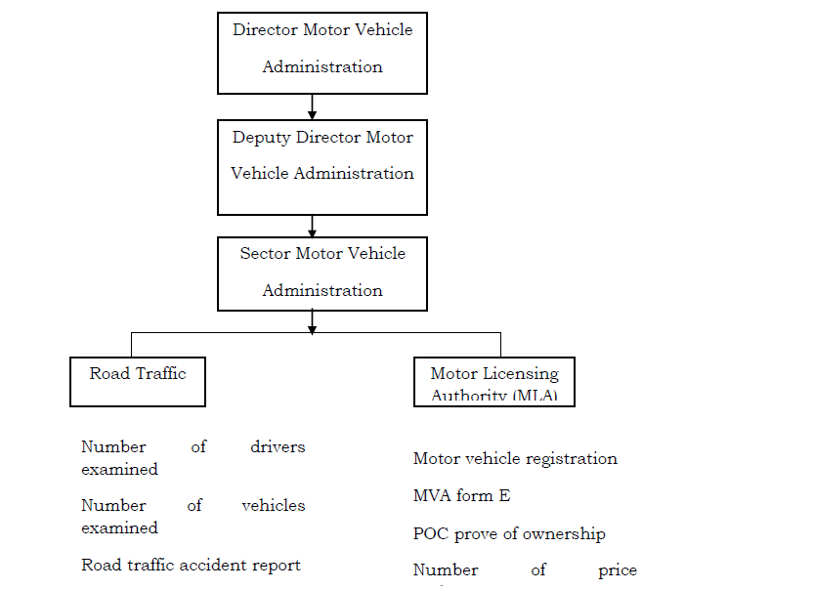
Fig 3.1: Data Collection Flow Chart

3.1 Organization Structure of Motor Licensing Office Abuja.
Board of internal revenue to an establishment that yields money for the government through motor licensing operation of which motor vehicle registration is one of the functions. Motor licensing office, Abuja is a body, which has their operational area at different local government and districts.
Motor licensing office, Abuja has the Directorate of motor vehicle administration as one of the order of command. They are in charge of administration of motor licensing operations all over the state, which is headed by Directorate of motor registration who is under the order of chairman of board of internal revenue, which is the apex of this structure. Below the directorate of motor vehicle administration is the principal licensing officer who is in control of the urban licensing offices: M.L.O Gwagwalada M.L.O Wuse zone 3 and M.L.O Central Area.
M.L.O. Wuse zone 3 operates under the command of motor licensing authority as the boss having three departments attached to it namely AutoReg, administration and assessment departments. Administration department is headed by an administration officers working under him is the secretary of this department in charge of correspondence, management and public affairs of the office.
The assistant motor licensing authority heads assessment department. They are in charge of every inspection done both in the vehicle and the form. They have clerks that write for them.
AutoReg is a proprietary, web-based, business solution, developed and trademarked by Courteville Business Solutions PLC, to address the inefficiencies of the motor-vehicle administration system in Nigeria. Courteville Business Solutions PLC is proud to be partnered with the following banks: Oceanic bank, Bank Phb, Sterling Bank, Afri Bank, Uba, Skye Bank, Fidelity Bank, Intercontinental Bank, Eco bank, Unity Bank, Wema Bank, Fin Bank.
Government approved inspection officer’s heads AutoReg department and it is presently controlled by Fin Bank. Vehicle licenses are to be renewed annually and they give the vehicle the right to drive on Nigerian roads within that period. It has been designed to show the details of the vehicle owner and vehicle details.
Since the commencement of AutoReg, over fifty thousand (50,000) cases of number plate duplication have been discovered and sorted out in Lagos State alone. The following are the inherent benefits of the AutoReg:
- Creation and maintenance of a credible data base and provision of accurate statistics of number of vehicles within the state
- We have more than doubled the revenue of the states the business solution has been deployed
- Quick and easy access to renewing genuine vehicle license
- The business solution model has been able to control crime in case of stolen vehicles

3.2 Diagram Showing the Organization Structure
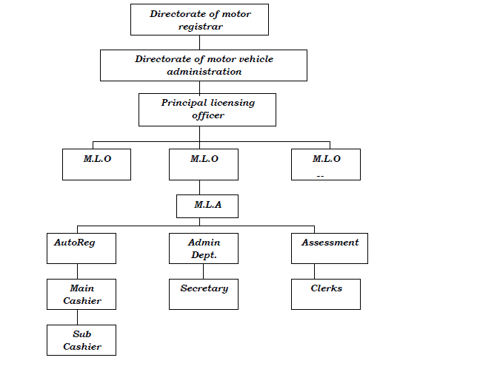
Fig 3.2: Diagram Showing the Organization Structure

3.1.4 Information Flow Diagram
Information, which is a source of organizational life, is important to be adequately communicated. The diagram below shows the way information flows in the motor licensing office.
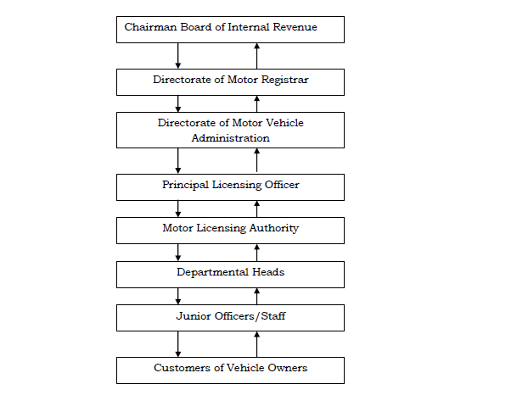
Fig 3.3: Information Flow Diagram

3.1.5 Objectives of the Existing System
The existing system i.e. the manual system of operating motor licensing office has some objectives which they want to achieve as much as possible to its maximum. The following are the objectives:
- This system aims at eliminating fraud by making the process to pass from one person to another yet it has not been possible since authorized officers still involve themselves in the work.
- This system has aimed at rendering/offering quick service to customers not minding that it is done by hand, which they know will help in pleasing their customers by attending to them within few minutes which has not been achieved.
- This existing system aims at keeping accurate account of money yielded in the registration of vehicles.
- This system keeps a comprehensive record of all registered vehicle owners in the states at large.

3.1.6 Problems of the Current System
Presently, the mode of storage is both in paring form and in digitized (i.e. computer) form. Owing to lack of proper database maintenance plan, database recovery plan coupled with the increase in the vehicle registration various problem raise their ugly head in various fashions. The problems are itemized below.
• Poor performance experienced during information retrieval, due to Lack of efficient storage of data.
• Lack of proper, correct, accurate and concise information about the car owner.
• The delay associated with the registration, because of the manual methods of operation.
• Lack of proper and accurate keeping of information about old records that have been stored for some time.
• The issue of security of records.
• Time wastage: some activities are time consuming in the system for instance, searching for a particular car owner’s record will take some time.
• As different people are in charge of registration, it is possible for registration anomalies to result.
• The problem of work monotony and tediousness that result from doing the same thing repeatedly.

3.1.7 Evaluating the Existing System
We can conclude that the existing system is:
- Ineffective
- Tedious
- Monotonous to its operation
- Inaccurate
- Inconsistent
- Incapacitated
- Unreliable
- Unproductive
- Substandard etc.
Having considered all these, it becomes obvious that a new computerized system is needed.

3.2 Analysis of Proposed System
New system, which is computerized, has so many benefits that will obviate the problem experience in the current system. The need this new system cannot be over emphasized as it is aimed at achieving;
- Accuracy of Computation: Measures of accuracy will be achieved since the computer system will maintain stability in assigning fees based on assessment and making of accurate calculation.
- Neatness/Reduced Use of Paper: Computerization gives room for production of a very neat job. Besides, since the vast volume of paper, which is used in keeping/storing information, will no longer be needed, it will help in keeping a very neat office.
- Reduction of Cost: The computerized system will keep in reducing cost of operation due to constant production of forms and registers for keeping records as less form will be used.
- Use of Less Space for Record Storage: There will be elimination of much space used in storing records by introducing a computer storage media (disks) which can keep vast volume of information in a less space.
- Speed Optimization: This will eliminate the problems of time wasting in registering records, checking from one line to the next as well as preparing a revenue report which is faster than using manual process to do it.
- Quick Retrieval of Information: There will be fast retrieval of information, which has advantage over the manual system that enables the user to retrieve information faster most especially as it concerns the vehicle owner by making use of his/her vehicle registration number to call up their information than in manual system where you search for information record line after the other.
- Less tedious
- Reliability
- Effectiveness and efficiency by reducing work intensity
- Ease of update and maintenance of operation
- Consistency of data

3.3 Design of Proposed System
There is need for one to design system by showing what the system entails, identifying and defining the various components of the system before the actual implementation. The whole aim is to determine how the information can be built. This gives the design the chance of making a choice of the way the problem can best be solved.

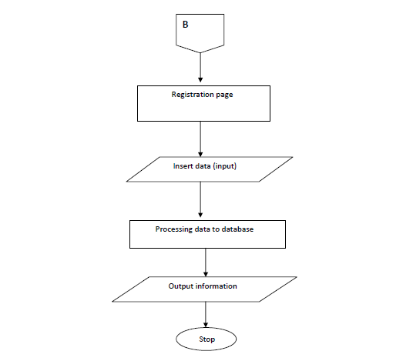
Fig 3.4: Registration Form
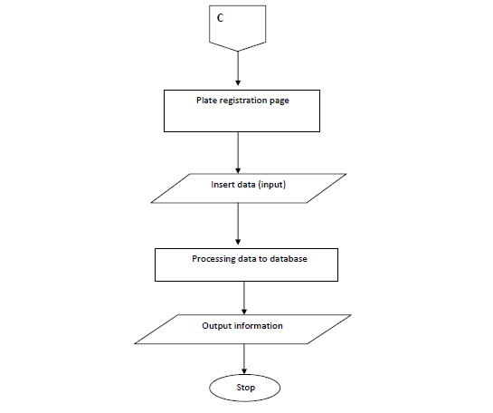Fig 3.5: Plate Registration Form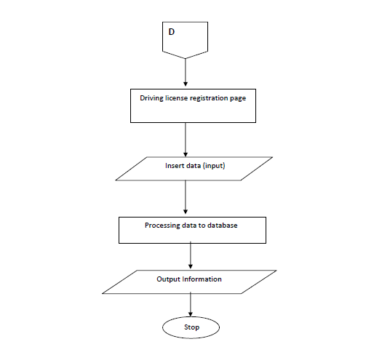
Fig 3.6: Driving Licence Registration Page

3.3.1 Database Design
This system’s database is developed using MySQL’s PHPMYADMIN frontend. Containing 3 tables with fields in them. The table’s below show the fields in the database.

s/n | Field | Data type | Description
1 | id | int(11) | admin id
2 | Usename | varchar(60) | admin username
3 | Password | varchar(60) | admin password
Table 3.1 Table showing the fields in admin table of the database
s/n | Field | Data type | Description
1 | Id | Int(11) | Driver id
2 | Fname | varchar(60) | Driver’s first name
3 | Mname | varchar(60) | Driver’s middle name
4 | Lname | varchar(60) | Driver’s last name
5 | Dob | varchar(60) | Driver’s Date of birth
6 | State | varchar(60) | Driver’s state
7 | Lga | varchar(60) | Driver’s LGA
8 | blood_group | varchar(3) | Driver’s blood group
9 | Certificate | varchar(60) | Driver’s certificate
10 | class_veh | varchar(60) | Driver’s class vehicle
11 | issue_date | varchar(60) | Driver’s issue date
12 | expiry_date | varchar(60) | Driver’s expiry date
13 | Passport | varchar(60) | Driver’s passport

Table 3.2 Table showing the fields in driver table of the database
s/n | Field | Data type | Description
1 | Id | Int(11) | Vehicle id
2 | rec_purchase | varchar(100) | Vechicle receipt
3 | proof_owner | varchar(100) | Vechicle proof owner
4 | Identification | varchar(100) | Vehicle identification
5 | Passport | varchar(100) | Vechicle passport
6 | cus_papers | varchar(100) | Vechicle customer papers
7 | ins_papers | varchar(100) | Vechicle insurance papers
8 | Fullname | varchar(100) | Vechicle fullname
9 | State | varchar(60) | Vechicle state
10 | Lga | varchar(60) | Vechicle LGA
11 | Age | varchar(60) | Vechicle age
12 | Plate | varchar(10) | Vehicle plate
13 | Image | varchar(60) | Vehicle image
14 | Vin | varchar(60) | Vehicle verification number

Table 3.3 Table showing the fields in vehicles table of the database

CHAPTER FOUR

SYSTEM IMPLEMENTATION

4.0 Introduction
The implementation requirement for software development varies and these requirements depend on some predefined factors, at these points we won’t dwell on what those factors are but on what is required of the online vehicle and plate number registration and identification system.
The simplicity of the programming language employed in the developments of this software makes the whole development process less tasking, which is a very important feature of software development. The software can run conveniently on a system of Pentium IV processor with at least an operating system of window 7, considering the platform upon which the software was developed.

4.1. Choice of Development Environment
The whole Project is divided in two parts the front end and the back end.

4.1.1 Front end
The front end is designed using of HTML, PHP, CSS, JavaScript
- HTML- HTML or Hyper Text Mark-up Language is the main mark-up language for creating web pages and other information that can be displayed in a web browser.HTML is written in the form of HTML elements consisting of tags enclosed in angle brackets (like <html>), within the web page content. HTML tags most commonly come in pairs like <h1> and </h1>, although some tags represent empty elements and so are unpaired, for example <img>.
- CSS- Cascading Style Sheets (CSS) is a style sheet language used for describing the look and formatting of a document written in a mark-up language. While most often used to style web pages and interfaces written in HTML and XHTML, the language can be applied to any kind of XML document, including plain XML, SVG and XUL. CSS is a cornerstone specification of the web and almost all web pages use CSS style sheets to describe their presentation.
- PHP- PHP is a server-side scripting language designed for web development but also used as a general-purpose programming language. PHP is now installed on more than 244 million websites and 2.1 million web servers. Originally created by Rasmus Lerdorf in 1995, the reference implementation of PHP is now produced by The PHP Group.

4.1.2 Back End
The back end is designed using mysql which is used to design the Databases
- MYSQL- MySQL ("My S-Q-L", officially, but also called "My Sequel") is (as of July 2013) the world's second most widely used open-source relational database management system (RDBMS). It is named after co-founder Michael Widenius daughter, My. The SQL phrase stands for Structured Query Language.

4.2 Implementation Architecture
The following block diagram shows the various components of the software and their linkages.
Admin
Approval
Make
payment

Database

System
login
Hostel
Application
Student
registration

Figure 4.1 Block Diagram showing the system architecture of the new system.

4.3 Software Testing
The test activity was carried out in stages. Each module or form as the case may be was tested during and after design using the Sublime Text IDE. The figures below are screen shots during testing for logical and syntax errors.
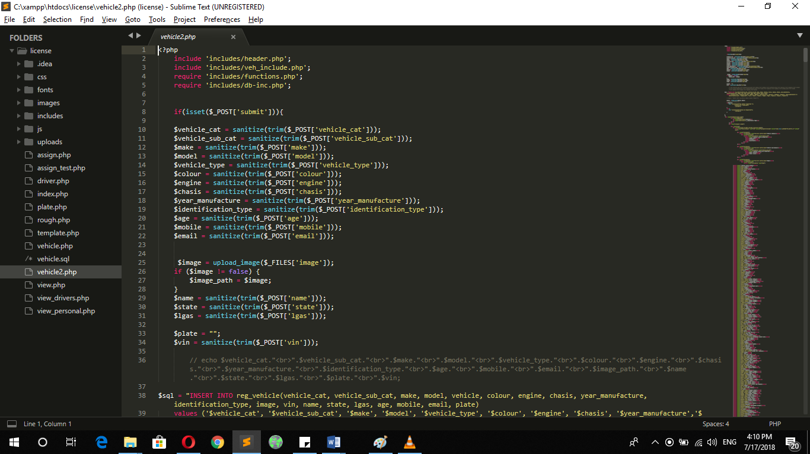
Figure 4.2 Screenshot showing debugging of the Vehicle registration page.
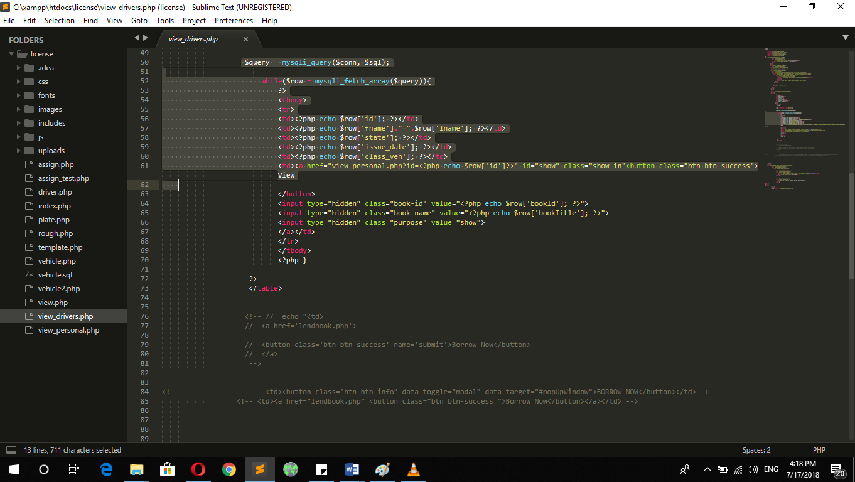
Figure 4.3 Screenshot showing debugging of the driver’s license page.
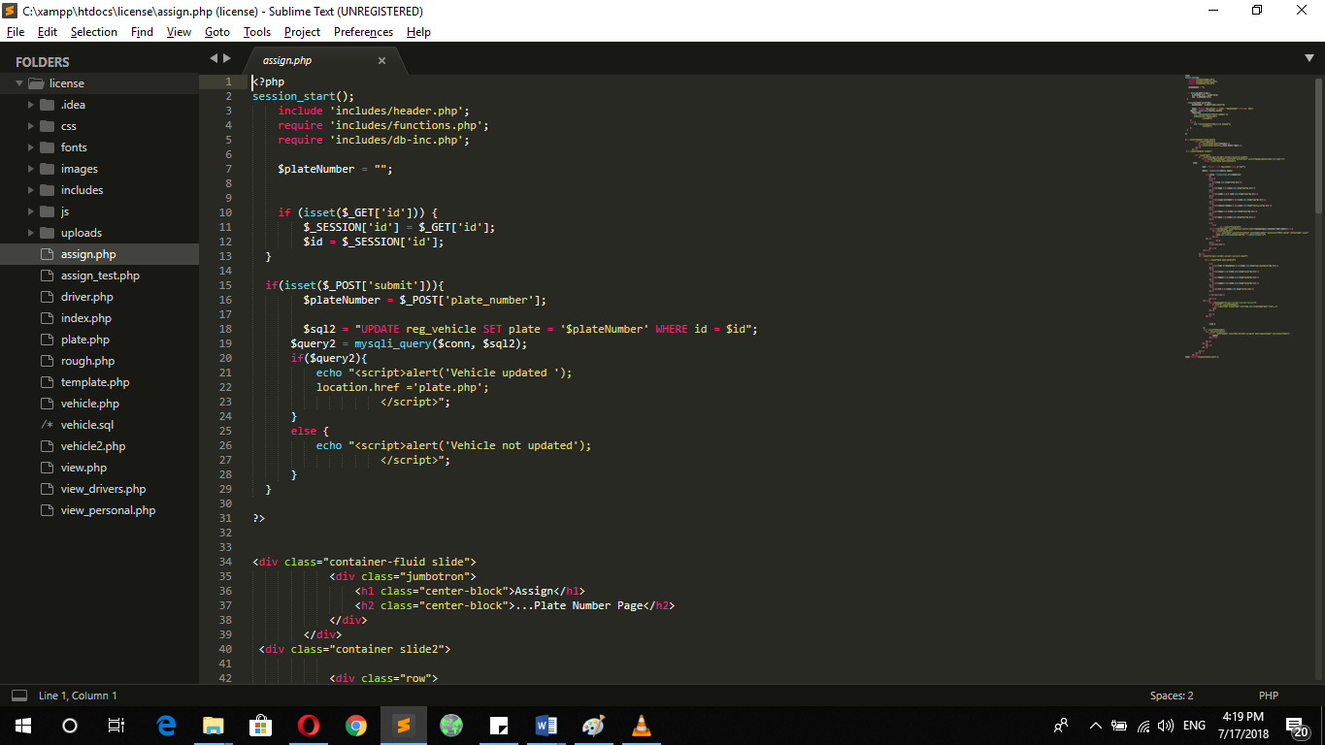
Figure 4.4 Screenshot showing debugging of the plate number assign page.
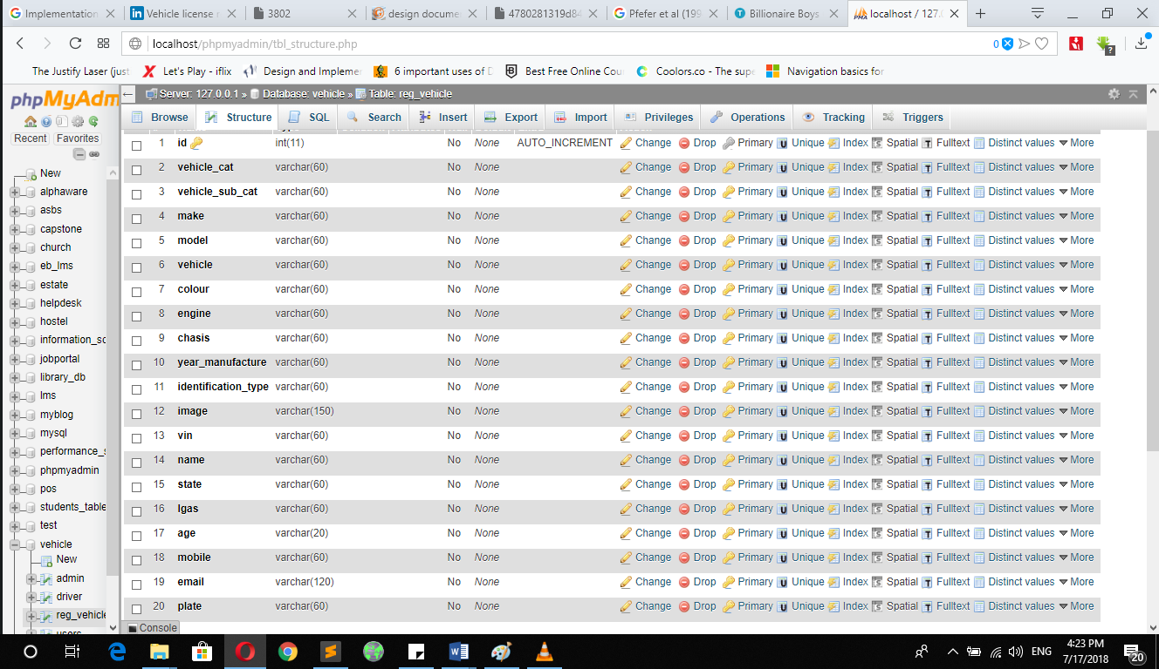Figure 4.5 Screenshot showing debugging of the update record tab.
The database was tested basically for connectivity and storage to ensure that the appropriate data types, validation rules and other properties were assigned to the fields. The main driver, being the diagnosis page was tested for proper connectivity to the database. Improper linkage to the database was corrected and assurance was made to see that data was accurately retrieved and presented without errors.
Testing was also done after the integration of the different modules of the system with realistic data samples. Below are some screen shots during system testing using realistic data samples.

4.4 Documentation
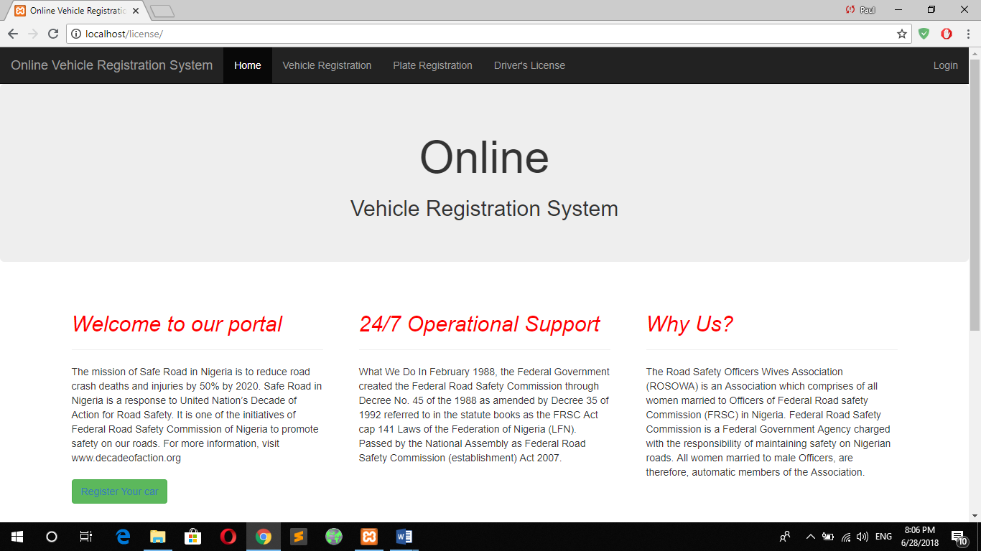
Figure 4.6 Screenshot showing home page.
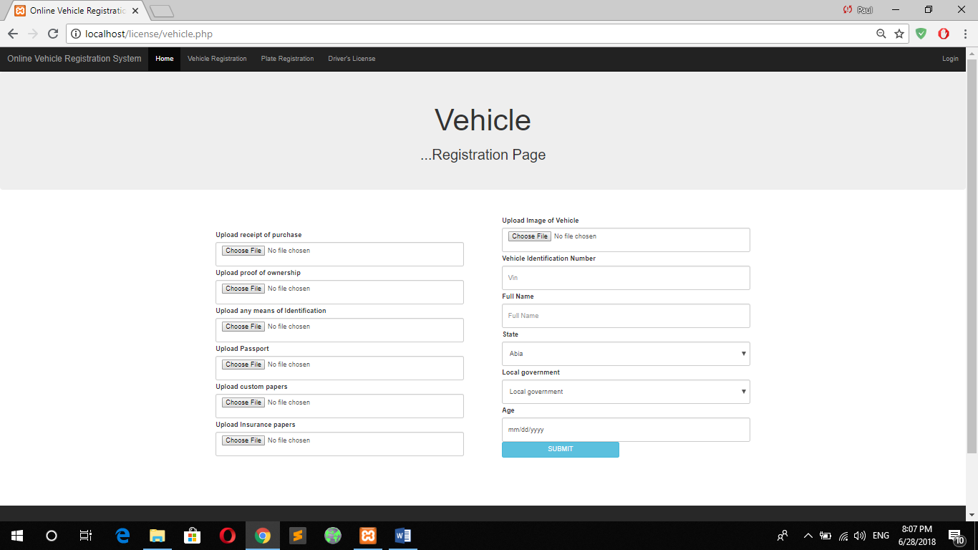
Figure 4.7 Screenshot showing vehicle registration page.
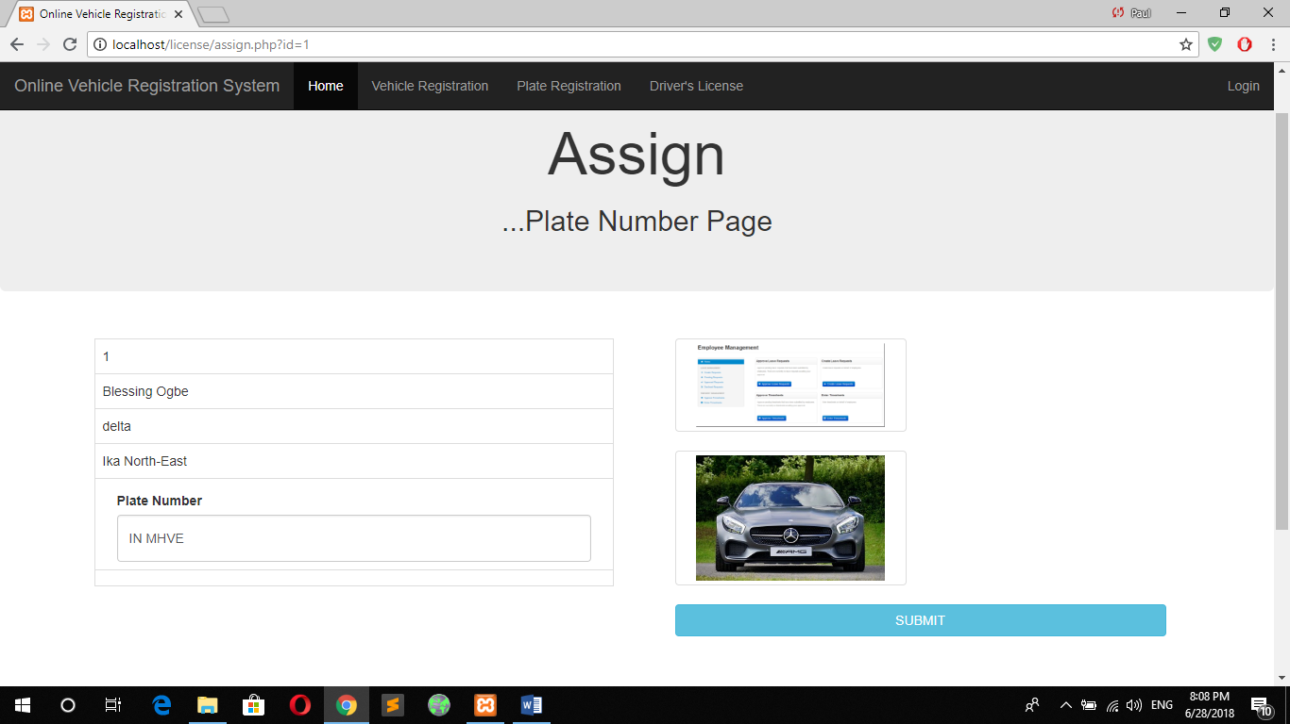
Figure 4.8 Screenshot showing Plate registration page.
Here, the plate number is automatically generated using the local government acronym and four random alpha numeric characters.
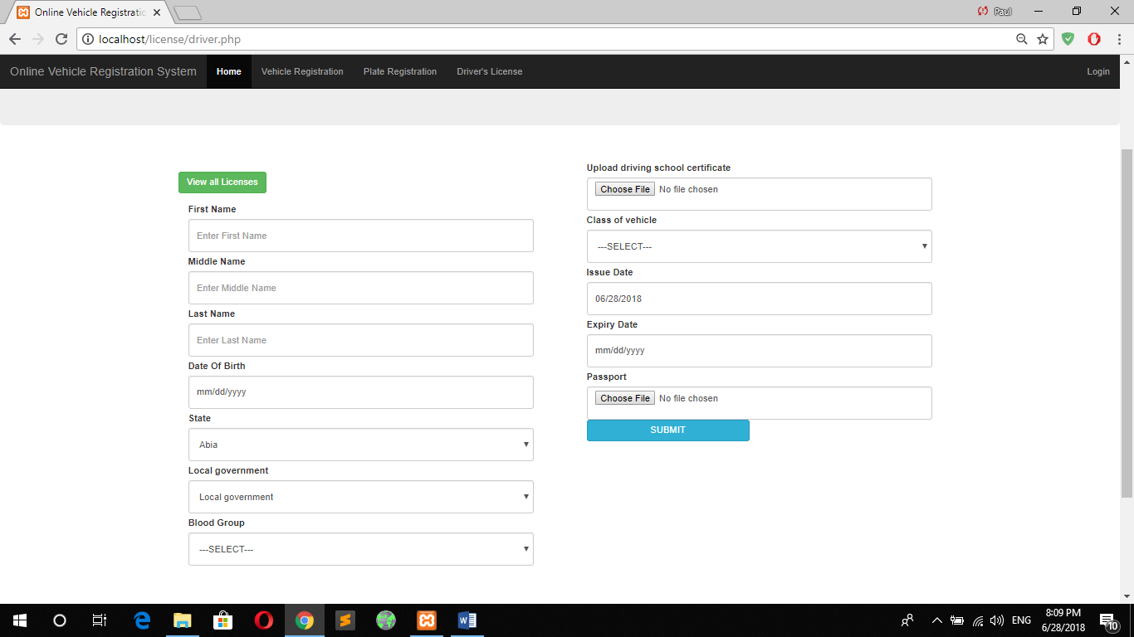
Figure 4.9 Screenshot showing Plate registration page.
Here, you register for a new driver’s license and when done you can view all license created as an administrator.
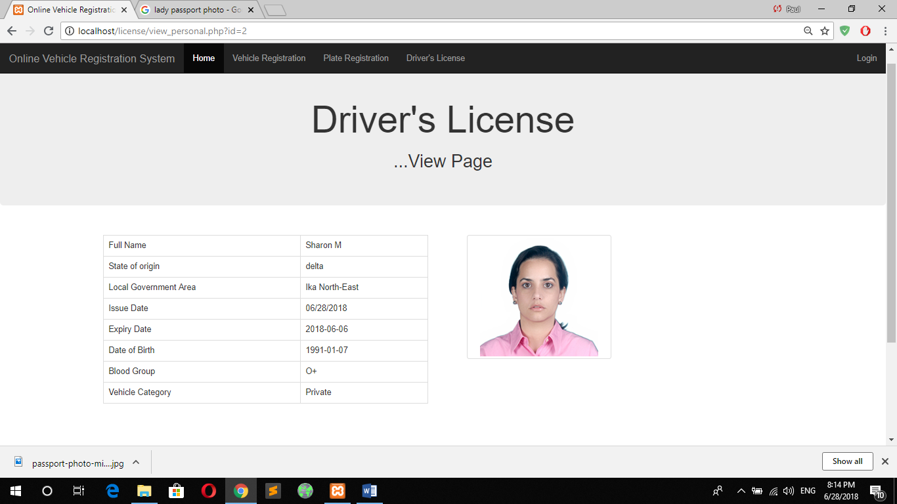
Figure 4.10 Screenshot showing registered driver’s license page.
The administrator can view a registered driver and generate a pdf or print out the license for the user.

CHAPTER FIVE

SUMMARY AND CONCLUSION

5.0 Summary
Vehicle registration used to involve manual recording of vehicles information, which ranges from cars to buses and later to truck and heavy duty equipment.
Vehicle registration in Nigeria began over 100 years ago and the records have been essentially manual which in turn is not helped to raise the efficiency of general automotive services in recent years.
The federal government of Nigeria has identified economic development as a major for achieving the 2020 socio-economic development. The vehicle registration system is a must for any country that wants to be information and communication technology inclined and ready to reduce the vehicle crime rate and corruption in her system.

5.1 Conclusion
The understanding of the problems that very peculiar to vehicle registration system was opened up also in the chapter one and three of this project these problems includes ineffective, time consuming, tedious, in accurate, inconsistent etc. which vary from operating system compatibility to machine dependencies.
However big a software project is, these problems and more are what they face and the bigger the software are project the more probable it is that they face these problems.
When the first computer was designed, the development of all that came after the first computer is founded on the concept of the very first and now it has gone from development of just computers to the development of software as this project is done so far.
Vehicle Registration in Nigeria began over 100 years ago and the records have been essentially manual which in turn has not help to raise the efficiency of general automotive services in recent years.
This is only focused on vehicle registration and inspection, and not on other supporting services such as vehicle tracking, learner’s driving permission, and drivers’ license management, monitoring of drivers and vehicles operations and documentation of both accident and crime report.

5.2 Recommendation
If one thing must be researched in the Computerization of vehicle registration system with the mind of perfecting it and making it more useful in the real sense of things, it is the security of information handling software. The security of vehicle registration system is very crucial considering the prevention of vehicle crime and similar vices so it is worth further researching.
Therefore, I Recommend that motor licensing office Abuja should set up a computer based system.

Reference

[1] Cronkhite LW Jr, Canada WJ. Generalized gastrointestinal polyposis: an unusual syndrome of polyposis, pigmentation, alopecia and onychotrophia. N E J M 252:1011. .
[2] Ahmed, S.T. (1991), “Essentials of Vehicle Registration in Nigeria”. Ibadan: University Press Plc.
[3] Balogun, S.A (2006). Road Safety Practice in Nigeria. Nigeria: Resources Nig Ltd.
[4] Filani, M.O. (2002), “Mobility Crisis and the Federal Government’s Mass Transit Programme” in Onakomaiya S.O. and Oyesiku O.O. (eds.). Environment, Physical Planning and Development in Nigeria, Department of Geography and Regional Planning, Olabisi Onabanjo University, Ago-Iwoye, Nigeria, pp. 37-51.
[5] Ikechukwu, D.N. (1995). Nigeria and Traffic Regulations. Ibadan: Africana FEB publishers Ltd.
[6] Oyeyemi, B.O. (2003). Stands in Road Traffic Administration Ibadan: Clemeve Media Konsult.
[7] Bishop (2003) How effective leaders reduce educational disparities. In Robertson. J., & Timperley. (Eds.), Leadership and Learning (pp. 27-40).
[8] O'Day, J., Goertz, M.E. & Floden, R.E. (1995, December). Building capacity for education reform. CPRE Policy Briefs/Consortium for Policy Research in Education. New Brunswick, NJ: Rutgers.
[9] Pfeffer, J. (1994) Competitive Advantage through People. Boston, MA: Harvard Business School Press.
[10] Marcellina H.A. (2006). Drivers and passengers conduct. London:
Macdonald and Evans Ltd.

APPENDIX 1
The codes would be broken down into section for the different pages on the web application.
Code for: Registation.php page
</div>
<?php include 'includes/footer.php'; ?><?php

include 'includes/header.php';
include 'includes/veh_include.php';
require 'includes/functions.php';
require 'includes/db-inc.php';
?>
<div class="container-fluid slide">
<div class="jumbotron">
<h1 class="center-block">Plate</h1>
<h2 class="center-block">...Registration Page</h2>
</div>
</div>
<div class="container slide2">
<div class="container">
<div class="panel panel-default">
<!-- Default panel contents -->
<div class="panel-heading">
<div class="row">
<div class="col-lg-6 col-md-6 col-sm-12 col-xs-12 pull-right">
<form method="post" action="plate.php" enctype="multipart/form-data">
<div class="input-group pull-right">
<span class="input-group-addon">
<button class="btn btn-success" name="search">Search</button>
</span>
<input type="text" class="form-control" name="text">
</div>
</form>

</div><!-- /.col-lg-6 -->

</div>
</div>

<table class="table table-bordered">
<thead>
<tr>
<th>ID</th>
<th>FULLNAME</th>
<th>STATE</th>
<th>LGA</th>
<th>PLATE NO.</th>
<th>ASSIGN PLATE NO.</th>
</tr>
</thead>
<?php

$sql = "SELECT * FROM reg_vehicle";

$query = mysqli_query($conn, $sql);

while($row = mysqli_fetch_array($query)){
?>
<tbody>
<tr>
<td><?php echo $row['id']; ?></td>
<td><?php echo $row['name']; ?></td>
<td><?php echo $row['state']; ?></td>
<td><?php echo $row['lgas']; ?></td>
<td><?php echo $row['plate']; ?></td>
<td><a href="assign.php?id=<?php echo $row['id']?>" id="show" class="show-in"<button class="btn btn-success">Assign Now

</button>

</a></td>
<td><a href="view.php?id=<?php echo $row['id']?>" id="show" class="show-in"<button class="btn btn-success">View Vehicle Profile

</button>

</a></td>
</tr>
</tbody>
<?php }

?>
</table>

<!-- // echo "<td>
// <a href='lendbook.php'>

// <button class='btn btn-success' name='submit'>Borrow Now</button>
// </a>
-->

<!-- <td><button class="btn btn-info" data-toggle="modal" data-target="#popUpWindow">BORROW NOW</button></td>-->
<!-- <td><a href="lendbook.php" <button class="btn btn-success ">Borrow Now</button></a></td> -->

</div>
</div>
<div class="mod modal fade" id="popUpWindow">
<div class="modal-dialog">
<div class="modal-content">

<!-- header begins here -->
<div class="modal-header">
<button type="button" class="close" data-dismiss="modal">&times;</button>
<h3 class="modal-title"> Warning</h3>
</div>

<!-- body begins here -->
<div class="modal-body">
<p>Are you sure you want to delete this book?</p>
</div>
</div>
</div>
</div>
Code for: Plate number page
<?php
session_start();
include 'includes/header.php';
require 'includes/functions.php';
require 'includes/db-inc.php';

$plateNumber = "";

if (isset($_GET['id'])) {
$_SESSION['id'] = $_GET['id'];
$id = $_SESSION['id'];
}

if(isset($_POST['submit'])){
$plateNumber = $_POST['plate_number'];

$sql2 = "UPDATE reg_vehicle SET plate = '$plateNumber' WHERE id = $id";
$query2 = mysqli_query($conn, $sql2);
if($query2){
echo "<script>alert('Vehicle updated ');
location.href ='plate.php';
</script>";
}
else {
echo "<script>alert('Vehicle not updated');
</script>";
}
?>
<div class="container-fluid slide">
<div class="jumbotron">
<h1 class="center-block">Assign</h1>
<h2 class="center-block">...Plate Number Page</h2>
</div>
</div>
<div class="container slide2">

<div class="row">
<div class="col-lg-6 col-md-4 col-sm-4 col-xs-12 column">
<form class="form-vertical" role="form" method="post" action="assign.php?id=<?php echo $id; ?>">
<table class="table table-bordered">
<?php

$sql = "SELECT * FROM reg_vehicle WHERE id='$id'";

$query = mysqli_query($conn, $sql);

while($row = mysqli_fetch_array($query)){
?>
<tbody>
<tr>
<td><?php echo $row['id']; ?></td>
</tr>
<tr>
<td><b>Name : </b><?php echo $row['name']; ?></td>
</tr>
<tr>
<td><b>State : </b> <?php echo $row['state']; ?></td>
</tr>
<tr>
<td><b>Local Government : </b><?php echo $row['lgas']; ?></td>
</tr>
<tr>
<td><b>Vehicle Category : </b><?php echo $row['vehicle_cat']; ?></td>
</tr>
<tr>
<td><b>Model : </b><?php echo $row['model']; ?></td>
</tr>
<tr>
<td><b>Make : </b><?php echo $row['make']; ?></td>
</tr>

<tr>
<td>
<div class="form-group">
<label for="Username" class="col-sm-8 control-label">Automatically Generated Plate Number</label>
<div class="col-sm-12">
<input type="text" class="form-control" name="plate_number" placeholder="Enter Course" id="username" value="<?php echo initials($row['lgas'])." ".randomString(); ?>">
</div>
</div>
</td>
</tr>
<tr><td></td></tr>

</tbody>
</table>

</div>
<div class="col-lg-6 col-md-4 col-sm-4 col-xs-12 column">

<table class="table table-bordered">

<tr>
<td><b>Year of Manufacture : </b><?php echo $row['year_manufacture']; ?></td>
</tr>
<tr>
<td><b>Colour : </b><?php echo $row['colour']; ?></td>
</tr>
<tr>
<td><b>Engine : </b><?php echo $row['engine']; ?></td>
</tr>
<tr>
<td><b>Chasis : </b><?php echo $row['chasis']; ?></td>
</tr>
<tr>
<td><b>Vin : </b><?php echo $row['vin']; ?></td>
</tr>

<tr><td></td></tr>

</tbody>
</table>
<div class=class="col-lg-3 col-md-3 col-sm-6 col-xs-3">
<a href="#" class="thumbnail">
<img width="200" height="200" src="<?php echo $row['image'];?>" alt="...">
</a>
</div>

</div>
</ <?php }

?>
<div class="form-group">
<div class="col-sm-12">
<button name="submit" class="btn btn-info col-lg-12" data-toggle="modal" data-target="#info">
SUBMIT
</button>

</div>
</div>
</form>
</div>

</div>
</div>
</div>
<?php include 'includes/footer.php'; ?>

