INFLUENCE OF FORMAL JOURNALISM EDUCATION ON JOURNALISTS’ PROFESSIONAL PRACTICE IN ENUGU STATE

BY

UCHE CHINONYE EILEEN
U14/MSS/MAC/060

DEPARTMENT OF MASS COMMUNICATION
FACULTY OF MANAGEMENT AND SOCIAL SCIENCES
GODFREY OKOYE UNIVERSITY,
ENUGU, ENUGU STATE

JULY, 2018
Title Page

INFLUENCE OF FORMAL JOURNALISM EDUCATION ON JOURNALIST ‘S PROFESSIONAL PRACTICE IN ENUGU STATE

BY

UCHE CHINONYE EILEEN
U14/MSS/MAC/060

A PROJECT SUBMITTED TO THE DEPARTMENT OF MASS COMMUNICATION
FACULTY OF MANAGEMENT AND SOCIAL SCIENCES
GODFREY OKOYE UNIVERSITY,
ENUGU, ENUGU STATE.
IN PARTIAL FULFILMENT OF THE REQUIREMENTS FOR THE AWARD OF BACHELOR OF SCIENCE DEGREE (B.SC)

JULY, 2018
Declaration
I UCHE CHINONYE EILEEN, hereby declare that the work “Influence of Formal Journalism Education on Journalists Professional Practice” is the report of the research work written by me and that it has not been submitted elsewhere for the award of any diploma or degree.

--------------------------------------- -------------------
UCHE CHINONYE EILEEN DATE
Certification
This is to certify that this project titled “Influence of Formal Journalism Education on Journalist’s Professional Practice in Enugu state” written by UCHE CHINONYE EILEEN with registration number U14/MSS/MAC/060 has been approved as meeting the requirement for the award of Bachelor of Science (BSc.) degree in mass communication.

------------------------------ -------------------
Mr Onwukwalonye Benjamin Date
(Project Supervisor)

-------------------------------- ---------------------
Prof, Nwokeafor Cosmas
(Head of Department) Date

--------------------------------- ---------------------

External Examiner Date

------------------------------- ---------------------
Onyema Ocheoha
Dean Faculty of Management and Social Science Date
Dedication
This research work is dedicated to the most Sacred Heart of Jesus and Immaculate Heart of Mary, for the constant grace and mercies received.
Acknowledgments
I wish to express my sincere gratitude to the Almighty God for his love and kindness towards my life and my family. May his name be highly exalted. Amen.
Lots of appreciation goes to my ever supporting and encouraging supervisor Mr. Benjamin Onwukwalonye for his encouragement and constant persuasion as a contribution to the completion of my work. I am grateful sir.
I express my sincere gratitude to my Head of department, Professor Comas Nwokeafor; your words of encouragement kept me pushing and to my ever determined and hardworking coordinator; Mr. Nnamdi George Nzekwe, I say a very big thank you for always being there. My appreciation also goes to, Mr. Chukwudubem Umeora, Dr. Alexander Onyebuchi, Mr Ment Nnomeh, Rev. Fr. Paul Obayi, Prof. Armstrong Idachaba, Miss Onwude Fiona Nnenna,Mr. Michael Nwosu and Dr, Louis Ezema and the management of Godfrey Okoye University Enugu state.
I also express my gratitude to my parents, Sir and Lady Ezekiel O. Uche for their constant and unending love, prayers, words of encouragement, financial assistance and steadfast commitment to my academic success and completion of this research project. I also appreciate my beloved siblings; Dr.Oluchi, Uchenna, Chiamaka and Chika. I am highly indebted to you all for your support.
To my friends: Dominion Okeke, Enekwe Chinonso, my course-mates and many others who helped, supported and encouraged me in my pursuit of university education, I say thank you very much.
Table of content
Title page -------------------------------------------------------------------------------------------
Declaration ----------------------------------------------------------------------------------------- i
Certification ---------------------------------------------------------------------------------------- ii
Dedication ------------------------------------------------------------------------------------------- iii
Acknowledgment------------------------------------------------------------------------------------ iv
List of tables------------------------------------------------------------------------------------------ v
Abstract----------------------------------------------------------------------------------------------- vi
CHAPTER ONE: INTRODUCTON
  - Background of the study ………………………………………………………………. 1
  - Statement of research problem …………………………………………………………4
  - Objectives of the study ………………………………………………………………….4
  - Research questions …………………………………………………………………….. 5
  - Scope of the study ………………………………………………………………………5
  - Significance of the study ………………………………………………………………..6
  - Operational definition of terms ………………………………………………………….6

CHAPTER TWO: REVIEW OF LITERATURE
2.1 Introduction ……………………………………………………………………………8
2.2 Review of concepts …………………………………………………………………….8
2.2.1 Formal Education ………………………………………………………………….8
2.2.2 Journalism ………………………………………………………………………….10
2.2.3 Journalism in Nigeria ………………………………………………………………13
2.2.4 Formal education and journalism professional practice in Nigeria ………………. 15
2.3 Review of related studies …………………………………………………………… 18
2.4 Theoretical framework ……………………………………………………………… 21
2.5 Summary ………………………………………………………………………………23
CHAPTER THREE: RESEARCH METHOD
3.1 Introduction ……………………………………………………………………………24
3.2 Research design ……………………………………………………………………… 24
3.3 Population of the study ……………………………………………………………….24
3.4 Sampling technique……………………………………………………………………24
3.5 Description of research instrument ……………………………………………………26
3.6 Validity and reliability of data gathering instrument …………………………………26
3.7 Method of data collection …………………………………………………………… 26
3.8 Method of data analysis ……………………………………………………………….26

CHAPTER FOUR: DATA PRESENTATION AND DISCUSSION OF FINDINGS
4.1 Introduction …………………………………………………………………………….28
4.2 Data presentation and analysis ………..…………………………………………………28
4.3 Discussion of findings …………………………………………………………………...43

CHAPTER FIVE: SUMMARY, CONCLUSION AND RECOMMENDATION
5.1 Introduction ………………………………………………………………………….47
5.2 Summary of findings …………………………………………………………………47
5.3 Conclusion …………………………………………………………………………….48
5.4 Recommendations …………………………………………………………………… 49
5.5 Suggestions for further studies …………………………………………………………50

END MATTERS
References …………………………………………………………………………………..52
Appendices …………………………………………………………………………………..55

List of tables
Table 1- Sex of respondents
Table 2-Location of respondent’s organization
Table 3-Respondent’s response on how long they have been in the practice
Table 4-Respondents’ response on their rank in their organization
Table 5-Respondents response on if they have a degree in Mass Communication/ Journalism
Table 6- Respondents response on if no, which discipline
Table 7- Respondents higher educational qualification
Table 8- Respondents’ response on whether a journalist/ media practitioner who obtained HND or Degree in Mass Comm. / Journalism performs better than a journalist who studied other disciplines.
Table 9- Respondents’ response on whether efficiency of a journalist is more dependent on his/ her talents and skill and not on the level of formal education received in Journalism/Mass Communication
Table 10- Respondents’ response on whether years of experience in journalism without formal education in Journalism/ Mass Communication can make one an efficient journalist
Table 11-Respondents’ response on whether a journalist with formal educational qualification in Journalism /Mass Comm. has higher chances of promotions/progress in his/her career than one without educational qualifications
Table 12-Respondents response on whether journalists / media practitioners with educational qualification in Journalism/ Mass Communication are held in high esteem and are more in demand

Abstract
This study was set to examine the role of formal journalism education on journalist’s professional practice in Enugu state. The population for the study is the entire registered journalists practicing in Enugu. Multi-stage sampling procedure which involved cluster and simple random sampling techniques was used to draw a sample size of 137 journalists from the population of 210 registered journalists in Enugu state. Survey methodology was adopted for the study, while two theories were found relevant for the study. They are: social responsibility theory and development media theory. The study found that majority of journalists practicing in Enugu state do not have a degree in Journalism/ Mass Communication but have in other disciplines. Many of them hold a degree in English language. The study also made a shocking finding that some people practice journalism as SSCE or OND holders. This could account for low level of professionalism recorded in the practice. The study recommends among others that: The Nigerian union of journalists should review the criteria for deciding who is qualified to practice journalism. The basic requirement should include possessing a degree in Mass Communication/ Journalism. Beyond possessing a degree in mass communication, fresh graduates should gain from the experience of others by undergoing internship programs before being certified to practice journalism as a first step towards attaining professionalism in the field.

CHAPTER ONE
INTRODUCTION
1.1 Background of the Study
Education as a critical component of a country’s human capital increases the efficiency of an individual worker (WEF, 2016).
Huang and Liu (2005) believe that intellectual capital (knowledge) is a critical force that is responsible for economic growth. There is a common perception that educated people can do certain tasks easily and efficiently compared to the uneducated or those who are less educated. Vugt (2006) asserts that lack of education and knowledge makes a person crippled and inefficient. He reveals that previous studies have found that education increases job satisfaction. Wright and Davis (2003) believes that education will foster an increase in professionalism and further exploitation of management, whereas a lack of it will cause lack of job satisfaction. Priti (1999) believes that educated individuals know the scope, expectations and depth of their jobs and will be able to add building blocks to their professionalism as they progress through their careers. Education also promotes core task performance by providing individuals with more declarative and procedural knowledge with which they can complete their task successfully. It is generally believed that good education helps in preparing individuals for more effectiveness in their profession.

(WJEC, 2007) established that journalism education provides the foundation as theory, research and training for effective and responsible practice of journalism. In 2013, the census of journalism education programs kept by the World Journalism Education Council (WJEC) listed almost 2,400 programs globally. In 2007 and in 2013, UNESCO released model curricula for journalism education (Beate, 2016).UNESCO’s support for journalism education is underpinned by a strong conviction that professional journalistic standards are essential to bring out the potential of media systems to foster democracy, dialogue and development. With respect to this, so many efforts has been made to ensure quality education in journalism that will have an impact on the practice.

In Nigeria, several professions have boundaries. They have regulated educational programs that individuals must undergo before being inducted and given license to practice such profession. Such professions like Law, Engineering, Accounting, Medicine, Nursing, etc enjoy a high sense of respect because the processes that one must go through before being admitted into such professions are clearly identified and strictly followed.

Ironically, journalism, which is widely seen as the conscience of society does not have such clearly set out regulations on who should be allowed to practice journalism. It is believed that some people who practice journalism did not have to obtain a formal education in journalism. The practice of journalism in Nigeria has courted great controversies especially in relation to educational qualifications, ethical regulation and adherence to professional precepts. Talabi and Ogundeji (2012) note that journalism is an esteemed profession that has a lot to offer in the reformation of the society; unfortunately in Nigeria, it has become an all-comers affair as individuals with no media qualifications dive into the mass media for livelihood. They also observed that it has now become a truism that low literacy rate contributes to a low degree of journalism training and also to a low standard of journalistic performance. Journalism profession has suffered serious setbacks in its developmental processes in Nigeria because; the nation has not given priority to degree programmes in journalism. Instead graduates from other disciplines such as Political Science, Economics, Sociology, English and others are given on-the-job training in journalism.

Akinfeleye (1990) quoted an American critic, Dean Rosco Pound who once wrote that every profession is governed by certain rules, educational qualifications and the absence of such rules makes it a vocation. For a very long time Nigerian scholars, professionals and practitioners have argued as to whether journalism is a profession or not in Nigeria. Some scholars and practitioners of journalism in Nigeria say journalism is a trade, others say it is a craft or an occupation while the rest simply say it is a vocation. .

Talabi and Ogundeji (2012) says that colonial rulers in Nigeria and their succeeding “Nigerian-Europeans” regarded journalism education as unnecessary undertaking. This view partly accounts for the reason why for many years all Nigerian universities did not offer any formal journalism training. Fortunately, the situation is different now. Many universities and polytechnics now offer courses in Mass Communication or Journalism. These institutions train students to become professional communicators. However, many still get into journalism practice without formal higher education that prepares them specifically for the job. The former Abuja bureau chief of The Tide newspaper, Alloys Nweke, during the January 2008 Nigerian union of journalists (NUJ) summit in Port Harcourt frowned at the numerous untrained journalists bestriding the streets with pen and paper claiming to be journalists. Nweke revealed that the number of untrained and fake journalists in Nigeria is higher than the trained journalists.

1.2 Statement of the Problem
From the background of the study, it is evident that scholars believe that formal education is very important for effectiveness and efficiency of professionals in every field of endeavor. However, in most media organizations in Nigeria, it is observed that people are employed to work as journalists without necessarily possessing formal education in journalism or mass communication obtained from institutions of higher learning. Some attend some weeks ‘certification courses and parade themselves as professional journalists. It is like an all-comer affairs unlike what obtains in such professions as medicine, nursing, law, engineering, medical laboratory science and others, which require one to be specifically trained in such field in an institution of higher learning accredited for that purpose.
This study seeks to ascertain if obtaining formal education in journalism/mass communication has any positive role on the performance of journalists practicing in Enugu state.

1.3 Objectives of the Study
The broad objective of this study is to examine whether obtaining a formal education in journalism or mass communication plays any significant role in the professional performance of those practicing journalism in Enugu state
The specific objectives are:
- To determine the number of journalists practicing journalism with formal education in Journalism/ Mass Communication to those practicing Journalism without formal education in Journalism/ Mass Communication in Enugu.
- To ascertain the extent to which journalists’ professional performance is dependent on formal journalism education.
- To determine the extent to which performance in journalism profession is dependent on talent and skills.
- To ascertain the extent to which obtaining a formal education in journalism contributes to career progress and promotion.

1.4 Research Questions
To guide the conduct of this research, the following questions were raised:
- What is the number of journalists with formal education in Journalism/ Mass Communication to those without formal education in Journalism/ Mass Communication in Enugu state?
- To what extent is a journalist’s professional performance dependent on formal journalism education?
- To what extent is performance in Journalism profession dependent on talents and skills?
- To what extent does obtaining a formal education in Journalism contribute to career progress and promotion?

1.5 Scope of the Study
The study seeks to ascertain the role of formal education on journalist’s professional performance in Enugu state. The scope covers only journalists who practice journalism as registered journalists in Enugu state.
1.6 Significance of the Study
This research work is aimed at determining the role formal education plays in the professional performance of journalists in Enugu state. This research work will be significant in different ways.
One, this research work will add to already existing literature on the role of formal education in professional efficiency.
Similarly, the result of this research work will serve as reference bank for subsequent researchers intending to study the role of formal education on journalists’ professional performance.
The result of this research work will also be of interest to leaders of the Nigeria Union of Journalists as they take decisions about who is qualified to be accepted and registered as a journalist.

1.7 Operational Definition of Terms
Formal Education- formal education in Journalism/Mass communication in an accredited institution of higher learning.
Journalism- The gathering, assessing, creating and presenting news and information.
Journalist- a journalist is a person who collects, writes, or distributes news or other current information to the public
Professional- a person formally certified by a professional body of belonging to a specific profession by virtue of behaving completed a required course of studies and/ or practice. And whose competence can usually be measured against an established set of standards.
Performance-The accomplishment of a given task measured against preset known standards.
Talents- Natural abilities and strengths that enable an individual excel at something.
Skills- Expertise needed to do a job or task.
Career- An occupation in journalism.

CHAPTER TWO
LITERATURE REVIEW
2.1 Introduction
This chapter will attempt to review available literature on the role of formal education on journalist’s professional performance. It reviews the concept of formal education and journalism as well as related theories and previous studies related to this research topic.
2.2 Review of concepts
2.2.1 Concept of Formal Education
Education, planned or unplanned elevates man towards attaining fullness physically, intellectually and especially ethically (UNESCO 2008). The educational process is any activity undertaken by people in the various stages of life, in order to improve their knowledge, skills and competences, from a personal, civic, social and occupational point of view, in a formal, non-formal or informal way (Nuria Sanz et al 2006). Therefore, forms of education can be distinguished according to the level of organization and structure, conditions in which learning takes place, functionality and applicability of knowledge, skills and attitudes and level of certification of learning outcomes. Education can generally be thought of as the transmission of values and accumulated knowledge of a society. It is a societal instrument for the expansion of human culture, which may be formal, non-formal and informal (OECD 2014).

Formal Education also known as formal learning refers to what takes place in the education and training system of a country. It is official, structured, organized by public organizations or recognized private institutions and results with formal certification and formal level of qualification which is recognized by relevant national educational authorities. Formal education is usually organized as full – time education and is organized as a continuous process with defined stages. Formal education encompasses primary, lower and upper secondary education, higher and university education that culminate in the achievement of a degree or a professional qualification or diploma or a recognized certification as well as adult education programs. Formal Education is also said to be education normally delivered by trained teachers in a systematic intentional way within a school, higher education or university. Formal Education is what most people focus on when they think about learning at work. For many, learning means courses and typically it means those courses where teachers and trainers provide instruction to a group of learners in a classroom.

Both formal and non-formal education are proactive approaches, with the same overall goal of equipping employees with the knowledge and skills that they require to meet present and future job responsibilities. The difference with formal learning is in the way that this task is tackled. Formal Education experiences are typically packaged as ‘courses’ or ‘programmes’. These tend to have a number of features in common: firstly, objectives that describe, in terms of knowledge, skills and attitudinal change, what learning is intended to result from successful completion of the course or programme. Some courses may adopt a more learner-centred approach, focusing on the goals of the learners themselves, but it would still be highly unlikely for a formal learning intervention to have no objectives at all, whether or not these are made explicit.
Secondly, an established curriculum or learning plan, which sets out how the learning objectives are to be achieved in terms of the topics to be covered and/or the activities to be undertaken.

Thirdly, Content assembled by or with reference to acknowledged subject experts. At the very least this content is likely to consist of a simple trainer guide or lecture notes. More commonly, it will extend to slides, videos and other visual aids, handouts, job aids and reference books. And where self-study forms an important part of the intervention, the content could include workbooks, online reference materials, interactive tutorials and simulations.
Fourthly, a designated teacher, trainer or tutor to facilitate the learning process. The role of this person or persons will vary widely depending on the type of intervention and pedagogical approach, from a formal instructor to a subject expert, a coach, an assessor, a moderator or a curator. In cases where the intervention consists entirely of unsupported self-study, there will, of course, be no role at all.

Lastly, some form of assessment, to determine whether the learning objectives have been achieved. Where a qualification is being awarded, this assessment could be elaborate, requiring an exam, a practical assessment, or the formal submission of a paper or portfolio. In other cases, the process of assessment could be much less formal, perhaps a practical exercise or a quiz (May, 2013)

2.2.2Concept of Journalism
Journalism is the act of gathering and presenting news and information. The term 'journalism' also refers to the news and information itself. There are varieties of information media today. The news and information can be presented in many different ways, including articles, reports, broadcasts, or even tweets (Ekpu, 1996).

Journalism is also said to be a form of communication, but distinct from other forms. It is unique because it's a one-way message, or story, from the journalist to the audience. It is most unique because the message is not the journalist's personal story or subjective thoughts. Instead, the journalist acts as a conduit, narrating an objective story about something that happened or is happening, based on his or her observations and discoveries (Momoh, 2005).

A journalist is a person who collects, writes, or distributes news or other current information to the public. A journalist's work is called journalism. A journalist can work with general issues or specialize in certain issues. However, most journalists tend to specialize, and by cooperating with other journalists, produce journals that span many topics. A journalist has also been defined as a person who works in journalism to report the news. They may work on their own or for a newspaper, a radio or television programme. A journalist can also be said to be a person who writes for newspapers, magazines or news websites or prepares news to be broadcast (Castro, 2009).

Though different scholars define who a journalist is in different ways, the 10 attributes of a journalist as given by Reuters Handbook, encompasses the meaning of who a journalist is: Always hold accuracy sacrosanct, always correct an error openly, always strive for balance and freedom from bias, always reveal a conflict of interest to a manager, always respect privileged information, always protect their sources from the authorities, always guard against putting their opinion in a news story, never fabricate or plagiarize, never alter a still or moving image beyond the requirements of normal image enhancement, never pay for a story and never accept a bribe (Reuters 2008).

There are several different forms of journalism, all with diverse audiences. Journalism is said to serve the role of a "fourth estate", acting as a watchdog on the workings of the government. A single publication (such as a newspaper) contains many forms of journalism, each of which may be presented in different formats. Each section of a newspaper, magazine, or website may cater to different audiences (Gerald Stone et al 1997).
Different forms of journalism includes the following:
Advocacy journalism – writing to advocate particular viewpoints or influence the opinions of the audience.
Broadcast journalism – written or spoken journalism for radio or television.
Citizen journalism – participatory journalism.
Data journalism – the practice of finding stories in numbers, and using numbers to tell stories. Data journalists may use data to support their reporting. They may also report about uses and misuses of data. The US news organization ProPublica is known as a pioneer of data journalism.
Drone journalism – use of drones to capture journalistic footage (Corcoran, 2012).
Gonzo journalism – first championed by Hunter S. Thompson, gonzo journalism is a "highly personal style of reporting" (Encyclopedia Britannica 2012).
Interactive journalism – a type of online journalism that is presented on the web.
Investigative journalism – in-depth reporting that uncovers social Problems. Often leads to major social problems being resolved.
Photojournalism – the practice of telling true stories through images
Sensor journalism – the use of sensors to support journalistic inquiry.
Tabloid journalism – writing that is light-hearted and entertaining. Considered less legitimate than mainstream journalism.
Yellow journalism (or sensationalism) – writing which emphasizes exaggerated claims or rumors.

2.2.3 Journalism in Nigeria
Journalism in Nigeria has its roots from the days of the struggle for independence from the British colonialists. The print media played an active role in the struggle for independence in Nigeria. Nationalists like Hebert Macaulay, Nnamdi Azikiwe, Obafemi Awolowo among others set up newspapers and later on became great icons of leadership in the country, whose shoes have remained too big for the feet of modern crop of leaders in the continent to fit in. Hence, in the past, journalism in Nigeria was a profession that was credited to people of noble character. According to Adaja (2012), journalism began in Nigeria before Nigeria became a nation. At the early time of journalism practice in Nigeria, the practice was not regulated by any law. Early journalists in the country did not need to acquire journalism training to be able to write good stories. This foundation is still playing a role in defining the practice of journalism in the country, more than a century after the practice started in the country. Ownership and control play very strong roles in defining what news in the country becomes. Thus, a well written story no matter how well investigated it may be may not see the light of the day if it continuously steps on the toes of the government in power or the rich in society who constitute those that place advertisements in the newspaper or broadcast organization. Journalists are left at cross roads in the country from choosing between professionalism and survival.
Amidst these confusion is the non-payment of salaries to journalists as at when due. This is despite the fact that the salaries are not even enough to take care of the basic needs of the journalists. It is common to hear the word, brown envelope (a subtle way of calling a bribe). Journalists can be spotted at the end of every media event, waiting on politicians and other rich newsmakers to give them brown envelope. In this regard, the brown envelope is seen as the motivation needed to get the story written. News makers who are in the habit of not giving brown envelopes stand the risk of being avoided like a plague by the journalists no matter how important the information they have may be. At the end of the day, the dent on the profession becomes enormous.
Majority of the reporters practicing in Nigeria today are pen-prostitutes. For a dollar, they’d sell or kill a story. For a dime, they’d write speeches for politicians. For a nickel, they’d fabricate stories.

Although, Nigerian Journalists most often lay claim to the observance of the professional tenets of objectivity, neutrality, impartiality, and the rest, it is however doubtful whether it could be said that Nigerian Journalists practice and belong to a profession in the real sense of it.

Evaluating the Nigerian Journalism practice, as presently constituted, with the above requirements, one would not but agree with the view expressed by Adaja (2011) that, “the Nigerian Media cannot be fully referred to as a profession”. Although, the Nigerian Union of Journalists parades a Code of Conduct in which in its Article I (i) referred to the Union as a professional body as well as a trade union (Nnameka et al, 1989:276). The Code, however, failed to state or identify the body of knowledge to be imbibed by its members. Again, the membership provision was so loose that anybody that has anything to do with media organization can call him/herself a Journalist. The provision provides for Public Relations Officers/Practitioners, those who are employed as editorial staff, those who had completed a probationary period of 12 months, etc. to be called Journalists, without stating any minimum qualifications. Also, no acceptable body to all the stakeholders was created or established to regulate the practice of Journalism and enforce its rules and regulations in Nigeria has been done in other advanced countries of the world. For example, in 1952, Britain established the National Council for the Training of Journalists (NCTJ). The body was charged with the task of securing minimum standards for journalism practitioners. The body, subsequently, introduced a qualifying examination, the proficiency test, as a measure of control and career advancement.
The National Council for the Training of Journalists (NCTJ) provides that candidates must have passed four basic subjects of English language, law, public administration and shorthand before admitting such candidates for the proficiency test. Although, emphasis was placed on apprenticeship; the on- the- job-training was designed to lead to some visible goals in form of passing an examination. At the same time, the apprenticeship was expected to last for 30 months, so as to regulate the practice of journalism in the land. This is very much unlike the Nigeria Union of Journalists (NUJ) provision of 12 months and without any qualifying examination (Nnaemeka, 1989).

2.2.5 Formal Education and Journalism Professional Practice in Nigeria
Formal education as earlier defined refers to what takes place in the education and training system of a country. It is official, structured, organized by public organizations or recognized private institutions and results with formal certification and formal level of qualification which is recognized by relevant national educational authorities While Journalism is the act of gathering and presenting news and information. According to Webster’s New World Dictionary, a profession is “a vocation or occupation that requires advanced education and training and involves intellectual skills”. Professionalism is the high standard which is expected of a person who is well trained in a profession/job. Journalism Education is the process of acquiring knowledge and training by potential journalists in a journalism school which is a school or department, usually part of an established university, where journalists are trained (Mogekwu, 2006).

Professionalism is attained when a profession has functional, clearly defined or prescribed educational standards, licensing and enforcement of performance of standard by the profession itself.
According to Odunewu (2000), a profession is “an occupation requiring advanced education and training, involving intellectual skills as in medicine, law, pharmacy, engineering, and etcetera”. However, practitioners of these professions are referred to as professionals. Odunewu went on to highlight some of the criteria by which professionals are judged. Some of which include: Specialized educational preparation, Dedication to public’s welfare, a distinct body of knowledge, an enforceable code of conduct, that is, a shared body of values and standards, and Individual accountability
From the above, it could be deduced that, for Journalists to live up to their expectations in the society and to acquire appropriate knowledge and skills to perform those functions as prescribed by the constitution of the land, they must be properly “schooled” in the art and science of journalism. The process of detecting news, gathering news, sorting news, processing news and eventual dissemination of news require both formal education and technical skills.
Certification and licensing are sacrosanct to the practice of a profession while a member can also expect to be put out of the profession if he does not live up to professional code of ethics. Also, a member of a profession is expected to meet the various minimum entrance standards for the profession such as a diploma, degree, or degrees in the professional area which is gotten from the standard formal education of the society.

However, in Nigeria, there is no minimum entry standard for Nigerian Journalists and as such, everybody moves in and out of the profession. Though the Press Council in its Ilorin Declaration of 1998 specified the minimum entry requirement for journalism in Nigeria but there is no known back-up legal force, rather, it is only being backed-up by professional ethics and codes which are often violated by all.
Okunna (1995) stated that the need for journalists to acquire higher education have become widely recognized globally. A review of studies in professionalism conducted in both developed and developing countries show that journalists with higher formal education are more professionally oriented in the performance of their duties, and are generally classified as high and medium professionals in contrast to their low professional colleagues most of whom have not had formal higher education. A high status could ultimately make the journalist become more ethical and professional inclined because the visibility arising from this attribute could engender the journalist the conviction that he or she has a name to protect.

Formal education is therefore necessary in every profession, journalism inclusive in order to attain a high professionalism status through the knowledge acquired from formal education. In Journalism profession, formal education acquired by the journalist who must have offered English language, mass communication and some other courses been offered at the school will help them in communicating better with their audience in good and understandable languages as opposed to a journalist who have failed to acquire such knowledge.
In the words of Andrew Ali Ibbi (2016), without the professional touch, the art of gathering and dissemination of news can be done by anybody. However, because of the nature of the audience who the information is meant for, it has become important that a professional should be there to put the piece of information together for public consumption, bearing in mind their diversities.

2.3 Review of related studies
Felix Olajide Talabi and Benjamin Kayode Ogundeji (2012), carried out a study on the Effects of Non-Professionalism in Nigeria Journalism. They discovered that every dicks and harry dabbles into this profession either to make ends meet, practice it for political ambition or easily pick it up at the time of “employment recession”. Journalism as a profession especially in Nigeria has been hijacked by quacks or subtly put, people from other professional careers such as Philosophy, English, and Psychology and obnoxiously from natural sciences at the detriment of this noble profession. In view of that their research seeks to elucidate the implications and activities of non-professionalism in news reportage. Their paper recommends among other things that the regulatory bodies; (NUJ), (NGE), (NPAN) and other regulatory bodies should enforce the code of ethical conduct and get rid of quacks in the profession. It pushes further that proper marriage between formal education and years of experience along necessary training should form basis for entrance into the profession.

Tokunbo Alex Adaja (2012), studied the issues and challenges of Nigerian journalism and professionalism. He found out that the loose definition of the criteria for membership has made the profession an all-comers-affair. Also, the absence of a prescribed qualifying test has made it difficult to moderate the standard of journalism practice in Nigeria. He recommended that to restore credibility to the profession, the gap between school curricula and journalism practice must be bridged. A revisit to the existing code of conduct to explicitly state those who can practice journalism in Nigeria is necessary. Also, an acceptable remuneration package comparable with other professions must be worked out.

Peter Golding (1977) in his analysis of the media professionalism in the third world, surveyed some national mass media systems in Africa, particularly Nigeria and found that professional media development amounts to an "integration into a dominant global culture of media practices and objectives as developed in the advanced industrialized societies "(1977:293) through training and education among other sources. And if for us in media education that is how it should be because of what we think is the universality of journalism and media education, then journalism is in real crises.

Surlin (1987) in his study of values system changes by students as a result of media ethics course opines that the media ethics course had a noticeable and ethically positive effect upon the student value system. Consequently, one might assure that this shift in values will lead to more ethical and responsible decision making by these soon-to-be media professionals.

Okunna (1995) ethics of mass communication, reviews that journalists with higher formal education exhibit more professional oriented in the performance of their duties thus, those with lower formal education will only offer little because even at National Diploma level, a lot of professional courses are not part of the curriculum as such, they are not being taught; such are reserved for the last two years of a four-year programme. The fact that 40% of the respondents studied non-journalism course is a threat to the profession of journalism. Among this great percentage are editors, sub-editors and reporters who probably learn the profession through on-the-job training.

Chibita (2010) Developing relevant journalism curricula in changing times experiences from east Africa. In this study, respondents were asked using oral interview technique the most critical gaps between Journalism Curricula and practice, “top on the list was investigative and analytical skills, language proficiency (particularly English), writing skills, computing skills, and lack of depth in cognate areas such as political science, economics, sociology and literature”.

Huei Lan Wang (2014) in his study, Impact of Journalism Educators on Media Performance and Journalism Practice in Taiwan examined the role of journalism educators in Taiwan in shaping their students’ views of the profession, and the extent to which the ethics and values taught at university are practiced in the newsroom. Interviews were conducted with educators and journalism graduates from National Chengchi University, a public institution recognized as setting the standard for journalism education in the country, and Nanhua University, a private institution. The study indicates that an individual educator’s attitudes and opinions on concepts such as public service, news value, and news ethics have an impact on the views of students, although business and political pressures, as well as Taiwan’s highly competitive media market, may compromise journalistic values and ethics.

Kwame (1988) studied Journalism profession and training in sub-Saharan Africa: Ghana. The study revealed that formal journalism training in the country started in February 1959 when the Ghana Institute of Journalism (GIJ) was established with the dual objective of giving formal and systematic preparation for would be journalists and of fostering development of a patriotic cadre of journalists to play an active role in the emancipation of the African continent. This study stated that the main policy objective of journalism training in Ghana was to produce professionally trained personal to operate and manage the country’s mass communication media. The journalism profession in Ghana may not satisfy all the properties of professionalism (Ansah1980). Nevertheless, one can speak of journalism as a profession in the country to the extent that people can be equipped through formal and informal procedures with basic knowledge and skills to practice it; journalism possesses its own ethics, tenets and set of standards and practices; conditions can be created to encourage people to be committed to and practice it and a professional body exists among whose aims is to follow the conduct of people in the profession and "take firm and consequent measures against journalists violating the moral principles of journalism"(Ansah1977).

Gap in literature: The various studies reviewed in this study established that a relationship exists between education in Journalism and a journalist performance. None of the studies however gave coverage on how journalistic education affects the performance of journalists practicing in Enugu state.
Therefore the purpose of this study was to fill this geographical gap by ascertaining if formal-journalistic education has any role to play on the performance of practicing journalists in Enugu state. The study would also sought to find out if there is any advantage of having a degree in Journalism/ Mass Communication when it comes to career progress and promotions since various studies reviewed in this work did not indicate any.

2.4 Theoretical Framework
Since journalism is very much related to mass media and due to unavailability of core theories of journalism, this study shall be anchored on two mass media theories. Social responsibility theory and the development media theory.
Social Responsibility Theory: The Hutchins Commission on Freedom of the Press set up in the United States of America in 1947 recommended that, apart from ensuring and preserving press freedom, the press is also expected to observe certain social standards and responsibilities in performing their professional functions. Thus, the emergence of social responsibility theory, according to Siebert et al (1956) as cited by Folarin (1998:28) was premised on six functions.
  - To serve the political system by making information, discussion and consideration of public affairs generally accessible.
  - To inform the public to enable it to take self-determined action.
  - To protect the rights of the individual by acting as watchdog over the government.
  - To serve the economic system, for instance bringing together buyers and sellers through the medium of advertising.
  - To provide good entertainment, whatever “good” may mean in the culture at any point in time.
  - To preserve financial autonomy in order not to become dependent on special interests and influences.
Development Media Theory: The theory seeks to prescribe the function of the press in developing nations of the world. The theory posits that the media/press must provide such platforms that can accelerate the development of their respective nations. The major thrusts of the theory according to McQuail (1987) as cited by Folarin (1998) are that:
  - Media must accept and carry out positive development tasks in line with nationally established policy.
  - Freedom of the media should be open to economic priorities and development needs of the society.
  - Media should give priority in their content to the national culture and language(s).
  - Media should give priority in news and information to links with other developing countries which are close geographically, culturally or politically.
  - Journalists and other media workers have responsibilities as well as freedoms in their information gathering and dissemination tasks.
  - In the interest of development ends the state has a right to intervene in, or restrict, media operation, devices of censorship, subsidy and direct control can be justified.
Thus, the above two theories present the media institution as central and germane to the existence of the society. And, for the media institution to perform its social responsibility and developmental functions, it must be peopled by professionals who understand and can uphold the central media tenets such as impartiality, truthfulness, balanced reporting, fairness to all parties, etc. It is only through this that the media institution/journalism can live up to the expectations of a profession.
2.5 Summary
This chapter reviewed existing literature on the subject of the research. Relevant concepts were reviewed, these include: concept of Formal Education, Journalism, Journalism in Nigeria and Formal Education and Journalism professional practice in Nigeria. Other empirical studies related to this study were reviewed. Gaps in literature which the study intended to fill were identified. Social responsibility theory and development media theory were reviewed as the theoretical framework for this study.

CHAPTER THREE
RESEARCH METHODOLOGY
3.1 Introduction
This chapter discusses research design, sources of data collection, tools for data collection, the population of the study, sample and sampling techniques, instrumentation, reliability and validity of data and test instruments and data analysis techniques

3.2 Research Design
Design simply means the plan or blue-print on how to go about data collection and analysis, all aimed at providing solutions to the problem under investigation.
Owing to the nature and requirement of the topic under study, Quantitative design was used and survey method was adopted as the methodology for this study.

3.3 Population of the Study
The population used for this study comprises of 210 (Two hundred and Ten) journalist’s registered under Nigerian union of journalist (NUJ), (NUJ Fact Sheet, 2017), in Enugu state.

3.4 Sampling Technique/sample
Taro Yamane statistical tool was used to determine the sample size of the study based on the population of 210 as stated above
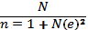
Where: n= Desired sample size
N= the entire population
e= level of significance or limit of tolerable error assumed to be 5% or 0.05
1= unit, constant figure
Therefore
n=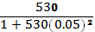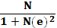

n= 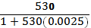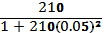
n= 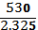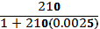
n= 137.7
n= 137
From the above calculations, the sample size for the study using Taro Yamane statistical tool is 137. To get 137 journalists who will be part of the study from among the 210 registered journalists in the state, multistage sampling procedure was applied.

Stage 1: This stage involved identifying journalists in their already existing groupings at local government levels. NUJ in Enugu state recognizes 17 local government areas of operation.
Consequently, the first stage involved dividing the sample size of 137 into 17 areas. This gave 8 journalists for each local government area. This will give us 136. This leaves us with 1 journalist left. Simple random sampling was used to distribute the remaining 1 respondent.

Stage 2: This stage involved selecting 8 journalists from each of the local government areas. This selection was done using simple random sampling method.

3.5 Description of research instrument
The instrument used in conducting this research is the questionnaire. This is a set of questions relating to the aims and objectives of the research study to which the respondents are required to answer by writing in their responses. This instrument was deemed fit because it is expected it will help the researcher get facts needed for the work from the respondents.

3.6 Reliability and Validity of Data gathering instruments
The validity of the instrument was done using face validity technique which involved the presentation of the instrument to a communication scholar who is a senior lecturer in the department of Mass Communication for correction and modification. It was tested for clarity and ambiguity.
To test for reliability, the instrument was administered to 5 journalists at the state secretariat of NUJ to see if they understand the instrument and to confirm that the instrument can be relied upon to generalize the data expected.

  - Method of Data Collection
The questionnaires were personally administered to members of the NUJ that made up our sample size (137) and were also personally retrieved back.

3.8 Method of data analysis
The method of data analysis employed in this study is frequency distribution analysis, whereby the researcher observe the frequency of the option ticked by the respondents, in which case, the option that has the highest frequency becomes the selected option that the conclusion will rest upon. Tables and charts was used for the analysis

CHAPTER FOUR
DATA PRESENTATION AND DISCUSSION OF FINDINGS
4.1 Introduction
In this chapter the researcher presents and analyses the data collected from the respondents according to the research questions. The responses were converted into scores and percentage distribution.

4.2 Data presentation and analysis
The researcher administered 137 copies of the questionnaire. 130 copies of the instrument where correctly filled and returned. Giving the figures obtained in percentage model, it will appear as follows:
Total number of questionnaire distributed = 137
Total number of questionnaire returned = 130

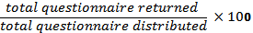
=94.8%
Therefore, 94.8% of the total number of questionnaire distributed were returned and used for the analysis.

Demographic analysis of respondents
Table4:2.1
Sex of respondents
 | Frequency | Percent
Male | 80 | 61.5%
Female | 50 | 38.4%
Total | 130 | 100%
(Field survey, 2018)
Figure4:2.1
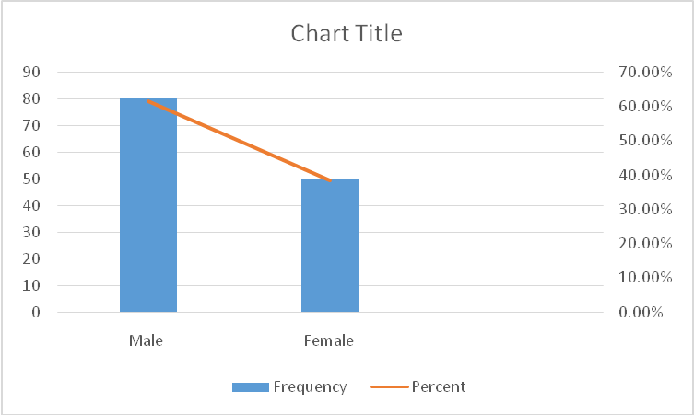
The table and chart show the distribution of the respondents. A total of 80(61.5%) of the respondents are male, while the remaining 50(38.4%) of the respondents are female. Hence majority of the respondents are male.

Table 4:2.2
Location of respondent’s organization
 | Frequency | Percent
Urban | 115 | 88.4%
Rural | 15 | 11.5%
Total | 130 | 100%
(Field survey, 2018)
Figure 4:2.2
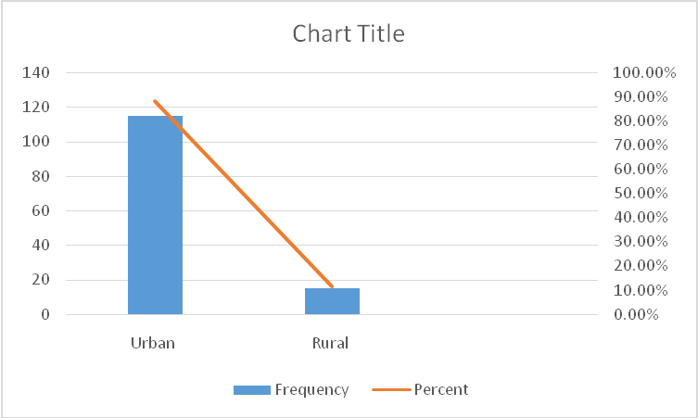
The figure and chart show that a total number of 115(88.4%) of the respondents are practicing in the urban area of the state while the remaining 15(11.5%) are practicing the rural area.

Table 4:2.3
Respondent’s response on how long they have been in the practice?
 | Frequency | Percent
Less than 1 year | 20 | 15.3%
1-5 years | 72 | 55.3%
6-10 years | 22 | 16.9%
Above 10years | 16 | 12.3%
Total | 130 | 100%
(Field survey, 2018)
Figure 4:2.3
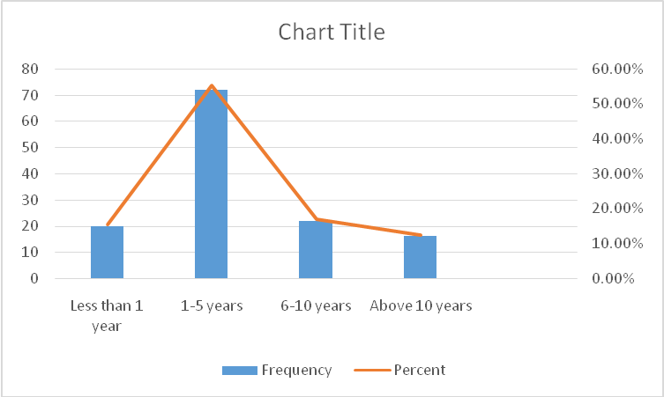
The table and chart above show that a total number of 20(15.3%) of the respondents have been in the practice for less than a year, 72(55.3%) of the respondents have been practicing for 1-5 years. While 22(16.9%) of the respondents have been in the profession for 6-10 years and the remaining 16(12.3%) of the respondents have been practicing for over 10 years.

Table 4:2.4
Respondents’ response on their rank in their organization
 | Frequency | Percent
Trainee | 10 | 7.6%
Junior staff | 69 | 53%
Senior staff | 51 | 39.2%
Total | 130 | 100%
(Field survey, 2018)
Figure 4:2.4
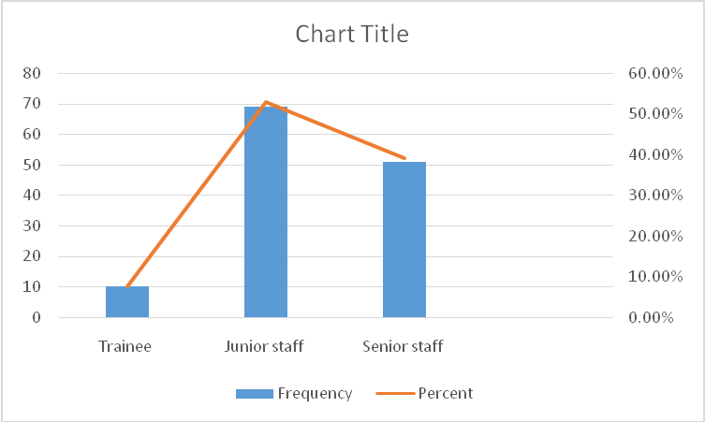
The table and chart reveal that a total number of 10(7.6%) of the respondents are trainees in their organization while 69(53%) representing majority of the respondents are practicing as junior staff and the remaining 51(39.2%) of the respondents are senior staff.

Analysis of results from the field
Research Question 1
What is the ratio of journalists with formal education in Journalism/Mass Communication to those without formal education in Journalism in Enugu state?
Table 4:2.5
Respondents response on if they have a degree in Mass Communication/ Journalism?
 | Frequency | Percentage
Yes | 50 | 38.4%
No | 80 | 61.5%
Total | 130 | 100%
(Field survey, 2018)
Figure 4:2.5
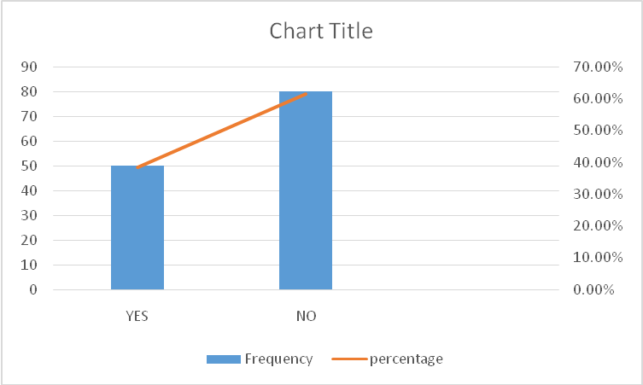

The table and chart above, show that only 50 (38.4%) of the respondents have a degree in Journalism/ Mass Communication. Meanwhile, 80 (61.5%) of the respondents are not graduates of mass communication/ journalism. Majority of the respondents therefore are journalists from other disciplines.

If no, which discipline?
Table 4:2.6
Course | Frequency | Percentage
Public administration | 16 | 12.3%
Political science | 18 | 13.8%
Economics | 7 | 5.3%
English | 25 | 19.2%
others | 14 | 10.7%
Total | 130 | 100%
(Field survey, 2018)
Figure 4:2.6

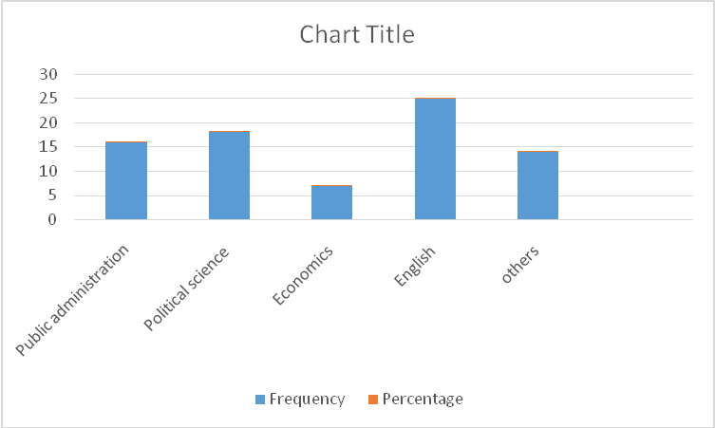
The table and chart above show the distribution of disciplines of respondents without a degree in Mass Communication/ Journalism. A total of 16 (12.3%) of the respondents are graduates of Public Administration, while a total of 18 (13.8%) are graduates of Political Science. 7 (5.3%) of the respondents have a degree in Economics and a total of 25 (19.2%) are graduates of English Language while 14 (10.7%) of the respondents indicated other disciplines not mentioned above. From the findings, it is clear that majority of the respondents who are not graduates of Mass Communication are graduates of English language.

Table 4:2.7
Respondent’s highest educational qualification
 | Frequency | Percent
SSCE | 6 | 4.6%
OND | 11 | 8.4%
HND/ First Degree | 91 | 70%
Higher/ Post-Graduate degree | 22 | 16.9%
Total | 130 | 100%
(Field survey, 2018)

Figure 4:2.7
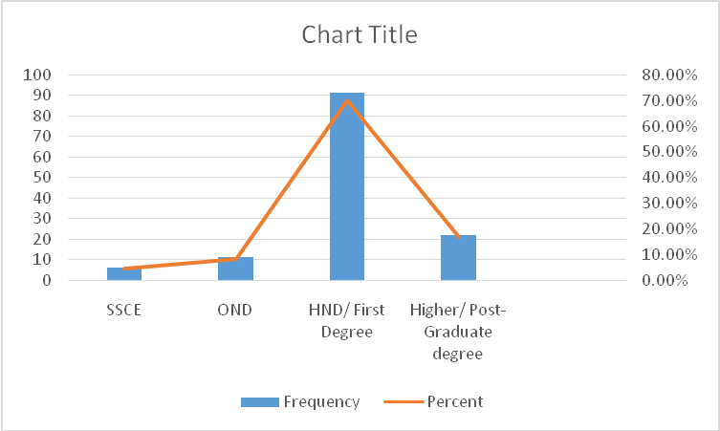
The table and chart reveal that 6(4.6%) of the total number of respondents are practicing Journalism as SSCE holders, 11(8.4%) are OND holders. 91(70%) are HND/ First Degree holders while the remaining 22(16.9%) are practicing with higher/ post graduate degrees.

Research Question 2
To what extent is a journalist professional efficiency dependent on formal journalism education?

Table 4:2.8
Respondents’ response on whether a journalist/ media practitioner who obtained HND or Degree in Mass Comm. / Journalism performs better than a journalist who studied other disciplines.
 | Frequency | Percent
Strongly agree | 66 | 50.7%
Agree | 34 | 26.1%
Disagree | 12 | 9.2%
Strongly disagree | 15 | 11.5%
Undecided | 2 | 1.5%
Total | 130 | 100%
(Field survey, 2018)
Figure 4:2.8
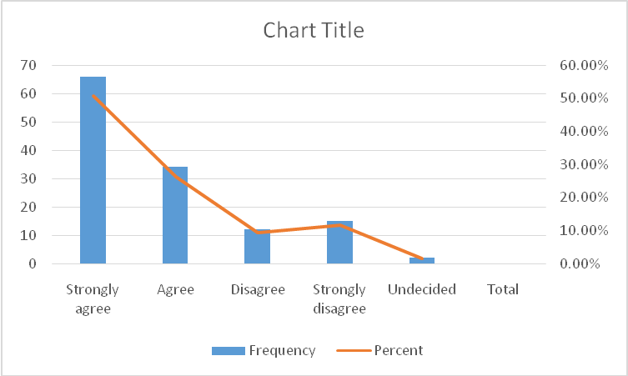
From the table and chart above, the results obtained shows that the number of respondents who strongly agree that a journalist/ media practitioner who obtained HND or Degree in Mass Comm. /Journalism performs better than a journalist who studied other disciplinesare 66 representing 50.7%, while respondents who agree are 34 representing 26.1%. Furthermore, respondents who disagree are 12 representing 9.2%while respondents who strongly disagree are 15 representing 11.5%. 2(1.5%) of the respondents were undecided. The table shows that majority of the respondents agrees and strongly agrees that a journalist/ media practitioner who obtained HND or Degree in Mass Comm./Journalism performs better than a journalist who studied other disciplines.
Research Question 3
To what extent is efficiency in journalism profession dependent on talents and skills than on formal journalistic education?
Table 4:2.9
Respondents’ response on whether efficiency of a journalist is more dependent on his/ her talents and skill and not on the level of formal education received in Journalism/Mass Communication
 | Frequency | Percent
Strongly agree | 14 | 10.7%
Agree | 9 | 6.9%
Disagree | 47 | 36.1%
Strongly disagree | 54 | 41.5%
Undecided | 6 | 4.6%
Total | 130 | 100%
(Field survey, 2018)
Figure 4:2.9
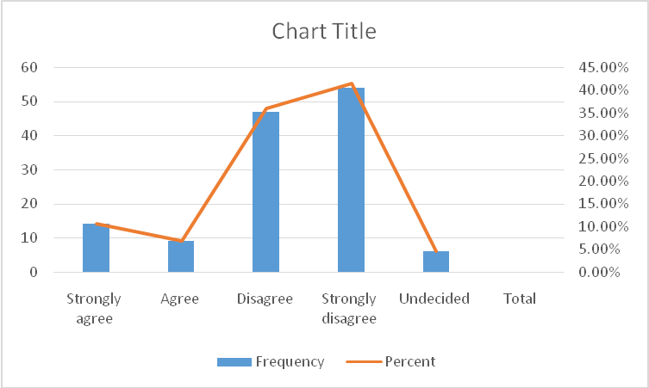
From the table and chart above, the results obtained shows that the number of respondents who strongly agree that efficiency of a journalist is more dependent on his/ her natural talents and not on the level of formal education received in Journalism/Mass Communication are 14 representing 10.7%. While respondents who agree are 9 representing 6.9%. Furthermore, respondents who disagree are 47 representing 36.1% while respondents who strongly disagree are 54 representing 41.5%. 6 representing 4.6% of the respondents were undecided. From the result, majority of the respondents disagree and strongly disagrees with the above statement.

Other findings;
Table 4:2.10
Respondents’ response on whether years of experience in journalism without formal education in journalism/ mass communication can make one an efficient journalist
 | Frequency | Percent
Strongly agree | 70 | 53.8%
Agree | 34 | 26.1
Disagree | 12 | 9.2%
Strongly disagree | 10 | 7.6%
Undecided | 4 | 3.0%
Total | 130 | 100%
(Field survey, 2018)
Figure 4:2.10
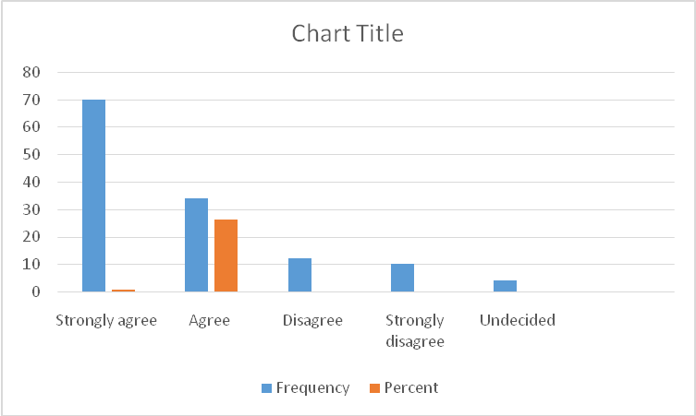
The table and chart above shows that a total number of 70(53.8%) of the respondents strongly agree that years of experience in the profession can make one a professional in the absence of a formal degree in journalism and 34(26.1%) of the respondents agree with the statement. However, 22(16.9%) disagree and strongly disagree that years of experience can make one a professional in the field without possessing a formal degree in the profession. Lastly, 4(3.0%) of the respondents remained undecided.
Research Question 4
To what extent does formal education in journalism contribute to career progress or promotion?
Table 4:2.11
Respondents’ response on whether a journalist with formal educational qualification in Journalism /Mass Comm. has higher chances of promotions/progress in his/her career than one without educational qualifications?
 | Frequency | Percent
Strongly agree | 73 | 56.1%
Agree | 39 | 30%
Disagree | 8 | 6.1%
Strongly disagree | 6 | 4.6%
Undecided | 4 | 3.0%
Total | 130 | 100%
(Field survey, 2018)

Figure 4:2.11
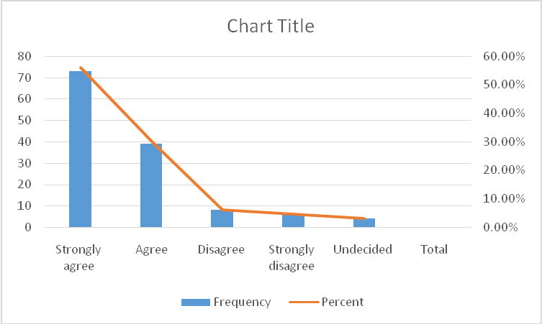
The table and chart above shows that, 73 (56.1%) of the respondents strongly agree while39 (30%) agree. Also, 8(6.1%) of the respondents disagree and 6(4.6) strongly disagree. 12(3.0%) of the respondents were undecided. From the result, majority of the respondents agree and strongly agree that a journalist with formal educational qualification in Journalism /Mass Comm. has higher chances of promotions/progress in his/her career than one without educational qualifications in journalism.
Other findings;

Table 4:2.12
Respondents response on whether journalists / media practitioners with educational qualification in Journalism/ Mass Communication are held in high esteem and are more in demand.
 | Frequency | Percent
Strongly agree | 69 | 53%
Agree | 30 | 23%
Disagree | 10 | 7.6%
Strongly disagree | 16 | 12.3%
Undecided | 5 | 3.8%
Total | 130 | 100%
(Field survey, 2018)
Figure 4:2.12
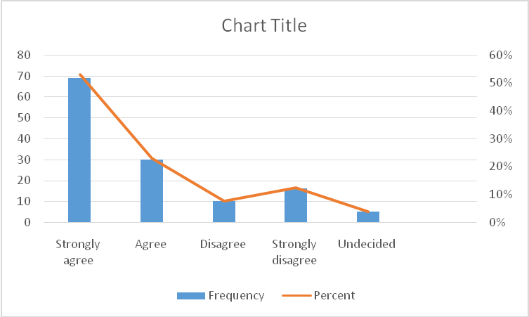
The table and chart above shows that 99(76.1%) of the total respondents agree and strongly agree that media practitioners with formal journalism education are more placed than those that do not possess it as they sought more in the field and usually held in/ with high regard.

  - Discussion of Findings
The number of journalists without formal degree/ education in Journalism is high. A total of 80(61.5%) of the respondents do not have a degree in Mass Communication/ Journalism. While the remaining 50 (38.4%) are those with a degree in Mass Communication/ Journalism. This finding is significant because it reveals to a great extent the underlying factor behind the decline of professionalism in the profession. This finding agrees with Okunna (1995) when she said that in order to achieve high professionalism, there is a dire need for formal education not just in journalism but in every profession. Similarly, Ornebring (2009) noted that there is a declining commitment to professionalism in journalism. This finding underscore the declining commitment to professionalism, owing to the fact that many of those practicing this profession do not have formal and background education in Journalism/ Mass Communication. The study also made a shocking finding that some people are practicing journalism in 21stcentury as SSCE holders.
With this foundational gap in professional education, the journalists who fall within this category will likely compromise on ethics and professionalism in the discharge of their duty. Furthermore, another very significant finding from the study is that, among the respondents who are practicing Journalism without formal education in the profession, 25(19.2%) of them studied English language at degree level, while 18(13.8%) studied political science. A total of 16(12.3%) studied public administration, 7(5.3%) studied economics and the remaining 14(10.7%) identified various courses which was categorized under others. The possible reason why those who studied English has the highest number/ percentage is because, to a layman, Journalism practice is all about speaking good English with sophisticated sentence structure. Although good command of English is quintessential to the profession, there is more to journalism practice than that.

It was also discovered from the study that a journalist who possess a formal degree in Journalism/ Mass Communication is most likely to perform more efficiently and professionally. A total of 66 (50.7%) of the respondents strongly agree that journalists who are educated in Journalism and have received proper education about the profession will always perform better than those without formal education in the profession. It is surprising to discover that though majority of the respondents do not have a degree in mass communication/ journalism, most of them believe that obtaining a degree in mass communication will make a journalist more efficient and professional. This finding agrees with Odunewu (2003) who noted that for journalists to be professionally efficient and live up to their expectations, they must be properly educated in Journalism. It is in line with this that we have Institutions of Journalism and Journalism/ Mass Communication courses offered in universities, colleges, polytechnics to make sure that the system produce journalists that will carry out the social responsibility of being the conscience of the society professionally and efficiently. Reason being that, there would be no professionalism if the system is filled with unqualified journalists causing more harm than good to this noble profession.
Kwame (1988) could not agree less. To him, the main policy objective of journalism training in Ghana and the Ghana Institute of Journalism was to produce professionally trained personal to operate and manage the country’s Mass Communication Media. Similarly, WJEC (2007) established that formal education in journalism provides the foundation for effective, professional and responsible practice of journalism.

Furthermore, it is evident from the result that majority of the respondents do not agree that professional performance is hinged on ones’ skills, talents and experience. Only 14 (10.7%) representing the least number of respondents agreed on this. 70(53.8%) believes that one can still be professionally efficient without any formal background in journalism but with years of experience. This is possibly because to them, years of experience in the profession have taught them arguably more than classroom knowledge.
Andrew (2009) argues that a worker’s years of experience in his job can make him efficient and professional due to his special gift of experience he acquired during the course of his work. This is so because it gives him an expert power, this is in accordance to the common adage “practice makes a man perfect”. (Talabi & Ogundeji, 2012) however believe that formal journalism education and not years of experience should form the basis for entrance into the profession.

Lastly, there are so many opportunities that open up for a person who is academically informed in his/ her area of study. No employer will want to employ an individual with no educational qualifications in a competitive society we have now. From the result, it is evident that 73 (35.8%) of the total number of respondents strongly believes that with formal educational qualifications in Journalism/ Mass Communication, ones’ chances of progressing in the field is very high. In line with this, 83(31.9%)of the total number of respondents believes that journalists who have acquired quality education, and grounding in Journalism/ Mass Communication are more in demand in the field and are always held in high regard. Journalists need to acquire a standard quality education in order to survive in a competitive world like ours. One needs to be highly educated in journalism to remain and survive in the field. According to ACS (1995), it is hard to find good jobs in journalism, the market is competitive. Still there will always be a demand for the smartest, those who have acquired the professional touch, educational qualifications in journalism.

CHAPTER FIVE
SUMMARY, CONCLUSION AND RECOMMENDATION
5.1 Introduction
This chapter shall give a summary of the findings gotten from the analysis, conclusion of the study and also necessary recommendations.

5.2 Summary of findings
This study found out that most registered and practicing journalists in the state do not possess formal journalism education. Majority of the respondents are graduates from other disciplines practicing journalism without a basic background in Journalism/ Mass Communication to enhance their performance. Graduates of English language are more in the profession than graduates from other areas like political science, public administration, economics and others.

It was also discovered from the study that for one to be fully efficient and professional in the field, formal journalism education is necessary as majority of the respondents agreed to this assertion.

Furthermore, the study found out that one’s talents, skills and experience is not a determinant for a journalist’s professional performance. It was also discovered that most journalists believe that without a formal background in journalism, one can still be efficient in the profession with many years of experience in the field.
Lastly, it was revealed from the study that though most journalists do not hold degrees in Mass Communication/ Journalism, they believe that for one to remain relevant and to increase one’s chances of career promotion/ progress in journalism, formal journalism education is a very strong factor that cannot be underestimated.

5.3 Conclusion
The results from this study and the various empirical literature reviewed in this study shows that for journalism to regain prestige in the presence of other professions like; medicine, law, engineering, etc., it needs to be in the hands of professionals who have acquired the basic formal education in journalism.
The study found out that formal journalism education has a very great impact on journalist’s professional performance as it enhances professionalism and therefore should not be overlooked. There is need to get rid of untrained/ unprofessional journalists bestriding the state and also ensure that formal journalism education becomes an important criteria to look out for when recruiting new journalists.
Also, the study found that having a degree in Journalism/ Mass Communication helps journalists climb up the ladder in their career.
In conclusion, for journalists to live up to their expectations in the society and to acquire appropriate knowledge and skills to perform those functions as expected of them by the society they must be properly “schooled” in journalism. The process of detecting news, gathering news, sorting news, processing news and eventual dissemination of news require both formal education and technical skills.
Therefore, to achieve professionalism in the field, there is a dire need to marry formal-journalism education with professional skill, practice and years of experience.

5.4 Recommendations
From the findings of this study, the following recommendations were therefore made.
- Journalists are referred to as watchdogs of the society. Discharging their duties efficiently with dedication to truthful and responsible journalism will require good quality training in Mass Communication/ Journalism. Government and other stakeholders should regulate journalism education in Nigeria, in order to ensure that would-be journalists are sufficiently trained to discharge their social responsibility to the society.
- The Nigerian union of journalists in the country should urgently review the criteria for who becomes a journalist in Nigeria. The basic requirement should include obtaining a degree in Mass Communication/ Journalism.
- Media houses and organizations should set a criteria that anyone who applies to work with them must possess a degree in Mass Communication/ Journalism.
- Journalists on their part, should know that beyond obtaining a degree in Mass Communication/ Journalism, they need to gain from the experience of those who have been in the profession before them. There may be need for internship programs for fresh graduates of Mass Communication before they are recognized as full-fledged Journalists. This is what obtains in other professions like Law, Medicine and Pharmacy.

5.5 Suggestions for further studies
The objective of the current study was to examine if formal journalistic education has any impact on journalists professional practice in Enugu state. Hence we suggest that further studies in this area should look into a wider coverage like studying the role formal education play on the performance of journalists in the country and not just in Enugu state.

References
"Gonzo journalism". encyclopædia britannica. Retrieved 14 October 2012

Adaja, T.A. (2011). The Nigerian media and the quest for probity and accountability in governance. a a u: African studies review, 10, 183 – 204.

Akinfeleye RA (1990) Nigerian Media – Dialectic Issues in Nigerian Journalism. Lagos: nelson publishers ltd.

American chemical society. (1995). The interview Handbook. Washington, DC: Department of career services, ACS. A thorough discussion of interviewing as well as self-education and job assessment. Targeting the job market. Washington DC: Department of career services, ACS.

Andrew Ali Ibbi (2016) the battle for professionalism in journalism in Nigeria amidst unethical practices; journal of mass communication & journalism, 6(3)

Andrew J. Dubrin. (2009). Leadership: research findings, practice and skills. Fifth edition. Boston USA: Houghton Mufiilin Co.

Ansah, P.A.V. (1977). 'The Press Trust: A New Perspective on thePress. Ghana: Universiias Legon.

Ansah, P.A.V. (1980, December): Mass Media Training and Professionalism. Paper presented at a workshop on Development, Democracy and the Mass Media in Ghana, University of Ghana, Legon.

Asika (1991) Democracy and Civil Society in Nigeria. Ibadan: Spectrum Books Ltd.

Beate, J. (2016). Journalism studies. Retrieved from 10.1093/acrefore/9780190228613.92

Castro, J. (2009). Journalism. Microsoft Encarta. Redmond, W.A: Microsoft Corporation

Chibita, M. B. (2010). Developing Relevant Journalism Curricula in Changing Times Experiences from East Africa. A paper delivered at the World, Journalism Education Congress (WJEC), Grahamstown, July 5-7.

Corcoran, Mark (21 February 2012). "Drone journalism takes off". Australian broadcasting corporation. Retrieved 25 march 2012.

Federal Government (1999) Constitution of the Federal Republic of Nigeria, Lagos, Federal Ministry of Information.

Felix Olajide Talabi* and Benjamin Kayode Ogundeji (2012) effects of non-professionalism in Nigeria Journalism; Mass Communication & Journalism, 2(7)
Folarin, B. (1998). Theories of mass communication: an introductory text. Ibadan: stirling-horden publishers (nig.) ltd.

Gerald Stone, Kaye O’donnell, K., & Stephen A. Banning (winter/spring 1997). "Public perceptions of a newspaper’s watchdog role". Newspaper research journal, 18(1-2), 86–102.

Golding, Peter (1977) "media professionalism in the third world: the transfer of an ideology, mass communication and society, (Eds.) James Curran, et al, London, Open University press.

Henrik Ornebring. (2009). The Two Professionalisms of Journalism: journalism and the changing context of work. Reuters Institute for the study of journalism working paper.

Huang, C.J. & Liu C.J. (2005). Exploration for the relationship between Innovation, IT and performance. Journal of intellectual capital, 6(2), 237-252.

Huei Lan Wang (2014) Impact of Journalism Educators on Media Performance and Journalism Practice in Taiwan; International Education Research, 2(3) , 53-65, ISSN 2291-5273 E-ISSN 2291-5281

Kwame S.T.B. (1988). Journalism profession and training in sub-saharan Africa; Ghana. Africa media review, 2(3).

May.S; Aikman (2013), “Indigenous Education: Addressing Current Issues and developments”, comparative Education. 39(2)

McQuail, D. (1987). Mass Communication Theory: An Introduction. London: Sage.

Mcquail, D. (2005). McQuails’s Mass Communication Theory. (Fifth Edition). London: Sage

Mogekwu, Matt (2006) "Xenophobia as Poor Intercultural Communication: Re-examining journalism education content in Africa as a viable strategy", Academic. Sun, ac. za, viewed June 29, 2006.

Nnaemeka, T., Uvieghara, E. & Uyo, D. (1989). Philosophy and dimensions of national communication policy,.2. Lagos: centre for black and African arts and civilization.

Nuria Sanz, Sjur Bergan (2006); “The heritage of European universities”, 2nd edition, Higher education series No.7, Council of Europe, 2006, ISBN, 136

Odunewu, A. (2000). Ethics and professionalism. In L. Arogundade & B. Eitokpah (Eds.), media in a civil democracy: thoughts & perspectives, 1-21. Lagos: International press center and friedrich ebert stiftung.

OECD (2014), Recognition of Non-formal and Informal learning
Okunna CS (1995). Ethics of mass communication. Enugu:New generation books.

Priti, J. (1999). On-the-job training: a key to Human Resource Development. Library Management, 20(5), 283-294.

Sieber et al (1987) “values system charges by students as a result of media ethics course”. Journalism

Surlin, S.H. (1987). Values system changes by students as a result of media ethics course. Journalism quarterly, July- September 2(10), 1-8.

Tokunbo Alex Adaja. (2012).Nigerian journalism and professionalism: issues and challenges; new media and mass communication, 5

UNESCO (2008), Education for all monitoring report, Net enrollment rate in primary education.

Van Vugt, M. (2006). Evolutionary origins of leadership and followership. Personality and social psychology, 10(4), 354-371.

World Economic Forum. (2016). Global competitive report 2015-2016. Retrieved from http://reports.weforum.org/global-competitiveness-report-2015-2016/education/#view/fn-53

Wright, B.E & Davis, B.S. (2003). Job satisfaction in the public sector-the role of the work environment. American review of public administration, 33, 70-90.

APPENDIX I
INFLUENCE OF FORMAL JOURNALISM EDUCATION ON JOURNALISTS’ PROFESSIONAL PRACTICE IN ENUGU STATE

Department of Mass Communication,
Godfrey Okoye University, Enugu,
Enugu State.
April 2018.

Dear Respondent,
Request To Respond To Research Questions
I am an undergraduate student of the above named institution and currently undertaking a research project on the topic: Influence of Formal Journalism Education on Journalist’s Professional Performance in Enugu state.
Please answer the questions as objectively as you can. This research is meant for academic purposes only. All information volunteered will be treated with utmost confidentiality.
Thanks for your cooperation.

Uche Chinonye E.

Instruction: please tick [√] in the box that depicts your answer to each question below.

Section A

A. Name of organization:
B. Sex: Male f Female
C. location of organization: (a) Urban
(b) Rural
D. How long have you been in the practice of Journalism?
Less than 1 year
1-5 years
6-10 years
Above 10 years

E. Where would you be classified in your media organization?
- Trainee
- Junior staff
- Senior staff
SECTION B
Instruction
Kindly respond to these questions and choose the option that best appeals to you by ticking (√) in the spaces provided where appropriate.
Key:
SA = Strongly Agree
A = Agree
D = Disagree
SD =Strongly Disagree
UD =Undecided

Research Question 1
What is the ratio of journalists with formal education in Journalism to those without formal education in Journalism in Enugu state?
- What is your highest educational qualification?
- SSCE
- OND
- HND/ First Degree
- Higher/ Post- Graduate degrees
- Is your Degree in Journalism/ Mass Communication
- Yes
- No

- If no, which discipline
- Public administration
- Political science
- Economics
- English
- Others

S/NO | Ratio of journalists with and without formal education in Journalism/Mass Communication | SA | A | D | SD | UD
4 | Some journalists / media practitioners in Enugu do not have HND or Degree in any discipline
5 | Some journalists / media practitioners in Enugu do not have HND or Degree in Mass Comm./ Journalism, but have Degrees in other areas
6 | Journalist/ media practitioners who obtained a HND or degree in disciplines other than Mass Communication or Journalism are more in number in your media organization?

Research Question 2: To what extent is a journalist professional performance dependent on formal Journalism education?

6 | A journalist / media practitioner who obtained HND or Degree in any discipline performs better than a journalist who did not obtain HND or Degree in any discipline.
7 | A journalist/ media practitioner who obtained HND or Degree in Mass Comm./ Journalism performs better than a journalist who studied other disciplines
8 | Higher education beyond HND / Degree level in Mass Comm. /Journalism will make a journalist / media practitioner more efficient
9 | Only few journalists go beyond HND/ Degree level in Mass Comm./Journalism education

Research question 3: To what extent is professional performance in journalism dependent on talents and skills?
S/NO | Performance is dependent on skills | SA | A | D | SD | UD
10 | Performance of a journalist is more dependent on his/ her natural talents and not on the level of formal education received in Journalism/Mass Communication
11 | Most journalists are employed because of their talents /skills rather than their formal educational qualification
12 | Some prominent journalists / media practitioners started practicing without any formal education in Journalism/ Mass Communication
13 | Some journalists / media practitioners excel in the industry because of talent /skills without any formal education in Journalism/ Mass Communication
14 | Years of experience in Journalism without formal education in Journalism/ Mass Communication can make one an efficient journalist.
Research Question 4: To what does obtaining a formal education in Journalism contribute to career progress or promotion?
S/NO | Career progress/promotion is dependent on formal education | SA | A | D | SD | UD
15 | A journalist with formal educational qualification in Journalism /Mass Comm. has higher chances of promotions/progress in his/her career than one without educational qualifications
16 | Journalists/media practitioners with educational qualification in Journalism/ Mass Comm. are held in high esteem and are in more demand
17 | Talents, skills and experience are stronger considerations for progress/ promotion in Journalism than higher educational qualification

