THE GEOLOGY OF AMURO AND THE ENVIRONS NEAR AFIKPO, EBONYI STATE, NIGERIA

BY

OKOYE EMMANUEL CHIGOZIE
U14/NAS/GLM/038

DEPARTMENT OF PHYSICAL AND GEOSCIENCES,
FACULTY OF NATURAL AND APPLIED SCIENCES,
GODFREY OKOYE UNIVERSITY,
UGWUOMU NIKE, ENUGU STATE, NIGERIA.

JULY, 2018
THE GEOLOGY OF AMURO AND THE ENVIRONS NEAR AFIKPO, EBONYI STATE, NIGERIA

BY

OKOYE EMMANUEL CHIGOZIE
U14/NAS/GLM/038

A PROJECT REPORT SUBMITTED TO THE DEPARTMENT OF PHYSICAL AND GEOSCIENCES, FACULTY OF NATURAL AND APPLIED SCIENCES, GODFREY OKOYE UNIVERSITY, UGWUOMU-NIKE, ENUGU STATE, NIGERIA.

IN PARTIAL FUFILLMENT OF THE REQUIREMENTS FOR THE AWARD OF BACHELOR OF SCIENCE (B.Sc) DEGREE IN GEOLOGY AND MINING.

JULY, 2018

CERTIFICATION
This is to certify that this research work was done by Okoye Emmanuel Chigozie, with Registration number U14/NAS/GLM/038, in the Department of Physical and Geosciences, Godfrey Okoye University, under the supervision of:

MR.EMMANUEL IKEJIAKU Date
Supervisor

PROF. CHIDI C. UHUEGBU Date
Head of Department

PROF. CHIDI C. UHUEGBU Date
Dean Faculty of Natural and Applied Sciences

External Examiner Date

DECLARATION PAGE
I hereby declare that this work “The Geology of Amuro and The Environs near Afikpo, Ebonyi State, Nigeria” is the product of my own effort, under the supervision of MR. EMMANUEL IKEJIAKU, and has not been presented elsewhere for the award of a degree or certificate. All sources have been duly acknowledged.
SIGNATURE:

NAME:

DATE:

DEDICATION
This work is solely dedicated to God Almighty the Giver of wisdom, the Great Protector, the Great Provider, the Hope Restorer and the Owner of my life, and to my beloved Parent, Late Mr. Emmanuel C. Okoye and Mrs. Catherine I. Okoye.

ACKNOWLEDGEMENT

My acknowledgement goes to my Supervisor and Departmental Coordinator Mr. E.O. Ikejiaku, who was a source of encouragement and great help during this project. I appreciate your effort in making this project a success by spending time to go through my work and making corrections where necessary.

Special thanks to my Dean and Head of Department of physical and Geosciences of Godfrey Okoye University, Enugu, Prof. Chidi Uhuegbu and to my colleagues most especially Okochi Gabriel, who accommodated me during the period of my field mapping.
I also appreciate the financial support and encouragement of my parent and family, may the Almighty Lord continue to bless you all for the support.

TABLE OF CONTENTS
Title page i
Certification page ii
Declaration iii
Dedication iv
Acknowledgment v
Table of contents vi
List of Figures x
List of Tables xiii
Abstract xiv
CHAPTER ONE: INTRODUCTION
1.0 Study Background 1
1.1 Aims and Objective of the study 1
1.2 Location and Extent 2
1.3 Physiography of the area 2
1.3.1 Accessibility 3
1.3.2 Geomorphology of the Area 3
1.3.3 Drainage 3
1.3.4 Vegetation 4
1.3.5 Climate 4

CHAPTER TWO: LITERATURE REVIEW
2.0 Previous geologic works 5
2.1 Geographical setting 6
2.2 Regional geology of the Area 7
2.3 Brief history of the Benue Trough 8
2.4 Lithostratigraphic Setting 9
2.5 Asu River Group 10
2.6 Eze-Aku Group 10
2.7 Awgu group 11
2.8 Anambra Basin 12
2.9 The Nkporo Group 14
CHAPTER THREE: METHODOLOGY AND MATERIAL USED
3.0 Introduction 16
3.1 Work Flow 17
3.2 Equipment Used 17
- Brunton compass 17
- Measuring Tape 18
- Topographical Map 18
- Hand lens 19
- Geologic hammer 20
- Sledge Hammer 20
- Sample Bag 21
- G.P.S (Geographic Positioning System) 21
- Geologic Field Bag 22
- Field note book 22
- Marker and masking tape 23
- Pen and pencils 23
CHAPTER FOUR: DESCRIPTIVE ANALYSIS OF MAPPED LITHOLOGIC UNITS
4.0 Introduction 24
4.1 Locations Mapped and Data Recorded 24
- Location 1: Crush Stone Quarry at Amasiri development Centre 25
- Location 2: Otueja Opposite Ezeke Modern Primary School 26
- Location 3: Amasiri Hill Adjacent to the Local Government Center 27
- Location 4: Dolerite Ridge Opposite the Timber Shade 29
- Location 5: Mc Gregor Hill Opposite Mc Gregor Hill Block Industry 30
- Location 6: Mc Gregor Hill 300 metres away from Mc Gregor Hill 32
- Location 7: Outcrop Located at Akpoha Express Road 34
- Location 8: Gorogoro Local Quarry along Ibi Express road 35
- Location 9: Ozara-Ukwu Quarry Site 36
CHAPTER FIVE: LABORATORY ANALYSES AND RESULTS
5.0 Method for Analysis: Grain Size Analysis 37
5.0.1 Objective of the Analysis 37
5.0.2 Equipment Used 37
5.0.3 Procedures 38
5.0.4 Analysis 38
5.0.5 Interpretation 40
5.1 Method for Analysis: Sandstone Petrography 49
5.1.1 Amasiri-Coarse grained Sandstone Unit 50
5.1.2 LO26-Medium grained Sandstone Unit 50
5.1.3 UNNAMED-Fine grained Sandstone Unit 50
5.2 Method for Analysis: Palynological laboratory Analysis 56
5.2.1 Method of sample preparation 56
5.2.2 Palynological results 57
5.2.3 Interpretation of results 65
5.2.4 Kerogen investigation 67
5.2.5 RESULT 67
CHAPTER SIX: ECONOMIC GEOLOGY, STRUCTURAL GEOLOGY, IGNEOUS ACTIVITY AND GEOLOGICAL HAZARD
6.0 Economic geology 70
6.0.1 Quarrying and Construction 70
6.0.2 Agriculture 71
6.1 Structural Geology 71
6.1.1 Primary sedimentary structures include 72
6.1.2 Secondary Sedimentary Structures 72
6.2 Igneous Activity 72
6.3 Geohazards of the area 73
CHAPTER SEVEN: SUMMARY AND CONCLUSION 74
REFFERRENCE 75
APPENDIX 110
LIST OF FIGURES
Fig 1.0: Topographic Map of Amuro and its Environs
Fig 1.1: Drainage Map of Amuro and its Environs
Fig 2.0: Map of South Eastern Nigeria showing the Physical features (after Ofomata, 1975)
Fig 2.1: Geologic Map of Amuro and Its Environs
Fig 2.2 Idealized North-South stratigraphic cross section across the Benue Trough and the relationship to the Niger Delta and Chad Basin (Vertical scale exaggerated; erosion and uplift not considered (Nuhu George Obaje, 2009)
Fig 2.3: Geological Sketch Map of the Anambra Basin (Nuhu George Obaje, 2009)
Fig 2.4: Stratigraphic successions in the Anambra Basin (Nuhu George Obaje, 2009)
Fig. 2.5: Stratigraphic successions in the Benue Trough and the Nigerian sector of the Chad Basin (Nuhu George Obaje, 2009)
Fig 3.0: Brunton Compass
Fig 3.1: Measuring Tapes
Fig 3.2: Topographical Map
Fig 3.3: Hand Lens
Fig 3.4: Geologic Hammer
Fig 3.5: Sledge Hammer
Fig 3.6: Sample Bag
Fig 3.7: Global Positioning System (GPS)
Fig 3.8: Geologic Field Bag
Fig 3.9: Field Notebook
Fig 3.10: Masking tape and Marker
Fig 3.11: Pen and Pencils
Fig 4.0: Sandstone outcrop at Crush Stone Quarry at Amasiri development Centre, Afikpo North L.G.A.
Fig 4.1: Sandstone outcrop Otueja Opposite Ezeke Modern Primary School, Amuro-Ndukwe.
Fig 4.2: Sandstone Outcrop at Amasiri Express Road close to Naira and Kobo Hotel few metres away from the Army check point
Fig 4.3: Dolerite Outcrop opposite the Timber Shade
Fig 4.4: Sandstone Outcrop at Mc Gregor Hill Opposite Mc Gregor Hill Block Industry, Afikpo
Fig 4.5: Sandstone Outcrop at Mc Gregor Hill 300 metres away from Mc Gregor Hill Block Industry, Afikpo
Fig 4.6: Sandstone Outcrop Located at Akpoha Express Road
Fig 4.7: The outcrop Located at Gorogoro Local Mine pit along Ibi Express road before Ozaraukwu
Fig 4.8: Diorite outcrop from Ozara-Ukwu Quarry Site
Fig 5.0: Graphic Median Vs Graphic Standard Deviation (After Stewart, 1958)
Fig 5.1: Graphic Skewnwss vs Graphic Kurtosis (after Friedman, 1961)
Fig 5.2: Graphic Standard Deviation Vs Graphic Skewness (After Friedman, 1967)
Fig 5.3: Graphic Mean Size Vs Graphic Skewness (after Moiola and Weiser, 1968)
Fig 5.4: Graphic Mean Size Vs Graphic Skewness (after Moiola and Weiser, 1968)
Fig 5.5: Graphic Mean Size Vs Graphic Standard Deviation (after Friedman, 1967)
Fig 5.6: Graphic Mean Size Vs Graphic Standard Deviation (after Glaister and Nelson, 1968)
Fig 5.7: Grain size standard by udden wentworth
Fig 5.8: Sandstone classification (after Folk, 1974)
Fig 5.9: Wokrpage of the JMicrovision software
Fig 5.10: The effect of source rock on composition of Amasiri sandstone using Suttner et al., (1981)
Fig 5.11: Photomicrographs showing mainly fine to medium grained monocrystalline quartz (Qm) with elongate crystals, and straight boundaries, with very few feldspar grains. K-feldspars exhibit simple Carlsbad twin (KF).
Fig 5.12: Micrographs of some palynomorphs recovered in the examined samples.
Fig 5.13: Histogram % frequency distribution of the total particulate organic matter (POM) present in the examined samples.
Fig 5.14: Summary of the kerogen characterization and interpretations.
Fig 5.15: Photomicrographs of the kerogen slides showing the various (POM) in the examined samples.

LIST OF TABLES
Table 1: Data Recorded from Crush Stone Quarry at Amasiri development Centre, Afikpo North L.G.A.
Table 2: Data Recorded from Otueja Opposite Ezeke Modern Primary School, Amuro-Ndukwe
Table 3: Data Recorded from Amasiri Express Road close to Naira and Kobo Hotel few metres away from the Army check point
Table 4: Data Recorded from the Dolerite Ridge opposite the Timber Shade, Afikpo
Table 5: Data Recorded from Mc Gregor Hill Opposite Mc Gregor Hill Block Industry, Afikpo
Table 6: Data Recorded from Mc Gregor Hill 300 metres away from Mc Gregor Hill Block Industry, Afikpo
Table 7: Data Recorded from Outcrop Located at Akpoha Express Road
Table 8: Data Recorded from Gorogoro Local Quarry along Ibi Express road before Ozaraukwu
Table 9: Data Recorded from Ozara-Ukwu Quarry Site
Table 10: Sample A/ST-8
Table 11: Sample A/ST-10
Table 12: Sample B/ST-10
Table 13: Sample A/ST-11
Table 14: Result of the analysis of the various textural grain size characteristics of Sand Samples obtained from the Mapped Area.
Table 15: Standard Descriptions of the various statistical parameters.
Table 16: Locations with their mineral results for sandstone petrography
Table 17: Occurrences and distributions of palynomorph species in station one / sample A (ST 1/SP A)
Table 18: Occurrences and distributions of palynomorph species in station one / sample B (ST 1/SP B)
Table 19: Occurrences and distributions of palynomorph species in station one / sample C (ST 1/SP C)
Table 20: Occurrences and distributions of palynomorph species in station one / sample D (ST 1/SP D)
Table 21: Summary of % frequency distribution of the total Particulate Organic Matter (POM) present in the analysed samples.
Table 22: Classification of sedimentary structures

ABSTRACT
The main objective of this work is to study the geology of Amuro and its environs near Afikpo, Ebonyi state and produce a geologic map of the study area. Amuro area offers a unique opportunity to study and understand the deformational processes and to determine the tectonic stresses active in the southern Benue Trough as the highly indurated nature of the sediments allow for an abundance of outcrops that is unmatched anywhere else in the region. Its coordinate is N005⁰57 and E007⁰52 with elevation of 31 metres. The work was done in the field making observations, taking measurements using the GPS, Compass, hammer and other field equipments, and as well taking down recordings of data gotten from the field. Laboratory analysis were also carried out on the samples from the field, Grain size, Petrographic and Biostratigraphic analysis were done on the samples. The results from this analysis helped us to determine the age of the sample in order to compare with the determined regional age of the area by earlier workers.

CHAPTER ONE
INTRODUCTION
1.0 Study background
Geology is an applied course that has been designed to show and expose students to the procedures of practical field geologic mapping. This involves the practical study of rock outcrops in a study area to deduce important information. They study area Amuro-Afikpo is a sedimentary environment, mostly comprised of shale and sandstone deposits. Research on the study of sedimentary rock has shown that sediments both old sedimentary and other preexisting rock types, have created features and properties which are distinct and useful in the study of geology. The study area is part of the Benue trough, which is a fundamental sedimentary basin in Nigeria. The Nigeria sedimentary basins belong mainly to the group of younger (Mesozoic to Cenozoic) sedimentary basins of West Africa, (Nwajide, 2013). Product of sedimentary rocks have been a major commodity which has sustained lives and economies of developed or developing nations, and further detailed study on its use and maintenance is necessary so as not only to develop new uses but also to preserve products of sedimentary rocks for future generations.
Thus the field work at Amuro provided a better practical understanding of the geology of the area which involves its Geomorphology, Regional/structural Geology, Hydrogeology, Economic Geology, Sedimentary facies of the area.
1.1 Aims and Objectives of the Study
The aim of this study is to investigate into “The geology of Amuro and environs near Afikpo, Ebonyi state”. The objectives of this study are:
- To carry out detailed geologic mapping of the study area indicating the various lithologies and noting the physical characteristics of the observed lithologies within the area in other to produce a detailed geologic map.
- Grain size analysis of the sandstones, which will involve microscopic study of these rocks under thin section.
- Determination of environment of deposition of the study area; the analysis would involve palynological sample analysis.

1.2 Location an.d Extent
Amuro is a village close to Amasiri community located in Afikpo area, Afikpo North Local Government Area, Ebonyi state. Its coordinate is 05⁰57N and 07⁰52E with elevation of 31 metres. Other prominent topographical structures close to Amuro are: Crush Stone Quarry at Amasiri development Centre and Ezeke Modern Primary School at Amuro-Ndukwe.
It is situated in the southern Benue trough of Nigeria and is bordered to the north by the town of Ibi community, to the North east by Ozara-ukwu in Afikpo North LGA, to the South by Amangwu and to the South east by Amasiri. Amuro and its environs span an area approximately 18 square kilometers in size. It is located within the co-ordinates of latitude 5⁰53’N and 5⁰55’N, and longitude 7⁰54’E and 7⁰57’N and it lies at an elevation of about 31m above sea level.
1.3 Physiography of the Area
This is the study of physical features of the study area ranging from its topography, accessibility, geomorphology, vegetation, climate and drainage.
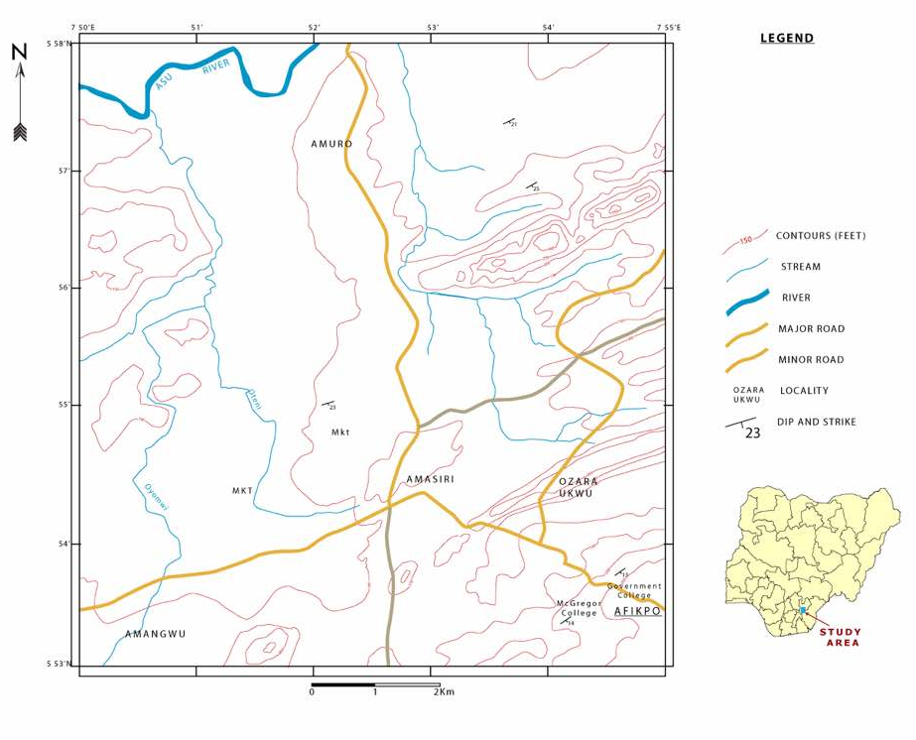
Fig 1.0 Topographic Map of Amuro and its Environs

1.3.1 Accessibility
Fig 1.0 Accessibility Map of Amuro and Environs
The primary access was through either the Amasiri-Akaeze road or the Abakiliki-Afikpo express road. Other accesses to the field area mapped are through minor roads and footpaths linking the various towns and communities around the area.
1.3.2 Geomorphology of the Area
Geomorphologically, the study area is undulating, composed of alternating highlands and lowlands with some of the low lands being occupied by surface water bodies.
The highlands are mainly the ridges and hills which are made up mainly of sandstone lithology with minor silt stones/mud stones and clay stones which serve as cementing material that bind the quartz grains. Shales and some silt stones usually underlie the lower areas. On a regional scale, Amuro and its environs is in a sub-basin but in terms of local topography is commonly undulating.
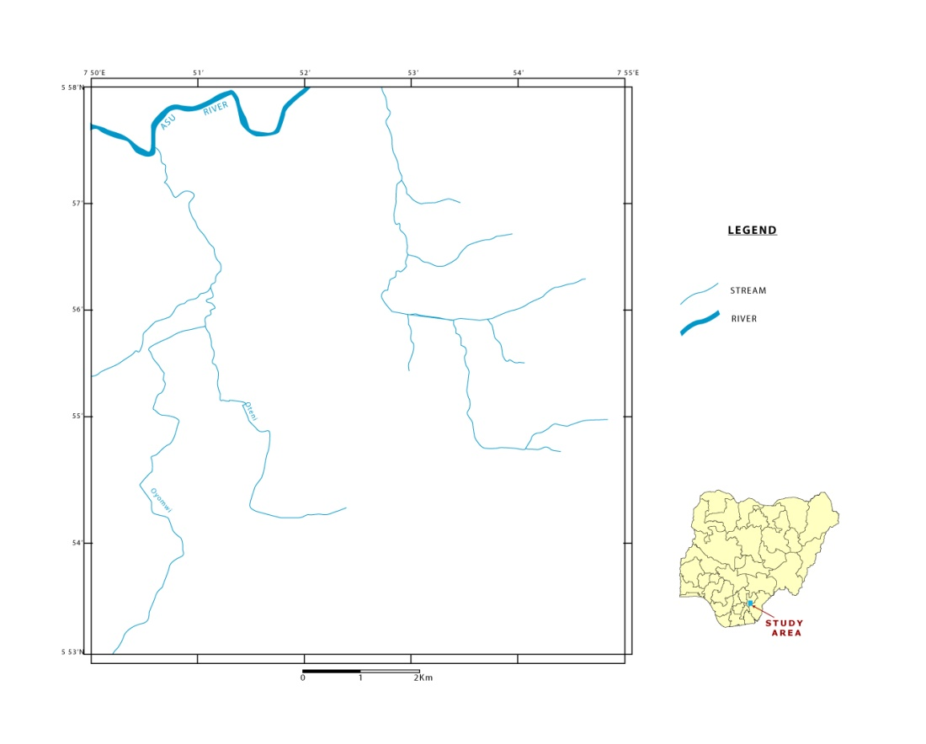
1.3.3 Drainage

Fig 1.1 Drainage Map of Amuro and its Environs
The drainage of the study area is controlled by relief, topography and geology. The drainage pattern of the study area is dentritic (tree-like pattern). Some of the streams are seasonal due to the fact that they dry up during the dry season and are restored during the rainy season.
1.3.4 Vegetation
Amuro and its environs are in transition between the tropical rain forest and guinea savannah. The field area comprises mostly of perennial trees, grasses, shrubs and climbers. Its vegetation is affected by various factors such as:
- Human activities
- Annual rainfall
- Topography, and various climatic factors
The valley terrain produces thick, green vegetation even during the dry season due to availability of surface water caused by the shale which does not permit water to percolate deep into the soil, while partially withered grasses are found in the hills.
1.3.5 Climate
The prevailing climate is typically tropical, with an average temperature of 25⁰C and average rainfall of about 200cm and 250cm (Offodile, 1992); though the temperature may be higher than 25⁰C during harmattan season. The climate is marked by 2 seasons:
- Rainy season (from September to mid-October with a peak period at the end of September)
- Dry season (from April to September)

CHAPTER TWO
LITERATURE REVIEW
2.0 Previous geologic works
The Afikpo area has been studied by various outstanding geologists such as Simpson (1955), Nwachukwu (1972), Murat (1972) Hogue (1977), etc.
Murat (1970) remarked three tectonic phases and epirogenic sedimentary cycle in Nigeria that affected the Benue Trough. In Southern Nigeria, sedimentation started with the formation of the North-East Benue Abakiliki Trough during the opening of the Atlantic Ocean and the separation of African Plate from the South American plate, during this period, shelf deposit were laid down on the Anambra Platform. The Santonian compression movement by Murat (second tectonic phase) probably folded the sediments in the Southern Benue Trough near the eastern flank, into a series of North-East trending folds which now constitute the Abakiliki Anticlinorium. Nwachukwu (1972) suggested that the sandstone in the study area is characterized by imprints of tectonic deformation with major unconformities marking the contact between some of the lithologic contacts.
Hogue (1977) established that the Eze-Aku group conformably overlain by the Awgu Shale and on the South-Eastern part of the Afikpo syncline which overlain unconformably by the Afikpo sandstone. He observed that the sands are made up of texturally and mineralogically immature feldsparthoid arenites.
Simpson (1955) noticed that the high angle of dip in the Eze-Aku was as a result of the Post-Turonian tectonic event which affected the Pre-Turonian units including the Eze-Aku Group. Ezepue (1984) established that a dolerite sill intruded the Eze-Aku Group. The Afikpo basin was formed during the Santonian orogeny in the upper cretaceous time (Campanian Maastrictian). Some of the research works on Afikpo where carried by notable researchers like; Rayment (1965), C.S. Nwajide (1976), Mckay (1939) among others. Majority of the shale’s and silt stone sediments are carbonaceous while majority of the sediments were sand stone deposits which changes from calcerous sand stone along the Abakaliki anticlinorium to arenaceous sandstone towards the core of the basin. They also observed that an igneous intrusion occurred along the axis of the Abakaliki anticlinorium which is dated to be about 55 million years. Also (Mckay, 1939) dated the age of Afikpo synclinorium to be mid Cretaceous based on the observation made and the outcome from the structural and lithological difference that exist between Amasiri and Afikpo sand stone. The santonian event on the region resulted in fracturing and folding of the post santonian sediment found on the Afikpo synclinorium.
2.1 Geographical setting
Fig 2.0 Map of South Eastern Nigeria showing the Physical features (after Ofomata, 1975)

2.2 Regional geology of the Area
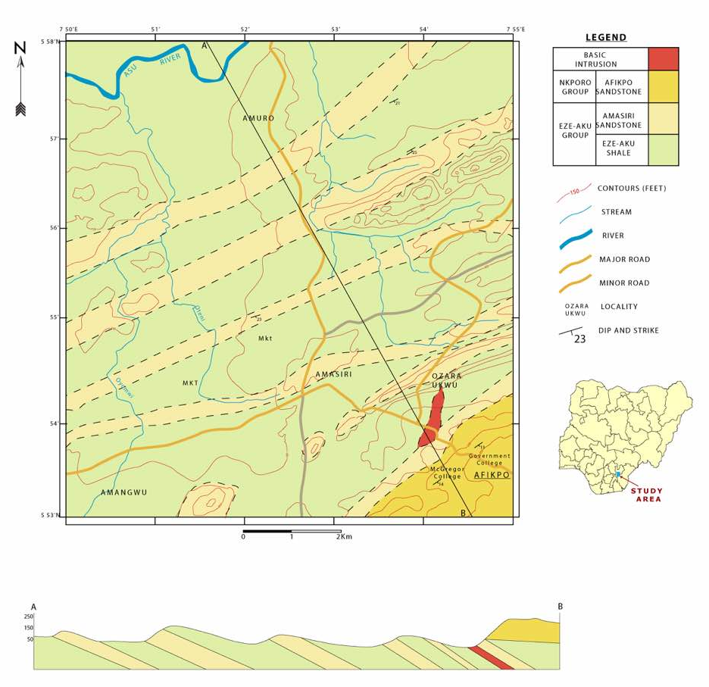
Fig 2.1 Geologic Map of Amuro and Its Environs

There has been a lot of argument among researchers and geologist for several years about the origin and evolution of Benue trough. Benue trough was under a tensional regime from the time when it originated as the failed arm of an RRR triple junction (Burke et al; 1970). Benue trough has often been described as elongate, partly fault- bounded depression occupied by up to 6,000m of marine and fluvideltaic sediments that have been compressionally folded in a non-orogenic shield environment. Might (1976), Olade (1975, 1976) emphasizes the wholly ensiabic nature of the trough, the thinned crust beneath it, and the dominant influence of vertical movement as causes of the folding. They conceded that the weight of evidence may eventually prove that the folding was in fact due to compressional movements, albeit accompanying broad regional uplift of the “Guinea dome” (Olade 1975), but Wright (1968), proved it wrong. So there is no obvious cause of the necessary compression movements.
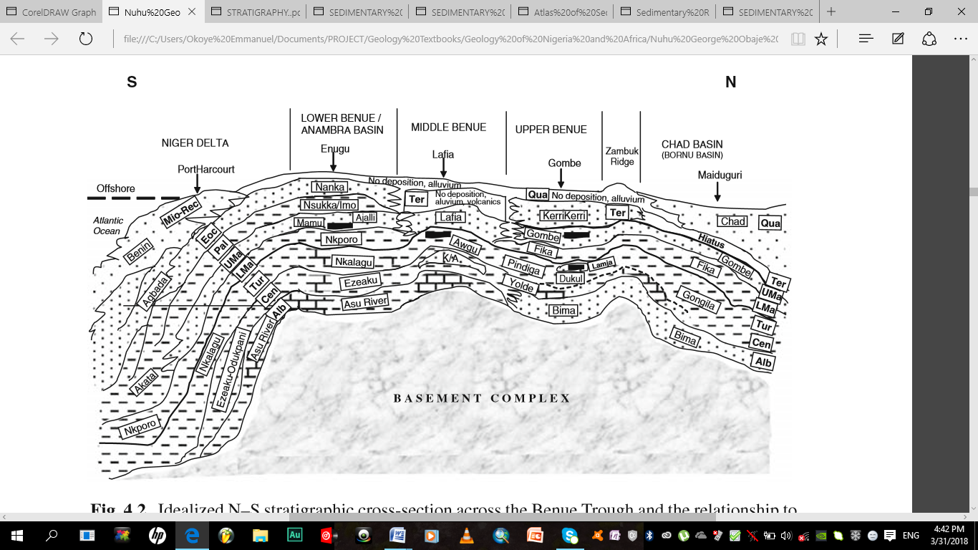
2.3 Brief history of the Benue Trough
Fig 2.2 Idealized North-South stratigraphic cross section across the Benue Trough and the relationship to the Niger Delta and Chad Basin (Vertical scale exaggerated; erosion and uplift not considered (Nuhu George Obaje, 2009)

The Benue Trough of Nigeria is a rift basin in central West Africa that extends NNE–SSW for about 800 km in length and 150 km in width. The southern limit is the northern boundary of the Niger Delta, while the northern limit is the southern boundary of the Chad Basin. The trough contains up to 6,000 m of Cretaceous – Tertiary sediments of which those predating the mid-Santonian have been compressionally folded, faulted, and uplifted in several places. Compressional folding during the mid-Santonian tectonic episode affected the whole of the Benue Trough and was quite intense, producing over 100 anticlines and synclines (Benkhelil, 1989). Some of such deformational structures include the Abakaliki anticlinorium and the Aﬁkpo syncline in the Lower Benue, the Giza anticline and the Obi syncline in the Middle Benue, and the Lamurde anticline and the Dadiya syncline in the Upper Benue Trough. Following mid-Santonian tectonism and magmatism, depositional axis in the Benue Trough was displaced westward resulting in subsidence of the Anambra Basin. The Anambra Basin, therefore, is a part of the Lower Benue Trough containing post-deformational sediments of Campanian-Maastrichtian to Eocene ages. It is logical to include the Anambra Basin in the Benue Trough, being a related structure that developed after the compressional stage (Akande and Erdtmann, 1998). The Benue Trough is arbitrarily subdivided into a lower, middle and upper portion (Fig 2.2). No concrete line of subdivision can be drawn to demarcate the individual portions, but major localities (towns/settlements) that constitute the depocentres of the different portions have been well documented (Petters, 1982; Nwajide, 1990; Idowu and Ekweozor, 1993; Obaje et al., 1999). The depocentres of the Lower Benue Trough comprise mainly the areas around Nkalagu and Abakaliki, while those of the Anambra Basin centre around Enugu, Awka and Okigwe. The Middle Benue Trough comprises the areas from Makurdi through Yandev, Laﬁa, Obi, Jangwa to Wukari. In the Upper Benue Trough, the depocenters comprise Pindiga, Gombe, Nafada, Ashaka (in the Gongola Arm) and Bambam, Tula, Jessu, Lakun, and Numan in the Yola Arm.
2.4 Lithostratigraphic Setting
Stratigraphic division of the units have evolved from the earlier works of Reyment to the more recent and detailed classifications of Ojoh (1992). Nwajide (2013) has urged for caution in the adoption of novel stratigraphic divisions as in the naming stratigraphic units, the law of precedence has to be taken into consideration. Also these proposed units are yet to be outlined on regional geologic maps. The geology of the Benue trough, in which the study area falls can best be described within the megatectonic framework proposed by Murat (1972). In the Albian to Santonian phase, the depositional centre was the NE-SW trending Abakaliki-Benue Trough. This graben like structure was flanked by the wide Anambra platform to the east and the Ikpe platform to the southwest. Here shelf deposits were laid down under different conditions for both platforms (Ojoh, 1992). With the folding of the southern Benue trough into the Abakaliki anticlinorium and the Afikpo and Anambra synclines deposition shifted to the south-eastern, southern and western flanks of the Structure which make up the Anambra basin.

2.5 Asu River Group
The existence of arkosic, non-fossiliferous conglomerates have been acknowledged from outcrops at Ogoja and Ikom and from geophysical data (Ojoh, 1992). They are named the Ogoja Sandstone (Nwajide, 2013) and are believed to be of pre-Middle Albian age, probably related to the earliest stages of the basin’s formation. The Ogoja sandstone is a lateral equivalent of the basal conglomeritic Awi Formation in the Calabar flank. This basal unit directly overlies the Basement complex (The Oban Massif).
The Albian sediments associated with the marine transgression in the area were described by first by Shell D’Arcy geologists (1957) and Reyment (1965) as the Asu River Group consisting of shale with sandy limestones and sandstones. Ojoh (1992) did a more detailed description of the group and divided it into three formations ranging from middle Albian to the lower Cenomanian. His middle Albian Ekebeligwe Formation was interpreted from the presence of mega slumps and turbidites and from the foraminifera and ammonite assemblages to have formed in a deep marine asymmetrical turbidite basin (Ojoh, 1992).
The Upper Albian is named as the Ngbo Formation which is sandier and changes from shelf to near shore environment implying regression. The rock units of this age show volcano-sedimentary tendencies due to the presence of sub-aerial and submarine volcanic eruptions during this period. Ojoh (1992) from the presence of the pollen and spores also established the presence of the Cenomanian units as part of the Asu River group. The upper sandstones of the Asu River Group, the Ibir and Agala Formations are part of the Asu River group. They mark a period of lowstand sea levels marked by extensive continental deposits in the middle and Benue trough (Offodile, 1976).
2.6 Eze-Aku Group
Marine shales outcropping at Ezillo originally classified as part of the Eze-aku Shale facies were also discovered to be of late Cenomanian age. They mark the start of a very extensive transgression which peaked in the lower Turonian with the first transcontinental connection of the Tethys Ocean (present day Mediterranean Sea) with the Atlantic Ocean through the Benue trough. The Turonian also marks beginning of subsidence on the western shelf of the lower Benue trough and a shift in the depocentre towards the west (the Anambra basin) (Ojoh, 1992). The occurrence of the Cenomanian was characterized by the shallow marine Odukpani Formation (now considered defunct according to Nwajide, (2013)) consisting of sandstones, shales and limestones of shallow marine shelf environment found in the Calabar flank of the basin (Kogbe, 1989; Reyment, 1965). The alleged absence of Cenomanian in the Abakaliki basin had been attributed to a possibly slight folding phase (Amajor, 1985; Nwachukwu, 1972). It has already been mentioned that the Agala and Ibir Formations are known to be Cenomanian and the absence of extensive marine deposition in the Cenomanian is related to a regression as a result of a fall in sea level and not as a result of an inferred folding episode (Nwajide, 2013; Ojoh, 1992).
In the southern Benue trough, black shales with limestone and calcareous sandstones occur (Nwajide, 2013; Odigi & Amajor, 2009b; Ojoh, 1992; Umeji, 1993). The eastern flank of the anticlinorium the Eze-Aku Group is represented by grey to black shales and linear ridges of sandstones termed the Amasiri Sandstones ranging from the upper Cenomanian to possibly as late as the Coniacian (Amajor, 1987; Banerjee, 1980; Umeji, 1981, 1993).
2.7 Awgu Group
The Late Turonian- Coniacian records the beginning of the regression that culminated in the uplift that ended the 1st tectonic phase. Marine deposition continued on the now subsiding western shelf with the Agwu Formation (Kogbe, 1989; Nwajide, 2013; Reyment, 1965) and the Nkalagu Formation (Ojoh, 1992) were deposited. In the late Coniacian to Early Santonian, a large deltaic complex developed on the Anambra platform; the Agbani Formation whose deposits were also encountered in Shell BP wells below the later Anambra basin deposits (Murat, 1972). The Awgu is absent on the eastern flank of the anticlinorium. There is some evidence though that some of the uppermost units of the Eze Aku group in the study area may actually be of Coniacian age. But this is yet to be verified by paleontological evidence.

2.8 Anambra Basin
Fig 2.3 Geological Sketch Map of the Anambra Basin (Nuhu George Obaje, 2009)

The Santonian period was one of tectonism and structural inversion which, along with intense magmatism and regional metamorphism uplifted and exposed the central core of the Lower Benue basin and created the Abakaliki anticlinorium and the flanking Anambra and Afikpo synclines. The depocentre was shifted to the West, south and extreme southeast of the Abakaliki anticlinorium.
The Nkporo Shale Formation consists of dark grey shales with thin layers of sandstones and limestone (Nwajide, 2013; Obi & Okogbue, 2004; Oboh-Ikuenobe et al, 2005; Reijers & Nwajide, 1998). In the Afikpo Syncline the Afikpo Sandstone Formation is consisting of pebbly, clayey, crossbedded and highly bioturbated sandstones interbedded with thin siltstones. Ojoh (1992) suggests, from palynological evidence that deposition actually began in the Santonian period probably contemporaneous with the uplift and structural inversion. The Enugu Formation consists of black carbonaceous shales interbedded with thin layers of sandstone and siltstone with abundant plant debris deposited in a coastal swamp environment. The last member of the group is the fluviatile Owelli Sandstone Formation formed from short rivers that flowed onto the shelf area (Obi & Okogbue, 2004; Oboh-Ikuenobe et al., 2005; Reijers & Nwajide, 1998). In the Maastrichtian stage a period of regression led to the deposition of the paralic Mamu Formation consisting of shales, heterolith, sandstone and coals. This formation is the major stratigraphic unit that forms the Enugu cuesta (Nwajide & Reijers, 1996). The Ajali Sandstone Formation lies conformably on the Mamu Formation. It consists of characteristically friable cross-bedded sandstones with a virtual absence of clay. It marks the height of the regression which ended the Nkporo depositional cycle. The youngest unit of the Anambra basin is the Nsukka Formation whose lithology is similar to Mamu Formation (shales, siltstones, heterolith, sandstone and coals) and whose age ranges from the later Maastrichtian to the Danian.

Fig 2.4 Stratigraphic successions in the Anambra Basin (Nuhu George Obaje, 2009)

2.9 The Nkporo Group
In the Campanian the deposits that form the Nkporo Group were deposited. The Nkporo group comprises the Nkporo Shale, the Afikpo Sandstone, the Enugu Shale and Owelli Sandstone. The sandstones were the off lap counterparts of the shales. The Tertiary sequences were assigned to the Niger Delta sedimentary basin (Nwajide, 2006).
The Turonian Eze-Aku Formation overlies the Albian Asu-River Group and unconformably underlies the Nkporo Group (Campano-Maastrichtia) in Afikpo Synclinorium. The type locality is the Eze-Aku River valley in southeastern Nigeria. The formation consists of hard grey to black shales and siltstones with frequent facies changes, to sandstones or sandy shales. The thickness varies, but may attain 100 meters in some places (Reyment, 1965). Locally, the outcrops of this sequence are seen at Amasiri “Amasiri Sandstone”, Egede-Olu (South of Otukpo), Nkalagu, Ezillo, Ugep, with its lateral equivalence is the Markurdi Formation. The Eze-Aku formation is of shallow Marine deposit.

Fig. 2.5 Stratigraphic successions in the Benue Trough and the Nigerian sector of the Chad Basin (Nuhu George Obaje, 2009)

CHAPTER THREE
METHODOLOGY AND MATERIALS USED
3.0 Introduction
This involves four stages; Desk work, Reconnaissance, field work and laboratory work and analysis.
- Desk work: This research stage is basically the research work done on the study area that has been earlier carried out so as to help aid a better understanding of the nature of research that will be carried out later on the area. This constitutes the early or initial part of the project.
- Reconnaissance: At this stage the topographical map was used in the survey area, the physical features were observed, drainage pattern, nature, and trends of outcrops, the lithologic units, vegetation variation and positions of contacts were also observed, a based camp which will be used later during the actual field map was located and field guards were met and introduced to, letters were given to the heads of the villages in the area, the D.P.O and security agents for security reasons.
- Field work: At this stage outcrops were located , observed and the position using the geographic positioning system (GPS) which was followed by describing the outcrop based on the rock types present, lateral extent, gross thickness, bed thickness, textural features. Sedimentary structures and tectonic structures as well as biogenic structure. The outcrop/exposure is logged and during the study samples were collected and properly labeled as well as photographs of the outcrops and important features was taken for reference purposes.
- Laboratory work and analysis: Samples were collected from outcrops and were sent into laboratory research for proper analysis. This form the most tedious aspect/ stage of the project and the last part of it.

3.1 Work Flow
My project research work began with desk study, reviewing the literature of the area and reconnaissance survey to determine the accessible routes and to familiarize with the area. The base map was gridded and traverse method was employed during the detailed mapping. The traverse was taken along the main road, footpath, the stream and the river channel. Contacts were delineated using lithologic difference. The detailed mapping includes the measurement of strikes and dip of the formation, descriptions of the rock unit and delineation of its contacts using lithologic difference; study of the rock type and sample collection. Strike and dip of bed were measured and carefully plotted into the map with the aid of a protractor, ruler and pencil. Important geological features were photographed and fresh rock samples were collected for further analysis. Geomorphologic features such as relief and drainage were noted. During the mapping, the technique adopted was the use of global positioning system, compass and traverse method in which distance between locations were estimated on the map. The mapping exercise was done with the help of the geological materials and equipments.
The field mapping commenced on Monday 9th of April and was completed on Sunday 15th of April, 2018. My supervisor arrived Tuesday 17th of April and corrected all errors I encountered during my mapping. He showed me places to remap in other to reduce all possible errors. The main aim and objectives of the field mapping exercise which was carried out was to:
- Locate and record good exposures of rock in the study area.
- To delineate contacts in the study area.
- To record various attitudes of beds that is the strike and dip of various outcrops in the study area.
- To measure and record various structural features and geologic successions in the study area.
3.2 Equipments Used
The various geologic equipments which were used to carry out the field mapping are as follows:
- Brunton compass: The Brunton Compass is a necessary measuring instrument for geologic survey. It was used during the field mapping exercise for determining directions and for measuring the strike and dip of various outcrops, the Clinometer which is located inside the compass was used to measure inclinations.
Fig 3.0 Brunton Compass

- Tape: The measuring tape is used to take accurate measurements of the vertical and horizontal distance of outcrops in the field for accuracy. It is also used to measure the stratigraphic sequence of outcrop that is stratified.
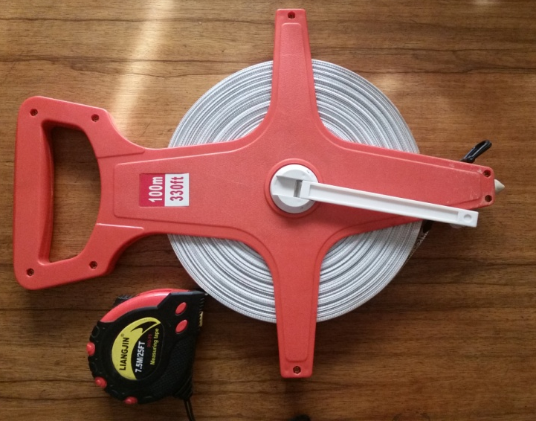
Fig 3.1 Measuring Tapes

- Topographical Map: It was used for easy access to the study area. It was also used as guide during the field mapping.
Fig 3.2 Topographical Map

- Hand lens: It was used to make the first analysis of rock samples in the field, analysis which involved all the properties of the sample such as rock type, color, texture, identifiable mineralogy, alteration as well as the physical properties such as folding foliations, intrusions, layering etc.
Fig 3.3 Hand Lens

- Geologic hammer: The use of the geologic hammer cannot be overemphasized; it was used to hit rock outcrops and to collect samples with its sharp head.
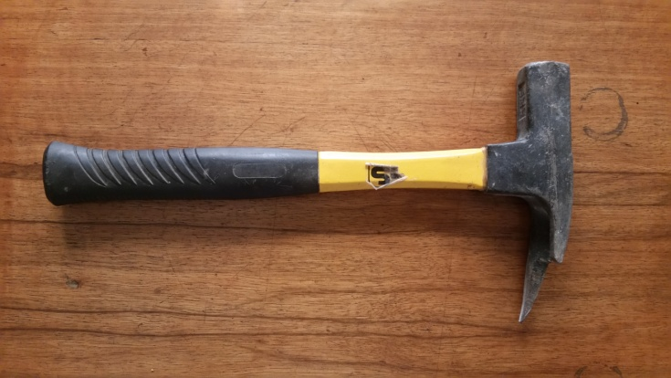
Fig 3.4 Geologic Hammer

- Sledge Hammer: This does almost the same job with the geologic hammer, but tends to be much longer than the geologic hammer. The head weighs about 8.0Lb and Length of 0.7m. It is used to hit very hard rocks in the field.
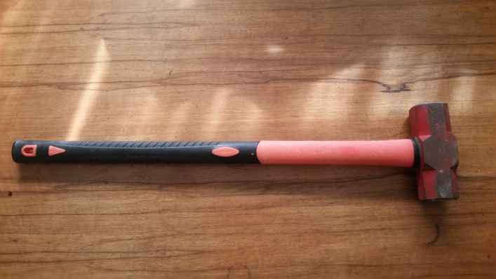
Fig 3.5 Sledge Hammer

- Sample Bag: Sample bags are used to put freshly collected samples in other to protect the sample from contamination and a label tag used to write the sample number and location where the sample was gotten.
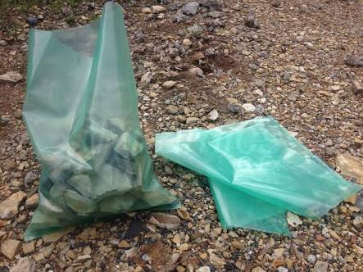
Fig 3.6 Sample Bag

- G.P.S (Geographic Positioning System): This is a satellite based navigation system which was used in finding ones position in the field, mapping lithologies, tracking structures, measuring elevation, storing sampling points and description of formations when samples are collected.
Fig 3.7 Global Positioning System (GPS)

- Geologic Field Bag: A geologic field bag is used to put geologic equipments such as the geologic hammer, GPS, Brunton compass, field note book, freshly collected samples and other equipments in other to keep it safe from rain and other hazards.
Fig 3.8 Geologic Field Bag

- Field notebook: All important observations were recorded in a concise, orderly and legible manner using the field notebook.

Fig 3.9 Field Notebook

- Marker and masking tape: They masking tape was used in wrapping the samples and the marker was used for writing the locations of where the samples were gotten from.

Fig 3.10 Masking tape and Marker

- Pen and Pencils: The pen was used for recording information, while the pencil is used for sketching or drawing outcrop.

Fig 3.11 Pen and Pencils

CHAPTER FOUR
DESCRIPTIVE ANALYSIS OF MAPPED LITHOLOGIC UNIT
4.0 Introduction
The stratigraphy of the study area consists of Asu-River Group and Eze-Aku formation which were deposited in alternating transgressive and regressive phases. The Asu-River Group, consist of shale, sandstone and limestone. It is the oldest lithostratigraphic unit in the area and was deposited during the Albian transgressive phase. It is also the oldest dated sedimentary rock unit in southern Benue Trough (Whiteman, 1982).
The Amuro environment is made up of two prominent lithologic units which are the Amuro shale and the Amuro sandstone. The Amuro shale is the youngest unit in the Asu river group, and it is unconformably overlain by the oldest Eze-Aku unit. The shale is fissile and grey in colour except it assumes reddish-brown to dirty brown colours when weathered.
4.1 Locations mapped and Data Recorded
From the Topographical Map given, three prominent towns were identified;
- Amuro
- Amasiri
- Ozara-Ukwu
Out of these three towns nine (9) Locations were mapped.

- Location 1 – Crush Stone Quarry at Amasiri development Centre, Afikpo North L.G.A.
The sample gotten is sandstone. It is been quarried by the company and sold to road contractor for road construction and for other economic uses.

Fig 4.0 Sandstone outcrop at Crush Stone Quarry at Amasiri development Centre, Afikpo North L.G.A.

Table 1: Data Recorded from Crush Stone Quarry at Amasiri development Centre, Afikpo North L.G.A.
+  Strike Direction | Dip Direction | Dip Amount | G.P.S  Coordinate |  | Elevation  (Metres) | Vegetation | Drainage
05⁰N 185⁰S | 195⁰SW | 3⁰ | Longitude | Latitude | 26 m | Sparsely Vegetated | ____
 |  |  | N05⁰55.987 | E007⁰53.200

- Location 2 – Otueja Opposite Ezeke Modern Primary School, Amuro-Ndukwe
The prominent lithology of this area is shale and it tends to be fissile and grey in colour.
Fig 4.1 Shale outcrop unit at Otueja Opposite Ezeke Modern Primary School, Amuro-Ndukwe.

Table 2: Data Recorded from Otueja Opposite Ezeke Modern Primary School, Amuro-Ndukwe
Strike Direction | Dip Direction | Dip Amount | G.P.S  Coordinate |  | Elevation  (Metres) | Vegetation | Drainage
350⁰NW 173⁰S | 224⁰SW | 2⁰ | Longitude | Latitude | 36 m | Sparsely Vegetated | ____
 |  |  | N05⁰55.649 | E007⁰53.009
- Location 3 – Amasiri Express Road close to Naira and Kobo Hotel few metres away from the Army check point.
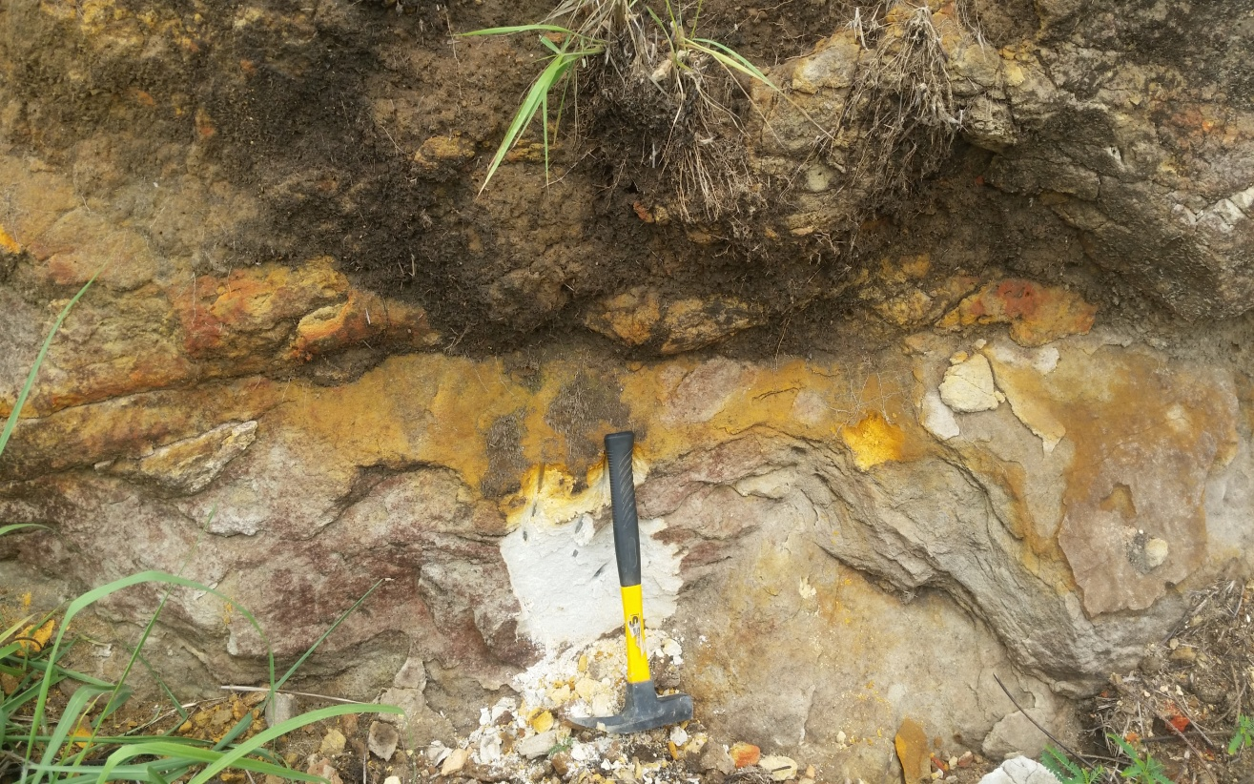
Here the outcrop is of sand stone. The base is fine grained. This location is densely vegetated.

Fig 4.2 Sandstone Outcrop at Amasiri Express Road close to Naira and Kobo Hotel few metres away from the Army check point

0.9m
Over Burden
Fined Grained

Yellow to white Colouration
0.76m
White in Colour
0.40m
Fined Grained

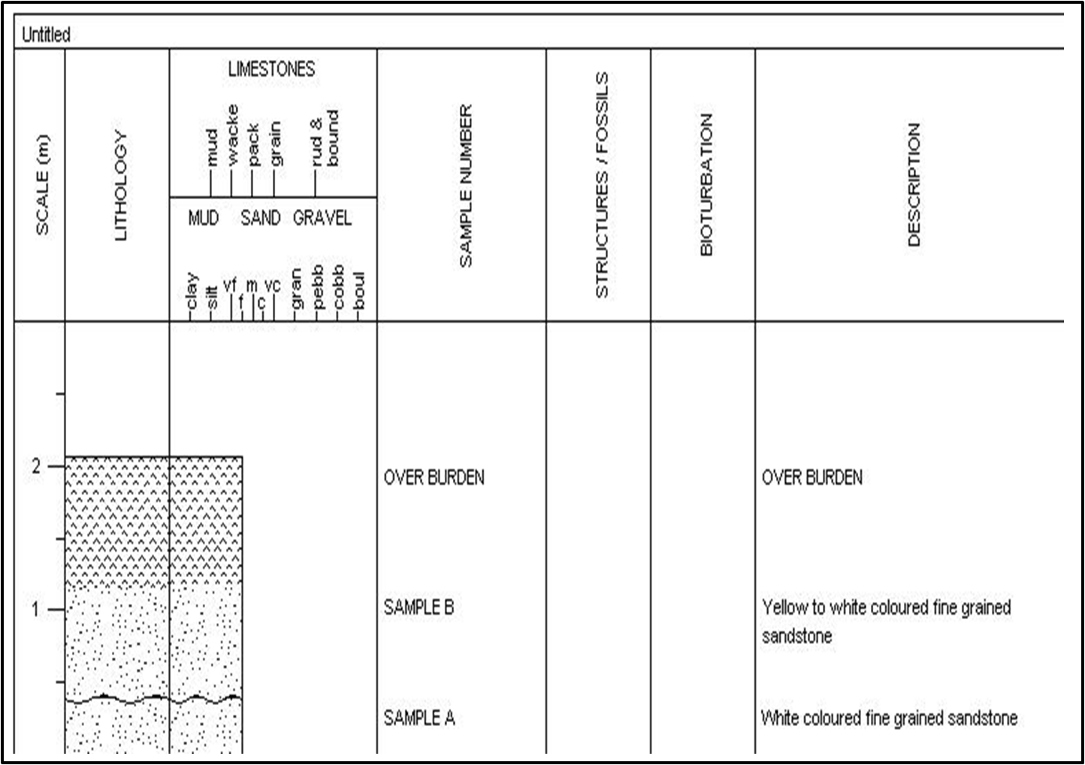
Location 3
Table 3: Data Recorded from Amasiri Express Road close to Naira and Kobo Hotel few metres away from the Army check point
Strike Direction | Dip Direction | Dip Amount | G.P.S  Coordinate |  | Elevation  (Metres) | Vegetation | Drainage
236⁰SW 64⁰NE | 235⁰SW | 4⁰ | Longitude | Latitude | 46 m | Densely vegetated | ____
 |  |  | N05⁰54.320 | E007⁰54.038

- Location 4 – Dolerite Ridge Opposite the Timber Shade
Here the Presence of intrusive Igneous rock (Dolerite) was seen. The dolerite intruded into the Amasiri Sandstone. The dolerite has a characteristic of ophitic texture as well as spheroidal weathering characteristic with a black colour.

Fig 4.3 Dolerite Outcrop opposite the Timber Shade

Table 4: Data Recorded from the Dolerite Ridge Opposite the Timber Shade, Afikpo
Strike Direction | Dip Direction | Dip Amount | G.P.S  Coordinate |  | Elevation  (Metres) | Vegetation | Drainage
259⁰SW 80⁰NE | 258⁰SW | 2⁰ | Longitude | Latitude | 42 m | Densely vegetated | ____
 |  |  | N05⁰53.980 | E007⁰54.591

- Location 5 – Mc Gregor Hill Opposite Mc Gregor Hill Block Industry, Afikpo
Here the exposure is of sandstone. The contacts between the layers are grey in colour and are erosional. It is moderately sorted and of coarse upward sequence. The base unit is pebbly. This location has presence of Ophiomorpha fossils. Here samples D, E and F were not to our reach due to the height of the outcrop but its value was estimated.

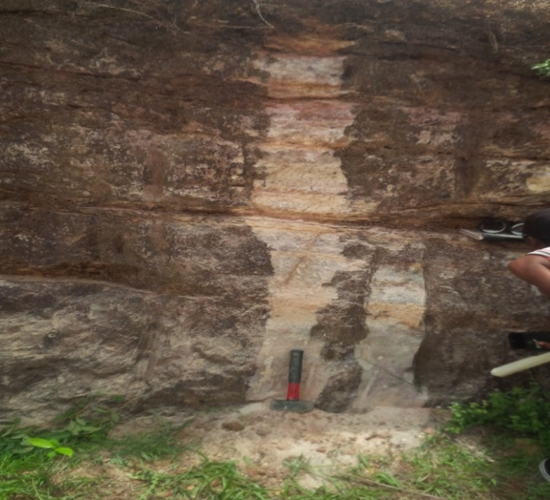

Fig 4.4 Sandstone Outcrop at Mc Gregor Hill Opposite Mc Gregor Hill Block Industry, Afikpo
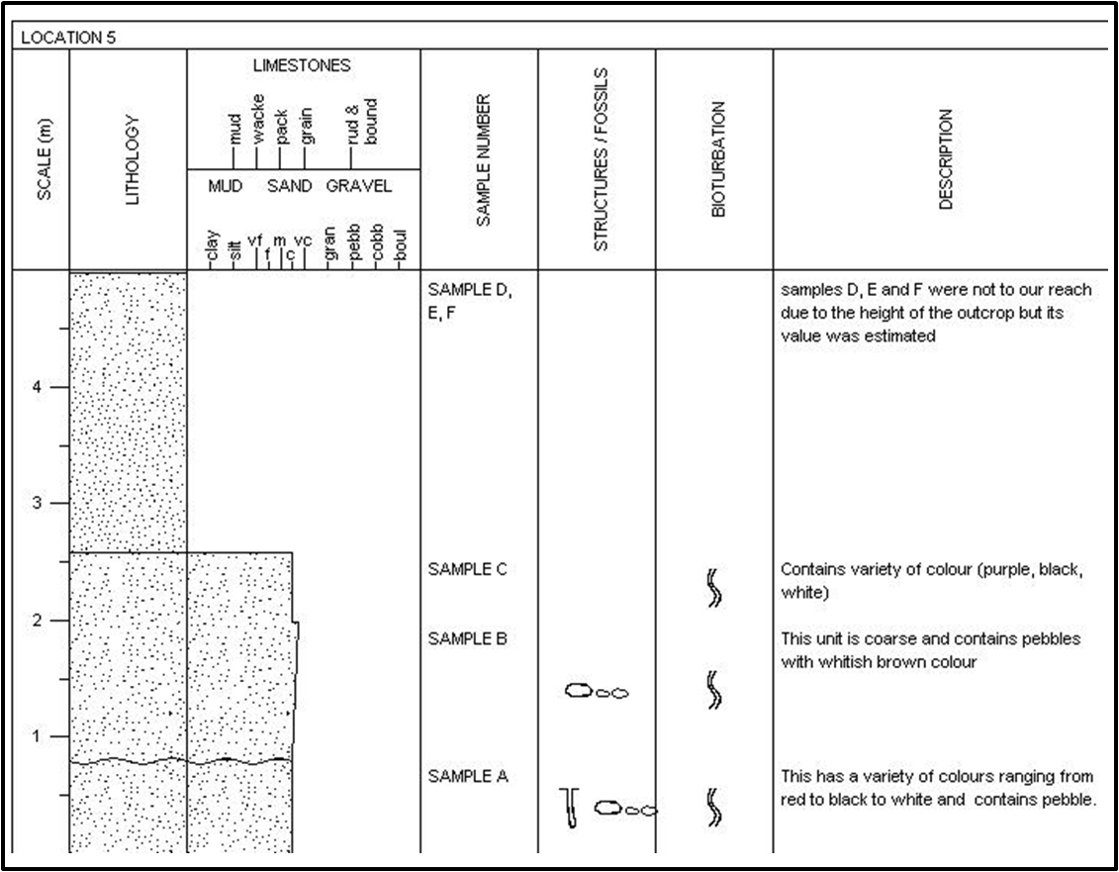
Table 5: Data Recorded from Mc Gregor Hill Opposite Mc Gregor Hill Block Industry, Afikpo
Strike Direction | Dip Direction | Dip Amount | G.P.S  Coordinate |  | Elevation  (Metres) | Vegetation | Drainage
240⁰SW 58⁰NE | 58⁰NE | 4⁰ | Longitude | Latitude | 95 m | sparsely vegetated | ____
 |  |  | N05⁰53.634 | E007⁰55.097

- Location 6 – Mc Gregor Hill 300 metres away from Mc Gregor Hill Block Industry, Afikpo
Here the outcrop is of sand stone. The base is coarse grained followed by medium grained then the subsequent units above are fined grained. They contain some notable trace fossils (few burrows) and the base is also laminated.
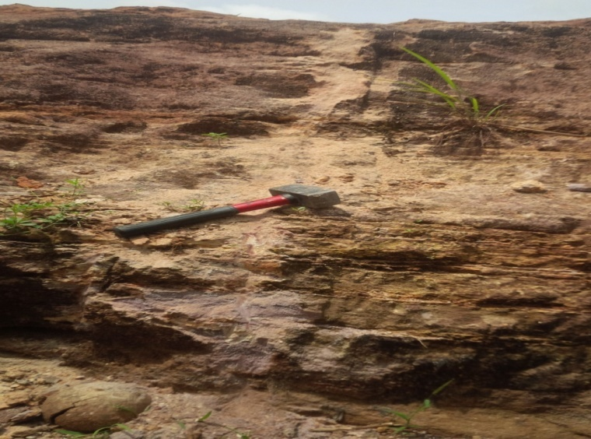
Burrows
Fracture
Laminated sandstone
Burrows
Fig 4.5 Sandstone Outcrop at Mc Gregor Hill 300 metres away from Mc Gregor Hill Block Industry, Afikpo

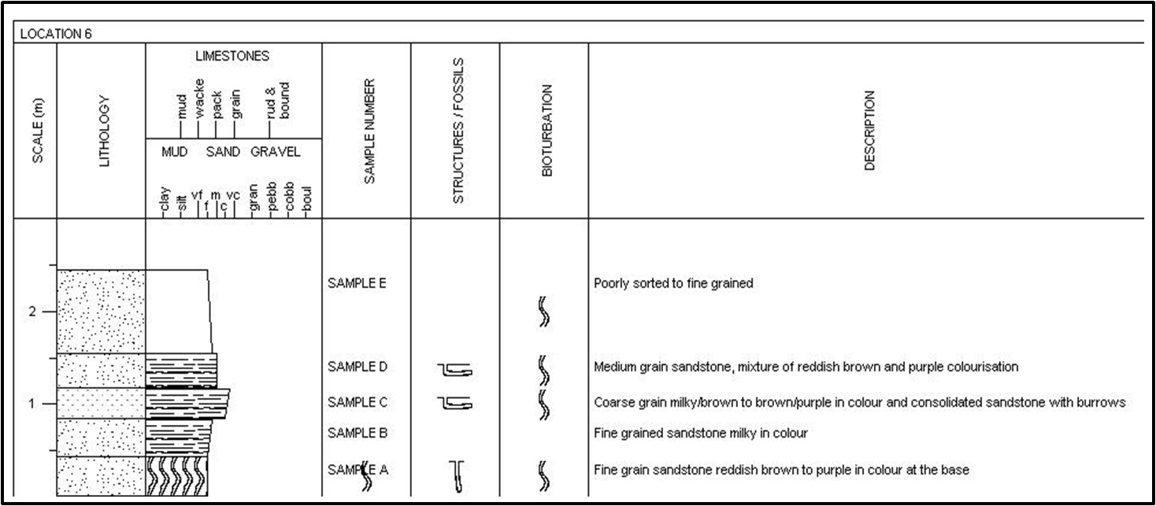
Coarse grained sandstone milky in colour
Coarse grained sandstone reddish brown to purple at the base
Table 6: Data Recorded from Mc Gregor Hill 300 metres away from Mc Gregor Hill Block Industry, Afikpo
Strike Direction | Dip Direction | Dip Amount | G.P.S  Coordinate |  | Elevation  (Metres) | Vegetation | Drainage
139⁰SE 318⁰NW | 138⁰SE | 2⁰ | Longitude | Latitude | 65 m | sparsely vegetated | ____
 |  |  | N05⁰53.751 | E007⁰55.873

- Location 7 – Outcrop Located at Akpoha Express Road.
Here the outcrop is sandstone and it is located on a hill with white colouration at the base and yellowish colour at the top. It is surrounded by vegetation and its surface is weathered. It has presence of pebbles and ripple mark features on the base and does not possess such feature at the top. It is moderately vegetated, that is to say that it is at intermediate level.

Fig 4.6 Sandstone Outcrop Located at Akpoha Express Road

Table 7: Data Recorded from Outcrop Located at Akpoha Express Road
Strike Direction | Dip Direction | Dip Amount | G.P.S  Coordinate |  | Elevation  (Metres) | Vegetation | Drainage
15⁰SE 196⁰SW | 195⁰SW | 2⁰ | Longitude | Latitude | 53 m | Moderately vegetated | ____
 |  |  | N05⁰54.82 | E007⁰53.339

- Location 8 – Gorogoro Local Quarry along Ibi Express road before Ozaraukwu
Here the rock is of igneous origin of economic importance. The rock according to a local miner is used for making cement, for building, road construction.

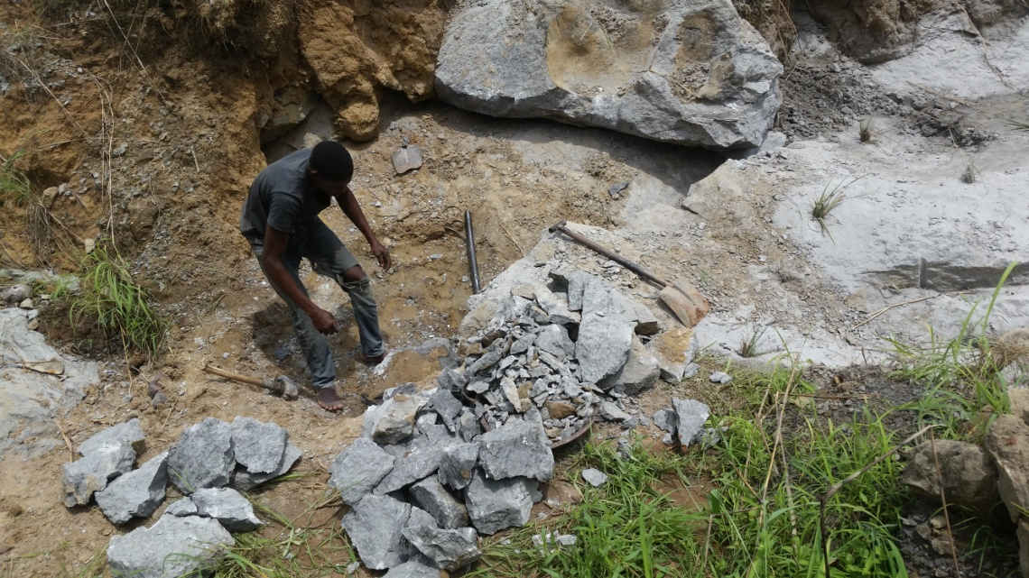
Fig 4.7 The outcrop Located at Gorogoro Local Mine pit along Ibi Express road before Ozaraukwu

Table 8: Data Recorded from Gorogoro Local Quarry along Ibi Express road before Ozaraukwu
Strike Direction | Dip Direction | Dip Amount | G.P.S  Coordinate |  | Elevation  (Metres) | Vegetation | Drainage
350⁰NW 172⁰SE | 341⁰NW | 3⁰ | Longitude | Latitude | 61 m | Densely vegetated | ____
 |  |  | N05⁰54.743 | E007⁰54.617

- Location 9 – Ozara-Ukwu Quarry Site.
This outcrop is Diorite. It is the diorite sill that intruded the sedimentary formation. It is an intrusive igneous which is overlain by mudstone. The colouration difference is due to the unconformity present in the Abakiliki formation. The Fracture in the exposure has been in existence.

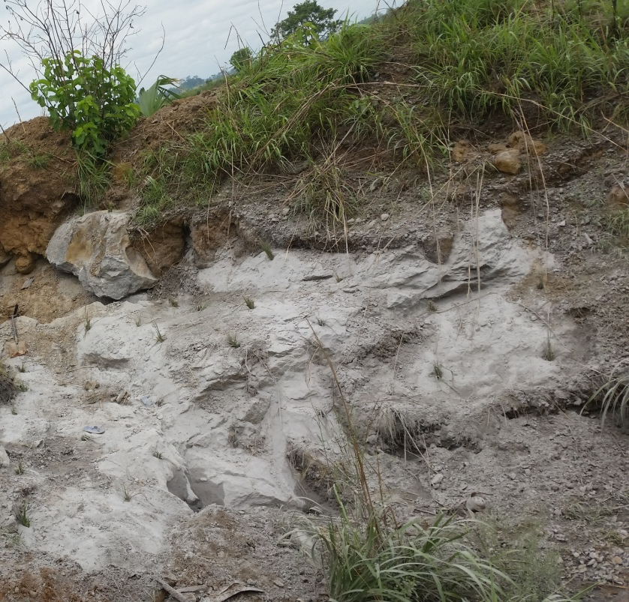
Fig 4.8 Diorite outcrop from Ozara-Ukwu Quarry Site

Table 9: Data Recorded from Ozara-Ukwu Quarry Site
Strike Direction | Dip Direction | Dip Amount | G.P.S  Coordinate |  | Elevation  (Metres) | Vegetation | Drainage
295⁰NW 114⁰SE | 115⁰SE | 4⁰ | Longitude | Latitude | 50 m | Sparsely vegetated | ____
 |  |  | N05⁰54.714 | E007⁰54.232

CHAPTER FIVE
LABORATORY ANALYSES AND RESULTS
5.0 Method for Analysis: Grain Size Analysis
Grain size is a fundamental descriptive measurement of sediments and sedimentary rocks. Granulometric studies of beach sediments provide the wealth of information on the intrinsic properties of sediments and their depositional environment (Friedman, 1961; Visher, 1969). Udden (1914) documented the hydrodynamic conditions prevailing during deposition of clastic sediments which controls the size and composition of the sediments. He therefore opined that sediments that accumulated under similar environmental condition should have similar grain size distribution.
5.0.1 Objective of the Analysis
The objectives of this study are to describe, compare and interpret the various clastic sedimentary rocks with respect to their grain size distribution. Further, the characteristics of the grain size distribution are related to source materials, process of weathering, abrasion, corrosion and sorting process during the transport and deposition (Rajamanickam and Gujar, 1984). Texture is an important grain size ingredient that provides useful information on mode, extent of transport and environment of deposition of clastic materials, (Mason and Folk, 1958; Friedman, 1961; Visher, 1969). Moreover, the sediments can bestow information about various depositional processes like nature of the particle, mode of weathering and changes that occur during transportation from place to place. We compared the size distribution of the respective clastic rocks by taking their representative samples and run it through a set of sieves to break these sample subsets into different class sizes, and using statistics to reconstruct what the population size characteristics are (Folk, (1974)).
5.0.2 Equipment Used:
The equipments used to run the process are listed below:
- Mechanical Sieve Shaker
- Electronic Weighing Balance/Scale
- ASTM Sieves
- Brush
5.0.3 Procedures:
A representative dried rock sample (unconsolidated) of about 100g was used. The lumpy rock particles were crushed with care in order to disaggregate the lumps. The required amount of rock sample for this analysis is 50g therefore each sample was weighed using the electronic weighing scale then prepared the sieves for the analysis. A set of fifteen clean sieves were used, and this was done by using a dry brush to poke the openings of the sieve, this was to make sure that accurate results were obtained. The sieves were then stacked, placing the sieve with larger openings at the top and the sieves with small openings at the bottom. The sample was placed into the topmost sieve, setting the timer of the mechanical shaker to twenty minutes then switched on the mechanical shaker. The mass of rock sample retained in each sieve was weighed then I tabulated my readings after twenty minutes elapsed. These procedures were undertaken for six more samples and results were also tabulated as shown in table 10-15.
5.0.4 Analysis:
The tabulated retained weights of the respective grain sizes were reduced by correcting the weights and calculate the individual weight percentages as well as their cumulative weight percent. The techniques for reducing and presenting grain-size data include both graphical and statistical or quasistatistical methods. Graphical presentation of grain-size data commonly involves plotting the data on bivariate diagrams in which either individual weight percent of each grain-size class or cumulative weight percent is plotted against phi size, Histograms (Boggs, 2009). These curves were constructed with the use of an arithmetic scale and a log-probability scale and providing an easily visualized pictorial representation of the grain-size distribution, whose shape is defined by the phi-size intervals selected for plotting, Folk and Ward (1957). Mathematical methods that permit statistical treatment of grain-size data, can be used to derive parameters that describe grain-size distributions mathematically since visual analysis can be cumbersome and sometimes deceptive, Boggs (2009). Different Percentiles (P₁, P₅, P₁₆, P₂₅, P₅₀, P₇₅, P₈₄, P₉₅) were derived from the curves with their corresponding phi-values were determined, Reineck and Singh (1980). The method describes the Average Grain Size (Median, and the Graphic Mean and Mode), the Standard Deviation (Sorting), the Skewness (Dissymmetry) and the Kurtosis.
The mean size is the arithmetic average of all the particle sizes in a sample. It reflects the overall average size of the sediments as influenced by source of supply and environmental deposition. It is influenced by parameters like velocity of transporting agent, shape, specific gravity, composition, durability, resisting nature of the sediments and the amount of tossing during transportation. The grain size will be larger if the amount of imparting energy on the sediments is greater. So the mean size of the sediment serves as an index of measure of abrasion, attrition and accretion. An approximation of the mean size can be calculated from formula 1, Table (14). The graphic mean size Table (14) is obtained by calculating the average of the 16th, 50th, and 84th percentile diameters determined from the cumulative curve, Boggs (2009). The median diameter (Md) is the 50% measure of the cumulative curve. It represents the midpoint of the grain-size distribution. Half of the grains by weight in the sample are larger than the median and half are smaller, Boggs (2009), and as only one point is considered, it has no value in bimodal or polymodal nature of the curves (Folk and Ward, 1957). The standard deviation measures the sorting or uniformity of the particle size distribution. The degree of sorting is dependent on the size of the sediments and serves as a measure to decipher the energy or the depositional environment and to know the presence or absence of coarse and fine-grained fractions (Mckirmey and Friedman, 1970). Standard deviation is one of the most useful textural attributes in classifying sands from different depositional environments. Sorting of sediments is influenced by many parameters like degree of turbulence, velocity of the transporting agent, hydrodynamic properties, nature of sediments supplied to the depositional environment and the rate of supply of detritus (Mckirmey and Friedman, 1970). The present study area, Amuro and the environs near Afikpo, is a sedimentary environment and is classified on the basis of Folk and Ward (1957) formula as shown in Table (14). The Skewness measures the asymmetry of particle distribution. It also shows how the close grain size distribution advances the normal Gaussian probability curve, the more extreme values and more non-normal size curve. If the sediment is coarser, the trailing of the curve swings left which leads to the occurrence of coarse skewed material and the values become negative. If the sediment is finer, the trialing of the curve swings left which produces fine skewed material and the values are found to be positive, therefore, the skewness values of the samples vary from very positive skewed to very negative skewed, Folk and Ward (1957). The Graphic kurtosis is the qualitative measure of parts of sediments already sorted elsewhere in a high energy environment; it is later transported and modified by another type of environment (Folk and Ward, 1957). Hence, the kurtosis is the ratio between sorting of either extremes to the central portion of distribution. If the central portion is best sorted than the extremes then the frequency curve is said to be excessively peaked or leptokurtic. In contrast, if the extremes are better sorted than the central portion of the frequency curve then it is called flat peaked or platykurtic. Some bimodal curves are strongly platykurtic with central depression in the double peaked frequency curve (Folk, 1980). Textural parameters can give useful information in determining the environments. Friedman (1967) showed that mean, standard deviation and skewness provide clear distinctions between beach sands and dune or river sands, and also established a useful correlation between sorting, measured by standard deviation, and the depositional environment of sediments. Many workers, in the field of sedimentology, tried to obtain information about the environments of deposition from the statistical parameters obtained from the grain size distribution data. Stewart, 1958; Folk and Ward, 1937; Friedman, 1967; Moiola and Weiser, 1963 established the relationship between grain size distribution parameters and environment of deposition with the help of bivariate scatter plots. Friedman (1961, 1967) arrived at the conclusion that a plot of skewness Vs. standard deviation was most effective in differentiating between river and beach sands, while Moiola and Weiser (1963) observed that most effective combination plot is mean size Vs. standard deviation for discrimination beach and river sands.
5.0.5 Interpretation
- Sample No: ST 8-A (300 meters away from McGregor Hill Block Industry)
This sample was collected 1.16 meters from the base of the outcrop. Graphical method of calculations shows that the sample has a mean grain size of 0.67 suggesting a coarse grained sandstone clastic sediment which is poorly sorted, very coarse skewed, and probably very leptokurtic in texture, Table (10). Histogram plot suggests that the dominant grain size based on their individual weight percentiles is Ф_{0.5} and Ф_{1,} both have almost equal weight percent, and the followed by the Ф₂ weight percentile, Figure (5.1). The cumulative frequency plot on the log-normal graph also suggests that the sediments were transported in both traction – saltation, acting on the sediment at the same time as well as some few fine grained materials were carried in tractionally suspended medium within a moderate to low energy environment where by the coarse grained sediments were transported in traction and saltation in a moderate medium and subsequent deposition of few suspended grain particles. The graphic method of to generate different bivariate plots, such as the combined plotting of the textural parameters, viz. Mean size vs. standard deviation, mean size Vs skewness, standard deviation Vs skewness, and mean size Vs standard deviation, shows that concentration of the points, in all the four bivariant plot, lie on the right hand sides specified for river deposits. This sample was probably deposited as a braided bar deposit as shown in figure (5.2), Glaister and Nelson. (1974).

- Sample No: ST 10-A ( Foot of Ozaraukwu ridge, Close to Naira and Kobo Hotel, at the Army Check point along Amaseri- Afikpo Road, Amaseri)
Graphical method of calculations shows that the sample has a mean grain size of 1.47 suggesting a medium grained clastic sediment which is poorly sorted, coarse skewed, and leptokurtic in texture, Table (11). Histogram plot suggests that the dominant grain size based on their individual weight percentiles is Ф_{0.5} and Ф_{2.5.} Figure (5.4). The cumulative frequency plot on the log-normal graph also suggests that the sediments were transported, is traction through saltation to suspension, acting on the sediment at the same time, within a moderately high to low energy environment where by the coarse grained sediments were transported in traction and saltation in a moderate medium and subsequent deposition of suspended grain particles. The graphic method of to generate different bivariate plots, such as the combined plotting of the textural parameters, viz. Mean size vs. standard deviation, mean size Vs skewness, standard deviation Vs skewness , and mean size Vs standard deviation, shows that concentration of the points, in all the four bivariant plot, lie on the right hand sides specified for river deposits. This sample was probably deposited as a braided bar deposit as shown in figure (5.5), Glaister and Nelson. (1974).

- Sample No: ST 10-B (Close to Naira and Kobo Hotel, at the Army Check point along Amaseri- Afikpo Road, Amaseri)
The sample was collected 0.7 meters above sample 10-A. Graphical method of calculations shows that the sample has a mean grain size of 0.92 of coarse grained clastic sediment (suggesting coarsening upward sequence strata from Sample 10-A), is poorly sorted, very coarse skewed, and leptokurtic in texture, Table (12). Histogram plot suggests that the dominant grain size based on their individual weight percentiles is Ф_{0.5} and Ф_{2.5.} Figure (5.7) with a very high value in the Ф_{1.75} percentile. The cumulative frequency plot on the log-normal graph also suggests that the sediments were transported is traction through saltation to suspension, acting on the sediment at the same time, within a moderately high to low energy environment where by the coarse grained sediments were transported in traction and saltation in a moderate medium and subsequent deposition of suspended grain particles. The graphic method of to generate different bivariate plots, such as the combined plotting of the textural parameters, viz. Mean size vs. standard deviation, mean size Vs skewness, standard deviation Vs skewness , and mean size Vs standard deviation, shows that concentration of the points, in all the four bivariant plot, lie on the right hand sides specified for river deposits. This sample was probably deposited as a braided bar deposit as shown in figure (5.8), Glaister and Nelson. (1974).

- Sample No: ST 11-A (300 meters away from McGregor Hill Block Industry)
Graphical method of calculations shows that the sample has a mean grain size of 0.95 suggesting coarse grained sandstone clastic sediment which is poorly sorted, coarse skewed, and leptokurtic in texture, Table (13). Histogram plot suggests that the dominant grain size based on their individual weight percentiles is Ф_{0.5} and Ф_{1.75,} both have almost very high values in weight percentages, Figure (5.10).The cumulative frequency plot on the log-normal graph also suggests that the sediments were transported is traction through saltation to suspension, acting on the sediment at the same time, within a moderately high to low energy environment where by the coarse grained sediments were transported in traction and saltation in a moderate medium and subsequent deposition of suspended grain particles. The graphic method of to generate different bivariate plots, such as the combined plotting of the textural parameters, viz. Mean size vs. standard deviation, mean size Vs skewness, standard deviation Vs skewness, and mean size Vs standard deviation, shows that concentration of the points, in all the four bivariant plot, lie on the right hand sides specified for river deposits. This sample was probably deposited as a braided bar deposit as shown in figure (5.11), Glaister and Nelson. (1974).

Table 10. Sample A/ST-8
S/N | Sieve size | Phi | Weight | Corrected | Cumulative | Percentage | Cumulative Percentage
 |  |  |  | Weight | Weight | Weight | Weight
 | (mm) | (Ф) | (gm) | (gm) | (gm) | (%) | (%)
1 | 4 | -2 | 0.7 | 0.70 | 0.70 | 1.40 | 1.40
2 | 2.36 | -1.25 | 2.3 | 2.31 | 3.01 | 4.62 | 6.02
3 | 1.4 | -0.5 | 5.7 | 5.73 | 8.74 | 11.47 | 17.49
4 | 1 | 0 | 4.9 | 4.93 | 13.67 | 9.87 | 27.36
5 | 0.71 | 0.5 | 8.4 | 8.45 | 22.12 | 16.91 | 44.27
6 | 0.5 | 1 | 8.7 | 8.75 | 30.87 | 17.51 | 61.78
7 | 0.355 | 1.5 | 4.9 | 4.93 | 35.80 | 9.87 | 71.65
8 | 0.3 | 1.75 | 2.4 | 2.41 | 38.21 | 4.82 | 76.47
9 | 0.25 | 2 | 7.4 | 7.44 | 45.65 | 14.89 | 91.36
10 | 0.18 | 2.5 | 1.4 | 1.41 | 47.06 | 2.82 | 94.18
11 | 0.15 | 2.75 | 1.5 | 1.51 | 48.57 | 3.02 | 97.20
12 | 0.125 | 3 | 0.5 | 0.50 | 49.07 | 1.00 | 98.20
13 | 0.09 | 3.25 | 0.4 | 0.40 | 49.47 | 0.80 | 99.00
14 | 0.063 | 4 | 0.0 | 0.00 | 49.47 | 0.00 | 99.00
15 | 0.045 | 4.5 | 0.5 | 0.50 | 49.97 | 1.00 | 100.00
16 |  |  | 49.70 | 49.97 |  | 100.00

Table 11. Sample A/ST-10
S/N | Sieve size | Phi | Weight | Corrected | Cumulative | Percent | Cumulative Percent
 |  |  |  | Weight | Weight | Weight | Weight
 | (mm) | (Ф) | (gm) | (gm) | (gm) | (%) | (%)
1 | 4 | -2 | 0.00 | 0.00 | 0.00 | 0.00 | 0.00
2 | 2.36 | -1.25 | 2.50 | 2.51 | 2.51 | 5.02 | 5.02
3 | 1.4 | -0.5 | 3.00 | 3.01 | 5.52 | 6.02 | 11.04
4 | 1 | 0 | 0.80 | 0.80 | 6.32 | 1.60 | 12.64
5 | 0.71 | 0.5 | 4.80 | 4.82 | 11.14 | 9.64 | 22.28
6 | 0.5 | 1 | 7.30 | 7.33 | 18.47 | 14.66 | 36.94
7 | 0.355 | 1.5 | 7.50 | 7.53 | 26.00 | 15.06 | 52.00
8 | 0.3 | 1.75 | 1.40 | 1.40 | 27.40 | 2.80 | 54.80
9 | 0.25 | 2 | 8.50 | 8.53 | 35.93 | 17.06 | 71.86
10 | 0.18 | 2.5 | 1.80 | 1.81 | 37.74 | 3.62 | 75.48
11 | 0.15 | 2.75 | 6.40 | 6.43 | 44.17 | 12.86 | 88.34
12 | 0.125 | 3 | 1.30 | 1.31 | 45.48 | 2.62 | 90.96
13 | 0.09 | 3.25 | 1.30 | 1.31 | 46.79 | 2.62 | 93.58
14 | 0.063 | 4 | 0.30 | 0.30 | 47.09 | 0.60 | 94.18
15 | 0.045 | 4.5 | 2.90 | 2.91 | 50.00 | 5.82 | 100.00
16 |  |  | 49.80 | 50.00 |  | 100.00

Table 12. Sample B/ST-10
S/N | Sieve size | Phi | Weight | Corrected | Cumulative | Percent | Cumulative Percent
 |  |  |  | Weight | Weight | Weight | Weight
 | (mm) | (Ф) | (gm) | (gm) | (gm) | (%) | (%)
1 | 4 | -2 | 3.4 | 3.4 | 3.40 | 6.80 | 6.80
2 | 2.36 | -1.25 | 3.0 | 3.0 | 6.40 | 6.00 | 12.80
3 | 1.4 | -0.5 | 3.4 | 3.4 | 9.80 | 6.40 | 19.60
4 | 1 | 0 | 2.3 | 2.3 | 12.10 | 4.60 | 24.20
5 | 0.71 | 0.5 | 4.4 | 4.4 | 16.50 | 8.80 | 33.00
6 | 0.5 | 1 | 5.9 | 5.9 | 22.40 | 11.80 | 44.80
7 | 0.355 | 1.5 | 0.0 | 0.0 | 22.40 | 0.00 | 44.80
8 | 0.3 | 1.75 | 0.9 | 0.9 | 23.30 | 1.80 | 46.60
9 | 0.25 | 2 | 14.4 | 14.4 | 37.70 | 28.80 | 75.40
10 | 0.18 | 2.5 | 5.0 | 5.0 | 42.70 | 10.00 | 85.40
11 | 0.15 | 2.75 | 2.4 | 2.4 | 45.10 | 4.80 | 90.20
12 | 0.125 | 3 | 1.4 | 1.4 | 46.50 | 2.80 | 93.00
13 | 0.09 | 3.25 | 1.0 | 1.0 | 47.50 | 2.00 | 95.00
14 | 0.063 | 4 | 0.5 | 0.5 | 48.00 | 1.00 | 96.00
15 | 0.045 | 4.5 | 2.0 | 2.0 | 50.00 | 4.00 | 100.00
16 |  |  | 50.0 | 50.0 |  | 100

Table 13. Sample A/ST-11
S/N | Sieve size | Phi | Weight | Corrected | Cumulative | Percent | Cumulative Percent
 |  |  |  | Weight | Weight | Weight | Weight
 | (mm) | (Ф) | (gm) | (gm) | (gm) | (%) | (%)
1 | 4 | -2 | 0.4 | 0.40 | 0.40 | 0.80 | 0.80
2 | 2.36 | -1.25 | 2.9 | 2.91 | 3.31 | 5.82 | 6.62
3 | 1.4 | -0.5 | 5.2 | 5.22 | 8.53 | 10.46 | 17.08
4 | 1 | 0 | 3.5 | 3.51 | 12.04 | 7.02 | 24.10
5 | 0.71 | 0.5 | 5.9 | 5.92 | 17.96 | 11.86 | 35.96
6 | 0.5 | 1 | 13.4 | 13.45 | 31.41 | 26.91 | 62.87
7 | 0.355 | 1.5 | 1.1 | 1.10 | 32.51 | 2.20 | 65.07
8 | 0.3 | 1.75 | 0.0 | 0.00 | 32.51 | 0.00 | 65.07
9 | 0.25 | 2 | 12.0 | 12.05 | 44.56 | 24.11 | 89.18
10 | 0.18 | 2.5 | 0.0 | 0.00 | 44.56 | 0.00 | 89.18
11 | 0.15 | 2.75 | 2.8 | 2.81 | 47.37 | 5.62 | 94.80
12 | 0.125 | 3 | 0.8 | 0.80 | 48.17 | 1.60 | 96.40
13 | 0.09 | 3.25 | 0.5 | 0.50 | 48.67 | 1.00 | 97.40
14 | 0.063 | 4 | 0.4 | 0.40 | 49.07 | 0.80 | 98.20
15 | 0.045 | 4.5 | 0.9 | 0.90 | 49.97 | 1.80 | 100.00
16 |  |  | 49.8 | 49.97 |  | 100.00

Table 10-13 show result of the various grain size distributions of the various sandstones obtained from the map area.

Grain Size Graphic Method
S/N | Sample Name | Graphic Median (M_{d}) | Graphic Mean Grain Size (M_{z}) | Standard Deviation (Sorting)  (Iσ) | Graphic Skewness  (Sk) | Kurtosis  (K_{z})
1 | ST 8-A | 0.95 | 0.67 Coarse | 1.08 Poorly Sorted | -0.38 V. Coarse Skewed | 1.53 V. Leptokurtic
2 | ST 10-A | 1.55 | 1.47 Medium | 1.41 Poorly Sorted | -0.11 Coarse Skewed | 1.22 Leptokurtic
3 | ST 10-B | 1.40 | 0.92 Coarse | 1.69 Poorly Sorted | -0.44 V. Coarse Skewed | 1.30 Leptokurtic
4 | ST 11-A | 0.85 | 0.72 Coarse | 1.23 Poorly Sorted | -0.11 Coarse Skewed | 1.47 Leptokurtic
 | Average | 1.19 | 0.95 (Coarse Sand) | 1.35 (Poorly Sorted) | -0.26 (Coarse Skewed) | 1.38 (Leptokurtic)
Table 14: Result of the analysis of the various textural grain size characteristics of Sand Samples obtained from the Mapped Area.

S/N | Phi standard deviation  (Verbal sorting) | Calculated skewness  (Verbal skewness) | Calculated kurtosis  (Verbal kurtosis)
1 | < 0.35  (Very well sorted) | > +0.30  (Strongly fine skewed) | < 0.67  (Very platykurtic)
2 | 0.35 to 0.50  (Well sorted) | + 0.30 to +0.10  (Fine skewed) | 0.67 to 0.90  (Platykurtic)
3 | 0.50 to 0.70  (Moderately well sorted) | +0.10 to –0.10  (Near symmetrical) | 0.90 to 1.11  (Mesokurtic)
4 | 0.70 to 1.00  (Moderately sorted) | –0.10 to –0.30  (Coarse skewed) | 1.11 to 1.50  (Leptokurtic)
5 | 1.00 to 2.00  (Poorly sorted) | < −0.30  (Strongly coarse skewed) | 1.50 to 3.00  (Very leptokurtic)
6 | 2.00 to 4.00  (Very poorly sorted) |  | > 0.30  (Extremely leptokurtic)
7 | > 4.00  (Extremely poorly sorted)
Table 15: Standard Descriptions of the various statistical parameters.

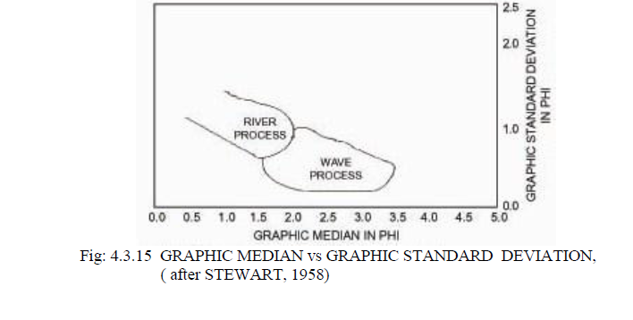
Fig 5.0: Graphic Median Vs Graphic Standard Deviation (After Stewart, 1958)

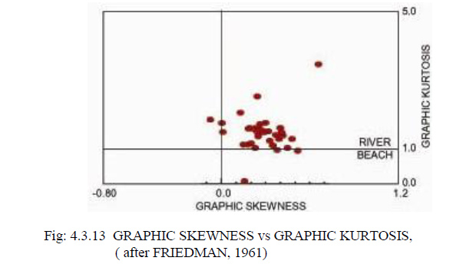
Fig 5.1: Graphic Skewnwss vs Graphic Kurtosis (after Friedman, 1961)

Fig 5.2: Graphic Standard Deviation Vs Graphic Skewness (After Friedman, 1967)

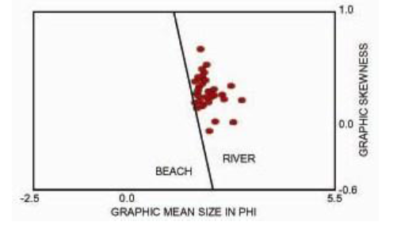
Fig 5.3: Graphic Mean Size Vs Graphic Skewness (after Moiola and Weiser, 1968)
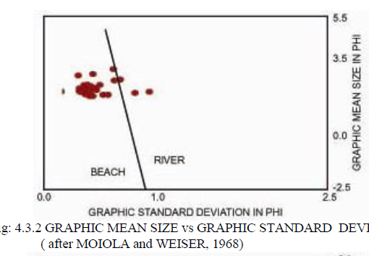
Fig 5.4: Graphic Mean Size Vs Graphic Skewness (after Moiola and Weiser, 1968)

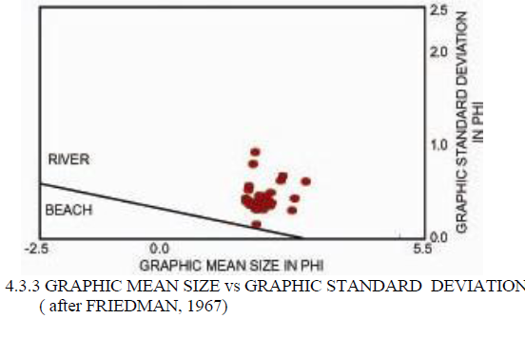
Fig 5.5: Graphic Mean Size Vs Graphic Standard Deviation (after Friedman, 1967)

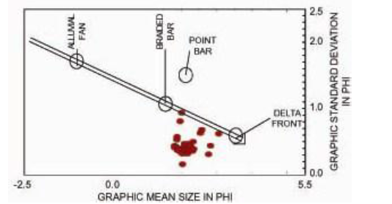
Fig 5.6: Graphic Mean Size Vs Graphic Standard Deviation (after Glaister and Nelson, 1968)

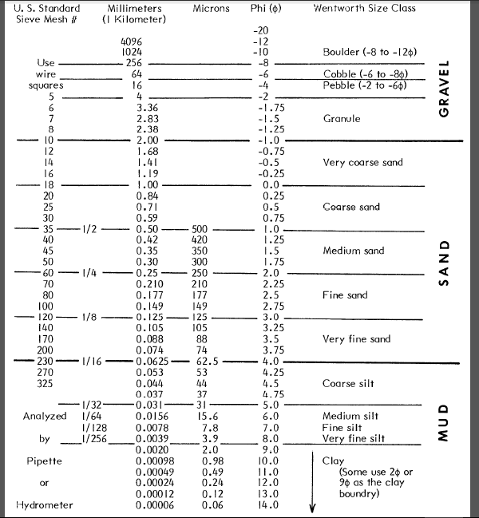

Fig 5.7: Grain size standard by udden wentworth

5.1 Method for Analysis: Sandstone Petrography
Table 16: Locations with their mineral results
UNIT | Quartz (%) |  | Feldspar (%) | Rock Fragment (%) | Matrix (%) | TOTAL
 | Polycrystalline | Monocrystalline
Amasiri | 20.94 | 44.76 | 13 | 10.8 | 10.5 | 100
L026 | 30.65 | 28.20 | 15.1 | 6.05 | 20 | 100
Unnamed | 45.15 | 21.30 | 14.56 | 6.72 | 12.72 | 100

5.1.1 Amasiri-Coarse grained Sandstone Unit
A. Classification: SUBARKOSE
This sample consists of medium to coarse grained, moderately to well sorted sandstone, rich in subangular to rounded quartz (monocrystalline and polycrystalline) grains, as well as plagioclase feldspars (multiple twinned) and k-feldspars and microcline (cross hatched and simple twinned), minor rock fragments and cement materials (clay minerals and calcite). The polycrystalline quartz exhibit undulose extinction (as a result of strain). The grain sizes range within 0.25 to 1.0 mm. A few grains of glauconites with brown margin, probably authigenic but possibly detrital is present.
5.1.2 LO26-Medium grained Sandstone Unit
A. Classification: ARKOSIC ARENITE
This sample consist of medium grained, moderately sorted, angular to sub-angular quartz grains, k-feldspars (simple twinned) and plagioclase feldspars (multiple twinned) and some rock fragments cemented by clay minerals and carbonates. The quartz are mainly polycrystalline with sutured boundaries, while the dominant feldspar mineral grain is plagioclase feldspars. The grain size ranges from 0.125 to 0.5 mm
5.1.3 UNNAMED-Fine grained Sandstone Unit
A. Classification: LITHIC ARKOSE
This sample consists of sandstone with fine grained, angular to sub-rounded, moderately to well sorted quartz grains, with very little k-feldspars (cross hatched and simple twinned), plagioclase feldspars (multiple twinned), rock fragments of sedimentary origin and some biotite minerals. There are minor clay minerals and calcite cements. The grain size ranges from 0.5 to 1.0 mm.

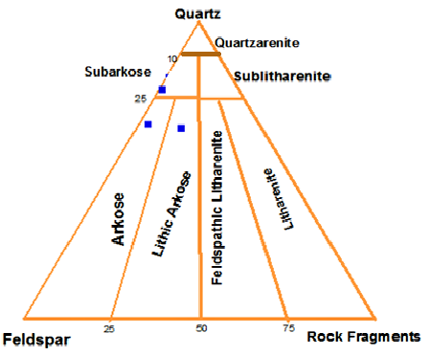
Fig 5.8: Sandstone classification (after Folk, 1974)

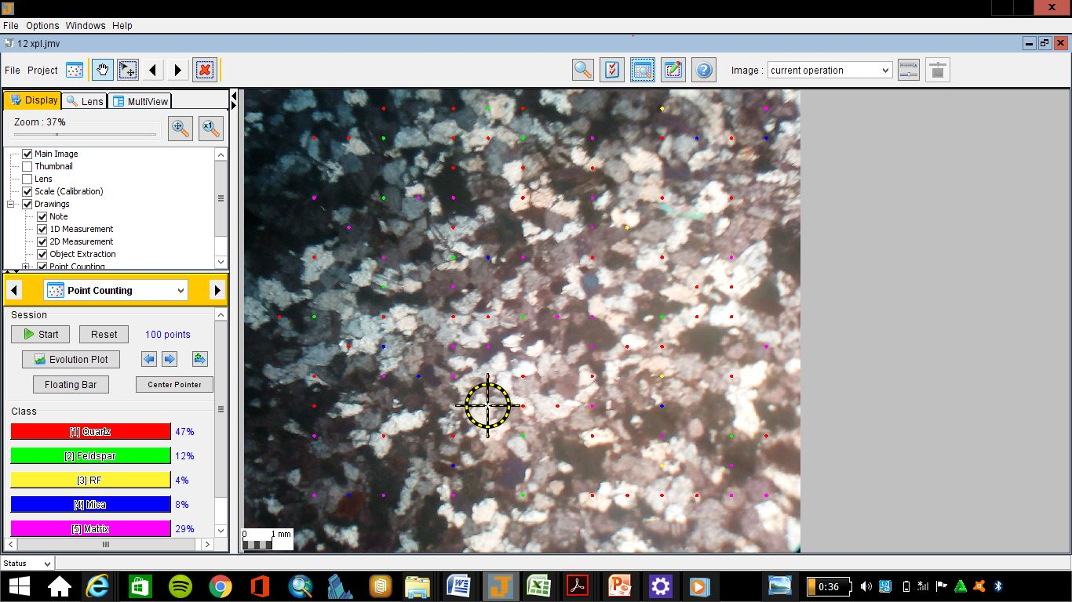
The point counting was facilitated by the use of JMicrovision software for pointcounting. The recursive method was adopted and a minimum of one hundred grains was examined for each sandstone.
Fig 5.9: Wokrpage of the JMicrovision software

e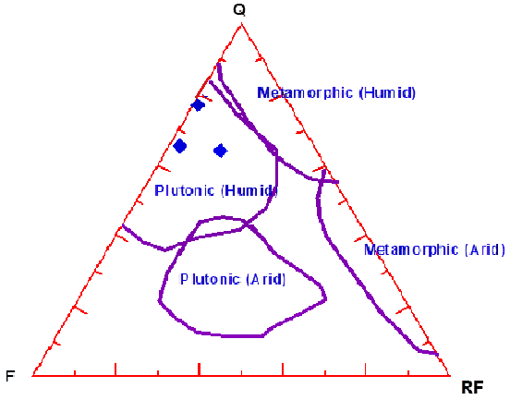
Fig 5.10: The effect of source rock on composition of Amasiri sandstone using Suttner et al., (1981)

- The sandstone appears to be polygenetic (Igneous and metamorphic source). But the climatic condition is sure to be humid.
- For first cycle sediments, Basu (1976) has suggested that the ratio of quartz to feldspar (Q/F) be used as a guide in climatic interpretation. If Q/F is less than unity, it indicates humid climate.
- In accepting the above criterion, one should not lose sight of the fact that the amount of feldspars in sandstone is a function not only of climate, relief and availability in the source rocks, but also of the rigor and duration of transport and post depositional processes.
- The presence of mica in the sandstones indicates deposition in low energy environment where sediments are rapidly deposited with little reworking (Reineck and Singh, 1973).
- From the foregoing, the provenance is most likely the metamorphic Precambrian basement complex of Southeastern Nigeria in the Oban and Bamenda massifs/cratons located at the eastern border of the rift, towards the eastern border of the study area.

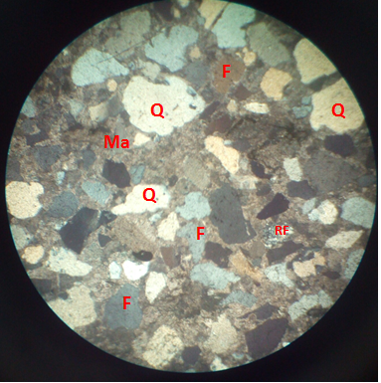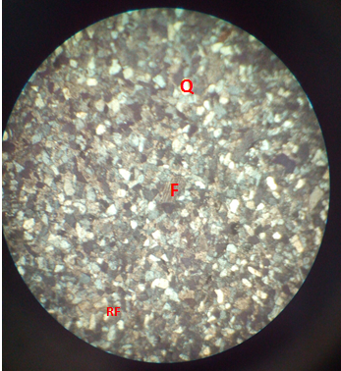

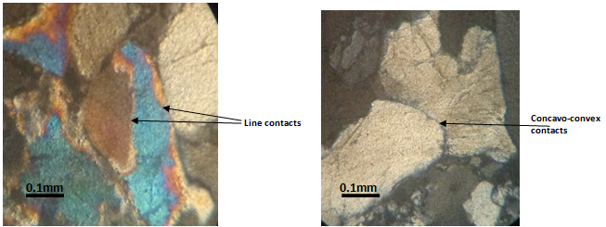
Concavo-convex contacts between quartz grains in the coarse- grained sandstone. Cross polars (x10)
Point and Line contacts between quartz grains in the medium- grained sandstone. Cross polars (x10)

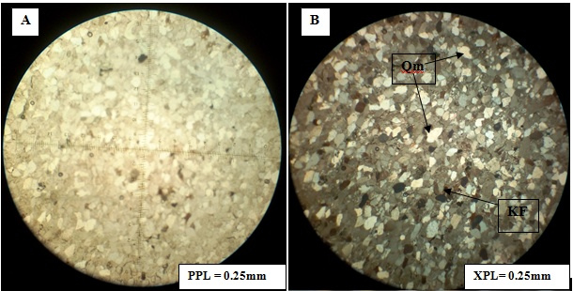
Fig 5.11: Photomicrographs Show mainly fine to medium grained monocrystalline quartz (Qm) with elongate crystals, and straight boundaries, with very few feldspar grains. K-feldspars exhibit simple Carlsbad twin (KF). In PPL, both quartz and feldspar grains have low relief appearing white and cloudy. In XPL most of the mineral grains appeared clearly, some dark-bluish colour alterations of the grains by hematite.

5.2 Method for Analysis: Palynological laboratory Analysis
This is the study of micro-organic materials such as spores, pollen, dinoflagellates and microfossils.
5.2.1 Method of sample preparation
The method of study included laboratory sample processing and transmitted light microscopic logging. Four (4) samples from location 2 (Otueja opposite Ezeke modern primary school), labeled (ST 1/SP A, ST 1/SP B, ST 1/SP C and ST 1/SP D), were subjected to palynological sample processing for their palynomorphs. The sample preparation was carried out, using the conventional maceration technique for recovering acid insoluble organic-walled microfossils from sediments. Each sample was digested for 30 minutes in 40% hydrochloric acid to remove traces of carbonate and 72 hours in 40% hydrofluoric acid for removal of silicate. The extracts were sieve-washed through 10 microns nylon mesh. The sieve-washed residues were oxidized for 30 minutes in 70% HNO₃ and 5 minutes in Schulze solution to render the fossils translucent for transmitted light microscopy. The oxidized residues were rinsed in 2% KOH solution to neutralize the acid. Swirling treatment was undertaken in order to get rid of the resistant coarse mineral particles and organic matter. The residues were stained with Safranin – O to increase the contrast for study and photography.
Aliquots were dispersed with polyvinyl alcohol, dried on cover-slips and mounted in petro- poxy resin. One slide was made from each sample and logged under the transmitted light microscopy. Light photomicrographs were taken with leica lll binocular microscope.

5.2.2 Palynological results
A. Station one / sample A (ST 1/SP A)
Table 17: Occurrences and distributions of palynomorph species in station one / sample A (ST 1/SP A)
Palynomorphs species | Total
TERRESTRIAL SPECIES
Spores
Laevigatosporites ovatus | 8
Leiotriletes adriennis | 2
Cingulatisporites ornatus | 3
Distaverrusporites simplex | 1
Zlivisporis blanensis | 2
Pollen
Buttinia andreevi | 1
Echitriporites trianguliformis | 2
Grimsdalea polygonalis | 3
Longapertites marginatus | 6
Monoporites annulatus | 2
Monocolpites marginatus | 2
Psilamonocolpites magnus | 1
Longapertites microfoveolatus | 2
MARINE SPECIES
Andalusiella polymorpha | 3
Ceratiopsis diebeli | 4
Senegaliniun sp. | 3
Glaphyrocysta ordinate | 2
Phelodinium sp. | 1
Dinogymnium acuminatum | 2
Total Counts | 50

Comments: Palynomorph percentage
Terrestrial species: Spores = 32 %
Pollen = 38 %
Marine species: Dinocysts = 30 %
Age: Late Campanian
Paleoenvironment: Marginal marine (estuary)
Paleo-salinity: Nearshore/brackish water

B. Station one / sample B (ST 1/SP B)
Table 18: Occurrences and distributions of palynomorph species in station one / sample B (ST 1/SP B)
Palynomorphs species | Total
TERRESTRIAL SPECIES
Spores
Laevigatosporites ovatus | 9
Leiotriletes adriennis | 0
Cingulatisporites ornatus | 2
Distaverrusporites simplex | 3
Zlivisporis blanensis | 0
Pollen
Buttinia andreevi | 3
Echitriporites trianguliformis | 1
Grimsdalea polygonalis | 0
Longapertites marginatus | 9
Monoporites annulatus | 4
Monocolpites marginatus | 2
Psilamonocolpites magnus | 0
Longapertites microfoveolatus | 0
MARINE SPECIES
Andalusiella polymorpha | 2
Ceratiopsis diebeli | 3
Senegaliniun sp. | 2
Glaphyrocysta ordinate | 0
Phelodinium sp. | 3
Areoligera senoniensis | 0
Paleocystodinium austrialinium | 2
Dinogymnium acuminatum | 1
Spiniferites sp. | 0
Glaphyrocysta ordinate | 1
Total Counts | 47

Comments: Palynomorph percentage
Terrestrial species: Spores = 30 %
Pollen = 40 %
Marine species: Dinocysts = 30 %
Age: Late Campanian
Paleoenvironment: Marginal marine (estuary)
Paleo-salinity: Nearshore/brackish water

C. Station one / sample C (ST 1/SP C)
Table 19: Occurrences and distributions of palynomorph species in station one / sample C (ST 1/SP C)
Palynomorphs species | Total
TERRESTRIAL SPECIES
Spores
Laevigatosporites ovatus | 7
Leiotriletes adriennis | 3
Cingulatisporites ornatus | 0
Distaverrusporites simplex | 2
Zlivisporis blanensis | 1
Pollen
Buttinia andreevi | 1
Echitriporites trianguliformis | 4
Grimsdalea polygonalis | 1
Longapertites marginatus | 12
Monoporites annulatus | 2
Monocolpites marginatus | 3
Retidiporites magdalensis | 1
Longapertites microfoveolatus | 0
MARINE SPECIES
Andalusiella manthei | 1
Ceratiopsis diebeli | 2
Senegaliniun bicarvatum | 1
Glaphyrocysta ordinate | 2
Phelodinium sp. | 1
Areoligera senoniensis | 0
Paleocystodinium austrialinium | 1
Dinogymnium acuminatum | 2
Spiniferites sp. | 3
Glaphyrocysta ordinate | 2
Total Counts | 52

Comments: Palynomorph percentage
Terrestrial species: Spores = 25 %
Pollen = 46 %
Marine species: Dinocysts = 29 %
Age: Late Campanian-Earliest Maastrichtian
Paleoenvironment: Marginal marine (estuary)
Paleo-salinity: Nearshore/brackish water

D. Station one / sample D (ST 1/SP D)
Table 20: Occurrences and distributions of palynomorph species in station one / sample D (ST 1/SP D)
Palynomorphs species | Total
TERRESTRIAL SPECIES
Spores
Laevigatosporites ovatus | 9
Leiotriletes adriennis | 0
Cingulatisporites ornatus | 2
Distaverrusporites simplex | 2
Cyathidites minor | 1
Pollen
Buttinia andreevi | 0
Echitriporites trianguliformis | 1
Grimsdalea polygonalis | 0
Longapertites marginatus | 7
Monoporites annulatus | 2
Monocolpites marginatus | 1
Retidiporites magdalensis | 2
Longapertites microfoveolatus | 3
MARINE SPECIES
Andalusiella manthei | 0
Ceratiopsis diebeli | 2
Senegaliniun bicarvatum | 1
Glaphyrocysta ordinate | 0
Phelodinium sp. | 3
Areoligera senoniensis | 1
Paleocystodinium austrialinium | 2
Dinogymnium acuminatum | 1
Spiniferites sp. | 0
Glaphyrocysta ordinate | 2
Total Counts | 42

Comments: Palynomorph percentage
Terrestrial species: Spores = 33 %
Pollen = 38 %
Marine species: Dinocysts = 29 %
Age: Late Campanian-Earliest Maastrichtian
Paleoenvironment: Marginal marine (estuary)
Paleo-salinity: Nearshore/brackish water

5.2.3 Interpretation of results
A. Age determination
The age determination of the examined samples was based on the selected key age-diagnostic palynomorph assemblages encountered. They are summarized as follow:
- From the tables 17 and 18 above, samples ST 1/SP A and ST 1/SP B, were assigned Late Campanian age based on the following index sporomorphs assemblage: Zlivisporis blanensis, Distaverrusporites simplex, Echitriporites trianguliformis, Longapertites marginatus, Monocolpites marginatus, Buttinia andreevi, and Longapertites microfoveolatus, (Lawal and Moullade, 1987; Umeji, 2007).
- Whereas samples ST 1/SP C and ST 1/SP D from tables 19 and 20, were dated Late Campanian-earliest Maastrichtian age, with the following index sporomorphs assemblage: Rugulatisporites caperatus, Retidiporites magdalensis, Distaverrusporites simplex, Echitriporites trianguliformis, Longapertites marginatus, Monocolpites marginatus, Buttinia andreevi, and Monocolpites marginatus, (Lawal and Moullade, 1987; Umeji, 2007; Chiaghanam et al., 2012).
- The age was further strengthened by the co-occurrence of the typical West African Campano-Maastrichtian dinoflagellate cysts association such as, Dinogymnium sp., Andalusiella polymorpha, A. manthei, Senegalinium ., Ceratiopsis diebeli, and Paleocystodinium autrialinium, (Lentin and Williams, 1978; May, 1980; Umeji, 2007) (Fig. 5.16).
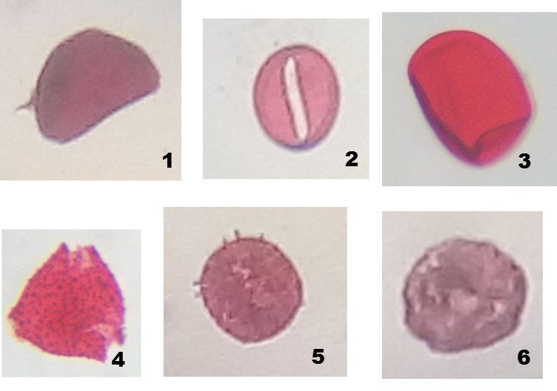
Fig. 5.12: Micrographs of some palynomorphs recovered in the examined samples.

Magnifications nos. 2 and 4 (X 100 oil immersion), others (X 40)
- Longapertites marginatus
- Monocolpites marginatus
- Laevigatosporites ovatus
- Echitriporites trianguliformis
- Spinizonocolpites baculatus
- Buttinia andreevi

5.2.4 Kerogen investigation
Method of Study
The kerogen slides were prepared from 4 analyzed samples of shale from the station 1, labeled (ST 1/SP A, ST 1/SP B, ST 1/SP C and ST 1/SP D), one for each sample, using the conventional method of acid maceration (Fig. 5.17). Each slide was examined using the transmitted light microscopy at X10 and 40 magnifications in order to make a qualitative as well as a quantitative analysis of particulate organic matter (POM), determine the palynofacies association and kerogen types, examine the spore /pollen colouration, estimate the Thermal Alteration Index (TAI), Vitrinite Reflectance (Ro %), as well as the degree of organic thermal maturation, (Fig. 5.18 and Fig. 5.19). Each slide was counted for its (POM) contents, in which the first 200 particles were counted in terms of abundant (>35 %), frequent (16-35 %), common (5-15 %) and rare (<5 %) (cf. Ibrahim et al., 1997; Zobba, 2007; Chiaghanam et al. 2013) table 21.
5.2.5 RESULT
Table 21: Summary of % frequency distribution of the total Particulate Organic Matter (POM) present in the analysed samples.
SAMPLE NO. | PHYTOCLAST | OPAQUES | AOM | PALYNOMORPHS
ST 1/SP A | 69 % | 26 % | 4 % | 1 %
ST 1/SP B | 60 % | 32 % | 8 % | 0 %
ST 1/SP C | 55 % | 30 % | 8 % | 7 %
ST 1/SP D | 50 % | 32 % | 15 % | 3 %

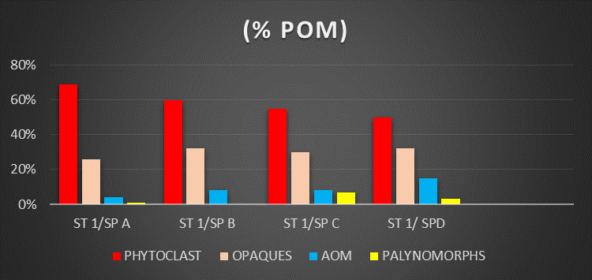
Fig. 5.13: Histogram % frequency distribution of the total particulate organic matter (POM) present in the examined samples.

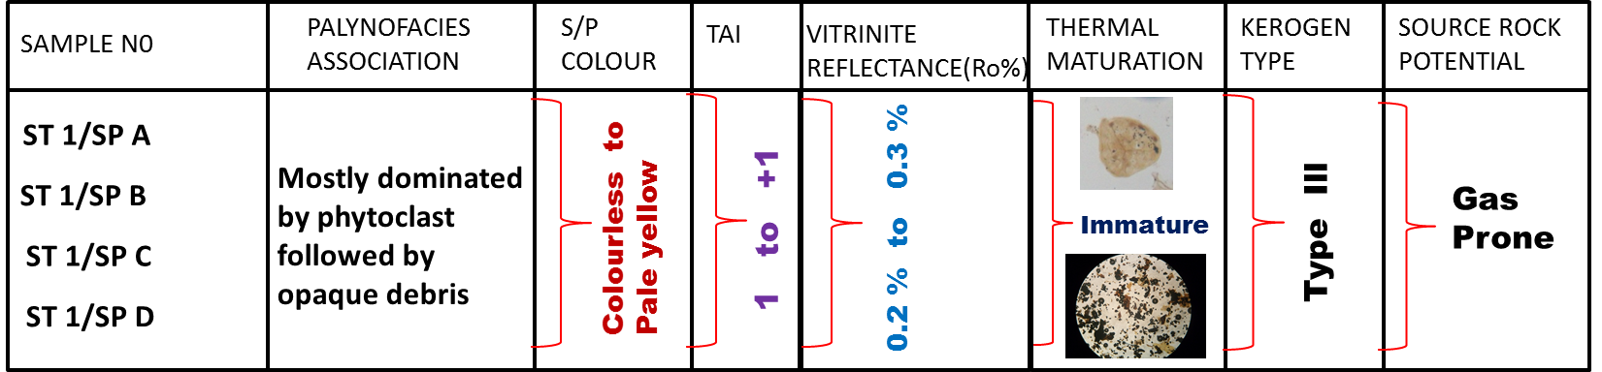
Fig. 5.14: Summary of the kerogen characterization and interpretations.

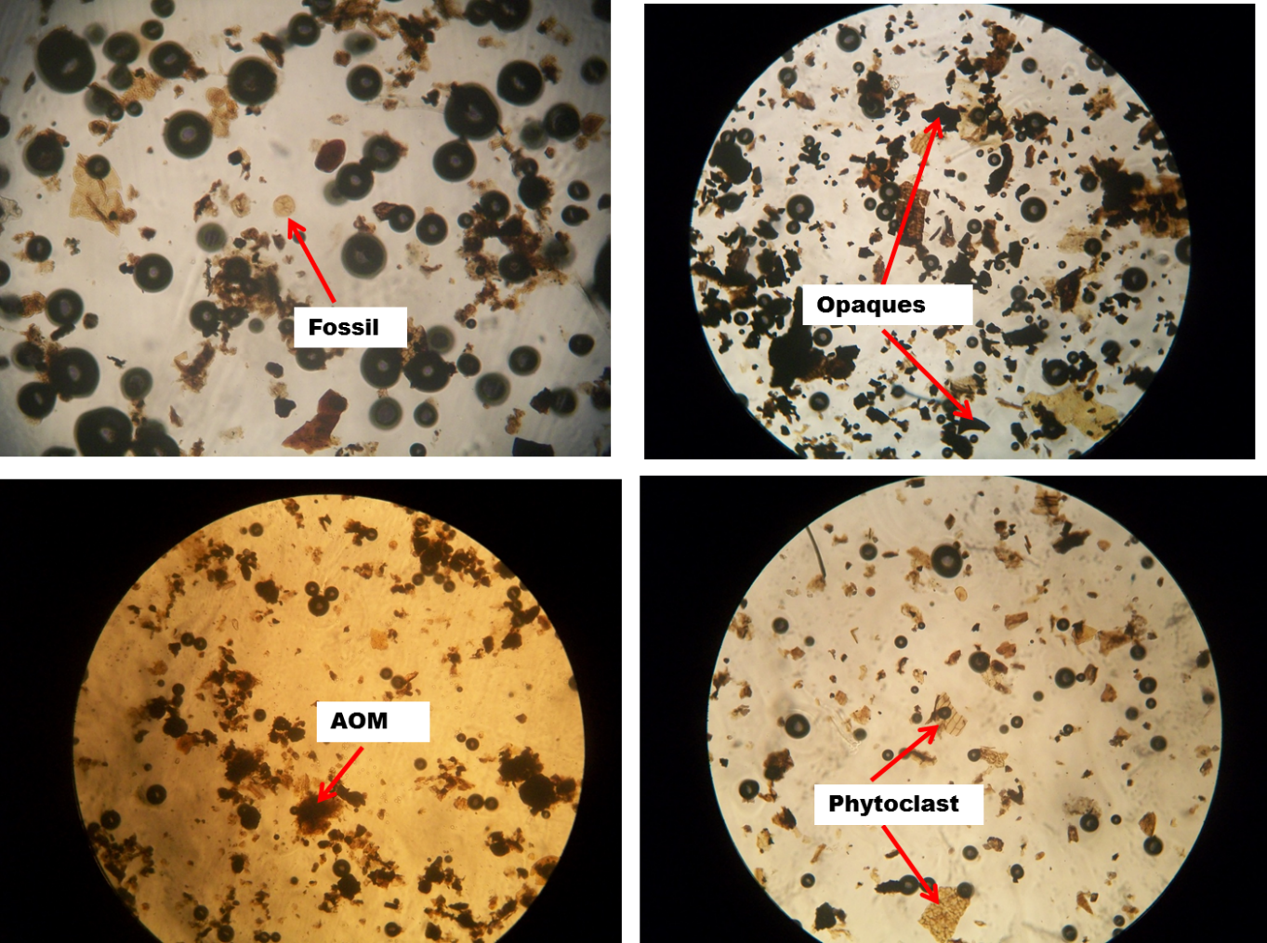
Fig. 5.15: Photomicrographs of the kerogen slides showing the various (POM) in the examined samples.

CHAPTER SIX
ECONOMIC GEOLOGY, STRUCTURAL GEOLOGY, IGNEOUS ACTIVITY AND GEOLOGICAL HAZARD
6.0 Economic geology
This constitutes the mineral resources of the study area. The stratigraphic pattern of sandstone and shale together along with some structural features control the mineral elements.
6.0.1 Quarrying and Construction
The highly indurated sandstones would serve as a good construction material like that of the diorite which is a major source of income for the people of Ozaraukwu. When these rocks are quarried they are broken into fragments and are sold to construction companies, which use them in building construction or road construction. It can also be used in solving slope problems such as delighting slope when used as riprap. Some rocks of economic importance are:
- Sand/Sandstone: It is a sedimentary rock with grain size of 1/16- 2.00 (sand) which turns into sandstone rock due to cement which fill the pores in the sand making the sandstone less porous and permeable. Sandstones could serve as host for some economic minerals such as uranium, rutile gold, diamond, etc which can be deposited as placer deposits since it is very porous it serves as a cereal rock for aquifer and as oil reservoir. It is one of the major minerals mined by large and small scale industries, which are basically used for construction of roads and buildings. They constitute important reservoirs for ground water, hydrocarbon, and can be used as filter paper and moulding sand.
- Laterite: Laterisation is a pedological process in the humid tropics which can convert any rock into a duricrust with varying degrees of indurations (Nwajide, 2013). It is a soil rich in iron oxide and it is derived from a wide variety of rocks weathering under strongly oxidizing and leaching conditions. It precisely contains goethite (FeO, HO), Bauxite (Al₂O₃) and titanium oxide and therefore can provide use for industrial development.
- Dolerite: It is basically used in road construction. Also quarrying of dolerite serves as a source of employment for people living in the area.

6.0.2 Agriculture
The shale units of the mapped area are covered by high vegetation as a result of high organic materials contained in the weathered shales. The major agricultural process in this area is the cultivation of rice and cassava, and when these crops are processed it becomes a good source of income for the indigenes of the study area.
6.1 Structural Geology
Structural geology is the study of the architecture of rocks insofar it has resulted from deformation (Maryland, 2006).This deals with the detailed analogy of sedimentary structures in the study area (Apemaa, 2016). It's not easy to classify sedimentary structures, because both their origins and their geometries are so highly varied. Two reasonable ways of classifying them are on the basis of; the kind of mechanism that produces them (physical sedimentary structures, chemical sedimentary structures and biogenic sedimentary structures) and time of development relative to time of deposition (primary sedimentary structures and secondary sedimentary structures).
 | PHYSICAL | CHEMICAL | BIOLOGICAL
Primary sedimentary structures | Stratification  Sole marks | Stratification | Bioturbation  (tracks and trails)
Secondary sedimentary structure | Deformation  Intrusion  Desiccation | Nodules  Concretions  Deformation  Stylotites | Bioturbation  (burrows)
Table 22: Classification of sedimentary structures

The primary structures are also called syngenetic structures, structures developed or formed from sediment deposition and secondary structures which are known as postgenetic or epigenetic, structures that develop on the sediment after deposition. Both primary and secondary sedimentary structures were observed in the field.

6.1.1 Primary sedimentary structures include:
- Joints: These are fractured blocks with no relative movement. Joints may occur in sets of parallel, regularly spaced fractures, and several sets may occur in the same rock, giving a conspicuous blocky appearance to the outcrop (Park, 1997).
- Beddings: A single bed is a sedimentation unit deposited under essentially constant physical conditions. It is the term used for sedimentary layers greater than 1cm thick. Beds thickness in the study area range from 1cm to 7cm, which infers they move from thin beds which are likely to be inequality of depositions of sediments as supplied to the deposition site. With finer grains or sediments, their bedding tends to become thinner as a result of slow rate of deposition.
- Cross bedding: This occurs when the internal structure of some beds are such that they are deposited at an angle to the binding surface.
- Laminations: They are similar to beddings but with different thickness that is less than 1cm.
6.1.2 Secondary Sedimentary Structures
- Fractures: They are discontinuities in a rock caused by breakages of rocks relative to their smooth surface or bedding. The fractures observed were faults and joints.
- Joint: It is a fracture in a rock in which there is no appreciable displacement along a crack.
- Ripple Marks: Ripple marks are secondary sedimentary structures. They are bed-flow of the lower flow regime and indicate agitation by water current or waves or wind.
6.2 Igneous Activity
Igneous Activities was observed in presence of a dolerite sill in out crop located about 400m from Amasiri Junction (Afikpo-Amasiri Road). The igneous intrusive rock is of Turonian time and was found close to the shale of the Eze-Aku formation at timber shed few metres from the army check point.
The environment was discovered to be a sedimentary environment with basic rocks. These basic rocks are mostly made of basalt and gabbro. The texture of the rock ranges from fine (Basalt) to coarse grain (gabbro) it contain plagioclase angite and K-feldspar, also there are present of iron oxides which exists in the form of magnetides and some other minerals that makes up the rocks are the pyroxene and olivine. The igneous intrusive (dolerite sill) that was observed, was formed by an emplacement of the intrusive by the fault plane fracture from the upper mantle, It intruded over 37 km running parallel to the strike plane it occurs as sill or dyke which can be either volcanic or plutonic. The dolerite sill observed with the bedding plane and was a result of uplift and erosion (hyper basal) and the exposure leads to the formation of basalt which is hyper-basal. The sill that was observed where horizontal in its orientation and they are also characterized as concordant intrusive contacts because they are intrusive rock formation in contact with the host or country rock in horizontal plane.
6.3 Geohazards of the area
Some of the major hazards prone to the Amuro formation and its environs include:
- Erosion
- Groundwater contamination
- Pollution
The problem of erosion can be corrected by planting cover crops and practicing Shifting Cultivation. Due to the lack of big industries in the study area, it is free from industrial waste pollution. Thus the major source of pollution is through human activities. Also, the open dumping method of disposal of waste in the area constitutes a source of pollution to the aquifers.

CHAPTER SEVEN
CONCLUSION
The study of geology cannot be overemphasized because it is an applied course that has been designed to show and expose students to the procedures of practical field geologic mapping. From the field observations of structures in the field and several analyses which were done by me and my partner Anyadike Obinna, I came to the conclusion that the area mapped is possibly made up of two lithologic units, which consist of sandstone and shales. The sandstone forms ridges which are highly indurated while the shale forms the lower areas. Result of the analysis of the various samples in the study area shows that most of the sandstone sediments are generally coarse grained with compositionally mean grain size of 0.95, ranging from medium grained to coarse grained sandstone having a dominant grain size ranges from the Ф_{-0.5} to Ф_{1.75,} weight percentiles from the histogram plots. They are generally poorly sorted, with modal grain sizes ranging from pebbly materials (at the foot of the McGregor college sandstone outcrop) to fine silt, generally, coarse skewed and leptokurtic respectively. These suggest that the sediments were locally derived and deposited not too far away from the source in a fluctuating, high to low energy fluvial transport medium within a braided river bar channel as shown in the various probability log distribution plots and bivariate plots respectively. While the shale from location 2 were dated Late Campanian-earliest Maastrichtian age.

References
Apemaa, D. Y. (2016). Facies Analysis of the Cretaceous Sediments of Afikpo, Ebonyi State. Unpublished B.Sc thesis. Godfrey Okoye University, Enugu.
Adighije, C. I. (1981). A gravity interpretation of the Benue trough, Nigeria. Tectonophysics , 79 (1–2), 109–128.
Akande, S. O., & Erdtmann, B. D. (1998). Burial Metamorphism (thermal maturation) in cretaceous sediments of the southern Benue Trough and Anambra Basin, Nigeria. AAPG Bull, 82:1191-1206.
Amajor, L. C. (1985). The Cenomanian hiatus in the Southern Benue Trough, Nigeria. Geological Magazine , 122 (01), 39–50.
Amajor, L. C. (1985). The Cenomanian hiatus in the Southern Benue Trough, Nigeria. Geological Magazine, 122(01), 39–50.
Amajor, L. C. (1987). The Ezeaku sandstone ridges (Turonian) of Southeastern Nigeria: A reinterpretation of their Depositional origin. Nigerian Journal of Mining and Geology, 23(1), 17–26.
Anderson, E. M. (1951). The Dynamics of Faulting and Dyke Formations. Oliver and Boyd.
Angelier, J. (1994). Fault slip analysis and paleostress reconstruction. Continental Deformation. Pergamon Press, Oxford, 53–100.
Banerjee, I. (1980). A subtidal bar model for the eze-aku sandstones, Nigeria. Sedimentary Geology, 25(4), 291–309.
Benkhelil, J. (1982). Benue Trough and Benue Chain. Geological Magazine, 119(02), 155–168.
Benkhelil, J. (1989). The origin and evolution of the Cretaceous Benue Trough (Nigeria). Journal of African Earth Sciences (and the Middle East), 8(2–4), 251–282.
Benkhelil, J., Guiraud, M., Ponsard, J. F., & Saugy, L. (1989). The Bornu–Benue Trough, the Niger Delta and its offshore: Tectono-sedimentary reconstruction during the Cretaceous and Tertiary from geophysical data and geology. In Geology of Nigeria. 2nd edn. Rock view Ltd Jos, Nigeria.
Binks, R. M., & Fairhead, J. D. (1992). A plate tectonic setting for Mesozoic rifts of West and Central Africa. Tectonophysics, 213(1–2), 141–151.
Bott, M. H. P. (1959). The mechanics of oblique slip faulting. Geological Magazine, 96(2), 109–117.
Boggs, J. S. (2009). Petrology of Sedimentary Rocks. Cambridge: Cambridge university press. doi:10.1017/CBO9780511626487
Burke, K., Dessauvagie, T. F. J., & Whiteman, A. J. (1971). Opening of the Gulf of Guinea and Geological History of the Benue Depression and Niger Delta. Nature, 233(38), 51–55.
Caen-Vachette, M., & Umeji, A. C. (1983). Whole-rock Rb-Sr dating of two monzogranites in southern Nigeria and their implications on the age of the Pan-African orogenic cycle. Journal of African Earth Sciences (1983), 1(3), 339–342.
Célérier, B., Etchecopar, A., Bergerat, F., Vergely, P., Arthaud, F., & Laurent, P. (2012). Inferring stress from faulting: From early concepts to inverse methods. Tectonophysics, 581, 206–219.
Central Bank of Nigeria (2011). Annual Reports and Statistical Bulletin.
Chiaghanam O.I, Chiadikobi K.C, Ikegwuonwu O.N, Omoboriowo A.O, Onyemesil, O.C and Acra E.J., 2013. Palynofacies and Kerogen Analysis of Upper cretaceous (Early Campanian to Maastrichtian) Enugu Shale and Mamu Formation in Anambra Basin, South Eastern, Nigeria. International Journal of Scientific and Technology research, 2(7): 225-229.
Cratchley, C. R., & Jones, G. P. (1965). An Interpretation of the geology and gravity anomalies of the Benue Valley, Nigeria. [With maps.].
Dada, S. S., Briqueu, L., Harms, U., Lancelot, J. R., & Matheis, G. (1995). Charnockitic and monzonitic Pan-African series from north-central Nigeria: Trace-element and Nd, Sr, Pb isotope constraints on their petrogenesis. Chemical Geology, 124(3–4), 233–252.
Ezepue, M. C. (1984). The geologic setting of lead-zinc deposits at Ishiagu, southeastern Nigeria. Journal of African Earth Sciences (1983), 2(2), 97–101.
Fairhead, J. D., Green, C. M., Masterton, S. M., & Guiraud, R. (2013). The role that plate tectonics, inferred stress changes and stratigraphic unconformities have on the evolution of the West and Central African Rift System and the Atlantic continental margins. Tectonophysics, 594, 118–127.
Falconer, J. D., Longbottom, A., & Woods, H. (1911). The Geology and Geography of Northern Nigeria. Macmillan and Company, Limited.
Folk, R. L., & Ward, W. C. (1957). Brazos River bar: a study in the significance of grain size parameters. Journal of Sedimentary Petrology, 27:3-26
Folk, R. L. (1980). Petrology of Sedimentary Rocks. Hemphill Austin, Texas, 159p
Friedmann, G. (1961). Distinction between dune, beach and river sands from textural characteristics. Journal of sedimentary Petrology. 31(2): 514-529
Friedmann, G. (1962). On sorting coefficient and the log-normality of the grain-size distribution of sandstones. Journal of Geology. 70: 737-756
Friedmann, G. (1967). Dyanamic processes and statistical parameters compared for size frequency distributions of beach and river sands. Journal of sedimentary Petrology. 37(2): 327-364
Ibrahim, M.I.A., Abul Ela, N.M, and Kholeif, S.E, 1997. Paleoecology, palynofacies, thermal maturation and hydrocarbon source-rock potential of the Jurassic-Lower Cretaceous sequence in the subsurface of the north Eastern Desert, Egypt. Qatar Univ., Sci. J., v. 17 (1), p. 153-172.
Ikejiaku, E. O. (1975). The geology of Amasiri area, near Afikpo, Eastern Nigeria. Unpublished B.Sc thesis. University of Nigeria, Nsukka.
Kogbe, C. A. (1976). Geology of Nigeria. Elizabethan Publishing Company.
Kogbe, C. A. (1989). Paleogeographic history of Nigeria from Albian times. In Geology of Nigeria. Elizabethan Publishers, Lagos (pp. 237–252).
Lawal, O. and Moullade, M., 1987. Palynological Biostratigraphy of Cretaceous Sediments in
The Upper Benue Basin, N.E. Nigeria, Revue De Micropaleontologie, vol. 29, nos 1, pp.
61-83.
Mason, C. C. & Folk, R. L. (1958). Differentiation of beach, dune and Aeolian flat environment by size analysis, Mustang Island, Texas, Jour. Sed. Pet. Vol28, p211-226
Murat, R. C. (1972). Stratigraphy and paleogeography of the Cretaceous and lower Tertiary in Southern Nigeria. In Proc. of the Conf. on African Geology held at Ibadan, Nigeria. pp (pp. 251–266).
Moiola, R. J., & Weiser, D. (1968). Textural parameters: An evaluation. Journal of Sedimentary Petrology, 38:45-53
Nwachukwu, S. O. (1972). The tectonic evolution of the the southern portion of the Benue Trough, Nigeria. Geological Magazine, 109(05), 411–419.
Nwajide, C. S. (2013). Geology of Nigeria’s Sedimentary Basins. Lagos: CSS Press.
Nwajide, C. S., & Reijers, T. J. A. (1996). Geology of the southern Anambra Basin. In selected chapters on Geology, SPDC, Warri (pp. 133–148).
Nwajide, C. S. (2006). Outcrop analogues as a learning facility for subsurface practitioners: the value of geological field trips. Petroleum Training Journal, 3:133–148).
Nwajide, C. S. (1990). Sedimentation and paleogeography of the Central Benue Trough, Nigeria. In: Ofoegbu CO (ed) The Benue trough structure and evolution. Vieweg, Braunschweig, pp 19–38
Obaje, N. G. (2009). Geology and Mineral Resources of Nigeria. Springer.
Obaje N. G. (1994) Coal petrography, microfossils and paleoenvironments of Cretaceous coal measures in the Middle Benue Trough of Nigeria. Tuebinger Mikropalaeontologische Mitteilungen. 11:1–165
Obaje N. G., & Abaa S. I. (1996) Potential for coal-derived gaseous hydrocarbons in the Middle Benue Trough of Nigeria. J Petrol Geol 19:77–94
Obaje N. G., & Ligouis B. (1996) Petrographic evaluation of the depositional environments of the Cretaceous Obi/Laﬁa coal deposits in the Benue Trough of Nigeria. J Afr Earth Sci, 22:159–171
Obaje N. G. (1997) Petrographic evaluation of the coking potential of the Cretaceous Obi/Laﬁa coal deposits in the Benue Trough of Nigeria. Zeitschrift fur Angewandte Geologie, 43: 218–223
Obaje N. G., Ulu O. K., & Petters S. W. (1999) Biostratigraphic and geochemical controls of hydrocarbon prospects in the Benue Trough and Anambra Basin, Nigeria. NAPE Bull, 14:18–54
Obi, G. C., & Okogbue, C. O. (2004). Sedimentary response to tectonism in the Campanian–Maastrichtian succession, Anambra Basin, Southeastern Nigeria. Journal of African Earth Sciences, 38(1), 99–108.
Oboh-Ikuenobe, F. E., Obi, C. G., & Jaramillo, C. A. (2005). Lithofacies, palynofacies, and sequence stratigraphy of paleogene strata in Southeastern Nigeria. Journal of African Earth Sciences, 41:79-101
Odigi, M. I., & Amajor, L. C. (2009a). Brittle deformation in the Afikpo Basin (Southeast Nigeria): Evidence for a terminal Cretaceous extensional regime in the Lower Benue Trough, Nigeria. Chinese Journal of Geochemistry, 28(4), 369–376.
Ofoegbu, C. O., & Onuoha, K. M. (1990). A review of geophysical investigations in the Benue Trough. The Benue Trough Structure and Evolution. Friedr. Vieweg and Sohn, Braunschweig, Germany. 360pp.
Offodile, M. E. (1976). The geology of the Middle Benue, Nigeria. Paleont inst univ. Uppsala, Sp. Publ. 4: 166pp.
Offodile, M. E. (1976). The geology of the Middle Benue, Nigeria. Cretaceous Research, 1:101-124
Ojoh KA (1992) The Southern part of the Benue Trough (Nigeria) Cretaceous stratigraphy, basin analysis, paleo-oceanography and geodynamic evolution in the equatorial domain of the South Atlantic. NAPE Bull 7:131–152
Okonkwo, I.A, (2014). Structural and Paleostress Analysis of the Upper Cretaceous Afikpo Syncline, South-Eastern Nigeria (pp. 1-42)
Ola, C.S., (2001). Income tax law and practice in Nigeria. Ibadan: Dalag Prints and Part.
Olade, M. A. (1975). Evolution of Nigeria’s Benue Trough (Aulacogen): a tectonic model. Geology magazine, 12:575-583.
Olade, M. A. (1976). On the genesis of lead/zinc deposits in Nigeria’s Benue rift (Aulacogen): a reinterpretation. Journal of Mining and Geology, 13:20-27
Olatunji, O.C., (2013). Value added tax and inflation in Nigeria. Asian Journal of Humanities and Social Science, 1(1), 123-135
Rajamanickam, G. V., & Gujar, A. R. (1984). Sediment deposition environment in some bays in the central west coast. Indian Journal of Marine Sciences, 14:17-19
Rajamanickam, G. V., & Gujar, A. R. (1993).Depositional processes inferred from the log probability distribution. Recent Researches in Sedimentology,Jhingran Ed. 154-164
Reyment, R. A. (1965). Aspects of the Geology of Nigeria: The Stratigraphy of the Cretaceous and Cenozoic Deposits. Ibadan University Press. 104
Reineck, H. E., & Singh, I. B. (1980). Depositional sedimentary environments. Springer-verlag, Newyork 2nd Ed. Page 551
Reijers, T. J. A., & Nwajide, C. S. (1998). Geology of the Southern Nigerian Basin. Unpublished report for Chevron Nigerian Limited. Field course note 66pp
Shell, B. P. (1957). Geological maps, 1: 250 000 Sheets: Makurdi (64); Ankpa (63); Enugu (72); Ogoja (73); Umuahia (79); Oban Hills (80); Calabar (85). Geological Survey of Nigeria.
Simpson, A., 1954. The Niprian Coalfield: The geology of parts of Owerri and Benue provinces. Bull. Geol. Surv. Nig., 24: 1-85.
Stewart, H. B. (1958). Sedimentary reflection on depositional environment, in San Mignellagoon, Baju California, Mexico AAPG Bull, 42:2567-2618
Visher, G. S. (1969). Grainsize distribution and depositional processes. Journal of Sedimentary Petrology. 39:1074-1106
Udden, J.A. (1914). Mechanical composition of clastic sediments. Geological society of America Bulletin. 25(1): 655-744.
http://pubs.geoscienceworld.org/gsa/gsabulletin/article-abstract/25/1/655/2771/mechanical-composition-of-clastic-sediments?redirectFrom=fulltext
Umeji, A. C. (2000). Evolution of the Abakaliki and the Anambra Sedimentary Basins, Southeastern Nigeria [R]. A Report Submitted to the Shell Petroleum Development Company Ltd, 155.
Umeji, O. P. (1981). Ammonite palaeoecology of the Eze-Aku Formation, southeastern Nigeria. Journal of Mining Geology, 21(1-2), 55–59.
Umeji, O. P. (1981).Hummocky cross-stratification in the Turonian Eze Aku Sandstones of southeastern Nigeria: Sedimentological significance. Journal of Mining Geology, 29: 55–59.
Umeji, 0. P. and Nwajide, C.S., 2007. Age control and designation of the standard stratotype of Nsukka Formation of Anambra Basin, southeastern Nigeria. Nig. J. Min. Geol. 43 (2): 147-166.
Whiteman, A. J. 1982. Nigeria: Its petroleum geology resources and potentials. Graham and Trotman, London. 394 pp.
Zobaa, M.K, Zavada, M.S. and Whitelaw, M.J., 2007. Palynofacies analysis, source rock
evaluation and organic thermal maturation of the Gray Fossil Site, Gray, Tennessee. In:
Eastern Section, AAPG 36th Annual Meeting, Abstract, Lexington, Kentucky, USA, pp.60.

Appendix
STA-8: Normal graph curve of sample A/ST-8 (300 meters away from McGregor Hill Block Industry)
STA-8: Histogram chart showing distribution of grain size of sample A/ST-8 (300 meters away from McGregor Hill Block Industry)
STA-8: Cumulative frequency Curve of sample A/ST-8(300 meters away from McGregor Hill Block Industry)
STA-10: Normal graph curve of sample A/ST-10 (Foot of Ozaraukwu ridge, Close to Naira and Kobo Hotel, at the Army Check point along Amaseri- Afikpo Road, Amaseri)
STA-10: Histogram chart showing distribution of grain size of sample A/ST-10 (Foot of Ozaraukwu ridge, Close to Naira and Kobo Hotel, at the Army Check point along Amaseri- Afikpo Road, Amaseri)
STA-10: Cumulative frequency Curve of sample A/ST-10 (Foot of Ozaraukwu ridge, Close to Naira and Kobo Hotel, at the Army Check point along Amaseri- Afikpo Road, Amaseri)
STB-10: Normal graph curve of sample B/ST-10 (Foot of Ozaraukwu ridge, Close to Naira and Kobo Hotel, at the Army Check point along Amaseri- Afikpo Road, Amaseri)
STB-10: Histogram chart showing distribution of grain size of sample B/ST-10 (Foot of Ozaraukwu ridge, Close to Naira and Kobo Hotel, at the Army Check point along Amaseri- Afikpo Road, Amaseri)
STB-10: Cumulative frequency Curve of sample B/ST -10 (Foot of Ozaraukwu ridge, Close to Naira and Kobo Hotel, at the Army Check point along Amaseri- Afikpo Road, Amaseri)
STA-11: Normal graph curve of sample A/ST-11 (300 meters away from McGregor Hill Block Industry)

STA-11: Histogram chart showing distribution of grain size of sample A/ST-11 (300 meters away from McGregor Hill Block Industry)
STA-11: Cumulative frequency Curve of sample A/ST-11 (300 meters away from McGregor Hill Block Industry)
