**DEVELOPMENT OF A WEBASE CAMPUS HELPDESK**

**BY**

**NNAEKWE BLESSING AMAKA**

**U14/NAS/CSC/066**

**BING A BSC PROJECT REPORT SUBMITTED IN A PARTIAL FULFILMENT OF THE REQUIREMENTS FOR AWARD OF BACHELOR’S DEGREE IN COMPUTER SCIENCE OF THE GODFREY OKOYE UNIVERSITY.**

**SUPERVISOR: MISS ROSEMARY OGUGUA**

**DEPARTMENT OF MATHEMATICS/ COMPUTER SCIENCE**

**GODFREY OKOYE UNIVERSITY, ENUGU**

**JULY, 2018**

## CERTIFICATION

## I hereby declare that the work presented herein was done by me, and not a third party. Should I be convicted of having cheated in this work, i shall accept the verdict of the university.

## NNAEKWE BLESSING AMAKA

**Approval page**

This is to certify that this research work titled**. DEVELOPMENT OF A WED BASED CAMPUS HELPDESK** was carried out by NNAEKWE BLESSING AMAKA Registration number U14/NAS/CSC/066 of department of computer science/ mathematics partial fulfilment of the requirement for the award of Bachelor of science in computer science

**Miss Rosemary Ogugua Date**

**Project Supervisor**

**___________________________ _________________________**

**Dr (mrs) Monica Agu Date**

**Head of Department**

## DEDICATION

This work is dedicated to God Almighty for his grace and love and my caring parents, my beloved sister and my wonderful brother in-law for their love and care and encouragement throughout the period of this research work.

**ACKNOWLEDGEMENT**

I wish to express my sincere gratitude to the number of people who helped me in making this work a reality. My profound gratitude goes to my supervisor miss rosemary ogugua for her sisterly guidance, concern and critical supervisions. In spite of her tight schedule, she still spares a lot of time in other to supervise and correct my work.

I also wish to thank my parents Mr and Mrs Celestine Nnaekwe in a special way for their support and care. I want to say a big thank you to my HOD Dr. (Mrs) Monica Agu words cannot express immense gratitude for your motherly support and counsel. I remain grateful to all my lectures and staff of computer science /mathematics department. Especially Dr Ndidiamaka ozofor and Mrs onus for their assistance and advice.

To my caring siblings (ify, jude chinwe ) and my my friends Stella , Stacey, blessing, chinasa , arinze , ifeanyi,peter, emma, dozie ,obasi and so many other thanks for your unconditional love and God bless you all.

## ABSTRACT

web-based campus helpdesk that allows students and staff to perform activities such as submitting a request, viewing a list of request made and checking the status of his/her request, the administrator has to perform tasks such as checking the request from the student and authorizing them that is taking necessary actions on them, the administrator furthermore, has the option to send a proper notification via email to the student with solution to their requests. The methodology for this project is SSADM (Structural system analysis and design methodology) and the programming language used for the project is SQL (Structured Query Language) was used for the database, programming language HTML (Hyper-text Mark-up Language), PHP (Hypertext Pre-processor), CSS (Cascading Style Sheets)

**TABLE OF CONTENT**

Title page i

Certification page ii

Approval page iii

Dedications iv

Acknowledgment v

Abstract vi

Table of contents vii

List of figures viii

List of table iv

Chapter 1: introduction

1.0 background of study 1

1.1statement of problem 2

1.2 objective 2

1.3 significance of the project 3

Chapter 2: literatue review

2.0 introductio 4

2.1 theoretical background 4

2.2 review of related literature 5

Chapter 3 system analysis and design

3.0 introduction 17

3.1 describe the existing system 18

3.2 analysis of the proposed system 19

3.3 design of the proposed system 23

Chapter 4 system implementation

4.0 introduction 32

4.1 choice of development environment 32

4.2 implementation architecture 33

4.3 software testing 34

4.4 documentation 39

4.4.1 user manual 39

4.4.2 source code listing 40

Chapter 5: summary and conclusion

5.0 summary 41

5.1 conclusion 41

5.2 recommendations 43

References 44

Appendices 46

LIST OF FIGURES

## Fig 2.1 Current manual helpdesk process 8

Fig 3.0 The waterfall model –adapter from hughes and cotterell 16

Fig 3.3.1 Use-case diagram of student 18

Fig 3.3.2 use-case diagram of facility head 19

Fig 3.3.3 use-case diagram of administrator 20

Fig 3.3.4 Architecture of an online campus helpdesk system 26

Fig 4.2.0 Block diagram showing the system architecture of the new system 33

Fig4.2.1 Screenshot showing debugging of the login page 34

Fig 4.2.2 screenshot showing debugging of menu item 35

Fig 4.2.3 screenshot showing database of the update record tab 35

Fig 4.2.4 screenshot of user page with selected Department 36

Fig 4.2.5 screenshot of Requests Page 37

Fig 4.2.6 screenshot of All Requests page in admin section 37

Fig 4.2.7 screenshot of login page with valid login details 38

Fig 4.2.8 screenshot of login page with invalid login details 38

Fig 4.2.8 screenshot of user information page  39

LIST OF TABLES

Table 3.1 table showing the fields in user table of database 24

Table 3.2 table showing the fields in student table of database 25

Table 3.3 table showing the fields in staff table of database 26

Table 3.4 table showing the fields in call table of database 27

Table 3.1 table showing the fields in knowledge base table of database 28

# CHAPTER ONE

# INTRODUCTION

## Background of Study

Customer care is a crucial element of business success. Every time you have contact with your customers you have an opportunity to improve your reputation with them and increase the likelihood of further sales, the same goes for the online campus helpdesk. From your telephone manner to the efficiency of your order-fulfilment systems, almost every aspect of your business affects the way your customers (students) view your business.

This guide outlines what student customer care involves. It explains how you can use customer contact, feedback and loyalty schemes to cater for the needs of other students. It also covers how to prepare for receiving a student complaint. Online Campus Helpdesk supports different types of users:

* Students: These are the users who will request for the different facilities of the campus.
* Departments: These are the users who will receive the requests and try to resolve them.
* Administrator: The Administrator will be able to add more students and facility heads to the system.

Online Campus Helpdesk is a web application aimed at providing different services of the college to the students for which they normally have to wait too long. Online Campus Helpdesk will allow students to easily request for different services via this online portal.

## 1.1 Statement of the Problem

At present the current system works manually. It provides the information in written or oral form within the campus. Individual has to spare his time and energy in order to obtain even the basic information regarding the campus. Apart from this there can be a long and tedious procedure in order to have a solution regarding any particular query.

Owing to

1. The difficulties people face in transferring information/data.
2. Sensitive/confidential nature of students’ information.
3. Time wasted in manual processing of students’ information.

## 1.2 Aim of study

The Aim of the project are;

1. Students and staff can perform activities such as submitting a request, viewing a list of requests made and checking the status of his/her request.
2. The administrator has to perform tasks such as checking the requests from the students and authorizing them i.e. taking necessary actions on them.
3. The administrator furthermore, has the option to send a proper notification via email to the students with solutions to their requests.
4. Students and staff will also be able to access possible solutions to or information about their complaints/problems from the knowledgebase that would be incorporated into the project.

**1.3 Significance of the Project**

The significance of this project is listed below:

1. To develop, promote, and provide adequate and efficiently Online Campus Help Desk.
2. To maintain an efficient system of collection, sorting and delivery of students information.
3. To demonstrate increased motivation to the Godfrey Okoye University staff.
4. To eliminate the error involved with the manual method of checking students’ information.
5. To save the time wasted with manual method of checking students’ information.

# CHAPTER TWO

# LITERATURE REVIEW

## Introduction

Helpdesk could also be seen as an information and assistance resource that supports the functionality of an organization by responding to users’ requests in a timely manner. It is hence, a core sector through which problems, complaints and requests are reported, managed, coordinated and resolved. Help desk software is a solution application that is used for managing organization’s help desk. It is accessible to customer support personnel who could direct request(s) to different department(s). Technical concerns are becoming a normal scenario in everyday work environment both in education and corporate. Thus, need to constantly and effectively monitor these concerns. These require a system that can handle them.

## 2.1 Theoretical Background

The major technologies used in this project are web technologies (HTML, CSS, and Php) and MySQL database technology. HTML, CSS, and Php are acronyms for different coding languages used for displaying webpages on the internet. Each has a different purpose and function and they work together to deliver beautiful websites with updated content to your web browser.HTML stands for Hyper Text Mark-up Language, CSS for Cascading Style Sheets, and Php for Php Hypertext Pre-processor.We will start with HTML, each of our HTML documents is a sequence of elements. The major HTML features used were form and cascading style sheet (CSS). We used the form to collect information from the students and staff alike and processed the information in PHP and stored the information or data collected in the MySQL database. php and MySQL instructions are used in our code to open the database, establish a connection between it and the HTML code to insert data, retrieve data, delete data and also modify data.

## 2.2 Review of Related Literature

Help desk automation is for many companies the first application area of knowledge-based systems. “The help desk is an automated knowledge distribution while payroll was an automation of record keeping… a universal application that fits the new technology like a glove” [1]. The theory above anchors on the help desk management system which has attracted a number of research works. Such as, in developed world, help desk has been established as a tool for inquiries made by users like students and staff of an institution for facilities and services.

Further, the help desk information retrieval mechanism will be suitable for users in managing the complaints and proper system maintenance. The system helps improve help desk usability and functionality.

Regularly the term help desk is utilized for interior backing within the organization or for outside care groups. Numerous organizations are turning to help work area to mechanize a mixed bag of errands and, at the same time, lessen costs by cutting staff and giving more client help from the current staff [3]. Organizations need to give high calibre client administration and backing to get by in today's business surroundings. Having the right help work area would guarantee high client fulfilment [5]. Customer help consolidates profits that help a customer or customer fathom and benefit from things limits by noting request, handling issue and giving online information. The preferences of automated help work area are basic in that they permit fewer individuals to manage larger work volume. The help desk is increasing its importance as companies move to client-server architectures. Users who interface with the help desk often form a general perception of the information system group. Information systems help desks plays an important role within an organization [6]. The help work area is in charge of uniting an association's assets with a specific end goal to give its clients quality help and administration. Help desk is designed and customized to provide businesses with an internal support system as well as a link for providing support to its customers. Help desk applications host a number of benefits that includes:

1. Giving existing clients with information and Frequently Asked Questions (FAQ's) concerning the organization's frameworks and approaches.
2. 24-hour availability thus catering to the trend of office personnel working late and to those overseas or in different time zones.
3. Troubleshooting peculiarities gives clients the capacity to take care of numerous help issues all alone. This apparatus gives the clients with brisk and simple arrangements and sparing the organization’s cash.
4. Serves as an instrument for following and recording help work area concerns, which gives an information base of resolutions to past exchanges concerning comparable issues.
5. Supplies information concerning trends and other issues, which aids in the continuing improvement of products and services.

A helpdesk could comprise of one person or group of persons that make use of telephone devices or software applications to keep track of problem(s) status and thus provide solution(s) that satisfy the users. Helpdesk could also be seen as an information and assistance resource that supports the functionality of an organization by responding to users’ requests in a timely manner. It is hence, a core sector through which problems, complaints and requests are reported, managed, coordinated and resolved [3]. Helpdesk software is a solution application that is used for managing organization’s helpdesk. It is accessible to customer support personnel who could direct request(s) to servicing department(s).

In a business enterprise, helpdesk unit is a place that users call to get help for a problem. Helpdesk can be classified into internal helpdesk (this is used to serve the employee within the organization) or External helpdesk (this is used to serve people that are external to the organization). Irrespective of the category, the smooth operation of the helpdesk is fundamental to the smooth running of the organization. Helpdesk management methods vary from one type of organization to the other. In many small scale companies, a helpdesk is simply one person that has some ideas of how to handle the users’ problems and users can contact him/her only by phone. In larger companies, a helpdesk may consist of a group of experts using dedicated software to: keep track of the status of user’s problems, analyse the problems and thus provide solutions to the problems. Moreover in some multi-national corporate organizations, helpdesk support can be provided to customers via a toll-free telephone number, website or e-mail. In Nigerian tertiary institutions and many of the tertiary institutions in developing countries of Africa, helpdesk processes are handled manually and thus poses a lot of difficulties to both the helpdesk officers and the users [9]. There are three conventional manual methods currently used for reporting problems in Nigerian institutions:

* Making requisition/complaints via the phone
* Making requisition/complaints via e-mail and
* The use of Requisition/Complaint form.



Figure 2:1 Current Manual Helpdesk Process

Presented in Figure 2 is the diagrammatic illustration of the current manual method for reporting problems to the different servicing departments. There is a lot of repetitive work on problems that have simple solutions. Also, problems that appear on a regular basis still go through the same process and therefore cause delay. Staff and students are confronted daily with recurring problems for which the cause never gets addressed or eliminated [12]. They have to explain their problems or complaints to support staff and wait a long time for problem resolution. There is also lack of follow-up of requests that need attentions.

Additionally, getting access to the support team could be quite challenging, even though there is telephone but there is no tool to log the problems automatically for the support personnel to attend to the problems later. Users have to keep on trying to contact the support personnel for days or weeks before getting access. Upon receiving the complaints, the support personnel will have to pass the case to the appropriate administrator. These could take additional hours or sometimes days to complete. This could reduce productivity or hinder management functions. Also, the current manual method does not have any system which could allow the user to monitor progress on the reported complaints. In view of these limitations, there is the need for computer aided helpdesk system solution tagged Online Campus Helpdesk for tertiary institutions in developing countries as currently done in developed world. It is a user friendly distributed software system that can serve as virtual partner to the human helpdesk officers [15]. The conceptual design of Online Campus Helpdesk for tertiary institutions in developing countries is presented in this project. The proposed Online Campus Helpdesk would be able to overcome the challenges of delay, loss of records, improper documentation and many others; by routing specific requests to the appropriate administrator electronically via established Intranet and Internet system and thus bringing about proper documentation and accountability.

The main users of the system are typically divided into four categories as follows:

1. User/Requestor: Requestors include staff and students of the institution and other individuals seeking information as regards to the institution. The requestor makes all the requests through the Online Campus Helpdesk for resolution. The request will contain the actual complaints and some information about the requestor, as well as his/her department. The requestor will also be able to access possible solutions to or information about his/her complaints/problems from the knowledgebase. Information retrieved from the knowledgebase depends on the privilege given to the requestor.
2. Helpdesk Department: This department receives all requests from the students and staff, and sends them to the appropriate servicing department(s). Helpdesk department liaises with experts in the servicing department(s) in order to ensure that necessary solutions are provided to requestor’s satisfaction and documented. The department also ensures that Online Campus Helpdesk is on and working and reports problems with the system to the technical team for quick resolution.
3. The Information and Communications Technology (ICT) Department: This department provides technology and maintenance support (i.e. hardware and software) for Online campus helpdesk. ICT attends to technical issues with the system as indicated by the helpdesk department.
4. Servicing Departments: These are the departments that are solely responsible for providing solutions to requestors’ complaints/requests. They hold the information required to solve these issues. They are able to see all requests and respond to them accordingly. When items or services are required by staff or students, they provide such items or services and allow the requestor to submit feedbacks.

### **2.2.1 Problems Occurring in Today's Help Desk Management System**

Providing cost-effective information technology (IT) support in today’s rapidly changing computing environments is a challenging, frequently frustrating, and sometimes seemingly impossible task. According to Right Answers’*,* todays organizations have implemented two types of support for end-user: staff support center and self-service portal.

* Staff Support Center

This group consists of technical professionals who are available by phone or by email to resolve users' problems. The staff members are increasingly equipped with real-time collaboration tools that improve efficiency but still require a one-to-one relationship between a support analyst and each problem presented.

* Self-Service Portal

This portal provides tools that allow users to troubleshoot, diagnose, and fix their own technology problems. Organizations will often implement a self-service portal to augment support-hour availability, provide a means 'Right Answers (The Knowledge-Pak Company), "improving Help Desk Performance with the Support Center.", to open tickets when the support center may not be staffed, or let end users check the status of previously opened tickets.

### 2.2.2 Staff Support Center

Staff support center is a typical support center operates on a call center model. Inbound requests (tickets) are received from users, and Tier-1 agents attempt to resolve the issues or pass them along to an expert (Tier-2 or Tier-3) for additional diagnosis and eventual resolution. The support center is usually responsible for capturing the end-user and problem information into a ticket in a system that tracks all resolution efforts and centrally manages the information. Sometimes questions are quickly resolved at the Tier-I level. Very often, they are not. Consider a typical help desk call:

1. A caller states a problem. The Tier-i agent asks diagnostic questions based on that agent's knowledge and begins to formulate possible solutions.
2. If a solution is not immediately apparent, the Tier-i agent will attempt to duplicate the issue on his or her computer and devise a solution while the caller is on the phone.
3. If the Tier-i agent is unable to resolve the issue, he or she will consult associates (if any are available), again while the caller is on the phone.
4. If this consultation does not result in a solution, the Tier-i agent may search the Internet. The results of such a search are unpredictable, and there is no way to assure that the information found there is accurate. Again, this process occurs while the caller is on the phone.
5. If at this point the problem is still not resolved, the call escalates to Tier-2. End users can be impatient and are easily frustrated. Before a caller even reaches a Tier-i agent, he or she has often had a lengthy wait on the phone because all the agents are busy going through this process with other callers. In addition, when a support center is underperforming, the challenge compounds with low morale and high turnover, which in turn increases training costs for support center personnel and adds to the overall cost of the support system.

### **2.2.3 Self-Service Portal**

Resolving technical problems by telephone is time-consuming and expensive, especially when calls follow a pattern like the one described above. Many organizations are deploying self-service portals so that end users can resolve problems on their own and can do so with the added advantage of 24x7 (24 hours X 7 days a week) availability.

Self-support systems typically work by using one of several models to find answers:

1. Questions and answers to navigate to a solution.
2. A decision tree to find information about particular topics.
3. A searchable knowledge base.

The goal of a successful self-service portal is to enable end users to solve their own problems by assisting them in troubleshooting, diagnosis, and resolution through knowledge-enabled systems. Only after failing to resolve their issue is a ticket opened. This step-wise approach assures that simple questions are resolved at the portal level and only problems that truly require a Tier-1 analysts' effort are escalated. Self-service is an appealing concept, but it can be difficult to effectively implement [2]. If the knowledge base content is not of the highest quality or is difficult to search or navigate, frustrated users will abandon the system and not return. Often, users will work through a troubleshooting matrix without ever finding information specific to heir issues, or they will wrack their brains thinking of different ways to pose their questions without ever getting the answers they want. Frequently, users will search a knowledge base only to find a great deal of information but nothing that answers their specific problem. In frustration, they may turn to Internet search engines. There again, they are often presented with countless search results, but the solutions they find are often unreliable, untested, or even occasionally malicious. In the end, frustrated end users will call the help desk, which defeats the purpose of implementing a self-service portal.

## 2.3 Related Works

Helpdesk management system has attracted a number of research works. For example, in developed world, helpdesk has been established as a tool for inquiries made by users (i.e. students and staff) on institution facilities and services [7], hence keeping both students and staff members abreast of institutional functions. Also, helpdesk has been proposed as a tool for creating a good culture of service in the IT Organization [10].

Additionally, helpdesk information retrieval mechanism has been developed [11], [13] and was demonstrated to be suitable for users and thus used in managing their complaints and proper system maintenance. The system has a knowledgebase and thus helps to improve helpdesk usability. Also, facility management helpdesk has been recommended as a good tool that could enhance systematic management of users' complaints in tertiary institutions [14], [16].

Contrary to the excellent customer satisfactions recorded in the developed world [17] the current helpdesk method in Nigerian tertiary institutions lacks consistent feedback processes and uses transactional rather than holistic view of services and manifests fuzzy understanding of the metric of service [8]. These could explain the gap and dissonances in the shared understanding of IT helpdesk services in tertiary institutions. Most tertiary institutions in Nigeria provide helpdesk services via telephone, email and in-person either at the helpdesk location or at the user's location [4].

# CHAPTER THREE

# SYSTEM ANALYSIS AND DESIGN

## Introduction

The model that is going to be used for the project is the Waterfall Model. This approach suggests making just one attempt at a project and getting it correct the first time. When it works well, the waterfall approach allows project completion times to be forecast with more confidence than with some more iterative approaches allowing projects to be controlled effectively.

The waterfall model in some respect is the “common-sense” approach. It is the simplest way to organize activities in stages. The activities are performed in sequence. Therefore, this is a linear model where each activity provides the input to the next stage in the process. This implies that the result of one activity flows into the next. The model is simple, widely known, understood and commonly used.

This process model usually has high visibility because at the close of each stage full documentation is generated for that stage. Because of the linear nature of the process it is not particularly robust because any changes tend to force us to loop back to some earlier change and then follow through each of the stages again.

Whilst the approach is generally suited to the project at Diagonal Solutions, it is felt that a prototype may be necessary to gauge users’ initial feelings about interface design and the functionality of the system. The process has the advantage of being able to determine exactly which stage the project is up to. For this reason, the overall aspect of the Waterfall cycle will be adopted for this project, although it will be altered somewhat in the coding, and testing stages. Instead of adhering to the waterfall approach for these levels, a prototype approach should be adopted that will allow for iterative implementation techniques to be utilised.

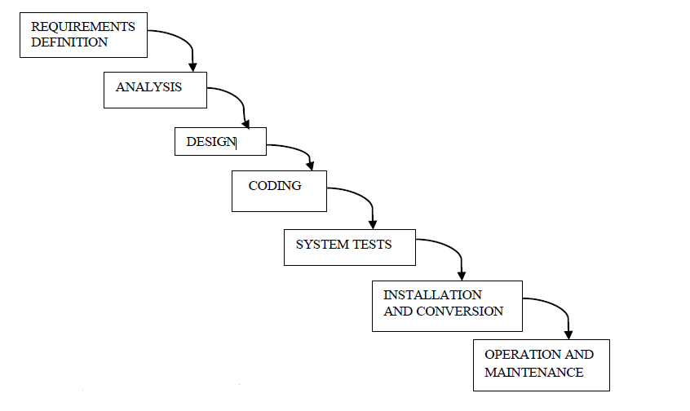

Figure 2:2 The waterfall model - adapted from Hughes and Cotterell

## 3.1 Description of the existing System

In the existing system the processes include:

* Current system working manually. It provides the information in written or orally within the organization/campus.
* Individual has to spare his time and energy in order to obtain even the basic information regarding the organization/campus.
* There can be long and tedious procedures in order to have a solution regarding any particular query.

## 3.2 Analysis of Proposed System

For proper implementation of the new system, there are some hardware and software requirements that are needed. The following are the hardware requirements for the implementation;

* A Pentium 4 processor or higher with speed of 1.5GHz or faster
* RAM of at least 256MB
* Hard disk
* A monitor
* A mouse
* A keyboard

The following are the software requirements for the system;

* Windows operating system
* Sublime Text IDE
* XAMPP (Cross platform Apache, MySQL, PHP) application.

### **3.2.1 System Modelling**

Structured system Analysis and design methodology (SSADM) is a set of standards for system analysis and application design. It uses a formal methodical approach to the analysis and design information system. The SSADM is an opened methodology based on the waterfall model. It has been used by many commercial businesses, consultants, educational establishments and case tools developers

The step or stages are as follows

* Feasibility
* Investigation of the current environment
* Business system options
* Definition of requirements
* Technical system options
* Logical designs
* Physical design.

s

Figure 3.0: Use-Case diagram of Student

Figure 3 specifies the activities that a student can perform, of which viewing a list of requests he can make and submitting a request are the major one. Moreover, he has options to change password and check status of his request.

s

**Helpdesk  
Department**

Figure 3.1: Use-Case diagram of Facility Head

Figure 3.1 specifies the tasks that the helpdesk department has to perform such as checking the requests from the students and authorizing them i.e. taking necessary actions on them. Furthermore, he has the option to send a proper notification via email to the students.



Figure 3.2: Use-Case diagram of Administrator

Figure 3.2 specifies the job of administrator, wherein he has the ability to add or remove students or staff from the system.

## 3.3 Design of Proposed System

Online Campus Helpdesk is proposed to be a web client-server based distributed software system in which multiple autonomous client systems connects to distributed servers via established Intranet or Internet connection. Client-server architecture is adopted because Online Campus Helpdesk is expected to be used by a large number of users from different locations. All communication is over the network with the server on the institutions intra-network.

**3.3.1 Database Design**

This system’s database is developed using MySQL’s PHPMYADMIN frontend. Containing 5 tables with fields in them. The table’s below show the fields in the database.

|  |  |  |  |
| --- | --- | --- | --- |
| Field | Data types | Size | Description |
| User_id | Int | 11 | Primary key of user table |
| Name | Varchar | 60 | Full name of the user |
| Phone | Int | 11 | Phone number of the user |
| Username | Varchar | 60 | Username of the user |
| Password | Varchar | 150 | Password of the user |
| Email | Varchar | 60 | Email of the user |
| User_role | Varchar | 20 | User role of the user |

**Table 3.1 Table showing the fields in user table of the database**

|  |  |  |  |
| --- | --- | --- | --- |
| Field | Data types | Size | Description |
| Student_id | Int | 11 | Primary key of student table |
| Student_name | Varchar | 60 | Name of registered student |
| Student_phone | Int | 11 | Student phone number |
| Student_matric_no | Varchar | 20 | Student registration number |
| Student_password | Varchar | 150 | Student password |
| Student_email | Varchar | 60 | Student email |
| Student_dept | Varchar | 60 | Student department |

**Table 3.2 Table showing the fields in student table of the database**

|  |  |  |  |  |
| --- | --- | --- | --- | --- |
| Field | Data types | Size | Identity | Description |
| Staff_id | Int | 11 | No | Primary key of staff |
| Staff_name | Varchar | 60 | No | The staff name |
| Staff_phone | Int | 11 | No | Staff phone number |
| Staff_password | Varchar | 150 | No | Staff password |
| Staff_email | Varchar | 60 | No | Staff email |
| Staff_dept | Varchar | 60 | No | Staff department |

**Table 3.3 Table showing the fields in staff table of the database**

|  |  |  |  |
| --- | --- | --- | --- |
| Field | Data types | Size | Description |
| call_id | Int | 11 | Primary key call id |
| Member_id | Int | 20 | Primary key |
| Date_logged | Varchar | 20 | The date logged |
| Date_responded | Varchar | 20 | The data responded |
| Call_priority | Varchar | 20 | Call priority |
| Title | Varchar | 60 | The title |
| Problem_outline | Text |  | The problem outline |
| Dept | Varchar | 30 | Department |

**Table 3.4 Table showing the fields in call table of the database**

|  |  |  |  |
| --- | --- | --- | --- |
| Field | Data types | Size | Description |
| Id | Int | 11 | Primary id |
| Question | Text |  | Question |
| Answer | Text |  | Answer |

**Table 3.4 Table showing the fields in knowledge base table of the database**

### **Transactions on Online campus helpdesk**

Transactions can be described as the activities that users’ carry out on the database. A transaction may be an update transaction or query type transaction. Update transactions are the activities that are responsible for the insertion of new records, modification of existing records and deletion of unwanted records in the database. Query transactions are the activities that are responsible for retrieving and processing records from the database with the view of generating specific reports for management decision making.

The transactions envisaged for the system are grouped into the following: Create, Read, Update and Delete. The acronym given is CRUD.

a. Create Transactions

1. Add users
2. Add request
3. Add/Send message referring to a request

b. Report Transactions

1. View/print users’ record
2. View/print request(s)
3. View/print thread of messages associated with a request
4. View/print list of cases (request/problem) reported in a given period
5. View/print List of solved and unsolved requests
6. Display/print status of requests

c. Update Transactions

1. Update user data
2. Update request status

d. Delete Transaction

1. Remove invalid requests.
2. Delete repeated users

### **3.3.2 System Architecture**

The architecture of the new system consists of the following; Case-specific data and the user interface.

User Interface (UI) Layer (Front-end Modules)

Requestors, IT department users, help desk department and servicing department users with unique interfaces dependent on assigned roles for data input and reports generation.

Fig 3.3 Architecture of an online campus helpdesk system

KNOWLEDGEBASE

KNOWLEDGE ACCESS LAYER

Business Logic Layer (System Kernel)

Knowledgebase Layer( Back-end)

Knowledgebase Update Component

Request Servicing Components

Report Component

Knowledgebase Browser

Authorization Component

Request Creator Component

UI Module

n

UI Module

3

UI Module

2

UI Module

1

Requestors or End users are the initiators of every request made to the helpdesk. Requests are made to the helpdesk via browsers residing on client workstation. The Requestors must be registered users of the system. Once a Requestor makes a request, the request is immediately forwarded to representative of the servicing department if specified or to the help desk department which forward the request to the servicing department(s). The representative may be a clerk, Faculty/College Dean, Head of Department etc. and may even be an Approving Officer. The request is forwarded to the necessary units for servicing but first to the Approving officer if not information based. Once approved, the intended service provider(s) in the servicing department services the request and indicates completion. The requestor will then indicate satisfaction once done. Also the transaction history and relevant data/information about the transaction are stored in the knowledgebase for future use by management of the institution or the helpdesk department.

# CHAPTER FOUR

# SYSTEM IMPLEMENTATION

## Introduction

The implementation of the proposed system entails putting all the theoretical design into practical design in order to put the new system into operation. This in practice is the development of the Online Campus Helpdesk. System implementation deals with coding and testing of the program.

## Choice of Development Environment

The system developed in this work is a web based application. The Integrated Development environment (IDE) is Sublime Text. The programming languages used for the development of the system are HTML, CSS, MySQL and php. The choice was made due to some advantageous features of the programming language such as;

* fast loading
* Ease of development
* Flexible of configuration.

**Software Requirements**

|  |  |
| --- | --- |
| Number | Description |
| 1 | Windows 2000/ XP/ or Higher with MS-office |
| 2. | Xamppor Wampp server |
| 3. | Ms-Internet Explorer, Mozilla Firefox, Google Chrome, Safari. |

## Implementation Architecture

The following block diagram shows the various components of the software and their linkages.

Users

& Departments

My

Profile

Requests

My Requests

Technical

Login

module

Figure 4.0 Block Diagram showing the system architecture of the new system.

## Software Testing

The test activity was carried out in stages. Each module or form as the case may be was tested during and after design. The figures below are screen shots during testing for logical and syntax errors. Using the sublime Text IDE.

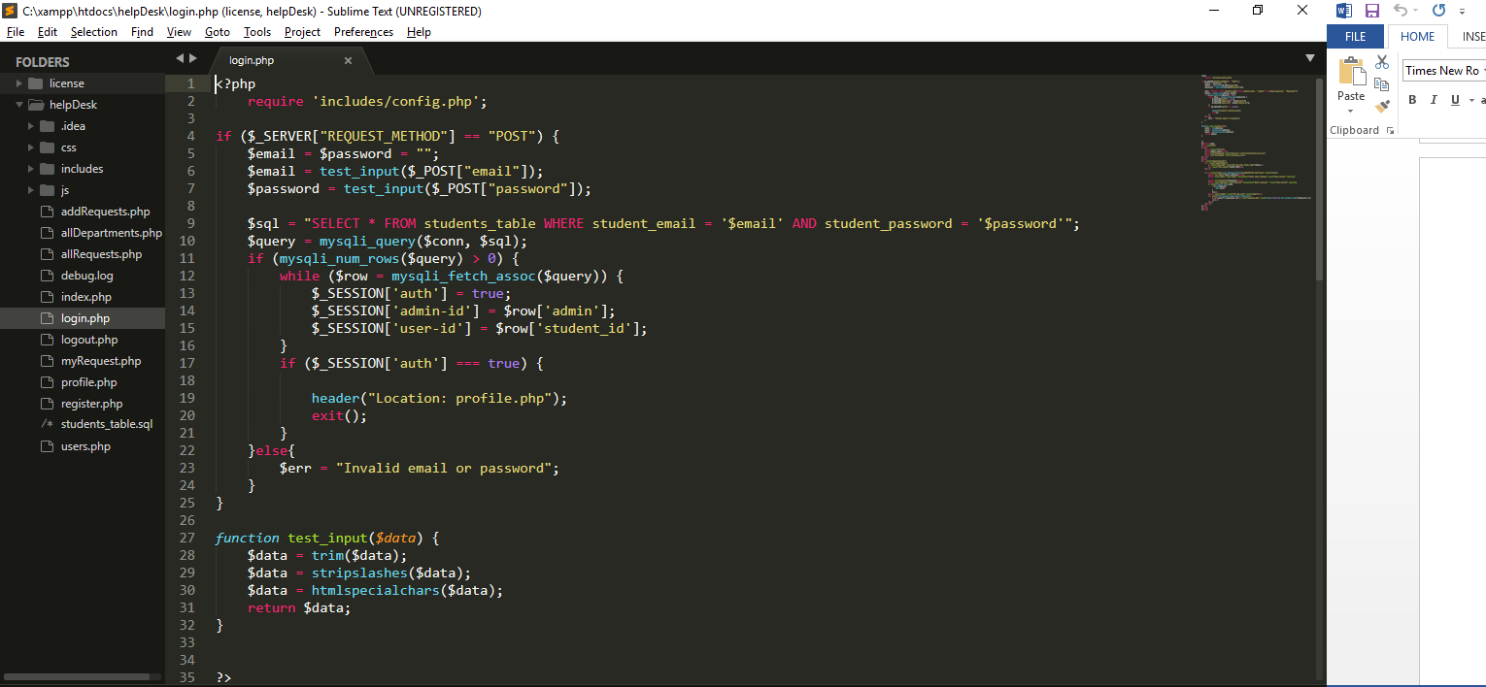

Figure 4.1 Screenshot showing debugging of the login page.

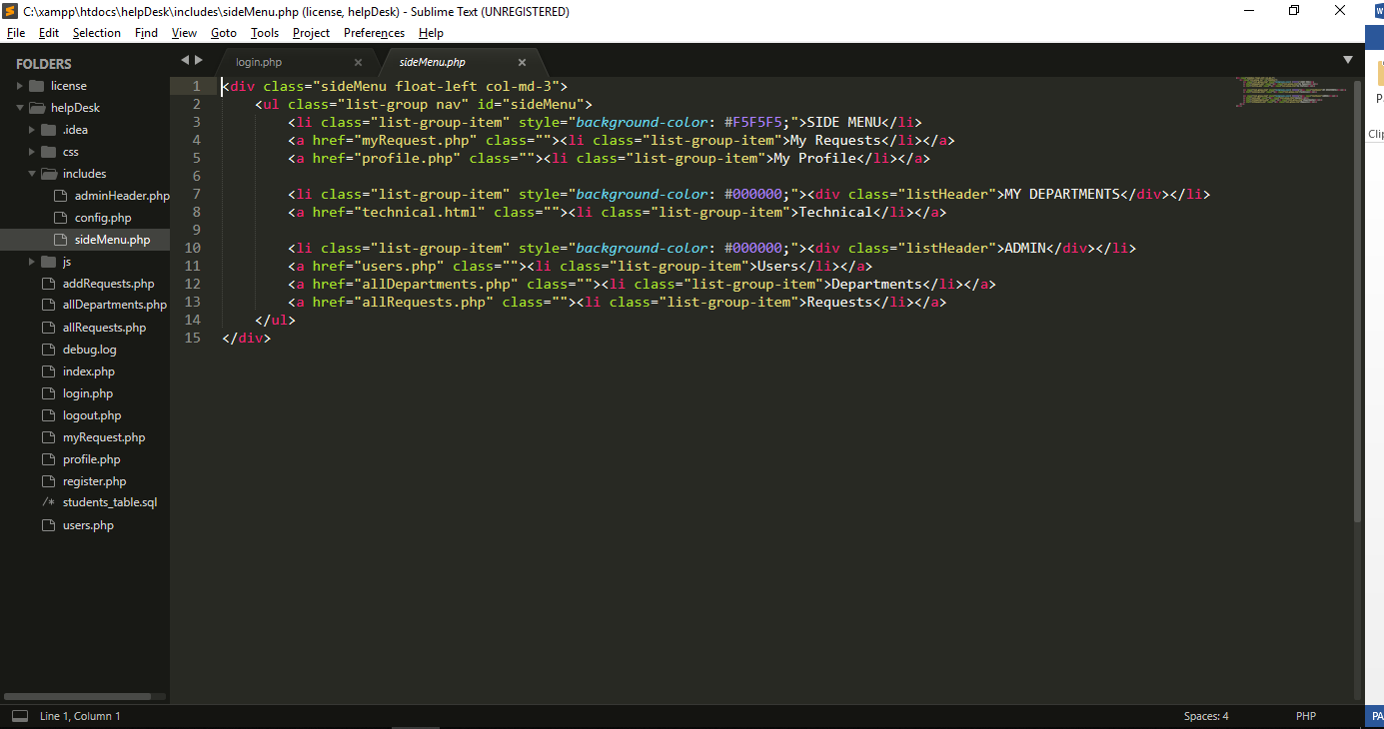

Figure 4.2 Screenshot showing debugging of a menu item.

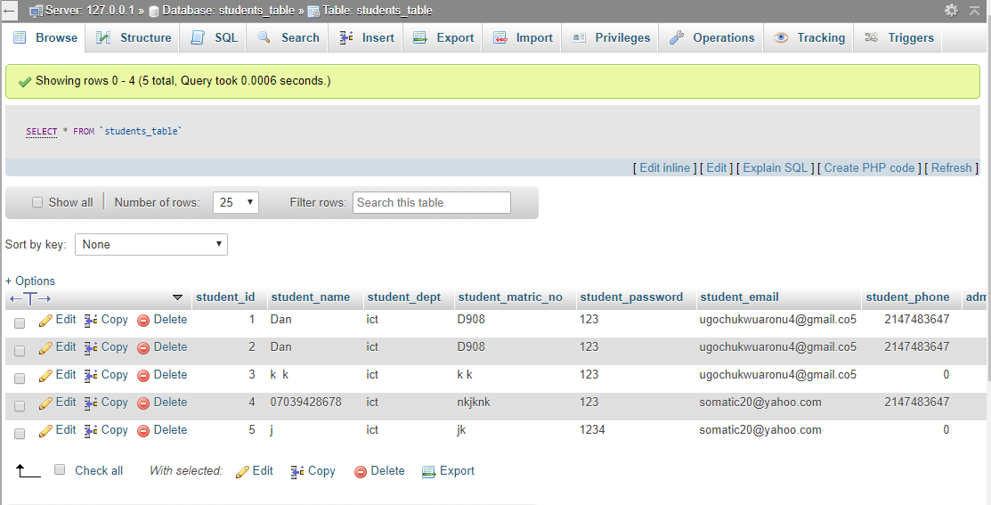

Figure 4.3 Screenshot showing database of the update record tab.

The database was tested basically for connectivity and storage to ensure that the appropriate data types, validation rules and other properties were assigned to the fields. The main driver, being the diagnosis page was tested for proper connectivity to the database. Improper linkage to the database was corrected and assurance was made to see that data was accurately retrieved and presented without errors.

Testing was also done after the integration of the different modules of the system with realistic data samples. Below are some screen shots during system testing using realistic data samples.

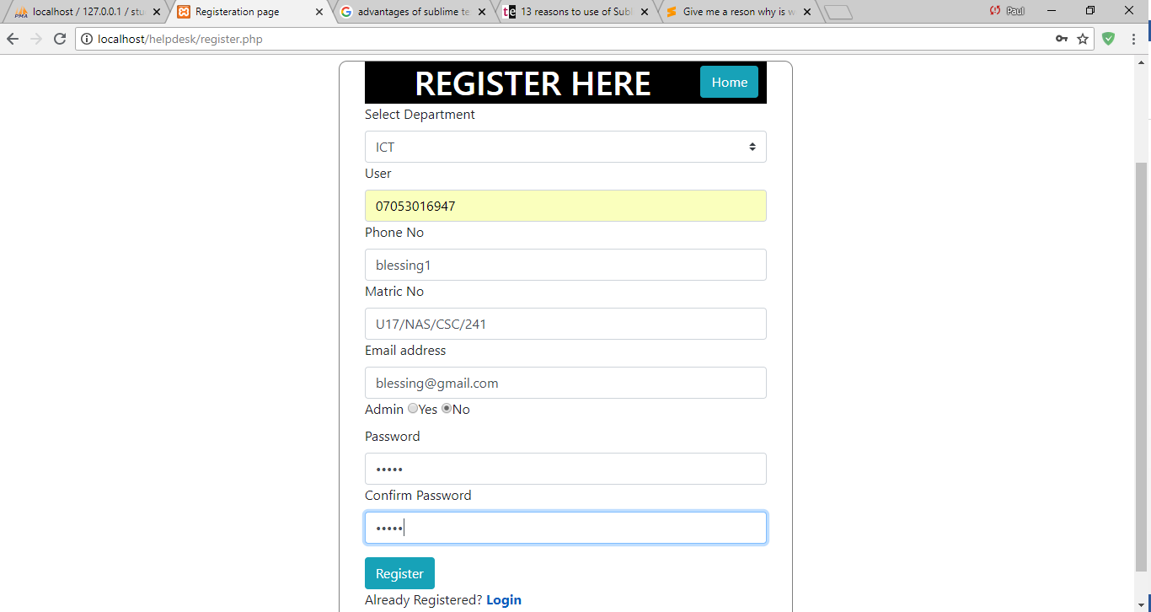

Figure 4.4 Screenshot of User page with selected Department

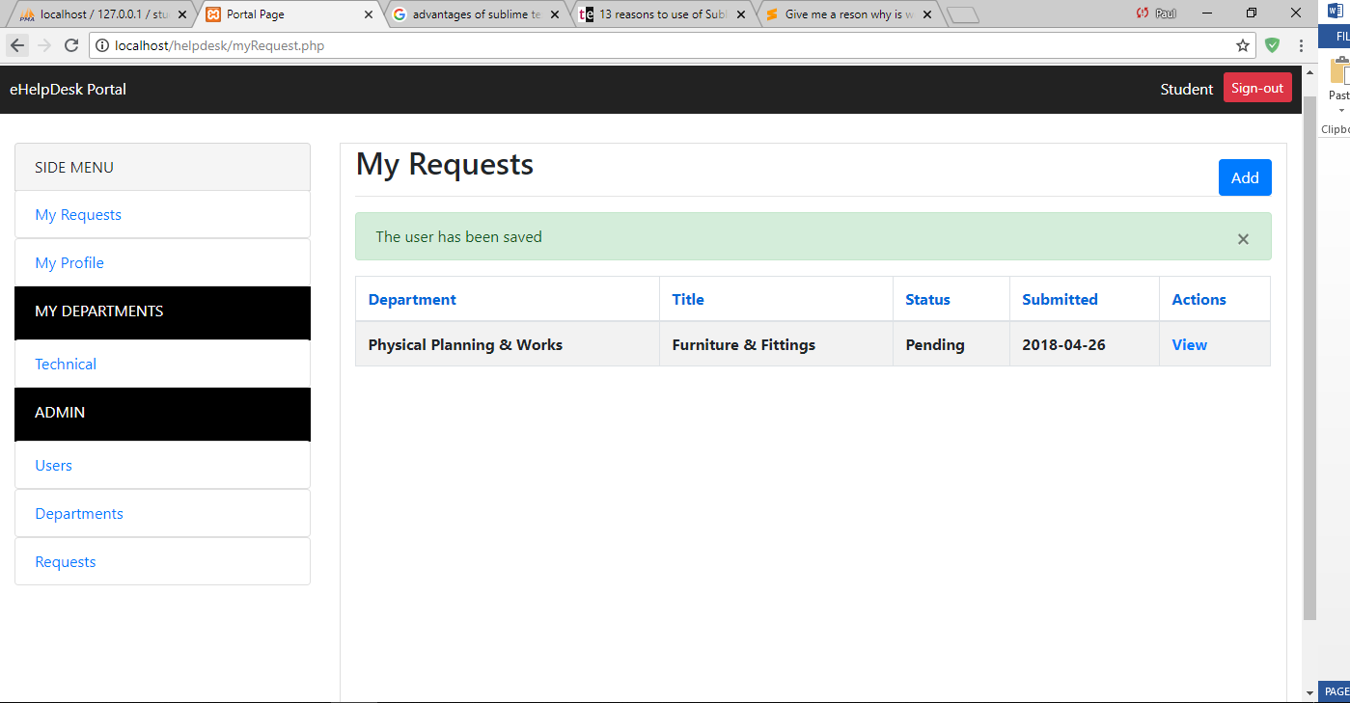

Figure 4.5 Screenshot of Requests Page.

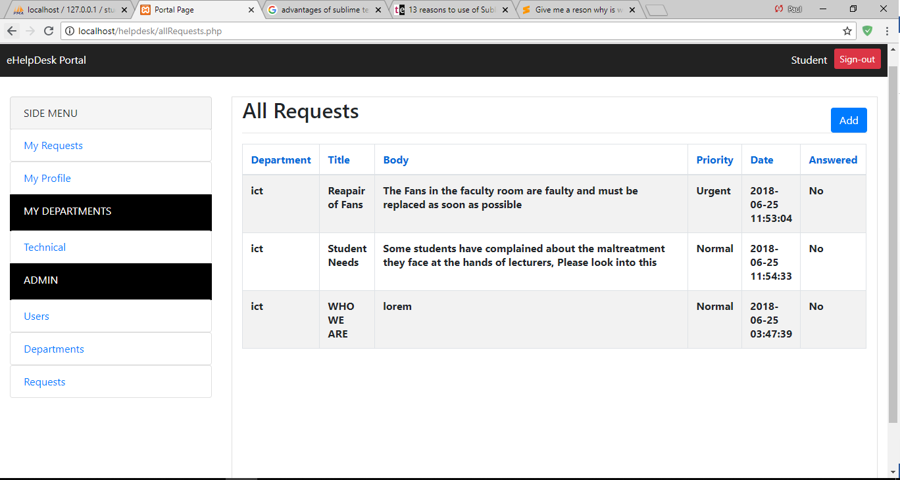

Figure 4.6 Screenshot of All Requests Page in Admin Section.

The screenshots below show the testing of the login page with both valid and invalid login details.

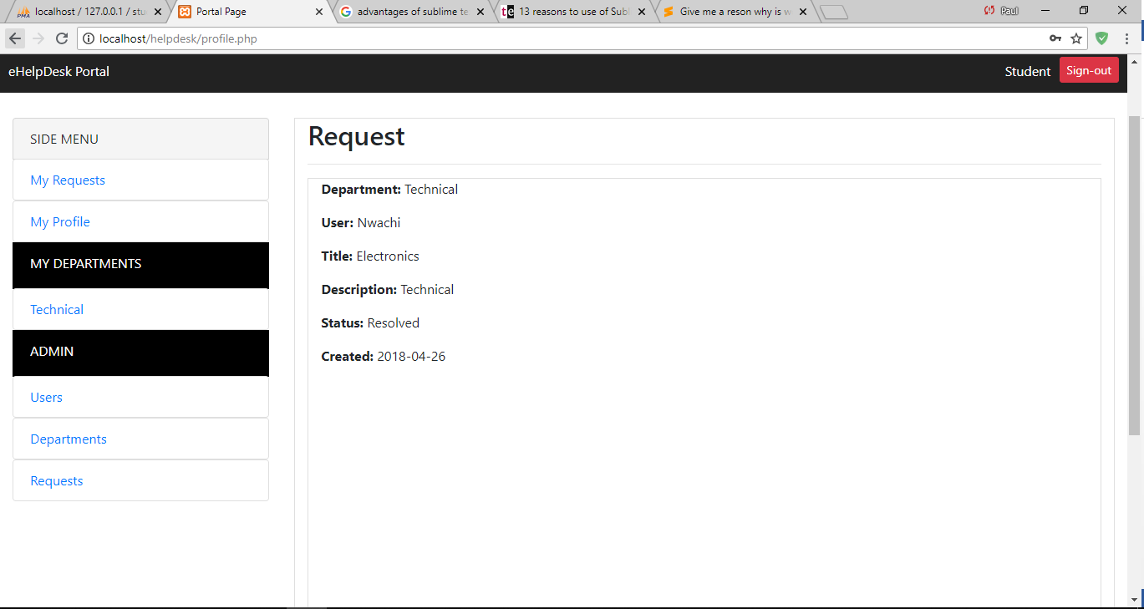

Figure 4.7a Screenshot of Login page with valid login details

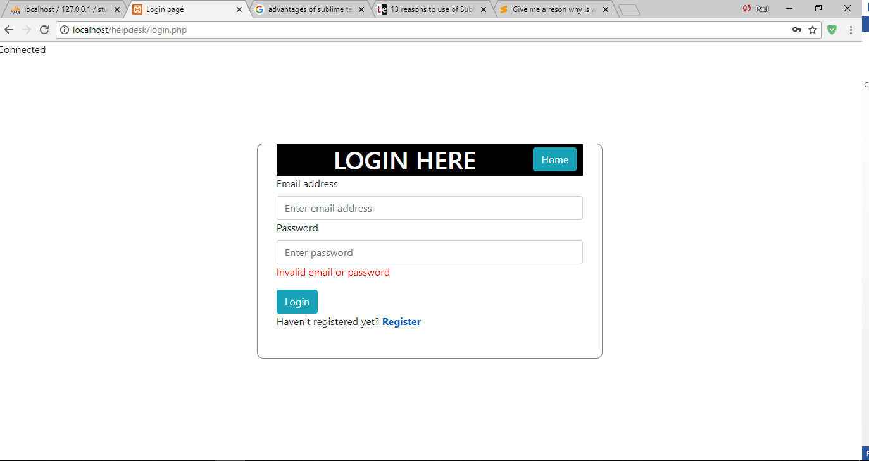

Figure 4.8b Screenshot of Login page with invalid login details

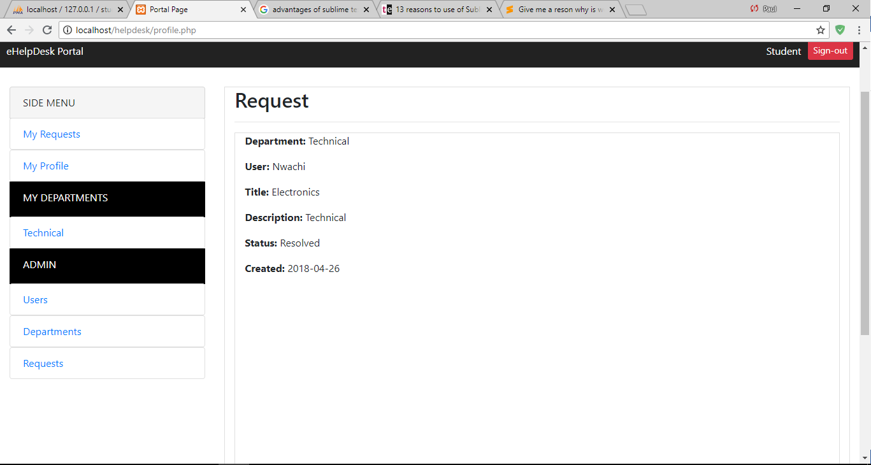

Figure 4.9 Screenshot of User information page

## Documentation

**4.4.1 User Manual**

To use this application, follow these steps;

1. Go online to gou-campus-help.xyz.
2. Create an account on the application
3. Login to the application
4. Raise a request
5. Wait for a response for the admin Department.

**4.4.2 Source Code Listing**

1. Refer to Appendix A for the source code of the login page.
2. Refer to Appendix B for the source code of the department page.
3. Refer to Appendix C for the source code of the request page.
4. Refer to Appendix D for the source code of the users page.

# CHAPTER FIVE

# SUMMARY AND CONCLUSIONS

## Summary

The motivation behind this section is to abridge the study that was directed including the statement of the research questions, the research methodology used, and a summary of the study results, conclusions and recommendations. The primary aim of this project has been met. All the objectives that were set out have been completed and giving positive results in the end. Although some users comment that they did not think online campus helpdesk was ideal, it has managed to convince them to try for Godfrey Okoye University.

## 5.2 Conclusion

In this paper, we proposed a design for online campus helpdesk and a conceptual framework for electronic helpdesk system, which can be adopted by any tertiary institution. The proposed system automates the process of request submission to the helpdesk department. It also provides a platform for users to receive help on various requests ranging from system failures to service provision. Therefore, it will be a central point through which problems could be reported and managed. Online campus helpdesk, if implemented, will serve as a computer based platform that will effectively and efficiently carry out users’ support services in tertiary institution. Online campus helpdesk provides the tools to carry out the following functions:

* Enables users to obtain information regarding the institution support services.
* Reduce turnaround time to complete requests submitted by users.
* Storage of records about helpdesk history, resolution tools, workflow for all helpdesk activities and automated escalation tools for timely support.
* Find, analyse, and eliminate common problems in the institution.
* Handle problems efficiently; maintain audit trails and enable helpdesk staff free up for more useful tasks.
* Enables management to measure problems resolved by the service provision departments to give them a fair rating during KPI (Key Performance Indicator) review.

Listed below are the benefits of online campus helpdesk:

* To log, analyse and assist in the resolution of helpdesk issues
* There is database of users’ details, helpdesk history and resolution tools.
* There is action log to record every event in a helpdesk job history.
* There is structured workflow for all helpdesk activity.
* There is automated escalation tools to assist in timely support solution
* Helpdesk managers can quickly generate meaningful reports that can highlight performance bottlenecks, recurring client issues, and outstanding service.
* Some institutions provide services to companies and other institutions, therefore with online campus helpdesk, helpdesk managers are able to quickly configure complex escalation and service level agreement rules so that their helpdesk support is effective and provides the level of service that clients demand.

Based on the aforementioned benefits, the following constraints are enforced: Users are enforced to use a specific workflow as defined by the management of the institution and service level agreement rules must be implemented in order to automate request/problem escalation procedure stated therein. Considering the economy of developing countries, online campus helpdesk is affordable because the implementation is based on Open Source applications.

## 5.3 Recommendation

Based on the foregoing conclusions, herewith were the following recommendations:

1. It is to recommend the full implementation of the proposed system.

2. The regular monitoring of access based application at best time to avoid the slow systems processing due to large volume of users.

# Reference

[1] L.A. Middleton and R. Marcella, *The Role of the Help Desk in the Strategic Management of Information Systems*, vol. 12, 4-19, 1997.

[10] Workman, S.B. and O. Cathy, Central IT Support Services. (Research Bulletin). Boulder, CO: EDUCAUSE Center for Applied Research, August 12, 2012, 2012.

[11] Boland, K., K. Lewis, and M. Mathias, How Collaboration Created an Online Help Desk and Knowledge Base for the Campus Community. EDUCAUSE Mid-Atlantic Regional Conference 2008, 2008.

[12] Byeong, H.K., et al., Help Desk System with Intelligent Interface. *Applied Artificial Intelligence: An International Journal*, vol. 11: pp. 611 – 631, 1997.

[13] Hu, M., User support system integrating FAQ and helpdesk features and FAQ maintenance capabilities. 2013, Google Patents.

[14] Shafie, F., et al., Application of Facilities Management (FM) Helpdesk in Higher Educational Institutions in Malaysia. 2011 International Conference on Management and Artificial Intelligence IPEDR, (2011) IACSIT Press, Bali, Indonesia, 2011. 6: p. 37-41.

[15] SitiSyatirah, R., Help Desk System (HDS) For ICT Asset. 2010.

[16] J. Yuhua, Practice of the Campus Smart the IT Helpdesk Cloud Architecture. *Journal of Beijing Polytechnic College*, vol 2, pp. 8, 2000.

[17] J. Sykes, *The Three – Continent, 24-Hour Helpdesk*: An Academic First. EDUCAUSE Quarterly, 2002, pp. 50-53.

[2] Samarakoon, L. and K. Pulasinghe. Automated question answering for customer helpdesk applications. in Industrial and Information Systems (ICIIS), 2011 6th IEEE International Conference on. 2011. IEEE.

[3] Berg, A., L. Kahle, and G. Wood, Merging User Support Services: Technology Help & Library Circulation. NERCOMP 2012 - Libraries and Scholarship In The 21st Century, 2012. 6.

[4] Caruso, B.J. and S.C. Mark, Service on the Front Line: The IT Helpdesk in Higher Education. EDUCAUSE Center for Applied Research, 2007.

[5] Littlefield, D., A. Damon, and T. Lamy, Leveraging Help Desk Infrastructure to Support Faculty Development. Instructional Development Center University of New Hampshire Durham, NH, 2007.

[6] Pirani, J.A. and C.S. Mark, Service on the Front Line: The IT Help Desk in Higher Education. (Roadmap). Boulder, CO: EDUCAUSE Center for Analysis and Research, 2007, 2007.

[7] Amaral, C., et al. Smart Helpdesk: Solutions for e-Learning. in World Conference on E-Learning in Corporate, Government, Healthcare, and Higher Education. 2011.

[8] Agee, A.S. and R. Renaud, Beyond the Helpdesk: Creating a Culture of Service in the IT Organization. (Research Bulletin). Boulder, CO:EDUCAUSECenter for Applied Research, 2009. 2009(17): p. 1–12.

[9] Sheehan, M., The Help Desk as a Pivot Point for IT Agility. . 2007 EDUCAUSE Midwest Regional Conference, Chicago, Illinois, 2008.

**APPENDIX SOURCE CODE OF THE INDEX PAGE**

<!DOCTYPE html>

<html>

<head>

<meta charset="UTF-8">

<title>eHelpDesk</title>

<link rel="stylesheet" type="text/css" href="css/bootstrap.min.css">

<link rel="stylesheet" href="css/styles.css">

</head>

<body>

<div class="container1">

<div class="header">

<h1 class="text-center headerText">WELCOME TO THE eHelpDesk SYSTEM</h1>

</div>

<p class="text-center">

<a class="btn btn-primary" href="login.php">Login</a>

<a class="btn btn-primary" href="register.php">Register</a>

</p>

<!-- <p class="text-center">You will find below all the available departmrnts. To access your department or make a new request, please click on the button</p>-->

</div>

<p class="text-center">Please note that you need to be authorised brfore you can use any part of this system. Contact the ICT team personally if you're not already a user.</p>

<h2 class="text-center" style="margin-bottom: 20px;">DEPARTMENTS</h2>

<div class="row departmentsRow">

<div class="col-sm-3">

<div class="contain">

<h3 class="text-center">Technical</h3>

<p>Manages all users and requestors. Responsible for managing all departments too.</p>

<p>Responsible for all the technicals that have to do with the system.</p>

</div>

</div>

<div class="col-sm-3">

<div class="contain">

<h3 class="text-center">Physical Planning & Works</h3>

<p>Servicing of all university equipments.</p>

</div>

</div>

<div class="col-sm-3">

<div class="contain">

<h3 class="text-center">Technical</h3>

<p></p>

</div>

</div>

<div class="col-sm-3">

<div class="contain">

<h3 class="text-center">Technical</h3>

<p></p>

</div>

</div>

</div>

</div>

</body>

<script src="js/custom.js"></script>

<script src="js/bootstrap.min.js"></script>

</html>