Chapter one
1.0 Introduction
Bitter yam (Dioscorea dumentorum pax) can also be called Trifoliate yam which belongs to the genus Dioscorea and family Dioscoreaceae (Onweme 1978; Bai and Ekanayake, (1998). it is an annual plant with an underground storage tuber in which starch is deposited (Bai, and Ekanayake et al., 1998). The starchy tubers may be single but are usually produced in clusters, in a stand of the plant (Bai, and Ekanayake). Though the plant still exists in the wild of tropical Africa, its cultivated landraces are considered amongst food yam of economic importance (Hahn, S.K,Osiru, D.S.O,Akoroda, M.O and Otoo, J.A (1987). The flesh of the tuber may be white or pale-yellow or dark yellow, with the cultivated variety eaten as food after boiling to softness (Coursey, Kay et al., 1967) while yam tubers are known to be rich in vitamin c (Coursey Kay et al 1967 and Degras, 1993). Tubers of Dioscorea species generally contain phytochemicals (Degras, 1993). Some of these phytochemicals are toxic at high concentrations while others are relatively beneficial or harmless the major non nutritional compounds found in yams include alkaloids, saponins, phenols and oxalates (Degras, 1993).
Dioscorea dumentorum is sometimes of the land races referred to bitter yam because of the bitterness of the tubers of the wild type and few cultivated landraces. This bitterness is known to be caused by the presence of a toxic alkaloid; dihydrodioscrine 6.dihydrodioscorine is structurally similar, but less potent than the bitter and toxic dioscorine found in the Asiatic dioscorea hispida (Degras, 1993).
Trifoliate yam (bitter yam) has benefited from great selection pressure by African civilizations to such an extent that cultivars of the plant in Africa have little or negligible quantity of the bitter alkaloid. Nutritionally, bitter yam is superior to other food yams in Africa in terms of protein content. The protein content of the tuber on dry matter basis is 12-13% (Onweme 1978, Coursey, D et al 1967; Oyenuga, 1968, Bell et al., 1981).
This protein content is comparable to those of cereals, and higher than 4%value for dehydrated cassava tuberous roots (UNECA 1985).
Manuel et al., 2005 reported yam to be one of the principal foods in Nigeria, also an economically, socially and traditionally valuable crop in many tropical countries predominantly in West African, south Asian and Caribbean Countries.
Yam has been reported to be rich in carbohydrate with many of its varieties widespread throughout the humid tropics. The most economically important species grown are; white yam (Dioscorea rotundata), yellow yam (Dioscorea cayenensis), water yam (Dioscorea alata), chinese yam (Dioscorea esculenta), Aerial yam (Dioscorea bulbifera) and trifoliate yam (Dioscorea dumentorum) (Ike and Inom, 2006) but only a few species are cultivated as food crops to some extent processing of food has not reached a significant level commercially.
Predominantly, the use of yam has been limited to the preparation of local dishes such as pounded yam (yam dough) and porridges (Amani et al., 2002). The production of instant yam flour, yam flakes and starch has been explored but industrial scale production has been limited due to various constraints including high fresh market price (Onayemi and Potter 1974; FAO 2005). In other words, some yam varieties are widely known and overexploited for food while others are known and exploited as food only in a few rural communities in Nigeria and as a result underutilized. Over dependence on the common yam varieties for food and industrial use account for the high market price of yam and this incidentally limits industrial exploitation.
Bitter yam is a species of yam in which limited work has been done in terms of its production and utilization though it is high yielding compared to other yam species. In Nigeria, its local names include; Esuru in Yoruba language, Ona in Igbo language and kosanrogo in Hausa language. Some of its other common names are three leaved yam, cluster yam. It has starch grains that are smaller, more soluble and more digestible than those of other yam species (Treche and Guion 1980). The proteins also are more balanced than those of white yam (Mbome and Treche 1994) and it is rich in vitamins and minerals. The consumption of bitter yam is restricted due to its bitter taste, inability to keep for longer time after harvesting and poor binding capacity of its flour (Martin et al., 1993; Mbome and Treche 1994; Sefadedeh and Afoakwa 2001).
  - PHYTOCHEMICAL ANALYSIS
Phytochemicals are chemical compound that occur naturally in plant (phyto means ‘plant’ in Greek. They are responsible for color and organoleptic properties, such as the deep purple of blueberries and smell of garlic. Phytochemical analysis is determination of metabolic nutritional values and medicinal values in food and plant product.
There are two methods of test in phytochemical analysis; quantitative and qualitative test
1.2 PROXIMATE ANALYSIS
Proximate analysis refers to the determination of the major constituents of food and it is used to assess if a feed is within its normal compositional parameters or somehow been
There are 6 methods of test in proximate analysis; ash content, crude protein, crude fiber, moisture content and carbohydrate
1.3 STATEMENT OF THE PROBLEM.
To study how beneficial are Dioscorea dumentorum in producing phytochemicals their quantitative and to have a basic knowledge of their respective proximate composition as regards consumption. To compare the phytonutrients present in these leaves. To gather a background knowledge of their concentrations and to assess their potential nutritive and medicinal benefits
1.4 AIMS
This work was aimed at assessing the nutritional and phytochemical composition of Dioscorea dumentorum commonly cultivated in south eastern Nigeria (Enugu)

1.5 OBJECTIVES
- To determine the qualitative phytochemicals presents in Dioscorea dumentorum (bitter yam).
- To determine the quantitative phytochemicals present in Dioscorea dumentorum (bitter yam).
- To determine the proximate composition of Dioscorea dumentorum (bitter yam).

CHAPTER TWO
2.0 LITERATURE REVIEW
2.1 Botany
The crop yam (Dioscorea spp) is one of the common food crops in the tropics and plays vital roles in food security as a stable food in the regions where it is being cultivated (Maroya et al, 2012). Dioscorea spp occur in Asia, East Africa the Caribbean, India and Tonga kingdom, South Pacific as well as west African (Okigbo,2004). (Maroya et al, 2012) estimated that yam consumption yearly is over 48 million tones globally. As shown in table1, out of the 48 million tons of yam (95% global supply) that are produced on 4 million hectares annually, Nigeria alone produces 67.7% of global yam supply (FAO, 2010).this stale crop after cassava and maize. However, demand for this commodity is increased as incomes increases consumers shift from substitutes to yam especially when the price of yam relative to price of its substitutes declines (Maroya et al, 2012).
Yam plays an outstanding function in social cultural lives of some producing region like the celebrated moon festival in West African, an act that is well observed. Nigeria for instance, the meals offered to deity and associates consist mainly of meshed yam (Ogunleye, 2005). Yam storage in comparison with some other staple crops has relatively longer life spam, so stored tuber symbolizes stored wealth, which can be solid throughout the year by the markets. Also, tuber yam in west African particularly Nigeria can be converted into different staple transitional and end product forms (Okaka and Anajekwu,1990; Okaka et al,. 1991) which can be consumed by human being and animals, used as the essential ingredient of snakes and flour that is now used in instant pure making (Coursey1983;Okaka and Okechukwu, 1987).
Yam can be eaten in a variety of ways as it can be roasted, fried, grilled, backed, barbecued, smoked and most commonly boiled. Yam is also used as food for livestock. Tuber yam can be dried, ground into flour and stored for use.
However, in Nigeria a country known to produce a large percentage of yams around the globe, it is believed that the supply of yam tuber is lower than its high demand, a problem currently facing the country (Ogundana 1971; Okigbo and Emoghene 2004; Okigbo and Ogonnaya, 2006).
2.1.1 ORIGIN
Bitter yam (Dioscorea dumentorum) also called trifoliate yam because of its leaves originates in African where wild cultivars also exist. One marked characteristics of the bitter yam is bitter yam flavor of its tubers. Another undesired characteristic is that the flesh hardens if not cooked soon after harvest. Some wild cultivars are highly poisonous.
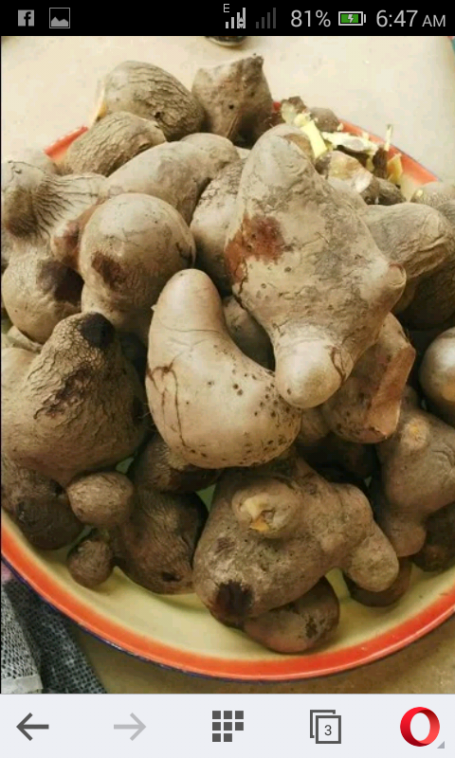 Fig 1(diagram of dioscorea dumentorum)

2.3 TAXAMONY OF YAM
Yam as known in English is ‘Dioscorea’. Yam belongs to the class Monocotyledons, family Dioscoreaceae, genus Dioscorea and species Dioscorea dumentorum (onweme, 1978 and Bai, and Ekanayake, 1998).

Scientific Classification Botanical name
Kingdom: Plantae
Clande: Angiosperms
Clande: Monocots
Order: Dioscoreales
Family: Dioscoreaceae
Genus: Dioscorea
Species: Dioscorea dumentorum
Bio nominal name: Dioscorea dumentorum

Flora of Zimbabwe; species of information
2.4 DESCIPTION OF YAM
A monocot related to lilies and grasses are vigorous herbaceous vines, providing an edible tuber
(Dioscorea dumentorum) bitter yam belongs to the genus Dioscorea and family Dioscoreacea (Bai and Ekanayake, 1998). Bitter yam serves as food of choice for the diabetic patients and as herb for the treatment of various ailments. They are native to Africa, Asia and the Americans. Some are also invasive plants often considered a ‘noxious weed’, outside cultivated areas (CABI 2017). Yam tuber varies in size from that of a small potato to over 60 kg (1301b). Some 870 species of yam are known (CABI, 2017) and 95% of these crops are grown in Africa (library of congress, 2011)
Yam tubers can grow up to 15m (4.9 ft.) in length and 7.6 to 15.2 cm (3.0 to 6.0 m) high. (CABI, 2017). The tuber may grow into the soil up to 1.5 meters (4.9 ft.) deep (CABI, 2017). The plant disperses by seed (CABI, 2017). The edible tuber has a rough skin difficult to peel, but softens after heating. The skins vary in color from dark brown to light pink. The majority of the vegetable is composed of a much softer substance ranges in color from white or yellow to purple or pink in mature yams.
2.5 USE OF DIOSCOREA DUMENTORUM (tuber)
Bitter yam is used as a vegetable, but not pounded as ‘fufu’.
The wild forms are regarded as famine food and the detoxified tubers can be grounded into flours which can be used for the preparation of beer.
The dried tuber can be used to prepare flour which can serve as food.
2.6 MEDICINAL IMPORTANCE OF DISCOREA DUMENTORUM
Dioscorea dumentorum (bitter yam) is rich in phytonutrients, including protein (Medova et al 2005; Alozie et al, .2009) and yet it remains an underutilized tropical tuber (Owuamanam et al, .2013).
- It serves as food for diabetic patients and as herb for the treatment of various ailments.
- In the southern-western Nigeria, it is utilized in the treatment of malaria (Dike et al., 2012).
2.7 Phytochemicals Analysis
Phytochemicals are natural bioactive compounds found in plants that work with nutrients and dietary fiber for disease protection (Oteng-Gang et.al., 1990). They are responsible for color and organoleptic properties, such as the deep purple of blueberries and smell of garlic. Phytochemical analysis is the determination of metabolites, nutritional values and medicinal values in foods and Plant product.
There is evidence from laboratory studies that phytochemicals in fruits and vegetables may reduce the risk of cancer, possibly due to dietary fibers, polypheonal antioxidants and inflammatory effects. Specific phytochemicals, such as fermentable dietary fibers, are allowed limited health claims by the US Food and Drug Administration (FDA).
There are two methods of test in phytochemical analysis; which include qualitative and the quantitative test. Qualitative analysis is used to test for the presence of nutrients in a specific food sample or plant sample. Quantitative analysis is used to test for the percentage or quantity of each nutrient present in a sample.
2.7.1 PHENOLS
Phenols are also known as carbolic acid and are an aromatic organic compound with the molecular formula C6H5OH. It is a white crystalline solid that is volatile. The molecule consists of a phenyl group (-C6H5) bonded to a hydroxyl group (-OH). It is mildly acidic and requires careful handling due to its propensity to cause chemical burns. Phenol was first extracted from coal tar, but today is produced on a large scale (about 7 billion kg/year) from petroleum. It is an important industrial commodity as a precursor to many materials and useful compounds. (Weber et al., 2004). It helps in the treatment of skin infection. Its major uses involve its conversion to plastics or related materials. Phenol and its chemical derivatives are keys for building polycarbonates, epoxies, Bakelite, nylon, detergents, herbicides such as phenoxy herbicides, and numerous pharmaceutical drugs.
2.7.2 FLAVONOIDS
Flavonoids are widely distributed in plants fulfilling many functions and the most important provided plant pigments coloration producing red or blue pigmentation in petals designed to attract pollinator animals. Flavonoid is a large group of phytonutrients that are water-soluble pigments, considered to have antioxidant and anti-inflammatory properties. Flavonoid protects body against cardiovascular disease as they are able to reduce the oxidation of low density lipoprotein. It is important for human health because of their high pharmacological activities as radical scavengers (Hertog et al., 1992). Flavonoid are potent free radical scavengers because they can donate their alcoholic hydrogen atoms to free radicals thus it can help in free radical scavenging capacities, coronary heart disease prevention and anticancer activities (Mohd Fadzley et al., 2008). Study on herb honey done by Robert et al., (2009) revealed that higher antioxidant properties will possess higher total flavonoid content.
Biological functions of flavonoids
They are linked to their potential cytotoxicity and their capacity to interact with enzymes through complexion.
Some provide stress protection, for example acting as scavengers of free radicals such as reactive oxygen species (ROS) (Williams et al., 2004).
They are also involved in the resistance aluminum toxicity in maize (kidd et al., 2001)
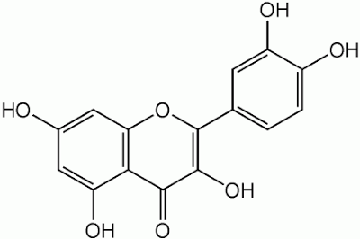
Figure 2

Structure of flavonoid.

2.7.3 TANNINS
Tannin is also known as tannic acid; is any group of pale yellow to light brown amorphous substances in the form of powder, flakes and used chiefly in various medical applications. They are water soluble polyphenols that are present in many plant foods. They have been reported to be responsible for decreases in feed intake, growth rate, feed efficiency, and net metabolized energy and protein digestibility in experimental animals (Balick, 2000). It helps in breaking down of sugar and also helps in digestion of food. The tannin compounds are widely distributed in many species of plants, where they play a role in protection from predation, and perhaps also as pesticides, and in plant growth regulation (Katie et al., 2006). The astringency from the tannins is what causes the dry and puckery feeling in the mouth following the consumption of unripe fruit or red wine. (Harold et al., 2004). Therefore, food rich in tannins are considered to be low nutritional value.
There are three basic classes of tannins according to chemical structure;
(1) Hydrolysable tannin.
(2) Condensable or non-hydrolysable tannin
(3) Phlorotannin.
2.7.4 STEROIDS
Steroids are strong medicines, and they can have side effects, including weakened bones and cataracts. Because of this, you usually take them for as short a time as possible. Steroids comprise a group of cyclic organic compounds whose most common characteristic is an arrangement of seventeen carbon atoms in a four-ring structure, where the rings are three composed of 6-carbons (rings A, B, and C) followed by one with 5-carbons (ring D). Steroids serve as blood cell builder. Further common features are an 8-carbon side chain attached to a carbon on ring D, and two or more methyl groups at the points where adjacent rings are "fused". Hundreds of distinct steroids are found in animals, fungi, plants, and elsewhere, and specific steroids underlie proper structure and function in many biological processes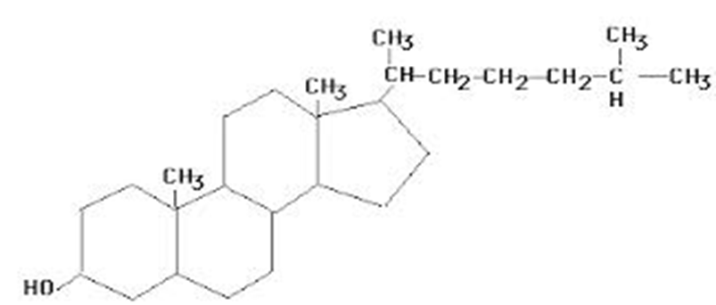
Figure 3

Structure of Steroid
2.7.5 ALKALOIDS
Alkaloids are group of naturally occurring chemical compounds that contain mostly basic nitrogen atoms. This group also includes some related compounds with neutral (McNaught et al., 1997) and even weakly acidic properties. (Manske, 1965) In addition to carbon, hydrogen and nitrogen, alkaloids may also contain oxygen, sulfur and more rarely other elements such as chlorine, bromine, and phosphorus. Alkaloids are produced by a large variety of organisms including bacteria, fungi, plants, and animals. They often have pharmacological effects and are used as medication or as recreational drugs. Common example are the local anesthetic and stimulant cocaine, the analgesic i.e. morphine, the anticancer compound vincristine, the stimulants caffeine and nicotine, the antibacterial barbering and the antimalarial drug quinine (Raymond et al., 2010). Although alkaloids act on a diversity of metabolic systems in humans and other animals, they almost uniformly invoke a bitter taste. (Rhoades, 1979) Some alkaloids have remarkable structural similarities with neurotransmitters in the central nervous system of human, including acetylcholine, dopamine and serotonin. The effect of these alkaloids on human has led to the development of the above mentioned medications and drugs.

2.7.6 SAPONINS
Saponins are glycosides with a distinctive foaming characteristic. They are found in many plants, but get their name from the soapwort plant (Saponaria), the root of which was used historically as a soap. They exhibit a range of biological properties, both beneficial and deleterious. In plants, saponins may serve as anti- feed ant, and to protect the plant against microbes and fungi. Some plant saponins (e.g. from oat and spinach) may enhance nutrient absorption and aid in animal digestion (Balick, 2000). However, saponins are often bitter to taste, and so can reduce plant palatability (e.g. in livestock feeds), or even imbue them with life- threatening animal toxicity. Data from the article “A Systematic Account of the family Asteraceae” by Turner (2007) makes clear that some saponins are toxic to cold- blooded organisms and insects at particular concentrations.
2.8 Proximate Analysis
Proximate analysis is a partitioning of compounds in a feed into six categories based on the chemical properties of the compounds. Hence, it is simply used to determine the amount or percentage of each present in the feed. The six categories are moisture, Ash content, crude fiber, crude lipids, protein content and nitrogen-free extract (digestible carbohydrates).
2.8.1 Moisture content
Moisture content of a sample is the level of water present in that sample under investigation. Moisture content of food is of great importance to every food processor as a number of biochemical reactions and physiological changes in food depend so much on it. It also has greater effect on the stability and quality of foods. Methods that are based upon the removal of water from the sample, and its measurement by loss of weight, sun or vacuum oven drying at 70-80⁰C are considered to be reliable methods provided that there is no chemical decomposition of the sample and water is the only volatile constituent removed.
2.8.2 Ash content
The ash of biological materials is analytical term for the inorganic residue that remains after the organic matters has burnt off at a temperature of 600⁰C. This result in oxidation of organic constituents to volatile material considered as carbon dioxide, nitrogen-oxide and sulphur oxide. The importance of the ash content is that it gives an idea of the amount of minerals elements present and the content of organic matters in the sample.
2.8.3 Crude fiber
Crude fiber is that portion of plant material which is not ash and cannot dissolve in boiling solution of 1.25% H₂SO₄ or 1.25% NaOH. Crude fiber was originally thought to be indigestible of the main food. It is known however that fiber consists of cellulose which can be digested to a considerable extent by both ruminants and non-ruminants. The interest of it in food and feed has increased, based on the noticed gelatinous masses with high water retention capacity with the digestive system. Findings show that fiber product can absorb cholesterol, toxic agents and raised the excretion of bile acid and steroids.
2.8.4 Fat and oil
Fats are mixtures of various glycerides of fatty acids, which are soluble in certain organic solvents, the usual procedures to continue extract the fat. Content with 40 to 60⁰C petroleum ether in a convert extractor- the ether extraction method is based on the principle that non polar components of the sample are easily extracted into organic solvents. The soxhlet extractor is mostly suitable for dried samples.
2.8.6 Carbohydrates
Carbohydrates are generally the most abundant components in nature and the widely distributed.
They are classified into monosaccharaides, disaccharides, oligosaccharides and polysaccharides.
There are different methods of carbohydrate determination which includes:
- Titration
- Colorimetry
- Refratometry
- Polarimetry
- Enzyme method
- High performance liquid chromatography (HPLC).

CHAPTER 3
MATERIALS AND METHODS
  - EQUIPMENT
Water bath, Hot air oven (DESCOTM), Soxhlet apparatus, Heating mantle, Weighing balance Measuring cylinder, Beakers, Test tubes, centrifuge, separating funnel, milling machine Filter paper, Plastic containers (for storing sample), Conical flask, Separating funnel, petri dish, stirring rod and crucible.
3.2 REAGENTS
Ammonia solution (NH₄), Chloroform, Sodium hydroxide (diluted) (NaOH), Hydrochloric acid (diluted) HCL, Distilled water H₂O, Sulphuric acid (concentrated) H₂SO₄, Acetic acid Methanol (CH₃OH), Ammonium sulphate NH₄ SO4, Boric acid and Methylene red.
3.3 METHOD OF COLLECTION OF SAMPLE (DIOSCOREA DUMENTORUM)
Dioscorea dumentorum (bitter yam) was obtained from Obinagu Village from Enugu East of Enugu State and was authenticated at the Department of Crop Science University of Nigeria Nsukka, Enugu State
3.4 EXTRACTION PROCEDURE
Dioscorea dumentorum was washed with water and shade dried for 6 days. The dried yam was grounded using a milling machine and was stored in a plastic container for further analysis.
The dried powder samples of the Dioscorea dumentorum (100 g) was soaked in 500 ml of methanol in a plastic container and left for 24 hours until complete extraction. After extraction, it was filtered using a clean cloth and was filtered using filter paper and was used for phytochemical screening which was carried out using standard procedures to identify the constituents as described by Trease and Evans (1989) and Harbourne (1998).

3.4.1 Test for alkaloids

Add 1ml of 1% HCL to 3ml of the extract into a test tube. The mixture was heated for 20minutes in a water bath. It was Shaked continuously on heating, the solution was cooled; add 0.5ml of Mayer’s reagent was added. Creamy color was observed.

3.4.2 Test for flavonoids
The stock solution (1 mL) was taken in a test tube; A few drop of dilute NaOH solution was added. An intense yellow color appeared in the test tube.

3.4.3 Test for saponins.
The stock solution (1 mL) was added in a test tube and was diluted with twenty mL of distilled water. It was shaken by hand for 15 min. A foam layer was obtained on top of the test tube. This foam layer indicates the presence of saponins.

3.4.4 Test for steroids
The stock solution (1 ml) was added into a test tube and was dissolved with chloroform (10 mL). An equal volume of concentrated sulphuric acid was added to the test tube by sides. The upper layer in the test tube turns into red and sulphuric acid layer showed yellow with green fluorescence. It showed the presence of steroids.

3.4.5 Test for tannins
Three ml of the stock solution was taken in a test tube and was diluted with chloroform. One ml of acetic anhydride was added. Sulphuric acid (1 mL) was added carefully by the side of test tube to the solution. A green color was formed which showed the presence of tannins.
3.4.6 Test for carbohydrate
Benedict’s test
Two ml of Benedict’s reagent was added to the extract and boiled. A reddish brown precipitate indicates the presence of carbohydrate (Reducing sugar).

3.5 QUANTITATIVE ANALYSIS
Quantitative analysis was done using modified Harbome method (1973). (Determination of alkaloid).
Ten gram (10 g) of the sample was weighed using weighing balance into a beaker. 10% acetic acid (100 mls) was added in ethanol (10 mls of acetic acid in 90 mls of ethanol). The mixture was covered and allowed to stand for 4hrs for proper extraction to take place. The sample was filtered with filter paper the Concentration NH₄OH (20 mls) was added drop wise to precipitate the alkaloid in the filtrate. The filtrate was centrifuge and then washed with 1% NH₄OH. The filter paper was weighed before filtering the precipitate (the precipitate to which 20 mls 0f NH₄OH was added). The filter paper and precipitate was dried in an oven at 40ºc.
The filter paper was reweighed and was calculated
Calculation of % alkaloid
% alkaloid = w₂-w₁ x 100
W₃ 1
W₁ = weight of empty filter paper
W₂ = weight of alkaloid + filter paper
W₃ = weight of the sample used.
3.3.1 Determination of flavonoid by MTD of BOHM and KOCIPN lab. (1994).
Ten gram of sample was extracted repeatedly with 100 ml 80% aqueous methanol at room temperature. (80 ml methanol + 20 ml H₂O).The solution was left for 45 minutes. The whole solution was filtered through what man filter paper No 1. The filtrate was transferred in a crucible and evaporated into dryness over a water bath and weighed to a constant weight.
Calculation
Weight of empty beaker + sample after drying = W₂
Weight of residue = W₂-W₁
Percentage % of flavonoid = W₂-W₁ x 100
Weight of sample 1
3.3.2 MOLIFIED METHOD OF DETERMINATION OF TOTAL PHENOL (GRAVIMETRIC METHOD)
Ten grams (10 g) was weighed of sample using electrical weighing balance, soak with 100 mls of 2 m HCL acid and put inside the oven for 1hr at 70’c – 80’c. it was allowed to cool. Pour into a separating funnel. Wash with 30mls of diethylether for the first time and shake. Allow to separate out into layers. Remove the lower layer into a wear and the upper layer into a weighing beaker.
Note: the upper layer is a clear/pure solution
Pour back the lower layer into the separating funnel and then wash with 20mls of diethylether and shake. Allow to separate for some time. Discard the lower layers and take the upper layer into that already contained in the weighed beaker. Heat to dryness and Cool the beaker in a desiccator and weigh again.
Calculation
W1 = weight of empty beaker
W2 = weight of the beaker + sample
W3 = weight of the sample used (10g)
% TOTAL PHENOL = W2-W1 * 100
W3 1
3.4 Preliminary proximate analysis
The sample was analyzed for Moisture content, Protein content, crude fiber, Lipid Content and Ash content. Crude protein was determined using the kjeldahl method. Crude fat was done using soxhlete extraction. The moisture, ash content and crude fiber was determined using standard methods (A.O.A.C 1990).
    - Ash content
An empty platinum crucible was washed, dried and the weight was noted. Two grams of grounded sample was weighed accurately into a platinum crucible and was ignited in a universal hot-air oven for one hour at 250⁰C. The platinum crucible and its content were then cooled to room temperature in desiccator. The ash content was then obtained by calculation.
Weight of the empty PC=W₁
Weight of PC + sample after burning=W₂
Ash content =w2 – w1
% Ash content = W2-W1 x 100
2g 1
3.4.2 Moisture content.
A petri-dish was washed and dried in an oven. Ten grams of sample was weighed into the petri dish. The petri dish and sample was weighed and the weight was noted. The sample was dried for one hour and the weight was noted. Continue drying till a constant weight was observed.
Calculation;
Weight of petri dish and sample before drying =w₁
Weight of petri dish and sample after drying = w₂
Weight of sample = w₃
W₁-w₂ x 100
W₃ 1
3.4.3 Crude Fiber
Two grams of the sample was weighed into a 250 ml conical flask and was soak in 200 mls 1.25% H₂SO₄. The sample was heated for 30 mins on a hot plate and filtered with watchman filter paper. The residue was resoaked in 200 mls of 1.25% NaOH. The samples were heated for another 30mins and filter in a noted weight of filter paper and dry in an oven and weigh again.
An empty platinum crucible (PC) was weighed and the residue in the filter paper was transferred into the weighed PC. It was burnt to ash using furnace. After ashing, cool in desiccators and weighed again.
Calculation
Wt of sample
Wt of filter paper
Wt of residue + filter paper after oven dried
Wt of residue
Wt of PC only
Wt of PC + ash after ashing
Wt of ash=wt of PC & ash-wt of PC only
Wt of fiber=wt of residue-wt of ash
% of crude fiber = Wt of fiber x 100
2g 1
3.4.4 Crude lipid
The soxhlete extraction consist of reflux condense hot plate with n- hexane as the solvent
The sample (5 g) was weighed and wrapped in a handkerchief and was put into the soxhlete extractor. A heating mantle was applied below the conical flask with n- hexane inside the flask which helps in extracting the oil from the sample.
The system was recycled about 8-9 times and was disconnected. A distillation apparatus was set up to separate the solvent n- hexane from the oil. An empty beaker was weighed and the sample containing the oil traces was transferred into the weighed beaker and was heated for the remaining hexane to evaporate leaving only the oil. Allow to cool in a desiccator and weigh the beaker again.
Calculation
Weight of empty beaker =w₁
Weight of beaker and oil = w₂
Weight of sample = w₃
W₂-w₁ x 100
W₃ 1

4.0 CHAPTER FOUR
RESULTS
Qualitative analysis of methanol extract of Dioscorea dumentorum showed the presence of various phytochemicals. The different phytochemicals present are shown in the table 4.1 below. From the table, the methanol extracts showed the presence of alkaloids, saponin, steroids flavonoids, tannins and phenol in Dioscorea dumentorum.
4.1 PHYTOCHEMICAL SCREENING
Table 4.1 Qualitative test of phytochemicals composition of Dioscorea dumentorum
PHYTOCHEICAL RESULT
Alkaloids ++
Flavonoids ++
Saponins +
Tannins -
Steroids -
Phenol ++
Carbohydrates ++
Key: ++ =high intensive; + low intensive; - absent
Alkaloids, phenol and Flavonoid had a high intensity colour change in methanol extract of Dioscorea dumentorum while Saponins had low intensity in its colour change in the methanol extract, while tannin and steriods were absent in the screening. The intensity is a reflection of the colour intensity when the tests were performed.

Table 4.2
4.1. Quantitative phytochemical composition of Dioscorea dumentorum Results
Determination of alkaloid 0.5%
Determination of flavonoid 11.6%
Determination of phenol 1.89%

This sturdy reviewed that quantity in flavonoid is high 11.6% and therefore the result obtained is according to the work done by Robert et al., (2009) which revealed that the higher antioxidant properties will possess higher total flavonoid content. It also shows that phenol helps in the treatment of sin infection (weber et al., 2004).

4.2 Proximate composition table 4.3
Parameters composition (%)
Ash content 8%
Crude fiber 10.45%
Moisture content 61.6%
Crude lipid 4.7%

The proximate compositions of Dioscorea dumentorum are presented in table 4.3.The least recorded nutrient composition was lipid, while moisture was highest. The moisture value recorded in this study is 61.6% but lower than the 67.3% reported for Dioscorea dumentorum by Bradbury and Holloway (1988). The high moisture content of the tuber suggests it cannot be stored for long periods of time after harvest. Tubers have never been known as sources of lipids though the value recorded here is higher than the 0.1% reported by Bradbury and Holloway (1988) for more common yam tubers.
Crude fiber for Dioscorea dumentorum recorded in this study was well above the range from 0.6% of Dioscorea rotundata and Dioscorea cayenensis to 1.4% of Dioscorea bulbifera (Eka, 1998). Crude fiber increases stool bulk and moves the waste faster in the gastrointestinal tract which helps prevent digestive tract problems such as diverticulosis and constipation, apart from other health benefits such as decreasing rate of sugar uptake, decreasing blood cholesterol and binding carcinogens (Chaney, 2006).
A relatively high ash value was recorded for Dioscorea dumentorum in this study, which was higher than the 1.1% reported for Dioscorea dumentorum and the range of 0.1 – 1.2% reported by Bradbury and Holloway (1988) for more common yams. The ash content is a reflection of the mineral content of the plant part.

CHAPTER 5
5.1 DISCUSSION
Results of phytochemical of Dioscorea dumentorum is showed in table 4.1. Tannin and steroids were absent while flavonoids, alkaloid and phenol were present. The presence of these chemicals leads credence to their pharmacological activities. Alkaloids are among the most powerful poisons known hence the presence of alkaloids (Table 4.1) justifies the use of Dioscorea dumentorum as an arrow poison. Cocaine, a drug derived from an alkaloid is local anesthetic central nervous system stimulate (leung, 1980). Thus presence of alkaloids in the Dioscorea dumentorum explains its use as an anesthetic. Also, hypoglycaemic alkaloids have been found in a number of Dioscorea (Oliver-Bever, 1980), thus justifying the use of Dioscorea dumentorum in treating diabetic persons. In addition, the current study found the presence of flavonoids (table 4.1). Some flavonoids have been showed to have hypoglyceaemic activity as well (Evans 1999). The presence of saponins reported in this study also justifies the local use of Dioscorea dumetorum as an anti-diabetic agent, as saponins have been reported to have hypocholesterolaemic activity apart from other pharmacological activities. Some of these chemicals are anti-nutritional factors which have been evolved by plants for their own defense, among other biological functions and reduce the optimal utilization of nutrients especially proteins, vitamins and minerals, thus preventing optimal availability of the nutrients in a food and decreasing the nutritive value. However, if consumed at appropriate amounts, they can be advantageous to human and animal health (Gemede and Ratta, 2014). Ascertaining the levels of these ant nutrients is thus important. In this study it reviews that tannin is absent which correspond to the astringency from the tannins is what causes the dry and puckery feeling in the mouth following the consumption of unripe fruit or red wine. (Harold et al., 2004). Therefore, food rich in tannins are considered to be low nutritional value. In phenol it helps in the treatment of skin infection according to (Weber et al., 2004) and therefore in this sturdy it’s good in treatment.

5.2 SUMMARY AND CONCLUSION
In conclusion, the present study has shown that Dioscorea dumentorum contains appreciable activities commonly consumed tubers. The study further revealed that it contains phytochemicals such as flavonoids, alkaloids and saponins which could be extracted for human use and may be responsible for its anti-diabetic and other pharmacological activities.
It is clear from this study that, these tuber owe their anti-diabetic and analgesic properties to their selective chemical composition, and that proper knowledge of the proximate and phytochemical composition is fundamental to understanding their presence and nutritive capabilities. Sofowora (1993) reported the roles of these phytochemicals as analgesic, anti-inflammatory, anti-hypertensive and anti-microbial.
Alkaloids, tannins and saponins have been reported to have medicinal properties. The presence of these phytochemical constituents showed that the Dioscorea dumentorum varieties have medicinal property.
The alkaloid present in the Dioscorea dumentorum suggests analgesic properties or effects would be present. The presence of saponins and alkaloids would protect plants from microbial pathogens as revealed by the paczkowski et al., (1998), with some possible anti-oxidant properties

REFERENCES
AOAC (1990) Official Methods of Analysis. 15th Edition, Association of Official Analytical Chemists, Washington DC, 200-210.
AOAC (1990). Official Methods of Aalysis. 16th edition. Association of Official Analytical.
Akindahunsi A.A, Salawu S.O. 2005. Phytochemical screening and nutrient composition of selected green leafy vegetables. African Journal of Biotechnology, 4(6): 497-501.
Alozie, Y.,E.I. Akpanaiatu, E.U. E Eyong, I.. Umoh and G. Alozie, 2009. Amino acid composition of Dioscorea dumentorum varieties. Pak.journal nutition, 103-105
Asaolu, M.F, Oyeyemi, O.A. and Olanlokun, J.O. (2009) chemical compositions, Phytochemical constitutents and in vitro Biological Activity of various. Extracts of Cymbopognon citrates: Pakistan Journal of Nutrition, 8, 192 1922.
Bai, K.V.and I.J. Ekanayake, 1998. Taxonomy, morphology and floral Biology. In food yams; advances in research, Orkwor,G.,R. Asiedu and I.J. Ekanayake, Bradbury, J.H; Holloway, W.D (1988). Chemistry of tropical root crops. Significance for Nutrition and Agriculture in the Pacifics. ACIAR. Monograph No. 6. pp. 201.
Chaney, S.G (2006). Principles of Nutrition 1: Macronutrients Textbook of Biochemistry with Clinical Correlations. Devlin, TM (ed.) Wiley – Liss, Hoboken, NJ. pp 1080 – 1082.
Coursey, D, G. 1967. Yams. London: Longmans, Green and co. limited, 230 pp.
Centre for agriculture and Biosciences international (CABI). 2017 Dioscorea alata
Degras, L., 1993. The Yam: A Tropical Root Crop. Macmillan press limited., London,Basingstoke,pp: 299-41.
Dike, I.P.,O.O.Obembe and E.F. Adebiyi 2012. Ethnobotanical survey for potencial anti-malarial plants in south-western Nigeria. Journal Ethnopharmacol., 144;618-626.
Evans, WC (1999). “Trease and Evans” Pharmacognosy. 14th ed WB Saunders Company Ltd., London, pp 376 – 635.
Eka, OU (1998). Roots and Tubers. In: Nutrition Quality of Plant Foods, Post- Harvest Research Unit, University of Benin, Benin City, Nigeria, p14.
FAO 2010 fats and fatty acids in human nutrition-Report of ann expert consultation. Food and Nutition,paer 91, Food and Agriculture Organization of the United Nations Rome.
Flora of Zimbabwe: species information: Dioscorea dumentorum
Gemede, HF; Ratta, N (2014). Antinutritional Factors in Plant Foods: Potential Health Benefits and Adverse Effects. International Journal of Nutrition and Food Sciences 3(4): 284289.
Harborne, JB (1973). Phytochemical Methods: A guide to modern techniques of plant analysis. Chapman and Hall Ltd. London.
Harbone J.B. (1984) phytochemical method. 2nd edu. Champion and Hall Publishers, London. 84 -196.
Hertog, M.G.L (1992) dietary antioxidant flavonids and risk of coronary heart disease:the zutphen elderly study lancet, 342: 1007-1011
IITA 2006 Yam: Research review. International institute of Tropical Agriculture, Ibadan, Nigeria.
Trease G.E, Evans WC (1996). Pharmacognosy. 4th edition, W.B. Sounders, USA, 243- 283
Kidd P.S., liuganny M., poschenrieder C., Gunse B., Barceloj. 2001 the role of root exudates in aluminum resistance and silicon induced amelioration of aluminum toxicity in three varieties of maize ournal
Katce E. Ferrll; Thorington, Richard W. (2006). Squirrels: The animals answer guide. Baltimore: John. Hop Kins University press. 91. ISBN 0-8018-
Oteng-Gang, K. and Mbachu, J.I. (1990) Changes in the Ascorbic Acid Content of Some Tropical Leafy Vegetables during Traditional Cooing and Local Processing: Journal of Food Chemistry, 23, 9-178402-0
Galeotti, F; Barile, E; Curir, P; Dolci, M: Lamzotti, V (2008). “Flavonoids from carnation (Dianthus caryophyllus) and their antifungal activity:
Phytochemistry letters 1: 44-48.
Katce E. Ferrll; Thorington, Richard W. (2006). Squirrels: The animals answer guide. Baltimore: John. Hop Kins University press. P 91. ISBN 0-8018- 8402-0
Harborne, J.B (1973). Phytochemical Methods. Chapman and hall Ltd Pp. 149- 188.
Leung, AY (1980). Encyclopaedia of common natural ingredients used in foods, drugs and cosmetics. John Wiley and Sons, New York, pp300 – 319.
Library of congress 2011 united states of American.
Martin G, Treche S, Nuobi L, Agbor 1983 introduction of flour from Dioscorea dumentorum in a rural area. Proceedings of the second Trinnial Symposiumm of the Society for Tropical Root Crops,, African Branch, held in Douala Cameroon.
McNaught, Alan D; Wilkinnson, Andrew; (1997) IUPAC compendium of chemical Terminology Oxford
Oliver-Bever, B (1980). Oral Hypoglycaemic Plants in West Africa. Journal of Ethnopharmacology 2: 119 – 127.
Owuamannam,C.I, C.I Iwuoha, N.C, C.C Ogueke and J.N. Nwosu2013. Quality characteristics of processed flours from trifoliate yam (Dioscorea dumentorum) as influenced by steeping and boiling in varying concentration of trona solution over time. America journal. Food technology pp 162-172
Sofowara A (2006). Medical plants and traditional medicine in Africa. Rep. edition, Spectrum Books Ltd., Ibadan, pp. 150-160.
Rhoades DF; Evolution of plant chemical defense against herbivores in: Their interaction with metaolites, Academic press, New York, p.41, 1979.
Williams R., Spencer j., Rice-Evans C. (2004). Flavonoids: antioxidants or signaling molecules? Free radical biology medical 36, 838-849

APPENDIX 1
Calculations of proximate analysis
- Ash content
Calculation:
Weight of the empty PC=W₁
Weight of PC + sample after burning=W₂
Ash content =w2 – w1
23.05-22.89 =0.16g
% Ash content = W2-W1 x 100
Wt sample 1
= 0.16 × 100
2g 1
%Ash =8%
- Crude fiber
Calculation:
Wt of sample = 2g
Wt of filter paper =0.80
Wt of residue + filter paper after oven dried =1.062
Wt of residue =1.062-0.80=0.262
Wt of PC only =22.890
Wt of PC + ash after ashing =22.943
Wt of ash=wt of PC + ash-wt of PC only
=22.943-22.890 =0.053
Wt of fibre=wt of residue-wt of ash
=0.262-0.053=0.209
% of crude fibre = Wt of fiber x 100
2g 1
= 0.209 × 100
2g 1 =10.45
Moisture content
Weight of petri dish and sample before drying w1=50.41g
Weight of petri dish and sample after drying w2= 44.25g
Weight of sample w3=10g
% of moisture content loss = moisture loss x 100
Wt of sample 1
=w1 – w2
W3
= 50.41-44.25
10 =6.16 x 100
10 1

= 61.6%
- Lipid content
Calculation:
Wt of sample = 10g
Wt of empty beaker (W₁) = 107.41g
Wt of beaker + oil (W₂) = 107.88g
Wt of oil W₂-W₁
107.88 – 107.41 =0.47
% lipid content = 0.47 × 100
10 1
% lipid content = 4.7%
Quantitative determination of alkaloid
Wt of filter paper w₁ = 0.76
Wt of sample w₃ = 10 g
Wt of alkaloid + filter paper w₂=1.81
W₂-w₁
W₃
= 0. 81-0.76 x 100
10 1 = 0.5%
Determination of flavonoid
Wt of empty beaker w1=82.50
Wt of beaker + sample after drying =w2= 83.66
Wtof sample = 10g
Wt of residue w2-w1= 83.66-82.50 = 1.16
% flavonoid = w2-w1 x 100
W3 1 = 1.16 x 100
10 1 = 11.6%

APPENDIX 2

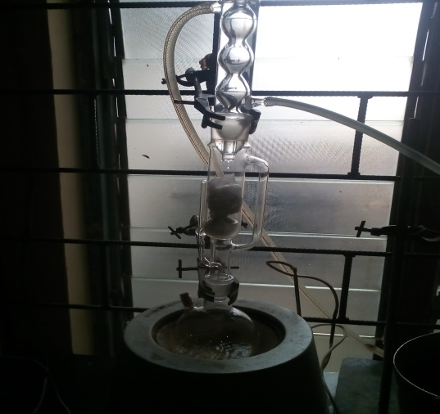 Determination of crude lipid

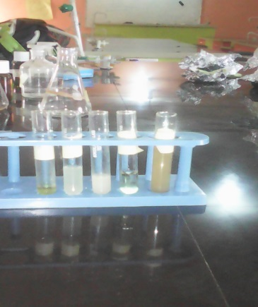 Determination of phytochemical analysis

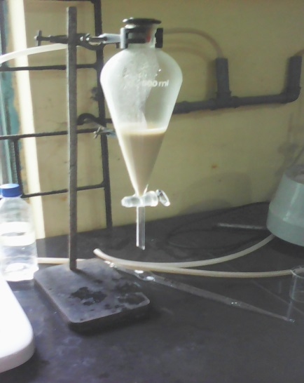 Determination of phenol using separating funnel

