SHELF LIFE PROFILE OF SOYMILK BEVERAGE USINGSTARTER CULTURE (LACTOBACILLUS BULGARICUS AND STREPTOCOCCUS THERMOPHILUS).

BY
EMMANUELLA, BENSON C.
U14/NAS/MCB/044

A RESEARCH PROJECT SUBMITTED TO THE DEPARTMENT OF MICROBIOLOGY,
FACULTY OF NATURAL AND APPLIED SCIENCES
GODFRY OKOYE UNIVERSITY UGWUOMU NIKE ENUGU STATE

IN PARTIAL FULFILMENT OF THE REQUIRMENT FOR THE AWARD OF BACHELOR OF SCIENCES (B.Sc.) DEGREE IN MICROBIOLOGY

SUPERVISOR
MRS. REGINA NWEZE

JULY, 2018

APPROVAL PAGE
This project has been presented and approved by Godfrey Okoye University, Enugu in partial fulfilment of the requirement for the award of Bachelor of Science, degree in microbiology from the department of microbiology, faculty of natural and applied sciences.

………………………….. …………………………….
Emmanuella, Benson .C. Date

………………………. ……………………………
Mrs. Regina Nweze Date
Project supervisor

…………………………. ……………………………
Dr. (Mrs) M.N. Unachukwu Date
Head of department Microbiology

DEDICATION
This work is dedicated to God Almighty whose unfathomable love and inexhaustible grace made it possible for this work to be accomplished.

ACKNOWLEDGEMENTS
I want to give thanks to God Almighty who has been guiding and protecting me throughout my project period.
My sincere gratitude and appreciation goes to my lovely supervisor Mrs. Regina Nweze, whose unrelenting supervision and genuine sense of understanding helped me in numerous ways and enhanced the completion of this research.
To my H.O.D, Dr. (MRS) Marian .N. Unachukwu who has been a mother to us. My deepest appreciation goes to Miss Irene Okoh and Mrs. Maria for the advice, support and assistance rendered. To my great lecturers, Prof. Mrs. J.I.Okafor, Mr. Okolo, Mrs. Onyinye, Miss ChinenyeEzeilo, Miss Adaeze, Dr. Ezebialu, Dr. Afunwa and other staff of microbiology I say thank you.
To my parents, Mr. & Mrs. Benson Adojii and siblings Samuel, Mary, and Divine, thank you for the prayers and love.
To my beloved friends, bunkmate and course mate, I thank you all for your support and encouragement.

ABSTRACT
Fermented foods are those processed through the activities of microorganisms. Soy milk is an aqueous extract from soybeans known for its nutritive health benefits. The aim of this work is to ferment soy milk product with starter culture (lactobacillus bulgaricus and streptococcus thermophilus) to prolong its shelf life. The soy bean was purchased from Ogbete main market located at Enugu North in Enugu state. It was immediately transferred to Godfrey Okoye University microbiology laboratory, where it was processed into soymilk. The processed product was pasteurized for 30mins, allowed to cool and added either milk or sugar as a carbon source before fermenting anaerobically with the starter culture (lactobacillus bulgaricus and streptococcus thermophilus) gotten from Aqua Rapha Company, Ninth mile, Enugu. Temperature and pH variations of fermented soymilk samples (soymilk with both organisms, mixed with milk and sugar respectively, soymilk with both organism mixed with either milk or sugar respectively) were determined. Sample containing both organisms with milk and sugar respectively, have the highest temperature (8⁰c) on day one and were slightly acidic (4.30), while sample containing both organism and sugar has the highest temperature (6⁰c) on the last day and are slightly acidic (4.25). Proximate analysis of this various soymilk samples were determined. Sample containing both organisms and sugar has the highest protein content (3.678%) while the control shows the least value (0.347%). Sensory evaluation showed that the product fermented with both organisms with milk and sugar was more acceptable than all other samples. Shelf life of these products were determined for 6 days. All the samples were acceptable from 0-3 days, but from the 4⁻5th day, sample 1 has a pungent smell and was not acceptable while sample 7 was able to retain its aroma and flavor. This is to show that starter culture fermentation was able to improve the shelf life and organoleptic properties for better acceptability.

TABLE OF CONTENTS
TITLE PAGE --- --- --- --- --- --- --- --- ---- --- --- --- --- --- --- i
APPROVAL PAGE --- --- --- --- --- --- --- --- ---- --- --- --- --- --- - ii
DEDICATION --- --- --- --- --- --- --- --- ---- --- --- --- ---- ----- ---iii
ACKNOWLEDGEMENTS --- --- --- --- --- --- --- --- ---- --- --- --- iv
ABSTRACT --- --- --- --- --- --- --- --- ---- --- ----- ---- ---- ---- v
TABLE OF CONTENTS --- --- --- --- --- --- --- --- ---- --- --- ---- --- vi-viii
LIST OF TABLES --- --- --- --- --- --- --- --- ---- --- --- --- ---- - ix
LIST OF FIGURES --- --- --- --- --- --- --- --- ---- --- ---- ---- --- x
CHAPTER ONE
- INTRODUCTION --- --- --- --- --- --- --- --- ---- --- ---- ----- 1
1.1PROBLEM STATEMENT --- --- --- --- --- --- --- --- ---- --- ---- -- 2
  - AIM --- --- --- --- --- --- --- --- ---- --- --- ----- ------ ----- 3
1.3 OBJECTIVES --- --- --- --- --- --- --- --- ---- --- ----- ----- --- 3
CHAPTER TWO
- LITERATURE REVIEW --- --- --- --- --- --- --- --- ---- --- ----- -- 4
2.1 SOYMILK --- --- --- --- --- --- --- --- ---- --- --- ---- ---- ---- -- 4
2.2 HISTORY OF SOYMILK --- --- --- --- --- --- --- --- ---- --- ---- --- 5
2.3 CONTENT OF SOY --- --- --- --- --- --- --- --- ---- --- --- ---- --- 6
2.4 HEALTH BENEFIT OF SOYMILK --- --- --- --- --- --- --- --- ---- -- 10
2.5 MICROBIAL FERMENTATION --- --- --- --- --- --- --- --- ---- --- 14
2.6 LACTIC ACID BACTERIA --- --- --- --- --- --- --- --- ---- --- 14
2.6.1 METABOLISM --- --- --- --- --- --- --- --- ---- --- --- --- -- 16
2.6.2 LACTIC ACID BACTERIA AS FUNCTIONAL STARTER CULTURE-- --- ---- 17
CHAPTER THREE
3.0 MATERIALS AND METHODS --- --- --- --- --- --- --- --- ---- --- --- 21
3.1 SAMPLE COLLECTION --- --- --- --- --- --- --- --- ---- --- --- --- -- 21
3.2ISOLATION OF MICROORGANISMS FROM STARTER --- --- --- --- --- --- 21
3.2.1 ISOLATION OF PURE CULTURES OF ISOLATES. --- --- --- --- --- --- --- 21
3.2.2 CHARACTERIZATION AND IDENTIFICATION OF ISOLATES. --- --- --- --- 21
3.3 PREPARATION OF SOYMILK --- --- --- --- --- --- --- --- ---- --- 22
3.3.1 LACTIC FERMENTATION --- --- --- --- --- --- --- --- ---- --- --- 23
3.3.2 PH VALUE --- --- --- --- --- --- --- --- ---- --- --- --- --- --- --- 23
3.3.3 SENSORY EVALUATION --- --- --- --- --- --- --- --- ---- --- --- --- 23
3.3.4 PROXIMATE ANALYSIS --- --- --- --- --- --- --- --- ---- --- ----- 24
3.3.5 EVALUATION OF SHELF LIFE --- --- --- --- --- --- --- --- ---- --- 24
CHAPTER FOUR
RESULTS --- --- --- --- --- --- --- --- ---- --- --- --- --- --- --- --- 25

CHAPTER FIVE
DISCUSSION --- --- --- --- --- --- --- --- ---- --- ---- ---- -- 32
CONCLUSION --- --- --- --- --- --- --- --- ---- --- ---- ---- - 34
REFERENCES --- --- --- --- --- --- --- --- ---- --- ---- ------ 35
APPENDIX --- --- --- --- --- --- --- --- ---- --- ---- ------ --- 39

LIST OF TABLES
Table 1: Propagation temperature for lactic acid bacteria --- --- --- --- --- --- --- 20
Table 2: Cell morphology of the isolate from freeze culture --- --- --- --- --- --- --- 25
Table 3: Microscopic view and cell morphology of sub cultured isolates -- --- --- --- --- 26
Table 4: Temperature measurement of samples --- -- --- --- --- --- --- --- --- --- --- 27
Table 5: pH measurements of samples -- --- --- ------ --- ---, --- --- --- --- --- --- 28
Table 6: Mean value of the sensory evaluation after 17hrs --- -- -- -- -- -- -- -- -- -- -- -- -- 29
Table 7: Proximate analysis of soymilk -- -- -- -- -- -- -- ------ --- --- --- --- -- --- - - 30
Table 8: Shelf life of soymilk at room temperature-- --- -- --- --- --- --- --- -- ----- 31

LIST OF FIGURES
Figure1: Soymilk during fermentation --- --- --- --- --- --- --- --- ---- ---41
Figure2: Soymilk before fermentation --- --- --- --- --- --- --- --- ---- --- 42
Figure 3: Refrigerated soymilk --- --- --- --- --- --- --- --- ---- --- --- -- 43

CHAPTER ONE

INTRODUCTION
Soymilk is a rich creamy liquid extract of soybean (Glycine max) (Tunde-Akintunde and Souley, 2009) and is the most available soy product. Soymilk is a popular nutritive beverage alternative to cow’s milk and is even cheaper(Soya-Agrodok, 2005). Soymilk has become a very interesting food due to its extraordinary nutritive value and health characteristics. It is a very rich source of highly valuable proteins, unsaturated fatty acids, soluble and insoluble dietary fibres, and isoflavones whose presence in everyday diet is very important (Boani, 2006). In some countries, soymilk is intended for the population who cannot digest milk due to lactose intolerance, allergy to milk proteins, or vegetarian way of diet. Soymilk has limited consumer acceptability due to its undesirable beany flavour. to improve its acceptability due to reduction in objectionable flavour and oligosaccharides such as starchyose and raffinose that cause flatulence (Wang et al., 2002). (Akabanda et al. 2010) reported that fermentation of soymilk provides a possibility for modifying or improving its flavour and texture so that it becomes more acceptable. In western countries, soymilk is intended forpopulation who cannot digest milk for reasons like lactose intolerance, allergy to milk proteins, or vegetarian way of diet. Fermenting soymilk with lactic acid bacteria considerably increases its health value. Because of greater antioxidative actions (Wang etal. 2006), they are considered healthier than pure soymilk. The purpose of fermentation is to remove the undesirable beany taste which is mostly due to the presence of n-hexanal and pentanal , and to improve on the nutritional characteristics of soymilk. Several studies (Hong et al., 2004; Song et al., 2008) have reported numerous benefits of fermented soymilk including degradation of soybean allergens during fermentation by proteolytic enzymes. Due to the characteristics of milk that is highly perishable, the purpose of milk fermentation using lactic acid bacteria is to prolong its shelf life as well as to preserve the nutritious component of milk.
1.1 PROBLEM STATEMENT
Development of a beany flavour during processing of soy milk has limited its use amongst populations. Thus much effort has been directed toward elimination of beany flavour in processing of soy milk. Heating of the soybeans either before or during initial processing to inactivate lipoxygenase and the use of fermentation has been used to stop undesirable flavours in soymilk. The heating process during conventional soy milk making considerably destroys most of the anti-nutritional factors in soy milk and improves the digestibility of soy protein, as well. However, compounds, like phytic acid, which interferes with the availability of calcium, is not reduced effectively (Onourah et al., 2007). At the same time, over-heating to eliminate trypsin inhibitor activity to a great extent can cause damage to amino acids, as well as loss in the overall nutritional value of soy milk. Incorporating the fermentation process into soy milk production has become a popular method to improve the acceptability and health properties of soy milk.

1.2 AIM
- The aim of this study is to examine the effect of starter culture (lactobacillus bulgaricus and streptococcus thermophilus) in the fermentation of soymilk.
1.3 OBJECTIVES
- To examine the effect of Lactobacillus bulgaricus and Streptococcus thermophilus in the soymilk mixed with milk respectively.
- To know the effect of Lactobacillus bulgaricus and Streptococcus thermophilus in the soymilk mixed with sugar respectively.
- To know the effect of both organisms (lactobacillus bulgaricus and streptococcus thermophilus)in the soymilk mixed with sugar and milk respectively.
- To examine the proximate analysis of both fermented and non-fermented soymilk
- To examine the sensory evaluation of the fermented soymilk product.
- Determination of shelf life of the final product.

CHAPTER TWO
2.0 LITERATURE REVIEW
2.1 SOYMILK
Soymilk is a plant based drink gotten from soybeans. The soybean belongs to the family Leguminosae/Fabaceae, subfamily Papilionoideae/Faboideae, and genus Glycine, L. The cultivated form called Glycine max (L.) Merrill, grows as a summer annual. However, some related species are perennial in nature (Mullen 2003). Soy products are important sources of many nutrients including isoflavones, dietary fiber, oligosaccharides, proteins, trace minerals and vitamins. Vitamin C, total phenolic content and total isoflavones per 100 g of soybean seed were: 34.8-88.7 mg, 0.68-1.39 mg gallic acid equivalent and 8.6-33.2 mg, respectively (Kumar et al., 2013). Soy protein is the most important among plant proteins because of its relatively high biological value, its cost advantage and content of essential amino acids (Farahmandfar et al., 2011). For example, the content of aspartic acid, glutamic acid, glycine and alanine was reported to be 0.37-1.51, 0.64-2.82, 0.17-0.72 and 0.11-0.51 g/100 g of green soybean seed, respectively (Kumar et al., 2011). Soy milk has been perceived as a functional food, because it provides additional health benefits resulting from its hypolipidemic, anticholesterolemic, antiatherogenic properties and reduced allergenicity (Messina, 2001; Donkor, 2007). The proximal composition of soy milk is: protein (3.0%-3.6%), sugar (2.9%-3.5%), fat (2.0%-2.5%), ash (0.5%), and it has a pH value of 6.8 to 7.0 (Donkor, 2007; Slavin, 1999). The addition of Streptoccocus thermophilus and Lactobacillus delbruekii subsp. bulgaricus cultures to soy milk, has become popular because it appears to reduce cardiovascular disease, can contribute to weight loss, mitigate arthritic sympt,oms and improve brain function (Donkor, 2007; Champagne, 2009; Wagar, 2009).
2.2 HISTORY OF SOYMILK
Soybeans originated in north eastern China and appear to have been domesticated around the 11th century BC (Shurtleff et al., 2014), but its uses on soups and beverages are only attested at much later dates. Soy gruel was first noted in the 3rd century BC, soy wine in the 4th century, and tofu broth (doufujiang) C.1365 amid the collapse of the mongol yuan.
As doujiang, this drink remains a common watery form of soymilk in China, usually prepared from fresh soybeans. It's popularity increase during the quig, apparently due to the discovery that gently heating doujiang for at least 90 minutes hydrolyzes it's raffinose and stachyose, oligosaccharides which can cause flatulence and digestive pain among lactose-intolerant adults (Huang, 2008). By the 18th century, it was popular enough that street vendors were hawking it in the streets; in the 19th , it was also common to take a cup to tofu shops to get hot, fresh doujiang for breakfast. It was often paired with youtiao, which was dipped into it (Shurtleff et al., 2013). The process was industralized in early republican China. In 1929, two Shanghai factories were selling over 1000 bottles a day and another in Beijing was almost as productive itself (Shurtleff et al., 2013). Following disruption from the Second World War and the Chinese civil war, soymilk began to be marketed in soft drink in Hong Kong, Singapore, and Japan (Shurtleff et al., 2013). The first non-diary milk; almond milk was created in the Levant around the 13th century and had spread to England by the 14th century. Soymilk entered the English language (as Soy bean milk) in 1897 USDA report (shurtleff et al., 2009) Li yuying established caseo-sojaine, the first soymilk "diary" in Colombes, France in 1910; he received the first British and American patent for soymilk manufacture in 1912 and 1913 (Shurtleff et al., 2013). J. A Chard began production of "soy lac" in new-miller, an American business man forced to relocate his factory from Shanghai owing to World War II.
John Harvey Kellogg had been working with what he called "soymilk" at his battle creek sanitarium since 1930, but was similarly compelled to market his acidophilus enriched beverages as "soy gal" when it began commercial production in 1942 (Shurtleff et al., 2004). A string of 40 court cases against rich products between 1949 and 1974 finally established that non-dairy "milk" and imitation dairy products were a new and district food rather than inferior and illegal knock-offs.
In the United States and Europe, Soymilk started to become popular in the 1980's. The first two brands sold nationwide were Vitasoy and Edensoy both aseptically packaged so they did not need refrigeration. The first superstar of soymilk; silk was launched by white wave of Boulder, Colorado, in 1996. It was sold in the diary case in gable-top cartons that looked like typical milk cartons.
2.3 CONTENT OF SOY
Soybean oil and protein content account for about 60% of dry soybeans by weight (protein at 40% and oil at 20%). The remainder consists of 35% carbohydrate and about 5% ash. Soybean consists of approximately 8% seed coat or hull, 90% cotyledons and 2% hypocotyl axis or germ.
PROTEINS:Raw soybeans primarily contain legume proteins belonging to the globulin family of seed storage proteins called legumins and vicilins, or in the case of soybeans, glycinin and beta-conglycinin. Soy protein is generally regarded as stored protein held in discrete particles called "protein bodies" estimated to contain at least 60% to 70% of the total protein within the soybean. This protein is important to the growth of new soybean plants, and when the soybean germinates, the protein will be digested, and the released amino acids will be transported to locations of seedling growth. Legume proteins, such as soy, belong to the globulin family of seed storage proteins called legumin (11S globulin fraction) and vicilins (7S globulin), or in the case of soybeans, glycinin and beta-conglycinin. Soybeans also contain biologically active or metabolic proteins, such as enzymes, trypsin inhibitors, hemagglutinins, and cysteine proteases. The soy cotyledon storage proteins, important for human nutrition, can be extracted most efficiently by water, water plus dilute alkali (pH 7–9), or aqueous solutions of sodium chloride (0.5–2 M).
CARBOHYDRATES:Soybeans are relatively low in carbohydrates (35%), and nearly all the carbohydrates in soy are fibres and oligosaccharides. The principal soluble carbohydrates of raw soybeans are the disaccharide sucrose, the trisaccharide raffinose, and the tetrasaccharide stachyose. The oligosaccharides raffinose and stachyose are not digestible sugars in humans, and contribute to flatulence and abdominal discomfort, as undigested oligosaccharides are broken down in the intestine by native microbes, producing gases such as carbon dioxide, hydrogen, and methane. The insoluble carbohydrates in soybeans consist of the complex polysaccharides cellulose, hemicellulose, and pectin. The majority of the insoluble soybean carbohydrates can be classed as belonging to dietary fibres (Choi and Rhee, 2006).
OILS:Raw soybeans contain app. 20% fat, and are thus relatively high in fat content. The major unsaturated fatty acids in soybean oil are the poly-unsaturated α-linolenic acid (Omega-3)(7-10%), and linoleic acid (Omega-6)(50-60%) and the mono-unsaturated oleic acid (20-25%). It also contains the saturated fatty acids, stearic acid (3-7%) and palmitic acid (5-10%) (Choi and Rhee, 2006).
PHYTOESTROGENS:Soybeans contain different isoflavones and coumestans, and further contain plant lignans, which are the principal precursor to mammalian lignans. However, the isoflavone content of soy is usually attracting the largest attention. Phytoestrogens are primarily interesting in relation to human intake because they have the ability to bind to human estrogen receptors, and thus influence bodily actions normally governed by natural estrogen levels. However, phytoestrogens have furthermore been reported to act as inhibitors of tyrosine kinases, influence signal transduction pathways, act against oxidation of DNA, and enhance the activity of anti-oxidant enzymes in various organs (Isanga and Zhang, 2008).
ISOFLAVONES:are groups of naturally occurring heterocyclic phenols, which are present in soy bean at levels of 0.1 to 5 mg/g (Isanga and Zhang, 2008). The three major groups of isoflavones found in soybeans are genistein, daidzein, and glycitein, and the genistein and daidzein forms constitute the absolutely largest proportion of isoflavones in soy. Isoflavones can generally exist in soybeans as aglycones (daidzein, genistein, and glycitein), glycosides (daidzin, genistin, and glycitin), acetylglycosides (acetyldaidzin, acetylgenistin, and -acetylglycitin), and malonylglycosides (malonyldaidzin, malonylgenistin, and malonylglycitin). Isoflavones in the acetylglycoside and malonylglycoside form are not bioavailable for the human body, whereas the glycoside forms can be deglycosinated into the aglycone forms, which are absorbable in the human intestine (Isanga and Zhang, 2008). The deglycosination of the glycoside forms into the aglycone forms was previously thought to be mediated by colon microflora, but experiments have shown that it is mediated by enzymes in the intestinal cells (Nielsen and Williamson, 2007). The enzymatic conversion of the glycoside form is very dependent on - the vitality of the intestine cells, - whether other food items compete for the enzymatic activity, - blood circulatory parameters, - etc. Another transformation of daidzein into the isoflaonoid equol is mediated by a specific microflora, however only an approximated 40% of the human population has this specific microflora in the intestine. Interestingly, a larger proportion of people from East Asia have this microflora than people of Western origin. All in all, the bioavailability of ingested isoflavones is thus depending on: - the ingested soy product, - which food the soy has been ingested along with, - the intestinal microflora, - and several other factors. This makes it very difficult to predict and standardize the absorption rate of biologically active isoflavones in e.g. human experiments, and to issue standardized recommendations for intake of isoflavones.
MINERALS:The mineral content of soybeans, determined as ash, is about five percent. When soybeans are processed, most of the mineral constituents go with the meal and few with the oil. The major mineral constituents are potassium, calcium and magnesium. The minor constituents comprise trace elements of nutritional importance, such as iron, zinc, copper etc. The biological availability of minerals may be impaired somewhat as a result of the presence of phytates in soybeans and soybean products.
ANTINUTRITIONAL ELEMENTS:Soybeans contain a number of elements which have unwanted or detrimental effects in the human organism. - Phytic acid or the salt form phytatewhichacts as an antioxidant, and furthermore has a strong binding affinity to important minerals, such as calcium, iron, and zinc, although the binding of calcium with phytic acid is pH-dependent and ascorbic acid (vitamin C) can reduce phytic acid's effect on iron. When iron and zinc bind to phytic acid they form insoluble precipitates and are far less absorbable in the intestines. This process can therefore contribute to iron and zinc deficiencies in people who rely their mineral intake on food containing high amounts of phytic acid for. Simple cooking will reduce the phytic acid to some degree. More effective methods are soaking in an acid medium, lactic acid fermentation, and sprouting (Isanga and Zhang, 2008).Trypsin inhibitorsare molecules, which bind to the enzyme trypsin, and thereby inhibit the degradation of certain lipid bonds among amino acids (lysine and arginine) of proteins in the intestine of humans and animals. This prevents the uptake of amino acids, and further detrimentally affects the enzyme balance and may cause hypertrophic pancreas responses. Soy beans contain at least two types of trypsin inhibitors, and the biological function of the inhibitors is thought to be, that animals will avoid eating the raw beans in the long run (Selgrade et al., 2009). Heating, fermentation and leaching eliminates the activity of the inhibitors (Isanga and Zhang, 2008). - Lectinsare a natural part of many legumes, and are toxic to humans at higher levels. In mature raw soybeans the lectin levels are low, whereas in green immature beans the levels may be higher. Lectins bind to the gut wall and reduce epithelial cell vitality and functionality, and thus inhibit the absorption of vital nutritional elements into the body. Possible beneficial effects of lectins, e.g. their anti-cancer effects, have, however, been debated in science (Isanga and Zhang, 2008).
2.4HEALTH BENEFITS OF SOY MILK
Naturally Soy has high content of essential fatty acids, fiber, protein, minerals and vitamins. It provides energy and maintains function of body at its optimum level. It is a perfect alternative for lactose intolerant people and who are allergic to dairy products. These types of nutrition offer energy and keep the body functioning at its highest level. Listed here are the few most significant health advantages of soy milk:-
1. Promote lipid profile
Soy milk is able to improve blood lipid profile. The fat in Soy milk is unsaturated having zero cholesterol. Soy has polyunsaturated and monounsaturated fatty acids which inhibits cholesterol to reach to blood stream. The studies show that daily intake of Soy lowers the blood triglycerides and low density lipoproteins and increase good cholesterol level. It is helpful for patients having high cholesterol or family history of coronary heart problems.
2. Strengthen blood vessels
Soy has omega-3 and omega-6 fatty acids with phyto-antioxidants which effectively protects blood vessels from lesions and haemorrhage. This compound binds to lining of blood vessels and defends lining cells from cholesterol deposits and free radical damage. These nutrients binding promote flexibility and fluidity of blood vessels so that it becomes much volatile to blood pressure changes. Soy milk has isoflavones that assist in lowering metabolic obesity in men and post-menopausal women.
3. Lose in weight
Naturally Soy milk has low content of sugar in comparison to regular milk. Cow’s milk contains 12 grams of sugar per cup whereas soy milk contains only 7 grams. A cup of whole soy milk offers only 80 calories. Moreover, Soy milk has monounsaturated fatty acid that inhibits intestinal absorption of fat which is beneficial for losing weight. Drink Soy milk to receive extra amount of fiber that keeps one full for longer time period. Soy milk has isoflavones that assist in lowering metabolic obesity in men and post-menopausal women. Besides this, it lowers waist circumference in overweight and obese individuals.
4. Lowers the risk of prostate cancer
Soy milk has good amounts of phytoestrogen which is an exclusive plant hormone that inhibits testosterone production in men. The reduction in level of testosterone cut down the chances of prostate cancer. The studies shows that men who consume soy rich diet have lower chances of developing prostate cancer and prostate hypertrophy.
5. Prevention of Postmenopausal Syndromes
A woman’s natural production of oestrogen lowers to minimum at the time of menopause. The sudden reduction of oestrogen results to a number of health problems. Postmenopausal women are at high chances of diabetes, heart disease and obesity. They are more prone to mood swings, depression, insomnia as well as other psychological disorders. Soy contains phytoestrogen which is an effective replacement of oestrogen. The regular consumption of Soy is an effective way for preventing these postmenopausal syndromes.
6. Stronger bones
Osteoporosis is the age and hormone related diseases. It provides relief from osteoporosis in postmenopausal women. The loss of calcium and brittle bones result in chances of this disease development. Soy has phytoestrogen that could accelerate the absorption of calcium by the body and prevent the loss of bone mass. Studies shows that diet rich in animal protein promotes urinary excretion of calcium whereas soy based protein diet does not. It is loaded with calcium which helps to retain and provide supplements to the body. Soy isoflavones with natural hormone replacement therapy improves retention of bone mass and density by lowering the chances of fracture in postmenopausal women.
7. Antioxidant activity
Soy isoflavones provide antioxidant effects which is helpful against some chronic diseases. Tofu or curdle soy milk contains hepatoprotective and antioxidant activities that lowers oxidative damage and stress. Study also concluded that it prevents liver damage caused due to oxidative stress. Moreover, antioxidant properties of Soy milk assist in enhancing antioxidant capacity and lowering menopausal symptoms in women.
8. Lower suffering from anaemia
Soy milk is rich in calcium and iron that helps to fight anaemia which is caused due to inadequate oxygen due to insufficient amount of red blood cells in the body. Iron assist in production of red blood cells with an improvement in function of red blood cells.
9. Helpful for kidney and diabetic patients
Research shows that Soy foods are helpful for people having kidney disease and diabetes. Soy milk is low in glycemic index which makes them an essential component for healthy diabetic diet. Soy contains fiber that helps to slow down sugar absorption so that it would be easier to handle by the body.
10. Great for pregnancy
While the women is pregnant, she should ensure the fulfilment of required nutrients for foetal development. Soy milk contains Vitamin C, Vitamin B complex, Vitamin K, Vitamin E, Vitamin C, calcium, mineral and folate that is vital for production of red blood cells in order to support optimal development of foetus.
2.5 MICROBIAL FERMENTATION
Microbial fermentation in food fermentation involves the breakdown of sugar and protein which results in the production of a large array of organic compounds that contribute to the flavour, preservation and outer appearance of the food product. However, they fall in four categories namely alcoholic, lactic acid, acetic acid and alkaline fermentation. Alcoholic fermentation involves the production of ethanol as the end while lactic acid and acetic acid fermentation produce respective acids as end products. The alkaline fermentation are not well known but widely consumed in South east and African countries. In alkaline fermented foods, the proteins are broken into amino acids and peptides releasing ammonia during fermentation resulting in alkaline pH of the food which is achieved spontaneously by mixing bacteria, especially Bacillus subtilus. A typical example for alkaline fermented food is Japanese natto. Among these, lactic acid fermentation is widely used for preservation of foods.Lactose is used by lactic acid bacteria (LAB) as the principal source of carbon for growth and energy. Milk fermentation is initiated by lactobacilli and streptococci bacteria which use nutrients in milk for their growth and alter the nutritional composition and physical appearance of milk. It is initially hydrolysed by lactase into galactose and glucose followed by subsequent glucose conversion to D- or L lactic acid via the glycolytic, Embden-Meyerhof-Parnas pathway.
2.6 LACTIC ACID BACTERIA
Lactobacillales or lactic acid bacteria (LAB) are an order of Gram-positive, acid-tolerant, generally non-sporulating, non-respiring, either rod- or coccus-shaped bacteria that share common metabolic and physiological characteristics. These bacteria, usually found in decomposing plants and milk products, produce lactic acid as the major metabolic end product of carbohydrate fermentation. This trait has, throughout history, linked LAB with food fermentations, as acidification inhibits the growth of spoilage agents. They are widely used recently in food technology, microbiology and biotechnology and hygiene with respect to the production of fermented food. LABS are used as industrial microorganisms in beverage, meat product, and sugar industry, souring of pickles, olives and dairy products. They alter flavour, texture, and appearance of foods, enhance nutritional values, retard spoilage, reduce contamination and are widely used in dairy processes because in addition to lactic acid production they also produce volatile compound such as acetaldehyde, diacetyl and alcohol. LAB are fastidious micro-organisms and their growth is often restricted in milk because of its paucity in essential nutrients. The large population of LAB in fermented milk products like yoghurt competes strongly with microbial contaminants for available nutrient and thus enhances product safety. Some LAB produces antimicrobial peptides, known as bacteriocins which may target certain pathogens. Classification of LAB genera was based on morphology, mode of glucose fermentation, growth at certain temperatures, and range of sugar utilization. The common agreement is that there is a core group consisting of four genera; Lactobacillus, Leuconostoc, Pediococcus and Streptococcus. Recent taxonomic revisions have proposed several new genera and the remaining group now comprises the following: Aerococcus, Alloiococcus, Carnobacterium, Dolosigranulum, Enterococcus, Globicatella, Lactococcus, Oenococcus, Tetragenococcus, Vagococcus, and Weissella. Lactobacilli, Carnobacteria and some Weissella are rods while the remaining genera are cocci (Jin et al., 2009). They are found in the gastrointestinal tract of various animals, dairy products, seafood products, soil and some plant surfaces. Although lactic acid bacteria are not dominant in the normal intestinal microbiota, several trials have been undertaken to induce an artificial dominance of lactic acid bacteria. Two health-promoting activities by LAB are removal of lactose and production of L-alanine, and the production of vitamins. Streptococcus thermophilus produce a greater amount of acid in soymilk than lactobacillus delbrueckii ssp. Bulgaricus. They are also divided into two groups of the basis of their growth optimum. Mesophilic lactic acid bacteria have an optimum growth temperature between 20 and 30ºC and the thermophilic have their optimum between 30 and 45ºC. Traditional fermented products from sub-tropical countries harbour mainly thermophilic lactic acid bacteria, whereas the products with mesophilic bacteria originated from western and northern European countries.
2.6.1 METABOLISM
Lactic acid bacteria are chemotrophic, they find the energy required for their entire metabolism from the oxidation of chemical compounds. The oxidation of sugars constitutes the principle energy producing pathway. Lactic acid bacteria of the genera Lactobacillus, Leuconostoc and Pediococcus, the important bacteria to winemaking, assimilate sugars by either a homofermentative or heterofermentative pathway.
- Homofermentative metabolism of hexoses
Homofermentative bacteria transform nearly all of the sugars they use, especially glucose into lactic acid. The homofermentative pathway includes a first phase of all the reactions of glycolysis that lead from hexose to pyruvate. The terminal electron acceptor in this pathway is pyruvate which is reduced to lactic acid. During fermentation, pyruvate is decarboxylated to ethanol, which is the terminal electron acceptor, being reduced to ethanol.
- Heterofermentative metabolism of hexoses
Bacteria using the heterofermentative pathway, which includes Leuconostoc (the most important bacterium in enology) use the pentose phosphate pathway. In this pathway, NADPH is generated as glucose is oxidized to ribose 5-phosphate. This five-carbon sugar and its derivatives are components of important biomolecules such as ATP, CoA, NAD+, FAD, RNA and DNA. NADPH is the currency of readily available reducing power in cells (NADH is used in the respiratory chain). This pathway occurs in the cytosol. After being transported into the cell, a glucokinase phosphorylates the glucose into glucose 6-P (glucose 6-phosphate). Its destination is completely different from the glucose 6-P in the homofermentative pathway. Two oxidation reactions occur: the first leads to gluconate 6-P and the second, accompanied by a decarboxylation, forms ribulose 5-P (See Fig. 2). In each of these reactions a molecule of NADP+ is reduced. Ribulose 5-P can then be epimerized either to ribose 5-P or to xylulose 5-P.
Xylulose 5-P is then cleaved into acetyl-phosphate and glyceraldehydes 3-phosphate. The glyceraldehyde 3-phosphate is metabolized into lactic acid by following the same pathway as in the homofermentative pathway. The acetylphosphate has two possible destinations, depending on environmental conditions.
This molecule can be successively reduced into ethanal and ethanol, in which case the molecules of the coenzyme NADPH formed during the two oxidation reactions of glucose at the beginning of the heterofermentative pathway, are reoxidized. This reoxidation is essential for regenerating the coenzymes necessary for this pathway. The final products are then lactate and ethanol. Or the acetyl-phosphate can produce acetate (acetic acid) through the enzyme acetate kinase. This reaction also yields a molecule of ATP. The final products of this pathway are then lactate and acetate. Bacteria of the genus Leuconostoc preferentially produce lactate and ethanol in a slightly aerated environment and lactate and acetate in an aerated environment.
2.6.2 LACTIC ACID BACTERIA AS FUNCTIONAL STARTER CULTURE
The most important application of lactic acid bacteria is their use as starter strains in the manufacture of various fermented dairy products. In particular, Streptococcus thermophilus, Lactobacillus lactis, Lactobacillus helveticus, and Lactobacillus delbrueckii ssp. Bulgaricus.S. thermophilus and L. bulgaricus are the two bacteria required to make yoghurt. The proper selection and balance of lactic acid bacteria used for starter culture is critical for the manufacture of milk fermented food products with their desirable texture and flavour. Mankind exploited these bacteria for thousands of years for the production of fermented products because of the ability to produce desirable changes in taste, flavour, and texture (Derek et al., 2009).
Starter cultures of LAB can be either mesophilic from the genera of Lactococcus and Leuconostoc or thermophilic from the genera of Streptococcus and Lactobacillus (Fox et al., 2004).
- Streptococcus thermophilus
Streptococcus thermophilus also known as Streptococcus salivarius ssp Thermophilus (Tannock, 2005) is a gram-positive bacterium, and a fermentative facultative anaerobe, of the viridans group. It tests negative for cytochrome, oxidase, and catalase, and positive for alpha-haemolytic activity. It is non-motile and does not form endospores. S. thermophilus is fimbriated. It has an optimal growth temperature range of 35 - 42 °C while L. bulgaricus has an optimal range of 43 - 46 °C. It is also classified as a lactic acid bacterium (Courtin, 2003). S. thermophilus is found in fermented milk products, and is generally used in the production of yogurt, alongside Lactobacillus bulgaricus. The two species are synergistic, and S. thermophilus provides L. d. bulgaricus with folic acid and formic acid which it uses for purine synthesis (Sieuwerts, 2010).
- Uses of Streptococcus thermophilus
S. thermophilus is one of the most widely used bacteria in the dairy industry. USDA statistics from 1998 showed that more than 1.02 billion kilograms of mozzarella cheese and 621 million kilograms of yogurt were produced from S. thermophiles (Hutkins, 2002). Although its genus, Streptococcus, includes some pathogenic species, food industries consider S. thermophilus a safer bacterium than many other Streptococcus species. In fact, yogurt and cheese that contain live cultures of S. thermophilus are thought to be beneficial to health (Taylor, 2007). Live cultures of S. thermophilus make it easier for people who are lactose intolerant to digest dairy products. The bacteria break down lactose, the sugar in milk, that lactose-intolerant people find difficult to digest (Leboffe, 2012).
- Lactobacillus bulgaricus
Lactobacillus delbrueckii ssp. bulgaricus (until 2014 known as Lactobacillus bulgaricus) is the main bacteria used for the production of yogurt. It is also found in other naturally fermented products. First identified in 1905 by the Bulgarian doctor Stamen Grigorov, the bacterium feeds on lactose to produce lactic acid, which is used to preserve milk. It is a gram-positive rod that may appear long and filamentous. It is non-motile and does not form spores. It is regarded as aciduric or acidophilic, since it requires a low pH (around 5.4–4.6) to grow effectively. The bacterium has complex nutritional requirements.
- Uses of Lactobacillus bulgaricus
Lactobacillus delbrueckii subsp. bulgaricus is commonly used alongside Streptococcus thermophiles (Courtin, 2003) as a starter for making yogurt. The two species work in synergy, with L. d. bulgaricus producing amino acids from milk proteins, which are then used by S.thermophiles. Both species produce lactic acid, which gives yogurt its tart flavour and acts as a preservative. The resulting decrease in pH also partially coagulates the milk proteins, such as casein, resulting in yogurt's thickness. While fermenting milk, L. d. bulgaricus produces acetaldehyde, one of the main yogurt aroma components. Some strains of L. d.bulgaricus, such as L. bulgaricus GLB44, also produce bacteriocins, (Simova, 2008) which have been shown to kill undesired bacteria in vitro. Some of the biggest importers of the bacterium are Japan, the United States, and the European Union. It has also been considered a contaminant of beer due to its homo-fermentative production of lactic acid, an off-flavour in many styles of beer. In other styles of beer, however, lactic acid bacteria can contribute to the overall appearance, aroma, taste, and/or mouthfeel, and generally produce an otherwise pleasing sourness (Priest, 2002).
Table 1:Propagation temperature for lactic acid bacteria
Organism temperature
Lactobacillus casei 37
Lactobacillus delbrucekii 37
Leuconostoc mesenteroides 26
Streptococcus thermophiles 37
American Type Culture Collection, 1984.

CHAPTER THREE
- MATERIALS AND METHODS
3.1 SAMPLE COLLECTION
A freeze dried starter culture containing Lactobacillus bulgaricus and Streptococcus thermophilus were obtained from Aqua Rapha Yoghurt Company, 9th mile Enugu state.Soybean, milk and sugar used for this work was purchased from ogbete market, Enugu state, Nigeria.
3.2 ISOLATION OF MICROORGANISMS FROM STARTER
A 10 fold serial dilution were made from the sample. Using pour plate method, 1ml of various dilutions (1, 3 and 5) was cultured into sterile petri dishes in duplicates.Sterilized molten nutrient agar was added and the plates were swirled gently to mix the contents. They were then allowed to gel and incubated at 37°C for 24 hours.
3.2.1 ISOLATION OF PURE CULTURES OF ISOLATES.
Different distinct colonies from the incubated plates were isolated into pure culture.
3.2.2 CHARACTERIZATION AND IDENTIFICATION OF ISOLATES.
The cultural characteristics such as shape, size, pigmentation, and nature of margins were observed and recorded. This was followed by microscopic examination of cell types, arrangement, and Gram's reaction.
Gram staining
- Smeared slides were placed on staining tray or rack
- Smear was flooded with crystal violet and let stand for 1 minute
- Tilted the slides and gently rinsed with slow running water or distilled water using a wash bottle.
- Flooded the smear with gram’s iodine and let stand for 1 minute
- Gently rinsed with slow running water or distilled water using a wash bottle. The smear will appear as a purple circle in the slide.
- Decolorized using 95% ethyl alcohol or acetone. Tilted the slides slightly and applied the alcohol drop by drop for 5-10 seconds until the alcohol runs almost clear. Do not over decolorize.
- Then immediately rinsed with water.
- Gently flooded with safranin to counter stain and let stand for 45 seconds.
- Rinsed with tap water or distilled water using a water bottle.
- Cotton wool was used to clean the back of the slide and kept in a draining rack to air dry.
- Viewed the smear using light microscope under oil immersion.

3.3 PREPARATION OF SOYMILK
1. Eight hundred and thirty grams of dry soybeans were sorted, washed to remove other impurities or unwanted particles and allowed to soak in 2litres of water for 10hours. The soaking was done to soften the beans.
2. The beans were dehaulled and blended with warm water using a kenwood blender.
3. The slurry was filtered using cheesecloth to obtain a filtrate which is the soymilk. The remaining insoluble material is called okara and can be used as an ingredient for bread making or as cattle feed.
4. The obtained soymilk was cooked/simmered for 30 minutes to destroy pathogens that may have contaminated the milk.
5. The soymilk were poured into seven (7) air tight sterilized bottles designated as samples 1-7.
3.3.1 LACTIC FERMENTATION
A loopful of L. bulgaricus, S. thermophilus was added to the samples of soymilk with either milk or sugar respectively and fermented at room temperature for 17h. The samples were designed as follows:
- Sample 7 and 2 -soymilk + powdered milk + L. bulgaricus and S. thermophilus respectively.
- Sample 3 and 5- soymilk + sugar + L. bulgaricus and S. thermophilus respectively.
- Sample 4 and 6 – soymilk + L. bulgaricus and S. thermophilus with either milk or sugar.
- Sample 1- soymilk only- Control.
3.3.2 PH VALUE
The pH Value of the soymilk samples was determined by immersing the electrode of a pH metre into the soymilk. pH of the Samples were taken at the beginning and end of fermentation.
3.3.3SENSORY EVALUATION
Sensory evaluation was carried out after 48h storage at 4°c. The beverage samples were evaluated for attributes of flavour, taste, texture, aroma, beany, and over all acceptability. Sensory analysis was conducted by a 10member panel consisting of 10 accessors particularly familiarized with the sensory descriptors and the attributes intensities. The samples were served in plastic cups labelled with 2 digit code and were scored on a 1-9 hedonic scale (nine being considered excellent, five acceptable and one is extremely poor). To rinse their mouth between tastes the panellist uses water, to aid remove the beans flavour between testing.
3.3.4 PROXIMATE ANALYSIS

Samples of fermented and unfermented soymilk were analyzed for the following parameters; fat, protein, moisture and ash content using the methods of the Association of Official Analytical Chemists (2000). The carbohydrate content was determined by difference between 100 and total sum of the percentage of moisture, protein, fat and ash (AOAC, 1990).
3.3.5EVALUATION OF SHELF LIFE
The soymilk samples were stored at room temperature. Samples were withdrawn daily and assessed fordeterioration in terms of taste, appearance and aroma.

CHAPTER FOUR
RESULTS
TABLE2: CELL MORPHOLOGY OF THE ISOLATE FROM FREEZE CULTURE
Isolates Size Colour Shape
Sample 11.0mm Creamy Circular
Sample 1 0.5mm, 0.7mm Creamy Circular and Filamentous
Sample 2 1.3mm Creamy Circular
Sample 2 0.5mm Creamy Circular
Sample 3 0.7mm Creamy Circular
Sample 3 1.5mm Creamy Circular

TABLE3: MICROSCOPIC VIEW AND CELL MORPHOLOGY OF SUBCULTURED ISOLATES
Isolate Shape Size Pigment Margin Gram reaction Organism
Sample 1 Rods 1.5mm Creamy Entire + L.bulgaricus
Sample 2 Cocci 0.7mm Creamy Entire + S. streptococcus

TABLE 4: TEMPERATURE MEASUREMENT OF SAMPLES

Sample Contents day 1 day 3 day 6
Sample 1 Soymilk 8^{oc} 5^{oc} 6^{oc}
Sample 2 Soymilk, L. bulgaricus and milk. 7^{oc}6^{oc} 6^{oc}
Sample 3 Soymilk, L. bulgaricus and sugar. 7^{oc}5.5^{oc} 5^{oc}
Sample 4 Soymilk, L. bulgaricus, S. thermophilus and milk 8^{oc}6^{oc} 5^{oc}
Sample 5 Soymilk, S. thermophilus and sugar. 7.5^{oc} 6^{oc} 5.5^{oc}
Sample 6 Soymilk, L. bulgaricus, S. thermophilus and sugar. 8^{oc} 6.5^{oc} 6^{oc}
Sample 7 Soymilk, S. thermophilus and milk. 7^{oc} 5.5^{oc} 5.5^{oc}

TABLE 5: pH MEASUREMENTS OF SAMPLES
Sample Contents day1 day 3 day 6
Sample 1Soymilk 6.65 5.40 5.20
Sample 2Soymilk, L. bulgaricus and milk. 6.70 5.45 4.55
Sample 3Soymilk,L. bulgaricus and sugar. 6.60 5.50 4.50
Sample 4 Soymilk, L. bulgaricus, S. thermophilus and milk 5.95 4.30 4.20
Sample 5 Soymilk, S. thermophilus and sugar.6.65 5.25 4.30
Sample 6 Soymilk, L. bulgaricus, S. thermophilus and sugar. 6.00 4.55 4.25
Sample 7 Soymilk, S. thermophilus and milk. 6.65 5.30 4.50

TABLE 6: MEAN VALUE OF THE SENSORY EVALUATION AFTER 2 DAYS
Sample | Flavor intensity | Over all acceptability Mouth feel texture
 | Beany Buttery Bitter Sour
01 3.4 2.4 1 3.1 5.4 6.1 5.1
02 1.6 4.52.7 2.9 4 6.7 5.6
03 2.4 2.4 1.1 4.6 3.0 7.2 7.9
04 1 5.2 1 5.1 6.56.5 3.9
05 3.2 2.3 1.8 3.8 4.35.2 5.9
06 1 5.3 1 4.9 6.8 4.6 4.7
07 1.4 4.1 4.8 3.6 2.9 5.6 5.7

TABLE7: PROXIMATE ANALYSIS OF SOYMILK
Sample moisture% Ash% Fats% Fibre% Protein% Carbohydrate%
Soymilk 81.438 1.680 0.347 - 0.494 16.034
Soymilk/L. bulgaricus/milk 78.250 2.093 0.668 - 2.661 16.320
Soymilk/L. bulgaricus/sugar 77.737 2.366 0.693 - 2.850 16.354
Soymilk/L. bulgaricus/S.thermophilus/milk 78.956 2.330 0.623 - 3.012 15.076
Soymilk/S.thermophilus/sugar75.550 2.426 0.742 - 2.872 18.410
Soymilk/L. bulgaricus/S.thermophilus/sugar 76.330 2.597 0.699 - 3.678 16.696
Soymilk/S.thermophilus/milk78.117 2.667 0.633 - 2.538 16.045

TABLE 8: SHELF LIFE OF SOYMILK AT ROOM TEMPERATURE
Day Sample Appearance Taste Aroma Remark
0-3 Sample 1 Milky Pleasant Beany Acceptable
Sample 2Milky Pleasant Cream Acceptable
Sample 3Milky Pleasant Beany Acceptable
Sample 4Milky Pleasant Cream Acceptable
Sample 5Milky Pleasant Cream Acceptable
Sample 6 Milky Pleasant Cream Acceptable
Sample 7Milky Pleasant Beany Acceptable
4-5Sample 1 Milky Rancid Pungent Spoilt
Sample 4&6 Milky Very sour Off-soy flavourFair
Sample 7 Milky Bitter Beany Good
Sample 2,3,&5 Milky Bitter/Sour Off-soy flavour Fair

CHAPTER FIVE
DISCUSSION
Soy milk is an aqueous extract from soybeans known for its nutritive health benefits. But the development of a beany flavour during processing of soy milk has limited its use amongst populations. Thus much effort has been directed toward elimination of beany flavour in processing of soy milk through fermentation to increase shelf life and quality. The effect of natural fermentation using the starter culture (lactobacillus bulgaricus and streptococcus thermophilus) on soymilk samples was shown by the changes in pH shown in Table 5. There was a decrease in the pH of each fermented soymilk (table 5), these could be as a result of the lactic acid produced during fermentation. As the acid level increases, the pH level drops. Lactobacillus bulgaricus and Streptococcus thermophilus with either milk or sugar has the lowest pH reduction of 4.55 and 4.30 respectively, this is because Streptococcus thermophilus grows faster and produces both acid and carbondioxide, which is responsible for the initial pH drop. The formate and carbon dioxide produced stimulates the proteolytic activities of lactobacillus bulgaricus stimulatory peptides and amino acids, which acts upon Streptococcus thermophilus to further decreases to the pH of 4 (Vinderola, 2002).
The fermented soymilk (Table 6) with starter culture microorganisms has been found to have little or no beany flavour, this could be because of the ability of the lactic acid fermentation to reduce the beany flavour of soymilk. There is a slight difference in taste of the soymilk. Sample 4(soymilk mixed with Lactobacillus bulgaricus, Streptococcus thermophilus and milk) has the highest mean value of sour taste (5.1), this is because fermented milk products are sour in taste which has been made by either fermenting the milk naturally or by the use of starter culture to produce the desirable milk products (Ajayi, 2006). However sample 7 (soymilk mixed with Streptococcus thermophilus and milk) has the highest mean value of bitter taste (4.1), which is as a result of non-volatile compounds present in the soybean. The trihydroxy fatty acids generated by the action of soy lipoxygenases on linoleic acid is responsible for the bitter tastes in soymilk.
The effect of fermentation on the proximate composition of fermented soymilk is presented in Table 7. It was observed that there was decrease in the moisture content of soymilk and an increase in the fat, ash, protein and carbohydrate content of the milk. This study was similar to (Obadina, et al., 2013) who observed that there was decrease in moisture, carbohydrate and fat contents while an increase was observed in ash and protein contents of fermented soymilk. However soymilk,L. bulgaricusand S. thermophilusmixed with sugar was found to have the highest protein content (3.678) in soymilk.
Soymilk samples showed no signs of deterioration within the period of 0-3 days while soymilk without organism (control) showed signs of deterioration after 3 days of storage. However S. thermophilusmixed with milk was observed to be the only sample to retain its aroma and flavour within the period of storage. Thisis because starter culture dominate and reduces the diversity of microorganisms in fermented milk products compared to that of products under natural fermentation. The preservative action of starter culture in food combines action of antimicrobial metabolites produced during the fermentation process. These include many organic acids such as lactic, acetic and propionic acids produced as end products which provide an acidic environment unfavourable for the growth of many pathogenic and spoilage microorganisms (Rattanachaikunsopon and Phumkhachorn, 2010). Therefore the shelf life of fermented food is prolonged.

CONCLUSION
From the result of this study, lactic acid fermentation using starter culture (L.bulgaricus and S. thermophilus) is a cheap and effective soymilk preservation method that can be applied for the improvement of texture, colour, taste and nutritional value of soymilk. It has also shown to improve the shelf life of soymilk by inhibiting the growth of pathogenic microorganism which causes food spoilage, food poisoning and disease.

REFERENCES
Ajayi, F. (2006) Technology of main categories of products. File://E:\Desktop\The technology of traditional milk products in developing countries.
Akabanda, F., Owusu-Kwarteng, J.R.L.K., Glover, R.L.K. and Tano-Debrah, K. (2010) Microbiological characteristics of Ghanian traditional fermented milk product, Nunu. Nature and Science 8 (9): 178 – 187.

AOAC (1990). Official Methods of Analysis. Association ofOfficial Analytical Chemists. 15th Edition.,Washington, DC, USA, pp. 200 – 210.

AOAC (2000). Official Methods of Analysis. Association of Official Analytical Chemists 17th edition, pp. 152 – 162.

Božanić R. (2006): Proizvodnja, svojstva i fermentacija sojinog mlijeka. Mljekarstvo, 56: 233– 254.

Champagne, J.M. Green-Johnson, Y. Raymond, J. Barrette, N.D. Buckley (2009). Selection of probiotic bacteria for the fermentation of a soy beverage in combination with Streptococcus thermophilus, Food Research International42) 612-621.

Choi MS, Rhee KC. 2006. Production and processing of soybeans and nutrition and safety of isoflavone and other soy products for human health. Journal of Medicinal Food 9: 1-10.
Courtin, P.; Rul, F. O. (2003). "Interactions between microorganisms in a simple ecosystem: yogurt bacteria as a study model". Le Lait . 84 : 125–134.
Derek, A.A., Joost, V.D., Inge, M.K., Jac, T.P., Antonius, J.A. (2009). Anaerobic homolactate fermentative with saccharomyces cerevisiae results in depletion of ATP and impaired metabolic activity. FEMS Yeast Res. 9(3):349-357.

Donkor, A. Henriksson, T. Vasiljevic, N.P. Shah (2007). Rheological properties and sensory characteristics ofset-type soy yogurt, Journal of Agricultural and Food Chemistry 55 9868-9876.

Farahmandfar, M.M. Tehrani, S.M.A. Razavi, M.B.H. Najafi (2011). Effect of trisodium citrate concentration and soy cheese on meltability of pizza cheese, International Journal of Food Properties 14 697-707.

Favaro, T.C.S., Terzi, C.S.S.C., Trugo, L.C., Della Modesta, R.C. and Couri, S. (2001) Development and sensory evaluation of soy milk based yoghurt. Archivos Latino Americanos De Nutricion 51 (1): 100 – 104.

Fox, P.F., McSweeney, P.L., Cogan, T.M., Guinee, T.P. (2004). Cheese: Chemistry, Physics and Microbiology, Elsevier.
Hong, K.J., Lee, C.H., Kim, S.W. (2004). Aspergillus oryzae 3.042GB-107 fermentation improves nutritional quality of food soybeans and feed soybean meals. J Med Food. 7: 430-434.
Huang, H.T. (2008), "Early Uses of Soybean in Chinese History", the World of Soy, University of Illinois Press, ISBN 978-0-252-03341-4.
Hutkins, and Robert (2002). "Streptococcus Thermophilus LMD-9". JGI Microbes.
Isanga J, Zhang GN. 2008. Soybean bioactive components and their implications to health - A review. Food Reviews International 24: 252-276.
Jin YL, Ai HL, Cheng J, Wu MY. 2009.First description of a novel Weissella species as an opportunistic pathogen for rainbow trout Oncorhynchus mykiss (Walbaum) in China. Veterinary Microbiology 136(3-4), 314-320.
Kumar, A. Rani, L. Goyal, J. Vaishnav, D. Pratap, G.S. Chauhan, et al., (2011). Evaluation of vegetable-type soybean for sucrose, taste-related amino acids and isoflavones contents, International Journal of Food Properties 14 1142-1151.

Kumar, A. Rani, L. Goyal, J. Vaishnav, D. Pratap, A.K. Dixit, et al., (2013). Assessment of antioxidant constituents and anti-oxidative properties of vegetable soybean, International Journal of Food Properties 17 536-544.

Leboffe and Michael (2012). Microbiology: Laboratory Theory and Application. Morton Publishing Company. p. 33.
Messina, C.L. Lopronzi (2001). Soy for breast cancersurvivors: A critical review of the literature, Journal ofNutrition 131 3095S-3108S.

Obadina, A.O., Akinola, O.J., Shittu, T.A. and Bakare, H.A (2013). Effect of Natural Fermentation on the Chemical and Nutritional Composition of Fermented Soymilk Nono. Nigerian Food Journal Vol. 31 No. 2, pages 91 – 97.

Onuorah, C.E.; Adejare, A.O.; Uhiara, N.S. Comparative physico-chemical evaluation of soy milk and soya cake produced by three different methods. Niger. Food J. 2007, 25, 28–38.

Priest, FG (2002). Brewing Microbiology. Springer. pp. 185–202.
Rattanachaikunsopon, P., Phumkhachorn, P. (2010). Lactic acid bacteria: their antimicrobial compounds and their uses in food production. Ann. Biol. Res. 1 (4): 218-228.
Selgrade, M.K, Bowman, C.C, Ladics, G.S, Privalle L, Laessig SA. 2009. Safety Assessment of Biotechnology Products for Potential Risk of Food Allergy: Implications of New Research. Toxicological Sciences 110: 31-39.
Shurtleff, William; et al. (2013). History of Soymilk and Other Non-Dairy Milks, 1226 to 2013 pp. 5 & 23–4.
Shurtleff, William; et al. (2014), History of Soybeans and Soyfoods in China and Taiwan and in Chinese Cookbooks, Restaurants, and Chinese Work with Soyfoods outside China, 1024 BCE to 2014 p. 9.
Shurtleff, William; et al. (2004), "Dr John Harvey Kellogg and Battle Creek Foods: Work with Soy", History of Soybeans and Soyfoods, 1100 BC to the 1980s
Shurtleff, William; et al. (2009), History of Miso, Soybean Jiang (China), Jang (Korea), and Tauco/Taotjo (Indonesia), 200 BC–2009p. 174.
Sieuwerts, S., Molenaar, D., Van Hijum, S. A. F. T., Beerthuyzen, M., Stevens, M. J. A., Janssen, P. W. M., Ingham, C. J.,De Bok, F. A. M., De Vos, W. M., Van Hylckama Vlieg, J.E.T. (2010). "Mixed-Culture Transcriptome Analysis Reveals the Molecular Basis of Mixed- Culture Growth in Streptococcus thermophilus and Lactobacillus bulgaricus" . Applied and Environmental Microbiology. 76 (23): 7775–7784.
Simova, E. D.; Beshkova, D. M.; Angelov, M. P.; Dimitrov, Z. P. (2008). "Bacteriocin production by strain Lactobacillus delbrueckii ssp. Bulgaricus BB18 during continuous prefermentation of yogurt starter culture and subsequent batch coagulation of milk". Journal of Industrial Microbiology & Biotechnology. 35 (6): 559–567.
Slavin, M.C. Martini, D.R. Jacobs, L. Marquart (1999). Plausible mechanisms for the protectiveness of whole grains, American Journal of Clinical Nutrition 70 459S-463S.

Song, Y.S., Frias, j., Martinez- Villaluenga, C, Vidal-Valdeverde, C, de Mejia, E.G. (2008). Immunoreactivity reduction of soybean meal by fermentation, effect on amino acid composition and antigenicity of commercial soy products. Food Chem. 108:571-581.
Soya-Agrodok, (2005) Cultivation of soya and other legumes. In: Mercier, C., P. Linko and J.M. Harper (Eds.). Extrusion Cooking, Agromise Foundation, USA. pp. 321 – 341.

Tannock, Gerald W.,(2005). Probiotics and Prebiotics: Scientific Aspects. Caister Academic Press. p. 43.
Taylor, John R. and Mitchell, Deborah. The Wonder of Probiotics. New York, NY: St. Martin’s Press, 2007.
Tunde-Akintunde, T.Y. and Souley, A. (2009) Effect of processing methods on quality of soymilk. Pakistan Journal of Nutrition 8 (8): 1156 – 1158.

Vinderola. C.G., Mocchiutti, P., and Reinheiner, J.A. (2002). Interactions among lactic acid starter and probiotic bacteria used for fermented dairy products, j.Dairy Sci. (American Dairy
Wang, Y.C., Yu, R.C., Chou, C.C. (2006). Antioxidative activities of soymilk fermented with lactic acid bacteria and bifidobacteria. Food Microbiology, 23: 128–135.
Wang, Y.C., Yu, R.C., Yang, H.Y. and Chou, C.C. (2002). Growth and survival of bifidobacteria and lactic acid bacteria during fermentation and storage of cultured soymilk drinks. Food Microbiology 19: 501 – 508.Mljekarstvo 56: 233 – 254.

Wagar, C.P. Champagne, N.D. Buckley, Y.Raymond, J.M., Green-Johnson (2009). Immunomodulatory properties of fermented soy and dairy milks prepared with lactic acid bacteria, Journal of Food Science 74 M423-M430.

APPENDIX
SENSORY EVALUATION SCORE SHEET
SOYMILK COMPARISON
Name: no: date:
Please rinse mouth and spoon before every taste
CODE | FLAVOR INTENSITY |  |  |  |  | MOUTH FEEL | TEXTURE
 | AROMA |  | TASTE |  | OVER ALL SOYMILK
 | BEANY | BUTTERY | BITTER | SOURNESS

Flavor intensity Mouth feel Texture
6. Very pronounced 9. Extremely smooth 9. Extremely firm
5. Moderately pronounced 8. Very smooth 8. Very firm
4. Slightly pronounced 7. Moderately smooth 7. Moderately firm
3. Moderately perceptible 6. Slightly smooth 6. Slightly firm
2. Slightly perceptible 5. Neither sandy nor smooth 5.Neither soft nor firm
1. im-perceptible 4. Slightly sandy 4. Slightly soft
3. Moderately sandy 3. Moderately soft
2. Very sandy 2. Very soft
1. Extremely sandy 1. Extremely soft

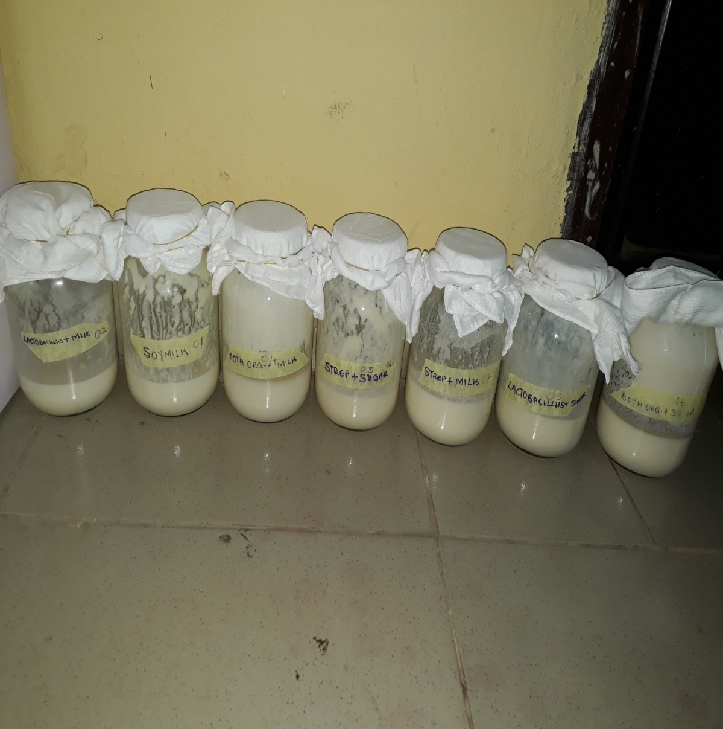

:

FIGURE1: SOYMILK DURING FERMENTATION

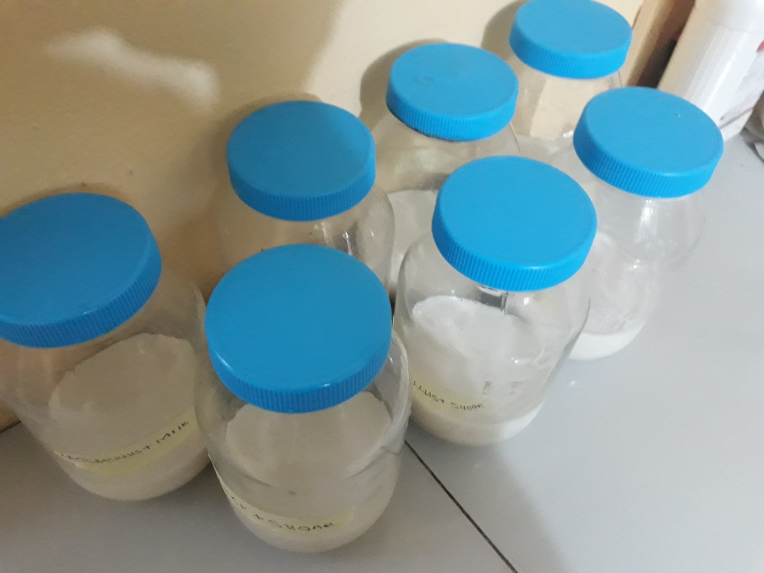
FIGURE2: SOYMILK BEFORE FERMENTATION

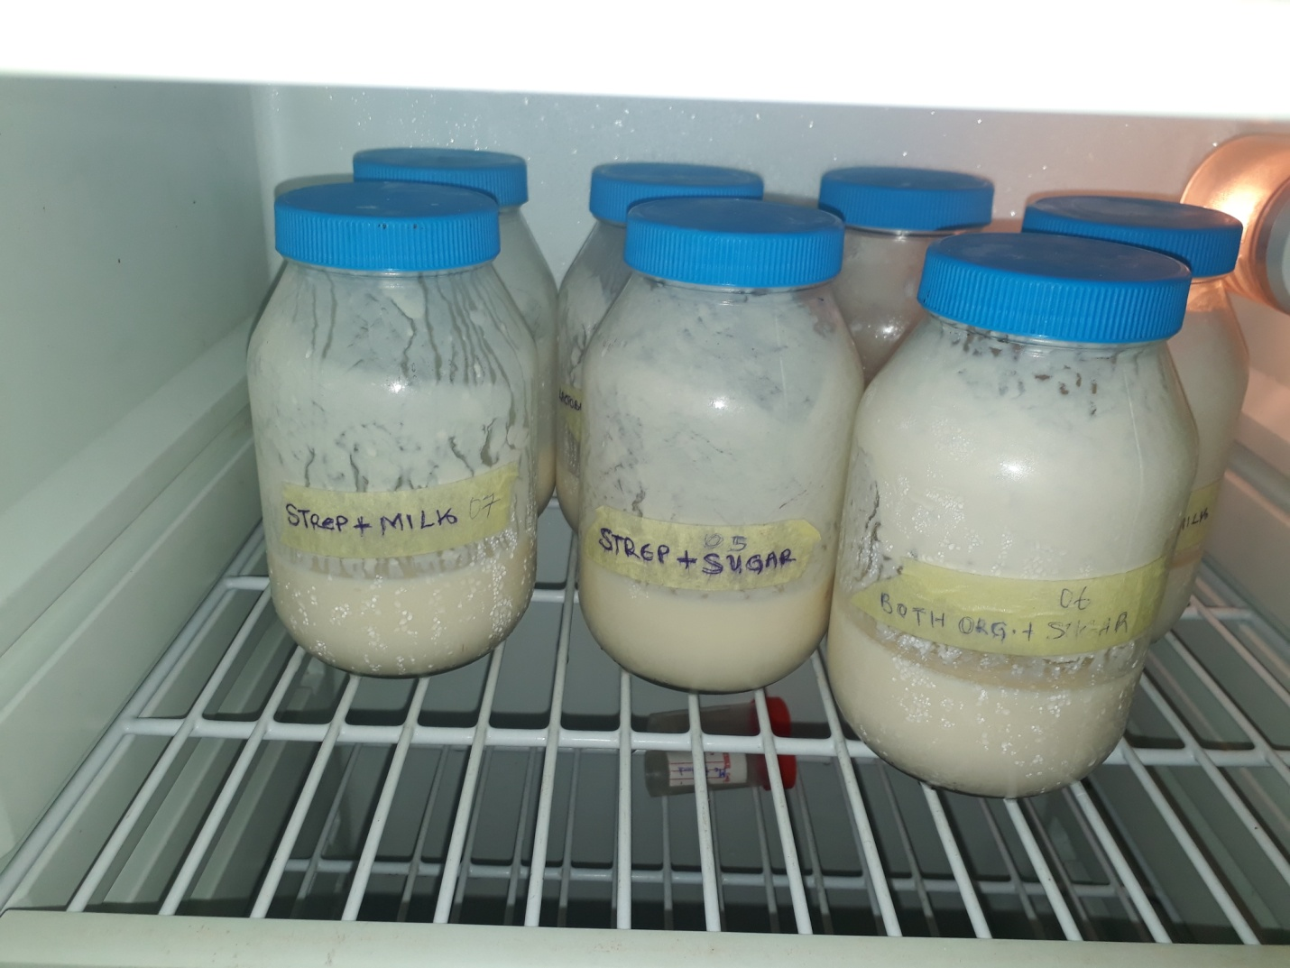
FIGURE 3: REFRIDGERATED SOYMILK.

