OXIDATIVE AND BIOCHEMICAL PARAMETER ASSESSMENT FOR ALLOXAN INDUCED DIABETIC RATS TREATED WITH METHANOL LEAF EXTRACTS OF OCIMUM GRATISSIMUM.

BY

OKECUKWU, CHINWENDU

U14/NAS/BCH/027

BIOCHEMISTRY

JULY, 2018.
TITLE PAGE

OXIDATIVE AND BIOCHEMICAL PARAMETER ASSESSMENT OF ALLOXAN INDUCED DIABETIC RATS TREATED WITH METHANOL LEAF EXTRACTS OF OCIMUM GRATISSIMUM.

BY

OKECHUKWU CHINWENDU
U14NAS/BCH/027

A PROJECT REPORT SUBMITTED TO THE DEPARTMENT OF CHEMICAL SCIENCES, FACULTY OF NATURAL AND APPLIED SCIENCES, GODFREY OKOYE UNIVERSITY UGWUOMU-NIKE IN PARTIAL FULFILMENT OF THE REQUIREMENTS FOR THE AWARD OF BACHELOR OF SCIENCE (B.SC) DEGREE OF GODFREY OKOYE UNIVERSITY.

SUPER VISOR: DR. EMMANUEL UHUO

JULY, 2018
APPROVAL PAGE
The research was undertaken by Okechukwu, Chinwendu (U14/NAS/BCH/027) and approved by department of Biochemistry, Godfrey Okoye University Enugu in partial fulfillment of the requirement for the award of Bachelor of Science (B.Sc) Degree in Biochemistry.

...................................................... ……………………………...............
DR. UHUO EMMANUEL Date
Supervisor

.............................................. ……………….……………..
MR. AYUK EUGENE Date
Head of Department

………................................ ……......................................
PROF. C.C. UHUEGBU Date
Dean of Natural and Applied Sciences

..…............................................. ……….……………………….
External Supervisor Date

CERTIFICATION PAGE
This is to certify that this work titled Oxidative and Biochemical Parameter Assessment of Alloxan Induced Diabetic Rats treated with methanol aqueous extract of Ocimum gratissimum is the original work of Okechukwu, Chinwendu with registration number U14/NAS/BCH/027.

…………………………… ……………………….
Okechukwu, Chinwendu Date
U14/NAS/BCH/027

DEDICATION
I dedicate this whole work to the Almighty God who is the giver of life, health, grace and the embodiment of strength to me through my four years in Godfrey Okoye University, am indebted to him alone.

ACKNOWDGEMENT
I wish to acknowledge the great effort of my caring, helpful, and understanding Project Supervisor, Dr. Uhuo Emmanuel, for your help and encouragement throughout all the project I had to do here I say thank you so much and may almighty God grant you all your heart desires and give you help when and where you need it most, Sir, your effort cannot be taken for granted.
To my Alma Mata Godfrey Okoye University, my vice chancellor Prof, Christian Anieke, the Dean of Natural and Applied Science, my amiable Head of Department Mr. Ayuk. To all my lecturers who had impacted greatly to my life here on campus as a biochemistry student and for their time to time encouragements which further groomed me to the woman am becoming of which am proud of, Mr. Odiudu, Mr. Engwa, Prof. Onwurah, Prof. Agbafor, Prof Eze, Miss Amanda, Mr Frank amongst others, I love all of you infinitum.
To parents Mr and Mrs. Okechuku, Samuel for their prayers, care, love and undividable attention and affection they had embedded on me, daddy would always tell me that if I can dream it I can get and there is no limitation for a purpose driven life. Those words were reminders every day I wake up in the morning. To my siblings Nma and Amaka, my love for you guys has no end. How can I forget the love of my life, my husband, Mr. Korie Chigozie, for his love and support, he is my number one fan.
To my fellow Departmental, hostel mates and roommates, those that had helped me in one way or the other throughout this whole project, my God will reward all of u for me.
All my friends both here in school and outside the school, uncles and aunts, in-laws and grandparents for your prayer and wishes I say thank you.

ABSRACT
Ocimum gratissimum is a vegetable plant of wide nutritional and medicinal application in Nigeria and some other parts of the world. The aim of this study is to know the effect and efficacy of oral administration of methanol extract of Ocimum gratissimum on the level of oxidative and biochemical parameters of alloxan-induced diabetic rats. Leaves of Ocimum gratissimum were obtained and dried under room temperature, after drying, it was grind into powder and 320.64g soaked in 50ml of methanol for 72hours. After which it was filtered with a Whatsman (no 1) filter paper. The filtrate was concentrated using rotary evaporator at 37ºC. A total of 20 male Wistar albino rats were grouped into the normal group, diabetic not treated, diabetic treated with gilbenclamide and the group treated with the leaf extract, they were all fed orally with the extract for 14days. All the rats were sacrificed and their blood was collected for assaying of biochemical parameters. Result of the study showed a significant (P>0.05) increase in the serum SOD activity compared with the normal control.Vitamin E was observed showing a significant (P>0.05) increase in the group treated with the extracts compared with diabetic untreated. The result also showed a significant (P<0.05) decrease in MDA level of test group compared with the diabetic untreated and a non-significant (P>0.05) increase was seen in the HDL level of the test group and also a significant (P<0.05) decrease was observed in the LDL level of the group treated with leaf extract. Data of the study suggests that the oral administration of the aqueous methanol leaf extract of Ocimum gratissimum may impair naturally generated oxidant/toxicant activity and hereby enhance specific activities of antioxidants in rats.

TABLE OF CONTENTS
Title Page i
Approval ii
Certification iii
Dedication iv
Acknowledgement v
Abstract vi
Table of contents vii
List of tables viii
List of figures ix
CHAPTER 1: INTRODUCTION
1.1 Background of study 1
1.2 Statement of the problem 2
1.3 Aim and Objectives 2
1.3.1 Aim of the study 2
1.3.2 Objective of the study 3
CHAPTER 2: LITREATURE REVIEW
  - About the plant 4
    - Scientific classification 5
    - Chemical constituents of plant 6
    - Geographical distribution 6
    - Composition of aqueous extract of Ocimum gratissimum 6
    - Medical uses of Ocimum gratissimum 7
    - Alternative and complimentary medical uses 7
    - Published pharmacological properties of O. gratissimum 8
    - Alloxan induced diabetes 8
  - Alloxan mechanism of action 8
2.2.1 Chemical properties of Alloxan 10
2.2.2 Impact of Alloxan upon beta cells 10
CHAPTER 3: METHOD AND MATERIAL
  - Materials and methods 12
  - chemical and reagents 12
3.1.2 Equipment 12
3.1.3 Materials 12
3.2 The plant 13
3.2.1 Extract Preparation 31
3.2.2 Preparation of extract for administration 14
3.2.3 Experimental animal 14
3.2.4 Experimental design 15
3.2.5 Collection of blood sample 15
3.2.6 Determination of the biochemical parameter 15
3.2.7 Glucose level 15
3.2.8 Determination of Malondialdehyde (MDA) level 16
3.2.9 Superoxide Dismutase (SOD) Assay 18
3.3 Determination of High Density Lipoprotein (HDL) level 20
3.3.1 Low density lipoprotein LDL 21
3.3.2 Vitamin E level 21
3.3.3 Statistical Analysis 23

CHAPTER 4: RESULTS
4.1 Results 24
4.2 Effects of Methanol extract of O.gratissimum on malondialdhyde
(MDA) 25
4.3 Effects of Methanol extract of O.gratissimum on superoxide dismutase
(SOD) 26
4.4 Effects of Methanol extract of O.gratissimum of high density
lipoprotein (LDL) level 27
4.5 Effects of Methanol extract of O.gratissimum of low density
lipoprotein (LDL) 28
4.6 Effects of Methanol extract of O.gratissimum on vitamin E level 29
CHAPTER 5 DISCUSSION AND CONCLUSION
5.1 Discussion 30
5.2 Conclusion 32
References 33
Appendix 36
Appendix

LIST OF TABLES
Table 1: Percentage yield for extraction 24
Table 2: Effects of methanol leaf extract of Ocimum gratissimum
on alloxan induced diabetic rats on glucose level. 24

LIST OF FIGURES
Figure1: Gratissimum. https://en.m.wikipedia.org/wiki/Ocimumgratissimum. 5
Figure 2: Structure of Alloxan. 9
Figure 3: Wistar adult male albino rats. 14
Figure 4: Effects of methanol extract of O.gratissimum on Malondialdehyde (MDA). 25
Figure 5: Effects of methanol extract of O.gratissimum on superoxide dismutase (SOD). 26
Figure 6: Effects of methanol extract of O.gratissimum on high density 27 lipoprotein (HDL).
Figure 7: Effects of methanol extract of O.gratissimum on low density lipoprotein (LDL). 28
Figure 8: Effects of methanol extract of O.gratissimum on Vitamin E 29

CHAPTER ONE
INTRODUCTION
  - BACKGROUND OF STUDY
The use of Ocimum gratissimum leaf extract to treat Alloxan induced diabetic rat and its oxidative and biochemical parameter assessments.
In Nigeria, especially in the southern part there is a consumption of plants extracts people consume. They also consume a lot of vegetable in their native diet and some of these plants are believed to cure some aliments. Ocimum gratissimum is one of the many found to lower glycaemia in Type-1 diabetes.
Many components of food such as secondary plants metabolites have been seen to alter biological processes which may reduce the risk of some chronic diseases in human such as diabetes.
Diabetes mellitus has its complications especially diabetes conditions among infected people, Ocimum gratissimum uses against various aliments has gained widespread acceptance in developing as well as developed nations (kolewale et al,. 2011). Diabetes mellitus is an important chronic metabolic disorder of public health concern, it occurs either as a result of pancreatic defects in insulin secretion or the failure of the effectively utilize secreted insulin or both. Hyperglycemia is a common consequence of uncontrolled diabetes, which may over time lead to serious damage to vascular tissue, heart, eye nerve and kidney.
Plants with known and suspected therapeutic potencies have been longed used in the alternative and complementary medicine. Numerous scientific reports exist, describing the relatively low toxicity and effectiveness in selected plants in management of diabetes.
Numerous scientific report exists, descending the relatively low toxicity and effectiveness of selected plants in the management of diabetes. It is unfortunate that a large number of those studies were conducted using either normoglycermeia or animal models.
Inducing of diabetes using either >100mg/kg body weight of Alloxan into these animal models, with recent review showing that Alloxan was one of the most frequently used diabetogenic agent globally.
High dose of the chemical are cytotoxic to the pancreatic beta cells giving rise to insulin deficiency.

  - STATEMENT OF THE PROBLEM
The statement of the problem in this research work is that the efficacy of Ocimum gratissimum leaf extract through assaying of biochemical parameters of alloxan-induced diabetic rats.
VISION: To determine the effect Ocimum gratissimum methanol leaf extract has alloxan-induced diabetic rats through assaying of biochemical parameters.
ISSUE STATEMENT: Diabetes mellitus has become one of the prevailing health cases people face today, with no or little knowledge on how it can be controlled and managed, it could worsen beyond control and as far as oxidative damage is concerned, it would multiple the generation of free radicals.
METHODS: Apart from modern drugs that can be used to control and manage diabetes, the use of Ocimum gratissimum menthol leaf extract was employed in other to determine the effect on alloxan-induced diabetic rats through assaying of biochemical parameter.

1.3 AIMS AND OBJECTIVE
1.3.1 AIM OF THE STUDY
The aim of this study is to determine the effects of the methanol leaf extract of Ocimum gratissimum on the oxidative and biochemical parameter of alloxan –induced diabetic rats.

    - OBJECTIVES OF THE STUDY
Specifically, the study sort to:
- Determine the effects of the extract on MDA level
- Determine the effects of the extract on lipid profile
- Determine the effects of the extract on antioxidant enzyme activity.

CHAPTER TWO
LITERATURE REVIEW
  - ABOUT THE PLANT
Ocimum gratissimum is an herbaceous and an aromatic medicinal plant which belongs to the Lamiaceae family. It is popularly known as scent leaf, it is used in cooking due to its minty aromatic flavor. In Nigeria the plant is called “Effirin-na” by the Yoruba speaking tribe, “Alumokho” in Esan, “Nchanwu” in Igbo, “Aramogbo” in Edo, and in the Northern part, the Hausa call it “Daidoya”.
The plant is indigenous to tropical areas especially India and it is also in West Africa, in Nigeria, it is found in the savannah and coastal areas.
It is cultivated in Ceylon, south sea low lands and also with Nepal, Bengal, Chittagong, and Decan.
Ocimum gratissimum L. commonly called basil is a culinary herb with pungent smell, propagation of basil is through seed and also reliably from cuttings.
The foliage is commonly used fresh in cooked recipes or added at the last moment as cooking quickly destroys the flavor.
Studies have established that compound in basil oil have potent antioxidant, anticancer, antiviral and antimicrobial properties (Edem S. et al., 2002).
The essential oil of O.gratissimum contains eugenol and shows some evidence of antibacterial activity. Leaf extracts of O.gratissimum shows antidiabetic properties in alloxan induced diabetic rats.
A study on rats also shows evidence that a leaf extract of Ocimum gratissimum prevented diarrhea and also have an effect in anti-fertility in male mice. Methanol extracts of Ocimum gratissimum showed a hepatoprotective effect in rats.

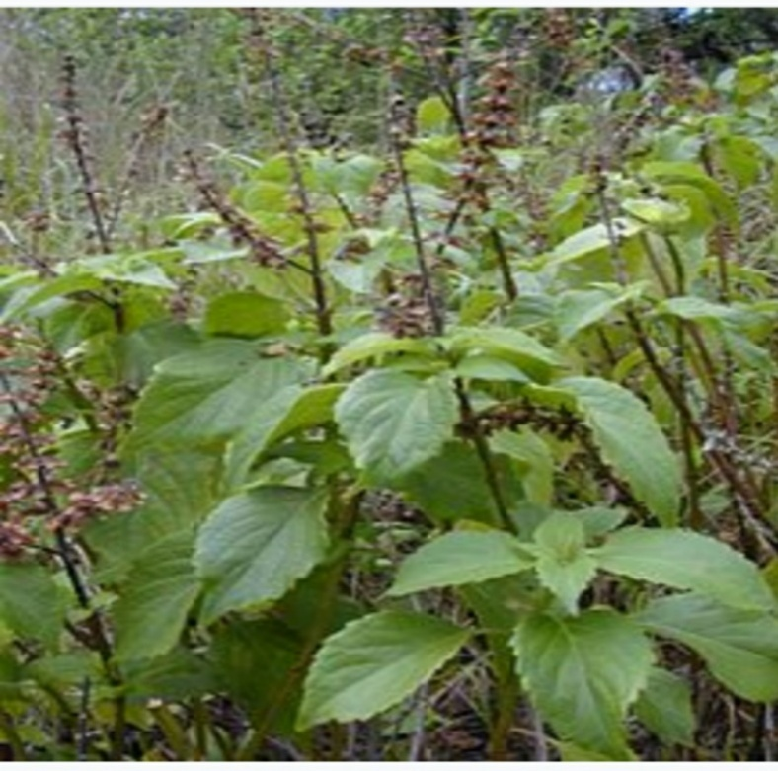
Figure1: O.gratissimum. https://en.m.wikipedia.org/wiki/ocimumgratissimum
2.1.2 SCIENTIFIC CLASSIFICATION
Binomial name; Ocimum gratissimum L.

Kingdom: Plantae

Class: Angiosperm

Order: Lamiales

Family: Lamiaceae

Genus: Ocimum

Species: O. gratissimum

2.1.3 CHEMICAL CONSTIUENTS OF THE PLANTS
The chemical composition of essential oils obtained by hydrodistillatiions from aerial part of the Ocimum gratissimum, Ocimum basillum and Ocimum canum.
At least six chemo types namely eugenol, thymol, citral, ethyl cinnamate, geraniol and linalool have been important economically.
In recent studies, phenlpropanoids were shown to be major constituents of ocimum gratissimum, very rich in alkaloid, tannis, phytates, flavonoids and oligosaccharides. It has tolerable cynogenic content (Ijeh et al., 2004).

2.1.4 GEOGRAPHICAL DISTRIBUTION
Ocimum gratissimum is formed throughout the trophics and subtropics and its greatest ability and variable occurs in tropical Africa and India.
It is widely spread and distributed throughout Central America, West Africa coast and has been used in Trinidad and Tabago and in Nigeria for the treatment of various aliments including diabetes mellitus. Barley and Day, 1989. (Aguiyi et al., 2000).

2.1.5 COMPOSITION OF AQEOUS EXTRACT OF OCIMUM GRATISSIMUM
Some of the constituents of O. gratissimum are alkaloids, saponins, tannis, phlobtannis, anthraquiones, steroid, terperiod, flavonoids and cardiac glycosides (Akinmoladen et al., 2007).
The plant is also said to contain major mineral elements like chloride, manganese, magnesium, zinc and potassium. (Chen et al., 1999).

2.1.6 MEDICINAL USES OF OCIMUM GRATISSIMUM
O. gratissimum has been used extensively in the traditional system of medicine in many countries.
In the North East of Brazil, it is used in the preparation of teas and infusion. (Rabelo et al., 2013).
In the coastal areas of Nigeria, the plant is used in the treatment of epilepsy, high fever and diarrhea. (Effrim et al., 2003).
In the savannah areas decoctions of the leaves are to treat mental illness. (Akinmoladeun et al., 2007).
O. gratissimum is used by the Igbo in the south Eastern Nigeria in the management of the babies’ cord, to keep the wound surface sterile.
It is also used in the treatment of fungal infections, cold and catarrh. The tribes of Nigeria uses the leaves extract in the treatment of diarrhea, while the cold leaves infusions are used for the relief of stomach upset and hemorrhoids. (Kabir et al., 2005).

2.1.7 ALTERNATIVE AND COMPLIMENTARY MEDICINAL USES.
Among the various species, O.gratissimum finds extensive uses clinically throughout the world.
Formulations of the leaf essential oil of O.gratissimum have been incorporated in the variety bases as tropical antiseptic and for use in the bases as tropical antiseptic and for use in the treatment of minor wounds, boils and pimples. (Ijeh, et al., 2005). Reported that O.gratissimum and xylopiathiopica in combination are used in the preparation of portions and teas for women during peupenum.

2.1.8 PUBLISHED PHARAMACOLOGICAL PROPERTIES OF O.GRATISSIMUM
A review of literature shows the following published pharmacological properties of O. gratissimum.
The plant is used by different tribes for the treatment of aliment or as a specie or condiment.
Its essential oil is said to contain eugenol and shows some evidence of antibacterial activity. Nakamura, 1999.
A test on guinea pigs found evidence that the essential oil release the muscle of the small intestine, constituent with the traditional use of the plant to treat gastrointestinal disorders. (Socono et al., 2002).
A study on rats also found evidence that leaf extract of the plant prevented diarrhea. (Sofawora et al., 1993, and Veronica et al., 1999).
Its methanol extract showed a hepatoprotective effect. (Surana and Jain,et al., 2010, Arhoghro et al., 2009).
A polyherbial preparation of water extract obtained from leaves of Gongronema lutifilia, Veronica amygdaline and Ocimum gratissimum should analgesic activity. (Irona et al., 2009).
There is however paucity of literature materials on O. gratissimum effect on fasting blood sugar, weight gain and pregnancy outcome in alloxan-induced diabetic rats.

2.1.9 ALLLOXAN-INDUCED DIABETES
Alloxan is toxic glucose analogue which selectively destroys insulin-producing cells in the pancreas i.e. the beta cells.
When administered to rodents and many other animal species, this causes an insulin-dependent diabetes mellitus also known as Alloxan-diabetes, in these animals with characteristics with human type 1 diabetes.
Alloxan is selectively toxic in insulin producing pancreatic beta cells because it preferentially accumulates in beta cells through uptake via the GLUT2 glucose transporter, alloxan in the presence of intracellular thiols generates reactive oxygen species (ROS) in a cyclic reaction with its reduction producing dialuric acid.
The beta cells toxic action of alloxan is initiated by free radicals formed in the redox reaction. One study suggests that alloxan does not cause diabetes in humans. Lenzen, 2008. Other plasma level in children with and without diabetes types 1. (Mrozikiewicz et al., 1994).
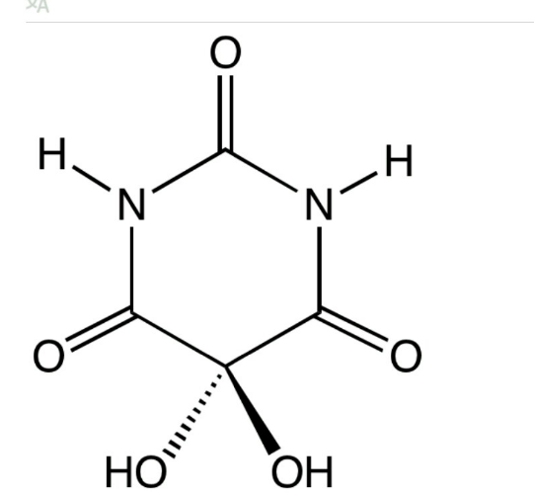

Figure 2: STRUCTURE OF ALLOXAN

2.2 MECHANISM OF ACTION
Alloxan has two distinct pathological effects. It selectively inhibits glucose induced insulin secretion through specific inhibition of glucokinase, the glucose sensor of the beta cells, and it causes a state of insulin dependent diabetes through its ability to induce ROS formation, resulting in the selective necrosis of beta cells.
These two effect can be assigned to the specific properties of Alloxan, the common denominator being selective for cellular uptake and accumulation of Alloxan by beta cells.

2.2.1 CHEMICAL PROPERTIES OF ALLOXAN
Chemical name--- 2, 4, 5, 6-tetraoxypyrimidine
2, 4, 5, 6-pyrimidinetetrone
Chemical structure--- oxygenated pyrimidine derivatives
Chemical properties--- very hydrophilic, beta-cells toxic glucose analogue. (Partition coefficient -1.8)
Mode of toxicity--- ROS
Chemical reactivity--- thiol reagent that is reduced by dialuric acid in the presence of GSH and other thiol.

2.2.2 IMPACT OF ALLOXAN UPON BETA CELLS
Because it selectively kills the insulin producing beta-cells found in the pancreas, Alloxan is used to induce diabetes in laboratory animals. This occurs most likely because of the selective uptake of the compound due to its structural similarity to glucose as well as the beta-cells is highly efficient in the uptake mechanism (GLUT2).
Some studies have shown that Alloxan is not toxic to the human beta-cell, even in high doses, probably because of differing glucose uptake mechanism in human and rodents. (Tyrberg et al., 2001) and (Eizirik et al., 1994).
alloxan exert its diabetogenic action when it is administered intravenously, intraperitoneally or subcutaneously (William, 1993). The dose of Alloxan required to induce diabetes depends on the animal species, route of administration and nutritional status (Taubes, 2008). Fasted animals are more susceptible to Alloxan (Szkudelski et al., 2001)

CHAPTER THREE
3.0 MATERIALS AND METHOD
3.1 CHEMICALS AND REAGENTS
All chemicals and reagents were gotten from the Biochemistry Laboratory, Godfrey Okoye University.
- Methanol (CH₃OH)
- Alloxan (C₄H₂N₂O₄)
- Glibenclamide (5mg)
- Distilled water( H₂0)
- DMSO (Dimethylsulphuroxide)
- Normal saline( NaH₂O)
- Phosphate buffer( H₂KO₄P)
- Lipid profile kit Randox Reagent Set
- Xanthine oxide Randox Rradox Set
3.1.2 EQUIPMENT
- Glucometer Accu Check One Touch
- Digital Weighing balance Model no. YP-502N
- Rotary evaporator
- Centrifuge Model 80-2
- Spectrophotometer Spectrum Lab 23A
3.1.3 MATERIALS
- Glucose strips
- Wahtsmann (no.1) filter paper
- Latex gloves
- Animal cages
- Glass wares
- Foil
- Beaker
- Spatula
- Hand towel
- Razor blade
- Funnel
- Beaker
- 5ml and 2ml syringes
- EDTA bottle (Ethylenediaminetetraacetic acid)

3.2 THE PLANT
The leaves of scent leaves (Ocimum gratissimum) were obtained from the market were it was bought, in Enugu state Nigeria in the month of April, 2018.
They were authenticated at the department of plant and environmental science, university of Nigeria Nsukka.

    - EXTRACT PREPARATION
    - The fresh leaves were air dried and made into powder by grinding.
    - The powdered leaves were now soaked in 500ml of methanol for 3 days and stirred.
    - The extract was filtered with a filter cloth and then filtered under suction pressure with a Whatsmann filter paper.
    - All extract were dried in a rotary evaporator of about 37oC.

    - PREPARATION OF EXTRACT FOR ADMINISTRATION
A quantity of 4.9g of the dried filtrate was placed in a beaker and 1ml of DMSO was added and stirred, 50ml of normal saline was also added and stirred.

3.2.3 EXPERIMENTAL ANIMAL
A total of twenty apparently healthy Wister male al rats (Rattus norvegicus) weighing on the average of 183g were obtained from the Department of Zoology, University of Nigeria, Nsukka Enugu State Nigeria. The animals were allowed to acclimatize for two weeks before commencement of experiment. They were allowed access to water and feed (Vital Agricultural Feeds) throughout the period of the experiment
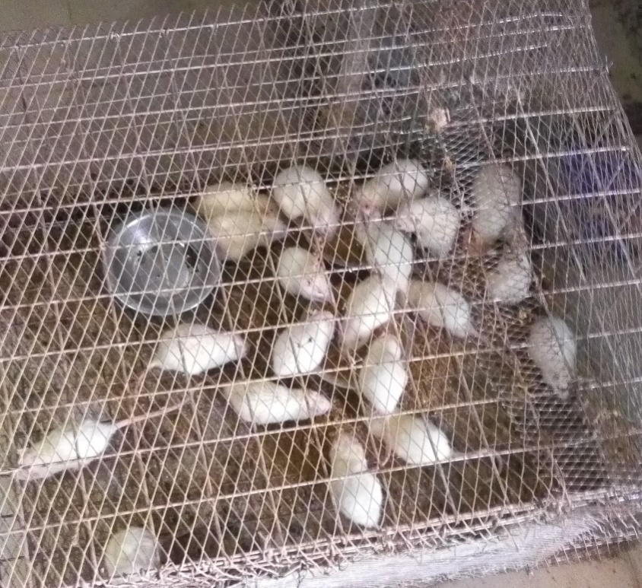

Figure 3: Wistar adult male albino rats.

3.2.4 EXPERIMENTAL DESIGN.
Fifteen (15) wistar albino rats were induced intraperitoreally with 183g/kg body weight of alloxan monohydrate. Diabetes was confirmed after 72hours.
The rats were grouped as follows:

GROUP 1: Normal control
GROUP 2: Diabetic untreated
GROUP 3; Diabetic treated with Modern Drug (glibenclamide)
GROUP 4: Diabetic treated with methanol leaf extract of Ocimum gratissimum
Treatment was done orally for a period of 14days (daily).

3.2.5 COLLECTION OF BLOOD SAMPLE
After about 14 days of treatment the rats were sacrificed and their blood was collected for analysis of the parameters. Blood samples were put in EDTA bottles.

3.2.6 DETERMINATION OF THE BIOCHEMICAL PARAMETERS
All the chosen biochemical parameters were assayed using randox bio diagnostic kits and the procedures were strictly followed as outlined in the manual guide.

3.2.7 GLUCOSE LEVEL
This assay is done to know the blood glucose level of the experimental rats. Accucheck machine was used to determine the glucose level.

PRINCIPLES
Glucose Gluconic acid + H₂O₂
Peroxidase
H₂O₂ H₂O + O
O-toluidine
O + Acceptor Colored Complex + H₂O

The method is based on the reaction of glucose and oxygen in the presence of oxidase to yield gluconic acid and hydrogen peroxide subsequently oxidizes. The dye in the reaction mediated by peroxides producing a blue colored form of dyes. The intensity of the blue color is proportional to the glucose concentration in the sample and it is measured and read by ONE TOUCH meter.
The one-touch glucometer was essentially a reflectance meter, the amount of light reflected in reagent area of the dextrostix measured in a readour meter scale was a measure of the concentration of glucose in blood.

PROCEDURES
Code key was inserted into the accu check machine code slot.
The code matched the test strip.
Glucometer strip was inserted into accu check machine properly.
The rat was bled in the tail and blood droplet was dropped on the strip.
The result was displayed after 5 seconds in mg/dl

3.2.8 DETERMINATION OF MALONDIALDEHYDE (MDA) LEVEL
Malondialdehyde (MDA) is one of the many low molecular weight end products of lipid hydro peroxide decomposition and is the most often measured as an index of lipid peroxidation, however the use of MDA as a maker for lipid peroxidation is controversial. MDA can be formed during eicosanoid metabolism and the analytical method for measuring MDA are prone to artifactual errors.

PRINCIPLES
MDA assay is based on the reaction of MDA with thiobartituric acid (TBA) forming an MDA-TBA and this assay abduct strongly in absorbance of 532nm.

REAGENTS PREPARATION
- Thiobarbituric acid was prepared by dissolving 1.0g of the compound in 83ml of distilled water on warming. After complete dissolution the volume was made up to 100ml with distilled water.
- 25% Trichloroacetic acid (TCA): Trichloroacetic acid (12.5g) was dissolved in distilled water and made up to 100ml in a volumetric flask with distilled water.
- Normal saline: Soduim chloride (0.3g) was dissolved in 10ml of disttiled water and make up to 100ml with distilled water.

PROCEDURE
To 0.1ml plasma in the test tube was added 0.45ml of normal saline and mixed thoroughly before adding 0.5ml of 25% trichloroacetic acid (TCA) and 0.5ml of 1% thiobarbituric acid.
To the blank was added the same volume of trichoacetic acid, thiobarbituric and saline and 0.10ml of distilled water instead of plasma.
The mixture was placed in water bath and heated 95oc for 40 minutes. The turbididty was removed by centrifuging the mixture.

It was allowed to cool before reading the absorbance of the clear supernatant against reagent blank at 532nm and 600nm.
Thiobarbituric acid reacting substances were quantified as lipid peroxidation product by referring to a standard curve of malondialdehyde (MDA) concentration equivalent generated by acid hydrolysis of 1,1,3,3-tetraethoxypropane (TET) prepared by serial dilution of stock solution.

3.2.9 SUPROXIDE DISMUTASE (SOD) ASSAY
The production of superoxide radicals, via immune responses and normal metabolism is a substantial contributor, if not the primary cause of pathology associated with neurodegenerative diseases aging and aging related diseases, SOD catalyzes the dismutation of the superoxide radicals (O2-) into hydrogen peroxide (H2O2) and elemental oxygen (O2) which diffuses into the intermembrame space or mitochondria matrix and thus, SODs provide an important defense against the toxicity of superoxide radical.
This was determined using the method (Xin et al, 1999).

PRINCIPLE
Superoxide dismutase SOD reduces superoxide to hydrogen peroxide, the theory of this method is based on the competition between SOD activity and iodonitrazolium violet in reacting with superoxide which is generated by Xanthine oxidase XOD reaction.

REAGENTS PREPARATION
Xanthine oxide was prepared by dissolving 1.0g of the compound in 50ml of distilled water on warming, after dissolution the volume was made up to 100ml with distilled water.
20g of phosphate buffer was PH of 7.0
12.5g of carbonate buffer of PH 10.2
TEST PROCEDURES
The blood sample were collected and poured inside an EDTA bottle
It was spinned and the serum was separation.
10micro liter of xanthine oxide was pipetted into a clean test tube and 10micro liter of distilled water was still added in the same test tube and using the spectrophotometer the mixture was placed inside a cuvette and absorbance at 550nm was taken.
10 microliter of xanthine oxide was also pipetted in a test tube and 10 micro liter of the test was also added then mixed.
A timer was set recording the absorbance at 550nm for every 30 seconds for 5miuntes.
CALCULATIONS

A₂ – A₁ = A (concentration of absorbance / min of standard solution.
Where
A₁ = initial absorbance
A₂ = final absorbance after 3 minutes
All standard rates and diluted sample rats were converted into percentages of the sample diluents rate and subtracted from 100% to give a percentage inhibition.
A sample in100 =% inhibition
ASi/min

Where A sample = Absorbance of sample
ASi = Absorbance of sample diluent rate

3.3 DETERMINATION OF HIGH DENSITY LIPOPROTEINS
High density lipoproteins (HDL) are one of the major classes of plasma lipoproproteins. They are composed of a number of heterogeneous particles, including cholesterol and vary with respect to size and content of lipid and Apo lipoprotein.
PRINCIPLE
Low density lipoprotein (LDL and VLDL) and chylomicron fractions are precipitated quantitatively by the addition of phosphotungstic acid in the presence of magnesium ion. After centrifugation the concentration of the HDL fraction which remains in the supernatant would now be determined.
LDL-cholesterol = cholesterol in the supernatant.
REAGENTS
Reagents used are commercial kit from Randox Lab Limited, UK.
Content concentration
4-Aminoantipyrine 0.30 mmol/L
Phenol 6 mmol/L
Peroxidase >0.5 u/ml
Cholesterol esterase > 0.15 u/ml
Cholesterol oxidase > 0.1 u/ml
Pipes buffer 80 mmol, PH 6.8
EDTA (Na2 salt) 5.0 m M
Polyethylene glycol monoemethyl ether 170g/l

PROCEDURES
The serum samples of 0.3ml was pipetted into labeled centrifuge tubes.
A drop of the precipitant solution or reagent of 10g of dextran sulphate, 1M of magnesium acetate and stabilizers) was added to each of the centrifuge tubes.
The content in the various tubes were thoroughly mixed and allowed to stand for 15 minutes at room temperature (20-25^{O}C) and then centrifuged at 2,000rpm.
The concentration of cholesterol in the supernatant was determined.
CALCUALTION
A sample * 52.5 = mg/dl HDL-Cholesterol
A standard
OR
A samples / A standard *1.36 mmol/dl HDL-Cholesterol
Where 52.5 and 1.36 are constant

3.3.1 LOW DENSITY LIPOPROTEIN LDL
LDL can be determined as the difference between content of the supernatant after precipitation of the LDL fraction by polyvinyl sulphate (PVS) in the presence of polyethylene glycol monosethyl ester.
REAGENTS
10ml precipitant solution
Dropper for 100 tests
Polyvinyl sulphate 0.7g/l
EDTA serum 4.0ml
Polyethylene glycol monoethyl ether 170g/l

PROCEDIURE
The precipitated solution of 0.1ml was carefully measured into test tubes labelled accordingly.
The serum 0.2ml was added to the labelled test tube.
The contents were thoroughly mixed and left to stand for 15minutes at room temperature (20-25⁰C).
Then the mixture was centrifuged at 2,000rpm for 15minutes and the cholesterol concentration in the supernatant was determined.
The concentration of serum total cholesterol was determined according to the OCACHOD-PAP method and absorbance was taken at 500nm.

CALCULATION
The LDL-Cholesterol concentration in the sample was calculated using the following general formula
LDL-Cholesterol (mg/dl) – 1.5 * Supernatant Cholesterol

3.3.2 VITAMIN E
PRINCIPLES
Vitamin E is a principle membrane-associated antioxidant molecule in mammals. It plays a major role in preventing oxidative damage to membrane lipids by scavenging free radicals.

PROCEDURES
A volume of 0.1ml of the serum was pipetted into a test tube.
A quantity of 0.9ml of distilled water was added.
About 1ml of 02% of ferric chloride and 1ml of alcohol were added.
X-dipyrioyl solution of 0.5% was added.
The whole mixtures were shaken.
It was then diluted in 5ml of distilled water.
The absorbance at 520nm was measured.

3.3.3 STATISTICAL ANALYSIS
The data were analyzed by analysis of variance (ANOVA) both one and two ways. The results were expressed in mean + or – standard deviation between fractions an animal groups were compared using Duncan Multiple Range Test (DMRT). A value of p < 0.005 was considered significant.

CHAPTER 4
4.1 RESULTS
Table 1: percentage yield for extraction
SAMPLE EXTRACT WEIGHT (g) PERCENTAGE YIELD %
Leaves dried and grinded 320.64
Methanol extract 4.9 1.528

Table 2: Glucose test result Normal range 95-115mg/dl
20 rats grouped into four groups  Five rats per group | Day zero  (mg/dl) | 3days  (Mg/dl) | 7days (mg/dl) | 14days (mg/dl)
Normal/ control group  $$\overline{x} \\ \overline{x}$$  Mean $X$ - | 102  95  110  98  100  101 | 101  96  97  110  98  100.4 | 101  95  97  105  96  98.8 | 96  90  95  98  93  94.4
Diabetic not treated  $$\overline{x} \\ \overline{x}$$  Mean X - | 109  101  111  97  102  104 | 193  210  189  200  195  197.4 | 181  187  179  179  180  181.2 | 106  118  102  104  113  108.6
Diabetic treated with Gilbenclamide  $$\overline{x} \\ \overline{x}$$  Mean X- | 95  104  102  110  99  102 | 185  204  190  211  197  197.4 | 176  180  179  181  180  179.2 | 129  156  130  143  140  139.6
Diabetic treated with leaf extract of Ocimum gratissimum  $$\overline{x} \\ \overline{x}$$  Mean X- | 103  109  98  110  101  104.2 | 210  209  187  199  205  202 | 185  182  181  179  187  182.8 | 162  155  92  77  170  131.2

4.3 Effects of methanol extract of O.gratissimum on malondialdhyde (MDA)
MDA level decreased significantly (p < 0.05) in group 4 treated with the leaf extract compared with diabetic not treated group as shown in fig 4.

FIGURE 4: EFFECT OF METHANOL LEAF EXTRACT OF OCIMUM GRATISSIMUM ON MALONDIAHYDEHYDE (MDA) OF ALLOXAN INDUCED DIABETIC RATS.

4.4 Effect of methanol leaf extract of O.gratissimum on superoxide dismutase (SOD).
A non-significant (P >0.05) increase of SOD activity was observed in group 4 treated with the extract compared with those treated with gilbenclamide drug. Similar trend was observed in group 2 compared with the normal control as seen in fig 5.

FIGURE 5: EFFECT OF AQUEOUS METHANOL LEAF EXTRACT OF OCIMUM GRATISSIMUM ON SUPEROXIDE DISMUTASE (SOD) OF ALLOXAN DIABETIC RATS.

4.5 Effect of O.gratissimum of High density lipoprotein (HDL) level.
There is a significant (P <0.05) decrease in the HDL level of diabetic treated with gilbenclamide drug. Diabetic untreated shows a non-significant (P< 0.05) decrease of HDL level compared with rats treated with extract which showed a significant (p>0.05) increase of HDL level as shown in fig 6.

FIGURE 6: EFFECT OF METHANOL LEAF EXTRACT OF OCIMUM GRATISSIMUM ON HIGH DENSITY LIPOPROTEIN (HDL) ON ALLOXAN INDUCED DIABETIC RATS.

4.6 Effect of methanol extract of O.gratissimum on the low density lipoprotein (LDL).
There is a significant (p>0.05) increase is the LDL level of group 3 treated with gilbenclamide compared with diabetic untreated group. In the same vein, LDL level decreased non- significantly (p< 0.05) decrease in group 4 compared with the control group as shown in fig 7.

FIGURE 7: EFFECT OF METHANOL LEAF EXTRACT OF OCIMUM GRATISSIMUM ON LOW DENSITY LIPOPROTEIN (LDL) OF ALLOXAN INDUCED DIABETIC RATS.

4.7 Effect of methanol extract on Vitamin E level.
Result showed a non- significant (p >0.05) increase in Vitamin E concentration of rats group 4 diabetic treated with leaf extract compared with the control group and a significant (P<0.05)decrease in group 3 treated with gilbernclamide as well as diabetic untreated as shown in fig 8.
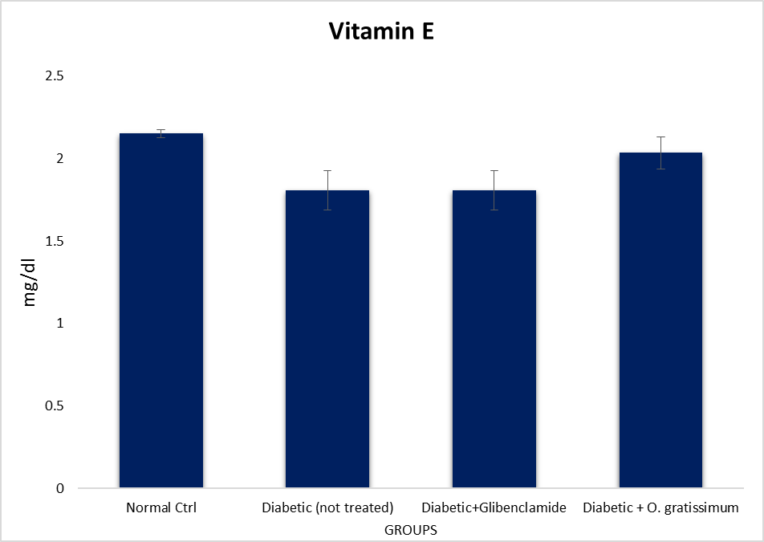
FIGURE 8: EFFECT OF METHANOL LEAF EXTRACT OF OCIMUM GRATISSIMUM ON THE VITAMIN E LEVEL OF ALLOXAN INDUCED DIABETIC RATS.

CHAPTER FIVE
5.1 DISCUSSIONS
The increasing prevalence of type 2 diabetes threatening the quality of human life demands extensive and qualitative research into development of efficient anti-diabetic agents free of the adverse effects.
Hence, medical plants are constantly being investigated using animal model of the disease with the anticipation of developing a comparatively safe anti-diabetic plant based product. In this study, we report the anti-diabetic potential of the leaf fractions of Ocimum gratissimum in a newly developed unique model of type 2 diabetes. Ocimum gratissimum, although used for the traditional remedy of diabetes mellitus in Nigeria, the anti-diabetic potential of the leaf fractions in type 2 diabetes model is either not available or scarce in the published literature (Kolawale et al., 2011).
In this study, extractions were done using methanol to obtain the extract needed for the experiment. It was discovered that malondialdehyde (MDA) which is the product lipid peroxidation, an oxidative degradation of lipids, decreased significantly (p<0.05) in the test group complied with the control group. The level of MDA is maker of oxidative stress and during the work it was discovered that there is a significant (p<0.05) decrease in the MDA level of group treated with leaf extract compelled with diabetic not treated as shown in fig 4. This may have happened because of the medicinal effect of Ocimum gratissimum as said by (Ijeh et al., 2005).
The study showed that a significant (p>0.05) increase of the HDL level of the group treated with Ocimum gratissimum compared with diabetic untreated rats. This increase could be as a result of its anti-hyperlipidermic effect of the leaf extract. A non- significant (P>0.05) increase was seen in HDL level of group treated with Gilbenclamide was observed compared with the normal control as shown in fig 6 Increase in LDL could raise a risk of heart disease and as the name implies “bad” cholesterol. Result showed a significant (P<0.05) decrease LDL in group 3 of diabetic treated with gilbenclamide compared with untreated group observed decreased was noticed in group 4 treated with leaf extract as shown in fig.7 compared with diabetic untreated groups.
The antioxidant superoxide dismutase and vitamin E were also assayed; antioxidant counteracts or inhibits oxidation, especially removing damaging oxidizing agents in living organisms as said by (Santos et al., 2002). SOD catalyzes the dismutation of superoxide radical into its ordinary molecular oxygen or hydrogen peroxide. In the study it was shown that there was a significant (p>0.05) increase in SOD activity test group compared with normal control group
Furthermore, non- significant (p>0.05) increase in the vitamin E concentration was recorded in the treatment groups (group 3 and 4) compared with the diabetic untreated in group 2. This implies that the extract has the ability to potentiate the action of Vitamin E (Edem et al., 2002).
In general, the extract of O.gratissimum has the ability to counteract the free radical and therefore could be used in management and control of the diabetic complication.

5.2 CONCLUSION
The study showed that the daily administration of methanol leaf extract of Ocimum gratissimum of Alloxan induced diabetic rats resulted in the decrease of their blood glucose level. The beneficial effects of the Ocimum gratissimum leaf extract could be attributed to the improved insulin sensitivity and beta-cell function as a result of alkaloids, flavonoids, saponins and / or tannins present in the leaf fractions.
The data from this study gives credibility to existing reports that Ocimum gratissimum is valuable in the ethno-therapeutic management of diabetes mellitus. Apart from the fact that all five fractions are found to be effective, it also has satisfactory ability to revert diabetic alterations to near normal.
Even though the intervention period of study was rather short at just two weeks, it shows promise of the effects of Ocimum gratissimum.

REFRENCES
Aguiyi, J., Obi, C.I, Gyang, S.S and Igweh, A.C, (2000). Hypoglycaemic activity of Ocimum gratissimum in rats. Herbs and medicine. Page 6: 123-128.
Akinmoledeun, K.O, Mendie, U.E, Smith, S.T, Oyefolu, A.O and Coker, A.O. (2007). Screening of some medicinal plants for anti-salmonella activity. Journal on Herb Pharmocother. Volume 1:2-5
Barley and Day (1989). Studies on essential oils for their antibacterial and antifungal properties: Preliminary screening of 35 essential oils. Journal on Science and Industrial Resources. Volume 2:11-15
Chen, A. and Sukul, N.C, (1999). Nematicides principal from two species of Ocimum gratissimum. Herbs. Page 1:2-4
Day, V. and Ignacimuthu, S. (1989). Antibacterial and antifungal activity of Ocimum gratissimum L. An ethno medicinal plant. Journal on Ethnopharmacol. Volume 1:12-14
Edeoga, U.G, Adelaiye, A.B, Ibu, J.O and Egesie, O.J. (2006) Safety and hypoglycaemic properties of aqueous leaf extract of Ocimum gratissimum in streptozotocin induced diabetic rats. Niger Journal of Physiological Science. Volume 13:5-12
Effrim, S. Mustafa, A., Erdem, Y. and Shigeru, I.(2003). Hypoglycaemic activity of Ocimum gratissimum and isolation of the active constituent through bioassay‑ directed fractionation techniques. Life Science 13:345-431
Eizirik, A.E, Owo, O.I, Itam, E.H, and Konya, R.S. (1994). Contribution of lymphocytes in edema induced by venom from the wasp. Pharmacological Biology. 50:456-500.
Effrim, A.J. and Gabuzda, T.G. (2003). Pathologic Physiology, Mechanisms of Diseases. Review of Medical Physiology. 30:456-458
Ijeh, Sheteolu, A.O., Omonibgehin, E.A. and Adeneye, A.A. (2004). Antibacterial activity of Ocimum gratissimum (Lamiaceae) Journal on Diarrhea Discovery Research. Volume 2:45-50
Kolawale and B.M. Padhy, (2011). Protective effect responsible for the antioxidant nephroprotective activities of aqueous suspension of dried latex Ocimum gratissimum against oxidative stress and renal damage in diabetic rats. Biocell, 35(3): 63-69.
Kabir, M.O. and Ijeh, (2005). Medicinal uses of some African leaves in Nigeria. Traditional medicine. 16(5):5-12.
Mrozikiewicz, A. Tanko, Y. Okasha, M.A and Magaji, R.A. (1994). Effects of aqueous leaves extract of Ocimum gratissimum on blood glucose levels of streptozotocin induced diabetic Wistar rats. African Journal of Biotechnology. Volume 5:8-20
Obianime, A.W, Aprioku, J.S, and Esomonu, C. (2011).The effects of aqueous Ocimum gratissimum leaf extract on some biochemical and hematological parameters in male mice. Asian Journal of Biological Science. Volume 4:16-18
Oladele, F.D. (1999). Smooth muscle contracting lipid soluble principles in chromatographic fractions of Ocimum gratissimum. Journal on Ethnological pharmacology. Volume 1:7-10
Rabelo, N.K, and Nammi, S. (2013). Antidiabetic and renoprotecticve effects of methalonic extract of Ocimum gratissimum in alloxan induced diabetic rats. BMC Complement Alternative Medicine.13:13-16 .
Santos, A. and James, E., (2002). Plant botany. Basil New Crop Fact Sheet. Page 15:407-422

APPENDIX
Table 1: The effect of aqueous and methanol leaf extract of Ocimum gratissimum of superoxide dismutase (SOD) in Alloxan induced diabetic rats in IU/L
Rat 1 Rat2 Rat3 Rat4 Rat5

Control 10.40 10.00 10.50 10.50 11.30
Diabetic not treated 10.70 11.20 11.10 11.40 10.80
Diabetic treated with gilbenclamide 10.40 11.10 11.00 11.20 10.80
Diabetic treated with leaf extract 10.64 10.80 11.30 11.20 11.20

Table 2: The effect of methanol leaf extract of Ocimum gratissimum for malondiahydiade (MDA) in Alloxan induced diabetic rats in mg/ml
Rat1 Rat2 Rat3 Rat4 Rat5

Control 2.12 2.63 2.50 2.87 2.34
Diabetic not treated 3.11 3.43 1.55 2.06 1.11
Diabetic treated with gilbenclamide 3.03 3.00 3.21 2.95 1.38
Diabetic treated with leaf extract 1.81 2.16 2.35 2.23 2.29

Table 3: The effect of methanol leaf extract of Ocimum gratissimum for vitamin E in Alloxan induced diabetic rats in mg/dl
Rat1 Rat2 Rat3 Rat4 Rat5

Control 2.17 2.21 2.07 2.12 2.19
Diabetic not treated 2.09 2.11 1.65 1.63 1.56
Diabetic treated with gilbenclamide 1.82 2.19 1.86 1.72 2.01
Diabetic treated with leaf extract 1.66 2.06 2.12 2.13 2.21

Table 4: The effect of methanol leaf extract of Ocimum gratissimum for high density lipoprotein (HDL) in Alloxan induced diabetic rats in mmol/l
Rat1 Rat2 Rat3 Rat4 Rat5

Control 1.30 1.30 1.20 1.30 1.30
Diabetic not treated 1.30 1.20 1.30 1.10 1.50
Diabetic treated with gilbenclamide 0.90 1.40 1.30 1.20 1.20
Diabetic treated with leaf extract 1.50 1.40 1.70 1.40 1.20

Table 5: The effect of methanol extract of Ocimum gratissimum for low density lipoprotein (LDL) in Alloxan induced diabetic rats in mmol/l
Rats1 Rat2 Rat3 Rat4 Rat5

Control 2.76 2.34 2.16 2.96 2.30
Diabetic not treated 2.76 2.14 2.40 2.92 2.14
Diabetic treated with gilbenclamide 3.54 2.56 3.94 4.56 2.94
Diabetic treated with leaf extract 2.28 2.85 3.02 2.72 2.80

NORMAL SALINE PREPARATION
0.8 of NaCl sodium chloride was 2.0g and poured into beaker and distilled water was added up to 200ml of the beaker.

ALLOXAN PREPARATION FOR INDUCTION
2.0g of alloxan of weighed into a beaker and normal saline was added up to 30ml.

MODERN DRUG (GILBENCLAMIDE PREPARATION
Gilbenclamide was grinded to power and 0.35g of the grinded gilbenclamide was weighed and poured in a beaker and 10ml of normal saline was added.

PERCENTAGE YEILD OF EXTRACT
Final weight of methanol extract after drying × 100 / initial weight of grinded leaves
4.9g × 100 ÷ 320.649 =1.528%

