ANTIMICROBIAL EFFICACY OF COMMONLY USED DISINFECTANTS AGAINST Escherichia coli AND Staphylococcus Aureus

BY

OGIDI, OCHANYA ANTHONIA
U14/NAS/MCB/070

DEPARTMENT OF MICROBIOLOGY, FACULTY OF NATURAL AND APPLIED SCIENCES
GODFREY OKOYE UNIVERSITY UGWUOMU NIKE ENUGU STATE

JULY 2018

ANTIMICROBIAL EFFICACY OF COMMONLY USED DISINFECTANTS AGAINST Escherichia coli AND Staphylococcus Aureus

BY

OGIDI, OCHANYA ANTHONIA
U14/NAS/MCB/070

A RESEARCH PROJECT SUBMITTED TO THE DEPARTMENT OF MICROBIOLOGY, FACULTY OF NATURAL AND APPLIED SCIENCES
GODFREY OKOYE UNIVERSITY UGWUOMU NIKE ENUGU STATE IN PARTIAL FULFILMENT OF THE REQUIREMENT FOR THE AWARD OF BACHELOR OF SCIENCE (B.Sc.) DEGREE IN MICROBIOLOGY

SUPERVISOR
DR CHINENYE EZEBIALU

DEDICATION
I dedicate this work to God Almighty who through him I was able to finish this work.

ACKNOWLEDGMENT
I would like to thank the supreme power the Almighty God who is obviously the one who has guided me to work on the right path of life and also for all his favours, care and immense love upon me.
Next to him are my parents Hon. And Mrs Tony Ogidi who I am greatly indebted to for their love and support up to this stage. I sincerely thank my Supervisor, Dr. Chinenye Ezebialu who has been my help throughout, and always been there to put me on the right tracks. I also want to thank my HOD Dr. Mrs M.N. Onachukwu who has always has showed her care and love towards us. I am grateful to all my lecturers and staff of microbiology department most especially Mr Okolo for their assistance.
My gratitude goes to my siblings (Onyi, Fifi and Junior) and family members who have been with me through all my toils. Lastly I want to thank all my friends Nkechi, Ijay, Jonathan, Benedict, Nnamdi, Ezege, Odinaka, Lucyann, Onyinye, Emmanuel, Ella, Francis, Tigana, Ifeanyi, Jennifer and many others. May God bless and protect you always.

TABLE OF CONTENT
Title page ………………………………………………….…………………………….. i
Approval page …………………………………………………………………………… ii
Dedication …………………………………………….…………………………………. iii
Acknowledgments ……………………………………...………………………………… iv
Table of contents …………………………………………………………………………. v
List of tables ……………………………………………………………………………… viii
Abstract ………………………………………………………….………………………… ix
CHAPTER ONE: INTRODUCTION
  - Background of study …………………………………………………………………… 1
  - Statement of Problem …………………………………………………………………… 2
  - Aim of study…………………………………………………………………………….. 3
  - Specific objectives ……………………………………………………………………… 3
CHAPTER TWO: LITERATURE REVIEW
2.0 Literature Review ……………………………………………………………………….. 4
2.1 Nosocomial infections ……………………………………………………….………….. 4
2.1.1 Impact of Nosocomial infection ………………………………………..………….… 4
2.1.2 Implications of Nosocomial Infections ……………………………………….……… 5
2.2 Studies on antimicrobial activities of disinfectants against Nosocomial Infection …… 6
2.3 Escherichia coli ……………………………………………………………………….. 9
2.3.1 Scientific Classification …………………………………………………………….. 9
2.3.2 Morphology ………………………………………………………………………… 10
2.3.3 Epidemiology ……………………….……………………………….……………… 10
2.3.4 Infection ………………………………….…………………..……………………… 11
2.4 Staphylococcus aureus …………………………….………………………………….. 12
2.4.1 Scientific Classification ……………………………………………………………. 12
2.4.2 Morphology ………………………………….…………………………………….. 12
2.4.3 Epidemiology ………………………………………………………………………. 13
2.4.4 Infection ……………………………………………………………………………. 13
CHAPTER THREE: MATERIALS AND METHODS
3.0 Materials and Methods ……………………………………………………………...... 14
3.1 Determination of disinfectants commonly used in hospitals ……………………….. 14
3.2 Disinfectants used …………………………………………………………………….. 14
3.3 Test Organism ………………………………………………………………………… 14
3.4 Culture media used …………………………………………………………………… 14
3.5 Standardization of test organism …………………………………………………….. 15
3.5.1 Preparation of 0.5 McFarland Standard ……………………………………………. 15
3.5.2 Preparation of test inoculum ……………………………………………………….. 15
3.6 Dilution of Disinfectants ……………………………………………………………… 15
3.7 Minimum Inhibitory Concentration using Agar Well Diffusion Method ……..…….. 15
CHAPTER FOUR: RESULTS
4.1 Results …………………………………………………………………………………. 17
CHAPTER FIVE: DISCUSSION AND CONCLUSION
5.1 Discussion ……………………………………………………………………………… 24
5.2 Conclusion …………………………………………………………………………….. 26
REFERNCES ………………………………………………………………………………. 27
APPENDICES ……………………………………………………………………………… 32

LIST OF TABLES
Table Title Page 1: Lists of disinfectants and their uses in hospitals 17
2: Antimicrobial activities of the disinfectants against the test organisms at 100% concentration 19
3: Antimicrobial activities of the disinfectants against the test organisms at 50% concentration 20
4: Antimicrobial activities of the disinfectants against the test organisms at 25% concentration 21
5: Antimicrobial activities of the disinfectants against the test organisms at 12.5% concentration 22
6: Antimicrobial activities of the disinfectants against the test organisms at 6.25% concentration 23

ABSTRACT
The antimicrobial effectiveness of two selected disinfectants (Izal and Jik) was determined using agar diffusion method. The test organisms used (Escherichia coli and Staphylococcus aureus) were obtained from Enugu State University Teaching Hospital, Enugu. The disinfectants were diluted to 100%, 50%, 25%, 62.5%, 12.5% concentrations. The diluted concentrations showed different zones of inhibition against the test organisms. At 100% concentration Izal completely cleared both Escherichia coli and Staphylococcus aureus while Jik had 25mm zone of inhibition for Escherichia coli and 24mm zone of inhibition for Staphylococcus aureus. At 50% concentration Izal cleared both Escherichia coli and Staphylococcus aureus while Jik had 20mm zone of inhibition for both test organisms. At 25% concentration Izal completely cleared both test organisms while Jik had 15mm zone of inhibition for Escherichia coli but no zone of inhibition for Staphylococcus aureus. At 12.5% concentration Izal completely cleared both test organisms while Jik had no zone of inhibition. At 6.25% concentration Izal completely cleared the test organisms while Jik had no zone of inhibition for the test organisms. The results showed that Izal was more effective at any concentration while Jik was effective only at high concentration of 100% and 50%. Escherichia coli and Staphylococcus aureus obtained from hospital are both susceptible to the disinfectants used in this research. Therefore, disinfectants such as Izal and Jik can help to control incessant spread of some of the hospital acquired infections when used at the right concentration.

CHAPTER ONE
  - BACKGROUND OF STUDY
INTRODUCTION
Disinfectants are chemical agents used to kill microorganism on the surface or in order to eliminate them from the environment (Melike et al, 2016).
Ever since the identification of microorganism as the causative agents of infectious diseases, various methods have been devised in reducing the population and prevalence of these organisms. The various methods embarked upon include, chemotherapy, immunization, sterilization and disinfection (Kim et al, 2007).
Disinfectants are used extensively in hospitals and other health care settings for a variety of topical and hard surface applications (Olowe et al., 2004). Chemical agents used in disinfection are referred to as disinfectants and the three main types of disinfection available are cleaning, heating and disinfection with chemical agents (Geo et al., 2004). Disinfectants take time to act, they are greatly inactivated by excess organic matter and show higher activity at adequate concentrations (Olowe et al., 2004). Disinfectants are an essential part of infection control practices and aid in the prevention of nosocomial infections (Olasehinde et al., 2008).
Disinfectants are toxic not only for microbial pathogens but for host cells as well and because of this they can only be used to inactivate microorganism in the inanimate environment (Brooks et al., 2004).

There are four classes of disinfectants. They include:
- Sterilants: are required for critical instruments that penetrate tissue or present a high risk if non- sterile, for e.g. implants, needles and other surgical instruments. E.g. heat, steam, higher concentrations of hydrogen peroxide and paracetic acid, glutaraldehyde.
- High level disinfectants: are required for semi- control items that do not penetrate tissues or contact mucous membranes (except dental) such as endoscopes, respiratory therapy equipment and diaphragms. Examples; hydrogen peroxide , glutaraldehyde, formaldehyde, ortho-phthaladehyde, paracetic acid.
- Intermediate level disinfectants: are required for non-critical items that touch intact skin [e.g thermoters and hydrotherapy tanks] examples; alcohols, hypochlorite, iodine and iodophor disinfectants.
- Low level disinfectants: are required for non-critical items such as stethoscopes, bedpans, blood pressure cuffs and bedside tables. Examples; phenolic, quaternary ammonium compounds.
1.2 STATEMENT OF PROBLEM
The current increase in the prevalence of nosocomial infections within the hospital environment despite adequate cleaning and disinfection is due to ineffectiveness of the various disinfectant formulations used in infection control and development of resistance to the various chemical disinfectant formulations being used in the hospitals by various micro-organisms

1.3 AIM OF STUDY
To determine the antimicrobial activity of disinfectants used in hospitals against Escherichia coli and Staphylococcus aureus.
1.4 SPECIFIC OBJECTIVES
- To determine the disinfectants used in hospitals.
- To determine the antimicrobial activities of the disinfectants used in the hospitals against the test organisms.
- To determine the Minimum inhibitory concentration of those disinfectants.

CHAPTER TWO
LITERATURE REVIEW
2.1. HOSPITAL ACQUIRED INFECTIONS/NOSOCOMIAL INFECTIONS
According to the World Health Organization, Nosocomial Infection is an infection acquired in hospitals by a patient who was admitted for a reason other than that infection. This includes infections acquired in hospitals but appearing after discharge and also occupational infections among staff of the facility (WHO, 2002).
In other words, Nosocomial Infections are infections acquired in hospitals or healthcare service unit that first appear 48hours or more after hospital admission or within 30 days after discharge following in- patient care (Nasir and Kadri, 2014).
Nosocomial Infection is a localized or systemic condition that results from adverse reactions to the presence of an infectious agent that was not present or incubating at the time of admission to the hospital from the centre for disease control (Horan and Gaynes, 2004). The history of nosocomial infections can be traced to the origin of hospitals themselves (Mbim et al., 2016). Studies have revealed that nosocomial infections are becoming more alarming in the present century which is due to the increased use of outpatient treatment meaning that people who are in the hospitals admit large number of sick people and whose immune system are often compromised (Samuel et al., 2010).
2.1.1. IMPACT OF NOSOCOMIAL INFECTIONS
Hospital Acquired Infections add to functional disability and emotional stress of the patient and may in some cases lead to disabling conditions that reduces the quality of life (Mbim et al., 2016). The costs of Nosocomial Infection in terms of both money and human suffering are enormous (Emori and Gaynes, 1993).
In March 2009, Center for Disease Control (CDC) released a report estimating overall annual direct medical cost of healthcare associated infections that range from 28-45 billion. (Horan and Gaynes, 2004)
Nosocomial Infections are also one of the leading causes of death. The increased use of drugs, the need for isolation and the use of additional laboratory and other diagnostic studies also contribute (Plowman et al., 2001).
Different types of infections acquired in hospitals
- Bloodstream infections
- Ventilator associated pneumonia
- Urinary tract infections
- Lower respiratory infection
- Gastrointestinal infection
- Skin, soft tissue, surgical site infections
- Ear, nose and throat infections (Weistein, 1993).

2.1.2. IMPLICATIONS OF NOSOCOMIAL INFECTIONS
There are numerous risk factors which predispose a host to acquire Nosocomial Infections including low body resistance as in infancy and old age, serious underlying illness, major surgeries (Dunn, 2001) immune deficiency state (Nasir and Kadri, 2014) and prolonged hospital stay (McNicholas et al.,2011).
There are areas in the hospital which carry a greater risk in patients acquiring Nosocomial Infections which include intensive care unit, dialysis unit, organ transplant unit, burns unit, operation theatres, delivery rooms, post-operative wards (Nasir and Kadri, 2014).
According to Mbim et al, (2016), several studies have shown that patients admitted into the hospitals are usually at a high risk of infections. Akingbade et al., (2013); Jose et al., (2014), observed that patients skin and openings are colonized by prevailing nosocomial agents. Bereket et al., (2012), also observed that the practices and conditions in a hospital enhances colonization by nosocomial agents.
The most important factor for acquisition of nosocomial infections has been found as the length of hospital stay (Mbim et al., 2016). At serious disadvantage are new-borns admitted into neonatal intensive care units that may possess several host factors that makes them prone to infections and also increases their risk of getting even more fatal illnesses (Samuel et al., 2010; Polin et al., 2013).
2.2. STUDIES ON ANTIMICROBIAL ACTIVITIES OF DISINFECTANTS AGAINST NOSOCOMIAL ORGANISMS
According to Iroha et al., (2011), the antimicrobial activities of Savlon, Izal and Z- germicide disinfectants against 23 clinical isolates of Pseudomonas aeruginosa were evaluated. The overall result of the study showed that Savlon and Izal have high antimicrobial activity against Pseudomonas aeruginosa isolates, while Z-germicide produced low activity. The use of Savlon and Izal disinfectants in hospitals and clinics in Nigeria were highly recommended.
Alabi and Sanusi, (2012), found out that the current increase in the prevalence of nosocomial infections within the hospital environment despite adequate cleaning and disinfection is due to ineffectiveness of the various disinfectant formulations used in infection control on the various hospital equipment and wards, development of resistance to the various chemical disinfectant formulations being used in the hospitals by various micro-organisms. The resistance demonstrated by some of the nosocomial agents developing some mechanisms against the various disinfectant formulations. The effectiveness of Jik formulation at half the manufactures prescribed dilution showed that Jik is still an important disinfectant formulation in the control of nosocomial agent most especially the resistant strains.
“Obi et al., (2016)”, assessed the commonly used hospital disinfectants on bacterial isolated from the operating theatre of Usmanu Danfodiyo University Teaching Hospital, Sokoto. Bacterial species were isolated by setting plate method using Nutrient and MacConkey agar as the isolating medium. The in-house disinfectants (Povidone iodine and Izal) used in the operating theatre was obtained and evaluated using Agar ditch diffusion method. It was conducted that disinfection remains one of the most effective ways of reducing nosocomial pathogens in hospital environment as demonstrated in the results of the research work. However, from time to time the potency of the in house disinfectant used must be checked in order to keep pace with degradation of disinfectant which normally occurs with time. The disinfectants, Savlon, Jik, Methylated Spirit and Kerosene were observed for their inhibitory activities on Bacillus subtilis, Pseudomonas aeruginosa and Candida albicans. This was done by measuring the zone of inhibition of the disinfectants on the tested organism. The results showed that Savlon was very effective at 100% concentration as it inhibits the growth of Pseudomonas aeruginosa, Bacillus subtilis. There was no inhibitory activity on Candida albicans at 6.25%. Jik at 100% concentration inhibited the growth of Pseudomonas aeruginosa, Bacillus subtilis and Candida albicans. The study showed that methylated spirit and Jik have inhibitory activities on both fungi and bacteria while kerosene had only antifungal activities and savlon had only antibacterial activities (Awodele et al., 2007).
This study aimed at comparing the efficacy of commercially available disinfectants on microorganism isolated from clinical samples. Four commonly used disinfectants namely savlon, 70% ethanol, Dettol and Lysol were tested for clinical samples from impatient admitted at Sri Siddhartha Medical College Hospital, Tumkur. The disinfectants savlon and Dettol can be used as alternatives to phenol and sodium hypochlorite solution to manage liquid spills in small health care settings. Agar well diffusion method was used to assess the effectiveness of disinfectants used in the hospitals to have quality control on the disinfectants (Sharoda et al., 2013).
The antimicrobial effectiveness of four selected disinfectants (Dettol, Izal, Z-germicide and Jik) were determined using agar diffusion (paper disc method). The test organism used include; Escherichia coli, Staphylococcus aureus, Streptococcus spp and Mucor spp. The results showed that Dettol was more effective against the test organisms than the other disinfectants. Izal recorded the least antimicrobial activity. Disinfectants for external uses are necessary to avoid related infections or diseases caused by those test microorganisms (Okore et al., 2014).
Five frequently used disinfectants in specialist Hospital, Yola, Nigeria were analysed for bacterial contamination and sensitivity to antibiotics. For ach disinfectant, 20 different samples of stock and left over diluted solutions were used for the analysis. All the stock were free from any bacterial growth. The Minimum inhibitory concentration and minimum bacterial concentration of the isolates were significantly higher than that of the control sensitive strains, but were lower than the values quoted by the manufactures of the disinfectants, all the isolates showed variable sensitivity to antibiotics with each disinfectant showing sensitivity to at least four antibiotics tested in the study (El-Mahmood and Doughari, 2009).
“Elias et al., (2014)” carried out a research on disinfectants, the aim of the study was to evaluate the efficacy of disinfectants using standard methods in hospitals in Kogi State. Dettol and Izal which phenolic disinfectants were evaluated for efficacy against phenol using locally isolated multi drug resistant Pseudomonas aeruginosa as test organism in randomly selected hospitals in Kogi state. The disinfectants tested were considered effective for use in the health care facilities. The study was conducted to evaluate the activities of three commonly used hospital disinfectant on Pseudomonas aeruginosa at the University College Hospital, Ibadan. Fifty five clinical isolates of Pseudomonas aeruginosa were subjected to the three commonly used disinfectants namely Jik, Izal and Dettol. Based on the results of this study Izal can be effectively used in University College Hospital while Dettol and Jik are either discarded or the use concentration increased.
2.3. Escherichia coli
Escherichia coli is a gram negative, facultative anaerobic , rod shaped coliform bacterium of the genus Escherichia that is commonly found in the lower intestine of warm blooded organisms (endotherms) (Tenaillion et al., 2010; Singleton, 1999).
2.3.1. SCIENTIFIC CLASSIFICATION
Domain Bacteria
Phylum Proteobacteria
Class Gammaproteobacteria
Order Enterobacteriales
Family Enterobacteriaceae
Genus Escherichia
Species coli

2.3.2 MORPHOLOGY
Escherichia coli is a Gram-negative, facultative anaerobic (that makes ATP by aerobic respiration if oxygen is present, but is capable of switching to fermentation or anaerobic respiration if oxygen is absent) and nonsporulating bacterium. Cells are typically rod-shaped, and are about 2.0 μm long and 0.25–1.0 μm in diameter, with a cell volume of 0.6–0.7 μm (Yu et al., 2014 and Kubitschek, 1990).
Escherichia coli stains gram negative because the cell because the cell wall consist of a thin peptidoglycan layer and an outer membrane. During the staining process Escherichia coli picks the colour of the counterstain safranin and stains pink. The outer membrane surrounding the cell wall provides a barrier to certain antibiotics such that Escherichia coli is not damaged by penicillin (Tortora, 2010). They grow at 37°c.
2.3.3. EPIDEMIOLOGY
Escherichia coli are responsible for most clinically important infections in the world (Ezeanya, 2013). Escherichia coli is one of the most common causative agents of gram negative sepsis, endotoxins induced shock, urinary tract and wound infections, pneumonia in immunosuppressed hospitalized patients, meningitis in neonates and diarrhoeal diseases (Ezeanya, 2013). They account for 90% of urinary tract infections in young women (Omeregie et al., 2008). In Nigeria, the prevalence of Escherichia coli infection varied from 23.3% to 54.6% (Ngwai et al., 2010). Reports from southern Nigeria showed prevalence of Escherichia coli in hospitals from south- south, South east and south west as 34.4%, 31.5% and 30% respectively (Umolu et al., 2006; Oreh and Attama, 2003; Akujobi and Ezeanya, 2013).
Treatment of Escherichia coli infections in hospitals ranges from tetracycline, cotrimoxazole, Augmentin and amoxicillin (Ezeanya, 2013). Studies have shown a high resistance to these previously used antibiotics in Southern Nigeria and also worldwide (Umolu et al., 2006 and Oreh and Attama 2013).
Escherichia coli comprises of non-pathogenic commensal isolates that form part of the normal flora and various animals (Tenaillon et al., 2010).In humans they are the major aerobic organism residing in the intestine typically with around 106- 109 colony forming unit per gram (Tenaillon et al., 2010). Several variants or pathotypes of Escherichia coli have been described that cause infections of the gastro intestinal system (i.e. intestinal pathogenic Escherichia coli) while other pathotypes cause infections outside the gastro intestinal system (Croxen et al., 2010).
2.3.4 INFECTION
Escherichia coli is responsible for a wide range of hospital and community onset infections affecting patients with normal immune systems as well as those with pre-existing conditions (Pitout, 2013).

2.4 Staphylococcus aureus
Gram positive cocci that tend to be arranged in grape like clusters.
2.4.1 SCIENTIFIC CLASSIFICATION
Domain Bacteria
Phylum Firmicutes
Class bacilli
Order Bacillales
Genus Staphylococcus
Specie Aureus

2.4.2. MORPHOLOGY AND IDENTIFICATION
Staphylococci are spherical cells about 1m in diameter arranged in irregular cluster. Single cocci, pairs, tetrads and chains are also seen.
In liquid cultures young cocci strains strongly gram positive, on aging, many cells become gram negative. Staphylococci are non-motile and do not form spores (Brooks et al., 2007).
Staphylococcus is a facultative anaerobe that grows at an optimum temperature of 37°c and an optimum pH of 7.5. Staphylococcus aureus produces white colonies that tend to turn a butt golden color with time, which is the basis of the species Epithet aureus (golden) most, but not all strain show a rim clear Beta haemolysis surrounding the colony (Ryan and Ray, 2004).

2.4.3 EPIDEMIOLOGY
Staphylococci are highly successful colonies of humans and animals. They reside mainly on the skin, particularly in moist areas such as anterior nares (nose), axilla and grown. Staphylococcal infections are worldwide and newly emerging hyper virulent or multiresistant strains spread rapidly over wide geographical areas. The bacteria survive in the air, in objects or in dust for days. Therefore they can contaminate environments (such as hospitals) and continue to be transmitted over long periods of time. Some individuals may shed the organism more heavily than others. Staphylococcal infections are acquired from either self (endogenous) or external (exogenous) sources (Irving et al., 2006).
2.4.4 INFECTION
Staphylococcus aureus causes serious infections of the skin, soft tissues, bone, lung, heart, brain or blood (Irving et al., 2006). Diseases caused by Staphylococcal toxins include scaled skin syndrome and toxic shock syndrome.

CHAPTER THREE
3.0 MATERIALS AND METHODS
3.1 Determination of disinfectants commonly used in the hospitals
Disinfectants used in two hospitals were determined.
- Enugu State University Teaching Hospital uses Jik and Izal for disinfection
- Poly sub-district Clinic uses Jik for disinfection
3.2 Disinfectants used
Jik (contains sodium hypochlorite) and Izal (contains 7% Tar acid phenol and 2% Cresylic Creosote) were obtained from the Ogbete main market, Enugu State, Nigeria.
3.3 Test Organisms
Two (2) bacteria were obtained from stock cultures in Microbiology Laboratory of Enugu State University Teaching Hospital.
- Escherichia coli
- Staphylococcus aureus
3.4 Culture media and reagents
The media used were Nutrient Agar and Muller Hinton Agar which was prepared according to the manufacture’s instruction.

3.5 Standardization of test organism
3.5.1 Preparation of 0.5 McFarland Standard
0.5ml of 1.175% w/v Barium Chloride Dehydrate (BaCl.2H₂O ) solution was added to 99.5ml of 15%w/v Sulphuric acid (H₂SO4). The mixture was dispensed into tubes identical to the ones used in preparing inoculum suspension of test organisms. The tubes containing McFarland standard were stored in well-sealed container at room temperature until when needed (Cheesebrough, 2006)
3.5.2 Preparation of Test Inoculum
The test inoculum was standardized using the method described by Vandepite et al., (2003). Saline solution was prepared by dissolving 8.5g of Sodium Chloride (NaCl) into 100ml of water, sterilized by autoclaving at 121°c for 15minutes. 4ml of the solution was dispensed into sterile test tubes. Sterile wire loop was used to pick a loopful of inoculum from the pure culture of test organisms. The turbidity was compared with the turbidity standard and adjusted by adding more test organism or more normal saline until it gets to 0.5 McFarland which is approximately 1x106 CFU/ml. the inoculum suspension was used within 15minutes to avoid further growth.
3.6 Dilution of disinfectants
Serial dilution method was used to dilute the disinfectants into 100, 50, 25, 12.5 and 6.25% concentration. The disinfectants were diluted with sterile water.
3.7 Minimum Inhibitory Concentration using Agar Well Diffusion Method
15-20 mL of Mueller-Hinton agar was poured on sterile petri dish plate and allowed to solidify. Agar surface of each plate was streaked by a sterile swab stick with the reference bacterial strain. The agar plate was punched with a sterile cork borer of 8mm size and 100 μL (0.1ml) of each sample was poured with micropipette in the holes bored. The plates were allowed to standby for 30 min. The plates were incubated at 37°C for 24- 48hours.

CHAPTER FOUR
RESULTS
TABLE 1: Name of disinfectants and their uses in hospitals
Name of the hospital | Disinfectants used | Applications
Enugu State University Teaching Hospital | Jik  Izal | Used for cleaning the floor, tables  Used for cleaning toilets
Poly Sub District Clinic | Jik | Used for cleaning floors and tables

In Table 2, Jik showed some zones of inhibition while Izal showed complete clearance of the test organisms at 100% concentration. Jik at 100% concentration showed higher zone of inhibition against Escherichia coli than Staphylococcus aureus. At 50% concentration, Jik had equal zones of inhibition against Escherichia coli and Staphylococcus aureus. Izal showed complete inhibition against the test organisms. Table 4 illustrates that Jik had equal zones of inhibition against Escherichia coli and Staphylococcus aureus while Izal showed complete inhibition against the two test organisms at 25% concentration. Table 5 illustrates that Jik had equal zones of inhibition against Escherichia coli and Staphylococcus aureus while Izal showed complete inhibition against the two test organisms at 12.5% concentration. Table 6 illustrates that Jik had no zones of inhibition against Escherichia coli and Staphylococcus aureus while Izal showed complete inhibition against Staphylococcus aureus but Escherichia coli was resistant against it at 6.25% concentration.

TABLE 2: Antibacterial activities of the disinfectants against the test organisms at 100% concentration
Organism | Zones of inhibition (disinfectants)
 | Jik | Izal
Escherichia coli | 25mm | complete inhibition
Staphylococcus aureus | 24mm | complete inhibition

TABLE 3: Antibacterial activities of the disinfectants against the test organisms at 50% concentration
Organism | Zones of inhibition (disinfectants)
 | Jik | Izal
Escherichia coli | 20mm | Complete inhibition
Staphylococcus aureus | 20mm | Complete inhibition

TABLE 4: Antibacterial activities of the disinfectants against the organisms at 25% concentration
Organism | Zones of inhibition (disinfectants)
 | Jik | Izal
Escherichia coli | 15mm | complete inhibition
Staphylococcus aureus | Resistant | complete inhibition

TABLE 5: Antibacterial activities of the disinfectants against the test organisms at 12.5% concentration
Organism | Zones of inhibition (disinfectants)
 | Jik | Izal
Escherichia coli | Resistant | complete inhibition
Staphylococcus aureus | Resistant | complete inhibition

TABLE 6: Antibacterial activities of disinfectants against test organism at 6.25% concentration
Organism | Zones of inhibition (disinfectants)
 | Jik | Izal
Escherichia coli | Resistant | complete inhibition
Staphylococcus aureus | Resistant | Resistant

CHAPTER FIVE
5.1 DISCUSSION
All over the world, Nosocomial Infections is a recognized public health problem. Nosocomial Infections rates vary substantially by body site, by type of hospital and by the infection control capabilities of the institution. In Nigeria, Nosocomial Infections at a rate of 2.7% was reported in Ife while 3.8% was reported in Lagos and 4.2% in Ilorin. (Kesah et al., 1999 and Odimayo et al., 2008). These continue to increase yearly. Although viruses, fungi, bacteria and parasites are recognized as sources of Nosocomial Infections, bacterial agents remain the most commonly recognized cause (Dembri et al., 1998).
The results obtained showed that the antimicrobial activities of the tested disinfectants were concentration dependent. It showed the zone of inhibition of the disinfectants on various test microorganisms. The results obtained from this study showed that disinfectants screened for antimicrobial activity have considerable antibacterial effects on the test organisms (Escherichia coli and Staphylococcus aureus). The disinfectants showed remarkable zones of inhibition against the test organisms. The results obtained from this study showed Izal was more effective against the test organisms at all concentrations. This result is consistent with Elias et al., 2014, that showed Izal to be an effective disinfectant for cleaning.
Jik showed zones of inhibition at 100% and 50% concentration for the test organisms but at 25% concentration Jik was effective against only Escherichia coli while Staphylococcus aureus was resistant to Jik. At 12.5% and 6.25% concentration the test organisms were resistant to Jik. This is same with Okore et al., (2014) which showed Staphylococcus aureus to be resistant to Jik.
Izal inhibited the test organism completely in each plate with very little growth, this result was similar to Obi et al., 2016. Jik at 100% concentration showed broad spectrum of activity on the test organisms with 25mm for Escherichia coli and 24mm for Staphylococcus aureus, at 50% concentration showed 20mm for Escherichia coli and 20mm for Staphylococcus aureus, at 25% concentration it showed 15mm for Escherichia coli and no zone of inhibition for Staphylococcus aureus. And at 12.5% and 6.25% concentration there was no zone of inhibition which in order with the work of (Okore et al., 2014) that showed Jik to have low antimicrobial effects on organisms when used at low concentrations.
The outcome of this study suggests that Izal is a more effective antimicrobial agent irrespective of the dilutions when compared with Jik. Jik is also effective but at high concentrations. The use of these disinfectants may be a means to reduce cases of nosocomial infections caused by these test organisms.

5.2 CONCLUSION
In conclusion, the potency of disinfectants is very important to enhance the antimicrobial activity of these disinfectants towards controlling microbial population which includes prevention of disease transmission and infection. Determination of antimicrobial effectiveness of disinfectants is essential to achieve total disinfection of hospital surfaces.
This study revealed that Izal is very effective against both Escherichia coli and Staphylococcus aureus at any concentration, while Jik is effective against both organisms at very high concentrations. Therefore the study suggests that Jik and Izal may be good disinfectants.

REFERNCES
Akingbade, O.A., Ojo, D.A., Okerentugba, P.O., Adejuwon, A.O., and Okonko, I.O. (2013) Antibiotic resistance profile of bacteria isolated from septicaemia cases in a tertiary health care in Abeokuta, Nigeria. National and Science. 11:107-112
Akujobi, C.N., and Ezeanya, C.C. (2013) Emergence of Carbapenem resistance among Extended Spectrum Beta-lactamase isolates of Escherichia coli from clinical specimens in a tertiary hospital, Nigeria. International Journal of Microbiology Research. 5(2):366- 69.
Alabi, O.S., and Sanusi, E.A. (2012). Efficacy of three disinfectant formulations against multidrug resistant nosocomial agents. African journal of Clinical and experimental Microbiology. 13:3
Awodele, O., Emeka, P.M., Agbamuche, H.C., and Akintonwa, A.(2007). The antimicrobial activities of some commonly used disinfectants on Bacillus subtilis, Pseudomonas aeruginosa and Candida albicans. African Journal of Biotechnology. 6(8):981-990
Bereket, W., Hemalatha, K., Getenet, B., Wondwossen, T., Solomon, A., Zeynudin, S., and Kannan, S.(2012). Update on bacterial nosocomial infections. European Review for Medical Pharmacological Science. 16:1039-1044.
Britannica Online Encyclopedia. Facts about E. coli: dimensions, as discussed in bacteria: Diversity of structure of bacteria: Britannica.com. Accessed 20 June 2018.
Brooks, G.F., Butel, S.J., Morse, A.S., and Jawete, M. (2007). Jawetz, Melnick and Adelberg’s Medical Microbiology, 23rd Edition. The McCraw- Hill Companies 161- 165
Cheesebrough, M. (2006). Direct Laboratories Practice in Tropical Countries.
Croxen, M.A., and Finbay, B.B. (2010). Molecular mechanisms of Escherichia coli pathogenicity. Nature Reviews Microbiology. 8:26-388 Press Syndicates of the University of (Cambridge) U.K. 234-244
Dembri, L., Zervos, M. J., and Heirholzer, W. J. (1998). Nosocomial bacterial infections :In E.A Brachman (ed.). Bacterial infection in humans. Plenum Publishing Corporation, 3rd edition. New York. N.Y. Pp.501-528.
Dunn, D.L. (2001). Hazardous crossing: immunosuppression and nosocomial infections in solid organ transplant recipients. Surgical Infections. 2:103–10.
Ekizoglu, M., Meral, S., Ekremkilic, A., and Gulsen, H. (2016). An investigation of the bactericidal activity of Chlorhexidine digluconate against multidrug resistant hospital isolates. Turkish Journal of Medical Sciences. 46:903-909
Elias, A.E., Obi, S., Nwankwo, E., and Ojoru, A. (2013). Evaluation of Efficacy of Disinfectants using Standard methods in healthcare facilities in Kogi State, Northcentral Nigeria. Asian journal of Biomedical and Pharmaceutical Sciences. 3(27):34-38
El-Mahmood, A.M., and Doughari, J.H. (2009). Bacteriological examination of some diluted disinfectants routinely used in the Specialist Hospital Yola, Nigeria. African Journal of Pharmacy and Pharmacology. 3(5):1185-190
Emori, T.G., and Gaynes, R.P. (1993). An overview of nosocomial Infections including the role of the Microbiology Laboratory. Clinical Microbiology Rev. 6:428-42
Geo, F.B., Janet, F.B., and Stephen, A.M. (2004). Medical Microbiology. Lange Medical Books. pp56
Horan, T.C., and Gaynes, R.P. (2014). Surveillance of nosocomial infections. In: Mayhall C.G eds. Williams and Wilkins Hospital epidemiology and infection control 3rd ed. Philadelphia: Lippincortt. 1659-1702.
Irving, W., Aldeen, D., and Boswell, T. (2006). Medical Microbiology. The McGraw Hill Companies, USA
José, P., Sandra, A., and de OcaRaúl, M. (2014). A Study on nosocomial infections – Is elderly people at risk? Nurse’s perspectives. International Journal of Commom Health Nursing. 1:7-11.
Kesah, C. N., Egri-Okwaji, M. T. C., Odugbemi, T. O., and Iroha, E. O. (1999). Bacteria associated with nosocomial infections and their antimicrobial pattern in pediatric patients in a tertiary health institution. Journal of Medicine and Medical Science.1: 6- 13
Kim, Y.M., Farrah, S., and Baney, R.H. (2007). Structure- antimicrobial activity relationship for silanols, a new class of disinfectants compared with alcohols and phenols. International Journal of Antimicrobial Agents. 29:217-222
Kubitschek, H.E. (1990). "Cell volume increase in Escherichia coli after shifts to richer media". Journal of Bacteriology. 172 (1): 94–101
Mbim, E.N., Mboto, C.I., and Agbo, B.E. (2016). A review of Nosocomial Infections in Sub- Saharan Africa. British Microbiology Research Journal. 15(1):1-11
McNicholas, S., Andrews, C., Boland, K., Shields, M., Doherty, G.A., Murray, F.E., Smith, E.G., Humphreys, H., and Fitzpatrick, F. (2011). Delayed acute hospital discharge and health associated infections: the forgotten risk factors. Journal of Hospital Infections. 78:157-8
Nasir, A., and Kadri, S.M. (2014). An overview of hospital acquired infections and the role of the microbiology laboratory. International Journal of Research in Medical Sciences 2(1):21-27
Ngwai, Y.B., Akpotu, M.O., Obidake, R.E., Sounyo, A.A., Onanuga, A., and Origbo, S.O. (2010). Antimicrobial susceptibility of Escherichia coli and other coliforms isolated from urine of asymptomatic students in Bayelsa state, Nigeria. African Journal of Microbiology Research 5:184-191
Obi, C., Muhammad, U.K., Manga, S.B., Atata, R.F., and Hauwa, T. (2016). Assestment of Commonly used Hospital Disinfectants on Bacteria isolates from the Operating Theatre. Journal of Bioscience and Biotechnology Discovery 1:59-65
Odimayo, M. S., Nwabuisi, C., and Adegboro, B., (2008). Hospital acquired infection in Nigeria. Tropical Journal of Health Sciences. 15 (1):49-54
Okesola, A.O., and Olola, A.F. (2011). The Efficacy of the Commonly used Hospital Disinfectants on Pseudomonas aeruginosa. International Journal of Microbiology. 2(7):226—229
Okore, C.C., Mbanefo, O.N., Onyekwere, B.C., Onyewenjo, S.C., and Ozurumba, A.U. (2014). Antimicrobial Efficacy of Selected Disinfectants. American Journal of Biology and Life Sciences. 2(2):53-57
Olasehinde, G.I., Akinyanju, J.A., and Ajayi, A.A. (2008). Comparative Antimicrobial Activity of Commercial disinfectants with Naphtholics. Research Journal of Microbiology. 3:262-268
Olowe, O.A., Olayemi, A.B., Eniola, K.T., and Adeyeba, O.A. (2004). Antimicrobial activity of some selected disinfectants regularly used in hospitals. African Journal of Clinical Experimental Microbiology. 5:126-130
Omoregie, R., Erebor, J.O, Ahonkhai, I., Isibor, J.O., and Ogefere, H.O. (2008) Observed changes in the prevalence of uropathogens in Benin city, Nigeria. New Zealand Journal of Medical Laboratory Science. 62:29-31.
Oreh, N.C., and Attama, A.A. (2013). Comparison of susceptibility patterns of Escherichia coli isolated from urinary tract infections in two health institutions in South-south Nigeria to commonly used antimicrobials. African Journal of Microbiology Res. 7(24):3066-3070.
Pitout, J.D. (2013). Enterobacteriaceae that produce extended-spectrum ibeta lactamases and Ampc beta lactamases in the community: the tip of the iceburg. Current Pharmacy Design. 19:257-63
Plowman, R., Graves, N., Griffin, M.A., Roberts, J.A., Swan, A.V., Cookson, B., and Taylor, L. (2001). The rate and cost of hospital-acquired infections occurring in patients admitted to selected specialties of a district general hospital in England and the national burden imposed. Journal of Hospital Infections. 47:198-209.
Polin, R.A., Denson, S., and Brady, M.T. (2013). Epidemiology and diagnosis of health care– Associated infections in the NICU: A technical report of the committees on fetus and newborn and infectious diseases 2011–2012. American Academy of Pediatrics. 4:23- 26.
Ryan, K., and Ray, C. (2004). Sheris Medical Microbiology: An introduction to infectious Diseases. 4th Edition
Samuel, S.O., Kayode, O.O., Musa, O.I., Nwigwe, G.C., Aboderin, A.O., Salami, T.A.T., and Taiwo, S.S. (2010). Nosocomial Infections and the Challenges of Control in Developing Countries. African Journal of Clinical Experimental Microbiology. 11:102-110
Sharada, M., Ashok, J., Saritha, H., Mahesh, H., and Nagaraj, E.R. (2013).Comparative Effectiveness of Disinfectants with Phenol on multi drug resistant bacteria and fungi isolated from the clinical sample- an invitro preliminary study. Journal of Evolution of Medical and Dental Sciences 2(18):3055
Singleton, P. (1999). Bacteria in Biology, Biotechnology and Medicine (5th ed.). Wiley. 444– 454
Tenaillon, O., Skurnik, D., Picard, B., and Denamur, E. (2010). The population genetics of commensial Eschrichia coli. Nature Reviews Microbiology. 8:207-17
Tortora, G. (2010). Microbiology: An Introduction. San Francisco, CA: Benjamin Cummings. 85–87,161,165
Umolu, P.I., Omigie, O., Tatfeng, Y., Omorogbe, F.I., Aisabokhale, F., and Ugbodagah, O.P. (2006). Antimicrobial Susceptibility and Plasmid Profiles of Escherichia coli isolates obtained from different human clinical specimens in Lagos, Nigeria. Journal of American Science. 2(4).
Vandepette, J., Engback, K., Piot, P., and Hark, C. (2003). Basic Laboratories procedures in cinical Bacteriology, World Health Organization. 31-36
Weistein, R.A. (1998).Nosocomial infection update. Emerging Infectious Diseases. 4(3):416- 20.
World Health Organisation (2002). Prevention of hospital-acquired infections. A practical guide 2nd edition. World Health Organization Department of Communicable Disease, Surveillance and Response. Available at: http://www.who.int/csr/resources/publications/whoc dscsreph200212.pdf.
World Health Organization (2003), “Manual for the Laboratory Identification and antimicrobial Susceptibility testing of Bacterial Pathogens of Public Health Importance in the developing World ”.
Yu, A.C., Loo, J.F., Yu. S., Kong, S.K., and Chan, T.F. (2014). "Monitoring bacterial growth using tunable resistive pulse sensing with a pore-based technique". Applied Microbiology Biotechnology 98(2):855–862

` APPENDICES
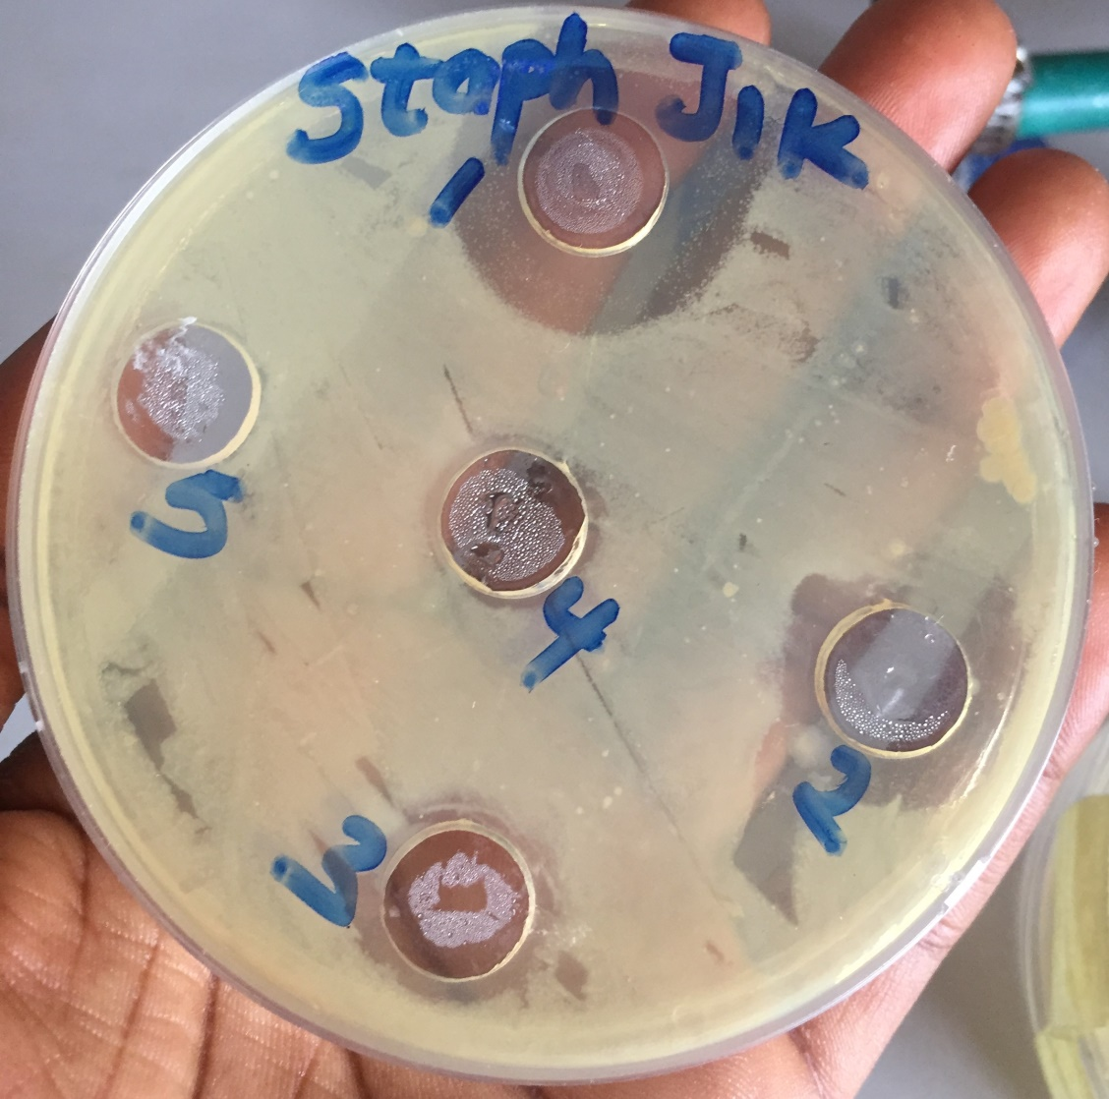

Zones of inhibition of Jik on Staphylococcus aureus

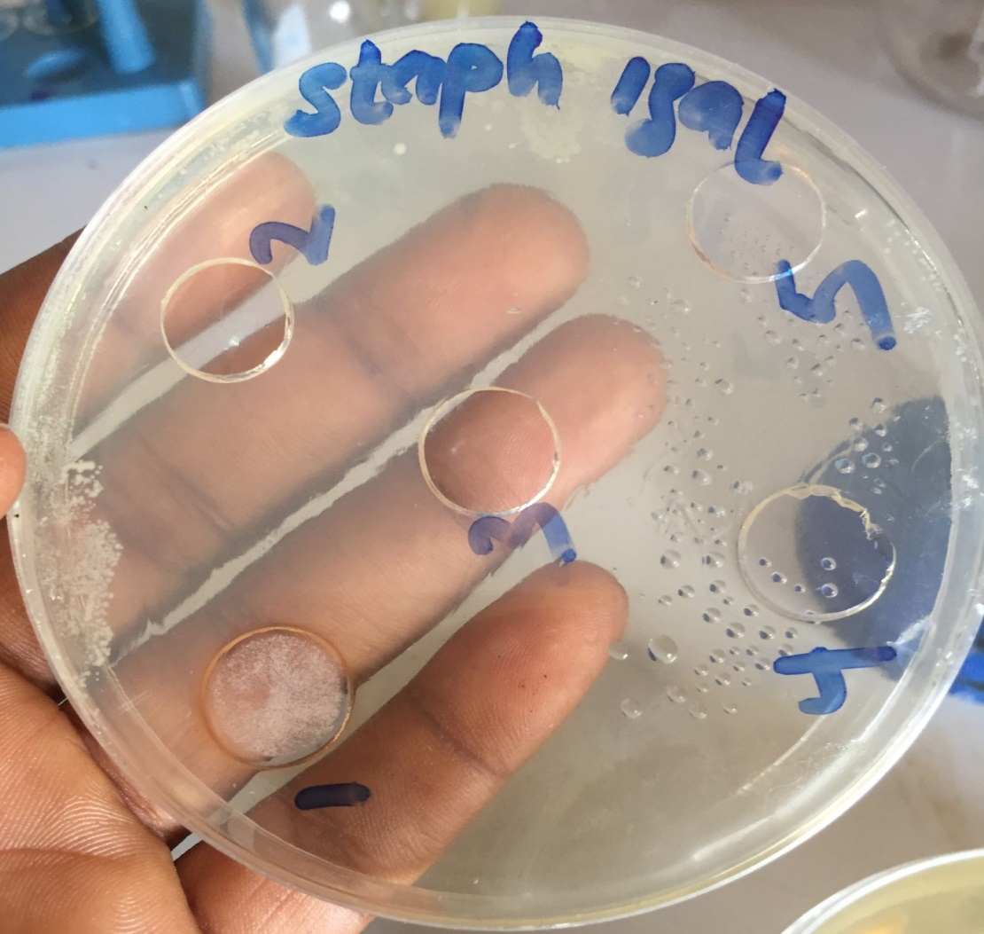

Zones of inhibition of Jik on Staphylococcus aureus

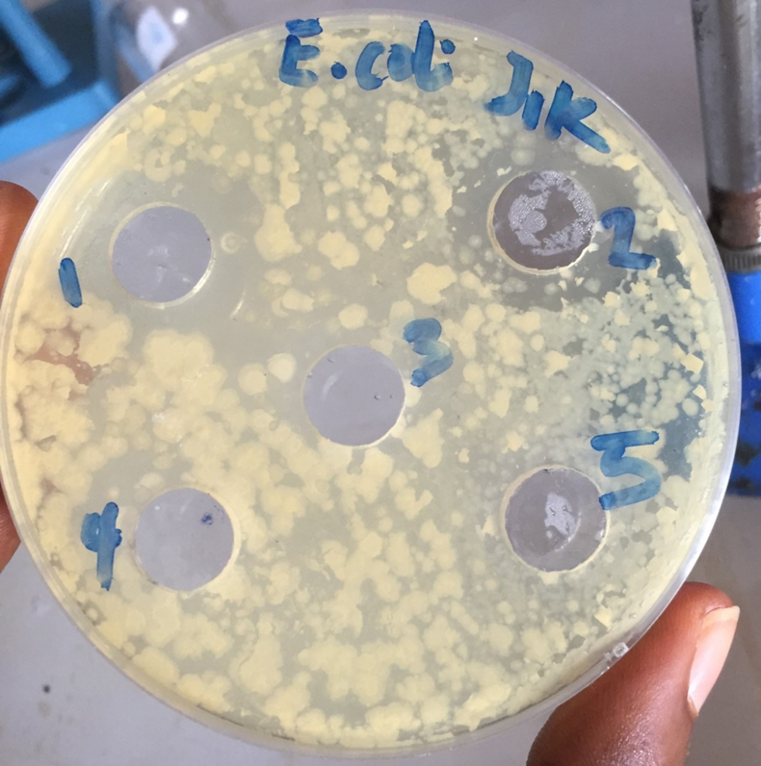

Zones of inhibition of Jik on Escherichia coli

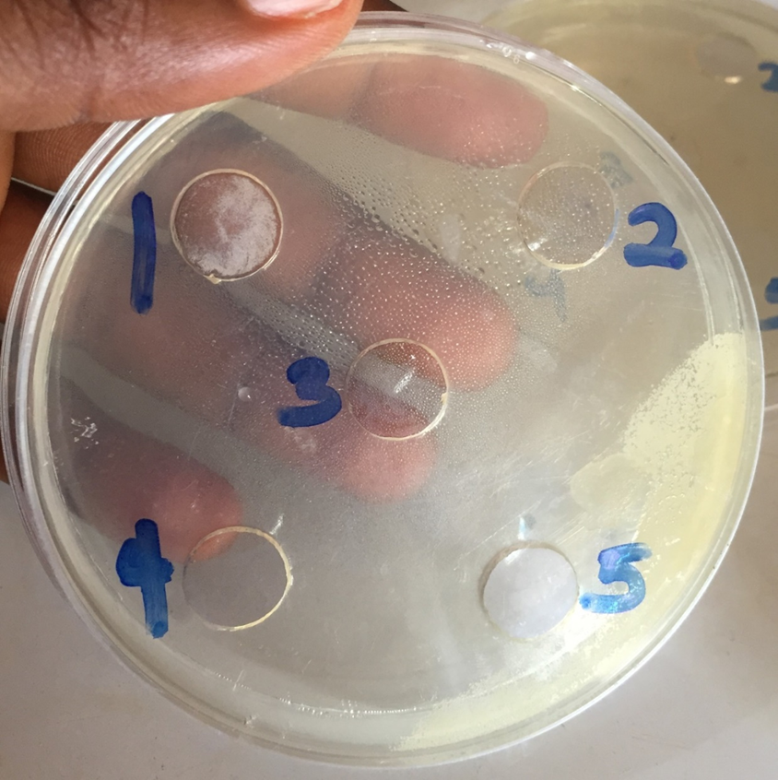
Zones of inhibition of Izal on Escherichia coli

KEYNOTES
- 1= 100% Concentration
- 2 = 50% Concentration
- 3 = 25% Concentration
- 4 = 12.5% Concentration
- 5 = 6.25% Concentration

