Godfrey Okoye University Welcomes You, the Catholic Bishop of Linz with Your Team

My Lord the Catholic Bishop of Linz,
Priests and People of God from the Diocese of Linz,
Priests from Awka Diocese and other dioceses,
Principal Officers of Our University and Its Group of Institutions,
Members of the Academic and Administrative Staff,
Members of the Omnium Sanctorum Chaplaincy,
Students of Our University and Its Group of Institutions,
Distinguished Friends of our University,
Ladies and Gentlemen.

On behalf of the staff and students of Godfrey Okoye University and Its Group of Institutions, I heartily welcome you to Nigeria and our university. I would like to thank you particularly for the ordination of our brothers from the Diocese of Awka and for the tremendous sacrifices you have made to participate in their thanksgiving mass (Primiz). My Lord, through this visit you have revealed that pastoral part of you for which we knew you in our student days at Innsbruck. You are a pastor with incredible theological wisdom and insight.

My Lord, distinguished ladies and gentlemen, Godfrey Okoye University is the result of the sound education and formation which I received from 1996 to 2005 at Innsbruck. My academic, spiritual and moral formation at Innsbruck under the guidance of the Jesuits was a turnaround in my life, with such indescribable reverberations that even the blind and deaf cannot but acknowledge. For me Austria means hard work, cleanliness, sense of responsibility, modesty and spirituality expressed in practical moral life. These are qualities which I furtively imbibed in the course of my studies and work, with such ripple effects that have become palpable realities in this university. Godfrey Okoye University is indeed Austrian qualities and virtues revealed in different shapes and colours.

At our main campus at Ugwuomu Nike with its beautiful lakes and incandescent floral beauty, there is a bridge we named Austrian Bridge. This is not only a reminder of the role Austria has played in my life as a priest, university professor and rector but also a strong acknowledgment that through my personality and work Austria has built a robust bridge to Nigeria. Also by training our priests and even accepting them into the Diocese of Linz and other dioceses, Austria has ensured that the bridge will be getting longer and stronger.

This university started in 2009 with just 215 students. Today we have 3000 registered students of the university. In addition, the university began with one hundred members of staff. Today we have 650 members of staff (academic and administrative staff). Our university is called the fastest growing private university in the Southeast, and one of the fastest in Nigeria. When we add teachers of our nursery, primary, secondary and college of education to the number of our staff, then we have a total of one thousand workers. So apart from providing education, we have also offered job opportunities to our people. Distinguished ladies and gentlemen, you see how Austria has indirectly (through my work) contributed to the strengthening of both our economy and the education industry.

Furthermore, we started with just two faculties (Management and Social Sciences and Natural and Applied Sciences). Today we have five faculties and the following academic programmes:

Applied biology
Accounting
Architecture
Banking & Finance
Biochemistry
Biotechnology
Biology Education
Business Management
Business Education
Chemistry
Chemistry Education
Computer Science
Computer Science Education
Economics
Economics Education
Education Management
English & Literary Studies
English & Literary Studies Education
Geography and Environmental Management
Geology and Mining
Guidance and Counseling
History, International Studies & Diplomacy
History, International Studies & Diplomacy Education
Industrial Chemistry
Industrial Design
Industrial Physics
International Relations
Law
Marketing
Mathematics
Mathematics Education
Mass Communication
Management
Microbiology
Music
Political Science
Political Science & Government Education
Public Administration
Physics
Philosophy
Physics Education
Psychology
Physics with Electronics
Primary Education
Religious Studies
Sociology
Statistics and Demography
Social Studies Education

We also have a School of Postgraduate Studies.

Moreover, we have graduated five sets of students (about 1600) and our graduates are doing exceedingly well in all walks of life. It is on record that 70 percent of our graduates get jobs within two years after graduation. Recently a graduate of our university doing a master’s programme at Bowie State University in the USA was the overall best graduating student in the master’s programme at Bowie State University. Also a lot of students have won full scholarships to do their master’s and doctoral degrees within and outside Nigeria. Godfrey Okoye University is indeed the Catholic University on the go!

Finally, let me thank you my Lord with you team for visiting us. Please do not relent in your effort to support the training of our priests in Austria, especially in your diocese. You have seen the result of such a good training in the work many of those educated in Austria do in this country. Let me also congratulate our brothers who were recently ordained priests in Austria. Please be good ambassadors of your country. Be part of the team of Nigerians who are presenting another fresh and positive face of Nigeria and showing that the devil is not as black as it is painted. Congratulations!

Rev. Prof. Dr. MMag. Christian Anieke
Rector/ Vice Chancellor

‎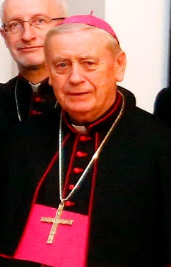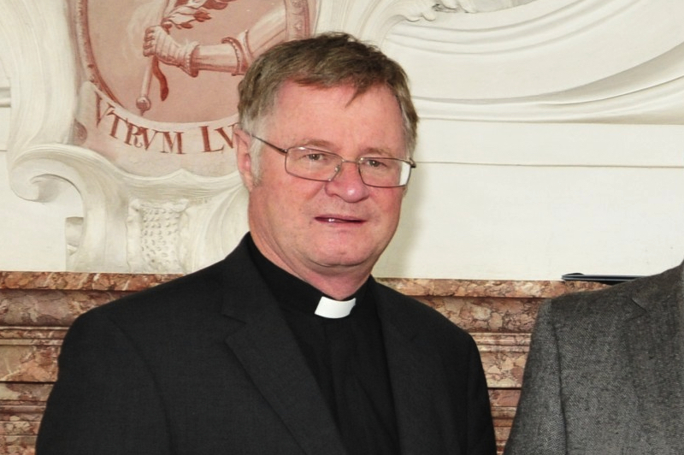
Manfred Scheuer

PROGRAMME

- Arrival
- National Anthem/University Anthem
- Opening Prayer/Breaking of Kolanuts
- Choir
- Vice Chancellor’s Welcome Address
- Choir
- Bishop Manfred Scheuer’s Speech
- Cultural Dance
- Closing Remarks
- Closing Prayer and Tour of Godfrey Okoye University Facilities

Brief Profile of Bishop Manfred Scheuer

Bishop Manfred Scheuer, the current Bishop of Linz, Austria, was born on 10 August 1955. He was ordained a Priest on 10 October 1980 by Joseph Cardinal Schröffer†. He has been a bishop for approximately 15 years.

- 21 Oct 2003 48.1 Appointed Bishop of Innsbruck, Austria
- 14 Dec 2003 48.3 Ordained Bishop of Innsbruck, Austria
- 18 Nov 2015 60.2 Appointed Bishop of Linz, Austria
- •Ad Limina - January 2014: Bishop

He has been a member of an international peace-activist group, Pax Christi, until in 2017 when he resigned from his post as its chairman on the ground of noticed anti-Semitism in the group’s policies.

