From a University to an Epistemic Shopping Mall:
A Post Covid-19 Higher Education Vision

By
Rev. Father Prof. Dr. Christian Anieke
Vice Chancellor, Godfrey Okoye University, Enugu, Nigeria

Abstract
Nothing has affected human life and epistemic space since the Second World War as much as the Covid-19 pandemic. Its ripples are everywhere and will continue for some time. Human consciousness has been incredibly jolted to respond to the challenges of this novel situation. The human society must continue to respond to questions connected with the unfolding narrative of this pandemic with new visions and social values that will make the visions realizable. Higher education as the theatre of human epistemic action must become visionary and responsive to a gamut of social visions in order to continue to be relevant in society. I am enthralled by a particular higher education vision which Prof. Amélé Ekue of Globethics mentioned last time during our conference, the idea of a leap from university to pluriversity. In the same line of thought, my new vision of university in this paper is captured by the title: From a University to an Epistemic Shopping Mall: a Post Covid-19 Higher Education Vision. This vision, in contradiction from pluriversity, means that a university will not only continue to celebrate its essential uniqueness but also wear an additional look as a shopping mall for knowledge. The uniqueness of each university will rest on the altar of its local content besides the variety of products from different scholars that are available for sale. In this case, there will be singularity and hybridity, connecting with human epistemic space as well as securing a unique epistemic territory. Such an arrangement will make the values of good social living inevitable and a desideratum.

Characteristics of Shopping

A shopping mall or centre has its history in the village or community buying and selling in an open market. Before the industrial revolution farmers and producers of different goods and buyers met in such an open market to exchange their products. But with the industrial revolution, there was an exponential rise in the volume of production and variety of products for sale. (Of course the industrial revolution had its dark clouds as Charles Dickens portrayed in his novel Hard Times but it jolted human productivity to unimaginable heights). Shopping malls or centres sprang with time to make buying and selling of products emerging from the roaring machines of the industrial revolution easier. “Shopping malls, a late 20th-century development in retail practices, were created to provide for a consumer’s every need in a single, self-contained shopping area.” (britannica.com).

It is important to show some of the characteristics of shopping malls so that we can see how they can be an inspiration for a post Covid-19 higher education vision.
Spaciousness
One of the features of a shopping mall or centre is that it has a large space to accommodate a lot of products provided in that single space. Buyers will not need to run from one market or market area to another to get their basic needs. This saves time and makes buying a joyful human experience.

Variety of Offers
This is another characteristic of a shopping mall. You have such a fascinating variety that you can find nearly all you need in a single commercial space. In fact, some malls boast about having everything. Interspar in Austria has this slogan in its advertisement: “INTERSPAR, alles da. Alles da, da, da”. As Terry Johnson (2019, online) observes, “The first thing you should look at when choosing a shopping plaza is the availability of a variety of products and services. You are guaranteed of good shopping experience from a shopping centre that has all varieties of products and services. Time-saving is witnessed while shopping in a plaza with a wide collection of different stores. You will have a smooth time shopping in a plaza that has all types of commodities and services.”

Community-oriented
A shopping mall provides immediate day-to-day needs of the community. It is always rich in what a community needs and reveals an incredible understanding of the size and taste of the community.

Comfort
One feature of a mall is the guarantee of comfort in buying and selling. Each mall tries to make buying and selling as comfortable as possible. This explains the provision of beautiful scenery, recreational facilities, parks, eateries, and everything that seduces the soul to plunge in an ocean of unceasing buying.

Accessibility
Shopping malls provide both external and internal accessibility. A mall always ensures that it is easily accessible to buyers. This is always one of the first considerations in its physical setting. Also it organises the compartments in such a way that buyers can easily find their way around and get what they need.

A University as a Shopping Mall
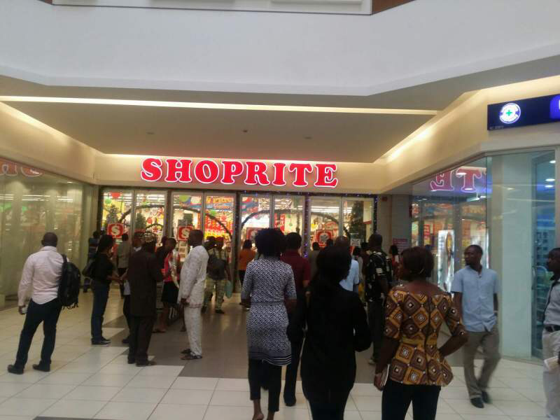

The Covid-19 pandemic has detonated and globalized an atomic bomb of incredible innovations. Humans have always been known for their adaptability and innovations. But at no point in history has there been such innovativeness within so short a time as we see today. Universities, as recognizable epistemic space for innovativeness, adaptability, research, teaching and learning, must catch up with breath-taking innovations in the world today. As the famous Nigerian author Chinua Achebe writes in his novel Arrow of God: “The world is like a dancing masquerade. If you want to see it well, you do not stand in one place.” I am delighted that many universities are abreast with the latest developments in the world. For instance, the wide use and adaptions of Zoom, Google meet, Webex, Skype, as well as such tools as Edmodo, Socative, Projeqt , Thinglink , TED-Ed, ClassDojo, eduClipper, Storybird , Animoto, Moodle and Kahoot, have redefined academic activities in the absence of face-to-face teaching and learning. These facilities have the promise of helping our universities offer a variety of products like a shopping mall. My higher education vision in this connection is this:

1. Every university, like a shopping mall, must have virtual space for a lot of epistemic products. This virtual space involves internet facilities. There cannot be a limit to the bandwidth a university can have. Investments in a university must tilt towards having as much bandwidth as can take every imaginary online activity of the university. At no point should the virtual life of the university community lose its tempo and vibrancy because of internet facilities.
2. A university, like a shopping mall, must have a variety of epistemic offers. Universities have always done this. But technology has offered us an opportunity to get the best scholars from anywhere in the world to deliver lectures in our universities. We can mount a number of courses using the best scholars in the world, who will not need to travel to deliver their lectures. Travel costs, inconveniences of travelling, immigration requirements, health challenges, aviophobia, hodophobia, xenoglossophobia or even xenophobia have been a great hindrance to many scholars in leaving the comfort of their homes and academic territories. Today these great scholars can be engaged by universities in the world to deliver lectures online without any of these hindrances. Experienced but retired academics can be engaged by universities to increase the variety of their offers. Also the emphasis in every MoU now must be that partner universities can enjoy the online classes available in each of the collaborating universities. Furthermore, on the side of students, every university must encourage them to shop for knowledge in other universities. Besides, universities in the economically rich counties of the world must consider fee waivers for students in poor countries to encourage them to get knowledge through the online courses available in such universities. Universities like Harvard and Oxford must stop taking a lot of money from African students for their online courses. From this standpoint, the value of university will now depend on how much is being offered the students from local and foreign-based scholars and how much a university is helping students to get products offered by other universities.
3. A university must also, like a shopping mall, be community-based. Every shopping mall, while offering a variety of products, still retains its face of specialisation, which will reflect the taste of the community. This is where the identity of the university will be underscored. Each university must define what its peculiar local content will be as “Universitas Magistrorum et Scholarium (a community of teachers and scholars). What researches and studies, curriculum, or pedagogical approaches are peculiar to the university? This is why I reject the concept of pluriversity, which appears to be the obliteration of the “universitiness” of the university. A university must maintain its singularity, underscored by the prefix “uni” (one). Therefore, while offering a variety of epistemic products, it must maintain its singularity, its epistemic oneness, its universitiness.
4. Finally, comfort and accessibility are as important in the university as they are in a shopping mall. The epistemic products must be offered in a setting of comfort, such that it is attractive to the buyers. Lectures must become a pleasurable experience. Online classes must not only be interactive but also a delightful experience. Also knowledge must be organized in such a fashion that it is easy to find and acquire. Every online app or platform that makes it difficult to teach and learn must be buried in a forgotten grave of useless ideas.

Conclusion
The Covid-19 pandemic has shaken our world but not broken it. It has rather jolted us to a fresh consciousness of doing so many things in varied ways. A higher institution that understands the full semantic weight of the word “adaptability” will survive and transform itself. This calls for a redefinition and redesigning of a university to fly on fascinating idea of a shopping mall. This also calls for deeper collaboration in higher institutions in a common understanding of our shared values as members of the human family deeply entangled in the web of our social space and collective home: the Earth!

References
Achebe, Chinua. Arrow of God. Oxford: Heinemann. 1974.

Barker, C. Cultural Studies: Theory and Practice. London: Sage Publications, 2000.

Bryson, B. Mother Tongue. London: Penguin Books, 1990.

Dickens, C. Hard Times. Cambridge: Hiberside Press. 1869.

Encyclopedia Brittanica (online).

Johnson, Terry (2019). https://medium.com/@johnsont628/characteristics-of-a-good-shopping-center-66accd4f6098

Nnaji, H.I. Modern English-Igbo Dictionary. Onitsha: Gonaj Books, 1985.

The Oxford English Dictionary. Second Edition. Oxford: Oxford University.
Rev. Father Prof. Dr. C. Anieke: From a University to an Epistemic Shopping Mall page 5 out of 5

