PUBLIC POLICY AND GRASS-ROOT DEVELOPMENT IN NIGERIA A
STUDY OF ENUGU EAST

BY

TIZHE ALPHA PETER
U14/MSS/PAD/052

DEPARTMENT OF BUSINESS MANAGEMENT, PROGRAMME PUBLIC
ADMINISTRATION
FACULTY OF MANAGEMENT AND SOCIAL SCIENCES
GODFREY OKOYE UNIVERSITY, UGWUOMU-NIKE
ENUGU STATE.

JULY, 2018.

TITLE PAGE
PUBLIC POLICY AND GRASS-ROOT DEVELOPMENT IN NIGERIA (A
STUDY OF ENUGU EAST)

BY

TIZHE ALPHA PETER
U14IMSS/PAD/052

A PROJECT REPORT SUBMITTED TO THE DEPARTMENT OF
BUSINESS MANAGEMENT, PUBLIC ADMINISTRATION
PROGRAMME, FACULTY OF MANAGEMENT AND SOCIAL
SCIENCES, GODFREY OKOYE UNIVERSITY, UGWUOMU-NIKE,
ENUGU STATE.
IN PARTIAL FUFILMENT FOR THE REQUIREMENT FOR THE
AWARD OF BACHELOR OF SCIENCE (B.Sc.) DEGREE IN PUBLIC
ADMINISTRATION
SUPERVISOR: MR. NDUKWE OKO

JULY, 2018.

APPROVAL PAGE
The project has been approved for the Department of public administration Godfrey Okoye University Ugwuomu-Nike Enugu.

___________________ _______________
MR. NDUKWE OKO Date
(Project Supervisor)

____________________ ________________
Asso. Prof. Dr. Nick N. Igwe Date
(Head of Department)

_____________________ ___________________
Prof A. Oyema Ocheoha Date
(Dean Faculty of Management and Social Science)

_____________________ ____________________
External Examiner Date

DEDICATION
I humbly dedicate this study to the Almighty God for His infinite mercy and grace that aided my stay in school, as well as the successful completion of this project.

ACKNOWLEDGEMENTS
First and foremost, my appreciation goes to the Almighty God, who in His infinite mercies, love, protection, and grace sustained me through the duration of this study.
Special appreciation goes to my supervisor, Mr. Ndukwe Oko and I also wish to thank the head of department associate professor Nick Igwe and all the lecturers in the Department of public administration who saw that my work came to reality. Namely Professor C Nze, Associate Professor Nick Obodo, Dr. Anthony Idede. Thank you all.
A special thanks to my parents Mr./Mrs. Peter Tizhe. And to my friends Okonkwo Julius ,Victor Akeagbusi, Obodo Kingsly, Dorothy Adado and so many of them.
Finally, to my siblings Anita Peter and Allen Peter for their continuous love and supports to me all through the years. God bless you continuously.

TABLE OF CONTENTS
Title page i
Approval page ii
Dedication iii
Acknowledgement iv
Table of contents V
List of table - vii
Abstract Viii
CHAPTER ONE INTRODUCTION
1.1 Background of the Study 1
1.2 Statement of the Problem 2
1.3 Objectives of the Study 3
1.4 Research Questions 3
1.5 Hypotheses of the Study 4
1.6 Significance of the Study 4
1.7 Scope of the Study 4
1.8 Definition of Terms 5
CHAPTER TWO LITERATURE REVIEW
2.0 Conceptual Review 6
2.l The Concept of Policy 6
2.2 The Concept of Public Policy 7
2.3 Features of Public Policy 10
2.4 Policy Implementation 12
2.5 The Concept of Development 13
2.6 The Concept of Grass-root Development 14
2.7 The Policy Process 17
2.8 Perceived Reasons Why Government Policy Fails 20
2.9 Empirical Review 24
2.10 Theoretical Framework 29
CHAPTER THREE RESEARCH METHODOLOGY
3.1 Research Design 30
3.2 Population of the 30
3.3 Sample Size Determination 31
3.4 Sampling Technique 32
3.5 Instrumentation 32
3 .6Reliability of the Instrument 32
3.7 Validity of Instrument 33
3.8 Data Collection technique 33
3.9 Method of Data Analysis 33
CHAPTER FOUR PRESENTATION AND ANALYSIS OF RESULTS
4.0 Introduction 35
4.1 Response Rate Analysis 35
4.2 Demographic Analysis 36
CHAPTER FIVE
SUMMARY OF FINDINGS, CONCLUSION AND RECOMMENDATION
5.1 Summary of Findings 48
5.2 Conclusion 48
5.3 Recommendations 49
References 50
Appendix I 55
Questionnaire 55

LIST OF TABLES
Table 1: Public Policies significantly influence grassroot development in Enugu East
local government area of Enugu state. 39
Table 2: Public policies in Enugu East local government area of Enugu state are in line
with their grassroot development requirements. 40
Table 3: Public policy contributes tremendously to the grassroot development in Enugu
jast local government area of Enugu state. 41
Table 4: Formulated policies are not effectively implemented in Enugu East local
government area. 42
Table 5: Delay in public policy implementation is one of the challenges surrounding grassroot development policy formulation and implementation in Enugu East local
government. 43
Table 6: Corruption is one of the challenges in development experience of Enugu East
local government area. 44
Table 7: Grassroot leaders play significant role in facilitating grassroot development
through policies. 45
Table 8: The challenges surrounding grassroot development policy formulation and implementation in Enugu East local government is also caused by lack of commitment
from the leaders. 46
Table 9: There is public policy continuity in change in leadership at the grassroot level in
Enugu East local government area. 47
VI

Abstract
The essence of this study is to carry out an empirical analysis of public policy and grassroot development in Nigeria with an empirical focus on Enugu East local government area. The theoretical frame work adopted from the study was the research design used for this study was survey research design because it studies both large and small population by selecting and studying samples chosen from the population. The sample was determined to be three hundred and ninety nine (399) using Taro Yamane statistical formula. Simple random sampling was used as the sampling technique for the reason that the method ensures equal chance of selection among the respondents. Data for the study was collected through the distribution of well structured questionnaire. The method of data analysis was the use of frequency tables and percentages to analyze the descriptive characteristics of the respondents. Findings from the study reveal that public policy has no significant impact on grassroot development in Nigeria, there are significant challenges surrounding grassroot development policy• formulation and implementation in Nigeria and grassroot leaders are not committed to the grassroot development of Enugu East local government area of Enugu State. The paper concluded it is the recommendation of this study that to make public policies effective in Nigeria and Enugu East in particular, there should be a continuous forum between the government and the people so that policies formulated are in line with the needs and priorities of the people and community in general.
VIII

CHAPTER ONE
INTRODUCTION
1.1 Background of the Study
The primary desire and goal of any community at the local, state or national level is to generate and sustain development. Development entails better welfare, better attitude towards life and positive radical multidimensional changes. However, the attainment and activation of development is intentional. Development does not just happen; it is strategically planned, organized and executed through the instrumentality of public policy. Publiê policies in an ordinary parlance are those definite acts or actions of government geared towards the fulfillment of the obligation of government on the citizens, which are the maintenance of law and order, the provision of social and economic facilities needed for an enhanced standard of living of the people (lyoha, 2000)
Nigeria gained independence in 1960 from the British colonial government. Ever since then, grassroot governance and development have been declared one of the major priorities by the successive governments, be it civilian or military. In this regard, several organizations, institutions and agencies have been set up to undertake and monitor the complicated process of nation-building, development and integration. This post colonial orientation is a deviation from the erstwhilecolonial arrangement whereby development efforts in all spheres were concentrated in the urbanareas to the neglect of grassroot and rural areas. Hence, projects such as the construction of roads, bridges,schools, railway lines, air trip, ports and marketing boards, among others, were all aimed atopening the rural areas as a link for the easy exploitation of export of raw materials (Hilary, 2009)

In Nigeria, over the years the stated objectives and strategies of grassroot development have been pronounced by policy makers and those concerned with• the issue of development. But there still exist enormous gap between public policy formulation and implementation and the reality of the level of the development of the grassroot sphere. For example, several approaches in terms of grassroot development planning and execution have been adopted. Some of these included the creation of states, local government areas, mobilization of people for local participation in planning and implementation of community development projects in order tocreate new centres of deelopment, and thus stem the drift from rural to urban areas. On the part of government therefore there is the realization that there is need to bring the neglected grassroot areas into the mainstream of national development (Michael, 2012).
On the basis of the above, the thrust of this paper is therefore to carry out an empirical analysis of public policy and grassroot development in Nigeria with an empirical focus on Enugu East local government area.
1.2 Statement of the Problem
Over the years, the speed and consistency df development at the grassroot level in Nigeria have not been impressive. This can be attributed to amongst other factors poor policy implementation. This is because the problem in Nigeria is not about conceptualizing policies, plans, programmes and projects. Neither is it about• putting down development plans. In spite of all the plans and concomitant programmes and projects, there are still lamentation on the state of the socioeconomic development and welfare of the people especially at the grassroot level; the indicators being the low level of human development index, poor infrastructural development and widespread poverty (Mike, 2011). With all the efforts made to uplift the qualitative standatd of living of the grassroot inhabitants

in Nigeria from pre independence to post-independence, it is unfortunate to note the sad situational position of the rural setting. Based on this, this study is motivated to embark on empirically evaluating the linkage between public policy and development at the grassroot level with focus on Enugu East local government area.
1.3 Objectives of the Study
The broad objective of this study is to carry out an empirical analysis of public policy and grassroot development in Nigeria with an empirical focus on Enugu East local government area. The specific objectives are therefore:
1. To ascertain the impact of public policie.s on grassroot development in Nigeria.
2. To evaluate various challenges surrounding grassroot development policy formulation and implementation in Nigeria.
3. To ascertain the role of grassroot leaders in facilitating grassroot development through policies.
1.4 Research Questions
In line with the objectives of the study, the following research questions will pilot the study:
1. What level of impact do public policies have on grassroot development in Nigeria?
2. What are the various challenges surrounding grassroot development policy formulation and implementation in Nigeria?
3. What are the roles of grassroot leaders in facilitating grassroot development through policies?

1.5 Hypotheses of the Study
In the course of the study, the following hypotheses will be tested:
Ho: public policy has no significant impact on grassroot development in Nigeria
1-b: There are no significant challenges surrounding grassroot development policy formulation and implementation in Nigeria.
1.6 Significance of the Study
The significance of a research lies on its usefulness. Therefore, this investigation is considered useful for the following beneficiaries:
Government: The federal/State/local government will find this study highly relevant as it will provide a picture of the impact and existing problems of public policy making on grassroot development in Nigeria and this is expected to generate reforms on the concept of policy making and implementation for grassroot development.
Researchers: Furthermore, this investigation will also be highly significant to subsequent researchers as this research will provide them with relevant literatures.
Students: This research hasthe ingredient of expanding the horizon research students on the concept ofgrassroot development and policies geared towards achieving them.
General Knowledge: Finally, this research is considered highly relevant given that it will be an addition to the existing stock of knowledge and hence creates a capacity building input to the education sector.
1.7 Scope of the Study
The focus of this study is to carry out an empirical analysis of public policy and grassroot development in Nigeria with an empirical focus on Enugu East local government area.

1.8 Definition of Terms
The following terms were given their meanings in the context of the study.
Grassroot: This is defined as the most basic level of an activity or organization. 1n the context of this study, it is the local government dimension of the country.
Development: This is a multidimensional radical improvement and the process of developing or being developed.
Public Policy: This is defined as a system of courses of action, regulatory measures, laws, and funding priorities concerning a given topic promulgated by a government entity or its representatives.
Local government
The administration of a particular county or district, with representatives elected by those who live there.

CHAPTER TWO
LITERATURE REVIEW
2.0 Conceptual Review
2.l The Concept of Policy
Forman (2008) asserts that the concept of policy has two distinct meanings in the field of public administration. First, policy is seen as a way of doing things or decision rule. Secondly, he posits policy as substantive programmes referring specifically to the context of what is being done and not necessarily how it is being done.
Ross (2009) suggested that policy should be seen as “a long series of more or less related activities and their consequences for those concerned• rather than as a discrete decision”. Lasswell and Kaplan (2001) had given a systematic definition of the concept which appear more applicable and relevant to many area or fields of the social and behavioural sciences. In their words: “Policy is a projected programme of goal, values and practices; policy process is the formulation, promulgation and application of identifications, demand and expectations concerning the future interpersonal relations of the self”
Also contributing to the understanding of the concept of policy, Lowi (2000) emphasized the importance of the concept of coercion in thinking about policy. According to him, policy, involves deliberate coercion or in other words statements intended to delineate the purpose, means, subject and objects of the exercise of

coercion within the context of power relationships in organizational structure. Gergan (2008) described policy as a “course-setting involving decisions of widest ramifications and longest time perspective in the sight of an organization”.
Friedrich (2003) perceives policy as an attempt to overcome and or utilize environment” obstacles and or opportunities in order to achieve a given goal or objective. Continuing he added that policy is directed towards the accomplishment of some purpose or goal.
Chikeleze (2013) made an empirical observation that policy involves purposive behaviour. Continuing, he conceived policy as a purposive course of action followed by an actor or set of actors in dealing with a problem or matter of concern”.
2.2 The Concept of Public Policy
Public policy is the principled guide to action taken by the administrative executive
branches of the state with regard to a class of issues, in a manner consistent with law and institutional customs. The foundation of public policy is composed of national constitutional laws and regulations, government actions and process. Public policy making can be characterized as a dynamic, complex, and interactive system through which public problems are identified and countered by creating new public policy or by reforming existing public policy (John, 2011).

To Franklin (2014), Public Policy is whatever government chooses to do or not to do. Thus, Public Policy is a course of government action or inaction in response to public problems. It is associated with formally approved policy goals and means, as well as the regulations and practices that implement programs.
Njoku (2015) define public policy as “the strategic use of resources to alleviate national problems or governmental concerns”. Benson (2011) posits that it is the public response to the interest in improving the human conditions. In these definitions there is divergence between what governments decide to do and what they actually do. Public policy is a guide which government has designed for direction and practice in certain problem areas.
Public policy is the cornerstone of every democracy and serves a very important purpose in almost every society. Poverty alleviation, grassroot development, energy, housing and healthcare are some major public policy issues in our clime today and are the focus of most national lawmakers. There are many laws that positively benefit our society, and there are many that do not. What we can be sure about is that successful public policy is usually made up of two things: Good policy (measurable and positive outcome) and good politics (bi-partisanship). Good public policy solves public problems effectively and efficiently, serves justice, supports democratic institutions and processes, and encourages an active and empathic citizenship (Nnamdi, 2016).

Semantically, Public Policy is pronouncement of government intention(s) by people in position of public trust demanding government actions or in actions and having impact either negative or positive on the majority of the members of a given society (Nwiza, 2007).
Public policy can also be seen as the aggregation of peoples hopes, aspirations and intentions embodied in official documents such as legislative enactments, white papers, estimates, government circulars, conclusions of the couflcil of the council of ministers (executive councils) development or rolling plans, etc, or otherwise enunciated and enacted as the current stand on certain issues (Maduabum, 2013).
Accordingly, public policy is a deliberate and binding action by the authoritative organs of the state designed to influence the behavior of the society. It is not a haphazard action but rather a systematic method of society fundamental national problems. The systematic approach is vital so that the numerous public problems will be prioritized against the available resources. As well as harmonize the various sectoral aspects of the total policy (Fred, 2000).
As a system of laws, regulatory measures, courses of action, and funding priorities concerning a given topic promulgated by a governmental entity or its representatives, public policy almost always involves efforts by competing interest groups to influence policy makers in their favour. This is one unique attribute of public policy. A good public policy begins at inception hence to create strong policy, one must first define the problem, gather evidence, identify causes, evaluate the policy, develop solution, select best solution, evaluate benefits and costs, utilized the prince system to, develop political strategies to solve public problems effective and efficient, serves justice, supports democratic institutions and processes and encourage an active/empathic citizenship (Gregory, 2016).
2.3 Features of Public Policy
According to Shahid (2015), there are certain features of the whole process of public policy which are common in all the countries. These features are;
Exclusive Domain of the Elected Representatives: Public policy formulation is the exclusive domain of the elected representatives of the county; however it is implemented by the state apparatus which formulates strategies to implement it. Consequently policy is distinct from the strategy in the sense that while the policy is fairly general in nature indicating what is to be done and why, the strategy outlines the exact measures to be taken for realizing the goals and objectives set out by the policy.
Not a Random Act: Policy formulation and implementation is not a random act of an organization, rather it is a deliberate action taken by a competent authority which initiated the action and is approved by the public representatives, usually the minister in charge of a ministry or the cabinet.
Different Formats: A policy could either be a part of an overall development policy and strategy of the country i.e. Growth Strategy for Pakistan prepared by the Planning Commission or it could be a specific document addressing a particular issue i.e. Food Security Policy, Poverty Reduction Strategy, National Housing Policy, Climate Change Policy etc..
Legal Sanctity: Although it is not a piece of legislation approved by the parliament in the form of an act of parliament, it has the sanctity of its own and can be used as a reference for dispute resolution in the court of law. In some cases the policy itself or parts of the document, which is in essence a value judgment of the regime in power, could be converted into an act of parliament.
2.4 The Concept of Policy Formulation
Having reviewed some of the available literature on the concept of policy and public policy in general, it may also be necessary to understand some conceptual approaches to public policy as enunciated in the literature. Public policies develop out of decision-making which is the most deliberate and voluntary aspect of social conduct. In this vein, attempt, have been made to distinguish between the way policy making is usually described in the literature, that is the rational

comprehensive approach, and the way policy is actually made, that is by incremental steps (Obinna, 2014).
Policy formulation involves adoption of an approach for solving a problem. In other coming up with an approach to solving a problem. There may be choice between a negative and a positive approach to a problem. The legislative branch, the executive branch and the courts may favour dependence on impersonal forces to correct momentary difficulties. However interest groups may desire vigorous human interference with these forces to control persistent difficulties. Either of these approaches involves the formulation of policy. After a policy is formulated, a bill is presented to the National Assembly, or proposed rules are drafted by regulatory agencies. The adoption of a policy takes place only when legislation is passed, or regulations are finalized or a decision has been passed by the Supreme Court (Nkiru and Victor, 2013).
2.4 Policy Implementation
Policy implementation is the process of translating policy mandates into action,
prescription into results and goals into reality. It refers to the processes and reality. It refers to the processes and activities involved in the application, effectuation and administering of a policy. It is the actions taken to carry-out, accomplish and fulfill the intents, objectives and expected outcomes of public policies. It is the act and process of converting a policy into reality and of enforcing a policy (Pressman, 2005).
Meanwhile, the implementation process consists of the implementing organization, the environment particularly the political and economic environment, the policy target group, the objectives and the enunciated method o implementation and policy resources (Anayo, 2010).
The carrying out of policy or its implementation is usually done by other institutions than those that were responsible for its formulation and adoption. Many problems are technically so complex and difficult that the legislature does not try to deal with them in detail. The legislature thus indicates the broad lines of policy, and leaves the elaboration of the policy to other governmental agencies. The complexity of the policy, coordination between the agencies putting it into effect and compliance, determine how successfully the policy is implemented (Ndukaku, 2013).
2.5 The Concept of Development
Development is a household concept in both the developed and developing countries. It is however, conceptualized variously by different people. Some take it to mean change while some see it as an advancement, improvement or progress. To others yet, development entails modernization or westernization (Ele, 2006). Similarly, Okoli and Onah (2002) assert that development involves progression, movement and advancement towards something better. They emphasized further that the movement should be on both the material and non-material aspects of life. In essence, development goes beyond economic and social indicators to include the improvement of human resources and positive change in their behaviour. In any case, the prevailing conception of development connotes essentially enhancement in the well being of people (Okoye, 2000).
2.6 The Concept of Grass-root Development
The concept of grass-root development or community development will be used interchangeably to mean the same thing. The scope of the concept of grassroot or community development is very wide. It is a multi-dimensional process involving stich areas as agriculture, health, education, provision of grassroot infrastructures, social life, political and economic issues, commerce and industry, among others, and their integration with the national economy. Since the scope of the concept is wide it is the pivot on which a sound national development in all its ramifications can effectively be achieved. It is, however often assumed by policy makers and development planners that grassroot development is synonymous with agriculture. To correct this impression, it is very necessary to carry out a detailed conceptualization of the concept by scholar in the field of grassroot or community development (Ikechukwu, 2013)
Furthermore, deriving from our understanding of what development generally is, grassroot development is then that part of development that seeks to enhance the quality of life in the grassroot areas by providing basic infrastructural facilities (Ezeah, 2005). Indeed, the basic objective of grassroot development is reduction in poverty and improvement of the quality of life of the people mostly at the rural areas.
Bello-Imam (1998) in this vein defined grassroot development as spatially sectional but determined and conscious attempt to focus on the general up liftment of the living conditions of men in the grassroot areas. So, grassroot development in Nigeria entails the process of making life more satisfying and fulfilling to the millions of Nigerians who live in the grassroot areas.
Grassroot development is a many sided process or a multi-dimensional process involving the totality of the grassroot man and his environment. In essence, development in this context entails developing the grassroot human person and as well as his environment.
Ele (2006) posits that it is not enough to provide for the grassroot people; they should be enabled to develop themselves and their environment. The foregoing entails that development can only be meaningfully achieved when the population becomes agents of their own development. The development requirement of the grassroot areas should, therefore, be multi-dimensional. In this direction, Olayiwole and Adeleye (2005) identified and classified the infrastructural development requirements of the grassroot areas into three. One is the basic infrastructure which entails the availability of good roads, water (pipe borne water), grassroot electricity, storage, and processing facilities etc. Two is the social infrastructure which is concerned with health and educational facilities, community centres, fire and security services etc. Three is the institutionalized infrastructure which is concerned with credit and financial institutions and agricultural research institutions to aid or enhance the economic activities and income of the grassroot population. The provision of these infrastructure will ensure integrated grassroot development that entails the promotion of grassroot productive activities, supportive human resource development and enlargement of enabling grassroot infrastructure.
Darby and Morris (2009), defines grassroot development as “an education which would raise levels of local awareness and increase the confidence and ability of community groups to identify and tackle their own problems. Ogunna (2013) believes that most writers on grassroot development are influenced by their fields of study in their definition of the concept. Thus, some economists would consider it in terms of “encouraging snme local material development”. While some political scientists emphasize such value as “enlargement of individual freedom and mass democratic process”. On the other hand, some Sociologists stress “group development and group action”.
2.7 The Policy Process
The framework for policy development! change presented here is based on that developed by Lyons (2003): Problem/Issue Identification: The process of policy change begins with identifying one or two key issues that the community wants to take action on. This requires isolating the problem and its causes. Understanding the problem and its causes often requires gathering information about the issue. It is also important at this point to identify individuals and groups who may be sympathetic to your issue and may be potential supporters. Not until the problem is properly understood and potential supporters identified, should you move on to the next step of identifying preferred solutions and developing an action plan. An example of the process of identifying a problem or issue comes from the Voluntary Planning Taskforce on Non-Resident Land Ownership. While the original mandate of this task force called upon focusing on matters related to the possibility of imposing higher taxes on non-resident property owners, it became evident soon in the consultation process that Nova Scotians in general identified other issues which they felt were a greater issue. These issues were related to overall land management practices, the need to create a long-term access strategy, and protection from escalating taxes on their own homesteads. Although these issues were similar to the original mandate of the taskforce, it was deemed necessary to broaden the dialogue so as to allow for a thorough examination of each of these concerns (Voluntary Planning, 2001). Identify Preferred Solutions and Develop an Action Plan: The next step after identifying the one or two key policy issues is to generate a solution(s) to them. This can be done by looking at how similar situations were dealt with, deciding on what information you need to deal with your particular key policy issues, figuring out who can help, soliciting ideas from the community, and thinking about the short and long term consequences of various solutions. Once a solution has been identified, decision on the best strategy is developed followed by a corresponding action. Selecting the best strategy and developing an action plan to carry out the strategy may be difficult. With help from other community organizations as well as universities, research centers, government agencies, other communities, and special interest groups you will be able to develop an action plan that outlines your objectives and the activities needed to implement your solution. Implementing The Action Plan: Once you have decided upon an action plan, you need to outline the steps that must be taken to carry out the strategies you have chosen. Some examples of potential actions include educating the public about your issue through the media; sending letters to appropriate authorities explaining the issue and requesting action; submitting a policy brief; presenting the issue at a public forum; and contacting your municipal, provincial, and federal government representatives. The timing of these actions may be critical and must be considered carefully to maximize their impact. Usually, keeping actions positive, constructive, and tactful will make it more likely that you can gain the support of the public as well as those who can change the policy .It is also important to be willing to listen and consider people’s objections or suggestions. By offering to cooperate with decision-makers, you open the door for a positive reception of your issue.
Monitoring and Evaluation: Policy change can be a long process. You should monitor and evaluate the progress you are making with the goal of identifying positive changes as well as areas that still need improvement. It is important to consider both the process itself as well as impacts and outcomes. When considering the process, you should ask yourself: what have you done, what worked, what did not work, and why? In terms of impacts and outcomes, you should assess whether there has been an increase in public and government awareness and support toward your issue, whether there have been any actual policy changes, and if so, whether implementation of the policy resulted in the desired effect.

2.8 Perceived Reasons Why Government Policy Fails
Larson (1987) asserts that the following reasons are seen as the primary reasons why government policies fail. Political Instability: Nigeria’ s socio-economic and political milieu for example has been characterized by unstable climate and economic recession. As a result of this high rate of instability in the political system, the country has experienced series of changes and frequent structural reforms, which have negatively affected policy implementation. These constant and unplanned changes adversely affects each administration coming with its own programmes. Non-continuity in policy and programme implementation becomes the end result. Projects started by previous administration could be abandoned by the present administration with impunity.
Disposition of Implementors: The value orientation, state of mind and feeling of those who implement policies and programmes at any given point in time affect negatively or positively the implementation. The attitude of the implementer is very vital in policy/programme implementation. In Nigeria where the workers are not adequately motivated, the desire to implement such policies and programmes may not be there.
Vague or Unrealistic Goals: A basic reason for the failure of many policies and programmes is lack of clear and realistic goals. The.problem of vague goals is most evident in new programmes that propose social innovation. One such programme called the universal Basic Education project can serve as an illustration here. The project was designed to aid about 200 million teenagers from deprived backgrounds to acquire basic education. The programme was an attractive collection of ideas. But due to its vagueness, not more than 30 million teenagers benefited from it. Where the goals are unrealistic, the policy/programme could suffer from either instrumental failure or failure in normative justification. Instrumental failure means that the programme lacks sufficient instrument for achieving its goals. While in normative justification, a programme fail to receive support from those affected by it and is unworkable.
Poor Implementation: Lack of concern for implementation is currently the crucial impediment to improving programmes operations, policy analysis, and experimentation in social policy for economic emancipation of any society. Being naive about implementation is a human factor which impedes policy implementation. It must be emphasized here that implementation period has not been the challenge faced by many policy makers but rather the naivety of the policy formulators and beneficiaries.
Environmental Factors: Economic policies/programmes are made and executed ‘within a given policy environment. Some of those policy environments include climate, topbgraphy, population, political, culture, social structure, technology etc. These factors separately or jointly influence the formulation and implementation of such policies and work against its success.
The complexity of Intergovernmental Actions: The problems of creating a policy/programmes that can survive intergovernmental action are closely associated with problems of implementation. As a rule of thumb, the greater the number of actors and agencies involved in a programme, the less likely it is to succeed.
Forces in the Economic Environment: The general state of the economy is a final impediment to the success of the government’s policies/programmes. A society plagued by high inflationary-pressure, government policies/programmes are bound to suffer. Other factors include institutional capacity, personnel, necessary materials or logistic supports. Where these elements are not in existence or are inadequate the chances of realizing the objectives of such policies/programmes may not be visible.
Bureaucratic Problems: The nature and pattern of authority allocation or relationship within the local government for instance affect the policy implementation. In the present dispensation where there is no convincing and clear-cut line of duty, cold war, is fought silently between the heads of department and the supervisors, special assistant and political Advisers who crave for one political favour or the other• from the chairman of government. In such cases, conflict usually arises among them over who supervises such policy/programme.
Inadequate Funding: Adequate funding is a sina qua non for policy implementation. But this is lacking in almost all the levels of government in Nigeria and other sub-Saharan countries. Inadequate funding brings about poor logistics. Precisely, all the level of government in Nigeria for instance depends heavily on oil for their recurrent and capital expenditure. Such over reliance on one source of revenue weakens the financial base of the government if at any point the oil market fails to live up to expectations. The economic policies and programmes of such government suffer.
Communication Problem: Communication is pertinent to administrative process as blood is pertinent to human beings. For policies and programme to be effectively implemented, a good communication network has to be put in place. Information they say, is power, which comes through effective communication. Lack of information on the nature and philosophy of policies and programmes inhibit bureaucratic implementation of policies. The channels of communication in the various levels of government are often inadequate and this gives room for misinformation and faulty implementation of policies and programmes. Adequate information on policy and programme matters especially to all relevant officers in the implementation process and the people who are the direct beneficiaries of such policies and programmes is inevitable.
2.9 Empirical Review
In this section of the research, some of the past studies related to the subject under study were reviewed.
Enyi (2014) examined grassroot development in Nigeria with emphasis on the institutions, agencies, policies and strategies employed to bring about the much needed grassroot development in the country. The study went further to assess the impacts of the various efforts made by both the domestic and foreign governments and international organizations, institutions, agencies and non-governmental organizations to bring about real development at the grassroots level. In the attempt to do this, clarification of concepts like development, grassroot areas, and grassroot development was carried out, which formed the theoretical basis of the analysis. It was found out that efforts made by the Nigerian government though several strategies like the nation’s development plans from colonial era to date which were ex-rayed did not bring about meaningful development. Similarly international organizations and regional strategies have not lead to any significant improvement in the living conditions of the grassroot dwellers and grassroot development in general. It was also found out that a number of issues such as corruption and
mismanagement, faulty planning from above rather than bottom-up approach; pursuance of the colonial and neo-colonial economic and social policies which were anti people among other factors led to failure of the grassroot development efforts. The paper therefore concludes among other things that for rapid and sustained grassroot development to take place, the lopsided and urban based development process must be reversed to grassroot based and bottom-up approach, government to continue to create conducive environment for grassroot development to thrive, change of attitudes and orientation by all and sundry, particularly the leadership class in Nigeria in order to minimize corruption and mismanagement of resources. Therefore, for grassroot development to be realistic and enduring, these measures should be given priority attention, especially at the implementation stages.
Larry and Sunday (2016) examined the activities of the Ebonyi State Grassroot Based Social Development Agency (EB-GSDA),particularly on poverty reduction in the rural communities of Ebonyi State. Survey and content Analytical Approach were adopted. Data were extensively drawn from documentary papers, publications, oral interviews, direct observation and the use of structured questionnaire distributed to 400 sampled respondents from rural communities in the 13 LGAs of the State. Findings reveal that despite efforts of successive governments aimed at reducing poverty, the scourge has remained pervasive. EBGSDA however, is rated high in the provision of micro-projects to the rural communities but its approach is group- targeted rather than on the individual poor. Consequently, the paper recommends among others that adequate background studies should be undertaken to understand the demographic characteristics of the grassroot communities to enable development agencies target their efforts on the real poor based on sufficient needs assessments of recipients.
Dahida and Maidoki (2013) carried out a research on public policy making and implementation in Nigeria. Secondary method of data collection was employed in this study where relevant literature was reviewed and elite’s theory was ‘adopted as framework of analysis. At the end, the study revealed that in Nigeria, there is a missing-link between the government and the public and also the government and its agencies when it come to policy formulation and implementaticn and that explain why policies grossly fail in Nigeria. The conclusion was drawn on the premise that, Nigeria’s problem is not policy formulation but that of accurate implementation. The study therefore, recommends among other things that; tere should be a very strong connecting link between the elites who are the policy makers and the mass. If that is done, it will reduce the tendency of imposed policies from the top. An enabling environment should also be instituted where policy making should be participatory. Public awareness should be created; the civil society groups, professional bodies, organized private sector, and the mass
public should be given the opportunity to present their proposals for policy making and implementation there by connecting the nexus between the government and other professional bodies.
Nseabasi (2012) carried out a time-series review on grassroot development practice in Nigeria to see what has changed over a fairly long period of time. Various development plan periods have been examined in relation to grassroot development practice. The review shows that the greater part of public efforts on grassroot development was subsumed under agricultural development which was more exploitative to the grassroot resources and residents than improve their quality of life. Although relatively improved understanding of grassroot development manifested among policy makers beginning in the late 1980s, the paper argues that such understanding surprisingly did not translate into corresponding improvement in grassroot development practice because of several factors including weak institutional arrangements, corruption and absence of coordinated practice among competing agencies.
Adedire (2014) examined Local Government policies and the Challenges of Grassroot Development in Nigeria from 1999 till 2013. The key problem facing most local governments’ policies is lack of adequate finance to implement various developmental programmes especially at the grassroot level. The study adopted secondary source in collection of data. This paper argued that local governments policies were faced wiiiì such challenges like inadequate finance, corruption, poor implementation of projects, lack of competent manpower, high level of illiteracy, lack of due consultation and non-involvement of local dwellers in policy decisions and hijack of local government allocation by the state government. The paper therefore recommended an upward review of statutory allocations to local councils as well as direct disbursement of funds to local governments, betier welfare package to workers and open administration that encourages local participation.
Ihemeje (2014) examined the imperatives of Nigeria’s public policy formulatiop and implementation as basis for determining and measuring grassroot development. Why policies fail at the local government level, is a major objective that the paper seeks to achieve. This work evaluated various policies adopted byprevious regimes with respect to infrastructure and found that, confrary to findings in other developed democracies, it is apparent that Nigeria’ s policies are not consistently useful to succeeding governments and by extension, her populace, due to their ‘continuity deficiency’. In this connection, this article challenges the inconsistency in policy actions in Nigeria, with the view to situating feasible national policy framework in the fourth republic and, recommends the need for sovereign national conference, constitutional review and that, the government be more sensitive and responsive informulation and implementation of public policy decisions that has direct impacts on the grassroot populace.
2.10 Theoretical Framework
The theory adopted in this study is the group theory. This theory states that public policy is the product of group struggle. As observed by Lathan (1965:36) “what may be called public policy is the equilibrium reached in this group struggle at any particular time, and it represents, a balance which the contending factors or groups constantly strive to weigh in their favour. The intellectual root of the group theory is found in the doctrines of pluralism as developed by a number of early twentieth century English writers, namely: John Figgis, F.W. Maitland and G.D.H. Cole. The focus of the group theorists is that group rather than the individual or society is the basic unit of political study. The application of this theory in this study is such that there is a group dynamics in the present study. The public policy formulators and the ruled communities are made two different groups clamoring for different interests.

CHAPTER THREE
RESEARCH METHODOLOGY
This chapter presented the method used in conducting this research. It was treated under the following headings; Research design, Populatioi of the study, Sample Size and Sampling Technique, Description of Research Instruments, Validity of gathering Instrument, Reliability of data gathering Instrumeit, Method of Data Collection, and method of Data Analysis.
3.1 Research Design
The research design used for this study was survey research design because it studies both large and small population by selecting and studying samples chosen from the population. The survey research design was considered appropriate for this study because it helped in gathering first-hand information on the impact of public policy on grassroot development. The method provided the researcher with the opportunity to ask direct questions that are relevant to the study that is being carried out.
3.2 Population of the Study
The population of this study is the generality of the Enugu East local government area of Enugu state. According to National Population Commission (NPC) Enugu zone, Enugu East local government area has a population of 258,000 and they all consist of working class, businessmen and women, traders, farmers and youth among others. The sample size will be acquired from the above population.
3.3 Sample Size Determination
Okwandu (2004) recommends the use of Taro Yamane’s formula for researchers in determining the sample size from a given population. It was adopted in this study. Taro Yamane’s formula is:
N
1+N(e)
Where:
n = Sample Size [Unknown]
N = Population Size (258,000)
1 = Fixed Numerical factor
e = margin of error usually 5%
To derive the optimal sample size, we have:
258000
12 =
1 + 25 8000(0.05)2
— 258000 399
— 1+258000(0.0025) — n=399
Using the above formula, the sample size is 399
3.4 Sampling Technique
The researcher in the course of conducting this study used the simple random sampling techniques. Simple random sampling was used as the sampling technique for the reason that the method ensures equal chance of selection among the respondents but also, the method avoids and minimizes biasness hence enhanced validity and reliability.
3.5 Instrumentation
The major instrument for data collection in this study was the questionnaire. The questionnaire covered information on the socio-demographic characteristics of the respondents. The questionnaire was designed to have two sections. Specifically all questions in section ‘A’ were drawn to provide some general and demographic information of the respondents, while the remaining questions in section ‘B’ were formed and directed to address the research questions. The instrument were designed in a 5-point likert scale format.
3.6 Reliability of the Instrument
A reliability test was conducted on the instrument to determine how consistent the responses are. The researcher utilized test/retest method of reliability testing whereby the questionnaire was administered at two different times to the same group of respondents.
3.7 Validity of Instrument
To make sure that the research instruments in this study were valid, the researcher ensured that the instrument measured the concepts they were supposed to measure. A proper structuring of the questionnaire and a conduct of a pre of every question contained in the questionnaire was carried out to ensure that they were valid. Also the design of the questionnaire was made easy for respondents to tick their preferred choice from the options provided.
3.8 Data Collection technique
Given that this study is survey in nature, the method of data collection was by the construction and distribution of well structured questionnaires and micro interviews to the targeted respondents. Hence, this research adopted questionnaire technique in gathering data for this study.
3.9 Method of Data Analysis
This research made use of frequency tables/percentages to analyze the descriptive characteristics of the respondents. The formular for the descriptive analysis is given as:
A%=-X19--
12 1
Where n = Total Number of Response to a Question.
33
a = Number of respondents ticking a Particular answer option to the
question.
A% = “a” expressed as a percentage of N.

CHAPTER FOUR
PRESENTATION AND ANALYSIS OF RESULTS
In this section of the study, data collected through the distribution of well- structured questionnaire were analyzed using frequency tables and percentages. This was divided into response rate analysis, demographic statistical analysis and evaluation of research questions items.
4.1 Response Rate Analysis
In a survey research, there is normally a discrepancy between distributed questionnaire copies distributed and the ones returned and filled properly. In the course of the study, three hundred and ninety nine (399) copies of the questionnaire were distributed to their respective respondents and 379 were returned with 6 invalidly filled. Hence, the, number of questionnaires used for the study was three hundred and eighty five (385). Table 4.1,, shows the distribution of administered and returned questionnaire with the corresponding response rate.
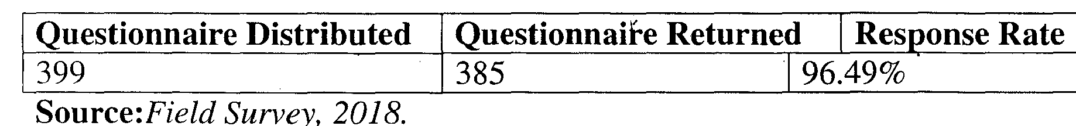
4.2 Demographic Analysis

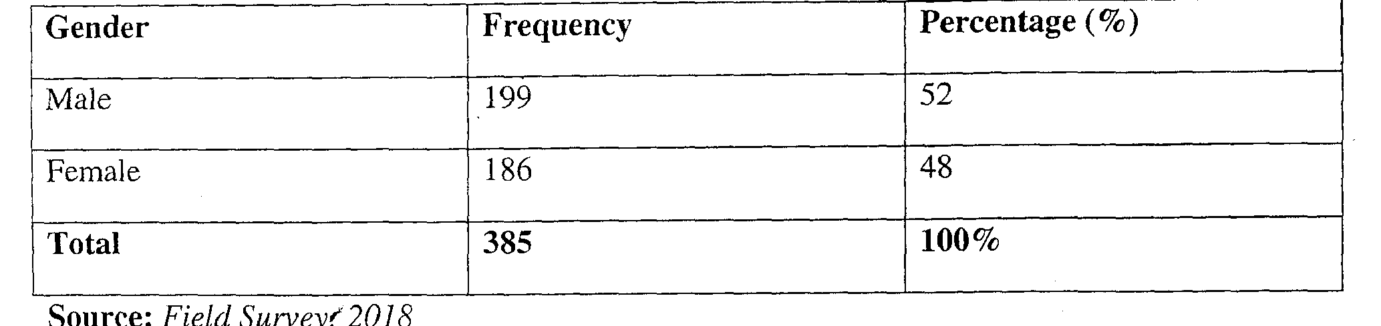

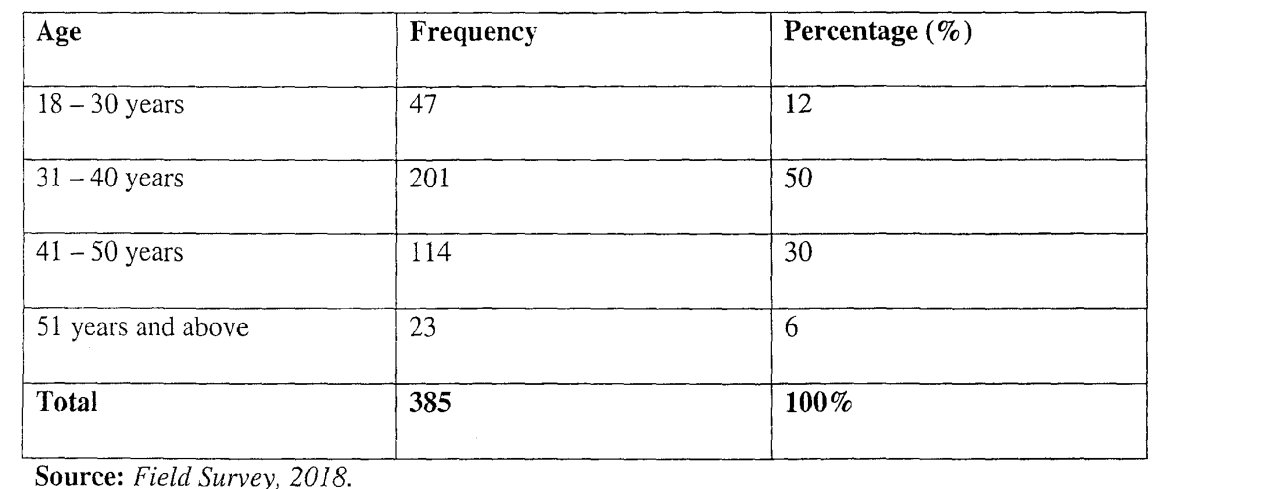

The table above shows the sex distribution of the respondents. It clearly shows that
199 respondents constituting 52 percent of the respondents are male while 186
respondents which are made up of 48 percent of the total respondents are female.
In essence, there are more male employees in the sampled local government.
The above table reveals that 47 of the respondents which is 12 percent of the total respondents fall into the age category of 18 — 30 years, 201 respondents fall into the age category of 31 — 40 years, 1 14 of the respondents making up 30 percent of the total respondents fall into the age category of 41 — 50 years and 23 of the respondents are into the age category of 51 years and above.

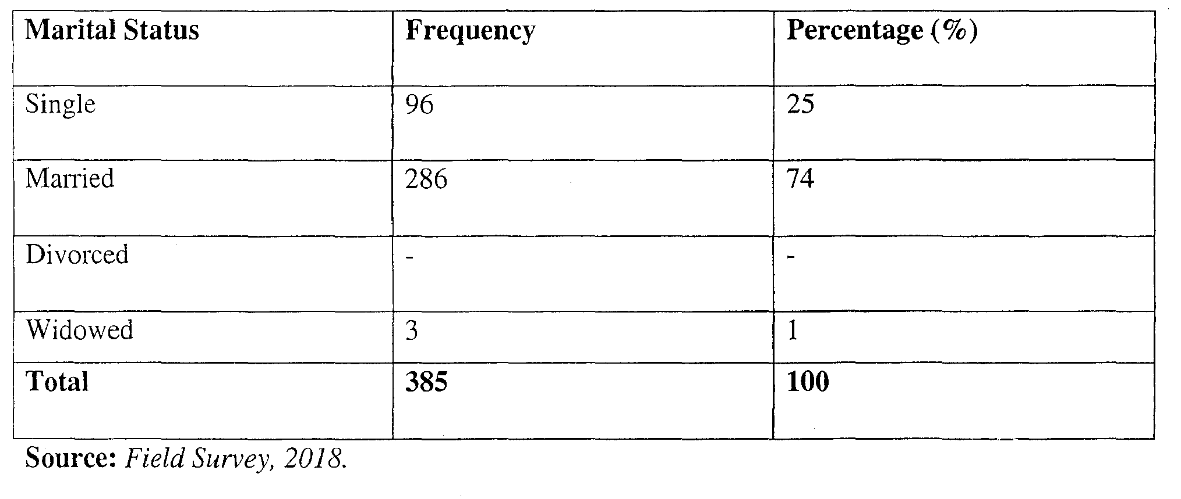
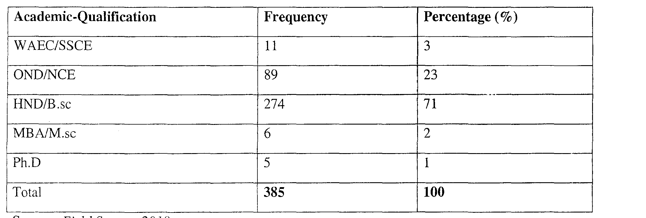
The above table shows that out of a total number of 385 respondents, 96 of them were single as at the time of this study, 286 which constitute about 74 percent of the respondents are married while 3 which is 1 percent of the sample are widowed. Hence; we have more of married respondents than single and widowed.
ACADEMIC QUALIFICATION
Source: Field Survey, 2018
The table shows that just 3 percent of the respondents possess an SSCE, 23 percent
possess an OND/NCE, 71 percent are HND/B.Sc holders, 4 percent have their
MBA/M.sc and 1 percent have P.hD as their highest level of academic

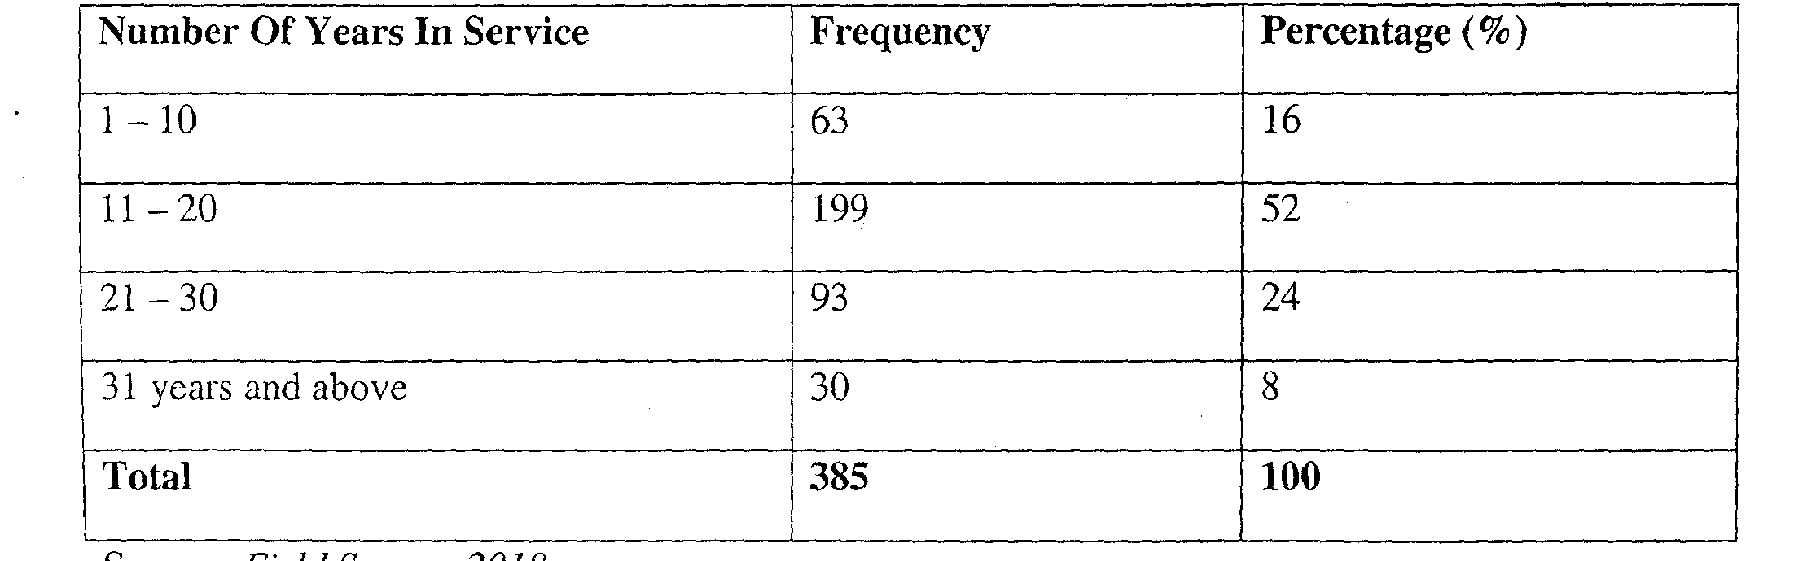
qualification. This shows on the average that most of the respondents are holders of HND/B.Sc.
4.6 WORK EXPERIENCE
Source: Field Survey, 2018.
The table shows that 16 percent of the respondents have a working experience of between 1 — 10 years, 52 percent of the respondents have worked for over 11 years. 24 percent of the respondents, have worked for over 21 years and 8 percent of the respondents have logged 31 years and above on the job.
38
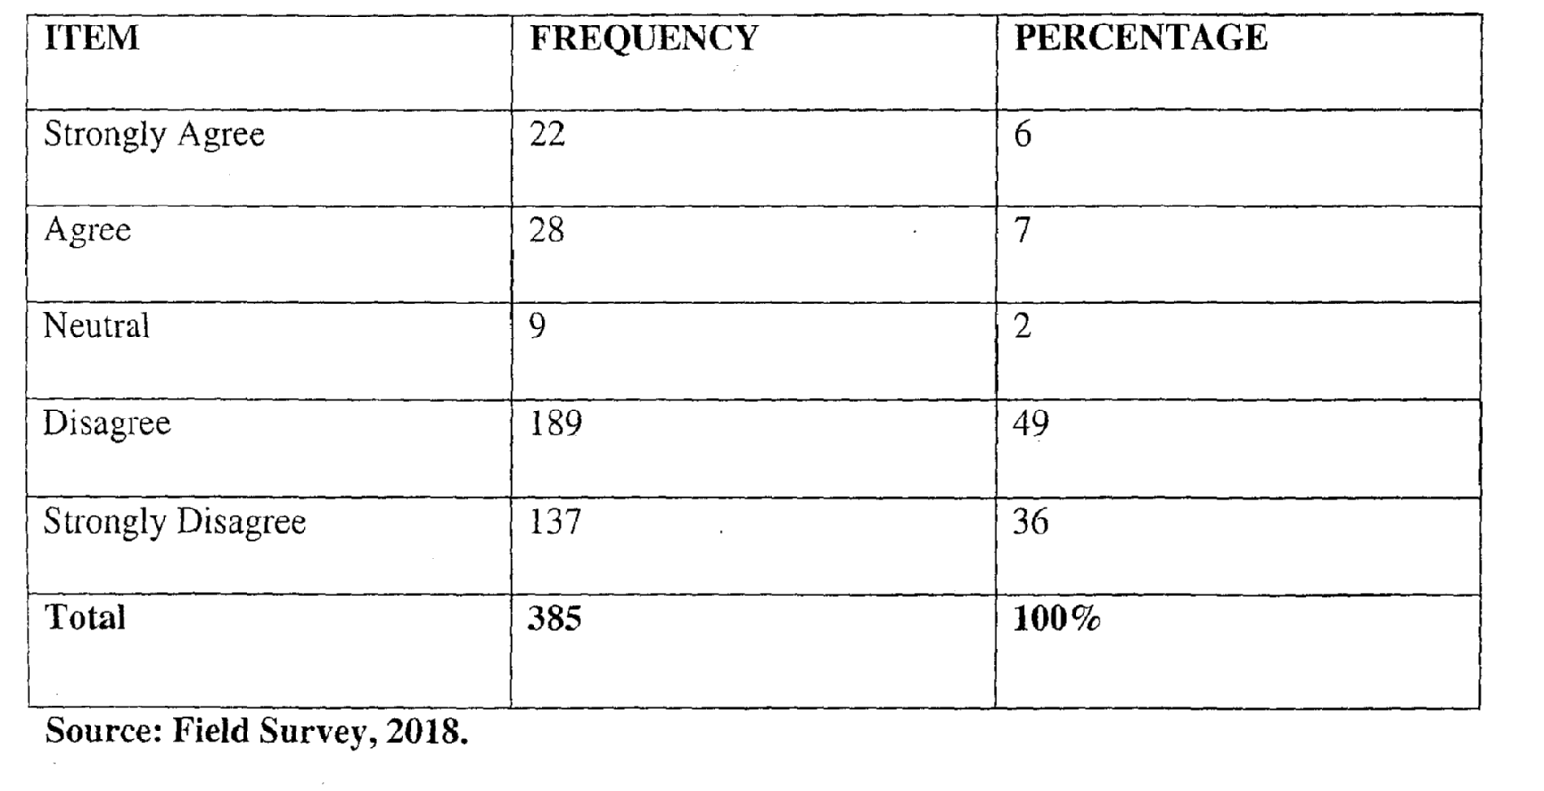
4.7 Section Two
Public Policies significantly influence grassroot development in Enugu East local government area of Enugu state.
The table above shows that 6 percent of the respondents strongly agree that public Policies significantly influence grassroot development in Enugu East local government area of Enugu state, 7 percent agreed, 2 percent were neutral, 49 percent disagreed and 36 percent strongly disagreed. The conclusion is that on the average, majority of the respondents disagreed that that public Policies significantly influence grassroot development in Enugu East local government area of Enugu state.
Source: Field Survey, 2018.
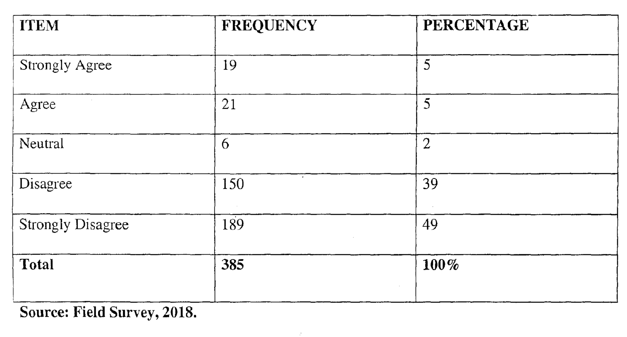

It can be clearly seen from the above table that 5 percent of the respondents strongly agree that public policies in Enugu East local government area of Enugu state are in line with their grassroot development requirements, 5 percent agree, 2 percent are neutral, 39 percent disagree and 49 percent strongly disagree. This implies that majority of the respondents do not agree that public policies in Enugu East local government area of Enugu state are in line with their grassroot development requirements.
4.9 Formulated Policy are not Effectively Implemented in Enugu East Local Government Area
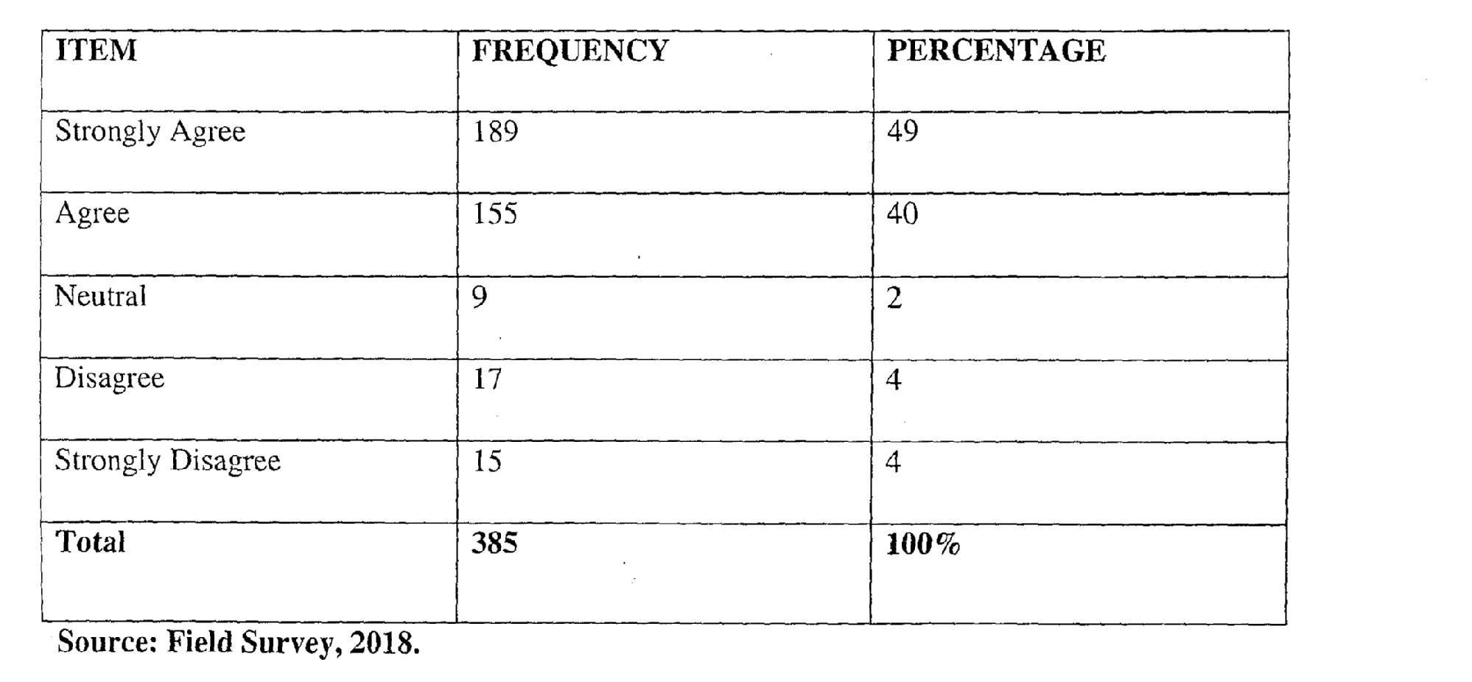
It is clearly seen from the table that 49 percent of the respondents strongly agree that formulated policies are not effectively implemented in Enugu East local government area, 40 percent agree, 2 percent are neutral and 4 percent disagree and strongly disagree respectively.

4.10 Delay in public policy implementation is one of the challenges surrounding grassroot development policy formulation and implementation in Enugu East local government.

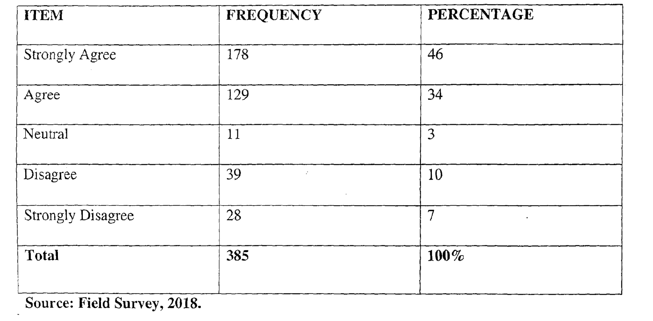
It is seen from the table that 46 percent of the respondents strongly agree that delay in public policy implementation is one of the challenges surrounding grassroot development policy formulation and implementation in Enugu East local government, 34 percent agree, 3 percent are neutral, 10 percent disagree while 7 percent strongly disagree. Hence, majority of the respondents agree to the assertion.
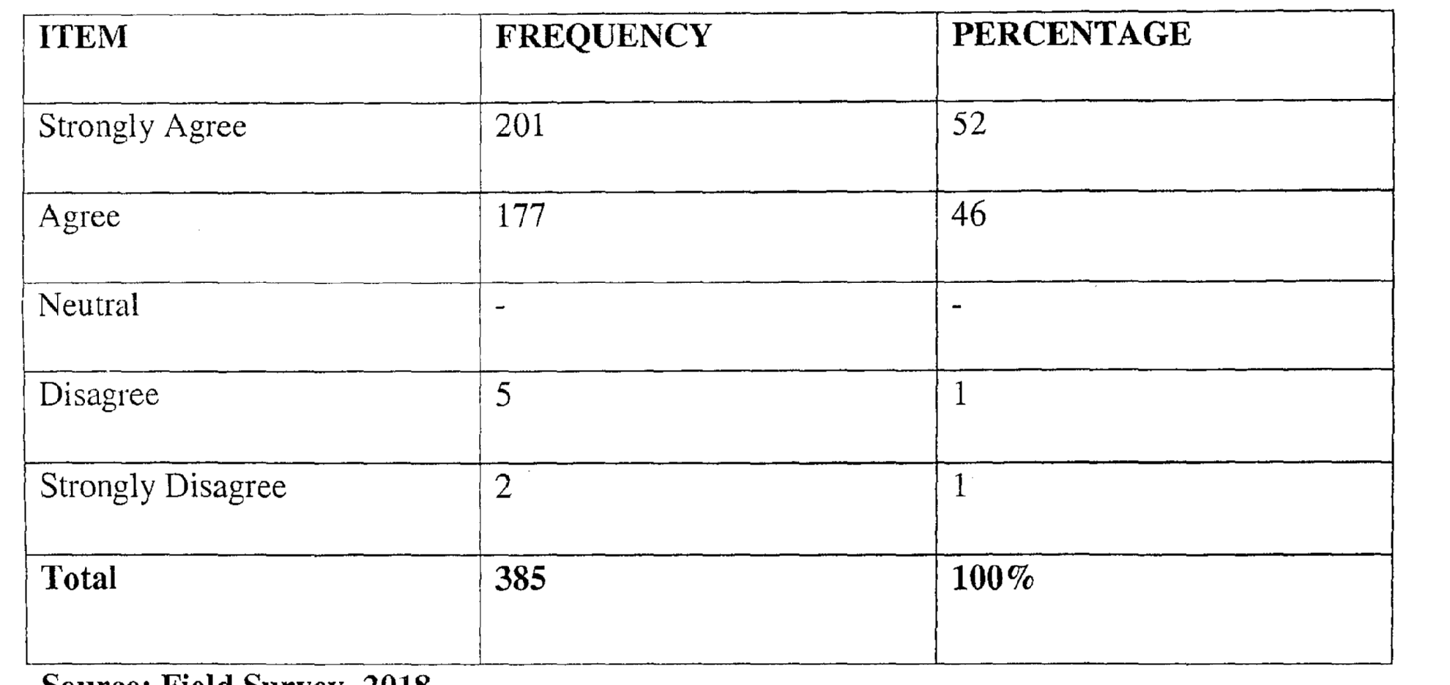
4.11 Corruption is one of the challenges in development experience of Enugu East local government area.
It can be clearly seen from the table that 52 percent of the respondents strongly agree that corruption is one of the challenges in development experience of Enugu East local government area, 46 percent agree, while 1 percent disagree and strongly disagree respectively.

4.13 Grassroot leaders play significant role in facilitating grassroot development through policies.
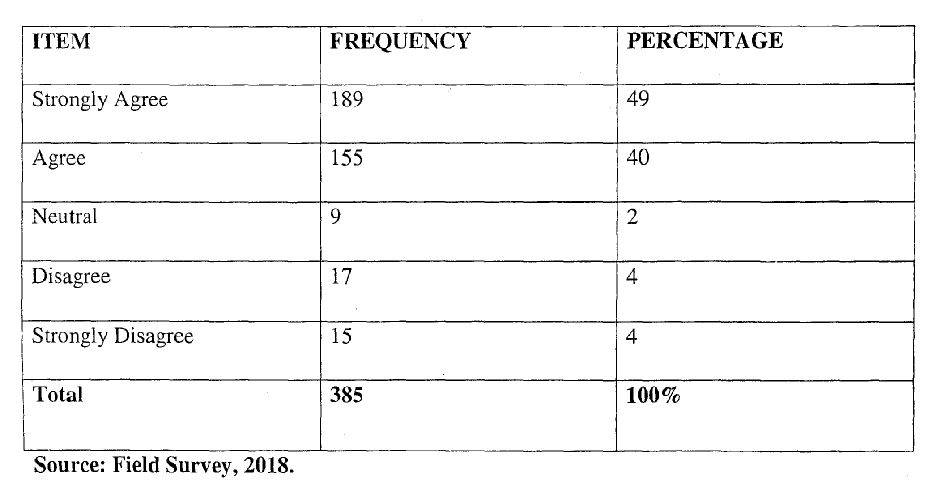
It is clearly seen from the table that 49 percent of the respondents strongly agree that grassroot leaders play significant role in facilitating grassroot development through policies, 40 percent agree, 2 percent are neutral and 4 percent disagree and strongly disagree respectively.

4.14 The challenges surrounding grassroot development policy formulation and implementation in Enugu East local government is also caused by lack of commitment from the leaders.
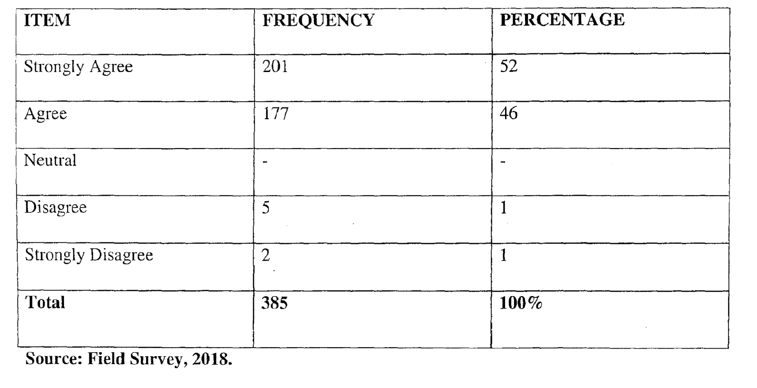
It can be clearly seen from the table that 52 percent of the respondents strongly agree that lack of commitment from the leaders is one of the challenges surrounding grassroot development policy formulation and implementation in Enugu East local government, 46 percent agree, while 1 percent disagree and strongly disagree respectively.
4.15 There is public policy continuity in change in leadership at the grassroot level in Enugu East local government area.
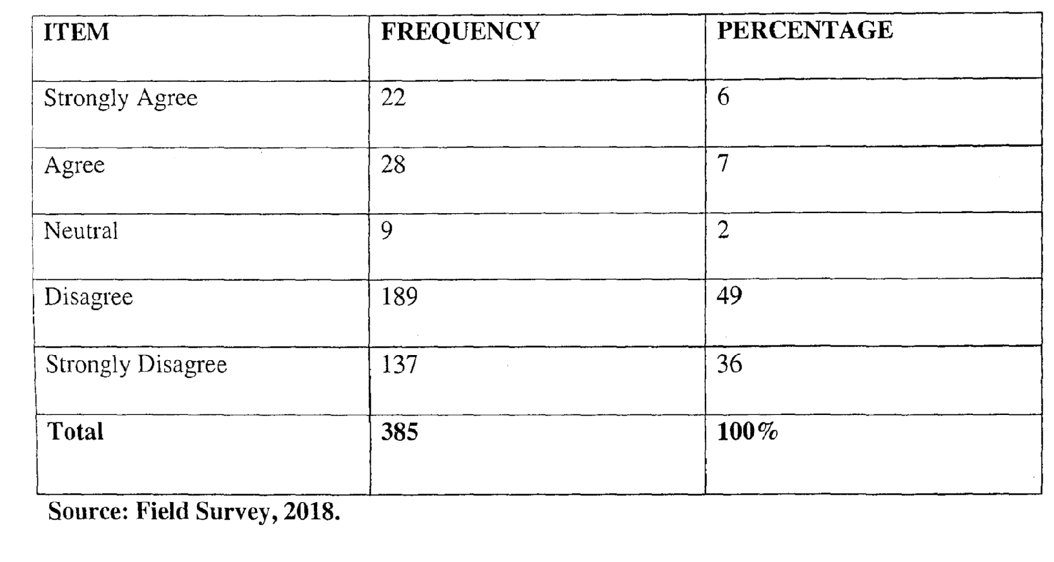
The table above shows that 6 percent of the respondents strongly agree that there is public policy continuity in change in leadership at the grassroot level in Enugu East local government area of Enugu state, 7 percent agreed, 2 percent were neutral, 49 percent disagreed and 36 percent strongly disagreed.

CHAPTER FIVE
SUMMARY OF FINDINGS, CONCLUSION AND RECOMMENIATIONs
5.1 Summary of Findings
The primary essence of this research has been to empirically investigate an empirical analysis of public policy and grassroot development in Nigeria with an empirical focus on Enugu East local government area. Based on the aims of the study, the following main findings were extracted:
1. Public policy has no significant impact on grassroot development in Nigeria.
2. There are significant challenges surrounding grassroot development policy formulation and implementation in Nigeria.
3. Grassroot leaders are not committed to the grassroot development of Enugu East local government area of Enugu State.
5.2 Conclusion
This study has been able to empirically ascertain the relationship between public policy and grassroot development in Enugu East local government area. Based on the findings of the study, one can draw the conclusion that public policy has not been contributing impressively to the development of Enugu East. The cause of this quagmire is traced to challenges like corruption, uncommitted leaders and a mismatch between policy formulation and the speed of implementation.
5.3 Recommendations
Based on the findings of the study, the following recommendations were proffered:
1. To make public policies effective in Nigeria and Enugu East in particular, there should be a continuous forum between the government and the people so that policies formulated are in line with the needs and priorities of the people and community in general.
2. To overcome the challenges surrounding grassroot development policy formulation and implementation in Nigeria, independent experts should be engaged and granted autonomy and independence. Corruption perpetrators should also be dealt with extensively.
3. Grassroot leaders should always be empowered through reorientation programmes and leadership trainings. This will unarguably increase their commitment and make them take leadership roles more seriously.

References
Adedire, S.A (2014) Local Government and the Challenges of Rural Development in Nigeria. IOSR Journal Of Humanities And Social Science (IOSR-JHSS). Anayo, M. (2010) Comparative government: An introduction. London and
Basingstoke: the Macmillan Press Ben, T. (2011). Poverty and the Survival of Democracy in Nigeria. Nigerian Journal of Political Administrative Studies, 1(4).
Chikeleze, L (2013); Politics and Administration in Nigeria. Ibadan:Spectrum Books ltd.
Darby, Y. and Morris, K. (2009) Public Policy-Making and Theories of Organizational Choice” Scandinavian Political Studies.
Dahida, D.P and Maidoki, B.P (2013) Public Policy Making and Implementation in Nigeria: Connecting the Nexus. PubJic Policy and Administration Research ISSN 2224-5731(Paper) ISSN 2225-0972(Online).
Ele, A. (2002), “What is public policy?”, Anifowose, R. and Enemno, F. (eds)), Elements of politics, Lagos:Malthouse Press Ltd. Pp. 281 —310
Enyi, J.E (2014) Rural and Community Development in Nigeria: An Assessment.Arabian Journal of. Business and Management Review (Nigerian Chapter).
Ezeah, L. E. (2005). Poverty Alleviation Strategies in Nigeria: The Ebonyi State Experience. EBSU journal ofSociety, 1(4), 76-82.
Friedrich, M.A. (2003) “The Role of Bureaucracy in Policy Formulation: A Case study of College of Education Eha-Amufu (1981-1989)” Unpublished MPA Thesis UNN, 1990.
Forman, P.B (2008) “The Theory of Case Studies” Social Forces.
Franklin, K.A (2014) “Using the work of others: Some Observations or Reviewing and Integrating” Sociology of Education.
Fred, V. I. (2000). Community Development and Urbanization In Nigeria (Theories and Applications). OnitshaChambers Books Ltd.
Gergan, R.L. (2008): Interviewing: Strategy, Technique and Tactics. Homewood III: Dorsey press.
Gregory, L. F. (2016). Human Capacity Development in Nigeria: A Historical and Analytical Perspective.
Hilary, J. (2009) “A strategy for Integrated Rural Development in Nigeria”, being a paper presented at a National Seminar Organized by the Directorate of Foods, roads and Rural Infrastructures, Lagos, 1996.
lyoha, J.E. (2000) “Local Government and Rural Development in Nigeria: A case study of Local Government in Benue State, 1999-2007” An Unpublished Ph.D. Thesis Presented to the post graduate school, BSU Makurdi in partial fulfillment of the requirements for the Award of the Doctor of Philosophy (Ph.D) in Political Science.
lkechukwu. 0. (2013), The Cluster Concept: Will Nigeria’s New Industrial Developmentstrategy Jumpstart the Country’s Industrial Takeoff?, in Afro Asian Journal of Social Sciences.
Ihemeje, G.C (2014) Why Nigeria’s Public Policies Fail at the Local Government
Level: Any Hope in the Fourth Republic?Singaporean Journal of Business Economics and Management Studies.
John, A. (2011): “Policy formulation in Nigeria PublicAdministration 1960-73”. Journal of Administration Overseas.
Larry, E.U and Sunday, 0.0 (2016) Approaches to Community Development in Nigeria, Issues and Challenges: A Study of Ebonyi State Grassroot and Social Development Agency (EB-GSDA). Journal of Sustainable Development; E-ISSN 1913-9o7lPublished by Canadian Center of Science and Education
Laswell, J. and Kaplan .J. (2001): Public Policy in Theory and Practice London:. Hodder and Soughton.

Maduabum, J. 0. (2013). Approaches fox Poverty Alleviation and Sustainable Development in Nigeria: A Study ofEbonyi State Community Based Poverty Reduction Agency (BB-CPRA). International Journal of Social Sciences Studies, 2(1), 153-163.
Mike, V.P. (2011) “Rural Development in Nigeria. Role of fiscal policy” in Rural Development in Nigeria: Proceedihgs of the 1972 Annual conference of the Nigerian Economic Society, Ibadan, Ibadan University Press.
Nseabasi, S.A (2012) Rural Development in Nigeria: A Review f Pre- and Postindepeiidence Practice. Journal of Sociological ResearchlSSN 1948-5468 2012.
Njoku, F. C. (2015). Politics of Developrneiu and Underdevelopinent (Theories of Development). Nsukka; TpomostPr&s & Business Centre.
Ndukaku, 0. (2013). Rural development in eastern Nigeria: an assessment of colonial and post colonial development plans in the former Owerri Province, 1946-1976. Lagos Historical Review, 6: 118-132.
Nnamdi, E. 0. (2016). United Nations DSvlopment Programme And Sustainable Human Development in Nigeria. A Study of Ebonyi State; Ph.D Thesis, UNN.
Nwiza, S. A. (2007). Tackling Poverty In Nigeria: An Appraisal of the National Directorate of Employment, (NDE) Programme in Cross River State. Multi-Disciplinary Journal of Research and Development Perspectives, 2(1), 1-16.
Nkiru, L. and Victor E. (2013). Human Capacity Building In Selected Local Government Areas of Ebonyi State — The ROle ofNon-Governmental Organizations (NGOs) and Development Agencies (2000-2008). Journal of Business andManagement, 3(1), 25-41. Retrieved from http://www.todayscience.org EB-CPP.

Landau, M. (1962), “The concept of decision making in the field of public administration”.
Lynos J.A. (2003); “Impact of Government Policies on food security in Nigeria”, in Fabiyi Y.L. and Idowu B .0. (eds) Poverty Alleviation and Food Security in Nigeria, (2003).
Larson, C. (1987), “The science of muddling through”, Stillman, R.J. II, (ed), Public administration:concepts and cases, 2nd Edition, Boston: Houghton Mifflin Company: 203 - 213
0layiwoe, N. and Adeleye, J. (2005)Politics, the State and agriarian development:
a comparative study of Nigeria and the Ivory Coast. Political Geography Quarterly 5, 103-125.
Okoli, A. and Onah 1. (2002). Politics and Nigerian Agriculture in the first decade of the oil boom, 1970-1980: a preliminary assessment. NJEH, No. 1: 57-69.
Okoye, E. (2000). The New Nigerian Economy: from poverty to prosperity. Benin City: AFBSN Publications.
Ogunna, I. A. (2013); “Rural Development New Imperative” Journal of the Institute of Town Planners.
Okwandu, J. W. (2004). Research Design: Qualitative, Quantitative and Mixed Approaches (4th ed.). Sage Publications.
Pressman, E.H. (2005). Concept and issues in administration behaviour, Englewood Cliff, New Jersey: Prentice Hall.
Ross, G. (2009). Implementation Analysis; The case for Early Dose of Realism in Development Administration” in George Honalde and Radiklaus (eds.) International Development Administration: Implementation Analysis for Development. New York: Praeger.
Shahid, D. (2015), Development projects as policy experiments: An adoptive approach to development administration, London and New York: Methuen.
Taro, Y. (1967): Statistics: An Introductory Analysis, 2 Ed., New York: Harper and Row.

APPENDIX A
Public administration programme,
Business management department,
Godfrey Okoye University,
Thinker’ s corner,
Enugu.
July, 2018.
Dear Respondent,
REQUEST FOR QUESTIONNAIRE RESPONSE
I am a 400 level student of public administration of the above named institution. I am currently out a research on public policy and grass-root development in Nigeria, Enugu East Local Government Area.
I will be glad if you would assist in this study by supplying responses to the questionnaire as they apply to you. Your responses will be treated with utmost confidentiality, and would be used purely for the research only.
Thank you.
Yours faithfully,

Tizhe Alpha Peter
Researcher

