International Journal of Pharmaceutical Science Invention ISSN (Online): 2319 – 6718, ISSN (Print): 2319 – 670X www.ijpsi.org Volume 3 Issue 8 ‖ August 2014 ‖ PP.01-05

Mineralization Of Diesel-Base Engine Oil By Fungi Isolated From
Selected Workshops In Benin City, Nigeria

^{1,}U. Udochukwu, ^{2,}E. M. Omoghie, ^{3,}C.C. Chikezie, ^{4,}O.C. Udinyiwe
¹Department of Bioscience, College of Natural and Applied Sciences, Salem University-Lokoja, Kogi State, Nigeria
²Department of Microbiology, Faculty of Life Science University of Benin, Edo State, Nigeria
³Department of Bioscience, Faculty of Natural and Applied Sciences, Godfrey Okoye University Ugwuomu Nike, Enugu State, Nigeria
⁴ Department of Science Laboratory Technology, Faculty of Life Science University of Benin, Edo State, Nigeria

ABSTRACT: The mineralization of diesel-based engine oils produced by African Petroleum (AP) was investigated for a period of twenty-eight (28) days. Two different samples of AP engine oils, Heavy Duty Visco SAE40 (H40) and Diesel Motor Oil SAE 40 (D40) were investigated. Soil from a mechanic workshop at Irediawa Junction, along Ekenwan Road, Benin City, Edo State, Nigeria served as seed for the mineralization. The study was carried out at room temperature (27-29⁰C). The pH of the test systems ranged from 6.6 to 4.8 where the count in first day were 2.56x10² and 4.46 x10⁵, for H40 and D40 respectively whereas the corresponding count on day 28 were 2.32 x10⁴ and 3.85 x10⁴ in colony forming unit per milliliters (cfu/ml). The hydrocarbon utilizing fungal isolates were identified as Aspergillus, Fusarium, Mucor, Penicillium Rhizopus, and Saccharomyces. The physicochemical analysis showed that nitrate, phosphate, sulphate, biochemical oxygen demand, (BOD), oil and grease content and total organic carbon (TOC) decreased with time. The rate mineralization between the two engine oils was in accordance with the normal growth rate for a close system. There was no significant difference between the rates of mineralization of the two engine oils.

KEY WORD(S): Engine Oils, Fungi, Polluted Soil, Total Organic Carbon (TOC) and Biochemical Oxygen Demand (BOD).

INTRODUCTION
Microorganisms (bacteria and fungi) have different rates at which they utilize and degrade hydrocarbons in the soil or water. This rate is reflected in the multiplication and colony forming units (cfu) for the isolated organisms. The use of microorganisms to degrade petroleum hydrocarbon resulting from oil spillage has been a subject of extensive research since the first publication of bacterial growth on petroleum hydrocarbons [1];[2]. Several petroleum hydrocarbon degrading microorganisms have been isolated from both soil and marine sources, which are the two major environments affected by petroleum hydrocarbon pollution [3];[4]. Microorganisms are equipped with metabolic machinery to use petroleum products as a carbon and energy source. The metabolic pathways that hydrocarbon-degrading heterotrophs use can be either aerobic (i.e. they utilize oxygen as the primary electron acceptor) or anaerobic (i.e. They utilize an alternative electron acceptor such as nitrate or sulfate). Aerobic degradation usually proceeds more rapidly and is considered to be more effective than anaerobic degradation. One reason is that aerobic reactions require less free energy for initiation and yield more energy per reaction. Petroleum hydrocarbondegrading fungi were isolated from Detarium senegalense seeds. An assessment of the relative ability of each fungus to degrade petroleum crude oil, diesel, unspent and spent engine oils, kerosene and Detarium senegalense oil extract, on minimal salt broth, was done measuring change in optical density read on a spectrophotometer. Five fungi were isolated from diseased namely: Aspergillus flavus, A. niger, Mucor, Rhizopus, and Talaromyces. The fungi isolated were used in the experiment and it was evident that all the fungi were capable of biodegrading the petroleum oil, though at different rates. Aspergillus niger had the highest ability to degrade unspent engine oil and Detarium senegalense oil extract while Rhizopus had the highest ability to degrade kerosene and diesel, and Talaromyces had the highest ability to degrade spent engine oil. [5] and [6] reported that Pleurotus tuber-regium have the ability to increase nutrient contents in soils polluted with 1 - 40% engine-oil concentration after six months of incubation and reduction in heavy metals after six months of incubation. Hence, the fungus can be employed in decontaminating environment polluted with engine oil. An experiment by [7] revealed the ability of white rot fungus, L. squarrosulus to improve the nutrient contents of the engine oil contaminated soil and an accumulation of Fe, Zn and Ni to an appreciable extent. This could represent a process that could be exploited in remediation of engine oil contaminated soils.
www.ijpsi.org

MATERIALS AND METHODS
The soil samples were collected at Irediawa junction along Ekenwa road, Benin City, Edo State, Nigeria. Soil samples for biological analysis were obtained from different points (about ten meters apart) and pooled together to form composite samples [8]. Two types of used engine oils produced by African Petroleum (AP) were obtained from the filling station located along Akpakpava Road, Benin City, Edo State, Nigeria. Heavy Duty Visco SAE40 (D40) and Diesel Motor Oil SAE 40 (D40) were aseptically taken to the laboratory for analysis. The soil sample was weighed and 10g was dissolved in 900ml of distilled water to obtain a ten-fold dilution of the soil sample. Toxicity test was conducted to obtain non-toxic concentration. The test was conducted by measuring equal volumes (10ml) from the 10-fold dilution of the soil sample into four conical flasks. Different volumes of 0.1ml, 1.0ml and 10.l of the engine oils were transfer into the flasks. One of the flasks served as control which was free from engine oil. The volumes were made up to 100ml with sterile distilled water. This resulted to concentrations of 1mg/l, 0.1mg/l and 0.01mg/l of the engine oils. The cultures were incubated for 48 hours at room temperature. The non-toxic concentrations of the engine oils were determined by plating out in a Potato Dextrose Agar (PDA) at room temperature for five days. The sample inoculated with engine oil that produced similar counts with control after two days of incubation was taken as the non-toxic concentration of the engine oil. The mineralization conditions of the experimental set up were monitored by withdrawing the samples before initiation of the experiment on the first day and subsequently at day 7, 14, 21 and 28 for microbiological and physicochemical analysis. Total heterotrophic fungal (THF) counts of the withdrawn samples were performed. Serial dilution using normal saline (0.85%) as diluents was done and spread plate technique was adopted. Acidified potato dextrose agar which is used for fungal growth was inoculated and incubated at room temperature for 5days [8]. Vapour phase transfer method was adopted in estimating the population of hydrocarbon utilizing fungi. Acidified mineral salt agar with a sterile filter paper (whatmann No. 1) saturated with the oil which supplied the hydrocarbon by vapour phase transfer to the inocula were incubated at room temperature for 8 days and the colonies were counted, taking note of each of the characteristic isolate. Physicochemical analyses were conducted, such as pH, total organic carbon, biochemical oxygen demand (BOD), oil and grease analysis, sulphate content, nitrate content and phosphate content to determine the rate of mineralization of the oils through the investigation period.

RESULT
Engine oils have been found to be susceptible to microbial attack and hence mineralization or even biodeterioration of unused and used engine oils can occur. The fungal isolates identified as Aspergillus, Fusarium, Mucor, Penicillium, Rhizopus, and Saccharomyces has been reported to mineralize petroleum and its products. It is well established that the availability of nitrogen and phosphorus limit the microbial mineralization of hydrocarbons. From the graphs, it can be observed that the phases of growth followed a normal batch growth curve pattern of log, exponential, stationary and death phases [9]. The pH profile obtained generally fell between the optimum rang of 6.6 and 4.8 which favoured most of the heterotrophic fungi due to the release of acidic by products into the test system. It showed that fungi in the utilization of hydrocarbon as nutrient source produced acidic metabolic products. These metabolic products must have contributed to the lowering of the pH readings. It was also observed that the nutrients (sulphate, phosphate and nitrate) decreased considerably with time. The decrease is understandable as they are used in the metabolism of the fungi biomass. There is a correspondence in the utilization of phosphate, sulphate and nitrate indicating their relative importance in cell metabolism as stated by Odum’s combine law [10]. The biochemical oxygen demand (BOD) of the media decreased as the study progressed indicating that the system is gradually re-aerated and there is also a gradual increase of dissolved oxygen in the system.

Table 1. Non-toxic concentration determination (cfu/ml)

S/N Oil Sample Concentration (mg/l)
1.0 0.1 0.01
- H40 4.21x10² 6.42x10² 2.32x10³

- D40 6.72x10² 8.27x10³ 2.87x10³

- Control (without oil) 2.81x10³

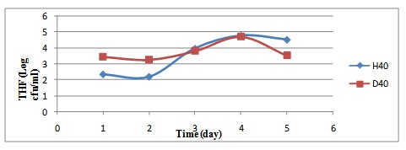

Fig 1. Change in total heterotrophic fungal count (Log cfu/ml) of the test system

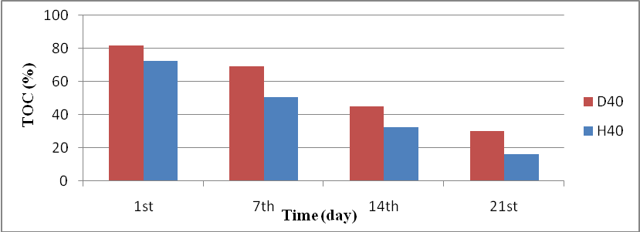

Fig 2.Change in percentage (%) of total organic carbon of the test system

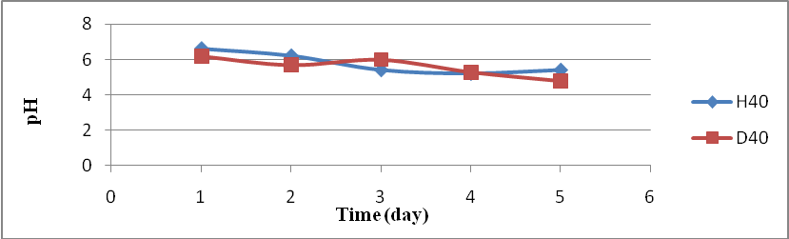

Fig. 3. Change in pH of the medium for the test systems.
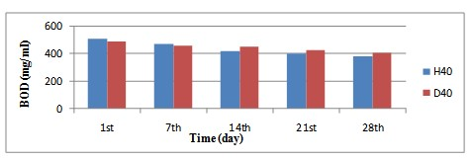

Fig. 4. Change in BOD of the test systems.

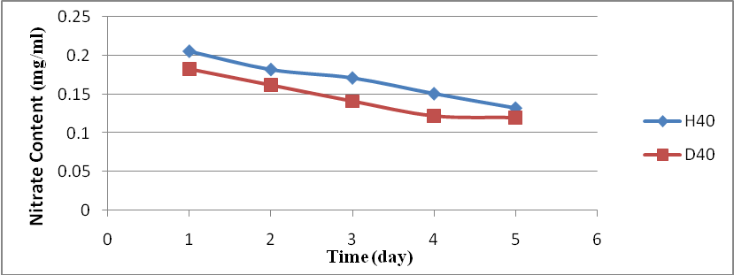

Fig. 5. Change in concentration of nitrate content for the test systems.

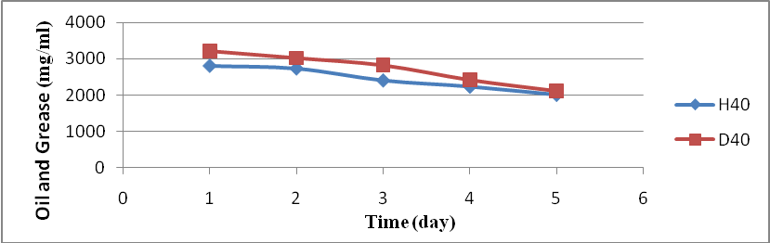

Fig. 6. Change in oil and grease of the test systems.

0
50
100
150
200
250
1
st
7
th
14
th
21
st
28
th
H40
D40
Time
(
day
)
Sulphate Content
mg/ml
(
)

Fig. 7. Change in the concentration of sulphate content of the test systems.

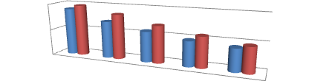
0
2
4
1
st
7
th
14
th
21
st
28
th
H40
D40
Time
(
day
)
Phosphate
Content
(
)
mg/ml

Fig. 8. Change in the concentration of phosphate content of the test systems.

CONCLUSION
The results of the research have shown that the mineralization was positive and in accordance with the previous researches. Mineralization processes by indigenous fungi from the soil have shown to be relatively efficient in the breaking down of petroleum products as evidently indicated by the physicochemical analysis. Further researches on genetically modified and fungi species which have more mineralization ability and can be controlled after the mineralization process has future prospects.

REFERENCES
[1]. | Atlas RM (1981). Microbial Degradation of petroleum hydrocarbons: an experimental perspective; Microbiol. Rev. 45(1): 180-209.
[2]. | Gerson DF (1985). The Biophysics of Microbial growth on hydrocarbon: Insoluble substrates. Int. Bioresour. J. 1: 39-53.
[3]. | Bossert, I. and R. Bartha (1984): The fate of petroleum in soil ecosystem. p. 435–473. In Petroleum Microbiology, ed. by Atlas, Macmillan, New York, U.S.A.
[4]. | Antai SP, Mgbomo E (1993). Pattern of Degradation of Bonny light crude oil by Bacillus Spp. and Pseudomonas Spp isolated from oil spilled site W.A.J. Biol. Appl. Chem. 38(1-4): 16-20.
[5]. | A.A. Adekunle, O. A. Adebambo (2007) .Petroleum Hydrocarbon Utilization by Fungi Isolated From Detarium Senegalense (J. F Gmelin) Seeds.The Journal of American Science. ;3 (1):69-76.
[6]. | Adenipekun, C.O. and Omoruyi, O.M. (2008). Bioaccumulation of heavy metals and enzyme activities of Pleurotus ostreatus. Proceedings of the 17th Congress of Edible and Medicinal Fungi. Mushroom Science 17: 842 – 849.
[7]. | Adenipekun, C.O. and Isikhuemhen, O.S. (2008). Bioremediation of engine oil polluted soil by the tropical white rot fungus, Lentinus squarrosulus Mont. Singer Pakistan Journal of Biological Sciences 11 (2): 1634 – 1637.
[8]. | Chikere, C. B. and Udochukwu, U. (2014) Effect of growth media and incubation time on the culturability of soil bacteria, IOSR Journal of Pharmacy and Biological Science. Vol 9(2) 6-9.
[9]. | Omoghie, E. M., Udochukwu, U. and Oshionebo, A.O. (2014): Effect of bacteria growth on the biodegradability of visco 2000-Sae (V20) and super –V Sae 20 (S20) Engine Oil, IOSR Journal of Pharmacy and Biological Science. Vol. 9(2): 10-14.
[10]. | Omoghie, E. M., Udochukwu, U. and Oshionebo, A. O. (2014) Biodagradability of visco 2000-Sae (V20) and super –V Sae 20 (S20) Engine Oil by Fungi isolated from polluted soil, IOSR Journal of Pharmacy and Biological Science. Vol 9(2): 24-28.

