DESIGN AND IMPLEMENTAION OF A DIGITAL
MUSEUM
In partial
A Project Report
Submitted By
Okoro Chukwuebuka
U14/NAS/CSC/089
In partial fulfillment for ii e award of the degree of
(B.Sc) in Computer Science
Department of Computer Science
GODFERY OKOYE UNIVERSITY
Supervisor: Mr. Benson Ikenna

July 2018

CERTIFICATION
I hereby declare that the work presented herein was done by me and not by a third party. Should I he convinced of having cheated in this work, I shall accept the verdict of the university.

_____________________________________________________
Okoro Chukwuebuka UI 4/NAS/CSC/089

APPROVAL
In partial fulfillment of the requirement for the award of Bachelors in Computer in the Department of Computer Science this project was presented by Okoro chukwuehuka With Registration Number U14/NAS/CSC/089 has been approved by

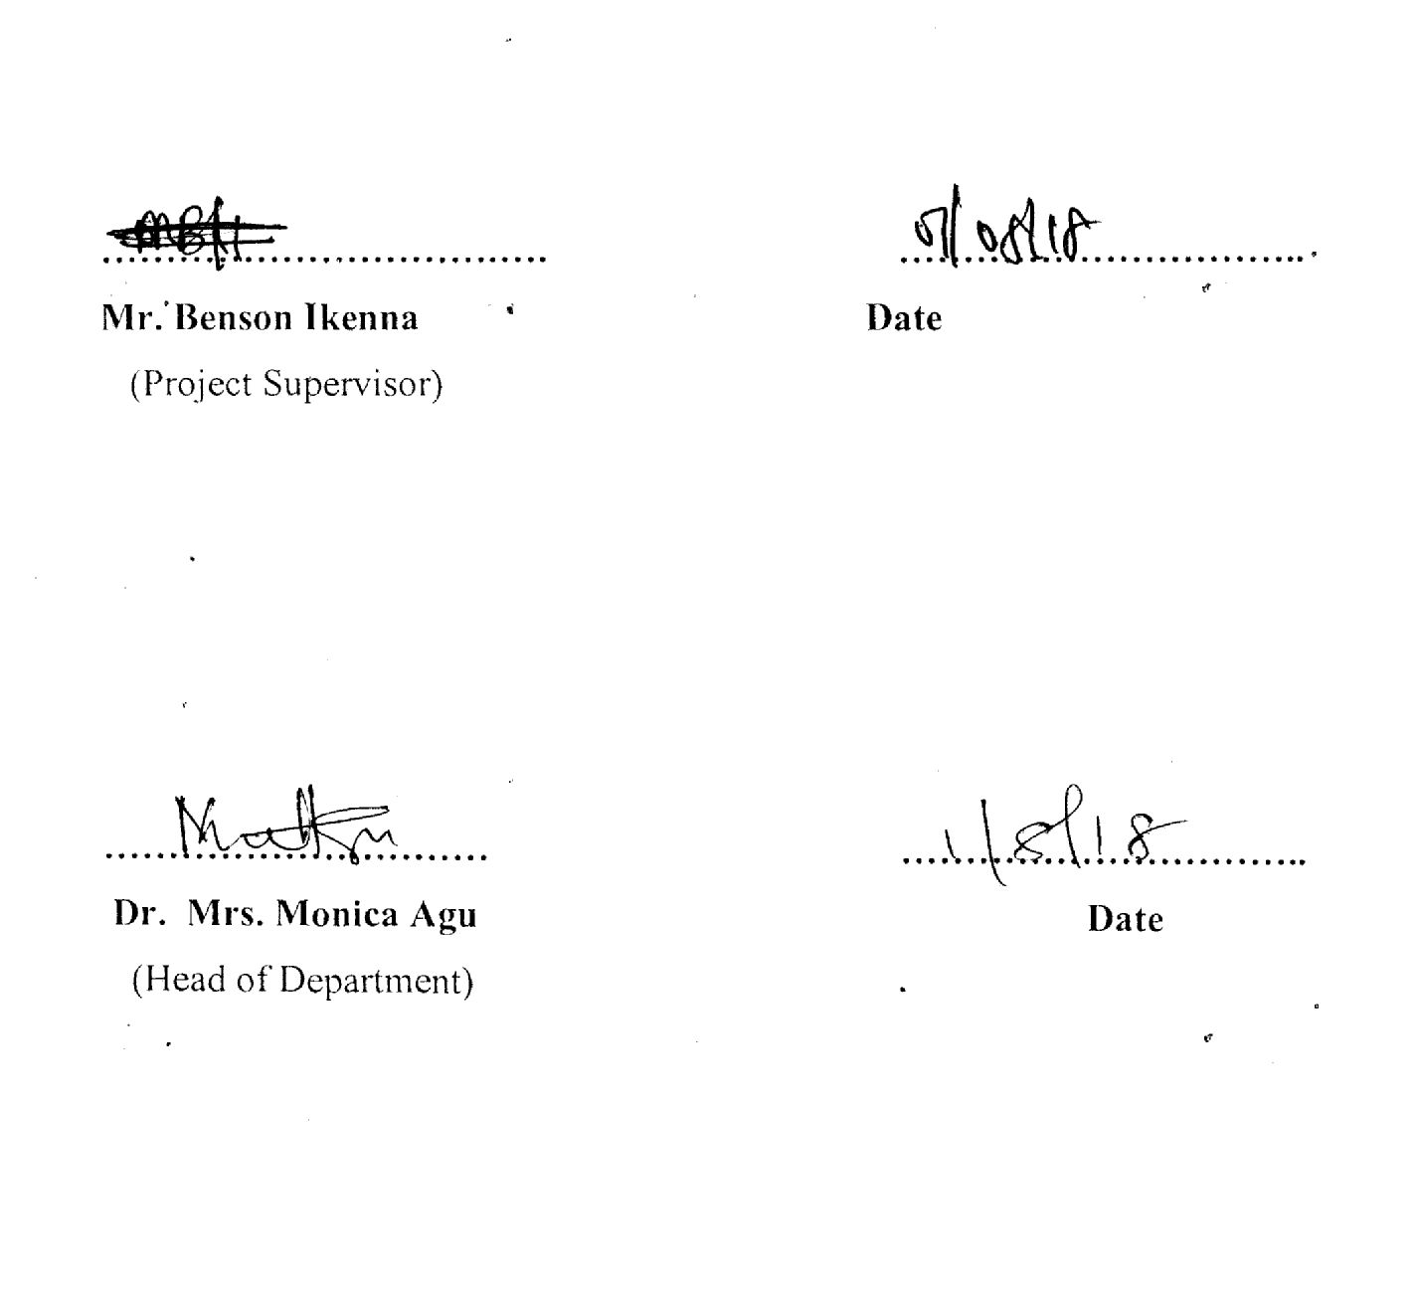

DEDICATION
This project is dedicated to the Almighty God for his love, mercies, guidance and protection during and even after this work. To my lovely parents Mr. & Mrs. Okoro for their help and support financially and other wise to make this successful also to my brother Okoro Benedict Chidiogor, friends, colleagues and course mates for being there for me throughout this journey.

ACKNOWLEDGEMENTS
My gratitude goes to God Almighty for his grace, kindness and love upon m5’ 1ifi. My project supervisor and the Head of my department for their understanding and guidance.
I am also using this medium to say a big thank you to my loving parents Mr. & Mrs. OKORO for their support towards my pursuit for academic excellence. To my brothers and sisters for their encouragement and prayers. My sincere appreciation also goes to my course mates who directly or indirectly affected my life in the progress of this work.

ABSTRACT
Digit1 museums appeared on the internet many years ago since first emerging in 4 1991. The term Digital museum was first coined by Tsichritzis and Gibbs in their article Digital museums and digital realities referring to a museum constructed for a digital landscape and functioning as a service rather than a location. However, despite the identity and quality of exhibitions their exhibits are comparable with traditional art museum pib1ication albums, catalogues and books, while the internet can create a qualitatively new display, where previously impossible or inconsistent methods of display of historical and artistic heritage have been set up. The objective of this project is to make remote and distant nausea contents accessible to all. Increase historical and cultural awareness in the general populace. Reduce the cost of preservation of historical heritage by adopting online archiving and story of historical detail. In order to achieve the above objectives, a method has to be used which is SSADM (structured system analysis and design method) which is system approach to the analysis and design of information systems. This methodology has a relationship to waterfall model because it has stages that helped me create my web site. This project was done using Html (hypertext markup language), Css (cascading style sheet), JavaScript, php for server scripting and Myself database. They are the technologies used in designing the website. The technologies mentioned enabled me achieve a result in designing a digital or online museum.

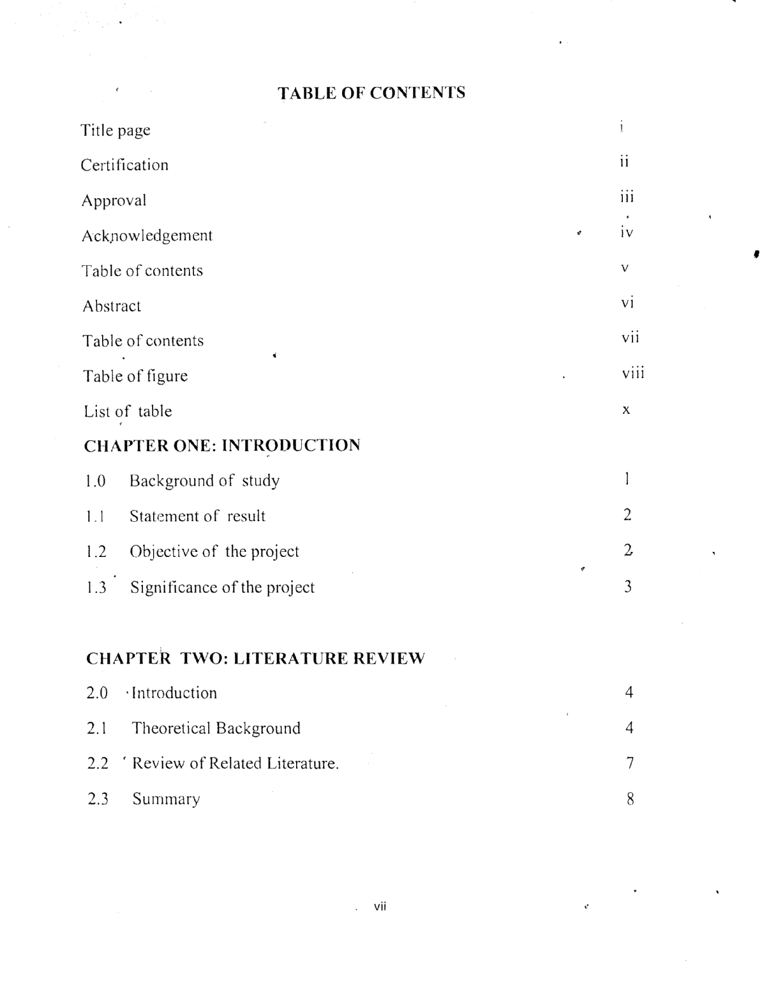
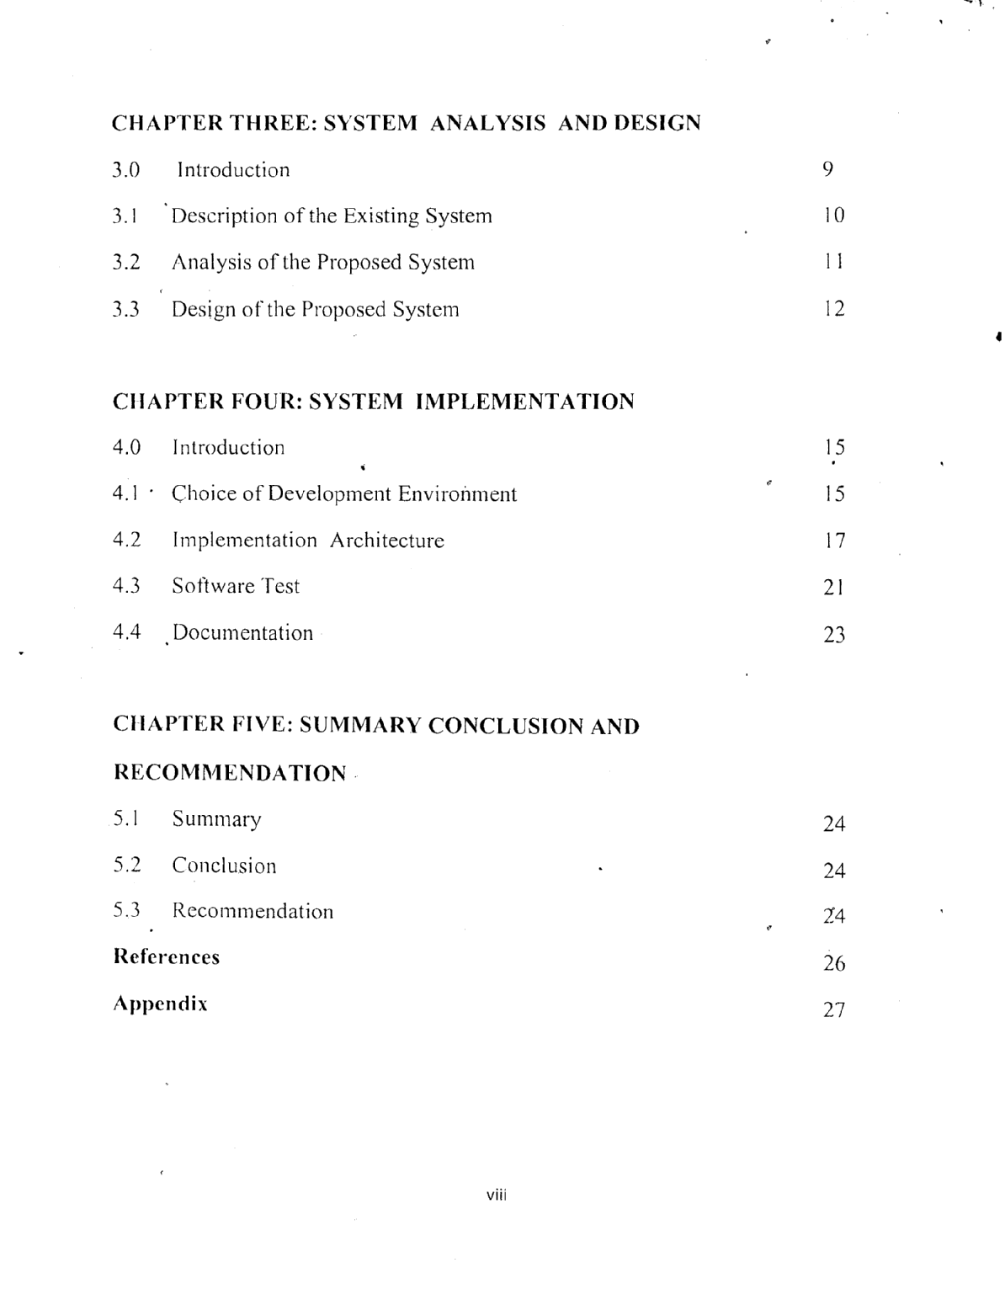
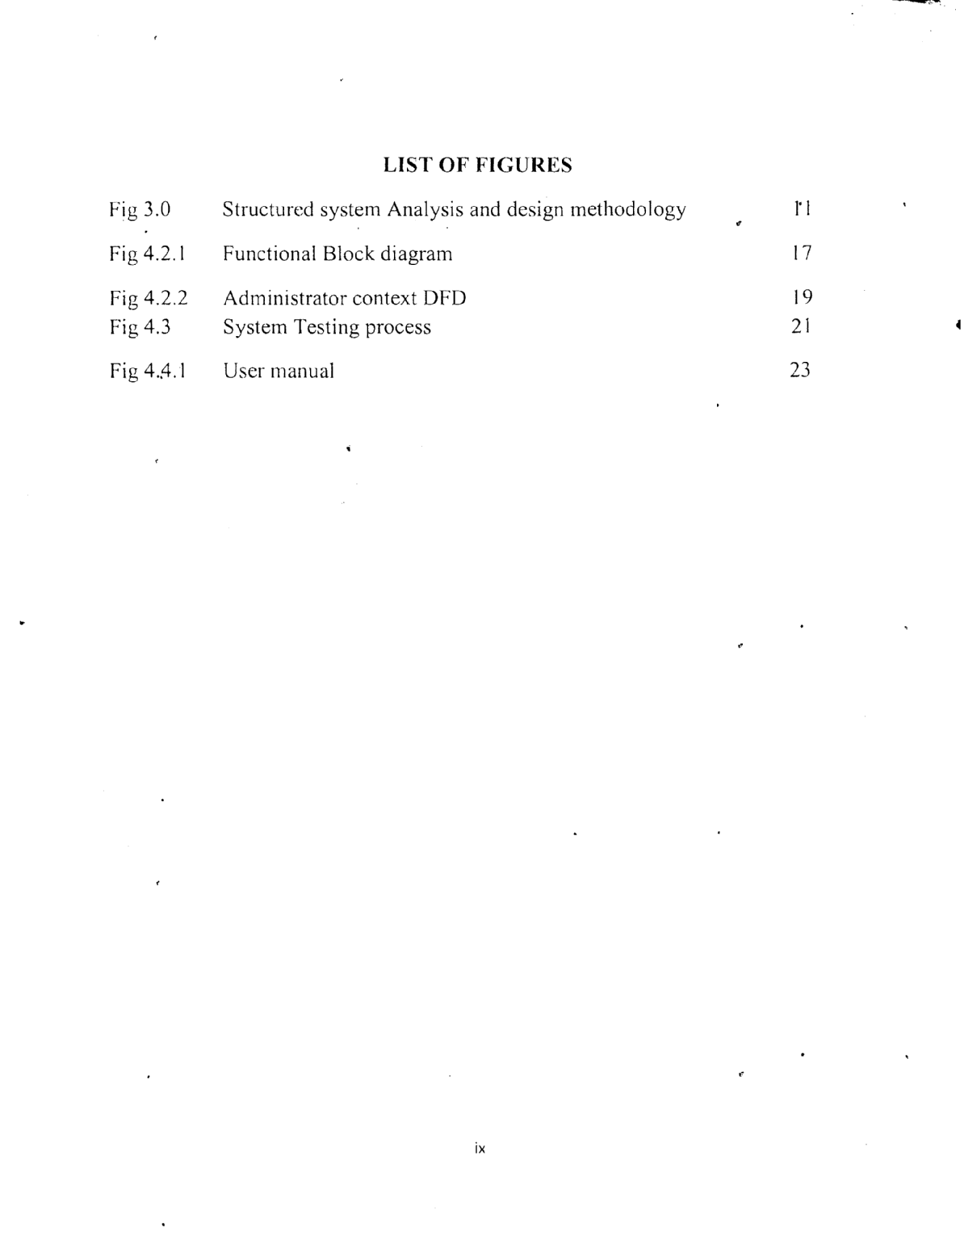
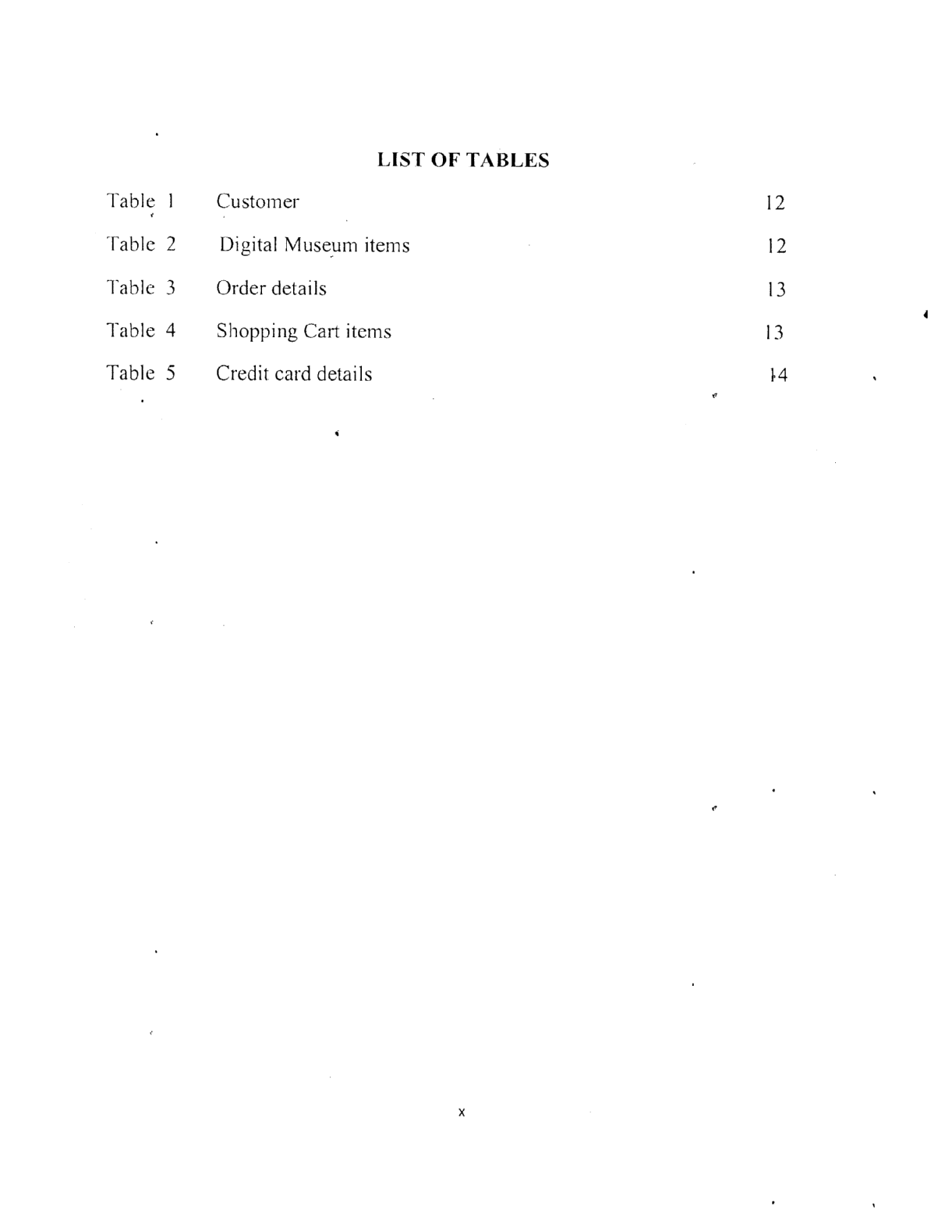
CHAPTER 1
INTRODUCTION

1.0 BACKGROUND OF THE STUDY
DiJtal museums appeared in the Internet many years ago. First digital museums have emerged since 199 1. However, despite the identity and quality of exhibitions their exhibits are comparable with traditional art museum publications albums, catalogues and hooks, vhile the Interneç can create a qualitatively new displays, where previously impossible or inconsistent methods of display historical and artistic heritage have been set up. What is the identity of the museum, in which you enter? The main feature is that here are collections, which actually stored in different museums in different countries or even on divergent continents or does not exist at all.The first definition of what a digital museum is, was simply the website of a physical museum. A concept of a museum “without walls” had, however, been introduced as early as 1953 by Mairaux, who imagined 1 being an environment for the presentation of mainly photography and art. The term Digital museum was first coined by Tsichritzis and Gibbs in their article Digital museums and digital realities referring to a museum constructed for a digital landscape and functioning as a service rather then a location.
Another early idea of the digital museum was the VR digital museum that
was a copy ol’ the physical museum in its architecture, and it generally contained 2D and 31) images of items from the museum’s collections. The digital museum later evolved to relbi to web sites of museums that contained different types of media (multimedia) to present information, such as images, text, sound etc.22 This is still partly the case, but a digital museum is today considered to hold a larger complexity then just different types of mediapresented information on a site. The digital museums have become a matter of not )ust basic information, but also of how the information is being presented to the users.

1.1 STATEMENT OF PROBLEM
• Museums are physical locations which cannot be accessed without a visit to these physical locations.
• Museums contain artifacts of cultural heritage and history which people need to have access to reinforce a sense of history and cultural identity.
• Inability of People to have access to museums hundreds of kilometers from them.
• physical museums even when they are close, are normally so fully booked That people cannot have access to them unless they book months in advance.
1.2 OBJECTIVES OF THE STUDY
This project has the following objectives
1. Make artifacts of cultural and colonial history available to all thorough the internet
and world wide web as a medium.
2. Increase historical and cultural awareness in the general populace.
3. Make remote and distant museum contents accessible to all.
4. Reduce the cost of perspiration of historical heritage by adopting online archiving and story of historical detail.
This digital museum is going to help us in our interactions with each other and one another.
People from distant countries will be able to visit the digital museum to learn more about culture of a place.

CHAPTER 2
LITERATURE REVIEW
2.0 INTRODUCTION
The system is developed using PHP, MYSQL, JavaScript and Codeigniter. The theoretical background covered the various technologies used in this system and the related work on this project.
2.1 Theoretical Background
The Technologies used in this work are listed below
i. Hypertext pre-processor (PHP)
ii. JavaScript
iii. MYSQL database
iv. Cascade Style Sheet (CSS)
PHP:PHP is a scripting language, and a tool for making dynamic and interactive Web pages. It can be embedded into the HTML (hypertext mark-up language).
JAVASCRIPT:
JavaScript is a client-side script, used to control a web page and buttons of the client. It’s also used to make webpage’s interactive. It supports event-driven, functional, and imperative programming style.
Cascade Style Sheet (CSS)
Cascading style sheets are used to format the layout of Web pages. They can be used to define text styles, table sizes, and other aspects of Web pages that previously could only be defined in a page’s HTML.
CSS helps Web developers create a uniform look across several pages of a Web site. Instead of defining the style of each table and each block of text within a page’s HTML,
commonly used styles need to be defined only once in a CSS document. Once the style is defined in cascading style sheet, it can be used by any page that references the CSS file. Plus, CSS makes it easy to change styles across several pages at once. For example, a Web developer may want to increase the default text size from lop to l2pt for fifty pages of a Web site. If the pages all reference the same style sheet, the text size only needs to be changed on the style sheet and all the pages will show the larger text.
While CSS is great for creating text styles, it is helpful for formatting other aspects of Web page layout as well. For example, CSS can be used to define the cell padding of table cells, the style, thickness, and color of a tables border, and the padding around images or other objects. CSS gives Web developers more exact control over how Web pages will look than HTML does. This is why most Web pages today incorporate cascading style sheet
Use Larger Font Sizes
The use of font size that is Readable on smaller screens, such as mobile devices. Incorporating larger font sizes in the designs, such as a minimum font size of 18 points for body text, where it makes sense. This includes any text place in header images or even the text on a homepage when using a large, hero image to make sure a web- friendly typeface that scales well is achieve
Phase Out Sidebars
Sidebars create clutter. They were meant to improve the usability of a site by displaying additional navigational elements, such as links to recent posts and popular content. While in theory sidebars containing links and other useful content that enhance the user experience, in reality, full-width content, alongside more traditional layouts that feature an accompanying sidebar.

Mobile Optimization
Mobile device usage continues to grow, especially when it comes to accessing websites. This means that it is more important to ensure your websites are mobile-friendly. So one key web design tip is to fully commit to responsive design.
Google’s Material Design
The core concepts of this is to design framework include using layers to create elegant shadows alongside the edges of elements, helping to add some much-needed style and depth to the minimal flat design trend.
MYSQL:
MySQL is a popular choice of database for use in web applications, and is a central component of the widely used LAMP open source web application software stack LAMP is an acronym for “Linux, Apache, MySQL, Perl/PHP/Python”. The MySQL Database powers the most demanding Web, E-commerce and Online Transaction Processing (OLTP) applications. It is a fully integrated transaction-safe, ACID compliant database with full commit, rollback, crash recovery and row level locking capabilities. MySQL delivers the ease of use, scalability, and performance that has made MySQL the world’s most popular open source database.
MySQL is the database construct that enables PHP and Apache to work together to access and display data in a readable format to a browser. It is a Structured Query Language server designed for heavy loads and processing of complex queries. As a relational database system, MySQL allows many different tables to be joined together for maximum efficiency and speed.

commonly used styles need to be defined only once in a CSS document. Once the style is defined in cascading style sheet, it can be used by any page that references the CSS file. Plus, CSS makes it easy to change styles across several pages at once. For example, a Web developer may want to increase the default text size from lOpt to l2pt for fifty pages of a Web site. If the pages all reference the same style sheet, the text size only needs to be changed on the style sheet and all the pages will show the larger text.
While CSS is great for creating text styles, it is helpful for formatting other aspects of Web page layout as well. For example, CSS can be used to define the cell padding of table cells, the style, thickness, and color of a table’s border, and the padding around images or other objects. CSS gives Web developers more exact control over how Web pages will look than HTML does. This is why most Web pages today incorporate cascading style sheet
Use Larger Font Sizes
The use of font size that is Readable on smaller screens, such as mobile devices.incorporating larger font sizes in the designs, such as a minimum font size of 1 points for body text, where it makes sense. This includes any text place in header images or even the text on a homepage when using a large, hero image to make sure a web- friendly typefacethat scales well is achieve
Phase Out Sidebars
Sidebars create clutter. They were meant to improve the usability of a site by displaying additional navigational elements, such as links to recent posts and popular content.While in theory sidebars containing. links and other useful content that enhance the user experience, in reality, full-width content, alongside more traditional layouts that feature an accompanying sidebar.

2.2 Review 01 Relevant Literature
There is only little research available on how museums use the World Wide Web[1]. Some examples are the reports of Lynne Teather (2014) and Christopher Dolgos (2013) for the North America and of GemotWersig and Petra Schuck-Wersig (201 1) for
Germany[2j.
Teather (2009) distinguishes three types of museums on Web pages, refernng to a MA research paper of Maria Piacente, one of her museum studies students[3]. Piacente has set up a typology based on an evaluation of existing museum Web pages[4]. According to Piacente the types are: “Electronic Brochure”, “The Museum in the Digital World”, and
“The True Interactives”. The “Electronic Brochure” is “essentially an advertising sheet format like the brochure or handout used at sites or to get visitors to come to the sites” (Teather 2014, p. 27)[5]. The second category is “The Museum in the Digital World” and means that “the actual museum was projected onto the web by means of maps, floorplans, images, online collections or exhibits, both real anddigital[6]. Here, the real- life museum is recreated online.” (p. 27)[7]. The types can vary considerably, some museums use the Web as an archive for former exhibitions, others establish searchable databases for collections information access (p. 28)[8]. The third type are “The True Interactives” where “the pages may have some relation to real museum [sic!] but they also add or reinvent the museum and even invite the audience to do so” (p. 28)[9]. Whereas Piacente suggests three types of Web museums[10], Dolgos (2013, p. 30 distinguishs between two types of museum Web pages[1 1]. The first type is the online brochure which provides information about the museum, opening hours, collections and sometimes floor plans[12].
The second type is a Web museum that brings up a selection of the physical museum on the Web and “relies on providing information about a topic as it related to the institution’s mission, whether it be a science-based exploration[13], and art history lesson, or a ‘digitaF exhibit” (Dolgos 2015, p. 3f)[14].
The findings of Dolgos and Teather respectively Piacente correspond roughly with the findings of an explorative study by Wersig and Schuck-Wersig (2011, WWW)[15]. This study classifies museum Web pages in four categories: a minimal Web presence which consists ofname{16j, address and opening hours of the museum as basic information only; a basic Web presence which includes the basic information and a short description of the museum and its collections[17]; a basic Web presence with additional information that adds information on permanent and special exhibitions to the basic information; and finally an extended Web presence with a home page of its own that contains information on the museum’s organization and collections including marketing and interactive[18].
These classifications describe how museums use the Web at the moment[19]. They indicate that currently the use of Web pages is more focused on the use for advertising and marketing purposes than on educational purposes[20].
2.3 Summary
Museums are changing to institutions involved in lifelong learning, using information technology to reach out to the public. Currently there are problems like financial limitations (e.g. for collection management systems and digitization), technical restrictions (e.g. bandwidth and image resolution) and concerns about intellectual property rights. As soon as these problems are solved museum will be able to open up their digitized collections to the public and start educational projects that will provide value-added cultural information for lifelong learning.

CHAPTER THREE
SYSTEM ANALYSIS AND DESIGN

3.0 INTRODUCTION
Methodology inbolves a process whereby the existing or current system is studied to identify the information requirements. It is used to refer to a specific series of steps or rocedures which governs a particular project. I t also includes the techniques and methods which are used to collect and analyze information. To achieve all these stated above, an internationally accepted software engineering model was used which is structured system.
Analysis and Design methodology (SSADM) is a system approach to the analysis and design of information systems.
SSADM method involves the application of a sequence of analysis documentation and design tasks conceded with analysis of the current system, logical data design, logical process design etc.

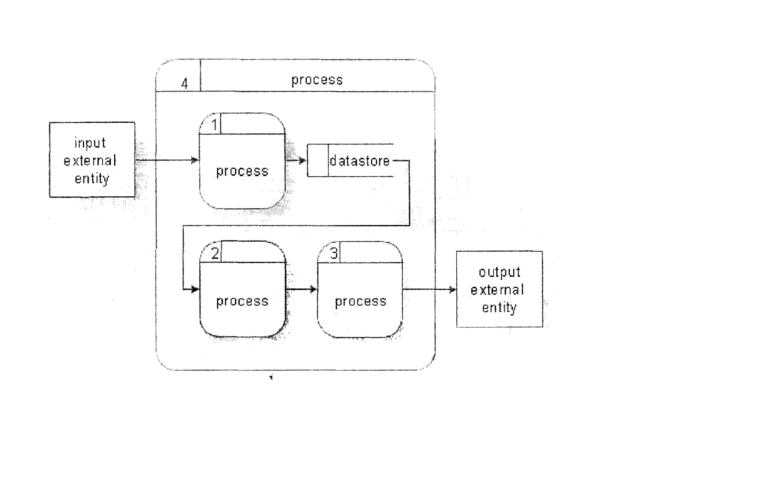
3.1 DESCRIPTION OF THE EXISTING SYSTEM
The existing system in a physical museum one have to travel or transport to the location of the museum in other for he or she to access the museum, during the visit on can book for accommodation of where he or she will stay. In the existing system one have to be physical present to make payment in other to view the museum after the payment one is allow into the museum.
3.2ANALYSIS OF THE PROPOSED SYSTEM
The new system is digital Museum that can be accessed from anywhere at any time at ones convenient. In this type of Museum one doesn’t need not to travel from his or her location in other to access the museum because it’s cost effective compared to the existing system , customer / user can make payment online at their pace without stress. A customer could request a quote or request a post buy in case a particular item is not available in the Museum at the moment. Here the customers/users have to register in order to access the paid platform of the museum and need approval by the admin before they can login into their panel to access the Museum items. The customer manages their Profile through their interface.
The administrator controls and manages the different users / Customers, verifies them before allowing them to access the website thereby giving the Customer a sense of security. :&i.so the administrator can create sub-aditih ahd assign privileges to them.
The administrator controls the entire site and can block a user! customer that defaulted to the rule of the system or suspected of any irregularities.

3.3 DESIGN OF THE PROPOSED SYSTEM
Database Design
In this section, the basic structure of the tables composing the database for the project are shown along with information about primary and foreign keys.
Customer

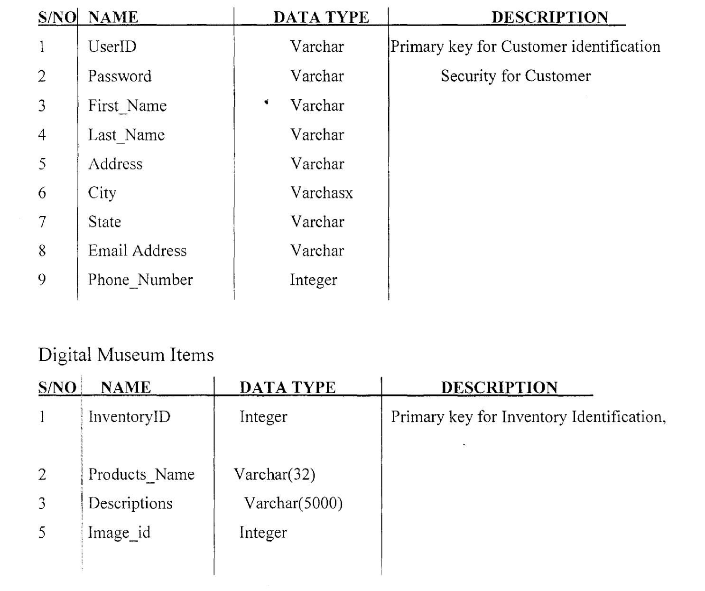

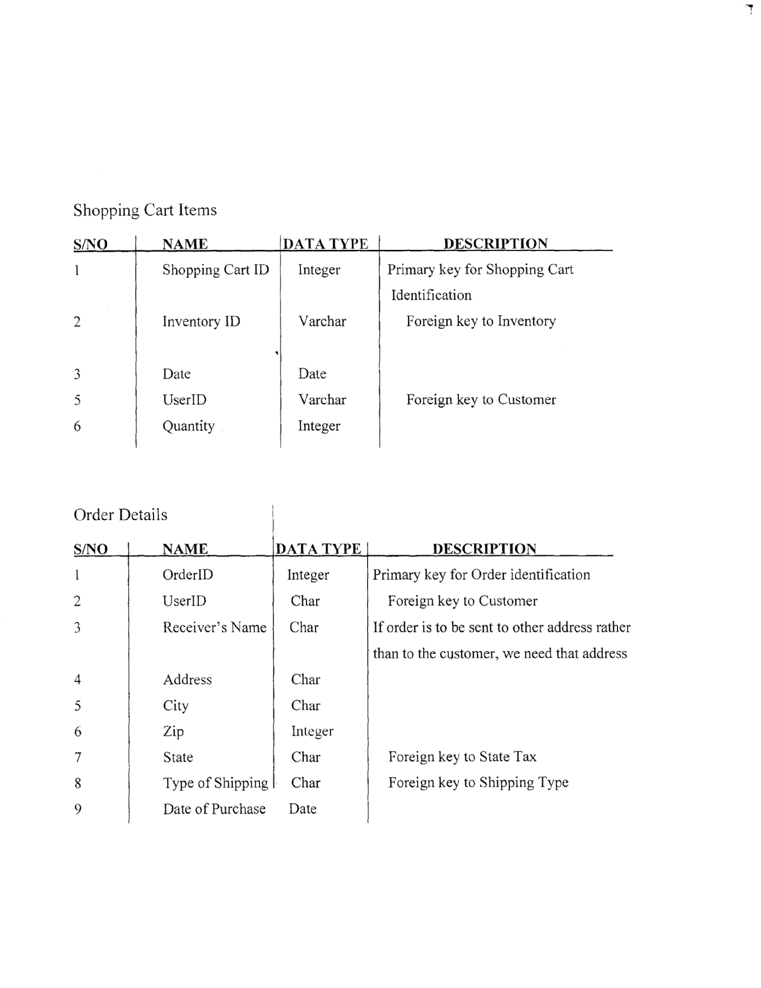
Credit Card Details
S/NO NAME DATA TYPE DESCRIPTION
1 Credit Username Varchar Primary key for Customer Identification
2 Credit Card Varchar Number
3 Card Type Varchar Master Card, Visa, Discover
4 CVV Number Integer Number present on the back of the card for extra security
5 Expiry Date Date
6 UseriD Varchar Foreign key to Customer

CHAPTER 4
SYSTEM IMPLEMENTATION
4.0 INTRODUCTION
System implementation is a collection of inter-dependent physical devices together with their programming which provides the functionality and performance for which the system was designed. It covers all the activities necessary to set the system that has been analyzed and designed to be fully functional to the users.
4.1 Choice of Development Environment
The development tools are the necessary requirement tools used during the design to enable us achieve the system design. The listed packages were used because of their features, accessibility and also because it is more effective.
1. MySQL database application
2. PHP scripting Language
3. HTML language and JavaScript
4. Notepad plus
5. Code Igniter
MySQL Database Server: MySQL is a popular choice of database for use in web applications, and is a central component of the widely used LAMP open source web application software stack—LAMP is an acronym for “Linux, Apache, MySQL, Perl/PHP/PythonIJSP”. The MySQL Database powers the most demanding Web, Ecommerce and Online Transaction Processing (OLTP) applications. It is a fully integrated transaction-safe, ACID compliant database with full commit, rollback, crash recovery and row level locking capabilities. MySQL delivers the ease of use, scalability, and performance that has made MySQL the world’s most popular open source database.

PHP: PHP is a server-side scripting language that allows your Web site to be truly dynamic. PHP stands for PHP: Hypertext Preprocessor Its flexibility and relatively small learning curve (especially for programmers who have a background in C, Java, or Perl) makes it one of the most popular scripting languages around. PHP’s popularity continues to increase as businesses, and individuals everywhere embrace it as an alternative to Microsoft’s ASP language and realize that PHP’s benefits most certainly outweigh the costs.
HTML Language:
Hypertext Mark-up Language (HTML), the standard text-formatting language for documents on the interconnected computing network known as the World Wide Web. HTML documents are text files that contain two parts: content that is meant to be rendered on a computer screen; and mark-upor tags, encoded information that directs the text format on the screen and is generally hidden from the user.
JavaScript is a programming language that adds interactivity to your website for example: games, responses when buttons are pressed or data entered in forms, dynamic styling, animation etc.

4.2 IMPLEMENTATION ARCHITECTURE
Block diagram
Functional Decomposition Diagram
A decomposition diagram shows a top-down functional decomposition of a system and exposes the system’s structure. The objective of the Functional Decomposition is to break down a system step by step, beginning with the main function of a system and continuing with the interim levels down to the level of elementary functions The diagram is the starting point for more detailed process diagrams, such as data flow diagrams (DFD). Figure 2 shows the Functional Decomposition Diagram for this project.
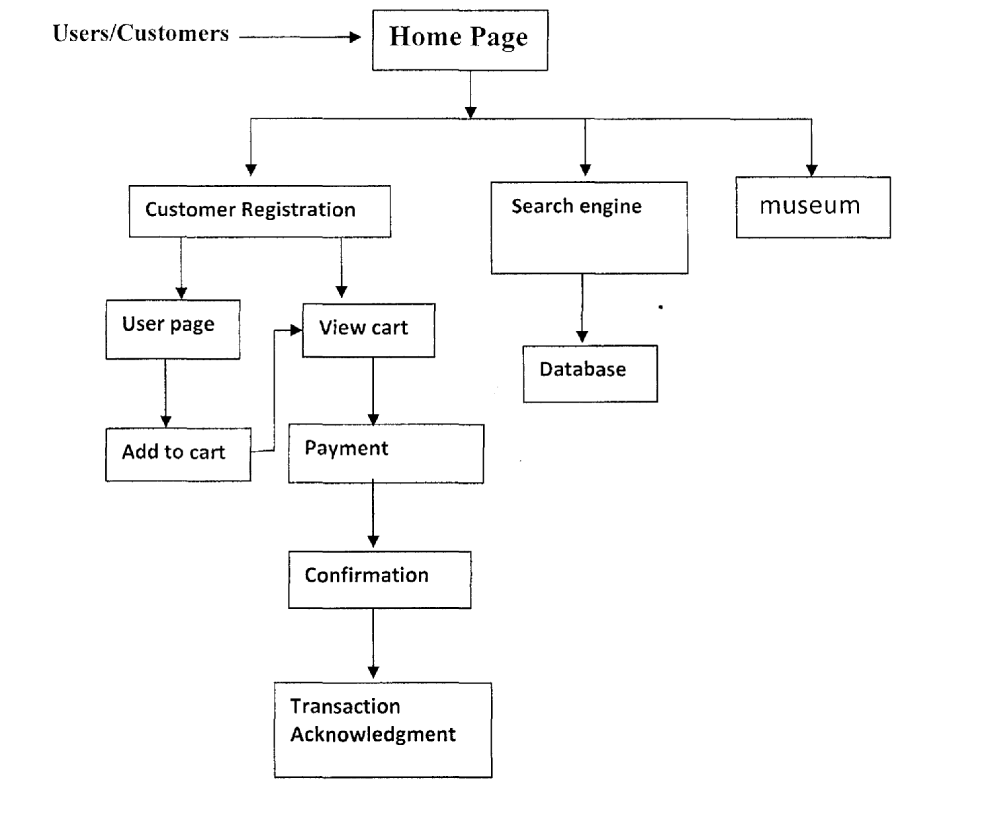

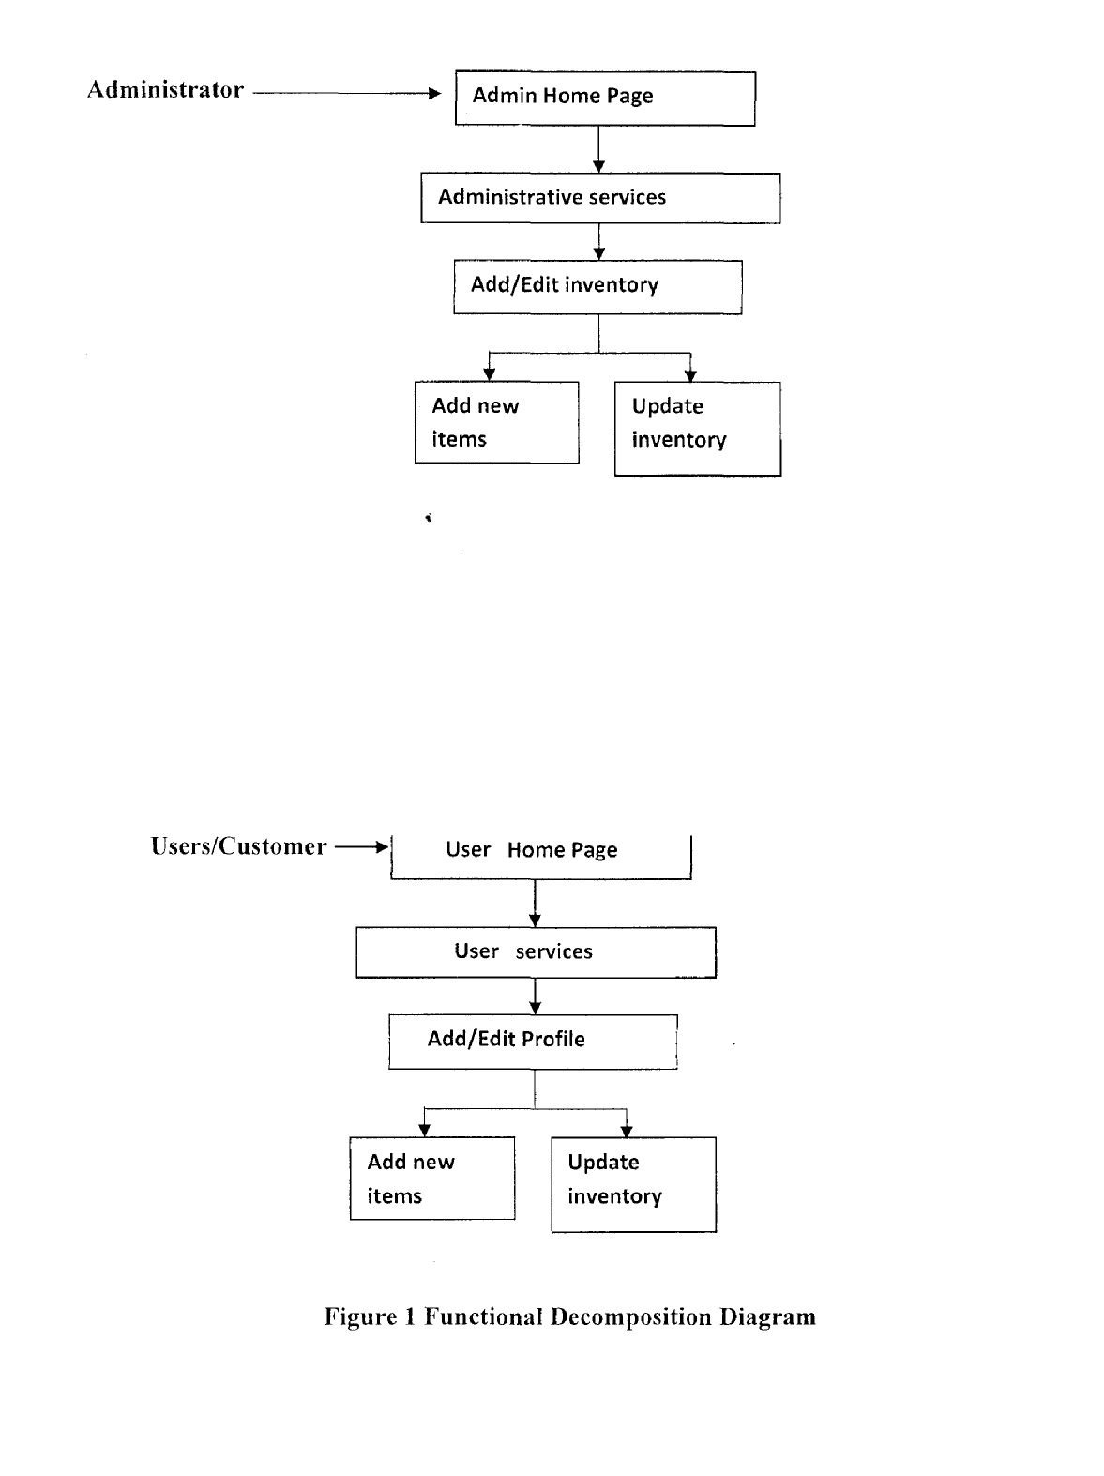
Data Flow Diagram (DFD)
Data Flow Diagrams show the flow of data from external entities into the system, and from one process to another within the system. There are four symbols for drawing a DFD:
1. Rectangles representing external entities, which are sources or destinations of data.
2. Ellipses representing processes, which take data as input, validate and process it and output it.
3. Arrows representing the data flows, which can either, be electronic data or physical items.
4. Open-ended rectangles or a Disk symbol representing data stores, including electronic stores such as databases or XML files and physical stores such as filing cabinets or stacks of paper.
Figures 1- 2 are the Data Flow Diagrams for the current system. Each process within the system is first shown as a Context Level DFD and later as a Detailed DFD. The Context Level DFD provides a conceptual view of the process ad its surrounding input, output and data stores. The Detailed DFD provides a more detailed and comprehensive view of the interaction among the sub -processes within the system.

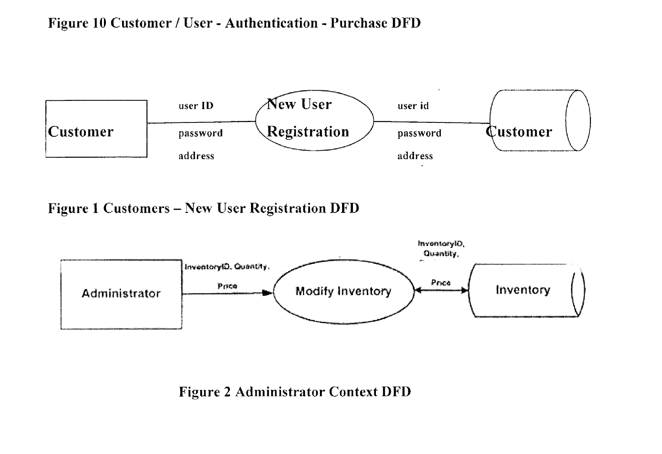
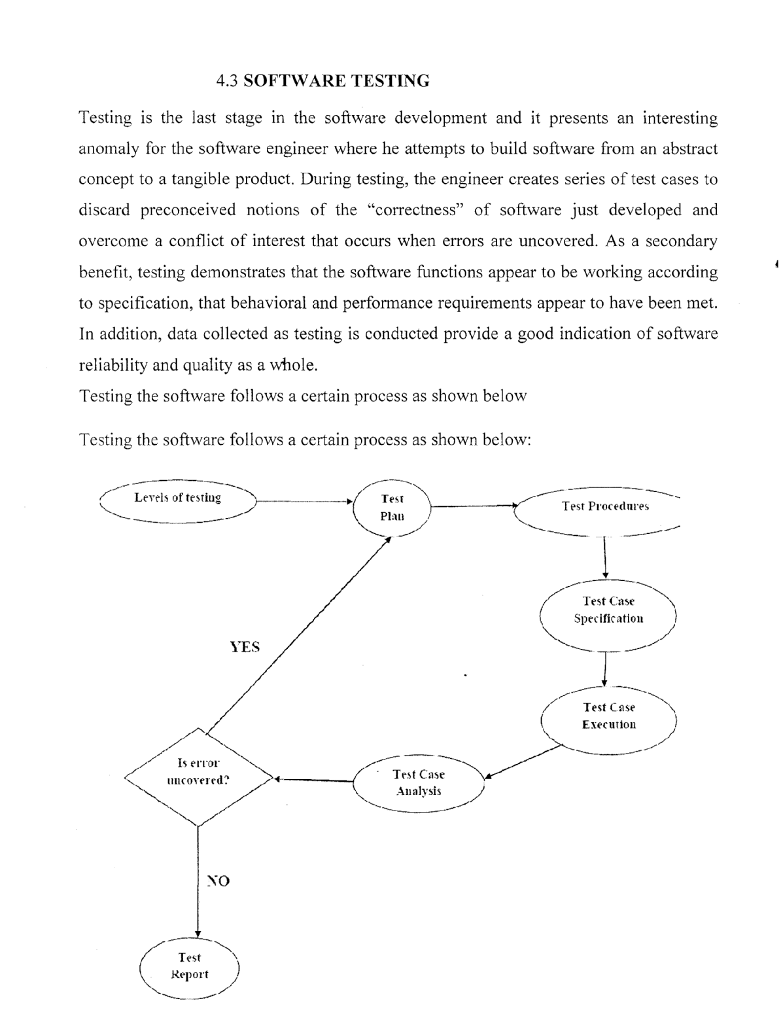
Fig 4.3 System Testing Process
Unit Test
Each unit of the new system was tested (test run) individually alongside with the old system in other to identify areas of further enhancement and development.
System Test
The entire system was as well tested (test run) in general alongside with the old system in other to identifi areas of further enhancement and development.
4.4 Documentation
Since the program is made of mark-up tags i.e. mark-up languages, the following steps must be adhered to before the program can run:
i. Boot the computer and make sure that Windows Operating System is installed in the system
ii. Click on the wampserver icon on the desktop.
iii. Click on wampserver tray on the task bar and select www root directory
iv. Upload your web files into the directory
v. Open any browser on your system (Microsoft internet Explorer, Mozilla Firefox, Netscape Navigator, Opera, Flock, Safari etc.)
vi. Type http://127.O.O.1/digitalmuseums on the address bar and press the return key or enter key.

vii. Then the website will come up
4.4.1 User Manual
The steps to use the proposed system are as follows:
i. On the address bar of any browser type http://127.O.O.1/digitalmuseums
ii. After which you can view the museum
iii .To view the paid platform of the digital museums the user have to register and make payment online
iv. After which the user can view the digital museum and adding to the cart at checkout.

CHAPTER FIVE SUMMARY, CONCLUSION AND RECOMMENDATION
5.1 SUMMARY
Every organization has one thing in mind; have we fared well without a website so far, why would we need one now? The answer is simple, for advertising and wider broadcasting of information. Advertising is the chief success tool of every organization; your target audience needs to know that you are out there.
A website has become an effective tool of running obtaining information. Internet today is used 24/7 and is accessible from anybody anywhere. People these days depend on the internet for everything, including pin or paper. Today you can obtain anything just by the click of a mouse button.
The question is, are you willing to foot the bills of obtaining one for your organization? The answer will take you a long way, if yes then you are ready to operate globally. With a website for your organization, members all over the world can effectively communicate together at a low cost. Newsletter can also be periodically posted on their e-mail box to remind them of an important date or event.
Also a news section will go a long way in keeping members abreast of recent happenings within and outside the organization.
Finally web development is expanding and changing in style, requiring the webmaster to periodically update.
5.2 CONCLUSION
Based on the result of the survey, it is pertinent to make the following conclusions.
1. Far more cheaper than print Advertising
The internet is extremely different from print advertising in that space is cheap, your advertisement is accessible for a longer period of time, the content can be changed

without having to ask someone to do it for you (if you use a content management system), you can reach a wider audience.
2. 24 Hours a Day, 7 Days a Week, 365 days a Year
The information included in the site will be available anytime, anyplace. No power failure, no hook. The internet is there to serve you every time. Even on public holidays or any other day of obligation, the internet is there to serve. No transmission failure.
Growth/Opportunity 4
Internet can help the organization to grow stronger and increase its members faster; also
opportunities provided by organizations can be savoured by the intended audience.
5.3 RECOMMENDATIONS
In order to remedy problems encountered in server-side scripting, web masters should incorporate server-side scripting technologies such as PHP Hypertext Preprocessor (PHP), Active Server Pages (ASP.NET). This new innovation would help create login controls, member’s portal where members and officials can create and modify their account.
However, this log in controls and student portals would enable online registration for both students and staff; thereby eliminating the rigors of manual or paper registration. Search Engine Optimization (SEO) should be employed in Webpages. With Search Engine Optimization (SEO), keywords or digitally every word could be searched or accessed or sought after in the Webpages. For instance webmasters should incorporate access to search engines such as Google, Yahoo, Mama, and MSN etc. Webmasters should learn to control a page with CSS (Cascading Style Sheet) as it is the ultimate styling sheet and occupies less space.

References
[1] Ballas, J. A. (2014). Delivery of Information through Sound. Belmont, Califonia:
Thomson Wadsworth.
[2] Britton, D. R., & Arthur, A. R. (2015). Discovering Usability Improvements for Mosaic: Application of the Contextual Inquiry Technique with an Expert User. Boston:
Pearson Allyn & Bacon.
[3] Bronette, A. A., & Sarah, W. C. (2013). Usability Expertise Centre, Digital Equipment Corp. Listening to Users about Internet Browsers: A Usability Study. New York: Prentice Hall.
[4] Cannon-Brookes, P. (2010). The Nature of Museum Collections: Manual of Curatorship, (2nd Ed.). London: Butterworth Press.
[5] FaIk, J., Dierking, H., & Lynn, D. (2013). The Museum Experience. Washington, D.C: Whalesback Books.
[6] James, S. (2015).Museum WebPage Survey Results. Internet URLhttp ://www. chass . utoronto .ca/sj ames/museum/survey. htm.
[7] Jerry, H. A. (2011). Benefits and Barriers: People with Disabilities and the National Information Infrastructure. Boston: Little, Brown and Company.
[8] Kramer, G. E. (2014). An Introduction to Auditory Display. Boston: Pearson Allyn & Bacon.
[9] MacDonald, G., & Aisford, S. (2012). Toward the Mew-Museum: The Wired Museum. London: Emerging Technology and Changing Paradigms.
[10] O’Connell, J. F., & Perkins, G. M. (2013). Microsoft Windows Guidelines for Accessible Software Design. White Paper, 76(3), 499-514.
[11] Pearce, S. M. (2010). Thinking about Things: Approaches to the Study of Artefacts. Museum Journal, Vol 2, Pg 23-24.
[12] Rivanus, 0. 0. (2011). Review of Usability Study Information Collected at
1999 CSUN. Boston: Pearson Allyn & Bacon.
[13] Shumila, D. S. (2009). Suggested Blind Access Features. Wilmington, M.A:
Great Source Education Group.
[14] Stam, D. C. (2017). Spiders across the Stars, A Web-based Model for Providing Access to Multi-institutional Museum Information. Archives and Museum Inform attics, p-p-2, 3.
[15] Campbell, D.J. (2014) Task complexity: A review and analysis. Academy of Management Review, 13(1), 40—52.
[16] Jump up to:a b C Falk, Louis K.; Sockel, Hy; Chen, Kuanchin. (2015) “Ecommerce and Consumer’s Expectations: What Makes a Website Work.” Journal of Website Promotion, 1(1) (65—75)
[17] Ram L. Kumar et al., “User interface features influencing overall ease of use and personalization”, Information & Management 41(2014): 289—302
[18] Steve Elliot and Sue Fowell, “Expectations versus reality: a snapshot of consumer experiences with Internet retailing”, International Journal of Information Management
20 (2010): 323—336

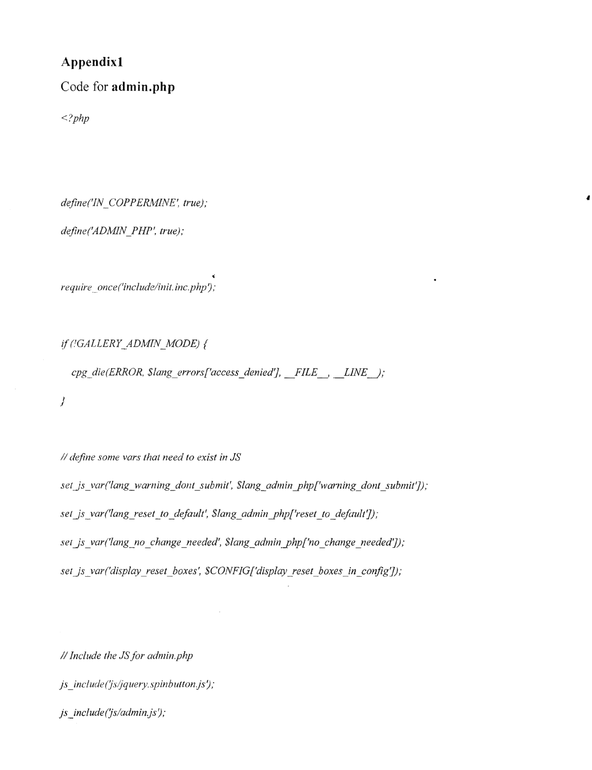
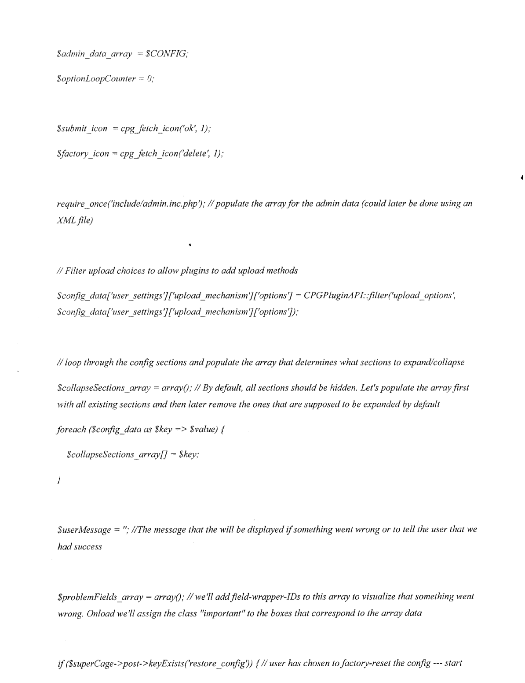
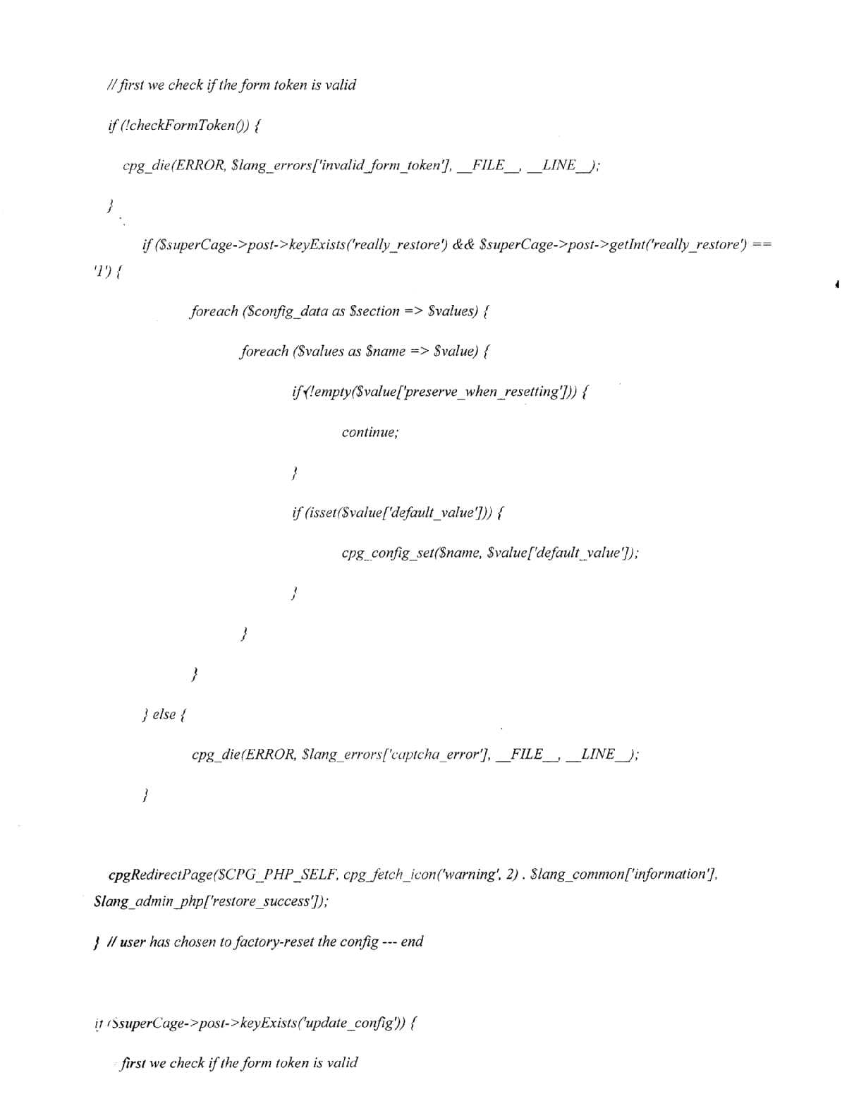
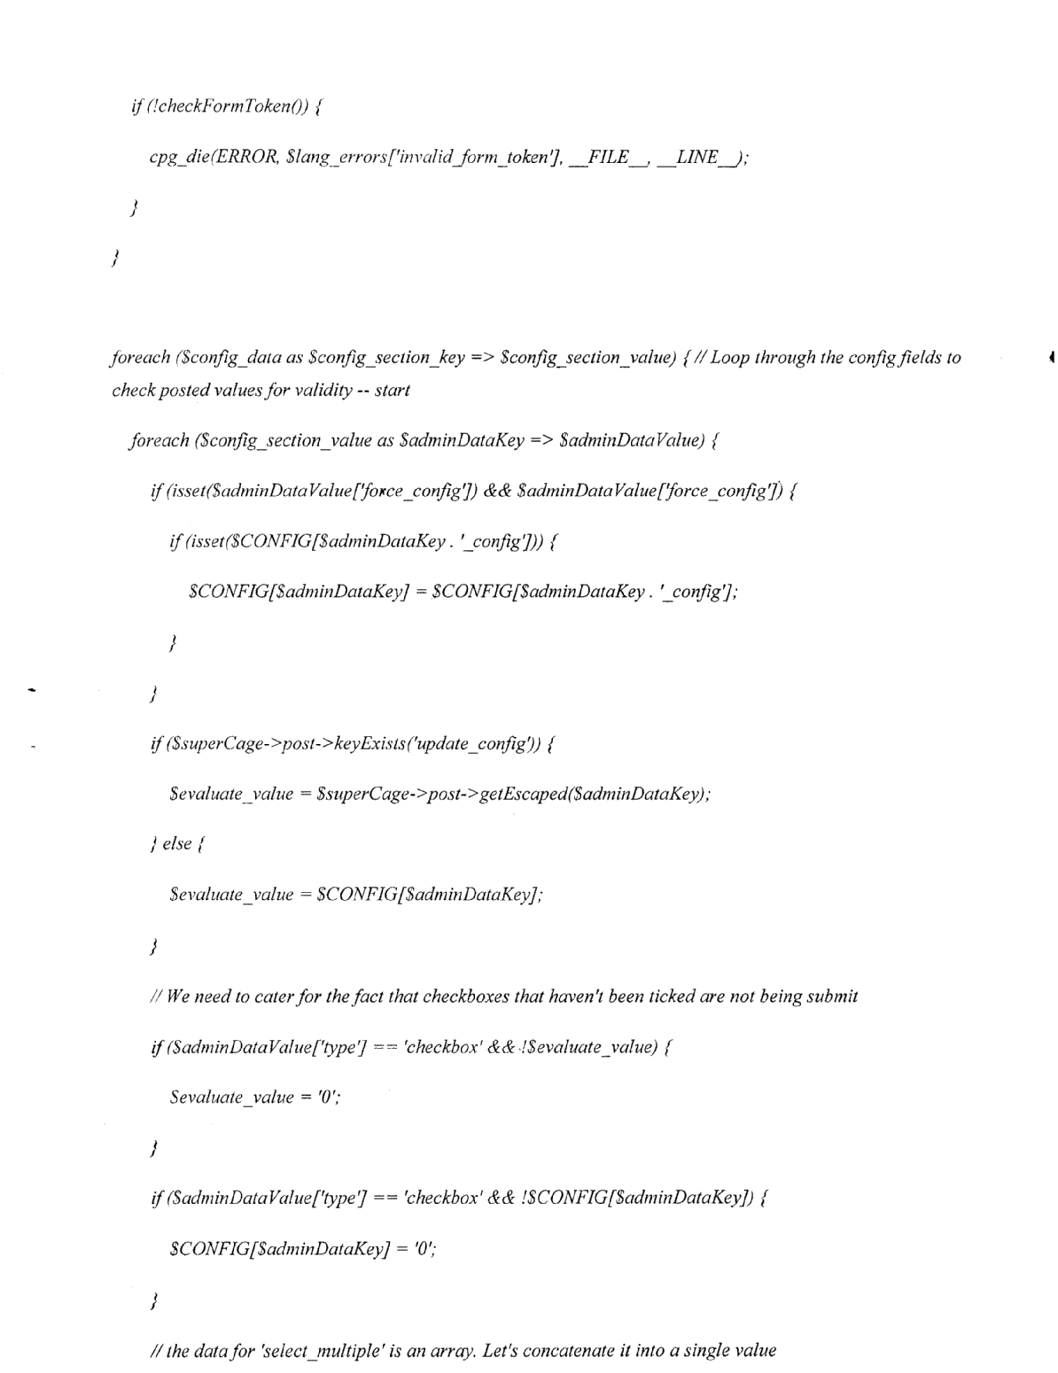
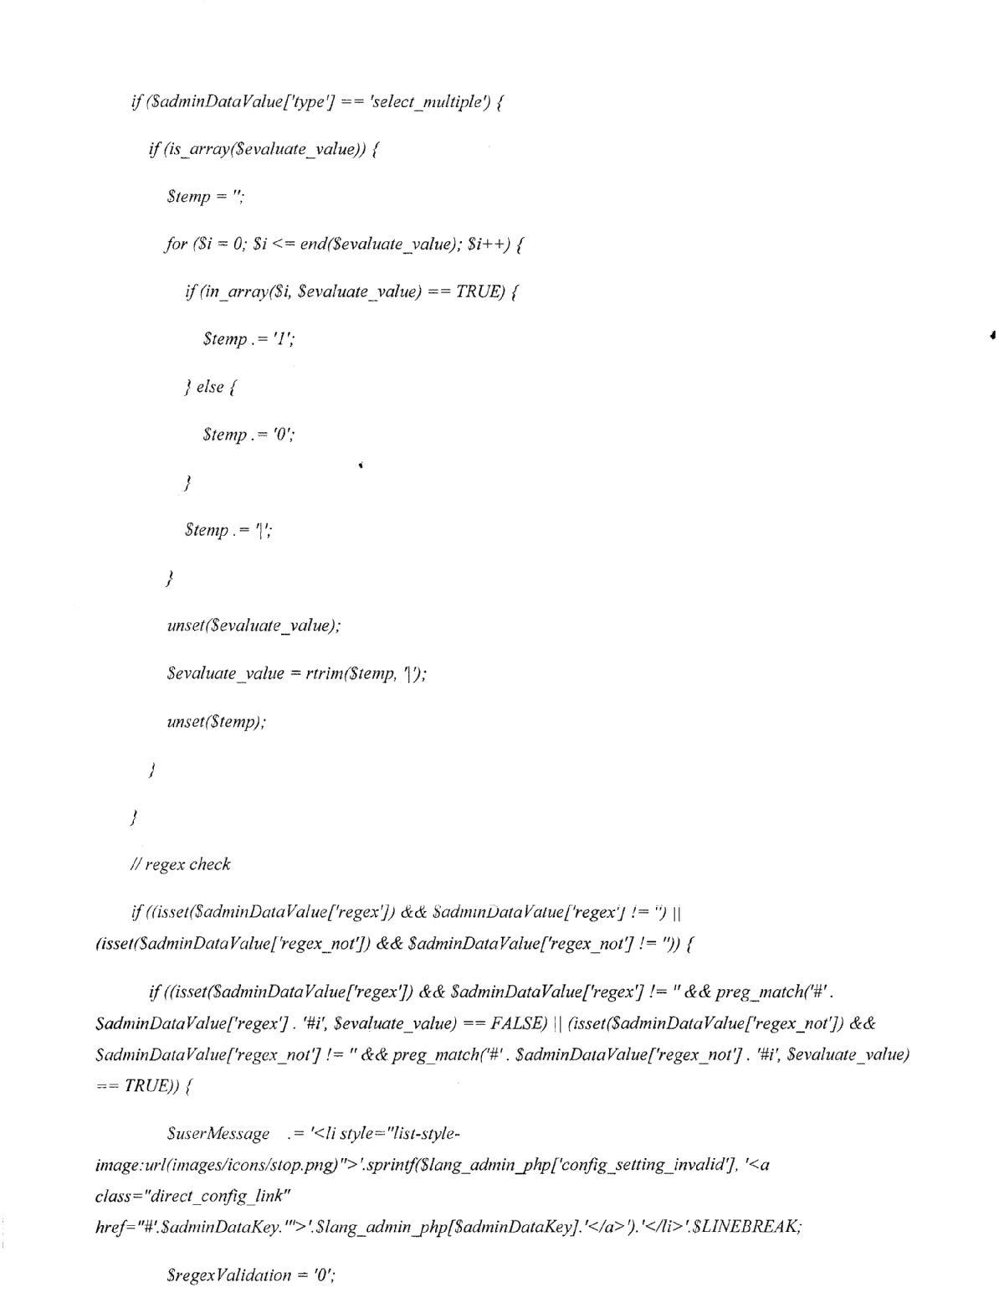
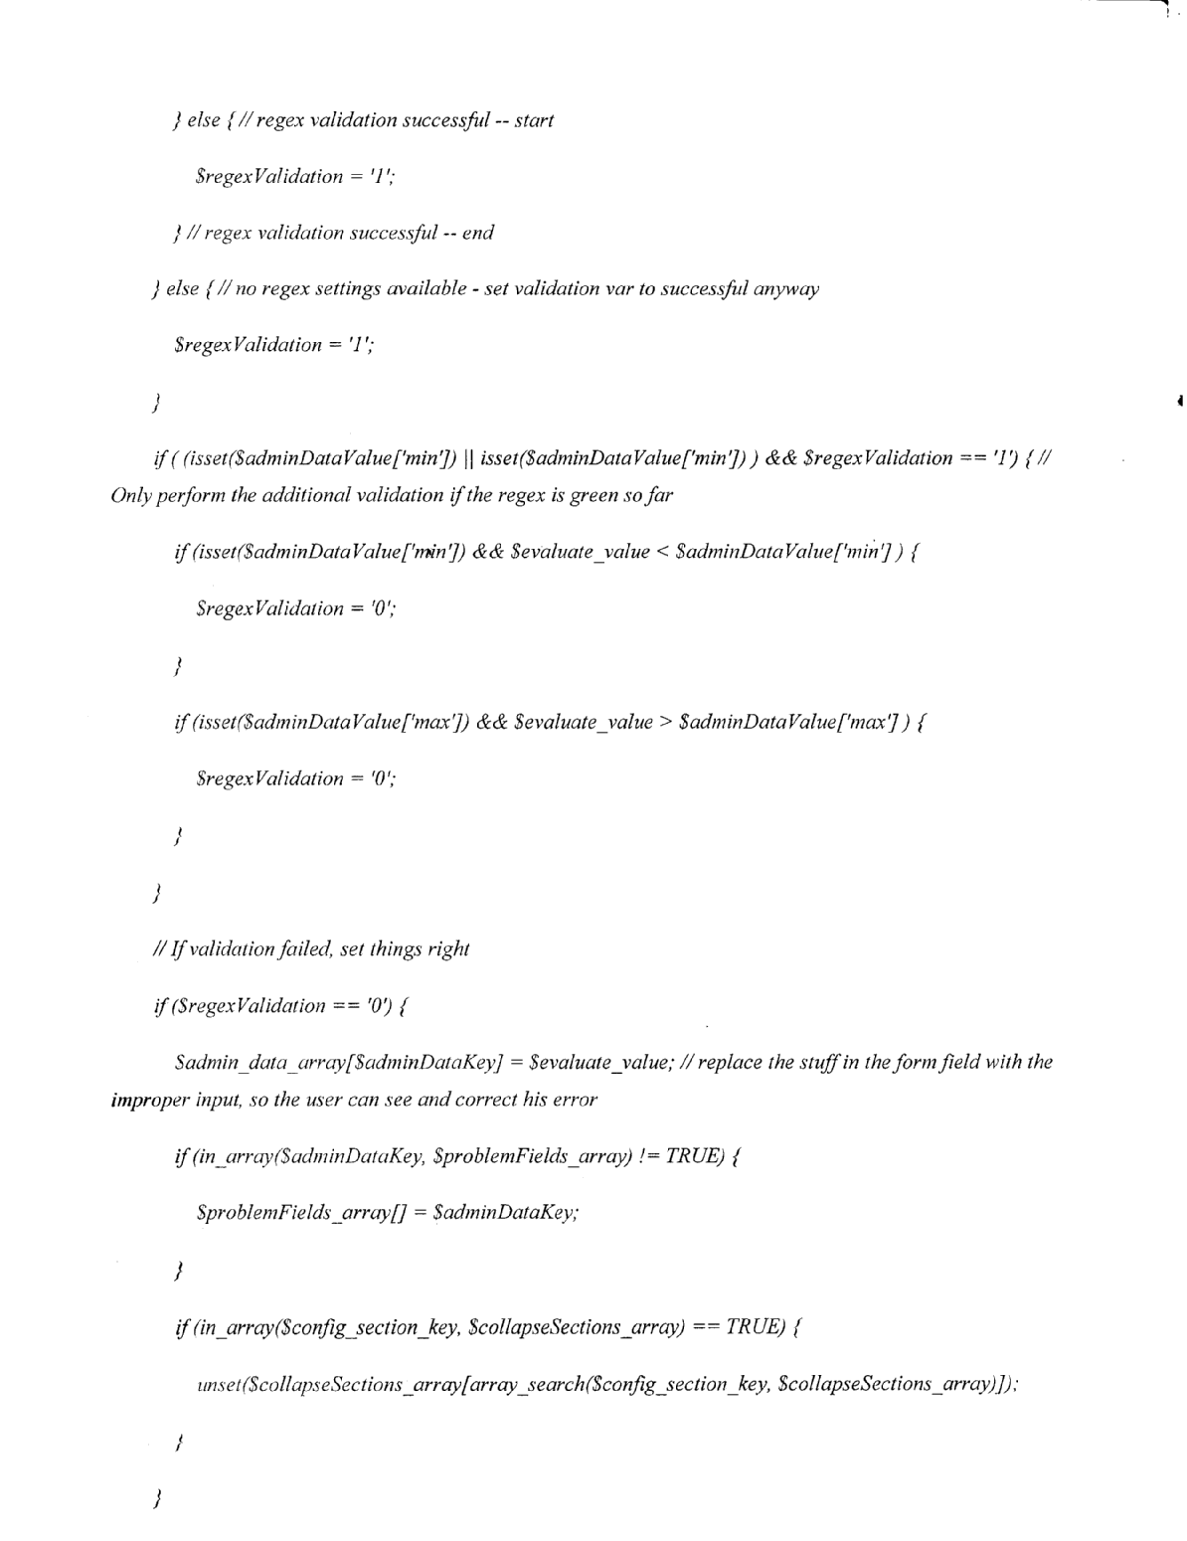
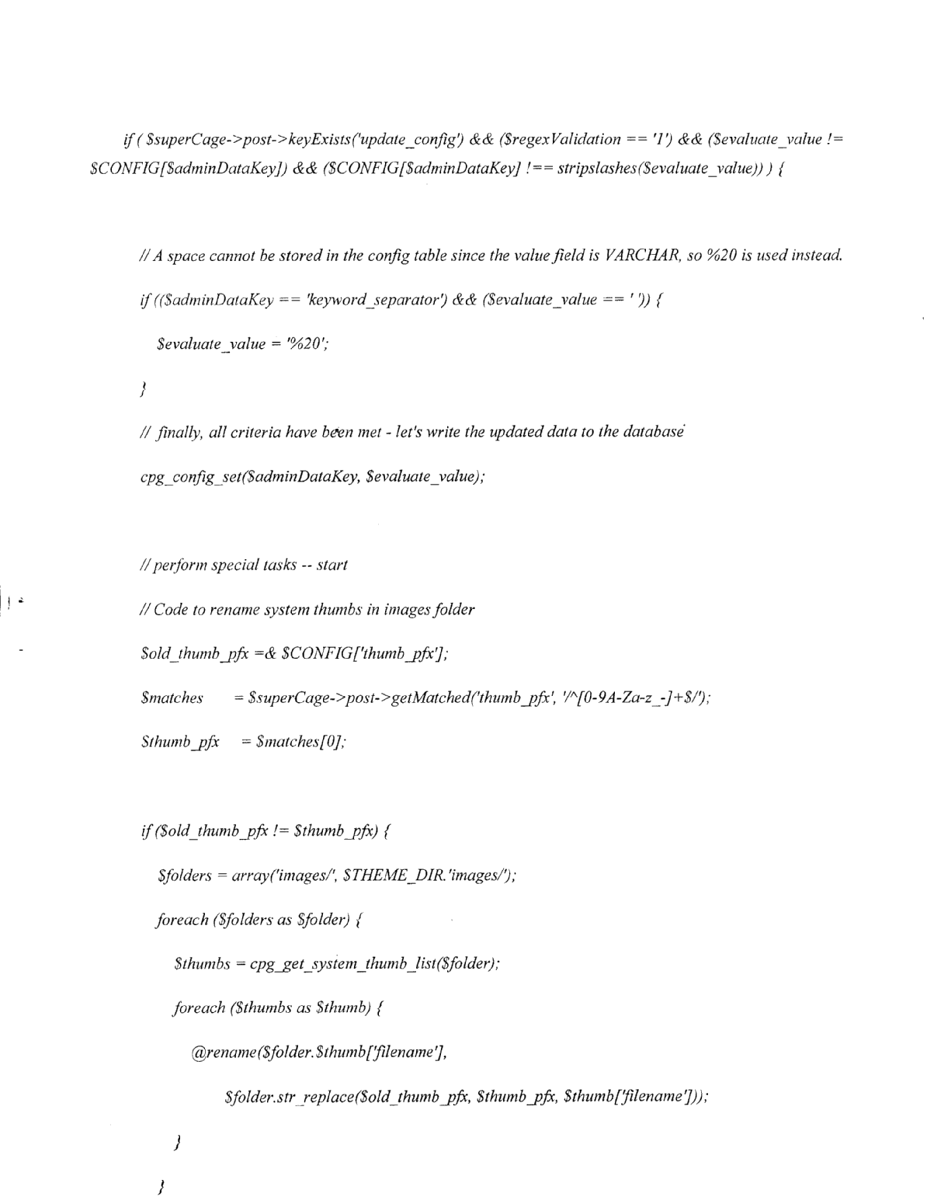
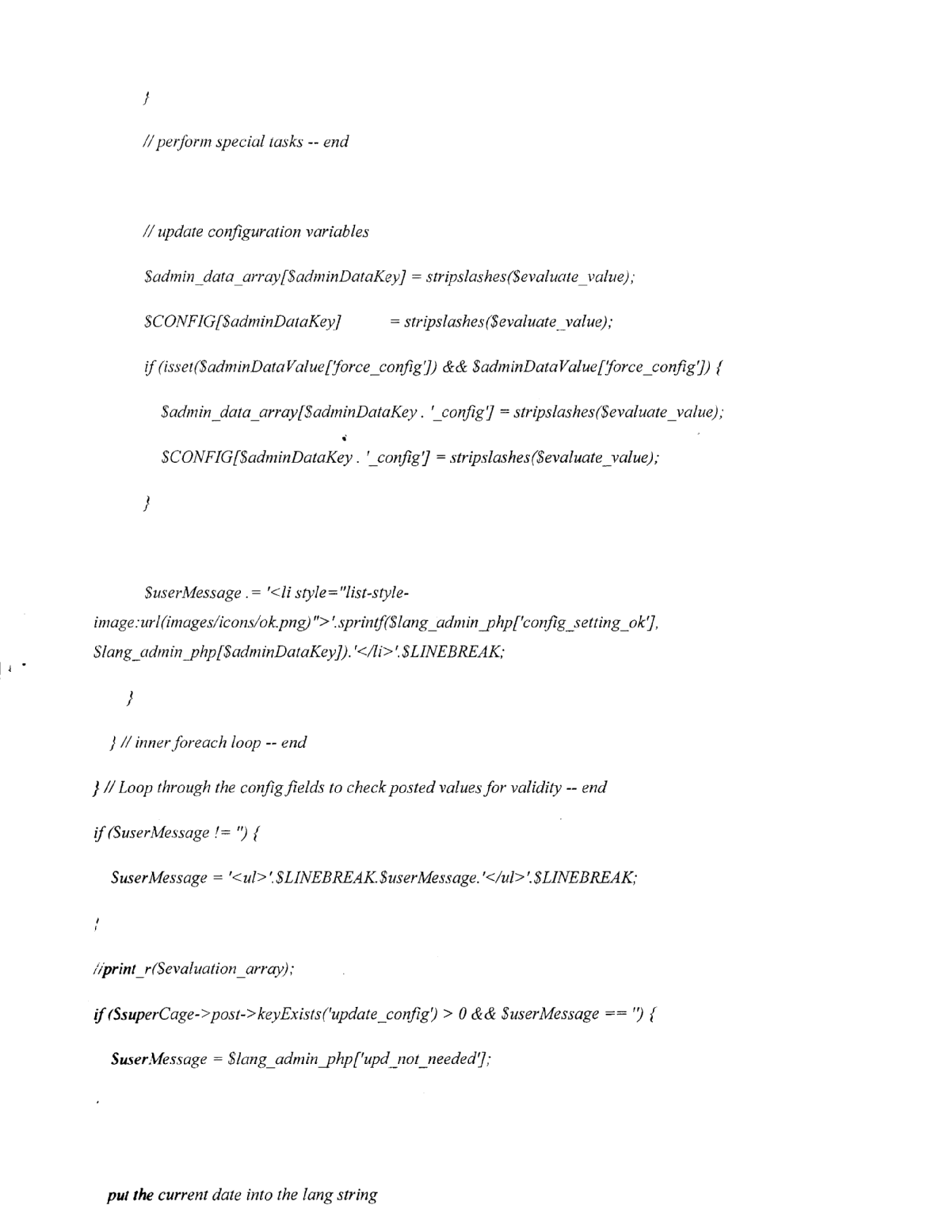
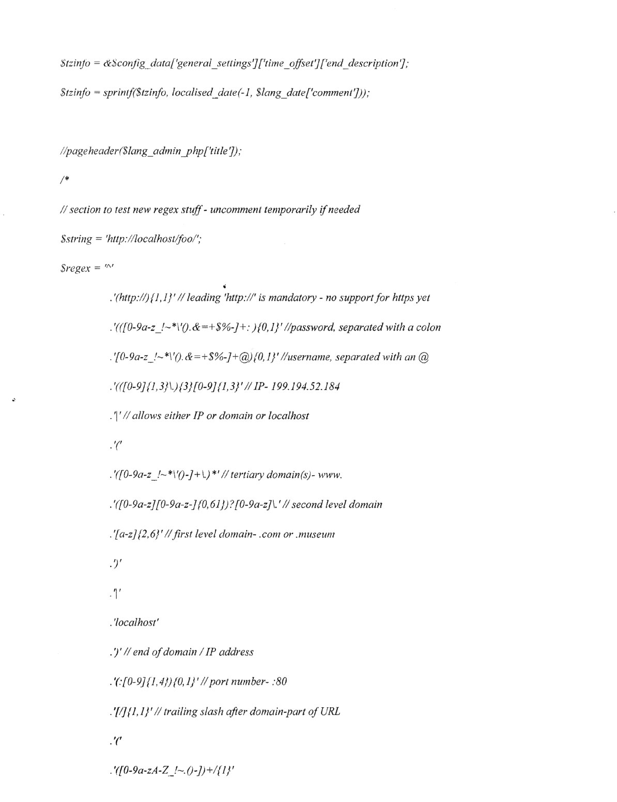
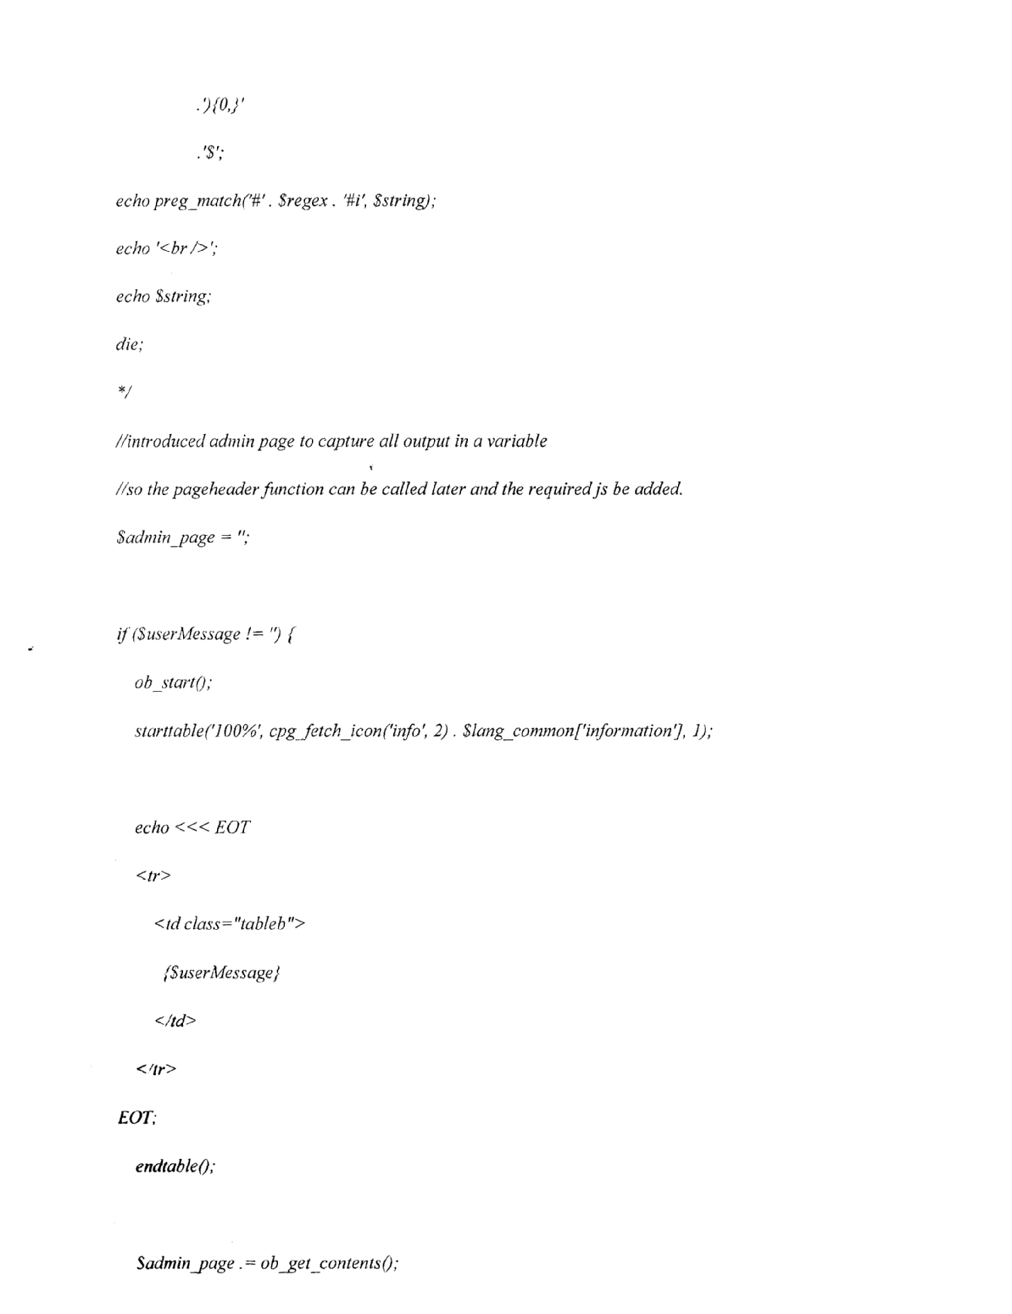
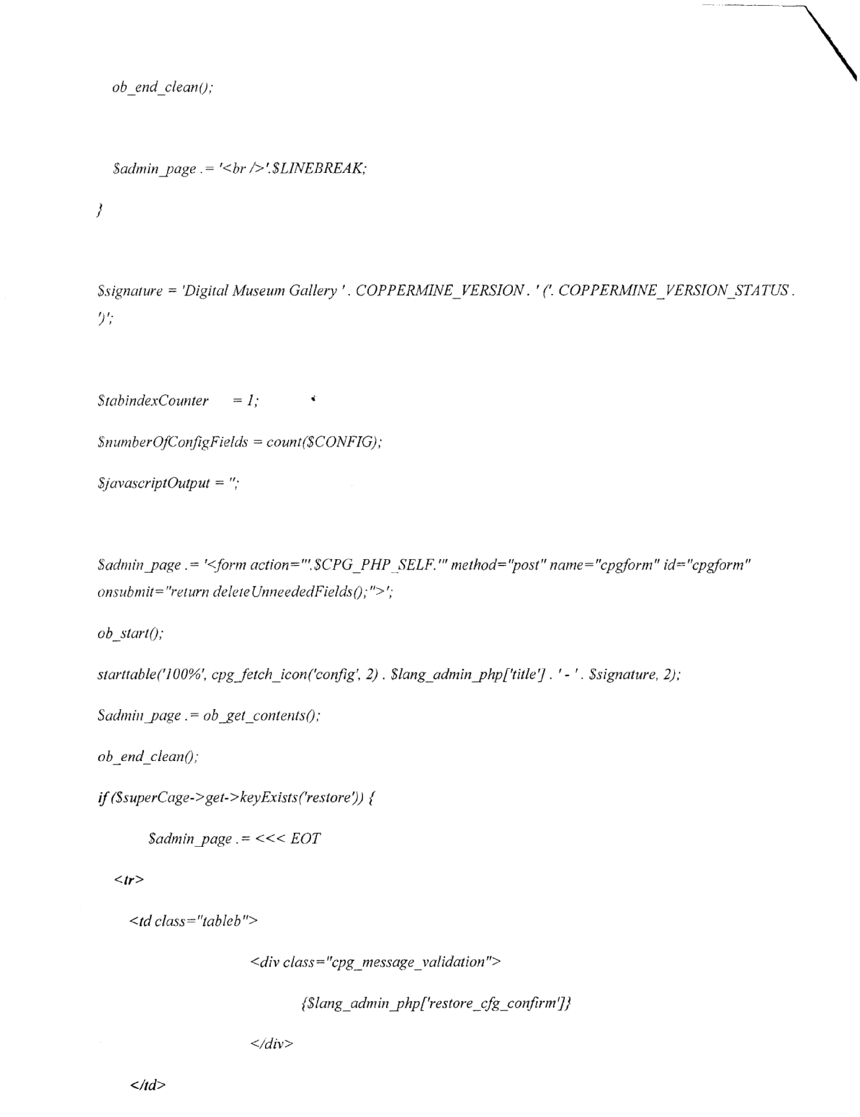
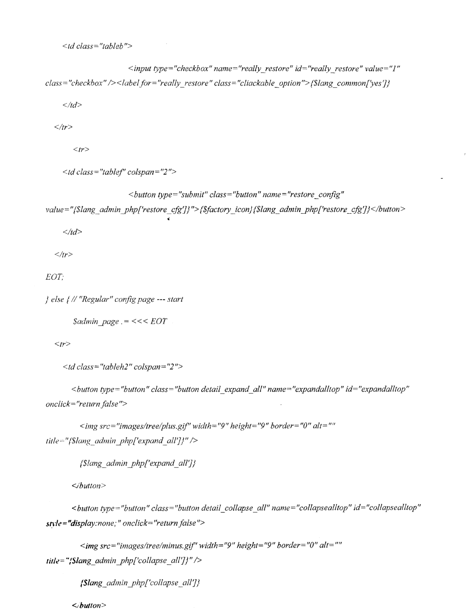
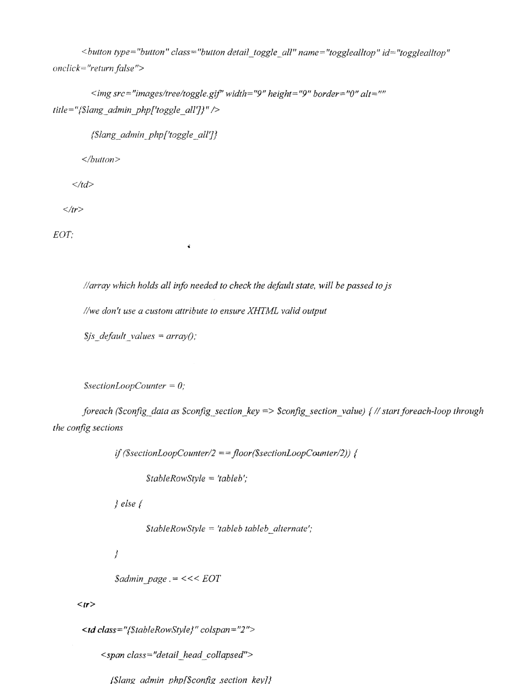
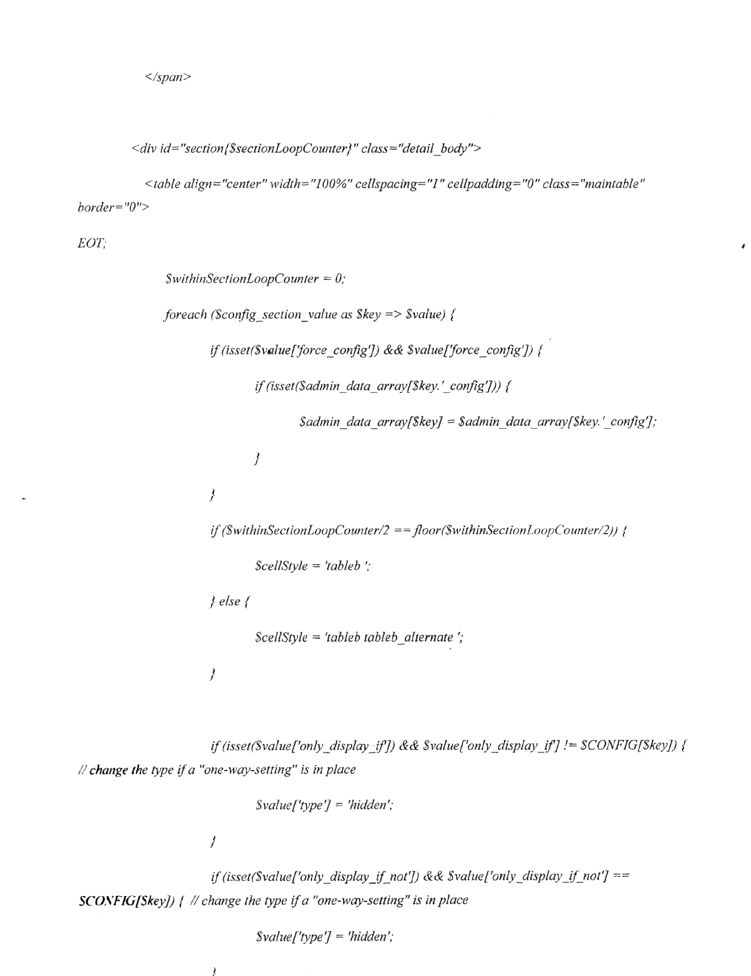
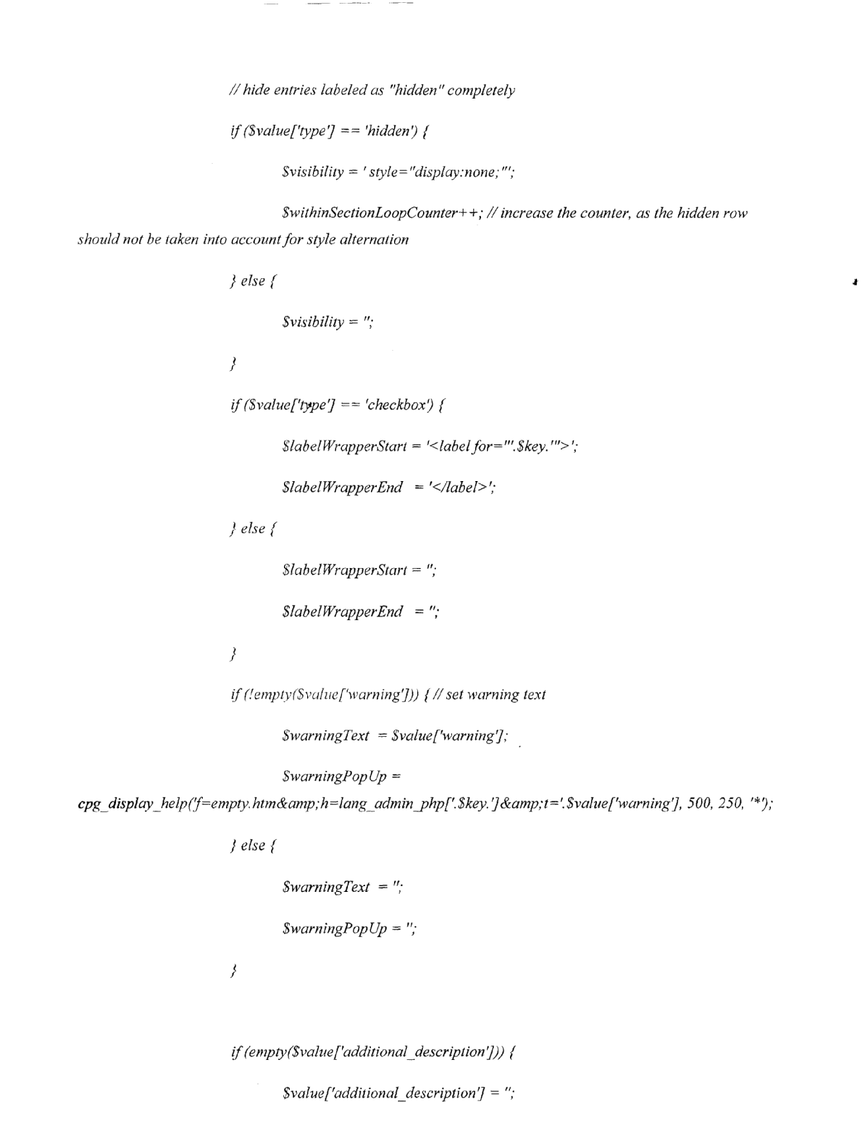
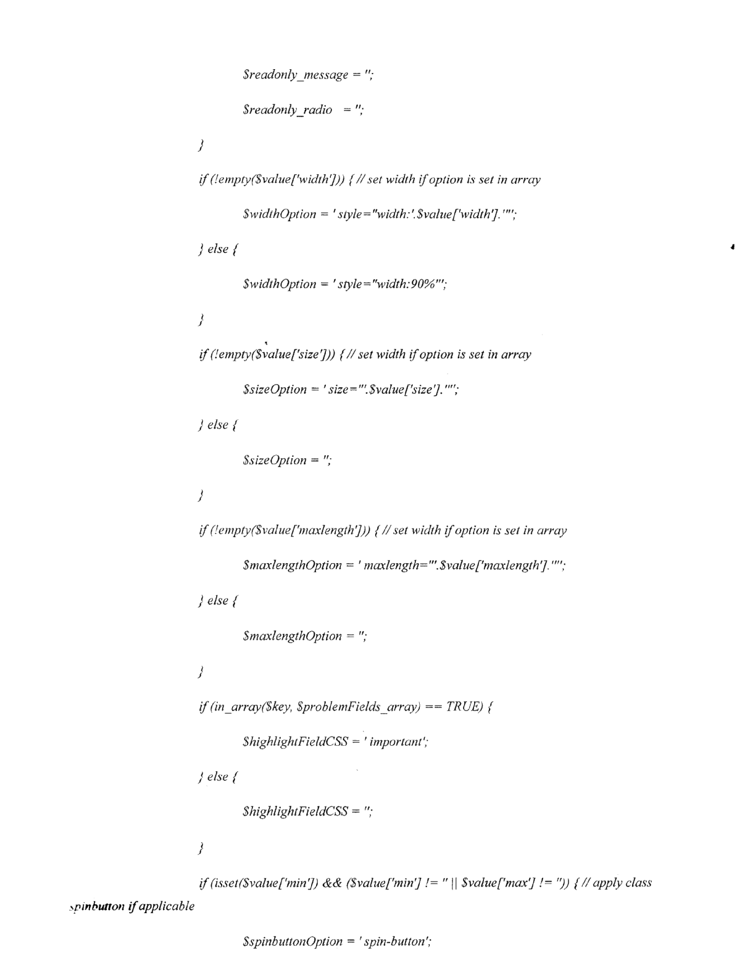
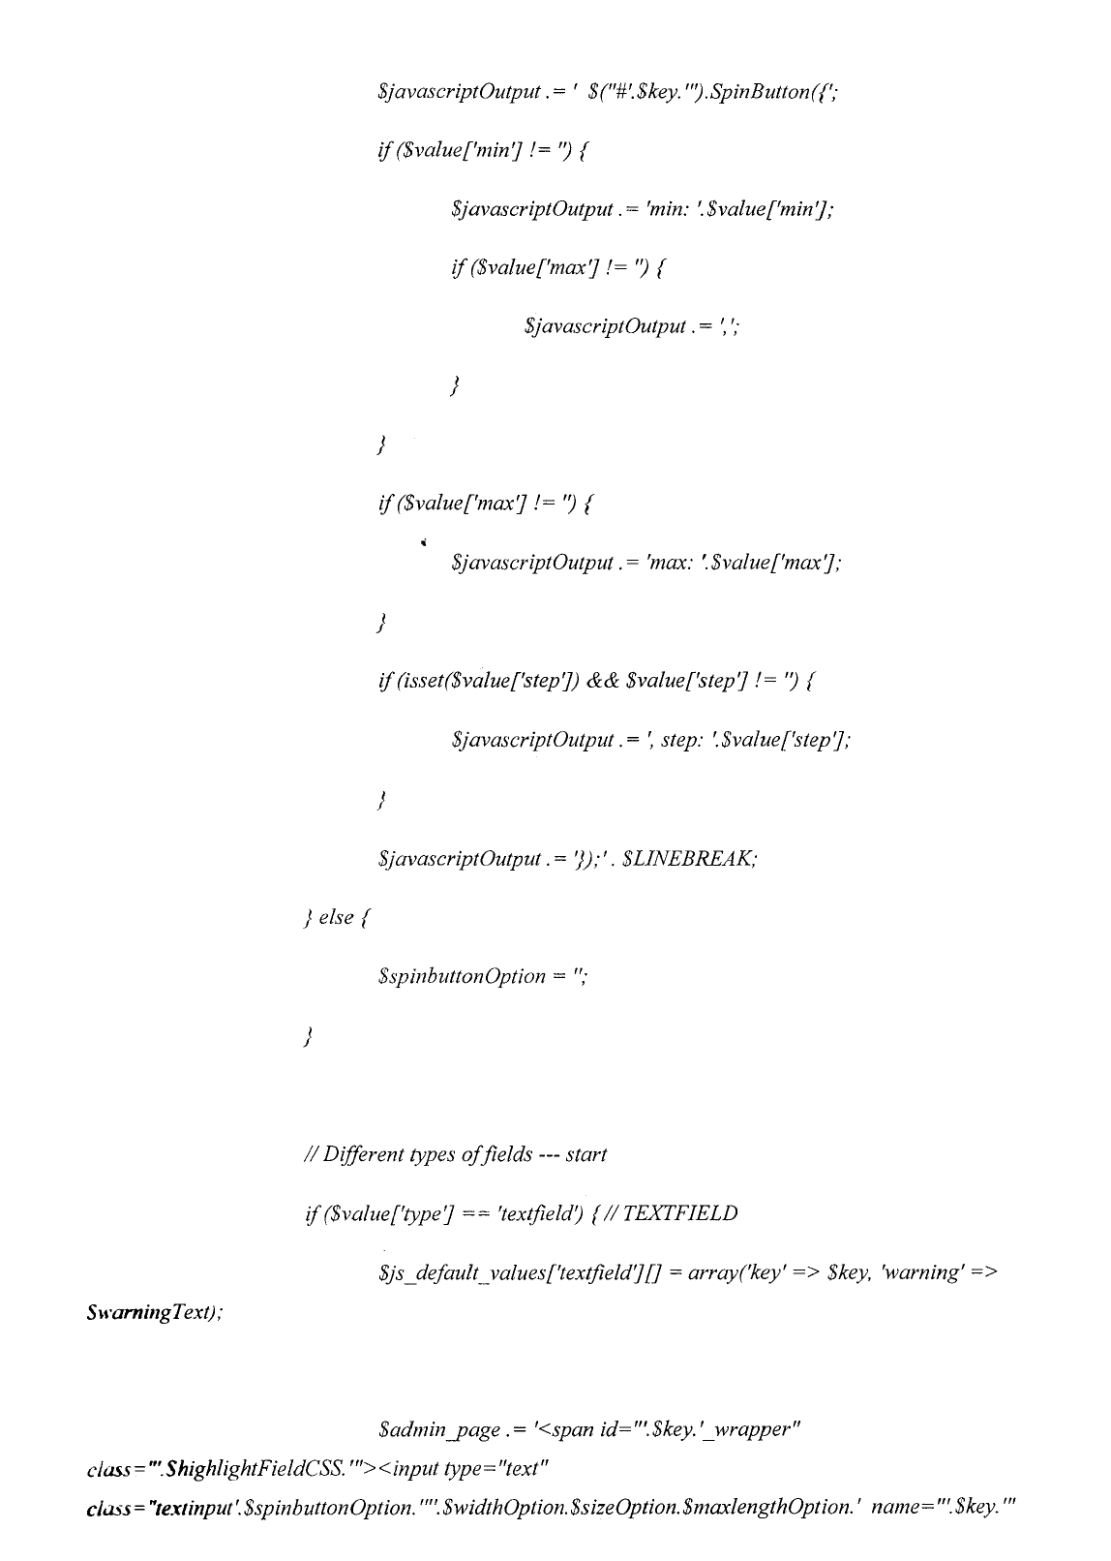
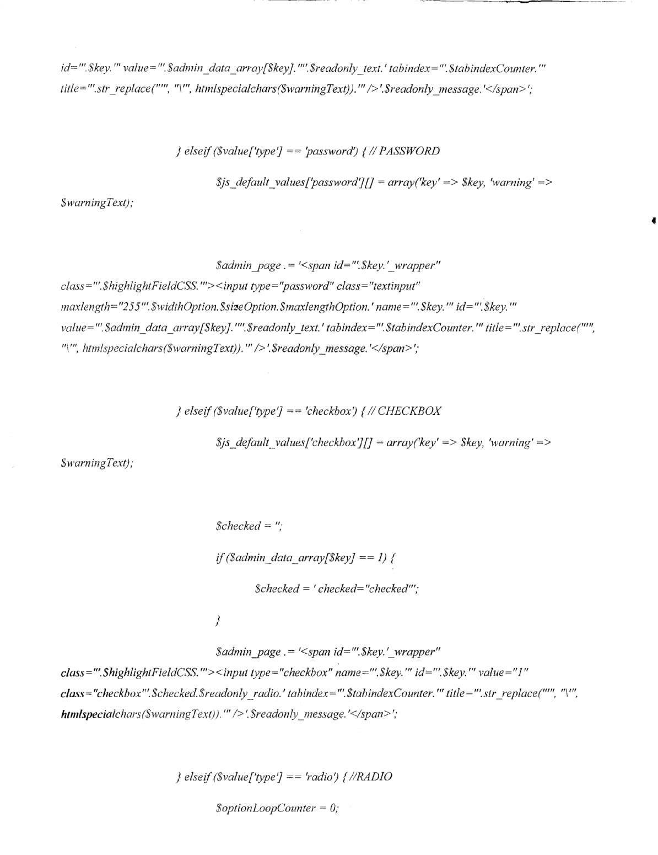
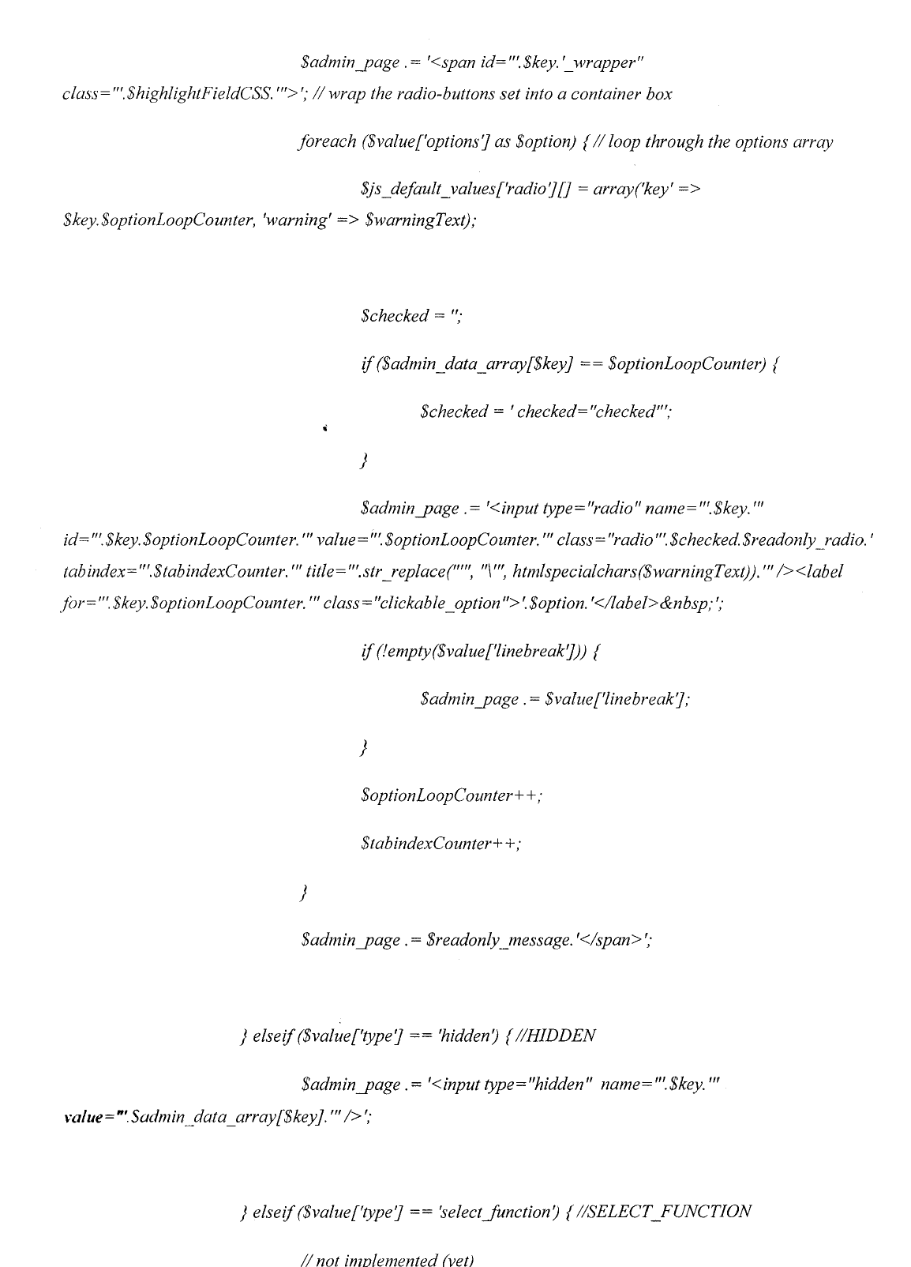
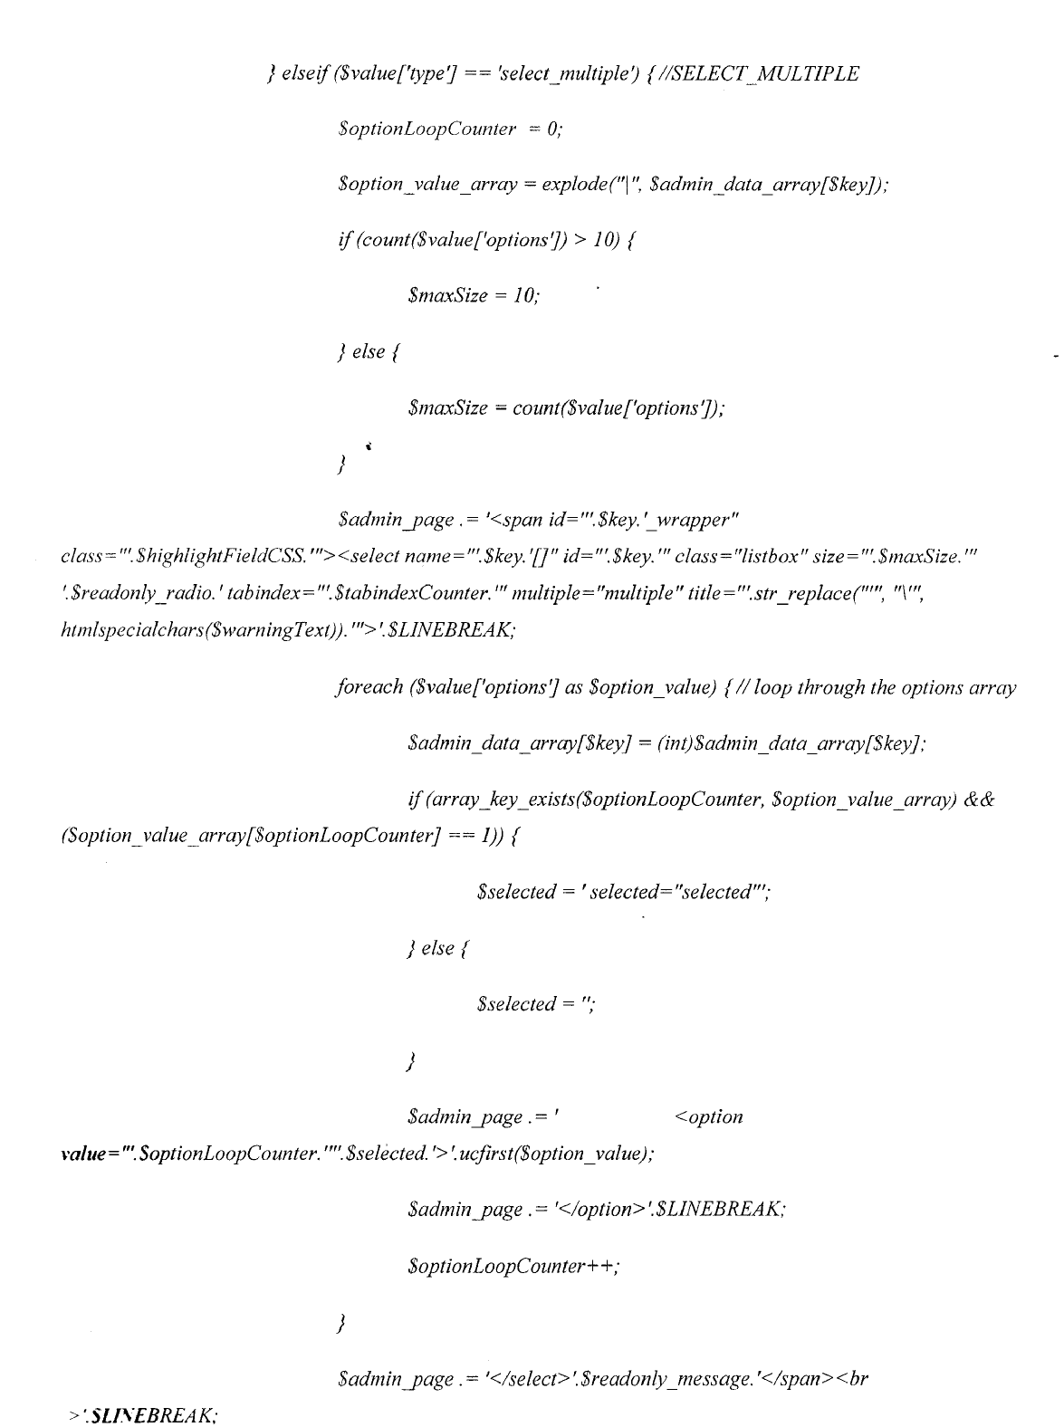
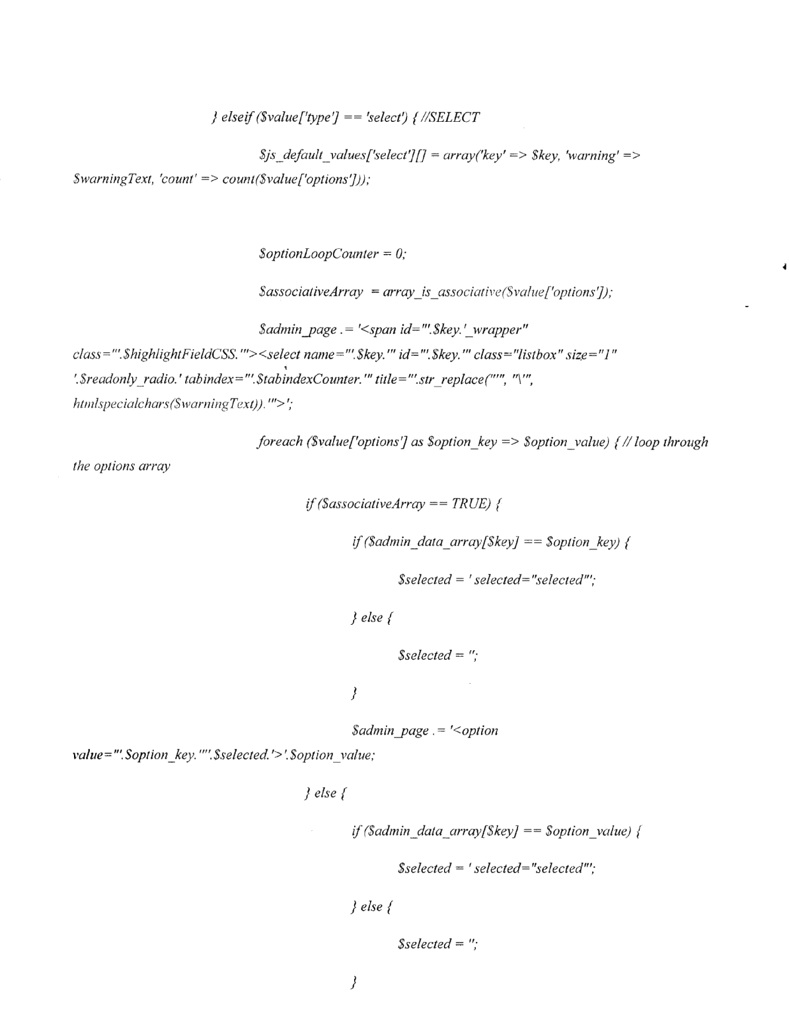
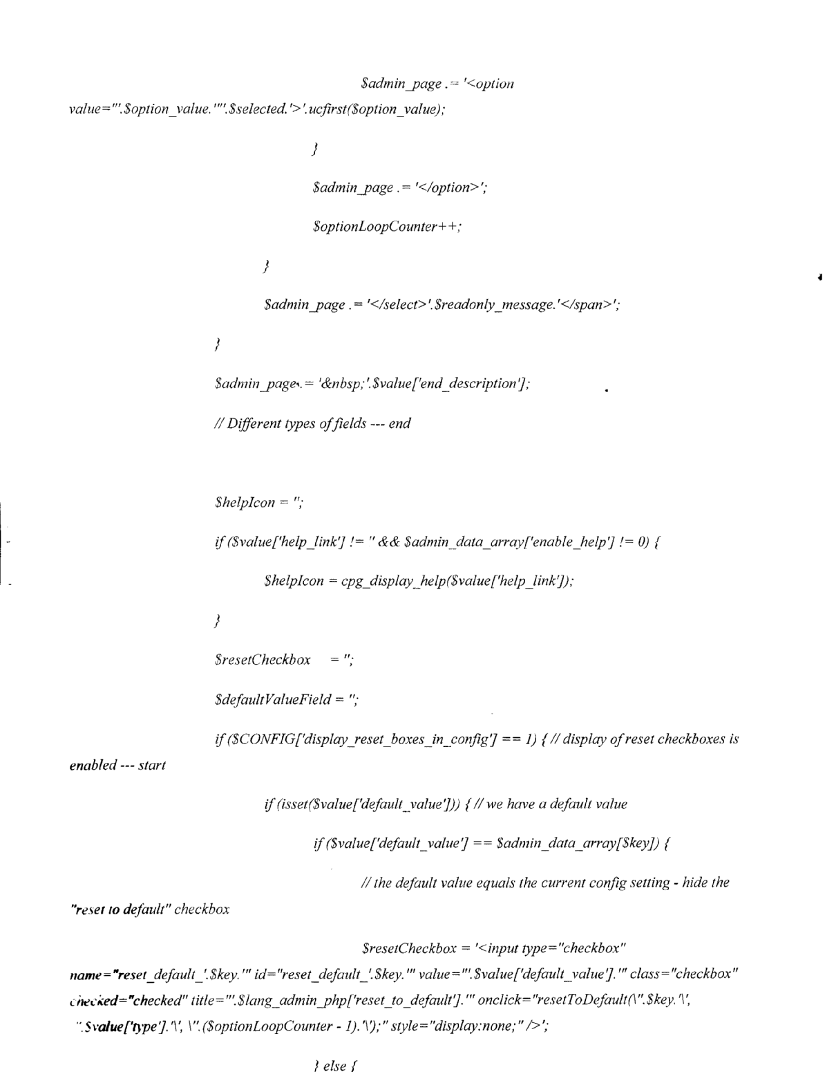
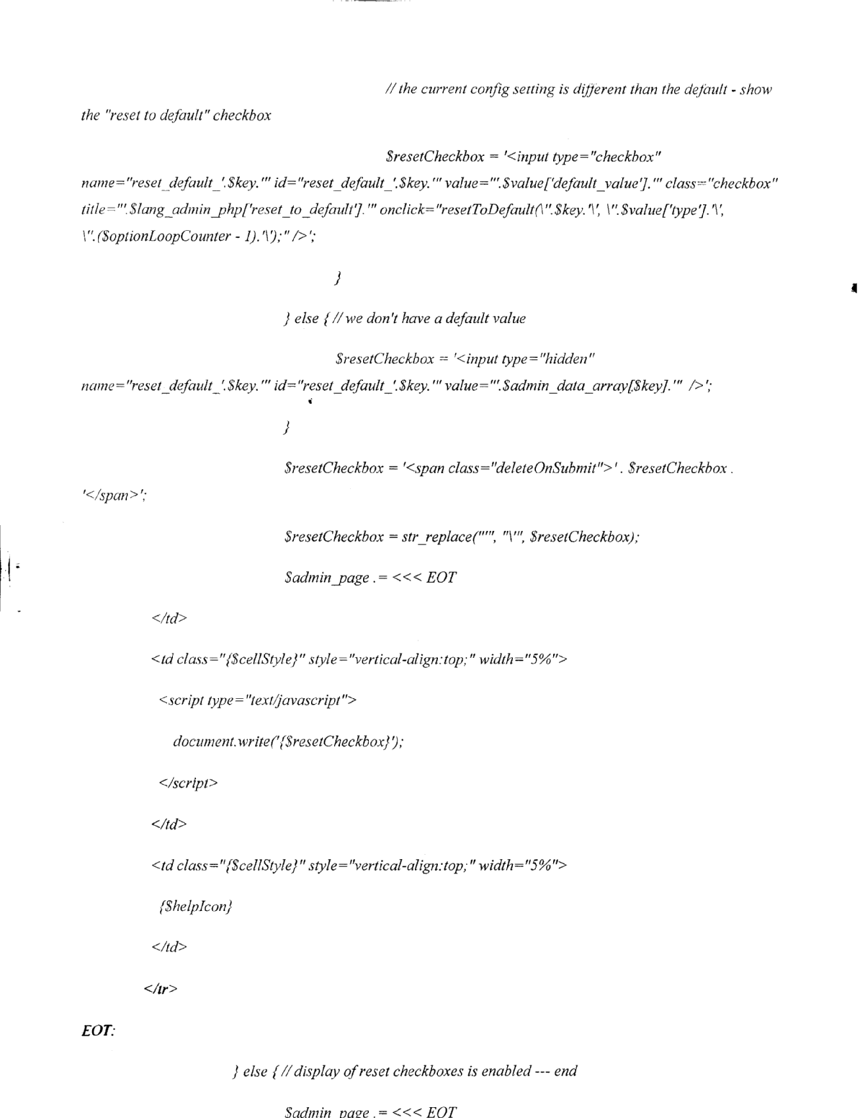
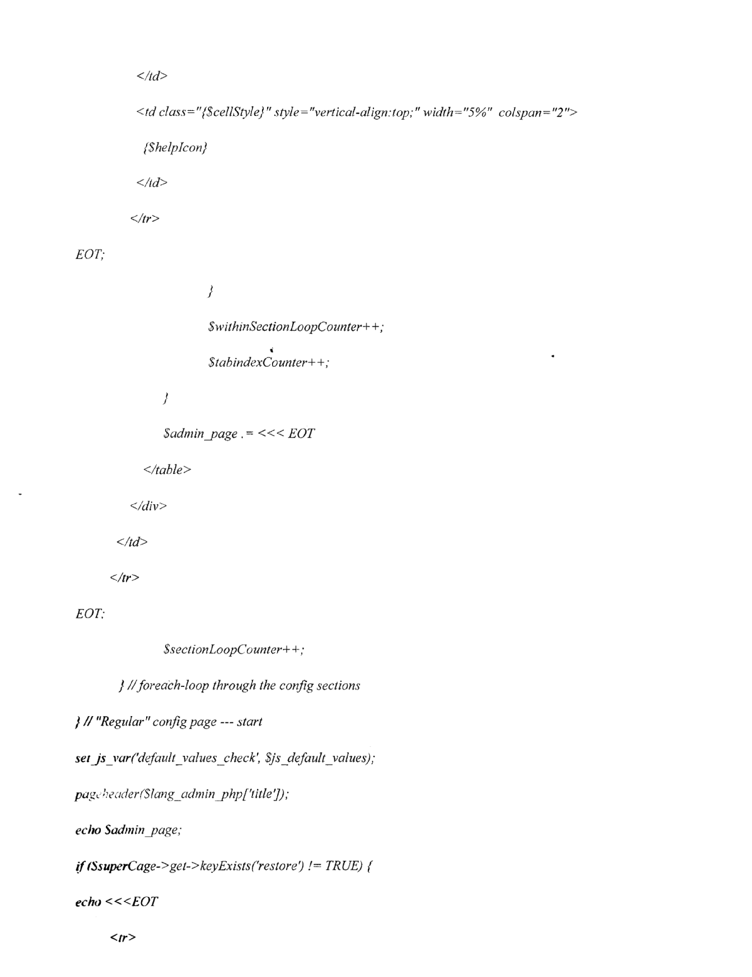
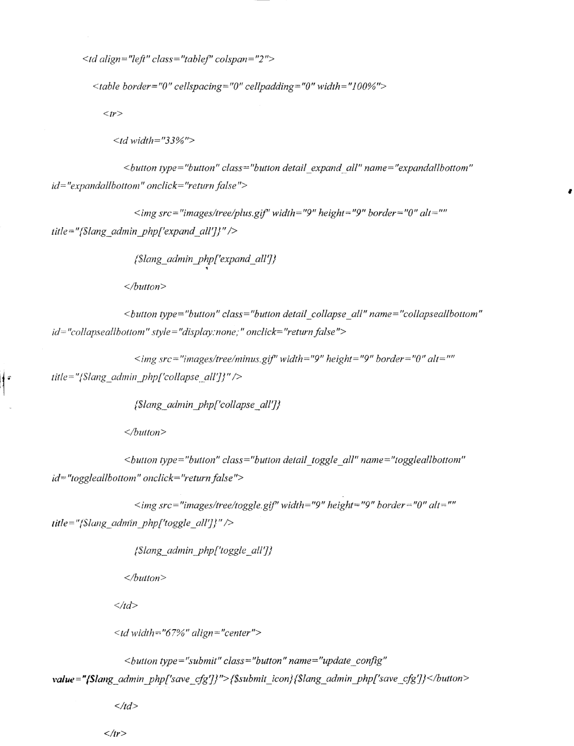
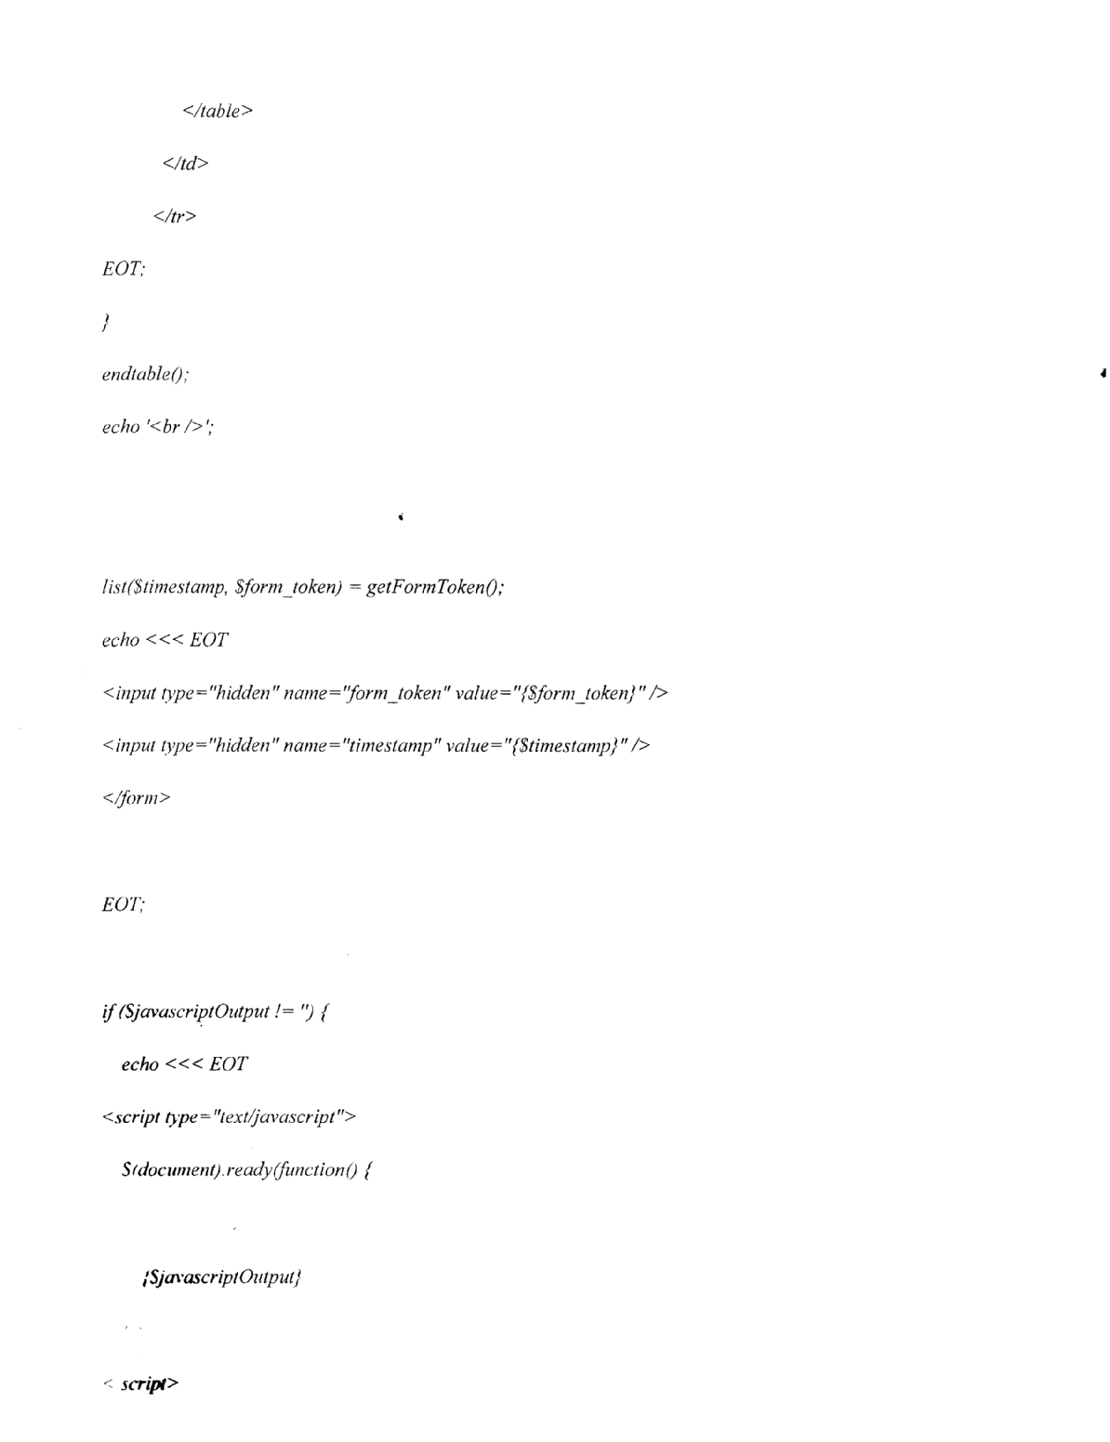
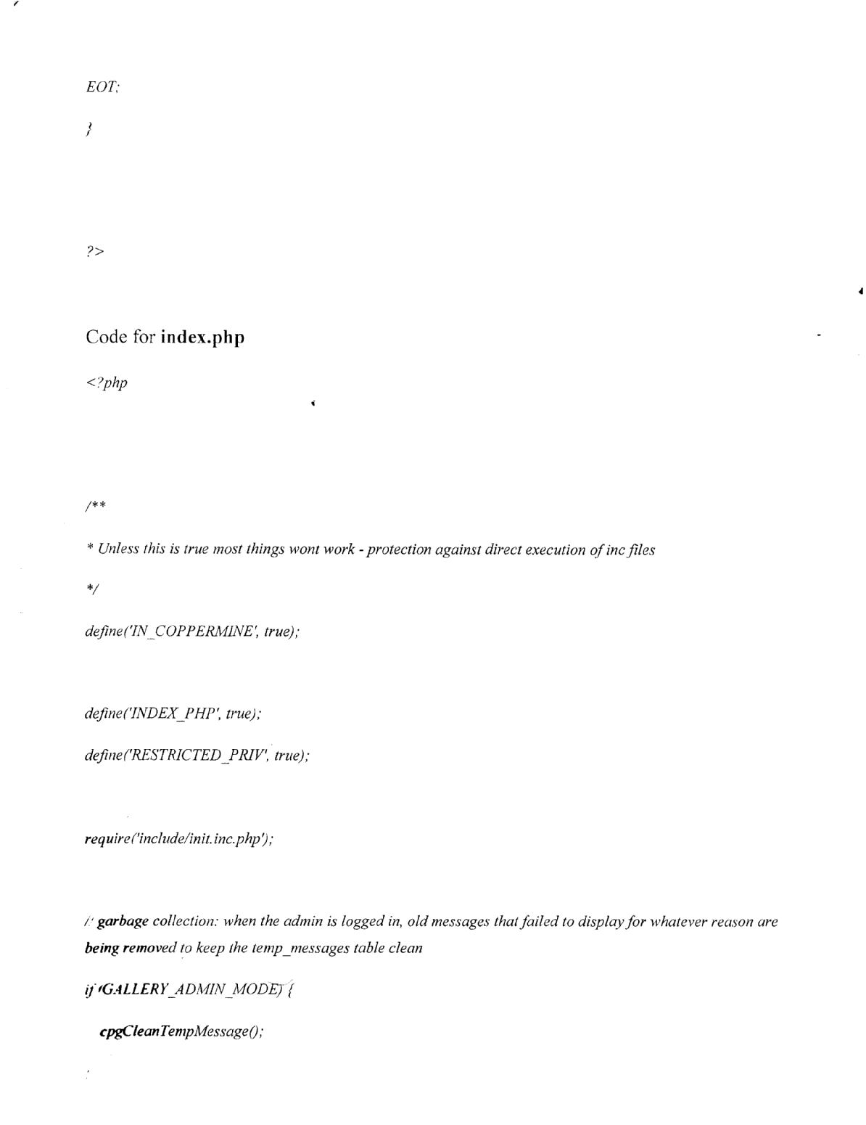
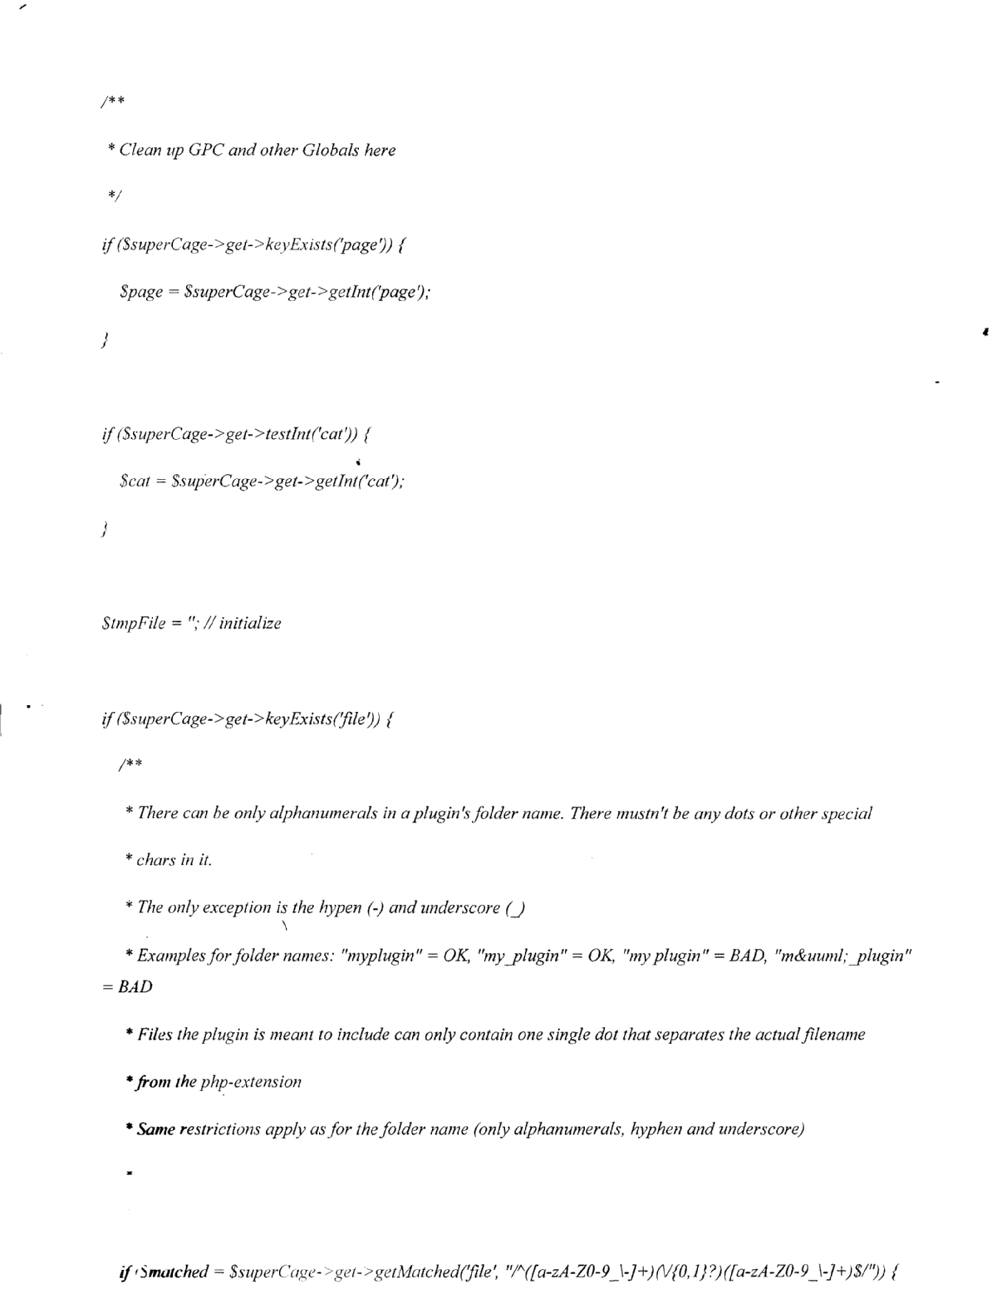
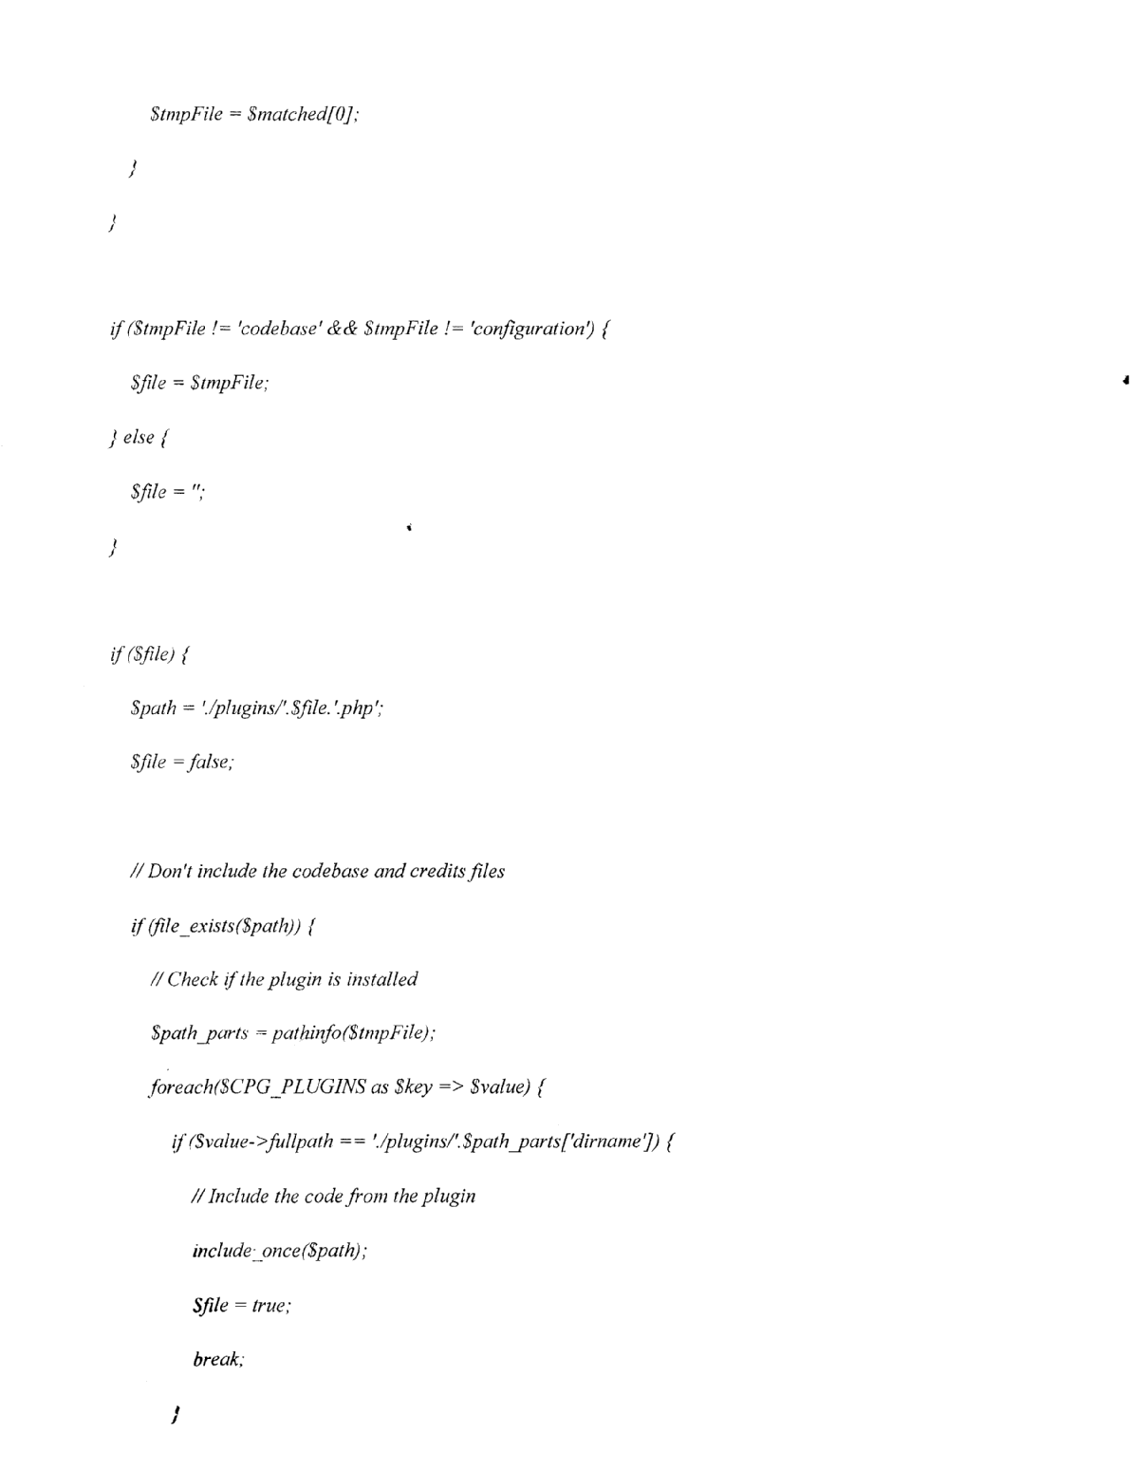
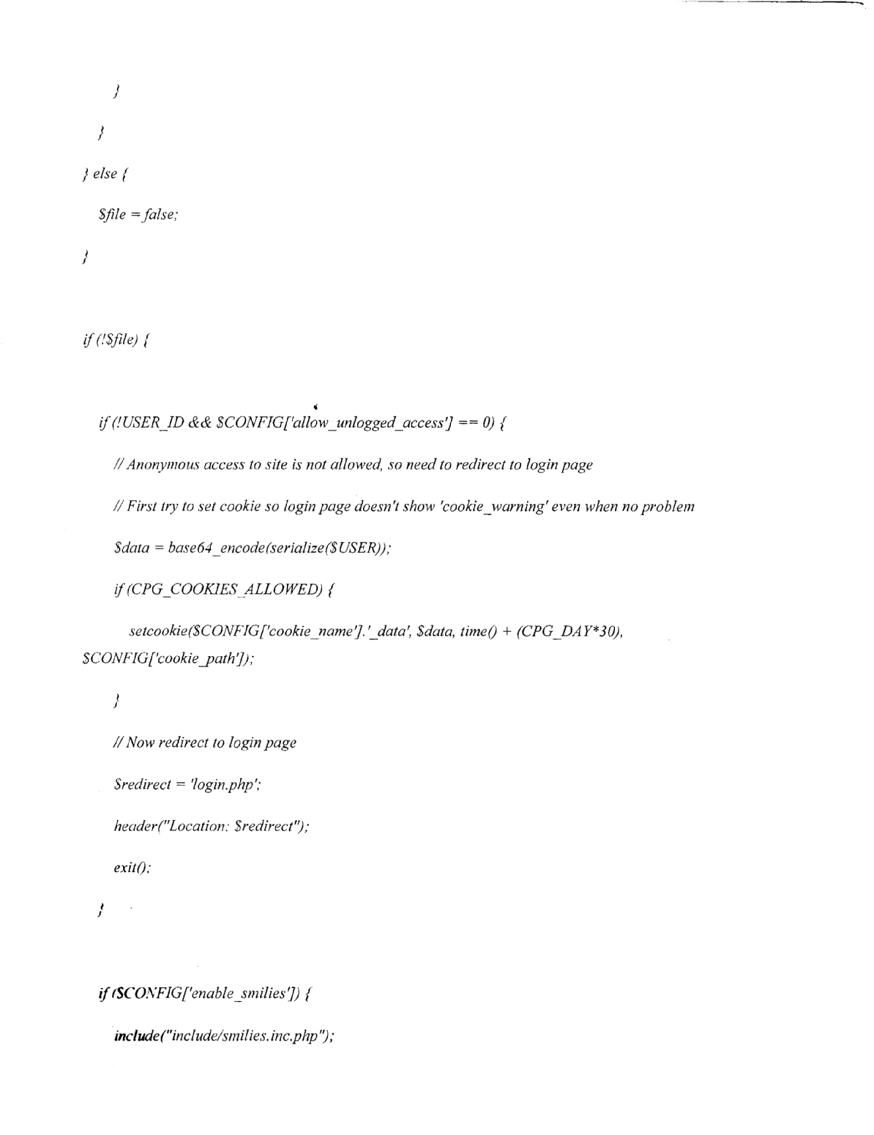
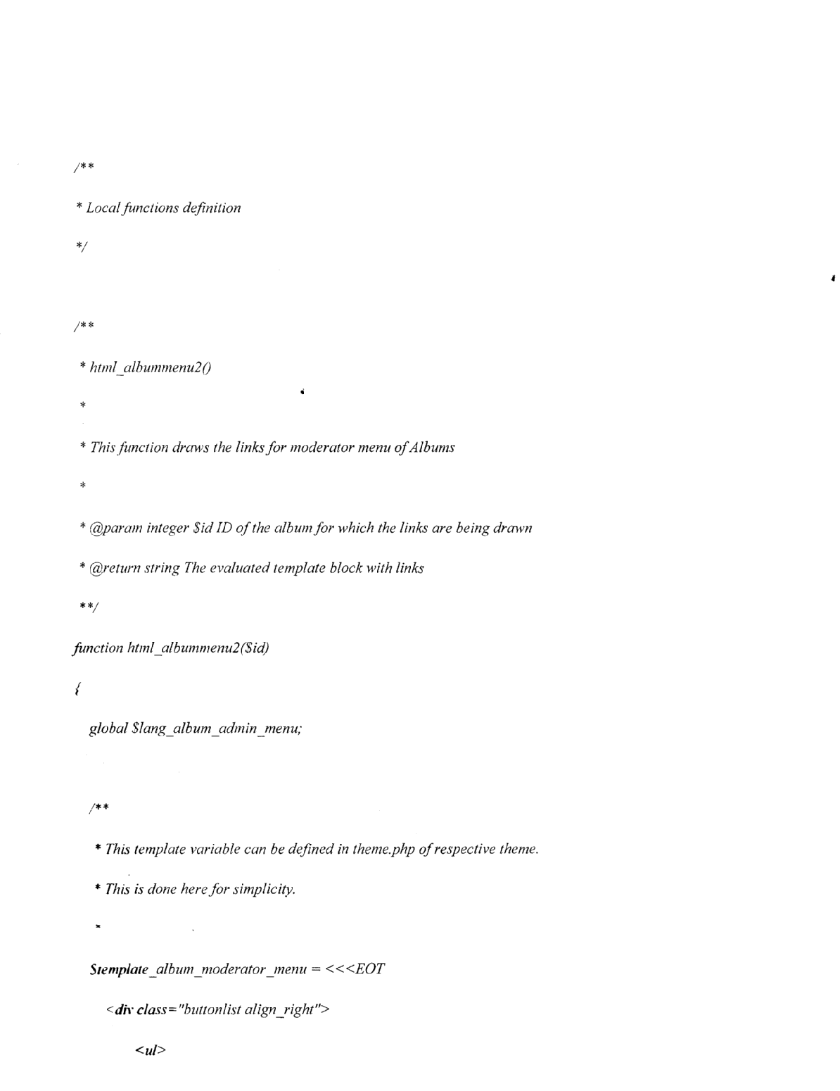
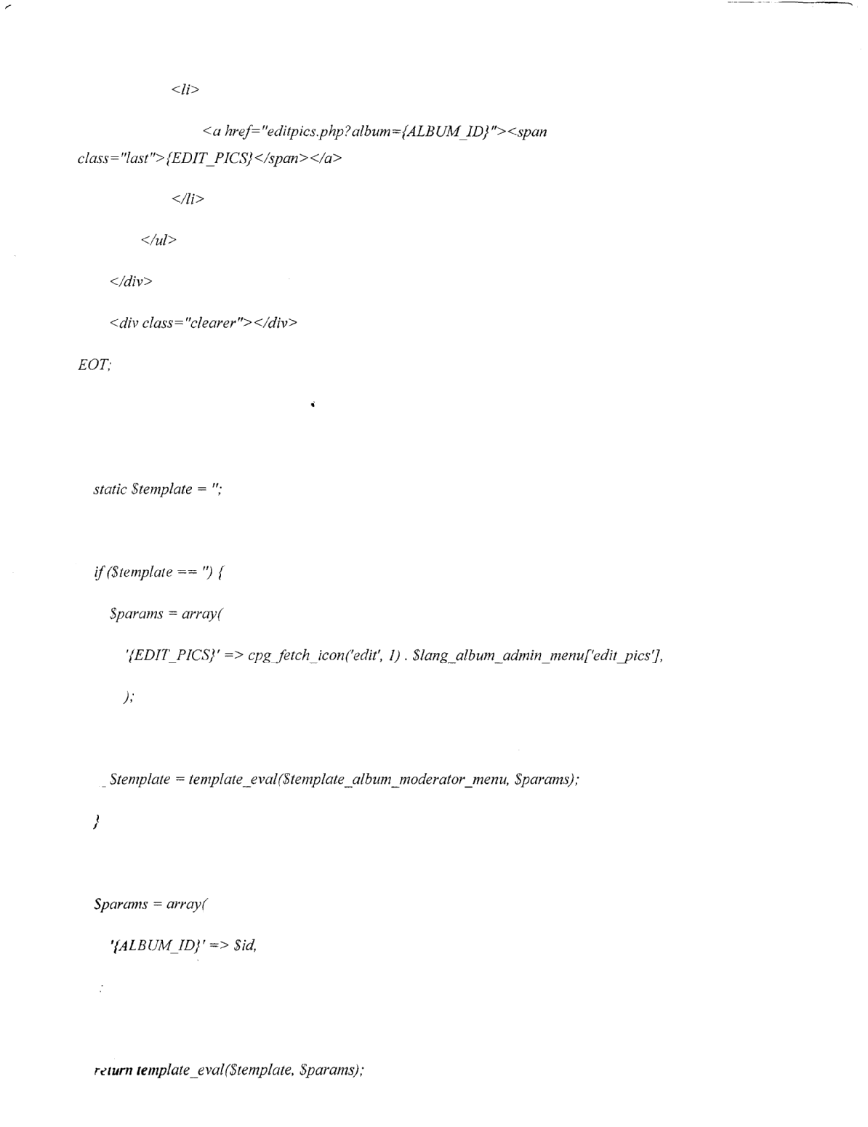
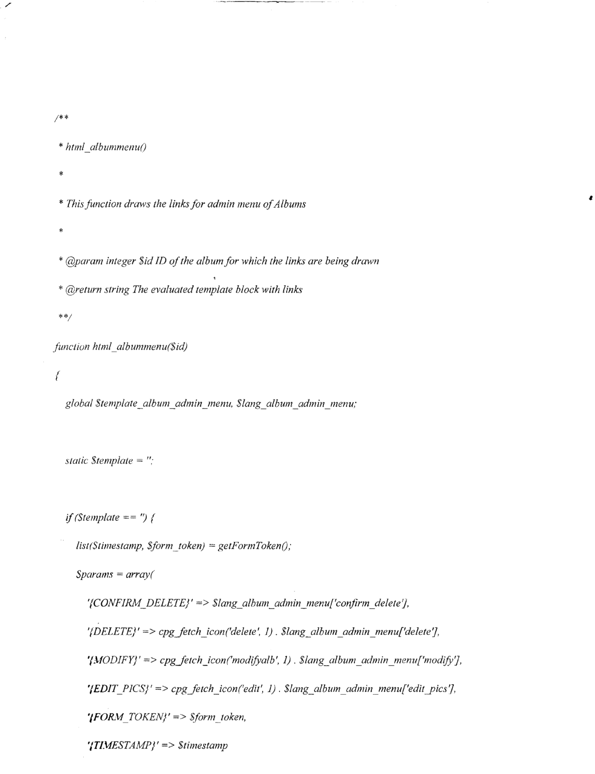
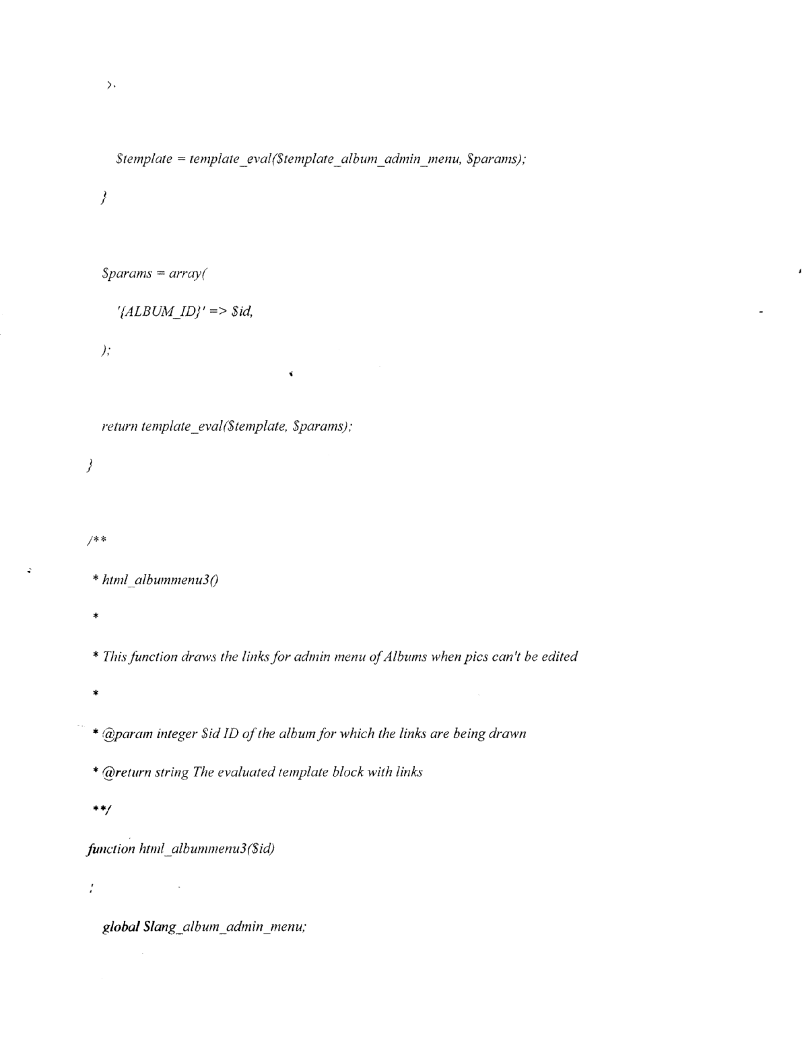
* This template variable can be defined in theme.php of respective theme.
* This is done here for simplicity.
*/
Stemplate album adn-iin nopic edit menu = <<<EOT <div class “buttonlist align right”>
<ul>
<li>
<a
href- “delete.php?id={ALBUM ID]&amp,what—album&amp,forin token —(FORMTOKENJ&amp;timestamp {TIIvIESTAMF}” onclick= “return confirm(’{C ONFIRM DELETE) 9;,,> <span> ‘DELETEJ </span> </a>
<Ii>
<a href “nodalb.php?albuni = {ALB UM JDJ “> <span> {MODIFYJ </span> </a>
</div>
<div class= “clearer”></div>
EOT;
static Steniplate
q(Stemplate == ‘91
lisI(Stimestamp, $forni token) = getForn2Token(’,)
Sparams = array(
‘(CONFIRM DELETE)’ => Slang_album _admin_mnenu[’confirmn_delete’],
‘I DELETE)’ => cpgjetch_icon (‘delete’, 1). $lang_albuni_adniin_menu[’delete 7,

